SECURITIES AND EXCHANGE COMMISSION

Washington, D.C. 20549

FORM 6-K

Report of Foreign Private Issuer

Pursuant to Rule 13a-16 or 15d-16 under the

Securities Exchange Act of 1934

For the month of May 2024

Commission File Number: 001-14014

CREDICORP LTD.

(Translation of registrant’s name into English)

Of our subsidiary

Banco de Credito del Peru:

Calle Centenario 156

La Molina

Lima 12, Peru

(Address of principal executive office)

Indicate by check mark whether the registrant files or will file annual reports under cover of Form 20-F or Form 40-F.

Form 20-F ☒ Form 40-F☐

Indicate by check mark if the registrant is submitting the Form 6-K in paper as permitted by Regulation S-T Rule 101(b)(1): ____

Indicate by check mark if the registrant is submitting the Form 6-K in paper as permitted by Regulation S-T Rule 101(b)(7): ____

The information in this Form 6-K (including any exhibit hereto) shall not be deemed “filed” for purposes of Section 18 of the Securities Exchange Act of 1934 (the “Exchange Act”) or otherwise subject to the liabilities of that section, nor shall it be deemed incorporated by reference in any filing under the Securities Act of 1933 or the Exchange Act.

SIGNATURE

Pursuant to the requirements of the Securities Exchange Act of 1934, the registrant has duly caused this report to be signed on its behalf by the undersigned, thereunto duly authorized.

Date: May 10th, 2024

CREDICORP LTD.

(Registrant)

By: /s/ Guillermo Morales

Guillermo Morales

Authorized Representative

Exhibit 99.1
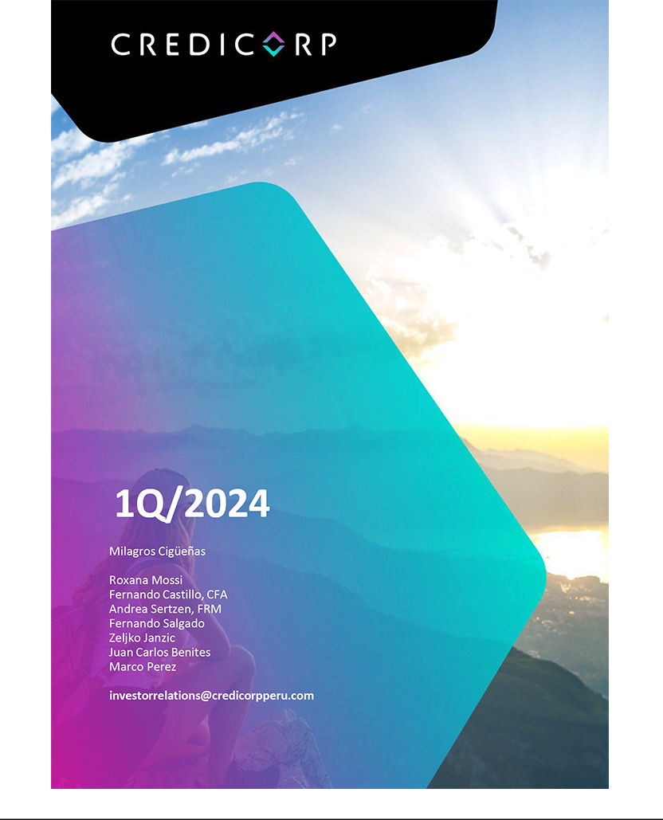

| Earnings Release 1Q / 2024

Table of Contents

Operating and Financial Highlights |  | 03
Senior Management Quotes |  | 05
First Quarter 2024 Earnings Conference Call |  | 06
Summary of Financial Performance and Outlook |  | 07
Financial Overview |  | 12
Credicorp’s Strategy Update |  | 13
Analysis of 1Q24 Consolidated Results
01 | Loan Portfolio | 16
02 | Deposits | 19
03 | Interest Earning Assets and Funding | 22
04 | Net Interest Income (NII) | 23
05 | Portfolio Quality and Provisions | 27
06 | Other Income | 31
07 | Insurance Underwriting Results | 34
08 | Operating Expenses | 36
09 | Operating Efficiency | 38
10 | Regulatory Capital | 39
11 | Economic Outlook | 41
12 | Appendix | 45
 | Datos elaborados por BCP para uso Interno | 2


| Earnings Release 1Q / 2024

Operating and Financial Highlights

Credicorp Ltd. Reports Financial and Operating Results for 1Q24

ROE stood at 18.2%, including a reversal for provisions at BCP and Mibanco, in a context of weak loan growth and a gradual improvement in the economy.

The resilience of Risk-Adjusted NIM reflects a disciplined strategy for interest rate management, backed by our position as leader in low-cost funding and a reduction in provisions.

Diversification of income sources with YoY increases of 9.4% in Net Interest Income (NII) and 8.7% in Other Core Income.

Controlled Cost of Risk, which rose 30 bps YoY to stand at 2.3%, while the NPL Ratio increased 77 bps to situate at 6.2%.

Efficiency ratio improved 70 bps YoY to 43.6%, mainly reflecting positive operating leverage at BCP.

Lima, Peru – May 09, 2024 – Credicorp Ltd. (“Credicorp” or “the Company”) (NYSE: BAP | BVL: BAP), the leading financial services holding company in Peru with a presence in Chile, Colombia, Bolivia, and Panama today reported its unaudited results for the quarter ended March 31, 2024. Financial results are expressed in Soles and are presented in accordance with International Financial Reporting Standards (IFRS).

1Q24 OPERATING AND FINANCIAL HIGHLIGHTS

- Net Income attributable to Credicorp increased 9.2% YoY to S/1,511.7 million, benefiting from a reversal of El Niño related provisions at BCP and Mibanco. Net Shareholders’ equity rose 11.5% YoY. In this context, ROE stood at 18.2%, slightly below the 18.7% reported in 1Q23.

- Total Loans, measured in average daily balances (ADB), dropped 1.3% QoQ (-1.4% FX Neutral) and 3.1% YoY (-2.8% FX Neutral), due primarily to a drop in Wholesale Banking balances and to amortization of Government Program Loans (GP). These loans represented 2.1% of the total portfolio at quarter-end and were mainly concentrated in SME- Pyme and SME-Business at BCP.

- Total Deposits remained relatively stable, dropping 0.1% QoQ (0.0% FX Neutral). Growth in Time Deposits was offset by a reduction in balances for Low-Cost Deposits. YoY, Total Deposits decreased 0.5% (+0.1% FX Neutral). Low-cost Deposits continue to be the main source of funding and represents 67.4% of total deposits.

- Net Interest Margin (NIM) increased 10 bps QoQ to stand at 6.30%, which reflects a slight increase in the yield on IEAs and a drop in the Funding Cost. YoY, NIM increased 46 bps.

- The NPL Ratio rose 34 bps QoQ to 6.2%, driven by an uptick in refinancings and an increase in delinquency in various segments, particularly in old vintages. At BCP, growth in delinquency was driven by: (i) Consumer, (ii) Mortgages, and (iii) Wholesale Banking. These dynamics were partially offset by amortization of Government Program (GP) lloans in SME-Pyme. At Mibanco, delinquency was concentrated in old vintages.

- Provisions dropped 30.6% QoQ, which reflects the impact of a reversal of approximately S/250 million for El Niño provisions. If we isolate the impact of El Niño provisions in both quarters, provisions increase 16.0% QoQ, driven mainly by BCP and, to a lesser extent, by Mibanco. The Cost of Risk fell to 2.3%, but if we isolate the effect of El Niño provisions, the Cost of Risk rose 45 bps QoQ to stand at 3.0%. The NPL Coverage Ratio stood at 93.5%.

- Core Income rose 2.3% QoQ, driven mainly by growth in Net Interest Income (NII), via repricing of Available Funds, mainly in US dollars, and through an increase in interest on investments. Other Core Income was up 2.0% QoQ, fueled by growth in Credit Cards transactions through the e-commerce channel and by an uptick in transactions through Yape. YoY, Core Income increased 9.2%, spurred mainly by an increase in NII.

Datos elaborados por BCP para uso Interno | 3

| Earnings Release 1Q / 2024

Operating and Financial Highlights

- Insurance Underwriting Results contracted 2.9% QoQ, after reporting unusually high levels in 4Q23. The contraction this quarter was driven primarily by a reduction in the Underwriting Result in Life, primarily through Disability and Survivorship (D&S) and in Credit Life. YoY, Insurance Underwriting Result contracted by 5.8%.

- The Efficiency Ratio improved 70 bps YoY to stand at 43.6%, impacted primarily by positive operating leverage at BCP in a context of an uptick in expenses associated with disruptive initiatives and IT expenses at BCP’s core businesses. Mibanco also reported positive operating leverage.

- Yape, continues to scale and reached the 11.5 million monthly active users mark in 1Q24; 75% of these affiliates generate fee income. Yape is on its way to breaking even in 2024.

- Credicorp maintains a solid capital base, with an IFRS CET1 Ratio of 11.86% at BCP and 16.06% at Mibanco, down 135 bps QoQ and 231 bps QoQ, respectively. A solid capital base supports the recently announced dividend of S/35.0 per share, to be paid in June 2024.

- At BCP, the Liquidity Coverage Ratio (LCR) in PEN at 30 days stood at 199.8% under regulatory requirements and 154.5% based on more stringent internal requirements, while USD 30-day LCR stood at 144.4% and 117.8% under regulatory and more stringent internal requirements, respectively.

- In March 2024, Credicorp published its 2023 Annual and Sustainability Report, which provides details on the progress we have made in integrating sustainability into our businesses while we focus on our purpose to “contribute to improving lives by driving the changes that our countries need”.

Datos elaborados por BCP para uso Interno | 4

| Earnings Release 1Q / 2024

Senior Management Quotes

SENIOR MANAGEMENT QUOTES
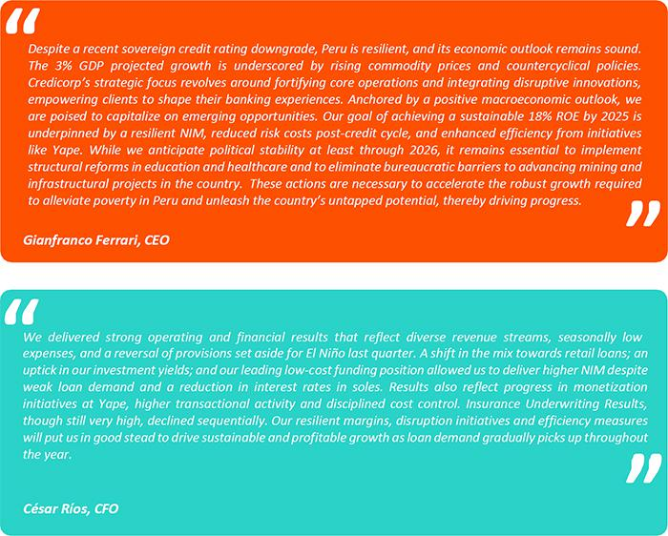

Datos elaborados por BCP para uso Interno | 5

| Earnings Release 1Q / 2024

First Quarter 2024 Earnings Conference Call

FIRST QUARTER 2024 EARNINGS CONFERENCE CALL

Date: Friday May 10th, 2024

Time: 10:30 am ET (9:30 am Lima, Perú)

Hosts: Gianfranco Ferrari – Chief Executive Officer, Cesar Rios - Chief Financial Officer, Francesca Raffo – Chief Innovation Officer, Reynaldo Llosa - Chief Risk Officer, Diego Cavero – Head of Universal Banking, Cesar Rivera - Head of Insurance and Pensions, Carlos Sotelo - Mibanco CFO and Investor Relations Team.

To pre-register for the listen-only webcast presentation use the following link:

https://dpregister.com/DiamondPassRegistration/register?confirmationNumber=10188428&linkSecurityString=fc4fdee 944

Callers who pre-register will be given a conference passcode and unique PIN to gain immediate access to the call and bypass the live operator. Participants may pre-register at any time, including up to and after the call start time.

Those unable to pre-register may dial in by calling:
1 844 435 0321 (U.S. toll free)
1 412 317 5615 (International)
Participant Web Phone: Click Here
Conference ID: Credicorp Conference Call

The webcast will be archived for one year on our investor relations website at:

https://credicorp.gcs-web.com/events-and-presentations/upcoming-events

For a full version of Credicorp´s Fourth Quarter 2023 Earnings Release, please visit:

https://credicorp.gcs-web.com/financial-information/quarterly-results

Datos elaborados por BCP para uso Interno | 6

| Earnings Release 1Q / 2024

Summary of Financial Performance and Outlook

Loans in Average Daily Balances (ADB)
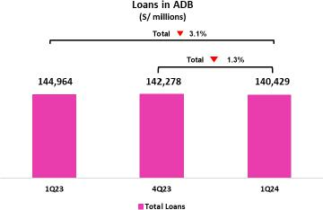

Total loans, measured in ADB, dropped 1.3% QoQ (-1.4% FX Neutral) to total S/140,429 million. This decrease was driven mainly by i) Wholesale Banking at BCP, due to a lower demand, ii) SME-Business & SME-Pyme segments at BCP, in line with the amortization of government program (GP) loans; and iii) Mibanco, in line with more restrictive origination policies.

YoY, total loans in ADB fell 3.1% (-2.8% FX Neutral), driven mainly by: i) Wholesale Banking at BCP; ii) SME-Business and SME-Pyme at BCP; and iii) Mibanco, due to the same dynamics as those seen QoQ.

GP loans represented 2.1% of total loans at quarter-end and are concentrated in SME-Pyme and SME-Business at BCP.

Deposits
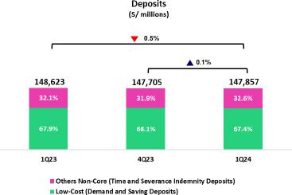

Our deposit base, measured in quarter-end balances, remained relatively stable (+0.1% QoQ and 0.0% FX Neutral). Growth in Term Deposits was largely offset by a drop in balances for Demand and Saving Deposits (Low-cost deposits).

In the YoY comparison, the deposit base dropped 0.5% (+0.1% FX Neutral). Low-cost deposits, which represent 67.4% of our deposit base at quarter-end, continued to play a preponderant role in our funding mix.

Net Interest Income (NII) and Margin (NIM)
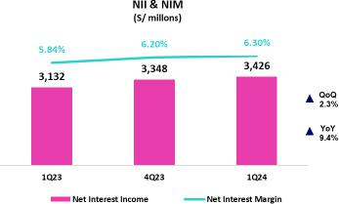

NII rose 2.3% QoQ to stand at S/3,426 million. This evolution was driven by an increase in Interest and Similar Income, in line with i) higher interest derived from repricing of Available Funds, mainly in US dollars and ii) growth in interest on investments. Interest and Similar Expenses fell 1.5% QoQ, in line with a decrease in the Cost of Funding, after term deposits were renewed at lower rates. In this context, the yield on IEA and the Cost of Funding reported slight improvements, which led NIM to stand at 6.30% at quarter-end.

YoY, NII rose 9.4%, driven primarily by a shift in the loan mix toward retail segments coupled with repricing of our dollar book.

Datos elaborados por BCP para uso Interno | 7


| Earnings Release 1Q / 2024

Summary of Financial Performance and Outlook

Portfolio Quality and Cost of Risk
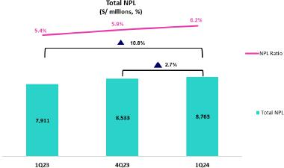

QoQ, the NPL balance increased 2.7%. This evolution was driven by growth in (i) Consumer, in line with an uptick in refinancing; (ii) Mortgage, in line with an increase in volumes of overdue loans; (iii) Wholesale Banking, due to refinancing for a specific client; and iv) Mibanco, in line with an uptick in overdue loans, primarily in old vintages.

YoY, the NPL balance rose 10.8%. This growth was concentrated in: i) Consumer, driven by an uptick in refinancing and in overdue loans, particularly in old vintages; ii) Mortgage, mainly due to growth in overdue and refinancing loans, and iii) Mibanco, in line with an increase in overdue loans.

In this context, NPL ratio stood at 6.2% by quarter-end. QoQ, the

NPL ratio rose by 34 bps, mainly due to a loan contraction and the
aforementioned NPL volume dynamics. YoY, the NPL Ratio rose 77
bps, fueled mainly by the aforementioned increase in the NPL

balance and secondarily, by a loan contraction.
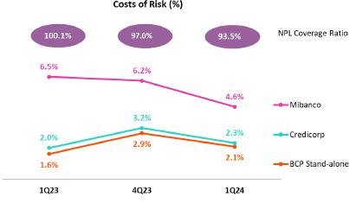

Provisions this quarter reflected the impact of a reversal of approximately S/250MM in provisions for the El Niño Phenomenon. Throughout this report, our analysis of provision expenses and Cost of Risk will isolate the impact of El Niño provisions registered in 4Q23 and reversed in 1Q24. If we isolate this effect, provisions rose 16.0% QoQ, driven by BCP, and to lesser extent, by Mibanco. At BCP, the following dynamics were noteworthy: i) Mortgage, due to a base effect given that in 4Q23, reversals were reported for specific sub-products and; ii) SME-Pyme, in line with an increase in write-offs (loans that were not 100% provisioned) and with estimates that risk levels rose due to a deterioration in client payment capacities. At Mibanco, the following points were noteworthy: i) a deterioration in the portfolio, particularly in old vintages. YoY, isolating the impact of the aforementioned provision reversal, provisions rise 46.9%, driven by i) SME-Pyme and Credit Cards, which were impacted by a deterioration in payment capacity, and by ii) Consumer, in line with a downturn in payment performance.

If we isolate the effect of El Niño Provisions, the Cost of Risk rose

to 3.0%. While the NPL Coverage Ratio, in turn, stood at 93.5%.

Datos elaborados por BCP para uso Interno | 8

| Earnings Release 1Q / 2024

Summary of Financial Performance and Outlook

Other Income
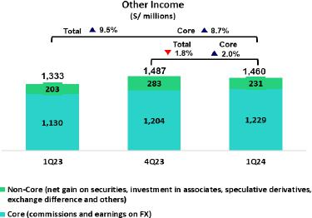

Other Core Income¹ increased 2.0% QoQ, driven primarily by BCP. Noteworthy drivers of the increase were the growth in credit cards transactions through the e-commerce channel and, secondarily, the uptick in transactions through Yape. YoY, Other Core Income rose 8.7%, spurred primarily by BCP, driven by solid growth in fee income through Yape and an uptick in transactions via credit and debit cards, and secondarily, by Credicorp Capital, via an uptick in fee income.

Other Non-Core Income¹ dropped 18.4% QoQ, due to a drop in the Gain on Securities at BCP and Pacifico. YoY, Other Non-Ordinary income rose 13.6%, driven by an uptick in the Gain on Derivatives at Credicorp Capital and ASB.

1. See calculation formula in Annex 12.7.

Insurance Underwriting Result
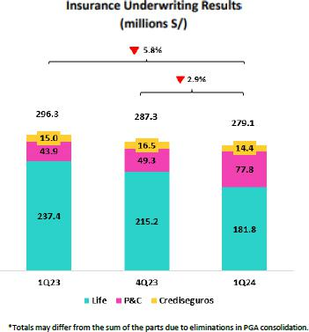

The Insurance Underwriting Result dropped 2.9% QoQ. This evolution was triggered by a drop in the underwriting result in the Life business, which was impacted by a reduction in income through D&S and Credit Life.

YoY, the Insurance Underwriting Result decreased 5.8%, driven by a lower underwriting result in Life, which was mainly attributable to a reduction in income from the D&S business.

Datos elaborados por BCP para uso Interno | 9

| Earnings Release 1Q / 2024

Summary of Financial Performance and Outlook

Efficiency
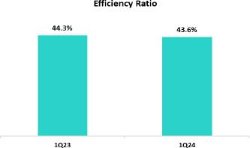

In 1Q24, the Efficiency ratio stood at 43.6%, which reflects an improvement of 70 bps with regard to 1Q23. This dynamic was driven by the positive operating leverage, mainly at BCP.

Net earnings attributable to Credicorp
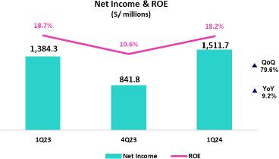

In 1Q24, net income attributable to Credicorp totaled S/1,511.7 million, up 79.6% QoQ and 9.2% YoY. Net Shareholders’ Equity stood at S/33,853 million (+4.3% QoQ and +11.5% YoY). In this context, ROE reached 18.2%.

Contributions and ROE by subsidiary in 1Q24

(S/ millions)
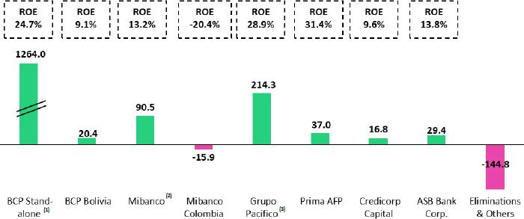

- At BCP Stand Alone, the figure is lower than net income because it does not include gains on investments in other Credicorp subsidiaries (Mibanco).
- At Mibanco, the figure is lower than net income because Credicorp owns 99.921% of Mibanco (directly and indirectly).
- The Contribution of Grupo Pacífico presented here is higher than the earnings reported for Pacifico Seguros because it includes 100% of Crediseguros (including 48% under Grupo Credito)

Datos elaborados por BCP para uso Interno | 10

| Earnings Release 1Q / 2024

Summary of Financial Performance and Outlook
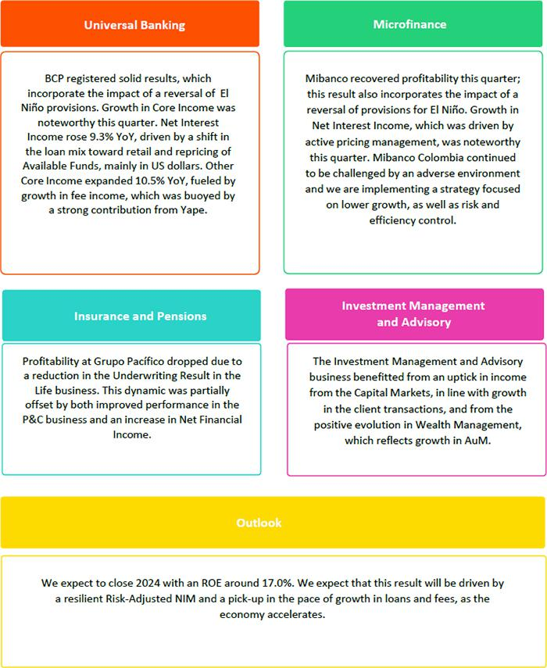

Datos elaborados por BCP para uso Interno | 11

Financial Overview

| Earnings Release 1Q / 2024

Financial Overview


Credicorp Ltd. | 1Q23 | Quarter | 1Q24 | QoQ | % change
S/000 | 1Q23 | 4Q23 | 1Q24 | QoQ | YoY
Net interest, similar income and expenses | 3,132,089 | 3,347,684 | 3,426,123 | 2.3% | 9.4%
Provision for credit losses on loan portfolio, net of recoveries | (726,998) | (1,173,454) | (814,699) | -30.6% | 12.1%
Net interest, similar income and expenses, after provision for credit losses on loan | 2,405,091 | 2,174,230 | 2,611,424 | 20.1% | 8.6%
portfolio
Other income | 1,333,275 | 1,486,823 | 1,459,394 | -1.8% | 9.5%
Insurance underwriting result | 296,341 | 287,295 | 279,062 | -2.9% | -5.8%
Total expenses | (2,126,908) | (2,661,542) | (2,279,317) | -14.4% | 7.2%
Profit before income tax | 1,907,799 | 1,286,806 | 2,070,563 | 60.9% | 8.5%
Income tax | (493,466) | (434,648) | (528,466) | 21.6% | 7.1%
Net profit | 1,414,333 | 852,158 | 1,542,097 | 81.0% | 9.0%
Non-controlling interest | 30,060 | 10,331 | 30,440 | 194.6% | 1.3%
Net profit attributable to Credicorp | 1,384,273 | 841,827 | 1,511,657 | 79.6% | 9.2%
Dividends distribution, net of treasury shares effect (S/000) | - | - | - | - | -
Net income / share (S/) | 17.4 | 10.6 | 19.0 | 79.6% | 9.2%
Dividends per share | - | - | - | - | -
Loans | 145,165,713 | 144,976,051 | 140,798,083 | -2.9% | -3.0%
Deposits and obligations | 148,623,300 | 147,704,994 | 147,857,127 | 0.1% | -0.5%
Net equity | 30,359,898 | 32,460,004 | 33,853,460 | 4.3% | 11.5%
Profitability
Net interest margin ⁽¹⁾ | 5.84% | 6.20% | 6.30% | 10 bps | 46 bps
Risk-adjusted Net interest margin | 4.54% | 4.10% | 4.85% | 75 bps | 31 bps
Funding cost ⁽²⁾ | 2.61% | 3.03% | 2.98% | -5 bps | 37 bps
ROAE | 18.66% | 10.57% | 18.24% | 767 bps | -42 bps
ROAA | 2.34% | 1.41% | 2.52% | 111 bps | 18 bps
Loan portfolio quality
Internal overdue ratio ⁽³⁾ | 4.0% | 4.2% | 4.4% | 18 bps | 42 bps
Internal overdue ratio over 90 days | 3.0% | 3.5% | 3.6% | 10 bps | 54 bps
NPL ratio ⁽⁴⁾ | 5.4% | 5.9% | 6.2% | 33 bps | 77 bps
Cost of risk ⁽⁵⁾ | 2.0% | 3.2% | 2.3% | -96 bps | 30 bps
Coverage ratio of IOLs | 136.7% | 135.1% | 132.0% | -312 bps | -472 bps
Coverage ratio of NPLs | 100.1% | 97.0% | 93.5% | -355 bps | -659 bps
Operating efficiency
Operating income ⁽⁶⁾ | 4,602,331 | 4,893,605 | 5,000,613 | 2.2% | 8.7%
Operating expenses ⁽⁷⁾ | 2,038,309 | 2,395,688 | 2,179,645 | -9.0% | 6.9%
Efficiency ratio ⁽⁸⁾ | 44.3% | 49.0% | 43.6% | -537 bps | -70 bps
Operating expenses / Total average assets | 3.5% | 4.0% | 3.6% | -39 bps | 18 bps
Capital adequacy - BCP Stand-alone
Global Capital ratio ⁽⁹⁾ | 16.45% | 17.46% | 16.12% | -134 bps | -33 bps
Tier 1 ratio ⁽¹⁰⁾ | 11.86% | 13.09% | 11.72% | -137 bps | -15 bps
Common equity tier 1 ratio ⁽¹¹⁾⁽¹³⁾ | 11.93% | 13.20% | 11.86% | -135 bps | -7 bps
Capital adequacy - Mibanco
Global Capital ratio ⁽⁹⁾ | 18.76% | 20.56% | 18.03% | -253 bps | -73 bps
Tier 1 ratio ⁽¹⁰⁾ | 16.40% | 18.22% | 15.69% | -253 bps | -71 bps
Common equity tier 1 ratio ⁽¹¹⁾⁽¹³⁾ | 16.38% | 18.37% | 16.06% | -231 bps | -32 bps
Employees | 37,184 | 36,947 | 35,508 | -3.9% | -4.5%
Share Information
Issued Shares | 94,382 | 94,382 | 94,382 | 0.0% | 0.0%
Treasury Shares ⁽¹²⁾ | 14,887 | 14,886 | 14,908 | 0.1% | 0.1%
Outstanding Shares | 79,495 | 79,496 | 79,474 | 0.0% | 0.0%
- Net Interest Margin = Net Interest Income (Excluding Net Insurance Financial Expenses) / Average Interest Earning Assets
- Funding Cost = Interest Expense (Does not include Net Insurance Financial Expenses) / Average Funding
- Internal Overdue Loans: includes overdue loans and loans under legal collection, according to our internal policy for overdue loans. Internal Overdue Ratio: Internal overdue loans / Total loans
- Non-performing loans (NPL): Internal overdue loans + Refinanced loans. NPL ratio: NPL / Total loans.
- Cost of risk = Annualized provision for loan losses, net of recoveries / Average Total loans. Cost of risk = Annualized provision for loan losses, net of recoveries / Average Total loans.
- Operating Income = Net interest, similar income and expenses + Fee Income+ Net gain on foreign exchange transactions + Net Gain From associates + Net gain on derivatives held for trading + Result on exchange differences + Insurance Underwriting Result
- Operating Expenses = Salaries and employee benefits + Administrative expenses + Depreciation and amortization + Association in participation + Acquisition cost
- Efficiency Ratio = Operating Expenses / Operating Income
- Regulatory Capital / Risk-weighted assets (legal minimum = 10% since July 2011).
- Tier 1 = Capital + Legal and other capital reserves + Accumulated earnings with capitalization agreement + (0.5 x Unrealized profit and net income in subsidiaries) - Goodwill - (0.5 x Investment in
subsidiaries) + Perpetual subordinated debt (maximum amount that can be included is 17.65% of Capital + Reserves + Accumulated earnings with capitalization agreement + Unrealized profit and net income in subsidiaries - Goodwill).
- Common Equity Tier I = Capital + Reserves – 100% of applicable deductions (investment in subsidiaries, goodwill, intangibles and net deferred taxes that rely on future profitability) + retained earnings + unrealized gains.
- These shares are held by Atlantic Security Holding Corporation (ASHC).

- Common Equity Tier I calculated based on IFRS Accounting.

Datos elaborados por BCP para uso Interno | 12

| Earnings Release 1Q / 2024

Credicorp’s Strategy Update

Credicorp’s Strategy

Credicorp continues to invest in technology in both its core businesses and disruptive initiatives to maintain a competitive advantage and ensure sustainability. Credicorp aims to solidify its position by understanding market trends and meeting customer needs.

Main KPIs of Credicorp’s Strategy

Transformation of traditional businesses ⁽¹⁾ | Subsidiary | 1Q23 | 4Q23 | 1Q24
Day-to-day
Digital Monetary Transactions ⁽²⁾ | BCP | 69% | 80% | 81%
Disbursements through Leads ⁽³⁾ | Mibanco | 77% | 71% | 69%
Disbursements through Alternative Channels ⁽⁴⁾ | Mibanco | 17% | 13% | 22%
Mibanco Productivity ⁽⁵⁾ | Mibanco | 28 | 21.6 | 25
Cashless
Cashless Transactions ⁽⁶⁾ | BCP | 48% | 51% | 56%
Mobile Banking rating iOs | BCP | 4.7 | 4.7 | 4.8
Mobile Banking rating Android | BCP | 4.6 | 4.7 | 4.6
Digital Acquisition
Digital Sales ⁽⁷⁾ | BCP | 61% | 58% | 61%

- Figures for March 2022, December 2023, and March 2023

- Monetary Transactions conducted through Retail Banking, Internet Banking, Yape, and Telecredito/Total Retail Monetary Transactions in Retail Banking.

- Disbursements generated through leads/Total disbursements. Figures differ from what was previously reported due to a methodological change.
- Disbursements conducted through alternative channels/Total disbursements.

- Number of loans disbursed/ Total relationship managers

- Amount transacted through Mobile Banking, Internet Banking, Yape y POS/ Total amount transacted through Retail Banking Minorista.

- Units sold by Retail Banking through digital channels/ Total number of units sold by Retail Banking.

Datos elaborados por BCP para uso Interno | 13

| Earnings Release 1Q / 2024

Credicorp’s Strategy Update

Disruptive Initiatives: Yape

Yape is making progress towards its goal of reaching breakeven in 2024. Thanks to new functionalities, Yape’s monthly active users (MAU) stood at 11.5, an NPS OF 78 and higher engagement with 1,127 million transactions conducted in 1Q24, which translated into an average of 36 transactions a month per MAU and a TPV of S/50.4 billion. As a result, Yape reached 8.6 million users who generated income, with the average monthly income per active yapero S/3.7, while the expense per active yapero stood at S/3.9.

In 1Q24, the drivers of monetization that stood out for each of Yape’s lines of business were:

Payments:

- Bill payments: 23.4 million payments through Yape, representing an increase of 29.9% QoQ and 35.2 times YoY.
- Payment with QR through POS: 35.6 million payments via POS, representing a growth of 19.5% QoQ and 3.2 times YoY.
- Mobile Top-Ups: 5.0 million Yaperos made more than 55.5 million mobile top-ups, which reflects growth of 9.5% QoQ and 82.5% YoY.

Financial:

- Microloans single-installment: 443.9 thousand single-installment microcredits were granted (+55.5 QoQ and +199.0% YoY) for a total of S/89.2 million, which represents growth of 36.7% compared to 3Q23 and 166.0% versus1Q23.

Marketplace:

- Yape Promos: 2.2 million transactions were conducted through Yape Promos (up +28.6% QoQ and +4.1 times YoY). This level of transactions translates into a GMV (gross merchant volume) of S/41.7 million (+40.3% QoQ and up 3.1 times YoY).

Main KPIs of Yape


Disruptive Initiatives: Yape | 1Q23 | 4Q23 | 1Q24
Users
Users (millions) | 12.3 | 14.2 | 15.1
Monthly Active Users (MAU) (millions) ⁽¹⁾ | 8.4 | 10.7 | 11.5
Fee Income Generating MAU (millions) | 4 | 7.9 | 8.6
Engagement
# Monthly Transactions (millions) | 480.3 | 1,027.90 | 1,127.70
TPV ⁽²⁾ (S/, billions) | 24 | 47.1 | 50.4
Experience
_{NPS} (3) | 73 | 80 | 78
Metric per Monthly Active User (MAU))
Monthly Transactions / MAU | 21 | 35 | 36
Monthly Revenues / MAU | 1.9 | 3.8 | 3.7
Monthly Expenses / MAU | 4.2 | 4.7 | 3.9
Monthly Cash Cost / MAU | 5.2 | 5.1 | 4.2
Monetization Drivers
Payments | 30.4 | 50.6 | 55.5
# Mobile Top-Ups transactions (millions) | 30.4 | 50.6 | 55.5
# Bill Payments transactions (millions) | 0.6 | 18.1 | 23.4
# QR POS transactions (millions) | 280.7 | 910.3 | 1,100.00
# Checkout transactions (millions) | 0.6 | 3.3 | 4
Market Place
Yape Promos GMV ⁽⁴⁾ (S/, millones) | 10.1 | 29.7 | 41.7
Financial | 148.5 | 290.5 | 471.5
# Microloans Disbursements (miles) | 148.5 | 290.5 | 471.5
# Insurance sales | 4.9 | 35.3 | 55.1
- Yape users that have made at least one transaction over the last month.

- Total Payment Volume
- Net Promoting Score

Datos elaborados por BCP para uso Interno | 14

| Earnings Release 1Q / 2024

Credicorp’s Strategy Update

Integrating Sustainability in Our Businesses

For more information on our sustainability strategy, program and initiatives, see “Sustainability Strategy 2020-25”. Among the milestones reached in the first quarter of this year, we published our Annual and Sustainability Report 2023, which was developed according to GRI and SASB standards. We would like to report on the progress we have made in our Sustainability Program:

Environmental Front – Driving environmental sustainability through the financial sector and ESG risk management

- Measuring the portfolio’s footprint: Pacífico Seguros and Prima AFP measured 68% and 75% of their portfolios, respectively. In terms of the loan portfolio, 22% of the wholesale banking portfolio at BCP was measured. The financed footprint was measured with the PCAF methodology (Partnership for Carbon Accounting Financials), which incorporates data on footprints reported by issuers, clients and other estimations. In this first quarter, we initiated an analysis of our results. Additionally, work began to measure the footprint of BCP Bolivia’s portfolios and two Latin American portfolios at Credicorp Capital Asset Management.

- Business Opportunities: The next step in our process to monitor our sustainable financing focuses on disbursements of sustainable loans and on labeling transactions (reported previously). In the first quarter, BCP disbursed a total of US$ 148 million in green loans ⁽¹⁾.

- Risks: On the investment front, we completed work to define and develop tools for ESG assessment (such as questionnaires and internal scores) for different types of prioritized assets. Atlantic Security Banking was included in the scope of the ESG Risk Enabler Project, and work began to review own portfolios (Managers, Treasury and Trading) to determine if they are aligned with corporate exclusions. This initiative is a complement to the regular investment control process.

Social Front – Expanding financial inclusion and education in finance and entrepreneurship

Financial Inclusion: Yape continued to affiliate microbusinesses in intermediate-size cities and smaller population centers in the regions; the app is now present in 12 departments. Also, 72.9 thousand people obtained their first loan from the Financial System through Yape; 43% of them were women. Lastly, the “Agente Móvil” at BCP has traveled 10.8 thousand km and posted a historic high of 15 thousand transactions completed in rural and urban locations in the departments of Arequipa, Cusco and Moquegua.

Financial Education: BCP continued to promote improvements in the financial behavior (Credit Risk, Day-to-Day and Savings Habits) of 64 thousand clients in the first quarter, thanks to its Financial Education through Business initiatives. More than 114 thousand clients from Mibanco received on-line or on-site training on business management, entrepreneurship and finance in 1Q24 through different education strategies at the bank, including the Basic Program for Digit Advice and Powerful Women and Pymes (Programa Básico Asesoría Digital, Mujeres Poderosas y Pymes). Prima’s web-based education program “Ahorrando a Fondo” reported 26 thousand sessions this quarter, posting an organic increase.

The table below shows our progress in other initiatives and platforms on the social front:

Progress on Initiatives | Company | 1Q23 | 4Q23 | 1Q24
Financial Inclusion
Financially included through BCP and Yape⁽²⁾ – cumulative since 2020 | BCP | 2.6 million | 4.1 million | 4.2 million
Stock of inclusive insurance policies – YTD | Pacífico Seguros | 2.8 million | 3.2 million | 3.3 million
Financial Education
Trained through online courses via ABC at BCP (ABC del BCP) – YTD | BCP | 117.5 thousand | 614.1 thousand | 142.6 thousand
Individuals trained in risk prevention via Safe Community (Comunidad Segura) – YTD | Pacífico Seguros | 0.3 thousand | 38.4 thousand | 0.1 thousand
Young people trained through the ABC of the Pension Culture (ABC de la Cultura Previsional) – YTD | Prima AFP | 5.6 thousand | 138.0 thousand | 110.4 thousand
Clients trained through the Basic Program for Digital Guidance (Programa Básico de Asesoría Digital) – YTD | Mibanco Perú | 108.0 thousand | 272.0 thousand | 35.9 thousand
Opportunities and Products for Women
Number of disbursements through Loans for Women ⁽³⁾ | Mibanco Perú | 12.9 thousand | 12.0 thousand | 10.6 thousand
Percentage of women banked on the asset side | Mibanco Perú | 54.3% | 55.9% | 63.6%
Helping small businesses grow
Trained via Accompanying Entrepreneurs (Contigo Emprendedor) – YTD | BCP | 13.1 thousand | 121.0 thousand | 3.7 thousand
SME-Pymes financially included through loans (working capital and invoice discounting) – YTD | BCP | 7.7 thousand | 33.9 thousand | 6.0 thousand⁽⁴⁾
Microbusiness affiliated to Yape – YTD | BCP | 1.6 thousand | 26.9 thousand | 8.3 thousand

- Partial information at the end of the first quarter of 2024.

- Stock of financially included clients through BCP since 2020: (i) New clients with savings accounts or affiliated to Yape. (ii) New clients without debt in the financial system or BCP products in the last twelve months. (iii) Clients with 3 monthly average transactions in the last three months.
- Non-cumulative. Figure for the period.
- Up to February.

Datos elaborados por BCP para uso Interno | 15

| Earnings Release 1Q / 2024 Analysis of 1Q24 Consolidated Results

01 Loan Portfolio


QoQ, total loans measured in average daily balances (ADB) dropped 1.3% (FX neutral -1.4%). This evolution was driven mainly by i) an uptick in loan amortizations in Wholesale Banking, which reflects seasonal factors seen every first quarter ii) an increase in amortizations of Government Program Loans in Small Businesses Banking and iii) tightened lending guidelines at Mibanco. The drop in total loans was partially offset by growth in Mortgage loans.

YoY, total loans in average daily balances decreased 3.1% (FX neutral -2.8%). In Wholesale Banking, the reduction in balances was mainly attributable to a weak macroeconomic environment and limited private investment while in Small Business and Mibanco, the decline was driven by the same factors as those seen QoQ. The decrease in ADBs YoY was partially offset by growth in Credit Cards and Mortgage loans.

1.1. Loans

Total Loans (in Average Daily Balances) ⁽¹⁾⁽²⁾

Total Loans |  | As of |  | Volume change |  | % change |  | % Part. in total loans
(S/ millions) | Mar 23 | Dec 23 | Mar 24 | QoQ | YoY | QoQ | YoY | Mar 23 | Dec 23 | Mar 24
BCP Stand-alone | 118,707 | 116,011 | 114,383 | -1,628 | -4,324 | -1.4% | -3.6% | 81.9% | 81.5% | 81.5%
Wholesale Banking | 55,141 | 52,476 | 51,266 | -1,210 | -3,876 | -2.3% | -7.0% | 38.0% | 36.9% | 36.5%
Corporate | 32,717 | 30,559 | 29,676 | -883 | -3,041 | -2.9% | -9.3% | 22.6% | 21.5% | 21.1%
Middle - Market | 22,424 | 21,916 | 21,589 | -327 | -835 | -1.5% | -3.7% | 15.5% | 15.4% | 15.4%
Retail Banking | 63,566 | 63,535 | 63,117 | -418 | -448 | -0.7% | -0.7% | 43.8% | 44.7% | 44.9%
SME - Business | 7,884 | 7,168 | 6,872 | -296 | -1,012 | -4.1% | -12.8% | 5.4% | 5.0% | 4.9%
SME - Pyme | 16,996 | 16,751 | 16,512 | -239 | -484 | -1.4% | -2.8% | 11.7% | 11.8% | 11.8%
Mortgage | 20,282 | 21,061 | 21,235 | 174 | 954 | 0.8% | 4.7% | 14.0% | 14.8% | 15.1%
Consumer | 12,984 | 12,604 | 12,496 | -109 | -489 | -0.9% | -3.8% | 9.0% | 8.9% | 8.9%
Credit Card | 5,420 | 5,951 | 6,002 | 51 | 582 | 0.9% | 10.7% | 3.7% | 4.2% | 4.3%
Mibanco | 14,098 | 13,665 | 13,244 | -421 | -854 | -3.1% | -6.1% | 9.7% | 9.6% | 9.4%
Mibanco Colombia | 1,250 | 1,667 | 1,730 | 63 | 479 | 3.8% | 38.3% | 0.9% | 1.2% | 1.2%
Bolivia | 8,951 | 9,186 | 9,362 | 175 | 410 | 1.9% | 4.6% | 6.2% | 6.5% | 6.7%
ASB Bank Corp. | 1,958 | 1,749 | 1,711 | -37 | -247 | -2.1% | -12.6% | 1.4% | 1.2% | 1.2%
BAP's total loans | 144,964 | 142,278 | 140,429 | -1,849 | -4,536 | -1.3% | -3.1% | 100.0% | 100.0% | 100.0%

For consolidation purposes. Loans generated in Foreign Currency (FC) are converted into Local Currency (LC).
- Includes Workout unit and other banking. For Quarter-end balance figures, please refer to “12. Annexes – 12.3 Loan Portfolio Quality”
- Internal Management Figures

QoQ, total loans in average daily balances dropped 1.3% (- 1.4%

FX Neutral). The decline was driven mainly by:

- Wholesale Banking, where both Corporate Banking and Middle Market Banking reported lower balances due to seasonal effect, given that clients that took on debt for working capital in 4Q23 amortized their loans in 1Q24.
- SME-Business and SME-Pyme, due to an uptick in amortizations of Government Program Loans (GP). If we exclude this effect, total loans in ADB fell slightly in SME-Business, while the SME-Pyme rose due to back-to-school campaigns in 1Q24.

- Mibanco, impacted by tightened lending guidelines and a still complicated scenario in which the industry shows similar commercial behavior. In this context, Mibanco has maintained its market share and is leveraging the strengths of its hybrid model to redirect loan flows to low-ticket, lower-risk loans.

The aforementioned was partially offset by growth in Mortgage loans.

YoY, total loans in average daily balances decreased 3.1% (- 2.8%

FX Neutral). The decline was driven primarily by:

- Wholesale Banking, due to weak macroeconomic performance, limited private investment, and the fact that our clients have less appetite for long-term debt.

- SME-Business and SME-Pyme, attributable to an uptick in amortizations of Government Program Loans (GP). If we exclude this effect from the calculation, both portfolios present growth. In SME- Pyme, growth was driven by higher-ticket loans.

- Mibanco, due to the same factors as those seen QoQ.

Datos elaborados por BCP para uso Interno | 16


| Earnings Release 1Q / 2024

01. Loan Portfolio

The aforementioned was partially offset by loan growth in:

- Mortgage, after new lending products were launched to meet a broader cross-section of needs in the market.

Analysis of 1Q24 Consolidated Results

- Credit Cards, which reflects the growth that occurred during the first half of 2023. However, this growth has slowed in recent months.

Evolution of Loan Dollarization (in Average Daily Balances) ⁽¹⁾⁽²⁾

Total Loans | Local Currency (LC) - S/ millions |  |  | % change |  | Foreign Currency (FC) - US$ millions |  |  | % change |  | % part. by currency
(S/ millions) |  | Total |  |  |  |  | Total |  |  |  |  | Mar 24
Back to index | Mar 23 | Dec 23 | Mar 24 | QoQ | YoY | Mar 23 | Dec 23 | Mar 24 | QoQ | YoY | LC | FC
BCP Stand-alone | 82,117 | 79,425 | 78,220 | -1.5% | -4.7% | 9,615 | 9,728 | 9,598 | -1.3% | -0.2% | 68.4% | 31.6%
Wholesale Banking | 25,984 | 23,454 | 22,587 | -3.7% | -13.1% | 7,662 | 7,717 | 7,611 | -1.4% | -0.7% | 44.1% | 55.9%
Corporate | 15,065 | 14,017 | 13,126 | -6.4% | -12.9% | 4,639 | 4,398 | 4,393 | -0.1% | -5.3% | 44.3% | 55.7%
Middle-Market | 10,919 | 9,436 | 9,462 | 0.3% | -13.3% | 3,023 | 3,318 | 3,218 | -3.0% | 6.5% | 43.9% | 56.1%
Retail Banking | 56,133 | 55,972 | 55,633 | -0.6% | -0.9% | 1,953 | 2,011 | 1,987 | -1.2% | 1.7% | 88.2% | 11.8%
SME - Business | 4,970 | 4,242 | 4,051 | -4.5% | -18.5% | 766 | 778 | 749 | -3.8% | -2.2% | 59.0% | 41.0%
SME - Pyme | 16,830 | 16,589 | 16,339 | -1.5% | -2.9% | 44 | 43 | 46 | 6.0% | 5.2% | 99.0% | 1.0%
Mortgage | 18,264 | 19,095 | 19,279 | 1.0% | 5.6% | 530 | 523 | 519 | -0.7% | -2.1% | 90.8% | 9.2%
Consumer | 11,514 | 11,075 | 10,934 | -1.3% | -5.0% | 386 | 407 | 415 | 2.0% | 7.3% | 87.5% | 12.5%
Credit Card | 4,555 | 4,971 | 5,029 | 1.2% | 10.4% | 227 | 260 | 258 | -0.9% | 13.5% | 83.8% | 16.2%
Mibanco | 13,619 | 13,181 | 12,922 | -2.0% | -5.1% | 126 | 129 | 85 | -34.1% | -32.7% | 97.6% | 2.4%
Mibanco Colombia | - | - | - | - | - | 329 | 443 | 459 | 3.6% | 39.7% | - | 100.0%
Bolivia | - | - | - | - | - | 2,352 | 2,443 | 2,485 | 1.7% | 5.6% | - | 100.0%
ASB Bank Corp. | - | - | - | - | - | 515 | 465 | 454 | -2.3% | -11.7% | - | 100.0%
Total loans | 95,735 | 92,606 | 91,142 | -1.6% | -4.8% | 12,936 | 13,208 | 13,081 | -1.0% | 1.1% | 64.9% | 35.1%

For consolidation purposes. Loans generated in Foreign Currency (FC) are converted into Local Currency (LC).
- Includes Workout unit and other banking. For Quarter-end balance figures, please refer to “12. Annexes – 12.3 Loan Portfolio Quality”.
- Internal Management Figures

At the end of March 2024, the dollarization level of total loans rose 14 bps QoQ (35.1% in Mar 24). This evolution was driven by a drop in loans in LC, particularly in Corporate Banking and to a lesser extent in SME-Pyme and Mibanco.

YoY, the dollarization level of the total portfolio increased 109 bps due to a drop in total loans in LC (-4.8%), which was spurred primarily by amortizations of Government Program Loans and to a lesser extent by growth in total loans in FC (+1.1%).

Datos elaborados por BCP para uso Interno | 17


| Earnings Release 1Q / 2024 Analysis of 1Q24 Consolidated Results

01. Loan Portfolio

Evolution of the Dollarization Level of Structural Loans (in Average Daily Balances)
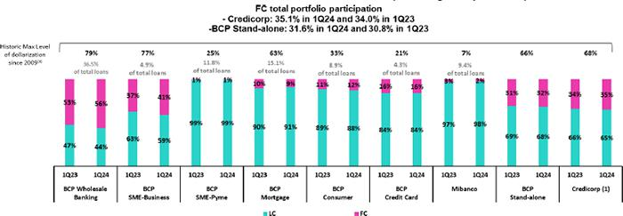

- The FC share of Credicorp’s loan portfolio is calculated including BCP Bolivia and ASB Bank Corp., however the chart shows only the loan books of BCP Stand-alone and Mibanco.

- The year with the historic maximum level of dollarization for Wholesale Banking was 2012, for Mibanco was 2016, for Credit Card was in 2021 and for the rest of segments was 2009. * For dollarization figures in the quarter-end period, please refer to “12. Annexes – 12.3 Loan Portfolio Quality.

Evolution of Loans in Quarter-end Balances

Total loans fell 2.9% QoQ and 3.0% YoY in quarter-end balances. This evolution was fueled by the same factors as those discussed in the analysis of average daily balances.

Datos elaborados por BCP para uso Interno | 18

| Earnings Release 1Q / 2024 Analysis of 1Q24 Consolidated Results

02 Deposits

QoQ, the total deposit balance rose 0.1%. This evolution was driven by a 3.0% uptick in Time Deposits, which was partially offset by a drop in the balance for Demand Deposits (-1.8%) and Savings Deposits (-0.3%).

YoY, the total deposit balance grew 0.1% (FX neutral). This increase was driven by growth in the balance for Time Deposits (+2.0%, FX neutral) and was offset by a drop in the balances for Savings Deposits (-1.7%, FX neutral) and Severance Indemnity Deposits (-6.8%, FX neutral).

67.4% of total deposits are low-cost (Demand + Savings). In this scenario, Credicorp continues to lead the market for low-cost deposits, posting a 39.4% market share at the end of February 2024. This represents a competitive advantage in the context of high-interest rates.


Deposits | Mar 23 | As of | Mar 24 | QoQ | % change | LC | Currency
S/000 | Mar 23 | Dec 23 | Mar 24 | QoQ | YoY | LC | FC
Demand deposits | 47,483,662 | 48,229,322 | 47,384,819 | -1.8% | -0.2% | 46.3% | 53.7%
Saving deposits | 53,418,288 | 52,375,813 | 52,238,357 | -0.3% | -2.2% | 57.9% | 42.1%
Time deposits | 43,194,573 | 42,484,664 | 43,775,526 | 3.0% | 1.3% | 45.2% | 54.8%
Severance indemnity deposits | 3,322,691 | 3,185,603 | 3,086,767 | -3.1% | -7.1% | 72.2% | 27.8%
Interest payable | 1,204,086 | 1,429,592 | 1,371,658 | -4.1% | 13.9% | 29.4% | 70.6%
Low-cost deposits ⁽¹⁾ | 100,901,950 | 100,605,135 | 99,623,176 | -1.0% | -1.3% | 52.4% | 47.6%
Deposits and obligations | 148,623,300 | 147,704,994 | 147,857,127 | 0.1% | -0.5% | 50.4% | 49.6%
(1) Includes Demand Deposits and Saving Deposits.

QoQ our Total Deposit balance rose 0.1%, driven primarily by:

- 3.0% growth in the balance of Time Deposits, which was fueled mainly by corporate clients at BCP and in FC in the context of high-interest rates. It is important to note that BCP reported a more significant increase in its balance QoQ than that registered by the financial system.

The aforementioned was partially offset by:

- A 1.8% reduction in Demand Deposits. This decrease was driven by a drop in deposits in FC and LC by corporate and institutional clients at BCP, which sought to increase their interest rate yields via shifts to remunerated accounts.
- A 0.3% reduction in the balance for Savings Deposits given that in 4Q23; the level was elevated in comparative terms due to statutory bonus payments in the month of December.

YoY, Total Deposits fell 0.5% (+0.1%, FX neutral). The following dynamics stood out:

- Growth of 1.3% (+2.0%, FX neutral) in the balance for Time Deposits, which was driven primarily by wholesale clients at BCP, which shifted funds to higher-yield deposits in FC. This dynamic was also seen, albeit to a lesser degree, among Mibanco’s clients.
- A 0.2% drop (+0.4%, FX neutral) in the balance for Demand Deposits, which was fueled mainly by an uptick in the FC balance at BCP via corporate and institutional clients.

The aforementioned was partially offset by:

- A 2.2% reduction in the balance for Savings Deposits (-1.7%, FX neutral), which was driven primarily by a drop in deposits in FC at BCP and, to a lesser extent, at Mibanco. This decrease was mainly driven by internal fund migration to higher-yield deposits.

- A 7.1% reduction in the balance for Severance Indemnity Deposits (-6.8%, FX neutral), after a government mandate to provide full access to funds kicked in and clients drew down accounts in LC and FC to cover liquidity needs.

Datos elaborados por BCP para uso Interno | 19

| Earnings Release 1Q / 2024 Analysis of 1Q24 Consolidated Results

02. Deposits

Volumes for low-cost deposits dropped 1.0% QoQ and 1.3% YoY. Notwithstanding, these deposits continued to account for a significant portion our total deposits with a 67.4% share at quarter-end (-70 bps QoQ and -50 bps YoY).

Dollarization Level of Deposits

Deposits by Currency

(measured at quarter-end balances)
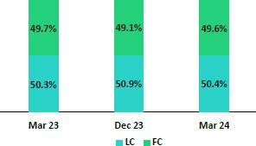

At the end of March 2023, the dollarization level of Total Deposits rose 50 bps QoQ to stand at 49.6%, which was below the average for the last 2 years (50.2%). This growth was primarily attributable to Time Deposits, which registered higher growth in FC balances than in LC balances after corporate and institutional clients sought out higher-yield alternatives for available funds.

YoY, the dollarization level fell 10 bps, driven primarily by a drop in balances for:

- Savings Deposits in FC (-6.7%), after funds migrated to higher-yield deposits; and (ii) Severance Indemnity Deposits (-13.3%) in FC, after clients drew down their funds to cover liquidity needs.

Deposits by Currency and Type

(measured at quarter-end balances)
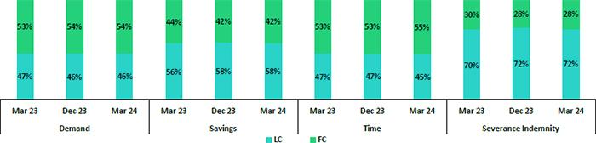

Loan / Deposit Ratio (L/D ratio)

QoQ, the L/D ratio dropped 370 bps and 340 bps at BCP and Mibanco, respectively. These reductions were driven by a decrease in the volume of total loans after credit guidelines were tightened. In this context, BAP’s L/D stood at 95.2%.
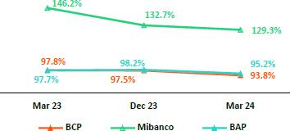

L/D Ratio Local Currency L/D Ratio Foreign Currency
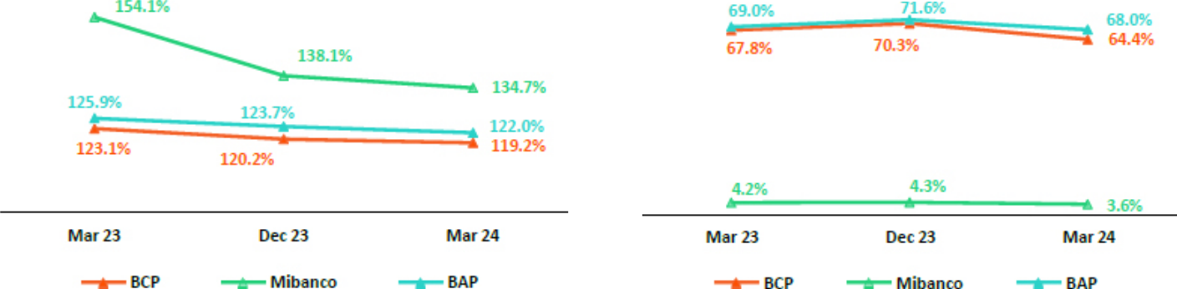

Datos elaborados por BCP para uso Interno | 20

| Earnings Release 1Q / 2024 Analysis of 1Q24 Consolidated Results

02. Deposits

Market Share of Deposits in the Peruvian Financial System
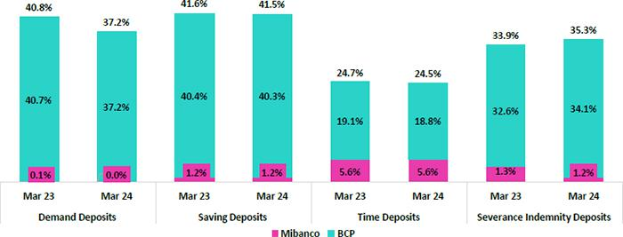

At the end of March 2024, the MS of Total Deposits at BCP and Mibanco in Peru stood at 31.1% and 2.5% (-132 bps and +0 pbs vs March 2023) respectively. With this figure, BCP continued to lead the market.

The balance reported by the financial system for low-cost deposits rose in YoY terms. BCP reported a reduction of 1.0%. This decline was primarily driven by a drop in balances for Savings Accounts, which was partially offset by growth in the balance for Demand Deposits. In this context, BCP continued to lead the low-cost deposit market with an MS of 38.8% at the end of March 2024 (-172 bps vs March 2023).

The financial system reported an +8.1% increase in its balance for Time Deposits vs March 2023; BCP, also registered growth, albeit more moderate, of +6.5% vs March 23. In this context, BCP’s market share fell 28 bps to stand at 18.8% at the end of March 2024.

Datos elaborados por BCP para uso Interno | 21

| Earnings Release 1Q / 2024 Analysis of 1Q24 Consolidated Results

03 Interest-Earning Assets (IEAs) and Funding


In 1Q24, IEAs grew 0.6%. This evolution was mainly fueled by Cash and due from banks, which registered an uptick after liquidity levels in both FC and LC rose in a less active lending context. Higher balances of liquid funds were capitalized mainly through BCRP overnight deposits, and to a lesser extent, via BCRP Certificates of deposit (BCRP CDs). Funding rose 0.4% QoQ, mainly due to an increase in Bonds and notes issued.

YoY, the investment balance rose, driven by a strategy to capitalize on surpluses and extend asset durations through sovereign bonds and by an increase in the balance of BCRP CDs. Funding increased slightly (+0.4% YoY), fueled primarily by an increase in the balance of Bonds and notes issued, and despite a drop in balances for Deposits and BCRP Instruments.

3.1. IEAs

Interest Earning Assets |  | As of |  | % change
S/000 | Mar 23 | Dec 23 | Mar 24 | QoQ | YoY
Cash and due from banks | 28,158,941 | 25,978,577 | 31,134,572 | 19.8% | 10.6%
Total investments | 47,729,504 | 52,215,528 | 52,555,386 | 0.7% | 10.1%
Cash collateral, reverse repurchase agreements and securities borrowing | 1,468,180 | 1,410,647 | 1,526,232 | 8.2% | 4.0%
Total loans | 145,165,713 | 144,976,051 | 140,798,083 | -2.9% | -3.0%
Total interest earning assets | 222,522,338 | 224,580,803 | 226,014,273 | 0.6% | 1.6%

QoQ, IEAs rose 0.6%. Growth was driven primarily by an uptick in Cash and due from banks, which was partially offset by a drop in the loan balance. The increase registered in Cash and due from banks was spurred by an increase in liquidity at BCP, but also reflected the impact of a drop in loan disbursements over the period. Liquidity maintained in the balance sheet was capitalized primarily through BCRP deposits, registered in the Cash and due from banks account. The investment balance rose 0.7% over the period, driven by an increase in the position of BCRP Certificates of Deposits (BCRP CDs); the position in sovereign bonds, which increased significantly in previous quarters, reported no major shifts this quarter.

YoY, IEAs increased 1.6% due to a strategy implemented last year to increase investments via government bonds to take advantage of favorable interest rates and increase the duration of IEAs. As in the case of the QoQ analysis, the recent rise in the balance for Available funds also contributed to growth in IEA YoY, albeit to a lesser extent, while loans contracted.

3.2. Funding¹


Funding |  | As of |  | % change
S/000 | Mar 23 | Dec 23 | Mar 24 | QoQ | YoY
Deposits and obligations | 148,623,300 | 147,704,994 | 147,857,127 | 0.1% | -0.5%
Due to banks and correspondents | 10,199,650 | 12,278,681 | 10,684,673 | -13.0% | 4.8%
BCRP instruments | 9,780,540 | 7,461,674 | 6,854,368 | -8.1% | -29.9%
Repurchase agreements with clients and third parties | 1,905,955 | 2,706,753 | 2,636,908 | -2.6% | 38.4%
Bonds and notes issued | 14,326,930 | 14,594,785 | 17,541,121 | 20.2% | 22.4%
Total funding | 184,836,375 | 184,746,887 | 185,574,197 | 0.4% | 0.4%
(1) Effective 1Q23, Funding includes Repurchase agreements with clients.

QoQ, funding balance increased 0.4%. This growth was driven mainly by an increase in the balance of Bonds and Issued Notes, which was fueled by a corporate bond issuance at BCP for US$ 800 million in the month of January. The aforementioned was partially offset by a drop in the balance of Due to Banks and Correspondents, which had registered growth in 4Q23 to obtain short-term financing prior to the bond issuance, and to a lesser extent by a decline in BCRP instruments.

YoY, the funding balance rose 0.4%, driven upward by growth in the balance of Bonds and Issued Notes. This increase, which was spurred by the same factors as those seen QoQ, was partially offset by a drop in the balance of BCRP Instruments. This decrease was spurred mainly by a drop in demand for BCRP repurchase agreements, as they are currently offered at relatively high rates, and secondarily by the expiration of the balance of BCRP repurchase agreements associated to government program loans (GP).

Datos elaborados por BCP para uso Interno | 22

| Earnings Release 1Q / 2024 Analysis of 1Q24 Consolidated Results

04 Net Interest Income (NII)


In 1Q24, Net Interest Income (NII) increased 2.3% QoQ. This evolution was driven mainly by an uptick in Interest and similar income, which rose, to a large extent, on the back of income from deposits in other banks, despite a drop in loan volumes. Interest and similar expenses fell, mainly fueled by a decrease in interest expenses for deposits after term deposits were renewed at lower rates and secondarily, by a drop in interest expenses for due to banks and correspondents. The aforementioned reductions were partially offset by an increase in interest expense for bonds and issued notes, following an issuance at BCP. YoY, NII rose, fueled by an increase in Interest and similar income income (via growth in interest on loans) and despite an uptick in Interest and similar expenses. The loan mix shifted given an increase in retail loans and a reduction in wholesale loans. On the funding side, term deposits, which imply higher rates, rose YoY, leading to an increase in Interest and similar expenses.

NIM increased 10 bps QoQ and 46 bps YoY. Risk-adjusted NIM rose 75 bps QoQ and 31 bps YoY. If we exclude the effect of “El Niño” provisions that were constituted in the 4Q23 and reversed in the 1Q24, risk-adjusted NIM fell 16 bps QoQ.

Net interest income |  | Quarter |  | % change
S/ 000 | 1Q23 | 4Q23 | 1Q24 | QoQ | YoY
Interest Income | 4,456,106 | 4,870,042 | 4,925,926 | 1.1% | 10.5%
Interest Expense | (1,324,017) | (1,522,358) | (1,499,803) | -1.5% | 13.3%
Interest Expense (excluding Net Insurance Financial
Expenses) | (1,208,267) | (1,402,925) | (1,377,799) | -1.8% | 14.0%
Net Insurance Financial Expenses | (115,750) | (119,433) | (122,004) | 2.2% | 5.4%
Net Interest Income | 3,132,089 | 3,347,684 | 3,426,123 | 2.3% | 9.4%
Balances
Average Interest Earning Assets (IEA) | 222,289,504 | 223,624,217 | 225,297,538 | 0.7% | 1.4%
Average Funding | 185,377,296 | 185,182,243 | 185,160,542 | 0.0% | -0.1%
Yields
Yield on IEAs | 8.02% | 8.71% | 8.75% | 4bps | 73bps
Cost of Funds | 2.61% | 3.03% | 2.98% | -5bps | 37bps
Net Interest Margin (NIM)⁽¹⁾ | 5.84% | 6.20% | 6.30% | 10bps | 46bps
Risk-Adjusted Net Interest Margin | 4.54% | 4.10% | 4.85% | 75bps | 31bps
Peru's Reference Rate | 7.75% | 6.75% | 6.25% | -50bps | -150bps
FED funds rate | 5.00% | 5.50% | 5.50% | 0bps | 50bps
(1) For further detail on the NIM and Cost of Funds calculation, please refer to Annex 12.7

QoQ, Net interest income (NII) rose 2.3%. This evolution was driven primarily by growth in Interest and similar income, which rose on the back of an increase in deposits in other banks after BCP moved to capitalize on surplus liquidity, mainly through FC overnight deposits in BCRP, in a context of slower lending activity. An uptick in income from securities, buoyed by growth in BCRP Certificates of Deposit (BCRP CDs), also bolstered financial income over the quarter, albeit to a lesser extent. Interest and similar expenses, had a positive impact on NII, driven mainly by the balance of term deposits. It is important to note that term deposits, which have been trending upward since 2023, have been renewed at lower rates. The expiration of Due to Banks and correspondents, which constituted short-term positions, also led interest expenses to drop. It is important to note the reductions in expenses for deposits and due to banks and correspondents were partially offset by an uptick in expenses for interest on bonds, which were impacted by the bond issuance that BCP made in January.

YoY, NII rose 9.4% due to an increase in Interest and similar income. This evolution was primarily driven by growth in income from loans, which reflects the positive impact of a shift in the portfolio mix toward a higher share of retail loans and a reduction in wholesale loans. Higher income from securities also contributed, albeit to a lesser extent, to the uptick in income, via an increase in positions in sovereign bonds under a strategy rolled out in 2023 to capitalize on liquidity surpluses. The uptick in Interest and similar expenses partially offset growth in income over the period. These expenses rose given that the share term deposits in the mix rose while the share of low-cost deposits fell, leading to an uptick in the cost of funding.

Datos elaborados por BCP para uso Interno | 23


| Earnings Release 1Q / 2024 Analysis of 1Q24 Consolidated Results

04. Net Interest Income (NII)

Net Interest Margin

NIM rose 10 bps QoQ and stood at 6.30%. This evolution was driven primarily by a reduction in interest expenses after terms deposits were renewed at lower rates, and secondarily by an uptick in interest income. YoY, NIM rose 46 bps on the back of an increase in interest income, which was mainly attributable to growth in the share of retail loans within the loan mix and to a renewal of FC loans at higher rates. Risk-adjusted NIM increased 75 bps QoQ. Isolating the effect of provisions for anticipated losses due to “El Niño” in 4Q23 and 1Q24, risk-adjusted NIM fell 16 bps QoQ. YoY, risk-adjusted NIM rose 31 bps (-14 bps isolating “El Niño” provisions).
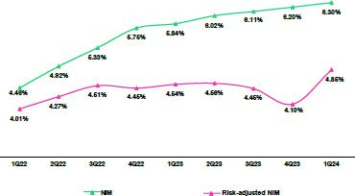

Net interest margin dynamics by currency

Interest Income / IEA |  | 1Q23 |  |  | 4Q23 |  |  | 1Q24
S/ millions | Average |  |  | Average |  |  | Average
 | Balance | Income | Yields | Balance | Income | Yields | Balance | Income | Yields
Cash and equivalents | 27,528 | 277 | 4.0% | 25,443 | 279 | 4.4% | 28,557 | 334 | 4.7%
Other IEA | 1,285 | 16 | 5.0% | 1,462 | 28 | 7.5% | 1,468 | 29 | 7.8%
Investments | 46,580 | 592 | 5.1% | 51,666 | 655 | 5.1% | 52,385 | 694 | 5.3%
Loans | 146,896 | 3,571 | 9.7% | 145,053 | 3,908 | 10.8% | 142,887 | 3,869 | 10.8%
Structural | 138,866 | 3,528 | 10.2% | 141,165 | 3,862 | 10.9% | 139,585 | 3,830 | 11.0%
Government Programs | 8,031 | 43 | 2.1% | 3,888 | 45 | 4.7% | 3,302 | 39 | 4.7%
Total IEA | 222,290 | 4,456 | 8.0% | 223,624 | 4,870 | 8.7% | 225,298 | 4,926 | 8.7%
IEA (LC) | 56.9% | 71.2% | 10.0% | 57.6% | 70.5% | 10.7% | 58.0% | 69.9% | 10.5%
IEA (FC) | 43.1% | 28.8% | 5.3% | 42.4% | 29.5% | 6.1% | 42.0% | 30.1% | 6.3%
Interest Expense / Funding |  | 1Q23 |  |  | 4Q23 |  |  | 1Q24
S/ millions | Average |  |  | Average |  |  | Average
 | Balance | Expense | Yields | Balance | Expense | Yields | Balance | Expense | Yields
Deposits | 147,822 | 677 | 1.8% | 148,088 | 827 | 2.2% | 147,781 | 780 | 2.1%
BCRP + Due to Banks | 20,108 | 239 | 4.8% | 19,925 | 297 | 6.0% | 18,640 | 265 | 5.7%
Bonds and Notes | 15,660 | 183 | 4.7% | 14,755 | 153 | 4.1% | 16,068 | 197 | 4.9%
Others | 1,091 | 225 | 40.1% | 1,201 | 245 | 41.8% | 1,113 | 259 | 49.1%
Total Funding | 185,377 | 1,324 | 2.6% | 185,182 | 1,522 | 3.0% | 185,161 | 1,500 | 3.0%
Funding (LC) | 50.5% | 56.6% | 2.9% | 50.2% | 55.9% | 3.3% | 49.5% | 51.9% | 3.0%
Funding (FC) | 49.5% | 43.4% | 2.3% | 49.8% | 44.1% | 2.7% | 50.5% | 48.1% | 2.9%
NIM | 222,290 | 3,132 | 5.6% | 223,624 | 3,348 | 6.0% | 225,298 | 3,426 | 6.1%
NIM (LC) | 56.9% | 77.4% | 7.7% | 57.6% | 77.2% | 8.0% | 58.0% | 77.8% | 8.2%
NIM (FC) | 43.1% | 22.6% | 2.9% | 42.4% | 22.8% | 3.2% | 42.0% | 22.2% | 3.2%
(1) The yield calculation includes “Financial Expense associated with the insurance and reinsurance activity, net”

QoQ Analysis

QoQ, Net Interest Income (NII) increased 2.3%. This evolution was driven by growth in NII in LC while growth in FC dropped over the period. IEAs in LC represented 58% of total IEAs and accounted for 77.8% of Net Interest Income in 1Q24.

Datos elaborados por BCP para uso Interno | 24


| Earnings Release 1Q / 2024 Analysis of 1Q24 Consolidated Results

04. Net Interest Income (NII)

Dynamics in Local Currency (LC)

NII in LC rose 3.2% due to the following dynamics:

Average IEA in LC rose 1.5%, driven primarily by Cash and equivalents, followed by Investments, while loan volumes dropped. At the income level, the highest contributor was investments, which were buoyed by attractive yields on BCRP CDs. In contrast, interest income on loans fell due to the negative volume effect generated by a drop in loan volumes at both BCP and Mibanco. In this context, the yield on IEAs in LC fell 10.7% to 10.5%.

On the funding side, the LC balance dropped 1.5% QoQ due to a reduction in average balances for deposits and for BCRP and due to banks. This reduction in the funding cost was driven by a more favorable mix, following the expiration of term deposits and debt obligations that had been assumed at relatively high rates. In this context, the funding cost in LC fell from 3.3% to 3.0%.

Dynamics in Foreign Currency (FC)

NII in FC dropped 0.5% QoQ due to the following dynamics:

Average IEA in FC dropped 0.3% QoQ due to a reduction in loan volumes (-2.3%), which was driven primarily by a decrease in the balances of loans in Wholesale Banking and Mibanco. This was partially offset by an increase in Cash and equivalents after BCP moved to capitalize on liquidity surpluses in a context marked by a decrease in lending. Accordingly, despite the drop in the average balance of IEAs in FC, interest income rose 3.2% QoQ and the IEA yield increased from 6.1% to 6.3%.

Average funding in FC rose 1.4% QoQ, which was driven primarily by growth in the average balances for bonds and issued notes and to a lesser degree, in deposits. The increase in the balance of bonds and notes, which was fueled by a bond issuance at BCP, led to a more expensive funding mix, which was reflected in the increase in interest expenses (+7.5%). This translated into a higher cost of funding in FC, which rose from 2.7% to 2.9%.

YoY Analysis

YoY, NII increased 6.6%, driven by upticks in NII in LC and FC:

Dynamics in local currency (LC)

NII in LC rose 4.5% YoY due to the following dynamics:

Average IEA in LC increased 3.4%. This evolution was driven primarily by investments and secondarily by Cash and equivalents, while loans dropped. Despite volume dynamics, loans were the highest contributor to growth in interest in LC due to a positive mix effect, where retail loans registered a higher share of total loans while the share of wholesale loans fell. Investments also contributed to growth in interest income, albeit to a lesser extent, through an increase in the position in government bonds in 2023. In this scenario, IEA in LC increased 49 bps YoY to 10.5%.

Average funding in LC dropped 2.1% YoY, fueled by a reduction in debt balances in BCRP and due to banks and correspondents. This evolution was driven by a reduction in the BCRP repurchase agreements balance after i) positions in these instruments were not renewed in a context marked by an upswing in demand and higher rates, and ii) the remaining balance associated to GP loans expired. The aforementioned was partially offset by an increase in the average balances for issuance, after BCP’s bond issuance, and deposits; both increases were similar in magnitude. These dynamics led interest expenses to rise 3.9%, driven by an uptick in the cost of the funding mix following the BCP issuance and by the fact that growth in deposits was concentrated in term deposits over the last 12 months. In this context, the funding cost rose 17 bps.

Foreign Currency Dynamics (FC)

NII in FE increased 7.6% YoY due to the following dynamics:

Average IEA in FC dropped 1.4% YoY, which was driven primarily by a contraction in Cash and equivalents funds and secondarily, by a decrease in loans. Notwithstanding, growth in rates in dollars over the period made it possible to renew part of the loan portfolio

Datos elaborados por BCP para uso Interno | 25

| Earnings Release 1Q / 2024 Analysis of 1Q24 Consolidated Results

04. Net Interest Income (NII)

at higher rates. Income from Cash and equivalents was also bolstered by higher rates over the year, which offset the negative volume effect.

In this context, the yield on IEAs in FC rose from 5.3% to 6.3%.

Average funding in FC increased 1.9% YoY, driven primarily by an uptick in the balance of obligations with BCRP and due to banks and correspondents. Notwithstanding, interest expenses rose 25.5%, fueled mainly by more expensive deposits, which reflected an increase in the share of term deposits within the mix. In this scenario, the funding cost increased 58 bps YoY.

Datos elaborados por BCP para uso Interno | 26

| ^{Earning Release 1Q / 2024} Analysis of 1Q24 Consolidated Results

05 Portfolio Quality and Provisions


QoQ, growth in NPLs was driven primarily by Individuals and Wholesale Banking at BCP Stand-alone, and secondarily by Mibanco; this was partially offset by a drop in SME-Pyme at BCP Stand-Alone. Provisions fell QoQ after provisions set aside for the impact of the “El Niño” Phenomenon in 4Q23 were reversed. If we isolate this effect, provisions rose, driven mainly by (i) Mortgage, due to a base effect;

- SME-Pyme, due to an increase in write-offs and a deterioration in the payment capacity of clients in a context marked by gradual economic recovery; and (iii) Mibanco, due to a further deterioration of old vintages. The NPL ratio stood at 6.2% at quarter-end.

YoY, the uptick in NPLs was fueled mainly by Individuals and SME-Pyme at BCP Stand-Alone, followed by Mibanco. YoY, if we isolate the “El Niño” effect, provisions rose, fueled primarily by (i) SME-Pyme and Credit Cards due to further deterioration in payment capacities and (ii) Consumer, due to an uptick in deterioration in the payment performance of vulnerable clients.

5.1 Portfolio Quality

Total Portfolio Quality (in Quarter-end balances)

Loan Portfolio quality and Delinquency ratios |  | As of |  |  | % change
'S/000 | Mar 23 | Dec 23 | Mar 24 | QoQ | YoY
Total loans (Quarter-end balance) | 145,165,713 | 144,976,051 | 140,798,083 | -2.9% | -3.0%
Write-offs | 677,148 | 879,401 | 950,433 | 8.1% | 40.4%
Internal overdue loans (IOLs) | 5,789,497 | 6,126,487 | 6,205,024 | 1.3% | 7.2%
Internal overdue loans over 90-days | 4,270,131 | 4,681,343 | 4,702,733 | 0.5% | 10.1%
Refinanced Loans | 2,121,068 | 2,406,058 | 2,557,749 | 6.3% | 20.6%
Non-performing loans (NPLs) | 7,910,565 | 8,532,545 | 8,762,773 | 2.7% | 10.8%
IOL ratio | 4.0% | 4.2% | 4.4% | 18 bps | 42 bps
IOL over 90-days ratio | 2.9% | 3.2% | 3.3% | 11 bps | 40 bps
NPL ratio | 5.4% | 5.9% | 6.2% | 34 bps | 77 bps

QoQ, the NPL portfolio increased 2.7%. This growth was led by Individuals and Wholesale Banking and partially offset by a contraction in SME-Pyme at BCP Stand-alone, followed by Mibanco. Write-offs remained high, registering an increase of 8.1%, and were concentrated primarily in SME-Pyme, Consumer and Credit Cards, which continue to write off overdue loans in higher risk segments.

QoQ, at BCP Stand-Alone, growth in NPLs occurs particularly through: (i) Consumer, due to an uptick in refinancing to assist clients in the most vulnerable segments, who are highly leveraged and lack stable employment; this was partially offset by an increase in write-offs; (ii) Mortgage, due to an increase in overdue loans held by clients that registered delinquency for consumer products; (iii) Wholesale, due to refinancing for a corporate client. The aforementioned was partially offset by (iv) SME-Pyme, which was impacted by a contraction in loan volumes via an increase in honoring processes for Government loans. If we exclude this effect, the NPL portfolio increases due to growth in refinancing to contain rising delinquency (for clients with good long-term payment potential) and to an increase in overdue loans, which was concentrated in older vintages. At Mibanco, the increase in NPLs was driven by an uptick in delinquency in old vintages related to clients affected by macroeconomic, social and environmental impacts in 2023.

YoY, the NPL portfolio increased 10.8%, led by Individuals and SME-Pyme at BCP Stand-Alone, followed by Mibanco. Growth in write-offs (+40.4%) was driven by Credit Cards, Consumer and SME-Pyme, which were impacted by an increase in write-offs of overdue loans in the highest risk segment.

YoY, at BCP Stand-Alone, growth in NPLs occurs particularly through (i) Consumer, due to the dynamics described for the QoQ evolution, coupled with an uptick in overdue loans in old vintages; (ii) Mortgage, due to the dynamics described for the QoQ evolution and among clients that had received refinancing in 2023; (iii) SME-Pyme, due to an uptick in overdue loans, which was concentrated in older vintages, partially offset by an increase in honoring programs for Government Loans. At Mibanco, growth in NPLs was driven by the same dynamics described for the QoQ evolution.

Datos elaborados por BCP para uso Interno | 27

| Earning Release 1Q / 2024

05. Provisions

NPL Ratio of Total Loans
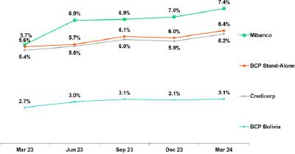

NPL Ratio of Total Loans at BCP ⁽¹⁾
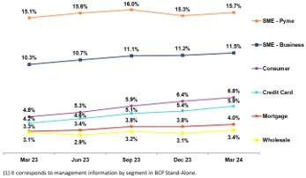

Analysis of 1Q24 Consolidated Results

At Credicorp, the NPL ratio rose 34 bps QoQ and stood at 6.2%. This evolution was due primarily to a contraction in loans and secondarily to the NPLs dynamics in the same period discussed above.

If we analyze QoQ evolution of NPL ratio by subsidiary, we have:

- BCP Stand-Alone, where the NPL ratio rose 35 bps. In the case of Business Clients, growth in the NPL ratio was primarily driven by a contraction in loans; while in Individuals, growth in the NPL was fueled mainly by an increase in NPLs.
- Mibanco, where the NPL ratio increased 39 bps, driven primarily by growth in NPLs and secondarily by a contraction in loans.

At Credicorp, the NPL ratio rose 77 bps YoY and stood at 6.2%. This evolution was driven mainly by NPL volume dynamics in the same period, and secondarily by a contraction in loans.

If we analyze YoY evolution of NPL ratio by subsidiary, we have:

- BCP Stand-Alone, where the NPL ratio rose 77 bps. In Individuals and SME-Pyme, growth in NPL ratio is due primarily to an increase in NPLs; while in Wholesale, growth in NPL ratio was due primarily to a contraction in loans.
- Mibanco, where the NPL ratio increased 172 bps, driven by the dynamics described for the QoQ evolution.

5.2 Provisions and Cost of Risk

Provisions and Cost of Risk in the Total Portfolio

Loan Portfolio Provisions |  | Quarter |  |  | % change
S/ 000 | 1Q23 | 4Q23 | 1Q24 | QoQ | YoY
Gross provision for credit losses on loan portfolio | (802,107) | (1,260,163) | (910,189) | -27.8% | 13.5%
Recoveries of written-off loans | 75,109 | 86,709 | 95,490 | 10.1% | 27.1%
Provision for credit losses on loan portfolio, net of recoveries | (726,998) | (1,173,454) | (814,699) | -30.6% | 12.1%
Cost of risk ⁽¹⁾ | 2.0% | 3.2% | 2.3% | -96 bps | 30 bps
(1) Provisions for credit losses on loan portfolio, net of annualized recoveries / Average Total Loans. Provisions include the impact of the “El Niño” Phenomenon.

This quarter, provisions include a reversal of provisions set aside in 4Q23 for anticipated impacts for the “El Niño” Phenomenon for approximately S/ 250 million. In this context, the Cost of Risk (CoR) stood at 2.3%. Next, we will explain the quarterly and yearly dynamics for provisions by isolating this impact.

QoQ, provisions rose 16.0%, driven primarily by (i) Mortgage, due to a base effect for reversals for specific subproducts; (ii) SME- Pyme, via growth in write-offs that was not 100% provisioned and due to a deterioration in the payment capacities of clients in a context of gradual economic recovery; this was partially offset by growth in amortization of Government Loans (GP); (iii) Mibanco, due to further deterioration in old vintages.

In this scenario, if we isolate the “El Niño” effect, the Cost of Risk (CoR) rose 45 bps QoQ to stand at 3.0%.

Datos elaborados por BCP para uso Interno | 28

| Earning Release 1Q / 2024

05. Provisions

YoY, provisions rose 46.9%, driven by SME-Pyme and Credit Cards, which were impacted by a deterioration in the payment capacity of highly leveraged clients and by Consumer, which was affected by deterioration in the payment performance of clients in the most vulnerable segments who are highly leveraged.

The aforementioned growth in provisions was partially offset by a decrease in provisions in Wholesale Banking and Mibanco. At Mibanco, provisions were down due to a base effect given that in 1Q23, more provisions were required for climatic and social events.

In this scenario, if we isolate the “El Niño” effect, the CoR rose 101 bps YoY to stand at 3.0%.

Analysis of 1Q24 Consolidated Results

Cost of Risk by Subsidiary ⁽¹⁾
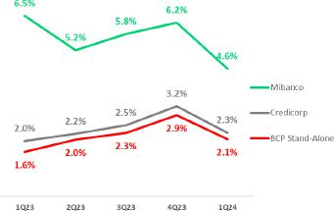

(1) It includes the impact of the “El Niño” Phenomenon.

QoQ Cost of Risk Evolution YoY Cost of Risk Evolution
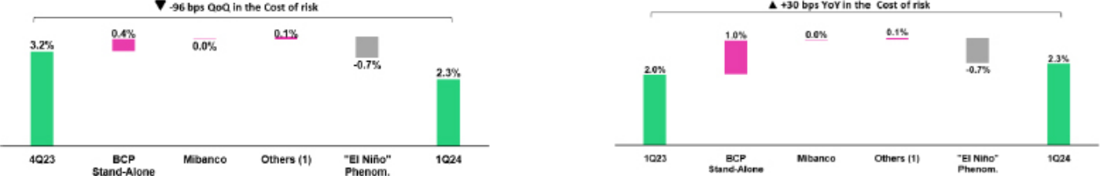

(1) Others include BCP Bolivia, Mibanco Colombia, ASB and eliminations. |  | (1) Others include BCP Bolivia, Mibanco Colombia, ASB and eliminations.
Coverage Ratio of NPLs (in Quarter-end balances)
Loan Portfolio Quality and Delinquency Ratios |  | As of |  |  | % change
S/ 000 | Mar 23 | Dec 23 | Mar 24 | QoQ | YoY
Total loans (Quarter-end balance) | 145,165,713 | 144,976,051 | 140,798,083 | -2.9% | -3.0%
Allowance for loan losses | 7,915,350 | 8,277,916 | 8,190,343 | -1.1% | 3.5%
Non-performing loans (NPLs) | 7,910,565 | 8,532,545 | 8,762,773 | 2.7% | 10.8%
Allowance for loan losses over Total loans | 5.5% | 5.7% | 5.8% | 11 bps | 37 bps
Coverage ratio of NPLs | 100.1% | 97.0% | 93.5% | -355 bps | -659 bps

Allowance for loan losses

(in S/ millions)
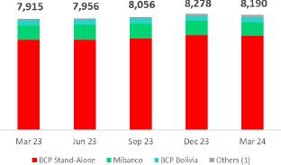

QoQ, the balance of accumulated provisions dropped 1.1%, driven primarily by the reversal of provisions for the “El Niño” effect in 1Q24.

YoY, the balance of accumulated provisions rose 3.5%, driven primarily by Individuals and SME-Pyme at BCP Stand-Alone.

(1) Others include Mibanco Colombia, ASB and eliminations

Datos elaborados por BCP para uso Interno | 29

| Earning Release 1Q / 2024

05. Provisions

Coverage Ratio of NPL
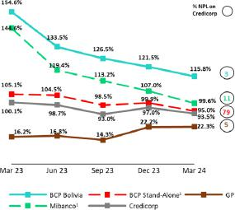

Analysis of 1Q24 Consolidated Results

The NPL Coverage Ratio stood at 93.5% at quarter-end. The impact of Government Programs Portfolio on this ratio is -368 bps.

QoQ

The NPL Coverage Ratio at Credicorp fell 355 bps, fueled mainly by BCP Stand-Alone. Next, we will analyze this evolution in BCP Stand-Alone by isolating the effect of the NPL portfolio of Government Programs, which are guaranteed and honoring processes are successfully underway.

(1) It excludes GP Loans.

QoQ, NPL Coverage Ratio at BCP Stand-Alone, excluding Government Programs, fell 488 bps and stood at 95.0%. This evolution is driven mainly by:

- Business Clients:

  - Wholesale: due to refinancing of a specific client, who was already in stage 3 and therefore did not require additional provision this quarter. The Wholesale Portfolio stage 3 is 85% collateralized¹.

- Individuals: contracted slightly, primarily driven by an increase in refinancing in Consumer and growth in the overdue portfolio in Credit Cards. The coverage levels for both products are approximately 162%.

YoY

the NPL Coverage Ratio at Credicorp fell 659 bps, fueled mainly by BCP Stand-alone and Mibanco. Next, we will analyze this evolution at BCP Stand-alone and Mibanco by isolating the effect of the NPL portfolio of Government Programs.

YoY, the NPL Coverage Ratio at BCP Stand-alone, excluding Government Programs, contracted 10 pps, due to the following dynamics:

- Business Clients:

  - Wholesale: due to the dynamics described for the QoQ evolution, coupled with a contraction in the allowance for loan losses given that exposure to loan default fell over the past year.

- Individuals: primarily driven by an increase in NPLs in Consumer, Credit Cards and Mortgage.

YoY, the NPL Coverage Ratio at Mibanco, excluding Government Programs, contracted 45 pps and stood at 99.6%. The contraction in the NPL Coverage Ratio is driven by (i) the calibration of risk models to clarify the client's payment behavior, an adjustment made in 2Q23; (ii) growth of the loan portfolio in lower risk segments, where the level of expected losses was significantly lower than the figure seen one year ago.

- To calculate the collateralized percentage of the portfolio, value of collateral considers the present value of the minimum between the realizable value, the lien value and the commercial value; adjusted for recoveries.

Datos elaborados por BCP para uso Interno | 30

| ^{Earning Release 1Q / 2024} Analysis of 1Q24 Consolidated Results

06. Other Income

Other Core Income, whose evolution has been positively affected by our operation in BCP Bolivia. If we exclude the effects of these operations, Other core income rose 1.3% QoQ. This growth was concentrated in (i) BCP, in Credit Cards which registered growth through the e-commerce channel and by an increase in transactions through Yape; and (ii) Prima, due to growth in the volume of payroll contributions. YoY, the growth of 8.5% was driven by an increase in net fee income, which was led by BCP, primarily via Yape, and by Credicorp Capital, which saw an uptick in fee income through Wealth Management and Brokerage businesses.

QoQ, Other Non-core Income fell. This reflects a drop in the Gain on securities, which was due to a devaluation of the trading portfolio at BCP and a downgrade in Pacífco's local fixed income portfolio. YoY, growth in Other Non-Core Income was in line with higher derivative income at Credicorp Capital via its trading strategies and at ASB via currency hedging derivate strategy.

6.1. Other Core Income

Other Core Income |  | Quarter |  | % Change
S/ (000) | 1Q23 | 4Q23 | 1Q24 | QoQ | YoY
Fee Income | 881,781 | 986,173 | 1,062,501 | 7.7% | 20.5%
Net Gain on Foreing exchange transactions | 248,515 | 218,047 | 166,269 | -23.7% | -33.1%
Total Other Income | 1,130,296 | 1,204,220 | 1,228,770 | 2.0% | 8.7%

It is important to note that, since 2023, Other Core Income has been affected by our operation in BCP Bolivia, which has adapted its fee structure for foreign transfers to offset the losses reported for FX sale-purchase transactions.

If we exclude income from the aforementioned transactions, other recurring income rose 1.3% and 8.5% QoQ and YoY respectively. This growth was fueled primarily by growth in net fee income.

Net Fee Income by Subsidiary

Net Fee Income by Subsidiary |  |  | Quarter |  |  | % Change
(S/ 000) |  | 1Q23 | 4Q23 | 1Q24 | QoQ | YoY
BCP Stand-Alone |  | 698,207 | 748,270 | 771,463 | 3.1% | 10.5%
BCP Bolivia |  | 50,134 | 104,959 | 153,969 | 46.7% | 207.1%
Mibanco |  | 28,691 | 24,402 | 24,173 | -0.9% | -15.7%
Mibanco Colombia |  | 9,074 | 10,082 | 11,250 | 11.6% | 24.0%
Pacífico |  | -3,131 | -2,577 | -3,199 | 24.1% | 2.2%
Prima |  | 89,496 | 87,457 | 94,528 | 8.1% | 5.6%
ASB |  | 15,254 | 10,704 | 17,062 | 59.4% | 11.9%
Credicorp Capital |  | 107,158 | 137,092 | 128,148 | -6.5% | 19.6%
Eliminations and Other ⁽¹⁾ |  | -113,102 | -134,216 | -134,893 | 0.5% | 19.3%
Total Net Fee Income |  | 881,781 | 986,173 | 1,062,501 | 7.7% | 20.5%
(1) Correspond mainly to the eliminations of Bancasseguros between Pacífico, BCP, and Mibanco

If we exclude fee income from BCP Bolivia, Net fee income was driven by the following dynamics:

QoQ, Net fee income rose 3.1%, spurred primarily by growth in the fee level at BCP Stand-alone, which we will discuss in the next chapter, and secondarily by Prima, which reported an uptick in payroll contributions. This quarter, net Fee Income growth was offset by a drop in fee income Credicorp Capital, which registered an unusually high level in 4Q23.

YoY, the 9.2% increase in Net fee income was mainly attributable to growth in fee income at BCP Stand-alone, which we will discuss in the next chapter, and by the increase reported by Credicorp Capital through its Wealth Management business, via growth in AUMs, and by an uptick in fees from its Brokerage business as our strategy to focus more on recurring businesses begins to bear fruit.

Datos elaborados por BCP para uso Interno | 31

| ^{Earning Release 1Q / 2024} Analysis of 1Q24 Consolidated Results

06. Other Income

BCP Stand-alone Net Fee Income

Composition of fee income in BCP Stand-alone^{(*)}


BCP Stand-alone Fees |  | Quarterly |  |  | % Change
(S/ 000,000) | 1Q23 | 4Q23 | 1Q24 | QoQ | YoY
Payments and transactionals ⁽¹⁾ | 321.1 | 319.6 | 340.0 | 6.4% | 5.9%
Yape | -11.5 | 44.5 | 55.3 | 24.1% | n.a.
Liability accounts ⁽²⁾ | 178.0 | 185.6 | 178.1 | -4.0% | 0.1%
Loan Disbursement ⁽³⁾ | 95.2 | 96.6 | 90.1 | -6.7% | -5.4%
Off-balance sheet | 61.7 | 56.5 | 57.3 | 1.4% | -7.1%
Insurances | 31.1 | 31.3 | 33.1 | 5.6% | 6.3%
ASB | 9.8 | 4.9 | 9.5 | 91.5% | -3.2%
Others ⁽⁴⁾ | 12.9 | 9.2 | 8.1 | -11.6% | -37.1%
Total | 698.2 | 748.2 | 771.5 | 3.1% | 10.5%
(*) This table corresponds to management numbers.
- Corresponds to fees from credit and debit cards; payments and collections. It is not comparable with the same line of previous reports given the change in details.
- Corresponds to fees from Account maintenance, interbank transfers, national money orders, and international transfers.
- Corresponds to fees from retail and wholesale loan disbursements.
- Use of third-party networks, other services to third parties, and Commissions in foreign branches.

QoQ, Net fee income rose 1.3%, driven mainly by growth in the fee volume generated by:

- Payments and services, which registered growth through an uptick in transactions via (i) an increase in fees generated by credit cards which reflecs the change in the channel mix as customers transact more in e-commerce; (ii) growth in billing for debit cards (+2.4%).

- Yape, where income growth was led by bill payments, followed by merchant fees and mobile top-ups.

YoY, Net fee income grew 10.5%, spurred primarily by growth in total fees received through:

- Yape, where income growth was led by bill payments, followed by the merchant fee and mobile top-ups.
- Payments and services, which reported growth on the back of higher transactionality via (i) higher billing through credit cards (+8.7%); and (ii) growth in billing through debit cards (+23.2%).

6.2 Other Non-Core Income

Other Non-Core Income |  | Quarter |  | % Change
S/ (000) | 1Q23 | 4Q23 | 1Q24 | QoQ | YoY
Net Gain Securities | 70,036 | 115,825 | 61,745 | -46.7% | -11.8%
Net Gain from associates ⁽¹⁾ | 27,212 | 34,132 | 32,295 | -5.4% | 18.7%
Net Gain of derivatives held for trading | -6,570 | 5,019 | 39,984 | 696.7% | -708.6%
Net Gain from exchange differences | 22,963 | 15,255 | -5,621 | -136.8% | -124.5%
Other non-operative income | 89,338 | 112,372 | 102,221 | -9.0% | 14.4%
Total Other Non-Core Income | 202,979 | 282,603 | 230,624 | -18.4% | 13.6%

(1) Includes gains on other investments, which are mainly attributable to the Banmedica result.

Datos elaborados por BCP para uso Interno | 32

| ^{Earning Release 1Q / 2024} Analysis of 1Q24 Consolidated Results

06. Other Income

Other Non-Core Income | Other Non-Core Income
QoQ evolution | YoY evolution
(Thousand of soles) | (Thousand of soles)
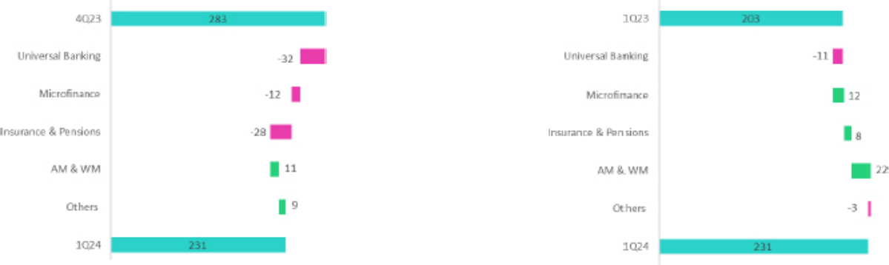

(1) Others includes: Grupo Crédito, Credicorp Stand-alone, eliminations and others.

QoQ, Other Non-Core Income fell, primarily due to a drop in the Gain on Securities, which reflected the devaluation of the trading portfolio at BCP Stand-alone and a downgrade within Pacífico's local fixed income portfolio.

YoY, Other Non-Core Income rose due to growth in the Gain on Derivatives, which reflects the gains generated by Credicorp Capital’s trading strategies in Colombia and Chile and the gains registered by ASB via its currency hedging strategy.

Datos elaborados por BCP para uso Interno | 33

| ^{Earning Release 1Q / 2024} Analysis of 1Q24 Consolidated Results

07. Insurance Underwriting Results

QoQ, the Insurance Underwriting Result dropped 2.9%. This evolution was driven primarily by a decrease in the underwriting result for Life, which was partially offset by and improvement in P & C’s result. In Life, the underwriting result was impacted by a drop in Insurance Service Income from the D & S lines and Credit Life. The uptick in P & C’s result, in turn, was primarily attributable to a drop in expenses and an increase in insurance service income in P & C Risks.

YoY, the Insurance Underwriting Result dropped 5.8%. This result was driven by a decrease in the underwriting result for Life, which was partially offset by an improvement in the result at P & C. In the Life business, the decrease in the underwriting result was mainly fueled by a drop in Insurance Service Income from the D & S lines. The uptick recorded for P & C’s result reflected both a drop in claims in P& C Risks as well as growth in direct premiums across all businesses.

Insurance Underwriting Results |  |  | Quarterly |  | % Change
S/ 000 |  | 1Q23 | 4Q23 | 1Q24 | QoQ | YoY
 | Income from Insurance Services | 956.6 | 1,019.6 | 937.9 | -8.0% | -2.0%
 | Expenses for Insurance Services | (545.2) | (634.0) | (476.2) | -24.9% | -12.6%
Total | Insurance Service Result | 411.5 | 385.7 | 461.7 | 19.7% | 12.2%
 | Reinsurance Results | (115.1) | (98.4) | (182.6) | 85.7% | 58.7%
 | Insurance Undewrwriting Result | 296.3 | 287.3 | 279.1 | -2.9% | -5.8%
 | Income from Insurance Services | 413.9 | 449.8 | 468.4 | 4.1% | 13.2%
 | Expenses for Insurance Services | (286.1) | (323.7) | (237.9) | -26.5% | -16.8%
P&C | Insurance Service Result | 127.8 | 126.1 | 230.5 | 82.8% | 80.3%
 | Reinsurance Results | (83.9) | (76.8) | (152.7) | 98.9% | 81.9%
 | Insurance Undewrwriting Result | 43.9 | 49.3 | 77.8 | 57.7% | 77.1%
 | Income from Insurance Services | 521.9 | 534.8 | 438.1 | -18.1% | -16.0%
 | Expenses for Insurance Services | (257.3) | (305.1) | (232.0) | -24.0% | -9.8%
Life | Insurance Service Result | 264.6 | 229.7 | 206.1 | -10.3% | -22.1%
 | Reinsurance Results | (27.2) | (14.5) | (24.3) | 67.7% | -10.6%
 | Insurance Undewrwriting Result | 237.4 | 215.2 | 181.8 | -15.5% | -23.4%
 | Income from Insurance Services | 20.9 | 37.1 | 34.4 | -7.4% | 64.9%
 | Expenses for Insurance Services | (1.9) | (11.5) | (11.5) | 0.6% | 522.2%
Crediseguros | Insurance Service Result | 19.0 | 25.6 | 22.8 | -10.9% | 20.2%
 | Reinsurance Results | (4.0) | (9.1) | (8.5) | -6.9% | 111.4%
 | Insurance Undewrwriting Result | 15.0 | 16.5 | 14.4 | -13.2% | -4.2%

QoQ, the Insurance Underwriting Result dropped 2.9%. This evolution was spurred primarily by a deterioration in the Total Reinsurance Result (+85.7%) and secondarily by a decrease in the Life Insurance Service Result (-10.3%). The aforementioned was partially offset by an improvement in the P & C Service Result (+82.8%).

YoY, the Insurance Underwriting Result fell 5.8%, driven mainly by a deterioration in the Total Reinsurance Result (+62.4%) and secondarily by a drop in the Life Insurance Service Result (-20.9%). The aforementioned was partially offset by an improvement in the P & C Service Result (+78.3%).

P & C Insurance

Income from Insurance Services Expenses for Insurance Services
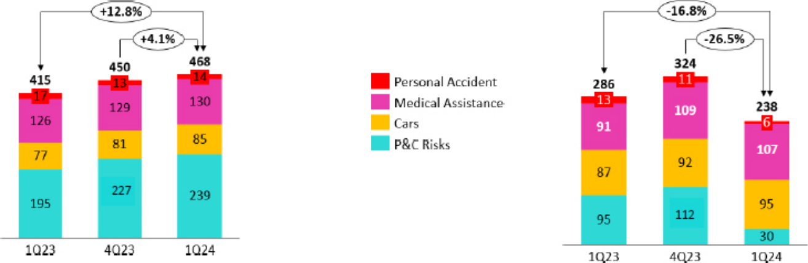

Datos elaborados por BCP para uso Interno | 34

| ^{Earning Release 1Q / 2024} Analysis of 1Q24 Consolidated Results

07. Insurance Underwriting Results

QoQ, the Insurance Underwriting Result rose 57.7% due to the following dynamics:

- Income from Insurance Services increased 4.1%, due primarily to (i) P & C Risks and (ii) Cars, both of which were impacted by an increase in releases for Reserves for Current Risks, which were set aside in previous quarters.

- Insurance Service Expenses fell 26.5%, which reflected a drop in expenses for claims in P & C Risks, including releases of reserves associated with El Niño.

- The deterioration reported for the Reinsurance Result was driven mainly by a drop in Reinsurance Recoveries.

YoY, the Insurance Underwriting Result rose 62.1% due to the following dynamics:

- Insurance Service Income increased 12.8%, driven primarily by (i) P & C Risks, via an uptick in direct premiums and (ii) Cars, due to an increase in sales through Yape and bancassurance.

- Insurance Service Expenses dropped 16.8%, which was driven primarily by P & C Risks via a drop in expenses for claims, including releases of reserves associated with El Niño.

- The deterioration in the Reinsurance Result was spurred mainly by the evolution of P & C Risks due to (i) a drop in Reinsurance Recoveries, and (ii) growth in the level of Ceded Premiums.

Life Insurance

Income from Insurance Services Expenses for Insurance Services
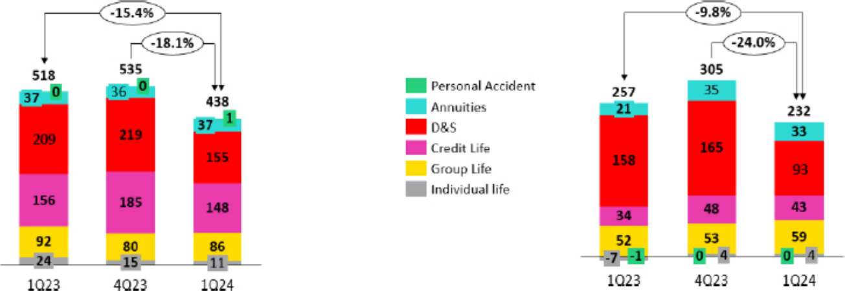

QoQ, the Insurance Underwriting Result dropped 15.5% due to the following dynamics:

- Insurance Service Income fell 18.1%, due primarily to (i) D & S due to a drop in the rates offered and in the portion won of the SISCO VII contract in comparison to the conditions and tranches obtained through SISCO VI and (ii) Credit Life, due to a drop in income associated with direct premiums from bancassurance.

- Insurance Service Expenses dropped 24.0%, driven mainly by D & S, which registered a decrease in claims frequency and a release of IBNR reserves after parameters were updated.

- The deterioration in the Reinsurance Result was fueled primarily by a decrease in Reinsurance Recoveries associated with D & S and Group Life.

YoY, the Insurance Underwriting Result fell 22.1% due to the following dynamics:

- Insurance Service Income dropped 15.4%. This decline was primarily driven by (i) D & S, driven by the same factors seen in the QoQ analysis, and to a lesser extent, by Individual Life and Credit Life.

- Insurance Service Expenses decreased 9.8% due to D & S, which reported a decrease in claims.
- The deterioration in the Reinsurance Result fell slightly due to a drop in ceded premiums in D & S.

Datos elaborados por BCP para uso Interno | 35

| ^{Earning Release 1Q / 2024} Analysis of 1Q24 Consolidated Results

08 Operating Expenses


Operating expenses rose 6.9% YoY, driven primarily by core businesses at BCP Stand-alone and disruptive initiatives at the Credicorp level. Disruption expenses at the Credicorp level increased 31.8%, driven primarily by Yape, where growth in transactions and new product development led to an increase in IT-related expenses. In 1Q24, Yape and Tenpo accounted for 60% of disruptive expenses. Core expenses for IT at BCP increased due to (i) an uptick in cloud use among increasingly digitalized clients, and ii) measures to attract more specialized digital talent.

Total operating expenses

Operating expenses |  | Quarter |  |  | % change
S/ 000 | 1Q23 | 4Q23 | 1Q24 | QoQ | YoY
Salaries and employees benefits | 1,029,558 | 1,119,758 | 1,107,069 | -1.1% | 7.5%
Administrative, general and tax expenses | 835,060 | 1,089,203 | 888,583 | -18.4% | 6.4%
Depreciation and amortization | 161,079 | 177,618 | 175,146 | -1.4% | 8.7%
Association in participation | 12,612 | 9,109 | 8,847 | -2.9% | -29.9%
Operating expenses | 2,038,309 | 2,395,688 | 2,179,645 | -9.0% | 6.9%

Our analysis of expenses focuses on year-over-year movements to eliminate the effects of seasonality between quarters.

Operating expenses rose 6.9% YoY due to:

- An increase in Salaries and Employee benefits, which was driven primarily by growth in the headcount for personnel that specializes in disruption and IT.
- Growth in Administrative and general expenses and taxes, mainly at BCP and via an increase in transactionality (primarily through digital channels), which led to an increase in cloud use and other system-related expenses.

Administrative and general expenses

Administrative and general expenses | 1Q23 | Quarter | 1Q24 | % change
S/ 000 | 1Q23 | 4Q23 | 1Q24 | QoQ | YoY
IT expenses and IT third-party services | 240,932 | 311,417 | 282,905 | -9.2% | 17.4%
Advertising and customer loyalty programs | 135,767 | 239,028 | 124,569 | -47.9% | -8.2%
Taxes and contributions | 85,073 | 93,090 | 92,887 | -0.2% | 9.2%
Audit Services, Consulting and professional fees | 51,878 | 105,340 | 58,992 | -44.0% | 13.7%
Transport and communications | 51,036 | 60,869 | 54,064 | -11.2% | 5.9%
Repair and maintenance | 25,790 | 49,698 | 32,638 | -34.3% | 26.6%
Agents' Fees | 26,152 | 31,911 | 30,465 | -4.5% | 16.5%
Services by third-party | 27,511 | 43,936 | 28,415 | -35.3% | 3.3%
Leases of low value and short-term | 25,116 | 30,205 | 27,388 | -9.3% | 9.0%
Miscellaneous supplies | 32,993 | 30,589 | 18,653 | -39.0% | -43.5%
Security and protection | 15,789 | 16,575 | 17,172 | 3.6% | 8.8%
Subscriptions and quotes | 13,086 | 18,444 | 15,903 | -13.8% | 21.5%
Electricity and water | 11,497 | 16,316 | 11,736 | -28.1% | 2.1%
Electronic processing | 8,730 | 11,284 | 7,748 | -31.3% | -11.2%
Insurance | 8,750 | 4,518 | 5,744 | 27.1% | -34.4%
Cleaning | 5,162 | 6,122 | 5,172 | -15.5% | 0.2%
Others | 69,798 | 19,861 | 74,132 | 273.3% | 6.2%
Total | 835,060 | 1,089,203 | 888,583 | -18.4% | 6.4%

Administrative and general expenses rose 6.4% YoY, driven primarily by higher expenses for IT and system outsourcing at BCP as well as disruptive initiatives at the Credicorp level.

Datos elaborados por BCP para uso Interno | 36

| ^{Earning Release 1Q / 2024} Analysis of 1Q24 Consolidated Results

08. Operating Expenses

Operating expenses for Core Businesses and Disruption ⁽¹⁾


Operating Expenses |  | Quarter |  | % change
S/ 000 | 1Q23 | 4Q23 | 1Q24 | QoQ | YoY
Core Business BCP | 1,149,281 | 1,359,738 | 1,203,361 | -11.5% | 4.7%
Core Business Mibanco | 297,780 | 299,717 | 304,389 | 1.6% | 2.2%
Core Business Pacifico | 64,268 | 85,485 | 76,174 | -10.9% | 18.5%
Disruption ⁽²⁾ | 186,416 | 331,673 | 245,757 | -25.9% | 31.8%
Others ⁽³⁾ | 340,564 | 319,075 | 349,964 | 9.7% | 2.8%
Total | 2,038,309 | 2,395,688 | 2,179,645 | -9.0% | 6.9%
- Management figures.
- Includes disruptive initiatives at the subsidiaries and Krealo.
- Includes Credicorp Capital, ASB, Prima, BCP Bolivia, Mibanco Colombia, and other entities within the Group.

The 6.9% YTD increase reported for operating expenses at Credicorp was driven by disruptive initiatives, which drove 42.0% of the aforementioned uptick, and by core businesses at BCP, which accounted for 38.3% of the YTD variation.

Disruption expenses represented 11.3% of total expenses and rose 31.8% in 1Q24. These expenses are mainly associated with disruptive initiatives such as Yape, where growth in transactions and new product development led to higher IT-related expenses. In 1Q24, Yape and Tenpo were the largest contributors to expenses and 60% of the total expenses for disruptive initiatives.

Growth in the core business at BCP corresponds to:

- Technology expenses (IT)

  - More personnel with specialized digital capacities were hired; the average salary paid to these personnel also rose.
  - An uptick in the transaction volume of increasingly digitalized clients led to an increase in the expenses associated with server use. Total monetary transactions, and transactions via digital channels, grew 96.6% and 130.5% respectively.

- Core business expenses excluding IT

  - Higher compensation expense due to hiring more personnel compared to 1Q23.

Datos elaborados por BCP para uso Interno | 37

| ^{Earning Release 1Q / 2024} Analysis of 1Q24 Consolidated Results

09 Operating Efficiency

The efficiency ratio improved by 70 bps YoY, driven by the fact that growth in income outstripped the increase registered for expenses. This evolution was in line with an increase in core income, which was driven by a rise in net interest income. NII rose due to an improvement in the loan mix via growth in Individuals and SME loans.

Efficiency ratio ⁽¹⁾ reported by subsidiary

Subsidiary |  | Quarter |  | % change
 | 1Q23 | 4Q23 | 1Q24 | QoQ | YoY
BCP | 36.8% | 41.8% | 36.2% | -560 bps | -60 bps
BCP Bolivia | 60.2% | 59.0% | 58.1% | -90 bps | -210 bps
Mibanco Peru | 54.1% | 52.9% | 53.3% | 40 bps | -80 bps
Mibanco Colombia | 93.2% | 98.2% | 85.5% | -1270 bps | -770 bps
Pacifico | 21.7% | 34.9% | 27.7% | -720 bps | 600 bps
Prima AFP | 49.6% | 54.2% | 50.4% | -380 bps | 80 bps
Credicorp | 44.3% | 49.0% | 43.6% | -537 bps | -70 bps

- Operating expenses / Operating income (under IFRS 17). Operating expenses = Salaries and employees benefits + Administrative expenses + Depreciation and amortization + Association in participation + Acquisition cost. Operating income = Net interest, similar income, and expenses + Fee income + Net gain on foreign exchange transactions + Net gain from associates + Net gain on derivatives held for trading + Net gain from exchange differences + Net Insurance Underwriting Results.

YoY movements will be considered in the analysis to eliminate seasonal effects between quarters.

The efficiency ratio improved this quarter. This evolution was led by an increase in core income at BCP, which was attributable to a shift in the mix toward a higher percentage of Retail Loans and to the fact that expenses remained under control.

Datos elaborados por BCP para uso Interno | 38

| ^{Earning Release 1Q / 2024} Analysis of 1Q24 Consolidated Results

10 Regulatory Capital


Credicorp´s Total Regulatory Capital level stood at 1.30 times above the required limit.

The IFRS CET1 at BCP Stand-alone dropped 7 bps YoY to stand at 11.86%; this reflected an increase in RWAS, which rose hand-in-hand with loan growth. This was partially offset by an improvement in Retained Earnings.

The IFRS CET1 at Mibanco decreased 32 bps YoY and stood at 16.06%. The reduction in Retained Earnings YoY (-144.5%) offset the drop in RWAs (-5.4%).

10.1 Regulatory Capital at Credicorp

Capital analysis of Financial Group.

In 2022, the Superintendency of Banking, Insurance, and AFP (SBS) established the legal bases to align the country’s regulato ry framework with the capital standards set by Basel III. The entity issued resolutions that modified both the structure and composition of regulatory capital and capital requirements for companies in the financial system. Most of these changes were implemented beginning in 2023. For more details, we suggest you refer to our 1Q23 Quarterly Report.

In 2024, with the objective is to continue aligning local regulation with Basel III, the SBS modified the structure and composition of Total Regulatory Capital for financial conglomerates. These changes included incorporating the following elements in the calculation of Total Regulatory Capital: (i) Retained Earnings¹ and (ii) Unrealized Gains/Losses², as well as deductions of Net Intangible Assets & DTAs.
Two minimum capital requirements have been included: minimum required for Common Equity Tier 1 Capital (CET 1) and minimum Tier 1 Total Regulatory Capital (Tier 1).
- Minimum required for CET 1: 45% of Credicorp’s capital requirement and 100% of the conservation, economic cycle and risk concentration buffers.

- Minimum required for Tier 1: 60% of Credicorp’s capital requirement and 100% of the conservation, economic cycle and risk concentration buffers.

Regarding Credifcorp, CET 1 stood 2.01 times above the minimum required. Tier 1, in turn, stood 1.65 times above the established minimum. Finally, Total Regulatory Capital stood at 1.30 times the required limit. These results are proof of our solid capitalization, which attests to our financial solidness and stability.

Capital Coverage Ratios
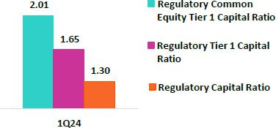

- Includes Accumulated Earnings solely from Financial Entities Supervised by the SBS, according to the current regulation.

- Includes Unrealized Losses attributable to Available-For-Sale Investments in debt instruments issued by the Peruvian Government, other Governments with Investment Grade Ratings, the Peruvian Central Bank and other instruments, in accordance with current regulation.

Datos elaborados por BCP para uso Interno | 39

| ^{Earning Release 1Q / 2024} Analysis of 1Q24 Consolidated Results

10. Regulatory Capital

10.2 Analysis of Capital at BCP Stand-alone

The IFRS CET 1 ratio at BCP Stand-alone dropped 135 bps QoQ to close 1Q24 at 11.86%, which remains above our internal appetite of 11%. The decline this quarter was attributable to a decrease in the balance of Retained Earnings, which was impacted by the declaration of dividend. The RWA level fell 1.3% due to a contraction in the loan portfolio. YoY, the IFRS CET 1 ratio decreased by 7 bps, which was attributable to an increase in RWAs.
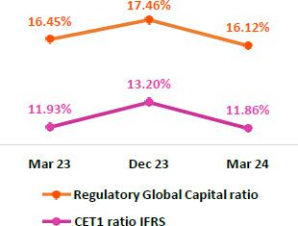

Finally, under the parameters of current regulation, the Regulatory Global Capital Ratio stood at 16.12% (-134 bps QoQ). This ratio compares favorably with the minimum of 12.57% required by the regulatory as of March 2024, which attests to our prudent solvency management. QoQ and YoY, the evolution of the Regulatory Global Capital Ratio was driven by the same dynamics as those seen for IFRS CET 1.

The local CET 1 ratio stood at 11.72%, which compares favorably with the 6.68% minimum required as of March 2024.

10.3 Analysis of Capital at Mibanco

As of 1Q24, IFRS CET 1 at Mibanco stood at 16.06% (-231 bps TaT), while our internal appetite stands at 15%. This drop was driven primarily by a decrease in Retained Earnings, which were impacted by dividend payments. RWA levels fell 1.1% due to a contraction in the loan portfolio. YoY, this ratio fell 32 bps due to the same dynamics explained in the QoQ analysis.
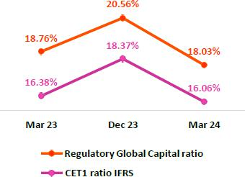

The Regulatory Global Capital Ratio at Mibanco stood at a very comfortable 18.03% (-73 bps QoQ), while the minimum required by the regulator was 12.80%. This variation was fueled by the same dynamics that spurred the evolution of the IFRS CET 1 Ratio. The local CET 1 ratio stood at 15.69%, versus the 6.68% minimum required as of March 2024.

Datos elaborados por BCP para uso Interno | 40

| ^{Earning Release 1Q / 2024} Analysis of 1Q24 Consolidated Results

11 Economic Outlook


In 1Q24, the Peruvian economy would have grown around 1.5% YoY, the first positive record after four consecutive quarters of declines. In the primary sectors, the dynamism of the mining sector stood out, while non-primary sectors grew around 2.0% YoY, driven by services, commerce and construction.

The annual inflation rate continued its slowdown , closing the quarter at 3.0% YoY (3.2% YoY in 4Q23). As such, the BCRP remained cutting rates; it lowered it by 25 bps in January, February and April to 6.00%.

According to the BCRP, the exchange rate closed at USDPEN 3.72 in 1Q24, a variation of -0.2% compared to the close of 4Q23 and 1.2% compared to a year ago.

Peru: Economic Forecast

Peru | 2018 | 2019 | 2020 | 2021 | 2022 | 2023 | 2024 ⁽⁴⁾
GDP (US$ Millions) | 226,919 | 232,519 | 205,933 | 226,140 | 245,209 | 268,027 | 282,325
Real GDP (% change) | 4.0 | 2.2 | -10.9 | 13.4 | 2.7 | -0.6 | 3.0
GDP per capita (US$) | 7,190 | 7,237 | 6,312 | 6,845 | 7,342 | 8,026 | 8,279
Domestic demand (% change) | 4.1 | 2.2 | -9.6 | 14.5 | 2.3 | -1.7 | 3.0
Gross fixed investment (as % GDP) | 22.2 | 22.5 | 21.0 | 25.1 | 25.3 | 22.9 | 23.2
Financial system loan without Reactiva (% change) ⁽¹⁾ | 10.3 | 6.4 | -4.3 | 12.6 | 9.7 | 2.8 | 4.5
Inflation, end of period⁽²⁾ | 2.2 | 1.9 | 2.0 | 6.4 | 8.5 | 3.2 | 2.5
Reference Rate, end of period | 2.75 | 2.25 | 0.25 | 2.50 | 7.50 | 6.75 | 5.00
Exchange rate, end of period | 3.37 | 3.31 | 3.62 | 3.99 | 3.81 | 3.71 | 3.75
Exchange rate, (% change) ⁽³⁾ | -4.0% | 1.8% | -9.3% | -10.3% | 4.5% | 2.7% | -1.2%
Fiscal balance (% GDP) | -2.3 | -1.6 | -8.9 | -2.5 | -1.7 | -2.8 | -2.5
Public Debt (as % GDP) | 25.6 | 26.6 | 34.6 | 35.9 | 33.8 | 32.9 | 33.0
Trade balance (US$ Millions) | 7,201 | 6,879 | 8,102 | 14,977 | 10,333 | 17,401 | 16,500
(As % GDP) | 3.2% | 3.0% | 3.9% | 6.6% | 4.2% | 6.5% | 5.8%
Exports | 49,066 | 47,980 | 42,826 | 62,967 | 66,235 | 67,241 | 69,000
Imports | 41,866 | 41,101 | 34,724 | 47,990 | 55,902 | 49,840 | 52,500
Current account balance (As % GDP) | -1.2% | -0.6% | 1.1% | -2.2% | -4.0% | 0.6% | -0.5%
Net international reserves (US$ Millions) | 60,121 | 68,316 | 74,707 | 78,495 | 71,883 | 71,033 | 74,000
(As % GDP) | 26.5% | 29.4% | 36.3% | 34.7% | 29.3% | 26.5% | 26.2%
(As months of imports) | 17 | 20 | 26 | 20 | 15 | 17 | 17

Sources: INEI, BCRP y SBS.
- Financial System, Current Exchange Rate
- Inflation target: 1% - 3%
- Negative % change indicates depreciation.
- Grey area indicate estimates by BCP Economic Research as of May 2024

Datos elaborados por BCP para uso Interno | 41

| Earning Release 1Q / 2024

11. Economic Outlook

Main Macroeconomic Variables

Gross Domestic Product

(Annual Real Variations, % YoY)
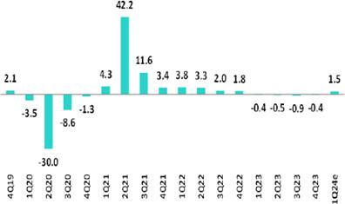

Source: BCRP

Estimate: BCP

Annual Inflation and Central Bank Reference Rate

(%)
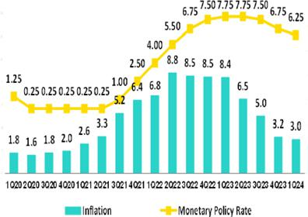

Analysis of 1Q24 Consolidated Results

In 1Q24, the Peruvian economy is expected to have expanded around 1.5% YoY, its first positive reading after four consecutive quarters of contraction. Among the primary sectors, the dynamism of the mining sector stood out. Non-primary activities grew around 2.0% YoY, its fastest pace in five quarters, fueled mainly by services, commerce, and construction.

On April 5, the multisectoral commission in charge of the national study of “El Niño” phenomenon (ENFEN, for its Spanish acronym) modified the status of the alert system to “Non-Active”. In this context, the Ministry of Production authorized the start date (April
- of the first anchovy fishing season in the north-central zone of the country with a maximum capture limit of 2.5 million metric tons, similar to the 2013-2022 average.

Inflation, measured using the Consumer Price index of Metropolitan Lima, slowed from 3.2% YoY at the end of 4Q23 to 3.0% YoY at the end of 1Q24, at the upper limit of the Central Bank (BCRP) target range of between 1% - 3% for the first time in three years and far from its peak of 8.8% YoY of June 2022. This result was driven by a drop in prices for chicken and agricultural commodities (1Q24 average price: -21% wheat, -34% corn and -21% soy). In March 2024, core inflation (excludes food and energy) stood at 3.1% YoY compared to 2.9% YoY at the end of 2023.

At its March meeting, the BCRP surprised markets by keeping its rate stable at 6.25% after six consecutive cuts of 25 bps. each. In April, it resumed rate cuts and reduced the rate by 25 bps to 6.00%. BCRP began its monetary policy easing cycle in September 2023 after maintaining the policy rate at a historic high of 7.75% for 7 consecutive months.

Source: BCRP and INEI

Datos elaborados por BCP para uso Interno | 42

| ^{Earning Release 1Q / 2024} Analysis of 1Q24 Consolidated Results

11. Economic Outlook

Fiscal Balance and Current Account Balance

(% of GDP, Quarter)
The annualized fiscal deficit for the last 12 months to March 2024 rose to 3.3% of GDP, compared to 2.8% of GDP in 4Q23. This increase was largely attributable to a decrease in fiscal revenues, which fell from 19.7% of GDP in 4Q23 to 19.2% in 1Q24 and was spurred by lower revenues from the annual regularization of corporate income tax and import VAT tax. Non-financial spending rose 8.7% YoY in 1Q24 due to an increase in current spending and public investment. The latter grew, in real terms, 45% YoY in 1Q24, its highest growth rate in 14 years excluding the pandemic.
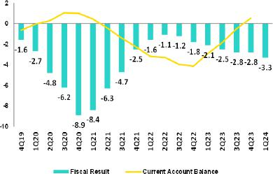

In April 2024, S&P lowered Peru’s sovereign debt credit rating from BBB to BBB- (the lowest level permissible to be considered an investment grade country) with a stable outlook. The agency indicated that its decision reflected the country’s complex political environment, which limits the government’s capacity to adopt policies to favor investment and, in turn, affects growth prospects. In April also, Fitch reaffirmed its BBB credit rating with a negative outlook, referring to high levels of political uncertainty and a deterioration in governance. Moody’s assign a rating of Baa1, two-steps above investment grade with a negative outlook.

Regarding external accounts, the 12-month accumulated trade balance surplus to February 2024 stood at USD 18 billion, a historic high. In the same period, exports grew 4.8% YoY to USD 68 billion, while imports fell 9.4% YoY to USD 50 billion due to lower import volumes of industrial supplies and construction materials, as well as lower commodity prices, mainly for oil and food.

In March 2024, gold prices reached a record high (2,230 dollar per ounce), copper prices reached their highest print in a year (4.12 dollar per pound) while WTI oil prices rose to a level not seen since October 2023 (83.2 dollar per barrel).

Terms of trade grew 2.5% YoY in February 2024 as the 5.2% YoY drop in import prices (lower oil and agricultural commodity prices) topped the 2.8% YoY decline registered for export prices, which was driven by lower prices for copper, zinc and coffee. In February, terms of trade fell 4.2% compared with the end of 2023 (highest since the end of 2021).

Exchange Rate

(PEN per USD)

According to BCRP, the exchange rate closed 1Q24 at USDPEN 3.72, stable year-to-date but with high volatility within the quarter. During mid-February, the exchange rate weakened to USDPEN 3.88. That month, the BCRP intervened in the spot market selling USD 233 million, almost three times the amount sold in 2023 (USD 81 million).
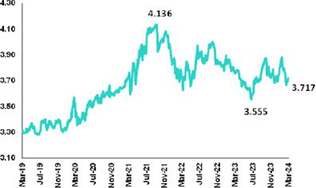

Latam main currencies registered mixed movements in 1Q24. The Mexican peso appreciated 2.4%, the Colombian peso remained stable (+0.4%) and the Chilean peso and Brazilian real depreciated 11.3% and 3.3%, respectively.

Net international reserves closed 1Q24 at USD 73.8 billion, above the end of 4Q23 level (USD 71.0 billion). The FX position of the BCRP stood at USD 51.8 billion, an increase of USD 270 million with respect to the end of 4Q23.

Datos elaborados por BCP para uso Interno | 43

| ^{Earning Release 1Q / 2024} Analysis of 1Q24 Consolidated Results

Safe Harbor for Forward-Looking Statements

This material includes “forward-looking statements” within the meaning of Section 27A of the U.S. Securities Act of 1933 and Section 21E of the U.S. Securities Exchange Act of 1934. All statements other than statements of historical fact are forward-looking and may contain information about financial results, economic conditions, trends and known uncertainties. Forward-looking statements are not assurances of future performance. Instead, they are based only on our management’s current views, beliefs, expectations and assumptions regarding the future of our business, future plans and strategies, projections, anticipated events and trends, the economy and other future conditions.

Many forward-looking statements can be identified by words such as: “anticipate”, “intend”, “plan”, “goal”, “seek”, “believe”, “project”, “estimate”, “expect”, “strategy”, “future”, “likely”, “would”, “may”, “should”, “will”, “see” and similar references to future periods. Examples of forward-looking statements include, among others, statements or estimates we make regarding guidance relating to losses in our credit portfolio, efficiency ratio, provisions and non-performing loans, current or future market risk and future market conditions, expected macroeconomic events and conditions, our belief that we have sufficient capital and liquidity to fund our business operations, expectations of the effect on our financial condition of claims, legal actions, environmental costs, contingent liabilities and governmental and regulatory investigations and proceedings, strategy for customer retention, growth, governmental programs and regulatory initiatives, credit administration, product development, market position, financial results and reserves and strategy for risk management.

We caution readers that forward-looking statements involve known and unknown risks and uncertainties that could cause actual results, performance, or events to differ materially from those that we expect or that are expressed or implied in the forward-looking statements, depending on the outcome of certain factors, including, without limitation, adverse changes in:

- The occurrence of natural disasters or political or social instability in Peru;

- The adequacy of the dividends that our subsidiaries are able to pay to us, which may affect our ability to pay dividends to shareholders and corporate expenses;

- Performance of, and volatility in, financial markets, including Latin-American and other markets;
- The frequency, severity and types of insured loss events;
- Fluctuations in interest rate levels;
- Foreign currency exchange rates, including the Sol/US Dollar exchange rate;
- Deterioration in the quality of our loan portfolio;
- Increasing levels of competition in Peru and other markets in which we operate;
- Developments and changes in laws and regulations affecting the financial sector and adoption of new international guidelines;
- Changes in the policies of central banks and/or foreign governments;
- Effectiveness of our risk management policies and of our operational and security systems;
- Losses associated with counterparty exposures;
- The scope of the coronavirus (“COVID-19”) outbreak, actions taken to contain the COVID-19 and related economic effects from such actions and our ability to maintain adequate staffing; and

- Changes in Bermuda laws and regulations applicable to so-called non-resident entities.

See “Item 3. Key Information—3. D Risk Factors” and “Item 5. Operating and Financial Review and Prospects” in our most recent Annual Report on Form 20-F filed with the U.S. Securities and Exchange Commission for additional information and other such factors. You are cautioned not to place undue reliance on these forward-looking statements, which speak only as of the date hereof and are based only on information currently available to us. Therefore, you should not rely on any of these forward-looking statements.
We undertake no obligation to publicly update or revise these or any other forward-looking statements that may be made to reflect events or circumstances after the date hereof, whether as a result of changes in our business strategy or new information, to reflect the occurrence of unanticipated events or otherwise.

Datos elaborados por BCP para uso Interno | 44

 | | Earning Release 1Q / 2024 | Analysis of 1Q24 Consolidated Results
12 Appendix
12.2. | Physical Point of Contact | 46
12.3. | Loan Portfolio Quality | 46
12.4 | Net Interest Income (NII) | 50
12.5. | Regulatory Capital | 51
12.6. | Financial Statements and Ratios by Business | 55
12.6.1. Credicorp Consolidated |  | 55
12.6.2. Credicorp Stand-alone |  | 57
12.6.3. BCP Consolidated |  | 58
12.6.4. BCP Stand-alone |  | 60
12.6.5. BCP Bolivia |  | 62
12.6.6. Mibanco |  | 63
12.6.7. Prima AFP |  | 64
12.6.8. Grupo Pacifico |  | 65
12.6.9. Investment Management and Advisory |  | 67
12.7. | Table of Calculations | 68
12.8. | Glossary of terms | 69
 | Datos elaborados por BCP para uso Interno | 45

| ^{Earning Release 1Q / 2024} Analysis of 1Q24 Consolidated Results

12. Appendix

12.1. Physical Point of contact

Physical Point of Contact ⁽¹⁾ |  | As of |  | change (units)
(Units) | Mar 23 | Dec 23 | Mar 24 | QoQ | YoY
Branches | 665 | 659 | 655 | -4 | -10
ATMs | 2,626 | 2,746 | 2,737 | -9 | 111
Agentes | 11,589 | 12,410 | 11,697 | -713 | 108
Total | 14,880 | 15,815 | 15,089 | -726 | 209

- Includes Banco de la Nacion branches, which in March 23 were 33, in December 23 were 36 and in March 24 were 36
- Includes Banco de la Nacion branches, which in March 23 were 33, in December 23 were 36 and in March 24 were 36

12.2. Loan Portfolio Quality

Portfolio Quality Ratios by Segment

Wholesale Banking
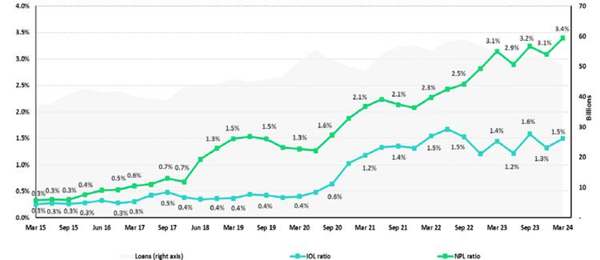

SME-Business
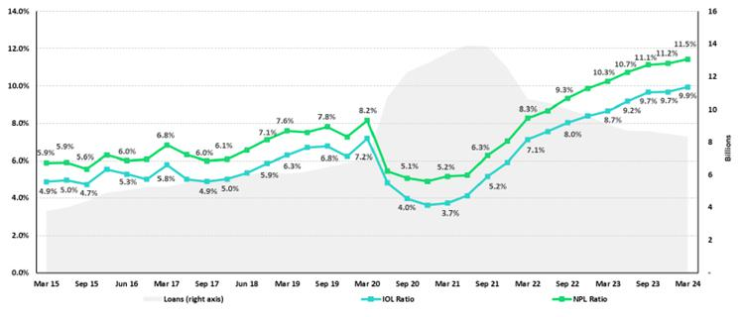

Datos elaborados por BCP para uso Interno | 46

| ^{Earning Release 1Q / 2024} Analysis of 1Q24 Consolidated Results

12. Appendix

SME-Pyme
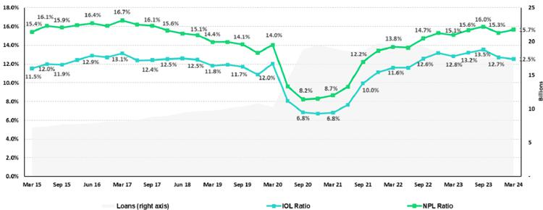

Mortgage
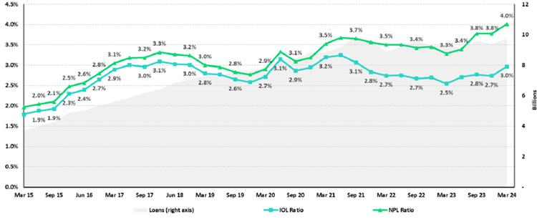

Datos elaborados por BCP para uso Interno | 47

| ^{Earning Release 1Q / 2024} Analysis of 1Q24 Consolidated Results

12. Appendix

Consumer
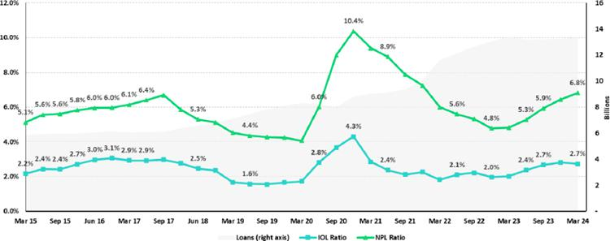

Credit Card
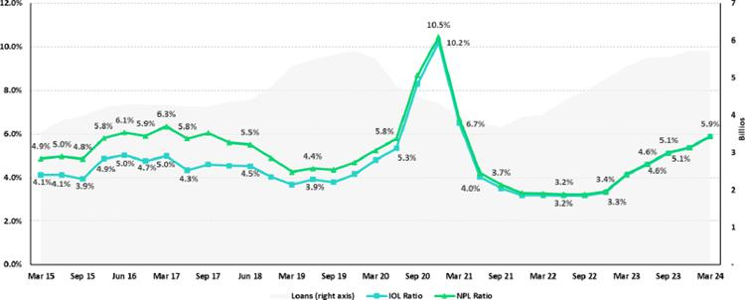

Datos elaborados por BCP para uso Interno | 48

| ^{Earning Release 1Q / 2024} Analysis of 1Q24 Consolidated Results

12. Appendix

Mibanco
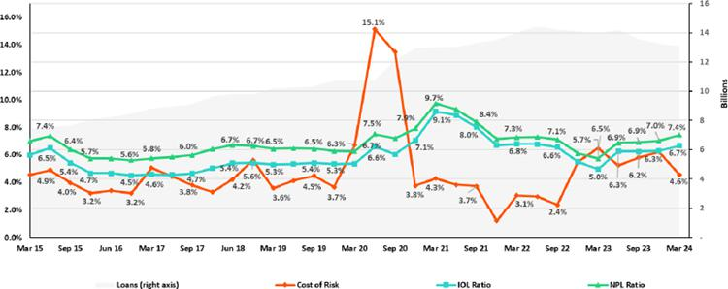

BCP Bolivia
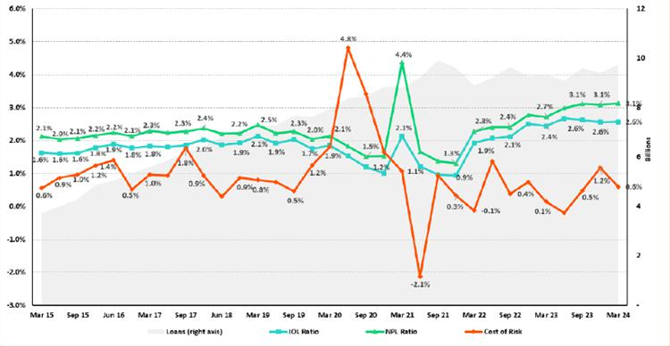

Datos elaborados por BCP para uso Interno | 49

| Earning Release 1Q / 2024 |  | Analysis of 1Q24 Consolidated Results
12. Appendix
12.3. Net Interest Income (NII)
 | NII Summary
Net interest income |  | Quarter |  | % change
S/ 000 | 1Q23 | 4Q23 | 1Q24 | QoQ | YoY
Interest income | 4,456,106 | 4,870,042 | 4,925,926 | 1.1% | 10.5%
Interest on loans | 3,570,952 | 3,907,705 | 3,868,792 | -1.0% | 8.3%
Dividends on investments | 6,477 | 11,647 | 10,861 | -6.7% | 67.7%
Interest on deposits with banks | 277,371 | 279,446 | 334,459 | 19.7% | 20.6%
Interest on securities | 585,268 | 643,737 | 683,075 | 6.1% | 16.7%
Other interest income | 16,038 | 27,507 | 28,739 | 4.5% | 79.2%
Interest expense | (1,324,017) | (1,522,358) | (1,499,803) | -1.5% | 13.3%
Interest expense (excluding Net Insurance Financial Expenses) | (1,208,267) | (1,402,925) | (1,377,799) | -1.8% | 14.0%
Interest on deposits | 677,088 | 827,124 | 779,526 | -5.8% | 15.1%
Interest on borrowed funds | 238,933 | 297,260 | 264,884 | -10.9% | 10.9%
Interest on bonds and subordinated notes | 182,898 | 152,960 | 196,630 | 28.5% | 7.5%
Other interest expense | 109,348 | 125,581 | 136,759 | 8.9% | 25.1%
Net Insurance Financial Expenses | (115,750) | (119,433) | (122,004) | 2.2% | 5.4%
Net interest income | 3,132,089 | 3,347,684 | 3,426,123 | 2.3% | 9.4%
Risk-adjusted Net interest income | 2,405,091 | 2,174,230 | 2,611,424 | 20.1% | 8.6%
Average interest earning assets | 222,289,504 | 223,624,217 | 225,297,538 | 0.7% | 1.4%
Net interest margin (1) | 5.84% | 6.20% | 6.30% | 10bps | 46bps
Risk-adjusted Net interest margin (1) | 4.54% | 4.10% | 4.85% | 75bps | 31bps
Net provisions for loan losses / Net interest income | 23.21% | 35.05% | 23.78% | -1127bps | 57bps

(1) Annualized. For further detail on the new NIM calculation due to IFRS17, please refer to Annex 12.1.7

Net Interest Margin (NIM) and Risk Adjusted NIM by Subsidiary

NIM Breakdown | BCP Stand-alone | Mibanco | BCP Bolivia | Credicorp
1Q23 | 5.55% | 12.52% | 2.86% | 5.84%
4Q23 | 5.99% | 13.35% | 2.87% | 6.20%
1Q24 | 6.04% | 13.42% | 2.96% | 6.30%

NIM: Annualized Net interest income (excluding Net Insurance Financial Expenses) / Average period end and period beginning interest-earning assets.

Risk Adjusted NIM Breakdown | BCP Stand-alone | Mibanco | BCP Bolivia | Credicorp
1Q23 | 4.42% | 7.03% | 2.74% | 4.54%
4Q23 | 3.96% | 8.17% | 1.93% | 4.10%
1Q24 | 4.64% | 9.71% | 2.46% | 4.85%

Risk-Adjusted NIM: (Annualized Net interest income (excluding Net Insurance Financial Expenses) - annualized provisions) / Average period end and period beginning interest-earning assets.

Datos elaborados por BCP para uso Interno | 50

| ^{Earning Release 1Q / 2024} Analysis of 1Q24 Consolidated Results

12. Appendix

12.5. Regulatory Capital

Regulatory Capital and Capital Adequacy Ratios

(S/ Thousands, IFRS)

Regulatory Capital and Capital Adequacy Ratios | As of
S/000 | Mar 24
Capital Stock | 1,318,993
Treasury Stocks | (208,343)
Capital Surplus | 201,965
Legal and Other Capital reserves | 26,213,432
Minority interest | 522,309
Current and Accumulated Earnings ⁽¹⁾ | 2,639,560
Unrealized Gains or Losses ⁽²⁾ | (991,283)
Goodwill | (768,869)
Intangible Assets ⁽³⁾ | (1,945,983)
Deductions in Common Equity Tier 1 instruments ⁽⁴⁾ | (73,914)
Perpetual subordinated debt | -
Subordinated Debt | 5,733,691
Loan loss reserves ⁽⁵⁾ | 1,946,564
Deductions in Tier 2 instruments ⁽⁶⁾ | (946,825)
Total Regulatory Capital (A) | 33,641,297
Total Regulatory Common Equity Tier 1 Capital (B) | 26,907,867
Total Regulatory Tier 1 Capital (C) | 26,907,867
Total Regulatory Capital Requirement (D) | 25,855,046
Total Regulatory Common Equity Tier 1 Capital Requirement (E) | 13,330,425
Total Regulatory Tier 1 Capital Requirement (F) | 16,309,166
Regulatory Capital Ratio (A) / (D) | 1.30
Regulatory Common Equity Tier 1 Capital Ratio (B) / (E) | 2.02
Regulatory Tier 1 Capital Ratio (C) / (F) | 1.65

- Legal and other capital reserves include restricted capital reserves (PEN 14,745 million) and optonal capital reserves (PEN 6,661 million).
- Minority interest includes Tier I (PEN 421 million)
- Up to 1.25% of total risk-weighted assets of Banco de Credito del Peru, Solucion Empresa Administradora Hipotecaria, Mibanco and ASB Bank Corp.
- Tier II + Tier III cannot be more than 50% of total regulatory capital.

- Tier I = capital + restricted capital reserves + Tier I minority interest - goodwill - (0.5 x investment in equity and subordinated debt of fnancial and insurance companies) + perpetual subordinated debt.

- Tier II = subordinated debt + Tier II minority interest ter + loan loss reserves - (0.5 x investment in equity and subordinated debt of fnancial and insurance companies).

- Tier III = Subordinated debt covering market risk only.
- Includes regulatory capital requirements of the fnancial consolidated group.
- Includes regulatory capital requirements of the insurance consolidated group.
- Regulatory Capital / Total Regulatory Capital Requirements (legal minimum = 1.00).

Datos elaborados por BCP para uso Interno | 51

| ^{Earning Release 1Q / 2024} Analysis of 1Q24 Consolidated Results

12. Appendix

Regulatory and Capital Adequacy Ratios at BCP Stand-alone

(S/ thousands, IFRS)
Regulatory Capital |  |  | Quarter |  |  | Change %
(S/ thousand) |  | Mar 23 | Dec 23 | Mar 24 | QoQ | YoY
Capital Stock |  | 12,973,175 | 12,973,175 | 12,973,175 | 0.0% | 0.0%
Reserves |  | 7,038,881 | 6,590,921 | 6,590,921 | 0.0% | -6.4%
Accumulated earnings |  | 2,050,746 | 5,383,865 | 2,644,894 | -50.9% | 29.0%
Loan loss reserves (1) |  | 1,634,876 | 1,695,577 | 1,662,636 | -1.9% | 1.7%
Perpetual subordinated debt |  | - | - | - | n.a | n.a
Subordinated Debt |  | 5,078,700 | 5,007,150 | 5,019,300 | 0.2% | -1.2%
Unrealized Profit or Losses |  | (1,046,284) | (668,717) | (691,921) | 3.5% | -33.9%
Investment in subsidiaries and others, net of unrealized |  | (2,613,563) | (2,772,786) | (2,416,070) | -12.9% | -7.6%
profit and net income in subsidiaries
Intangibles |  | (934,718) | (1,294,279) | (1,209,735) | -6.5% | 29.4%
Goodwill |  | (122,083) | (122,083) | (122,083) | 0.0% | 0.0%
Total Regulatory Capital |  | 24,059,729 | 26,792,823 | 24,451,116 | -8.7% | 1.6%
Tier 1 Common Equity (2) |  | 17,346,153 | 20,090,096 | 17,769,180 | -11.6% | 2.4%
Regulatory Tier 1 Capital (3) |  | 17,346,153 | 20,090,096 | 17,769,180 | -11.6% | 2.4%
Regulatory Tier 2 Capital (4) |  | 6,713,576 | 6,702,727 | 6,681,936 | -0.3% | -0.5%
Total risk-weighted assets |  |  | Quarter |  |  | Change %
(S/ thousand) |  | Mar 23 | Dec 23 | Mar 24 | QoQ | YoY
Market risk-weighted assets (5) |  | 1,715,934 | 2,680,010 | 3,032,546 | 13.2% | 76.7%
Credit risk-weighted assets |  | 129,623,885 | 134,427,146 | 131,793,619 | -2.0% | 1.7%
Operational risk-weighted assets |  | 14,880,988 | 16,365,974 | 16,842,059 | 2.9% | 13.2%
Total |  | 146,220,807 | 153,473,130 | 151,668,224 | -1.2% | 3.7%
Capital requirement |  |  | Quarter |  |  | Change %
(S/ thousand) |  | Mar 23 | Dec 23 | Mar 24 | QoQ | YoY
Market risk capital requirement (5) |  | 171,589 | 268,001 | 303,255 | 13.2% | 76.7%
Credit risk capital requirement |  | 11,018,030 | 12,098,443 | 11,861,426 | -2.0% | 7.7%
Operational risk capital requirement |  | 1,488,062 | 1,636,597 | 1,684,206 | 2.9% | 13.2%
Additional capital requirements |  | 3,534,427 | 5,383,837 | 5,418,896 | 0.7% | 53.3%
Total |  | 16,212,108 | 19,386,878 | 19,267,782 | -0.6% | 18.8%
 | Capital Ratios under Local Regulation
Capital ratios under Local Regulation |  |  | Quarter |  |  | % Change
(S/. thousand) |  | Mar 23 | Dec 23 | Mar 24 | QoQ | YoY
Common Equity Tier 1 ratio |  | 11.86% | 13.09% | 11.72% | -137 bps | -15 bps
Tier 1 Capital ratio |  | 11.86% | 13.09% | 11.72% | -137 bps | -15 bps
Regulatory Global Capital ratio |  | 16.45% | 17.46% | 16.12% | -134 bps | -33 bps

- Up to 1.25% of total risk-weighted assets.

- Common Equity Tier 1 = Capital Stock + Reserves + Accumulated earnings – Unrealized profits or losses - 100% deductions (investment in subsidiaries, goodwill, intangible assets and deferred tax assets based on future returns).
- Regulatory Tier 1 Capital = Common Equity Tier 1 + Tier 1 Subordinated Debt (Perpetual).
- Regulatory Tier 2 Capital = Subordinated Debt + Loan loss reserves.

Datos elaborados por BCP para uso Interno | 52

| ^{Earning Release 1Q / 2024} Analysis of 1Q24 Consolidated Results

12. Appendix

Regulatory Capital and Capital Adequacy Ratios at Mibanco

(S/ thousands, IFRS)
Regulatory Capital |  |  | Quarter |  | % Change
(S/ thousand) |  | Mar 23 | Dec 23 | Mar 24 | QoQ | YoY
Capital Stock |  | 1,840,606 | 1,840,606 | 1,840,606 | 0.0% | 0.0%
Reserves |  | 308,056 | 308,056 | 334,650 | 8.6% | 8.6%
Accumulated earnings |  | 556,972 | 717,919 | 310,119 | -56.8% | -44.3%
Loan loss reserves |  | 168,965 | 157,368 | 154,452 | -1.9% | -8.6%
Perpetual subordinated debt |  | - | - | - | n.a | n.a.
Subordinated debt |  | 179,000 | 173,000 | 173,000 | 0.0% | -3.4%
Unrealidez Profit or Losses |  | (15,467) | (1,695) | (4,984) | 194.1% | -67.8%
Investment in subsidiaries and others, net of unrealized |  | (281) | (282) | (283) | 0.4% | 1.0%
profit and net income in subsidiaries
Intangibles |  | (135,202) | (156,884) | (150,274) | -4.2% | 11.1%
Goodwill |  | (139,180) | (139,180) | (139,180) | 0.0% | 0.0%
Total Regulatory Capital |  | 2,763,469 | 2,898,907 | 2,518,105 | -13.1% | -8.9%
Tier Common Equity (2) |  | 2,415,504 | 2,568,539 | 2,190,653 | -14.7% | -9.3%
Regulatory Tier 1 Capital (3) |  | 2,415,504 | 2,568,539 | 2,190,653 | -14.7% | -9.3%
Regulatory Tier 2 Capital (4) |  | 347,965 | 330,368 | 327,452 | -0.9% | -5.9%
Total risk-weighted assets |  |  | Quarter |  | % change
(S/ thousand) |  | Mar 23 | Dec 23 | Mar 24 | QoQ | YoY
Market risk-weighted assets |  | 141,441 | 220,327 | 252,255 | 14.5% | 78.3%
Credit risk-weighted assets |  | 13,160,337 | 12,349,400 | 12,151,596 | -1.6% | -7.7%
Operational risk-weighted assets |  | 1,427,428 | 1,527,140 | 1,559,737 | 2.1% | 9.3%
Total |  | 14,729,206 | 14,096,867 | 13,963,589 | -0.9% | -5.2%
Capital requirement |  |  | Quarter |  | % change
(S/ thousand) |  | Mar 23 | Dec 23 | Mar 24 | QoQ | YoY
Market risk capital requirement (5) |  | 14,144 | 22,033 | 25,226 | 14.5% | 78.3%
Credit risk capital requirement |  | 1,316,034 | 1,111,446 | 1,093,644 | -1.6% | -16.9%
Operational risk capital requirement |  | 142,743 | 152,714 | 155,974 | 2.1% | 9.3%
Additional capital requirements |  | 398,603 | 568,059 | 164,047 | -71.1% | -58.8%
Total |  | 1,871,523 | 1,854,252 | 1,438,889 | -22.4% | -23.1%
 | Capital Ratios under Local Regulation
Capital ratios under Local Regulation |  |  | Quarter |  | % change
 |  | Mar 23 | Dec 23 | Mar 24 | QoQ | YoY
Common Equity Tier 1 Ratio |  | 16.40% | 18.22% | 15.69% | -253 bps | -71 pbs
Tier 1 Capital ratio |  | 16.40% | 18.22% | 15.69% | -253 bps | -71 pbs
Regulatory Global Capital Ratio |  | 18.76% | 20.56% | 18.03% | -253 bps | -73 pbs

- Up to 1.25% of total risk-weighted assets.

- Common Equity Tier 1 = Capital Stock + Reserves + Accumulated earnings – Unrealized profits or losses - 100% deductions (investment in subsidiaries, goodwill, intangible assets and deferred tax assets based on future returns).
- Regulatory Tier 1 Capital = Common Equity Tier 1 + Tier 1 Subordinated Debt (Perpetual).
- Regulatory Tier 2 Capital = Subordinated Debt + Loan loss reserves.

Datos elaborados por BCP para uso Interno | 53

| ^{Earning Release 1Q / 2024} Analysis of 1Q24 Consolidated Results

12. Appendix

Common Equity Tier 1 IFRS

BCP Stand-alone
 | Common Equity Tier 1 IFRS |  |  | Quarter |  | % Change
 | (S/. thousand) |  | Mar 23 | Dec 23 | Mar 24 | QoQ | YoY
 | Capital and reserves |  | 19,499,813 | 19,051,853 | 19,051,853 | 0.0% | -2.3%
 | Retained earnings |  | 2,746,522 | 6,058,923 | 3,429,163 | -43.4% | 24.9%
 | Unrealized gains (losses) |  | (467,041) | (109,202) | (161,369) | 47.8% | -65.4%
 | Goodwill and intangibles |  | (1,454,205) | (1,670,116) | (1,650,626) | -1.2% | 13.5%
 | Investments in subsidiaries |  | (2,736,368) | (2,917,670) | (2,570,974) | -11.9% | -6.0%
 | Total |  | 17,588,721 | 20,413,787 | 18,098,046 | -11.3% | 2.9%
 | Adjusted RWAs IFRS |  | 147,477,433 | 154,627,042 | 152,645,988 | -1.3% | 3.5%
 | Adjusted Credit RWAs IFRS |  | 130,880,511 | 135,581,058 | 132,771,383 | -2.1% | 1.4%
 | Others |  | 16,596,922 | 19,045,984 | 19,874,605 | 4.4% | 19.7%
 | CET1 ratio IFRS |  | 11.93% | 13.20% | 11.86% | -135 bps | -7 bps
 |  |  | Mibanco
 | Common Equity Tier 1 IFRS |  |  | Quarter |  | % Change
 | (S/. thousand) |  | Mar 23 | Sep 23 | Dec 23 | QoQ | YoY
 | Capital and reserves |  | 2,676,791 | 2,676,791 | 2,703,385 | 1.0% | 1.0%
 | Retained earnings |  | 140,612 | 321,235 | (62,632) | -119.5% | -144.5%
 | Unrealized gains (losses) |  | (16,118) | (1,403) | (8,967) | 538.9% | -44.4%
 | Goodwill and intangibles |  | (342,684) | (360,171) | (352,162) | -2.2% | 2.8%
 | Investments in subsidiaries |  | (281) | (271) | (275) | 1.8% | -1.9%
 | Total |  | 2,458,321 | 2,636,182 | 2,279,349 | -13.5% | -7.3%
 | Adjusted RWAs IFRS |  | 15,005,498 | 14,349,534 | 14,188,737 | -1.1% | -5.4%
 | Adjusted Credit RWAs IFRS |  | 15,005,498 | 12,595,184 | 12,366,207 | -1.8% | -17.6%
 | Others |  | - | 1,754,350 | 1,822,530 | 3.9% | n.a.
 | CET1 ratio IFRS |  | 16.38% | 18.37% | 16.06% | -231 bps | -32 bps
 |  | Datos elaborados por BCP para uso Interno |  |  |  |  | 54

| ^{Earning Release 1Q / 2024} Analysis of 1Q24 Consolidated Results

12. Appendix

12.6. Financial Statements and Ratios by Business

12.6.1. Credicorp Consolidated

Consolidated Statement of Financial Position

(In S/ thousands, IFRS)
 |  | As of |  |  | % change
 | Mar 23 | Dec 23 | Mar 24 | QoQ | YoY
ASSETS
Cash and due from banks
Non-interest bearing | 6,946,112 | 7,952,371 | 8,024,262 | 0.9% | 15.5%
Interest bearing | 28,158,941 | 25,978,577 | 31,134,572 | 19.8% | 10.6%
Total cash and due from banks | 35,105,053 | 33,930,948 | 39,158,834 | 15.4% | 11.5%
Cash collateral, reverse repurchase agreements and securities borrowing | 1,468,180 | 1,410,647 | 1,526,232 | 8.2% | 4.0%
Fair value through profit or loss investments | 4,080,266 | 4,982,661 | 4,448,122 | -10.7% | 9.0%
Fair value through other comprehensive income investments | 33,395,987 | 37,043,940 | 38,047,888 | 2.7% | 13.9%
Amortized cost investments | 10,253,251 | 10,188,927 | 10,059,376 | -1.3% | -1.9%
Loans | 145,165,713 | 144,976,051 | 140,798,083 | -2.9% | -3.0%
Current | 139,376,216 | 138,849,564 | 134,593,059 | -3.1% | -3.4%
Internal overdue loans | 5,789,497 | 6,126,487 | 6,205,024 | 1.3% | 7.2%
Less - allowance for loan losses | (7,915,350) | (8,277,916) | (8,190,343) | -1.1% | 3.5%
Loans, net | 137,250,363 | 136,698,135 | 132,607,740 | -3.0% | -3.4%
Financial assets designated at fair value through profit or loss | 795,225 | 810,932 | 868,239 | 7.1% | 9.2%
Property, plant and equipment, net | 1,786,992 | 1,857,240 | 1,815,570 | -2.2% | 1.6%
Due from customers on acceptances | 496,170 | 412,401 | 322,346 | -21.8% | -35.0%
Investments in associates | 660,741 | 748,663 | 691,908 | -7.6% | 4.7%
Intangible assets and goodwill, net | 2,942,367 | 3,225,499 | 3,161,382 | -2.0% | 7.4%
Reinsurance contract assets | 804,958 | 872,046 | 957,474 | 9.8% | 18.9%
Other assets (1) | 8,112,749 | 6,658,149 | 7,506,630 | 12.7% | -7.5%
Total Assets | 237,152,302 | 238,840,188 | 241,171,741 | 1.0% | 1.7%
LIABILITIES AND EQUITY
Deposits and obligations
Non-interest bearing | 41,596,964 | 42,234,498 | 41,706,139 | -1.3% | 0.3%
Interest bearing | 107,026,336 | 105,470,496 | 106,150,988 | 0.6% | -0.8%
Total deposits and obligations | 148,623,300 | 147,704,994 | 147,857,127 | 0.1% | -0.5%
Payables from repurchase agreements and securities lending | 11,686,495 | 10,168,427 | 9,491,276 | -6.7% | -18.8%
BCRP instruments | 9,780,540 | 7,461,674 | 6,854,368 | -8.1% | -29.9%
Repurchase agreements with third parties | 1,206,574 | 1,134,886 | 1,092,031 | -3.8% | -9.5%
Repurchase agreements with customers | 699,381 | 1,571,867 | 1,544,877 | -1.7% | 120.9%
Due to banks and correspondents | 10,199,650 | 12,278,681 | 10,684,673 | -13.0% | 4.8%
Bonds and notes issued | 14,326,930 | 14,594,785 | 17,541,121 | 20.2% | 22.4%
Banker’s acceptances outstanding | 496,170 | 412,401 | 322,346 | -21.8% | -35.0%
Insurance contract liability | 11,448,674 | 12,318,133 | 12,343,975 | 0.2% | 7.8%
Financial liabilities at fair value through profit or loss | 417,146 | 641,915 | 309,228 | -51.8% | -25.9%
Other liabilities | 9,019,443 | 7,613,787 | 8,185,785 | 7.5% | -9.2%
Total Liabilities | 206,217,808 | 205,733,123 | 206,735,531 | 0.5% | 0.3%
Net equity | 30,359,898 | 32,460,004 | 33,853,460 | 4.3% | 11.5%
Capital stock | 1,318,993 | 1,318,993 | 1,318,993 | 0.0% | 0.0%
Treasury stock | (208,041) | (208,033) | (208,343) | 0.1% | 0.1%
Capital surplus | 226,189 | 228,239 | 201,965 | -11.5% | -10.7%
Reserves | 23,603,001 | 26,252,578 | 26,213,432 | -0.1% | 11.1%
Other reserves | (244,725) | 295,783 | 243,405 | -17.7% | -199.5%
Retained earnings | 5,664,481 | 4,572,444 | 6,084,008 | 33.1% | 7.4%
Non-controlling interest | 574,596 | 647,061 | 582,750 | -9.9% | 1.4%
Total Net Equity | 30,934,494 | 33,107,065 | 34,436,210 | 4.0% | 11.3%
Total liabilities and equity | 237,152,302 | 238,840,188 | 241,171,741 | 1.0% | 1.7%
Off-balance sheet | 154,477,055 | 149,769,480 | 162,365,717 | 8.4% | 5.1%
Total performance bonds, stand-by and L/Cs. | 18,731,789 | 20,051,616 | 20,466,103 | 2.1% | 9.3%
Undrawn credit lines, advised but not committed | 87,232,214 | 87,091,701 | 88,546,531 | 1.7% | 1.5%
Total derivatives (notional) and others | 48,513,052 | 42,626,163 | 53,353,083 | 25.2% | 10.0%

(1) Includes mainly accounts receivables from brokerage and others.

* Due to reclassifications, the Balance Sheet may differ from those reported in previous quarters.

Datos elaborados por BCP para uso Interno | 55

| ^{Earning Release 1Q / 2024} Analysis of 1Q24 Consolidated Results

12. Appendix

Consolidated Statement of Income

(In S/ thousands, IFRS)

 |  |  | As of |  | % change
 |  | 1Q23 | 4Q23 | 1Q24 | QoQ | YoY
 | Interest income and expense
 | Interest and similar income | 4,456,106 | 4,870,042 | 4,925,926 | 1.1% | 10.5%
 | Interest and similar expenses | (1,324,017) | (1,522,358) | (1,499,803) | -1.5% | 13.3%
 | Net interest, similar income and expenses | 3,132,089 | 3,347,684 | 3,426,123 | 2.3% | 9.4%
 |  | - | - | - | 0.0% | 0.0%
 | Gross provision for credit losses on loan portfolio | (802,107) | (1,260,163) | (910,189) | -27.8% | 13.5%
 | Recoveries of written-off loans | 75,109 | 86,709 | 95,490 | 10.1% | 27.1%
 | Provision for credit losses on loan portfolio, net of recoveries | (726,998) | (1,173,454) | (814,699) | -30.6% | 12.1%
 |  | - | - | - | 0.0% | 0.0%
 | Net interest, similar income and expenses, after provision for credit | 2,405,091 | 2,174,230 | 2,611,424 | 20.1% | 8.6%
 | losses on loan portfolio
 | Other income
 | Fee income | 881,781 | 986,173 | 1,062,501 | 7.7% | 20.5%
 | Net gain on foreign exchange transactions | 248,515 | 218,047 | 166,269 | -23.7% | -33.1%
 | Net loss on securities | 70,036 | 115,825 | 61,745 | -46.7% | -11.8%
 | Net gain from associates | 27,212 | 34,132 | 32,295 | -5.4% | 18.7%
 | Net gain (loss) on derivatives held for trading | (6,570) | 5,019 | 39,984 | 696.7% | -708.6%
 | Net gain (loss) from exchange differences | 22,963 | 15,255 | (5,621) | -136.8% | -124.5%
 | Others | 89,338 | 112,372 | 102,221 | -9.0% | 14.4%
 | Total other income | 1,333,275 | 1,486,823 | 1,459,394 | -1.8% | 9.5%
 | Insurance underwriting result
 | Insurance Service Result | 406,877 | 385,043 | 458,997 | 19.2% | 12.8%
 | Reinsurance Result | (110,536) | (97,748) | (179,935) | 84.1% | 62.8%
 | Total insurance underwriting result | 296,341 | 287,295 | 279,062 | -2.9% | -5.8%
 | Total expenses
 | Salaries and employee benefits | (1,029,558) | (1,119,758) | (1,107,069) | -1.1% | 7.5%
 | Administrative, general and tax expenses | (835,060) | (1,089,203) | (888,583) | -18.4% | 6.4%
 | Depreciation and amortization | (161,079) | (177,618) | (175,146) | -1.4% | 8.7%
 | Impairment loss on goodwill | - | (71,959) | - | n.a | n.a
 | Association in participation | (12,612) | (9,109) | (8,847) | -2.9% | -29.9%
 | Other expenses | (88,599) | (193,895) | (99,672) | -48.6% | 12.5%
 | Total expenses | (2,126,908) | (2,661,542) | (2,279,317) | -14.4% | 7.2%
 | Profit before income tax | 1,907,799 | 1,286,806 | 2,070,563 | 60.9% | 8.5%
 | Income tax | (493,466) | (434,648) | (528,466) | 21.6% | 7.1%
 | Net profit | 1,414,333 | 852,158 | 1,542,097 | 81.0% | 9.0%
 | Non-controlling interest | 30,060 | 10,331 | 30,440 | 194.6% | 1.3%
 | Net profit attributable to Credicorp | 1,384,273 | 841,827 | 1,511,657 | 79.6% | 9.2%
 | Datos elaborados por BCP para uso Interno |  |  |  |  | 56

 | | Earning Release 1Q / 2024 |  |  |  |  | Analysis of 1Q24 Consolidated Results
12. Appendix
12.6.2. Credicorp Stand-alone
 | Separate Statement of Financial Position
 | (In S/ thousands, IFRS)
 |  |  |  |  | As of |  |  | % change
 |  |  |  | Mar 23 | Dec 23 | Mar 24 |  | QoQ | YoY
 | ASSETS
 | Cash and cash equivalents |  | 131,218 |  | 529,773 | 510,036 | -3.7% |  | 288.7%
 | At fair value through profit or loss |  | 949,378 |  | 501,026 | - |  | n.a | n.a
 | Fair value through other comprehensive income investments |  | 318,962 |  | 1,418,293 | 1,427,450 | 0.6% |  | 347.5%
 | In subsidiaries and associates investments |  | 35,207,564 |  | 36,150,565 | 37,392,797 | 3.4% |  | 6.2%
 | Held to maturity |  | - |  | 166,977 | 640,723 | 283.7% |  | n.a
 | Other assets |  | 69,217 |  | 99 | 294,639 |  | n.a | 325.7%
 | Total Assets |  | 36,676,339 |  | 38,766,733 | 40,265,645 | 3.9% |  | 9.8%
 | LIABILITIES AND NET SHAREHOLDERS’ EQUITY
 | Due to banks, correspondents and other entities |  | - |  | 30,866 | - |  | n.a | n.a
 | Dividends payable |  | 1,885,839 |  | 1,798,858 | 1,816,584 | 1.0% |  | -3.7%
 | Bonds and notes issued |  | 267,558 |  | 255,707 | 296,682 | 16.0% |  | 10.9%
 | Other liabilities |  | - |  | - | - | 0.0% |  | 0.0%
 | Total Liabilities |  | 2,153,397 |  | 2,085,431 | 2,113,266 | 1.3% |  | -1.9%
 | NET EQUITY
 | Capital stock |  | 1,318,993 |  | 1,318,993 | 1,318,993 | 0.0% |  | 0.0%
 | Capital Surplus |  | 384,542 |  | 384,542 | 384,542 | 0.0% |  | 0.0%
 | Reserve |  | 23,300,350 |  | 25,905,526 | 25,910,975 | 0.0% |  | 11.2%
 | Unrealized results |  | (592,006) |  | 68,056 | 17,616 | -74.1% |  | n.a
 | Retained earnings |  | 10,111,063 |  | 9,004,185 | 10,520,253 | 16.8% |  | 4.0%
 | Total net equity |  | 34,522,942 |  | 36,681,302 | 38,152,379 | 4.0% |  | 10.5%
 | Total Liabilities And Equity |  | 36,676,339 |  | 38,766,733 | 40,265,645 | 3.9% |  | 9.8%
 | Statement of Income
 | (S/ Thousands, IFRS)
 |  |  |  |  | Quarter |  |  | % change
 |  |  |  | 1Q23 | 4Q23 | 1Q24 |  | QoQ | YoY
 | Interest income
 | Net share of the income from investments in subsidiaries and associates |  |  | 1,439,211 | 906,901 | 1,557,394 |  | 71.7% | 8.2%
 | Interest and similar income |  |  | 300 | 1,170 | 18,725 |  | n.a | n.a
 | Net gain on financial assets at fair value through profit or loss |  |  | 3,759 | 32,430 | 1,234 |  | -96.2% | -67.2%
 | Total income |  |  | 1,443,270 | 940,501 | 1,577,353 |  | 67.7% | 9.3%
 | Interest and similar expense |  |  | (13,796) | (14,444) | (13,565) |  | -6.1% | -1.7%
 | Administrative and general expenses |  |  | (4,407) | (9,274) | (4,802) |  | -48.2% | 9.0%
 | Total expenses |  |  | (18,203) | (23,718) | (18,367) |  | -22.6% | 0.9%
 | Operating income |  |  | 1,425,067 | 916,783 | 1,558,986 |  | 70.0% | 9.4%
 | Net gain (losses) from exchange differences |  |  | (158) | 510 | 93 |  | -81.8% | n.a
 | Other, net |  |  | 102 | 111 | 111 |  | 0.0% | 8.8%
 | Profit before income tax |  |  | 1,425,011 | 917,404 | 1,559,190 |  | 70.0% | 9.4%
 | Income tax |  |  | (46,795) | (68,500) | (43,104) |  | -37.1% | -7.9%
 | Net income |  |  | 1,378,216 | 848,904 | 1,516,086 |  | 78.6% | 10.0%
 | Double Leverage Ratio |  |  | 102.0% | 98.6% | 98.0% |  | -50 bps | -400 bps
 | Datos elaborados por BCP para uso Interno |  |  |  |  |  |  |  | 57

| ^{Earning Release 1Q / 2024} Analysis of 1Q24 Consolidated Results

12. Appendix

12.6.3 BCP Consolidated

Condolidated Statement of Financial Position

(S/ thousands, IFRS)

 |  | As of |  | % change
 | Mar 23 | Dec 23 | Mar 24 | QoQ | YoY
ASSETS
Cash and due from banks
Non-interest bearing | 5,456,302 | 6,025,352 | 5,842,595 | -3.0% | 7.1%
Interest bearing | 26,924,509 | 24,668,794 | 30,040,974 | 21.8% | 11.6%
Total cash and due from banks | 32,380,811 | 30,694,146 | 35,883,569 | 16.9% | 10.8%
Cash collateral, reverse repurchase agreements and securities borrowing | 232,059 | 100,211 | 415,202 | 314.3% | 78.9%
Fair value through profit or loss investments | 39,638 | 362,360 | 465,261 | 28.4% | n.a
Fair value through other comprehensive income investments | 17,702,831 | 20,592,731 | 21,739,359 | 5.6% | 22.8%
Amortized cost investments | 9,661,389 | 9,557,451 | 9,389,695 | -1.8% | -2.8%
Loans | 132,290,495 | 131,767,137 | 127,359,955 | -3.3% | -3.7%
Current | 126,846,139 | 125,948,604 | 121,494,564 | -3.5% | -4.2%
Internal overdue loans | 5,444,356 | 5,818,533 | 5,865,391 | 0.8% | 7.7%
Less - allowance for loan losses | (7,450,091) | (7,772,720) | (7,663,849) | -1.4% | 2.9%
Loans, net | 124,840,404 | 123,994,417 | 119,696,106 | -3.5% | -4.1%
Property, furniture and equipment, net ⁽¹⁾ | 1,489,392 | 1,559,485 | 1,512,734 | -3.0% | 1.6%
Due from customers on acceptances | 496,170 | 412,401 | 322,346 | -21.8% | -35.0%
Investments in associates | 18,246 | 21,426 | 23,270 | 8.6% | 27.5%
Other assets ⁽²⁾ | 6,873,005 | 6,510,227 | 6,955,937 | 6.8% | 1.2%
Total Assets | 193,733,945 | 193,804,855 | 196,403,479 | 1.3% | 1.4%
Liabilities and Equity
Deposits and obligations
Non-interest bearing ⁽¹⁾ | 37,978,204 | 39,377,289 | 38,519,886 | -2.2% | 1.4%
Interest bearing ⁽¹⁾ | 93,952,305 | 92,931,227 | 94,436,692 | 1.6% | 0.5%
Total deposits and obligations | 131,930,509 | 132,308,516 | 132,956,578 | 0.5% | 0.8%
Payables from repurchase agreements and securities lending | 10,318,686 | 8,005,844 | 7,388,795 | -7.7% | -28.4%
BCRP instruments | 9,780,540 | 7,461,674 | 6,854,368 | -8.1% | -29.9%
Repurchase agreements with third parties | 538,146 | 544,170 | 534,427 | -1.8% | -0.7%
Due to banks and correspondents | 9,647,935 | 11,870,116 | 10,160,253 | -14.4% | 5.3%
Bonds and notes issued | 10,972,861 | 10,961,427 | 13,833,480 | 26.2% | 26.1%
Banker’s acceptances outstanding | 496,170 | 412,401 | 322,346 | -21.8% | -35.0%
Financial liabilities at fair value through profit or loss | 193,031 | 91,966 | - | n.a | n.a.
Other liabilities ⁽³⁾ | 8,245,729 | 4,995,178 | 9,283,873 | 85.9% | 12.6%
Total Liabilities | 171,804,921 | 168,645,448 | 173,945,325 | 3.1% | 1.2%
Net equity | 21,777,751 | 24,998,419 | 22,315,713 | -10.7% | 2.5%
Capital stock | 12,679,794 | 12,679,794 | 12,679,794 | 0.0% | 0.0%
Reserves | 6,820,019 | 6,372,059 | 6,372,059 | 0.0% | -6.6%
Unrealized gains and losses | (467,041) | (108,012) | (159,740) | 47.9% | -65.8%
Retained earnings | 2,744,979 | 6,054,578 | 3,423,600 | -43.5% | 24.7%
Non-controlling interest | 151,273 | 160,988 | 142,441 | -11.5% | -5.8%
Total Net Equity | 21,929,024 | 25,159,407 | 22,458,154 | -10.7% | 2.4%
Total liabilities and equity | 193,733,945 | 193,804,855 | 196,403,479 | 1.3% | 1.4%
Off-balance sheet | 142,247,161 | 138,140,917 | 151,042,451 | 9.3% | 6.2%
Total performance bonds, stand-by and L/Cs. | 17,932,260 | 19,328,506 | 19,720,490 | 2.0% | 10.0%
Undrawn credit lines, advised but not committed | 76,157,911 | 76,719,565 | 78,799,124 | 2.7% | 3.5%
Total derivatives (notional) and others | 48,156,990 | 42,092,846 | 52,522,837 | 24.8% | 9.1%

- Right of use asset of lease contracts is included by application of IFRS 16.

- Mainly includes intangible assets, other accounts receivable and tax credit.
- Mainly includes other accounts payable.

Datos elaborados por BCP para uso Interno | 58

| ^{Earning Release 1Q / 2024} Analysis of 1Q24 Consolidated Results

12. Appendix

Consolidated Statement of Income

(S/ thousands, IFRS)

 |  | Quarter |  | % change
 | 1Q23 | 4Q23 | 1Q24 | QoQ | YoY
Interest income and expense
Interest and dividend income | 3,902,811 | 4,265,959 | 4,278,901 | 0.3% | 9.6%
Interest expense | (994,836) | (1,153,770) | (1,119,658) | -3.0% | 12.5%
Net interest income | 2,907,975 | 3,112,189 | 3,159,243 | 1.5% | 8.6%
Provision for credit losses on loan portfolio | (782,079) | (1,160,527) | (844,151) | -27.3% | 7.9%
Recoveries of written-off loans | 69,694 | 81,398 | 90,798 | 11.5% | 30.3%
Provision for credit losses on loan portfolio, net of recoveries | (712,385) | (1,079,129) | (753,353) | -30.2% | 5.8%
Risk-adjusted net interest income | 2,195,590 | 2,033,060 | 2,405,890 | 18.3% | 9.6%
Non-financial income
Fee income | 727,489 | 773,261 | 796,536 | 3.0% | 9.5%
Net gain on foreign exchange transactions | 242,570 | 268,615 | 261,882 | -2.5% | 8.0%
Net gain (loss) on securities | (2,584) | 10,759 | (10,529) | n.a | 307.5%
Net gain (loss) on derivatives held for trading | 22,288 | 21,750 | 17,956 | -17.4% | -19.4%
Net gain (loss) from exchange differences | 4,308 | 8,795 | 6,526 | -25.8% | 51.5%
Others | 71,277 | 101,244 | 56,936 | -43.8% | -20.1%
Total other income | 1,065,348 | 1,184,424 | 1,129,307 | -4.7% | 6.0%
Total expenses
Salaries and employee benefits | (750,011) | (788,885) | (795,569) | 0.8% | 6.1%
Administrative expenses | (645,131) | (874,101) | (696,850) | -20.3% | 8.0%
Depreciation and amortization | (134,267) | (146,657) | (142,270) | -3.0% | 6.0%
Other expenses | (43,944) | (124,472) | (52,973) | -57.4% | 20.5%
Total expenses | (1,573,353) | (1,934,115) | (1,687,662) | -12.7% | 7.3%
Profit before income tax | 1,687,585 | 1,283,369 | 1,847,535 | 44.0% | 9.5%
Income tax | (422,491) | (327,708) | (462,578) | 41.2% | 9.5%
Net profit | 1,265,094 | 955,661 | 1,384,957 | 44.9% | 9.5%
Non-controlling interest | (1,112) | (2,670) | (4,630) | 73.4% | 316.4%
Net profit attributable to BCP Consolidated | 1,263,982 | 952,991 | 1,380,327 | 44.8% | 9.2%

Selected Financial Indicators


 |  | Quarter
 | 1Q23 | 4Q23 | 1Q24
Profitability
ROAA (1)(2) | 2.6% | 2.0% | 2.8%
ROAE (1)(2) | 22.5% | 15.5% | 23.3%
Net interest margin (1)(2) | 6.22% | 6.67% | 6.71%
Risk adjusted NIM (1)(2) | 4.70% | 4.36% | 5.11%
Funding Cost (1)(2)(3) | 2.4% | 2.8% | 2.7%
Quality of loan portfolio
IOL ratio | 4.1% | 4.4% | 4.6%
NPL ratio | 5.7% | 6.2% | 6.6%
Coverage of IOLs | 136.8% | 133.6% | 130.7%
Coverage of NPLs | 98.9% | 95.3% | 91.8%
Cost of risk (4) | 2.2% | 3.3% | 2.4%
Operating efficiency
Oper. expenses as a percent. of total income - reported (5) | 39.2% | 43.2% | 38.5%
Oper. expenses as a percent. of av. tot. assets (1)(2)(5) | 3.2% | 3.7% | 3.4%

- Ratios are annualized.

- Averages are determined as the average of period-beginning and period-ending balances.
- The funding costs differs from previously reported due to a methodology change in the denominator, which no longer includes the following accounts: acceptances outstanding, reserves for property and casualty claims, reserve for unearned premiums, reinsurance payable and other liabilities.
- Cost of risk: Annualized provision for loan losses / Total loans.
- Total income includes net interest income, fee income, net gain on foreign exchange transactions, result on exchange difference and net gain on derivatives. Operating expenses includes Salaries and social benefits, administrative, general and tax expenses and depreciation and amortization.

Datos elaborados por BCP para uso Interno | 59

| Earning Release 1Q / 2024 |  | Analysis of 1Q24 Consolidated Results
12. Appendix
12.6.4. BCP Stand-alone
Statement of Financial Position
 | (S/ thousands, IFRS)
 |  | As of |  | % change
 | Mar 23 | Dec 23 | Mar 24 | QoQ | YoY
ASSETS
Cash and due from banks
Non-interest bearing | 4,832,635 | 5,236,016 | 5,150,933 | -1.6% | 6.6%
Interest bearing | 26,052,997 | 24,554,369 | 29,572,183 | 20.4% | 13.5%
Total Cash and due from banks | 30,885,632 | 29,790,385 | 34,723,116 | 16.6% | 12.4%
Cash collateral, reverse repurchase agreements and securities borrowing | 232,059 | 100,211 | 415,202 | 314.3% | 78.9%
Fair value through profit or loss investments | 39,638 | 362,360 | 465,261 | 28.4% | n.a
Fair value through other comprehensive income investments | 16,582,128 | 18,178,514 | 18,996,635 | 4.5% | 14.6%
Amortized cost investments | 9,369,229 | 9,415,232 | 9,250,403 | -1.8% | -1.3%
Loans | 119,751,399 | 119,425,134 | 115,355,734 | -3.4% | -3.7%
Current | 115,009,487 | 114,445,408 | 110,365,981 | -3.6% | -4.0%
Internal overdue loans | 4,741,912 | 4,979,726 | 4,989,753 | 0.2% | 5.2%
Less - allowance for loan losses | (6,404,541) | (6,764,601) | (6,689,926) | -1.1% | 4.5%
Loans, net | 113,346,858 | 112,660,533 | 108,665,808 | -3.5% | -4.1%
Property, furniture and equipment, net (1) | 1,238,722 | 1,300,690 | 1,262,342 | -2.9% | 1.9%
Due from customers on acceptances | 496,170 | 412,401 | 322,346 | -21.8% | -35.0%
Investments in associates | 2,736,368 | 2,917,670 | 2,570,974 | -11.9% | -6.0%
Other assets (2) | 6,203,938 | 5,776,165 | 6,647,263 | 15.1% | 7.1%
Total Assets | 181,130,742 | 180,914,161 | 183,319,350 | 1.3% | 1.2%
Liabilities and Equity
Deposits and obligations
Non-interest bearing | 37,968,322 | 39,385,047 | 38,529,409 | -2.2% | 1.5%
Interest bearing | 84,477,317 | 83,047,645 | 84,392,216 | 1.6% | -0.1%
Total deposits and obligations | 122,445,639 | 122,432,692 | 122,921,625 | 0.4% | 0.4%
Payables from repurchase agreements and securities lending | 9,578,869 | 7,583,520 | 6,816,019 | -10.1% | -28.8%
BCRP instruments | 9,040,723 | 7,039,350 | 6,281,592 | -10.8% | -30.5%
Repurchase agreements with third parties | 538,146 | 544,170 | 534,427 | -1.8% | -0.7%
Due to banks and correspondents | 8,535,930 | 10,497,414 | 8,830,355 | -15.9% | 3.4%
Bonds and notes issued | 10,396,500 | 10,350,260 | 13,316,718 | 28.7% | 28.1%
Banker’s acceptances outstanding | 496,170 | 412,401 | 322,346 | -21.8% | -35.0%
Financial liabilities at fair value through profit or loss | 193,031 | 91,966 | - | n.a | n.a
Other liabilities (3) | 7,705,309 | 4,544,335 | 8,792,640 | 93.5% | 14.1%
Total Liabilities | 159,351,448 | 155,912,588 | 160,999,703 | 3.3% | 1.0%
Net equity | 21,779,294 | 25,001,573 | 22,319,647 | -10.7% | 2.5%
Capital stock | 12,679,794 | 12,679,794 | 12,679,794 | 0.0% | 0.0%
Reserves | 6,820,019 | 6,372,059 | 6,372,059 | 0.0% | -6.6%
Unrealized gains and losses | (467,041) | (109,202) | (161,369) | 47.8% | -65.4%
Retained earnings | 2,746,522 | 6,058,922 | 3,429,163 | -43.4% | 24.9%
 | - | - | - | n.a | n.a
Total Net Equity | 21,779,294 | 25,001,573 | 22,319,647 | -10.7% | 2.5%
Total liabilities and equity | 181,130,742 | 180,914,161 | 183,319,350 | 1.3% | 1.2%
Off-balance sheet | 138,810,501 | 134,844,989 | 147,001,354 | 9.0% | 5.9%
Total performance bonds, stand-by and L/Cs. | 17,932,454 | 19,328,506 | 19,720,490 | 2.0% | 10.0%
Undrawn credit lines, advised but not committed | 73,838,085 | 74,091,027 | 75,957,799 | 2.5% | 2.9%
Total derivatives (notional) and others | 47,039,962 | 41,425,456 | 51,323,065 | 23.9% | 9.1%

- Right of use asset of lease contracts is included by application of IFRS 16.

- Mainly includes intangible assets, other receivable accounts, trading derivatives receivable accounts and tax credit.
- Mainly includes other payable accounts, trading derivatives payable accounts and taxes for payable.

Datos elaborados por BCP para uso Interno | 60

| ^{Earning Release 1Q / 2024} Analysis of 1Q24 Consolidated Results

12. Appendix

Statement of Income

(S/ thousands, IFRS)

 |  |  |  | Quarter |  | % change
 |  | 1Q23 |  | 4Q23 | 1Q24 | QoQ | YoY
Interest income and expense
 | Interest and similar income | 3,205,509 |  | 3,507,996 | 3,522,707 | 0.4% | 9.9%
 | Interest and similar expenses ⁽¹⁾ | (817,056) |  | (936,600) | (911,699) | -2.7% | 11.6%
Net interest, similar income and expenses |  | 2,388,453 |  | 2,571,396 | 2,611,008 | 1.5% | 9.3%
Provision for credit losses on loan portfolio |  | (532,192) |  | (922,169) | (657,384) | -28.7% | 23.5%
Recoveries of written-off loans |  | 47,417 |  | 52,943 | 55,320 | 4.5% | 16.7%
Provision for credit losses on loan portfolio, net of recoveries |  | (484,775) |  | (869,226) | (602,064) | -30.7% | 24.2%
Net interest, similar income and expenses, |  | 1,903,678 |  | 1,702,170 | 2,008,944 | 18.0% | 5.5%
after provision for credit losses on loan portfolio
Other income
 | Fee income | 698,207 |  | 748,269 | 771,463 | 3.1% | 10.5%
 | Net gain on foreign exchange transactions | 239,547 |  | 266,027 | 259,059 | -2.6% | 8.1%
 | Net loss on securities | 26,998 |  | 63,754 | 77,981 | 22.3% | 188.8%
 | Net gain (loss) from associates | (7,269) |  | (1,373) | (535) | -61.0% | -92.6%
 | Net gain (loss) on derivatives held for trading | 20,553 |  | 29,594 | 18,726 | -36.7% | -8.9%
 | Net gain (loss) from exchange differences | 4,691 |  | (13) | 8,987 | n.a | 91.6%
 | Others | 68,255 |  | 77,366 | 44,337 | -42.7% | -35.0%
 | Total other income | 1,050,982 |  | 1,183,624 | 1,180,018 | -0.3% | 12.3%
Total expenses
 | Salaries and employee benefits | (546,048) |  | (592,595) | (588,744) | -0.6% | 7.8%
 | Administrative expenses | (571,780) |  | (794,793) | (622,024) | -21.7% | 8.8%
 | Depreciation and amortization ⁽²⁾ | (112,872) |  | (123,363) | (119,025) | -3.5% | 5.5%
 | Other expenses | (39,563) |  | (100,066) | (45,953) | -54.1% | 16.2%
 | Total expenses | (1,270,263) |  | (1,610,817) | (1,375,746) | -14.6% | 8.3%
Profit before income tax |  | 1,684,397 |  | 1,274,977 | 1,813,216 | 42.2% | 7.6%
Income tax |  | (420,795) |  | (320,936) | (431,670) | 34.5% | 2.6%
Net profit |  | 1,263,602 |  | 954,041 | 1,381,546 | 44.8% | 9.3%
Non-controlling interest
Net profit attributable to BCP |  | 1,263,602 |  | 954,041 | 1,381,546 | 44.8% | 9.3%
 | Selected Financial Indicators
 |  |  |  |  | Quarter
 |  |  |  | 1Q23 | 4Q23 |  | 1Q24
 | Profitability
 | _{ROAA} (1)(2) |  |  | 2.8% | 2.1% |  | 3.0%
 | _{ROAE} (1)(2) |  |  | 22.5% | 15.5% |  | 23.4%
 | Net interest margin ⁽¹⁾⁽²⁾ |  |  | 5.55% | 5.99% |  | 6.04%
 | Risk adjusted NIM ⁽¹⁾⁽²⁾ |  |  | 4.42% | 3.96% |  | 4.64%
 | Funding Cost ⁽¹⁾⁽²⁾⁽³⁾ |  |  | 2.2% | 2.5% |  | 2.4%
 | Quality of loan portfolio
 | IOL ratio |  |  | 4.0% | 4.2% |  | 4.3%
 | NPL ratio |  |  | 5.6% | 6.0% |  | 6.4%
 | Coverage of IOLs |  |  | 135.1% | 135.8% |  | 134.1%
 | Coverage of NPLs |  |  | 95.3% | 93.8% |  | 90.8%
 | Cost of risk ⁽⁴⁾ |  |  | 1.6% | 2.9% |  | 2.1%
 | Operating efficiency
 | Oper. expenses as a percent. of total income - reported ⁽⁵⁾ |  |  | 36.8% | 41.8% |  | 36.2%
 | Oper. expenses as a percent. of av. tot. assets ⁽¹⁾⁽²⁾⁽⁵⁾ |  |  | 2.7% | 3.3% |  | 2.9%

- Ratios are annualized.

- Averages are determined as the average of period-beginning and period-ending balances.
- The funding costs differs from previously reported due to a methodoloy change in the denominator, which no longer includes the following accounts: acceptances outstanding, reserves for property and casualty claims, reserve for unearned premiums, reinsurance payable and other liabilities.
- Cost of risk: Annualized provision for loan losses / Total loans.
- Total income includes net interest income, fee income, net gain on foreign exchange transactions, result on exchange difference and net gain on derivatives. Operating expenses includes Salaries and social benefits, administrative, general and tax expenses and depreciation and amortization.

Datos elaborados por BCP para uso Interno | 61

| ^{Earning Release 1Q / 2024} Analysis of 1Q24 Consolidated Results

12. Appendix

12.6.5. BCP Bolivia

Statement of Financial Position

(S/ Thousands, IFRS)

 |  | As of |  | % change
 | Mar 23 | Dec 23 | Mar 24 | QoQ | YoY
ASSETS
Cash and due from banks | 1,979,856 | 2,552,099 | 2,374,484 | -7.0% | 19.9%
Investments | 1,668,326 | 1,522,673 | 1,578,839 | 3.7% | -5.4%
Total loans | 9,362,120 | 9,401,800 | 9,739,036 | 3.6% | 4.0%
Current | 9,108,055 | 9,112,231 | 9,434,678 | 3.5% | 3.6%
Internal overdue loans | 228,195 | 240,528 | 250,051 | 4.0% | 9.6%
Refinanced | 25,869 | 49,040 | 54,307 | 10.7% | 109.9%
Allowance for loan losses | (392,762) | (351,688) | (352,327) | 0.2% | -10.3%
Net loans | 8,969,357 | 9,050,112 | 9,386,709 | 3.7% | 4.7%
Property, plant and equipment, net | 63,692 | 66,129 | 65,712 | -0.6% | 3.2%
Other assets | 290,842 | 309,865 | 339,170 | 9.5% | 16.6%
Total assets | 12,972,073 | 13,500,877 | 13,744,915 | 1.8% | 6.0%
LIABILITIES AND NET SHAREHOLDERS’ EQUITY
Deposits and obligations | 10,836,041 | 11,482,143 | 11,727,803 | 2.1% | 8.2%
Due to banks and correspondents | 81,653 | 78,296 | 76,650 | -2.1% | -6.1%
Bonds and subordinated debt | 94,607 | 161,916 | 161,970 | 0.0% | 71.2%
Other liabilities | 1,109,657 | 889,949 | 879,269 | -1.2% | -20.8%
Total liabilities | 12,121,958 | 12,612,305 | 12,845,693 | 1.9% | 6.0%
Net equity | 850,115 | 888,573 | 899,222 | 1.2% | 5.8%
TOTAL LIABILITIES AND NET SHAREHOLDERS’ EQUITY | 12,972,073 | 13,500,877 | 13,744,915 | 1.8% | 6.0%

Statement of Income

(S/ Thousands, IFRS)

 |  |  |  | Quarter |  | % change
 |  |  | 1Q23 | 4Q23 | 1Q24 | QoQ | YoY
 | Net interest income |  | 82,670 | 84,160 | 86,848 | 3.2% | 5.1%
 | Provision for loan losses, net of recoveries |  | (3,349) | (27,530) | (14,653) | -46.8% | 337.5%
 | Net interest income after provisions |  | 79,321 | 56,630 | 72,195 | 27.5% | -9.0%
 | Non-financial income |  | 45,306 | 48,427 | 62,912 | 29.9% | 38.9%
 | Total expenses |  | (92,549) | (82,730) | (101,421) | 22.6% | 9.6%
 | Translation result |  | (51) | 190 | 163 | -14.0% | -420.8%
 | Income taxes |  | (11,290) | (2,865) | (13,002) | 353.8% | 15.2%
 | Net income |  | 20,738 | 19,652 | 20,847 | 6.1% | 0.5%
 |  | Selected Financial Indicators
 |  |  |  | Quarter |  | % change
 |  |  | 1Q23 | 4Q23 | 1Q24 | QoQ | YoY
 | Efficiency ratio |  | 60.2% | 59.0% | 58.1% | -90 bps | -220 bps
 | ROAE |  | 9.6% | 8.8% | 8.8% | 0 bps | -80 bps
 | L/D ratio |  | 86.4% | 81.9% | 83.0% | 120 bps | -340 bps
 | IOL ratio |  | 2.4% | 2.6% | 2.6% | 0 bps | 10 bps
 | NPL ratio |  | 2.7% | 3.1% | 3.1% | 0 bps | 40 bps
 | Coverage of IOLs |  | 172.1% | 146.2% | 140.9% | -530 bps | n.a.
 | Coverage of NPLs |  | 154.6% | 121.5% | 115.8% | -570 bps | n.a.
 | Branches |  | 46 | 46 | 46 | 0.0% | 0.0%
 | Agentes |  | 1,355 | 1,350 | 1,350 | 0.0% | -0.4%
 | ATMs |  | 313 | 315 | 315 | 0.0% | 0.6%
 | Employees |  | 1,690 | 1,726 | 1,719 | -0.4% | 1.7%
 |  | Datos elaborados por BCP para uso Interno |  |  |  |  | 62

| ^{Earning Release 1Q / 2024} Analysis of 1Q24 Consolidated Results

12. Appendix

12.6.6. Mibanco

Statement of Financial Position

(S/ Thousands, IFRS)

 |  | As of |  | % change
 | Mar 23 | Dec 23 | Mar 24 | QoQ | YoY
ASSETS
Cash and due from banks | 1,733,556 | 1,121,452 | 1,250,746 | 11.5% | -27.9%
Investments | 1,412,863 | 2,556,436 | 2,882,015 | 12.7% | 104.0%
Total loans | 14,006,154 | 13,269,018 | 13,080,143 | -1.4% | -6.6%
Current | 13,204,563 | 12,333,980 | 12,106,939 | -1.8% | -8.3%
Internal overdue loans | 696,787 | 834,356 | 870,892 | 4.4% | 25.0%
Refinanced | 104,805 | 100,682 | 102,312 | 1.6% | -2.4%
Allowance for loan losses | (1,040,487) | (1,002,847) | (968,082) | -3.5% | -7.0%
Net loans | 12,965,667 | 12,266,171 | 12,112,061 | -1.3% | -6.6%
Property, plant and equipment, net | 131,164 | 139,064 | 135,215 | -2.8% | 3.1%
Other assets | 753,989 | 815,263 | 810,313 | -0.6% | 7.5%
Total assets | 16,997,238 | 16,898,386 | 17,190,351 | 1.7% | 1.1%
LIABILITIES AND NET SHAREHOLDERS’ EQUITY
Deposits and obligations | 9,577,206 | 9,999,230 | 10,118,296 | 1.2% | 5.6%
Due to banks and correspondents | 2,759,826 | 2,411,642 | 2,428,753 | 0.7% | -12.0%
Bonds and subordinated debt | 576,360 | 611,166 | 516,761 | -15.4% | -10.3%
Other liabilities | 1,282,571 | 879,725 | 1,494,755 | 69.9% | 16.5%
Total liabilities | 14,195,963 | 13,901,763 | 14,558,564 | 4.7% | 2.6%
Net equity | 2,801,275 | 2,996,623 | 2,631,786 | -12.2% | -6.1%
TOTAL LIABILITIES AND NET SHAREHOLDERS’ EQUITY | 16,997,238 | 16,898,386 | 17,190,351 | 1.7% | 1.1%

Statement of Income

(S/ Thousands, IFRS)

 |  | Quarter |  |  | % change
 | 1Q23 | 4Q23 | 1Q24 | QoQ | YoY
Net interest income | 518,763 | 538,522 | 546,271 | 1.4% | 5.3%
Provision for loan losses, net of recoveries | (227,369) | (208,880) | (150,725) | -27.8% | -33.7%
Net interest income after provisions | 291,394 | 329,642 | 395,546 | 20.0% | 35.7%
Non-financial income | 36,337 | 55,776 | 39,713 | -28.8% | 9.2%
Total expenses | (302,982) | (324,854) | (311,728) | -4.0% | 2.9%
Translation result | - | - | - | n.a | n.a
Income taxes | (1,607) | (6,670) | (30,960) | 364.2% | n.a
Net income | 23,142 | 53,893 | 92,571 | 71.8% | 300.0%

Selected Financial Indicators

 |  |  | Quarter |  |  | % change
 |  | 1Q23 | 4Q23 | 1Q24 | QoQ | YoY
 | Efficiency ratio | 54.1% | 52.9% | 53.3% | 40 bps | -90 bps
 | ROAE | 3.3% | 7.3% | 13.1% | 580 bps | 980 bps
 | ROAE incl. Goowdill | 3.2% | 6.9% | 12.5% | 550 bps | 930 bps
 | L/D ratio | 146.2% | 132.7% | 129.3% | -340 bps | -1700 bps
 | IOL ratio | 5.0% | 6.3% | 6.7% | 40 bps | 170 bps
 | NPL ratio | 5.7% | 7.0% | 7.4% | 40 bps | 170 bps
 | Coverage of IOLs | 149.3% | 120.2% | 111.2% | -900 bps | -3820 bps
 | Coverage of NPLs | 129.8% | 107.3% | 99.5% | -780 bps | -3030 bps
 | Branches ⁽¹⁾ | 286 | 292 | 290 | (2) | 4
(1) Includes Banco | Employees | 9,904 | 9,842 | 9,485 | (357) | (419)
(1) Includes Banco | de la Nacion branches, which in March 23 were 33, in December 23 were 36 and in March 24 were 36
 |  | Datos elaborados por BCP para uso Interno |  |  |  | 63

 | | Earning Release 1Q / 2024 |  |  |  | Analysis of 1Q24 Consolidated Results
12. Appendix
12.6.7. Prima AFP
 |  | Key Indicators of Financial Position
 |  |  | (S/ Thousands, IFRS)
 |  |  |  | Quarter |  | % change
 |  |  | Mar 23 | Dec 23 | Mar 24 | QoQ | YoY
 | Total assets |  | 790,586 | 740,729 | 782,372 | 5.6% | -1.0%
 | Total liabilities |  | 400,483 | 240,657 | 339,806 | 41.2% | -15.2%
 | Net shareholders’ equity (1) |  | 390,103 | 500,072 | 442,566 | -11.5% | 13.4%
 |  |  | Statement of Income
 |  |  | (S/ Thousands, IFRS)
 |  |  |  | Quarter |  | % change
 |  |  | 1Q23 | 4Q23 | 1Q24 | QoQ | YoY
 | Income from commissions | 89,532 |  | 87,477 | 94,613 | 8.2% | 5.7%
 | Administrative and sale expenses | (38,986) |  | (41,049) | (41,498) | 1.1% | 6.4%
 | Depreciation and amortization | (6,194) |  | (6,388) | (6,606) | 3.4% | 6.7%
 | Operating income | 44,352 |  | 40,040 | 46,509 | 16.2% | 4.9%
 | Other income and expenses, net (profitability of lace) | 8,742 |  | 13,653 | 5,057 | -63.0% | -42.2%
 | Income tax | (13,295) |  | (12,848) | (14,297) | 11.3% | 7.5%
 | Net income before translation results | 39,799 |  | 40,845 | 37,269 | -8.8% | -6.4%
 | Translations results | (41) |  | (466) | (256) | -44.9% | 521.0%
 | Net income | 39,758 |  | 40,379 | 37,013 | -8.3% | -6.9%
 | ROE ⁽¹⁾ | 35.9% |  | 33.7% | 31.4% | -220 pbs | -450 pbs

(1) Net shareholders’ equity includes unrealized gains from Prima’s investment portfolio.

Funds under management

Funds under management | Dec 23 | Dec 23 | Mar 24 | Mar 24
Funds under management | Dec 23 | % share | Mar 24 | % share
Fund 0 | 1,555 | 4.2% | 1,625 | 4.3%
Fund 1 | 6,385 | 17.3% | 6,540 | 17.2%
Fund 2 | 25,292 | 68.6% | 26,240 | 68.8%
Fund 3 | 3,619 | 9.8% | 3,707 | 9.7%
Total S/ Millions | 36,851 | 100% | 38,113 | 100%
Source: SBS

Nominal profitability over the last 12 months

 | Dec 23 / Dec 22(1) | Mar 24 / Mar 23(1)
Fund 0 | 8.4% | 8.3%
Fund 1 | 16.4% | 12.3%
Fund 2 | 10.3% | 8.7%
Fund 3 | 5.0% | 10.1%
(1) Includes new methodology of SBS to calculate quota value.

AFP commissions

Fee based on flow | 1.60% | Applied to the affiliates’ monthly remuneration
Mixed fee |  | Applies annualy to the new balance since February 2013 for new affiliates to the system and beginning on June
Balance | 1.25% | 2013 for old affiliates who have chosen this commission scheme.

Main indicators

Main indicators and market share | Prima | System | % share | Prima | System 1Q24
Main indicators and market share | 4Q23 | 4Q23 | 4Q23 | 1Q24 | System 1Q24
Affiliates | 2,342,422 | 9,285,783 | 25.2% | 2,342,539 | 9,409,604
New affiliations | - | 107,451 | 0.0% | - | 128,591
Funds under management (S/ Millions) | 36,851 | 122,806 | 30.0% | 38,113 | 126,617
Collections (S/ Millions) | 1,030 | 3,783 | 27.2% | 694 | 2,593
Voluntary contributions (S/ Millions) | 854 | 2,008 | 42.5% | 912 | 2,086
RAM Flow (S/ Millions) ⁽¹⁾ | 1,399 | 4,581 | 30.5% | 1,459 | 4,787
Source: SBS
(1) Prima AFP estimate: Average of aggregated income for flow during the last 4 months, excluding special collections and voluntary contribution fees.

Datos elaborados por BCP para uso Interno | 64

| ^{Earning Release 1Q / 2024} Analysis of 1Q24 Consolidated Results

12. Appendix

12.6.8. Grupo Pacifico

Key Indicators of Financial Position

(S/ Thousands, IFRS)

 |  | As of |  |  | % Change
 | Mar-23 | Dec 23 | Mar-24 | QoQ | YoY
Total Assets | 16,302,041 | 16,549,171 | 16,811,863 | 1.6% | 3.1%
Investment on Securities (1) | 11,191,968 | 12,704,842 | 12,485,677 | -1.7% | 11.6%
Total Liabilities | 13,857,430 | 13,443,688 | 13,920,334 | 3.5% | 0.5%
Net Equity | 2,431,696 | 3,086,571 | 2,878,536 | -6.7% | 18.4%

Statement of Income

(S/ Thousands, IFRS)

 |  | Quarter |  |  | % Change
 | 1Q23 | 4Q23 | 1Q24 | QoQ | YoY
Insurance Service Result | 296,390 | 255,886 | 341,794 | 33.6% | 15.3%
Reinsurance Result | -114,009 | -96,996 | -180,053 | 85.6% | 57.9%
Insurance underwriting result | 182,381 | 158,890 | 161,741 | 1.8% | -11.3%
Interest income | 189,963 | 183,933 | 219,545 | 19.4% | 15.6%
Interest Expenses | -102,453 | -126,387 | -129,114 | 2.2% | 26.0%
Net Interest Income | 87,510 | 57,546 | 90,431 | 57.1% | 3.3%
Fee Income and Gain in FX | -3,184 | -2,744 | -3,262 | 18.9% | 2.4%
Other Income No Core:
Net gain (loss) from exchange differences | -1,343 | 893 | -182 | -120.4% | -86.4%
Net loss on securities and associates | 30,090 | 39,233 | 23,222 | -40.8% | -22.8%
Other Income not operational | 12,501 | 32,649 | 29,751 | -8.9% | 138.0%
Other Income | 38,064 | 70,031 | 49,529 | -29.3% | 30.1%
Operating expenses | -64,268 | -85,485 | -76,174 | -10.9% | 18.5%
Other expenses | 654 | -35,317 | -4,979 | -85.9% | -861.3%
Total Expenses | -63,614 | -120,802 | -81,153 | -32.8% | 27.6%
Income tax | -3,200 | -29,667 | -3,795 | -87.2% | 18.6%
Net income | 241,141 | 135,998 | 216,753 | 59.4% | -10.1%

*Financial statements without consolidatio

(1) Excluding investments in real estate.

From 1Q15 and on, Grupo Pacifico’s financial statements reflect the agreement with Banmedica (in equal parts) of the businesses of:

- private health insurance managed by Grupo Pacifico and included in its Financial Statements in each of the accounting lines;
- corporate health insurance (dependent workers); and
- medical services.

The businesses described in ii) and iii) are managed by Banmedica, therefore they do not consolidate in Grupo Pacifico’s financial statements. The 50% of net income generated by Banmedica is recorded in Grupo Pacifico’s Income Statement as a gain/loss on investments in subsidiaries.

As explained before, corporate health insurance and medical services businesses are consolidated by Banmedica. The following table reflects the consolidated results from which Grupo Pacifico receives the 50% net income.

Datos elaborados por BCP para uso Interno | 65

| ^{Earning Release 1Q / 2024} Analysis of 1Q24 Consolidated Results

12. Appendix

Corporate health insurance and Medical Services (1)

(S/ in thousands)

 |  |  |  | Quarterly |  | % change
 |  |  | 1Q22 | 4Q23 | 1Q24 | QoQ | YoY
 | Results
 | Net earned premiums |  | 340,905 | 350,926 | 357,999 | 2.0% | 5.0%
 | Net claims |  | (259,039) | (260,201) | (290,266) | 11.6% | 12.1%
 | Net fees |  | (14,627) | (14,818) | (15,658) | 5.7% | 7.0%
 | Net underwriting expenses |  | (2,995) | (3,262) | (3,305) | 1.3% | 10.4%
 | Underwriting result |  | 64,243 | 72,645 | 48,769 | -32.9% | -24.1%
 | Net financial income |  | 4,133 | 5,035 | 5,776 | 14.7% | 39.8%
 | Total expenses |  | (22,469) | (33,987) | (25,897) | -23.8% | 15.3%
 | Other income |  | 2,709 | 2,036 | 2,216 | 8.8% | -18.2%
 | Traslations results |  | (1,180) | (1,596) | 64 | -104.0% | -105.4%
 | Income tax |  | (15,249) | (13,532) | (9,193) | -32.1% | -39.7%
 | Net income before Medical services |  | 32,187 | 30,602 | 21,734 | -29.0% | -32.5%
 | Net income of Medical services |  | 28,462 | 30,083 | 31,106 | 3.4% | 9.3%
 | Net income |  | 60,649 | 60,685 | 52,840 | -12.9% | -12.9%
(1) Reported under IFRS 4 standards.
 |  | Datos elaborados por BCP para uso Interno |  |  |  |  | 66

| ^{Earning Release 1Q / 2024} Analysis of 1Q24 Consolidated Results

12. Appendix

12.6.9. Investment Management & Advisory *

Investment Management & Advisory |  | Quarter |  | % change
S/000 | 1Q23 | 4Q23 | 1Q24 | QoQ | YoY
Net interest income | 22,042 | 18,757 | 6,460 | -65.6% | -71%
Non-financial income | 192,785 | 226,078 | 233,390 | 3.2% | 21.1%
Fee income | 122,861 | 147,019 | 145,099 | -1.3% | 18.1%
Net gain on foreign exchange transactions | 16,084 | 14,844 | 12,638 | -14.9% | -21.4%
Net gain on sales of securities | 51,902 | 64,928 | 54,569 | -16.0% | 5.1%
Derivative Result | (28,858) | (16,731) | 22,028 | -231.7% | -176.3%
Result from exposure to the exchange rate | 22,997 | 9,470 | (12,973) | -237.0% | -156.4%
Other income | 7,799 | 6,548 | 12,029 | 83.7% | 54.2%
Operating expenses ⁽¹⁾ | (163,109) | (192,097) | (180,091) | -6.2% | 10.4%
Operating income | 51,718 | 52,738 | 59,759 | 13.3% | 15.5%
Income taxes | (7,611) | (10,006) | (10,943) | 9.4% | 43.8%
Non-controlling interest | (175) | (6,818) | 2,576 | -137.8% | -1572.0%
Net income | 44,282 | 49,550 | 46,240 | -6.7% | 4.4%

* Includes ASB and Credicorp Capital. Does not include Wealth Management at BCP.

(1) Includes: Salaries and employee’s benefits + Administrative expenses + Assigned expenses + Depreciation and amortization + Tax and contributions + Other expenses.

Datos elaborados por BCP para uso Interno | 67

| ^{Earning Release 1Q / 2024} Analysis of 1Q24 Consolidated Results

12. Appendix

12.7. Table of calculations


Table of calculations ⁽¹⁾
 | Interest earning assets |  |  |  |  |  |  |  | Cash and due from banks + Total investments
 | Interest earning assets |  |  |  | + Cash collateral, reverse repurchase agreements and securities borrowing + Loans
 | Funding |  |  |  | Deposits and obligations + Due to banks and correspondents + BCRP instruments
 | Funding |  |  |  | + Repurchase agreements with clients and third parties + Bonds and notes issued
 | Net Interest Margin (NIM) |  |  |  |  |  |  | Net Interest Income (excluding Net Insurance Financial Expenses)
 | Net Interest Margin (NIM) |  |  |  |  |  |  |  |  | Average Interest Earning Assets
 | Risk-adjusted Net Interest Margin | Annualized Net Interest Income (excluding Net Insurance Financial Expenses) — Annualized Provisions
 | (Risk-adjusted NIM) |  |  |  |  |  |  | Average period end and period beginning interest earning assets
 | Funding cost |  |  |  |  |  | Interest Expense (Does not Include Net Insurance Financial Expenses)
Profitability | Funding cost |  |  |  |  |  |  |  |  |  |  |  | Average Funding
Profitability | Core income |  |  |  | Net Interest Margin + Fee Income + Net Gain on Foreign exchange transactions
 | Other core income |  |  |  |  |  |  | Fee Income + Net Gain on Foreign exchange transactions
 | Other non-core income |  |  | Net Gain Securities + Net Gain from associates + Net Gain of derivatives held for trading
 | Other non-core income |  |  |  |  |  | + Net Gain from exchange differences + Other non operative income
 | Return on average assets (ROA) |  |  |  |  |  |  |  | Annualized Net Income attributable to Credicorp
 | Return on average assets (ROA) |  |  |  |  |  |  |  |  |  |  |  | Average Assets
 | Return on average equity (ROE) |  |  |  |  |  |  |  | Annualized Net Income attributable to Credicorp
 | Return on average equity (ROE) |  |  |  |  |  |  |  |  |  |  |  | Average Net Equity
 | Internal overdue ratio |  |  |  |  |  |  |  |  |  |  |  | Internal overdue loans
 | Internal overdue ratio |  |  |  |  |  |  |  |  |  |  |  | Total Loans
 | Non – performing loans ratio |  |  |  |  |  |  |  |  | (Internal overdue loans + Refinanced loans)
 | (NPL ratio) |  |  |  |  |  |  |  |  |  |  |  | Total Loans
Portfolio | Coverage ratio of internal |  |  |  |  |  |  |  |  |  |  | Allowance for loans losses
Portfolio | overdue loans |  |  |  |  |  |  |  |  |  |  | Internal overdue loans
quality | overdue loans
 | Coverage ratio of non – |  |  |  |  |  |  |  |  |  | Allowance for loans losses
 | performing loans |  |  |  |  |  |  |  |  |  |  | Non – performing loans
 | Cost of risk |  |  |  |  | Annualized provision for credit losses on loans portfolio, net of recoveries
 | Cost of risk |  |  |  |  |  |  |  |  |  |  |  | Average Total Loans
 | Operating expenses |  |  | Salaries and empoyees benefits + Administrtive expenses + Depreciation and amortization
 | Operating expenses |  |  |  |  |  |  |  | + Association in participation + Acquisition cost
 | Operating Income | Net interest, similar income, and expenses + Fee income + Net gain on foreign exchange transactions
Operating | Operating Income | + Net gain from associates + Net gain on derivatives held for trading + Net gain from echange differences
performance
performance |  |  |  | Salaries and employee benefits + Administrativeexpenses + Depreciation and amortization
 | Efficiency ratio |  |  |  |  |  |  |  |  |  | + Association in participation
 | Efficiency ratio |  |  |  | Net interest, similar income and expenses + Fee Income + Net gain on foreign
 |  |  |  | exchange transactions + Net gain from associates+Net gain on derivatives held for trading
 |  |  |  |  |  |  |  | + Result on exchange differences+Insurance Underwriting Result
 | Liquidity Coverage ratio |  |  |  | Total High Quality Liquid Assets + Min( Total Inflow30 days ; 75% * Total Outflow30 days)
 | Liquidity Coverage ratio |  |  |  |  |  |  |  |  |  |  |  | Total Outflow 30 days
 | Regulatory Capital ratio |  |  |  |  |  |  |  |  |  |  |  | Regulatory Capital
 | Regulatory Capital ratio |  |  |  |  |  |  |  |  |  |  | Risk — weighted assets
Capital
Adequacy | Tier 1 ratio |  |  |  |  |  |  |  |  |  |  |  | Tier 1⁽²⁾
 | Tier 1 ratio |  |  |  |  |  |  |  |  |  |  | Risk — weighted assets
 | Common Equity Tier 1 ratio ⁽³⁾ | Capital + Reserves — 100% of applicable deductions ⁽⁴⁾ + Retained Earnings + Unrealized gains or losses
 | Common Equity Tier 1 ratio ⁽³⁾ |  |  |  |  |  |  |  |  |  |  | Risk — weighted assets

- Averages are determined as the average of period-beginning and period-ending balances.

- Includes investment in subsidiaries, goodwill, intangibles and deferred tax that rely on future profitability.
- Common Equity Tier 1 = Capital Stock + Reserves + Accumulated earnings – Unrealized profits or losses - 100% deductions (investment in subsidiaries, goodwill, intangible assets and deferred tax assets based on future returns).

- Includes investment in subsidiaries, goodwill, intangible assets and deferred taxes based on future returns.

Datos elaborados por BCP para uso Interno | 68

| ^{Earning Release 1Q / 2024} Analysis of 1Q24 Consolidated Results

12. Appendix

12.8. Glossary of terms

 | Term |  | Definition
 | Government Program Loans (“GP” or “GP Loans”) |  | Loan Portfolio related to Reactiva Peru and FAE-Mype and Impulso Myperu programs to
 |  |  | respond quickly and effectively to liquidity needs and maintain the payment chain
 |  |  | Stock of financially included clients through BCP since 2020. New clients with BCP
 | Financially Included |  | savings accounts or new Yape a-liates that: (i)Do not have debt in the financial system nor
 | Financially Included |  | other BCP products in the 12 months prior to their inclusion,
 |  |  | and (ii) Have performed at least 3 monthly transactions on average through any BCP
 |  |  | channel in the last three months
 | MAU |  | Monthly Active Users
 | TPV |  | Total Payment Volume
 | GMV |  | Gross Merchant Volume
 |  | Datos elaborados por BCP para uso Interno |  | 69

