SECURITIES AND EXCHANGE COMMISSION

Washington, D.C. 20549

FORM 6-K

Report of Foreign Private Issuer

Pursuant to Rule 13a-16 or 15d-16 of the

Securities Exchange Act of 1934

For the month of May 2007

CREDICORP LTD.

(Exact name of registrant as specified in its charter)

Clarendon House

Church Street

Hamilton HM 11 Bermuda

(Address of principal executive office)

Indicate by check mark whether the registrant files or will file annual reports under cover Form 20-F or Form 40-F.

Form 20-F x Form 40-F o

Indicate by check mark whether the registrant by furnishing the information contained in this Form is also thereby furnishing the information to the Commission pursuant to Rule 12g3-2(b) under the Securities Exchange Act of 1934.

Yes o No x

SIGNATURE

Pursuant to the requirements of the Securities Exchange Act of 1934, the registrant has duly caused this report to be signed on its behalf by the undersigned, thereunto duly authorized.

Date: May 10, 2007

CREDICORP LTD.

By: /s/ Guillermo Castillo

Guillermo Castillo

Authorized Representative

FORWARD-LOOKING STATEMENTS

This press release may contain forward-looking statements. These statements are statements that are not historical facts, and are based on management's current view and estimates of future economic circumstances, industry conditions, company performance and financial results. The words "anticipates", "believes", "estimates", "expects", "plans" and similar expressions, as they relate to the company, are intended to identify forward-looking statements. Statements regarding the declaration or payment of dividends, the implementation of principal operating and financing strategies and capital expenditure plans, the direction of future operations and the factors or trends affecting financial condition, liquidity or results of operations are examples of forward-looking statements. Such statements reflect the current views of management and are subject to a number of risks and uncertainties. There is no guarantee that the expected events, trends or results will actually occur. The statements are based on many assumptions and factors, including general economic and market conditions, industry conditions, and operating factors. Any changes in such assumptions or factors could cause actual results to differ materially from current expectations.




CREDICORP Ltd. Reports First Quarter 2007 Earnings

Lima, Peru, May 10, 2007 - Credicorp (NYSE:BAP) announced today its unaudited results for the first quarter of 2007. These results are reported on a consolidated basis in accordance with IFRS in nominal U.S. Dollars.

HIGHLIGHTS

- Credicorp reported 1Q07 record net earnings of US$ 79.0 million, up 24.8% QoQ and 54.4% YoY, continuing this way its accelerating income growth.

- A 4.5% QoQ increase in NII follows Credicorp’s 5.2% loan growth and reflects the continuing growth trend.

- Non Financial income reported stronger growth at 10.4%, following the increasing transactional activity, the fee expansion at the pension fund business, and the excellent performance of the capital markets which generated gains in the sale of securities contributing to the overall growth on total non-interest income.

- Net loan growth at BCP continued strong, reaching 5.5% QoQ, and a very solid 24.7% YoY, but more importantly, a continuing shift in loan portfolio towards higher yielding retail loans continues to be evident as these grew around 9.6% QoQ.

- Despite the above, competitive pressure remained strong and combined with increased liquidity invested in instruments with lower nominal interest rate (but higher yields through tax shelters), led to an understated NII and to a further, though small drop of NIM to 5.22% from 5.32% QoQ at BCP and to 5.1% from 5.2% QoQ at Credicorp.

- Loan growth was achieved at the same time as loan portfolio quality continued strengthening, a fact reflected in the low PDL/Loans ratio of only 1.2%, down from 1.3% for 4Q06. Net provisioning at US$ 4.4 million for 1Q07 starts reflecting the lower recoveries as our portfolio of charged-off assets diminishes.

- BCP’s own numbers reflect a very healthy and dynamic banking environment with net interest income up 4.7% QoQ, resulting in Core Earnings growth of 3.7% QoQ and 15.9% for the year. Such improved income combined with an important reduction of operating expenses led to a 7.3% higher net income for BCP for 1Q07 which reached US$ 72.7 million, and translates into a solid contribution to Credicorp of US$ 70 million for this 1Q07.

- BCB, which is consolidated in BCP, continues its consistent growth and reports a contribution 19% higher QoQ and 57% higher YoY, reaching US$ 4.8 million for 1Q07.

- ASHC remains a stable and growing business and reports a contribution improvement of 25% QoQ at US$ 4.97 million.

- PPS, which is in the execution phase of its new business plan, continues its improving performance. This first quarter of 2007, PPS reports a significantly improved result with its contribution to Credicorp reaching US$ 6.6 million, which reflects an ROE of 16.9%, a remarkable improvement.

- Finally, Prima AFP reflects its turn around with a break-even result for 1Q07 of US$ 180 thousand. Though not yet a significant number, the impact on Credicorp’s total results is important. More importantly, results reflect a further consolidation of its position in the market.

- Credicorp’s ROAE rose to 22.4% from 18.8% QoQ; the efficiency ratio recovered to 42.5% from 47.3% as a result mainly of the lower operating costs at BCP and in the pension fund business.

1


I. Credicorp Ltd.

Overview

Continuing the improvements reported throughout the year 2006 for all of Credicorp’s business segments, Credicorp closed its 1Q07 with a total net income after minority deductions of US$ 79.0 million, reflecting a 54.4% earnings growth from 1Q06 and 24.8% growth QoQ, resulting in an improved ROAE of 22.4% for the quarter, a significant breakthrough of the 20% ROAE hurdle.

Credicorp’s core banking business reflected a strong business performance, with total loan growth this last quarter reaching 5.2% QoQ, being the retail segment the main driver of growth with 9.6% QoQ loan growth in this segment.

Growth in interest income reached 4.5% QoQ resulting in an important contribution to Credicorp’s improved bottom line results. At the same time, given the continuing high liquidity levels as bank deposits grow as much as loans, the growing investment of such excess liquidity in BCR CD’s reflect only a portion of its return in NII, since an important component of the return on such investment is a tax shelter provided by such instruments and that is only reflected in a lower tax payment before net income. Thus, the drop in the calculation of NIM to 5.1% from 5.2% responds to (i) the impact in NII of investment decisions in favor of instruments (CD’s) that pay lower nominal rates but offer a tax benefit and thus a better after tax return and (ii) continuing competitive pressure on margins (flat lending rates + slightly increasing deposit rates).

Non-financial income on the other hand grew stronger at 10.4% QoQ and 41.4% YoY, reflecting the importance of the strategy to focus in (i) transactional fee income to compensate for increasing competition with tightening margins despite good loan growth in the wholesale segment, and complement strong loan growth in the retail segment, and (ii) the important contribution in fees generated by the pension fund business at Prima. Such business fee income, which grew 6.5% QoQ, together with continuing good performance of the capital markets which in turn generated gains in the sale of securities, led to the total non financial income QoQ growth of 10.4% mentioned above.

2

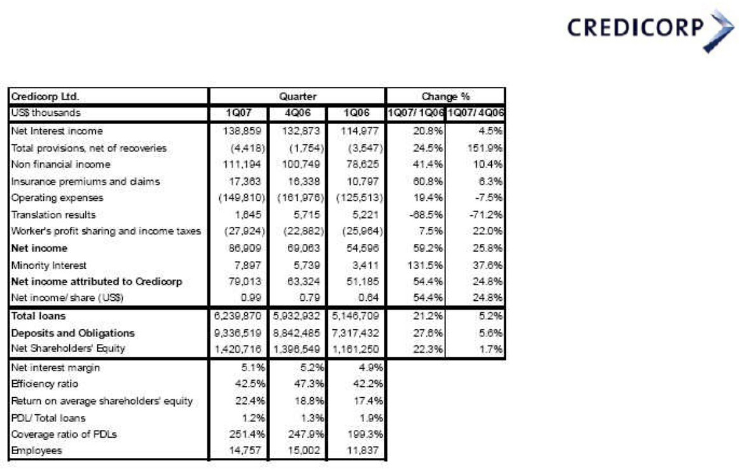

The insurance business is also showing improved results. Net premiums earned grew 8.1% contributing to overall growth, and after incurred net claims and policy cost increases, the insurance business still shows a 6.3% QoQ income increase and contribution.

On the cost side, a reduction of operating expenses contributed significantly to the improved net income result. Lower operating costs at BCP respond to a reduced marketing activity after the holiday season the previous quarter, and lower personnel expenses reflecting the drop from higher 4Q06 personnel costs which included exceptional compensation related provisions. However, a drop in operating expenses has also been gradually achieved at Prima as expected; a reduction that should continue in the course of the year. This overall operating cost is however lower than expected as some approved investment decisions are showing some time lag to impact our income statement. Thus the resulting better efficiency ratio for 1Q07 may not be sustainable in the coming quarters of 2007.

Another positive development is that strong loan growth continues while portfolio quality remains healthy with an even improving PDL/Loans ratio which reached in 1Q07 only 1.2% vs. 1.3% for 4Q06. Total provisions net of recoveries however, start showing a reduction in recoveries in line with expectations as our book of assets for recoveries diminishes and reached US$ 4.4 million for 1Q07.

These developments resulted in improved ratios for the quarter, with ROAE climbing to 22.4% from 18.8% the previous quarter, and an efficiency ratio recovering to 42.5% this 1Q07 vs. 47.3% the previous quarter.

3

Earnings Contribution
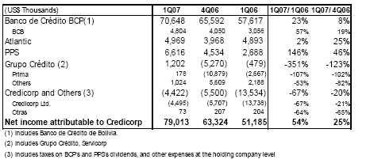

Credicorp - the Sum of its Parts

More and more, as profitability of the individual businesses is recovered, looking at Credicorp as the sum of the different contributors starts reflecting the desired effect of combining strengths.

In fact, BCP reported excellent 1Q07 results, confirming its expanding earnings generation capacity reaching for 1Q07 earnings of US$ 77.0 million, which result in a contribution to Credicorp of US$ 70.6 million for the quarter. This puts BCP on an excellent growth track, fueled by the country’s strong economic growth and reflects an impressive 23% growth over the previous quarter and an equally excellent 31.5% ROAE on an annualized basis.

BCB, which is consolidated within BCP, reported a contribution of US$ 4.8 million for 1Q07, 19% higher QoQ and 57% higher YoY. Thus, the performance of BCB is not being negatively affected by the uncertain political scenario of Bolivia, and in fact, continues growing and gaining in market share and brand positioning.

ASHC reports a contribution improvement of 25% QoQ reaching US$ 4.97 million for the 1Q07. ASHC’s business is constantly expanding as a result also of the increasing wealth generation in the country, and represents a stable, no-risk investment, for which a return of 12 % is very good.

PPS, after having had a restructuring year which changed business policies, marketing policies, and the whole management structure, showing some “early wins” in 2006, starts the 2007 year with further improved results in the 1Q07 that reached a contribution to Credicorp of US$ 6.6 million. This reflects an impressive 46% contribution growth QoQ, confirming the promising future outlook for the company.

Finally, following the completion of the merger of Prima and Union Vida in December 2006 which resulted in higher than expected losses for the year 2006, Prima closed the 1Q07 with a small but positive result of US$ 180 thousand. Competition and resulting high operating costs continue being Prima’s main problem, which are being tackled and gradually reduced.

After the accounting change in 2006 of the withholding taxes paid at Credicorp Limited for the dividend received by Credicorp from its subsidiaries in Peru and which resulted in a double charge in 2006, deductions in this line include such normalized provision for withholding taxes of 2007 and some other costs such as financing costs, minor provision for Stock Options and some admin costs, resulting in a total of US$ 4.5 million negative charge.

Altogether, the improvement of PPS’s results, the turn around and break-even results at Prima, and increased net income at BCP have had an important impact in Credicorp’s 1Q07 net earnings, delivering a 25% QoQ and 54% YoY increase in net earnings.

4

II. Banco de Crédito Consolidated

Overview 1Q07

Net earnings at BCP reached another record level for 1Q07 with US$ 72.7 million, up 7.3% from US$ 67.7 million in 4Q06 and 21.3% higher than earnings of US$ 59.9 million of 1Q06. This superb result follows the implementation of a coordinated strategy focused on growth of the retail/consumer sector, expansion of our network and a parallel and successful policy of careful and profitable investment of our excess liquidity. Once again, the driver behind this growth was the expanded lending activity both in the commercial and consumer sectors. Strong performers were the Personal Loans segment, SME (PYME), Credit Cards and Mortgages. Thus, total loans were up 5.3% QoQ and 23.5% YoY. At the same time, the booming economic environment contributed as well to further growth of our proprietary investment portfolio, leading to an increase of 21% and 45% QoQ of our Investments available for sale and trading position, respectively.
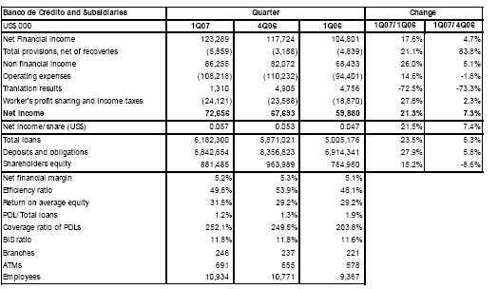

Therefore, NII grew 4.7% QoQ, fueled by such lending activity and expanded investment portfolio. In fact, interest from loans grew 3.5% while interest from securities was up 29%, as a result of an increase in volumes invested in Central Bank CD’s. The latter offer a tax shelter which results in a very attractive after tax yield but has a relatively lower nominal interest than alternative investments, understating this way interest income and thus, NII.

On the other hand, interest expense grows 8.1% following also strong growth of deposit volumes which were up by 5.8%.

Net Provisions reached this 1Q07 US$ 5.9 million, reflecting gross provisions of US$ 12.4 million and US$ 6.5 million of recoveries vs. US$ 11.2 million of gross provisions and US$ 8.0 million of recoveries in 4Q06. It does however reflect the diminishing book of recoverable charged-off assets. Good economic performance and high liquidity levels in the market are allowing for the continuing improvement in portfolio quality and drop in non-performing loans.

Non financial income was also up 5.1% QoQ, following an increase of 78% QoQ in gains from the sale of securities. The index of the Lima Stock Exchange (IGBVL) registered an increase of 29% QoQ, surpassing the 19% growth of 4Q06. Fee income recorded only a small increase of 0.6% QoQ, but still a 13% growth YoY.

5

On the cost side, operating costs dropped 1.8% QoQ. This drop reflects an uneven distribution of costs throughout the year with a tendency to load more costs in the last quarter of a year while the first quarter tends to report the lowest cost as the execution of approved cost budgets usually lags in time at the start of the year. Thus, personnel costs were down 1.5% while administrative costs were down 10% QoQ, since 4Q06 included some personnel incentive related expenses and provisions from the retail banking segment and some strong marketing costs.

Finally, the translation result for 1Q07 drops to US$ 1.3 million from US$ 4.9 million in 4Q06, as the local currency stabilized and reduced its revaluation trend which generates a gain given the net Soles position in BCP’s balance sheet.

As a result of these developments, BCP’s quarterly ratios reflect additional improvements continuing this way its growth trend: ROAE reached a record 31.5%, the efficiency ratio 49.38% and portfolio quality ratios reached 1.18% delinquencies ratio and 252% coverage ratio.

Core Earnings

Operating income was up 3.7% QoQ and 15.9% YoY. Despite the stronger growth of FX transactions (+10%), it is still NII the main component of core earnings, and this recorded 4.7% growth QoQ and 17.6% YoY. As mentioned before, NII growth is supported by a QoQ loan growth of 5.3%, but also by increased volume of liquidity invested in government securities (up 29%). This stronger growth in invested liquidity has an understating effect on Interest Income, since these securities carry a lower nominal rate than alternative investments, but provide a tax shelter that increases the after tax yield significantly and makes them very attractive. Furthermore, interest expense also recorded an increase of 8.1% mainly as deposits expanded.
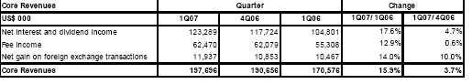

What becomes evident is that fee income remained fairly flat after an important growth in transaction volumes in 4Q06 given the year end holidays, and has been able to maintain its already expanded volume and income generation. However, on FX transaction, an improved FX margin was possible given the movements in the market and resulted in a strong 10.0% QoQ growth.

Assets and Liabilities

Good economic growth and increasing consumer confidence have had a very positive effect in the banking business, leading to improved performance, strong growth and lower provisions.

6

Total Loans reached at the end of March 2007 US$ 6,182 million, 5.3% higher QoQ, reaching this way a 23.5% YoY growth. Once again, it is the Retail Banking sector the main driver of loan growth, though Wholesale Banking has also contributed with important growth numbers to total results. It is important to point out, that as of February, a re-segmentation of our portfolio has been carried out for business and management purposes. The segmentation criteria changed as follows:
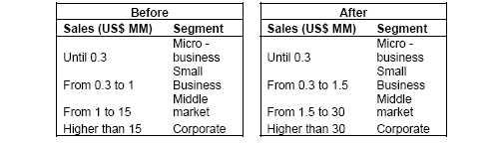

The re-segmentation is the result of an analysis which included criteria beyond the simple size and volumes of activity for each client, such as their associations with other companies/groups, degree of follow-up required, credit ratings, type of activity, etc. As a result of this process, the SME segment (Retail) transferred a net volume of US$ 75 million of its loan portfolio to the Middle Market segment (Wholesale).

In this context, non performing loans continue dropping and reached US$ 73.2 million, 2.7% lower than December 2006 and 23.6% lower than March 2006. Total provisions also dropped despite loan portfolio growth to US$ 178.1 million for 1Q07 from US$ 187.7 million in 4Q06, a 5.1% drop.

BCP’s Total Deposits and Obligations maintained as well their growth rhythm reaching US$ 8,843 million, i.e. 5.8% growth by the end of 1Q07. This reflects mainly deposits growth of 10.3% for current account deposits, 5.8% for savings accounts and 4.7% for time deposits. Overall growth is similar to loan growth, reflecting the deposits’ continuing role as main funding source.

II.1 Interest Earning Assets

IEA growth for 1Q07 remains strong at 4.2%
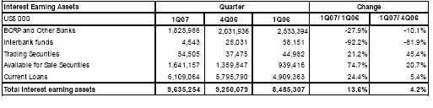

IEA growth of 4.2% for the quarter was supported mainly by loan growth of 5.4% and growth in our investment portfolio (Assets available for sale) of 21%. The latter captures a significant portion of our existing liquidity and is mainly invested in CDs from the Central Bank which provide a very attractive after tax yield.

7

The re-composition of interest earnings assets also impacts the overall profitability of assets, since the re-composition is in favor of higher yielding assets, with loans increasing its share from 58% to 63% of total IEA.
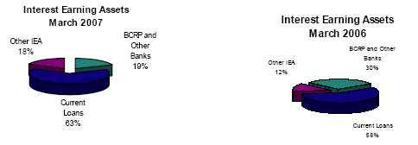

Loan Portfolio

Given the re-segmentation described before, some adjustment is necessary for growth comparison purposes. In fact, the shift of US$ 75 million of net loans from SME to the Middle Market distorts the growth numbers shown by the graphs for these segments, i.e. it understates growth for SME and exacerbates growth of the Middle Market segment. To clarify this impact, we have created a second differently colored bar which excludes the effect of the new segmentation.

Thus, growth for the Retail segment is also understated at 5.6% QoQ. Should the new segmentation had not been implemented, the comparable growth rate remains at high levels reaching 9.6% QoQ and 33.3% YoY. The strongest performers are consumer loans, which grew an impressive 15.8% QoQ and 49.0% YoY, followed by credit cards at 8.7% QoQ and 43.6% YoY. Mortgages also show a slight increase in growth rate reaching 4.2% QoQ and 18.0% YoY, though this product offers an immense potential of future growth.

SME loans in turn, which are directly affected by the new segmentation, reflect an impressive real comparable growth (eliminating the new segmentation effect) of 15.3% QoQ and 48.7% YoY since it would have recorded total SME loans of US$ 672 million (vs. US$ 597 million after the re-segmentation).
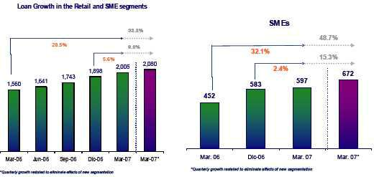

8

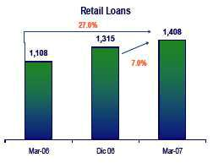

On the other hand, the Middle Market segment, which appears to have an important growth this quarter, reached still (eliminating the re-segmentation benefit) a healthy but not as strong growth of 5.5% which in turn represents an excellent 19% YoY growth rate. Lending activity was concentrated in loans for working capital needs, leasing and medium term financing as a response to increasing economic growth and consumer demand that is leading to the expansion of production and commercial capacity.

The Corporate Sector also benefits from the economic environment, growing its demand for leasing transactions, trade loans and medium and long term financing.

Thus, growth achieved for 1Q07 reached a moderate 2.6% QoQ, but still shows a very strong 24% YoY.
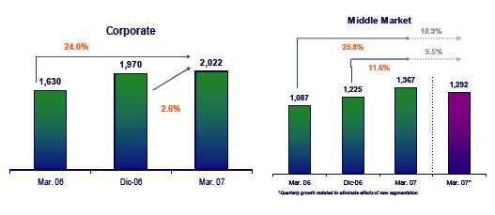

Another impact of the re-segmentation is the distortion of the rate at which the shift of loan portfolio from wholesale to retail is happening. Thus, though the Retail segment represents according to the new segmentation 37.2% of total portfolio, eliminating the effect of the re-segmentation, the Retail segment would represent today 38.6%, a further advance in the process of re-composition of our loan portfolio.

9

Market Share

Market shares continue showing the stronghold position of BCP. Market share evolution in wholesale banking, which includes the corporate and middle market segments, reflects the continuing strong position of BCP in the market with an approximate 47% market participation calculated based on a “share of wallet” methodology. In the retail segment, we continue to position ourselves as an important market player expanding our share QoQ in consumer loans - up 260 bps to reach 15.5%, mortgages - very stable at 37.4%, and SME (PYMES) - up 60 bps reaching 19.2%. BCP recovered its position in the fiercely competitive credit card business where its market share reached 17.7% - up 80 bps.

Dollarization

The process of de-dollarization continues as efforts are made to encourage Soles savings and borrowings. Currency breakdown of loans moved 1% increasing the Soles portfolio from 26% to 27% of total loans. The financial system however, has achieved further de-dollarization as the US Dollar portfolio reached only 65% leaving 35% of the overall portfolio in Soles.

10

II.2 Deposits and Mutual Funds

Deposits grew 5.8% QoQ and 27.9% YoY, maintaining its position as main funding source to support growth.
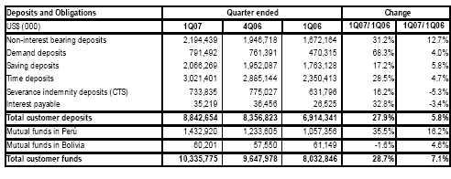

In terms of book balances, deposits grew 5.8% QoQ and 27.9% YoY. With this strong growth, BCP’s deposits continue playing its role as main funding source to support loan growth (+5.4%). This growth is composed of 5.8% growth in savings deposits and 4.7% growth in time deposits, which make up for 23% and 34% of total deposits respectively. It is noteworthy that about 50% of all deposits are generated by the Retail segment, confirming again the importance of this segment to fuel growth for both sides of the balance sheet.
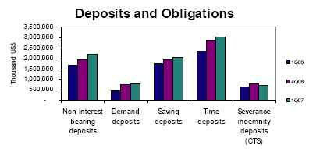

Based on average balances outstanding of deposits, BCP’s market share reaches 37.5% at the end of 1Q07 vs. 36.9% for 4Q06 and 35.3% for 1Q06. In addition, the composition in local and foreign currency registered 34% y 66%, respectively, compared to a composition of 31% y 69% at the end of 2006, confirming this way the de-dollarization process.

BCP leads the market with the highest market share in basically all types of deposits. The strongest position is held in CTS, where a 55% market share was achieved, followed by demand deposits at 43.1% and 40.7% in local and foreign currency; savings deposits at 34.0% and 43.1%, in soles and dollars. Even with time deposits, BCP’s market share was 19.0% and 35.7% in soles and dollars.

11

Mutual Funds administered through its subsidiary Credifondo, continues being a stronghold for BCP with a solid market share of 46.8% as of March 2007, though slightly lower than the previous quarter with 47.8%. The drop is a reflection of the competitive environment which affects also the capital markets and related services.

II.3 Net Interest Income

Interest Income was up 5.9% fueled by loan growth and increased investment portfolio, while interest expense increased 8.1%, resulting in a NIM of 5.22%
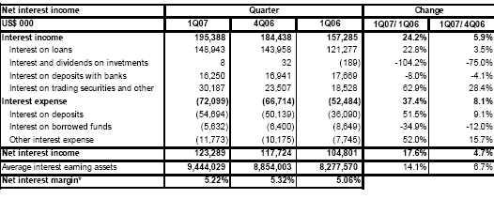

Interest Income was up 5.9% QoQ and 24.2% YoY. Main driver was its largest component, interest income from loans, which grew 3.5% QoQ, below loan growth revealing the competitive pressures on rates. However, the increase in interest income from securities is substantial and denotes the increased volumes invested in market instruments. This is a consequence of increased liquidity which is not fully absorbed by loan growth. Furthermore, most of these investments went into Central Bank CD’s, which provide a nominal lower interest income, but a significantly more attractive yield than alternative investments through the tax shelter these instruments offer. Therefore, the investment decisions in favor of nominally lower yielding assets distorts the real income achieved, understating comparable NII and impacting BCP’s NIM negatively.

On the other hand, interest expense increases 8.1% QoQ and 37.4% YoY. The increase responds to higher interest expenses for deposits by 9.1% QoQ resulting from growing volumes of deposits, and to higher expenses related to such deposits. As interest income results understated and interest expense grows proportionately more, NIM appears negatively affected and drops to 5.22% from 5.32% the previous quarter.
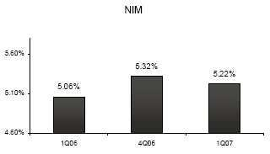

12

II.4 Loan provisions

During1Q07, gross provisions and recoveries of charged-off loans developed as expected, with gross provisions representing 0.8% of total loans.
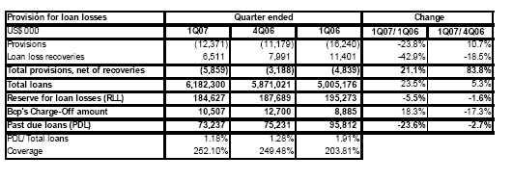

Total gross provisions for 1Q07 reached US$ 12.4 million, 10.7% higher than the 4Q06. Furthermore, recoveries from previously charged-off loans totaled US$ 6.5 million and resulted in a net provision of US$ 5.9 million. Growth of provisions was generated primarily by the commercial lending activity.
Despite very strong growth of the riskier Retail segment products (consumer loans, mortgages, credit cards and PYME), past-due loans ratio continued improving as delinquencies dropped 2.7% QoQ, and reached US$ 73.2 million at the end of 1Q07. Consequently, this ratio reached 1.18%, lower from 1.28% by the end of 4Q06. The decreasing trend of past due loans reveals the improving liquidity and healthier financial situation of the market as a whole.

Coverage ratio also reflects this trend reaching 252.1% at the end of 1Q07 vs. 249.48% in December 2006.

The improved financial environment is also reflected in the ratio of provisions to NII, which reached 10% and is at the low end of the 10 to 15% range expected.
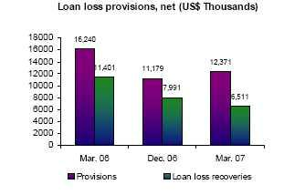

II.5 Non Financial Income

1Q07 saw strong income from the sale of securities which expanded 78% as a result of the booming capital market.

13

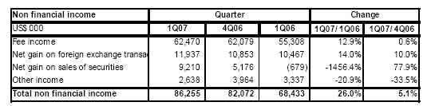

Total non financial income grew 5.1% QoQ, that is US$ 4.2 million more income than in the previous quarter following stronger gains in the sale of securities. The Peruvian capital markets is in a bull phase which is reflected in the growing activity and important gains generated in this market.

On the other hand, fee income grew only moderately by 0.6% QoQ, since the strong seasonal growth by the end of the year given the holidays levels out growth. In fact, the transactions volume is usually strongly boosted through the Christmas holidays and reached 27.7 million in 4Q06, normalizing the volume at 26.7 million for 1Q07, i.e. 3% down. Thus, despite the drop in volumes, growth of 0.6% could still be achieved.
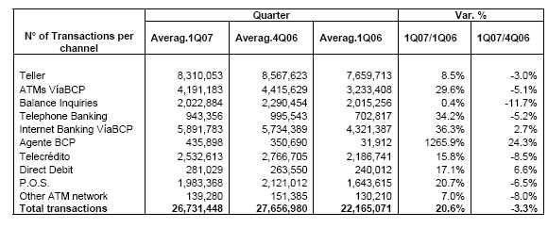

In this context, it is worth noting the quarterly growth achieved by our new distribution channel, the Agente BCP. This confirms the acceptance and thus, importance of this channel to penetrate the market, expand quickly and efficiently and support the traditional network.

Fee income from Credibolsa reflects as well an impressive growth of 90% QoQ fueled by the reported booming activity in the capital markets.

For this same reason, gains from the sale of securities jumped 77.9% QoQ, whereas in the 1Q06 the capital market laid still given the political uncertainties of the election period, which is responsible of the volatility reflected by this income source.

14

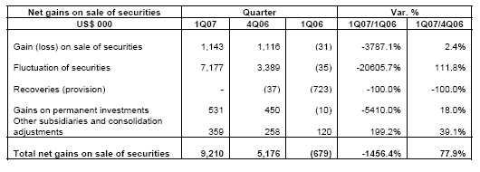

II.6 Operating Costs and Efficiency

BCP’s efficiency ratio improved to 49.81% in 1Q07 as a result of a drop in operating expenses mainly personnel and administrative expenses which drop 1.5% and 10% QoQ.
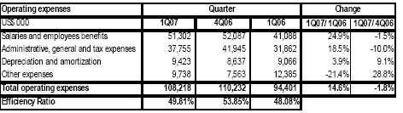

Operating costs for 1Q07 dropped 1.8% QoQ following lower personnel and administrative costs.

The drop in personnel expenses is explained by boosted expenses for 4Q06 due to extraordinary selling incentives for the retail sales force by the end of the year, as well as provisions related to payroll benefits which were made in that period. In fact, the number of employees increased during 1Q07 from 10,771 to 10,934 growing the salaries expenses correspondingly which was offset by the drop in the extraordinary/benefit expenses.

As for the administrative expenses, these dropped as a consequence of a reduced marketing expense alter the aggressive campaigns run during 4Q06 (Christmas and credit cards campaigns). Marketing expenses represent approximately 10% of total administrative expenses compared to 22% represented in the previous quarter. Likewise, higher expenses are typically registered during 4Q06, which decrease in 1Q07.

In addition, the other expenses caption increase 28.8% QoQ but decrease 21.4% YoY. The increase is mainly due to higher provisions for income tax related to the SARs program. With respect to the hedge operation of the SAR program the net effect generated an expense of US$ 2.4 million in 1Q07 vs. US$ 3.9 million charged in 4Q06.

15

Finally while operating income grew 3.7% QoQ, operating costs (excluding “Other expenses”) drop 4.1% QoQ, resulting in an improvement in the efficiency ratio which reached 49.81% for 1Q07 vs. 53.85% in 4Q06.

II.7 Shareholders’ Equity and Regulatory Capital
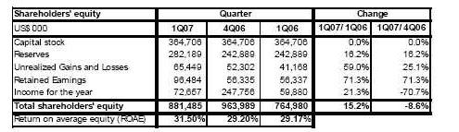

Total shareholders’ equity reached US$ 886 million as of March 2007, i.e. 8.1% lower QoQ, following the dividend payment in the first quarter. The distribution of retained earnings thru dividends plus the improved net earnings resulted in a superb ROAE of 31.5%, vs. 29.2% of 4Q06 and 29.17% for 1Q06.

At the end of 1Q07, the capital adequacy ratio for BCP unconsolidated reached 11.84% (8.4 times). This ratio is lower than the system average (11.5% or 8.7 times), calculated based on the 3 largest banks in the system. Tier I capital reached 9.8% (US$659 million). Risk adjusted assets include US$ 474 million market risk, which requires US$ 43.1 million of equity. Total regulatory capital includes US$137.6 million subordinated debt.

16

III. Banco de Crédito de Bolivia

III.1 Bolivian Financial System

Following the trend of previous quarters and despite the political uncertainty, the favorable international context has allowed Bolivia to obtain fair macroeconomic results, which have impacted positively on the financial system.

Deposits increased 7.9% QoQ and 24.5% YoY, reaching US$ 3,585 million as of March 2007. The system’s total loans reached US$ 2,795 million, 1.0% more than the US$ 2,767 million achieved in December 2006. The quality of loan portfolio remains at 8.7% QoQ and the coverage of past due loans with provisions was 88.4%, lower than the 90.7% level reached in the previous quarter.

III.2 Net Income

Net income of BCB reached US$ 4.8 million in 1Q07, 19% higher than the net income of US$ 4.1 million registered in 4Q06, and 57% higher than US$ 3.1 million in 1Q06. This way, BCB continues the upward trend experienced during the last year, showing an ROE as of March 2007 of 27.6%, significantly higher than 12.6% ROE of the system. In addition, thanks to a strategic conservative management on credit risk, past due loan ratio reached 3.6%, a much better level than 8.8% of the system. Altogether, BCB shows a consistent development, with profitability and loan quality ratios superior to those of the Bolivian banking system.

As we mentioned in the previous quarter, highly profitable segments such us the retail, middle market and “consolidated” segments have been more relevant for BCB’s results. The “consolidated” segment was created with a target on middle market enterprises with total sales below US$ 1 million annually. In addition, the SME segment has also contributed to the positive developments of BCB’s business. All of these segments show a high growth potential in the Bolivian market and BCB is positioned as the best institution with infrastructure and corporate knowledge to attend these segments.

III.3 Assets and Liabilities

Total loans as of March 2007 reached US$ 384.8 million, reflecting a slight decrease of 0.6% QoQ. However, excluding the last evolution on loans, BCB maintains a well diversified loan portfolio in the different business segments. BCB’s market share achieved 14.7% for loans and deposits, positioning BCB third in the financial market ranking.

As mentioned above, BCB’s loan portfolio quality is superior to the system. Past due loans over total loans reached 3.6% as of March 2007. This represents a better ratio compared to the 8.8% of the system.

On the other hand, BCB’s total deposits also increased 3.1% QoQ and 31.9% YoY, mainly due to a higher confidence of individuals and to a relative political stability.

Total Deposits were boosted by better interest rates and more campaigns.

17

The following chart presents figures and indicators of BCB:
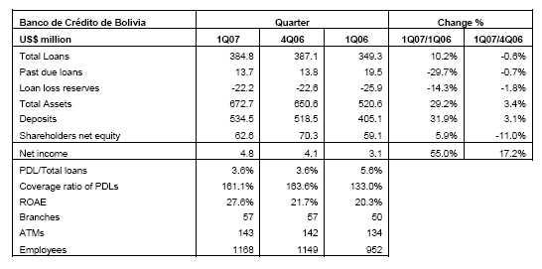

18

IV. Atlantic Security Holding Corporation

Net income for Atlantic Security Holding Corporation (ASHC) of USD 24.0 million reflects growth of 14.3% YoY and 545.5% QoQ. Due to significant recurring dividend income that is received during the first quarter of each year, reference to QoQ variations will henceforth be made only where pertinent.

Core revenues grew by 24.0% YoY, driven by higher dividend income, wider margins and increased commissions income. Excluding dividend income, core revenues for 1Q07 grew 9.8% with respect to 4Q06. Decreased operating expenses and greater net gains from sale of securities contributed to further improve net income in comparison to the last quarter of 2006.
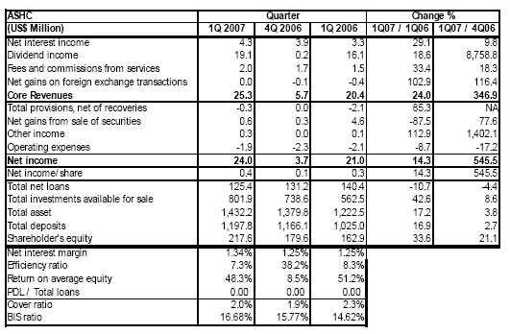

Asset growth QoQ increased to 3.8% from 0.9% last quarter, reflecting that while growth rates are much reduced in comparison to those registered in the first half of 2006 (note YoY of 17.2%), they are on the rise and reveal moderate but sustained growth in business activity. Net interest income posted 14.3% YoY, mostly due to greater dividend income, but, more interestingly, due also to greater income from net interest and fees. During 1Q06, net gains from sales of securities contributed heavily to net income because of a profitable one-time transaction; for 1Q07 this item was in line with expected results. As predicted in the previous quarterly commentary, net interest margin has widened (1.34% vs 1.25% QoQ), revealing that growth in net interest income has been balanced between the effects of a larger asset base and healthier margins. However, the flat yield curve scenario of previous quarters remains largely unchanged, so further widening, although expected, will probably be restrained for the time being.

Fees and commissions grew 18.3% QoQ and 33.4% YoY. Most of the growth in this income stems from larger placement fees due to an increase in assets under management. However, as in the previous quarter, the positive performance of funds has allowed incentive fees to play an important role in the results posted for this item.

19

Operating expenses are typically lower during the first quarter due to a delay in incurring budgeted expenses, particularly in technology-related items. However, comparing 1Q07 and 1Q06, expenses have dropped by 8.7% despite greater levels of income. Consequently, the efficiency ratio between both quarters has improved from 8.3% to 7.3%.

Interest Earning Assets

Interest earning assets reached US$ 1.280 MM, as shown in the table below. QoQ growth of 2.7% vs 18.5% YoY reveals a asset growth has slowed, as was expected given the high rate of growth during the first half of 2006. Loans continue to fall and the transfer of assets from Due from banks to Investments has kept steady, increasing the share of Investments in the total asset distribution. The rebalancing of the investment portfolio of previous quarters towards less risky and more liquid securities has reversed somewhat, moving from a portfolio composition of 73% investment grade securities in 4Q06 to 70% for 1Q07. Still, in comparison to 1Q06, when investment grade securities represented only 54% of the total portfolio, investment remains concentrated in high credit quality, high liquidity securities.
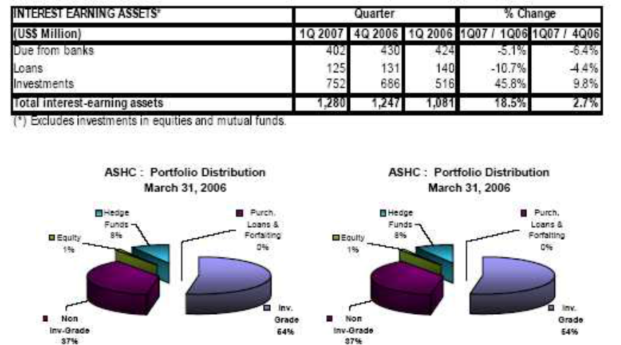

Asset Management Business

Third party managed funds include customers’ deposits, mutual funds and securities custody. The total of these funds has grown 11.2% and 36.7% QoQ and YoY, reaching US$ 2.826 billion as of 1Q07 (US$ 2.542 billion in 4Q06). Quarterly growth in time deposits increased from 0.2% to 2.7%, but the largest growth occurred in mutual & investment funds, which rose from 2.9% to 18.3% quarterly growth between 1Q07 and 4Q06, revealing that while traditional on-balance sheet funding has slowed to traditional rates of growth, the management of third party funds in off-balance sheet accounts is growing at a much faster rates. Part of this growth, however, is due to the general effect of higher asset prices between the two quarters.

20

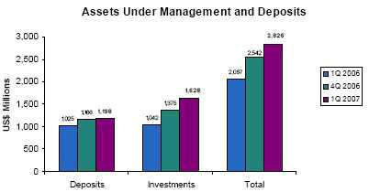

21

V. Prima AFP

V.I Developments in the private pension fund market

During 1Q07, competition in the private pension fund system eased slightly as some reduction in the sales force became possible. Thus, the intensity of the fight for clients diminished as measured by the number of client transfers between companies which dropped to 45 thousand per month. Nevertheless, the rate of new affiliations recovered to 60 thousand per quarter.

In terms of administered funds, the total volume continued growing especially because of the performance of the Peruvian capital markets (which was up 16.5% to US$ 16.8 billion). In relative terms, the flow among funds towards the more aggressively invested fund continued, which represents in the meantime 9.7% of total managed funds (4.9% in December 2006).

Private Pension Fund System: Main Indicators
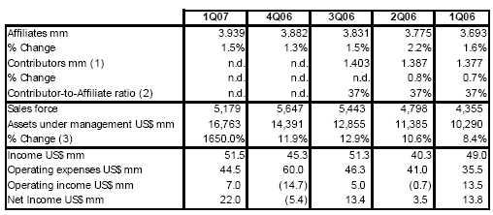

- Average affiliates 12 months.

- Based on average affiliates.

- Quarter Variation for 1Q2007.

According to Peruvian GAAP. In local Peruvian Accounting, legal reserves are included in the income statement, as opposed to the IFRS.

V.2 PRIMA AFP

During 1Q07, Prima was focused in the execution of its consolidation plan after the merger with AFP Unión Vida, which consisted of: (i) Achieving greater efficiency of its sales force, (ii) Maintaining the high rate of RAM achieved through the merger and (iii) leading the market in new affiliations into the system. Furthermore, the company achieved a breakthrough as it became market leader in returns offered for all of its funds.

22

PRIMA AFP: Main indicators
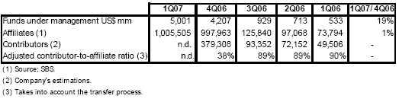

Commercial Results

During this quarter, the company made efforts to reduce its sales force in order to achieve greater efficiency. Furthermore, in order to maintain its RAM, the company also increased the productivity of its sales promoters measured by affiliations per promoter and client income per affiliation.

Investments

A significant achievement for Prima was the consolidation of its leadership in the market in terms of offering the highest returns in all of its funds. Thus in March Prima could publish its offered returns which reached 20.33% in Fund No 1, 34.74% in Fund No 2 and 91.47% in Fund No 3 during the last 12 months.

This translated into a surge in voluntary contributions to the funds, putting Prima as a leader in market share of total collections in the system with a total for Prima of US$ 164.4 million or 35.1% of all collections in the system as a whole.
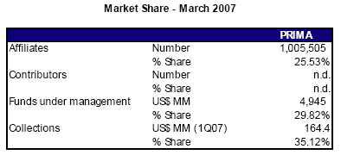

Financial Results

In 1Q07 Prima finally reached break-even and reported a small but positive result for the quarter of US$ 0.2 million. Income generated for the period was US$ 13.7 million, following some deep ground work in prior months. Prima has this way consolidated and expanded its solid base of income generation.

23

Nevertheless, the company has had severe competitive pressure, which explains bottom line results:

- Expenses related still to the merger activities initiated before the merger.

- Administrative expenses demanded by the large sales force and the increased activity in transfer of money between alternative investment funds within the company.
- Charges related to the merger and consequent amortization of assets as well as increased depreciation costs related to significant investments in systems and premises which led to a US$ 2.1 million charge alone for this concept.
- Financial charges which amounted to US$ 1.02 million related to loans to finance in part the acquisition itself and finance the installation of its premises.

Thus, main financial indicators for the company are shown below:

PRIMA AFP: Main Financial indicators (US$ m) (1)
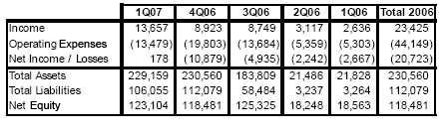

(1)Figures include estimations of DAC and merger adjustments.

24

VI. EL PACIFICO PERUANO SUIZA AND SUBSIDIARIES (PPS)

Results obtained by PPS for 1Q07 have improved QoQ and YoY. Production has grown 12.9% and underwriting results of US$ 8.8 million are 120% higher than 1Q06, reflecting an improved NEL ratio 5.8 percentage points lower. Furthermore, 1Q07 net earnings after minorities reached US$ 8.7 million, which is triple the earnings a year ago, thanks to not only the better underwriting results, but also to an improved financial result from gains on the sale of securities given the booming capital markets environment. These results reflect a significantly improved ROAE of 16.9%, contributing this way to the also improved ROAE for Credicorp.

Noteworthy is the recovery of market share obtained as of February 2007. This reached 32% vs. 27% a year ago considering all business segments.

VI.1 Net Income

Net consolidated income before minority interest for 1Q07 reached US$ 12.5 million, significantly higher than the US$ 3.8 million generated for 1Q06. Therefore, the contribution to Credicorp after consolidation adjustments and minority interests reached US$ 6.6 million, which is 46% above 4Q06 contribution and close to 3 times the contribution in 1Q06. This improvement was fueled by a recovery in the Property & Casualty segment and additional growth in the Life business.

These improved results represent the recovery in underwriting results and increased financial income related to the booming capital markets. With regards to underwriting results, a substantial improvement in Net Earned Premiums accompanied by lower casualties was recorded in the P&C business. Furthermore in the Life segment, a better underwriting result was due to lower reserves requirements and lower casualties, whereas in the health business, the increasing production was offset by an increase of 5% in the casualties’ ratio.

As a result of the above, net earnings at P&C improves from US$0.05 million in 1Q06 to US$ 1.9 million for 1Q07. In the Life business, net earnings of US$ 6.1 million in 1Q07 reflects a 321% earnings growth from a year ago and responds to the lower reserves mentioned and an important gain in the sale of securities. The health business however, reports a slight drop in earnings to US$ 0.7 million, despite a 13% growth in premiums, mainly due to increased claims.

VI.2 Revenue and Operating Expenses

During 1Q07, income from Total Premiums was up 13% compared to 1Q06 and 20.2% compared to 4Q06. This is the combined result of 23% premiums YoY growth in P&C, while Health grows 13% and Life drops 1 %.

Net Premiums Earned reached US$ 72.0 million, 18.4% higher than 1Q06. This is a clear result of the growth in premiums mentioned above and the lower reserves registered in the Life business. Total reserves drop 35% YoY, though not on a quarterly basis.

25

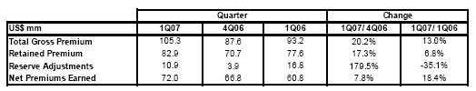

Net Earned Loss Ratio (NEL) for 1Q07 was 73.0%, 5.8 percentage points below 1Q06 and 0.6 percentage points above 4Q06. Though a significant improvement is recorded compared to a year ago and is related to lower casualties in P&C (mainly fire, Transportation and Marine Hull), the QoQ slight increase in casualties is mainly due to the increase in the health insurance segment, which reports a NEL up to 79%.

Net Claims reached US$ 52.6 millions, growing in line with increased production and resulting 9% higher than 4Q06 and 10% higher than 1Q06.

Financial Income for 1Q07 reached US$ 12.9 million, 27% above 4Q06. This improvement is the result of increased dividends collected and returns achieved on investments via PPS and PV due to the expanded investment portfolio for both funds. Other Income includes earnings on security sales, and thus reflects the drop from the previous quarter when a significant stock position of BCP and Alicorp was sold. Nevertheless, this income continues being significantly more important this quarter at 176% above 1Q06, given the impressive performance of the Stock market in Peru.

Salaries and Employees Benefits were 32% above 1Q06 expenses and 14% above 4Q06, mainly due to increased sales force in P&C and Life.

General Expenses and Other Operating Expenses drop slightly (-1%) from 4Q06, but increase 16% from 1Q06 as the increased expenses following production growth and marketing stabilized this quarter.

VI.3 Business Lines

Total contribution to BAP

(In US$, thousands)
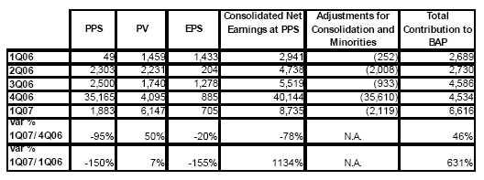

Property & Casualty (PPS)

26

Premiums for this segment grew 36% QoQ and 23% YoY following an increase in the fire, theft, transportation and technical segments. Underwriting results were 5 times the results from the previous quarter at US$ 5 million, given such production growth and lower commissions’ costs and casualties. On the other hand, higher marketing costs and increased sales force resulted in some additional expenses, while returns and gains on investments benefited the results. Thus, bottom line results (after consolidation adjustments) were still higher at US$ 1.9 million.

Life (PV)

Total Premiums grew 9% QoQ and dropped 1% YoY. Though a contraction in premiums has been observed in the course of the year as a result of a re-composition of the Life business away from the annuity business and in favor of disability and survival policies, financial revenues and income have increased by around 50% as gains in securities were realized. As bottom line results, the Life business can report a very strong US$ 6.1 million contribution to PPS, significantly higher QoQ and YoY.

Health (EPS)

Total Premiums at EPS grew 5.4% QoQ and 13% YoY. However, Net Earned Loss ratio deteriorated to 79% vs. 75.9% in 4Q06 as claims increased by 17%, especially in the corporate health plans. Nevertheless, NEL is still within expectations. Underwriting Result reached US$ 3.8 million, 6.5% below 4Q06 and 17% below a year ago, leaving net earnings contribution of US$ 0.7 million.

VI. 4 Claims

Net Claims were up this 1Q07, rising 9% compared to 4Q06 and reaching US$ 52.6 million. Thus, NEL ratio reached 73% vs. 78.8% in 1Q06. This improvement responds to a drop in casualties in P&C, mainly fire, transportation, technical insurance and marine hull, and also to a reduction of the NEL ratio for Life insurance as a result of reduced reserve requirements.

VI.5 Investment Portfolio

The portfolio of securities reached US$ 754.4 million in 1Q07, compared to US$ 631.1 million a year ago. Furthermore, non realized gains increased to US$ 87.8 million vs. US$ 65.6 million a year ago mainly as the portfolio which is primarily invested in fixed income instruments grew.
It is worth mentioning, that non realized gains were positive in the portfolio invested in the stock market, whereas the portfolio of fixed income paper had a mixed performance given the combination of movements in the yield curve and increases in prices of Peruvian government instruments.

VI.6 Market Share

The developments related to market share of Pacífico’s business is certainly satisfying. In P&C and Life, the combined market share of PPS reached 29.2%, an important recovery from 24.1% it held a year ago, being the individual market shares, 31.6% vs. 25.7% for P&C and 25.3% vs. 22% for Life, all numbers as of February 2007 vs. the previous year.

27

VII. ECONOMIC OUTLOOK

Economic Activity

The Peruvian economy shows a good development during the 1Q07, with growth rates over 9.2% in January and 7.4% in February. Thus growth of GDP in the first two months of the year reached 8.3%, slightly over the result obtained for the year 2006. This expansion is led by the non-primary sectors, which respond to the dynamism of internal demand. Therefore, in the first two months of the year non-primary manufacturing leads the growth (11.2%), responding to the higher production of consumer and intermediate goods, specially the ones destined towards construction. The most dynamic sector of the economy was the construction sector, accumulating growth of 8.2% in the first two months, mainly due to the dynamism of the real estate projects, the productive infrastructure development and auto construction. On the other hand, mining production shows decreases during the last six months (in the recent two months, the fall reaches 4.8%, mainly due to the lower production of gold and molibdeno).

Gross Domestic Product and Internal Demand

(annualized percentage variation)
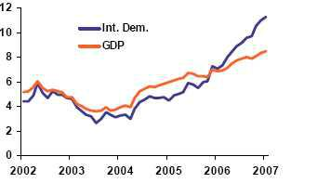

Source: INEI

External Sector

During the first two months of the year, the trade balance surplus was of US$ 673MM, an amount US$ 125MM lower than the surplus achieved at the end of 2006, mainly due to accelerated imports growth which surpassed the higher exports. Thus shipments to other countries grew 20% in first two months, reaching US$ 3,486MM, with this growth explained by better terms of exchange (21%), since a decrease of 0.5% was experienced on exported volumes. On the other hand, imports have been growing 3.4% during the first two months of the year, due to investment in capital assets and construction equipments. Finally the international reserves continued growing, closing the quarter with US$ 18,427MM, 7% more than at the end of 2006.

28

Exports and Imports

(annualized percentage variation)
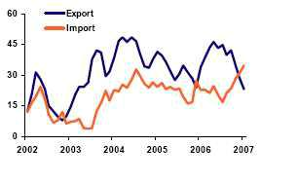

Source: BCRP

Prices and Exchange rate

Prices were relatively stable during the first quarter, accumulating an inflation of 0.62% in the first three months of the year. The inflation of the last 12 months increased 0.25% below the goal of inflation of the Central Bank of Perú (2% ± 1%). Within this context of low inflation and high growth, the Central Bank decided to maintain without any variations their reference interest rate at 4.5%, tough they will be alert to potential pressures of demand that could cause problems to the inflation targets. The Exchange rate closed in March at S/. 3.182 per dollar, accumulating an increase of 0.4% in respect of 2006. In the last months, the national currency experienced some revaluation pressure which was specially perceived during the periods of tax payments, as in the forwards market and in the “yield curve” for national currency. The Central Bank of Peru has increased its intervention in the exchange market, buying foreign currency (dollars) for a total amount of US$ 1,530MM.

Consumer price index | Exchange Rate and purchases US$
BCRP
(Annual percentage variation) | (S/. per dollar and US$ MM)
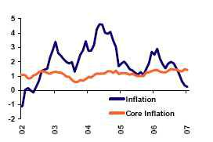

29

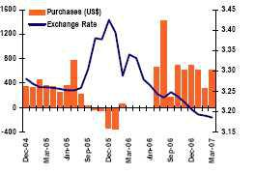

Source: INEI, BCR

Fiscal Aspects

At the closing of 1Q07, the tax revenue increased to S/.12,814 million, that is 12.8% more in real terms than 1Q06. This increase is supported by the expansion of collections for value added tax (IGV) and income tax, which more than compensated the reduced collections of some selective consumption taxes (Impuesto Selectivo al Consumo -ISC) and duties. Furthermore, the period of regularization of income taxes usually brings increased collections between S/. 4,000 million and S/. 4,500 million. On the expense side, there has been an increase in public expenses of 16.5% in February, due to an increase in current expenditure (17.1%), and public investments (5.6%), which was in fact expected to grow more as an “investment shock” was announced. This way, the economic results as of February shows a surplus of S/. 1,025 million, slightly smaller than the surplus registered in February 2006.

Tributary Incomes of the Central Government

(Annualized, expressed in thousand of millions of Nuevos Soles)
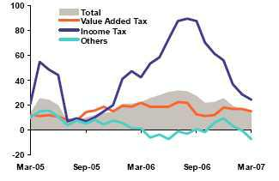

Source: Sunat

30

Banking System

To the closing of the 1Q07, the total loan placements in the banking system continued to grow and reached US$16,480 million, amount that represents an increase of 23.9% compared to 1Q06 and of 4.6% compared to the closing of 2006. This result is supported by the stronger credit activity in the retail segments such as consumer loans (+41.9% YoY), SME lending (+32.4% YoY) and mortgages (+17.6% YoY). Commercial credits registered an important dynamism reaching the amount of US$ 10,475MM (+20.6% YoY). The credit dynamism came along with a further delinquencies reduction, which reached a record level of 1.63%.

Looking at the banking system’s main source of funding, deposits also continued increasing and reached US$19,756MM, which represents a growth rate of +14.8% YoY and +4.5% QoQ. The increase was spread among demand deposits (+28.5%) savings deposits (+15.4%) and time deposits (+8.7%).

With regards to the level of dollarization of the banking system, this continues decreasing in loans and deposits. This way, loans in dollars registered an increase of +16.6% Y0Y, while loans in soles increased (+32.7% YoY), resulting in a drop in credit dollarization. This way, dollar loans represented the 68.7% of the total lending in March 2006 and dropped to 64.7% at the closing of 1Q07. The deposits dollarization decreased from 66.0% in 1Q06 to 60.7% at the closing of 1Q07, which reflects the preference for national currency savings.

Finally, interest rates have begun to stabilize in the last months. Thus, the S/. lending rate closed the quarter at 23.4%, below the S/. lending rate at the closing of 1Q06 (24.3%), tough above the 4Q06 closing (23.1%). On the other hand, the US$ lending rate stayed relatively stable and closed the 1Q07 at 10.7% (10.6% at the closing of 1Q06 and 10.8% to the closing of 4Q06). The Soles deposit rate and the US$ deposit rate closed the 1Q07 in the same levels registered to the 2006 closing (3.2% y 2.2%, respectively) even over the 1TQ06 (3% y 2%).

Main Financial Indicators
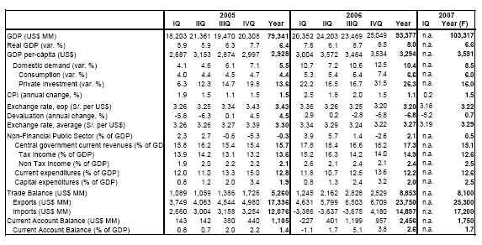

31

Company Description:

Credicorp Ltd. (NYSE: BAP) is the leading financial services holding company in Peru. It primarily operates via its four principal Subsidiaries: Banco de Credito del Peru (BCP), Atlantic Security Holding Corporation (ASHC), El Pacífico-Peruano Suiza Compañía de Seguros y Reaseguros (PPS) and Grupo Credito. Credicorp is engaged principally in commercial banking (including trade finance, corporate finance and leasing services), insurance (including commercial property, transportation and marine hull, automobile, life, health and pension fund underwriting insurance) and investment banking (including brokerage services, asset management, trust, custody and securitization services, trading and investment). BCP is the Company's primary subsidiary.

Safe Harbor for forward-looking statements

This material includes “forward-looking statements” within the meaning of Section 21E of the Securities Exchange Act of 1934. All statement other than statements of historical information provided herein are forward-looking and may contain information about financial results, economic conditions, trends and known uncertainties.

The Company cautions readers that actual results could differ materially from those expected by the Company, depending on the outcome of certain factors, including, without limitation: (1) adverse changes in the Peruvian economy with respect to the rates of inflation, economic growth, currency devaluation, and other factors, (2) adverse changes in the Peruvian political situation, including, without limitation, the reversal of market-oriented reforms and economic recovery measures, or the failure of such measures and reforms to achieve their goals, and (3) adverse changes in the markets in which the Company operates, including increased competition, decreased demand for financial services, and other factors. Readers are cautioned not to place undue reliance on these forward-looking statements, which speak only as of the date hereof.

The Company undertakes no obligation to release publicly the result of any revisions to these forward-looking statements which may be made to reflect events or circumstances after the date hereof, including, without limitation, changes in the Company’s business strategy or planned capital expenditures, or to reflect the occurrence of unanticipated events.

32

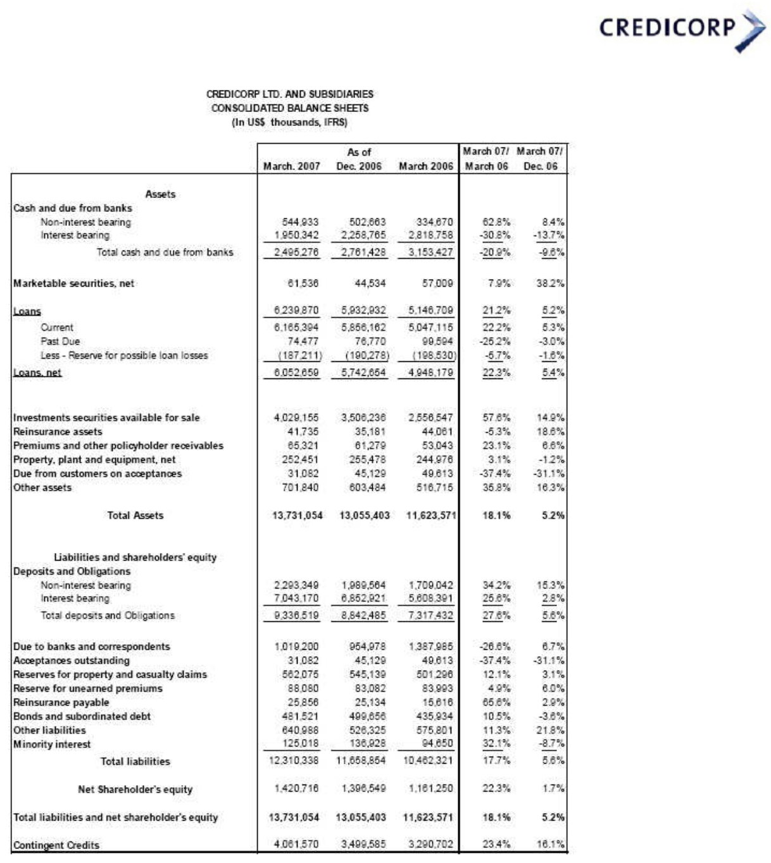

33

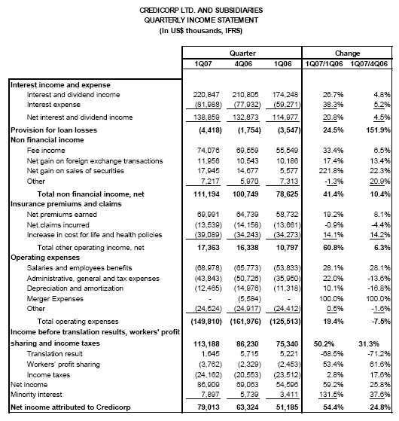

34

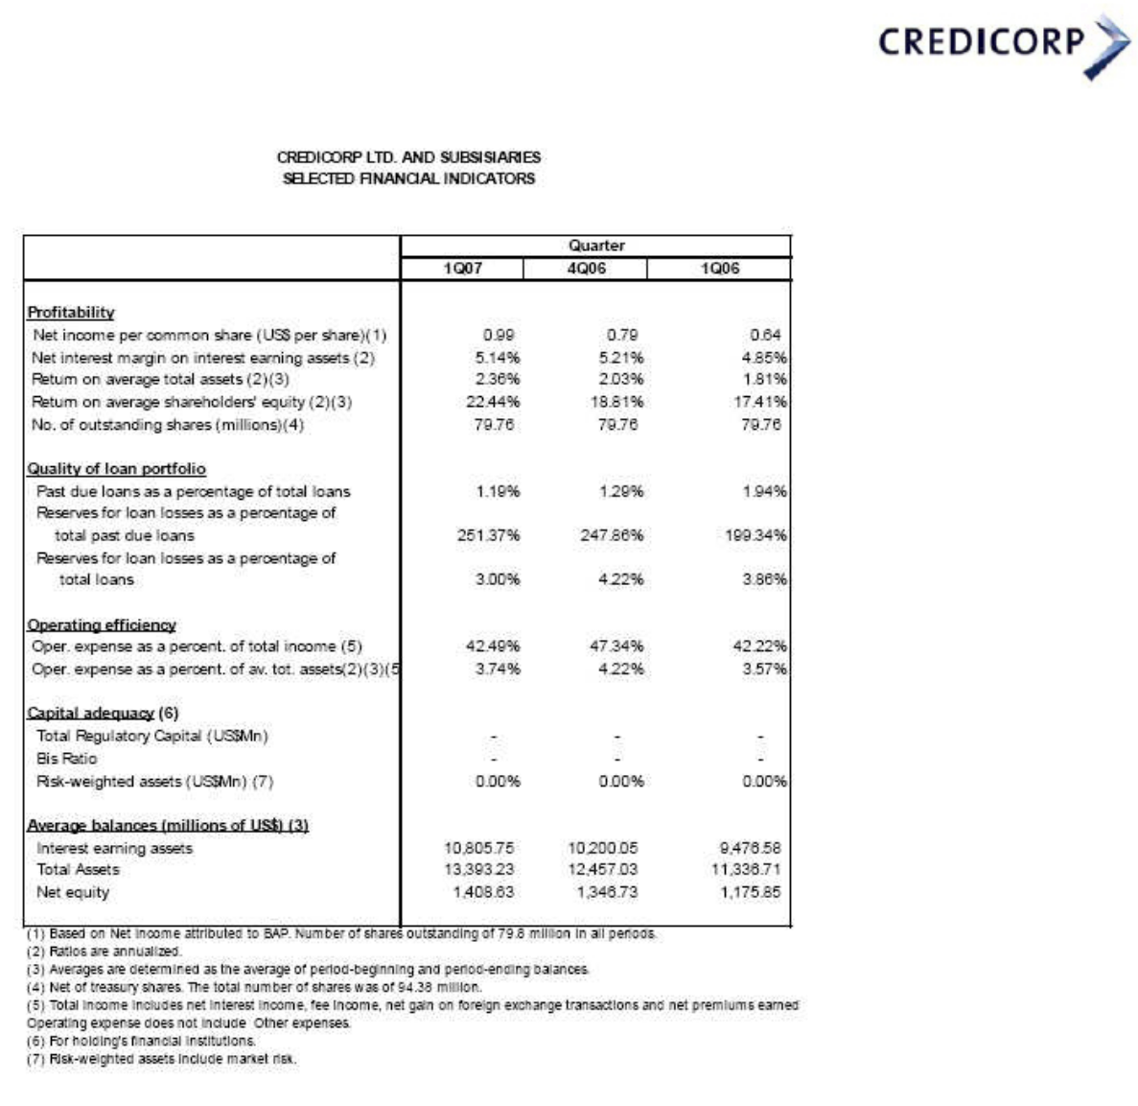

35

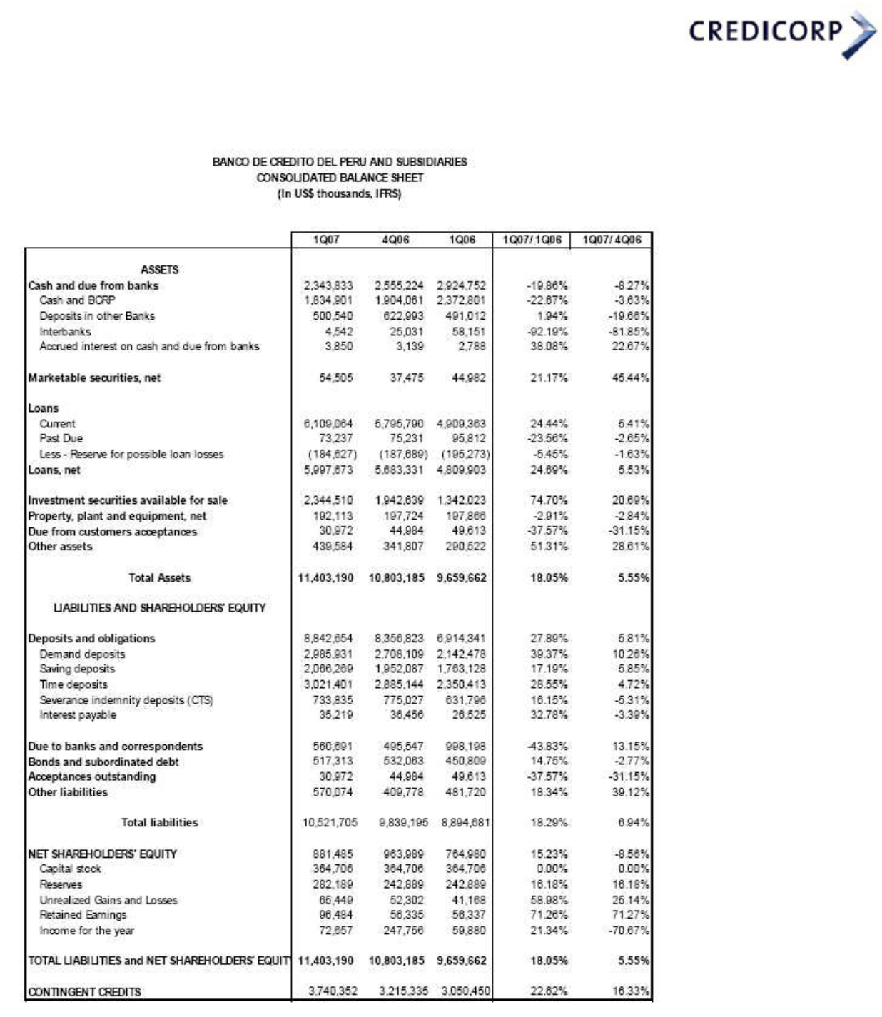

36

37

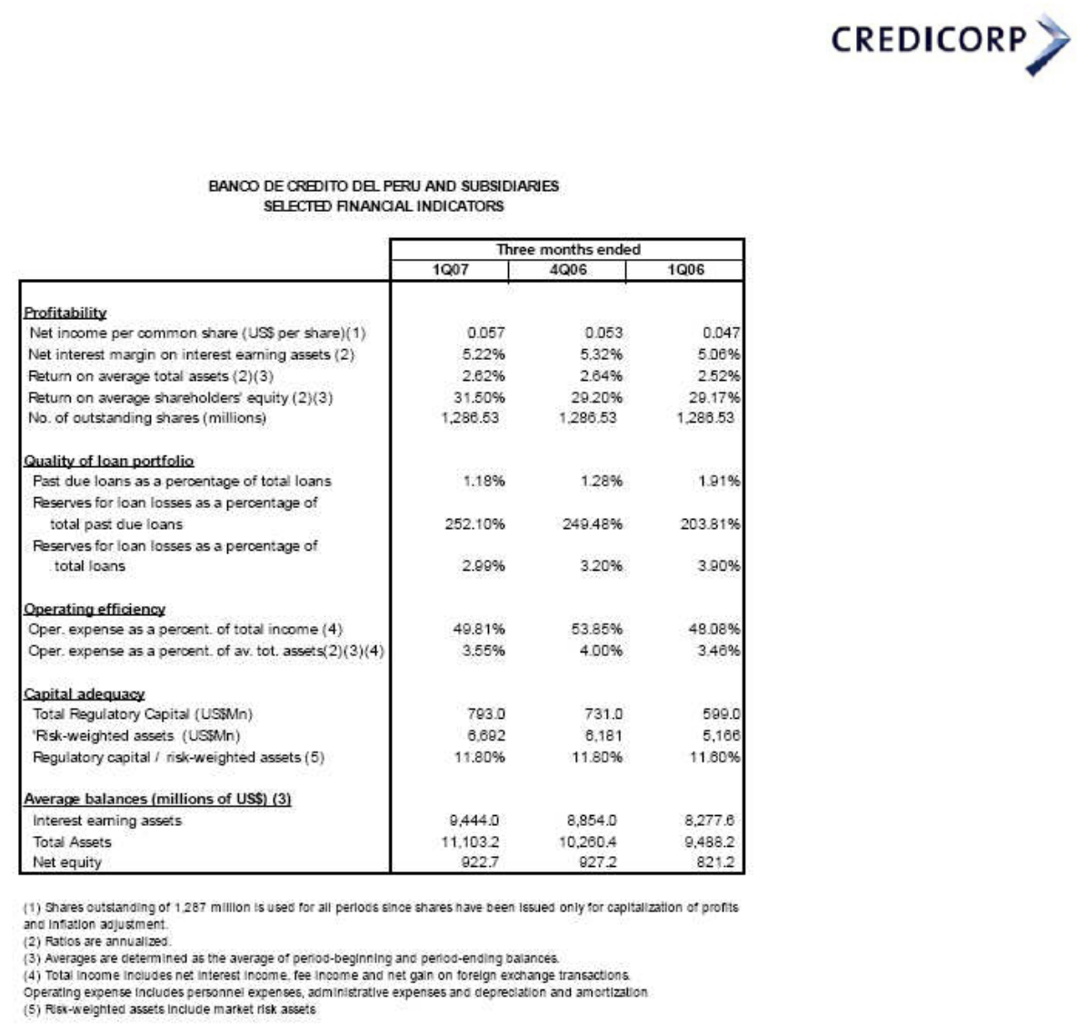

38

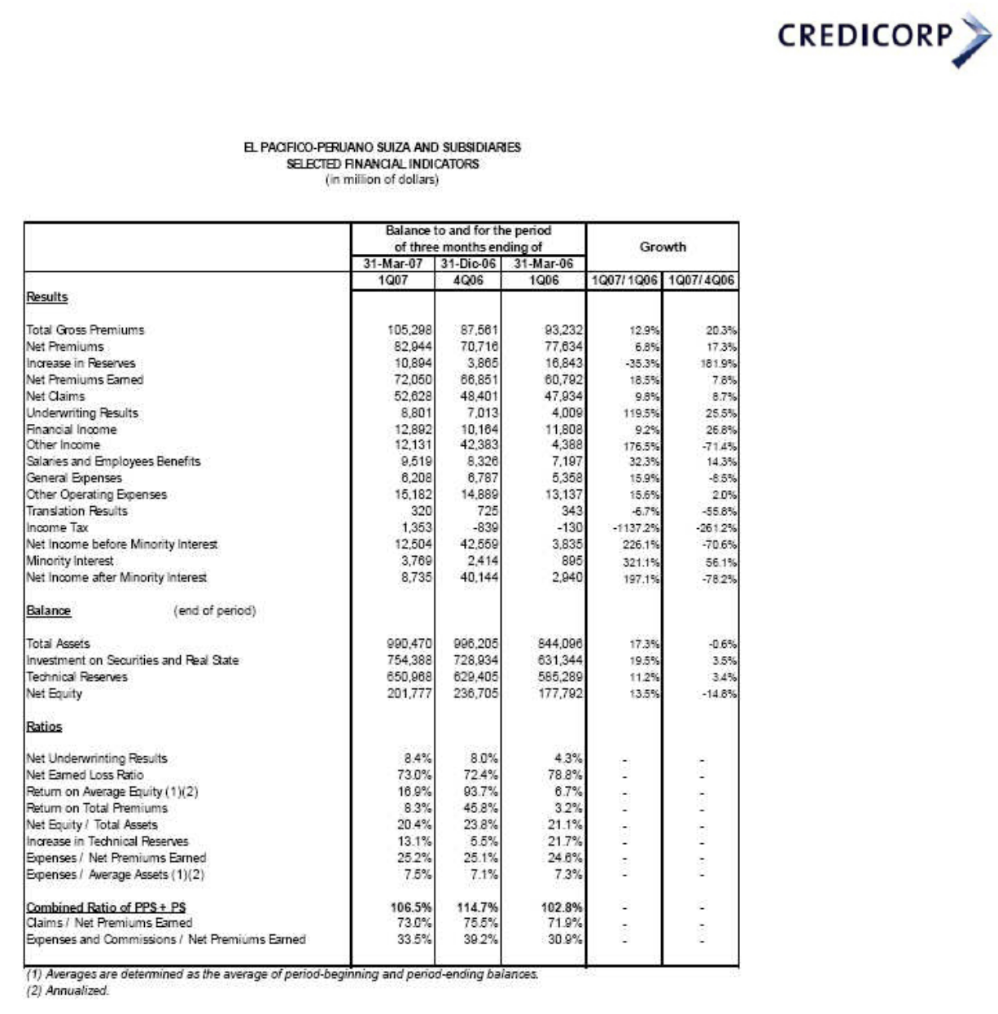

39

