SECURITIES AND EXCHANGE COMMISSION

Washington, D.C. 20549

FORM 6-K

Report of Foreign Private Issuer

Pursuant to Rule 13a-16 or 15d-16 under the

Securities Exchange Act of 1934

For the month of August 2022

Commission File Number: 001-14014

CREDICORP LTD.

(Translation of registrant’s name into English)

Of our subsidiary

Banco de Credito del Peru:

Calle Centenario 156

La Molina

Lima 12, Peru

(Address of principal executive office)

Indicate by check mark whether the registrant files or will file annual reports under cover of Form 20-F or Form 40-F.

Form 20-F ☒ Form 40-F☐

Indicate by check mark if the registrant is submitting the Form 6-K in paper as permitted by Regulation S-T Rule 101(b)(1): ☐

Indicate by check mark if the registrant is submitting the Form 6-K in paper as permitted by Regulation S-T Rule 101(b)(7): ☐

The information in this Form 6-K (including any exhibit hereto) shall not be deemed “filed” for purposes of Section 18 of the Securities Exchange Act of 1934 (the “Exchange Act”) or otherwise subject to the liabilities of that section, nor shall it be deemed incorporated by reference in any filing under the Securities Act of 1933 or the Exchange Act.

SIGNATURE

Pursuant to the requirements of the Securities Exchange Act of 1934, the registrant has duly caused this report to be signed on its behalf by the undersigned, thereunto duly authorized.

Date: August 11th, 2022

CREDICORP LTD.

(Registrant)

By: /s/ Guillermo Morales

Guillermo Morales

Authorized Representative

Exhibit 99.1
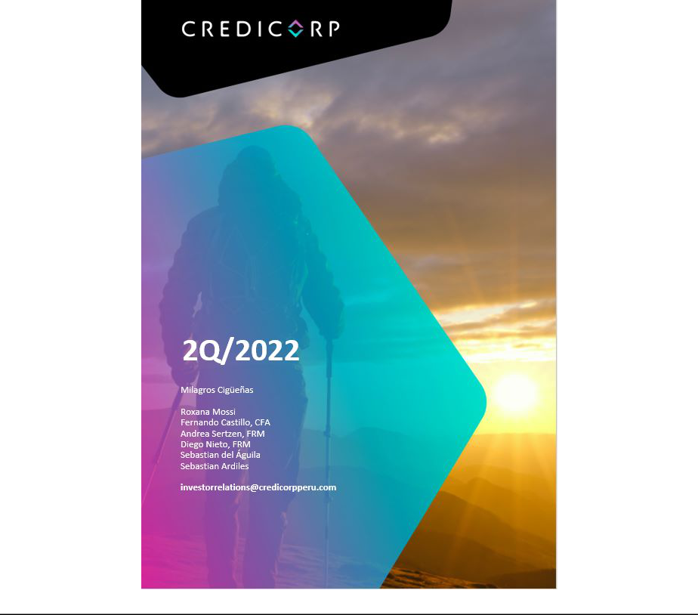

Earnings Release 2Q / 2022

Table of Contents


Operating and Financial Highlights | 03
Senior Management Quotes | 04
First Quarter 2022 Earnings Conference Call | 05
Second Quarter 2022 Earnings Conference Call | 06
Financial Overview | 10
Credicorp’s Strategy Update | 11
Analysis of 2Q22 Consolidated Results

01

02

03

04

05

06

07

08

09

10

11

12

Loans and Portfolio Quality | 14
Deposits | 20
Interest Earning Assets and Funding | 23
Net Interest Income | 24
Provisions | 27
Other Income | 29
Insurance Underwriting Results | 31
Operating Expenses | 33
Operating Efficiency | 35
Regulatory Capital | 36
Economic Outlook | 38
Appendix | 43

Earnings Release 2Q / 2022

Operating and Financial Highlights

Credicorp Ltd. Reports Second Quarter 2022 Financial and Operating Results ROE of 16.9% Driven Mainly by Higher Core Income and a Low Level of Provisions Well-Positioned in Current Environment, Driving Sustainable Growth by Strengthening Our Core and Building Disruptors

Lima, Peru – August 11, 2022 – Credicorp Ltd. (“Credicorp” or “the Company”) (NYSE: BAP | BVL: BAP), the leading financial services holding company in Peru with presence in Chile, Colombia, Bolivia and Panama today reported its unaudited results for the quarter ended June 30, 2022. Financial results are expressed in Soles and are presented in accordance with International Financial Reporting Standards (IFRS).

2Q22 OPERATING AND FINANCIAL HIGHLIGHTS

- Net Income attributable to Credicorp up 60.4% YoY to S/1,122 million, reflecting core income growth and a low level of provisions at BCP, further supported by Mibanco & Pacifico. ROAE of 16.9% in 2Q22 and 17.2% in 1H22

- Structural Loans increased 4.5% QoQ (+3.6% FX Neutral) and 13.8% YoY (+14.6% FX Neutral) in average daily balances.

- Total Deposits at S/147,441 million in 2Q22, relatively unchanged QoQ (-2.0% FX Neutral) and down 1.2% YoY (-0.5% FX Neutral). Low-cost Deposits decreased 6.1% YoY and accounted for 56.7% of Total Funding.

- Structural NPL ratio declined 65bps YoY and 18 bps QoQ to stand at 4.9%, with lower ratios across segments principally due to an uptick in structural loan volumes in Peru, which offset higher NPL volumes at BCP.

- Structural Provisions increased 45.8% QoQ and 0.3% YoY due to the deterioration of macroeconomic outlook and the Structural Cost of Risk stands at 1.08%. The Allowance for Loan Losses represents 5.9% of Structural Loans and NPL Coverage stands at 119.9%, while both ratios continue their downward trend towards pre-pandemic levels.

- Core Income increased 15.0% YoY supported by growth of 18.7% in Net Interest Income (NII), 6.7% in Fees and 9.1% in Gains on FX Transactions.

- Efficiency Ratio of 44.6%, compared to 44.5% in 1Q22 and 43.7% in 2Q21, driven by accelerated investments for digital transformation and innovation initiatives. If we exclude operating expenses for our disruptive initiatives Yape and Krealo the efficiency ratio stands at 42.1%.

- Sound Capital base, with CET1 Ratio of 11.6% at BCP Stand Alone and 15.2% at Mibanco, up 36bps and relatively unchanged YoY, respectively. As of 2022, both subsidiaries report solvency levels in IFRS and as such, CET1 ratio figures will differ from reported figures in 2Q21. Regulatory Capital stood at 1.56 times Regulatory Requirement

- On June 10, 2022, Credicorp paid a cash dividend of S/ 15 per share for a total amount of S/1,415.7 million.

- Advancing our Strategic Initiatives: BCP Stand-alone digital clients accounted for 58% of total BCP retail clients as of June 2022; ii) more than 230 thousand individuals were financially included through Credicorp’s businesses in the quarter, and iii) BCP issued the first international green bond in the Peruvian banking system.

3

Earnings Release 2Q / 2022

Senior Management Quotes

SENIOR MANAGEMENT QUOTES
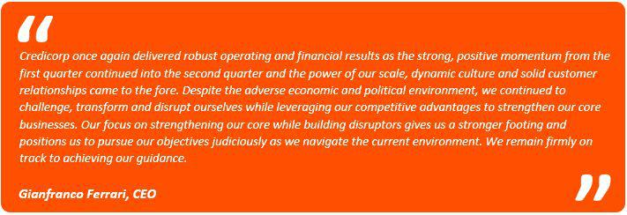
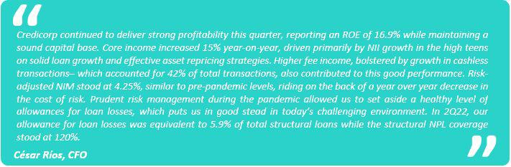

4

Earnings Release 2Q / 2022

Senior Management Quotes

SECOND QUARTER 2022 EARNINGS CONFERENCE CALL

Date: Friday August 12, 2022

Time: 10:30 am ET (9:30 am Lima, Peru time)

Hosts: Gianfranco Ferrari - CEO, Cesar Rios - Chief Financial Officer, Francesca Raffo – Chief Innovation Officer, Reynaldo Llosa - Chief Risk Officer, Diego Cavero - Head of Universal Banking, Cesar Rivera - Head of Insurance and Pensions, and Investor Relations Team.

To pre-register for the listen-only webcast presentation use the following link:

https://dpregister.com/sreg/10169419/f3b8e39472

Callers who pre-register will be given a conference passcode and unique PIN to gain immediate access to the call and bypass the live operator. Participants may pre-register at any time, including up to and after the call start time.

Those unable to pre-register may dial in by calling:

1 844 435 0321 (U.S. toll free)

1 412 317 5615 (International)
Conference ID: Credicorp Conference Call

The webcast will be archived for one year on our investor relations website at:

https://credicorp.gcs-web.com/events-and-presentations/upcoming-events

For a full version of Credicorp´s Second Quarter 2022 Earnings Release, please visit:

https://credicorp.gcs-web.com/financial-information/quarterly-results

5

Earnings Release 2Q / 2022

Summary of Financial Performance and Outlook

Loans (in Average Daily Balances)
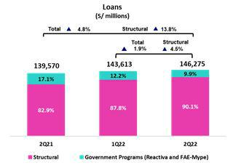

Structural loans grew 3.6% QoQ (FX neutral) to stand at S/131,785 million. Growth was driven by the SME-Pyme and Consumer segments at BCP, and by Mibanco, which reported an uptick in disbursements through alternative channels and an improvement in the productivity of its relationship managers.

YoY, structural loan growth stood at 14.6% (FX neutral). This evolution was primarily attributable to Wholesale Banking and secondarily to SME-Pyme and Consumer at BCP and spurred by economic reactivation. Growth was also driven by Mibanco, reflecting the positive impact of the bank’s hybrid model.

The Government Program portfolio (GP) represented 10% of the total portfolio in average daily balances (9% in quarter-end balances).

Deposits
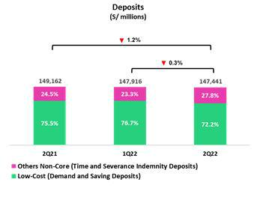

Our deposit base fell 2.0% QoQ (FX Neutral). This reduction is attributable primarily to a drop in Demand and Savings Deposits, driven by reduced liquidity levels systemwide (due to the amortization of Reactiva loans) and the impact of rising interest rates. Higher rates increase the opportunity cost associated with this type of deposits and has triggered a migration to Time Deposits.

In the YoY comparison, the deposit base fell 0.7% (FX Neutral). This evolution was primarily driven by a reduction in Demand Deposits, which reflected the impact of amortizations of Reactiva loans; the migration of funds to Time deposits; and a reduction in Severance Indemnity balances (CTS) after restrictions on fund availability were lifted.

Net Interest Income (NII) and Margin (NIM)

NII rose 8.1% QoQ to stand at S/2,740 million. This evolution was driven by an uptick in the yield of interest-earning assets, primarily in LC, which reflected solid loan growth, a drop in low-yield assets and effective repricing strategies. These dynamics were partially offset by an increase in the funding cost, mainly in LC. In this scenario, NIM rose by 50bps sequentially to stand at 4.9%.
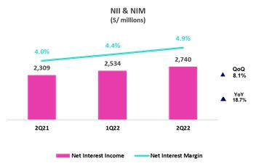

YoY, NII grew 18.7%, fueled by growth in interest income in a context marked by an uptick in structural loan volumes and in yields on IEAs in LC. In this context, NIM rose 90pbs.

6

Earnings Release 2Q / 2022

Summary of Financial Performance and Outlook

Structural Portfolio Quality and Cost of Risk (CoR)
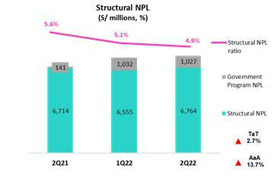

QoQ, structural NPL growth was driven mainly by SME-Pyme and Wholesale Banking at BCP Stand-alone. In SME-Pyme, growth in early delinquency was attributable to clients that also have Reactiva loans. In Wholesale, growth in NPLs was associated with clients in sectors that were heavily impacted by the pandemic. Given that structural loans grew at a faster pace than structural NPLs, the structural NPL ratio stood at 4.9% (-17 bps QoQ).

YoY, growth in the NPL portfolio was fueled mainly by SME-Pyme and driven by an uptick in delinquency for long-term loans. This was attenuated by an improvement at Mibanco, which has bolstered its collections capabilities, and by the evolution in Individuals, which benefitted from growth in personal liquidity. Finally, the positive loan evolution led the structural NPL ratio to fall 65bps.

The structural CoR increased QoQ, driven by growth in provisions in Individuals, which primarily reflects the deterioration in current and projected macroeconomic conditions.
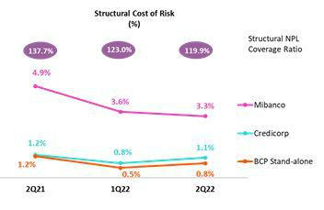

YoY, the slight increase in provisions was offset by growth in origination volumes, which reduced the CoR at the majority of subsidiaries. YTD, the reduction in the CoR reflects our prudent management during the pandemic.

The structural NPL coverage ratio has followed a downward trend since Sept 20, driven by growth in NPLs and a gradual reduction in allowances for loan losses.

Other Income

Other Core income (Fees + Gains on Foreign Exchange Transactions) rose 3.4% QoQ and 8.1 YoY, which reflected the impact of growth in transaction volumes and exchange rate volatility.
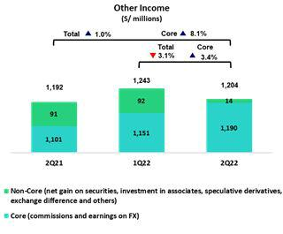

Other non-core income fell QoQ due primarily to growth in the Net loss on Securities and to a lesser extent, to a drop in Other Non-Financial Income. In YoY terms, the decline in Other Non-Core income was mainly driven by a drop in gains on speculative derivatives and by the exchange rate difference.

7

Earnings Release 2Q / 2022

Summary of Financial Performance and Outlook

Insurance Underwriting Result
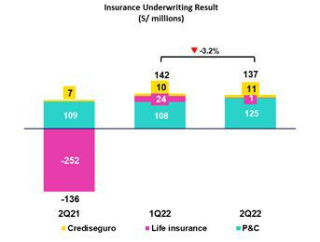

The insurance underwriting result fell 3.2% QoQ, which reflected growth in claims in the Life business and in Group Life in particular, where compensation for the Complementary Insurance for Occupational Risk product was impacted by inflation. This evolution was partially offset by growth in net earned premiums in P&C, particularly in the Cars and Medical Assistance lines. In YoY terms, the insurance underwriting result recovered after claims levels normalized in the Life business and net earned premiums registered solid dynamism in both the Life and P&C businesses.

Efficiency

The Efficiency ratio deteriorated 90bps YoY to stand at 44.6%. This evolution was driven by an uptick in IT investments and in disruptive initiatives. If we exclude operating expenses associated with disruptive initiatives (Yape + Krealo), the efficiency ratio will stand at 42.1%, which represent an improvement of 240bps with regard to the reported figure.
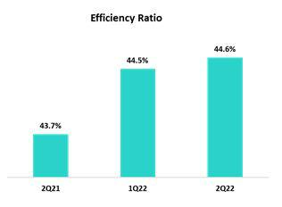

Net Income Attributable to Credicorp

Net income attributable to Credicorp stood at S/1,122 million, down -1.3% QoQ but up +60.4% YoY. With these results, net shareholders’ earnings totaled S/.26,175 million (-2.6% QoQ due to dividend payments). In this scenario, ROAE stood at 16.9%.
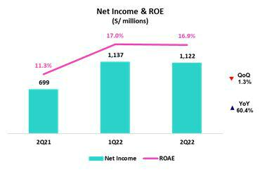

8

Earnings Release 2Q / 2022

Summary of Financial Performance and Outlook

Contributions* and ROE by subsidiary in 2Q22

(S/ millions)
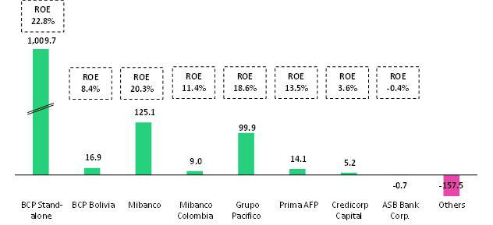

*Contributions to Credicorp reflect the eliminations for consolidation purposes (eliminations for transactions among Credicorp’s subsidiaries or between Credicorp and its subsidiaries).

- The figure is lower than the net income of BCP Stand Alone as contribution do not consider investments in other Credicorp subsidiaries (Mibanco).
- The figure is lower than the net income of Mibanco as Credicorp owns 99.921% of Mibanco (directly and indirectly).
- The contribution is higher than Grupo Pacifico’s net income because Credicorp owns 65.20% directly, and 33.66% through Grupo Credito.
- Includes Grupo Credito excluding Prima, others of Atlantic Security Holding Corporation and others of Credicorp Ltd.

9

Earnings Release 2Q / 2022

Summary of Financial Performance and Outlook

Universal Banking Business


Profitability is up at BCP due to growth in
NII and controlled levels of loan
provisions. Strong origination of
structural loans, as well as a reduction in
cash and investments, worked alongside
higher interest rates to buttress
expansion in NII. The YoY drop in loan
provisions, which was driven by an
improvement in payment behavior in the
mortgage and corporate banking
segments also bolstered profitability.


Insurance and Pension Businesses

Pacifico Seguros consolidates its recovery
due to an improvement in the sanitary
situation and to an uptick in the issuance of

policies in the Life and P&C businesses.

Microfinance Business


Mibanco’s hybrid model continues to drive positive performance and led to record highs for loan origination. This dynamic, coupled with active yield management strategies, allowed Mibanco to boost its Net Interest Income, while keeping asset quality at healthy levels.


Investment Banking

& Wealth Management

The IB & WM business is challenged by the current environment. Market volatility and political uncertainty negatively impacted the non-core businesses while AM & WM reflect the impact of last year´s funds outflows.

Outlook

We expect an ROE close to 17.5% for the full year figure. Likewise, current loan dynamics in a context of high inflation and interest rate hikes led us to expect Net Interest Margin and Cost of Risk figures to situate within the upper end of the guidance range.

10

Earnings Release 2Q / 2022

Financial Overview

Credicorp Ltd. |  | Quarter |  | % change |  | As of |  | % change
S/ 000 | 2Q21 | 1Q22 | 2Q22 | QoQ | YoY | Jun 21 | Jun 22 | Jun 22 / Jun 21
Net interest, similar income and expenses | 2,309,042 | 2,534,090 | 2,740,440 | 8.1% | 18.7% | 4,432,425 | 5,274,530 | 19.0%
Provision for credit losses on loan portfolio, net of recoveries | (363,380) | (257,590) | (363,291) | 41.0% | 0.0% | (921,027) | (620,881) | -32.6%
Net interest, similar income and expenses, after provision for credit losses on loan | 1,945,662 | 2,276,500 | 2,377,149 | 4.4% | 22.2% | 3,511,398 | 4,653,649 | 32.5%
portfolio
Total other income | 1,191,694 | 1,242,749 | 1,203,980 | -3.1% | 1.0% | 2,386,224 | 2,446,729 | 2.5%
Insurance underwriting result | (136,335) | 141,546 | 137,042 | -3.2% | -200.5% | (201,582) | 278,588 | n.a
Total other expenses | (1,860,447) | (1,950,182) | (2,054,810) | 5.4% | 10.4% | (3,540,718) | (4,004,992) | 13.1%
Profit (loss) before income tax | 1,140,574 | 1,710,613 | 1,663,361 | -2.8% | 45.8% | 2,155,322 | 3,373,974 | 56.5%
Income tax | (423,491) | (546,001) | (513,181) | -6.0% | 21.2% | (761,090) | (1,059,182) | n.a
Net profit (loss) | 717,083 | 1,164,612 | 1,150,180 | -1.2% | 60.4% | 1,394,232 | 2,314,792 | 66.0%
Non-controlling interest | 17,614 | 27,786 | 28,420 | 2.3% | 61.3% | 33,965 | 56,206 | n.a
Net profit (loss) attributable to Credicorp | 699,469 | 1,136,826 | 1,121,760 | -1.3% | 60.4% | 1,360,267 | 2,258,586 | 66.0%
Net profit (loss) / share (S/) | 8.77 | 14.25 | 14.06 | -1.3% | 60.4% | 17.05 | 28.32 | 66.0%
Loans | 143,091,752144,621,513150,370,184 |  |  | 4.0% | 5.1% | 143,091,752150,370,184 |  | 5.1%
Deposits and obligations | 149,161,803147,915,964147,440,575 |  |  | -0.3% | -1.2% | 149,161,803147,440,575 |  | -1.2%
Net equity | 25,073,706 | 26,872,626 | 26,175,222 | -2.6% | 4.4% | 25,073,706 | 26,175,222 | 4.4%
Profitability
Net interest margin | 4.01% | 4.44% | 4.90% | 46 bps | 89 bps | 3.90% | 4.65% | 75 bps
Risk-adjusted Net interest margin | 3.38% | 3.99% | 4.25% | 26 bps | 87 bps | 3.09% | 4.10% | 101 bps
Funding cost | 1.18% | 1.33% | 1.59% | 26 bps | 41 bps | 1.31% | 1.45% | 14 bps
ROAE | 11.3% | 17.0% | 16.9% | -10 bps | 560 bps | 10.9% | 17.2% | 630 bps
ROAA | 1.1% | 1.9% | 1.9% | 0 bps | 80 bps | 1.1% | 1.9% | 80 bps
Loan portfolio quality
Internal overdue ratio ⁽¹⁾ | 3.53% | 4.06% | 4.06% | 0 bps | 53 bps | 3.53% | 4.06% | 53 bps
Internal overdue ratio over 90 days | 3.53% | 4.06% | 4.06% | 0 bps | 53 bps | 3.53% | 4.06% | 53 bps
NPL ratio ⁽²⁾ | 4.79% | 5.25% | 5.18% | -7 bps | 39 bps | 4.79% | 5.18% | 39 bps
Cost of risk ⁽³⁾ | 1.02% | 0.71% | 0.97% | 26 bps | -5 bps | 1.29% | 0.83% | -46 bps
Coverage ratio of IOLs | 185.8% | 140.7% | 136.1% | -460 bps | -4970 bps | 185.8% | 136.1% | -4970 bps
Coverage ratio of NPLs | 137.0% | 108.9% | 106.6% | -230 bps | -3040 bps | 137.0% | 106.6% | -3040 bps
Operating efficiency
Efficiency ratio ⁽⁴⁾ | 43.7% | 44.5% | 44.6% | 10 bps | 90 bps | 43.9% | 44.5% | 60 bps
Operating expenses / Total average assets | 2.96% | 3.23% | 3.49% | 26 bps | 53 bps | 2.92% | 3.34% | 40 bps
Insurance ratios
Combined ratio of P&C ⁽⁵⁾ ⁽⁶⁾ | 88.9% | 94.4% | 89.9% | -450 bps | 100 bps | 88.9% | 89.9% | 100 bps
Loss ratio ⁽⁶⁾ | 107.4% | 69.1% | 70.5% | 140 bps | -3690 bps | 68.5% | 93.1% | 2460 bps
Capital adequacy - BCP Stand-alone ⁽⁷⁾
Global Capital ratio ⁽⁸⁾ | 15.34% | 15.79% | 15.23% | -56 bps | -11 bps | 15.34% | 15.23% | -11 bps
Tier 1 ratio ⁽⁹⁾ | 10.31% | 10.74% | 10.25% | -49 bps | -6 bps | 10.31% | 10.25% | -6 bps
Common equity tier 1 ratio ⁽¹⁰⁾ ⁽¹²⁾ | 11.21% | 11.63% | 11.57% | -6 bps | 36 bps | 11.21% | 11.57% | 36 bps
Capital adequacy - Mibanco ⁽⁷⁾
Global Capital ratio ⁽⁸⁾ | 17.25% | 15.61% | 14.81% | -80 bps | -244 bps | 17.25% | 14.81% | -244 bps
Tier 1 ratio ⁽⁹⁾ | 14.69% | 13.24% | 12.55% | -69 bps | -214 bps | 14.69% | 12.55% | -214 bps
Common equity tier 1 ratio ⁽¹⁰⁾ ⁽¹²⁾ | 15.16% | 15.21% | 15.25% | 4 bps | 9 bps | 15.16% | 15.25% | 9 bps
Employees | 35,776 | 36,198 | 34,398 | -5.0% | -3.9% | 36,806 | 36,358 | -1.2%
Share Information
Issued Shares | 94,382 | 94,382 | 94,382 | 0.0% | 0.0% | 94,382 | 94,382 | 0.0%
Treasury Shares (11) | 14,866 | 14,862 | 14,849 | -0.1% | -0.1% | 14,915 | 14,866 | -0.3%
Outstanding Shares | 79,516 | 79,520 | 79,533 | 0.0% | 0.0% | 79,467 | 79,516 | 0.1%
- Internal overdue loans includes overdue loans and loans under legal collection, according to our internal policy for overdue loans. Internal Overdue ratio: Internal overdue loans / Total loans.
- Non-performing loans (NPL): Internal overdue loans + Refinanced loans. NPL ratio: NPL / Total loans.
- Cost of risk: Annualized provision for loan losses, net of recoveries / Total loans.
- Efficiency ratio = (Salaries and employee benefits + Administrative expenses + Depreciation and amortization + Association in participation + Acquisition cost) / (Net interest, similar income and expenses + Fee Income + Net gain on foreign exchange transactions + Net Gain From associates + Net gain on derivatives held for trading + Result on exchange differences + Net Premiums Earned).
- Combined ratio = (Net claims / Net earned premiums) + [(Acquisition cost + Operating expenses) / Net earned premiums]. Does not include Life insurance business.
- Considers Grupo Pacifico's figures before eliminations for consolidation to Credicorp.
- All Capital ratios for BCP Stand-alone and Mibanco are based on Peru GAAP.
- Regulatory Capital / Risk-weighted assets (legal minimum = 10% since July 2011).
- Tier 1 = Capital + Legal and other capital reserves + Accumulated earnings with capitalization agreement + (0.5 x Unrealized profit and net income in subsidiaries) - Goodwill - (0.5 x Investment in subsidiaries) + Perpetual subordinated debt (maximum amount that can be included is 17.65% of Capital + Reserves + Accumulated earnings with capitalization agreement + Unrealized profit and net income in subsidiaries - Goodwill).
- Common Equity Tier I = Capital + Reserves – 100% of applicable deductions (investment in subsidiaries, goodwill, intangibles and net deferred taxes that rely on future profitability) + retained earnings + unrealized gains.
Adjusted Risk-Weighted Assets = Risk-weighted assets - (RWA Intangible assets, excluding goodwill, + RWA Deferred tax assets generated as a result of temporary differences in income tax, in excess of 10% of CET1, + RWA Deferred tax assets generated as a result of past losses)."
- Consider shares held by Atlantic Security Holding Corporation (ASHC) and stock awards.
- Common Equity Tier I calculated based on IFRS Accounting.

11

Earnings Release 2Q / 2022

Credicorp’s Strategy Update

Credicorp Strategy

Credicorp remains resilient as it continues to register profitability levels in the high teens. In the current context, Credicorp differentiates itself through its solid management performance; adequate capitalization levels; efforts to develop technological capacities; and attraction and retention of the best talent through a comprehensive value proposition.

Credicorp continues to strengthen and consolidate its core business, while developing its own disruptors. The Company is continuously reviewing its business portfolio with a long-term view. The aim is to strengthen its leadership position and continue operating as a top player in the markets where it operates.

In terms of its digital strategy, Credicorp made progress in 2Q22 in defining its appetite for investment in innovation at the Group level. Additionally, Credicorp has determined which domains will be allocated resources to secure a competitive position.

In 2022, investment in disruption is expected to impact ROE by 150pbs (ROE is expected to stand around 17.5% in 2022) and efforts will focus primarily on fortifying the domains that strengthen Credicorp’s leadership in its core businesses. The domains that have been targeted in the first horizon include the digital businesses for Payments, Digital Financing, Neobanks model, Acquiring and Services for SMEs.

Mai KPIs of Credicorp’s Strategy

 | Experience | Efficiency |  |  | Growth
 | Traditional Business Transformation ⁽¹⁾ |  | Subsidiary | 2Q19 | 2Q21 | 2Q22
 | Day to Day
 | Digital clients ⁽²⁾ |  | BCP | 34% | 56% | 58%
 | Digital monetary transactions ⁽³⁾ |  | BCP | 23% | 48% | 57%
 | Transactional cost by unit |  | BCP | 0.42 | 0.20 | 0.11
 | Disbursements through leads ⁽⁴⁾ |  | Mibanco | ND. | 68% | 77%
 | Disbursements through alternative channels ⁽⁵⁾ |  | Mibanco | 13% | 33% | 49%
 | Mibanco Productivity ⁽⁶⁾ |  | Mibanco | 20.9 | 18.7 | 24.1
 | Cashless
 | Cashless transactions ⁽⁷⁾ |  | BCP | 20% | 40% | 43%
 | Mobile Banking rating Apple |  | BCP | ND. | 2.2 | 4.7
 | Mobile Banking rating Android |  | BCP | 3.7 | 3.3 | 4.2
 | Digital Acquisition
 | Digital sales ⁽⁸⁾ |  | BCP | 15% | 34% | 37%
 | Digital loans ⁽⁹⁾ |  | BCP | 26% | 44% | 58%
- Figures for June 2019, 2021, and 2022
- Digital Client: Retail Banking clients that conduct 50% of their monetary transactions through digital channels or have purchased an online in the last 12 months. Digital clients; Total Retail Banking clients.
- Retail Monetary Transactions conducted through Retail Banking, Internet Banking, Yape and Telecredito/Total Retail Monetary Transactions in Retail Banking.
- Disbursements generated through leads/Total disbursements.
- Disbursements conducted through alternative channels/Total disbursements.
- Number of loans disbursed/ Total relationship managers.
- Amount transacted through Mobile Banking, Internet Banking, Yape y POS/ Total amount transacted through Retail Banking.
- Units sold by Retail Banking through digital channels/ Total number of units sold by Retail Banking.
- Retail Banking loans disbursed through digital channels/ Total Retail banking loans disbursed.

12

Earnings Release 2Q / 2022

Credicorp’s Strategy Update

Disruptive Initiatives: Yape

Yape continues to make progress in its quest to become the main payment venue in Peru. Proof of this is the fact that we hit the 10-million user mark in early July. To bolster the affiliate base and usage levels, Yape has conducted a number of campaigns. Additionally, in 2022, Yape continued efforts to jump-start the application’s use at different establishments, including gas stations, convenience stores, pharmacies and other low-ticket establishments.

This quarter, Yape also focused on boosting the use of mobile phone top-ups. Yape rolled out this new service on November 2021 and at quarter-end, 142 thousand mobile top-ups were registered on a daily basis.

Additionally, in line with its goal to be present in the day-to-day of Yaperos, Yape will launch “Yape ofertas” this quarter. This new functionality will allow Yaperos to access different offers and unique promotions at participating establishments if they use Yape to pay.

Finally, after concluding the pilot run of Friends and Family for Microloans, Yape is about to launch the Microcredit functionality to the public. Microloans are granted through Yape for either S/100 and S/200 and can be paid in 15, 20, 25 and 30 days.

Disruptive Initiatives: Yape ⁽¹⁾ | 2Q19 | 2Q21 | 2Q22
Day to Day
% Microbusiness users ⁽²⁾ | 0.6% | 20% | 22%
Mobile phone top-ups (thousands) | - | 2,769 | 4,185
Cashless
Users (thousands) | 1,106 | 6,610 | 9,965
% User’s clients of BCP ⁽³⁾ | 100% | 71% | 59%
% of Yape Users ⁽⁴⁾ | - | 26% | 37%
Active users (thousands) ⁽⁵⁾ | 333 | 3,051 | 5,957
% Active users on a monthly basis ⁽⁶⁾ | 30% | 46% | 60%
No. of monthly Transactions (thousands) | 1,262 | 27,222 | 88,950
Monthly transaction amount (millions, S/) | 62 | 1,735 | 4,951
Number of monthly transactions by Active Yapero ⁽⁷⁾ | 4 | 9 | 15
- Figures for 2019, 2021 and 2022
- Yape users that are Microbusinesses/Total Yape users
- BCP clients that are Yape users/Total Yape users
- Yapecard users / Total Yape users
- Yape users that have conducted at least one transaction a month
- Yape users that have conducted at least one transaction in the past month/Total Yape Users
- Number of Yape transactions/Active Users

13

Earnings Release 2Q / 2022

Credicorp’s Strategy Update

Integrating Sustainability in our way of doing business

For more information on our sustainability strategy, program and initiatives please review the documents “Sustainability Strategy 2020-25” and our latest Annual and Sustainability Report.

Among the milestones hit in the second quarter of 2022 in the framework for the company’s ESG journey, the following stand out:

Governance front – New Corporate Sustainability Policies

To ensure that our initiatives are aligned with our purpose, we continue to implement a series of corporate policies that will guide and direct our businesses in the quest to incorporate more sustainable practices. In 2Q22, the following corporate policies were approved and published: (i) Sustainability Policy, (ii) Corporate Human Rights Policy and (iii) Corporate Policy for Responsible and Sustainable Investments.

Environmental Front – Developing sustainable financial solutions and making progress with the ESG risk management framework

- BCP launched the Peruvian banking system’s first international green issuance for a total of US$ 30 million. The funds raised will be used to finance projects for eco-friendly production plants.

- BCP granted a certified green loan to Aceros Arequipa, a company in the steel sector, to finance the development of a steel recycling plant.

- BCP granted a certified green loan to Hialpesa, a company in the textile sector, to finance the development of a water treatment plant.

- Credicorp Capital acted as a structuring and placement agent for sustainable commercial papers for Bosques Amazonicos S.A. The company will use the funds for conservation and reforestation projects in the Amazon.

- Within the ESG risk management platform, Credicorp has defined the strategic criteria at the corporate level to determine clients’ eligibility for or exclusion from financing and is working to incorporate these guidelines at the operating level based on each subsidiary’s characteristics and capacities. The Pilot for the Green Taxonomy Program was satisfactorily completed for a portion of the loan portfolio and will eventually be applied to the complete portfolio.

Social Front – Expanding financial inclusion and education; helping small businesses grow; and providing solutions to reinsert people with financial problems in the system

- Yape spurred the financial inclusion of more than 1.9 million people since November 2020 and Mibanco, through its microfinance role, has included over 600 thousand entrepreneurs in the financial system over the past seven years.

- BCP launched Ando ─ a web platform that offers Yape users who have no credit history and are interested in obtaining microloans ─ the opportunity to demonstrate their debt service capacities by successfully completing a series of challenges.

- Yape launched a campaign to create fraud awareness among users and ensure prevention. These initiatives provided affiliates with educational information on fraud as well as advice and tools to prevent cybernetic and organized crime.

- Yape implemented a chatbox to reduce response times and efficiently address users’ requests in real time.

- Through Yape, nearly 65K people have received training on financial matters through workshops and working groups this quarter. At Mibanco, more than 76K clients have benefitted from different financial and business advisory services.

- BCP and Prima AFP launched new chapters of the financial education programs “El Depa” and “5to piso”.

- Mibanco’s Yevo, which is an online ecosystem for entrepreneurs, hit the 100 thousand-affiliate mark and launched 7 online courses for financial education and digital tools.

- Mibanco granted its first loan “A-morosos”; this program seeks to reinsert delinquent clients in the financial system. The program has registered 400+ payment agreements with delinquent clients.

14

Earnings Release 2Q / 2022 Analysis of 2Q22 Consolidated Results

01 Loan Portfolio


Structural loans increased QoQ and YoY. This evolution was mainly driven by an uptick in growth at the subsidiaries in Peru, spurred by higher demand for financing in a context of economic reactivation and boosted by sales through digital or alternative channels.

Structural NPL portfolio grew QoQ and YoY mostly attributable to BCP Stand-alone, driven by an increase in early delinquency from clients who also hold Reactiva loans in SME-Pyme and to specific clients who were impacted by the pandemic in Wholesale Banking at BCP Stand-alone. Nevertheless, the structural NPL ratios improved QoQ and YoY, fueled by an increase in structural loans and a reduction in the refinanced portfolio.

1.1. Loans

Structural Loans (in Average Daily Balances) ⁽¹⁾⁽²⁾⁽³⁾

Structural Loans |  | As of |  | Volume change |  | % change |  | % Part. in total structural
(S/ millions) |  |  |  |  |  |  |  |  | loans
 | Jun 21 | Mar 22 | Jun 22 | QoQ | YoY | QoQ | YoY | Jun 21 | Mar 22 | Jun 22
BCP Stand-alone | 93,418 | 102,936 | 107,668 | 4,732 | 14,250 | 4.6% | 15.3% | 80.7% | 81.6% | 81.7%
Wholesale Banking | 45,890 | 52,039 | 53,465 | 1,426 | 7,575 | 2.7% | 16.5% | 39.6% | 41.3% | 40.6%
Corporate | 28,244 | 31,234 | 32,099 |  |  | 2.8% | 13.6% | 24.4% | 24.8% | 24.4%
 |  |  |  | 865 | 3,855
Middle - Market | 17,646 | 20,805 | 21,366 | 562 | 3,720 | 2.7% | 21.1% | 15.2% | 16.5% | 16.2%
Retail Banking | 47,528 | 50,897 | 54,203 | 3,306 | 6,675 | 6.5% | 14.0% | 41.1% | 40.4% | 41.1%
SME - Business | 4,866 | 4,858 | 5,430 | 572 | 564 | 11.8% | 11.6% | 4.2% | 3.9% | 4.1%
SME - Pyme | 10,836 | 12,210 | 13,190 |  |  | 8.0% | 21.7% | 9.4% | 9.7% | 10.0%
 |  |  |  | 980 | 2,353
Mortgage | 17,884 | 18,833 | 19,301 | 468 | 1,417 | 2.5% | 7.9% | 15.4% | 14.9% | 14.6%
Consumer | 10,076 | 10,974 | 11,848 |  | 1,772 | 8.0% | 17.6% | 8.7% | 8.7% | 9.0%
 |  |  |  | 874
Credit Card | 3,866 | 4,022 | 4,435 | 412 | 569 | 10.2% | 14.7% | 3.3% | 3.2% | 3.4%
Mibanco | 10,232 | 11,411 | 12,313 |  |  | 7.9% | 20.3% | 8.8% | 9.0% | 9.3%
 |  |  |  | 902 | 2,081
Mibanco Colombia | 963 | 1,077 | 1,152 | 74 | 189 | 6.9% | 19.7% | 0.8% | 0.9% | 0.9%
Bolivia | 8,747 | 8,602 | 8,622 | 20 |  | 0.2% | -1.4% | 7.6% | 6.8% | 6.5%
 |  |  |  |  | -125
ASB | 2,402 | 2,103 | 2,030 |  | -372 | -3.5% | -15.5% | 2.1% | 1.7% | 1.5%
 |  |  |  | -73
BAP's total loans | 115,761 | 126,129 | 131,785 | 5,655 | 16,024 | 4.5% | 13.8% | 100.0% | 100.0% | 100.0%

For consolidation purposes, Loans generated in Foreign Currency (FC) are converted to Local Currency (LC).

- Includes Work out unit, and other banking. For Quarter-end Balances figures, please refer to “12. Annexes – 12.2 Loan Portfolio Quality”.

- Structural Portfolio excludes the Loans offered through Reactiva Peru and FAE-Mype Government Programs (GP).

- Internal Management Figures.

QoQ, structural loans increased 3.6% FX Neutral (excludes the effect from the +3.4% USDPEN FX depreciation). This evolution was mainly driven by:

- BCP Stand-alone, particularly in the SME, Consumer and Corporate segments. In SME-Pyme, disbursement volumes increased for Working Capital Loans (+17% QoQ). Better performance was focused on Micro and Small Clients with average ticket disbursements of up to S/45K, driven by successful leads and powered by data analytics and digital channels. In the Consumer segment, growth was fueled by a 17% increase in preferential cash loans (S/18k ticket approximately) after improvements were made in the quantity and effectiveness of leads to reach payroll-based employees with medium to high income levels. In Corporate, growth was

concentrated in short-term operations with corporate clients in Foreign Currency (FC), mainly in the energy, hydrocarbons, mining and fishing sectors; and

- Mibanco, due to an uptick in disbursements generated through leads (disbursements through leads represented 78.2% of total placements in 2Q22 vs 74.5% in 1Q22) and by an increase in the productivity of relationship managers (sales levels rose to 26.6 operations per month in 2Q22 vs 25.2 in 1Q22). It is important to note that Mibanco’s market share for loans has followed an upward trend over the last four months. Growth was also due, albeit to a lesser extent, to debt purchases, mainly in the month of April.

15

Earnings Release 2Q / 2022

01. Loan Portfolio

YoY, structural loans grew 14.6% FX Neutral, with all segments reporting an uptick with the exception of ASB Bank Corp. Growth was driven by:

- Wholesale Banking at BCP Stand-alone, via an increase in short-term loans in the corporate segment reflecting higher financing needs for Working Capital loans and to a decrease in volumes in 2Q21 due to an uptick in prepayments. In this context, Wholesale Banking structural loan’s share of total loans increased 100bps. SME-Pyme and Consumer segments also drove YoY growth in loans. It is important to note that initiatives in the

Government Program Loans (in average Daily Balances – S/ million)

Government Program (GP) loans decreased 17.1% QoQ and 39.1% YoY, which was primarily due to amortizations of loans in the SMEs segment at BCP Stand-alone. GP loans in quarter-end balances represented 9% of total loans at quarter-end (vs. 11% in March 2022 and 16% in June 2021).

On average, loan terms in Wholesale Banking, Retail Banking and Mibanco expire in 1.4, 1.8 and 2.9 years respectively.

Analysis of 2Q22 Consolidated Results

Consumer segment alone led to a 0.9% increase in its loans market share (MS); and

- Mibanco, which garnered the fruits of a hybrid model that incorporates centralized assessment and multiple distribution channels that registered significant improvements in disbursements through alternative channels (ACH). At the end of June 2022, operations through ACH accounted for 49.2% of total disbursements vs 31.7% in June 2021. It is important to note sustained growth in the average loan ticket (S/10.3k in 2Q22 vs S/8.9K in 2Q21), which reflect successful efforts to follow more leads to clients with better risk profiles.
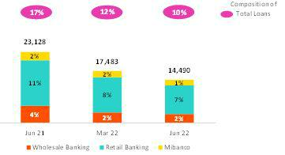

Total Loans (in Average Daily Balances) ⁽¹⁾⁽²⁾

Total Loans | As of |  |  | Volume change |  | % |  | % Part. in total
(S/ millions) |  |  |  |  |  | change |  | loans
 | Jun 21 | Mar 22 | Jun 22 | QoQ | YoY | QoQ | YoY | Jun 21 | Mar 22 | Jun 22
BCP Stand-alone | 114,436 | 118,248 | 120,299 | 2,051 | 5,863 | 1.7% | 5.1% | 82.0% | 82.3% | 82.2%
Wholesale Banking | 51,684 | 55,580 | 56,447 | 867 | 4,763 | 1.6% | 9.2% | 37.0% | 38.7% | 38.6%
Corporate | 28,825 | 31,625 | 32,435 |  |  | 2.6% | 12.5% | 20.7% | 22.0% | 22.2%
 |  |  |  | 810 | 3,610
Middle - Market | 22,859 | 23,955 | 24,012 | 56 | 1,153 | 0.2% | 5.0% | 16.4% | 16.7% | 16.4%
Retail Banking | 62,752 | 62,668 | 63,852 | 1,184 | 1,100 | 1.9% | 1.8% | 45.0% | 43.6% | 43.7%
SME - Business | 11,279 | 9,435 | 9,330 |  |  | -1.1% | -17.3% | 8.1% | 6.6% | 6.4%
 |  |  |  | -105 | -1,950
SME - Pyme | 19,647 | 19,404 | 18,939 | -465 | -707 | -2.4% | -3.6% | 14.1% | 13.5% | 12.9%
Mortgage | 17,884 | 18,833 | 19,301 | 468 | 1,417 | 2.5% | 7.9% | 12.8% | 13.1% | 13.2%
Consumer | 10,076 | 10,974 | 11,848 |  | 1,772 | 8.0% | 17.6% | 7.2% | 7.6% | 8.1%
 |  |  |  | 874
Credit Card | 3,866 | 4,022 | 4,435 | 412 | 569 | 10.2% | 14.7% | 2.8% | 2.8% | 3.0%
Mibanco | 13,023 | 13,582 | 14,172 |  | 1,149 | 4.3% | 8.8% | 9.3% | 9.5% | 9.7%
 |  |  |  | 589
Mibanco Colombia | 963 | 1,077 | 1,152 | 74 | 189 | 6.9% | 19.7% | 0.7% | 0.8% | 0.8%
Bolivia | 8,747 | 8,602 | 8,622 | 20 | -125 | 0.2% | -1.4% | 6.3% | 6.0% | 5.9%
ASB | 2,402 | 2,103 | 2,030 | -73 | -372 | -3.5% | -15.5% | 1.7% | 1.5% | 1.4%
BAP's total loans | 139,570 | 143,613 | 146,275 | 2,662 | 6,704 | 1.9% | 4.8% | 100.0% | 100.0% | 100.0%

For consolidation purposes, Loans generated in Foreign Currency (FC) are converted to Local Currency (LC).

- Includes Work out unit, and other banking. For Quarter-end Balances figures, please refer to “12. Annexes – 12.2 Loan Portfolio Quality”.

- Internal Management Figures.

QoQ and YoY, loans were affected by amortizations of GP loans. This effect was more than offset by growth in the structural loan portfolio. Note that in 3Q22, new reprogramming facilities will be rolled out for Reactiva Peru loans that fulfill certain requirements. Accordingly, we expect GP loan amortization levels to drop slightly in coming quarters.

16

Earnings Release 2Q / 2022 Analysis of 2Q22 Consolidated Results

01. Loan Portfolio

Evolution of the Dollarization Level of Loans per Segment (in Average Daily Balances)⁽¹⁾⁽²⁾

Total Loans | Local Currency (LC) - S/ millions |  |  |  |  |  | % change |  | % Structural changeForeign Currency (FC) - US$ millions |  |  |  |  | % change |  | % part. by currency
 |  | Total |  | Structural |  |  |  |  |  |  |  | Total |  |  |  | Jun 22
 | Jun 21 | Mar 22 | Jun 22 Jun 21 Mar 22 Jun 22 |  |  |  | QoQ | YoY | QoQ | YoY | Jun 21 | Mar 22 | Jun 22 | QoQ | YoY | LC | FC
BCP Stand-alone | 80,960 | 85,292 | 85,162 | 59,941 69,980 |  | 72,531 | -0.2% | 5.2% | 3.6% | 21.0% | 8,758 | 8,751 | 9,278 | 6.0% | 5.9% | 70.8% | 29.2%
Wholesale | 25,860 | 29,181 | 28,411 | 20,065 25,640 |  | 25,429 | -2.6% | 9.9% | -0.8% | 26.7% | 6,757 | 7,009 | 7,403 | 5.6% | 9.6% | 50.3% | 49.7%
Banking
Corporate | 12,572 | 15,548 | 15,375 | 11,990 15,157 |  | 15,039 | -1.1% | 22.3% | -0.8% | 25.4% | 4,252 | 4,268 | 4,505 | 5.5% | 5.9% | 47.4% | 52.6%
Middle- | 13,288 | 13,633 | 13,036 | 8,074 | 10,482 | 10,390 | -4.4% | -1.9% | -0.9% | 28.7% | 2,504 | 2,741 | 2,899 | 5.7% | 15.7% | 54.3% | 45.7%
Market
Retail Banking | 55,100 | 56,111 | 56,751 | 39,876 44,340 |  | 47,102 | 1.1% | 3.0% | 6.2% | 18.1% | 2,002 | 1,741 | 1,875 | 7.7% | -6.3% | 88.9% | 11.1%
SME - | 8,284 | 7,016 | 6,586 | 1,871 | 2,440 | 2,687 | -6.1% | -20.5% | 10.1% | 43.6% | 783 | 642 | 724 | 12.8% | -7.5% | 70.6% | 29.4%
Business
SME - Pyme | 19,463 | 19,238 | 18,775 | 10,653 12,044 |  | 13,025 | -2.4% | -3.5% | 8.1% | 22.3% | 48 | 44 | 43 | -1.5% | -9.4% | 99.1% | 0.9%
Mortgage | 15,722 | 16,922 | 17,353 | 15,722 16,922 |  | 17,353 | 2.5% | 10.4% | 2.5% | 10.4% | 566 | 507 | 514 | 1.4% | -9.1% | 89.9% | 10.1%
Consumer | 8,491 | 9,615 | 10,373 | 8,491 | 9,615 | 10,373 | 7.9% | 22.2% | 7.9% | 22.2% | 415 | 361 | 390 | 7.9% | -6.1% | 87.6% | 12.4%
Credit Card | 3,139 | 3,320 | 3,664 | 3,139 | 3,320 | 3,664 | 10.4% | 16.7% | 10.4% | 16.7% | 190 | 187 | 203 | 9.0% | 7.0% | 82.6% | 17.4%
Mibanco | 12,551 | 13,109 | 13,696 | 9,760 | 10,938 | 11,837 | 4.5% | 9.1% | 8.2% | 21.3% | 124 | 126 | 126 | 0.0% | 1.8% | 96.6% | 3.4%
Mibanco | - | - | - | - | - | - | - | - | - | - | 252 | 286 | 304 | 6.3% | 20.8% | - | 100.0%
Colombia
Bolivia | - | - | - | - | - | - | - | - | - | - | 2,289 | 2,284 | 2,277 | -0.3% | -0.5% | - | 100.0%
ASB Bank Corp. | - | - | - | - | - | - | - | - | - | - | 629 | 558 | 536 | -4.0% -14.7% |  | - | 100.0%
Total loans | 93,511 | 98,401 | 98,858 | 69,701 80,918 |  | 84,368 | 0.5% | 5.7% | 4.3% | 21.0% | 12,051 | 12,005 | 12,521 | 4.3% | 3.9% | 67.6% | 32.4%

- Includes Work out unit, and other banking.

- Internal Management Figures.

At the end of June 2022, the dollarization level of structural loans increased 20bps QoQ (35.8% in Jun22). This evolution was primarily attributable to an uptick in FC disbursements in Wholesale Banking (whose share in FC rose 170bps QoQ) and to a variation in the exchange rate, which impacted the Wholesale Banking and Middle Market portfolios at BCP Stand-alone and BCP Bolivia in particular.

YoY, the dollarization level of the structural portfolio fell (-380bps) given that growth in LC loans (+21.1%) outstripped the increase registered for FC loans (+3.9%). The uptick in LC was seen primarily in the Wholesale Banking and SME-Pyme segments at BCP Stand-alone and was driven by short-term financing for Working Capital.

Evolution of the Dollarization Level of Loans by Segment (in Average Daily Balances)
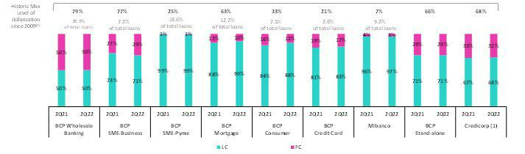

- The FC share of Credicorp’s loan portfolio is calculated including BCP Bolivia and ASB Bank Corp., however the chart shows only the loan books of BCP Stand-alone and Mibanco.

- The year with the historic maximum level of dollarization for Wholesale Banking was 2012, for Mibanco was 2016, for Credit Card was in 2021 and for the rest of segments was 2009. * For dollarization figures in quarter-end period, please refer to “12. Annexes – 12.2 Loan Portfolio Quality”.

Evolution of Quarter-end Loan Balances

Structural loans balances increased 6.8% QoQ. If we isolate the impact of the drop in the exchange rate, structural loans increased 5.7% QoQ, driven by upticks in Wholesale Banking, SME-Pyme and Consumer loans at BCP Individuals and by growth at Mibanco, which was attributable to the same factors that drove the evolution of average daily balances. If we incorporate the contraction of the GP portfolio in the analysis, total loan balances increased 4.0% QoQ.

In the YoY evolution, structural loans registered 14.1% growth in quarter-end balances. FX Neutral, structural loans rose 14.8%, driven by the same segments responsible for QoQ growth. Taking into account the decline in GP loans, total loans increased 5.1% YoY.

17

Earnings Release 2Q / 2022 Analysis of 2Q22 Consolidated Results

01. Loan Portfolio

1.2. Portfolio Quality

Structural Portfolio Quality (in Quarter-end Balances)⁽¹⁾

Structural Portfolio quality and Delinquency ratios |  | As of |  |  | % change
S/ 000 | Jun 21 | Mar 22 | Jun 22 | QoQ | YoY
Structural loans (Quarter-end balance) | 120,095,401 | 128,265,640 | 137,036,175 | 6.8% | 14.1%
Structural Allowance for loan losses | 9,245,140 | 8,061,670 | 8,112,356 | 0.6% | -12.3%
Structural Write-offs | 742,211 | 378,093 | 413,501 | 9.4% | -44.3%
Structural IOLs | 4,913,569 | 4,841,329 | 5,077,879 | 4.9% | 3.3%
Structural Refinanced loans | 1,800,076 | 1,714,074 | 1,686,186 | -1.6% | -6.3%
Structural NPLs | 6,713,645 | 6,555,403 | 6,764,066 | 3.2% | 0.8%
Structural IOL ratio | 4.09% | 3.77% | 3.71% | -6 bps | -38 bps
Structural NPL ratio | 5.59% | 5.11% | 4.94% | -17 bps | -65 bps
Structural Allowance for loan losses over Structural loans | 7.7% | 6.3% | 5.9% | -37 bps | -178 bps
Structural Coverage ratio of NPLs | 137.7% | 123.0% | 119.9% | -305 bps | -1778 bps
- The Structural Portfolio excludes Government Programs (GP) effects.

The structural NPL portfolio grew QoQ and YoY, which was attributable to an uptick in overdue loans and loans under legal collections at SME-Pyme and Wholesale Banking at BCP Stand-alone and, to a lesser extent, to growth at BCP Bolivia. Nevertheless, given that loan growth outstripped the expansion registered in structural NPLs, the structural delinquency ratio improved QoQ and YoY.

NPL Ratio by Segment
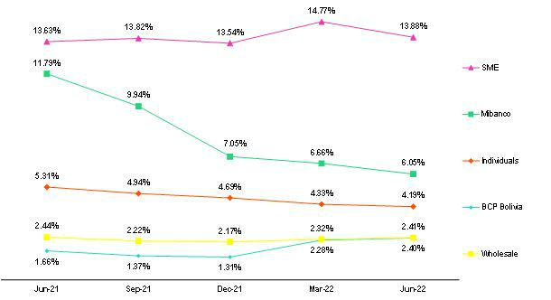

In the QoQ analysis, the segments that contributed to the increase in the NPL portfolio of structural loans were:

- SMEs: due to an increase in overdue loans in the early delinquency tranche (<30 days behind), which represents loans that although volatile, tend to be highly recoverable. This increase was driven mainly by SME-Pyme Working Capital loans and from clients that also have GP loans and were unable to service both debts simultaneously. The increase in the NPL portfolio is also due to a drop in write-offs, given that structural loans held by clients that also have GP loans cannot be written-off (for further information see “1.2 Portfolio Quality – Structural Write-offs”);

18

Earnings Release 2Q / 2022 Analysis of 2Q22 Consolidated Results

- Loan Portfolio

  - Wholesale Banking: NPL growth is mainly due to the performance of some clients in the real estate (builders and office leasing) and tourism (hotels) sectors, primarily in the Middle Market Banking segment, which were impacted by the pandemic and had been offered debt reprogramming facilities that have already expired. In the coming quarters, we expect an increase of the NPL portfolio. However, this evolution is within our expectations and the exposures are provisioned; and

  - BCP Bolivia: the increase in NPL volumes was in line with expectations, driven by the expiration of grace periods in most of the reprogrammed operations, giving rise to the payment obligation and reflecting an increase in the overdue portfolio. It is important to note that by the end of 2Q22, the grace periods of the majority of high-risk clients had already expired. As such, we expect the delinquency ratio to stabilize and tend towards pre-pandemic levels in coming quarters.

The aforementioned was partially attenuated by the positive evolution at Mibanco, which registered an improvement in payment behavior, and by the evolution at Mibanco Colombia, which benefitted from good collections management.

In the YoY analysis, the uptick in NPL volumes was due to:

- SMEs: growth was driven by the same factors discussed in the QoQ analysis. Additionally, the increase in NPL volumes is due to an increase in the late delinquency tranche (>61 days) of long-term loans in SME-Pyme. The latter reflects the accumulation of pending GP related client’s write-offs, which are expected to be regularized in the coming quarters;

- Wholesale: where the increase in NPLs was driven by the factors outlined in the QoQ analysis. Higher NPLs are within expectations and reflect the real delinquency of clients affected since the pandemic started; and

- BCP Bolivia: where delinquency was spurred by the same drivers as those outlined in the QoQ analysis. It is important to note that the NPL volumes in 2Q21 was lower in YoY terms due to the fact that a portion of loans were reprogrammed, which led overdue loans to be reclassified as current.

The aforementioned evolution in NPL levels was partially attenuated by the positive performance of both Mibanco, which has bolstered its collections capabilities, and of Individuals at BCP Stand-alone, where payment behavior improved alongside an uptick in personal liquidity following fund releases from AFPs (Pension Funds) and Severance Indemnity (CTS) accounts.

Structural Write-offs (in Quarter-end balances – S/ thousands)

QoQ, growth in structural write-offs (+9.4%) was driven by BCP Stand-alone, which registered upticks through Individuals and Wholesale Banking. This was partially attenuated by a drop in write-offs at Mibanco and BCP Bolivia. Despite the increase of structural write-offs, the structural write-offs over total structural loans ratio continued to fall below pre-pandemic levels.

YoY, contraction was attributable to Individuals and SMEs at BCP Stand-alone and, to a lesser extent, to Mibanco. This reflects atypically high write-offs in 2Q21, after regulatory restrictions on write-offs (instituted in 2020) were lifted and qualifying loans were allowed to progress to write-off status. It is important to note that new regulatory requirements to report write-offs for clients that simultaneously hold Reactiva loans has been announced. This regulation will go into effect in August and will lead to additional write-offs in 2H22.
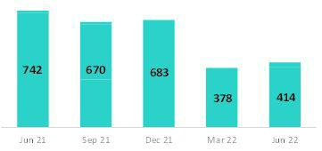

19

Earnings Release 2Q / 2022 Analysis of 2Q22 Consolidated Results

01. Loan Portfolio

NPL Coverage Ratio for Structural NPL Loans by Segment
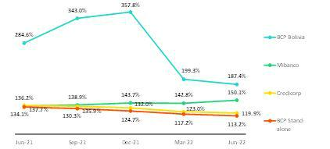

Credicorp’s Coverage ratio fell QoQ. This was attributable to an uptick in NPL loans (+3.2%), driven primarily by BCP Stand-alone and BCP Bolivia, which outpaced growth in the Allowances balance (+0.6%). In this context, the NPL coverage ratio stood near pre-pandemic levels.

YoY, the NPL coverage ratio continues to follow a downward trend. This reflects a reduction in the Allowances balance, which was driven by a better-than-expected improvement in payment behavior and by a slight increase in the NPL portfolio. It should be noted

that the significant drop in NPL Coverage at BCP Bolivia is due to the fact that grace periods for loans that had been reprogrammed under government mandate in 2021 began to expire and were reflected in the NPL portfolio recently in 2022.

NPL Loans in the Government Program Portfolio (in quarter-end balances – S/ thousands)

At the end of June 2022, NPL loans in the GP portfolio fell slightly QoQ after honoring processes for SME-Pyme loans were completed. This was attenuated by deterioration at Mibanco and within Wholesale Banking.
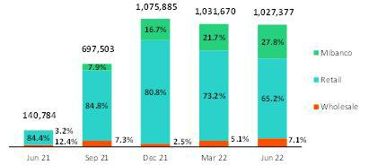

Honoring processes are being executed through state-backed guarantees for loans that are more than 90 days past due. Average coverages under these guarantees stands at 84%, 91% and 97% for Wholesale Banking, Retail Banking and Mibanco respectively.

Finally, the reprogrammed portfolio represented 45% of the total GP portfolio at quarter-end (vs 42% in March 2022) due to new reprogramming facilities.

Quality of the Total Portfolio (in Quarter-end Balances)

Loan Portfolio Quality and Delinquency Ratios |  | As of |  |  | % change
S/ 000 | Jun 21 | Mar 22 | Jun 22 | QoQ | YoY
Total loans (Quarter-end balance) | 143,091,752 | 144,621,513 | 150,370,184 | 4.0% | 5.1%
Allowance for loan losses | 9,391,151 | 8,262,383 | 8,306,500 | 0.5% | -11.5%
Write-offs | 742,211 | 378,093 | 413,501 | 9.4% | -44.3%
Internal overdue loans (IOLs) ⁽¹⁾⁽²⁾ | 5,054,353 | 5,872,999 | 6,105,256 | 4.0% | 20.8%
Internal overdue loans over 90-days ⁽¹⁾ | 3,817,463 | 4,424,384 | 4,596,259 | 3.9% | 20.4%
Refinanced loans ⁽²⁾ | 1,800,076 | 1,714,074 | 1,686,186 | -1.6% | -6.3%
Non-performing loans (NPLs) ⁽³⁾ | 6,854,429 | 7,587,073 | 7,791,442 | 2.7% | 13.7%
IOL ratio | 3.53% | 4.06% | 4.06% | 0 bps | 53 bps
IOL over 90-days ratio | 2.67% | 3.06% | 3.06% | 0 bps | 39 bps
NPL ratio | 4.79% | 5.25% | 5.18% | -7 bps | 39 bps
Allowance for loan losses over Total loans | 6.6% | 5.7% | 5.5% | -19 bps | -104 bps
Coverage ratio of IOLs | 185.8% | 140.7% | 136.1% | -463 bps | -4975 bps
Coverage ratio of IOL 90-days | 246.0% | 186.7% | 180.7% | -603 bps | -6529 bps
Coverage ratio of NPLs | 137.0% | 108.9% | 106.6% | -229 bps | -3040 bps

- Includes Overdue Loans and Loans under legal collection. (Quarter-end balances net of deferred earnings).

- Figures net of deferred earnings.
- Non-performing Loans include Internal overdue loans and Refinanced loans. (Quarter-end balances net of deferred earnings).

In the aforementioned context, Credicorp’s NPL ratio fell 7bps QoQ due to the positive evolution of the structural portfolio. YoY, however, the ratio increased 39bps due to the deterioration and amortization of GP loans.

20

Earnings Release 2Q / 2022 Analysis of 2Q22 Consolidated Results

02 Deposits


At the end of 2Q22, 72.2% of Credicorp’s deposit volume was low-cost, which represents a competitive advantage in a context of rising funding costs. In YoY terms, low-cost deposits (FX Neutral) fell 5.1%, driven by a decrease in demand deposits in LC clients moved to amortize GP loans. Likewise, Severance Indemnity deposits (CTS) dropped 23.6% (FX neutral) YoY after the government decreed that funds be released for withdrawal.

Over the same period, Time Deposits registered an increase after a migration from low-cost deposits to this deposit type to take advantage of higher interest rates.

At the end of May 2022, BCP Stand-alone’s share of total deposits stood at 32.4% (-100 bps with regard to June 2021). This evolution was triggered by drop in demand deposits related to the amortization of Reactiva loans. Mibanco reported an MS of 2.5% (+30bps with regard to June 2021) in a context marked by an uptick in time deposits after retail clients that had withdrawn funds last year due to unfavorable juncture migrated back.

Deposits |  | As of |  | % change |  | Currency
S/ 000 | Jun 21 | Mar 22 | Jun 22 | QoQ | YoY | LC | FC
Demand deposits | 59,998,764 | 56,923,859 | 51,554,195 | -9.4% | -14.1% | 41.9% | 58.1%
Saving deposits | 52,687,270 | 56,454,479 | 54,936,107 | -2.7% | 4.3% | 52.9% | 47.1%
Time deposits | 30,302,103 | 30,029,261 | 35,923,266 | 19.6% | 18.6% | 48.4% | 51.6%
Severance indemnity deposits | 5,456,510 | 3,750,593 | 4,155,932 | 10.8% | -23.8% | 70.1% | 29.9%
Interest payable | 717,156 | 757,772 | 871,075 | 15.0% | 21.5% | 48.2% | 51.8%
Total Deposits | 149,161,803 | 147,915,964 | 147,440,575 | -0.3% | -1.2% | 48.2% | 51.8%

Our deposit base fell 0.3% QoQ. FX neutral fell 2.0% due to:

- An 11.2% drop in Demand Deposits, which was triggered by the fact that Wholesale Clients at BCP Stand-alone used deposit balances to amortize Reactiva loans and to regularize income tax;

- A 4.2% drop in Savings Deposits, which was driven by an outflow from LC funds. The latter was partially offset by an increase in FC after individuals purchased US Dollars at BCP Stand-alone;
- A 17.6% increase in Time Deposits, which was driven primarily by evolution at BCP Stand-alone (fund inflows due to rising interest rates) and by an uptick at Mibanco, which also, reflects efforts to capture stable funding.
- Growth of 9.7% in Severance Indemnity Deposits, given that statutory payments are deposited in May. The effect of these deposits was partially offset after the government lifted restrictions to fund access.

Low-cost deposits (Demand + savings) represented 72.2% of total deposits, which represented a drop of 4.5 p.p QoQ.

In the YoY analysis, deposits fell 1.2%. FX neutral deposits dropped 0.7%, driven by:

- A 13.6% drop in Demand Deposits in both currencies after clients used balances to amortize Reactiva loans and meet other liquidity needs.

- A 23.6% decrease in Severance Indemnity Deposits after restrictions on fund use were lifted.
- A 19.1% increase in Time Deposits, spurred by outflows from low-cost deposits at BCP Stand-alone to this deposit type to take advantage of higher interest rates and to a lesser extent, by an increase in the Time Deposit volume at Mibanco, after retail clients that had withdrawn funds last year due to the juncture migrated back.
- Growth of 4.7% in Savings Deposits, after funds were released from AFPs and Severance Indemnity Accounts (CTS) and subsequently deposited in FC to hedge against exchange rate volatility.

21

Earnings Release 2Q / 2022 Analysis of 2Q22 Consolidated Results

Deposit Dollarization Level

Deposits by Currency

(measured in quarter-end balances)
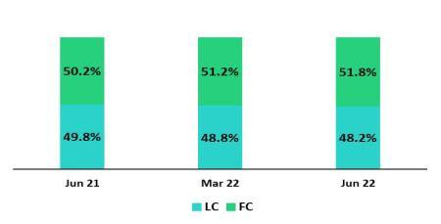

At the end of June 2022, the dollarization level was up 0.6 p.p. QoQ (-0.3 p.p FX neutral) due to an uptick in the exchange rate. Savings Deposits absorbed the brunt of this impact after individuals at BCP Stand-alone moved to purchase dollars. Dollarization levels of Time Deposits fell slightly after LC balances registered growth in a context of interest rate hikes in LC.

In YoY terms, dollarization rose. This was primarily driven by 4.3% drop in LC deposits, which was attributable to a decrease in Demand Deposits, which in turn reflected the consumption of excess liquidity and the use of funds to amortize Reactiva loans. FC balances increased 1.9% (+2.8% with a constant exchange rate), through Time Deposits and Savings Deposits.

Deposits by currency and type

(measured in quarter-end balances)

Loan/Deposit Ratio (L/D Ratio)

The L/D ratio rose 8.7 and 3.9 percentage points YoY at BCP Stand-alone and Mibanco respectively. This growth reflects a significant uptick in loan origination at both subsidiaries due to economic reactivation. In parallel, deposit balances fell, driven by reduced volumes of Demand Deposits in LC, mainly at BCP Individual and triggered by amortization of GP loans. In this scenario, the L/D ratio at Credicorp stood at 102%.
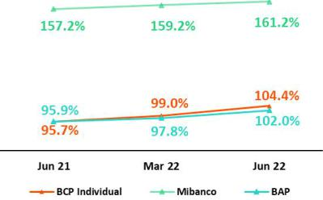

L/D Ratio Local Currency L/D Ratio Foreign Currency
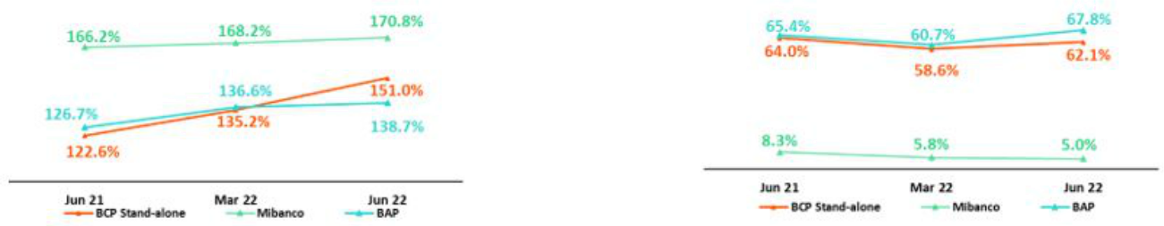

22

Earnings Release 2Q / 2022 Analysis of 2Q22 Consolidated Results

02. Deposits

Market Share of Deposits in the Peruvian Financial System
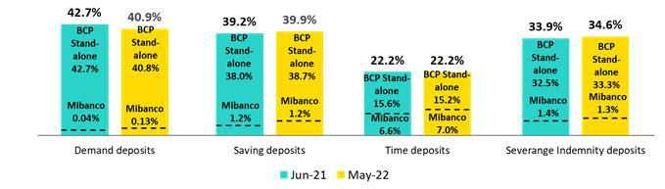

At the end of May 2022, the MS of Total Deposits at BCP Stand-alone and Mibanco in Peru was 32.4% and 2.5% (-100bps and +30bps with regard to June 2021 respectively. At BCP Stand-alone Demand Deposits dropped due to amortizations of loans through government programs, where the bank was a major player. The increase of the share of Time Deposits at Mibanco is noteworthy and primarily attributable to a returned of funds from retail clients and secondarily, to the bank’s successful strategy to capture stable funds.

It is noteworthy, in a context of higher interest rates, BCP leads the market share of low-cost deposits in the Peruvian financial system.

23

Earnings Release 2Q / 2022 Analysis of 2Q22 Consolidated Results

03 Interest-earning assets (“IEAs”) and Funding


At the end of 2Q22 IEAs dropped 3.1% YoY, due to a decrease in cash and due from banks and investment’s balances, which was partially offset by growth in structural loans. The decrease in cash and due from banks reflects the drop in the liquidity level of the banking system, the use of liquid assets to fund loan growth and the fact that dividend payments were made this quarter. Investments fell 17.2% YoY, mainly due to the expiration of CDs, which were not renewed. The latter was aimed to maintain liquidity in a context of loan growth but with a reduced funding balance. Structural loans increased 14.1% YoY, driven by growth in economic activity and in client consumption.

YoY, funding fell 4.6%, spurred by lower balances of BCRP instruments and the utilization of deposits balances by clients, which impacted our low-cost funding base (core deposits).

3.1. IEAs

Interest Earning Assets |  | As of |  | % change
S/000 | Jun 21 | Mar 22 | Jun 22 | QoQ | YoY
Cash and due from banks | 29,058,684 | 29,560,067 | 23,644,089 | -20.0% | -18.6%
Interbank funds | 16,790 | 3,445 | 187,376 | 5339.1% | 1016.0%
Total investments | 54,772,644 | 48,145,429 | 45,342,775 | -5.8% | -17.2%
Cash collateral, reverse repurchase agreements | 1,616,654 | 1,516,855 | 2,046,209 | 34.9% | 26.6%
and securities borrowing
Financial assets designated at fair value through | 921,851 | 856,337 | 765,195 | -10.6% | -17.0%
profit or loss
Total loans | 143,091,752 | 144,621,513 | 150,370,184 | 4.0% | 5.1%
Total interest earning assets | 229,478,375 | 224,703,646 | 222,355,828 | -1.0% | -3.1%

QoQ, IEAs fell 1.0%. This evolution was triggered by a decrease in balances cash and due from banks and investments, which was partially offset by loan growth.

The decline in cash and due from banks was associated with (i) a system-wide decrease in liquidity levels due to amortizations of government program (GP) loans, (ii) the use of liquid assets to fund loan growth, and (iii) Credicorp’s dividend payment. The decrease in investments was attributable to the expiration of certificates of deposits, which were not renewed to maintain liquidity in a climate marked by both loan growth and a decrease in the funding base.

Loans grew 4.0%, spurred by mixed dynamics, where growth was influenced by an exchange rate effect on our dollar-denominated portfolio, and by amortizations in GP loans. If we isolate the exchange rate effect and the effect of variation in the GP loan balance, structural loans grew 4.9%, driven by better dynamics at both the wholesale and retail portfolios.

YoY, IEAs fell 3.1%. This decline was spurred by the same factors identified in the quarterly analysis, but the YoY evolution reflects a larger reduction of investment balances, which was attributable to (i) a drop in the company and system-wide liquidity levels due to the decrease in GP loan balances following amortizations and to (ii) strategies to reduce the portfolio duration. Structural loans rose 14.1% in line with post-pandemic economic recovery while government loans fell 42.0%.

3.2. Funding

Funding | As of |  |  | % change
S/ 000 | Jun 21 | Mar 22 | Jun 22 | QoQ | YoY
Deposits and obligations | 149,161,803 | 147,915,964 | 147,440,575 | -0.3% | -1.2%
Due to banks and correspondents | 6,239,161 | 6,362,990 | 6,456,360 | 1.5% | 3.5%
BCRP instruments | 23,329,990 | 17,532,350 | 16,031,618 | -8.6% | -31.3%
Repurchase agreements | 1,276,678 | 1,218,028 | 1,340,423 | 10.0% | 5.0%
Bonds and notes issued | 16,951,481 | 16,044,671 | 16,579,674 | 3.3% | -2.2%
Total funding | 196,959,113 | 189,074,003 | 187,848,650 | -0.6% | -4.6%

QoQ, funding fell 0.6% mainly due to a decrease in the BCRP instrument volume, which was attributable to amortizations of GP loans. YoY, funding fell 4.6%. This evolution was driven primarily by amortizations of GP loans and by moves by retail and wholesale clients to use account balances.

24

Earnings Release 2Q / 2022 Analysis of 2Q22 Consolidated Results

04 Net Interest Income (NII)


In 2Q22, Net Interest Income continued to recover. This evolution was attributable to the fact that loans ─our highest yielding asset─ reported strong growth, which was accompanied by our effective repricing strategies. It is worth mentioning that the volume dynamics explained in the IEAs section led to a higher yielding IEA mix. These factors offset the negative effect generated by an increase in the funding cost that was driven by higher interest rates and by a decrease in low-cost funding sources which negatively impacted the funding mix. At the end of 2Q22, 56% of the funding base was composed of low-cost deposits.

In this context, the Net Interest Margin in 2Q22 rose 46bps QoQ and 89bps YoY to stand at 4.90% while the Structural Net Interest Margin stood at 5.18% (+46bps QoQ, +86pbs YoY).

Net Interest Income / Margin | Quarter |  |  | % change |  | As of |  | % change
S/ 000 | 2Q21 | 1Q22 | 2Q22 | QoQ | YoY | Jun 21 | Jun 22 | Jun 22 / Jun 21
Interest Income | 2,891,579 | 3,172,346 | 3,488,113 | 10.0% | 20.6% | 5,707,652 | 6,660,459 | 16.7%
Interest Expense | 582,537 | 638,256 | 747,673 | 17.1% | 28.3% | 1,275,227 | 1,385,929 | 8.7%
Net Interest Income | 2,309,042 | 2,534,090 | 2,740,440 | 8.1% | 18.7% | 4,432,425 | 5,274,530 | 19.0%
Balances
Average Interest Earning Assets (IEA) | 230,237,853 | 228,195,289 | 223,529,737 | -2.0% | -2.9% | 227,052,978 | 227,021,380 | 0.0%
Average Funding | 197,108,681 | 192,347,695 | 188,461,327 | -2.0% | -4.4% | 194,215,081 | 191,735,019 | -1.3%
Yields
Yield on IEAs | 5.02% | 5.56% | 6.24% | 68bps | 122bps | 5.03% | 5.87% | 84bps
Cost of Funds | 1.18% | 1.33% | 1.59% | 26bps | 41bps | 1.31% | 1.45% | 14bps
Net Interest Margin (NIM) | 4.01% | 4.44% | 4.90% | 46bps | 89bps | 3.90% | 4.65% | 75bps
Risk-Adjusted Net Interest Margin | 3.38% | 3.99% | 4.25% | 26bps | 87bps | 3.09% | 4.10% | 101bps
Peru's Reference Rate | 0.25% | 4.00% | 5.50% | 150bps | 525bps | 0.25% | 5.50% | 525bps
FED funds rate | 0.25% | 0.50% | 1.75% | 125bps | 150bps | 0.25% | 1.75% | 150bps

Net Interest Income rose 8.1% QoQ, 18.7% YoY during the quarter and 19.0% YTD as of the end of June given that growth in income outpaced the increase registered in expenses in a context marked by rising interest rates, on-going growth in structural loans, and a drop in low-yield assets. The positive evolution of interest income offset growth in expenses, which was attributable to an uptick in passive rates and a reduction in low-cost funding. In this scenario, NIM grew 46pbs QoQ, 89bps YoY and 75bps YTD to stand at 4.90% in 2Q22 and 4.65% YTD at the end of June.

For more information on interest income and interest expenses by segment, see annex 12.3.

Net Interest Margin |  | Structural NIM registered an uptick in recovery, driven by a higher-yield balance
 |  | structure and the positive price effect generated by an increase in interest rates and
 |  | active yield management strategies. This dynamic also explains the evolution of
 |  | the Risk-Adjusted NIM, which stood at 4.25% this quarter, very close to pre-
 |  | pandemic levels.
 |  | To analyze the evolution of Net Interest Income, it is important to differentiate
 |  | dynamics by currency given that the trends for volumes and variations in market
 |  | rates vary for each. The reference rate in LC (BCRP) increased 150bps QoQ and
 |  | 375bps YoY while the FC rate (FED funds rate) rose 125bps QoQ and 150 bps
 |  | YoY.
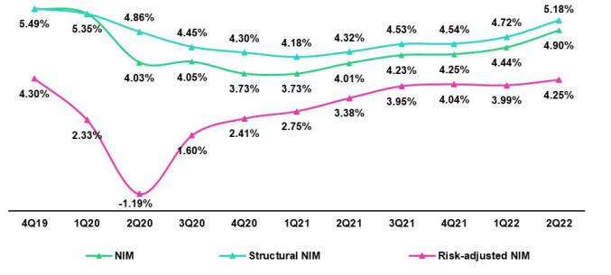

25

Earnings Release 2Q / 2022 Analysis of 2Q22 Consolidated Results

04. Net Interest Income (NII)

Dynamics of Net Interest Income by Currency

Interest Income / IEA |  | 2Q21 |  |  |  |  |  |  |  | 1Q22 |  |  |  |  | 2Q22 |  |  |  |  | Jun 21 |  |  |  |  |  |  | Jun 22
S/ millions | Average |  |  |  |  |  |  | Average |  |  |  |  | Average |  |  |  |  | Average |  |  |  |  |  |  |  | Average
 | Balance |  | IncomeYields |  |  |  |  | Balance Income Yields |  |  |  |  | Balance IncomeYields |  |  |  |  | Balance |  |  | Income Yields |  |  |  |  | Balance Income Yields
Cash and equivalents | 30,485 |  |  |  | 6 | 0.1% |  | 30,979 |  |  | 35 | 0.5% | 26,697 |  | 48 | 0.7% |  | 28,826 |  |  |  |  | 14 | 0.1% |  |  | 28,113 | 83 | 0.6%
Other IEA | 2,598 |  |  |  | 16 | 2.4% |  |  | 2,557 |  | 19 | 2.9% | 2,592 |  | 14 | 2.2% |  | 2,878 |  |  |  |  | 25 | 1.7% |  |  | 2,777 | 33 | 2.4%
Investments | 57,093 |  |  |  | 394 | 2.8% |  | 48,549 |  |  | 433 | 3.6% | 46,744 |  | 497 | 4.2% |  | 54,973 |  |  |  |  | 760 | 2.8% |  | 47,148 |  | 929 | 3.9%
Loans | 140,061 |  |  |  | 2,476 | 7.1% |  | 146,109 |  | 2,686 |  | 7.4% | 147,496 |  | 2,930 | 7.9% |  | 140,376 |  |  | 4,909 |  |  | 7.0% |  | 148,984 |  | 5,615 | 7.5%
Structural | 116,439 |  |  |  | 2,397 | 8.2% |  | 128,597 |  | 2,619 |  | 8.1% | 132,651 |  | 2,871 | 8.7% |  | 116,557 |  |  | 4,744 |  |  | 8.1% |  | 132,982 |  | 5,490 | 8.3%
Government Programs | 23,622 |  |  |  | 79 | 1.3% |  | 17,513 |  |  | 66 | 1.5% | 14,845 |  | 59 | 1.6% |  | 23,819 |  |  |  |  | 165 | 1.4% |  | 16,002 |  | 125 | 1.6%
Total IEA | 230,238 |  |  |  | 2,892 | 5.0% |  | 228,195 |  | 3,172 |  | 5.6% | 223,530 |  | 3,488 | 6.2% |  | 227,053 |  |  | 5,708 |  |  | 5.0% |  | 227,021 |  | 6,660 | 5.9%
IEA (LC) | 59.9% |  |  | 75.7% |  | 6.4% |  | 57.8% |  | 78.8% |  | 7.6% | 58.6% |  | 78.2% | 8.3% |  | 60.5% |  |  | 75.9% |  |  | 6.3% |  |  | 57.2% | 78.5% | 8.1%
IEA (FC) | 40.1% |  |  | 24.3% |  | 3.0% |  | 42.2% |  | 21.2% |  | 2.8% | 41.4% |  | 21.8% | 3.3% |  | 39.5% |  |  | 24.1% |  |  | 3.1% |  |  | 42.8% | 21.5% | 2.9%
Interest Expense / Funding |  |  |  |  | 2Q21 |  |  |  |  |  | 1Q22 |  |  |  | 2Q22 |  |  |  |  |  | Jun 21 |  |  |  |  |  | Jun 22
S/ millions |  | Average |  |  |  |  |  |  | Average |  |  |  |  | Average |  |  |  |  |  | Average |  |  |  |  |  |  | Average
 |  | BalanceExpenseYields |  |  |  |  |  |  | Balance ExpenseYields |  |  |  |  | Balance ExpenseYields |  |  |  |  |  | Balance |  | ExpenseYields |  |  |  |  | BalanceExpenseYields
Deposits |  | 148,894 |  |  | 210 |  | 0.6% |  | 149,128 |  |  | 259 | 0.7% | 147,678 |  | 337 |  | 0.9% |  | 145,764 |  |  |  | 433 | 0.6% |  | 148,891 | 596 | 0.8%
BCRP + Due to Banks |  | 29,589 |  |  | 101 |  | 1.4% |  | 25,400 |  |  | 116 | 1.8% | 23,192 |  | 142 |  | 2.4% |  | 30,641 |  |  |  | 213 | 1.4% |  | 24,697 | 258 | 2.1%
Bonds and Notes |  | 17,407 |  |  | 179 |  | 4.1% |  | 16,562 |  |  | 165 | 4.0% | 16,312 |  | 168 |  | 4.1% |  | 16,635 |  |  |  | 446 | 5.4% |  | 16,829 | 334 | 4.0%
Others |  | 1,218 |  |  |  | 9230.3% |  |  | 1,257 |  |  | 9831.1% |  | 1,279 |  | 10131.5% |  |  |  | 1,175 |  |  |  | 18331.2% |  |  | 1,318 | 19830.1%
Total Funding |  | 197,109 |  |  | 583 |  | 1.2% |  | 192,348 |  |  | 638 | 1.3% | 188,461 |  | 748 |  | 1.6% |  | 194,215 |  |  | 1,275 |  | 1.3% |  | 191,735 | 1,386 | 1.4%
Funding (LC) |  | 54.5% |  |  | 48.6% |  | 1.1% |  | 51.4% |  | 53.6% |  | 1.4% | 51.4% |  | 58.4% |  | 1.8% |  | 55.5% |  |  | 45.5% |  | 1.1% |  | 51.0% | 56.2% | 1.6%
Funding (FC) |  | 45.5% |  |  | 51.4% |  | 1.3% |  | 48.6% |  | 46.4% |  | 1.3% | 48.6% |  | 41.6% |  | 1.4% |  | 44.5% |  |  | 54.5% |  | 1.6% |  | 49.0% | 43.8% | 1.3%
NIM |  | 230,238 |  |  | 2,309 |  | 4.0% |  | 228,195 |  | 2,534 |  | 4.4% | 223,530 |  | 2,740 |  | 4.9% |  | 227,053 |  |  | 4,432 |  | 3.9% |  | 227,021 | 5,275 | 4.6%
NIM (LC) |  | 59.9% |  |  | 82.5% |  | 5.5% |  | 57.8% |  | 85.1% |  | 6.5% | 58.6% |  | 83.7% |  | 7.0% |  | 60.5% |  |  | 84.6% |  | 2.7% |  | 57.2% | 84.4% | 3.4%
NIM (FC) |  | 40.1% |  |  | 17.5% |  | 1.7% |  | 42.2% |  | 14.9% |  | 1.6% | 41.4% |  | 16.3% |  | 1.9% |  | 39.5% |  |  | 15.4% |  | 0.8% |  | 42.8% | 15.6% | 0.8%


QoQ analysis

QoQ, Net Interest Income rose 8.1%. This evolution was driven primarily by the dynamics of IEAs in LC and by Peru’s reference rate. IEAs in LC represent 59% of total IEAs and account for 84% of the Net Interest Margin generated in 2Q22.

Local Currency Dynamics (LC)

Net Interest Income in LC rose 6.3%, product of the fact that growth in interest income outpaced the increase reported for expenses due to the following dynamics:

Average IEAs in LC fell slightly and registered mixed variations in their components. Average structural loans grew 3.8% while liquid assets, investments and government program loans (GP) dropped. The movements in these accounts generated a higher-yield IEA mix in LC. Yields on components of IEA in LC increased, mainly for our loans and investments, which reflects the increase in Peru’s reference rate and our active yield management strategies. Yields of IEAs in LC rose from 7.6% in 1Q22 to 8.3% in 2Q22. Accordingly, the key factors that contributed to a 9.2% increase in interest income in LC were price and mix effects.

Average funding in LC fell 2.1%, driven by a decrease in the volumes of BCRP instruments and deposits after GP loans were amortized. Within the deposit mix, funds from demand deposits and savings deposits (both low cost) migrated to time deposits, which entail higher costs and led the funding cost to rise. The funding cost in LC rose from 1.4% in 1Q21 to 1.8% in 2Q22, driven primarily by an increase in market rates, which subsequently impacted wholesale banking deposits and funding sources. Interest expenses in LC increased 27.5% due to negative price and mix effects.

Dynamics in Foreign Currency (FC)

Net Interest Income in FC rose 18.9% due to the following dynamics:

Average IEA in FC fell 3.9%, spurred by a decrease in the balance for liquid assets and investments. This drop was partially offset by loan growth, where wholesale segments drove demand. The aforementioned dynamic generated a higher-yield mix of IEAs in FC. FC rates increased slightly, in line with growth in the FED’s funds rate. Higher yields and a favorable evolution of the IEA mix led interest income in FC to rise 12.8%.

Average funding in FC dropped 1.9%, spurred by income tax regularization payments, which impacted account balances, and the fact that wholesale funding registered a decrease. The cost of funding this quarter rose due to interest rate hikes in US Dollars. In this context, interest expenses in FC rose 5.1%.

26

Earnings Release 2Q / 2022 Analysis of 2Q22 Consolidated Results

04. Net Interest Income (NII)

YoY Analysis

YoY, Net Interest Income rose 18.7%, driven primarily by the evolution of IEAs and of LC rates.

Dynamics in Local Currency (LC)

Net Interest Income in LC rose 20.3% YoY in tandem with the following dynamics:

Average IEA in LC fell 5.0% YoY due to the following:

- Average structural loans grew 20.3% after origination levels rose in Wholesale Banking, Retail Banking and Microfinance;
- Average balances of government programs fell 37.2% due to loan amortization;
- Investments fell after certificates of deposits were not renewed to maintain liquidity to fund loan growth, and sales of sovereign bonds to reduce the portfolio’s duration; and
- Available funds fell due to a drop in liquidity in the system; dividends distribution; and a reduction in retail funding.

Movements in these accounts led to a higher-yield IEA mix in LC. Yields on assets with shorter maturities (Available funds and Short-term Investments) increased due to upward shifts in the reference rate, which led market rates in LC to rise. Additionally, our loan portfolio has benefitted from higher yields through effective repricing strategies. Combined, these effects boosted the yield of IEA in LC, which rose from 6.4% in 2Q21 to 8.3% in 2Q22. In this context, income in LC increased 24.7%, driven by an uptick in the volume of structural loans and by a positive price effect across IEAs.

Average funding in LC fell 9.9% due to lower balances of BCRP Instruments and low-cost deposits, in line with our clients’ amortizations of Reactiva loans.

Yields on LC funding sources increased, in particular for interest-bearing deposits and BCRP Instruments, in line with the increase in the reference rate. The cost of funds in LC rose from 1.1% in 2Q21 to 1.8% in 2Q22. Due the price effect, interest expenses in LC increased 54.1%.

Dynamics in Foreign Currency (FC)

Net Interest Income in FC grew 11.1%, which was driven by the following dynamics:

Average IEA in FC remained stable given that the drop in investments was offset by an uptick in structural loans. This generated a positive mix effect on the IEA yield.

The IEA yield in FC rose from 3.0% in 2Q21 to 3.3% in 2Q22 due to the mix effect described above and to a slight increase in yields on liquid assets. Positive volume and price effects led FC income to rise 8.1%.

Average funding in FC rose 2.1%, which was attributable to an increase in savings deposits after clients migrated to the US dollar as a refuge in a context marked by exchange rate volatility. The FC funding cost rose from 1.3% in 2Q21 to 1.4% in 2Q22, in line with an increase in FC rates. Interest expenses in FC grew 4.0%, which was primarily attributable to an increase in passive rates.

YTD analysis

In the YTD analysis, Net interest Income rose 19%. The drivers of this growth were the same as those that drove the YoY evolution.

27

Earnings Release 2Q / 2022 Analysis of 2Q22 Consolidated Results

05 Provisions


Structural provisions remain below pre-pandemic levels. Nonetheless, provisions increased QoQ due to the deterioration of economic projections. Growth in expenses was primarily driven by the Individuals segment at BCP Stand-alone and by BCP Bolivia and to a lesser extent by a reduction in recoveries of written-off loans. YoY, structural Provisions remained stable, given that higher expenses at BCP Bolivia were offset by a decrease at BCP Stand-alone and Mibanco.

The Structural Cost of Risk (CoR) stood at 1.08% in 2Q22. This quarter, the increase in provisions was offset by Loan growth. YTD, the reduction in provisions was attributable to our prudent management during the pandemic. Currently, CoR is situated in the inferior range of our guidance.

Provisions⁽¹⁾ and Cost of Risk (CoR) of the Structural Portfolio

Structural Loan Portfolio Provisions |  | Quarter |  | % change |  | As of |  | % change
S/ 000 | 2Q21 | 1Q22 | 2Q22 | QoQ | YoY | Jun 21 | Jun 22 | Jun 22 / Jun 21
Gross provision for credit losses on loan portfolio | (446,508) | (346,809) | (453,605) | 30.8% | 1.6% | (1,053,509) | (800,414) | -24.0%
Recoveries of written-off loans | 77,627 | 93,091 | 83,745 | -10.0% | 7.9% | 142,962 | 176,836 | 23.7%
Provision for credit losses on loan portfolio, net | (368,881) | (253,718) | (369,860) | 45.8% | 0.3% | (910,547) | (623,578) | -31.5%
of recoveries
Structural Cost of risk ⁽¹⁾ | 1.23% | 0.79% | 1.08% | 29 bps | -15 bps | 1.52% | 0.91% | -61 bps

- Annualized Provision for credit losses on loan portfolio, net of recoveries.

- The Structural Cost of risk excludes the Provisions for credit losses on loan portfolio, net of recoveries and Total Loans from the Reactiva Peru and FAE Government Programs.

QoQ structural Provisions increased, which was mainly attributable to the evolution at BCP Stand-alone. Notably, the structural Cost of Risk remains within the Guidance range. The segments that pushed the ratio upwards were:

- Individuals: mainly Consumer and Credit Card (CC) after the macroeconomic variables of our models were updated to reflect the deterioration in real and projected indicators (such as GDP and inflation), which led real and forward-looking risk to increase for low-income clients. Additionally, the increase in Credit Cards was triggered by a change in the portfolio mix, where the share of “revolving” vs “total payers” clients rose. The Mortgage segment also registered an expansion in provisions due to an increase in client risk; and

- BCP Bolivia: due to grace periods expirations; debt forgiveness and charge-offs, which reached historic levels; together with an exchange rate effect. In line with grace periods expirations, we expect a normalization of provisions during the 2H22, given that most of the delinquency from reprogrammed operations was already materialized in the first half of the year.

The above was partially attenuated by a reduction in provisions for Wholesale Banking at BCP Stand-alone, which was mainly driven by a base effect from 1Q21, when methodological adjustments were made to models. The drop in was attributable to SMEs at BCP Stand-alone, which registered an improvement in payment behavior among a specific set of clients. Mibanco also registered a decrease in provisions, albeit comparatively lower, due to positive payment behavior. However, we expect expenses at Mibanco to increase in 2H22 due to a less favorable macroeconomic context.

Structural Cost of Risk by Subsidiary
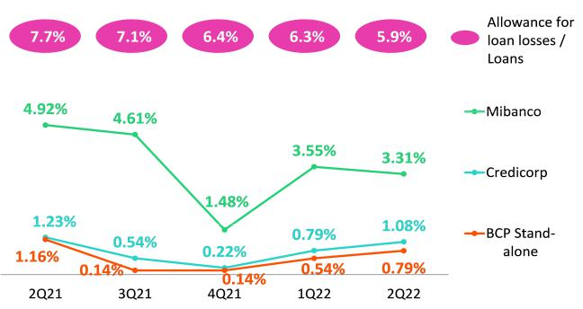

YoY, the structural provisions increased slightly, while the structural CoR fell 15 bps due to a denominator effect. Within the main variations, the following stood out:

28

Earnings Release 2Q / 2022 Analysis of 2Q22 Consolidated Results

05. Provisions

- Bolivia: growth in provisions for approximately S/80 million was primarily driven by the base effect given that in 2Q21, historically low levels of provisions were reported due to reversals after the Bank required clients in the Consumer segment to provide collateral against loans.

The aforementioned was offset by a drop in provisions expenses in Individuals and Wholesale Banking at BCP Stand-alone and, to a lesser extent, by a drop in expenses at Mibanco after methodological adjustments were made to its models to reflect variations in payment behavior. In Individuals, the reduction was driven by a base effect in 2Q21, when extraordinary provisions were set aside for Mortgage loans. In Wholesale Banking, the reduction was spurred by a drop in the balance of Stage 3 loans of specific clients. At Mibanco, the decline was attributable to a decrease in volumes of written-off loans.

Provisions and CoR in the Government Loan Portfolio (PG)

GP Loan Portfolio Provisions |  | Quarter |  | % change |  | As of |  | % change
S/ 000 | 2Q21 | 1Q22 | 2Q22 | QoQ | YoY | Jun 21 | Jun 22 | Jun 22 / Jun 21
Gross provision for credit losses on loan portfolio | 5,501 | (3,872) | 6,569 | -269.6% | 19.4% | (10,480) | 2,697 | -125.7%
Recoveries of written-off loans | - | - | - | - | - | - | - | -
Provision for credit losses on loan portfolio, | 5,501 | (3,872) | 6,569 | -269.6% | 19.4% | (10,480) | 2,697 | -125.7%
net of recoveries
GP Cost of risk ⁽¹⁾ | -0.10% | 0.09% | -0.20% | -29 bps | -10 bps | 0.09% | -0.04% | -13 bps
(1) The GP Cost of risk includes the Provisions for credit losses on loan portfolio, net of recoveries and Total Loans from the Reactiva Peru and FAE Government Programs.

GP Provisions fell QoQ after more honoring processes of state-backed guarantees were executed and the portfolio registered lower levels of deterioration, particularly in SME-Pyme. YoY, the drop reflects an uptick in amortizations and effective execution of honoring processes.

The GP Allowances for loan losses represents 2% of the total Allowances balance at Credicorp. This volume reflects the fact that state-backed coverage of GP loans is significant (loan coverage between 80% to 98%). For more information, see 1.2 Portfolio Quality – NPL Portfolio of Government Loans.

Provisions and CoR of Total Portfolio

Loan Portfolio Provisions |  | Quarter |  | % change |  | As of |  | % change
S/ 000 | 2Q21 | 1Q22 | 2Q22 | QoQ | YoY | Jun 21 | Jun 22 | Jun 22 / Jun 21
Gross provision for credit losses on loan portfolio | (441,007) | (350,681) | (447,036) | 27.5% | 1.4% | (1,063,989) | (797,717) | -25.0%
Recoveries of written-off loans | 77,627 | 93,091 | 83,745 | -10.0% | 7.9% | 142,962 | 176,836 | 23.7%
Provision for credit losses on loan portfolio, | (363,380) | (257,590) | (363,291) | 41.0% | 0.0% | (921,027) | (620,881) | -32.6%
net of recoveries
Cost of risk ⁽¹⁾ | 1.02% | 0.71% | 0.97% | 26 bps | -5 bps | 1.29% | 0.83% | -46 bps
(1) Annualized Provision for credit losses on loan portfolio, net of recoveries / Total Loans.

The analysis of structural and GP loans shows that the CoR for the total portfolio rose 26bps QoQ and dropped -5bps YoY. The impact of GP loans, which stood at 11 bps, was attributable to a denominator effect, in line with amortizations of GP loans.

QoQ Evolution of the Cost of Risk YoY Evolution of the Cost of Risk
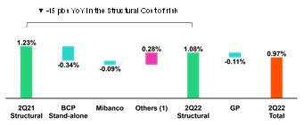

(1) Others include BCP Bolivia, Mibanco Colombia, ASB Bank Corp and eliminations.
(1) Others include BCP Bolivia, Mibanco Colombia, ASB Bank Corp and eliminations.

29

Earnings Release 2Q / 2022 Analysis of 2Q22 Consolidated Results

06 Other Income


Other core income rose maintains a growing trend driven by growth in fees in a context marked by an uptick in transactions and higher on-going FX volatility.

Non-core other income fell due to Net losses on securities. These losses were driven by higher volatility in the stock markets, which negatively affected investments at Credicorp Stand-alone, Prima, ASB and Pacífico.

6.1 Other core income

Core Other Income |  | Quarter |  | % Change |  | As of |  | % Change
(S/ 000) | 2Q21 | 1Q22 | 2Q22 | QoQ | YoY | Jun 21 | Jun 22 | Jun 22/ Jun
 |  |  |  |  |  |  |  | 21
Fee income | 862,411 | 891,031 | 920,492 | 3.3% | 6.7% | 1,693,182 | 1,811,523 | 7.0%
Net gain on foreign exchange transactions | 238,440 | 259,710 | 269,059 | 3.6% | 12.8% | 413,251 | 528,769 | 28.0%
Total other income Core | 1,100,851 | 1,150,741 | 1,189,551 | 3.4% | 8.1% | 2,106,433 | 2,340,292 | 11.1%
The upward trend in other core income continued. This positive evolution was led by BCP Stand-alone, which registered an increase in fee income due to an uptick in digital transactions, which reflected on-going migration from traditional to digital channels, and growth in POS use. In this context, cashless transactions represented 43% of the transaction amount at the end of June. Mibanco also reported an increase in fee income, which was driven primarily by growth in insurance sales and secondarily by a decrease in in fees paid to commercial partners. The aforementioned was partially offset by a drop in fee income from mutual funds, after extraordinary income from entry to third-party funds through international platforms were reported in 2Q21. Gains of foreign exchange transactions continued to trend upward due to growth in transaction volumes and an uptick in exchange rate volatility.

Fee income by banking business

Composition of fee income by banking business

Banking Business Fees |  | Quarter |  | % Change |  | As of |  | % Change
S/ 000 | 2Q21 | 1Q22 | 2Q22 | TaT | AaA | Jun 21 | Jun 22 | Jun 22 / Jun
 |  |  |  |  |  |  |  | 21
Payments and transactionals ⁽¹⁾ | 234,282 | 290,197 | 306,095 | 5.48% | 30.65% | 460,039 | 596,292 | 29.62%
Liability accounts ⁽²⁾ | 207,005 | 217,956 | 234,038 | 7.38% | 13.06% | 624,606 | 692,623 | 10.89%
Loan Disbursement ⁽³⁾ | 88,473 | 90,576 | 91,940 | 1.51% | 3.92% | 575,178 | 634,510 | 10.32%
Off-balance sheet | 60,592 | 60,370 | 59,304 | -1.77% | -2.13% | 286,081 | 302,190 | 5.63%
Mibanco (Peru and Colombia) | 16,713 | 33,276 | 35,190 | 5.75% | 110.56% | 160,252 | 188,140 | 17.40%
Insurances | 26,897 | 30,303 | 28,823 | -4.88% | 7.16% | 93,882 | 127,592 | 35.91%
BCP Bolivia | 30,558 | 27,400 | 25,470 | -7.04% | -16.65% | 119,176 | 111,996 | -6.02%
Wealth Management and Corporate Finance | 21,590 | 18,785 | 18,126 | -3.51% | -16.04% | 98,537 | 89,781 | -8.89%
ASB | 11,202 | 12,280 | 9,483 | -22.78% | -15.34% | 57,784 | 58,674 | 1.54%
Others ⁽⁴⁾ | 9,407 | 4,596 | -1,145 | -124.91% | -112.17% | 42,566 | 25,214 | -40.77%
Total | 706,719 | 785,739 | 807,324 | 2.75% | 14.24% | 2,518,100 | 2,827,012 | 12.27%
- Corresponds to fees from: credit and debit cards; payments and collections.
- Corresponds to fees from: Account maintenance, interbank transfers, national money orders y international transfers.
- Corresponds to fees from retail and wholesale loan disbursements.
- Use of third-party network, other services to third parties and Commissions in foreign branches.

Fees for banking services registered maintain a growing trend due to:

- Economic reactivation in Peru as well as growth in digital transactions and an uptick in the use of POS, both of which were reflected an increase in fee paying transactions. In the aforementioned context, credit and debit cards registered growth of 32% and 118% year over year respectively.

- Fees relative maintenance of deposits and for interbank transfers rose 51% year over year.
- Fees relative to loan disbursements rose, led by personal loans (+12% QoQ, +96% YoY and +72% YTD). In a context marked by an uptick in digital adoption, 71% of the personal loans were granted through digital channels.
- Growth in the fee level registered by Mibanco, which was driven by an uptick in sales of bancassurance; and in the level reported by Mibanco Colombia for microfinance fees, which was associated with an uptick in loan disbursements.

The aforementioned was partially offset by an increase in fees relative to other networks use and other third-party services.

30

Earnings Release 2Q / 2022 Analysis of 2Q22 Consolidated Results

06. Other Income

6.2 Other Non-Core income

Non-core Other income |  | Quarter |  | % Change |  | As of |  | % Change
(S/ 000) | 2Q21 | 1Q22 | 2Q22 | QoQ | YoY | Jun 21 | Jun 22 | Jun 22/ Jun 21
Net gain on securities | (69,947) | (56,866) | (94,180) | n.a. | n.a. | (53,660) | (151,046) | 181.5%
Net gain from associates ⁽¹⁾ | 12,302 | 24,014 | 29,219 | 21.7% | 137.5% | 41,707 | 53,233 | 27.6%
Net gain on derivatives held for | 52,606 | (5,982) | 12,304 | n.a. | -76.6% | 131,153 | 6,322 | -95.2%
trading
Net gain from exchange | 32,959 | (17,060) | (17,066) | 0.0% | -151.8% | 23,677 | (34,126) | -244.1%
differences
Other non-financial income | 62,923 | 147,902 | 84,152 | -43.1% | 33.7% | 136,914 | 232,054 | 69.5%
Total other income Non-Core | 90,843 | 92,008 | 14,429 | -84.3% | -84.1% | 279,791 | 106,437 | -62.0%
- Includes net income from other investments, mainly from the result of Banmedica.

YoY evolution of other non-core income

YTD evolution of other non-core income

(thousands of soles)
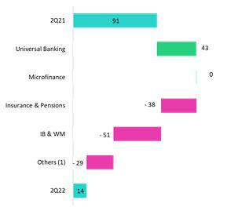

(thousands of soles)
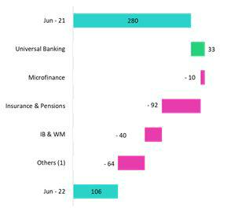

(1)Others includes Grupo Credito, Credicorp Stand-alone, eliminations y others.

Other non-core income fell driven primarily by to the negative results reported for the Net loss on securities in a context impacted by higher levels of volatility across stock markets this quarter. This volatility has mainly affected:

- Investments in mutual funds at Credicorp Stand-alone,

- International fixed-income portfolios at ASB and Credicorp Capital,
- Investments that are part of Prima’s legal reserve; and
- Fixed-income investments at Pacífico.

In addition, YoY, other non-core income was affected by Net Loss on derivatives at BCP Stand-alone which maintains where these losses were offset by higher interest income on investments in fixed income in LC.

YTD, these losses were partially offset by extraordinary income at BCP Stand-alone, which was associated with tax refunds in 1Q22.

31

Earnings Release 2Q / 2022 Analysis of 2Q22 Consolidated Results

07 Insurance Underwriting Results


The insurance underwriting result registered a decrease of 3.2% QoQ. This result was driven by growth in claims in the life business attributable to higher cases reported and the negative effect of inflation, partially mitigated by an improvement in the results of the P&C business.

In the YoY and YTD analysis, the underwriting result increased due to a drop in claims in the Life business associated with the improvement in the sanitary context. Net earned premiums also rose YoY and YTD in both the Life and P&C lines, which reflected economic reactivation.

Insurance underwriting result ⁽¹⁾ |  |  | Quarter |  | % change |  | As of |  | % change
S/ 000 |  | 2Q21 | 1Q22 | 2Q22 | QoQ | YoY | Jun 2021 | Jun 2022 | 2022 /
 |  |  |  |  |  |  |  |  | 2021
 | Net earned premiums | 639,944 | 690,536 | 695,547 | 0.7% | 8.7% | 1,283,872 | 1,386,083 | 8.0%
 | Net claims | (691,335) | (478,506) | (492,258) | 2.9% | -28.8% | (1,314,688) | (970,764) | -26.2%
Total | Acquisition cost ⁽²⁾ | (84,944) | (70,484) | (66,247) | -6.0% | -22.0% | (170,766) | (136,731) | -19.9%
Total | Total insurance underwriting | (136,335) | 141,546 | 137,042 | -3.2% | n.a. | (201,582) | 278,588 | n.a.
 | result
 | Loss Ratio | 108.0% | 69.3% | 70.8% | 150 pbs | -3720 pbs | 102.4% | 70.0% | -3240 pbs
 | Net earned premiums | 331,825 | 365,492 | 365,452 | 0.0% | 10.1% | 674,983 | 730,944 | 8.3%
Life | Net claims | (546,439) | (315,718) | (335,204) | 6.2% | -38.7% | (1,048,152) | (650,922) | -37.9%
 | Loss Ratio | 164.7% | 86.4% | 91.7% | 530 pbs | -7300 pbs | 155.3% | 89.1% | -6620 pbs
 | Net earned premiums | 291,172 | 308,891 | 313,518 | 1.5% | 7.7% | 575,595 | 622,408 | 8.1%
P&C | Net claims | (135,982) | (156,851) | (153,046) | -2.4% | 12.5% | (250,114) | (309,897) | 23.9%
 | Loss Ratio | 46.7% | 50.8% | 48.8% | -200 pbs | 210 pbs | 43.5% | 49.8% | 630 pbs
- Includes the results of the Life, Property & Casualty and Crediseguros business.
- Includes net fees and underwriting expenses.

From a QoQ perspective, the underwriting result decreased. This was attributable to 6.2% growth in claims in the Life business, which was primarily attributable to higher cases reported in D&S and Credit Life, also the negative effect of inflation on Group Life particularly in Complementary Insurance for Occupational Risk (SCTR) product. It is important to note that this quarter, reported cases dropped and IBNR reserves for COVID-19 were released, which reflected the fact that the fourth wave of the pandemic has generated less severe impacts. This result was partially mitigated by growth in net earned premiums and a decrease in claims in P&C.

From a YoY perspective, the insurance underwriting result returned to positive terrain. This evolution was drive by the following factors:

- A 38.7% decrease in claims in the Life business. This reflected the improvement in the sanitary situation and the fact that COVID-19 reserves were released in a context marked by advances in vaccination in 2Q22 versus 2Q21, when higher levels of excess mortality were reported; this was partially mitigated by an inflationary effect;
- Growth of 10.1% and 7.7% in net earned premiums in the Life and P&C businesses respectively associated with economic reactivation; and
- A drop of 22.0% in the acquisition cost, which was driven primarily by a drop in commissions after a contract in the alliance channel expired at the end of 2021 and to a lesser extent by a decrease in underwriting expenses in the P&C business.

In YTD terms, Insurance Underwriting results rose specifically in the life business due to lower excess mortality from COVID-19 given the advance in vaccination process and to a lesser extent, the improvement in net earned premiums in both businesses associate to the economic reactivation.

32

Earnings Release 2Q / 2022 Analysis of 2Q22 Consolidated Results

07. Insurance Underwriting Results

Net Earned Premiums by Business

Net earned premiums in the Life Business (1)

(S/ millions)
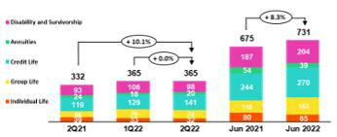

Net Earned Premiums in P&C (1)

(S/ millions)
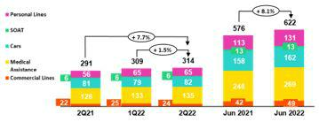

In the QoQ analysis, net earned premiums in the Life business remained stable. Growth in Credit Life stood out and was attributable to an uptick in sales through BCP and Mibanco. This effect was offset by a drop in Disability and Survivorship and Group Life. In P&C, net earned premiums rose 1.5%, which was primarily driven by growth in Cars and Medical Assistance.

In the YoY and YTD analysis, net premiums in the Life Insurance business reported growth of 10.1% and 8.3% respectively in (i) Credit Life, which was primarily associated with an increase in premiums through BCP and Mibanco and (ii) Group Life, in line with price adjustments and an uptick in new sales for the Complementary Insurance for Occupational Risk Product (SCTR). Net premiums rose in P&C, 7.7% YoY and 8.1% YTD, drive by: (i) Personal Lines, due to growth in sales for Card Protection products and Household Mortgages through Bancassurance channel, and (ii) Medical Assistance, which was associated with growth in sales for Oncological and Compensation Products.

Net Claims by Business

Loss Ratio | The Total Loss Ratio stood at 70.8%, (+150 bps QoQ). This result was driven
(%) | primarily by the Life business (+530 bps QoQ), which was in turn due to the
 | evolution of (i) Group Life, where inflation impacted compensation for
 | Complementary Insurance for Occupational Risk and (ii) Disability and
 | Survivorship, due to an increase in cases. It is important to note that COVID-19
 | IBNR reserves were released in 2Q22, which reflected a drop in reported COVID-
 | 19 claims due to an improvement in the sanitary situation and the advances in the
 | vaccination process.
 | The Loss Ratio in the P&C business fell 200 bps QoQ. This was primarily
 | attributable to the evolution of Commercial Lines, which reported high claims
 | frequency in the previous quarter, particularly in the Transportation and Machinery
 | lines and (ii) Cars, which reported a drop in claims frequency in the business
 | segment.
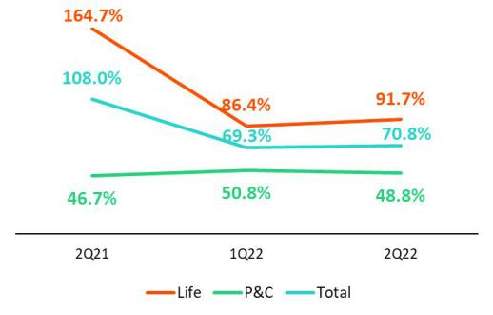

In the YoY and YTD analysis, the Total Loss Ratio improved due to a 28.8% and 26.2% reduction respectively in net claims primarily in the Life business. This was associated with a decrease in reported COVID-19 cases and to the release of IBNR COVID-19 reserves, in line with the positive evolution of the vaccination process.

It is important to mention that the negative impact of inflation on claims and the accumulation of technical reserves adjusted for constant purchasing power are counterbalanced by a positive impact on net interest income associated with the assets that back said claims and reserves.

¹ Total premiums less premiums ceded to reinsurance and adjustments in constitution of technical reserves

33

Earnings Release 2Q / 2022 Analysis of 2Q22 Consolidated Results

07. Insurance Underwriting Results

Acquisition Cost

Acquisition cost |  | Quarter |  | % change |  | As of |  | % change
S/ 000 | 2Q21 | 1Q22 | 2Q22 | QoQ | YoY | Jun 2021 | Jun 2022 | 2022 / 2021
Net fees | (53,808) | (39,875) | (39,352) | -1.3% | -26.9% | (109,413) | (79,227) | -27.6%
Underwriting expenses | (31,842) | (31,286) | (27,943) | -10.7% | -12.2% | (63,399) | (59,230) | -6.6%
Underwriting income | 706 | 678 | 1,047 | 54.5% | 48.5% | 2,045 | 1,725 | -15.6%
Acquisition cost | (84,944) | (70,484) | (66,248) | -6.0% | -22.0% | (170,767) | (136,732) | -19.9%

Finally, the acquisition cost fell 6.0% QoQ, 22.0% YoY and 19.9% YTD. In the QoQ analysis, the decline is due primarily to a drop in underwriting expenses in the P & C business, mainly in Cars due to a decrease in sales expenses for promotions. The aforementioned was partially attenuated by an increase in underwriting expenses in Life, and in Individual Life in particular. In the YoY and YTD analysis, the acquisition cost fell after a contract in the Alliance channel expired at thde end of 2021.

34

Earnings Release 2Q / 2022 Analysis of 2Q22 Consolidated Results

08 Operating Expenses

Operating expenses increased in core businesses as due to an uptick in administrative expenses, which was primarily associated with IT development and secondarily to un uptick in expenses for customer loyalty program due to higher transactionality. Growth in variable compensation reflects the fact that commercial targets were exceed this quarter. Finally, expenses related to disruptive initiatives continue to grow.

Operating expenses |  | Quarter |  | % change |  | As of |  | % change
S/ 000 | 2Q21 | 1Q22 | 2Q22 | QoQ | YoY | Jun 21 | Jun 22 | Jun 22 / Jun 21
Salaries and employees benefits | 882,177 | 977,953 | 975,420 | -0.3% | 10.6% | 1,739,736 | 1,953,373 | 12.3%
Administrative, general and tax expenses | 672,805 | 725,539 | 850,972 | 17.3% | 26.5% | 1,253,647 | 1,576,511 | 25.8%
Depreciation and amortization | 163,869 | 164,514 | 168,845 | 2.6% | 3.0% | 330,634 | 333,359 | 0.8%
Association in participation | 8,879 | 7,691 | 10,329 | 34.3% | 16.3% | 22,785 | 18,020 | -20.9%
Acquisition cost ⁽¹⁾ | 84,944 | 70,484 | 66,247 | -6.0% | -22.0% | 170,766 | 136,731 | -19.9%
Operating expenses | 1,812,674 | 1,946,181 | 2,071,813 | 6.5% | 14.3% | 3,517,568 | 4,017,994 | 14.2%

- The acquisition cost of Pacifico includes net fees and underwriting expenses.

For the expenses analysis, YoY and YTD movements will be taken into account in order to eliminate seasonal effects between quarters.

Operating expenses continue to rise due to:

- Growth in Administrative and general expenses and taxes, which was attributable to growth in IT expenses related to the digital transformation strategy, and to an increase in transactional expenses in a context marked by economic reactivation and an uptick in consumption; and

- Increase in Salaries and Employee benefits, after more provisions were set aside for earnings this quarter. Variable compensation rose after commercial targets for the quarter were exceeded.

Administrative and general expenses and taxes

Administrative and general expenses |  | Quarter |  | % Change |  | As of |  | % change
S/ 000 | 2Q21 | 1Q22 | 2Q22 | QoQ | YoY | Jun - 21 | Jun - 22 | Jun - 22 / Jun
 |  |  |  |  |  |  |  | - 21
IT expenses and IT third-party services | 155,615 | 200,757 | 218,788 | 9.0% | 40.6% | 292,648 | 419,545 | 43.4%
Advertising and customer loyalty programs | 105,060 | 110,497 | 156,285 | 41.4% | 48.8% | 177,386 | 266,782 | 50.4%
Taxes and contributions | 77,406 | 74,063 | 78,510 | 6.0% | 1.4% | 146,214 | 152,573 | 4.3%
Audit Services, Consulting and professional fees | 60,317 | 52,518 | 70,586 | 34.4% | 17.0% | 102,042 | 123,104 | 20.6%
Transport and communications | 47,341 | 40,164 | 49,771 | 23.9% | 5.1% | 87,723 | 89,935 | 2.5%
Repair and maintenance | 29,325 | 29,939 | 39,913 | 33.3% | 36.1% | 56,768 | 69,852 | 23.0%
Agents' Fees | 25,218 | 27,018 | 26,091 | -3.4% | 3.5% | 50,254 | 53,109 | 5.7%
Services by third-party | 23,002 | 18,411 | 25,922 | 40.8% | 12.7% | 42,047 | 44,333 | 5.4%
Leases of low value and short-term | 20,145 | 20,931 | 22,610 | 8.0% | 12.2% | 41,047 | 43,541 | 6.1%
Miscellaneous supplies | 14,171 | 19,077 | 20,657 | 8.3% | 45.8% | 28,990 | 39,734 | 37.1%
Security and protection | 15,692 | 15,476 | 15,798 | 2.1% | 0.7% | 31,651 | 31,274 | -1.2%
Subscriptions and quotes | 13,462 | 13,437 | 15,664 | 16.6% | 16.4% | 26,645 | 29,101 | 9.2%
Electricity and water | 12,709 | 10,677 | 13,567 | 27.1% | 6.8% | 23,400 | 24,244 | 3.6%
Electronic processing | 11,123 | 7,693 | 8,208 | 6.7% | -26.2% | 21,091 | 15,901 | -24.6%
Insurance | 5,320 | 8,916 | 5,925 | -33.5% | 11.4% | 13,594 | 14,841 | 9.2%
Cleaning | 5,206 | 4,506 | 5,203 | 15.5% | -0.1% | 10,488 | 9,709 | -7.4%
Others ⁽¹⁾ | 51,693 | 71,459 | 77,474 | 8.4% | 49.9% | 101,659 | 148,933 | 46.5%
Total | 672,805 | 725,539 | 850,972 | 17.3% | 26.5% | 1,253,647 | 1,576,511 | 25.8%

(1) Others consists mainly of security and protection services, cleaning service, representation expenses, electricity and water utilities, insurance policy expenses, subscription expenses and commission expenses.

35

Earnings Release 2Q / 2022 Analysis of 2Q22 Consolidated Results

08. Operating Expenses

Administrative and general expenses and taxes rose due to:

- Growth in IT expenses and systems outsourcing, which was related to cybersecurity, infrastructure upgrades, development of new applications, renewal and improvement of software; and

- A 62% increase in Advertising expenses, which was primarily associated with disruptive initiatives. If we exclude disruptive expenses, expenses for advertising register a 15% increase.
- The 38% increase in expenses for the Loyalty Program. This was related to an increase of consumption of LATAM miles, which reflected growth in consumption with credit and debit cards at establishments (related fees up 44%).

36

Earnings Release 2Q / 2022 Analysis of 2Q22 Consolidated Results

09 Operating Efficiency

The efficiency ratio deteriorated 60bps YTD after growth in expenses outpaced the expansion in. If we exclude expenses related to disruptive initiatives (Yape + Krealo) from both 1S22 and 1S21, the efficiency ratio improves 34bps YTD. .

Operating Efficiency |  | Quarter |  | % change |  | Year |  | % change
S/ 000 | 2Q21 | 1Q22 | 2Q22 | QoQ | YoY | Jun - 21 | Jun - 22 | Jun - 22 / Jun - 21
Operating expenses (1) | 1,812,674 | 1,946,181 | 2,071,813 | 6.5% | 14.3% | 3,517,568 | 4,017,994 | 14.2%
Operating income (2) | 4,147,704 | 4,376,339 | 4,649,995 | 6.3% | 12.1% | 8,019,267 | 9,026,334 | 12.6%
Efficiency ratio (3) | 43.7% | 44.5% | 44.6% | 10 bps | 90 bps | 43.9% | 44.5% | 60 bps
- Operating expenses = Salaries and employee’s benefits + Administrative expenses + Depreciation and amortization + Association in participation + Acquisition cost.
- Operating income = Net interest, similar income and expenses + Fee income + Net gain on foreign exchange transactions + Net gain from associates + Net gain on derivatives held for trading + Net gain from exchange differences + Net premiums earned
- Operating expenses / Operating income.

Efficiency Ratio by Subsidiary

 | BCP | BCP | Mibanco | Mibanco | Pacifico | Prima | Credicorp
 | Stand- | Bolivia | Peru | Colombia |  | AFP
 | alone
2Q21 | 40.3% | 58.9% | 55.6% | 74.1% | 36.6% | 44.9% | 43.7%
1Q22 | 40.6% | 59.9% | 53.0% | 79.2% | 36.1% | 54.5% | 44.5%
2Q22 | 41.5% | 58.0% | 50.4% | 75.6% | 34.6% | 52.6% | 44.6%
Var. QoQ | 90 bps | -190 bps | -260 bps | -360 bps | -150 bps | -190 bps | 10 bps
Var. YoY | 120 bps | -90 bps | -520 bps | 150 bps | -200 bps | 770 bps | 90 bps
Jun - 21 | 40.2% | 59.3% | 58.6% | 76.1% | 37.0% | 45.7% | 43.9%
Jun - 22 | 41.1% | 58.9% | 51.6% | 77.3% | 35.4% | 53.5% | 44.5%
% change | 90 bps | -40 bps | -700 bps | 120 bps | -160 bps | 780 bps | 60 bps
Jun - 22 / Jun - 21

The analysis of the efficiency ratio is performed based on income and expenses in a YTD basis in order to eliminate seasonal effects between quarters.

The deterioration of the efficiency ratio is mainly due to the fact that expenses in BCP Stand-alone increased more than income. These expenses are related to:

- IT development and increased benefits of the customer loyalty program due to an uptick in transactionality,

- higher variable compensation after commercial targets were exceed this quarter; and

- the evolution of disruptive initiatives.

The aforementioned deterioration was partially offset by an improvement in efficiency at Mibanco Peru, which was attributable to an increase in interest income through active interest rate management in a context of rising funding cost. Advances in the implementation of Mibanco’s hybrid model has enabled to maintain it to control operating expenses and bolster disbursement levels through leads and alternative channels.

If we exclude expenses related to internal disruptive initiatives (Yape) and to our Corporate Venture Capital Center (Krealo) from both 2022 and 2021, Credicorp’s efficiency ratio improves 34bsp YTD.

37

Earnings Release 2Q / 2022 Analysis of 2Q22 Consolidated Results

10 Regulatory Capital


The Regulatory Capital Ratio was 1.56 times above the required level.

BCP Stand-alone’s ratio increased 36 bps YoY to stand at 11.6%, which reflected a 9.5% increase in capital and reserves and the uptick in retained earnings results.

Mibanco’s CET1 ratio remained relatively stable at 15.2%.

10.1 Credicorp’s Regulatory Capital

Credicorp’s regulatory capital ratio was 1.56 times above the required capital level at the end of 2Q22. In the QoQ analysis, the ratio rose 5bps due to a 11.2% increase in Optional Capital Reserves and Restricted Reserves, which was associated with balance transfers from the accumulated earnings account. This was partially offset by an increase in capital requirements to cover the uptick in loan growth reported at BCP Stand-alone and Mibanco.
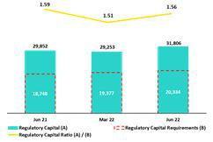

In the YoY analysis, the Regulatory Capital Ratio was relatively stable.

10.2 BCP Stand-alone’s Regulatory Capital Ratio

At the end of 2Q22, the Tier 1 and Global Capital Ratio at BCP Stand-alone stood

at 10.3% (-49bps QoQ) and 15.2% (-56bps QoQ) respectively. These reductions

were primarily driven by the increase in loans’ share of risk-weighted assets

(RWAs). In the case of the Global Regulatory Ratio, the aforementioned dynamic

was partially offset by growth in the Subordinated Debt Balance, which was

spurred by exchange rate movements.

In the YoY analysis, these ratios remained stable.

Common Equity Tier 1 Ratio IFRS – BCP Stand-alone
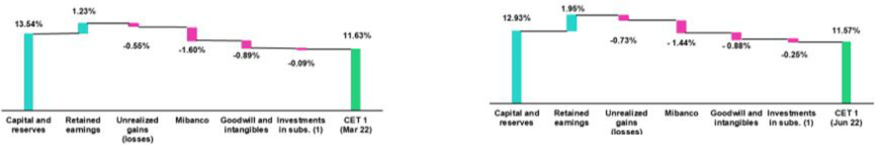

BCP’s Common Equity Tier 1 Ratio (CET 1) under IFRS accounting reflected a drop of 6bps QoQ, standing at 11.57% for 2Q22. This was associated to growth in Risk-weighted Assets (+4.7%) was partially offset by an increase in Retained Earnings Results (+66.5%). Finally, in the YoY analysis, the CET1 ratio rose 36bps, driven by a 9.5% increase in Capital and Reserves, which was spurred by the capitalization of earnings from 2021 and by the uptick reported for Retained Earnings Results. This evolution was partially mitigated by 6.9% growth in RWAs.

38

Earnings Release 2Q / 2022 Analysis of 2Q22 Consolidated Results

10. Regulatory Capital

10.3 Mibanco’s Regulatory Capital

At the end of 2Q22, the Tier 1 Regulatory Ratio and the Global Capital Ratio at Mibanco stood at 12.6% (-69bps QoQ) and 14.8% (-80bps QoQ) respectively. This evolution was driven primarily by the 5.5% increase in Risk-Weighted Assets (RWAs), which in turn reflected an uptick in loan growth.
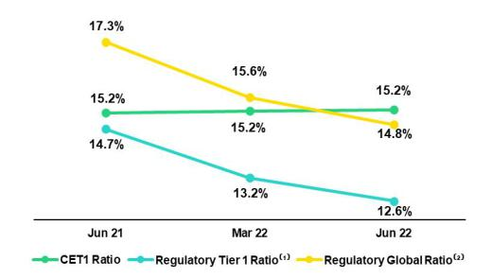

The YoY evolution shows a 214 bps and 244 bps decrease in the Tier 1 Regulatory and Global Capital Ratio respectively. Both variations were fueled by a 23.3% increase in RWAs and were driven by the same factors mentioned in the QoQ analysis.

Finally, the CET1 Ratio under IFRS accounting was relatively stable QoQ and YoY. The accumulation of retained earnings was offset by the increase in RWAs. Mainly due to Credit Risk.

39

Earnings Release 2Q / 2022 Analysis of 2Q22 Consolidated Results

11 Economic Outlook

Estimates indicate that the Peruvian economy grew 3.0% YoY in 2Q22, driven primarily by the service sector and non-primary manufacturing. The uptick in the service sector was triggered by a loosening of restrictions, which benefitted lodging, restaurant and transportation businesses in particular. Growth this quarter was offset by a 1.5% drop in primary activities, which was fueled by a downturn in mining production.

The annual Inflation rate for 2Q22 closed at 8.8% YoY, which represented the highest point since July 1997. The uptick was primarily driven by rising prices for imported commodities in the context set by the war in the Ukraine.

According to BCRP, the exchange rate closed at USDPEN 3.826 in 2Q22, which represents a decrease of 4.1% from the 3.676 registered in 1Q22.

Peru: Economic Forecast

Peru | 2018 | 2019 | 2020 | 2021 | 2022 ⁽³⁾
GDP (US$ Millions) | 226,856 | 232,447 | 205,553 | 225,661 | 250,462
Real GDP (% change) | 4.0 | 2.2 | -11.0 | 13.5 | 2.5
GDP per capita (US$) | 7,045 | 7,152 | 6,300 | 6,831 | 7,507
Domestic demand (% change) | 4.2 | 2.3 | -9.8 | 14.6 | 2.5
Gross fixed investment (as % GDP) | 22.4 | 21.8 | 19.7 | 21.9 | 20.7
Public Debt (as % GDP) | 25.6 | 26.6 | 34.6 | 35.9 | 34.5
System loan growth (% change)(1) | 10.3 | 6.4 | 12.9 | 7.0 | 1.8
Inflation(2) | 2.2 | 1.9 | 2.0 | 6.4 | 7.3
Reference Rate | 2.75 | 2.25 | 0.25 | 2.50 | 7.00
Exchange rate, end of period | 3.37 | 3.31 | 3.62 | 3.99 | 3.85
Exchange rate, (% change) | 4.0% | -1.8% | 9.3% | 10.3% | -3.5%
Fiscal balance (% GDP) | -2.3 | -1.6 | -8.9 | -2.5 | -2.0
Trade balance (US$ Millions) | 7,197 | 6,614 | 8,196 | 14,833 | 9,500
(As % GDP) | 3.2% | 2.8% | 4.0% | 6.6% | 3.8%
Exports | 49,066 | 47,688 | 42,905 | 63,151 | 64,800
Imports | 41,870 | 41,074 | 34,709 | 48,317 | 55,300
Current account balance (As % GDP) | -1.7% | -1.5% | 1.2% | -2.3% | -4.5%
Net international reserves (US$ Millions) | 60,121 | 68,316 | 74,707 | 78,495 | 74,000
(As % GDP) | 26.5% | 29.4% | 36.3% | 34.8% | 29.5%
(As months of imports) | 17 | 20 | 26 | 19 | 16
Sources: INEI, BCRP, y SBS.
- Financial System, Current Exchange Rate
- Inflation target: 1% - 3%
- Estimates by BCP Economic Research as of August, 2022.

40

Earnings Release 2Q / 2022 Analysis of 2Q22 Consolidated Results

11. Economic Outlook

Main Macroeconomic Variables

Gross Domestic Product

(Annual Variations, % YoY)
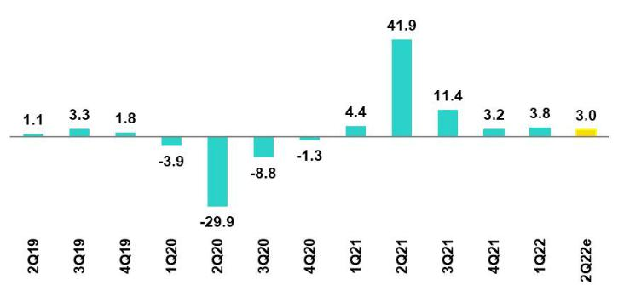

Source: BCRP

*Estimate; BCP

In 2Q22, the Peruvian economy is expected to have grown 3.0% YoY (1Q22 3.8% YoY). Non-primary sectors are expected to register 4.2% growth YoY, propelled by an uptick in the service sector and in non-primary manufacturing. Services (lodging and restaurants and transportation) continue to benefit from advances on the vaccination front and the lifting of restrictions on movement. Non-primary manufacturing is expected to have registered growth in most branches of activity. Finally, Primary activities more than likely dropped 1.5% YoY, in a context marked by a 6.0% deterioration in mining production. According to INEI, the economy grew 2.3% YoY in May and 3.7% YoY in April.

Annual Inflation and Central Bank Reference Rate

(%)
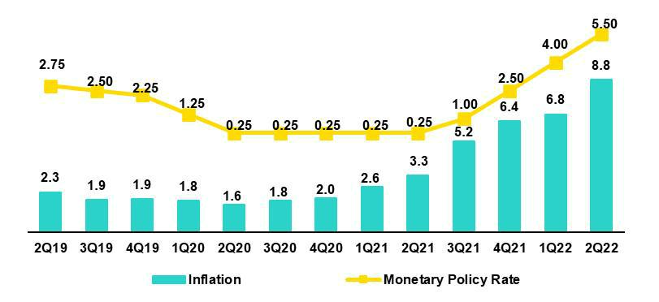

Sources: BCRP and INEI

The annual inflation rate in 2Q22 closed at 8.8% YoY, the highest print since July 1997 and well above the upper limit of the BCRP's target range (1%-3%). At the end of 2Q22, food and energy inflation rose to 13.5% YoY, due in large part to rising prices for imported commodities in a context impacted by the war in the Ukraine. Core inflation (excluding food and energy) stood at 5.0% YoY, which is close to the historic high reported 22 years ago in November 2000.

Since August 2021, the Central Reserve Bank (BCRP) has been responding to the increases in inflation and price expectations by raising its reference rate from 0.25% to 5.5% in June 2022. Thus, the monetary authority seeks to return inflation expectations to their target range (1% to 3%) in the second half of part of 2023. On July 7th, the BCRP raised its rate to 6.0% and its next monetary policy meeting will take place on Thursday, August 11.

41

Earnings Release 2Q / 2022 Analysis of 2Q22 Consolidated Results

11. Economic Outlook

Fiscal Balance and Current Account Balance

(% of GDP, Quarter)
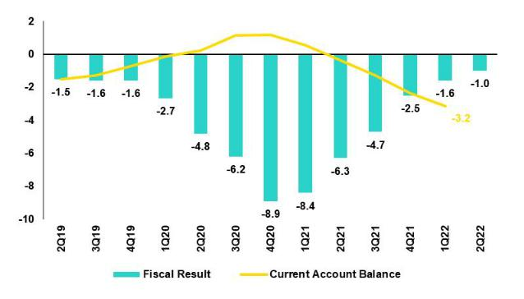

The annualized fiscal deficit for 2Q22 was 1.0% of GDP, compared to 6.3% in 2Q21. In the first semester, the current income of the general government increased 27% YoY, driven by an increase in collections for income tax collection (48%), the General Sales Tax for imports (23%) and non-tax income (25%). In 1S22, non-financial expenses at the general government level grew 4.5% YoY in the first semester. In this context, current spending grew 3.7%; capital spending, 3.3%; and other capital spending, 26.8%.

Source: BCRP

In April, Fitch Ratings affirmed its credit rating for Peru's long-term debt in foreign currency at BBB with a stable outlook. S&P rates Peru at BBB with a stable outlook, and Moody's, Baa1 with a stable outlook.

In terms of external accounts, the current account deficit according to the latest BCRP Inflation Report closed 1Q22 at 5.7% of GDP, and in accumulated terms for the last 4 quarters, the current account deficit stood at 3.2% of GDP. As of May 2022, exports reached a near-record high, totaling US$ 67.3 billion over the 12-months accumulated period. Imports also reached a historical record, annualized to May, of USD 51.8 billion. Thus, the accumulated trade surplus 12 months to May stood at USD 15.4 billion, a decrease compared to the accumulated 12 months to March 2022, which reached USD 16.3 billion and set a historical record.

In May, the terms of trade registered a decrease of 12.7% compared to the same month of 2021. Import prices rose 18.5% due to higher prices for oil and derivatives, food and industrial inputs, while export prices rose to a lesser extent (3.5%). Despite a YoY drop, terms of trade stood 8.4% higher than the level reported in May 2019.

Exchange rate

(PEN per USD)
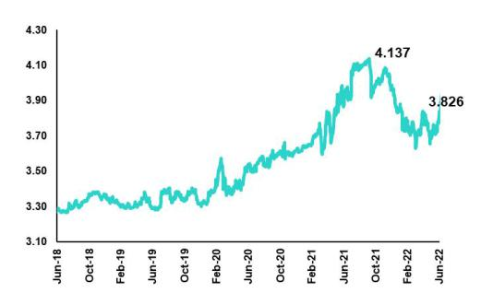

Source: BCRP

According to the Central Bank. the exchange rate closed at USDPEN 3.826 in 2Q22 (3.676 in 1Q22 and 3.99 in 4Q21), depreciating 4.1% compared to the end of 1Q22. It is important to note that the region's currencies depreciated during 2Q22 compared to the 1Q22: the Chilean Peso 16.8% (1Q21: 7.7%) and the Colombian Peso 10.3% (1Q21: 7.4%), the Brazilian Real 10.9% (1Q21: 14.9%), the Mexican Peso 1.3% (1Q21: 3.2%). It should be noted that as of July 19th, 2022, USDPEN closed at 3.8750, which represented a depreciation of 5.2% compared to the figure at the end of 1Q22.

Net International Reserves closed 2Q22 at US$73.3 billion, falling below the US$75.3 billion reported in 1Q21 and the US$78.5 billion registered at year-end. BCR's foreign exchange position stood at US$ 52.7 billion, which represented a drop of US$ 3.6 billion compared to the figure at the end of 1Q22. This reduction was primarily driven by net sales of foreign currency to the public sector to strengthen the fiscal stabilization fund.

In 2Q22, BCRP made net sales in the spot foreign exchange market for US$641 million, which topped the US$371 million registered in 1Q22. Sales were concentrated in April (US$ 392 million) followed by June (US$212 million).

42

Earnings Release 2Q / 2022 Analysis of 2Q22 Consolidated Results

Safe Harbor for Forward-Looking Statements

This material includes “forward-looking statements” within the meaning of Section 27A of the U.S. Securities Act of 1933 and Section 21E of the U.S. Securities Exchange Act of 1934. All statements other than statements of historical fact are forward-looking and may contain information about financial results, economic conditions, trends and known uncertainties. Forward-looking statements are not assurances of future performance. Instead, they are based only on our management’s current views, beliefs, expectations and assumptions regarding the future of our business, future plans and strategies, projections, anticipated events and trends, the economy and other future conditions.

Many forward-looking statements can be identified by words such as: “anticipate”, “intend”, “plan”, “goal”, “seek”, “believe”, “project”, “estimate”, “expect”, “strategy”, “future”, “likely”, “would”, “may”, “should”, “will”, “see” and similar references to future periods. Examples of forward-looking statements include, among others, statements or estimates we make regarding guidance relating to losses in our credit portfolio, efficiency ratio, provisions and non-performing loans, current or future market risk and future market conditions, expected macroeconomic events and conditions, our belief that we have sufficient capital and liquidity to fund our business operations, expectations of the effect on our financial condition of claims, legal actions, environmental costs, contingent liabilities and governmental and regulatory investigations and proceedings, strategy for customer retention, growth, governmental programs and regulatory initiatives, credit administration, product development, market position, financial results and reserves and strategy for risk management.

We caution readers that forward-looking statements involve known and unknown risks and uncertainties that could cause actual results, performance or events to differ materially from those that we expect or that are expressed or implied in the forward-looking statements, depending on the outcome of certain factors, including, without limitation, adverse changes in:

- The occurrence of natural disasters or political or social instability in Peru;

- The adequacy of the dividends that our subsidiaries are able to pay to us, which may affect our ability to pay dividends to shareholders and corporate expenses;

- Performance of, and volatility in, financial markets, including Latin-American and other markets;

- The frequency, severity and types of insured loss events;

- Fluctuations in interest rate levels;

- Foreign currency exchange rates, including the Sol/US Dollar exchange rate;

- Deterioration in the quality of our loan portfolio;

- Increasing levels of competition in Peru and other markets in which we operate;

- Developments and changes in laws and regulations affecting the financial sector and adoption of new international guidelines;

- Changes in the policies of central banks and/or foreign governments;

- Effectiveness of our risk management policies and of our operational and security systems;

- Losses associated with counterparty exposures;

- The scope of the coronavirus (“COVID-19”) outbreak, actions taken to contain the COVID-19 and related economic effects from such actions and our ability to maintain adequate staffing; and
- Changes in Bermuda laws and regulations applicable to so-called non-resident entities.

See “Item 3. Key Information—3.D Risk Factors” and “Item 5. Operating and Financial Review and Prospects” in our most recent Annual Report on Form 20-F filed with the U.S. Securities and Exchange Commission for additional information and other such factors.

You are cautioned not to place undue reliance on these forward-looking statements, which speak only as of the date hereof and are based only on information currently available to us. Therefore, you should not rely on any of these forward-looking statements. We undertake no obligation to publicly update or revise these or any other forward-looking statements that may be made to reflect events or circumstances after the date hereof, whether as a result of changes in our business strategy or new information, to reflect the occurrence of unanticipated events or otherwise.

43

 | Earnings Release 2Q / 2022 | Analysis of 2Q22 Consolidated Results
12 Appendix
12.1. | Physical Channels | 45
12.2. | Loan Portfolio Quality | 45
12.3 Net Interest Income (INI) |  | 49
12.4. | Regulatory Capital | 50
12.5. | Financial Statements and Ratios by Business | 53
12.5.1. Credicorp Consolidated |  | 53
12.5.2. Credicorp Stand-alone |  | 55
12.5.3. BCP Consolidated |  | 56
12.5.4. BCP Stand-alone |  | 60
12.5.5. BCP Bolivia |  | 62
12.5.6. Mibanco |  | 63
12.5.7. Prima AFP |  | 64
12.5.8. Grupo Pacifico |  | 66
12.5.9. Investment Banking & Wealth Management |  | 68
12.6. | Table of calculations | 69
12.7. | Glossary of terms | 70
 |  | 44

Earnings Release 2Q / 2022 Analysis of 2Q22 Consolidated Results

12. Appendix

12.1. | Physical Point of contact
 |  | Physical Point of Contact |  | As of |  | change (units)
 |  | (Units) | Jun-21 | Mar-22 | Jun-22 | QoQ | YoY
 |  | Branches | 730 | 706 | 691 | -15 | -39
 |  | ATMs | 2,596 | 2,551 | 2,540 | -11 | -56
 |  | Agentes | 7,669 | 8,916 | 9,863 | 947 | 2,194
 |  | Total | 10,995 | 12,173 | 13,094 | 921 | 2,099
12.2. | Loan Portfolio Quality

Loan Portfolio Quality (in Quarter-end Balances)
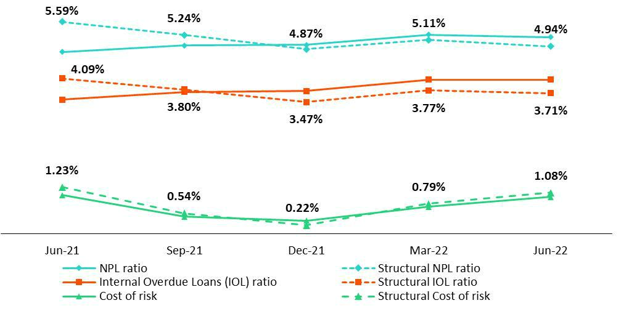

45

Earnings Release 2Q / 2022 Analysis of 2Q22 Consolidated Results

12. Appendix

Government Program (GP) Loan Portfolio Quality (in Quarter-end Balances)

GP Portfolio quality and Delinquency ratios ⁽¹⁾ |  | As of |  | % change
S/000 |  | As of
S/000 | Jun 21 | Mar 22 | Jun 22 | QoQ | YoY
GP Total loans (Quarter-end balance) | 22,996,351 | 16,355,873 | 13,334,009 | -18.5% | -42.0%
GP Allowance for loan losses | 146,011 | 200,713 | 194,144 | -3.3% | 33.0%
GP IOLs | 140,784 | 1,031,670 | 1,027,377 | -0.4% | n.a
GP IOL ratio | 0.61% | 6.31% | 7.70% | 139 bps | 709 bps
GP Allowance for loan losses over GP Total loans | 0.6% | 1.2% | 1.5% | 23 bps | 83 bps
GP Coverage ratio of IOLs | 103.7% | 19.5% | 18.9% | -56 bps | n.a
- Government Programs (GP) include Reactiva Peru and FAE-Mype.

Portfolio Quality Ratios by Segment

Wholesale Banking
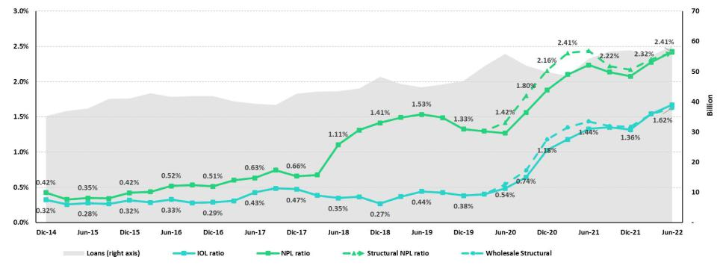

SME-Business
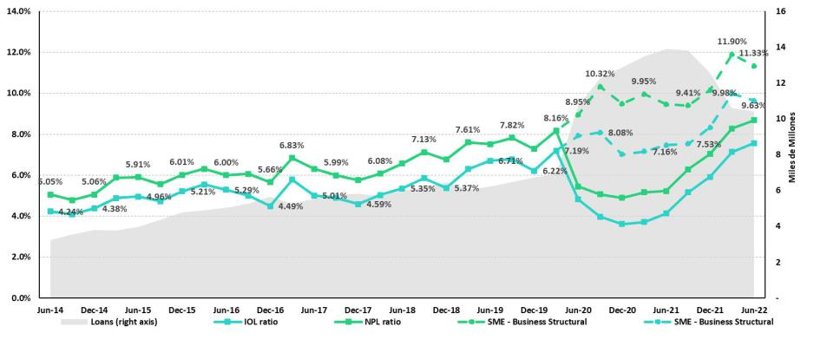

46

Earnings Release 2Q / 2022 Analysis of 2Q22 Consolidated Results

12. Appendix

SME-Pyme
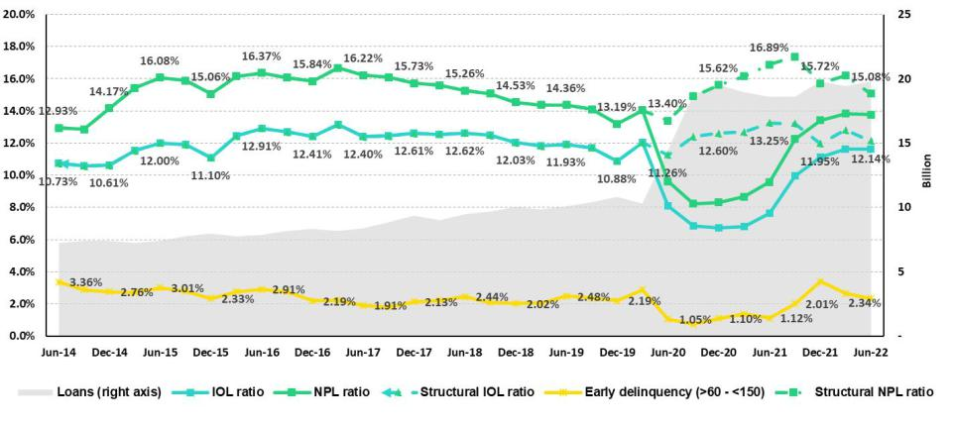

Mortgage
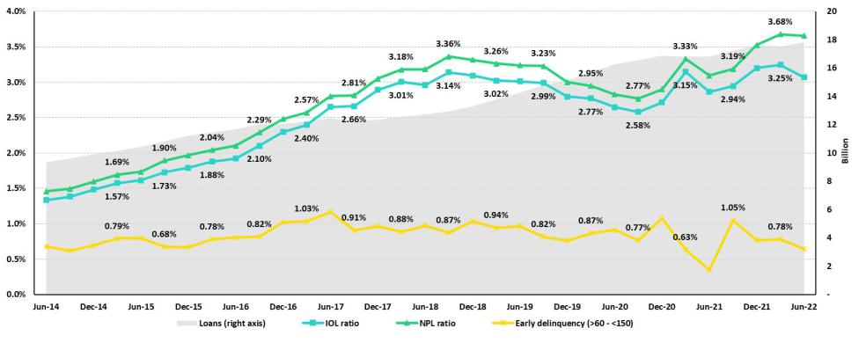

Consumer
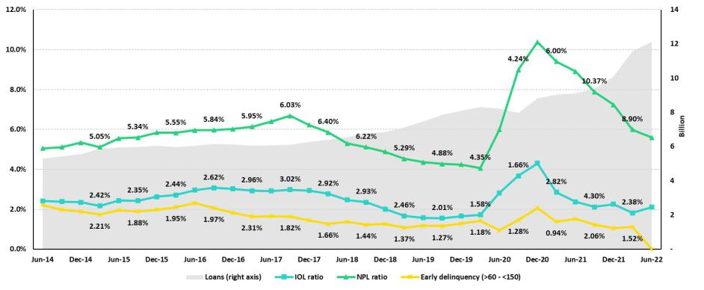

47

Earnings Release 2Q / 2022 Analysis of 2Q22 Consolidated Results

12. Appendix

Credit Card
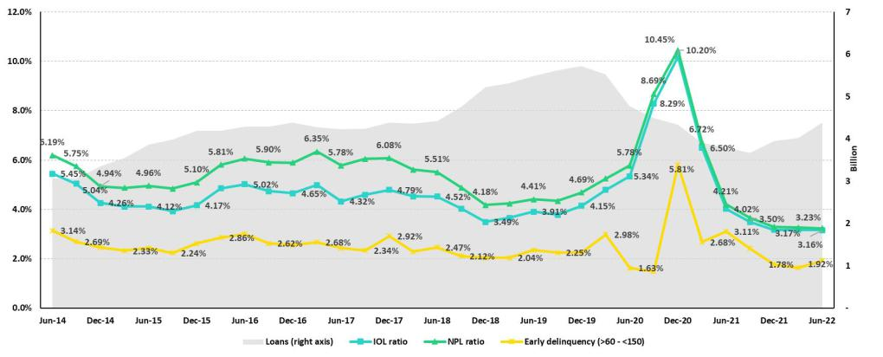

Mibanco
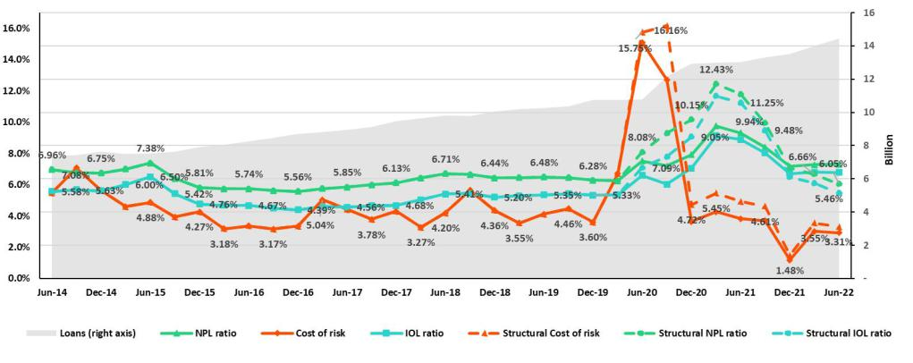

BCP Bolivia
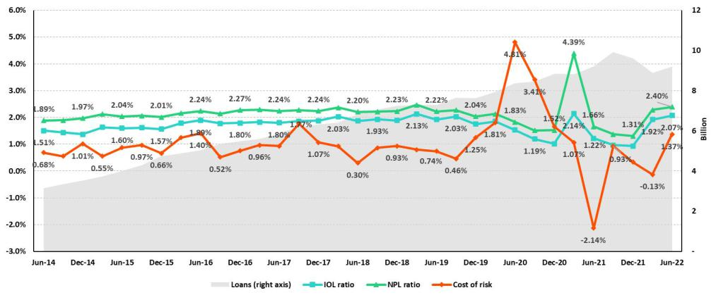

48

Earnings Release 2Q / 2022 Analysis of 2Q22 Consolidated Results

12. Appendix

12.3 Net Interest Income (NII)

NII Summary

 | Net interest income |  | Quarter |  | % change |  | As of |  | % change
 | S/ 000 | 2Q21 | 1Q22 | 2Q22 | QoQ | YoY | Jun 21 | Jun 22 | Jun 22 / Jun 21
 | Interest income | 2,891,579 | 3,172,346 | 3,488,113 | 10.0% | 20.6% | 5,707,652 | 6,660,459 | 16.7%
 | Interest on loans | 2,476,187 | 2,685,552 | 2,929,782 | 9.1% | 18.3% | 4,908,948 | 5,615,334 | 14.4%
 | Dividends on investments | 11,536 | 4,320 | 13,682 | 216.7% | 18.6% | 14,757 | 18,002 | 22.0%
 | Interest on deposits with banks | 6,076 | 35,351 | 47,785 | 35.2% | 686.5% | 13,972 | 83,135 | 495.0%
 | Interest on securities | 382,140 | 428,456 | 482,872 | 12.7% | 26.4% | 745,104 | 911,328 | 22.3%
 | Other interest income | 15,640 | 18,667 | 13,992 | -25.0% | -10.5% | 24,871 | 32,660 | 31.3%
 | Interest expense | 582,537 | 638,256 | 747,673 | 17.1% | 28.3% | 1,275,227 | 1,385,929 | 8.7%
 | Interest on deposits | 210,275 | 258,939 | 336,953 | 30.1% | 60.2% | 432,918 | 595,892 | 37.6%
 | Interest on borrowed funds | 101,265 | 116,231 | 141,530 | 21.8% | 39.8% | 213,493 | 257,762 | 20.7%
 | Interest on bonds and subordinated notes | 178,664 | 165,496 | 168,366 | 1.7% | -5.8% | 445,635 | 333,861 | -25.1%
 | Other interest expense | 92,333 | 97,590 | 100,824 | 3.3% | 9.2% | 183,181 | 198,414 | 8.3%
 | Net interest income | 2,309,042 | 2,534,090 | 2,740,440 | 8.1% | 18.7% | 4,432,425 | 5,274,530 | 19.0%
 | Adjusted Net interest income ⁽²⁾ | 2,346,170 | 2,522,080 | 2,740,440 | 8.7% | 16.8% | 4,540,699 | 5,362,530 | 18.1%
 | Risk-adjusted Net interest income | 1,945,662 | 2,276,500 | 2,377,149 | 4.4% | 22.2% | 3,511,398 | 4,653,649 | 32.5%
 | Average interest earning assets | 230,237,853 | 228,195,289 | 223,529,737 | -2.0% | -2.9% | 227,052,978 | 227,021,380 | 0.0%
 | Net interest margin ⁽¹⁾ | 4.01% | 4.44% | 4.90% | 46bps | 89bps | 3.90% | 4.65% | 75bps
 | Risk-adjusted Net interest margin ⁽¹⁾ | 3.38% | 3.99% | 4.25% | 26bps | 87bps | 3.09% | 4.10% | 101bps
 | Net provisions for loan losses / Net interest income | 15.74% | 10.16% | 13.26% | 3.1% | -2.5% | 20.78% | 11.77% | -9.01%
 | 13) Annualized.

Net Interest Margin (NIM) and Risk Adjusted NIM by subsidiary

NIM Breakdown | BCP Stand- | Mibanco | BCP Bolivia | Credicorp
NIM Breakdown | alone | Mibanco | BCP Bolivia | Credicorp
2Q21 | 3.43% | 11.88% | 2.83% | 4.01%
1Q22 | 3.85% | 12.71% | 2.76% | 4.44%
2Q22 | 4.29% | 12.95% | 2.88% | 4.90%

NIM: Annualized Net interest income / Average period end and period beginning interest earning assets.

Risk Adjusted NIM Breakdown | BCP Stand- | Mibanco | BCP Bolivia | Credicorp
Risk Adjusted NIM Breakdown | alone | Mibanco | BCP Bolivia | Credicorp
2Q21 | 2.81% | 8.66% | 4.57% | 3.38%
1Q22 | 3.52% | 10.10% | 2.86% | 3.99%
2Q22 | 3.79% | 10.41% | 1.77% | 4.25%

Risk-Adjusted NIM: (Annualized Net interest income - annualized provisions) / Average period end and period beginning interest earning assets.

49

Earnings Release 2Q / 2022 Analysis of 2Q22 Consolidated Results

12. Appendix

12.4. Regulatory Capital

Regulatory Capital and Capital Adequary Ratios

(S/ thousands, IFRS)

 |  | As of |  | % Change
 | Jun 21 | Mar 22 | Jun 22 | QoQ | YoY
Capital Stock | 1,318,993 | 1,318,993 | 1,318,993 | 0.0% | 0.0%
Treasury Stocks | (207,756) | (207,700) | (207,518) | -0.1% | -0.1%
Capital Surplus | 224,103 | 227,361 | 231,179 | 1.7% | 3.2%
Legal and Other capital reserves ⁽¹⁾ | 21,725,663 | 21,292,614 | 23,666,823 | 11.2% | 8.9%
Minority interest ⁽²⁾ | 429,448 | 493,113 | 490,576 | -0.5% | 14.2%
Loan loss reserves ⁽³⁾ | 1,913,045 | 1,971,343 | 2,074,630 | 5.2% | 8.4%
Perpetual subordinated debt | - | - | - | - | -
Subordinated Debt | 5,979,619 | 5,695,192 | 5,863,208 | 3.0% | -1.9%
Investments in equity and subordinated debt of financial and insurance companies | (717,711) | (727,620) | (829,315) | 14.0% | 15.6%
Goodwill | (813,492) | (809,980) | (802,622) | -0.9% | -1.3%
Current year Net Loss | - | - | - | - | -
Deduction for subordinated debt limit (50% of Tier I excluding deductions) ⁽⁴⁾ | - | - | - | - | -
Deduction for Tier I Limit (50% of Regulatory capital) ⁽⁴⁾ | - | - | - | - | -
Regulatory Capital (A) | 29,851,912 | 29,253,316 | 31,805,954 | 8.7% | 6.5%
Tier 1 ⁽⁵⁾ | 15,337,348 | 15,402,884 | 16,973,919 | 10.2% | 10.7%
Tier 2 ⁽⁶⁾ + Tier 3 ⁽⁷⁾ | 14,514,564 | 13,850,433 | 14,832,035 | 7.1% | 2.2%
Financial Consolidated Group (FCG) Regulatory Capital Requirements ⁽⁸⁾ | 17,894,230 | 18,372,067 | 19,270,916 | 4.9% | 7.7%
Insurance Consolidated Group (ICG) Capital Requirements ⁽⁹⁾ | 1,325,595 | 1,450,871 | 1,512,297 | 4.2% | 14.1%
FCG Capital Requirements related to operations with ICG | (471,394) | (446,149) | (449,113) | 0.7% | -4.7%
ICG Capital Requirements related to operations with FCG | - | - | - | - | -
Regulatory Capital Requirements (B) | 18,748,432 | 19,376,789 | 20,334,099 | 4.9% | 8.5%
Regulatory Capital Ratio (A) / (B) | 1.59 | 1.51 | 1.56
Required Regulatory Capital Ratio ⁽¹⁰⁾ | 1.00 | 1.00 | 1.00

- Legal and other capital reserves include restricted capital reserves (PEN 14,745 million) and optional capital reserves (PEN 6,661 million).

- Minority interest includes Tier I (PEN 421 million)
- Up to 1.25% of total risk-weighted assets of Banco de Credito del Peru, Solucion Empresa Administradora Hipotecaria, Mibanco and ASB Bank Corp.
- Tier II + Tier III can not be more than 50% of total regulatory capital.
- Tier I = capital + restricted capital reserves + Tier I minority interest - goodwill - (0.5 x investment in equity and subordinated debt of financial and insurance companies)+ perpetual subordinated debt.
- Tier II = subordinated debt + TierII minority interest tier + loan loss reserves - (0.5 x investment in equity and subordinated debt of financial and insurance companies).
- Tier III = Subordinated debt covering market risk only.
- Includes regulatory capital requirements of the financial consolidated group.
- Includes regulatory capital requirements of the insurance consolidated group.
- Regulatory Capital / Total Regulatory Capital Requirements (legal minimum = 1.00).

50

Earnings Release 2Q / 2022 Analysis of 2Q22 Consolidated Results

12. Appendix

Regulatory and Capital Adecuacy Ratios at BCP Stand-alone

(In S/ thousands)

Regulatory Capital and Capital Adequacy Ratios - SBS |  | As of |  | % change
S/ 000 | Jun 21 | Mar 22 | Jun 22 | QoQ | YoY
Capital Stock | 11,317,387 | 12,176,365 | 12,176,365 | 0.0% | 7.6%
Legal and Other capital reserves | 6,707,831 | 7,516,510 | 7,516,897 | 0.0% | 12.1%
Accumulated earnings with capitalization agreement | - | - | - | n.a. | n.a.
Loan loss reserves (1) | 1,676,768 | 1,707,458 | 1,797,358 | 5.3% | 7.2%
Perpetual subordinated debt | - | - | - | n.a. | n.a.
Subordinated Debt | 5,223,300 | 5,007,300 | 5,163,750 | 3.1% | -1.1%
Investment in subsidiaries and others, net of unrealized profit and net income | (2,263,859) | (2,432,571) | (2,436,525) | 0.2% | 7.6%
Investment in subsidiaries and others | (2,326,241) | (2,535,289) | (2,674,646) | 5.5% | 15.0%
Unrealized profit and net income in subsidiaries | 62,381 | 102,718 | 238,121 | 131.8% | n.a.
Goodwill | (122,083) | (122,083) | (122,083) | 0.0% | 0.0%
Total Regulatory Capital - SBS | 22,539,343 | 23,852,979 | 24,095,761 | 1.0% | 6.9%
Off-balance sheet | 96,842,778 | 87,775,815 | 91,019,217 | 3.7% | -6.0%
Regulatory Tier 1 Capital (2) | 15,142,961 | 16,220,724 | 16,219,133 | 0.0% | 7.1%
Regulatory Tier 2 Capital (3) | 7,396,382 | 7,632,256 | 7,876,628 | 3.2% | 6.5%
Total risk-weighted assets - SBS (4) | 146,936,014 | 151,045,319 | 158,176,424 | 4.7% | 7.6%
Credit risk-weighted assets | 132,013,903 | 135,397,192 | 142,632,376 | 5.3% | 8.0%
Market risk-weighted assets (5) | 3,127,460 | 2,231,891 | 1,868,921 | -16.3% | -40.2%
Operational risk-weighted assets | 11,794,652 | 13,416,236 | 13,675,127 | 1.9% | 15.9%
Total capital requirement - SBS | 13,925,638 | 14,355,691 | 15,023,680 | 4.7% | 7.9%
Credit risk capital requirement | 10,561,112 | 10,831,775 | 11,410,590 | 5.3% | 8.0%
Market risk capital requirement | 312,746 | 223,189 | 186,892 | -16.3% | -40.2%
Operational risk capital requirement | 1,179,465 | 1,341,624 | 1,367,513 | 1.9% | 15.9%
Additional capital requirements | 1,872,315 | 1,959,102 | 2,058,686 | 5.1% | 10.0%
Common Equity Tier 1 - Basel IFRS (6) | 15,557,626 | 16,477,382 | 17,160,382 | 4.1% | 10.3%
Capital and reserves | 17,512,975 | 19,180,633 | 19,181,019 | 0.0% | 9.5%
Retained earnings | 1,522,687 | 1,740,668 | 2,897,372 | 66.5% | 90.3%
Unrealized gains (losses) | (123,542) | (780,063) | (1,089,747) | 39.7% | n.a
Goodwill and intangibles | (1,230,017) | (1,266,218) | (1,312,578) | 3.7% | 6.7%
Investments in subsidiaries | (2,124,477) | (2,397,638) | (2,515,685) | 4.9% | 18.4%
Risk-Weighted Assets - Basel IFRS (7) | 138,825,472 | 141,697,998 | 148,378,629 | 4.7% | 6.9%
Total risk-weighted assets | 146,936,014 | 151,045,319 | 158,176,424 | 4.7% | 7.6%
(-) RWA Intangible assets, excluding goodwill. | 10,013,815 | 10,798,886 | 11,347,690 | 5.1% | 13.3%
(+) RWA Deferred tax assets generated as a result of temporary differences in | 1,383,156 | 882,435 | 904,457 | 2.5% | -34.6%
income tax, in excess of 10% of CET1
(+) RWA Deferred tax assets generated as a result of past losses | - | - | - | n.a. | n.a.
(+) IFRS Adjustments (11) | 520,116 | 569,130 | 645,439 | 13.4% | 24.1%
Capital ratios
Regulatory Tier 1 ratio (8) | 10.31% | 10.74% | 10.25% | -49 bps | -6 bps
Common Equity Tier 1 ratio (9)(12) | 11.21% | 11.63% | 11.57% | -6 bps | 36 bps
Regulatory Global Capital ratio (10) | 15.34% | 15.79% | 15.23% | -56 bps | -11 bps
Risk-weighted assets / Regulatory capital | 6.52 | 6.33 | 6.56 | 3.7% | 0.7%

- Up to 1.25% of total risk-weighted assets.

- Regulatory Tier 1 Capital = Capital + Legal and other capital reserves + Accumulated earnings with capitalization agreement + (0.5 x Unrealized profit and net income in subsidiaries) - Goodwill - (0.5 x Investment in subsidiaries) + Perpetual subordinated debt (maximum amount that can be included is 17.65% of Capital + Reserves + Accumulated earnings with capitalization agreement + Unrealized profit and net income in subsidiaries - Goodwill).
- Regulatory Tier 2 Capital = Subordinated debt + Loan loss reserves + Unrestricted Reserves + (0.5 x Unrealized profit and net income in subsidiaries) - (0.5 x Investment in subsidiaries).
- Since July 2012, Total Risk-weighted assets = Credit risk-weighted assets * 1.00 + Capital requirement to cover market risk * 10 + Capital requirement to cover operational risk * 10 * 1.00 (since July 2014)
- It includes capital requirement to cover price and rate risk.
- Common Equity Tier I = Capital + Reserves – 100% of applicable deductions (investment in subsidiaries, goodwill, intangibles and net deferred taxes that rely on future profitability) + retained earnings + unrealized gains. Figures differ from previously reported cause current calculations are based on IFRS figures.
- Adjusted Risk-Weighted Assets = Risk-weighted assets - (RWA Intangible assets, excluding goodwill, + RWA Deferred tax assets generated as a result of temporary differences in income tax, in excess of 10% of CET1, + RWA Deferred tax assets generated as a result of past losses). Figures differ from previously reported cause current calculations are based on IFRS figures.
- Regulatory Tier 1 Capital / Total Risk-weighted assets
- Common Equity Tier I / Adjusted Risk-Weighted Assets Risk-Weighted Assets
- Total Regulatory Capital / Total Risk-weighted assets (legal minimum = 10% since July 2011)
- Adjustments for differences in balance assets under Local Accounting (which regulatory Rwas are calculated) and IFRS in the Right of use account (lease). As of March 2022, the 'Right of Use' account increased to S/ 364M, explained the 64% of the adjustment. The rest adjustments correspond to differences in stock of provisions and Deferred Taxes.
- Common Equity Tier I calculated based on IFRS Accounting

51

Earnings Release 2Q / 2022 Analysis of 2Q22 Consolidated Results

12. Appendix

Regulatory Capital and Capital Adequacy Ratios at Mibanco

(S/ thousands)

 |  | As of |  | % change
 | Jun 21 | Mar 22 | Jun 22 | QoQ | YoY
Capital Stock | 1,714,577 | 1,840,606 | 1,840,606 | 0.0% | 7.4%
Legal and Other capital reserves | 246,305 | 264,221 | 264,221 | 0.0% | 7.3%
Accumulated earnings with capitalization agreement | 46,524 | - | - | n.a. | -100.0%
Loan loss reserves ⁽¹⁾ | 138,555 | 163,711 | 171,843 | 5.0% | 24.0%
Perpetual subordinated debt |  |  |  | n.a. | n.a.
Subordinated Debt | 185,000 | 185,000 | 179,000 | -3.2% | -3.2%
Investment in subsidiaries and others, net of unrealized profit and net | - | - | - | n.a. | n.a.
income
Investment in subsidiaries and others | - | - | - | n.a. | n.a.
Unrealized profit and net income in subsidiaries | - | - | - | n.a. | n.a.
Goodwill | (139,180) | (139,180) | (139,180) | 0.0% | 0.0%
Accumulated Losses | - | - | - | n.a. | n.a.
Total Regulatory Capital - SBS | 2,191,781 | 2,314,357 | 2,316,490 | 0.1% | 5.7%
Regulatory Tier 1 Capital ⁽²⁾ | 1,865,495 | 1,962,906 | 1,962,906 | 0.0% | 5.2%
Regulatory Tier 2 Capital ⁽³⁾ | 326,287 | 351,451 | 353,583 | 0.6% | 8.4%
Total risk-weighted assets - SBS ⁽⁴⁾ | 12,703,309 | 14,825,319 | 15,638,132 | 5.5% | 23.1%
Credit risk-weighted assets | 10,662,694 | 12,747,979 | 13,605,110 | 6.7% | 27.6%
Market risk-weighted assets ⁽⁵⁾ | 170,320 | 177,097 | 105,570 | -40.4% | -38.0%
Operational risk-weighted assets | 1,870,294 | 1,900,243 | 1,927,452 | 1.4% | 3.1%
Total capital requirement | 1,384,066 | 1,618,510 | 1,708,934 | 5.6% | 23.5%
Credit risk capital requirement | 1,066,269 | 1,274,798 | 1,360,511 | 6.7% | 27.6%
Market risk-weighted assets | 17,032 | 17,710 | 10,557 | -40.4% | -38.0%
Operational risk capital requirement | 187,029 | 190,024 | 192,745 | 1.4% | 3.1%
Additional capital requirements | 113,735 | 135,978 | 145,121 | 6.7% | 27.6%
Common Equity Tier 1 - Basel IFRS ⁽⁶⁾ | 1,827,004 | 2,133,203 | 2,254,712 | 5.7% | 23.4%
Capital and reserves | 2,489,011 | 2,632,956 | 2,632,956 | 0.0% | 5.8%
Retained earnings | (316,452) | (160,683) | (32,701) | 79.6% | 89.7%
Unrealized gains (losses) | 697 | (8,191) | (13,045) | 59.3% | n.a.
Goodwill and intangibles | (321,948) | (330,879) | (332,498) | 0.5% | 3.3%
Excess DT of 10% CET1 Basilea | (24,304) | - | - | n.a. | n.a.
Adjusted Risk-Weighted Assets - Basel IFRS ⁽⁷⁾ | 12,052,925 | 14,022,901 | 14,787,085 | 5.4% | 22.7%
Total risk-weighted assets | 12,703,309 | 14,825,319 | 15,638,132 | 5.5% | 23.1%
(-) RWA Intangible assets, excluding goodwill. | 836,447 | 1,166,501 | 1,199,443 | 2.8% | 43.4%
(+) RWA Deferred tax assets generated as a result of temporary | 232,440 | 161,572 | 175,275 | 8.5% | -24.6%
differences in income tax, in excess of 10% of CET1
(+) IFRS Adjustments | 269,854 | 168,871 | 151,442 | -10.3% | -43.9%
(+) RWA for Market Risk difference (exchange risk) for temporary | 25,202 | 33,640 | 21,679 | -35.6% | -14.0%
difference
(-) RWA assets that exceed 10% of CET1 SBS | 352,031 | - | - | n.a. | -100.0%
(-) RWA difference between excees SBS and Basel methodology | (10,598) | - | - | n.a. | -100.0%
(-) RWA adjustment for state coverage, originated by temporary | - | - | - | N/A | -
difference
(+) RWA Deferred tax assets generated as a result of past losses | - | - | - | N/A | -
Capital ratios
Regulatory Tier 1 ratio ⁽⁸⁾ | 14.69% | 13.24% | 12.55% | -69 bps | -214 bps
Common Equity Tier 1 ratio ⁽⁹⁾⁽¹¹⁾ | 15.16% | 15.21% | 15.25% | 4 bps | 9 bps
Regulatory Global Capital ratio ⁽¹⁰⁾ | 17.25% | 15.61% | 14.81% | -80 bps | -244 bps
Risk-weighted assets / Regulatory capital | 5.80 | 6.41 | 6.75 | 5.4% | 16.5%

- Up to 1.25% of total risk-weighted assets.

- Regulatory Tier 1 Capital = Capital + Legal and other capital reserves + Accumulated earnings with capitalization agreement + (0.5 x Unrealized profit and net income in subsidiaries) - Goodwill - (0.5 x Investment in subsidiaries) + Perpetual subordinated debt (maximum amount that can be included is 17.65% of Capital + Reserves + Accumulated earnings with capitalization agreement + Unrealized profit and net income in subsidiaries - Goodwill).
- Regulatory Tier 2 Capital = Subordinated debt + Loan loss reserves + Unrestricted Reserves + (0.5 x Unrealized profit and net income in subsidiaries) - (0.5 x Investment in subsidiaries).
- Since July 2012, Total Risk-weighted assets = Credit risk-weighted assets * 1.00 + Capital requirement to cover market risk * 10 + Capital requirement to cover operational risk * 10 * 1.00 (since July 2014)
- It includes capital requirement to cover price and rate risk.
- Common Equity Tier I = Capital + Reserves – 100% of applicable deductions (investment in subsidiaries, goodwill, intangibles and net deferred taxes that rely on future profitability) + retained earnings + unrealized gains.
- Adjusted Risk-Weighted Assets = Risk-weighted assets - (RWA Intangible assets, excluding goodwill, + RWA Deferred tax assets generated as a result of temporary differences in income tax, in excess of 10% of CET1, + RWA Deferred tax assets generated as a result of past losses). Figures differ from previously reported cause current calculations are based on IFRS figures.
- Regulatory Tier 1 Capital / Total Risk-weighted assets
- Common Equity Tier I / Adjusted Risk-Weighted Assets Risk-Weighted Assets
- Total Regulatory Capital / Total Risk-weighted assets (legal minimum = 10% since July 2011)
- Common Equity Tier I calculated based on IFRS Accounting

52

Earnings Release 2Q / 2022 Analysis of 2Q22 Consolidated Results

12. Appendix

12.5. Financial Statements and Ratios by Business

12.5.1. Credicorp Consolidated

CREDICORP LTD. AND SUBSIDIARIES

CONSOLIDATED STATEMENT OF FINANCIAL POSITION

(In S/ thousands, IFRS)

 |  | As of |  | % change
 | Jun 21 | Mar 22 | Jun 22 | QoQ | YoY
ASSETS
Cash and due from banks
Non-interest bearing | 8,883,164 | 6,748,517 | 7,017,129 | 4.0% | -21.0%
Interest bearing | 29,075,474 | 29,563,512 | 23,831,465 | -19.4% | -18.0%
Total cash and due from banks | 37,958,638 | 36,312,029 | 30,848,594 | -15.0% | -18.7%
Cash collateral, reverse repurchase agreements and securities borrowing | 1,616,654 | 1,516,855 | 2,046,209 | 34.9% | 26.6%
Fair value through profit or loss investments | 6,791,288 | 4,628,870 | 4,187,000 | -9.6% | -38.4%
Fair value through other comprehensive income investments | 40,273,400 | 35,452,509 | 32,955,721 | -7.0% | -18.2%
Amortized cost investments | 7,707,956 | 8,064,050 | 8,200,054 | 1.7% | 6.4%
Loans | 143,091,752 | 144,621,513 | 150,370,184 | 4.0% | 5.1%
Current | 138,037,399 | 138,748,514 | 144,264,928 | 4.0% | 4.5%
Internal overdue loans | 5,054,353 | 5,872,999 | 6,105,256 | 4.0% | 20.8%
Less - allowance for loan losses | (9,391,151) | (8,262,383) | (8,306,500) | 0.5% | -11.5%
Loans, net | 133,700,601 | 136,359,130 | 142,063,684 | 4.2% | 6.3%
Financial assets designated at fair value through profit or loss | 921,851 | 856,337 | 765,195 | -10.6% | -17.0%
Accounts receivable from reinsurers and coinsurers | 1,043,042 | 1,166,096 | 1,105,527 | -5.2% | 6.0%
Premiums and other policyholder receivables | 780,824 | 873,505 | 816,076 | -6.6% | 4.5%
Property, plant and equipment, net | 1,944,127 | 1,864,825 | 1,837,436 | -1.5% | -5.5%
Due from customers on acceptances | 558,934 | 524,448 | 743,925 | 41.8% | 33.1%
Investments in associates | 627,683 | 629,009 | 636,217 | 1.1% | 1.4%
Intangible assets and goodwill, net | 2,647,676 | 2,703,238 | 2,729,593 | 1.0% | 3.1%
Other assets ⁽¹⁾ | 8,455,556 | 6,949,490 | 7,645,232 | 10.0% | -9.6%
Total Assets | 245,028,230 | 237,900,391 | 236,580,463 | -0.6% | -3.4%
LIABILITIES AND EQUITY
Deposits and obligations
Non-interest bearing | 52,879,988 | 50,939,859 | 46,043,988 | -9.6% | -12.9%
Interest bearing | 96,281,815 | 96,976,105 | 101,396,587 | 4.6% | 5.3%
Total deposits and obligations | 149,161,803 | 147,915,964 | 147,440,575 | -0.3% | -1.2%
Payables from repurchase agreements and securities lending | 25,963,227 | 19,388,995 | 18,138,863 | -6.4% | -30.1%
BCRP instruments | 23,329,990 | 17,532,350 | 16,031,618 | -8.6% | -31.3%
Repurchase agreements with third parties | 1,276,678 | 1,218,028 | 1,340,423 | 10.0% | 5.0%
Repurchase agreements with customers | 1,356,559 | 638,617 | 766,822 | 20.1% | -43.5%
Due to banks and correspondents | 6,239,161 | 6,362,990 | 6,456,360 | 1.5% | 3.5%
Bonds and notes issued | 16,951,481 | 16,044,671 | 16,579,674 | 3.3% | -2.2%
Banker’s acceptances outstanding | 558,934 | 524,448 | 743,925 | 41.8% | 33.1%
Reserves for property and casualty claims | 2,492,303 | 2,475,580 | 2,551,089 | 3.1% | 2.4%
Reserve for unearned premiums | 9,664,914 | 9,482,582 | 9,150,249 | -3.5% | -5.3%
Accounts payable to reinsurers | 317,185 | 414,506 | 343,959 | -17.0% | 8.4%
Financial liabilities at fair value through profit or loss | 313,256 | 232,185 | 527,541 | 127.2% | 68.4%
Other liabilities | 7,789,038 | 7,656,939 | 7,927,550 | 3.5% | 1.8%
Total Liabilities | 219,451,302 | 210,498,860 | 209,894,043 | -0.3% | -4.4%
Net equity | 25,073,706 | 25,192,569 | 26,175,222 | -2.6% | 4.4%
Capital stock | 1,318,993 | 1,318,993 | 1,318,993 | 0.0% | 0.0%
Treasury stock | (207,756) | (207,745) | (207,518) | -0.1% | -0.1%
Capital surplus | 224,103 | 215,071 | 231,179 | 1.7% | 3.2%
Reserves | 21,725,663 | 21,350,150 | 23,666,823 | 11.2% | 8.9%
Unrealized gains and losses | 677,159 | 19,435 | (1,098,325) | 144.4% | -262.2%
Retained earnings | 347,152 | 2,496,665 | 3,556,281 | -51.7% | 69.5%
Non-controlling interest | 503,222 | 528,905 | 545,456 | 3.1% | 8.4%
Total Net Equity | 25,576,928 | 27,401,531 | 26,720,678 | -2.5% | 4.5%
Total liabilities and equity | 245,028,230 | 237,900,391 | 236,614,721 | -0.5% | -3.4%
Off-balance sheet | 149,828,527 | 142,337,944 | 142,573,498 | 0.2% | -4.8%
Total performance bonds, stand-by and L/Cs. | 22,723,385 | 21,196,817 | 21,331,467 | 0.6% | -6.1%
Undrawn credit lines, advised but not committed | 91,280,633 | 80,155,277 | 84,820,503 | 5.8% | -7.1%
Total derivatives (notional) and others | 35,824,509 | 40,985,850 | 36,421,528 | -11.1% | 1.7%

(1) Includes mainly accounts receivables from brokerage and others.

53

Earnings Release 2Q / 2022 Analysis of 2Q22 Consolidated Results

12. Appendix

CREDICORP LTD. AND SUBSIDIARIES

CONSOLIDATED STATEMENT OF INCOME

(In S/ thousands, IFRS)

 |  | Quarter |  | % change |  | As of |  | % change
 | 2Q21 | 1Q22 | 2Q22 | QoQ | YoY | Jun-21 | Jun-22 | Jun-21/ Jun-22
Interest income and expense
Interest and dividend income | 2,891,579 | 3,172,346 | 3,488,113 | 10.0% | 20.6% | 5,707,652 | 6,660,459 | 16.7%
Interest expense ⁽¹⁾ | (582,537) | (638,256) | (747,673) | 17.1% | 28.3% | (1,275,227) | (1,385,929) | 8.7%
Net interest income | 2,309,042 | 2,534,090 | 2,740,440 | 8.1% | 18.7% | 4,432,425 | 5,274,530 | 19.0%
Gross provision for credit losses on loan portfolio | (441,007) | (350,681) | (447,036) | 27.5% | 1.4% | (1,063,989) | (797,717) | -25.0%
Recoveries of written-off loans | 77,627 | 93,091 | 83,745 | -10.0% | 7.9% | 142,962 | 176,836 | 23.7%
Provision for credit losses on loan portfolio, | (363,380) | (257,590) | (363,291) | 41.0% | 0.0%
net of recoveries |  |  |  |  |  | (921,027) | (620,881) | -32.6%
Risk-adjusted net interest income | 1,945,662 | 2,276,500 | 2,377,149 | 4.4% | 22.2% | 3,511,398 | 4,653,649 | 32.5%
Non-financial income
Fee income | 862,411 | 891,031 | 920,492 | 3.3% | 6.7% | 1,693,182 | 1,811,523 | 7.0%
Net gain on foreign exchange transactions | 232,668 | 262,196 | 253,941 | -3.1% | 9.1% | 412,557 | 516,137 | 25.1%
Net gain on sales of securities | (69,947) | (56,866) | (94,180) | n.a. | n.a. | (53,660) | (151,046) | 181.5%
Net gain from associates | 12,302 | 24,014 | 29,219 | 21.7% | 137.5% | 41,707 | 53,233 | 27.6%
Net gain on derivatives held for trading | 45,413 | (138) | 4,784 | -3566.7% | -89.5% | 115,136 | 4,646 | -96.0%
Net gain from exchange differences | 45,924 | (25,390) | 5,572 | n.a. | n.a. | 40,388 | (19,818) | -149.1%
Other non-financial income | 62,923 | 147,902 | 84,152 | -43.1% | 33.7% | 136,914 | 232,054 | 69.5%
Total non-financial income | 1,191,694 | 1,242,749 | 1,203,980 | -3.1% | 1.0% | 2,386,224 | 2,446,729 | 2.5%
Insurance underwriting result
Net earned premiums | 639,944 | 690,536 | 695,547 | 0.7% | 8.7% | 1,283,872 | 1,386,083 | 8.0%
Net claims | (691,335) | (478,506) | (492,258) | 2.9% | -28.8% | (1,314,688) | (970,764) | -26.2%
Acquisition cost ⁽¹⁾ | (84,944) | (70,484) | (66,247) | -6.0% | -22.0% | (170,766) | (136,731) | -19.9%
Total insurance underwriting result | (136,335) | 141,546 | 137,042 | -3.2% | n.a. | (201,582) | 278,588 | -238.2%
Total expenses
Salaries and employee benefits | (882,177) | (977,953) | (975,420) | -0.3% | 10.6% | (1,739,736) | (1,953,373) | 12.3%
Administrative, general and tax expenses | (672,805) | (725,539) | (850,972) | 17.3% | 26.5% | (1,253,647) | (1,576,511) | 25.8%
Depreciation and amortization | (163,869) | (164,514) | (168,845) | 2.6% | 3.0% | (330,634) | (333,359) | 0.8%
Association in participation | (8,879) | (7,691) | (10,329) | 34.3% | 16.3% | (22,785) | (18,020) | -20.9%
Other expenses | (132,717) | (74,485) | (49,244) | -33.9% | -62.9% | (193,916) | (123,729) | -36.2%
Total expenses | (1,860,447) | (1,950,182) | (2,054,810) | 5.4% | 10.4% | (3,540,718) | (4,004,992) | 13.1%
Profit before income tax | 1,140,574 | 1,710,613 | 1,663,361 | -2.8% | 45.8% | 2,155,322 | 3,373,974 | 56.5%
Income tax | (423,491) | (546,001) | (513,181) | -6.0% | 21.2% | (761,090) | (1,059,182) | 39.2%
Net profit | 717,083 | 1,164,612 | 1,150,180 | -1.2% | 60.4% | 1,394,232 | 2,314,792 | 66.0%
Non-controlling interest | 17,614 | 27,786 | 28,420 | 2.3% | 61.3% | 33,965 | 56,206 | 65.5%
Net profit attributable to Credicorp | 699,469 | 1,136,826 | 1,121,760 | -1.3% | 60.4% | 1,360,267 | 2,258,586 | 66.0%

(1) The acquisition cost of Pacifico includes net fees and underwriting expenses.

54

Earnings Release 2Q / 2022 Analysis of 2Q22 Consolidated Results

12. Appendix

12.5.2. Credicorp Stand-alone

Credicorp Ltd.

Separate Statement of Financal Position

(S/ thousands, IFRS)

 |  | As of |  |  | % change
 | Jun 21 | Mar 21 | Jun 22 |  | QoQ | YoY
ASSETS
Cash and cash equivalents | 1,019,773 | 168,634 | 115,612 |  | -31.4% | -88.7%
At fair value through profit or loss | 520,413 | 947,826 | 938,816 |  | -1.0% | n.a
Fair value through other comprehensive income investments | 397,551 | 343,373 | 332,280 |  | -3.2% | -16.4%
In subsidiaries and associates investments | 29,354,310 | 31,647,183 | 31,251,710 |  | -1.2% | 6.5%
Other assets | 345 | 106 | 230 |  | 117.0% | -33.3%
Total Assets | 31,292,392 | 33,107,122 | 32,638,648 |  | -1.4% | 4.3%
LIABILITIES AND NET SHAREHOLDERS' EQUITY
Due to banks, correspondents and other entities | - | - | 240,996 |  | n.a. | n.a.
Bonds and notes issued | 1,914,141 | 1,850,185 | 1,901,462 |  | 2.8% | -0.7%
Other liabilities | 149,936 | 195,286 | 164,451 |  | -15.8% | 9.7%
Total Liabilities | 2,064,077 | 2,045,471 | 2,306,909 |  | 12.8% | 11.8%
NET EQUITY
Capital stock | 1,318,993 | 1,318,993 | 1,318,993 |  | 0.0% | 0.0%
Capital Surplus | 384,542 | 384,542 | 384,542 |  | 0.0% | 0.0%
Reserve | 21,417,403 | 20,945,491 | 23,300,350 |  | 11.2% | 8.8%
Unrealized results | 495,986 | (638,233) | (1,285,376) |  | n.a. | n.a.
Retained earnings | 5,611,391 | 9,050,858 | 6,613,230 |  | -26.9% | 17.9%
Total net equity | 29,228,315 | 31,061,651 | 30,331,739 |  | -2.3% | 3.8%
Total Liabilities And Equity | 31,292,392 | 33,107,122 | 32,638,648 |  | -1.4% | 4.3%
 |  | Quarter |  |  | % change
 | 2Q21 | 1Q22 | 2Q22 |  | QoQ | YoY
Interest income
Net share of the income from investments in subsidiaries and associates | 725,297 | 1,236,032 | 1,425,812 |  | 15.4% | 96.6%
Interest and similar income | 7,062 | 298 | 7,056 |  | 2267.8% | -0.1%
Net gain on financial assets at fair value through profit or loss | 4,898 | (26,898) | (41,316) |  | 53.6% | n.a
Total income | 737,257 | 1,209,432 | 1,391,552 |  | 15.1% | 88.7%
Interest and similar expense | (14,357) | (13,651) | (14,778) |  | 8.3% | n.a
Administrative and general expenses | (3,832) | (4,259) | (3,766) |  | -11.6% | -1.7%
Total expenses | (18,189) | (17,910) | (18,544) |  | 3.5% | 2.0%
Operating income | 719,068 | 1,191,522 | 1,373,008 |  | 15.2% | 90.9%
Net gain (losses) from exchange differences | (15) | (145) | (752) |  | 418.6% | 4913.3%
Other, net | (10) | 232 | (13) |  | -105.6% | 30.0%
Profit before income tax | 719,043 | 1,191,609 | 1,372,243 |  | 15.2% | 90.8%
Income tax | (19,546) | (42,000) | (42,290) |  | 0.7% | n.a
Net income | 699,497 | 1,149,609 | 1,329,953 |  | 15.7% | 90.1%
Double Leverage Ratio | 100.43% | 101.89% | 103.03% |  | 115bps | 260bps
 |  |  |  |  |  | 55

Earnings Release 2Q / 2022 Analysis of 2Q22 Consolidated Results

12. Appendix

12.5.3. BCP Consolidated

BANCO DE CREDITO DEL PERU AND SUBSIDIARIES

CONSOLIDATED STATEMENT OF FINANCIAL POSITION
(In S/ thousands, IFRS)

 |  | As of |  | % change
 | Jun 21 | Mar 22 | Jun 22 | QoQ | YoY
ASSETS
Cash and due from banks
Non-interest bearing | 6,919,815 | 4,959,579 | 5,236,507 | 5.6% | -24.3%
Interest bearing | 26,482,164 | 28,253,501 | 22,383,291 | -20.8% | -15.5%
Total cash and due from banks | 33,401,979 | 33,213,080 | 27,619,798 | -16.8% | -17.3%
Cash collateral, reverse repurchase agreements and securities borrowing | 544,937 | 202,127 | 542,521 | 168.4% | -0.4%
Fair value through profit or loss investments | 2,118,559 | 729,168 | 163,187 | -77.6% | -92.3%
Fair value through other comprehensive income investments | 25,716,257 | 20,202,882 | 17,868,118 | -11.6% | -30.5%
Amortized cost investments | 7,366,267 | 7,538,562 | 7,630,677 | 1.2% | 3.6%
Loans | 130,864,182 | 132,578,949 | 138,012,365 | 4.1% | 5.5%
Current | 126,045,797 | 126,930,472 | 132,146,911 | 4.1% | 4.8%
Internal overdue loans | 4,818,385 | 5,648,477 | 5,865,454 | 3.8% | 21.7%
Less - allowance for loan losses | (8,797,871) | (7,769,920) | (7,813,526) | 0.6% | -11.2%
Loans, net | 122,066,311 | 124,809,029 | 130,198,839 | 4.3% | 6.7%
Property, furniture and equipment, net ⁽¹⁾ | 1,729,286 | 1,628,645 | 1,593,758 | -2.1% | -7.8%
Due from customers on acceptances | 532,584 | 532,404 | 524,448 | -1.5% | -1.5%
Investments in associates | 18,901 | 31,859 | 26,411 | -17.1% | 39.7%
Other assets ⁽²⁾ | 6,455,086 | 6,321,863 | 6,100,840 | -3.5% | -5.5%
Total Assets | 200,246,075 | 194,945,753 | 193,370,326 | -0.8% | -3.4%
Liabilities and Equity
Deposits and obligations
Non-interest bearing ⁽¹⁾ | 45,881,848 | 45,297,294 | 40,994,205 | -9.5% | -10.7%
Interest bearing ⁽¹⁾ | 86,547,213 | 85,125,304 | 88,145,130 | 3.5% | 1.8%
Total deposits and obligations | 132,429,061 | 130,422,598 | 129,139,335 | -1.0% | -2.5%
Payables from repurchase agreements and securities lending | 23,879,115 | 18,064,487 | 16,578,846 | -8.2% | -30.6%
BCRP instruments | 23,329,990 | 17,532,350 | 16,031,618 | -8.6% | -31.3%
Repurchase agreements with third parties | 549,125 | 532,137 | 547,228 | 2.8% | -0.3%
Due to banks and correspondents | 5,636,702 | 5,872,463 | 5,963,573 | 1.6% | 5.8%
Bonds and notes issued | 14,368,316 | 13,575,977 | 14,093,426 | 3.8% | -1.9%
Banker’s acceptances outstanding | 558,934 | 524,448 | 743,925 | 41.8% | 33.1%
Financial liabilities at fair value through profit or loss | 84,071 | - | 210,393 | 0.0% | 150.3%
Other liabilities ⁽³⁾ | 4,261,450 | 6,211,275 | 5,512,852 | -11.2% | 29.4%
Total Liabilities | 181,217,649 | 174,671,248 | 172,242,350 | -1.4% | -5.0%
Net equity | 18,908,512 | 20,140,022 | 20,987,313 | 4.2% | 11.0%
Capital stock | 11,024,006 | 11,882,984 | 11,882,984 | 0.0% | 7.8%
Reserves | 6,488,969 | 7,297,648 | 7,298,035 | 0.0% | 12.5%
Unrealized gains and losses | (123,542) | (780,063) | (1,089,747) | n.a. | n.a.
Retained earnings | 1,519,079 | 1,739,453 | 2,896,041 | 66.5% | 90.6%
Non-controlling interest | 119,914 | 134,483 | 140,663 | 4.6% | 17.3%
Total Net Equity | 19,028,426 | 20,274,505 | 21,127,976 | 4.2% | 11.0%
Total liabilities and equity | 200,246,075 | 194,945,753 | 193,370,326 | -0.8% | -3.4%
Off-balance sheet | 131,540,506 | 131,406,579 | 130,782,706 | -0.5% | -0.6%
Total performance bonds, stand-by and L/Cs. | 21,228,772 | 19,638,213 | 19,490,337 | -0.8% | -8.2%
Undrawn credit lines, advised but not committed | 75,964,511 | 70,893,784 | 74,845,631 | 5.6% | -1.5%
Total derivatives (notional) and others | 34,347,223 | 40,874,582 | 36,446,738 | -10.8% | 6.1%

- Right of use asset of lease contracts is included by application of IFRS 16.

- Mainly includes intangible assets, other receivable accounts and tax credit.
- Mainly includes other payable accounts.

56

Earnings Release 2Q / 2022 Analysis of 2Q22 Consolidated Results

12. Appendix

BANCO DE CREDITO DEL PERU AND SUBSIDIARIES

CONSOLIDATED STATEMENT OF INCOME
(In S/ thousands, IFRS)

 |  | Quarter |  | % change |  | As of |  | % change
 | 2Q21 | 1Q22 | 2Q22 | QoQ | YoY | Jun 21 | Jun 22 | Jun 22 / Jun 21
Interest income and expense
Interest and dividend income | 2,446,731 | 2,712,960 | 2,988,885 | 10.2% | 22.2% | 4,854,728 | 5,701,845 | 17.4%
Interest expense | (438,943) | (494,035) | (590,599) | 19.5% | 34.6% | (993,951) | (1,084,634) | 9.1%
Net interest income | 2,007,788 | 2,218,925 | 2,398,286 | 8.1% | 19.4% | 3,860,777 | 4,617,211 | 19.6%
Provision for credit losses on loan portfolio | (480,116) | (340,235) | (400,124) | 17.6% | -16.7% | (1,065,373) | (740,359) | -30.5%
Recoveries of written-off loans | 73,023 | 86,428 | 77,244 | -10.6% | 5.8% | 134,119 | 163,672 | 22.0%
Provision for credit losses on loan portfolio, net of | (407,093) | (253,807) | (322,880) | 27.2% | -20.7% | (931,254) | (576,687) | -38.1%
recoveries
Risk-adjusted net interest income | 1,600,695 | 1,965,118 | 2,075,406 | 5.6% | 29.7% | 2,929,523 | 4,040,524 | 37.9%
Non-financial income
Fee income | 648,980 | 731,705 | 753,835 | 3.0% | 16.2% | 1,280,758 | 1,485,540 | 16.0%
Net gain on foreign exchange transactions | 240,553 | 242,504 | 243,566 | 0.4% | 1.3% | 414,018 | 486,070 | 17.4%
Net gain (loss) on securities | (130,474) | (1,898) | (2,611) | 37.6% | -98.0% | (88,362) | (4,509) | -94.9%
Net gain (loss) on derivatives held for trading | 31,844 | (10,978) | (19,037) | 73.4% | -159.8% | 44,164 | (30,015) | -168.0%
Net gain (loss) from exchange differences | 56,816 | (17,051) | 9,043 | -153.0% | -84.1% | 53,995 | (8,008) | -114.8%
Others | 41,734 | 120,328 | 46,354 | -61.5% | 11.1% | 100,126 | 166,682 | 66.5%
Total other income | 889,453 | 1,064,610 | 1,031,150 | -3.1% | 15.9% | 1,804,699 | 2,095,760 | 16.1%
Total expenses
Salaries and employee benefits | (632,636) | (694,339) | (688,691) | -0.8% | 8.9% | (1,235,811) | (1,383,030) | 11.9%
Administrative expenses | (516,669) | (532,560) | (638,366) | 19.9% | 23.6% | (950,386) | (1,170,926) | 23.2%
Depreciation and amortization | (125,592) | (126,426) | (130,253) | 3.0% | 3.7% | (253,170) | (256,679) | 1.4%
Other expenses | (59,093) | (49,556) | (52,035) | 5.0% | -11.9% | (108,269) | (101,591) | -6.2%
Total expenses | (1,333,990) | (1,402,881) | (1,509,345) | 7.6% | 13.1% | (2,547,636) | (2,912,226) | 14.3%
Profit before income tax | 1,156,158 | 1,626,847 | 1,597,211 | -1.8% | 38.1% | 2,186,586 | 3,224,058 | 47.4%
Income tax | (356,194) | (466,694) | (434,823) | -6.8% | 22.1% | (630,992) | (901,517) | 42.9%
Net profit | 799,964 | 1,160,153 | 1,162,388 | 0.2% | 45.3% | 1,555,594 | 2,322,541 | 49.3%
Non-controlling interest | (2,742) | (5,157) | (6,426) | 24.6% | 134.4% | (3,322) | (11,583) | 248.7%
Net profit attributable to BCP Consolidated | 797,222 | 1,154,996 | 1,155,962 | 0.1% | 45.0% | 1,552,272 | 2,310,958 | 48.9%
 |  |  |  |  |  |  |  | 57

Earnings Release 2Q / 2022 Analysis of 2Q22 Consolidated Results

12. Appendix

BANCO DE CREDITO DEL PERU AND SUBSIDIARIES

SELECTED FINANCIAL INDICATORS

 |  | Quarter |  | As of
 | 2Q21 | 1Q22 | 2Q22 | Jun 21 | Jun 22
Profitability
Earnings per share ⁽¹⁾ | 0.065 | 0.095 | 0.095 | 0.127 | 0.190
_{ROAA} (2)(3) | 1.6% | 2.3% | 2.4% | 1.6% | 2.4%
_{ROAE} (2)(3) | 17.2% | 22.7% | 22.5% | 16.7% | 22.5%
Net interest margin ⁽²⁾⁽³⁾ | 4.12% | 4.63% | 5.10% | 4.02% | 4.91%
Risk adjusted NIM ⁽²⁾⁽³⁾ | 3.28% | 4.10% | 4.41% | 3.05% | 4.30%
Funding Cost ⁽²⁾⁽³⁾⁽⁴⁾ | 0.99% | 1.16% | 1.42% | 1.14% | 1.30%
Quality of loan portfolio
IOL ratio | 3.68% | 4.26% | 4.25% | 3.68% | 4.25%
NPL ratio | 5.03% | 5.52% | 5.44% | 5.03% | 5.44%
Coverage of IOLs | 182.6% | 137.6% | 133.2% | 182.6% | 133.2%
Coverage of NPLs | 133.7% | 106.2% | 104.0% | 133.7% | 104.0%
Cost of risk ⁽⁵⁾ | 1.24% | 0.77% | 0.94% | 1.42% | 0.84%
Operating efficiency
Oper. expenses as a percent. of total income - reported ⁽⁶⁾ | 42.7% | 42.8% | 43.0% | 43.1% | 42.9%
Oper. expenses as a percent. of av. tot. assets ⁽²⁾⁽³⁾⁽⁶⁾ | 2.54% | 2.75% | 3.00% | 2.5% | 2.9%
Share Information
N° of outstanding shares (Million) | 12,176 | 12,176 | 12,176 | 12,176 | 12,176

- Shares outstanding of 12,176 million is used for all periods since shares have been issued only for capitalization of profits.

- Ratios are annualized.
- Averages are determined as the average of period-beginning and period-ending balances.
- The funding costs differs from previously reported due to a methodoloy change in the denominator, which no longer includes the following accounts: acceptances outstanding, reserves for property and casualty claims, reserve for unearned premiums, reinsurance payable and other liabilities.
- Cost of risk: Annualized provision for loan losses / Total loans.
- Total income includes net interest income, fee income, net gain on foreign exchange transactions, result on exchange difference and net gain on derivatives. Operating expenses includes Salaries and social benefits, administrative, general and tax expenses and depreciation and amortization.

58

Earnings Release 2Q / 2022 Analysis of 2Q22 Consolidated Results

12. Appendix

BANCO DE CREDITO DEL PERU

STATEMENT OF FINANCIAL POSITION
(S/ thousands, IFRS)

 |  | As of |  | % change
 | Jun 21 | Mar 22 | Jun 22 | QoQ | YoY
ASSETS
Cash and due from banks
Non-interest bearing | 6,919,815 | 4,959,579 | 5,236,507 | 5.6% | -24.3%
Interest bearing | 26,482,164 | 28,253,501 | 22,383,291 | -20.8% | -15.5%
Total cash and due from banks | 33,401,979 | 33,213,080 | 27,619,798 | -16.8% | -17.3%
Cash collateral, reverse repurchase agreements and securities
borrowing | 544,937 | 202,127 | 542,521 | 168.4% | -0.4%
Fair value through profit or loss investments | 2,118,559 | 729,168 | 163,187 | -77.6% | -92.3%
Fair value through other comprehensive income investments | 25,716,257 | 20,202,882 | 17,868,118 | -11.6% | -30.5%
Amortized cost investments | 7,366,267 | 7,538,562 | 7,630,677 | 1.2% | 3.6%
Loans | 130,864,182 | 132,578,949 | 138,012,365 | 4.1% | 5.5%
Current | 126,045,797 | 126,930,472 | 132,146,911 | 4.1% | 4.8%
Internal overdue loans | 4,818,385 | 5,648,477 | 5,865,454 | 3.8% | 21.7%
Less - allowance for loan losses | (8,797,871) | (7,769,920) | (7,813,526) | 0.6% | -11.2%
Loans, net | 122,066,311 | 124,809,029 | 130,198,839 | 4.3% | 6.7%
Property, furniture and equipment, net ⁽¹⁾ | 1,729,286 | 1,628,645 | 1,593,758 | -2.1% | -7.8%
Due from customers on acceptances | 532,584 | 532,404 | 524,448 | -1.5% | -1.5%
Investments in associates | 18,901 | 31,859 | 26,411 | -17.1% | 39.7%
Other assets ⁽²⁾ | 6,455,086 | 6,321,863 | 6,100,840 | -3.5% | -5.5%
Total Assets | 200,246,075 | 194,945,753 | 193,370,326 | -0.8% | -3.4%
Liabilities and Equity
Deposits and obligations
Non-interest bearing ⁽¹⁾ | 45,881,848 | 45,297,294 | 40,994,205 | -9.5% | -10.7%
Interest bearing ⁽¹⁾ | 86,547,213 | 85,125,304 | 88,145,130 | 3.5% | 1.8%
Total deposits and obligations | 132,429,061 | 130,422,598 | 129,139,335 | -1.0% | -2.5%
Payables from repurchase agreements and securities lending | 23,879,115 | 18,064,487 | 16,578,846 | -8.2% | -30.6%
BCRP instruments | 23,329,990 | 17,532,350 | 16,031,618 | -8.6% | -31.3%
Repurchase agreements with third parties | 549,125 | 532,137 | 547,228 | 2.8% | -0.3%
Due to banks and correspondents | 5,636,702 | 5,872,463 | 5,963,573 | 1.6% | 5.8%
Bonds and notes issued | 14,368,316 | 13,575,977 | 14,093,426 | 3.8% | -1.9%
Banker’s acceptances outstanding | 558,934 | 524,448 | 743,925 | 41.8% | 33.1%
Financial liabilities at fair value through profit or loss | 84,071 | - | 210,393 | 0.0% | 150.3%
Other liabilities ⁽³⁾ | 4,261,450 | 6,211,275 | 5,512,852 | -11.2% | 29.4%
Total Liabilities | 181,217,649 | 174,671,248 | 172,242,350 | -1.4% | -5.0%
Net equity | 18,908,512 | 20,140,022 | 20,987,313 | 4.2% | 11.0%
Capital stock | 11,024,006 | 11,882,984 | 11,882,984 | 0.0% | 7.8%
Reserves | 6,488,969 | 7,297,648 | 7,298,035 | 0.0% | 12.5%
Unrealized gains and losses | (123,542) | (780,063) | (1,089,747) | n.a. | n.a.
Retained earnings | 1,519,079 | 1,739,453 | 2,896,041 | 66.5% | 90.6%
Non-controlling interest | 119,914 | 134,483 | 140,663 | 4.6% | 17.3%
Total Net Equity | 19,028,426 | 20,274,505 | 21,127,976 | 4.2% | 11.0%
Total liabilities and equity | 200,246,075 | 194,945,753 | 193,370,326 | -0.8% | -3.4%
Off-balance sheet | 131,540,506 | 131,406,579 | 130,782,706 | -0.5% | -0.6%
Total performance bonds, stand-by and L/Cs. | 21,228,772 | 19,638,213 | 19,490,337 | -0.8% | -8.2%
Undrawn credit lines, advised but not committed | 75,964,511 | 70,893,784 | 74,845,631 | 5.6% | -1.5%
Total derivatives (notional) and others | 34,347,223 | 40,874,582 | 36,446,738 | -10.8% | 6.1%

- Right of use asset of lease contracts is included by application of IFRS 16.

- Mainly includes intangible assets, other receivable accounts and tax credit.
- Mainly includes other payable accounts.

59

Earnings Release 2Q / 2022 Analysis of 2Q22 Consolidated Results

12. Appendix

12.5.4. BCP Stand-alone

BANCO DE CREDITO DEL PERU
STATEMENT OF FINANCIAL POSITION
(S/ thousands, IFRS)

 |  | As of |  | % change
 | Jun 21 | Mar 22 | Jun 22 | QoQ | YoY
ASSETS
Cash and due from banks
Non-interest bearing | 6,413,791 | 4,429,348 | 4,596,609 | 3.8% | -28.3%
Interest bearing | 25,585,201 | 27,448,742 | 21,860,250 | -20.4% | -14.6%
Total cash and due from banks | 31,998,992 | 31,878,090 | 26,456,859 | -17.0% | -17.3%
Cash collateral, reverse repurchase agreements and securities borrowing | 544,937 | 202,127 | 542,521 | 168.4% | -0.4%
Fair value through profit or loss investments | 2,118,559 | 729,168 | 163,187 | -77.6% | -92.3%
Fair value through other comprehensive income investments | 24,477,519 | 18,749,758 | 16,569,716 | -11.6% | -32.3%
Amortized cost investments | 7,071,197 | 7,249,994 | 7,331,851 | 1.1% | 3.7%
Loans | 118,872,541 | 120,541,004 | 125,535,209 | 4.1% | 5.6%
Current | 115,221,323 | 115,852,249 | 120,657,794 | 4.1% | 4.7%
Internal overdue loans | 3,651,218 | 4,688,755 | 4,877,415 | 4.0% | 33.6%
Less - allowance for loan losses | (7,124,855) | (6,616,033) | (6,636,936) | 0.3% | -6.8%
Loans, net | 111,747,686 | 113,924,971 | 118,898,273 | 4.4% | 6.4%
Property, furniture and equipment, net ⁽¹⁾ | 1,359,061 | 1,314,065 | 1,291,209 | -1.7% | -5.0%
Due from customers on acceptances | 558,934 | 524,448 | 743,925 | 41.8% | 33.1%
Investments in associates | 2,142,791 | 2,429,540 | 2,541,615 | 4.6% | 18.6%
Other assets ⁽²⁾ | 5,836,135 | 5,360,983 | 6,295,694 | 17.4% | 7.9%
Total Assets | 187,855,811 | 182,363,144 | 180,834,850 | -0.8% | -3.7%
Liabilities and Equity
Deposits and obligations
Non-interest bearing | 45,880,454 | 45,294,239 | 40,978,979 | -9.5% | -10.7%
Interest bearing | 78,320,355 | 76,416,598 | 79,282,172 | 3.7% | 1.2%
Total deposits and obligations | 124,200,809 | 121,710,837 | 120,261,151 | -1.2% | -3.2%
Payables from repurchase agreements and securities lending | 21,394,306 | 16,093,566 | 14,886,829 | -7.5% | -30.4%
BCRP instruments | 20,845,181 | 15,561,430 | 14,339,601 | -7.9% | -31.2%
Repurchase agreements with third parties | 549,125 | 532,137 | 547,228 | 2.8% | -0.3%
Due to banks and correspondents | 4,830,856 | 4,905,616 | 4,946,046 | 0.8% | 2.4%
Bonds and notes issued | 14,179,541 | 13,319,276 | 13,833,991 | 3.9% | -2.4%
Banker’s acceptances outstanding | 558,934 | 524,448 | 743,925 | 41.8% | 33.1%
Financial liabilities at fair value through profit or loss | 84,071 | - | 210,393 | 0.0% | 150.3%
Other liabilities ⁽³⁾ | 3,695,174 | 5,668,164 | 4,963,871 | -12.4% | 34.3%
Total Liabilities | 168,943,691 | 162,221,907 | 159,846,206 | -1.5% | -5.4%
Net equity | 18,912,120 | 20,141,237 | 20,988,644 | 4.2% | 11.0%
Capital stock | 11,024,006 | 11,882,984 | 11,882,984 | 0.0% | 7.8%
Reserves | 6,488,969 | 7,297,648 | 7,298,035 | 0.0% | 12.5%
Unrealized gains and losses | (123,542) | (780,063) | (1,089,747) | 39.7% | 782.1%
Retained earnings | 1,522,687 | 1,740,668 | 2,897,372 | 66.5% | 90.3%
Total Net Equity | 18,912,120 | 20,141,237 | 20,988,644 | 4.2% | 11.0%
Total liabilities and equity | 187,855,811 | 182,363,144 | 180,834,850 | -0.8% | -3.7%
Off-balance sheet | 119,457,875 | 127,873,817 | 131,117,219 | 2.5% | 9.8%
Total performance bonds, stand-by and L/Cs. | 21,229,047 | 19,638,213 | 19,490,337 | -0.8% | -8.2%
Undrawn credit lines, advised but not committed | 75,613,731 | 68,137,602 | 71,528,880 | 5.0% | -5.4%
Total derivatives (notional) and others | 22,615,097 | 40,098,002 | 40,098,002 | 0.0% | 77.3%

- Mainly includes intangible assets, other receivable accounts and tax credit.

- Mainly includes other payable accounts.

60

Earnings Release 2Q / 2022 Analysis of 2Q22 Consolidated Results

12. Appendix

BANCO DE CREDITO DEL PERU

STATEMENT OF INCOME
(S/ thousands, IFRS)

 |  | Quarter |  | % change |  | As of |  | % change
 | 2Q21 | 1Q22 | 2Q22 | QoQ | YoY | Jun 21 | Jun 22 | Jun 22 / Jun 21
Interest income and expense
Interest and dividend income | 1,930,221 | 2,120,216 | 2,340,804 | 10.4% | 21.3% | 3,869,970 | 4,461,020 | 15.3%
Interest expense ⁽¹⁾ | (382,994) | (414,863) | (481,139) | 16.0% | 25.6% | (875,093) | (896,002) | 2.4%
Net interest income | 1,547,227 | 1,705,353 | 1,859,665 | 9.0% | 20.2% | 2,994,877 | 3,565,018 | 19.0%
Provision for credit losses on loan portfolio | (337,668) | (202,768) | (268,439) | 32.4% | -20.5% | (773,046) | (471,207) | -39.0%
Recoveries of written-off loans | 55,807 | 56,125 | 51,155 | -8.9% | -8.3% | 105,832 | 107,280 | 1.4%
Provision for credit losses on loan portfolio,
net of recoveries | (281,861) | (146,643) | (217,284) | 48.2% | -22.9% | (667,214) | (363,927) | -45.5%
Risk-adjusted net interest income | 1,265,366 | 1,558,710 | 1,642,381 | 5.4% | 29.8% | 2,327,663 | 3,201,091 | 37.5%
Other income
Fee income | 637,821 | 706,861 | 727,644 | 2.9% | 14.1% | 1,252,244 | 1,434,505 | 14.6%
Net gain on foreign exchange transactions | 238,775 | 238,738 | 240,387 | 0.7% | 0.7% | 411,264 | 479,125 | 16.5%
Net gain (losses) on securities | (130,488) | 90,463 | 112,761 | 24.6% | -186.4% | (88,525) | 203,224 | -329.6%
Net gain from associates | 52,809 | 5,701 | 7,421 | n.a. | n.a. | 66,919 | 13,122 | n.a.
Net gain (losses) on derivatives held for trading | 31,076 | (9,976) | (16,568) | 66.1% | -153.3% | 42,904 | (26,544) | -161.9%
Net gain (losses) from exchange differences | 55,219 | (10,017) | 7,249 | n.a. | n.a. | 52,167 | (2,768) | -105.3%
Others | 41,144 | 110,750 | 45,276 | -59.1% | 10.0% | 91,075 | 156,026 | 71.3%
Total other income | 926,356 | 1,132,520 | 1,124,170 | -0.7% | 21.4% | 1,828,048 | 2,256,690 | 23.4%
Total expenses
Salaries and employee benefits | (444,586) | (501,213) | (487,698) | -2.7% | 9.7% | (862,983) | (988,911) | 14.6%
Administrative expenses | (461,867) | (463,927) | (575,071) | 24.0% | 24.5% | (841,499) | (1,038,998) | 23.5%
Depreciation and amortization ⁽²⁾ | (104,592) | (105,859) | (109,824) | 3.7% | 5.0% | (208,456) | (215,683) | 3.5%
Other expenses | (50,765) | (43,686) | (46,381) | 6.2% | -8.6% | (92,958) | (90,067) | -3.1%
Total expenses | (1,061,810) | (1,114,685) | (1,218,974) | 9.4% | 14.8% | (2,005,896) | (2,333,659) | 16.3%
Profit before income tax | 1,129,912 | 1,576,545 | 1,547,577 | -1.8% | 37.0% | 2,149,815 | 3,124,122 | 45.3%
Income tax | (332,151) | (420,120) | (391,499) | -6.8% | 17.9% | (596,536) | (811,619) | 36.1%
Net profit attributable to BCP Stand-alone | 797,761 | 1,156,425 | 1,156,078 | 0.0% | 44.9% | 1,553,279 | 2,312,503 | 48.9%

 | BANCO DE CREDITO DEL PERU
SELECTED FINANCIAL INDICATORS
 |  | Quarter |  | As od
 | 2Q21 | 1Q22 | 2Q22 | Jun 21 | Jun 22
Profitability
_{ROAA} (2)(3) | 1.7% | 2.5% | 2.5% | 1.7% | 2.5%
_{ROAE} (2)(3) | 17.2% | 22.7% | 22.5% | 16.7% | 22.5%
Net interest margin ⁽²⁾⁽³⁾ | 3.43% | 3.85% | 4.29% | 3.38% | 4.11%
Risk adjusted NIM ⁽²⁾⁽³⁾ | 2.81% | 3.52% | 3.79% | 2.63% | 3.69%
Funding Cost ⁽²⁾⁽³⁾⁽⁴⁾ | 0.93% | 1.04% | 1.24% | 1.08% | 1.16%
Quality of loan portfolio | - | - | -
IOL ratio | 3.07% | 3.89% | 3.89% | 3.07% | 3.89%
NPL ratio | 4.50% | 5.22% | 5.13% | 4.50% | 5.13%
Coverage of IOLs | 195.1% | 141.1% | 136.1% | 195.1% | 136.1%
Coverage of NPLs | 133.1% | 105.2% | 103.0% | 133.1% | 103.0%
Cost of risk ⁽⁵⁾ | 0.95% | 0.49% | 0.69% | 1.12% | 0.58%
Operating efficiency
Oper. expenses as a percent. of total income - reported ⁽⁶⁾ | 40.3% | 40.6% | 41.5% | 40.2% | 4.1%
Oper. expenses as a percent. of av. tot. assets ⁽²⁾⁽³⁾⁽⁶⁾ | 2.15% | 2.32% | 2.58% | 2.06% | 2.47%

- Shares outstanding of 12,176 million is used for all periods since shares have been issued only for capitalization of profits.

- Ratios are annualized.
- Averages are determined as the average of period-beginning and period-ending balances.
- The funding costs differs from previously reported due to a methodology change in the denominator, which no longer includes the following accounts: acceptances outstanding, reserves for property and casualty claims, reserve for unearned premiums, reinsurance payable and other liabilities.
- Cost of risk: Annualized provision for loan losses / Total loans.
- Total income includes net interest income, fee income, net gain on foreign exchange transactions, result on exchange difference and net gain on derivatives. Operating expenses includes Salaries and social benefits, administrative, general and tax expenses and depreciation and amortization.

61

Earnings Release 2Q / 2022 Analysis of 2Q22 Consolidated Results

12. Appendix

12.5.5. BCP Bolivia

BCP BOLIVIA
(S/ thousands, IFRS)

 |  |  | Jun 21 |  | As of |  |  | Jun 22 | % change
 |  |  |  |  | Mar 21 |  |  | Jun 22 | QoQ | YoY
ASSETS
Cash and due from banks |  |  | 2,228,226 |  | 2,220,657 |  |  | 2,308,217 | 3.9% | 3.6%
Investments |  |  | 1,671,904 |  | 1,598,725 |  |  | 1,562,065 | -2.3% | -6.6%
Total loans |  |  | 9,197,759 |  | 8,890,948 |  |  | 9,208,057 | 3.6% | 0.1%
Current |  |  | 9,045,300 |  | 8,688,239 |  |  | 8,987,381 | 3.4% | -0.6%
Internal overdue loans |  |  | 112,005 |  |  | 170,937 |  | 191,007 | 11.7% | 70.5%
Refinanced |  |  | 40,455 |  |  | 31,772 |  | 29,669 | -6.6% | -26.7%
Allowance for loan losses |  |  | (433,953) |  | (404,078) |  |  | (413,446) | 2.3% | -4.7%
Net loans |  |  | 8,763,806 |  | 8,486,870 |  |  | 8,794,611 | 3.6% | 0.4%
Property, plant and equipment, net |  |  | 56,091 |  |  | 62,645 |  | 64,017 | 2.2% | 14.1%
Other assets |  |  | 393,292 |  |  | 368,350 |  | 350,795 | -4.8% | -10.8%
Total assets |  |  | 13,113,320 |  | 12,737,246 |  | 13,079,705 |  | 2.7% | -0.3%
LIABILITIES AND NET SHAREHOLDERS'
EQUITY
Deposits and obligations |  |  | 11,057,286 |  | 10,678,175 |  | 10,955,468 |  | 2.6% | -0.9%
Due to banks and correspondents |  |  | 119,795 |  |  | 89,938 |  | 86,639 | -3.7% | -27.7%
Bonds and subordinated debt |  |  | 178,578 |  |  | 171,787 |  | 178,395 | 3.8% | -0.1%
Other liabilities |  |  | 994,580 |  | 1,007,946 |  |  | 1,038,527 | 3.0% | 4.4%
Total liabilities |  |  | 12,350,240 |  | 11,947,847 |  | 12,259,029 |  | 2.6% | -0.7%
Net equity |  |  | 763,080 |  |  | 789,399 |  | 820,677 | 4.0% | 7.5%
TOTAL LIABILITIES AND NET |  |  | 13,113,320 |  | 12,737,246 |  | 13,079,705 |  | 2.7% | -0.3%
SHAREHOLDERS' EQUITY
 |  |  |  | Quarter |  |  |  | % change |  | As of |  |  | % change
 |  | 2Q21 |  | 1Q22 |  | 2Q22 |  | QoQ | YoY | Jun 21 |  | Jun 22 | Jun 22/ Jun 21
Net interest income |  | 79,897 |  | 81,157 |  | 82,086 |  | 1.1% | 2.7% | 181,692 |  | 336,530 | 85.2%
Provision for loan losses, net of recoveries |  | 49,116 |  |  | 2,858 | (31,509) |  | -1202.4% | -164.2% | (245,311) |  | (5,535) | -97.7%
Net interest income after provisions |  | 129,012 |  | 84,015 |  | 50,577 |  | -39.8% | -60.8% | -63,619 |  | 330,995 | n.a.
Non-financial income |  | 37,598 |  | 39,645 |  | 43,982 |  | 10.9% | 17.0% | 110,151 |  | 166,326 | 51.0%
Total expenses |  | (127,985) |  | (72,563) |  | (44,296) |  | -39.0% | -65.4% | (260,356) |  | (361,989) | 39.0%
Translation result |  | 21 |  |  | 17 | (41) |  | -343.2% | -297.3% | 134 |  | (70) | n.a.
Income taxes |  | (23,486) |  | (30,640) |  | (33,364) |  | 8.9% | 42.1% | 139,434 |  | (62,994) | n.a.
Net income |  | 15,161 |  | 20,474 |  | 16,859 |  | 17.7% | 11.2% | (74,257) |  | 72,267 | n.a.
Efficiency ratio |  | 58.9% |  |  | 59.9% | 58.0% |  | -190 pbs | -90 pbs | 59.3% |  | 58.9% | -40 pbs
ROAE |  | 8.2% |  |  | 10.1% | 8.4% |  | -170 pbs | 20 pbs | -10.4% |  | 9.5% | 1987 pbs
L/D ratio |  | 83.2% |  |  | 83.3% | 84.0% |  | 70 pbs | 87 pbs
IOL ratio |  | 1.22% |  |  | 1.92% | 2.07% |  | 20 pbs | 85 pbs
NPL ratio |  | 1.66% |  |  | 2.28% | 2.40% |  | 10 pbs | 74 pbs
Coverage of IOLs |  | 387.4% |  | 236.4% |  | 216.5% |  | -1990 pbs | -17098 pbs
Coverage of NPLs |  | 284.6% |  | 199.3% |  | 187.4% |  | -1190 pbs | -9729 pbs
Branches |  | 48 |  |  | 45 | 45 |  | 0 | -3
Agentes |  | 851 |  |  | 1078 | 1090 |  | 12 | 239
ATMs |  | 305 |  |  | 310 | 312 |  | 2 | 7
Employees |  | 1,564 |  |  | 1,586 | 1,604 |  | 18 | 40
 |  |  |  |  |  |  |  |  |  |  |  |  | 62

Earnings Release 2Q / 2022 Analysis of 2Q22 Consolidated Results

12. Appendix

12.5.6. Mibanco

MIBANCO
(In S/ thousands, IFRS)

 |  |  |  | As of |  |  |  | % change
 |  | Jun 21 |  | Mar 22 |  | Jun 22 |  | QoQ | YoY
ASSETS
Cash and due from banks |  | 1,477,527 |  | 1,400,085 |  | 1,242,267 |  | -11.3% | -15.9%
Investments |  | 1,533,808 |  | 1,746,228 |  | 1,597,228 |  | -8.5% | 4.1%
Total loans |  | 13,039,316 |  | 13,983,905 |  | 14,434,898 |  | 3.2% | 10.7%
Current |  | 11,824,810 |  | 12,965,841 |  | 13,379,071 |  | 3.2% | 13.1%
Internal overdue loans |  | 1,158,977 |  |  | 951,029 | 979,685 |  | 3.0% | -15.5%
Refinanced |  | 55,529 |  |  | 67,035 | 76,142 |  | 13.6% | 37.1%
Allowance for loan losses |  | -1,662,457 |  | -1,146,067 |  | -1,168,604 |  | 2.0% | -29.7%
Net loans |  | 11,376,859 |  | 12,837,838 |  | 13,266,294 |  | 3.3% | 16.6%
Property, plant and equipment, net |  | 148,899 |  |  | 139,875 | 136,399 |  | -2.5% | -8.4%
Other assets |  | 1,075,526 |  |  | 854,944 | 823,401 |  | -3.7% | -23.4%
Total assets |  | 15,612,618 |  | 16,978,970 |  | 17,065,588 |  | 0.5% | 9.3%
LIABILITIES AND NET SHAREHOLDERS'
EQUITY
Deposits and obligations |  | 8,292,913 |  | 8,782,960 |  | 8,956,909 |  | 2.0% | 8.0%
Due to banks and correspondents |  | 1,898,921 |  | 2,952,092 |  | 3,014,403 |  | 2.1% | 58.7%
Bonds and subordinated debt |  | 188,775 |  |  | 256,701 | 259,436 |  | 1.1% | 37.4%
Other liabilities |  | 3,058,752 |  | 2,523,136 |  | 2,247,632 |  | -10.9% | -26.5%
Total liabilities |  | 13,439,362 |  | 14,514,889 |  | 14,478,379 |  | -0.3% | 7.7%
Net equity |  | 2,173,257 |  | 2,464,082 |  | 2,587,209 |  | 5.0% | 19.0%
TOTAL LIABILITIES AND NET |  | 15,612,618 |  | 16,978,970 |  | 17,065,588 |  | 0.5% | 9.3%
SHAREHOLDERS' EQUITY |  |  |  |  |  | 17,065,588 |  | 0.5% | 9.3%
 |  |  | Quarter |  |  | % change |  |  | As of |  |  | % change
 |  | 2Q21 | 1Q22 |  | 2Q22 | QoQ |  | YoY | Jun 21 |  | Jun 22 | Jun 22/ Jun 21
Net interest income |  | 458,762 | 512,222 |  | 537,262 | 4.9% |  | 17.1% | 862,169 |  | 1,049,484 | 21.7%
Provision for loan losses, net of recoveries |  | -124,451 -105,337 -105,522 |  |  |  | 0.2% |  | -15.2% | -263,169 |  | -210,859 | -19.9%
Net interest income after provisions |  | 334,311 | 406,885 |  | 431,740 | 6.1% |  | 29.1% | 599,000 |  | 838,625 | 40.0%
Non-financial income |  | 16,552 | 30,620 |  | 29,708 | -3.0% |  | 79.5% | 44,891 |  | 60,328 | 34.4%
Total expenses |  | -271,465 | -288,029 |  | -290,293 | 0.8% |  | 6.9% | -540,215 |  | -578,322 | 7.1%
Translation result |  | 0 |  | 0 | 0 | 0.0% |  | 0.0% | 0 |  | 0 | 0.0%
Income taxes |  | -24,093 | -46,540 |  | -43,174 | -7.2% |  | 79.2% | -34,316 |  | -89,714 | 161.4%
Net income |  | 55,305 | 102,935 |  | 127,982 | 24.3% |  | 131.4% | 69,360 |  | 230,917 | 232.9%
Efficiency ratio |  | 55.6% |  | 53.0% | 50.4% | -262 pbs |  | -520 pbs | 58.62% |  | 51.60% | -700 pbs
ROAE |  | 10.3% |  | 17.1% | 20.3% | 319 pbs |  | 1000 pbs | 6.48% |  | 18.64% | 1210 pbs
ROAE incl. Goowdill |  | 9.8% |  | 16.3% | 19.4% | 302 pbs |  | 960 pbs | 6.18% |  | 17.83% | 1160 pbs
L/D ratio |  | 157.2% | 159.2% |  | 161.2% | 194 pbs |  | 400 pbs
IOL ratio |  | 8.9% |  | 6.8% | 6.8% | -1 pbs |  | -210 pbs
NPL ratio |  | 9.3% |  | 7.3% | 7.3% | 3 pbs |  | -200 pbs
Coverage of IOLs |  | 143.4% | 120.5% |  | 119.3% | -122 pbs |  | -2410 pbs
Coverage of NPLs |  | 136.9% | 112.6% |  | 110.7% | -189 pbs |  | -2620 pbs
Branches ⁽¹⁾ |  | 319 |  | 310 | 304 | -6 |  | -15
Employees |  | 10,057 |  | 9,810 | 9,593 | -217 |  | -464

(1) Includes Banco de la Nacion branches, which in June 21, March 22 and June 22 were 34.

63

Earnings Release 2Q / 2022 Analysis of 2Q22 Consolidated Results

12. Appendix

12.5.7. Prima AFP

Prima AFP
(In S/ thousands, IFRS)

 |  |  |  | Quarter |  |  |  |  | % change |  |  | As of |  | % change
 |  |  | 2Q21 | 1Q22 | 2Q22 |  |  |  | QoQ | YoY |  | Jun 21 | Jun 22 | Jun 22 / Jun 21
Income from commissions |  |  | 97,331 | 93,192 |  | 98,749 |  |  | 6.0% | 1.5% |  | 194,932 | 191,941 | -1.5%
Administrative and sale expenses |  |  | (38,412) | (43,800) | (45,786) |  |  |  | 4.5% | 19.2% |  | (77,290) | (89,586) | 15.9%
Depreciation and amortization |  |  | (5,541) | (6,215) |  | (6,247) |  |  | 0.5% | 12.7% |  | (11,465) | (12,461) | 8.7%
Operating income |  |  | 53,378 | 43,178 |  | 46,717 |  |  | 8.2% | -12.5% |  | 106,177 | 89,894 | -15.3%
Other income and expenses, net (profitability of lace)* |  |  | 6,577 | (4,133) | (17,121) |  |  | 314.3% |  | -360.3% |  | 5,023 | (21,254) | -523.1%
Income tax |  |  | (16,134) | (13,194) | (16,032) |  |  |  | 21.5% | -0.6% |  | (32,361) | (29,226) | -9.7%
Net income before translation results |  |  | 43,822 | 25,851 |  | 13,563 |  | -47.5% |  | -69.0% |  | 78,840 | 39,414 | -50.0%
Translations results |  |  | 479 | (1,416) |  | 529 |  | -137.4% |  | 10.5% |  | 57 | (887) | -1653.9%
Net income |  |  | 44,301 | 24,434 |  | 14,092 |  | -42.3% |  | -68.2% |  | 78,897 | 38,527 | -51.2%
ROAE ⁽¹⁾ |  |  | 28.5% | 19.8% |  | 13.5% |  | -636 pbs |  | -1503 pbs |  | 23.5% | 15.4% | -806 pbs
 |  | 2Q21 | As of | 2Q22 |  |  | % change
 |  | 2Q21 | 1Q22 | 2Q22 |  | QoQ |  |  | YoY
Total assets |  | 867,605 | 872,173 | 694,432 |  | -20.4% |  |  | -20.0%
Total liabilities |  | 223,284 | 460,279 | 268,858 |  | -41.6% |  |  | 20.4%
Net shareholders' equity |  | 644,321 | 411,894 | 425,574 |  | 3.3% |  |  | -33.9%

- The net profitability of lace and mutual funds is being presented net of taxes, for which the retroactive change was made (it was presented gross before)

(1) Net shareholders' equity includes unrealized gains from Prima's investment portfolio.
 |  |  |  |  | Funds under management
Funds under management |  | Dec 21 |  | % share |  |  | Jun 22 |  | % share
Fund 0 |  | 1,240 |  | 3.1% |  |  | 1,325 |  | 3.6%
Fund 1 |  | 5,960 |  | 15.1% |  |  | 5,522 |  | 15.0%
Fund 2 |  | 27,387 |  | 69.3% |  |  | 25,567 |  | 69.5%
Fund 3 |  | 4,924 |  | 12.5% |  |  | 4,374 |  | 11.9%
Total S/ Millions |  | 39,510 |  | 100% |  |  | 36,789 |  | 100%
Source: SBS.
 |  | Nominal profitability over the last 12 months
 | Dec 21 / Dec 20 |  |  | Jun 22 / Jun 21
Fund 0 | 1.2% |  |  | 2.3%
Fund 1 | -4.0% |  |  | -8.9%
Fund 2 | 1.1% |  |  | -7.0%
Fund 3 | 11.6% |  |  | -2.7%

AFP commissions


Fee based on flow

Mixed fee

Flow

Balance

1.60% Applied to the affiliates' monthly remuneration.

0.18% Applied to the affiliates' monthly remuneration since June 2017. Feb 17- may 17 =0.87%.

_{1.25%} Applies annualy to the new balance since February 2013 for new affiliates to the system and beginning on June 2013 for old affiliates who have chosen this commission scheme.

64

Earnings Release 2Q / 2022 Analysis of 2Q22 Consolidated Results

12. Appendix

Main indicators

Main indicators and market share | Prima | System | % share | Prima | System | % share
Main indicators and market share | 1Q22 | 1Q22 | 1Q22 | 2Q22 | 2Q22 | 2Q22
Affiliates | 2,349,153 | 8,387,918 | 28.0% | 2,347,956 | 8,529,346 | 27.5%
New affiliations (1) | - | 93,252 | 0.0% | - | 144,713 | 0.0%
Funds under management (S/ Millions) | 39,510 | 132,214 | 29.9% | 36,789 | 122,771 | 30.0%
Collections (S/ Millions) | 1030 | 3,536 | 29.1% | 1054 | 3,666 | 28.8%
Voluntary contributions (S/ Millions) (3) | 980 | 2,600 | 37.7% | 820 | 2,180 | 37.6%
RAM (S/ Millions) (2) | 1,376 | 4,571 | 30.1% | 1,468 | 4,733 | 31.0%
Source: SBS
- As of June 2019, another AFP has the exclusivity of affiliations.
- Prima AFP estimate: Average of aggregated income for flow during the last 4 months, excluding special collections and voluntary contribution fees.

65

Earnings Release 2Q / 2022 Analysis of 2Q22 Consolidated Results

12. Appendix

12.5.8. Grupo Pacifico

GRUPO PACIFICO
(S/ in thousands )

 |  | Jun21 |  | As of |  | Jun 22 |  |  | % change
 |  |  |  | Mar 22 |  |  |  |  | QoQ | YoY
Total assets |  | 15,775,105 |  | 15,630,799 |  | 15,229,244 |  |  | -2.6% | -3.5%
Invesment on securities (6) |  | 12,102,502 |  | 11,951,579 |  | 11,573,077 |  |  | -3.2% | -4.4%
Technical reserves |  | 12,173,277 |  | 11,962,492 |  | 11,707,217 |  |  | -2.1% | -3.8%
Net equity |  | 2,125,685 |  | 2,205,194 |  | 2,101,532 |  |  | -4.7% | -1.1%
 |  |  | Quarter |  |  | % change |  |  | As of |  | % change
 | 2Q21 |  | 1Q22 | 2Q22 |  | QoQ | YoY |  | Jun 21 | Jun 22 | Jun 22/ Jun 21
Net earned premiums | 643,970 |  | 692,774 | 697,921 |  | 0.7% | 8.4% |  | 1,295,480 | 1,390,695 | 7.3%
Net claims | (691,450) |  | (478,506) | (492,257) |  | 2.9% | -28.8% |  | (1,319,240) | (970,764) | -26.4%
Net fees | (144,590) |  | (149,160) | (152,233) |  | 2.1% | 5.3% |  | (287,290) | (301,393) | 4.9%
Net underwriting expenses | (31,136) |  | (30,608) | (26,896) |  | -12.1% | -13.6% |  | (61,354) | (57,504) | -6.3%
Underwriting result | (223,206) |  | 34,499 | 26,535 |  | -23.1% | -111.9% |  | (372,404) | 61,034 | -116.4%
Net financial income | 159,184 |  | 148,315 | 182,955 |  | 23.4% | 14.9% |  | 308,641 | 331,271 | 7.3%
Total expenses | (103,844) |  | (121,720) | (118,352) |  | -2.8% | 14.0% |  | (212,680) | (240,073) | 12.9%
Other income | 10,177 |  | 12,339 | 6,109 |  | -50.5% | -40.0% |  | 13,419 | 18,448 | 37.5%
Traslations results | (92) |  | (5,416) | (287) |  | -94.7% | 213.1% |  | 475 | (5,704) | n.a.
EPS business deduction | 8,800 |  | 14,653 | 17,941 |  | 22.4% | 103.9% |  | 32,177 | 32,594 | 1.3%
Medical Assistance insurance deduction | (8,879) |  | (7,691) | (10,329) |  | 34.3% | 16.3% |  | (22,785) | (18,020)
Income tax | (2,029) |  | (2,684) | (3,510) |  | 30.8% | 73.0% |  | (3,428) | (6,194) | 80.7%
Income before minority interest | (159,887) |  | 72,294 | 101,063 |  | 39.8% |  | n.a. | (256,585) | 173,356 | n.a.
Non-controlling interest | (659) |  | (1,348) | (1,763) |  | 30.8% | 167.7% |  | (2,389) | (3,111) | 30.2%
Net income | (160,546) |  | 70,946 | 99,300 |  | 40.0% |  | n.a. | (258,974) | 170,246 | n.a.
Ratios
Ceded | 15.5% |  | 21.5% | 14.2% | -730 pbs |  | -130 pbs |  | 16.9% | 18.2% | 130 pbs
Loss ratio ⁽¹⁾ | 107.4% |  | 69.1% | 70.5% | -140 pbs |  | 3690 pbs |  | 101.8% | 69.8% | 3200 pbs
Fees + underwriting expenses, net / net earned premiums | 27.3% |  | 25.9% | 25.7% |  | 20 pbs | 160 pbs |  | 26.9% | 25.8% | 110 pbs
Operating expenses / net earned premiums | 16.1% |  | 17.6% | 17.0% |  | 60 pbs | -90 pbs |  | 16.4% | 17.3% | -90 bps
_{ROAE} (2)(3) | -28.4% |  | 12.8% | 18.6% | 580 pbs |  | 4700 pbs |  | -20.1% | 16.5% | 3660 pbs
Return on written premiums | 17.0% |  | 6.0% | 9.7% | 370 pbs |  | 2670 pbs |  | -13.3% | 7.7% | 2100 pbs
Combined ratio of Life ⁽⁴⁾ | 143.3% |  | 89.6% | 89.8% |  | 20 pbs -5350 pbs |  |  | 143.3% | 89.8% | -5350 pbs
Combined ratio of P&C ⁽⁵⁾ | 88.9% |  | 94.4% | 89.9% | -450 pbs |  | 100 pbs |  | 88.9% | 89.9% | 100 pbs
Equity requirement ratio ⁽⁷⁾ | 1.22 |  | 1.24 | 1.18 | -600 pbs |  | -350 pbs |  | 1.22 | 1.18 | -350 pbs

*Financial statements without consolidation adjustments.

- Excluding investments in real estate.
- Net claims / Net earned premiums.
- Includes unrealized gains.
- Annualized and average are determined as the average of period beginning and period ending.
- (Net claims / Net earned premiums) + Reserves / Net earned premiums) + [(Acquisition cost + total expenses) / Net earned premiums] - (Net Financial Income without real state sales, securities sales, impairment loss and fluctuation / Net earned premiums).

- (Net claims / Net earned premiums) + [(Acquisition cost + total expenses) / Net earned premiums].
- Support to cover credit risk, market risk and operational risk.

From 1Q15 and on, Grupo Pacifico’s financial statements reflect the agreement with Banmedica (in equal parts) of the businesses of:

- private health insurance managed by Grupo Pacifico and included in its Financial Statements in each of the accounting lines;
- corporate health insurance (dependent workers); and
- medical services.

The businesses described in ii) and iii) are managed by Banmedica, therefore they do not consolidate in Grupo Pacifico’s financial statements. The 50% of net income generated by Banmedica is recorded in Grupo Pacifico’s Income Statement as a gain/loss on investments in subsidiaries.

As explained before, corporate health insurance and medical services businesses are consolidated by Banmedica. The following table reflects the consolidated results from which Grupo Pacifico receives the 50% net income.

66

Earnings Release 2Q / 2022 Analysis of 2Q22 Consolidated Results

12. Appendix

Corporate health insurance and Medical services

(S/ in thousands )


 | Quarter |  | % change |  | As of | % change
2Q21 | 1Q22 | 2Q22 | QoQ | YoY | Jun 21 | Jun 22 Jun 22/ Jun 21

Results
Net earned premiums | 288,352 | 314,362 | 315,592 | 0.4% | 9.4% | 566,296 | 629,954 | 11.2%
Net claims | (273,350) | (276,082) | (266,259) | -3.6% | -2.6% | (488,989) | (542,341) | 10.9%
Net fees | (12,231) | (13,671) | (13,395) | -2.0% | 9.5% | (24,540) | (27,065) | 10.3%
Net underwriting expenses | (2,412) | (3,263) | (2,505) | -23.2% | 3.8% | (5,289) | (5,768) | 9.0%
Underwriting result | 358 | 21,346 | 33,434 | 56.6% | n.a. | 47,477 | 54,780 | 15.4%
Net financial income | 1,904 | 1,883 | 1,759 | -6.6% | -7.6% | 3,091 | 3,642 | 17.8%
Total expenses | (19,179) | (18,870) | (20,251) | 7.3% | 5.6% | (39,888) | (39,122) | -1.9%
Other income | (13) | 1,226 | 40 | -96.7% | -417.2% | (430) | 1,266 | -394.6%
Traslations results | 3,005 | (4,397) | 1,784 | -140.6% | -40.6% | 4,390 | (2,613) | -159.5%
Income tax | 3,503 | (424) | (6,114) | n.a. | -274.5% | (5,143) | (6,537) | 27.1%
Net income before Medical services | (10,422) | 763 | 10,652 | n.a. | n.a. | 9,499 | 11,415 | 20.2%
Net income of Medical services | 27,939 | 28,460 | 25,076 | -11.9% | -10.2% | 54,689 | 53,535 | -2.1%
Net income | 17,517 | 29,222 | 35,728 | 22.3% | 104.0% | 64,188 | 64,951 | 1.2%

67

Earnings Release 2Q / 2022 Analysis of 2Q22 Consolidated Results

12. Appendix

12.5.9. Investment Banking & Wealth Management

Investment Banking & Wealth Management

(S/ thousands, IFRS)

Investment Banking and Wealth Management |  | Quarter |  | % change |  | As of |  | % change
S/ 000 | 2Q21 | 1Q22 | 2Q22 | QoQ | YoY | Jun 21 | Jun 22 | Jun 22 / Jun 21
Net interest income | 23,055 | 19,340 | 18,930 | -2.1% | -18% | 46,142 | 38,270 | -17.1%
Non-financial income | 213,732 | 179,997 | 146,646 | -18.5% | -31.4% | 391,797 | 326,643 | -16.6%
Fee income | 168,937 | 137,586 | 138,468 | 0.6% | -18.0% | 316,531 | 276,054 | -12.8%
Net gain on foreign exchange transactions | -2,498 | 8,160 | 12,338 | 51.2% | n.a | 4,712 | 20,498 | 335.0%
Net gain on sales of securities | 44,184 | 10,696 | -15,406 | n.a | n.a | 132 | -4,710 | n.a
Derivative Result | 21,640 | 4,997 | 31,345 | n.a | 44.8% | 86,729 | 36,342 | -58.1%
Result from exposure to the exchange rate | -24,660 | 10,557 | -28,225 | n.a | 14.5% | -29,407 | -17,668 | -39.9%
Other income | 6,129 | 8,001 | 8,126 | 1.6% | 32.6% | 13,100 | 16,127 | 23.1%
Operating expenses (1) | -162,087 | -162,258 | -160,877 | -0.9% | -0.7% | -318,772 | -323,135 | 1.4%
Operating income | 74,700 | 37,079 | 4,699 | -87.3% | -93.7% | 119,167 | 41,778 | -64.9%
Income taxes | -9,314 | -1,548 | 273 | -117.6% | -102.9% | -16,451 | -1,275 | -92.2%
Non-controlling interest | 943 | 757 | 459 | -39.4% | -51.3% | 1,572 | 1,216 | -22.6%
Net income | 64,443 | 34,774 | 4,513 | -87.0% | -93.0% | 101,144 | 39,287 | -61.2%

(1) Includes: Salaries and employees benefits + Administrative expenses + Assigned expenses + Depreciation and amortization + Tax and contributions + Other expenses.

68

Earnings Release 2Q / 2022 Analysis of 2Q22 Consolidated Results

12. Appendix

12.6. Table of calculations
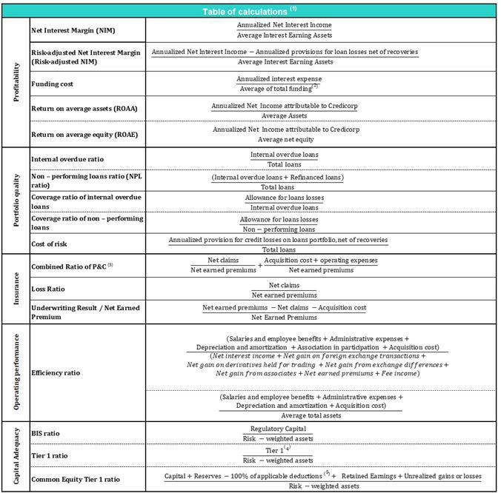

- Averages are determined as the average of period-beginning and period-ending balances.

- Includes total deposits, due to banks and correspondents, BCRP instruments, repurchase agreements and bonds and notes issued.
- Does not include Life insurance business.
- Tier 1 = Capital + Legal and other capital reserves + Accumulated earnings with capitalization agreement + (0.5 x Unrealized profit and net income in subsidiaries) - Goodwill - (0.5 x Investment in subsidiaries) + Perpetual subordinated debt (maximum amount that can be included is 17.65% of Capital + Reserves + Accumulated earnings with capitalization agreement + Unrealized profit and net income in subsidiaries - Goodwill).
- Includes investment in subsidiaries, goodwill, intangibles and deferred tax that rely on future profitability.

69

Earnings Release 2Q / 2022 Analysis of 2Q22 Consolidated Results

12. Appendix

12.7. Glossary of terms

Term | Definition
Government Program Loans ("GP" or "GP Loans") | Loan Portfolio related to Reactiva Peru and FAE-Mype programs to respond quickly and
 | effectively to liquidity needs and maintain the payment chain.
Structural Loans | Loan Portfolio excluding GP Loans.
Non-Recurring Events at Interest Income | Impairment charge (related to the government facility that allowed for deferment of certain
Non-Recurring Events at Interest Income | installments at zero cost) and subsequent amortization thereof.
Non-Recurring Events at Interest Expenses | Charges related to the liability management operation at BCP Stand-alone (3Q20 and 1Q21).
Structural Cost of Risk | Cost of Risk related to the Structural Loans. It excludes, in the numerator, provisions for credit
Structural Cost of Risk | losses on GP loans, and in the denominator, the total amount of GP Loans.
Structural NPL ratio | NPL Ratio related to Structural Loans. It excludes the impact of GP Loans.
Structural NIM | NIM related to Structural Loans and Other Interest Earning Assets. It deducts the impact of GP
Structural NIM | Loans and Non-recurring Events from Interest Income and Interest Expenses.
Structural Funding Cost | Funding Cost deducting the impact in expenses and funding related to GP Loans and deducting
Structural Funding Cost | Non-recurring Events from Interest Expenses
 | 70

