SECURITIES AND EXCHANGE COMMISSION
Washington, D.C. 20549

FORM 6-K

Report of Foreign Private Issuer
Pursuant to Rule 13a-16 or 15d-16 under the
Securities Exchange Act of 1934

For the month of April 2023

Commission File Number: 001-14014

CREDICORP LTD.
(Translation of registrant’s name into English)

Of our subsidiary
Banco de Credito del Peru:
Calle Centenario 156
La Molina
Lima 12, Peru
(Address of principal executive office)

Indicate by check mark whether the registrant files or will file annual reports under cover of Form 20-F or Form 40-F.

Form 20-F ⌧ Form 40-F ☐

Indicate by check mark if the registrant is submitting the Form 6-K in paper as permitted by Regulation S-T Rule 101(b)(1): ____

Indicate by check mark if the registrant is submitting the Form 6-K in paper as permitted by Regulation S-T Rule 101(b)(7): ____



April 24, 2023

Securities and Exchange Commission - SEC

Re.: MATERIAL EVENT

Dear Sirs:

We hereby notify you as a Material Event that Fitch Ratings has updated the credit rating report of Credicorp Ltd. (Credicorp) dated March 31, 2023.

The information in this Form 6-K regarding the rating of Fitch Ratings has been disclosed in Peru in conformity with Peruvian law (Article 30 of the Capital Markets Law, approved by Supreme Decree 020-2023-EF, and by the Regulation of the Disclosure of Material Events and Reserved Information approved by Resolution 005-2014-SMV/01 of the Peruvian Capital Markets Superintendency). The ratings of Fitch Ratings do not necessarily represent the opinion of Credicorp, nor should they be seen as a recommendation to buy shares or any other securities of Credicorp. Credicorp accepts no liability for the completeness, timeliness, accuracy or selection of such information.

The information in this Form 6-K (including any exhibit hereto) shall not be deemed “filed” for purposes of Section 18 of the Securities Exchange Act of 1934 (the ‘Exchange Act’) or otherwise subject to the liabilities of that section, nor shall it be deemed incorporated by reference in any filing under the Securities Act of 1933 or the Exchange Act.

Sincerely,

/s/ Guillermo Morales
Authorized Representative
Credicorp Ltd.

SIGNATURE

Pursuant to the requirements of the Securities Exchange Act of 1934, the registrant has duly caused this report to be signed on its behalf by the undersigned, thereunto duly authorized.

Date: April 24, 2023

CREDICORP LTD.
(Registrant)
 | By: | /s/ Guillermo Morales
 |  | Guillermo Morales
 |  | Authorized Representative

Exhibit 99.1

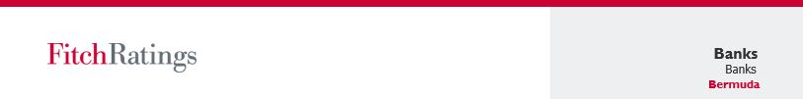

Credicorp Ltd.
Update
Key Rating Drivers
IDRs and Senior Debt
IDRs Driven by Main Subsidiary's IDRs: Credicorp's IDRs are driven primarily by the IDR of its main subsidiary, BCP, which has a strong business and financial profile. Credicorp's Foreign Currency Long-Term IDR of 'BBB' with a Negative Outlook is equalized with BCP's rating.
Low Double Leverage: The equalization is mainly driven by Credicorp's low double leverage and its strong liquidity management. Double leverage reached 102.1% at YE 2022. There is a long track record of significant dividend flows that provide the bulk of Credicorp's liquidity.
Strong Corporate Strategy: Credicorp is a non-operating holding company that maintains an integrated business platform composed of leading Peruvian and Bolivian banking, insurance, pension, and asset and wealth management companies, as well as entities in the microfinance sector in Peru and Colombia.
Consistent Performance: Credicorp's capital structure benefits from its subsidiaries' profitability, which allows it to maintain consistent dividend flows. Asset quality ratios on a consolidated basis were: 90-days impaired loans to total loan ratio at YE 2022 was 3.1% (YE 2021: 2.9%) and reserve coverage was 170.4% (YE 2021: 201.7%).
Improving Profitability: Following the profitability improvement in its main subsidiary, Credicorp's consolidated profitability is improving and close to pre-pandemic levels (ROAE and ROAA at YE22: 17.1% and 2.0%, respectively).
Senior Debt Ratings: The senior global debt rating is at the same level as Credicorp's Long-Term IDRs of 'BBB', as the likelihood of default of the notes is the same as that of Credicorp.
Rating Sensitivities
Factors that could, individually or collectively, lead to negative rating action/downgrade:
• | Credicorp's IDRs would remain at the same level as BCP's and would move in tandem with any rating actions on its main operating subsidiary. However, the relativity between these two entities' ratings could also be affected and the holding company downgraded in the event of a material and sustained increase in Credicorp's double- leverage metrics (above 1.2x) and if Fitch perceives a material weakening of the holding company's liquidity position and its management.
• | A change in the dividend flows from the operating companies or debt levels at the holding company that affects its debt coverage ratios could also be detrimental to Credicorp's ratings.
• | The ratings for Credicorp's senior unsecured debt would move in line with its Long-Term IDR.
Factors that could, individually or collectively, lead to positive rating action/upgrade:
• | Credicorp Ltd's ratings would move in tandem with positive rating actions on its main operating subsidiary, BCP.
• | The ratings for Credicorp's senior unsecured debt would move in line with Credicorp's Long-Term IDR.

Ratings
Foreign Currency
Long-Term IDR | BBB
Short-Term IDR | F2
Sovereign Risk (Peru)
Long-Term Foreign-Currency IDR | BBB
Long-Term Local-Currency IDR | BBB
Country Ceiling | BBB+
Outlooks
Long-Term Foreign-Currency IDR | Negative
Sovereign Long-Term Foreign-Currency IDR | Negative
Sovereign Long-Term Local-Currency IDR | Negative
Applicable Criteria

Bank Rating Criteria (September 2022)

Financial Data
Credicorp Ltd.
 | 12/31/22 | 12/31/21
Total Assets (USD Mil.) | 62,156.4 | 61,443.6
Total Assets (PEN Mil.) | 236,753.6 | 244,846.7
Total Equity (PEN Mil.) | 29,579.7 | 27,037.4

Analysts
Robert Stoll
+1 212 908 9155
robert.stoll@fitchratings.com
Andres Marquez
+57 601 241 3254
andres.marquez@fitchratings.com

Update │ April 21, 2023 | fitchratings.com 1

Issuer Ratings (Including Main Issuing Entities)
Rating Level | Rating
Long-Term Foreign-Currency IDR | BBB
Short-Term Foreign-Currency IDR | F2
Outlook/Watch | Negative
Source: Fitch Ratings

Debt Rating Classes
Rating Level | Rating
Senior unsecured: Long-Term | BBB
Source: Fitch Ratings

Significant Changes
On October 2022, Fitch revised the Rating Outlook on the sovereign’s Long-Term (LT) Issuer Default Ratings (IDR) to Negative as a deterioration in political stability and government effectiveness has increased downside risks to Peru's ratings. In the agency’s view, weaker governance poses greater downside risks to investment and economic growth.
Fitch believes Credicorp's and its main subsidiary's credit profiles are sensitive to a material deterioration in the local operating environment or a negative sovereign rating action. In consequence, the Outlook on the OE score remains negative as a slowdown in economic and loan growth, an increase in borrowing costs and persistent political uncertainty are detracting from Peruvian banking sector activity. However, sustained capitalization, improving profitability and lower loan impairment charges provide sufficient resilience to face stress from political uncertainty and external shocks.

Credicorp Ltd.  Update │ April 21, 2023 | fitchratings.com 2

Summary Financials
 | 2022 |  | 2021 | 2020 | 2019
(Year End as of Dec. 31, Audited – Unqualified) | (USD Mil.) | (PEN Mil.) | (PEN Mil.) | (PEN Mil.) | (PEN Mil.)
Summary Income Statement
Net Interest and Dividend Income | 3,024 | 11,518.1 | 9,362.0 | 8,571.3 | 9,090.8
Net Fees and Commissions | 956 | 3,640.3 | 3,493.7 | 2,912.8 | 3,232.8
Other Operating Income | 571 | 2,173.7 | 1,434.3 | 1,895.4 | 2,146.5
Total Operating Income | 4,550 | 17,332.1 | 14,290.0 | 13,379.5 | 14,470.1
Operating Costs | 2,263 | 8,620.6 | 7,740.1 | 7,127.0 | 6,666.4
Pre-Impairment Operating Profit | 2,287 | 8,711.5 | 6,549.9 | 6,252.5 | 7,803.7
Loan and Other Impairment Charges | 491 | 1,869.8 | 1,219.0 | 5,972.8 | 1,845.2
Operating Profit | 1,796 | 6,841.7 | 5,330.9 | 279.7 | 5,958.5
Other Non-Operating Items (Net) | 4 | 14.2 | 1.9 | -55.5 | 16.9
Tax | 554 | 2,110.5 | 1,661.0 | -109.9 | 1,623.1
Net Income | 1,246 | 4,745.4 | 3,671.8 | 334.1 | 4,352.3
Other Comprehensive Income | -234 | -891.0 | -1,660.0 | 787.0 | 387.7
Fitch Comprehensive Income | 1,012 | 3,854.4 | 2,011.8 | 1,121.1 | 4,740.0
Summary Balance Sheet
Assets
Gross Loans | 39,020 | 148,626.4 | 147,597.4 | 137,659.9 | 115,609.7
- of which impaired | 1,213 | 4,620.5 | 4,208.9 | 3,833.8 | 2,479.9
Loan Loss Allowances | 2,067 | 7,872.4 | 8,477.3 | 9,898.8 | 5,124.0
Net Loan | 36,953 | 140,754.0 | 139,120.1 | 127,761.1 | 110,485.7
Interbank | 1,035 | 3,942.9 | 8,047.6 | 4,410.9 | 2,036.1
Derivatives | 388 | 1,478.7 | 1,661.6 | 1,214.5 | 1,092.1
Other Securities and Earning Assets | 13,284 | 50,597.3 | 53,860.8 | 59,593.3 | 37,760.5
Total Earning Assets | 51,660 | 196,772.9 | 202,690.1 | 192,979.8 | 151,374.4
Cash and Due from Banks | 7,939 | 30,241.0 | 31,273.1 | 32,342.1 | 23,950.7
Other Assets | 2,557 | 9,739.7 | 10,883.5 | 12,084.3 | 12,534.2
Total Assets | 62,156 | 236,753.6 | 244,846.7 | 237,406.2 | 187,859.3
Liabilities
Customer Deposits | 38,226 | 145,602.0 | 148,268.9 | 141,162.5 | 110,825.0
Interbank and Other Short-Term Funding | 4,072 | 15,511.1 | 23,342.4 | 29,128.0 | 9,064.5
Other Long-Term Funding | 6,516 | 24,818.9 | 25,035.2 | 22,296.3 | 23,582.0
Trading Liabilities and Derivatives | 403 | 1,536.7 | 1,862.7 | 1,766.8 | 1,534.0
Total Funding and Derivatives | 49,217 | 187,468.7 | 198,509.2 | 194,353.6 | 145,005.5
Other Liabilities | 5,173 | 19,705.2 | 19,300.1 | 17,607.0 | 16,107.5
Preference Shares and Hybrid Capital | N.A. | N.A. | N.A. | N.A. | N.A.
Total Equity | 7,766 | 29,579.7 | 27,037.4 | 25,445.6 | 26,746.3
Total Liabilities and Equity | 62,156 | 236,753.6 | 244,846.7 | 237,406.2 | 187,859.3
Exchange Rate |  | USD1 = PEN3.8090 | USD1 = PEN3.9849 | USD1 = PEN3.6200 | USD1 = PEN3.3120
N.A. – Not applicable
Source: Fitch Ratings, Fitch Solutions

Credicorp Ltd.  Update │ April 21, 2023 | fitchratings.com 3

Key Ratios
(%, as of Dec. 31) | 2022 | 2021 | 2020 | 2019
Ratios (annualized as appropriate)
Profitability
Operating Profit/Risk-Weighted Assets | N.A. | N.A. | N.A. | N.A.
Net Interest Income/Average Earning Assets | 5.7 | 4.4 | 4.6 | 5.8
Non-Interest Expense/Gross Revenue | 50.0 | 54.5 | 53.5 | 46.3
Net Income/Average Equity | 17.1 | 14.3 | 1.4 | 17.1
Asset Quality
Impaired Loans Ratio | 3.1 | 2.9 | 2.8 | 2.2
Growth in Gross Loans | 0.7 | 7.2 | 19.1 | 4.4
Loan Loss Allowances/Impaired Loans | 170.4 | 201.7 | 258.2 | 206.6
Loan Impairment Charges/Average Gross Loans | 1.2 | 0.9 | 4.6 | 1.7
Capitalization
Common Equity Tier 1 Ratio | N.A. | N.A. | N.A. | N.A.
Fully Loaded Common Equity Tier 1 Ratio | N.A. | N.A. | N.A. | N.A.
Fitch Core Capital Ratio | N.A. | N.A. | N.A. | N.A.
Tangible Common Equity/Tangible Assets | 11.4 | 10.0 | 9.7 | 13.1
Basel Leverage Ratio | N.A. | N.A. | N.A. | N.A.
Net Impaired Loans/Common Equity Tier 1 | N.A. | N.A. | N.A. | N.A.
Net Impaired Loans/Fitch Core Capital | -12.2 | -17.6 | -26.6 | -10.9
Funding and Liquidity
Gross Loans/Customer Deposits | 102.1 | 99.6 | 97.5 | 104.3
Liquidity Coverage Ratio | N.A. | N.A. | N.A. | N.A.
Customer Deposits/Total Non-Equity Funding | 78.2 | 75.3 | 73.1 | 77.0
Net Stable Funding Ratio | N.A. | N.A. | N.A. | N.A.
N.A. – Not applicable
Source: Fitch Ratings, Fitch Solutions

Credicorp Ltd.  Update │ April 21, 2023 | fitchratings.com 4

Environmental, Social and Governance Considerations
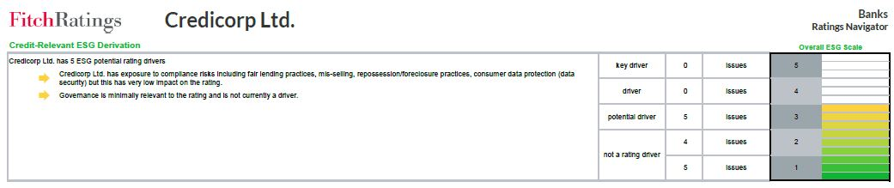
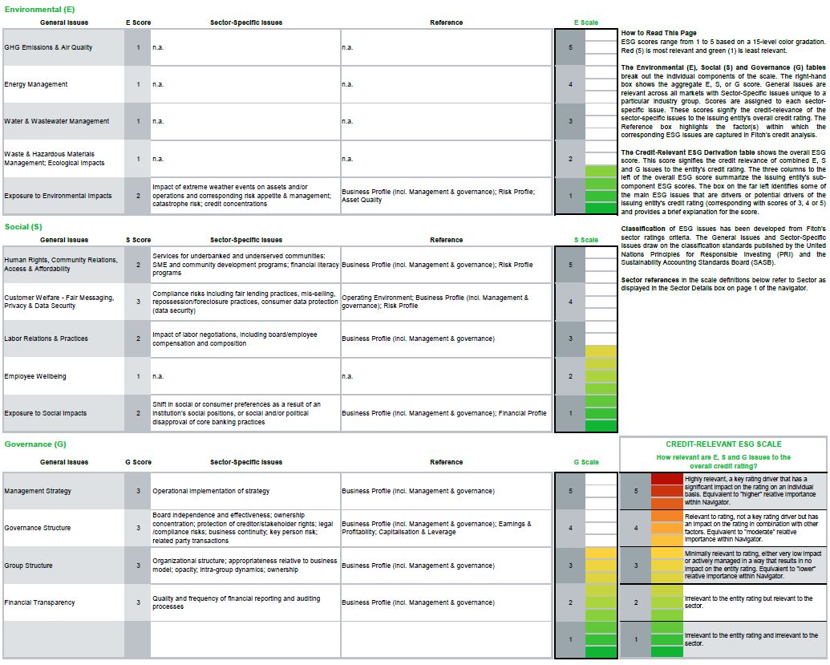

Unless otherwise disclosed in this section, the highest level of ESG credit relevance is a score of ‘3’. This means ESG issues are credit-neutral or have only a minimal credit impact on the entity, either due to their nature or the way in which they are being managed by the entity. For more information on Fitch’s ESG Relevance Scores, visit www.fitchratings.com/esg.

Credicorp Ltd.  Update │ April 21, 2023 | fitchratings.com 5

The ratings above were solicited and assigned or maintained at the request of the rated entity/issuer or a related third party. Any exceptions follow below.

DISCLAIMER & DISCLOSURES
All Fitch Ratings (Fitch) credit ratings are subject to certain limitations and disclaimers. Please read these limitations and disclaimers by following this link: https://www.fitchratings.com/understandingcreditratings. In addition, the following https://www.fitchratings.com/rating-definitions-document details Fitch's rating definitions for each rating scale and rating categories, including definitions relating to default. Published ratings, criteria, and methodologies are available from this site at all times. Fitch's code of conduct, confidentiality, conflicts of interest, affiliate firewall, compliance, and other relevant policies and procedures are also available from the Code of Conduct section of this site. Directors and shareholders’ relevant interests are available at https://www.fitchratings.com/site/regulatory. Fitch may have provided another permissible or ancillary service to the rated entity or its related third parties. Details of permissible or ancillary service(s) for which the lead analyst is based in an ESMA- or FCA-registered Fitch Ratings company (or branch of such a company) can be found on the entity summary page for this issuer on the Fitch Ratings website.
In issuing and maintaining its ratings and in making other reports (including forecast information), Fitch relies on factual information it receives from issuers and underwriters and from other sources Fitch believes to be credible. Fitch conducts a reasonable investigation of the factual information relied upon by it in accordance with its ratings methodology, and obtains reasonable verification of that information from independent sources, to the extent such sources are available for a given security or in a given jurisdiction. The manner of Fitch's factual investigation and the scope of the third-party verification it obtains will vary depending on the nature of the rated security and its issuer, the requirements and practices in the jurisdiction in which the rated security is offered and sold and/or the issuer is located, the availability and nature of relevant public information, access to the management of the issuer and its advisers, the availability of pre-existing third-party verifications such as audit reports, agreed-upon procedures letters, appraisals, actuarial reports, engineering reports, legal opinions and other reports provided by third parties, the availability of independent and competent third- party verification sources with respect to the particular security or in the particular jurisdiction of the issuer, and a variety of other factors. Users of Fitch's ratings and reports should understand that neither an enhanced factual investigation nor any third-party verification can ensure that all of the information Fitch relies on in connection with a rating or a report will be accurate and complete. Ultimately, the issuer and its advisers are responsible for the accuracy of the information they provide to Fitch and to the market in offering documents and other reports. In issuing its ratings and its reports, Fitch must rely on the work of experts, including independent auditors with respect to financial statements and attorneys with respect to legal and tax matters. Further, ratings and forecasts of financial and other information are inherently forward-looking and embody assumptions and predictions about future events that by their nature cannot be verified as facts. As a result, despite any verification of current facts, ratings and forecasts can be affected by future events or conditions that were not anticipated at the time a rating or forecast was issued or affirmed.
The information in this report is provided "as is" without any representation or warranty of any kind, and Fitch does not represent or warrant that the report or any of its contents will meet any of the requirements of a recipient of the report. A Fitch rating is an opinion as to the creditworthiness of a security. This opinion and reports made by Fitch are based on established criteria and methodologies that Fitch is continuously evaluating and updating. Therefore, ratings and reports are the collective work product of Fitch and no individual, or group of individuals, is solely responsible for a rating or a report. The rating does not address the risk of loss due to risks other than credit risk, unless such risk is specifically mentioned. Fitch is not engaged in the offer or sale of any security. All Fitch reports have shared authorship. Individuals identified in a Fitch report were involved in, but are not solely responsible for, the opinions stated therein. The individuals are named for contact purposes only. A report providing a Fitch rating is neither a prospectus nor a substitute for the information assembled, verified and presented to investors by the issuer and its agents in connection with the sale of the securities. Ratings may be changed or withdrawn at any time for any reason in the sole discretion of Fitch. Fitch does not provide investment advice of any sort. Ratings are not a recommendation to buy, sell, or hold any security. Ratings do not comment on the adequacy of market price, the suitability of any security for a particular investor, or the tax- exempt nature or taxability of payments made in respect to any security. Fitch receives fees from issuers, insurers, guarantors, other obligors, and underwriters for rating securities. Such fees generally vary from US$1,000 to US$750,000 (or the applicable currency equivalent) per issue. In certain cases, Fitch will rate all or a number of issues issued by a particular issuer, or insured or guaranteed by a particular insurer or guarantor, for a single annual fee. Such fees are expected to vary from US$10,000 to US$1,500,000 (or the applicable currency equivalent). The assignment, publication, or dissemination of a rating by Fitch shall not constitute a consent by Fitch to use its name as an expert in connection with any registration statement filed under the United States securities laws, the Financial Services and Markets Act of 2000 of the United Kingdom, or the securities laws of any particular jurisdiction. Due to the relative efficiency of electronic publishing and distribution, Fitch research may be available to electronic subscribers up to three days earlier than to print subscribers.
For Australia, New Zealand, Taiwan and South Korea only: Fitch Australia Pty Ltd holds an Australian financial services license (AFS license no. 337123) which authorizes it to provide credit ratings to wholesale clients only. Credit ratings information published by Fitch is not intended to be used by persons who are retail clients within the meaning of the Corporations Act 2001.
Fitch Ratings, Inc. is registered with the U.S. Securities and Exchange Commission as a Nationally Recognized Statistical Rating Organization (the "NRSRO"). While certain of the NRSRO's credit rating subsidiaries are listed on Item 3 of Form NRSRO and as such are authorized to issue credit ratings on behalf of the NRSRO (see https://www.fitchratings.com/site/regulatory), other credit rating subsidiaries are not listed on Form NRSRO (the "non-NRSROs") and therefore credit ratings issued by those subsidiaries are not issued on behalf of the NRSRO. However, non- NRSRO personnel may participate in determining credit ratings issued by or on behalf of the NRSRO.
Copyright © 2023 by Fitch Ratings, Inc., Fitch Ratings Ltd. and its subsidiaries. 33 Whitehall Street, NY, NY 10004. Telephone: 1-800-753-4824, (212) 908-0500. Fax: (212) 480-4435. Reproduction or retransmission in whole or in part is prohibited except by permission. All rights reserved.

Credicorp Ltd.  Update │ April 21, 2023 | fitchratings.com 6

