UNITED STATES

SECURITIES AND EXCHANGE COMMISSION

Washington, D.C. 20549

SCHEDULE 13G

Under the Securities Exchange Act of 1934

(Amendment No. 12)

Credicorp Ltd.

(Name of Issuer)

Common Shares

(Title of Class of Securities)

G2519Y 10 8

(CUSIP Number)

N/A

(Date of Event Which Requires Filing of this Statement)

Check the appropriate box to designate the rule pursuant to which this Schedule is filed:

o Rule 13d-1(b)

o Rule 13d-1(c)

x Rule 13d-1(d)

- The remainder of this cover page shall be filled out for a reporting person’s initial filing on this form with respect to the subject class of securities, and for any subsequent amendment containing information which would alter the disclosures provided in a prior cover page.

The information required in the remainder of this cover page shall not be deemed to be “filed” for the purpose of Section 18 of the Securities Exchange Act of 1934 (“Act”) or otherwise subject to the liabilities of that section of the Act, but shall be subject to all other provisions of the Act (however, see the Notes).

CUSIP No. G2519Y 10 8 Page 2 of 35
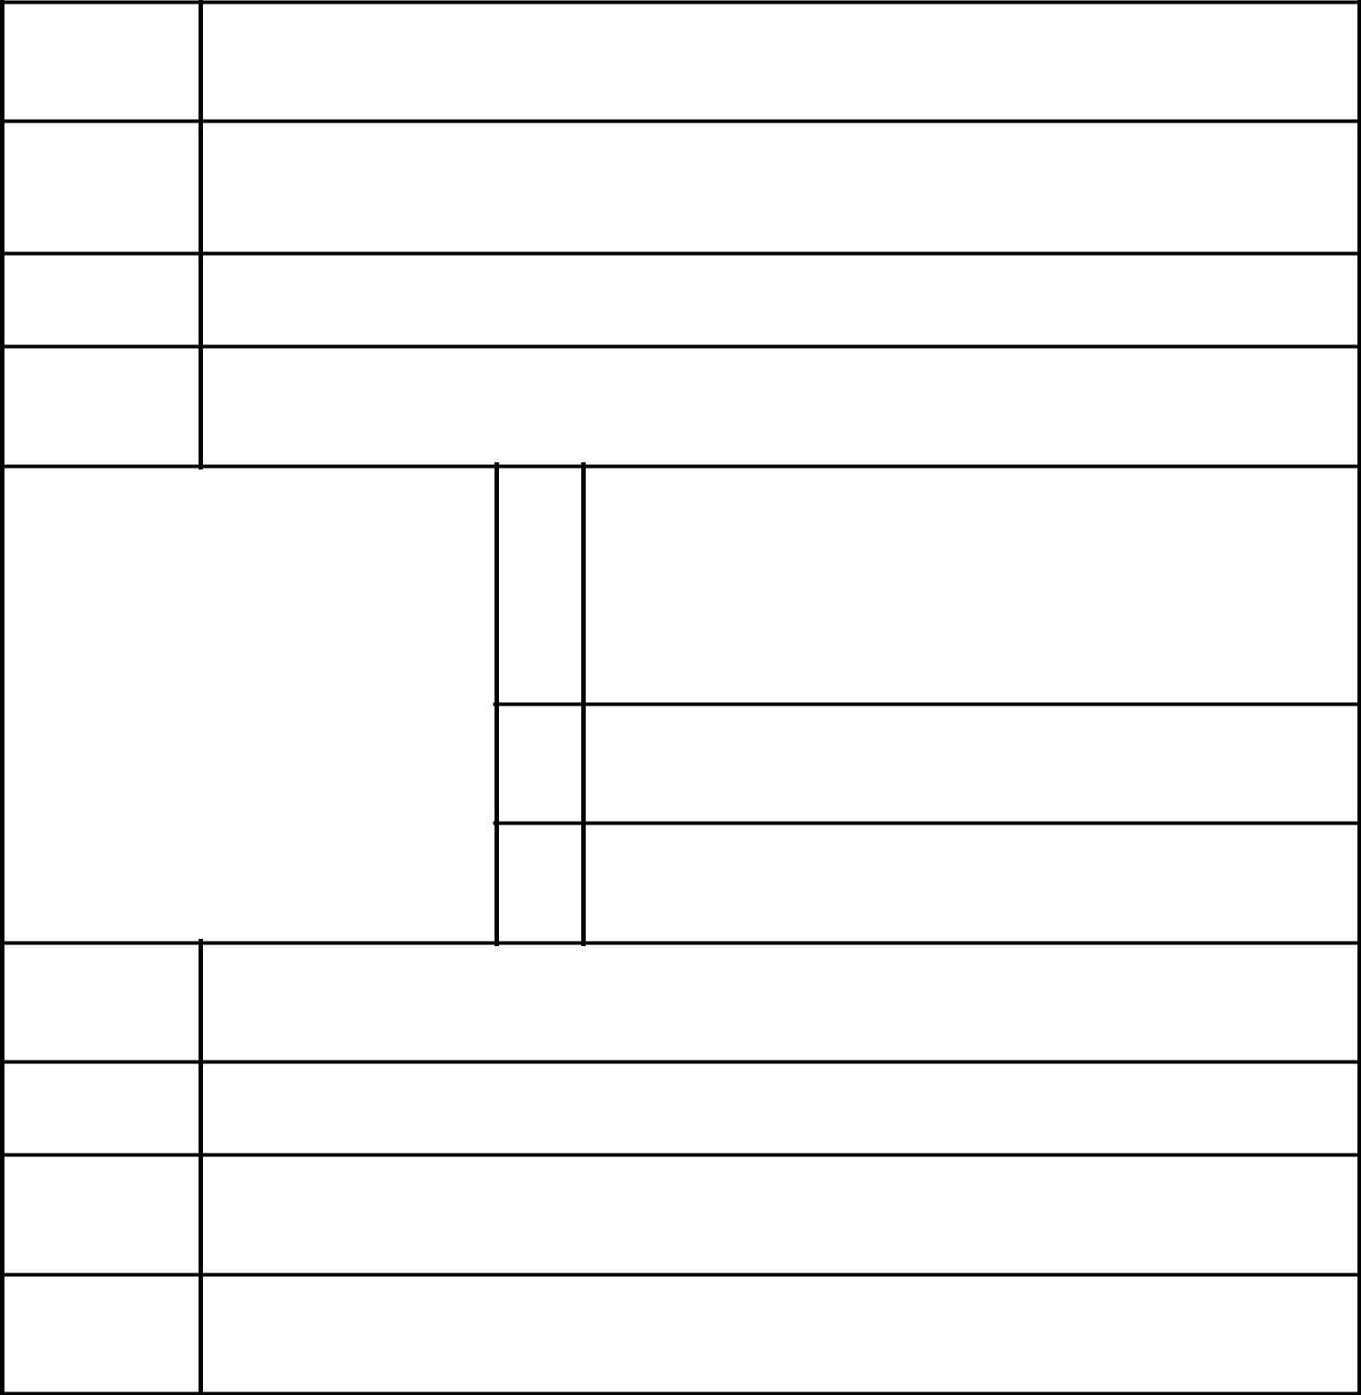

- Names of Reporting Persons/I.R.S. Identification Nos. of Above Persons (Entities Only)

Dionisio Romero Seminario

2. | Check the Appropriate Box if a Member of a Group | (a) x
 |  | (b) o

- SEC Use Only

- Citizenship or Place of Organization

Perú

NUMBER OF | 5. | Sole Voting Power
SHARES
BENEFICIALLY |  | 0
OWNED BY
EACH | 6. | Shared Voting Power
REPORTING | 6. | Shared Voting Power
PERSON |  | 14,865,336
WITH |  | 14,865,336

  - Sole Dispositive Power

0

  - Shared Dispositive Power

13,825,446

- Aggregate Amount Beneficially Owned by Each Reporting Person

14,865,336

- Check if the Aggregate Amount in Row (9) Excludes Certain Shares: o

- Percent of Class Represented by Amount in Row (9)

15.7%

- Type of Reporting Person

IN

CUSIP No. G2519Y 10 8 Page 3 of 35
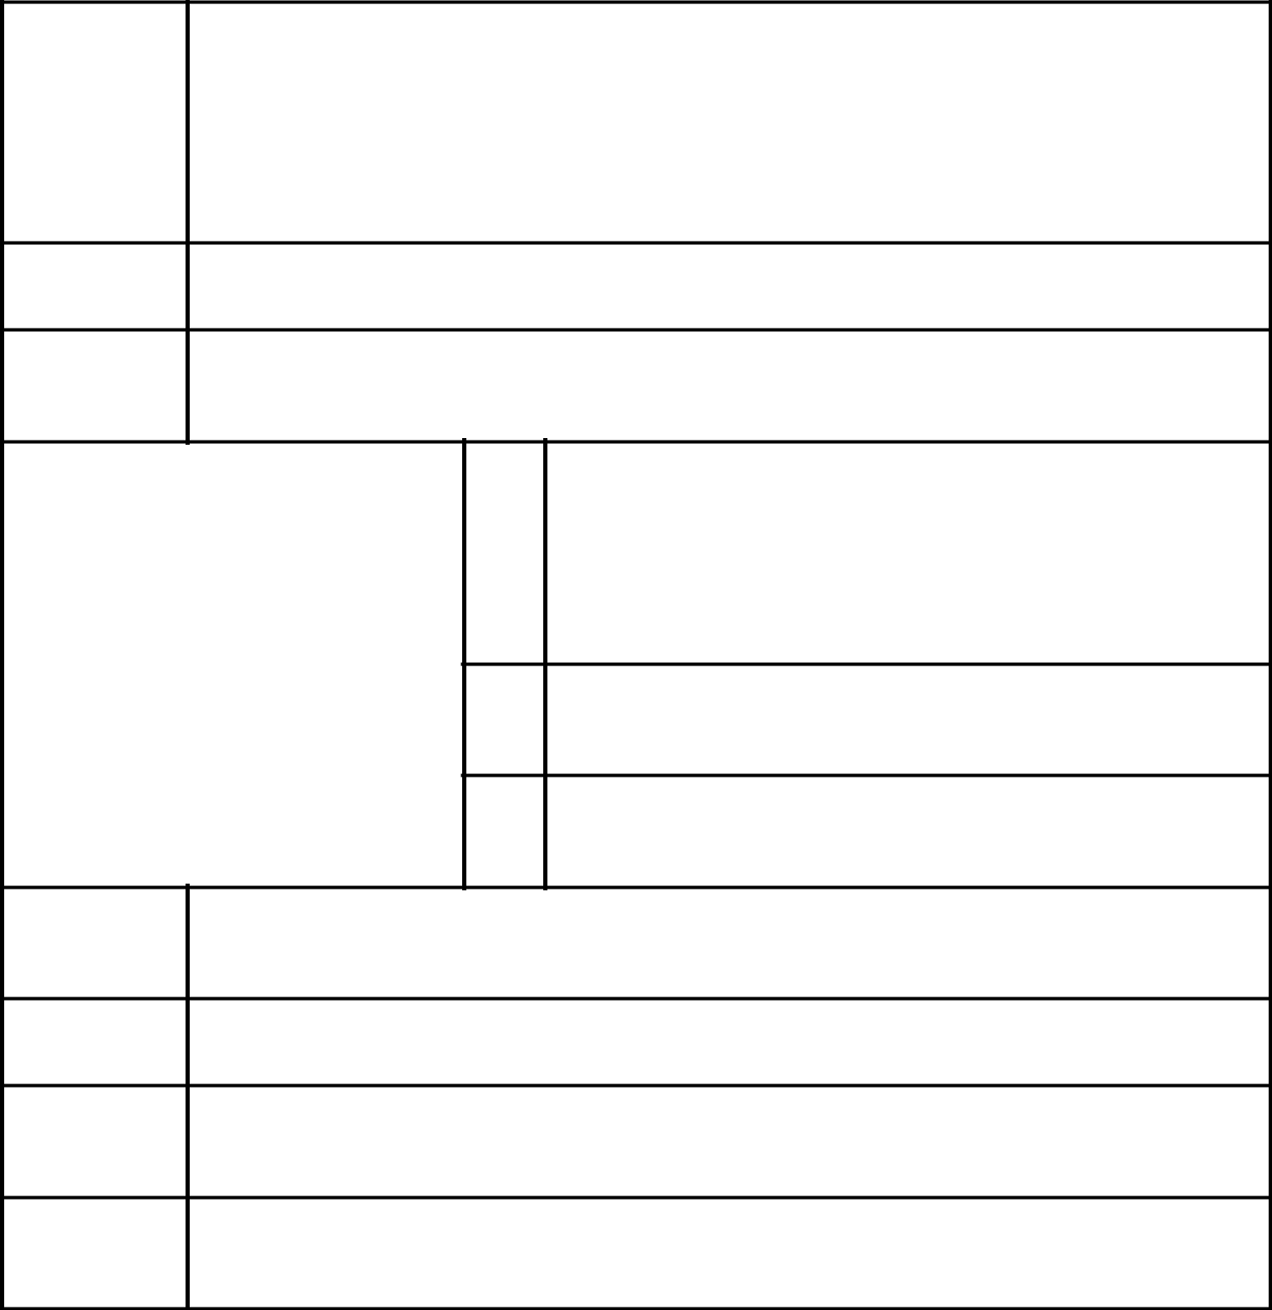

- Names of Reporting Persons/I.R.S. Identification Nos. of Above Persons (Entities Only)

 | Rosalina María Helguero Romero
2. | Check the Appropriate Box if a Member of a Group | (a) x
 |  | (b) o

- SEC Use Only

- Citizenship or Place of Organization

Perú

NUMBER OF | 5. | Sole Voting Power
SHARES
BENEFICIALLY |  | 0
OWNED BY
EACH | 6. | Shared Voting Power
REPORTING | 6. | Shared Voting Power
PERSON |  | 1,298,896
WITH |  | 1,298,896

  - Sole Dispositive Power

0

  - Shared Dispositive Power

1,298,896

- Aggregate Amount Beneficially Owned by Each Reporting Person

1,298,896

- Check if the Aggregate Amount in Row (9) Excludes Certain Shares: o

- Percent of Class Represented by Amount in Row (9)

1.4%

- Type of Reporting Person

IN

CUSIP No. G2519Y 10 8 Page 4 of 35

- Names of Reporting Persons/I.R.S. Identification Nos. of Above Persons (Entities Only)

 | José Antonio Onrubia Romero
2. | Check the Appropriate Box if a Member of a Group | (a) x
 |  | (b) o

- SEC Use Only

- Citizenship or Place of Organization

Spain

NUMBER OF | 5. | Sole Voting Power
SHARES
BENEFICIALLY |  | 0
OWNED BY
EACH | 6. | Shared Voting Power
REPORTING | 6. | Shared Voting Power
PERSON |  | 9,707,420
WITH |  | 9,707,420

  - Sole Dispositive Power

0

  - Shared Dispositive Power

9,707,420

- Aggregate Amount Beneficially Owned by Each Reporting Person

9,707,420

- Check if the Aggregate Amount in Row (9) Excludes Certain Shares: o

- Percent of Class Represented by Amount in Row (9)

10.3%

- Type of Reporting Person

IN

CUSIP No. G2519Y 10 8 Page 5 of 35

- Names of Reporting Persons/I.R.S. Identification Nos. of Above Persons (Entities Only)

Maria del Carmen Onrubia de Beeck

2. | Check the Appropriate Box if a Member of a Group | (a) x
 |  | (b) o

- SEC Use Only

- Citizenship or Place of Organization Perú
NUMBER OF | 5. | Sole Voting Power
SHARES
BENEFICIALLY |  | 0
OWNED BY
EACH | 6. | Shared Voting Power
REPORTING | 6. | Shared Voting Power
PERSON |  | 9,043,427
WITH |  | 9,043,427

  - Sole Dispositive Power

0

  - Shared Dispositive Power

9,043,427

- Aggregate Amount Beneficially Owned by Each Reporting Person

9,043,427

- Check if the Aggregate Amount in Row (9) Excludes Certain Shares: o

- Percent of Class Represented by Amount in Row (9)

9.6%

- Type of Reporting Person

IN

CUSIP No. G2519Y 10 8 Page 6 of 35

- Names of Reporting Persons/I.R.S. Identification Nos. of Above Persons (Entities Only)

Teresa Holder de Onrubia

2. | Check the Appropriate Box if a Member of a Group | (a) x
 |  | (b) o

- SEC Use Only

- Citizenship or Place of Organization

Perú

NUMBER OF | 5. | Sole Voting Power
SHARES
BENEFICIALLY |  | 0
OWNED BY
EACH | 6. | Shared Voting Power
REPORTING | 6. | Shared Voting Power
PERSON |  | 263,491
WITH |  | 263,491

  - Sole Dispositive Power

0

  - Shared Dispositive Power

263,491

- Aggregate Amount Beneficially Owned by Each Reporting Person

263,491

- Check if the Aggregate Amount in Row (9) Excludes Certain Shares: o

- Percent of Class Represented by Amount in Row (9)

0.3%

- Type of Reporting Person

IN

CUSIP No. G2519Y 10 8 Page 7 of 35

- Names of Reporting Persons/I.R.S. Identification Nos. of Above Persons (Entities Only)

Maria Lourdes Onrubia Holder

2. | Check the Appropriate Box if a Member of a Group | (a) x
 |  | (b) o

- SEC Use Only

- Citizenship or Place of Organization

Perú

NUMBER OF | 5. | Sole Voting Power
SHARES
BENEFICIALLY |  | 0
OWNED BY
EACH | 6. | Shared Voting Power
REPORTING | 6. | Shared Voting Power
PERSON |  | 9,167
WITH |  | 9,167

  - Sole Dispositive Power

0

  - Shared Dispositive Power

9,167

- Aggregate Amount Beneficially Owned by Each Reporting Person

9,167

- Check if the Aggregate Amount in Row (9) Excludes Certain Shares: o

- Percent of Class Represented by Amount in Row (9)

0.0%

- Type of Reporting Person

IN

CUSIP No. G2519Y 10 8 Page 8 of 35
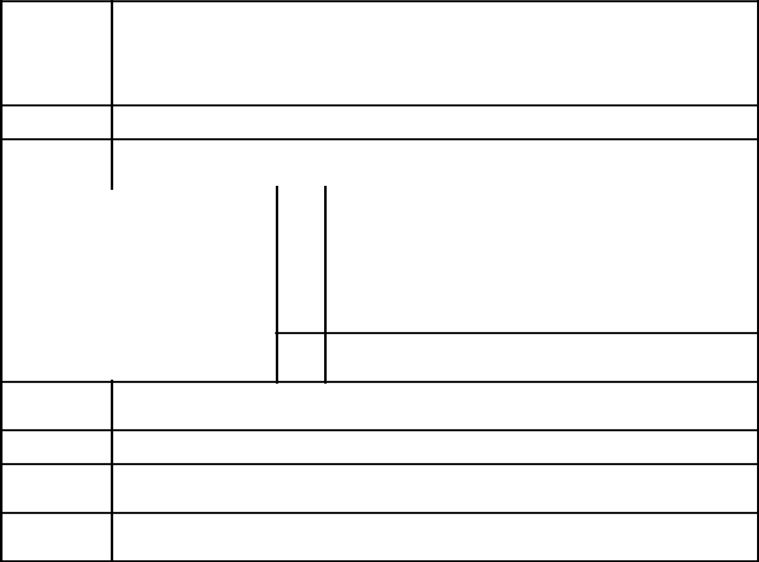

- Names of Reporting Persons/I.R.S. Identification Nos. of Above Persons (Entities Only)

 | Maria Inmaculada Onrubia Holder
2. | Check the Appropriate Box if a Member of a Group | (a) x
 |  | (b) o

- SEC Use Only

- Citizenship or Place of Organization

Perú

 | 5. | Sole Voting Power
NUMBER OF |  | 0
SHARES |  | 0
BENEFICIALLY | 6. | Shared Voting Power
OWNED BY
EACH |  | 7,332
REPORTING |  | 7,332
REPORTING | 7. | Sole Dispositive Power
PERSON | 7. | Sole Dispositive Power
WITH |  | 0

  - Shared Dispositive Power

7,332

- Aggregate Amount Beneficially Owned by Each Reporting Person

7,332

- Check if the Aggregate Amount in Row (9) Excludes Certain Shares: o

- Percent of Class Represented by Amount in Row (9)

0.0%

- Type of Reporting Person

IN

CUSIP No. G2519Y 10 8 Page 9 of 35
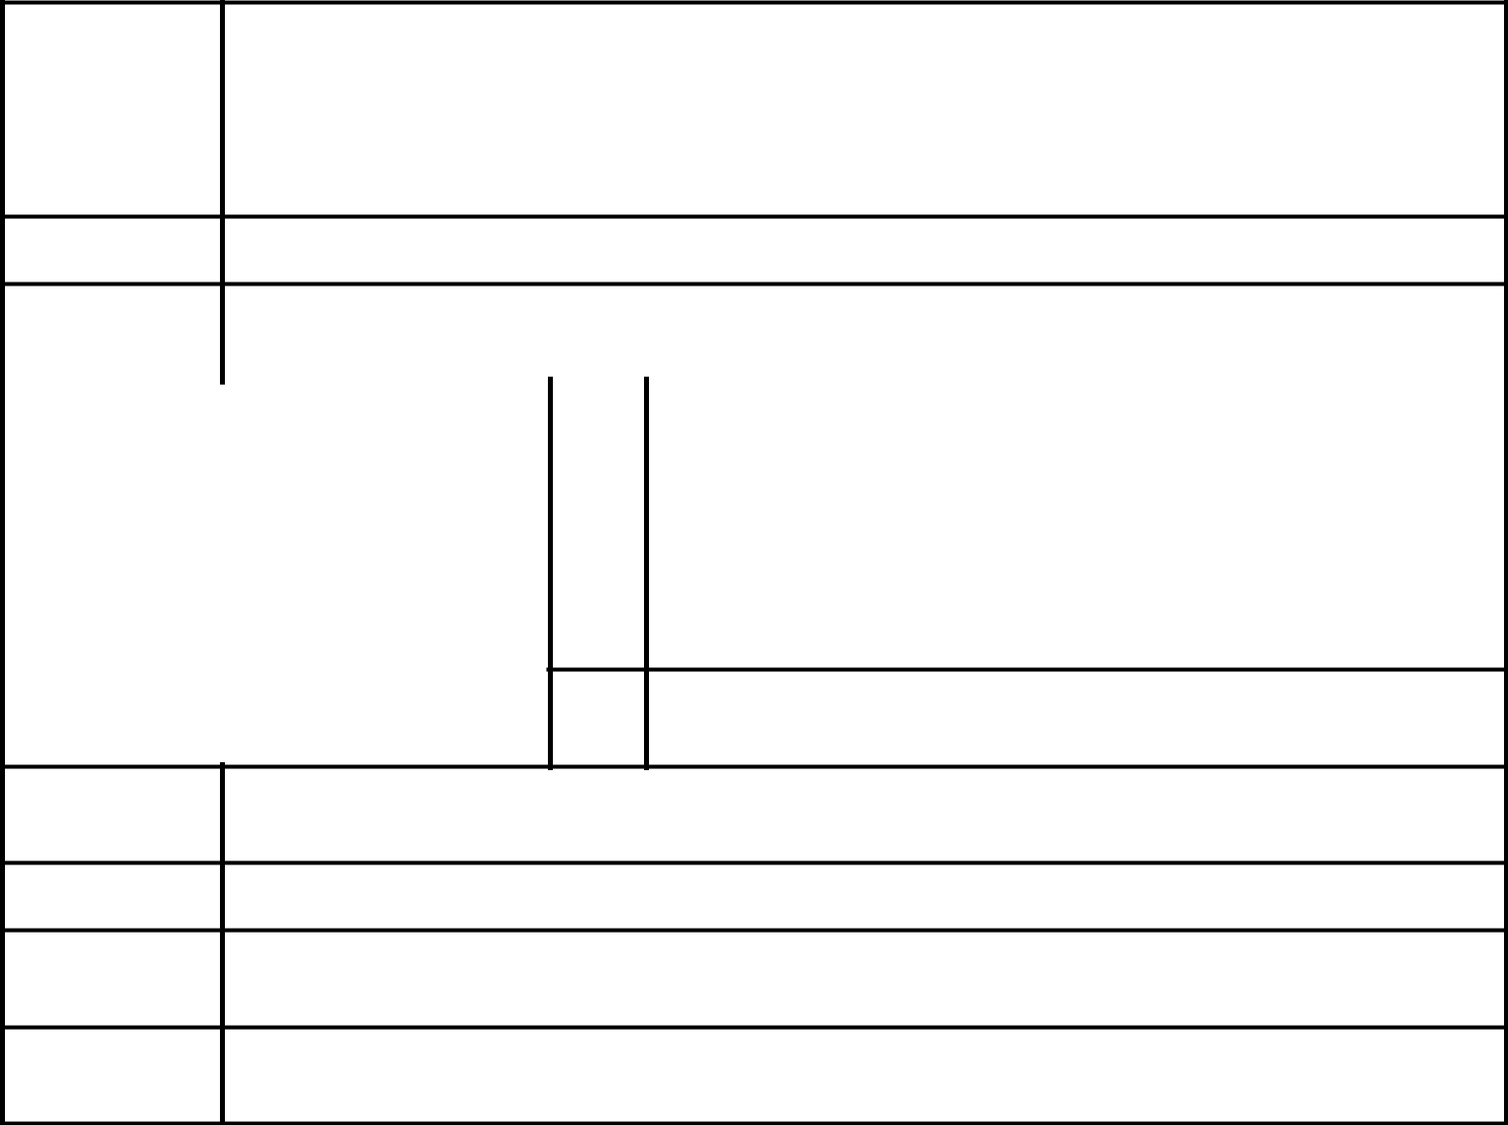

- Names of Reporting Persons/I.R.S. Identification Nos. of Above Persons (Entities Only)

 | Ana Silvia Guzman Portilla de Romero
2. | Check the Appropriate Box if a Member of a Group | (a) x
 |  | (b) o

- SEC Use Only

- Citizenship or Place of Organization

Perú

 | 5. | Sole Voting Power
NUMBER OF |  | 0
SHARES |  | 0
BENEFICIALLY | 6. | Shared Voting Power
OWNED BY
EACH |  | 495
REPORTING |  | 495
REPORTING | 7. | Sole Dispositive Power
PERSON | 7. | Sole Dispositive Power
WITH |  | 0

  - Shared Dispositive Power

495

- Aggregate Amount Beneficially Owned by Each Reporting Person

495

- Check if the Aggregate Amount in Row (9) Excludes Certain Shares: o

- Percent of Class Represented by Amount in Row (9)

0.0%

- Type of Reporting Person

IN

CUSIP No. G2519Y 10 8 Page 10 of 35

- Names of Reporting Persons/I.R.S. Identification Nos. of Above Persons (Entities Only)

 | Manuel Antonio Romero Belismelis
2. | Check the Appropriate Box if a Member of a Group | (a) x
 |  | (b) o

- SEC Use Only

- Citizenship or Place of Organization

Perú

 | 5. | Sole Voting Power
NUMBER OF |  | 0
SHARES |  | 0
BENEFICIALLY | 6. | Shared Voting Power
OWNED BY
EACH |  | 11,873
REPORTING |  | 11,873
REPORTING | 7. | Sole Dispositive Power
PERSON | 7. | Sole Dispositive Power
WITH |  | 0

  - Shared Dispositive Power

495

- Aggregate Amount Beneficially Owned by Each Reporting Person

11,873

- Check if the Aggregate Amount in Row (9) Excludes Certain Shares: o

- Percent of Class Represented by Amount in Row (9)

0.0%

- Type of Reporting Person

IN

CUSIP No. G2519Y 10 8 Page 11 of 35

- Names of Reporting Persons/I.R.S. Identification Nos. of Above Persons (Entities Only)

 | Alfredo Romero Belismelis
2. | Check the Appropriate Box if a Member of a Group | (a) x
 |  | (b) o

- SEC Use Only

- Citizenship or Place of Organization

Perú

 | 5. | Sole Voting Power
NUMBER OF |  | 0
SHARES |  | 0
BENEFICIALLY | 6. | Shared Voting Power
OWNED BY
EACH |  | 0
REPORTING |  | 0
REPORTING | 7. | Sole Dispositive Power
PERSON | 7. | Sole Dispositive Power
WITH |  | 0

  - Shared Dispositive Power

0

- Aggregate Amount Beneficially Owned by Each Reporting Person

0*

- Check if the Aggregate Amount in Row (9) Excludes Certain Shares: o

- Percent of Class Represented by Amount in Row (9)

0.0%*

- Type of Reporting Person

IN

- Reporting person Alfredo Romero Belismelis sold all of its Common Shares of issuer Credicorp Ltd. on the stock market. As of the date of this report, reporting person Alfredo Romero Belismelis does not beneficially own any Common Shares of issuer Credicorp Ltd.

CUSIP No. G2519Y 10 8 Page 12 of 35

- Names of Reporting Persons/I.R.S. Identification Nos. of Above Persons (Entities Only)

 | Fernando Romero Belismelis
2. | Check the Appropriate Box if a Member of a Group | (a) x
 |  | (b) o

- SEC Use Only

- Citizenship or Place of Organization

Perú

 | 5. | Sole Voting Power
NUMBER OF |  | 0
SHARES |  | 0
BENEFICIALLY | 6. | Shared Voting Power
OWNED BY
EACH |  | 1,324
REPORTING |  | 1,324
REPORTING | 7. | Sole Dispositive Power
PERSON | 7. | Sole Dispositive Power
WITH |  | 0

  - Shared Dispositive Power

1,324

- Aggregate Amount Beneficially Owned by Each Reporting Person

1,324

- Check if the Aggregate Amount in Row (9) Excludes Certain Shares: o

- Percent of Class Represented by Amount in Row (9)

0.0%

- Type of Reporting Person

IN

CUSIP No. G2519Y 10 8 Page 13 of 35

- Names of Reporting Persons/I.R.S. Identification Nos. of Above Persons (Entities Only)

 | Dionisio Romero Paoletti
2. | Check the Appropriate Box if a Member of a Group | (a) x
 |  | (b) o

- SEC Use Only

- Citizenship or Place of Organization

Perú

 | 5. | Sole Voting Power
NUMBER OF |  | 0
SHARES |  | 0
BENEFICIALLY | 6. | Shared Voting Power
OWNED BY
EACH |  | 0
REPORTING |  | 0
REPORTING | 7. | Sole Dispositive Power
PERSON | 7. | Sole Dispositive Power
WITH |  | 0

  - Shared Dispositive Power

0

- Aggregate Amount Beneficially Owned by Each Reporting Person

0*

- Check if the Aggregate Amount in Row (9) Excludes Certain Shares: o

- Percent of Class Represented by Amount in Row (9)

0.0%*

- Type of Reporting Person

IN

- Reporting person Dionisio Romero Paoletti sold all of its Common Shares of issuer Credicorp Ltd. on the stock market. As of the date of this report, reporting person Dionisio Romero Paoletti does not beneficially own any Common Shares of issuer Credicorp Ltd.

CUSIP No. G2519Y 10 8 Page 14 of 35

- Names of Reporting Persons/I.R.S. Identification Nos. of Above Persons (Entities Only)

 | Rafael Ernesto Romero Guzman
2. | Check the Appropriate Box if a Member of a Group | (a) x
 |  | (b) o

- SEC Use Only

- Citizenship or Place of Organization

Perú

 | 5. | Sole Voting Power
NUMBER OF |  | 0
SHARES |  | 0
BENEFICIALLY | 6. | Shared Voting Power
OWNED BY
EACH |  | 0
REPORTING |  | 0
REPORTING | 7. | Sole Dispositive Power
PERSON | 7. | Sole Dispositive Power
WITH |  | 0

  - Shared Dispositive Power

0

- Aggregate Amount Beneficially Owned by Each Reporting Person

0*

- Check if the Aggregate Amount in Row (9) Excludes Certain Shares: o

- Percent of Class Represented by Amount in Row (9)

0.0%*

- Type of Reporting Person

IN

- Reporting person Rafael Ernesto Romero Guzman sold all of its Common Shares of issuer Credicorp Ltd. on the stock market. As of the date of this report, reporting person Ernesto Romero Guzman does not beneficially own any Common Shares of issuer Credicorp Ltd.

CUSIP No. G2519Y 10 8 Page 15 of 35

- Names of Reporting Persons/I.R.S. Identification Nos. of Above Persons (Entities Only)

 | La Roncadora S.A.
2. | Check the Appropriate Box if a Member of a Group | (a) x
 |  | (b) o

- SEC Use Only

- Citizenship or Place of Organization

Panama

 | 5. | Sole Voting Power
NUMBER OF |  | 0
SHARES |  | 0
BENEFICIALLY | 6. | Shared Voting Power
OWNED BY
EACH |  | 1,039,890
REPORTING |  | 1,039,890
REPORTING | 7. | Sole Dispositive Power
PERSON | 7. | Sole Dispositive Power
WITH |  | 0

  - Shared Dispositive Power

1,039,890

- Aggregate Amount Beneficially Owned by Each Reporting Person

1,039,890

- Check if the Aggregate Amount in Row (9) Excludes Certain Shares: o

- Percent of Class Represented by Amount in Row (9)

1.1%

- Type of Reporting Person

IN

CUSIP No. G2519Y 10 8 Page 16 of 35

- Names of Reporting Persons/I.R.S. Identification Nos. of Above Persons (Entities Only)

 | Birmingham Merchant S.A.
2. | Check the Appropriate Box if a Member of a Group | (a) x
 |  | (b) o

- SEC Use Only

- Citizenship or Place of Organization

Perú

 | 5. | Sole Voting Power
NUMBER OF |  | 0
SHARES |  | 0
BENEFICIALLY | 6. | Shared Voting Power
OWNED BY
EACH |  | 2,943,868
REPORTING |  | 2,943,868
REPORTING | 7. | Sole Dispositive Power
PERSON | 7. | Sole Dispositive Power
WITH |  | 0

  - Shared Dispositive Power

2,943,868

- Aggregate Amount Beneficially Owned by Each Reporting Person

2,943,868

- Check if the Aggregate Amount in Row (9) Excludes Certain Shares: o

- Percent of Class Represented by Amount in Row (9)

3.1%

- Type of Reporting Person

CO

CUSIP No. G2519Y 10 8 Page 17 of 35 Pages
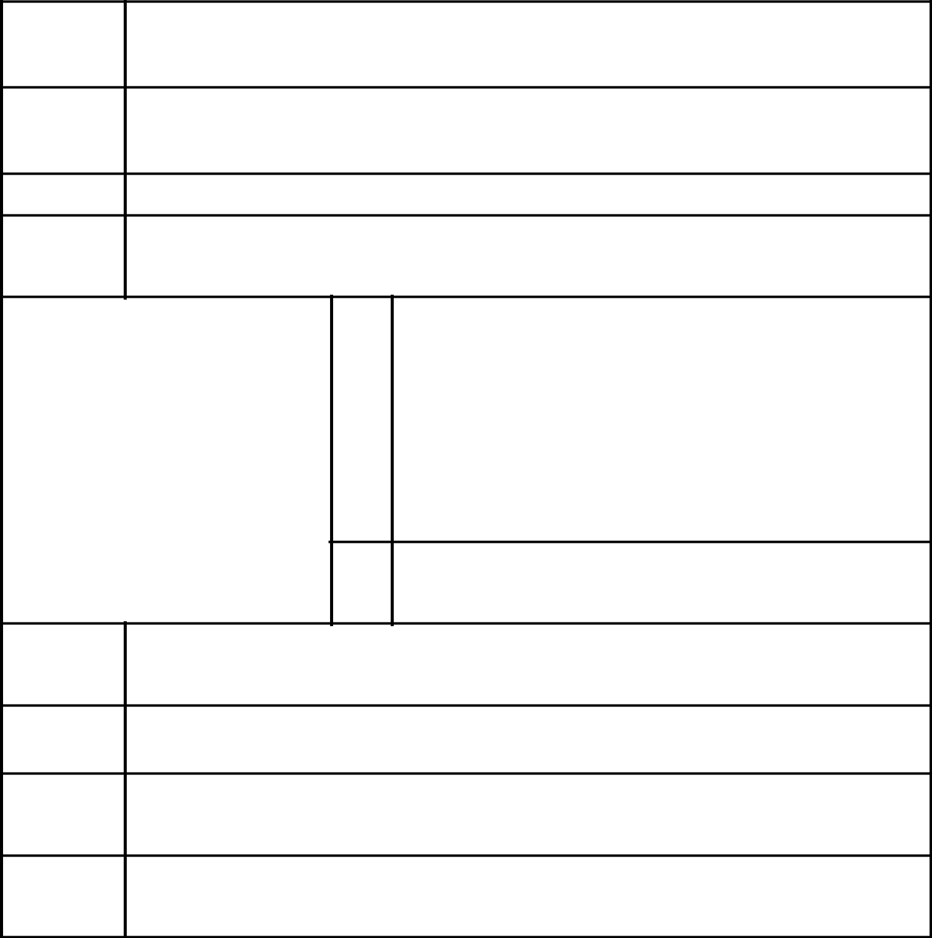

- Names of Reporting Persons/I.R.S. Identification Nos. of Above Persons (Entities Only)

Urigeler Internacional S.A.

- Check the Appropriate Box if a Member of a Group

  - x

  - o

- SEC Use Only

- Citizenship or Place of Organization

Panamá

 | 5. | Sole Voting Power
NUMBER OF |  | 0
SHARES |  | 0
BENEFICIALLY
OWNED BY | 6. | Shared Voting Power
EACH | 6. | Shared Voting Power
REPORTING |  | 5,285,672
PERSON |  | 5,285,672
WITH
  - Sole Dispositive Power

0

  - Shared Dispositive Power

5,285,672

- Aggregate Amount Beneficially Owned by Each Reporting Person

5,285,672

- Check if the Aggregate Amount in Row (9) Excludes Certain Shares: o

- Percent of Class Represented by Amount in Row (9)

5.6%

- Type of Reporting Person

CO

CUSIP No. G2519Y 10 8 Page 18 of 35 Pages
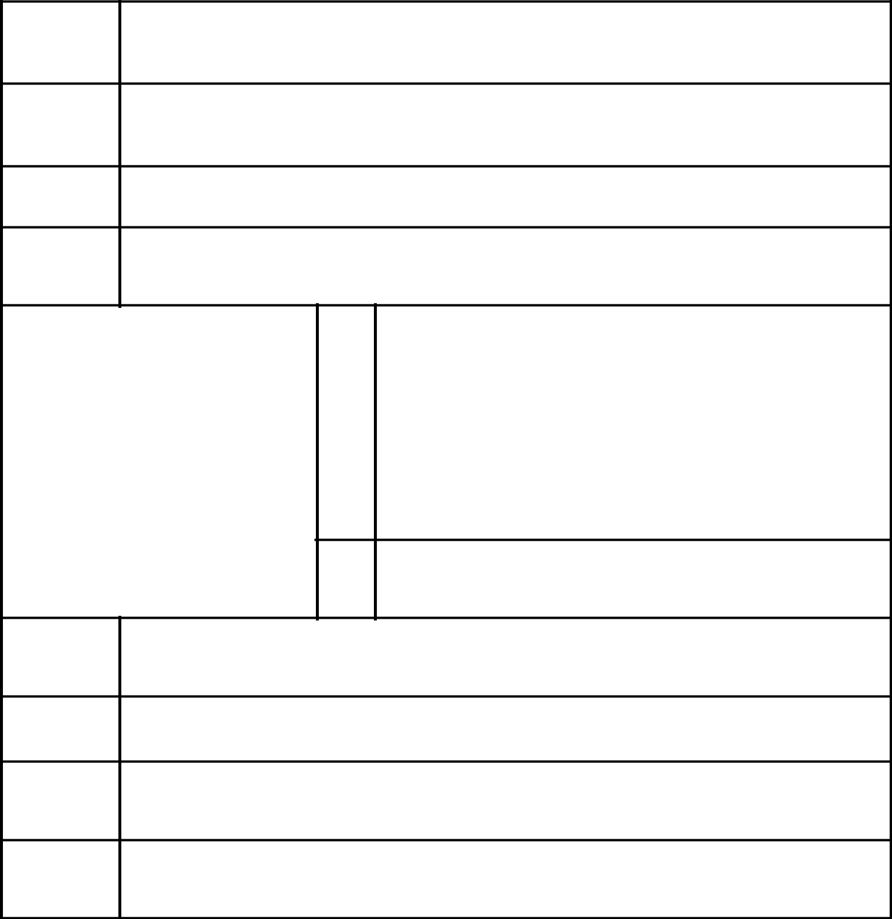

- Names of Reporting Persons/I.R.S. Identification Nos. of Above Persons (Entities Only)

Maray S.A.

- Check the Appropriate Box if a Member of a Group

  - x

  - o

- SEC Use Only

- Citizenship or Place of Organization

Panama

 | 5. | Sole Voting Power
NUMBER OF |  | 0
SHARES |  | 0
BENEFICIALLY
OWNED BY | 6. | Shared Voting Power
EACH | 6. | Shared Voting Power
REPORTING |  | 0
PERSON |  | 0
WITH
  - Sole Dispositive Power

0

  - Shared Dispositive Power

0

- Aggregate Amount Beneficially Owned by Each Reporting Person

0*

- Check if the Aggregate Amount in Row (9) Excludes Certain Shares: o

- Percent of Class Represented by Amount in Row (9)

0%*

- Type of Reporting Person

CO

- Effective December, 21 2006, reporting person Maray S.A. transferred all of its Common Shares of issuer Credicorp Ltd. to Tech American Enterprises Inc. As of the date of this report, reporting person Maray S.A. does not beneficially own any Common Shares of issuer Credicorp Ltd.

CUSIP No. G2519Y 10 8 Page 19 of 35 Pages
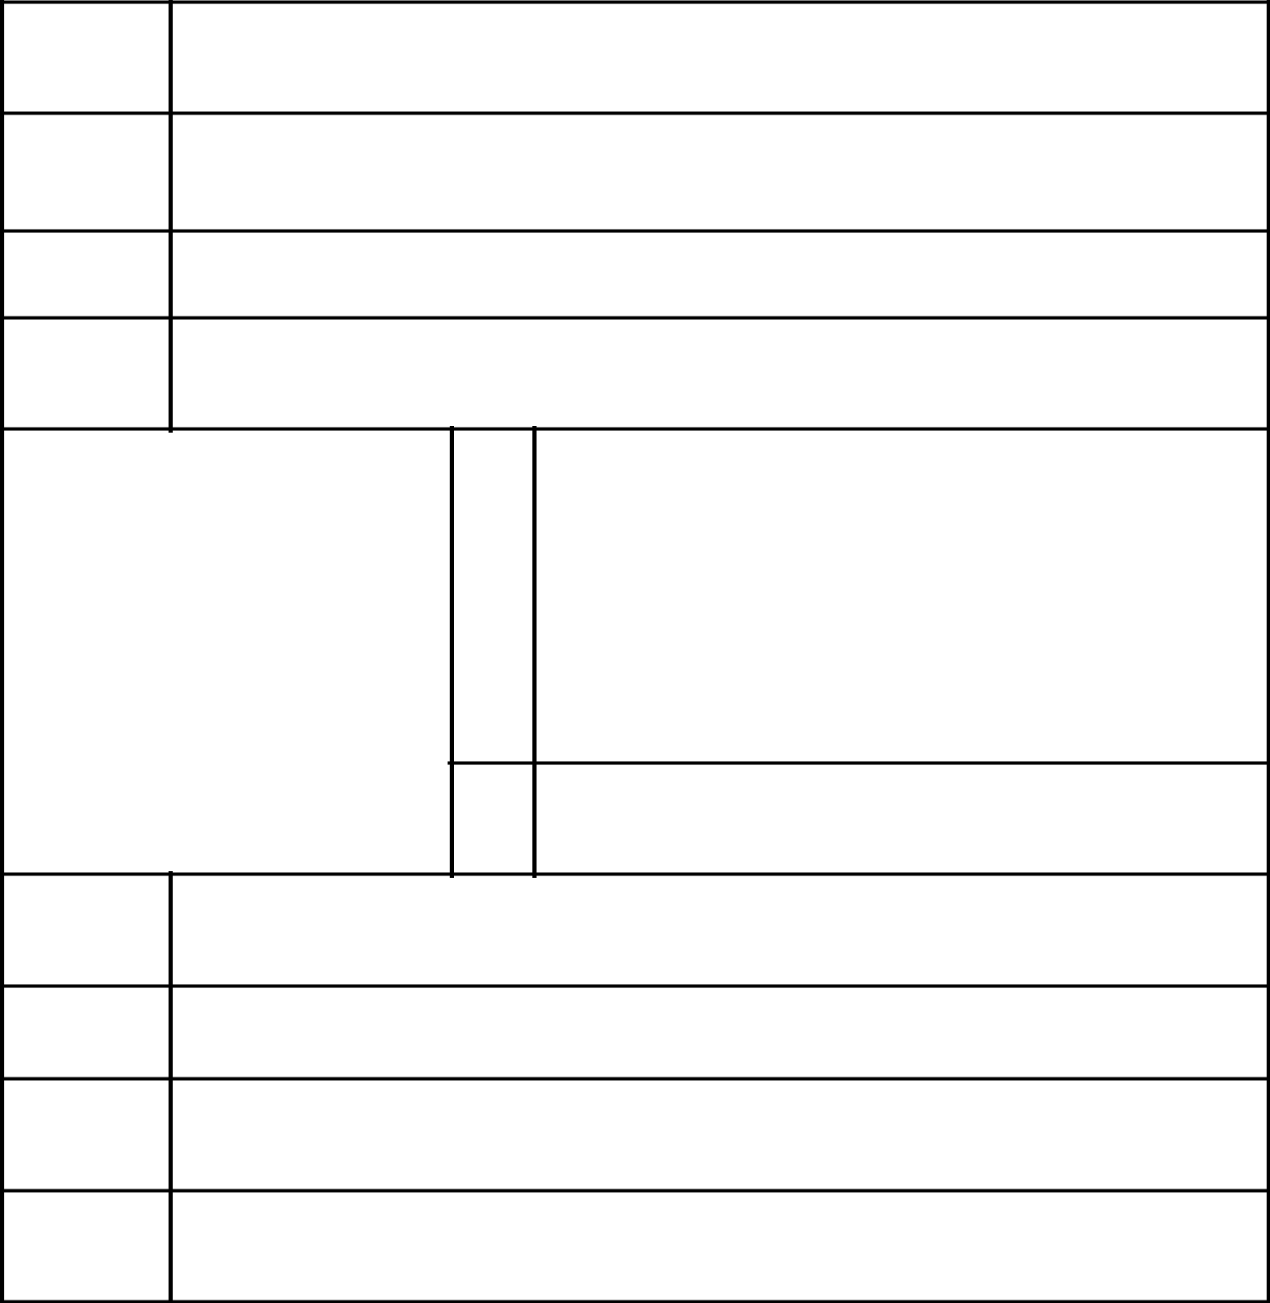

- Names of Reporting Persons/I.R.S. Identification Nos. of Above Persons (Entities Only)

Tech American Enterprises Inc.

- Check the Appropriate Box if a Member of a Group

  - x

  - o

- SEC Use Only

- Citizenship or Place of Organization

Panamá

 | 5. | Sole Voting Power
NUMBER OF |  | 0
SHARES |  | 0
BENEFICIALLY
OWNED BY | 6. | Shared Voting Power
EACH | 6. | Shared Voting Power
REPORTING |  | 682,883
PERSON |  | 682,883
WITH
  - Sole Dispositive Power

0

  - Shared Dispositive Power

682,883

- Aggregate Amount Beneficially Owned by Each Reporting Person

682,883

- Check if the Aggregate Amount in Row (9) Excludes Certain Shares: o

- Percent of Class Represented by Amount in Row (9)

0.7%

- Type of Reporting Person

CO

CUSIP No. G2519Y 10 8 Page 20 of 35 Pages

- Names of Reporting Persons/I.R.S. Identification Nos. of Above Persons (Entities Only)

Ransa Comercial S.A.

- Check the Appropriate Box if a Member of a Group

  - x

  - o

- SEC Use Only

- Citizenship or Place of Organization

Perú

 | 5. | Sole Voting Power
NUMBER OF |  | 0
SHARES |  | 0
BENEFICIALLY
OWNED BY | 6. | Shared Voting Power
EACH | 6. | Shared Voting Power
REPORTING |  | 0
PERSON |  | 0
WITH
  - Sole Dispositive Power

0

  - Shared Dispositive Power

0

- Aggregate Amount Beneficially Owned by Each Reporting Person

0*

- Check if the Aggregate Amount in Row (9) Excludes Certain Shares: o

- Percent of Class Represented by Amount in Row (9)

0%*

- Type of Reporting Person

CO

- Effective December, 06 2006, reporting person Ransa Comercial S.A. transferred all of its Common Shares of issuer Credicorp Ltd. to Van Intercorp Inc. As of the date of this report, reporting person Ransa Comercial S.A. does not beneficially own any Common Shares of issuer Credicorp Ltd.

CUSIP No. G2519Y 10 8 Page 21 of 35 Pages

- Names of Reporting Persons/I.R.S. Identification Nos. of Above Persons (Entities Only)

Van Intercorp Inc.

- Check the Appropriate Box if a Member of a Group

  - x

  - o

- SEC Use Only

- Citizenship or Place of Organization

Panamá

 | 5. | Sole Voting Power
NUMBER OF |  | 0
SHARES |  | 0
BENEFICIALLY
OWNED BY | 6. | Shared Voting Power
EACH | 6. | Shared Voting Power
REPORTING |  | 158,000
PERSON |  | 158,000
WITH
  - Sole Dispositive Power

0

  - Shared Dispositive Power

158,000

- Aggregate Amount Beneficially Owned by Each Reporting Person

158,000

- Check if the Aggregate Amount in Row (9) Excludes Certain Shares: o

- Percent of Class Represented by Amount in Row (9)

0.2%

- Type of Reporting Person

CO

CUSIP No. G2519Y 10 8 Page 22 of 35 Pages

- Names of Reporting Persons/I.R.S. Identification Nos. of Above Persons (Entities Only)

Alicorp S.A.

- Check the Appropriate Box if a Member of a Group

  - x

  - o

- SEC Use Only

- Citizenship or Place of Organization

Perú

 | 5. | Sole Voting Power
NUMBER OF |  | 0
SHARES |  | 0
BENEFICIALLY
OWNED BY | 6. | Shared Voting Power
EACH | 6. | Shared Voting Power
REPORTING |  | 0
PERSON |  | 0
WITH
  - Sole Dispositive Power

0

  - Shared Dispositive Power

0

- Aggregate Amount Beneficially Owned by Each Reporting Person

0*

- Check if the Aggregate Amount in Row (9) Excludes Certain Shares: o

- Percent of Class Represented by Amount in Row (9)

0%*

- Type of Reporting Person

CO

- Effective October, 11 2006, reporting person Alicorp S.A. transferred all of its Common Shares of issuer Credicorp Ltd. to Cernical Group S.A. As of the date of this report, reporting person Alicorp S.A . does not beneficially own any Common Shares of issuer Credicorp Ltd.

CUSIP No. G2519Y 10 8 Page 23 of 35 Pages

- Names of Reporting Persons/I.R.S. Identification Nos. of Above Persons (Entities Only)

Cernical Group S.A.

- Check the Appropriate Box if a Member of a Group

  - x

  - o

- SEC Use Only

- Citizenship or Place of Organization

Panamá

 | 5. | Sole Voting Power
NUMBER OF |  | 0
SHARES |  | 0
BENEFICIALLY
OWNED BY | 6. | Shared Voting Power
EACH | 6. | Shared Voting Power
REPORTING |  | 505,845
PERSON |  | 505,845
WITH
  - Sole Dispositive Power

0

  - Shared Dispositive Power

505,845

- Aggregate Amount Beneficially Owned by Each Reporting Person

505,845

- Check if the Aggregate Amount in Row (9) Excludes Certain Shares: o

- Percent of Class Represented by Amount in Row (9)

0.5%

- Type of Reporting Person

CO

CUSIP No. G2519Y 10 8 Page 24 of 35 Pages

- Names of Reporting Persons/I.R.S. Identification Nos. of Above Persons (Entities Only)

Arlow Holding Corporation

- Check the Appropriate Box if a Member of a Group

  - x

  - o

- SEC Use Only

- Citizenship or Place of Organization

Panamá

 | 5. | Sole Voting Power
NUMBER OF |  | 0
SHARES |  | 0
BENEFICIALLY
OWNED BY | 6. | Shared Voting Power
EACH | 6. | Shared Voting Power
REPORTING |  | 111,927
PERSON |  | 111,927
WITH
  - Sole Dispositive Power

0

  - Shared Dispositive Power

111,927

- Aggregate Amount Beneficially Owned by Each Reporting Person

111,927

- Check if the Aggregate Amount in Row (9) Excludes Certain Shares: o

- Percent of Class Represented by Amount in Row (9)

0.1%

- Type of Reporting Person

CO

CUSIP No. G2519Y 10 8 Page 25 of 35 Pages

- Names of Reporting Persons/I.R.S. Identification Nos. of Above Persons (Entities Only)

Vineyard Investment Inc.

- Check the Appropriate Box if a Member of a Group

  - x

  - o

- SEC Use Only

- Citizenship or Place of Organization

Panama

 | 5. | Sole Voting Power
NUMBER OF |  | 0
SHARES |  | 0
BENEFICIALLY
OWNED BY | 6. | Shared Voting Power
EACH | 6. | Shared Voting Power
REPORTING |  | 1,888,786
PERSON |  | 1,888,786
WITH
  - Sole Dispositive Power

0

  - Shared Dispositive Power

1,888,786

- Aggregate Amount Beneficially Owned by Each Reporting Person

1,888,786

- Check if the Aggregate Amount in Row (9) Excludes Certain Shares: o

- Percent of Class Represented by Amount in Row (9)

2.0%

- Type of Reporting Person

CO

CUSIP No. G2519Y 10 8 Page 26 of 35 Pages

- Names of Reporting Persons/I.R.S. Identification Nos. of Above Persons (Entities Only)

Belle Company Inc.

- Check the Appropriate Box if a Member of a Group

  - x

  - o

- SEC Use Only

- Citizenship or Place of Organization

Panama

 | 5. | Sole Voting Power
NUMBER OF |  | 0
SHARES |  | 0
BENEFICIALLY
OWNED BY | 6. | Shared Voting Power
EACH | 6. | Shared Voting Power
REPORTING |  | 1,298,896
PERSON |  | 1,298,896
WITH
  - Sole Dispositive Power

0

  - Shared Dispositive Power

1,298,896

- Aggregate Amount Beneficially Owned by Each Reporting Person

1,298,896

- Check if the Aggregate Amount in Row (9) Excludes Certain Shares: o

- Percent of Class Represented by Amount in Row (9)

1.4%

- Type of Reporting Person

CO

CUSIP No. G2519Y 10 8 Page 27 of 35 Pages

- Names of Reporting Persons/I.R.S. Identification Nos. of Above Persons (Entities Only)

Sparkling Business, Inc.

- Check the Appropriate Box if a Member of a Group

  - x

  - o

- SEC Use Only

- Citizenship or Place of Organization

Panama

 | 5. | Sole Voting Power
NUMBER OF |  | 0
SHARES |  | 0
BENEFICIALLY
OWNED BY | 6. | Shared Voting Power
EACH | 6. | Shared Voting Power
REPORTING |  | 655,887
PERSON |  | 655,887
WITH
  - Sole Dispositive Power

0

  - Shared Dispositive Power

655,887

- Aggregate Amount Beneficially Owned by Each Reporting Person

655,887

- Check if the Aggregate Amount in Row (9) Excludes Certain Shares: o

- Percent of Class Represented by Amount in Row (9)

0.7%

- Type of Reporting Person

CO

CUSIP No. G2519Y 10 8

Item 1(a). Name of Issuer:

Credicorp Ltd.

Item 1(b). Address of Issuer’s Principal Executive Offices:

Clarendon House

Church Street

Hamilton HM11 Bermuda

Item 2(a). Name of Persons Filing:

See Exhibit B attached hereto.

Item 2(b). Address of Principal Business Office or if None, Residence:

See Exhibit B attached hereto.

Item 2(c). Citizenship:

See Item 4 on Page 2

See Item 4 on Page 3

See Item 4 on Page 4

See Item 4 on Page 5

See Item 4 on Page 6

See Item 4 on Page 7

See Item 4 on Page 8

See Item 4 on Page 9

See Item 4 on Page 10

See Item 4 on Page 11

See Item 4 on Page 12

See Item 4 on Page 13

See Item 4 on Page 14

See Item 4 on Page 15

See Item 4 on Page 16

See Item 4 on Page 17

See Item 4 on Page 18

See Item 4 on Page 19

See Item 4 on Page 20

See Item 4 on Page 21

See Item 4 on Page 22

See Item 4 on Page 23

See Item 4 on Page 24

See Item 4 on Page 25

See Item 4 on Page 26

See Item 4 on Page 27

See Item 4 on Page 28

Page 28 of 35 Pages

CUSIP No. G2519Y 10 8 Page 29 of 35 Pages

Item 2(d). Title of Class of Securities:

Common Shares

Item 2(e). Cusip Number:

G2519Y 10 8

Item 3. If this statement is filed pursuant to Rules 13d-1(b), or 13d-2(b), check whether the person filing is a:

Not Applicable

Item 4. Ownership

- Amount Beneficially Owned:

See Item 9 on Page 2

See Item 9 on Page 3

See Item 9 on Page 4

See Item 9 on Page 5

See Item 9 on Page 6

See Item 9 on Page 7

See Item 9 on Page 8

See Item 9 on Page 9

See Item 9 on Page 10

See Item 9 on Page 11

See Item 9 on Page 12

See Item 9 on Page 13

See Item 9 on Page 14

See Item 9 on Page 15

See Item 9 on Page 16

See Item 9 on Page 17

See Item 9 on Page 18

See Item 9 on Page 19

See Item 9 on Page 20

See Item 9 on Page 21

See Item 9 on Page 22

See Item 9 on Page 23

See Item 9 on Page 24

See Item 9 on Page 25

See Item 9 on Page 26

See Item 9 on Page 27

See Item 9 on Page 28

CUSIP No. G2519Y 10 8

(b) Percent of Class:

See Item 11 on Page 2

See Item 11 on Page 3

See Item 11 on Page 4

See Item 11 on Page 5

See Item 11 on Page 6

See Item 11 on Page 7

See Item 11 on Page 8

See Item 11 on Page 9

See Item 11 on Page 10

See Item 11 on Page 11

See Item 11 on Page 12

See Item 11 on Page 13

See Item 11 on Page 14

See Item 11 on Page 15

See Item 11 on Page 16

See Item 11 on Page 17

See Item 11 on Page 18

See Item 11 on Page 19

See Item 11 on Page 20

See Item 11 on Page 21

See Item 11 on Page 22

See Item 11 on Page 23

See Item 11 on Page 24

See Item 11 on Page 25

See Item 11 on Page 26

See Item 11 on Page 27

See Item 11 on Page 28

Page 30 of 35 Pages

CUSIP No. G2519Y 10 8

(c) Number of shares as to which such person has:

- Sole power to vote or to direct the vote:

See Item 5 on Page 2

See Item 5 on Page 3

See Item 5 on Page 4

See Item 5 on Page 5

See Item 5 on Page 6

See Item 5 on Page 7

See Item 5 on Page 8

See Item 5 on Page 9

See Item 5 on Page 10

See Item 5 on Page 11

See Item 5 on Page 12

See Item 5 on Page 13

See Item 5 on Page 14

See Item 5 on Page 15

See Item 5 on Page 16

See Item 5 on Page 17

See Item 5 on Page 18

See Item 5 on Page 19

See Item 5 on Page 20

See Item 5 on Page 21

See Item 5 on Page 22

See Item 5 on Page 23

See Item 5 on Page 24

See Item 5 on Page 25

See Item 5 on Page 26

See Item 5 on Page 27

See Item 5 on Page 28

- Shared power to vote or to direct the vote:

See Item 6 on Page 2

See Item 6 on Page 3

See Item 6 on Page 4

See Item 6 on Page 5

See Item 6 on Page 6

See Item 6 on Page 7

See Item 6 on Page 8

See Item 6 on Page 9

See Item 6 on Page 10

See Item 6 on Page 11

Page 31 of 35 Pages

CUSIP No. G2519Y 10 8

See Item 6 on Page 12

See Item 6 on Page 13

See Item 6 on Page 14

See Item 6 on Page 15

See Item 6 on Page 16

See Item 6 on Page 17

See Item 6 on Page 18

See Item 6 on Page 19

See Item 6 on Page 20

See Item 6 on Page 21

See Item 6 on Page 22

See Item 6 on Page 23

See Item 6 on Page 24

See Item 6 on Page 25

See Item 6 on Page 26

See Item 6 on Page 27

See Item 6 on Page 28

- Sole power to dispose or to direct the disposition of:

See Item 7 on Page 2

See Item 7 on Page 3

See Item 7 on Page 4

See Item 7 on Page 5

See Item 7 on Page 6

See Item 7 on Page 7

See Item 7 on Page 8

See Item 7 on Page 9

See Item 7 on Page 10

See Item 7 on Page 11

See Item 7 on Page 12

See Item 7 on Page 13

See Item 7 on Page 14

See Item 7 on Page 15

See Item 7 on Page 16

See Item 7 on Page 17

See Item 7 on Page 18

See Item 7 on Page 19

See Item 7 on Page 20

See Item 7 on Page 21

See Item 7 on Page 22

See Item 7 on Page 23

See Item 7 on Page 24

Page 32 of 35 Pages

CUSIP No. G2519Y 10 8

See Item 7 on Page 25

See Item 7 on Page 26

See Item 7 on Page 27

See Item 7 on Page 28

- Shared power to dispose or to direct the disposition of:

See Item 8 on Page 2

See Item 8 on Page 3

See Item 8 on Page 4

See Item 8 on Page 5

See Item 8 on Page 6

See Item 8 on Page 7

See Item 8 on Page 8

See Item 8 on Page 9

See Item 8 on Page 10

See Item 8 on Page 11

See Item 8 on Page 12

See Item 8 on Page 13

See Item 8 on Page 14

See Item 8 on Page 15

See Item 8 on Page 16

See Item 8 on Page 17

See Item 8 on Page 18

See Item 8 on Page 19

See Item 8 on Page 20

See Item 8 on Page 21

See Item 8 on Page 22

See Item 8 on Page 23

See Item 8 on Page 24

See Item 8 on Page 25

See Item 8 on Page 26

See Item 8 on Page 27

See Item 8 on Page 28

Item 5. Ownership of Five Percent or Less of a Class

Not Applicable

Item 6. Ownership of More than Five Percent on Behalf of Another Person

Not Applicable

Page 33 of 35 Pages

CUSIP No. G2519Y 10 8 Page 34 of 35 Pages

Item 7. Identification and Classification of the Subsidiary Which Acquired the Security Being Reported on by the Parent Holding Company or Control Person

Not Applicable

Item 8. Identification and Classification of Members of the Group

See Exhibit C attached hereto

Item 9. Notice of Dissolution of Group

Not Applicable

Item 10. Certification

Not Applicable

Page 33 of 35 Pages

SIGNATURE

After reasonable inquiry and to the best of my knowledge and belief, I certify that the information set forth in this statement is true, complete and

correct.

February 11 2008

(Date)

/s/ Dionisio Romero Seminario

(Signature)

Name: Dionisio Romero Seminario

Title: Authorized Signatory

EXHIBITS

Exhibit A Joint Filing Statement

Exhibit B Names of Persons Filing

^{Exhibit C} Identification and Classification of Members of Group

Exhibit D Powers of Attorney with English Translations

Exhibit A to Schedule 13G

Joint Filing Agreement

Pursuant to Rule 13d-1(k)

The undersigned persons (the "Reporting Persons") hereby agree that a joint statement on this Schedule 13G, and any amendments thereto, be filed on their behalf by Dionisio Romero Seminario.

Each of the Reporting Persons is responsible for the completeness and accuracy of the information concerning each of them contained therein, but none of the Reporting Persons is responsible for the completeness or accuracy of the information concerning any other Reporting Person.

Date: February 11, 2008

Dionisio Romero Seminario

Rosalina María Helguero Romero

José Antonio Onrubia Romero

Maria del Carmen Onrubia de Beeck

Teresa Holder de Onrubia

Maria Lourdes Onrubia Holder

Maria Inmaculada Onrubia Holder

Ana Silvia Guzman Portilla de Romero

Manuel Antonio Romero Belismelis

Alfredo Romero Belismelis

Fernando Romero Belismelis

Dionisio Romero Paoletti

Rafael Ernesto Romero Guzman

La Roncadora S.A.

Birmingham Merchant S.A.

Urigeler Internacional S.A.

Maray S.A.

Ransa Comercial S.A.

Alicorp S.A.

Vineyard Investment Inc.

Belle Company Inc.

Sparkling Business Inc.

Arlow Holding Corporation

Tech American Enterprises Inc.

Van Intercorp Inc.

Cernical Group S.A.

By: /s/ Dionisio Romero Seminario

Name:Dionisio Romero Seminario

Attorney-in-fact

Exhibit B to Schedule 13G

Shareholders:

Dionisio Romero Seminario

Rosalina María Helguero Romero

José Antonio Onrubia Romero

Maria del Carmen Onrubia de Beeck

Teresa Holder de Onrubia

Maria Lourdes Onrubia Holder

Maria Inmaculada Onrubia Holder

Ana Silvia Guzman Portilla de Romero

Manuel Antonio Romero Belismelis

Alfredo Romero Belismelis

Fernando Romero Belismelis

Dionisio Romero Paoletti

Rafael Ernesto Romero Guzman

La Roncadora S.A.

Birmingham Merchant S.A.

Urigeler Internacional S.A.

Maray S.A.

Ransa Comercial S.A.

Alicorp S.A.

Vineyard Investment Inc.

Belle Company Inc.

Sparkling Business Inc.

Arlow Holding Corporation

Tech American Enterprises Inc.

Van Intercorp Inc.

Cernical Group S.A.

Address:

Las Laderas de Melagarejo

La Molina

Lima 12 Perú

Exhibit C to Schedule 13G
Members of Group:
Dionisio Romero Seminario |  | (IN)
Rosalina María Helguero Romero |  | (IN)
José Antonio Onrubia Romero |  | (IN)
Maria del Carmen Onrubia de Beeck |  | (IN)
Teresa Holder de Onrubia |  | (IN)
Maria Lourdes Onrubia Holder |  | (IN)
Maria Inmaculada Onrubia Holder |  | (IN)
Ana Silvia Guzman Portilla de Romero |  | (IN)
Manuel Antonio Romero Belismelis |  | (IN)
Alfredo Romero Belismelis |  | (IN)
Fernando Romero Belismelis |  | (IN)
Dionisio Romero Paoletti |  | (IN)
Rafael Ernesto Romero Guzman |  | (IN)
La Roncadora S.A. |  | (CO)
Birmingham Merchant S.A. |  | (CO)
Urigeler Internacional S.A. |  | (CO)
Maray S.A. |  | (CO)
Ransa Comercial S.A. |  | (CO)
Alicorp S.A. |  | (CO)
Vineyard Investment Inc. |  | (CO)
Belle Company Inc. |  | (CO)
Sparkling Business Inc. |  | (CO)
Arlow Holding Corporation |  | (CO)
Tech American Enterprises Inc. | . | (CO)
Cernical Group S.A. . |  | (CO)
Van Intercorp Inc. |  | (CO)
Aggregate Amount of Common Shares Beneficially Owned by Group: |  | 14,865,336
Percent of Class: |  | 15.8%

Exhibit D Index

D.1 | Reciprocal General Power of Attorney granted between Messrs. Jose |  | Antonio Onrubia Romero, Calixto Romero Seminario, Manuel
 | Romero | Seminario and Dionisio Romero Seminario dated November 6, 1970. (1)
D.2 | English-language summary of D.1 (2)
D.3 | General Power of Attorney from Willy Beeck Navarro and Maria del |  | Carmen Onrubia de Beeck to Calixto Romero Seminario,
 | Manuel | Romero Seminario and
 | Dionisio Romero Seminario dated December 6, 1985. (3)
D.4 | English-language summary of D.3 (4)
D.5 | Power of Attorney from Rosalina Maria Helguero Romero to Dionisio Romero Seminario dated December 21, 2001. (5)
D.6 | Power of Attorney from Jose Antonio Onrubia Romero to Dionisio Romero Seminario dated December 16, 1996. (6)
D.7 | Power of Attorney from Maria del Carmen Onrubia de Beeck to Dionisio Romero Seminario dated December 16, 1996. (6)
D.9 | Power of Attorney from Maria Lourdes Onrubia Holder to Dionisio Romero Seminario dated February 13, 1997. (6)
D.10 | Power of Attorney from Maria Inmaculada Onrubia Holder to Dionisio Romero Seminario dated December 16, 1996. (6)
D.11 | Power of Attorney from Ana Sylvia Guzman de Romero to Dionisio Romero Seminario dated February 14, 1997. (6)
D.12 | Power of Attorney from Manuel Antonio Romero Belismelis to Dionisio Romero Seminario dated December 16, 1996. (6)
D.13 | Power of Attorney from Alfredo Romero Belismelis to Dionisio Romero Seminario dated December 16, 1996. (6)
D.14 | Power of Attorney from Fernando Romero Belismelis to Dionisio Romero Seminario dated December 16, 1996. (6)
D.15 | Power of Attorney from Dionisio Romero Paoletti to Dionisio Romero Seminario dated December 16, 1996. (6)
D.16 | Power of Attorney from Birmingham Merchant S.A. to Dionisio Romero Seminario dated February 17, 1998. (7)
D.17 | Power of Attorney from Urigeler Internacional S.A. to Dionisio Romero Seminario dated December 16, 1996. (6)
D.18 | Power of Attorney from Maray S.A. to Dionisio Romero Seminario dated December 16, 1996. (6)
D.19 | Power of Attorney from Ransa Comercial S.A. to Dionisio Romero Seminario dated December 16, 1996. (6)
D.20 | Power of Attorney from Alicorp S.A. f/k/a Consorcio Fabril Pacificio to Dionisio Romero Seminario dated December 16, 1996. (6)
D.21 | Power of Attorney from Robelis S.A. to Dionisio Romero Seminario dated December 16, 1996. (6)
D.22 | Power of Attorney from Vineyard Investment Inc. to Dionisio Romero Seminario dated February 5, 2003.(8)
D.23 | Power of Attorney from Belle Company Inc. to Dionisio Romero Seminario dated February 5, 2003.(9)
D.24 | Power of Attorney from Sparkling Business Inc. to Dionisio Romero Seminario dated February 5, 2003.(10)
D.25 | Power of Attorney from La Roncadora S.A. to Dionisio Romero Seminario dated February 12, 2004.(11)
D.26 | Power of Attorney from Arlow Holding Corporation to Dionisio Romero Seminario dated February 8, 2006.(12)
D.27 | Power of Attorney from Tech American Enterprises Inc. to Dionisio Romero Seminario dated January 12, 2007.
D.28 | Power of Attorney from Van Intercorp Inc. to Dionisio Romero Seminario dated January 12, 2007.

D.29 Power of Attorney from Cernical Group S.A. to Dionisio Romero Seminario dated January 12, 2007.

- Incorporated by reference to Exhibit D.1 to Amendment No. 6 to Schedule 13G, as filed by the Reporting Persons with the Securities and Exchange Commission on June 5, 2002.

- Incorporated by reference to Exhibit D.2 to Amendment No. 6 to Schedule 13G, as filed by the Reporting Persons with the Securities and Exchange Commission on June 5, 2002.

- Incorporated by reference to Exhibit D.5 to Amendment No. 6 to Schedule 13G, as filed by the Reporting Persons with the Securities and Exchange Commission on June 5, 2002.

- Incorporated by reference to Exhibit D.6 to Amendment No. 6 to Schedule 13G, as filed by the Reporting Persons with the Securities and Exchange Commission on June 5, 2002.

- Incorporated by reference to Amendment No. 6 to Schedule 13G, as filed by the Reporting Persons with the Securities and Exchange Commission on June 5, 2002.

- Incorporated by reference to Amendment No. 1 to Schedule 13G, as filed by the Reporting Persons with the Securities and Exchange Commission on February 14, 1997.

- Incorporated by reference to Amendment No. 2 to Schedule 13G, as filed by the Reporting Persons with the Securities and Exchange Commission on February 17, 1998.

- Incorporated by reference to Exhibit D.7 to Amendment No. 7 to Schedule 13G, as filed by the Reporting Persons with the Securities and Exchange Commission on February 19, 2003.

- Incorporated by reference to Exhibit D.8 to Amendment No. 7 to Schedule 13G, as filed by the Reporting Persons with the Securities and Exchange Commission on February 19, 2003.

- Incorporated by reference to Exhibit D.9 to Amendment No. 7 to Schedule 13G, as filed by the Reporting Persons with the Securities and Exchange Commission on February 19, 2003.

- Incorporated by reference to Exhibit D.8 to Amendment No. 8 to Schedule 13G, as filed by the Reporting Persons with the Securities and Exchange Commission on February 18, 2004.

- Incorporated by reference to Exhibit D.26 to Amendment No.10 to Schedule 13G, as filed by the Reporting Persons with the Securities and Exchange Commission on February 13, 2006.

{00004622.DOC v.2 }

