UNITED STATES

SECURITIES AND EXCHANGE COMMISSION
Washington, D.C. 20549

FORM 6-K

Report of Foreign Private Issuer

Pursuant to Rule 13a-16 or 15d-16 under the

Securities Exchange Act of 1934

For the month of May 2026

Commission File Number: 001-14014

CREDICORP LTD.

(Translation of registrant’s name into English)

Of our subsidiary

Banco de Credito del Peru:

Calle Centenario 156

La Molina 15026

Lima, Peru

(Address of principal executive office)

Indicate by check mark whether the registrant files or will file annual reports under cover of Form 20-F or Form 40-F.

Form 20-F ☒ Form 40-F ☐

The information in this Form 6-K (including any exhibit hereto) shall not be deemed “filed” for purposes of Section 18 of the Securities Exchange Act of 1934 (the “Exchange Act”) or otherwise subject to the liabilities of that section, nor shall it be deemed incorporated by reference in any filing under the Securities Act of 1933 or the Exchange Act.

SIGNATURE

Pursuant to the requirements of the Securities Exchange Act of 1934, the registrant has duly caused this report to be signed on its behalf by the undersigned, thereunto duly authorized.

Date: May 18, 2026

CREDICORP LTD.

(Registrant)

By: /s/ Milagros Cigüeñas

Milagros Cigüeñas
Authorized Representative

Exhibit 99.1


| Earnings Release 1Q / 2026

Table of Contents

Operating and Financial Highlights

Senior Management Quotes

First Quarter 2026 Earnings Conference Call

Summary of Financial Performance and Outlook

Financial Overview

Credicorp’s Strategy Update

Analysis of 1Q26 Consolidated Results

01 | Loan Portfolio
02 | Deposits
03 | Interest Earning Assets and Funding
04 | Net Interest Income (NII)
05 | Portfolio Quality and Provisions
06 | Other Income
07 | Insurance Underwriting Results and for Medical Services
08 | Operating Expenses
09 | Operating Efficiency
10 | Regulatory Capital
11 | Economic Outlook
12 | Appendix

Analysis of 1Q26 Consolidated Results

03

04

05

06

11

12

15

18

21

23

26

30

33

36

38

39

41

44

| Earnings Release 1Q / 2026 Analysis of 1Q26 Consolidated Results

Credicorp Ltd. Reports Financial and Operating Results for 1Q26

Record-high net income and 21.1% ROE, driven by broad-based business strength and favorable operating momentum

Loan book up 8.2% YoY, led by BCP and Mibanco, while asset quality improved with NPL ratio at 4.3% and Cost of Risk at 1.3%

Core Income at record levels and Risk-Adjusted NIM rose to 5.8%, supported by resilient margins, lower funding costs and effective risk management

Innovation Portfolio generated 9.0% of risk-adjusted revenues, advancing decoupling strategy toward its 10% year-end target

Lima, Peru – May 14, 2026 – Credicorp Ltd. (“Credicorp” or “the Company”) (NYSE: BAP | BVL: BAP), the leading financial services holding company in Peru with presence in Chile, Colombia, Bolivia, and Panama today reported its unaudited results for the three-months ended March 31, 2026. Financial results are expressed in Soles and are presented in accordance with IFRS.

1Q26 OPERATING AND FINANCIAL HIGHLIGHTS

- Net Income attributable to Credicorp reached S/2,063 million, up 16.1% YoY and 30.0% QoQ, supported by solid results across all lines of business. ROE reached a record 21.1%.

- Total loans measured in quarter-end balances increased 8.2% YoY, and 1.9% QoQ. Excluding the BCP Bolivia accounting adjustment and FX impacts, loans rose 9.1% YoY and 1.0% QoQ. The YoY expansion reflected a more favorable macroeconomic backdrop, which supported credit demand across Wholesale Banking, Individuals, SME and Mibanco. QoQ growth was driven mainly by BCP, particularly Wholesale Banking through higher Corporate Banking disbursements, while Mibanco continued to gain momentum with disbursements at an all-time high in March.

- Total Deposits expanded 13.3% YoY and 4.8% QoQ. Excluding the BCP Bolivia accounting adjustment and FX impacts, deposits increased 13.7% YoY and 0.8% QoQ, primarily reflecting higher low-cost deposit balances, which represented 74.9% of total deposits and 63.9% of the funding base.

- Net Interest Income (NII) grew 10.9% YoY driven by loan growth at BCP and Mibanco, and lower funding costs amid lower rates. QoQ, NII expanded 4.2%, reflecting interest income from securities and increased loan interest income from portfolio growth. NIM stood at 6.58%, up 36 bps YoY and slightly down 4 bps QoQ.

- Asset Quality strengthened further, with the NPL ratio declining 83 bps YoY and 28 bps QoQ to 4.3%, supported by more robust risk management, better payment behavior and debt repayments amid a favorable macroeconomic backdrop.

- Provisions declined 17.2% YoY, driven mainly by BCP, largely reflecting improved payment behavior in Retail Banking, particularly across Consumer and Credit Card vintages, alongside provision reversals in Wholesale Banking; partially offset by Mibanco. QoQ, provisions fell 25.4%, also led by BCP, reflecting lower Wholesale provisions and a higher share of lower-risk vintages in SME-Pyme, Consumer and Credit Cards. Cost of Risk stood at 1.3%, while Risk-Adjusted NIM continued to trend upward to 5.8%.

- Other Core Income reached a historic high, increasing 19.5% YoY and 3.4% QoQ. YoY growth was driven by stronger transactional activity at Yape and by solid performance in BCP’s core banking business, on the back of consistent execution of Credicorp’s revenue diversification and decoupling strategy.

- Insurance Underwriting Result declined 9.1% YoY, mainly due to lower premiums in Commercial Lines and Cars, and higher inflation-linked claims in Life, which were offset in interest income. Life Credit continued to expand through bancassurance and retail channels. Medical Services Result, consolidated through Pacifico Salud, continued to advance with operating and commercial discipline. QoQ, results declined 6.8% reflecting lower income from Commercial Lines and Cars, as well as higher claims in EPS.

- With 16.4 million monthly active users (MAU), Yape continued to expand engagement and monetization reaching 67 monthly transactions per MAU. Revenue per MAU increased 65% YoY to S/10.3, outpacing growth in expenses per MAU. Yape represented 17% of the Group’s fee income and 8% of its risk-adjusted revenues.

- Efficiency Ratio stood at 45.8%, in line with 2026 guidance and consistently stable YoY. Operating expenses increased 13.1% YoY, driven by BCP’s core business, reflecting new initiatives aimed at strengthening commercial, technological and transactional capabilities, and investments in the Innovation Portfolio.

- Capital base continued moving closer to target, with IFRS CET1 Ratio standing at 11.3% at BCP Stand-alone and 15.7% at Mibanco.

Subsequent Events

- Subsequent to quarter-end, Credicorp announced the appointment of three new directors and the re-election of six existing directors, following a structured, skills-based Board refreshment process aligned with the Company’s long-term strategy, evolving risk profile and capital allocation priorities. The new Board composition further strengthens expertise in technology and AI oversight, financial and regulatory governance, and strategic execution.
- Credicorp also declared a record-high ordinary dividend of S/50 per share based on 2025 results.

| Earnings Release 1Q / 2026 Analysis of 1Q26 Consolidated Results

SENIOR MANAGEMENT QUOTES
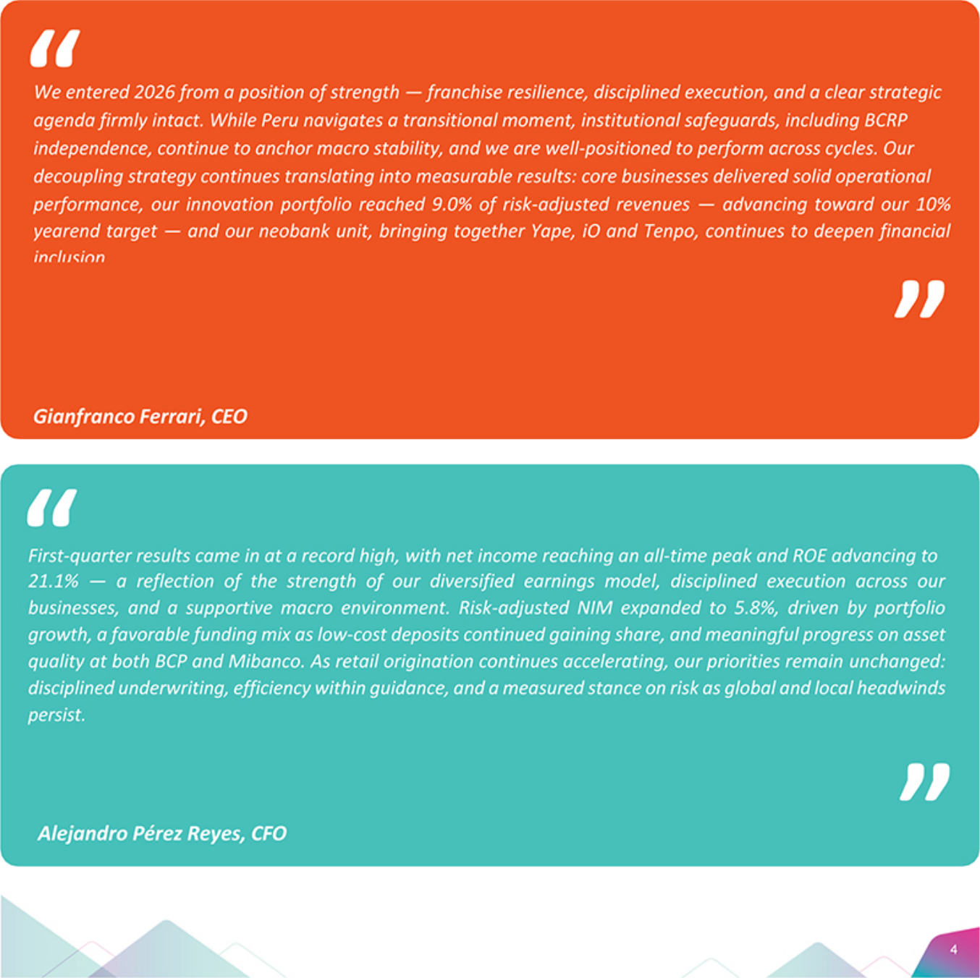

| Earnings Release 1Q / 2026 Analysis of 1Q26 Consolidated Results

First Quarter 2026 Earnings Conference Call

First 2026 EARNINGS CONFERENCE CALL

Date: Friday, May 15th, 2026

Time: 10:30 am E.T. (9:30 am Lima, Perú)

Hosts: Gianfranco Ferrari – Chief Executive Officer; Alejandro Perez-Reyes – Chief Financial Officer; Francesca Raffo – Chief Innovation Officer; Cesar Rios – Chief Risk Officer; Eduardo Montero – Head of Insurance and Pensions and CEO of Pacífico; and the Investor Relations Team.

To pre-register for the listen-only webcast presentation use the following link:

https://dpregister.com/DiamondPassRegistration/register?confirmationNumber=10208758&linkSecurityString=103ed5 b9252

Callers who pre-register will be given a conference passcode and unique PIN to gain immediate access to the call and bypass the live operator.

Participants may pre-register at any time, including up to and after the call start time.

Those unable to pre-register may dial in by calling:

1 844 435 0321 (U.S. toll free)
1 412 317 5615 (International)
Participant Web Phone: Click Aquí
Conference ID: Credicorp Conference Call

The webcast will be archived for one year on our investor relations website at:

https://credicorp.gcs-web.com/events-and-presentations/upcoming-events

For a full version of Credicorp´s Fourth Quarter 2025 Earnings Release, please visit:

https://credicorp.gcs-web.com/company-reports/quarterly-materials

| Earnings Release 1Q / 2026 Analysis of 1Q26 Consolidated Results

Loans in Quarter-end Balances (EOP)

Total loans (measured in EOP) expanded 1.9% QoQ and 8.2% YoY.

If we exclude the non-cash accounting adjustment at BCP Bolivia¹ and the depreciation of the USD against PEN, loans rose 1.0% QoQ and 9.1% YoY:
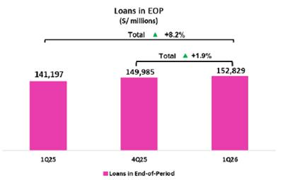

Growth was led by BCP, and Wholesale Banking in particular, where Corporate Banking drove growth through an uptick in medium and long-term loans. In the aggregate, Retail Banking remained stable over the period. In the disaggregate, expansion in Individuals was led by Consumer and driven by Yape as well as an uptick in the risk appetite at BCP Stand-alone. Mortgage and SME-Pyme, in turn, ticked up due to a rise in demand in a favorable macroeconomic environment. These positive dynamics were offset by a contraction in SME-Business, where annual resegmentation processes migrated some clients to the Wholesale Banking portfolio. At Mibanco, the portfolio expanded after disbursements accelerated to hit a record high in March. Growth was concentrated in smaller ticket, higher-yield loans.

The YoY result was primarily attributable to a more favorable macroeconomic environment, where loan demand continued to gain traction. The main factors that drove this evolution were: (i) loan growth acceleration in both Wholesale and Retail Banking at BCP, and (ii) an increase in the pace of disbursements at Mibanco.

Deposits

The balance for total deposits (measured in EOP) expanded 4.8% QoQ and 13.3% YoY.
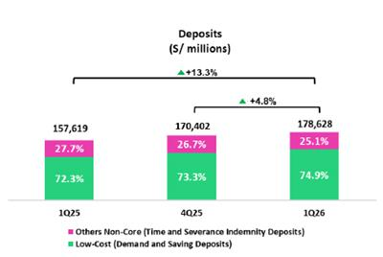

If we exclude the impacts generated by a non-cash accounting adjustment at BCP Bolivia¹ and the depreciation of the USD against PEN, deposits rose 0.8% QoQ and 13.7% YoY:

QoQ growth reflects an increase in the balance for Low-cost Deposits, which was bolstered primarily by inflows from the 8th private pension fund withdrawal. YoY, this evolution was driven mainly by growth in the balance for Low-cost Deposits, which rose 17.4% to represent 74.9% of our total deposit base at quarter-end.

At BCP, the Liquidity Coverage Ratio (RCL) in PEN at 30 days stood at 195.3% under regulatory standards and 164.8% by stricter internal standards. The LCR in US at 30 days stood at 206.5% under regulatory standards and 143.6% under stricter internal standards.

¹Accounting revaluations throughout 2025 applied exchange rates that were better aligned with the market.

| Earnings Release 1Q / 2026 Analysis of 1Q26 Consolidated Results

Net Interest Income (NII) and Margin (NIM)

NII rose 3.2% QoQ, driven primarily by an uptick in Interest and Similar Income. This evolution was fueled by (i) an increase in interest on securities, which rose on the back of BCP’s investment strategy to capitalize surplus liquidity, and (ii) growth in interest on loans, which rose alongside portfolio growth at BCP and Mibanco. To a lesser extent, Interest and Similar Expenses also contributed to the increase in NII given that ample liquidity was captured as low-cost deposits, which led to a drop in funding from more expensive sources such as time deposits and BCRP Instruments. In this context, NIM stood at 6.58% at quarter-end, compared to 6.62% in 4Q25 and 6.22% in 1Q25.
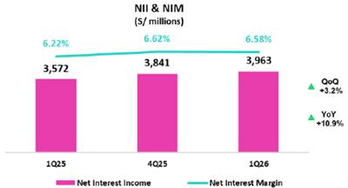

YoY, NII rose 10.9%, driven primarily by Interest and Similar Income. This evolution was fueled by growth in interest on loans, in line with an uptick in loan volumes at BCP and Mibanco. Interest and Similar Expenses dropped in a lower-interest rates environment. In this context, NIM rose 36 bps YoY.

Portfolio Quality and Cost of Risk

Our portfolio quality indicators and cost of risk have improved significantly over the last year and continue to strengthen thanks to fortified risk management, an uptick in payment performance, and a more favorable macroeconomic environment.
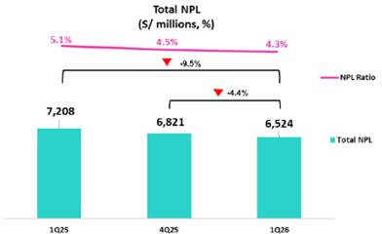

QoQ, the NPL balance dropped 4.4%, driven mainly by BCP Stand-alone. At BCP Stand-alone, the decline was fueled by Retail Banking, primarily through debt payments in (i) SME-Pyme, by clients with loans under judicial recovery, and in (i) Individuals, which benefitted from an uptick in liquidity through inflows from the pension fund withdrawal.

YoY, the NPL portfolio decreased 9.5%, driven by BCP Stand-alone and Mibanco. At BCP Stand-alone, the reduction was fueled by: (i) Retail Banking, driven by the same dynamics in play QoQ, and (ii) Wholesale Banking, which registered debt amortizations by corporate clients in the real estate and commercial sectors. At Mibanco, the decrease was driven by lower overdue loans, reflecting improvements in origination quality and enhanced debt collection management.
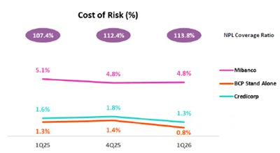

In this context, the NPL Ratio dropped 28 bps QoQ and 83 bps YoY to stand at 4.3% at quarter-end.

Provisions fell 25.4% QoQ, fueled by BCP Stand-alone and partially offset by Mibanco. At BCP Stand-alone, the reduction in provisions was primarily attributable to Wholesale Banking, which was impacted by a base effect given that some clients in the construction sector saw an increase in risk for indirect exposure in 4Q25. In Retail Banking, the decrease in provisions was mainly driven by an uptick in the share of lower-risk vintages in the SME-Pyme, Consumer and Credit Card segments, where payment performance was bolstered by macroeconomic improvements. At Mibanco, provisions rose on the back of loan growth.

| Earnings Release 1Q / 2026 Analysis of 1Q26 Consolidated Results

YoY, provisions fell 17.2%, fueled by BCP Stand-alone and partially offset by Mibanco. At BCP Stand-alone, the drop in provisions was driven by Retail Banking, mainly due to Consumer and Credit Cards, which registered an improvement in payment performance of earlier vintages. Wholesale Banking also contributed to the drop in provisions following an uptick in reversals after a corporate client regularized its refinanced debt and returned to up-to-date status. At Mibanco, growth in provisions was driven by the same factors that drove the QoQ evolution.
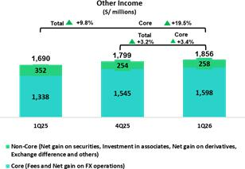

Other Income

Other Core Income hit a record high this quarter, growing 3.4% QoQ and 19.5% YoY. With these levels, other core income represented 27.7% of Credicorp’s total risk-adjusted income in 1Q26 (28.4% in 4Q25 and 26.5% in 1Q25). The quarter-end improvement reflects consistent execution of strategy to diversify revenue streams and decouple from the macroeconomy as we strengthen our model’s resilience. QoQ and YoY, other core income rose on the back of solid performance in the core business at BCP Stand-alone and an uptick in transactions through Yape.

Insurance Underwriting and Medical Services Results

Insurance Underwriting Results*

(S/ millions)

The Insurance Underwriting Result (IUR) reflected an execution consistent with our strategy, supported by healthy commercial dynamism in retail segments. QoQ, the IUR fell 6.8%, primarily due to (i) P&C, through lower income from Commercial Lines and Cars, and (ii) Corporate Health, through higher claims. YoY, the IUR decreased 9.1%, due to (i) P&C, which registered a decrease in premiums in Commercial Lines and Cars, which fell on the back of exchange rate depreciation, and (ii) Life, which was impacted by an inflation-related increase in expenses —which was offset in the Interest income line. Credit Life, which has become a channel for structural business growth, continued to expand its policy base through bancassurance and retail channels.
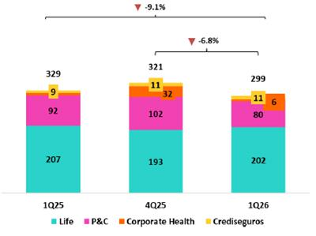

Medical Services Results continued to advance with operating and commercial discipline.

*Totals may differ from the sum of the parts due to eliminations in PGA consolidation.

Efficiency

| Earnings Release 1Q / 2026 Analysis of 1Q26 Consolidated Results

Efficiency ratio

Operating expenses increased 13.1% YoY, mainly driven by core businesses of BCP, Mibanco and Pacífico, as well as by initiatives within Credicorp’s innovation portfolio. Expenses in the ordinary businesses increased primarily due to BCP, reflecting higher personnel expenses, associated with increased headcount to support new initiatives aimed at strengthening commercial, technological and transactional capabilities. Expenses related to Credicorp’s innovation portfolio initiatives rose 40.2% YoY, mainly driven by Yape, reflecting higher cloud usage due to increased transaction volumes.
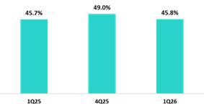

Operating Income, in turn, increased 12.9% over the same period. In this context, the Efficiency Ratio stood at 45.8% at the end of 1Q26, in line with guidance for the year.

Net income attributable to Credicorp

Net Income & ROE

(S/ millions)

In 1Q26, Credicorp reported a record high net attributable income of S/2,063.2 million (+30.0% QoQ and +16.1% YoY), backed by solid results in all our lines of business. Net Shareholders’ Equity stood at S/40,015 million (+4.3% QoQ and +11.6% YoY). In this scenario, ROE stood at 21.1%.
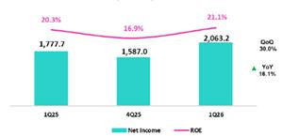

Contributions and ROE by subsidiary in 1Q26

(S/ millions)
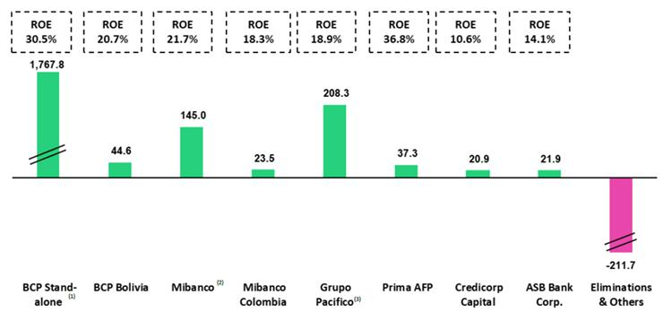

- In BCP Stand-alone, the figure is lower than the net profit since the contribution eliminates investment gains in other subsidiaries of Credicorp (Mibanco).
- In Mibanco, the figure is less than the net profit because Credicorp owns (directly and indirectly) 99.921% of Mibanco.
- The contribution for Grupo Pacifico presented here is greater than the profit of Pacifico Seguros since 100% of Crediseguros is being included (including 48% under Grupo Crédito)

| | Earnings Release 1Q / 2026 | Analysis of 1Q26 Consolidated Results


Universal Banking Microfinance


Profitability at BCP was off to a start this year, bolstered by loan growth under disciplined risk management and on-going diversification in revenue streams. In this context, ROE stood at 30.5%. The Risk-adjusted margin rose, sustained by improvements in client payment performance in a more favorable economic environment; solid transactional funding; and a shift toward a broader base for retail loans. BCP continues to invest in developing technological and business capacities to enable growth, innovation and operating leverage down the line.


Mibanco registered solid performance by leveraging opportunities in a dynamic economic environment and focusing on disciplined strategy execution. Armed with a stronger transactional offering, improvements in productivity, and prudent risk management, the bank outperformed its peers this quarter. Profitability is backed by resilient margins, active pricing management, lower funding costs and on-going improvements in portfolio quality. Mibanco continues to invest in strategic digital transformation projects to modernize its technological infrastructure and elevate the client experience. In Colombia, the business continued to follow an upward trajectory as it leverages consistent commercial and risk management.


Insurance and Pensions


Grupo Pacifico’s performance was solid, backed by healthy commercial dynamics and consistent strategy execution. The Life Business was a strong driver of commercial activity, registering growth in bancassurance channels and optional policies in retail segments, while registering an uptick in investment results. The P&C, business reflected a decrease in premiums in the corporate segment. In parallel, Medical Services continue to advance with operating and commercial discipline

Investment Management and

Advisory


Investment maintained profitability, Management and Advisory healthy levels of operating which was supported by solid results in core businesses. Strong commercial dynamics in the Capital Markets and Asset and Wealth Management, which were sustained by an increase in market activity, drove growth in income and in AUMs. These trends partially offset higher operating expenses associated with comparative base effects, reflecting a resilient performance of the business portfolio.


Outlook

We expect to close 2026 with an ROE around 19.5%. We believe this result will be driven by: (i) an acceleration in the pace of growth of our loan portfolio, particularly in the retail segment, (ii) an increase in our NIM, and (iii) a controlled cost of risk.


| Earnings Release 1Q / 2026 Analysis of 1Q26 Consolidated Results

Financial Overview

Credicorp Ltd. |  | Quarter |  |  | % change
S/ 000 | 1Q25 | 4Q25 | 1Q26 | QoQ | YoY
Net interest, similar income and expenses | 3,572,012 | 3,841,267 | 3,962,727 | 3.2% | 10.9%
Provision for credit losses on loan portfolio, net of recoveries | (581,893) | (646,286) | (482,088) | -25.4% | -17.2%
Net interest, similar income and expenses, after provision for | 2,990,119 | 3,194,981 | 3,480,639 | 8.9% | 16.4%
credit losses on loan portfolio
Other income | 1,690,216 | 1,799,499 | 1,856,324 | 3.2% | 9.8%
Insurance underwriting result | 329,134 | 320,843 | 299,063 | -6.8% | -9.1%
Medical services result | 42,689 pp | 124,673 | 123,838 | -0.7% | 190.1%
Total expenses | (2,532,874) | (3,079,957) | (2,840,831) | -7.8% | 12.2%
Profit before income tax | 2,519,284 | 2,360,039 | 2,919,033 | 23.7% | 15.9%
Income tax | (704,469) | (735,153) | (808,891) | 10.0% | 14.8%
Net profit | 1,814,815 | 1,624,886 | 2,110,142 | 29.9% | 16.3%
Non-controlling interest | 37,118 | 37,876 | 46,958 | 24.0% | 26.5%
Net profit attributable to Credicorp | 1,777,697 | 1,587,010 | 2,063,184 | 30.0% | 16.1%
Dividends paid to third parties | - | - | 0 | -100.0% | n.a.
Net income / share (S/) | 22.3 | 19.9 | 25.9 | 30.0% | 16.1%
Dividends per Share (S/) | - | - | 0.00 | n.a. | n.a.
Loans | 141,196,646 | 149,984,954 | 152,824,685 | 1.9% | 8.2%
Deposits and obligations | 157,619,082 | 170,401,633 | 178,627,906 | 4.8% | 13.3%
Net equity | 35,843,202 | 38,366,950 | 40,018,343 | 4.3% | 11.6%
Profitability
Net interest margin⁽¹⁾ | 6.2% | 6.6% | 6.6% | -4 bps | 36 bps
Risk-adjusted Net interest margin | 5.2% | 5.5% | 5.8% | 26 bps | 57 bps
Funding cost⁽²⁾ | 2.4% | 2.3% | 2.1% | -20 bps | -31 bps
ROAE | 20.3% | 16.9% | 21.1% | 420 bps | 80 bps
ROAA | 2.8% | 2.4% | 3.0% | 60 bps | 20 bps
Loan portfolio quality
Internal overdue ratio⁽³⁾ | 3.7% | 3.2% | 2.9% | -28 bps | -76 bps
Internal overdue ratio over 90 days | 3.0% | 2.7% | 2.4% | -30 bps | -60 bps
NPL ratio⁽⁴⁾ | 5.1% | 4.5% | 4.3% | -28 bps | -83 bps
Cost of risk⁽⁵⁾ | 1.6% | 1.8% | 1.3% | -48 bps | -35 bps)
Coverage ratio of IOLs | 148.7% | 159.3% | 165.9% | 660 bps | 1720 bps
Coverage ratio of NPLs | 107.4% | 112.4% | 113.8% | 140 bps | 640 bps
Operating efficiency
Operating income⁽⁶⁾ | 5,340,199 | 5,857,472 | 6,029,112 | 2.9% | 12.9%
Operating expenses⁽⁷⁾ | 2,442,089 | 2,871,709 | 2,762,628 | -3.8% | 13.1%
Efficiency ratio⁽⁸⁾ | 45.7% | 49.0% | 45.8% | -320 pbs | 10 pbs
Operating expenses / Total average assets | 3.8% | 4.4% | 4.0% | -35 pbs | 17 pbs
Capital adequacy - BCP Stand-alone
Global Capital Ratio⁽⁹⁾ | 16.87% | 19.44% | 16.70% | -274 bps | -17 bps
Ratio Tier 1⁽¹⁰⁾ | 11.34% | 13.66% | 10.96% | -270 bps | -38 bps
Ratio common equity tier 1⁽¹¹⁾ ⁽¹³⁾ | 11.62% | 13.99% | 11.29% | -270 bps | -33 bps
Capital adequacy - Mibanco
Global Capital Ratio⁽⁹⁾ | 18.53% | 21.25% | 20.31% | -94 bps | 178 bps
Ratio Tier 1⁽¹⁰⁾ | 15.48% | 17.41% | 15.87% | -154 bps | 39 bps
Ratio common equity tier 1⁽¹¹⁾ ⁽¹³⁾ | 15.89% | 17.30% | 15.70% | -161 bps | -19 bps
Employees⁽¹⁴⁾ | 48,853 | 51,005 | 51,509 | 1.0% | 5.4%
Share Information
Issued Shares | 94,382 | 94,382 | 94,382 | 0.0% | 0.0%
Treasury Shares⁽¹²⁾ | 15,016 | 15,016 | 14,934 | -0.5% | -0.5%
Outstanding Shares | 79,366 | 79,366 | 79,448 | 0.1% | 0.1%

- Net Interest Margin = Net Interest Income (Excluding Net Insurance Financial Expenses) / Average Interest Earning Assets
- Funding Cost = Interest Expense (Does not include Net Insurance Financial Expenses) / Average Funding
- Internal Overdue Loans: includes overdue loans and loans under legal collection, according to our internal policy for overdue loans. Internal Overdue Ratio: Internal overdue loans / Total loans
- Non-performing loans (NPL): Internal overdue loans + Refinanced loans. NPL ratio: NPL / Total loans.
- Cost of risk = Annualized provision for loan losses, net of recoveries / Average Total loans.
- Operating Income = Net interest, similar income and expenses + Fee Income+ Net gain on foreign exchange transactions + Net Gain From associates + Net gain on derivatives held for trading + Result on exchange differences + Insurance Underwriting Result + Results for Medical Services
- Operating Expenses = Salaries and employee benefits + Administrative expenses + Depreciation and amortization + Association in participation
- Efficiency Ratio = (Salaries and employee benefits + Administrative expenses + Depreciation and amortization + Association in participation) / (Net interest, similar income and expenses + Fee Income + Net gain on foreign exchange transactions + Net Gain From associates + Net gain on derivatives held for trading + Result on exchange differences + Insurance Underwriting Result + Results for Medical Services)
- Regulatory Capital / Risk-weighted assets (legal minimum = 10% since July 2011).
- Tier 1 = Capital + Legal and other capital reserves + Accumulated earnings with capitalization agreement + (0.5 x Unrealized profit and net income in subsidiaries) - Goodwill - (0.5 x Investment in subsidiaries) + Perpetual subordinated debt (the maximum amount that can be included is 17.65% of Capital + Reserves + Accumulated earnings with capitalization agreement + Unrealized profit and net income in subsidiaries - Goodwill).
- Common Equity Tier I = Capital + Reserves – 100% of applicable deductions (investment in subsidiaries, goodwill, intangibles and net deferred taxes that rely on future profitability) + retained earnings + unrealized gains.
- Consider shares held by Atlantic Security Holding Corporation (ASHC) and stock award.
- Common Equity Tier I calculated based on IFRS Accounting.
- Internal management figures.

| | Earnings Release 1Q / 2026 | Analysis of 1Q26 Consolidated Results

Credicorp’s Strategy Update

Credicorp’s Strategy

Credicorp has consolidated its leadership in the Andean region through a strategy anchored in digital transformation and innovation; efforts to develop the best talent; and initiatives to integrate sustainability at the core of its business. Our strategic guideposts have channeled our transition to an integrated financial ecosystem whose power wielded is greater than the sum of its parts. Four differentiated growth levers:

- Strengthing Our Leading Position in Underpenetrated Markets with Clear Growth Avenues

Leader in various financial verticals in an under-penetrated region that offers opportunities for long-term growth. In Peru, low levels of financial inclusion and high degrees of informality mean that banking, insurance, payments and remittances have untapped opportunities for penetration and growth.

- Scaling an Integrated Digital Ecosystem

Thanks to its innovation portfolio and base of more than 19 million users, Credicorp has evolved into an integrated financial ecosystem. We leverage data to enhance our value proposition with more personalized experiences; heighten engagement; and scale efficiently. By deepening our relationship with the client, we grow our user base and bolster product penetration in the ecosystem’s businesses. We will continue to broaden access to inclusive products and services to advance financial inclusion and create opportunities for people who are currently excluded and unbanked, with the ambition of financially including 8 million Peruvians by 2028.

High-potential businesses such as bancassurance, payments and supply chain finance are expected to grow between 3x and 6x in the medium term. The innovation portfolio, led by Yape, continues to scale and monetize and represented 9.0% of risk-adjusted income at the end of 1Q26, well on its way to hitting the 10% target set for 2026. These advances strengthen our efforts to diversify and generate new sources of income.

- Unlocking Synergies by Leveraging Shared Capabilities Across Our Ecosystem

Shared capacities for technology, data, analytics, IA and risk generate competitive advantages that enable synergies, cross-selling, client acquisition, and multi-product adoption. This strengthens efficiency, drives monetization and improves decisions.

- Delivering Strong, Resilient Returns Across Economic Cycles

Credicorp has demonstrated resilience over three decades of disciplined execution while creating value through a strategy designed to decouple from the evolution of the macroeconomy.

 | Main KPIs of Credicorp’s Strategy
Core Businesses Transformation ⁽¹⁾ |  |  | Quarter
Core Businesses Transformation ⁽¹⁾ |  | 1Q25 | 4Q25 | 1Q26
Credicorp |  | 5.4% | 8.1% | 9.0%
Innovation Portfolio Risk-Adjusted Revenue Share ⁽²⁾ |  | 5.4% | 8.1% | 9.0%
People financially included ⁽³⁾ |  | 6.0 | 6.6 | 6.8
Total loan disbursements for MSMEs (S/ million) |  | 3,902 | 4,444 | 4,591
Disbursements of sustainable financings (USD million) |  | 430 | 1,154 | 630
BCP Stand-alone |  | 2.3 | 3.2 | 3.753
Loan enabled clients ⁽⁴⁾ |  | 2.3 | 3.2 | 3.753
Consumer NPS |  | 51 | 51 | 53
Cashless transactions ⁽⁵⁾ |  | 64% | 68% | 68%
Mibanco |  | 5.2% | 6.4% | 6.5%
Share of Low-Cost Deposits / Total Funding ⁽⁶⁾ |  | 5.2% | 6.4% | 6.5%
Share of Other Income / Total Risk-Adjusted Revenue |  | 7.1% | 7.0% | 8.7%
Pacifico |  | n.a. | 7.1 | 7.3
Insured Clients ⁽⁷⁾ |  | n.a. | 7.1 | 7.3
Digital Policies (thousands) ⁽⁸⁾ |  | 722.1 | 599.0 | 733.0

- Management figures, may differ from previously reported. Figures for March 2025, December 2025 and March 2026.
- As a percentage of Credicorp’s total Risk-Adjusted Revenue.
- Stock of financially included clients through BCP since 2020: (i) New clients with savings accounts or affiliated to Yape. (ii) New clients without debt in the financial system or BCP products in the last twelve months. (iii) Clients with 3 monthly average transactions in the last three months.
- Clients with an active loan.
- Amount transacted through Mobile Banking, Internet Banking, Yape y POS/Total amount transacted through Retail Banking.
- Includes low-cost funding products (Ahorro Negocio, Ahorro, Cuenta Premio, and Demand Deposits) as a proportion of total funding.
- Includes natural and legal clients. New methodological adjustments since 4Q25, related to customers with loan life insurance.

- Number of insurance policies issued through digital channels.

| | Earnings Release 1Q / 2026 | Analysis of 1Q26 Consolidated Results

Credicorp’s Strategy Update

Innovation Portfolio

Credicorp’s Innovation Portfolio works alongside the Group’s core businesses, providing scalable digital platforms that operate within the framework of a disciplined strategy to create value. These platforms diversify income; enhance the value proposition; and enable new venues for growth by leveraging capacities across the ecosystem.

The portfolio invests in the verticals such as Neobank, Acquiring and services for MIPYMEs, InsurTech and WealthTech, where initiatives are at different levels of maturity. This focus facilitates dynamic allocation of capital and actively rotates the portfolio as businesses grow. These initiatives can incubate within the core business or be channeled through Krealo, our Corporate Venture Capital arm. Krealo enables outside-in innovation through investments and acquisitions that complement and expand current and future lines of business.

The portfolio is managed with explicit financial appetites, which contemplate an impact of up to 150 bps on ROE and 350 bps in the efficiency ratio. By 2026, this portfolio is expected to account for 10% of the Group’s risk-adjusted income.

Yape: main driver of scale, monetization and inclusion

Main Management Indicators


Management KPI’s ⁽¹⁾ |  | Quarter |  | Change %
Management KPI’s ⁽¹⁾ | 1Q25 | 4Q25 | 1Q26 | QoQ | YoY
Users | 18.0 | 19.1 | 19.4 | 1.8% | 8.0%
Users (millions)
Monthly Active Users (MAU) (millions) ⁽²⁾ | 14.3 | 15.9 | 16.4 | 2.7% | 14.1%
Revenue Generating MAU (millions) | 12.0 | 14.0 | 14.3 | 2.6% | 19.6%
Engagement | 2,025 | 2,989 | 3,005 | 0.6% | 48.4%
# Transactions (millions)
# Revenue Generating Transactions (millions) | 229 | 318 | 337 | 6.0% | 47.2%
# Transactions / MAU | 52 | 66 | 67 | 0.0% | 27.8%
# Average Functionalities / MAU | 3 | 3 | 3 | 0.7% | 9.2%
Experience | 77 | 81 | 77 | -4 p | 0 p
_{NPS} (3)
Unit Economics
Monthly Indicators ⁽⁴⁾ | 6.2 | 9.6 | 10.3 | 6.8% | 65.0%
Revenues / MAU (S/)
Expenses / MAU (S/) | -4.7 | -6.1 | -5.9 | -2.7% | 26.1%
Quarterly Indicators ⁽⁵⁾ | 5.6 | 8.5 | 9.7 | 14.6% | 74.3%
Revenues / MAU (S/)
Expenses / MAU (S/) | -4.3 | -5.5 | -5.5 | -0.5% | 27.6%
Drivers Monetization | 91.6 | 128.9 | 129.8 | 0.7% | 41.8%
Total TPV (S/, billions) ⁽⁶⁾
Total Revenue Generating TPV (S/, billions) ⁽⁶⁾ | 8.7 | 14.0 | 15.6 | 11.3% | 79.5%
Payments | 45 | 61 | 67 | 9.5% | 49.1%
# Bill Payments transactions (millions)
Financials | 3,100 | 5,118 | 5,734 | 12.0% | 84.9%
# Loans Disbursements (thousands)
E-Commerce | 124.1 | 181.6 | 175.3 | -3.4% | 41.3%
GMV (S/, millions) ⁽⁷⁾
- Management Figures.
- Yape users that have made at least one outgoing transaction in the measurement month.
- Net Promoter Score.
- Monthly indicators consider the results of the last month of the quarter for the numerator and denominator.
- Quarterly indicators are calculated using the sum of the three months in the period for numerator accounts, and the average of the denominator—based on the last month’s data from both the current and previous quarters.
- Total Payment Volume.
- Gross Merchant Volume, includes the following functionalities: Yape Promos, Yape Store, Ticketing, Gaming, Delivery, Buses, Gas, Brand Solutions and Insurance.

| Earnings Release 1Q / 2026 Analysis of 1Q26 Consolidated Results

Credicorp’s Strategy Update

Main financial results

Financial Results ⁽¹⁾ | 1Q25 | Quarter | 1Q26 | QoQ | Change %
S/ millions | 1Q25 | 4Q25 | 1Q26 | QoQ | YoY
Net Interest Income after Provisions ⁽²⁾ | 93.0 | 179.5 | 235.7 | 31.3% | 153.5%
Other Income ⁽³⁾ | 141.6 | 221.7 | 235.6 | 6.3% | 66.4%
Total Income | 234.6 | 401.2 | 471.3 | 17.5% | 100.9%
Total Operating Expenses | -179.7 | -259.8 | -266.1 | 2.4% | 48.1%

- Management figures.
- Includes interest income, interest expense and net provisions.
- Includes Other income recorded in BCP and in Yape Market.

At the end of 1Q26, Yape reached the 16.4-million mark for monthly active users (MAU), which is equivalent to approximately 82% of the country’s Economically Active Population and indicates consolidation of nationwide coverage. Although the platform continues to expand its users, the strategic focus has evolved and now seeks to deepen recurrence, broaden multi-product adoption, and monetize the installed base that is already highly penetrated, in a context where the use of cash in Peru remains relevant.

Average frequency of use stood at 67 monthly transactions per user, which proves that Yape is highly integrated in users’ daily lives. Revenue-generating transactions, in turn, grew 47.2% YoY and accounted for 11% of the total, reflecting tangible progress in the monetization strategy. Our NPS remains high at 77 points—a clear indicator of client satisfaction and trust.

Monthly revenue per MAU reached S/10.3 (+65.0% YoY), driven by higher transaction levels and an increase in the use of features (2.9 in 1Q26 vs. 2.6 in 1Q25). This growth far outpaced the uptick in monthly expenses per MAU, which stood at S/5.9 (+26.1% YoY), in line with the platform’s asset-light and highly scalable model.

Lines of Business

- Payments (accounts for 47% of Yape’s total revenues)

The Payments business is Yape’s main fee generator, where strong momentum is reflected in a higher share of Credicorp’s total fee income (17% in 1Q26 vs. 12% in 1Q25). In 1Q26, the main revenue drivers were: (i) QR/POS payments, associated with a higher number of transactions and active customers; and (ii) bill payments, driven by an increase in the adoption of features, which translated into 67 million transactions during the quarter (+49.1% YoY), mainly in services such as telecom, financial instit utions, electricity, and education. These results have situated Yape as the Group’s primary collections channel. This quarter, revenue-generating TPV grew 79.5% YoY, reinforcing Yape’s role as the country’s digital payments infrastructure.

- Finance (accounts for 50% of Yape’s total revenues)

The financial business is consolidating as the main long-term growth vertical, as reflected in a higher contribution to Credicorp’s risk-adjusted net interest income (8% in 1Q26 vs. 5% in 1Q25). At quarter-end, the lending business accounted for 23% of Yape’s total revenues (vs. 13% in 1Q25), supported by shared capabilities across the Credicorp ecosystem for risk management, analytics, and funding.

In 1Q26, more than 5.7 million disbursements were recorded, composed mainly of single-installment loans. Despite this momentum, credit penetration remains limited, with only 30% of MAUs having obtained a loan (4.9 million customers with at least one loan disbursed), leaving ample room to scale in a disciplined manner. Average ticket sizes and durations by loan type are: (i) Single-installment: ~S/200 and <1 month; (ii) Multi-installment: ~S/700 and 8 months; and (iii) Pyme: ~S/2,300 and 10 months. In addition, as of 1Q26, the portfolio balance was mainly composed of multi-installment loans.

- E-Commerce (accounts for 3% of Yape’s total revenues)

E-commerce continues to contribute to revenue diversification and heightened engagement. In 1Q26, its GMV totaled S/175 million (+41.3% YoY), driven mainly by solutions such as Yape Promos, which recorded growth in active customers and transactions over the period.

Rising contribution to and optionality for Credicorp

At the end of 1Q26, Yape contributed 8.0% of Credicorp’s risk-adjusted revenue, sustaining an upward trajectory YoY (up from 4.5% in 1Q25). This progress bolsters Yape’s strategic optionality and advances its ambition to become the Group’s second most important contributor to net income in time. The app’s scale, growing monetization and financial discipline will support efforts down the line.

| | Earnings Release 1Q / 2026 | Analysis of 1Q26 Consolidated Results

01 Loan Portfolio


Total loans increased 1.9% QoQ and 8.2% YoY. If we exclude the impacts of asset revaluation at BCP Boliva and the depreciation of USD against PEN, total loans registered growth of 1.0% QoQ and 9.1% YoY.

QoQ, expansion in total loans was primarily driven by: (i) growth in medium- and long-term loans within Wholesale Banking at BCP; (ii) higher lending to Individuals and SME-PYME, which was offset by a decline in SME-Business within BCP’s retail segments; and (iii) record-high disbursements at Mibanco, achieved in March.

- YoY, total loans rose 9.1% with a Neutral Exchange rate. This evolution reflects on-going improvements in the dynamism of the economy, which have sustained loan growth. The drivers of YoY performance were (i) the same dynamics seen QoQ in Wholesale Banking, (ii) growth in disbursement in Individuals and SME-Pyme, which was attributable to an increase in risk appetite, and (iii) an acceleration in disbursements at Mibanco.

Evolution of Loans in Quarter-end Balances

This quarter, total loans in quarter-end balances rose 1.9% and 8.2% QoQ and YoY, respectively. Both evolutions were impacted by asset revaluation at BCP Bolivia¹. If we isolate this impact and the influence of the depreciation of USD against PEN, which gives us a clearer view of commercial performance, loans in quarter-end balances increased 1.0% QoQ and 9.1% YoY.

Total loans (in Quarter-end balances)


Total Loans |  | As of |  | % change |  | USD/PEN Neutral |  | USD/PEN Neutral
Total Loans |  | As of |  |  |  | Volume change |  | % Change
(S/ Millions)
(S/ Millions) | Mar 25 | Dec 25 | Mar 26 | QoQ | YoY | QoQ | YoY | QoQ | YoY
BCP Stand-alone | 119,379 | 125,201 | 128,142 | 2.3% | 7.3% | 1,408 | 10,884 | 1.1% | 9.1%
Mibanco | 12,525 | 13,607 | 14,080 | 3.5% | 12.4% | 473 | 1,555 | 3.5% | 12.4%
Mibanco Colombia | 1,904 | 2,315 | 2,618 | 13.1% | 37.5% | 207 | 847 | 8.9% | 44.5%
BCP Bolivia | 6,294 | 7,553 | 7,319 | -3.1% | 16.3% | n.a. | n.a. | n.a. | n.a.
ASB Bank Corp. | 1,777 | 1,462 | 1,459 | -0.2% | -17.9% | -57 | -244 | -3.9% | -13.7%
Others ⁽¹⁾ | -682 | -153 | -794 | 418.5% | 16.4% | -644 | -93 | 420.5% | 13.7%
Total Loans BAP | 141,197 | 149,985 | 152,825 | 1.9% | 8.2% | n.a. | n.a. | n.a. | n.a.
BCP Bolivia (Adjusted for Asset Revaluation) | 9,877 | 9,258 | 9,685 | 4.6% | -1.9% | 65 | 293 | 0.7% | 3.0%
Total Loans BAP (Adjusted for Asset Revaluation) | 144,780 | 151,690 | 155,190 | 2.3% | 7.2% | 1,452 | 13,242 | 1.0% | 9.1%
For consolidation purposes, loans generated in Foreign Currency (FC) are converted into Local Currency (LC).
(1) Includes eliminations for intercompany transactions.

QoQ, loan evolution at a Neutral Exchange rate was driven mainly by BCP Stand-alone (+1.1%), followed by Mibanco (+3.5%). At Mibanco, loan growth was driven primarily by an acceleration in loan disbursements, which hit a peak in the month of March, fueled mainly by smaller ticket and higher yield loans.

YoY, loan evolution at a Neutral Exchange rate was fueled mainly by BCP Stand-alone (+9.1%) and secondarily by Mibanco (+12.4%) and Mibanco Colombia (+44.5%). At Mibanco, loans rose on the back of an uptick in disbursements, which began gaining traction last year and rose in YoY terms, supported by a more dynamic microfinance environment. At Mibanco Colombia, growth was robust YoY, as loans continued to recover significantly, spurred by the origination guidelines implemented in 2024 and a more favorable economic context for microfinance.

- As in recent quarters, this evolution is impacted by a non-cash accounting adjustment for the revaluation of assets related to the balance sheet of BCP Bolivia.

| Earnings Release 1Q / 2026 Analysis of 1Q26 Consolidated Results

01. Loan Portfolio

Next, we will analyze dynamics by segment at BCP Stand-alone:

QoQ: Total loans by Segment at BCP Stand-alone (in Quarter-end balances)

Total Loans |  | As of | QoQ Change |  | Balance in USD/PEN Neutral |  | QoQ Change
Total Loans |  | As of |  |  |  | As of | in USD/PEN Neutral
(S/ Millions) |  |  |  |  |  | As of
(S/ Millions) | Dec 25 | Mar 26 | Volume | % | Dec 25 | Mar 26 | Volume | %
BCP Stand-alone | 125,201 | 128,142 | 2,942 | 2.3% | 125,201 | 126,609 | 1,408 | 1.1%
Wholesale Banking | 54,142 | 56,335 | 2,193 | 4.0% | 54,142 | 55,159 | 1,017 | 1.9%
Corporate | 31,958 | 33,209 | 1,251 | 3.9% | 31,958 | 32,528
 |  |  |  |  |  |  | 570 | 1.8%
Middle - Market | 22,184 | 23,125 | 942 | 4.2% | 22,184 | 22,631 | 447 | 2.0%
Retail Banking | 69,501 | 69,808 | 307 | 0.4% | 69,501 | 69,501 | 0 | 0.0%
SME - Business | 8,434 | 7,100 | -1,333 | -15.8% | 8,434 | 6,983
 |  |  |  |  |  |  | -1,451 | -17.2%
SME - Pyme | 16,735 | 17,036 | 301 | 1.8% | 16,735 | 17,031 | 296 | 1.8%
Mortgage | 23,822 | 24,396 | 574 | 2.4% | 23,822 | 24,337 | 515 | 2.2%
Consumer | 14,074 | 14,879 | 805 | 5.7% | 14,074 | 14,793 | 719 | 5.1%
Credit Card | 6,437 | 6,396 | -40 | -0.6% | 6,437 | 6,358 | -79 | -1.2%
Others ⁽¹⁾ | 1,558 | 2,000 | 442 | 28.4% | 1,558 | 1,948 | 390 | 25.1%

For consolidation purposes, loans generated in Foreign Currency (FC) are converted into Local Currency (LC).
(1) Includes other assets and accruals.
Larger contraction in volume
Larger expansion in volume

QoQ, total loans in quarter-end balances at BCP Stand-alone increased 1.1% at Neutral exchange rate. This growth was driven mainly by Wholesale Banking (+1.9%), while loans in Retail Banking remained stable. In Wholesale Banking, expansion was driven by an uptick in medium and long-term disbursements, fueled mainly by Corporate Banking, where growth was led by the Energy sector. In Middle Market Banking, expansion was spurred by specific clients in the agriculture sector.

In Retail Banking, loan growth in Individuals and SME-Pyme was offset by a drop in loans in SME-Business, whose evolution was spurred by yearly resegmentation processes, which migrated clients from the SME-Business segment to Wholesale Banking. Segments that evolved positively QoQ include:

- Consumer, driven mainly by growth in disbursements through Yape and an uptick in risk appetite at BCP Stand-alone.

- Mortgage, fueled by growth in disbursements, which was sustained by favorable macroeconomic conditions and low interest rates.

- SME-Pyme, where an increase in the risk appetite led disbursements of working capital loans to rise.

YoY: Total Loans by Segment at BCP Stand-alone (in Quarter-end Balances)

Total Loans |  | As of | YoY Change |  |  | Balance in USD/PEN |  |  |  | YoY Change
Total Loans |  | As of |  |  |  |  | Neutral As of |  |  | in USD/PEN Neutral
(S/ Millions)
(S/ Millions) | Mar 25 | Mar 26 | Volume | % |  | Mar 25 |  | Mar 26 |  | Volume | %
BCP Stand-alone | 119,379 | 128,142 | 8,764 | 7.3% | 119,379 |  |  | 130,263 |  | 10,884 | 9.1%
Wholesale Banking | 52,602 | 56,335 | 3,732 | 7.1% | 52,602 |  |  | 57,962 |  | 5,360 | 10.2%
Corporate | 31,369 | 33,209 | 1,840 | 5.9% | 31,369 |  |  | 34,153
 |  |  |  |  |  |  |  |  |  | 2,784 | 8.9%
Middle - Market | 21,234 | 23,125 | 1,892 | 8.9% | 21,234 |  |  | 23,809 |  | 2,575 | 12.1%
Retail Banking | 64,875 | 69,808 | 4,932 | 7.6% | 64,875 |  |  | 70,232 |  | 5,356 | 8.3%
SME - Business | 7,711 | 7,100 | -611 | -7.9% | 7,711 |  |  | 7,262
 |  |  |  |  |  |  |  |  |  | -449 | -5.8%
SME - Pyme | 15,922 | 17,036 | 1,114 | 7.0% | 15,922 |  |  | 17,043 |  | 1,121 | 7.0%
Mortgage | 22,115 | 24,396 | 2,282 | 10.3% | 22,115 |  |  | 24,478 |  | 2,364 | 10.7%
Consumer | 13,173 | 14,879 | 1,707 | 13.0% | 13,173 |  |  | 14,999 |  | 1,826 | 13.9%
Credit Card | 5,955 | 6,396 | 441 | 7.4% | 5,955 |  |  | 6,450 |  | 495 | 8.3%
Others ⁽¹⁾ | 1,901 | 2,000 | 99 | 5.2% | 1,901 |  |  | 2,069 |  | 168 | 8.8%
For consolidation purposes, loans generated in Foreign Currency (FC) are converted into Local Currency (LC).
(1) Includes other assets and accruals. |  |  |  |  |  |  | Larger contraction in volume
 |  |  |  |  |  |  | Larger expansion in volume

YoY, total loans in quarter-end balances at BCP Stand-alone increased 9.1% with a Neutral exchange rate. This growth was driven mainly by Wholesale Banking (+10.2%) and secondarily by Retail Banking (+8.3%).

| Earnings Release 1Q / 2026 Analysis of 1Q26 Consolidated Results

01. Loan Portfolio

In Wholesale Banking, growth was fueled primarily by an uptick in medium and long-term loans. This evolution was driven by an increased risk appetite within the business, underpinned by a favorable macroeconomic environment, particularly the recovery in private investment.

In Retail Banking, all segments, excluding SME Business, evolved favorably YoY, buoyed by the same dynamics seen QoQ coupled with a more dynamic economic backdrop.

YoY evolution of the Dollarization Level of Loans (in Quarter-end balances)
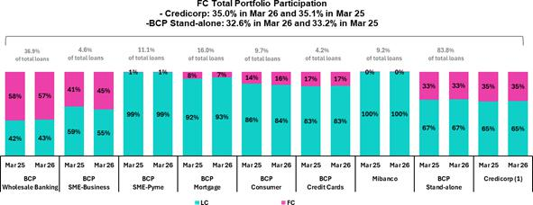

(1) Participation in FC loans at the Credicorp level considers BCP Stand-alone, Mibanco, Mibanco Colombia, BCP Bolivia and ASB.

YoY, the dollarization level of total loans dropped 10 bps. This evolution was driven by loan growth in LC (+8.4%), mainly in Retail Banking, and partially offset by loan expansion in FC (+7.9%), mainly in Wholesale Banking.

Evolution of Loans in Average Daily Balances

Loans in average daily balances (ADB) rose 2.2% and 4.6%, QoQ and YoY, respectively. It is important to note that the figures for ADB are derived from internal management figures and exclude the impact of the revaluation of BCP Bolivia’s asset balance.

For more details on loan dynamics in ADB, see Annex 12.1.

| Earnings Release 1Q / 2026 Analysis of 1Q26 Consolidated Results

02 Deposits


Total deposits rose 4.8% QoQ and 13.3% YoY. If we exclude the impacts generated by asset revaluation at BCP Bolivia and devaluation of USD PEN (Neutral exchange rate), total deposits increased 0.8% QoQ and 13.7% YoY.

QoQ, growth was driven mainly by an uptick in the Low-cost Deposit balance, which was fueled mainly by our investments in digital infrastructure and initiatives to strengthen client relations, which has helped us captured inflows from pension fund withdrawal and, to a lesser extent, the profit-sharing payments in the month of March.

YoY, the uptick was fueled by the same dynamics in play QoQ and by an increase in the FC balance for Low-cost Deposits due to an appreciation in the exchange rate to bolster their balances in USD.

At the end of 1Q26, 74.6% of Total Deposits were Low-cost (Demand + Savings). Credicorp continues to lead the market for low-cost deposits with a 41.2% share at the end of March.

This quarter, Total Deposits rose 4.8% and 13.3%, QoQ and YoY, respectively. Both evolutions were impacted by asset revaluation at BCP Bolivia¹. If we exclude this impact and effects from changes of PEN against the US Dollar, the deposit balance increased 0.8% QoQ and 13.7% YoY, driven by the following dynamics:

Deposits |  | As of |  |  | Change | Change |  | Change FX Neutral USD PEN |  | Change FX Neutral USD PEN
 |  | As of |  |  | (Volume) | (%) |  |  | (Volume) |  | (%)
S/000 | Mar 25 | Dec 25 | Mar 26 | QoQ | YoY | QoQ | YoY | QoQ | YoY | QoQ | YoY
Demand deposits | 53,992,479 | 57,051,969 | 62,594,945 | 5,542,976 | 8,602,466 | 9.7% | 15.9% | 2,972,339 | 8,234,568 | 5.1% | 14.8%
Saving deposits | 59,969,559 | 67,811,945 | 71,249,909 | 3,437,964 | 11,280,350 | 5.1% | 18.8% | 1,021,819 | 11,192,938 | 1.5% | 18.4%
Time deposits | 39,779,546 | 41,344,255 | 40,877,361 | (466,894) | 1,097,815 | -1.1% | 2.8% | (2,352,834) | 2,662,421 | -5.6% | 6.4%
Severance indemnity deposits | 2,921,196 | 3,192,565 | 2,987,508 | (205,057) | 66,312 | -6.4% | 2.3% | -212,840 | 192,723 | -6.7% | 6.6%
Interest payable | 956,302 | 1,000,899 | 918,183 | (82,716) | (38,119) | -8.3% | -4.0% | (43,886) | 8,337 | -3.8% | 0.7%
Low-cost deposits ⁽¹⁾ | 113,962,038 | 124,863,914 | 133,844,854 | 8,980,940 | 19,882,816 | 7.2% | 17.4%
Total Deposits | 157,619,082 | 170,401,633 | 178,627,906 | 8,226,273 | 21,008,824 | 4.8% | 13.3%
Adjusted by Bolivia’s revaluation
Low-cost deposits ⁽¹⁾ | 116,433,747 | 126,058,318 | 135,579,062 | 9,520,744 | 19,145,315 | 7.6% | 16.4% | 3,994,159 | 19,427,506 | 3.2% | 16.7%
Total Deposits | 162,272,979 | 172,605,609 | 181,702,552 | 9,096,943 | 19,429,573 | 5.3% | 12.0% | 1,384,598 | 22,290,986 | 0.8% | 13.7%
- Includes: Demand and Saving Deposits.

QoQ, our balance for Total Deposits rose 0.8%, driven primarily by:

- A 5.1% increase in the balance of Demand Deposits. This evolution was fueled primarily by growth in LC volumes at BCP Stand-alone, which was in turn primarily attributable to inflows from the 8th pension fund withdrawal and, to a lesser extent, to growth in Middle Market Banking, which rose an uptick in movements by institutional clients.
- The 1.5% increase in the balance of Savings Deposits, spurred mainly by growth in LC volumes at BCP Stand-alone. This evolution was attributable to inflows from both pension fund withdrawals and deposits by clients who received profit-sharing payments in March.

- A 5.6% reduction in the balance for Time Deposits. This evolution was driven by a drop in LC volumes at BCP Stand-alone, related to deposits expirations of wholesale clients, in line with the strategic decision to optimize our funding structure.

YoY, our balance for Total Deposits increased 13.7%, driven mainly by:

- Expansion of 14.8% and 18.4% in the balance for Demand Deposits and Savings Deposits, respectively. YoY growth was propelled by the same dynamics seen QoQ and by an uptick in the FC volume at BCP Stand-alone, which rose on the back of an appreciation in the US Dollar’s value against the PEN. Balance expansion for both deposit types was driven by on-going efforts to differentiate our transactional offerings, which has facilitated deposit captures in a context of high liquidity.

Finally, thanks to our investments in digital infrastructure and initiatives to strengthen client relations, our Low-cost Deposits continued to grow and currently represent 74.6% of total deposits, up 286 bps YoY. This growth led our market share of low-cost deposits to situate at 41.2% at quarter-end.

- As in recent quarters, this evolution is impacted by a non-cash accounting adjustment for the revaluation of assets related to the balance sheet of BCP Bolivia.

| Earnings Release 1Q / 2026 Analysis of 1Q26 Consolidated Results

02. Deposits

Deposit Dollarization Level

Deposits by Currency

(Measured at quarter-end balances)
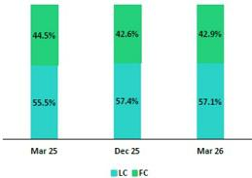

At the end of March 2026, the dollarization level of Total Deposits rose 33 bps QoQ to stand at 42.9%. This level remains below the average for the last 4 years (48.1%). The uptick in dollarization over the period was primarily attributable to an increase in volumes of Savings Deposits and Demand Deposits in FC, which rose on the back of a depreciation in the PEN’s value against the US Dollar. Growth in the aforementioned deposit types was partially offset by an increase in Low-cost Deposits in LC, which ticked up through inflows from pension funds withdrawals.

YoY, the dollarization level dropped 160 bps. This evolution was driven mainly by an appreciation in the exchange rate, which impacted our FC balances, and by the same dynamics that drove growth in our LC balances QoQ.

Deposits by Currency and Type

(Measured at quarter-end balance)
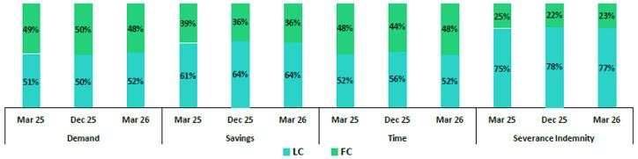

Loan / Deposit Ratio (Ratio L/D)
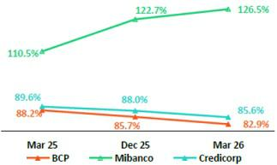

QoQ, the L/D ratio dropped 275 bps at BCP Stand-alone. This evolution was fueled by an increase in the balance of Low-cost Deposits, which rose on back of inflows from pension fund withdrawals, and offset by loan expansion in the Wholesale Banking segment. At Mibanco, the ratio rose 384 bps, driven mainly by loan growth, which has gained traction in a more favorable environment for microfinance. This growth was partially offset by an increase in Savings Deposits, which reflected a system-wide uptick in liquidity.

YoY, the L/D ratio dropped 526 bps at BCP Stand-alone. This evolution was driven by the same dynamics that drove the QoQ result. At Mibanco, the ratio rose 16pp, driven by loan expansion, which ticked up through the dynamics seen QoQ. The reduction in Total Deposits also drove the uptick in the YoY ratio. The rise in savings

deposits, which rose on the back of higher liquidity system-wide, was offset by a larger decrease in Time Deposits, where the downward trajectory was fueled by a drop in interest rates.

In this context, the L/D ratio at Credicorp stood at 85.6%.

| Earnings Release 1Q / 2026 Analysis of 1Q26 Consolidated Results

02. Deposits

L/D Ratio Local Currency L/D Ratio Foreign Currency
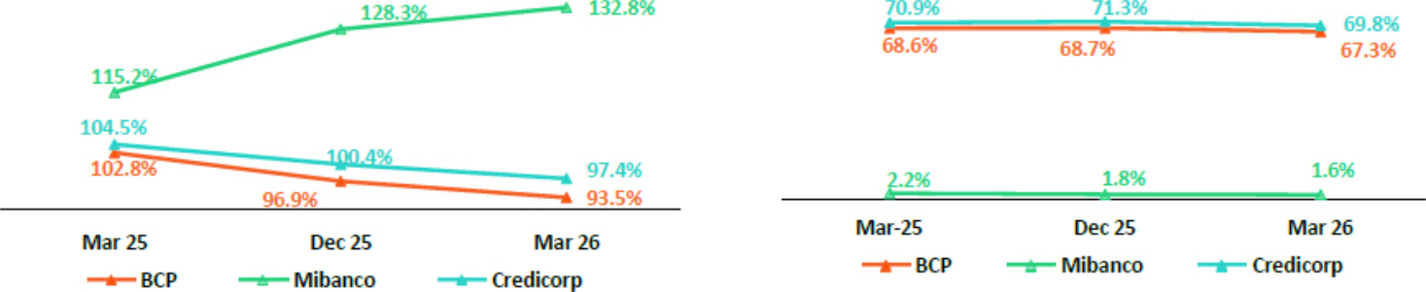

Market Share (MS) of Deposits in the Peruvian Financial System

Share of the Deposit Market in the Peruvian Financial System
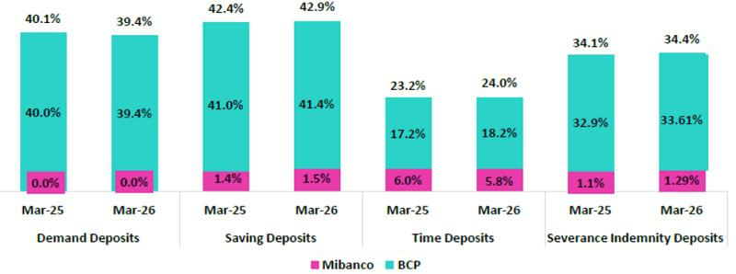

At the end of March 2026, the MS of Total Deposits at BCP and Mibanco in Peru was 33.1% and 2.4% (117 bps and -27 bps vs March 2025, respectively). In this context, BCP continues to lead the market for total deposits.

BCP reported growth in Low-cost Deposits (+16.3% YoY); this level stood below the financial system’s print (+16.5% YoY). At quarter-end, BCP continued to lead the market for Low-cost Deposits with a MS of 40.5% at the end of March 2026 (-9 bps vs Mar25). Time Deposits, in turn, registered a downward trajectory across the financial system (-1.4% vs Mar25) but rose 4.6% at BCP. In this context, BCP increased its market share (105 bps vs Mar25) to 18.2% at the end of March 2026.

Credicorp’s share (BCP + Mibanco) of the Low-cost Deposit market dropped 6 bps versus the print in March 2025 to stand at 41.2% at the end of March 2026.

Credicorp’s share of Time Deposits rose 76 bps compared to the figure in March 2025 to situate at 24.0% at the end of March 2026.

| Earnings Release 1Q / 2026 Analysis of 1Q26 Consolidated Results

03 Interest-earning Assets (IEA) and Funding

In 1Q26, IEA increased 3.7% QoQ and 8.2% YoY. Funding, in turn, rose 3.0% QoQ and 8.5% YoY. If we exclude the impact generated by an accounting adjustment at BCP Bolivia, and maintain the USD/PEN exchange rate constant, the evolution of IEA and Funding was as follows:

IEA grew 2.3% QoQ. This evolution was driven by an increase in Total investments, which allowed us to capitalize on surpluses while maintaining ample liquidity in a context of an uptick in loan growth. Funding rose 1.6%, driven primarily by Deposits, which rose on the back of inflows from pension fund withdrawals, and secondarily from company profit-sharing payments.

YoY, IEA increased 9.9%, fueled mainly by loan growth. The increase in Cash and due from banks, which ticked up due to a context of ample liquidity, acted as a secondary driver, followed by an uptick in Total investments. Growth in deposits was the main engine of growth in funding; this evolution was partially offset by a drop in the balance for BCRP instruments.

In 1Q26, consistent with the treatment applied since 1Q25, Credicorp’s balance sheet reflects the impact of a non-cash accounting adjustment to revalue BCP Bolivia’s balance sheet using exchange rates more closely aligned with market levels. This revaluation resulted in a 1.3% accounting contraction in Credicorp’s total assets as of March 2026.

The analysis of the evolution of IEA and Funding will focus on the business’s underlying dynamics, excluding the impact of this accounting adjustment.

3.1. IEA

Interest Earning Assets |  | As of |  | % change
S/000 | Mar 25 | Dec 26 | Mar 26 | QoQ | YoY
Cash and due from banks | 37,521,839 | 41,394,817 | 42,979,690 | 3.8% | 14.5%
Total investments | 55,604,610 | 52,804,942 | 57,505,821 | 8.9% | 3.4%
Cash collateral, reverse repurchase agreements and securities borrowing | 1,835,893 | 2,177,200 | 2,211,576 | 1.6% | 20.5%
Total loans | 141,196,646 | 149,984,954 | 152,824,685 | 1.9% | 8.2%
Total interest earning assets | 236,158,988 | 246,361,913 | 255,521,772 | 3.7% | 8.2%
Total interest earning assets (Adjusted for Asset Revaluation) | 240,384,621 | 248,477,652 | 258,497,432 | 4.0% | 7.5%
Total interest earning assets (Adjusted for Asset Revaluation, FX Neutral USD/PEN) |  |  |  | 2.3% | 9.9%

IEA rose 3.7% QoQ and 8.2% YoY. If we exclude the impacts of both the non-cash accounting adjustment at BCP Bolivia and the depreciation of the USD against

PEN, IEA evolved as follows:

QoQ, IEA increased 2.3%. This evolution was driven mainly by an increase in the balance of Total investments, which is part of our strategy to capitalize surplus liquidity. Loan growth, which sustained its momentum through the dynamics explained in chapter 1. Loan Portfolio, was a secondary driver of IEA.

YoY, IEA expanded 9.9%. This evolution was fueled, in order of impact, by: i) an increase in the Loan balance, which was led primarily by BCP Stand-alone (Wholesale Banking in particular), and to a lesser extent by Mibanco; ii) an uptick in Cash and due from banks, which was driven by the cumulative effect of inflows from pension fund withdrawals and higher liquidity at Mibanco; and iii) growth in the balance of Investments, which rose on the back of the same dynamics seen QoQ.

| Earnings Release 1Q / 2026 Analysis of 1Q26 Consolidated Results

03. Interest-earning Assets (IEA) and Funding

3.2. Funding

Funding |  | As of |  | % change
S/ 000 | Mar 25 | Dec 25 | Mar 26 | QoQ | YoY
Deposits and obligations | 157,619,082 | 170,401,633 | 178,627,906 | 4.8% | 13.3%
Due to banks and correspondents | 10,899,579 | 10,675,238 | 10,213,175 | -4.3% | -6.3%
BCRP instruments | 7,064,476 | 4,776,512 | 2,338,426 | -51.0% | -66.9%
Repurchase agreements with clients and third parties | 3,094,138 | 3,467,275 | 3,534,049 | 1.9% | 14.2%
Bonds and notes issued | 14,391,733 | 14,025,535 | 14,750,710 | 5.2% | 2.5%
Total funding | 193,069,008 | 203,346,193 | 209,464,266 | 3.0% | 8.5%
Total funding (Adjusted for Asset Revaluation) | 197,948,116 | 205,659,047 | 212,689,317 | 3.4% | 7.4%
Total funding (Adjusted for Asset Revaluation, FX Neutral USD/PEN) |  |  |  | 1.6% | 10.0%

Funding grew 3.0% QoQ and 8.5% YoY. Excluding the impact of both a non-cash accounting adjustment at BCP Bolivia and USD’s depreciation against PEN, funding evolved as follows:

QoQ, funding increased 1.6%, driven primarily by an increase in Deposits and obligations, which rose on the back of growth in low-cost deposits. The rise in the latter was fueled by inflows from pension fund withdrawals and, to a lesser extent, annual employee profit-sharing payments. These dynamics were partially offset by a drop in the balance for BCRP Instruments, which reflected a decrease in liquidity requirements.

YoY, funding rose 10.0%, driven mainly by an increase in Deposits and Obligations, which was driven by the same dynamics seen QoQ. The increase in funding was partially offset by a reduction in the balance for BCRP instruments, which reflects the regulatory entity’s decision to reduce repo offerings in a high liquidity environment.

| Earnings Release 1Q / 2026 Analysis of 1Q26 Consolidated Results

04 Net Interest Income (NII)


NII rose 3.2% QoQ, driven primarily by an uptick in interest income from securities and loan growth. A reduction in Interest and Similar Expenses, which was fueled by a drop in expenses for deposits and a decrease in funding through other instruments, was a secondary driver of NII’s evolution.

YoY, NII increased 10.9%. This result was mainly fueled by an increase in Similar Income and Yields, which rose on the back of loan growth. The decrease in Similar Interest and Expenses, which were impacted by a drop in interest rates and an uptick in market liquidity, also contributed to growth in NII.

NIM expanded 36 bps YoY to stand at 6.58%, driven primarily by a drop in the funding costs and secondarily by an increase in the yield on IEA. Risk-adjusted NIM hit a new high¹ of 5.81% (+57 bps) on the back of an improvement in payment performance, as reflected in the decrease seen in the cost of risk.


Net interest income |  | Quarter |  |  | % change
S/000 | 1Q25 | 4Q25 | 1Q26 | QoQ | YoY
Interest and Similar Income | 4,894,790 | 5,125,394 | 5,212,412 | 1.7% | 6.5%
Interest and Similar Expenses | (1,322,778) | (1,284,127) | (1,249,685) | -2.7% | -5.5%
Interest Expense (excluding Net Insurance Financial Expenses) | (1,187,156) | (1,140,166) | (1,086,768) | -4.7% | -8.5%
Net Insurance Financial Expenses | (135,622) | (143,961) | (162,917) | 13.2% | 20.1%
Net Interest, similar income and expenses | 3,572,012 | 3,841,267 | 3,962,727 | 3.2% | 10.9%
Balances
Average Interest Earning Assets (IEA) | 238,435,117 | 240,783,785 | 250,941,843 | 4.2% | 5.2%
Average Funding | 195,997,306 | 197,704,312 | 206,405,230 | 4.4% | 5.3%
Yields
Yield on IEAs | 8.21% | 8.51% | 8.31% | -20 bps | 10 bps
Cost of Funds⁽¹⁾ | 2.42% | 2.31% | 2.11% | -20 bps | -31 bps
Net Interest Margin (NIM)⁽¹⁾ | 6.22% | 6.62% | 6.58% | -4 bps | 36 bps
Risk-Adjusted Net Interest Margin⁽¹⁾ | 5.24% | 5.55% | 5.81% | 26 bps | 57 bps
Peru’s Reference Rate | 4.75% | 4.25% | 4.25% | 0 bps | -50 bps
FED funds rate | 4.50% | 3.75% | 3.75% | 0 bps | -75 bps

(1) For further detail on the NIM and Cost of Funds calculation, please refer to Annex 12.8.

QoQ, Net Interest Income (NII) rose 3.2%. This result was primarily attributable to an increase in Interest and Similar Income, which rose on the back of the following factors (in order of magnitude): i) an increase in interest from securities, which ticked up through a strategy to capitalize surplus liquidity, and ii) higher interest from Loans, which increased alongside growth in volumes at BCP and Mibanco. Interest and Similar Expenses were a secondary driver in NII’s advance this quarter, after Interest on deposits and Interest on due to Banks and correspondents fell by similar measure. Interest expenses for deposits dropped, fueled by an increase in low-cost deposits’ share of the mix and a decrease in time deposits’ participation. Interest on due to Banks and correspondents fell after some contracts expired and were not renewed due to high levels of liquidity.

YoY, NII rose 10.9%. This evolution was driven mainly by an increase in Interest and Similar Income and secondarily by a decrease in Interest and Similar Expenses. Growth in Interest and Similar Income was fueled primarily by an increase in interest from loans, which rose alongside an uptick in the loan volume at BCP and Mibanco. Interest on securities also drove the rise in NII, albeit to a lesser extent. Similar Interest and Expenses, in turn, dropped over the period due to the following dynamics (in order of magnitude): i) a drop in Interest on deposits and obligations, which were impacted by a decrease in interest rates and an increase in liquidity across the financial system; and ii) a reduction in Interest on due to banks and correspondents, which was driven by the same factors in play QoQ.

- Since the implementation of IFRS 9 in 2018.

| Earnings Release 1Q / 2026 Analysis of 1Q26 Consolidated Results

04. Net Interest Income (NII)

Net Interest Margin
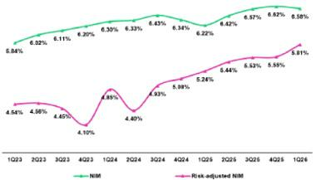

NIM rose 36 bps YoY to stand at 6.58% at the end of 1Q26. This expansion was mainly driven by a 31-bps reduction in the cost of funding, which was positively impacted by a downward trend in interest rates and a shift in the funding mix toward a larger share of low-cost deposits. The IEA yield rose 10 bps YoY, as loans’ share of the IEA mix rose ticked up faster than the increase reported for Cash and equivalents. Risk-adjusted NIM hit a new high of 5.81% at the end of 1Q26 (+57 bps). This result was primarily attributable to an improvement in client payment performance at BCP, as reflected in the decrease in the cost of risk.

Dynamics of the Net Interest Margin by Currency

Interest Income / IEA | Average | 1Q25 |  | Average | 4Q25 |  | Average | 1Q26
Interest Income / IEA | Average | Income | Yields | Average | Income | Yields | Average | Income | Yields
S/ millions | Balance | Income | Yields | Balance | Income | Yields | Balance | Income | Yields
Total (LC + FC)
Cash and equivalents | 38,821 | 345 | 3.6% | 38,628 | 366 | 3.8% | 42,187 | 322 | 3.1%
Other IEA | 1,434 | 19 | 5.3% | 2,791 | 26 | 3.7% | 2,194 | 22 | 4.0%
Investments | 54,716 | 683 | 5.0% | 51,996 | 639 | 4.9% | 55,156 | 727 | 5.3%
Loans | 143,465 | 3,848 | 10.7% | 147,369 | 4,094 | 11.1% | 151,405 | 4,143 | 10.9%
Total IEA | 238,436 | 4,895 | 8.2% | 240,784 | 5,125 | 8.5% | 250,942 | 5,214 | 8.3%
IEA (LC) | 55.6% | 70.5% | 10.4% | 56.6% | 71.2% | 10.7% | 56.4% | 72.5% | 10.7%
IEA (FC) | 44.4% | 29.5% | 5.5% | 43.4% | 28.8% | 5.6% | 43.6% | 27.5% | 5.2%
Interest Income / Funding | Average | 1Q25 |  | Average | 4Q25 |  | Average | 1Q26
Interest Income / Funding | Average | Expense | Yields | Average | Expense | Yields | Average | Expense | Yields
S/ millions | Balance | Expense | Yields | Balance | Expense | Yields | Balance | Expense | Yields
Total (LC + FC)
Deposits | 159,731 | 620 | 1.6% | 164,416 | 578 | 1.4% | 174,515 | 539 | 1.2%
BCRP + Due to Banks | 17,683 | 266 | 6.0% | 16,669 | 245 | 5.9% | 14,001 | 211 | 6.0%
Bonds and Notes | 15,830 | 168 | 4.2% | 13,117 | 185 | 5.6% | 14,389 | 188 | 5.2%
Others | 2,754 | 269 | 39.1% | 3,502 | 276 | 31.5% | 3,501 | 311 | 35.5%
Total Funding | 195,998 | 1,323 | 2.7% | 197,704 | 1,284 | 2.6% | 206,406 | 1,249 | 2.4%
Funding (LC) | 51.7% | 53.4% | 2.8% | 54.1% | 54.0% | 2.6% | 54.2% | 53.2% | 2.4%
Funding (FC) | 48.3% | 46.6% | 2.6% | 45.9% | 46.0% | 2.6% | 45.8% | 46.8% | 2.5%
NIM⁽¹⁾ | 238,436 | 3,572 | 6.0% | 240,784 | 3,841 | 6.4% | 250,942 | 3,965 | 6.3%
NIM (LC) | 55.6% | 76.8% | 8.3% | 56.6% | 77.0% | 8.7% | 56.4% | 78.6% | 8.8%
NIM (FC) | 44.4% | 23.2% | 3.1% | 43.4% | 23.0% | 3.4% | 43.6% | 21.4% | 3.1%
(1) Unlike the NIM figure calculated according to the formula in Appendix 12.8, the NIM presented in this table includes “Financial Expense associated with the insurance and reinsurance activity, net”.

QoQ Analysis

QoQ, Net Interest Income (NII) rose 3.2% in the aggregate, with NII rising in LC but falling in FC. IEA in LC represented 56.4% of total IEA at the end of 1Q26 and accounted for 72.5% of interest income generated over the quarter.

Dynamics in Local Currency (LC)

NII in LC rose 5.3%, driven by growth in interest income. This evolution was fueled by both an uptick in the investment volume and a strategy to take advantage of market opportunities. A secondary driver in the rise in NII in LC was the increase in interest on Loans, which rose on the back of growth in loan volumes at BCP and Mibanco. Interest expenses fell over the period, spurred by a reduction in expenses for BCRP and Banks, which primarily reflected a decrease in repos positions with BCRP and secondarily, a drop in expenses for deposits, as low-cost deposits’ share of the funding mix ticked up.

| Earnings Release 1Q / 2026 Analysis of 1Q26 Consolidated Results

04. Net Interest Income (NII)

Foreign Currency Dynamics (FC)

NII in FC fell 3.7% QoQ. This evolution was driven primarily by a drop in income from Cash and equivalents, which reflected lower average rates, following the Fed’s rate cut in December 2025. This dynamic was partially offset by growth in interest on Loans, which rose on the back of loan growth, particularly in Wholesale Banking at BCP. Interest expenses fell, fueled primarily by a drop in expenses for deposits, which fell alongside an increase in low-cost deposits’ participation in the funding mix.

YoY Analysis

YoY, NII rose 11.0%, driven by an increase in NII in LC and FC.

Dynamics in Local Currency (LC)

NII in FC increased 13.5% YoY, fueled mainly by an increase in interest income and secondarily, by a drop in interest expenses. These results were driven by the following dynamics:

Interest income on Loans rose, driven by: i) growth in total loan volumes at BCP Mibanco Perú and Mibanco Colombia; and ii) an increase in Investment income, which followed the same dynamics seen in the QoQ analysis. In this context, the yield on IEA in LC increased 26 bps to 10.7%.

Interest expenses fell over the period, pressured downward by decreasing interest rates and an uptick in the low-cost deposits’ share of the funding mix, which was bolstered by inflows from pension fund withdrawals. It is important to note that in the current context of elevated liquidity in the financial system, our balance of BCRP and Banks fell, reflecting both a reduction in BCRP’s offering of repos and a decrease in funding through other instruments. In this context, the funding cost in LC dropped 42 bps to stand at 2.4%.

Foreign Currency Dynamics (FC)

NII in FC rose 2.8% YoY, driven by the following dynamics:

Interest expenses in FC dropped. This dynamic was fueled by: i) a drop in interest expenses on Deposits, which fell on the back of a downward trend in interest rates, and ii) a decrease in balances for BCRP and Banks, which reflects expirations of debt obligations that were not renewed because marginal funding needs are lower. In this context, the cost of funding in FC dropped 13 bps to stand at 2.5%.

Interest income fell over the period, driven primarily by a drop in interest on Cash and Equivalents, which fell alongside declining market rates. The reduction in the investment balance acted as a secondary catalyst in the reduction in interest income. In this context, IEA in FC dropped 21 bps to stand at 5.2%.

| Earnings Release 1Q / 2026 Analysis of 1Q26 Consolidated Results

05 Portfolio Quality and Provisions


Our portfolio quality indicators continued to strengthen thanks to a favorable economic backdrop, adequate risk management measures, and an additional impulse this quarter from inflows from pension (AFP) fund withdrawals.

QoQ basis, the reduction in BCP stand-alone NPLs was driven mainly by debt repayments in the SME-Pyme and Individuals segments. YoY, the improvement was supported by the same trends, alongside corporate amortizations in Wholesale Banking and lower overdue loans at Mibanco, reflecting improved origination and collections. In this context, the NPL ratio decreased 28 bps and 83 bps QoQ and YoY, respectively, to stand at 4.3%— below the levels reported prior to the economic recession in 2023.

QoQ, the decline in provisions was mainly driven by BCP stand-alone, reflecting a base effect in Wholesale Banking and, to a lesser extent, a higher mix of lower-risk vintages across SME-Pyme, Consumer, and Credit Card portfolios, supported by a more favorable macroeconomic environment. YoY, the decrease was driven by stronger Retail Banking payment performance and provision reversals in Wholesale Banking. This evolution was partially offset by an increase in provisions at Mibanco, which was driven by loan growth. In this context, the cost of risk dropped 48 bps QoQ and 35 bps YoY to stand at 1.3% at quarter-end.

Portfolio quality indicators continued to follow a positive trajectory in all segments, driven by a favorable economic environment; fortified risk management; and an uptick in debt amortizations, which was fueled by pension fund withdrawals.

5.1 Portfolio Quality

Total Portfolio Quality (in Quarter-end balances)

Loan Portfolio quality and Delinquency ratios |  | As of |  |  | % change
S/000 | Mar 25 | Dec 25 | Mar 26 | QoQ | YoY
Total loans (Quarter-end balance) | 141,196,646 | 149,984,954 | 152,824,685 | 1.9% | 8.2%
Write-offs | 716,585 | 656,331 | 852,041 | 29.8% | 18.9%
Internal overdue loans (IOLs) | 5,206,395 | 4,813,536 | 4,475,120 | -7.0% | -14.0%
Internal overdue loans over 90-days | 4,232,843 | 4,073,183 | 3,690,265 | -9.4% | -12.8%
Refinanced loans | 2,001,282 | 2,007,364 | 2,048,877 | 2.1% | 2.4%
Non-performing loans (NPLs) | 7,207,677 | 6,820,900 | 6,523,997 | -4.4% | -9.5%
IOL ratio | 3.7% | 3.2% | 2.9% | -28 bps | -76 bps
IOL over 90-days ratio | 3.0% | 2.7% | 2.4% | -31 bps | -59 bps
NPL ratio | 5.1% | 4.5% | 4.3% | -28 bps | -83 bps

QoQ, the NPL portfolio dropped 4.4%, led mainly by BCP Stand-alone. Write-offs increased 29.8% due to extraordinary write-offs, mainly for loans that were in the judicial recovery stage in Mortgage and SME-Pyme at BCP Stand-alone.

QoQ, at BCP Stand-alone, the decrease in the NPL portfolio was fueled by Retail Banking, which reported an uptick in debt repayments by clients in the judicial recovery stage in SME-Pyme and debt payments in Individuals, after clients used funds from the pension fund withdrawal to amortize debt. This dynamic was partially offset by an increase in the NPL balance in Wholesale Banking, which was driven mainly by a refinanced loan from a corporate client in the construction sector.

YoY, the NPL portfolio dropped 9.5%, driven primarily by BCP Stand-alone and secondarily by Mibanco. Growth in write-offs (+18.9%) was fueled mainly by the same dynamics in play QoQ.

YoY, at BCP Stand-alone, the decline in the NPL portfolio was spurred primarily by Retail Banking and secondarily by Wholesale Banking. In Retail Banking, the drop was driven by the same dynamics that drove the QoQ evolution in SME-Pyme and Individuals. Additionally, improvements in the quality of origination and debt collections in Consumer and Credit Cards were registered. In Wholesale Banking, the drop in NPLs was spurred primarily by debt repayments from clients in the real estate and commercial sectors. Finally, at Mibanco, the decrease in the NPL portfolio was mainly attributable to a reduction in overdue loans, which was mainly fueled by the improvements in play since 2024 to strengthen the quality of origination and debt collections management . Thanks to these efforts, 88% of the loan portfolio is currently composed of new, healthier loans.

| Earnings Release 1Q / 2026 Analysis of 1Q26 Consolidated Results

05. Portfolio Quality and Provisions

NPL Ratio for Total Loans The NPL Ratio at Credicorp dropped 28 bps QoQ to stand at 4.3%. This level

was below the prints reported prior to the economic recession in 2023. This

decline was driven mainly by a decrease in NPL volumes, which was fueled
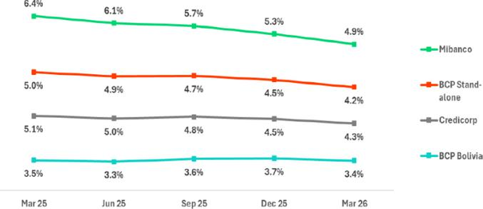
primarily by the same dynamics seen QoQ and secondarily by loan growth.

If we analyze the QoQ evolution of the NPL Ratio by Subsidiary, we see:

- BCP Stand-alone, where the NPL Ratio dropped 32 bps. In the case of Individuals and SME-Pyme, the decrease in the ratio was spurred mainly by a drop in NPL volumes. In Wholesale Banking, the increase in the ratio was driven by an uptick in NPL volumes; while the decline in SME-Business, in turn, was driven primarily by a drop in loan volumes, which fell due to client resegmentation (see the chapter on Loans).

- Mibanco, where the NPL Ratio dropped 33 bps, primarily on the back of loan growth and secondary due to a drop in NPL volumes.

NPL Ratio for Total Loans at BCP Stand-Alone ⁽¹⁾
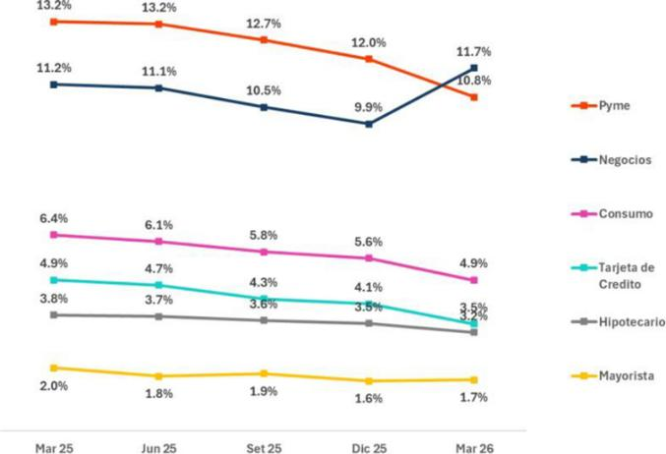

The NPL Ratio at Credicorp decreased 84 bps YoY to stand at 4.3%. This drop was driven primarily by the same dynamics that drove the YoY evolution of the NPL portfolio and secondarily, by loan growth.

If we analyze the YoY evolution of the NPL Ratio, we find:

- BCP Stand-alone, where the NPL Ratio fell 86 bps YoY. In the case of Wholesale, SME-Pyme, Consumer and Credit Cards, the reduction was driven primarily by a drop in NPL volumes. In the case of Mortgage, the decline was mainly spurred by loan growth. At SME-Business, the increase in the ratio was driven by a drop in loans, which was fueled by the same factors at play QoQ.

- Corresponds to management information by segment in BCP Stand-Alone.

- Mibanco, where the NPL Ratio decreased 149 bps YoY, driven primarily by a drop in NPL volumes and secondarily by loan growth.

| Earnings Release 1Q / 2026 Analysis of 1Q26 Consolidated Results

05. Portfolio Quality and Provisions

5.2 Provisions and Cost of Risk for Total Loans

Loan Portfolio Provisions |  | Quarter |  |  | % change
S/000 | 1Q25 | 4Q25 | 1Q26 | QoQ | YoY
Gross provision for credit losses on loan portfolio | (695,733) | (773,311) | (612,011) | -20.9% | -12.0%
Recoveries of written-off loans | 113,840 | 127,025 | 129,923 | 2.3% | 14.1%
Provision for credit losses on loan portfolio, net of recoveries | (581,893) | (646,286) | (482,088) | -25.4% | -17.2%
Cost of risk ⁽¹⁾ | 1.6% | 1.8% | 1.3% | -48 bps | -35 bps

QoQ, provisions dropped 25.4%, driven by the evolution at BCP Stand-alone and partially offset by Mibanco. At BCP Stand-alone, the decrease in provisions was primarily fueled by Wholesale Banking and secondarily by Retail Banking. In Wholesale Banking, the decrease in provisions was driven by a base effect, given that the risk of indirect exposure, associated with some clients in the construction sector, rose in 4Q25. In Retail Banking, the drop in provisions was primarily due to an uptick in the share of lower-risk loans in the SME-Pyme, Consumer and Credit Card portfolios, in a context of a more favorable macroeconomic conditions, where clients also benefited from higher liquidity from pension fund withdrawals. At Mibanco, provisions rose on the back of loan growth. In this context, the CofR at Credicorp fell 48 bps QoQ, sitting at a low level once again this quarter (1.3%).

YoY, provisions dropped 17.2%, driven by BCP Stand-alone and partially | Cost of Risk by Subsidiary
offset by Mibanco. At BCP Stand-alone, the decline was driven mainly by
Retail Banking and secondarily by Wholesale Banking. In the first case, the
drop in provisions was fueled mainly by an improvement in payment
performance of prior vintages in Consumer and Credit Cards. In Wholesale
Banking, the decrease in provisions was mainly fueled by an uptick in
reversals this quarter, which was primarily attributable to a corporate client that
regularized its refinanced debt and returned to up-to-date status. At Mibanco,
growth was driven primarily by the same dynamics in play QoQ. The CofR at
Credicorp dropped 35 bps YoY to stand at 1.3%. This result was impacted by
measures that began in 2024 to strengthen risk management; sustained
improvement in the Peruvian economy; and the effect of higher liquidity.
QoQ Cost of Risk Evolution | YoY Cost of Risk Evolution
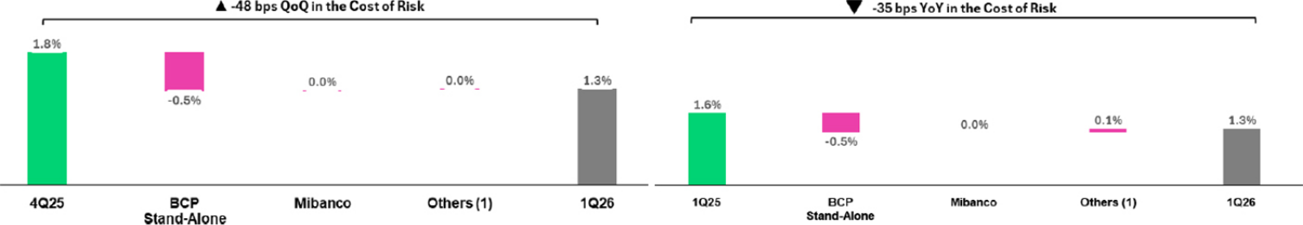
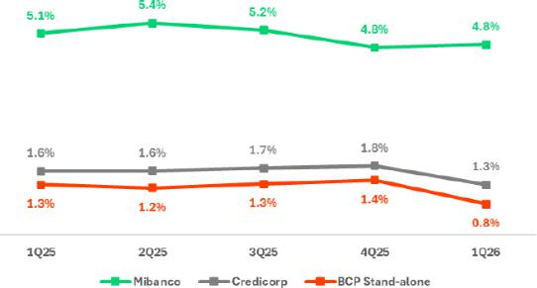

(1) Others include BCP Bolivia, Mibanco Colombia, ASB and eliminations. (1) Others include BCP Bolivia, Mibanco Colombia, ASB and eliminations.

| Earnings Release 1Q / 2026 Analysis of 1Q26 Consolidated Results

05. Portfolio Quality and Provisions

NPL Coverage Ratio (in Quarter-end balances)

Loan Portfolio Quality and Delinquency Ratios |  | As of |  |  | % change
S/000 | Mar 25 | Dec 25 | Mar 26 | QoQ | YoY
Total loans (Quarter-end balance) | 141,196,646 | 149,984,954 | 152,824,685 | 1.9% | 8.2%
Allowance for loan losses | 7,742,792 | 7,669,950 | 7,425,425 | -3.2% | -4.1%
Non-performing loans (NPLs) | 7,207,677 | 6,820,900 | 6,523,997 | -4.4% | -9.5%
Allowance for loan losses over Total loans | 5.5% | 5.1% | 4.9% | -25 bps | -62 bps
Coverage ratio of NPLs | 107.4% | 112.4% | 113.8% | 137 bps | 640 bps

Allowance for loan losses

(in S/ millions)
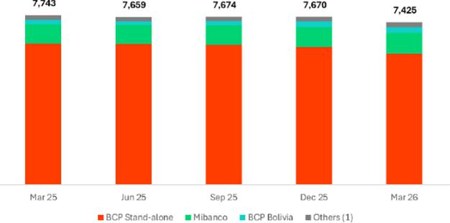

QoQ, the loan allowance dropped 3.2%, driven mainly by SME-Pyme and Individuals at BCP Stand-alone.

YoY, the allowance fell 4.1%, fueled primarily by the same dynamics seen QoQ.

(1) Others include BCP Bolivia, Mibanco Colombia, ASB and eliminations.
NPL Coverage Ratio | The Total NPL Coverage Ratio at Credicorp stood at 113.8% at the end of
 | 1Q26.
 | QoQ
 | The Total NPL Coverage Ratio at Credicorp rose 137 bps, driven by the
 | evolution at BCP Stand-alone and Mibanco.
 | At BCP Stand-alone, the ratio increased 4 bps to state at 112.2%. This
 | evolution was fueled by a decrease in the NPL portfolio, which was led by the
 | same dynamics seen QoQ. At Mibanco, the ratio increased 10 pp. to stand at
 | 137.4%. This evolution was fueled mainly by an increase in the provisions
 | balance and secondarily by a drop in the NPL portfolio, which was driven by
 | the same factors that drove the QoQ evolution.
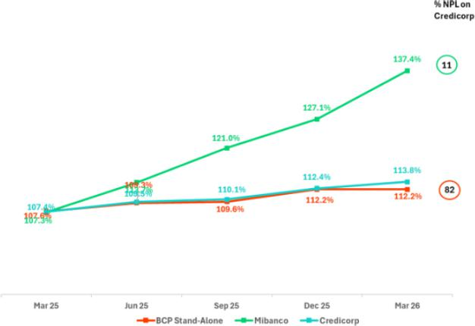

YoY

The Total NPL Coverage Ratio at Credicorp increased 640 bps, spurred mainly by the evolution of BCP Stand-alone and Mibanco.

At BCP Stand-alone, the ratio rose 467 bps, impacted by a drop in the NPL portfolio, which was fueled by the same dynamics seen in the YoY analysis. At Mibanco, the ratio increased 30 pp. YoY, driven by a drop in the NPL portfolio, which fell on the back of the dynamics seen in the YoY evolution.

| Earnings Release 1Q / 2026 Analysis of 1Q26 Consolidated Results

06 Other Income


In 1Q26, Other Income continued to consolidate within Credicorp’s ecosystem, driven mainly by the solid performance of Other Core Income. This reaffirms that our strategy to diversify revenue streams is well underway as we leverage competitive advantages and strengthen our digital capacities.

Growth in Other Core Income (+3.4% QoQ and +19.5% YoY) was fueled primarily by a combination of an uptick in fee income and the positive performance of FX transactions, which were buoyed by an increase in client activity and consistent execution of our commercial strategy. Additionally, exchange-rate volatility also boosted FX gains.

Other Non-Core Income increased slightly QoQ (+1.4%) but dropped 26.7% YoY, which primarily reflected the normalization of non-recurring income following the consolidation of Pacifico Salud.

6. Other Income

Other Income |  | Quarter |  |  | % Change
(S/ 000) | 1Q25 | 4Q25 | 1Q26 | QoQ | YoY
Other Core Income | 1,337,838 | 1,545,026 | 1,598,168 | 3.4% | 19.5%
Other Non-Core Income | 352,378 | 254,473 | 258,156 | 1.4% | -26.7%
Total Other Income | 1,690,216 | 1,799,499 | 1,856,324 | 3.2% | 9.8%

Other Income rose 3.2% QoQ and 9.8% YoY, mainly due to higher Other Core Income (includes Fee Income and Net Gain on FX Transactions).

6.1. Other Core Income

Other Core Income |  | Quarter |  |  | % Change
(S/ 000) | 1Q25 | 4Q25 | 1Q26 | QoQ | YoY
Fee Income | 994,024 | 1,118,110 | 1,149,284 | 2.8% | 15.6%
Net Gain on Foreign Exchange Transactions | 343,814 | 426,916 | 448,884 | 5.1% | 30.6%
Total Other Core Income | 1,337,838 | 1,545,026 | 1,598,168 | 3.4% | 19.5%

Other Core Income rose 3.4% QoQ and 19.5% YoY, hitting a record high that represents 27.7% of total risk-adjusted income at Credicorp (28.4% in 4Q25 and 26.5% in 1Q25). This solid participation in revenue generation also bolsters our decoupling strategy.

- QoQ, growth in Fee Income (+2.8%) and in the Net Gain on FX Transactions (+5.1%) was driven mainly by BCP Stand-alone. FX performance was buoyed primarily by higher income from institutional trading and secondarily, from Retail Banking. Increases in transactional activity rose on the back of exchange rate volatility due to geopolitical tensions in the Middle East and uncertainty surrounding Peru’s elections, which led to higher levels of transactional activity. Additionally, BCP Bolivia registered better results through an increase in the volume of foreign transfers through USDT (crypto assets) and transactions with pre-paid cards (linked to USDT).

- YoY, growth was driven by Fee Income (+15.6%), whose dynamics will be discussed in the next section, as well as by solid growth in FX Transactions (+30.6). Growth in the latter was driven primarily by BCP Stand-alone (+27.2% YoY), buoyed by an uptick in the transactions volume on the back of exchange rate volatility and by good commercial management with better pricing strategies. Credicorp Capital (+99.5% YoY), which reported settlements from foreign currency sales in Colombia, was also a relevant player in the uptick in Gains on FX Transactions.
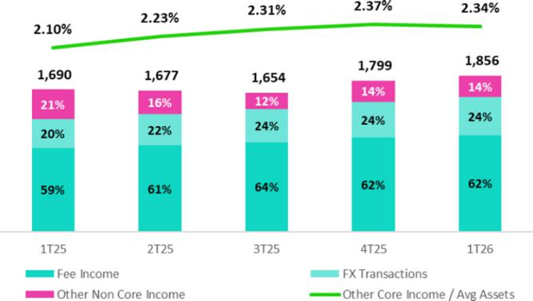

These performance levels reflect sustained growth in transaction volumes in our core businesses and a deepening of our relationship with clients, both of which fuel a more diversified and structurally recurrent income base. At the end of 1Q26, Other Core Income over the total of average assets stood at 2.34% (2.37% in 4Q25 and 2.10% in 1Q25).

| Earnings Release 1Q / 2026 Analysis of 1Q26 Consolidated Results

06. Otros Ingresos

Fee Income by Subsidiary


Fee Income by Subsidiary |  | Quarter |  |  | % Change
(S/ 000) | 1Q25 | 4Q25 | 1Q26 | QoQ | YoY
BCP Stand-Alone | 831,427 | 924,682 | 961,546 | 4.0% | 15.7%
BCP Bolivia | 12,844 | 14,535 | 17,281 | 18.9% | 34.5%
Mibanco | 28,339 | 31,596 | 34,270 | 8.5% | 20.9%
Mibanco Colombia | 9,126 | 16,744 | 17,488 | 4.4% | 91.6%
Pacífico | (3,757) | (4,033) | (5,204) | 29.0% | 38.5%
Prima | 94,072 | 97,023 | 91,195 | -6.0% | -3.1%
ASB | 13,826 | 13,992 | 13,596 | -2.8% | -1.7%
Credicorp Capital | 136,264 | 153,872 | 161,001 | 4.6% | 18.2%
Eliminations and Other ⁽¹⁾ | (128,117) | (130,301) | (141,889) | 8.9% | 10.7%
Total Net Fee Income | 994,024 | 1,118,110 | 1,149,284 | 2.8% | 15.6%
(1) Correspond mainly to the eliminations of bancassurance between Pacifico, BCP, and Mibanco.

QoQ and YoY, growth in fee income cut across various business units, where BCP Stand-alone, Credicorp Capital and Mibanco (Peru and Colombia) were the star performers. This evolution is proof that we have built a diversified and more structurally recurr ent income base. The dynamics of the increase in fee income at BCP Stand-alone, which topped the list of contributors, will be discussed in the next section. The second driver of growth in Fee Income was Credicorp Capital, via strong performance by its Capital Markets Business, which rose on the back of an uptick in Sales and Corporate in the context of heightened global volatility—a primary driver of an upward swing in transactional activity. Two more minor players in the evolution of fee income in 1Q26 were (i) Mibanco (Peru and Colombia), which reported growth in disbursements, and (ii) BCP Bolivia, which experienced an increase in the transactions volume through Yape Bolivia (posting upticks in active users and transactionality) and via top-ups, service payments, collections and insurance for the core business.

Fee Income at BCP Stand-alone

Composition of Fee Income at BCP Stand-alone (*)


BCP Stand-alone Fees (*) |  | Quarter |  |  | % Change
(S/ 000,000) | 1Q25 | 4Q25 | 1Q26 | QoQ | YoY
Payments and transactional services ⁽¹⁾ | 283 | 293 | 295 | 0.6% | 4.2%
Yape ⁽²⁾ | 121 | 187 | 199 | 6.4% | 65.3%
Liability and Transactional Accounts ⁽³⁾ | 197 | 201 | 210 | 4.5% | 6.5%
Loan Disbursement ⁽⁴⁾ | 98 | 98 | 112 | 14.6% | 14.6%
Off-balance sheet | 56 | 56 | 54 | -4.6% | -4.7%
Insurances | 48 | 49 | 47 | -4.9% | -3.2%
Wealth Management and Corporate Finance | 15 | 19 | 23 | 19.3% | 54.3%
Others ⁽⁵⁾ | 14 | 21 | 22 | 6.9% | 60.2%
Total | 831 | 924 | 962 | 4.0% | 15.7%
(*) Management Figures.
- Corresponds to fees from credit cards, debit cards, bill payments and services, collections, Culqi, network usage and other services provided to third parties.
- Not includes fees related to E-Commerce. Not includes FX and remittances.
- Corresponds to fees from Account maintenance, interbank transfers, national transfers, and international transfers.
- Corresponds to fees from retail and wholesale loan disbursements.
- Use of third-party networks, Other services to third parties, and Commissions in foreign branches.

QoQ, growth of 4.0% was driven mainly by:

- The core business, which includes Payment and Transactional Services, Liability and Transactional Accounts, and Loan Disbursements, evolved favorably. The increase in Loan disbursements was driven by an uptick in the dynamism of the loan portfolio, while passive and transactional accounts rose mainly on the back of growth in foreign transfers.

- Yape, which continued to report significant growth, was driven an increase in the use of features, in particular: (i) bill payments, mainly for telecom, financial institutions, electricity and education; (ii) checkout, in line with the increase in transactional activity among active customers; and (iii) QR/POS payments, supported by stronger consumption dynamics.

YoY, fee income rose 15.7% due to:

- Yape, driven by more consolidated features and by sustained growth in the frequency of use. The Remittance business was also a key player, in line with higher coverage of the formal market.

- Core Business was driven, in order of impact, by Loan disbursements, which rose through an upswing in origination; Liabilities and transactional accounts, which reported an uptick in interbank and foreign transactions; and Payment and Transactional Services, which registered an increase in transactions through a larger base of active cards, as we push to implement our strategy to digitalize services.

| Earnings Release 1Q / 2026 Analysis of 1Q26 Consolidated Results

06. Otros Ingresos

6.2 Other Non-core Income

Other Non-Core Income |  | Quarter |  |  | % change
(S/ 000) | 1Q25 | 4Q25 | 1Q26 | QoQ | YoY
Net Gain (Loss) on Securities | (28,149) | 96,280 | 135,637 | 40.9% | -581.9%
Net Gain from Associates | 24,068 | 5,588 | 9,296 | 66.4% | -61.4%
Net Gain (Loss) of Derivatives Held for Trading | 18,499 | 11,756 | 27,463 | 133.6% | 48.5%
Net Gain (Loss) from Exchange Differences | 15,959 | 8,319 | 8,557 | 2.9% | -46.4%
Other Non-operative Income | 322,001 | 132,530 | 77,203 | -41.7% | -76.0%
Total Other Non-Core Income | 352,378 | 254,473 | 258,156 | 1.4% | -26.7%

Other Non-Core Income rose 1.4% QoQ but fell 26.7% YoY, impacted by a normalization of non-recurring components. Other Non-core Income represents 13.9% of total Other Income at Credicorp (14.1% in 4Q25 and 20.8% in 1Q25). This level falls below the peak reported in 1Q25, and attests to the volatility of these sources of income, which are pegged to one-off events and the changing market conditions.

- QoQ, the result was driven by an uptick in the Net Gain on Securities (+40.9%) and by strong performance in Net Gain of Derivatives held for trading (+133.6%), which rose on the back of more favorable market conditions. Higher gains on sales of securities was fueled by (i) BCP Stand-alone, which reported the sovereign bond sales under our plan to manage asset durations and rate risk to monetize valuations in a context characterized by significant shifts in the curve, (ii) Credicorp Capital, due to an uptick in the sale of securities after fixed income products registered favorable results in a context marked by low local rates, and (iii) BCP Bolivia, which reconfigured its investment portfolio to favor Central Bank securities, which allowed it to capture better rates, supported by a larger invested volume. These effects were partially offset by a drop in other non-operating income (-41.7%), given that the comparative base normalized after reporting provision reversals at Pacifico and sales of properties at BCP Stand-alone in 4Q25.

- YoY, the drop was driven mainly by a decrease in other non-operating income (-76.0%) and by a reduction in the contribution of Net Gain from associates (-61.4%), both linked to Pacífico Salud’s consolidation in March 2025. These drops were partially offset by a recovery in the Net Gain on Securities, which was driven mainly by (i) Pacifico, due to a base effect given that losses were reported in 1Q25 for deterioration of some investments, (ii) BCP Stand-alone, in line with the dynamics in play in the QoQ analysis, and (iii) Prima, due to an increase in the yield on reserves.

| Earnings Release 1Q / 2026 Analysis of 1Q26 Consolidated Results

07 Insurance Underwriting and Medical Services Results


The Insurance Underwriting Result (IUR) attests to our consistent strategy execution, which is sustained by healthy levels of activity in retail segments.

QoQ, the IUR dropped 6.8% due to (i) P&C, fueled by a drop in insurance service income in Personal Lines and Cars, and (ii) EPS, which exprienced an uptick in claim. in claims. These dynamics were partially offset by Life, which presented lower levels of claims in D&S. YoY, the IUR decreased 9.1%, driven by (i) P & C, which reported a reduction in premiums in the Commercial Lines and Cars due to fluctuations in the exchange rate, and (ii) Life, due to an inflation-related uptick in claims expenses —which was offset by the evolution of the Interest Income line. However, Credit Life partially offset this lower IUR, by continuing to expand its policy base through bancassurance and retail channels, positioning itself as a channel for structural business growth. Our Medical services Result, in turn, continued to advance with operating and commercial discipline.

Insurance Underwriting Result

Insurance Underwriting Results |  |  | Quarterly |  |  | % Change
S/ millions |  | 1Q25 | 4Q25 | 1Q26 | QoQ | YoY
 | Insurance Service Income | 987.9 | 1,262.7 | 1,236.8 | -2.1% | 25.2%
Total | Insurance Service Expenses | (571.8) | (743.4) | (891.0) | 19.8% | 55.8%
Total | Reinsurance Results | (87.0) | (198.5) | (46.8) | -76.4% | -46.2%
 | Insurance Undewrwriting Result | 329.1 | 320.8 | 299.1 | -6.8% | -9.1%
 | Insurance Service Income | 490.0 | 510.3 | 463.2 | -9.2% | -5.5%
P&C | Insurance Service Expenses | (325.3) | (248.5) | (358.2) | 44.1% | 10.1%
P&C | Reinsurance Results | (72.4) | (159.7) | (25.3) | -84.2% | -65.1%
 | Insurance Undewrwriting Result | 92.3 | 102.1 | 79.7 | -22.0% | -13.7%
 | Insurance Service Income | 332.9 | 334.5 | 332.0 | -0.7% | -0.3%
Life | Insurance Service Expenses | (112.3) | (131.2) | (112.5) | -14.2% | 0.2%
Life | Reinsurance Results | (13.3) | (10.6) | (17.4) | 64.1% | 30.9%
 | Insurance Undewrwriting Result | 207.2 | 192.7 | 202.1 | 4.9% | -2.5%
 | Insurance Service Income | 22.9 | 18.2 | 18.7 | 2.6% | -18.2%
Crediseguros | Insurance Service Expenses | (5.8) | (3.6) | (3.9) | 7.9% | -32.5%
Crediseguros | Reinsurance Results | (8.3) | (4.0) | (3.9) | -4.0% | -53.6%
 | Insurance Undewrwriting Result | 8.7 | 10.5 | 10.9 | 3.3% | 25.2%
 | Insurance Service Income | 130.1 | 406.6 | 415.2 | 2.1% | n.a.
EPS | Insurance Service Expenses | (122.9) | (374.1) | (409.5) | 9.4% | n.a.
EPS | Reinsurance Results | (0.4) | 0.0 | 0.0 | 0.0% | n.a.
 | Insurance Undewrwriting Result | 6.8 | 32.4 | 5.7 | -82.4% | n.a.

QoQ, the Insurance Underwriting Result dropped 6.8%, driven by an uptick in Insurance Service Expenses (+19.8%) and a reduction in Insurance Service Income (-2.1%). This evolution was partially offset by a more favorable reinsurance result (-76.4%).

YoY, the Insurance Underwriting Result fell 9.1%, fueled by an uptick in Insurance Service Expenses (+55.8%), which was partially offset by an increase in Insurance Service Income (+25.2%) and a more favorable Reinsurance Result (-46.2%).

P & C
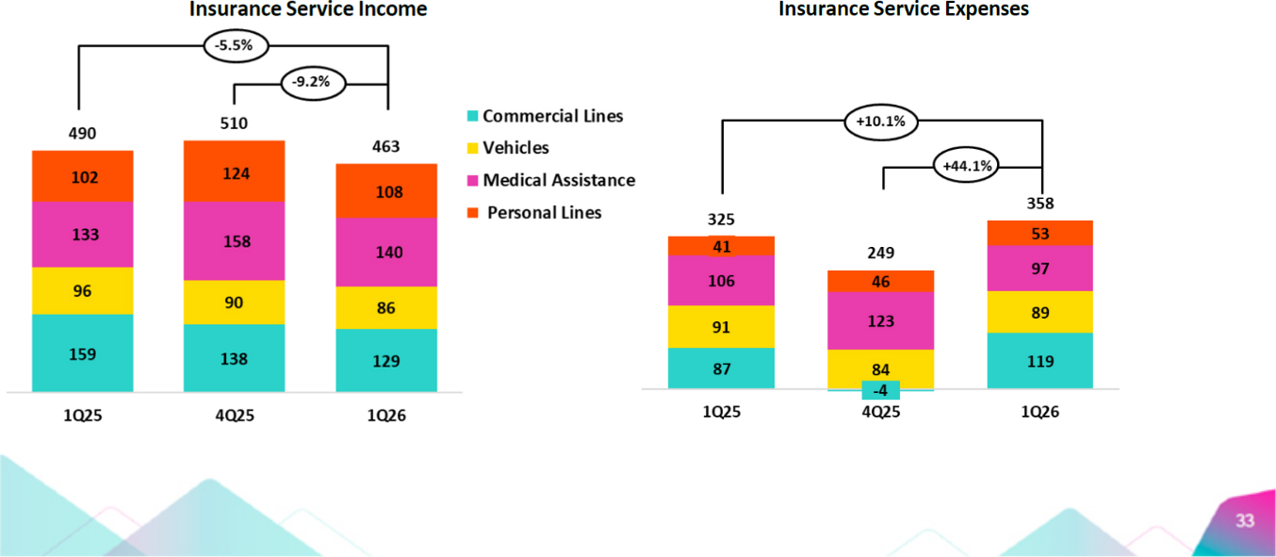

| Earnings Release 1Q / 2026 Analysis of 1Q26 Consolidated Results

07. Insurance Underwriting and Medical Services Results

QoQ, the Insurance Underwriting Result fell 22.0%, driven by the following dynamics:

- Insurance Service Income dropped 9.2%, fueled mainly by (i) Personal lines, which reported a drop in premiums for the Card Protection Product due to a base effect in 4Q25, when extraordinary premiums were recorded, (ii) Commercial lines and Cars, which registered a reduction in premiums due to seasonality, and (iii) Medical Assistance.
- Insurance Service Expenses increased 44.1%, driven primarily by Commercial lines, which reported growth in claims in the Third-party Liability and Fire lines (100% ceded to reinsurer).
- The Reinsurance result improved, after an uptick was recorded in claims recovered from the reinsurer in Commercial Lines, which rose on the back of higher claims.

YoY, the Insurance Underwriting Result dropped 13.7%, fueled by the following dynamics:

- Insurance Service Income dropped 5.5%, led mainly by (i) Commercial lines, and (ii) Cars, both impacted by a drop in premium renewals and in the exchange rate.
- Insurance Underwriting Expenses rose 10.1%, driven by the same dynamics seen QoQ.

- The Reinsurance Result improved, fueled by the same dynamics in play QoQ.

Life

Insurance Service Income Insurance Service Expenses
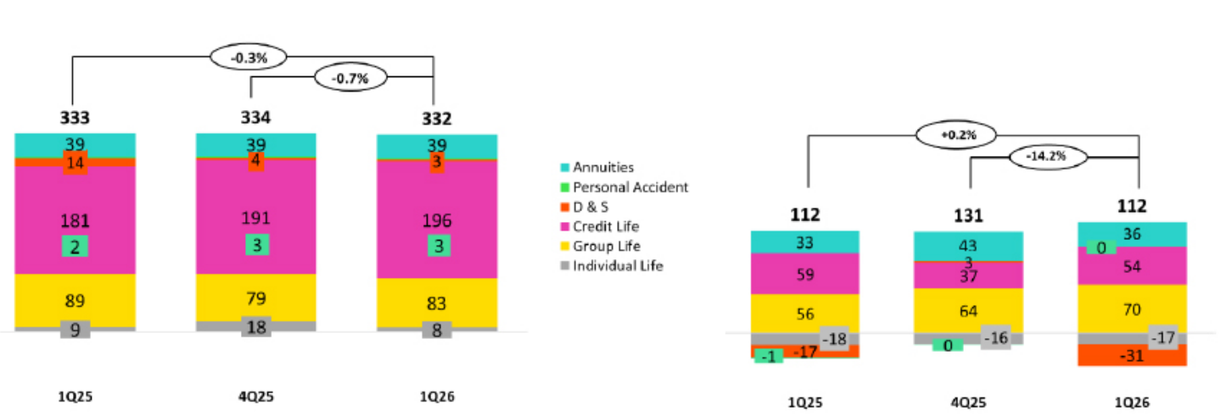

QoQ, the Insurance Underwriting Result increased 4.9%, driven by the following dynamics:

- Insurance Service Income dropped 0.7%, fueled mainly by the evolution in Individual Life and D&S. The aforementioned was attenuated by Credit Life, which registered higher premiums in the Bancassurance and Alliance channel.
- Insurance Service Expenses dropped 14.2%, due primarily to (i) D&S, which reported an uptick in releases of reserves for claims under SISCO, and (ii) Annuities, due to a base effect associated with onerous contracts in 4Q25. These dynamics were partially offset by Group Life, which registered an increase in claims costs due to inflation in SCTR (excluding this inflation-related costs, lower claims were recorded).
- The Insurance Underwriting Result dropped due to the evolution of D&S, which reported a decrease in claims recovered from the reinsurer (as indicated above).

YoY, the Insurance Underwriting Result decreased 2.5%, fueled by the following:

- Insurance Service Income dropped 0.3%, primarily due to (i) D&S, due to lower income from the SISCO VII contract (run off), and (ii) Group Life, which reported a drop in premiums from D&S. The aforementioned was attenuated by Credit Life, which reported significant growth in premiums allotted to the period, which were distributed through the Bancassurance and Alliances channel.
- Insurance Service Expenses increased 0.2%, primarily on the back of Group Life, driven by inflation’s impact on D & S -if we isolate the effect of inflation, we registered lower claims. The aforementioned was attenuated by D&S, which reflects releases of incurred but not reported reserves, and (ii) Credit Life, which registered a decrease in reported cases.
- The Reinsurance Result decreased, which reflects a reduction in the claims recovered from the reinsurer.

| Earnings Release 1Q / 2026 Analysis of 1Q26 Consolidated Results

07. Insurance Underwriting and Medical Services Results

Medical Services Result

QoQ, the Medical Services Result dropped slightly by 0.7%, due to the increased cost of sales associated with higher medical expenses. These higher costs were partially offset by revenue growth from increased outpatient and inpatient services. YoY, the result increased given that 1Q26 contemplates three months of reporting versus the result in 1Q25, which includes only one month given that Pacifico Salud was consolidated in March.

Notwithstanding, the Medical Services business continues to report solid commercial performance as it exercises prudent control of expenses.
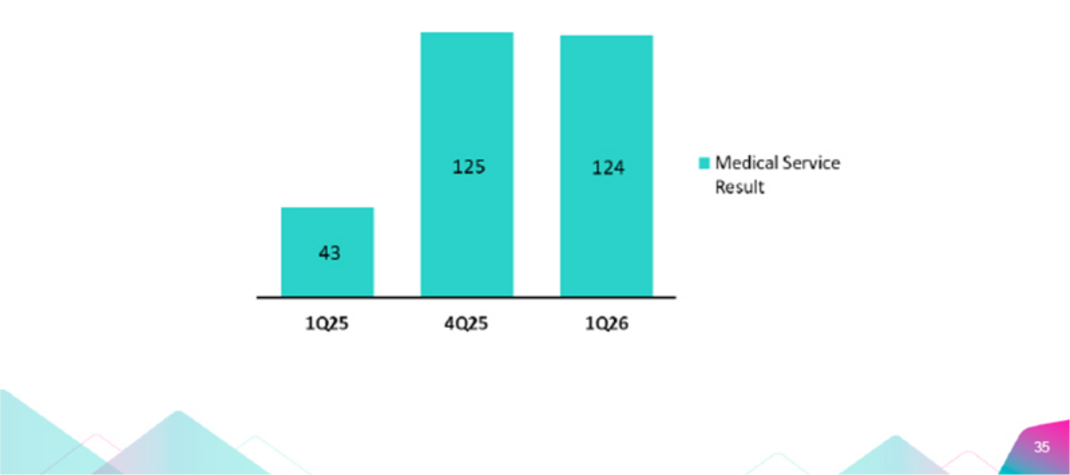


| Earnings Release 1Q / 2026 Analysis of 1Q26 Consolidated Results

08 Operating Expenses


Operating expenses increased 13.1% YoY, mainly driven by the core businesses of BCP, Mibanco and Pacífico, as well as by initiatives within Credicorp’s innovation portfolio. Expenses in the ordinary businesses increased primarily due to: (i) BCP, reflecting higher personnel expenses, associated with increased headcount to support new initiatives aimed at strengthening commercial, technological and transactional capabilities; (ii) Mibanco, due mainly to higher expenses related to the rollout of strategic projects; and (iii) Pacífico, reflecting the consolidation of 100% of the operations of the joint venture previously held with Empresas Banmédica. Expenses related to Credicorp’s innovation portfolio initiatives increased 40.2%, mainly driven by Yape, reflecting higher cloud usage due to increased transaction volumes.

Total Operating Expenses

Operating expenses |  | Quarter |  |  | % change
S/ 000 | 1Q25 | 4Q25 | 1Q26 | QoQ | YoY
Salaries and employees benefits | 1,361,690 | 1,428,178 | 1,459,421 | 2.2% | 7.2%
Administrative and general expenses | 869,834 | 1,186,497 | 1,061,666 | -10.5% | 22.1%
Depreciation and amortization | 203,766 | 256,914 | 241,368 | -6.1% | 18.5%
Association in participation | 6,799 | 120 | 173 | 44.2% | -97.5%
Operating expenses | 2,442,089 | 2,871,709 | 2,762,628 | -3.8% | 13.1%

To analyze expenses, we focus on YoY movements to eliminate seasonal effects between quarters.

Operating Expenses rose 13.1%, driven mainly by:

- An increase in Administrative Expenses, which was led by BCP Stand-alone, Mibanco and Pacifico. At BCP Stand-alone, Yape reported growth in transactions, which generated an uptick in expenses for use of infrastructure in the cloud and other IT-related services. At Mibanco, growth in expenses was driven mainly by strategic project roll out to develop technological and distribution capacities. At Pacifico, administrative expenses rose on the back of a change in the consolidation perimeter following Credicorp’s acquisition of 50% Empresa Banmedica’s stake in a joint venture with Pacífico Compañía de Seguros y Reaseguros S.A., which took effect in March 2025.

- Growth in Employee Salaries and Benefits, which was led mainly by (i) BCP Stand-alone, where higher expenses were reported to increase headcount, primarily for new projects to develop commercial, technological and transactional capacities, and (ii) Pacífico, which registered an uptick in compensation.

Administrative Expenses

Administrative and General Expenses |  | Quarter |  |  | % change
S/ 000 | 1Q25 | 4Q25 | 1Q26 | QoQ | YoY
IT expenses and IT third-party services | 302,029 | 422,856 | 392,131 | -7.3% | 29.8%
Advertising and customer loyalty programs | 85,390 | 183,504 | 122,989 | -33.0% | 44.0%
Taxes and contributions | 83,347 | 93,975 | 110,168 | 17.2% | 32.2%
Audit Services, Consulting and professional fees | 71,072 | 165,592 | 87,825 | -47.0% | 23.6%
Transport and communications | 52,810 | 74,704 | 48,515 | -35.1% | -8.1%
Repair and maintenance | 31,635 | 57,177 | 28,381 | -50.4% | -10.3%
Agents’ Fees | 26,102 | 26,734 | 24,074 | -9.9% | -7.8%
Services by third-party | 21,436 | 37,126 | 23,428 | -36.9% | 9.3%
Leases of low value and short-term | 33,177 | 40,883 | 41,329 | 1.1% | 24.6%
Miscellaneous supplies | 19,383 | 15,014 | 16,772 | 11.7% | -13.5%
Security and protection | 16,946 | 18,905 | 18,007 | -4.8% | 6.3%
Subscriptions and quotes | 18,330 | 19,525 | 20,849 | 6.8% | 13.7%
Electricity and water | 10,275 | 13,972 | 10,177 | -27.2% | -1.0%
Electronic processing | 7,635 | 9,247 | 10,067 | 8.9% | 31.9%
Insurance | 11,719 | -18,515 | 23,102 | -224.8% | 97.1%
Cleaning | 6,558 | 7,208 | 7,163 | -0.6% | 9.2%
Others | 71,990 | 18,590 | 76,689 | 312.5% | 6.5%
Total | 869,834 | 1,186,497 | 1,061,666 | -10.5% | 22.1%

YoY, administrative expenses increased 22.1%. Growth in operating expenses corresponds primarily to BCP Stand-alone, which reported higher expenses for IT, systems outsourcing, as well as Advertising and Fidelity Programs. Mibanco and Pacifico also drove growth, albeit to a lesser extent.

| Earnings Release 1Q / 2026 Analysis of 1Q26 Consolidated Results

08. Operating Expenses

Operating Expenses for Core Businesses and the Innovation Portfolio

 |  | Operating Expenses ⁽¹⁾ |  | Quarter |  |  | % change
 |  | S/ 000 | 1Q25 | 4Q25 | 1Q26 | QoQ | YoY
 |  | Operating Expenses Ex Innovation | 2,134,620 | 2,431,092 | 2,331,614 | -4.1% | 9.2%
 |  | Innovation Portafolio ⁽²⁾ | 307,469 | 440,617 | 431,014 | -2.2% | 40.2%
 |  | Total Operating Expenses | 2,442,089 | 2,871,709 | 2,762,628 | -3.8% | 13.1%
(1) | Management figures.
(2) | Includes innovation portfolio initiatives in subsidiaries and Krealo.

YoY, operating expenses rose 13.1%, driven mainly by core business at BCP Stand-alone and our innovation portfolio at the Credicorp level. Disruption expenses represented 15.6% of total expenses and rose 40.2% YoY. Yape, Tenpo and Culqi were the main drivers of disruption expenses, and represented 84% of total expenses for disruptive initiatives.

Growth in expenses for core businesses at BCP Stand-alone was fueled by:

- Core expenses excluding IT

  - Growth in expenses for Employee Salaries and Benefits, due to (i) hiring of additional headcount for initiatives to develop commercial, technological and transactional capacities, and (ii) a significant increase in the share price, which led to expenses for the Stock Award program to rise.
- Technology expenses (IT)

  - Increase in spending for licenses and third-party IT services, in line with an uptick in hiring of specialized personnel.

| Earnings Release 1Q / 2026 Analysis of 1Q26 Consolidated Results

09 Operating Efficiency

The efficiency ratio evolved in line with expectations and remains within the projected range. YoY, the efficiency ratio increased by 9 bps after growth in operating expenses outpaced the expansion reported for operating income. This evolution reflects an uptick in expenses for core businesses at BCP Stand-alone and innovation initiatives at the Credicorp level, where the objective is to strengthen capacities, drive future efficiency and ensure sustainable competitive advantages in the long term.

Efficiency Ratio⁽¹⁾ reported by subsidiary

 | Subsidiary |  | Quarter |  |  | % change
 | Subsidiary | 1Q25 | 4Q25 | 1Q26 | QoQ | YoY
BCP Stand-alone |  | 37.7% | 42.7% | 38.6% | -411 bps | 93 bps
BCP Bolivia |  | 69.6% | 74.2% | 65.2% | -899 bps | -440 bps
Mibanco Peru |  | 52.9% | 49.6% | 49.2% | -37 bps | -366 bps
Mibanco Colombia |  | 70.6% | 66.2% | 64.5% | -163 bps | -612 bps
Pacífico |  | 31.5% | 45.0% | 39.4% | -565 bps | 783 bps
Prima AFP |  | 54.4% | 57.7% | 57.2% | -45 bps | 280 bps
Credicorp |  | 45.7% | 49.0% | 45.8% | -320 bps | 9 bps

- Operating expenses / Operating income (under IFRS 17). Operating expenses = Salaries and employee benefits + Administrative expenses + Depreciation and amortization + Association in participation + Acquisition cost. Operating income = Net interest, similar income, and expenses + Fee income + Net gain on foreign exchange transactions + Net gain from associates + Net gain on derivatives held for trading + Net gain from exchange differences + Insurance Underwriting Results + Results for Medical Services.

Our analysis focuses on YoY movements to eliminate the impact of seasonality between quarters.

The efficiency ratio evolved in line with expectations and remains within the guidance range, registering an increase of 9 bps that was primarily attributable to growth in operating expenses for (i) core business at BCP, in line with an increase in Employee Salaries and Benefits and Administrative Expenses, and (ii) initiatives in the innovation portfolio at the Credicorp level. It is important to note that expansion in Operating Expenses was accompanied by growth in Operating Income.

| Earnings Release 1Q / 2026 Analysis of 1Q26 Consolidated Results

10 Regulatory Capital


At the end of 1Q26, the regulatory ratio stood at 135%, which was above the minimum required.

The IFRS CET1 ratio at BCP Stand-alone dropped 33bps YoY to stand at 11.29%, which was above our internal appetite of 11%. This decline was attributable to an uptick in credit RWAs, which rose alongside loan growth, and was offset by an increase in Retained Earnings, which ticked upward with business growth.

The IFRS CET1 ratio at Mibanco dropped 23 bps YoY to stand at 15.70%, which was above our internal appetite of 15%. The ratio fell on the back of an uptick and RWAs (buoyed by loan growth), which was partially offset by an increase in Retained Earnings in a context of business growth.

10.1 Regulatory Capital at Credicorp

Capital Analysis of Financial Group

At the end of 1Q26, Credicorp’s Regulatory Capital Ratio stood 134% above the regulatory minimum. This attests to the Group’s financial solidity and stability. The ratio decreased by 29 bps QoQ mainly by growth in capital requirements which rose alongside portfolio growth in BCP Stand-alone and Mibanco. This decrease was partially offset by an increase in Legal and Other Capital Reserves driven by profit capitalization for 2025. It is important to note that this allocation is independent of the dividends assessed by the Board in April. YoY, the ratio fell 300 bps, impacted by an increase in capital requirements due to the same dynamics seen QoQ and higher levels of Subordinated Debt.

Capital Coverage Ratios
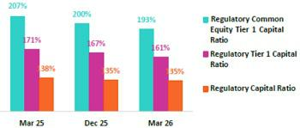

The Regulatory Tier 1 Ratio stood at 161% (-529 bps QoQ, -930 bps YoY), while the Regulatory CET1 ratio was situated at 193% (-632 bps QoQ, -1375 bps YoY), both above the regulatory minimum. Growth in both ratios was driven by the same dynamics that fueled the Regulatory Capital Ratio, with the exception of Subordinated Debt, which had no impact on either the Regulatory Tier 1 or CET1 ratios.

10.2 Analysis of Capital at BCP Stand-alone
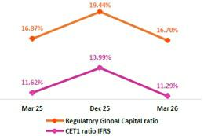

The IFRS CET 1 ratio at BCP Stand-alone dropped 270 bps QoQ to stand at 11.29% at the end of 1Q26, which is above our internal appetite of 11%. The drop was spurred primarily by an increase in credit RWAs, which rose through growth in the wholesale portfolio, and secondarily by a drop in Retained Earnings, which fell after dividends were declared. YoY, the ratio fell 33 pbs due to an uptick in credit RWAs, which ticked up through the same dynamics seen QoQ. This reduction was partially offset by an increase in Retained Earnings, which rose on the back of business growth.

Finally, under the parameters of current regulations, the local CET1 Ratio stood

at 10.96%, which compares favorably with the minimum of 8.38% required at

the end of March 2026. The Regulatory Global Capital Ratio stood at 16.70% (-274 bps QoQ). This ratio is above the minimum of 15.00% required by the regulator at the end of March 2026. The QoQ and YoY variations in both these ratios were driven by the same dynamics that drove the trajectory of IFRS CET1 over the same period; YoY, Global Capital Ratio is also explained by an increase in Subordinated Debt.

| Earnings Release 1Q / 2026 Analysis of 1Q26 Consolidated Results

10. Capital Regulatorio

10.3 Analysis of Capital at Mibanco
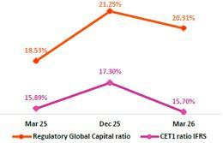

At the end of 1Q26, the IFRS CET1 ratio at Mibanco stood at 15.70% (-161bps QoQ), which is above our internal appetite of 15%. QoQ, this decline was driven mainly by an increase in the credit RWA level, which rose alongside loan growth, and secondarily by a drop in Retained Earnings, which were impacted by a dividend declaration. YoY, the ratio fell 19bps, pressured downward by an increase in RWAs, which rose on the back of the same dynamics seen QoQ. This decline was partially offset by an increase in Retained Earnings, which ticked up alongside business growth.

Under the parameters of current regulation, the local CET 1 ratio stood at

15.87%, which compares favorably with the minimum requirement of 8.38% at the end of March 2026. This ratio’s QoQ and YoY variations were driven by the same

dynamics in play for IFRS CET over the same periods. The Regulatory Global Capital Ratio stood at 20.32% (-94bps QoQ), standing comfortably above the

regulator’s minimum of 15.25%. The QoQ variation was driven by the same drivers in play for the IFRS CET 1 evolution over the same period. YoY, the ratio rose

178bps, fueled mainly by a Subordinated Debt Issuance and by an uptick in Retained Earnings, which offset the rise in RWAs that accompanied portfolio growth.

| Earnings Release 1Q / 2026 Analysis of 1Q26 Consolidated Results

11 Economic Outlook


In 1Q26, GDP grew close to 3.0% YoY, slightly below the growth recorded in 4Q25 (3.2%). Primary sectors contracted due to declines in fishing and hydrocarbons, while non-primary sectors continued to expand at a solid pace of close to 4% YoY, similar to 4Q25, driven by construction, commerce, and services.

Inflation accelerated significantly in March and closed the quarter at 3.8% YoY (1.5% YoY in 4Q25), its highest level since October 2023 and above the upper bound of the BCRP’s target range (1%–3%). Around 80% of monthly inflation was explained by transportation, fuels, and food. As of April 2026, the BCRP has kept its policy rate at 4.25% since October 2025.

According to the BCRP, the exchange rate closed 1Q26 at PEN/USD 3.488, a 3.8% depreciation relative to end-2025.

Peru: Economic Forecast


 | 2020 | 2021 | 2022 | 2023 | 2024 | 2025 | 2026 ⁽⁴⁾
GDP (US$ bn) | 210 | 230 | 249 | 272 | 296 | 341 | 391
Real GDP (% change) | -10.9 | 13.4 | 2.8 | -0.4 | 3.5 | 3.4 | 3.2
GDP per capita (US$) | 6,428 | 6,959 | 7,442 | 8,159 | 8,673 | 9,926 | 11,254
Domestic demand (% change) | -9.3 | 13.9 | 2.4 | -1.0 | 4.0 | 5.8 | 4.3
Financial system loan excluding Reactiva (% change) ⁽¹⁾ | -4.3 | 12.6 | 9.7 | 2.8 | 1.3 | 4.4 | 7.8
Financial system loan excluding Reactiva, FX neutral (% change) ⁽¹⁾ | -6.6 | 9.8 | 10.9 | 3.6 | 0.9 | 7.3 | 8.7
Inflation, end of period ⁽²⁾ | 2.0 | 6.4 | 8.5 | 3.2 | 2.0 | 1.5 | 4.2
Reference Rate, end of period | 0.25 | 2.50 | 7.50 | 6.75 | 5.00 | 4.25 | 4.50 - 4.75
Exchange rate, end of period | 3.62 | 3.99 | 3.81 | 3.71 | 3.76 | 3.36 | 3.25
Exchange rate, (% change) ⁽³⁾ | -9.3% | -10.3% | 4.5% | 2.7% | -1.3% | 10.6% | 3.3%
Fiscal balance (% GDP) | -8.7 | -2.5 | -1.7 | -2.7 | -3.4 | -2.2 | -2.0
Public Debt (as % GDP) | 34 | 35 | 33 | 32 | 32 | 30 | 30
Trade balance (US$ bn) | 8 | 15 | 10 | 17 | 24 | 35 | 43
(As % GDP) | 3.9% | 6.6% | 4.2% | 6.3% | 8.2% | 10.1% | 11.0%
Exports | 43 | 63 | 66 | 67 | 76 | 93 | 112
Imports | 35 | 48 | 56 | 50 | 52 | 59 | 69
Current account balance (As % GDP) | 0.8% | -2.2% | -4.0% | 0.3% | 2.2% | 3.1% | 3.3%
Net international reserves (US$ bn) | 75 | 78 | 72 | 71 | 79 | 90 | 110
(As % GDP) | 36% | 34% | 29% | 26% | 27% | 26% | 28%
(As months of imports) | 26 | 20 | 15 | 17 | 18 | 19 | 19
Sources: INEI, BCRP y SBS.
- End of period
- Inflation target: 1% - 3%
- Negative % change indicates depreciation
- Grey area indicate estimates by BCP Economic Research as of May 2026

Main Macroeconomic Variables

Gross Domestic Product

(real percentage change, % YoY)
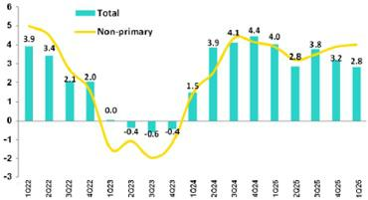

In 1Q26, GDP grew close to 3% year over year, slowing slightly relative to 4Q25 (3.2%), reflecting the impact of three simultaneous supply shocks that disrupted activity in March: (i) the conflict in the Middle East, which drove oil prices to levels not seen since 2022; (ii) the rupture of the Camisea pipeline, which interrupted gas supply for two weeks, affecting power generation, industrial activity, and transportation; and (iii) adverse weather conditions linked to the El Niño phenomenon, which weighed on agricultural and fishing production.

Primary sectors contracted for the first time since 3Q22. By contrast, non-primary sectors continued to expand at a solid

| Earnings Release 1Q / 2026 Analysis of 1Q26 Consolidated Results

11. Economic Outlook

pace, close to 4% year over year (similar to 4Q25), driven by construction, commerce, and services. Favorable terms of trade and inertia from the economic cycle continued to underpin the strength of domestic demand.

Annual Inflation and Central Bank Reference Rate

(%) Annual inflation in Metropolitan Lima closed 1Q26 at 3.8%, its highest level since October 2023 and well above the end-2025 reading (1.5%). As a result, inflation exceeded the upper bound of the BCRP’s target range (1%–3%) for the first time since February 2024. Nearly 80% of March’s monthly inflation was explained by transportation, fuels, and food. The three supply shocks—higher international oil prices, disruptions in natural gas supply, and adverse weather conditions associated with the El Niño phenomenon— significantly pushed prices higher. Core inflation (excluding food and energy) also accelerated, closing 1Q26 at 3.7%, its highest level since September 2023, after ending 2025 at a seven-year low (1.8%).
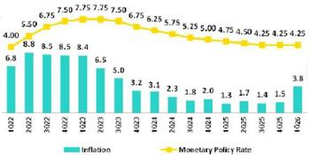

In 1Q26, the BCRP kept the policy rate unchanged at 4.25%. The last adjustment took place in September 2025, when the central bank cut
the rate by 25 basis points.

Fiscal and Current Account Balance

(% of GDP, Accumulated over the last 4Q) The annualized fiscal deficit as of March 2026 remained at 2.2% of

GDP, unchanged from end-2025. Fiscal revenues increased by 7.8%

YoY in 1Q26, supported by high metal prices and strong domestic
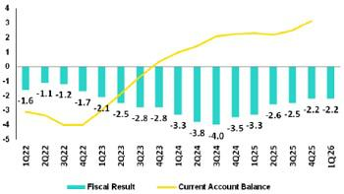
demand, while public spending rose by 9.4% YoY (current

expenditure +13% and gross capital formation +1%).

Credit rating agencies (Moody’s, Fitch, and S&P) made no changes in 1Q26, thereby maintaining Peru’s investment-grade rating and stable outlook.

The 12-month cumulative trade balance surplus through February rose to USD 39 billion, a new historical high, driven by a strong 24% increase in exports amid elevated copper, gold, and silver prices. Imports, meanwhile, grew by 11%, in line with the strength of domestic demand and investment.

Exchange Rate

($/ per dollar) According to the BCRP, the exchange rate closed 1Q26 at PEN 3.488 per U.S. dollar, representing a 3.8% depreciation relative to end-2025. The currency remained broadly stable between January and February at around PEN 3.350, influenced by BCRP intervention aimed at limiting excessive appreciation relative to fundamentals. In March, exchange-rate dynamics shifted following the outbreak of the U.S.–Iran conflict and the sharp rise in oil prices, which generated broad-based depreciation pressures across emerging-market currencies.
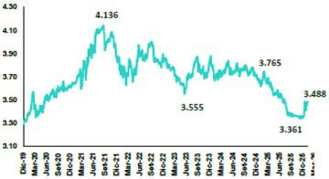

Net International Reserves closed 1Q26 at USD 94.7 billion, up from USD 90.2 billion at end-4Q25, further strengthening the country’s external position.

| Earnings Release 1Q / 2026 Analysis of 1Q26 Consolidated Results

Safe Harbor for Forward-Looking Statements

This material includes “forward-looking statements” within the meaning of Section 27A of the U.S. Securities Act of 1933 and Section 21E of the U.S. Securities Exchange Act of 1934. All statements other than statements of historical fact are forward-looking and may contain information about financial results, economic conditions, trends and known uncertainties. Forward-looking statements are not assurances of future performance. Instead, they are based only on our management’s current views, beliefs, expectations and assumptions regarding the future of our business, future plans and strategies, projections, anticipated events and trends, the economy and other future conditions.

Many forward-looking statements can be identified by words such as: “anticipate”, “intend”, “plan”, “goal”, “seek”, “believe”, “project”, “estimate”, “expect”, “strategy”, “future”, “likely”, “would”, “may”, “should”, “will”, “see” and similar references to future periods. Examples of forward-looking statements include, among others, statements or estimates we make regarding guidance relating to losses in our credit portfolio, efficiency ratio, provisions and non-performing loans, current or future market risk and future market conditions, expected macroeconomic events and conditions, our belief that we have sufficient capital and liquidity to fund our business operations, expectations of the effect on our financial condition of claims, legal actions, environmental costs, contingent liabilities and governmental and regulatory investigations and proceedings, strategy for customer retention, growth, governmental programs and regulatory initiatives, credit administration, product development, market position, financial results and reserves and strategy for risk management.

We caution readers that forward-looking statements involve known and unknown risks and uncertainties that could cause actual results, performance, or events to differ materially from those that we expect or that are expressed or implied in the forward-looking statements, depending on the outcome of certain factors, including, without limitation, adverse changes in:

- The occurrence of natural disasters or political or social instability in Peru;

- The adequacy of the dividends that our subsidiaries are able to pay to us, which may affect our ability to pay dividends to shareholders and corporate expenses;

- Performance of, and volatility in, financial markets, including Latin-American and other markets;

- The frequency, severity and types of insured loss events;

- Fluctuations in interest rate levels;

- Foreign currency exchange rates, including the Sol/US Dollar exchange rate;

- Deterioration in the quality of our loan portfolio;

- Increasing levels of competition in Peru and other markets in which we operate;

- Developments and changes in laws and regulations affecting the financial sector and adoption of new international guidelines;

- Changes in the policies of central banks and/or foreign governments;

- Effectiveness of our risk management policies and of our operational and security systems;

- Losses associated with counterparty exposures;

- The scope of the coronavirus (“COVID-19”) outbreak, actions taken to contain the COVID-19 and related economic effects from such actions and our ability to maintain adequate staffing; and
- Changes in Bermuda laws and regulations applicable to so-called non-resident entities.

See “Item 3. Key Information—3. D Risk Factors” and “Item 5. Operating and Financial Review and Prospects” in our most recent Annual Report on Form 20-F filed with the U.S. Securities and Exchange Commission for additional information and other such factors. You are cautioned not to place undue reliance on these forward-looking statements, which speak only as of the date hereof and are based only on information currently available to us. Therefore, you should not rely on any of these forward-looking statements.
We undertake no obligation to publicly update or revise these or any other forward-looking statements that may be made to reflect events or circumstances after the date hereof, whether as a result of changes in our business strategy or new information, to reflect the occurrence of unanticipated events or otherwise.

 |  | | | Earnings Release 1Q / 2026 | Analysis of 1Q26 Consolidated Results
12 |  | Appendix
12.1. | Evolution of Loans in Average Daily Balances |  |  | 45
12.2. | Loan Portfolio Quality |  |  | 46
12.3. | Net Interest Income (NII) |  |  | 49
12.4. | Net Interest Margin (NIM) and Risk Adjusted NIM |  |  | 49
12.5. | Physical Point of Contact |  |  | 50
12.6. | Regulatory Capital |  |  | 50
12.7. | Financial Statements and Ratios by Business |  |  | 54
12.7.1. Credicorp Consolidated |  |  |  | 54
12.7.2. Credicorp Stand-alone |  |  |  | 56
12.7.3. BCP Consolidated |  |  |  | 57
12.7.4. BCP Stand-alone |  |  |  | 59
12.7.5. BCP Bolivia |  |  |  | 61
12.7.6. Mibanco |  |  |  | 62
12.7.7. Prima AFP |  |  |  | 63
12.7.8. Grupo Pacifico |  |  |  | 64
12.7.9. Investment Management and Advisory |  |  |  | 65
12.8. | Table of Calculations |  |  | 66
12.9. | Glossary of terms |  |  | 67

| Earnings Release 1Q / 2026 Analysis of 1Q26 Consolidated Results

12. Appendix

12.1. Evolution of Loans in Average Daily Balances

Total Loans (in Average Daily Balances) ⁽¹⁾⁽²⁾


Total Loans |  | As of |  | Volume change |  | % change |  |  | % Part. in total loans
(S/ millions) | Mar 25 | Dec 25 | Mar 26 | QoQ | YoY | QoQ | YoY | Mar 25 | Dec 25 | Mar 26
BCP Stand-alone | 118,771 | 121,585 | 124,030 | 2,444 | 5,259 | 2.0% | 4.4% | 82.6% | 82.6% | 82.4%
Wholesale Banking | 54,548 | 53,227 | 55,554 | 2,327 | 1,007 | 4.4% | 1.8% | 37.9% | 36.2% | 36.9%
Corporate | 32,977 | 31,609 | 32,532 | 924 | -445 | 2.9% | -1.3% | 22.9% | 21.5% | 21.6%
Middle - Market | 21,571 | 21,618 | 23,022 | 1,404 | 1,451 | 6.5% | 6.7% | 15.0% | 14.7% | 15.3%
Retail Banking | 64,223 | 68,358 | 68,475 | 117 | 4,253 | 0.2% | 6.6% | 44.6% | 46.4% | 45.5%
SME - Business | 7,590 | 8,078 | 6,969 |  |  | -13.7% | -8.2% | 5.3% | 5.5% | 4.6%
 |  |  |  | -1,109 | -621
SME - Pyme | 15,940 | 16,574 | 16,787 | 212 | 847 | 1.3% | 5.3% | 11.1% | 11.3% | 11.2%
Mortgage | 21,870 | 23,525 | 24,030 | 505 | 2,160 | 2.1% | 9.9% | 15.2% | 16.0% | 16.0%
Consumer | 12,961 | 13,862 | 14,343 | 481 | 1,383 | 3.5% | 10.7% | 9.0% | 9.4% | 9.5%
Credit Card | 5,862 | 6,319 | 6,346 | 27 | 484 | 0.4% | 8.3% | 4.1% | 4.3% | 4.2%
Mibanco | 12,147 | 13,171 | 13,588 |  |  | 3.2% | 11.9% | 8.4% | 8.9% | 9.0%
 |  |  |  | 417 | 1,441
Mibanco Colombia | 1,832 | 2,193 | 2,390 | 197 | 558 | 9.0% | 30.4% | 1.3% | 1.5% | 1.6%
Bolivia | 9,469 | 8,976 | 9,067 | 90 | -402 | 1.0% | -4.2% | 6.6% | 6.1% | 6.0%
ASB Bank Corp. | 1,644 | 1,299 | 1,356 | 56 | -288 | 4.3% | -17.5% | 1.1% | 0.9% | 0.9%
BAP’s total loans | 143,863 | 147,225 | 150,430 | 3,205 | 6,568 | 2.2% | 4.6% | 100.0% | 100.0% | 100.0%

For consolidation purposes, loans generated in FC are converted to LC.
(1) | Includes Special accounts, and other banking. |  | Larger contraction in volume
(2) | Portfolio Management Figures. Non-audited figures. |  | Larger expansion in volume

12.2. Loan Portfolio Quality

Portfolio Quality Ratios by Segment

Wholesale Banking
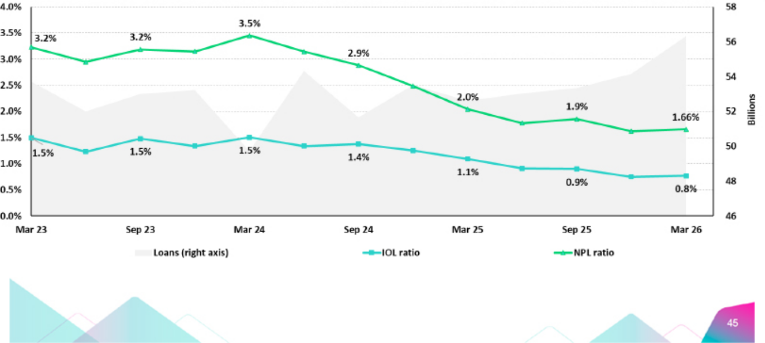

| Earnings Release 1Q / 2026 Analysis of 1Q26 Consolidated Results

12. Appendix

SME-Business
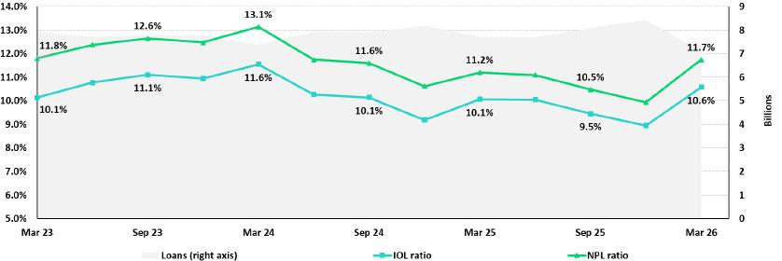

SME-Pyme
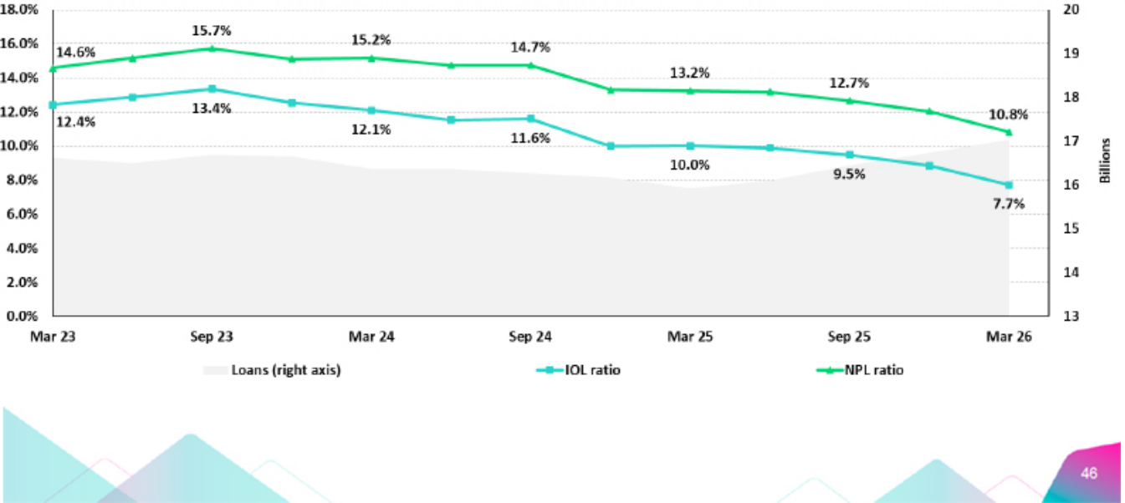

| Earnings Release 1Q / 2026 Analysis of 1Q26 Consolidated Results

12. Appendix

Mortgage
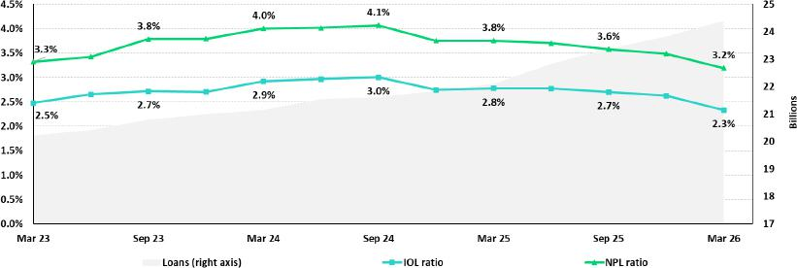

Consumer
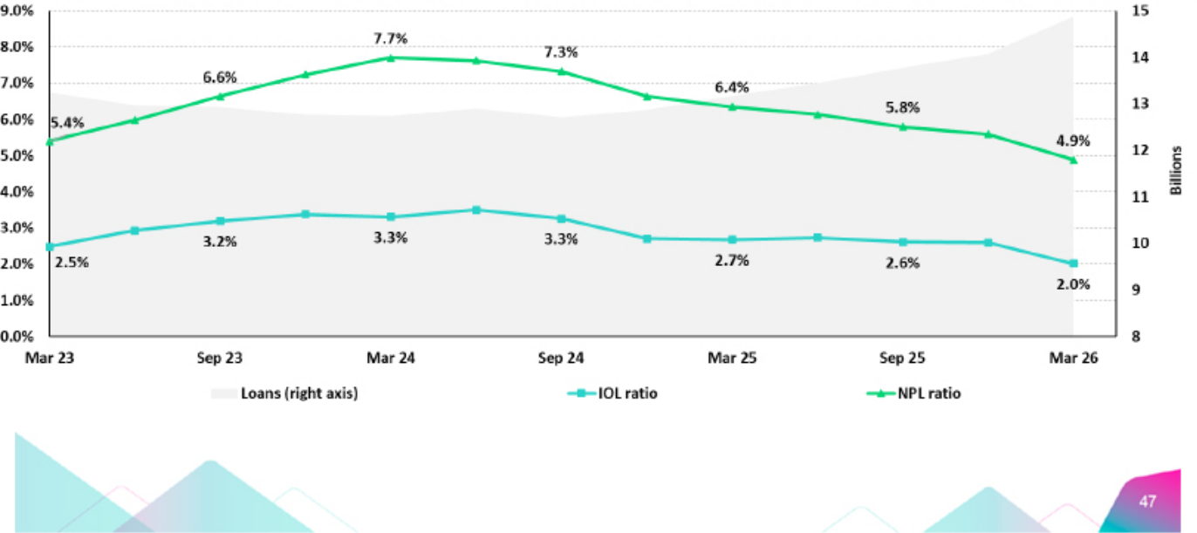

| Earnings Release 1Q / 2026 Analysis of 1Q26 Consolidated Results

12. Appendix

Credit Cards
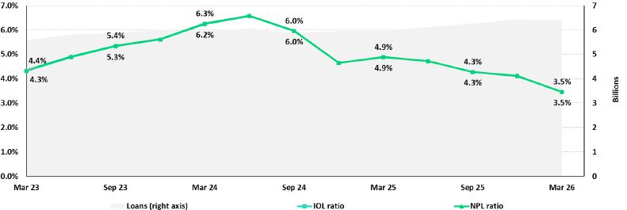

Mibanco
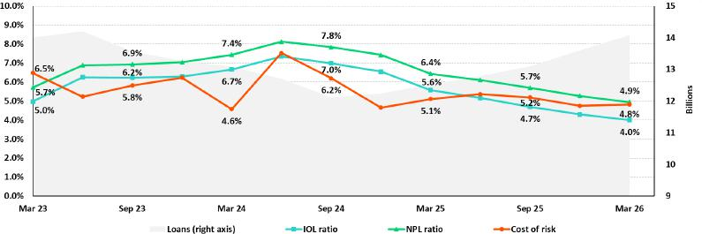

BCP Bolivia
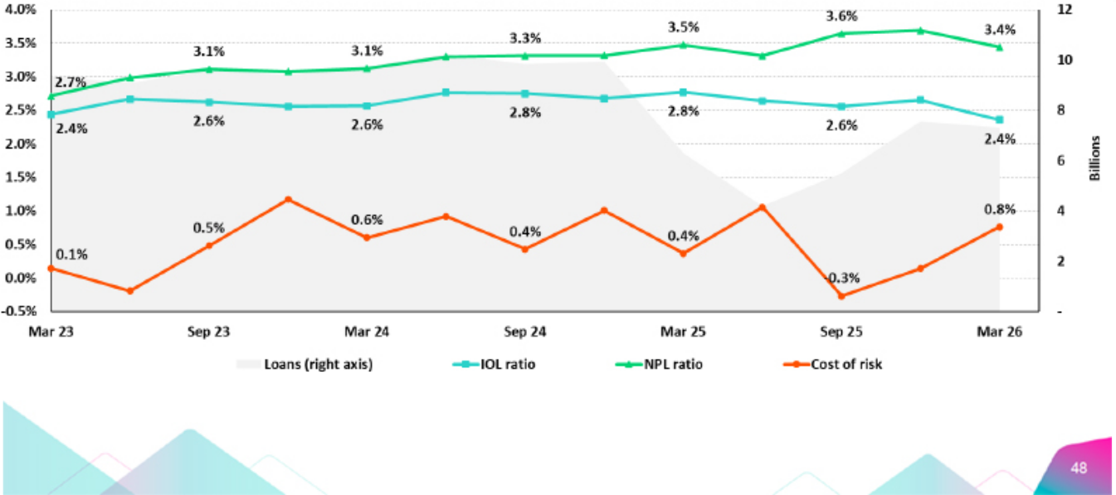

| Earnings Release 1Q / 2026 Analysis of 1Q26 Consolidated Results

12. Appendix

12.3. Net Interest Income (NII)

NII Summary

Net interest income |  | Quarter |  |  | % change
S/000 | 1Q25 | 4Q25 | 1Q26 | QoQ | YoY
Interest income | 4,894,790 | 5,125,394 | 5,212,412 | 1.7% | 6.5%
Interest on loans | 3,847,640 | 4,094,165 | 4,142,813 | 1.2% | 7.7%
Dividends on investments | 25,109 | 20,063 | 16,992 | -15.3% | -32.3%
Interest on deposits with banks | 344,622 | 366,208 | 321,572 | -12.2% | -6.7%
Interest on securities | 657,872 | 618,810 | 709,233 | 14.6% | 7.8%
Other interest income | 19,547 | 26,148 | 21,802 | -16.6% | 11.5%
Interest expense | 1,322,778 | 1,284,127 | 1,249,685 | -2.7% | -5.5%
Interest expense (excluding Net Insurance Financial Expenses) | 1,187,156 | 1,140,166 | 1,086,768 | -4.7% | -8.5%
Interest on deposits | 619,613 | 577,645 | 539,328 | -6.6% | -13.0%
Interest on borrowed funds | 266,202 | 245,191 | 210,799 | -14.0% | -20.8%
Interest on bonds and subordinated notes | 168,024 | 184,588 | 188,366 | 2.0% | 12.1%
Other interest expense | 133,317 | 132,742 | 148,275 | 11.7% | 11.2%
Net Insurance Financial Expenses | 135,622 | 143,961 | 162,917 | 13.2% | 20.1%
Net interest, similar income and expenses | 3,572,012 | 3,841,267 | 3,962,727 | 3.2% | 10.9%
Provision for credit losses on loan portfolio, net of recoveries | 581,893 | 646,286 | 482,088 | -25.4% | -17.2%
Net interest, similar income and expenses, after provision for credit losses on loan portfolio | 2,990,119 | 3,194,981 | 3,480,639 | 8.9% | 16.4%
Average interest earning assets | 238,435,117 | 240,783,785 | 250,941,843 | 4.2% | 5.2%
Net interest margin ⁽¹⁾ | 6.22% | 6.62% | 6.58% | -4 bps | 36 bps
Risk-adjusted Net interest margin ⁽¹⁾ | 5.24% | 5.55% | 5.81% | 26 bps | 57 bps
Net provisions for loan losses / Net interest income ⁽¹⁾ | 16.29% | 16.82% | 12.17% | -465 bps | -412 bps

(1) Annualized. For further detail on the NIM calculation due to IFRS17, please refer to Annex 12.8.

12.4. Net Interest Margin (NIM) and Risk-Adjusted NIM by Subsidiary

NIM Breakdown | 1Q25 | 4Q25 | 1Q26
BCP | 5.80% | 6.11% | 6.00%
Mibanco | 13.94% | 15.22% | 14.93%
BCP Bolivia | 2.85% | 2.74% | 2.74%
Credicorp | 6.22% | 6.62% | 6.58%

NIM: Annualized Net interest income (excluding Net Insurance Financial Expenses) / Average period end and period beginning interest-earning assets.

Risk Adjusted NIM | 1Q25 | 4Q25 | 1Q26
Breakdown | 1Q25 | 4Q25 | 1Q26
BCP | 4.98% | 5.19% | 5.50%
Mibanco | 10.14% | 11.57% | 11.25%
BCP Bolivia | 2.62% | 2.60% | 2.12%
Credicorp | 5.24% | 5.55% | 5.81%

Risk-Adjusted NIM: (Annualized Net interest income (excluding Net Insurance Financial Expenses) - annualized provisions) / Average period end and period beginning interest-earning assets.


| Earnings Release 1Q / 2026 Analysis of 1Q26 Consolidated Results

12. Appendix

12.5. Physical Point of contact

Physical Point of Contact ⁽¹⁾ |  | As of |  | Change (units)
(Units) | Mar 25 | Dec 25 | Mar 26 | QoQ | YoY
Branches ⁽²⁾ | 650 | 646 | 648 | 2 | (2)
ATMs | 2,787 | 4,903 | 4,833 | (70) | 531
Agents | 12,434 | 10,698 | 9,731 | (967) | (418)
Total | 15,871 | 16,247 | 15,212 | (1,035) | 111

- Includes Physical Point of Contact of BCP Stand-Alone, Mibanco and BCP Bolivia
- Includes Banco de la Nacion branches

12.6. Regulatory Capital

Regulatory Capital and Capital Adequacy Ratios

(IFRS)

Regulatory Capital and Capital Adequacy Ratios |  | As of |  |  | Change %
S/000 | Mar 25 | Dec 25 | Mar 26 | QoQ | YoY
Capital Stock | 1,318,993 | 1,318,993 | 1,318,993 | - | -
Treasury Stocks | (209,845) | (209,845) | (208,702) | -0.5% | -0.5%
Capital Surplus | 124,148 | 148,730 | 112,194 | -24.6% | -9.6%
Legal and Other Capital reserves | 32,792,830 | 29,648,582 | 36,483,716 | 23.1% | 11.3%
Minority interest | 476,695 | 475,351 | 475,465 | 0.0% | -0.3%
Current and Accumulated Earnings ⁽¹⁾ | 3,410,505 | 8,330,246 | 2,206,249 | -73.5% | -35.3%
Unrealized Gains or Losses ⁽²⁾ | (462,800) | 159,324 | (66,934) | -142.0% | -85.5%
Goodwill | (1,698,492) | (1,252,858) | (1,263,931) | 0.9% | -25.6%
Intangible Assets ⁽³⁾ | (2,590,377) | (3,586,460) | (3,660,945) | 2.1% | 41.3%
Deductions in Common Equity Tier 1 instruments ⁽⁴⁾ | (38,573) | (99,319) | (45,924) | -53.8% | 19.1%
Subordinated Debt | - | - | - | - | -
Subordinated Debt | 7,892,454 | 8,854,662 | 9,270,139 | 4.7% | 17.5%
Loan loss reserves ⁽⁵⁾ | 1,972,285 | 2,062,637 | 2,128,083 | 3.2% | 7.9%
Deductions in Tier 2 instruments ⁽⁶⁾ | (751,236) | (2,036,821) | (1,062,616) | -47.8% | 41.4%
Total Regulatory Capital (A) | 42,236,587 | 43,813,222 | 45,685,787 | 4.3% | 8.2%
Total Regulatory Common Equity Tier 1 Capital (B) | 33,123,084 | 34,932,743 | 35,350,180 | 1.2% | 6.7%
Total Regulatory Tier 1 Capital (C) | 33,123,084 | 34,932,743 | 35,350,180 | 1.2% | 6.7%
Total Regulatory Capital Requirement (D) | 30,571,363 | 32,346,541 | 33,801,576 | 4.5% | 10.6%
Total Regulatory Common Equity Tier 1 Capital Requirement (E) | 15,997,614 | 17,499,583 | 18,287,421 | 4.5% | 14.3%
Total Regulatory Tier 1 Capital Requirement (F) | 19,424,645 | 20,978,426 | 21,925,953 | 4.5% | 12.9%
Regulatory Capital Ratio (A) / (D) | 138% | 135% | 135% | (29) | -300 bps
Regulatory Common Equity Tier 1 Capital Ratio (B) / (E) | 207% | 200% | 193% | (632) | -1375 bps
Regulatory Tier 1 Capital Ratio (C) / (F) | 171% | 167% | 161% | (529) | -930 bps

- Earnings include Banco de Crédito del Perú and Mibanco Perú. Losses include all subsidiaries.
- Gains include Investment Grade Government Bonds and Peruvian Central Bank Certificates of Deposits. Losses include all bonds.
- Different to Goodwill. Includes Diferred Tax Assets.
- Investments in Equity.
- Up to 1.25% of total risk-weighted assets of Banco de Crédito del Perú, Solución Empresa Administradora Hipotecaria, Mibanco and Atlantic Security Bank.
- Investments in Tier 2 Subordinated Debt.

| Earnings Release 1Q / 2026 Analysis of 1Q26 Consolidated Results

12. Appendix

Regulatory and Capital Adequacy Ratios at BCP Stand-alone

Regulatory Capital |  | Quarter |  | % Change
(S/ thousand) | Mar 25 | Dec 25 | Mar 26 | QoQ | YoY
Capital Stock | 12,973,175 | 12,973,175 | 12,973,175 | 0.0% | 0.0%
Reserves | 6,124,302 | 6,125,452 | 6,125,452 | 0.0% | 0.0%
Accumulated earnings | 3,418,149 | 8,320,658 | 4,827,901 | -42.0% | 41.2%
Loan loss reserves ⁽¹⁾ | 1,740,158 | 1,799,773 | 1,867,164 | 3.7% | 7.3%
Subordinated Debt | 7,152,600 | 7,903,050 | 8,203,850 | 3.8% | 14.7%
Unrealized Profit or Losses | (341,947) | 138,930 | (241,505) | -273.8% | -29.4%
Investment in subsidiaries and others, net of unrealized profit and net income in subsidiaries | (2,310,402) | (2,691,973) | (2,549,702) | -5.3% | 10.4%
Intangibles | (1,509,701) | (1,795,540) | (1,784,514) | -0.6% | 18.2%
Goodwill | (122,083) | (122,083) | (122,083) | 0.0% | 0.0%
Total Regulatory Capital | 27,124,251 | 32,651,442 | 29,299,737 | -10.3% | 8.0%
Tier 1 Common Equity ⁽²⁾ | 18,231,493 | 22,948,619 | 19,228,724 | -16.2% | 5.5%
Regulatory Tier 1 Capital ⁽³⁾ | 18,231,493 | 22,948,619 | 19,228,724 | -16.2% | 5.5%
Regulatory Tier 2 Capital ⁽⁴⁾ | 8,892,758 | 9,702,823 | 10,071,014 | 3.8% | 13.2%
Total risk-weighted assets |  | Quarter |  | % Change
(S/ thousand) | Mar 25 | Dec 25 | Mar 26 | QoQ | YoY
Market risk-weighted assets | 3,903,493 | 5,019,033 | 6,640,053 | 32.3% | 70.1%
Credit risk-weighted assets | 138,028,766 | 142,806,023 | 148,234,223 | 3.8% | 7.4%
Operational risk-weighted assets | 18,895,091 | 20,123,383 | 20,574,067 | 2.2% | 8.9%
Total | 160,827,350 | 167,948,439 | 175,448,343 | 4.5% | 9.1%
Capital requirement |  | Quarter |  | % Change
(S/ thousand) | Mar 25 | Dec 25 | Mar 26 | QoQ | YoY
Market risk capital requirement | 390,349 | 501,903 | 664,005 | 32.3% | 70.1%
Credit risk capital requirement | 13,802,877 | 14,280,602 | 14,823,422 | 3.8% | 7.4%
Operational risk capital requirement | 1,889,509 | 2,012,338 | 2,057,407 | 2.2% | 8.9%
Additional capital requirements | 7,057,150 | 8,400,182 | 8,765,691 | 4.4% | 24.2%
Total | 23,139,885 | 25,195,026 | 26,310,526 | 4.4% | 13.7%
Capital Ratios under Local Regulation
Capital ratios under Local Regulation |  | Quarter |  | % Change
 | Mar 25 | Dec 25 | Mar 26 | QoQ | YoY
Common Equity Tier 1 ratio | 11.34% | 13.66% | 10.96% | -270 bps | -38 bps
Tier 1 Capital ratio | 11.34% | 13.66% | 10.96% | -270 bps | -38 bps
Regulatory Global Capital ratio | 16.87% | 19.44% | 16.70% | -274 bps | -17 bps

- Up to 1.25% of total risk-weighted assets.
- Common Equity Tier 1 = Capital Stock + Reserves + Accumulated earnings – Unrealized profits or losses - 100% deductions (investment in subsidiaries, goodwill, intangible assets and deferred tax assets based on future returns).
- Regulatory Tier 1 Capital = Common Equity Tier 1 + Tier 1 Subordinated Debt (Perpetual).
- Regulatory Tier 2 Capital = Subordinated Debt + Loan loss reserves.

| Earnings Release 1Q / 2026 Analysis of 1Q26 Consolidated Results

12. Appendix

Regulatory Capital and Capital Adequacy Ratios at Mibanco

Regulatory Capital |  | As of |  | % Change
(S/ thousand) | Mar 25 | Dec 25 | Mar 26 | QoQ | YoY
Capital Stock | 1,840,606 | 1,840,606 | 1,840,606 | 0.0% | 0.0%
Reserves | 365,847 | 365,847 | 420,856 | 15.0% | 15.0%
Accumulated earnings | 168,090 | 550,164 | 357,055 | -35.1% | 112.4%
Loan loss reserves ⁽¹⁾ | 149,412 | 167,481 | 173,250 | 3.4% | 16.0%
Perpetual subordinated debt | - | - | - | n.a | n.a.
Subordinated debt | 267,000 | 382,551 | 483,217 | 26.3% | 81.0%
Unrealidez Profit or Losses | (4,037) | 12,032 | (1,130) | -109.4% | -72.0%
Investment in subsidiaries and others, net of unrealized profit and net income in subsidiaries | (295) | (216) | (214) | -0.8% | -27.4%
Intangibles | (119,759) | (138,648) | (133,121) | -4.0% | 11.2%
Goodwill | (139,180) | (139,180) | (139,180) | 0.0% | 0.0%
Total Regulatory Capital | 2,527,685 | 3,040,636 | 3,001,338 | -1.3% | 18.7%
Tier Common Equity ⁽²⁾ | 2,111,272 | 2,490,604 | 2,344,871 | -5.9% | 11.1%
Regulatory Tier 1 Capital ⁽³⁾ | 2,111,272 | 2,490,604 | 2,344,871 | -5.9% | 11.1%
Regulatory Tier 2 Capital ⁽⁴⁾ | 416,412 | 550,032 | 656,467 | 19.4% | 57.6%
Total risk-weighted assets |  | As of |  | % Change
(S/ thousand) | Mar 25 | Dec 25 | Mar 26 | QoQ | YoY
Market risk-weighted assets | 225,498 | 157,365 | 161,513 | 2.6% | -28.4%
Credit risk-weighted assets | 11,793,102 | 13,221,315 | 13,674,755 | 3.4% | 16.0%
Operational risk-weighted assets | 1,623,262 | 928,897 | 940,160 | 1.2% | -42.1%
Total | 13,641,862 | 14,307,577 | 14,776,429 | 3.3% | 8.3%
Capital requirement |  | As of |  | % Change
(S/ thousand) | Mar 25 | Dec 25 | Mar 26 | QoQ | YoY
Market risk capital requirement | 22,550 | 15,737 | 16,151 | 2.6% | -28.4%
Credit risk capital requirement | 1,179,310 | 1,322,131 | 1,367,476 | 3.4% | 16.0%
Operational risk capital requirement | 162,326 | 92,890 | 94,016 | 1.2% | -42.1%
Additional capital requirements | 176,897 | 198,320 | 205,121 | 3.4% | 16.0%
Total | 1,541,083 | 1,629,077 | 1,682,764 | 3.3% | 9.2%

Capital Ratios under Local Regulation

Capital ratios under Local Regulation |  | As of |  |  | % change
Capital ratios under Local Regulation | Mar 25 | Dec 25 | Mar 26 | QoQ | YoY
Common Equity Tier 1 Ratio | 15.48% | 17.41% | 15.87% | -154 bps | 39 bps
Tier 1 Capital ratio | 15.48% | 17.41% | 15.87% | -154 bps | 39 bps
Regulatory Global Capital Ratio | 18.53% | 21.25% | 20.31% | -94 bps | 178 bps

- Up to 1.25% of total risk-weighted assets.
- Common Equity Tier 1 = Capital Stock + Reserves + Accumulated earnings – Unrealized profits or losses - 100% deductions (investment in subsidiaries, goodwill, intangible assets and deferred tax assets based on future returns).
- Regulatory Tier 1 Capital = Common Equity Tier 1 + Tier 1 Subordinated Debt (Perpetual).
- Regulatory Tier 2 Capital = Subordinated Debt + Loan loss reserves.


| Earnings Release 1Q / 2026 Analysis of 1Q26 Consolidated Results

12. Appendix

Common Equity Tier 1 IFRS

BCP Stand-alone

Common Equity Tier 1 IFRS |  |  | As of |  |  |  | % Change
(S/ thousand) |  | Mar 25 | Dec 25 | Mar 26 |  | QoQ | YoY
Capital and reserves |  | 18,585,234 | 18,586,384 | 18,586,384 |  | 0.0% | 0.0%
Retained earnings |  | 4,176,630 | 9,077,924 | 5,586,466 |  | -38.5% | 33.8%
Unrealized gains (losses) |  | 140,002 | 636,199 | 196,962 |  | -69.0% | 40.7%
Goodwill and intangibles |  | (1,706,438) | (1,971,859) | (1,948,580) |  | -1.2% | 14.2%
Investments in subsidiaries |  | (2,416,979) | (2,723,662) | (2,549,601) |  | -6.4% | 5.5%
Total |  | 18,778,449 | 23,604,986 | 19,871,630 |  | -15.8% | 5.8%
Adjusted RWAs IFRS |  | 161,628,694 | 168,734,761 | 175,966,882 |  | 4.3% | 8.9%
Adjusted Credit RWAs IFRS |  | 138,830,109 | 143,592,345 | 148,752,762 |  | 3.6% | 7.1%
Others |  | 22,798,584 | 25,142,416 | 27,214,120 |  | 8.2% | 19.4%
CET1 ratio IFRS |  | 11.62% | 13.99% | 11.29% |  | -270 bps | -33 bps
 |  | Mibanco
Common Equity Tier 1 IFRS |  |  | As of |  |  |  | % Change
(S/ thousand) |  | Mar 25 | Dec 25 | Mar 26 |  | QoQ | YoY
Capital and reserves |  | 2,734,582 | 2,734,582 | 2,789,591 |  | 2.0% | 2.0%
Retained earnings |  | (247,483) | 55,838 | (170,948) |  | -406.2% | -30.9%
Unrealized gains (losses) |  | (4,257) | 11,531 | 993 |  | -91.4% | -123.3%
Goodwill and intangibles |  | (292,948) | (308,880) | (302,651) |  | -2.0% | 3.3%
Investments in subsidiaries |  | (299) | (166) | (212) |  | 28.1% | -28.9%
Total |  | 2,189,595 | 2,492,906 | 2,316,772 |  | -7.1% | 5.8%
Adjusted RWAs IFRS |  | 13,782,186 | 14,407,727 | 14,760,089 |  | 2.4% | 7.1%
Adjusted Credit RWAs IFRS |  | 11,933,425 | 13,321,465 | 13,658,416 |  | 2.5% | 14.5%
Others |  | 1,848,760 | 1,086,263 | 1,101,673 |  | 1.4% | -40.4%
CET1 ratio IFRS |  | 15.89% | 17.30% | 15.70% |  | -161 bps | -19 bps


| Earnings Release 1Q / 2026 Analysis of 1Q26 Consolidated Results

12. Appendix

12.7. Financial Statements and Ratios by Business

12.7.1. Credicorp Consolidated

Consolidated Statement of Financial Position

(S/ Thousands, IFRS)

 |  | As of |  |  | % change
 | Mar 25 | Dec 25 | Mar 26 | QoQ | YoY
ASSETS
Cash and due from banks | 7,015,098 | 7,649,640 | 7,708,541 | 0.8% | 9.9%
Non-interest bearing
Interest bearing | 37,521,839 | 41,394,817 | 42,979,690 | 3.8% | 14.5%
Total cash and due from banks | 44,536,937 | 49,044,457 | 50,688,231 | 3.4% | 13.8%
Cash collateral, reverse repurchase agreements and securities borrowing | 1,835,893 | 2,177,200 | 2,211,576 | 1.6% | 20.5%
Fair value through profit or loss investments | 5,149,628 | 4,957,236 | 5,194,008 | 4.8% | 0.9%
Fair value through other comprehensive income investments | 41,705,253 | 39,034,049 | 43,603,824 | 11.7% | 4.6%
Amortized cost investments | 8,749,729 | 8,813,657 | 8,707,989 | -1.2% | -0.5%
Loans | 141,196,646 | 149,984,954 | 152,824,685 | 1.9% | 8.2%
Current | 135,990,251 | 145,171,418 | 148,349,565 | 2.2% | 9.1%
Internal overdue loans | 5,206,395 | 4,813,536 | 4,475,120 | -7.0% | -14.0%
Less - allowance for loan losses | (7,742,792) | (7,669,950) | (7,425,425) | -3.2% | -4.1%
Loans, net | 133,453,854 | 142,315,004 | 145,399,260 | 2.2% | 9.0%
Financial assets designated at fair value through profit or loss | 871,626 | 992,429 | 992,047 | 0.0% | 13.8%
Property, plant and equipment, net | 2,681,862 | 2,672,458 | 2,655,820 | -0.6% | -1.0%
Due from customers on acceptances | 639,749 | 345,906 | 608,309 | 75.9% | -4.9%
Investments in associates | 1,002 | 65,338 | 65,888 | 0.8% | 6475.6%
Intangible assets and goodwill, net | 4,420,422 | 4,764,394 | 4,728,692 | -0.7% | 7.0%
Reinsurance contract assets | 976,832 | 708,560 | 858,291 | 21.1% | -12.1%
Other assets ⁽¹⁾ | 9,049,787 | 11,471,845 | 12,799,711 | 11.6% | 41.4%
Total Assets | 254,072,574 | 267,362,533 | 278,513,646 | 4.2% | 9.6%
LIABILITIES AND EQUITY
Deposits and obligations | 49,620,679 | 52,217,286 | 57,405,484 | 9.9% | 15.7%
Non-interest bearing
Interest bearing | 107,998,403 | 118,184,347 | 121,222,422 | 2.6% | 12.2%
Total deposits and obligations | 157,619,082 | 170,401,633 | 178,627,906 | 4.8% | 13.3%
Payables from repurchase agreements and securities lending | 10,158,614 | 8,243,787 | 5,872,475 | -28.8% | -42.2%
BCRP instruments | 7,064,476 | 4,776,512 | 2,338,426 | -51.0% | -66.9%
Repurchase agreements with third parties | 2,872,797 | 3,332,706 | 3,473,827 | 4.2% | 20.9%
Repurchase agreements with customers | 221,341 | 134,569 | 60,222 | -55.2% | -72.8%
Due to banks and correspondents | 10,899,579 | 10,675,238 | 10,213,175 | -4.3% | -6.3%
Bonds and notes issued | 14,391,733 | 14,025,535 | 14,750,710 | 5.2% | 2.5%
Banker’s acceptances outstanding | 639,749 | 345,906 | 608,309 | 75.9% | -4.9%
Insurance contract liability | 13,725,052 | 14,264,155 | 14,504,324 | 1.7% | 5.7%
Financial liabilities at fair value through profit or loss | 736,192 | 1,055,893 | 1,451,894 | 37.5% | 97.2%
Other liabilities | 9,487,673 | 9,254,277 | 11,836,817 | 27.9% | 24.8%
Total Liabilities | 217,657,674 | 228,266,424 | 237,865,610 | 4.2% | 9.3%
Net equity | 35,843,202 | 38,366,950 | 40,018,343 | 4.3% | 11.6%
Capital stock | 1,318,993 | 1,318,993 | 1,318,993 | 0.0% | 0.0%
Treasury stock | (209,845) | (209,845) | (208,702) | -0.5% | -0.5%
Capital surplus | 124,149 | 148,729 | 112,194 | -24.6% | -9.6%
Reserves | 32,792,830 | 29,648,582 | 36,483,716 | 23.1% | 11.3%
Other reserves | 33,460 | 544,767 | 207,887 | -61.8% | 521.3%
Retained earnings | 1,783,615 | 6,915,724 | 2,104,255 | -69.6% | 18.0%
Non-controlling interest | 571,698 | 729,159 | 629,693 | -13.6% | 10.1%
Total Net Equity | 36,414,900 | 39,096,109 | 40,648,036 | 4.0% | 11.6%
Total liabilities and equity | 254,072,574 | 267,362,533 | 278,513,646 | 4.2% | 9.6%
Off-balance sheet | 144,439,635 | 142,310,181 | 156,490,608 | 10.0% | 8.3%
Total performance bonds, stand-by and L/Cs. | 20,843,657 | 21,267,157 | 21,640,536 | 1.8% | 3.8%
Undrawn credit lines, advised but not committed | 79,021,358 | 80,250,985 | 86,229,700 | 7.5% | 9.1%
Total derivatives (notional) and others | 44,574,620 | 40,792,039 | 48,620,372 | 19.2% | 9.1%

(1) Includes mainly accounts receivables from brokerage and others.

* Due to reclassifications, the Balance Sheet may differ from those reported in previous quarters.

| Earnings Release 1Q / 2026 Analysis of 1Q26 Consolidated Results

12. Appendix

Consolidated Statement of Income

(S/ Thousands, IFRS)

 |  | Quarter |  |  | % change
 | 1Q25 | 4Q25 | 1Q26 | QoQ | YoY
Interest income and expense
Interest and similar income | 4,894,790 | 5,125,394 | 5,212,412 | 1.7% | 6.5%
Interest and similar expenses | (1,322,778) | (1,284,127) | (1,249,685) | -2.7% | -5.5%
Net interest, similar income and expenses | 3,572,012 | 3,841,267 | 3,962,727 | 3.2% | 10.9%
Provision for credit losses on loan portfolio | (695,733) | (773,311) | (612,011) | -20.9% | -12.0%
Recoveries of written-off loans | 113,840 | 127,025 | 129,923 | 2.3% | 14.1%
Provision for credit losses on loan portfolio, net of recoveries | (581,893) | (646,286) | (482,088) | -25.4% | -17.2%
Net interest, similar income and expenses, after provision for credit losses on | 2,990,119 | 3,194,981 | 3,480,639 | 8.9% | 16.4%
loan portfolio
Other income
Fee income | 994,024 | 1,118,110 | 1,149,284 | 2.8% | 15.6%
Net gain on foreign exchange transactions | 343,814 | 426,916 | 448,884 | 5.1% | 30.6%
Net loss on securities | (28,149) | 96,280 | 135,637 | 40.9% | -581.9%
Net gain from associates | 24,068 | 5,588 | 9,296 | 66.4% | -61.4%
Net gain (loss) on derivatives held for trading | 18,499 | 11,756 | 27,463 | 133.6% | 48.5%
Net gain (loss) from exchange differences | 15,959 | 8,319 | 8,557 | 2.9% | -46.4%
Others | 322,001 | 132,530 | 77,203 | -41.7% | -76.0%
Total other income | 1,690,216 | 1,799,499 | 1,856,324 | 3.2% | 9.8%
Insurance underwriting result
Insurance Service Result | 416,106 | 519,300 | 345,846 | -33.4% | -16.9%
Reinsurance Result | (86,972) | (198,457) | (46,783) | -76.4% | -46.2%
Total insurance underwriting result | 329,134 | 320,843 | 299,063 | -6.8% | -9.1%
Medical services result
Sales of medical services | 78,121 | 414,114 | 424,565 | 2.5% | 443.5%
Cost of sales of medical services | (35,432) | (289,441) | (300,727) | 3.9% | 748.7%
Total medical services result | 42,689 | 124,673 | 123,838 | -0.7% | 190.1%
Total Expenses
Salaries and employee benefits | (1,361,690) | (1,428,178) | (1,459,421) | 2.2% | 7.2%
Administrative, general and tax expenses | (869,834) | (1,186,497) | (1,061,666) | -10.5% | 22.1%
Depreciation and amortization | (203,766) | (256,914) | (241,368) | -6.1% | 18.5%
Impairment loss on goodwill | - | - | - | n.a. | n.a.
Association in participation | (6,799) | (120) | (173) | 44.2% | -97.5%
Other expenses | (90,785) | (208,248) | (78,203) | -62.4% | -13.9%
Total expenses | (2,532,874) | (3,079,957) | (2,840,831) | -7.8% | 12.2%
Profit before income tax | 2,519,284 | 2,360,039 | 2,919,033 | 23.7% | 15.9%
Income tax | (704,469) | (735,153) | (808,891) | 10.0% | 14.8%
Net profit | 1,814,815 | 1,624,886 | 2,110,142 | 29.9% | 16.3%
Non-controlling interest | 37,118 | 37,876 | 46,958 | 24.0% | 26.5%
Net profit attributable to Credicorp | 1,777,697 | 1,587,010 | 2,063,184 | 30.0% | 16.1%

| Earnings Release 1Q / 2026 Analysis of 1Q26 Consolidated Results

12. Appendix

12.7.2. Credicorp Stand-alone

Statement of Financial Position

(S/ thousands, IFRS)

 |  | As of |  |  | % change
 | Mar 25 | Dec 25 | Mar 26 | QoQ | YoY
ASSETS
Cash and cash equivalents | 399,817 | 320,909 | 321,003 | 0.0% | -19.7%
At fair value through profit or loss | - | - | - | n.a. | n.a.
Fair value through other comprehensive income investments | 1,232,139 | 101,684 | 102,795 | 1.1% | -91.7%
In subsidiaries and associates investments | 39,435,439 | 42,246,625 | 43,803,642 | 3.7% | 11.1%
Investments at amortized cost | 686,418 | - | - | n.a. | n.a.
Other assets | 250,990 | 8,836 | 269,011 | n.a. | 7.2%
Total Assets | 42,004,803 | 42,678,054 | 44,496,451 | 4.3% | 5.9%
LIABILITIES AND NET SHAREHOLDERS’ EQUITY
Due to banks, correspondents and other entities | - | - | - | n.a. | n.a.
Bonds and notes issued | 1,796,058 | - | - | n.a. | n.a.
Other liabilities | 276,279 | 274,606 | 342,671 | 24.8% | 24.0%
Total Liabilities | 2,072,337 | 274,606 | 342,671 | 24.8% | -83.5%
NET EQUITY
Capital stock | 1,318,993 | 1,318,993 | 1,318,993 | 0.0% | 0.0%
Capital Surplus | 384,542 | 384,542 | 384,542 | 0.0% | 0.0%
Reserve | 32,291,005 | 28,438,708 | 35,324,402 | 24.2% | 9.4%
Unrealized results | (245,864) | 275,191 | (55,555) | n.a. | n.a.
Retained earnings | 6,183,790 | 11,986,014 | 7,181,398 | -40.1% | 16.1%
Total net equity | 39,932,466 | 42,403,448 | 44,153,780 | 4.1% | 10.6%
Total Liabilities And Equity | 42,004,803 | 42,678,054 | 44,496,451 | 4.3% | 5.9%

Statement of Income

(S/ Thousands, IFRS)

 |  | Quarter |  | % Change
 | 1Q25 | 4Q25 | 1Q26 | QoQ | YoY
Interest income | 1,660,468 | 1,700,043 | 2,158,931 | 27.0% | 30.0%
Net share of the income from investments in subsidiaries and associates
Interest and similar income | 21,312 | 298 | 787 | 164.1% | -96.3%
Net gain on financial assets at fair value through profit or loss | - | - | - | n.a. | n.a.
Total income | 1,681,780 | 1,700,341 | 2,159,718 | 27.0% | 28.4%
Interest and similar expense | (13,129) | 15 | 0 | n.a. | n.a.
Administrative and general expenses | (4,958) | (10,992) | (3,842) | -65.0% | -22.5%
Total expenses | (18,087) | (10,977) | (3,842) | -65.0% | -78.8%
Operating income | 1,663,693 | 1,689,364 | 2,155,876 | 27.6% | 29.6%
Results from exchange differences | 65 | 352 | 368 | 4.5% | n.a.
Other, net | (295) | 103 | (458) | n.a. | 55.3%
Profit before income tax | 1,663,463 | 1,689,819 | 2,155,786 | 27.6% | 29.6%
Income tax | (45,071) | (57,526) | (66,365) | 15.4% | 47.2%
Net income | 1,618,392 | 1,632,293 | 2,089,421 | 28.0% | 29.1%
Double Leverage Ratio | 98.8% | 99.6% | 99.2% | -42 bps | 45 bps

| Earnings Release 1Q / 2026 Analysis of 1Q26 Consolidated Results

12. Appendix

12.7.3 BCP Consolidated

Consolidated Statement of Financial Position

(S/ Thousands, IFRS)

 |  | As of |  |  | % change
 | Mar 25 | Dec 25 | Mar 26 | QoQ | YoY
ASSETS
Cash and due from banks
Non-interest bearing | 5,330,664 | 5,215,104 | 5,716,550 | 9.6% | 7.2%
Interest bearing | 35,977,823 | 39,683,584 | 40,573,684 | 2.2% | 12.8%
Total cash and due from banks | 41,308,487 | 44,898,688 | 46,290,234 | 3.1% | 12.1%
Cash collateral, reverse repurchase agreements and securities borrowing | 776,081 | 852,396 | 877,929 | 3.0% | 13.1%
Fair value through profit or loss investments | 537,503 | 641,157 | 551,864 | -13.9% | 2.7%
Fair value through other comprehensive income investments | 24,940,660 | 22,839,625 | 27,197,340 | 19.1% | 9.0%
Amortized cost investments | 8,134,166 | 8,227,850 | 8,090,030 | -1.7% | -0.5%
Loans | 131,470,639 | 138,303,962 | 141,129,333 | 2.0% | 7.3%
Current | 126,570,181 | 133,820,771 | 136,977,465 | 2.4% | 8.2%
Internal overdue loans | 4,900,458 | 4,483,191 | 4,151,868 | -7.4% | -15.3%
Less - allowance for loan losses | (7,323,541) | (7,209,280) | (6,944,235) | -3.7% | -5.2%
Loans, net | 124,147,098 | 131,094,682 | 134,185,098 | 2.4% | 8.1%
Property, furniture and equipment, net ⁽¹⁾ | 1,643,626 | 1,567,598 | 1,516,211 | -3.3% | -7.8%
Due from customers on acceptances | 639,749 | 346,540 | 608,592 | 75.6% | -4.9%
Investments in associates | 24,738 | 30,556 | 33,218 | 8.7% | 34.3%
Other assets ⁽²⁾ | 8,045,520 | 9,423,377 | 9,857,231 | 4.6% | 22.5%
Total Assets | 210,197,628 | 219,922,469 | 229,207,747 | 4.2% | 9.0%
Liabilities and Equity
Deposits and obligations
Non-interest bearing | 46,181,912 | 47,989,475 | 53,429,872 | 11.3% | 15.7%
Interest bearing | 100,410,686 | 109,090,077 | 112,129,605 | 2.8% | 11.7%
Total deposits and obligations | 146,592,598 | 157,079,552 | 165,559,477 | 5.4% | 12.9%
Payables from repurchase agreements and securities lending | 7,892,912 | 6,013,486 | 3,495,042 | -41.9% | -55.7%
BCRP instruments | 7,064,476 | 4,776,512 | 2,338,426 | -51.0% | -66.9%
Repurchase agreements with third parties | 828,436 | 1,236,974 | 1,156,616 | -6.5% | 39.6%
Due to banks and correspondents | 10,314,235 | 9,768,390 | 9,195,995 | -5.9% | -10.8%
Bonds and notes issued | 10,759,498 | 11,675,417 | 12,162,209 | 4.2% | 13.0%
Banker’s acceptances outstanding | 639,749 | 346,540 | 608,592 | 75.6% | -4.9%
Financial liabilities at fair value through profit or loss | 367,988 | 578,541 | 784,502 | 35.6% | 113.2%
Other liabilities ⁽³⁾ | 10,599,135 | 6,014,541 | 12,894,438 | 114.4% | 21.7%
Total Liabilities | 187,166,115 | 191,476,467 | 204,700,255 | 6.9% | 9.4%
Net equity | 22,896,863 | 28,295,366 | 24,366,155 | -13.9% | 6.4%
Capital stock | 12,679,794 | 12,679,794 | 12,679,794 | 0.0% | 0.0%
Reserves | 5,905,440 | 5,906,590 | 5,906,590 | 0.0% | 0.0%
Unrealized gains and losses | 141,193 | 638,465 | 195,628 | -69.4% | 38.6%
Retained earnings | 4,170,436 | 9,070,517 | 5,584,143 | -38.4% | 33.9%
Non-controlling interest | 134,650 | 150,636 | 141,337 | -6.2% | 5.0%
Total Net Equity | 23,031,513 | 28,446,002 | 24,507,492 | -13.8% | 6.4%
Total liabilities and equity | 210,197,628 | 219,922,469 | 229,207,747 | 4.2% | 9.0%
Off-balance sheet | 136,896,925 | 132,887,977 | 147,078,826 | 10.7% | 7.4%
Total performance bonds, stand-by and L/Cs. | 20,571,287 | 20,991,000 | 21,519,458 | 2.5% | 4.6%
Undrawn credit lines, advised but not committed | 72,392,139 | 71,432,289 | 77,343,334 | 8.3% | 6.8%
Total derivatives (notional) and others | 43,933,499 | 40,464,688 | 48,216,034 | 19.2% | 9.7%

- Right of use asset of lease contracts is included by application of IFRS 16.
- Mainly includes intangible assets, other receivable accounts, trading derivatives receivable accounts and tax credit.
- Mainly includes other payable accounts, trading derivatives payable accounts and taxes for payable.

| Earnings Release 1Q / 2026 Analysis of 1Q26 Consolidated Results

12. Appendix

Consolidated Statement of Income

(S/ Thousands, IFRS)


 |  | Quarter |  | % change
 | 1Q25 | 4Q25 | 1Q26 | QoQ | YoY
Interest income and expense
Interest and similar income | 4,260,384 | 4,486,502 | 4,494,642 | 0.2% | 5.5%
Interest and similar expense ⁽¹⁾ | (975,337) | (937,173) | (865,903) | -7.6% | -11.2%
Interest income and expense | 3,285,047 | 3,549,329 | 3,628,739 | 2.2% | 10.5%
Provision for credit losses on loan portfolio | (648,883) | (714,928) | (538,747) | -24.6% | -17.0%
Recoveries of written-off loans | 108,978 | 123,065 | 125,768 | 2.2% | 15.4%
Provision for credit losses on loan portfolio, net of recoveries | (539,905) | (591,863) | (412,979) | -30.2% | -23.5%
Net interest, similar income and expenses, after provision for credit losses on loan portfolio | 2,745,142 | 2,957,466 | 3,215,760 | 8.7% | 17.1%
Other income
Fee income | 860,089 | 956,996 | 996,706 | 4.1% | 15.9%
Net gain on foreign exchange transactions | 305,799 | 374,685 | 389,372 | 3.9% | 27.3%
Net gain (loss) on securities | 11,361 | 21,796 | 70,261 | n.a. | n.a.
Net gain on derivatives held for trading | 14,635 | 13,149 | 21,280 | 61.8% | 45.4%
Net loss (gain) from exchange differences | 784 | 3,372 | 12,384 | n.a. | n.a.
Others | 23,975 | 58,303 | 19,439 | -66.7% | -18.9%
Total other income | 1,216,643 | 1,428,301 | 1,509,442 | 5.7% | 24.1%
Total expenses
Salaries and employee benefits | (979,534) | (1,016,716) | (1,050,981) | 3.4% | 7.3%
Administrative expenses | (628,741) | (936,160) | (783,220) | -16.3% | 24.6%
Depreciation and amortization ⁽²⁾ | (168,136) | (186,914) | (191,573) | 2.5% | 13.9%
Other expenses | (53,526) | (71,464) | (61,203) | -14.4% | 14.3%
Total expenses | (1,829,937) | (2,211,254) | (2,086,977) | -5.6% | 14.0%
Profit before income tax | 2,131,848 | 2,174,513 | 2,638,225 | 21.3% | 23.8%
Income tax | (549,462) | (613,892) | (676,089) | 10.1% | 23.0%
Net profit | 1,582,386 | 1,560,621 | 1,962,136 | 25.7% | 24.0%
Non-controlling interest | (4,721) | (6,856) | (7,453) | 8.7% | 57.9%
Net profit attributable to BCP Consolidated | 1,577,665 | 1,553,765 | 1,954,683 | 25.8% | 23.9%
- Financing expenses related to lease agreements are included according to the application of IFRS 16.
- The effect of the application of IFRS 16 is included, which corresponds to a greater depreciation for the asset for right-of-use”.

Selected Financial Indicators

 |  | Quarter |  |  | Change
 | 1Q25 | 4Q25 | 1Q26 | QoQ | YoY
Profitability
_{ROAA} (1)(2) | 3.0% | 2.9% | 3.5% | 59 bps | 49 bps
_{ROAE} (1)(2) | 25.8% | 22.6% | 29.7% | 706 bps | 389 bps
Net interest margin ⁽¹⁾⁽²⁾ | 6.48% | 6.90% | 6.77% | -13 bps | 28 bps
Risk-adjusted Net interest margin ⁽¹⁾⁽²⁾ | 5.42% | 5.75% | 6.00% | 25 bps | 58 bps
Funding cost ⁽¹⁾⁽²⁾⁽³⁾ | 2.20% | 2.08% | 1.85% | -24 bps | -35 bps
Loan portfolio quality
Internal overdue ratio | 3.7% | 3.2% | 2.9% | -30 bps | -79 bps
NPL ratio | 5.2% | 4.6% | 4.3% | -30 bps | -91 bps
Coverage ratio of IOLs | 149.4% | 160.8% | 167.3% | 645 bps | 1781 bps
Coverage ratio of NPLs | 107.5% | 113.8% | 115.1% | 123 bps | 757 bps
Cost of risk ⁽⁴⁾ | 1.6% | 1.7% | 1.2% | -55 bps | -46 bps
Operating efficiency
Operating expenses / Total income ⁽⁵⁾ | 39.8% | 43.7% | 40.1% | -356 bps | 35 bps
Operating expenses / Total average assets ⁽¹⁾⁽²⁾⁽⁵⁾ | 3.4% | 4.0% | 3.6% | -38 bps | 23 bps

- Ratios are annualized.
- Averages are determined as the average of period-beginning and period-ending balances.
- The funding costs differs from previously reported due to a methodology change in the denominator, which no longer includes the following accounts: acceptances outstanding, reserves for property and casualty claims, reserve for unearned premiums, reinsurance payable and other liabilities.
- Cost of risk: Annualized provision for loan losses / Total loans.
- Total income includes net interest income, fee income, net gain on foreign exchange transactions, result on exchange difference and net gain on derivatives. Operating expenses includes Salaries and social benefits, administrative, general and tax expenses and depreciation and amortization.

| Earnings Release 1Q / 2026 Analysis of 1Q26 Consolidated Results

12. Appendix

12.7.4. BCP Stand-alone

Statement of Financial Position

(S/ Thousands, IFRS)


 |  | As of |  | % change
 | Mar 25 | Dec 25 | Mar 26 | QoQ | YoY
ASSETS
Cash and due from banks
Non-interest bearing | 4,776,238 | 4,504,068 | 6,477,304 | 43.8% | 35.6%
Interest bearing | 34,709,343 | 38,567,869 | 37,134,802 | -3.7% | 7.0%
Total cash and due from banks | 39,485,581 | 43,071,937 | 43,612,106 | 1.3% | 10.5%
Cash collateral, reverse repurchase agreements and securities borrowing | 776,081 | 852,396 | 877,929 | 3.0% | 13.1%
Fair value through profit or loss investments | 537,503 | 641,157 | 551,864 | -13.9% | 2.7%
Fair value through other comprehensive income investments | 21,877,682 | 20,080,093 | 24,896,990 | 24.0% | 13.8%
Amortized cost investments | 8,072,234 | 8,126,661 | 7,991,186 | -1.7% | -1.0%
Loans | 119,378,598 | 125,200,572 | 128,142,162 | 2.3% | 7.3%
Current | 115,180,766 | 121,306,169 | 124,556,355 | 2.7% | 8.1%
Internal overdue loans | 4,197,832 | 3,894,403 | 3,585,807 | -7.9% | -14.6%
Less - allowance for loan losses | (6,453,864) | (6,294,039) | (5,986,238) | -4.9% | -7.2%
Loans, net | 112,924,734 | 118,906,533 | 122,155,924 | 2.7% | 8.2%
Property, furniture and equipment, net ⁽¹⁾ | 1,428,475 | 1,375,263 | 1,332,154 | -3.1% | -6.7%
Due from customers on acceptances | 639,749 | 346,540 | 608,592 | 75.6% | -4.9%
Investments in associates | 2,431,259 | 2,740,803 | 2,569,443 | -6.3% | 5.7%
Other assets ⁽²⁾ | 7,642,354 | 8,750,924 | 9,485,856 | 8.4% | 24.1%
Total Assets | 195,815,652 | 204,892,307 | 214,082,044 | 4.5% | 9.3%
Liabilities and Equity
Deposits and obligations
Non-interest bearing | 46,158,361 | 47,965,701 | 53,394,140 | 11.3% | 15.7%
Interest bearing | 89,206,307 | 98,156,445 | 101,116,887 | 3.0% | 13.4%
Total deposits and obligations | 135,364,668 | 146,122,146 | 154,511,027 | 5.7% | 14.1%
Payables from repurchase agreements and securities lending | 7,070,379 | 5,012,782 | 2,734,061 | -45.5% | -61.3%
BCRP instruments | 6,241,943 | 3,775,808 | 1,577,445 | -58.2% | -74.7%
Repurchase agreements with third parties | 828,436 | 1,236,974 | 1,156,616 | -6.5% | 39.6%
Due to banks and correspondents | 9,007,034 | 8,025,742 | 7,563,884 | -5.8% | -16.0%
Bonds and notes issued | 10,350,044 | 11,004,111 | 11,246,413 | 2.2% | 8.7%
Due from customers on acceptances | 639,749 | 346,540 | 608,592 | 75.6% | -4.9%
Financial liabilities at fair value through profit or loss | 367,988 | 578,541 | 784,502 | 35.6% | 113.2%
Other liabilities ⁽³⁾ | 10,113,924 | 5,501,938 | 12,263,753 | 122.9% | 21.3%
Total Liabilities | 172,913,786 | 176,591,800 | 189,712,232 | 7.4% | 9.7%
Net equity | 22,901,866 | 28,300,507 | 24,369,812 | -13.9% | 6.4%
Capital stock | 12,679,794 | 12,679,794 | 12,679,794 | 0.0% | 0.0%
Reserves | 5,905,440 | 5,906,590 | 5,906,590 | 0.0% | 0.0%
Unrealized gains and losses | 140,002 | 636,199 | 196,962 | -69.0% | 40.7%
Retained earnings | 4,176,630 | 9,077,924 | 5,586,466 | -38.5% | 33.8%
Total Net Equity | 22,901,866 | 28,300,507 | 24,369,812 | -13.9% | 6.4%
Total liabilities and equity | 195,815,652 | 204,892,307 | 214,082,044 | 4.5% | 9.3%
Off-balance sheet | 133,060,043 | 129,206,284 | 142,330,825 | 10.2% | 7.0%
Total performance bonds, stand-by and L/Cs. | 20,571,287 | 20,991,000 | 21,519,458 | 2.5% | 4.6%
Undrawn credit lines, advised but not committed | 69,917,928 | 67,739,850 | 72,715,349 | 7.3% | 4.0%
Total derivatives (notional) and others | 42,570,828 | 40,475,434 | 48,096,018 | 18.8% | 13.0%
- Right of use asset of lease contracts is included by application of IFRS 16.
- Mainly includes intangible assets, other receivable accounts, trading derivatives receivable accounts and tax credit
- Mainly includes other payable accounts, trading derivatives payable accounts and taxes for payable.

| Earnings Release 1Q / 2026 Analysis of 1Q26 Consolidated Results

12. Appendix

Statement of Income

(S/ Thousands, IFRS)

 |  | Quarter |  | % Change
 | 1Q25 | 4Q25 | 1Q26 | QoQ | YoY
Interest income and expense
Interest and similar income | 3,519,001 | 3,663,268 | 3,655,168 | -0.2% | 3.9%
Interest and similar expenses ⁽¹⁾ | (814,465) | (776,688) | (705,611) | -9.2% | -13.4%
Interest income and expense | 2,704,536 | 2,886,580 | 2,949,557 | 2.2% | 9.1%
Provision for credit losses on loan portfolio | (467,002) | (532,684) | (352,577) | -33.8% | -24.5%
Recoveries of written-off loans | 84,839 | 99,511 | 104,411 | 4.9% | 23.1%
Provision for credit losses on loan portfolio, net of recoveries | (382,163) | (433,173) | (248,166) | -42.7% | -35.1%
Net interest, similar income and expenses, after provision for credit losses on loan portfolio | 2,322,373 | 2,453,407 | 2,701,391 | 10.1% | 16.3%
Other income
Fee income | 831,427 | 924,682 | 961,546 | 4.0% | 15.7%
Net gain on foreign exchange transactions | 303,693 | 371,917 | 386,255 | 3.9% | 27.2%
Net gain on securities | 100,397 | 150,134 | 201,491 | 34.2% | 100.7%
Net gain (loss) from associates | 1,509 | 1,413 | 3,556 | 151.7% | 135.7%
Net gain on derivatives held for trading | 13,752 | 17,605 | 11,669 | -33.7% | -15.1%
Net loss (gain) from exchange differences | 1,549 | (1,847) | 18,682 | n.a. | n.a.
Others | 23,180 | 58,607 | 17,534 | -70.1% | -24.4%
Total other income | 1,275,507 | 1,522,511 | 1,600,733 | 5.1% | 25.5%
Total expenses
Salaries and employee benefits | (745,935) | (790,252) | (817,495) | 3.4% | 9.6%
Administrative expenses | (562,439) | (840,548) | (686,749) | -18.3% | 22.1%
Depreciation and amortization ⁽²⁾ | (145,142) | (164,073) | (168,601) | 2.8% | 16.2%
Other expenses | (48,353) | (64,624) | (51,904) | -19.7% | 7.3%
Total expenses | (1,501,869) | (1,859,497) | (1,724,749) | -7.2% | 14.8%
Profit before income tax | 2,096,011 | 2,116,421 | 2,577,375 | 21.8% | 23.0%
Income tax | (517,741) | (562,559) | (626,588) | 11.4% | 21.0%
Net profit | 1,578,270 | 1,553,862 | 1,950,787 | 25.5% | 23.6%
Non-controlling interest
Net profit attributable to BCP | 1,578,270 | 1,553,862 | 1,950,787 | 25.5% | 23.6%

- Financing expenses related to lease agreements are included according to the application of IFRS 16.
- The effect of the application of IFRS 16 is included, which corresponds to a greater depreciation for the asset for right-of-use”.

Selected Financial Indicators


 |  | Quarter |  |  | Change
 | 1Q25 | 4Q25 | 1Q26 | QoQ | YoY
Profitability
_{ROAA} (1)(2) | 3.2% | 3.1% | 3.7% | 62 bps | 51 bps
_{ROAE} (1)(2) | 25.8% | 22.6% | 29.6% | 699 bps | 382 bps
Net interest margin ⁽¹⁾⁽²⁾ | 5.80% | 6.11% | 6.00% | -10 bps | 21 bps
Risk-adjusted Net interest margin ⁽¹⁾⁽²⁾ | 4.98% | 5.19% | 5.50% | 31 bps | 52 bps
Funding cost ⁽¹⁾⁽²⁾⁽³⁾ | 1.99% | 1.87% | 1.63% | -24 bps | -36 bps
Loan portfolio quality
Internal overdue ratio | 3.5% | 3.1% | 2.8% | -31 bps | -72 bps
NPL ratio | 5.0% | 4.5% | 4.2% | -32 bps | -86 bps
Coverage ratio of IOLs | 153.7% | 161.6% | 166.9% | 533 bps | 1320 bps
Coverage ratio of NPLs | 107.6% | 112.2% | 112.2% | 4 bps | 467 bps
Cost of risk ⁽⁴⁾ | 1.3% | 1.4% | 0.8% | -61 bps | -49 bps
Operating efficiency
Operating expenses / Total income ⁽⁵⁾ | 37.7% | 42.7% | 38.6% | -411 bps | 93 bps
Operating expenses / Total average assets ⁽¹⁾⁽²⁾⁽⁵⁾ | 3.0% | 3.6% | 3.2% | -39 bps | 24 bps
- Ratios are annualized.
- Averages are determined as the average of period-beginning and period-ending balances.
- The funding costs differs from previously reported due to a methodology change in the denominator, which no longer includes the following accounts: acceptances outstanding, reserves for property and casualty claims, reserve for unearned premiums, reinsurance payable and other liabilities.
- Cost of risk: Annualized provision for loan losses / Average total loans.
- Total income includes net interest income, fee income, net gain on foreign exchange transactions, result on exchange difference and net gain on derivatives. Operating expenses includes Salaries and social benefits, administrative, general and tax expenses and depreciation and amortization.

| Earnings Release 1Q / 2026 Analysis of 1Q26 Consolidated Results

12. Appendix

12.7.5. BCP Bolivia

Statement of Financial Position

(S/ Thousands, IFRS)

 |  | As of |  |  | % change
 | Mar 25 | Dec 25 | Mar 26 | QoQ | YoY
ASSETS | 1,646,883 | 2,137,473 | 2,038,421 | -4.6% | 23.8%
Cash and due from banks
Investments | 1,248,084 | 1,239,176 | 1,369,382 | 10.5% | 9.7%
Loans | 6,293,810 | 7,553,091 | 7,319,044 | -3.1% | 16.3%
Current | 6,075,092 | 7,274,231 | 7,066,855 | -2.9% | 16.3%
Internal overdue loans | 174,431 | 200,397 | 173,194 | -13.6% | -0.7%
Refinanced loans | 44,287 | 78,463 | 78,995 | 0.7% | 78.4%
Less - allowance for loan losses | (226,534) | (252,729) | (249,077) | -1.4% | 10.0%
Loans, net | 6,067,276 | 7,300,362 | 7,069,967 | -3.2% | 16.5%
Property, furniture and equipment, net | 81,105 | 96,827 | 90,408 | -6.6% | 11.5%
Other assets | 210,298 | 251,774 | 295,456 | 17.3% | 40.5%
Total assets | 9,253,646 | 11,025,612 | 10,863,634 | -1.5% | 17.4%
LIABILITIES AND NET SHAREHOLDERS’ EQUITY | 7,971,085 | 9,459,528 | 9,285,342 | -1.8% | 16.5%
Deposits and obligations
Due to banks and correspondents | - | - | - | n.a. | n.a.
Bonds and subordinated debt | 97,465 | 143,754 | 138,743 | -3.5% | 42.4%
Other liabilities | 475,663 | 551,978 | 583,682 | 5.7% | 22.7%
Total liabilities | 8,544,213 | 10,155,260 | 10,007,767 | -1.5% | 17.1%
Net equity | 709,433 | 870,352 | 855,867 | -1.7% | 20.6%
TOTAL LIABILITIES AND NET EQUITY | 9,253,646 | 11,025,612 | 10,863,634 | -1.5% | 17.4%

Statement of Income

(S/ Thousands, IFRS)

 |  |  |  | Quarter |  |  | % change
 |  |  | 1Q25 | 4Q25 | 1Q26 | QoQ | YoY
 | Interests income, net |  | 71,066 | 54,243 | 61,726 | 13.8% | -13.1%
 | Provisions for doubtful accounts receivable, net of recoveries |  | (5,743) | (2,684) | (13,938) | 419.3% | 142.7%
 | Net interest income after provisions |  | 65,323 | 51,559 | 47,788 | -7.3% | -26.8%
 | Non financial income |  | 60,815 | 48,979 | 67,506 | 37.8% | 11.0%
 | Total expenses |  | (93,862) | (68,286) | (61,286) | -10.3% | -34.7%
 | Translation result |  | 3,768 | 2,034 | 1,215 | -40.3% | -67.8%
 | Income tax |  | (11,817) | (9,552) | (10,655) | 11.5% | -9.8%
 | Net profit |  | 24,227 | 24,734 | 44,568 | 80.2% | 84.0%
 |  | Selected Financial Indicators
 |  |  |  | Quarter |  |  | Change
 |  |  | 1Q25 | 4Q25 | 1Q26 | QoQ | YoY
 | Efficiency ratio |  | 69.6% | 74.2% | 65.2% | -899 bps | -440 bps
 | ROAE |  | 11.3% | 12.9% | 20.7% | 779 bps | 936 bps
 | L/D ratio |  | 79.0% | 79.8% | 78.8% | -102 bps | -13 bps
 | IOL ratio |  | 2.8% | 2.7% | 2.4% | -29 bps | -41 bps
 | NPL ratio |  | 3.5% | 3.7% | 3.4% | -25 bps | -3 bps
 | Coverage of IOLs |  | 129.9% | 126.1% | 143.8% | 1770 bps | 1394 bps
 | Coverage of NPLs |  | 103.6% | 90.6% | 98.8% | 814 bps | -481 bps
 | Branches |  | 46 | 46 | 46 | - | -
 | Agentes |  | 1,848 | 2,501 | 2,449 | -52 | 601
 | ATMs |  | 314 | 316 | 316 | - | 2
 | Employees |  | 1,859 | 1,926 | 1,926 | - | 67

| Earnings Release 1Q / 2026 Analysis of 1Q26 Consolidated Results

12. Appendix

12.7.6. Mibanco

Statement of Financial Position

(S/ Thousands, IFRS)

 |  | As of |  | % change
 | Mar 25 | Dec 25 | Mar 26 | QoQ | YoY
ASSETS | 1,931,908 | 1,953,012 | 2,760,349 | 41.3% | 42.9%
Cash and due from banks
Investments | 3,124,911 | 2,860,721 | 2,399,194 | -16.1% | -23.2%
Total loans | 12,525,099 | 13,607,074 | 14,079,941 | 3.5% | 12.4%
Current | 11,719,353 | 12,889,949 | 13,384,026 | 3.8% | 14.2%
Internal overdue loans | 698,528 | 585,387 | 563,191 | -3.8% | -19.4%
Refinanced | 107,218 | 131,738 | 132,724 | 0.7% | 23.8%
Allowance for loan losses | (864,812) | (911,339) | (955,901) | 4.9% | 10.5%
Net loans | 11,660,287 | 12,695,735 | 13,124,040 | 3.4% | 12.6%
Property, plant and equipment, net | 127,401 | 123,218 | 119,791 | -2.8% | -6.0%
Other assets | 719,368 | 728,795 | 707,042 | -3.0% | -1.7%
Total assets | 17,563,875 | 18,361,481 | 19,110,416 | 4.1% | 8.8%
LIABILITIES AND NET SHAREHOLDERS’ EQUITY | 11,330,151 | 11,088,854 | 11,126,091 | 0.3% | -1.8%
Deposits and obligations
Due to banks and correspondents | 1,763,462 | 2,268,219 | 2,743,364 | 20.9% | 55.6%
Bonds and subordinated debt | 409,454 | 671,307 | 915,797 | 36.4% | 123.7%
Other liabilities | 1,577,966 | 1,531,150 | 1,705,528 | 11.4% | 8.1%
Total liabilities | 15,081,033 | 15,559,530 | 16,490,780 | 6.0% | 9.3%
Net equity | 2,482,842 | 2,801,951 | 2,619,636 | -6.5% | 5.5%
TOTAL LIABILITIES AND NET SHAREHOLDERS’ EQUITY | 17,563,875 | 18,361,481 | 19,110,416 | 4.1% | 8.8%

Statement of Income

(S/ Thousands, IFRS)

 |  |  |  | Quarter |  | % change
 |  |  | 1Q25 | 4Q25 | 1Q26 | QoQ | YoY
Net interest income |  | 579,900 |  | 661,425 | 677,933 | 2.5% | 16.9%
Provision for loan losses, net of recoveries |  | (158,212) |  | (158,622) | (166,972) | 5.3% | 5.5%
Net interest income after provisions |  | 421,688 |  | 502,803 | 510,961 | 1.6% | 21.2%
Non-financial income |  | 32,815 |  | 37,707 | 48,515 | 28.7% | 47.8%
Total expenses |  | (327,944) |  | (352,558) | (362,024) | 2.7% | 10.4%
Translation result |  | (749) |  | (101) | 201 | -299.0% | -126.8%
Income taxes |  | (31,423) |  | (51,339) | (49,348) | -3.9% | 57.0%
Net income |  | 94,387 |  | 136,512 | 148,305 | 8.6% | 57.1%
 | Selected Financial Indicators
 |  |  |  | Quarter |  | Change
 |  |  | 1Q25 | 4Q25 | 1Q26 | QoQ | YoY
Efficiency ratio |  |  | 52.9% | 49.6% | 49.2% | -37 bps | -366 bps
ROAE |  |  | 14.7% | 20.0% | 21.9% | 189 bps | 723 bps
ROAE incl. GoodWill |  |  | 13.9% | 19.0% | 20.8% | 179 bps | 690 bps
L/D ratio |  |  | 110.5% | 122.7% | 126.5% | 384 bps | 1600 bps
IOL ratio |  |  | 5.6% | 4.3% | 4.0% | -30 bps | -158 bps
NPL ratio |  |  | 6.4% | 5.3% | 4.9% | -33 bps | -149 bps
Coverage of IOLs |  |  | 123.8% | 155.7% | 169.7% | 1405 bps | 4592 bps
Coverage of NPLs |  |  | 107.3% | 127.1% | 137.4% | 1028 bps | 3003 bps
Branches ⁽¹⁾ |  |  | 285 | 282 | 282 | 0 | -3
Employees |  |  | 9,735 | 9,490 | 9,535 | 45 | -200

(1) Includes Banco de la Nacion branches

| Earnings Release 1Q / 2026 Analysis of 1Q26 Consolidated Results

12. Appendix

12.7.7. Prima AFP

Statement of Financial Position

(S/ Thousands, IFRS)

 |  | As of |  |  | % change
 | Mar 25 | Dec 25 | Mar 26 | QoQ | YoY
Cash and due from banks | 132,293 | 126,874 | 126,919 | 0.0% | -4.1%
Non-interest bearing | 2,244 | 1,458 | 3,436 | 135.7% | 53.1%
Interest bearing | 130,049 | 125,416 | 123,483 | -1.5% | -5.0%
Fair value through profit or loss investments | 302,482 | 335,803 | 317,051 | -5.6% | 4.8%
Fair value through other comprehensive income investments | 1,968 | 1,543 | 2,689 | 74.3% | 36.6%
Property, plant and equipment, net | 6,233 | 5,484 | 5,002 | -8.8% | -19.7%
Other Assets | 214,822 | 214,805 | 211,755 | -1.4% | -1.4%
Total Assets | 657,798 | 684,509 | 663,416 | -3.1% | 0.9%
Due to banks and correspondents | 29 | 39 | 20 | -48.7% | -31.0%
Lease payable | 2,745 | 2,373 | 2,021 | -14.8% | -26.4%
Other liabilities | 265,049 | 228,823 | 304,085 | 32.9% | 14.7%
Total Liabilities | 267,823 | 231,235 | 306,126 | 32.4% | 14.3%
Capital stock | 40,505 | 40,505 | 40,505 | n.a. | n.a.
Reserves | 20,243 | 20,243 | 20,243 | n.a. | n.a.
Other reserves | 445 | 924 | 1,265 | 36.9% | 184.3%
Retained earnings | 304,310 | 245,059 | 257,992 | 5.3% | -15.2%
Net Income for the Period | 24,472 | 146,543 | 37,285 | -74.6% | 52.4%
Total Liabilities and Equity | 657,798 | 684,509 | 663,416 | -3.1% | 0.9%

Statement of Income

(S/ Thousands, IFRS)

 |  |  |  |  |  | Quarter |  | % change
 |  |  |  |  | 1Q25 | 4Q25 | 1Q26 | QoQ | YoY
 | Financial income |  |  |  | 1,481 | 1,207 | 1,201 | -0.5% | -18.9%
 | Financial expenses |  |  |  | (453) | (895) | (972) | 8.6% | 114.6%
 | Interest income, net |  |  |  | 1,028 | 312 | 229 | -26.6% | -77.7%
 | Fee income |  |  |  | 94,072 | 97,023 | 91,195 | -6.0% | -3.1%
 | Net gain (loss) on securities |  |  |  | (7,380) | 10,733 | 15,648 | 45.8% | -312.0%
 | Net gain (loss) from exchange differences |  |  |  | 250 | 398 | (113) | -128.4% | -145.2%
 | Other income |  |  |  | 206 | 647 | 673 | 4.0% | 226.7%
 | Salaries and employee benefits |  |  |  | (23,431) | (29,382) | (24,830) | -15.5% | 6.0%
 | Administrative expenses |  |  |  | (21,577) | (19,811) | (20,162) | 1.8% | -6.6%
 | Depreciation and amortization |  |  |  | (6,870) | (7,160) | (7,244) | 1.2% | 5.4%
 | Other expenses |  |  |  | (165) | (3,661) | (264) | -92.8% | 60.0%
 | Profit before income tax |  |  |  | 36,133 | 49,099 | 55,132 | 12.3% | 52.6%
 | Income tax |  |  |  | (11,661) | (14,775) | (17,847) | 20.8% | 53.0%
 | Net profit |  |  |  | 24,472 | 34,324 | 37,285 | 8.6% | 52.4%
 |  |  | Selected Financial Indicators
 |  |  |  |  |  | Quarter |  |  | Change
 |  |  |  |  | 1Q25 | 4Q25 | 1Q26 | QoQ | YoY
 | ROE |  |  |  | 22.6% | 29.5% | 36.8% | 732 pbs | 1418 pbs
 | Net Interest Margin |  |  |  | 1.0% | 0.3% | 0.2% | -8 pbs | -75 pbs
 | Efficiency Ratio |  |  |  | 54.4% | 57.7% | 57.2% | -45 pbs | 280 pbs
 | Operating Expenses / Total Average Assets |  |  |  | 31.5% | 33.9% | 31.0% | -286 pbs | -54 pbs
 |  |  | Main Indicators and Market Share
 |  |  |  | Prima | System | Share % | Prima | System | Share %
 |  |  |  | 4Q25 | 4Q25 | 4Q25 | 1Q26 | 1Q26 | 1Q26
 |  | AUMs (S/ Millions) |  | 32,819 | 115,071 | 29% | 31,611 | 111,767 | 28%
 |  | Affiliates (S/ Millions) |  | 2,360,014 | 10,290,313 | 23% | 2,362,143 | 10,432,929 | 23%
 |  | Collections (S/ Millions) |  | 1,123 | 4,525 | 25% | 763 | 3,143 | 24%
 |  | Source: Superintendencia de Banca, Seguros y AFPs.

| Earnings Release 1Q / 2026 Analysis of 1Q26 Consolidated Results

12. Appendix

12.7.8. Grupo Pacifico

Key Indicators of Financial Position

(S/ Thousands, IFRS)

 |  | As of |  |  | % Change
 | Mar 25 | Dec 25 | Mar 26 | QoQ | YoY
Total assets | 20,203,139 | 20,626,179 | 21,109,210 | 2.3% | 4.5%
Total Invesment ⁽¹⁾ | 14,117,211 | 14,870,100 | 14,826,311 | -0.3% | 5.0%
Total Liabilities | 16,280,582 | 16,311,360 | 17,089,133 | 4.8% | 5.0%
Net equity | 3,177,756 | 3,596,512 | 3,412,102 | -5.1% | 7.4%

 | Statement of Income
 | (S/ Thousands, IFRS)
 |  |  | Quarter |  |  | % Change
 |  | 1Q25 | 4Q25 | 1Q26 | QoQ | YoY
Insurance Service Result |  | 279,931 | 385,944 | 221,138 | -42.7% | -21.0%
Reinsurance Result |  | (94,861) | (175,202) | (65,101) | -62.8% | -31.4%
Insurance underwriting result |  | 185,070 | 210,742 | 156,037 | -26.0% | -15.7%
Sale of medical services |  | 78,267 | 414,421 | 424,663 | 2.5% | 442.6%
Cost of sales of medical services |  | (35,393) | (289,738) | (300,820) | 3.8% | 749.9%
Medical services result |  | 42,874 | 124,683 | 123,843 | -0.7% | 188.9%
Interest income |  | 238,213 | 226,388 | 281,302 | 24.3% | 18.1%
Interest Expenses |  | (145,698) | (160,732) | (182,052) | 13.3% | 25.0%
Interest expenses attributable to insurance activities |  | (135,622) | (143,961) | (162,917) | 13.2% | 20.1%
Net Interest Income |  | 92,515 | 65,656 | 99,250 | 51.2% | 7.3%
Fee Income and Gain in FX |  | (4,151) | (4,433) | (5,799) | 30.8% | 39.7%
Other Income No Core: |  | (351) | (4,500) | (660) | -85.3% | 88.0%
Net gain (loss) from exchange differences
Net loss on securities and associates |  | (34,396) | 20,281 | 4,024 | -80.2% | -111.7%
Other Income not operational |  | 26,264 | 92,116 | 32,161 | -65.1% | 22.5%
Other Income |  | (12,634) | 103,464 | 29,726 | -71.3% | -335.3%
Operating expenses |  | (105,415) | (176,482) | (146,656) | -16.9% | 39.1%
Other expenses |  | (3,837) | (42,273) | (16,372) | -61.3% | 326.7%
Total Expenses |  | (109,252) | (218,755) | (163,028) | -25.5% | 49.2%
Income tax |  | (16,052) | (54,675) | (27,856) | -49.1% | 73.5%
Net income |  | 182,521 | 231,115 | 217,972 | -5.7% | 19.4%

*Financial statements without consolidation adjustments.

(1) Excluding investments in real estate.

Up to February 2025, Grupo Pacifico’s financial statements reflect the agreement with Banmedica (in equal parts) of the businesses of:

- private health insurance managed by Grupo Pacifico and included in its Financial Statements in each of the accounting lines;

- corporate health insurance (dependent workers); and

- medical services.

The businesses described in ii) and iii) are managed by Banmedica, therefore they do not consolidate in Grupo Pacifico’s financial statements. The 50% of net income generated by Banmedica is recorded in Grupo Pacifico’s Income Statement as a gain/loss on investments in subsidiaries.

As explained before, corporate health insurance and medical services businesses are consolidated by Banmedica. The following table reflects the consolidated results from which Grupo Pacifico receives the 50% net income.

| Earnings Release 1Q / 2026 Analysis of 1Q26 Consolidated Results

12. Appendix

12.7.9. Investment Management & Advisory *

Investment Management & Advisory * |  | Quarter |  | % change
S/ 000 | 1Q25 | 4Q25 | 1Q26 | QoQ | YoY
Net interest income | 10,441 | 16,878 | 4,207 | -75.1% | -59.7%
Other income | 264,926 | 252,100 | 294,109 | 16.7% | 11.0%
Fee income | 150,272 | 168,396 | 174,595 | 3.7% | 16.2%
Net gain on foreign exchange transactions | 15,069 | 31,462 | 30,048 | -4.5% | 99.4%
Net gain on sales of securities | 41,192 | 44,433 | 47,422 | 6.7% | 15.1%
Derivative Result | 3,864 | (1,392) | 6,191 | -544.8% | 60.2%
Result from exposure to the exchange rate | 12,599 | 8,391 | (286) | -103.4% | -102.3%
Other income | 41,930 | 810 | 36,139 | 4361.6% | -13.8%
Operating expenses ⁽¹⁾ | (202,074) | (207,372) | (243,650) | 17.5% | 20.6%
Operating income | 73,293 | 61,606 | 54,666 | -11.3% | -25.4%
Income taxes | (11,098) | (10,592) | (11,751) | 10.9% | 5.9%
Non-controlling interest | 152 | (27) | 139 | -614.8% | -8.6%
Net income | 62,043 | 51,041 | 42,776 | -16.2% | -31.1%

* Includes ASB and Credicorp Capital. Does not include Wealth Management at BCP.

(1)Includes: Salaries and employee’s benefits + Administrative expenses + Assigned expenses + Depreciation and amortization + Tax and contributions + Other expenses.

| Earnings Release 1Q / 2026 Analysis of 1Q26 Consolidated Results

12. Appendix

12.8.Table of calculations


Table of calculations ⁽¹⁾
 | Interest earning assets |  |  |  |  |  |  | Cash and due from banks + Total investments
 | Interest earning assets |  | + Cash collateral, reverse repurchase agreements and securities borrowing + Loans
 | Funding |  | Deposits and obligations + Due to banks and correspondents + BCRP instruments
 | Funding |  | + Repurchase agreements with clients and third parties + Bonds and notes issued
 | Net Interest Margin (NIM) |  |  |  |  | Net Interest Income (excluding Net Insurance Financial Expenses)
 | Net Interest Margin (NIM) |  |  |  |  |  |  |  | Average Interest Earning Assets
 | Risk-adjusted Net Interest Margin
 | (Risk-adjusted NIM)
 |  |  | Annualized Net Interest Income (excluding Net Insurance Financial Expenses) — Annualized Provisions
 |  |  |  |  |  | Average period end and period beginning interest earning assets
 | Funding cost |  |  |  | Interest Expense (Does not Include Net Insurance Financial Expenses)
 | Funding cost |  |  |  |  |  |  |  |  |  | Average Funding
 | Core income |  | Net Interest Income + Fee Income + Net Gain on Foreign exchange transactions
 | Other core income |  |  |  |  | Fee Income + Net Gain on Foreign exchange transactions
 | Other non-core income |  | Net Gain Securities + Net Gain from associates + Net Gain of derivatives held for trading
 | Other non-core income |  |  |  | + Net Gain from exchange differences + Other non operative income
 | Return on average assets (ROA)
 |  |  |  |  |  | Annualized Net Income attributable to Credicorp
 |  |  |  |  |  |  |  |  |  |  | Average Assets
 | Return on average equity (ROE)
 |  |  |  |  |  | Annualized Net Income attributable to Credicorp
 |  |  |  |  |  |  |  |  |  |  | Average Net Equity
 | Internal overdue ratio |  |  |  |  |  |  |  |  |  | Internal overdue loans
 | Internal overdue ratio |  |  |  |  |  |  |  |  |  | Total Loans
 | Non - performing loans ratio (NPL
 | ratio)
 |  |  |  |  |  |  | (Internal overdue loans + Refinanced loans)
 |  |  |  |  |  |  |  |  |  |  | Total Loans
 | Coverage ratio of internal overdue |  |  |  |  |  |  |  |  | Allowance for loans losses
 | loans |  |  |  |  |  |  |  |  |  | Internal overdue loans
 | Coverage ratio of non - performing
 | loans
 |  |  |  |  |  |  |  |  | Allowance for loans losses
 |  |  |  |  |  |  |  |  |  | Non — performing loans
 | Cost of risk |  |  | Annualized provision for credit losses on loans portfolio, net of recoveries

 |  |  |  |  | Average Total Loans
 | Operating expenses |  | Salaries and employees benefits + Administrtive expenses + Depreciation and amortization
 | Operating expenses |  |  |  | + Association in participation + Acquisition cost
 | Operating Income |  | Net interest, similar income, and expenses + Fee income + Net gain on foreign exchange transactions
 | Operating Income |  | + Net gain from associates + Net gain on derivatives held for trading + Net gain from echange differences
 |  |  | Salaries and employee benefits + Administrative expenses + Depreciation and amortization
 |  |  |  |  | + Association in participation
 | Efficiency ratio
 | Efficiency ratio |  |  | Net interest, similar income and expenses + Fee Income + Net gain on foreign
 |  |  |  | exchange transactions + Net gain from associates+Net gain on derivatives held for trading
 |  |  |  |  | + Result on exchange differences+Insurance Underwriting Result
 | Liquidity Coverage ratio |  |  | Total High Quality Liquid Assets + Min( Total Inflow 30 days ; 75% * Total Outflow 30 days)
 | Liquidity Coverage ratio |  |  |  |  | Total Outflow 30 days
 |  |  |  |  |  | Regulatory Capital
 | Regulatory Capital ratio
 | Regulatory Capital ratio |  |  |  | Risk — weighted assets
 |  |  |  |  |  | Tier 1⁽²⁾
 | Tier 1 ratio
 | Tier 1 ratio |  |  |  | Risk — weighted assets
 | Common Equity Tier 1 ratio ⁽³⁾ |  | Capital + Reserves — 100% of applicable deductions |  |  |  | (4) | + Retained Earnings + Unrealized gains or losses
 | Common Equity Tier 1 ratio ⁽³⁾ |  |  |  | Risk — weighted assets

- Averages are determined as the average of period-beginning and period-ending balances.
- Includes investment in subsidiaries, goodwill, intangibles, and deferred tax that rely on future profitability.
- Common Equity Tier 1 = Capital Stock + Reserves + Accumulated earnings – Unrealized profits or losses - 100% deductions (investment in subsidiaries, goodwill, intangible assets, and deferred tax assets based on future returns).
- Includes investment in subsidiaries, goodwill, intangible assets, and deferred taxes based on future returns.

| Earnings Release 1Q / 2026 Analysis of 1Q26 Consolidated Results

12. Appendix

12.9. Glossary of terms

Term | Definition
AFP | Administradora de Fondo de Pensiones or Private Pension Funds Administrators
BCRP | Banco Central de Reserva del Perú or Peruvian Central Bank
EAP | Economically active population
 | Stock of financially included clients through BCP since 2020. New clients with BCP
Financially Included | savings accounts or new Yape affiliates that: (i) Do not have debt in the financial system nor other BCP products in the 12 months
Financially Included | prior to their inclusion,
 | and (ii) Have performed at least 3 monthly transactions on average through any BCP channel in the last 3 months
GMV | Gross Merchant Volume
Government Program Loans (“GP” or “GP Loans”) | Loan Portfolio related to Reactiva Peru, FAE-Mype and Impulso Myperu programs to respond quickly and effectively to liquidity
Government Program Loans (“GP” or “GP Loans”) | needs and maintain the payment chain
MAU | Monthly Active Users
MEF | Ministry of Economy and Finance of Peru
TPV | Total Payment Volume

