SECURITIES AND EXCHANGE COMMISSION

Washington, D.C. 20549

FORM 6-K

Report of Foreign Private Issuer

Pursuant to Rule 13a-16 or 15d-16 under the

Securities Exchange Act of 1934

For the month of August 2020

Commission File Number: 001-14014

CREDICORP LTD.

(Translation of registrant’s name into English)

Clarendon House

Church Street

Hamilton HM 11 Bermuda

(Address of principal executive office)

Indicate by check mark whether the registrant files or will file annual reports under cover of Form 20-F or Form 40-F.

Form 20-F ☒ Form 40-F ☐

Indicate by check mark if the registrant is submitting the Form 6-K in paper as permitted by Regulation S-T Rule 101(b)(1): ☐

Indicate by check mark if the registrant is submitting the Form 6-K in paper as permitted by Regulation S-T Rule 101(b)(7): ☐

The information in this Form 6-K (including any exhibit hereto) shall not be deemed “filed” for purposes of Section 18 of the Securities Exchange Act of 1934 (the “Exchange Act”) or otherwise subject to the liabilities of that section, nor shall it be deemed incorporated by reference in any filing under the Securities Act of 1933 or the Exchange Act.

SIGNATURE

Pursuant to the requirements of the Securities Exchange Act of 1934, the registrant has duly caused this report to be signed on its behalf by the undersigned, thereunto duly authorized.

Date: August 7th, 2020

CREDICORP LTD.

(Registrant)

By: /s/ Miriam Bottger

Miriam Bottger
Authorized Representative

Exhibit 99.1

Lima, Peru, August 6, 2020 – Credicorp Ltd. (NYSE: BAP) announced its unaudited results for the second quarter of 2020. These results are consolidated according to IFRS in Soles.

Second Quarter 2020 results

In 2Q20, Credicorp reported a net loss of -S/ 620.4 million, which translated into an ROAE and ROAA of -10.7% and -1.2% respectively. This result represented a decrease of -396.4% QoQ, -156.5% YoY and -118.7% YTD. These results were attributable, in large part, to an event without precedence in Peru and the world: the COVID-19 pandemic.

In Peru, where the majority of Credicorp’s income is concentrated, COVID-19 has severely impacted public health. In this context, the Peruvian government stablished a nation-wide quarantine from March 16th until June 30th. This generated significant impacts on the economy in 2Q20, when GDP contracted considerably and unemployment skyrocketed. Nevertheless, signs of reactivation have begun to appear. This has been bolstered by the Government’s four-phase reactivation plan and economic measures implemented.

To contain economic contraction, the Peruvian government began executing a series of measures that when combined, represent an economic stimulus package equivalent to approximately 26% of GDP. This package includes liquidity programs (Reactiva Peru, FAE, among others), tax alleviations, public spending (Reactivation and COVID-19), and private saving access (pension funds, severance indemnity deposits, among others).

Credicorp is contributing to reactivation on 4 fronts, 1) Employees, by seeking to protect the health of thousands of workers by providing optimum working conditions, 2) Clients, by offering facilities including debt reprogramming; elimination of some banking fees for transactions conducted by individuals; and participating in Reactiva 1 with over 40% share of the Program, 3) Business Continuity, implementing contingency plans to ensure operating continuity and to maintain our solvency and liquidity, and 4) Communities, by making donations and developing programs to help the most vulnerable populations. It is important to note that the progress we have made through our transformation efforts has positioned us well to serve the accelerated demand for digital services that has been generated by the sanitary emergency.

Given the economic uncertainty generated by this unprecedented context, and backed by the strength of our Balance (CET1 of 11.22% and 15.30% at BCP Stand-alone and Mibanco, respectively; and comfortable liquidity levels), we have assumed a conservative position that will temporarily compromise results but allow us to immediately absorb most of the impact of the crisis, which is manifest primarily in our margin, fees and provisions. The results for 2Q20 show:

QoQ expansion in average daily loan balances, which was mainly driven by loans under the Reactiva program. These loans are concentrated in the SME-Pyme, SME Business and Middle Market segments. In the YoY analysis, total loans grew 16.8%. If we eliminate government programs (GP), the structural portfolio growth was situated at 9.8% YoY and was led by corporate loans in both currencies.

NII fell -17.6% QoQ, -12.9% YoY and -2.5% YTD. This evolution was mainly impacted by: (i) a one-off charge of S/ 323.8 million for impairment related to the facilities offered to clients in April and May to freeze installment payments, and (ii) the inflow of low-interest Reactiva loans. These impacts were mitigated by a drop in interest expenses of -2.3% QoQ, -7.8% YoY and -5.2% YTD, which was attributable to an improvement in the deposit mix (increase in demand/savings and decrease in time deposits). In this context, the Net Interest Margin (NIM) was situated at 4.03% in 2Q20, which represents a drop of -132 bps QoQ and -144 bps YoY. NIM adjusting for one-off charge and Government Programs would be at 4.88% in 2Q20.

Provisions for loans losses net of recoveries increased +89.4% QoQ, 466.7% YoY and 366.9% YTD. We continue to apply IFRS9, which requires forward-looking provisions for credit risk. Due to the current situation, we expect deterioration in the economic scenario and an increase in the probability of default in all our segments. In this context, the cost of risk (CoR) in 2Q20 was situated at 7.66% in and 5.85% YTD, while the coverage ratio was situated at 167.5%. Adjusting for GP, the CoR related to our structural loan portfolio situated at 8.41% and 6.48% YTD. Risk-adjusted NIM was situated at -1.19% in 2Q20 and 0.48% YTD.

Non-financial income expanded 6.0% QoQ, which was mainly attributable to positive non-recurring results in the Net gain on securities due to a recovery in the global markets. Nevertheless, fees have been impacted by the decrease in transactional activity during the quarantine. Debit and credit card transactions, the main driver of fee income, contracted more than 60% y/y in March but have since risen to the same levels reported at the end of June 2019. As a result, non-financial income fell 15% YoY and 16.8% YTD.

The underwriting result registered a decrease of -4.4% QoQ, which was primarily attributable to a decrease in net premiums in the life insurance and property and casualty business lines. YoY and YTD, the underwriting result increased 14.8% and 22.1% respectively. This growth was mainly attributable to a drop in claims and a decrease in the acquisition cost. The efficiency ratio increased 700bps YoY, which was primarily driven by a decrease in operating income. If we exclude the one-off impairment charge, the efficiency ratio deteriorated 250bps to situate at 45.6%.


Table of Contents
Credicorp Ltd. (NYSE: BAP): Second Quarter Results 2020 |  |  | 3
 | Financial Overview |  | 3
 | Credicorp and subsidiaries |  | 4
1. | Interest-earning assets (IEA) |  | 5
 | 1.1. | Evolution of IEA | 5
 | 1.2. | Credicorp Loans | 6
 | 1.2.1. Loan evolution by business segment |  | 6
 | 1.2.2. Evolution of the level of dollarization by segment |  | 10
 | 1.2.3. BCRP de-dollarization plan at BCP Stand-alone |  | 11
 | 1.2.4. Market share in loans |  | 12
2. | Funding Sources |  | 13
 | 2.1. | Funding Structure | 13
 | 2.2. | Deposits | 14
 | 2.2.1. Deposits: dollarization level |  | 15
 | 2.2.2. Market share in Deposits |  | 16
 | 2.3. | Other funding sources | 16
 | 2.4. | Loan / Deposit (L/D) | 17
 | 2.5. | Funding Cost | 18
3. Portfolio quality and Provisions for loan losses |  |  | 20
 | 3.1. | Provisions for loan losses | 20
 | 3.2. | Portfolio Quality: Delinquency ratios | 21
 | 3.2.1. Delinquency indicators by business line |  | 23
4. Net Interest Income (NII) |  |  | 27
 | 4.1. | Interest Income | 27
 | 4.2. | Interest Expenses | 28
 | 4.3. | Net Interest Margin (NIM) and Risk-Adjusted NIM | 29
5. | Non-Financial Income |  | 32
 | 5.1. | Fee Income | 34
 | 5.1.1. By subsidiary |  | 34
 | 5.1.2. Fee income in the Banking Business |  | 35
6. | Insurance Underwriting Result |  | 36
 | 6.1. | Life Insurance | 36
 | 6.2. | Property and Casualty Insurance | 38
 | 6.3. | Acquisition Cost | 39
 | 6.4 Underwriting Result by Business |  | 40
7. Operating Expenses and Efficiency |  |  | 42
 | 7.1. | Credicorp’s Administrative, General and Tax Expenses | 43
 | 7.2. | Efficiency Ratio | 44
8. | Regulatory Capital |  | 46
 | 8.1. | Regulatory Capital – BAP | 46
 | 8.2. | Regulatory Capital – BCP Stand-alone based on Peru GAAP | 47
 | 8.3. | Regulatory Capital at Mibanco based on Peru GAAP | 49
9. | Distribution channels |  | 51
 | 9.1. | Universal Banking | 51
 | 9.1.1. Points of contact by geographic area – BCP Stand-alone |  | 51
 | 9.1.2. Transactions per channel – BCP Stand-alone |  | 52
 | 9.1.3. Points of Contact – BCP Bolivia |  | 53
 | 9.2. | Microfinance | 53
 | 9.2.1. Points of Contact – Mibanco |  | 53
10. Economic Perspectives |  |  | 54
 | 10.1. Peru Economic Forecasts |  | 54
 | 10.2. Main Economic Variables |  | 54
11. Appendix |  |  | 58
 | 11.1. Credicorp |  | 58
 | 11.2. Credicorp Stand-alone |  | 60
 | 11.3. BCP Consolidated |  | 61
 | 11.4. BCP Stand-alone |  | 64
 | 11.5. Mibanco |  | 67
 | 11.6. BCP Bolivia |  | 68
 | 11.7. Credicorp Capital |  | 69
 | 11.8. Atlantic Security Bank |  | 70
 | 11.9. Grupo Pacifico |  | 72
 | 11.10. Prima AFP |  | 74
 | 11.11. Table of calculations |  | 75
 | 11.12. Glossary of terms |  | 76

Credicorp Ltd. (NYSE: BAP): Second Quarter Results 2020

Financial Overview

Credicorp Ltd. |  |  |  | Quarter |  |  |  | % change |  |  |  |  | YTD |  |  |  |  | % change
S/ 000 |  | 2Q19 |  | 1Q20 |  | 2Q20 |  | QoQ |  |  | YoY |  | Jun 19 |  |  | Jun 20 |  | Jun 20 / Jun 19
Net interest income ⁽¹⁾ |  | 2,252,403 |  | 2,379,300 |  | 1,961,128 |  | -17.6% |  |  | -12.9% |  | 4,449,571 |  |  | 4,340,428 |  | -2.5%
Provision for credit losses on loan portfolio, net of
recoveries |  | (448,294) |  | (1,341,481) |  | (2,540,457) |  | 89.4% |  |  | 466.7% |  | (831,505) |  |  | (3,881,938) |  | 366.9%
Risk-adjusted net interest income ⁽ ¹ ⁾ |  | 1,804,109 |  | 1,037,819 |  | (579,329) |  | -155.8% |  |  | -132.1% |  | 3,618,066 |  |  | 458,490 |  | -87.3%
Non-financial income ⁽¹⁾ |  | 1,195,115 |  | 957,864 |  | 1,015,349 |  | 6.0% |  |  | -15.0% |  | 2,371,452 |  |  | 1,973,214 |  | -16.8%
Insurance underwriting result ⁽¹⁾ |  | 118,225 |  | 141,926 |  | 135,680 |  | -4.4% |  |  | 14.8% |  | 227,336 |  |  | 277,606 |  | 22.1%
Total expenses ⁽¹⁾ |  | (1,582,452) |  | (1,778,635) |  | (1,627,912) |  | -8.5% |  |  | 2.9% |  | (3,136,428) |  |  | (3,406,547) |  | 8.6%
Profit before income tax (1) |  | 1,534,997 |  | 358,974 |  | (1,056,212) |  | -394.2% |  |  | -168.8% |  | 3,080,426 |  |  | (697,237) |  | -122.6%
Income taxes ⁽¹⁾ |  | (414,466) |  | (145,799) |  | 414,775 |  | -384.5% |  |  | -200.1% |  | (836,631) |  |  | 268,976 |  | -132.1%
Net profit |  | 1,120,531 |  | 213,175 |  | (641,437) |  | -400.9% |  |  | -157.2% |  | 2,243,795 |  |  | (428,261) |  | -119.1%
Non-controlling interest |  | 21,958 |  | 3,901 |  | (21,046) |  | -639.5% |  |  | -195.8% |  | 44,355 |  |  | (17,145) |  | -138.7%
Net profit attributable to Credicorp |  | 1,098,573 |  | 209,274 |  | (620,391) |  | -396.4% |  |  | -156.5% |  | 2,199,440 |  |  | (411,116) |  | -118.7%
Net income / share (S/) |  | 13.77 |  | 2.62 |  | (7.78) |  | -396.4% |  |  | -156.5% |  | 27.58 |  |  | (5.15) |  | -118.7%
Loans |  | 109,381,123 |  | 120,708,515 |  | 132,741,720 |  | 10.0% |  |  | 21.4% |  | 109,381,123 |  |  | 132,741,720 |  | 21.4%
Deposits and obligations |  | 103,157,044 |  | 119,563,545 |  | 129,664,332 |  | 8.4% |  |  | 25.7% |  | 103,157,044 |  |  | 129,664,332 |  | 25.7%
Net equity |  | 25,221,894 |  | 23,205,639 |  | 23,396,028 |  | 0.8% |  |  | -7.2% |  | 25,221,894 |  |  | 23,396,028 |  | -7.2%
Profitability
Net interest margin ⁽¹⁾⁽²⁾ |  | 5.47% |  | 5.35% |  | 4.03% |  | -132 pbs |  |  | -144 pbs |  | 5.41% |  |  | 4.55% |  | -86 bps
Risk-adjusted Net interest margin ⁽¹⁾⁽²⁾ |  | 4.38% |  | 2.33% |  | -1.19% |  | -352 pbs |  |  | -557 pbs |  | 4.40% |  |  | 0.48% |  | -392 bps
Funding cost ⁽¹⁾⁽²⁾ |  | 2.46% |  | 2.14% |  | 1.86% |  | -28 pbs |  |  | -60 pbs |  | 2.40% |  |  | 1.95% |  | -45 bps
ROAE ⁽²⁾ |  | 18.0% |  | 3.4% |  | -10.7% |  | -1410 pbs |  |  | -2870 pbs |  | 17.90% |  |  | -3.31% |  | -2120 bps
_{ROAA} (1)(2) |  | 2.5% |  | 0.4% |  | -1.2% |  | -160 pbs |  |  | -370 pbs |  | 2.5% |  |  | -0.4% |  | -290 bps
Loan portfolio quality
IOL ratio ⁽³⁾ |  | 3.00% |  | 2.97% |  | 2.89% |  | -8 pbs |  |  | -11 pbs |  | 3.00% |  |  | 2.89% |  | -11 bps
IOL over 90 days ratio |  | 2.22% |  | 1.86% |  | 1.50% |  | -36 pbs |  |  | -72 pbs |  | 2.22% |  |  | 1.50% |  | -72 bps
NPL ratio ⁽⁴⁾ |  | 4.11% |  | 3.90% |  | 3.78% |  | -12 pbs |  |  | -33 pbs |  | 4.11% |  |  | 3.78% |  | -33 bps
Cost of risk ⁽²⁾⁽⁵⁾ |  | 1.64% |  | 4.45% |  | 7.66% |  | 321 pbs |  |  | 602 pbs |  | 1.52% |  |  | 5.85% |  | 433 bps
Coverage ratio of IOLs |  | 148.5% |  | 165.7% |  | 218.9% |  | 5320 pbs |  |  | 7040 pbs |  | 148.5% |  |  | 218.9% |  | 7040 bps
Coverage ratio of IOL 90-days |  | 201.3% |  | 264.8% |  | 423.2% |  | 15840 pbs |  |  | 22190 pbs |  | 201.3% |  |  | 423.2% |  | 22190 bps
Coverage ratio of NPLs |  | 108.5% |  | 126.1% |  | 167.5% |  | 4140 pbs |  |  | 5900 pbs |  | 108.5% |  |  | 167.5% |  | 5900 bps
Operating efficiency
Efficiency ratio ⁽⁶⁾ |  | 43.1% |  | 43.4% |  | 50.1% |  | 670 pbs |  |  | 700 pbs |  | 42.8% |  |  | 46.4% |  | 360 bps
Operating expenses / Total average assets ⁽¹⁾⁽⁷⁾ |  | 3.69% |  | 3.57% |  | 3.07% |  | -50 pbs |  |  | -62 pbs |  | 3.64% |  |  | 3.26% |  | -38 bps
Insurance ratios
Combined ratio of P&C ⁽⁸⁾⁽⁹⁾ |  | 97.5% |  | 94.4% |  | 79.8% |  | -1460 pbs |  |  | -1770 pbs |  | 97.5% |  |  | 79.8% |  | -1770 bps
Loss ratio ⁽⁹⁾⁽¹⁰⁾ |  | 64.1% |  | 59.9% |  | 59.8% |  | -10 pbs |  |  | -430 pbs |  | 64.9% |  |  | 59.8% |  | -510 bps
Capital adequacy ⁽¹¹⁾
BIS ratio ⁽¹²⁾ |  | 14.95% |  | 13.52% |  | 14.80% |  | 128 pbs |  |  | -15 pbs |  | 14.95% |  |  | 14.80% |  | -15 bps
Tier 1 ratio ⁽¹³⁾ |  | 11.33% |  | 10.33% |  | 10.54% |  | 21 pbs |  |  | -79 pbs |  | 11.33% |  |  | 10.54% |  | -79 bps
Common equity tier 1 ratio ⁽¹⁴⁾ |  | 11.82% |  | 11.89% |  | 11.22% |  | -67 pbs |  |  | -60 pbs |  | 11.82% |  |  | 11.22% |  | -60 bps
Employees ⁽¹⁾ |  | 34,963 |  | 38,641 |  | 38,219 |  | -1.1% |  |  | 9.3% |  | 34,963 |  |  | 38,219 |  | 9.3%
Share Information
Outstanding Shares |  | 94,382 |  | 94,382 |  | 94,382 |  | 0.0% |  |  | 0.0% |  | 94,382 |  |  | 94,382 |  | 0.0%
Treasury Shares ⁽¹⁾⁽¹⁵⁾ |  | 14,872 |  | 14,977 |  | 14,977 |  | 0.0% |  |  | 0.7% |  | 14,872 |  |  | 14,977 |  | 0.7%
Floating Shares ⁽¹⁾ |  | 79,510 |  | 79,405 |  | 79,405 |  | 0.0% |  |  | -0.1% |  | 79,510 |  |  | 79,405 |  | -0.1%

- Figures differ from previously reported, please consider the data presented on this report.

- Annualized.
- Internal overdue loans: includes overdue loans and loans under legal collection, according to our internal policy for overdue loans. Internal Overdue ratio: Internal overdue loans / Total loans.
- Non-performing loans (NPL): Internal overdue loans + Refinanced loans. NPL ratio: NPL / Total loans.
- Cost of risk: Annualized Provision for credit losses on loan portfolio, net of recoveries / Total loans.
- Efficiency ratio = (Salaries and employee benefits + Administrative expenses + Depreciation and amortization + Association in participation + Acquisition cost) / (Net interest income + Fee Income + Net gain on foreign exchange transactions + Net Gain From associates + Net gain on derivatives held for trading + Result on exchange differences + Net Premiums Earned).
- Operating expenses / Average of Total Assets. Average is calculated with period-beginning and period-ending balances. "
- Combined ratio = (Net claims / Net earned premiums) + [(Acquisition cost + Operating expenses) / Net earned premiums]. Does not include Life insurance business.
- Considers Grupo Pacifico's figures before eliminations for consolidation to Credicorp.
- Net claims / Net earned premiums.
- All Capital ratios are for BCP Stand-alone and based on Peru GAAP.
- Regulatory Capital / Risk-weighted assets (legal minimum = 10% since July 2011).
- Tier 1 = Capital + Legal and other capital reserves + Accumulated earnings with capitalization agreement + (0.5 x Unrealized profit and net income in subsidiaries) - Goodwill - (0.5 x Investment in subsidiaries) + Perpetual subordinated debt (maximum amount that can be included is 17.65% of Capital + Reserves + Accumulated earnings with capitalization agreement + Unrealized profit and net income in subsidiaries - Goodwill).
- Common Equity Tier I = Capital + Reserves – 100% of applicable deductions (investment in subsidiaries, goodwill, intangibles and net deferred taxes that rely on future profitability) + retained earnings + unrealized gains.
Adjusted Risk-Weighted Assets = Risk-weighted assets - (RWA Intangible assets, excluding goodwill, + RWA Deferred tax assets generated as a result of temporary differences in income tax, in excess of 10% of CET1, + RWA Deferred tax assets generated as a result of past losses)."
- Include shares held by Atlantic Security Holding Corporation (ASHC) and share-based payments.

3

Credicorp and subsidiaries

Earnings contribution * |  |  |  | Quarter |  |  |  | % change |  |  |  |  | Year |  |  |  |  | % change
S/ 000 |  | 2Q19 |  | 1Q20 |  | 2Q20 |  | QoQ |  |  | YoY |  | Jun 19 |  |  | Jun 20 |  | Jun 20 / Jun 19
Universal Banking
BCP Stand-alone |  | 790,383 |  | 142,204 |  | (528,404) |  | -471.6% |  |  | -166.9% |  | 1,606,349 |  |  | (386,200) |  | -124.0%
BCP Bolivia |  | 26,806 |  | 6,829 |  | (39,583) |  | -679.6% |  |  | -247.7% |  | 39,446 |  |  | (32,754) |  | -183.0%
Microfinance
Mibanco (1) |  | 96,906 |  | 33,326 |  | (271,439) |  | -914.5% |  |  | -380.1% |  | 196,517 |  |  | (238,113) |  | -221.2%
Bancompartir S.A |  | - |  | (3,412) |  | (12,932) |  | 279.0% |  |  | 0.0% |  | - |  |  | (16,344) |  | 0.0%
Encumbra |  | 1,263 |  | 1,047 |  | (1,164) |  | -211.2% |  |  | -192.2% |  | 3,088 |  |  | (117) |  | -103.8%
Insurance and Pensions
Grupo Pacifico (2) |  | 97,133 |  | 98,661 |  | 99,686 |  | 1.0% |  |  | 2.6% |  | 174,290 |  |  | 198,347 |  | 13.8%
Prima AFP |  | 50,367 |  | (4,079) |  | 51,232 |  | 1356.0% |  |  | 1.7% |  | 107,367 |  |  | 47,153 |  | -56.1%
Investment Banking and Wealth Management
Credicorp Capital |  | 10,823 |  | 359 |  | 15,616 |  | N/A |  |  | 44.3% |  | 26,242 |  |  | 15,975 |  | -39.1%
Atlantic Security Bank |  | 50,592 |  | (512) |  | 127,105 |  | 24925.2% |  |  | 151.2% |  | 100,340 |  |  | 126,593 |  | 26.2%
Others (3) |  | (25,700) |  | (65,149) |  | (60,507) |  | 7.1% |  |  | -135.4% |  | (54,199) |  |  | (125,656) |  | 131.8%
Net income attributed to Credicorp |  | 1,098,573 |  | 209,274 |  | (620,390) |  | -396.4% |  |  | -156.5% |  | 2,199,440 |  |  | (411,116) |  | -118.7%

*Contributions to Credicorp reflect the eliminations for consolidation purposes (e.g. eliminations for transactions among Credicorp’s subsidiaries or between Credicorp and its subsidiaries).
- The figure is lower than the net income of Mibanco because Credicorp owns 99.921% of Mibanco (directly and indirectly).
- The contribution is higher than Grupo Pacifico’s net income because Credicorp owns 65.20% directly, and 33.59% through Grupo Credito.
- Includes Grupo Credito excluding Prima (Servicorp and Emisiones BCP Latam), others of Atlantic Security Holding Corporation and others of Credicorp Ltd.

 |  |  |  | Quarter |  |  |  | Year
ROAE |  | 2Q19 |  | 1Q20 |  | 2Q20 |  | Jun 19 |  |  | Jun 20
Universal Banking
BCP Stand-alone |  | 21.5% |  | 3.5% |  | -13.6% |  | 21.5% |  |  | -5.0%
BCP Bolivia |  | 15.8% |  | 3.8% |  | -22.5% |  | 11.4% |  |  | -9.1%
Microfinance
Mibanco ⁽¹⁾ |  | 20.0% |  | 6.5% |  | -56.0% |  | 20.4% |  |  | -24.8%
Bancompartir |  | 0.0% |  | -10.9% |  | -59.4% |  | 0.0% |  |  | -30.6%
Encumbra |  | 8.4% |  | 7.4% |  | -8.5% |  | 10.5% |  |  | -0.4%
Insurance and Pensions
Grupo Pacifico ⁽²⁾ |  | 13.6% |  | 14.4% |  | 14.5% |  | 12.3% |  |  | 14.2%
Prima |  | 33.3% |  | -2.6% |  | 35.8% |  | 34.0% |  |  | 14.6%
Investment Banking and Wealth
Management
Credicorp Capital |  | 7.7% |  | 0.2% |  | 10.2% |  | 8.3% |  |  | 4.9%
Atlantic Security Bank |  | 25.7% |  | -0.3% |  | 73.5% |  | 25.1% |  |  | 34.3%
Credicorp |  | 18.0% |  | 3.4% |  | -10.7% |  | 17.9% |  |  | -3.3%

'(1) ROAE including goodwill of BCP from the acquisition of Edyficar (Approximately US$ 50.7 million) was 18.6% in 2Q19, 6.1% in 1Q20 and -52.2% in 2Q20. YTD was 19.1% for June 2019 and -23.1% for June 2020.
- Figures include unrealized gains or losses that are considered in Pacifico’s Net Equity from the investment portfolio of Pacifico Vida. ROAE excluding such unrealized gains was 18.6% in 2Q19, 16.5% in 1Q20 and 16.7% in 2Q20." YTD was 15.9% for June 2019 and 17.0% for June 2020.

4

- Interest-earning assets (IEA)

At the end of June 2020, IEAs registered growth of +13.9% QoQ and +24.7% YoY, which was primarily attributable to loan growth and, to a lesser extent, to an increase in available funds and investments. Loans, the group’s most profitable asset, posted growth of +10.3% QoQ and +16.8% YoY in average daily balances, which was mainly due to the increase registered in loans at BCP Stand-alone, where growth was led by Middle-Market and SME segments after BCRP injected liquidity through the Reactiva Peru financial relief program. If we exclude the effect generated by Government Programs (Reactiva Perú and FAE-Mype), loans from the Structural Portfolio registered growth of +3.8% QoQ and +9.8% YoY in average daily balances. This growth was attributable to expansion at BCP Stand-alone.

Interest earning assets |  |  |  | As of |  |  |  |  | % change
S/ 000 |  | Jun 19 |  | Mar 20 |  | Jun 20 |  | QoQ |  |  |  | YoY
Cash and due from banks |  | 17,298,234 |  | 19,162,140 |  | 29,425,115 |  |  | 53.6% |  |  | 70.1%
Interbank funds |  | 190,415 |  | 376,289 |  | 5,403 |  |  | -98.6% |  |  | -97.2%
Total investments ⁽¹⁾ |  | 34,414,427 |  | 36,816,653 |  | 41,637,044 |  |  | 13.1% |  |  | 21.0%
Cash collateral, reverse repurchase agreements and
securities borrowing |  | 4,445,749 |  | 4,424,345 |  | 2,920,789 |  |  | -34.0% |  |  | -34.3%
Financial assets designated at fair value through profit
or loss |  | 588,074 |  | 559,321 |  | 662,634 |  |  | 18.5% |  |  | 12.7%
Total loans ⁽²⁾ |  | 109,381,123 |  | 120,708,515 |  | 132,741,720 |  |  | 10.0% |  |  | 21.4%
Total interest earning assets |  | 166,318,022 |  | 182,047,263 |  | 207,392,705 |  |  | 13.9% |  |  | 24.7%

- Figures differ from previously reported, please consider the data presented on this report.

- Quarter-end balances.

Total Investments |  |  |  | As of |  |  |  |  | % change
S/ 000 |  | Jun 19 |  | Mar 20 |  | Jun 20 |  | QoQ |  |  |  | YoY
Fair value through profit or loss investments |  | 4,024,490 |  | 4,185,638 |  | 5,118,994 |  |  | 22.3% |  |  | 27.2%
Fair value through other comprehensive income
investments |  | 26,800,577 |  | 28,388,372 |  | 32,213,665 |  |  | 13.5% |  |  | 20.2%
Amortized cost investments |  | 3,589,360 |  | 4,242,643 |  | 4,304,385 |  |  | 1.5% |  |  | 19.9%
Total investments |  | 34,414,427 |  | 36,816,653 |  | 41,637,044 |  |  | 13.1% |  |  | 21.0%

1.1. Evolution of IEA

Total loans

Total loans, measured in quarter-end balances, grew +10.0% QoQ. This growth was driven by the fact that BCP Stand-alone was awarded, via tenders, the right to distribute a large share of the total amount offered in the first phase of the government’s largest financial relief program for businesses, Reactiva Peru (Over 40% share of disbursed amount as of June 2020). Mibanco was awarded an important share of the total amount offered by the government’s relief program FAE-Mype (S/385 million in loans as of June 2020) and was also granted a small share of the Reactiva Peru program. If we exclude the loans associated with government programs (Reactiva Perú and FAE-Mype), loans from the “Structural Portfolio” measured in quarter-end balances at BCP Stand-alone registered a contraction of -2.4% QoQ and +7.7% YoY.

The portfolio’s quarterly evolution was primarily driven by a variation in loan balances at BCP Stand-alone, which registered significant growth in the

Wholesale Banking and Retail Banking segments:

The increase in portfolio growth was attributable to Wholesale Banking and was driven primarily by Corporate Banking and to a lesser extent by Middle Market Banking, where loan growth was significantly bolstered by the Reactiva Peru program.

The Retail Banking portfolio registered considerable growth, which was led by the SME Business and SME-Pyme segments. Notwithstanding, quarter-end balances in the Credit Card, Consumer and Mortgage segments fell in a context marked by government lockdowns to control Covid-19. These measures paralyzed much of the economic apparatus, negatively affecting disbursements in these portfolios.

5

In YoY terms, loans, measured in quarter-end balances, increased +21.4%. This growth was primarily attributable to the loan disbursement rights that BCP was awarded under the Reactiva Peru financial relief program. The YoY increase in loans was also attributable, although to a lesser extent, to an exchange rate effect on FC loans, which was driven by the 7.6% appreciation in the US Dollar. If we eliminate the exchange rate effect, total loan growth situates at 18.3% YoY in real terms. At the end of June 2020, FC loans accounted for 35.5% of total loans, which represents a drop with regard to the 39.7% reported in 2Q19. This decrease was driven by the increase in LC disbursements for the Reactiva Peru program and, to a lesser extent, by growth in the Retail Banking portfolio prior to the pandemic. Year-on-year expansion was attributable, in order of the contribution to total growth, to the following:

Growth in the Wholesale Portfolio, which was led by Corporate Banking due to an increase in disbursement in LC and FC for working capital and medium term, fixed-rate financing, followed by expansion in Middle Market Banking, which also significantly contributed to portfolio growth given that more disbursements were made for working capital in LC under Reactiva Perú. It is important to note that the increase in the balances of both segments is attributable, although to a lesser extent, to the exchange rate effect caused by the appreciation in the US Dollar.

Loan growth in the Retail Banking portfolio, which was led by SME-Pyme and SME-Business, reflected the increase in disbursements in LC for Reactiva Perú, followed by Mortgage and Consumer. Loans in quarter-end balances for the Credit Card segment fell after card use decreased during the lockdown imposed by the Government.

Portfolio growth at BCP Bolivia (+15.1% YoY) and Mibanco (+5.0% YoY). At BCP Bolivia, growth was primarily attributable to the favorable evolution of Retail Banking until the end of 1Q20, while in 2Q20 Wholesale Banking led growth after the evolution of the Consumer, Mortgage and Credit Card segments was negatively affected by the quarantine. At Mibanco, growth in quarter-end balances was primarily attributable to the Reactiva Perú and FAE-Mype programs.

Investments

Total investments increased +13.1% QoQ and +21.0% YoY due to growth in investments through the fair value through other comprehensive income portfolio at BCP Stand-alone, given that the excess liquidity generated by the Reactiva Peru program was used to purchase more profitable low-risk assets. The recovery posted by this portfolio positively contributed to growth in investments. Unrealized gains in this portfolio have recovered to the levels posted in December 2019 and have offset the losses generated by a market depression at the end of 1Q20 due to the pandemic. Growth in total investments was also attributable, although to a lesser extent, to expansion in the fair value through profit or loss investments due to an increase in sovereigns and other regional investment opportunities that surged in the 2Q20 in line with business reopenings and a gradual recovery in LatAm economies. This was aimed at bolstering the profitability of the company’s liquid assets, which have increased.

Other IEA

Available funds increased 53.6% QoQ and 70.1% YoY due to growth in the balances held in the BCRP special account (time deposits). A significant portion of Reactiva Peru’s loans are held in clients’ current accounts; this excess in liquidity is held in a time deposit at BCR given that there are few liquid and short-term investments available and investment rates are low. The increase in available funds was also associated with the additional liquidity provided by Credicorp’s first bond issuance in 2Q20.

1.2. Credicorp Loans

1.2.1. Loan evolution by business segment

Next, we will discuss loan composition by subsidiary and business segment measured in average daily balances. These balances provide the most complete picture of how loan interest, which constitutes Credicorp’s primary source of income, has evolved. Additionally, average daily balances reflect trends or variations to a different degree than quarter-end balances which may include pre-payments or loans made at the end of the quarter. In comparative terms, these payments, affect average daily balances less than quarter-end balances and as such, the former provide a more balanced picture of loan evolution.

6

Average daily balances registered growth of +10.3% QoQ and +16.8% YoY. This was primarily associated with growth in balances in Wholesale Banking and in the SME Business and SME-Pyme segments in Retail Banking within BCP Stand-alone, which was attributable to the bank’s significant stake in the Government’s financial relief program “Reactiva Peru.” If we exclude loans associated with the Government’s financial relief programs, loans in the “Structural Portfolio” grew +3.8% QoQ and +9.8% YoY. In contrast, Credit Card balances fell due to a drop in card use during the government-mandated lockdown. QoQ and YoY growth in loan balances was concentrated in local currency.

Loan evolution measured in average daily balances by segment ⁽¹⁾⁽²⁾

 |  | TOTAL LOANS |  | Structural |  | % change |  |  |  | % change |  |  |  | % Part. in total loans |  |  | Structural
 | Expressed in million S/ |  |  |  |  |  |  |  |  | Structural |  |  |  |  |  |  | Structural
 | 2Q19 | 1Q20 | 2Q20 | 2Q20 |  | QoQ |  | YoY |  | QoQ |  | YoY |  | 2Q19 | 1Q20 | 2Q20 | 2Q20
BCP Stand-alone | 89,632 | 95,083 | 106,612 | 99,220 |  | 12.1% |  | 18.9% |  | 4.4% |  | 10.7% |  | 81.9% | 82.1% | 83.4% | 82.5%
Wholesale Banking | 45,883 | 47,658 | 55,942 | 52,630 |  | 17.4% |  | 21.9% |  | 10.4% |  | 14.7% |  | 41.9% | 41.2% | 43.8% | 43.8%
Corporate | 28,065 | 29,146 | 34,030 | 33,574 |  | 16.8% |  | 21.3% |  | 15.2% |  | 19.6% |  | 25.6% | 25.2% | 26.6% | 27.9%
Middle - Market | 17,818 | 18,511 | 21,912 | 19,056 |  | 18.4% |  | 23.0% |  | 2.9% |  | 6.9% |  | 16.3% | 16.0% | 17.1% | 15.9%
Retail Banking | 43,749 | 47,425 | 50,670 | 46,590 |  | 6.8% |  | 15.8% |  | -1.8% |  | 6.5% |  | 40.0% | 40.9% | 39.7% | 38.8%
SME - Business | 5,340 | 5,456 | 7,532 | 5,262 |  | 38.0% |  | 41.0% |  | -3.6% |  | -1.5% |  | 4.9% | 4.7% | 5.9% | 4.4%
SME - Pyme | 9,558 | 10,330 | 11,928 | 10,118 |  | 15.5% |  | 24.8% |  | -2.0% |  | 5.9% |  | 8.7% | 8.9% | 9.3% | 8.4%
Mortgage | 15,539 | 16,905 | 16,939 | 16,939 |  | 0.2% |  | 9.0% |  | 0.2% |  | 9.0% |  | 14.2% | 14.6% | 13.3% | 14.1%
Consumer | 7,878 | 8,984 | 9,118 | 9,118 |  | 1.5% |  | 15.7% |  | 1.5% |  | 15.7% |  | 7.2% | 7.8% | 7.1% | 7.6%
Credit Card | 5,433 | 5,750 | 5,153 | 5,153 |  | -10.4% |  | -5.2% |  | -10.4% |  | -5.2% |  | 5.0% | 5.0% | 4.0% | 4.3%
Mibanco | 10,031 | 10,629 | 10,823 | 10,635 |  | 1.8% |  | 7.9% |  | 0.1% |  | 6.0% |  | 9.2% | 9.2% | 8.5% | 8.8%
Bolivia | 7,244 | 7,686 | 7,902 | 7,902 |  | 2.8% |  | 9.1% |  | 2.8% |  | 9.1% |  | 6.6% | 6.6% | 6.2% | 6.6%
ASB | 2,530 | 2,415 | 2,443 | 2,443 |  | 1.2% |  | -3.4% |  | 1.2% |  | -3.4% |  | 2.3% | 2.1% | 1.9% | 2.0%
BAP's total loans | 109,436 | 115,813 | 127,780 | 120,201 |  | 10.3% |  | 16.8% |  | 3.8% |  | 9.8% |  | 100.0% | 100.0% | 100.0% | 100.0%

Highest growth in volumes

Largest contraction in volumes

For consolidation purposes, loans generated in FC are converted to LC.

- Includes Work out unit, and other banking.

- Structural Portfolio excludes the average daily balances from loans offered through Reactiva Peru y FAE-Mype Government Programs.

Loan Growth QoQ in Average Daily Balances

Expressed in millions of S/

+10.3% (+3.8% Structural Portfolio)
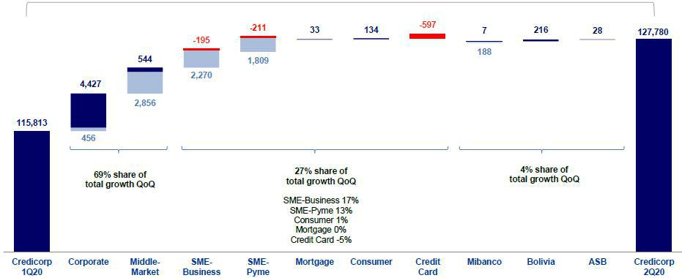

Structural

Government programs

The analysis by segment reveals QoQ growth in average daily loan balances in the portfolio’s Middle-Market and SMEs segments, which was in line with the effect generated by the Reactiva Peru financial relief program and with an increase in disbursements in the Corporate segment.

The Wholesale Banking portfolio posted the highest contribution to growth. Growth was primarily attributable to the increase reported in balances in the Corporate segment, which required more financing for working capital and medium term fixed-rate loans in LC and FC. The effect of Reactiva Peru loans on this loan segment was limited. The Middle Market Banking segment also registered a significant increase in its contribution to total loan growth in Wholesale Banking. This growth was, unlike that of Corporate Banking, highly influenced by the presence of disbursements for Reactiva Peru.

7

Within the Retail Banking portfolio, the SME Business and SME-Pyme segments grew 38.0% and 15.5% respectively, which was primarily attributable to Reactiva Peru. Personal lines were affected by the pandemic and the consequent government-mandated lockdown as well as by the hold put on disbursements in a context in which full risk assessment proved inviable.

The microfinance portfolio at Mibanco also posted growth that was spurred by Government financial relief programs: Reactiva Peru and FAE (Fund for Business Support); nevertheless, this growth was partially offset by i) the lockdown, which paralyzed the commercial environment in which Mibanco operates and was further accentuated by ii) the suspension of disbursements in a context in which it was difficult to determine the full dimension of risk.

Loan Growth YoY in Average Daily Balances

Expressed in millions of S/

+16.8% (+9.8% Structural Portfolio)
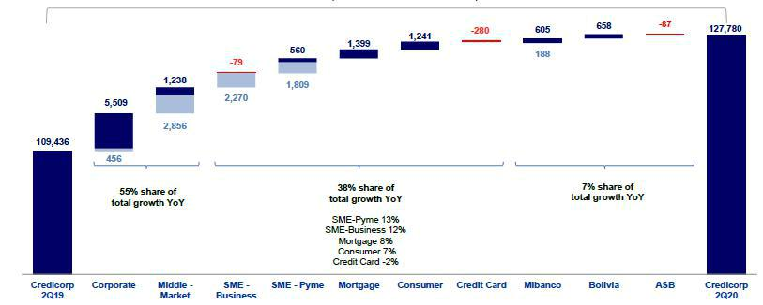

Structural
Government programs

An analysis of YoY growth by segment, measured in average daily balances, reveals:

Growth in Wholesale Banking, led by Corporate Banking (+S/5,965 million, +21.3% YoY) and due to an increase in disbursements in LC and FC and for working capital and medium term financing at fixed-rates, followed by Middle Market Banking, which registered significant growth (+S/4,094 million, +23.0% YoY); this was primarily driven by the effect of Reactiva Peru. It is important to note that growth in these segments was also attributable, although to a lesser extent, to the exchange rate effect generated by an appreciation in the US Dollar. 55.2% of the loans in the Corporate Banking segment and 45.4% in Middle Market Banking are in FC. If we exclude the exchange rate effect, the Corporate Banking and Middle Market Banking segments reported growth of 18.1% and 20.4% respectively. If we exclude the effect of the Government programs, Corporate Banking grew 19.6% YoY and Middle Market Banking, 6.9% YoY.

8

Growth in Retail Banking was led by the SME-Pyme segment (+S/2,370 million, +24.8% YoY) and SME Business (+S/2,192 million, +41.0% YoY) due to the effect of Reactiva Peru. Expansion in these segments was followed by growth in Mortgage portfolio (+S/1,399 million, +9.0% YoY) and in the Consumer portfolio (+S/1,241 million, +15.7% YoY). Both of these segments registered significant growth until the end of 1Q20, when the pandemic began to generate effects. Credit Cards registered a decline YoY, which was attributable to limited card use during the government-mandated lockdown. If we exclude the effect of the Governments programs on portfolio growth, SME-Pyme expanded +5.9% YoY while SME Business contracted -1.5%.

Loan growth at Mibanco (+7.9% YoY) was associated with the favorable evolution of the microfinance industry until the end of 1Q20. After that, in 2Q20, growth was attributable to the Government’s financial relief programs, Reactiva Peru and FAE. At the end of 2Q20, Reactiva and FAE loans represented approximately 2% of Mibanco’s portfolio in average daily balances. If we exclude loans disbursed under the Reactiva Peru and FAE-Mype programs, Mibanco expanded +6.0% YoY. Mibanco has also provided reprogramming facilities to more than 86% of its portfolio, which is evidence of the solid support that the bank is offering its clients, many of whom, as microbusiness owners, have been particularly hard hit by the effects of the pandemic.

The +9.1% YoY growth in loans at BCP Bolivia. This evolution was primarily attributable to growth in the Retail Banking portfolio, which evolved favorably until 1Q20. In 2Q20, however, the decreases registered in the Consumer, Mortgage and Credit Card segments in Bolivia due to the lockdown led to a subsequent increase in Wholesale Banking’s share of total loans.

Accumulated growth in average daily loan balances by segment

Expressed in millions of S/

+12.3% (+8.8% Structural Portfolio)
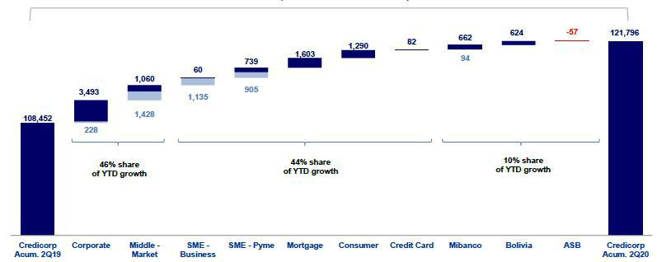

Structural
Government programs

An analysis of YTD growth by segment measured in average daily balances shows:

Growth in Wholesale Banking, where the Corporate segment posted higher growth (+S/3,721 million, +13.4% YTD) due to an increase in disbursements in LC and FC for working capital and medium term fixed-rate loans followed by Middle Market Banking, which also registered significant growth (+S/2,488 million, +14.0% YTD), due primarily to Reactiva Peru loans. Growth in these segments was also attributable, although to a lesser extent, to the exchange rate effect caused by an appreciation in the US Dollar.

Growth in Retail Banking, where the increase registered in the in the SME Pyme segment led the expansion (+S/1,643 million +17.3% YTD), spurred by Reactiva Peru disbursements. Other drivers of growth in this portfolio were the expansion in the Mortgage segment (+S/1,603 million, +10.5% YTD), which registered dynamic growth until the end of 1Q20; expansion in the Consumer segment (+S/1,290 millions, +16.6% YTD), which similar to the Mortgage segment, registered significant dynamism until 1Q20; and growth in SME Business (+S/1,195 million +22.5% YTD), which also reported a significant increase due to Reactiva Peru.

9

Growth in Mibanco loans (+7.6% YTD) and BCP Bolivia loans (+8.7% YTD). Growth at Mibanco was associated with portfolio expansion until 1Q20 and with the Government’s financial relief programs, Reactiva Peru and FAE in 2Q20. With regard to BCP Bolivia, the evolution of average daily balances was due primarily to growth in the Retail Banking Portfolio as well as to higher growth in the Wholesale Banking portfolio than in the Retail Portfolio, given that the Consumer, Mortgage and Credit Card segments bore the brunt of the impact of the lockdown while business loans registered an uptick to maintain working capital.

1.2.2. Evolution of the level of dollarization by segment

Loan evolution by currency - average daily balances ⁽¹⁾⁽²⁾

 | DOMESTIC CURRENCY LOANS |  |  |  |  |  |  |  |  | % change |  |  |  |  |  |  | % change |  |  |  |  |  |  |  |  | FOREIGN CURRENCY LOANS |  |  |  |  |  |  |  |  |  |  |  | % part. by currency
 | Expressed in million S/ |  |  |  |  |  | Structural |  |  |  |  |  |  |  |  |  | Structural |  |  |  |  |  |  | 2Q19 |  | Expressed in million US$ |  |  |  |  |  |  |  |  | YoY |  |  | 2Q20
 | 2Q19 |  | 1Q20 |  | 2Q20 |  | 2Q20 |  |  | QoQ |  |  | YoY |  |  |  | QoQ |  |  |  | YoY |  |  |  |  | 1Q20 |  | 2Q20 |  |  | QoQ |  |  |  |  |  |  | LC |  |  | FC
BCP Stand-
alone | 56,165 |  | 60,854 |  | 70,857 |  | 63,466 |  |  | 16.4% |  | 26.2% |  |  | 4.3% |  |  |  | 13.0% |  |  |  | 10,075 |  |  | 10,009 |  | 10,371 |  |  | 3.6% |  | 2.9% |  |  |  | 66.5% |  |  |  | 33.5%
Wholesale
Banking | 19,876 |  | 20,733 |  | 27,209 |  | 23,896 |  |  | 31.2% |  | 36.9% |  |  | 15.3% |  |  |  | 20.2% |  |  |  | 7,829 |  |  | 7,873 |  | 8,335 |  |  | 5.9% |  | 6.5% |  |  |  | 48.6% |  |  |  | 51.4%
Corporate | 11,581 |  | 12,186 |  | 15,247 |  | 14,791 |  |  | 25.1% |  |  | 31.6% |  |  |  | 21.4% |  |  |  | 27.7% |  | 4,962 |  |  | 4,959 |  | 5,449 |  |  | 9.9% |  |  |  | 9.8% |  | 44.8% |  |  |  | 55.2%
Middle-
Market | 8,295 |  | 8,546 |  | 11,962 |  | 9,105 |  |  | 40.0% |  |  | 44.2% |  |  |  | 6.5% |  |  |  | 9.8% |  | 2,867 |  |  | 2,914 |  | 2,886 |  |  | -0.9% |  | 0.7% |  |  |  | 54.6% |  |  |  | 45.4%
Retail
Banking | 36,289 |  | 40,122 |  | 43,649 |  | 39,569 |  |  | 8.8% |  | 20.3% |  |  | -1.4% |  |  |  | 9.0% |  |  |  | 2,246 |  |  | 2,136 |  | 2,036 |  |  | -4.7% |  | -9.3% |  |  |  | 86.1% |  |  |  | 13.9%
SME -
Business | 2,542 |  | 2,624 |  | 4,740 |  | 2,470 |  |  | 80.6% |  |  | 86.5% |  | -5.9% |  |  |  | -2.8% |  |  |  | 843 |  |  | 828 |  | 810 |  |  | -2.2% |  | -3.9% |  |  |  | 62.9% |  |  |  | 37.1%
SME -
Pyme | 9,324 |  | 10,104 |  | 11,700 |  | 9,891 |  |  | 15.8% |  |  | 25.5% |  | -2.1% |  |  |  | 6.1% |  |  |  | 70 |  |  | 66 |  | 66 |  |  | 0.0% |  | -6.4% |  |  |  | 98.1% |  |  |  | 1.9%
Mortgage | 13,008 |  | 14,698 |  | 14,794 |  | 14,794 |  |  | 0.7% |  |  | 13.7% |  | 0.7% |  |  |  |  |  | 13.7% |  | 762 |  |  | 646 |  | 622 |  |  | -3.7% |  |  |  | -18.4% |  | 87.3% |  |  |  | 12.7%
Consumer | 6,732 |  | 7,763 |  | 7,899 |  | 7,899 |  |  | 1.7% |  | 17.3% |  |  | 1.7% |  |  |  |  |  | 17.3% |  | 345 |  |  | 357 |  | 353 |  |  | -1.0% |  | 2.4% |  |  |  | 86.6% |  |  |  | 13.4%
Credit
Card | 4,684 |  | 4,932 |  | 4,515 |  | 4,515 |  |  | -8.4% |  |  | -3.6% |  |  |  | -8.4% |  |  |  | -3.6% |  | 226 |  |  | 239 |  | 185 |  |  | -22.6% |  | -18.0% |  |  |  | 87.6% |  |  |  | 12.4%
Mibanco | 9,489 |  | 10,064 |  | 10,276 |  | 10,088 |  |  | 2.1% |  | 8.3% |  |  | 0.2% |  |  |  | 6.3% |  |  |  | 163 |  |  | 165 |  | 159 |  |  | -3.7% |  | -2.6% |  |  |  | 94.9% |  |  |  | 5.1%
Bolivia | - |  | - |  | - |  | - |  |  | - |  | - |  |  | - |  |  |  | - |  |  |  | 2,181 |  |  | 2,247 |  | 2,291 |  |  | 1.9% |  | 5.0% |  |  |  | - |  |  |  | 100.0%
ASB | - |  | - |  | - |  | - |  |  | - |  | - |  |  | - |  |  |  | - |  |  |  | 762 |  |  | 706 |  | 708 |  |  | 0.3% |  | -7.0% |  |  |  | - |  |  |  | 100.0%
Total loans | 65,654 |  | 70,919 |  | 81,133 |  | 73,553 |  |  | 14.4% |  | 23.6% |  |  | 3.7% |  |  |  | 12.0% |  |  |  | 13,181 |  |  | 13,127 |  | 13,529 |  |  | 3.1% |  | 2.6% |  |  |  | 63.5% |  |  |  | 36.5%




Highest growth in volumes

Largest contraction in volumes

For consolidation purposes, loans generated in FC are converted to LC.

- Includes Work out unit, and other banking.

- Structural Portfolio excludes the average daily balances from loans offered through Reactiva Peru y FAE-Mype Government Programs.

In the QoQ analysis of loan expansion by currency, growth in LC was led by Wholesale Banking segments and the SME Business and SME-Pyme segments within Retail Banking. This reflected the increase in LC disbursements under the Reactiva Peru Program. Loan expansion in FC was driven by Corporate Banking through the increase in working capital needs and medium-term financing as clients sought to leverage low interest rates in the context generated by the pandemic.

In the YoY evolution, the Corporate Banking, Middle Market Banking, SME Business and SME-Pyme segments contributed positively to growth in LC. This growth was mainly attributable to disbursements under the Reactiva Peru Program and to an increase in financing for working capital and medium-term loans in the Corporate segment. The Mortgage segment registered a sizeable increase due to dynamic growth in 2019 and in 1Q20. In terms of the portfolio denominated in FC, the Corporate Banking segment drove growth, which was partially offset by the drop in FC balances in Retail Banking.

The Credit Card segment reported a drop in LC and FC balances due to a decrease in credit card use due to the government-mandated lockdown.

10

YoY evolution of the level of dollarization by segment ⁽¹⁾⁽²⁾⁽³⁾
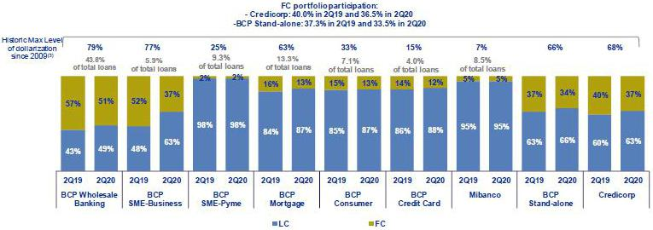

- Average daily balances

- The FC share of Credicorp’s loan portfolio is calculated including BCP Bolivia and ASB, however the chart shows only the loan books of BCP Stand-alone and Mibanco.
- The year with the historic maximum level of dollarization for Wholesale Banking was 2012, for Mibanco was 2016 and for the rest of segments was 2009.

At BCP Stand-alone, the loan dollarization level fell YoY to situate at 33.5%. This downward trend was seen across segments but the most noteworthy decrease was seen in the SME Business segment, which registered a drop in its dollarization level, which went from 52% in June 2019 to 37% in June 2020 due to the effect generated by Reactiva Peru loans, which are issued in Soles.

It is important to note that, as is evident in the chart below, the percentage of the loan portfolio that is highly exposed to exchange rate risk remains very low.

FX risk on credit risk – BCP Stand-alone
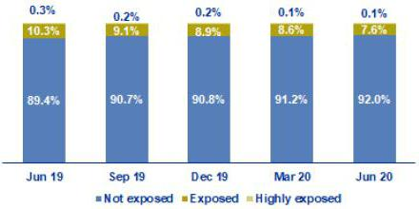

1.2.3. BCRP de-dollarization plan at BCP Stand-alone

At the end of 2014, BCRP set up a Program to reduce the dollarization level of the loan book in the Peruvian Banking System. As part of this Program, BCRP set some targets to reduce the loan balances in US Dollars progressively at the end of June 2015, December 2015, December 2016, December 2017, December 2018 and December 2019. Nevertheless, for the remainder of 2020, BCRP has suspended the requirement for additional reserves for FC loans and consequently suspended the reduction targets for loan balances in FC. BCRP’s decisions were driven by the need to shore up the financial system’s liquidity to mitigate the impact of the COVID-19 crisis on all fronts.

11

1.2.4. Market share in loans

Market share in Peru ⁽¹⁾
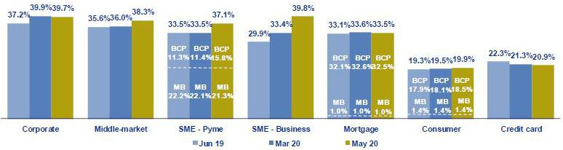

(1) Market shares are different that previously reported, please consider the figures presented on this report.

Peruvian Financial System

At the end of May 2020, BCP Stand-alone continued to lead the Peruvian financial system ¹ today, it holds a market share (MS) of 31.2%, which outpaced the MS of 17.3% posted by its closest competitor. Mibanco registered an MS of 3.1% of the total Financial System, which falls below the figure posted for previous quarters (3.2%) given that BCP has considerably increased its share of the system, particularly in terms of the SME-Pyme segment and through loans granted under the Reactiva Peru Program.

Within Wholesale Banking, the Corporate Banking segment reported an MS of 39.7%, which was -20pbs lower than the figure reported in 1Q20. This contrasted with the result for Middle Market Banking, which registered a considerable increase in its share of total loans, which rose from 36.0% in 1Q20 to 38.3% due to loans under Reactiva Peru. In the YoY evolution, Corporate Banking reported an increase of +260bps in its MS while Middle Market Banking registered growth of +270pbs. It is important to note that these BCP segments continue to lead in their respective markets.

Within Retail Banking, BCP continued to lead the market in the Mortgage segment (-10 bps QoQ and +40 bps YoY) and SME Business (+640 bps QoQ and +990 bps YoY). In the Consumer and Credit Card segments, BCP is situated in second place in these markets.

In the SME segment, Mibanco continues to lead with a market share of 21.3%, which falls below the MS registered in 1Q20 of 22.1% and the 22.2% reported in 2T19 de 22.2%. This reflects the fact that BCP’s share of this segment was bolstered (+440 bps QoQ and +450 bps YoY) by the bank’s significant participation in Reactiva Peru. BCP continues to rank second in this segment with an MS of 15.8%.

Bolivian Financial System

Finally, BCP Bolivia’s MS decreased slightly QoQ but grew in YoY terms. The subsidiary is ranked fifth in the Bolivian financial system with a 9.4% market share.

- Includes Multipurpose Banks, Finance Companies, Municipal and Rural Banks, EDPYMEs and Leasing and Mortgages Companies.

12

- Funding Sources

In 2Q20, total funding increased +16.4% QoQ and +29.8% YoY. Growth was due primarily to an expansion in Deposits and obligations and BCRP instruments. With regard to deposits, the increase was due to growth in the volume of demand deposits, particularly non-interest bearing, and savings deposits, which constitute lower-cost sources of funding. Within Other sources of funding, growth in BCRP Instruments is attributable to the funds facilitated for loans under Government Programs. With regard to the Credicorp’s funding cost, the funding mix effect and interest rate effect contributed to a contraction of -28 bps QoQ and -60 bps YoY.

Funding |  |  |  | As of |  |  |  | % change
S/ 000 |  | Jun 19 |  | Mar 20 |  | Jun 20 |  | QoQ |  |  | YoY
Demand deposits |  | 29,863,335 |  | 38,746,287 |  | 48,926,791 |  | 26.3% |  |  | 63.8%
Saving deposits |  | 32,604,309 |  | 37,872,908 |  | 42,562,229 |  | 12.4% |  |  | 30.5%
Time deposits |  | 32,472,216 |  | 35,045,214 |  | 30,019,871 |  | -14.3% |  |  | -7.6%
Severance indemnity deposits |  | 7,609,448 |  | 7,204,922 |  | 7,441,044 |  | 3.3% |  |  | -2.2%
Interest payable |  | 607,736 |  | 694,214 |  | 714,397 |  | 2.9% |  |  | 17.6%
Deposits and obligations |  | 103,157,044 |  | 119,563,545 |  | 129,664,332 |  | 8.4% |  |  | 25.7%
Due to banks and correspondents |  | 9,222,278 |  | 9,854,630 |  | 8,374,009 |  | -15.0% |  |  | -9.2%
BCRP instruments |  | 6,304,186 |  | 5,346,373 |  | 19,441,733 |  | 263.6% |  |  | 208.4%
Repurchase agreements |  | 2,455,665 |  | 1,935,879 |  | 2,091,798 |  | 8.1% |  |  | -14.8%
Bonds and notes issued |  | 15,058,760 |  | 15,178,148 |  | 17,250,531 |  | 13.7% |  |  | 14.6%
Total funding |  | 136,197,933 |  | 151,878,575 |  | 176,822,403 |  | 16.4% |  |  | 29.8%

2.1. Funding Structure

Evolution of the funding structure and cost – BAP

(S/ billions)
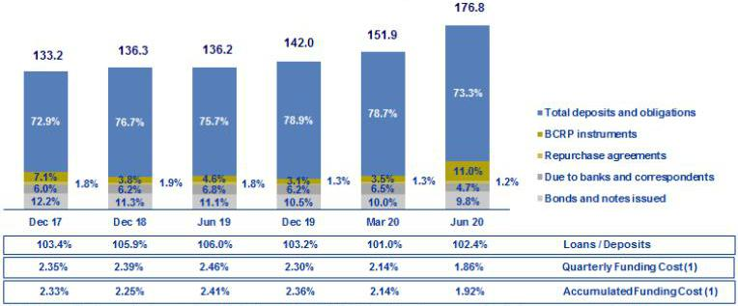

(1) 2019 figures differ from previously reported due to the implementation of IFRS 19, where financing expenses related to lease agreements are included.

The figure showing the Evolution of the funding structure and cost at Credicorp is calculated with quarter-end balances. In general terms, the funding structure reflects:

- Significant growth in deposits, the main source of funding, which entail lower costs in comparison to those associated with Other sources of funding. Despite the drop in share of total funding (73.3% in Jun 20 vs 78.7% in Mar 20 and 75.7% in Jun 19), growth in deposits represented 40.5% QoQ and 65.2% YoY of the total increase in funding.

- Within the deposit mix, demand deposits and savings deposits reported significant growth at the end of Jun 20. Consequently, these deposits came to represent 70.6% of total deposits share (vs 64.1% in Mar 20 and 60.6% in Jun 19). Both deposit types are considered the lowest cost alternatives within the deposit mix.

13

- Expansion in Other sources of funding, which was primarily due to an increase in the volume of BCRP Instruments (+263.6% QoQ and +208.4% YoY) and, to a lesser extent, to Bonds and notes issued (+13.7% QoQ and +14.6% YoY), which will be explained in greater detail in the section 2.3 Other sources of funding. Other sources of funding account for 59.5% and 34.8% of the increase in total funding QoQ and YoY, respectively.

2.2. Deposits

Deposits and obligations |  |  |  | As of |  |  |  | % change
S/ 000 |  | Jun 19 |  | Mar 20 |  | Jun 20 |  | QoQ |  |  | YoY
Demand deposits |  | 29,863,335 |  | 38,746,287 |  | 48,926,791 |  | 26.3% |  |  | 63.8%
Saving deposits |  | 32,604,309 |  | 37,872,908 |  | 42,562,229 |  | 12.4% |  |  | 30.5%
Time deposits |  | 32,472,216 |  | 35,045,214 |  | 30,019,871 |  | -14.3% |  |  | -7.6%
Severance indemnity deposits |  | 7,609,448 |  | 7,204,922 |  | 7,441,044 |  | 3.3% |  |  | -2.2%
Interest payable |  | 607,736 |  | 694,214 |  | 714,397 |  | 2.9% |  |  | 17.6%
Deposits and obligations |  | 103,157,044 |  | 119,563,545 |  | 129,664,332 |  | 8.4% |  |  | 25.7%

Deposits and obligations expanded +8.4% QoQ. The QoQ evolution of the deposit mix shows:

- A +26.3% increase in demand deposits, which was attributable to (i) BCP Stand-alone, due to an increase in the volume of current accounts in Wholesale Banking; this growth was attributable to Government Programs (Reactiva Peru and FAE) loans, which are held in clients’ accounts, and to a lesser extent, to (ii) the variation in the exchange rate and the consequent increase in the value of FC deposits, which represent approximately 50% of the total volume of demand deposits.

- Growth in savings deposits, which increased +12.4% QoQ, mainly due to an increase in volumes in LC. This growth reflects (i) the decisions taken by the Peruvian government to bolster liquidity, including approving the suspension of obligatory contributions to pension funds (April) and allowing affiliates to AFPs to withdraw up to 25% of their funds (May), (ii) the lockdown imposed by the Peruvian government, which lasted throughout 2Q20 to flatten the Covid-19 curve, which led individuals to consume less through their credit and debit cards, and (iii) the results of campaigns to capture savings through digital and cost-efficient channels.

- The drop in time deposits, mainly at (i) BCP Stand-alone and in LC and FC, in the Wholesale Banking portfolio, and to a lesser extent, at (iii) Mibanco in LC, due to a decrease in campaign activities to capture this deposit type. It is important to note that lower-cost alternatives have replaced time deposits in the mix.

In YoY terms, total deposits and obligations registered growth of +25.7%, which is mainly attributable to:

- The increase in demand deposits, due to an increase in the volume of non-interest bearing deposits (+63.0%), mainly at BCP Stand-alone, and interest bearing deposits (+68.4%), mainly at ASB. It is important to mention that growth in non-interest bearing demand deposits, which constitute the lowest-cost source of funding, represent 60% of the total increase in deposits.

- +30.5% expansion in savings deposits, mainly at BCP Stand-alone, which reflects the same trend seen for the QoQ evolution.

- The -7.6% contraction in time deposits, in line with the QoQ analysis.

14

2.2.1. Deposits: dollarization level

Dollarization Level of Deposits ⁽¹⁾ – BAP
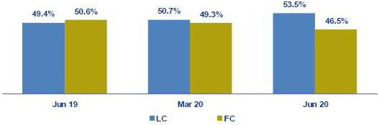

(1) Q-end balances.

Credicorp – Deposit Dollarization measured in quarter-end balances
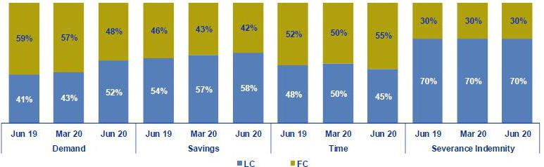

The dollarization level of Credicorp’s deposits fell considerably QoQ, which was attributable to growth of +14.5% in LC volumes in comparison to +2.3% for volumes in FC.

Growth in LC volumes, which was primarily attributable to an increase in demand deposits and, to a lesser extent, to the expansion in savings deposits. These deposit types represent 124% of the total growth in LC deposits, which offset the significant contraction in LC time deposits (-22.3%).

In terms of FC volumes, growth was also attributable to an increase in savings deposits and demand deposits. Growth in savings deposits was mainly associated to individuals.

In the YoY evolution, a significant contraction in the dollarization level is evident. This was attributable to +35.9% growth in LC volumes, which outpaced the increase of +15.7% registered for FC. The aforementioned was associated with an increase in demand deposits and savings deposits in LC of +110.8% and 41.3%, respectively. The increase in FC is due to the same deposit types, which grew +31.8% and +18.0 respectively.

It is important to note that the increase in the volumes of demand and savings deposits in LC (QoQ and YoY) reflects: (i) the fact that both companies and individuals have immediate needs for liquidity to absorb the impact of COVID-19 and (ii) the inflow of Government Programs (GP) loans, whose funds were held in the accounts of clients at BCP Stand-alone. The effect of immediate liquidity also explains the drop in time deposits in both LC and FC.

15

2.2.2. Market share in Deposits

Market share in Peru
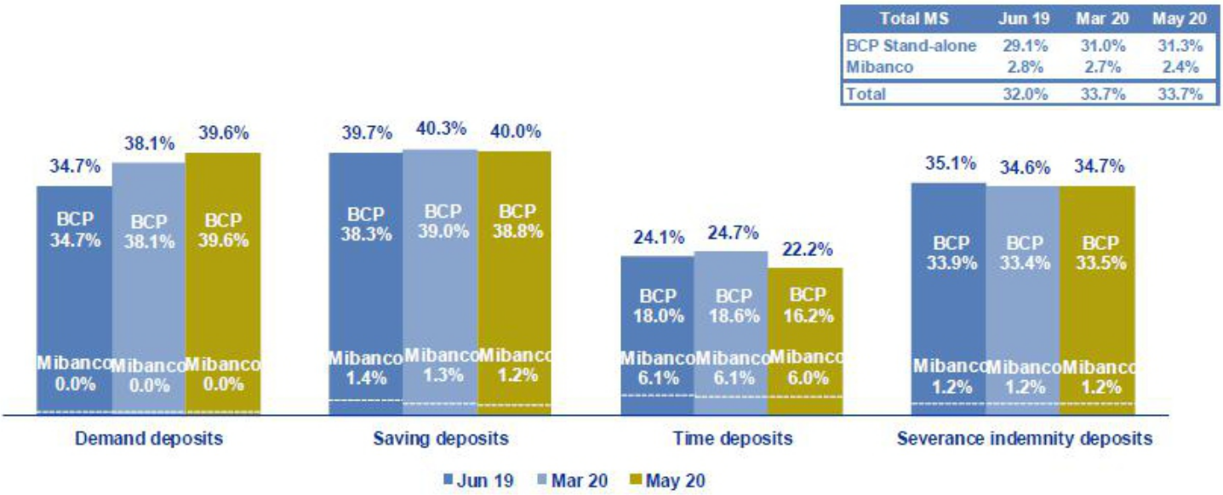

Source: SBS

(1) Figures may not add due to rounding.

Peruvian Financial System

At the end of May 20, Credicorp’s subsidiaries in Peru, BCP Stand-alone and Mibanco, reported market shares (MS) of 31.3% and 2.4%, respectively. Consequently, Credicorp continued to lead the market for total deposits in the financial system with an MS that significantly outpaced that of its closest competitor (which was situated at 19.6%).

In the YoY analysis, the MS of BCP Stand-alone increased 220 bps in comparison to the figure posted at the end of Jun 19. This was primarily attributable to an increase in the MS of demand deposits (+490 bps). Mibanco’s MS fell YoY (2.4% May 20 vs 2.8% June 19) due to a contraction in the MS for time deposits and savings deposits.

Bolivian Financial System

BCP Bolivia continued to rank fifth in the Bolivian financial system with an MS of 9.4% at the end of Jun 20 (versus 9.7% in Mar 20). In the YoY analysis, the MS fell 50 bps in comparison to the figure at the end of Jun 19 (9.9%).

2.3. Other funding sources
Other funding sources |  |  |  | As of |  |  |  |  | % change
S/ 000 |  | Jun 19 |  | Mar 20 |  | Jun 20 |  | QoQ |  |  |  | YoY
Due to banks and correspondents |  | 9,222,278 |  | 9,854,630 |  | 8,374,009 |  |  | -15.0% |  |  | -9.2%
BCRP instruments |  | 6,304,186 |  | 5,346,373 |  | 19,441,733 |  |  | 263.6% |  |  | 208.4%
Repurchase agreements |  | 2,455,665 |  | 1,935,879 |  | 2,091,798 |  |  | 8.1% |  |  | -14.8%
Bonds and notes issued |  | 15,058,760 |  | 15,178,148 |  | 17,250,531 |  |  | 13.7% |  |  | 14.6%
Total other funding sources |  | 33,040,889 |  | 32,315,030 |  | 47,158,071 |  |  | 45.9% |  |  | 42.7%

The total of Other sources of funding increased 45.9% QoQ, which was primarily attributable to growth in the sales volume of all sources with the exception of Due to banks and correspondents. Expansion was mainly attributable to growth in the volume of BCRP instruments, which represented 95% of the QoQ variation in Other sources of funding.

16

Due to banks and correspondents posted a decrease in its level due to: i) a drop in the obligations level at BCP Stand-alone after FC operations with foreign institutions expired and ii) a decline in the level at ASB, due to a drop in the FC volume after deposits replaced funding from Due to banks in the funding mix. The aforementioned was partially offset by an increase at Mibanco, mainly driven by new long-term obligations with companies in the national financial system and with COFIDE, which were assumed to take advantage of lower local interest rates.

In terms of BCRP Instruments, the significant increase was driven by BCP Stand-alone and, to a lesser extent, by Mibanco, due to new repo and CD agreements. Growth in these instruments was driven by the liquidity facilities provided by the Peruvian government, which were channeled through loan disbursements for GP in the months of May and June. This non-structural funding (includes RP funds), represents 73% of the total BCRP instruments at the end of Jun 20. It is worth mentioning that the repos with the Central Bank for RP funds were made at a 0.5% interest rate.

Repo agreements registered a slight increase due to an uptick in repo transactions at ASB and BCP Stand-alone, mainly in FC.

Bonds and notes issued registered growth that was attributable to a corporate bond issuance in the month of June at Credicorp Ltd. This transaction represented the financial holding’s first public debt issuance. The public offering was for US$ 500 million at a rate of 2.750% with an expiration date in 2025. This funding will be used to finance different corporate purposes and increase the liquidity position of the subsidiaries if the need arises. To a lesser extent, growth in this line reflected the variation in the exchange rate, which generated an exchange rate difference that was reflected in the balance at BCP Stand-alone.

The YoY evolution of Other sources of funding reflected an increase of +42.8%, which was primarily attributable to an increase in the level of BCRP Instruments and reflected the same trend as that explained for the QoQ evolution. Growth in this source represented 93% of the total increase in Other sources of funding.

2.4. Loan / Deposit (L/D)

Loan / Deposit Ratio by Subsidiary
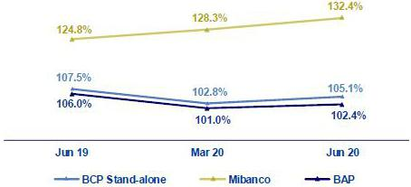

The L/D ratio at Credicorp increased QoQ to situate at 102.4%. This growth was attributable to the fact that the increase in loans (+10.0%) outpaced the growth registered for deposits (+8.4%).

The analysis by subsidiary reveals that the same trend is in play for both BCP Stand-alone (105.1% Jun 20 vs 102.8% Mar 20) and Mibanco (132.4% Jun 20 vs 128.3% Mar 20). QoQ growth in the L/D ratio at BCP Stand-alone reflects the fact that the increase in loans (+11.0%) outpaced that registered for deposits (+8.6%). The aforementioned was primarily driven by an increase in the loan level in Wholesale Banking. In the case of Mibanco, QoQ growth in the L/D was due to the -2.7% drop in deposits after the deposit level for time deposits fell.

In the YoY analysis, the L/D ratios at Credicorp and BCP Stand-alone fell in a scenario in which the increase in the deposit volume (25.7% and 26.2%, respectively) outpaced that posted by loans (21.4% and 23.4%, respectively). The L/D ratio at Mibanco followed the same trend as that seen in the QoQ analysis.

17

Loan / Deposit Ratio by Currency

Local Currency Foreign Currency
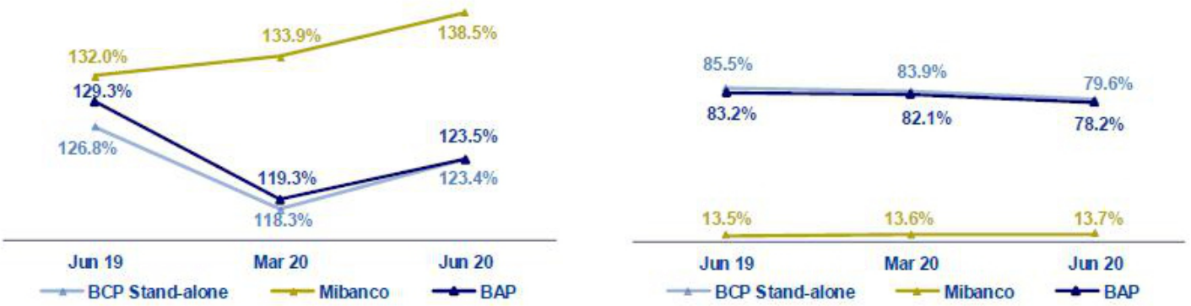

The QoQ analysis by currency shows an expansion of the L/D ratio in LC of Credicorp, BCP Stand-alone and Mibanco, as a result of the loans associated with the GP. In the case of the L/D in FC at Credicorp and BCP Stand-alone, the contraction is due to the increase in deposits (+2.3% and +0.5%, respectively) and a drop in loans (-2.7% and -4.6%, respectively). In the case of Mibanco, the L/D ratio in FC remained stable.

In the YoY analysis, a reduction in the L/D ratio in LC and FC of Credicorp and BCP Stand-alone is observed in a scenario in which the increase in deposits outpaced the expansion registered for loans.

2.5. Funding Cost

Funding Cost – Credicorp ⁽¹⁾⁽²⁾
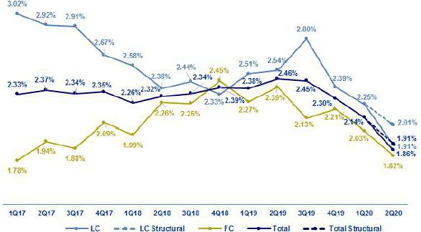

- The funding cost by currency is calculated with the average of period-beginning and period-end balances.

- 2019 figures differ from previously reported due to the implementation of IFRS 16, where financing expenses related to lease agreements are included.

Credicorp’s funding cost fell -28 bps QoQ and -60 bps YoY. The QoQ evolution shows:

- A drop in the cost of funding in LC (-34 bps); this was due primarily to an increase in the total volume of funding in LC (denominator of the calculation), which registered growth of +31.3%. This was driven by an expansion of +263.6% in BCRP instruments after repos were executed in the context of GP. In the case of interest expenses in LC (numerator), a slight increase of +1.3% was reported. Growth in expenses was due primarily to an increase in interest from Central Bank instruments. It is important to note that the structural funding cost in LC (excluding GP), situates at 2.01%.

18

- The contraction in the cost of funding in FC (-21 bps) was attributable to the fact that interest expenses in FC (-6.1%) decreased for all sources. The decrease in interest expenses was primarily attributable to a contraction in interest on deposits, which fell -8.7% and in interest on obligations, which fell -17.0%. In addition, the drop in the funding cost is due to an increase in the funding volume in FC (+2.2%).

- The reduction in the total funding cost was due primarily to a drop in expenses for deposits, which offset the increase in interest on BCRP Instruments. The decrease in expenses for deposits was due to a contraction in higher-cost deposits, which were replaced in the funding mix by lower-cost deposits. In addition, the total structural funding cost (without GP), locates at 1.91%.

In the YoY analysis, the total funding cost fell due to:

- A more favorable deposit mix, where non-interest bearing deposits and savings deposits posted the highest growth with variations of +63.0% and +30.5% respectively. Time deposits registered a decrease of -7.6%.

- Interest expenses dropped in both currencies but ME posted the highest decrease (-14.7%). The contraction in FC was mainly associated with a drop in expenses for bonds and notes issued (-21.2%) after BCP Stand-alone executed issuances at attractive rates at the end of 2019. The drop in LC was attributable to a decrease in expenses for deposits, which was partially offset by an increase in expenses for BCRP instruments.

- The reduction in national and international rates, whose impact was reflected in a decrease in the funding cost in both currencies.

The funding cost by subsidiary is depicted in the following figure:

Funding Cost by subsidiary– Credicorp ⁽¹⁾
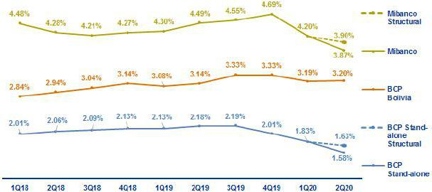

  - 2019 figures differ from previously reported due to the implementation of IFRS 16, where financing expenses related to lease agreements are included.

- The funding cost at BCP Stand-alone followed the same trend as that seen for Credicorp’s funding, which reflected a contraction QoQ and YoY that was primarily driven by (i) the deposit mix, which registered an increase in the volumes of lower-cost deposits (which represent 159% QoQ and 120% YoY of the increase in total deposits) and offset the decrease in the volumes of higher-cost deposits, and by (ii) a volume effect, where significant growth of BCRP Instruments, which are represented in the denominator, attenuated the higher expenses of this funding type in the numerator. If we exclude expenses and funding related to repos with BCRP from GP, the structural funding cost at BCP Stand-alone situates at 1.63% (+6 bps higher than the non-structural funding cost).

- Mibanco also reported a considerable contraction QoQ and YoY in the cost of funding. In the QoQ and YoY analysis, the decrease in financial expenses (-7.5% and -11.1% respectively) was due to a drop in interest on deposits, mainly due to a decrease in the volume of time deposits. Total funding volume increased +1.2% QoQ and +3.9% YoY due to an increase in due to banks, which contributed to the denominator of the calculation. Mibanco’s structural funding cost, after eliminating GP effects, situates at 3.90% (up +3 bps than non-structural).

- The cost of funding at BCP Bolivia increased slightly QoQ, which was attributable to the fact that growth in expenses outpaced the expansion registered for funding (+6.1% vs +2.3%, respectively). The cost of funding YoY moved in the opposite direction. The contraction in this case occurred in a scenario in which funding increased at a higher rate than expenses (+31.1% vs +19.6%, respectively).

19

- Portfolio quality and Provisions for loan losses

The provisions had a significant increase QoQ, YoY, and YTD, in line with the expectations of a contraction in the Peruvian economy and the increase in the probability of default in all of our segments. The aforementioned led to a Cost of Risk (CofR) at Credicorp of 7.66% in the 2Q20 and 5.85%YTD. Excluding the effects of the government programs in provisions and loans, the Structural Cost of Risk was 8.41% in the 2Q20 and 6.48% YTD. Regarding our portfolio quality ratios, the IOL and NPL ratios posted an improvement due to the inflow of Reactiva Peru loans. Nevertheless, total IOL and NPL portfolios have increased due to an uptick in the deterioration of clients in the Retail Banking segments. In this context, the coverage ratio for the NPL portfolio rose to 167.5% in 2Q20 versus 108.5% in 2Q19.

YoY Evolution of the Cost of Risk (bps)
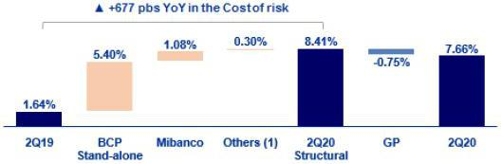

(1) Includes BCP Bolivia, Encumbra, Bancompartir, ASB and eliminations for consolidation purposes

3.1. Provisions for loan losses

Provision for credit losses on loan portfolio, net of recoveries |  |  |  | Quarter |  |  |  | % change |  |  |  |  | YTD |  |  |  |  | % change
 |  |  |  |  |  |  |  |  |  |  |  |  |  |  |  |  |  | Jun 20 /
S/ 000 |  | 2Q19 |  | 1Q20 |  | 2Q20 |  | QoQ |  |  | YoY |  | Jun 19 |  |  | Jun 20 |  | Jun 19
Gross provision for credit losses on loan portfolio |  | (510,045) |  | (1,388,711) |  | (2,557,658) |  | 84.2% |  |  | 401.5% |  | (963,330) |  |  | (3,946,369) |  | 309.7%
Recoveries of written-off loans |  | 61,751 |  | 47,230 |  | 17,201 |  | -63.6% |  |  | -72.1% |  | 131,825 |  |  | 64,431 |  | -51.1%
Provision for credit losses on loan portfolio, net of recoveries |  | (448,294) |  | (1,341,481) |  | (2,540,457) |  | 89.4% |  |  | 466.7% |  | (831,505) |  |  | (3,881,938) |  | 366.9%

Credicorp has continued to offer different facilities (reprogramming and debt freezing) to mitigate the deterioration in its clients’ debt service capacity.

Despite these measures, net provisions for loan losses increased significantly, which was attributable to COVID-19 effects:

- A change in macroeconomic expectations due to COVID-19: in 2Q20, the outbreak for the Peruvian economy were updated negatively.

- Model changes: methodological adjustments and a new source of information was incorporated into the expected loss models. This change includes a greater granularity and better capture of the real situation of deterioration of the clients. This affected mainly the SME-Pyme and Consumer portfolios.

Excluding the provisions in the portfolio for effects related to COVID-19, there was a decrease in provisions in all segments. This was due in part to the reprograming and debt freezes facilities offered to Credicorp clients which makes it easier for clients to solve their temporary liquidity problems and postponing the probability of default of some clients.

Cost of risk

 |  |  |  | Quarter |  |  |  | % change |  |  |  | Year |  |  |  |  | % change
Cost of risk and Provisions |  | 2Q19 |  | 1Q20 |  | 2Q20 |  | QoQ |  | YoY |  | Jun 19 |  |  | Jun 20 |  | Jun 20 /
 |  |  |  |  |  |  |  |  |  |  |  |  |  |  |  |  | Jun 19
Cost of risk ⁽¹⁾ |  | 1.64% |  | 4.45% |  | 7.66% |  | 321 bps |  | 602 bps |  | 1.52% |  |  | 5.85% |  | 433 bps
Structural Cost of risk ⁽²⁾ |  | 1.64% |  | 4.45% |  | 8.41% |  | 396 bps |  | 677 bps |  | 1.52% |  |  | 6.48% |  | 496 bps
Provision for credit losses on loan portfolio, net of
recoveries / Net interest income |  | 19.9% |  | 56.4% |  | 129.5% |  | 7320 bps |  | 10960 bps |  | 18.7% |  |  | 89.4% |  | 7030 bps

- Annualized Provision for credit losses on loan portfolio, net of recoveries / Total loans.
- The Structural Cost of risk excludes the provisions for credit losses on loan portfolio, net of recoveries and total loans from the Reactiva Peru and FAE Government Programs.

20

In the aforementioned context, Credicorp’s CofR increased 321 bps QoQ, 602 bps YoY and 433 bps YTD. If we exclude the provisions and loans for government programs, the cost of risk at Credicorp was situated at 8.41% in 2Q20 and 6.48% YTD.

3.2. Portfolio Quality: Delinquency ratios
Portfolio quality and Delinquency ratios |  |  |  | As of |  |  |  |  | % change
S/ 000 |  | Jun 19 |  | Mar 20 |  | Jun 20 |  |  | QoQ |  |  | YoY
Total loans (Quarter-end balance) |  | 109,381,123 |  | 120,708,515 |  | 132,741,720 |  |  | 10.0% |  |  | 21.4%
Structural Loan Portfolio |  | 109,381,123 |  | 120,708,515 |  | 117,769,055 |  |  | -2.4% |  |  | 7.7%
Allowance for loan losses |  | 4,878,150 |  | 5,931,772 |  | 8,412,544 |  |  | 41.8% |  |  | 72.5%
Write-offs |  | 407,348 |  | 519,866 |  | 42,104 |  |  | -91.9% |  |  | -89.7%
Internal overdue loans (IOLs) ⁽¹⁾ |  | 3,285,279 |  | 3,579,504 |  | 3,842,830 |  |  | 7.4% |  |  | 17.0%
Internal overdue loans over 90-days ⁽¹⁾ |  | 2,431,144 |  | 2,239,789 |  | 1,987,988 |  |  | -11.2% |  |  | -18.2%
Refinanced loans |  | 1,212,669 |  | 1,125,394 |  | 1,179,031 |  |  | 4.8% |  |  | -2.8%
Non-performing loans (NPLs)⁽²⁾ |  | 4,497,948 |  | 4,704,898 |  | 5,021,861 |  |  | 6.7% |  |  | 11.6%
IOL ratio |  | 3.00% |  | 2.97% |  | 2.89% |  |  | -8 bps |  |  | -11 bps
Structural IOL ratio |  | 3.00% |  | 2.97% |  | 3.26% |  |  | 29 bps |  |  | 26 bps
IOL over 90-days ratio |  | 2.22% |  | 1.86% |  | 1.50% |  |  | -36 bps |  |  | -72 bps
NPL ratio |  | 4.11% |  | 3.90% |  | 3.78% |  |  | -12 bps |  |  | -33 bps
Structural NPL ratio |  | 4.11% |  | 3.90% |  | 4.26% |  |  | 36 bps |  |  | 15 bps
Coverage ratio of IOLs |  | 148.5% |  | 165.7% |  | 218.9% |  |  | 5320 bps |  |  | 7040 bps
Coverage ratio of IOL 90-days |  | 200.7% |  | 264.8% |  | 423.2% |  |  | 15840 bps |  |  | 22250 bps
Coverage ratio of NPLs |  | 108.5% |  | 126.1% |  | 167.5% |  |  | 4140 bps |  |  | 5900 bps

- Includes overdue loans and loans under legal collection. (Quarter-end balances)

- Non-performing loans include internal overdue loans and refinanced loans. (Quarter-end balances)

In terms of delinquency ratios, it is important to note that:

- The total IOL portfolio increased 7.4% QoQ and 17.0% YoY. This was due primarily to the evolution of the Retail Banking portfolio and of the Consumer and Mortgage segments in particular given that some clients were not eligible to avail of the facilities for reprogramming and debt freezing given that they were delinquent prior to lockdown. Wholesale Banking also presented a deterioration, which was primarily attributable to the transportation, construction and advertising segments.

- Total refinanced loans increased 4.8% QoQ given that a larger number of clients in the Consumer segment, who were already behind in their payments, reprogrammed their credit to match payment schedules with payment capacities. The YoY analysis reflects a 2.8% drop in this concept after some clients in the Wholesale segment with refinanced loans were transferred to the NPL portfolio. In this context, the NPL portfolio registered growth of 5.0% QoQ and 6.2% YoY.

- The total number of loans written off has fallen this quarter given that we are concentrating on supporting clients that have experienced a significant increase in the total number of days that their loans are past due since the beginning of the lockdown.

Despite the increase in IOL and NPL loans, the IOL and NPL ratios improved 8 bps QoQ and 12 bps QoQ respectively and 11 bps QoQ and 33 bps YoY respectively. This was primarily attributable to significant loan growth, which was fueled by Reactiva Peru and FAE loans. If we exclude Reactiva Loans, both ratios deteriorate and situate at 3.26% and 4.26% respectively.

21

Delinquency Ratios
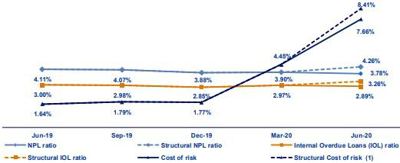

- The Structural Cost of risk excludes the provisions for credit losses on loan portfolio, net of recoveries and total loans from the Reactiva Peru and FAE Government Programs.

Coverage ratios improved significantly QoQ and YoY. This reflected the increase in provisions for loan losses due to COVID-19, which offset the increase registered in IOL and NPL loans.

Prior to analyzing the evolution of the delinquency indicators, it is important to remember that:

- Credicorp has offered its retail banking client’s facilities to reprogram and freeze debt and as such, delinquency indicators do not, at present, fully reflect the deterioration in this portfolio.

- The delinquency indicators for the Wholesale, SME-Business and SME-Pyme sectors are distorted by the inflow of Reactiva Peru and FAE facilities. Therefore, we are also showing the adjusted indicator to isolate the effect and analyze the evolution of the quality of the structural portfolio.

- Traditional delinquency ratios (IOL and NPL ratios) continue to be distorted by the presence of loans with real estate collateral (commercial and residential properties). This means that a significant portion of loans that are more than 150 days past due cannot be written off (despite the fact that provisions have been set aside) given that a judicial process must be initiated to liquidate the collateral, which takes five years on average.

22

3.2.1. Delinquency indicators by business line

Wholesale Banking – Delinquency ratios
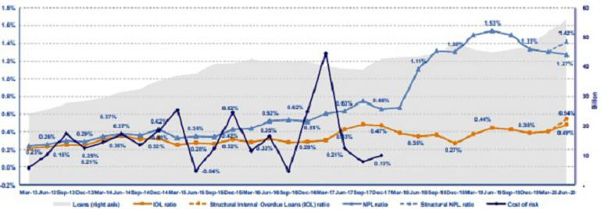

- The IOL ratio increased QoQ and YoY due to a deterioration in the debt service capacity of clients in Middle Market Banking and in the construction, advertising and transportation sectors in particular. In contrast, the NPL ratio fell QoQ and YoY given that some clients with refinanced loans began to fall behind in their payments and are now included in the IOL portfolio. It is important to note that the Middle Market Banking segment has received a larger number of loans from Reactiva Peru than any other segment.

SME-Business – Delinquency ratios
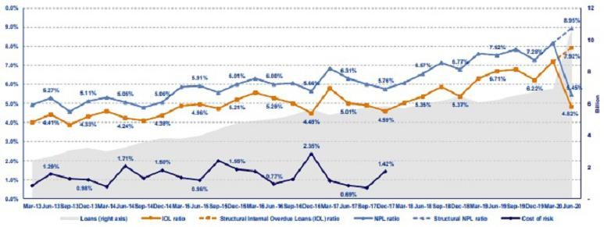

- The IOL and NPL ratios in the SME-Business segment also improved significantly due to the increase in loans that was fueled by Reactiva Peru. Despite this, total IOL loans increased given the deterioration of particular clients that were already fully provisioned. It is important to note that this segment continues to register credit quality levels that are within the organization’s appetite for risk. The objective is to maximize the portfolio’s profitability by achieving an adequate match between risk and growth.

23

SME - Pyme – Delinquency ratios
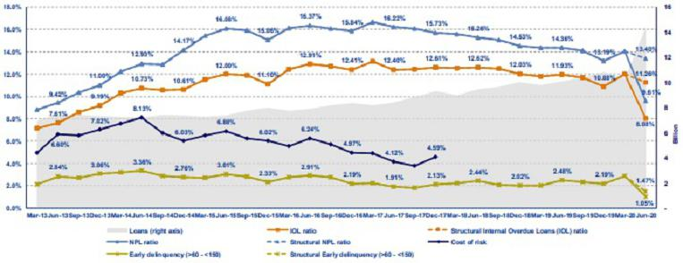

- In the SME-Pyme loan book, it is important to analyze the early delinquency ratio, which excludes loans that are overdue less than 60 days (volatile loans whose percentage of recovery is very high) and those overdue more than 150 days (loans that have been provisioned but which cannot be written off due to the existence of real estate collateral- commercial properties - that take five years on average to liquidate).

Similar to the situation seen in the Wholesale and SME Business segments, traditional and early delinquency ratios for the SME-Pyme segment fell significantly due to the presence of Reactiva Peru loans. Nevertheless, if we exclude the effect created by these loans, we find that both the IOL and NPL ratios fell. This is attributable to the fact that SME-Pyme segments have used the majority of the reprogramming facilities that Credicorp has offered to attenuate the impacts of COVID-19.

Mortgage – Delinquency ratios
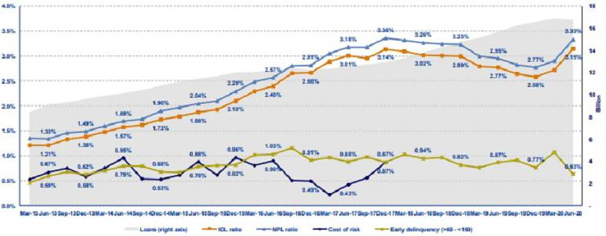

- With regard to mortgage loans, it is important to remember that these ratios are also affected by the existence of real estate collateral, where the recovery process is protracted (around 5 years) and as such, impedes the bank’s capacity to write-off loans even if the same are completely provisioned.

Traditional delinquency ratios increased QoQ and YoY, which was primarily driven by the deterioration of clients in riskier sectors that had already registered signs of delinquency before the state of emergency and by the significant reduction in write-offs this quarter.

24

In terms of early delinquency, the ratio fell QoQ and YoY, which was in line with the reprogramming that BCP offers to clients whose income has been affected by COVID-19. This led to a decrease in the number of new delinquent clients.

Consumer – Delinquency ratios
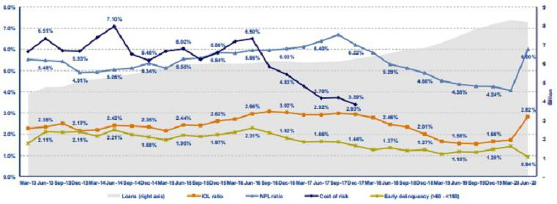

- The consumer segment delinquency ratios evolved lines similar to those seen for the mortgage segment, which also registered a significant increase in the IOL and NPL ratios QoQ and YoY. This growth was primarily attributable to the deterioration of clients in riskier segments prior to the state of emergency and to the significant reduction in write-offs this quarter.

The early delinquency ratio fell QoQ and YoY, which was in line with the reprogramming facilities that BCP offered clients whose income has been affected by COVID-19. This led to a decrease in the number of new delinquent clients.

Credit Card – Delinquency ratios
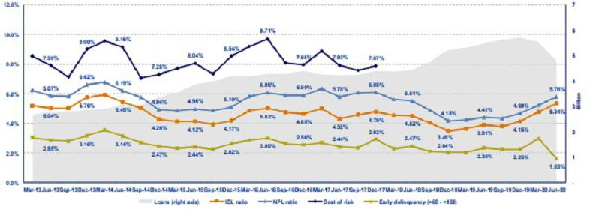

- The Credit Card segment registered growth in its delinquency ratios QoQ and YoY. This was primarily due to a drop in credit card placements and the fact that some clients who have accepted skips and debt freezing facilities have refinanced their debt through consumer loans.

The early delinquency ratio fell QoQ and YoY. This was due to the skips and debt freezing facilities that BCP Stand-alone has offered to its clients. If we eliminate the effect of these measures, a smaller percentage of the portfolio deteriorated QoQ and YoY given that a number of clients registered signs of delinquency prior to the state of emergency.

25

Mibanco – Delinquency ratios
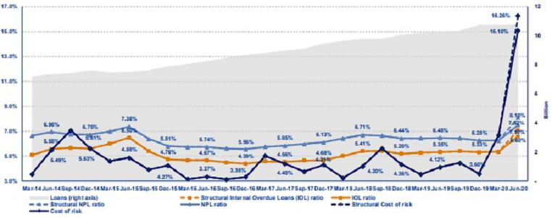

- The IOL and NPL ratios increased QoQ and YoY due to the fact that the requests of debt reprogramming of a percentage of clients were not processed in June. It is important to mention that these loans are beign reprogrammed since the beginning of July, without affecting the credit quality of clients by the delay.

The cost of risk increased significantly QoQ and YoY after an adjustment was made in the expected loss model and the contraction expectations of the Peruvian Economy, as mentioned in section 3.1. Allowance for loan losses

BCP Bolivia – Delinquency ratios
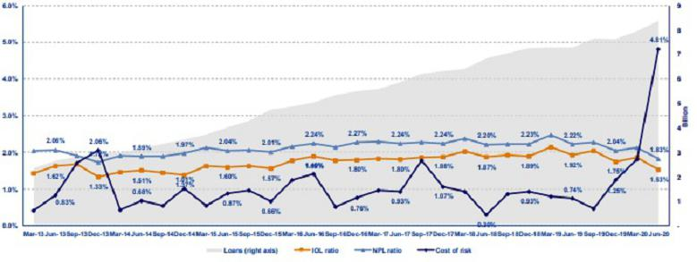

- BCP Bolivia reported improvements in its delinquency ratios QoQ and YoY due to the debt reprogramming facilities that are required by law to support clients affected by COVID-19. Unlike loans at BCP Stand-Alone and Mibanco, BCP Bolivia loans for Retail banking clients were automatically reprogramed (aligned with the debt facilities offered to retail clients in Bolivia to reprogram debt) for these customers in March. After March, clients were free to contact BCP Bolivia to request that their debts don’t get reprogramed.

The cost of risk deteriorated QoQ and YoY. This was primarily attributable to an increase in provisions due to the COVID-19 crisis, given the adjustments in the expected loss model, as mentioned in section 3.1. Allowance for loan losses.

26

- Net Interest Income (NII)

In 2Q20, NII, the main component of income, registered decreases of -17.6% QoQ, -12.9% YoY and -2.5% YTD while average interest-earning assets grew +9.4% QoQ, +18.2% YoY and 15.8% YTD. The aforementioned led NIM to drop -132 bps QoQ, - 144 bps YoY and -86 bps YTD. These results were mainly attributable to the economic reactivation programs (Reactiva Perú and FAE-Mype), which have pressured the loan margin downward and led interest income to fall -13.8% QoQ, -11.6% YoY and -3.2% YTD. Additionally, risk-adjusted NIM fell -352 bps QoQ, -557pbs YoY and -392 bps YTD due to the increase in the cost of risk generated by a material change in the expectations for economic growth in Peru in the context of the COVID-19 pandemic.

Net interest income |  |  |  |  | Quarter |  |  |  |  |  | % change |  |  |  |  |  | YTD |  |  |  |  | % change
S/ 000 |  |  | 2Q19 |  | 1Q20 |  | 2Q20 |  |  |  | QoQ |  | YoY |  |  |  | Jun-19 |  | Jun-20 |  |  | jun-20 / jun-19
Interest income |  |  | 3,083,623 |  | 3,163,609 |  | 2,727,369 |  |  |  | -13.8% |  | -11.6% |  |  |  | 6,085,297 |  | 5,890,978 |  |  | -3.2%
Interest on loans |  |  | 2,632,649 |  | 2,770,351 |  | 2,353,285 |  |  |  | -15.1% |  | -10.6% |  |  |  | 5,194,935 |  | 5,123,636 |  |  | -1.4%
Dividends on investments |  |  | 8,914 |  | 7,879 |  | 4,867 |  |  |  | -38.2% |  | -45.4% |  |  |  | 18,581 |  | 12,746 |  |  | -31.4%
Interest on deposits with banks |  |  | 85,477 |  | 49,113 |  | 9,264 |  |  |  | -81.1% |  | -89.2% |  |  |  | 172,176 |  | 58,376 |  |  | -66.1%
Interest on securities |  |  | 341,930 |  | 322,734 |  | 350,617 |  |  |  | 8.6% |  | 2.5% |  |  |  | 674,718 |  | 673,352 |  |  | -0.2%
Other interest income |  |  | 14,653 |  | 13,532 |  | 9,336 |  |  |  | -31.0% |  | -36.3% |  |  |  | 24,887 |  | 22,868 |  |  | -8.1%
Interest expense |  |  | 831,220 |  | 784,309 |  | 766,241 |  |  |  | -2.3% |  | -7.8% |  |  |  | 1,635,726 |  | 1,550,550 |  |  | -5.2%
Interest on deposits |  |  | 364,997 |  | 364,107 |  | 320,169 |  |  |  | -12.1% |  | -12.3% |  |  |  | 718,831 |  | 684,276 |  |  | -4.8%
Interest on borrowed funds |  |  | 152,832 |  | 137,126 |  | 157,819 |  |  |  | 15.1% |  | 3.3% |  |  |  | 298,135 |  | 294,945 |  |  | -1.1%
Interest on bonds and subordinated notes |  |  | 227,869 |  | 198,114 |  | 199,347 |  |  |  | 0.6% |  | -12.5% |  |  |  | 454,367 |  | 397,462 |  |  | -12.5%
Other interest expense ⁽¹⁾⁽³⁾ |  |  | 85,522 |  | 84,962 |  | 88,906 |  |  |  | 4.6% |  | 4.0% |  |  |  | 164,393 |  | 173,867 |  |  | 5.8%
Net interest income ⁽¹⁾⁽³⁾
 |  |  | 2,252,403 |  | 2,379,300 |  | 1,961,128 |  |  |  | -17.6% |  | -12.9% |  |  |  | 4,449,571 |  | 4,340,428 |  |  | -2.5%
Risk-adjusted Net interest income ⁽¹⁾⁽³⁾
 |  |  | 1,804,109 |  | 1,037,819 |  | (579,329) |  |  |  | -155.8% |  | -132.1% |  |  |  | 3,618,066 |  | 458,490 |  |  | -87.3%
Average interest earning assets ⁽¹⁾
 |  |  | 164,668,086 |  | 177,957,957 |  | 194,719,984 |  |  |  | 9.4% |  | 18.2% |  |  |  | 164,638,683 |  | 190,653,514 |  |  | 15.8%
Net interest margin ⁽¹⁾⁽²⁾⁽³⁾
 |  |  | 5.47% |  | 5.35% |  | 4.03% |  |  |  | -132bps |  | -144bps |  |  |  | 5.41% |  | 4.55% |  |  | -86bps
NIM on loans ⁽¹⁾⁽²⁾⁽³⁾ |  |  | 7.65% |  | 7.62% |  | 5.85% |  |  |  | -177bps |  | -180bps |  |  |  | 7.45% |  | 6.63% |  |  | -82bps
Risk-adjusted Net interest margin ⁽¹⁾⁽²⁾⁽³⁾ |  |  | 4.38% |  | 2.33% |  | -1.19% |  |  |  | -352bps |  | -557bps |  |  |  | 4.40% |  | 0.48% |  |  | -392bps
Net provisions for loan losses / Net interest
_{income} (1)(2)(3) |  |  | 19.90% |  | 56.38% |  | 129.54% |  |  |  | 7316bps |  | 10964bps |  |  |  | 18.69% |  | 89.44% |  |  | 7075bps

- Figures differ from previously reported, please consider the data presented on this report.

- Annualized.

- Figures differ from those presented previously

4.1. Interest Income

Interest Income - LC

(S/ millions)
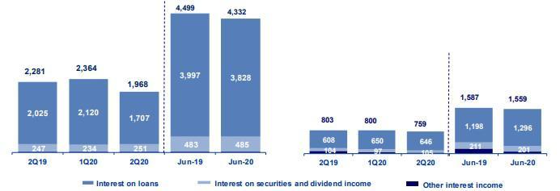

Interest Income – FC

(S/ millions)

In the QoQ analysis, the -13.8% decrease in Interest Income was attributable to a -15.1% contraction in interest on loans, which was attributable to the following factors:

- the expense for 323.8 million registered in interest income. This was generated by the zero-interest loans that were granted to clients to finance installment payments that had been frozen in the months of April and May in the context of the COVID-19 pandemic. According to IFRS9, the present value of the new flow of loans must be calculated at market rates and by recognizing a loss that will be amortized over the life of the zero-interest loan.

27

- the interest rates that are charged for the loans issued under the economic reactivation programs given that the conditions of these loans (S/. 14,204 million in quarter-end balances) stipulate that they must be granted at rates below those offered by the market, which translated into a figure of only 0.86% for interest on loans.

Interest income on deposits in other banks contracted -81.1% after BCR freed up reserves in FC to inject liquidity into the financial system and the remuneration rate fell due to a drop in the libor rate.

In the YoY analysis, net interest income fell -11.6% due to a -10.6% contraction in interest on loans and the -89.2% reduction in interest on deposits in other banks due to the reasons indicated above.

At the YTD level, interest income fell -3.2%, which was attributable to:

- The contraction in interest on deposits in other banks (-66.1%) after BCR released reserves to inject liquidity into the financial system to mitigate the impacts generated by COVID-19 and a drop in the libor rate, which directly impacted the calculation of the remuneration of legal reserves.

- Interest income on loans fell -1.4% due to:

  - the expense associated with installment payments that were frozen in the months of April and May.

  - the implementation of the reactivation programs, which offer loans below market rates.

4.2. Interest Expenses
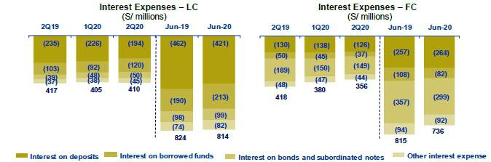

In the QoQ analysis, interest expenses fell -2.3%, which was primarily due to a decrease in interest expenses on deposits. The main factors that drove the drop of -12.1% QoQ in interest expenses on deposits were:

- The deposit mix, given that although deposits increased 8.4% QoQ, the reduction in expenses was generated by a -14.3% drop in time deposits, which constitute the most expensive deposit type.

- The rate effect given that the rates in both LC and FC have followed a downward trend in the last two quarters, which accentuates the decrease in expenses.

28

The aforementioned was partially offset by the increase in interest on borrowed funds, which includes repos with the BCR that were generated by the Reactiva Peru program. It is important to note that the rate paid to the BCR is 0.5%.

In the YoY analysis, interest expenses fell -7.8%, which was attributable to:

- The contraction in interest expenses on deposits due to a drop in the most expensive deposit types, time deposits and severance indemnity deposits which fell -7.6% and -2.2% respectively. The reduction in severance indemnity deposits was driven by the fact that the Government allowed individuals to tap their funds during the COVID-19 crisis.

- The debt restructuring strategy that BCP Stand-alone implemented in the second half of 2019, which generated a decrease in interest expenses on bonds and subordinated results to the order of -12.5%.

YTD, interest expenses fell -5.2%. This was attributed to a -12.5% drop in interest expenses on bonds and subordinated notes, which was in line with the debt restructuring strategy that BCP Stand-alone implemented in the second half of 2019. This strategy was divided into two phases. During the first phase, a liability management of corporate bonds issued by BCP Stand-alone was carried, in both LC and FC. In the second phase, a BCP Stand-alone perpetual subordinated bond was repurchased. These actions extended terms and reduced rates. In the month of June, Credicorp conducted its first bond issuance. The additional expense generated by this issuance did not heavily impact results in 2Q20 given that calculations cover only the last 15 days of the quarter.

Secondly, the reduction in interest expenses is attributable to a -4.8% reduction in the interest rate on deposits. The main factors that drove this decrease were:

- The deposit mix, given that although deposits registered a 25.7% increase YoY, the reduction in expenses was generated by a contraction in the most expensive deposits, time deposits (-7.6%) and severance indemnity deposits (-2.2%).

- The rate effect given that rates have followed a downward trend in response to the economic contraction generated by the pandemic.

Additionally, there was a -1.1% decline in expenses for interest on borrowed funds due to a drop in international rates. This mainly impacted interest on loans in FC, which contracted -23.8% with regard to the figure reported for the first half of 2019.

4.3. Net Interest Margin (NIM) and Risk-Adjusted NIM

Credicorp’s NIM and Risk-Adjusted NIM ⁽¹⁾
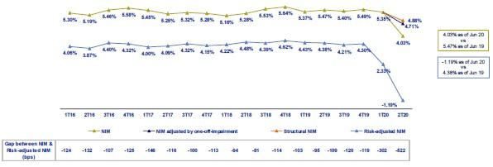

NIM fell QoQ, YoY and YTD due to:

- The drop in income for interest on loans due to the expense generated by freezing installment payments for April and May. NIM without this effect would have been 68 pbs higher, situating at 4.71%

- The low interest rates associated with loan disbursements under Reactiva Peru. NIM without this effect would have been 16 pbs higher.

- Structural NIM situated at 4.88%, falling -47bps QoQ and -60bps YoY. This was attributable to:

  - A drop in interest rates in the structural portfolio due to lower market rates in both LC and FC.

  - The mix of interest earning assets, given that loans went from representing 66% of the mix in 2Q19 to representing 63% in 2Q20, while deposits in other banks went from representing 12% in 2Q19 to representing 15% in 2Q20.

29

Risk-adjusted NIM contracted -352bps QoQ, -557bps YoY and -392bps YTD due to an increase in net provisions for loan losses after expectations for economic growth in Peru were altered by the COVID-19 pandemic.

NIM on loans fell -177bps QoQ, -180bps YoY and -82bps YTD. This contraction was attributable to the preferential rates offered by the Reactiva Peru program, which led to lower margins in the recipient segments (corporate banking, middle market banking, SME Business, and SME-Pyme). In addition, to the Reactiva Program, Mibanco implemented FAE-Mype program, which also offered preferential rates to clients. Both programs offer facilities in Soles, which led the loan margin to contract significantly. The Structural NIM on loans was situated at 7.39% for the quarter, which represents a reduction of -23bps QoQ and -27bps YoY. This result was driven by a drop in market rates in both LC and FC. YTD, Structural NIM on loans was 7.69%, which translates into an improvement of 24bps compared to the previous year.
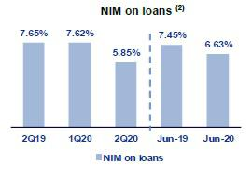

It is important to also analyze NIM by line of business. The chart below shows the interest margins for each of Credicorp’s business lines.

 |  | Universal
NIM Breakdown |  | Banking⁽¹⁾ |  | Microfinance⁽²⁾ |  | Credicorp⁽³⁾⁽⁴⁾
2Q19 |  | 4.78% |  | 14.89% |  | 5.47 | %
1Q20 |  | 4.63% |  | 15.50% |  | 5.35%
2Q20 |  | 3.71% |  | 9.01% |  | 4.03%
June-19 |  | 4.70% |  | 14.72% |  | 5.41%
June-20 |  | 4.12% |  | 8.98% |  | 4.55%

NIM: Annualized Net interest income / Average period end and period beginning interest earning assets.

- Universal Banking includes BCP Stand-alone and BCP Bolivia

- Microfinance includes Mibanco, Encumbra and Bancompartir

- Credicorp also includes Credicorp Capital, Prima, Grupo Credito and Eliminations for consolidation purposes.

In the YTD evolution, Credicorp posted a drop in NIM due to the deterioration registered in both Universal Banking and Microfinance. Universal Banking represents 77% of net interest income and Microfinance, 16%.

The NIM for Universal Banking deteriorated -92bps QoQ, -107bps YoY and -58bps YTD due to the expense registered in interest income. This was generated by the zero-interest loans that were granted to clients to finance installment payments that had been frozen in the months of April and May.

The NIM for Microfinance contracted -648bps QoQ -588bps YoY and -574 YTD due to the expense registered in interest income generate by installment payments that had been frozen in the months of April and May.

It is also important to analyze risk-adjusted NIM by business line. The table below shows the risk-adjusted net interest margins for each of Credicorp’s lines of business.

- NIM on loans is calculated as follows:

The share of loans within total earning assets is calculated by dividing the average of the beginning and closing balances of total loans for the reporting period, by the average of the beginning and closing balances of the interest earning assets for the reporting period.

30

 |  | Universal
Risk Adjusted NIM Breakdown |  | Banking⁽¹⁾ |  | Microfinance⁽²⁾ |  | Credicorp⁽³⁾⁽⁴⁾
2Q19 |  | 3.77% |  | 11.55% |  | 4.38%
1Q20 |  | 1.49% |  | 10.01% |  | 2.33%
2Q20 |  | -1.47% |  | -3.69% |  | -1.19%
June-19 |  | 3.76% |  | 11.65% |  | 4.40%
June-20 |  | -0.06% |  | 3.10% |  | 0.48%

Risk-Adjusted NIM: (Annualized Net interest income - annualized provisions) / Average period end and period beginning interest earning assets.

- Universal Banking includes BCP Stand-alone and BCP Bolivia

- Microfinance includes Mibanco, Encumbra and Bancompartir

- Credicorp also includes Credicorp Capital, Prima, Grupo Credito and Eliminations for consolidation purposes.

Credicorp registered strong deterioration in its risk-adjusted margin of -352bps Qo, -557bps YoY and -391bps YTD due to a deterioration in its main lines of business after the cost of risk rose. This increase was attributable to the material change in expectations for economic growth due to the COVID-19 pandemic. The aforementioned led to a drop of -297bps QoQ, -524bps YoY and -382bps YTD at Universal Banking and -1370bps QoQ -1524bps YoY and -855bps YTD at Microfinance.

31

- Non-Financial Income

In 2Q20, non-financial income expanded 6.0% QoQ. This was primarily attributable to the positive results registered for the Net gain on securities, which were spurred by a recovery in the global markets after economic expectations rose in comparison to those registered in 1Q20, when losses due to the COVID-19 crisis began to materialize. The main components of Non-financial income, Fee income and the Net gain on foreign exchange transactions, reported a drop in income due to a decrease in transactional activity in the context of the quarantine imposed by the Peruvian government, which was in place throughout 2Q20.

Non-financial income |  |  |  |  |  | Quarter |  |  |  |  |  | % change |  |  |  |  |  |  | Year |  |  |  |  |  | % change
(S/ 000)
(S/ 000) |  |  | 2Q19 |  |  | 1Q20 |  |  | 2Q20 |  |  | QoQ |  |  |  | YoY |  |  | Jun 19 |  |  | Jun 20 |  | Jun 20 / Jun 19
Fee income |  |  | 787,250 |  |  | 760,329 |  |  | 503,488 |  |  | -33.8% |  |  |  | -36.0% |  |  | 1,570,172 |  |  | 1,263,817 |  | -19.5%
Net gain on foreign exchange transactions |  |  | 188,358 |  |  | 166,983 |  |  | 149,308 |  |  | -10.6% |  |  |  | -20.7% |  |  | 366,781 |  |  | 316,291 |  | -13.8%
Net gain on securities |  |  | 100,987 |  |  | (120,633) |  |  | 280,563 |  |  | 332.6% |  |  |  | 177.8% |  |  | 214,532 |  |  | 159,930 |  | -25.5%
Net gain from associates (1) |  |  | 20,478 |  |  | 19,225 |  |  | 14,906 |  |  | -22.5% |  |  |  | -27.2% |  |  | 35,264 |  |  | 34,131 |  | -3.2%
Net gain on derivatives held for trading |  |  | (724) |  |  | 35,420 |  |  | 8,358 |  |  | -76.4% |  |  |  | NA |  |  | (3,158) |  |  | 43,788 |  |  | NA
Net gain from exchange differences (2) |  |  | 63 |  |  | (21,240) |  |  | 23,531 |  |  | 210.8% |  |  |  | NA |  |  | 13,553 |  |  | 2,291 |  | -83.1%
Other non-financial income |  |  | 98,703 |  |  | 117,770 |  |  | 35,196 |  |  | -70.1% |  |  |  | -64.3% |  |  | 174,308 |  |  | 152,966 |  | -12.2%
Total non-financial income, net |  |  | 1,195,115 |  |  | 957,864 |  |  | 1,015,350 |  |  | 6.0 | % |  |  | -15.0 | % |  | 2,371,452 |  |  | 1,973,214 |  |  | -16.8 | %

- Includes gains on other investments, mainly made up of the profit of Banmedica.
- Figures from 2Q19 differ from previously reported due to the implementation of IFRS 16.

(S/ 000) |  |  |  | Quarter |  |  |  | % change |  |  |  |  | Year |  |  |  |  | % change
(S/ 000) |  | 2Q19 |  | 1Q20 |  | 2Q20 |  | QoQ |  |  | YoY |  | Jun 19 |  |  | Jun 20 |  | Jun 20 / Jun 19
(+) EPS contribution (50%) |  | 12,758 |  | 17,186 |  | 16,806 |  | -33.8% |  |  | 34.7% |  | 21,676 |  |  | 33,992 |  | 56.8%
(-) Private health insurance deduction (50%) |  | (4,746) |  | (6,430) |  | (17,944) |  | -10.6% |  |  | 35.5% |  | (7,482) |  |  | (24,374) |  | 225.8%
(=) Net gain from association with Banmedica |  | 8,012 |  | 10,756 |  | (1,138) |  | -332.6% |  |  | 34.2% |  | 14,194 |  |  | 9,618 |  | -32.2%

The QoQ evolution shows expansion of +6.0% of non-financial income due to:

- The expansion in Net gain on securities is attributable to (i) ASB, due to non-recurring income in the fair value through other comprehensive investments explained by a mark-to-market (MtM) increase of an investment after its IPO, which generated unrealized earnings for S/ 96 million; and (ii) Prima AFP, due to an increase in the reserve fund profitability after a recovery in the value of the funds under management, and (iii) Credicorp Capital, due to earnings in its proprietary investment portfolios, attributable to a recovery in the value of Fixed Income positions, which partially reversed March’s results. All of the aforementioned results are related to a decrease in market volatility and by a recovery in assets value after the negative results posted in 1Q19 due to the onset of the pandemic.

- Growth in the Net gain from exchange difference, due to the valuation of the exchange rate for regional currencies, which was reflected in gains on Trading positions and on off-balance positions at Credicorp Capital and BCP Stand-alone.

The aforementioned was partially offset by:

- The contraction in Fee Income, mainly at (i) BCP Stand-alone due to a decrease in transactional activity at banks due to the quarantine and, to a lesser extent, at (ii) Prima AFP, due to a decrease in flow fees due to the suspension of contributions in the month of April (liquidity measure enacted by the Peruvian government), (iii) Mibanco, which posted a decline for the same reasons that affected BCP Stand-alone, and (iv) Credicorp Capital, due to a drop in income in Corporate Finance due to an unfavorable juncture for transactions and in Wealth Management due to a drop in fees in the Family Office and brokerage businesses. For more information, please see 5.1.2 Fee income in the Banking Business.

- Other non-financial income, due to extraordinary income in 1Q20 at (i) BCP Stand-alone due to the sale of a judicial portfolio and provisions reversals, and (ii) Mibanco, due to the sale of a property.

32

- The drop in the Net gain on speculative derivatives was attributable to Credicorp Capital, specifically to Trading and Currency derivatives to cover investment positions and exchange rate differences, which were reflected in losses. In addition, the drop was attributable to the outstanding results obtained in 1Q20 by the Asset Management business. All of the aforementioned was slightly attenuated by the increase at BCP Stand-alone after gains were registered for Trading Swaps and Forwards in the month of June.

- The decrease in income from the Net gain on foreign exchange transactions was due to lower transactions volume of clients in Wholesale Banking and Retail Banking at BCP Stand-alone.

The YoY analysis indicates a decrease of -15.0% in non-financial income due to:

(i) A decrease in the result for Fee income, due to (i) benefits and fee exonerations for our clients during the crisis generated by the pandemic, and (ii) a decrease in the consumption volume as explained in the QoQ analysis. It is important to note that the subsidiary that was the most affected by these effects was BCP Stand-alone. The contraction in fee income at this subsidiary represented 78% of the total decline reported for this account.

- Other non-financial income due to BCP Bolivia, following the sale of a property in 2Q19.

- A decrease in income from the Net gain on foreign exchange transactions, which was mainly attributable to a decrease in the volumes and margins for client transactions through Retail Banking at BCP Stand-alone.

The aforementioned was slightly offset by:

- Growth in the Net gain on sales of securities, mainly at ASB and Prima AFP, which was attributable to the favorable evolution of the financial markets in 2Q20.

YTD (Jun 20 vs Jun 19), non-financial income fell -16.8% due to:

(i) The contraction in Fee Income as 2020 has been a challenging year for banking products and services given that the transactions level has dropped by 50% since the beginning of the quarantine. The positive evolution of banking fees in 2019 casts this quarter’s figure in an even starker light.

- Net gain on sales of securities, whose recovery in 2Q20 was insufficient to offset the impact of COVID-19 in the first quarter and the higher results in 2Q19 in a scenario marked by declining international interest rates, which positively affected the global markets.

33

5.1. Fee Income

5.1.1. By subsidiary

The figure below shows the contribution of each of Credicorp’s subsidiaries to growth in its fee income in 2Q20

Evolution of fee income QoQ by subsidiary (S/ Million)
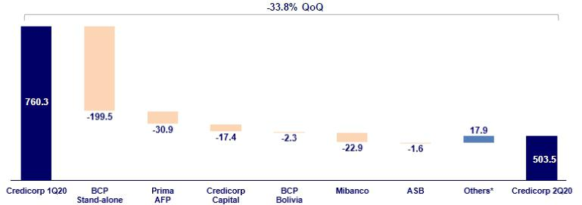

Evolution of fee income YoY by subsidiary (S/ Million)
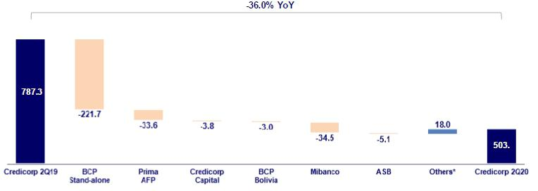

Evolution of fee income YTD by subsidiary (S/ Millions)
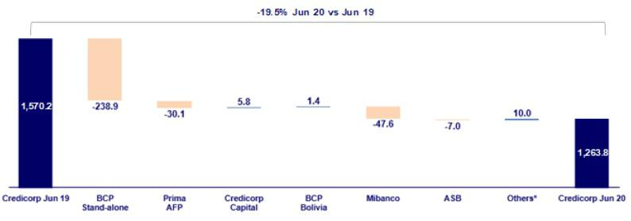

*Others include Encumbra, Bancompartir, Grupo Pacifico and eliminations for consolidation purposes.

34

5.1.2. Fee income in the Banking Business

The figure below shows the evolution of the main components of fee income in the banking business:

Composition of Fee Income in the Banking Business

Fee Income |  |  |  | Quarter |  |  |  | % change |  |  |  |  | Year |  |  |  |  | % change
S/ 000 |  | 2Q19 |  | 1Q20 |  | 2Q20 |  | QoQ |  |  | YoY |  | Jun 19 |  |  | Jun 20 |  | Jun 20 / Jun 19
Miscellaneous accounts (1) |  | 169,732 |  | 164,963 |  | 115,586 |  | -29.9% |  |  | -31.9% |  | 347,249 |  |  | 280,549 |  | -19.2%
Credit cards (2) |  | 71,029 |  | 60,435 |  | 12,606 |  | -79.1% |  |  | -82.3% |  | 140,529 |  |  | 73,041 |  | -48.0%
Drafts and transfers |  | 64,485 |  | 61,846 |  | 40,995 |  | -33.7% |  |  | -36.4% |  | 124,717 |  |  | 102,841 |  | -17.5%
Personal loans (2) |  | 24,918 |  | 28,352 |  | 11,298 |  | -60.2% |  |  | -54.7% |  | 48,508 |  |  | 39,650 |  | -18.3%
SME loans (2) |  | 16,971 |  | 18,808 |  | 6,450 |  | -65.7% |  |  | -62.0% |  | 35,535 |  |  | 25,258 |  | -28.9%
Insurance (2) |  | 23,549 |  | 25,179 |  | 22,747 |  | -9.7% |  |  | -3.4% |  | 45,759 |  |  | 47,926 |  | 4.7%
Mortgage loans (2) |  | 9,738 |  | 9,402 |  | -870 |  | -109.3% |  |  | -108.9% |  | 19,166 |  |  | 8,531 |  | -55.5%
Off-balance sheet (3) |  | 47,869 |  | 50,093 |  | 49,231 |  | -1.7% |  |  | 2.8% |  | 95,171 |  |  | 99,324 |  | 4.4%
Payments and collections (3) |  | 104,948 |  | 101,283 |  | 82,325 |  | -18.7% |  |  | -21.6% |  | 208,711 |  |  | 183,608 |  | -12.0%
Commercial loans (3)(4) |  | 20,725 |  | 17,978 |  | 10,448 |  | -41.9% |  |  | -49.6% |  | 43,148 |  |  | 28,426 |  | -34.1%
Foreign trade (3) |  | 13,849 |  | 11,576 |  | 9,960 |  | -14.0% |  |  | -28.1% |  | 28,797 |  |  | 21,536 |  | -25.2%
Corporate finance and mutual funds (4) |  | 21,844 |  | 16,673 |  | 12,151 |  | -27.1% |  |  | -44.4% |  | 36,872 |  |  | 28,825 |  | -21.8%
ASB (4) |  | 11,915 |  | 8,412 |  | 6,772 |  | -19.5% |  |  | -43.2% |  | 22,186 |  |  | 15,184 |  | -31.6%
Others (4)(5) |  | 73,382 |  | 62,067 |  | 29,633 |  | -52.3% |  |  | -59.6% |  | 143,218 |  |  | 91,700 |  | -36.0%
Total fee income |  | 674,954 |  | 637,067 |  | 409,332 |  | -35.7% |  |  | -39.4% |  | 1,339,566 |  |  | 1,046,399 |  | -21.9%

Source: BCP
- Saving accounts, current accounts, debit card and master account.
- Mainly Retail fees.
- Mainly Wholesale fees.
- Figures differ from previously reported, please consider the data presented on this report.
- Includes fees from BCP Bolivia, Mibanco, network usage and other services to third parties, among others.

In the QoQ analysis, fee income in the banking business fell -35.7% QoQ. The components that registered the highest contraction in the quarter were:

- Miscellaneous accounts, primarily for (i) Debit cards, due to a decrease in fees for card placement and cash withdrawals and, to a lesser extent, to a decrease in fees for (ii) Savings accounts and (iii) Current accounts. The contraction in the last two is due to a drop in income for account maintenance and a decrease in transactions.

- Credit cards, attributable to (i) merchant-fee, associated with a reduction in fees paid by establishments that experienced a decline in billing, (ii) lower fees for late payment penalties from clients who requested skips or debt freezing, and (iii) a decrease in membership fees (collections delayed until July).

- Others, mainly at Mibanco, which accounts for 71% of the total contraction in this item due to a drop in fees for late payment penalties.

- Drafts and transfers, after no-cost national drafts were offered to clients. It is important to note that in the months of May and June, an uptick was registered in the transactions volume.

In the YoY and YTD analysis, the contractions observed, which were -39.4% and -21.9% respectively, were primarily attributable to the same accounts responsible for the contractions in the quarterly analysis. These decreases were also due, although to a lesser extent, to Collections and payments, which registered a decline due to a drop in collections and retention of guarantees and invoices.

It is important to note that the variations in fee income as of June 2020 versus similar periods in 2019 are generally attributable to COVID-19, given that the quarantine led to a drop in transactional activity that was visible throughout 2Q20. This, coupled with the group’s decision to offer clients at the subsidiary level facilities or exonerations to deal with fallout from the pandemic, had a major impact on fee income. Another factor that impacted fee income, this time on the positive note, was client migration to digital and cost-efficient channels, which reflects the group’s strategy to build a profitable and efficacious client service network.

35

6. Insurance Underwriting Result

The insurance underwriting result registered a drop of 4.4% QoQ, which was mainly attributable to a decrease in net earned premiums for both P&C and Life insurance, which was mitigated by a decrease in claims in P&C and lower acquisition costs in both businesses. In the YoY analysis, the underwriting result increased 14.8%, which was attributable to a decrease in claims in property and casualty insurance and lower acquisition costs in life insurance, which was attenuated by a drop in net premiums in both businesses and higher claims in Life Insurance. YTD, the underwriting result rose 22.1% due to P&C, which was attenuated by Life insurance. In P&C, the increase in the underwriting result was associated with a decrease in claims while the drop in Life insurance was attributable to an increase in claims and fees.

Insurance underw riting result ⁽¹⁾ |  |  |  | Quarter |  |  |  |  | % change |  |  |  |  | YTD |  |  |  |  | % change
S/ 000 |  | 2Q19 |  | 1Q20 |  | 2Q20 |  | QoQ |  |  | YoY |  |  | Jun 19 |  |  | Jun 20 |  | Jun 20 / Jun 19
Net earned premiums |  | 584,579 |  | 627,935 |  | 552,061 |  |  | -12.1% |  |  | -5.6% |  | 1,168,788 |  |  | 1,179,997 |  | 1.0%
Net claims |  | (374,688) |  | (373,502) |  | (328,783) |  |  | -12.0% |  |  | -12.3% |  | (758,506) |  |  | (702,285) |  | -7.4%
Acquisition cost ⁽²⁾ |  | (91,666) |  | (112,507) |  | (87,598) |  |  | -22.1% |  |  | -4.4% |  | (182,947) |  |  | (200,105) |  | 9.4%
Total insurance underwriting result |  | 118,225 |  | 141,926 |  | 135,680 |  |  | -4.4% |  |  | 14.8% |  | 227,336 |  |  | 277,607 |  | 22.1%

- Includes the results of the Life, Property & Casualty and Crediseguros business

- Includes net fees and underwriting expenses.

6.1. Life Insurance
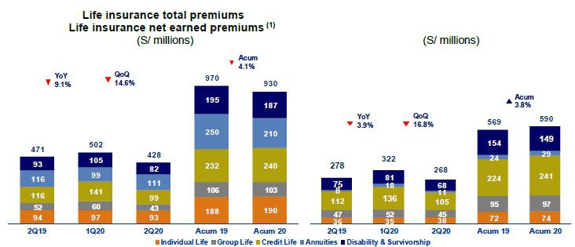

(1) Total premiums without considering reinsurance nor reserve premiums.

Total premiums decreased 14.6% QoQ due to (i) Credit Life, which was mainly attributable to a decrease in new sales for bancassurance (Mibanco) in the current scenario and to alliances, which regularized solidarity payments (debts with penalties that are assumed by the entity) in the last quarter; (ii) D&S, explained by provisions of lower estimated collections of premiums in SISCO IV, in line with expectations of an increase in unemployment; (iii) Group Life, attributable to the SCTR product (insurance for high-risk occupations), which was affected by the fact that fewer companies were operating during the lockdown and to a decrease in mining renewals in comparison to figures for 1Q20, and in Collective Life, due a decrease in sales through the bancassurance channel; and (iv) Individual Life, due to a decrease in policy issuances through the direct channel. The aforementioned was mitigated by Annuities, primarily through an increase in new sales for the Individual Annuities product.

Net earned premiums fell 16.8% due to the aforementioned reasons and Annuities decreased due to an increase in reserves in line with growth in total premiums.

36

In the YoY analysis, total premiums fell 9.1%, primarily for products in Credit Life, D&S, Group Life and Individual Life lines, which was attributable to the same reasons outlined in the QoQ analysis and due to Annuities, which was primarily driven by a drop in new sales for Individual Annuities product

In this context, Net earned premiums fell 3.9% which was mitigated by a drop in reserves in line to a decrease in total premiums.

YTD, in 2020, total premiums fell 4.1%, which was primarily attributable to Annuities and in Individual Annuities products in particular; D&S, due to provisions to anticipate a decrease in estimated collections of premiums, and Group Life, due to a drop in new sales of SCTR and Collective Life products, which was mitigated by an increase in Credit Life in the Alliance Channel; Statutory Life, due to the new regulation went into effect in January; and Individual Life, via the direct channel.

Net earned premiums rise 3.8% due to a drop in reserves, in line to a decrease in total premiums.
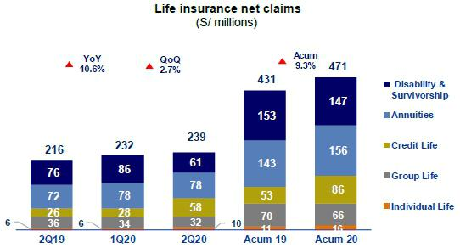

Net claims increased 2.7% QoQ, which was primarily attributable to Credit Life and Individual Life after the number of reported cases increased and more incurred but not reported claims (IBNR) were reported due to COVID-19. This was mitigated by D&S due to a decrease in case frequency and to the fact that reserves were released for SISCO II and SISCO III; and Group Life, due to a decrease in cases for the SCTR product due to the lockdown.

In the YoY analysis, net claims increased 10.6%, which was primarily driven by Credit Life and Individual Life due to the reasons outlined in the QoQ analysis; and Annuities, which was attributable to an increase in pension payments for Individual Annuities. The aforementioned was mitigated by D&S given that fewer cases were registered by Group Life, through the SCTR product, given that client exposure decreased during the lockdown.

In the YTD analysis, claims increased 9.3% for the same reasons outlined in the YoY analysis.

37

6.2. Property and Casualty Insurance
Property and Casualty total premiums | Property and
Casualty net earned premiums ⁽¹⁾
(S/ millions) | (S/ millions)
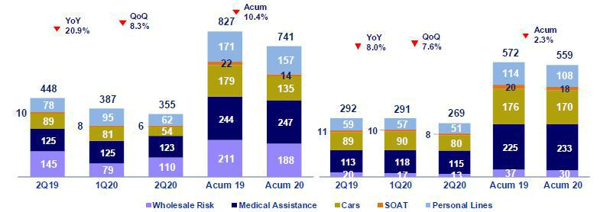

(1) Total premiums without considering reinsurance nor reserve premiums.

Total premiums fell 8.3% QoQ, which was attributable to (i) Personal lines, due to an increase in renewed premiums on the mortgage product in the last quarter and to a decrease in new sales through the bancassurance channel; (ii) Cars, due to a decrease in new sales and renewals and policy cancellations due to the current context; (iii) Medical assistance, due to cancellations; and (iv) SOAT, due to a decrease in new sales through the brokers’ channel. The aforementioned was mitigated by Commercial Lines through an increase in renewals in the fire and aviation risks.

Net earned premiums decreased 7.6%, due to the aforementioned factors, which were mitigated by a release of reserves for current risk, in line with a decrease in sales for the Cars and Personal Lines products.

In the YoY analysis, total premiums fell 20.9% due to (i) Commercial lines, through the aviation risks due to new accounts in 2Q19; (ii) Cars, due to a decrease in new sales and renewals; and to cancellations of policies issued; (iii) Personal lines, due to a decrease in new sales through the bancassurance channel and lower premiums for renewals for student accident policies due to closures of schools and universities during the pandemic; (iv) SOAT, due to a decrease in new sales through the brokers’ channel and (v) Medical assistance due to policy cancellations.

Net earned premiums fell 8.0%, which was primarily attributable to Cars after reserves were released for current risk, in line with the decrease in sales and a drop in ceded premiums in Commercial lines.

YTD, total premiums in 2020 fell 10.4%, which was driven by Cars, Commercial Lines, SOAT and Personal Lines, due to the factors described in the YoY analysis. The aforementioned was mitigated by Medical Assistance, due to an increase in sales of oncological and comprehensive health products in the first few months of the year.

Net earned premiums fell 2.3% YTD due to an increase in releases of reserves for current risk, in line with a decrease in sales and a drop in ceded premiums in Commercial Lines.

38

Property & Casualty net claims

(S/ millions)
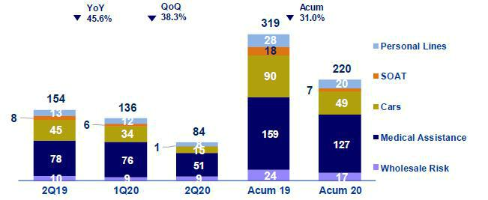

Net claims fell 38.3% QoQ, which was attributable to a drop in claims due to the lockdown, which began in mid-March and continued until the end of June. This decrease was driven mainly by the Medical Assistance, Cars, SOAT and Personal lines and was mitigated by Commercial Lines through an increase in cases in the marine hulls and technical lines.

In the YoY analysis, net claims fell 45.6%. This decrease in claims was seen across business segments but was led by Cars due to the drop in notifications of claims during the lockdown and to an improvement in claims management; Medical Assistance, due to a drop in the exposure levels of clients, who preferred to avoid going to clinics; SOAT, due to a drop in cases (motorcycles); and Personal Lines, due to a drop in Student Accident claims given that schools and universities were closed due to the lockdown.

YTD, claims fell 31.0%, which was attributable to a decrease in cases across business lines, due to the same reasons explained in the YoY analysis.

6.3. Acquisition Cost

Acquisition cost per Business

(S/ millions)
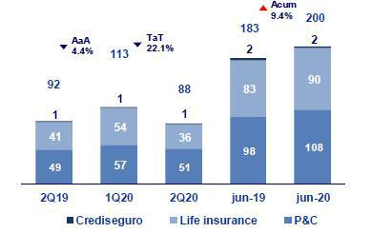

39

Acquisition cost |  |  |  | Quarter |  |  |  | % change |  |  |  |  | YTD |  |  |  |  |  | % change
S/ 000 |  | 2Q19 |  | 1Q20 |  | 2Q20 |  | QoQ |  |  | YoY |  | Jun 19 |  |  | Jun 20 |  |  | Jun 20 / Jun 19
Net fees |  | (58,717) |  | (66,650) |  | (49,084) |  | -26.4% |  |  | -16.4% |  | (118,731) |  |  | (115,734) |  |  | -2.5%
Underwriting expenses |  | (49,237) |  | (46,461) |  | (39,189) |  | -15.7% |  |  | -20.4% |  | (83,813) |  |  | (85,650) |  | 2.2%
Underwriting income |  | 16,288 |  | 604 |  | 675 |  | 11.7% |  |  | -95.9% |  | 19,597 |  |  | 1,279 |  | -93.5%
Acquisition cost |  | (91,666 | ) | (112,507 | ) | (87,598 | ) | -22.1 | % |  | -4.4 | % | (182,947 | ) |  | (200,105 | ) |  | 9.4 |  | %

The acquisition cost fell 22.1% QoQ, which was attributable to a decrease in fees and underwriting expenses in both businesses. In life insurance, the drop in the fee was driven primarily by Credit Life and Group Life after registered premiums fell and to a decrease in underwriting expenses after profit sharing in Group Life and a release of provisions for uncollectible premiums in Credit Life. In property and casualty, the decrease in fee was primarily attributable to a drop in premiums in the quarter and to a decrease in the underwriting expenses, which was driven primarily by Cars given that last quarter, clients were reimbursed for a total of 8 million Soles because clients were unable to use their vehicles during a portion of the quarantine period.

In the YoY analysis, the acquisition cost fell 4.4% due to the evolution of life insurance; this was attenuated by the performance of P&C. The decrease in the underwriting expense in the life business was attributable to profit sharing in Group Life and to the release of provisions for uncollectible premiums in Credit Life. In P&C, the increase was due to the same reasons outlined in the YoY analysis and to an increase in reserves for uncollectible premiums in Cars, Commercial Lines and Medical Assistance, and higher provisions for uncollectible reinsurance premiums in Medical Assistance.

In the YTD analysis, the acquisition cost increased 9.4% due to growth in underwriting expenses in P&C and an increase in fee for life insurance. In P&C, expansion was primarily due to Cars given that a total of 10 million Soles was returned to clients who were unable to use their vehicles during the lockdown, to an increase in reserves for uncollectible premiums in Cars, Commercial Lines and Medical Assistance and to an increase in uncollectible reinsurance premiums in Medical Assistance. In the Life insurance business, the increase was driven mainly by an increase in fees in Credit Life due to growth in premiums through the alliance channel.

6.4 Underwriting Result by Business

Underwriting Result by Business

(S/ millions)
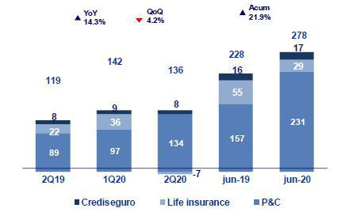

In the QoQ analysis, the decrease in the underwriting result was attributable to the Life business, in line with (i) a decrease in net premiums, mainly in Credit Life, Statutory Life and Group Life; and (ii) an increase in claims, mainly in the Credit Life and Individual Life lines, which was mitigated by a decrease in the acquisition cost due to a drop in the fee , in line with a decrease in premiums and by a decrease in the underwriting expenses due to release of profit sharing and provisions for uncollectible premiums

The aforementioned was mitigated by an increase in P&C, due to a drop in claims across business lines in the context of the lockdown, led by Medical Assistance and Cars; and to a decrease in the acquisition cost due to an increase in fee income from reinsurers and to the decrease in the underwriting expense due to premium reimbursements last quarter in the Cars line. The aforementioned was attenuated by a decrease in net premiums across business lines.

40

In the YoY analysis, the increase in the underwriting result was attributable to P&C and attenuated by life insurance. In P&C, growth was due to a decrease in claims, which was attenuated by a drop in the premiums level due to the reasons explained in the QoQ analysis and to an increase in the acquisition cost due to higher underwriting expenses after uncollectible premiums were registered and premiums were returned in Cars. In Life insurance, the decrease in the result was attributable to a lower underwriting result, which was attributable to the reasons outlined in the QoQ analysis.

In the YTD analysis, the highest underwriting result is explained by general insurance, attenuated by life insurance. The P&C result was driven by a drop in claims given that clients’ exposure levels fell during the lockdown. This was attenuated by a decrease in the net earned premium after new sales dropped and policies were canceled due to lack of payment and by an increase in the acquisition cost after 10 million Soles were reimbursed in the Cars segment. In the Life insurance business, the decrease in the underwriting results was attributable to an increase in claims in Credit Life, Group Life and Individual Life due to the current context and to an increase in acquisition costs in Credit Life, which was mitigated by the increase in the premium levels for Credit Life and Statutory life.

41

7. Operating Expenses and Efficiency

Credicorp’s operating efficiency ratio deteriorated QoQ, YoY and YTD. This was attributable to the fact that operating income fell mainly at BCP Stand-alone and Mibanco, which reflects both the impairment that was taken this quarter and the drop registered in fee income. The aforementioned was attenuated by a decrease in operating expenses, which is in line with the measures Credicorp is taking to offset the anticipated reduction in operating income due to COVID-19.

Operating expenses |  |  |  | Quarter |  |  |  | % change |  |  |  |  | YTD |  |  |  |  | % change
S/ 000 |  | 2Q19 |  | 1Q20 |  | 2Q20 |  | QoQ |  |  | YoY |  | Jun 19 |  |  | Jun 20 |  | Jun 20 / Jun 19
Salaries and employees benefits |  | 845,835 |  | 891,183 |  | 825,997 |  | -7.3% |  |  | -2.3% |  | 1,680,152 |  |  | 1,717,180 |  | 2.2%
Administrative, general and tax expenses |  | 552,653 |  | 539,644 |  | 508,078 |  | -5.8% |  |  | -8.1% |  | 1,090,810 |  |  | 1,047,722 |  | -4.0%
Depreciation and amortization |  | 158,663 |  | 171,748 |  | 171,439 |  | -0.2% |  |  | 8.1% |  | 289,988 |  |  | 343,187 |  | 18.3%
Association in participation |  | 4,746 |  | 6,430 |  | 17,944 |  | 179.1% |  |  | 278.1% |  | 7,482 |  |  | 24,374 |  | 225.8%
Acquisition cost ⁽¹⁾ |  | 91,666 |  | 112,507 |  | 87,598 |  | -22.1% |  |  | -4.4% |  | 182,947 |  |  | 200,105 |  | 9.4%
Operating expenses ⁽²⁾
 |  | 1,653,563 |  | 1,721,512 |  | 1,611,056 |  | -6.4% |  |  | -2.6% |  | 3,251,379 |  |  | 3,332,568 |  | 2.5%
Operating income ⁽³⁾
 |  | 3,832,407 |  | 3,967,962 |  | 3,212,780 |  | -19.0% |  |  | -16.2% |  | 7,600,971 |  |  | 7,180,742 |  | -5.5%
Efficiency ratio ⁽⁴⁾
 |  | 43.1% |  | 43.4% |  | 50.1% |  | 670bps |  |  | 700bps |  | 42.8% |  |  | 46.4% |  | 360bps
Operating expenses / Total average assets ⁽⁵⁾
 |  | 3.69 % |  | 3.57% |  | 3.07% |  | -50bps |  |  | -62bps |  | 3.64% |  |  | 3.26% |  | -38bps

- The acquisition cost of Pacífico includes net fees and underwriting expenses.

- Figures differ from previously reported, please consider the data presented on this report. Operating expenses = Salaries and employee’s benefits + Administrative, general and tax expenses + Depreciation and amortization + Acquisition cost + Association in participation.
- Operating income = Net interest income + Fee income + Net gain on foreign exchange transactions + Net gain from associates + Net gain on derivatives held for trading + Result on exchange differences + Net premiums earned.
- Figures differ from previously reported, please consider the data presented on this report. Operating expenses / Operating income.

- Figures differ from previously reported, please consider the data presented on this report. Operating expenses / Average of Total Assets. Average is calculated with period-beginning and period-ending balances.

The QoQ and YoY analysis reveal a deterioration of 670 bps and 700 bps respectively in the efficiency ratio. This was primarily attributable to a decrease in operating income.

The figure below shows the impact of the variation in each component of income and operating expenses on the efficiency ratio YoY:

YoY evolution of the efficiency ratio by account
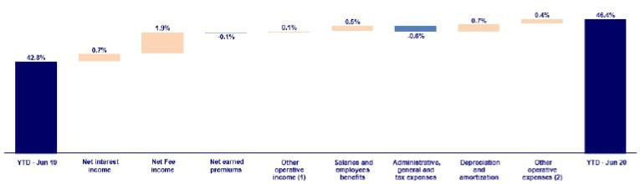

- Other operating income includes: Net gain on foreign exchange transactions, Net gain from associates, Net gain on derivatives held for trading and Net gain from exchange difference.
- Other operating expenses includes: Acquisition cost and Association in participation

Operating income fell, mainly due to:

- The reduction in net interest income, which was attributable to the impairment taken at BCP Stand-alone and Mibanco due to the debt freezing facilities offered to some clients whose income has been affected by the COVID-19 crisis, as explained in section 4.1. Interest income.

- A decrease in fee income at BCP Stand-alone and, to a lesser extent, at Mibanco. Both reductions were attributable to a decrease in the transaction levels, as explained in 5.1.2. Fee income in the banking business.

42

Operating expenses also fell, which reflects the efforts being made to reduce the impact of lower operating income. The drop in operating expenses was due to:

- The contraction in administrative and general expenses and taxes due to the savings generated by the fact that a large percentage of our employees are working remotely. Currently, a long-term project to optimize the workspace and generate savings in the medium term is in development.

- The reduction in salaries and employee benefits, which was mainly registered at BCP Stand-alone, was attributable to a reduction in variable compensation. It is important to note that we are working to retain personnel and relocate some employees to areas that are working at full capacity during the pandemic to ensure our capacity to grow down the line.

YTD, efficiency deteriorated 360 bps. This impact was less significant given that in 1Q20, operating income increased in the annual comparison, which attenuated the impact of the YoY decrease. The increase in operating expenses was mainly attributable to growth in salaries and employee benefits in the Microfinance business after Mibanco increased its head count in 2019 and employees from Bancompatir were added to the payroll. The chart below shows the impact of the variation of each component of operating income and expenses on the YTD efficiency ratio:

YTD evolution of the efficiency ratio by account
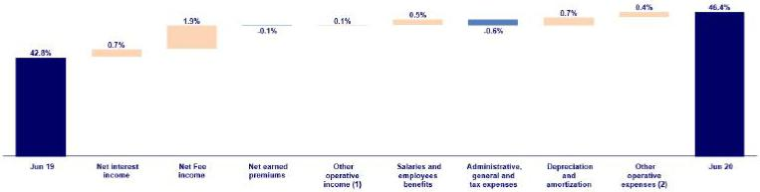

- Other operating income includes: Net gain on foreign exchange transactions, Net gain from associates, Net gain on derivatives held for trading and Net gain from exchange difference.
- Other operating expenses includes: Acquisition cost and Association in participation

7.1. Credicorp’s Administrative, General and Tax Expenses

Credicorp’s administrative, general and tax expenses

Administrative, general and tax expenses |  |  |  |  |  | Quarter |  |  |  |  |  |  |  |  | % change |  |  |  | YTD |  |  |  |  |  | % change
S/ 000 |  | 2Q19 |  | % |  | 1Q20 |  |  | % |  | 2Q20 |  | % |  | QoQ |  | YoY |  | Jun 19 |  |  | Jun 20 |  |  | Jun 20 / Jun 19
Repair and maintenance |  | 92,654 |  | 17% |  | 76,051 |  |  | 14% |  | 98,069 |  | 19% |  | 29.0% |  | 5.8% |  | 170,310 |  |  | 174,120 |  |  | 2.2%
Publicity |  | 86,323 |  | 16% |  | 75,256 |  |  | 14% |  | 53,505 |  | 11% |  | -28.9% |  | -38.0% |  | 162,498 |  |  | 128,761 |  | -20.8%
Taxes and contributions |  | 64,182 |  | 12% |  | 68,017 |  |  | 13% |  | 63,344 |  | 12% |  | -6.9% |  | -1.3% |  | 130,891 |  |  | 131,361 |  | 0.4%
Leases of low value and short-term |  | 8,162 |  | 1% |  | 18,843 |  |  | 3% |  | 12,476 |  | 2% |  | -33.8% |  | 52.9% |  | 30,580 |  |  | 31,319 |  | 2.4%
Consulting and professional fees |  | 43,255 |  | 8% |  | 39,485 |  |  | 7% |  | 46,412 |  | 9% |  | 17.5% |  | 7.3% |  | 84,615 |  |  | 85,897 |  | 1.5%
Transport and communications |  | 43,096 |  | 8% |  | 35,466 |  |  | 7% |  | 30,156 |  | 6% |  | -15.0% |  | -30.0% |  | 84,732 |  |  | 65,622 |  | -22.6%
Sundry supplies |  | 18,603 |  | 3% |  | 23,424 |  |  | 4% |  | 9,776 |  | 2% |  | -58.3% |  | -47.4% |  | 36,167 |  |  | 33,200 |  | -8.2%
Security and protection |  | 17,200 |  | 3% |  | 15,286 |  |  | 3% |  | 15,277 |  | 3% |  | -0.1% |  | -11.2% |  | 34,202 |  |  | 30,563 |  | -10.6%
Electricity and water |  | 14,012 |  | 3% |  | 11,175 |  |  | 2% |  | 12,579 |  | 2% |  | 12.6% |  | -10.2% |  | 26,039 |  |  | 23,754 |  | -8.8%
Subscriptions and quotes |  | 9,781 |  | 2% |  | 10,752 |  |  | 2% |  | 12,219 |  | 2% |  | 13.6% |  | 24.9% |  | 19,351 |  |  | 22,971 |  | 18.7%
Services by third-party and others ⁽¹⁾ |  | 155,385 |  | 28% |  | 165,889 |  |  | 31% |  | 154,265 |  | 30% |  | -7.0% |  | -0.7% |  | 311,425 |  |  | 320,154 |  | 2.8%
Total administrative and general expenses |  | 552,653 |  | 100% |  | 539,644 |  |  | 100% |  | 508,078 |  | 100% |  | -5.8% |  | -8.1% |  | 1,090,810 |  |  | 1,047,722 |  | -4.0%

(1) The balance consists mainly of security and protection services, cleaning service, representation expenses, electricity and water utilities, insurance policiy expenses, subscription expenses and commission expenses.

43

Administrative, general expenses and taxes decreased QoQ, YoY and YTD, which reflects the efforts Credicorp has made to control operating expenses. The main reductions in expenses YTD were reported in the following accounts:

- Total expenses for Publicity fell, mainly at BCP Stand-alone, due to a decrease in expenses for the Latam Miles Program, which reflects the drop reported in transactional activity of clients with BCP credit and debit cards.

- Expenses for transport and communications fell at BCP Stand-alone, which was attributable to a decrease in transportation of cash between branches and fund replenishment for ATMs, both handled by private security companies. The aforementioned is aligned with growth in the digitalization level of our clients.

The aforementioned was attenuated by the increase in expenses for third-party services and others, which was in line with an increase in expenses for maintenance of our servers during the first half of the year.

It is important to mention that the reduction in administrative and general expenses mitigated the increase in other expenses. The latter increased due to (i) the expenses of the donations made by BCP Stand-Alone, Mibanco and Pacifico in the first quarter and (ii) the protection measures of COVID-19 for our employees and clients who are served through physical channels (medical supplies, mobility payment, gloves, among others).

7.2. Efficiency Ratio

Efficiency Ratio by Subsidiary ⁽¹⁾⁽²⁾

 |  | BCP |  |  |  | Microfinance ⁽³⁾
 |  | Stand-alone |  | BCP Bolivia |  | Microfinance ⁽³⁾ |  | Pacifico |  |  | Prima AFP |  | Credicorp
2Q19 |  | 40.2% |  | 61.7% |  | 52.6% |  |  | 38.6% |  | 40.6% |  | 43.1%
1Q20 |  | 38.8% |  | 56.4% |  | 58.4% |  |  | 40.6% |  | 40.6% |  | 43.4%
2Q20 |  | 43.0% |  | 51.0% |  | 93.1% |  |  | 40.0% |  | 57.3% |  | 50.1%
Var. QoQ |  | 420bps |  | -540bps |  | 3470bps |  |  | -60bps |  | 1670bps |  | 670bps
Var. YoY |  | 280bps |  | -1070bps |  | 4050bps |  |  | 140bps |  | 1670bps |  | 700bps
YTD - Jun 19 | 39.2% |  |  | 61.7% |  | 53.8% |  |  | 38.8% |  | 41.1% |  | 42.8%
YTD - Jun 20 | 40.7% |  |  | 53.7% |  | 70.9% |  |  | 40.3% |  | 47.1% |  | 46.4%
% change
Jun 20 / Jun 19 |  | 150bps |  | -800bps |  | 1710bps |  |  | 150bps |  | 600bps |  | 360bps

- (Salaries and employee’s benefits + Administrative, general and tax expenses + Depreciation and amortization + Acquisition cost + Association in participation) / (Net interest income + Fee income + Net gain on foreign exchange transactions + Net gain from associates + Net gain on derivatives held for trading + Result on exchange differences + Net premiums earned).

- The efficiency ratio differs from previously reported, please consider the data presented on this report.

- Microfinance includes Mibanco, Bancompartir and Encumbra

In the QoQ and YoY analysis, the efficiency ratio deteriorated after operating income at BCP Stand-alone and Mibanco fell.

The figure below shows the contribution of each of the subsidiaries to the evolution of the YoY efficiency ratio.

YoY evolution of the efficiency ratio by subsidiary
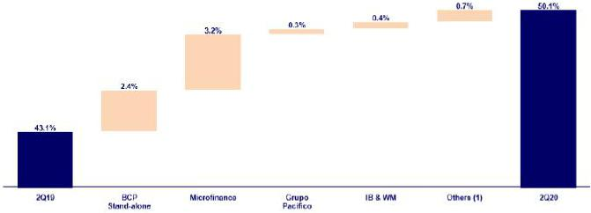

- Others includes: Credicorp Capital, Prima AFP, BCP Bolivia, ASB, Grupo Crédito, among other subsidiaries and the eliminations for consolidation purposes.

44

In the YoY analysis, the efficiency ratio deteriorated 700 bps, which was attributable to:

- In the Microfinance business, the main driver of the increase was Mibanco, which registered a drop operating income. This decline was mainly attributable to a decrease in net interest income due to the impairment taken for loans that were frozen to support clients that are experiencing economic difficulties and to a lesser extent, to a decrease in fee income due to a drop in transactional activity. The Microfinance business also registered an increase in operating expenses due to expenses at Bancompartir, which have been included in the balance sheet since December 2019.

- At BCP Stand-alone due to a decrease in operating income, which was mainly attributable to a decrease in net interest income due to the impairment that was taken for loans that were frozen to support clients during the pandemic and to a lesser extent, to a decrease in fee income due to lower transactional levels. The aforementioned was attenuated by the drop in operating expenses, which was primarily due to a decrease in variable compensation; a reduction in marketing expenses associated with the Milla Latam program; and the savings that were generated by a decrease in the use of physical space on BCP’s properties.

- At Prima AFP, due to a drop in fee income after the government implemented measures to generate liquidity for Peruvians, including eliminating obligatory fund contributions in the month of April for affiliates in the private pension system.

YTD, efficiency deteriorated 360 bps. This impact was less significant given that in 1Q20, operating income increased in the annual comparison, which attenuated the impact of the YoY reduction. The increase in efficiency was due to the same reasons outlined in the YoY analysis. The figure below shows the impact of the variation of each subsidiary on the efficiency ratio YTD:

YTD evolution of the efficiency ratio by subsidiary
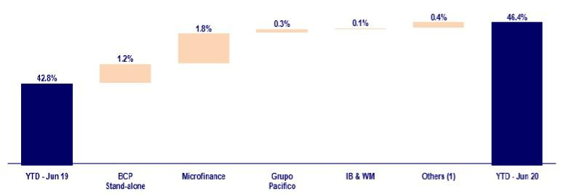

45

8. | Regulatory Capital
8.1. Regulatory Capital – BAP
Regulatory Capital and Capital Adequacy Ratios |  |  |  |  | As of |  |  |  | % Change
S/ 000 |  |  | Jun-19 |  | Mar-20 |  | Jun-20 |  | QoQ |  |  | YoY
Capital Stock |  |  | 1,318,993 |  | 1,318,993 |  | 1,318,993 |  | 0.0% |  |  | 0.0%
Treasury Stocks |  |  | (207,839) |  | (209,309) |  | (209,309) |  | 0.0% |  |  | 0.7%
Capital Surplus |  |  | 227,380 |  | 165,188 |  | 160,430 |  | -2.9% |  |  | -29.4%
Legal and Other capital reserves ⁽¹⁾ |  |  | 19,423,324 |  | 21,360,272 |  | 21,381,402 |  | 0.1% |  |  | 10.1%
Minority interest ⁽²⁾ |  |  | 357,067 |  | 386,326 |  | 440,412 |  | 14.0% |  |  | 23.3%
Loan loss reserves ⁽³⁾ |  |  | 1,608,215 |  | 1,728,836 |  | 1,770,605 |  | 2.4% |  |  | 10.1%
Perpetual subordinated debt |  |  | 575,225 |  | - |  | - |  | - |  |  | -100.0%
Subordinated Debt |  |  | 4,735,573 |  | 4,568,131 |  | 4,698,109 |  | 2.8% |  |  | -0.8%
Investments in equity and subordinated debt of financial and insurance
 | companies |  | (777,011) |  | (630,805) |  | (676,471) |  | 7.2% |  |  | -12.9%
Goodwill |  |  | (601,333) |  | (819,338) |  | (851,731) |  | 4.0% |  |  | 41.6%
Deduction for subordinated debt limit (50% of Tier I excluding deductions) ⁽⁴⁾ |  |  | - |  | - |  | - |  | - |  |  | -
Deduction for Tier I Limit (50% of Regulatory capital) ⁽⁴⁾ |  |  | - |  | - |  | - |  | - |  |  | -
Total Regulatory Capital (A) |  |  | 26,659,594 |  | 27,868,294 |  | 28,032,439 |  | 0.6% |  |  | 5.1%
Tier 1⁽⁵⁾ |  |  | 14,746,304 |  | 15,271,365 |  | 15,265,466 |  | 0.0% |  |  | 3.5%
Tier 2 ⁽⁶⁾ + Tier 3 ⁽⁷⁾ |  |  | 11,913,290 |  | 12,596,929 |  | 12,766,973 |  | 1.3% |  |  | 7.2%
Financial Consolidated Group (FCG) Regulatory Capital Requirements ⁽⁸⁾ |  |  | 19,877,961 |  | 19,925,877 |  | 19,518,177 |  | -2.0% |  |  | -1.8%
Insurance Consolidated Group (ICG) Capital Requirements ⁽⁹⁾ |  |  | 1,090,628 |  | 1,243,035 |  | 1,231,777 |  | -0.9% |  |  | 12.9%
FCG Capital Requirements related to operations with ICG |  |  | (235,272) |  | (503,013) |  | (500,356) |  | -0.5% |  |  | 112.7%
ICG Capital Requirements related to operations with FCG |  |  | - |  | - |  | - |  | - |  |  | -
Total Regulatory Capital Requirements (B) |  |  | 20,733,318 |  | 20,665,899 |  | 20,249,597 |  | -2.0% |  |  | -2.3%
Regulatory Capital Ratio (A) / (B) |  |  | 1.29 |  | 1.35 |  | 1.38
Required Regulatory Capital Ratio (10) |  |  | 1.00 |  | 1.00 |  | 1.00

- Legal and other capital reserves include restricted capital reserves (PEN 14,745 million) and optional capital reserves (PEN 6,636 million).

- Minority interest includes Tier I (PEN 440 million)

- Up to 1.25% of total risk-weighted assets of Banco de Crédito del Perú, Solución Empresa Administradora Hipotecaria, Mibanco and Atlantic Security Bank.
- Tier II + Tier III cannot be more than 50% of total regulatory capital.

- Tier I = capital + restricted capital reserves + Tier I minority interest - goodwill - (0.5 x investment in equity and subordinated debt of financial and insurance companies) + perpetual subordinated debt.

- Tier II = subordinated debt + TierII minority interest tier + loan loss reserves - (0.5 x investment in equity and subordinated debt of financial and insurance companies).

- Tier III = Subordinated debt covering market risk only.

- Includes regulatory capital requirements of the financial consolidated group.

- Includes regulatory capital requirements of the insurance consolidated group.

- Regulatory Capital / Total Regulatory Capital Requirements (legal minimum = 1.00).

Total regulatory capital at Credicorp increased 0.6% QoQ and 5.1% YoY. This was driven by an increase in legal and other capital reserves; and in loan loss reserves, both of which reflect preventive measures to absorb the potential effects of variations in expectations for economic growth in Peru due to the COVID-19 pandemic. Credicorp’s regulatory capital requirement fell -2.0% QoQ and -2.3% YoY, which was in line with the reduction in capital requirements set for financial companies that have benefited from the economic reactivation programs, and with the capital release instituted by the regulating entity, which was driven by the economic cycle. This readjustment is activated when real GDP is believed to be greater than potential GDP.

Credicorp’s regulatory capital ratio remained at a comfortable level at the end of 2Q20 and represented 1.38 times the capital required by the regulator in Peru.

46

8.2. Regulatory Capital – BCP Stand-alone based on Peru GAAP

Regulatory Capital and Capital Adequacy Ratios - SBS |  |  |  |  |  | As of |  |  |  |  |  | % change
S/ 000 |  |  | Jun-19 |  |  | Mar-20 |  |  | Jun-20 |  |  | QoQ |  |  |  | YoY
Capital Stock |  |  | 10,217,387 |  |  | 10,217,387 |  |  | 11,067,387 |  |  | 8.3% |  |  |  | 8.3%
Legal and Other capital reserves |  |  | 4,695,118 |  |  | 4,695,118 |  |  | 6,164,175 |  |  | 31.3% |  |  |  | 31.3%
Accumulated earnings with capitalization agreement |  |  | - |  |  | 850,000 |  |  | - |  |  | -100.0% |  |  |  | n.a.
Loan loss reserves ⁽¹⁾ |  |  | 1,298,104 |  |  | 1,383,834 |  |  | 1,603,535 |  |  | 15.9% |  |  |  | 23.5%
Perpetual subordinated debt |  |  | 575,225 |  |  | - |  |  | - |  |  | n.a. |  |  |  | n.a.
Subordinated Debt |  |  | 4,197,063 |  |  | 4,128,099 |  |  | 4,248,967 |  |  | 2.9% |  |  |  | 1.2%
Investment in subsidiaries and others, net of unrealized profit and net income |  |  | (1,722,979) |  |  | (1,937,102) |  |  | (1,934,790) |  |  | -0.1% |  |  |  | 12.3%
Investment in subsidiaries and others |  |  | (1,903,858) |  |  | (2,008,782) |  |  | (2,020,533) |  |  | 0.6% |  |  |  | 6.1%
Unrealized profit and net income in subsidiaries |  |  | 180,879 |  |  | 71,680 |  |  | 85,742 |  |  | 19.6% |  |  |  | -52.6%
Goodwill |  |  | (122,083) |  |  | (122,083) |  |  | (122,083) |  |  | 0.0% |  |  |  | 0.0%
Total Regulatory Capital - SBS |  |  | 19,137,835 |  |  | 19,215,253 |  |  | 21,027,190 |  |  | 9.4% |  |  |  | 9.9%
Off-balance sheet |  |  | 84,178,682 |  |  | 88,755,362 |  |  | 87,359,668 |  |  | -1.6 | % |  |  | 3.8 | %
Regulatori Tier 1 Capital (2) |  |  | 14,504,157 |  |  | 14,671,871 |  |  | 14,971,384 |  |  | 2.0% |  |  |  | 3.2%
Regulatory Tier 2 Capital (3) |  |  | 4,633,677 |  |  | 4,543,382 |  |  | 6,055,806 |  |  | 33.3% |  |  |  | 30.7%
Total risk-weighted assets - SBS (4) |  |  | 128,023,739 |  |  | 142,084,684 |  |  | 142,071,064 |  |  | 0.0 | % |  |  | 11.0 | %
Credit risk-weighted assets |  |  | 115,994,876 |  |  | 129,331,389 |  |  | 128,282,795 |  |  | -0.8% |  |  |  | 10.6%
Market risk-weighted assets (5) |  |  | 2,701,436 |  |  | 3,074,766 |  |  | 4,010,627 |  |  | 30.4% |  |  |  | 48.5%
Operational risk-weighted assets |  |  | 9,327,427 |  |  | 9,678,529 |  |  | 9,777,642 |  |  | 1.0% |  |  |  | 4.8%
Total capital requirement -SBS |  |  | 16,265,477 |  |  | 16,411,339 |  |  | 16,077,302 |  |  | -2.0 | % |  |  | -1.2 | %
Credit risk capital requirement |  |  | 11,599,488 |  |  | 12,933,139 |  |  | 12,828,280 |  |  | -0.8% |  |  |  | 10.6%
Market risk capital requirement |  |  | 270,144 |  |  | 307,477 |  |  | 401,063 |  |  | 30.4% |  |  |  | 48.5%
Operational risk capital requirement |  |  | 932,743 |  |  | 967,853 |  |  | 977,764 |  |  | 1.0% |  |  |  | 4.8%
Additional capital requirements |  |  | 3,463,103 |  |  | 2,202,871 |  |  | 1,870,195 |  |  | -15.1% |  |  |  | -46.0%
Common Equity Tier 1 - Basel (6) |  |  | 14,682,446 |  |  | 16,146,039 |  |  | 15,266,427 |  |  | -5.4 | % |  |  | 4.0 | %
Capital and reserves |  |  | 14,912,505 |  |  | 14,912,505 |  |  | 17,231,562 |  |  | 15.6% |  |  |  | 15.6%
Retained earnings |  |  | 2,377,670 |  |  | 4,273,266 |  |  | 742,390 |  |  | -82.6% |  |  |  | -68.8%
Unrealized gains (losses) |  |  | 230,993 |  |  | (20,316) |  |  | 330,343 |  |  | 1526.0% |  |  |  | 43.0%
Goodwill and intangibles |  |  | (934,863) |  |  | (1,010,634) |  |  | (1,017,336) |  |  | 0.7% |  |  |  | 8.8%
Investments in subsidiaries |  |  | (1,903,858) |  |  | (2,008,782) |  |  | (2,020,533) |  |  | 0.6% |  |  |  | 6.1%
Adjusted Risk-Weighted Assets - Basel (7) |  |  | 124,260,803 |  |  | 135,790,140 |  |  | 136,054,845 |  |  | 0.2 | % |  |  | 9.5 | %
Total risk-weighted assets |  |  | 128,023,739 |  |  | 142,084,684 |  |  | 142,071,064 |  |  | 0.0% |  |  |  | 11.0%
(-) RWA Intangible assets, excluding goodwill. |  |  | 4,168,753 |  |  | 6,802,121 |  |  | 6,841,476 |  |  | 0.6% |  |  |  | 64.1%
(+) RWA Deferred tax assets generated as a result of temporary differences
in income tax, in excess of 10% of CET1 |  |  | 405,816 |  |  | 507,578 |  |  | 825,258 |  |  | 62.6% |  |  |  | -
(+) RWA Deferred tax assets generated as a result of past losses |  |  | - |  |  | - |  |  | - |  |  | - |  |  |  | -
Capital ratios
Regulatory Tier 1 ratio (8) |  |  | 11.33% |  |  | 10.33% |  |  | 10.54% |  |  | 21 bps |  |  |  | -79 bps
Common Equity Tier 1 ratio (9) |  |  | 11.82% |  |  | 11.89% |  |  | 11.22% |  |  | -67 bps |  |  |  | -60 bps
BIS ratio (10) |  |  | 14.95% |  |  | 13.52% |  |  | 14.80% |  |  | 128 bps |  |  |  | -15 bps
Risk-weighted assets / Regulatory capital |  |  | 6.69 |  |  | 7.39 |  |  | 6.76 |  |  | -8.6% |  |  |  | 1.0%

- Up to 1.25% of total risk-weighted assets.

- Regulatory Tier 1 Capital = Capital + Legal and other capital reserves + Accumulated earnings with capitalization agreement + (0.5 x Unrealized profit and net income in subsidiaries) - Goodwill - (0.5 x Investment in subsidiaries) + Perpetual subordinated debt (maximum amount that can be included is 17.65% of Capital + Reserves + Accumulated earnings with capitalization agreement + Unrealized profit and net income in subsidiaries - Goodwill).

- Regulatory Tier 2 Capital = Subordinated debt + Loan loss reserves + Unrestricted Reserves + (0.5 x Unrealized profit and net income in subsidiaries) - (0.5 x Investment in subsidiaries).
- Since July 2012, Total Risk-weighted assets = Credit risk-weighted assets * 1.00 + Capital requirement to cover market risk * 10 + Capital requirement to cover operational risk * 10 * 1.00 (since July 2014)
- It includes capital requirement to cover price and rate risk.

- Common Equity Tier I = Capital + Reserves – 100% of applicable deductions (investment in subsidiaries, goodwill, intangibles and net deferred taxes that rely on future profitability) + retained earnings + unrealized gains.
- Adjusted Risk-Weighted Assets = Risk-weighted assets - (RWA Intangible assets, excluding goodwill, + RWA Deferred tax assets generated as a result of temporary differences in income tax, in excess of 10% of CET1, + RWA Deferred tax assets generated as a result of past losses).
- Regulatory Tier 1 Capital / Total Risk-weighted assets

- Common Equity Tier I / Adjusted Risk-Weighted Assets Risk-Weighted Assets

- Total Regulatory Capital / Total Risk-weighted assets (legal minimum = 10% since July 2011)

47

At the end of 2Q20, the BIS and Tier 1 ratios at BCP Stand-alone rose QoQ to situate at 14.80% and 10.54% respectively. This was attributable to the 9.4% and 2.0% increase in total regulatory and Tier 1 capital respectively.

The total increase in regulatory capital was primarily driven by the 31.3% increase in reserves. Growth in reserves was in turn driven by an increase in facultative reserves due to the COVID-19 pandemic. Total RWAs remained relatively stable due to the economic reactivation programs implemented by the Government, which drove an increase in the loan portfolio without generating associated risk given that loans under these programs are government-backed.

The YoY evolution reported a reduction in both the BIS and Tier 1 ratios with regard to the levels in 2Q19, which was driven by an increase in RWAs (+11.0%). This growth was driven by growth in retail loans in the second half of 2019 and first quarter of 2020 and by the risk associated with these kinds of loans. The aforementioned was slightly offset by the increase in regulatory capital and in the Tier 1.

The YoY evolution of RWAs mainly reflects growth of +10.6% in Credit RWAs and operational risk RWAs. Additionally, it is important to note that additional capital requirements have fallen 46% due to the capital release instituted by the regulating entity, which was driven by the economic cycle. This readjustment is activated when real GDP is believed to be greater than potential GDP

Common Equity Tier 1 Ratio – BCP Stand-alone

March 2020 June 2020
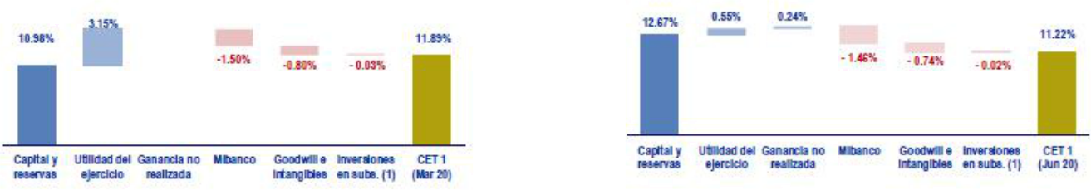

(1) Includes investments in BCP Bolivia and other subsidiaries

Finally, the Tier 1 common equity (CET 1), which is considered the most rigorous indicator by which to measure capitalization levels, fell -67bps QoQ to situate at 11.22% at the end of 2Q20. This was driven by a -82.6% QoQ and -68.8% decline in results due to the crisis generated by the COVID-19 pandemic. In the YoY analysis, the CET1 Ratio fell -60pbs due to an increase in adjusted RWAs. This variation was attributable to growth in retail loan portfolio in the second half of 2019 and in the first quarter of 2020. The +4.0% increase in the Tier 1 common equity was insufficient to offset the aforementioned evolution.

48

8.3. Regulatory Capital at Mibanco based on Peru GAAP
Regulatory Capital and Capital Adequacy Ratios - SBS |  |  |  | As of |  |  |  | % change
S/ 000 |  | June-19 |  | Mar-20 |  | June-20 |  | QoQ |  |  | YoY
Capital Stock |  | 1,173,726 |  | 1,331,484 |  | 1,714,369 |  | 28.8% |  |  | 46.1%
Legal and Other capital reserves |  | 207,129 |  | 207,129 |  | 246,305 |  | 18.9% |  |  | 18.9%
Accumulated earnings with capitalization agreement |  | - |  | 156,000 |  | - |  | -100.0% |  |  | n.a.
Loan loss reserves ⁽¹⁾ |  | 130,046 |  | 141,004 |  | 144,980 |  | 2.8% |  |  | 11.5%
Perpetual subordinated debt |  |  |  |  |  |  |  | n.a. |  |  | n.a.
Subordinated Debt |  | 242,009 |  | 130,000 |  | 130,000 |  | 0.0% |  |  | -46.3%
Investment in subsidiaries and others, net of unrealized profit and
net income |  | - |  | - |  | - |  | - |  |  | -
Investment in subsidiaries and others |  |  |  |  |  |  |  | - |  |  | -
Unrealized profit and net income in subsidiaries |  |  |  |  |  |  |  | - |  |  | -
Goodwill |  | (139,180) |  | (139,180) |  | (139,180) |  | 0.0% |  |  | 0.0%
Total Regulatory Capital - SBS |  | 1,613,730 |  | 1,826,436 |  | 2,096,473 |  | 14.8% |  |  | 29.9%
Regulatori Tier 1 Capital ⁽²⁾
 |  | 1,238,938 |  | 1,552,693 |  | 1,818,754 |  | 17.1% |  |  | 46.8%
Regulatory Tier 2 Capital ⁽³⁾ |  | 374,791 |  | 273,743 |  | 277,719 |  | 1.5 | % |  | %
 |  |  |  | 273,743 |  |  |  | 1.5 |  |  | -25.9
Total risk-weighted assets - SBS ⁽⁴⁾
 |  | 10,859,990 |  | 13,030,959 |  | 13,154,838 |  | 1.0 | % |  | 21.1 | %
Credit risk-weighted assets
 |  | 10,108,444 |  | 10,929,378 |  | 11,052,499 |  | 1.1% |  |  | 9.3%
Market risk-weighted assets ⁽⁵⁾ |  | 95,837 |  | 152,782 |  | 160,484 |  | 5.0% |  |  | 67.5%
Operational risk-weighted assets |  | 655,709 |  | 1,948,798 |  | 1,941,855 |  | -0.4% |  |  | 196.1%
Total capital requirement |  |  |  |  |  |  |  |  | % |  |  | %
 |  | 1,474,500 |  | 1,448,821 |  | 1,462,850 |  | 1.0 | % |  | -0.8 | %
Credit risk capital requirement |  | 1,010,844 |  | 1,092,938 |  | 1,105,250 |  | 1.1% |  |  | 9.3%
Market risk-weighted assets |  | 9,584 |  | 15,278 |  | 16,048 |  | 5.0% |  |  | 67.5%
Operational risk capital requirement |  | 65,571 |  | 194,880 |  | 194,185 |  | -0.4% |  |  | 196.1%
Additional capital requirements |  | 388,501 |  | 145,725 |  | 147,366 |  | 1.1% |  |  | -62.1%
Common Equity Tier 1 - Basel ⁽⁶⁾ |  | 1,703,865 |  | 1,809,165 |  | 1,819,014 |  | 0.5 | % |  | 6.8 | %
Capital and reserves |  | 1,380,855 |  | 1,538,613 |  | 1,960,674 |  | 27.4% |  |  | 42.0%
Retained earnings |  | 520,041 |  | 485,218 |  | 70,284 |  | -85.5% |  |  | -86.5%
Unrealized gains (losses) |  | 2,091 |  | 5,549 |  | 11,181 |  | -301.5% |  |  | 434.6%
Goodwill and intangibles |  | (198,922) |  | (219,993) |  | (222,904) |  | 1.3% |  |  | 12.1%
Investments in subsidiaries |  | (200) |  | (223) |  | (221) |  | -0.9% |  |  | 10.5%
Adjusted Risk-Weighted Assets - Basel ⁽⁷⁾ |  |  |  |  |  |  |  |  | % |  |  | %
 |  | 10,624,842 |  | 12,447,266 |  | 11,888,430 |  | -4.5 | % |  | 11.9 | %
Total risk-weighted assets
 |  | 10,859,990 |  | 13,030,959 |  | 13,154,838 |  | 1.0% |  |  | 21.1%
(-) RWA Intangible assets, excluding goodwill. |  | 235,148 |  | 583,693 |  | 642,000 |  | 10.0% |  |  | 173.0%
(+) RWA Deferred tax assets generated as a result of temporary
differences in income tax, in excess of 10% of CET1 |  | - |  | - |  | - |  | - |  |  | -
(-) RWA adjustment for state coverage, originated by temporary
difference |  | - |  | - |  | 624,408 |  | - |  |  | -
(+) RWA Deferred tax assets generated as a result of past losses |  | - |  | - |  | - |  | - |  |  | -
Capital ratios
Regulatory Tier 1 ratio ⁽⁸⁾ |  | 11.41% |  | 11.92% |  | 13.83% |  | 191 bps |  |  | 242 bps
Common Equity Tier 1 ratio ⁽⁹⁾ |  | 16.04% |  | 14.53% |  | 15.30% |  | 77 bps |  |  | -74 bps
BIS ratio ⁽¹⁰⁾ |  | 14.86% |  | 14.02% |  | 15.94% |  | 192 bps |  |  | 108 bps
Risk-weighted assets / Regulatory capital |  | 6.73 |  | 7.13 |  | 6.27 |  | -12.1% |  |  | -6.8%

- Up to 1.25% of total risk-weighted assets.

- Regulatory Tier 1 Capital = Capital + Legal and other capital reserves + Accumulated earnings with capitalization agreement + (0.5 x Unrealized profit and net income in subsidiaries) - Goodwill - (0.5 x Investment in subsidiaries) + Perpetual subordinated debt (maximum amount that can be included is 17.65% of Capital + Reserves + Accumulated earnings with capitalization agreement + Unrealized profit and net income in subsidiaries - Goodwill).

- Regulatory Tier 2 Capital = Subordinated debt + Loan loss reserves + Unrestricted Reserves + (0.5 x Unrealized profit and net income in subsidiaries) - (0.5 x Investment in subsidiaries).
- Since July 2012, Total Risk-weighted assets = Credit risk-weighted assets * 1.00 + Capital requirement to cover market risk * 10 + Capital requirement to cover operational risk * 10 * 1.00 (since July 2014)
- It includes capital requirement to cover price and rate risk.

- Common Equity Tier I = Capital + Reserves – 100% of applicable deductions (investment in subsidiaries, goodwill, intangibles and net deferred taxes that rely on future profitability) + retained earnings + unrealized gains.
- Adjusted Risk-Weighted Assets = Risk-weighted assets - (RWA Intangible assets, excluding goodwill, + RWA Deferred tax assets generated as a result of temporary differences in income tax, in excess of 10% of CET1, + RWA Deferred tax assets generated as a result of past losses).
- Regulatory Tier 1 Capital / Total Risk-weighted assets

- Common Equity Tier I / Adjusted Risk-Weighted Assets Risk-Weighted Assets

- Total Regulatory Capital / Total Risk-weighted assets (legal minimum = 10% since July 2011)

49

At the end of 2Q20, the BIS and Tier 1 ratios at Mibanco registered growth of +1.91pp and 1.92pp, situating at 14.80% and 10.54% respectively. This was attributable to expansion of +14.8% and +17.1% in total regulatory capital and in Tier 1 respectively.

Growth in total regulatory capital was mainly associated with a 28.8% increase in capital after an additional S/379 million in earnings were capitalized (in addition to the S/156 million previously agreed upon) and was also driven, although to a lesser extent, by 18.9% growth in reserves after the forecast for GDP was revised downward due to the COVID-19 crisis. RWAs increased slightly by +1.0%; this was attributable to a decrease in loan risk, which was driven by loans under the Reactiva and FAE-Mype reactivation programs, which have government-backed coverage.

The YoY evolution shows growth in both the BIS Ratio and in the Tier 1 Ratio with regard to the levels reported in 2Q19. This was driven by larger increases in total regulatory capital (+29.9%) and in Tier 1 (+46.8%) respectively than in RWAs, which were up +21.1%.

The YoY evolution of total RWAs mainly reflects growth of +9.3% in Credit RWAs and, to a lesser extent, expansion in market risk and operational risk RWAs.

Finally, the Tier 1 common equity Ratio (CET 1), which is considered the most rigorous ratio with which to measure capitalization, reported an increase of +77bps QoQ, situated at 15.30% at the end of 2Q20 due to a -4.5% reduction in adjusted RWAs. In the YoY analysis, the CET fell -74 bps due to an increase of 11.9% in adjusted RWAs. The 6.8% increase in CET 1 was insufficient to offset the aforementioned.

50

- Distribution channels

The distribution channels at BCP Stand-alone, Mibanco and BCP Bolivia reported a total of 10,903 points of contact at the end of 2Q20. This represented an increase of 97 points QoQ that was driven by growth in the number of Agentes at BCP Stand-alone and BCP Bolivia. In YoY terms, points of contact were up +231.

Consolidated Points of Contact
 |  |  |  |  | As of |  |  |  |  |  | change (units)
 |  | Jun 19 |  |  | Mar 20 |  |  | Jun 20 |  |  | TaT |  |  | AaA
BCP Stand-alone
Branches |  | 403 |  |  | 404 |  |  | 403 |  |  | -1 |  |  | -
ATMs |  | 2,261 |  |  | 2,291 |  |  | 2,291 |  |  | - |  |  | 30
Agentes BCP |  | 6,940 |  |  | 6,869 |  |  | 6,939 |  |  | 70 |  |  | -1
Total BCP Stand-alone |  | 9,604 |  |  | 9,564 |  |  | 9,633 |  |  | 69 |  |  | 29
Total Mibanco's Network ⁽¹⁾ |  | 324 |  |  | 325 |  |  | 324 |  |  | -1 |  |  | -
BCP Bolivia
Branches |  | 56 |  |  | 55 |  |  | 55 |  |  | - |  |  | -1
ATMs |  | 300 |  |  | 307 |  |  | 308 |  |  | 1 |  |  | 8
Agentes BCP Bolivia |  | 388 |  |  | 555 |  |  | 583 |  |  | 28 |  |  | 195
Total Bolivia's Network |  | 744 |  |  | 917 |  |  | 946 |  |  | 29 |  |  | 202
Total points of contact |  | 10,672 |  |  | 10,806 |  |  | 10,903 |  |  | 97 |  |  | 231

- Mibanco does not have Agents or ATMs because it uses the BCP network. Mibanco branches include Banco de la Nacion branches, which in Jun 19, Mar

20 and Jun 20 were 35.

9.1. Universal Banking
9.1.1. Points of contact by geographic area – BCP Stand-alone
 |  |  |  |  | As of |  |  |  |  |  | change (units)
 |  | Jun 19 |  |  | Mar 20 |  |  | Jun 20 |  |  | QoQ |  |  | YoY
Lima |  | 255 |  |  | 255 |  |  | 254 |  |  | -1 |  |  | -1
Provinces |  | 148 |  |  | 149 |  |  | 149 |  |  | 0 |  |  | 1
Total Branches ⁽¹⁾
 |  | 403 |  |  | 404 |  |  | 403 |  |  | -1 |  |  | 0
Lima |  | 1,507 |  |  | 1,536 |  |  | 1,536 |  |  | 0 |  |  | 29
Provinces |  | 754 |  |  | 755 |  |  | 755 |  |  | 0 |  |  | 1
Total ATM's |  | 2,261 |  |  | 2,291 |  |  | 2,291 |  |  | 0 |  |  | 30
Lima |  | 3,475 |  |  | 3,418 |  |  | 3,445 |  |  | 27 |  |  | -30
Provinces |  | 3,465 |  |  | 3,451 |  |  | 3,494 |  |  | 43 |  |  | 29
Total Agentes BCP |  | 6,940 |  |  | 6,869 |  |  | 6,939 |  |  | 70 |  |  | -1
Total points of contact |  | 9,604 |  |  | 9,564 |  |  | 9,633 |  |  | 69 |  |  | 29

(1) Figures differ from previously reported, consider the amounts presented in this report.

BCP Stand-alone registered a +69 increase in its points of contact QoQ, reaching a total of 9,633 points at the end of 2Q20. This growth was due primarily to an increase in the number of Agentes BCP, which rose by 70 points (+27 in Lima and+43 in the provinces). Assessments were conducted in the first quarter of 2019 to optimize the network by relocating agentes. When the lockdown was instituted in March to combat COVID-19, relocation activities stopped and resumed recently this quarter. For this reason, the increase in agentes is considerable in QoQ terms.

The number of offices fell -1 QoQ while the number of ATMs registered no variation.

51

In the YoY analysis, the total number of points of contact at BCP Stand-alone increased by +29 units, which was mainly attributable to growth in ATMs in Lima and in the provinces (+29 and +1 respectively). This was aligned with our strategy to expand through cost-efficient channels.

9.1.2. Transactions per channel – BCP Stand-alone

Transactions per channel – BCP Stand-alone

 | N° of Transactions per channel ⁽¹⁾ |  |  |  |  |  |  | Monthly average in each quarter |  |  |  |  |  |  |  |  | % change
 |  |  |  | 2Q19 |  | % |  |  | 1Q19 |  | % |  | 2Q20 |  | % |  | QoQ |  |  | YoY
Traditional
Traditional |  | Teller |  | 7,742,591 |  | 4.0% |  |  | 6,699,584 |  | 2.9% |  | 3,038,449 |  | 1.3% |  | -54.6% |  |  | -60.8%
channels |  | Telephone banking |  | 4,689,830 |  | 2.4% |  | 4,354,138 |  |  | 1.9% |  | 4,783,305 |  | 2.1% |  | 9.9% |  |  | 2.0%
Cost-
efficient |  | Agentes BCP |  | 27,012,231 |  | 14.1% |  | 28,285,371 |  |  | 12.2% |  | 21,618,091 |  | 9.4% |  | -23.6% |  |  | -20.0%
channels |  | ATMs |  | 24,685,223 |  | 12.9% |  | 21,110,659 |  |  | 9.1% |  | 9,944,206 |  | 4.3% |  | -52.9% |  |  | -59.7%
Digital |  | Mobile banking |  | 81,062,483 |  | 42.2% |  | 114,479,895 |  |  | 49.4% |  | 138,411,476 |  | 59.9% |  | 20.9% |  |  | 70.7%
Digital |  | Internet banking Via BCP |  | 16,150,532 |  | 8.4% |  | 22,722,489 |  |  | 9.8% |  | 29,623,195 |  | 12.8% |  | 30.4% |  |  | 83.4%
channels |  | Balance inquiries |  | 1,226,680 |  | 0.6% |  | 991,474 |  |  | 0.4% |  | 510,564 |  | 0.2% |  | -48.5% |  |  | -58.4%
Others |  | Telecrédito |  | 11,785,008 |  | 6.1% |  | 13,571,633 |  |  | 5.9% |  | 9,198,079 |  | 4.0% |  | -32.2% |  |  | -22.0%
Others |  | Direct debit |  | 718,412 |  | 0.4% |  | 1,028,329 |  |  | 0.4% |  | 989,707 |  | 0.4% |  | -3.8% |  |  | 37.8%
 |  | Points of sale P.O.S. |  | 16,788,165 |  | 8.7% |  | 18,389,832 |  |  | 7.9% |  | 12,882,526 |  | 5.6% |  | -29.9% |  |  | -23.3%
 |  | Other ATMs network |  | 223,279 |  | 0.1% |  | 256,084 |  |  | 0.1% |  | 155,221 |  | 0.1% |  | -39.4% |  |  | -30.5%
 |  | Total transactions |  |  |  |  | % |  |  |  |  | % |  |  |  | % |  | % |  |  | %
 |  |  |  | 192,084,435 |  | 100.0 | % | 231,889,489 |  |  | 100.0 | % | 231,154,819 |  | 100.0 | % | -0.3 | % |  | 20.3 | %

(1) Figures include monetary and non-monetary transactions.

In the context of COVID-19, where strict measures were instituted in March to limit the population’s movements and economic activities, the average number of transactions fell -0.3% QoQ. The majority of this decline was seen in April after the Peruvian government declared a State of Emergency and a strict nation-wide lockdown, which limited activities in numerous economic sectors. The national lockdown ended on June 30th and focalized lockdowns were implemented in the provinces. In YoY terms, in contrast, the transactions level increased +20.3% with regard to the same quarter last year.

In the QoQ analysis, the drop in transactions was evident in the majority of channels with the exception of Mobile Banking (+20.9%), Internet Banking Vía BCP (30.4%) and Telephone Banking (+9.9%), which experienced explosive growth after the vast majority of transactions migrated from in-person channels to channels that require no physical interaction. It is important to note that in 2Q20, the largest decrease in volume was registered for Tellers (-54.6%), ATMs (-52.9%) and Balance Inquiries (-48.5%) given that fewer people went to branches due to fears of contracting COVID-19.

The YoY analysis reveals the following:

- Transactions via digital channels and those that are not in-person registered more activity due to the pandemic: Mobile Banking (+70.7% YoY), Internet Banking Vía BCP (+83.4% YoY), Direct Debit (+37.8% YoY) and Telephone Banking (+2.0%) given that digital channels offer functions that are comparable to those offered by in-person venues. This also reflects on-going efforts to develop other digital platforms in the branches, which allow clients to make inquiries, open savings accounts and collect debit cards.

- Transactions through in-person channels (traditional and cost-efficient) fell due to the pandemic: ATMs (-59.7%), Agentes BCP (-20.0%), Tellers (-60.8%), Points of Sale POS (-23.3%), Telecrédito (-22.0%), Balance Inquiries (-58.4%) and Other ATMs Network (-30.5%) due to restrictions on movement during the quarantine; limits on the number of people allowed at the same time in establishments; and shorter business hours.

We expect growth in banking transactions in the region will continue to be seen primarily in digital channels. Demand for these kinds of transactions will be bolstered by social distancing and public health measures to combat COVID-19. Consequently, increases in transactions volumes will take place mainly through Mobile Banking and Internet Banking, which is aligned with our objective to possess an efficient and profitable network for client services. Lastly, it is important to note that the interbank payment application Yape hit the 3-million user mark in 2Q20 and has become a useful tool for individual and business-based payments that offers efficient, no-cost transactions.

52

9.1.3. Points of Contact – BCP Bolivia
 |  |  |  | As of |  |  |  | change (units)
 | Jun 19 |  |  | Mar 20 |  | Jun 20 |  | QoQ |  | YoY
Branches |  | 56 |  | 55 |  | 55 |  | - |  | -1
ATMs |  | 300 |  | 307 |  | 308 |  | 1 |  | 8
Agentes BCP Bolivia |  | 388 |  | 555 |  | 583 |  | 28 |  | 195
Total Bolivia's Network |  | 744 |  | 917 |  | 946 |  | 29 |  | 202

At BCP Bolivia, points of contact increased QoQ (+29) due to growth in Agentes BCP (+28) and ATMs (+1), which was in line with our strategy to expand through cost-efficient channels.

In the YoY evolution, the total number of points of contact at BCP Bolivia grew +202. This was driven primarily by an increase in Agentes BCP (+195) and, to a lesser extent, to growth in ATMs (+8). In contrast, the number of branches fell (-1). Growth in the number of Agentes and ATMs was attributable, once again, to the strategy to bet on cost-efficient channels to reach more clients and, to a lesser extent, to offset branch closings.

9.2. Microfinance
9.2.1. Points of Contact – Mibanco
 |  |  | As of |  |  |  | change (units)
 | Jun 19 |  | Mar 20 |  | Jun 20 |  | QoQ |  | YoY
Total Mibanco's Network ⁽¹⁾ | 324 |  | 325 |  | 324 |  | -1 |  | -

- Mibanco does not have Agents or ATMs because it uses the BCP network. Mibanco branches include Banco de la Nacion branches, which in Jun 19, Mar

20 and Jun 20 were 35.

Mibanco reported a decrease in branches QoQ (-1), due to an office closing. In the YoY analysis, the points of contact registered no variation. It is important to note that Mibanco has an agreement with the Banco de la Nacion to use the latter’s branches throughout the country to reduce operating costs. At the end of 2Q20, these branches represented 11% (35 branches) of the 325 branches run by Mibanco.

53

10. | Economic Perspectives
10.1. Peru Economic Forecasts
 | Peru |  | 2016 |  | 2017 |  | 2018 |  | 2019 ⁽³⁾ |  | 2020 ⁽³⁾
GDP (US$ Millions) |  |  | 194,660 |  | 214,352 |  | 225,308 |  | 230,809 |  | 196,994
Real GDP (% change) |  |  | 4.0 |  | 2.5 |  | 4.0 |  | 2.2 |  | -11 - -15
GDP per capita (US$) |  |  | 6,180 |  | 6,741 |  | 6,997 |  | 7,102 |  | 6,038
Domestic demand (% change) |  |  | 1.1 |  | 1.4 |  | 4.3 |  | 2.3 |  | -12 - -16
Gross fixed investment (as % GDP) |  |  | 22.0 |  | 20.6 |  | 21.7 |  | 21.4 |  | 14-15
Public Debt (as % GDP) |  |  | 23.9 |  | 24.9 |  | 25.7 |  | 26.8 |  | 36.8
System loan growth (% change) ⁽¹⁾ |  |  | 4.9 |  | 5.6 |  | 10.1 |  | 6.2 |  | -
Inflation ⁽²⁾
 |  |  | 3.2 |  | 1.4 |  | 2.2 |  | 1.9 |  | 0.0
Reference Rate |  |  | 4.25 |  | 3.25 |  | 2.75 |  | 2.25 |  | 0.25
Exchange rate, end of period |  |  | 3.36 |  | 3.24 |  | 3.37 |  | 3.31 |  | 3.40-3.45
Exchange rate, (% change) |  |  | -1.7% |  | -3.5% |  | 4.1% |  | -1.7% |  | 4.1%
Fiscal balance (% GDP) |  |  | -2.6 |  | -3.1 |  | -2.5 |  | -1.6 |  | -9.6
Trade balance (US$ Millions) |  |  | 1,953 |  | 6,700 |  | 7,197 |  | 6,614 |  | 6,500
(As % GDP) |  |  | 1.0% |  | 3.1% |  | 3.2% |  | 2.9% |  | 3.3%
Exports |  |  | 37,082 |  | 45,422 |  | 49,066 |  | 47,688 |  | 37,000
Imports |  |  | 35,128 |  | 38,722 |  | 41,870 |  | 41,074 |  | 30,500
Current account balance (US$ Millions) |  |  | -5,064 |  | -2,779 |  | -3,821 |  | -3,530 |  | -2,364
(As % GDP) |  |  | -2.6% |  | -1.3% |  | -1.7% |  | -1.5% |  | -1.2%
Net international reserves (US$ Millions) |  |  | 61,686 |  | 63,621 |  | 60,121 |  | 68,316 |  | 71,200
(As % GDP) |  |  | 31.7% |  | 29.7% |  | 26.7% |  | 29.6% |  | 36.1%
(As months of imports) |  |  | 21 |  | 20 |  | 17 |  | 20 |  | 28

Source: INEI, BCRP, and SBS.

- Financial System, Current Exchange Rate

- Inflation target: 1% - 3%

- Estimates by BCP Economic Research as of July, 2020

10.2. Main Economic Variables

Economic Activity – GDP (% change YoY)
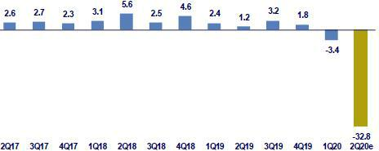

Fuente: INEI

As the COVID-19 pandemic developed, the economy went into nation-wide lockdown for 107 days (from March 16th to June 30th). The lockdown severely affected national production levels. In April, national production declined 40.5% YoY and in May, it fell 32.8% YoY. These contractions were observed in both the primary sectors (Apr/May-20: -28% YoY) and non-primary sectors (Apr/May-20: -39% YoY). Similarly, according to preliminary indicators, economic activity decreased between 20% - 25% YoY in June. Based on these results, our estimates indicate that GDP declined 33% YoY in the second quarter of 2020.

54

Despite the harsh blow to national economic activity, certain signs of recovery have begun to appear. For example, electricity demand has only registered a decline of 6% YoY in July, after having suffered double digit declines in the three previous months (April: -30%, May: -25%, June: -12%). Similarly, our aggregated weekly indicator suggests that consumption has recovered 77% of the level registered pre-pandemic (in the last week of July). Based on aggregated transactions through BCP’s credit and debit cards, as well as non-monetary variables (such as Metropolitano tickets, poultry sales, transactions via telecommunications, and delivery apps), we have constructed an aggregated index to track the evolution of household consumption in real time.

In our opinion, GDP figures will not post a contraction similar to the one registered during the second quarter of 2020. Despite uncertainty surrounding COVID-19’s evolution in Peru, we believe it is highly unlikely that a nation-wide lockdown like the one imposed between March 16th and June 30st will be instituted going forward. If a new lockdown were necessary, we expect it to be focalized. As such, the worst appears to be behind us in terms of effects on GDP.

Inflation and Monetary Policy rate (%)
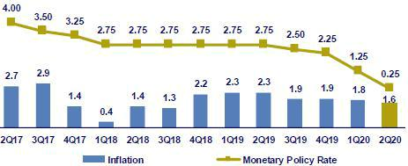

Source: INEI, BCRP

The headline inflation rate closed the second quarter of 2020 at 1.6% YoY (1Q20: 1.8%), a 9-quarter minimum that fell slightly below the midpoint of the

target range (1%-3%). In parallel, core inflation (excluding food and energy) accelerated to 1.9% YoY (1Q20: 1.7%).

The reference rate has been maintained at 0.25% since April, when it was cut 100bps during the monthly monetary policy meeting. In the last monetary policy meeting, held in July, the Central Bank stressed for the third consecutive month that “the Board considers it appropriate to maintain a strong monetary stimulus for a prolonged period as the negative effects of the pandemic continue to pressure inflation and its determinants. The Central Bank remains vigilant and is prepared to increase monetary stimulus through several mechanisms”. The government has launched the second phase of the “Reactiva Peru” program (each phase is made up of PEN 30 billion), a loan program for working capital, where liquidity is provided by the Central Bank and loans have government-backed guarantees. Through this program, as well as other Central Bank operations, the Central Bank has provided unprecedented levels of liquidity.

Fiscal Result and Current Account Balance (% of GDP, Quarter)
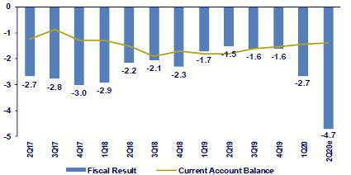

Source: BCRP

*BCP estimates

55

In the second quarter of 2020, fiscal revenues fell 37% YoY in real terms (1Q20: -5.5%), the worst decline registered since the data is available. The sharp drop can be explained by a drop in income from the value added tax (37% YoY) and property tax (22% YoY). These declines are attributable to a decrease in economic activity and to measures to postpone tax payments amid the national emergency. In 2Q20, non-financial government spending dropped by 10% YoY in real terms (1Q20: +12%). Even though current expenses grew 6% YoY, public spending fell 74% YoY in real terms.

From January to May 2020, the trade balance posted a surplus of USD 230 million, 87% below the number recorded for the same period in 2019. Exports fell 26% YoY during the same period (4.8% YoY drop in price and 22.9% YoY decline in volume). Traditional exports such as copper declined 28% YoY whereas non-traditional exports fell 19% YoY. It is important to note that in 2Q20, the price of copper rose to USD/lb. 2.95. Imports also fell, registering a decline of 19.5% YoY where the most affected sectors were raw materials (-20.5% YoY) and capital goods (-20.2% YoY). Terms of trade grew 0.8% YoY in the same period.

Exchange rate (S/ per US$)

Source: SBS

The exchange rate closed 2Q20 at USDPEN 3.538. Consequently, the Peruvian Sol depreciated 2.9% compared to 1Q20’s closing rate (USDPEN 3.437). After having reached USDPEN 3.57 on March 18th (below the historic maximum: USDPEN 3.65 in September 2002) in a context marked by escalating risk aversion in global financial markets, the Peruvian Sol appreciated in April. In May, USDPEN ranged between 3.40-3.45 in a financial landscape where monetary stimulus measures favored emerging markets. In June, two factors drove the depreciation of the Peruvian Sol and the increase of USDPEN to 3.50:

- the increase in global risk aversion due to the threat of a second wave of COVID-19 infections, and (2) a local increase in demand for USD as the banking system’s position in USD remained light. As a result, the Peruvian Sol depreciated despite the ascent in the price of copper.

In 2Q20, the Central Bank intervened in the exchange rate market to mitigate PEN’s volatility. Initially, the institution bought USD 32 million in April (at levels between USDPEN 3.35 and 3.37). In May, the institution sold USD 7 million in May (at USDPEN 3.44). Additionally, in 2Q20 (mainly in May and June), the Central Bank issued USD 683 million in BCRP Re-adjustable Deposit Certificates and USD 1,629 million in FX Swaps (sales) to mitigate the depreciation of the Peruvian Sol. At the end of 2Q20, net international reserves stood at USD 71.4 billion, which represented an increase of USD 3.4 million with regard to the level in 1Q20. The FX position at the end of 2Q20 was situated at USD 46.1 billion, which reflected an increase of USD 2.5 billion compared to 1Q20.

Finally, at 2Q20’s closing, the region’s currencies showed mixed results with respect to 1Q20. The Colombian Peso (+7.6%), Chilean Peso (+3.8%) and Mexican Peso (+2.9%) appreciated while the Brazilian Real depreciated (-5.0%).

56

Safe Harbor for Forward-Looking Statements

This material includes “forward-looking statements” within the meaning of Section 21E of the Securities Exchange Act of 1934. All statements other than statements of historical information provided herein are forward-looking and may contain information about financial results, economic conditions, trends and known uncertainties. Forward-looking statements are neither historical facts nor assurances of future performance. Instead, they are based only on the Company’s current beliefs, expectations and assumptions regarding the future of our business, future plans and strategies, projections, anticipated events and trends, the economy and other future conditions.

Forward-looking statements can be identified by words such as: "anticipate”, "intend", "plan", "goal”, "seek”, "believe”, "project", "estimate”, "expect", "strategy”, "future”, "likely”, "may”, "should”, "will" and similar references to future periods. Examples of forward-looking statements include, among others, statements or estimates we make regarding guidance relating to Return on Average Equity, Sustainable Return on Average Equity, Cost of Risk, Loan growth, Efficiency ratio, BCP Stand-alone Common Equity Tier 1 Capital ratio and Net Interest Margin, current or future volatility in the credit markets and future market conditions, expected macroeconomic conditions, our belief that we have sufficient liquidity to fund our business operations during the next year, expectations of the effect on our financial condition of claims, litigation, environmental costs, contingent liabilities and governmental and regulatory investigations and proceedings, strategy for customer retention, growth, product development, market position, financial results and reserves and strategy for risk management.

The Company cautions readers that actual results could differ materially from those expected by the Company, depending on the outcome of certain factors, including, without limitation: (1) adverse changes in the Peruvian economy with respect to the rates of inflation, economic growth, currency devaluation, and other factors, (2) adverse changes in the Peruvian political situation, including, without limitation, the reversal of market-oriented reforms and economic recovery measures, or the failure of such measures and reforms to achieve their goals, and (3) adverse changes in the markets in which the Company operates, including increased competition, decreased demand for financial services, and other factors. Readers are cautioned not to place undue reliance on these forward-looking statements, which speak only as of the date hereof. Our actual results and financial condition may differ materially from those indicated in the forward-looking statements. Therefore, you should not rely on any of these forward-looking statements.

Any forward-looking statement made in this material is based only on information currently available to the Company and speaks only as of the date on which it is made. The Company undertakes no obligation to release publicly the result of any revisions to these forward-looking statements which may be made to reflect events or circumstances after the date hereof, including, without limitation, changes in the Company’s business strategy or planned capital expenditures, or to reflect the occurrence of unanticipated events

57

- Appendix

- Credicorp

CREDICORP LTD. AND SUBSIDIARIES

CONSOLIDATED STATEMENT OF FINANCIAL POSITION

(In S/ thousands, IFRS)

 |  |  | As of |  |  |  | % change
 | Jun 2019 |  | Mar 2020 |  | Jun 2020 |  | QoQ |  |  | YoY
ASSETS
Cash and due from banks ⁽¹⁾
Non-interest bearing | 6,350,168 |  | 6,787,357 |  | 6,685,864 |  | -1.5% |  |  | 5.3%
Interest bearing | 17,488,649 |  | 19,538,429 |  | 29,430,518 |  | 50.6% |  |  | 68.3%
Total cash and due from banks | 23,838,817 |  | 26,325,786 |  | 36,116,382 |  | 37.2% |  |  | 51.5%
Cash collateral, reverse repurchase agreements and securities borrowing ⁽¹⁾ | 4,445,749 |  | 4,424,345 |  | 2,920,789 |  | -34.0% |  |  | -34.3%
Fair value through profit or loss investments | 4,024,490 |  | 4,185,638 |  | 5,118,994 |  | 22.3% |  |  | 27.2%
Fair value through other comprehensive income investments | 26,800,577 |  | 28,388,372 |  | 32,213,665 |  | 13.5% |  |  | 20.2%
Amortized cost investments | 3,589,360 |  | 4,242,643 |  | 4,304,385 |  | 1.5% |  |  | 19.9%
Loans | 109,381,123 |  | 120,708,515 |  | 132,741,720 |  | 10.0% |  |  | 21.4%
Current | 106,095,844 |  | 117,129,011 |  | 128,898,890 |  | 10.0% |  |  | 21.5%
Internal overdue loans | 3,285,279 |  | 3,579,504 |  | 3,842,830 |  | 7.4% |  |  | 17.0%
Less - allowance for loan losses | (4,878,150) |  | (5,931,772) |  | (8,412,544) |  | 41.8% |  |  | 72.5%
Loans, net | 104,502,973 |  | 114,776,743 |  | 124,329,176 |  | 8.3% |  |  | 19.0%
Financial assets designated at fair value through profit or loss ⁽²⁾ | 588,074 |  | 559,321 |  | 662,634 |  | 18.5% |  |  | 12.7%
Accounts receivable from reinsurers and coinsurers | 862,521 |  | 787,672 |  | 817,773 |  | 3.8% |  |  | -5.2%
Premiums and other policyholder receivables | 884,572 |  | 822,669 |  | 799,644 |  | -2.8% |  |  | -9.6%
Property, plant and equipment, net ⁽³⁾ | 2,235,241 |  | 2,203,086 |  | 2,122,445 |  | -3.7% |  |  | -5.0%
Due from customers on acceptances | 534,637 |  | 555,598 |  | 331,591 |  | -40.3% |  |  | -38.0%
Investments in associates ⁽⁴⁾ | 576,333 |  | 618,310 |  | 626,992 |  | 1.4% |  |  | 8.8%
Intangible assets and goodwill, net | 2,061,611 |  | 2,424,404 |  | 2,474,740 |  | 2.1% |  |  | 20.0%
Other assets ⁽⁵⁾ | 5,539,096 |  | 7,507,302 |  | 8,673,717 |  | 15.5% |  |  | 56.6%
Total Assets | 180,484,051 |  | 197,821,889 |  | 221,512,927 |  | 12.0% |  |  | 22.7%
LIABILITIES AND EQUITY
Deposits and obligations
Non-interest bearing | 25,339,482 |  | 32,231,854 |  | 41,310,487 |  | 28.2% |  |  | 63.0%
Interest bearing | 77,817,562 |  | 87,331,691 |  | 88,353,845 |  | 1.2% |  |  | 13.5%
Total deposits and obligations | 103,157,044 |  | 119,563,545 |  | 129,664,332 |  | 8.4% |  |  | 25.7%
Payables from repurchase agreements and securities lending | 10,448,517 |  | 8,254,726 |  | 22,437,742 |  | 171.8% |  |  | 114.7%
BCRP instruments | 6,304,186 |  | 5,346,373 |  | 19,441,733 |  | 263.6% |  |  | 208.4%
Repurchase agreements with third parties | 2,455,665 |  | 1,935,879 |  | 2,091,798 |  | 8.1% |  |  | -14.8%
Repurchase agreements with customers | 1,688,666 |  | 972,474 |  | 904,211 |  | -7.0% |  |  | -46.5%
Due to banks and correspondents | 9,222,278 |  | 9,854,630 |  | 8,374,009 |  | -15.0% |  |  | -9.2%
Bonds and notes issued | 15,058,760 |  | 15,178,148 |  | 17,250,531 |  | 13.7% |  |  | 14.6%
Banker’s acceptances outstanding | 534,637 |  | 555,598 |  | 331,591 |  | -40.3% |  |  | -38.0%
Reserves for property and casualty claims | 1,525,832 |  | 1,637,791 |  | 1,791,871 |  | 9.4% |  |  | 17.4%
Reserve for unearned premiums | 7,412,792 |  | 8,338,154 |  | 8,839,019 |  | 6.0% |  |  | 19.2%
Accounts payable to reinsurers | 302,079 |  | 198,473 |  | 221,118 |  | 11.4% |  |  | -26.8%
Financial liabilities at fair value through profit or loss ⁽⁶⁾ | 548,367 |  | 533,146 |  | 480,952 |  | -9.8% |  |  | -12.3%
Other liabilities | 6,607,565 |  | 9,984,867 |  | 8,245,706 |  | -17.4% |  |  | 24.8%
Total Liabilities | 154,817,871 |  | 174,099,078 |  | 197,636,871 |  | 13.5% |  |  | 27.7%
Net equity | 25,221,894 |  | 23,205,639 |  | 23,396,028 |  | 0.8% |  |  | -7.2%
Capital stock | 1,318,993 |  | 1,318,993 |  | 1,318,993 |  | 0.0% |  |  | 0.0%
Treasury stock | (207,839) |  | (209,309) |  | (209,309) |  | 0.0% |  |  | 0.7%
Capital surplus | 227,380 |  | 165,188 |  | 160,430 |  | -2.9% |  |  | -29.4%
Reserves | 19,423,324 |  | 21,360,272 |  | 21,381,402 |  | 0.1% |  |  | 10.1%
Unrealized gains and losses | 1,541,235 |  | 359,565 |  | 1,151,939 |  | 220.4% |  |  | -25.3%
Retained earnings | 2,918,801 |  | 210,930 |  | (407,427) |  | -293.2% |  |  | -114.0%
Non-controlling interest | 444,286 |  | 517,172 |  | 480,028 |  | -7.2% |  |  | 8.0%
Total Net Equity | 25,666,180 |  | 23,722,811 |  | 23,876,056 |  | 0.6% |  |  | -7.0%
Total liabilities and equity | 180,484,051 |  | 197,821,889 |  | 221,512,927 |  | 12.0% |  |  | 22.7%
Off-balance sheet | 125,418,778 |  | 131,725,399 |  | 129,132,266 |  | -2.0% |  |  | 3.0%
Total performance bonds, stand-by and L/Cs. | 19,666,170 |  | 20,426,402 |  | 19,271,152 |  | -5.7% |  |  | -2.0%
Undrawn credit lines, advised but not committed | 76,368,545 |  | 79,703,253 |  | 80,651,014 |  | 1.2% |  |  | 5.6%
Total derivatives (notional) and others | 29,384,063 |  | 31,595,744 |  | 29,210,100 |  | -7.6% |  |  | -0.6%

- The amounts differ from those previously reported in 2018 period, due to the reclassification to the item "Cash collateral, reverse repurchase agreements and securities borrowing" mainly for the cash collateral in dollars delivered to the BCRP, previously presented in the item "Cash and due from banks".

- In the 2019 period, this item was opened in the statement of financial position; previously presented under the item "Investments at fair value through profit or loss".
- The amounts differ from those previously reported in 2018 period, due to the reclassification of the expenses on improvements in building for rent, previously presented in the item “Other assets”. Likewise, in the period 2019, the asset for the right to use the lease contracts was incorporated, in application of IFRS 16.

- Includes investments in associates, mainly Banmedica and Visanet, among others.

- Includes mainly accounts receivables from brokerage and others.

- In the 2019 period, this item was opened in the statement of financial position; previously presented in the item "Other liabilities".

58

CREDICORP LTD. AND SUBSIDIARIES

CONSOLIDATED STATEMENT OF INCOME

(In S/ thousands, IFRS)

 |  |  | Quarter |  |  |  | % change |  |  |  |  | YTD |  |  |  |  |  | % change
 | 2Q19 |  | 1Q20 |  | 2Q20 |  | QoQ |  |  | YoY |  | Jun 19 |  |  | Jun 20 |  |  | Jun 20/ Jun 19
Interest income and expense
Interest and dividend income | 3,083,623 |  | 3,163,609 |  | 2,727,369 |  | -13.8% |  |  | -11.6% |  | 6,085,297 |  |  | 5,890,978 |  | -3.2%
Interest expense ⁽¹⁾ | (831,220) |  | (784,309) |  | (766,241) |  | -2.3% |  |  | -7.8% |  | (1,635,726) |  |  | (1,550,550) |  | -5.2%
Net interest income | 2,252,403 |  | 2,379,300 |  | 1,961,128 |  | -17.6% |  |  | -12.9% |  | 4,449,571 |  |  | 4,340,428 |  | -2.5%
Gross provision for credit losses on loan portfolio | (510,045) |  | (1,388,711) |  | (2,557,658) |  | 84.2% |  |  | 401.5% |  | (963,330) |  |  | (3,946,369) |  | 309.7%
Recoveries of written-off loans | 61,751 |  | 47,230 |  | 17,201 |  | -63.6% |  |  | -72.1% |  | 131,825 |  |  | 64,431 |  | -51.1%
Provision for credit losses on loan portfolio, net of recoveries | (448,294) |  | (1,341,481) |  | (2,540,457) |  | 89.4% |  |  | 466.7% |  | (831,505) |  |  | (3,881,938) |  | 366.9%
 | - |  | - |  | -
Risk-adjusted net interest income | 1,804,109 |  | 1,037,819 |  | (579,329) |  | -155.8% |  |  | -132.1% |  | 3,618,066 |  |  | 458,490 |  | -87.3%
Non-financial income
Fee income | 787,250 |  | 760,329 |  | 503,488 |  | -33.8% |  |  | -36.0% |  | 1,570,172 |  |  | 1,263,817 |  | -19.5%
Net gain on foreign exchange transactions | 188,358 |  | 166,983 |  | 149,308 |  | -10.6% |  |  | -20.7% |  | 366,781 |  |  | 316,291 |  | -13.8%
Net gain on sales of securities ⁽²⁾ | 100,987 |  | (120,633) |  | 280,563 |  | -332.6% |  |  | 177.8% |  | 214,532 |  |  | 159,930 |  | -25.5%
Net gain from associates ⁽²⁾⁽³⁾ | 20,478 |  | 19,225 |  | 14,906 |  | -22.5% |  |  | -27.2% |  | 35,264 |  |  | 34,131 |  | -3.2%
Net gain on derivatives held for trading | (724) |  | 35,430 |  | 8,358 |  | 76.4% |  |  | -1254.4% |  | (3,158) |  |  | 43,788 |  | -1486.6%
Net gain from exchange differences | 63 |  | (21,240) |  | 23,531 |  | -210.8% |  |  | 37250.8% |  | 13,553 |  |  | 2,291 |  | -83.1%
Other non-financial income | 98,703 |  | 117,770 |  | 35,196 |  | -70.1% |  |  | -64.3% |  | 174,308 |  |  | 152,966 |  | -12.2%
Total non-financial income | 1,195,115 |  | 957,864 |  | 1,015,350 |  | 6.0% |  |  | -15.0% |  | 2,371,452 |  |  | 1,973,214 |  | -16.8%
Insurance underwriting result
Net earned premiums | 584,579 |  | 627,935 |  | 552,061 |  | -12.1% |  |  | -5.6% |  | 1,168,788 |  |  | 1,179,996 |  | 1.0%
Net claims | (374,688) |  | (373,502) |  | (328,783) |  | -12.0% |  |  | -12.3% |  | (758,505) |  |  | (702,285) |  | -7.4%
Acquisition cost ⁽⁴⁾ | (91,666) |  | (112,507) |  | (87,598) |  | -22.1% |  |  | -4.4% |  | (182,947) |  |  | (200,105) |  | 9.4%
Total insurance underwriting result | 118,225 |  | 141,926 |  | 135,680 |  | -4.4% |  |  | 14.8% |  | 227,336 |  |  | 277,606 |  | 22.1%
Total expenses
Salaries and employee benefits | (845,835) |  | (891,183) |  | (825,997) |  | -7.3% |  |  | -2.3% |  | (1,680,152) |  |  | (1,717,180) |  | 2.2%
Administrative, general and tax expenses | (552,653) |  | (539,644) |  | (508,078) |  | -5.8% |  |  | -8.1% |  | (1,090,810) |  |  | (1,047,722) |  | -4.0%
Depreciation and amortization ⁽⁵⁾ | (158,663) |  | (171,748) |  | (171,439) |  | -0.2% |  |  | 8.1% |  | (289,988) |  |  | (343,187) |  | 18.3%
Impairment loss on goodwill | - |  | - |  | - |  | - |  |  | -
Association in participation ⁽⁶⁾ | (4,746) |  | (6,430) |  | (17,944) |  | 179.1% |  |  | 278.1% |  | (7,482) |  |  | (24,374) |  | 225.8%
Other expenses | (20,555) |  | (169,630) |  | (104,454) |  | -38.4% |  |  | 408.2% |  | (67,996) |  |  | (274,084) |  | 303.1%
Total expenses | (1,582,452) |  | (1,778,635) |  | (1,627,912) |  | -8.5% |  |  | 2.9% |  | (3,136,428) |  |  | (3,406,547) |  | 8.6%
Profit before income tax | 1,534,997 |  | 358,974 |  | (1,056,211) |  | -394.2% |  |  | -168.8% |  | 3,080,426 |  |  | (697,237) |  | -122.6%
Income tax | (414,466) |  | (145,799) |  | 414,775 |  | -384.5% |  |  | -200.1% |  | (836,631) |  |  | 268,976 |  | -132.1%
Net profit | 1,120,531 |  | 213,175 |  | (641,436) |  | -400.9% |  |  | -157.2% |  | 2,243,795 |  |  | (428,261) |  | -119.1%
Non-controlling interest | 21,958 |  | 3,901 |  | (21,046) |  | -639.5% |  |  | -195.8% |  | 44,355 |  |  | (17,145) |  | -138.7%
Net profit attributable to Credicorp | 1,098,573 |  | 209,274 |  | (620,390) |  | -396.4% |  |  | -156.5% |  | 2,199,440 |  |  | (411,116) |  | -118.7%

- As of 2019, financing expenses related to lease agreements is included according to the application of IFRS 16.

- Starting in 2019 the gain from other investments in related companies has been included in the item "Net gain in associates"; which previously was presented in the item "Net gain on securities".
- Includes gains on other investments, mainly made up of the profit of Banmedica.

- The acquisition cost of Pacifico includes net fees and underwriting expenses.

- From 1Q19, the effect is being incorporated by the application of IFRS 16, which corresponds to a greater depreciation for the asset for right-of-use". Likewise, the expenses related to the depreciation of improvements in building for rent is being reclassified to the item "Other expenses".
- From this quarter, the item “Association in participation” was incorporated, which previously was presented in the item “Net gain on securities”

59

11.2. Credicorp Stand-alone
 | Credicorp Ltd.
 | Separate Statement of Financal Position
 | (In S/ thousands, IFRS)
 |  |  | As of
 |  |  | Jun-20
 | ASSETS
 | Cash and cash equivalents |  | 1,817,197
 | Fair value through other comprehensive income investments |  | 469,393
 | In subsidiaries and associates investments |  | 27,118,956
 | Total Assets |  | 29,405,546
 | LIABILITIES AND NET SHAREHOLDERS' EQUITY
 | Bonds and notes issued |  | 1,756,654
 | Other liabilities |  | 102,383
 | Total Liabilities |  | 1,859,037
 | NET EQUITY
 | Capital stock |  | 1,318,993
 | Capital Surplus |  | 384,542
 | Reserve |  | 21,070,409
 | Unrealized results |  | 935,610
 | Retained earnings |  | 3,837,046
 | Total net equity |  | 27,546,600
 | Total Liabilities And Equity |  | 29,405,637
 |  |  | Quarter
 |  |  | 2Q20
 | Interest income
 | Net share of the income from investments in subsidiaries and associates |  | 45,010
 | Interest and similar income |  | 939
 | Total interest income |  | 45,949
 | Administrative and general expenses |  | (11,340)
 | Total expenses |  | (11,340)
 | Operating income |  | 69,218
 | Exchange differences, net |  | (4,073)
 | Other, net |  | (1,972)
 |  |  | (6,045)
 | Profit before income tax |  | 63,173
 | Income tax |  | (32,986)
 | Net income |  | 30,187
 | Double Leverage Ratio |  | 98.45%

60

11.3. BCP Consolidated

BANCO DE CREDITO DEL PERU AND SUBSIDIARIES

CONSOLIDATED STATEMENT OF FINANCIAL POSITION

(In S/ thousands, IFRS)

 |  |  | As of |  |  |  | % change
 | Jun 2019 |  | Mar 2020 |  | Jun 2020 |  | QoQ |  |  | YoY
ASSETS
Cash and due from banks
Non-interest bearing | 5,039,035 |  | 4,957,324 |  | 5,041,371 |  | 1.7% |  |  | 0.0%
Interest bearing | 16,660,085 |  | 18,437,537 |  | 26,863,958 |  | 45.7% |  |  | 61.2%
Total cash and due from banks | 21,699,120 |  | 23,394,861 |  | 31,905,329 |  | 36.4% |  |  | 47.0%
Cash collateral, reverse repurchase agreements
and securities borrowing | 3,255,249 |  | 3,324,737 |  | 1,987,570 |  | -40.2% |  |  | -38.9%
Fair value through profit or loss investments | 516,973 |  | 883,548 |  | 1,630,272 |  | 84.5% |  |  | 215.3%
Fair value through other comprehensive income
investments | 15,626,554 |  | 16,062,998 |  | 18,724,601 |  | 16.6% |  |  | 19.8%
Amortized cost investments | 3,347,118 |  | 4,223,311 |  | 4,280,002 |  | 1.3% |  |  | 27.9%
Loans | 99,791,392 |  | 110,087,710 |  | 121,391,338 |  | 10.3% |  |  | 21.6%
Current | 96,649,966 |  | 106,693,682 |  | 117,707,704 |  | 10.3% |  |  | 21.8%
Internal overdue loans | 3,141,426 |  | 3,394,028 |  | 3,683,634 |  | 8.5% |  |  | 17.3%
Less - allowance for loan losses | (4,637,969) |  | (5,571,581) |  | (7,910,329) |  | 42.0% |  |  | 70.6%
Loans, net | 95,153,423 |  | 104,516,129 |  | 113,481,009 |  | 8.6% |  |  | 19.3%
Property, furniture and equipment, net ⁽¹⁾ | 1,978,509 |  | 1,926,344 |  | 1,837,161 |  | -4.6% |  |  | -7.1%
Due from customers on acceptances | 534,637 |  | 555,598 |  | 331,591 |  | -40.3% |  |  | -38.0%
Other assets ⁽²⁾ | 4,641,232 |  | 5,937,221 |  | 7,295,908 |  | 22.9% |  |  | 57.2%
Total Assets | 146,752,815 |  | 160,824,747 |  | 181,473,443 |  | 12.8% |  |  | 23.7%
Liabilities and Equity
Deposits and obligations
Non-interest bearing ⁽¹⁾ | 23,243,024 |  | 29,496,275 |  | 44,355,291 |  | 50.4% |  |  | 90.8%
Interest bearing ⁽¹⁾ | 69,210,922 |  | 76,834,615 |  | 70,151,519 |  | -8.7% |  |  | 1.4%
Total deposits and obligations | 92,453,946 |  | 106,330,890 |  | 114,506,810 |  | 7.7% |  |  | 23.9%
Payables from repurchase agreements and
securities lending | 8,019,941 |  | 6,781,667 |  | 20,912,125 |  | 208.4% |  |  | 160.8%
BCRP instruments | 6,304,186 |  | 5,346,373 |  | 19,441,733 |  | 263.6% |  |  | 208.4%
Repurchase agreements with third parties | 1,715,756 |  | 1,435,294 |  | 1,470,392 |  | 2.4% |  |  | -14.3%
Due to banks and correspondents | 9,280,977 |  | 9,035,804 |  | 8,205,084 |  | -9.2% |  |  | -11.6%
Bonds and notes issued | 14,429,601 |  | 14,570,806 |  | 14,964,339 |  | 2.7% |  |  | 3.7%
Banker’s acceptances outstanding | 534,637 |  | 555,598 |  | 331,591 |  | -40.3% |  |  | -38.0%
Financial liabilities at fair value through profit or
loss | 70,459 |  | 9,131 |  | 108,189 |  | - |  |  | 53.5%
Other liabilities ⁽³⁾ | 4,309,665 |  | 4,708,160 |  | 5,378,042 |  | 14.2% |  |  | 24.8%
Total Liabilities | 129,099,226 |  | 141,992,056 |  | 164,406,180 |  | 15.8% |  |  | 27.3%
Net equity | 17,539,343 |  | 18,714,668 |  | 16,963,220 |  | -9.4% |  |  | -3.3%
Capital stock | 9,924,006 |  | 9,924,006 |  | 10,774,006 |  | 8.6% |  |  | 8.6%
Reserves | 4,476,256 |  | 4,476,256 |  | 5,945,313 |  | 32.8% |  |  | 32.8%
Unrealized gains and losses | 235,391 |  | (22,277) |  | 333,548 |  | -1597.3% |  |  | 41.7%
Retained earnings | 2,903,690 |  | 4,336,683 |  | (89,647) |  | -102.1% |  |  | -103.1%
Non-controlling interest | 114,246 |  | 118,023 |  | 104,043 |  | -11.8% |  |  | -8.9%
Total Net Equity | 17,653,589 |  | 18,832,691 |  | 17,067,263 |  | -9.4% |  |  | -3.3%
Total liabilities and equity | 146,752,815 |  | 160,824,747 |  | 181,473,443 |  | 12.8% |  |  | 23.7%
Off-balance sheet | 112,550,680 |  | 119,606,613 |  | 115,150,387 |  | -3.7% |  |  | 2.3%
Total performance bonds, stand-by and L/Cs. | 17,678,879 |  | 18,238,079 |  | 17,490,615 |  | -4.1% |  |  | -1.1%
Undrawn credit lines, advised but not committed | 67,316,327 |  | 71,174,841 |  | 70,509,409 |  | -0.9% |  |  | 4.7%
Total derivatives (notional) and others | 27,555,474 |  | 30,193,693 |  | 27,150,363 |  | -10.1% |  |  | -1.5%

- The amounts differ from those previously reported due to the reclassification of the expenses on improvements in building for rent, previously presented in the item “Other assets”. Likewise, in the 2019 the asset is incorporated for the right to use the lease contracts, in application of the IFRS 16.

- Mainly includes intangible assets, other receivable accounts and tax credit.

- Mainly includes other payable accounts.

61

BANCO DE CREDITO DEL PERU AND SUBSIDIARIES

CONSOLIDATED STATEMENT OF INCOME

(In S/ thousands, IFRS)

 |  |  | Quarter |  |  |  | % change |  |  |  |  | YTD |  |  |  |  | % change
 | 2Q19 |  | 1Q20 |  | 2Q20 |  | QoQ |  |  | YoY |  | Jun-19 |  |  | Jun-20 |  | Jun 20 / Jun 19
Interest income and expense
Interest and dividend income | 2,727,447 |  | 2,763,923 |  | 2,325,119 |  | -15.9% |  |  | -14.8% |  | 5,383,662 |  |  | 5,089,042 |  | -5.5%
Interest expense ⁽¹⁾ | (720,921) |  | (660,975) |  | (636,539) |  | -3.7% |  |  | -11.7% |  | (1,411,077) |  |  | (1,297,514) |  | -8.0%
Net interest income | 2,006,526 |  | 2,102,948 |  | 1,688,580 |  | -19.7% |  |  | -15.8% |  | 3,972,585 |  |  | 3,791,528 |  | -4.6%
Provision for credit losses on loan portfolio | (494,492) |  | (1,340,975) |  | (2,425,753) |  | 80.9% |  |  | 390.6% |  | (931,706) |  |  | (3,766,728) |  | 304.3%
Recoveries of written-off loans | 60,861 |  | 43,954 |  | 16,184 |  | -63.2% |  |  | -73.4% |  | 130,697 |  |  | 60,138 |  | -54.0%
Provision for credit losses on loan
portfolio, net of recoveries | (433,631) |  | (1,297,021) |  | (2,409,569) |  | 85.8% |  |  | 455.7% |  | (801,009) |  |  | (3,706,590) |  | 362.7%
Risk-adjusted net interest income | 1,572,895 |  | 805,927 |  | (720,989) |  | -189.5% |  |  | -145.8% |  | 3,171,576 |  |  | 84,938 |  | -97.3%
Non-financial income
Fee income | 635,782 |  | 602,585 |  | 379,933 |  | -36.9% |  |  | -40.2% |  | 1,268,108 |  |  | 982,518 |  | -22.5%
Net gain on foreign exchange transactions | 184,131 |  | 177,407 |  | 143,905 |  | -18.9% |  |  | -21.8% |  | 354,150 |  |  | 321,312 |  | -9.3%
Net gain on securities | 20,431 |  | (31,791) |  | 72,350 |  | -327.6% |  |  | 254.1% |  | 26,301 |  |  | 40,559 |  | 54.2%
Net gain on derivatives held for trading | 12,918 |  | (568) |  | 34,979 |  | -6258.3% |  |  | 170.8% |  | 25,588 |  |  | 34,411 |  | 34.5%
Net gain from exchange differences | 4,618 |  | (19,548) |  | 8,495 |  | -143.5% |  |  | 84.0% |  | 15,479 |  |  | (11,053) |  | -171.4%
Others | 47,128 |  | 92,808 |  | 21,512 |  | -76.8% |  |  | -54.4% |  | 97,913 |  |  | 114,320 |  | 16.8%
Total other income | 905,008 |  | 820,893 |  | 661,174 |  | -19.5% |  |  | -26.9% |  | 1,787,539 |  |  | 1,482,067 |  | -17.1%
Total expenses
Salaries and employee benefits | (638,802) |  | (657,774) |  | (589,893) |  | -10.3% |  |  | -7.7% |  | (1,265,570) |  |  | (1,247,667) |  | -1.4%
Administrative expenses | (503,987) |  | (404,917) |  | (378,687) |  | -6.5% |  |  | -24.9% |  | (963,353) |  |  | (783,604) |  | -18.7%
Depreciation and amortization ⁽²⁾ | (63,593) |  | (133,928) |  | (134,137) |  | 0.2% |  |  | 110.9% |  | (134,947) |  |  | (268,065) |  | 98.6%
Other expenses | (27,943) |  | (151,363) |  | (77,386) |  | -48.9% |  |  | 176.9% |  | (59,033) |  |  | (228,749) |  | 287.5%
Total expenses | (1,234,325) |  | (1,347,982) |  | (1,180,103) |  | -12.5% |  |  | -4.4% |  | (2,422,903) |  |  | (2,528,085) |  | 4.3%
Profit before income tax | 1,243,578 |  | 278,838 |  | (1,239,918) |  | -544.7% |  |  | -199.7% |  | 2,536,212 |  |  | (961,080) |  | -137.9%
Income tax | (334,458) |  | (97,582) |  | 422,109 |  | -532.6 % |  |  | -226.2 % |  | (689,536) |  |  | 324,527 |  | -147.1%
Net profit | 909,120 |  | 181,256 |  | (817,809) |  | -551.2% |  |  | -190.0% |  | 1,846,676 |  |  | (636,553) |  | -134.5%
Non-controlling interest | (4,844) |  | (1,534) |  | 14,266 |  | -1030.0% |  |  | -394.5 % |  | (9,775) |  |  | 12,732 |  | -230.3%
Net profit attributable to BCP
Consolidated | 904,276 |  | 179,722 |  | (803,543) |  | -547.1% |  |  | -188.9% |  | 1,836,901 |  |  | (623,821) |  | -134.0%

- As of 2019, financing expenses related to lease agreements is included according to the application of IFRS 16.

- From this quarter, the effect is being incorporated by the application of IFRS 16, which corresponds to a greater depreciation for the asset for right-of-use". Likewise, the expenses related to the depreciation of improvements in building for rent is being reclassified to the item "Other expenses".

62

BANCO DE CREDITO DEL PERU AND SUBSIDIARIES

SELECTED FINANCIAL INDICATORS

 |  |  | Quarter |  |  |  | YTD
 | 2Q19 |  | 1Q20 |  | 2Q20 |  | Jun 19 |  |  | Jun 20
Profitability
Earnings per share ⁽¹⁾ | 0.082 |  | 0.016 |  | (0.073) |  | 0.166 |  |  | (0.056)
_{ROAA} (2)(3) | 2.5% |  | 0.5% |  | -1.9% |  | 2.9% |  |  | 2.4%
_{ROAE} (2)(3) | 21.2% |  | 3.8% |  | -18.0% |  | 10.6% |  |  | -3.5%
Net interest margin ⁽²⁾⁽³⁾ | 5.82% |  | 5.65% |  | 4.12% |  | 2.92% |  |  | 2.37%
Risk adjusted NIM ⁽²⁾⁽³⁾ | 4.56% |  | 2.16% |  | -1.76% |  | 2.33% |  |  | 0.05%
Funding Cost ⁽²⁾⁽³⁾⁽⁴⁾ | 2.35% |  | 1.99% |  | 1.72% |  | 1.14% |  |  | 0.90%
Quality of loan portfolio
IOL ratio | 3.15% |  | 3.08% |  | 3.03% |  | 3.15% |  |  | 3.03%
NPL ratio | 4.34% |  | 4.09% |  | 3.99% |  | 4.34% |  |  | 3.99%
Coverage of IOLs | 147.6% |  | 164.2% |  | 214.7% |  | 147.6% |  |  | 214.7%
Coverage of NPLs | 107.1% |  | 123.9% |  | 163.5% |  | 107.1% |  |  | 163.5%
Cost of risk ⁽⁵⁾ | 1.74% |  | 4.71% |  | 7.94% |  | 0.80% |  |  | 3.05%
Operating efficiency
Oper. expenses as a percent. of total income - reported ⁽⁶⁾ | 42.4% |  | 41.8% |  | 48.9% |  | 41.9% |  |  | 44.9%
Oper. expenses as a percent. of total income - including all
other items | 42.4% |  | 46.1% |  | 50.2% |  | 42.1% |  |  | 47.9%
Oper. expenses as a percent. of av. tot. assets ⁽²⁾⁽³⁾⁽⁶⁾ | 3.31% |  | 3.06% |  | 2.58% |  | 1.62% |  |  | 1.41%
Capital adequacy ⁽⁷⁾
Total regulatory capital (S/ Million) | 19,138 |  | 19,215 |  | 21,027 |  | 19,138 |  |  | 21,027
Tier 1 capital (S/ Million) ⁽⁸⁾ | 14,504 |  | 14,672 |  | 14,971 |  | 14,504 |  |  | 14,971
Common equity tier 1 ratio ⁽⁹⁾ | 11.82% |  | 11.89% |  | 11.22% |  | 11.82% |  |  | 11.22%
BIS ratio ⁽¹⁰⁾ | 14.95% |  | 13.52% |  | 14.80% |  | 14.95% |  |  | 14.80%
Share Information
N° of outstanding shares (Million) | 11,067 |  | 11,067 |  | 11,067 |  | 11,067 |  |  | 11,067

- Shares outstanding of 10,217 million is used for all periods since shares have been issued only for capitalization of profits.

- Ratios are annualized.

- Averages are determined as the average of period-beginning and period-ending balances.

- The funding costs differs from previously reported due to a methodology change in the denominator, which no longer includes the following accounts: acceptances outstanding, reserves for property and casualty claims, reserve for unearned premiums, reinsurance payable and other liabilities.
- Cost of risk: Annualized provision for loan losses / Total loans.

- Total income includes net interest income, fee income, net gain on foreign exchange transactions, result on exchange difference and net gain on derivatives. Operating expenses includes Salaries and social benefits, administrative, general and tax expenses and depreciation and amortization.
- All capital ratios are for BCP Stand-alone and based on Peru GAAP

- Tier 1 = Capital + Legal and other capital reserves + Accumulated earnings with capitalization agreement + Unrealized profit and net income in subsidiaries - Goodwill - (0.5 x Investment in subsidiaries) + Perpetual subordinated debt (maximum amount that can be included is 17.65% of Capital + Reserves + Accumulated earnings with capitalization agreement + Unrealized profit and net income in subsidiaries - Goodwill).
- Common Equity Tier I = Capital + Reserves – 100% of applicable deductions (investment in subsidiaries, goodwill, intangibles and net deferred taxes that rely on future profitability) + retained earnings + unrealized gains.
- Regulatory capital/ risk-weighted assets. Risk weighted assets include market risk and operational risk.

63

11.4. BCP Stand-alone
 |  | BANCO DE CREDITO DEL PERU
 | STATEMENT OF FINANCIAL POSITION
 |  | (In S/ thousands, IFRS)
 |  |  |  | As of |  |  |  |  | % change
 |  | Jun 2019 |  | Mar 2020 |  |  | Jun 2020 |  | QoQ |  |  | YoY
ASSETS
Cash and due from banks
Non-interest bearing | 4,632,855 |  |  | 4,320,100 |  |  | 4,402,832 |  | 1.9% |  |  | -5.0%
Interest bearing | 16,130,654 |  |  | 18,202,901 |  |  | 26,045,808 |  | 43.1% |  |  | 61.5%
Total cash and due from banks | 20,763,509 |  |  | 22,523,001 |  |  | 30,448,640 |  | 35.2% |  |  | 46.6%
Cash collateral, reverse repurchase agreements
and securities borrowing | 3,255,249 |  |  | 3,324,737 |  |  | 1,987,570 |  | -40.2% |  |  | -38.9%
Fair value through profit or loss investments | 516,973 |  |  | 883,548 |  |  | 1,630,272 |  | 84.5% |  |  | 215.3%
Fair value through other comprehensive income
investments | 16,132,624 |  |  | 16,692,311 |  |  | 19,425,075 |  | 16.4% |  |  | 20.4%
Amortized cost investments | 3,059,858 |  |  | 3,942,806 |  |  | 3,995,043 |  | 1.3% |  |  | 30.6%
Loans | 90,645,086 |  |  | 100,730,089 |  |  | 111,821,212 |  | 11.0% |  |  | 23.4%
Current | 88,060,593 |  |  | 97,920,461 |  |  | 108,857,750 |  | 11.2% |  |  | 23.6%
Internal overdue loans | 2,584,493 |  |  | 2,809,628 |  |  | 2,963,462 |  | 5.5% |  |  | 14.7%
Less - allowance for loan losses | (3,716,743) |  |  | (4,507,844) |  |  | (6,438,182) |  | 42.8% |  |  | 73.2%
Loans, net | 86,928,343 |  |  | 96,222,245 |  |  | 105,383,030 |  | 9.5% |  |  | 21.2%
Property, furniture and equipment, net | 1,579,335 |  |  | 1,523,405 |  |  | 1,447,090 |  | -5.0% |  |  | -8.4%
Due from customers on acceptances | 534,637 |  |  | 555,598 |  |  | 331,591 |  | -40.3% |  |  | -38.0%
Other assets (1) | 3,981,275 |  |  | 5,123,191 |  |  | 6,486,760 |  | 26.6% |  |  | 62.9%
Total Assets | 136,751,803 |  |  | 150,790,842 |  |  | 171,135,071 |  | 13.5% |  |  | 25.1%
Liabilities and Equity
Deposits and obligations
Non-interest bearing | 27,437,778 |  |  | 35,761,340 |  |  | 44,355,685 |  | 24.0% |  |  | 61.7%
Interest bearing | 56,859,259 |  |  | 62,258,736 |  |  | 62,066,600 |  | -0.3% |  |  | 9.2%
Total deposits and obligations | 84,297,037 |  |  | 98,020,076 |  |  | 106,422,285 |  | 8.6% |  |  | 26.2%
Payables from repurchase agreements and
securities lending | 7,807,525 |  |  | 6,722,157 |  |  | 20,656,894 |  | 207.3% |  |  | 164.6%
BCRP instruments | 6,091,769 |  |  | 5,286,863 |  |  | 19,186,502 |  | 262.9% |  |  | 215.0%
Repurchase agreements with third parties | 1,715,756 |  |  | 1,435,294 |  |  | 1,470,392 |  | 2.4% |  |  | -14.3%
Due to banks and correspondents | 8,673,491 |  |  | 8,229,065 |  |  | 7,062,622 |  | -14.2% |  |  | -18.6%
Bonds and notes issued | 14,165,988 |  |  | 14,435,544 |  |  | 14,831,741 |  | 2.7% |  |  | 4.7%
Banker’s acceptances outstanding | 534,637 |  |  | 555,598 |  |  | 331,591 |  | -40.3% |  |  | -38.0%
Financial liabilities at fair value through profit or
loss | 70,459 |  |  | 9,131 |  |  | 108,189 |  | - |  |  | 53.5%
Other liabilities (2) | 3,663,557 |  |  | 4,103,298 |  |  | 4,756,793 |  | 15.9% |  |  | 29.8%
Total Liabilities | 119,212,694 |  |  | 132,074,869 |  |  | 154,170,115 |  | 16.7% |  |  | 29.3%
Net equity | 17,539,109 |  |  | 18,715,973 |  |  | 16,964,956 |  | -9.4% |  |  | -3.3%
Capital stock | 9,924,006 |  |  | 9,924,006 |  |  | 10,774,006 |  | 8.6% |  |  | 8.6%
Reserves | 4,476,256 |  |  | 4,476,256 |  |  | 5,945,313 |  | 32.8% |  |  | 32.8%
Unrealized gains and losses | 235,391 |  |  | (22,277) |  |  | 333,548 |  | -1597.3% |  |  | 41.7%
Retained earnings | 2,903,456 |  |  | 4,337,988 |  |  | (87,911) |  | -102.0% |  |  | -103.0%
Non-controlling interest | - |  |  | - |  |  | - |  | - |  |  | -
Total Net Equity | 17,539,109 |  |  | 18,715,973 |  |  | 16,964,956 |  | -9.4% |  |  | -3.3%
Total liabilities and equity | 136,751,803 |  |  | 150,790,842 |  |  | 171,135,071 |  | 13.5% |  |  | 25.1%
Off-balance sheet | 110,145,630 |  |  | 116,914,484 |  |  | 113,527,769 |  | -2.9% |  |  | 3.1%
Total performance bonds, stand-by and L/Cs. | 17,679,494 |  |  | 18,238,441 |  |  | 17,490,977 |  | -4.1% |  |  | -1.1%
Undrawn credit lines, advised but not committed | 65,955,854 |  |  | 69,951,222 |  |  | 69,526,957 |  | -0.6% |  |  | 5.4%
Total derivatives (notional) and others |  | 26,510,282 |  | 28,724,821 |  |  | 26,509,835 |  | -7.7% |  |  | 0.0%

- The amounts differ from those previously reported due to the reclassification of the expenses on improvements in building for rent, previously presented in the item “Other assets”. Likewise, in the 2019 the asset is incorporated for the right to use the lease contracts, in application of the IFRS 16.

- Mainly includes intangible assets, other receivable accounts and tax credit.

- Mainly includes other payable accounts.

64

BANCO DE CREDITO DEL PERU

STATEMENT OF INCOME

(In S/ thousands, IFRS)

 |  |  | Quarter |  |  |  | % change |  |  |  |  | YTD |  |  |  |  | % change
 | 2Q19 |  | 1Q20 |  | 2Q20 |  | QoQ |  |  | YoY |  | Jun-19 |  |  | Jun-20 |  | Jun 20 / Jun
 |  |  |  |  |  |  |  |  |  |  |  |  |  |  |  |  | 19
Interest income and expense
Interest and dividend income | 2,150,148 |  | 2,179,313 |  | 1,968,404 |  | -9.7% |  |  | -8.5% |  | 4,234,901 |  |  | 4,147,717 |  | -2.1%
Interest expense ⁽¹⁾ | (619,047) |  | (563,389) |  | (546,174) |  | -3.1% |  |  | -11.8% |  | (1,207,931) |  |  | (1,109,563) |  | -8.1%
Net interest income | 1,531,101 |  | 1,615,924 |  | 1,422,230 |  | -12.0% |  |  | -7.1% |  | 3,026,970 |  |  | 3,038,154 |  | 0.4%
Provision for credit losses on loan
portfolio | (372,789) |  | (1,151,580) |  | (2,017,137) |  | 75.2% |  |  | 441.1% |  | (703,671) |  |  | (3,168,717) |  | 350.3%
Recoveries of written-off loans | 44,810 |  | 34,422 |  | 14,089 |  | -59.1% |  |  | -68.6% |  | 99,054 |  |  | 48,511 |  | -51.0%
Provision for credit losses on loan | (327,979) |  | (1,117,158) |  | (2,003,048) |  | 79.3% |  |  | 510.7%
portfolio, net of recoveries |  |  |  |  |  |  |  |  |  |  |  | (604,617) |  |  | (3,120,206) |  | 416.1%
Risk-adjusted net interest income | 1,203,122 |  | 498,766 |  | (580,818) |  | -216.5% |  |  | -148.3% |  | 2,422,353 |  |  | (82,052) |  | -103.4%
Non-financial income
Fee income | 600,784 |  | 578,583 |  | 379,049 |  | -34.5% |  |  | -36.9% |  | 1,196,497 |  |  | 957,632 |  | -20.0%
Net gain on foreign exchange
transactions | 182,415 |  | 174,787 |  | 142,210 |  | -18.6% |  |  | -22.0% |  | 350,660 |  |  | 316,997 |  | -9.6%
Net gain on securities | 115,776 |  | 3,257 |  | (189,379) |  | -5914.5% |  |  | -263.6% |  | 216,371 |  |  | (186,122) |  | -186.0%
Net gain on derivatives held for
trading | 11,711 |  | (1,309) |  | 34,437 |  | -2730.8% |  |  | 194.1% |  | 23,863 |  |  | 33,128 |  | 38.8%
Net gain from exchange differences | 4,652 |  | (13,056) |  | 10,806 |  | -182.8% |  |  | 132.3% |  | 16,583 |  |  | (2,250) |  | -113.6%
Others | 44,783 |  | 72,084 |  | 19,983 |  | -72.3% |  |  | -55.4% |  | 87,106 |  |  | 92,067 |  | 5.7%
Total other income | 960,121 |  | 814,346 |  | 397,106 |  | -51.2% |  |  | -58.6% |  | 1,891,080 |  |  | 1,211,452 |  | -35.9%
Total expenses
Salaries and employee benefits | (444,732) |  | (447,977) |  | (400,800) |  | -10.5% |  |  | -9.9% |  | (882,475) |  |  | (848,777) |  | -3.8%
Administrative expenses | (442,448) |  | (357,181) |  | (342,849) |  | -4.0% |  |  | -22.5% |  | (826,439) |  |  | (700,030) |  | -15.3%
Depreciation and amortization ⁽²⁾ | (50,595) |  | (109,334) |  | (109,693) |  | 0.3% |  |  | 116.8% |  | (109,272) |  |  | (219,027) |  | 100.4%
Other expenses | (25,716) |  | (137,515) |  | (68,142) |  | -50.4% |  |  | 165.0% |  | (46,671) |  |  | (205,658) |  | 340.7%
Total expenses | (963,491) |  | (1,052,007) |  | (921,484) |  | -12.4% |  |  | -4.4% |  | (1,864,857) |  |  | (1,973,492) |  | 5.8%
Profit before income tax | 1,199,752 |  | 261,105 |  | (1,105,196) |  | -523.3% |  |  | -192.1% |  | 2,448,576 |  |  | (844,092) |  | -134.5%
Income tax | (294,965) |  | (80,487) |  | 302,083 |  | -475.3% |  |  | -202.4% |  | (610,650) |  |  | 221,596 |  | -136.3%
Net profit | 904,787 |  | 180,618 |  | (803,113) |  | -544.6% |  |  | -188.8% |  | 1,837,926 |  |  | (622,496) |  | -133.9%
Non-controlling interest | - |  | - |  | - |  | - |  |  | - |  | - |  |  | - |  | -
Net profit attributable to BCP
Consolidated | 904,787 |  | 180,618 |  | (803,113) |  | -544.6% |  |  | -188.8% |  | 1,837,926 |  |  | (622,496) |  | -133.9%

- As of 2019, financing expenses related to lease agreements is included according to the application of IFRS 16.
- From this quarter, the effect is being incorporated by the application of IFRS 16, which corresponds to a greater depreciation for the asset for right-of-use". Likewise, the expenses related to the depreciation of improvements in building for rent is being reclassified to the item "Other expenses".

65

BANCO DE CREDITO DEL PERU

SELECTED FINANCIAL INDICATORS

 |  |  | Quarter |  |  |  | YTD
 | 2Q19 |  | 1Q20 |  | 2Q20 |  | Jun-19 |  |  | Jun-20
Profitability
_{ROAE} (1)(2) | 22.9% |  | 4.2% |  | -11.8% |  | 21.3% |  |  | -7.0%
_{ROAA} (1)(2) | 3.1% |  | 0.6% |  | -1.9% |  | 14.0% |  |  | -4.9%
Net interest margin ⁽¹⁾⁽²⁾ | 4.86% |  | 4.70% |  | 3.73% |  | 4.77% |  |  | 4.21%
Risk adjusted NIM ⁽¹⁾⁽²⁾ | 3.82% |  | 1.45% |  | -1.52% |  | 3.82% |  |  | -0.11%
Funding Cost ⁽¹⁾⁽²⁾ | 3.46% |  | 2.87% |  | 1.58% |  | 2.80% |  |  | 1.66%
Quality of loan portfolio
IOL ratio | 2.85% |  | 2.79% |  | 2.65% |  | 2.85% |  |  | 2.65%
NPL ratio | 4.04% |  | 3.79% |  | 3.59% |  | 4.04% |  |  | 3.59%
Coverage of IOLs | 143.8% |  | 160.4% |  | 217.3% |  | 143.8% |  |  | 217.3%
Coverage of NPLs | 101.6% |  | 118.1% |  | 160.3% |  | 101.6% |  |  | 160.3%
Cost of risk ⁽³⁾ | 1.45% |  | 4.44% |  | 7.17% |  | 0.89% |  |  | 3.72%
Operating efficiency
Oper. expenses as a percent. of total income - reported ⁽⁴⁾ | 40.2% |  | 38.8% |  | 42.9% |  | 39.4% |  |  | 40.7%
Oper. expenses as a percent. of total income - including all other
items | 38.7% |  | 43.3% |  | 50.6% |  | 37.9% |  |  | 46.4%
Oper. expenses as a percent. of av. tot. assets ⁽¹⁾⁽²⁾ | 3.09% |  | 2.74% |  | 2.12% |  | 1.77% |  |  | 1.64%
Capital adequacy
Total regulatory capital (S/ Million) | 19,138 |  | 19,215 |  | 21,027 |  | 19,138 |  |  | 21,027
Tier 1 capital (S/ Million) ⁽⁵⁾ | 14,504 |  | 14,672 |  | 14,971 |  | 14,504 |  |  | 14,971
Common equity tier 1 ratio ⁽⁶⁾ | 11.82% |  | 11.89% |  | 11.22% |  | 11.82% |  |  | 11.22%
BIS ratio ⁽⁷⁾ | 14.95% |  | 13.52% |  | 14.80% |  | 14.95% |  |  | 14.80%

- Ratios are annualized.

- Averages are determined as the average of period-beginning and period-ending balances.

- Cost of risk: Annualized provision for loan losses / Total loans.

- Total income includes net interest income, fee income, net gain on foreign exchange transactions, result on exchange difference and net gain on derivatives. Operating expenses includes Salaries and social benefits, administrative, general and tax expenses and depreciation and amortization.
- Tier 1 = Capital + Legal and other capital reserves + Accumulated earnings with capitalization agreement + Unrealized profit and net income in subsidiaries - Goodwill - (0.5 x Investment in subsidiaries) + Perpetual subordinated debt (maximum amount that can be included is 17.65% of Capital + Reserves + Accumulated earnings with capitalization agreement + Unrealized profit and net income in subsidiaries - Goodwill).

- Common Equity Tier I = Capital + Reserves – 100% of applicable deductions (investment in subsidiaries, goodwill, intangibles and net deferred taxes that rely on future profitability) + retained earnings + unrealized gains.
- Regulatory capital/ risk-weighted assets. Risk weighted assets include market risk and operational risk.

66

11.5. Mibanco
 |  |  |  | MIBANCO
 |  |  | (In S/ thousands, IFRS)
 |  |  |  |  |  |  |  | As of |  |  |  |  |  |  |  |  |  |  |  |  |  | % change
 |  | Jun 19 |  |  |  |  |  | Mar 20 |  |  |  |  |  | Jun 20 |  |  |  |  |  | QoQ |  |  |  |  |  | YoY
ASSETS
Cash and due from banks | 1,021,867 |  |  |  |  |  |  | 919,001 |  |  |  |  |  |  | 1,516,399 |  |  |  |  |  |  | 65.0% |  |  | 48.4%
Investments | 1,807,917 |  |  |  |  |  |  | 1,744,788 |  |  |  |  |  |  | 1,419,390 |  |  |  |  |  |  | -18.6% |  |  | -21.5%
Total loans | 10,256,643 |  |  |  |  |  |  | 10,732,068 |  |  |  |  |  |  | 10,773,466 |  |  |  |  |  |  | 10.4% |  |  | 5.0%
Current | 9,59,920 |  |  |  |  |  |  | 10,061,078 |  |  |  |  |  |  | 9,963,251 |  |  |  |  |  |  | -1.0% |  |  | 3.9%
Internal overdue loans | 548,278 |  |  |  |  |  |  | 574,899 |  |  |  |  |  |  | 710,551 |  |  |  |  |  |  | 23.6% |  |  | 29.6%
Refinanced |  |  | 116,445 |  |  |  |  | 96,091 |  |  |  |  |  |  | 99,664 |  |  |  |  |  |  | 3.7% |  |  | -14.4%
Allow ance for loan losses | -909,004 |  |  |  |  |  |  | -1,051,741 |  |  |  |  |  |  | -1,460,508 |  |  |  |  |  |  | 38.9% |  |  | 60.7%
Net loans | 9,347,640 |  |  |  |  |  |  | 9,680,327 |  |  |  |  |  |  | 9,312,957 |  |  |  |  |  |  | -3.8% |  |  | -0.4%
Property, plant and equipment, net | 187,951 |  |  |  |  |  |  | 166,018 |  |  |  |  |  |  | 163,287 |  |  |  |  |  |  | -1.6% |  |  | -13.1%
Other assets | 840,950 |  |  |  |  |  |  | 1,018,840 |  |  |  |  |  |  | 996,259 |  |  |  |  |  |  | -2.2% |  |  | 18.5%
Total assets | 13,206,324 |  |  |  |  |  |  | 13,528,974 |  |  |  |  |  |  | 13,408,292 |  |  |  |  |  |  | -0.9% |  |  | 1.5%
LIABILITIES AND NET SHAREHOLDERS'
EQUITY
Deposits and obligations | 8,216,878 |  |  |  |  |  |  | 8,366714 |  |  |  |  |  |  | 8,137,844 |  |  |  |  |  |  | -27% |  |  | -1.0%
Due to banks and correspondents | 1,823,461 |  |  |  |  |  |  | 2,235,744 |  |  |  |  |  |  | 2,403,370 |  |  |  |  |  |  | 7.5% |  |  | 31.8%
Bonds and subordinated debt | 263,613 |  |  |  |  |  |  | 135,262 |  |  |  |  |  |  | 132,599 |  |  |  |  |  |  | -2.0% |  |  | -49.7%
Other liabilities | 867,815 |  |  |  |  |  |  | 670,371 |  |  |  |  |  |  | 885,695 |  |  |  |  |  |  | 32.1% |  |  | 2.1%
Total liabilities | 11,171,768 |  |  |  |  |  |  | 11,408,091 |  |  |  |  |  |  | 11,559,509 |  |  |  |  |  |  | 1.3% |  |  | 3.5%
Net equity | 2,034,557 |  |  |  |  |  |  | 2,120,883 |  |  |  |  |  |  | 1,848,784 |  |  |  |  |  |  | -12.8% |  |  | -9.1%
TOTAL LIABILITIES AND NET
SHAREHOLDERS' EQUITY | 13,206,24 |  |  |  |  |  |  | 13,528,974 |  |  |  |  |  |  | 13,408,292 |  |  |  |  |  |  | -0.9% |  |  | 1.5%
 |  |  |  | Quarter |  |  |  |  |  |  |  |  | % change |  |  |  |  |  |  | YTD |  |  |  |  |  | % change
 |  | 1Q19 |  | 4Q19 |  |  |  | 1Q20 |  |  | QoQ |  |  |  |  | YoY |  |  | Jun 19 |  |  | June 20 |  |  |  | Jun 20 / Jun 19
Net interest income |  | 473,889 |  | 485,079 |  |  |  | 265,259 |  |  | -45.3% |  |  |  |  | -44.0% |  |  | 941,830 |  |  | 750,338 |  |  |  | -20.3
Provision for loan losses, net of recoveries | -105,550 |  | -179,839 |  |  |  |  | 406,604 |  |  | 126.1% |  |  |  | 285.2% -196,042 |  |  |  |  |  |  | -586,443 |  |  | 199.1
Net interest income after provisions | 368,339 |  | 305,240 |  |  |  |  | -141,346 |  |  | -146.3% |  |  |  | -138.4% 746,788 |  |  |  |  |  |  | 163,894 |  |  | -78.0
Non-financial income | 43,884 |  | 40,838 |  |  |  |  | 1,970 |  |  | -95.2% |  |  |  | -95.5% |  |  |  | 89,530 |  |  | 42,808 |  |  | -52.2
Total expenses | -273,787 |  | -294,967 |  |  |  |  | -258,435 |  |  | -12.4% |  |  |  | -56% -554,817 -553,402 |  |  |  |  |  |  |  |  |  | -0.3
Translation result | - |  | - |  |  |  |  | - |  |  | 0.0% |  |  |  | 0.0% |  |  |  | - |  |  | - |  |  | 0.0
Income taxes | -39,294 |  | -17,016 |  |  |  |  | 120,108 |  |  | -805.9% |  |  |  | -405.7% |  |  |  | -79,44 |  |  | 103,092 |  |  | -229.8
Net income | 99,142 |  | 34,095 |  |  |  |  | -227,703 |  |  | -914.5% |  |  |  | -380.1% 201,052 |  |  |  |  |  |  | -243,608 |  |  | -221.2
Efficiency ratio | 52.3 |  | 55.6 |  |  |  |  | 93.7 |  |  | 3810bps% |  |  |  |  | 4140bps% |  |  | 53.5 |  |  | 68.8 |  |  |  | 1530bps
ROAE | 20.0 |  | 6.5 |  |  |  |  | -55.9 |  |  | -6240bps% |  |  |  |  | -7590bps% |  |  | 20.4 |  |  | -24.7 |  |  |  | -4510bps
ROAE incl. goowdill | 18.6 |  | 6.1 |  |  |  |  | -52.2 |  |  | -5830bps% |  |  |  |  | -7080bps% |  |  | 19.1 |  |  | -23.1 |  |  |  | -4220bps
L/D ratio | 124.8 |  | 128.3 |  |  |  |  | 132.4 |  |  | 410bps |  |  |  |  | 760bps
IOL ratio | 5.3 |  | 5.4 |  |  |  |  | 6.6 |  |  | 120bps% |  |  |  |  | 130bps%
NPL ratio | 6.5 |  | 6.3 |  |  |  |  | 7.5 |  |  | 120bps% |  |  |  |  | 100bps%
Coverage of IOLs | 165.8 |  | 182.9 |  |  |  |  | 205.5 |  |  | 2260bps% |  |  |  |  | 3970bps%
Coverage of NPLs | 136.7 |  | 156.7 |  |  |  |  | 180.3 |  |  | 2360bps% |  |  |  |  | 4360bps%
Branches | 324 |  | 325 |  |  |  |  | 324 |  |  | -1% |  |  |  | -%
Employees | 11,545 |  | 11,656 |  |  |  |  | 11,388 |  |  | -268% |  |  |  | -157%

- Figures differ than previously reported, consider the data presented in this report.

- Includes Banco de la Nacion branches, which in June 19 were 35, in March 20 were 35 and in June 20 were 34.

67

11.6. BCP Bolivia
 |  |  |  |  | BCP BOLIVIA
 |  |  | (In S/ thousands, IFRS)
 |  |  |  |  |  | As of |  |  |  |  |  |  | % change
 |  | Jun 19 |  |  |  | Mar 20 |  |  |  | Jun 20 |  |  | QoQ |  |  | YoY
ASSETS
Cash and due from banks |  | 1,437,175 |  |  | 2,080,341 |  |  |  |  | 1,902,835 |  |  | -8.5% |  |  | 32.4%
Investments |  | 1,214,420 |  |  | 1,406,483 |  |  |  |  | 1,410,359 |  |  | 0.3% |  |  | 16.1%
Total loans |  | 7,277,055 |  |  | 7,945,254 |  |  |  |  | 8,374,583 |  |  | 5.4% |  |  | 15.1%
Current |  | 7,115,507 |  |  | 7,775,930 |  |  |  |  | 8,221,417 |  |  | 5.7% |  |  | 15.5%
Internal overdue loans |  | 139,487 |  |  | 147,421 |  |  |  |  | 128,441 |  |  | -12.9% |  |  | -7.9%
Refinanced |  | 22,061 |  |  | 21,903 |  |  |  |  | 24,725 |  |  | 12.9% |  |  | 12.1%
Allowance for loan losses |  | (231,814) |  |  | (263,746) |  |  |  |  | (376,247) |  |  | 42.7% |  |  | 62.3%
Net loans |  | 7,045,241 |  |  | 7,681,508 |  |  |  |  | 7,998,336 |  |  | 4.1% |  |  | 13.5%
Property, plant and equipment, net |  | 45,862 |  |  | 51,639 |  |  |  |  | 50,950 |  |  | -1.3% |  |  | 11.1%
Other assets |  | 101,709 |  |  | 138,720 |  |  |  |  | 175,573 |  |  | 26.6% |  |  | 72.6%
Total assets |  | 9,844,408 |  |  | 11,358,690 |  |  |  |  | 11,538,053 |  |  | 1.6% |  |  | 17.2%
LIABILITIES AND NET
SHAREHOLDERS' EQUITY
Deposits and obligations |  | 8,589,045 |  |  | 9,769,903 |  |  |  |  | 9,990,773 |  |  | 2.3% |  |  | 16.3%
Due to banks and correspondents |  | 27,151 |  |  | 55,691 |  |  |  |  | 54,571 |  |  | -2.0% |  |  | 101.0%
Bonds and subordinated debt |  | 102,966 |  |  | 106,703 |  |  |  |  | 111,239 |  |  | 4.3% |  |  | 8.0%
Other liabilities |  | 434,668 |  |  | 716,332 |  |  |  |  | 683,892 |  |  | -4.5% |  |  | 57.3%
Total liabilities |  | 9,153,830 |  |  | 10,648,630 |  |  |  |  | 10,840,474 |  |  | 1.8% |  |  | 18.4%
Net equity |  | 690,579 |  |  | 710,060 |  |  |  |  | 697,579 |  |  | -1.8% |  |  | 1.0%
TOTAL LIABILITIES AND NET
SHAREHOLDERS' EQUITY |  | 9,844,408 |  |  | 11,358,690 |  |  |  |  | 11,538,053 |  |  | 1.6% |  |  | 17.2%
 |  |  |  |  |  | Quarter |  |  |  |  |  |  | % change
 |  | 1Q19 |  |  |  | 4Q19 |  |  |  | 1Q20 |  |  | QoQ |  |  | YoY
Net interest income |  | 81,048 |  |  | 86,646 |  |  |  |  | 83,164 |  |  | -4.0% |  |  | 2.6%
Provision for loan losses, net of recoveries |  | (13,459) |  |  | (36,010) |  |  |  |  | (100,707) |  |  | 179.7% |  |  | N/A
Net interest income after provisions |  | 67,589 |  |  | 50,636 |  |  |  |  | -17,543 |  |  | -134.6% |  |  | -126.0%
Non-financial income |  | 30,232 |  |  | 26,452 |  |  |  |  | 24,951 |  |  | -5.7% |  |  | -17.5%
Total expenses |  | (60,149) |  |  | (64,025) |  |  |  |  | (55,334) |  |  | -13.6% |  |  | -8.0%
Translation result |  | (1) |  |  | (27) |  |  |  |  | 38 |  |  | -239.8% |  |  | -6657.7%
Income taxes |  | (10,864) |  |  | (6,207) |  |  |  |  | 8,305 |  |  | -233.8% |  |  | -176.4%
Net income |  | 26,807 |  |  | 6,829 |  |  |  |  | -39,582 |  |  | -679.6% |  |  | -247.7%
Efficiency ratio |  | 61.7% |  |  | 56.4% |  |  |  |  | 51.0% |  |  | -540 bps |  |  | -1070 bps
ROAE |  | 15.8% |  |  | 3.8% |  |  |  |  | -22.5% |  |  | -2630 bps |  |  | -3830 bps
L/D ratio |  | 84.7% |  |  | 81.3% |  |  |  |  | 83.8% |  |  | 250 bps |  |  | -90 bps
IOL ratio |  | 1.92% |  |  | 1.86% |  |  |  |  | 1.53% |  |  | -40 bps |  |  | -39 bps
NPL ratio |  | 2.22% |  |  | 2.13% |  |  |  |  | 1.83% |  |  | -30 bps |  |  | -39 bps
Coverage of IOLs |  | 166.2% |  |  | 178.9% |  |  |  |  | 292.9% |  |  | 11400 bps |  |  | 12674 bps
Coverage of NPLs |  | 143.5% |  |  | 155.8% |  |  |  |  | 245.6% |  |  | 8980 bps |  |  | 10215 bps
Branches |  | 56 |  |  | 55 |  |  |  |  | 55 |  |  | 0 |  |  | -1
Agentes |  | 388 |  |  | 555 |  |  |  |  | 583 |  |  | 28 |  |  | 195
ATMs |  | 300 |  |  | 307 |  |  |  |  | 308 |  |  | 1 |  |  | 8
Employees |  | 1,713 |  |  | 1,748 |  |  |  |  | 1,692 |  |  | -56 |  |  | -21
 |  |  |  |  |  |  |  |  |  |  |  |  |  |  |  | 68

11.7. Credicorp Capital

Credicorp Capital |  |  |  |  |  | Quarter |  |  |  |  |  |  | % change |  |  |  |  |  |  |  |  | YTD |  |  |  |  | % change
S/ 000 |  |  | 2Q19 |  |  | 1Q20 |  |  | 2Q20 |  |  | QoQ |  |  |  | YoY |  |  |  | Jun 19 |  |  |  | Jun 20 |  | Jun 20 / Jun 19
Net interest income |  |  | -6,206 |  |  | -9,443 |  |  | -8,785 |  |  |  | -7.0% |  |  |  | 41.6% |  |  | -15,297 |  |  | -18,228 |  |  | 19.2%
Non-financial income |  |  | 139,041 |  |  | 136,964 |  |  | 159,421 |  |  |  | 16.4% |  |  |  | 14.7% |  |  | 290,730 |  | 296,385 |  |  |  | 1.9%
Fee income |  |  | 90,644 |  |  | 104,251 |  |  | 86,830 |  |  |  | -16.7% |  |  |  | -4.2% |  |  | 185,294 |  | 191,081 |  |  |  | 3.1%
Net gain on foreign
exchange transactions |  |  | 9,041 |  |  | 1,547 |  |  | 3,602 |  |  |  | 132.8% |  |  |  | -60.2% |  |  | 19,166 |  | 5,149 |  |  |  | -73.1%
Net gain on sales of
securities |  |  | 47,452 |  |  | -20,475 |  |  | 70,118 |  |  |  | 442.5% |  |  |  | 47.8% |  |  | 97,937 |  | 49,643 |  |  |  | -49.3%
Derivative Result |  |  | -13,806 |  |  | 43,951 |  |  | -20,388 |  |  |  | -146.4% |  |  |  | 47.7% |  |  | -29,276 |  | 23,563 |  |  |  | 180.5%
Result from exposure to
the exchange rate |  |  | -1,075 |  |  | 170 |  |  | 15,601 |  |  |  | N/A |  |  |  | N/A |  |  | 613 |  | 15,771 |  |  |  |  | N/A
Other income |  |  | 6,785 |  |  | 7,520 |  |  | 3,658 |  |  |  | -51.4% |  |  |  | -46.1% |  |  | 16,996 |  | 11,178 |  |  |  | -34.2%
Operating expenses⁽¹⁾ |  |  | -118,246 |  |  | -124,830 |  |  | -127,665 |  |  |  | 2.3% |  |  |  | 8.0% |  |  | -240,523 |  | -252,495 |  |  |  | 5.0%
Operating income |  |  | 14,589 |  |  | 2,691 |  |  | 22,971 |  |  |  | N/A |  |  |  | 57.5 | % |  | 34,910 |  |  |  | 25,662 |  |  | -26.5 | %
Income taxes |  |  | -3,394 |  |  | -2,301 |  |  | -7,242 |  |  |  | 214.7% |  |  |  | 113.4% |  |  | -8,144 |  |  |  | -9,543 |  |  | 17.2%
Non-controlling interest |  |  | 372 |  |  | 32 |  |  | 112 |  |  |  | 250.0% |  |  |  | -69.9% |  |  | 524 |  | 144 |  |  |  | -72.5%
Net income |  |  | 10,823 |  |  | 358 |  |  | 15,617 |  |  |  | N/A |  |  |  | 44.3 | % |  | 26,242 |  |  |  | 15,975 |  |  | -39.1 | %

* Unaudited results.

(1) Includes: Salaries and employee’s benefits + Administrative expenses + Assigned expenses + Depreciation and amortization + Tax and contributions + Other expenses.

69

11.8. Atlantic Security Bank
ASB |  |  |  |  |  |  |  |  |  |  | Quarter |  |  |  |  |  |  |  |  |  |  | % change
US$ Millions |  |  |  |  |  | 2Q19 |  |  |  |  | 1Q20 |  |  |  |  | 2Q20 |  |  |  |  |  | QoQ |  |  |  |  | YoY
Total loans |  |  |  |  |  | 736.2 |  |  |  |  | 765.0 |  |  |  |  | 722.1 |  |  |  |  |  | -5.6% |  |  |  |  | -1.9%
Total investments |  |  |  |  |  | 808.4 |  |  |  |  | 782.7 |  |  |  |  | 1,093.2 |  |  |  |  |  | 39.7% |  |  |  |  | 35.2%
Total assets |  |  |  |  |  | 1,919.9 |  |  |  |  | 1,903.4 |  |  |  |  | 2,880.0 |  |  |  |  |  | 51.3% |  |  |  |  | 50.0%
Total deposits |  |  |  |  |  | 1,267.4 |  |  |  |  | 1,418.3 |  |  |  |  | 2,097.2 |  |  |  |  |  | 47.9% |  |  |  |  | 65.5%
Net shareholder's equity |  |  |  |  |  | 248.4 |  |  |  |  | 161.9 |  |  |  |  | 233.7 |  |  |  |  |  | 44.3% |  |  |  |  | -5.9%
Net income |  |  |  |  |  | 15.2 |  |  |  |  | -0.1 |  |  |  |  | 36.2 |  |  |  |  |  | N/A |  |  |  |  | 137.5 | %
Interest earning assets
Interest earning assets* |  |  |  |  |  |  |  |  |  |  | Quarter |  |  |  |  |  |  |  |  |  |  | % change
US$ 000 |  |  |  |  |  | 2Q19 |  |  |  |  | 1Q20 |  |  |  |  | 2Q20 |  |  | QoQ |  |  |  |  |  |  |  | YoY
Due from banks |  |  |  |  |  | 142 |  |  |  |  | 99 |  |  |  |  | 736 |  |  |  |  |  | 43.7% |  |  |  |  | -80.8%
Total loans |  |  |  |  |  | 736 |  |  |  |  | 765 |  |  |  |  | 722 |  |  |  |  |  | -3.8% |  |  |  |  | 2.0%
Investments |  |  |  |  |  | 753 |  |  |  |  | 742 |  |  |  |  | 1051 |  |  |  |  |  | 1.5% |  |  |  |  | -28.4%
Total interest earning assets |  |  |  |  |  | 1,631 |  |  |  |  | 1,606 |  |  |  |  | 2,509 |  |  |  |  |  | 1.6 | % |  |  |  | -35.0 | %
* Excludes investments in equities and mutual funds.
Liabilities
Liabilities |  |  |  |  |  |  |  |  |  |  | Quarter |  |  |  |  |  |  |  |  |  |  | % change
US$ 000 |  |  |  |  |  | 2Q19 |  |  |  |  | 1Q20 |  |  |  |  | 2Q20 |  |  |  |  | QoQ |  |  |  |  |  | YoY
Deposits |  |  |  |  |  | 1,267 |  |  |  |  | 1,418 |  |  |  |  | 2,097 |  |  |  |  |  | -10.6% |  |  |  |  | -39.6%
Borrowed Funds |  |  |  |  |  | 228 |  |  |  |  | 89 |  |  |  |  | 148 |  |  |  |  |  | 156.9% |  |  |  |  | 100.0%
Other liabilities |  |  |  |  |  | 176 |  |  |  |  | 234 |  |  |  |  | 401 |  |  |  |  |  | -24.8% |  |  |  |  | -56.1%
Total liabilities |  |  |  |  |  | 1,672 |  |  |  |  | 1,741 |  |  |  |  | 2,646 |  |  |  |  |  | -4.0 | % |  |  |  | -36.8 | %
 |  |  |  |  |  |  |  |  |  |  |  |  |  |  |  |  |  |  |  |  |  |  |  |  |  |  | 70

Assets under management and Deposits

(US$ Millions)
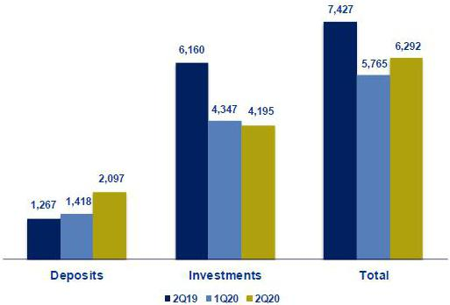

Portfolio distribution as of June 2020
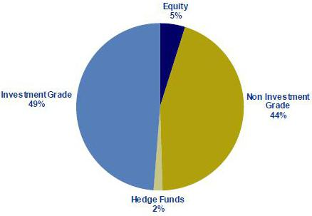

71

11.9. Grupo Pacifico

GRUPO PACIFICO *

(S/ in thousands )

 |  |  | As of |  |  |  |  | % change
 | Jun 19 |  | Mar 20 |  | Jun 20 |  | QoQ |  |  |  | YoY
Total assets | 13,154,757 |  | 13,729,726 |  | 14,509,571 |  |  | 5.7% |  |  | 10.3%
Investment on securities (1) | 9,642,535 |  | 10,586,838 |  | 11,089,545 |  |  | 4.7% |  |  | 15.0%
Technical reserves | 8,946,136 |  | 9,980,047 |  | 10,635,795 |  |  | 6.6% |  |  | 18.9%
Net equity | 3,097,078 |  | 2,724,095 |  | 2,821,972 |  |  | 3.6% |  |  | -8.9%

 |  |  | Quarter |  |  |  | % change |  |  |  |  | YTD |  |  |  |  | % change
 | 2Q19 |  | 1Q20 |  | 2Q20 |  |  |  |  |  |  | Jun 19 |  |  | Jun 20
 |  |  |  |  |  |  | QoQ |  |  | YoY |  |  |  |  |  |  | Jun 20 / Jun 19
Net earned premiums | 592,546 |  | 640,707 |  | 560,754 |  | -12.5% |  |  | -5.4% |  | 1,181,488 |  |  | 1,201,461 |  | 1.7%
Net claims | (379,718) |  | (383,525) |  | (335,152) |  | -12.6% |  |  | -11.7% |  | (766,239) |  |  | (718,677) |  | -6.2%
Net fees | (138,357) |  | (156,165) |  | (118,750) |  | -24.0% |  |  | -14.2% |  | (272,864) |  |  | (274,916) |  | 0.8%
Net underwriting expenses | (33,761) |  | (50,159) |  | (40,105) |  | -20.0% |  |  | 18.8% |  | (70,772) |  |  | (90,264) |  | 27.5%
Underwriting result | 40,710 |  | 50,858 |  | 66,746 |  | 31.2% |  |  | 64.0% |  | 71,612 |  |  | 117,604 |  | 64.2%
Net financial income | 150,249 |  | 135,099 |  | 137,648 |  | 1.9% |  |  | -8.4% |  | 293,605 |  |  | 272,747 |  | -7.1%
Total expenses | (107,614) |  | (105,254) |  | (112,832) |  | 7.2% |  |  | 4.8% |  | (215,064) |  |  | (218,086) |  | 1.4%
Other income | 8,772 |  | 8,339 |  | 11,435 |  | 37.1% |  |  | 30.3% |  | 15,870 |  |  | 19,774 |  | 24.6%
Traslations results | (478) |  | 1,590 |  | 151 |  | -90.5% |  |  | -131.7% |  | (978) |  |  | 1,741 |  | -277.9%
Net gain on associates - EPS business and medical
services | 12,758 |  | 17,186 |  | 16,806 |  | -2.2% |  |  | 31.7% |  | 14,194 |  |  | 9,617 |  | -32.2%
Medical Assistance insurance deduction | (4,746) |  | (6,430) |  | (17,944) |  | 179.0% |  |  | 278.1% |  | (7,482) |  |  | (24,374) |  | 225.8%
Income tax | (1,359) |  | (1,550) |  | (1,125) |  | -27.4% |  |  | -17.2% |  | (2,875) |  |  | (2,674) |  | -7.0%
Income before minority interest | 98,293 |  | 99,838 |  | 100,884 |  | 1.0% |  |  | 2.6% |  | 176,363 |  |  | 200,723 |  | 13.8%
Non-controlling interest | (2,454) |  | (2,523) |  | (1,848) |  | -26.7% |  |  | -24.7% |  | (5,046) |  |  | (4,371) |  | -13.4%
Net income | 95,839 |  | 97,315 |  | 99,036 |  | 1.8% |  |  | 3.3% |  | 171,317 |  |  | 196,351 |  | 14.6%
Ratios
Ceded | 18.5% |  | 13.0% |  | 17.8% |  | 480 bps |  |  | -70 bps |  | 12.2% |  |  | 15.5% |  | 330 bps
Loss ratio ⁽²⁾ | 64.1% |  | 59.9% |  | 59.8% |  | -10 bps |  |  | -430 bps |  | 64.9% |  |  | 59.8% |  | -510 bps
Fees + underwriting expenses, net / net earned
premiums | 29.0% |  | 32.2% |  | 28.3% |  | -390 bps |  |  | -70 bps |  | 29.1% |  |  | 30.4% |  | 130 bps
Operating expenses / net earned premiums | 18.2% |  | 16.4% |  | 20.1% |  | 370 bps |  |  | 190 bps |  | 18.2% |  |  | 18.2% |  | 0 bps
ROAE (3)(4) | 13.7% |  | 14.5% |  | 14.6% |  | 10 bps |  |  | 90 bps |  | 12.9% |  |  | 14.1% |  | 120 bps
Return on written premiums | 10.2% |  | 10.6% |  | 12.3% |  | 170 bps |  |  | 210 bps |  | 8.4% |  |  | 10.1% |  | 170 bps
Combined ratio of Life ⁽⁵⁾ | 115.1% |  | 87.6% |  | 122.1% |  | 3450 bps |  |  | 700 bps |  | 115.1% |  |  | 122.1% |  | 700 bps
Combined ratio of P&C ⁽⁶⁾ | 97.5% |  | 94.4% |  | 79.8% |  | -1460 bps |  |  | -1770 bps |  | 97.5% |  |  | 79.8% |  | -1770 bps
Equity requirement ratio ⁽⁷⁾ | 1.45x |  | 1.27x |  | 1.35x |  | 0.08x |  |  | -0.10x |  | 1.45x |  |  | 1.35x |  | -0.10x

*Financial statements without consolidation adjustments.
- Excluding investments in real estate.
- Net claims / Net earned premiums.
- Includes unrealized gains.
- Annualized and average are determined as the average of period beginning and period ending.
- (Net claims / Net earned premiums) + Reserves / Net earned premiums) + [(Acquisition cost + total expenses) / Net earned premiums] - (Net Financial Income without real state sales, securities sales, impairment loss and fluctuation / Net earned premiums).

- (Net claims / Net earned premiums) + [(Acquisition cost + total expenses) / Net earned premiums].
- Support to cover credit risk, market risk and operational risk.

From 1Q15 and on, Grupo Pacifico’s financial statements reflect the association with Banmedica. This partnership includes:

- the private health insurance business, which is managed by Grupo Pacifico and incorporated in each line of Grupo Pacifico’s financial statements;

- corporate health insurance for payroll employees; and

- medical services.

The businesses described in ii) and iii) are managed by Banmedica, therefore they do not consolidate in Grupo Pacifico’s financial statements. The 50% of net income generated by Banmedica is recorded in Grupo Pacifico’s Income Statement as a gain/loss on investments in subsidiaries.

As explained before, corporate health insurance and medical services businesses are consolidated by Banmedica. The following table reflects the consolidated results from which Grupo Pacifico receives the 50% net income.

72

Corporate Health Insurance and Medical Services

(S/ in thousands)

 |  |  | Quarter |  |  |  | % change |  |  |  |  | YTD |  |  |  |  | % change
 | 2Q19 |  | 1Q20 |  | 2Q20 |  | QoQ |  |  | YoY |  | Jun19 |  |  | Jun20 |  | Jun 20 / Jun 19
Results
Net earned premiums | 264,725 |  | 278,256 |  | 266,614 |  | -4.2% |  |  | 0.7% |  | 523,181 |  |  | 544,871 |  | 4.1%
Net claims | (225,704) |  | (213,978) |  | (173,711) |  | -18.8% |  |  | -23.0% |  | (459,301) |  |  | (387,689) |  | -15.6%
Net fees | (11,697) |  | (12,118) |  | (11,455) |  | -5.5% |  |  | -2.1% |  | (23,576) |  |  | (23,573) |  | 0.0%
Net underwriting expenses | (2,492) |  | (2,845) |  | (2,929) |  | 2.9% |  |  | 17.5% |  | (5,404) |  |  | (5,775) |  | 6.9%
Underwriting result | 24,832 |  | 49,315 |  | 78,520 |  | 59.2% |  |  | 216.2% |  | 34,900 |  |  | 127,835 |  | 266.3%
Net financial income | 1,070 |  | 532 |  | 1,990 |  | 274.0% |  |  | 86.0% |  | 2,575 |  |  | 2,522 |  | -2.0%
Total expenses | (18,203) |  | (19,659) |  | (19,767) |  | 0.5% |  |  | 8.6% |  | (35,739) |  |  | (39,426) |  | 10.3%
Other income | 621 |  | 244 |  | 162 |  | -33.6% |  |  | -73.9% |  | 1,633 |  |  | 406 |  | -75.2%
Traslations results | (197) |  | 919 |  | 1,386 |  | 50.8% |  |  | -803.8% |  | (214) |  |  | 2,305 |  | -1179.0%
Income tax | (2,670) |  | (9,825) |  | (19,699) |  | 100.5% |  |  | N/A |  | (1,055) |  |  | (29,524) |  | 2697.8%
Net income before Medical services | 5,452 |  | 21,526 |  | 42,592 |  | 97.9% |  |  | N/A |  | 2,100 |  |  | 64,118 |  | 2953.7%
Net income of Medical services | 19,983 |  | 12,765 |  | -9,169 |  | -171.8% |  |  | -145.9% |  | 41,091 |  |  | 3,596 |  | -91.2%
Net income | 25,435 |  | 34,290 |  | 33,424 |  | -2.5% |  |  | 31.4% |  | 43,191 |  |  | 67,714 |  | 56.8%

73

11.10. Prima AFP

 |  |  |  | Quarter |  |  |  |  |  |  | % change |  |  |  |  |  |  |  |  |  | YTD |  |  |  |  |  |  |  | % change
 | 2Q19 |  |  | 1Q20 |  | 2Q20 |  |  |  |  | QoQ |  |  |  |  | YoY |  |  |  | Jun 19 |  |  |  | Jun 20 |  |  |  |  | Jun 20 / Jun 19
Income from commissions | 105,867 |  | 103,233 |  |  | 72,296 |  |  |  |  | -30.0% |  |  |  |  | -31.7% |  |  |  | 205,624 |  |  |  | 175,529 |  |  |  |  | -14.6%
Administrative and sale expenses | (38,358) |  | (35,807) |  |  | (30,129) |  |  |  | -15.9% |  |  |  |  |  | -21.5% |  |  |  | (75,650) |  |  |  | (65,936) |  |  |  |  | -12.8%
Depreciation and amortization | (4,725) |  | (6,100) |  |  | (6,126) |  |  |  | 0.4% |  |  |  |  |  | 29.6% |  |  |  | (9,198) |  |  |  | (12,226) |  |  |  |  | 32.9%
Operating income | 62,783 |  | 61,326 |  |  | 36,041 |  |  |  | -41.2% |  |  |  |  |  | -42.6% |  |  |  | 120,776 |  |  |  | 97,367 |  |  |  |  | -19.4%
Other income and expenses, net (profitability of
lace) | 8,108 |  | (44,933) |  |  | 24,020 |  |  |  | -153.5% |  |  |  |  |  | 196.3% |  |  |  | 25,820 |  |  |  | (20,913) |  |  |  |  | -181.0%
Income tax | (20,495) |  | (20,155) |  |  | (8,759) |  |  |  | -56.5% |  |  |  |  |  | -57.3% |  |  |  | (39,324) |  |  |  | (28,914) |  |  |  |  | -26.5%
Net income before translation results | 50,396 |  | (3,762) |  |  | 51,302 |  |  |  | -1463.6% |  |  |  |  |  | 1.8% |  |  |  | 107,272 |  |  |  | 47,540 |  |  |  |  | -55.7%
Translations results | (29) |  | (317) |  |  | (70) |  |  |  | -77.8% |  |  |  |  |  | 145.5% |  |  |  | 95 |  |  |  | (387) |  |  |  |  | -507.5%
Net income | 50,367 |  | (4,079) |  |  | 51,232 |  |  |  | -1356.0% |  |  |  |  |  | 1.7% |  |  |  | 107,367 |  |  |  | 47,153 |  |  |  |  | -56.1%
ROAE | 33.3 | % | -2.6 |  | % | 35.8 |  |  | % |  | 3839 pbs |  |  |  |  | 246 pbs |  |  |  | 34.0 |  | % |  | 14.5 |  | % |  |  | -1945 pbs
 |  |  |  |  |  |  |  |  |  | As of |  |  |  |  |  |  |  |  |  |  |  |  |  | % change
 |  |  |  | 2Q19 |  |  |  |  |  | 1Q20 |  |  |  |  |  | 2Q20 |  |  |  |  | QoQ |  |  |  |  |  |  |  | YoY
Total assets |  |  |  | 868,192 |  |  |  |  |  | 973,862 |  |  |  |  |  | 951,560 |  |  |  |  |  |  |  | -2.3% |  |  |  |  | 9.6%
Total liabilities |  |  | 238,247 |  |  |  |  |  |  | 426,510 |  |  |  |  |  | 353,019 |  |  |  |  |  |  |  | -17.2% |  |  |  |  | 48.2%
Net shareholders' equity ⁽¹⁾ |  |  | 629,945 |  |  |  |  |  |  | 547,352 |  |  |  |  |  | 598,541 |  |  |  |  |  |  |  | 9.4% |  |  |  |  | -5.0%

(1) Net shareholders' equity includes unrealized gains from Prima's investment portfolio.

Funds under management
Funds under management |  | Mar 20 |  | % share |  | Jun 20 |  | % share
Fund 0 |  | 776 |  | 1.7% |  | 932 |  | 2.0%
Fund 1 |  | 5,842 |  | 12.5% |  | 7,278 |  | 15.7%
Fund 2 |  | 35,336 |  | 75.4% |  | 33,353 |  | 72.0%
Fund 3 |  | 4,910 |  | 10.5% |  | 4,769 |  | 10.3%
Total S/ Millions |  | 46,864 |  | 100 | % | 46,331 |  | 100 | %

Source: SBS
Nominal profitability over the last 12 months
 |  |  |  |  | Mar 20 / Mar 19 Jun 20 / Jun 19
Fund 0
Fund 0 |  |  |  |  |  |  | 4.3% |  |  |  | 4.1%
Fund 1 |  |  |  |  |  |  | 3.3% |  |  |  | 4.6%
Fund 2 |  |  |  |  |  |  | -1.8% |  |  |  | 1.6%
Fund 3 |  |  |  |  |  |  | -11.8% |  |  |  | -8.4%
AFP fees
Fee based on
flow | 1.60% | Applied to the affiliates' monthly remuneration.
Mixed fee
Flow | 0.18% | Applied to the affiliates' monthly remuneration since June 2017. Feb 17- may 17 =0.87%.
Balance |  | Applies annualy to the new balance since February 2013 for new affiliates to the system and beginning on June
 | 1.25% 2013 for old affiliates who have chosen this commission scheme.
Main indicators
 |  |  |  | Prima |  |  | System |  |  |  | % share |  |  |  | Prima |  | System |  | % share
Main indicators and market share |  |  |  | 1Q20 |  |  | 1Q20 |  |  |  | 1Q20 |  |  |  | 2Q20 |  | 2Q20 |  | 2Q20
Affiliates |  |  |  | 2,365,347 |  |  | 7,521,916 |  |  |  | 31.4% |  |  |  | 2,364,850 |  | 7,576,582 |  | 31.2%
New affiliations ⁽¹⁾ |  | - |  |  |  |  | 100,553 |  |  |  | 0.0% |  |  |  | - |  | 55,288 |  | 0.0%
Funds under management (S/ Millions) |  | 46,864 |  |  |  |  | 154,044 |  |  |  | 30.4% |  |  |  | 46,331 |  | 152,384 |  | 30.4%
Collections (S/ Millions) ⁽²⁾ |  | 1,002 |  |  |  |  | 3,089 |  |  |  | 32.4% |  |  |  | 349 |  | 1,072 |  | 32.5%
Voluntary contributions (S/ Millions) ⁽²⁾ |  | 977 |  |  |  |  | 2,057 |  |  |  | 47.5% |  |  |  | 1,013 |  | 2,130 |  | 47.5%
RAM (S/ Millions) ⁽²⁾ ⁽³⁾ |  | 1,419 |  |  |  |  | 4,482 |  |  |  | 31.7% |  |  |  | 1,058 |  | 3,235 |  | 32.7%

Source: SBS

- As of June 2019, another AFP has the exclusivity of affiliations.

- Information available as of May 2020.

- Prima AFP estimate: Average of aggregated income for flow during the last 4 months, excluding special collections and voluntary contribution fees.

74

11.11. Table of calculations
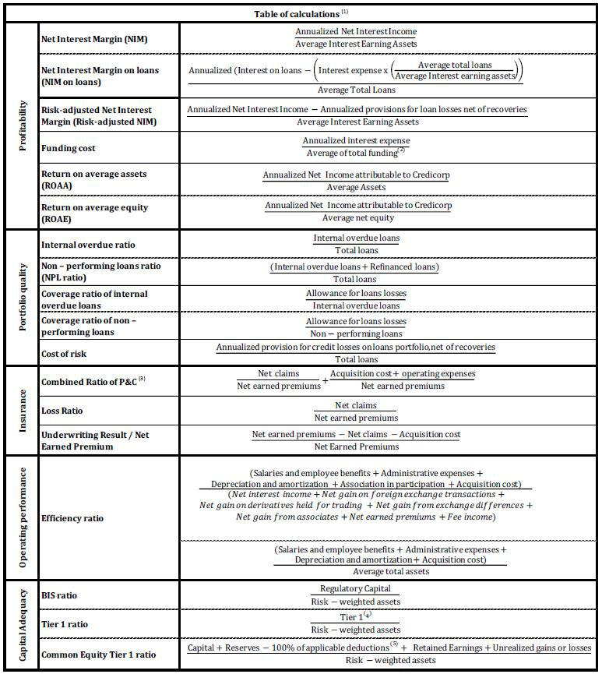

- Averages are determined as the average of period-beginning and period-ending balances.

- Includes total deposits, due to banks and correspondents, BCRP instruments, repurchase agreements and bonds and notes issued.

- Does not include Life insurance business.

- Tier 1 = Capital + Legal and other capital reserves + Accumulated earnings with capitalization agreement + (0.5 x Unrealized profit and net income in subsidiaries) - Goodwill - (0.5 x Investment in subsidiaries) + Perpetual subordinated debt (maximum amount that can be included is 17.65% of Capital + Reserves + Accumulated earnings with capitalization agreement + Unrealized profit and net income in subsidiaries - Goodwill).
- Includes investment in subsidiaries, goodwill, intangibles and deferred tax that rely on future profitability.

75

11.12. Glossary of terms
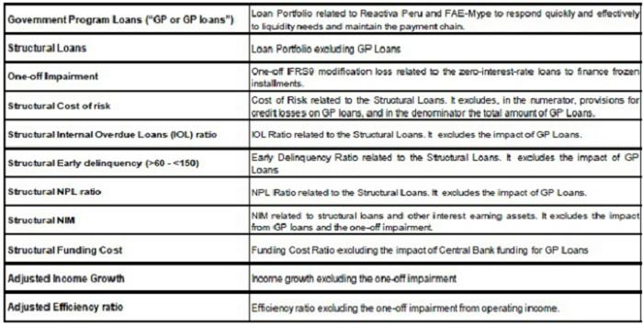

76

