SECURITIES AND EXCHANGE COMMISSION
Washington, D.C. 20549

FORM 6-K

Report of Foreign Private Issuer
Pursuant to Rule 13a-16 or 15d-16 under the
Securities Exchange Act of 1934

For the month of August 2023

Commission File Number: 001-14014

CREDICORP LTD.
(Translation of registrant’s name into English)

Of our subsidiary
Banco de Credito del Peru:
Calle Centenario 156
La Molina
Lima 12, Peru
(Address of principal executive office)

Indicate by check mark whether the registrant files or will file annual reports under cover of Form 20-F or Form 40-F.

Form 20-F ☒ Form 40-F ☐

Indicate by check mark if the registrant is submitting the Form 6-K in paper as permitted by Regulation S-T Rule 101(b)(1): ☐

Indicate by check mark if the registrant is submitting the Form 6-K in paper as permitted by Regulation S-T Rule 101(b)(7): ☐

The information in this Form 6-K (including any exhibit hereto) shall not be deemed “filed” for purposes of Section 18 of the Securities Exchange Act of 1934 (the “Exchange Act”) or otherwise subject to the liabilities of that section, nor shall it be deemed incorporated by reference in any filing under the Securities Act of 1933 or the Exchange Act.

SIGNATURE

Pursuant to the requirements of the Securities Exchange Act of 1934, the registrant has duly caused this report to be signed on its behalf by the undersigned, thereunto duly authorized.

Date: August 14th, 2023

CREDICORP LTD.
(Registrant)
 | By: | /s/ Guillermo Morales
 |  | Guillermo Morales
 |  | Authorized Representative

Exhibit 99.1

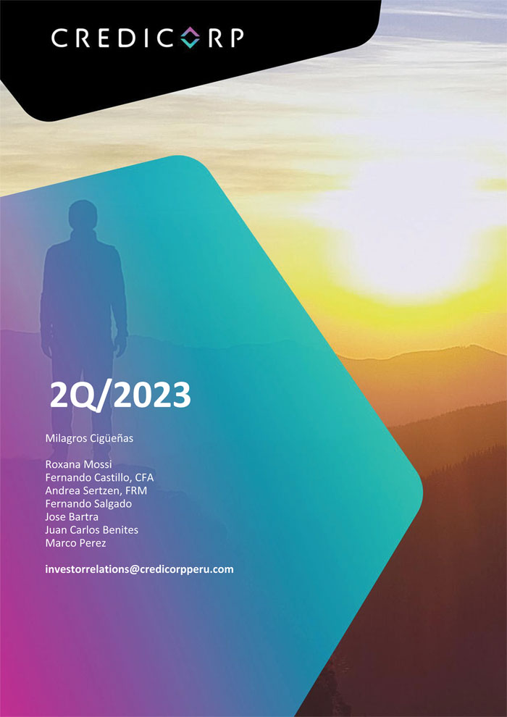

 | | | Earnings Release 2Q / 2023

Table of Contents

 | Operating and Financial Highlights |  | 03
 | Senior Management Quotes |  | 05
 | Second Quarter 2023 Earnings Conference Call |  | 06
 | Summary of Financial Performance and Outlook |  | 07
 | Financial Overview |  | 12
 | Credicorp’s Strategy Update |  | 13
 | Analysis of 2Q23 Consolidated Results
 | 01 | Loans and Portfolio Quality | 16
 | 02 | Deposits | 22
 | 03 | Interest Earning Assets and Funding | 25
 | 04 | Net Interest Income | 26
 | 05 | Provisions | 29
 | 06 | Other Income | 31
 | 07 | Insurance Underwriting Results | 34
 | 08 | Operating Expenses | 37
 | 09 | Operating Efficiency | 39
 | 10 | Regulatory Capital | 40
 | 11 | Economic Outlook | 42
 | 12 | Appendix | 46

2

 | | | Earnings Release 2Q / 2023
Operating and Financial Highlights

Credicorp Ltd. Reports Second Quarter 2023 Financial and Operating Results

ROE of 18.6% Driven by Strong Results in Universal Banking and Insurance together with a Moderate Recovery in Microfinance

Efficiency Ratio Improved 310 bps to 44.6%

Cost of Risk Increased 25 bps Sequentially to 2.3% Reflecting Challenging Macro Dynamics in 1H23

Lima, Peru – August 10, 2023 – Credicorp Ltd. (“Credicorp” or “the Company”) (NYSE: BAP | BVL: BAP), the leading financial services holding company in Peru with a presence in Chile, Colombia, Bolivia and Panama today reported its unaudited results for the quarter ended June 30, 2023. Financial results are expressed in Soles and are presented in accordance with International Financial Reporting Standards (IFRS). Effective 1Q23, the Company reports under IFRS 17 accounting standards for insurance contracts. While the impact on consolidated net income is not material, the reclassification of line items in the P&L has impacted the efficiency ratio. To facilitate comparability, figures for 2Q22 and 4Q22 have been restated to reflect IFRS 17.

2Q23 OPERATING AND FINANCIAL HIGHLIGHTS

 | ● | Net Income attributable to Credicorp increased 22.6% YoY to S/1,401 million, supported by Universal Banking and strong results in the Insurance business. This resulted in ROE of 18.6% compared to 18.7% in 1Q23 and 17.3% in 2Q22.

 | ● | Structural Loans measured in average daily balances declined 0.6% QoQ, principally due to Wholesale Banking, but increased 5.5% YoY, driven by growth in Retail Banking at BCP and to a lesser extent by Mibanco.

 | ● | Total Deposits at quarter-end declined 3.5% QoQ and 2.7% YoY, after lower liquidity and continued migration to Time Deposits in a high-interest rate environment led to a system-wide drop in Demand and Savings deposits. Nonetheless, Credicorp maintains its undisputable leadership position in low-cost deposits with a 40.6% market share, which accounted for 51.3% of total funding.

 | ● | The Structural NPL ratio increased 23 bps QoQ to 5.3%, after social unrest and climatic events in 1Q23, coupled with a contraction in internal demand and high inflation and interest rates, impacted payment performance. At Mibanco, loans reprogrammed in the first quarter fell delinquent. At BCP, payment behavior in SME-Pyme deteriorated, particularly in lower-ticket segments, while in Credit Cards and Consumers Loans, the debt service capacity of vulnerable subsegments fell due to over-indebtedness. These dynamics were partially offset by a sale of a delinquent portfolio in the energy sector in Wholesale banking.

 | ● | Structural Provisions increased 10.5% QoQ and 124.3% YoY. Provisions in Consumer Loans and Credit Cards at BCP and at Mibanco remained at high levels after a recessive, high-inflation environment in the first semester affected client payment capacity. The Structural Cost of Risk increased 127bps sequentially to 2.3% against a particularly low base in 2Q22, while Structural NPL Coverage ratio dropped 2.3 pps to 107.7%. Credicorp has fine-tuned client segmentation by risk profile and gradually implemented stricter origination guidelines for Consumer Loans, Credit Cards, SME-Pyme at BCP and Mibanco.

 | ● | Core Income increased 2.7% QoQ and 14.3% YoY, reflecting structural loan growth and a high-interest rate environment, both of which drove an uptick in Net Interest Income (NII) of 2.3% QoQ and 21.5% YoY. In turn, Other Core Income increased 3.6% QoQ but fell 1.6% YoY. In this context, growth in the yield of IEA outpaced the expansion in the funding cost, which led the Net Interest Margin (NIM) to stand at 6.0%, up 18 bps QoQ and 110 bps YoY.

 | ● | Insurance Underwriting Results remained unusually high, up 53% YoY driven by higher profitability in the Life Business and stable P&C performance.

3

 | | | Earnings Release 2Q / 2023
Operating and Financial Highlights

 | ● | The Efficiency Ratio was seasonally higher at 44.6% in 2Q23 compared to 44.3% in 1Q23 but improved from 47.7% in 2Q22. For 1H23, the efficiency ratio improved 310 bps YoY to 44.4% as core income growth at BCP more than offset higher expenses at BCP and in disruptive initiatives at Credicorp.

 | ● | The CET1 Ratio for BCP at quarter-end was 12.8%, up 123 bps YoY and 87 bps QoQ. CET1 at Mibanco increased 157 bps YoY and 21 bps QoQ to 16.6%.

 | ● | At BCP stand-alone, 30-day local currency LCR currency stood at 198.7% under regulatory standards and 118.4% based on more stringent internal standards, while USD 30-day LCR stood at 179.8% and 115.1% under regulatory and more stringent internal standards, respectively.

 | ● | Yape continues to advance towards monetization as it pursues its goal of driving financial inclusion. Monthly active users (MAU) reached 9.0 million at quarter-end with monthly revenue per MAU up 32% QoQ to s/2.5 while the cash-cost per MAU declined to S/4.4.Yape stands on track to reach cashflow breakeven in 2024.

 | ● | On June 9, 2023, the Company paid a cash dividend of S/25.00 per share equivalent to a total of S/ 2,359,557,925. This translates to a 50.8% dividend payout ratio.

4

 | | | Earnings Release 2Q / 2023
Senior Management Quotes

SENIOR MANAGEMENT QUOTES

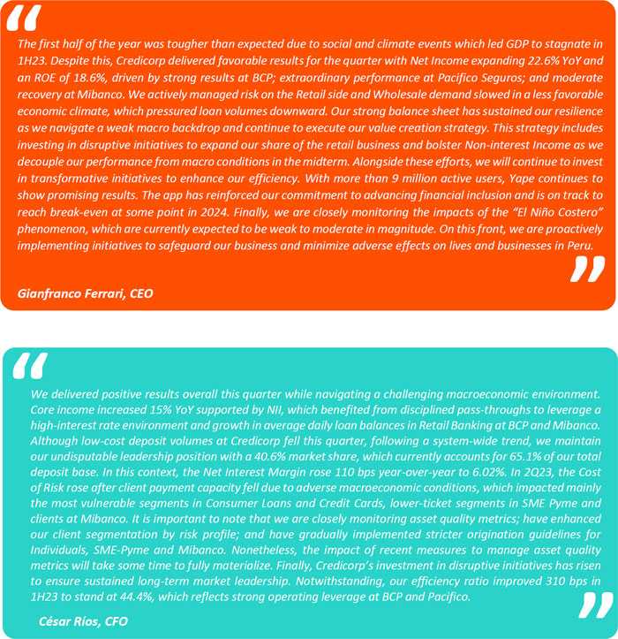

5

 | | | Earnings Release 2Q / 2023
Second Quarter 2023 Earnings Conference Call

SECOND QUARTER 2023 EARNINGS CONFERENCE CALL

Date: Friday August 11th, 2023

Time: 10:30 am ET (9:30 am Lima, Peru time)

Hosts: Gianfranco Ferrari – Chief Executive Officer, Cesar Rios - Chief Financial Officer, Francesca Raffo – Chief Innovation Officer, Reynaldo Llosa - Chief Risk Officer, Diego Cavero – Head of Universal Banking, Cesar Rivera - Head of Insurance and Pensions, Carlos Sotelo - Mibanco CFO, and the Investor Relations Team.

To pre-register for the listen-only webcast presentation use the following link:
https://dpregister.com/DiamondPassRegistration/register?confirmationNumber=10181250&linkSecurityString=fa033bcdf8

Callers who pre-register will be given a conference passcode and unique PIN to gain immediate access to the call and bypass the live operator. Participants may pre-register at any time, including up to and after the call start time.

Those unable to pre-register may dial in by calling:
1 844 435 0321 (U.S. toll free)
1 412 317 5615 (International)
Conference ID: Credicorp Conference Call

The webcast will be archived for one year on our investor relations website at:
https://credicorp.gcs-web.com/events-and-presentations/upcoming-events

For a full version of Credicorp´s Second Quarter 2023 Earnings Release, please visit:
https://credicorp.gcs-web.com/financial-information/quarterly-results

6

 | | | Earnings Release 2Q / 2023
Summary of Financial Performance and Outlook

Loans (in Average Daily Balances)

Structural loans measured in ADB dropped 0.6% QoQ (+0.2% FC neutral) to stand at S/136,426 million (total loans, measured in ADB, stood at S/142,001 million). This decline was driven primarily by Wholesale Banking at BCP and was partially offset by the positive evolution of balances in Retail Banking at BCP and Mibanco.

YoY, growth in structural ADBs stood at 5.5%. This evolution was driven primarily by Retail Banking at BCP, specifically by SME-Pyme and Individuals, and, to a lesser extent, by Mibanco.

The Government Program (GP) portfolio represented 4% of total loans measured in average daily balances QoQ (3% in quarter-end balances).
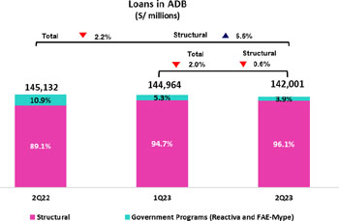
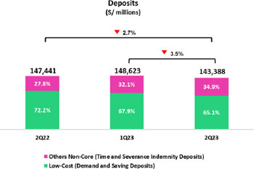
Deposits

Our deposit base measured in quarter-end balances dropped 3.5% QoQ (-1.8% FX Neutral). This reduction was mainly attributable to a drop in Demand deposits and Savings deposits, which reflects a decrease in liquidity across the system and fund migration to Time deposits.

In the YoY comparison, the deposit base fell 2.7% (-0.2% FX Neutral). Low-cost deposits, which represented 65.1% of our total deposit base at quarter-end, continue to play a preponderant role in our funding mix.
Net interest income (NII) and Margin (NIM)

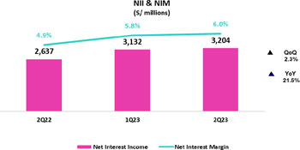
QoQ, NII rose 2.3% to stand at S/3,204 million. This evolution was fueled by the on-going shift towards higher-margin retail loans and the positive impact that higher rates had on investments. This increase was partially compensated by an uptick in the interest expense due to the aforementioned deposits dynamics. In this context, growth in the IEA yield outpaced the increase in funding cost, which led NIM to stand at 6.0%.

YoY, NII rose 21.5%. This evolution was primarily driven by the same factors as those seen QoQ and by positive rate dynamics in both currencies.

(1) For further details on the new NIM calculation due to IFRS17, please refer to Annex 12.1.8
7

 | | | Earnings Release 2Q / 2023
Summary of Financial Performance and Outlook

Structural Portfolio Quality and Cost of Risk (CofR)

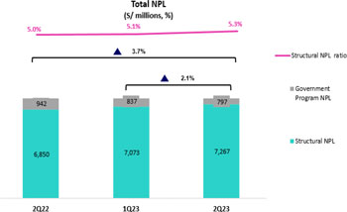
The social unrest and climate events of the first quarter of the year, coupled with a tough economic environment characterized by a contraction in internal demand, high inflation and high interest rates have notably impacted clients’ payment performance and therefore, portfolio quality.

QoQ, the Structural NPL volume rose 2.7%. This growth was primarily driven by: (i) Mibanco, which was impacted by the expiration of loans reprogrammed in 1Q23; (ii) SME-Pyme, due to a deterioration in payment behavior in lower-ticket (<than 90 thousand) segments; and (iii) Consumer Loans and Credit Cards, primarily in vulnerable subsegments that registered over- indebtedness. The aforementioned was partially offset by a sale of a delinquent portfolio in the energy sector in Wholesale banking.

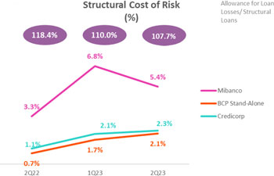
YoY, the Structural NPL portfolio volume rose 6.1% due to growth in refinanced loans for the real estate and tourism sectors in Wholesale Banking. The factors mentioned in the QoQ dynamic also contributed to this result.

In this context, the Structural NPL ratio increased at 5.3% and the Structural NPL Coverage ratio stood at 107.7%.

Structural provisions remain at historically high levels in Consumer Loans and Credit Cards at BCP, as well as at Mibanco due to the impacts of the macroeconomic context. At BCP, the most affected portfolio corresponds to the vulnerable subsegments since they have greater leverage system wide and less job stability, while in Mibanco, the clients were impacted by the events of the first quarter. SMEs led QoQ growth due to lower payment capacity in higher risk segments and high yield subsegments.

In this context, Structural Cost of Risk stood at 2.3%.
8

 | | | Earnings Release 2Q / 2023
Summary of Financial Performance and Outlook

Other income

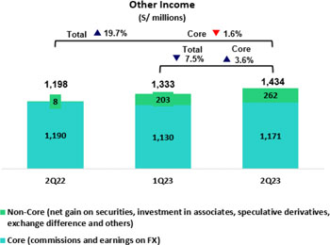
When analyzing Other Core income, it is important to note that Fee income and Gains on FX transactions have been affected by our strategy at BCP Bolivia, where we have adjusted our fee framework for foreign transfers to offset the impact of the drop in FX transactions due to restrictions on foreign currency availability. Excluding this impact, Fee income increased 4.1% QoQ through higher transactions while Gains on FX transactions remained flat.

YoY, excluding the aforementioned impact, Other Core Income declined 2.3% due to lower fees in the Pensions business and the elimination of intercity fees.

Other Non-core Income* rose 29.2% QoQ mainly by Universal Banking, due to the recognition of fees from previous periods, and to the sale of a delinquent portfolio in Wholesale Banking. YoY growth was driven by the aforementioned QoQ Universal Banking dynamics and positive results from trading strategies in Credicorp Capital Colombia and ASB.

(*) For more details regarding the content of this grouping, please refer to Annex 12.1.8
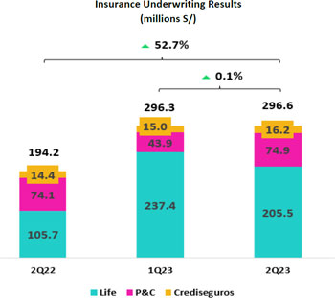
Insurance Underwriting Result

The Insurance Underwriting* Result rose 0.1% QoQ, where an uptick in P & C’s result was offset by a drop in results in the Life business. YoY, the result was up 52.7% mainly due to Life business which registered growth in income from insurance services in the Pensions, Group Life and Credit Life segments in particular.

(*) For more details regarding the new composition of Insurance Underwriting Result to reflect IFRS17, please refer to Annex 12.1.8
9

 | | | Earnings Release 2Q / 2023
Summary of Financial Performance and Outlook

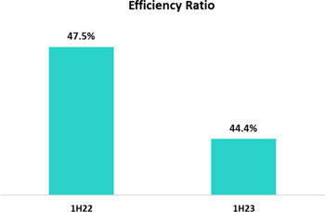
Efficiency

In 1H23, the Efficiency ratio* stood at 44.4%. This represents an improvement of 310 bps versus the result in 1H22 and was attributable to significant growth in income at BCP and Pacifico.

Operating expenses were up 9.1% YoY, driven primarily by traditional expenses at BCP and disruptive initiatives at Credicorp.

Note: The efficiency ratio of 44.4% achieved this first semester was affected by a reversal of non-recurring expenses. Excluding this effect, the efficiency ratio would stand at 45.1%, 234 bps less than 1H22.

(*) For more details regarding the new calculation of the Efficiency ratio due to IFRS17, please refer to Annex 12.1.8
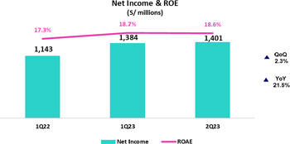
Net Income attributable to Credicorp

In 2Q23, net income attributable to Credicorp totaled S/1,401 million, up +1.2% QoQ and +22.6% YoY. Net equity stood at S/30,027 million (-1.1% QoQ and +14.7% YoY). The QoQ contraction was fueled primarily by dividend payment in June. In this context, ROE stood at 18.6%.
Contributions* and ROE by subsidiary in 2Q23
(S/ millions)

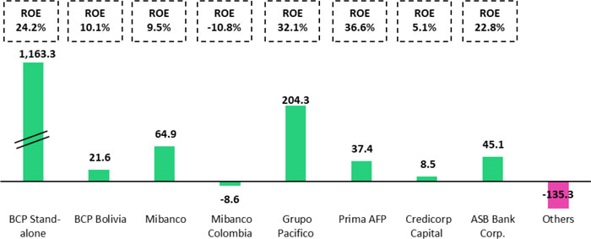

*Contributions to Credicorp reflect eliminations for consolidation purposes (eliminations for transactions among Credicorp’s subsidiaries or between Credicorp and its subsidiaries).
- At BCP Stand Alone, the figure is lower than net income because it does not include gains on investments in other Credicorp subsidiaries (Mibanco).
- At Mibanco, the figure is lower than net income because Credicorp owns 99.924% of Mibanco (directly and indirectly).
- The contribution of Grupo Pacifico presented here is higher than the earnings reported for Pacifico Seguros because it includes 100% of Crediseguros (including 48% under Grupo Credito).

10

 | | | Earnings Release 2Q / 2023
Summary of Financial Performance and Outlook

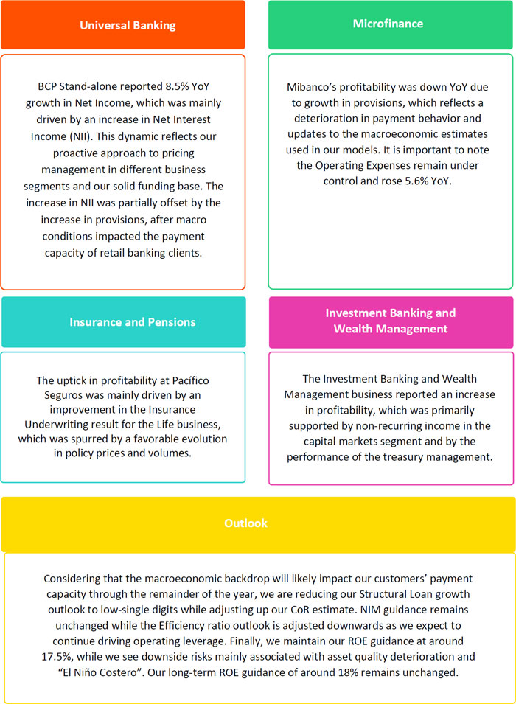

11

 | | | Earnings Release 2Q / 2023 | Analysis of 2Q23 Consolidated Results
Financial Overview

Credicorp Ltd. | Quarter |  |  | % change |  | As of |  | % change
S/000 | 2Q22 | 1Q23 | 2Q23 | QoQ | YoY | 1H22 | 1H23 | 1H23 / 1H22
Net interest, similar income and expenses | 2,637,106 | 3,132,089 | 3,204,156 | 2.3% | 21.5% | 5,274,531 | 6,567,161 | 24.5%
Provision for credit losses on loan portfolio, net of recoveries | (363,291) | (726,998) | (804,251) | 10.6% | 121.4% | (620,881) | (1,531,249) | 146.6%
Net interest, similar income and expenses, after provision for credit losses on loan portfolio | 2,273,815 | 2,405,091 | 2,399,905 | -0.2% | 5.5% | 4,653,650 | 5,035,912 | 8.2%
Total other income | 1,197,592 | 1,333,275 | 1,433,786 | 7.5% | 19.7% | 2,436,990 | 2,767,061 | 13.5%
Insurance underwriting result | 194,197 | 296,341 | 296,564 | 0.1% | 52.7% | 400,864 | 592,905 | 47.9%
Total other expenses | (1,981,125) | (2,126,908) | (2,195,966) | 3.2% | 10.8% | (3,855,644) | (4,322,874) | 12.1%
Profit before income tax | 1,684,479 | 1,907,799 | 1,934,289 | 1.4% | 14.8% | 3,430,142 | 3,842,088 | 12.0%
Income tax | (513,182) | (493,466) | (504,472) | 2.2% | -1.7% | (1,059,182) | (997,938) | -5.8%
Net profit | 1,171,297 | 1,414,333 | 1,429,817 | 1.1% | 22.1% | 2,370,960 | 2,844,150 | 20.0%
Non-controlling interest | 28,420 | 30,060 | 28,550 | -5.0% | 0.5% | 56,206 | 58,610 | 4.3%
Net profit attributable to Credicorp | 1,142,877 | 1,384,273 | 1,401,267 | 1.2% | 22.6% | 2,314,754 | 2,785,540 | 20.3%
Net income / share (S/) | 14.33 | 17.36 | 17.57 | 1.2% | 22.6% | 29.02 | 34.92 | 20.3%
Loans | 150,370,184 | 145,165,713 | 142,845,549 | -1.6% | -5.0% | 150,370,184 | 142,845,549 | 0.7%
Deposits and obligations | 147,440,576 | 148,623,300 | 143,387,717 | -3.5% | -2.7% | 147,440,576 | 143,387,717 | -1.7%
Net equity | 26,167,811 | 30,359,898 | 30,027,036 | -1.1% | 14.7% | 26,167,811 | 30,027,036 | 9.4%
Profitability
Net interest margin | 4.92% | 5.84% | 6.02% | 18 bps | 110 bps | 4.66% | 5.96% | 130 bps
Risk-adjusted Net interest margin | 4.27% | 4.54% | 4.56% | 2 bps | 29 bps | 4.12% | 4.57% | 45 bps
Funding cost | 1.58% | 2.61% | 2.91% | 30 bps | 133 bps | 1.44% | 2.76% | 132 bps
ROAE | 17.3% | 18.7% | 18.6% | -10 bps | 130 bps | 17.6% | 18.9% | 130 bps
ROAA | 1.9% | 2.3% | 2.4% | 10 bps | 50 bps | 2.0% | 2.3% | 30 bps
Loan portfolio quality
Internal overdue ratio (1) | 4.06% | 3.99% | 4.19% | 20 bps | 13 bps | 4.06% | 4.19% | 13 bps
Internal overdue ratio over 90 days | 3.06% | 3.02% | 3.40% | 38 bps | 34 bps | 3.06% | 3.40% | 34 bps
NPL ratio (2) | 5.18% | 5.45% | 5.64% | 19 bps | 46 bps | 5.18% | 5.64% | 46 bps
Cost of risk (3) | 0.97% | 2.00% | 2.25% | 25 bps | 128 bps | 0.83% | 2.14% | 131 bps
Coverage ratio of IOLs | 136.1% | 136.7% | 133.1% | -360 bps | -300 bps | 136.1% | 133.1% | -300 bps
Coverage ratio of NPLs | 106.6% | 100.1% | 98.7% | -140 bps | -790 bps | 106.6% | 98.7% | -790 bps
Operating efficiency
Efficiency ratio (4) | 47.7% | 44.3% | 44.6% | 30 bps | -310 bps | 47.5% | 44.4% | -310 bps
Operating expenses / Total average assets | 3.25% | 3.43% | 3.56% | 13 bps | 31 bps | 3.09% | 3.51% | 40 bps
Capital adequacy - BCP Stand-alone (7)
Global Capital ratio (8) | n.a | 16.45% | 17.20% | 75 pbs | n.a | n.a | 17.20% | n.a
Tier 1 ratio (9) | n.a | 11.86% | 12.75% | 89 pbs | n.a | n.a | 12.75% | n.a
Common equity tier 1 ratio (10) | 11.56% | 11.93% | 12.79% | 86 pbs | 123 pbs | 11.56% | 12.79% | 123 pbs
Capital adequacy - Mibanco (7)
Global Capital ratio (8) | n.a | 18.76% | 18.78% | 2 pbs | n.a | n.a | 18.78% | n.a
Tier 1 ratio (9) | n.a | 16.40% | 16.49% | 9 pbs | n.a | n.a | 16.49% | n.a
Common equity tier 1 ratio (10)(12) | 15.02% | 16.38% | 16.59% | 21 pbs | 157 pbs | 15.02% | 16.59% | 157 pbs
Employees | 36,087 | 37,184 | 37,380 | 0.5% | 3.6% | 36,087 | 37,380 | 3.6%
Share Information
Issued Shares | 94,382 | 94,382 | 94,382 | 0.0% | 0.0% | 94,382 | 94,382 | 0.0%
Treasury Shares (11) | 14,849 | 14,887 | 14,829 | -0.4% | -0.1% | 14,849 | 14,829 | -0.1%
Outstanding Shares | 79,533 | 79,495 | 79,553 | 0.1% | 0.0% | 79,533 | 79,553 | 0.0%
(1) Net Interest Margin = Net Interest Income (Excluding Net Insurance Financial Expenses) / Average Interest Earning Assets
(2) Funding Cost = Interest Expense (Does not include Net Insurance Financial Expenses) / Average Funding
(3) Internal Overdue Loans: includes overdue loans and loans under legal collection, according to our internal policy for overdue loans. Internal Overdue Ratio: Internal overdue loans / Total loans
(4) Non-performing loans (NPL): Internal overdue loans + Refinanced loans. NPL ratio: NPL / Total loans.
(5) Cost of risk = Annualized provision for loan losses, net of recoveries / Total loans.
(6) Efficiency Ratio = (Salaries and employee benefits + Administrative expenses + Depreciation and amortization + Association in participation) / (Net interest, similar income and expenses + Fee Income + Net gain on foreign exchange transactions + Net Gain From associates + Net gain on derivatives held for trading + Result on exchange differences + Insurance Underwriting Result)
(7) Regulatory Capital / Risk-weighted assets (legal minimum = 10% since July 2011).
(8) Tier 1 = Capital + Legal and other capital reserves + Accumulated earnings with capitalization agreement + (0.5 x Unrealized profit and net income in subsidiaries) - Goodwill - (0.5 x Investment in subsidiaries) + Perpetual subordinated debt (maximum amount that can be included is 17.65% of Capital + Reserves + Accumulated earnings with capitalization agreement + Unrealized profit and net income in subsidiaries - Goodwill).
(9) Common Equity Tier I = Capital + Reserves – 100% of applicable deductions (investment in subsidiaries, goodwill, intangibles and net deferred taxes that rely on future profitability) + retained earnings + unrealized gains.
Adjusted Risk-Weighted Assets = Risk-weighted assets - (RWA Intangible assets, excluding goodwill, + RWA Deferred tax assets generated as a result of temporary differences in income tax, in excess of 10% of CET1, + RWA Deferred tax assets generated as a result of past losses).”
(10) Consider shares held by Atlantic Security Holding Corporation (ASHC) and stock awards.
(11) Common Equity Tier I calculated based on IFRS Accounting.

12

 | | | Earnings Release 2Q / 2023 | Analysis of 2Q23 Consolidated Results
Credicorp’s Strategy Update

Credicorp Strategy

Credicorp is advancing in its execution of a long-term strategy that focuses on three priorities: accelerating digital transformation and innovation; ensuring with have the best talent in place; and integrating sustainability at the core of our businesses.

On June 20, 2023, we held Credicorp’s Investor Day. Our senior management highlighted its confidence in our capable team’s ability to anticipate and tackle future challenges and capitalize on emerging markets opportunities. Our strategic approach involves (i) decoupling from the macro by reducing correlation on Peruvian GDP; (ii) strengthening our competitive moats by leveraging our parenting advantage, bolstering digital engagement and developing the best talent; and (iii) increasing focus on sustainability by strengthening corporate governance, pursuing social impact initiatives, and leading the energy transition. We are committed to shaping a resilient and innovative future at Credicorp.

The following link contains details on this event https://www.credicorpday.com/

Main KPIs of Credicorp’s Strategy

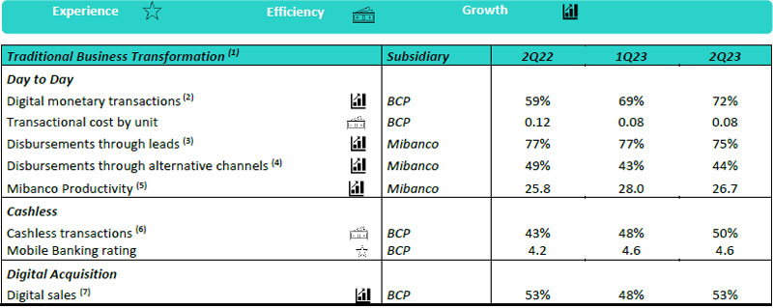
(1) Figures for June 2022, March 2023, and June 2023
(2) Retail Monetary Transactions conducted through Retail Banking, Internet Banking, Yape and Telecredito/Total Retail Monetary Transactions in Retail Banking.
(3) Disbursements generated through leads/Total disbursements.
(4) Disbursements conducted through alternative channels/Total disbursements.
(5) Number of loans disbursed/ Total relationship managers.
(6) Amount transacted through Mobile Banking, Internet Banking, Yape y POS/ Total amount transacted through Retail Banking.
(7) Units sold by Retail Banking through digital channels/ Total number of units sold by Retail Banking.

13

 | | | Earnings Release 2Q / 2023 | Analysis of 2Q23 Consolidated Results
Credicorp’s Strategy Update

Disruptive Initiatives: Yape

Yape continues to progress towards its goal of reaching breakeven at some point in 2024, buoyed by its monetization strategy. At the end of 2Q23, Yape hit the 12.6 million user mark and 9.0 million of these affiliates (70%) engage in transactions at least once a month (MAU). Over the last quarter, 615 million transactions were executed (S/53 billion thus far this year), which translated into an average of 25 transactions a month per MAU. By the end of 2Q23, recently launched functionalities had generated income flow for Yape, propelled by transactions by 5.2 million users; in this context, average revenue per MAU situated at S/ 2.5. Yape users see the application as a tool that improves their day-to-day experience. This perception led Yape’s NPS to reach 78 points last quarter.

Monetization drivers that stood out in each of Yape’s ambitions during 2Q23 were:

Be the main source of payments in the country:

○ Mobile Top-Ups: In 2Q23, Yape users made more than 34.4 million top-ups, which represent an increase of 13.3% and 208% with respect to 1Q23 and 2Q22, respectively.
○ Service Payments: In the second quarter of operations, Yaperos made more than 4 million service payments through the Yape app, which represents 8 times 1Q23 transactions.

Be present in the daily lives of all Yaperos:

○ In 2Q23, 1.4 million transactions were made through Yape Promos, which represented approximately S/25 million in total transactions.

Solving Yaperos financial needs:

○ In 2Q23, 165.8 thousand microloans were disbursed for a total of S/53.3 million, which represents a slightly reduction of 0.5% with respect to 1Q23.

Disruptive Initiatives: Yape | 2Q22 | 1Q23 | 2Q23
Users
Users (millions) | 10.0 | 12.3 | 12.6
Monthly Active Users (MAU) (millions) (1) | 5.9 | 8.4 | 9.0
Fee Income Generating MAU (millions) | 1.4 | 4.0 | 5.2
Engagement
# Monthly Transactions (millions) | 88.9 | 178.0 | 220.7
TPV (3) (S/, millions) | 24.6 | 24.0 | 53.5
Experience
NPS (2) | 58 | 73 | 78
Metric per Monthly Active User (MAU)
Monthly Transactions / MAU | 15 | 21 | 25
Monthly Revenues / MAU | 1.0 | 1.9 | 2.5
Monthly Cash Cost / MAU | 6.0 | 5.1 | 4.4
Monetization Drivers
Payments
# Mobile Top-Ups transactions (millions) | 11.2 | 30.4 | 34.4
# Utilities Payments transactions (thousands) | - | 646.8 | 5,099.4
Yape Promos
GMV (4) (S/, millions) | - | 10 | 25
Microloans
# Disbursements (thousands) | - | 166.7 | 165.8
(1) Yape users that have made at least one transaction over the last month.
(2) Net Promoting Score
(3) Total Payment Volume
(4) Gross Merchant Volume

14

 | | | Earnings Release 2Q / 2023 | Analysis of 2Q23 Consolidated Results
Credicorp’s Strategy Update

Integrating Sustainability in Our Businesses
For more information regarding our sustainability strategy, program and initiatives, please review the following documents: “Sustainability Strategy 2020-25” and the “Annual and Sustainability Report 2022”. Noteworthy milestones achieved in the framework of the Sustainability Program during the second quarter of 2023 included:

Environmental Front – Driving environmental sustainability through the financial sector and ESG risk management

 | ● | Credicorp’s Environmental Strategy has four axes: Carbon Footprint Measurement, Opportunities for Growth, Environmental and Climate Risk Management, and a Delivery Program
 | ● | In 2Q23, we began work to roll out the environmental strategy at the corporate level:
 | ○ | Carbon Footprint Measurement: We made progress in our quest to build internal capacities to apply the PCAF methodology to measure our financed footprint.
 | ○ | Business Opportunities: We developed comprehensive governance for Wholesale Banking’s commercial strategy. USD 146.3 MM was placed in the first half of 2023 via green loans. We developed the Real Estate and Mortgage front and disbursed PEN 5.4 MM in green mortgage loans.
 | ○ | Risks: We continued to roll out questionnaires to determine on the level of ESG risk management in prioritized sectors (350 Wholesale Banking Clients were assessed). Meetings were held to develop relations with relevant issuers for the investment portfolio (12 issuers).

Social Front – Expanding financial exclusion and educating people about finance and entrepreneurship

 | ● | Financial Inclusion: We continued to disseminate studies derived from the Financial Inclusion Index 2022: “Financial Inclusion in Peru’s Macroregions” and “Financial Inclusion and Digitalization.” BCP launched its mobile agent “Chasqui” to bank people in rural areas and in the south of the country. Mibanco Peru launched its “Powerful Women” program, which trained more than 2,200 women leaders and users affiliated with 500 communal food pots and community kitchens. Mibanco Peru also rolled out its “Simi” program to provide services and guidance in Indigenous languages (Quechua and Aymara). Since its launch, 46 branches have set up signage in Quechua and business advisors have been trained to provide services in this language.

 | ● | Financial Education: BCP continued improving financial behaviors (avoiding Over-indebtedness/Overdraft TC/ Delinquent payments and promoting Savings) of 89 thousand clients through its Educating through our Business initiatives. Prima AFP formalized partnerships with more than 30 organizations to provide financial and pension education. Pacifico Seguros launched “Lima 8.8: Earthquake Alert,” a fiction-based podcast to create awareness of what could happen if a powerful earthquake occurs; this edition reached 7 thousand listeners.

For information on other initiatives through the aforementioned platforms and others on the social front, please review the following table:

Progress on initiatives | Company | 1Q23 | 2Q23
Financial Inclusion
Financially included through Yape (1) | BCP | 93 thousand | 150 thousand
SME-Pymes financially included through loans (working capital and invoice discounting) – YTD 2023 | BCP | 7.7 thousand | 12.3 thousand (2)
Stock of inclusive insurance policies | Pacifico Seguros | 2.7 million | 2.9 million
Financial Education
Trained through online courses via ABC at BCP (ABC del BCP) – YTD 2023 | BCP | 77 thousand | 202 thousand
Individuals trained in risk prevention via Safe Community (Comunidad Segura) – YTD 2023 | Pacifico Seguros | 0.4 thousand | 24.3 thousand
Young people trained through the ABC of the Pension Culture (ABC de la Cultura Previsional) – YTD 2023 | Prima AFP | 5.6 thousand | 24.5 thousand
Clients trained through the Basic Program for Digital Guidance (Programa Básica de Asesoría Digital) – YTD 2023 | Mibanco Perú | 108 thousand | 184 thousand
Opportunities and Products for Women
Number of disbursements through Loans for Women | Mibanco Perú | 12.8 thousand | 16.9 thousand
Helping small businesses grow
Trained through Accompanying Entrepreneurs (Contigo Emprendedor) – YTD 2023 | BCP | 13.1 thousand | 44 thousand
Microbusiness affiliated to Yape – YTD 2023 | BCP | 1.6 thousand | 3.9 thousand
(1) Clients that have engaged in at least 3 transactions in the last 3 months

15

 | | | Earnings Release 2Q / 2023 | Analysis of 2Q23 Consolidated Results

01 | Loan Portfolio

QoQ, the structural loan volume, excluding the exchange rate effect, increased 0.2%. As reported and including the impact of the exchange rate variation, the volume fell 0.6%, driven primarily by a downturn in the Wholesale Banking loan volume. This reduction was partially offset by growth in Retail Banking and Mibanco loans, which was buoyed by a decline in heavy rains on the coast this quarter and a respite from social unrest. YoY, structural loans in average daily balances registered growth due to an uptick in loan balances across segments in the Retail Banking portfolio at Mibanco.

QoQ, the NPL volume growth was driven by (i) Mibanco, which registered growth in its NPL portfolio after reprogrammed loans in 1Q23 became delinquent; (ii) SME-Pyme, which registered deterioration in lower-ticket and higher risk profiles portfolio; and (iii) Individuals, where vulnerable segments, which are more leveraged and have unstable employment, continued to report high levels of NPLs. YoY, growth in the non-performing portfolio was mainly driven by debt refinancing in Wholesale Banking for commercial real estate and tourism loans in 2022 and 1Q23 and secondarily to by an uptick in NPLs in retail, which was attributable to the same factors as those seen QoQ. YoY growth was partially offset by a drop in NPLs for Retail Banking, which fell due to a based effect associated with a portfolio sale 1Q23. As a result of the aforementioned dynamics, the Structural NPL ratio increased QoQ and YoY, standing at 5.3%.

1.1. Loans

Structural loans (in Average Daily Balances) (1)(2)(3)

Structural Loans | As of |  |  | Volume change |  | % change |  | % Part. in total structural loans
(S/ millions) | Jun 22 | Mar 23 | Jun 23 | QoQ | YoY | QoQ | YoY | Jun 22 | Mar 23 | Jun 23
BCP Stand-alone | 105,248 | 111,792 | 110,692 | -1,099 | 5,444 | -1.0% | 5.2% | 81.4% | 81.4% | 81.1%
Wholesale Banking | 52,356 | 53,773 | 52,022 | -1,751 | -334 | -3.3% | -0.6% | 40.5% | 39.2% | 38.1%
Corporate | 31,404 | 32,543 | 31,964 | -579 | 560 | -1.8% | 1.8% | 24.3% | 23.7% | 23.4%
Middle - Market | 20,952 | 21,230 | 20,058 | -1,172 | -894 | -5.5% | -4.3% | 16.2% | 15.5% | 14.7%
Retail Banking | 52,892 | 58,018 | 58,670 | 652 | 5,778 | 1.1% | 10.9% | 40.9% | 42.3% | 43.0%
SME - Business | 5,105 | 5,749 | 5,921 | 172 | 816 | 3.0% | 16.0% | 3.9% | 4.2% | 4.3%
SME - Pyme | 12,202 | 13,583 | 13,838 | 254 | 1,635 | 1.9% | 13.4% | 9.4% | 9.9% | 10.1%
Mortgage | 19,298 | 20,282 | 20,448 | 167 | 1,150 | 0.8% | 6.0% | 14.9% | 14.8% | 15.0%
Consumer | 11,842 | 12,984 | 12,771 | -214 | 929 | -1.6% | 7.8% | 9.2% | 9.5% | 9.4%
Credit Card | 4,445 | 5,420 | 5,692 | 273 | 1,247 | 5.0% | 28.1% | 3.4% | 3.9% | 4.2%
Mibanco | 12,313 | 13,335 | 13,728 | 393 | 1,415 | 2.9% | 11.5% | 9.5% | 9.7% | 10.1%
Mibanco Colombia | 1,152 | 1,250 | 1,340 | 90 | 188 | 7.2% | 16.4% | 0.9% | 0.9% | 1.0%
Bolivia | 8,622 | 8,951 | 8,834 | -117 | 212 | -1.3% | 2.5% | 6.7% | 6.5% | 6.5%
ASB | 2,030 | 1,958 | 1,831 | -127 | -199 | -6.5% | -9.8% | 1.6% | 1.4% | 1.3%
BAP’s total loans | 129,365 | 137,287 | 136,426 | -861 | 7,061 | -0.6% | 5.5% | 100.0% | 100.0% | 100.0%
For consolidation purposes, Loans generated in Foreign Currency (FC) are converted to Local Currency (LC).
(1) Includes Work out unit, and other banking. For Quarter-end Balances figures, please refer to “12. Annexes – 12.2 Loan Portfolio Quality”.
(2) Structural Portfolio excludes the Loans offered through Reactiva Peru and FAE-Mype Government Programs (GP).
(3) Internal Management Figures
QoQ, excluding the drop in the exchange rate (USDPEN: -3.6%), structural loans grew 0.2% in average daily balances. As reported and including the aforementioned drop, loans fell -0.6%, driven by:

 | ● | Wholesale Banking, which declined 3.3% drop (-2.0% FX Neutral) due to a reduction in balances in the fishing and mining segments within Corporate Banking and Middle Banking, respectively. The aforementioned decline was driven by a reduction in our clients’ investment appetite due to uncertainty surrounding the evolution and impacts of the El Nino

Phenomenon. This contraction was concentrated primarily in Middle Market Banking, which registered a reduction in short-term transactions in both LC and FC.

The contraction in Wholesale loans was partially offset by slight growth in average daily balances in:

 | ● | Retail Banking, where all segments, with the exception of Consumer, reported slight growth with regard to 1Q23.

16

 | | | Earnings Release 2Q / 2023 | Analysis of 2Q23 Consolidated Results
01. Loan Portfolio

 | ● | Mibanco, where balances rose in line with a pick-up in originations once strong rains and social protests subsided.

YoY, structural loans in average daily balances rose 5.5% (+7.0 FX Neutral). This growth was driven mainly by:

 | ● | Retail Banking, where all segments evolved positively YoY. This evolution was led by the SME-

Pyme segment, driven primarily by growth in higher-ticket clients with better risk profiles and secondarily by Credit Card segment where the positive evolution is due to the growth in existing card balances due to the new interest-free installment payment strategies.
 | ● | Mibanco, where growth in balances reflects an uptick in disbursements to clients with better risk profiles.

Government Program Loans
(in Average Daily Balances – S/ millions)

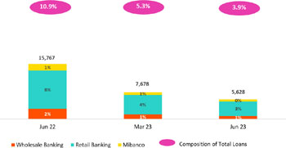

Government Program Loans (GP) dropped 26.7% QoQ and 64.3% YoY. This was primarily due to amortizations at both BCP and Mibanco. GP loans in average daily balances represented 3.9% of total loans at quarter-end (vs 5.3% in March 23 and 10.9% in June 22).
Total loans (in Average Daily Balances) (1) (2)

Total Loans | As of |  |  | Volume change |  | % change |  | % Part. in total loans
(S/ millions) | Jun 22 | Mar 23 | Jun 23 | QoQ | YoY | QoQ | YoY | Jun 22 | Mar 23 | Jun 23
BCP Stand-alone | 119,157 | 118,707 | 115,763 | -2,944 | -3,394 | -2.5% | -2.8% | 82.1% | 81.9% | 81.5%
Wholesale Banking | 55,343 | 55,141 | 52,941 | -2,200 | -2,402 | -4.0% | -4.3% | 38.1% | 38.0% | 37.3%
Corporate | 31,741 | 32,717 | 32,091 | -626 | 350 | -1.9% | 1.1% | 21.9% | 22.6% | 22.6%
Middle - Market | 23,602 | 22,424 | 20,850 | -1,574 | -2,752 | -7.0% | -11.7% | 16.3% | 15.5% | 14.7%
Retail Banking | 63,814 | 63,566 | 62,822 | -744 | -992 | -1.2% | -1.6% | 44.0% | 43.8% | 44.2%
SME - Business | 9,292 | 7,884 | 7,420 | -463 | -1,871 | -5.9% | -20.1% | 6.4% | 5.4% | 5.2%
SME - Pyme | 18,937 | 16,996 | 16,490 | -506 | -2,447 | -3.0% | -12.9% | 13.0% | 11.7% | 11.6%
Mortgage | 19,298 | 20,282 | 20,448 | 167 | 1,150 | 0.8% | 6.0% | 13.3% | 14.0% | 14.4%
Consumer | 11,842 | 12,984 | 12,771 | -214 | 929 | -1.6% | 7.8% | 8.2% | 9.0% | 9.0%
Credit Card | 4,445 | 5,420 | 5,692 | 273 | 1,247 | 5.0% | 28.1% | 3.1% | 3.7% | 4.0%
Mibanco | 14,172 | 14,098 | 14,232 | 134 | 61 | 1.0% | 0.4% | 9.8% | 9.7% | 10.0%
Mibanco Colombia | 1,152 | 1,250 | 1,340 | 90 | 188 | 7.2% | 16.4% | 0.8% | 0.9% | 0.9%
Bolivia | 8,622 | 8,951 | 8,834 | -117 | 212 | -1.3% | 2.5% | 5.9% | 6.2% | 6.2%
ASB | 2,030 | 1,958 | 1,831 | -127 | -199 | -6.5% | -9.8% | 1.4% | 1.4% | 1.3%
BAP’s total loans | 145,132 | 144,964 | 142,001 | -2,964 | -3,131 | -2.0% | -2.2% | 100.0% | 100.0% | 100.0%
For consolidation purposes, Loans generated in Foreign Currency (FC) are converted to Local Currency (LC).
(1) Includes Work out unit, and other banking. For Quarter-end Balances figures, please refer to “12. Annexes – 12.2 Loan Portfolio Quality”.
(2) Internal Management Figures
QoQ and YoY total loans dropped given that growth in structural loans was insufficient to offset the decline registered in GP loans.

17

 | | | Earnings Release 2Q / 2023 | Analysis of 2Q23 Consolidated Results
01. Loan Portfolio

Evolution of the Dollarization Level of Loans (in Average Daily Balances) (1)(2)

Total Loans | Local Currency (LC) |  |  |  |  |  | % change |  | % change Structural |  | Foreign Currency (FC) |  |  | % change |  | % part. by currency
Total Loans | Total |  |  | Structural |  |  |  |  |  |  | Total |  |  |  |  | Jun 23
(S/ millions) | Jun 22 | Mar 23 | Jun 23 | Jun 22 | Mar 23 | Jun 23 | QoQ | YoY | QoQ | YoY | Jun 22 | Mar 23 | Jun 23 | Mar 23 | QoQ | YoY | LC
BCP Stand-alone | 85,162 | 82,117 | 80,559 | 71,253 | 75,201 | 75,489 | -1.9% | -5.4% | 0.4% | 5.9% | 8,977 | 9,615 | 9,582 | -0.3% | 6.7% | 69.6% | 30.4%
Wholesale Banking | 28,403 | 25,984 | 25,062 | 25,416 | 24,616 | 24,143 | -3.5% | -11.8% | -1.9% | -5.0% | 7,113 | 7,662 | 7,589 | -1.0% | 6.7% | 47.3% | 52.7%
Corporate | 15,376 | 15,065 | 15,267 | 15,040 | 14,890 | 15,140 | 1.3% | -0.7% | 1.7% | 0.7% | 4,321 | 4,639 | 4,579 | -1.3% | 6.0% | 47.6% | 52.4%
Middle-Market | 13,027 | 10,919 | 9,795 | 10,377 | 9,725 | 9,003 | -10.3% | -24.8% | -7.4% | -13.2% | 2,793 | 3,023 | 3,009 | -0.5% | 7.8% | 47.0% | 53.0%
Retail Banking | 56,759 | 56,133 | 55,498 | 45,837 | 50,586 | 51,346 | -1.1% | -2.2% | 1.5% | 12.0% | 1,863 | 1,953 | 1,994 | 2.1% | 7.0% | 88.3% | 11.7%
SME - Business | 6,586 | 4,970 | 4,486 | 2,399 | 2,836 | 2,987 | -9.7% | -31.9% | 5.3% | 24.5% | 715 | 766 | 799 | 4.3% | 11.8% | 60.5% | 39.5%
SME - Pyme | 18,781 | 16,830 | 16,332 | 12,046 | 13,417 | 13,680 | -3.0% | -13.0% | 2.0% | 13.6% | 41 | 44 | 43 | -1.7% | 3.6% | 99.0% | 1.0%
Mortgage | 17,351 | 18,264 | 18,495 | 17,351 | 18,264 | 18,495 | 1.3% | 6.6% | 1.3% | 6.6% | 514 | 530 | 532 | 0.2% | 3.4% | 90.4% | 9.6%
Consumer | 10,367 | 11,514 | 11,388 | 10,367 | 11,514 | 11,388 | -1.1% | 9.8% | -1.1% | 9.8% | 390 | 386 | 376 | -2.5% | -3.4% | 89.2% | 10.8%
Credit Card | 3,674 | 4,555 | 4,796 | 3,674 | 4,555 | 4,796 | 5.3% | 30.5% | 5.3% | 30.5% | 204 | 227 | 244 | 7.3% | 19.9% | 84.3% | 15.7%
Mibanco | 13,696 | 13,619 | 13,746 | 11,837 | 12,856 | 13,242 | 0.9% | 0.4% | 3.0% | 11.9% | 126 | 126 | 132 | 5.1% | 5.3% | 96.6% | 3.4%
Mibanco Colombia | - | - | - | - | - | - | - | - | - | - | 304 | 329 | 365 | 11.1% | 19.9% | - | 100.0%
Bolivia | - | - | - | - | - | - | - | - | - | - | 2,277 | 2,352 | 2,405 | 2.2% | 5.6% | - | 100.0%
ASB | - | - | - | - | - | - | - | - | - | - | 536 | 515 | 498 | -3.1% | -7.0% | - | 100.0%
Total loans | 98,857 | 95,735 | 94,305 | 83,091 | 88,058 | 88,730 | -1.5% | -4.6% | 0.8% | 6.8% | 12,220 | 12,936 | 12,982 | 0.4% | 6.2% | 66.4% | 33.6%
For consolidation purposes, Loans generated in Foreign Currency (FC) are converted to Local Currency (LC).
(1) Includes Work out unit, and other banking. For Quarter-end Balances figures, please refer to “12. Annexes – 12.2 Loan Portfolio Quality”
(2) Internal Management Figures
At the end of June 2023, the dollarization of structural loans fell -60bps QoQ (35.0% in June 23). This evolution was driven by: i) loan growth in LC across Retail Banking segments, with the exception of consumer loans, where loans are typically disbursed in soles; and ii) by a variation in the exchange rate (-3.6% QoQ), which impacted Wholesale Banking in particular, where loans are mainly disbursed in US Dollars.

YoY, the dollarization of the structural portfolio dropped 81bps due to an uptick in structural loans in LC (+6.8%) which exceeded the FC growth (+6.2%). Expansion in the LC volume this quarter was buoyed by growth in loans across Retail Banking segments while the uptick in the FC volume was driven by Wholesale Banking, where a larger proportion of loans is concentrated in US Dollars.

Evolution of the Dollarization Level of Structural Loans (in Average Daily Balances) *

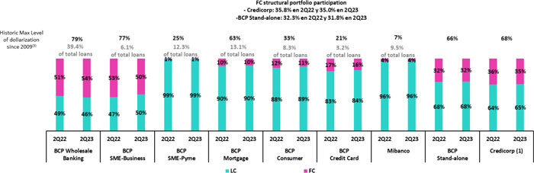

(1) The FC share of Credicorp’s loan portfolio is calculated including BCP Bolivia and ASB Bank Corp., however the chart shows only the loan books of BCP Stand-alone and Mibanco.
(2) The year with the historic maximum level of dollarization for Wholesale Banking was 2012, for Mibanco was 2016, for Credit Card was in 2021 and for the rest of segments was 2009.
* For dollarization figures in quarter-end period, please refer to “12. Annexes – 12.2 Loan Portfolio Quality

Loan Evolution in Quarter-end Balances

Structural loans measured in quarter-end balances dropped 0.5% QoQ, driven by the same factors as those seen in the analysis of average daily balances. If we include the contraction of GP loans in the analysis, total loans fell 1.6% QoQ.

In YoY Terms, structural loans reported a 1.6% increase in quarter-end balances, propelled by the same factors as those seen in the ADB dynamic. If we include the drop in GP loans in the analysis, total loans also contract.

18

 | | | Earnings Release 2Q / 2023 | Analysis of 2Q23 Consolidated Results
01. Loan Portfolio

1.2. Portfolio Quality

Quality of the Structural Portfolio (in Quarter-end balances) (1)(2)

 | As of |  |  | % change
Structural Portfolio quality and Delinquency ratios
S/000 | Jun 22 | Mar 23 | Jun 23 | QoQ | YoY
Structural loans (Quarter-end balance) | 135,722,381 | 138,615,801 | 137,905,144 | -0.5% | 1.6%
Structural Allowance for loan losses | 8,112,356 | 7,779,501 | 7,824,302 | 0.6% | -3.6%
Structural Write-offs | 413,501 | 677,148 | 682,154 | 0.7% | 65.0%
Structural IOLs | 5,163,525 | 4,952,108 | 5,182,725 | 4.7% | 0.4%
Structural Refinanced loans | 1,686,186 | 2,121,068 | 2,084,124 | -1.7% | 23.6%
Structural NPLs | 6,849,711 | 7,073,176 | 7,266,849 | 2.7% | 6.1%
Structural IOL ratio | 3.80% | 3.57% | 3.76% | 19 bps | -4 bps
Structural NPL ratio | 5.05% | 5.10% | 5.27% | 17 bps | 22 bps
Structural Allowance for loan losses over Structural loans | 6.0% | 5.6% | 5.7% | 6 bps | -31 bps
Structural Coverage ratio of NPLs | 118.4% | 110.0% | 107.7% | -232 bps | -1076 bps
(1) The Structural Portfolio excludes Government Programs (GP) effects.

Over recent quarters, client payment capacities in Retail Banking and at Mibanco clients have been affected by a challenging macroeconomic environment, which reflects a contraction in domestic demand, high inflation and high interest rates. In this context, the structural loan volume rose 2.9% and 6.3% respectively QoQ and YoY. QoQ, growth was driven by an increase in NPLs at Mibanco and in Retail Banking. This uptick was partially offset by the sale of delinquent Wholesale Banking portfolio in the energy sector in 2Q23. YoY, the dynamics reflect growth in the refinanced portfolio in Wholesale Banking, which began in 2022 and continued until 1Q23, and to an uptick in IOL loans in Individuals and Mibanco. Noteworthy, Wholesale Banking’s provisions models foresaw the potential deterioration and steps were taken to fully provision the portfolio in advance. This growth was partially offset by the sale of a Retail Banking portfolio in 1Q23.

Structural NPL Ratio

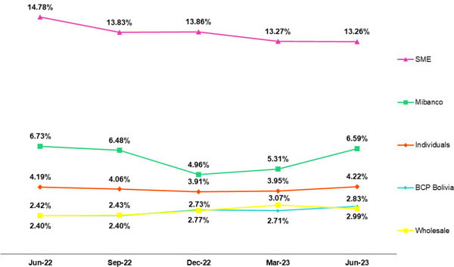

In the QoQ analysis, the structural NPL volume rose due to the deterioration of clients payment behavior given the challenging macroeconomic environment explained lines above. The segments that contributed to growth were:

 | ● | Mibanco, where reprogrammed loans from 1Q23 became delinquent this quarter.
 | ● | SME-Pyme, which reported growth in IOLs that was concentrated in lower-ticket loans (< than S/90 thousand) and higher-risk segments.
 | ● | Consumer and Credit Cards, where IOLs were concentrated in the most vulnerable subsegments, which report high levels of leverage systemic wide and tend to experience unstable employment.

19

 | | | Earnings Release 2Q / 2023 | Analysis of 2Q23 Consolidated Results
01. Loan Portfolio

This growth was partially offset by the sale of an overdue loan portfolio of a Wholesale Banking client of the energy sector.

In the aforementioned context, the Structural NPL ratio increased 17 bps QoQ, standing at 5.4%.

YoY, growth in the loan volume was partially offset by an uptick in NPL loans, which was driven by:

 | ● | Wholesale Banking, given that in 2022 some loans in the commercial real estate and tourism sectors─ which continued to suffer fallout from the pandemic─ were refinanced. It is important to note that these loans are covered by guarantees that exceed 100% of the debt.
 | ● | Consumer and Credit Cards, where the portfolio deteriorated due to the same reasons outlined in the QoQ analysis.

Structural NPL ratio declined 4bps YoY driven by the loan growth outlined in the previous section and by the sale of the Retail Banking portfolio in 1Q23.

Structural write-offs
(in quarter-end balances – S/ thousands)

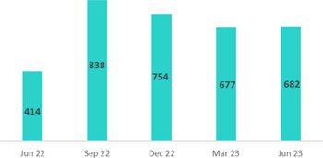

QoQ, structural write-offs remained at high levels and reported an increase of 0.7% after a significant number of write-offs of higher-risk loans were made in the Consumer and Credit Card Segments.

YoY, growth in structural loans (+64.8%) was driven by the SME-Pyme and Consumer segments as well as Mibanco. This growth was driven by write-offs on loans in default.
Coverage Ratio of Structural NPL Loans

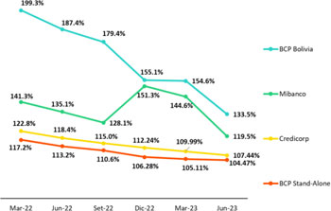

QoQ, Coverage of NPL Loans decline 232bps. This drop was driven primarily by Mibanco, which has yet to write off the underperforming portion of portfolio in 1Q23 that received reprogramming and was subsequently unable to service its debt.

YoY, Coverage for the NPL portfolio declined 1,076bps. This drop was attributable to Wholesale Banking, where structural NPL loan volumes have risen significantly due to an uptick in refinanced loans. Nevertheless, these loans have not triggered a considerable increase in provisions given that they are covered by guarantees whose commercial value is well above the total volume of the borrowers’ debt.
20

 | | | Earnings Release 2Q / 2023 | Analysis of 2Q23 Consolidated Results
01. Loan Portfolio

NPL loans in the Government Loan Portfolio
(in quarter-end balances– S/ thousands)
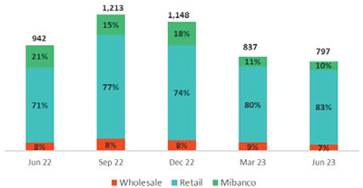 |  | QoQ, the non-performing GP portfolio decreased after more honoring processes were rolled out for Reactiva loans. At the end of June 2023, S/1,465 million had been received from State guarantees.  To execute honoring processes, loans must have been delinquent for a period exceeding 90 days. Average guarantees stand at 84%, 91% and 97% for Wholesale Banking, Retail Banking and Mibanco, respectively.

Quality of the Total Portfolio (in quarter-end balances)

Loan Portfolio quality and Delinquency ratios | As of |  |  | % change
S/000 | Jun 22 | Mar 23 | Jun 23 | QoQ | YoY
Total loans (Quarter-end balance) | 150,370,184 | 145,165,713 | 142,845,549 | -1.6% | -5.0%
Allowance for loan losses | 8,306,500 | 7,915,350 | 7,956,184 | 0.5% | -4.2%
Write-offs | 413,501 | 677,148 | 682,154 | 0.7% | 65.0%
Internal overdue loans (IOLs) (1)(2) | 6,105,256 | 5,789,497 | 5,979,395 | 3.3% | -2.1%
Internal overdue loans over 90-days (1) | 4,596,259 | 4,386,959 | 4,862,669 | 10.8% | 5.8%
Refinanced Loans (2) | 1,686,186 | 2,121,068 | 2,084,124 | -1.7% | 23.6%
Non-performing loans (NPLs) (3) | 7,791,442 | 7,910,565 | 8,063,519 | 1.9% | 3.5%
IOL ratio | 4.1% | 4.0% | 4.2% | 20bps | 13bps
IOL over 90-days ratio | 3.1% | 3.0% | 3.4% | 38bps | 34bps
NPL ratio | 5.2% | 5.4% | 5.6% | 19bps | 46bps
Allowance for loan losses over Total loans | 5.5% | 5.5% | 5.6% | 12bps | 5bps
Coverage ratio of IOLs | 136.1% | 136.7% | 133.1% | -366bps | -300bps
Coverage ratio of IOL 90-days | 180.7% | 180.4% | 163.6% | -1681bps | -1710bps
Coverage ratio of NPLs | 106.6% | 100.1% | 98.7% | -100bps | -790bps
(1) Includes Overdue Loans and Loans under legal collection (Quarter-end balances net of deferred earnings).
(2) Figures net of deferred earnings.
(3) Non-performing Loans include Internal overdue loans and Refinanced loans (Quarter-end balances net of deferred earnings).

In the aforementioned context, Credicorp’s NPL Ratio rose 21bps QoQ and 48bps YoY. This evolution was fueled by growth in structural NPL loans.

21

 | | | Earnings Release 2Q / 2023 | Analysis of 2Q23 Consolidated Results

02 | Deposits

At the end of 2Q23, 65.1% of deposits were low-cost, which represents a competitive advantage in a context of historically high interest rates.

The low-cost deposit balance fell 12.3% YoY and 7.4% QoQ, which reflected a drop in balances for Savings Deposits and Demand Deposits at BCP Stand-alone and Mibanco after liquidity levels normalized system-wide. YoY, low-cost deposits at BCP and Mibanco declined less than the banking system, where Credicorp leads the system with a market share of 40.6% as of June 2023. Over this period, the increase registered in Time Deposits, which reflected client moves to migrate from low-cost, low-interest deposits to higher-yield products, was also noteworthy.

At the end of June 2023, the market share of deposits held by BCP Stand-alone + Mibanco stood at 34.5% (-85bps with regard to June 22).

Deposits | As of |  |  | % change |  | Currency
S/000 | Jun 22 | Mar 23 | Jun 23 | QoQ | YoY | LC | FC
Demand deposits | 51,554,195 | 47,483,662 | 43,930,450 | -7.5% | -14.8% | 45.4% | 54.6%
Saving deposits | 54,936,107 | 53,418,288 | 49,456,054 | -7.4% | -10.0% | 55.6% | 44.4%
Time deposits | 35,923,266 | 43,194,573 | 45,107,429 | 4.4% | 25.6% | 49.7% | 50.3%
Severance indemnity deposits | 4,155,932 | 3,322,691 | 3,545,001 | 6.7% | -14.7% | 72.2% | 27.8%
Interest payable | 871,075 | 1,204,086 | 1,348,783 | 12.0% | 54.8% | 50.8% | 49.2%
Deposits and obligations | 147,440,575 | 148,623,300 | 143,387,717 | -3.5% | -2.7% | 50.8% | 49.2%

Our Total Deposit base dropped 3.5% QoQ and 2.7% YoY (-1.8% and -0.2% with neutral exchange rate respectively). The following dynamics were noteworthy:

 | ● | A 7.4% reduction (-5.9% FX neutral) in Savings Deposits, both in LC and FC. This decline was driven primarily by a drop in deposit volumes in LC and FC at BCP Stand-alone and Mibanco, which reflected the impact of two factors: i) a decrease in client liquidity levels, which were impacted by inflation which eroded buying power, and ii) internal fund migration to higher-yield deposits. Notably, the drop deposits at BCP Stand-alone are lower than that registered by the system as a whole.
 | ● | A 7.5% reduction (-5.62%, FX neutral) in Demand Deposits was driven primarily by a drop in LC deposits at BCP Stand-alone, which reflected a seasonal impact linked to income tax payments.

The aforementioned was partially offset by:

 | ● | A 4.4% growth (+6.37%, FX neutral) in Time Deposits, which was fueled primarily by Wholesale and Retail clients at BCP Stand-alone, who veered to higher-yield deposits in LC, and secondly by Mibanco clients, who also sought better rates. It is important to note that this increase was offset by a drop in FC deposits due to a decrease in the exchange rate.

Low-cost deposit volumes (Demand + Savings) decreased 7.4% QoQ and 12.3% YoY. Notwithstanding, the deposit types continue to represent a significant share of total deposits at 65.1%. This level remains above the pre-pandemic print (62.0% at the end of December 2019).

22

 | | | Earnings Release 2Q / 2023 | Analysis of 2Q23 Consolidated Results
02. Deposits

Deposit Dollarization Level

Deposits by currency
Currency deposits
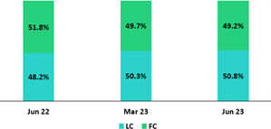 |  | At the end of June 2023, the dollarization level for Total Deposits fell 50 bps QoQ. This drop was primarily driven by Time Deposits, which increased in LC on the back of an upswing in PEN and higher interest rates. Severance Deposits also contributed to this dynamic via a seasonal effect (deposit corresponding to May). At 49.2%, the dollarization level remains below the average reported for the last 2 years (50.5%).

In YoY terms, the dollarization level fell 260bps due to a drop in Demand Deposits in FC (-19.9%) and Savings Deposits in FC (-15.1%) and to an increase in Time Deposits (28.8%). All three movements were fueled primarily by fund migration to higher-yield deposits.

Deposits by currency and type
(measured in quarter-end balances)
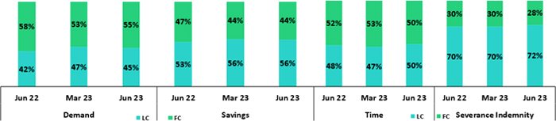
Loan / Deposit Ratio (L/D Ratio)

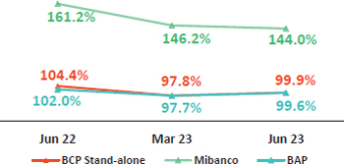 |  | The L/D ratio increased 210bps and fell 220bps QoQ at BCP Stand-alone and Mibanco, respectively. The uptick at BCP Stand-alone was associated with a drop in total deposits, which was led by a reduction in Savings Deposits and Demand Deposits in a context of high interest rates and a system-wide drop in deposits. The reduction at Mibanco was driven by growth in total deposits, which was mainly fueled by an uptick in Time Deposits in LC. In this context, BAP’s L/D ratio stood at 99.6%.
L/D Ratio in Local Currency |  | L/D Ratio in Foreign Currency
 |  | 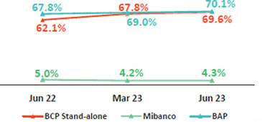

23

 | | | Earnings Release 2Q / 2023 | Analysis of 2Q23 Consolidated Results
02. Deposits

Share of the Deposit Market in the Peruvian Financial System

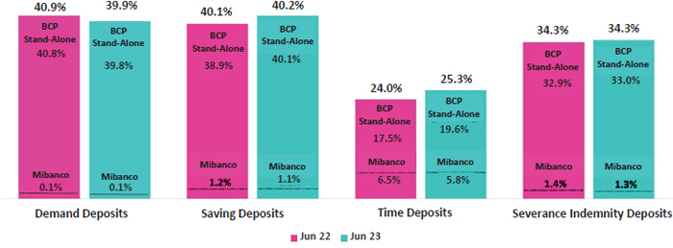

At the end of June 2023, the MS of Total Deposits held at BCP Stand-alone and Mibanco in Peru stood at 31.8% and 2.5% (-103bps and 18bps with regard to June 2022) respectively, with BCP Stand-alone maintaining a market leading position.

The drop in low-cost deposits was seen system-wide, and BCP Stand-alone was no exception. In this context, BCP Stand-alone continued to lead the low-cost deposit market YoY with an MS of 40.0% at the end of June 2023 (+19bps with regard to June 2022). This leadership is reflected in the expansion registered in our MS of Savings Deposits, which was equivalent to 111 bps. BCP Stand-alone also reported an increase in its share of Time Deposits, which were bolstered by funds that migrated from low-cost alternatives in search of higher yields.

24

 | | | Earnings Release 2Q / 2023 | Analysis of 2Q23 Consolidated Results

03 | Interest-earning Assets (IEA) and Funding

At the end of 2Q23, IEAs dropped 1.7% in QoQ terms. This decline was driven by a reduction in balances for Loans and Available Funds and was offset by an increase in Total investments. Structural loans fell 1.6%, driven downward by a decrease in Wholesale Banking balances. YoY, IEAs dropped 1.3%, driven primarily by a reduction in Loan balances in a context marked by a downward shift in the exchange rate.

Funding decreased 0.5% QoQ and 2.5% YoY. This evolution was driven by a drop in balances for Deposits and Obligations, which was attributable to a decrease in balances from Savings Deposits and Current Accounts. The reduction registered in Bonds and Notes Issued also impacted funding, albeit to a lesser degree.

3.1. IEA1

Interest Earning Assets | As of |  |  | % change
S/000 | Jun 22 | Mar 23 | Jun 23 | QoQ | YoY
Cash and due from banks | 23,831,465 | 28,158,941 | 26,036,894 | -7.5% | 9.3%
Total investments | 45,342,775 | 47,729,504 | 48,035,351 | 0.6% | 5.9%
Cash collateral, reverse repurchase agreements and securities borrowing | 2,046,209 | 1,468,180 | 1,863,243 | 26.9% | -8.9%
Total loans | 150,370,184 | 145,165,713 | 142,845,549 | -1.6% | -5.0%
Total interest earning assets | 221,590,633 | 222,522,338 | 218,781,037 | -1.7% | -1.3%

IEA dropped 1.7% QoQ due to a decrease in balances for Loans and Available Funds, which was partially offset by an uptick in Total investments and in Cash collateral, reverse repurchase agreements and securities borrowing.

Loans fell 1.6% QoQ due to the impact of amortizations of Government Program Loans (GP) and to a drop in the exchange rate. Available funds fell this quarter after having registered a seasonal peak in liquidity in 1Q23, which reflected the impact of income tax payments.

YoY, IEAs reported a reduction of 1.3% due to a decrease in Loans. Structural loans dropped over the period due to a reduction in disbursements in Wholesale Banking and in Middle Market Banking in particular. It is important to note that the drop in the exchange rate generated a negative effect YoY.

Total Investments, in turn, rose YoY due to purchases of sovereign bonds. Cash and due from banks also registered growth in year-over-year terms after the trading position in US Dollars was increased and monetized via overnight deposits in BCR.

3.2. Funding

Funding | As of |  |  | % change
S/000 | Jun 22 | Mar 23 | Jun 23 | QoQ | YoY
Deposits and obligations | 147,440,576 | 148,623,300 | 143,387,717 | -3.5% | -2.7%
Due to banks and correspondents | 6,456,360 | 10,199,650 | 10,062,290 | -1.3% | 55.9%
BCRP instruments | 16,031,618 | 9,780,540 | 11,772,772 | 20.4% | -26.6%
Repurchase agreements with clients and third parties | 2,107,245 | 1,905,955 | 2,534,108 | 33.0% | 20.3%
Bonds and notes issued | 16,579,674 | 14,326,930 | 14,235,697 | -0.6% | -14.1%
Total funding | 188,615,473 | 184,836,375 | 181,992,584 | -1.5% | -3.5%

QoQ and YoY, funding fell 1.5% and 3.5% respectively due to a reduction in Deposits and obligations. This was driven by a drop in balances of Savings Deposits and Current Accounts, which was partially offset by an uptick in Time deposits. Funding with BCRP instruments rose QoQ, driven by an upswing in repos. YoY, in contrast, funding via BCR instruments fell due to the expiration of GP repos. It is important to note that YoY growth in Due to banks and correspondents was attributable to a decision to increase short-term positions following the expiration of a BCP bond, which was not renewed due to high long-term interest rates.

(1) Effective 1Q23, IEA does not include “Financial assets designated at Fair Value through P&L” (mainly comprised of Investment Link contracts) as one of its components
(2) Effective 1Q23, Funding includes Repurchase agreements with clients

25

 | | | Earnings Release 2Q / 2023 | Analysis of 2Q23 Consolidated Results

04 | Net Interest Income (NII)

In 2Q23, Net Interest Income rose 2.3% QoQ. This evolution was due primarily to a shift in the loan mix towards to focus on higher yield segments and to moves to renew investments at higher rates. The uptick in the funding cost this quarter was partially offset by the IEA dynamic.

YoY, Net interest income increased 21.5% in a context marked by rising market rates. It is important to note that the uptick in interest expenses, which reflects growth in time deposits, was partially offset by substitutions with other sources of funding.

In this context in 2Q23, the Net Interest Margin (NIM) rose 18 bps QoQ and 110 bps YoY to stand at 6.02%. NIM continues to follow an upward trend, but the pace of growth has fallen. Finally, the Structural Net Interest Margin stood at 6.14%.

Net Interest Income / Margin | Quarter |  |  | % change |  | As of |  | % change
S/ 000 | 2Q22 | 1Q23 | 2Q23 | QoQ | YoY | 1H22 | 1H23 | 1H23 / 1H22
Interest Income | 3,488,113 | 4,456,106 | 4,653,246 | 4.4% | 33.4% | 6,660,459 | 9,109,352 | 36.8%
Interest Expense | (851,007) | (1,324,017) | (1,449,090) | 9.4% | 70.3% | (1,591,646) | (2,773,107) | 74.2%
Interest Expense (excluding Net Insurance Financial Expenses) | (747,047) | (1,208,267) | (1,333,924) | 10.4% | 78.6% | (1,385,928) | (2,542,191) | 83.4%
Net Insurance Financial Expenses | (103,960) | (115,750) | (115,166) | -0.5% | 10.8% | (205,718) | (230,916) | 12.2%
Net Interest Income | 2,637,106 | 3,132,089 | 3,204,156 | 2.3% | 21.5% | 5,068,813 | 6,336,245 | 25.0%
Balances
Average Interest Earning Assets (IEA) | 222,718,971 | 222,289,504 | 220,651,688 | -0.7% | -0.9% | 226,151,471 | 220,418,854 | -2.5%
Average Funding | 189,164,046 | 185,377,296 | 183,407,530 | -1.1% | -3.0% | 192,630,988 | 183,962,350 | -4.5%
Yields
Yield on IEAs | 6.26% | 8.02% | 8.44% | 42bps | 218bps | 5.89% | 8.27% | 238pbs
Cost of Funds | 1.55% | 2.53% | 2.88% | 35bps | 133bps | 1.44% | 2.76% | 132pbs
Net Interest Margin (NIM)(1) | 4.92% | 5.84% | 6.02% | 18bps | 110bps | 4.66% | 5.96% | 130pbs
Risk-Adjusted Net Interest Margin | 4.27% | 4.54% | 4.56% | 2pbs | 29pbs | 4.12% | 4.57% | 45pbs
Peru’s Reference Rate | 5.50% | 7.75% | 7.75% | 0pbs | 225pbs | 5.50% | 7.75% | 225pbs
FED funds rate | 1.75% | 5.00% | 5.25% | 25pbs | 350pbs | 1.75% | 5.25% | 350pbs
(1) For further detail on the new NIM calculation due to IFRS17, please refer to Annex 12.1.8

Net Interest Income rose 2.3% QoQ despite the fact that growth in expenses outpaced the expansion registered for income this quarter. Income rose 4.4% over the period, driven mainly by the positive impact of a shift in the loan mix to favor higher-yield segments. This quarter, Investment income increased 5.8%, which reflected renewals of BCRP Certificates of Deposit at higher rates. Expenses, in turn, were up 9.4% as Time deposits assumed a larger share of the loan mix. The mix effect contributed to the 35 bps increase in the funding cost. The Net Interest Margin rose 18 bps to stand at 6.02% this quarter while the Structural Interest Margin stood at 6.14% (+13bps).

Net Interest Income rose 21.5% YoY, which once again reflects the fact that growth in interest expenses outstripped the expansion reported for income. Income increased 33.4% over the period, in line with loan and investment dynamics and well as with an increase in Available funds. Expenses rose 70.3% due to a mix effect, which was generated primarily by an uptick in Time deposit’s share of total funding and secondarily by an uptick in debt at higher rates via Due to banks and correspondents (price effect).

Net Interest Margin

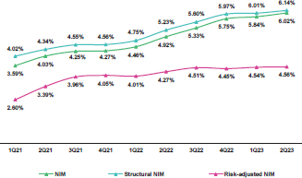 |  | Structural NIM continued to increase QoQ due to a positive variation in the loan mix and investment renewals at more favorable rates. Risk-adjusted NIM remained relatively stable, reporting a marginal increase of 2bps to stand at 4.56%.  It is important to note that reference rates are currently high for both soles (BCRP) and US dollars (FED), which continues to buoy net interest income. In soles, and despite the fact that BCRP’s rate registered no variation over the period, renewals of some IEA drove an uptick in income, which reflects disciplined passthroughs.

26

 | | | Earnings Release 2Q / 2023 | Analysis of 2Q23 Consolidated Results
04. Net Interest Income (NII)

Dynamics of Net Interest Margin by Currency

 | 2Q22 |  |  | 1Q23 |  |  | 2Q23 |  |  |  | 1H22 |  |  | 1H23
Interest Income / IEA | Average | Income |  | Average | Income |  | Average | Income |  |  | Average | Income |  | Average | Income
S/ millions | Balance | Income | Yields | Balance | Income | Yields | Balance | Income | Yields |  | Balance | Income | Yields | Balance | Income | Yields
Cash and equivalents | 26,697 | 48 | 0.7% | 27,528 | 277 | 4.0% | 27,098 | 286 | 4.2% |  | 28,113 | 83 | 0.3% | 26,467 | 564 | 2.1%
Other IEA | 1,782 | 14 | 3.1% | 1,285 | 16 | 5.0% | 1,666 | 17 | 4.2% |  | 1,907 | 33 | 1.7% | 1,483 | 34 | 2.3%
Investments | 46,744 | 497 | 4.2% | 46,580 | 592 | 5.1% | 47,882 | 636 | 5.3% |  | 47,148 | 929 | 2.0% | 46,733 | 1,228 | 2.6%
Loans | 147,496 | 2,930 | 7.9% | 146,896 | 3,571 | 9.7% | 144,006 | 3,713 | 10.3% |  | 148,984 | 5,615 | 3.8% | 145,736 | 7,284 | 5.0%
Structural | 131,654 | 2,871 | 8.7% | 138,866 | 3,528 | 10.2% | 138,300 | 3,679 | 10.6% |  | 132,325 | 5,490 | 4.1% | 138,550 | 7,207 | 5.2%
Government Programs | 15,842 | 59 | 1.5% | 8,031 | 43 | 2.1% | 5,705 | 34 | 2.4% |  | 16,659 | 125 | 0.8% | 7,186 | 77 | 1.1%
Total IEA | 227,280 | 3,488 | 6.3% | 222,290 | 4,456 | 8.0% | 220,652 | 4,653 | 8.4% |  | 226,151 | 6,660 | 2.9% | 220,419 | 9,109 | 4.1%
IEA (LC) | 57.6% | 78.2% | 8.3% | 56.9% | 71.2% | 10.0% | 57.3% | 71.4% | 10.5% |  | 57.4% | 78.5% | 4.0% | 57.5% | 71.3% | 5.1%
IEA (FC) | 40.3% | 21.8% | 3.3% | 43.1% | 28.8% | 5.3% | 42.7% | 28.6% | 5.7% |  | 42.6% | 21.5% | 1.5% | 42.5% | 28.7% | 2.8%

 | 2Q22 |  |  | 1Q23 |  |  | 2Q23 |  |  |  | 1H22 |  |  | 1H23
Interest Expense / Funding | Average | Expense |  | Average | Expense |  | Average | Expense |  |  | Average | Expense |  | Average | Expense
S/ millions | Balance | Expense | Yields | Balance | Expense | Yields | Balance | Expense | Yields |  | Balance | Expense | Yields | Balance | Expense | Yields
Deposits | 147,678 | 337 | 0.9% | 147,822 | 677 | 1.8% | 146,006 | 777 | 2.1% |  | 148,519 | 596 | 0.4% | 145,204 | 1,455 | 1.0%
BCRP + Due to Banks | 23,192 | 142 | 2.4% | 20,108 | 239 | 4.8% | 20,908 | 297 | 5.7% |  | 24,697 | 258 | 1.0% | 21,035 | 536 | 2.5%
Bonds and Notes | 16,312 | 166 | 4.1% | 15,660 | 183 | 4.7% | 14,274 | 149 | 4.2% |  | 17,201 | 340 | 2.0% | 15,621 | 332 | 2.1%
Others | 1,279 | 206 | 32.0% | 1,091 | 225 | 40.1% | 1,242 | 226 | 35.6% |  | 1,318 | 192 | 14.6% | 1,126 | 220 | 19.5%
Total Funding | 189,164 | 851 | 1.6% | 185,377 | 1,324 | 2.6% | 183,408 | 1,449 | 2.9% |  | 192,631 | 1,386 | 0.7% | 183,962 | 2,542 | 1.4%
Funding (LC) | 51.2% | 58.6% | 1.8% | 50.5% | 56.6% | 2.9% | 50.8% | 60.3% | 3.4% |  | 50.7% | 56.2% | 0.8% | 50.8% | 57.8% | 1.6%
Funding (FC) | 48.8% | 41.4% | 1.3% | 49.5% | 43.4% | 2.3% | 49.2% | 39.7% | 2.4% |  | 49.3% | 43.8% | 0.6% | 49.2% | 42.2% | 1.2%
NIM | 227,280 | 2,637 | 4.6% | 222,290 | 3,132 | 5.6% | 220,652 | 3,204 | 5.8% |  | 226,151 | 5,275 | 4.7% | 220,419 | 6,567 | 6.0%
NIM (LC) | 57.6% | 84.6% | 6.8% | 56.9% | 77.4% | 7.7% | 57.3% | 76.4% | 7.7% |  | 57.4% | 84.4% | 3.4% | 57.5% | 76.6% | 4.0%
NIM (FC) | 40.3% | 15.4% | 1.8% | 43.1% | 22.6% | 2.9% | 42.7% | 23.6% | 3.2% |  | 42.6% | 15.6% | 0.9% | 42.5% | 23.4% | 1.6%

QoQ Analysis

QoQ, Net Interest Income rose 2.3%, driven by growth in both LC and FC. IEAs in LC represented 57.3% of total IEAs and accounted for 71.4% of Net Interest Income in 2Q23.

Dynamics in Local Currency (LC)

Net Interest Income in LC increased 1.0% due to the following dynamics:

A shift in the loan mix where a drop in Wholesale Loans was partially offset by growth in Retail Loans, leading to a 4.6% increase in structural loan income QoQ. Investment income also contributed positively (although to a lesser extent) with growth of 9.4% via renewals at higher interest rates. The combination of mix and pricing effects led the implicit rates for IEAs in LC to rise from 10.0% at the end of the first quarter to 10.5% at the end of 2Q23 and led income to rise 4.7%, despite the fact that average IEAs in LC remained stable.

Average funding in LC registered a moderate decline of 0.4%, which reflects a drop in Deposits and Due to banks and correspondents. This was partially offset by growth in funding with BCRP instruments, which registered an uptick in repo positions that compensated for expirations in Reactiva repos. The funding cost in LC rose from 2.9% in 1Q23 to 3.4% in 2Q23, which reflects growth in the share of time deposits within total funding and an uptick in the funding cost with repos. In this context, interest expenses rose 16.6%.

Dynamics in Foreign currency (ME)

Net Interest Income in FC rose 6.9% due to the following dynamics:

Average IEA in FC fell 1.8%, which was driven primarily by a drop in loans and to a lesser extent, by a reduction in the volume of Available funds and equivalents. The decrease in the exchange rate registered in the first quarter contributed to a drop in IEA. Notwithstanding income from loans was fueled by a positive mix effect, which led to an increase in implicit rates. In this context, yields on IEA in FC rose from 5.3% in 1Q23 to 5.7% in 2Q23. The aforementioned let interest income in FC to rise 3.9%.

Average funding in FC fell 1.7% due to a reduction in balances for Bonds and Notes Issued (-11.4%) and deposits (-1.8%), which was partially offset by growth in funding with BCRP and banks (+17.2%). In this context, the average funding cost rose slightly from 2.3% to 2.4%, fueled almost entirely by growth in the cost of deposits (mix and price effect) and by the fact that other sources of funding reported reductions in their implicit rates. Interest expenses rose marginally (+0.2%).

27

 | | | Earnings Release 2Q / 2023 | Analysis of 2Q23 Consolidated Results
04. Net Interest Income (NII)

YoY Analysis

YoY, Net interest income rose 21.512.7% in a context marked by a drop in average IEAs in LC.

Dynamics in Local Currency (LC)

Net Interest Income in LC rose 9.8% YoY due to the following dynamics:

Average IEA in LC dropped 3.5% due to a reduction in loan volumes, where the 6.5% increase in structural loans was insufficient to offset the impact of Reactiva amortizations. The IEA yield rose from 8.2% to 10.5% (218bps), triggered by the fact that the Reactiva balance contracted while structural loans reported higher growth in year-over-year terms. Investment positions were renewed at higher rates during the period, which also contributed, albeit to a lesser extent, to the increase in yield. In this context, interest income from IEA rose 21.7%.

Average funding in LC dropped 3.7% due to a reduction in BCRP repo balances, which reflects amortizations of Reactiva loans. This decrease was offset by growth in Time deposits. The loan mix registered a YoY variation that led the funding cost to rise from 1.8% in 2Q22 to 3.4% in 2Q23. In this context, interest expenses in LC increased 75.0%.

Dynamics in Foreign Currency (FC)

Net Interest Income in FC rose 85.6%, driven by the following dynamics:

Average IEA in FC rose 2.7%, fueled primarily by growth in Available funds (+8.2%) and secondarily by an uptick in loans (+2.7%). The uptick in Available funds was monetized through BCP deposits, which, in a context of higher rates, contributed to increasing the IEA yield. Loan growth, in turn, was concentrated in higher-yield segments. In this context, the IEA yield rose from 3.3% in 2Q22 to 5.7% in 2Q23 while interest income increased 75.4%.

Average funding in LC contracted 2.3%, which was primarily due to a drop in deposit balances (-5.1%) and secondarily to a decrease in Bonds and Notes Issued (-14.1%), which fell due to the expiration of an issuance. It is important to note that the reduction in deposits was concentrated in low-cost deposits (Demand and Savings) while Time deposits registered an increase in their share of total deposits. In this context, the average funding cost rose from 1.3% in 2Q22 to 2.4% in 2Q23. Interest expenses, in turn, rose 63.6%.

28

 | | | Earnings Release 2Q / 2023 | Analysis of 2Q23 Consolidated Results

05 | Provisions

Structural provisions remain at historically high levels in Consumer Loans and Credit Cards at BCP, as well as at Mibanco due to the impacts of the recessive macroeconomic context where high inflation, lower domestic demand and high interest rates weighed heavily. At BCP, the most affected portion of the portfolio corresponds to vulnerable subsegments, which report higher leverage system wide and less job stability; while at Mibanco deterioration was most significant for loans impacted by the adverse events in the first quarter. SMEs, in turn, drove QoQ growth after higher-risk and high-yield subsegments registered a decrease in payment capacity.

In the aforementioned context, the Structural Cost of Risk (CdR) increased 23bps QoQ and stood at 2.32% in 2Q23.

Provisions and the Cost of Risk (CdR) (1) of the Structural Portfolio

Structural Loan Portfolio Provisions | Quarter |  |  | % change |  | As of |  | % change
S/ 000 | 2Q22 | 1Q23 | 2Q23 | QoQ | YoY | 1H22 | 1H23 | 1H23 / 1H22
Gross provision for credit losses on loan portfolio | (440,467) | (799,129) | (882,156) | 10.4% | 100.3% | (795,020) | (1,681,285) | 111.5%
Recoveries of written-off loans | 83,745 | 75,109 | 81,872 | 9.0% | -2.2% | 176,836 | 156,981 | -11.2%
Provision for credit losses on loan portfolio, net of recoveries | (356,722) | (724,020) | (800,284) | 10.5% | 124.3% | (618,184) | (1,524,304) | 146.6%
Structural Cost of risk (2) | 1.05% | 2.09% | 2.32% | 23 bps | 127 bps | 0.91% | 2.21% | 130 bps
 | (1) | Provision for credit losses on loan portfolio, net of annualized recoveries / Total loans.
 | (2) | The Cost of structural risk excludes Provisions for credit losses for the loan portfolio, net of recoveries and Placements of the government programs (PG) Reactiva Perú and FAE.

Structural provisions remain at historic peak (excluding the outlier expense reported during the pandemic) in Retail Banking and at Mibanco where clients have been severely impacted by an adverse macroeconomic environment marked by a drop internal demand, high inflation and historically high interest rates. At BCP, Consumer Loans and Credit Cards, were the most impacted, particularly via vulnerable subsegments which are highly leveraged at the system level and experience instability on the employment front. In the case of Mibanco, clients have begun to register further deterioration due to adverse events in 1Q23.

Pyme led growth of the QoQ provisions expense, via a deterioration in payment behavior in higher-risk and lower-ticket (< S/90 thousand) subsegments. This increase was partially offset by the slight reduction in Mibanco’s provisions due to methodological improvements implemented to better reflect payment behavior.

The evolution of provisions and a drop in loan volume led the structural CdR increased 23bps, standing at 2.32%.

Structural Cost of Risk by Subsidiary

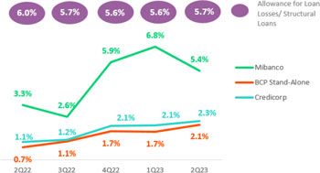
YoY and YTD, provisions presented growth over an low base after pre-pandemic parameters on provision models were reinstituted in 2022. Growth in provisions was driven by:

 | ● | Consumer and Credit Card, due to the impact of the macroeconomic environment on the most vulnerable subsegments (describe in the QoQ evolution).
 | ● | SME-Pyme, due to the same factors that drove the QoQ evolution and to an increase in the leverage reported in the system for higher-risk sub-segments.
 | ● | Mibanco, driven by a deterioration in payment behavior of clients who had benefitted from reprogrammed loans in 1Q23 and by new macroeconomic projections that indicate challenges down the road.

The evolution of provisions led the structural CdR to increase YoY and YTD 127bps and 130bps, respectively.

An adverse macroeconomic scenario and the impact we have observed on all of our clients payment behavior led us to refine our process to segment clients by risk profile. We have also reviewed the risk appetite for the Individuals (consumer loans and credit cards), SMEs and Mibanco segments and are implementing more restrictive origination policies. Mibanco began this restrictive process in May 2022; while BCP rolled-out gradual restrictions throughout the first half of this year.

29

 | | | Earnings Release 2Q / 2023 | Analysis of 2Q23 Consolidated Results
05. Provisions

Provisions and CofR of Government Loans (PG)

GP Loan Portfolio Provisions | Quarter |  |  | % change |  | As of |  | % change
S/ 000 | 2Q22 | 1Q23 | 2Q23 | QoQ | YoY | 1H22 | 1H23 | 1H23/ 1H22
Gross provision for credit losses on loan portfolio | (6,569) | (2,978) | (3,967) | 33.2% | n.a. | (2,697) | (6,945) | 157.5%
Recoveries of written-off loans | - | - | - | - | - | - | - | -
Provision for credit losses on loan portfolio, net of recoveries | (6,569) | (2,978) | (3,967) | 33.2% | n.a. | (2,697) | (6,945) | 157.5%
GP Cost of risk (1) | 0.18% | 0.18% | 0.32% | 14 bps | 14 bps | 0.02% | 0.14% | 12 bps
 | (1) | PG Cost of risk includes the Provisions for credit losses for the loan portfolio, net of recoveries and placements of the Reactiva Perú and FAE government programs.

GP provisions rose slightly QoQ, YoY and YTD given that honoring process to execute State guarantees are still underway.

The GP provisions balance represents 1.67% of Credicorp’s total provisions balance. This relatively low balance reflects the fact that ample State guarantees are in place for these loans and cover 80% to 98% of the loan amount. For more information, see 1.2 Portfolio Quality-Non-performing GP Loan Portfolio.

Provisions and CofR of Total Loans

Loan Portfolio Provisions | Quarter |  |  | % change |  | As of |  | % change
S/ 000 | 2Q22 | 1Q23 | 2Q23 | QoQ | YoY | 1H22 | 1H23 | 1H23 / 1H22
Gross provision for credit losses on loan portfolio | (447,036) | (802,107) | (886,123) | 10.5% | 98.2% | (797,717) | (1,688,230) | 111.6%
Recoveries of written-off loans | 83,745 | 75,109 | 81,872 | 9.0% | -2.2% | 176,836 | 156,981 | -11.2%
Provision for credit losses on loan portfolio, net of recoveries | (363,291) | (726,998) | (804,251) | 10.6% | 121.4% | (620,881) | (1,531,249) | 146.6%
Cost of risk (1) | 0.97% | 2.00% | 2.25% | 25 bps | 128 bps | 0.83% | 2.14% | 131 bps
(1) | Provision for credit losses on loan portfolio, net of annualized recoveries / Total loans.

The CofR for the complete portfolio, which is comprised of structural loans and GP loans, reported growth of 25bps QoQ, 128bps YoY and 131 bps YTD in line with an uptick in structural provisions.

QoQ Cost of Risk Evolution |  | YoY Cost of Risk Evolution
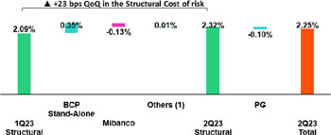 |  | 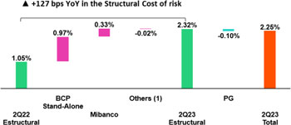

(1) Otros incluye BCP Bolivia, Mibanco Colombia, ASB y eliminaciones.

30

 | | | Earnings Release 2Q / 2023 | Analysis of 2Q23 Consolidated Results

06 | Other Income

When analyzing other core income results (fee income + gains on FX transactions) it is important to note that both lines have been affected by our strategy at BCP Bolivia, where we have implemented a new fee framework for international transfers in response to a drop in the availability of foreign currency. On a QoQ basis, excluding this strategy, Other Core Income increased 3.2% via an uptick in transactions while the result for FX transactions remained flat. YoY and YTD, fee income contracted 2.3% after the fee level for the Pensions business dropped and inter-city fees were eliminated at BCP Perú.

Other Non-core Income rose QoQ, YoY and YTD, which primarily reflected two impacts: the recognition of fees from previous periods, and the sale of a delinquent portfolio in Wholesale Banking at BCP Perú.

6.1 Other Core Income

Other Core Income | Quarter |  |  | % Change |  | As of |  | % Change
(S/ 000) | 2Q22 | 1Q23 | 2Q23 | QoQ | YoY | 1H22 | 1H23 | 1H23/ 1H22
Fee income | 920,950 | 881,781 | 960,550 | 8.9% | 4.3% | 1,812,578 | 1,842,331 | 1.6%
Net gain on foreign exchange transactions | 269,059 | 248,515 | 210,944 | -15.1% | -21.6% | 528,769 | 459,459 | -13.1%
Total other income Core | 1,190,009 | 1,130,296 | 1,171,494 | 3.6% | -1.6% | 2,341,347 | 2,301,790 | -1.7%

The banking business in Bolivia implemented a strategy to attenuate the impact of the Bolivian Central Bank’s decision to restrict purchases of US dollars in 1Q23. To mitigate the impact of these limitations, BCP Bolivia adjusted its fee framework for foreign transfers, which led to a subsequent increase in Fee income. Thanks to this strategy, Other Core Income at BCP Bolivia rose S/ 6 MM, S/ 8.2 MM and S/ 13 MM QoQ, YoY and YTD, respectively.

QoQ, Other Core Income rose 3.6%. This evolution was driven by 8.9% growth in fees and by a 15.1% drop in the Net gain on FX transactions.

If we exclude BCP Bolivia strategy, growth in Other Core Income stands at 3.2%, driven by:

 | ○ | Growth of 4.1% in Fee income, primarily driven by BCP Peru; we will provide further details in the section on fees for banking services section.
 | ○ | A relatively flat Net gain on FX transactions (0.3%), where the minimal upward variation was driven primarily by BCP Peru.

YoY, a -1.6% drop was registered in Other Core Income. This decline was triggered by a -21.6% decrease in FX transactions and offset by 4.3% growth in fee income.

If we exclude BCP Bolivia, Other Core Income falls -2.3%, which reflects:

 | ○ | A -3.3% drop in fee income, which was primarily attributable to a regulatory change that eliminated mixed commissions at Prima AFP as of 2Q23 and to a drop in liability and transactional accounts, which will be discussed in the section on banking fees.
 | ○ | The aforementioned was partially offset by the FX business at BCP Peru and Credicorp Capital, which registered growth of 1.3% due to exchange rate volatility.

YTD, Other Core Income dropped -1.7%. This evolution was driven by a -13.1% reduction in FX transactions and by 1.6% growth in fee income.

If we exclude BCP Bolivia, Other Core Income decreases -2.3%. This reduction was triggered by:

 | ○ | A -3.6% decrease in fee income, which was primarily driven by a reduction in total fees in the capital markets and asset management businesses and by the same dynamics outlined in the YoY analysis.
 | ○ | The aforementioned was partially offset by the FX business, which reported growth of 2.2%, propelled by the same dynamics as those seen YoY.

31

 | | | Earnings Release 2Q / 2023 | Analysis of 2Q23 Consolidated Results
06. Other Income

Fee Income from the banking business

Composition of fee income in the banking business1

Banking Business Fees | Quarter |  |  | % Change |  | As of |  | % Change
S/ 000 | 2Q22 | 1Q23 | 2Q23 | QoQ | YoY | 1H22 | 1H23 | 1H23/ 1H23
Payments and transactionals (2) | 304,950 | 325,973 | 344,632 | 5.72% | 13.01% | 595,147 | 670,605 | 12.68%
Liability accounts (3) | 234,038 | 177,971 | 182,018 | 2.27% | -22.23% | 451,994 | 359,989 | -20.36%
Loan Disbursement (4) | 91,957 | 95,201 | 91,599 | -3.78% | -0.39% | 182,533 | 186,800 | 2.34%
Off-balance sheet | 59,304 | 61,654 | 57,154 | -7.30% | -3.63% | 119,674 | 118,808 | -0.72%
Mibanco (Peru and Colombia) | 45,000 | 46,839 | 52,432 | 11.94% | 16.52% | 78,276 | 99,271 | 26.82%
Insurances | 28,823 | 31,102 | 30,540 | -1.81% | 5.96% | 59,126 | 61,642 | 4.26%
BCP Bolivia | 25,468 | 50,134 | 95,027 | 89.55% | 273.13% | 52,868 | 145,161 | 174.57%
Wealth Management and Corporate Finance | 18,126 | 15,254 | 16,878 | 10.65% | -6.89% | 36,911 | 32,132 | -12.95%
ASB | 7,546 | 9,786 | 8,531 | -12.83% | 13.06% | 19,826 | 18,318 | -7.61%
Others (5) | -42 | -3,501 | 8,524 | n.a | n.a | 4,554 | 5,023 | 10.30%
Total | 815,170 | 810,414 | 887,335 | 9.49% | 8.85% | 1,600,909 | 1,697,749 | 6.05%
(1) Management Figures
(2) Corresponds to fees from: credit and debit cards; payments and collections.
(3) Corresponds to fees from: Account maintenance, interbank transfers, national money orders y international transfers.
(4) Corresponds to fees from retail and wholesale loan disbursements.
(5) Use of third-party network, other services to third parties and Commissions in foreign branches.

If we extract banking fees of BCP Bolivia’s results from total results for banking business fees, we find that:

Fees for banking services rose QoQ, YoY and YTD, driven primarily by:

 | ○ | Payment and Transactional, via growth in transactions and on-going migration to digital channels and POS which, unlike cash, generate fee income. The consumption volume through debit and credit cards rose QoQ 1.98% and 3.01% respectively YoY; 17.15% an 18.51% respectively; and YTD 18.26% and 22.76% respectively.
 | ○ | Others, due to a drop in fees paid to third-parties.
 | ○ | Mibanco, which registered an uptick in sales of insurance for banking products.

YoY and YTD, the aforementioned was partially offset by the elimination of inter-city fees in the liability accounts, which began in 4Q22 and was completed in 1Q23.

6.2 Other Non-Core income

Non-core Other income | Quarter |  |  | % change |  | As of |  | % change
(S/ 000) | 2Q22 | 1Q23 | 2Q23 | QoQ | YoY | 1H22 | 1H23 | 1H23 / 1H22
Net gain on securities | (94,179) | 70,036 | 68,603 | -2.0% | n.a | (151,045) | 138,639 | n.a
Net gain from associates (1) | 29,219 | 27,212 | 23,689 | -12.9% | -18.9% | 41,787 | 50,901 | 21.8%
Net gain on derivatives held for trading | 12,304 | (6,570) | 16,671 | n.a | 35.5% | 6,322 | 10,101 | 59.8%
Net gain from exchange differences | (18,441) | 22,963 | 2,996 | -87.0% | n.a | (26,804) | 25,959 | n.a
Other non-financial income | 78,681 | 89,338 | 150,333 | 68.3% | 91.1% | 225,384 | 239,671 | 6.3%
Total other income Non-Core | 7,584 | 202,979 | 262,292 | 29.2% | 3358.5% | 95,644 | 465,271 | 386.5%
(1) Includes gains on other investments, which are mainly attributable to the Banmedica result.

32

 | | | Earnings Release 2Q / 2023 | Analysis of 2Q23 Consolidated Results
06. Other Income

QoQ Other Non-Core Income Evolution  (Thousands of soles) |  | YoY Other Non-Core Income Evolution  (Thousands of soles)
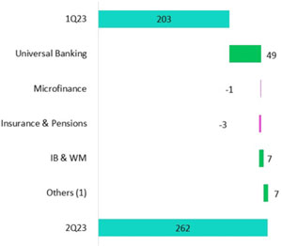 |  | 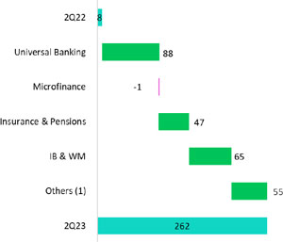

 | (1) | Other includes: Grupo Crédito, Credicorp Individual, eliminations and others.

QoQ, Other Non-Core Income rose, driven primarily by:

 | ● | Universal Banking, due to:
 | ○ | The recognition of fees from previous periods.
 | ○ | The sale of a delinquent portfolio in the energy sector in Wholesale Banking.
 | ○ | Growth in income in the derivatives line, which reflects derivatives trading to take advantage of market opportunities.
 | ○ | This was partially offset by a drop in the Net gain on securities, which reflects a strategy to manage the balance sheet to prepare for new rate scenarios.

YoY and YTD, Other Non-Core income rose, driven mainly by:

 | ● | Universal Banking, fueled by the same dynamics as those seen QoQ.
 | ● | Investment Banking and Wealth Management, which reaped positive results through trading strategies at Credicorp Capital Colombia and ASB in a context marked by rate curve variations and volatility.
 | ● | Others, due to growth in the market value of investments held by Credicorp Stand-Alone.
 | ● | Insurance and Pensions, due to growth in the Net gain on investments.

33

 | | | Earnings Release 2Q / 2023 | Analysis of 2Q23 Consolidated Results

07 | Insurance Underwriting Results

The insurance underwriting result rose 0.1% QoQ due to an improvement in the results for P&C. This evolution was mitigated by lower results in Life. P&C’s result rose due to the favorable evolution of P&C Risks and Medical Assistance. The aforementioned was attenuated by the results registered in Life, which reported lower results in Individual Life and Group Life; and was partially offset by uptick in the results posted by Pensions.

YoY and YTD, results rose 52.7% and 47.9% respectively, driven by the Life businesses and by Pensions, Group Life and Credit Life in particular. The drop registered in P&C was attributable to lower results in P&C risks and Cars.

Insurance Underwriting Result |  | Quarter |  |  | Change % |  | As of |  | Change %
S/ 000 |  | 2Q22 | 1Q23 | 2Q23 | QoQ | YoY | Jun 22 | Jun 23 | Jun23 / Jun22
Total | Income from Insurance Services | 844.2 | 956.6 | 957.7 | 0.1% | 13.4% | 1689.3 | 1914.3 | 13.3%
Total | Expenses for Insurance Services | (513.6) | (545.2) | (550.4) | 1.0% | 7.2% | (1044.4) | (1095.6) | 4.9%
Total | Reinsurance Results | (136.4) | (115.1) | (110.7) | -3.8% | -18.8% | (244.0) | (225.8) | -7.4%
Total | Insurance Undewrwriting Result | 194.2 | 296.3 | 296.6 | 0.1% | 52.7% | 400.9 | 592.9 | 47.9%
P&C | Income from Insurance Services | 420.2 | 413.9 | 430.1 | 3.9% | 2.3% | 825.7 | 844.0 | 2.2%
P&C | Expenses for Insurance Services | (212.6) | (286.1) | (274.1) | -4.2% | 28.9% | (457.1) | (560.2) | 22.6%
P&C | Reinsurance Results | (133.5) | (83.9) | (81.1) | -3.4% | -39.3% | (245.3) | (165.0) | -32.7%
P&C | Insurance Undewrwriting Result | 74.1 | 43.9 | 74.9 | 70.5% | 1.0% | 123.3 | 118.8 | -3.6%
Life | Income from Insurance Services | 411.5 | 521.9 | 500.1 | -4.2% | 21.5% | 830.3 | 1022.0 | 23.1%
Life | Expenses for Insurance Services | (306.0) | (257.3) | (270.7) | 5.2% | -11.5% | (584.4) | (527.9) | -9.7%
Life | Reinsurance Results | 0.2 | (27.2) | (24.0) | -11.8% | n.a | 7.1 | (51.1) | -819.2%
Life | Insurance Undewrwriting Result | 105.7 | 237.4 | 205.5 | -13.5% | 94.5% | 253.0 | 442.9 | 75.1%
Crediseguros | Income from Insurance Services | 16.9 | 20.9 | 27.5 | 31.9% | 63.1% | 33.2 | 48.4 | 45.6%
Crediseguros | Expenses for Insurance Services | 0.6 | (1.9) | (5.6) | 203.6% | -1000.2% | (2.9) | (7.5) | 156.8%
Crediseguros | Reinsurance Results | (3.1) | (4.0) | (5.7) | 42.0% | 83.9% | (5.7) | (9.2) | 60.3%
Crediseguros | Insurance Undewrwriting Result | 14.4 | 15.0 | 16.2 | 8.0% | 12.5% | 24.6 | 31.7 | 29.0%

In the QoQ analysis, the Insurance Underwriting result rose 0.1% due to an uptick in income from insurance contracts via the P & C business. This increase was attenuated by growth in expenses for insurance services through Life and Crediseguros.

In the YoY and YTD analysis, the Insurance Underwriting Result increased 52.7% and 47.9% respectively. This expansion was driven by an uptick in income and a drop in expenses for insurance services in the Life Business (+21.5% and -11.5% respectively) and by an improvement in the Reinsurance result in the P & C business (-39.3%). The aforementioned was partially offset by an increase in expenses for insurance services via P & C (+28.9%).

P & C

Income from Insurance Services |  | Expenses for Insurance Services
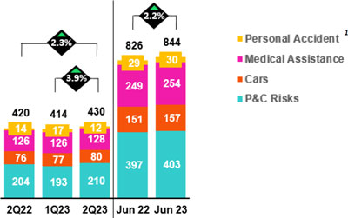 |  | 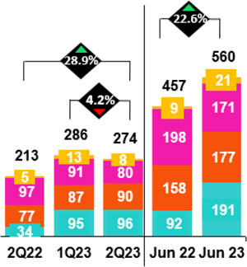

1 This quarter we have reclassified most of our Personal Accidents insurance products from the Life business to the P&C business (accounted for using the PAA methodology). The remaining portion in the Life business (BBA and VFA methodology) is negligible.

34

 | | | Earnings Release 2Q / 2023 | Analysis of 2Q23 Consolidated Results
07. Insurance Underwriting Results

QoQ, the Insurance Underwriting Result rose 70.5% via the following dynamics:
 | ● | Income from insurance services increased 3.9%, driven primarily by the fact that fewer reserves with set aside for Current Risks, in line with a drop in production in P & C Risks and Cars.
 | ● | Expenses for insurance services fell 4.2%, pushed downward by a decrease in claims in the Medical Assistance and Personal Accident lines.
 | ● | The reinsurance results improved 3.4% due to a decrease in the ceded premium volume and an uptick in claims recovered from the reinsurer in P & C; the aforementioned was mitigated by the impact of Cyclone Yaku.

YoY, the Underwriting Insurance Result rose 1.0% (-3.6% YTD) due to the following dynamics:
 | ● | Income from insurance services rose 2.3% and 2.2% (YoY and YTD respectively), fueled primarily by growth in total premiums in Cars and P & C Risks.
 | ● | Expenses for insurance services rose 29% and 23% (YoY and YTD respectively) due to: (i) P & C Risks, through the card protection product, which registered higher levels of unrecognized internet purchases and via an uptick in cases in the fire line due to the impacts of Cyclone Yaku; and (ii) Cars, due to an increase in the frequency of cases, which was mitigated by Medical Assistance, which registered a decrease in IBNR COVID-19 reserves.
 | ● | The reinsurance results improved 39.3% due to the evolution of P & C Risks, which reported an uptick in claims recovered from the reinsurer; the aforementioned was mitigated by the impact of Cyclone Yaku.

Life Insurance

Income from Insurance Services |  | Expenses for Insurance Services
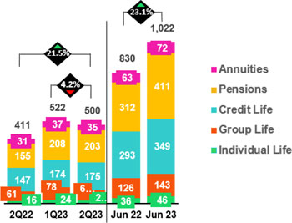 |  | 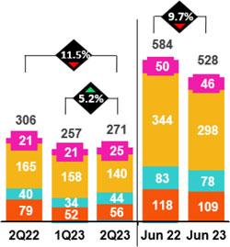

QoQ, the Insurance Underwriting Result dropped 13.5% due to the following dynamics:
 | ● | Income from insurance services fell 4.2% due to seasonal effects: i) a drop in income through Group Life via Obligatory Insurance for High-Risk Occupations (SCTR) given that in 1Q23, income reflected the impact of statutory job bonuses and seasonal renewals and ii) a decrease in collections through SISCO VI(2).
 | ● | Expenses for insurance services rose 5.2%, mainly through (i) Individual Life, driven by an uptick in claims, redemptions and expenses attributable to (ii) Credit Life, due to an increase in claims. The aforementioned was mitigated by the evolution of the Pensions line, which registered a decrease in claims.
 | ● | The reinsurance results improved 11.8% due to growth in claims recovered from the reinsurer in Credit Life and Group Life.

YoY and YTD, the Insurance Underwriting Result rose 94.5% and 75.1% respectively due to the following dynamics:
 | ● | Income from insurance services rose 21.5% and 23.1% respectively. These upticks were primarily driven by the Pension line, which benefitted from higher insurance premium rates and the fact that the Company was awarded a larger portion of the SISCO VI contract than that registered through SISCO V; Credit Life, which was mainly fueled by an uptick in total premiums through BCP and the Banco de la Nacion due to rate adjustments and growth in volumes; Group Life, through Obligatory Insurance for High Risk Occupations (SCTR) due to growth in renewals and to rate adjustments in mining and fishing.

(2) Public bidding process product of which the insurance companies that will collectively manage the risks of disability, survival and burial of Pension affiliates are selected for the period 2023.

35

 | | | Earnings Release 2Q / 2023 | Analysis of 2Q23 Consolidated Results
07. Insurance Underwriting Results

 | ● | Expenses for insurance services fell 11.5% YoY and 9.7% YTD, which was driven primarily by Pensions, Credit Life and Group Life via an uptick in claims versus periods affected by Covid-19.
 | ● | The reinsurance result deteriorated primarily via the Pensions line, which reflects an increase in ceded premiums via the new SISCO VI contract (growth in market share and higher percentage of cession).

36

 | | | Earnings Release 2Q / 2023 | Analysis of 2Q23 Consolidated Results

08 | Operating Expenses

Operating expenses rose 11.2 % YTD, driven primarily by core businesses at BCP and disruptive initiatives at the Credicorp level. At BCP, core businesses expenses increased via an uptick in Information Technology (IT) expenses related to cloud usage, licenses, cybersecurity, and new IT specialized personnel hired, as well as Advertising and Loyalty Programs. These increases were partially offset by a non-recurrent tax expense reversal. Expenses for disruptive initiatives at Credicorp increased 70%, to ensure market leadership in the long-term. If we exclude disruptive expenses, the YTD variation in Operating expenses stands at 7.6%.

Total operating expenses1

Operating expenses | Quarter |  |  | % change |  | As of |  | % change
S/ 000 | 2Q22 | 1Q23 | 2Q23 | QoQ | YoY | Jun 22 | Jun 23 | Jun 23 / Jun 22
Salaries and employees benefits | 942,159 | 1,029,558 | 1,054,735 | 2.4% | 11.9% | 1,881,677 | 2,084,293 | 10.8%
Administrative, general and tax expenses | 819,100 | 835,060 | 871,047 | 4.3% | 6.3% | 1,515,165 | 1,706,107 | 12.6%
Depreciation and amortization | 156,891 | 161,079 | 160,548 | -0.3% | 2.3% | 308,785 | 321,627 | 4.2%
Association in participation | 10,329 | 12,612 | 16,742 | 32.7% | 62.1% | 18,020 | 29,354 | 62.9%
Operating expenses | 1,928,479 | 2,038,309 | 2,103,072 | 3.2% | 9.1% | 3,723,647 | 4,141,381 | 11.2%
(1) Due to the application of IFRS 17, which impacts reporting for Insurance contracts, Operating Expenses have been restated and as such, differ with regard to calculations in previous reports. For more details, review annex 12.1.8.

The analysis of expenses will focus on movements at the YTD level to eliminate impact of seasonal effects between quarters.

Operating expenses continue to trend upward due to:

 | ● | Growth in Salaries and Employee Benefits was driven primarily by an uptick in expenses to hire specialized personnel for disruptive projects and IT.
 | ● | An increase Administrative and General Expenses and Taxes, which was mainly fueled by BCP through IT expenses for the transformation strategy, marketing expenses, loyalty programs and disruptive expenses at the Credicorp level. The aforementioned was partially offset by a tax reversal.

Growth in Operating expenses YTD stood at 11.2%. If we exclude disruption expenses, Operating Expenses stands at 7.6% YTD.

Administrative and general expenses and taxes

Administrative general, and tax expenses | Quarter |  |  | % change |  | As of |  | % change
S/000 | 2Q22 | 1Q23 | 2Q23 | QoQ | YoY | Jun 22 | Jun 23 | Jun 23 / Jun 22
IT expenses and IT third-party services | 207,929 | 240,932 | 256,348 | 6.4% | 23.3% | 437,009 | 497,280 | 13.8%
Advertising and customer loyalty programs | 156,049 | 135,767 | 174,021 | 28.2% | 11.5% | 266,782 | 309,788 | 16.1%
Taxes and contributions | 72,982 | 85,073 | 20,557 | -75.8% | -71.8% | 152,573 | 105,630 | -30.8%
Audit Services, Consulting and professional fees | 69,239 | 51,878 | 67,017 | 29.2% | -3.2% | 123,172 | 118,895 | -3.5%
Transport and communications | 48,899 | 51,036 | 57,437 | 12.5% | 17.5% | 89,935 | 108,473 | 20.6%
Repair and maintenance | 39,173 | 25,790 | 37,555 | 45.6% | -4.1% | 70,771 | 63,345 | -10.5%
Agents’ Fees | 26,091 | 26,152 | 27,747 | 6.1% | 6.3% | 53,109 | 53,899 | 1.5%
Services by third-party | 18,621 | 27,511 | 27,661 | 0.5% | 48.5% | 52,202 | 55,172 | 5.7%
Leases of low value and short-term | 22,610 | 25,116 | 25,282 | 0.7% | 11.8% | 43,541 | 50,398 | 15.7%
Miscellaneous supplies | 20,656 | 32,993 | 27,837 | -15.6% | 34.8% | 39,734 | 60,830 | 53.1%
Security and protection | 15,798 | 15,789 | 16,004 | 1.4% | 1.3% | 31,274 | 31,793 | 1.7%
Subscriptions and quotes | 14,877 | 13,086 | 16,024 | 22.5% | 7.7% | 29,405 | 29,110 | -1.0%
Electricity and water | 13,426 | 11,497 | 14,954 | 30.1% | 11.4% | 24,244 | 26,451 | 9.1%
Electronic processing | 8,208 | 8,730 | 9,791 | 12.2% | 19.3% | 15,901 | 18,521 | 16.5%
Insurance | 6,550 | 8,750 | 5,022 | -42.6% | -23.3% | 13,804 | 13,772 | -0.2%
Cleaning | 5,203 | 5,162 | 5,463 | 5.8% | 5.0% | 9,709 | 10,625 | 9.4%
Others (1) | 72,789 | 69,798 | 82,326 | 17.9% | 13.1% | 122,309 | 152,124 | 24.4%
Total | 819,100 | 835,060 | 871,046 | 4.3% | 6.3% | 1,515,165 | 1,706,106 | 12.6%
(1) Others consists mainly of security and protection services, cleaning service, representation expenses, electricity and water utilities, insurance policy expenses, subscription expenses and commission expenses.

General and administrative expenses rose 12.6% YTD in the first half of 2023, driven primarily by expenses for IT, marketing, loyalty programs and others, mainly via BCP and disruptive initiatives.

37

 | | | Earnings Release 2Q / 2023 | Analysis of 2Q23 Consolidated Results
08. Operating Expenses

Operating Expenses of Core Businesses and Disruption (1)

Operating Expenses  S/ (000) | Quarter |  |  | % change |  | As of |  | % change
Operating Expenses  S/ (000) | 2Q22 | 1Q23 | 2Q23 | QoQ | YoY | Jun 22 | Jun 23 | Jun 23 / Jun 22
Core Business BCP | 1,124,617 | 1,150,502 | 1,195,522 | 3.9% | 6.3% | 2,164,203 | 2,346,024 | 8.4%
Core Business Mibanco | 284,647 | 297,780 | 300,220 | 0.8% | 5.5% | 566,900 | 598,000 | 5.5%
Core Business Pacifico | 61,945 | 64,268 | 72,708 | 13.1% | 17.4% | 120,714 | 136,976 | 13.5%
Disruption (3) | 130,807 | 185,195 | 186,994 | 1.0% | 43.0% | 219,490 | 372,189 | 69.6%
Others (2) | 326,465 | 340,564 | 347,627 | 2.1% | 6.5% | 652,339 | 688,192 | 5.5%
Total | 1,928,480 | 2,038,309 | 2,103,072 | 3.2% | 9.1% | 3,723,647 | 4,141,381 | 11.2%
(1) Management figures
(2) Include Credicorp Capital, ASB, Prima, BCP Bolivia, Mibanco Colombia and other entities within the Group.
(3) Includes disruptive initiatives at the subsidiaries and Krealo

The core business at BCP and our disruptive initiatives were responsible for 44% and 37% respectively of the 11.2% increase in operating expenses at Credicorp.

In the case of Core business at BCP, YTD growth of 8.4 % was driven by technology expenses and other components of Core Expenses (excluding technology expenses):

 | ● | Technology (IT)
 | ● | In line with an uptick in monetary and non-monetary transactions of the most digitalized clients, expenses for the use of the bank’s cloud servers rose.
 | ● | Additionally, an uptick was recorded in the use of IT applications, data center, licenses and other software to bolster capacity and improve cybersecurity.
 | ● | More specialized personnel with digital capacities were hired, which also increased the average salary level.

 | ● | Marketing Expenses in the Core business
 | ● | Increase in advertising expenses to boost deposits and digital sales;
 | ● | Growth in expenses for the Loyalty Program; this was fueled by a recovery in the level of miles consumed, which rose due to an uptick in the use of credit and debit cards at establishments. Billing evolved favorably for debit and credit cards, registering upticks of 18.2% and 22.8% respectively YTD;

 | ● | This growth was partially offset by a tax reversal associated with a non-domiciled supplier.

Growth in disruptive expenses stood at 69.6% YTD and represented 9.0% OPEX at the YTD level as of June 2023. These expenses were attributable to investment in improvements of different functionalities and to an increase in expenses for specialized personnel to steer initiatives such as Yape, IO, Culqui, Tenpo, among others, which are geared to strengthen our leadership long-term.

38

 | | | Earnings Release 2Q / 2023 | Analysis of 2Q23 Consolidated Results

09 | Operating Efficiency

The efficiency ratio improved 310 bps YTD. This evolution reflected an uptick in core income, which was driven by growth in net interest income at BCP and by adept pricing management in a context of rising rates. If we exclude disruption expenses, the efficiency ratio stands at 40.4%.

Operating efficiency | Quarter |  |  | % change |  | As of |  | % change
S/000 | 2Q22 | 1Q23 | 2Q23 | QoQ | YoY | 1H22 | 1H23 | Jun 23 / Jun 22
Operating expenses (1) | 1,928,479 | 2,038,309 | 2,103,072 | 3.2% | 9.1% | 3,723,648 | 4,141,381 | 11.2%
Operating income (2) | 4,044,394 | 4,602,331 | 4,715,570 | 2.5% | 16.6% | 7,843,775 | 9,317,901 | 18.8%
Efficiency ratio (3) | 47.7% | 44.3% | 44.6% | 30 pbs | -310 pbs | 47.5% | 44.4%(4) | -310 pbs
Due to the application of IFRS 17, which impacts reporting for Insurance contracts, Operating Income has been restated and as such, differs with regard calculations in previous reports. For more details, review annex 12.1.8
(1) Operating expenses = Salaries and employees benefits + Administrative expenses + Depreciation and amortization + Association in participation + Acquisition cost.
(2) Operating income = Net interest, similar income and expenses + Fee income + Net gain on foreign exchange transactions + Net gain from associates + Net gain on derivatives held for trading + Net gain from exchange differences + Net Insurance Underwriting Results
(3) Operating expenses / Operating income (under IFRS 17)
(4) Excluding the non-recurring expense reversal, the efficiency ratio stands at 45.1%

Efficiency ratio by Subsidiary

IFRS 17 | BCP  Stand-alone | BCP Bolivia | Mibanco Peru | Mibanco Colombia | ASB | Credicorp Capital | Pacifico | Prima AFP | Credicorp
2Q22 | 41.5% | 58.0% | 50.4% | 75.8% | 42.3% | 102.7% | 33.9% | 52.6% | 47.7%
1Q23 | 36.8% | 60.2% | 54.1% | 93.2% | 34.8% | 131.4% | 21.7% | 49.6% | 44.3%
2Q23 | 37.3% | 60.7% | 52.4% | 88.8% | 34.5% | 137.6% | 28.4% | 49.8% | 44.6%
Var. QoQ | 50 bps | 50 bps | -170 bps | -440 bps | -30 bps | 620 bps | 670 bps | 20 bps | 30 bps
Var. YoY | -420 bps | 270 bps | 200 bps | 1300 bps | -780 bps | 3490 bps | -550 bps | -280 bps | -310 bps
Jun 22 | 41.1% | 58.9% | 51.6% | 77.3% | 39.0% | 102.3% | 32.9% | 53.5% | 47.5%
Jun 23 | 37.1% | 60.5% | 53.2% | 91.0% | 34.7% | 134.5% | 24.8% | 49.7% | 44.4%
% change  Jun 23 / Jun 22 | -400 bps | 160 bps | 160 bps | 1370 bps | -430 bps | 3220 bps | -810 bps | -380 bps | -310 bps

This analysis is based on movements at the YTD level to eliminate the impact of seasonality between periods.

The efficiency ratio improved, driven primarily by growth in core income at BCP Stand-alone and by growth of Insurance Underwriting Results at Pacifico.

Additionally, if we exclude disruptive initiatives at Credicorp, the YTD efficiency ratio at the end of June 2023 would be 40.4.%.

39

 | | | Earnings Release 2Q / 2023 | Analysis of 2Q23 Consolidated Results

10 | Regulatory Capital

Credicorp’s Regulatory Capital stood 1.46 times above the minimum requirement required by the regulatory entity.

The IFRS CET1 Ratio at BCP Stand-alone rose 123 bps YoY to stand at 12.8%. An uptick in the balance of Retained Earnings (+38.1%), coupled with a drop in Unrealized Losses (-74.9%) drove this dynamic.

The IFRS CET1 Ratio at Mibanco increased 157 bps YoY to stand at 16.6%. Growth in Capital and Reserves (+27.2%) and a drop in Unrealized Losses (-55.5%) fueled this evolution.

10.1 Credicorp’s Regulatory Capital

Credicorp’s Regulatory Capital Ratio stood 1.46 times above the figure required by the regulatory entity at the end of 2Q23. In the QoQ analysis, the ratio rose 3 bps. Growth was driven by an uptick in regulatory capital through growth in the volume of discretionary reserves.  In the YoY analysis, the Regulatory Capital Ratio dropped 10 bps. This evolution was driven by an uptick in the capital requirement for both BCP Stand-alone and Mibanco. The increase in the capital requirement was partially offset by growth in the balance of Discretionary and Restricted Reserves. |  | Figures in millions S/.  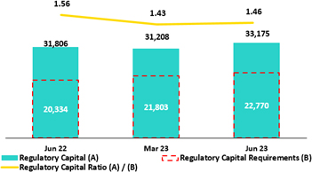

Analysis of capital at the Subsidiaries

Under the current local regulations, which has been in effect since January 2023, three regulatory ratios exist: Common Equity Tier 1 (CET 1), Tier 1 Capital and Global Capital. For all effective purposes, Tier 1 Capital is equal to CET 1 Ratio in Credicorp’s case given that we possess no subordinated Tier 1 debt. Additionally, as has been our practice over the last few years, for management purposes, we use the IFRS CET 1 ratio, which differs slightly from regulatory CET 1 (calculated under local accounting); these differences are primarily driven by Provisions and Unrealized Loss accounts. Given the aforementioned, our analysis focuses solely on IFRS CET 1.

10.2 Analysis of Capital at BCP Stand-alone

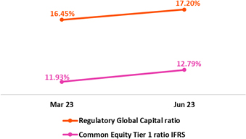 |  | At the end of 2Q23, IFRS CET 1 at BCP Stand-alone registered an increase of 87 bps QoQ and stood at 12.79% at the end of 2Q23. This was attributable to (i) an uptick in the balance of Retained Earnings and (ii) a reduction in the balance of Unrealized Losses, in line with a drop in sovereign rates. The RWA level registered no significant variations this quarter despite a reduction in the loan volume. YoY, IFRS CET 1 rose 123 bps, driven by the same dynamics outlined in the QoQ analysis.  Finally, under the parameters of current local regulations, the Global Capital Ratio at BCP Stand-alone stood at 17.2% (+75 bps QoQ). The uptick in this ratio was generated by the same drivers at those that drove the evolution of IFRS CET 1.

40

 | | | Earnings Release 2Q / 2023 | Analysis of 2Q23 Consolidated Results
10. Regulatory Capital

10.3 Analysis of Capital at Mibanco

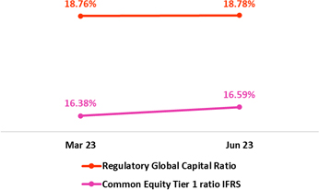 |  | At the end of 2Q23, the IFRS CET 1 ratio increased 21 bps QoQ. This evolution was spurred by growth in Retained Earning and to a reduction in the balance for Unrealized Losses. The aforementioned was partially offset by an increase in RWAs, which was driven by credit-risk weighted assets and operational risk weighted assets. YoY, this ratio rose 157 bps due to growth in Capital and Reserves.  Under current local regulation, Mibanco’s Global Capital ratio stood at 18.8% (+2 bps QoQ). This variation was driven by the same dynamics as those seen for IFRS CET 1.

41

 | | | Earnings Release 2Q / 2023 | Analysis of 2Q23 Consolidated Results

11 | Economic Outlook

In 2Q23, the Peruvian economy would have contracted slightly YoY (1Q23 -0.4% YoY) affected by the impact of the “El Niño Costero” phenomenon and unfavorable weather conditions that caused negative growth rates in the primary sectors. The growth of the mining sector, mainly due to Quellaveco’s copper production and the recovery of production at Las Bambas, offset part of this drop.

The annual inflation rate closed the quarter at 6.5% YoY, after standing above or close to 8.0% for 14 consecutive months. On the other hand, it is estimated that real GDP will grow 1.0% this year.

Using as source the BCRP, the exchange rate closed at USDPEN 3.626 in 2Q23, which represents an appreciation of 3.6% compared to the end of 1Q23 and 5.1% compared to a year ago.

Peru: Economic Forecast

Peru | 2018 | 2019 | 2020 | 2021 | 2022 | 2023 (3)
GDP (US$ Millions) | 226,919 | 232,519 | 205,755 | 225,803 | 244,789 | 268,043
Real GDP (% change) | 4.0 | 2.2 | -11.0 | 13.3 | 2.7 | 1.0
GDP per capita (US$) | 7,190 | 7,237 | 6,306 | 6,835 | 7,330 | 7,933
Domestic demand (% change) | 4.1 | 2.2 | -9.8 | 14.5 | 2.3 | -0.2
Gross fixed investment (as % GDP) | 22.4 | 21.8 | 19.9 | 21.6 | 22.0 | 20.8
Financial system loan without Reactiva (% change) (1) | 10.3 | 6.4 | -4.3 | 12.6 | 9.7 | 2.9
Inflation, end of period(2) | 2.2 | 1.9 | 2.0 | 6.4 | 8.5 | 4.0
Reference Rate, end of period | 2.8 | 2.3 | 0.3 | 2.5 | 7.5 | 6.8
Exchange rate, end of period | 3.37 | 3.31 | 3.62 | 3.99 | 3.81 | 3.65
Exchange rate, (% change) | 4.0% | -1.8% | 9.3% | 10.3% | -4.5% | -4.2%
Fiscal balance (% GDP) | -2.3 | -1.6 | -8.9 | -2.5 | -1.6 | -2.5
Public Debt (as % GDP) | 25.6 | 26.6 | 34.6 | 35.9 | 34.0 | 33.7
Trade balance (US$ Millions) | 7,201 | 6,879 | 8,196 | 14,927 | 9,565 | 13,500
(As % GDP) | 3.2% | 3.0% | 4.0% | 6.6% | 3.9% | 5.0%
Exports | 49,066 | 47,980 | 42,905 | 63,151 | 65,834 | 65,600
Imports | 41,866 | 41,101 | 34,709 | 48,223 | 56,269 | 52,100
Current account balance (US$ Millions) | -2,895 | -1,680 | 2,398 | -5,179 | -10,644 | -5,300
Current account balance (As % GDP) | -1.3% | -0.7% | 1.2% | -2.3% | -4.3% | -2.0%
Net international reserves (US$ Millions) | 60,121 | 68,316 | 74,707 | 78,495 | 71,883 | 74,000
(As % GDP) | 26.5% | 29.4% | 36.3% | 34.8% | 29.4% | 27.6%
(As months of imports) | 17 | 20 | 26 | 20 | 15 | 17

Sources: INEI, BCRP y SBS.
(1) Financial System, Current Exchange Rate
(2) Inflation target: 1% - 3%
(3) Grey area indicate estimates by BCP Economic Research as of July 2023

42

 | | | Earnings Release 2Q / 2023 | Analysis of 2Q23 Consolidated Results
11. Economic Outlook

Main Macroeconomic Variables

Gross Domestic Product
(Annual Variations, % YoY)

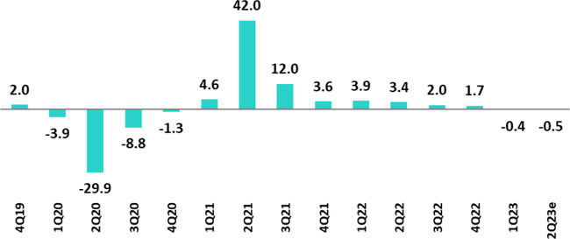

Sources: BCRP
Estimate: BCP

In 2Q23, the Peruvian economy is expected to have registered a slight contraction due to the impact of “El Niño Costero” and unfavorable climatic conditions, which led to negative growth rates in the primary sectors (agriculture, fishing and primary manufacturing). The Ministry of Production canceled the first anchovy fishing season in the north-central zone, which marks the first time this campaign has been cancelled since the anchovy quota system was established in 2008. Agricultural activity, in turn, fell 20% YoY in April 2023 (worst monthly contraction since data is available at that frequency) and 13% YoY in May 2023. Growth in the mining sector, which was driven primarily by copper production at Quellaveco’s and the recovery of production at Las Bambas, after last year’s temporary shutdowns, offset part of this drop. According to INEI, the monthly economic activity index grew 0.3% YoY in April and fell 1.4% YoY in May.

In 1H23, the Peruvian economy would have contracted around 0.5% YoY, its worst performance in 22 years, excluding the pandemic, and even lower than what was recorded during the global financial crisis (1st half 2009: +0.8% YoY). For its part, domestic demand would have fallen around 2% YoY in the first half due to the sharp deterioration in private investment (-10% YoY) and the slowdown in private consumption (0.6% YoY). At sectoral level, non-primary GDP fell around 1.5% YoY in the first half, highlighting the contractions of the construction (-9% YoY) and non-primary manufacturing (-8% YoY) sectors. These variations are the worst recorded in the last 22 and 14 years, excluding the pandemic, respectively. On the side of the primary sectors, the poor performance was mitigated by the notable increase of almost 20% YoY in copper production during the first half thanks to Quellaveco and the recovery of production at Las Bambas.

Annual Inflation and Central Bank Reference Rate
(%)

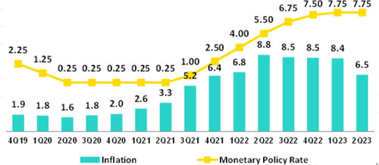

Sources: BCRP and INEI

43

 | | | Earnings Release 2Q / 2023 | Analysis of 2Q23 Consolidated Results
11. Economic Outlook

Inflation measured using the Consumer Price index of Metropolitan Lima closed 2Q23 at 6.5% YoY after remaining above or close to 8.0% YoY for 14 consecutive months (peak 8.8% YoY in June 2022, highest in 26 years). In June 2023, monthly inflation fell for the first time in 15 months (-0.15% MoM), mainly due to a drop in poultry prices. In the same period, core inflation (excluding food and energy) slowed to 4.4% YoY, a 12-month low.

At its July meeting, the Central Reserve Bank of Peru (BCRP) held the monetary policy rate at its all-time high of 7.75% (at that level since January 2023).

Fiscal Balance and Current Account Balance
(% of GDP, Quarter)

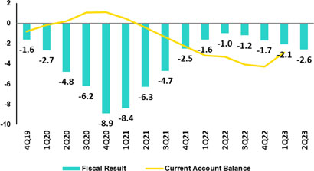

The annualized fiscal deficit in the last 12 months to June 2023 rose to 2.6% of GDP. In 2Q23, tax revenues fell 14.2% YoY (lower income tax revenue fell 22.1% YoY), while non-financial spending grew 3.8% YoY (current spending: +3.3% YoY and capex: +5.4% YoY).
In 2Q23, there were no changes to Peru’s sovereign debt credit rating. In January 2023, Moody’s changed the outlook for Peruvian long-term debt in foreign currency to negative from stable (kept the credit rating at Baa1). The decision came after Fitch and Standard & Poor’s changed the outlook to negative in October and December 2022, respectively (both affirmed the credit rating at BBB). In April 2023, Fitch reaffirmed its BBB rating with a negative outlook.

Regarding external accounts, the current account deficit closed 1Q23 at 2.9% of GDP in cumulative terms for the last 4 quarters.

The 12-month accumulated trade balance surplus to May 2023 rose to USD 11.6 billion, which was higher than the USD 10.1 billion registered in March but still far from the historical record of USD 16.1 billion reached in March 2022. In the same period, exports fell 3.2% YoY to USD 64.9 billion, affected by lower prices, which were partially offset by higher volumes. Imports grew 2.9% YoY to USD 53.3 billion.

Terms of trade grew 4.8% YoY in May 2023, which reflected the fact that the reduction registered for import prices (-11.1% YoY) outpaced the drop registered for export prices, which fell 6.8% YoY (due to lower prices for copper, zinc and hydrocarbons). In YTD until May, terms of trade rose 0.9% and stood 10.6% above October 2022 levels (minimum since April 2020).

Exchange Rate
(PEN per USD)

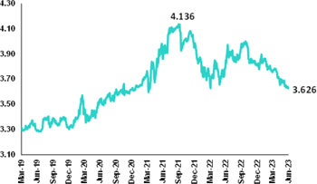

According to BCRP, the exchange rate closed 2Q23 at USDPEN 3.626, an appreciation of 3.6% compared to the end of 1Q23 and 5.1% compared to a year ago. In the same period, Latam main currencies also appreciated compared to the previous quarter due to the weakening of the global dollar. Thus, the Colombian peso appreciated 10.5%, the Brazilian real 5.5% and the Mexican peso 5.1%. The Chilean peso, on the other hand, slightly depreciated (-0.9%).

Net international reserves closed 2Q23 at USD 72.9 billion, relatively stable compared to 1Q23 (USD 72.7 billion).
44

 | | | Earnings Release 2Q / 2023 | Analysis of 2Q23 Consolidated Results
Safe Harbor for Forward-Looking Statements

This material includes “forward-looking statements” within the meaning of Section 27A of the U.S. Securities Act of 1933 and Section 21E of the U.S. Securities Exchange Act of 1934. All statements other than statements of historical fact are forward-looking and may contain information about financial results, economic conditions, trends and known uncertainties. Forward-looking statements are not assurances of future performance. Instead, they are based only on our management’s current views, beliefs, expectations and assumptions regarding the future of our business, future plans and strategies, projections, anticipated events and trends, the economy and other future conditions.

Many forward-looking statements can be identified by words such as: “anticipate”, “intend”, “plan”, “goal”, “seek”, “believe”, “project”, “estimate”, “expect”, “strategy”, “future”, “likely”, “would”, “may”, “should”, “will”, “see” and similar references to future periods. Examples of forward-looking statements include, among others, statements or estimates we make regarding guidance relating to losses in our credit portfolio, efficiency ratio, provisions and non-performing loans, current or future market risk and future market conditions, expected macroeconomic events and conditions, our belief that we have sufficient capital and liquidity to fund our business operations, expectations of the effect on our financial condition of claims, legal actions, environmental costs, contingent liabilities and governmental and regulatory investigations and proceedings, strategy for customer retention, growth, governmental programs and regulatory initiatives, credit administration, product development, market position, financial results and reserves and strategy for risk management.

We caution readers that forward-looking statements involve known and unknown risks and uncertainties that could cause actual results, performance or events to differ materially from those that we expect or that are expressed or implied in the forward-looking statements, depending on the outcome of certain factors, including, without limitation, adverse changes in:

● The occurrence of natural disasters or political or social instability in Peru;
● The adequacy of the dividends that our subsidiaries are able to pay to us, which may affect our ability to pay dividends to shareholders and corporate expenses;
● Performance of, and volatility in, financial markets, including Latin-American and other markets;
● The frequency, severity and types of insured loss events;
● Fluctuations in interest rate levels;
● Foreign currency exchange rates, including the Sol/US Dollar exchange rate;
● Deterioration in the quality of our loan portfolio;
● Increasing levels of competition in Peru and other markets in which we operate;
● Developments and changes in laws and regulations affecting the financial sector and adoption of new international guidelines;
● Changes in the policies of central banks and/or foreign governments;
● Effectiveness of our risk management policies and of our operational and security systems;
● Losses associated with counterparty exposures;
● The scope of the coronavirus (“COVID-19”) outbreak, actions taken to contain the COVID-19 and related economic effects from such actions and our ability to maintain adequate staffing; and
● Changes in Bermuda laws and regulations applicable to so-called non-resident entities.

See “Item 3. Key Information—3. D Risk Factors” and “Item 5. Operating and Financial Review and Prospects” in our most recent Annual Report on Form 20-F filed with the U.S. Securities and Exchange Commission for additional information and other such factors. You are cautioned not to place undue reliance on these forward-looking statements, which speak only as of the date hereof and are based only on information currently available to us. Therefore, you should not rely on any of these forward-looking statements. We undertake no obligation to publicly update or revise these or any other forward-looking statements that may be made to reflect events or circumstances after the date hereof, whether as a result of changes in our business strategy or new information, to reflect the occurrence of unanticipated events or otherwise.

45

 | | | Earnings Release 2Q / 2023 | Analysis of 2Q23 Consolidated Results

12 | Appendix

12.1. Implementation of IFRS 17 – Restatement of figures and ratios for 2022 | 47
12.1.1. Introduction to the new standards IFRS 17 | 47
12.1.2. Conceptual Framework | 47
12.1.3. Recognition of Profit and Loss | 47
12.1.4. Valuation Methods | 47
12.1.5. Impact on Equity Under IFRS 17 | 48
12.1.6. Reformulation of Profit and Loss Statement at Pacífico Grupo Asegurador for year 2022 | 48
12.1.7. Reformulation Credicorp’s Profit and Loss Statement for year 2022 | 49
12.1.8. Changes in the Methodology to Calculate Financial Indicators and their Reformulation for the year 2022 | 49
12.1.9. Glossary of Terms Under IFRS 17 | 52
12.2. Physical Point of contact | 52
12.3. Loan Portfolio Quality | 53
12.4 Net Interest Income (NII) | 58
12.5. Regulatory Capital | 59
12.6. Financial Statements and Ratios by Business | 63
12.6.1. Credicorp Consolidated | 63
12.6.2. Credicorp Stand-alone | 65
12.6.3. BCP Consolidated | 66
12.6.4. BCP Stand-alone | 68
12.6.5. BCP Bolivia | 70
12.6.6. Mibanco | 71
12.6.7. Prima AFP | 72
12.6.8. Grupo Pacifico | 74
12.7. Table of calculations | 77
12.8. Glossary of terms | 78

46

 | | | Earnings Release 2Q / 2023 | Analysis of 2Q23 Consolidated Results
12. Appendix

12.1. Implementation of IFRS 17 – Restatement of figures and ratios for 2022

12.1.1. Introduction to the new standards IFRS 17

IFRS 17 was published in May 2017 as a replacement to IFRS 4 “Insurance Contracts.” The aim of this change is to ensure that consistent measurement criteria are applied to improve transparency and the comparability of Financial Statements. The new standard became effective in January 2023.

The primary objectives of this standard include:

 | (i) | Improving comparability between insurers at the global level. IFRS 4 allowed entities to use a wide variety of accounting practices with regard to insurance contracts.
 | (ii) | Adequately reflecting the economic value of insurance contracts. Some previous accounting practices allowed under IFRS failed to adequately reflect real underlying financial situations or the financial yields on insurance contracts.
 | (iii) | Providing more useful information to users of financial statements.

12.1.2. Conceptual Framework

Insurance contracts combine attributes of risk coverage, provision of services and instruments of investments and by nature, generate cash flows (outflows such as claims payments, redemptions, expirations, pensions, attributable expenses, income such as premiums) during their term.

The difference between expected outflows and inflows (fulfillment cashflows), combined with recognition of cash value over time, constitute the best estimate of the company’s obligations. Due to potential underwriting deviations relative to expected flows, an additional reserve, known as Risk Adjustment (RA) must be set aside and the underwriting income that the company expects to obtain from its current product portfolio constitutes the Contractual Service Margin (CSM). These 3 concepts, combined with the claims reserves (including reserves for pending claims, IBNR reserves and liquidation expenses) constitute the company’s liabilities.

12.1.3. Recognition of Profit and Loss

The P & L under IFRS shows the difference between a company’s expected cash flows (valued in liabilities) and real flows that occur. Anticipated flows must be based on realistic parameters that reflect the company’s actual experience and current market interest rates.

The standard also requires that results be separated into 3 blocks: (i) Insurance service (or direct insurance), (ii) Reinsurance and (iii) Financial Results. This structure allows users to visualize the company’s sources of income.

Unlike IFRS4, which recognized profit and losses on products during their term, IFRS17 stipulates that expected losses must be recognized at a single moment, meaning upon issuance of policies, while recognition of underwriting income (CSM) must be made gradually over the effective period of products.

The company chose the Other Comprehensive Income (OCI) option, which recognizes movements of reserves generated by underwriting issues within the Profit and Loss Statement (changes in mortality, expenses, redemptions, etc.) while within Equity, only variations in liabilities generated by changes in interest rates are recognized. This variation produces an offset to that generated by investments that back reserves and lends stability to the Balance Sheet and the Profit and Loss Statement.

12.1.4. Valuation Methods

IFRS 17 introduces different approaches to valuate underwriting provisions based on the product’s characteristics (contract duration, cash flow).

 | ● | General Method (GM) or Building Block Approach (BBA): general default model valuation of insurance contracts.
 | ● | Variable Fee Approach (VFA): model for contract valuation in which cash flows depend on the value of the underlying assets that back said contracts.
 | ● | Premium Allocation Approach (PAA): simplification of the general model.

47

 | | | Earnings Release 2Q / 2023 | Analysis of 2Q23 Consolidated Results
12. Appendix

12.1.5. Impact on Equity Under IFRS 17

The impact of the implementation of the IFRS 17 standard on the net equity balance of Pacifico Seguros is not material, registering at the end of December 2022 a net equity under IFRS 17 which is S/ 10 million greater than the net equity calculated under IFRS 4.

It should be mentioned that as of the end of December 2021 (date of the “first application” of the standard), the net equity of Pacifico Seguros under IFRS 17 was S/ 211 million less than the net equity registered under IFRS 4. This initial gap narrowed during 2022 as a result of a contraction in the value of liabilities under IFRS 17, associated with the interest rates increases.

12.1.6. Reformulation of Profit and Loss Statement at Pacifico Grupo Asegurador for year 2022

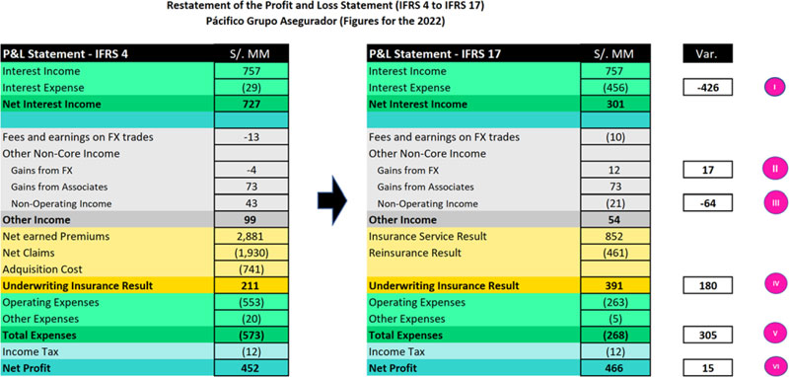

 | I. | A new sub-account, “Financial Expenses associated with insurance and reinsurance activities, net” is included in the account for Interest Expenses at Pacifico Seguros. This concept corresponds to interest accredited to reserves. This interest is attributable to an update of the present value of said reserves to the date of the close of the period. This concept was previously presented as part of reserves adjustment included in the underwriting result under IFRS4. IFRS17 separates the financial component from the underwriting component.

 | II. | An impact is registered in the “Gain on exchange rate difference” line because the structure of the assets and liabilities related to insurance activities has been modified. The monetary position of these assets and liabilities changes due to the way that assets and liabilities are recognized under IFRS17.

 | III. | Some concepts of income that were previously registered (under IFRS 4) as “Non-Operating Income” are now (under IFRS 17) reclassified and included in the cash flows associated with insurance contracts. As such, these concepts are now part of the Insurance Underwriting Result.

 | IV. | Recognition of insurance underwriting income is completely different under IFRS 17. IFRS 17 recognizes that insurance contracts combine financial and service characteristics, and in many cases generate variable cash flows in the long-term. To adequately reflect these characteristics, IFRS combines measurements of future cash flows with recognition of the results of the insurance contract throughout the period in which the service is provided. IFRS 17 requires present value measurements of insurance obligations where estimates are recalculated in each reporting period. Contracts are measured using the components of: (i) Fulfilment Cash Flows, (ii) An explicit adjustment for risk or uncertainty of flows, or “Risk Adjustment” and (iii) a Contractual Service Margin, which represents unaccrued underwriting income associated with the contract. This Contractual Service Margin is recognized as income during the coverage term. Insurance contracts combine

48

 | | | Earnings Release 2Q / 2023 | Analysis of 2Q23 Consolidated Results
12. Appendix

financial and service characteristics, whereas IFRS combines future cash flows with registry of the results of the insurance contract during the service provision period.

 | V. | One of the changes generated by the application of IFRS 17 is that it sets forth a new concept for costs that are directly associated with obtaining and fulfilling insurance contracts. Said costs are denominated “Attributable Costs” and are included in the expected flows for the disbursements associated with these contracts. Under IFRS 4, some of these expenses were included in Total Expenses.

 | VI. | The aggregate impact of implementing IFRS 17 in the Net Earnings of Pacifico Grupo Asegurador is not material and stands at S/15 million for the year 2022.

12.1.7. Reformulation of Credicorp’s Profit and Loss Statement for year 2022

Below, we reformulate Credicorp’s Profit and Loss Statement. As is evident in the image below, the impact of implementing IFRS at Pacifico Grupo Asegurador translates to Credicorp account by account in identical or highly similar amounts. The aggregate impact of implementing IFRS 17 on the Net Earnings of Credicorp is not material and amounts to S/15 million.

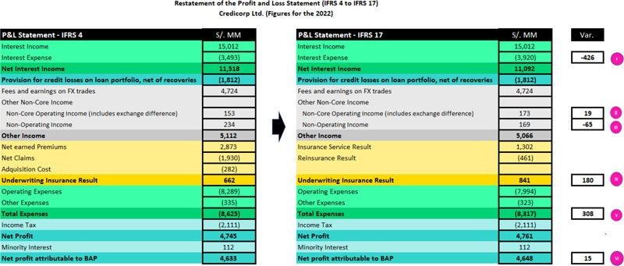

12.1.8. Changes in the Methodology to Calculate Financial Indicators and their Reformulation for the year 2022

 | I. | Net Interest Margin

The Net Interest Margin is reformulated in the following way:

Under IFRS 4, the numerator of the Net Interest Margin was comprised of the difference between Interest Income and Interest Expenses. Under IFRS 17, we need to adjust the formula because Interest Expenses now include the concept “Financial Expense associated with the insurance and reinsurance activity, net.” We seek to exclude the impact of this concept on the Net Interest Margin given that this particular kind of interest expense is not associated with a source of funding. As such, we adjust the numerator by reincorporating “Financial Expense associated with insurance and reinsurance activity, net” to “Net Interest Income” calculated under IFRS 17. It is important to note that as a result of this adjustment, the numerator of the Net Interest Margin under IRFS4 is identical to that seen under IFRS 17.

From now on, we will exclude from the denominator (average balance of Interest-earning Assets) the following: the balance associated with the account “Financial Assets at Fair Value through P&L” given that this account is primarily comprised of investments associated from Investment Link contracts, which do not accrue interests for Credicorp. This change is not related to IFRS 17.

Below, we present the aforementioned change in graphic form.

49

 | | | Earnings Release 2Q / 2023 | Analysis of 2Q23 Consolidated Results
12. Appendix

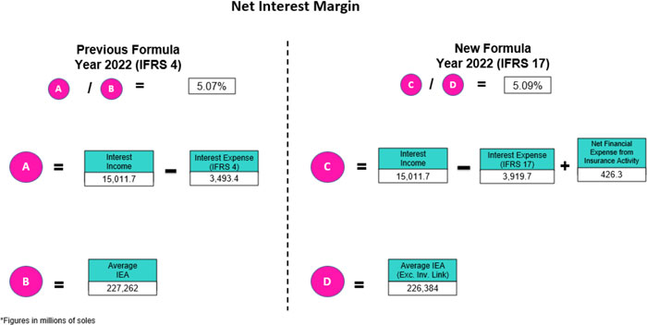

 | II. | Funding Cost

The Funding Cost indicator is being reformulated as follows: under IFRS 4, the numerator of the Funding Cost is comprised of the balance of the “Interest Expenses” account while under IFRS 17, we must adjust the formula given that Interest Expenses now include the concept of “Financial expense associated with insurance and reinsurance activity, net.” We seek to exclude the impact of this new concept on the Funding Cost given that this particular type of expense is not associated with a source of funding. As such, we adjust the numerator by deducting the “Financial Expense associated with insurance and reinsurance activity, net” from “Interest Expenses “calculated under IFRS 17. It is important to note that as a result of this adjustment, the figure for the Funding Cost under IFRS is identical to the same figure under IFRS 17. The following figure is a graphic representation of the aforementioned change.

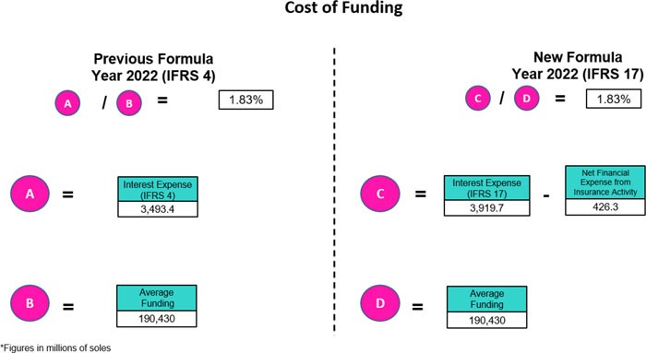

50

 | | | Earnings Release 2Q / 2023 | Analysis of 2Q23 Consolidated Results
12. Appendix

 | III. | Efficiency Ratio

The Efficiency Ratio is being reformulated as follows:

Under IFRS 4, the numerator of the Efficiency Ratio is comprised of the total of the “Salaries and Employee Benefits,” “Administrative Expenses,” “Depreciation and Amortization,” “Expenses for Participation in Association,” and the “Acquisition Cost” accounts. Collectively, these accounts constitute “Operating Expenses.” Under IFRS 17, we make an adjustment to the components of this group of “Operating Expenses” given that the “Acquisition Cost” no longer exists in the Profit and Loss Statement under IFRS 17. Consequently, under IFRS 17, the grouping of “Operating Expenses” is comprised solely of “Salaries and Employee Benefits,” “Administrative Expenses,” “Depreciation and Amortization,” and “Expenses for Participation in Association.” It is important to note that balances of these accounts under IFRS17 are not the same as the balances of the accounts with the same name under IFRS17.

Under IFRS 4, the denominator of the Efficiency Ratio is comprised of the total of the accounts grouped as Core Operating Income (“Interest Income, net”, “Fee income, net,” and “Net gain on FX transactions”); the accounts grouped as Non-Core Operating Income (“Gain on Investments in Associates, “Gain on derivatives,” “Net gain on Exchange Differences); and the “Net Earned Premiums” account. Collectively, all of these accounts constitute “Operating Income.” Under IFRS 17, we are adjusting the components of the grouping for “Operating Income” to replace the component of “Net Earned Premiums” with the “Insurance Underwriting Result.”

It is important to note that the result of replacing the “Net Earned Premiums “account with the “Insurance Underwriting Result” in the denominator of the efficiency ratio is in fact very significant (upward). The aforementioned is due to the fact that the balance of Insurance Technical results is usually materially lower than the balance of Net Earned Premiums as Insurance Technical results have embedded the impact of charges for Incurred Claims. Below, we present a graphic depiction of the aforementioned change.

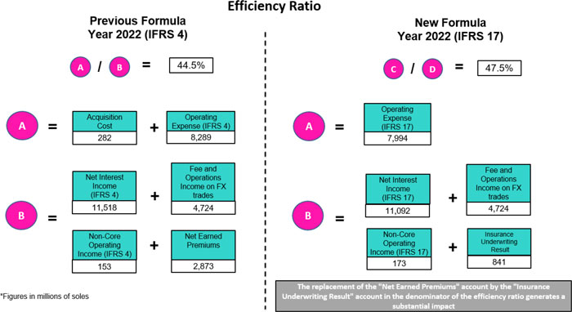

51

 | | | Earnings Release 2Q / 2023 | Analysis of 2Q23 Consolidated Results
12. Appendix

12.1.9. Glossary of Terms Under IFRS 17

Reserve for BEL (Best Estimate Liability) o Fulfillment Cashflows. | Represents the best estimate of the difference between payments for obligations (claims, income and expenses) and premiums, flowed and brought to present value at the time of valuation.
Reserve for RA (risk Adjustment). | Represents the margin of prudence that will be used to cover deviations in the underwriting parameters beyond changes in the interest rate.
Reserve for CSM (Contractual Service Margin). | Represents the present value of future underwriting income (non-financial). Income accrues over the life of the policy.
Attributable Expenses | Corresponds to necessary expenses to place a policy or maintain the same throughout its term. It is part of insurance flows.
Financial Expense associated with the insurance and reinsurance activity, net | Represents interest accredited to reserves in the period after updating their present value. This concept was previously included in reserves under IFRS 4. IFRS 17 separates the financial component from the underwriting component.
Onerous Contracts | The contracts that the company estimates will generate underwriting losses (not including financial income) during the policy term.

12.2. Physical Point of contact

Physical Point of Contact (1) | As of |  |  | change (units)
(Units) | Jun 22 | Mar 23 | Jun 23 | QoQ | YoY
Branches | 1046 | 675 | 669 | (6) | (377)
ATMs | 1,852 | 2,626 | 2,663 | 37 | 811
Agents (2) | 8,986 | 11,254 | 11,570 | 316 | 2,584
Total | 11,884 | 14,555 | 14,902 | 347 | 3,018
(1) Includes Physical Point of Contact of BCP Stand-Alone, Mibanco and BCP Bolivia
(2) Figures differ from previously reported due to changes in BCP Bolivia agents

52

 | | | Earnings Release 2Q / 2023 | Analysis of 2Q23 Consolidated Results
12. Appendix

12.3. Loan Portfolio Quality

Loan Portfolio Quality (in Quarter-end Balances)

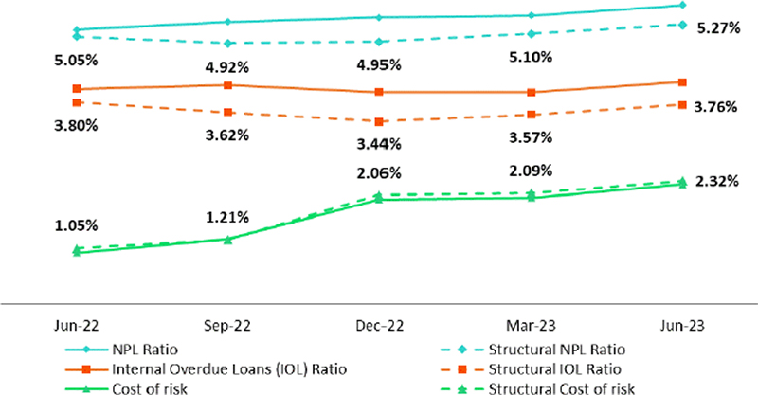

Government Program (GP) Loan Portfolio Quality (in Quarter-end Balances)

 | As of |  |  | % change
GP Portfolio quality and Delinquency ratios (1)
S/000 | Jun 22 | Mar 23 | Jun 23 | QoQ | YoY
Total loans (Quarter-end balance) | 14,647,803 | 6,549,912 | 4,940,405 | -24.6% | -66.3%
Allowance for loan losses | 194,144 | 135,849 | 131,882 | -2.9% | -32.1%
IOLs | 941,731 | 837,389 | 796,670 | -4.9% | -0.15
IOL ratio | 6.43% | 12.78% | 16.13% | 335 bps | 970 bps
Allowance for loan losses over Total loans | 1.3% | 2.1% | 2.7% | 60 bps | 134 bps
Coverage ratio of NPLs | 20.6% | 16.2% | 16.6% | 33 bps | -407 bps
(1) Government Programs (GP) include Reactiva Peru and FAE-Mype.

53

 | | | Earnings Release 2Q / 2023 | Analysis of 2Q23 Consolidated Results
12. Appendix

Portfolio Quality Ratios by Segment

Wholesale Banking

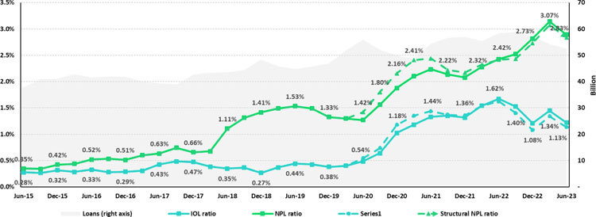

SME-Business

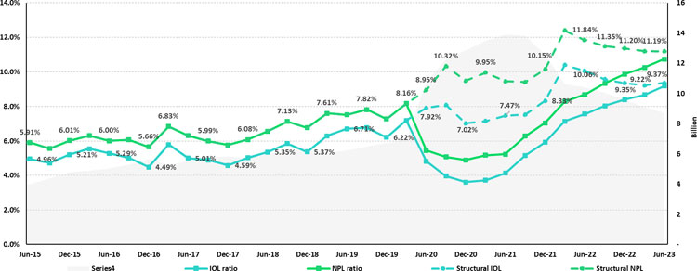

54

 | | | Earnings Release 2Q / 2023 | Analysis of 2Q23 Consolidated Results
12. Appendix

SME-Pyme

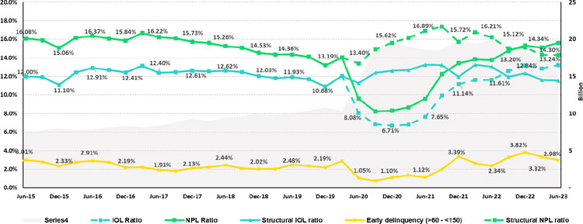

Mortgage

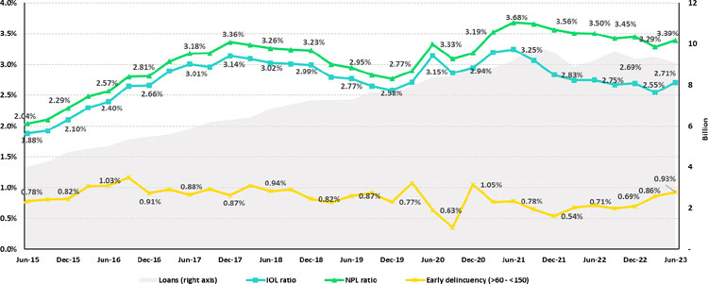

55

 | | | Earnings Release 2Q / 2023 | Analysis of 2Q23 Consolidated Results
12. Appendix

Consumer

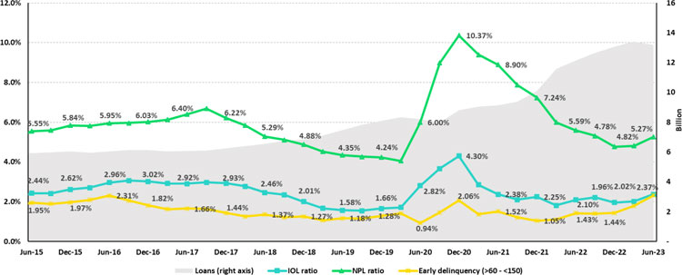

Credit Card

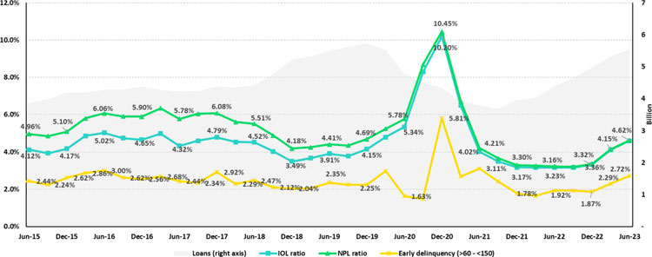

56

 | | | Earnings Release 2Q / 2023 | Analysis of 2Q23 Consolidated Results
12. Appendix

Mibanco

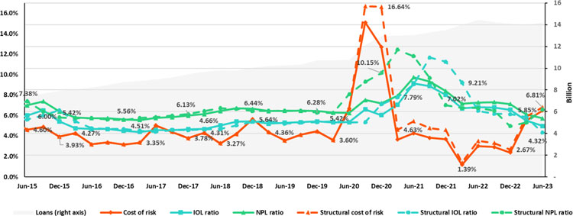

BCP Bolivia

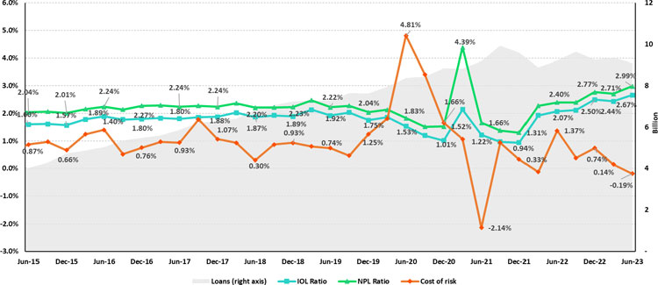
57

 | | | Earnings Release 2Q / 2023 | Analysis of 2Q23 Consolidated Results
12. Appendix

12.4 Net Interest Income (NII)

NII Summary

Net interest income | Quarter |  |  | % change |  | As of |  | change %
S/ 000 | 2Q22 | 1Q23 | 2Q23 | QoQ | YoY | 1H22 | 1H23 | 1H23 / 1H22
Interest income | 3,488,113 | 4,456,106 | 4,653,246 | 4.4% | 33.4% | 6,660,459 | 9,109,352 | 36.8%
Interest on loans | 2,929,782 | 3,570,952 | 3,712,845 | 4.0% | 26.7% | 5,615,334 | 7,283,797 | 29.7%
Dividends on investments | 13,682 | 6,477 | 17,492 | 170.1% | 27.8% | 18,002 | 23,969 | 33.1%
Interest on deposits with banks | 50,526 | 277,371 | 286,459 | 3.3% | 467.0% | 87,360 | 563,830 | 545.4%
Interest on securities | 483,936 | 585,268 | 618,952 | 5.8% | 27.9% | 921,959 | 1,204,220 | 30.6%
Other interest income | 10,187 | 16,038 | 17,498 | 9.1% | 71.8% | 17,804 | 33,536 | 88.4%
Interest expense | (851,007) | (1,324,017) | (1,449,090) | 9.4% | 70.3% | (1,591,646) | (2,773,107) | 74.2%
Interest expense (excluding Net Insurance Financial Expenses) | (747,047) | (1,208,267) | (1,333,924) | 10.4% | 78.6% | (1,385,928) | (2,542,191) | 83.4%
Interest on deposits | 336,953 | 677,088 | 777,436 | 14.8% | 130.7% | 595,892 | 1,454,524 | 144.1%
Interest on borrowed funds | 141,531 | 238,933 | 296,854 | 24.2% | 109.7% | 257,762 | 535,787 | 107.9%
Interest on bonds and subordinated notes | 166,118 | 182,898 | 148,992 | -18.5% | -10.3% | 345,727 | 331,890 | -4.0%
Other interest expense | 102,445 | 109,348 | 110,642 | 1.2% | 8.0% | 186,547 | 219,990 | 17.9%
Net Insurance Financial Expenses | (103,960) | (115,750) | (115,166) | -0.5% | 10.8% | (205,718) | (230,916) | 12.2%
Net interest income | 2,637,106 | 3,132,089 | 3,204,156 | 2.3% | 21.5% | 5,068,813 | 6,336,245 | 25.0%
Risk-adjusted Net interest income | 2,273,815 | 2,405,091 | 2,399,905 | -0.2% | 5.5% | 4,447,932 | 4,804,996 | 8.0%
Average interest earning assets | 222,718,971 | 222,289,504 | 220,651,688 | -0.7% | -0.9% | 226,151,471 | 220,418,854 | -2.5%
Net interest margin (1) | 4.92% | 5.84% | 6.02% | 18pbs | 110pbs | 4.66% | 5.96% | 130pbs
Risk-adjusted Net interest margin (1) | 4.27% | 4.54% | 4.56% | 2pbs | 29pbs | 4.12% | 4.57% | 45pbs
Net provisions for loan losses / Net interest income | 13.78% | 23.21% | 25.10% | 1.9% | 11.3% | 12.25% | 24.17% | 1192pbs

(1) Annualized. For further detail on the new NIM calculation due to IFRS17, please refer to Annex 12.1.8

Net Interest Margin (NIM) and Risk Adjusted NIM by subsidiary

NIM Breakdown | BCP Stand-alone | Mibanco | BCP Bolivia | Credicorp
2Q22 | 4.29% | 12.95% | 2.88% | 4.91%
1Q23 | 5.55% | 12.52% | 2.86% | 5.84%
2Q23 | 5.67% | 13.09% | 2.85% | 6.02%

NIM: Annualized Net interest income (excluding Net Insurance Financial Expenses) / Average period end and period beginning interest earning assets.

Risk Adjusted NIM Breakdown | BCP Stand-alone | Mibanco | BCP Bolivia | Credicorp
2Q22 | 3.79% | 10.41% | 1.77% | 4.26%
1Q23 | 4.42% | 7.03% | 2.74% | 4.54%
2Q23 | 4.25% | 8.64% | 3.00% | 4.56%

Risk-Adjusted NIM: (Annualized Net interest income (excluding Net Insurance Financial Expenses) - annualized provisions) / Average period end and period beginning interest earning assets.

58

 | | | Earnings Release 2Q / 2023 | Analysis of 2Q23 Consolidated Results
12. Appendix

12.5. Regulatory Capital

Regulatory Capital and Capital Adequacy Ratios
(S/ Thousands, IFRS)

Capital Stock |  | As of |  | % change
S/000 | Jun 22 | Mar 23 | Jun 23 | QoQ | YoY
Capital Stock | 1,318,993 | 1,318,993 | 1,318,993 | 0.0% | 0.0%
Treasury Stocks | (207,518) | (208,041) | (208,035) | 0.0% | 0.2%
Capital Surplus | 231,179 | 226,189 | 231,019 | 2.1% | -0.1%
Legal and Other capital reserves (1) | 23,666,823 | 23,603,001 | 26,221,577 | 11.1% | 10.8%
Minority interest (2) | 490,576 | 514,951 | 207,919 | -59.6% | -57.6%
Loan loss reserves (3) | 2,074,630 | 1,908,632 | 1,903,625 | -0.3% | -8.2%
Perpetual subordinated debt | - | - | -
Subordinated Debt | 5,863,208 | 5,649,060 | 5,595,446 | -0.9% | -4.6%
Investments in equity and subordinated debt of financial and insurance companies | (829,315) | (1,002,770) | (1,265,052) | 26.2% | 52.5%
Goodwill | (802,622) | (802,366) | (830,725) | 3.5% | 3.5%
Current year Net Loss | - | - | - | - | -
Deduction for subordinated debt limit (50% of Tier I excluding deductions) (4) | - | - | - | - | -
Deduction for Tier I Limit (50% of Regulatory capital) (4) | - | - | - | - | -
Total Regulatory Capital (A) | 31,805,954 | 31,207,649 | 33,174,767 | 6.3% | 4.3%
Tier 1 (5) | 16,973,919 | 16,906,310 | 17,834,543 | 5.5% | 5.1%
Tier 2 (6) + Tier 3 (7) | 14,832,035 | 14,301,339 | 15,340,224 | 7.3% | 3.4%
Financial Consolidated Group (FCG) Regulatory Capital Requirements (8) | 19,270,916 | 20,915,785 | 21,863,219 | 4.5% | 13.5%
Insurance Consolidated Group (ICG) Capital Requirements (9) | 1,512,297 | 1,406,417 | 1,532,425 | 9.0% | 1.3%
FCG Capital Requirements related to operations with ICG | (449,113) | (518,975) | (625,441) | 20.5% | 39.3%
ICG Capital Requirements related to operations with FCG | - | - | - | - | -
Total Regulatory Capital Requirements (B) | 20,334,099 | 21,803,226 | 22,770,203 | 4.4% | 12.0%
Regulatory Capital Ratio (A) / (B) | 1.56 | 1.43 | 1.46
Required Regulatory Capital Ratio (10) | 1.00 | 1.00 | 1.00
(1) Legal and other capital reserves include restricted capital reserves (PEN 14,745 million) and optional capital reserves (PEN 6,661 million).
(2) Minority interest includes Tier I (PEN 421 million)
(3) Up to 1.25% of total risk-weighted assets of Banco de Credito del Peru, Solucion Empresa Administradora Hipotecaria, Mibanco and ASB Bank Corp.
(4) Tier II + Tier III cannot be more than 50% of total regulatory capital.
(5) Tier I = capital + restricted capital reserves + Tier I minority interest - goodwill - (0.5 x investment in equity and subordinated debt of financial and insurance companies) + perpetual subordinated debt.
(6) Tier II = subordinated debt + Tier II minority interest tier + loan loss reserves - (0.5 x investment in equity and subordinated debt of financial and insurance companies).
(7) Tier III = Subordinated debt covering market risk only.
(8) Includes regulatory capital requirements of the financial consolidated group.
(9) Includes regulatory capital requirements of the insurance consolidated group.
(10) Regulatory Capital / Total Regulatory Capital Requirements (legal minimum = 1.00).

59

 | | | Earnings Release 2Q / 2023 | Analysis of 2Q23 Consolidated Results
12. Appendix

Regulatory and Capital Adequacy Ratios at BCP Stand-alone
(under current regulation as of January 2023)
 | Mar 23 | Jun 23 | Change %  QoQ
Regulatory Capital | Mar 23 | Jun 23 | Change %  QoQ
(S/ thousand) | Mar 23 | Jun 23 | Change %  QoQ
Capital Stock | 12,973,175 | 12,973,175 | N/A
Reserves | 7,038,881 | 7,039,359 | N/A
Accumulated earnings | 2,050,746 | 3,346,790 | 63.2%
Loan loss reserves (1) | 1,634,876 | 1,625,735 | -0.6%
Perpetual subordinated debt | - | - | N/A
Subordinated Debt | 5,078,700 | 4,897,800 | -3.6%
Unrealized Profit or Losses | (1,046,284) | (834,411) | -20.3%
Investment in subsidiaries and others, net of unrealized profit and net income in subsidiaries | (2,613,563) | (2,667,540) | 2.1%
Intangibles | (934,718) | (1,036,167) | 10.9%
Goodwill | (122,083) | (122,083) | N/A
Total Regulatory Capital | 24,059,729 | 25,222,659 | 4.8%
Tier 1 Common Equity (2) | 17,346,153 | 18,699,124 | 7.8%
Regulatory Tier 1 Capital (3) | 17,346,153 | 18,699,124 | 7.8%
Regulatory Tier 2 Capital (4) | 6,713,576 | 6,523,535 | -2.8%
Total risk-weighted assets | Mar 23 | Jun 23 | Change %  QoQ
(S/ thousand) | Mar 23 | Jun 23 | Change %  QoQ
Market risk-weighted assets (5) | 1,715,934 | 2,307,252 | 34.5%
Credit risk-weighted assets | 129,623,885 | 128,912,504 | -0.5%
Operational risk-weighted assets | 14,880,988 | 15,407,799 | 3.5%
Total | 146,220,807 | 146,627,555 | 0.3%
Capital requirement | Mar 23 | Jun 23 | Change %  QoQ
(S/ thousand) | Mar 23 | Jun 23 | Change %  QoQ
Market risk capital requirement (5) | 171,589 | 230,725 | 34.5%
Credit risk capital requirement | 11,018,030 | 11,602,125 | 5.3%
Operational risk capital requirement | 1,488,062 | 1,540,780 | 3.5%
Additional capital requirements | 3,534,427 | 3,494,025 | -1.1%
Total | 16,212,108 | 16,867,655 | 4.0%
Capital ratios under Local Regulation
 | Mar 23 | Jun 23 | Change
 | Mar 23 | Jun 23 | QoQ
Common Equity Tier 1 ratio | 11.86% | 12.75% | 89 bps
Tier 1 Capital ratio | 11.86% | 12.75% | 89 bps
Regulatory Global Capital ratio | 16.45% | 17.20% | 75 bps
[1] (1) Up to 1.25% of total risk-weighted assets.
[2] Common Equity Tier 1 = Capital Stock + Reserves + Accumulated earnings – Unrealized profits or losses - 100% deductions (investment in subsidiaries, goodwill, intangible assets and deferred tax assets based on future returns).
[3] Regulatory Tier 1 Capital = Common Equity Tier 1 + Tier 1 Subordinated Debt (Perpetual).
[4] Regulatory Tier 2 Capital = Subordinated Debt + Loan loss reserves.

60

 | | | Earnings Release 2Q / 2023 | Analysis of 2Q23 Consolidated Results
12. Appendix

Regulatory Capital and Capital Adequacy Ratios at Mibanco
(under current regulation as of January 2023)

 | Mar 23 | Jun 23
Regulatory Capital | Mar 23 | Jun 23 | % Change
(S/ thousand) | Mar 23 | Jun 23 | QoQ
Capital Stock | 1,840,606 | 1,840,606 | 0.0%
Reserves | 308,056 | 308,056 | 0.0%
Accumulated earnings | 556,972 | 611,151 | 9.7%
Loan loss reserves | 168,965 | 170,901 | 1.1%
Perpetual subordinated debt | 0 | 0 | N/A
Subordinated debt | 179,000 | 173,000 | -3.4%
Unrealized Profit or Losses | -15,467 | -4,727 | -69.4%
Investment in subsidiaries and others, net of unrealized profit and net income in subsidiaries | -281 | -275 | -2.0%
Intangibles | -135,202 | -138,239 | 2.2%
Goodwill | -139,180 | -139,180 | 0.0%
Total Regulatory Capital | 2,763,469 | 2,821,292 | 2.1%
Tier Common Equity (2) | 2,415,504 | 2,477,391 | 2.6%
Regulatory Tier 1 Capital (3) | 2,415,504 | 2,477,391 | 2.6%
Regulatory Tier 2 Capital (4) | 347,965 | 343,901 | -1.2%
Total risk-weighted assets | Mar 23 | Jun 23 | % Change
(S/ thousand) | Mar 23 | Jun 23 | QoQ
Market risk-weighted assets | 141,441 | 181,227 | 28.1%
Credit risk-weighted assets | 13,160,337 | 13,372,354 | 1.6%
Operational risk-weighted assets | 1,427,428 | 1,470,726 | 3.0%
Total | 14,729,206 | 15,024,307 | 2.0%
Capital requirement | Mar 23 | Jun 23 | % Change
(S/ thousand) | Mar 23 | Jun 23 | QoQ
Market risk capital requirement (5) | 14,144 | 18,123 | 28.1%
Credit risk capital requirement | 1,118,629 | 1,203,512 | 7.6%
Operational risk capital requirement | 142,743 | 147,073 | 3.0%
Additional capital requirements | 398,603 | 405,891 | 1.8%
Total | 1,674,118 | 1,774,599 | 6.0%
Capital ratios under Local Regulation
 | Mar 23 | Jun 23 | Change
 | Mar 23 | Jun 23 | QoQ
Common Equity Tier 1 Ratio | 16.40% | 16.49% | 9 bps
Tier 1 Capital ratio | 16.40% | 16.49% | 9 bps
Regulatory Global Capital Ratio | 18.76% | 18.78% | 2 bps
[1] Up to 1.25% of total risk-weighted assets.
[2] Common Equity Tier 1 = Capital Stock + Reserves + Accumulated earnings – Unrealized profits or losses - 100% deductions (investment in subsidiaries, goodwill, intangible assets and deferred tax assets based on future returns).
[3] Regulatory Tier 1 Capital = Common Equity Tier 1 + Tier 1 Subordinated Debt (Perpetual).
[4] Regulatory Tier 2 Capital = Subordinated Debt + Loan loss reserves.

61

 | | | Earnings Release 2Q / 2023 | Analysis of 2Q23 Consolidated Results
12. Appendix

Common Equity Tier 1 IFRS
BCP Stand-alone

Common Equity Tier 1 IFRS | Jun 22 | Mar 23 | Jun 23 | % Change | % Change
(S/ thousand) | Jun 22 | Mar 23 | Jun 23 | QoQ | YoY
Capital and reserves | 19,181,019 | 19,499,813 | 19,500,292 | 0.0% | 1.7%
Retained earnings | 2,897,372 | 2,746,522 | 4,000,489 | 45.7% | 38.1%
Unrealized gains (losses) | (1,089,747) | (467,041) | (274,021) | -41.3% | -74.9%
Goodwill and intangibles | (1,312,578) | (1,454,205) | (1,516,702) | 4.3% | 15.6%
Investments in subsidiaries | (2,515,685) | (2,736,368) | (2,800,043) | 2.3% | 11.3%
Total | 17,160,382 | 17,588,721 | 18,910,015 | 7.5% | 10.2%
Adjusted RWAs IFRS | 148,337,779 | 147,477,433 | 147,805,770 | 0.2% | -0.4%
Adjusted Credit RWAs IFRS | 132,793,731 | 130,880,511 | 130,090,719 | -0.6% | -2.0%
Others | 15,544,047 | 16,596,922 | 17,715,052 | 6.7% | 14.0%
CET1 ratio IFRS | 11.57% | 11.93% | 12.79% | 87 bps | 123 bps
Mibanco
Common Equity Tier 1 IFRS | Jun 22 | Mar 23 | Jun 23 | % Change | % Change
(S/ thousand) | Jun 22 | Mar 23 | Jun 23 | QoQ | YoY
Capital and reserves | 2,632,956 | 2,676,791 | 2,676,791 | 0.0% | 1.7%
Retained earnings | (32,701) | 140,612 | 206,920 | 47.2% | N/A
Unrealized gains (losses) | (13,045) | (16,118) | (5,399) | -66.5% | -58.6%
Goodwill and intangibles | (332,258) | (342,684) | (344,323) | 0.5% | 3.6%
Investments in subsidiaries | (241) | (281) | (275) | -2.0% | 14.4%
Total | 2,254,711 | 2,458,321 | 2,533,715 | 3.1% | 12.4%
Adjusted RWAs IFRS | 14,787,084 | 15,005,498 | 15,271,513 | 1.8% | 3.3%
Adjusted Credit RWAs IFRS | 12,732,383 | 13,422,514 | 13,602,081 | 1.3% | 6.8%
Others | 2,054,701 | 1,582,984 | 1,669,432 | 5.5% | -18.8%
CET1 ratio IFRS | 15.25% | 16.38% | 16.59% | 21 bps | 134 bps

62

 | | | Earnings Release 2Q / 2023 | Analysis of 2Q23 Consolidated Results
12. Appendix

12.6. Financial Statements and Ratios by Business

12.6.1. Credicorp Consolidated

CREDICORP LTD. AND SUBSIDIARIES
CONSOLIDATED STATEMENT OF FINANCIAL POSITION
(In S/ thousands, IFRS)

 |  |  | As of |  |  | % change
 |  |  | Jun 22 | Mar 23 | Jun 23 | QoQ | YoY
ASSETS
Cash and due from banks
 | Non-interest bearing |  | 7,017,129 | 6,946,112 | 7,154,236 | 3.0% | 2.0%
 | Interest bearing |  | 23,831,465 | 28,158,941 | 26,036,894 | -7.5% | 9.3%
Total cash and due from banks |  |  | 30,848,594 | 35,105,053 | 33,191,130 | -5.5% | 7.6%
Cash collateral, reverse repurchase agreements and securities borrowing |  |  | 2,046,209 | 1,468,180 | 1,863,243 | 26.9% | -8.9%
Fair value through profit or loss investments |  |  | 4,187,000 | 4,080,266 | 4,508,563 | 10.5% | 7.7%
Fair value through other comprehensive income investments |  |  | 32,955,721 | 33,395,987 | 33,344,169 | -0.2% | 1.2%
Amortized cost investments |  |  | 8,200,054 | 10,253,251 | 10,182,619 | -0.7% | 24.2%
Loans |  |  | 150,370,184 | 145,165,713 | 142,845,549 | -1.6% | -5.0%
 | Current |  | 144,264,928 | 139,376,216 | 136,866,154 | -1.8% | -5.1%
 | Internal overdue loans |  | 6,105,256 | 5,789,497 | 5,979,395 | 3.3% | -2.1%
 | Less - allowance for loan losses |  | (8,306,500) | (7,915,350) | (7,956,184) | 0.5% | -4.2%
Loans, net |  |  | 142,063,684 | 137,250,363 | 134,889,365 | -1.7% | -5.1%
Financial assets designated at fair value through profit or loss |  |  | 765,195 | 795,225 | 789,845 | -0.7% | 3.2%
Assets by insurance contracts |  |  | 816,076 | 842,865 | 893,031 | 6.0% | 9.4%
Property, plant and equipment, net |  |  | 1,837,436 | 1,786,992 | 1,749,132 | -2.1% | -4.8%
Due from customers on acceptances |  |  | 743,925 | 496,170 | 226,161 | -54.4% | -69.6%
Investments in associates |  |  | 636,217 | 660,741 | 675,623 | 2.3% | 6.2%
Intangible assets and goodwill, net |  |  | 2,729,609 | 2,942,367 | 3,046,846 | 3.6% | 11.6%
Assets by reinsurance contracts |  |  | 960,616 | 1,020,986 | 1,166,949 | 14.3% | 21.5%
Other assets (1) |  |  | 7,598,783 | 8,132,168 | 8,098,627 | -0.4% | 6.6%
Total Assets |  |  | 236,542,725 | 238,338,233 | 234,625,303 | -1.6% | -0.8%
LIABILITIES AND EQUITY
Deposits and obligations
 | Non-interest bearing |  | 46,043,989 | 41,596,964 | 39,475,762 | -5.1% | -14.3%
 | Interest bearing |  | 101,396,587 | 107,026,336 | 103,911,955 | -2.9% | 2.5%
 | Total deposits and obligations |  | 147,440,576 | 148,623,300 | 143,387,717 | -3.5% | -2.7%
Payables from repurchase agreements and securities lending |  |  | 18,138,863 | 11,686,495 | 14,306,880 | 22.4% | -21.1%
 | BCRP instruments |  | 16,031,618 | 9,780,540 | 11,772,772 | 20.4% | -26.6%
 | Repurchase agreements with third parties |  | 1,340,423 | 1,206,574 | 1,276,709 | 5.8% | -4.8%
 | Repurchase agreements with customers |  | 766,822 | 699,381 | 1,257,399 | 79.8% | 64.0%
Due to banks and correspondents |  |  | 6,456,360 | 10,199,650 | 10,062,290 | -1.3% | 55.9%
Bonds and notes issued |  |  | 16,579,674 | 14,326,930 | 14,235,697 | -0.6% | -14.1%
Banker’s acceptances outstanding |  |  | 743,925 | 496,170 | 226,161 | -54.4% | -69.6%
Liabilities by insurance contracts |  |  | 11,671,658 | 12,291,538 | 12,460,388 | 1.4% | 6.8%
Liabilities by reinsurance contracts |  |  | 343,959 | 343,067 | 421,982 | 23.0% | 22.7%
Financial liabilities at fair value through profit or loss |  |  | 527,541 | 417,146 | 413,665 | -0.8% | -21.6%
Other liabilities |  |  | 7,926,902 | 9,019,443 | 8,471,870 | -6.1% | 6.9%
Total Liabilities |  |  | 209,829,458 | 207,403,739 | 203,986,650 | -1.6% | -2.8%
Net equity |  |  | 26,167,811 | 30,359,898 | 30,027,036 | -1.1% | 14.7%
Capital stock |  |  | 1,318,993 | 1,318,993 | 1,318,993 | 0.0% | 0.0%
Treasury stock |  |  | (207,518) | (208,041) | (208,035) | 0.0% | 0.2%
Capital surplus |  |  | 231,179 | 226,189 | 231,019 | 2.1% | -0.1%
Reserves |  |  | 23,666,823 | 23,603,001 | 26,221,577 | 11.1% | 10.8%
Other reserves |  |  | -782,829 | (244,725) | (13,015) | -94.7% | -98.3%
Retained earnings |  |  | 1,941,163 | 5,664,481 | 2,476,497 | -56.3% | 27.6%
 |  |  | - | - | -
Non-controlling interest |  |  | 545,456 | 574,596 | 611,617 | 6.4% | 12.1%
Total Net Equity |  |  | 26,713,267 | 30,934,494 | 30,638,653 | -1.0% | 14.7%
 |  |  | - | - | -
Total liabilities and equity |  |  | 236,542,725 | 238,338,233 | 234,625,303 | -1.6% | -0.8%
 |  |  | - | - | -
Off-balance sheet |  |  | 142,573,498 | 154,477,055 | 144,709,112 | -6.3% | 1.5%
Total performance bonds, stand-by and L/Cs. |  |  | 21,331,467 | 18,731,789 | 18,654,864 | -0.4% | -12.5%
Undrawn credit lines, advised but not committed |  |  | 84,820,503 | 87,232,214 | 85,762,478 | -1.7% | 1.1%
Total derivatives (notional) and others |  |  | 36,421,528 | 48,513,052 | 40,291,770 | -16.9% | 10.6%

(1) Includes mainly accounts receivables from brokerage and others.

63

 | | | Earnings Release 2Q / 2023 | Analysis of 2Q23 Consolidated Results
12. Appendix

CREDICORP LTD. AND SUBSIDIARIES
CONSOLIDATED STATEMENT OF INCOME
(In S/ thousands, IFRS)

 |  |  | Quarter |  |  | % change |  | As of |  | % change
 |  |  | 2Q22 | 1Q23 | 2Q23 | QoQ | YoY | 1H22 | 1H23 | 1H 23/ 1H 22
Interest income and expense
 | Interest and similar income |  | 3,488,113 | 4,456,106 | 4,653,246 | 4.4% | 33.4% | 6,660,459 | 9,109,352 | 36.8%
 | Interest and similar expenses |  | (851,007) | (1,324,017) | (1,449,090) | 9.4% | 70.3% | (1,591,646) | (2,773,107) | 74.2%
 | Net interest, similar income and expenses |  | 2,637,106 | 3,132,089 | 3,204,156 | 2.3% | 21.5% | 5,068,813 | 6,336,245 | 25.0%
Gross provision for credit losses on loan portfolio |  |  | (447,036) | (802,107) | (886,123) | 10.5% | 98.2% | (797,717) | (1,688,230) | 111.6%
Recoveries of written-off loans |  |  | 83,745 | 75,109 | 81,872 | 9.0% | -2.2% | 176,836 | 156,981 | -11.2%
Provision for credit losses on loan portfolio, net of recoveries |  |  | (363,291) | (726,998) | (804,251) | 10.6% | 121.4% | (620,881) | (1,531,249) | 146.6%
 |  |  | - | - | -
Net interest, similar income and expenses, after provision for credit losses on loan portfolio |  |  | 2,273,815 | 2,405,091 | 2,399,905 | -0.2% | 5.5% | 4,447,932 | 4,804,996 | 8.0%
Other income
 | Fee income |  | 920,950 | 881,781 | 960,550 | 8.9% | 4.3% | 1,812,578 | 1,842,331 | 1.6%
 | Net gain on foreign exchange transactions |  | 269,059 | 248,515 | 210,944 | -15.1% | -21.6% | 528,769 | 459,459 | -13.1%
 | Net loss on securities |  | (94,180) | 70,036 | 68,603 | -2.0% | n.a | (151,046) | 138,639 | n.a
 | Net gain from associates |  | 29,219 | 27,212 | 23,689 | -12.9% | -18.9% | 53,233 | 50,901 | -4.4%
 | Net gain (loss) on derivatives held for trading |  | 12,304 | (6,570) | 16,671 | -353.7% | 35.5% | 6,322 | 10,101 | 59.8%
 | Net gain (loss) from exchange differences |  | (18,441) | 22,963 | 2,996 | -87.0% | -116.2% | (26,804) | 25,959 | n.a
 | Others |  | 78,681 | 89,338 | 150,333 | 68.3% | 91.1% | 213,938 | 239,671 | 12.0%
 | Total non-financial income |  | 1,197,592 | 1,333,275 | 1,433,786 | 7.5% | 19.7% | 2,436,990 | 2,767,061 | 13.5%
Insurance underwriting result
 | Insurance Service Result |  | 320,290 | 406,877 | 393,487 | -3.3% | 22.9% | 629,548 | 800,364 | 27.1%
 | Reinsurance Result |  | (126,093) | (110,536) | (96,923) | -12.3% | -23.1% | (228,684) | (207,459) | -9.3%
 | Total insurance underwriting result |  | 194,197 | 296,341 | 296,564 | 0.1% | 52.7% | 400,864 | 592,905 | 47.9%
Total expenses
 | Salaries and employee benefits |  | (942,159) | (1,029,558) | (1,054,735) | 2.4% | 11.9% | (1,881,677) | (2,084,293) | 10.8%
 | Administrative, general and tax expenses |  | (819,100) | (835,060) | (871,046) | 4.3% | 6.3% | (1,515,165) | (1,706,106) | 12.6%
 | Depreciation and amortization |  | (156,892) | (161,079) | (160,549) | -0.3% | 2.3% | (308,786) | (321,628) | 4.2%
 | Impairment loss on goodwill |  | - | - | - | #DIV/0! | #DIV/0! | - | - | n.a.
 | Association in participation |  | (10,329) | (12,612) | (16,742) | 32.7% | 62.1% | (18,020) | (29,354) | 62.9%
 | Other expenses |  | (52,645) | (88,599) | (92,894) | 4.8% | 76.5% | (131,996) | (181,493) | 37.5%
 | Total expenses |  | (1,981,125) | (2,126,908) | (2,195,966) | 3.2% | 10.8% | (3,855,644) | (4,322,874) | 12.1%
Profit before income tax |  |  | 1,684,479 | 1,907,799 | 1,934,289 | 1.4% | 14.8% | 3,430,142 | 3,842,088 | 12.0%
 | Income tax |  | (513,182) | (493,466) | (504,472) | 2.2% | -1.7% | (1,059,182) | (997,938) | -5.8%
Net profit |  |  | 1,171,297 | 1,414,333 | 1,429,817 | 1.1% | 22.1% | 2,370,960 | 2,844,150 | 20.0%
Non-controlling interest |  |  | 28,420 | 30,060 | 28,550 | -5.0% | 0.5% | 56,206 | 58,610 | 4.3%
Net profit attributable to Credicorp |  |  | 1,142,877 | 1,384,273 | 1,401,267 | 1.2% | 22.6% | 2,314,754 | 2,785,540 | 20.3%

64

 | | | Earnings Release 2Q / 2023 | Analysis of 2Q23 Consolidated Results
12. Appendix

12.6.2. Credicorp Stand-alone

Credicorp Ltd.
Separate Statement of Financal Position
(S/ thousands, IFRS)

 | As of |  |  | % change
 | Jun22 | Mar23 | Jun23 | QoQ | YoY
ASSETS
Cash and cash equivalents | 115,612 | 131,218 | 122,665 | -6.5% | 6.1%
At fair value through profit or loss | 938,816 | 949,378 | 937,921 | -1.2% | n.a
Fair value through other comprehensive income investments | 332,280 | 318,962 | 317,479 | -0.5% | -4.5%
In subsidiaries and associates investments | 31,251,710 | 35,207,564 | 34,755,621 | -1.3% | 11.2%
Loans | - |  |  | 0.0% | 0.0%
Other assets | 230 | 69,217 | 197 | n.a | n.a
Total Assets | 32,638,648 | 36,676,339 | 36,133,883 | -1.5% | 10.7%
LIABILITIES AND NET SHAREHOLDERS’ EQUITY
Due to banks, correspondents and other entities | 240,996 | - | - | n.a. | n.a.
Dividends payable | - | - | - | #DIV/0! | #DIV/0!
Bonds and notes issued | 1,901,462 | 1,885,839 | 1,803,725 | -4.4% | -5.1%
Other liabilities | 164,451 | 267,558 | 161,170 | -39.8% | -2.0%
Total Liabilities | 2,306,909 | 2,153,397 | 1,964,895 | -8.8% | -14.8%
NET EQUITY
Capital stock | 1,318,993 | 1,318,993 | 1,318,993 | 0.0% | 0.0%
Capital Surplus | 384,542 | 384,542 | 384,542 | 0.0% | 0.0%
Reserve | 23,300,350 | 23,300,350 | 25,905,604 | 11.2% | 11.2%
Unrealized results | (1,285,376) | (592,006) | (362,199) | -38.8% | n.a.
Retained earnings | 6,613,230 | 10,111,063 | 6,922,048 | -31.5% | 4.7%
Total net equity | 30,331,739 | 34,522,942 | 34,168,988 | -1.0% | 12.7%
Total Liabilities And Equity | 32,638,648 | 36,676,339 | 36,133,883 | -1.5% | 10.7%
 | Quarter |  |  | % change |  | As of |  | % Change
 | 2Q22 | 1Q23 | 2Q23 | QoQ | YoY | 1H22 | 1H23 | 1H23/1H22
Interest income
Net share of the income from investments in subsidiaries and associates | 1,425,812 | 1,439,211 | 1,804,873 | 25.4% | 26.6% | 2,661,844 | 3,244,084 | 21.9%
Interest and similar income | 7,056 | 300 | 8,996 | 2898.7% | 27.5% | 7,354 | 9,296 | 26.4%
Net gain on financial assets at fair value through profit or loss | (41,316) | 3,759 | 22,618 | 501.7% | n.a | (68,214) | 26,377 | n.a.
Total income | 1,391,552 | 1,443,270 | 1,836,487 | 27.2% | 32.0% | 2,600,984 | 3,279,757 | 26.1%
Interest and similar expense | (14,778) | (13,796) | (14,156) | 2.6% | -4.2% | (28,429) | (27,952) | -1.7%
Administrative and general expenses | (3,766) | (4,407) | (7,584) | 72.1% | 101.4% | (8,025) | (11,991) | 49.4%
Total expenses | (18,544) | (18,203) | (21,740) | 19.4% | 17.2% | (36,454) | (39,943) | 9.6%
Operating income | 1,373,008 | 1,425,067 | 1,814,747 | 27.3% | 32.2% | 2,564,530 | 3,239,814 | 26.3%
Net gain (losses) from exchange differences | (752) | (158) | (3,284) | 1978.5% | 336.7% | (897) | (3,442) | 283.7%
Other, net | (13) | 102 | 99 | n.a | n.a | 219 | 201 | -8.2%
 |  | (56) | (3,185) |  |  | (678) | (3,241)
Profit before income tax | 1,372,243 | 1,425,011 | 1,811,562 | 27.1% | 32.0% | 2,563,852 | 3,236,573 | 26.2%
Income tax | (42,290) | (46,795) | (47,093) | 0.6% | 11.4% | (84,290) | (93,888) | 11.4%
Net income | 1,329,953 | 1,378,216 | 1,764,469 | 28.0% | 32.7% | 2,479,562 | 3,142,685 | 26.7%
Double Leverage Ratio | 103.03% | 101.98% | 101.72% | -27bps | -132bps | 103.03% | 101.72% | -132bps

65

 | | | Earnings Release 2Q / 2023 | Analysis of 2Q23 Consolidated Results
12. Appendix

12.6.3. BCP Consolidated

BANCO DE CREDITO DEL PERU AND SUBSIDIARIES
CONSOLIDATED STATEMENT OF FINANCIAL POSITION
(In S/ thousands, IFRS)

 |  |  | As of |  |  | % change
 |  |  | Jun 22 | Mar 23 | Jun 23 | QoQ | YoY
ASSETS
Cash and due from banks
 | Non-interest bearing |  | 5,236,507 | 5,456,302 | 5,300,381 | -2.9% | 1.2%
 | Interest bearing |  | 22,383,291 | 26,924,509 | 25,182,623 | -6.5% | 12.5%
Total cash and due from banks |  |  | 27,619,798 | 32,380,811 | 30,483,004 | -5.9% | 10.4%
 |  |  |  | - | -
Cash collateral, reverse repurchase agreements and securities borrowing |  |  | 542,521 | 232,059 | 537,814 | 131.8% | -0.9%
 |  |  |  | - | -
Fair value through profit or loss investments |  |  | 163,187 | 39,638 | 221,253 | 458.2% | 35.6%
Fair value through other comprehensive income investments |  |  | 17,868,118 | 17,702,831 | 17,169,798 | -3.0% | -3.9%
Amortized cost investments |  |  | 7,630,677 | 9,661,389 | 9,611,227 | -0.5% | 26.0%
 |  |  |  | - | -
Loans |  |  | 138,012,365 | 132,290,495 | 130,175,792 | -1.6% | -5.7%
 | Current |  | 132,146,911 | 126,846,139 | 124,488,630 | -1.9% | -5.8%
 | Internal overdue loans |  | 5,865,454 | 5,444,356 | 5,687,162 | 4.5% | -3.0%
 | Less - allowance for loan losses |  | (7,813,526) | (7,450,091) | (7,504,879) | 0.7% | -4.0%
Loans, net |  |  | 130,198,839 | 124,840,404 | 122,670,913 | -1.7% | -5.8%
 |  |  |  | - | -
Property, furniture and equipment, net (1) |  |  | 1,558,507 | 1,489,392 | 1,460,108 | -2.0% | -6.3%
Due from customers on acceptances |  |  | 743,925 | 496,170 | 226,161 | -54.4% | -69.6%
Investments in associates |  |  | 26,411 | 18,246 | 16,670 | -8.6% | -36.9%
Other assets (2) |  |  | 7,018,343 | 6,873,005 | 7,653,151 | 11.4% | 9.0%
 |  |  |  | - | -
Total Assets |  |  | 193,370,326 | 193,733,945 | 190,050,099 | -1.9% | -1.7%
 |  |  |  | - | -
Liabilities and Equity |  |  |  | - | -
Deposits and obligations |  |  |  | - | -
 | Non-interest bearing (1) |  | 40,994,205 | 37,978,204 | 36,484,571 | -3.9% | -11.0%
 | Interest bearing (1) |  | 88,145,130 | 93,952,305 | 91,074,922 | -3.1% | 3.3%
Total deposits and obligations |  |  | 129,139,335 | 131,930,509 | 127,559,493 | -3.3% | -1.2%
 |  |  |  | - | -
Payables from repurchase agreements and securities lending |  |  | 16,578,846 | 10,318,686 | 12,310,396 | 19.3% | -25.7%
 | BCRP instruments |  | 16,031,618 | 9,780,540 | 11,772,771 | 20.4% | -26.6%
 | Repurchase agreements with third parties |  | 547,228 | 538,146 | 537,625 | -0.1% | -1.8%
Due to banks and correspondents |  |  | 5,963,573 | 9,647,935 | 9,704,721 | 0.6% | 62.7%
Bonds and notes issued |  |  | 14,093,426 | 10,972,861 | 10,804,531 | -1.5% | -23.3%
Banker’s acceptances outstanding |  |  | 743,925 | 496,170 | 226,161 | -54.4% | -69.6%
Financial liabilities at fair value through profit or loss |  |  | 210,393 | 193,031 | 138,339 | -28.3% | -34.2%
Other liabilities (3) |  |  | 5,512,852 | 8,245,729 | 5,925,279 | -28.1% | 7.5%
Total Liabilities |  |  | 172,242,350 | 171,804,921 | 166,668,920 | -3.0% | -3.2%
 |  |  |  | - | -
Net equity |  |  | 20,987,313 | 21,777,751 | 23,226,061 | 6.7% | 10.7%
Capital stock |  |  | 11,882,984 | 12,679,794 | 12,679,794 | 0.0% | 6.7%
Reserves |  |  | 7,298,035 | 6,820,019 | 6,820,497 | 0.0% | -6.5%
Unrealized gains and losses |  |  | (1,089,747) | (467,041) | (274,021) | -41.3% | -74.9%
Retained earnings |  |  | 2,896,041 | 2,744,979 | 3,999,791 | 45.7% | 38.1%
 |  |  |  | - | -
Non-controlling interest |  |  | 140,663 | 151,273 | 155,118 | 2.5% | 10.3%
 |  |  |  | - | -
Total Net Equity |  |  | 21,127,976 | 21,929,024 | 23,381,179 | 6.6% | 10.7%
 |  |  |  | - | -
Total liabilities and equity |  |  | 193,370,326 | 193,733,945 | 190,050,099 | -1.9% | -1.7%
 |  |  |  | - | -
Off-balance sheet |  |  | 130,782,706 | 142,247,161 | 142,443,947 | 0.1% | 8.9%
Total performance bonds, stand-by and L/Cs. |  |  | 19,490,337 | 17,932,260 | 17,955,475 | 0.1% | -7.9%
Undrawn credit lines, advised but not committed |  |  | 74,845,631 | 76,157,911 | 76,331,482 | 0.2% | 2.0%
Total derivatives (notional) and others |  |  | 36,446,738 | 48,156,990 | 48,156,990 | 0.0% | 32.1%

(1) Right of use asset of lease contracts is included by application of IFRS 16.
(2) Mainly includes intangible assets, other receivable accounts and tax credit.
(3) Mainly includes other payable accounts.

66

 | | | Earnings Release 2Q / 2023 | Analysis of 2Q23 Consolidated Results
12. Appendix

BANCO DE CREDITO DEL PERU AND SUBSIDIARIES
CONSOLIDATED STATEMENT OF INCOME
(In S/ thousands, IFRS)

 |  | Quarter |  |  | % change |  | As of |  | % change
 |  | 2Q22 | 1Q23 | 2Q23 | QoQ | YoY | 1H22 | 1H23 | 1H23 / 1H22
Interest income and expense
Interest and similar income |  | 2,988,885 | 3,902,811 | 4,066,734 | 4.2% | 36.1% | 2,988,885 | 4,066,734 | 36.1%
Interest and similar expenses |  | (590,599) | (994,836) | (1,112,623) | 11.8% | 88.4% | (590,599) | (1,112,623) | 94.3%
Net interest, similar income and expenses |  | 2,398,286 | 2,907,975 | 2,954,111 | 1.6% | 23.2% | 2,398,286 | 2,954,111 | 27.0%
 |  |  |  |  |  |  | - | -
Provision for credit losses on loan portfolio |  | (400,124) | (782,079) | (864,243) | 10.5% | 116.0% | (400,124) | (864,243) | 122.4%
Recoveries of written-off loans |  | 77,244 | 69,694 | 77,154 | 10.7% | -0.1% | 77,244 | 77,154 | -10.3%
Provision for credit losses on loan portfolio, net of recoveries |  | (322,880) | (712,385) | (787,089) | 10.5% | 143.8% | (322,880) | (787,089) | 160.0%
 |  |  |  |  |  |  | - | -
Net interest, similar income and expenses, after provision for credit losses on loan portfolio |  | 2,075,406 | 2,195,590 | 2,167,022 | -1.3% | 4.4% | 2,075,406 | 2,167,022 | 8.0%
 |  |  |  |  |  |  | - | -
Other income |  |  |  |  |  |  | - | -
Fee income |  | 753,835 | 727,489 | 754,473 | 3.7% | 0.1% | 753,835 | 754,473 | -0.2%
Net gain on foreign exchange transactions |  | 243,566 | 242,570 | 246,228 | 1.5% | 1.1% | 243,566 | 246,228 | 0.6%
Net gain (loss) on securities |  | (2,611) | (2,584) | (29,111) | n.a | n.a. | (2,611) | (29,111) | 602.9%
Net gain (loss) on derivatives held for trading |  | (19,037) | 22,288 | 38,344 | 72.0% | n.a | (19,037) | 38,344 | -302.0%
Net gain (loss) from exchange differences |  | 9,043 | 4,308 | 5,663 | 31.5% | -37.4% | 9,043 | 5,663 | -224.5%
Others |  | 46,354 | 71,277 | 118,211 | 65.8% | 155.0% | 46,354 | 118,211 | 13.7%
Total other income |  | 1,031,150 | 1,065,348 | 1,133,808 | 6.4% | 10.0% | 1,031,150 | 1,133,808 | 4.9%
 |  |  |  |  |  |  | - | -
Total expenses |  |  |  |  |  |  | - | -
Salaries and employee benefits |  | (688,691) | (750,011) | (774,886) | 3.3% | 12.5% | (688,691) | (774,886) | 10.3%
Administrative expenses |  | (638,366) | (645,131) | (667,935) | 3.5% | 4.6% | (638,366) | (667,935) | 12.1%
Depreciation and amortization |  | (130,253) | (134,267) | (133,876) | -0.3% | 2.8% | (130,253) | (133,876) | 4.5%
Other expenses |  | (52,035) | (43,944) | (49,267) | 12.1% | -5.3% | (52,035) | (49,267) | -8.2%
Total expenses |  | (1,509,345) | (1,573,353) | (1,625,964) | 3.3% | 7.7% | (1,509,345) | (1,625,964) | 9.9%
 |  |  |  |  |  |  | - | -
Profit before income tax |  | 1,597,211 | 1,687,585 | 1,674,866 | -0.8% | 4.9% | 1,597,211 | 1,674,866 | 4.3%
 |  |  |  |  |  |  | - | -
Income tax |  | (434,823) | (422,491) | (416,753) | -1.4% | -4.2% | (434,823) | (416,753) | -6.9%
 |  |  |  |  |  |  | - | -
Net profit |  | 1,162,388 | 1,265,094 | 1,258,113 | -0.6% | 8.2% | 1,162,388 | 1,258,113 | 8.6%
Non-controlling interest |  | (6,426) | (1,112) | (3,301) | 196.9% | -48.6% | (6,426) | (3,301) | -61.9%
Net profit attributable to BCP Consolidated |  | 1,155,962 | 1,263,982 | 1,254,812 | -0.7% | 8.6% | 1,155,962 | 1,254,812 | 9.0%

BANCO DE CREDITO DEL PERU AND SUBSIDIARIES
SELECTED FINANCIAL INDICATORS

 | Quarter |  |  | As of
 | 2Q22 | 1Q23 | 2Q23 | 1H22 | 1H23
Profitability
Earnings per share (1) | 0.09 | 0.10 | 0.10 | 0.18 | 0.19
ROAA (2)(3) | 2.4% | 2.6% | 2.6% | 2.4% | 2.6%
ROAE (2)(3) | 22.5% | 22.5% | 22.3% | 22.5% | 22.4%
Net interest margin (2)(3) | 5.1% | 6.2% | 6.4% | 4.9% | 6.3%
Risk adjusted NIM (2)(3) | 4.4% | 4.7% | 4.7% | 4.3% | 4.7%
Funding Cost (2)(3)(4) | 1.4% | 2.4% | 2.8% | 1.3% | 2.6%
Quality of loan portfolio
IOL ratio | 4.2% | 4.1% | 4.4% | 4.2% | 4.4%
NPL ratio | 5.4% | 5.7% | 5.9% | 5.4% | 5.9%
Coverage of IOLs | 133.2% | 136.8% | 132.0% | 133.2% | 132.0%
Coverage of NPLs | 104.0% | 98.9% | 97.1% | 104.0% | 97.1%
Cost of risk (5) | 0.9% | 2.2% | 2.4% | 0.8% | 2.3%
Operating efficiency
Oper. expenses as a percent. of total income - reported (6) | 43.0% | 39.2% | 39.4% | 42.9% | 39.3%
Oper. expenses as a percent. of av. tot. assets (2)(3)(6) | 3.0% | 3.2% | 3.3% | 2.9% | 3.2%
Share Information
N° of outstanding shares (Million) | 12,973 | 12,973 | 12,973 | 12,973 | 12,973

(1) Shares outstanding of 12,176 million is used for all periods since shares have been issued only for capitalization of profits.
(2) Ratios are annualized.
(3) Averages are determined as the average of period-beginning and period-ending balances.
(4) The funding costs differs from previously reported due to a methodology change in the denominator, which no longer includes the following accounts: acceptances outstanding, reserves for property and casualty claims, reserve for unearned premiums, reinsurance payable and other liabilities.
(5) Cost of risk: Annualized provision for loan losses / Total loans.

67

 | | | Earnings Release 2Q / 2023 | Analysis of 2Q23 Consolidated Results
12. Appendix

12.6.4. BCP Stand-alone

BANCO DE CREDITO DEL PERU
STATEMENT OF FINANCIAL POSITION
(S/ thousands, IFRS)

 |  |  | As of |  |  | % change
 |  |  | Jun 22 | Mar 23 | Jun 23 | QoQ | YoY
ASSETS
Cash and due from banks
 | Non-interest bearing |  | 4,596,609 | 4,832,635 | 4,634,064 | -4.1% | 0.8%
 | Interest bearing |  | 21,860,250 | 26,052,997 | 24,308,715 | -6.7% | 11.2%
 | Total cash and due from banks |  | 26,456,859 | 30,885,632 | 28,942,779 | -6.3% | 9.4%
 |  |  | - | - | -
Cash collateral, reverse repurchase agreements and securities borrowing |  |  | 542,521 | 232,059 | 537,814 | 131.8% | -0.9%
 |  |  | - | - | -
Fair value through profit or loss investments |  |  | 163,187 | 39,638 | 221,253 | 458.2% | 35.6%
Fair value through other comprehensive income investments |  |  | 16,569,716 | 16,582,128 | 15,738,281 | -5.1% | -5.0%
Amortized cost investments |  |  | 7,331,851 | 9,369,229 | 9,467,981 | 1.1% | 29.1%
 |  |  | - | - | -
Loans |  |  | 125,535,209 | 119,751,399 | 117,611,694 | -1.8% | -6.3%
 | Current |  | 120,657,794 | 115,009,487 | 112,818,171 | -1.9% | -6.5%
 | Internal overdue loans |  | 4,877,415 | 4,741,912 | 4,793,523 | 1.1% | -1.7%
 | Less - allowance for loan losses |  | (6,636,936) | (6,404,541) | (6,410,732) | 0.1% | -3.4%
Loans, net |  |  | 118,898,273 | 113,346,858 | 111,200,962 | -1.9% | -6.5%
 |  |  |  | - | -
Property, furniture and equipment, net (1) |  |  | 1,291,209 | 1,238,722 | 1,217,932 | -1.7% | -5.7%
Due from customers on acceptances |  |  | 743,925 | 496,170 | 226,161 | -54.4% | -69.6%
Investments in associates |  |  | 2,541,615 | 2,736,368 | 2,800,043 | 2.3% | 10.2%
Other assets (2) |  |  | 6,295,694 | 6,203,938 | 7,015,286 | 13.1% | 11.4%
 |  |  | - | - | -
Total Assets |  |  | 180,834,850 | 181,130,742 | 177,368,492 | -2.1% | -1.9%
 |  |  | - | - | -
Liabilities and Equity |  |  | - | - | -
Deposits and obligations |  |  | - | - | -
 | Non-interest bearing |  | 40,978,979 | 37,968,322 | 36,465,910 | -4.0% | -11.0%
 | Interest bearing |  | 79,282,172 | 84,477,317 | 81,295,129 | -3.8% | 2.5%
 | Total deposits and obligations |  | 120,261,151 | 122,445,639 | 117,761,039 | -3.8% | -2.1%
 |  |  | - | - | -
Payables from repurchase agreements and securities lending |  |  | 14,886,829 | 9,578,869 | 11,759,891 | 22.8% | -21.0%
 | BCRP instruments |  | 14,339,601 | 9,040,723 | 11,222,266 | 24.1% | -21.7%
 | Repurchase agreements with third parties |  | 547,228 | 538,146 | 537,625 | -0.1% | -1.8%
Due to banks and correspondents |  |  | 4,946,046 | 8,535,930 | 8,670,982 | 1.6% | 75.3%
Bonds and notes issued |  |  | 13,833,991 | 10,396,500 | 10,152,890 | -2.3% | -26.6%
Banker’s acceptances outstanding |  |  | 743,925 | 496,170 | 226,161 | -54.4% | -69.6%
Financial liabilities at fair value through profit or loss |  |  | 210,393 | 193,031 | 138,339 | -28.3% | n.a.
Other liabilities (3) |  |  | 4,963,871 | 7,705,309 | 5,432,431 | -29.5% | 9.4%
Total Liabilities |  |  | 159,846,206 | 159,351,448 | 154,141,733 | -3.3% | -3.6%
 |  |  | - | - | -
Net equity |  |  | 20,988,644 | 21,779,294 | 23,226,759 | 6.6% | 10.7%
 | Capital stock |  | 11,882,984 | 12,679,794 | 12,679,794 | 0.0% | 6.7%
 | Reserves |  | 7,298,035 | 6,820,019 | 6,820,497 | 0.0% | -6.5%
 | Unrealized gains and losses |  | (1,089,747) | (467,041) | (274,021) | -41.3% | -74.9%
 | Retained earnings |  | 2,897,372 | 2,746,522 | 4,000,489 | 45.7% | 38.1%
Total Net Equity |  |  | 20,988,644 | 21,779,294 | 23,226,759 | 6.6% | 10.7%
 |  |  | - | - | -
Total liabilities and equity |  |  | 180,834,850 | 181,130,742 | 177,368,492 | -2.1% | -1.9%
 |  |  | - | - | -
Off-balance sheet |  |  | 131,117,219 | 138,810,501 | 129,969,150 | -6.4% | -0.9%
Total performance bonds, stand-by and L/Cs. |  |  | 19,490,337 | 17,932,454 | 17,955,670 | 0.1% | -7.9%
Undrawn credit lines, advised but not committed |  |  | 71,528,880 | 73,838,085 | 73,510,275 | -0.4% | 2.8%
Total derivatives (notional) and others |  |  | 40,098,002 | 47,039,962 | 38,503,205 | -18.1% | -4.0%

(1) Right of use asset of lease contracts is included by application of IFRS 16.
(2) Mainly includes intangible assets, other receivable accounts, trading derivatives receivable accounts and tax credit
(3) Mainly includes other payable accounts, trading derivatives payable accounts and taxes for payable.

68

 | | | Earnings Release 2Q / 2023 | Analysis of 2Q23 Consolidated Results
12. Appendix

BANCO DE CREDITO DEL PERU
STATEMENT OF INCOME
(S/ thousands, IFRS)

 |  |  | Quarter |  |  | % change |  | Year |  | % change
 |  |  | 2Q22 | 1Q23 | 2Q23 | QoQ | YoY | 1H22 | 1H23 | 1H23 / 1H22
Interest income and expense
 | Interest and dividend income |  | 2,340,804 | 3,205,509 | 3,323,237 | 3.7% | 42.0% | 4,461,020 | 6,528,746 | 46.4%
 | Interest expense |  | (481,139) | (817,056) | (912,744) | 11.7% | 89.7% | (896,002) | (1,729,800) | 93.1%
 | Net interest income |  | 1,859,665 | 2,388,453 | 2,410,493 | 0.9% | 29.6% | 3,565,018 | 4,798,946 | 34.6%
Provision for credit losses on loan portfolio |  |  | (268,439) | (532,192) | (657,546) | 23.6% | 145.0% | (471,207) | (1,189,738) | 152.5%
Recoveries of written-off loans |  |  | 51,155 | 47,417 | 53,892 | 13.7% | 5.4% | 107,280 | 101,309 | -5.6%
Provision for credit losses on loan portfolio, net of recoveries |  |  | (217,284) | (484,775) | (603,654) | 24.5% | 177.8% | (363,927) | (1,088,429) | 199.1%
Risk-adjusted net interest income |  |  | 1,642,381 | 1,903,678 | 1,806,839 | -5.1% | 10.0% | 3,201,091 | 3,710,517 | 15.9%
Other income
 | Fee income |  | 727,644 | 698,207 | 723,231 | 3.6% | -0.6% | 1,434,505 | 1,421,438 | -0.9%
 | Net gain on foreign exchange transactions |  | 240,387 | 239,547 | 244,314 | 2.0% | 1.6% | 479,125 | 483,861 | 1.0%
 | Net gain (losses) on securities |  | 112,761 | 26,998 | 36,377 | 34.7% | -67.7% | 203,224 | 63,375 | -68.8%
 | Net gain from associates |  | 7,421 | (7,269) | (1,355) | -81.4% | -118.3% | 13,122 | (8,624) | -165.7%
 | Net gain (losses) on derivatives held for trading |  | (16,568) | 20,553 | 36,271 | 76.5% | n.a. | (26,544) | 56,824 | -314.1%
 | Net gain (losses) from exchange differences |  | 7,249 | 4,691 | 7,961 | 69.7% | 9.8% | (2,768) | 12,652 | -557.1%
 | Others |  | 45,276 | 68,255 | 113,963 | 67.0% | 151.7% | 156,026 | 182,218 | 16.8%
 | Total other income |  | 1,124,170 | 1,050,982 | 1,160,762 | 10.4% | 3.3% | 2,256,690 | 2,211,744 | -2.0%
Total expenses
 | Salaries and employee benefits |  | (487,698) | (546,048) | (563,407) | 3.2% | 15.5% | (988,911) | (1,109,455) | 12.2%
 | Administrative expenses |  | (575,071) | (571,780) | (599,803) | 4.9% | 4.3% | (1,038,998) | (1,171,583) | 12.8%
 | Depreciation and amortization |  | (109,824) | (112,872) | (112,661) | -0.2% | 2.6% | (215,683) | (225,533) | 4.6%
 | Other expenses |  | (46,381) | (39,563) | (44,011) | 11.2% | -5.1% | (90,067) | (83,574) | -7.2%
 | Total expenses |  | (1,218,974) | (1,270,263) | (1,319,882) | 3.9% | 8.3% | (2,333,659) | (2,590,145) | 11.0%
Profit before income tax |  |  | 1,547,577 | 1,684,397 | 1,647,719 | -2.2% | 6.5% | 3,124,122 | 3,332,116 | 6.7%
 | Income tax |  | (391,499) | (420,795) | (393,752) | -6.4% | 0.6% | (811,619) | (814,547) | 0.4%
Net profit attributable to BCP Stand-alone |  |  | 1,156,078 | 1,263,602 | 1,253,967 | -0.8% | 8.5% | 2,312,503 | 2,517,569 | 8.9%

BANCO DE CREDITO DEL PERU
SELECTED FINANCIAL INDICATORS

 | Quarter |  |  | As of
 | 2Q22 | 1Q23 | 2Q23 | 1H22 | 1H23
Profitability
ROAA (1)(2) | 2.5% | 2.8% | 2.8% | 2.5% | 2.8%
ROAE (1)(2) | 22.5% | 22.5% | 22.3% | 22.5% | 22.4%
Net interest margin (1)(2) | 4.3% | 5.6% | 5.7% | 4.1% | 5.6%
Risk adjusted NIM (1)(2) | 3.8% | 4.4% | 4.3% | 3.6% | 4.4%
Funding Cost (1)(2)(3) | 1.2% | 2.2% | 2.4% | 1.2% | 2.3%
Quality of loan portfolio
IOL ratio | 3.9% | 4.0% | 4.1% | 3.9% | 4.1%
NPL ratio | 5.1% | 5.6% | 5.7% | 5.1% | 5.7%
Coverage of IOLs | 136.1% | 135.1% | 133.7% | 136.1% | 133.7%
Coverage of NPLs | 103.0% | 95.3% | 95.1% | 103.0% | 95.1%
Cost of risk (4) | 0.7% | 1.6% | 2.1% | 0.6% | 1.9%
Operating efficiency
Oper. expenses as a percent. of total income - reported (5) | 41.6% | 36.8% | 37.0% | 41.1% | 37.1%
Oper. expenses as a percent. of av. tot. assets (1)(2)(5) | 2.6% | 2.7% | 2.8% | 2.47% | 2.80%

(1) Shares outstanding of 12,973 million is used for all periods since shares have been issued only for capitalization of profits.
(2) Ratios are annualized.
(3) Averages are determined as the average of period-beginning and period-ending balances.
(4) The funding costs differs from previously reported due to a methodology change in the denominator, which no longer includes the following accounts: acceptances outstanding, reserves for property and casualty claims, reserve for unearned premiums, reinsurance payable and other liabilities.
(5) Cost of risk: Annualized provision for loan losses / Total loans.

69

 | | | Earnings Release 2Q / 2023 | Analysis of 2Q23 Consolidated Results
12. Appendix

12.6.5. BCP Bolivia

BCP BOLIVIA
(S/ thousands, IFRS)

 | As of |  |  | % change
 | Jun 22 | Mar 22 | Jun 23 | QoQ | YoY
ASSETS
Cash and due from banks | 2,308,217 | 1,979,856 | 2,220,058 | 12.1% | -3.8%
Investments | 1,562,065 | 1,668,326 | 1,459,846 | -12.5% | -6.5%
Total loans | 9,208,057 | 9,362,120 | 9,087,400 | -2.9% | -1.3%
Current | 8,987,381 | 9,108,055 | 8,815,936 | -3.2% | -1.9%
Internal overdue loans | 191,007 | 228,195 | 242,399 | 6.2% | 26.9%
Refinanced | 29,669 | 25,869 | 29,064 | 12.4% | -2.0%
Allowance for loan losses | (413,446) | (392,762) | (362,495) | -7.7% | -12.3%
Net loans | 8,794,611 | 8,969,357 | 8,724,904 | -2.7% | -0.8%
Property, plant and equipment, net | 64,017 | 63,692 | 60,510 | -5.0% | -5.5%
Other assets | 350,795 | 290,842 | 262,197 | -9.8% | -25.3%
Total assets | 13,079,705 | 12,972,073 | 12,727,516 | -1.9% | -2.7%
LIABILITIES AND NET SHAREHOLDERS’ EQUITY
Deposits and obligations | 10,955,468 | 10,836,041 | 10,637,386 | -1.8% | -2.9%
Due to banks and correspondents | 86,639 | 81,653 | 81,339 | -0.4% | -6.1%
Bonds and subordinated debt | 178,395 | 94,607 | 154,264 | 63.1% | -13.5%
Other liabilities | 1,038,527 | 1,109,657 | 999,370 | -9.9% | -3.8%
Total liabilities | 12,259,029 | 12,121,958 | 11,872,360 | -2.1% | -3.2%
Net equity | 820,677 | 850,115 | 855,157 | 0.6% | 4.2%
TOTAL LIABILITIES AND NET SHAREHOLDERS’ EQUITY | 13,079,705 | 12,972,073 | 12,727,516 | -1.9% | -2.7%
 | Quarter |  |  | % change |  | As of |  | % change
 | 2Q22 | 1Q23 | 2Q23 | QoQ | YoY | 1H22 | 1H23 | 1H 23 / 1H 22
Net interest income | 82,086 | 82,670 | 82,279 | -0.5% | 0.2% | 163,243 | 164,950 | 1.0%
Provision for loan losses, net of recoveries | (31,509) | (3,349) | 4,337 | -229.5% | -113.8% | (28,651) | 987 | -103.4%
Net interest income after provisions | 50,577 | 79,321 | 86,616 | 9.2% | 71.3% | 134,592 | 165,937 | 23.3%
Non-financial income | 43,982 | 45,306 | 57,444 | 26.8% | 30.6% | 83,627 | 102,750 | 22.9%
Total expenses | (44,296) | (92,549) | (92,555) | 0.0% | 108.9% | (116,858) | (185,103) | 58.4%
Translation result | (41) | (51) | (59) | 15.2% | 42.0% | (24) | (110) | 350.6%
Income taxes | (33,364) | (11,290) | (29,844) | 164.3% | -10.5% | (64,003) | (41,134) | -35.7%
Net income | 16,859 | 20,738 | 21,603 | 4.2% | 28.1% | 37,333 | 42,340 | 13.4%
Efficiency ratio | 56.3% | 59.3% | 60.6% | 129 pbs | 431 pbs | 57.7% | 60.0% | 232 pbs
ROAE | 8.4% | 9.7% | 10.1% | 43 pbs | 175 pbs | 18.0% | 19.8% | 171 pbs
L/D ratio | 84.0% | 86.4% | 85.4% | -97 pbs | 138 pbs
IOL ratio | 2.07% | 2.44% | 2.67% | 23 pbs | 60 pbs
NPL ratio | 2.40% | 2.71% | 2.99% | 28 pbs | 59 pbs
Coverage of IOLs | 216.5% | 172.1% | 149.5% | -2258 pbs | -6692 pbs
Coverage of NPLs | 187.4% | 154.6% | 133.5% | -2106 pbs | -5382 pbs
Branches | 45 | 46 | 46 | 0 | 1
Agentes | 1090 | 1355 | 1355 | 0 | 265
ATMs | 312 | 313 | 314 | 1 | 2
Employees | 1,604 | 1,690 | 1,729 | 39 | 125

70

 | | | Earnings Release 2Q / 2023 | Analysis of 2Q23 Consolidated Results
12. Appendix

12.6.6. Mibanco

Mibanco
(S/ thousands, IFRS)

 | As of |  |  | % change
 | Jun 22 | Mar 23 | Jun 23 | QoQ | YoY
ASSETS
Cash and due from banks | 1,242,267 | 1,733,556 | 1,605,462 | -6.3% | 23.8%
Investments | 1,597,228 | 1,412,863 | 1,574,763 | -3.2% | -19.1%
Total loans | 14,434,898 | 14,006,154 | 14,198,690 | -0.6% | 0.2%
Current | 13,379,071 | 13,204,563 | 13,220,657 | -0.2% | 1.8%
Internal overdue loans | 979,685 | 696,787 | 887,987 | -10.2% | -26.7%
Refinanced | 76,142 | 104,805 | 90,046 | 24.0% | 56.3%
Allowance for loan losses | (1,168,604) | (1,040,487) | (1,090,404) | 4.2% | -9.2%
Net loans | 13,266,294 | 12,965,667 | 13,108,286 | -1.0% | 1.0%
Property, plant and equipment, net | 136,399 | 131,164 | 130,977 | -1.9% | -6.2%
Other assets | 823,401 | 753,989 | 724,569 | 9.1% | -11.8%
Total assets | 17,065,588 | 16,997,238 | 17,144,058 | -1.3% | 0.1%
LIABILITIES AND NET SHAREHOLDERS’ EQUITY
Deposits and obligations | 8,956,909 | 9,577,206 | 9,858,344 | 2.8% | 9.0%
Due to banks and correspondents | 3,014,403 | 2,759,826 | 2,696,599 | -10.2% | -6.5%
Bonds and subordinated debt | 259,436 | 576,360 | 651,641 | 4.3% | 124.5%
Other liabilities | 2,247,632 | 1,282,571 | 1,059,119 | -14.6% | -49.2%
Total liabilities | 14,478,379 | 14,195,963 | 14,265,703 | -1.7% | -2.2%
Net equity | 2,587,209 | 2,801,275 | 2,878,354 | 0.7% | 13.7%
TOTAL LIABILITIES AND NET SHAREHOLDERS’ EQUITY | 17,065,588 | 16,997,238 | 17,144,058 | -1.3% | 0.1%
 | Quarter |  |  | % change |  | As of |  | % change
 | 2Q22 | 1Q23 | 2Q23 | QoQ | YoY | Jun 22 | Jun 23 | Jun 23 / Jun 22
Net interest income | 537,262 | 518,763 | 542,880 | -3.8% | 1.3% | 1,049,484 | 1,061,643 | 1.2%
Provision for loan losses, net of recoveries | (105,522) | (227,369) | (184,516) | 17.1% | 115.8% | (210,859) | (411,884) | 95.3%
Net interest income after provisions | 431,740 | 291,394 | 358,365 | -15.6% | -28.4% | 838,625 | 649,759 | -22.5%
Non-financial income | 29,708 | 36,337 | 37,606 | 1.6% | 18.7% | 60,328 | 73,943 | 22.6%
Total expenses | (290,293) | (302,982) | (306,677) | -4.2% | 5.2% | (578,322) | (609,658) | 5.4%
Translation result | - | - | - | 0.0% | 0.0% | - | - | 0.0%
Income taxes | (43,174) | (1,607) | (22,934) | -91.0% | -96.5% | (89,714) | (24,542) | -72.6%
Net income | 127,982 | 23,142 | 66,360 | -50.7% | -77.5% | 230,917 | 89,502 | -61.2%
Efficiency ratio | 7.0% | 54.4% | 52.7% | -176 bps | 197 bps | 52.0% | 53.5% | 156
ROAE | 20.3% | 3.3% | 9.4% | 603 bps | -1092 bps | 18.7% | 6.4% | -1235
ROAE incl. Goodwill | 19.4% | 3.2% | 8.9% | 575 bps | -1046 bps | 17.7% | 6.1% | -1164
L/D ratio | 161.2% | 146.2% | 144.0% | -222 bps | -1713 bps
IOL ratio | 6.8% | 5.0% | 6.3% | 128 bps | -53 bps
NPL ratio | 7.3% | 5.7% | 6.9% | 117 bps | -43 bps
Coverage of IOLs | 119.3% | 149.3% | 122.8% | -2653 bps | 351 bps
Coverage of NPLs | 110.7% | 129.8% | 111.5% | -1831 bps | 81 bps
Branches (1) | 304 | 286 | 292 | 6 | -12
Employees | 9,593 | 9,904 | 10,094 | 190 | 501
(1) Includes Banco de la Nacion branches, which in December 21, September 22 and December 22 were 34.

71

 | | | Earnings Release 2Q / 2023 | Analysis of 2Q23 Consolidated Results
12. Appendix

12.6.7. Prima AFP

PRIMA
(In S/ thousands, IFRS)

 | As of |  |  | % change
 | Jun-22 | Mar-23 | Jun-23 | QoQ | YoY
Total assets | 694,432 | 790,586 | 633,654 | -19.9% | -8.8%
Total liabilities | 268,858 | 400,483 | 205,962 | -48.6% | -23.4%
Net shareholders’ equity (1) | 425,574 | 390,103 | 427,692 | 9.6% | 0.5%
(1) Net shareholders’ equity includes unrealized gains from Prima’s investment portfolio.

 | Quarter |  |  | % change |  | As of |  | % change
Back to index | 2Q22 | 1Q23 | 2Q23 | QoQ | YoY | Jun 22 | Jun 23 | Jun 23 / Jun 22
Income from commissions | 98,749 | 89,532 | 88,459 | -1.2% | -10.4% | 191,941 | 177,991 | -7.3%
Administrative and sale expenses | (45,786) | (38,986) | (38,279) | -1.8% | -16.4% | (89,586) | (77,265) | -13.8%
Depreciation and amortization | (6,247) | (6,194) | (6,262) | 1.1% | 0.2% | (12,461) | (12,455) | 0.0%
Operating income | 46,717 | 44,352 | 43,918 | -1.0% | -6.0% | 89,894 | 88,270 | -1.8%
Other income and expenses, net (profitability of lace)* | (17,653) | 8,742 | 6,685 | -23.5% | -137.9% | (21,786) | 15,427 | -170.8%
Income tax | (15,501) | (13,295) | (13,499) | 1.5% | -12.9% | (28,695) | (26,794) | -6.6%
Net income before translation results | 13,563 | 39,799 | 37,104 | -6.8% | 173.6% | 39,414 | 76,903 | 95.1%
Translations results | 529 | (41) | 310 | -850.1% | -41.5% | (887) | 268 | -130.3%
Net income | 14,092 | 39,758 | 37,414 | -5.9% | 165.5% | 38,527 | 77,171 | 100.3%
ROAE (1) | 13.5% | 35.9% | 36.6% | 74 pbs | 2314 pbs | 18.4% | 33.4% | 1499 pbs
(*) The net profitability of lace and mutual funds is being presented net of taxes, for which the retroactive change was made (it was presented gross before)
(1) Net shareholders' equity includes unrealized gains from Prima's investment portfolio.

Funds under management

Funds under management | Mar 23 | % share | Jun 23 | % share
Fund 0 | 1,403 | 4.3% | 1,440 | 4.2%
Fund 1 | 5,533 | 16.8% | 5,848 | 17.3%
Fund 2 | 22,256 | 67.6% | 23,007 | 67.9%
Fund 3 | 3,736 | 11.3% | 3,598 | 10.6%
Total S/ Millions | 32,928 | 100.00% | 33,893 | 100.00%
Source: SBS.

Nominal profitability over the last 12 months

 | Mar 23 / Mar 22(1) | Jun 23 / Jun 22(1)
Fund 0 | 6.4% | 7.2%
Fund 1 | 1.0% | 12.5%
Fund 2 | -2.2% | 7.8%
Fund 3 | -11.2% | 0.1%
(1) Included new methodology of SBS to calculate quota value.

AFP commissions

Fee based on flow |  | 1.60% | Applied to the affiliates’ monthly remuneration.
Mixed fee
Flow |  | 0.18% | Applied to the affiliates’ monthly remuneration since June 2017. Feb 17- may 17 =0.87%.
Balance |  | 1.25% | Applies annualy to the new balance since February 2013 for new affiliates to the system and beginning on June 2013 for old affiliates who have chosen this commission scheme.

72

 | | | Earnings Release 2Q / 2023 | Analysis of 2Q23 Consolidated Results
12. Appendix

Main indicators

Main indicators and market share | Prima  1Q23 | System  1Q23 | % share  1Q23 | Prima  2Q23 | System  2Q23 (3) | % share  2Q23
Affiliates | 2,342,499 | 8,948,255 | 26.2% | 2,341,661 | 9,063,654 | 25.8%
New affiliations (1) | - | 135,763 | 0.0% | - | 118,899 | 0.0%
Funds under management (S/ Millions) | 32,928 | 109,564 | 30.1% | 33,893 | 112,828 | 30.0%
Collections(S/ Millions) | 1,014 | 3,611 | 28.1% | 995 | 3,708 | 26.8%
Voluntary contributions (S/ Millions) | 797 | 2,061 | 38.7% | 794 | 1,984 | 40.0%
RAM Flow (S/ Millions) (2) | 1,405 | 4,684 | 30.0% | 1,463 | 4,818 | 30.4%
Source: SBS
(1) As of June 2019, another AFP has the exclusivity of affiliations.
(2) Prima AFP estimate: Average of aggregated income for flow during the last 4 months, excluding special collections and voluntary contribution fees.
(3) Information available until Feb 2023.

73

 | | | Earnings Release 2Q / 2023 | Analysis of 2Q23 Consolidated Results
12. Appendix

12.6.8. Grupo Pacifico

GRUPO PACIFICO *
(S/ in thousands )

 |  |  | As of |  |  | % change
 |  |  | Jun 22 | Mar 23 | Jun 23 | QoQ | YoY
Balance
Total assets |  |  | 15,190,772 | 16,302,041 | 16,717,523 | 2.5% | 10.1%
Investment on securities (6) |  |  | 11,573,077 | 12,599,486 | 13,020,928 | 3.3% | 12.5%
Total Liabilities |  |  | 13,081,833 | 13,857,430 | 14,008,394 | 1.1% | 7.1%
Net equity |  |  | 2,108,939 | 2,444,611 | 2,709,129 | 10.8% | 28.5%
 |  |  | Quarter |  |  | % change |  | As of |  | % change
 |  |  | 2Q22 | 1Q23 | 2Q23 | QoQ | YoY | Jun 22 | Jun 23 | Jun 23 / Jun 22
Insurance revenue |  |  | 737,595 | 845,402 | 830,385 | -1.8% | 12.6% | 1,479,355 | 1,675,786 | 13.3%
Insurance service expenses |  |  | -521,160 | -549,012 | -555,184 | 1.1% | 6.5% | -1,053,826 | -1,104,196 | 4.8%
Insurance Service Result |  |  | 216,436 | 296,390 | 275,201 | -7.1% | 27.2% | 425,528 | 571,591 | 34.3%
Reinsurance Result |  |  | -126,093 | -114,009 | -96,697 | -15.2% | -23.3% | -228,684 | -210,706 | -7.9%
Total insurance underwriting result |  |  | 90,343 | 182,381 | 178,505 | -2.1% | 97.6% | 196,845 | 360,885 | 83.3%
Financial result of the insurance activity |  |  | 66,064 | 97,644 | 81,675 | -16.4% | 23.6% | 125,506 | 179,319 | 42.9%
Other Expenses |  |  | -54,818 | -51,002 | -77,257 | 51.5% | 40.9% | -106,881 | -128,259 | 20.0%
Other income |  |  | 18,189 | -20,727 | 30,371 | -246.5% | 67.0% | 4,015 | 9,644 | 140.2%
Translations results |  |  | -1,700 | -1,343 | -4,334 | 222.7% | 154.9% | 1,660 | -5,677 | -442.0%
EPS business deduction |  |  | 17,941 | 30,276 | 17,586 | -41.9% | -2.0% | 32,594 | 47,862 | 46.8%
Medical Assistance insurance deduction |  |  | -10,329 | -12,612 | -16,743 | 32.8% | 62.1% | -18,020 | -29,354 | 62.9%
Income tax |  |  | -3,510 | -3,200 | -3,116 | -2.6% | -11.2% | -6,194 | -6,316 | 2.0%
Income before minority interest |  |  | 122,179 | 221,416 | 206,687 | -6.7% | 69.2% | 229,525 | 428,103 | 86.5%
Non-controlling interest |  |  | -1,763 | -1,607 | -1,401 | -12.9% | -20.6% | -3,111 | -3,008 | -3.3%
Net income |  |  | 120,416 | 219,808 | 205,286 | -6.6% | 70.5% | 226,414 | 425,094 | 87.8%
*Financial statements without consolidation adjustments.
(1) Excluding investments in real estate.

From 1Q15 and on, Grupo Pacifico’s financial statements reflect the agreement with Banmedica (in equal parts) of the businesses of:
 | ● | private health insurance managed by Grupo Pacifico and included in its Financial Statements in each of the accounting lines;
 | ● | corporate health insurance (dependent workers); and
 | ● | medical services.

The businesses described in ii) and iii) are managed by Banmedica, therefore they do not consolidate in Grupo Pacifico’s financial statements. The 50% of net income generated by Banmedica is recorded in Grupo Pacifico’s Income Statement as a gain/loss on investments in subsidiaries.

As explained before, corporate health insurance and medical services businesses are consolidated by Banmedica. The following table reflects the consolidated results from which Grupo Pacifico receives the 50% net income.

74

 | | | Earnings Release 2Q / 2023 | Analysis of 2Q23 Consolidated Results
12. Appendix

Corporate health insurance and Medical services (1)
(S/ in thousands )

 | Quarter |  |  | % change |  | As of |  | % change
 | 2Q22 | 1Q23 | 2Q23 | QoQ | YoY | Jun 22 | Jun 23 | Jun 23 / Jun 22
Results
Net earned premiums | 315,592 | 340,905 | 325,488 | -4.5% | 3.1% | 629,954 | 666,393 | 5.8%
Net claims | (266,259) | (259,039) | (277,753) | 7.2% | 4.3% | (542,341) | (536,792) | -1.0%
Net fees | (13,395) | (14,627) | (14,344) | -1.9% | 7.1% | (27,065) | (28,971) | 7.0%
Net underwriting expenses | (2,505) | (2,995) | (2,903) | -3.1% | 15.9% | (5,768) | (5,898) | 2.3%
Underwriting result | 33,434 | 64,243 | 30,488 | -52.5% | -8.8% | 54,780 | 94,731 | 72.9%
Net financial income | 1,759 | 4,133 | 3,653 | -11.6% | 107.7% | 3,642 | 7,786 | 113.8%
Total expenses | (20,251) | (22,469) | (20,237) | -9.9% | -0.1% | (39,122) | (42,706) | 9.2%
Other income | 40 | 2,709 | (5,791) | -313.8% | -14498.2% | 1,266 | (3,083) | -343.5%
Traslations results | 1,784 | (1,180) | (2,417) | 104.8% | -235.5% | (2,613) | (3,597) | 37.6%
Income tax | (6,114) | (15,249) | (4,295) | -71.8% | -29.8% | (6,537) | (19,544) | 199.0%
Net income before Medical services | 10,652 | 32,187 | 1,401 | -95.6% | -86.9% | 11,415 | 33,587 | 194.2%
Net income of Medical services | 25,076 | 28,462 | 33,467 | 17.6% | 33.5% | 53,535 | 61,930 | 15.7%
Net income | 35,728 | 60,649 | 34,868 | -42.5% | -2.4% | 64,951 | 95,517 | 47.1%
(1) Reported under IFRS 4 standards.

75

 | | | Earnings Release 2Q / 2023 | Analysis of 2Q23 Consolidated Results
12. Appendix

12.6.9. Investment Banking & Wealth Management

Investment Banking and Wealth Management |  | Quarter |  | % change |  | As of |  | % change
S/000 | 2Q22 | 1Q23 | 2Q23 | QoQ | YoY | Jun 22 | Jun 23 | Jun 23 / Jun 22
Net interest income | 18,930 | 22,042 | 21,206 | -3.8% | -11% | 38,270 | 43,248 | 13%
Non-financial income | 146,646 | 192,785 | 207,535 | 7.7% | -29.3% | 326,643 | 400,320 | 22.6%
Fee income | 138,468 | 122,861 | 133,448 | 8.6% | 3.8% | 276,054 | 256,309 | -7.2%
Net gain on foreign exchange transactions | (2,780) | 16,084 | 12,836 | -20.2% | -121.7% | 20,498 | 28,920 | 41.1%
Net gain on sales of securities | (15,406) | 51,902 | 64,116 | 23.5% | -124.0% | (4,710) | 116,018 | -2563.2%
Derivative Result | 23,825 | (28,858) | (21,679) | -24.9% | -209.9% | 36,342 | (50,537) | -239.1%
Result from exposure to the exchange rate | (5,587) | 22,997 | 8,513 | -63.0% | -165.6% | (17,668) | 31,510 | -278.3%
Other income | 8,126 | 7,799 | 10,301 | 32.1% | -21.1% | 16,127 | 18,100 | 12.2%
Operating expenses (1) | (160,877) | (163,109) | (167,982) | 3.0% | -4.2% | (323,135) | (331,091) | 2.5%
Operating income | 4,699 | 51,718 | 60,759 | 17.5% | -92.3% | 41,778 | 112,477 | 169.2%
Income taxes | 273 | (7,611) | (8,840) | 16.1% | -103.1% | (1,275) | (16,451) | 1190.3%
Non-controlling interest | 459 | (175) | (1,681) | N/A | -127.3% | 1,216 | (1,856) | -252.6%
Net income | 4,513 | 44,282 | 53,600 | 21.0% | -91.6% | 39,287 | 97,882 | 149.1%

(1) Includes: Salaries and employee’s benefits + Administrative expenses + Assigned expenses + Depreciation and amortization + Tax and contributions + Other expenses.

76

 | | | Earnings Release 2Q / 2023 | Analysis of 2Q23 Consolidated Results
12. Appendix
12.7. Table of calculations

Table of calculations (1)
Profitability | Net Interest Margin (NIM) | For further details on the new NIM calculation due to IFRS17, please refer to Annex 12.1
Profitability | Risk-adjusted Net Interest Margin (Risk-adjusted NIM) | For further details on the new NIM calculation due to IFRS17, please refer to Annex 12.1
Profitability | Funding cost | For further details on the new Funding cost calculation due to IFRS17, please refer to  Annex 12.1
Profitability | Return on average assets (ROA) | Annualized Net Income attributable to Credicorp  Average Assets
Profitability | Return on average equity (ROE) | Annualized Net Income attributable to Credicrop  Average net equity
Portfolio quality | Internal overdue ratio | Internal overdue loans  Total loans
Portfolio quality | Non – performing loans ratio (NPL ratio) | (Internal overdue loans + Refinanced loans)  Total loans
Portfolio quality | Coverage ratio of internal overdue loans | Allowance for loans losses  Internal overdue loans
Portfolio quality | Coverage ratio of non – performing loans | Allowance for loans losses  Non – performing loans
Portfolio quality | Cost of risk | Annualized provision for credit losses on loans portfolio, net of recoveries  Total loans
Operating performance | Efficiency ratio | For further details on the new Efficiency ratio calculation due to IFRS17, please refer to Annex 12.1
Capital Adequacy | BIS ratio | Regulatory Capital  Risk – weighted assets
Capital Adequacy | Tier 1 ratio | Tier 1  Risk – weighted assets
Capital Adequacy | Common Equity Tier 1 ratio | Capital + Reserves – 100% of applicable deduction (2) + Retained Earnings + Unrealized gains or losses  Risk – weighted assets
(1) Averages are determined as the average of period-beginning and period-ending balances.
(2) Tier 1 = Capital + Legal and other capital reserves + Accumulated earnings with capitalization agreement + (0.5 x Unrealized profit and net income in subsidiaries) - Goodwill - (0.5 x Investment in subsidiaries) + Perpetual subordinated debt (maximum amount that can be included is 17.65% of Capital + Reserves + Accumulated earnings with capitalization agreement + Unrealized profit and net income in subsidiaries - Goodwill).
(3) Includes investment in subsidiaries, goodwill, intangibles and deferred tax that rely on future profitability.

77

 | | | Earnings Release 2Q / 2023 | Analysis of 2Q23 Consolidated Results
12. Appendix
12.8. Glossary of terms

Term | Definition
Government Program Loans (“GP” or “GP Loans”) | Loan Portfolio related to Reactiva Peru and FAE-Mype programs to respond quickly and effectively to liquidity needs and maintain the payment chain.
Structural Loans | Loan Portfolio excluding GP Loans.
Structural Cost of Risk | Cost of Risk related to the Structural Loans. It excludes, in the numerator, provisions for credit losses on GP loans, and in the denominator, the total amount of GP Loans.
Structural NPL ratio | NPL Ratio, excluding the impact of GP Loans.
Structural NIM | NIM related to Structural Loans and Other Interest Earning Assets. It deducts the impact of GP Loans
Structural Funding Cost | Funding Cost deducting the impact in expenses and funding related to GP Loans

78

