UNITED STATES

SECURITIES AND EXCHANGE COMMISSION

Washington, D.C. 20549

FORM 6-K

Report of Foreign Private Issuer

Pursuant to Rule 13a-16 or 15d-16 under the

Securities Exchange Act of 1934

For the month of February 2025

Commission File Number: 001-14014

CREDICORP LTD.

(Translation of registrant’s name into English)

Of our subsidiary

Banco de Credito del Peru:

Calle Centenario 156

La Molina

Lima 12, Peru

(Address of principal executive office)

Indicate by check mark whether the registrant files or will file annual reports under cover of Form 20-F or Form 40-F.

Form 20-F ☒ Form 40-F ☐

The information in this Form 6-K (including any exhibit hereto) shall not be deemed “filed” for purposes of Section 18 of the Securities Exchange Act of 1934 (the “Exchange Act”) or otherwise subject to the liabilities of that section, nor shall it be deemed incorporated by reference in any filing under the Securities Act of 1933 or the Exchange Act.

SIGNATURE

Pursuant to the requirements of the Securities Exchange Act of 1934, the registrant has duly caused this report to be signed on its behalf by the undersigned, thereunto duly authorized.

Date: February 14, 2025

CREDICORP LTD.

(Registrant)

By: /s/ Milagros Cigüeñas

Milagros Cigüeñas

Authorized Representative

Exhibit 99.1


| Earnings Release 4Q / 2024 Analysis of 4Q24 Consolidated Results

Table of Contents

Operatng and Financial Highlights | 03
Senior Management Quotes | 05
Fourth Quarter 2024 Earnings Conference Call | 06
Summary of Financial Performance and Outlook | 07
Financial Overview | 12
Credicorp’s Strategy Update | 13
Analysis of 4Q24 Consolidated Results

01

02

03

04

05

06

07

08

09

10

11

12

Loan Portolio | 17
Deposits | 20
Interest Earning Assets and Funding | 23
Net Interest Income (NII) | 24
Portolio Quality and Provisions | 27
Other Income | 31
Insurance Underwritng Results | 35
Operatng Expenses | 37
Operatng Efciency | 39
Regulatory Capital | 40
Economic Outlook | 42
Appendix | 46

2

| Earnings Release 4Q / 2024 Analysis of 4Q24 Consolidated Results

Credicorp Ltd. Reports Financial and Operatng Results for 4Q24

Strong 4Q24 performance, with positve operatonal trends supported by improved CoR, a resilient margin and diversifed non-interest revenue streams

NIM at 6.34% underpinned by our low-cost funding advantage and disciplined interest rate management strategy

Yape reached 13.7 million monthly actve users, maintaining its growth trajectory toward the 2026 target of 16.5 million.

FY24 Net Income reached a historic high with ROE at 16.5%, or 17.2% excluding extraordinary items related to the Sartor case, in line with guidance

Lima, Peru – February 10, 2025 – Credicorp Ltd. (“Credicorp” or “the Company”) (NYSE: BAP | BVL: BAP), the leading fnancial services holding company in Peru with a presence in Chile, Colombia, Bolivia, and Panama today reported its unaudited results for the quarter ended December 31, 2024. Financial results are expressed in Soles and are presented in accordance with IFRS.

4Q24 OPERATING AND FINANCIAL HIGHLIGHTS

- Net Income atributed to Credicorp declined 26.1% QoQ, but increased 33.8% YoY to S/1,126.7 million. As a result, ROE stood at 13.3%, impacted by a 259 million soles one-ofs related to Sartor case. FY24 net income increased 13.1% YoY to a record high of S/5,501 million, with ROE reaching 16.5% and 17.2% when excluding the above- mentoned one-tme charge.

- Total Loans, measured in average daily balances (ADB) expanded by 0.7% QoQ, driven mainly by short-term corporate loans, government program loans at SME-Business and Mortgages - marking an infecton point. YoY, total loans declined 0.5% mainly due to stricter credit policies at Mibanco, higher amortzatons of short-term Middle Market banking loans, and a decrease in long-term SME-Pyme disbursements.

- Total Deposits increased by 4.8% QoQ due to a seasonal increase in savings deposits, and 9.6% YoY driven by Low- Cost deposits, in the context of higher system liquidity. Low-cost deposits accounted for 69.4% of total deposits.

- NPL Rato improved 60 bps QoQ and 63 bps YoY to 5.3%, which refected improvements in risk management measures and repayments at BCP and Mibanco.

- Provisions fell 14.4% QoQ, driven by beter payment performance in SMEs and Individuals. CoR declined to 2.1%, down 34 bps QoQ and 118 bps YoY, allowing for proactve lending at both BCP and Mibanco.

- Core Income expanded by 1.7% QoQ and 8.9% YoY, driven by solid NII and record-high transactonal volumes, mainly via growth in digital transactons and FX.

- Insurance Underwritng Results increased by 7.2% QoQ, largely driven by stronger reinsurance results in the P&C business, and was up 8.8% YoY.

- Yape reached 13.7 million Monthly Actve Users (MAU), with an average of 51 monthly transactons per user. Afer reaching break-even in May 2024, the super app contnues its growth trajectory across its three business lines: payments, fnancial and e-commerce. In 4Q24, monthly revenues per actve user increased to S/6.5, while costs per actve user reached S/5.3, due to seasonal expenses recorded during the quarter.

- Efciency Rato improved 30 bps YoY to 45.8% for FY24, refectng mainly growth in interest income and fee income. Operatng expenses increased 9.4% YoY, primarily due to BCP´s core business and disruptve initatves at Credicorp, where expenses rose 27.1%. Yape, Tenpo and Culqi were the main consumers of expenses, representng 61% of total expenses for disruptve initatves.

- Strong capital base, with IFRS CET1 Rato at BCP at 13.32% at quarter-end, down 10 bps QoQ, while Mibanco’s IFRS CET1 Rato declined 83 bps to 17.53% in the same period.

3

| Earnings Release 4Q / 2024 Analysis of 4Q24 Consolidated Results

SENIOR MANAGEMENT QUOTES
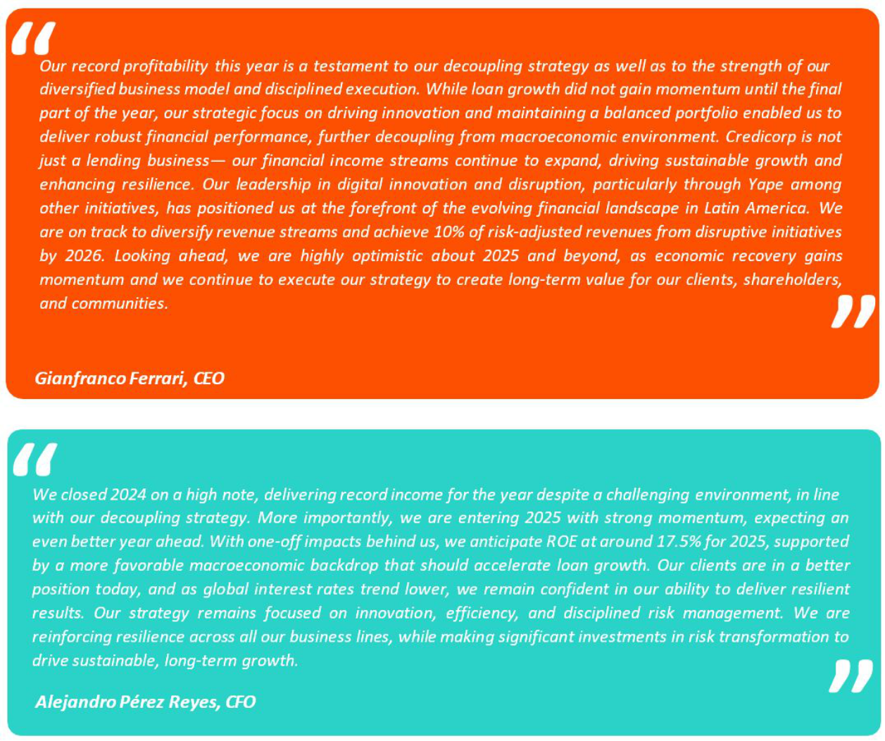

4

| Earnings Release 4Q / 2024 Analysis of 4Q24 Consolidated Results

Fourth Quarter 2024 Earnings Conference Call

FOURTH QUARTER 2024 EARNINGS CONFERENCE CALL

Date: Tuesday, February 11th, 2025

Time: 9:30 am E.T. (9:30 am Lima, Perú)

Hosts: Gianfranco Ferrari - Chief Executve Ofcer, Alejandro Perez Reyes - Chief Financial Ofcer, Francesca Rafo - Chief Innovaton Ofcer, Cesar Rios - Chief Risk Ofcer, Diego Cavero – Head of Universal Banking, Cesar Rivera - Head of Insurance and Pensions, Carlos Sotelo - Mibanco CFO and Investor Relatons Team.

To pre-register for the listen-only webcast presentaton use the following link: htps://dpregister.com/DiamondPassRegistraton/register? confrmatonNumber=10196121&linkSecurityString=fe53fdc c1c

Callers who pre-register will be given a conference passcode and unique PIN to gain immediate access to the call and bypass the live operator. Partcipants may pre-register at any tme, including up to and afer the call start tme.

Those unable to pre-register may dial in by calling:

1 844 435 0321 (U.S. toll free)

1 412 317 5615 (Internatonal)

Partcipant Web Phone: Click Here

Conference ID: Credicorp Conference Call

The webcast will be archived for one year on our investor relatons website at:

htps://credicorp.gcs-web.com/events-and-presentatons/upcoming-events

For a full version of Credicorp´s Third Quarter 2024 Earnings Release, please visit:

htps://credicorp.gcs-web.com/company-reports/quarterly-materials

5

| Earnings Release 4Q / 2024

Loans in Average Daily Balances (ADB)

Total loans measured in ADB rose 0.7% QoQ to stand at S/141,838 million. This evoluton was mainly driven by: (i) Corporate Banking at BCP, via an uptck in short-term loans, (ii) SME-Business Banking, due to growth in government program loans and negotable invoices, and (iii) Mortgage, via a rebound in disbursements. This growth was partally ofset by a drop in Middle Market Banking and Mibanco.

YoY, the portolio contracted 0.5%, driven mainly by: (i) Mibanco, which was impacted by tghter lending guidelines, (ii) Middle Market Banking, which registered growth in short-term loans amortzatons, and (iii) SME-Pyme, which registered a reducton in long-term loan disbursements. This YoY contracton was partally ofset by growth in balances in Corporate Banking, Mortgage, and SME-Business.

YTD, loans in ADB dropped 1.1%, driven mainly by Mibanco and Middle Market Banking.

Deposits

Our deposit base, measured in quarter-end balances, expanded 4.8% QoQ. This evoluton refects growth in balances for Savings Deposits and Time Deposits, which was partally ofset by a reducton in the balance for Demand Deposits.

YoY, the deposit base increased 9.6%. This evoluton was fueled by growth in Low-Cost Deposits, which rose 11.7% to represent 69.4% of total deposits are quarter-end.

At BCP the 30-day Liquidity Coverage Rato (LCR) in PEN stood at 162.7% under regulatory standards and 132.5% according to stricter internal standards. The 30-day LCR in USD stood at 184.6% under regulatory standards and 133.1% according to stricter internal standards.

Net Interest Income (NII) and Margin (NIM)

NII rose 1.1% QoQ, driven mainly by a drop in Interest and Similar Expenses which was impacted by a drop in market rates and an increase in low-cost deposits’ share of the mix. In this context, NIM stood at

6.34% at the end of the quarter, versus 6.43% in 3Q24 and 6.20% in 4Q23.

YoY, NII increased 8.4%, driven mainly by growth in Interest and Similar Income. This evoluton was atributable to an uptck in Interest on deposits in other banks, which registered a marked increase in volumes in a context of high liquidity. Interest and Similar Expenses dropped 9.2%, impacted by lower interest rates afer the Fed and BCRP insttuted rate cuts, and growth in low-cost deposits’ share of funding. In this context, NIM rose 14 bps YoY.

YTD, NII increased 9.1%, mainly due to an increase in Interest and Similar Income, which was driven by a shif in the compositon of the loan portolio towards retail segments.

Analysis of 4Q24 Consolidated Results
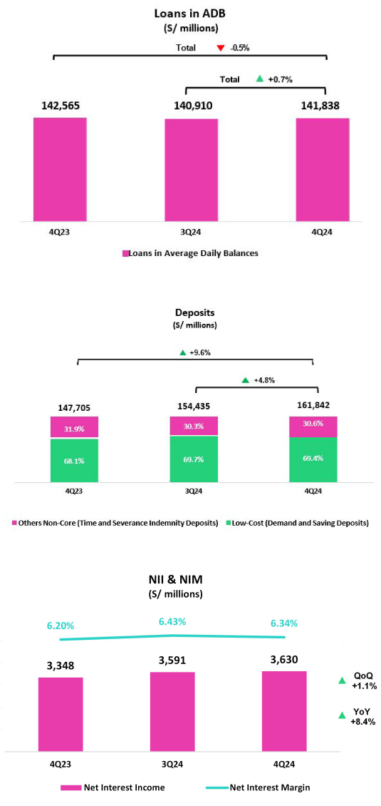

6

| Earnings Release 4Q / 2024

Portolio Quality and Cost of Risk

QoQ, the NPL balance dropped 8.3%, driven primarily by BCP and Mibanco. At BCP, the decline was fueled mainly by: (i) a drop in overdue loans in SMEs;

- debt repayments in Wholesale banking; and (iii) an increase in write-ofs and debt repayments in Consumer and Credit Cards. At Mibanco, the reducton in NPLs was mainly on the back of a decrease in overdue loans, which primarily refected positve impacts from tghter originaton guidelines and improvements in collectons management.

YoY, the overdue portolio decreased 10.2%, fueled by the evoluton at BCP and Mibanco. This decline was mainly atributable to:(i) SME- Pyme, due to an uptck in honoring of Reactva loans and to the same dynamics seen QoQ, and (ii) Wholesale Banking, due primarily to debt cancellaton by a refnanced client. At Mibanco, the reducton in NPLS was driven by the same dynamics in play QoQ.

In this context, the NPL Rato dropped 60 bps QoQ and 63 bps YoY to stand at 5.3% at quarter-end.

Provisions this quarter fell 14.4% QoQ, driven mainly by BCP and Mibanco. At BCP Stand-alone, the reducton in provisions was due primarily to an improvement in payment performance in (i) SME- Pyme, thanks to an uptck in low-risk vintages’ share of total loans; and (ii) Mortgage, due to an update to our risk models’ parameters. At Mibanco, the drop in provisions was mainly driven by stricter originaton policies. This evoluton was partally ofset by Consumer and Credit Cards, due to risk model calibratons. Notably, the underlying risk has improved for both products afer healthier vintages increased their weight within portolios and rescheduling eforts were ramped up.

YoY, and isolatng the efect of provisions set aside for the El Nino Phenomenon in 4Q23, provisions declined 19.2%, driven mainly by BCP and Mibanco. At BCP, this decline was fueled mainly by SME- Pyme and Consumer, which registered an improvement in payment performance. At Mibanco, the reducton was driven by the same dynamics seen QoQ.

On a Full-Year basis, the Cost of Risk stood at 2.4%. The NPL Coverage Rato, in turn, stood at 104.3%.

Analysis of 4Q24 Consolidated Results
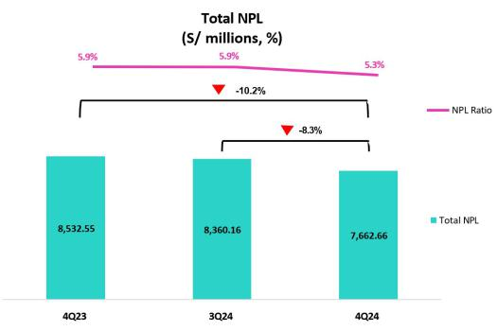
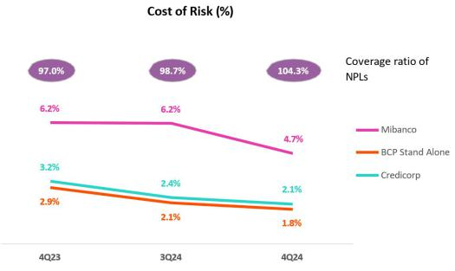

7

| Earnings Release 4Q / 2024

Other Income

It is important to note that Other Core Income contnued to be afected by our operaton in BCP Bolivia, which since 2023 has

evolved and adapted its non-interest income structure for foreign

transfers to ofset the losses reported for FX transactons. Excluding BCP Bolivia, Other Core Income increased 0.6% QoQ, driven mainly by growth in the Net Gain on FX Transactons at BCP Stand-alone. Other Non-Core Income dropped 7.9% QoQ, pressured by a deterioraton in an asset in Pacifco’s portolio and lower gains on securites at Credicorp Capital.

YoY and YTD, Other Ordinary Income rose 17.1% and 15.2%, respectvely. Growth in both periods was driven mainly by BCP Stand-alone, via (i) an increase in fee income, which rose on the back of growth in transactons through Yape and Cards, and (ii) an increase in the Net gain on FX transactons, which was driven by higher volumes and beter spreads. Other Non-Core Income fell 23.1% and 0.9% respectvely, due to the same factors seen in the QoQ analysis.

Insurance Underwritng Result

The Insurance Underwritng Result rose 7.2% QoQ. This evoluton was mainly fueled by a stronger Reinsurance Result in P & C.

YoY, the uptck of 8.8% was atributable to a decrease in Insurance Service Expenses in the Life Business.

YTD, the Insurance Underwritng Result dropped 1.0% on the back of a weaker Reinsurance Result, primarily in P & C Risks.

Efciency

Operatng Expenses rose 9.4% YTD, driven primarily by core businesses at BCP Stand-alone and by disruptve initatves at Credicorp. Operatng Income rose 10.1% YTD.

In this context, the Efciency rato stood at 45.8% on a full-year basis, which represents an improvement of 30 bps with regard to the result in 2023.

Analysis of 4Q24 Consolidated Results
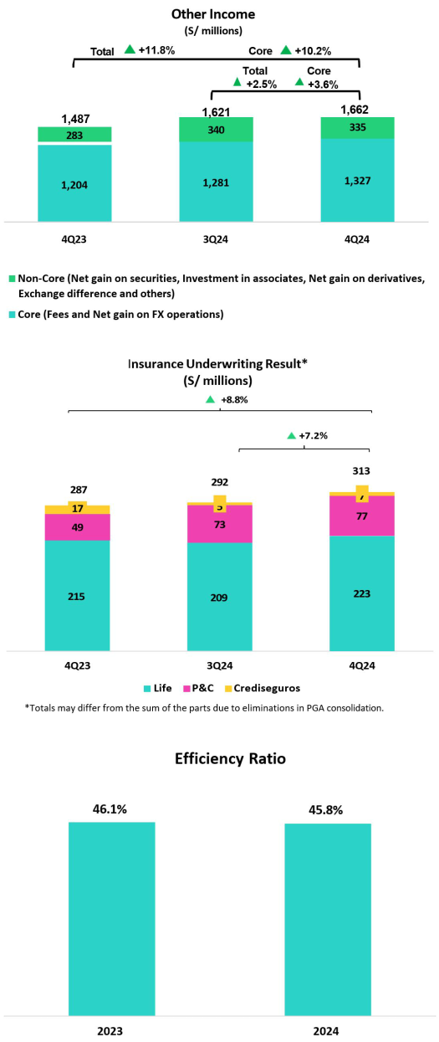

8

| Earnings Release 4Q / 2024 Analysis of 4Q24 Consolidated Results
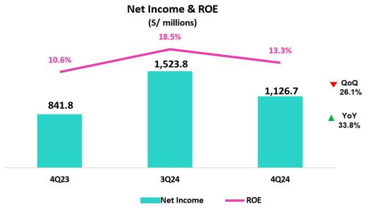

Net earnings atributable to Credicorp

In 4Q24, net earnings atributable to Credicorp stood at S/1,126.7 million, -26.1% QoQ and +33.8% YoY. Net shareholders’ equity, in turn, stood at S/34,346 million (+2.6% QoQ and +5.8% YoY). As a result, ROE stood at 13.3%, impacted by a 259 million soles one-ofs related to Sartor case*.

YTD, Credicorp's net income increased 13.1%, reaching a record high of S/5,501.3 million As a results, ROE stood at 16.5% and 17.2% when excluding the above-mentoned one-tme charge.

*Please refer to our Dec 30th press release for more details on the Sartor case.

Contributons and ROE by subsidiary in 4Q24

(S/ millions)

ROE |  | ROE |  | ROE |  | ROE |  | ROE |  | ROE |  | ROE |  | ROE
20.1% |  | 9.5% |  | 17.3% |  | 12.9% |  | 20.5% |  | 19.7% |  | 18.0% |  | -1.4%
1,131.1
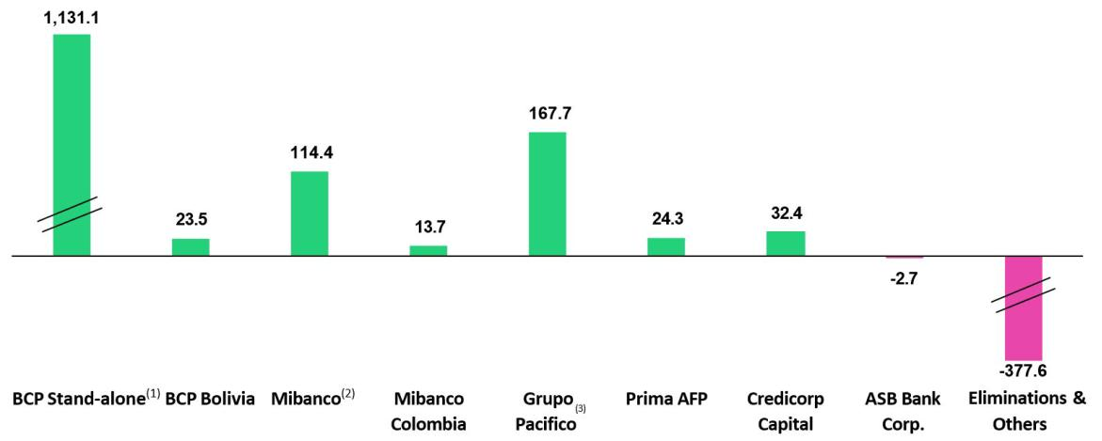

- In BCP Stand-alone, the fgure is lower than the net proft since the contributon eliminates investment gains in other subsidiaries of Credicorp (Mibanco)
- In Mibanco, the fgure is less than the net proft because Credicorp owns (directly and indirectly) 99.921% of Mibanco.
- The contributon of Grupo Pacífco presented here is greater than the proft of Pacifco Seguros since 100% of Crediseguros is being included (including 48% under Grupo Crédito).

9

| Earnings Release 4Q / 2024 Analysis of 4Q24 Consolidated Results

Universal Banking Microfinance

BCP registered a strong performance, which was mainly driven by resilient margins amid a shif in the loan portolio to retail and solid transactonal funding, alongside diversifed income streams. NIM stood at 6.0%, primarily bolstered by an improvement in the funding cost, and by uptck in the yield on interest earning assets. Other core income rose 15.2%, as fee income was boosted by Yape ´s consolidaton as a key revenue stream and BCP´s strong transactonal actvity. These dynamics were partally ofset by growth in operatng expenses.


Insurance and Pensions


Grupo Pacifco concluded 2024 with another year of remarkable performance, achieving an ROE of 23.7% on the back of solid commercial dynamics in both the P&C and Life business lines. Net Income slightly dropped 5% mainly driven by (i) lower Insurance Underwritng Results, due to normalizaton of underwritng margins in the Life business, and (ii) higher Operatng Expenses.

In 2024, Mibanco registered a 51.7% increase in Net Income. This evoluton was mainly driven by a drop in provisions, which fell due to the risk- management measures implemented and to growth in Net interest income, which rose on the back of actve pricing management of loans and a reducton in the cost of funding.


Mibanco Colombia's results improved signifcantly thanks to a focus on efciency and disciplined risk processes and controls, despite a challenging business environment. This helped us become the third largest private microfnance lender in Colombia.


Investment Management

and Advisory


Operatng dynamics have been strong throughout the year for IM&A, which afrms that our new strategic approach is on target and puts us in good stead for 2025. Excluding one-ofs for the Sartor case, net income rose 15%, led primarily by Sales actvites in our Capital Markets Business. Our Wealth and Asset Management businesses also contributed to growth in net income.

Outlook

We expect to close the year in 2025 with a ROE around 17.5%. We antcipate that this result will be

driven by: (i) growth in our loan portolio, partcularly in the retail segment, (ii) the resilience of our NIM, and (iii) a reducton in the cost of risk.

10

| | Earnings Release 4Q / 2024 |  |  |  | Analysis of 4Q24 Consolidated Results
Financial Overview
Credicorp Ltd. |  |  | Quarter |  | % change |  | Up to |  | % change
S/000 |  | 4Q23 | 3Q24 | 4Q24 | QoQ | YoY | Dec 23 | Dec 24 | Dec 24 / Dec 23
Net interest, similar income and expenses |  | 3,347,684 | 3,590,750 | 3,629,794 | 1.1% | 8.4% | 12,937,972 | 14,115,131 | 9.1%
Provision for credit losses on loan portolio, net of recoveries |  | (1,173,454) | (868,081) | (743,296) | -14.4% | -36.7% | (3,622,345) | (3,519,447) | -2.8%
Net interest, similar income and expenses, afer provision for credit losses on loan portolio |  | 2,174,230 | 2,722,669 | 2,886,498 | 6.0% | 32.8% | 9,315,627 | 10,595,684 | 13.7%
Total other income |  | 1,486,823 | 1,621,282 | 1,661,964 | 2.5% | 11.8% | 5,655,825 | 6,404,119 | 13.2%
Insurance underwritng result |  | 287,295 | 291,775 | 312,683 | 7.2% | 8.8% | 1,211,100 | 1,199,020 | -1.0%
Total expenses |  | (2,661,542) | (2,524,166) | (3,105,459) | 23.0% | 16.7% | (9,334,223) | (10,374,296) | 11.1%
Proft before income tax |  | 1,286,806 | 2,111,560 | 1,755,686 | -16.9% | 36.4% | 6,848,329 | 7,824,527 | 14.3%
Income tax |  | (434,648) | (555,117) | (598,348) | 7.8% | 37.7% | (1,888,451) | (2,201,275) | 16.6%
Net proft |  | 852,158 | 1,556,443 | 1,157,338 | -25.6% | 35.8% | 4,959,878 | 5,623,252 | 13.4%
Non-controlling interest |  | 10,331 | 32,655 | 30,625 | -6.2% | 196.4% | 94,338 | 121,998 | 29.3%
Net proft atributable to Credicorp |  | 841,827 | 1,523,788 | 1,126,713 | -26.1% | 33.8% | 4,865,540 | 5,501,254 | 13.1%
Dividends paid to third partes |  | 0 | 875,992 | 0 | -100.0% | n.a. | 1,994,037 | 3,667,644 | 83.9%
Net income / share (S/) |  | 10.6 | 19.1 | 14.1 | -26.1% | 33.8% | 61.0 | 69.0 | 13.1%
Dividends per Share (S/) |  | 0.0 | 11.0 | 0.0 | -100.0% | -100.0% | 25.0 | 46.0 | 83.9%
Loans |  | 144,976,051 | 142,568,785 | 145,732,273 | 2.2% | 0.5% | 144,976,051 | 145,732,273 | 0.5%
Deposits and obligatons |  | 147,704,994 | 154,435,451 | 161,842,066 | 4.8% | 9.6% | 147,704,994 | 161,842,066 | 9.6%
Net equity |  | 32,460,004 | 33,462,591 | 34,346,451 | 2.6% | 5.8% | 32,460,004 | 34,346,451 | 5.8%
Proftability
Net interest margin(1) |  | 6.20% | 6.43% | 6.34% | -9 bps | 14 bps | 6.00% | 6.29% | 29 bps
Risk-adjusted Net interest margin |  | 4.10% | 4.93% | 5.08% | 15 bps | 98 bps | 4.38% | 4.77% | 39 bps
Funding cost(2) |  | 3.0% | 2.7% | 2.6% | -12 bps | -47 bps | 2.9% | 2.7% | -21 bps
ROAE |  | 10.6% | 18.5% | 13.3% | -521 bps | 273 bps | 15.8% | 16.5% | 63 bps
ROAA |  | 1.4% | 2.4% | 1.8% | -67 bps | 37 bps | 2.1% | 2.2% | 17 bps
Loan portfolio quality
Internal overdue ratio⁽³⁾ |  | 4.2% | 4.2% | 3.7% | -51 bps | -51 bps | 4.2% | 3.7% | -51 bps
Internal overdue ratio over 90 days |  | 3.2% | 3.4% | 3.0% | -39 bps | -19 bps | 3.2% | 3.0% | -19 bps
NPL ratio⁽⁴⁾ |  | 5.9% | 5.9% | 5.3% | -60 bps | -63 bps | 5.9% | 5.3% | -63 bps
Cost of risk⁽⁵⁾ |  | 3.2% | 2.4% | 2.1% | -34 bps | -118 bps | 2.5% | 2.4% | -5 bps
Coverage ratio of IOLs |  | 135.1% | 136.9% | 147.4% | 1052 bps | 1230 bps | 135.1% | 147.4% | 1230 bps
Coverage ratio of NPLs |  | 97.0% | 98.7% | 104.3% | 566 bps | 732 bps | 97.0% | 104.3% | 732 bps
Operating efficiency |  | 4,893,605 | 5,287,099 | 5,475,434 | 3.6% | 11.9% | 19,056,189 | 20,976,379 | 10.1%
Operating income⁽⁶⁾
Operating expenses⁽⁷⁾ |  | 2,395,688 | 2,389,261 | 2,692,110 | 12.7% | 12.4% | 8,780,760 | 9,601,950 | 9.4%
Efficiency ratio⁽⁸⁾ |  | 49.0% | 45.2% | 49.2% | 398 bps | 21 bps | 46.1% | 45.8% | -30 bps
Operating expenses / Total average assets |  | 4.0% | 3.8% | 4.3% | 42 bps | 24 bps | 3.7% | 3.9% | 18 bps
Capital adequacy - BCP Stand-alone
Global Capital Ratio⁽⁹⁾ |  | 17.46% | 18.96% | 18.71% | -25 bps | 125 bps | 17.46% | 18.71% | 125 bps
Ratio Tier 1⁽¹⁰⁾ |  | 13.09% | 13.25% | 13.08% | -17 bps | -1 bps | 13.09% | 13.08% | -1 bps
Ratio common equity tier 1⁽¹¹⁾ ⁽¹³⁾ |  | 13.20% | 13.42% | 13.32% | -10 bps | 12 bps | 13.20% | 13.32% | 12 bps
Capital adequacy - Mibanco
Global Capital Ratio⁽⁹⁾ |  | 20.65% | 20.22% | 19.42% | -80 bps | -123 bps | 20.65% | 19.42% | -123 bps
Ratio Tier 1⁽¹⁰⁾ |  | 18.26% | 17.85% | 17.07% | -78 bps | -119 bps | 18.26% | 17.07% | -119 bps
Ratio common equity tier 1⁽¹¹⁾ ⁽¹³⁾ |  | 18.37% | 18.35% | 17.53% | -83 bps | -84 bps | 18.37% | 17.53% | -84 bps
Employees |  | 36,947 | 38,642 | 38,676 | 0.1% | 4.7% | 36,947 | 38,676 | 470.0%
Share Information |  | 94,382 | 94,382 | 94,382 | 0.0% | 0.0% | 94,382 | 94,382 | 0.0%
Issued Shares
Treasury Shares⁽¹²⁾ |  | 14,886 | 14,948 | 14,948 | 0.0% | 0.4% | 14,886 | 14,948 | 0.4%
Outstanding Shares |  | 79,496 | 79,434 | 79,434 | 0.0% | -0.1% | 79,496 | 79,434 | -0.1%

- Net Interest Margin = Net Interest Income (Excluding Net Insurance Financial Expenses) / Average Interest Earning Assets
- Funding Cost = Interest Expense (Does not include Net Insurance Financial Expenses) / Average Funding
- Internal Overdue Loans: includes overdue loans and loans under legal collecton, according to our internal policy for overdue loans. Internal Overdue Rato: Internal overdue loans / Total loans
- Non-performing loans (NPL): Internal overdue loans + Refnanced loans. NPL rato: NPL / Total loans.
- Cost of risk = Annualized provision for loan losses, net of recoveries / Total loans.
- Operatng Income = Net interest, similar income and expenses + Fee Income+ Net gain on foreign exchange transactons + Net Gain From associates + Net gain on derivatves held for trading + Result on exchange diferences + Insurance Underwritng Result
- Operatng Expenses = Salaries and employee benefts + Administratve expenses + Depreciaton and amortzaton + Associaton in partcipaton + Acquisiton cost.
- Efciency Rato = (Salaries and employee benefts + Administratve expenses + Depreciaton and amortzaton + Associaton in partcipaton) / (Net interest, similar income and expenses + Fee Income+ Net gain on foreign exchange transactons + Net Gain From associates + Net gain on derivatves held for trading + Result on exchange diferences + Insurance Underwritng Result)
- Regulatory Capital / Risk-weighted assets (legal minimum = 10% since July 2011).
- Tier 1 = Capital + Legal and other capital reserves + Accumulated earnings with capitalizaton agreement + (0.5 x Unrealized proft and net income in subsidiaries) - Goodwill - (0.5 x Investment in subsidiaries) + Perpetual subordinated debt (maximum amount that can be included is 17.65% of Capital + Reserves + Accumulated earnings with capitalizaton agreement + Unrealized proft and net income in subsidiaries - Goodwill).
- Common Equity Tier I = Capital + Reserves – 100% of applicable deductons (investment in subsidiaries, goodwill, intangibles and net deferred taxes that rely on future proftability) + retained earnings
+ unrealized gains.
- Consider shares held by Atlantc Security Holding Corporaton (ASHC) and stock awards.
- Common Equity Tier I calculated based on IFRS Accountng

11

| Earnings Release 4Q / 2024 Analysis of 4Q24 Consolidated Results

Credicorp’s Strategy Update

Credicorp’s Strategy

Credicorp contnues to execute its strategy by investng in technology to strengthen and consolidate its core businesses, while developing complimentary new disruptve initatves to fuel growth. Understanding current and projected market trends, Credicorp constantly reviews and optmizes its business agilely and with a self-disruptve mindset to maintain a compettve advantage and ensure sustainable growth. This allows us to generate new sources of income and capture market opportunites, as we leverage the expansion of our Total Adressable Market to decouple from the macroeconomic environment.

Credicorp holds fast to its long-term objectves to ofer the best client experience; optmize efciency; and drive growth through technology. To achieve its objectves, all our businesses focus on three strategic priorites: (i) ensuring we have the best talent by ofering a comprehensive value propositon; (ii) acceleratng digital transformaton and innovaton; and (iii) integratng sustainability in our way of doing business.

In 2024, Credicorp delivered solid proftability and consolidated its leadership as a result of the strength of its “decoupling” strategy, in a context of slow economic recovery and a cycle of credit deterioraton in the Peruvian fnancial system. We managed to decouple from economic and loan portolio performance, as a result of our income diversifcaton. We have boosted non-interest income through the digitalizaton of our core businesses complemented with our innovaton portolio. Thanks to our priority to understand our customers and advances in digitalizaton and innovaton, we have signifcantly improved transactonal actvity, interacton frequency, and the personalizaton level of our product and service oferings. This has increased our client satsfacton levels, as evidenced by the 5-point increase in our Net Promoter Score.

Credicorp’s achievements in 2024 are set forth in the following table, where fgures show strong client experience and improvements in operatng efciency, as well as growth in digital clients and sales.

Main KPIs in Credicorp’s Strategy

Transformaton of traditonal businesses ⁽¹⁾ | Subsidiary | 4Q23 | 3Q24 | 4Q24
Day-to-day
Digital Clients⁽²⁾ | BCP | 68% | 74% | 76%
Digital monetary transactons ⁽³⁾ | BCP | 80% | 85% | 86%
Transactonal cost by unit | BCP | 0.07 | 0.04 | 0.04
Disbursements through leads ⁽⁴⁾ | Mibanco | 71% | 66% | 65%
Disbursements through alternatve channels ⁽⁵⁾ | Mibanco | 13% | 23% | 24%
Mibanco Productvity ⁽⁶⁾ | Mibanco | 21.6 | 23.6 | 24.5
Cashless
Cashless transactons⁽⁷⁾ | BCP | 60% | 66% | 69%
Mobile Banking ratng iOS | BCP | 4.7 | 4.8 | 4.8
Mobile Banking ratng Android | BCP | 4.7 | 4.7 | 4.7
Digital Acquisiton
Digital sales ⁽⁸⁾ | BCP | 58% | 65% | 74%

- Figures for December 2023, September 2024, and December 2024.
- Clients that made 70%, or more, of their transactons through digital channels in the last 6 months (includes Yape).
- Monetary Transactons conducted through Mobile Banking, Internet Banking, Yape and Telecredito/Total Monetary Transactons in Retail Banking.
- Disbursements generated through leads/Total disbursements.
- Disbursements conducted through alternatve channels/Total disbursements. Figures difer from previously reported due to a methodological change.
- Number of loans disbursed/Total relatonship managers.
- Amount transacted through Mobile Banking, Internet Banking, Yape y POS/Total amount transacted through Retail Banking. Figures difer from previously reported due to a methodological change.
- Units sold by Retail Banking through digital channels/Total number of units sold by Retail Banking.

12

| Earnings Release 4Q / 2024 Analysis of 4Q24 Consolidated Results

Credicorp’s Strategy Update

Disruptve Initatves: Yape

At the end of 2024, Yape hit the 13.7 million-user mark for monthly actve users (MAU). This number represents 69% of the economically actve populaton. Importantly, in 2024 Yape hit breakeven, and registered monthly revenue and expenses per actve yapero of S/6.5 and S/5.3, respectvely, with revenue generaton outpacing expenses, despite seasonal charges in 4Q24.

Monthly transactons by MAU stood at 51.1 in 4Q24 (vs 44.1 QoQ), which atests to the app’s levels of usability and engagement.

Main KPI’s for Yape’s management

Monthly evolution of revenue and expenses / MAU ⁽¹⁾
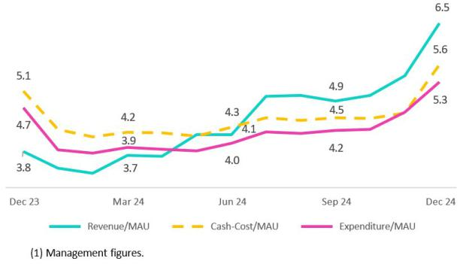

Management KPIs |  | Quarter |  |  | Change % |  | Up to | Change %
 | 4Q23 | 3Q24 | 4Q24 | QoQ | YoY | Dec 23 | Dec 24 | Dec 24 / Dec 23
Users
Users (millions) | 14.2 | 16.6 | 17.3 | 4.2% | 21.6% | 14.2 | 17.3 | 21.6%
Monthly Actve Users (MAU) (millions) ⁽¹⁾ | 10.7 | 13.0 | 13.7 | 5.3% | 28.1% | 10.7 | 13.7 | 28.1%
Fee Income Generatng MAU (millions) | 7.9 | 10.4 | 11.4 | 9.6% | 44.9% | 7.9 | 11.4 | 44.9%
Engagement
# Transactons (millions) | 1,027.9 | 1,664.2 | 1,953.1 | 17.4% | 90.0% | 2,918.0 | 6,145.7 | 110.6%
Experience
NPS ⁽²⁾ | 80 | 74 | 79 | 5.0% | -1.0% | 80 | 79 | -1.0%
Metric per Monthly Actve User (MAU) ⁽³⁾
# Monthly Transactons / MAU | 35.3 | 44.1 | 51.1 | 15.8% | 44.6% | 35.3 | 51.1 | 44.6%
# Average Functonalites / MAU | 2.2 | 2.4 | 2.6 | 6.3% | 18.1% | 2.2 | 2.6 | 18.1%
Monthly Revenues / MAU (S/) | 3.8 | 4.9 | 6.5 | 34.4% | 72.9% | 3.8 | 6.5 | 72.9%
Monthly Expenses / MAU (S/) | 4.7 | 4.2 | 5.3 | 24.5% | 11.7% | 4.7 | 5.3 | 11.7%
Monthly Cash Cost / MAU (S/) | 5.1 | 4.5 | 5.6 | 25.4% | 11.2% | 5.1 | 5.6 | 11.2%
Drivers Monetzación
Payments
TPV ⁽⁴⁾ (S/, billions) | 47.1 | 76.8 | 90.3 | 17.6% | 91.6% | 137.9 | 279.5 | 102.8%
# Bill Payments transactons (millions) | 18.1 | 34.6 | 40.5 | 17.0% | 124.1% | 34.4 | 127.1 | 269.6%
Financials
# Loans Disbursements (thousands) | 293.2 | 1294.9 | 2143.1 | 65.5% | 630.8% | 854.3 | 4612.5 | 439.9%
E-Commerce
GMV ⁽⁵⁾ (S/, millions) | 39.3 | 112.9 | 116.4 | 3.0% | 196.4% | 100.9 | 358.0 | 254.7%

- Yape users that have made at least one transacton over the last month.
- Net Promoter Score.
- Management Figures.
- Total Payment Volume, includes the following functonalites: Bill Payments, QRs payments, Mobile Top-ups, Yape Businesses, Money Exchange, Checkout, and Remitances.
- Gross Merchant Volume, includes the following functonalites: Yape Promos, Yape Store, Ticketng, Gaming, Delivery, Buses, Insurance and Gas.

In 4Q24, Yape presented the following operatng results in its three lines of business:

- Payment: the main drivers are (i) the Total Payment Volume (TPV), which reached S/90.3 billion (+17.6% QoQ and +1.9x YoY) and (ii) transactons in Bill Payments, which totaled 40.5 million (+17.0% QoQ and +2.2x YoY).

- Financial: excluding foatng (remuneraton-based funds transacted through Yape that are held in BCP), the main driver of monetzaton is Yape Lending, with 2,143.1 thousand disbursements (+65.5% and +7.3x YoY).
- E-Commerce: Yape monetzes mainly through the Gross Market Volume (GMV) transacted, which was S/116.4 million (+3.0% QoQ and +3.0x YoY).

13

| Earnings Release 4Q / 2024 Analysis of 4Q24 Consolidated Results

Credicorp’s Strategy Update

Yape’s Main Financial Results ⁽¹⁾

Financial results ⁽¹⁾ |  |  |  | Quarter |  |  |  | Change % |  | Up to |  |  | Change %
S/ millions |  | 4Q23 |  | 3Q24 |  | 4Q24 | QoQ | YoY |  | Dec 23 |  | Dec 24 | Dec 24 / Dec 23
Net Interest Income |  | 54.8 |  | 75.0 |  | 94.2 | 25.6% | 71.9% |  | 163.0 |  | 283.6 | 74.0%
Net Fee Income ⁽²⁾ |  | 52.5 |  | 114.7 |  | 139.0 | 21.1% | 164.8% |  | 127.8 |  | 400.1 | 213.0%
Total Income |  | 107.3 |  | 189.7 |  | 233.2 | 22.9% | 117.3% |  | 290.8 |  | 683.7 | 135.1%
Total Expenses | - | 137.5 | - | 161.5 | - | 195.6 | 21.1% | 42.2% | - | 444.1 | - | 624.4 | 40.6%

- Management fgures.
- Includes fee income recorded in BCP from the Payments and E-Commerce businesses.

In 4Q24, Yape generated total income of S/233.2 million (+22.9% QoQ and +117.3% YoY), which was monetzed through its three lines of business. At year end, the Payments business accounted for the largest share of Yape’s total income (55%), followed by the Financial business, which represented 40% of income. E-Commerce, in turn, represented 5% of income.

14

| Earnings Release 4Q / 2024 Analysis of 4Q24 Consolidated Results

Credicorp’s Strategy Update

Integratng Sustainability in Our Businesses

For more informaton on our sustainability strategy, program and initatves, please see “Sustainability Strategy 2020-25”. Among the milestones reached in 2024 in the framework of the Sustainability Program, the following stand out:

Environmental Front – Driving environmental sustainability through eforts in the fnancial sector and ESG risk management

- Portolio Emissions:

  - Credicorp signed a commitment to become a signatory to the PCAF (Partnership for Carbon Accountng Financials), a global initatve to standardize measurement and disclosure of the greenhouse gas emissions (GEI) associated with loans and investments.

  - We completed our measurement of the emissions generated by prioritzed segments in the wholesale loan portolio at BCP and BCP Bolivia; prioritzed portolios at Prima AFP, Pacifco Seguros and Credicorp Capital; and the prioritzed underwritng portolio at Pacifco Seguros. The objectve is to determine the indirect environmental impact generated by our actvites.

- Sustainable Finance:

  - As part of our objectve to accompany clients in their quest to incorporate best socio-environmental practces, BCP disbursed +US$ 1500 in fnancing in 2024. Additonally, BCP structured its frst Sustainability Linked Loan (SLL), which ofers incentves in lending conditons if compliance with environmental and social KPIs is verifed.

  - Mibanco Colombia announced the launch of a Sustainable Term Certfcate of Deposit, which is a tme deposit for insttutonal investors that seeks to generate a positve impact by earmarking captured funds for use in the Crédito Mujeres pa’ lante and Crédito Agropecuario progams. Funds are disbursed to clients that meet the criteria set forth in the Sustainable Financing Framework at Mibanco Colombia.

- Reportng: At the end of the 1Q25, we will publish the second editon of Credicorp’s TCFD Report, which will provide informaton on results in 2024 and be aligned with the annual Sustainability Report.

Social Front – Expanding fnancial inclusion and educatng people about fnance and entrepreneurship

Financial Inclusion:

As part of our commitment to serve Credicorp’s purpose and ensure the sustainability of our businesses, in 2024 we contnued to focus our eforts on strengthening fnancial inclusion. In 4Q24, we achieved the following results:

- BCP and Yape have fnancially included 5.7 MM people, which represents growth of 1.8 MM people versus the fgure in 2023.

- Mibanco Perú banked 58 thousand people this year, 62% of which were women. More than 51 thousand clients have received Crediagua loans, whose purpose is to improve the quality of life of recipients by fnancing sanitary initatves.

- Pacífco Seguros placed 3.6 MM in inclusive insurance policies, an increase of 420 thousand over last year’s loan amount. This is part of our commitment to protect more people.

Financial educaton (FE):

We believe that fnancial educaton is a key enabler in our eforts to ensure our clients’ fnancial inclusion and fnancial health. Improvements in fnancial behaviors generate positve impacts on the business’s indicators. In 2024, BCP helped +345 thousand clients change their behavior (exitng situaton of overindebtedness, late payments or overdraw on credit cards, among others) and improve poor credit histories. The Protege365 initatve of Pacífco, whose objectve is to strengthen risk management at companies through educaton, had trained and certfed more than 39 thousand employees at more than 8 thousand business clients by the end of 4Q24.

15

| Earnings Release 4Q / 2024 Analysis of 4Q24 Consolidated Results

Credicorp’s Strategy Update

To see progress for other initatves on the social front, please see the table below:

Progress on initatves | Company | 2022 | 2023 | 2024
Financial Inclusion
Financially included through BCP and Yape – cumulatve since 2020 ⁽¹⁾ | BCP | 2.5 million | 3.8 million | 5.7 million
Stock of inclusive insurance policies | Pacífco Seguros | 2.6 million | 3.2 million | 3.6 million
Financial Educaton
Trained through online courses via ABC at BCP (“ABC del BCP”) – YTD | BCP | 310 thousand | 614 thousand | 521 thousand
Consumer Clients who changed at least one fnancial behavior towards a healthier or | BCP | 136 thousand | 214 thousand | 345 thousand
greater banking use – YTD
Young people trained through the ABC of the Pension Culture (“ABC de la Cultura | Prima AFP | 61 thousand | 138 thousand | 423 thousand
Previsional”) – YTD
Clients trained in FE through Mibanco “Progress Academy” programs (“Academia del | Mibanco Perú | 251 thousand | 413 thousand | 405 thousand
Progreso”) – YTD⁽²⁾
Client company employees trained and certfed through “Protege 365” – YTD | Pacífco Seguros | 36 thousand | 33 thousand | 52 thousand
Opportunites and Products for Women
Number of clients with “Credito Mujer” disbursements | Mibanco Perú | 31 thousand | 51 thousand | 39 thousand
Percentage of women banked on the asset side (loans) | Mibanco Perú | 56% | 56% | 62%
Helping small businesses grow
Trained via Accompanying Entrepreneurs (“Contgo Emprendedor”) – YTD | BCP | 111 thousand | 121 thousand | 68 thousand
SME-Pymes fnancially included through loans (working capital and invoice | BCP | 49 thousand | 33 thousand | 39 thousand ⁽³⁾
discountng) – YTD
Microbusiness afliated to Yape – YTD | BCP | NA | 78 thousand | 104 thousand

- Stock of fnancially included clients through BCP since 2020: (i) New clients with savings accounts or afliated to Yape. (ii) New clients without debt in the fnancial system or BCP products in the last twelve months. (iii) Clients with 3 monthly average transactons in the last three months. The fgure for 4Q23 has been revised.

- Covers virtual or in-person trainings about risk management for businesses, entrepreneurship, and fnance through our diferent educatonal strategies, such as the Basic Program for Digital Guidance, Powerful Women and MiConsultor.

- Up to November.

16

| Earnings Release 4Q / 2024 Analysis of 4Q24 Consolidated Results

01 Loan Portfolio


This quarter, total loans in average daily balances (ADB) increased 0.7% (+0.3% FX Neutral). Notably, this quarter marked a turning point, partcularly in the retail segment at BCP, which rode favorable macroeconomic tailwinds to rebound. QoQ, this evoluton was driven primarily by i) growth in short-term loans in Corporate Banking, ii) an increase in loan disbursements through Government Programs and negotable invoices in SME-Business, and iii) a rebound in disbursements through Mortgage. This growth was partally ofset by a decline in balances in Middle Market Banking and Mibanco.

YoY, total loans in average daily balances dropped 0.5% (-0.5% FX Neutral). This evoluton was mainly atributable to i) stricter lending policies at Mibanco, ii) growth in short-term loan amortzatons in Middle Market banking and iii) a decrease in disbursements of long-term loans in SME-Pyme. The interannual decline was partally ofset by growth in Corporate Banking, Mortgage and SME-Business, which was driven by the same factors outlined in the QoQ analysis. On a Full-Year basis, loans in ADB dropped 1.1%, driven primarily by Mibanco and Middle Market Banking. If we exclude the impact of Government Program loans, loans in average daily balances rose 0.2%.

1.1. Loans
Total Loans (in Average Daily Balances) ⁽¹⁾⁽²⁾

Total Loans |  | As of |  |  | Year |  | Volume change |  |  |  | % change |  |  | % Part. in total loans
S/ millions | Dec 23 | Sep 24 | Dec 24 | 2023 | 2024 | QoQ |  | YoY | Year | QoQ | YoY | Year | Dec 23 | Sep 24 | Dec 24 | 2023 | 2024
BCP Stand-alone | 116,011 | 115,569 | 116,631 | 116,585 | 115,758 | 1,062 | 621 |  | -827 | 0.9% | 0.5% | -0.7% | 81.4% | 82.0% | 82.2% | 81.5% | 81.8%
Wholesale Banking | 52,476 | 52,257 | 52,672 | 53,339 | 52,338 | 416 | 197 |  | -1,001 | 0.8% | 0.4% | -1.9% | 36.8% | 37.1% | 37.1% | 37.3% | 37.0%
Corporate | 30,559 | 31,108 | 31,968 | 31,626 | 31,158 | 859 | 1,408 |  | -468 | 2.8% | 4.6% | -1.5% | 21.4% | 22.1% | 22.5% | 22.1% | 22.0%
Middle - Market | 21,916 | 21,148 | 20,705 | 21,713 | 21,180 | -443 | -1,212 |  | -533 | -2.1% | -5.5% | -2.5% | 15.4% | 15.0% | 14.6% | 15.2% | 15.0%
Retail Banking | 63,535 | 63,312 | 63,959 | 63,246 | 63,420 | 647 | 424 |  | 174 | 1.0% | 0.7% | 0.3% | 44.6% | 44.9% | 45.1% | 44.2% | 44.8%
SME - Business | 7,168 | 7,356 | 7,629 | 7,441 | 7,245 | 272 | 461 |  | -196 | 3.7% | 6.4% | -2.6% | 5.0% | 5.2% | 5.4% | 5.2% | 5.1%
SME - Pyme | 16,751 | 16,184 | 16,251 | 16,698 | 16,311 | 66 |  | -500 | -388 | 0.4% | -3.0% | -2.3% | 11.7% | 11.5% | 11.5% | 11.7% | 11.5%
Mortgage | 21,061 | 21,606 | 21,868 | 20,626 | 21,535 | 262 |  | 807 | 910 | 1.2% | 3.8% | 4.4% | 14.8% | 15.3% | 15.4% | 14.4% | 15.2%
Consumer | 12,604 | 12,319 | 12,358 | 12,753 | 12,410 | 39 | -246 |  | -344 | 0.3% | -2.0% | -2.7% | 8.8% | 8.7% | 8.7% | 8.9% | 8.8%
Credit Card | 5,951 | 5,847 | 5,853 | 5,728 | 5,920 | 6 | -98 |  | 192 | 0.1% | -1.6% | 3.4% | 4.2% | 4.1% | 4.1% | 4.0% | 4.2%
Mibanco | 13,665 | 12,199 | 12,057 | 14,029 | 12,579 | -142 | -1,608 |  | -1,450 | -1.2% | -11.8% | -10.3% | 9.6% | 8.7% | 8.5% | 9.8% | 8.9%
Mibanco Colombia | 1,667 | 1,721 | 1,715 | 1,454 | 1,728 | -6 | 48 |  | 274 | -0.4% | 2.9% | 18.8% | 1.2% | 1.2% | 1.2% | 1.0% | 1.2%
Bolivia | 9,186 | 9,555 | 9,628 | 8,982 | 9,547 | 73 | 442 |  | 565 | 0.8% | 4.8% | 6.3% | 6.4% | 6.8% | 6.8% | 6.3% | 6.7%
ASB | 2,036 | 1,867 | 1,807 | 2,080 | 1,893 | -60 | -229 |  | -187 | -3.2% | -11.3% | -9.0% | 1.4% | 1.3% | 1.3% | 1.5% | 1.3%
BAP's total loans | 142,565 | 140,910 | 141,838 | 143,130 | 141,505 | 928 | -727 |  | -1,625 | 0.7% | -0.5% | -1.1% | 100.0% | 100.0% | 100.0% | 100.0% | 100.0%

QoQ, total loans in average daily balances rose 0.7% (+0.3% FX Neutral).

Growth was driven mainly by:

- Corporate Banking, due to an increase in disbursements of short-term loans, mainly in the mining and energy sectors.

- SME-Business, due to growth in loan disbursements through Government Programs (Impulso MyPerú) and negotable invoices.

- Mortgage, due to a rebound in disbursements this quarter, which was driven by economic reactvaton and an uptck in the demand for loans.

The aforementoned was partally ofset by a drop in loans in:

- Middle Market Banking, due primarily to growth in short-term loan amortzatons.

- Mibanco, given that growth in small-tcket, higher- yield loans was insufcient to ofset the decline in higher-tcket loans. It is important to note that this

quarter marked a turning point, where the industry began to recover, and disbursements started to grow.

YoY, total loans in average daily balances fell 0.5% (-0.5% FX Neutral). This reducton was mainly atributable to:

- Mibanco, afer stricter lending policies went into efect since the end of 2Q24, as the industry contnues to adopt a prudent approach to originaton.

- Middle Market Banking, due to the same dynamics as those seen

QoQ.

- SME-Pyme, due to a drop in long-term loan disbursements.

The aforementoned was partally ofset by loan growth via:

- Corporate Banking, Mortgage and SME-Business due to the same dynamics reported in the QoQ analysis.

17

| Earnings Release 4Q / 2024 Analysis of 4Q24 Consolidated Results

FY, total loans in average daily balances dropped 1.1%. This decline was mainly atributable to Mibanco and Middle Market Banking, and was driven by the same dynamics in

play YoY. If we exclude amortzatons of Government Program loans, loans in average daily balances rose 0.2%.

Evoluton of Loan Dollarizaton (in Average Daily Balances) ⁽¹⁾⁽²⁾

Total Loans | Local Currency (LC) - S/ millions |  |  | % change |  |  | Foreign Currency (FC) - US$ millions |  |  |  | % change |  | % part. by currency
 |  | Total |  |  |  |  |  | Total |  |  |  |  |  | Dec 24
S/ millions | Dec 23 | Sep 24 | Dec 24 | QoQ |  | YoY | Dec 23 | Sep 24 | Dec 24 | QoQ |  | YoY | LC | FC
BCP Stand-alone | 79,425 | 78,619 | 79,735 | 1.4% |  | 0.4% | 9,728 | 9,924 | 9,818 | -1.1% | 0.9% |  | 68.4% | 31.6%
Wholesale Banking | 23,454 | 22,748 | 23,500 | 3.3% |  | 0.2% | 7,717 | 7,925 | 7,763 | -2.0% | 0.6% |  | 44.6% | 55.4%
Corporate | 14,017 | 13,916 | 14,540 | 4.5% |  | 3.7% | 4,398 | 4,618 | 4,638 | 0.4% |  | 5.4% | 45.5% | 54.5%
Middle-Market | 9,436 | 8,833 | 8,960 | 1.4% |  | -5.0% | 3,318 | 3,308 | 3,125 | -5.5% |  | -5.8% | 43.3% | 56.7%
Retail Banking | 55,972 | 55,870 | 56,235 | 0.7% |  | 0.5% | 2,011 | 1,999 | 2,055 | 2.8% | 2.2% |  | 87.9% | 12.1%
SME - Business | 4,242 | 4,581 | 4,721 | 3.1% |  | 11.3% | 778 | 745 | 774 | 3.8% | -0.5% |  | 61.9% | 38.1%
SME - Pyme | 16,589 | 16,023 | 16,095 | 0.4% |  | -3.0% | 43 | 43 | 42 | -4.2% | -3.8% |  | 99.0% | 1.0%
Mortgage | 19,095 | 19,690 | 19,953 | 1.3% |  | 4.5% | 523 | 515 | 510 | -0.9% | -2.5% |  | 91.2% | 8.8%
Consumer | 11,075 | 10,742 | 10,679 | -0.6% |  | -3.6% | 407 | 423 | 447 | 5.5% | 9.9% |  | 86.4% | 13.6%
Credit Card | 4,971 | 4,834 | 4,788 | -1.0% |  | -3.7% | 260 | 272 | 283 | 4.2% | 8.8% |  | 81.8% | 18.2%
Mibanco | 13,181 | 12,186 | 12,045 | -1.2% |  | -8.6% | 129 | 4 | 3 | -8.1% | -97.5% |  | 99.9% | 0.1%
Mibanco Colombia | - | - | - | - |  | - | 443 | 462 | 456 | -1.3% | 2.9% |  | - | 100.0%
Bolivia | - | - | - | - |  | - | 2,443 | 2,566 | 2,562 | -0.2% | 4.9% |  | - | 100.0%
ASB Bank Corp. | - | - | - | - |  | - | 541 | 501 | 481 | -4.1% | -11.2% |  | - | 100.0%
Total loans | 92,606 | 90,805 | 91,779 | 1.1% |  | -0.9% | 13,284 | 13,457 | 13,321 | -1.0% | 0.3% |  | 64.7% | 35.3%

Measured in Average Daily Balances.
- Includes Special accounts, and other banking.
- Internal Management Figures.
Largest contracton in volumes
Highest growth in volumes

At the end of December 2024, the dollarizaton level of total loans fell 27 bps QoQ (35.3% in December 24). This evoluton was primarily driven by growth LC loans, partcularly in Wholesale Banking.

YoY, the dollarizaton level of total loans rose 25 bps due to a drop in total loans in LC (-0.9%), primarily via Mibanco and SME-Pyme, and to a lesser extent, through growth in total loans in FC (+0.3%).

18

| Earnings Release 4Q / 2024 Analysis of 4Q24 Consolidated Results

01. Loan Portolio

Evoluion of the Dollarizaton Level of Total Loans (in Average Daily Balances)
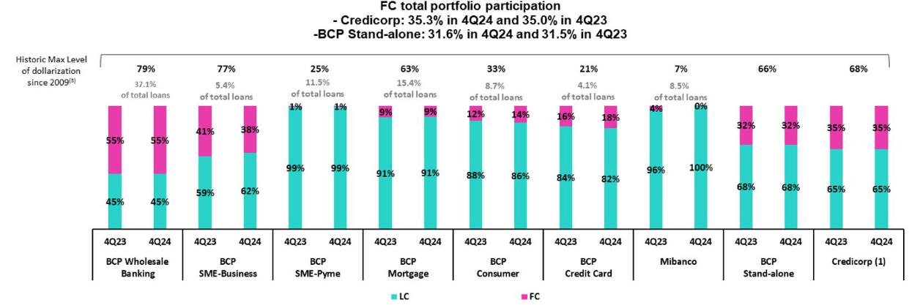

- The FC share of Credicorp’s loan portolio is calculated including BCP Bolivia and ASB Bank Corp., however the chart shows only the loan books of BCP Stand-alone and Mibanco.
- The year with the historic maximum level of dollarizaton for Wholesale Banking was 2012, for Mibanco was 2016, for Credit Card was in 2021 and for the rest of segments was 2009. * For dollarizaton fgures in the quarter-end period, please refer to “12. Annexes – 12.3 Loan Portolio Quality.

Evoluton of Loans in Quarter-End balances

Total loans increased 2.2% QoQ and 0.5% YoY in quarter-end balances, driven by the same factors that drove the evoluton of average daily balances.

19

| Earnings Release 4Q / 2024 Analysis of 4Q24 Consolidated Results

02 Deposits


Total deposits contnued to grow this quarter, closing the year with a record high-balance. QoQ, growth was primarily driven by a 9.7% increase in Savings Deposits, which was mainly atributable to payments of statutory bonuses in December, and secondarily by a 6.4% increase in Time Deposits, which was driven by the recurrent capture of funds, mainly in wholesale clients.

YoY, the deposit balance grew fueled by low-cost deposits (+11.7%), and by Savings Deposits in partcular, which rose 14.1% thanks to improvements in our transactonal ofering. These improvements have enabled us to atract infows related to pension funds withdrawals.

At the end of 4Q24, 69.4% of total deposits were low-cost (Demand and Savings). Credicorp contnued to lead the low-cost deposit market with a 40.9% share at the end of November 2024. This evoluton represents an important compettve advantage to a context marked by an easing cycle in interest rates.

Deposits |  | As of |  |  | % change |  | Currency
S/000 | Dec 23 | Sep 24 | Dec 24 | QoQ | YoY | LC | FC
Demand deposits | 48,229,323 | 53,149,144 | 52,590,952 | -1.1% | 9.0% | 49.4% | 50.6%
Saving deposits | 52,375,813 | 54,474,960 | 59,757,825 | 9.7% | 14.1% | 61.3% | 38.7%
Time deposits | 42,484,664 | 42,514,849 | 45,217,785 | 6.4% | 6.4% | 46.4% | 53.6%
Severance indemnity deposits | 3,185,603 | 2,989,705 | 2,996,020 | 0.2% | -6.0% | 74.4% | 25.6%
Interest payable | 1,429,591 | 1,306,793 | 1,279,484 | -2.1% | -10.5% | 20.5% | 79.5%
Low-cost deposits ⁽¹⁾ | 100,605,136 | 107,624,104 | 112,348,777 | 4.4% | 11.7% | 55.7% | 44.3%
Deposits and obligatons | 147,704,994 | 154,435,451 | 161,842,066 | 4.8% | 9.6% | 53.2% | 46.8%

(1) Includes Demand Deposits and Saving Deposits

QoQ, our Total Deposit balance rose 4.8% (+4.1% FX neutral), driven mainly by:

- Growth of 9.7% (+9.1% FX neutral) in the Savings Deposit balance, which was primarily fueled by LC deposits and to a lesser extent by FC deposits, both at BCP Stand-alone and associated with liquidity from statutory bonuses and campaigns to capture more deposits.

- An increase of 6.4% (+5.5% FX neutral) in the Time Deposit balance, which was mainly driven by an uptck in LC volumes due to recurrent captures of wholesale funds and migraton from Low Cost Deposits as clients looked to leverage, stll relatvely high rates.

YoY, our Total Deposit volume rose 9.6% (+8.8% FX neutral), fueled mainly by:

- A 14.1% (+13.5% FX neutral) increase in Savings Deposits, driven primarily by growth in LC deposits at BCP Stand-alone, primarily atributable to improvements in our transactonal oferings, which has enabled us to atract infows related to pension funds withdrawals and secondarily by the same dynamics seen QoQ.

- A 9.0% (+8.2% FX neutral) rise in the Demand Deposits balance, which was driven by growth in the LC balance at BCP Stand- alone. This expansion was primarily atributable to growth in the balances of the individuals and small business banking segments, which was driven by the enhancements in our transactonal ofering and by disbursements of government program loans, respectvely.

- Growth of 6.4% (+5.6% FX neutral) in the Time Deposits balance, which was driven primarily by BCP Stand-alone. This expansion was mainly atributable to an uptck in the LC balance, which was fueled by corporate clients via the same dynamics seen QoQ, and secondarily, by an increase in the FC balance via recurrent captures of deposits.

Noteworthy, low-cost deposits grew over the year to represent 69.4% of total deposits (+125 bps YoY) by year-end. This advance refects improvements in deposit mix management as we strengthen the fnancial margin in a context marked by an easing cycle in interest rates.

20

| Earnings Release 4Q / 2024

02. Deposits

Dollarizaton Level of Deposits
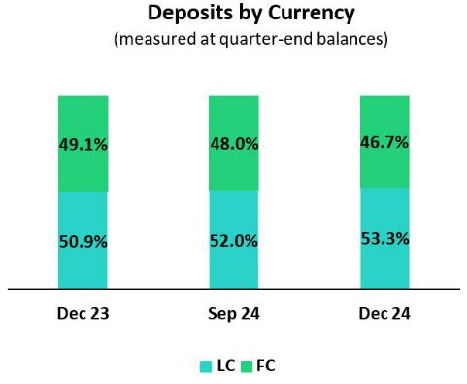

Analysis of 4Q24 Consolidated Results

At the end of December 2024, the dollarizaton level of Total Deposits dropped 135 bps QoQ to stand at 46.7%, which is below the average reported for the last 2 years (49.6%). This result was driven mainly by growth in Savings Deposits fueled by liquidity from payments of statutory bonuses, and impacted by capturing campaigns. Time Deposits also drove growth in the LC balance, which refect migraton of wholesale funds from Demand to Time deposits.

YoY, the dollarizaton level dropped 237 bps due to growth in the LC balances for Low-cost Deposits, which were bolstered by infows from pension fund withdrawals and the dynamics seen in the QoQ. Time deposits also increased the LC balance due to the dynamics seen in the QoQ and recurrent captures of deposits.

Deposits by Currency and Type

(measured at quarter-end balance)
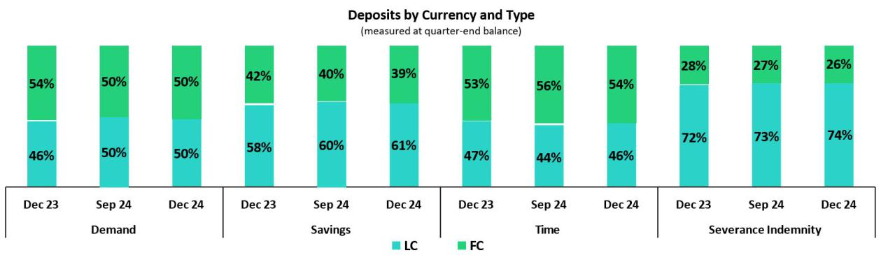

Loan / Deposit Rato (L/D rato)
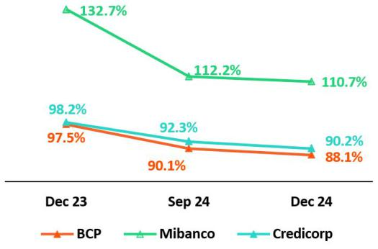

In this context, the L/D rato at Credicorp declined to 90.2%.
L/D Rato Local Currency
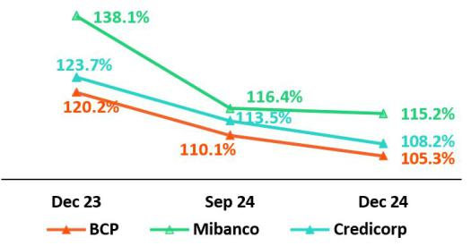

QoQ, the L/D rato dropped 198 bps at BCP and 156 bps at Mibanco. Both reductons refect the impact of growth in the balance of LC deposits due to statutory bonus payments. This dynamic was ofset by loan growth at the end of the period. At BCP, loan growth was driven primarily by the wholesale segment, while at Mibanco, expansion was fueled by growth in small-tcket loans.

YoY, the L/D rato fell 940 bps and 2204 bps at BCP and Mibanco respectvely. At BCP, the decline was atributable to growth in low-cost deposits, which benefted from infows from pension fund withdrawals, and was partallyofset by loan growth in the wholesale segment. At Mibanco, the reducton was driven by growth in low-cost deposits and a contracton in loans, which were impacted by moves to tghten credit guidelines.

L/D Ratio Foreign Currency
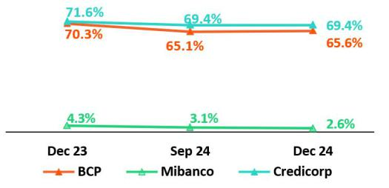

21

| Earnings Release 4Q / 2024 Analysis of 4Q24 Consolidated Results

02. Deposits

Market Share (MS) of Deposits in the Peruvian Financial System
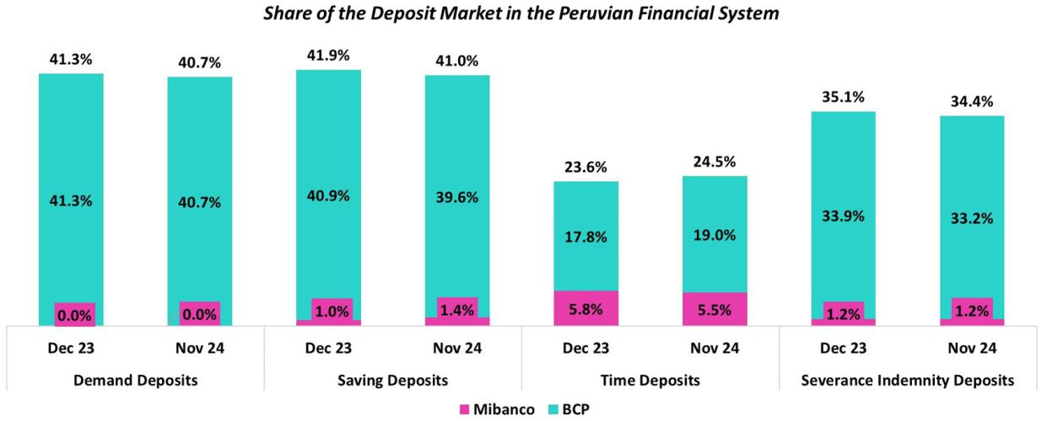

At the end of November 2024, the MS for Total Deposits at BCP and Mibanco in Peru was 32.0% and 2.6% (-6 bps and -3 bps vs December 2023, respectvely).

With this result, BCP contnues to lead the market for total deposits.

BCP reported interannual growth in its low-cost deposit balance (+7.9%), which fell below the fgure reported by the fnancial system (+10.4%). Nonetheless, BCP contnued to lead the market for low-cost deposits with a MS of 40.9% to November 2024 (-75 bps versus December 2023). Growth in BCP’s balance for Time Deposits stood at +15.9% (versus December 2023), outperforming the system’s result of +9.0% for the same period. In this context, BCP’s MS for Time Deposits rose +114 bps (versus December 2023) to stand at 19.0% at the end of November 2024.

Credicorp’s share (BCP + Mibanco) of the low-cost deposit market dropped 75 bps YoY to stand at 40.9% at the end of November 2024. Credicorp’s share of the market for tme deposits, in turn, increased 80 bps with regard to 2023, situatng at 24.5% at the end of November 2024.

22

| Earnings Release 4Q / 2024 Analysis of 4Q24 Consolidated Results

03 Interest-earning Assets (IEA) and Funding

QoQ, IEA increased 2.7%. This growth was driven by an increase in wholesale loans and by a higher balance of Cash and due

from banks. Funding rose 3.9%, fueled mainly by growth in Deposits. This uptck was concentrated in low-cost deposits, underscoring the strength of BCP’s transactonal ofering. Growth in funding through deposits was partally ofset by a drop in Due to banks and correspondents, which registered expiratons over the period.

YoY, IEA advanced (+7.2%), fueled primarily by growth in the balance for Cash and due from banks and secondarily by an uptck in the balance for Investments, which rose on the back of higher sovereign bond holdings. Lastly, funding rose 7.7%, driven mainly by growth in Deposits and to a lesser extent by an increase in the balance of Bonds and notes issued.

3.1. | IEA
Interest Earning Assets |  |  | As of |  | % change
S/000 |  | Dec 23 | Sep 24 | Dec 24 | QoQ | YoY
Cash and due from banks |  | 25,978,577 | 37,007,966 | 40,119,937 | 8.4% | 54.4%
Total investments |  | 52,215,528 | 53,328,873 | 53,825,858 | 0.9% | 3.1%
Cash collateral, reverse repurchase agreements and securites borrowing |  | 1,410,647 | 1,419,305 | 1,033,177 | -27.2% | -26.8%
Total loans |  | 144,976,051 | 142,568,785 | 145,732,273 | 2.2% | 0.5%
Total interest earning assets |  | 224,580,803 | 234,324,929 | 240,711,245 | 2.7% | 7.2%

QoQ, IEA rose 2.7%, driven primarily by growth in Loans and Cash and due from banks (both registering similar uptcks). Loans increased 2.2%, fueled mainly by commercial loans to corporate clients. The balance for Cash and due from banks rose on the back of high liquidity, where surpluses were capitalized in short-term deposits.

YoY, IEA increased 7.2%, fueled primarily by growth in the balance for Cash and due from banks. In a context market by less lending actvity and high market liquidity, partcularly due to pension fund withdrawals from AFPs, the balance of Cash and due from banks rose signifcantly over the year. Total investments also contributed to growth in IEA, although to a lesser extent, via the strategy implemented this year to extend the duraton of the portolio by increasing sovereign bond holdings.

3.2. | Funding
Funding |  |  | As of |  | % change
S/000 |  | Dec 23 | Sep 24 | Dec 24 | QoQ | YoY
Deposits and obligatons |  | 147,704,994 | 154,435,451 | 161,842,066 | 4.8% | 9.6%
Due to banks and correspondents |  | 12,278,681 | 12,704,234 | 10,754,385 | -15.3% | -12.4%
BCRP instruments |  | 7,461,674 | 4,788,939 | 6,646,830 | 38.8% | -10.9%
Repurchase agreements with clients and third partes |  | 2,706,753 | 2,594,165 | 2,413,880 | -6.9% | -10.8%
Bonds and notes issued |  | 14,594,785 | 16,952,011 | 17,268,443 | 1.9% | 18.3%
Total funding |  | 184,746,887 | 191,474,800 | 198,925,604 | 3.9% | 7.7%

QoQ, funding rose 3.9% driven by growth in deposits, partcularly low-cost deposits. The uptck in funding was also atributable, albeit to a lesser extent, to an increase in the balance of BCRP instruments, which refected an uptck in the supply of repos auctoned by the entty. In this context, BCP increased its balance of repos, which are an efcient source of funding. The balance of Due to Banks and correspondents dropped this quarter due to expiratons and lower funding requirements in US Dollars.

YoY, funding rose 7.7%, fueled primarily by growth in deposits. This growth, like that registered QoQ, was concentrated in low-cost deposits, which received infows from AFP pension fund withdrawals throughout the year. The increase in funding was also driven, albeit to a lesser extent, by issuances of Bonds and notes through a structural funding management strategy. These dynamics were partally ofset by a drop in the balance for Due to banks and obligatons, which was fueled by the same dynamics as those seen QoQ.

23

| Earnings Release 4Q / 2024 Analysis of 4Q24 Consolidated Results

04 Net Interest Income (NII)

In 4Q24, Net Interest Income (NII) rose 1.1% QoQ, driven by a drop in Interest and similar expenses. These reductions were fueled by a decrease in interest on deposits, in a juncture marked by lower market rates and an uptick in low-cost deposits’ share of the mix. Interest and similar income increased, spurred mainly by growth in interest on deposits with banks.


YoY, NII grew 8.4% on the back of growth in Interest and similar income, which rose primarily due to an increase in interest on deposits with banks and secondarily to an increase in interest on loans, which reflects advances in pricing management in key sectors at BCP. Interest and similar expenses also contributed to NII’s expansion, via the same drivers mentioned in the QoQ analysis.

NIM dropped 9 bps QoQ to stand at 6.34%. Notwithstanding, full-year growth reported a 29-bps increase in 2024, bolstered by a shift in the composition of the loan portfolio towards retail loans. Lastly, risk-adjusted NIM rose 15 bps QoQ and 39 bps for the full-year in 2024. FY24 risk-adjusted NIM stood at 4.8% which represents a record high¹ on the back of improvements in the risk profile of the loan portfolio.

Net interest income |  | Quarter |  |  | % change | Up to |  | % Change
S/000 | 4Q23 | 3Q24 | 4Q24 | QoQ | YoY | Dec 23 | Dec 24 | Dec 24 / Dec 23
Interest Income | 4,870,042 | 4,995,971 | 5,012,121 | 0.3% | 2.9% | 18,798,495 | 19,869,256 | 5.7%
Interest Expense | (1,522,358) | (1,405,221) | (1,382,327) | -1.6% | -9.2% | (5,860,523) | (5,754,125) | -1.8%
Interest Expense (excluding Net Insurance Financial | (1,402,925) | (1,276,643) | (1,250,239) | -2.1% | -10.9% | (5,393,709) | (5,246,769) | -2.7%
Expenses)
Net Insurance Financial Expenses | (119,433) | (128,578) | (132,088) | 2.7% | 10.6% | (466,814) | (507,356) | 8.7%
Net Interest Income | 3,347,684 | 3,590,750 | 3,629,794 | 1.1% | 8.4% | 12,937,972 | 14,115,131 | 9.1%
Balances
Average Interest Earning Assets (IEA) | 223,624,217 | 231,316,507 | 237,518,087 | 2.7% | 6.2% | 223,318,737 | 232,646,024 | 4.2%
Average Funding | 185,182,243 | 190,855,164 | 195,200,202 | 2.3% | 5.4% | 185,339,502 | 191,836,246 | 3.5%
Yields
Yield on IEAs | 8.71% | 8.64% | 8.44% | -20 bps | -27 bps | 8.42% | 8.54% | 12 bps
Cost of Funds⁽¹⁾ | 3.03% | 2.68% | 2.56% | -12 bps | -47 bps | 2.91% | 2.74% | -17 bps
Net Interest Margin (NIM)⁽¹⁾ | 6.20% | 6.43% | 6.34% | -9 bps | 14 bps | 6.00% | 6.29% | 29 bps
Risk-Adjusted Net Interest Margin⁽¹⁾ | 4.10% | 4.93% | 5.08% | 15 bps | 98 bps | 4.38% | 4.77% | 39 bps
Peru's Reference Rate | 6.75% | 5.25% | 5.00% | -25 bps | -175 bps | 6.75% | 5.00% | -175 bps
FED funds rate | 5.50% | 5.00% | 4.50% | -50 bps | -100 bps | 5.50% | 4.50% | -100 bps
(1) For further detail on the new NIM calculation due to IFRS17, please refer to Annex 12.7

QoQ, Net Interest Income (INI) rose 1.1% due to a drop in Interest and similar expenses, which was spurred by: i) renewals of liabilities at lower rates after the Fed and BCRP instituted rate cuts, and ii) growth in low-cost deposits, which led to a funding composition with lower rates. Net interest income also rose, albeit to a lesser extent, due to growth in the volume of available funds.

YoY, NII increased 8.4%. This evolution was mainly attributable to growth in Interest and similar income and secondarily by a reduction in Interest and similar expenses. Interest and similar income were boosted primarily by growth in Interest on deposits with banks, which registered a marked increase in volumes in a context of high liquidity. Interest on loans was a secondary contributor to growth in income, buoyed by fine-tuning of pricing management and a consequent increase in rates on working capital loans in the SME-Pyme segment. Interest and similar expenses dropped over the year, driven, as was the case QoQ, by a drop in market rates and a funding composition that included a higher proportion of low-cost deposits.

For the full year (FY), NII rose 9.1% in 4Q24, bolstered by growth in Interest and similar income, which was in turn driven by reconfiguring of the loan portfolio to favor a higher proportion of retail loans. A secondary driver was the increase in interest on securities, which were impacted by the strategy to extend the portfolio’s duration by increasing bond holdings. To a lesser extent, a decrease in Interest and similar expenses, which was driven by the same factors seen YoY, contributed to NII growth.

Net Interest Margin

NIM fell 9 bps QoQ to stand at 6.34%. This evolution was due primarily to a lower yield on IEAs, which dropped due to: i) more significant growth in balances in Cash and equivalents, and low growth in Loans, which led to a less profitable mix; and ii) reference rate cuts at the Fed and BCRP, which led to a downward repricing in rates. Although the funding cost continued to follow a downward

- Since the implementation of IFRS 9 in 2018.

24

| Earnings Release 4Q / 2024 Analysis of 4Q24 Consolidated Results

04. Net Interest Income (NII)

trend, the pace slowed alongside an increase in low-cost deposits’ share of the funding mix. Risk-adjusted NIM increased 15 bps due to improvements in client payment performance, which led provisions and the cost of risk to drop.
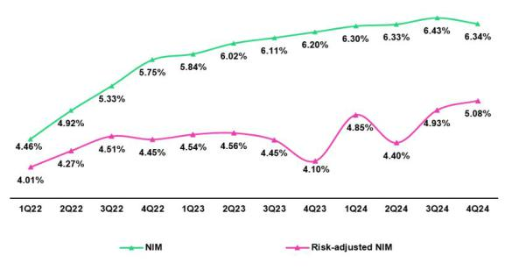

NIM rose 29 bps for the FY. This evolution was primarily attributable to a reduction in the cost of funding and secondarily to a resilient yield on IEAs, which was bolstered by growth in retail loans’ share of total loans. Risk-adjusted NIM increased 39 bps FY, to stand at 4.8%, which represents a record high on the back of improvements in the risk profile of the loan portfolio.

Net Margin Dynamics by Currency

Interest Income / IEA |  | 4Q23 |  |  | 3Q24 |  |  | 4Q24
S/ millions | Average |  |  | Average |  |  | Average
 | Balance | Income | Yields | Balance | Income | Yields | Balance | Income | Yields
Cash and equivalents | 25,443 | 279 | 4.4% | 32,083 | 365 | 4.6% | 38,564 | 386 | 4.0%
Other IEA | 1,462 | 28 | 7.7% | 1,598 | 26 | 6.5% | 1,227 | 18 | 5.9%
Investments | 51,666 | 656 | 5.1% | 52,877 | 681 | 5.2% | 53,578 | 667 | 5.0%
Loans | 145,053 | 3,908 | 10.8% | 144,757 | 3,924 | 10.8% | 144,150 | 3,940 | 10.9%
Total IEA | 223,624 | 4,871 | 8.7% | 231,315 | 4,996 | 8.6% | 237,519 | 5,011 | 8.4%
IEA (LC) | 57.6% | 70.5% | 10.7% | 55.7% | 68.8% | 10.7% | 54.7% | 68.8% | 10.6%
IEA (FC) | 42.4% | 29.5% | 6.1% | 44.3% | 31.2% | 6.1% | 45.3% | 31.2% | 5.8%
Interest Expense / Funding |  | 4Q23 |  |  | 3Q24 |  |  | 4Q24
S/ millions | Average |  |  | Average |  |  | Average
 | Balance | Expense | Yields | Balance | Expense | Yields | Balance | Expense | Yields
Deposits | 148,088 | 827 | 2.2% | 153,203 | 678 | 1.8% | 158,139 | 655 | 1.7%
BCRP + Due to Banks | 19,925 | 297 | 6.0% | 17,828 | 262 | 5.9% | 17,447 | 287 | 6.6%
Bonds and Notes | 14,755 | 153 | 4.1% | 17,453 | 201 | 4.6% | 17,110 | 201 | 4.7%
Others | 2,415 | 245 | 40.6% | 2,371 | 264 | 44.5% | 2,504 | 239 | 38.2%
Total Funding | 185,183 | 1,522 | 3.3% | 190,855 | 1,405 | 2.9% | 195,200 | 1,382 | 2.8%
Funding (LC) | 50.2% | 55.9% | 3.7% | 49.3% | 48.5% | 2.9% | 49.6% | 49.8% | 2.8%
Funding (FC) | 49.8% | 44.1% | 2.9% | 50.7% | 51.5% | 3.0% | 50.4% | 50.2% | 2.8%

Average | Dec 23 |  | Average | Dec 24
Balance | Income | Yields | Balance | Income | Yields
26,438 | 1,133 | 4.3% | 33,050 | 1,406 | 4.3%
1,257 | 85 | 6.8% | 1,222 | 100 | 8.2%
48,823 | 2,536 | 5.2% | 53,021 | 2,710 | 5.1%
146,801 | 15,045 | 10.2% | 145,354 | 15,655 | 10.8%
223,319 | 18,799 | 8.4% | 232,647 | 19,871 | 8.5%
57.4% | 71.1% | 10.4% | 56.2% | 69.2% | 10.5%
42.6% | 28.9% | 5.7% | 43.8% | 30.8% | 6.0%
Average | Dec 23 |  | Average | Dec 24
Balance | Expense | Yields | Balance | Expense Yields
147,363 | 3,142 | 2.1% | 154,773 | 2,850 | 1.8%
19,987 | 1,159 | 5.8% | 18,571 | 1,081 | 5.8%
15,801 | 634 | 4.0% | 15,931 | 800 | 5.0%
2,188 | 926 | 42.3% | 2,561 | 1,023 | 39.9%
185,339 | 5,861 | 3.2% | 191,836 | 5,754 | 3.0%
50.1% | 58.1% | 3.7% | 50.1% | 50.5% | 3.0%
49.9% | 41.9% | 2.7% | 49.9% | 49.5% | 3.0%

NIM | 223,624 | 3,349 | 6.0% | 231,315 | 3,591 | 6.2% | 237,519 | 3,629 | 6.1% |  | 223,319 | 12,938 | 5.8% | 232,647 | 14,117 | 6.1%
NIM (LC) | 57.6% | 77.2% | 8.0% | 55.7% | 76.8% | 8.6% | 54.7% | 76.1% | 8.5% |  | 57.4% | 77.0% | 7.8% | 56.2% | 76.9% | 8.3%
NIM (FC) | 42.4% | 22.8% | 3.2% | 44.3% | 23.2% | 3.3% | 45.3% | 23.9% | 3.2% |  | 42.6% | 23.0% | 3.1% | 43.8% | 23.1% | 3.2%
(1) Unlike the NIM figure calculated according to the formula in Appendix 12.7, the NIM presented in this table includes “Financial Expense associated with the insurance and reinsurance activity, net”.

QoQ Analysis

QoQ, Net Interest Income (NII) rose 1.1%, driven mainly by higher NII in FC, while NII in LC increased only marginally. IEAs in LC represent 54.7% of total IEAs and account for 68.8% of interest income generated in 4Q24.

Local Currency Dynamics (LC)

NII in LC rose 0.1%. This evolution was fueled by growth in interest income, which rose primarily through an uptick in disbursements for Small Businesses at BCP via SME-Pyme working capital loans, which registered increasing interest rates. Growth in income was partially offset by higher interest expenses, which were impacted by an increase in funding with BCRP and banks, mainly through the repo balance with BCRP.

Foreign Currency Dynamics (FC)

NII in FC increased 4.3% QoQ, driven by the following dynamics:

Interest expenses fell 4.0% QoQ. This evolution was fueled by a decrease in market rates (which reflects rates cuts from the Fed) which led to a downward repricing, particularly for time deposits and BCRP + due to banks. In this scenario, the funding cost in FC dropped from 3.0% to stand at 2.8% QoQ. Income was a minor contributor to growth in NII given that the increase in interest on available funds, which was attributable to a positive volume effect, was offset by a drop in interest on loans.

25

| Earnings Release 4Q / 2024 Analysis of 4Q24 Consolidated Results

04. Net Interest Income (NII)

YoY Analysis

YoY, NII rose 8.4%, driven by NII in both LC and FC:

Local Currency Dynamics (LC)

NII in LC rose 6.8% YoY due to the following dynamics:

Interest expenses dropped 19.2%, driven mainly by deposits. The average deposit balance rose, but associated interest expenses dropped, which reflected: i) downward repricing of rates, which were impacted by reference rate cuts at BCRP, and ii) growth in low- cost deposits’ share of total deposits. In this context, the cost of funding in LC dropped 82 bps YoY.

Interest income remained relatively stable (+0.4% YoY), given that growth in the loan volume was concentrated in wholesale segments, which yield lower interest rates. In this context, the yield on IEAs dropped 6 bps to 10.6%.

Foreign Currency Dynamics (FC)

NII in FC rose 13.7% YoY due to the following dynamics:

Average IEA in FC rose 13.4% YoY, driven by growth in the volume of available funds, which was capitalized mainly through overnight deposits in BCRP. The positive volume effect led interest income to rise 8.9%. Nevertheless, less profitable assets predominated in the IEA mix, which led the yield on IEAs to drop 24 bps and stand at 5.8%.

Funding, in turn, increased 6.6% YoY, driven mainly by debt issuances at BCP this year and secondarily by growth in the deposit balance. Interest expenses rose 3.4%, fueled primarily by an issuance effect. Notwithstanding, the downward trend in the Fed’s reference rate offset this effect, as interest expenses fell alongside lower rates on deposits. The combination of the aforementioned dynamics led the funding cost to drop 9 bps.

FY Analysis

At the end of 2024, NII rose 9.1%, driven by NII in both LC and FC.

Local Currency Dynamics (FC)

NII in LC increased 9.0% due to the following dynamics:

Interest expenses dropped 14.7% over the course of 2024, driven by the same dynamics mentioned in the YoY analysis and by a decrease in interest on deposits, which fell from 3.7% to 3.0%. Interest income reported a marginal contribution to growth in NII in LC, which was fueled by the factors in play YoY and by growth in interest on Investments due to our strategy to extend the portfolio’s duration through sovereign bond holdings.

Foreign Currency Dynamics (FC)

NII in FC increased 9.6% due to the following dynamics:

NII in FC rose 12.5% in 2024. This evolution was primarily attributable to growth in Interest on loans, driven mainly by pricing improvements and reflected in the rise in the implicit interest rate. A positive volume effect, fueled by growth in the wholesale loan balance, was the second most important contributor to the FY increase in NII. The third player in NII’s evolution in terms of impact was the uptick in interest on Cash and equivalents, where volumes rose, albeit to a lesser extent than loans.

Interest expenses, which played only a minor role in FY growth in NII, fell in 2024 due to a decrease in Interest on deposits. This decline was driven by the same factors indicated in the YoY analysis.

26

| Earnings Release 4Q / 2024 Analysis of 4Q24 Consolidated Results

05 Portfolio Quality and Provisions

This quarter, NPLs continued to drop after reaching a turning point in 3Q24, particularly in the segments most impacted by the recent credit cycle: the Individuals and the SME-Pyme portfolio at BCP Stand-alone, and the loan portfolio at Mibanco. This is the result of successful risk management measures at BCP and Mibanco. At BCP, portfolio quality metrics improved due to risk management measures such as adjusting credit guidelines in high-risk segments, shoring up credit processes and calibrating specific models to better predict losses; while at Mibanco, portfolio quality metrics improved due to the positive impact of stricter origination policies, improvements in debt collection management and the debt relief facilities rolled out as of 2Q24.


QoQ, the decline in the NPL portfolio at BCP was fueled primarily by a reduction in overdue loans in Small Businesses and debt cancellations in Wholesale. At Mibanco, the reduction in NPLs was attributable to a drop in overdue loans. As a result, the NPL ratio dropped 60 bps and 63 pbs QoQ and YoY, respectively, to stand at 5.3%. On the other hand, provisions fell this quarter, mainly on the back of BCP, which reported an improvement in payment performance in SME-Pyme and Mortgage, followed by the same dynamic at Mibanco. This evolution was partially offset by an increase in provisions for Consumer and Credit Cards, due to risk model calibrations. Despite higher provisions, the underlying risk improved for both segments. In this context, the cost of risk dropped 34 bps and 118 bps QoQ and YoY, respectively, to stand at 2.1%.

5.1 Portfolio Quality

Quality of Total Loans (in quarter-end balances)

Loan Portfolio quality and Delinquency ratios |  | As of |  |  | % change
S/000 | Dec 23 | Sep 24 | Dec 24 | QoQ | YoY
Total loans (Quarter-end balance) | 144,976,051 | 142,568,785 | 145,732,273 | 2.2% | 0.5%
Write-offs | 879,401 | 923,946 | 896,714 | -2.9% | 2.0%
Internal overdue loans (IOLs) | 6,126,487 | 6,026,341 | 5,423,212 | -10.0% | -11.5%
Internal overdue loans over 90-days | 4,673,564 | 4,851,591 | 4,383,795 | -9.6% | -6.2%
Refinanced loans | 2,406,058 | 2,333,814 | 2,239,445 | -4.0% | -6.9%
Non-performing loans (NPLs) | 8,532,545 | 8,360,155 | 7,662,657 | -8.3% | -10.2%
IOL ratio | 4.2% | 4.2% | 3.7% | -51 bps | -51 bps
IOL over 90-days ratio | 3.2% | 3.4% | 3.0% | -39 bps | -19 bps
NPL ratio | 5.9% | 5.9% | 5.3% | -60 bps | -63 bps

QoQ, NPLs dropped 8.3%, driven primarily by BCP Stand-alone and secondarily by Mibanco. Charge-offs, which remain at high levels, declined 2.9% mainly as newer and healthier vintages increased their weight within the loan portfolio at Mibanco.

At BCP Stand-alone, portfolio quality metrics have improved due to risk management measures such as adjusting credit guidelines in high-risk segments, shoring up credit processes and calibrating specific models to better predict losses. QoQ, the reduction in NPLs was mainly attributable to (i) SME-Pyme, where overdue loans dropped mainly via the lower-risk, mid-sized ticket segment (> s/ 150 thousand); (ii) Wholesale, on the back of debt cancellation by a refinanced client in the hotel and restaurant sector; (iii) SME- business, which reported a drop in overdue loans after improvements in debt collection management led to extraordinary recoveries; and (iv) Consumer and Credit Cards, due to a) an extraordinary charge-off, b) debt cancellations, given that the impact generated the liquidity surplus associated with pension fund withdrawals has yet to dissipate, and c) improvements in debt collection management. At Mibanco, the reduction in NPLs was driven by a drop in overdue loans, which was mainly attributable to stricter origination policies; improvements in debt collection management; and the debt relief facilities rolled out as of 2Q24.

YoY, NPLs decreased 10.2%, driven primarily by BCP Stand-alone and secondarily by Mibanco. The uptick in charge-offs (+2.0%) was driven mainly by SME-Pyme due to an extraordinary write-off in 4Q24.

At BCP Stand-alone YoY, the reduction in NPLs was driven by the following segments: (i) SME-Pyme, via an increase in honoring processes for Reactiva loans and due to the same dynamics seen QoQ; (ii) Wholesale, where the decrease was fueled mainly by the debt cancellation of a refinanced client in the real estate sector ; and (iii) SME-Business, which was impacted by the same drivers seen in the QoQ evolution. At Mibanco, the drop in NPLs was driven by the same dynamics seen QoQ.

27

| Earnings Release 4Q / 2024

05. Portolio Quality and Provisions

NPL Ratio for Total Loans
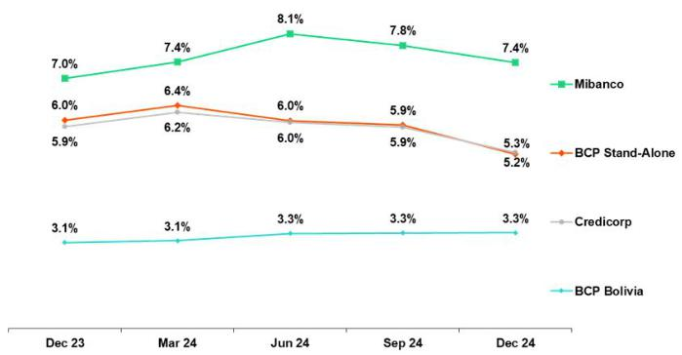

Analysis of 4Q24 Consolidated Results

Credicorp’s NPL Ratio dropped 60 bps QoQ to stand at 5.3%. This reduction was mainly driven by the same factors that impacted the evolution of the NPL portfolio QoQ and secondarily by loan growth.

If we analyze the QoQ evolution of the NPL portfolio by Subsidiary, we see:

- BCP Stand-alone, where the NPL Ratio fell 69 bps. In all segments, except for Consumer, the reduction in the NPL ratio was mainly attributable to a drop in NPL volumes. In Consumer, the decline in the ratio was fueled primarily by loan growth and secondarily by a reduction in NPL volumes.

- Mibanco, where the NPL ratio fell 41 bps, mainly on the back of a reduction in NPL volumes.

NPL Ratio for Total Loans at BCP ⁽¹⁾

The NPL Ratio at Credicorp fell 63 bps YoY to stand at 5.3%. This reduction was primarily driven by the dynamics of the NPL portfolio YoY, and secondarily by slight growth in the loan portfolio.
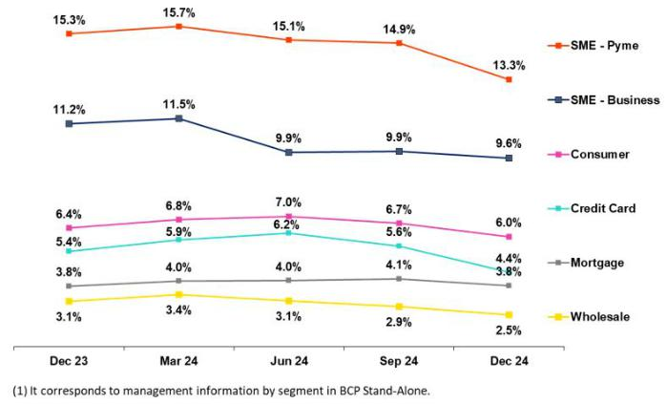

If we analyze the YoY evolution of the NPL Ratio by Subsidiary, we see:

• BCP Stand-alone, where the NPL Ratio dropped 82 bps, driven by the same segments responsible for the QoQ evolution, barring Mortgage.

- Mibanco, where the NPL Ratio rose 38 bps due to a contraction in the loan portfolio, which was partially offset by a decrease in NPL volumes.

5.2 Provisions and Cost of Risk of the Total Portfolio

Loan Portfolio Provisions |  | Quarter |  | % change |  |  | Up to | % change
S/000 | 4Q23 | 3Q24 | 4Q24 | QoQ | YoY | Dec 23 | Dec 24 | Dec 24 / Dec 23
Gross provision for credit losses on loan portfolio | (1,260,163) | (981,870) | (857,694) | -12.6% | -31.9% | (3,957,143) | (3,943,301) | -0.3%
Recoveries of written-off loans | 86,709 | 113,789 | 114,398 | 0.5% | 31.9% | 334,798 | 423,854 | 26.6%
Provision for credit losses on loan portfolio, net of | (1,173,454) | (868,081) | (743,296) | -14.4% | -36.7% | (3,622,345) | (3,519,447) | -2.8%
recoveries
Cost of risk ⁽¹⁾ | 3.2% | 2.4% | 2.1% | -34 bps | -118 bps | 2.5% | 2.4% | -5 bps
(1) Provisions for credit losses on loan portfolio, net of annualized recoveries / Average Total Loans. It includes provisions set aside for “El Niño” Phenomenon in 4Q23 and reversed in 1Q24.

QoQ, provisions dropped 14.4%, driven mainly by BCP Stand-alone and Mibanco. At BCP Stand-alone, the reduction in provisions was primarily fueled by an improvement in payment performance in SME-Pyme and Mortgage. In SME-Pyme, provisions fell primarily on the back of an improvement in payment performance, as lower-risk vintages increased their participation in the total loan portfolio, and secondarily due to calibrations in our risk models. In Mortgage, provisions dropped, which was mainly attributable to parameter updates in our risk models, and secondarily to a strengthening in payment capacity in Individuals. The aforementioned reductions were partially offset by an increase in provisions for Consumer and Credit Cards, which was attributable to risk models calibrations. Despite higher provisions, both segments reported improvements in payment performance due to: i) an increase in the share of lower-risk vintages within total loan portfolio, ii) a significant increase in debt relief facilities, and iii) a lag in the dissipation of the impact of the surplus liquidity generated by pension fund withdrawals in 3Q24. At Mibanco, the drop in provisions was driven by an improvement in payment performance, mainly due to stricter origination policies; an uptick in debt relief facilities; and better

28

| Earnings Release 4Q / 2024 Analysis of 4Q24 Consolidated Results

05. Portolio Quality and Provisions

debt collecton management, where changes were frst rolled out in 2Q24 and contnue to reap benefts. In this context, the CofR at Credicorp dropped 34 bps QoQ to stand at 2.1%.
Cost of Risk by Subsidiary ⁽¹⁾
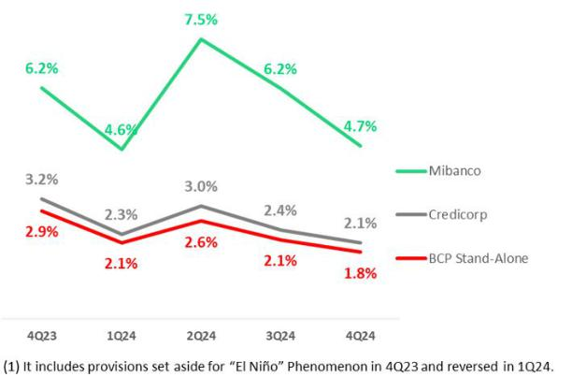

YoY, if we isolate the efect of provisions set aside for the “El Niño” Phenomenon in 4Q23, provisions dropped 19.2%, driven by BCP Stand-alone and Mibanco. At BCP Stand-alone, the decrease in provisions was led mainly by SME-Pyme and Consumer, which experienced an improvement in payment performance via the same dynamics seen QoQ and through a reducton in refnancing. This evoluton was partally ofset by Wholesale Banking, which reported an increase in deterioraton, associated in large part with two corporate clients. At Mibanco, the reducton was primarily atributable to the same drivers seen QoQ. In this context, the CofR at Credicorp fell 48 bps YoY to stand at 2.1%.

On a Full-Year basis, if we isolate the efect of provisions set aside for the El Niño Phenomenon in 4Q23 and reversed in 1Q24, provisions rose12.0%, mainly at BCP Stand-alone. This growth was driven mainly by Credit Cards, which reported a deterioraton in payment performance that accentuated in the frst semester of 2024, and by Wholesale, which was impacted by a base efect generated by high reversal levels in 2023. In this context, the CofR at Credicorp rose 30 bps FY to stand at 2.6%.

QoQ Cost of Risk Evoluton YoY Underlying Cost of Risk Evoluton*
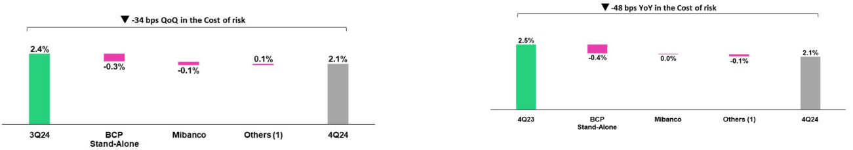

(1) Others include BCP Bolivia, Mibanco Colombia, ASB and eliminatons.

- It excludes provisions set aside for “El Niño” Phenomenon in 4Q23.
(1) Others include BCP Bolivia, Mibanco Colombia, ASB and eliminatons.

FY Underlying Cost of Risk Evoluton*
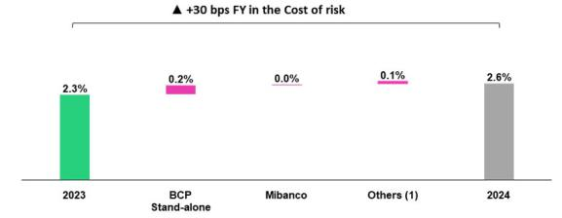

- It excludes provisions set aside for “El Niño” Phenomenon in 4Q23 and reversed in 1Q24.
(1) Others include BCP Bolivia, Mibanco Colombia, ASB and eliminatons.

Coverage Rato of NPLs (in Quarter-end balances)

Loan Portolio Quality and Delinquency Ratos | As of |  |  | % change
S/000 | Dec 23 | Sep 24 | Dec 24 | QoQ | YoY
Total loans (Quarter-end balance) | 144,976,051 | 142,568,785 | 145,732,273 | 2.2% | 0.5%
Allowance for loan losses | 8,277,916 | 8,250,023 | 7,994,977 | -3.1% | -3.4%
Non-performing loans (NPLs) | 8,532,545 | 8,360,155 | 7,662,657 | -8.3% | -10.2%
Allowance for loan losses over Total loans | 5.7% | 5.8% | 5.5% | -30 pbs | -22 pbs
Coverage rato of NPLs | 97.0% | 98.7% | 104.3% | 566 pbs | 732 pbs

29

| Earnings Release 4Q / 2024

05. Portolio Quality and Provisions

Allowance for loan losses

(in S/ millions)
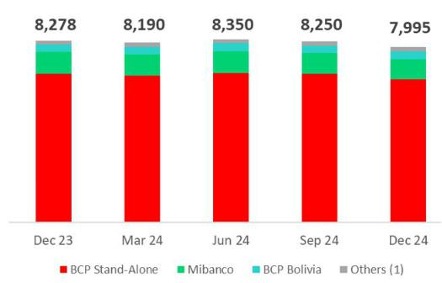

(1) Others include Mibanco Colombia, ASB and eliminatons.

Analysis of 4Q24 Consolidated Results

QoQ, the allowance for loan losses dropped 3.1%, fueled primarily by the evoluton of SME-Pyme and Mortgage at BCP Stand-alone.

YoY, the allowance for loan losses fell 3.4%, driven mainly by decreases in Small Businesses and Consumer at BCP Stand-alone, and secondarily by a reducton at Mibanco.

NPL Coverage Rato

The total NPL Coverage Rato at Credicorp reached 104.3% at the end of 4Q24. If we exclude the volume of NPLs in the Government Program portolio (GP), the rato stood at 107.4%.
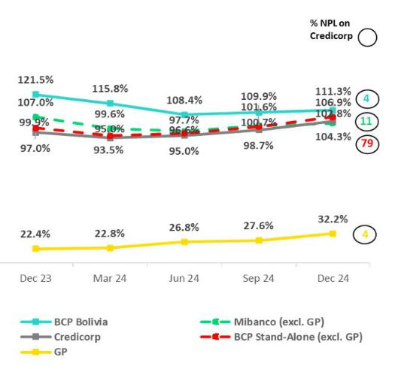

QoQ

Credicorp’s NPL Total Coverage Rato rose 566 bps, fueled by the evoluton at BCP Stand-alone and Mibanco. Next, we will analyze this evoluton by isolatng the efect of NPLs from the Government Loan portolio, which are covered by broad guarantees and are being satsfactorily honored.

QoQ, the NPL Coverage Rato at BCP Stand-alone, excluding Government Programs, rose 622 bps to stand at 106.9%. This evoluton was driven mainly by a decrease in NPL volumes in the Small Businesses and Wholesale portolios. The NPL Coverage Rato at Mibanco, excluding Government Programs, increased 128 bps to stand at 102.8%. This evoluton was driven by a decrease in NPL volumes, as described in the QoQ dynamics.

YoY

The NPL Coverage Rato at Credicorp increased 732 bps YoY, driven mainly by the evoluton at BCP Stand-alone. Next, we will analyze this evoluton by isolatng the efect of NPL volumes associated with Government Programs.

YoY, the NPL Coverage Rato at BCP Stand-alone, excluding Government Programs, rose 705 bps, driven primarily by a decrease in NPL volumes as described in the QoQ analysis. The NPL Coverage Rato at Mibanco, excluding Government Programs, fell 413 bps YoY due to a reducton in the allowance for loan losses.

30

| Earnings Release 4Q / 2024 Analysis of 4Q24 Consolidated Results

06. Other Income

06 Other Income


As explained in recent quarters, we exclude BCP Bolivia results to analyze the evoluton of Other Income.

QoQ, growth of 0.6% in Other Core Income was driven by the Gain on FX transactons, mainly at BCP Stand-alone. This growth was ofset by a drop in fee income from Credicorp Capital. Other Non-core Income decreased 7.9% due to (i) a deterioraton in an investment in Pacifco’s portolio, and (ii) a drop in the gain on securites at Credicorp Capital.

YoY, Other Core Income rose 17.1%, driven primarily by BCP Stand-alone via (i) growth in fee income due to an uptck in transactons via Yape and Debit/Credit Cards, and (ii) an increase in FX transactons, driven by higher wholesale client’s volumes and by improvements in pricing strategies. Other Non-core income fell 23.1%, due to the same factors seen QoQ.

FY, Other Core income rose 15.2%, driven by good results for fee income and FX transactons at BCP Stand-alone and, to a lesser extent, at Credicorp Capital. This evoluton refects growth in transactons as the economy picks up. Other Non-core income dropped 0.9% due to a drop in the gain on securites and losses from exchange diferences.

6.1. Other Core Income

Other Core Income | Quarter |  |  | % Change |  | Up to |  | % Change
S/000 | 4Q23 | 3Q24 | 4Q24 | QoQ | YoY | Dec 23 | Dec 24 | Dec 24 / Dec 23
Fee income | 986,173 | 1,108,314 | 1,103,548 | -0.4% | 11.9% | 3,804,459 | 4,423,193 | 16.3%
Net gain on foreign exchange transactons | 218,047 | 172,998 | 223,913 | 29.4% | 2.7% | 886,126 | 781,076 | -11.9%
Total other income Core | 1,204,220 | 1,281,312 | 1,327,461 | 3.6% | 10.2% | 4,690,585 | 5,204,269 | 11.0%

It is important to note that Other Core Income contnued to be afected by our operaton in BCP Bolivia, which since 2023 has evolved and adapted its non-interest income structure for foreign transfers to ofset the losses reported for FX transactons. The analysis below will exclude BCP Bolivia to focus on Other Core Income evoluton:

- QoQ, growth of 0.6% was driven by Net Gain on Foreign Exchange Transactons (+3.4%) at BCP Stand-alone via an uptck in the volume of transactons executed by corporate clients. The aforementoned was partally ofset by a slight decline in Fee Income at Credicorp Capital.

- YoY, expansion of 17.1% was driven by an increase in Fee Income at BCP Stand-alone and to the Net Gain on Foreign Exchange Transactons (+14.7%) at BCP Stand-alone, which was fueled by growth in transactons among wholesale and retail clients and by improvements in pricing strategies.

- FY, the uptck of 15.2% was fueled by growth in Fee Income, mainly at BCP Stand-alone, and, to a lesser extent, at Credicorp Capital. The rise in the Net Gain on Foreign Exchange Transactons (+16.6%) at BCP Stand-alone was driven by the same factors QoQ and YoY.

Fee Income by Subsidiary

Net Fee Income by Subsidiary | Quarter |  |  | % Change |  | Up to |  | % Change
S/000 | 4Q23 | 3Q24 | 4Q24 | QoQ | YoY | Dec 23 | Dec 24 | Dec 24 / Dec 23
BCP Stand-Alone | 748,270 | 879,995 | 888,292 | 0.9% | 18.7% | 2,927,395 | 3,352,254 | 14.5%
BCP Bolivia | 104,959 | 67,939 | 65,174 | -4.1% | -37.9% | 335,061 | 439,649 | 31.2%
Mibanco | 24,402 | 18,412 | 24,108 | 30.9% | -1.2% | 110,627 | 88,466 | -20.0%
Mibanco Colombia | 10,082 | 12,333 | 11,356 | -3.7% | 50.5% | 42,550 | 45,982 | 8.1%
Pacífco | -2,577 | -3,218 | -3,115 | -7.9% | -540.7% | -11,622 | -12,020 | 3.4%
Prima | 87,457 | 90,748 | 88,102 | -7.4% | 50.0% | 350,846 | 372,480 | 6.2%
ASB | 10,704 | 15,760 | 15,170 | -3.2% | -129.1% | 59,264 | 63,477 | 7.1%
Credicorp Capital | 137,092 | 141,657 | 131,199 | -2.9% | -35.7% | 470,904 | 554,486 | 17.7%
Eliminatons and Other (1) | -134,216 | -115,312 | -116,738 | 1.2% | -13.0% | -480,566 | -481,581 | 0.2%
Total Net Fee Income | 986,173 | 1,108,314 | 1,103,548 | -0.4% | 11.9% | 3,804,459 | 4,423,193 | 16.3%

(1) Correspond mainly to the eliminatons of bancassurance between Pacifco, BCP, and Mibanco.

31

| Earnings Release 4Q / 2024 Analysis of 4Q24 Consolidated Results

06. Other Income

Excluding the results of BCP Bolivia, Fee income followed the following dynamics:

QoQ, Fee Income dropped 0.2%, fueled mainly by a decrease in the fee level at Credicorp Capital due to a drop in the brokerage business. This was slightly ofset by higher Fee income at BCP Stand-alone, which we will discuss in the following chapter, and by growth at Mibanco, which was associated with an increase in fees from credit life insurance, which was aligned with growth in disbursements.

YoY, growth of 17.8% was driven mainly by BCP Stand-alone; the dynamics of this increase will be discussed in the next chapter.

FY, the increase of 14.8% was atributable to BCP Stand-alone and, to a lesser extent, to Credicorp Capital, which experienced an uptck in AUMs in its Wealth Management and Asset Management businesses and an increase in corporate transactons.

Fee Income at BCP Stand-alone

Compositon of fee income at BCP Stand-alone ^{(*)}
BCP Stand-alone Fees |  | Quarterly |  |  | % Change |  | Up to | % Change
S/000,000 | 4Q23 | 3Q24 | 4Q24 | QoQ | YoY | Dec 23 | Dec 24 | Dec 24 / Dec 23
Payments and transactonals ⁽¹⁾ | 322 | 377 | 361 | 4.3% | 11.1% | 1,302 | 1,411 | 8.4%
Yape ⁽²⁾ | 42 | 96 | 118 | -4.9% | 7.4% | 90 | 340 | 278.9%
Liability accounts ⁽³⁾ | 186 | 198 | 192 | 2.7% | 1.6% | 724 | 760 | 4.9%
Loan Disbursement ⁽⁴⁾ | 96 | 96 | 98 | -2.3% | 2.9% | 372 | 385 | 3.4%
Of-balance sheet | 57 | 57 | 55 | -27.7% | 28.4% | 231 | 224 | -3.0%
Insurances | 32 | 34 | 35 | -8.7% | -44.2% | 126 | 137 | 8.7%
Wealth Management and Corporate Finance | 5 | 13 | 19 | 8.3% | 16.0% | 33 | 59 | 78.2%
Others ⁽⁵⁾ | 9 | 10 | 10 | 3.6% | 11.4% | 50 | 36 | -27.6%
Total | 748 | 880 | 888 | 0.9% | 18.7% | 2,928 | 3,352 | 14.5%
(*) Management fgures.

- Corresponds to fees from credit and debit cards, payments and collectons.
- Not includes fees related to E-Commerce. Not includes FX and remitances.
- Corresponds to fees from Account maintenance, interbank transfers, natonal transfers, and internatonal transfers.
- Corresponds to fees from retail and wholesale loan disbursements.
- Use of third-party networks, other services to third partes, and Commissions in foreign branches.

QoQ, Fee income at BCP Stand-alone grew 0.9%, propelled by an increase in the fee volume through:

- Yape, mainly via Bill Payments, POS Payments (QR) and Yape for Businesses, associated with growth in transactons.

- Wealth Management and Corporate Finance, which rose on the back of an increase in the total fee level in Wholesale Banking.

The aforementoned was ofset by a drop in Payment and transactonal services, associated with a base efect, where extraordinary income was recorded in 3Q24.

YoY, Fee income rose 18.7%, driven primarily by:

- Yape, which accounted for 54% of total growth in fee income; the App’s growth was atributable to the same factors seen in the QoQ analysis.

- Payment and transactonal services, which accounted for 27% of the growth in fee income, was the result of an uptck in the use of credit cards (+24.8%) and debit cards (+16.5%), in line with an increase in liquidity via AFP withdrawals.

- Wealth Management and Fincorp, which accounted for 10% of the growth in fee income, in line with the factors described in the QoQ analysis.

FY, Fee income at BCP Stand-alone rose 14.5%. This evoluton was driven by the same dynamics seen QoQ and YoY, and by improvements in the results for Liability and Transactonal Accounts, which was primarily atributable to Current Accounts, which registered growth in accounts openings, and secondarily to Wires and Transfers, where digitalizaton strategies have begun to bear fruit.

32

| Earnings Release 4Q / 2024 Analysis of 4Q24 Consolidated Results

06. Other Income

6.2 Other Non-ordinary Income

Other Non-Core Income | Quarter |  |  | % Change |  | Up to |  | % Change
S/000 | 4Q23 | 3Q24 | 4Q24 | QoQ | YoY | Dec 23 | Dec 24 | Dec 24 / Dec 23
Net gain on securites | 115,825 | 120,033 | -47,377 | -139.5% | -140.9% | 308,055 | 227,112 | -26.3%
Net gain from associates (1) | 34,132 | 35,600 | 38,560 | 8.3% | 13.0% | 117,089 | 135,183 | 15.5%
Net gain on derivatves held for trading | 5,019 | 93,801 | 188,301 | 100.7% | N/A | 53,665 | 363,834 | 578.0%
Net gain from exchange diferences | 15,255 | -6,139 | -21,365 | 248.0% | -240.1% | 45,778 | -41,058 | -189.7%
Other non-fnancial income | 112,372 | 96,675 | 176,384 | 82.5% | 57.0% | 440,653 | 514,779 | 16.8%
Total Other Non-Core Income | 282,603 | 339,970 | 334,503 | -1.6% | 18.4% | 965,240 | 1,199,850 | 24.3%
(1) Includes gains on other investments, which are mainly attributable to the Banmedica result.

Other Non-Core Income | Other Non-Core Income
QoQ evoluton | YoY evoluton
(millions of soles) | (millions of soles)
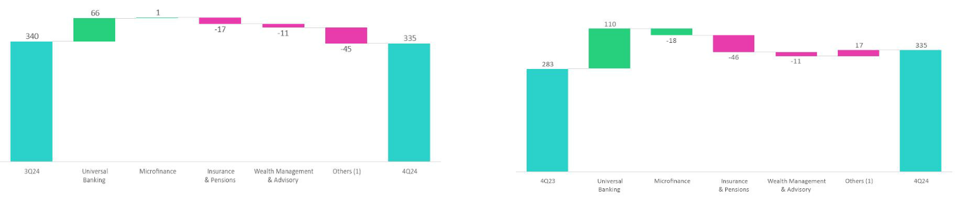

Other Non-Core Income

FY evoluton

(millions of soles)
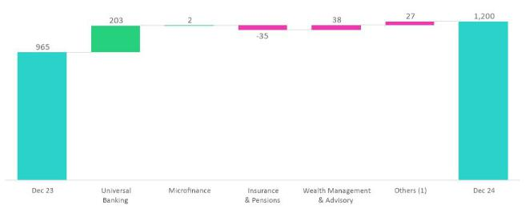

(1) Others: include Grupo Credito, Credicorp Stand-alone, eliminatons and others.

33

| Earnings Release 4Q / 2024 Analysis of 4Q24 Consolidated Results

06. Other Income

If we exclude operatons at BCP Bolivia, the Other Non-Ordinary lines show the following dynamics:

QoQ, Other Non-Ordinary Income dropped 7.9%, which was primarily atributable to:

- Net Gain (Loss) on Securites: (i) Pacifco reported losses due to the deterioraton of an investment, (ii) Credicorp Capital was impacted by a drop in income from trading, and (iii) BCP Stand-alone registered losses due to the devaluaton of sovereign bonds in the trading portolio.

- Net Gain (Loss) from Exchange Diference: due to losses at ASB Bank Corp, which were driven by this portolio’s exposure in local currencies.

This contracton was partally ofset by growth in the Net Gain (Loss) of Derivatves Held for Trading in the Investment Banking and Advisory business afer the treasury’s mo e to cover exposure in local currencies generated gains. Improvements were also registered in Other Non-operatve Income at (i) BCP Stand-alone, which was associated with sales of propertes, and (ii) Pacifco, where a provisions reversal and a property sale were reported.

YoY, Other Non-Core Income dropped 23.1% due to:

- Net Gain (Loss) on Securites due to (i) losses at Pacifco, as described in the QoQ analysis, (ii) BCP Stand-alone, due to the devaluaton of a corporate bond and negatve results for sovereign bond trading, and (iii) Prima AFP, due to a drop in the proftability of funds under management.
- Net Gain (Loss) from Exchange Diference: as outlined in the QoQ analysis.

This decline was ofset by the same factors in play QoQ.

FY, Other Non-Core Income fell 0.9%, driven mainly by:

- Net Gain (Loss) on Securites: due to (i) losses at Pacifco, as outlined in the QoQ dynamics, and (ii) Others, due to a base efect given that the market price for investments at Credicorp Stand-alone was higher in 2023. These losses were partally ofset by BCP Stand-alone, which reported growth in ALM income and a revaluaton of the trading portolio.

- Net Gain (Loss) from Exchange Diference: in line with the factors outlined in the QoQ analysis.

This contracton was partally ofset by growth in the Net Gain (Loss) of Derivatves Held for Trading in the Investment Banking and Advisory business, which was driven by the same factors in play QoQ, and in Other Non-operatve Income at (i) Pacifco, as outlined in the QoQ explanaton, and (ii) Others, related to a provisions reversal.

34

| Earnings Release 4Q / 2024 Analysis of 4Q24 Consolidated Results

07 Insurance Underwriting Results

QoQ, the Insurance Underwritng Result increased 7.2%. Growth was mainly driven by a stronger Reinsurance Result in P & C.

Additonally, higher Insurance Service Income in both business lines contributed to the higher underwritng result. These positve dynamics were partally ofset by growth in Insurance Service Expenses in both businesses.
YoY, theaInsuranceSUnderwritng Result rose 8.8%, due to lower Insurance Service Expenses in Life, mainly in D&S and Individual

Life, and higher Insurance Service Income in P&C. For the FY24, the Insurance Underwritng Result decreased by 1.0% due to lower results in Life and Crediseguros businesses. In terms of business lines, this decline was driven by Credit Life, Annuites and Individual Life.

Insurance Underwritng Results |  |  | Quarterly |  |  | % change |  | Year | % change
S/000 |  | 4Q23 | 3Q24 | 4Q24 | QoQ | YoY | 2023 | 2024 | 2024 / 2023
 | Income from Insurance Services | 1,019.6 | 940.9 | 982.5 | 4.4% | -3.6% | 3,843 | 3,771 | -1.9%
Total | Expenses for Insurance Services | (634.0) | (514.7) | (570.0) | 10.7% | -10.1% | (2,235) | (2,057) | -8.0%
Total | Reinsurance Results | (98.4) | (134.4) | (99.9) | -25.7% | 1.6% | (397) | (515) | 29.6%
 | Insurance Undewrwritng Result | 287.3 | 291.8 | 312.7 | 7.2% | 8.8% | 1,211 | 1,199 | -1.0%
 | Income from Insurance Services | 449.8 | 471.1 | 491.9 | 4.4% | 9.4% | 1,695 | 1,875 | 10.6%
P&C | Expenses for Insurance Services | (323.7) | (278.1) | (331.0) | 19.0% | 2.3% | (1,139) | (1,149) | 0.9%
P&C | Reinsurance Results | (76.8) | (120.4) | (83.8) | -30.4% | 9.1% | (293) | (432) | 47.5%
 | Insurance Undewrwritng Result | 49.3 | 72.6 | 77.2 | 6.3% | 56.4% | 263 | 293 | 11.5%
 | Income from Insurance Services | 534.8 | 453.0 | 471.5 | 4.1% | -11.8% | 2,033 | 1,819 | -10.5%
Life | Expenses for Insurance Services | (305.1) | (234.5) | (238.7) | 1.8% | -21.8% | (1,076) | (910) | -15.4%
Life | Reinsurance Results | (14.5) | (9.4) | (10.2) | 8.7% | -29.8% | (83) | (62) | -25.5%
 | Insurance Undewrwritng Result | 215.2 | 209.1 | 222.6 | 6.4% | 3.4% | 874 | 846 | -3.1%
 | Income from Insurance Services | 37.1 | 23.5 | 25.3 | 7.7% | -31.8% | 124 | 99 | -19.8%
Crediseguros | Expenses for Insurance Services | (11.5) | (7.1) | (5.6) | -20.8% | -51.0% | (39) | (18) | -53.2%
Crediseguros | Reinsurance Results | (9.1) | (11.2) | (12.3) | 9.7% | 35.6% | (30) | (42) | 40.6%
 | Insurance Undewrwritng Result | 16.5 | 5.2 | 7.3 | 42.6% | -55.6% | 54 | 39 | -29.0%

QoQ and YoY, the Insurance Underwritng result increased 7.2% and 8.8% respectvely. The QoQ result refected the impact of an increase in Insurance Service Income (+4.4%) and an improvement in the Reinsurance Result (-25.7%); the aforementoned growth was atenuated by an uptck in Insurance Service Expenses (+10.7%). YoY, the increase in the result was driven by a drop in Insurance Service Expenses (-10.1%) and was partally atenuated by a decrease in Insurance Income (-3.6%).

For the FY24, the Insurance Underwritng Result fell -1.0% due to a weaker Reinsurance Result (+29.6%) and to a drop in Insurance Service Income (-1.9%); the aforementoned was partally atenuated by a decrease in Insurance Service Expenses (-8.0%).

P&C Insurance
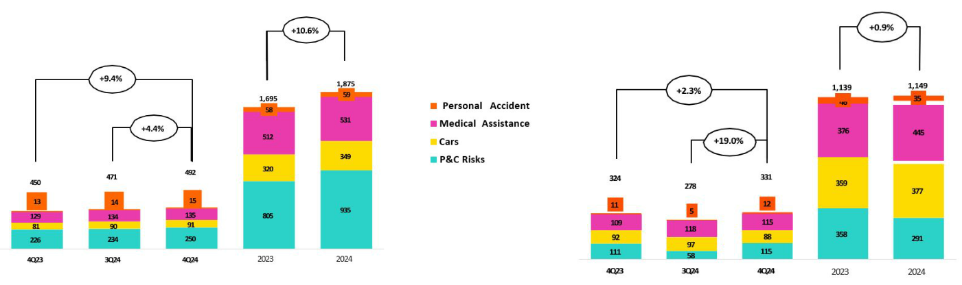

QoQ, the Insurance Underwritng Result increased 6.3%. The following dynamics drove this result:

- Insurance Service Income increased 4.4%, refectng growth in premiums allocated to the period¹ in P & C Risks through the Fire, Agricultural and Card Protecton products.

- Insurance Income Expenses rose 19.0%, driven mainly by P & C Risks via an uptck in expenses for claims in the Fire and Technical Lines, and higher technical expenses in the Alliances channel.

- Premiums alloted for the period = Direct premiums + change of RRC + Fees

35

| Earnings Release 4Q / 2024 Analysis of 4Q24 Consolidated Results

07. Insurance Underwritng Result

- The improvement in the Reinsurance Result was mainly atributable to the evoluton at P & C Risks, which registered an increase in claims recovered from reinsurers (for claims in the Fire and Technical Lines mentoned above).

YoY, the Insurance Underwritng Result rose 56.4%, driven by the following dynamics:

- Insurance Service Income rose 9.4%, fueled by an increase in premiums allocated to the period in P & C Risks, in line with an uptck in premium turnover in Third-Party Liability and Card Protecton.

- Insurance Service Expenses rose 2.3%, spurred mainly by Medical Assistance, which reported a higher level of expenses for claims due to an increase in average costs and higher IBNR reserves.
- The Reinsurance Result deteriorated primarily due to the evoluton of P & C Risks, which was impacted by an increase in ceded premiums.

For the FY24, the Insurance Underwritng Result rose 11.5%, due to an uptck in Insurance Service Income, partcularly in P&C Risks and Cars, and mitgated by higher Insurance Service Expenses in Medical Assistance and SOAT.

Life Insurance

Insurance Service Income Insurance Service Expenses
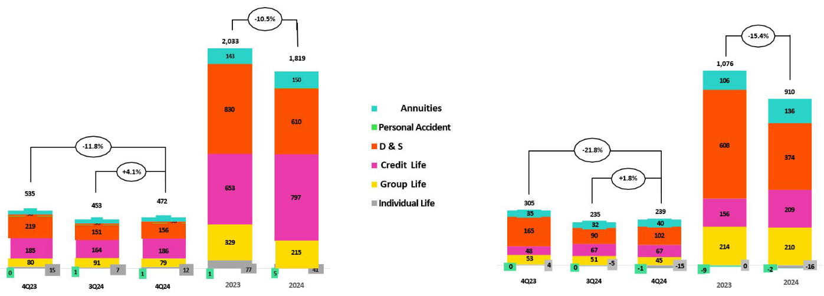

QoQ, the Insurance Underwritng Result increased 6.4%. The following dynamics were noteworthy:

- Insurance Service Income rose 4.1%, driven primarily by Credit Life via an increase in premiums allocated to the period, which was in turn fueled mainly by the bancassurance and Alliances channels. The aforementoned growth was partally ofset by a drop in income in Group Line, mainly via seasonal factors in SCTR products.

- Insurance Service Expenses increased 1.8%, fueled primarily by (i) D&S, which reported an increase in expenses for claims in line with growth in cases and in the average cost, and (ii) Annuites, due to an increase in onerous contracts.
- The Reinsurance Underwritng Result dropped, which was driven mainly by Individual Life via a decrease in reinsurance recoveries.

YoY, the Insurance Underwritng Result increased 3.4% due to the following dynamics:

- Insurance Service Income dropped 11.8%, driven mainly by D&S, which won a smaller tranche of the SISCO VII contract and at lower rates in comparison to the award secured under SISCO VI.

- Insurance Service Expenses fell 21.8%, primarily due to (i) D&S, in line with a reducton in the tranche awarded under SISCO VII, and (ii) Individual Life, which reported a drop in claims. The reducton in total expenses was atenuated by the evoluton at Credit Life, which reported growth in underwritng expenses for Alliances and an increase in claims.

- The Reinsurance Result improved, fueled primarily by a decrease in ceded premiums in D&S.

For the FY24, the Insurance Underwritng Result dropped 3.1% on the back of a decrease in Insurance Service Income, which was driven mainly by D&S.

36

| Earnings Release 4Q / 2024 Analysis of 4Q24 Consolidated Results

08 Operating Expenses

Operatng expenses rose 9.4% YTD, driven mainly by core businesses at BCP Stand-alone and disruptve initatves at the Credicorp level. Expenses for core businesses at BCP rose due to: (i) increased salary and beneft expenses from hiring more talent, and variable compensaton provisioning, and (ii) growth in administratve expenses, which was driven primarily by an increase in cloud use afer transactons levels rose, fueled by increasingly digitalized clients. Expenses for disruptve initatves at the Credicorp level increased 27.1%.

Total operatng expenses

Operatng expenses |  | Quarter |  |  | % change |  | Year | % change
S/000 | 4Q23 | 3Q24 | 4Q24 | QoQ | YoY | 2023 | 2024 | 2024 / 2023
Salaries and employees benefts | 1,119,758 | 1,155,966 | 1,271,578 | 10.0% | 13.6% | 4,265,453 | 4,676,436 | 9.6%
Administratve, general and tax expenses | 1,089,203 | 1,047,386 | 1,230,099 | 17.4% | 12.9% | 3,803,203 | 4,183,775 | 10.0%
Depreciaton and amortzaton | 177,618 | 179,495 | 186,625 | 4.0% | 5.1% | 659,007 | 713,470 | 8.3%
Associaton in partcipaton | 9,109 | 6,414 | 3,808 | -40.6% | -58.2% | 53,097 | 28,269 | -46.8%
Operatng expenses | 2,395,688 | 2,389,261 | 2,692,110 | 12.7% | 12.4% | 8,780,760 | 9,601,950 | 9.4%

The analysis of expenses will focus on YTD movements to eliminate the impact of seasonality across quarters.

Operatng expenses rose 9.4% YTD due to:

- Growth in Salaries and Employee Benefts, which was fueled mainly by an increase in personnel for both the traditonal business and specialized IT, and secondarily by an uptck in expenses for provisions for variable compensaton.

- An increase in Administratve, general and tax expenses, driven by growth in transactons via digital channels, which led to a subsequent uptck in expenses for cloud use and other IT-related actvites.

Administratve, general and tax expenses

Administratve, general and tax expenses |  | Quarter |  | % change |  |  | Year | % change
S/000 | 4Q23 | 3Q24 | 4Q24 | QoQ | YoY | 2023 | 2024 | 2024 / 2023
IT expenses and IT third-party services | 311,417 | 287,372 | 386,150 | 34.4% | 24.0% | 1,080,001 | 1,251,424 | 15.9%
Advertsing and customer loyalty programs | 239,028 | 199,111 | 243,129 | 22.1% | 1.7% | 720,718 | 770,965 | 7.0%
Taxes and contributons | 93,090 | 90,080 | 105,296 | 16.9% | 13.1% | 264,326 | 382,711 | 44.8%
Audit Services, Consultng and professional fees | 105,340 | 101,570 | 171,101 | 68.5% | 62.4% | 336,715 | 407,508 | 21.0%
Transport and communicatons | 60,869 | 62,568 | 67,398 | 7.7% | 10.7% | 226,860 | 244,255 | 7.7%
Repair and maintenance | 49,698 | 36,316 | 50,981 | 40.4% | 2.6% | 157,127 | 154,533 | -1.7%
Agents' Fees | 31,911 | 29,957 | 31,436 | 4.9% | -1.5% | 115,120 | 118,156 | 2.6%
Services by third-party | 43,936 | 36,689 | 6,220 | -83.0% | -85.8% | 144,534 | 107,274 | -25.8%
Leases of low value and short-term | 30,205 | 26,378 | 36,936 | 40.0% | 22.3% | 108,357 | 124,781 | 15.2%
Miscellaneous supplies | 30,589 | 23,552 | 24,864 | 5.6% | -18.7% | 118,510 | 91,769 | -22.6%
Security and protecton | 16,575 | 16,909 | 16,614 | -1.7% | 0.2% | 64,432 | 65,970 | 2.4%
Subscriptons and quotes | 18,444 | 18,349 | 14,261 | -22.3% | -22.7% | 61,945 | 74,002 | 19.5%
Electricity and water | 16,316 | 11,857 | 15,053 | 27.0% | -7.7% | 56,359 | 52,260 | -7.3%
Electronic processing | 11,284 | 7,578 | 8,124 | 7.2% | -28.0% | 39,764 | 29,466 | -25.9%
Insurance | 4,518 | 28,296 | 14,312 | -49.4% | 216.8% | 56,324 | 55,150 | -2.1%
Cleaning | 6,122 | 5,761 | 8,415 | 46.1% | 37.5% | 22,677 | 25,549 | 12.7%
Others | 19,861 | 65,043 | 29,809 | -54.2% | 50.1% | 229,434 | 228,002 | -0.6%
Total | 1,089,203 | 1,047,386 | 1,230,099 | 17.4% | 12.9% | 3,803,203 | 4,183,775 | 10.0%

YTD, Administratve and general expenses rose 10.0%. The increase in operatng expenses was driven by higher expenses at BCP for IT expenses and third-party services, and by disruptve initatves at Credicorp.

37

| Earnings Release 4Q / 2024 Analysis of 4Q24 Consolidated Results

08. Operatng Expenses

Operatng expenses at Core Business and Disrupton ⁽¹⁾
 | Operatng Expenses |  | Quarter |  |  | % change |  | Year | % change
 | S/000 | 4Q23 | 3Q24 | 4Q24 | QoQ | YoY | 2023 | 2024 | 2024 / 2023
 | Core Business BCP | 1,359,738 | 1,316,399 | 1,536,314 | 16.7% | 13.0% | 4,901,001 | 5,357,641 | 9.3%
 | Core Business Mibanco | 149,437 | 315,089 | 313,667 | -0.5% | 109.9% | 1,200,445 | 1,228,873 | 2.4%
 | Core Business Pacifco | 85,485 | 64,306 | 84,896 | 32.0% | -0.7% | 301,816 | 300,773 | -0.3%
 | Disrupton ⁽²⁾ | 331,673 | 295,848 | 416,970 | 40.9% | 25.7% | 976,598 | 1,243,401 | 27.3%
 | Others ⁽³⁾ | 469,355 | 397,619 | 340,263 | -14.4% | -27.5% | 1,400,900 | 1,471,261 | 5.0%
 | Total | 2,395,688 | 2,389,261 | 2,692,110 | 12.7% | 12.4% | 8,780,760 | 9,601,950 | 9.4%
- Management fgures.
- Includes disruptve initatves at the subsidiaries and Krealo.
- Includes Credicorp Capital, ASB, Prima, BCP Bolivia, Mibanco Colombia, and other enttes within the Group.

Operatng expenses were up 9.4% YTD, driven primarily by core business at BCP and by disruptve initatves at Credicorp, which represent 56.0% and 32.7% respectvely of the total rise reported for the period.

Growth in core business expenses at BCP corresponds to:

- Core business expenses excluding IT

  - Higher expenses for salaries and employee benefts; this refected an increase in hiring and provisioning for variable compensaton, which went hand-in-hand with an improvement in results.

- Technology Expenses (IT)

  - Growth in expenses for server use, which was driven by an uptck in transactons among increasingly digitalized clients. Total monetary transactons and transactons through digital channels rose 84.2% and 104.8%, respectvely.

  - More digital talent personnel was hired with comparatvely higher average salaries, which refects advances in strategic project development.

Disrupton expenses represented 13.0% of total expenses and rose 27.3% YTD. For the FY24, Yape, Tenpo and Culqi were the main consumers of expenses, representng 61% of total expenses for disruptve initatves.

38

| Earnings Release 4Q / 2024 Analysis of 4Q24 Consolidated Results

09 Operating Efficiency

The efciency rato improved 30 bps YTD, afer growth in income outstripped the increase in expenses. This evoluton was driven by growth in core income, which was fueled by (i) a rise in net interest income, which rose on the back of higher contributon from the retail segments and (ii) growth in fee income, led by Yape and core transactonal actvity.

Efciency rato ⁽¹⁾ reported by subsidiary

Subsidiary |  | Quarter |  | % change |  |  | As of | % change
 | 4Q23 | 3Q24 | 4Q24 | QoQ | YoY | Dec 23 | Dec 24 | Dec 24 / Dec 23
BCP | 41.8% | 37.6% | 44.8% | 720 bps | 300 bps | 38.8% | 39.3% | 48 bps
BCP Bolivia | 59.0% | 80.3% | 63.0% | -1730 bps | 400 bps | 61.3% | 63.9% | 260 bps
Mibanco Perú | 52.9% | 54.2% | 52.2% | -200 bps | -70 bps | 52.7% | 52.7% | 0 bps
Mibanco Colombia | 98.2% | 72.0% | 69.5% | -260 bps | -2870 bps | 91.6% | 76.2% | -1540 bps
Pacífco | 34.9% | 25.5% | 29.6% | 410 bps | -530 bps | 26.5% | 27.6% | 110 bps
Prima AFP | 54.2% | 50.7% | 64.2% | 1348 bps | 410 bps | 51.3% | 54.2% | 292 bps
Credicorp | 49.0% | 45.2% | 49.2% | 398 bps | 21 bps | 46.1% | 45.8% | -30 bps

- Operatng expenses / Operatng income (under IFRS 17). Operatng expenses = Salaries and employee’s benefts + Administratve expenses + Depreciaton and amortzaton + Associaton in partcipaton + Acquisiton cost. Operatng income = Net interest, similar income, and expenses + Fee income + Net gain on foreign exchange transactons + Net gain from associates +Net gain on derivatves held for trading + Net gain from exchange diferences + Net Insurance Underwritng Results

To analysis the evoluton of the efciency rato, we will use YTD movements to eliminate seasonal impacts between quarters.

The efciency rato improved 30 bps YTD, driven mainly by growth in core income via (i) an uptck in Net interest income, boosted by a higher contributon form retail segment, and (ii) growth in fee income, which was fueled by an uptck in use of digital channels, led by Yape. The rise in income this quarter was supported by cost control.

As of 1Q25, there will be a change in the accountng lines that impact the efciency rato. In Operatng Income, the Fee Income line will include the net expense associated with the credit card loyalty program, which has historically been reported in the General and Administratve Expenses line. It is important to note that our efciency rato of 45.8% for the full year in 2024 would be 45.0% if we were to utlize the new form of accountng.

39

| Earnings Release 4Q / 2024 Analysis of 4Q24 Consolidated Results

10 Regulatory Capital


The Regulatory Capital Rato at Credicorp stood 1.37 tmes above the regulatory limit.

The IFRS CET1 rato at BCP Stand-alone increased 12 bps YoY to stand at 13.32%, driven by growth in the balance of Retained Earnings (+21.2%) and partally ofset by an uptck in the RWA level (+5.2%).

The IFRS CET1 rato at Mibanco dropped 84 bps YoY, situatng at 17.53%. The decrease in Retained Earnings (-109.3%) due to dividend payments, partally ofset by a drop in the RWA level (6.3%), drove this dynamic.

10.1 Regulatory Capital at Credicorp

Capital analysis of Financial Group.

In 2022, the Superintendency of Banking, Insurance, and AFP (SBS) established the legal bases to align the country’s regulatory framework with the capital standards set by Basel III. The entty issued resolutons that modifed both the structure and compositon of regulatory capital and capital requirements for companies in the fnancial system. Most of these changes were implemented at the beginning of 2023. For more details, we suggest you refer to our 1Q23 Quarterly Report.

In 2024, with the objectve to contnue aligning local regulaton with Basel III, the SBS modifed the structure and compositon of Total Regulatory Capital for fnancial conglomerates. These changes included incorporatng the following elements in the calculaton of Total Regulatory Capital: (i) Retained Earnings¹ and (ii) Unrealized Gains/Losses², as well as deductons of Net Intangible Assets & DTAs.

Additonally, two minimum capital requirements have been included: minimum required for Common Equity Tier 1 Capital (CET 1) and minimum Tier 1 Total Regulatory Capital (Tier 1).

- Minimum required for CET 1: 45% of Credicorp’s capital requirement and 100% of the conservaton, economic cycle and risk concentraton bufers.

- Minimum required for Tier 1: 60% of Credicorp’s capital requirement and 100% of the conservaton, economic cycle and risk concentraton bufers.

At Credicorp, the Regulatory Capital Rato stood at 1.37 at the end of 4Q24. | Capital Coverage Ratios
This atests to the Group’s fnancial strenght and stability. The rato dropped 6
bps QoQ, driven by an increase in Regulatory Capital requirement, which rose
on the back of loan growth at the subsidiaries, and an increase in the combined
bufers requirements according to the established schedule. The decline in the
rato was ofset by growth in Total Regulatory Capital, which rose on the back of
growth in Earnings and Accumlated Results, partcularly via BCP Stand-alone.
Regulatory Tier 1 stood at 1.67 (-12 bps QoQ) while the CET1 rato situated at
2.02 (-17 bps QoQ), both above the minimum required. Growth in both was
driven by the same dynamics as those that drove the Regulatory Capital Rato
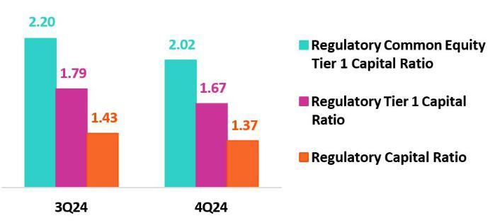

- Includes Accumulated Earnings solely from Financial Enttes Supervised by the SBS, according to the current regulaton.

- Includes Unrealized Losses atributable to Available-For-Sale Investments in debt instruments issued by the Peruvian Government, other Governments with Investment Grade Ratngs, the Peruvian Central Bank and other instruments, in accordance with current regulaton.

40

| Earnings Release 4Q / 2024 Analysis of 4Q24 Consolidated Results

10. Regulatory Capital

10.2 Analysis of Capital at BCP Stand-alone

The IFRS CET 1 Rato dropped 10 bps QoQ to stand at 13.32% at the end of 4Q24, which is above our internal risk appette of 11%. This decline was driven by growth in RWAs, which were impacted by loan growth in th wholesale banking segment. The decline of the rato was partally ofset by Retained Earnings, which registered a rise on the back of business growth that was ofset by a decline in Reserves due to dividend payments. YoY, the IFRS CET 1 Rato rose 12 bps, driven by an increase in Retained Earnings, ofset by higher credit RWAs, which rose due to loan growth, and in RWAs for operatng risk, which increased alongside an uptck in the bank’s fnancial margin.
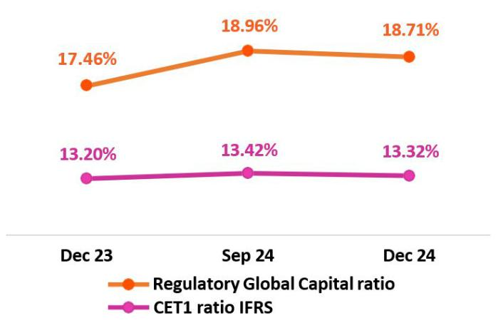

Finally, under the parameters of current regulaton, the Regulatory Capital Global Rato stood at 18.71% (-25 bps QoQ, +125 bps YoY). This rato is above the 13.76% minimum required by the regulator as of

December 2024, which atests to our prudent management of solvency. QoQ, the decline in the rato was driven by the same dynamics in play for IFRS CET1 while YoY, the rise in the rato was atributable to growth in Subordinated Debt due to a bond issuance in September and to growth in the balance for Retained Earnings, which was partally ofset by dividend payments and growth in RWAs.

The local CET 1 rato stood at 13.08%, well above the minimum requirement of 7.53% to December 2024.

10.3 Analysis of Capital at Mibanco

At the end of 4Q24, the IFRS CET 1 Rato at Mibanco stood at 17.53% (- 83
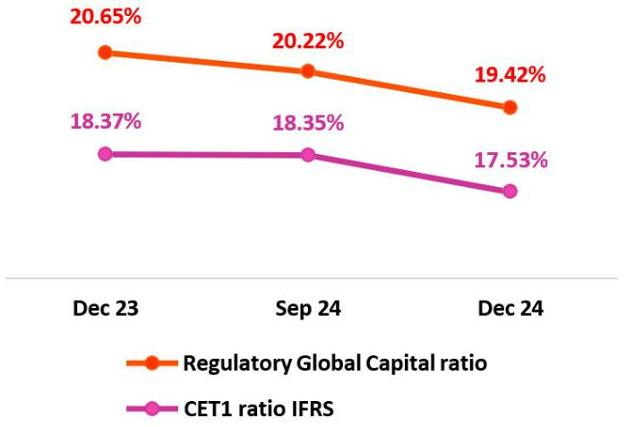
bps QoQ), which exceeded our internal appette of 15%. This reducton was

driven by an increase in the RWA level, which was fueled by loan growth. The

decrease in Retained Earnings, which was associated with dividend payments,

also infuenced the IFRS CET1 Result. YoY, this rato dropped 84 bps due to a

reducton in Retained earnings, which fell via the same dynamics seen QoQ.

The decrease in the rato was partally ofset by a decrease in the RWA level,

which was fueled by a contracton in loans afer credit guidelines were

tghtened

throughout the year.

The Regulatory Capital Global Rato stood at 19.42% (-80 bps QoQ), which is comfortably above the 14.14% minimum required by the regulator. This variaton was driven by the same dynamics that

impacted the evoluton of the IFRS CET 1 Rato. The local CET 1 rato stood at 17.07%, which compares favorably with the minimum of 7.53% required as of December 2024.

41

| Earnings Release 4Q / 2024 Analysis of 4Q24 Consolidated Results

11 Economic Outlook


In 4Q24, the Peruvian economy is expected to have grown around 4% YoY. Primary sectors are estmated to have expanded 4.7% YoY, driven by the fshing and agriculture sectors, while non-primary sectors are projected to have slowed approximately 4.0%. At the end of 2024, GDP grew around 3.2%, amid a cyclical and gradual recovery.

The annual infaton rate increased marginally, closing the quarter at 2.0% YoY (1.8% YoY in 3Q24). In January 2025, BCRP cut its reference rate 25bps to 4.75%, afer closing 2024 at 5.00%.

BCRP has indicated that the exchange rate closed at USDPEN 3.76 in 4Q24, deppreciatng 1.6% over the fgure of 3Q24. This result situates the Peruvian Sol among the best-performing emerging market currencies.

Peru: Economic Forecast
 |  | 2019 | 2020 | 2021 | 2022 | 2023 | 2024 ⁽⁴⁾ | 2025 ⁽⁴⁾
 | GDP (US$ Millions) | 232,447 | 205,689 | 225,433 | 244,465 | 267,346 | 280,326 | 295,521
Real GDP (% change) |  | 2.2 | (10.9) | 13.4 | 2.7 | (0.6) | 3.2 | 2.8
GDP per capita (US$) |  | 7,234 | 6,304 | 6,824 | 7,320 | 7,927 | 8,220 | 8,588
Domestc demand (% change) |  | 2.2 | (9.6) | 14.5 | 2.4 | (2.1) | 3.6 | 2.9
Gross fxed investment (as % GDP) |  | 22.5 | 21.0 | 25.1 | 25.2 | 22.9 | 23.2 | 23.2
Financial system loan without Reactva (% change) ⁽¹⁾ |  | 6.4 | (4.3) | 12.6 | 9.7 | 2.8 | 1.3 | 5.5
Infaton, end of period⁽²⁾ |  | 1.9 | 2.0 | 6.4 | 8.5 | 3.2 | 2.0 | 2.5
Reference Rate, end of period |  | 2.25 | 0.25 | 2.50 | 7.50 | 6.75 | 5.00 | 4.25
Exchange rate, end of period |  | 3.31 | 3.62 | 3.99 | 3.81 | 3.71 | 3.76 | 3.75
Exchange rate, (% change) ⁽³⁾ |  | 1.8% | -9.3% | -10.3% | 4.5% | 2.7% | -1.3% | 0.2%
Fiscal balance (% GDP) |  | -1.6 | -8.9 | -2.5 | -1.7 | -2.8 | -3.6 | -2.6
Public Debt (as % GDP) |  | 26.6 | 34.6 | 35.8 | 33.9 | 32.9 | 34.0 | 34.0
Trade balance (US$ Millions) |  | 6,879 | 8,102 | 15,115 | 10,166 | 17,678 | 22,000 | 22,500
(As % GDP) |  | 3.0% | 3.9% | 6.7% | 4.2% | 6.6% | 7.8% | 7.6%
Exports |  | 47,980 | 42,826 | 63,114 | 66,167 | 67,518 | 73,500 | 75,500
Imports |  | 41,101 | 34,724 | 47,999 | 56,001 | 49,840 | 51,500 | 53,000
Current account balance (As % GDP) |  | -0.6% | 0.9% | -2.1% | -4.0% | 0.8% | 2.2% | 1.3%
Net internatonal reserves (US$ Millions) |  | 68,316 | 74,707 | 78,495 | 71,883 | 71,033 | 78,987 | 83,000
(As % GDP) |  | 29.4% | 36.3% | 34.8% | 29.4% | 26.6% | 28.2% | 28.1%
(As months of imports) |  | 20 | 26 | 20 | 15 | 17 | 18 | 19

Source: INEI, BCRP y SBS.

- Financial System, Current Exchange Rate

- Infaton Target: 1%-3%

- Negatve % change indicates depreciaton.

- Grey area indicates estmates by BCP – Economic Research as of January 2025.

42

| Earnings Release 4Q / 2024 | Analysis of 4Q24 Consolidated Results
11. Economic Outlook
Main Macroeconomic Variables
Gross Domestc Product | In 4Q24, economic recovery contnued to gain momentum. GDP is estmated
(Annual Real Variatons, % YoY) | to have grown around 4% YoY, similar to the 3.8% reported in 3Q24. The
 | primary sectors are estmated to have accelerated to 4.6% YoY, favored by
 | double-digit growth in the agriculture and fshing sectors, the later of which
 | reported a good second anchovy fshing season in the north- central zone of
 | the country. Meanwhile, growth in the non- primary sectors slowed slightly
 | from 4.2% YoY, its best pace in more than two years, to 3.8% YoY.
 | In 2024, GDP grew around 3.2%, amid a cyclical and gradual afer supply
 | shocks in 2023 led GDP to contract 0.4% (frst
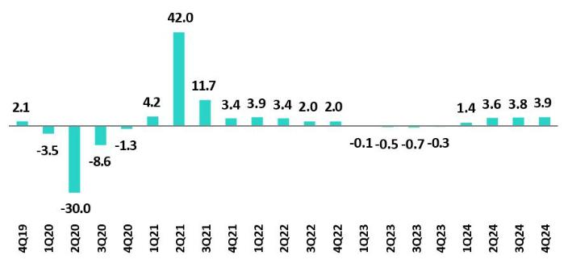

decline in 25 years, excluding the pandemic). Withdrawals from pension funds (AFPs) and freed-up access to severance accounts (CTS) fueled private consumpton which, alongside growth of public investment (18.2%), drove a rebound.

Annual Infaton and Central Bank Reference Rate | Infaton, measured with Consumer Price Index for Metropolitan Lima,
Annual Infaton and Central Bank Reference Rate | accelerated marginally to 2.0% at the end of Q424 from 1.8% at the end of
 | Q324, remaining comfortably within the BCRP's target range of 1% - 3%. Core
 | infaton, which excludes food and energy, fell from 2.9% YoY to 2.6% in the
 | same period, afer hovering around the upper limit of the target range of 3%
 | YoY between November 2023 and August 2024. In both cases, this is the
 | lowest end-of-period infaton in four years.
 | In its December meetng, the BCRP opted to maintain its rate
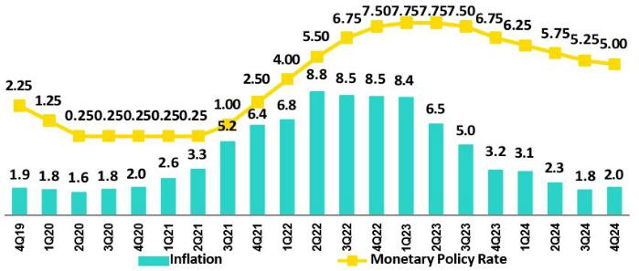

at 5.00%, afer cutng it by 25 basis points in November and made no further changes in October. In January 2025, BCRP cut the rate again to 4.75%. Thus, since September 2023, when the rate-cutng cycle began, the BCRP has reduced its reference rate by 300 basis points

Fiscal Balance and Current Account Balance

(% of GDP, Quarter)
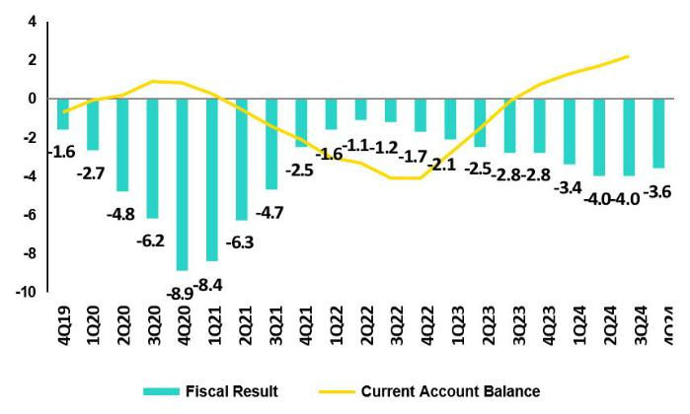

The annualized fscal defcit as of December 2024 stood at 3.6% of GDP, the highest level in 32 years, excluding the pandemic, and notably above the fscal rule limit (2.8% of GDP). The high defcit refected a stll modest improvement in fscal revenues (+4.7% in 2024), consistent with the early stages of economic recovery, and signifcant fscal stmulus with public investment growing at its fastest pace in more than a decade (18.2%). Current expenditure grew by 3.8%.

In November 2024, Fitch upgraded the outlook from negatve to stable and afrmed its ratng at BBB (two levels above investment grade). The agency highlighted that solid macroeconomic policy has supported the economic recovery this year and preserved broad macro-fnancial

43

| Earnings Release 4Q / 2024 Analysis of 4Q24 Consolidated Results

11. Economic Outlook

stability. In September, Moody’s upgraded the outlook from negatve to stable (ratng Baa1, three notches above investment grade. Meanwhile, S&P assigns a credit ratng of BBB-, the minimum investment grade, with a stable outlook.

Regarding external accounts, the current account surplus closed 3Q24 at 2.2% of GDP (accumulated last four quarters), versus 0.8% at the end of 2023. This is the best result in 17 years and the highest among the group of countries that includes Mexico, Brazil, Chile, and Colombia.

The 12-month accumulated trade balance surplus as of November 2024 stood at US$ 23.1 billion, a historic record and higher than the US$ 22.0 billion recorded in September. Imports grew 2.6% YoY to US$ 51.5 billion, infuenced by lower prices for agricultural commodites and almost zero growth in the import of inputs. In contrast, exports increased 10.6% YoY to US$ 74.6 billion thanks to higher exported volumes of traditonal products and beter prices for both traditonal and non-traditonal goods.

Terms of trade grew 12.3% YoY in November 2024, driven by a 9.5% YoY increase in export prices (mainly due to higher prices of copper, gold, and silver) and a 2.5% decrease in import prices due to lower prices of industrial inputs and food items such as wheat, corn, and soybeans. In October 2024, terms of trade reached a historic high, as did the price of gold (a record of US$ 2,749 per ounce), while the price of silver rose to its best level in 12 years (US$ 34.8 per ounce).

Exchange Rate | According to the Central Bank of Peru (BCRP), the exchange rate closed Q424
(PEN per USD) | at USDPEN 3.76, a depreciaton of 1.6% compared to the end of 3Q24
 | (USDPEN 3.71). The electon of Donald Trump as president of the U.S.,
 | coupled with expectaton of fewer rate cuts by the FED led the global dollar to
 | strenghten 7.6% in Q424 versus Q3 2024 (appreciatng 7.1% over the year).
 | Consequently, regional currencies depreciated (Brazilian real -13.3%, Chilean
 | peso - 10.9%, Mexican peso -5.8%, and Colombian peso -4.8%).
 | Over the year, the Peruvian sol also depreciated 1.6% and was one of the
 | best-performing currencies among emerging markets. In the region, the
 | Mexican peso and the Brazilian real depreciated 22.7% and 27.2%,
 | respectvely, afected by idiosyncratc factors, while the Chilean peso and the
 | Colombian peso depreciated 13.1% and 13.7%, respectvely.
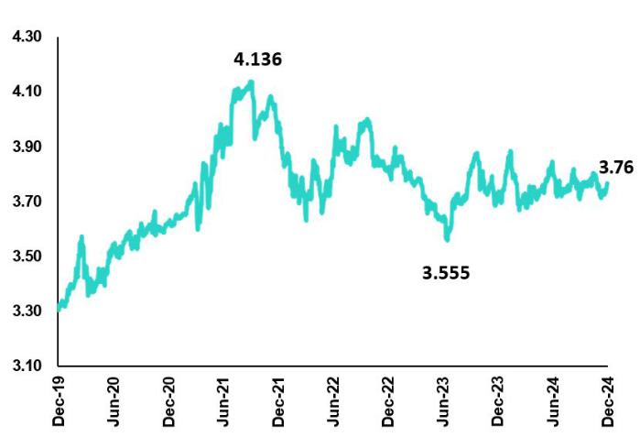

In 4Q24, the BCRP did not intervene in the spot exchange market; it accumulated sales of USD 318 million for the year (2022: USD 1.2 billion and 2023: USD 81 million), concentrated in the frst half.

Net Internatonal Reserves (NIR) closed 4Q24 at USD 79.0 billion, below the USD 80.4 billion at the end of Q324 and above the USD

71.0 billion at the end of 2023. Meanwhile, the BCRP's foreign exchange positon closed 2024 at USD 53.6 billion, a reducton of USD 1 billion compared to the end of 3Q24 and an increase of USD 2.0 billion compared to the end of 2023.

44

| Earnings Release 4Q / 2024 Analysis of 4Q24 Consolidated Results

Safe Harbor for Forward-Looking Statements

Thismaterial includes “forward-looking statements” within the meaning of Secton 27A of the U.S. Securites Act of 1933 and Secton 21E of the U.S. Securites Exchange Act of 1934. All statements other than statements of historical fact are forward-looking and may contain informaton about fnancial results, economic conditons, trends and known uncertaintes. Forward-looking statements are not assurances of future performance. Instead, they are based only on our management’s current views, beliefs, expectatons and assumptons regarding the future of our business, future plans and strategies, projectons, antcipated events and trends, the economy and other future conditons.

Many forward-looking statements can be identfed by words such as: “antcipate”, “intend”, “plan”, “goal”, “seek”, “believe”, “project”, “estmate”, “expect”, “strategy”, “future”, “likely”, “would”, “may”, “should”, “will”, “see” and similar references to future periods. Examples of forward-looking statements include, among others, statements or estmates we make regarding guidance relatng to losses in our credit portolio, efciency rato, provisions and non-performing loans, current or future market risk and future market conditons, expected macroeconomic events and conditons, our belief that we have sufcient capital and liquidity to fund our business operatons, expectatons of the efect on our fnancial conditon of claims, legal actons, environmental costs, contngent liabilites and governmental and regulatory investgatons and proceedings, strategy for customer retenton, growth, governmental programs and regulatory initatves, credit administraton, product development, market positon, fnancial results and reserves and strategy for risk management.

We cauton readers that forward-looking statements involve known and unknown risks and uncertaintes that could cause actual results, performance, or events to difer materially from those that we expect or that are expressed or implied in the forward-looking statements, depending on the outcome of certain factors, including, without limitaton, adverse changes in:

- The occurrence of natural disasters or politcal or social instability in Peru;

- The adequacy of the dividends that our subsidiaries are able to pay to us, which may afect our ability to pay dividends to shareholders and corporate expenses;

- Performance of, and volatlity in, fnancial markets, including Latn-American and other markets;

- The frequency, severity and types of insured loss events;

- Fluctuatons in interest rate levels;

- Foreign currency exchange rates, including the Sol/US Dollar exchange rate;

- Deterioraton in the quality of our loan portolio;

- Increasing levels of competton in Peru and other markets in which we operate;

- Developments and changes in laws and regulatons afectng the fnancial sector and adopton of new internatonal guidelines;

- Changes in the policies of central banks and/or foreign governments;

- Efectveness of our risk management policies and of our operatonal and security systems;

- Losses associated with counterparty exposures;

- The scope of the coronavirus (“COVID-19”) outbreak, actons taken to contain the COVID-19 and related economic efects from such actons and our ability to maintain adequate stafng; and
- Changes in Bermuda laws and regulatons applicable to so-called non-resident enttes.

See “Item 3. Key Informaton—3. D Risk Factors” and “Item 5. Operatng and Financial Review and Prospects” in our most recent Annual Report on Form 20-F fled with the U.S. Securites and Exchange Commission for additonal informaton and other such factors. You are cautoned not to place undue reliance on these forward-looking statements, which speak only as of the date hereof and are based only on informaton currently available to us. Therefore, you should not rely on any of these forward-looking statements.

We undertake no obligaton to publicly update or revise these or any other forward-looking statements that may be made to refect events or circumstances afer the date hereof, whether as a result of changes in our business strategy or new informaton, to refect the occurrence of unantcipated events or otherwise.

45

 | | Earnings Release 4Q / 2024 | Analysis of 4Q24 Consolidated Results
12 Appendix
12.1. | Physical Point of Contact | 47
12.2. | Loan Portfolio Quality | 47
12.3. | Net Interest Income (NII) | 51
12.4. Net Interest Margin (NIM) and Risk Adjusted NIM |  | 51
12.5. | Regulatory Capital | 52
12.6. Financial Statements and Ratios by Business |  | 56
12.6.1. Credicorp Consolidated |  | 56
12.6.2. Credicorp Stand-alone |  | 58
12.6.3. BCP Consolidated |  | 59
12.6.4. BCP Stand-alone |  | 61
12.6.5. BCP Bolivia |  | 63
12.6.6. Mibanco |  | 64
12.6.7. Prima AFP |  | 65
12.6.8. Grupo Pacifico |  | 66
12.6.9. Investment Management and Advisory |  | 68
12.7. | Table of Calculations | 69
12.8. Glossary of terms |  | 70

46

 |  | | Earnings Release 4Q / 2024 |  |  |  | Analysis of 4Q24 Consolidated Results
12. Appendix
12.1. Physical Point of contact
 | Physical Point of Contact ⁽¹⁾ |  |  | As of |  | Change (units)
 | (Units)
 |  |  | Dec 23 | Sep 24 | Dec 24 | QoQ | YoY
 | Branches |  | 659 | 648 | 648 | 0 | -11
 | ATMs |  | 2,746 | 2,765 | 2,787 | 22 | 41
 | Agents |  | 12,410 | 11,653 | 12,434 | 781 | 24
 | Total |  | 15,815 | 15,066 | 15,869 | 803 | 54

(1)Includes Physical Point of Contact of BCP Stand-Alone, Mibanco and BCP Bolivia

(2)Includes Banco de la Nacion branches, which in December 23 were 36, in September 24 were 36 and in December 24 were 36

12.2. Loan Portolio Quality

Portolio Quality Ratos by Segment

Wholesale Banking
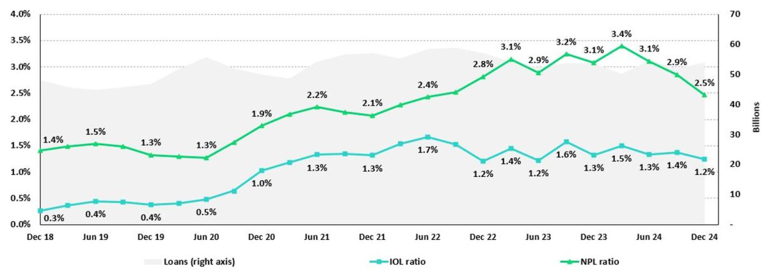

SME-Business
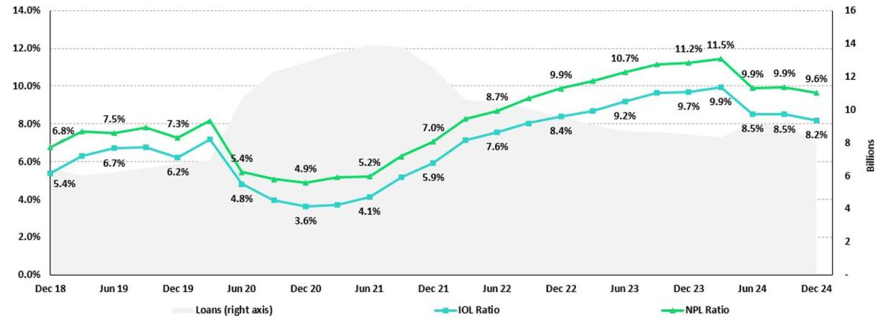

47

| Earnings Release 4Q / 2024 Analysis of 4Q24 Consolidated Results

12. Appendix

SME-Pyme
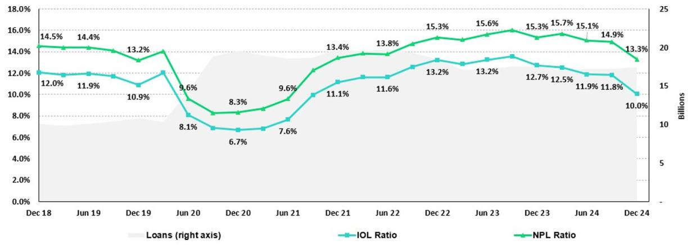

Mortgage
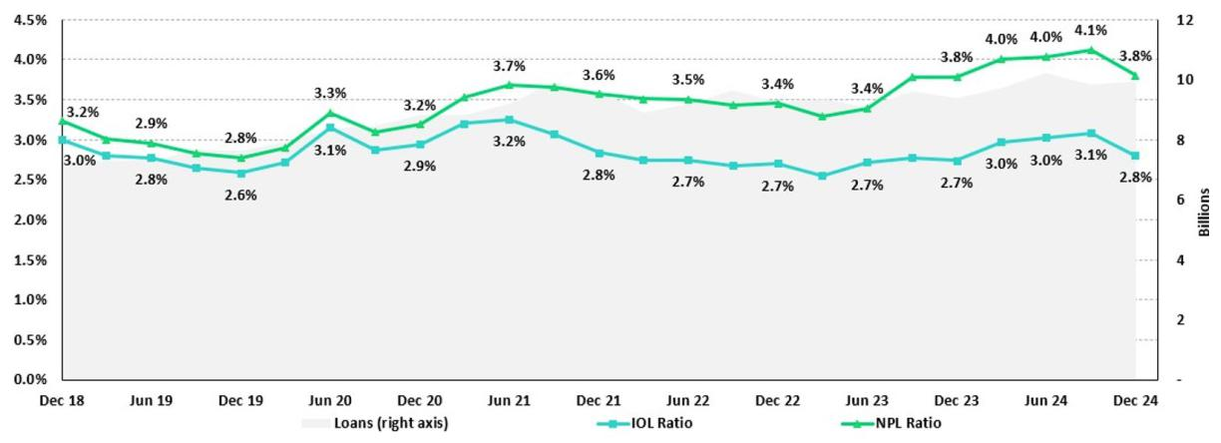

48

| Earnings Release 4Q / 2024 Analysis of 4Q24 Consolidated Results

12. Appendix

Consumer
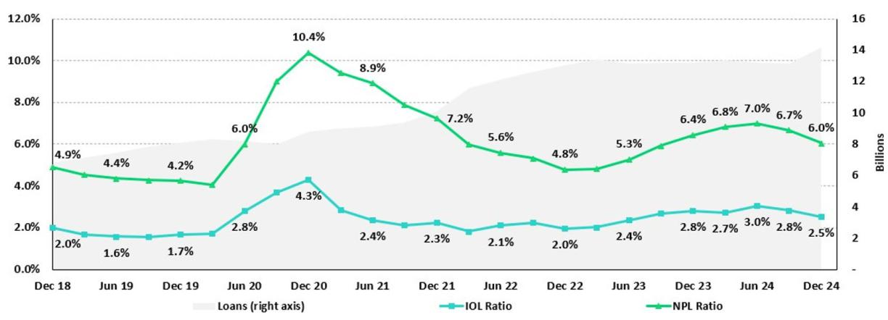

Credit Card
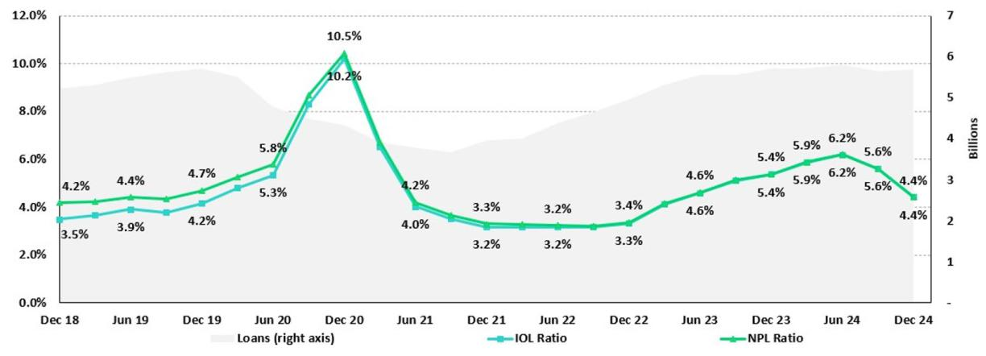

49

| Earnings Release 4Q / 2024 Analysis of 4Q24 Consolidated Results

12. Appendix

Mibanco
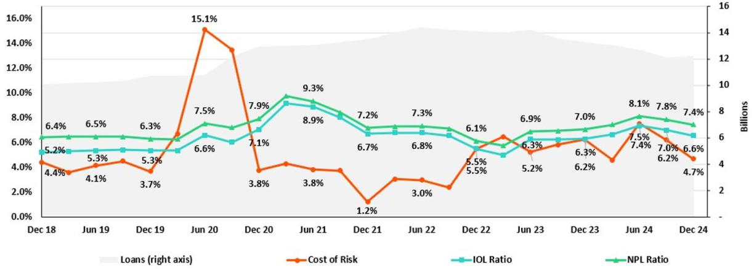

BCP Bolivia
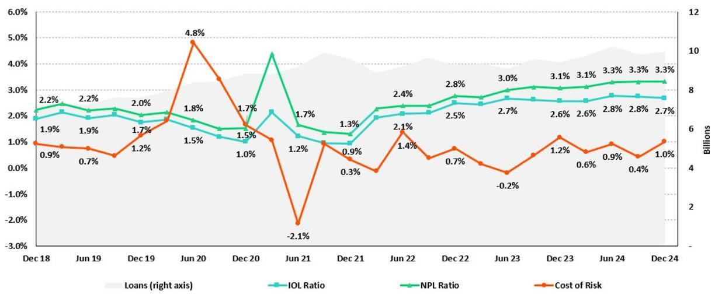

50

| Earnings Release 4Q / 2024 |  |  |  | Analysis of 4Q24 Consolidated Results
12. Appendix
12.3. Net Interest Income (NII)
 | NII Summary
Net interest income |  | Quarter |  | % change |  | Up to |  | % change
S/000 | 4Q23 | 3Q24 | 4Q24 | QoQ | YoY | Dec 23 | Dec 24 | Dec 24 / Dec 23
Interest income | 4,870,042 | 4,995,971 | 5,012,121 | 0.3% | 2.9% | 18,798,495 19,869,256 |  | 5.7%
Interest on loans | 3,907,705 | 3,924,222 | 3,940,002 | 0.4% | 0.8% | 15,044,864 | 15,654,391 | 4.1%
Dividends on investments | 11,647 | 13,187 | 15,285 | 15.9% | 31.2% | 46,080 | 49,469 | 7.4%
Interest on deposits with banks | 279,446 | 365,361 | 386,205 | 5.7% | 38.2% | 1,133,211 | 1,405,854 | 24.1%
Interest on securites | 643,737 | 667,195 | 652,155 | -2.3% | 1.3% | 2,489,327 | 2,660,322 | 6.9%
Other interest income | 27,507 | 26,006 | 18,474 | -29.0% | -32.8% | 85,013 | 99,220 | 16.7%
Interest expense | 1,522,358 | 1,405,221 | 1,382,327 | -1.6% | -9.2% | 5,860,523 | 5,754,125 | -1.8%
Interest expense (excluding Net Insurance Financial Expenses) | 1,402,925 | 1,276,643 | 1,250,239 | -2.1% | -10.9% | 5,393,709 | 5,246,769 | -2.7%
Interest on deposits | 827,124 | 677,509 | 655,429 | -3.3% | -20.8% | 3,141,307 | 2,850,474 | -9.3%
Interest on borrowed funds | 297,260 | 262,319 | 286,638 | 9.3% | -3.6% | 1,158,666 | 1,081,126 | -6.7%
Interest on bonds and subordinated notes | 152,960 | 200,801 | 201,053 | 0.1% | 31.4% | 634,299 | 799,223 | 26.0%
Other interest expense | 125,581 | 136,014 | 107,119 | -21.2% | -14.7% | 459,437 | 515,946 | 12.3%
Net Insurance Financial Expenses | 119,433 | 128,578 | 132,088 | 2.7% | 10.6% | 466,814 | 507,356 | 8.7%
Net interest income | 3,347,684 | 3,590,750 | 3,629,794 | 1.1% | 8.4% | 12,937,972 | 14,115,131 | 9.1%
Risk-adjusted Net interest income | 2,174,230 | 2,722,669 | 2,886,498 | 6.0% | 32.8% | 9,315,627 | 10,595,684 | 13.7%
Average interest earning assets | 223,624,217231,316,507237,518,087 |  |  | 2.7% | 6.2% | 223,318,737232,646,024 |  | 4.2%
Net interest margin (1) | 6.20% | 6.43% | 6.34% | -9 bps | 14 bps | 6.00% | 6.29% | 29 bps
Risk-adjusted Net interest margin (1) | 4.10% | 4.93% | 5.08% | 15 bps | 98 bps | 4.38% | 4.77% | 39 bps
Net provisions for loan losses / Net interest income | 35.05% | 24.18% | 20.48% | -370 bps-1457 bps |  | 28.00% | 24.93% | -307 bps

(1) Annualized. For further detail on the new NIM calculaton due to IFRS17, please refer to Annex 12.7.

12.4. Net Interest Margin (NIM) and Risk-Adjusted NIM by Subsidiary

NIM Breakdown | BCP Stand-alone | Mibanco | BCP Bolivia | Credicorp
4Q23 | 5.99% | 13.35% | 2.87% | 6.20%
3Q24 | 6.17% | 13.86% | 2.95% | 6.43%
4Q24 | 6.01% | 14.16% | 2.96% | 6.34%

NIM: Annualized Net interest income (excluding Net Insurance Financial Expenses) / Average period end and period beginning interest-earning assets.

Risk-Adjusted | BCP Stand-alone | Mibanco | BCP Bolivia | Credicorp
NIM Breakdown
4Q23 | 3.96% | 8.17% | 1.93% | 4.10%
3Q24 | 4.75% | 9.12% | 2.59% | 4.93%
4Q24 | 4.85% | 10.66% | 2.12% | 5.08%

Risk-Adjusted NIM: (Annualized Net interest income (excluding Net Insurance Financial Expenses) - annualized provisions) / Average period end and period beginning interest-earning assets.

51

| Earnings Release 4Q / 2024 Analysis of 4Q24 Consolidated Results

12.5. Regulatory Capital

Regulatory Capital and Capital Adequacy Ratos

(IFRS)

Regulatory Capital and Capital Adequacy Ratos |  | As of | % Change
S/000 | Sep 24 | Dec 24 | QoQ
Capital Stock | 1,318,993 | 1,318,993 | -
Treasury Stocks | (208,901) | (208,879) | 0.0%
Capital Surplus | 179,027 | 176,307 | -1.5%
Legal and Other Capital reserves | 27,187,346 | 27,202,665 | 0.1%
Minority interest | 479,027 | 467,916 | -2.3%
Current and Accumulated Earnings (1) | 5,432,237 | 6,592,462 | 21.4%
Unrealized Gains or Losses (2) | (227,247) | (504,016) | 121.8%
Goodwill | (734,431) | (722,361) | -1.6%
Intangible Assets (3) | (2,050,646) | (2,396,687) | 16.9%
Deductons in Common Equity Tier 1 instruments (4) | (678,924) | (673,952) | -0.7%
Perpetual subordinated debt | - | - | -
Subordinated Debt | 7,939,610 | 8,047,314 | 1.4%
Loan loss reserves (5) | 1,967,574 | 2,033,379 | 3.3%
Deductons in Tier 2 instruments (6) | (1,525,608) | (1,322,352) | -13.3%
Total Regulatory Capital (A) | 39,078,056 | 40,010,790 | 2.4%
Total Regulatory Common Equity Tier 1 Capital (B) | 30,696,480 | 31,252,448 | 1.8%
Total Regulatory Tier 1 Capital (C) | 30,696,480 | 31,252,448 | 1.8%
Total Regulatory Capital Requirement (D) | 27,276,454 | 29,124,775 | 6.8%
Total Regulatory Common Equity Tier 1 Capital Requirement (E) | 13,968,158 | 15,445,079 | 10.6%
Total Regulatory Tier 1 Capital Requirement (F) | 17,131,013 | 18,681,850 | 9.1%
Regulatory Capital Rato (A) / (D) | 1.43 | 1.37 | -6 bps
Regulatory Common Equity Tier 1 Capital Rato (B) / (E) | 2.20 | 2.02 | -17 bps
Regulatory Tier 1 Capital Rato (C) / (F) | 1.79 | 1.67 | -12 bps

- Earnings include Banco de Crédito del Perú and Mibanco Perú. Losses include all subsidiaries.

- Gains include Investment Grade Government Bonds and Peruvian Central Bank Certfcates of Deposits. Losses include all bonds.

- Diferent to Goodwill. Includes Diferred Tax Assets.

- Investments in Equity.

- Up to 1.25% of total risk-weighted assets of Banco de Crédito del Perú, Solución Empresa Administradora Hipotecaria, Mibanco and Atlantc Security Bank.

- Investments in Tier 2 Subordinated Debt.

52

| Earnings Release 4Q / 2024 Analysis of 4Q24 Consolidated Results

Regulatory and Capital Adequacy Ratos at BCP Stand-alone

Regulatory Capital |  |  | Quarter |  | Change %
(S/ thousand) |  | Dec 23 | Sep 24 | Dec 24 | QoQ | YoY
Capital Stock |  | 12,973,175 | 12,973,175 | 12,973,175 | 0.0% | 0.0%
Reserves |  | 6,590,921 | 6,591,330 | 6,124,302 | -7.1% | -7.1%
Accumulated earnings |  | 5,383,865 | 5,426,132 | 6,589,252 | 21.4% | 22.4%
Loan loss reserves ⁽¹⁾ |  | 1,695,577 | 1,689,307 | 1,757,256 | 4.0% | 3.6%
Subordinated Debt |  | 5,007,150 | 7,232,550 | 7,339,800 | 1.5% | 46.6%
Unrealized Proft or Losses |  | (668,717) | (322,210) | (413,658) | 28.4% | -38.1%
Investment in subsidiaries and others, net of unrealized proft and net income in |  | (2,772,786) | (2,537,005) | (2,477,732) | -2.3% | -10.6%
subsidiaries
Intangibles |  | (1,294,279) | (1,330,135) | (1,515,214) | 13.9% | 17.1%
Goodwill |  | (122,083) | (122,083) | (122,083) | 0.0% | 0.0%
Total Regulatory Capital |  | 26,792,823 | 29,601,060 | 30,255,097 | 2.2% | 12.9%
Tier 1 Common Equity ⁽²⁾ |  | 20,090,096 | 20,679,203 | 21,158,042 | 2.3% | 5.3%
Regulatory Tier 1 Capital ⁽³⁾ |  | 20,090,096 | 20,679,203 | 21,158,042 | 2.3% | 5.3%
Regulatory Tier 2 Capital ⁽⁴⁾ |  | 6,702,727 | 8,921,857 | 9,097,056 | 2.0% | 35.7%
Total risk-weighted assets |  |  | Quarter |  | Change %
(S/ thousand) |  | Dec 23 | Sep 24 | Dec 24 | QoQ | YoY
Market risk-weighted assets |  | 2,680,010 | 4,301,156 | 3,922,295 | -8.8% | 46.4%
Credit risk-weighted assets |  | 134,427,146 | 133,937,442 | 139,402,972 | 4.1% | 3.7%
Operatonal risk-weighted assets |  | 16,365,974 | 17,871,737 | 18,409,113 | 3.0% | 12.5%
Total |  | 153,473,130 | 156,110,335 | 161,734,381 | 3.6% | 5.4%
Capital requirement |  |  | Quarter |  | Change %
(S/ thousand) |  | Dec 23 | Sep 24 | Dec 24 | QoQ | YoY
Market risk capital requirement |  | 268,001 | 430,116 | 392,230 | -8.8% | 46.4%
Credit risk capital requirement |  | 12,098,443 | 12,724,057 | 13,243,282 | 4.1% | 9.5%
Operatonal risk capital requirement |  | 1,636,597 | 1,787,174 | 1,840,911 | 3.0% | 12.5%
Additonal capital requirements |  | 5,383,837 | 5,647,686 | 6,882,642 | 21.9% | 27.8%
Total |  | 19,386,878 | 20,589,033 | 22,359,066 | 8.6% | 15.3%
 | Capital Ratos under Local Regulaton
Capital ratos under Local Regulaton |  |  | Quarter | Dec 24 | % Change
 |  | Dec 23 | Sep 24 |  | QoQ | YoY
Common Equity Tier 1 rato |  | 13.09% | 13.25% | 13.08% | -16 bps | -1 bps
Tier 1 Capital rato |  | 13.09% | 13.25% | 13.08% | -16 bps | -1 bps
Regulatory Global Capital rato |  | 17.46% | 18.96% | 18.71% | -25 bps | 125 bps

- Up to 1.25% of total risk-weighted assets.

- Common Equity Tier 1 = Capital Stock + Reserves + Accumulated earnings – Unrealized profts or losses - 100% deductons (investment in subsidiaries, goodwill, intangible assets and deferred tax assets based on future returns).
- Regulatory Tier 1 Capital = Common Equity Tier 1 + Tier 1 Subordinated Debt (Perpetual).

- Regulatory Tier 2 Capital = Subordinated Debt + Loan loss reserves.

53

| Earnings Release 4Q / 2024 Analysis of 4Q24 Consolidated Results

Regulatory Capital and Capital Adequacy Ratos at Mibanco

Regulatory Capital |  |  | Quarter | Dec 24 |  |  | % Change
(S/ thousand) |  | Dec 23 | Sep 24 |  | QoQ |  |  | YoY
Capital Stock |  | 1,840,606 | 1,840,606 | 1,840,606 | 0.0% |  | 0.0%
Reserves |  | 308,056 | 334,650 | 334,650 | 0.0% |  | 8.6%
Accumulated earnings |  | 717,919 | 424,627 | 369,573 | -13.0% |  | -48.5%
Loan loss reserves ⁽¹⁾ |  | 163,158 | 143,193 | 144,751 | 1.1% |  | -11.3%
Perpetual subordinated debt |  | - | - | - | n.a |  |  | n.a.
Subordinated debt |  | 173,000 | 167,000 | 167,000 | 0.0% |  | -3.5%
Unrealidez Proft or Losses |  | 4,252 | 6,366 | (3,728) | -158.6% |  | -187.7%
Investment in subsidiaries and others, net of unrealized proft and net income in |  | (282) | (293) | (298) | 1.8% |  | 5.6%
subsidiaries
Intangibles |  | (156,884) | (128,688) | (136,691) | 6.2% |  | -12.9%
Goodwill |  | (139,180) | (139,180) | (139,180) | 0.0% |  | 0.0%
Total Regulatory Capital |  | 2,910,644 | 2,648,281 | 2,576,683 | -2.7% |  | -11.5%
Tier Common Equity ⁽²⁾ |  | 2,574,486 | 2,338,088 | 2,264,932 | -3.1% |  | -12.0%
Regulatory Tier 1 Capital ⁽³⁾ |  | 2,574,486 | 2,338,088 | 2,264,932 | -3.1% |  | -12.0%
Regulatory Tier 2 Capital ⁽⁴⁾ |  | 336,158 | 310,193 | 311,751 | 0.5% |  | -7.3%
Total risk-weighted assets |  |  | Quarter |  |  | % change
(S/ thousand) |  | Dec 23 | Sep 24 | Dec 24 | QoQ |  |  | YoY
Market risk-weighted assets |  | 220,327 | 238,117 | 241,964 | 1.6% |  | 9.8%
Credit risk-weighted assets |  | 12,349,400 | 11,263,844 | 11,419,696 | 1.4% |  | -7.5%
Operatonal risk-weighted assets |  | 1,527,140 | 1,594,338 | 1,605,950 | 0.7% |  | 5.2%
Total |  | 14,096,867 | 13,096,299 | 13,267,611 | 1.3% |  | -5.9%
Capital requirement |  |  | Quarter |  | % change
(S/ thousand) |  | Dec 23 | Sep 24 | Dec 24 | QoQ |  |  | YoY
Market risk capital requirement |  | 22,033 | 23,812 | 24,196 | 1.6% |  | 9.8%
Credit risk capital requirement |  | 1,111,446 | 1,070,065 | 1,084,871 | 1.4% |  | -2.4%
Operatonal risk capital requirement |  | 152,714 | 159,434 | 160,595 | 0.7% |  | 5.2%
Additonal capital requirements |  | 166,717 | 160,510 | 184,428 | 14.9% |  | 10.6%
Total |  | 1,452,910 | 1,413,821 | 1,454,091 | 2.8% |  | 0.1%
 | Capital Ratos under Local Regulaton
Capital ratos under Local Regulaton |  | Dec 23 | Quarter | Dec 24 |  | % change
 |  |  | Sep 24 |  | QoQ |  | YoY
Common Equity Tier 1 Rato |  | 18.26% | 17.85% | 17.07% | -78 bps |  |  | -119 pbs
Tier 1 Capital rato |  | 18.26% | 17.85% | 17.07% | -78 bps |  |  | -119 pbs
Regulatory Global Capital Rato |  | 20.65% | 20.22% | 19.42% | -80 bps |  |  | -123 pbs

- Up to 1.25% of total risk-weighted assets.

- Common Equity Tier 1 = Capital Stock + Reserves + Accumulated earnings – Unrealized profts or losses - 100% deductons (investment in subsidiaries, goodwill, intangible assets and deferred tax assets based on future returns).
- Regulatory Tier 1 Capital = Common Equity Tier 1 + Tier 1 Subordinated Debt (Perpetual).

- Regulatory Tier 2 Capital = Subordinated Debt + Loan loss reserves.

54

| Earnings Release 4Q / 2024 Analysis of 4Q24 Consolidated Results

Common Equity Tier 1 IFRS

BCP Stand-alone

Common Equity Tier 1 IFRS |  |  |  | Quarter |  |  |  |  | % Change
(S/. thousand) |  |  | Dec 23 | Sep 24 | Dec 24 |  |  | QoQ | YoY
Capital and reserves |  |  | 19,051,853 | 19,052,262 | 18,585,234 |  |  | -2.5% | -2.4%
Retained earnings |  |  | 6,058,923 | 6,076,551 | 7,345,245 |  |  | 20.9% | 21.2%
Unrealized gains (losses) |  |  | (109,202) | 222,730 | 81,399 |  |  | -63.5% | -174.5%
Goodwill and intangibles |  |  | (1,670,116) | (1,599,568) | (1,741,267) |  |  | 8.9% | 4.3%
Investments in subsidiaries |  |  | (2,917,670) | (2,669,334) | (2,598,905) |  |  | -2.6% | -10.9%
Total |  |  | 20,413,787 | 21,082,641 | 21,671,706 |  |  | 2.8% | 6.2%
Adjusted RWAs IFRS |  |  | 154,627,042 | 157,046,547 | 162,676,386 |  |  | 3.6% | 3.5%
Adjusted Credit RWAs IFRS |  |  | 135,581,058 | 134,873,654 | 140,344,978 |  |  | 4.1% | 3.5%
Others |  |  | 19,045,984 | 22,172,893 | 22,331,409 |  |  | 0.7% | 17.2%
CET1 rato IFRS |  |  | 13.20% | 13.42% | 13.32% |  |  | -10 bps | 12 bps
 |  |  | Mibanco
Common Equity Tier 1 IFRS |  |  |  | Quarter |  |  |  |  | % change
(S/. thousand) |  |  | Dec 23 | Sep 24 | Dec 24 |  |  | QoQ | YoY
Capital and reserves |  |  | 2,676,791 | 2,703,385 | 2,703,385 |  |  | 0.0% | 1.0%
Retained earnings |  |  | 321,235 | 36,907 | (29,980) |  |  | -181.2% | -109.3%
Unrealized gains (losses) |  |  | (1,403) | 3,081 | (5,037) |  |  | -263.5% | 258.9%
Goodwill and intangibles |  |  | (360,171) | (303,850) | (310,730) |  |  | 2.3% | -13.7%
Investments in subsidiaries |  |  | (271) | (296) | (302) |  |  | 2.0% | 11.6%
Total |  |  | 2,636,182 | 2,439,227 | 2,357,337 |  |  | -3.4% | -10.6%
Adjusted RWAs IFRS |  |  | 14,349,534 | 13,291,063 | 13,449,807 |  |  | 1.2% | -6.3%
Adjusted Credit RWAs IFRS |  |  | 12,595,184 | 11,455,585 | 11,597,881 |  |  | 1.2% | -7.9%
Others |  |  | 1,754,350 | 1,835,478 | 1,851,926 |  |  | 0.9% | 5.6%
CET1 rato IFRS |  |  | 18.37% | 18.35% | 17.53% |  |  | -83 bps | -84 bps

55

| Earnings Release 4Q / 2024 Analysis of 4Q24 Consolidated Results

12.6. Financial Statements and Ratios by Business

12.6.1. Credicorp Consolidated

Credicorp Ltd. and Subsidiaries
Consolidated Statement of Financial Position
(In S/ thousands, IFRS)

 |  | As of |  | % change
 | Dec 23 | Sep 24 | Dec 24 | QoQ | YoY
ASSETS
Cash and due from banks
Non-interest bearing | 7,952,371 | 7,222,945 | 7,535,259 | 4.3% | -5.2%
Interest bearing | 25,978,577 | 37,007,966 | 40,119,937 | 8.4% | 54.4%
Total cash and due from banks | 33,930,948 | 44,230,911 | 47,655,196 | 7.7% | 40.4%
Cash collateral, reverse repurchase agreements and securities borrowing | 1,410,647 | 1,419,305 | 1,033,177 | -27.2% | -26.8%
Fair value through profit or loss investments | 4,982,661 | 4,642,905 | 4,715,343 | 1.6% | -5.4%
Fair value through other comprehensive income investments | 37,043,940 | 39,832,274 | 40,142,638 | 0.8% | 8.4%
Amortized cost investments | 10,188,927 | 8,853,694 | 8,967,877 | 1.3% | -12.0%
Loans | 144,976,051 | 142,568,785 | 145,732,273 | 2.2% | 0.5%
Current | 138,849,564 | 136,542,444 | 140,309,061 | 2.8% | 1.1%
Internal overdue loans | 6,126,487 | 6,026,341 | 5,423,212 | -10.0% | -11.5%
Less - allowance for loan losses | (8,277,916) | (8,250,023) | (7,994,977) | -3.1% | -3.4%
Loans, net | 136,698,135 | 134,318,762 | 137,737,296 | 2.5% | 0.8%
Financial assets designated at fair value through profit or loss | 810,932 | 900,107 | 932,734 | 3.6% | 15.0%
Property, plant and equipment, net | 1,857,240 | 1,836,732 | 1,841,147 | 0.2% | -0.9%
Due from customers on acceptances | 412,401 | 466,957 | 528,184 | 13.1% | 28.1%
Investments in associates | 748,663 | 729,770 | 763,918 | 4.7% | 2.0%
Intangible assets and goodwill, net | 3,225,499 | 3,167,296 | 3,289,157 | 3.8% | 2.0%
Reinsurance contract assets | 872,046 | 880,563 | 841,170 | -4.5% | -3.5%
Other assets ⁽¹⁾ | 6,658,149 | 8,480,514 | 7,749,647 | -8.6% | 16.4%
Total Assets | 238,840,188 | 249,759,790 | 256,197,484 | 2.6% | 7.3%
LIABILITIES AND EQUITY
Deposits and obligations
Non-interest bearing | 42,234,498 | 47,436,563 | 47,160,191 | -0.6% | 11.7%
Interest bearing | 105,470,496 | 106,998,888 | 114,681,875 | 7.2% | 8.7%
Total deposits and obligations | 147,704,994 | 154,435,451 | 161,842,066 | 4.8% | 9.6%
Payables from repurchase agreements and securities lending | 10,168,427 | 7,383,104 | 9,060,710 | 22.7% | -10.9%
BCRP instruments | 7,461,674 | 4,788,939 | 6,646,830 | 38.8% | -10.9%
Repurchase agreements with third parties | 2,608,631 | 2,517,833 | 2,298,494 | -8.7% | -11.9%
Repurchase agreements with customers | 98,122 | 76,332 | 115,386 | 51.2% | 17.6%
Due to banks and correspondents | 12,278,681 | 12,704,234 | 10,754,385 | -15.3% | -12.4%
Bonds and notes issued | 14,594,785 | 16,952,011 | 17,268,443 | 1.9% | 18.3%
Banker’s acceptances outstanding | 412,401 | 466,957 | 528,184 | 13.1% | 28.1%
Insurance contract liability | 12,318,133 | 13,289,394 | 13,422,285 | 1.0% | 9.0%
Financial liabilities at fair value through profit or loss | 641,915 | 698,747 | 151,485 | -78.3% | -76.4%
Other liabilities | 7,613,787 | 9,752,701 | 8,192,692 | -16.0% | 7.6%
Total Liabilities | 205,733,123 | 215,682,599 | 221,220,250 | 2.6% | 7.5%
Net equity | 32,460,004 | 33,462,591 | 34,346,451 | 2.6% | 5.8%
Capital stock | 1,318,993 | 1,318,993 | 1,318,993 | 0.0% | 0.0%
Treasury stock | (208,033) | (208,901) | (208,879) | 0.0% | 0.4%
Capital surplus | 228,239 | 179,027 | 176,307 | -1.5% | -22.8%
Reserves | 26,252,578 | 27,187,346 | 27,202,665 | 0.1% | 3.6%
Other reserves | 295,783 | 470,550 | 214,627 | -54.4% | -27.4%
Retained earnings | 4,572,444 | 4,515,576 | 5,642,738 | 25.0% | 23.4%
Non-controlling interest | 647,061 | 614,600 | 630,783 | 2.6% | -2.5%
Total Net Equity | 33,107,065 | 34,077,191 | 34,977,234 | 2.6% | 5.6%
Total liabilities and equity | 238,840,188 | 249,759,790 | 256,197,484 | 2.6% | 7.3%
Off-balance sheet | 149,769,480 | 155,876,986 | 151,223,851 | -3.0% | 1.0%
Total performance bonds, stand-by and L/Cs. | 20,051,616 | 20,206,333 | 22,139,322 | 9.6% | 10.4%
Undrawn credit lines, advised but not committed | 87,091,701 | 88,226,431 | 85,269,774 | -3.4% | -2.1%
Total derivatives (notional) and others | 42,626,163 | 47,444,222 | 43,814,755 | -7.6% | 2.8%

(1) Includes mainly accounts receivables from brokerage and others

* Due to reclassifications, the Balance Sheet may differ from those reported in previous quarters.

56

| Earnings Release 4Q / 2024 Analysis of 4Q24 Consolidated Results

Credicorp Ltd. and Subsidiaries

Consolidated Statement of Income
(In S/ thousands, IFRS)

 |  | Quarter |  | % change |  |  | As of | % change
 | 4Q23 | 3Q24 | 4Q24 | QoQ | YoY | Dec 23 | Dec 24 | Dec 24 / Dec 23
Interest income and expense
Interest and similar income | 4,870,042 | 4,995,971 | 5,012,121 | 0.3% | 2.9% | 18,798,495 | 19,869,256 | 5.7%
Interest and similar expenses | (1,522,358) | (1,405,221) | (1,382,327) | -1.6% | -9.2% | (5,860,523) | (5,754,125) | -1.8%
Net interest, similar income and expenses | 3,347,684 | 3,590,750 | 3,629,794 | 1.1% | 8.4% | 12,937,972 | 14,115,131 | 9.1%
Gross provision for credit losses on loan portfolio | (1,260,163) | (981,870) | (857,694) | -12.6% | -31.9% | (3,957,143) | (3,943,301) | -0.3%
Recoveries of written-off loans | 86,709 | 113,789 | 114,398 | 0.5% | 31.9% | 334,798 | 423,854 | 26.6%
Provision for credit losses on loan portfolio, net of recoveries | (1,173,454) | (868,081) | (743,296) | -14.4% | -36.7% | (3,622,345) | (3,519,447) | -2.8%
Net interest, similar income and expenses, after provision for credit losses | 2,174,230 | 2,722,669 | 2,886,498 | 6.0% | 32.8% | 9,315,627 | 10,595,684 | 13.7%
on loan portfolio
Other income
Fee income | 986,173 | 1,108,314 | 1,103,548 | -0.4% | 11.9% | 3,804,459 | 4,423,193 | 16.3%
Net gain on foreign exchange transactions | 218,047 | 172,998 | 223,913 | 29.4% | 2.7% | 886,126 | 781,076 | -11.9%
Net loss on securities | 115,825 | 120,033 | (47,377) | -139.5% | -140.9% | 308,055 | 227,112 | -26.3%
Net gain from associates | 34,132 | 35,600 | 38,560 | 8.3% | 13.0% | 117,089 | 135,183 | 15.5%
Net gain (loss) on derivatives held for trading | 5,019 | 93,801 | 188,301 | 100.7% | 3651.8% | 53,665 | 363,834 | 578.0%
Net gain (loss) from exchange differences | 15,255 | (6,139) | (21,365) | 248.0% | -240.1% | 45,778 | (41,058) | -189.7%
Others | 112,372 | 96,675 | 176,384 | 82.5% | 57.0% | 440,653 | 514,779 | 16.8%
Total other income | 1,486,823 | 1,621,282 | 1,661,964 | 2.5% | 11.8% | 5,655,825 | 6,404,119 | 13.2%
Insurance underwriting result | 385,043 | 419,805 | 407,149 | -3.0% | 5.7% | 1,602,421 | 1,693,617 | 5.7%
Insurance Service Result | (97,748) | (128,030) | (94,466) | -26.2% | -3.4% | (391,321) | (494,597) | 26.4%
Reinsurance Result | 287,295 | 291,775 | 312,683 | 7.2% | 8.8% | 1,211,100 | 1,199,020 | -1.0%
Total insurance underwriting result
Total Expenses | (1,119,758) | (1,155,966) | (1,271,578) | 10.0% | 13.6% | (4,265,453) | (4,676,436) | 9.6%
Salaries and employee benefits | (1,089,203) | (1,047,386) | (1,230,099) | 17.4% | 12.9% | (3,803,203) | (4,183,775) | 10.0%
Administrative, general and tax expenses | (177,618) | (179,495) | (186,625) | 4.0% | 5.1% | (659,007) | (713,470) | 8.3%
Depreciation and amortization | (71,959) | (23,046) | (4,300) | -81.3% | -94.0% | (71,959) | (27,346) | -62.0%
Association in participation | (9,109) | (6,414) | (3,808) | -40.6% | -58.2% | (53,097) | (28,269) | -46.8%
Other expenses | (193,895) | (111,859) | (409,049) | 265.7% | 111.0% | (481,504) | (745,000) | 54.7%
Total expenses | (2,661,542) | (2,524,166) | (3,105,459) | 23.0% | 16.7% | (9,334,223) | (10,374,296) | 11.1%
Profit before income tax | 1,286,806 | 2,111,560 | 1,755,686 | -16.9% | 36.4% | 6,848,329 | 7,824,527 | 14.3%
Income tax | (434,648) | (555,117) | (598,348) | 7.8% | 37.7% | (1,888,451) | (2,201,275) | 16.6%
Net profit | 852,158 | 1,556,443 | 1,157,338 | -25.6% | 35.8% | 4,959,878 | 5,623,252 | 13.4%
Non-controlling interest | 10,331 | 32,655 | 30,625 | -6.2% | 196.4% | 94,338 | 121,998 | 29.3%
Net profit attributable to Credicorp | 841,827 | 1,523,788 | 1,126,713 | -26.1% | 33.8% | 4,865,540 | 5,501,254 | 13.1%

57

| Earnings Release 4Q / 2024 Analysis of 4Q24 Consolidated Results

12.6.2. Credicorp Stand-alone

Credicorp Ltd.

Separate Statement of Financial Position
(In S/ thousands, IFRS)

 |  | As of |  | % change
 | Dec 23 | Sep 24 | Dec 24 | QoQ | YoY
ASSETS
Cash and cash equivalents | 529,773 | 594,754 | 399,943 | -32.8% | -24.5%
At fair value through profit or loss | 501,026 | - | - | n.a. | n.a.
Fair value through other comprehensive income investments | 1,418,293 | 1,279,564 | 1,262,327 | -1.3% | -11.0%
In subsidiaries and associates investments | 36,150,565 | 37,481,263 | 38,291,133 | 2.2% | 5.9%
Investments at amortized cost | 166,977 | 629,491 | 695,652 | 10.5% | 316.6%
Other assets | 99 | 856,336 | 6,777 | -99.2% | n.a.
Total Assets | 38,766,733 | 40,841,408 | 40,655,832 | -0.5% | 4.9%
LIABILITIES AND NET SHAREHOLDERS' EQUITY
Due to banks, correspondents and other entities | 30,866 | - | - | n.a. | n.a.
Bonds and notes issued | 1,798,858 | 1,814,219 | 1,829,657 | 0.9% | 1.7%
Other liabilities | 255,707 | 1,294,018 | 230,660 | -82.2% | -9.8%
Total Liabilities | 2,085,431 | 3,108,237 | 2,060,317 | -33.7% | -1.2%
NET EQUITY
Capital stock | 1,318,993 | 1,318,993 | 1,318,993 | 0.0% | 0.0%
Capital Surplus | 384,542 | 384,542 | 384,542 | 0.0% | 0.0%
Reserve | 25,905,526 | 26,651,433 | 26,651,390 | 0.0% | 2.9%
Unrealized results | 68,056 | 292,640 | 35,535 | -87.9% | -47.8%
Retained earnings | 9,004,185 | 9,085,563 | 10,205,055 | 12.3% | 13.3%
Total net equity | 36,681,302 | 37,733,171 | 38,595,515 | 2.3% | 5.2%
Total Liabilities And Equity | 38,766,733 | 40,841,408 | 40,655,832 | -0.5% | 4.9%

Statement of Income

(S/ Thousands, IFRS)

 |  | Quarter |  | % Change |  |  | Up to | % Change
 | 4Q23 | 3Q24 | 4Q24 | QoQ | YoY | Dec 23 | Dec 24 | Dec 24 / Dec 23
Interest income
Net share of the income from investments in subsidiaries and associates | 906,901 | 1,735,379 | 1,121,288 | -35.4% | 23.6% | 5,439,451 | 6,313,139 | 16.1%
Interest and similar income | 1,170 | 22,290 | 24,419 | 9.6% | n.a. | 10,895 | 93,486 | 758.1%
Net gain on financial assets at fair value through profit or loss | 32,430 | - | - | n.a. | n.a. | 67,652 | 1,234 | -98.2%
Total income | 940,501 | 1,757,669 | 1,145,707 | -34.8% | 21.8% | 5,517,998 | 6,407,859 | 16.1%
Interest and similar expense | (14,444) | (13,527) | (13,637) | 0.8% | -5.6% | (56,276) | (54,237) | -3.6%
Administrative and general expenses | (9,274) | (4,034) | (4,134) | 2.5% | -55.4% | (25,362) | (18,085) | -28.7%
Total expenses | (23,718) | (17,561) | (17,771) | 1.2% | -25.1% | (81,638) | (72,322) | -11.4%
Operating income | 916,783 | 1,740,108 | 1,127,936 | -35.2% | 23.0% | 5,436,360 | 6,335,537 | 16.5%
Results from exchange differences | 510 | (119) | 175 | n.a. | -65.7% | (1,549) | (2,681) | 73.1%
Other, net | 111 | (367) | (7) | n.a. | -106.3% | 2,977 | (292) | n.a.
Profit before income tax | 917,404 | 1,739,622 | 1,128,104 | -35.2% | 23.0% | 5,437,788 | 6,332,564 | 16.5%
Income tax | (68,500) | (43,118) | (8,612) | -80.0% | -87.4% | (209,238) | (146,713) | -29.9%
Net income | 848,904 | 1,696,504 | 1,119,492 | -34.0% | 31.9% | 5,228,550 | 6,185,851 | 18.3%
Double Leverage Ratio | 98.6% | 99.3% | 99.2% | -12 bps | 66 bps | 98.6% | 99.2% | 66 bps

58

| Earnings Release 4Q / 2024 |  |  | Analysis of 4Q24 Consolidated Results
12.6.3 BCP Consolidated | Banco de Credito del Peru
Consolidated Statement of Financial Position
 | (S/ thousands, IFRS)
 |  |  | As of |  | % change
 |  | Dec 23 | Sep 24 | Dec 24 | QoQ | YoY
ASSETS
Cash and due from banks
Non-interest bearing |  | 6,025,352 | 5,134,613 | 5,430,818 | 5.8% | -9.9%
Interest bearing |  | 24,668,794 | 36,092,693 | 39,106,465 | 8.4% | 58.5%
Total cash and due from banks |  | 30,694,146 | 41,227,306 | 44,537,283 | 8.0% | 45.1%
Cash collateral, reverse repurchase agreements and securities borrowing |  | 100,211 | 622,399 | 19,151 | -96.9% | -80.9%
Fair value through profit or loss investments |  | 362,360 | 704,968 | 603,635 | -14.4% | 66.6%
Fair value through other comprehensive income investments |  | 20,592,731 | 22,888,341 | 23,375,769 | 2.1% | 13.5%
Amortized cost investments |  | 9,557,451 | 8,178,619 | 8,277,440 | 1.2% | -13.4%
Loans |  | 131,767,137 | 129,063,925 | 132,053,791 | 2.3% | 0.2%
Current |  | 125,948,604 | 123,400,733 | 126,990,918 | 2.9% | 0.8%
Internal overdue loans |  | 5,818,533 | 5,663,192 | 5,062,873 | -10.6% | -13.0%
Less - allowance for loan losses |  | (7,772,720) | (7,714,711) | (7,443,523) | -3.5% | -4.2%
Loans, net |  | 123,994,417 | 121,349,214 | 124,610,268 | 2.7% | 0.5%
Property, furniture and equipment, net ⁽¹⁾ |  | 1,559,485 | 1,479,708 | 1,496,066 | 1.1% | -4.1%
Due from customers on acceptances |  | 412,401 | 466,957 | 528,184 | 13.1% | 28.1%
Investments in associates |  | 21,426 | 29,053 | 29,368 | 1.1% | 37.1%
Other assets ⁽²⁾ |  | 6,510,227 | 7,959,779 | 7,609,096 | -4.4% | 16.9%
Total Assets |  | 193,804,855 | 204,906,344 | 211,086,260 | 3.0% | 8.9%
Liabilities and Equity
Deposits and obligations
Non-interest bearing ⁽¹⁾ |  | 39,377,289 | 45,310,064 | 44,280,933 | -2.3% | 12.5%
Interest bearing ⁽¹⁾ |  | 92,931,227 | 95,985,178 | 103,434,795 | 7.8% | 11.3%
Total deposits and obligations |  | 132,308,516 | 141,295,242 | 147,715,728 | 4.5% | 11.6%
Payables from repurchase agreements and securities lending |  | 8,005,844 | 5,621,745 | 7,203,885 | 28.1% | -10.0%
BCRP instruments |  | 7,461,674 | 4,788,939 | 6,646,830 | 38.8% | -10.9%
Repurchase agreements with third parties |  | 544,170 | 832,806 | 557,055 | -33.1% | 2.4%
Due to banks and correspondents |  | 11,870,116 | 12,210,085 | 10,165,266 | -16.7% | -14.4%
Bonds and notes issued |  | 10,961,427 | 13,351,992 | 13,627,208 | 2.1% | 24.3%
Banker’s acceptances outstanding |  | 412,401 | 466,957 | 528,184 | 13.1% | 28.1%
Financial liabilities at fair value through profit or loss |  | 91,966 | 354,562 | - | n.a. | n.a.
Other liabilities ⁽³⁾ |  | 4,995,178 | 6,110,653 | 5,694,394 | -6.8% | 14.0%
Total Liabilities |  | 168,645,448 | 179,411,236 | 184,934,665 | 3.1% | 9.7%
Net equity |  | 24,998,419 | 25,347,135 | 26,007,483 | 2.6% | 4.0%
Capital stock |  | 12,679,794 | 12,679,794 | 12,679,794 | 0.0% | 0.0%
Reserves |  | 6,372,059 | 6,372,468 | 5,905,440 | -7.3% | -7.3%
Unrealized gains and losses |  | (108,012) | 223,921 | 82,590 | n.a. | n.a.
Retained earnings |  | 6,054,578 | 6,070,952 | 7,339,659 | 20.9% | 21.2%
Non-controlling interest |  | 160,988 | 147,973 | 144,112 | -2.6% | -10.5%
Total Net Equity |  | 25,159,407 | 25,495,108 | 26,151,595 | 2.6% | 3.9%
Total liabilities and equity |  | 193,804,855 | 204,906,344 | 211,086,260 | 3.0% | 8.9%
Off-balance sheet |  | 138,140,917 | 144,241,520 | 139,066,953 | -3.6% | 0.7%
Total performance bonds, stand-by and L/Cs. |  | 19,328,506 | 19,593,247 | 21,683,478 | 10.7% | 12.2%
Undrawn credit lines, advised but not committed |  | 76,719,565 | 77,964,739 | 74,193,794 | -4.8% | -3.3%
Total derivatives (notional) and others |  | 42,092,846 | 46,683,534 | 43,189,681 | -7.5% | 2.6%

- Right of use asset of lease contracts is included by application of IFRS 16.

- Mainly includes intangible assets, other receivable accounts, trading derivatives receivable accounts and tax credit.
- Mainly includes other payable accounts, trading derivatives payable accounts and taxes for payable.

59

| Earnings Release 4Q / 2024 Analysis of 4Q24 Consolidated Results

Banco de Credito del Peru

Consolidated Statement of Income
(S/ thousands, IFRS)

 |  | Quarter |  | % change |  |  | As of | % Change
 | 4Q23 | 3Q24 | 4Q24 | QoQ | YoY | Dec 23 | Dec 24 | Dec 24 / Dec
 |  |  |  |  |  |  |  | 23
Interest income and expense
Interest and similar income | 4,265,959 | 4,363,712 | 4,381,994 | 0.4% | 2.7% | 16,463,174 | 17,346,146 | 5.4%
Interest and similar expenses ⁽¹⁾ | (1,153,770) | (1,040,332) | (1,025,087) | -1.5% | -11.2% | (4,477,974) | (4,286,492) | -4.3%
Interest income and expense | 3,112,189 | 3,323,380 | 3,356,907 | 1.0% | 7.9% | 11,985,200 | 13,059,654 | 9.0%
Provision for credit losses on loan portfolio | (1,160,527) | (935,374) | (786,209) | -15.9% | -32.3% | (3,768,729) | (3,683,332) | -2.3%
Recoveries of written-off loans | 81,398 | 107,848 | 108,560 | 0.7% | 33.4% | 313,405 | 402,380 | 28.4%
Provision for credit losses on loan portfolio, net of recoveries | (1,079,129) | (827,526) | (677,649) | -18.1% | -37.2% | (3,455,324) | (3,280,952) | -5.0%
Net interest, similar income and expenses, after provision for credit losses on | 2,033,060 | 2,495,854 | 2,679,258 | 7.3% | 31.8% | 8,529,876 | 9,778,702 | 14.6%
loan portfolio
Other income
Fee income | 773,261 | 898,766 | 912,573 | 1.5% | 18.0% | 3,039,965 | 3,442,417 | 13.2%
Net gain on foreign exchange transactions | 268,615 | 299,425 | 313,538 | 4.7% | 16.7% | 997,648 | 1,166,567 | 16.9%
Net gain (loss) on securities | 10,759 | 24,114 | (19,571) | n.a. | n.a. | (23,102) | 27,933 | n.a.
Net gain on derivatives held for trading | 21,750 | 13,639 | 24,881 | 82.4% | 14.4% | 99,156 | 77,674 | -21.7%
Net loss (gain) from exchange differences | 8,795 | (10,714) | (1,989) | -81.4% | n.a. | 9,431 | (5,455) | n.a.
Others | 101,244 | 19,336 | 95,118 | 391.9% | -6.1% | 345,103 | 246,098 | -28.7%
Total other income | 1,184,424 | 1,244,566 | 1,324,550 | 6.4% | 11.8% | 4,468,201 | 4,955,234 | 10.9%
Total expenses
Salaries and employee benefits | (788,885) | (850,918) | (973,566) | 14.4% | 23.4% | (3,071,184) | (3,441,259) | 12.0%
Administrative expenses | (874,101) | (802,127) | (978,885) | 22.0% | 12.0% | (2,954,789) | (3,260,696) | 10.4%
Depreciation and amortization ⁽²⁾ | (146,657) | (146,719) | (154,731) | 5.5% | 5.5% | (547,006) | (583,990) | 6.8%
Other expenses | (124,472) | (62,292) | (104,374) | 67.6% | -16.1% | (296,430) | (283,169) | -4.5%
Total expenses | (1,934,115) | (1,862,056) | (2,211,556) | 18.8% | 14.3% | (6,869,409) | (7,569,114) | 10.2%
Profit before income tax | 1,283,369 | 1,878,364 | 1,792,252 | -4.6% | 39.7% | 6,128,668 | 7,164,822 | 16.9%
Income tax | (327,708) | (472,791) | (517,677) | 9.5% | 58.0% | (1,545,006) | (1,853,018) | 19.9%
Net profit | 955,661 | 1,405,573 | 1,274,575 | -9.3% | 33.4% | 4,583,662 | 5,311,804 | 15.9%
Non-controlling interest | (2,670) | (3,172) | (5,867) | 85.0% | 119.7% | (10,081) | (15,418) | 52.9%
Net profit attributable to BCP Consolidated | 952,991 | 1,402,401 | 1,268,708 | -9.5% | 33.1% | 4,573,581 | 5,296,386 | 15.8%

- Financing expenses related to lease agreements are included according to the application of IFRS 16.

- The effect of the application of IFRS 16 is included, which corresponds to a greater depreciation for the asset for right-of-use".

Selected Financial Indicators

 |  | Quarter |  |  | As of
 | 4Q23 | 3Q24 | 4Q24 | Dec 23 | Dec 24
Profitability
_{ROAA} (1)(2) | 2.0% | 2.8% | 2.4% | 2.4% | 2.6%
_{ROAE} (1)(2) | 15.5% | 22.9% | 19.8% | 19.0% | 20.8%
Net interest margin ⁽¹⁾⁽²⁾ | 6.67% | 6.84% | 6.70% | 6.41% | 6.69%
Risk-adjusted Net interest margin ⁽¹⁾⁽²⁾ | 4.36% | 5.13% | 5.35% | 4.56% | 5.01%
Funding cost ⁽¹⁾⁽²⁾⁽³⁾ | 2.82% | 2.43% | 2.29% | 2.74% | 2.51%
Quality of loan portfolio
Internal overdue ratio | 4.4% | 4.4% | 3.8% | 4.4% | 3.8%
NPL ratio | 6.2% | 6.1% | 5.5% | 6.2% | 5.5%
Coverage ratio of IOLs | 133.6% | 136.2% | 147.0% | 133.6% | 147.0%
Coverage ratio of NPLs | 95.3% | 97.4% | 103.2% | 95.3% | 103.2%
Cost of risk ⁽⁴⁾ | 3.3% | 2.5% | 2.1% | 2.6% | 2.5%
Operating efficiency
Operating expenses / Total income ⁽⁵⁾ | 43.2% | 39.8% | 45.7% | 40.7% | 41.1%
Operating expenses / Total average assets ⁽¹⁾⁽²⁾ | 3.7% | 3.5% | 4.1% | 3.4% | 3.6%
(5)

- Ratios are annualized.

- Averages are determined as the average of period-beginning and period-ending balances.

- The funding costs differs from previously reported due to a methodology change in the denominator, which no longer includes the following accounts: acceptances outstanding, reserves for property and casualty claims, reserve for unearned premiums, reinsurance payable and other liabilities.
- Cost of risk: Annualized provision for loan losses / Total loans.

- Total income includes net interest income, fee income, net gain on foreign exchange transactions, result on exchange difference and net gain on derivatives. Operating expenses includes Salaries and social benefits, administrative, general and tax expenses and depreciation and amortization.

60

| |  | Earnings Release 4Q / 2024 |  |  |  | Analysis of 4Q24 Consolidated Results
12. Appendix
12.6.4. BCP Stand-alone
 |  |  | Statement of Financial Positon
 |  |  | (S/ Thousands, IFRS)
 |  |  |  |  | As of |  | % change
 |  |  |  | Dec 23 | Sep 24 | Dec 24 | QoQ | YoY
 | ASSETS
 | Cash and due from banks
 | Non-interest bearing |  |  | 5,236,016 | 4,561,696 | 4,792,810 | 5.1% | -8.5%
 | Interest bearing |  |  | 24,554,369 | 35,307,925 | 38,063,318 | 7.8% | 55.0%
 | Total cash and due from banks |  |  | 29,790,385 | 39,869,621 | 42,856,128 | 7.5% | 43.9%
 | Cash collateral, reverse repurchase agreements and securites borrowing |  |  | 100,211 | 622,399 | 19,151 | -96.9% | -80.9%
 | Fair value through proft or loss investments |  |  | 362,360 | 704,968 | 603,635 | -14.4% | 66.6%
 | Fair value through other comprehensive income investments |  |  | 18,178,514 | 19,855,738 | 20,521,337 | 3.4% | 12.9%
 | Amortzed cost investments |  |  | 9,415,232 | 8,116,588 | 8,214,476 | 1.2% | -12.8%
 | Loans |  |  | 119,425,134 | 117,687,023 | 120,571,109 | 2.5% | 1.0%
 | Current |  |  | 114,445,408 | 112,874,488 | 116,314,563 | 3.0% | 1.6%
 | Internal overdue loans |  |  | 4,979,726 | 4,812,535 | 4,256,546 | -11.6% | -14.5%
 | Less - allowance for loan losses |  |  | (6,764,601) | (6,768,497) | (6,513,398) | -3.8% | -3.7%
 | Loans, net |  |  | 112,660,533 | 110,918,526 | 114,057,711 | 2.8% | 1.2%
 | Property, furniture and equipment, net (1) |  |  | 1,300,690 | 1,246,350 | 1,271,219 | 2.0% | -2.3%
 | Due from customers on acceptances |  |  | 412,401 | 466,957 | 528,184 | 13.1% | 28.1%
 | Investments in associates |  |  | 2,917,670 | 2,682,807 | 2,612,080 | -2.6% | -10.5%
 | Other assets (2) |  |  | 5,776,165 | 7,227,029 | 6,897,204 | -4.6% | 19.4%
 | Total Assets |  |  | 180,914,161 | 191,710,983 | 197,581,125 | 3.1% | 9.2%
 | Liabilites and Equity
 | Deposits and obligatons
 | Non-interest bearing (1) |  |  | 39,385,047 | 45,296,819 | 44,267,223 | -2.3% | 12.4%
 | Interest bearing (1) |  |  | 83,047,645 | 85,282,102 | 92,516,659 | 8.5% | 11.4%
 | Total deposits and obligatons |  |  | 122,432,692 | 130,578,921 | 136,783,882 | 4.8% | 11.7%
 | Payables from repurchase agreements and securites lending |  |  | 7,583,520 | 5,122,666 | 6,711,406 | 31.0% | -11.5%
 | BCRP instruments |  |  | 7,039,350 | 4,289,860 | 6,154,351 | 43.5% | -12.6%
 | Repurchase agreements with third partes |  |  | 544,170 | 832,806 | 557,055 | -33.1% | 2.4%
 | Due to banks and correspondents |  |  | 10,497,414 | 11,160,491 | 8,962,379 | -19.7% | -14.6%
 | Bonds and notes issued |  |  | 10,350,260 | 13,045,879 | 13,317,657 | 2.1% | 28.7%
 | Due from customers on acceptances |  |  | 412,401 | 466,957 | 528,184 | 13.1% | 28.1%
 | Financial liabilites at fair value through proft or loss |  |  | 91,966 | 354,562 | - | n.a. | n.a.
 | Other liabilites (3) |  |  | 4,544,335 | 5,629,964 | 5,265,739 | -6.5% | 15.9%
 | Total Liabilites |  |  | 155,912,588 | 166,359,440 | 171,569,247 | 3.1% | 10.0%
 | Net equity |  |  | 25,001,573 | 25,351,543 | 26,011,878 | 2.6% | 4.0%
 | Capital stock |  |  | 12,679,794 | 12,679,794 | 12,679,794 | 0.0% | 0.0%
 | Reserves |  |  | 6,372,059 | 6,372,468 | 5,905,440 | -7.3% | -7.3%
 | Unrealized gains and losses |  |  | (109,202) | 222,730 | 81,399 | -63.5% | n.a.
 | Retained earnings |  |  | 6,058,922 | 6,076,551 | 7,345,245 | 20.9% | 21.2%
 | Total Net Equity |  |  | 25,001,573 | 25,351,543 | 26,011,878 | 2.6% | 4.0%
 | Total liabilites and equity |  |  | 180,914,161 | 191,710,983 | 197,581,125 | 3.1% | 9.2%
 | Of-balance sheet |  |  | 134,844,989 | 140,242,082 | 135,041,209 | -3.7% | 0.1%
 | Total performance bonds, stand-by and L/Cs. |  |  | 19,328,506 | 19,593,247 | 21,683,478 | 10.7% | 12.2%
 | Undrawn credit lines, advised but not commited |  |  | 74,091,027 | 75,257,883 | 71,516,643 | -5.0% | -3.5%
 | Total derivatves (notonal) and others |  |  | 41,425,456 | 45,390,952 | 41,841,088 | -7.8% | 1.0%

- Right of use asset of lease contracts is included by applicaton of IFRS 16.

- Mainly includes intangible assets, other receivable accounts, trading derivatves receivable accounts and tax credit

- Mainly includes other payable accounts, trading derivatves payable accounts and taxes for payable.

61

| |  | Earnings Release 4Q / 2024 |  |  |  |  | Analysis of 4Q24 Consolidated Results
12. Appendix
 |  |  | Statement of Income
 |  |  | (S/ Thousands, IFRS
 |  |  |  | Quarter |  | % change |  |  | As of | % change
 |  |  | 4Q23 | 3Q24 | 4Q24 | QoQ | YoY | Dec 23 | Dec 24 | Dec 24 / Dec 23
 | Interest income and expense
 | Interest and similar income |  | 3,507,996 | 3,616,878 | 3,639,485 | 0.6% | 3.7% | 13,486,861 | 14,345,027 | 6.4%
 | Interest and similar expenses ⁽¹⁾ |  | (936,600) | (856,286) | (857,707) | 0.2% | -8.4% | (3,668,766) | (3,529,865) | -3.8%
 | Interest income and expense |  | 2,571,396 | 2,760,592 | 2,781,778 | 0.8% | 8.2% | 9,818,095 | 10,815,162 | 10.2%
 | Provision for credit losses on loan portolio |  | (922,169) | (714,464) | (616,654) | -13.7% | -33.1% | (2,845,501) | (2,832,738) | -0.4%
 | Recoveries of writen-of loans |  | 52,943 | 79,057 | 80,396 | 1.7% | 51.9% | 213,583 | 279,687 | 31.0%
 | Provision for credit losses on loan portolio, net of recoveries |  | (869,226) | (635,407) | (536,258) | -15.6% | -38.3% | (2,631,918) | (2,553,051) | -3.0%
 | Net interest, similar income and expenses, afer provision for credit losses on loan portolio |  | 1,702,170 | 2,125,185 | 2,245,520 | 5.7% | 31.9% | 7,186,177 | 8,262,111 | 15.0%
 | Other income
 | Fee income |  | 748,269 | 879,996 | 888,292 | 0.9% | 18.7% | 2,927,395 | 3,352,254 | 14.5%
 | Net gain on foreign exchange transactons |  | 266,027 | 297,478 | 311,657 | 4.8% | 17.2% | 988,264 | 1,157,575 | 17.1%
 | Net gain on securites |  | 63,754 | 73,084 | 88,641 | 21.3% | 39.0% | 181,511 | 305,786 | 68.5%
 | Net gain (loss) from associates |  | (1,373) | 3,078 | 88 | -97.1% | n.a. | (9,180) | 5,278 | n.a.
 | Net gain on derivatves held for trading |  | 29,594 | 13,899 | 23,551 | 69.4% | -20.4% | 89,706 | 73,326 | -18.3%
 | Net loss (gain) from exchange diferences |  | (13) | (10,324) | (1,525) | -85.2% | n.a. | 18,226 | 3,248 | -82.2%
 | Others |  | 59,169 | 18,406 | 94,340 | 412.6% | 59.4% | 292,352 | 229,387 | -21.5%
 | Total other income |  | 1,165,427 | 1,275,617 | 1,405,044 | 10.1% | 20.6% | 4,511,231 | 5,126,854 | 14.2%
 | Total expenses
 | Salaries and employee benefts |  | (592,595) | (640,392) | (762,850) | 19.1% | 28.7% | (2,254,885) | (2,615,512) | 16.0%
 | Administratve expenses |  | (794,793) | (720,329) | (899,798) | 24.9% | 13.2% | (2,656,468) | (2,950,178) | 11.1%
 | Depreciaton and amortzaton ⁽²⁾ |  | (123,363) | (123,740) | (131,376) | 6.2% | 6.5% | (460,043) | (491,360) | 6.8%
 | Other expenses |  | (100,066) | (57,047) | (106,338) | 86.4% | 6.3% | (252,114) | (266,982) | 5.9%
 | Total expenses |  | (1,610,817) | (1,541,508) | (1,900,362) | 23.3% | 19.3% | (5,623,510) | (6,324,032) | 12.5%
 | Proft before income tax |  | 1,274,977 | 1,859,294 | 1,750,202 | -5.9% | 37.3% | 6,073,898 | 7,064,933 | 16.3%
 | Income tax |  | (320,936) | (456,956) | (481,509) | 5.4% | 50.0% | (1,497,896) | (1,767,305) | 18.0%
 | Net proft |  | 954,041 | 1,402,338 | 1,268,693 | -9.5% | 33.0% | 4,576,002 | 5,297,628 | 15.8%
 | Non-controlling interest |  | - | - | - | n.a. | n.a. | - | - | n.a.
 | Net proft atributable to BCP |  | 954,041 | 1,402,338 | 1,268,693 | -9.5% | 33.0% | 4,576,002 | 5,297,628 | 15.8%

- Financing expenses related to lease agreements are included according to the applicaton of IFRS 16.

- The efect of the applicaton of IFRS 16 is included, which corresponds to a greater depreciaton for the asset for right-of-use".

Selected Financial Indicators

 |  | Quarter |  |  | As of
 | 4Q23 | 3Q24 | 4Q24 | Dec 23 | Dec 24
Proftability
ROAA (1)(2) | 2.1% | 2.9% | 2.6% | 2.5% | 2.8%
ROAE (1)(2)
ROAE (1)(2) | 15.5% | 22.9% | 19.8% | 19.0% | 20.8%
Net interest margin ⁽¹⁾⁽²⁾
Net interest margin ⁽¹⁾⁽²⁾ | 6.0% | 6.2% | 6.0% | 5.7% | 6.0%
Risk-adjusted Net interest margin ⁽¹⁾⁽²⁾ | 4.0% | 4.7% | 4.9% | 4.2% | 4.6%
Funding cost ⁽¹⁾⁽²⁾⁽³⁾ | 2.5% | 2.2% | 2.1% | 2.4% | 2.2%
Quality of loan portolio
Internal overdue rato | 4.2% | 4.1% | 3.5% | 4.2% | 3.5%
NPL rato | 6.0% | 5.9% | 5.2% | 6.0% | 5.2%
Coverager rato of IOLs | 135.8% | 140.6% | 153.0% | 135.8% | 153.0%
Coverage rato of NPLs | 93.8% | 97.2% | 103.5% | 93.8% | 103.5%
Cost of risk ⁽⁴⁾ | 2.9% | 2.1% | 1.8% | 2.2% | 2.1%
Operatng efciency
Operatng expenses / Total income ⁽⁵⁾ | 41.8% | 37.6% | 44.8% | 38.8% | 39.3%
Operatng expenses / Total average assets ⁽¹⁾⁽²⁾⁽⁵⁾ | 3.3% | 3.1% | 3.7% | 3.0% | 3.2%

- Ratos are annualized.

- Averages are determined as the average of period-beginning and period-ending balances.

- The funding costs difers from previously reported due to a methodology change in the denominator, which no longer includes the following accounts: acceptances outstanding, reserves for property and casualty claims, reserve for unearned premiums, reinsurance payable and other liabilites.

- Cost of risk: Annualized provision for loan losses / Average total loans.

- Total income includes net interest income, fee income, net gain on foreign exchange transactons, result on exchange diference and net gain on derivatves. Operatng expenses includes Salaries and social benefts, administratve, general and tax expenses and depreciaton and amortzaton.

62

| |  | Earnings Release 4Q / 2024 |  |  |  |  |  |  |  |  |  | Analysis of 4Q24 Consolidated Results
12. Appendix
 | 12.6.5. BCP Bolivia
 |  |  |  |  | Statement of Financial Positon
 |  |  |  |  | (S/ Thousands, IFRS)
 |  |  |  |  |  |  |  |  |  | As of |  |  |  |  |  | % change
 |  |  |  |  |  |  | Dec 23 |  |  | Sep 24 |  |  | Dec 24 |  |  | QoQ | YoY
 | ASSETS
 | Cash and due from banks |  |  |  |  | 2,552,099 |  |  |  | 2,215,684 |  |  | 2,216,270 |  |  | 0.0% | -13.2%
 | Investments |  |  |  |  | 1,522,673 |  |  |  | 1,405,967 |  |  | 1,739,760 |  |  | 23.7% | 14.3%
 | Loans |  |  |  |  | 9,401,800 |  |  |  | 9,829,567 |  |  | 9,938,971 |  |  | 1.1% | 5.7%
 | Current |  |  |  |  | 9,112,232 |  |  |  | 9,504,083 |  |  | 9,609,399 |  |  | 1.1% | 5.5%
 | Internal overdue loans |  |  |  |  |  | 240,528 |  |  | 270,433 |  |  | 266,296 |  |  | -1.5% | 10.7%
 | Refnanced loans |  |  |  |  |  | 49,040 |  |  | 55,051 |  |  | 63,276 |  |  | 14.9% | 29.0%
 | Less - allowance for loan losses |  |  |  |  |  | (351,688) |  |  | (357,720) |  |  | (366,704) |  |  | 2.5% | 4.3%
 | Loans, net |  |  |  |  | 9,050,112 |  |  |  | 9,471,846 |  |  | 9,572,267 |  |  | 1.1% | 5.8%
 | Property, furniture and equipment, net |  |  |  |  |  | 66,129 |  |  | 130,797 |  |  | 132,210 |  |  | 1.1% | 99.9%
 | Other assets |  |  |  |  |  | 309,864 |  |  | 264,972 |  |  | 314,226 |  |  | 18.6% | 1.4%
 | Total assets |  |  |  |  | 13,500,877 |  |  |  | 13,489,266 |  | 13,974,733 |  |  |  | 3.6% | 3.5%
 | LIABILITIES AND NET SHAREHOLDERS' EQUITY
 | Deposits and obligatons |  |  |  |  | 11,482,143 |  |  |  | 11,704,551 |  | 12,145,811 |  |  |  | 3.8% | 5.8%
 | Due to banks and correspondents |  |  |  |  |  | 78,296 |  |  | 2,032 |  |  | - |  |  | -100.0% | -100.0%
 | Bonds and subordinated debt |  |  |  |  |  | 161,916 |  |  | 162,042 |  |  | 157,253 |  |  | -3.0% | -2.9%
 | Other liabilites |  |  |  |  |  | 889,949 |  |  | 651,779 |  |  | 665,519 |  |  | 2.1% | -25.2%
 | Total liabilites |  |  |  |  | 12,612,304 |  |  |  | 12,520,404 |  | 12,968,583 |  |  |  | 3.6% | 2.8%
 | Net equity |  |  |  |  |  | 888,573 |  |  | 968,862 |  |  | 1,006,150 |  |  | 3.8% | 13.2%
 | TOTAL LIABILITIES AND NET EQUITY |  |  |  |  | 13,500,877 |  |  |  | 13,489,266 |  | 13,974,733 |  |  |  | 3.6% | 3.5%
 |  |  |  |  | Statement of Income
 |  |  |  |  | (S/ Thousands, IFRS)
 |  |  |  |  | Quarter |  |  |  |  | % change |  |  |  |  | Up to |  | % change
 |  |  |  | 4Q23 | 3Q24 |  |  | 4Q24 |  | QoQ | YoY |  |  | Dec 23 |  | Dec 24 | Dec 24 /Dec 23
 | Interests income, net |  | 84,160 |  | 87,687 |  | 87,812 |  |  | 0.1% |  | 4.3% |  | 332,337 | 353,396 |  | 6.3%
 | Provisions for doubtul accounts receivable, net of recoveries |  | (27,530) |  | (10,542) |  | (25,027) |  |  | 137.4% |  | -9.1% |  | (38,040) | (73,688) |  | 93.7%
 | Net interest income afer provisions |  | 56,630 |  | 77,145 |  | 62,785 |  |  | -18.6% |  | 10.9% |  | 294,297 | 279,708 |  | -5.0%
 | Non fnancial income |  | 48,427 |  | 36,365 |  | 85,923 |  |  | 136.3% |  | 77.4% |  | 210,717 | 276,802 |  | 31.4%
 | Total expenses |  | (82,730) |  | (77,107) |  | (114,966) |  |  | 49.1% |  | 39.0% |  | (359,811) | (391,844) |  | 8.9%
 | Translaton result |  | 190 |  | 850 |  | 1,281 |  |  | 50.7% |  | 574.2% |  | 50 | 1,731 |  | 3362.0%
 | Income tax |  | (2,865) |  | (20,638) |  | (11,521) |  |  | -44.2% |  | 302.1% |  | (62,202) | (72,886) |  | 17.2%
 | Net proft |  | 19,652 |  | 16,615 |  | 23,502 |  |  | 41.5% |  | 19.6% |  | 83,051 | 93,511 |  | 12.6%
 |  |  |  |  | Selected Financial Indicators
 |  |  |  |  | Quarter |  |  |  |  | % change |  |  |  |  | Up to |  | % change
 |  |  |  | 4Q23 |  | 3Q24 |  | 4Q24 |  | QoQ |  | YoY |  | Dec 23 |  | Dec 24 | Dec 24 /Dec 23
 | Efciency rato |  |  | 59.0% | 80.3% |  |  | 63.0% |  | -1732 pbs |  | 397 pbs |  | 61.3% | 63.9% |  | 262 pbs
 | ROAE |  |  | 8.8% | 6.8% |  |  | 9.5% |  | 271 pbs |  | 68 pbs |  | 9.5% | 9.9% |  | 37 pbs
 | L/D rato |  |  | 81.9% | 84.0% |  |  | 81.8% |  | -215 pbs |  | -5 pbs
 | IOL rato |  |  | 2.6% | 2.8% |  |  | 2.7% |  | -7 pbs |  | 12 pbs
 | NPL rato |  |  | 3.1% | 3.3% |  |  | 3.3% |  | 1 pbs |  | 24 pbs
 | Coverage of IOLs |  |  | 146.2% | 132.3% |  |  | 137.7% |  | 543 pbs |  | -851 pbs
 | Coverage of NPLs |  |  | 121.5% | 109.9% |  |  | 111.3% |  | 136 pbs |  | -1019 pbs
 | Branches |  |  | 46 | 46 |  |  | 46 |  | 0.0% |  | 0.0%
 | Agentes |  |  | 1,350 | 1,541 |  |  | 1,834 |  | 19.0% |  | 35.9%
 | ATMs |  |  | 315 | 314 |  |  | 314 |  | 0.0% |  | -0.3%
 | Employees |  |  | 1,726 | 1,791 |  |  | 1,819 |  | 1.6% |  | 5.4%

63

| |  |  | Earnings Release 4Q / 2024 |  |  |  |  |  |  |  | Analysis of 4Q24 Consolidated Results
12. Appendix
 | 12.6.6. Mibanco
 |  |  |  |  | Statement of Financial Positon
 |  |  |  |  |  | (S/ Thousands, IFRS)
 |  |  |  |  |  |  |  |  |  | As of |  |  |  |  |  |  |  |  |  | % change
 |  |  |  |  |  |  | Dec 23 |  |  | Sep 24 |  |  | Dec 24 |  |  |  | QoQ |  |  | YoY
 | ASSETS
 | Cash and due from banks |  |  |  |  |  | 1,121,452 |  | 1,590,356 |  |  | 1,833,225 |  |  |  |  | 15.3% |  |  | 63.5%
 | Investments |  |  |  |  |  | 2,556,436 |  | 3,094,635 |  |  | 2,917,396 |  |  |  |  | -5.7% |  |  | 14.1%
 | Total loans |  |  |  |  |  | 13,269,018 |  | 12,118,953 |  |  | 12,239,171 |  |  |  |  | 1.0% |  |  | -7.8%
 | Current |  |  |  |  |  | 12,333,980 |  | 11,168,560 |  |  | 11,330,124 |  |  |  |  | 1.4% |  |  | -8.1%
 | Internal overdue loans |  |  |  |  |  | 834,356 |  | 846,455 |  |  | 802,133 |  |  |  |  | -5.2% |  |  | -3.9%
 | Refnanced |  |  |  |  |  | 100,682 |  | 103,938 |  |  | 106,914 |  |  |  |  | 2.9% |  |  | 6.2%
 | Allowance for loan losses |  |  |  |  |  | (1,002,847) |  | (940,310) |  |  | (924,703) |  |  |  |  | -1.7% |  |  | -7.8%
 | Net loans |  |  |  |  |  | 12,266,171 |  | 11,178,643 |  |  | 11,314,468 |  |  |  |  | 1.2% |  |  | -7.8%
 | Property, plant and equipment, net |  |  |  |  |  | 139,064 |  | 132,430 |  |  | 131,261 |  |  |  |  | -0.9% |  |  | -5.6%
 | Other assets |  |  |  |  |  | 815,263 |  | 795,856 |  |  | 750,972 |  |  |  |  | -5.6% |  |  | -7.9%
 | Total assets |  |  |  |  |  | 16,898,386 |  | 16,791,920 |  |  | 16,947,322 |  |  |  |  | 0.9% |  |  | 0.3%
 | LIABILITIES AND NET SHAREHOLDERS' EQUITY
 | Deposits and obligatons |  |  |  |  |  | 9,999,230 |  | 10,800,163 |  |  | 11,060,598 |  |  |  |  | 2.4% |  |  | 10.6%
 | Due to banks and correspondents |  |  |  |  |  | 2,411,642 |  | 1,958,657 |  |  | 1,985,746 |  |  |  |  | 1.4% |  |  | -17.7%
 | Bonds and subordinated debt |  |  |  |  |  | 611,166 |  | 306,113 |  |  | 309,551 |  |  |  |  | 1.1% |  |  | -49.4%
 | Other liabilites |  |  |  |  |  | 879,725 |  | 983,614 |  |  | 923,059 |  |  |  |  | -6.2% |  |  | 4.9%
 | Total liabilites |  |  |  |  |  | 13,901,763 |  | 14,048,547 |  |  | 14,278,954 |  |  |  |  | 1.6% |  |  | 2.7%
 | Net equity |  |  |  |  |  | 2,996,623 |  | 2,743,373 |  |  | 2,668,368 |  |  |  |  | -2.7% |  |  | -11.0%
 | TOTAL LIABILITIES AND NET SHAREHOLDERS' EQUITY |  |  |  |  |  | 16,898,386 |  | 16,791,920 |  |  | 16,947,322 |  |  |  |  | 0.9% |  |  | 0.3%
 |  |  |  |  |  | Statement of Income
 |  |  |  |  |  | (S/ Thousands, IFRS)
 |  |  |  |  | Quarter |  |  |  |  | % change |  |  |  |  | Up to |  |  |  |  | % change
 |  |  |  | 4Q23 | 3Q24 |  | 4Q24 |  |  | QoQ | YoY |  | Dec 23 |  |  |  | Dec 24 |  |  | Dec 24 / Dec 23
 | Net interest income |  |  | 538,522 | 562,421 |  | 574,720 |  |  | 2.2% | 6.7% |  | 2,160,467 |  |  | 2,240,270 |  |  |  | 3.7%
 | Provision for loan losses, net of recoveries |  |  | (208,880) | (192,435) |  | (141,899) |  |  | -26.3% | -32.1% |  | (822,663) |  |  | (727,833) |  |  |  | -11.5%
 | Net interest income afer provisions |  |  | 329,642 | 369,986 |  | 432,821 |  |  | 17.0% | 31.3% |  | 1,337,804 |  |  | 1,512,437 |  |  |  | 13.1%
 | Non-fnancial income |  |  | 56,230 | 30,861 |  | 32,748 |  |  | 6.1% | -41.8% |  | 165,258 |  |  | 130,695 |  |  |  | -20.9%
 | Total expenses |  |  | (324,854) | (320,796) |  | (312,016) |  |  | -2.7% | -4.0% |  | (1,248,582) |  |  | (1,246,390) |  |  |  | -0.2%
 | Translaton result |  |  | (454) | (337) |  | (466) |  |  | 38.3% | 2.6% |  | (3,813) |  |  | (1,860) |  |  |  | -51.2%
 | Income taxes |  |  | (6,670) | (15,890) |  | (36,098) |  |  | 127.2% | 441.2% |  | (46,892) |  |  | (85,782) |  |  |  | 82.9%
 | Net income |  |  | 53,894 | 63,824 |  | 116,989 |  |  | 83.3% | 117.1% |  | 203,775 |  |  | 309,100 |  |  |  | 51.7%
 |  |  |  |  | Selected Financial Indicators
 |  |  |  |  | Quarter |  |  |  |  | % change |  |  |  |  |  |  |  |  |  | % change
 |  |  | 4Q23 |  | 3Q24 |  | 4Q24 |  | QoQ |  | YoY |  | Dec 23 | Up to |  |  | Dec 24 |  |  | Dec 24 / Dec 23
 | Efciency rato |  | 52.9% |  | 54.2% |  | 52.2% |  | -197 bps |  | -67 bps | 52.7% |  |  |  | 52.7% |  |  |  | 0 bps
 | ROAE |  | 7.3% |  | 9.4% |  | 17.3% |  | 787 bps |  | 1002 bps | 7.1% |  |  |  | 10.9% |  |  |  | 386 bps
 | ROAE incl. Goowdill |  | 6.9% |  | 9.0% |  | 16.4% |  | 748 bps |  | 949 bps | 6.7% |  |  |  | 10.4% |  |  |  | 367 bps
 | L/D rato |  | 132.7% |  | 112.2% |  | 110.7% |  | -156 bps |  | -2204 bps
 | IOL rato |  | 6.3% |  | 7.0% |  | 6.6% |  | -43 bps |  | 27 bps
 | NPL rato |  | 7.0% |  | 7.8% |  | 7.4% |  | -42 bps |  | 38 bps
 | Coverage of IOLs |  | 120.2% |  | 111.1% |  | 115.3% |  | 419 bps |  | -491 bps
 | Coverage of NPLs |  | 107.3% |  | 98.9% |  | 101.7% |  | 278 bps |  | -553 bps
 | Branches ⁽¹⁾ |  | 292 |  | 283 |  | 283 |  | - |  | (9)
 | Employees |  | 9,842 |  | 10,101 |  | 9,950 |  | (151) |  | 108

(1) Includes Banco de la Nacion branches, which in December 23 were 36, in September 24 were 36 and in December 24 were 36.

64

| Earnings Release 4Q / 2024 Analysis of 4Q24 Consolidated Results

12. Appendix

12.6.7. Prima AFP

Statement of Financial Positon

(In S/ thousands, IFRS)

 |  | As of |  |  | % change
 | Dec 23 | Sep 24 | Dec 24 | QoQ | YoY
Cash and due from banks | 109,574 | 144,402 | 123,278 | -14.6% | 12.5%
Non-interest bearing | 6,176 | 4,555 | 3,779 | -17.0% | -38.8%
Interest bearing | 103,398 | 139,847 | 119,499 | -14.6% | 15.6%
Fair value through proft or loss investments | 333,577 | 317,682 | 306,759 | -3.4% | -8.0%
Fair value through other comprehensive income investments | 687 | 1,171 | 1,218 | 4.0% | 77.3%
Property, plant and equipment, net | 9,700 | 7,638 | 7,347 | -3.8% | -24.3%
Other Assets | 287,191 | 260,067 | 219,369 | -15.6% | -23.6%
Total Assets | 740,729 | 730,960 | 657,971 | -10.0% | -11.2%
Due to banks and correspondents | 7 | 6 | 22 | 266.7% | 214.3%
Lease payable | 6,254 | 4,203 | 3,723 | -11.4% | -40.5%
Other liabilites | 234,396 | 212,464 | 178,674 | -15.9% | -23.8%
Total Liabilites | 240,657 | 216,673 | 182,419 | -15.8% | -24.2%
Capital stock | 40,505 | 40,505 | 40,505 | 0.0% | 0.0%
Reserves | 20,243 | 20,243 | 20,243 | 0.0% | 0.0%
Other reserves | 178 | 425 | 459 | 8.0% | 157.9%
Retained earnings | 289,597 | 344,510 | 281,419 | -18.3% | -2.8%
Net Income for the Period | 149,549 | 108,604 | 132,926 | 22.4% | -11.1%
Total Liabilites and Equity | 740,729 | 730,960 | 657,971 | -10.0% | -11.2%

Statement in Income

(In S/ thousands, IFRS)

 |  | Quarter |  | % change |  | Up to |  |  | % change
 | 4Q23 | 3Q24 | 4Q24 | QoQ | YoY | Dec 23 |  | Dec 24 | Dec 24 / Dec 23
Financial income | 1,768 | 1,429 | 1,786 | 25.0% | 1.0% | 6,902 |  | 5,678 | -17.7%
Financial expenses | (1,277) | (1,055) | (1,782) | 68.9% | 39.5% | (3,212) |  | (4,083) | 27.1%
Interest income, net | 491 | 374 | 4 | -98.9% | -99.2% | 3,690 |  | 1,595 | -56.8%
Fee income | 87,458 | 90,748 | 88,102 | -2.9% | 0.7% | 350,846 |  | 372,480 | 6.2%
Net gain (loss) on securites | 14,673 | 2,579 | (2,115) | -182.0% | -114.4% | 32,772 |  | 10,528 | -67.9%
Net gain (loss) from exchange diferences | (466) | 110 | (32) | -129.1% | -93.1% | (793) |  | (530) | -33.2%
Other income | 760 | 124 | 5,628 | 4438.7% | 640.5% | 5,523 |  | 7,137 | 29.2%
Salaries and employee benefts | (24,498) | (22,384) | (29,371) | 31.2% | 19.9% | (85,874) |  | (97,457) | 13.5%
Administratve expenses | (16,550) | (17,272) | (20,545) | 18.9% | 24.1% | (70,196) |  | (78,570) | 11.9%
Depreciaton and amortzaton | (6,388) | (6,603) | (6,612) | 0.1% | 3.5% | (25,273) |  | (26,381) | 4.4%
Other expenses | (53) | (245) | (71) | -71.0% | 34.0% | (4,388) |  | (1,249) | -71.5%
Proft before income tax | 55,427 | 47,431 | 34,988 | -26.2% | -36.9% | 206,307 |  | ##### | -9.1%
Income tax | (15,047) | (12,744) | (10,666) | -16.3% | -29.1% | (56,758) |  | (54,627) | -3.8%
Net proft | 40,380 | 34,687 | 24,322 | -29.9% | -39.8% | 149,549 |  | ##### | -11.1%

Selected Financial Indicators

 |  | Quarter |  |  | Change |  |  | Up to | Change
 | 4Q23 | 3Q24 | 4Q24 | QoQ |  | YoY | Dec 23 | Dec 24 | Dec 24 / Dec 23
ROE | 33.7% | 27.9% | 19.7% | -827 bps |  | -1401 bps | 30.0% | 27.2% | -276 bps
Net Interest Margin | 0.5% | 0.3% | 0.0% | -34 bps |  | -47 bps | 0.9% | 0.4% | -50 bps
Efciency Rato | 54.2% | 50.7% | 64.2% | 1348 bps |  | 996 bps | 51.3% | 54.2% | 292 bps
Operatng Expenses / Total Average Assets | 26.6% | 26.5% | 32.6% | 609 bps |  | 594 bps | 24.6% | 28.9% | 437 bps

Main Indicators and Market Share

 | Prima | System | Share % | Prima | System | Share %
 | 3Q24 | 3Q24 | 3Q24 | 4Q24 | 4Q24 | 4Q24
AUMs (S/ Millions) | 32,142 | 106,729 | 30% | 32,118 | 106,976 | 30%
Afliates (S/ Millions) | 2,341,483 | 9,677,410 | 24% | 2,340,087 | 9,795,699 | 24%
Collectons (S/ Millions) | 1,044 | 4,003 | 26% | 711 | 2,704 | 26%

Source: Superintendencia de Banca, Seguros y AFPs.

65

 | | Earnings Release 4Q / 2024 |  |  |  |  |  |  | Analysis of 4Q24 Consolidated Results
12. Appendix
12.6.8. Grupo Pacifco |  |  | Key Indicators of Financial Positon
 |  |  |  | (S/ Thousands, IFRS)
 |  |  |  | As of |  |  |  |  |  |  | % Change
 |  |  |  | Dec 23 |  | Sep 24 |  | Dec 24 |  |  | QoQ |  | YoY
Total Assets |  |  | 16,549,171 |  | 17,683,826 |  | 17,890,138 |  |  |  | 1.2% |  | 8.1%
Investment on Securites (1) |  |  | 12,704,842 |  | 13,550,847 |  | 13,898,637 |  |  |  | 2.6% |  | 9.4%
Total Liabilites |  |  | 13,443,688 |  | 14,442,027 |  | 14,504,765 |  |  |  | 0.4% |  | 7.9%
Net Equity |  |  | 3,086,571 |  | 3,226,717 |  | 3,369,625 |  |  |  | 4.4% |  | 9.2%
 |  |  |  | Statement of Income
 |  |  |  | (S/ Thousands, IFRS)
 |  |  | Quarter |  |  | % Change |  |  |  |  | As of |  | % change
 |  | 4Q23 | 3Q24 | 4Q24 |  | QoQ | YoY |  | Dec 23 |  | Dec 24 |  | Dec 24 / Dec 23
Insurance Service Result |  | 255,887 | 308,072 | 293,055 |  | -4.9% | 14.5% |  | 1,152,472 |  | 1,229,908 |  | 6.7%
Reinsurance Result |  | (96,996) | (151,920) | (102,995) |  | -32.2% | 6.2% |  | (426,290) |  | (530,204) |  | 24.4%
Insurance underwritng result |  | 158,891 | 156,152 | 190,060 |  | 21.7% | 19.6% |  | 726,182 |  | 699,704 |  | -3.6%
Interest income |  | 183,933 | 209,425 | 208,159 |  | -0.6% | 13.2% |  | 778,280 |  | 834,304 |  | 7.2%
Interest Expenses |  | (126,386) | (135,554) | (138,943) |  | 2.5% | 9.9% |  | (493,247) |  | (535,059) |  | 8.5%
Net Interest Income |  | 57,547 | 73,871 | 69,216 |  | -6.3% | 20.3% |  | 285,033 |  | 299,245 |  | 5.0%
Fee Income and Gain in FX |  | (2,743) | (4,676) | (4,066) |  | -13.0% | 48.2% |  | (11,951) |  | (14,265) |  | 19.4%
Other Income No Core:
Net gain (loss) from exchange diferences |  | 893 | 191 | 1,150 |  | 502.1% | 28.8% |  | 15,888 |  | (657) |  | -104.1%
Net loss on securites and associates |  | 39,232 | 29,761 | (15,450) |  | -151.9% | -139.4% |  | 118,319 |  | 62,389 |  | -47.3%
Other Income not operatonal |  | 32,649 | 26,028 | 52,455 |  | 101.5% | 60.7% |  | 94,605 |  | 152,442 |  | 61.1%
Other Income |  | 70,031 | 51,305 | 34,089 |  | -33.6% | -51.3% |  | 216,866 |  | 199,908 |  | -7.8%
Operatng expenses |  | (85,773) | (64,305) | (84,895) |  | 32.0% | -1.0% |  | (301,815) |  | (300,773) |  | -0.3%
Other expenses |  | (35,317) | (24,099) | (25,602) |  | 6.2% | -27.5% |  | (75,550) |  | (84,030) |  | 11.2%
Total Expenses |  | (121,090) | (88,404) | (110,497) |  | 25.0% | -8.7% |  | (377,365) |  | (384,803) |  | 2.0%
Income tax |  | (29,379) | (3,615) | (13,274) |  | 267.2% | -54.8% |  | (40,290) |  | (44,280) |  | 9.9%
Net income |  | 136,000 | 189,308 | 169,594 |  | -10.4% | 24.7% |  | 810,426 |  | 769,774 |  | -5.0%

- The net proftability of lace and mutual funds is being presented net of taxes, for which the retroactve change was made (it was presented gross before)
(1) Net shareholders' equity includes unrealized gains from Prima's investment portolio.

From 1Q15 and on, Grupo Pacifco’s fnancial statements refect the agreement with Banmedica (in equal parts) of the businesses of:

- private health insurance managed by Grupo Pacifco and included in its Financial Statements in each of the accountng lines;

- corporate health insurance (dependent workers); and

- medical services.

The businesses described in ii) and iii) are managed by Banmedica, therefore they do not consolidate in Grupo Pacifco’s fnancial statements. The 50% of net income generated by Banmedica is recorded in Grupo Pacifco’s Income Statement as a gain/loss on investments in subsidiaries.

As explained before, corporate health insurance and medical services businesses are consolidated by Banmedica. The following table refects the consolidated results from which Grupo Pacifco receives the 50% net income.

66

| Earnings Release 4Q / 2024 Analysis of 4Q24 Consolidated Results

12. Appendix

Corporate health insurance and Medical services (1)

(S/ in thousands)

 |  | Quarterly |  | % change |  |  | Up to | % change
 | 4Q23 | 3Q24 | 4Q24 | QoQ | YoY | Dec 23 | Dec 24 | Dec 24 / Dec 23
Results
Net earned premiums | 350,926 | 374,166 | 375,687 | 0.4% | 7.1% | 1,360,411 | 1,464,885 | 7.7%
Net claims | (260,201) | (315,869) | (300,166) | -5.0% | 15.4% | (1,070,205) | (1,216,644) | 13.7%
Net fees | (14,818) | (16,553) | (16,671) | 0.7% | 12.5% | (58,543) | (64,397) | 10.0%
Net underwritng expenses | (3,262) | (4,433) | (3,275) | -26.1% | 0.4% | (12,051) | (14,495) | 20.3%
Underwritng result | 72,645 | 37,312 | 55,574 | 48.9% | -23.5% | 219,613 | 169,348 | -22.9%
Net fnancial income | 5,035 | 5,834 | 5,304 | -9.1% | 5.3% | 16,562 | 22,501 | 35.9%
Total expenses | (33,987) | (24,998) | (33,712) | 34.9% | -0.8% | (99,844) | (110,797) | 11.0%
Other income | 2,036 | 1,945 | 9,389 | 382.6% | 361.1% | (2,686) | 15,795 | -688.1%
Traslatons results | (1,596) | (2,780) | 1,261 | -145.4% | -179.1% | (2,423) | 1,004 | -141.4%
Income tax | (13,532) | (4,866) | (11,122) | 128.6% | -17.8% | (44,855) | (28,760) | -35.9%
Net income before Medical services | 30,602 | 12,448 | 26,695 | 114.5% | -12.8% | 86,367 | 69,092 | -20.0%
Net income of Medical services | 30,083 | 40,519 | 33,837 | -16.5% | 12.5% | 118,449 | 138,156 | 16.6%
Net income | 60,685 | 52,967 | 60,531 | 14.3% | -0.3% | 204,816 | 207,248 | 1.2%
(1) Reported under IFRS 4 standards.

67

 | | Earnings Release 4Q / 2024 |  |  |  |  | Analysis of 4Q24 Consolidated Results
12. Appendix
12.6.9. Investment Management & Advisory *
Investment Management & Advisory |  |  | Quarter |  | % change |  |  | Up to |  | % change
S/000 |  | 4Q23 | 3Q24 | 4Q24 | QoQ | YoY | Dec 23 | Dec 24 |  | Dec 24 / Dec 23
Net interest income |  | 18,757 | 9,934 | (15,640) | -257.4% | -183% | 82,105 | 6,031 |  | -92.7%
Non-fnancial income |  | 226,078 | 241,628 | 214,144 | -11.4% | -5.3% | 809,387 | 944,976 |  | 16.8%
Fee income |  | 147,019 | 157,828 | 145,476 | -7.8% | -1.0% | 530,413 | 617,225 |  | 16.4%
Net gain on foreign exchange transactons |  | 14,844 | 19,448 | 15,356 | -21.0% | 3.4% | 55,473 | 66,524 |  | 19.9%
Net gain on sales of securites |  | 64,928 | 72,105 | 15,289 | -78.8% | -76.5% | 209,066 | 187,606 |  | -10.3%
Derivatve Result |  | (16,731) | (17,139) | 53,081 | -409.7% | -417.3% | (45,497) | 78,521 |  | -272.6%
Result from exposure to the exchange rate |  | 9,470 | 6,061 | (21,323) | -451.8% | -325.2% | 33,330 | (32,613) |  | -197.8%
Other income |  | 6,548 | 3,325 | 6,265 | 88.4% | -4.3% | 26,602 | 27,713 |  | 4.2%
Operatng expenses (1) |  | (192,097) | (187,915) | (145,999) | -22.3% | -24.0% | (698,702) | (686,698) |  | -1.7%
Operatng income |  | 52,738 | 63,647 | 52,505 | -17.5% | -0.4% | 192,790 | 264,309 |  | 37.1%
Income taxes |  | (10,006) | (11,053) | (22,722) | 105.6% | 127.1% | (31,394) | (68,660) |  | 118.7%
Non-controlling interest |  | (6,818) | 86 | 156 | 81.4% | -102.3% | (11,955) | 392 |  | -103.3%
Net income |  | 49,550 | 52,508 | 29,627 | -43.6% | -40.2% | 173,351 | 195,257 |  | 12.6%

* Unaudited results.
(1) Includes: Salaries and employees benefts + Administratve expenses + Assigned expenses + Depreciaton and amortzaton + Tax and contributons + Other expenses.

68

| Earnings Release 4Q / 2024 Analysis of 4Q24 Consolidated Results

12. Appendix

12.7. Table of calculatons

 |  |  |  |  | Table of calculatons ⁽¹⁾
Proftability | Interest earning assets |  | Cash and due from banks+Total investments+Cash collateral, reverse repurchase
 |  |  |  |  |  |  |  | agreements and securities borrowing+Loans
 | Funding |  |  |  |  | Deposits and obligations+Due to banks and correspondents+BCRP
 |  |  | instruments+Repurchase agreements with clients and third parties+Bonds and notes
 |  |  |  |  |  |  |  |  |  |  |  |  |  |  |  |  |  | issued
 | Net Interest Margin (NIM) |  |  |  |  | (Net Interest Income (excluding Net Insurance Financial Expenses)
 |  |  |  |  |  |  |  |  | (Average Interest Earning Assets)
 | Risk-adjusted Net | (Annualized Net Interest Income (excluding Net Insurance Financial Expenses)-Annualized
 | Interest Margin (Risk- |  |  |  |  |  |  |  |  |  |  |  |  |  |  |  | Provisions )
 | adjusted NIM) |  |  |  |  | (Average period end and period beginning interest earning assets )
 | Funding cost |  |  |  | (Interest Expense (Does not Include Net Insurance Financial Expenses)
 |  |  |  |  |  |  |  |  |  |  |  |  | (Average Funding )
 | Core income |  | Net Interest Income+Fee Income+Net Gain on Foreign exchange transactions
 | Other core income |  |  |  |  | Fee Income+Net Gain on Foreign exchange transactions
 | Other non-core income | Net Gain Securities+Net Gain from associates+Net Gain of derivatives held for trading+Net
 |  |  |  |  |  | Gain from exchange differences+Other non operative income
 | Return on average assets (ROA) |  |  |  |  | (Annualized Net |  |  |  |  |  |  |  |  | Income attributable to Credicorp)
 |  |  |  |  |  |  |  |  |  |  |  |  |  |  | (Average Assets)
 | Return on average equity (ROE) |  |  |  |  | (Annualized Net |  |  |  |  |  |  |  |  | Income attributable to Credicorp)
 |  |  |  |  |  |  |  |  |  |  |  |  | (Average Net Equity)
Portolio | Internal overdue rato |  |  |  |  |  |  |  |  |  |  |  | (Internal overdue loans)
quality |  |  |  |  |  |  |  |  |  |  |  |  |  |  |  | (Total Loans)
 | Non – performing loans rato (NPL |  |  |  |  |  |  | (Internal overdue loans+Refinanced loans)
 | rato) |  |  |  |  |  |  |  |  |  |  |  |  |  |  | (Total Loans)
 | Coverage rato of internal overdue |  |  |  |  |  |  |  |  |  | (Allowance for loans losses)
 | loans |  |  |  |  |  |  |  |  |  |  |  | (Internal overdue loans)
 | Coverage rato of non – performing |  |  |  |  |  |  |  |  |  | (Allowance for loans losses)
 | loans |  |  |  |  |  |  |  |  |  |  |  | (Non-performing loans)
 | Cost of risk |  | (Annualized provision for credit losses on loans portfolio, net of recoveries )
 |  |  |  |  |  |  |  |  |  |  |  |  | (Average Total Loans)
Operatng | Operatng expenses |  | Salaries and employees benefits+Administrtive expenses+Depreciation and
performance |  |  |  |  |  | amortization+Association in participation +Acquisition cost
 | Operatng Income | Net interest, similar income, and expenses+Fee income+Net gain on foreign exchange
 |  | transactions+Net gain from associates+Net gain on derivatives held for trading+Net gain
 |  |  |  |  |  | from echange differences+Net Insurance Underwriting Results
 | Efciency rato | Salaries and employee benefits + Administrative expenses + Depreciation and amortization
 |  |  |  |  |  |  |  |  |  | + Association in participation
 |  | Net interest, similar income and expenses + Fee Income + |  |  |  |  |  |  |  |  |  |  |  |  |  |  |  |  |  |  |  |  |  |  |  |  |  | Net gain on foreign exchange
 |  | transactions + Net gain from associates+Net gain on derivatives held for trading + Result
 |  |  |  |  |  | on exchange differences+Insurance Underwriting Result
Capital | Liquidity Coverage rato | Total High Quality Liquid Assets + Min(Total Inflow 30 days; 75% * Total Outflow 30 days)
Adequacy |  |  |  |  |  |  |  |  |  |  |  |  | Total Outflow 30 days
 | Regulatory Capital rato |  |  |  |  |  |  |  |  |  |  |  | (Regulatory Capital)
 |  |  |  |  |  |  |  |  |  |  |  |  | (Risk -weighted assets)
 | Tier 1 rato |  |  |  |  |  |  |  |  |  |  |  |  |  |  |  |  | Tier 1 | (2)
 |  |  |  |  |  |  |  |  |  |  |  |  | Risk - |  |  |  |  | weighted |  |  | assets
 | Common Equity Tier 1 rato ⁽³⁾ |  | Capital+Reserves -100% of applicable deductions |  |  |  |  |  |  |  |  |  |  |  |  |  |  |  |  |  |  |  | (4)
 |  |  |  |  |  |  |  |  |  |  |  |  |  |  |  |  |  |  |  |  |  |  |  |  | + Retained Earnings+Unrealized
 |  |  |  |  |  |  |  |  |  |  |  |  |  |  |  | gains or losses
 |  |  |  |  |  |  |  |  |  |  |  |  | Risk |  |  | -weighted assets

- Averages are determined as the average of period-beginning and period-ending balances.
- Includes investment in subsidiaries, goodwill, intangibles and deferred tax that rely on future proftability.

- Common Equity Tier 1 = Capital Stock + Reserves + Accumulated earnings – Unrealized profts or losses - 100% deductons (investment in subsidiaries, goodwill, intangible assets and deferred tax assets based on future returns).

- Includes investment in subsidiaries, goodwill, intangible assets and deferred taxes based on future returns.

69

| Earnings Release 4Q / 2024 |  | Analysis of 4Q24 Consolidated Results
12. Appendix
12.8. Glossary of terms
Term |  | Defniton
AFP | Administradora de Fondo de Pensiones or Private Pension Funds Administrators
BCRP | Banco Central de Reserva del Perú or Peruvian Central Bank
Financially Included | Stock of fnancially included clients through BCP since 2020. New clients with BCP
 | savings accounts or new Yape afliates that: (i) Do not have debt in the fnancial system nor other BCP products in the 12
 | months prior to their inclusion,
 | and (ii) Have performed at least 3 monthly transactons on average through any BCP channel in the last 3 months
GMV | Gross Merchant Volume
Government Program Loans ("GP" or "GP Loans") | Loan Portolio related to Reactva Peru, FAE-Mype and Impulso Myperu programs to respond quickly and efectvely to
 | liquidity needs and maintain the payment chain
MAU | Monthly Actve Users
MEF | Ministry of Economy and Finance of Peru
TPV | Total Payment Volume

70

