SECURITIES AND EXCHANGE COMMISSION

Washington, D.C. 20549

FORM 6-K

Report of Foreign Private Issuer

Pursuant to Rule 13a-16 or 15d-16 under the

Securities Exchange Act of 1934

For the month of August 2021

Commission File Number: 001-14014

CREDICORP LTD.

(Translation of registrant’s name into English)

Clarendon House

Church Street

Hamilton HM 11 Bermuda

(Address of principal executive office)

Indicate by check mark whether the registrant files or will file annual reports under cover of Form 20-F or Form 40-F.

Form 20-F ☒ Form 40-F ☐

Indicate by check mark if the registrant is submitting the Form 6-K in paper as permitted by Regulation S-T Rule 101(b)(1): ___

Indicate by check mark if the registrant is submitting the Form 6-K in paper as permitted by Regulation S-T Rule 101(b)(7): ____

The information in this Form 6-K (including any exhibit hereto) shall not be deemed “filed” for purposes of Section 18 of the Securities Exchange Act of 1934 (the “Exchange Act”) or otherwise subject to the liabilities of that section, nor shall it be deemed incorporated by reference in any filing under the Securities Act of 1933 or the Exchange Act.

SIGNATURE

Pursuant to the requirements of the Securities Exchange Act of 1934, the registrant has duly caused this report to be signed on its behalf by the undersigned, thereunto duly authorized.

Date: Aug 12th, 2021

CREDICORP LTD.

(Registrant)

By: /s/ Miriam Bottger

Miriam Bottger
Authorized Representative

Exhibit 99.1



Table of Contents
Credicorp Ltd. (NYSE:BAP) |  | 3
Financial Overview |  | 3
01 | lnterest-Earning Assets (IEA) | 8
02 | Funding Structure | 15
03 | Net lnterest lncome (Nll) | 22
04 | Portfolio Quality | 27
05 | Non-Financial Income | 35
06 | lnsurance Underwriting Results | 39
07 | Operating Expenses | 44
08 | Operating Efficiency | 47
09 | Regulatory Capital | 51
10 | Credicorp’s Distribution Model | 54
11 | Economic Perspectives | 58
12 | Appendix | 62


2



Second Quarter Results
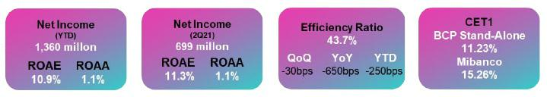

Economic activity is getting close to pre-pandemic levels, showing during the first half of the year a rebound of around 20% YoY, and standing only 0.5% below the figure reported for the same period in 2019. This recovery occurs amid a favorable external environment of high copper prices, expansionary monetary and fiscal policies, as well as a greater opening of the economy as the sanitary conditions improve (the mortality rate has rapidly fallen after a peak in the beginning of 2Q21, and the vaccination rate has accelerated to almost 35% of the population over 18 with at least one shot). However, the current political and regulatory uncertainty is raising the risk perception.

Loan Growth

QoQ growth in average daily balances and quarter-end balances was driven primarily by an uptick in structural loans in the Wholesale Banking and SME-Business segments; this was offset by a drop in balances in Government Program (“GP”) loans. YoY and YTD, the result was spurred by growth in GP loans at very attractive rates in the SME-Pyme and SME-Business segments.
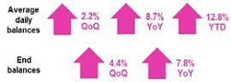

Net interest income and Margin

NII increased QoQ due to a context marked by structural loan growth, improved funding mix to lower funding deposits, and the fact that in 1Q21, a non-recurring expense was reported for a subordinated bond exchange. If we exclude the effect of the bond exchange, NII still registers growth and shows an upward trend, due to the loan portfolio evolution and the reduction in the cost of funds.
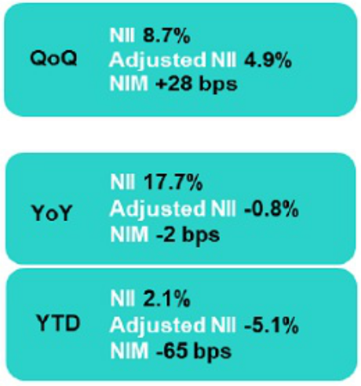

NII in YoY and YTD terms grew due to the one-off impairment charge registered in 2Q20. If we exclude this charge, YoY and YTD NII contracts due to the mix of less profitable assets from the lower volume of structural loans, which is partially offset by a decrease in funding rates and an improvement in the funding mix.

Net Provisions for Loan Losses and Portfolio Quality

Provisions fell QoQ due to improvements in the Probability of Default (“PD”) for Retail Banking and a decrease in the volume of loans that advanced to stage 3. This was offset by an increase in net provisions for loan losses in Wholesale Banking, which accompanied loan growth. The YoY and YTD decreased due to the forward-looking provisions that were set aside at the beginning of the pandemic.
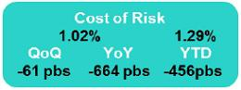

NPL ratio registered a contraction, due to the reduction of the refinanced portfolio and, in the other hand, an increase of structural loans. The aforementioned offsets the uptick of the IOL portfolio, driven by higher maturities of GP loans. If we exclude GP effect, the structural NPL ratio ascends to 5.38%.
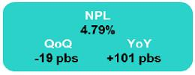

4

Core non-financial income

Growth in Core NII, which was fueled by an uptick in fees at BCP driven by international transfer and at Credicorp Capital due to brokerage fees and up-front fee to clients that entered to international platform through ASB.
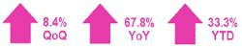

Non-financial income

BCP Stand-alone made a move to reduce interest rates sensitivity in its investment at fair value with changes in other comprehensive income portfolio by selling sovereign bonds at a loss. This was partially offset by a gain on the exchange position. This strategy led to a contraction in the non-core NFI in the quarter and in QoQ NFI. YoY and YTD increase, which was spurred primarily by a recovery in fee income in Universal Banking and Microfinance.


Underwriting Result

The underwriting result was negative QoQ, YoY and YTD due to an increase in claims in the Life business after a peak in mortality was reached in April during the second wave. This trend has begun to turn around.

Operating Efficiency

The efficiency ratio was 43.7%, which represented a 30-bps improvement QoQ. This increase was spurred by growth in core income, including NII as well as fees and gains on foreign exchange transactions, which combined, lifted core income to levels close to those seen pre-pandemic. YoY and YTD, the ratio improved 650 bps and 250 bps respectively, driven by growth in NII, fee income and net premiums.

Net Income at Credicorp and Contribution by Business Line

Contribution* and ROAE by subsidiary in 2Q21 (S/ millions)

Credicorp Consolidated: Net Income of S/699 million, ROAE of 11.3%
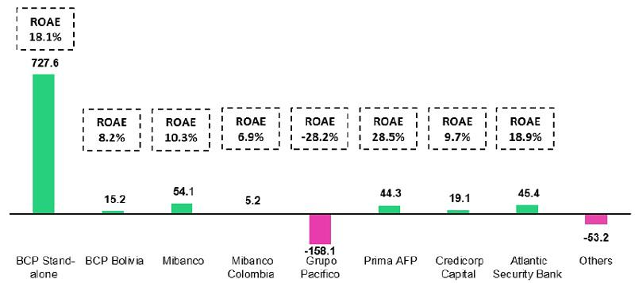

*Contributions to Credicorp reflect the eliminations for consolidation purposes (e.g. eliminations for transactions among Credicorp’s subsidiaries or between Credicorp and its subsidiaries).

- In Mibanco, the figure is lower than the net income because Credicorp owns 99.921% of Mibanco (directly and indirectly). ROAE including goodwill of BCP from the acquisition of Edyficar (Approximately US$ 50.7 million) was 52.2% in 2Q20, 2.5% in 1Q21 and 9.7% in 2Q21. YTD was -23.1% for June 2020 and 6.1% for June 2021.
- In Grupo Pacifico, the contribution is higher than the net income because Credicorp owns 65.20% directly, and 33.57% through Grupo Credito. Figures include unrealized gains or losses that are considered in Pacifico’s Net Equity from the investment portfolio of Pacifico Vida. ROAE excluding such unrealized gains was 16.7% in 2Q20, -17.6% in 1Q21 and -32.6% in 2Q21. YTD was 17.0% for June 2020 and -24.2% for June 2021.

- Others includes Grupo Credito excluding Prima (Servicorp and Emisiones BCP Latam), others of Atlantic Security Holding Corporation and others of Credicorp Ltd.

5

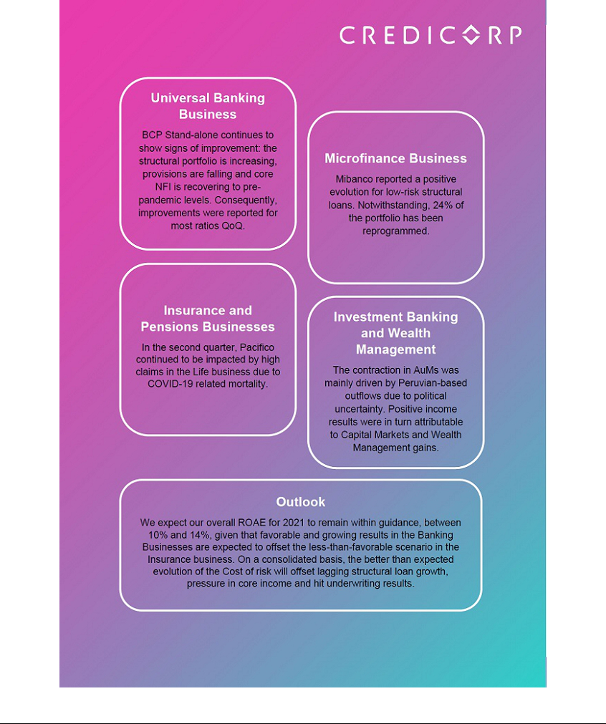

Overview Financial Information: Second Quarter 2021

Credicorp Ltd. |  |  |  |  | Quarter |  |  |  | % change |  |  |  |  | YTD |  |  |  |  | % change
 | S/ 000 |  | 2Q20 |  | 1Q21 |  | 2Q21 |  | QoQ |  |  | YoY |  | Jun 20 |  |  | Jun 21 |  | 2021 / 2020
 | Net interest, similar income and expenses |  | 1,961,350 |  | 2,123,383 |  | 2,309,042 |  | 8.7% |  |  | 17.7% |  | 4,340,877 |  |  | 4,432,425 |  | 2.1%
 | Provision for credit losses on loan portfolio, net of
recoveries |  |  | (2,540,457) |  | (557,647) |  | (363,380) |  | -34.8% |  |  | -85.7% |  | (3,881,938) |  |  | (921,027) |  | -76.3%
 | Net interest, similar income and expenses, after |  | (579,107) |  | 1,565,736 |  | 1,945,662 |  | 24.3% |  |  | n.a |  | 458,939 |  |  | 3,511,398 |  | 665.1%
 | provision for credit losses on loan portfolio
 | Total other income |  | 1,015,663 |  | 1,194,530 |  | 1,191,694 |  | -0.2% |  |  | 17.3% |  | 1,973,918 |  |  | 2,386,224 |  | 20.9%
 | Insurance underwriting result |  | 135,680 |  | (65,247) |  | (136,335) |  | 109.0% |  |  | n.a |  | 277,606 |  |  | (201,582) |  | n.a
 | Total other expenses |  | (1,628,398) |  | (1,680,271) |  | (1,860,447) |  | 10.7% |  |  | 14.3% |  | (3,407,704) |  |  | (3,540,718) |  | 3.9%
 | Profit (loss) before income tax |  | (1,056,162) |  | 1,014,748 |  | 1,140,574 |  | 12.4% |  |  | n.a |  | (697,241) |  |  | 2,155,322 |  | n.a
 | Income tax |  | 414,726 |  | (337,599) |  | (423,491) |  | 25.4% |  |  | n.a |  | 268,980 |  |  | (761,090) |  | n.a
 | Net profit (loss) |  | (641,436) |  | 677,149 |  | 717,083 |  | 5.9% |  |  | n.a |  | (428,261) |  |  | 1,394,232 |  | n.a
 | Non-controlling interest |  | (21,046) |  | 16,351 |  | 17,614 |  | 7.7% |  |  | n.a |  | (17,145) |  |  | 33,965 |  | n.a
 | Net profit (loss) attributable to Credicorp |  | (620,390) |  | 660,798 |  | 699,469 |  | 5.9% |  |  | n.a |  | (411,116) |  |  | 1,360,267 |  | n.a
 | Net profit (loss) / share (S/) |  | (7.78) |  | 8.28 |  | 8.77 |  | 5.9% |  |  | n.a |  | (5.15) |  |  | 17.05 |  | n.a
 | Loans |  | 132,741,720 |  | 137,031,239 |  | 143,091,752 |  | 4.4% |  |  | 7.8% |  | 132,741,720 |  |  | 143,091,752 |  | 7.8%
 | Deposits and obligations |  | 129,664,332 |  | 148,626,339 |  | 149,161,803 |  | 0.4% |  |  | 15.0% |  | 129,664,332 |  |  | 149,161,803 |  | 15.0%
 | Net equity |  | 23,396,062 |  | 24,529,958 |  | 25,073,706 |  | 2.2% |  |  | 7.2% |  | 23,396,062 |  |  | 25,073,706 |  | 7.2%
 | Profitability
 | Net interest margin |  | 4.03% |  | 3.73% |  | 4.01% |  | 28bps |  |  | -2bps |  | 4.55% |  |  | 3.90% |  | -65bps
 | Risk-adjusted Net interest margin |  | -1.19% |  | 2.75% |  | 3.38% |  | 63bps |  |  | 457bps |  | 0.48% |  |  | 3.09% |  | 261bps
 | Funding cost |  | 1.86% |  | 1.43% |  | 1.18% |  | -25bps |  |  | -68bps |  | 1.95% |  |  | 1.31% |  | -64bps
 | ROAE |  | -10.7% |  | 10.7% |  | 11.3% |  | 60bps |  |  | 2200bps |  | -3.3% |  |  | 10.9% |  | 1420bps
 | ROAA |  | -1.2% |  | 1.1% |  | 1.1% |  | 0bps |  |  | 230bps |  | -0.4% |  |  | 1.1% |  | 150bps
 | Loan portfolio quality
 | Internal overdue ratio ⁽¹⁾ |  | 2.89% |  | 3.55% |  | 3.53% |  | -2bps |  |  | 64bps |  | 2.89% |  |  | 3.53% |  | 64bps
 | Internal overdue ratio over 90 days |  | 2.35% |  | 2.77% |  | 2.67% |  | -10bps |  |  | 32bps |  | 2.35% |  |  | 2.67% |  | 32bps
 | NPL ratio ⁽²⁾ |  | 3.78% |  | 4.98% |  | 4.79% |  | -19bps |  |  | 101bps |  | 3.78% |  |  | 4.79% |  | 101bps
 | Cost of risk ⁽³⁾ |  | 7.66% |  | 1.63% |  | 1.02% |  | -61bps |  |  | -664bps |  | 5.85% |  |  | 1.29% |  | -456bps
 | Coverage ratio of IOLs |  | 218.9% |  | 200.2% |  | 185.8% |  | -1440bps |  |  | -3310bps |  | 218.9% |  |  | 185.8% |  | -3310bps
 | Coverage ratio of NPLs |  | 167.5% |  | 142.9% |  | 137.0% |  | -590bps |  |  | -3050bps |  | 167.5% |  |  | 137.0% |  | -3050bps
 | Operating efficiency
 | Efficiency ratio ⁽⁴⁾ |  | 50.2% |  | 44.0% |  | 43.7% |  | -30bps |  |  | -650bps |  | 46.4% |  |  | 43.9% |  | -250bps
 | Operating expenses / Total average assets |  | 3.07% |  | 2.83% |  | 2.96% |  | 13bps |  |  | -11bps |  | 3.26% |  |  | 2.92% |  | -40bps
 | Insurance ratios
 | Combined ratio of P&C ⁽⁵⁾ ⁽⁶⁾ |  | 79.8% |  | 85.5% |  | 88.9% |  | 340bps |  |  | 910bps |  | 79.8% |  |  | 88.9% |  | 910bps
 | Loss ratio ⁽⁶⁾ |  | 59.8% |  | 96.4% |  | 107.4% |  | 1100bps |  |  | 4760bps |  | 59.8% |  |  | 101.8% |  | 4200bps
 | Capital adequacy - BCP Stand-alone (7)
 | BIS ratio ⁽⁸⁾ |  | 14.80% |  | 16.46% |  | 15.34% |  | -112bps |  |  | 54bps |  | 14.80% |  |  | 15.34% |  | 54bps
 | Tier 1 ratio ⁽⁹⁾ |  | 10.54% |  | 10.59% |  | 10.31% |  | -28bps |  |  | -23bps |  | 10.54% |  |  | 10.31% |  | -23bps
 | Common equity tier 1 ratio ⁽¹⁰⁾ |  | 11.22% |  | 11.11% |  | 11.23% |  | 12bps |  |  | 1bps |  | 11.22% |  |  | 11.23% |  | 1bps
 | Capital adequacy - Mibanco ⁽⁷⁾
 | BIS ratio ⁽⁸⁾ |  | 15.94% |  | 17.87% |  | 17.22% |  | -65bps |  |  | 128bps |  | 15.94% |  |  | 17.22% |  | 128bps
 | Tier 1 ratio ⁽⁹⁾ |  | 13.83% |  | 14.48% |  | 14.66% |  | 18bps |  |  | 83bps |  | 13.83% |  |  | 14.66% |  | 83bps
 | Common equity tier 1 ratio ⁽¹⁰⁾ |  | 14.54% |  | 14.88% |  | 15.26% |  | 38bps |  |  | 72bps |  | 14.54% |  |  | 15.26% |  | 72bps
 | Employees |  | 38,219 |  | 36,233 |  | 35,776 |  | -1.3% |  |  | -6.4% |  | 38,219 |  |  | 35,776 |  | -6.4%
 | Share Information
 | Outstanding Shares |  | 94,382 |  | 94,382 |  | 94,382 |  | 0.0% |  |  | 0.0% |  | 94,382 |  |  | 94,382 |  | 0.0%
 | Treasury Shares ⁽¹¹⁾ |  | 14,977 |  | 14,872 |  | 14,866 |  | 0.0% |  |  | -0.7% |  | 14,977 |  |  | 14,866 |  | -0.7%
 | Floating Shares |  | 79,405 |  | 79,510 |  | 79,516 |  | 0.0% |  |  | 0.1% |  | 79,405 |  |  | 79,516 |  | 0.1%

- Internal overdue loans includes overdue loans and loans under legal collection, according to our internal policy for overdue loans. Internal Overdue ratio: Internal overdue loans / Total loans.

- Non-performing loans (NPL): Internal overdue loans + Refinanced loans. NPL ratio: NPL / Total loans.
- Cost of risk: Annualized provision for loan losses, net of recoveries / Total loans.
- Efficiency ratio = (Salaries and employee benefits + Administrative expenses + Depreciation and amortization + Association in participation + Acquisition cost) / (Net interest, similar income and expenses + Fee Income + Net gain on foreign exchange transactions + Net Gain From associates + Net gain on derivatives held for trading + Result on exchange differences + Net Premiums Earned).

- Combined ratio = (Net claims / Net earned premiums) + [(Acquisition cost + Operating expenses) / Net earned premiums]. Does not include Life insurance business.
- Considers Grupo Pacifico's figures before eliminations for consolidation to Credicorp.
- All Capital ratios are for BCP Stand-alone and based on Peru GAAP.
- Regulatory Capital / Risk-weighted assets (legal minimum = 10% since July 2011).
- Tier 1 = Capital + Legal and other capital reserves + Accumulated earnings with capitalization agreement + (0.5 x Unrealized profit and net income in subsidiaries) - Goodwill - (0.5 x Investment in subsidiaries) + Perpetual subordinated debt (maximum amount that can be included is 17.65% of Capital + Reserves + Accumulated earnings with capitalization agreement + Unrealized profit and net income in subsidiaries - Goodwill).

- Common Equity Tier I = Capital + Reserves – 100% of applicable deductions (investment in subsidiaries, goodwill, intangibles and net deferred taxes that rely on future profitability) + retained earnings + unrealized gains.

Adjusted Risk-Weighted Assets = Risk-weighted assets - (RWA Intangible assets, excluding goodwill, + RWA Deferred tax assets generated as a result of temporary differences in income tax, in excess of 10% of CET1, + RWA Deferred tax assets generated as a result of past losses)."

- These shares are held by Atlantic Security Holding Corporation (ASHC) and for shared based payments.

7

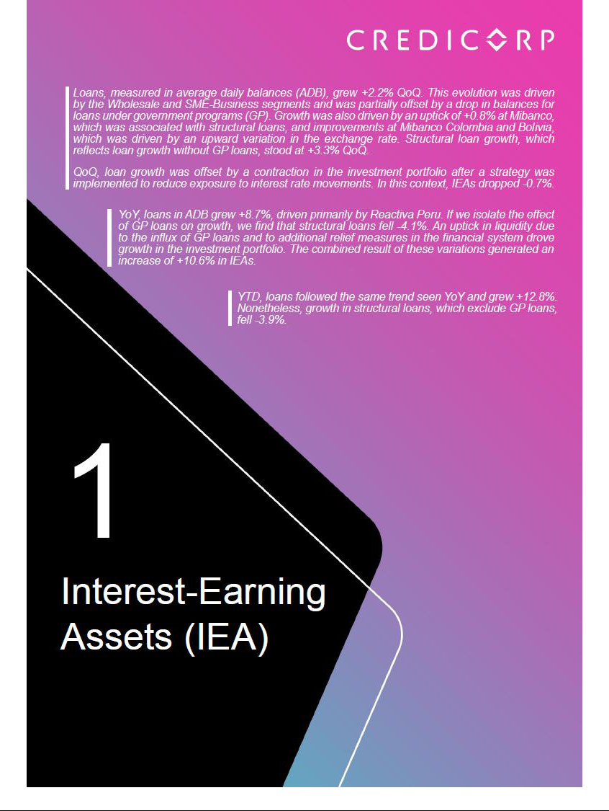

1. Interest Earning Assets (IEAs)
Interest earning assets |  |  |  | As of |  |  |  | % change
S/ 000 |  | Jun 20 |  | Mar 21 |  | Jun 21 |  | QoQ |  |  | YoY
Cash and due from banks⁽¹⁾ |  | 29,425,115 |  | 31,831,948 |  | 29,058,684 |  | -8.7% |  |  | -1.2%
Interbank funds |  | 5,403 |  | 63,301 |  | 16,790 |  | -73.5% |  |  | 210.8%
Total investments |  | 41,637,044 |  | 59,412,732 |  | 54,772,644 |  | -7.8% |  |  | 31.5%
Cash collateral, reverse repurchase agreements and securities
borrowing |  | 2,920,789 |  | 1,769,690 |  | 1,616,654 |  | -8.6% |  |  | -44.7%
Financial assets designated at fair value through profit or loss |  | 662,634 |  | 888,420 |  | 921,851 |  | 3.8% |  |  | 39.1%
Total loans |  | 132,741,720 |  | 137,031,239 |  | 143,091,752 |  | 4.4% |  |  | 7.8%
Total interest earning assets |  | 207,392,705 |  | 230,997,330 |  | 229,478,375 |  | -0.7 | % |  | 10.6 | %

(1) Figures differ from previously reported, please consider the data presented on this report.

1.1. Structure and Evolution of IEA

Composition of IEA

At the end of June 2021, loans, our most profitable asset, represented 62.3% of IEAs, followed by investments with 23.9%, and other assets ¹ with 13.8%.
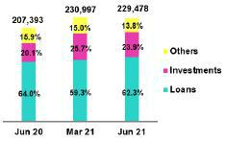

The IEA structure evolved favorably QoQ due to the loan growth and a drop in investments and available funds, which led loans to register an increase in their share of total IEA. YoY, the IEA structure followed an opposite trend, which was driven by an uptick in liquidity due to GP loans and growth in investment purchases to make surplus cash more profitable. This scenario led the share of loans in total IEAs to drop.

Total Loans in Quarter-end Balances

QoQ, quarter-end balances increased 4.4% in a context of mixed evolutions at the portfolio level:

- Growth was driven by Wholesale Banking, which registered an increase in loan disbursements for working capital and medium-term financing in LC in a context marked by economic recovery and an uptick in financing needs in the Corporate and Middle-Market segments.

- The Retail Banking portfolio fell slightly, which partially offset growth in Wholesale Banking. Growth in the SME-Business and Consumer segments was insufficient to offset the drop in balances in the SME-Pyme, Mortgage and Credit Card segments.

- Mibanco’s portfolio registered a modest increase, where disbursement levels for structural loans fell slightly below those reported last quarter. Balances at BCP Bolivia posted a more marked increase due to the depreciation of LC.

If we exclude the loans issued under government programs (Reactiva Perú and FAE-Mype) from the calculation base, structural loans registered growth of +6.5% QoQ.

YoY, loans measured in quarter-end balances increased +7.8% due to:

- Growth in the Retail Banking portfolio at BCP Stand-alone, which was led by SME-Pyme and SME-Business (in order of contribution to growth) after both registered an uptick in disbursements for working capital loans in LC through Reactiva Peru. The Mortgage and Consumer segments also drove the overall increase, albeit to a lesser extent. On the contrary, the Credit Card segment registered a contraction in balances due to a decrease in card use during the pandemic.

- Growth in the Mibanco portfolio, which was driven by disbursements through Reactiva Peru and FAE-Mype and to an increase in balances for Bolivia’s portfolio. The uptick in the latter was mainly attributable to the exchange rate effect generated by a depreciation in LC and, in a lesser extent, disbursements for wholesale clients.

- Includes Cash and Due from Banks; Interbank Funds; Cash Collateral,reverse repurchase agreements, and securities borrowings, and Financial Assets designated at fair value through profit or loss.

9

- Growth in the total portfolio was partially offset by a decrease in Wholesale Banking, after fewer businesses sought out loans due to confinement measures and/or to the fact that many had already shored up their liquidity at the beginning of the pandemic.

If we exclude loans granted through GP loans from the calculation base, we find that loans in the “Structural Portfolio” in quarter-end balances register +2.0% growth YoY.

It is important to note that growth QoQ and YoY in loans in quarter-end balances is attributable to the exchange rate effect generated by a +2.7% QoQ and +9.0% YoY appreciation in the US dollar. If we isolate the exchange rate effect, in real terms, total loans rose +3.5% QoQ and +4.7% YoY while structural loans reported an increase of +5.3% QoQ but dropped -1.5% YoY. At the end of June 2021, FC loans registered a 34.2% share of total loans, which topped the 32.6% reported in March 2021 but fell below the 35.5% reported in June 2020. QoQ growth was attributable to an increase in disbursements for FC loans in the Middle Market Banking, SME-Business and Credit Card segments while the YoY drop was driven by disbursements for GP loans in LC and a decline in FC loans, particularly in the Wholesale Banking portfolio.

Total Investments
Total Investments |  |  |  | As of |  |  |  | % change
S/ 000 |  | Jun 20 |  | Mar 21 |  | Jun 21 |  | QoQ |  |  | YoY
Fair value through profit or loss investments |  | 5,118,994 |  | 8,083,128 |  | 6,791,288 |  | -16.0% |  |  | 32.6%
Fair value through other comprehensive income investments |  | 32,213,665 |  | 45,681,969 |  | 40,273,400 |  | -11.8% |  |  | 25.0%
Amortized cost investments |  | 4,304,385 |  | 5,647,635 |  | 7,707,956 |  | 36.5% |  |  | 79.1%
Total investments |  | 41,637,044 |  | 59,412,732 |  | 54,772,644 |  | -7.8 | % |  | 31.5 | %

Total investments fell -7.8% but increased +31.5% YoY. The QoQ evolution was primarily driven by the strategy to reduce exposure to interest rate movements through the sale in the fair value through profit or loss and other comprehensive income investment portfolios and increase the amortized cost accounting portfolio at BCP Stand-alone. Efforts to purchase certificates of deposit after their expirations ceased to maintain liquidity levels.

YoY, growth in investments was driven by loans through government programs, whose funds drove an uptick in deposit balances and liquidity system-wide that was reflected in a considerable increase in liquidity at BCP Stand-alone. This surplus liquidity was used profitably through investments in certificates of deposit and sovereign bonds, particularly in LC.

Other IEA

Available funds fell -8.7% QoQ and -1.2% YoY. This evolution was driven by capital flight from BCP and Mibanco accounts after balances were transferred abroad in a context of high political uncertainty and to take advantage of deposits in US Dollars in other financial entities that offer more attractive rates. Liquid assets associated with liability management operations at BCP Stand-alone in 1Q21, and the subsequent payment of the balance for bond repurchases in 2Q21, also fueled this account’s result.

1.2. Credicorp Loans

1.2.1. Evolution of loans in average daily balances (ADB)

The ADB for loans registered growth of +2.2% QoQ and +8.7% YoY. The QoQ evolution was driven primarily to growth in the Wholesale portfolio. YoY growth was attributable to an uptick in balances in the SME-Pyme segment and Retail Bankings at BCP Stand-alone, which was driven by BCP’s participation in Reactiva Peru. If we exclude loans from government programs from the calculation base, we see that Structural Loans grew 3.3% QoQ but fell -4.0% YoY. Higher growth in the structural portfolio in QoQ terms versus YoY terms was attributable to gradual amortization of loans under government programs.

ADB balances provide the most complete picture of how loan interest, which constitutes Credicorp’s primary source of income, has evolved. Additionally, average daily balances reflect trends or variations to a different degree than quarter-end balances which may include pre-payments or loans made at the end of the quarter. In comparative terms, these payments, affect average daily balances less than quarter-end balances and as such, the former provide a more balanced picture of loan evolution.

10

Evolution of ADB of loans by business segment ⁽¹⁾⁽²⁾⁽³⁾

 |  |  |  |  |  |  |  | TOTAL LOANS |  |  |  |  |  |  |  |  |  |  |  |  |  |  |  |  |  |  |  | % change
 |  | Expressed in million S/ |  |  |  |  |  |  |  |  |  |  | Structural |  |  |  |  |  |  |  | % change |  |  |  |  |  |  | Structural |  |  |  |  |  |  | % Part. in total loans |  |  |  |  |  |  |  | Structural
 |  | 2Q20 |  |  | 1Q21 |  |  | 2Q21 |  |  | 2Q20 |  |  |  | 1Q21 |  |  | 2Q21 |  | QoQ |  |  | YoY |  |  |  | QoQ |  |  | YoY |  |  |  | 2Q20 |  |  | 1Q21 |  |  | 2Q21 |  |  |  | 2Q21
BCP Stand-alone |  | 106,610 |  |  | 111,969 |  |  | 114,614 |  |  | 99,218 |  |  | 90,319 |  |  |  | 93,595 |  | 2.4% |  |  | 7.5% |  |  |  | 3.6% |  |  | -5.7% |  |  |  | 82.9% |  |  | 81.9% |  |  | 82.0% |  |  |  | 80.7%
Wholesale Banking |  | 55,940 |  |  | 49,860 |  |  | 51,862 |  |  | 52,628 |  | 43,518 |  |  |  |  | 46,067 |  | 4.0% |  |  | -7.3% |  |  | 5.9% |  |  |  | -12.5% |  |  |  | 43.5% |  |  | 36.5% |  |  | 37.1% |  |  | 39.7%
Corporate |  | 34,028 |  |  | 27,271 |  |  | 28,869 |  |  | 33,572 |  | 26,621 |  |  |  |  | 28,288 |  |  | 5.9% |  | -15.2% |  |  |  | 6.3% |  |  |  | -15.7% |  |  | 26.5% |  |  | 19.9% |  |  | 20.7% |  |  | 24.4%
Middle - Market |  | 21,912 |  |  | 22,590 |  |  | 22,993 |  |  | 19,056 |  | 16,898 |  |  |  |  | 17,780 |  |  | 1.8% |  | 4.9% |  |  |  | 5.2% |  |  |  | -6.7% |  |  | 17.0% |  |  | 16.5% |  |  | 16.5% |  |  | 15.3%
Retail Banking |  | 50,670 |  |  | 62,109 |  |  | 62,752 |  |  | 46,590 |  | 46,801 |  |  |  |  | 47,528 |  | 1.0% |  |  | 23.8% |  |  | 1.6% |  |  |  | 2.0% |  |  |  | 39.4% |  |  | 45.4% |  |  | 44.9% |  |  | 41.0%
SME - Business |  | 7,532 |  |  | 10,793 |  |  | 11,279 |  |  | 5,262 |  | 4,287 |  |  |  |  | 4,866 |  | 4.5% |  |  | 49.8% |  |  | 13.5% |  |  |  | -7.5% |  |  |  | 5.9% |  |  | 7.9% |  |  | 8.1% |  |  | 4.2%
SME - Pyme |  | 11,928 |  |  | 19,562 |  |  | 19,647 |  |  | 10,118 |  | 10,760 |  |  |  |  | 10,836 |  | 0.4% |  |  | 64.7% |  |  |  | 0.7% |  |  |  | 7.1% |  |  | 9.3% |  |  | 14.3% |  |  | 14.1% |  |  | 9.3%
Mortgage |  | 16,939 |  |  | 17,720 |  |  | 17,884 |  |  | 16,939 |  | 17,720 |  |  |  |  | 17,884 |  | 0.9% |  |  | 5.6% |  |  | 0.9% |  |  |  |  | 5.6% |  |  | 13.2% |  |  | 13.0% |  |  | 12.8% |  |  | 15.4%
Consumer |  | 9,118 |  |  | 9,958 |  |  | 10,076 |  |  | 9,118 |  | 9,958 |  |  |  |  | 10,076 |  | 1.2% |  |  | 10.5% |  |  | 1.2% |  |  |  |  | 10.5% |  |  | 7.1% |  |  | 7.3% |  |  | 7.2% |  |  | 8.7%
Credit Card |  | 5,153 |  |  | 4,075 |  |  | 3,866 |  |  | 5,153 |  | 4,075 |  |  |  |  | 3,866 |  | -5.1% |  |  | -25.0% |  |  | -5.1% |  |  |  | -25.0% |  |  |  | 4.0% |  |  | 3.0% |  |  | 2.8% |  |  | 3.3%
Mibanco |  | 10,823 |  |  | 12,923 |  |  | 13,023 |  |  | 10,508 |  | 10,102 |  |  |  |  | 10,232 |  | 0.8% |  |  | 20.3% |  |  |  | 1.3% |  |  | -2.6% |  |  |  | 8.4% |  |  | 9.5% |  |  | 9.3% |  |  | 8.8%
Mibanco Colombia |  | 758 |  |  | 909 |  |  | 963 |  |  | 758 |  | 909 |  |  |  |  | 963 |  | 5.9% |  |  | 27.0% |  |  | 5.9% |  |  |  | 27.0% |  |  |  | 0.6% |  |  | 0.7% |  |  | 0.7% |  |  | 0.8%
Bolivia |  | 7,902 |  |  | 8,420 |  |  | 8,747 |  |  | 7,902 |  | 8,420 |  |  |  |  | 8,747 |  | 3.9% |  |  | 10.7% |  |  | 3.9% |  |  |  | 10.7% |  |  |  | 6.1% |  |  | 6.2% |  |  | 6.3% |  |  | 7.5%
ASB |  | 2,443 |  |  | 2,509 |  |  | 2,390 |  |  | 2,443 |  | 2,509 |  |  |  |  | 2,390 |  | -4.7% |  |  | -2.2% |  |  | -4.7% |  |  |  | -2.2% |  |  |  | 1.9% |  |  | 1.8% |  |  | 1.7% |  |  | 2.1%
BAP's total loans |  | 128,536 |  |  | 136,730 |  |  | 139,736 |  |  | 120,829 |  |  |  | 112,258 |  |  | 115,927 |  |  | 2.2 | % |  | 8.7 | % |  |  | 3.3 | % |  | -4.1 | % |  |  | 100.0 | % |  | 100.0 | % |  | 100.0 | % |  |  | 100.0 | %



Largest contraction in volumes
Highest growth in volumes

For consolidation purposes, loans generated in FC are converted to LC.
- Include work out unit and other banking.
- Structural Portfolio excludes the average daily balances from loans offered through de Reactiva Peru y FAE-Mype Government Programs.
- Figures differ from previously reporte, please consider the data presented on this report that now inclides Mibanco Colombia.

QoQ growth in ADB for loans by segments

Expressed in millions S/

+2.2% (+3.3% Structural Portfolio)
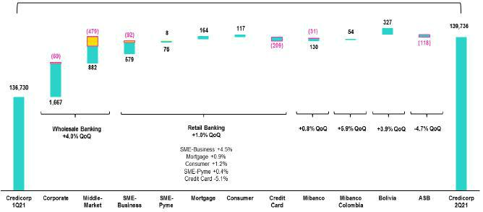

Government Programs (Reactiva y FAE-Mype)
Structural

The figure above shows that the +2.2% increase QoQ (+3.3% structural) in loans measured in ADB was the result of the evolution of the Wholesale Banking portfolio:

The Wholesale Banking portfolio increased +4.0% QoQ in ADB, which was attributable to growth in structural balances in the Corporate Segment and, to a lesser extent, in the Middle-Market Segment balances. These upticks were primarily driven by economic recovery and by campaigns in the fishing and agricultural sector. Consequently, financing needs in the Wholesale Segment increased, in particular for working capital and medium-term loans.

The Retail Banking portfolio registered a positive evolution of +1.0 QoQ in ADB after the increase of the balances in the SME-Business, Mortgage, Consumer and SME-Pyme segments. Structural loans in the SME-Business segment reversed a downward trend this quarter after GP loans ceased and economic recovery launched. The Mortgage, Consumer and SME-Pyme segments presented slight growth since 4Q20 after having been highly impacted by the sanitary crisis and contention measures in 2020. On the contrary, loans in the Credit Card segment continued to register a downward trend after the use of this product fell due to the pandemic and after clients has used liquidity to reduce their balances.

11

Mibanco’s loan portfolio grew +0.8% QoQ due to the structural loan disbursements, which fell slightly with regard to last quarter. If we exclude GP loans from the calculation base, the structural portfolio at Mibanco grew +1.3% QoQ. Mibanco Colombia registered high levels of disbursements until June, when the company and clients adopted a more cautious attitude in a context of social protests and elevated tension. The exchange rate effect generated by an uptick in the value of the US dollar also impacted growth in this portfolio.

At BCP Bolivia, the loan portfolio grew +3.9% QoQ mainly due to an increase in the exchange rate and some disbursements to wholesale clients that offset the drop in the SME-Pyme and micro segments.

YoY growth in ADB of loans by segment

Expressed in millions of S/

+8.7% (-4.1% Structural Portfolio)
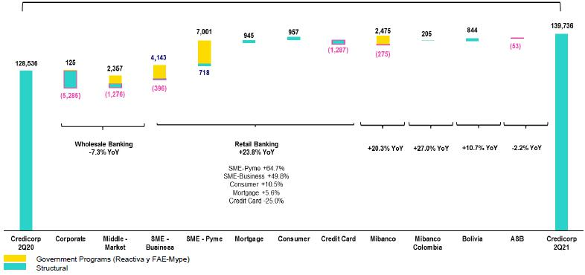

An analysis of YoY growth per segment measured in ADB shows:

Within Retail Banking, growth was led by significant expansion in the business segments of SME (+64.7% YoY) and SME-Business (+49.8% YoY) due to the influx of loans under Reactiva Peru. Growth in Consumer (+10.5% YoY) and Mortgage (+5.6% YoY), which absorbed the brunt of the pandemic and quarantine measures in 2020 through the third quarter but registered an upward trend in 4Q20 due to economic recovery, also drove overall growth year-on-year. Credit Card balances fell (-25% YoY) due to the impact of the sanitary crisis, containment measures, a decrease in the appetite for risk and the fact that clients have used liquidity to reduce their balances. If we exclude government programs from the calculation base, SME-Pyme grew +7.1% YoY while SME-Business contracted -7.5% YoY.

The Wholesale Banking portfolio dropped -7.3% YoY. Within this portfolio, Middle Market banking registered growth of +4.9% YoY due to Reactiva Peru while Corporate Banking fell -15.2% YoY given that clients requested less financing. Variations were also impacted by the exchange rate effect generated by the appreciation of the US dollar. It is important to note that 42.2% of the loans in the Middle Market segment and 56.5% of the Corporate Segment are in FC. If we exclude the exchange rate effect, the Middle Market segment reported growth of +1.6% while Corporate Banking registered a decrease of -18.7% in real terms. If we exclude loans granted under government programs from the calculation base, Middle Market Banking fell -6.7% YoY and Corporate Banking, -15.7%.

Loan growth of +20.3% YoY at Mibanco was driven by government loans under Reactiva Peru and FAE-Mype. Reactiva and FAE loans represented approximately 21% of Mibanco’s portfolio in average daily balances in 2Q21. If we exclude government loans from the calculation base, Mibanco’s structural loans fell -2.6% YoY in ADB. At Mibanco Colombia, the portfolio grew +27% YoY due to an uptick in disbursements and on-target operating and commercial strategies, which have been implemented hand-in-hand with the sales force. Nevertheless, dynamism has been affected by a decrease in the commercial appetite in a context of social tensions. It is important to note that the exchange rate effect has also contributed to this growth. If we exclude this effect, the portfolio at Mibanco Colombia grew 17.6% YoY.

12

Growth of +10.7% YoY in loans at BCP Bolivia was mainly driven by the exchange rate effect. If we exclude this effect, loans at BCP Bolivia grew +2.5% YoY mainly because of an uptick in wholesale disbursements and refinancing. It is important to note that uncertainty due to the on-going sanitary crisis has reduced the commercial appetite at BCP Bolivia, which is reflected by a drop in disbursements rates.

YTD growth in ADB of loans by segment

Expressed in millions of S/

+12.8% (-3.9% Structural Portfolio)
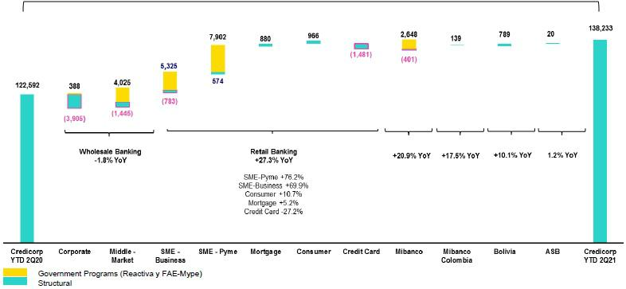

Variations in YTD figures for ADB registered a trend similar to that same YoY, where the Retail Banking portfolio led expansion through Reactive loans to the SME-Pyme and Business segments. Next in line as drivers of growth were the Consumer and Mortgage segments, whose recovery, however, only partially offset the drop in Credit Card balances. Corporate Banking reported a decrease in balances due to a drop in the structural of loan disbursements; the uptick in Middle Market Banking was insufficient to offset this decline. YTD, growth at Mibanco Peru, Colombia and BCP Bolivia evolved along the lines similar to those seen YoY while ASB’s result reflects growth registered in 1Q21.

1.2.2. Evolution of the dollarization level of Credicorp loans by segment

Evolution of average daily balances by currency ⁽¹⁾⁽²⁾⁽³⁾

 |  |  |  |  |  |  |  |  |  |  |  |  |  |  |  |  |  |  |  |  |  |  |  |  |  |  |  |  |  |  |  |  |  |  |  |  | % part. by
 |  |  |  |  | DOMESTIC CURRENCY LOANS |  |  |  |  |  |  |  |  |  |  |  |  |  |  |  | % change |  |  |  | FOREIGN CURRENCY LOANS |  |  |  |  |  |  |  |  |  |  |  | currency
 | Expressed in million S/ |  |  |  |  |  |  |  | Structural |  |  |  |  | % change |  |  |  |  |  |  | Structural |  |  |  |  | Expressed in million US$ |  |  |  |  |  |  |  |  |  |  | 2Q21
 | 2Q20 |  | 1Q21 |  | 2Q21 |  | 2Q20 |  | 1Q21 |  | 2Q21 |  |  | QoQ |  |  |  | YoY |  |  | QoQ |  | YoY |  | 2Q20 |  | 1Q21 |  | 2Q21 |  | QoQ |  |  | YoY |  |  | LC |  | FC
BCP Stand-
alone | 70,856 |  | 80,117 |  | 80,960 |  | 63,464 |  | 58,466 |  | 59,941 |  |  | 1.1% |  |  |  | 14.3% |  |  | 2.5% |  | -5.6% 10,371 |  |  | 8,654 |  |  | 8,805 |  | 1.7% |  |  | -15.1% |  | 70.6% |  |  | 29.4%
Wholesale
Banking | 27,207 |  | 24,935 |  | 25,860 |  | 23,895 |  | 18,593 |  | 20,065 |  |  | 3.7% |  |  |  | -5.0% |  |  | 7.9% |  | -16.0% |  | 8,335 | 6,772 |  |  | 6,803 |  | 0.5% |  |  | -18.4% |  | 49.9% |  |  | 50.1%
Corporate | 15,245 |  | 11,538 |  | 12,572 |  | 14,789 |  | 10,887 |  | 11,990 |  |  | 9.0% |  |  |  | -17.5% |  |  | 10.1% |  | -18.9% |  | 5,449 | 4,275 |  |  | 4,264 |  | -0.3% |  |  | -21.8% |  | 43.5% |  |  | 56.5%
Middle-
Market | 11,962 |  | 13,398 |  | 13,288 |  | 9,105 |  | 7,706 |  | 8,074 |  |  | -0.8% |  |  |  | 11.1% |  |  | 4.8% |  | -11.3% |  | 2,886 | 2,497 |  |  | 2,539 |  | 1.7% |  |  | -12.0% |  | 57.8% |  |  | 42.2%
Retail
Banking | 43,649 |  | 55,181 |  | 55,100 |  | 39,569 |  | 39,873 |  | 39,876 |  |  | -0.1% |  |  |  | 26.2% |  |  | 0.0% |  | 0.8% |  | 2,036 | 1,882 |  |  | 2,002 |  | 6.4% |  |  | -1.7% |  | 87.8% |  |  | 12.2%
SME -
Business | 4,740 |  | 8,320 |  | 8,284 |  | 2,470 |  | 1,814 |  | 1,871 |  |  | -0.4% |  |  |  | 74.8% |  |  | 3.1% |  | -24.3% |  | 810 | 672 |  |  | 783 |  |  | 16.6% |  | -3.3% |  | 73.4% |  |  | 26.6%
SME -
Pyme | 11,700 |  | 19,352 |  | 19,463 |  | 9,891 |  | 10,550 |  | 10,653 |  |  | 0.6% |  |  |  | 66.3% |  |  | 1.0% |  | 7.7% |  | 66 | 57 |  |  | 48 |  | -15.9% |  |  | -27.2% |  | 99.1% |  |  | 0.9%
Mortgage | 14,794 |  | 15,572 |  | 15,722 |  | 14,794 |  | 15,572 |  | 15,722 |  |  | 1.0% |  |  |  | 6.3% |  |  | 1.0% |  | 6.3% |  | 622 | 584 |  |  | 566 |  | -3.0% |  |  | -9.0% |  | 87.9% |  |  | 12.1%
Consumer | 7,899 |  | 8,436 |  | 8,491 |  | 7,899 |  | 8,436 |  | 8,491 |  |  | 0.7% |  |  |  | 7.5% |  |  | 0.7% |  | 7.5% |  | 353 | 414 |  |  | 415 |  | 0.3% |  |  | 17.3% |  | 84.3% |  |  | 15.7%
Credit
Card | 4,515 |  | 3,502 |  | 3,139 |  | 4,515 |  | 3,502 |  | 3,139 |  |  | -10.3% |  |  |  | -30.5% |  |  | -10.3% |  | -30.5% |  | 185 | 156 |  |  | 190 |  | 22.0% |  |  | 2.7% |  | 81.2% |  |  | 18.8%
Mibanco | 10,276 |  | 12,441 |  | 12,551 |  | 9,960 |  | 9,619 |  | 9,760 |  |  | 0.9% |  |  |  | 22.1% |  |  | 1.5% |  | -2.0% |  | 159 | 131 |  |  | 124 |  | -5.7% -22.2% |  |  |  |  | 96.4% |  |  | 3.6%
Mibanco
Colombia | - |  | - |  | - |  | - |  | - |  | - |  |  | - |  |  |  | - |  |  | - |  | - |  | 220 | 247 |  |  | 252 |  | 2.1% |  |  | 14.7% |  | - |  |  | 100.0%
Bolivia | - |  | - |  | - |  | - |  | - |  | - |  |  | - |  |  |  | - |  |  | - |  | - |  | 2,291 | 2,287 |  |  | 2,289 |  | 0.1% |  |  | -0.1% |  | - |  |  | 100.0%
ASB | - |  | - |  | - |  | - |  | - |  | - |  |  | - |  |  |  | - |  |  | - |  | - |  | 708 | 682 |  |  | 626 |  | -8.2% -11.7% |  |  |  |  | - |  |  | 100.0%
Total loans | 81,131 |  | 92,558 |  | 93,511 |  | 73,424 |  | 68,086 |  | 69,701 |  |  | 1.0 | % |  |  | 15.3 | % |  | 2.4 | % | -5.1 | % | 13,749 |  | 12,000 |  | 12,095 |  | 0.8 |  | % | -12.0 | % |  | 66.9 | % | 33.1 | %



- Include work out unit and other banking.

- Structural Portfolio excludes the average daily balances from loans offered through de Reactiva Peru y FAE-Mype Government Programs.

- Figures differ from previously report, please consider the data presented on this report that now includes Mibanco Colombia.

13

YoY evolution of the dollarization level by segment at Credicorp ⁽¹⁾⁽²⁾⁽³⁾
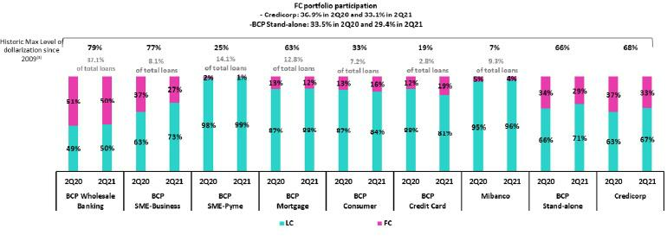

- Average daily balances.

- The FC share of Credicorp’s loan portfolio is calculated including BCP Bolivia and ASB, however the chart shows only the loan books of BCP Stand-alone and Mibanco.
- The year with the historic maximum level of dollarization for Wholesale Banking was 2012, for Mibanco was 2016, for Credit Card was in 2021 and for the rest of segments was 2009.

The loan dollarization level remained stable QoQ. YoY, the portfolio’s dollarization level followed a downward trend in the majority of segments due to disbursements under Reactiva Peru and to recovery in retail loans in LC. On the contrary, the dollarization level for the Credit Card segment followed an upward trend over the course of the pandemic and reached a record high this quarter, pressured by on-going decreases in LC balances.

14

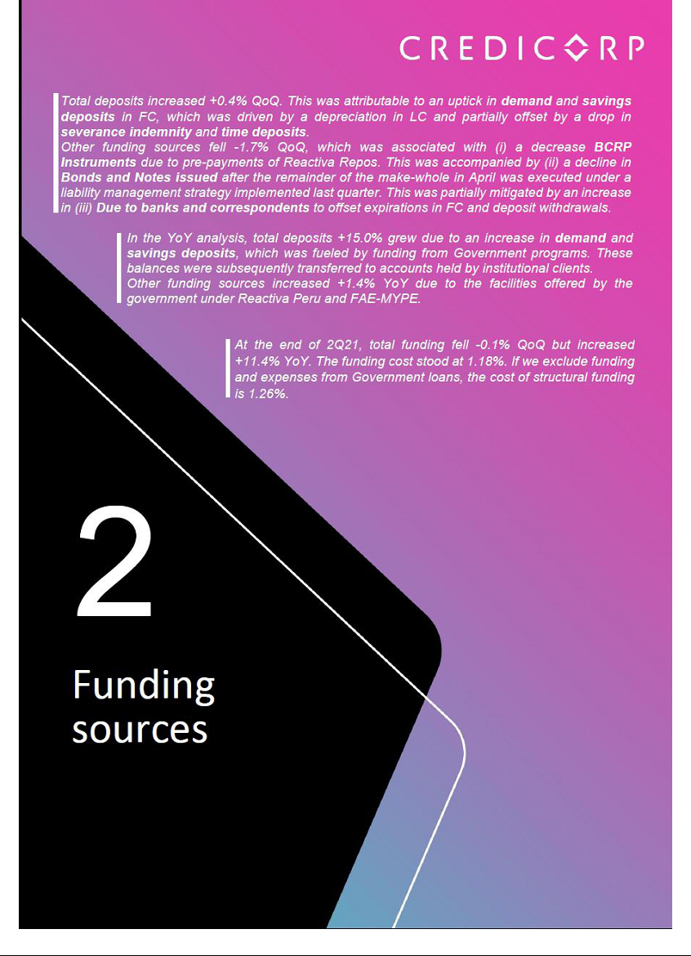

- Funding Sources

2.1 Funding structure
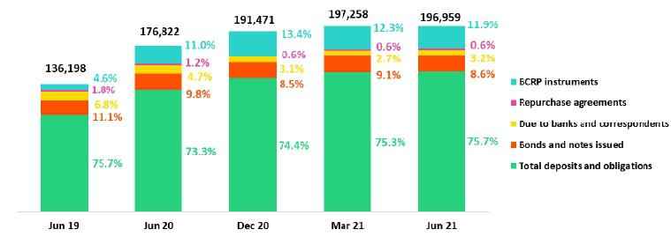

(*) In Mar21 the data differ from previously reported consider this report.

Total funding fell -0.2% QoQ, which was driven mainly by a reduction in Other Sources of Funding given the variation in:

- BCRP instruments, which registered a share of 11.9% of total funding (vs 12.3% in 1Q21); this drop was primarily attributable to pre-payments of Repos under the Reactiva and FAE programs.

- Bonds and notes issued, which reported a share of 8.6% (vs 9.1% in 1Q21); this result was primarily attributable to the execute remainder of the make-whole in April within the framework of the liability management strategy implemented last quarter in BCP-Stand alone.

The aforementioned was attenuated by:

- An increase in deposits and obligations, which represented 75.7% at the end of 2Q21 (vs 75.3% in 1Q21). This result was driven by an increase in the volume of sales and savings deposits in FC in a context marked by uncertainty due to exchange rate volatility. The aforementioned was partially offset by withdrawals of time and severance indemnity deposits (high-cost funding). It is important to note that this quarter, low-interest funding has been captured.

- Due to banks and correspondents, which reported a share of 3.2% (vs 2.7% in 1Q21). This result was mainly driven by new debt at BCP Stand-alone, which was taken on to offset the effect of the expiration of bonds in FC and the outflow of deposits to foreign accounts.

In the YoY analysis, the funding level registered an increase. This was primarily driven by growth in deposits and obligations, which was fueled by high inflows of funding from government programs. This was accompanied by an increase in BCRP Instruments via repos under the Reactiva and FAE programs.

2.2. Deposits
Deposits and obligations |  |  |  |  | As of |  |  |  | % change
 | S/ 000 |  | Jun 20 |  | Mar 20 |  | Jun 21 |  | QoQ |  |  | YoY
 | Demand deposits |  | 48,926,791 |  | 58,074,996 |  | 59,998,764 |  | 3.3% |  |  | 22.6%
 | Saving deposits |  | 42,562,229 |  | 51,013,689 |  | 52,687,270 |  | 3.3% |  |  | 23.8%
 | Time deposits |  | 30,019,871 |  | 31,389,760 |  | 30,302,103 |  | -3.5% |  |  | 0.9%
 | Severance indemnity deposits |  | 7,441,044 |  | 7,457,440 |  | 5,456,510 |  | -26.8% |  |  | -26.7%
 | Interest payable |  | 714,397 |  | 690,454 |  | 717,156 |  | 3.9% |  |  | 0.4%
 | Deposits and obligations |  | 129,664,332 |  | 148,626,339 |  | 149,161,803 |  | 0.4 | % |  | 15.0 | %
 |  |  |  |  |  |  |  |  |  |  |  | 16

Deposits and obligations expanded +0.4% QoQ. The evolution of deposits reflects:

- The 3.3% increase in demand deposits, which was driven by (i) an increase in the volume at ASB of non-interest-bearing demand deposits after funds were drawn down and transferred to this type of deposit, (ii) an increase in non-interest-bearing demand deposits from corporate clients at BCP Stand-alone in April and May. Both of the aforementioned effects were driven by a context of uncertainty. It should be noted that growth of demand deposits was entirely in FC.

- Growth in savings deposits in FC, which increased +3.3% QoQ. This expansion reflected the fact that individual clients at BCP Stand-alone moved to dollarize their deposits at BCP Stand-alone in April and May. The dollarization is partially offset by higher outflows abroad in the last month of the quarter.

- The decrease in Severance indemnity deposits (-26.8%), which took place after the government issued a decree permitting access to these funds; this was partially offset by statutory deposits of Severance funds in May.

- The -3.5% drop in time deposits, which was driven mainly by a decrease in the demand for FC of corporate and institutional clients at BCP Stand-alone, who in the face of uncertainty, decided to transfer funding to foreign entities.

In YoY terms, total deposits and obligations reported growth of +15.0%. The increase in deposits was associated with (i) an uptick in the volume of Repos associated with government programs (Reactiva Peru and FAE), which were subsequently deposited in demand and savings accounts; and (ii) government facilities, which led drawdowns of AFP and Severance indemnity funds to inject liquidity; these funds were deposits in low-cost accounts.

2.2.1. Deposits: Dollarization Level

Credicorp – Dollarization level of deposits measured in quarter-end balances

The QoQ increase in dollarization was reflected in the composition of deposits:
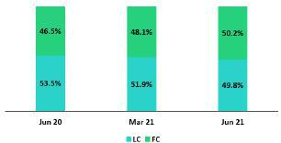

The share of LC deposits fell from 51.9% in 1Q21 to 49.8% this quarter while the share of FC deposits rose from 48.1% to 50.2%. The variation in total deposits QoQ was driven by an exchange rate effect after the Peruvian sol depreciated 2.7%; demand deposits suffered the brunt of the impact of currency variations. If we exclude the exchange rate effect, the composition of total deposits indicates a 50.5% share for LC and 49.5% for FC.

In the YoY analysis, the Peruvian sol depreciated 9.0%. If we exclude this effect up to June 20, the composition of deposits stands at 52.0% in LC and 48.0% in FC.

Credicorp – Deposit Dollarization measured in quarter-end balances
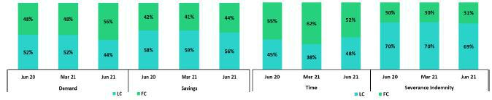

17

2.3. Other sources of funding
Other funding sources |  |  |  |  | As of |  |  |  |  | % change
S/ 000 |  |  | Jun 20 |  | Mar 20 |  | Jun 21 |  | QoQ |  |  |  | YoY
 | Due to banks and correspondents |  | 8,374,009 |  | 5,305,933 |  | 6,239,161 |  |  | 17.6% |  |  | -25.5%
 | BCRP instruments |  | 19,441,733 |  | 24,303,193 |  | 23,329,990 |  |  | -4.0% |  |  | 20.0%
 | Repurchase agreements |  | 2,091,798 |  | 1,159,587 |  | 1,276,678 |  |  | 10.1% |  |  | -39.0%
 | Bonds and notes issued |  | 17,250,531 |  | 17,863,198 |  | 16,951,481 |  |  | -5.1% |  |  | -1.7%
 | Total other funding sources |  | 47,158,071 |  | 48,631,911 |  | 47,797,310 |  |  | -1.7 | % |  | 1.4 | %

- In Mar21 the data differ from previously reported consider this report. The total of other sources of funding fell -1.7% QoQ. The evolution shows:
A decrease in BCRP Instruments, mainly at BCP Stand-alone, due to pre-payments of Repos under the Reactiva Peru program.

A drop in Bonds and Notes Issued, which was associated with the execution of the remainder of the make-whole in April under the bond repurchase program launched in March. Additionally, Mibanco registered a prepayment on a subordinated bond at a rate of 8.5% in LC.

An increase in Due to banks and correspondents, which was driven by an increase in the debt level at (i) BCP Stand-alone, with foreign institutions in FC to offset the effect of outflows of other types of funding; additionally (ii) at Mibanco, an increase in the proportion of debts owed to local financial institutions in LC.

Repurchase agreements registered a slight increase, which was attributable to new regular repo transactions at BCP Bolivia and BCP Stand-alone.

The YoY evolution shows an +1.4% increase in other sources of funding. This was attributable to an uptick in the level of BCRP Instruments, which was driven by government facilities under the Reactiva and FAE programs. This result was partially offset by the expiration of debt obligations with foreign institutions at BCP Stand-alone and to a lesser degree, by expirations at Mibanco of debt obligations with local financial institutions.

2.4. Loans / Deposits(C/D)

Loan / Deposit Ratio by subsidiary

Credicorp’s L/D ratio increased QoQ and reached 95.9%. This was attributable to the fact that growth in loans (+4.4%) outpaced the expansion in deposits (+0.4%) in a context of economic reactivation.
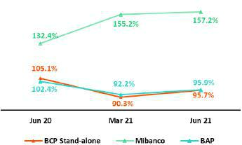

The analysis by subsidiary reveals that an upward trend was also play at BCP Stand-alone (95.7% in June 21). The QoQ increase in the L/D at BCP Stand-alone was driven by higher growth in loans (+5.6%). At Mibanco, the L/D ratio rose to 157.2% due to an uptick in the loan balance.

In the YoY analysis, the L/D ratio at Credicorp and BCP Stand-alone fell given that the increase in the deposit volume (+15.0% and +16.7% respectively) outpaced the expansion registered by loans (+7.8% and +6.3% respectively). The L/D ratio at Mibanco followed the same trend as that seen in the QoQ analysis.

18

Loan/Deposit ratio by currency

Local Currency Foreign Currency
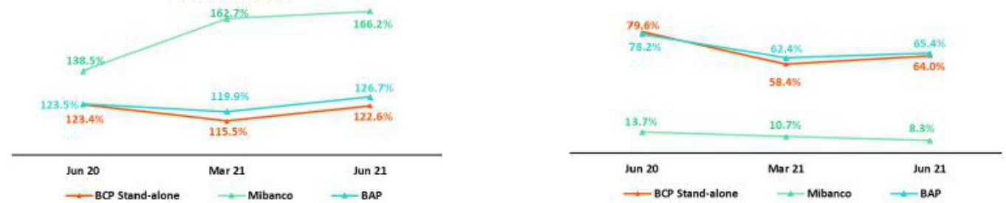

In the QoQ analysis by currency the L/D ratio in LC at Credicorp and BCP Stand-alone rose, which was driven primarily by a drop in LC deposits (-3.6% y -3.5% respectively) after deposit dollarization. The L/D ratio in FC at Credicorp and BCP Stand-alone also increased QoQ given that loan growth outpaced the expansion in deposits. In the YoY analysis, Credicorp registered an increase in its L/D ratio in LC in a context in which loan growth (+10.0%) outstripped the expansion reported by deposits (+7.1%); the L/D ratio in FC fell over the same period.

2.5. Funding cost

Funding cost – Credicorp ⁽¹⁾⁽²⁾
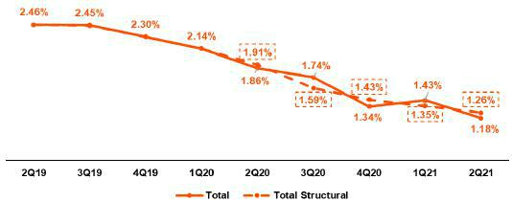

- Expenses are included in accordance with IFRS16.

- Structural Funding Cost deducts the impact in expenses and funding related to GP Loans (BCRP Repos) and deducts non-recurring events from Interest Expense.

The funding cost at Credicorp fell -25 bps QoQ due to a decrease in interest expenses (-15.9%), (i) which was primarily due to a one-off effect on the premium for the subordinated bond issuance in 1Q21; and to a lesser extent, to (ii) an improvement in the deposit mix and (iii) lower interest rates on new debts. If we isolate the effects of government programs and non-recurring premiums in 1Q21, the structural cost of funding was 1.26% (-9 bps).

In the YoY analysis, the Cost of funding fell -68 bps, which was due to (i) an improvement in the deposit mix, due to higher volume in low-cost deposits and a reduction in interest expenses on deposits of -34.3%; (ii) a rate effect, given that interest rates (national and international) have followed a downward trend in a context of economic contraction due to the pandemic.

19

Funding cost– Credicorp in Local Currency ⁽¹⁾⁽²⁾⁽³⁾
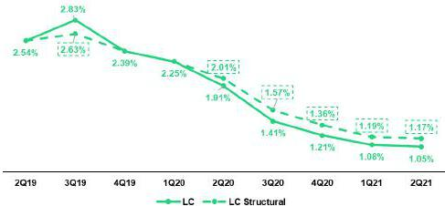

- The funding cost by currency is calculated with the average of period-beginning and period-end balances.

- Expenses are included in accordance with IFRS16.

- Structural Funding Cost deducts the impact in expenses and funding related to GP Loans (BCRP Repos) and deducts non-recurring events from Interest Expense.

The drop in the cost of funding in LC (-3 bps) was driven by a drop in interest expenses (-4.6%) which was partially offset by a contraction in the deposit levels in LC (-3.3%) given that dollarized funds landed in low-cost deposits. If we isolate the effects of government programs and non-recurring premiums in 1Q21 in LC, the cost of structural funding fell to 1.17% in 2Q21, which represents an improvement over the figure registered last quarter (-2 bps).

Cost of funding – Credicorp in Foreign Currency ⁽¹⁾⁽²⁾⁽³⁾

- The funding cost by currency is calculated with the average of period-beginning and period-end balances.

- Expenses are included in accordance with IFRS16.

- Structural Funding Cost deducts the impact in expenses and funding related to GP Loans (BCRP Repos) and deducts non-recurring events from Interest Expense

The decrease in the cost of funding in FC (-54 bps) was attributable to a drop in interest expenses generated by a reduction in the interest rates on bonds and notes issued. The aforementioned, was driven mainly by the one-off effect generated by BCP Stand-alone’s liability management strategy last quarter and by an improvement in the funding mix.

The cost of funding in LC and FC fell -86 bps and -49 bps respectively, which ratifies Credicorp’s strategy to restructure liabilities to improve the profile of expirations and reduce the funding cost curve in local and foreign currencies.

20

Cost of funding by subsidiary ⁽¹⁾⁽²⁾
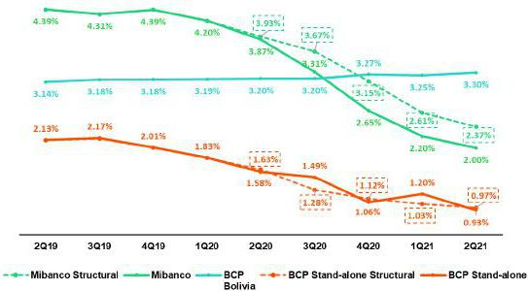

  - Expenses are included in accordance with IFRS16.

  - Structural Funding Cost deducts the impact in expenses and funding related to GP Loans (BCRP Repos) and deducts non-recurring events from Interest Expense.

- BCP Stand-alone’s cost of funding fell -27bps QoQ due to a drop in interest expenses (-22.2%), which was mainly attributable to a one-off payment of the premium related to the liability management strategy in 1Q21; this one-off payment represented 81% of the decrease in total expenses. The improvement in the funding mix, which materialized despite a decrease in deposits, also contributed, although to a lesser extent, to the decrease in this line.

YoY, the cost of funding fell -65 bps due to (i) an improvement in the funding mix and (ii) the rate effect, where all funding sources registered a decrease in rates.

If we isolate the effects of government programs and non-recurring premiums in 1Q21, the cost of funding ratio at BCP Stand-alone stood at 0.97%, which represented a decrease of -6 bps QoQ and was driven by an improvement in the deposit mix.

- Mibanco reported a significant contraction of -20 bps QoQ in its cost of funding; this reflected a decrease in interest expenses (-9.7% QoQ), which was primarily attributable to an improvement in the rate mix.

In the YoY analysis, interest expenses fell (-39.5%) in a context of abundant low-interest government funding and driven by an increase in total funding (+17.7%).

The cost of structural funding at Mibanco, if we isolate the effects of Reactiva and FAE, stands at 2.37%, which represents a decrease of -24 bps QoQ.

- The cost of funding at BCP Bolivia reported a slight increase QoQ (5 bps), which was fueled by an increase in interest expenses (+3.7%) and offset by an increase in funding (+4.6%).

21



- Net interest income (NII)

Net interest income |  |  |  | Quarter |  |  |  | % change |  |  |  | YTD |  |  |  | % change
S/ 000 |  | 2Q20 |  | 1Q21 |  | 2Q21 |  | QoQ |  | YoY |  | Jun-20 |  | Jun-21 |  | Jun-21 / Jun-20
Interest income |  | 2,727,369 |  | 2,816,073 |  | 2,891,579 |  | 2.7% |  | 6.0% |  | 5,890,978 |  | 5,707,652 |  | -3.1%
Interest on loans |  | 2,353,285 |  | 2,432,761 |  | 2,476,187 |  | 1.8% |  | 5.2% |  | 5,123,636 |  | 4,908,948 |  | -4.2%
Dividends on
investments |  | 4,867 |  | 3,221 |  | 11,536 |  | 258.1% |  | 137.0% |  | 12,746 |  | 14,757 |  | 15.8%
Interest on deposits
with banks |  | 9,264 |  | 7,896 |  | 6,076 |  | -23.0% |  | -34.4% |  | 58,377 |  | 13,972 |  | -76.1%
Interest on securities |  | 350,617 |  | 362,964 |  | 382,140 |  | 5.3% |  | 9.0% |  | 673,351 |  | 745,104 |  | 10.7%
Other interest income |  | 9,336 |  | 9,231 |  | 15,640 |  | 69.4% |  | 67.5% |  | 22,868 |  | 24,871 |  | 8.8%
Interest expense ⁽¹⁾ |  | 766,019 |  | 692,690 |  | 582,537 |  | -15.9% |  | -24.0% |  | 1,550,101 |  | 1,275,227 |  | -17.7%
Interest on deposits |  | 320,169 |  | 222,643 |  | 210,275 |  | -5.6% |  | -34.3% |  | 684,276 |  | 432,918 |  | -36.7%
Interest on borrowed
funds |  | 157,819 |  | 112,228 |  | 101,265 |  | -9.8% |  | -35.8% |  | 294,945 |  | 213,493 |  | -27.6%
Interest on bonds and
subordinated notes |  | 199,347 |  | 266,971 |  | 178,664 |  | -33.1% |  | -10.4% |  | 397,461 |  | 445,635 |  | 12.1%
Other interest expense |  | 88,684 |  | 90,848 |  | 92,333 |  | 1.6% |  | 4.1% |  | 173,419 |  | 183,181 |  | 5.6%
(1)
Net interest income ⁽¹⁾
 |  | 1,961,350 |  | 2,123,383 |  | 2,309,042 |  | 8.7% |  | 17.7% |  | 4,340,877 |  | 4,432,425 |  | 2.1%
Risk-adjusted Net
interest income ⁽¹⁾ |  | (579,107) |  | 1,565,736 |  | 1,945,662 |  | 24.3% |  | -436.0% |  | 458,939 |  | 3,511,398 |  | 665.1%
Average interest earning
assets ⁽¹⁾ |  | 194,719,985 |  | 227,812,456 |  | 230,237,853 |  | 1.1% |  | 18.2% |  | 190,625,695 |  | 227,052,978 |  | 19.1%
Net interest margin ⁽²⁾
 |  | 4.03% |  | 3.73% |  | 4.01% |  | 28bps |  | -2bps |  | 4.55% |  | 3.90% |  | -65
Risk-adjusted Net
interest margin ⁽²⁾ |  | -1.19% |  | 2.75% |  | 3.38% |  | 63bps |  | 457bps |  | 0.48% |  | 3.09% |  | 261
Net provisions for loan
losses / Net interest
income |  | 129.53% |  | 26.26% |  | 15.74% |  | -10.5% |  | -113.8% |  | 89.43% |  | 20.78% |  | -68.65%

- Figures differ from previously reported, please consider the data from this report.

- Annualized.

3.1. Net Interest Income

Interest income – local currency

(S/ millions)
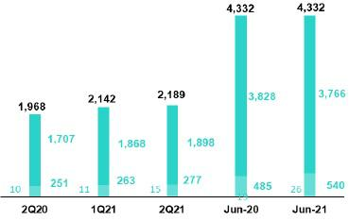

Interest income – foreign currency

(S/ millions)
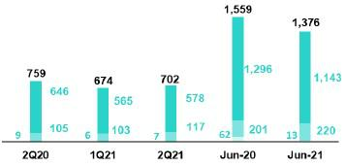

In the QoQ analysis, the 2.7% increase in Net interest income reflects growth of +1.8% in interest on loans after loan volumes at BCP Stand-alone and

Mibanco registered an uptick in volumes. The dynamics of interest generation were:

- Mix effect: loans grew, which was driven primarily by the evolution of Wholesale Banking. The investment portfolio contracted after sales were executed to reduce duration and after the expiration of CDs, which were not renewed to maintain liquidity. This dynamic generated a more profitable IEA structure.

- Rate effect: rates fell due to market alignment and to campaigns to maintain MS in Wholesale Banking, particularly in the Middle Market segment. The SME-Pyme and Credit Card segments also registered a drop in interest rates.

- The exchange rate effect had a positive impact on interest in FC loans.

It is important to note that growth in interest income was slightly impacted by amortizations of the one-off impairment charge registered in 2020, after clients were offered zero-rate facilities. If we exclude this effect, adjusted Interest income grew +3.0% QoQ.

In the YoY analysis, interest income rose +6.0%, which was primarily due to the fact that in 2Q20, this account was impacted by non-recurring charges that included the one-off impairment and subsequent amortizations generated by the zero-rate facilities that were offered to clients at BCP Stand-alone, Mibanco Peru and Colombia. If we exclude these charges, adjusted Net interest income falls -6.6% YoY. This evolution was driven by:

23

- Mix effect: the drop in structural loans, mainly in Wholesale Banking and in the SME-Business and Credit Card segments within Retail Banking. This decline, coupled with growth in the investment portfolio, led structural loans’ share of the IEA mix to drop. The variation in the mix was further accentuated by the weight of government loans in the total portfolio.

- Rate effect: YoY, active interest rates fell, mainly in the Wholesale Banking portfolio, where working capital products and mid and long-term financing were the most affected. Retail Banking segments, specifically Credit Card and Mortgage, were also hard hit by variations in the interest rate.

YTD, interest income fell -3.1%, which was primarily attributable to a drop in interest on loans, which was accentuated by a decrease in interest on deposits in other banks. The decrease in interest on loans was primarily associated with a reduction in the volume of structural loans, primarily in the Credit Card segment and secondarily in Wholesale Banking segments. Lower interest rates also generated a strong impact that resonated in the Credit Card and Wholesale Banking segments in particular. If we exclude the aforementioned non-recurring charges, YTD income falls -9.7%.

3.2. Interest Expenses

Interest expenses – Local Currency

(S/ millions)
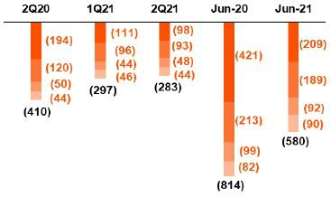

Interest expenses – Foreign currency

(S/ millions)
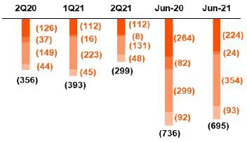

In the QoQ analysis, interest income fell -15.9% given that in 1Q21, a non-recurring charge was reported for S/88 million for interest on bonds and subordinated notes in FC under BCP Stand-alone’s liability management strategy. If we exclude this non-recurring charge, interest-adjusted income contracts -3.7% QoQ given an improvement in the funding structure and funding cost due to the following:

- Mix effect: a decrease in the volume of higher-cost deposits such as severance indemnity and time deposits in LC and an increase in the volume of lower-cost deposits such as demand and savings deposits, in FC in particular. This coupled with the expiration of subordinated bonds in FC -which were replaced by debt with lower interest rates- drove the mix effect this quarter.

- Rate effect: lower interest rates on bank borrowings and a reduction in passive rates for high-cost products such as Severance and Time deposits.

In the YoY analysis, interest expenses fell -24.0%, which was attributable to the following:

- Rate effect: the cost of funding fell due to a decrease in market rates, mainly in time and demand deposits. This was fueled, albeit to a lesser extent, by the decrease in rates on bank borrowings and the impact of low-interest government loans.

- Mix effect: drop in time deposits and an increase in demand and savings deposits. Growth in demand and savings deposits was attributable to the impact of government programs, which generated high liquidity across the system; increased retail funding; and helped reduce funding with other banks. This increase was also driven by a recent drop in severance indemnity deposits after the government released access to these funds.

24

In the YTD analysis, interest expenses fell -17.7%. If we exclude the non-recurring charge in 1Q21 related to liability management at BCP Stand-alone, adjusted interest expenses fall -23.4%. YTD. This variation was driven primarily by a reduction in market rates and to a lesser degree by a change in the funding structure, where high cost sources of funding such as severance indemnity deposits, bank debt and repos, registered a reduction in their shares of total funding while less costly sources, such as savings and demand deposits and funding from GP, registered an increase in share.

3.3. Net interest margin (NIM) and Risk-adjusted NIM

NIM and Risk-adjusted NIM at Credicorp
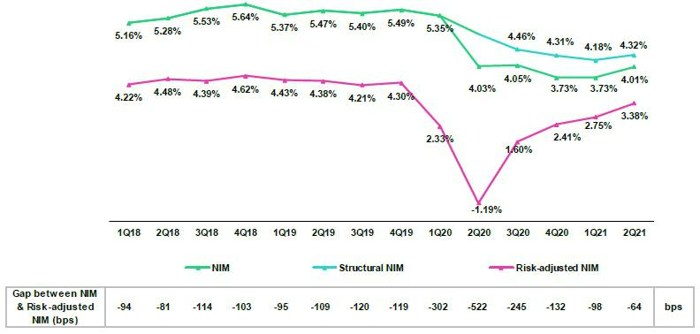

NIM stood at 4.01% in 2Q21, which represented an increase with regard to the 3.73% obtained in 1Q21 but fell below the 4.03% registered in 2Q20. This result was impacted by non-recurring charges for the amortization the one-off interest impairments. The impact of non-recurring expenses on NIM was positive: +6pbs for 2Q21. Government loans continued to impact NIM and generated a drop of -38 bps this quarter. An analysis of structural NIM, which excludes non-recurring charges and GP loans, shows:

- The Structural Portfolio reported a NIM of 4.32% in 2Q21, which represented an increase of +14bps QoQ. This growth was attributable to an improvement in the profitability of the IEA mix and the favorable effects generated by the funding mix and a reduction in passive rates.

- YoY, Structural NIM fell -55bps, falling from 4.87% to 4.32% due to:

  - Mix effect: the contraction in structural loans and an increase in investments generated a negative effect.

  - Rate effect: The decrease in market rates impacted repricing for the structural portfolio, which was partially offset by a reduction in passive rates.

- YTD, Structural NIM fell -81bps from 5.10% to 4.29% due to factors similar to those that set the YoY trend; in this case, the loan mix effect generated a slightly greater impact on interest income than the drop in interest rates. The negative impact on income was partially offset by a reduction in passive rates and by the positive evolution of the funding structure.

25

The table below shows the NIM and risk-adjusted NIM reported by Credicorp’s main subsidiaries:

 |  | BCP |  |  |  | BCP |  | Credicorp ⁽¹⁾ |  |  | Risk Adjusted NIM | BCP |  |  |  | BCP |  | Credicorp ⁽¹⁾
NIM Breakdown |  | Stand-alone |  | Mibanco |  | Bolivia |  |  |  |  | Breakdown | Stand-alone |  | Mibanco |  | Bolivia
 | 2Q20 | 3.73% |  | 8.23% |  | 3.29% |  | 4.03% |  |  | 2Q20 | -1.52% |  | -4.39% |  | -0.69% |  | -1.19%
 | 1Q21 | 3.23% |  | 10.37% |  | 2.77% |  | 3.73% |  |  | 1Q21 | 2.37% |  | 6.81% |  | 1.90% |  | 2.75%
 | 2Q21 | 3.43% |  | 11.88% 2.84% |  |  |  | 4.01% |  |  | 2Q21 | 2.81% |  | 8.66% |  | 4.58% |  | 3.38%
 | Jun 20 | 4.10% |  | 11.58% |  | 3.46% |  | 4.55% |  |  | Jun 20 | -0.11% |  | 2.53% |  | 0.67% |  | 0.48%
 | Jun 21 | 3.38% |  | 11.05% |  | 2.78% |  | 3.90% |  |  | Jun 21 | 2.63% |  | 7.67% |  | 3.24% |  | 3.09%

NIM: Annualized Net interest income / Average period end and period beginning interest earning assets.

Risk-Adjusted NIM: (Annualized Net interest income - annualized provisions) / Average period end and period beginning interest earning assets.

(1) Credicorp also includes Mibanco colombia, Credicorp Capital, Prima, Pacífico, ASB and Eliminations for consolidation purposes.

As BCP Stand-alone’s NIM mirrors that of Credicorp (given its relative contribution to the Group’s NIM), we would like to focus on relevant variations at

Mibanco Peru and BCP Bolivia:

- Mibanco Peru reported an increase of +151 bps QoQ in NIM due to the evolution of structural loans and the reduction in interest expenses. Another factor that contributed positively to the margin was a reverse of interest income provisions made previously into the reprogrammed delinquent loans^{[2]}. This reversal was triggered after write-offs this quarter to compensate for the fact that the interest income provisions had been also recorded in IFRS provisions for credit losses for delinquent loans.

YoY, NIM at Mibanco increased +365bps after the registration of the one-off impairment in 2Q20 (related to zero-rate facilities were granted to large numbers of clients). The recovery in structural disbursements and amortizations of the impairment and reversals of provisions for interest also contributed, albeit to a lesser extent, to this increase.

- QoQ, NIM at BCP Bolivia increased mainly due to the amortization of the one-off impairment. YoY, NIM fell in a context of an increased cost of funds and a drop in loans with higher margins due to the reduction of the risk appetite.

Risk-adjusted NIM at Credicorp increased +63bps QoQ, +457bps YoY and +261bps YTD due to a significant reduction in provisions in 2Q21.

- In recent months, we registered provisions for interest income that was accrued over the reprogrammed loans grace periods and was not paid-back when grace periods expired due to delinquency.

26

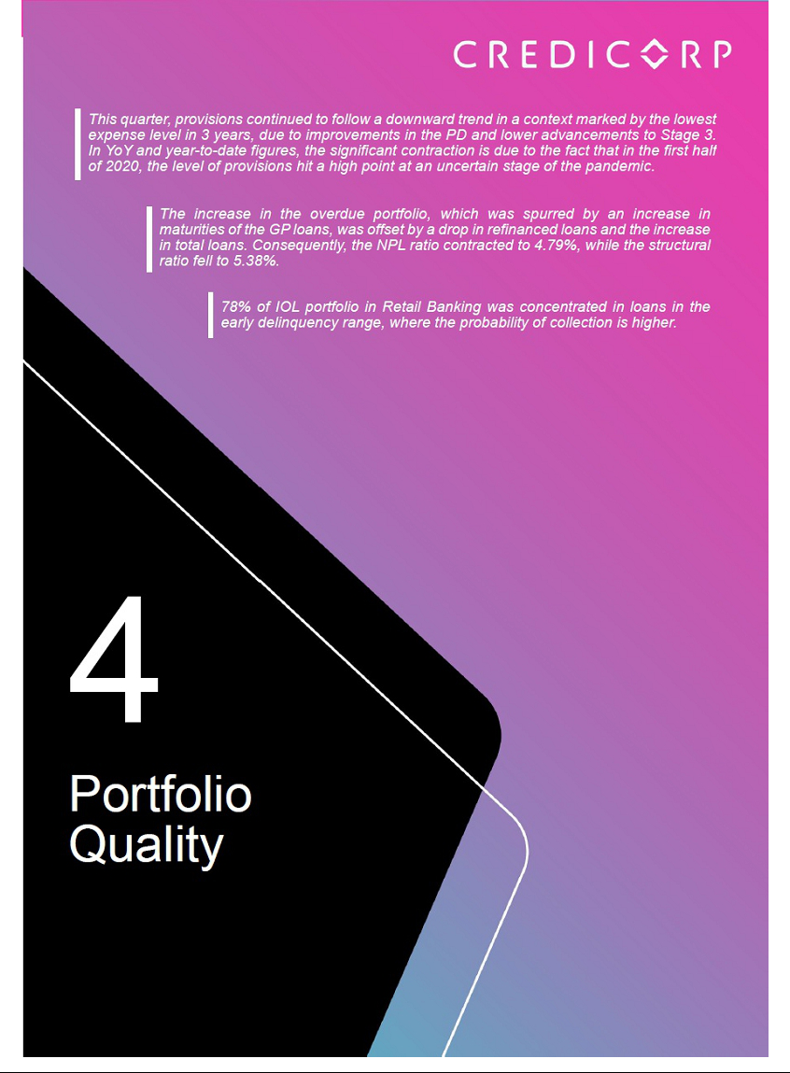

4. Portfolio Quality
4.1. Net provisions for loan losses and the CofR
Provision for credit losses on loan portfolio, net of |  |  |  |  |  |  |  |  |  | Quarter |  |  |  |  |  |  |  |  |  |  | % change |  |  |  |  |  |  |  | YTD |  |  |  |  |  |  |  |  | % change
S / 000 |  |  |  |  |  |  | 2Q20 |  |  |  |  | 1Q21 |  |  |  | 2Q21 |  |  |  | QoQ |  |  |  |  | YoY |  |  |  | Jun 20 |  |  |  | Jun 21 |  |  |  | Jun 21 / Jun 20
Gross provision for credit losses on loan portfolio |  |  |  |  |  | (2,557,658) |  |  |  |  | (622,982) |  |  |  | (441,007) |  |  |  |  | -29.2% |  |  |  |  | -82.8% |  |  | (3,946,369) |  |  |  | (1,063,989) |  |  |  |  | -73.0%
Recoveries of written-off loans |  |  |  |  |  | 17,201 |  |  |  |  |  | 65,335 |  |  | 77,627 |  |  |  | 18.8% |  |  |  |  | 351.3% |  |  |  | 64,431 |  |  |  | 142,962 |  |  |  | 121.9%
Provision for credit losses on loan portfolio, net of
recoveries |  |  |  |  |  | (2,540,457) |  |  |  | (557,647) |  |  |  |  | (363,380) |  |  |  | -34.8% |  |  |  |  | -85.7% |  |  |  | (3,881,938) |  |  |  | (921,027) |  |  |  | -76.3%
Cost of risk and Provisions |  |  |  |  |  |  | Quarter |  |  |  |  |  |  |  |  |  |  |  |  | % change |  |  |  |  |  |  |  |  | YTD |  |  |  |  |  |  |  |  | % change
Cost of risk and Provisions |  | 2Q20 |  |  |  |  | 1Q21 |  |  |  |  |  | 2Q21 |  |  |  | QoQ |  |  |  |  |  |  |  | YoY |  |  |  | Jun 20 |  |  |  | Jun 21 |  |  |  |  | Jun 21 / Jun 20
Cost of risk ⁽¹⁾ |  | 7.66% |  |  |  | 1.63% |  |  |  |  |  | 1.02% |  |  |  |  |  |  | -61bps |  |  |  |  | -664 bps |  |  |  | 5.85% |  |  |  | 1.29% |  |  |  |  |  | -456 bps
Structural Cost of risk ⁽²⁾ |  | 8.41% |  |  |  | 1.92% |  |  |  |  |  | 1.23% |  |  |  |  |  |  | -69bps |  |  |  |  | -718 bps |  |  |  | 6.50% |  |  |  | 1.51% |  |  |  |  |  | -499 bps
Provision for credit losses on loan
portfolio, net of recoveries / Net interest
income |  | 129.5% |  |  |  | 26.3% |  |  |  |  |  | 15.7% |  |  |  |  | -1050bps |  |  |  |  |  |  |  | n.a |  |  | 89.4% |  |  |  | 20.8% |  |  |  |  |  | -6950 bps

- Annualized Provision for credit losses on loan portfolio, net of recoveries / Total loans.

- The Structural Cost of risk excludes the provisions for credit losses on loan portfolio, net of recoveries and total loans from the Reactiva Peru and FAE Government Programs.

Provisions contracted -34.8% QoQ, following the trend registered in previous quarters, and reflected the lowest level of expenses in the last 3 years.

Contractions was due to:

- BCP Stand-alone: driven by (i) improvements in the risk levels (Probability of Default (“PD”) Bottom-Up models) of SME-Pyme and Individuals clients, due to a recovery in transactional activity and in income levels, and (ii) due to a decrease in the volume of advances to Stage 3, which reflected a decrease in refinancing and write-offs. The aforementioned was attenuated by an increase in provisions in Mortgage and Wholesale Banking, which was associated with an increase in the level of risk and in disbursement volumes, respectively.

- BCP Bolivia: results were impacted by provision reversals due to the inclusion of guarantees in the consumer portfolio, which was partially offset by new provisions to cover delinquency.
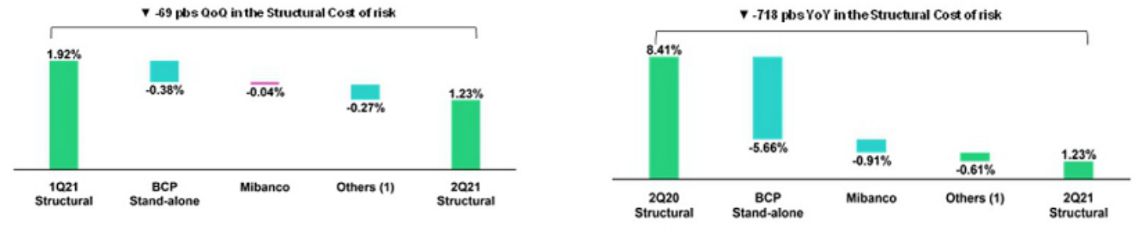

(1) Others include BCP Bolivia, ASB and eliminations. (1) Others include BCP Bolivia, ASB and eliminations

In the YoY analysis, net provisions for loan losses fell -82.8% with regard to 2Q20. It is important to note that the highest level of provisions in more than 5 years was reported in 2Q20, when significant forward-looking provisions were set aside in the context of the pandemic. The YoY contraction was driven primarily by:

- BCP Stand-alone: led by the evolution of the SME-Pyme and Credit Card segments, where risk levels were aligned with payment behavior after transactions and income recovered, and by adjustments made to the models to reflect new macroeconomic projections.

- Mibanco: due to (i) adjustments to the Bottom-Up Model, which required fewer provisions for new disbursements after credit scores were updated,

  - improvements in client payment behavior, which were reflected in a decrease in advances between Stages and higher stages of delinquency and

  - a drop in provision expenses related to external alignment.

In the aforementioned context, the CofR at Credicorp fell -61 bps QoQ and -664 bps YoY. If we exclude provisions and loans related to Government Programs (GP), the cost of risk for Credicorp’s structural portfolio stands at 1.23%, versus 1.92% and 8.41% in 1Q21 and 2Q20 respectively. In the YTD analysis, provisions fell -76.3% with regard to the level registered in June 20. Consequently, the cost of risk of the structural portfolio was 1.51%, compared to 6.50% in June 20.

28

4.2. Delinquency
Portfolio quality and Delinquency ratios |  |  |  | As of |  |  |  | % change
S/ 000 |  | Jun 20 |  | Mar 21 |  | Jun 21 |  | QoQ |  |  | YoY
Total loans (Quarter-end balance) |  | 132,741,720 |  | 137,031,239 |  | 143,091,752 |  | 4.4% |  |  | 7.8%
Structural Loan Portfolio |  | 117,793,155 |  | 112,782,997 |  | 120,095,401 |  | 6.5% |  |  | 2.0%
Allowance for loan losses |  | 8,412,544 |  | 9,744,298 |  | 9,391,151 |  | -3.6% |  |  | 11.6%
Write-offs |  | 42,104 |  | 767,136 |  | 742,211 |  | -3.2% |  |  | n.a
Internal overdue loans (IOLs) ⁽¹⁾ |  | 3,842,830 |  | 4,868,483 |  | 5,054,353 |  | 3.8% |  |  | 31.5%
Internal overdue loans over 90-days ⁽¹⁾ |  | 3,112,920 |  | 3,789,286 |  | 3,817,463 |  | 0.7% |  |  | 22.6%
Refinanced loans |  | 1,179,031 |  | 1,951,855 |  | 1,800,076 |  | -7.8% |  |  | 52.7%
Non-performing loans (NPLs) ⁽²⁾ |  | 5,021,861 |  | 6,820,338 |  | 6,854,429 |  | 0.5% |  |  | 36.5%
IOL ratio |  | 2.89% |  | 3.55% |  | 3.53% |  | -2 bps |  |  | 64 bps
Structural IOL ratio |  | 3.26% |  | 4.32% |  | 3.89% |  | -43 bps |  |  | 63 bps
IOL over 90-days ratio |  | 2.35% |  | 2.77% |  | 2.67% |  | -10 bps |  |  | 32 bps
NPL ratio |  | 3.78% |  | 4.98% |  | 4.79% |  | -19 bps |  |  | 101 bps
Structural NPL ratio |  | 4.26% |  | 6.05% |  | 5.38% |  | -67 bps |  |  | 112 bps
Allowance for loan losses over Total loans |  | 6.34% |  | 7.11% |  | 6.56% |  | -50 bps |  |  | 30 bps
Coverage ratio of IOLs |  | 218.9% |  | 200.2% |  | 185.8% |  | -1440 bps |  |  | -3310 bps
Coverage ratio of IOL 90-days |  | 270.2% |  | 257.2% |  | 246.0% |  | -1120 bps |  |  | -2420 bps
Coverage ratio of NPLs |  | 167.5% |  | 142.9% |  | 137.0% |  | -590 bps |  |  | -3050 bps

- Includes overdue loans and loans under legal collection. (Quarter-end balances)

- Non-performing loans include internal overdue loans and refinanced loans. (Quarter-end balances)

In terms of portfolio delinquency, it is important to note that:

- Total IOLs increased +3.8% QoQ and +31.5% YoY; the bulk of IOL loans were in the early delinquency stage (less than 30 days). In the QoQ analysis, growth was driven mainly by the expiration of grace periods for clients in the SME segments and in Wholesale Banking at BCP Stand-alone. The aforementioned was partially offset by a reduction in the IOL portfolio at the Individuals segment at BCP Stand-alone and BCP Bolivia and, to a lesser extent, at Mibanco. In Individuals and at Mibanco, client payments evolved positively, in line with an uptick in transactions and income balances. In BCP Bolivia, the reduction was generated by loan migration to the up-to-date portfolio due to reprogramming requests. For more information, see 4.2.1 Delinquency by Segment.

In the YoY analysis, an uptick in deterioration was primarily led by Wholesale Banking, due to the evolution of a small number of clients in the transportation and energy sectors in Corporate Banking, and by Mibanco, which registered a decrease in transactional activity in the microfinance sector due to COVID-19. This was slightly attenuated by a reduction in the Credit Card segment, which registered volumes of IOLs that fell below pre-pandemic levels.

- Total refinanced loans reduced -7.8% QoQ. The reduction was primarily attributable to BCP Bolivia, attributable to the loan reprogramming mandate, reflected in a transfer of the refinanced portfolio to the up-to-date portfolio. BCP Bolivia represented 103% of the QoQ contraction in total refinanced loans.

In the YoY analysis, growth of +52.7% was driven mainly by BCP Stand-alone, particularly to Retail Banking, after clients who had initially not qualified for reprogramming facilities were offered refinancing options.

- Total write-offs contracted -3.2% QoQ, which was primarily attributable to a decrease in write-offs in Individuals, particularly in the Consumer and Credit Card segments. The reduction reflects the fact that the comparative base in 1Q21 was significantly larger and represented the highest level of write-offs reported in more than 5 years. The aforementioned was attenuated by an increase in write-offs at Mibanco and, to a lesser extent, at BCP Bolivia.

In the YoY analysis, considerable growth in write-offs was attributable to a regulatory mandate, which impeded loans from continuing to accumulate overdue days, impeding loans from progressing naturally to a situation of loss and its subsequent write-off.

- The IOL and NPL Coverage ratios contracted QoQ and YoY, which was driven by growth in IOLs and, in the other hand, to the reduction of allowances for loan loans. It is important to note that these levels remain within the appetite for risk and are still slightly above pre-pandemic levels.

29

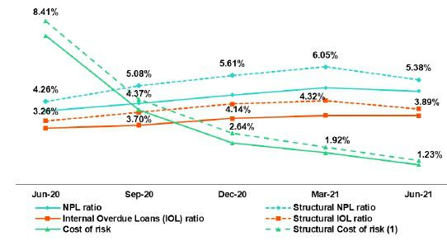
When analyzing the evolution of delinquency indicators, it is necessary to note that:

(i) traditional delinquency indicators (IOL and NPL ratios) continue to be distorted by the presence of loans that have collateral (commercial and residential properties). This means that a significant portion of loans that are more than 150 days overdue cannot be written off, despite being fully provisioned, given that the judicial process to liquidate the collateral can take up to five years on average.

- The Structural Cost of risk excludes the provisions for credit losses on loan portfolio, net of recoveries and total loans from the Reactiva Peru and FAE Government Programs.

Consequently, the NPL ratio at Credicorp situates at 4.79% at the end of June (-19 bps QoQ and +101 bps YoY), if we exclude loans and overdue loans related to GP, the ratio increases to 5.38%. In the QoQ analysis, the NPL ratio reduction is attributable to a higher structural loan dynamism, as indicated in section 1.2.1. Evolution of loans by business segment. In the YoY evolution, the significant NPL ratio growth reflects the impact of the pandemic in the payment capacity of clients.

4.2.1 Delinquency by Segment
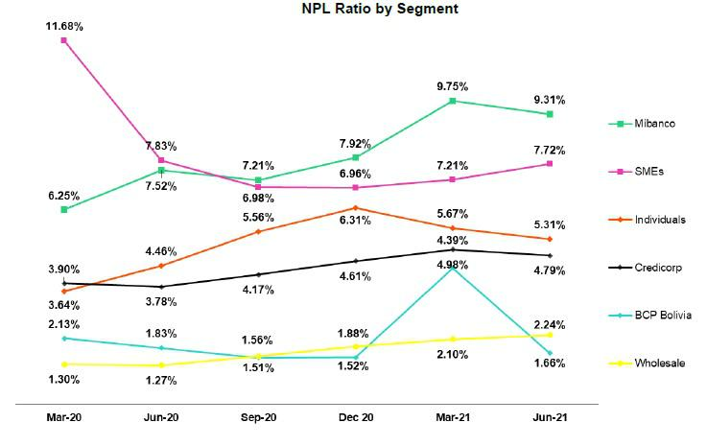

In the analysis of the NPL portfolio by segment, it is important to note:

- Wholesale: an increase of +14 bps QoQ and +97 bps YoY, which was primarily driven by an uptick in the volume of IOL loans and, to lesser extent, by growth in refinanced loans. The increase in IOLs was associated with the evolution of a small number of clients in the fishing and financial sector while growth in the refinanced portfolio was attributable to clients in the hotel and manufacturing sectors, which were severely impacted by confinement measures. The aforementioned was partially attenuated by loan growth, as indicated in section 1.2.1. Evolution of loans by business segment.

30

- SME: the ratio grew QoQ and YoY, driven by an increase in IOL loans in SME-Pyme and SME-Business, which registered an uptick in expirations of grace periods. Deterioration was also due to a contraction in loans in the SME-Pyme segment and to a lesser degree, to a drop in the payment ratio in SME-Business. The highest growth in IOLs was registered by the agriculture, service and transportation sectors. Sixty-seven (67%) of loans in the IOL portfolio was within the 1–15-day early stage. Collections conducts on-going monitoring of loans to mitigate the advance toward more advanced levels of delinquency. The delinquency ratio in more advanced stages (31 to 120 days) fell -11 bps QoQ.

- Individuals: in the QoQ analysis, the contraction was associated fueled primarily by movements in the Credit Card and Consumer segments, which saw an improvement in payment levels after funds from Pension funds and Severance Indemnity accounts were freed up for withdrawal (government mandates). In the Credit Card segment, the reduction was driven mainly by clients that were granted payment facilities and accordingly, are considered higher risk. It is important to note that in 2Q21, the Credit Card segment reported the lowest level of NPL loans registered in more than 5 years. Fifty-eight (58%) of IOL loans in Individuals were within the 1–15-day segment and remained within a holding pattern (not progressing to more advanced stages). The delinquency ratio in advanced stages (31-120 days) fell -1 bps QoQ to stand at 1.5%.

In the YoY analysis, the increase in delinquency ratios was associated with expirations in grace periods, which in turn spurred in growth in IOL and refinanced loans. The increase in NPL reflects the impact of the pandemic and the political-economic crisis in Peru, which negatively affected clients’ debt service capacities.

- Mibanco: the QoQ reduction was associated with a drop in IOL and refinanced loans and an uptick in loan growth. The contraction in the IOL portfolio was attributable to a decrease in loans under legal collection (after write-offs were taken) and to collections actions to reduce refinancing. The decrease was also fueled by a drop in the volume of expirations and by an uptick in on-time installment payments.

YoY, ratios increased to a deterioration in the debt service capacity of clients whose grace periods expired. Growth in IOLs was concentrated in Small Businesses and in the 31–120-day stage. This was slightly offset by an increase in written-off loans.

- BCP Bolivia: contraction QoQ and YoY due to loans reprogramming, as mandated by the Bolivia government to mitigate the impact of the pandemic, classifying these loans as up-to-date. Reprogramming requests was in effect up to July 2021. This disposition establishes deferments with grace periods for capital and interest for up to 6 months.

4.3 Reprogramming and payment management

At the end of June, total reprogrammed loans at the Credicorp level accounted for approximately 12% of total loans. This represented a contraction with regard to last quarter’s result (14% of total loans at the end of March), which was driven by a decrease in loans volumes at Mibanco and BCP Stand-alone. It is important to note that reprogramming facilities have helped clients weather the storm generated by the pandemic.

4.3.1 Structural Portfolio³

BCP Stand-alone – Wholesale Banking:

In 2Q21, the volume of reprogrammed loans fell -9.0% QoQ. This decline was primarily driven by a decrease in the volume of Middle Market banking loans and represents the lowest level of reprogrammed loans reported since the beginning of the pandemic.

- Analysis excludes Government Program loans (GP).

31

BCP Stand-alone- Retail Banking⁴:

Portfolio Composition and Payment Ratio⁵ (as of Jun 21)
(S/ millions)
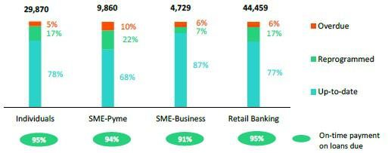

- Small and Medium Businesses (SME):

On-time payment on loans due ratio increased QoQ in SME-Pyme but deteriorated in SME-Business. In the case of SME-Pymes, the ratio rose from 92% to 94% but fell in SME-Business from 93% to 91%. In both cases, the volume of loans with expirations increased. Specifically, in SME-Pyme, 94% of the portfolio matured during the quarter; the figure stood at 61% for the SME-Business portfolio.

In terms of the composition of the structural portfolio: In SME-Pyme, 68% of the portfolio is up-to-date; 22% is reprogrammed; and 10% is overdue (compared to 67%, 25% and 8% at the end of March respectively). In SME-Business, 87% of the portfolio is up-to-date, 7% is reprogrammed and 6% overdue (in comparison to 88%, 9% and 3% at the end of March respectively). In both cases, the uncertain portfolio, which is composed of the reprogrammed and IOL portfolios, remained stable QoQ. It is important to note that in SME-Pyme and SME-Business, the demand for new reprogramming has fallen; only 1.5% of the SME-Pyme portfolio with maturities was reprogrammed, while the SME-Business portfolio didn’t presented (vs 3.6% and 1.6% respectively in March). The total volume of reprogramming fell -9.3% QoQ, which was primarily attributable to the evolution of SME-Pyme.

- Individuals:

This quarter, the ratio of on-time payments on loans due deteriorated in Personal Banking, falling from 97% in March to 95% in June. The contraction is mainly due to an increase in the very early overdue (less than 15 days), which has been contained and has not migrated to more advanced sections, which remained stable during the quarter.

In terms of the composition of the structural portfolio: 79% of the portfolio was up-to-date, 16% reprogrammed and 5% overdue (compared to 78%, 18% and 4% at the end of March respectively). In this context, the uncertain portfolio also remained stable QoQ. At the end of June, the demand for new reprogramming represented 0.6% of the portfolio with expirations (vs 1.0% in March).

- Analysis excludes loans that are more than 120 days overdue and the under legal collection portfolio.

⁵ On-time payment ratio of loans due in the month.

32

Mibanco:

Portfolio Composition and Payment Ratio⁶ (as of Jun 21)
(S/ millions)
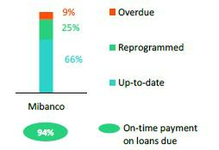

In 2Q21, the payment ratio registered a slight increase, going from 93% in March to 94% in June. Growth was driven by an uptick in on-time payments, which reflected recovery at the transactions level in the microfinance sector. This quarter, 81% of the portfolio expired.

In terms of the composition of the portfolio: 66% of the portfolio was up-to-date, 25% reprogrammed and 9% overdue (compared to 57%, 34% and 9% at the end of March respectively). The uncertain portfolio fell -9 pp due to a decrease in the volume of reprogramming. The demand for new reprogramming fell considerably, and only 0.6% of the portfolio with maturities was reprogrammed at the end of June (vs 2.1% in March). In this context, the reprogramming volume fell -25.9% QoQ.

BCP Bolivia:

In 2Q21, the volume of reprogrammed loans fell -3.1% QoQ. It is important to note that 64% of reprogrammed loans are set to mature in 2022.

These loans were primarily in the Mortgage sector.

4.3.2 Government Programs (GP)⁷

Loans under GP by Segment

(S/ millions)
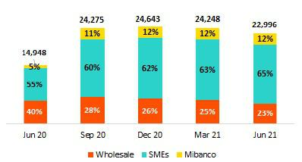

BCP Stand-alone – Wholesale Banking:

The GP portfolio fell -14.8% QoQ, which was primarily driven by the evolution of Middle Market banking. At the end of June, GP loans represented 9.7% of total loans (-300 bps vs March). It is important to note that in June, grace periods expired on 80% of the loans with maturities; 73% of these loans were paid, 26% reprogrammed; and 1% became overdue.

- On-time payment ratio of loans due in the month.
- The GP portfolio includes Reactiva Peru and FAE loans.

33

The Peruvian government has offered new reprogramming facilities, including extending grace periods and tenure, for clients that fulfill certain criteria. Reprogramming will be reflected in next quarter’s balances, but deterioration levels will not be fully evident until 2022. Corporate banking accounted for the 9% of the reprogrammed portfolio at the end of June and Middle Market Banking, 91%.

BCP Stand-alone – Retail Banking⁸:

- Small and Medium Businesses (SME):

The GP portfolio fell -2.0% QoQ. At the end of June, these loans represented 46% of total loans for SME (-100 bps vs March). It is important to note that in June─ the first month of expirations─ the grace periods of 46% of total GP loans expired (35% of the SME-Pyme portfolio and 63% of the SME-Business portfolio). Within the universe of SME-Pyme loans with expirations, which totaled 35% of total loans in this segment as of June 21, 57% were paid, 33% reprogrammed, and the remaining 10% were delinquent. In SME-Business, 63% of the loans registered grace period expirations; 71% of these loans were paid, 28% were reprogrammed, and the remaining 1% became delinquent.

As is the case with Wholesale Banking, in a context of new government measures, clients will be able to apply for reprogramming of grace periods and tenures. At the end of 2Q21, 84% of the overdue clients had been approved for reprogramming and were in the process of being reprogrammed (these are being considered as reprogrammed in the ratios mentioned previously). Additionally, 67% of the clients opted for reprogramming to extend grace periods and tenures while 33% opted solely for grace periods. As indicated above, the trajectory of the behavior of this reprogramming will be more evident in 2022.

Mibanco:

The GP portfolio registered a reduction of -1.2% QoQ. At the end of June, these loans represented 21.3% of the total portfolio (-30 bps vs March). As of June, 13% of total GP loans have expired. Within the universe of loans with expirations, 98% paid, 0% reprogrammed, and the remaining 2% become overdue. It should be noted that reprogramming applications are still under review and as such, these has yet to be approved.

Portfolio Composition and Guarantees (as of Jun 21)

(S/ millions)
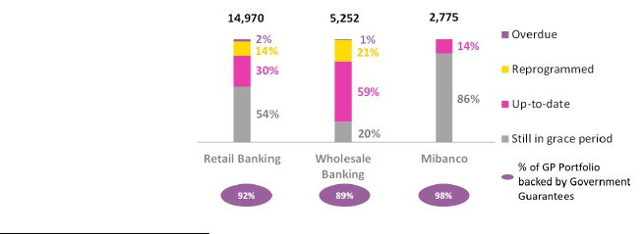

- Analysis excludes loans that are more than 120 days overdue and the under legal collection portfolio.

34



5. Non-financial income (NFI)

Non-financial income |  |  |  | Quarter |  |  |  | % change |  |  |  |  | YTD |  |  |  |  | % change
(S/ 000) |  | 2Q20 |  | 1Q21 |  | 2Q21 |  | QoQ |  |  | YoY |  | Jun 20 |  |  | Jun 21 |  | Jun 21 / Jun 20
Fee income |  | 503,488 |  | 830,771 |  | 862,411 |  | 3.8% |  |  | 71.3% |  | 1,263,817 |  |  | 1,693,182 |  | 34.0%
Net gain on foreign exchange
transactions |  | 149,308 |  | 179,889 |  | 232,668 |  | 29.3% |  |  | 55.8% |  | 316,291 |  |  | 412,557 |  | 30.4%
Net gain on securities |  | 280,563 |  | 16,287 |  | (69,947) |  | -529.5% |  |  | -124.9% |  | 159,930 |  |  | (53,660) |  | -133.6%
Net gain from associates ⁽¹⁾ |  | 14,906 |  | 29,405 |  | 12,302 |  | -58.2% |  |  | -17.5% |  | 34,131 |  |  | 41,707 |  | 22.2%
Net gain on derivatives held for
trading |  | 8,358 |  | 69,723 |  | 45,413 |  | -34.9% |  |  | 443.3% |  | 43,788 |  |  | 115,136 |  | 162.9%
Net gain from exchange
differences |  | 23,845 |  | (5,536) |  | 45,924 |  | n.a. |  |  | 92.6% |  | 2,996 |  |  | 40,388 |  | 1248.1%
Other non-financial income |  | 35,195 |  | 73,991 |  | 62,923 |  | -15.0% |  |  | 78.8% |  | 152,965 |  |  | 136,914 |  | -10.5%
Total non-financial income, net |  | 1,015,663 |  | 1,194,530 |  | 1,191,694 |  | -0.2 | % |  | 17.3 | % | 1,973,918 |  |  | 2,386,224 |  | 20.9 | %

- Includes gains on other investments, mainly made up of the profit of Banmedica.

- It differs from what was previously reported by reclassification of IFRS16.

Evolution of non-financial income QoQ evolution of non-financial income
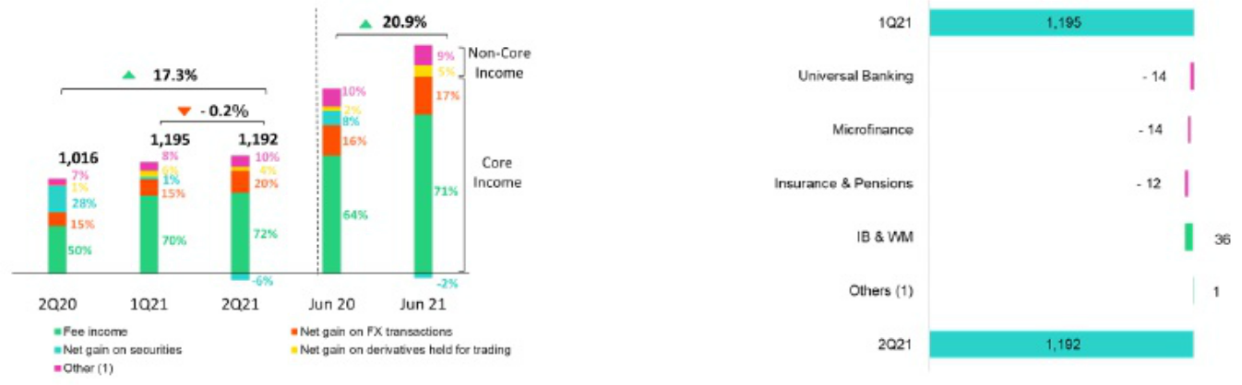

- Others includes Net gain from associates, Net gain from exchange difference and Other non-financial income.

In the QoQ analysis, core NFI evolved favorably due to:

(i) Positive results in Universal Banking due to:

- Others includes Grupo Crédito, Credicorp Stand-alone, elimination and others.

  - Growth in Fee income due to an uptick in foreign transfers by clients in the import sector, despite changes in regulations on fees⁹ and;

  - An increase in the Net gain on foreign exchange transactions due to higher volume operations related to political uncertainty.

- Growth in income in Investment Banking and in Wealth Management was driven by Fee income, which grew by an uptick in brokerage fees associated with growth in the sale of securities, which was stoked by political uncertainty, and by growth in fees to enter third-party funds through international platforms, which was mainly at ASB.

The aforementioned was partially offset by a decrease in Fee income in Microfinance due to provisions that were set aside to cover fee reimbursements stipulated in new Peruvian legislation and to an increase in payments to third parties for physical agreements.

Non-core NFI fell due to:

- The implementation of a strategy at BCP Stand-alone which, reduced interest rates sensitivity in the investment at fair value with changes in other comprehensive income portfolio by selling sovereign bonds at a loss. This was partially offset by a gain on the exchange position.

- Elimination of fees for inter-place transfers and penalty for late payment.

36

- The decrease in the Net gain from associates, which was generated by a decrease in gains in the EPS business due to high numbers of claims for COVID-19.

The aforementioned was partially offset by strategies for exchange rate derivatives in a scenario marked by an exchange rate volatility, which generated positive results in the Net gain for speculative derivatives. Combined, these results led to a -0.2% reduction in NFI.

YoY evolution of Non-Financial Income YTD evolution of non-financial income
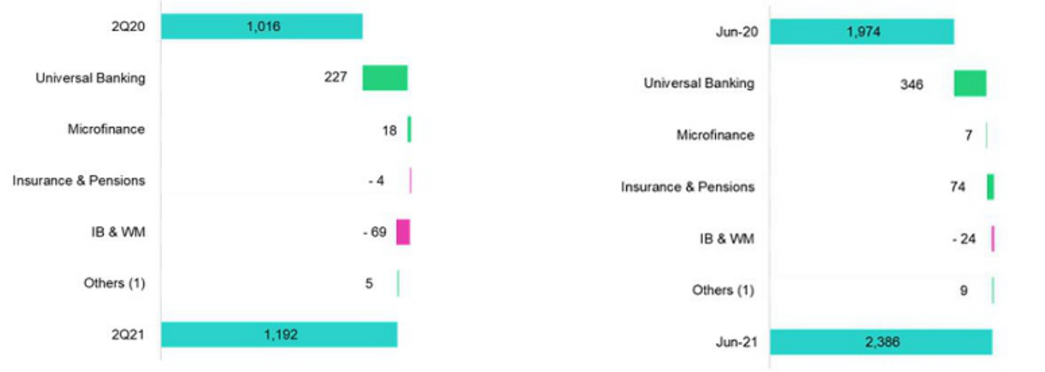

- Others includes Grupo Crédito, Credicorp Stand-alone, elimination and others.

YoY, growth in core NFI was driven by:

- An improvement in results for Universal Banking, which was due to:

  - Growth in Fee income given that fee exemptions were granted during the quarantine in 2020.

  - Growth in the Net gain on foreign exchange transactions in a context of high uncertainty due to the elections.

- An increase in Fee income in Microfinance given that in 2020, clients received fee exemptions to weather the pandemic.

In contrast, non-core NFI registered a reduction due to:

- A drop in the Net gain on securities in Investment Banking and in Wealth Management, given that in 2Q20, extraordinary income was reported for acting as a structuring agent for an IPO.

- A decrease in the Net gain on securities in Insurance and Pensions due to a decrease in income generated by Prima AFP’s legal reserves (reduction in legal reserve requirement and market downturn).

- Others includes Grupo Crédito, Credicorp Stand-alone, elimination and others.

These results were partially offset by an increase in the Net gain from exchange differences in Universal Banking, which was associated with the exchange rate position strategy assumed to mitigate the impacts of exchange rate volatility.

YTD, the positive evolution of core NFI was driven by growth in Fee income in Universal Banking, given that this year, unlike last, all fees have been charged.

Non-core NFI evolved positively due to:

- Growth in the Net gain on securities in Insurance and Pensions given that the benchmark period in 2020 was impacted by a sharp market downturn.

- An increase in the Gain on the exchange rate difference in Microfinance, which reflects the increase in the position in FC in a scenario marked by an upward trend in the exchange rate.

This growth was partially attenuated by a decrease in the Net gain in securities in Investment Banking and Wealth Management given that in 2Q20, extraordinary income was generated.

37

5.1. Fee income

5.1.2. Fee income in the Banking Business

Composition of fee income in the banking business

Fee Income |  |  |  | Quarter |  |  |  | % change |  |  |  | Year |  |  |  |  | % change
S/ 000 |  | 2Q20 |  | 1Q21 |  | 2Q21 |  | QoQ |  | YoY |  | Jun 20 |  |  | Jun 21 |  | Jun 21 / Jun 20
Miscellaneous accounts ⁽¹⁾ |  | 115,586 |  | 181,065 |  | 180,183 |  | -0.5% |  | 55.9% |  | 280,549 |  |  | 361,247 |  | 28.8%
Credit cards ⁽²⁾ |  | 12,606 |  | 54,020 |  | 56,218 |  | 4.1% |  | 345.9% |  | 73,041 |  |  | 110,237 |  | 50.9%
Drafts and transfers |  | 40,995 |  | 84,625 |  | 98,796 |  | 16.7% |  | 141.0% |  | 102,841 |  |  | 183,422 |  | 78.4%
Personal loans ⁽²⁾ |  | 11,298 |  | 24,271 |  | 27,608 |  | 13.7% |  | 144.4% |  | 39,650 |  |  | 51,879 |  | 30.8%
SME loans ⁽²⁾ |  | 6,450 |  | 14,535 |  | 16,821 |  | 15.7% |  | 160.8% |  | 25,258 |  |  | 31,356 |  | 24.1%
Insurance ⁽²⁾ |  | 22,747 |  | 27,189 |  | 26,897 |  | -1.1% |  | 18.2% |  | 47,926 |  |  | 54,086 |  | 12.9%
Mortgage loans ⁽²⁾ |  | -870 |  | 7,763 |  | 9,373 |  | 20.7% |  | n.a. |  | 8,531 |  |  | 17,136 |  | 100.9%
Off-balance sheet ⁽³⁾ |  | 49,231 |  | 59,864 |  | 60,592 |  | 1.2% |  | 23.1% |  | 99,324 |  |  | 120,456 |  | 21.3%
Payments and collections ⁽³⁾ |  | 82,325 |  | 106,384 |  | 108,670 |  | 2.1% |  | 32.0% |  | 183,608 |  |  | 215,053 |  | 17.1%
Commercial loans ⁽³⁾⁽⁴⁾ |  | 10,448 |  | 15,392 |  | 16,766 |  | 8.9% |  | 60.5% |  | 28,426 |  |  | 32,158 |  | 13.1%
Foreign trade ⁽³⁾ |  | 9,960 |  | 15,191 |  | 17,905 |  | 17.9% |  | 79.8% |  | 21,536 |  |  | 33,096 |  | 53.7%
Corporate finance and mutual funds ⁽⁴⁾ |  | 12,151 |  | 13,583 |  | 13,011 |  | -4.2% |  | 7.1% |  | 28,825 |  |  | 26,594 |  | -7.7%
Mibanco |  | 639 |  | 17,647 |  | 10,727 |  | -39.2% |  | n.a. |  | 24,172 |  |  | 28,373 |  | 17.4%
BCP Bolivia |  | 24,070 |  | 34,532 |  | 30,558 |  | -11.5% |  | 27.0% |  | 50,420 |  |  | 65,091 |  | 29.1%
ASB |  | 6,772 |  | 11,858 |  | 21,590 |  | 82.1% |  | 218.8% |  | 15,184 |  |  | 33,448 |  | 120.3%
Others ⁽⁴⁾⁽⁵⁾ |  | 4,924 |  | 10,583 |  | 5,019 |  | -52.6% |  | 1.9% |  | 17,108 |  |  | 15,602 |  | -8.8%
Total fee income |  | 409,332 |  | 678,503 |  | 700,733 |  | 3.3 | % | 71.2 | % | 1,046,399 |  |  | 1,379,236 |  | 31.8 | %

Source: BCP

- Saving accounts, current accounts, debit card and master account.

- Mainly Retail fees.

- Mainly Wholesale fees.

- Figures differ from previously reported, please consider the data presented on this report.

- Includes fees from trust business, wealth management, network usage and other services to third parties, among others.

Fee income in the banking business rose 3.3% QoQ. The components that registered the highest growth were:

- Drafts and transfers, given that the volume of transfers grew via an uptick in interbank transactions, mainly by clients sending transfers abroad (companies in the import sector).

- ASB, via fees charged to clients that used this subsidiary’s international platform to transfer funds, after funds migrated abroad in a context of political uncertainty.

This growth was partially offset by a drop in fee income at Mibanco, as outlined above, and by a decrease in income in Others, from the Network usage and other services to third-party.

YoY and at the YTD level, growth was primarily attributable to Miscellaneous Accounts, Drafts and Transfers and Credit Cards, given that during the quarantine in 2020, clients were offered fee exemptions.

It is important to mention that the new legislation, which prohibits the collection of late payment penalties and inter-place commissions, will have an annual impact of 5% on the income of commissions at Credicorp level.

38

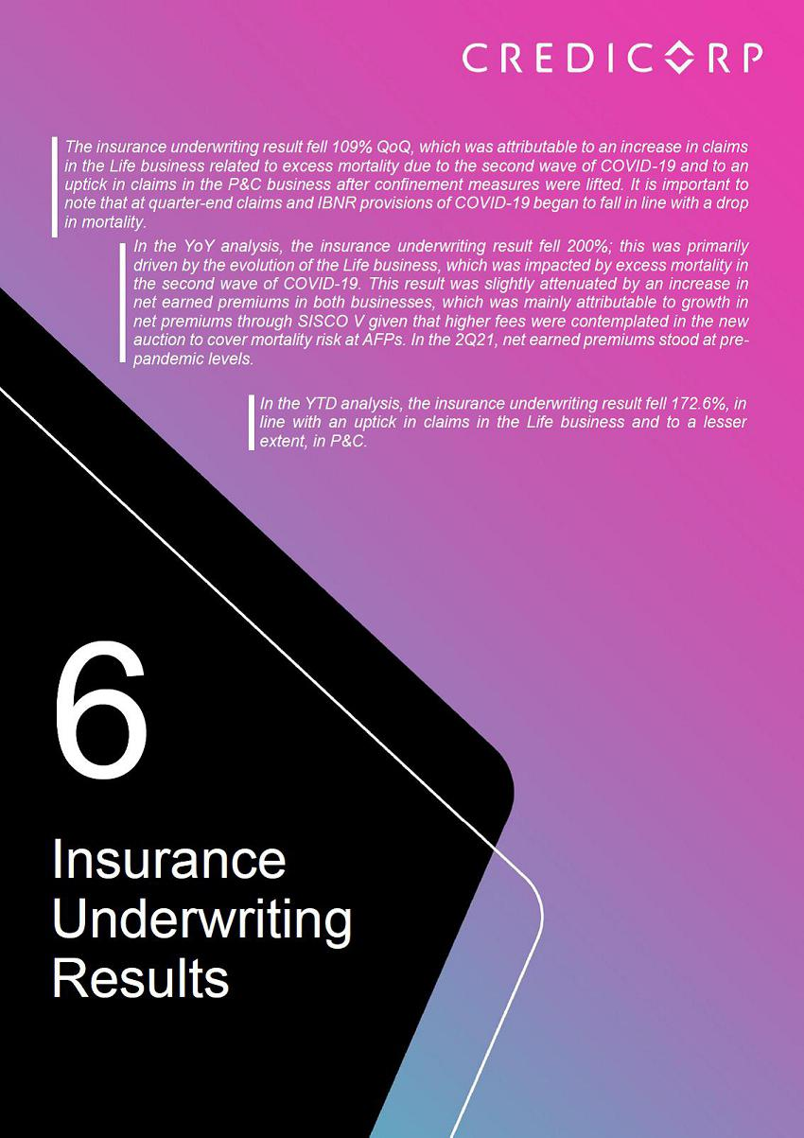

6. Insurance Underwriting Result
Insurance underwriting result ⁽¹⁾ |  |  |  |  | Quarter
S/ 000 |  |  | 2Q20 |  | 1Q21 |  | 2Q21
 | Net earned premiums |  | 552,061 |  | 643,928 |  | 639,944
Net claims |  |  | (328,783) |  | (623,353) |  | (691,335)
Acquisition cost ⁽²⁾ |  |  | (87,598) |  | (85,822) |  | (84,944)
Total insurance underwriting result |  |  | 135,680 |  | (65,247 | ) | (136,335 |  | )

- Includes the results of the Life, Property & Casualty and Crediseguros business.

- Includes net fees and underwriting expenses.

6.1. Life Insurance

Total life insurance premiums

(S/ millions)
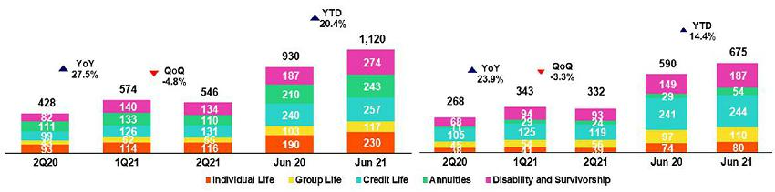

% change |  |  |  | YTD |  |  |  | % change
QoQ |  | YoY |  | Jun 20 |  | Jun 21 |  | Jun21 / Jun20
-0.6% |  | 15.9% |  | 1,179,996 |  | 1,283,872 |  | 8.8%
-10.9% |  | -110.3% |  | (702,285) |  | (1,314,688) |  | -87.2%
1.0% |  | 3.0% |  | (200,105) |  | (170,766) |  | 14.7%
109.0 | % | N/A |  | 277,606 |  | (201,582 | ) | N/A

Net earned premiums ⁽¹⁰⁾
(S/ millions)

Total premiums fell 4.8% QoQ, which was attributable to (i) Annuities, which was associated with a decrease in the sales of period certain products due to political uncertainty; (ii) Group life, which was driven by a seasonal effect that is registered in the first quarter of the year for mining renewals of SCTR (Insurance for high-risk occupations) policies; (iii) D&S, after lower premiums were registered in SISCO V⁽^{[11]}⁾. The aforementioned was mitigated by

- Credit Life, via the bancassurance channel for Mibanco, which implemented an increase in fees in May and (v) Individual Life, due to an increase in sales and to an uptick in the exchange rate.

Net earned premiums fell 3.3% QoQ, for the reasons outlined above. This result was mitigated by a drop in reserves, which was associated with a decrease in direct premiums.

In the YoY analysis, total premiums increased 27.5%. This was mainly driven by (i) D&S, due to an uptick in collections under SISCO V, which contemplates a more favorable fee structure; (ii) Credit life, due to a decrease in premiums at Mibanco in 2Q20 due to the economic juncture (iii) Individual life; due to an increase in sales and in the exchange rate; (iv) Group Life, which was driven mainly by an uptick in premiums for renewals. The aforementioned was attenuated by (v) Annuities, due to a decrease in premiums for individual products.

Net earned premiums increased 23.9% YoY for the reasons outlined in the analysis of direct premiums.

YTD, total premiums increased 20.4% for the reasons explained in the YoY analysis. Meanwhile, accumulated Net earned premiums increased 14.4% due to the reasons outlined in the analysis of direct premiums; this result was attenuated by an increase in reserves in Individual Life and Annuities and by an uptick in ceased premiums in D&S.

40

Net life insurance claims

(S/ millions)
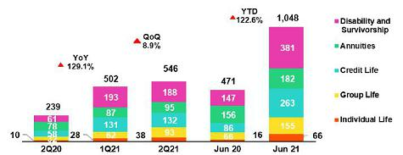

Net claims increased 8.9% QoQ, which was due to growth in the number of deaths reported in the second wave of COVID-19. In 2Q21, net claims totaled S/ 219 million (vs S/ 119 million in 1Q21), led by Credit Life, D&S, Group Life as well as Annuities (which was impacted by an increase in the stock of policies). The aforementioned was mitigated by a drop in total IBNR reserves set aside this quarter- S/ 35 million in 2Q21 vs. S/ 141 million in 1Q21- and we expect that this will continue to free up as more COVID cases are reported.

In the YoY analysis, net claims increased 129.1% in all lines due to excess mortality during the second wave of COVID-19 given that more cases were reported (vs S/ 20 million in 2Q20), mainly in D&S and Credit Life; this was partially attenuated by a decrease in IBNR reserves (vs S/ 38.8 million in 2Q20). YTD, claims increased 122.6% after an increase of S/ 337.7 million was registered (to June 21) for reported cases.

After registering a peak in COVID-19 provisions in the months of March and April, we have observed that claims begin to decrease in June and the trend is favorable for the coming months.

6.2. P&C Insurance

Total P&C Premiums

(S/ millions)

Net Earned Premiums (12)

(S/ millions)
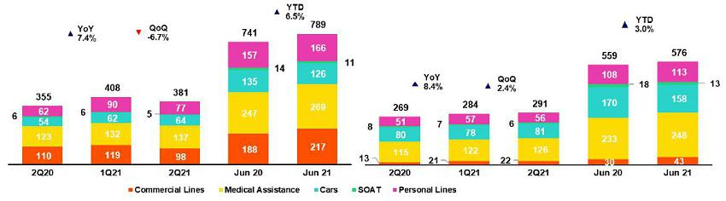

Total premiums fell 6.7% QoQ, which was attributable to (i) Commercial lines, after higher premiums were registered for renewals in 1Q21 in the fire and third-party liability lines; (ii) Personal lines, after an increase in premiums for renewals was reported for the Home Mortgage product in 2Q21 and a change in the status of Autoseguro, given that the contract ended in May. The aforementioned was mitigated by (iii) Medical Assistance, due to an increase in renewals of comprehensive health insurance products; and (iv) Cars, due to an increase in sales and renewals in the brokers channel.

Net earned premiums increased 2.4% QoQ, for the reasons outlined in the total premiums analysis, which was mainly mitigated by the decrease in ceded premiums in Commercial Lines following to lower premiums ceded for facultative insurance⁽¹³⁾ (ii) a decrease in the direct premium for facultative insurance and a decrease in Reserves for Current Risk in Cars.

- Total premiums excluding premiums ceded to reininsurance and premium reserves.

- Accounts 100% reinsured due to the high level of risk of the clients in this product.

41

In the YoY analysis, total premiums increased 7.4%, mainly in (i) Medical Assistance, due to an increase in premiums for renewals of comprehensive health products and policy cancellations for lack of payment in 2Q20; (ii) Cars, due to an increase sale in the brokers and digital channels and, to a lesser extent, due to cancellations for lack of payment in 2Q20. The aforementioned was attenuated by (iii) Commercial Lines, due to an increase in premiums for renewals in 2Q20 in the fire and aviation lines; (v) SOAT, due to a decrease in new sales in the brokers and bancassurance channels.

Net earned premiums increased 8.4% YoY for the reasons outlined in the QoQ analysis.

YTD, total premiums increased 6.5% and accumulated net premiums, 3.0%, for the reasons given in the YoY analysis.

Net Claims in P&C

(S/ millions)
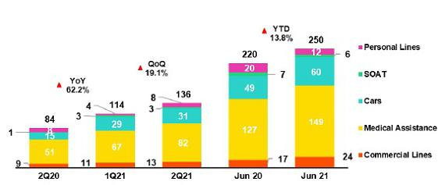

Net claims increased 19.1% QoQ, which was primarily attributable to (i) Medical Assistance, due to an increase in the frequency of cases of COVID and other illnesses under comprehensive policies (ii) Commercial lines, due to an increase in severity in the transportation line for damaged merchandise and in maritime, due to sunken vessels; (iii) Cars, due to an uptick in case frequency after confinement measures and restrictions on car use were lifted; (iv) Personal lines, after more cases were filed for property insurance. The aforementioned was mitigated by the evolution of SOAT, which was marked by a catastrophic event in 1Q21.

In the YoY and YTD analyses, net claims rose 62.2% and 13.8% respectively. These increases were driven by Medical Assistance, after claims were liquidated in a context of low consumption of insurance products due to the quarantine and by Cars, which was affected by more stringent mobilization restrictions in 2Q20. The aforementioned was mitigated by Personal Lines, due to a decrease in premiums for Autoseguro.

6.3. Acquisition Cost
Acquisition cost |  |  |  | Quarter |  |  |  |  | % change |  |  |  | YTD |  |  |  | % change
S/ 000 |  | 2Q20 |  |  | 1Q21 |  | 2Q21 |  | QoQ |  | YoY |  | Jun 20 |  | Jun 21 |  | Jun21 / Jun20
Net fees |  | (49,084) |  |  | (55,605) |  | (53,808) |  | 3.2% |  | -9.6% |  | (115,734) |  | (109,413) |  | 5.5%
Underwriting expenses |  | (39,189) |  | (31,557) |  |  | (31,842) |  | -0.9% |  | 18.7% |  | (85,650) |  | (63,399) |  | 26.0%
Underwriting income |  | 675 |  | 1,340 |  |  | 706 |  | N/A |  | 4.5% |  | 1,279 |  | 2,045 |  | 59.9%
Acquisition cost |  | (87,598 | ) |  | (85,822 | ) | (84,944 | ) | -1.0 | % | -3.0 | % | (200,105 | ) | (170,767 | ) | -14.7 | %

Acquisition cost per business

(S/ million)
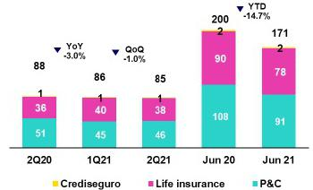

42

The acquisition cost fell 1.0% QoQ after commissions dropped, in line with a decrease in direct premiums in both businesses. This was partially offset by an increase in underwriting expenses in the P&C business and through Medical Assistance, which experienced an uptick in sales expenses and in provisions for doubtful collections, and via Personal Lines, which experienced an increase in sales expenses for promotions and claims servicing.

In the YoY analysis, the acquisition cost fell 3.0%. This result was mainly driven by the evolution of the P&C business and due to the following in 2Q20:

- premium reversals in Cars given that clients were unable to use their vehicles due to COVID-19 restrictions, and (ii) an increase in provisions for doubtful collections in all business lines. The aforementioned was attenuated by an uptick in commissions in both businesses. The result in P&C was attributable to the evolution of Commercial Lines and Personal Lines whereas the result in Life was driven by growth in direct premiums in Credit Life, Individual Life and Group life.

YTD, the acquisition cost fell 14.7% given that the underwriting expenses registered in P&C last year was higher. This was due to the fact that the Cars line was impacted by premium reversals for 10 million in the context of COVID-19 mobility restrictions; provisions to cover uncollectible premiums increased; and sales expenses in Individual Life fell. Commissions declined in the Life business via the alliance channel given that solidarity payments were reported for Financiera Oh last year.

6.4. Underwriting Result by Business

Underwriting Result by Business

(S/ millions)
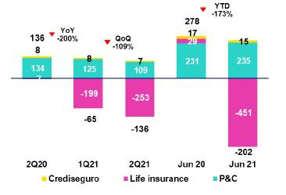

In the QoQ analysis, the decrease in the underwriting result was attributable primarily to Life insurance and to a lesser extent, to P&C. The result in Life was mainly driven by an increase in claims due to an uptick in cases reported in the second wave of COVID-19 and by a decrease in net premiums. In P&C, the decrease in the underwriting result was attributable to an increase in claims in Medical Assistance after cases of COVID-19 and other illnesses were registered in comprehensive products.

In the YoY analysis, is given for the reasons outlined in the analysis QoQ and higher IBNR provisions due to the second wave of COVID-19 in the life business.

YTD, the decrease in the underwriting result was attributable to Life insurance and mitigated by P&C insurance. The result in Life was driven by an increase in claims and in IBNR for the second wave of COVID-19; this was mitigated by an increase in net premiums in all business lines and by a drop in acquisition costs. The result in P&C was attributable to an increase in sales in Commercial lines and in Medical Assistance, which was attenuated by growth in claims after confinement and social distancing measures were eased.

43

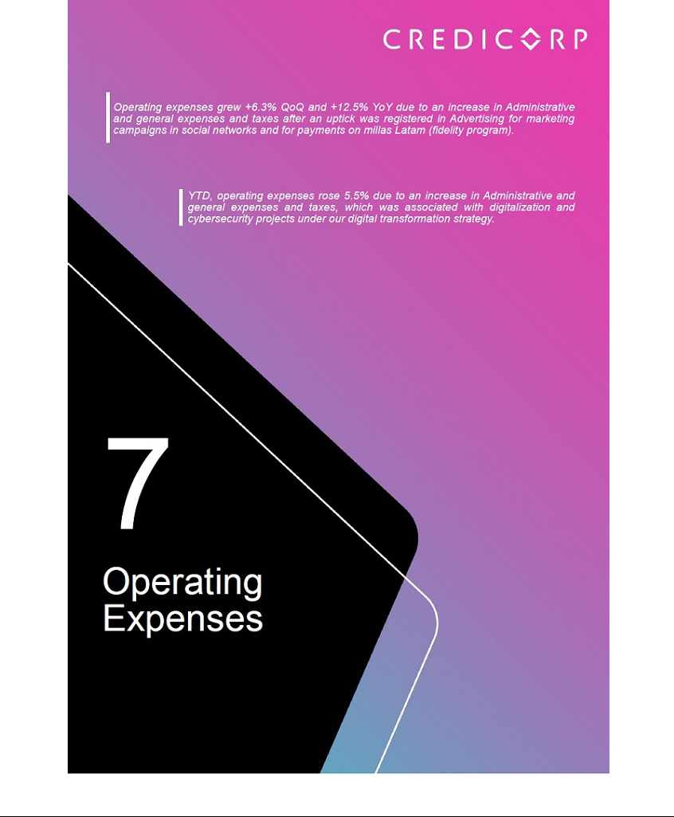

7. Operating Expenses

Operating expenses |  |  |  | Quarter |  |  |  | % change |  |  |  |  | YTD |  |  |  | % change
S/ 000 |  | 2Q20 |  | 1Q21 |  | 2Q21 |  | QoQ |  |  | YoY |  | Jun 20 |  | Jun 21 |  | Jun 21 / Jun 20
Salaries and employees benefits |  | 825,997 |  | 857,559 |  | 882,177 |  | 2.9% |  |  | 6.8% |  | 1,717,180 |  | 1,739,736 |  | 1.3%
Administrative, general and tax expenses ⁽¹⁾ |  | 510,694 |  | 580,842 |  | 672,805 |  | 15.8% |  |  | 31.7% |  | 1,052,798 |  | 1,253,647 |  | 19.1%
Depreciation and amortization ⁽¹⁾ |  | 169,310 |  | 166,765 |  | 163,869 |  | -1.7% |  |  | -3.2% |  | 339,269 |  | 330,634 |  | -2.5%
Association in participation |  | 17,944 |  | 13,906 |  | 8,879 |  | -36.1% |  |  | -50.5% |  | 24,374 |  | 22,785 |  | -6.5%
Acquisition cost ⁽²⁾ |  | 87,598 |  | 85,822 |  | 84,944 |  | -1.0% |  |  | -3.0% |  | 200,105 |  | 170,766 |  | -14.7%
Operating expenses ⁽³⁾
 |  | 1,611,543 |  | 1,704,894 |  | 1,812,674 |  | 6.3% |  |  | 12.5% |  | 3,333,726 |  | 3,517,568 |  | 5.5%

- It differs from what was previously reported by reclassification of IFRS16.
- The acquisition cost of Pacifico includes net fees and underwriting expenses.
- Operating expenses = Salaries and employee’s benefits + Administrative expenses + Depreciation and amortization + Association in participation + Acquisition cost.

Composition of operating expenses as of

June-21

In the QoQ and YoY analysis, +6.3% and +12.5% growth in Operating Expenses, respectively, was attributable to:

- Growth in Administrative and general expenses and taxes (+15.8%), which was driven primarily by BCP Stand-alone and via an increase in advertising expenses in social networks to promote Yape, Savings accounts and Personal loans, and through an uptick in expenses for the fidelity program Millas Latam, which reflected growth in credit card transactions.

- A 2.9% increase in Salaries and Employee Benefits, which reflected an increase in provisions for profit sharing, in line with growth in net income this quarter.
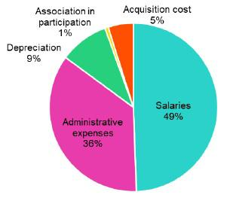

The increase in spending was partially offset by a reduction in Association in Participation, which was driven by a decrease in earnings on private health insurance after claims levels rose relative to COVID-19 cases and other illnesses.

YTD, Operating Expenses increased +5.5%, due to:

- An increase in Administrative and general expenses and taxes due to an uptick in investment in cybersecurity and digital transformation projects, in line with strategies to promote digital channels.

- Growth in Salaries and Employee Benefits after provisions were shored up to cover profit sharing, in line with the improvement in results this year.

This increase was partially offset by a reduction in the Acquisition cost (-14.7%), which was primarily associated with premium reversals for car insurance in the first half of 2020 in the context of the pandemic.

45

7.1. Administrative and general expenses and taxes

Administrative and general expenses and taxes

Administrative, general and tax expenses |  |  |  | Quarter |  |  |  | % change |  |  |  |  | YTD |  |  |  |  | % change
S/ 000 |  | 2Q20 |  | 1Q21 |  | 2Q21 |  | QoQ |  |  | YoY |  | Jun 20 |  |  | Jun 21 |  | Jun 21 / Jun 20
IT, Repair and maintenance |  | 98,069 |  | 106,625 |  | 116,692 |  | 9.4% |  |  | 19.0% |  | 174,120 |  |  | 223,317 |  | 28.3%
Marketing |  | 53,505 |  | 72,270 |  | 104,862 |  | 45.1% |  |  | 96.0% |  | 128,761 |  |  | 177,132 |  | 37.6%
Taxes and contributions |  | 63,344 |  | 68,808 |  | 77,406 |  | 12.5% |  |  | 22.2% |  | 131,361 |  |  | 146,214 |  | 11.3%
Consulting and professional fees |  | 46,412 |  | 40,858 |  | 57,720 |  | 41.3% |  |  | 24.4% |  | 85,897 |  |  | 98,578 |  | 14.8%
Transport and communications |  | 30,156 |  | 42,697 |  | 51,169 |  | 19.8% |  |  | 69.7% |  | 65,622 |  |  | 93,866 |  | 43.0%
IBM services expenses |  | 33,006 |  | 40,445 |  | 42,826 |  | 5.9% |  |  | 29.8% |  | 63,315 |  |  | 83,271 |  | 31.5%
Comissions by agents |  | 19,076 |  | 25,036 |  | 25,218 |  | 0.7% |  |  | 32.2% |  | 40,505 |  |  | 50,254 |  | 24.1%
Security and protection |  | 15,823 |  | 15,959 |  | 15,691 |  | -1.7% |  |  | -0.8% |  | 31,802 |  |  | 31,650 |  | -0.5%
Sundry supplies |  | 9,908 |  | 14,819 |  | 14,171 |  | -4.4% |  |  | 43.0% |  | 33,547 |  |  | 28,990 |  | -13.6%
Leases of low value and short-term |  | 15,091 |  | 20,902 |  | 20,145 |  | -3.6% |  |  | 33.5% |  | 36,394 |  |  | 41,047 |  | 12.8%
Electricity and water |  | 13,133 |  | 10,691 |  | 12,709 |  | 18.9% |  |  | -3.2% |  | 24,946 |  |  | 23,400 |  | -6.2%
Subscriptions and quotes |  | 12,219 |  | 13,183 |  | 13,462 |  | 2.1% |  |  | 10.2% |  | 22,971 |  |  | 26,645 |  | 16.0%
Insurance |  | 3,195 |  | 8,274 |  | 5,320 |  | -35.7% |  |  | 66.5% |  | 8,105 |  |  | 13,594 |  | 67.7%
Electronic processing |  | 6,840 |  | 9,968 |  | 11,123 |  | 11.6% |  |  | 62.6% |  | 15,477 |  |  | 21,091 |  | 36.3%
Cleaning |  | 5,522 |  | 5,282 |  | 5,206 |  | -1.4% |  |  | -5.7% |  | 11,040 |  |  | 10,488 |  | -5.0%
Audit Services |  | 1,220 |  | 1,258 |  | 2,206 |  | 75.4% |  |  | 80.8% |  | 2,470 |  |  | 3,464 |  | 40.2%
Services by third-party and others ⁽¹⁾ |  | 84,175 |  | 83,767 |  | 96,878 |  | 15.7% |  |  | 15.1% |  | 176,465 |  |  | 180,645 |  | 2.4%
Total administrative and general expenses |  | 510,694 |  | 580,842 |  | 672,804 |  | 15.8 | % |  | 31.7 | % | 1,052,798 |  |  | 1,253,646 |  | 19.1 | %

(1) The balance consists mainly of security and protection services, cleaning service, representation expenses, electricity and water utilities, insurance policiy expenses, subscription expenses and commission expenses.

In the QoQ analysis, administrative and general expenses and taxes increased 15.8% due to:

- Growth in expenses for Marketing (+45.1%) due to higher advertising expenses in social networks and an increase in expenses for Millas Latam, in line with an uptick in the use of credit and debit cards.

- The 41.3% increase in expenses for Consulting and Professional Fees related to the digital transformation program and services for account auditing.

In the YoY analysis, administrative and general expenses and taxes grew +31.7% due to:

- Growth in expenses for Marketing (+96.0%), after consumption relative to millas LATAM rose in line with economic activation and an uptick in card use.

- Higher expenses in Transportation and Communications (69.7%), which reflects an increase in the use of services for transport and custody of remittances after US Dollars were imported to satisfy internal demand in a context of a stronger dollar.

YTD, administrative and general expenses and taxes increased +19.1%, which was attributable to:

- Higher expenses for IT, Repair and Maintenance for digitalization and cybersecurity projects implemented in the first half of the year under the digital transformation strategy.

- An increase in expenses for Marketing due to higher consumption under the millas LATAM program. This reflected an uptick in transactions with cards compared to the same period in 2020, when a strict quarantine was in effect.

46

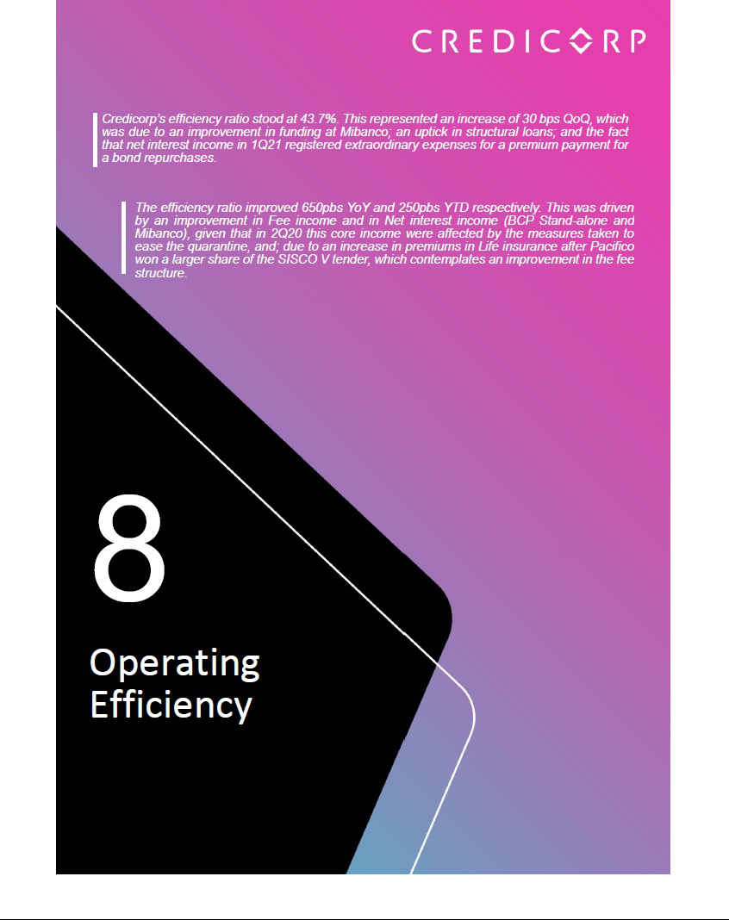

- Operating Efficiency

Operating Efficiency |  |  |  |  | Quarter |  |  |  | % change |  |  |  |  | Year |  |  |  |  | % change
 | S/ 000 |  | 2Q20 |  | 1Q21 |  | 2Q21 |  | QoQ |  |  | YoY |  | Jun 20 |  |  | Jun 21 |  | Jun 21 / Jun 20
 | Operating expenses ⁽¹⁾ |  | 1,611,543 |  | 1,704,894 |  | 1,812,674 |  | 6.3% |  |  | 12.5% |  | 3,333,726 |  |  | 3,517,568 |  | 5.5%
 | Operating income ⁽²⁾ |  | 3,213,316 |  | 3,871,563 |  | 4,147,704 |  | 7.1% |  |  | 29.1% |  | 7,181,896 |  |  | 8,019,267 |  | 11.7%
 | Efficiency ratio ⁽³⁾ |  | 50.2% |  | 44.0% |  | 43.7% |  | -30 bps |  |  | -650 bps |  | 46.4% |  |  | 43.9% |  | -250 bps
 | Operating expenses /
Total average assets ⁽⁴⁾ |  |  | 3.07% |  | 2.83% |  | 2.96% |  | 13 bps |  |  | -11 bps |  | 3.26% |  |  | 2.92% |  | -34 bps

- Operating expenses = Salaries and employee’s benefits + Administrative expenses + Depreciation and amortization + Association in participation + Acquisition cost.

- Operating income = Net interest, similar income and expenses + Fee income + Net gain on foreign exchange transactions + Net gain from associates + Net gain on derivatives held for trading + Net gain from exchange differences + Net premiums earned
- Operating expenses / Operating income.

- Operating expenses / Average of Total Assets. Average is calculated with period beginning and period-ending balances.

8.1 Efficiency ratio by income and expense item

In the QoQ analysis, the efficiency ratio improved 30bps due to an uptick in operating income, which was in turn attributable to growth in Net interest income given that i) in 1Q21, extraordinary expenses were reported for the payment of premiums on bond repurchases, ii) structural loans registered growth and iii) Mibanco improved its funding structure.

The was partially offset by an increase in Administrative and general expenses and taxes, which registered an increase in advertising expenses in the social networks for the Yape, Savings Accounts and Personal Loans campaigns.

YoY evolution of the efficiency ratio by account
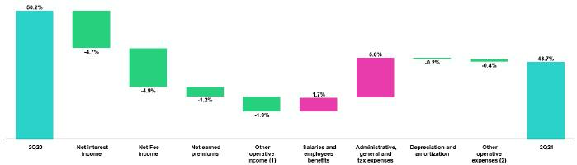

YTD evolution of the efficiency ratio by account
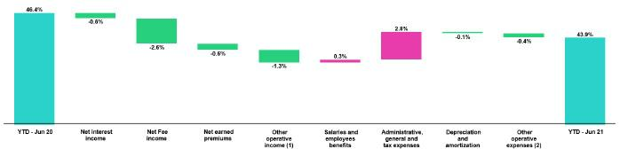

- Other operating income includes: Net gain on foreign exchange transactions, Net gain from associates, Net gain on derivatives held for trading and Net gain from exchange difference.

- Other operating expenses includes: Acquisition cost and Association in participation.

The improvement of 650 bps and 250 bps in the efficiency ratio YoY and YTD respectively was primarily due to:

- An increase in Fee income given that in 2Q20, clients were offered exemptions that have since been discontinued.

- Growth in Net interest income given that in 2Q20, a loss was recognized of one-off impairment in the loan portfolio due to frozen loans.

48

- Higher income from Net earned premiums after Pacifico won higher portion of the auction under SISCO V¹⁴ (which contemplates a higher fee structure than SISCO IV) and premiums rose for credit life insurance, in line with an uptick in loans at Mibanco.

- Growth in Net gains on foreign exchange operations, which was spurred by uncertainty surrounding the elections in 2Q21.

The aforementioned improvement was partially offset by an increase in Administrative and general expenses and taxes (higher expenses for the fidelity program Millas Latam, transportation of remittances and IT projects) and Salaries and employee benefits (increase in profit sharing, in line with an improvement in results).

8.2. Efficiency ratio by subsidiary ⁽¹⁾

 | BCP
 | Stand- |  |  | BCP |  |  |  |  | Mibanco
 | alone |  |  | Bolivia |  | Mibanco Peru |  |  | Colombia |  | Pacifico |  | Prima AFP |  | Credicorp
2Q20
2Q20 | 43.0% |  |  | 51.0% |  |  | 93.7% |  | 89.8% |  | 40.0% |  | 57.3% |  | 50.2%
1Q21 | 40.2% |  |  | 59.7% |  |  | 62.0% |  | 78.3% |  | 37.4% |  | 46.5% |  | 44.0%
2Q21 | 40.3% |  |  | 58.9% |  |  | 55.6% |  | 74.1% |  | 36.6% |  | 44.9% |  | 43.7%
Var. QoQ | 10bps |  |  | -80bps |  |  | -640bps |  | -420bps |  | -80bps |  | -160bps |  | -30bps
Var. YoY | -270bps |  |  | 790bps |  |  | -3810bps |  | -1570bps |  | -340bps |  | -1240bps |  | -650bps
Jun 21 | 40.7% |  |  | 53.7% |  |  | 62.6% |  | 76.1% |  | 40.3% |  | 47.1% |  | 46.4%
Jun 20 | 40.2% |  |  | 59.3% |  |  | 58.6% |  | 87.5% |  | 37.0% |  | 45.7% |  | 43.9%
% change | -50bps |  |  | 560bps |  |  | -400bps |  | 1140bps |  | -330bps |  | -140bps |  | -250bps
Jun 21 / Jun 20

- (Salaries and employees benefits + Administrative, general and tax expenses + Depreciation and amortization + Acquisition cost + Association in participation) / (Net interest income + Fee income + Net gain on foreign exchange transactions + Net gain from associates + Net gain on derivatives held for trading + Result on exchange differences + Net premiums earned).

In the QoQ analysis, the efficiency ratio improved. This was primarily driven by:

- Growth in Net interest income in Microfinance, which was attributable to growth in structural loans and to a decrease in the funding cost due to lower market rates.

- A drop in operating expenses at Pacifico. This was primarily attributable to a decrease in remunerations and in association in participation; the former was a product of the strategy to control expenses and the latter, the result of an uptick in claims in the health insurance segment.

YoY evolution of the efficiency ratio by subsidiary
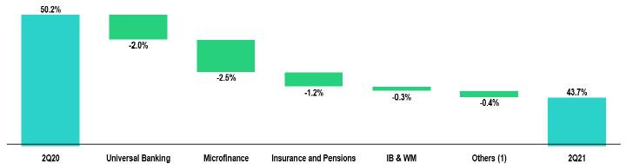

  - Others includes: Credicorp Capital, Prima AFP, BCP Bolivia, ASB, Grupo Crédito, among other subsidiaries and the eliminations for consolidation purposes.

- Consist in the join administration of the risk of disability, survival and burial expenses of the AFP affiliates by the insurance companies that are winners in the public bidding process.

49

In the YoY analysis, efficiency improved 650 bps, which was primarily attributable to:

- Growth in Net interest income in Microfinance given that in 2Q20, a one-off impairment was recognized in the loan portfolio (generated by frozen loans).

- An increase in operating income at BCP Stand-alone, which reflected two factors: in 2Q20, clients were offered exemptions to weather the pandemic and a one-off impairment in the loan portfolio (due to frozen loans) was recognized.

YTD Evolution of the efficiency ratio by subsidiary
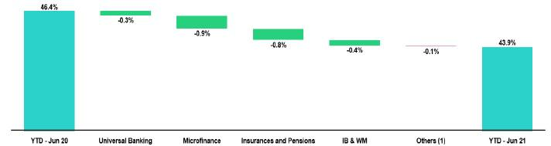

- Others includes: Credicorp Capital, Prima AFP, BCP Bolivia, ASB, Grupo Crédito, among other subsidiaries and the eliminations for consolidation purposes.

A YTD, the efficiency ratio improved due to:

- An increase in interest income in Microfinance due to the factors mentioned above,

- Growth in premiums at Pacifico, which was attributable to the fact that Pacifico won a higher portion of the SISCO V auction, which offered a better fee structure than SISCO IV, and to an increase in health policy renewals.

- An increase in Net fee income at BCP Stand-alone due to the factors outlined above and

- Growth in Net fee income from Investment Banking and Wealth Management due to fee charged to clients which enter to international platforms through the services of ASB.

50

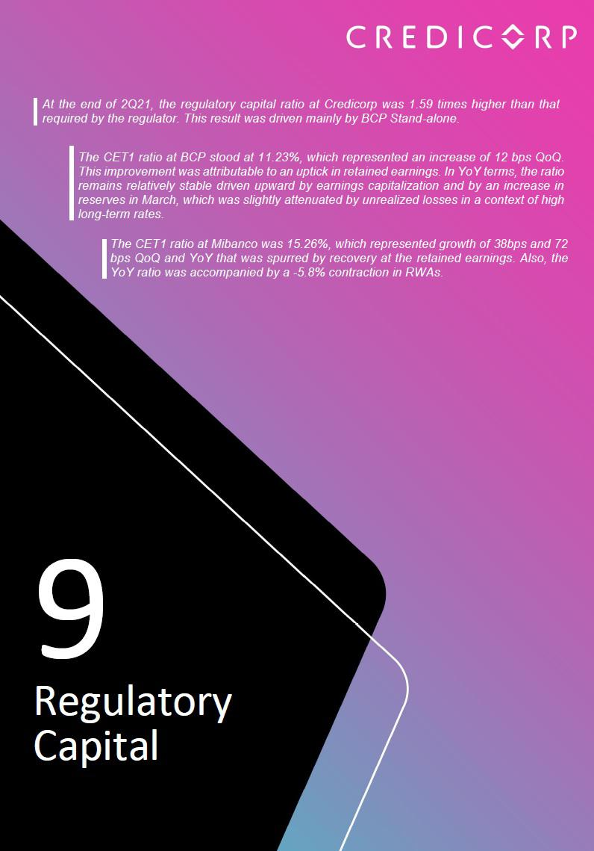

9. Regulatory capital

9.1. Regulatory Capital at Credicorp

Total regulatory capital ratio at Credicorp grew +16 bps QoQ and grew +23 bps YoY due to:
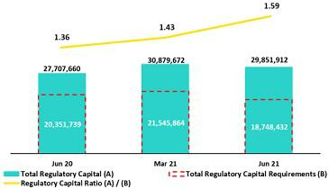

- In the QoQ analysis, a drop of -13.0% QoQ in the regulatory capital requirement at Credicorp, which reflected the regulator’s decision to reduce the reserve requirement for companies in the financial system due to large-scale withdrawals of severance indeminity funds. This result was slightly attenuated by a decrease in total capital (-3.3%), which was driven primarily by a drop in subordinated debt after the remainder of the make-whole in FC at BCP Stand-alone was executed in the month of April, and by pre-payments at Mibanco.

- In the YoY analysis, growth of +7.7% in Total Capital at Credicorp due to

  - an increase in subordinated debt, which was primarily generated by liability management at BCP Stand-alone and (ii) losses that were reported in 2Q20 for the current year net loss at the Credicorp Level in the context of the pandemic. The result was also boost by an -7.9% YoY decrease in Credicorp’s Regulatory capital requirement, as outlined in the QoQ analysis.

The Regulatory capital ratio at Credicorp was 1.60 times higher than that required by the regulator in Peru.

9.2. Regulatory Capital BCP Individual – Peru GAAP

At the end of 2Q21, the Tier 1 and BIS ratios at BCP Stand-alone fell QoQ to 10.31% and 15.34% respectively, driven by a +2.9% increased QoQ in RWAs, which was in turn spurred by loan growth.
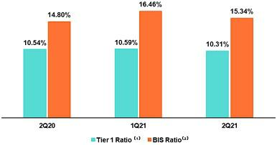

Total regulatory capital fell -4.1%, which was attributable to the execution of the remainder of the make-whole of a subordinated bond in April under the liability management strategy.

- Regulatory Tier 1 Capital / Total Risk-weighted assets

- Total Regulatory Capital / Total Risk-weighted assets (legal minimum = 10% since July 2011)

The YoY evolution shows inverse variations. In the comparison with 2Q20, the BIS ratio increased but the Tier 1 level decreased. The uptick in the BIS ratio was attributable to was attributable to (i) growth in subordinated debt, which was a product of the liability management strategy at BCP Stand-alone in a context of low interest rates due to the pandemic (ii) capitalization of earnings and reserves to cover future obligations. The result for the Tier 1 ratio was primarily impacted by an +3.4% increase in RWAS.

52

Tier 1 Common Equity Ratio– BCP Individual
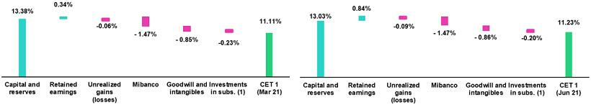

- Figures at Mar21 differ from previously reported, please consider the data presented on this report.

(1) Includes investments in BCP Bolivia and other subsidiaries.

Finally, the Tier 1 Common Equity ratio (CET1), which is considered the most rigorous indicator of capitalization levels, registered growth of +12 bps QoQ and stood at 11.23% at the end of 2Q21. This increase was driven by growth in Tier 1 Common Equity and Tier 1 (+3.8% QoQ) in a context market by an improvement in YTD and quarterly results.

In the YoY analysis, the CET1 ratio rose + 1 bps due to a +4.6% increase in (i) capital and reserves after capitalization in March 21 and (ii) in YTD and period-end results, which was partially attenuated by a decrease in unrealized earnings due to high long-term rates.

9.3. Regulatory Capital Mibanco – Perú GAAP

At the end of 2Q21, the Tier 1 Ratio at Mibanco stood at 14.66%, which reflected a QoQ increase of +18 bps due to growth in accumulated earnings agreements.
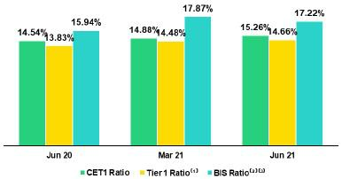

The BIS ratio stood at 17.22%, after falling -65 bps due to a pre-payment on a subordinated bond in LC and driven by an increase in RWAs (+2.0%), which was attributable to growth in Mibanco’s loans.

- Regulatory Tier 1 Capital / Total Risk-weighted assets

- Total Regulatory Capital / Total Risk-weighted assets (legal minimum = 10% since July 2011)

- Mar 21 BIS Ratio differ from previously reported, please consider the data presented on this report.

The YoY evolution registered growth of +83 bps and +128 bps in the Tier 1 and BIS ratios respectively. The uptick in Tier 1 was driven by the positive evolution of Level 1 regulatory capital (+2.6%) while the increase in the BIS ratio was fueled by growth in total regulatory capital (+18.5%). The upward trend in Tier 1 was spurred by an increase in accumulated earning agreements, while the uptick in BIS reflected both growth in accumulated earnings agreements and active debt management. RWAs fell -3.2%, which reflected a decrease in the risk profile of Mibanco’s loans due to Government programs.

Finally, the Tier 1 Common Equity ratio (CET 1), which is considered the most rigorous indicator of capitalization levels, registered growth of +38 bps QoQ and stood at 15.26% at the end of 2Q21. This expansion was driven by a 4.6% increase in Tier 1 Common Equity Ratio, after Mibanco registered an uptick in retained earnings this quarter. This was partially attenuated by growth of +2.0% in RWAs. In the YoY analysis, the CET 1 ratio rose +72 bps, driven by the effect described in the QoQ evolution and by a contraction of -5.8% in RWAs.

53

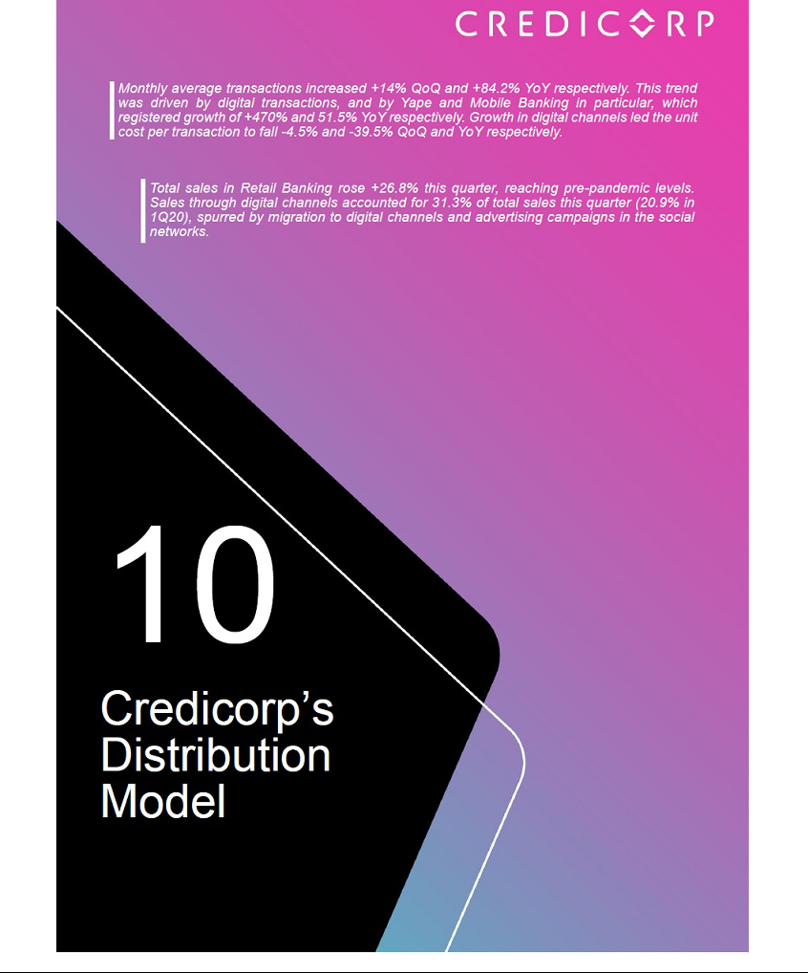

10. Distribution Model
10.1. Distribution Model at BCP Stand-alone
10.1.1 Digital Clients in Personal Banking
Evolution of digital clients ⁽¹⁾ |  | Composition of digital clients ⁽¹⁾ by segment
 | Group |  |  | 2Q20 |  | 1Q21 |  | 2Q21
 | Enalta |  |  | 84.04% |  | 86.78% |  | 86.96%
 | Affluent | 77.04% |  |  |  | 80.88% |  | 81.23%
 | Consumer | 48.14% |  |  |  | 54.97% |  | 55.15%
 | Total |  |  | 49.60 | % | 56.14 | % | 56.33 | %
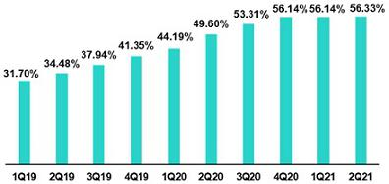

- Clientes digitales: Clientes de la banca minorista que realizan el 50% de sus transacciones monetarias a través de canales digitales; o compró productos online en los últimos 12 meses

  - The number of digitalized clients within the pool of total clients has followed an upward trend over the last few quarters. In 2Q21, digital clients represented 56.33% of total clients in Individuals Banking at BCP Stand-alone. The consumer segment, which marks the trend for digitalization given that it possesses the largest share of clients of total individuals banking clients, registered the most pronounced increase in digitalization since the quarantine began, reaching a digitalization level of 55.15% in 2Q21.

10.1.2. Transactions per channel

Evolution of transactions per channel and the unit transaction cost

Expressed in thousands of transactions
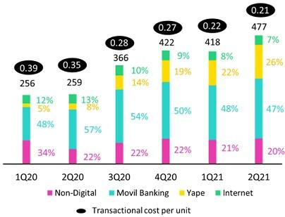

In the QoQ analysis, monthly average transactions increased +14%. This growth was primarily driven by digital channels, which have lower transactional cost and grew 16.2%, led by:

- Yape, which has registered on-going growth over the past few quarters that was particularly noteworthy this 2Q21: +35.8% in monthly average transactions. This improvement was driven by aggressive marketing campaigns.

- Transactions through Mobile Banking increased 9.6%, which reflected economic reactivation after a second quarantine was enacted in the first quarter of the year to contain COVID-19.

In the YoY analysis, monthly average transactions increased +84.2%. Growth was driven by a significant uptick in transactions via digital channels, where volume was up +88.3%.

55

Traditional and self-service channels grew 75.2% and 53.2% respectively given that in 2Q20, a strict quarantine was in place, which meant that fewer people visited branches and other physical points of service.

The most significant variations were registered by Yape and Mobile Banking, which expanded 470.4% and 51.5%, respectively. This growth led the transaction cost per unit to fall -64.2% in the case of Yape while the cost for Mobile Banking remained flat.

It is important to note that over the last few quarters, client migration has driven down the was transactions cost per unit in digital channels. In this contact, the total average monthly transactions cost fell from 0.35 in 2Q20 to 0.21 in 2Q21.

10.1.3. Retail Banking Sales

 | Unit sold per Quarter |  |  |  |  |  |  | % Change |  |  |  |  | Unit sold YTD |  |  |  | % Change
 | 2Q20 |  | 1Q21 |  |  | 2Q21 |  | TaT |  |  | AaA |  | Jun 20 |  | Jun 21 |  | Jun 21/ Jun 20
Traditionals Sales ⁽¹⁾ | 781,740 |  | 1,067,135 |  |  | 1,459,229 |  | 36.7% |  |  | 86.7% |  | 1,977,813 |  | 2,526,364 |  | 27.7%
Selfserved Sales | 143,533 |  | 265,067 |  |  | 337,929 |  | 27.5% |  |  | 135.4% |  | 612,833 |  | 602,996 |  | -1.6%
Digital Sales ⁽¹⁾ | 516,696 |  | 729,008 |  |  | 816,952 |  | 12.1% |  |  | 58.1% |  | 672,126 |  | 1,545,960 |  | 130.0%
Total Sales ⁽¹⁾
Total Sales ⁽¹⁾ | 1,441,969 |  | 2,061,210 |  |  | 2,614,110 |  | 26.8% |  |  | 81.3% |  | 3,546,933 |  | 4,675,320 |  | 31.8%

- Figures differ from those previously reported

- Includes advance on wages, personal loans, saving account, time deposits, cash withdrawal, insurance, credit cards y SME working capital loans.

In the QoQ analysis, retail banking sales registered growth of +26.8%. This improvement was driven primarily by:

- Growth in traditional channels, in a context of economic reactivation and given that fact that that in the first quarter of the year, a second quarantine was imposed.

- An uptick in sales through digital channels, which also benefitted from economic reactivation. The products that registered the most favorable evolution were: Advances on wages and Insurance, which posted growth of 22% and 56% respectively due to aggressive marketing campaigns this quarter

In the YoY and YTD analysis, sales grew +81.3% and +31.8% respectively. This evolution was attributable to:

- Growth in sales through digital channels, which has captured high numbers of clients this year. The products that have led this growth are: Savings Accounts, Advances on wages and Insurance.

- Sales through traditional channels, which registered an uptick in sales of Insurance.

The aforementioned was partially offset by a slight drop in self-service channels. Advances on wages, accounted for the majority of the decline in the use of self-service options due to its clients have migrated to digital channels.

It is important to note that Total sales have topped pre-pandemic levels (increase of +7% with regard to 4Q19). Sales in digital channels went from representing 20.9% of total sales in 1Q20 to 31.3% in 2Q21, driven by client migration to digital platforms and by advertising campaigns to spur purchases through these venues.

10.2. Points of Contact
10.2.1 Points of Contact BCP
 |  |  | As of |  |  |  | change (units)
 | Jun 20 |  | Mar 21 |  | Jun 21 |  | QoQ |  | YoY
Branches | 403 |  | 388 |  | 363 |  | -25 |  | -40
ATMs | 2,291 |  | 2,306 |  | 2,291 |  | -15 |  | -
Agentes BCP | 6,939 |  | 6,860 |  | 6,818 |  | -42 |  | -121
Total BCP's Network | 9,633 |  | 9,554 |  | 9,472 |  | -82 |  | -161

Client migration to digital channels led BCP Stand-alone to reduce its number of Branches, ATMS and Agentes BCP by 25 units, 15 untis and 42 units QoQ respectively. In YoY terms, Branches and Agentes fell by 40 and 121 respectively.

56

10.2.2 Points of Contact BCP Bolivia
 |  |  | As of |  |  |  | change (units)
 | Jun 20 |  | Mar 21 |  | Jun 21 |  | QoQ |  | YoY
Branches | 54 |  | 54 |  | 47 |  | -7 |  | -7
ATMs | 308 |  | 310 |  | 305 |  | -5 |  | -3
Agentes BCP Bolivia | 583 |  | 850 |  | 851 |  | 1 |  | 268
Total Bolivia's Network | 945 |  | 1,214 |  | 1,203 |  | -11 |  | 258

At BCP Bolivia, points of contact fell by 11 units QoQ after 7 branches were closed and 5 ATMs were eliminated. On the contrary, YoY, points of contact rose +258 due to growth in Agentes BCP (+268), in line with the strategy to expand through cost-efficient channels.

10.2.1. Physical points of contact Mibanco
 |  |  | As of |  |  |  | change (units)
 | Jun 20 |  | Mar 21 |  | Jun 21 |  | QoQ |  | YoY
Total Mibanco's Network ⁽¹⁾ | 324 |  | 317 |  | 319 |  | 2 |  | -5

- Mibanco has not ATMs of Agentes given that it uses BCP’s network. The branch number includes branches operated by the Banco de la Nacion that can be used by Mibanco’s clients, which in Jun 20, Mar 21 and June 21 totaled 34, 34 and 34 respectively.

Mibanco registered an increase of 2 branches QoQ. YoY, however, 8 branches were eliminated under a strategy to reduce costs in the context of the pandemic. It is important to note that Mibanco has an agreement with the Banco de la Nacion to use its branches at the national level to reduce operating costs. At the end of 2Q21, these branches represented 11% (34 branches) of the 319 operated by Mibanco.

57



11. Economic Perspectives
11.1. Peru: Economic Forecasts
Peru |  | 2017 |  | 2018 |  | 2019 |  | 2020 |  | 2021 ⁽³⁾
GDP (US$ Millions) |  | 214,330 |  | 225,430 |  | 231,006 |  | 204,500 |  | 210,155
Real GDP (% change) |  | 2.5 |  | 4.0 |  | 2.2 |  | -11.1 |  | 9.0
GDP per capita (US$) |  | 6,740 |  | 7,001 |  | 7,108 |  | 6,268 |  | 6,371
Domestic demand (% change) |  | 1.5 |  | 4.2 |  | 2.3 |  | -9.7 |  | 8.5
Gross fixed investment (as % GDP) |  | 20.6 |  | 21.6 |  | 21.3 |  | 18.7 |  | 20.0
Public Debt (as % GDP) |  | 24.9 |  | 25.8 |  | 26.8 |  | 34.8 |  | 35.6
System loan growth (% change)⁽¹⁾ |  | 5.6 |  | 10.1 |  | 6.2 |  | 12.4 |  | -
Inflation⁽²⁾
 |  | 1.4 |  | 2.2 |  | 1.9 |  | 2.0 |  | 4.0
Reference Rate |  | 3.25 |  | 2.75 |  | 2.25 |  | 0.25 |  | 0.25 - 0.50
Exchange rate, end of period |  | 3.24 |  | 3.37 |  | 3.31 |  | 3.62 |  | 4.00 - 4.25
Exchange rate, (% change) |  | -3.5% |  | 4.1% |  | -1.7% |  | 9.3% |  | 13.9%
Fiscal balance (% GDP) |  | -3.1 |  | -2.5 |  | -1.6 |  | -8.9 |  | -5.2
Trade balance (US$ Millions) |  | 6,700 |  | 7,197 |  | 6,614 |  | 7,750 |  | 14,000
(As % GDP) |  | 3.1% |  | 3.2% |  | 2.9% |  | 3.8% |  | 6.7%
Exports |  | 45,422 |  | 49,066 |  | 47,688 |  | 42,413 |  | 59,000
Imports |  | 38,722 |  | 41,870 |  | 41,074 |  | 34,663 |  | 45,000
Current account balance (US$ Millions) |  | -2,779 |  | -3,821 |  | -3,531 |  | 992 |  | -1,051
Current account balance (As % GDP) |  | -1.3% |  | -1.7% |  | -1.5% |  | 0.5% |  | -0.5%
Net international reserves (US$ Millions) |  | 63,621 |  | 60,121 |  | 68,316 |  | 74,707 |  | 68,000
(As % GDP) |  | 29.7% |  | 26.7% |  | 29.6% |  | 36.5% |  | 32.4%
(As months of imports) |  | 20 |  | 17 |  | 20 |  | 26 |  | 18

Source: INEI, BCRP, and SBS.

- Financial System, Current Exchange Rate.

- Inflation target: 1% - 3%.

- Estimates by BCP Economic Research as of July 2021.

10.2. Main Economic Variables

Gross Domestic Product

(Annual Variations, % y/y)
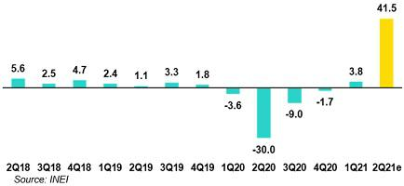

· After a rebound of 58% YoY in April, the economy advanced 48% YoY in May 2021 and stood only 0.4% below the level of May 2019.

· Our estimates suggest that GDP grew around 41.5% YoY in 2Q21 after contracting 30% YoY in 2Q20 in a context of strict lockdowns.

- In the first half of 2021, GDP experienced a rebound of around 20% YoY, but remained 0.5% below the figure reported for the same period of 2019.

- In June, according to the Central Bank’s macroeconomic expectations survey, 12-months-ahead economic expectations fell to their lowest point (47 points) if we isolate the effects of the global financial crisis (44 points) and results of the second quarter of 2020 (41 points).

59

Inflation and Monetary Policy Rate (%)

· The headline inflation rate closed the second quarter of 2021 at 3.3% YoY (1Q21: 2.6%) and exceeded the upper band of the Central Bank’s target range (1%-3%) for the first time since August 2017.
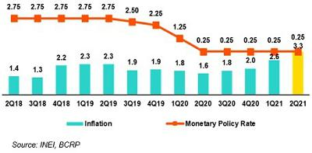

· Acceleration in the 2Q21 was driven primarily by the Food and Energy items due to an uptick in the exchange rate, higher prices for agricultural commodities and an increase in prices for fuel and electricity.

· Core inflation (excluding food and energy) stood at 1.9% YoY (1Q21:

1.8%) and registered 16 consecutive months below 2%.

- The reference rate has remained at 0.25% since April 2020. At the last monetary policy meeting in July 2021, the official statement reflected changes: phrases referring to maintaining a strong expansive stance “for a prolonged period” and that the Board “stands ready to expand monetary policy stimulus using a range of instruments” were withdrawn.

- As of the end of the second quarter of 2021, repo operations with state guarantees (mainly associated with the Reactiva Peru program) that were liquidated stood at PEN 48.0 billion (1Q21: PEN 49.9 billion).

Fiscal Result and Current Account Balance

(% of GDP, Quarter)
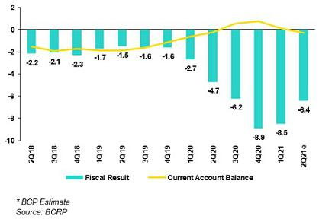

· In annualized terms, fiscal deficit represented 6.4% of GDP in 2Q21 (1Q21: 8.5%).

· In the second quarter of 2021, fiscal revenues grew 73% YoY after declining 38% YoY in 2Q20 and have increased 7% compared to 2Q19.

a. Higher VAT revenues (+82% YoY, +17% vs 2Q19).

b. An increase in Income Tax revenues (+45% YoY, +15% vs 2Q19).

· In the second quarter of 2021, non-financial government spending increased 28% YoY (1Q21: 21%) and 17% compared to 2Q19.

- Current spending rose 9% YoY (1Q21: +15%) amid an uptick in spending for goods and services (+49%).

- Public investment by the general government increased 320% YoY (1Q21: +43%) after falling 73% YoY in 2Q20 and stands 13% above the levels of 2Q19.

- In May 2021, Moody’s changed the credit rating outlook for Peru from stable to negative but ratified the country’s A3 credit rating.

- From January to May 2021, the trade balance posted a surplus of US$ 3,981 million, almost 700% above the number recorded for the same period last year (Jan/May-20: US$ 500 million).

- Exports grew 60% YoY during the same period; this result was driven by 68% YoY increase in traditional exports and an advance of 40% YoY in non-traditional exports. Imports grew 36% YoY and Capital goods imports rose 44%. In the past 12-months up to May-21, the trade balance registered a surplus of US$ 11.2 billion, a new historical peak for Perú.

60

- In May-21, the terms of trade grew 22% YoY (for 10 consecutive months of two-digit growth) to hit a record high.

Exchange rate

(S/ por US$)
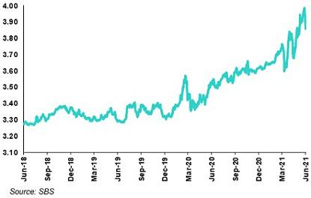

· The exchange rate closed 2Q21 at USDPEN 3.858. In this context, the Peruvian Sol depreciated 2.6% compared to 1Q21 (USDPEN 3.757) and 16.3% compared to the closing rate of 2019 (USDPEN 3.314).

· In 2Q21, the exchange rate reached a peak of USDPEN 3.985.

· In June 2021, the real multilateral exchange rate stood at a peak of 116 points, the highest point recorded since data has been available (January 1991).

- Other currencies in the LatAm region presented mixed results in 2Q21: appreciation in the Brazilian Real (+11.8%) and Mexican Peso (+2.4%) and depreciation in the Colombian Peso (-2.5%) and Chilean Peso (-2.1%).

- In the second quarter of 2021, the Central Bank made sales in the spot FX market for US$ 2,571 million (in Jun-21 alone it sold US$ 1,292 million) and accumulated spot US$ sales for 4,967 million YTD. The monetary entity continued to use instruments to mitigate depreciation pressures on the exchange rage: by the end of 2Q21, the outstanding BCRP Re-adjustable Certificate Deposits totalled PEN 7.7 billion (1Q21: PEN 6.9 billion) while outstanding cross currency swaps (sales) stood at PEN 26.9 billion (1Q21: PEN 28.6 billion).

- Net International Reserves closed 2Q21 at US$ 71.9 billion compared to US$ 79.9 billion at the end of 1Q21 (by end-2020, they stood at US$ 74.7 billion).

61



12.1. Credicorp

CREDICORP LTD. AND SUBSIDIARIES

CONSOLIDATED STATEMENT OF FINANCIAL POSITION

(S/ thousands, IFRS)

 |  |  |  | As of |  |  |  | % change
 |  | Jun 2020 |  | Mar 2021 |  | Jun 2021 |  | QoQ |  |  | YoY
 | ASSETS
 | Cash and due from banks ⁽¹⁾
 | Non-interest bearing | 6,685,864 |  | 7,281,695 |  | 8,883,164 |  | 22.0% |  |  | 32.9%
 | Interest bearing | 29,430,518 |  | 31,895,249 |  | 29,075,474 |  | -8.8% |  |  | -1.2%
 | Total cash and due from banks | 36,116,382 |  | 39,176,944 |  | 37,958,638 |  | -3.1% |  |  | 5.1%
 | Cash collateral, reverse repurchase agreements and
 | securities borrowing | 2,920,789 |  | 1,769,690 |  | 1,616,654 |  | -8.6% |  |  | -44.7%
 | Fair value through profit or loss investments ⁽¹⁾⁽²⁾ | 5,118,994 |  | 8,083,128 |  | 6,791,288 |  | -16.0% |  |  | 32.7%
 | Fair value through other comprehensive income
investments ⁽¹⁾ |  | 32,213,665 |  | 45,681,969 |  | 40,273,400 |  | -11.8% |  |  | 25.0%
 | Amortized cost investments ⁽¹⁾ | 4,304,385 |  | 5,647,635 |  | 7,707,956 |  | 36.5% |  |  | 79.1%
 | Loans | 132,741,720 |  | 137,031,239 |  | 143,091,752 |  | 4.4% |  |  | 7.8%
 | Current | 128,898,890 |  | 132,162,756 |  | 138,037,399 |  | 4.4% |  |  | 7.1%
 | Internal overdue loans | 3,842,830 |  | 4,868,483 |  | 5,054,353 |  | 3.8% |  |  | 31.5%
 | Less - allowance for loan losses | (8,412,544) |  | (9,744,298) |  | (9,391,151) |  | -3.6% |  |  | 11.6%
 | Loans, net | 124,329,176 |  | 127,286,941 |  | 133,700,601 |  | 5.0% |  |  | 7.5%
 | Financial assets designated at fair value through profit
 | or loss | 662,634 |  | 888,420 |  | 921,851 |  | 3.8% |  |  | 39.1%
 | Accounts receivable from reinsurers and coinsurers | 817,773 |  | 981,379 |  | 1,043,042 |  | 6.3% |  |  | 27.5%
 | Premiums and other policyholder receivables | 799,644 |  | 827,807 |  | 780,824 |  | -5.7% |  |  | -2.4%
 | Property, plant and equipment, net | 2,104,654 |  | 1,996,860 |  | 1,944,127 |  | -2.6% |  |  | -7.6%
 | Due from customers on acceptances | 331,591 |  | 532,584 |  | 558,934 |  | 4.9% |  |  | 68.6%
 | Investments in associates | 626,992 |  | 620,603 |  | 627,683 |  | 1.1% |  |  | 0.1%
 | Intangible assets and goodwill, net | 2,474,740 |  | 2,599,291 |  | 2,647,676 |  | 1.9% |  |  | 7.0%
 | Other assets ⁽¹⁾ | 8,681,365 |  | 8,109,764 |  | 8,455,556 |  | 4.3% |  |  | -2.6%
 | Total Assets | 221,502,784 |  | 244,203,015 |  | 245,028,230 |  | 0.3% |  |  | 10.6%
 | LIABILITIES AND EQUITY
 | Deposits and obligations
 | Non-interest bearing | 41,310,487 |  | 48,469,215 |  | 52,879,988 |  | 9.1% |  |  | 28.0%
 | Interest bearing | 88,353,845 |  | 100,157,124 |  | 96,281,815 |  | -3.9% |  |  | 9.0%
 | Total deposits and obligations | 129,664,332 |  | 148,626,339 |  | 149,161,803 |  | 0.4% |  |  | 15.0%
 | Payables from repurchase agreements and securities
lending |  | 22,437,742 |  | 26,657,010 |  | 25,963,227 |  | -2.6% |  |  | 15.7%
 | BCRP instruments | 19,441,733 |  | 24,303,193 |  | 23,329,990 |  | -4.0% |  |  | 20.0%
 | Repurchase agreements with third parties | 2,091,798 |  | 1,159,587 |  | 1,276,678 |  | 10.1% |  |  | -39.0%
 | Repurchase agreements with customers ⁽¹⁾ | 904,211 |  | 1,194,230 |  | 1,356,559 |  | 13.6% |  |  | 50.0%
 | Due to banks and correspondents | 8,374,009 |  | 5,305,933 |  | 6,239,161 |  | 17.6% |  |  | -25.5%
 | Bonds and notes issued ⁽¹⁾ | 17,250,531 |  | 17,863,198 |  | 16,951,481 |  | -5.1% |  |  | -1.7%
 | Banker’s acceptances outstanding | 331,591 |  | 532,584 |  | 558,934 |  | 4.9% |  |  | 68.6%
 | Reserves for property and casualty claims | 1,791,871 |  | 2,248,082 |  | 2,492,303 |  | 10.9% |  |  | 39.1%
 | Reserve for unearned premiums | 8,839,019 |  | 9,561,612 |  | 9,664,914 |  | 1.1% |  |  | 9.3%
 | Accounts payable to reinsurers | 221,118 |  | 290,866 |  | 317,185 |  | 9.0% |  |  | 43.4%
 | Financial liabilities at fair value through profit or loss | 480,952 |  | 772,385 |  | 313,256 |  | -59.4% |  |  | -34.9%
 | (1)
 | Other liabilities ⁽¹⁾⁽²⁾ | 8,235,529 |  | 7,326,432 |  | 7,789,038 |  | 6.3% |  |  | -5.4%
 | Total Liabilities | 197,626,694 |  | 219,184,441 |  | 219,451,302 |  | 0.1% |  |  | 11.0%
 | Net equity | 23,396,062 |  | 24,529,958 |  | 25,073,706 |  | 2.2% |  |  | 7.2%
 | Capital stock | 1,318,993 |  | 1,318,993 |  | 1,318,993 |  | 0.0% |  |  | 0.0%
 | Treasury stock | (209,309) |  | (207,840) |  | (207,756) |  | 0.0% |  |  | -0.7%
 | Capital surplus | 160,430 |  | 224,591 |  | 224,103 |  | -0.2% |  |  | 39.7%
 | Reserves | 21,381,402 |  | 21,707,166 |  | 21,725,663 |  | 0.1% |  |  | 1.6%
 | Unrealized gains and losses | 1,151,939 |  | 840,581 |  | 677,159 |  | -19.4% |  |  | -41.2%
 | Retained earnings | (407,393) |  | 646,467 |  | 1,335,544 |  | 106.6% |  |  | -427.8%
 | Non-controlling interest | 480,028 |  | 488,616 |  | 503,222 |  | 3.0% |  |  | 4.8%

 | Total Net Equity | 23,876,090 | 25,018,574 | 25,576,928 | 2.2% | 7.1%
 | Total liabilities and equity | 221,502,784 | 244,203,015 | 245,028,230 | 0.3% | 10.6%
 | Off-balance sheet | 129,132,266 | 150,250,539 | 149,828,527 | -0.3% | 16.0%
 | Total performance bonds, stand-by and L/Cs. | 19,271,152 | 21,761,484 | 22,723,385 | 4.4% | 17.9%
 | Undrawn credit lines, advised but not committed | 80,651,014 | 90,946,335 | 91,280,633 | 0.4% | 13.2%
 | Total derivatives (notional) and others | 29,210,100 | 37,542,720 | 35,824,509 | -4.6% | 22.6%

- The amounts differ from those previously reported in 2020 period, due to the reclassifications.

- Includes mainly accounts receivables from brokerage and others.

63

CREDICORP LTD. AND SUBSIDIARIES

CONSOLIDATED STATEMENT OF INCOME

(S/ thousands, IFRS)

 |  |  |  | Quarter |  |  |  | % change |  |  |  |  | YTD |  |  |  |  | % change
 |  | 2Q20 |  | 1Q21 |  | 2Q21 |  | QoQ |  |  | YoY |  | Jun 20 |  |  | Jun 21 |  | Jun 21 / Jun 20
 | Interest income and expense
 | Interest and dividend income | 2,727,369 |  | 2,816,073 |  | 2,891,579 |  | 2.7% |  |  | 6.0% |  | 5,890,978 |  |  | 5,707,652 |  | -3.1%
 | Interest expense ⁽¹⁾ | (766,019) |  | (692,690) |  | (582,537) |  | -15.9% |  |  | -24.0% |  | (1,550,101) |  |  | (1,275,227) |  | -17.7%
 | Net interest income | 1,961,350 |  | 2,123,383 |  | 2,309,042 |  | 8.7% |  |  | 17.7% |  | 4,340,877 |  |  | 4,432,425 |  | 2.1%
 | Gross provision for credit losses on loan portfolio | (2,557,658) |  | (622,982) |  | (441,007) |  | -29.2% |  |  | -82.8% |  | (3,946,369) |  |  | (1,063,989) |  | -73.0%
 | Recoveries of written-off loans | 17,201 |  | 65,335 |  | 77,627 |  | 18.8% |  |  | 351.3% |  | 64,431 |  |  | 142,962 |  | 121.9%
 | Provision for credit losses on loan portfolio, net of | (2,540,457) |  | (557,647) |  | (363,380) |  | -34.8% |  |  | -85.7% |  | (3,881,938) |  |  | (921,027) |  | -76.3%
recoveries
 |  | - |  | - |  | -
 | Risk-adjusted net interest income | (579,107) |  | 1,565,736 |  | 1,945,662 |  | 24.3% |  |  | -436.0% |  | 458,939 |  |  | 3,511,398 |  | 665.1%
 | Non-financial income
 | Fee income | 503,488 |  | 830,771 |  | 862,411 |  | 3.8% |  |  | 71.3% |  | 1,263,817 |  |  | 1,693,182 |  | 34.0%
 | Net gain on foreign exchange transactions | 149,308 |  | 179,889 |  | 232,668 |  | 29.3% |  |  | 55.8% |  | 316,291 |  |  | 412,557 |  | 30.4%
 | Net gain on sales of securities | 280,563 |  | 16,287 |  | (69,947) |  | 529.5% |  |  | n.a. |  | 159,930 |  |  | (53,660) |  | -133.6%
 | Net gain from associates | 14,906 |  | 29,405 |  | 12,302 |  | -58.2% |  |  | -17.5% |  | 34,131 |  |  | 41,707 |  | 22.2%
 | Net gain on derivatives held for trading | 8,358 |  | 69,723 |  | 45,413 |  | -34.9% |  |  | 443.3% |  | 43,788 |  |  | 115,136 |  | n.a.
 | Net gain from exchange differences ⁽¹⁾ | 23,845 |  | (5,536) |  | 45,924 |  | n.a. |  |  | 92.6% |  | 2,996 |  |  | 40,388 |  | 1248.1%
 | Other non-financial income ⁽¹⁾ | 35,195 |  | 73,991 |  | 62,923 |  | -15.0% |  |  | 78.8% |  | 152,965 |  |  | 136,914 |  | -10.5%
 | Total non-financial income | 1,015,663 |  | 1,194,530 |  | 1,191,694 |  | -0.2% |  |  | 17.3% |  | 1,973,918 |  |  | 2,386,224 |  | 20.9%
 | Insurance underwriting result
 | Net earned premiums ⁽¹⁾ | 552,061 |  | 643,928 |  | 639,944 |  | -0.6% |  |  | 15.9% |  | 1,179,996 |  |  | 1,283,872 |  | 8.8%
 | Net claims ⁽¹⁾ | (328,783) |  | (623,353) |  | (691,335) |  | 10.9% |  |  | 110.3% |  | (702,285) |  |  | (1,314,688) |  | 87.2%
 | Acquisition cost ⁽²⁾ | (87,598) |  | (85,822) |  | (84,944) |  | -1.0% |  |  | -3.0% |  | (200,105) |  |  | (170,766) |  | -14.7%
 | Total insurance underwriting result | 135,680 |  | (65,247) |  | (136,335) |  | n.a. |  |  | n.a. |  | 277,606 |  |  | (201,582) |  | -172.6%
 | Total expenses
 | Salaries and employee benefits | (825,997) |  | (857,559) |  | (882,177) |  | 2.9% |  |  | 6.8% |  | (1,717,180) |  |  | (1,739,736) |  | 1.3%
 | Administrative, general and tax expenses ⁽¹⁾ | (510,694) |  | (580,842) |  | (672,805) |  | 15.8% |  |  | 31.7% |  | (1,052,798) |  |  | (1,253,647) |  | 19.1%
 | Depreciation and amortization ⁽¹⁾ | (169,310) |  | (166,765) |  | (163,869) |  | -1.7% |  |  | -3.2% |  | (339,269) |  |  | (330,634) |  | -2.5%
 | Impairment loss on goodwill | - |  | - |  | - |  | n.a. |  |  | n.a. |  | - |  |  | - |  | n.a.
 | Association in participation | (17,944) |  | (13,906) |  | (8,879) |  | -36.1% |  |  | -50.5% |  | (24,374) |  |  | (22,785) |  | -6.5%
 | Other expenses ⁽¹⁾ | (104,453) |  | (61,199) |  | (132,717) |  | 116.9% |  |  | 27.1% |  | (274,083) |  |  | (193,916) |  | -29.2%
 | Total expenses | (1,628,398) |  | (1,680,271) |  | (1,860,447) |  | 10.7% |  |  | 14.3% |  | (3,407,704) |  |  | (3,540,718) |  | 3.9%
 | Profit before income tax | (1,056,162) |  | 1,014,748 |  | 1,140,574 |  | 12.4% |  |  | -208.0% |  | (697,241) |  |  | 2,155,322 |  | -409.1%
 | Income tax | 414,726 |  | (337,599) |  | (423,491) |  | 25.4% |  |  | -202.1% |  | 268,980 |  |  | (761,090) |  | n.a.
 | Net profit | (641,436) |  | 677,149 |  | 717,083 |  | 5.9% |  |  | -211.8% |  | (428,261) |  |  | 1,394,232 |  | -425.6%
 | Non-controlling interest | (21,046) |  | 16,351 |  | 17,614 |  | 7.7% |  |  | -183.7% |  | (17,145) |  |  | 33,965 |  | -298.1%
 | Net profit attributable to Credicorp | (620,390) |  | 660,798 |  | 699,469 |  | 5.9% |  |  | -212.7% |  | (411,116) |  |  | 1,360,267 |  | -430.9%

- The amounts differ from those previously reported in 2020 period due to reclassifications.
- The acquisition cost of Pacifico includes net fees and underwriting expenses.

64

Regulatory Capital and Capital Adequacy Ratios

(S/ thousands, IFRS)

 |  |  |  | As of |  |  |  | % change
 |  | Jun 20 |  | Mar 21 |  | Jun 21 |  | QoQ |  |  | YoY
 | Capital Stock | 1,318,993 |  | 1,318,993 |  | 1,318,993 |  | 0.0% |  |  | 0.0%
 | Treasury Stocks | (209,309) |  | (207,840) |  | (207,756) |  | 0.0% |  |  | -0.7%
 | Capital Surplus | 160,430 |  | 224,591 |  | 224,103 |  | -0.2% |  |  | 39.7%
 | Legal and Other capital reserves ⁽¹⁾ | 21,381,402 |  | 21,707,166 |  | 21,725,663 |  | 0.1% |  |  | 1.6%
 | Minority interest ⁽²⁾ | 418,868 |  | 456,849 |  | 429,448 |  | -6.0% |  |  | 2.5%
 | Loan loss reserves ⁽³⁾ | 1,876,506 |  | 1,809,048 |  | 1,913,045 |  | 5.7% |  |  | 1.9%
 | Perpetual subordinated debt | - |  | - |  | - |  | - |  |  | -
 | Subordinated Debt | 4,698,109 |  | 7,118,128 |  | 5,979,619 |  | -16.0% |  |  | 27.3%
 | Investments in equity and subordinated debt of
 | financial and insurance companies | (674,492) |  | (735,021) |  | (717,711) |  | -2.4% |  |  | 6.4%
 | Goodwill | (851,731) |  | (812,242) |  | (813,492) |  | 0.2% |  |  | -4.5%
 | Current year Net Loss | (411,117) |  | - |  | - |  | - |  |  | -
 | Deduction for subordinated debt limit (50% of Tier I
excluding deductions) ⁽⁴⁾ |  | - |  | - |  | - |  | - |  |  | -
 | Deduction for Tier I Limit (50% of Regulatory capital) | - |  | - |  | - |  | - |  |  | -
 | (4) | - |  |  |  |  |  | - |  |  | -
 | Total Regulatory Capital (A) | 27,707,660 |  | 30,879,672 |  | 29,851,912 |  | -3.3 | % |  | 7.7 | %
 | Tier 1 ⁽⁵⁾ | 14,833,795 |  | 15,357,748 |  | 15,337,348 |  | -0.1% |  |  | 3.4%
 | Tier 2 ⁽⁶⁾ + Tier 3 ⁽⁷⁾ | 12,873,865 |  | 15,357,748 |  | 14,514,564 |  | -5.5% |  |  | 12.7%
 | Financial Consolidated Group (FCG) Regulatory
 | Capital Requirements ⁽⁸⁾ | 19,619,598 |  | 20,650,921 |  | 17,894,230 |  | -13.3% |  |  | -8.8%
 | Insurance Consolidated Group (ICG) Capital
Requirements ⁽⁹⁾ |  | 1,232,497 |  | 1,362,246 |  | 1,325,595 |  | -2.7% |  |  | 7.6%
 | FCG Capital Requirements related to operations with
 | ICG | (500,356) |  | (467,303) |  | (471,394) |  | 0.9% |  |  | -5.8%
 | ICG Capital Requirements related to operations with
FCG |  | - |  | - |  | - |  | - |  |  | -
 | Total Regulatory Capital Requirements (B) | 20,351,739 |  | 21,545,864 |  | 18,748,432 |  | -13.0 | % |  | -7.9 | %
 | Regulatory Capital Ratio (A) / (B) | 1.36 |  | 1.43 |  | 1.59
 | Required Regulatory Capital Ratio ⁽¹⁰⁾ | 1.00 |  | 1.00 |  | 1.00

- Legal and other capital reserves include restricted capital reserves (PEN 14,745 million) and optional capital reserves (PEN 6,661 million).

- Minority interest includes Tier I (PEN 429 million)

- Up to 1.25% of total risk-weighted assets of Banco de Credito del Peru, Solucion Empresa Administradora Hipotecaria, Mibanco and Atlantic Security Bank.
- Tier II + Tier III cannot be more than 50% of total regulatory capital.

- Tier I = capital + restricted capital reserves + Tier I minority interest - goodwill - (0.5 x investment in equity and subordinated debt of financial and insurance companies) + perpetual subordinated debt.
- Tier II = subordinated debt + TierII minority interest tier + loan loss reserves - (0.5 x investment in equity and subordinated debt of financial and insurance companies).
- Tier III = Subordinated debt covering market risk only.

- Includes regulatory capital requirements of the financial consolidated group.

- Includes regulatory capital requirements of the insurance consolidated group.

- Regulatory Capital / Total Regulatory Capital Requirements (legal minimum = 1.00).

65

12.2. Credicorp Stand-alone
 |  |  | Credicorp Stand-alone
 |  |  | Separate Statement of Financial Position
 |  |  | (S/ thousands, IFRS)
 |  |  |  |  |  |  | As of |  |  |  |  |  |  |  |  | % change
 |  |  | Jun 20 |  |  |  | Mar 21 |  |  |  |  | Jun 21 |  |  |  | QoQ |  |  |  |  | YoY
 | ASSETS
 | Cash and cash equivalents |  | 1,817,197 |  |  |  | 800,622 |  |  |  |  | 1,019,773 |  |  |  | 27.4% |  |  |  |  | -43.9%
 | At fair value through profit or loss |  | - |  |  |  | 583,176 |  |  |  |  | 520,413 |  |  |  | -10.8% |  |  |  |  | n.a
 | Fair value through other comprehensive income
investments |  |  | 469,393 |  |  |  | 490,778 |  |  |  |  | 397,551 |  |  |  | -19.0% |  |  |  |  | -15.3%
 | In subsidiaries and associates investments |  | 27,118,956 |  |  |  | 28,688,953 |  |  |  |  | 29,354,310 |  |  |  | 2.3% |  |  |  |  | 8.2%
 | Loans |  | - |  |  |  | - |  |  |  |  | - |  |  |  | 0.0% |  |  |  |  | 0.0%
 | Other assets |  | 91 |  |  |  | 137,049 |  |  |  |  | 345 |  |  |  | -99.7% |  |  |  |  | 279.1%
 | Total Assets |  | 29,405,637 |  |  |  | 30,700,578 |  |  |  |  | 31,292,392 |  |  |  | 1.9% |  |  |  |  | 6.4%
 | LIABILITIES AND NET SHAREHOLDERS'
 | EQUITY
 | Bonds and notes issued |  | 1,756,654 |  |  |  | 1,875,925 |  |  |  |  | 1,914,141 |  |  |  | 2.0% |  |  |  |  | 9.0%
 | Other liabilities |  | 102,383 |  |  |  | 133,300 |  |  |  |  | 149,936 |  |  |  | 12.5% |  |  |  |  | 46.4%
 | Total Liabilities |  | 1,859,037 |  |  |  | 2,009,225 |  |  |  |  | 2,064,077 |  |  |  | 2.7% |  |  |  |  | 11.0%
 | NET EQUITY
 | Capital stock |  | 1,318,993 |  |  |  | 1,318,993 |  |  |  |  | 1,318,993 |  |  |  | 0.0% |  |  |  |  | 0.0%
 | Capital Surplus |  | 384,542 |  |  |  | 384,542 |  |  |  |  | 384,542 |  |  |  | 0.0% |  |  |  |  | 0.0%
 | Reserve |  | 21,070,409 |  |  |  | 21,417,403 |  |  |  |  | 21,417,403 |  |  |  | 0.0% |  |  |  |  | 1.6%
 | Unrealized results |  | 935,610 |  |  |  | 652,340 |  |  |  |  | 495,986 |  |  |  | -24.0% |  |  |  |  | -47.0%
 | Retained earnings |  | 3,837,046 |  |  |  | 4,918,075 |  |  |  |  | 5,611,391 |  |  |  | 14.1% |  |  |  |  | 46.2%
 | Total net equity |  | 27,546,600 |  |  |  | 28,691,353 |  |  |  |  | 29,228,315 |  |  |  | 1.9% |  |  |  |  | 6.1%
 | Total Liabilities And Equity |  | 29,405,637 |  |  |  | 30,700,578 |  |  |  |  | 31,292,392 |  |  |  | 1.9% |  |  |  |  | 6.4%
 |  |  |  |  |  |  | Quarter |  |  |  |  |  |  |  |  | % Change
 |  |  | 2Q20 |  |  |  | 1Q21 |  |  |  |  | 2Q21 |  |  |  | QoQ |  |  |  |  | YoY
 | Interest income
 | Net share of the income from investments in
subsidiaries and associates |  |  | (608,651) |  |  |  | 676,484 |  |  |  |  | 725,297 |  |  |  | 7.2% |  |  |  |  | -219.2%
 | Interest and similar income |  | 174 |  |  |  | 3,038 |  |  |  |  | 7,062 |  |  |  | 132.5% |  |  |  |  | 3958.6%
 | Net gain on financial assets at fair value through
profit or loss |  |  | - |  |  |  | (4,494) |  |  |  |  | 4,898 |  |  |  | -209.0% |  |  |  |  | n.a
 | Total income |  | (608,477) |  |  |  | 675,028 |  |  |  |  | 737,257 |  |  |  | 9.2% |  |  |  |  | -221.2%
 | Interest and similar expense |  | - |  |  |  | (13,363) |  |  |  |  | (14,357) |  |  |  | 7.4% |  |  |  |  | n.a
 | Administrative and general expenses |  | (5,765) |  |  |  | (4,761) |  |  |  |  | (3,832) |  |  |  | -19.5% |  |  |  |  | -33.5%
 | Total expenses |  | (5,765) |  |  |  | (18,124) |  |  |  |  | (18,189) |  |  |  | 0.4% |  |  |  |  | 215.5%
 | Operating income |  | (614,242) |  |  |  | 656,904 |  |  |  |  | 719,068 |  |  |  | 9.5% |  |  |  |  | -217.1%
 | Exchange differences, net |  | (3,842) |  |  |  | (1,268) |  |  |  |  | (15) |  |  |  | -98.8% |  |  |  |  | -99.6%
 | Other, net |  | (1,899) |  |  |  | (5) |  |  |  |  | (10) |  |  |  | 100.0% |  |  |  |  | -99.5%
 | Profit before income tax |  | (619,983) |  |  |  | 655,631 |  |  |  |  | 719,043 |  |  |  | 9.7% |  |  |  |  | -216.0%
 | Income tax |  | - |  |  |  | (19,229) |  |  |  |  | (19,546) |  |  |  | 1.6% |  |  |  |  | n.a
 | Net income |  | (619,983) |  |  |  | 636,402 |  |  |  |  | 699,497 |  |  |  | 9.9% |  |  |  |  | -212.8%
 | Double Leverage Ratio |  | 98.45% |  |  |  | 99.99% |  |  |  |  | 100.43% |  |  |  | -44bps |  |  |  |  | 202bps
 |  |  |  |  |  |  |  |  |  |  |  |  |  |  |  |  |  |  |  |  | 66

12.3. BCP Consolidated

BANCO DE CREDITO DEL PERU AND SUBSIDIARIES

CONSOLIDATED STATEMENT OF FINANCIAL POSITION

(S/ thousands, IFRS)

 |  |  |  | As of |  |  |  | % change
 |  | Jun 20 |  | Mar 21 |  | Jun 21 |  | QoQ |  |  | YoY
 | ASSETS
 | Cash and due from banks
 | Non-interest bearing | 5,041,371 |  | 5,227,840 |  | 6,919,815 |  | 32.4% |  |  | 37.3%
 | Interest bearing | 26,863,958 |  | 30,566,460 |  | 26,482,164 |  | -13.4% |  |  | -1.4%
 | Total cash and due from banks | 31,905,329 |  | 35,794,300 |  | 33,401,979 |  | -6.7% |  |  | 4.7%
 | Cash collateral, reverse repurchase agreements and
 | securities borrowing | 1,987,570 |  | 772,790 |  | 544,937 |  | -29.5% |  |  | -72.6%
 | Fair value through profit or loss investments | 1,630,272 |  | 3,549,042 |  | 2,118,559 |  | -40.3% |  |  | 30.0%
 | Fair value through other comprehensive income
investments |  | 18,724,601 |  | 31,556,758 |  | 25,735,158 |  | -18.4% |  |  | 37.4%
 | Amortized cost investments | 4,280,002 |  | 5,466,463 |  | 7,366,267 |  | 34.8% |  |  | 72.1%
 | Loans | 121,391,338 |  | 124,970,804 |  | 130,864,182 |  | 4.7% |  |  | 7.8%
 | Current | 117,707,704 |  | 120,335,694 |  | 126,045,797 |  | 4.7% |  |  | 7.1%
 | Internal overdue loans | 3,683,634 |  | 4,635,110 |  | 4,818,385 |  | 4.0% |  |  | 30.8%
 | Less - allowance for loan losses | (7,910,329) |  | (9,090,737) |  | (8,797,871) |  | -3.2% |  |  | 11.2%
 | Loans, net | 113,481,009 |  | 115,880,067 |  | 122,066,311 |  | 5.3% |  |  | 7.6%
 | Property, furniture and equipment, net ⁽¹⁾ | 1,819,369 |  | 1,729,286 |  | 1,681,651 |  | -2.8% |  |  | -7.6%
 | Due from customers on acceptances | 331,591 |  | 532,584 |  | 558,934 |  | 4.9% |  |  | 68.6%
 | Other assets ⁽²⁾ | 7,303,556 |  | 6,455,086 |  | 6,772,279 |  | 4.9% |  |  | -7.3%
 | Total Assets | 181,463,299 |  | 201,736,376 |  | 200,246,075 |  | -0.7% |  |  | 10.4%
 | Liabilities and Equity
 | Deposits and obligations
 | Non-interest bearing ⁽¹⁾ | 44,355,291 |  | 44,470,186 |  | 45,881,848 |  | 3.2% |  |  | 3.4%
 | Interest bearing ⁽¹⁾ | 70,151,519 |  | 88,611,086 |  | 86,547,213 |  | -2.3% |  |  | 23.4%
 | Total deposits and obligations | 114,506,810 |  | 133,081,272 |  | 132,429,061 |  | -0.5% |  |  | 15.7%
 | Payables from repurchase agreements and
 | securities lending | 20,912,125 |  | 24,839,353 |  | 23,879,115 |  | -3.9% |  |  | 14.2%
 | BCRP instruments | 19,441,733 |  | 24,303,193 |  | 23,329,990 |  | -4.0% |  |  | 20.0%
 | Repurchase agreements with third parties | 1,470,392 |  | 536,160 |  | 549,125 |  | 2.4% |  |  | -62.7%
 | Due to banks and correspondents | 8,205,084 |  | 5,040,881 |  | 5,636,702 |  | 11.8% |  |  | -31.3%
 | Bonds and notes issued | 14,964,339 |  | 15,301,214 |  | 14,368,316 |  | -6.1% |  |  | -4.0%
 | Banker’s acceptances outstanding | 331,591 |  | 532,584 |  | 558,934 |  | 4.9% |  |  | 68.6%
 | Financial liabilities at fair value through profit or
 | loss | 108,189 |  | 461,069 |  | 84,071 |  | -81.8% |  |  | -22.3%
 | Other liabilities ⁽³⁾ | 5,367,864 |  | 4,197,747 |  | 4,261,450 |  | 1.5% |  |  | -20.6%
 | Total Liabilities | 164,396,002 |  | 183,454,120 |  | 181,217,649 |  | -1.2% |  |  | 10.2%
 | Net equity | 16,963,254 |  | 18,165,016 |  | 18,908,512 |  | 4.1% |  |  | 11.5%
 | Capital stock | 10,774,006 |  | 11,024,006 |  | 11,024,006 |  | 0.0% |  |  | 2.3%
 | Reserves | 5,945,313 |  | 6,488,641 |  | 6,488,969 |  | 0.0% |  |  | 9.1%
 | Unrealized gains and losses | 333,548 |  | (68,242) |  | (123,542) |  | 81.0% |  |  | -137.0%
 | Retained earnings | (89,613) |  | 720,611 |  | 1,519,079 |  | 110.8% |  |  | -1795.2%
 | Non-controlling interest | 104,043 |  | 117,240 |  | 119,914 |  | 2.3% |  |  | 15.3%
 | Total Net Equity | 17,067,297 |  | 18,282,256 |  | 19,028,426 |  | 4.1% |  |  | 11.5%
 | Total liabilities and equity | 181,463,299 |  | 201,736,376 |  | 200,246,075 |  | -0.7% |  |  | 10.4%
 | Off-balance sheet | 115,150,387 |  | 130,403,638 |  | 131,540,506 |  | 0.9% |  |  | 14.2%
 | Total performance bonds, stand-by and L/Cs. | 17,490,615 |  | 20,320,600 |  | 21,228,772 |  | 4.5% |  |  | 21.4%
 | Undrawn credit lines, advised but not committed | 70,509,409 |  | 73,973,965 |  | 75,964,511 |  | 2.7% |  |  | 7.7%
 | Total derivatives (notional) and others | 27,150,363 |  | 36,109,073 |  | 34,347,223 |  | -4.9% |  |  | 26.5%

- Right of use asset of lease contracts is included by application of IFRS 16.

- Mainly includes intangible assets, other receivable accounts and tax credit.

- Mainly includes other payable accounts.

(4) Figures differ from those presented in fiscal year 2020.

67

BANCO DE CREDITO DEL PERU AND SUBSIDIARIES

CONSOLIDATED STATEMENT OF INCOME

(S/ thousands, IFRS)

 |  |  |  | Quarter |  |  |  | % change |  |  |  | Year |  |  |  |  | % change
 |  |  |  |  |  |  |  |  |  |  |  |  |  |  |  |  | Jun 2021
 |  |  |  |  |  |  |  |  |  |  |  |  |  |  |  |  | /
 |  | 2Q20 |  | 1Q21 |  | 2Q21 |  | QoQ |  | YoY |  | Jun 20 |  |  | Jun 21 |  | Jun 2020
 | Interest income and expense
 | Interest and dividend income | 2,325,119 |  | 2,407,997 |  | 2,446,731 |  | 1.6% |  | 5.2% |  | 5,089,042 |  |  | 4,854,728 |  | -4.6%
 | Interest expense | (636,317) |  | (555,008) |  | (438,943) |  | -20.9% |  | -31.0% |  | (1,297,065) |  |  | (993,951) |  | -23.4%
 | Net interest income | 1,688,802 |  | 1,852,989 |  | 2,007,788 |  | 8.4% |  | 18.9% |  | 3,791,977 |  |  | 3,860,777 |  | 1.8%
 | Provision for credit losses on loan
portfolio |  | (2,425,753) |  | (585,257) |  | (480,116) |  | -18.0% |  | -80.2% |  | (3,766,728) |  |  | (1,065,373) |  | -71.7%
 | Recoveries of written-off loans | 16,184 |  | 61,096 |  | 73,023 |  | 19.5% |  | 351.2% |  | 60,138 |  |  | 134,119 |  | 123.0%
 | Provision for credit losses on loan
portfolio, net of recoveries |  | (2,409,569) |  | (524,161) |  | (407,093) |  | -22.3% |  | -83.1% |  | (3,706,590) |  |  | (931,254) |  | -74.9%
 | Risk-adjusted net interest income | (720,767) |  | 1,328,828 |  | 1,600,695 |  | 20.5% |  | -322.1% |  | 85,387 |  |  | 2,929,523 |  | n.a.
 | Non-financial income
 | Fee income | 379,933 |  | 631,778 |  | 648,980 |  | 2.7% |  | 70.8% |  | 982,518 |  |  | 1,280,758 |  | 30.4%
 | Net gain on foreign exchange
 | transactions | 143,905 |  | 173,465 |  | 240,553 |  | 38.7% |  | 67.2% |  | 321,312 |  |  | 414,018 |  | 28.9%
 | Net gain on securities | 72,350 |  | 42,112 |  | (130,474) |  | -409.8% |  | n.a. |  | 40,559 |  |  | (88,362) |  | -317.9%
 | Net gain on derivatives held for
 | trading | 34,979 |  | 12,320 |  | 31,844 |  | 158.5% |  | n.a. |  | 34,411 |  |  | 44,164 |  | 28.3%
 | Net gain from exchange
 | differences | 8,809 |  | (2,821) |  | 56,816 |  | -2114.0% |  | n.a. |  | (10,348) |  |  | 53,995 |  | n.a.
 | Others | 21,512 |  | 58,392 |  | 41,734 |  | -28.5% |  | 94.0% |  | 114,320 |  |  | 100,126 |  | -12.4%
 | Total other income | 661,488 |  | 915,246 |  | 889,453 |  | -2.8% |  | 34.5% |  | 1,482,772 |  |  | 1,804,699 |  | 21.7%
 | Total expenses
 | Salaries and employee benefits | (589,893) |  | (603,175) |  | (632,636) |  | 4.9% |  | 7.2% |  | (1,247,667) |  |  | (1,235,811) |  | -1.0%
 | Administrative expenses | (381,303) |  | (433,717) |  | (516,669) |  | 19.1% |  | 35.5% |  | (788,680) |  |  | (950,386) |  | 20.5%
 | Depreciation and amortization | (132,008) |  | (127,578) |  | (125,592) |  | -1.6% |  | -4.9% |  | (264,147) |  |  | (253,170) |  | -4.2%
 | Other expenses | (77,386) |  | (49,176) |  | (59,093) |  | 20.2% |  | -23.6% |  | (228,749) |  |  | (108,269) |  | -52.7%
 | Total expenses | (1,180,590) |  | (1,213,646) |  | (1,333,990) |  | 9.9% |  | 13.0% |  | (2,529,243) |  |  | (2,547,636) |  | 0.7%
 | Profit before income tax | (1,239,869) |  | 1,030,428 |  | 1,156,158 |  | 12.2% |  | -193.2% |  | (961,084) |  |  | 2,186,586 |  | n.a.
 | Income tax | 422,060 |  | (274,798) |  | (356,194) |  | 29.6% |  | -184.4% |  | 324,531 |  |  | (630,992) |  | -294.4%
 | Net profit | (817,809) |  | 755,630 |  | 799,964 |  | 5.9% |  | -197.8% |  | (636,553) |  |  | 1,555,594 |  | n.a.
 | Non-controlling interest | 14,266 |  | (580) |  | (2,742) |  | 372.8% |  | -119.2% |  | 12,732 |  |  | (3,322) |  | -126.1%
 | Net profit attributable to BCP
Consolidated |  | (803,543) |  | 755,050 |  | 797,222 |  | 5.6% |  | -199.2% |  | (623,821) |  |  | 1,552,272 |  | n.a.
 |  |  |  |  |  |  |  |  |  |  |  |  |  |  |  |  | 68

BANCO DE CREDITO DEL PERU AND SUBSIDIARIES

SELECTED FINANCIAL INDICATORS

 |  |  |  | Quarter |  |  |  | YTD
 |  | 2Q20 |  | 1Q21 |  | 2Q21 |  | Jun 20 |  |  | Jun 21
 | Profitability
 | Earnings per share ⁽¹⁾ | (0.071) |  | 0.067 |  | 0.070 |  | (0.055) |  |  | 0.137
 | _{ROAA} (2)(3) | -1.7% |  | 1.5% |  | 1.6% |  | -0.7% |  |  | 1.6%
 | _{ROAE} (2)(3) | -18.3% |  | 16.6% |  | 17.2% |  | -6.9% |  |  | 16.6%
 | Net interest margin ⁽²⁾⁽³⁾ | 3.63% |  | 3.82% |  | 4.12% |  | 4.74% |  |  | 4.02%
 | Risk adjusted NIM ⁽²⁾⁽³⁾ | -1.55% |  | 2.74% |  | 3.28% |  | 0.11% |  |  | 3.05%
 | Funding Cost ⁽²⁾⁽³⁾⁽⁴⁾ | 1.51% |  | 1.26% |  | 0.99% |  | 1.81% |  |  | 1.14%
 | Quality of loan portfolio
 | IOL ratio | 3.03% |  | 3.71% |  | 3.68% |  | 3.03% |  |  | 3.68%
 | NPL ratio | 3.99% |  | 5.11% |  | 5.03% |  | 3.99% |  |  | 5.03%
 | Coverage of IOLs | 214.7% |  | 196.1% |  | 182.6% |  | 214.7% |  |  | 182.6%
 | Coverage of NPLs | 163.5% |  | 142.3% |  | 133.7% |  | 163.5% |  |  | 133.7%
 | Cost of risk ⁽⁵⁾ | 7.94% |  | 1.68% |  | 1.24% |  | 6.11% |  |  | 1.42%
 | Operating efficiency
 | Oper. expenses as a percent. of total income - reported ⁽⁶⁾ | 48.9% |  | 43.7% |  | 42.7% |  | 44.9% |  |  | 43.1%
 | Oper. expenses as a percent. of total income - including all
other items |  | 50.2% |  | 43.8% |  | 46.0% |  | 48.0% |  |  | 45.0%
 | Oper. expenses as a percent. of av. tot. assets ⁽²⁾⁽³⁾⁽⁶⁾ | 2.30% |  | 2.34% |  | 2.54% |  | 2.76% |  |  | 2.46%
 | Share Information
 | N° of outstanding shares (Million) | 11,317 |  | 11,317 |  | 11,317 |  | 11,067 |  |  | 11,067

- Shares outstanding of 10,217 million is used for all periods since shares have been issued only for capitalization of profits.

- Ratios are annualized.

- Averages are determined as the average of period-beginning and period-ending balances.

- The funding costs differs from previously reported due to a methodoloy change in the denominator, which no longer includes the following accounts: acceptances outstanding, reserves for property and casualty claims, reserve for unearned premiums, reinsurance payable and other liabilities.
- Cost of risk: Annualized provision for loan losses / Total loans.

- Total income includes net interest income, fee income, net gain on foreign exchange transactions, result on exchange difference and net gain on derivatives. Operating expenses includes Salaries and social benefits, administrative, general and tax expenses and depreciation and amortization.

69

12.4. BCP Stand-alone
 |  | BANCO DE CREDITO DEL PERU
 | STATEMENT OF FINANCIAL POSITION
 |  |  | (S/ thousands, IFRS)
 |  |  |  |  | As of |  |  |  | % change
 |  |  | Jun 20 |  | Mar 21 |  | Jun 21 |  | QoQ |  |  | YoY
 | ASSETS
 | Cash and due from banks
 | Non-interest bearing | 4,402,832 |  |  | 4,774,267 |  | 6,413,791 |  | 34.3% |  |  | 45.7%
 | Interest bearing | 26,045,808 |  |  | 29,710,731 |  | 25,585,201 |  | -13.9% |  |  | -1.8%
 | Total cash and due from banks | 30,448,640 |  |  | 34,484,998 |  | 31,998,992 |  | -7.2% |  |  | 5.1%
 | Cash collateral, reverse repurchase agreements and
 | securities borrowing | 1,987,570 |  |  | 772,790 |  | 544,937 |  | -29.5% |  |  | -72.6%
 | Fair value through profit or loss investments | 1,630,272 |  |  | 3,549,042 |  | 2,118,559 |  | -40.3% |  |  | 30.0%
 | Fair value through other comprehensive income
investments |  | 17,562,854 |  |  | 30,302,999 |  | 24,477,519 |  | -19.2% |  |  | 39.4%
 | Amortized cost investments | 3,995,043 |  |  | 5,174,978 |  | 7,071,197 |  | 36.6% |  |  | 77.0%
 | Loans | 111,821,212 |  |  | 112,597,400 |  | 118,872,541 |  | 5.6% |  |  | 6.3%
 | Current | 108,857,750 |  |  | 109,158,605 |  | 115,221,323 |  | 5.6% |  |  | 5.8%
 | Internal overdue loans | 2,963,462 |  |  | 3,438,795 |  | 3,651,218 |  | 6.2% |  |  | 23.2%
 | Less - allowance for loan losses | (6,438,182) |  |  | (7,218,294) |  | (7,124,855) |  | -1.3% |  |  | 10.7%
 | Loans, net | 105,383,030 |  |  | 105,379,106 |  | 111,747,686 |  | 6.0% |  |  | 6.0%
 | Property, furniture and equipment, net | 1,429,298 |  |  | 1,386,433 |  | 1,359,061 |  | -2.0% |  |  | -4.9%
 | Due from customers on acceptances | 331,591 |  |  | 532,584 |  | 558,934 |  | 4.9% |  |  | 68.6%
 | Investments in associates | 1,862,221 |  |  | 2,106,918 |  | 2,142,791 |  | 1.7% |  |  | 15.1%
 | Other assets ⁽¹⁾ | 6,494,408 |  |  | 5,485,436 |  | 5,836,135 |  | 6.4% |  |  | -10.1%
 | Total Assets | 171,124,927 |  |  | 189,175,284 |  | 187,855,811 |  | -0.7% |  |  | 9.8%
 | Liabilities and Equity
 | Deposits and obligations
 | Non-interest bearing | 44,355,685 |  |  | 44,464,518 |  | 45,880,454 |  | 3.2% |  |  | 3.4%
 | Interest bearing | 62,066,600 |  |  | 80,288,334 |  | 78,320,355 |  | -2.5% |  |  | 26.2%
 | Total deposits and obligations | 106,422,285 |  |  | 124,752,852 |  | 124,200,809 |  | -0.4% |  |  | 16.7%
 | Payables from repurchase agreements and securities
lending |  | 20,656,894 |  |  | 22,313,686 |  | 21,394,306 |  | -4.1% |  |  | 3.6%
 | BCRP instruments | 19,186,502 |  |  | 21,777,527 |  | 20,845,181 |  | -4.3% |  |  | 8.6%
 | Repurchase agreements with third parties | 1,470,392 |  |  | 536,159 |  | 549,125 |  | 2.4% |  |  | -62.7%
 | Due to banks and correspondents | 7,062,622 |  |  | 4,288,270 |  | 4,830,856 |  | 12.7% |  |  | -31.6%
 | Bonds and notes issued | 14,831,741 |  |  | 15,010,690 |  | 14,179,541 |  | -5.5% |  |  | -4.4%
 | Banker’s acceptances outstanding | 331,591 |  |  | 532,584 |  | 558,934 |  | 4.9% |  |  | 68.6%
 | Financial liabilities at fair value through profit or loss | 108,189 |  |  | 461,069 |  | 84,071 |  | -81.8% |  |  | -22.3%
 | Other liabilities ⁽²⁾ | 4,746,615 |  |  | 3,648,048 |  | 3,695,174 |  | 1.3% |  |  | -22.2%
 | Total Liabilities | 154,159,937 |  |  | 171,007,199 |  | 168,943,691 |  | -1.2% |  |  | 9.6%
 | Net equity | 16,964,990 |  |  | 18,168,085 |  | 18,912,120 |  | 4.1% |  |  | 11.5%
 | Capital stock | 10,774,006 |  |  | 11,024,006 |  | 11,024,006 |  | 0.0% |  |  | 2.3%
 | Reserves | 5,945,313 |  |  | 6,488,641 |  | 6,488,969 |  | 0.0% |  |  | 9.1%
 | Unrealized gains and losses | 333,548 |  |  | (68,242) |  | (123,542) |  | 81.0% |  |  | -137.0%
 | Retained earnings | (87,877) |  |  | 723,680 |  | 1,522,687 |  | 110.4% |  |  | -1832.7%
 | Total Net Equity | 16,964,990 |  |  | 18,168,085 |  | 18,912,120 |  | 4.1% |  |  | 11.5%
 | Total liabilities and equity | 171,124,927 |  |  | 189,175,284 |  | 187,855,811 |  | -0.7% |  |  | 9.8%
 | Off-balance sheet | 113,527,769 |  |  | 117,468,548 |  | 119,457,875 |  | 1.7% |  |  | 5.2%
 | Total performance bonds, stand-by and L/Cs. | 17,490,977 |  |  | 20,320,875 |  | 21,229,047 |  | 4.5% |  |  | 21.4%
 | Undrawn credit lines, advised but not committed | 69,526,957 |  |  | 74,532,576 |  | 75,613,731 |  | 1.5% |  |  | 8.8%
 | Total derivatives (notional) and others | 26,509,835 |  |  | 22,615,097 |  | 22,615,097 |  | 0.0% |  |  | -14.7%

- Mainly includes intangible assets, other receivable accounts and tax credit.

- Mainly includes other payable accounts.

70

BANCO DE CREDITO DEL PERU

STATEMENT OF INCOME

(S/ thousands, IFRS)

 |  |  |  | Quarter |  |  |  | % change |  |  |  | Year |  |  |  |  | % change
 |  |  |  |  |  |  |  |  |  |  |  |  |  |  |  |  | Jun 2021 /
 |  | 2Q20 |  | 1Q21 |  | 2Q21 |  | QoQ |  | YoY |  | Jun 20 |  |  | Jun 21 |  | Jun 2020
 | Interest income and expense
 | Interest and dividend income | 1,968,404 |  | 1,939,749 |  | 1,930,221 |  | -0.5% |  | -1.9% |  | 1,968,404 |  |  | 1,930,221 |  | -1.9%
 | Interest expense ⁽¹⁾ | (545,952) |  | (492,099) |  | (382,994) |  | -22.2% |  | -29.8% |  | (545,952) |  |  | (382,994) |  | -29.8%
 | Net interest income | 1,422,452 |  | 1,447,650 |  | 1,547,227 |  | 6.9% |  | 8.8% |  | 1,422,452 |  |  | 1,547,227 |  | 8.8%
 | Provision for credit losses on loan
portfolio |  | (2,017,137) |  | (435,378) |  | (337,668) |  | -22.4% |  | -83.3% |  | (2,017,137) |  |  | (337,668) |  | -83.3%
 | Recoveries of written-off loans | 14,089 |  | 50,025 |  | 55,807 |  | 11.6% |  | 296.1% |  | 14,089 |  |  | 55,807 |  | 296.1%
 | Provision for credit losses on
loan portfolio, net of recoveries |  | (2,003,048) |  | (385,353) |  | (281,861) |  | -26.9% |  | -85.9% |  | (2,003,048) |  |  | (281,861) |  | -85.9%
 | Risk-adjusted net interest
income |  | (580,596) |  | 1,062,297 |  | 1,265,366 |  | 19.1% |  | -317.9% |  | (580,596) |  |  | 1,265,366 |  | n.a.
 | Non-financial income
 | Fee income | 379,049 |  | 614,423 |  | 637,821 |  | 3.8% |  | 68.3% |  | 379,049 |  |  | 637,821 |  | 68.3%
 | Net gain on foreign exchange
 | transactions | 142,210 |  | 172,489 |  | 238,775 |  | 38.4% |  | 67.9% |  | 142,210 |  |  | 238,775 |  | 67.9%
 | Net gain on securities | (22,406) |  | 41,963 |  | (130,488) |  | -411.0% |  | n.a. |  | (22,406) |  |  | (130,488) |  | 482.4%
 | Net gain from associates | (166,973) |  | 14,110 |  | 52,809 |  | 274.3% |  | -131.6% |  | (166,973) |  |  | 52,809 |  | n.a.
 | Net gain on derivatives held for
 | trading | 34,437 |  | 11,828 |  | 31,076 |  | 162.7% |  | n.a. |  | 34,437 |  |  | 31,076 |  | -9.8%
 | Net gain from exchange
 | differences | 11,120 |  | (3,052) |  | 55,219 |  | -1909.3% |  | n.a. |  | 11,120 |  |  | 55,219 |  | 396.6%
 | Others | 19,983 |  | 49,931 |  | 41,144 |  | -17.6% |  | 105.9% |  | 19,983 |  |  | 41,144 |  | 105.9%
 | Total other income | 397,420 |  | 901,692 |  | 926,356 |  | 2.7% |  | 133.1% |  | 397,420 |  |  | 926,356 |  | 133.1%
 | Total expenses
 | Salaries and employee benefits | (400,800) |  | (418,397) |  | (444,586) |  | 6.3% |  | 10.9% |  | (400,800) |  |  | (444,586) |  | 10.9%
 | Administrative expenses | (345,465) |  | (379,632) |  | (461,867) |  | 21.7% |  | 33.7% |  | (345,465) |  |  | (461,867) |  | 33.7%
 | Depreciation and amortization | (107,564) |  | (103,864) |  | (104,592) |  | 0.7% |  | -2.8% |  | (107,564) |  |  | (104,592) |  | -2.8%
 | (2)
 | Other expenses | (68,142) |  | (42,193) |  | (50,765) |  | 20.3% |  | -25.5% |  | (68,142) |  |  | (50,765) |  | -25.5%
 | Total expenses | (921,971) |  | (944,086) |  | (1,061,810) |  | 12.5% |  | 15.2% |  | (921,971) |  |  | (1,061,810) |  | 15.2%
 | Profit before income tax | (1,105,147) |  | 1,019,903 |  | 1,129,912 |  | 10.8% |  | -202.2% |  | (1,105,147) |  |  | 1,129,912 |  | n.a.
 | Income tax | 302,034 |  | (264,385) |  | (332,151) |  | 25.6% |  | -210.0% |  | 302,034 |  |  | (332,151) |  | -210.0%
 | Net profit | (803,113) |  | 755,518 |  | 797,761 |  | 5.6% |  | -199.3% |  | (803,113) |  |  | 797,761 |  | -199.3%
 | Non-controlling interest | - |  | - |  | - |  | - |  | - |  | - |  |  | - |  | -
 | Net profit attributable to BCP
 | Stand-alone | (803,113) |  | 755,518 |  | 797,761 |  | 5.6% |  | -199.3% |  | (803,113) |  |  | 797,761 |  | n.a.

- As of 2019, financing expenses related to lease agreements is included according to the application of IFRS 16.

- From this quarter, the effect is being incorporated by the application of IFRS 16, which corresponds to a greater depreciation for the asset for right-of-use". Likewise, the expenses related to the depreciation of improvements in building for rent is being reclassified to the item "Other expenses".

71

BANCO DE CREDITO DEL PERU

SELECTED FINANCIAL INDICATORS

 |  |  |  | Quarter |  |  |  | YTD
 | 2Q20 |  |  | 1Q21 |  | 2Q21 |  | Jun 20 |  |  | Jun 21
Profitability
_{ROAA} (2)(3) |  | -2.0% |  | 1.6% |  | 1.7% |  | -0.8% |  |  | 1.7%
_{ROAE} (2)(3) |  | -18.0% |  | 16.6% |  | 17.2% |  | -7.0% |  |  | 17.3%
Net interest margin ⁽¹⁾⁽²⁾ |  | 3.73% |  | 3.23% |  | 3.43% |  | 4.10% |  |  | 3.38%
Risk adjusted NIM ⁽¹⁾⁽²⁾ |  | -1.52% |  | 2.37% |  | 2.81% |  | -0.11% |  |  | 2.63%
Funding Cost ⁽¹⁾⁽²⁾ |  | 1.58% |  | 1.20% |  | 0.93% |  | 1.63% |  |  | 0.94%
Quality of loan portfolio
IOL ratio |  | 2.65% |  | 3.05% |  | 3.07% |  | 2.65% |  |  | 3.07%
NPL ratio |  | 3.59% |  | 4.54% |  | 4.50% |  | 3.59% |  |  | 4.50%
Coverage of IOLs |  | 217.3% |  | 209.9% |  | 195.1% |  | 217.3% |  |  | 195.1%
Coverage of NPLs |  | 160.3% |  | 141.2% |  | 133.1% |  | 160.3% |  |  | 133.1%
Cost of risk ⁽³⁾ |  | 7.17% |  | 1.37% |  | 0.95% |  | 5.58% |  |  | 1.19%
Operating efficiency
Oper. expenses as a percent. of total income -
reported ⁽⁴⁾ |  | 50.7% |  | 40.2% |  | 42.9% |  | 46.5% |  |  | 41.6%
Oper. expenses as a percent. of av. tot. assets ⁽¹⁾⁽²⁾ |  | 2.12% |  | 1.94% |  | 2.15% |  | 1.09% |  |  | 1.63%

- Ratios are annualized.

- Averages are determined as the average of period-beginning and period-ending balances.

- Cost of risk: Annualized provision for loan losses / Total loans.

- Total income includes net interest income, fee income, net gain on foreign exchange transactions, result on exchange difference and net gain on derivatives. Operating expenses includes Salaries and social benefits, administrative, general and tax expenses and depreciation and amortization.

72

Regulatory Capital and Capital Adequacy Ratios at BCP Stand-alone

(S/ thousands, Peru GAAP)

Regulatory Capital and Capital Adequacy Ratios - SBS |  |  |  |  |  | As of |  |  |  | % change
S/ 000 |  |  |  | Jun 20 |  | Mar 21 |  | Jun 21 |  | QoQ |  |  | YoY
 | Capital Stock |  |  | 11,067,387 |  | 11,317,387 |  | 11,317,387 |  | 0.0% |  |  | 2.3%
 | Legal and Other capital reserves |  |  | 6,164,175 |  | 6,707,503 |  | 6,707,831 |  | 0.0% |  |  | 8.8%
 | Accumulated earnings with capitalization agreement |  |  | - |  | - |  | - |  | N/A |  |  | N/A
 | Loan loss reserves ⁽¹⁾ |  |  | 1,603,535 |  | 1,609,750 |  | 1,676,768 |  | 4.2% |  |  | 4.6%
 | Perpetual subordinated debt |  |  | - |  | - |  | - |  | N/A |  |  | N/A
 | Subordinated Debt |  |  | 4,248,967 |  | 6,276,991 |  | 5,223,300 |  | -16.8% |  |  | 22.9%
 | Investment in subsidiaries and others, net of unrealized profit and net income |  |  | (1,934,790) |  | (2,281,859) |  | (2,263,859) |  | -0.8% |  |  | 17.0%
 | Investment in subsidiaries and others |  |  | (2,020,533) |  | (2,295,243) |  | (2,326,241) |  | 1.4% |  |  | 15.1%
 | Unrealized profit and net income in subsidiaries |  |  | 85,742 |  | 13,383 |  | 62,381 |  | N/A |  |  | -27.2%
 | Goodwill |  |  | (122,083) |  | (122,083) |  | (122,083) |  | 0.0% |  |  | 0.0%
 | Total Regulatory Capital - SBS |  |  | 21,027,190 |  | 23,507,689 |  | 22,539,343 |  | -4.1% |  |  | 7.2%
 | Off-balance sheet |  |  | 87,017,934 |  | 94,853,451 |  | 96,842,778 |  | 2.1 | % |  | 11.3 | %
 | Regulatory Tier 1 Capital ⁽²⁾ |  |  | 14,971,384 |  | 15,133,634 |  | 15,142,961 |  | 0.1% |  |  | 1.1%
 | Regulatory Tier 2 Capital ⁽³⁾ |  |  | 6,055,806 |  | 8,374,055 |  | 7,396,382 |  | -11.7% |  |  | 22.1%
 | Total risk-weighted assets - SBS ⁽⁴⁾ |  |  | 142,071,064 |  | 142,854,356 |  | 146,936,014 |  | 2.9% |  |  | 3.4%
 | Credit risk-weighted assets
 |  |  |  | 128,282,795 |  | 126,638,687 |  | 132,013,903 |  | 4.2% |  |  | 2.9%
 | Market risk-weighted assets ⁽⁵⁾ |  |  | 4,010,627 |  | 4,708,619 |  | 3,127,460 |  | -33.6% |  |  | -22.0%
 | Operational risk-weighted assets |  |  | 9,777,642 |  | 11,507,050 |  | 11,794,652 |  | 2.5% |  |  | 20.6%
 | Total capital requirement -SBS |  |  | 16,077,302 |  | 16,509,727 |  | 13,925,638 |  | -15.7 | % |  | -13.4 | %
 | Credit risk capital requirement |  |  | 12,828,280 |  | 12,663,869 |  | 10,561,112 |  | -16.6% |  |  | -17.7%
 | Market risk capital requirement |  |  | 401,063 |  | 470,862 |  | 312,746 |  | -33.6% |  |  | -22.0%
 | Operational risk capital requirement |  |  | 977,764 |  | 1,150,705 |  | 1,179,465 |  | 2.5% |  |  | 20.6%
 | Additional capital requirements |  |  | 1,870,195 |  | 2,224,292 |  | 1,872,315 |  | -15.8% |  |  | 0.1%
 | Common Equity Tier 1 - Basel ⁽⁶⁾
 |  |  |  | 15,266,427 |  | 14,966,550 |  | 15,531,636 |  | 3.8% |  |  | 1.7%
 | Capital and reserves
 |  |  |  | 17,231,562 |  | 18,024,890 |  | 18,025,217 |  | 0.0% |  |  | 4.6%
 | Retained earnings |  |  | 742,390 |  | 460,214 |  | 1,159,776 |  | 152.0% |  |  | 56.2%
 | Unrealized gains (losses) |  |  | 330,343 |  | (77,354) |  | (130,864) |  | 69.2% |  |  | N/A
 | Goodwill and intangibles |  |  | (1,017,336) |  | (1,145,958) |  | (1,196,253) |  | 4.4% |  |  | 17.6%
 | Investments in subsidiaries |  |  | (2,020,533) |  | (2,295,243) |  | (2,326,241) |  | 1.4% |  |  | 15.1%
 | Adjusted Risk-Weighted Assets - Basel ⁽⁷⁾
 |  |  |  | 136,054,845 |  | 134,747,468 |  | 138,305,356 |  | 2.6% |  |  | 1.7%
 | Total risk-weighted assets
 |  |  |  | 142,071,064 |  | 142,854,356 |  | 146,936,014 |  | 2.9% |  |  | 3.4%
 | (-) RWA Intangible assets, excluding goodwill. |  |  | 6,841,476 |  | 9,387,483 |  | 9,951,130 |  | 6.0% |  |  | 45.5%
 | (+) RWA Deferred tax assets generated as a result of temporary differences in income
 | tax, in excess of 10% of CET1 |  |  | 825,258 |  | 1,280,595 |  | 1,320,471 |  | 3.1% |  |  | 60.0%
 | (+) RWA Deferred tax assets generated as a result of past losses |  |  | - |  | - |  | - |  | - |  |  | -
Capital ratios
 | Regulatory Tier 1 ratio (8) |  |  | 10.54% |  | 10.59% |  | 10.31% |  | -28 bps |  |  | -23 bps
 | Common Equity Tier 1 ratio (9) |  |  | 11.22% |  | 11.11% |  | 11.23% |  | 12 bps |  |  | 1 bps
 | BIS ratio (10) |  |  | 14.80% |  | 16.46% |  | 15.34% |  | -112 bps |  |  | 54 bps
 | Risk-weighted assets / Regulatory capital |  |  | 6.76 |  | 6.08 |  | 6.52 |  | 7.3% |  |  | -3.5%

- Up to 1.25% of total risk-weighted assets.

- Regulatory Tier 1 Capital = Capital + Legal and other capital reserves + Accumulated earnings with capitalization agreement + (0.5 x Unrealized profit and net income in subsidiaries) - Goodwill - (0.5 x Investment in subsidiaries) + Perpetual subordinated debt (maximum amount that can be included is 17.65% of Capital + Reserves + Accumulated earnings with capitalization agreement + Unrealized profit and net income in subsidiaries - Goodwill).

- Regulatory Tier 2 Capital = Subordinated debt + Loan loss reserves + Unrestricted Reserves + (0.5 x Unrealized profit and net income in subsidiaries) - (0.5 x Investment in subsidiaries).
- Since July 2012, Total Risk-weighted assets = Credit risk-weighted assets * 1.00 + Capital requirement to cover market risk * 10 + Capital requirement to cover operational risk * 10 * 1.00 (since July 2014)
- It includes capital requirement to cover price and rate risk.

- Common Equity Tier I = Capital + Reserves – 100% of applicable deductions (investment in subsidiaries, goodwill, intangibles and net deferred taxes that rely on future profitability) + retained earnings + unrealized gains.
- Adjusted Risk-Weighted Assets = Risk-weighted assets - ( RWA Intangible assets, excluding goodwill, + RWA Deferred tax assets generated as a result of temporary differences in income tax, in excess of 10% of CET1, + RWA Deferred tax assets generated as a result of past losses).

- Regulatory Tier 1 Capital / Total Risk-weighted assets

- Common Equity Tier I / Adjusted Risk-Weighted Assets Risk-Weighted Assets

- Total Regulatory Capital / Total Risk-weighted assets (legal minimum = 10% since July 2011)

73

12.5. BCP Bolivia
 |  |  |  |  |  |  |  |  |  |  |  | BCP BOLIVIA
 |  |  |  |  |  |  |  |  |  |  | (S/ thousands, IFRS)
 |  |  |  |  |  |  |  |  |  |  |  | As of |  |  |  |  |  |  |  |  |  |  |  | % change
 |  |  |  |  | Jun 20 |  |  |  |  |  |  | Mar 21 |  |  |  |  |  | Jun 21 |  |  |  |  | QoQ |  |  |  |  |  | YoY
ASSETS
Cash and due from banks |  |  |  | 1,902,835 |  |  |  |  |  | 2,124,586 |  |  |  |  |  |  |  |  | 2,228,226 |  |  |  | 4.9% |  |  |  |  |  | 17.1%
Investments |  |  |  | 1,410,359 |  |  |  |  |  | 1,568,083 |  |  |  |  |  |  |  |  | 1,671,904 |  |  |  | 6.6% |  |  |  |  |  | 18.5%
Total loans |  |  |  | 8,374,583 |  |  |  |  |  | 8,822,909 |  |  |  |  |  |  |  |  | 9,197,759 |  |  |  | 4.2% |  |  |  |  |  | 9.8%
Current |  |  |  | 8,221,417 |  |  |  |  |  | 8,435,719 |  |  |  |  |  |  |  |  | 9,045,300 |  |  |  | 7.2% |  |  |  |  |  | 10.0%
Internal overdue loans |  |  |  | 128,441 |  |  |  |  |  |  |  |  | 188,432 |  |  |  |  |  | 112,005 |  |  |  | -40.6% |  |  |  |  |  | -12.8%
Refinanced |  |  |  |  |  |  | 24,725 |  |  |  |  |  | 198,758 |  |  |  |  |  | 40,455 |  |  |  | -79.6% |  |  |  |  |  | 63.6%
Allowance for loan losses |  |  |  | (376,247) |  |  |  |  |  |  |  |  | (487,161) |  |  |  |  |  | (433,953) |  |  |  | -10.9% |  |  |  |  |  | 15.3%
Net loans |  |  |  | 7,998,336 |  |  |  |  |  | 8,335,748 |  |  |  |  |  |  |  |  | 8,763,806 |  |  |  | 5.1% |  |  |  |  |  | 9.6%
Property, plant and equipment, net |  |  |  |  |  |  | 50,950 |  |  |  |  |  | 55,179 |  |  |  |  |  | 56,091 |  |  |  | 1.7% |  |  |  |  |  | 10.1%
Other assets |  |  |  | 175,573 |  |  |  |  |  |  |  |  | 386,073 |  |  |  |  |  | 393,292 |  |  |  | 1.9% |  |  |  |  |  | 124.0%
Total assets |  |  |  | 11,538,053 |  |  |  |  |  | 12,469,669 |  |  |  |  |  |  |  | 13,113,320 |  |  |  |  | 5.2% |  |  |  |  |  | 13.7%
LIABILITIES AND NET
SHAREHOLDERS' EQUITY
Deposits and obligations |  |  |  | 9,990,773 |  |  |  |  |  | 10,691,224 |  |  |  |  |  |  |  | 11,057,286 |  |  |  |  | 3.4% |  |  |  |  |  | 10.7%
Due to banks and correspondents |  |  |  |  |  |  | 54,571 |  |  |  |  |  | 89,702 |  |  |  |  |  | 119,795 |  |  |  | 33.5% |  |  |  |  |  | 119.5%
Bonds and subordinated debt |  |  |  | 111,239 |  |  |  |  |  |  |  |  | 173,208 |  |  |  |  |  | 178,578 |  |  |  | 3.1% |  |  |  |  |  | 60.5%
Other liabilities |  |  |  | 683,892 |  |  |  |  |  |  |  |  | 795,200 |  |  |  |  |  | 994,580 |  |  |  | 25.1% |  |  |  |  |  | 45.4%
Total liabilities |  |  |  | 10,840,474 |  |  |  |  |  | 11,749,334 |  |  |  |  |  |  |  | 12,350,240 |  |  |  |  | 5.1% |  |  |  |  |  | 13.9%
Net equity |  |  |  | 697,579 |  |  |  |  |  |  |  |  | 720,335 |  |  |  |  |  | 763,080 |  |  |  | 5.9% |  |  |  |  |  | 9.4%
TOTAL LIABILITIES AND NET
SHAREHOLDERS' EQUITY |  |  |  | 11,538,053 |  |  |  |  |  | 12,469,669 |  |  |  |  |  |  |  | 13,113,320 |  |  |  |  | 5.2% |  |  |  |  |  | 13.7%
 |  |  |  | Quarter |  |  |  |  |  |  |  |  |  |  | % change |  |  |  |  |  |  |  |  |  | Year |  |  |  |  |  |  | % change
 |  | 2Q20 |  | 1Q21 |  |  |  | 2Q21 |  |  |  |  |  | QoQ |  |  |  |  |  | YoY |  |  |  | Jun 20 |  |  |  |  | Jun 21 |  |  | Jun 21/ Jun 20
Net interest income |  | 83,164 |  | 75,189 |  |  |  | 79,897 |  |  |  |  |  | 6.3% |  |  |  |  |  | -3.9% |  |  |  | 169,809 |  |  |  |  | 155,086 |  |  | -8.7%
Provision for loan losses,
net of recoveries |  | (100,707) |  | (23,581) |  |  | 49,116 |  |  |  |  |  |  | n.a. |  |  |  |  | -148.8% |  |  |  | (136,716) |  |  |  |  |  | 25,534 |  |  | -118.7%
Net interest income
after provisions |  | -17,543 |  | 51,608 |  |  | 129,012 |  |  |  |  |  | 150.0% |  |  |  |  |  |  | n.a. |  |  | 33,093 |  |  |  |  |  | 180,620 |  |  | 445.8%
Non-financial income |  | 24,951 |  | 35,623 |  |  | 37,598 |  |  |  |  |  | 5.5% |  |  |  |  |  | 50.7% |  |  |  | 51,403 |  |  |  |  |  | 73,222 |  |  | 42.4%
Total expenses |  | (55,334) |  | (64,743) |  |  | (127,985) |  |  |  |  |  | 97.7% |  |  |  |  |  | 131.3% |  |  |  | (119,359) |  |  |  |  |  | (192,727) |  |  | 61.5%
Translation result |  | 38 |  | (12) |  |  |  |  |  | 21 |  |  |  | n.a. |  |  |  |  | -45.5% |  |  |  | 11 |  |  |  |  |  | 9 |  |  | -20.9%
Income taxes |  | 8,305 |  | (11,023) |  |  | (23,486) |  |  |  |  |  | 113.1% |  |  |  |  |  |  | n.a. |  |  | 2,098 |  |  |  |  |  | (34,509) |  |  | N.A.
Net income |  | (39,582) |  | 11,453 |  |  | 15,161 |  |  |  |  |  | -32.4% |  |  |  |  |  | -138.3% |  |  |  | (32,754) |  |  |  |  |  | 26,615 |  |  | -181.3%
Efficiency ratio |  | 51.0% |  | 59.7% |  |  |  |  |  | 58.9% |  |  |  | n.a. |  |  |  |  |  | n.a. |  |  | 53.7% |  |  |  |  |  | 59.3% |  |  | 560pbs
ROAE |  | -22.5% |  | 6.5% |  |  |  |  |  | 8.2% |  |  |  | 170pbs |  |  |  |  |  | 3068pbs |  |  | -9.1% |  |  |  |  |  | 7.3% |  |  | 1646pbs
L/D ratio |  | 83.8% |  | 82.5% |  |  |  |  |  | 83.2% |  |  |  |  | 70pbs |  |  |  |  | -64pbs
IOL ratio |  | 1.53% |  | 2.14% |  |  |  |  |  | 1.22% |  |  |  |  | -90pbs |  |  |  |  | -31pbs
NPL ratio |  | 1.83% |  | 4.39% |  |  |  |  |  | 18.72% |  |  |  | 1430pbs |  |  |  |  |  | 1689pbs
Coverage of IOLs |  | 292.9% |  | 258.5% |  |  |  |  |  | 387.4% |  |  |  | 12890pbs |  |  |  |  |  | 9451pbs
Coverage of NPLs |  | 245.6% |  | 125.8% |  |  |  |  |  | 25.2% |  |  |  | -10060pbs |  |  |  |  |  | -22045pbs
Branches |  | 54 |  | 54 |  |  |  |  |  | 47 |  |  | -7 |  |  |  |  |  | -7
Agentes |  | 583 |  | 850 |  |  |  |  |  | 851 |  |  | 1 |  |  |  |  |  | 268
ATMs |  | 308 |  | 310 |  |  |  |  |  | 305 |  |  | -5 |  |  |  |  |  | -3
Employees |  | 1,692 |  | 1,618 |  |  |  |  |  | 1,564 |  |  | -54 |  |  |  |  |  | -128
 |  |  |  |  |  |  |  |  |  |  |  |  |  |  |  |  |  |  |  |  |  |  |  |  |  |  |  |  |  |  |  | 74

12.6. Mibanco
 |  |  |  |  |  |  |  |  |  |  |  |  | Mibanco
 |  |  |  |  |  |  |  |  |  | (S/ thousands, IFRS)
 |  |  |  |  |  |  |  |  |  |  | As of |  |  |  |  |  |  |  |  |  |  |  | % change
 |  |  |  |  | Jun 20 |  |  |  |  |  | Mar 20 |  |  |  |  |  |  | Jun 21 |  |  |  |  | QoQ |  |  |  |  | YoY
ASSETS
Cash and due from banks |  |  |  | 1,516,399 |  |  |  |  |  |  | 1,373,259 |  |  |  |  |  |  | 1,477,527 |  |  |  |  | 7.6% |  |  |  |  | -2.6%
Investments |  |  |  | 1,419,390 |  |  |  |  |  |  | 1,528,708 |  |  |  |  |  |  | 1,533,808 |  |  |  |  | 0.3% |  |  |  |  | 8.1%
Total loans |  |  |  | 10,773,466 |  |  |  |  |  |  | 12,990,370 |  |  |  |  |  | 13,039,316 |  |  |  |  |  | 0.4% |  |  |  |  | 21.0%
Current |  |  |  | 9,963,251 |  |  |  |  |  |  | 11,724,305 |  |  |  |  |  |  | 11,824,810 |  |  |  |  | 0.9% |  |  |  |  | 18.7%
Internal overdue loans |  |  |  | 710,551 |  |  |  |  |  |  | 1,187,277 |  |  |  |  |  |  | 1,158,977 |  |  |  |  | -2.4% |  |  |  |  | 63.1%
Refinanced |  |  |  |  |  |  | 99,664 |  |  |  |  | 78,789 |  |  |  |  |  | 55,529 |  |  |  |  | -29.5% |  |  |  |  | -44.3%
Allow ance for loan losses |  |  |  | -1,460,508 |  |  |  |  |  |  | -1,862,739 |  |  |  |  |  |  | -1,662,457 |  |  |  |  | -10.8% |  |  |  |  | 13.8%
Net loans |  |  |  | 9,312,957 |  |  |  |  |  |  | 11,127,631 |  |  |  |  |  |  | 11,376,859 |  |  |  |  | 2.2% |  |  |  |  | 22.2%
Property, plant and equipment, net |  |  |  | 163,287 |  |  |  |  |  |  |  | 151,052 |  |  |  |  |  | 148,899 |  |  |  |  | -1.4% |  |  |  |  | -8.8%
Other assets |  |  |  | 996,259 |  |  |  |  |  |  | 1,120,807 |  |  |  |  |  |  | 1,075,526 |  |  |  |  | -4.0% |  |  |  |  | 8.0%
Total assets |  |  |  | 13,408,292 |  |  |  |  |  |  | 15,301,458 |  |  |  |  |  | 15,612,618 |  |  |  |  |  | 2.0% |  |  |  |  | 16.4%
LIABILITIES AND NET
SHAREHOLDERS' EQUITY
Deposits and obligations |  |  |  | 8,137,844 |  |  |  |  |  |  | 8,371,900 |  |  |  |  |  |  | 8,292,913 |  |  |  |  | -0.9% |  |  |  |  | 1.9%
Due to banks and correspondents |  |  |  | 2,403,370 |  |  |  |  |  |  | 1,423,122 |  |  |  |  |  |  | 1,898,921 |  |  |  |  | 33.4% |  |  |  |  | -21.0%
Bonds and subordinated debt |  |  |  | 132,599 |  |  |  |  |  |  |  | 290,524 |  |  |  |  |  | 188,775 |  |  |  |  | -35.0% |  |  |  |  | 42.4%
Other liabilities |  |  |  | 885,695 |  |  |  |  |  |  | 3,096,616 |  |  |  |  |  |  | 3,058,752 |  |  |  |  | -1.2% |  |  |  |  | 245.4%
Total liabilities |  |  |  | 11,559,509 |  |  |  |  |  |  | 13,182,162 |  |  |  |  |  | 13,439,362 |  |  |  |  |  | 2.0% |  |  |  |  | 16.3%
Net equity |  |  |  | 1,848,784 |  |  |  |  |  |  | 2,119,295 |  |  |  |  |  |  | 2,173,257 |  |  |  |  | 2.5% |  |  |  |  | 17.6%
TOTAL LIABILITIES AND NET
SHAREHOLDERS' EQUITY |  |  |  | 13,408,292 |  |  |  |  |  |  | 15,301,458 |  |  |  |  |  | 15,612,618 |  |  |  |  |  | 2.0% |  |  |  |  | 16.4%
 |  |  |  | Quarter |  |  |  |  |  |  |  |  |  | % change |  |  |  |  |  |  |  |  |  | YTD |  |  |  |  |  |  | % change
 |  | 2Q20 |  | 1Q21 |  |  |  | 2Q21 |  |  |  |  | QoQ |  |  |  |  |  | YoY |  |  |  | Jun 20 |  |  |  |  | Jun 21 |  |  | Jun 21 / Jun 20
Net interest income |  | 265,259 |  | 403,407 |  |  |  | 458,762 |  |  |  |  | 13.7% |  |  |  |  |  | 72.9% |  |  |  | 750,338 |  |  |  |  | 862,169 |  |  | 14.9%
Provision for loan losses,
net of recoveries |  | -406,604 |  | -138,718 |  |  | -124,451 |  |  |  |  | -10.3% |  |  |  |  |  | -69.4% |  |  |  |  | -586,443 |  |  |  |  | -263,169 |  |  | -55.1%
Net interest income
after provisions |  | -141,345 |  | 264,689 |  |  | 334,311 |  |  |  |  | 26.3% |  |  |  |  |  | -336.5% |  |  |  |  | 163,894 |  |  |  |  | 599,000 |  |  | 265.5%
Non-financial income |  | 1,970 |  | 28,339 |  |  | 16,552 |  |  |  |  | -41.6% |  |  |  |  |  |  | N/A |  |  |  | 42,808 |  |  |  |  | 44,891 |  |  | 4.9%
Total expenses |  | -258,435 |  | -268,751 |  |  | -271,465 |  |  |  |  | 1.0% |  |  |  |  |  | 5.0% |  |  |  |  | -553,402 |  |  |  |  | -540,215 |  |  | -2.4%
Translation result |  | - |  | - |  |  | - |  |  |  |  | 0.0% |  |  |  |  |  | 0.0% |  |  |  |  | - |  |  |  |  | - |  |  | 0.0%
Income taxes |  | 120,108 |  | -10,222 |  |  | -24,093 |  |  |  |  | 135.7% |  |  |  |  |  | -120.1% |  |  |  |  | 103,092 |  |  |  |  | -34,316 |  |  | -133.3%
Net income |  | -277,703 |  | 14,055 |  |  | 55,305 |  |  |  |  | 293.5% |  |  |  |  |  | -119.9% |  |  |  |  | -243,608 |  |  |  |  | 69,360 |  |  | -128.5%
Efficiency ratio |  | 93.7% |  | 62.0% |  |  | 55.6% |  |  |  |  |  | -640bps |  |  |  |  |  | -3810bps |  |  |  | 58.6% |  |  |  |  | 62.6% |  |  | 400bps
ROAE |  | -55.9% |  | 2.7% |  |  | 10.3% |  |  |  |  |  | 760bps |  |  |  |  |  | 6620bps |  |  |  | -24.7% |  |  |  |  | 6.5% |  |  | 3120bps
ROAE incl. Goow dill |  | -52.2% |  | 2.5% |  |  | 9.7% |  |  |  |  |  | 720bps |  |  |  |  |  | 6190bps |  |  |  | -23.1% |  |  |  |  | 6.1% |  |  | 2920bps
L/D ratio |  | 132.4% |  | 155.2% |  |  | 157.2% |  |  |  |  |  | 200bps |  |  |  |  |  | 2480bps
IOL ratio |  | 6.6% |  | 9.1% |  |  | 8.9% |  |  |  |  |  | -20bps |  |  |  |  |  | 230bps
NPL ratio |  | 7.5% |  | 9.7% |  |  | 9.3% |  |  |  |  |  | -40bps |  |  |  |  |  | 180bps
Coverage of IOLs |  | 205.5% |  | 156.9% |  |  | 143.4% |  |  |  |  |  | -1350bps |  |  |  |  |  | -6210bps
Coverage of NPLs |  | 180.3% |  | 147.1% |  |  | 136.9% |  |  |  |  |  | -1020bps |  |  |  |  |  | -4340bps
Branches ⁽¹⁾ |  | 324 |  | 317 |  |  | 319 |  |  |  |  | 2 |  |  |  |  |  | -5
Employees |  | 11,388 |  | 10,483 |  |  | 10,057 |  |  |  |  | -426 |  |  |  |  |  | -1,331

(1) Includes Banco de la Nacion branches, which in June 20, March 21 and June 21 were 34.

75

Regulatory Capital and Capital Adequacy Ratios at Mibanco

(S/ thousands, Peru GAAP)

 |  |  |  |  | As of |  |  |  |  |  | % change
 |  | Jun 20 |  |  | Mar 21 |  |  | Jun 21 |  |  | QoQ |  |  |  | YoY
Capital Stock | 1,714,369 |  |  | 1,714,577 |  |  | 1,714,577 |  |  | 0.0% |  |  |  |  | 0.0%
Legal and Other capital reserves | 246,305 |  |  | 246,305 |  |  | 246,305 |  |  | 0.0% |  |  |  |  | 0.0%
Accumulated earnings with capitalization agreement | - |  |  | 4,888 |  |  | 46,524 |  |  |  | N/A |  |  |  | N/A
Loan loss reserves ⁽¹⁾ | 144,980 |  |  | 139,073 |  |  | 138,555 |  |  | -0.4% |  |  |  |  | -4.4%
Perpetual subordinated debt | - |  |  | - |  |  | - |  |  |  | NA |  |  |  | N/A
Subordinated Debt | 130,000 |  |  | 285,000 |  |  | 185,000 |  |  | -35.1% |  |  |  |  | 42.3%
Investment in subsidiaries and others, net of
unrealized profit and net income | - |  |  | - |  |  | - |  |  | - |  |  |  |  | -
Investment in subsidiaries and others | - |  |  | - |  |  | - |  |  | - |  |  |  |  | -
Unrealized profit and net income in subsidiaries | - |  |  | - |  |  | - |  |  | - |  |  |  |  | -
Goodwill | (139,180) |  |  | (139,180) |  |  | (139,180) |  |  | 0.0% |  |  |  |  | 0.0%
Total Regulatory Capital - SBS |  | 2,096,473 |  |  | 2,250,663 |  |  | 2,191,781 |  |  | -2.6 | % |  |  | 4.5 | %
Regulatory Tier 1 Capital ⁽²⁾ | 1,818,754 |  |  | 1,823,859 |  |  | 1,865,495 |  |  | 2.3% |  |  |  |  | 2.6%
Regulatory Tier 2 Capital ⁽³⁾ | 277,719 |  |  | 426,804 |  |  | 326,287 |  |  | -23.6% |  |  |  |  | 17.5%
Total risk-weighted assets - SBS ⁽⁴⁾
Total risk-weighted assets - SBS ⁽⁴⁾ | 13,154,838 |  |  | 12,595,303 |  |  | 12,728,511 |  |  | 1.1% |  |  |  |  | -3.2%
Credit risk-weighted assets
Credit risk-weighted assets | 11,052,499 |  |  | 10,530,894 |  |  | 10,662,694 |  |  | 1.3% |  |  |  |  | -3.5%
Market risk-weighted assets ⁽⁵⁾ | 160,484 |  |  | 184,495 |  |  | 195,522 |  |  | 6.0% |  |  |  |  | 21.8%
Operational risk-weighted assets | 1,941,855 |  |  | 1,879,913 |  |  | 1,870,294 |  |  | -0.5% |  |  |  |  | -3.7%
Total capital requirement | 1,462,850 |  |  | 1,399,942 |  |  | 1,386,586 |  |  | -1.0 |  | % |  |  | -5.2 | %
Credit risk capital requirement | 1,105,250 |  |  | 1,053,089 |  |  | 1,066,269 |  |  | 1.3% |  |  |  |  | -3.5%
Market risk-weighted assets | 16,048 |  |  | 18,450 |  |  | 19,552 |  |  | 6.0% |  |  |  |  | 21.8%
Operational risk capital requirement | 194,185 |  |  | 187,991 |  |  | 187,029 |  |  | -0.5% |  |  |  |  | -3.7%
Additional capital requirements | 147,366 |  |  | 140,412 |  |  | 113,735 |  |  | -19.0% |  |  |  |  | -22.8%
Common Equity Tier 1 - Basel ⁽⁶⁾
Common Equity Tier 1 - Basel ⁽⁶⁾ | 1,819,014 |  |  | 1,718,640 |  |  | 1,797,589 |  |  | 4.6% |  |  |  |  | -1.2%
Capital and reserves
Capital and reserves | 1,960,674 |  |  | 1,960,882 |  |  | 1,960,882 |  |  | 0.0% |  |  |  |  | 0.0%
Retained earnings | 70,284 |  |  | 88,907 |  |  | 140,952 |  |  | 58.5% |  |  |  |  | 100.5%
Unrealized gains (losses) | 11,181 |  |  | 2,904 |  |  | 1,563 |  |  | -46.2% |  |  |  |  | -86.0%
Goodwill and intangibles | (222,904) |  |  | (242,350) |  |  | (243,629) |  |  | 0.5% |  |  |  |  | 9.3%
Excess DT of 10% CET1 Basilea | - |  |  | (91,468) |  |  | (61,928) |  |  | -32.3% |  |  |  |  | N/A
Investments in subsidiaries | (221) |  |  | (234) |  |  | (251) |  |  | 7.3% |  |  |  |  | 13.7%
Adjusted Risk-Weighted Assets - Basel ⁽⁷⁾
Adjusted Risk-Weighted Assets - Basel ⁽⁷⁾ | 12,512,838 |  |  | 11,546,385 |  |  | 11,783,071 |  |  | 2.0% |  |  |  |  | -5.8%
Total risk-weighted assets
Total risk-weighted assets | 13,154,838 |  |  | 12,595,303 |  |  | 12,728,511 |  |  | 1.1% |  |  |  |  | -3.2%
(-) RWA Intangible assets, excluding goodwill. | 642,000 |  |  | 840,797 |  |  | 836,447 |  |  | -0.5% |  |  |  |  | 30.3%
(+) RWA Deferred tax assets generated as a result
of temporary differences in income tax, in excess of
10% of CET1 | - |  |  | 226,264 |  |  | 232,440 |  |  | 2.7% |  |  |  |  | N/A
(-) RWA assets that exceed 10% of CET1 SBS | - |  |  | 426,732 |  |  | 352,031 |  |  | -17.5% |  |  |  |  | N/A
(-) RWA difference between excees SBS and Basel |  |  |  |  |  |  | (10,598)
methodology | - |  |  | 7,652 |  |  |  |  |  |  | N/A |  |  |  | N/A
Capital ratios
Regulatory Tier 1 ratio ⁽⁸⁾ | 13.83% |  |  | 14.48% |  |  | 14.66% |  |  |  | 18 bps |  |  |  | 83 bps
Common Equity Tier 1 ratio ⁽⁹⁾ | 14.54% |  |  | 14.88% |  |  | 15.26% |  |  |  | 38 bps |  |  |  | 72 bps
BIS ratio ⁽¹⁰⁾ | 15.94% |  |  | 17.87% |  |  | 17.22% |  |  |  | -65 bps |  |  |  | 128 bps
Risk-weighted assets / Regulatory capital | 6.27 |  |  | 5.60 |  |  | 5.81 |  |  | 3.8% |  |  |  |  | -7.4%

- Up to 1.25% of total risk-weighted assets.

- Regulatory Tier 1 Capital = Capital + Legal and other capital reserves + Accumulated earnings with capitalization agreement + (0.5 x Unrealized profit and net income in subsidiaries) - Goodwill - (0.5 x Investment in subsidiaries) + Perpetual subordinated debt (maximum amount that can be included is 17.65% of Capital + Reserves + Accumulated earnings with capitalization agreement + Unrealized profit and net income in subsidiaries - Goodwill).

- Regulatory Tier 2 Capital = Subordinated debt + Loan loss reserves + Unrestricted Reserves + (0.5 x Unrealized profit and net income in subsidiaries) - (0.5 x Investment in subsidiaries).
- Since July 2012, Total Risk-weighted assets = Credit risk-weighted assets * 1.00 + Capital requirement to cover market risk * 10 + Capital requirement to cover operational risk * 10 * 1.00 (since July 2014)
- It includes capital requirement to cover price and rate risk.

- Common Equity Tier I = Capital + Reserves – 100% of applicable deductions (investment in subsidiaries, goodwill, intangibles and net deferred taxes that rely on future profitability) + retained earnings + unrealized gains.
- Adjusted Risk-Weighted Assets = Risk-weighted assets - ( RWA Intangible assets, excluding goodwill, + RWA Deferred tax assets generated as a result of temporary differences in income tax, in excess of 10% of CET1, + RWA Deferred tax assets generated as a result of past losses).

- Regulatory Tier 1 Capital / Total Risk-weighted assets

- Common Equity Tier I / Adjusted Risk-Weighted assets Risk-Weighted Assets

- Total Regulatory Capital / Total Risk-weighted assets (legal minimum = 10% since July 2011)

76

12.8. Investment Banking & Wealth Management
 | Investment Banking & Wealth Management
 |  |  | (S/ thousands, IFRS)
 |  |  | Quarter |  |  |  | % change |  |  |  |  | YTD |  |  |  |  | % change
 | 2Q20 |  | 1Q21 |  | 2Q21 |  | QoQ |  |  | YoY |  | Jun 20 |  |  | Jun 21 |  | Jun 21 / Jun 20
Net interest income | 17,534 |  | 23,087 |  | 23,055 |  | -0.1% |  |  | 31% |  | 31,269 |  |  | 46,142 |  | 47.6%
Non-financial income | 282,425 |  | 178,065 |  | 213,732 |  | 20.0% |  |  | -24.3% |  | 415,743 |  |  | 391,797 |  | -5.8%
Fee income | 93,602 |  | 147,594 |  | 168,937 |  | 14.5% |  |  | 80.5% |  | 206,260 |  |  | 316,531 |  | 53.5%
Net gain on foreign exchange transactions | 8,209 |  | 12,288 |  | -8,270 |  | -167.3% |  |  | -200.7% |  | 2,803 |  |  | 4,018 |  | 43.3%
Net gain on sales of securities | 178,536 |  | -44,052 |  | 44,184 |  | -200.3% |  |  | -75.3% |  | 153,343 |  |  | 132 |  | -99.9%
Net gain on derivatives held for trading | -26,746 |  | 56,265 |  | 14,447 |  | -74.3% |  |  | -154.0% |  | 9,211 |  |  | 70,712 |  | n.a
Net gain from exchange differences | 15,601 |  | -1,001 |  | -11,695 |  | n.a |  |  | -175.0% |  | 15,771 |  |  | -12,696 |  | n.a
Other non-financial income | 13,223 |  | 6,971 |  | 6,129 |  | -12.1% |  |  | -53.6% |  | 28,355 |  |  | 13,100 |  | -53.8%
Operating expenses ⁽¹⁾ | -149,884 |  | -156,685 |  | -162,087 |  | 3.4% |  |  | 8.1% |  | -294,757 |  |  | -318,772 |  | 8.1%
Operating income | 150,075 |  | 44,467 |  | 74,700 |  | 68.0 | % |  | -50.2 | % | 152,255 |  |  | 119,167 |  | -21.7 | %
Income taxes | -7,242 |  | -7,137 |  | -9,314 |  | 30.5% |  |  | 28.6% |  | -9,543 |  |  | -16,451 |  | 72.4%
Non-controlling interest | 112 |  | 629 |  | 943 |  | 49.9% |  |  | n.a |  | 144 |  |  | 1,572 |  | n.a
Net income | 142,721 |  | 36,701 |  | 64,443 |  | 75.6 | % |  | -54.8 | % | 142,568 |  |  | 101,144 |  | -29.1 | %

* Unaudited results.

- Includes: Salaries and employee benefits + Administrative expenses + Assigned expenses + Depreciation and amortization + Tax and contributions + Other expenses.

77

12.9. Grupo Pacifico
 |  |  | GRUPO PACIFICO *
 |  |  |  | (S/ thousands, IFRS)
 |  |  |  |  |  |  |  |  | As of |  |  |  |  |  |  |  |  | % change
 |  |  | Jun 20 |  |  |  |  | Jun 21 |  |  |  | Mar 21 |  |  |  |  | QoQ |  |  |  |  | YoY
Total assets |  |  | 14,509,571 |  |  |  |  |  | 15,743,014 |  |  | 15,775,105 |  |  |  |  |  | 0.2% |  |  |  | 8.7%
Invesment on securities ⁽⁶⁾ |  |  | 11,089,545 |  |  |  |  |  | 12,210,160 |  |  | 12,102,502 |  |  |  |  |  | -0.9% |  |  |  | 9.1%
Technical reserves |  |  | 10,635,795 |  |  |  |  |  | 11,826,778 |  |  | 12,173,277 |  |  |  |  |  | 2.9% |  |  |  | 14.5%
Net equity |  |  | 2,821,972 |  |  |  |  |  | 2,374,371 |  |  | 2,125,685 |  |  |  |  |  | -10.5% |  |  |  | -24.7%
 |  |  | Quarter |  |  |  |  |  | % change |  |  |  |  |  |  | YTD |  |  |  |  |  | % change
 | 2Q20 |  | 1Q21 |  | 2Q21 |  |  |  | QoQ |  |  | YoY |  | Jun 20 |  |  |  | Jun 21 |  |  |  | Jun 21 / Jun 20
Net earned premiums | 560,754 |  | 651,510 |  | 643,970 |  |  |  | -1.2% |  |  | 14.8% |  | 1,201,461 |  |  |  | 1,295,480 |  |  |  | 7.8%
Net claims | (335,152) |  | (627,791) |  | (691,450) |  |  |  | -10.1% |  |  | -106.3% |  | (718,677) |  |  |  | (1,319,240) |  |  |  | -83.6%
Net fees | (118,750) |  | (142,700) |  | (144,590) |  |  |  | -1.3% |  |  | -21.8% |  | (274,916) |  |  |  | (287,290) |  |  |  | -4.5%
Net underwriting expenses | (40,105) |  | (30,218) |  | (31,136) |  |  |  | -3.0% |  |  | 22.4% |  | (90,264) |  |  |  | (61,354) |  |  |  | 32.0%
Underwriting result | 66,746 |  | (149,198) |  | (223,206) |  |  |  | 49.6% |  |  | N/A |  | 117,604 |  |  |  | (372,404) |  |  |  | N/A
Net financial income | 137,648 |  | 149,457 |  | 159,184 |  |  |  | 6.5% |  |  | 15.6% |  | 272,747 |  |  |  | 308,641 |  |  |  | 13.2%
Total expenses | (112,832) |  | (108,836) |  | (103,844) |  |  |  | 4.6% |  |  | 8.0% |  | (218,086) |  |  |  | (212,680) |  |  |  | 2.5%
Other income | 11,435 |  | 3,241 |  | 10,177 |  |  |  | 214.0% |  |  | -11.0% |  | 19,774 |  |  |  | 13,419 |  |  |  | -32.1%
Traslations results | 151 |  | 566 |  | (92) |  |  |  | -116.2% |  |  | -160.7% |  | 1,741 |  |  |  | 475 |  |  |  | -72.7%
EPS business & Medical Services
deduction | 16,806 |  | 23,377 |  | 8,800 |  |  |  | -62.4% |  |  | -47.6% |  | 33,992 |  |  |  | 32,177 |  |  |  | -5.3%
Medical Assistance insurance deduction | (17,944) |  | (13,906) |  | (8,879) |  |  |  | 36.2% |  |  | 50.5% |  | (24,374) |  |  |  | (22,785) |  |  |  | 6.5%
Income tax | (1,125) |  | (1,399) |  | (2,029) |  |  |  | 45.0% |  |  | -80.4% |  | (2,674) |  |  |  | (3,428) |  |  |  | -28.2%
Income before minority interest | 100,884 |  | (96,698) |  | (159,887) |  |  |  | -65.3% |  |  | N/A |  | 200,723 |  |  |  | (256,585) |  |  |  | N/A
Non-controlling interest | (1,848) |  | (1,730) |  | (659) |  |  |  | 61.9% |  |  | 64.4% |  | (4,371) |  |  |  | (2,389) |  |  |  | 45.4%
Net income | 99,036 |  | (98,428) |  | (160,546) |  |  |  | -63.1% |  |  | N/A |  | 196,351 |  |  |  | (258,974) |  |  |  | N/A
Ratios
Ceded | 17.8% |  | 18.2% |  | 15.5% |  |  |  | -270 bps |  |  | -230 bps |  | 15.3% |  |  |  | 16.9% |  |  |  | 160 bps
Loss ratio ⁽¹⁾ | -59.8% |  | -96.4% |  |  | -107.4% -1100 bps |  |  |  |  |  | -4760 bps |  | -59.8% |  |  |  | -101.8% |  |  |  | -4200 bps
Fees + underwriting expenses, net / net
earned premiums | -28.3% |  | -26.5% |  | -27.3% |  |  |  | -80 bps |  |  | 100 bps |  | -30.4% |  |  |  | -26.9% |  |  |  | 350 bps
Operating expenses / net earned premiums | -20.1% |  | -16.7% |  | -16.1% |  |  |  | 60 bps |  |  | 400 bps |  | -18.2% |  |  |  | -16.4% |  |  |  | 180 bps
_{ROAE} (2)(3) | 14.5% |  | -14.5% |  |  | -28.4% -1390 bps |  |  |  |  |  | -4290 bps |  | 14.5% |  |  |  | -14.5% |  |  |  | -2900 bps
Return on written premiums | 12.3% |  | -9.8% |  | -17.0% |  |  |  | -720 bps |  |  | -2930 bps |  | 11.4% |  |  |  | -13.3% |  |  |  | -2470 bps
Combined ratio of Life ⁽⁴⁾ | 122.1% |  | 133.4% |  | 143.3% |  |  |  | 990 bps |  |  | 2120 bps |  | 122.1% |  |  |  | 143.3% |  |  |  | 2120 bps
Combined ratio of P&C ⁽⁵⁾ | 79.8% |  | 85.5% |  | 88.9% |  |  |  | 340 bps |  |  | 910 bps |  | 79.8% |  |  |  | 88.9% |  |  |  | 910 bps
Equity requirement ratio ⁽⁷⁾ | 1.35 |  | 1.25 |  | 1.22 |  |  |  | -330 bps |  |  | -1330 bps |  | 1.35 |  |  |  | 1.22 |  |  |  | -1330 bps

*Financial statements without consolidation adjustments.

- Excluding investments in real estate.

- Net claims / Net earned premiums.

- Includes unrealized gains.

- Annualized and average are determined as the average of period beginning and period ending.

- (Net claims / Net earned premiums) + Reserves / Net earned premiums) + [(Acquisition cost + total expenses) / Net earned premiums] - (Net Financial Income without real state sales, securities sales, impairment loss and fluctuation / Net earned premiums).
- (Net claims / Net earned premiums) + [(Acquisition cost + total expenses) / Net earned premiums].

- Support to cover credit risk, market risk and operational risk.

From 1Q15 and on, Grupo Pacifico’s financial statements reflect the association with Banmedica. This partnership includes:

The private health insurance business, which is managed by Grupo Pacifico and incorporated in each line of Grupo Pacifico’s financial statements; corporate health insurance for payroll employees; and medical services.

The businesses described in ii) and iii) are managed by Banmedica, therefore they do not consolidate in Grupo Pacifico’s financial statements. The 50% of net income generated by Banmedica is recorded in Grupo Pacifico’s Income Statement as a gain/loss on investments in subsidiaries.

As explained before, corporate health insurance and medical services businesses are consolidated by Banmedica. The following table reflects the consolidated results from which Grupo Pacifico receives the 50% net income.

78

Corporate health insurance and Medical services

(S/ thousands, IFRS)

 |  |  |  | Quarter |  |  |  | % change |  |  |  | YTD |  |  |  | % change
 |  | 2Q20 |  | 1Q21 |  | 2Q21 |  | QoQ |  | YoY |  | Jun 20 |  | Jun 21 |  | Jun 21 / Jun 20
 | Results
 | Net earned premiums | 266,614 |  | 277,944 |  | 288,352 |  | 3.7% |  | 8.2% |  | 544,871 |  | 566,296 |  | 3.9%
 | Net claims | (173,711) |  | (215,638) |  | (273,350) |  | -26.8% |  | -57.4% |  | -387,689 |  | -488,989 |  | -26.1%
 | Net fees | (11,455) |  | (12,309) |  | (12,231) |  | 0.6% |  | -6.8% |  | -23,573 |  | -24,540 |  | -4.1%
 | Net underwriting expenses | (2,929) |  | (2,877) |  | (2,412) |  | 16.1% |  | 17.6% |  | -5,775 |  | -5,289 |  | 8.4%
 | Underwriting result | 78,520 |  | 47,120 |  | 358 |  | -99.2% |  | -99.5% |  | 127,835 |  | 47,477 |  | -62.9%
 | Net financial income | 1,990 |  | 1,188 |  | 1,904 |  | 60.3% |  | -4.4% |  | 2,522 |  | 3,091 |  | 22.6%
 | Total expenses | (19,767) |  | (20,709) |  | (19,179) |  | 7.4% |  | 3.0% |  | -39,426 |  | -39,888 |  | -1.2%
 | Other income | 162 |  | -417 |  | -13 |  | 97.0% |  | N/A |  | 406 |  | -430 |  | N/A
 | Traslations results | 1,386 |  | 1,385 |  | 3,005 |  | 117.0% |  | 116.9% |  | 2,305 |  | 4,390 |  | 90.5%
 | Income tax | (19,699) |  | (8,645) |  | 3,503 |  | N/A |  | N/A |  | -29,524 |  | -5,143 |  | 82.6%
 | Net income before Medical services | 42,592 |  | 19,921 |  | -10,422 |  | N/A |  | N/A |  | 64,118 |  | 9,499 |  | -85.2%
 | Net income of Medical services | -9,169 |  | 26,750 |  | 27,939 |  | 4.4% |  | N/A |  | 3,596 |  | 54,689 |  | N/A
 | Net income | 33,424 |  | 46,671 |  | 17,517 |  | -62.5% |  | -47.6% |  | 67,714 |  | 64,188 |  | -5.2%
 |  |  |  |  |  |  |  |  |  |  |  |  |  |  |  | 79

12.10. Prima AFP
 |  |  |  |  |  |  |  | Prima AFP
 |  |  |  |  | (S/ thousands, IFRS)
 |  |  |  |  |  |  |  |  | As of |  |  |  |  |  |  |  |  |  |  |  | % change
 |  | 2Q20 |  |  |  |  |  |  | 1Q21 |  |  |  |  |  | 2Q21 |  |  |  |  | QoQ |  |  |  |  | YoY
Total assets |  |  |  | 951,560 |  |  |  | 1,016,650 |  |  |  |  |  |  | 867,605 |  |  |  |  |  | -14.7% |  |  | -8.8%
Total liabilities |  |  |  | 353,019 |  |  |  | 416,933 |  |  |  |  |  |  | 223,284 |  |  |  |  |  | -46.4% |  |  | -36.8%
Net shareholders' equity |  |  |  | 598,541 |  |  |  | 599,717 |  |  |  |  |  |  | 644,321 |  |  |  |  |  | 7.4% |  |  | 7.6%
 |  |  |  | Quarter |  |  |  |  |  |  |  | % change |  |  |  |  |  |  | YTD |  |  |  |  |  | % change
 | 2Q20 |  |  |  | 1Q21 |  |  |  | 2Q21 |  | QoQ |  |  |  | YoY |  |  | Jun 20 |  |  | Jun 21 |  |  |  | Jun 21 / Jun 20
Income from commissions | 72,296 |  |  |  | 97,600 |  |  |  | 97,331 |  | -0.3% |  |  |  | 34.6% |  |  | 175,529 |  |  | 194,932 |  |  |  | 11.1%
Administrative and sale expenses | (30,129) |  |  | (38,878) |  |  |  | (38,412) |  |  | -1.2% |  |  |  | 27.5% |  |  | (65,936) |  |  | (77,290) |  |  | 17.2%
Depreciation and amortization | (6,126) |  |  | (5,923) |  |  |  | (5,541) |  |  | -6.4% |  |  |  | -9.5% |  |  | (12,226) |  |  | (11,465) |  |  | -6.2%
Operating income | 36,041 |  |  | 52,799 |  |  |  | 53,378 |  |  | 1.1% |  |  |  | 48.1% |  |  | 97,367 |  |  | 106,177 |  |  | 9.0%
Other income and expenses, net (profitability
of lace) (*) | 24,020 |  |  | (1,554) |  |  |  | 6,577 |  |  | -523.3% |  |  |  | -72.6% |  |  | (20,913) |  |  | 5,023 |  |  | -124.0%
Income tax | (8,759) |  |  | (16,227) |  |  |  | (16,134) |  |  | -0.6% |  |  |  | 84.2% |  |  | (28,914) |  |  | (32,361) |  |  | 11.9%
Net income before translation results | 51,302 |  |  | 35,018 |  |  |  | 43,822 |  |  | 25.1% |  |  |  | -14.6% |  |  | 47,540 |  |  | 78,840 |  |  | 65.8%
Translations results | (70) |  |  | (422) |  |  |  | 479 |  |  | -213.5% |  |  |  | -782.2% |  |  | (387) |  |  | 57 |  |  | -114.7%
Net income | 51,232 |  |  | 34,596 |  |  |  | 44,301 |  |  | 28.1% |  |  |  | -13.5% |  |  | 47,153 |  |  | 78,897 |  |  | 67.3%
ROAE (1) | 35.8% |  |  | 21.3% |  |  |  | 28.5% |  |  |  |  |  |  | -728 |  |  | 14.5% |  |  | 23.5%
 |  |  |  |  |  |  |  |  |  |  | 720 pbs |  |  |  | pbs |  |  |  |  |  |  |  |  |  | 892 pbs

- The net profitability of lace and mutual funds is being presented net of taxes, for which the retroactive change was made (it was presented gross before)

(1) Net shareholders' equity includes unrealized gains from Prima's investment portfolio.

Funds under management
Funds under management |  |  |  |  |  |  |  |  |  | Mar 21 |  |  |  |  | % share |  |  |  | Jun 21 |  |  |  |  |  |  | % share
 | Fund 0 |  |  |  |  |  |  |  |  | 1,109 |  |  |  | 2.3% |  |  |  |  |  |  | 1,175 |  |  |  |  | 2.5%
 | Fund 1 |  |  |  |  |  |  |  |  | 7,495 |  |  |  | 15.6% |  |  |  |  |  |  | 7,156 |  |  |  |  | 15.2%
 | Fund 2 |  |  |  |  |  |  |  |  | 34,377 |  |  |  | 71.3% |  |  |  |  |  |  | 33,757 |  |  |  |  | 71.6%
 | Fund 3 |  |  |  |  |  |  |  |  | 5,218 |  |  |  | 10.8% |  |  |  |  |  |  | 5,027 |  |  |  |  | 10.7%
 | Total S/ Millions |  |  |  |  |  |  |  |  | 48,198 |  |  |  | 100 |  |  | % |  |  |  | 47,114 |  |  |  |  | 100 |  | %
Source: SBS
Nominal profitability over the last 12 months
 |  |  |  | Mar 21 / Mar 20 Jun 21 / Jun 20
 | Fund 0
 | Fund 0 |  |  | 2.2% |  |  |  |  |  | 1.5%
 | Fund 1 |  |  | 15.5% |  |  |  |  |  | 9.6%
 | Fund 2 |  |  | 22.4% |  |  |  |  |  | 27.3%
 | Fund 3 |  |  | 28.6% |  |  |  |  |  | 17.2%
AFP fees
 | Fee based on flow | 1.60% | Applied to the affiliates' monthly remuneration.
 | Mixed fee
 | Flow | 0.18% | Applied to the affiliates' monthly remuneration since June 2017. Feb 17- may 17 =0.87%.
 | Balance |  | Applies annualy to the new balance since February 2013 for new affiliates to the system and beginning on June 2013
 |  | 1.25% for old affiliates who have chosen this commission scheme.
Main Indicators
 |  |  |  |  |  | Prima |  |  |  |  | System |  |  |  | % share |  |  | Prima |  |  |  | System |  |  |  |  | % share
Main indicators and market share |  |  |  |  |  | 1Q21 |  |  |  |  | 1Q21 |  |  |  | 1Q21 |  |  | 2Q21 |  |  |  | 2Q21 |  |  |  |  | 2Q21
 | Affiliates ⁽¹⁾ |  |  |  |  | 2,357,334 |  |  |  |  | 7,878,727 |  |  |  | 29.9% |  |  | 2,354,819 |  |  | 7,946,062 |  |  |  |  | 29.6%
 | New affiliations ⁽¹⁾⁽²⁾ |  |  | - |  |  |  |  |  | 102,645 |  |  |  | 0.0% |  |  |  | - |  |  | 71,738 |  |  |  |  | 0.0%
 | Funds under management (S/ Millions) |  |  | 48,198 |  |  |  |  |  | 160,128 |  |  |  | 30.1% |  |  |  | 47,114 |  |  | 158,148 |  |  |  |  | 29.8%
 | Collections (S/ Millions) ⁽¹⁾ |  |  | 959 |  |  |  |  |  | 3,381 |  |  |  | 28.4% |  |  |  | 644 |  |  | 2,172 |  |  |  |  | 29.6%
 | Voluntary contributions (S/ Millions) ⁽¹⁾ |  |  | 1,245 |  |  |  |  |  | 2,956 |  |  |  | 42.1% |  |  |  | 1,144 |  |  | 2,666 |  |  |  |  | 42.9%
 | RAM (S/ Millions) ⁽¹⁾⁽³⁾ |  |  | 1,319 |  |  |  |  |  | 4,354 |  |  |  | 30.3% |  |  |  | 1,379 |  |  | 4,479 |  |  |  |  | 30.8%

Source: SBS

- Information available as of May 2021.

- As of June 2019, another AFP has the exclusivity of affiliations.

- Prima AFP estimate: Average of aggregated income for flow during the last 4 months, excluding special collections and voluntary contribution fees.

80

12.11. Portfolio Quality indicators by Business Segment

Wholesale Banking
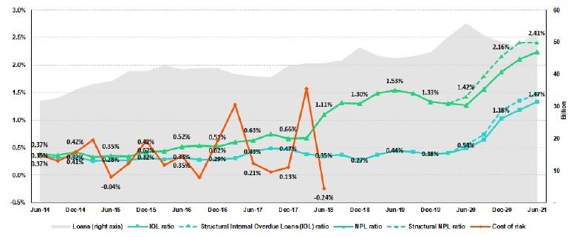

SME-Business
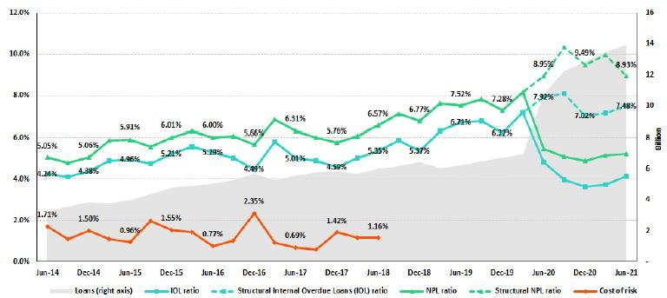

81

SME-Pyme
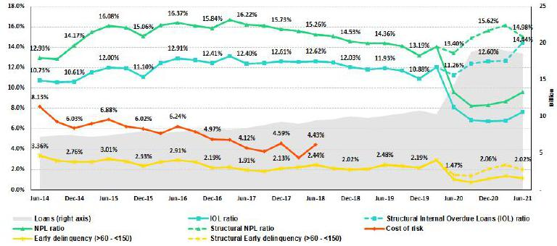

Mortgage
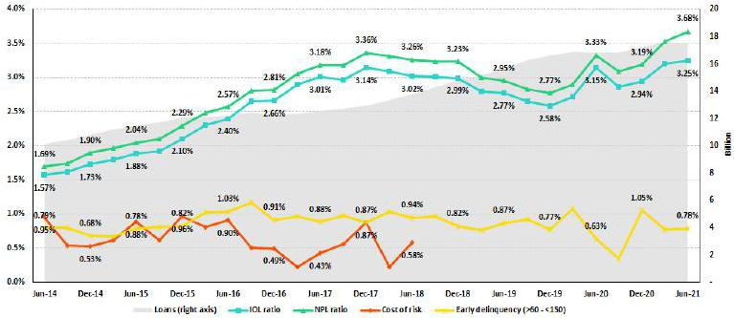

82

Consumer
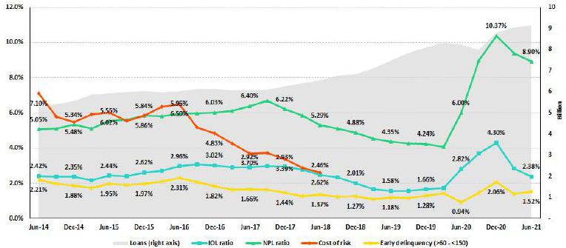

Credit Card
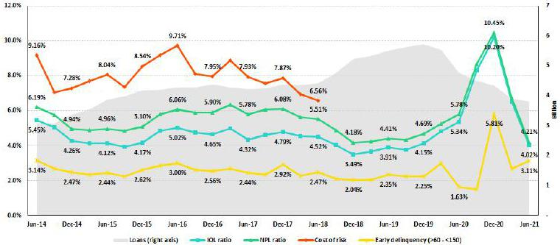

83

Mibanco
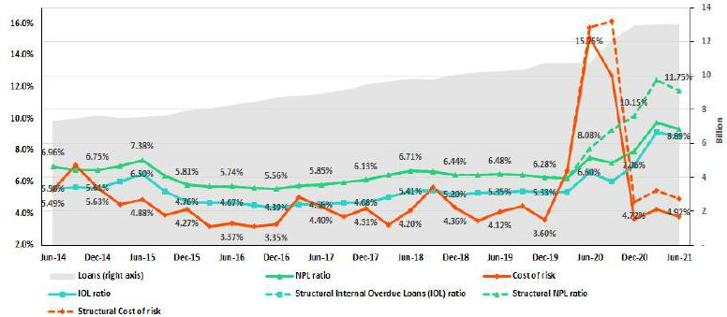

BCP Bolivia
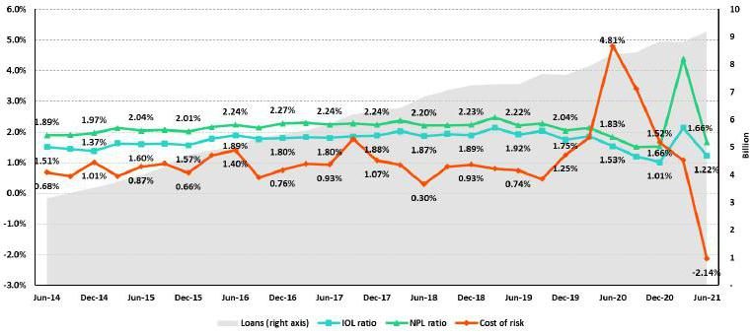

84

12.12. Table of calculations
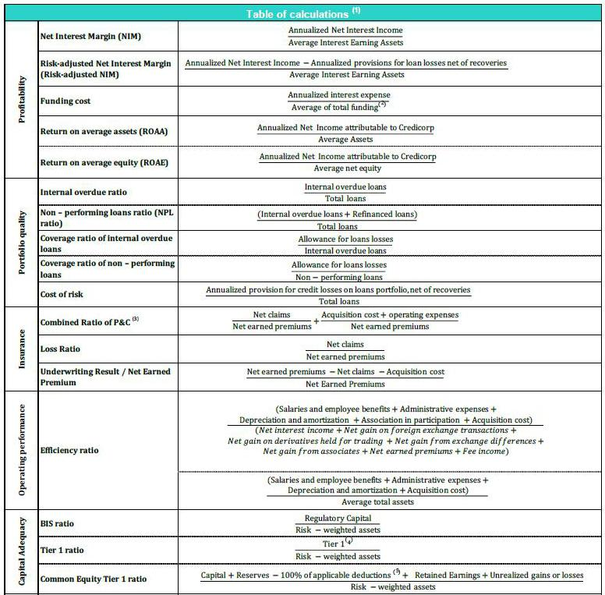

- Averages are determined as the average of period-beginning and period-ending balances.

- Includes total deposits, due to banks and correspondents, BCRP instruments, repurchase agreements and bonds and notes issued.

- Does not include Life insurance business.

- Tier 1 = Capital + Legal and other capital reserves + Accumulated earnings with capitalization agreement + (0.5 x Unrealized profit and net income in subsidiaries) - Goodwill - (0.5 x Investment in subsidiaries) + Perpetual subordinated debt (maximum amount that can be included is 17.65% of Capital + Reserves + Accumulated earnings with capitalization agreement + Unrealized profit and net income in subsidiaries - Goodwill).

- Includes investment in subsidiaries, goodwill, intangibles and deferred tax that rely on future profitability.

85

12.13. Glossary of terms

Government Program Loans (“GP or GP loans”) | Loan Portfolio related to Reactiva Peru and FAE-Mype to respond quickly and effectively to
Government Program Loans (“GP or GP loans”) | liquidity needs and maintain the payment chain.
Structural Loans | Loan Portfolio excluding GP Loans
One-off Impairment | One-off IFRS9 modification loss related to the zero-interest-rate loans to finance frozen
One-off Impairment | installments.
Structural Cost of risk | Cost of Risk related to the Structural Loans. It excludes, in the numerator, provisions for credit
Structural Cost of risk | losses on GP loans, and in the denominators the total amount of GP Loans.
Structural Internal Overdue Loans (IOL) ratio | IOL Ratio related to the Structural Loans. It excludes the impact to GP Loans.
Structural Early delinquency (>60 - <150) | Early Delinquency Ratio related to the Structural Loans. It excludes the impact of GP Loans
Structural NPL ratio | NPL Ratio related to the Structural Loans. It excludes the impact of GP Loans.
Structural NIM | NIM related to Structural loans and other interest earning assets. It excludes the impact from
Structural NIM | GP loans and the one-off impairment.
Structural Funding Cost | Funding Cost Ratio excluding the impact of Central Bank funding for GP Loans
Adjusted Income Growth | Income growth excluding the one-off impairment
Adjusted Efficiency ratio | Efficiency ratio excluding the one-off impairment from operating income.
 | 86

