UNITED STATES

SECURITIES AND EXCHANGE COMMISSION

Washington, D.C. 20549

FORM 6-K

Report of Foreign Private Issuer

Pursuant to Rule 13a-16 or 15d-16 under the

Securities Exchange Act of 1934

For the month of May 2025

Commission File Number: 001-14014

CREDICORP LTD.

(Translation of registrant’s name into English)

Of our subsidiary

Banco de Credito del Peru:

Calle Centenario 156

La Molina 15026

Lima, Peru

(Address of principal executive office)

Indicate by check mark whether the registrant files or will file annual reports under cover of Form 20-F or Form 40-F.

Form 20-F ☒ Form 40-F ☐

The information in this Form 6-K (including any exhibit hereto) shall not be deemed “filed” for purposes of Section 18 of the Securities Exchange Act of 1934 (the “Exchange Act”) or otherwise subject to the liabilities of that section, nor shall it be deemed incorporated by reference in any filing under the Securities Act of 1933 or the Exchange Act.

SIGNATURE

Pursuant to the requirements of the Securities Exchange Act of 1934, the registrant has duly caused this report to be signed on its behalf by the undersigned, thereunto duly authorized.

Date: May 19, 2025

CREDICORP LTD.

(Registrant)

By: /s/ Milagros Cigüeñas

Milagros Cigüeñas

Authorized Representative

Exhibit 99.1
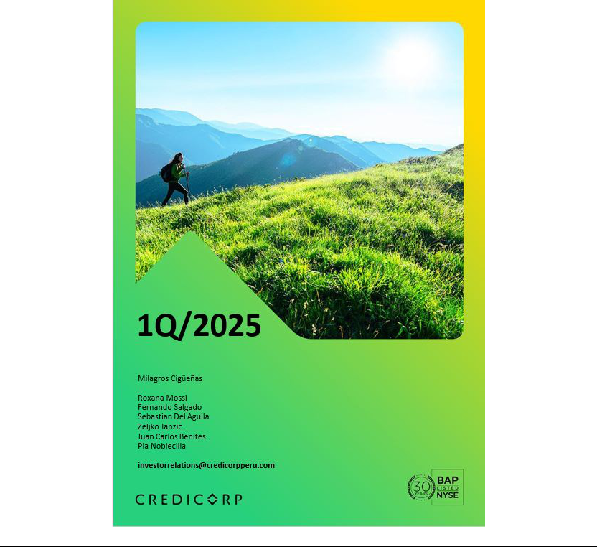

| Earnings Release 4Q / 2024 | Analysis of 4Q24 Consolidated Results
Table of Contents
Operating and Financial Highlights | 03
Senior Management Quotes | 04
First Quarter 2025 Earnings Conference Call | 05
Summary of Financial Performance and Outlook | 06
Financial Overview | 12
Credicorp’s Strategy Update | 13
Analysis of 1Q25 Consolidated Results

01

02

03

04

05

06

07

08

09

10

11

12

Loan Portfolio | 17
Deposits | 20
Interest Earning Assets and Funding | 23
Net Interest Income (NII) | 25
Portfolio Quality and Provisions | 28
Other Income | 32
Insurance Underwriting Results and the Medical Services | 36
Operating Expenses | 39
Operating Efficiency | 41
Regulatory Capital | 42
Economic Outlook | 44
Appendix | 49

2

| Earnings Release 1Q / 2025 Analysis of 1Q25 Consolidated Results

Credicorp Ltd. Reports Financial and Operating Results for 1Q25

Robust operational results in Universal Banking and Insurance & Pensions, improved momentum in Microfinance, and continued

growth in fee-based and transactional volumes.

Risk-adjusted NIM strengthened to 5.24%, driven by lower provisioning resulting from a more dynamic portfolio management and

supported by improvements in payment performance and the economic backdrop.

Advances in our decoupling strategy with 5.4% of risk-adjusted revenues from innovation portfolio this quarter; on track to meet our

10% target by 2026.

ROE reached a high 20.3%, or 18.2% excluding an extraordinary gain from the Empresas Banmedica 50% JV acquisition,

reflecting strong fundamentals across core businesses.

Lima, Peru – May 15, 2025 – Credicorp Ltd. (“Credicorp” or “the Company”) (NYSE: BAP | BVL: BAP), the leading financial services holding company in Peru with a presence in Chile, Colombia, Bolivia, and Panama today reported its unaudited results for the quarter ended March 31, 2025. Financial results are expressed in Soles and are presented in accordance with IFRS.

1Q25 OPERATING AND FINANCIAL HIGHLIGHTS

- Net Income attributed to Credicorp increased 57.8% QoQ and 17.6% YoY to S/1,777.7 million, delivering an ROE of 20.3%. Excluding the extraordinary gain related to the previously disclosed acquisition of the remaining 50% stake in the JV with Empresas Banmedica, Net Income attributed to Credicorp increases 43.0% QoQ and 6.6% YoY, with an ROE at 18.4%.

- In March 2025, Credicorp revalued Bolivia´s balance sheet using a market-reflective FX rate, resulting in an accounting contraction of 2.0% in Credicorp Total Assets. The loan and deposit figures cited below exclude this adjustment.

- Total Loans measured in average daily balances (ADB) expanded by 1.5% YoY, mainly driven by short-term loans in Wholesale Banking and Mortgages. QoQ, Total Loans rose 0.8% led by growth in Wholesale Banking, Consumer (supported by Yape and BCP Stand-alone), and Mortgages.

- Total Deposits increased by 9.7% YoY fueled by Low-cost deposits, amid higher system liquidity, and 0.3% QoQ. Low-cost deposits accounted for 71.8% of total deposits and represent 59.0% of the total funding base.

- Portfolio quality indicators and the Cost of Risk have improved notably as a result of the cumulative impact of a more dynamic portfolio management, enhancements in underwriting and risk management and a more favorable macroeconomic environment.

- NPL Ratio improved 16 bps QoQ to stand at 5.1%, driven by debt repayments at BCP Stand-alone and by a drop in internal overdue loans at both BCP Stand-alone and Mibanco. YoY, the NPL Ratio improved 112 bps.

- Provisions, excluding provision reversals in 1Q24, declined 45.5% YoY, while CoR stood at 1.6%, reflecting an improvement in payment performance and in the economic backdrop; successful risk management measures at both BCP and Mibanco; and some one-time events outlined in the Portfolio Quality chapter. QoQ, provisions declined 21.7%.

- Core Income increased 7.0% YoY, underpinned by diversified revenue streams, which drove a 15.1% YoY increase in other core income. Achieved record-high Risk-Adjusted NIM of 5.24%.

- Insurance Underwriting Results rose 17.9% YoY, largely due to stronger reinsurance results in the P&C business, and was up 5.3% QoQ.

- Yape reached 14.3 million Monthly Active Users (MAU), with average monthly transactions per user rising to 52. The platform sustained its growth trajectory and captured 4.8% of Credicorp’s total risk-adjusted revenue share.

- Efficiency Ratio reached 45.7%, aligned with our full-year guidance. Operating expenses increased 15.6% YoY, mainly due to the core business at BCP Stand-alone and investments in disruptive initiatives.

- Capital base moving closer to target, with the IFRS CET 1 Ratio falling 24 bps YoY at BCP Stand-alone and 18 bps YoY at Mibanco, standing at 11.6% and 15.9%, respectively.

- After quarter-end, on April 14, 2025, Credicorp declared an ordinary cash dividend of S/40 per share based on 2024 results, to be paid out in June 13, 2025, as capital levels advance closer to target across subsidiaries.

3

| Earnings Release 1Q / 2025 Analysis of 1Q25 Consolidated Results

SENIOR MANAGEMENT QUOTES
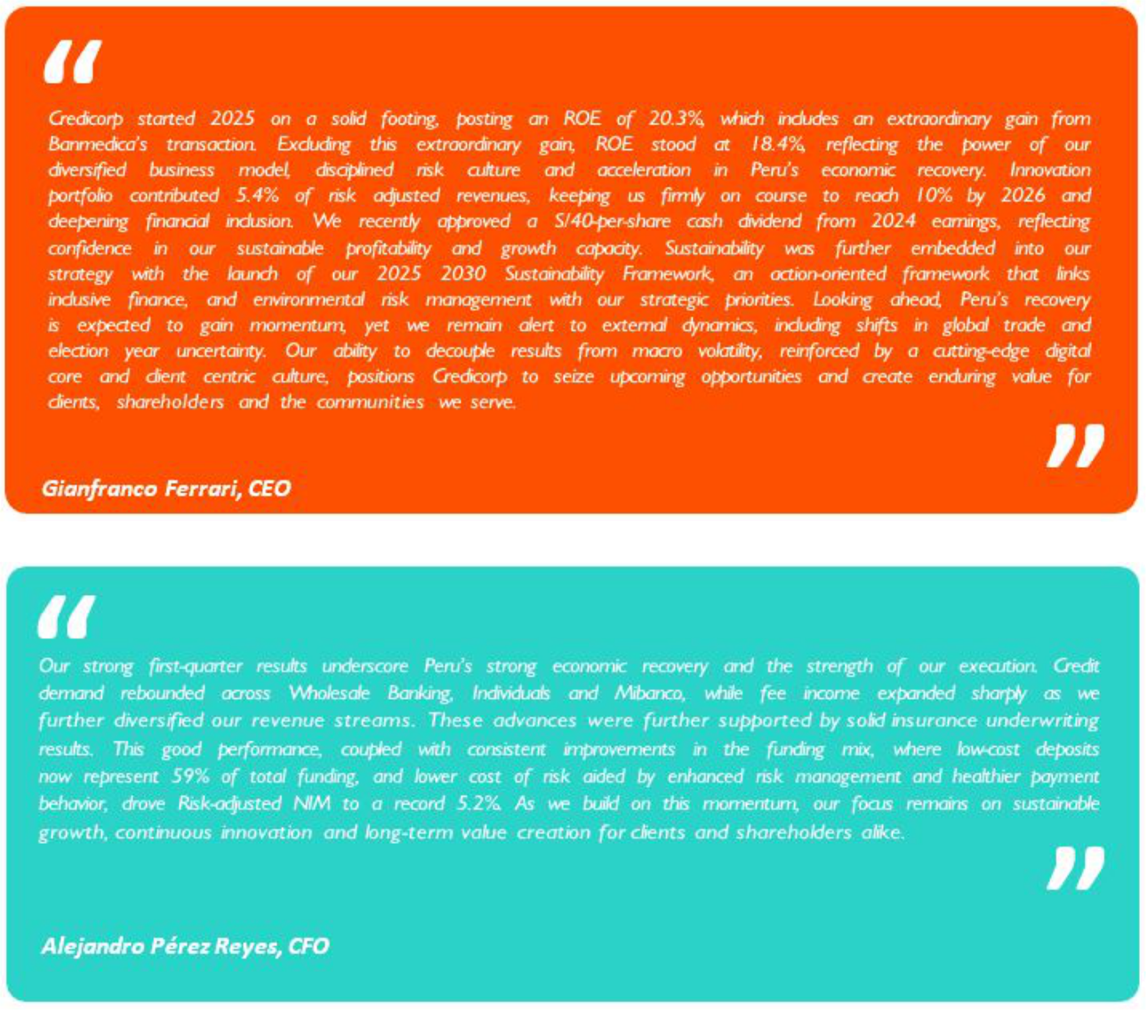

4

| Earnings Release 1Q / 2025 Analysis of 1Q25 Consolidated Results

First Quarter 2025 Earnings Conference Call

FIRST 2025 EARNINGS CONFERENCE CALL

Date: Friday, May 16th, 2025

Time: 10:30 am E.T. (9:30 am Lima, Perú)

Hosts: Gianfranco Ferrari - Chief Executive Officer, Alejandro Perez Reyes - Chief Financial Officer, Francesca Raffo - Chief Innovation Officer, Cesar Rios - Chief Risk Officer, Cesar Rivera - Head of Insurance and Pensions, Carlos Sotelo - Mibanco CFO and Investor Relations Team.

To pre-register for the listen-only webcast presentation use the following link:

https://dpregister.com/DiamondPassRegistration/register?confirmationNumber=10199249&linkSecurityString=ff04339 90d

Callers who pre-register will be given a conference passcode and unique PIN to gain immediate access to the call and bypass the live operator. Participants may pre-register at any time, including up to and after the call start time.

Those unable to pre-register may dial in by calling:
1 844 435 0321 (U.S. toll free)
1 412 317 5615 (International)
Participant Web Phone: Click Here
Conference ID: Credicorp Conference Call

The webcast will be archived for one year on our investor relations website at:

https://credicorp.gcs-web.com/events-and-presentations/upcoming-events

For a full version of Credicorp´s Fourth Quarter 2024 Earnings Release, please visit:

https://credicorp.gcs-web.com/company-reports/quarterly-materials

5

| Earnings Release 1Q / 2025 Analysis of 1Q25 Consolidated Results

Loans and Deposits

Our 1Q25 balance sheet was affected by a non-cash accounting adjustment introduced in March, related to our operations in Bolivia. The adjustment involved updating the exchange rate used to translate Bolivia’s balance sheet to more accurately reflect prevailing market conditions. As a result, Credicorp’s total assets declined 2.0% on an accounting basis, with no impact on cash flow.

To better reflect underlying business performance, our analysis of loan and deposit trends excludes the effect of this non-cash accounting adjustment.
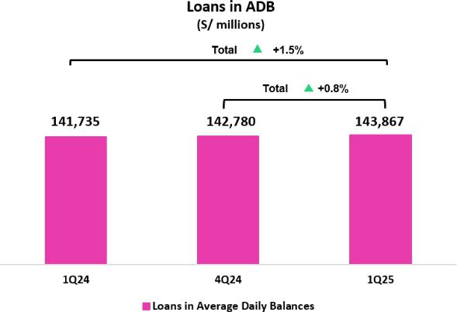

Loans in Average Daily Balances (ADB)

Total loans measured in ADB increased by 0.8% QoQ to stand at S/143,867 million. This evolution was primarily attributable to: (i) Wholesale Banking at BCP Stand-alone, which registered an uptick in the need for financing for working capital, (ii) Consumer, driven by higher disbursements via Yape and BCP Stand-alone, and (iii) Mortgage, due to an upswing in disbursements. This growth was partially offset by a reduction in balances for SME-Business and SME-Pyme.

YoY, the portfolio expanded 1.5%, driven mainly by: (i) Corporate, due to growth in disbursements of short-term loans, (ii) Mortgage, due to an uptick in demand for loans in a context marked by lower rates and economic reactivation, and (iii) SME-Business, which registered growth in disbursements of Government Loans (GP). This inter-annual growth was partially offset by a drop in balances for Mibanco and SME-Pyme.
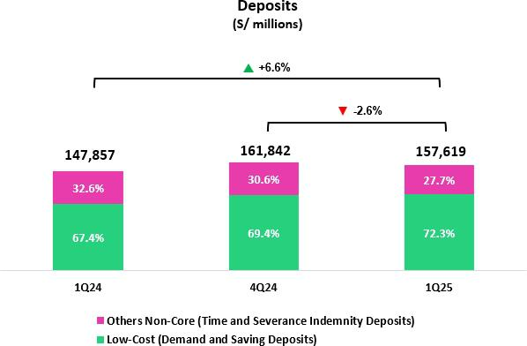

Deposits

The total deposit balance (measured in quarter-end balances) contracted 2.6% QoQ but grew 6.6% YoY, impacted by the aforementioned accounting adjustment at BCP Bolivia.

If we exclude this impact, the dynamics were as follows: QoQ, our deposit base expanded 0.3%. This evolution reflects growth in Demand Deposits and Savings Deposits, which was partially offset by a decrease in the balance for Time Deposits. YoY, the deposit base rose 9.7%. This evolution was fueled by Low-Cost Deposits, which grew 16.9% and represented 71.8% of the total deposit base at quarter-end.

At BCP, the 30-day Liquidity Coverage Ratio (LCR) in PEN stood at

179.2% under regulatory standards and 139.7% according to
stricter internal standards. The 30-day LCR stood at 191.1% under
regulatory standards and 140.5% according to stricter internal

standards.

6

| Earnings Release 1Q / 2025

Net Interest Income (NII) and Margin (NIM)

NII dropped 1.6% QoQ, driven mainly by a reduction in Interest and Similar Income, which fell on the back of lower market rates and an uptick in short-term wholesale loans’ share of total loans. This decline was partially offset by a decrease in Interest and Similar Expenses, which were impacted by a drop in rates. In this context, NIM stood at 6.22% at quarter-end, compared to 6.34% in 4Q24 and 6.30% in 1Q24.

YoY, NII rose 4.3%, fueled primarily by a reduction in Interest and Similar Expenses, due to a drop in market rates and an uptick in low-cost deposits’ share of our funding base. Interest and Similar Income fell 0.6% due to (i) renewals of investments at lower interest rates, and (ii) growth in short-term wholesale loans’ share of funding. In this context, NIM dropped 8 bps YoY.

Portfolio Quality and Cost of Risk

Portfolio quality indicators and the Cost of Risk have improved notably as a result of cumulative impact of enhancements in underwriting and risk management, a more favorable macroeconomic environment and some specific events outlined in the Portfolio Quality chapter.

QoQ, the NPL balance fell 5.9%, driven primarily by BCP Stand-alone and Mibanco. At BCP Stand-alone, the decline was fueled by: (i) Wholesale, due primarily to debt repayment by a refinanced corporate client; and (ii) SME-Pyme, due to a drop in internal overdue loans. At Mibanco, the reduction was spurred by a decrease in internal overdue loans.

YoY, the NPL balance fell 17.7%, driven by BCP Stand-alone and Mibanco. This decline was attributable to: (i) Wholesale, due to debt repayment by two refinanced clients; (ii) SME-Pyme, due to the same dynamics QoQ; and (iii) Consumer and Credit Cards, on the back of an uptick in debt repayment. At Mibanco, the decline was fueled by the same dynamics seen in QoQ.

In this context, the NPL Ratio dropped 16 bps QoQ and 112 bps YoY to stand at 5.1% at quarter-end.

Provisions this quarter dropped 21.7% QoQ, fueled mainly by BCP Stand-alone and partially offset by Mibanco. At BCP Stand-alone, the reduction in provisions was attributable primarily to (i) Credit Cards and Consumer, due to a base effect after we calibrated our risk models and secondarily to an improvement in payment performance, which reflects an increase in lower-risk vintages’ share of total loans, and (ii) Wholesale, which reported an uptick in reversals made for debt repayments for refinanced corporate clients.

YoY, if we isolate the impact of provision reversals in 1Q24, provisions dropped 45.5%, driven by BCP Stand-alone, primarily through Retail Banking, and Mibanco.

Analysis of 1Q25 Consolidated Results
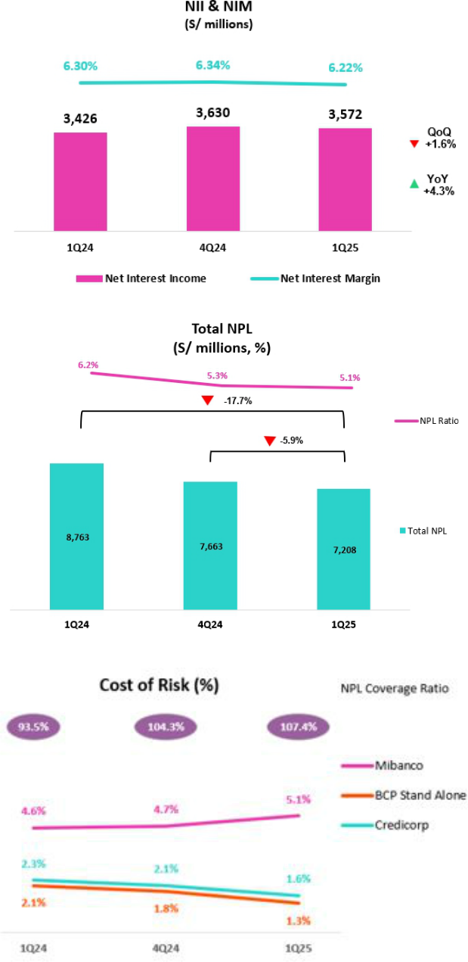

7

| Earnings Release 1Q / 2025 Analysis of 1Q25 Consolidated Results

Other Income and the Insurance

Underwriting Result

In March 2025, Credicorp completed the acquisition of Empresas

Banmedica’s (Banmedica) remaining 50% interest in the joint
venture executed in December 2014 between Pacifico Compañia

de Seguros y Reaseguros S.A. (Pacifico) and Banmedica.

As a result of this transaction, Credicorp revalued its previously

held 50% stake, recognizing an extraordinary gain of approximately
S/ 236 million, recorded under Other Non-Core Income.

As of March 2025, the EPS business has been primarily

consolidated into Credicorp’s Insurance Underwriting line, while the
Medical Services operations are now reported separately under a
newly created “Medical Services Result” account. Given that this
quarter only reflects one month of this new consolidation structure,
the transaction had no material impact on the evolution of the
Insurance Underwriting Result for the period.

Other Income¹
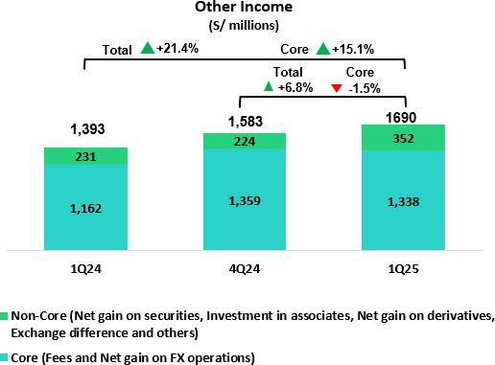

QoQ, Other Income rose 6.8%, driven mainly by Other Non-Core Income, which increased on the back of the aforementioned extraordinary gain. If we exclude this effect, Other Income dropped 8.1%, spurred by exchange rate losses at BCP Bolivia. This quarterly evolution overshadowed the expansion reported by Fee Income, which was driven by high transaction levels for Yape and BCP Stand- alone.

YoY, Other Income rose 21.4%. If we exclude the impact of the aforementioned extraordinary gain, Other Income rose 4.5%, fueled by solid growth of 15.1% in Other Core Income, which rose on the back of an uptick in Fee Income (+16.0%) and an increase in the Net Gain on FX Transactions (+12.6%), both driven mainly by BCP Stand-alone.

- Beginning in 1Q25, reclassifications have been incorporated, affecting the presentation of Fee Income, Net Gain on Foreign Exchange Transactions, and Net Gain on Derivatives Held for Trading. Figures for prior periods have been restated to ensure comparability and may differ from those previously reported.

8

| Earnings Release 1Q / 2025

Insurance Underwriting Result

The Insurance Underwriting Result increased 5.3% QoQ. This evolution was spurred mainly by (i) lower Insurance Service Expenses in Life and P & C, and (ii) an improvement in the Reinsurance Result in P & C.

YoY, the Insurance Underwriting Result rose 17.9%, due to (i) an improvement in the Reinsurance Result, primarily via P & C, and (ii) growth in Insurance Service Income, driven mainly by EPS and P & C.

Efficiency

Operating Expenses rose 15.6% YoY, driven mainly by the core business at BCP Stand-alone as well as our innovation portfolio initiatives at the Credicorp level. Operating Income, in turn, rose 8.2% YoY.

In this scenario, in 1Q25, the Efficiency ratio rose to stand at 45.7%, which is aligned with guidance for the year.

Net earnings attributable to Credicorp

In 1Q25, Credicorp reported net earnings attributable to Credicorp of S/1,777.7 million (+57.8% QoQ and +17.6% YoY), which includes an extraordinary gain generated by the aforementioned acquisition of Empresas Banmedica. Net shareholders’ earnings rose to S/35,843 million (+4.4% QoQ and +5.9% YoY). In this context, ROE stood at 20.3%.

If we exclude the effect of the extraordinary gain, net earnings attributable to Credicorp increased 43.0% QoQ and 6.6% YoY while ROE situated at 18.4%.

Analysis of 1Q25 Consolidated Results
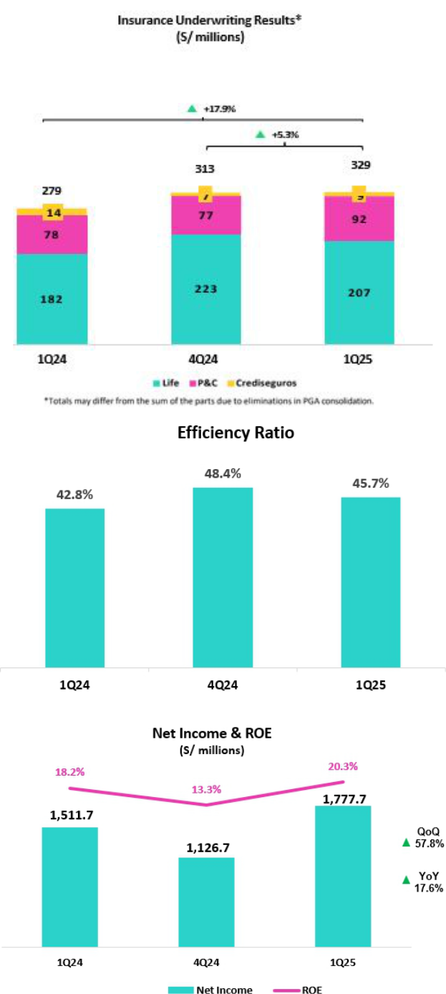

9

| Earnings Release 1Q / 2025 Analysis of 1Q25 Consolidated Results

Contributions and ROE by subsidiary in 1Q25

(S/ million)
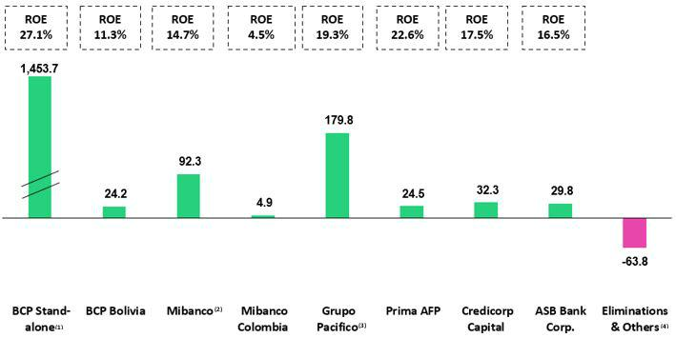

- In BCP Stand-alone, the figure is lower than the net profit since the contribution eliminates investment gains in other subsidiaries of Credicorp (Mibanco)

- In Mibanco, the figure is less than the net profit because Credicorp owns (directly and indirectly) 99.921% of Mibanco.
- The contribution for Grupo Pacifico presented here is greater than the profit of Pacifico Seguros since 100% of Crediseguros is being included (including 48% under Grupo Crédito).
- Includes the extraordinary gain of approximately S/ 166 million (net of taxes) related to the acquisition of Empresas Banmedica.

10

| Earnings Release 1Q / 2025 Analysis of 1Q25 Consolidated Results

Universal Banking _{Microfinance}


BCP Stand-alone reported good results, which were driven mainly by an improvement in risk management indicators and diversified sources of income, which continued to represent a core strength. NIM stood at 5.8%, supported in large part by an improvement in the cost of funding. YoY, other core income rose 15.1% on the back of Yape’s consolidation as a key source of income and alongside a strong transactions level. These dynamics were partially offset by growth in operating expenses.


Mibanco’s profitability rose YoY, fueled mainly by a resilient NIM and fortified risk management. NIM stood at 13.9%, driven by active price management and a decrease in the funding cost.


Mibanco Colombia’s profitability improved thanks to its focus on efficiency; improvements in processes and controls; and disciplined risk management, which helped attenuate the impact of a challenging business environment.


Insurance and Pensions1 Investment Management and Advisory


Profitability at Grupo Pacífico dropped AaA due to a reduction in the Net gain on Securities, on the back of deterioration in the investment portfolio. This dynamic was partially offset by an uptick in the Insurance Underwriting Result via Life and P & C and supported by solid commercial dynamics in both businesses.

Operating dynamics for Investment Banking and Advisory were solid in 1Q25, which reaffirms that our strategic focus is on-target and puts us in good stead for 2025. Net earnings rose 10% YoY, driven primarily by a reduction in operating expenses. Our Asset Management and Capital Markets businesses also contributed to results through an uptick in AUMs and growth in transactions, respectively.


Outlook

Although ROE in 1Q25 situates us in an advantageous position going forward, uncertainty at the global level has led us to maintain our guidance for ROE for the year 2025 at around 17.5%. These results will be supported by: (i) acceleration in the pace of growth of our loan portfolio, in the retail segment in particular, (ii) the resilience of our NIM, and (iii) a controlled cost of risk.

- In March 2025. Credicorp concluded the acquisition of the remaining 50% of the stake Empresas Banmedica under the joint venture with Pacifico Seguros. This consolidation did not materially impact Grupo Pacifico’s results in 1Q25.

11

| Earnings Release 1Q / 2025 Analysis of 1Q25 Consolidated Results

Financial Overview

Credicorp Ltd. |  | Quarter |  | % change
S/000 | 1Q24 | 4Q24 | 1Q25 | QoQ | YoY
Net interest, similar income and expenses | 3,426,123 | 3,629,794 | 3,572,012 | -1.6% | 4.3%
Provision for credit losses on loan portfolio, net of recoveries | (814,699) | (743,296) | (581,893) | -21.7% | -28.6%
Net interest, similar income and expenses, after provision for credit losses on loan portfolio | 2,611,424 | 2,886,498 | 2,990,119 | 3.6% | 14.5%
Other income | 1,392,559 | 1,582,732 | 1,690,216 | 6.8% | 21.4%
Insurance underwriting result | 279,062 | 312,683 | 329,134 | 5.3% | 17.9%
Medical services result | - | - | 42,689 | n.a. | n.a.
Total expenses | (2,212,482) | (3,026,227) | (2,532,874) | -16.3% | 14.5%
Profit before income tax | 2,070,563 | 1,755,686 | 2,519,284 | 43.5% | 21.7%
Income tax | (528,466) | (598,348) | (704,469) | 17.7% | 33.3%
Net profit | 1,542,097 | 1,157,338 | 1,814,815 | 56.8% | 17.7%
Non-controlling interest | 30,440 | 30,625 | 37,118 | 21.2% | 21.9%
Net profit attributable to Credicorp | 1,511,657 | 1,126,713 | 1,777,697 | 57.8% | 17.6%
Dividends paid to third parties | - | - | - | n.a. | n.a.
Net income / share (S/) | 19.0 | 14.1 | 22.3 | 57.8% | 17.6%
Dividends per Share (S/) | - | - | - | n.a. | n.a.
Loans | 140,798,083 | 145,732,273 | 141,196,646 | -3.1% | 0.3%
Deposits and obligations | 147,857,127 | 161,842,066 | 157,619,082 | -2.6% | 6.6%
Net equity | 33,853,460 | 34,346,451 | 35,843,202 | 4.4% | 5.9%
Profitability
Net interest margin⁽¹⁾ | 6.30% | 6.34% | 6.22% | -12 bps | -8 bps
Risk-adjusted Net interest margin | 4.85% | 5.08% | 5.24% | 16 bps | 39 bps
Funding cost⁽²⁾ | 2.98% | 2.56% | 2.42% | -14 bps | -56 bps
ROAE | 18.2% | 13.3% | 20.3% | 697 bps | 203 bps
ROAA | 2.5% | 1.8% | 2.8% | 100 bps | 30 bps
Loan portfolio quality
Internal overdue ratio⁽³⁾ | 4.4% | 3.7% | 3.7% | -3 bps | -72 bps
Internal overdue ratio over 90 days | 3.3% | 3.0% | 3.0% | -1 bps | -34 bps
NPL ratio⁽⁴⁾ | 6.2% | 5.3% | 5.1% | -16 bps | -112 bps
Cost of risk⁽⁵⁾ | 2.3% | 2.1% | 1.6% | -44 bps | -66 bps
Coverage ratio of IOLs | 132.0% | 147.4% | 148.7% | 130 bps | 1672 bps
Coverage ratio of NPLs | 93.5% | 104.3% | 107.4% | 308 bps | 1395 bps
Operating efficiency
Operating income⁽⁶⁾ | 4,933,778 | 5,396,202 | 5,340,199 | -1.0% | 8.2%
Operating expenses⁽⁷⁾ | 2,112,810 | 2,612,878 | 2,442,089 | -6.5% | 15.6%
Efficiency ratio⁽⁸⁾ | 42.8% | 48.4% | 45.7% | -270 bps | 291 bps
Operating expenses / Total average assets | 3.5% | 4.1% | 3.8% | -30 bps | 31 bps
Capital adequacy - BCP Stand-alone
Global Capital Ratio⁽⁹⁾ | 16.12% | 18.71% | 16.87% | -184 bps | 75 bps
Ratio Tier 1⁽¹⁰⁾ | 11.72% | 13.08% | 11.34% | -174 bps | -38 bps
Ratio common equity tier 1⁽¹¹⁾ ⁽¹³⁾ | 11.86% | 13.32% | 11.62% | -170 bps | -24 bps
Capital adequacy - Mibanco
Global Capital Ratio⁽⁹⁾ | 18.03% | 19.42% | 18.53% | -89 bps | 50 bps
Ratio Tier 1⁽¹⁰⁾ | 15.69% | 17.07% | 15.48% | -159 bps | -21 bps
Ratio common equity tier 1⁽¹¹⁾ ⁽¹³⁾ | 16.06% | 17.53% | 15.89% | -164 bps | -17 bps
Employees⁽¹⁴⁾ | 36,912 | 38,695 | 46,621 | 20.5% | 26.3%
Share Information
Issued Shares | 94,382 | 94,382 | 94,382 | 0.0% | 0.0%
Treasury Shares⁽¹²⁾ | 14,908 | 14,948 | 15,016 | 0.5% | 0.7%
Outstanding Shares | 79,474 | 79,434 | 79,366 | -0.1% | -0.1%

- Net Interest Margin = Net Interest Income (Excluding Net Insurance Financial Expenses)/ Average Interest Earning Assets

- Funding Cost = Interest Expense (Does not include Net Insurance Financial Expenses) / Average Funding
- Internal Overdue Loans: include overdue loans and loans under legal collection, according to our internal policy for overdue loans. Internal Overdue Ratio: Internal overdue loans/ Total loans
- Non-performing loans (NPL): Internal overdue loans + Refinanced loans. NPL ratio: NPL / Total loans.
- Cost of risk = Annualized provision for loan losses, net of recoveries/ Total loans.
- Operating Income = Net interest, similar income and expenses + Fee Income+ Net gain on foreign exchange transactions + Net Gain From associates + Net gain on derivatives held for trading + Result on exchange differences + Insurance Underwriting Result + Results for Medical Services
- Operating Expenses = Salaries and employee benefits + Administrative expenses + Depreciation and amortization + Association in participation + Acquisition cost.
- Efficiency Ratio = (Salaries and employee benefits + Administrative expenses + Depreciation and amortization + Association in participation) / (Net interest, similar income and expenses + Fee Income+ Net gain on foreign exchange transactions + Net Gain From associates + Net gain on derivatives held for trading + Result on exchange differences + Insurance Underwriting Result)
- Regulatory Capital/ Risk-weighted assets (legal minimum = 10% since July 2011).
- Tier 1 = Capital + Legal and other capital reserves + Accumulated earnings with capitalization agreement + (0.5 x Unrealized profit and net income in subsidiaries) - Goodwill - (0.5 x Investment in subsidiaries) + Perpetual subordinated debt (the maximum amount that can be included is 17.65% of Capital + Reserves + Accumulated earnings with capitalization agreement + Unrealized profit and net income in subsidiaries - Goodwill).

- Common Equity TierI = Capital + Reserves – 100% of applicable deductions (investment in subsidiaries, goodwill, intangibles, and net deferred taxes that rely on future profitability) + retained earnings + unrealized gains.
- Consider shares held by Atlantic Security Holding Corporation (ASHC) and stock awards.
- Common Equity Tier I calculated based on IFRS Accounting
- Internal management figures. Since 1Q25, includes corporate health and medical services employees.

12

| Earnings Release 1Q / 2025 Analysis of 1Q25 Consolidated Results

Credicorp’s Strategy Update

Credicorp’s Strategy

Credicorp continues to execute its strategy by investing in technology to strengthen and consolidate its core businesses while developing its innovation portfolio to fuel growth. Armed with an in-depth understanding of current and projected market trends, Credicorp constantly reviews and optimizes its business agilely and with a self-disruptive mindset to maintain a competitive advantage and ensure sustainable growth. This will generate new sources of income and capture market opportunities, as the expansion of the Total Addressable Market (TAM) is leveraged to decouple from the macroeconomic environment.

Credicorp holds fast to its long-term objectives to offer the best client experience; optimize efficiency; and drive growth through technology. To achieve its objectives, all our businesses focus on three strategic priorities: (i) ensuring we have the best talent by offering a comprehensive value proposition; (ii) accelerating digital transformation and innovation; and (iii) integrating sustainability in our way of doing business.

Credicorp’s operating results for 1Q25 reflect the solid execution of its ‘decoupling’ strategy and the benefits of a series of measures taken to improve risk management, amid a more favorable economic context. Credicorp continues to decouple from economic performance and loan portfolio growth by diversifying its income sources. Non-financial income is accelerating, boosted by the digitalization of core businesses and our innovation portfolio. At the end of 1Q25, the innovation portfolio accounted for 5. 4% of Credicorp’s risk-adjusted revenues. Our goal is that by 2026, our innovation portfolio represents 10% of this ratio.

Main KPIs in Credicorp’s Strategy
Core Businesses Transformation ⁽¹⁾ | 1Q24 | 4Q24 | 1Q25
Credicorp
Innovation Portfolio Risk-Adjusted Revenue Share ⁽²⁾ | 3.1% | 5.6% | 5.4%
BCP
Stand-alone
Digital clients ⁽³⁾ | 70% | 76% | 78%
Digital monetary transactions ⁽⁴⁾ | 83% | 88% | 89%
Cashless transactions ⁽⁵⁾ | 62% | 69% | 69%
Mibanco
Disbursements through leads ⁽⁶⁾ | 69% | 65% | 70%
Disbursements through alternative channels ⁽⁷⁾ | 22% | 24% | 26%
Relationship managers productivity ⁽⁸⁾ | 25.0 | 24.5 | 28.2

- Management figures. Figures for March 2024, December 2024, and March 2025.

- As a percentage of Credicorpʼs total Risk-Adjusted Revenue.

- Retail clients that made 70%, or more, of their transactions through digital channels in the last 6 months (including Yape).

- Monetary Transactions conducted through Mobile Banking, Internet Banking, Yape and Telecredito/Total Monetary Transactions in Retail Banking.

- Amount transacted through Mobile Banking, Internet Banking, Yape y POS/Total amount transacted through Retail Banking.

- Disbursements generated through leads/Total disbursements.

- Disbursements conducted through alternative channels/Total disbursements. Figures differ from previously reported due to a methodological change.

- Number of loans disbursed/Total relationship managers.

13

| Earnings Release 1Q / 2025 Analysis of 1Q25 Consolidated Results

Credicorp’s Strategy Update

Yape

Main Management KPI’s

Management KPI’s ⁽¹⁾ |  | Quarter |  | Change %
 | 1Q24 | 4Q24 | 1Q25 | QoQ | YoY
Users
Users (millions) | 15.1 | 17.3 | 18.0 | 3.9% | 18.9%
Monthly Active Users (MAU) (millions) ⁽²⁾ | 11.5 | 13.7 | 14.3 | 4.4% | 24.3%
Fee Income Generating MAU (millions) | 8.6 | 11.4 | 12.0 | 5.2% | 38.7%
Engagement
# Transactions (millions) | 1,127.7 | 1,953.1 | 2,025.4 | 3.7% | 79.6%
# Transactions / MAU | 36.0 | 51.0 | 52.1 | 2.1% | 44.5%
# Average Functionalities / MAU | 2.2 | 2.6 | 2.6 | 2.7% | 18.0%
Experience
NPS ⁽³⁾ | 78 | 79 | 77 | -200.0% | -140.0%
Unit Economics
Monthly Indicators ⁽⁴⁾
Revenues / MAU (S/) ⁽⁵⁾ | 3.4 | 6.1 | 6.2 | 1.1% | 80.4%
Expenses / MAU (S/) ⁽⁵⁾ | -3.9 | -5.0 | -4.7 | -6.1% | 21.2%
Quarterly Indicators ⁽⁶⁾
Revenues / MAU (S/) | 9.8 | 16.0 | 16.6 | 4.0% | 69.0%
Expenses / MAU (S/) | -11.5 | -13.4 | -12.7 | -5.4% | 10.5%
Drivers Monetization
Total TPV (S/, billions) ⁽⁷⁾ | 50.5 | 90.3 | 91.6 | 1.4% | 81.4%
Payments
# Bill Payments transactions (millions) | 23.4 | 40.5 | 45.0 | 11.3% | 92.0%
Financials
# Loans Disbursements (thousands) | 472.4 | 2,143.1 | 3,097.1 | 44.5% | 555.7%
E-Commerce
GMV (S/, millions) ⁽⁸⁾ | 59.1 | 120.4 | 119.2 | -1.0% | 101.7%

- Management Figures.

- Yape users that have made at least one outgoing transaction in the measurement month.

- Net Promoter Score.

- Monthly indicators consider the results of the last month of the quarter for the numerator and denominator.

- Beginning in 1Q25, Credicorp incorporated reclassifications between Operating Expenses and Fee Income, along with new accounting allocations—primarily related to interest expenses associated with the Deposit Insurance Fund. Figures for prior periods have been restated for comparability and may differ from those previously reported.
- Quarterly indicators are calculated using the sum of the three months in the period for numerator accounts, and the average of the denominator—based on the last month’s data from both the current and previous quarters.
- Total Payment Volume.

- Gross Merchant Volume, includes the following functionalities: Yape Promos, Yape Store, Ticketing, Gaming, Delivery, Buses, Insurance, Gas, Brand Solutions and Insurance.

Main Financial Results
Financial results ⁽¹⁾ |  | Quarter |  | Change %
S/ millions | 1Q24 | 4Q24 | 1Q25 | QoQ | YoY
Net Interest Income after Provisions ⁽²⁾ | 50.7 | 88.3 | 93.0 | 5.3% | 83.6%
Other Income ⁽³⁾ | 59.7 | 127.7 | 141.6 | 10.9% | 137.1%
Total Income | 110.4 | 216.0 | 234.6 | 8.6% | 112.5%
Total Operating Expenses | -128.8 | -181.3 | -179.1 | -1.2% | 39.1%

- Management figures. Beginning in 1Q25, reclassifications between Operating Expenses and Fee Income have been incorporated, along with new accounting allocations — primarily related to interest expenses associated with the Deposit Insurance Fund. Figures for prior periods have been restated for comparability and may differ from those previously reported.
- Includes interest income, interest expense and net provisions.

- Includes Other Income recorded in BCP and in Yape Market.

14

| Earnings Release 1Q / 2025 Analysis of 1Q25 Consolidated Results

Credicorp’s Strategy Update

Operating Results | Evolution of MAU, # of Transactions and # of Functionalities
At the end of 1Q25, Yape reached the 14.3-million monthly active
users (MAU) mark after having registered growth of more than half
a million users per quarter. These MAUs represent 72% of the
economically active population, which attests to Yape’s popularity.
We aspire to reach 16.5 million MAU in 2026, as we focus on
increasing the share of Yaperos that generate fee income.
Monthly transactions per MAU situated at 52.1, which is proof that
Yape has become part of Peruvians’ day-to-day. The average
number of functionalities used per MAU has been growing
sustainedly, as users start learning about and using the rest of the
functionalities available in the app. These indicators of engagement
attest to Yape’s usability.
Monetization Drivers
Yape is advancing in its monetization strategy, where the gap | Evolution of monthly revenue and expenses / MAU
between monthly income (S/6.2) and expense (S/4.7) per MAU
continues to widen steadily.
The main driver in Yape’s monetization continues to be the
Payments business, where Bill Payment transactions totaled 45.0
million. This growth was driven mainly by expansion in the number
of affiliated establishments and due to the increase in MAUs using
the functionality. In the Financial business, floating volumes have
continued to increase alongside growth in average balances.
Additionally, the Lending business is gradually expanding and
reached the 3.1-million mark for disbursements in 1Q25. At the end
of the quarter, Yape reached the 2.4-million mark for users that
received loan disbursements, which brings us closer to our target of
5 million. The GMV for the E-Commerce business was S/119.2
million, buoyed by Yaperos’ high transaction and adoption levels
Financial results
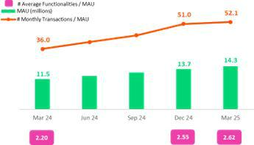
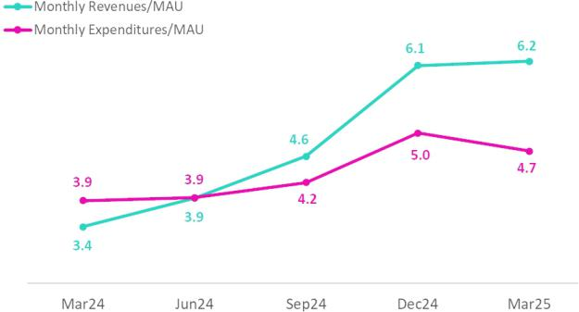
Within the evolution of revenue, the share of the Payments business, the main driver of income, continued to grow and represented 56% of Yape’s income. The Bill Payments and Top-up functionalities are the most mature solutions. Additionally, we have been making significant progress in QR code payments, Yape for Business, and Checkout, which all have substantial growth potential.

The Financial business generated 40% of Yape’s revenue this | Evolution of revenue by business
quarter, mainly through Floating volumes. The Lending business is | Evolution of revenue by business
gaining relevance in the consumer loan portfolio. Multi- installment
loans, which have more favorable risk profiles than those
associated with single-installment loans, have accelerated and now
represent approximately 50% of the portfolio balance (compared to
approximately 25% at the beginning of 2024). As of 1Q25, the
Lending business generates 13% of Yape’s total income.
Finally, the E-commerce business continues to bring us closer to
new clients as it bolsters daily use, mainly through Yape Promos,
which receives more than 10 million visits per month.
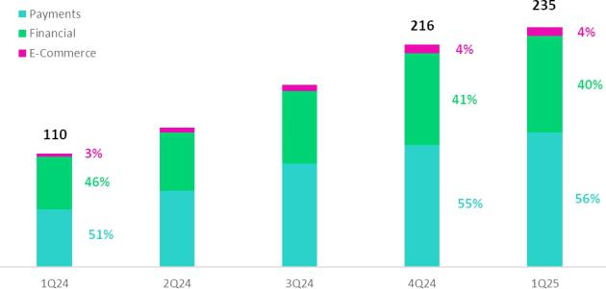

15

| Earnings Release 1Q / 2025 Analysis of 1Q25 Consolidated Results

Credicorp’s Strategy Update

Integrating Sustainability in Our Businesses

In the 1Q25, we approved our new Sustainability Strategy 2025-2030. We have renewed the focus that builds on the vision of sustainability that we have implemented over the last few years, which is anchored by our purpose. The strategy is focused on three pillars and one axis from the perspective of the impact plan:
- Inclusion: Includes the financial inclusion and financial education fronts, as well as access to quality healthcare.
- Finance for the Future: involves the fronts of support to micro, small and medium enterprises (MSMEs), resilience of businesses and people, and sustainable financing and investments.

- Trust: Encompasses promoting trust in Credicorp and its subsidiaries, as well as in the private sector in general.
- Country Vision: Seeks to promote development in the countries in which we operate by leveraging the three pillars mentioned above.

We have also published our Sustainability Report 2024 and the TCFD Report 2024, which outline our achievements for 2024. For more information, please review the published documents.

Among the milestones achieved in the 1Q25, the following stand out:

Inclusion

- BCP and Yape financially included 200 thousand people this quarter, accumulating a total of 6.0 million since 2020. More than 1.6 million clients received loan disbursements through Yape in the first quarter.

- BCP reached 81 thousand clients in 1Q25 through financial education initiatives that focus on promoting changes in behavior to safeguard and improve their financial health (avoid over-indebtedness, late payments, overdraws on credit cards, among others).

- Pacifico closed the 1Q25 with +2.7 million clients included through inclusive insurance products¹ placed through the BCP, Mibanco and Yape channels.

Finance for the Future

- Mibanco reported a YTD increase of 16 thousand SME clients in its loan portfolio. Additionally, the bank reached more than 108 thousand clients through its financial education programs.

- Mibanco disbursed 231 million soles in the 1Q25 through its Crediagua product, which equips households with drinking water and sewage connections.

- BCP, in the framework of the program “Contigo Emprendedor,” rolled out the program “Despegue Empresarial,” which benefitted more than 70 thousand clients by helping them improve their credit score.

- BCP disbursed more than US$ 430 million in sustainable financing in the 1Q25, led by loans for working capital for sustainable fishing and agriculture.

- Pacifico certified more than 11 thousand people (including clients, non-clients and businesses’ employees) in risk prevention through its “ABC de Pacifico”, “Comunidad Segura” and “Protege365” programs, which bolster resilience.

The table below summaries some of our main results:

Indicator | Company | Unit | 2024 | 1Q24 | 1Q25
Inclusion
People included financially through BCP and Yape – | BCP Peru and Yape | Million | 5.7 | 4.2 | 6.0
cumulative since 2020²
Clients included in inclusive insurance services | Pacifico | Million | 2.67 | N.D. | 2.77
Finance for the Future
Total loan balance for micro and small businesses | Mibanco Peru | S/ Million | 11,356 | 11,618 | 11,629
Disbursements of sustainable financings | BCP Peru | $ Million | 1,600 | 147 | 430

- Simple and affordable optional insurance products with single or monthly payments of S/40 or less.

- Stock of financially included clients through BCP since 2020: (i) New clients with savings accounts or affiliated to Yape. (ii) New clients without debt in the financial system or BCP products in the last twelve months. (iii) Clients with 3 monthly average transactions in the last three months.

16

| Earnings Release 1Q / 2025 Analysis of 1Q25 Consolidated Results

01 Loan Portfolio


After reaching a turning point last quarter, total loans in average daily balances (ADB) rose 0.8% (+1.4% FX Neutral). QoQ, this evolution was primarily driven by i) an increase in disbursements of short-term loans in Wholesale Banking, and ii) growth in loan disbursements through Yape and BCP in Consumer, and iii) an upturn in disbursements at Mibanco. This growth was partially offset by a drop in loans in Small Businesses.

YoY, total loans in average daily balances rose 1.5% (+2.3% FX Neutral). This evolution was mainly driven by i) an uptick in disbursements of short-term loans in Corporate Banking, ii) an upturn in disbursements in Mortgage and by iii) growth in disbursements in SME-Business. YoY growth was partially attenuated by the application of stricter loan guidelines at Mibanco and by a drop in disbursements for long-term loans in SME-Pyme.

1.1. Loans

Our 1Q25 balance sheet was affected by a non-cash accounting adjustment introduced in March, related to our operations in Bolivia. The adjustment involved updating the exchange rate used to translate BCP Bolivia’s balance sheet to more accurately reflect prevailing market conditions. As a result, Credicorp’s total assets declined 2.0% on an accounting basis, with no impact on cash flow.

Our analysis of loans in quarter-end balances is run with and without the aforementioned accounting adjustment. The analysis of loans in average daily balances, however, excludes this effect and focuses on operating trends.

Evolution of Loans measured in Quarter-end Balances

This quarter, loans measured in quarter-end balances dropped 3.1% QoQ and rose 0.3% YoY. If we exclude the effect of the accounting adjustment related to BCP Bolivia’s balance sheet, loans measured in quarter-end balances contracted 0.7% QoQ and rose 2.8% YoY.

Evolution of Loans measured in Average Daily Balances

Total Loans (in Average Daily Balances) ⁽¹⁾⁽²⁾⁽³⁾
Total Loans ⁽¹⁾ ⁽²⁾ ⁽³⁾ |  | As of |  | Volume change |  | % change |  | % Part. In total |  | loans
(S/ millions) | Mar 24 | Dec 24 | Mar 25 | QoQ | YoY | QoQ | YoY | Mar 24 | Dec 24 | Mar 25
BCP Stand-alone | 115,412 | 117,601 | 118,771 | 1,169 | 3,359 | 1.0% | 2.9% | 81.4% | 82.4% | 82.6%
Wholesale Banking | 51,835 | 53,068 | 54,548 | 1,480 | 2,713 | 2.8% | 5.2% | 36.6% | 37.2% | 37.9%
Corporate | 30,063 | 32,318 | 32,977 | 659 | 2,914 | 2.0% | 9.7% | 21.2% | 22.6% | 22.9%
Middle - Market | 21,772 | 20,750 | 21,571 | 821 | -201 | 4.0% | -0.9% | 15.4% | 14.5% | 15.0%
Retail Banking | 63,577 | 64,533 | 64,223 | -311 | 646 | -0.5% | 1.0% | 44.9% | 45.2% | 44.6%
SME - Business | 7,294 | 7,956 | 7,590 | -367 | 295 | -4.6% | 4.0% | 5.1% | 5.6% | 5.3%
SME - Pyme | 16,499 | 16,251 | 15,940 | -311 | -559 | -1.9% | -3.4% | 11.6% | 11.4% | 11.1%
Mortgage | 21,050 | 21,709 | 21,870 | 161 | 821 | 0.7% | 3.9% | 14.9% | 15.2% | 15.2%
Consumer | 12,723 | 12,755 | 12,961 | 206 | 237 | 1.6% | 1.9% | 9.0% | 8.9% | 9.0%
Credit Card | 6,010 | 5,862 | 5,862 | 1 | -148 | 0.0% | -2.5% | 4.2% | 4.1% | 4.1%
Mibanco | 13,244 | 12,057 | 12,147 | 90 | -1,097 | 0.7% | -8.3% | 9.3% | 8.4% | 8.4%
Mibanco Colombia | 1,730 | 1,715 | 1,832 | 118 | 103 | 6.9% | 5.9% | 1.2% | 1.2% | 1.3%
Bolivia | 9,362 | 9,628 | 9,469 | -159 | 107 | -1.7% | 1.1% | 6.6% | 6.7% | 6.6%
ASB | 1,989 | 1,779 | 1,648 | -131 | -340 | -7.4% | -17.1% | 1.4% | 1.2% | 1.1%
BAP’s total loans | 141,735 | 142,780 | 143,867 | 1,087 | 2,132 | 0.8% | 1.5% | 100.0% | 100.0% | 100.0%

For consolidation purposes. Loans generated in Foreign Currency (FC) are converted into Local Currency (LC).
- Includes Special Accounts and other banking. For Quarter-end balance figures, please refer to “12. Annexes – 12.3 Loan Portfolio Quality”.
- Internal Management Figures, non-audited.
- Segmentation criteria have been updated and historical information restated to ensure comparability and better alignment with managerial reporting standards.

17

| Earnings Release 1Q / 2025

01. Loan Portfolio

QoQ, total loans in average daily balances rose 0.8% (+1.4% FX Neutral). Growth was driven mainly by:

- Wholesale Banking, due to an uptick in financing for working capital. In Middle Market Banking, growth was concentrated mainly in the fishing sector, spurred by the fishing campaign that began at the end of 2024. In Corporate Banking, expansion was driven primarily by the construction and mining sectors.

- Consumer, mainly through an uptick in disbursements through Yape and BCP.

- Mibanco, due to an upturn in disbursements, particularly in the month of March, which reflects the improvements incorporated in our models to better assess risk profiles and subsequently expand loan offerings.

The aforementioned was partially offset by a drop in loans in:

- SME-Business, due to a seasonal effect given that clients that took on debt for working capital in 4Q24 amortized loans in 1Q25.

Analysis of 1Q25 Consolidated Results

- SME-Pyme, attributable to a drop in disbursements for long-term loans.

YoY, total loans in average daily balances rose 1.5% (+2.3% FX Neutral). Growth was fueled mainly by:

- Corporate Banking, due to the same dynamics seen QoQ.

- Mortgage, attributable to an uptick in the demand for loans due to favorable interest rates and economic reactivation.

- SME-Business, due to growth in loan disbursements through Government Programs (Impulso MyPerú), which were rolled out in 2Q24, and to an increase in disbursements of negotiable invoices.

The aforementioned was partially offset by a drop in loans at:

- Mibanco, after stricter lending guidelines were into effect at the end of 2Q24.
- Pyme, due to the same drivers in play QoQ.

Evolution of the Dollarization Level of Total Loans (in Average Daily Balances) ⁽¹⁾⁽²⁾⁽³⁾
Total Loans | Local Currency (LC) - S/ millions |  |  |  | % change |  | Foreign Currency (FC) - US$ millions |  |  | % change |  | % part. by currency
 | Mar 24 | Total | Mar 25 |  | QoQ | YoY | Total | Dec 24 | Mar 25 | QoQ | YoY | Mar 25 | FC
 | Mar 24 | Dec 24 | Mar 25 |  | QoQ | YoY | Mar 24 |  |  |  |  | LC | FC
BCP Stand-alone | 78,329 | 79,978 | 79,947 |  | 0.0% | 2.1% | 9,842 | 10,011 | 10,526 | 5.1% | 6.9% | 67.3% | 32.7%
Wholesale Banking | 22,594 | 23,501 | 23,512 |  | 0.0% | 4.1% | 7,760 | 7,868 | 8,415 | 7.0% | 8.4% | 43.1% | 56.9%
Corporate | 13,126 | 14,540 | 14,110 |  | -3.0% | 7.5% | 4,495 | 4,731 | 5,116 | 8.1% | 13.8% | 42.8% | 57.2%
Middle-Market | 9,468 | 8,961 | 9,401 |  | 4.9% | -0.7% | 3,265 | 3,137 | 3,299 | 5.2% | 1.0% | 43.6% | 56.4%
Retail Banking | 55,735 | 56,478 | 56,436 |  | -0.1% | 1.3% | 2,082 | 2,144 | 2,111 | -1.5% | 1.4% | 87.9% | 12.1%
SME - Business | 4,141 | 4,738 | 4,529 |  | -4.4% | 9.4% | 837 | 856 | 830 | -3.1% | -0.9% | 59.7% | 40.3%
SME - Pyme | 16,349 | 16,121 | 15,808 |  | -1.9% | -3.3% | 40 | 35 | 36 | 3.2% | -10.1% | 99.2% | 0.8%
Mortgage | 19,100 | 19,794 | 20,049 |  | 1.3% | 5.0% | 518 | 510 | 494 | -3.1% | -4.6% | 91.7% | 8.3%
Consumer | 11,108 | 11,030 | 11,199 |  | 1.5% | 0.8% | 429 | 459 | 478 | 4.1% | 11.4% | 86.4% | 13.6%
Credit Card | 5,036 | 4,794 | 4,850 |  | 1.2% | -3.7% | 259 | 284 | 274 | -3.4% | 6.1% | 82.7% | 17.3%
Mibanco | 12,922 | 12,045 | 12,136 |  | 0.8% | -6.1% | 85 | 3 | 3 | -8.2% | -96.5% | 99.9% | 0.1%
Mibanco Colombia |  | - | - | - | - | - | 459 | 456 | 497 | 8.9% | 8.2% | - | 100.0%
Bolivia |  | - | - | - | - | - | 2,485 | 2,562 | 2,567 | 0.2% | 3.3% | - | 100.0%
ASB Bank Corp. |  | - | - | - | - | - | 528 | 473 | 447 | -5.6% | -15.3% | - | 100.0%
Total loans | 91,251 | 92,023 | 92,083 |  | 0.1% | 0.9% | 13,399 | 13,506 | 14,039 | 3.9% | 4.8% | 64.0% | 36.0%

For consolidation purposes. Loans generated in Foreign Currency (FC) are converted into Local Currency (LC).

- Includes Workout unit and other banking. For Quarter-end balance figures, please refer to “12. Annexes – 12.3 Loan Portfolio Quality”.
- Internal Management Figures, non-audited.
- Segmentation criteria have been updated and historical information restated to ensure comparability and better alignment with managerial reporting standards.

At the end of March 2025, the dollarization level of total loans rose 45 bps QoQ (36.0% in Mar 25). This evolution was driven primarily by loan expansion in FC, particularly in Wholesale Banking.

YoY, the dollarization level of the total portfolio rose 38 bps, buoyed by growth in total loans in FC (+4.8%), primarily in Wholesale Banking, and partially offset by growth in total loans in LC (+3.9%), primarily in Corporate Banking and Mortgage.

18

| Earnings Release 1Q / 2025 Analysis of 1Q25 Consolidated Results

01. Loan Portfolio

Evolution of the Dollarization Level of Total Loans (in Average Daily Balances)
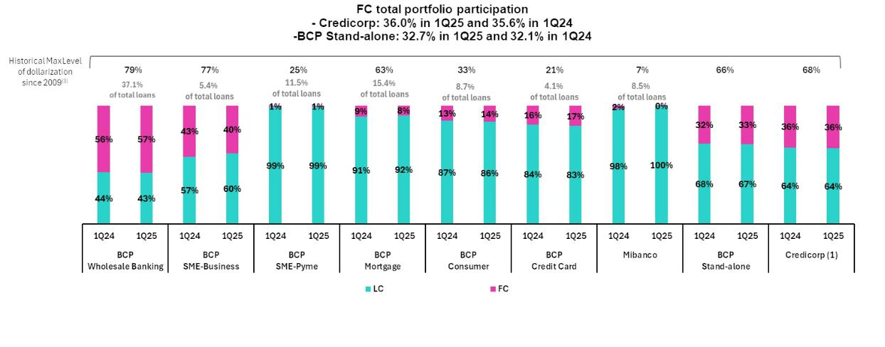

- The FC share of Credicorp’s loan portfolio is calculated including BCP Bolivia and ASB Bank Corp., however the chart shows only the loan books of BCP Stand-alone and Mibanco.

- The year with the historical maximum level of dollarization for Wholesale Banking was 2012, for Mibanco was 2016, for Credit Card was in 2021 and for the rest of segments was 2009. * For dollarization figures in the quarter-end period, please refer to “12. Annexes – 12.3 Loan Portfolio Quality.

19

| Earnings Release 1Q / 2025 Analysis of 1Q25 Consolidated Results

02 Deposits


Excluding the effect of the accounting adjustment related to the balance sheet of BCP Bolivia, the evolution of Deposists presented the following dynamics.

Total Deposits rose slightly QoQ, driven primarily by a 5.2% increase in Demand Deposits, which was fueled by mainly by growth in institutional activity and, to a lesser extent, by a 1.9% increase in Savings Deposits, which rose due to an uptick in Individuals through fund inflows from payments of employee profit sharing. YoY, the balance of deposits grew due to a rise the low-cost deposit balance (+16.9%), where Savings Deposits rose 16.6% due to our ability to continue capturing funds and Demand Deposits were up 17.1%, driven by the same dynamics as those seen QoQ.

At the end of 1Q25, 71.8% of total deposits were low-cost deposits (Demand + Savings). Credicorp continues to lead the market for low-cost deposits with a market share of 41.3% at the end of March.

Deposits |  | As of |  |  | Change % |  | Currency
S/ 000 | Mar 24 | Dec 24 | Mar 25 | QoQ | YoY | LC | FC
Demand deposits | 47,384,819 | 52,590,952 | 53,992,480 | 2.7% | 13.9% | 50.9% | 49.1%
Saving deposits | 52,238,357 | 59,757,825 | 59,969,559 | 0.4% | 14.8% | 61.6% | 38.4%
Time deposits | 43,775,526 | 45,217,785 | 39,779,546 | -12.0% | -9.1% | 52.4% | 47.6%
Severance indemnity deposits | 3,086,767 | 2,996,020 | 2,921,196 | -2.5% | -5.4% | 75.1% | 24.9%
Interest payable | 1,371,658 | 1,279,484 | 956,301 | -25.3% | -30.3% | 29.4% | 70.6%
Low-cost deposits ⁽¹⁾ | 99,623,176 | 112,348,777 | 113,962,039 | 1.4% | 14.4% | 56.5% | 43.5%
Total Deposits | 147,857,127 | 161,842,066 | 157,619,082 | -2.6% | 6.6% | 55.6% | 44.4%

- Includes Demand Deposits and Saving Deposits

This quarter, our balance figures were impacted by an accounting adjustment (which does not affect cash flow). In March, Credicorp revalued the Balance Sheet of Bolivia using an exchange rate that better reflects the exchange rate of that market, which generated an accounting contraction of 2.0% in Credicorp’s total assets at the accounting level.

When analyzing the evolution of Deposits, we will focus on emphasizing operational trends, without considering the impact of this accounting adjustment.

Total Deposits fell by 2.6% QoQ and grew by 6.6% YoY. For better analysis, we will explain the dynamics excluding this adjustment related to the balance of BCP Bolivia.

QoQ, our balance of Total Deposits posted slight growth of 0.3%, which was driven by:

- 5.2% growth in the balance of Demand Deposits, which was fueled primarily by an uptick in LC volumes at BCP Stand-alone. This expansion was driven mainly by Middle Market Banking, principally via an increase in institutional activity and to a lesser degree through fund migration to Time Deposits following maturity.

- 1.9% growth in Savings Deposits, which was driven mainly by an increase in LC volumes at BCP Stand-alone via clients in Individuals in the private sector, who received profit-sharing payments in March.

The aforementioned was offset by:

- An 8.6% reduction in the Time Deposit balance. This decline was fueled by a drop in FC deposits at BCP Stand-alone after some wholesale deposits reached maturity and were not renewed, in line with strategic decisions to optimize our funding structure.

YoY, our balance for Total Deposits rose 9.7%, driven primarily by:

- A 16.6% increase in the Savings Deposit balance, which was driven by growth in LC deposits at BCP Stand-alone. The primary driver of the uptick was our on-going efforts to capture funds in a high-liquidity context; growth was also driven, albeit to a lesser extent, by the dynamics in play QoQ.

- 17.1% growth in the balance of Demand Deposits, which was fueled by growth in the LC balance at BCP Stand-alone. The increase in LC was mainly attributable to the evolution of the balance for Wholesale Banking, which rose due same dynamics seen QoQ, and secondarily to SMEs, where the balance increased through fund inflows from government loan disbursements.

20

| Earnings Release 1Q / 2025 Analysis of 1Q25 Consolidated Results

02. Deposits

The aforementioned was offset by:

- A 4.9% contraction in the Time Deposit balance, which was mainly fueled by a drop in the FC balance at BCP Stand-alone. This decrease was due to the same dynamics seen QoQ, but was partially offset by growth in the LC balance in Individuals, which rose on the back of fund inflows from profit-sharing payments.

It is important to note that over the year, our Low-cost deposit balance rose 16.9% YoY. Currently, this balance represents 71.8% (+437 bps YoY) of Total Deposits. This growth reflects an improvement management of the deposit mix to strengthen the financial margin in a context marked by low rates.

Dollarization Level of Deposits
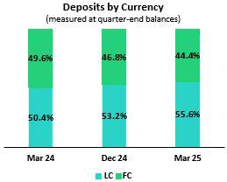

Loan / Deposit Ratio (L/D ratio)
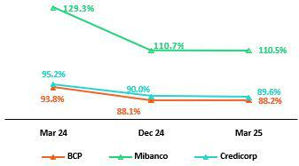

The end of March 2025, the dollarization level of Total Deposits dropped 245 bps QoQ to stand at 44.4%, below the average for the last 2 years (48.2%). This result was driven by growth in Demand Deposits, which was fueled by growth in institutional deposits and in Savings Deposits, the latter associated with employee profit-sharing payments. Time Deposits in FC dropped due to maturities, which also impacted the ratio this quarter.

YoY, the dollarization level dropped 520 bps. This decline was driven mainly by growth in LC fund captures and secondarily by the same dynamics seen QoQ. Time Deposits also drove the drop in FC balances, impacted by the same dynamics mentioned in the QoQ analysis.
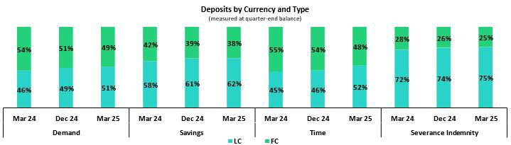

QoQ, the L/D ratio rose 10 bps at BCP Stand-alone, driven by a slight contraction in Total Deposit, which was offset by a drop in quarter- end loans in the wholesale segment. At Mibanco, the ratio fell 20 bps, fueled primarily by growth in Time Deposits. This expansion was offset by an uptick in loans, which rose on the back of improvements in models and in efforts to step-up offerings to new clients.

YoY, the L/D ratio dropped 565 bps and 1873 bps at BCP and Mibanco respectively. At BCP Stand-alone, the decrease was driven by growth in Low-cost Deposits in a context marked by high liquidity. This expansion was partially offset by loan growth in the wholesale and retail sector. At Mibanco, the L/D ratio decreased due to growth in time deposits and a contraction in loans, which were impacted by stricter lending guidelines.

21

| Earnings Release 1Q / 2025 Analysis of 1Q25 Consolidated Results

02. Deposits

In this context, the L/D ratio at Credicorp stood at 89.6%.

L/D Ratio Local Currency
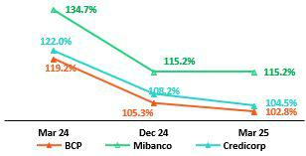

L/D Ratio Foreign Currency
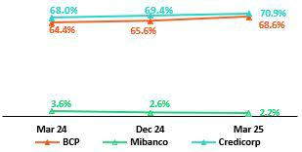

Market Share (MS) of Deposits in the Peruvian Financial System
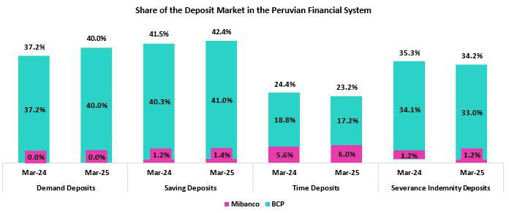

At the end of March 2025, the MS for Total Deposits at BCP Stand-alone and Mibanco in Peru was 31.9% and 2.7% respectively (84 bps and 14 bps vs March 2024 respectively). As such, BCP continues to lead the market for total deposits.

BCP Stand-alone registered YoY growth in low-cost deposits (+15.6%); this level stood above the increase reported by the financial system (+10.5%). BCP continues to lead the market for low-cost deposits with an MS of 40.6% as of March 2025 (177 bps vs March 2024). Time deposits rose across the financial system (+2.4% vs March 2024), but BCP fell 6.8% vs March 24. In this context, BCP Stand-alone’s MS fell (-163 bps vs March 2024) to stand at 17.2% at the end of March 2025.

Credicorp’s share (BCP + Mibanco) of the market for low-cost deposits rose 191 bps versus the figure in March 2024 to stand at 41.3% at the end of March 2025. Over the same period, Credicorp’s market share of time deposits fell 122 bps versus the figure for March 2024 and stood at 23.2% at the end of March 2025.

22

| Earnings Release 1Q / 2025 Analysis of 1Q25 Consolidated Results

03 Interest-Earning Assets (IEA) and Funding


Excluding the effect of the accounting adjustment associated with the balance sheet of BCP Bolivia, the evolution of the IEA and funding presented the following dynamics:

QoQ, IEA dropped 0.1% primarily due to a contraction in Cash and due from banks and secondarily to a decrease in the Loan balance. These dynamics were partially offset by an increase in the investment balance in a context of a gradual acceleration in loan growth. Funding dropped 0.5%, mainly on the back of a bond maturity at BCP.

YoY, IEA rose 6.4% due to growth in Cash and due from banks, which reflects a high-liquidity environment. Balances for Loans and Total Investments also contributed to growth in IEA, albeit to a lesser extent. Funding rose 6.7% due to expansion in deposits, which was concentrated in low-cost deposits, reflecting BCP’s solid transactional offering.

This quarter, our balance sheet figures were impacted by an accounting adjustment (cash flow-neutral). In March, Credicorp revalued BCP Bolivia’s Balance Sheet using an exchange rate that better reflects that market’s current exchange rate, generating a accounting contraction of 2.0% in Credicorp’s total assets.

When analyzing the evolution of the IEA and funding, we will focus on the operating dynamics, excluding the impact of the accounting adjustment.

3.1. IEA

Interest earning assets |  | As of |  | % change
S/000 | Mar 24 | Dec 24 | Mar 25 | QoQ | YoY
Cash and due from banks | 31,134,572 | 40,119,937 | 37,521,839 | -6.5% | 20.5%
Total investments | 52,555,386 | 53,825,858 | 55,604,610 | 3.3% | 5.8%
Cash collateral, reverse repurchase agreements and securities borrowing | 1,526,232 | 1,033,177 | 1,835,893 | 77.7% | 20.3%
Loans | 140,798,083 | 145,732,273 | 141,196,646 | -3.1% | 0.3%
Total interest earning assets | 226,014,273 | 240,711,245 | 236,158,988 | -1.9% | 4.5%

IEA decreased 1.9% QoQ and rose 4.5% YoY. Excluding the effect of the accounting adjustment in BCP Bolivia, IEA presented the following dynamics:

QoQ, IEA remained relatively stable (-0.1% QoQ). This evolution was primarily attributable to a drop in Cash and due from banks and secondarily to a decrease in balances for Loans at quarter-end. Total investments partially offset the downward trend in IEA due to the increase in short and medium-term positions, in a context marked by a gradual acceleration in loan growth.

YoY, IEA rose 6.4%, driven mainly by an increase in the balance of Cash and due from banks, which reflected accumulated liquidity driven by high transaction levels. Secondary drivers of growth in IEA were: i) an increase in the balance for Loans, which was mainly fueled by short-term financing for wholesale clients; and ii) growth in the balance for Investments, which reflected moves to capitalize on surplus liquidity.

3.2. Funding

Funding |  | As of |  | % change
S/000 | Mar 24 | Dec 24 | Mar 25 | QoQ | YoY
Deposits and obligations | 147,857,127 | 161,842,066 | 157,619,082 | -2.6% | 6.6%
Due to banks and correspondents | 10,684,673 | 10,754,385 | 10,899,579 | 1.4% | 2.0%
BCRP instruments | 6,854,368 | 6,646,830 | 7,064,476 | 6.3% | 3.1%
Repurchase agreements with clients and third parties | 2,636,908 | 2,413,880 | 3,094,138 | 28.2% | 17.3%
Bonds and notes issued | 17,541,121 | 17,268,443 | 14,391,733 | -16.7% | -18.0%
Total Funding | 185,574,197 | 198,925,604 | 193,069,008 | -2.9% | 4.0%

Funding decreased 2.9% QoQ and rose 4.0% YoY. Excluding the effect of the accounting adjustment in BCP, funding presented the following dynamics:

23

| Earnings Release 1Q / 2025 Analysis of 1Q25 Consolidated Results

03. Interest-earning Assets (IEA) and Funding

QoQ, funding dropped 0.5% due to a decrease in Bonds and notes issued, associated to a bond maturity for US$ 700 million at BCP Stand-alone, whose effect was partially offset by an increase in Repurchase agreements with third parties to take advantage of favorable market conditions. Growth in Deposits and BCRP Instruments also offset the QoQ decline in funding, albeit to a lesser extent.

YoY, funding rose 6.7%, driven mainly by growth in Deposits and obligations. It is important to note that the expansion reported for deposits was concentrated in low-cost deposits in a scenario in which time deposits declined. These dynamics were partially offset by the effect of the aforementioned bond maturity at BCP Stand-alone.

24

| Earnings Release 1Q / 2025 Analysis of 1Q25 Consolidated Results

04 Net Interest Income (NII)


In 1Q25, Net Interest Income (NII) fell 1.6% QoQ due to a drop in Interest and similar income, which registered a reduction in income on loans due to lower interest rates and an uptick in Wholesale Loans’ share of total loans. Interest and similar expenses partially offset the reduction in income, given lower interest rates and a reduction in the funding volume.

YoY, NII rose 4.3%, driven by a reduction in Interest and similar expenses. This decline was attributable to a drop in interest on deposits, which reflected lower interest rates, and an uptick in low-cost deposits’ share of the funding structure. Interest and similar income had a negative impact on NII, due primarily to a drop in interest on investments in a context of lower rates and secondarily to a decline in interest on loans, given the same factors mentioned in the QoQ analysis.

NIM fell 12 bps QoQ to stand at 6.22%, spurred by a drop the yield on IEAs, which was partially offset by a reduction in the cost of funding. It is important to note that Risk-adjusted NIM continued to trend upward and stood at a record high¹ of 5.24%.

Net interest income |  | Quarter |  | % change
S/000 | 1Q24 | 4Q24 | 1Q25 | QoQ | YoY
Interest and Similar Income | 4,925,926 | 5,012,121 | 4,894,790 | -2.3% | -0.6%
Interest and Similar Expenses | (1,499,803) | (1,382,327) | (1,322,778) | -4.3% | -11.8%
Interest Expense (excluding Net Insurance Financial Expenses) | (1,377,799) | (1,250,239) | (1,187,156) | -5.0% | -13.8%
Net Insurance Financial Expenses | (122,004) | (132,088) | (135,622) | 2.7% | 11.2%
Net Interest, similar income and expenses | 3,426,123 | 3,629,794 | 3,572,012 | -1.6% | 4.3%
Balances
Average Interest Earning Assets (IEA) | 225,297,538 | 237,518,087 | 238,435,117 | 0.4% | 5.8%
Average Funding | 185,160,542 | 195,200,202 | 195,997,306 | 0.4% | 5.9%
Yields
Yield on IEAs | 8.75% | 8.44% | 8.21% | -23 bps | -54 bps
Cost of Funds⁽¹⁾ | 2.98% | 2.56% | 2.42% | -14 bps | -56 bps
Net Interest Margin (NIM)⁽¹⁾ | 6.30% | 6.34% | 6.22% | -12 bps | -8 bps
Risk-Adjusted Net Interest Margin⁽¹⁾ | 4.85% | 5.08% | 5.24% | 16 bps | 39 bps
Peru’s Reference Rate | 6.25% | 5.00% | 4.75% | -25 bps | -150 bps
FED funds rate | 5.50% | 4.50% | 4.50% | 0 bps | -100 bps

- For further details on the NIM and Cost of Funds calculation, please refer to Annex 12.7.

QoQ, Net Interest Income (NII) dropped 1.6% due to a decline in Interest and similar Income. This evolution was fueled primarily by a drop in income from loans, which reflects lower market interest rates, and by an uptick in wholesale loans’ share of total loans. To a lesser extent, income fell due to a negative price effect given that lower interest rates impacted the balances of Cash and due from banks. Interest and similar expenses, which decreased on the back of lower interest rates and a negative volume effect on funding due to a bond maturity at BCP, partially offset the drop in NII.

YoY, NII rose 4.3% due to reduction in Interest and similar expenses. The main driver of this decline was a reduction in Interest on deposits, which fell due to declining interest rates and an uptick in low-cost deposits’ share of total funding. The drop in Interest on securities for bonds and subordinated notes, which was attributable to a bond maturity at BCP (indicated in the QoQ analysis), was a secondary driver of a decline in interest expenses. Interest and similar income decreased on the back of: i) a drop in Interest on securities, given that a portion of the portfolio was renewed at lower rates, particularly BCRP Certificated of deposit (CDs); and ii) to a lesser extent, due to a decrease in Interest on loans, which fell due to reductions in market rates and volume growth that was concentrated in short-term wholesale loans.

- Since the implementation of IFRS 9 in 2018.

25

| Earnings Release 1Q / 2025 Analysis of 1Q25 Consolidated Results

04. Net Interest Income (NII)

Net Interest Margin
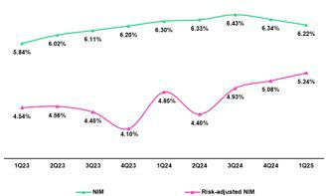

NIM fell 12 bps QoQ to stand at 6.22%. This evolution was primarily attributable to a reduction in the yield on IEAs, which was driven by:
- reference rate cuts at the Fed and BCRP, which led to a downward adjustment in interest rates and ii) a concentration of loan growth in short-term, wholesale loans. The cost of funding fell over the period, driven downward by lower rates. Risk-adjusted NIM continued to trend upward, rising 16 bps to stand at a record-high of 5.24%, driven by a drop in both provisions and cost of risk.

Net Margin by Currency

Interest Income / IEA |  | 1Q24 |  |  | 4Q24 |  |  | 1Q25
S/ millions | Average |  |  | Average |  |  | Average
 | Balance | Income | Yields | Balance | Income | Yields | Balance | Income | Yields
Cash and equivalents | 28,556 | 334 | 4.7% | 38,564 | 386 | 4.0% | 38,821 | 345 | 3.6%
Other IEA | 1,469 | 28 | 7.6% | 1,227 | 18 | 5.9% | 1,434 | 19 | 5.3%
Investments | 52,385 | 694 | 5.3% | 53,578 | 667 | 5.0% | 54,715 | 683 | 5.0%
Loans | 142,887 | 3,869 | 10.8% | 144,150 | 3,940 | 10.9% | 143,464 | 3,848 | 10.7%
Total IEA | 225,297 | 4,925 | 8.7% | 237,519 | 5,011 | 8.4% | 238,434 | 4,895 | 8.2%
IEA (LC) | 58.0% | 69.9% | 10.5% | 54.7% | 68.8% | 10.6% | 55.6% | 70.5% | 10.4%
IEA (FC) | 42.0% | 30.1% | 6.3% | 45.3% | 31.2% | 5.8% | 44.4% | 29.5% | 5.5%
Interest Expense / Funding |  | 1Q24 |  |  | 4Q24 |  |  | 1Q25
S/ millions | Average |  |  | Average |  |  | Average
 | Balance | Expense | Yields | Balance | Expense | Yields | Balance | Expense | Yields
Deposits | 147,782 | 780 | 2.1% | 158,139 | 655 | 1.7% | 159,731 | 620 | 1.6%
BCRP + Due to Banks | 18,640 | 265 | 5.7% | 17,447 | 287 | 6.6% | 17,683 | 266 | 6.0%
Bonds and Notes | 16,068 | 197 | 4.9% | 17,110 | 201 | 4.7% | 15,830 | 168 | 4.2%
Others | 2,672 | 259 | 38.8% | 2,504 | 239 | 38.2% | 2,754 | 269 | 39.1%
Total Funding | 185,162 | 1,501 | 3.2% | 195,200 | 1,382 | 2.8% | 195,998 | 1,323 | 2.7%
Funding (LC) | 49.5% | 51.9% | 3.4% | 49.6% | 49.8% | 2.8% | 51.7% | 53.4% | 2.8%
Funding (FC) | 50.5% | 48.1% | 3.1% | 50.4% | 50.2% | 2.8% | 48.3% | 46.6% | 2.6%
NIM⁽¹⁾ | 225,297 | 3,424 | 6.1% | 237,519 | 3,629 | 6.1% | 238,434 | 3,572 | 6.0%
NIM (LC) | 58.0% | 77.8% | 8.2% | 54.7% | 76.1% | 8.5% | 55.6% | 76.8% | 8.3%
NIM (FC) | 42.0% | 22.2% | 3.2% | 45.3% | 23.9% | 3.2% | 44.4% | 23.2% | 3.1%
(1) Unlike the NIM figure calculated according to the formula in Appendix 12.7, the NIM presented in this table includes “Financial Expense associated with the insurance and reinsurance activity, net”.

QoQ Analysis

QoQ, Net Interest Income (NII) dropped 1.6% due to a comparatively lower contribution of NII in both FC and LC. IEAs in LC represented 55.6% of total IEAs at quarter-end and accounted for 70.5% of Interest Income generated in 1Q25.

Dynamics in National Currency (LC)

NII in LC dropped 0.5% on the back of an increase in interest expenses, which rose primarily through extraordinary interest expenses at BCP and Mibanco, and secondarily via the positive volume effect generated by an uptick in the deposit balance. These dynamics were partially offset by a drop in interest expenses in the BCRP + Banks and Bonds and Issued Notes accounts, which were impacted by lower interest rates.

26

| Earnings Release 1Q / 2025 Analysis of 1Q25 Consolidated Results

04. Net Interest Income (NII)

Interest income remained relatively stable, given that the drop in Interest on loans, after a portion of the portfolio was repriced at lower rates, was offset by an uptick in Interest on investments after positions in BCRP certificate of deposits rose.

Foreign Currency Dynamics (FC)

NII in FC dropped 4.8% QoQ, fueled mainly by a drop in interest income, which was partially offset by a decline in interest expenses. The reduction in income was primarily attributable to a decline in income from loans, which primarily reflected lower market rates, and secondarily a drop in the average balance. FC interest expenses contracted due to the following: i) a reduction in interest on deposits due to a contraction in time deposits, which was in turn generated by a decrease in funding requirements; ii) a negative volume effect in Bonds, originated by a bond maturity at BCP; and iii) a decrease in expenses in BCRP + Banks, due to a downward readjustment in rates on due to banks.

YoY analysis

YoY, NII rose 4.3%, driven by NII in both LC and FC:

Local Currency Dynamics (LC)

NII in LC rose 3.0% YoY due to the following dynamics:

Interest expenses fell due to a reduction in expenses for deposits, reflecting a downward repricing in time deposits, and, to a lesser extent, an increase in low-cost deposits’ share of the funding mix. In this context, the funding cost in LC dropped 62 bps to stand at 2.8%.

Interest income registered slight growth due to an uptick in Interest on loans, which benefitted from a rise in mortgage loan disbursements. This result was partially offset by a drop in interest on investments, given that the growth in volumes was accompanied by comparatively lower interest rates. The yield on IEA in LC dropped 13 bps to 10.4%.

Foreign Currency Dynamics (FC)

NII in FC rose 9.0% YoY due to the following dynamics:

Interest expenses dropped, due mainly to a reduction in expenses for deposits, reflecting the positive impact of lower market rates and, to a lesser extent, growth in low-cost deposits’ share of the funding structure. It is important to note that the funding cost in FC fell 48 bps to stand at 2.6%.

Interest income fell, spurred mainly by a drop in interest on loans given that rate decreases triggered a downward adjustment to the yield on loans in a context marked by an uptick in volumes of short-term wholesale loans. The yield on IEAs in FC fell 80 bps to stand at 5.5%.

27

| Earnings Release 1Q / 2025 Analysis of 1Q25 Consolidated Results

05 Portfolio Quality and Provisions


This quarter, the NPL ratio and Cost of Risk clearly reflect a noteworthy improvement and continue to contract across segments, as a result of the cumulative impact of fortified underwriting and risk management, a relatively strong Peru economy, and some one-time events.

QoQ, the decline in NPLs at BCP Stand-alone was driven mainly by debt repayments in Wholesale and to a lesser extent, by a drop in internal overdue loans in SME-Pyme. At Mibanco, the decrease in NPL volumes was fueled mainly by a reduction in internal overdue loans. In this context, the NPL ratio fell 16 bps and 112 bps QoQ and YoY to stand at 5.1% at quarter-end.

QoQ, the decline in provisions was mainly attributable to BCP Stand-alone, where provisions dropped primarily due to (i) a base effect base via calibrations in our risk models and an improvement in payment performance in Credit Cards and Consumer, and (ii) due to an uptick in reversals in Wholesale Banking. This evolution was partially offset by an increase in provisions at Mibanco, due to a base effect given that write-offs were low last quarter. In this context, the cost of risk fell 44 bps and 66 bps QoQ and YoY respectively to stand at 1.6% at quarter-end.

This quarter, portfolio quality and provisions indicators improved due to the cumulative impact of fortified underwriting and risk management, particularly in the Retail segment, a relatively strong Peru economy, and some one-time events.

One-time events include: (i) Consumer and Credit Cards risk model recalibrations, which increased provisioning levels last quarter; (ii) pension fund withdrawals in the second half last year, which boosted Individuals debt repayment in recent quarters; and (iii) increased customized loan restructuring to clients in hardship, which is a cashflow positive initiative but reduces levels of default at the beginning of the process.

5.1 Portfolio Quality

Quality of Total Loans (in quarter-end balances)

Loan Portfolio quality and Delinquency ratios |  | As of |  |  | % change
S/000 | Mar 24 | Dec 24 | Mar 25 | QoQ | YoY
Total loans (Quarter-end balance) | 140,798,083 | 145,732,273 | 141,196,646 | -3.1% | 0.3%
Write-offs | 950,433 | 896,714 | 716,585 | -20.1% | -24.6%
Internal overdue loans (IOLs) | 6,205,024 | 5,423,212 | 5,206,395 | -4.0% | -16.1%
Internal overdue loans over 90-days | 4,702,733 | 4,383,795 | 4,232,843 | -3.4% | -10.0%
Refinanced loans | 2,557,749 | 2,239,445 | 2,001,282 | -10.6% | -21.8%
Non-performing loans (NPLs) | 8,762,773 | 7,662,657 | 7,207,677 | -5.9% | -17.7%
IOL ratio | 4.4% | 3.7% | 3.7% | -3 bps | -72 bps
IOL over 90-days ratio | 3.3% | 3.0% | 3.0% | -1 bps | -34 bps
NPL ratio | 6.2% | 5.3% | 5.1% | -16 bps | -112 bps

QoQ, the NPL portfolio dropped 5.9%, led by BCP Stand-alone and followed by Mibanco. Write-offs, which continue to be high, fell 20.1%, driven mainly by an increase in the weight of new vintages with lower levels of risk within the Individuals and SME-Pyme portfolios.

QoQ, the decline in the NPL portfolio was fueled primarily by (i) Wholesale Banking, due primarily to debt cancellation of a refinanced client in the commercial real estate sector and (ii) SME-Pyme, on the back of a drop in internal overdue loans in the small-ticket segment in particular (< s/ 90 thousand) and higher-risk loans. At Mibanco, the decline in NPL loans was driven by a decrease in internal overdue loans, which were impacted by stricter origination policies; improvements in debt collections management; and the debt relief facilities rolled out since 2Q24.

YoY, the NPL Ratio dropped 17.7%, led mainly by BCP Stand-alone and followed by Mibanco. The decline in write-offs (-24.6%) was attributable to the same dynamics as those seen QoQ.

28

| Earnings Release 1Q / 2025 Analysis of 1Q25 Consolidated Results

05. Portfolio Quality and Provisions

YoY, at BCP Stand-alone, the decrease in NPLs was driven by the following segments: (i) Wholesale, due primarily to debt cancellations by two clients in the commercial real estate sector (ii) SME-Pyme, due to the same dynamics as those seen QoQ and to an uptick in honoring of loan guarantees under Reactiva; and (iii) Consumer and Credit Cards, driven primarily by growth in debt cancellations on the back of higher liquidity from pension fund withdrawals in previous quarters, and secondarily by improvements in debt collection management and an uptick in debt relief facilities through reprogramming. At Mibanco, the drop in NPLs was fueled by the same dynamics as those in play QoQ.

NPL Ratio for Total Loans

Credicorp’s NPL Ratio dropped 16 bps QoQ to stand at 5.1%. This decline was fueled primarily by the dynamics that drove the decline in NPL volumes in the QoQ analysis; the aforementioned was offset mainly by a drop in total loans.
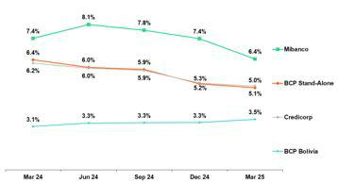

If we analyze the QoQ evolution of the NPL Ratio by subsidiary, we see:

• BCP Stand-alone, where the NPL ratio fell 19 bps. In the case of Wholesale and SME-Pyme, the drop in the ratio was fueled mainly by a decrease in NPL volumes. In the case of Consumer, the reduction in the NPL ratio was driven primarily by growth in total loans and secondarily by a reduction in NPL volumes.

- Mibanco, where the NPL Ratio dropped 99 bps, driven mainly by a decrease in NPL volumes and secondarily by slight growth in total loans.

NPL Ratio for Total Loans at BCP ⁽¹⁾⁽²⁾

Credicorp’s NPL Ratio dropped 112 bps YoY to stand at 5.1%. This decline was spurred primarily by the same dynamics that drove the YoY evolution of NPLs, and secondarily by slight growth in total loans.
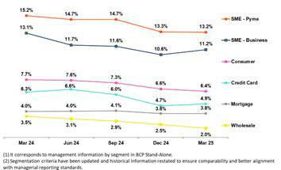

If we analyze the YoY evolution of the NPL Ratio by Subsidiary, we see:

• BCP Stand-alone, where the NPL ratio fell 136 bps. Across segments, with the exception of Mortgage, the decline in the NPL ratio was driven mainly by a decrease in NPL volumes. In the case of Mortgage, the decline in the ratio was attributable primarily to growth in total loans and secondarily to a reduction in NPL volumes.

- Mibanco, where the NPL Ratio fell 101 bps, due to a decrease in NPL Volumes, which was partially offset by a contraction in total loans.

29

| Earnings Release 1Q / 2025 Analysis of 1Q25 Consolidated Results

05. Portfolio Quality and Provisions

5.2 Provisions and Cost of Risk of the Total Portfolio

Loan Portfolio Provisions |  | Quarter |  | % change
S/000 | 1Q24 | 4Q24 | 1Q25 | QoQ | YoY
Gross provision for credit losses on loan portfolio | (910,189) | (857,694) | (695,733) | -18.9% | -23.6%
Recoveries of written-off loans | 95,490 | 114,398 | 113,840 | -0.5% | 19.2%
Provision for credit losses on loan portfolio, net of recoveries | (814,699) | (743,296) | (581,893) | -21.7% | -28.6%
Cost of risk ⁽¹⁾ | 2.3% | 2.1% | 1.6% | -44 bps | -66 bps

(1) Provisions for credit losses on loan portfolio, net of annualized recoveries / Average Total Loans. It includes reversal of provisions for “El Niño” Phenomenon in 1Q24.

QoQ, provisions dropped 21.7%, driven primarily by BCP Stand-alone and partially offset by Mibanco. At BCP Stand-alone, the reduction in provisions was primarily spurred by (i) Credit Cards and Consumer, due primarily to a base effect via calibrations in our risk models and secondarily by improvement in payment performance, on the back of an increase in lower-risk vintages’ share of total loans and debt relief facilities, and (ii) Wholesale, due to an uptick in reversals originated by debt cancellations by refinanced clients. At Mibanco, provisions rose through a base effect given that write-offs were lower last quarter. In this context, the Cost of Risk at Credicorp dropped 44 bps QoQ to stand at 1.6%.

Next, our analysis of the yearly evolution of provisions will isolate the impact of provision reversals for the “El Niño” phenomenon in 1Q24.

Cost of Risk by Subsidiary ⁽¹⁾
YoY, provisions fell 45.5%, driven by BCP Stand-alone and Mibanco, which reported an improvement in payment performance in a context of economic recovery. At BCP Stand-alone, the drop in provisions was primarily attributable to i) Consumer and Credit Cards, due to the same dynamics seen QoQ; and ii) SME-Pyme, due primarily to growth in the share of lower- risk vintages in the loan mix. This evolution was partially offset by an uptick in provisions in Wholesale, which was associated with a base effect given that reversals were higher in 1Q24. At Mibanco, the drop was spurred by an improvement in underlying risk as lower-risk vintages gained traction in the portfolio mix. In this context, the Cost of Risk at Credicorp fell 137 bps YoY to stand at 1.6%.
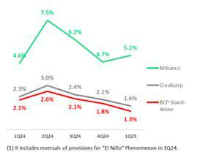

QoQ Cost of Risk Evolution YoY Underlying Cost of Risk Evolution*
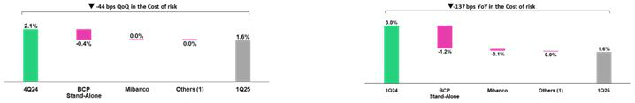

(1) Others include BCP Bolivia, Mibanco Colombia, ASB and eliminations.

  - It excludes reversals of provisions for “El Niño” Phenomenon in 1Q24.

- Others include BCP Bolivia, Mibanco Colombia, ASB and eliminations.

30

| Earnings Release 1Q / 2025 Analysis of 1Q25 Consolidated Results

05. Portfolio Quality and Provisions

Coverage Ratio of NPLs (in Quarter-end balances)

Loan Portfolio Quality and Delinquency Ratios |  | As of |  |  | % change
S/000 | Mar 24 | Dec 24 | Mar 25 | QoQ | YoY
Total loans (Quarter-end balance) | 140,798,083 | 145,732,273 | 141,196,646 | -3.1% | 0.3%
Allowance for loan losses | 8,190,343 | 7,994,977 | 7,742,792 | -3.2% | -5.5%
Non-performing loans (NPLs) | 8,762,773 | 7,662,657 | 7,207,677 | -5.9% | -17.7%
Allowance for loan losses over Total loans | 5.8% | 5.5% | 5.5% | -1 bps | -34 bps
Coverage ratio of NPLs | 93.5% | 104.3% | 107.4% | 308 bps | 1395 bps

Allowance for loan losses

(in S/ millions)

QoQ, Allowances for Loan Losses fell 3.2%, driven primarily by BCP Bolivia and Mibanco.
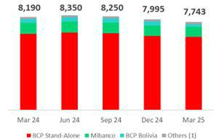

YoY, Allowances for Loan Losses dropped 5.5%, driven primarily by Small Businesses and Consumer at BCP Individual and secondarily by BCP Bolivia.

(1) Others include Mibanco Colombia, ASB and eliminations.

NPL Coverage Ratio

The NPL Coverage Ratio at Credicorp stood at 107.4% at the end of 1Q25. If we exclude NPL volumes from Government Loans (PG), the ratio stands at 110.6%.
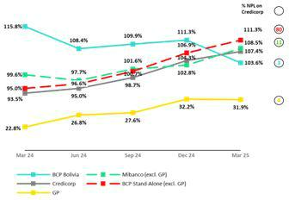

QoQ

the NPL Coverage Ratio at Credicorp rose 308 bps, driven by the evolution at BCP Stand-alone and Mibanco. Next, our analysis of this evolution will isolate the effect of NPL volumes of Government loans, which have broad guarantees and are being honored satisfactorily.

QoQ, the NPL Coverage Ratio at BCP Stand-alone, excluding

Government Loans (GP), increased 431 bps to stand at 111.3%.
This evolution was primarily driven by a decrease in NPL loans in
Wholesale Banking and Consumer. The NPL Coverage Ratio at
Mibanco, excluding Government Loans (GP), rose 562 bps to stand at 108.5%, fueled by a drop in NPLs, which was originated by the same factors seen QoQ.

YoY

The NPL Coverage Ratio at Credicorp increased 1395 bps, driven primarily by the evolution of BCP Stand-alone. Next, our analysis will isolate the effect of NPL volumes from Government Loans (GP).

YoY, the NPL Coverage Ratio at BCP Stand-alone, excluding Government Loans (GP), rose 1625 bps, fueled mainly by a decrease in NPL loans, which was driven by the same dynamics in play QoQ. The NPL Coverage Ratio at Mibanco, excluding Government Loans (GP), rose 888 bps YoY, spurred primarily by a decrease in NPL loans.

31

| Earnings Release 1Q / 2025 Analysis of 1Q25 Consolidated Results

06 Other Income


This quarter, Other Income grew by 6.8% QoQ and 21.4% YoY. This evolution includes an extraordinary gain of approximately S/236 million, resulting from the acquisition of the remaining 50% of Empresas Banmedica in the joint venture with Pacifico Seguros. Excluding this extraordinary gain, Other Income showed the following dynamics:

QoQ, Other Income decreased by 8.1%. Other Core Income dropped 1.5% due to a decrease in Net Gain on FX Transactions. Although Fee Income grew by 2.1%, reflecting solid recurring transactional dynamics, this evolution was offset by lower FX results, due to a loss in the USD position at BCP Bolivia. Other Non-Core Income decreased by 47.9%, due to a base effect from the sale of real estate in BCP Stand-alone, as well as lower derivative income in ASB.

YoY, Other Income increased by 4.5%. Other Core Income rose 15.1%, driven by BCP Stand-alone, which registered an uptick in fee income from Yape and gains on a rise in the volume of FX transactions by Retail clients.

6. Other Income

Other Income ⁽¹⁾ |  | Quarter |  |  | % Change
(S/ 000) | 1Q24 | 4Q24 | 1Q25 | QoQ | YoY
Other Core Income | 1,161,935 | 1,358,568 | 1,337,838 | -1.5% | 15.1%
Other Non-Core Income | 230,624 | 224,164 | 352,378 | 57.2% | 52.8%
Total Other Income | 1,392,559 | 1,582,732 | 1,690,216 | 6.8% | 21.4%
- Beginning in 1Q25, accounting reclassifications have been incorporated affecting Fee Income, Net Gain on Foreign Exchange Transactions, and Net Gain on Derivatives Held for Trading. Prior periods have been restated for comparability and may differ from previously reported figures.

In March 2025, Credicorp completed the acquisition of the remaining 50% of Empresas Banmedica in the joint venture with Pacifico Compañia de Seguros y Reaseguros S.A. (“Pacifico Seguros”), established in December 2014. As a result of this acquisition, the initial 50% stake was revalued in our books, generating an extraordinary gain of approximately S/236 million recorded in Other Non-Core Income.

In this context, Other Income increased by 6.8% QoQ and 21.4% YoY. Excluding the effect of the extraordinary gain, Other Income decreased by 8.1% QoQ and grew by 4.5% YoY.

6.1. Other Core Income

Other Core Income ⁽¹⁾ |  | Quarter |  |  | % Change
(S/ 000) | 1Q24 | 4Q24 | 1Q25 | QoQ | YoY
Fee Income | 856,565 | 973,338 | 994,024 | 2.1% | 16.0%
Net Gain on Foreign Exchange Transactions | 305,370 | 385,230 | 343,814 | -10.8% | 12.6%
Total Other Core Income | 1,161,935 | 1,358,568 | 1,337,838 | -1.5% | 15.1%
- Beginning in 1Q25, accounting reclassifications have been incorporated affecting Fee Income, Net Gain on Foreign Exchange Transactions, and Net Gain on Derivatives Held for Trading. Prior periods have been restated for comparability and may differ from previously reported figures.

Income diversification and digital capabilities drove growth in the primary recurring contributors to Other Income, as indicated below:

- QoQ, Other Core Income recorded solid results, maintaining levels above S/1.3 billion for the third consecutive quarter. The recurring business generated through Fee Income grew by 2.1% QoQ, underpinned by the solid business dynamics described in the next section. However, this evolution was offset by a decline in Net Gain on Foreign Exchange Transactions (-10.8%), which reflects a strategic decision to increase our balance position in USD at BCP Bolivia, which generated losses. As a result, Other Core Income fell 1.5% QoQ.

- YoY, the growth of 15.1% was mainly driven by an increase in Fee Income, whose dynamics will be described in the next section. To a lesser extent, the growth is due to the Net Gain on Foreign Exchange Transactions (+12.6%) at BCP Stand-alone, due to higher transaction volumes in Retail Banking amid exchange rate volatility.

32

| Earnings Release 1Q / 2025 Analysis of 1Q25 Consolidated Results

06. Other Income
Fee Income by Subsidiary

Fee Income by Subsidiary |  | Quarter |  |  | % Change
(S/000) | 1Q24 | 4Q24 | 1Q25 | QoQ | YoY
BCP Stand-Alone ⁽¹⁾ | 704,628 | 809,060 | 831,427 | 2.8% | 18.0%
BCP Bolivia ⁽²⁾ | 14,868 | 14,197 | 12,844 | -9.5% | -13.6%
Mibanco | 24,173 | 24,108 | 28,339 | 17.6% | 17.2%
Mibanco Colombia | 11,250 | 11,356 | 9,126 | -19.6% | -18.9%
Pacífico | -3,199 | -3,115 | -3,757 | 20.6% | 17.4%
Prima | 94,528 | 88,102 | 94,072 | 6.8% | -0.5%
ASB | 17,062 | 15,170 | 13,826 | -8.9% | -19.0%
Credicorp Capital | 128,148 | 131,199 | 136,264 | 3.9% | 6.3%
Eliminations and Other ⁽³⁾ | -134,893 | -116,738 | -128,117 | 9.7% | -5.0%
Total Net Fee Income | 856,565 | 973,339 | 994,024 | 2.1% | 16.0%
- Beginning in 1Q25, accounting reclassifications related to credit card loyalty program expenses and Yape’s transactional fee expenses have been incorporated. These reclassifications affected Administrative and General Expenses as well as Fee Income. Prior periods have been restated for comparability and may differ from previously reported figures.
- Beginning in 1Q25, reclassifications related to FX operations at BCP Bolivia have been incorporated. These reclassifications affected Fee Income and Net Gain on Derivatives Held for Trading, which are now consolidated into Net Gain on Foreign Exchange Transactions. Prior periods have been restated for comparability and may differ from previously reported figures.
- Correspond mainly to the eliminations of bancassurance between Pacifico, BCP, and Mibanco.

QoQ, the 2.1% increase was driven mainly by an uptick in fee income at BCP Stand-alone (dynamics to be described in the next section). YoY, growth of 16.0% was fueled primarily by BCP Stand-alone (details in the next section). Fee Income at BCP Stand-alone

Composition of Fee Income at BCP Stand-alone ^{(*)}

BCP Stand-alone Fees |  | Quarter |  |  | % Change
(S/ 000,000) | 1Q24 | 4Q24 | 1Q25 | QoQ | YoY
Payments and transactional services ⁽¹⁾ | 272 | 281 | 278 | -1.3% | 2.1%
Yape ⁽²⁾ | 54 | 114 | 120 | 5.6% | 123.1%
Liability and Transactional Accounts ⁽³⁾ | 179 | 192 | 200 | 4.1% | 11.6%
Loan Disbursement ⁽⁴⁾ | 90 | 98 | 98 | -0.1% | 9.0%
Off-balance sheet | 57 | 55 | 56 | 2.1% | -1.9%
Insurances | 34 | 35 | 48 | 37.3% | 43.0%
Wealth Management and Corporate Finance | 9 | 19 | 15 | -22.9% | 57.6%
Others ⁽⁵⁾ | 9 | 14 | 16 | 16.0% | 73.5%
Total | 705 | 809 | 831 | 2.8% | 18.0%

(*) Management figures.

- Includes fees from credit and debit card activity, payments, and collections. Beginning in 1Q25, accounting reclassifications related to expenses associated with the credit card loyalty program have been incorporated. These reclassifications affected Administrative and General Expenses and Fee Income. Figures for prior periods have been restated for comparability and may differ from those previously reported.
- Beginning in 1Q25, accounting reclassifications associated with Yape’s transactional fee expenses have been incorporated. These reclassifications affected Administrative and General Expenses and Fee Income. Figures for prior periods have been restated for comparability and may differ from those previously reported.
- Corresponds to fees from Account maintenance, interbank transfers, national transfers, and international transfers.
- Corresponds to fees from retail and wholesale loan disbursements.
- Use of third-party networks, other services to third parties, and Commissions in foreign branches.

QoQ, Fee Income at BCP Stand-alone rose 2.8% on the back of a growth in fee volume from:

- Yape, mainly through Service Payments, POS (QR) Payments and Checkout.

- Liability and transactional accounts, after income increased through (i) Wires and Transfers, which rose primarily due to a base effect that included expenses for clearing services with the Cámara de Compensación Electrónica, and (ii) Current Accounts, which experienced growth in the client base after new accounts were opened to receive funds from AFP releases.

- Insurance, due to an extraordinary income between related parties in the credit life insurance, and to a lesser extent, higher fees in the optional insurance brokerage service. Excluding this extraordinary income, the evolution of Insurance would remain stable

The aforementioned was partially offset by a drop in Payments and Transactional Services, which was associated with a seasonal effect where a normalization in consumption with debit and credit cards was recorded.

33

| Earnings Release 1Q / 2025 Analysis of 1Q25 Consolidated Results

06. Other Income

YoY, Fee Income rose 18.0%, driven mainly by an increase in fees from:

- Yape, which represented 52% of the growth in total fees and rose on the back of the same factors seen QoQ and via Yape Businesses and Top-Ups.
- Liability and transactional accounts, which represented 16% of growth in total fees, where growth was fueled by (i) Wires and Transfers (+10.4%), which reflected an increase in the volume of inter-bank transfers, foreign transfers and remittances, and (ii) Current Accounts (+17.3%), driven by the same factors seen in the QoQ analysis.

- Insurance, which represents 11% of growth in total fees, rose on the back of the same drivers seen QoQ. Excluding this extraordinary income, the evolution of Insurance would remain stable.

This growth was supported by an increase in Payments and Transactional Services (+2.1%). Although merchant fees related to credit and debit cards have been growing at a mid-teens compound annual growth rate (CAGR), this impact has been overshadowed by a new allocation of paid commissions and a base effect stemming from the recognition of extraordinary income last year.

6.2 Other Non-Core Income

Other Non-Core Income ⁽¹⁾ |  | Quarter |  |  | % Change
S/000 | 1Q24 | 4Q24 | 1Q25 | QoQ | YoY
Net Gain on Securities | 61,745 | -47,377 | -28,149 | -40.6% | -145.6%
Net Gain from Associates ⁽²⁾ | 32,295 | 38,560 | 24,068 | -37.6% | -25.5%
Net Gain of Derivatives Held for Trading ⁽³⁾ | 39,984 | 77,962 | 18,499 | -76.3% | -53.7%
Net Gain from Exchange Differences | -5,621 | -21,365 | 15,959 | -174.7% | -383.9%
Other Non-operative Income | 102,221 | 176,384 | 322,001 | 82.6% | 215.0%
Total Other Non-Core Income | 230,624 | 224,164 | 352,378 | 57.2% | 52.8%
- Since March 2025, revenues from the EPS and Medical Services businesses are no longer reported under Net Gain from Associates. Instead, they are fully consolidated into the Underwriting Insurance Result and the newly created Medical Services Result, respectively.
- Includes gains on other investments, which are mainly attributable to the Banmedica result.
- Beginning in 1Q25, accounting reclassifications related to FX operations at BCP Bolivia have been incorporated. These reclassifications affected Fee Income and Net Gain on Derivatives Held for Trading, which are now consolidated into Net Gain on Foreign Exchange Transactions. Figures for prior periods have been restated for comparability and may differ from those previously reported.

Other Non-Core Income | Other Non-Core Income
QoQ evolution | YoY evolution
(millions of soles) | (millions of soles)
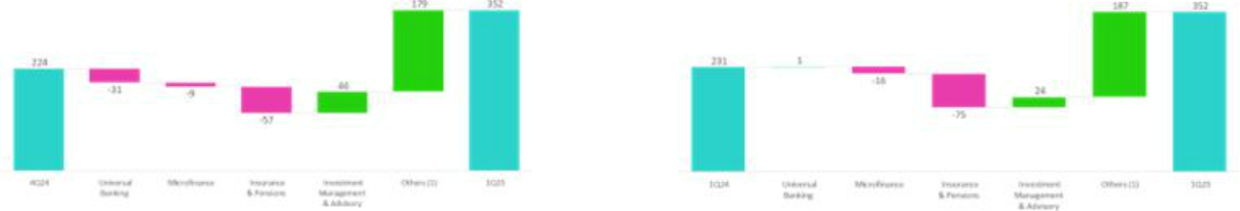

(1)Others: include Grupo Credito, Credicorp Stand-alone, eliminations and others.

Due to the extraordinary gain of approximately S/236 million, resulting from the acquisition of the remaining 50% of Empresas Banmedica in the joint venture with Pacifico Seguros, Other Non-Core Income increased by 57.2% QoQ and 52.8% YoY. Excluding this extraordinary gain, Other Non-Core Income showed the following dynamics:

QoQ, Other Non-Core Income decreased -47.9%, driven mainly by:

- Other Non-Operative Income: at BCP Stand-alone due to a base effect from the sale of real estate.

- Net Gain on Derivatives Held for Trading: at ASB, due to local currency exposures.

34

| Earnings Release 1Q / 2025 Analysis of 1Q25 Consolidated Results

06. Other Income
To a greater extent, this decline was partially mitigated by an increase in Net Gain From Exchange Difference in ASB, due to realized gains in treasury from hedging exposures in local currencies. To a lesser extent, the decrease was offset by a higher Net Gain on Securities in BCP Stand-alone, due to the revaluation of sovereign bonds in the trading portfolio. The latter was partially attenuated by a decline in Others, related to the devaluation of an investment fund.

YoY, Other Non-Core Income dropped -49.3% due to:

- Net Gain (Loss) on securities: through (i) Pacifico, attributable to the deterioration of an investment, and (ii) Others, due to the same factors in play QoQ. These results were partially attenuated by BCP Stand-alone, which registered a base effect given that in 1Q24, the bank reported devaluation in its trading portfolio.

- Net Gain (Loss) on Derivatives Held for Trading: at ASB, driven by the same factors seen QoQ.

This decline was partially offset by higher Net Gain From Exchange Difference in ASB, in line with the QoQ dynamics.

35

| Earnings Release 1Q / 2025 Analysis of 1Q25 Consolidated Results

07 Insurance Underwriting Result and the Medical Services


QoQ, the Underwriting Result for Insurance rose 5.3%, due primarily to (i) a drop in Insurance Service Expenses in Life and P

- C businesses, which was driven by D & S and Personal lines via a reduction in claims, and (ii) an improvement in the Reinsurance Result in P &C. This was partially attenuated by a reduction in Insurance Service Income, primarily through Life and led by AFP. YoY, the Insurance Underwriting Result increased 17.9%, due to (i) an improvement in the Reinsurance Result, primarily in P & C, and (ii) growth in Insurance Service Income, mainly through EPS and P & C. This was partially attenuated by an increase in Insurance Service Expenses in EPS and P & C.

In March 2025, Credicorp completed its acquisition of the remaining 50% stake of Empresas Banmédica in the joint venture with Pacifico Compañía de Seguros y Reaseguros S.A. (“Pacifico Seguros”), which went into effect in December 2014. This transaction gave Credicorp, through its subsidiaries Pacifico Seguros and Grupo Crédito S.A., full ownership of Pacifico S.A. Entidad Prestadora de Salud (“Pacifico EPS”), which manages corporate health insurance for employees and medical services in Peru as well as private medical insurance. This acquisition strengthens Credicorp’s capacity to create a more sustainable and inclusive economy by improving access to health insurance as well as services and advances the Group’s financial including efforts in Peru.

Due to this acquisition, as of March 2025, the EPS business will be consolidated primarily in Credicorp’s Underwriting Insurance Result while the Medical Services Result will be registered in a new account denominated “Medical Services Results.” It is worth mentioning that there is no analysis of the Medical Services business this quarter as the impact on P&L is not material and there is no comparative basis.

Insurance Underwriting Results |  |  | Quarter |  | % change
S/millions |  | 1Q24 | 4Q24 | 1Q25 | QoQ | YoY
 | Insurance Service Income | 937.9 | 982.5 | 978.0 | -0.5% | 4.3%
Total | Insurance Service Expenses | (476.2) | (570.0) | (557.9) | -2.1% | 17.2%
Total | Reinsurance Results | (182.6) | (99.9) | (90.9) | -9.0% | -50.2%
 | Insurance Undewrwriting Result | 279.1 | 312.7 | 329.1 | 5.3% | 17.9%
 | Insurance Service Income | 468.4 | 492.0 | 490.0 | -0.4% | 4.6%
P&C | Insurance Service Expenses | (237.9) | (331.5) | (325.3) | -1.9% | 36.7%
P&C | Reinsurance Results | (150.0) | (78.4) | (72.4) | -7.6% | -51.7%
 | Insurance Undewrwriting Result | 80.5 | 82.1 | 92.3 | 12.5% | 14.8%
 | Insurance Service Income | 438.1 | 471.5 | 332.9 | -29.4% | -24.0%
Life | Insurance Service Expenses | (232.0) | (238.1) | (112.3) | -52.8% | -51.6%
Life | Reinsurance Results | (27.0) | (15.6) | (13.3) | -14.6% | -50.7%
 | Insurance Undewrwriting Result | 179.2 | 217.7 | 207.2 | -4.8% | 15.7%
 | Insurance Service Income | 31.7 | 25.3 | 22.9 | -9.6% | -27.9%
Crediseguros | Insurance Service Expenses | (11.5) | (5.6) | (5.8) | 3.8% | -49.5%
Crediseguros | Reinsurance Results | (5.8) | (12.3) | (8.3) | -32.5% | 44.0%
 | Insurance Undewrwriting Result | 14.4 | 7.3 | 8.7 | 18.4% | -39.4%
 | Insurance Service Income | 0.0 | 0.0 | 137.0 | n.a | n.a
EPS | Insurance Service Expenses | 0.0 | 0.0 | (122.9) | n.a | n.a
EPS | Reinsurance Results | 0.0 | 0.0 | (0.4) | n.a | n.a
 | Insurance Undewrwriting Result | 0.0 | 0.0 | 13.7 | n.a | n.a

QoQ, the Insurance Underwriting Result rose 5.3% on the back of a reduction in Insurance Service Expenses (-2.1%) and an improvement in the Reinsurance Result (-9.0%); both the aforementioned were partially offset by a drop in Insurance Service Income (-0.5%).

YoY, the Insurance Underwriting Result rose 17.9% due to a significant improvement in the Reinsurance result (-50.2%) and to an uptick in Insurance Service Income (+4.3%); the aforementioned were partially attenuated by growth in Insurance Service Expenses (+17.2%)

36

| Earnings Release 1Q / 2025 Analysis of 1Q25 Consolidated Results

07. Insurance Underwriting Results and the Medical Services

P & C Insurance

Insurance Service Income Insurance Service Expense
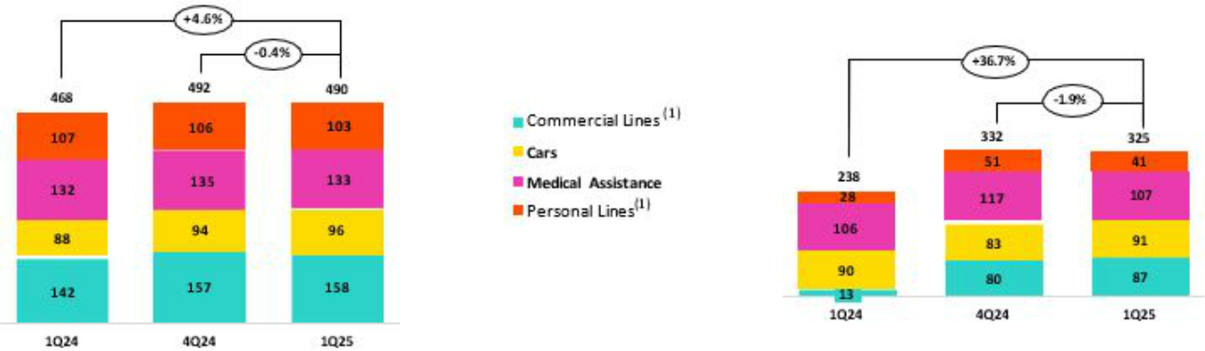

- As of 1Q25, the business previously known as “P & C” has been reclassified into two separate categories: Personal Lines and Commercial Lines to better reflect the nature of insured risks. Historical figures have been adjusted for comparability purposes.

QoQ, the Insurance Underwriting Result rose 12.5% on the back of the following dynamics:

- Insurance Service Income dropped slightly by 0.4%, driven by the evolution of Personal Lines and Medical Assistance, both of which were impacted by an increase in Reserves for Current Risks due to an uptick in premium turnover.

- Insurance Service Expenses dropped 1.9%, due to Personal Lines and Medical Assistance, which registered a drop in claims. The aforementioned was partially attenuated by (i) Cars, due to an increase in onerous contracts and (ii) Commercial Trees, which reported an uptick in claims for its Fire and Third-Party Liability products.

- The Reinsurance Result improved, mainly due to a drop in ceded claims in the Personal Lines and Medical Assistance.

YoY, the Insurance Underwriting Result increased 14.8%. The following dynamics drove this evolution:

- Insurance Service Income increased 4.6%, fueled mainly by (i) Commercial Lines, which reported growth in allotted premiums for new sales and growth in renewals and (ii) Cars, which reflected growth in sales through Yape.

- Insurance Service Income rose 36.7% due primarily to Commercial and Service Lines, which reported an uptick in claims through its Fire, Third-Party Liability and Technical Lines.

- The Reinsurance Result improved, primarily through (i) Commercial Lines, which reported an uptick in claims recovered from the reinsurer, in line with growth in claims as described above, and (ii) Personal Line, which reflected a drop in ceded premiums.

Life Insurance

Insurance Service Income Insurance Service Expense
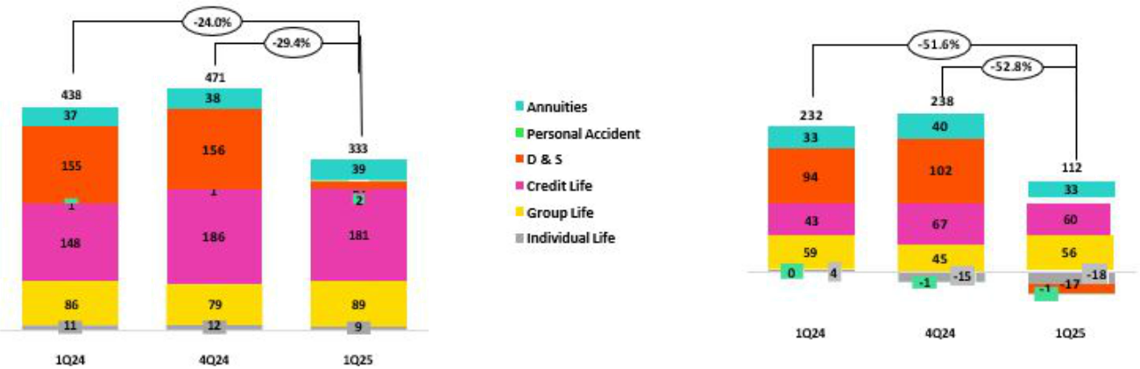

37

| Earnings Release 1Q / 2025 Analysis of 1Q25 Consolidated Results

07. Insurance Underwriting Results and the Medical Services

QoQ, the Insurance Underwriting Result dropped 4.8%. The following dynamics drove this evolution:

- Insurance Service Income dropped 29.4%, driven primarily by (i) D & S, given that Pacifico was not awarded a tranche of SISCO VIII for 2025 (having won a tranche under SISCO VII last year), and (ii) Credit Life, due to a decrease in premium turnover in the Bancassurance channel.

- Insurance Service Expenses fell 52.8%, fueled mainly by (i) D & S, which reported a drop in expenses for claims, which reflects the fact that Pacifico was not awarded a tranche of the SISCO VIII contract (having won a tranche under SISCO VII last year), and (ii) Credit Life, which reported a decrease in attributable expenses.

- The Reinsurance Result improved, mainly via Individual Life, which reported growth in claims recovered from reinsurers.

YoY, the Insurance Underwriting Result rose 15.7% due to the following dynamics:

- Insurance Service Income dropped 24.0%, primarily driven by D & S given that Pacifico was not awarded a tranche of SISCO VIII for 2025 (having won a tranche under SISCO VII last year); this dynamic was attenuated by Credit Life, which reported an uptick in premiums allotted to the period, distributed through Bancassurance and Alliances.

- Insurance Service Expenses dropped 51.6%, mainly fueled by (i) D & S, which reflects the impact of having received no tranche award under SISCO VIII, and (ii) Individual Life, which reported a drop in expenses for claims. The aforementioned dynamics were partially offset by Credit Life, which reported growth in underwriting expenses in Alliances and an uptick in claims.

- The Reinsurance Result improved, primarily via D & S, which registered a decrease in ceded premiums.

38

| Earnings Release 1Q / 2025 Analysis of 1Q25 Consolidated Results

08 Operating Expenses

Operating expenses rose 15.6% YoY, driven mainly by core businesses at BCP Stand-alone and innovation portfolio initiatives at the Credicorp level. Core business expenses at BCP Stand-alone rose due to: (i) higher expenses for employee salaries and benefits, which rose on the back of higher provisions for variable compensation and an uptick in headcount; and (ii) an increase in administrative expenses, which rose primarily due to an uptick in spending for Advertising and secondarily due to an increase in cloud use, which reflects growth in transactions among an increasingly digital client base. Expenses for innovation portfolio initiatives at Credicorp rose 17.5%.


Total operating expenses

Operating expenses |  | Quarter |  |  | % change
S/ 000 | 1Q24 | 4Q24 | 1Q25 | QoQ | YoY
Salaries and employees benefits | 1,107,069 | 1,271,578 | 1,361,690 | 7.1% | 23.0%
Administrative and general expenses | 821,748 | 1,150,867 | 869,834 | -24.4% | 5.9%
Depreciation and amortization | 175,146 | 186,625 | 203,766 | 9.2% | 16.3%
Association in participation | 8,847 | 3,808 | 6,799 | 78.5% | -23.1%
Operating expenses | 2,112,810 | 2,612,878 | 2,442,089 | -6.5% | 15.6%

Operating expenses rose 15.6% YoY due to:

- An increase in Employee Salaries and Benefits, which was driven primarily by (i) BCP Stand-alone, which reported an uptick in provisions for variable compensation, followed by growth in the headcount for new projects, and (ii) Mibanco y Pacifico, due to growth in salaries.

- The increase reported in Administrative Expenses was attributable to BCP Stand-alone, which registered (i) higher expenses for Advertising, and (ii) growth in transactions through digital channels, which led expenses for cloud use and other IT-related activities to rise.

On the heels of Credicorp’s acquisition of the 50% stake held by Empresas Banmedica in the joint venture with Pacifico Compañia de Seguros y Reaseguros S.A., the holding began consolidating all expenses relative to this operation in March 2025. Accordingly, all expenses that were previously reported in the Association in Participation are now consolidated on a line-by-line basis for each line account presented in the consolidated financial statement.

Administrative and General Expenses

Administrative and General Expenses |  | Quarter |  | % change
S/ 000 | 1Q24 | 4Q24 | 1Q25 | QoQ | YoY
IT expenses and IT third-party services | 282,905 | 386,150 | 302,029 | -21.8% | 6.8%
Advertising | 57,734 | 163,897 | 85,390 | -47.9% | 47.9%
Taxes and contributions | 92,887 | 105,296 | 83,347 | -20.8% | -10.3%
Audit Services, Consulting and professional fees | 58,992 | 171,101 | 71,072 | -58.5% | 20.5%
Transport and communications | 54,064 | 67,398 | 52,810 | -21.6% | -2.3%
Repair and maintenance | 32,638 | 50,981 | 31,635 | -37.9% | -3.1%
Agents’ Fees | 27,388 | 31,436 | 26,102 | -17.0% | -4.7%
Services by third-party | 28,415 | 6,220 | 21,436 | 244.6% | -24.6%
Leases of low value and short-term | 30,465 | 36,936 | 33,177 | -10.2% | 8.9%
Miscellaneous supplies | 18,653 | 24,864 | 19,383 | -22.0% | 3.9%
Security and protection | 15,903 | 16,614 | 16,946 | 2.0% | 6.6%
Subscriptions and quotes | 17,172 | 14,261 | 18,330 | 28.5% | 6.7%
Electricity and water | 11,736 | 15,053 | 10,275 | -31.7% | -12.4%
Electronic processing | 7,748 | 8,124 | 7,635 | -6.0% | -1.5%
Insurance | 5,172 | 14,312 | 11,719 | -18.1% | 126.6%
Cleaning | 5,744 | 8,415 | 6,558 | -22.1% | 14.2%
Others | 74,132 | 29,809 | 71,990 | 141.5% | -2.9%
Total | 821,748 | 1,150,867 | 869,834 | -24.4% | 5.9%

39

| Earnings Release 1Q / 2025 Analysis of 1Q25 Consolidated Results

08. Operating Expenses

YoY, Administrative and General Expenses rose 5.9%. Growth in operating expenses corresponds primarily to BCP Stand-alone, which reported (i) higher expenses for Advertising, and (ii) an increase in IT expenses and system outsourcing.

Operating expenses at Core Business and innovation portfolio

Operating Expenses ⁽¹⁾ |  | Quarter |  |  | % change
S/ 000 | 1Q24 | 4Q24 | 1Q25 | QoQ | YoY
Operating Expenses Ex | 1,856,886 | 2,257,102 | 2,141,262 | -5.1% | 15.3%
Innovation | 255,924 | 355,776 | 300,827 | -15.4% | 17.5%
Innovation Portfolio ⁽²⁾
Total Operating Expenses | 2,112,810 | 2,612,878 | 2,442,089 | -6.5% | 15.6%
- Management figures.
- Includes innovation portfolio initiatives in subsidiaries and Krealo.

YoY, the 15.6% growth in operating expenses was driven mainly by our core businesses, where the following stand out: (i) BCP Stand- alone, due to higher provisions for variable compensation, and (ii) Pacifico, which reported growth in Employee Salaries and Benefits following the consolidation of Empresas Banmedica as of March 2025. Additionally, operating expenses for our innovation portfolio initiatives grew 17.5%.

The growth in core businesses at BCP Stand-alone was fueled by:

- Expenses for core businesses excluding IT

  - Growth in expenses for Employee Salaries and Benefits due to (i) provisions for variable compensation, which rose alongside an improvement in results, and (ii) an increase in headcount.

  - Expenses for marketing and advertising rose to capture deposits and drive sales of digital products.
- Technology Expenses (IT)
  - More specialized personnel with digital capacities and higher average salaries were hired to execute strategic projects.
  - Higher expenses for the use of services to process data, in line with growth in the transaction volume via digital channels as our client base becomes more digitalized. Total monetary transactions and transactions through digital channels rose 64.8% and 77.2%, respectively.

40

| Earnings Release 1Q / 2025 Analysis of 1Q25 Consolidated Results

09 Operating Efficiency

YoY, the efficiency ratio deteriorated 291 bps given that expansion in operating expenses outstripped growth in operating income. This evolution reflects growth in expenses for disruptive initiatives at the Credicorp level and for core businesses at BCP Stand-alone.

Efficiency ratio ⁽¹⁾ reported by subsidiary

Subsidiary |  | Quarter |  | % change
 | 1Q24 | 4Q24 | 1Q25 | QoQ | YoY
BCP Stand-alone | 35.1% | 43.7% | 37.7% | -600 bps | 260 bps
BCP Bolivia | 58.1% | 63.0% | 69.6% | 670 bps | 1160 bps
Mibanco Peru | 53.3% | 52.2% | 52.9% | 60 bps | -40 bps
Mibanco Colombia | 85.5% | 69.5% | 70.6% | 120 bps | -1490 bps
Pacifico | 27.7% | 29.6% | 31.5% | 190 bps | 380 bps
Prima AFP | 50.4% | 64.2% | 54.4% | -980 bps | 400 bps
Credicorp | 42.8% | 48.4% | 45.7% | -270 bps | 291 bps

- Operating expenses / Operating income (under IFRS 1). Operating expenses = Salaries and employee benefits + Administrative expenses + Depreciation and amortization + Association in participation + Acquisition cost. Operating income = Net interest, similar income, and expenses + Fee income + Net gain on foreign exchange transactions + Net gain from associates +Net gain on derivatives held for trading + Net gain from exchange differences + Insurance Underwriting Results + Results for Medical Services

Our analysis will focus on year-over-year movements to eliminate the effects of seasonality between quarters.

The efficiency ratio deteriorated 291 bps YoY, driven mainly by growth in operating expenses associated with (i) disruptive initiatives at the Credicorp level, and (ii) core businesses at BCP Stand-alone, in line with growth in expenses for employee salaries and benefits and administrative expenses. Growth in expenses was accompanied by expansion in core business income.

Effective 1Q25, changes were made in how the accounting items included in the efficiency ratio are calculated. In Operating Income, expenses associated with credit card loyalty programs were netted in the Fee Income line instead of being included General and administrative expenses, as was the case before 1Q25.

41

| Earnings Release 1Q / 2025 Analysis of 1Q25 Consolidated Results

10 Regulatory Capital


The Regulatory Capital Ratio at Credicorp was 138% higher than the regulatory minimum.

BCP Stand-alone’s IFRS CET1 Ratio slightly declined 24 bps YoY, stand at 11.62%, aligned with our internal appetite of 11%. This evolution was fueled by higher RWAs levels driven by loan growth, which was partially offset by a growth in Retained Earnings, which was offset by the declaration of dividends.

Mibanco’s IFRS CET1 Ratio slightly declined 18 bps YoY, stand at 15.89%, aligned with our internal appetite of 15%. This result was fueled primarily by a decrease in Retained Earnings, which was primarily associated with dividends declared, and partially offset by a drop in RWA levels, which fell due to loan contraction.

10.1 Regulatory Capital at Credicorp

Capital analysis of Financial Group.

At the end of 1Q25, Credicorp’s Regulatory Capital Ratio | Capital Coverage Ratios
stood 138% above the regulatory minimum. This attests to
the Group’s financial solidity and stability. The ratio rose 78
bps QoQ, fueled primarily by an increase in discretionary
reserves in response to dividends declare for 2024. Growth
was partially offset by a drop in Retained Earnings, which
reflected declarations of dividend payments at BCP Stand-
alone and an increase in the balance of Goodwill associated
with the acquisition of the remaining 50% stake in the joint
venture with Empresas Banmedica. YoY, the ratio rose 1065
bps driven by the same dynamics seen QoQ and a higher
balance of Subordinated Debt associated with the issuance
of subsidiaries.
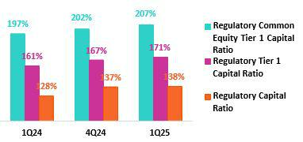

The Regulatory Tier 1 Ratio stood at 171% (+323 bps QoQ, +958 bps YoY), while the CET1 ratio situated at 207% (+470 bps QoQ, +1012 bps YoY), both above the regulatory minimum. Growth in both ratios QoQ was driven by the same dynamics that fueled the QoQ increase in the Regulatory Capital Ratio. YoY, drivers of the increase in all three ratios were the same, with the exception of Subordinated Debt, which had no impact on either the Regulatory Tier 1 or CET1 ratios.

10.2 Analysis of Capital at BCP Stand-alone

BCP Stand-alone’s IFRS CET1 Ratio dropped 170 bps QoQ to close 1Q25 at 11.62%, which is above our internal appetite of 11.%. This decline was associated with a drop in the balance for Retained Earnings, which fell on the back of dividend payments. The drop in RWAs, which was driven by a contraction in Wholesale Loans, partially offset the decline in the aforementioned balance. YoY, The IFRS CET 1 ratio decreased 24 bps, due primarily to an increase in credit RWAs, which as associated with loan growth, and in operating RWAs, which accompanied growth in the Bank’s margin. The ratio fell in year-over-year was a partially offset by an increase in Retained Earnings, which rose on the back of business growth.
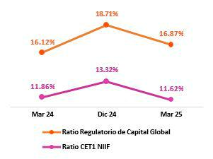

Finally, under the parameters of current regulation, the local CET1 Ratio stood at 11.34%, which compares favorably with the minimum requirement of 7.53% at the end of March 2025, and its variations were driven by the same dynamics that drove the evolution of IFRS CET 1. The Regulatory Global Capital Ratio stood at 16.87% (-184 bps QoQ). This ratio is above the regulatory minimum of 13.89% at the end of March 2025. QoQ, the decline was fueled by the same dynamics as those seen for IFRS CET1; and YoY, the rise of 74 bps was attributable to an increase in the balance for Subordinated Debt, which was driven by an issuance in September, and to growth in Retained Earnings, which was offset by an increase in RWAs.

42

| Earnings Release 1Q / 2025 Analysis of 1Q25 Consolidated Results

10. Capital Regulatorio

10.3 Capital Analysis at Mibanco

At the end of 1Q25, Mibanco’s IFRS CET1 Ratio stood at 15.89% (-164 bps QoQ), which exceeded our internal appetite of 15%. QoQ, this decline was driven by growth in RWAS, which rose alongside loan growth. A drop in Retained Earnings, which fell due to dividend declarations also impacted the IFRS CET1 result. YoY, this ratio dropped 18 bps due to a reduction in Retained Earnings, which was fueled by the same dynamics as those seen QoQ. The decrease in the IFRS CET1 Ratio was partially offset by a reduction in RWA levels due to loan contraction, which reflected the implementation of stricter lending guidelines over the year.
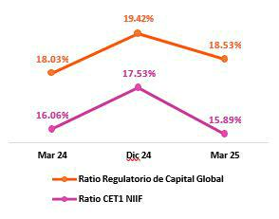

Under the parameters of current regulation, local CET1 stood at 15.48%, which compares favorably with the minimum requirement of 7.75% at the end of March 2025. The variations in this result were driven by the same dynamics as those observed for IFRS CET1. The Regulatory Global Capital Ratio stood at 18.53% (-89 bps QoQ), which is significantly above the regulatory minimum of 14.55% This variation was fueled by the same dynamics that drove the evolution of IFRS CET1. YoY, the ratio rose 50 bps, fueled mainly by a decrease in the RWA balance, which was driven primarily by loan contraction and secondarily by a Subordinated Debt Issuance and growth in the Reserves balance. The aforementioned rise in the IFRS in year-over-year terms was offset by a drop in Retained Earnings due to dividend declaration.

43

| Earnings Release 1Q / 2025 Analysis of 1Q25 Consolidated Results

11 Economic Outlook


In 1Q25, the Peruvian economy grew 3.9% YoY, the third consecutive quarter at a pace around 4%, favored by non-primary sectors, whose growth was driven by the recovery of formal employment and real wages.

The annual inflation rate slowed marginally and closed the quarter at 1.3% YoY (2.0% YoY in the fourth quarter of 2024), approaching the lower limit of the target range of 1-3%. In its May 2025 monetary policy meeting, the BCRP lowered its policy rate 25 basis points to 4.50%, marking its second rate cut of the year after the first rate cut in January 2025.

According to the BCRP, the exchange rate closed at USDPEN 3.67 in the first quarter of 2025, an appreciation of 2.6% compared to the close of the fourth quarter of 2024, making it one of the best-performing currencies among emerging countries.

Peru: Economic Forecast

Peru | 2019 | 2020 | 2021 | 2022 | 2023 | 2024 | 2025 ⁽⁴⁾
GDP (US$ Millions) | 236,517 | 209,723 | 229,791 | 248,403 | 272,221 | 295,160 | 306,026
Real GDP (% change) | 2.2 | -10.9 | 13.4 | 2.8 | -0.4 | 3.3 | 3.2
GDP per capita (US$) | 7,361 | 6,428 | 6,956 | 7,438 | 8,072 | 8,671 | 8,893
Domestic demand (% change) | 2.9 | -9.3 | 13.9 | 2.4 | -1.1 | 4.0 | 3.7
Gross fixed investment (as % GDP) | 22 | 21 | 25 | 25 | 23 | 23 | 23
Financial system loan without Reactiva (% change) | 6.4 | -4.3 | 12.6 | 9.7 | 2.8 | 1.3 | 6.0
(1)
Inflation, end of period⁽²⁾ | 1.9 | 2.0 | 6.4 | 8.5 | 3.2 | 2.0 | 2.3
Reference Rate, end of period | 2.25 | 0.25 | 2.50 | 7.50 | 6.75 | 5.00 | 4.25
Exchange rate, end of period | 3.31 | 3.62 | 3.99 | 3.81 | 3.71 | 3.76 | 3.75
Exchange rate, (% change) ⁽³⁾ | 1.8% | -9.3% | -10.3% | 4.5% | 2.7% | -1.3% | 0.2%
Fiscal balance (% GDP) | -1.6 | -8.7 | -2.5 | -1.7 | -2.7 | -3.5 | -2.7
Public Debt (as % GDP) | 26 | 34 | 35 | 33 | 32 | 32 | 34
Trade balance (US$ Millions) | 6,893 | 8,098 | 15,115 | 10,331 | 17,150 | 24,081 | 27,000
(As % GDP) | 2.9% | 3.9% | 6.6% | 4.2% | 6.3% | 8.2% | 8.8%
Exports | 47,995 | 42,822 | 63,114 | 66,339 | 67,108 | 76,172 | 81,500
Imports | 41,102 | 34,724 | 47,999 | 56,009 | 49,958 | 52,091 | 54,500
Current account balance (As % GDP) | -0.7% | 0.8% | -2.2% | -4.0% | 0.3% | 2.2% | 1.5%
Net international reserves (US$ Millions) | 68,316 | 74,707 | 78,495 | 71,883 | 71,033 | 78,987 | 83,000
(As % GDP) | 28.9% | 35.6% | 34.2% | 28.9% | 26.1% | 26.8% | 27.1%
(As months of imports) | 20 | 26 | 20 | 15 | 17 | 18 | 18

Source: INEI, BCRP y SBS.

- Financial System, Current Exchange Rate
- Inflation Target: 1%-3%
- Negative % change indicates depreciation.
- Grey area indicates estimates by BCP – Economic Research as of January 2025.

44

| Earnings Release 1Q / 2025 Analysis of 1Q25 Consolidated Results

11. Economic Outlook

Main Macroeconomic Variables
Gross Domestic Product | In 1Q25, GDP grew by approximately 3.9% YoY, the third
(Annual Real Variations, % YoY) | consecutive quarter at a pace of around 4%, favored by the
 | transition to the mid-phase of the economic cycle. The sectors that
 | contributed the most to growth during the quarter were services,
 | commerce, non-primary manufacturing, and construction. The
 | growth of non- primary sectors was driven by the continued
 | recovery of formal employment and real wages, amidst inflation
 | comfortably within the target range of the Central Bank (BCRP).
 | It is worth noting the double-digit growth of indicators such as car
 | sales and imports of capital goods and industrial inputs, as well as
 | the improvement in business investment expectations, which in
 | March 2025 reached their highest level in 12 years, according to
 | the BCRP survey. The Ministry of Production authorized the start of
 | the first anchovy fishing season in the North-Central zone of the
 | country with a quota of 3.0 million tons, 20.0% higher than in 2024
 | and the highest level in 7 years.
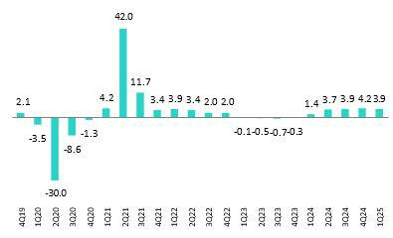

Annual Inflation and Central Bank Reference Rate | Inflation, measured with the Consumer Price Index of Metropolitan
(%) | Lima, slowed from 2.0% at the end of 4Q24 to 1.3% at the end of
 | 1Q25, the lowest print since late 2018 and close to the lower limit of
 | the BCRP’s target range of 1% - 3%. Core inflation, which excludes
 | food and energy, moderated from 2.6% to 1.9% during the same
 | period, reaching its lowest level since mid-2021 and settling,
 | around the midpoint of the target range for the second consecutive
 | month.
 | In its May 2025 monetary policy meeting, the BCRP lowered its
 | policy rate 25 basis points to 4.50%. The last cut was made in
 | January 2025 when the rate was lowered by 25 basis points, and
 | since September 2023, when the rate cut cycle began, it
 | accumulates a reduction of 325 basis points in the reference rate.
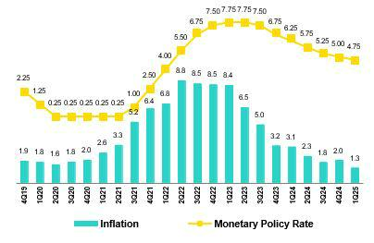

45

| Earnings Release 1Q / 2025

11. Economic Outlook

Fiscal Balance and Current Account Balance

(% of GDP, Quarter)
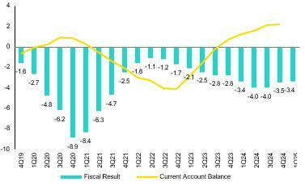

Analysis of 1Q25 Consolidated Results

The annualized fiscal deficit as of March 2025 stood at 3.4% of GDP, around the levels of December 2024 (3.5% of GDP), which was the highest year-end level in 32 years, excluding the pandemic and remains above the fiscal rule limit for 2025 (2.2% of GDP). In 1Q25, tax revenues grew 14.5% YoY, driven by growth in income tax collections, mainly due to the income tax clearance campaign in March, and an increase in general sales tax collected on imports. Meanwhile, non-financial public spending grew 9.9% YoY due to a 14.9% YoY increase in gross capital formation (mainly public investment) and a 7.6% YoY increase in current spending.

In 1Q25, there were no changes from credit rating agencies. The three main rating agencies provide different evaluations of Peru’s sovereign debt. Moody’s assigns a rating of Baa1 (3 notches above investment grade), Fitch assigns BBB (2 notches above investment grade) and S&P assigns BB- (minimal level for investment grade). The three agencies hold a stable outlook for Peru’s credit rating.

Regarding external accounts, the current account surplus closed 4Q24 at 2.2% of GDP (accumulated over the last four quarters), an increase from the 0.7% of GDP surplus at the end of 2023. This is the best result since 2006 and the highest among the group of countries that includes Mexico, Brazil, Chile, and Colombia.

The 12-month accumulated trade balance surplus as of February 2025 stood at US$ 24.7 billion, a historic record and higher than the US$ 23.8 billion recorded in December 2024. Imports grew 6.8% YoY to US$ 53.5 billion, driven by a 9.6% increase in capital goods and a 7.6% increase in consumer goods. Exports grew 14.3% YoY to US$ 78.2 billion thanks to higher volumes of non-traditional products and an increase in prices for traditional products.

In February 2025, the terms of trade grew 14.5% YoY and reached a new historical high, driven by a 15.5% YoY increase in export prices (mainly due to higher copper and gold prices). Specifically, the price of gold reached historical highs during 1Q25 and approached US$ 3,500 per ounce in April 2025. Import prices, on the other hand, rose only 0.9% YoY due to lower input prices such as oil, which fell 7.0% YoY (monthly average).

Exchange Rate

(PEN per USD)
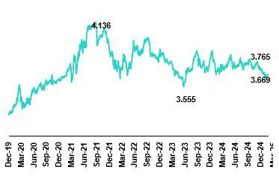

A According to the BCRP, the exchange rate closed 1Q25 at USDPEN 3.67, an appreciation of 2.6% compared to the end of 4Q24 (USDPEN 3.77). The global dollar index depreciated by about 4.0% in 1Q25 compared to the end of 2024 due to uncertainty caused by the policies of Donald Trump’s government in the U.S., particularly trade policy. As a result, Latam currencies appreciated (Brazilian real 7.6%, Chilean peso 5.0%, Colombian peso 4.6%, and Mexican peso 1.7%).

During 1Q25, the BCRP did not intervene in the spot foreign exchange market. In 2024, it accumulated sales of US$ 318 million for the year (2022: US$ 1.2 billion and 2023: US$ 81 million).

Net International Reserves (NIR) closed 1Q25 at US$ 81.0 billion, above the US$ 79.0 billion at the end of 4Q24 and the US$ 73.8

46

| Earnings Release 1Q / 2025 Analysis of 1Q25 Consolidated Results

11. Economic Outlook

billion in 1Q24. Meanwhile, the BCRP’s foreign exchange position closed 1Q25 at US$ 55.1 billion, an increase of US$ 1.5 billion compared to the end of 4Q24 and US$ 3.2 billion compared to 1Q24.

47

| Earnings Release 1Q / 2025 Analysis of 1Q25 Consolidated Results

Safe Harbor for Forward-Looking Statements

This material includes “forward-looking statements” within the meaning of Section 27A of the U.S. Securities Act of 1933 and Section 21E of the U.S. Securities Exchange Act of 1934. All statements other than statements of historical fact are forward-looking and may contain information about financial results, economic conditions, trends and known uncertainties. Forward-looking statements are not assurances of future performance. Instead, they are based only on our management’s current views, beliefs, expectations and assumptions regarding the future of our business, future plans and strategies, projections, anticipated events and trends, the economy and other future conditions.

Many forward-looking statements can be identified by words such as: “anticipate”, “intend”, “plan”, “goal”, “seek”, “believe”, “project”, “estimate”, “expect”, “strategy”, “future”, “likely”, “would”, “may”, “should”, “will”, “see” and similar references to future periods. Examples of forward-looking statements include, among others, statements or estimates we make regarding guidance relating to losses in our credit portfolio, efficiency ratio, provisions and non-performing loans, current or future market risk and future market conditions, expected macroeconomic events and conditions, our belief that we have sufficient capital and liquidity to fund our business operations, expectations of the effect on our financial condition of claims, legal actions, environmental costs, contingent liabilities and governmental and regulatory investigations and proceedings, strategy for customer retention, growth, governmental programs and regulatory initiatives, credit administration, product development, market position, financial results and reserves and strategy for risk management.

We caution readers that forward-looking statements involve known and unknown risks and uncertainties that could cause actual results, performance, or events to differ materially from those that we expect or that are expressed or implied in the forward-looking statements, depending on the outcome of certain factors, including, without limitation, adverse changes in:

- The occurrence of natural disasters or political or social instability in Peru;

- The adequacy of the dividends that our subsidiaries are able to pay to us, which may affect our ability to pay dividends to shareholders and corporate expenses;

- Performance of, and volatility in, financial markets, including Latin-American and other markets;
- The frequency, severity and types of insured loss events;
- Fluctuations in interest rate levels;
- Foreign currency exchange rates, including the Sol/US Dollar exchange rate;
- Deterioration in the quality of our loan portfolio;
- Increasing levels of competition in Peru and other markets in which we operate;
- Developments and changes in laws and regulations affecting the financial sector and adoption of new international guidelines;
- Changes in the policies of central banks and/or foreign governments;
- Effectiveness of our risk management policies and of our operational and security systems;
- Losses associated with counterparty exposures;
- The scope of the coronavirus (“COVID-19”) outbreak, actions taken to contain the COVID-19 and related economic effects from such actions and our ability to maintain adequate staffing; and

- Changes in Bermuda laws and regulations applicable to so-called non-resident entities.

See “Item 3. Key Information—3. D Risk Factors” and “Item 5. Operating and Financial Review and Prospects” in our most recent Annual Report on Form 20-F filed with the U.S. Securities and Exchange Commission for additional information and other such factors. You are cautioned not to place undue reliance on these forward-looking statements, which speak only as of the date hereof and are based only on information currently available to us. Therefore, you should not rely on any of these forward-looking statements.
We undertake no obligation to publicly update or revise these or any other forward-looking statements that may be made to reflect events or circumstances after the date hereof, whether as a result of changes in our business strategy or new information, to reflect the occurrence of unanticipated events or otherwise.

48

 | | Earnings Release 1Q / 2025 | Analysis of 1Q25 Consolidated Results
12 Appendix
12.1. | Physical Point of Contact | 50
12.2. | Loan Portfolio Quality | 50
12.3. | Net Interest Income (NII) | 54
12.4. | Net Interest Margin (NIM) and Risk Adjusted NIM | 54
12.5. | Regulatory Capital | 55
12.6. | Financial Statements and Ratios by Business | 59
12.6.1. Credicorp Consolidated |  | 59
12.6.2. Credicorp Stand-alone |  | 61
12.6.3. BCP Consolidated |  | 62
12.6.4. BCP Stand-alone |  | 64
12.6.5. BCP Bolivia |  | 66
12.6.6. Mibanco |  | 67
12.6.7. Prima AFP |  | 68
12.6.8. Grupo Pacifico |  | 69
12.6.9. Investment Management and Advisory |  | 70
12.7. | Table of Calculations | 71
12.8. | Glossary of terms | 72

49

| Earnings Release 1Q / 2025 Analysis of 1Q25 Consolidated Results

12. Appendix

12.1.Physical Point of contact

Physical Point of Contact ⁽¹⁾ |  | As of |  | change (units)
(Units) | Mar 24 | Dec 24 | Mar 25 | QoQ | YoY
Branches ⁽²⁾ | 655 | 648 | 648 | - | -7
ATMs | 2,737 | 2,787 | 2,768 | (19) | 31
Agents | 11,328 | 12,434 | 11,683 | (751) | 355
Total | 14,720 | 15,869 | 15,099 | (770) | 379

- Includes Physical Point of Contact of BCP Stand-Alone, Mibanco and BCP Bolivia

- Includes Banco de la Nacion branches, which in March 24 were 36, in December 24 were 36 and in March 25 were 36

12.2.Loan Portfolio Quality

In this section, segmentation criteria within BCP Stand-Alone have been updated and historical information restated to ensure comparability and better alignment with managerial reporting standards.

Portfolio Quality Ratios by Segment

Wholesale Banking
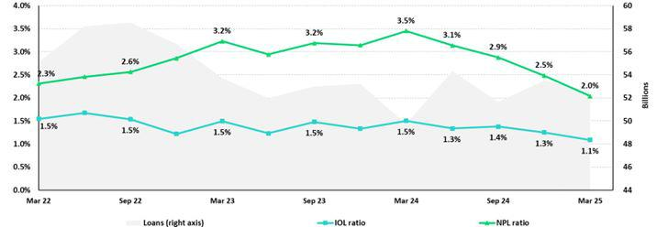

SME-Business
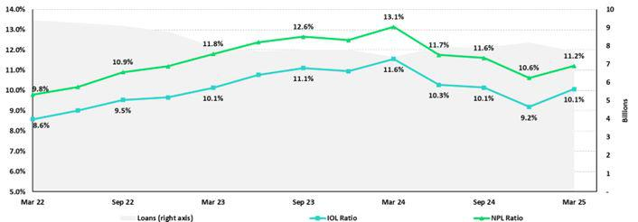

50

| Earnings Release 1Q / 2025 Analysis of 1Q25 Consolidated Results

12. Appendix

SME-Pyme
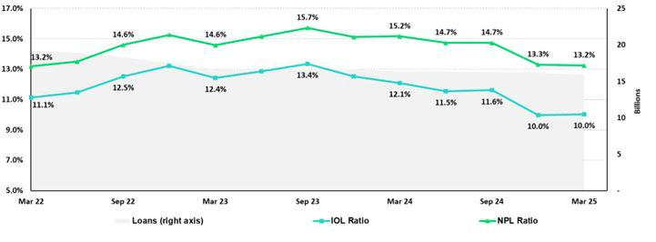

Mortgage
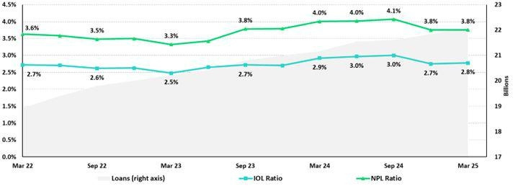

51

| Earnings Release 1Q / 2025 Analysis of 1Q25 Consolidated Results

12. Appendix

Consumer
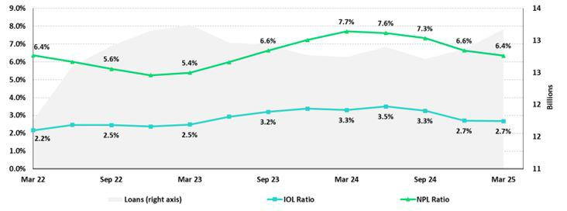

Credit Cards
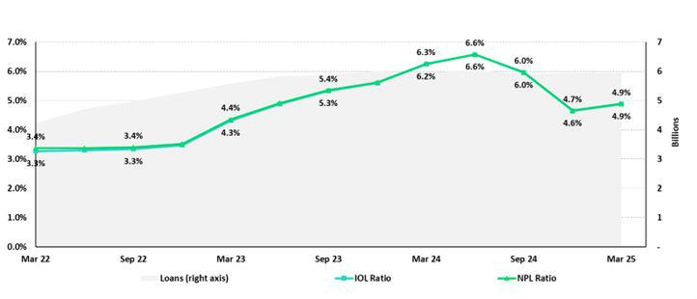

52

| Earnings Release 1Q / 2025 Analysis of 1Q25 Consolidated Results

12. Appendix

Mibanco
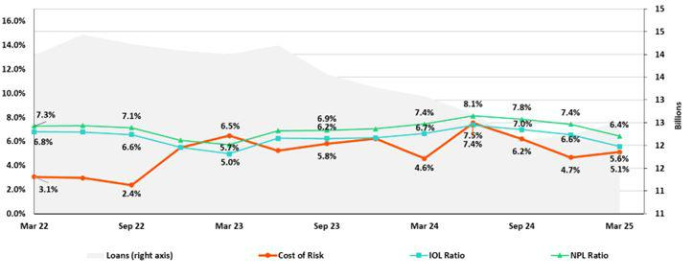

BCP Bolivia
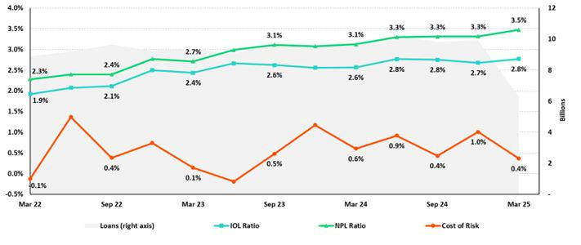

53

| Earnings Release 1Q / 2025 Analysis of 1Q25 Consolidated Results

12. Appendix

12.3.Net Interest Income (NII)

NII Summary

Net interest income |  | Quarter |  | % | change
S/000 | 1Q24 | 4Q24 | 1Q25 | QoQ | YoY
Interest income | 4,925,926 | 5,012,121 | 4,894,790 | -2.3% | -0.6%
Interest on loans | 3,868,792 | 3,940,002 | 3,847,640 | -2.3% | -0.5%
Dividends on investments | 10,861 | 15,285 | 25,109 | 64.3% | 131.2%
Interest on deposits with banks | 334,459 | 386,205 | 344,622 | -10.8% | 3.0%
Interest on securities | 683,075 | 652,155 | 657,872 | 0.9% | -3.7%
Other interest income | 28,739 | 18,474 | 19,547 | 5.8% | -32.0%
Interest expense | 1,499,803 | 1,382,327 | 1,322,778 | -4.3% | -11.8%
Interest expense (excluding Net Insurance Financial Expenses) | 1,377,799 | 1,250,239 | 1,187,156 | -5.0% | -13.8%
Interest on deposits | 779,526 | 655,429 | 619,613 | -5.5% | -20.5%
Interest on borrowed funds | 264,884 | 286,638 | 266,202 | -7.1% | 0.5%
Interest on bonds and subordinated notes | 196,630 | 201,053 | 168,024 | -16.4% | -14.5%
Other interest expense | 136,759 | 107,119 | 133,317 | 24.5% | -2.5%
Net Insurance Financial Expenses | 122,004 | 132,088 | 135,622 | 2.7% | 11.2%
Net interest, similar income and expenses | 3,426,123 | 3,629,794 | 3,572,012 | -1.6% | 4.3%
Provision for credit losses on loan portfolio, net of recoveries | 814,699 | 743,296 | 581,893 | 0.0% | 0.0%
Net interest, similar income and expenses, after provision for credit | 2,611,424 | 2,886,498 | 2,990,119 | 3.6% | 14.5%
losses on loan portfolio
Average interest earning assets | 225,297,538 | 237,518,087 | 238,435,117 | 0.4% | 5.8%
Net interest margin ⁽¹⁾ | 6.30% | 6.34% | 6.22% | -12 bps | -8 bps
Risk-adjusted Net interest margin ⁽¹⁾ | 4.85% | 5.08% | 5.24% | 16 bps | 39 bps
Net provisions for loan losses / Net interest income ⁽¹⁾ | 23.78% | 20.48% | 16.29% | -419 bps | -749 bps

(1) Annualized. For further detail on the NIM calculation due to IFRS17, please refer to Annex 12.7.

12.4.Net Interest Margin (NIM) and Risk-Adjusted NIM by Subsidiary

NIM Breakdown | BCP Stand-alone | Mibanco | BCP Bolivia | Credicorp
1Q24 | 6.03% | 13.42% | 2.96% | 6.30%
4Q24 | 6.01% | 14.16% | 2.96% | 6.34%
1Q25 | 5.80% | 13.94% | 2.85% | 6.22%

NIM: Annualized Net interest income (excluding Net Insurance Financial Expenses) / Average period end and period beginning interest-earning assets.

Risk-Adjusted NIM | BCP | Mibanco | BCP | Credicorp
Breakdown | Stand-alone |  | Bolivia | Credicorp
1Q24 | 4.64% | 9.71% | 2.46% | 4.85%
4Q24 | 4.85% | 10.66% | 2.12% | 5.08%
1Q25 | 4.98% | 10.14% | 2.62% | 5.24%

Risk-Adjusted NIM: (Annualized Net interest income (excluding Net Insurance Financial Expenses) - annualized provisions) / Average period end and period beginning interest-earning assets.

54

| Earnings Release 1Q / 2025 Analysis of 1Q25 Consolidated Results

12.5.Regulatory Capital

Regulatory Capital and Capital Adequacy Ratios

(IFRS)

Regulatory Capital and Capital Adequacy Ratios |  | As of |  |  | Change %
S/000 | Mar 24 | Dec 24 | Mar 25 | QoQ | YoY
Capital Stock | 1,318,993 | 1,318,993 | 1,318,993 | - | 0.0%
Treasury Stocks | (208,343) | (208,879) | (209,845) | 0.5% | 0.7%
Capital Surplus | 201,965 | 176,307 | 124,148 | -29.6% | -38.5%
Legal and Other Capital reserves | 26,213,432 | 27,202,665 | 32,792,830 | 20.6% | 25.1%
Minority interest | 522,309 | 467,916 | 476,695 | 1.9% | -8.7%
Current and Accumulated Earnings ⁽¹⁾ | 2,639,191 | 6,592,462 | 3,410,505 | -48.3% | 29.2%
Unrealized Gains or Losses ⁽²⁾ | (991,283) | (504,016) | (462,800) | -8.2% | -53.3%
Goodwill | (768,869) | (722,361) | (1,698,492) | 135.1% | 120.9%
Intangible Assets ⁽³⁾ | (1,935,419) | (2,396,687) | (2,590,377) | 8.1% | 33.8%
Deductions in Common Equity Tier 1 instruments ⁽⁴⁾ | (699,843) | (673,952) | (38,573) | -94.3% | -94.5%
Subordinated Debt | 5,733,691 | 8,047,314 | 7,892,454 | -1.9% | 37.7%
Loan loss reserves ⁽⁵⁾ | 1,946,564 | 2,033,379 | 1,972,285 | -3.0% | 1.3%
Deductions in Tier 2 instruments ⁽⁶⁾ | (945,603) | (1,322,352) | (751,236) | -43.2% | -20.6%
Total Regulatory Capital (A) | 33,026,785 | 40,010,790 | 42,236,587 | 5.6% | 27.9%
Total Regulatory Common Equity Tier 1 Capital (B) | 26,292,132 | 31,252,448 | 33,123,084 | 6.0% | 26.0%
Total Regulatory Tier 1 Capital (C) | 26,292,132 | 31,252,448 | 33,123,084 | 6.0% | 26.0%
Total Regulatory Capital Requirement (D) | 25,901,090 | 29,124,775 | 30,571,363 | 5.0% | 18.0%
Total Regulatory Common Equity Tier 1 Capital Requirement (E) | 13,351,145 | 15,445,079 | 15,997,614 | 3.6% | 19.8%
Total Regulatory Tier 1 Capital Requirement (F) | 16,336,793 | 18,681,850 | 19,424,645 | 4.0% | 18.9%
Regulatory Capital Ratio (A) / (D) | 128% | 137% | 138% | 78 pp | 1065 bps
Regulatory Common Equity Tier 1 Capital Ratio (B) / (E) | 197% | 202% | 207% | 470 pp | 1012 bps
Regulatory Tier 1 Capital Ratio (C) / (F) | 161% | 167% | 171% | 323 pp | 958 bps

- Earnings include Banco de Crédito del Perú and Mibanco Perú. Losses include all subsidiaries.

- Gains include Investment Grade Government Bonds and Peruvian Central Bank Certificates of Deposits. Losses include all bonds.

- Different to Goodwill. Includes Diferred Tax Assets.

- Investments in Equity.

- Up to 1.25% of total risk-weighted assets of Banco de Crédito del Perú, Solución Empresa Administradora Hipotecaria, Mibanco and Atlantic Security Bank.

- Investments in Tier 2 Subordinated Debt.

55

| Earnings Release 1Q / 2025 Analysis of 1Q25 Consolidated Results

Regulatory and Capital Adequacy Ratios at BCP Stand-alone

Regulatory Capital |  | As of |  | Change %
(S/ thousand) | Mar 24 | Dec 24 | Mar 25 | QoQ | YoY
Capital Stock | 12,973,175 | 12,973,175 | 12,973,175 | 0.0% | 0.0%
Reserves | 6,590,921 | 6,124,302 | 6,124,302 | 0.0% | -7.1%
Accumulated earnings | 2,644,894 | 6,589,252 | 3,418,149 | -48.1% | 29.2%
Loan loss reserves ⁽¹⁾ | 1,662,636 | 1,757,256 | 1,740,158 | -1.0% | 4.7%
Subordinated Debt | 5,019,300 | 7,339,800 | 7,152,600 | -2.6% | 42.5%
Unrealized Profit or Losses | (691,921) | (413,658) | (341,947) | -17.3% | -50.6%
Investment in subsidiaries and others, net of unrealized profit and net income in | (2,416,070) | (2,477,732) | (2,310,402) | -6.8% | -4.4%
subsidiaries | (1,209,735) | (1,515,214) | (1,509,701) | -0.4% | 24.8%
Intangibles
Goodwill | (122,083) | (122,083) | (122,083) | 0.0% | 0.0%
Total Regulatory Capital | 24,451,116 | 30,255,097 | 27,124,251 | -10.3% | 10.9%
Tier 1 Common Equity ⁽²⁾ | 17,769,180 | 21,158,042 | 18,231,493 | -13.8% | 2.6%
Regulatory Tier 1 Capital ⁽³⁾ | 17,769,180 | 21,158,042 | 18,231,493 | -13.8% | 2.6%
Regulatory Tier 2 Capital ⁽⁴⁾ | 6,681,936 | 9,097,056 | 8,892,758 | -2.2% | 33.1%
Total risk-weighted assets |  | As of |  | Change %
(S/ thousand) | Mar 24 | Dec 24 | Mar 25 | QoQ | YoY
Market risk-weighted assets | 3,032,546 | 3,922,295 | 3,903,493 | -0.5% | 28.7%
Credit risk-weighted assets | 131,793,619 | 139,402,972 | 138,028,766 | -1.0% | 4.7%
Operational risk-weighted assets | 16,842,059 | 18,409,113 | 18,895,091 | 2.6% | 12.2%
Total | 151,668,224 | 161,734,381 | 160,827,350 | -0.6% | 6.0%
Capital requirement |  | As of |  | Change %
(S/ thousand) | Mar 24 | Dec 24 | Mar 25 | QoQ | YoY
Market risk capital requirement | 303,255 | 392,230 | 390,349 | -0.5% | 28.7%
Credit risk capital requirement | 11,861,426 | 13,243,282 | 13,802,877 | 4.2% | 16.4%
Operational risk capital requirement | 1,684,206 | 1,840,911 | 1,889,509 | 2.6% | 12.2%
Additional capital requirements | 5,418,896 | 6,882,642 | 7,057,150 | 2.5% | 30.2%
Total | 19,267,782 | 22,359,066 | 23,139,885 | 3.5% | 20.1%
Capital Ratios under Local Regulation
Capital ratios under Local Regulation |  | As of |  | Change %
 | Mar 24 | Dec 24 | Mar 25 | QoQ | YoY
Common Equity Tier 1 ratio | 11.72% | 13.08% | 11.34% | -175 bps | -38 bps
Tier 1 Capital ratio | 11.72% | 13.08% | 11.34% | -175 bps | -38 bps
Regulatory Global Capital ratio | 16.12% | 18.71% | 16.87% | -184 bps | 74 bps

- Up to 1.25% of total risk-weighted assets.

- Common Equity Tier 1 = Capital Stock + Reserves + Accumulated earnings – Unrealized profits or losses - 100% deductions (investment in subsidiaries, goodwill, intangible assets and deferred tax assets based on future returns).
- Regulatory Tier 1 Capital = Common Equity Tier 1 + Tier 1 Subordinated Debt (Perpetual).

- Regulatory Tier 2 Capital = Subordinated Debt + Loan loss reserves.

56

| Earnings Release 1Q / 2025 Analysis of 1Q25 Consolidated Results

Regulatory Capital and Capital Adequacy Ratios at Mibanco

Regulatory Capital |  | As of |  | % Change
(S/ thousand) | Mar 24 | Dec 24 | Mar 25 | QoQ | YoY
Capital Stock | 1,840,606 | 1,840,606 | 1,840,606 | 0.0% | 0.0%
Reserves | 334,650 | 334,650 | 365,847 | 9.3% | 9.3%
Accumulated earnings | 310,119 | 369,573 | 168,090 | -54.5% | -45.8%
Loan loss reserves ⁽¹⁾ | 154,452 | 144,751 | 149,412 | 3.2% | -3.3%
Perpetual subordinated debt | - | - | - | n.a | n.a.
Subordinated debt | 173,000 | 167,000 | 267,000 | 59.9% | 54.3%
Unrealidez Profit or Losses | (4,984) | (3,728) | (4,037) | 8.3% | -19.0%
Investment in subsidiaries and others, net of unrealized profit and net income in | (283) | (298) | (295) | -1.1% | 4.1%
subsidiaries
Intangibles | (150,274) | (136,691) | (119,759) | -12.4% | -20.3%
Goodwill | (139,180) | (139,180) | (139,180) | 0.0% | 0.0%
Total Regulatory Capital | 2,518,105 | 2,576,683 | 2,527,685 | -1.9% | 0.4%
Tier Common Equity ⁽²⁾ | 2,190,653 | 2,264,932 | 2,111,272 | -6.8% | -3.6%
Regulatory Tier 1 Capital ⁽³⁾ | 2,190,653 | 2,264,932 | 2,111,272 | -6.8% | -3.6%
Regulatory Tier 2 Capital ⁽⁴⁾ | 327,452 | 311,751 | 416,412 | 33.6% | 27.2%
Total risk-weighted assets |  | As of |  | % change
(S/ thousand) | Mar 24 | Dec 24 | Mar 25 | QoQ | YoY
Market risk-weighted assets | 252,255 | 241,964 | 225,498 | -6.8% | -10.6%
Credit risk-weighted assets | 12,151,596 | 11,419,696 | 11,793,102 | 3.3% | -3.0%
Operational risk-weighted assets | 1,559,737 | 1,605,950 | 1,623,262 | 1.1% | 4.1%
Total | 13,963,589 | 13,267,611 | 13,641,862 | 2.8% | -2.3%
Capital requirement |  | As of |  | % change
(S/ thousand) | Mar 24 | Dec 24 | Mar 25 | QoQ | YoY
Market risk capital requirement | 25,226 | 24,196 | 22,550 | -6.8% | -10.6%
Credit risk capital requirement | 1,093,644 | 1,084,871 | 1,179,310 | 8.7% | 7.8%
Operational risk capital requirement | 155,974 | 160,595 | 162,326 | 1.1% | 4.1%
Additional capital requirements | 164,047 | 184,428 | 176,897 | -4.1% | 7.8%
Total | 1,438,889 | 1,454,091 | 1,541,083 | 6.0% | 7.1%
Capital Ratios under Local Regulation
Capital ratios under Local Regulation |  | As of |  | % change
 | Mar 24 | Dec 24 | Mar 25 | QoQ | YoY
Common Equity Tier 1 Ratio | 15.69% | 17.07% | 15.48% | -159 bps | -21 pbs
Tier 1 Capital ratio | 15.69% | 17.07% | 15.48% | -159 bps | -21 pbs
Regulatory Global Capital Ratio | 18.03% | 19.42% | 18.53% | -89 bps | 50 pbs

- Up to 1.25% of total risk-weighted assets.

- Common Equity Tier 1 = Capital Stock + Reserves + Accumulated earnings – Unrealized profits or losses - 100% deductions (investment in subsidiaries, goodwill, intangible assets and deferred tax assets based on future returns).
- Regulatory Tier 1 Capital = Common Equity Tier 1 + Tier 1 Subordinated Debt (Perpetual).

- Regulatory Tier 2 Capital = Subordinated Debt + Loan loss reserves.

57

| Earnings Release 1Q / 2025 Analysis of 1Q25 Consolidated Results

Common Equity Tier 1 IFRS

BCP Stand-alone

Common Equity Tier 1 IFRS |  | As of |  | % Change
(S/ thousand) | Mar 24 | Dec 24 | Mar 25 | QoQ | YoY
Capital and reserves | 19,051,853 | 18,585,234 | 18,585,234 | 0.0% | -2.4%
Retained earnings | 3,429,163 | 7,345,245 | 4,176,630 | -43.1% | 21.8%
Unrealized gains (losses) | (161,369) | 81,399 | 140,002 | 72.0% | -186.8%
Goodwill and intangibles | (1,650,626) | (1,741,267) | (1,706,438) | -2.0% | 3.4%
Investments in subsidiaries | (2,570,974) | (2,598,905) | (2,416,979) | -7.0% | -6.0%
Total | 18,098,046 | 21,671,706 | 18,778,449 | -13.4% | 3.8%
Adjusted RWAs IFRS | 152,645,988 | 162,676,386 | 161,628,694 | -0.6% | 5.9%
Adjusted Credit RWAs IFRS | 132,771,383 | 140,344,978 | 138,830,109 | -1.1% | 4.6%
Others | 19,874,605 | 22,331,409 | 22,798,584 | 2.1% | 14.7%
CET1 ratio IFRS | 11.86% | 13.32% | 11.62% | -170 bps | -24 bps
 | Mibanco
Common Equity Tier 1 IFRS |  | As of |  | % Change
(S/ thousand) | Mar 24 | Dec 24 | Mar 25 | QoQ | YoY
Capital and reserves | 2,703,385 | 2,703,385 | 2,734,582 | 1.2% | 1.2%
Retained earnings | (62,632) | (29,980) | (247,483) | 725.5% | 295.1%
Unrealized gains (losses) | (8,967) | (5,037) | (4,257) | -15.5% | -52.5%
Goodwill and intangibles | (352,162) | (310,730) | (292,948) | -5.7% | -16.8%
Investments in subsidiaries | (275) | (302) | (299) | -1.1% | 8.4%
Total | 2,279,349 | 2,357,337 | 2,189,595 | -7.1% | -3.9%
Adjusted RWAs IFRS | 14,188,737 | 13,449,807 | 13,782,186 | 2.5% | -2.9%
Adjusted Credit RWAs IFRS | 12,366,207 | 11,597,881 | 11,933,425 | 2.9% | -3.5%
Others | 1,822,530 | 1,851,926 | 1,848,760 | -0.2% | 1.4%
CET1 ratio IFRS | 16.06% | 17.53% | 15.89% | -164 bps | -18 bps

58

| Earnings Release 1Q / 2025 Analysis of 1Q25 Consolidated Results

12.6.Financial Statements and Ratios by Business

12.6.1.Credicorp Consolidated

Consolidated Statement of Financial Position

(S/ Thousands, IFRS)

 |  | As of |  |  | % change
 | Mar 24 | Dec 24 | Mar 25 | QoQ | YoY
ASSETS
Cash and due from banks
Non-interest bearing | 8,024,262 | 7,535,259 | 7,015,098 | -6.9% | -12.6%
Interest bearing | 31,134,572 | 40,119,937 | 37,521,839 | -6.5% | 20.5%
Total cash and due from banks | 39,158,834 | 47,655,196 | 44,536,937 | -6.5% | 13.7%
Cash collateral, reverse repurchase agreements and securities borrowing | 1,526,232 | 1,033,177 | 1,835,893 | 77.7% | 20.3%
Fair value through profit or loss investments | 4,448,122 | 4,715,343 | 5,149,628 | 9.2% | 15.8%
Fair value through other comprehensive income investments | 38,047,888 | 40,142,638 | 41,705,253 | 3.9% | 9.6%
Amortized cost investments | 10,059,376 | 8,967,877 | 8,749,729 | -2.4% | -13.0%
Loans | 140,798,083 | 145,732,273 | 141,196,646 | -3.1% | 0.3%
Current | 134,593,059 | 140,309,061 | 135,990,251 | -3.1% | 1.0%
Internal overdue loans | 6,205,024 | 5,423,212 | 5,206,395 | -4.0% | -16.1%
Less - allowance for loan losses | (8,190,343) | (7,994,977) | (7,742,792) | -3.2% | -5.5%
Loans, net | 132,607,740 | 137,737,296 | 133,453,854 | -3.1% | 0.6%
Financial assets designated at fair value through profit or loss | 868,239 | 932,734 | 871,626 | -6.6% | 0.4%
Property, plant and equipment, net | 1,815,570 | 1,841,147 | 2,681,862 | 45.7% | 47.7%
Due from customers on acceptances | 322,346 | 528,184 | 639,749 | 21.1% | 98.5%
Investments in associates | 691,908 | 763,918 | 1,002 | -99.9% | -99.9%
Intangible assets and goodwill, net | 3,161,382 | 3,289,157 | 4,420,422 | 34.4% | 39.8%
Reinsurance contract assets | 957,474 | 841,170 | 1,126,512 | 33.9% | 17.7%
Other assets ⁽¹⁾ | 7,506,630 | 7,641,103 | 9,049,787 | 18.4% | 20.6%
Total Assets | 241,171,741 | 256,088,940 | 254,222,254 | -0.7% | 5.4%
LIABILITIES AND EQUITY
Deposits and obligations
Non-interest bearing | 41,706,139 | 47,160,191 | 49,620,679 | 5.2% | 19.0%
Interest bearing | 106,150,988 | 114,681,875 | 107,998,403 | -5.8% | 1.7%
Total deposits and obligations | 147,857,127 | 161,842,066 | 157,619,082 | -2.6% | 6.6%
Payables from repurchase agreements and securities lending | 9,491,276 | 9,060,710 | 10,158,614 | 12.1% | 7.0%
BCRP instruments | 6,854,368 | 6,646,830 | 7,064,476 | 6.3% | 3.1%
Repurchase agreements with third parties | 2,527,339 | 2,298,494 | 2,872,797 | 25.0% | 13.7%
Repurchase agreements with customers | 109,569 | 115,386 | 221,341 | 91.8% | 102.0%
Due to banks and correspondents | 10,684,673 | 10,754,385 | 10,899,579 | 1.4% | 2.0%
Bonds and notes issued | 17,541,121 | 17,268,443 | 14,391,733 | -16.7% | -18.0%
Banker’s acceptances outstanding | 322,346 | 528,184 | 639,749 | 21.1% | 98.5%
Insurance contract liability | 12,343,975 | 13,422,285 | 13,874,732 | 3.4% | 12.4%
Financial liabilities at fair value through profit or loss | 309,228 | 151,485 | 736,192 | 386.0% | 138.1%
Other liabilities | 8,185,785 | 8,084,148 | 9,487,673 | 17.4% | 15.9%
Total Liabilities | 206,735,531 | 221,111,706 | 217,807,354 | -1.5% | 5.4%
Net equity | 33,853,460 | 34,346,451 | 35,843,202 | 4.4% | 5.9%
Capital stock | 1,318,993 | 1,318,993 | 1,318,993 | 0.0% | 0.0%
Treasury stock | (208,343) | (208,879) | (209,845) | 0.5% | 0.7%
Capital surplus | 201,965 | 176,307 | 124,149 | -29.6% | -38.5%
Reserves | 26,213,432 | 27,202,665 | 32,792,830 | 20.6% | 25.1%
Other reserves | 243,405 | 214,627 | 33,460 | -84.4% | -86.3%
Retained earnings | 6,084,008 | 5,642,738 | 1,783,615 | -68.4% | -70.7%
Non-controlling interest | 582,750 | 630,783 | 571,698 | -9.4% | -1.9%
Total Net Equity | 34,436,210 | 34,977,234 | 36,414,900 | 4.1% | 5.7%
Total liabilities and equity | 241,171,741 | 256,088,940 | 254,222,254 | -0.7% | 5.4%
Off-balance sheet | 162,365,717 | 151,223,851 | 144,439,635 | -4.5% | -11.0%
Total performance bonds, stand-by and L/Cs. | 20,466,103 | 22,139,322 | 20,843,657 | -5.9% | 1.8%
Undrawn credit lines, advised but not committed | 88,546,531 | 85,269,774 | 79,021,358 | -7.3% | -10.8%
Total derivatives (notional) and others | 53,353,083 | 43,814,755 | 44,574,620 | 1.7% | -16.5%

(1) Includes mainly accounts receivables from brokerage and others

*Due to reclassifications, the Balance Sheet may differ from those reported in previous quarters.

59

| | Earnings Release 1Q / 2025 |  |  | Analysis of 1Q25 Consolidated Results
 | Consolidated Statement of Income
 | (S/ Thousands, IFRS)
 |  |  | Quarter |  | % change
 |  | 1Q24 | 4Q24 | 1Q25 | QoQ | YoY
Interest income and expense
Interest and similar income |  | 4,925,926 | 5,012,121 | 4,894,790 | -2.3% | -0.6%
Interest and similar expenses |  | (1,499,803) | (1,382,327) | (1,322,778) | -4.3% | -11.8%
Net interest, similar income and expenses |  | 3,426,123 | 3,629,794 | 3,572,012 | -1.6% | 4.3%
Provision for credit losses on loan portfolio |  | (910,189) | (857,694) | (695,733) | -18.9% | -23.6%
Recoveries of written-off loans |  | 95,490 | 114,398 | 113,840 | -0.5% | 19.2%
Provision for credit losses on loan portfolio, net of recoveries |  | (814,699) | (743,296) | (581,893) | -21.7% | -28.6%
Net interest, similar income and expenses, after provision for credit losses on loan |  | 2,611,424 | 2,886,498 | 2,990,119 | 3.6% | 14.5%
portfolio
Other income
Fee income |  | 856,565 | 973,338 | 994,024 | 2.1% | 16.0%
Net gain on foreign exchange transactions |  | 305,370 | 385,230 | 343,814 | -10.8% | 12.6%
Net loss on securities |  | 61,745 | (47,377) | (28,149) | -40.6% | -145.6%
Net gain from associates |  | 32,295 | 38,560 | 24,068 | -37.6% | -25.5%
Net gain (loss) on derivatives held for trading |  | 39,984 | 77,962 | 18,499 | -76.3% | -53.7%
Net gain (loss) from exchange differences |  | (5,621) | (21,365) | 15,959 | -174.7% | -383.9%
Others |  | 102,221 | 176,384 | 322,001 | 82.6% | 215.0%
Total other income |  | 1,392,559 | 1,582,732 | 1,690,216 | 6.8% | 21.4%
Insurance underwriting result |  | 458,997 | 407,149 | 416,106 | 2.2% | -9.3%
Insurance Service Result |  | (179,935) | (94,466) | (86,972) | -7.9% | -51.7%
Reinsurance Result |  | 279,062 | 312,683 | 329,134 | 5.3% | 17.9%
Total insurance underwriting result
Medical services result |  | 0 | 0 | 78,121 | n.a. | n.a.
Sales of medical services |  | 0 | 0 | (35,432) | n.a. | n.a.
Cost of sales of medical services |  | 0 | 0 | 42,689 | n.a. | n.a.
Total medical services result
Total Expenses
Salaries and employee benefits |  | (1,107,069) | (1,271,578) | (1,361,690) | 7.1% | 23.0%
Administrative, general and tax expenses |  | (821,748) | (1,150,867) | (869,834) | -24.4% | 5.9%
Depreciation and amortization |  | (175,146) | (186,625) | (203,766) | 9.2% | 16.3%
Impairment loss on goodwill |  | 0 | (4,300) | 0 | -100.0% | n.a.
Association in participation |  | (8,847) | (3,808) | (6,799) | 78.5% | -23.1%
Other expenses |  | (99,672) | (409,049) | (90,785) | -77.8% | -8.9%
Total expenses |  | (2,212,482) | (3,026,227) | (2,532,874) | -16.3% | 14.5%
Profit before income tax |  | 2,070,563 | 1,755,686 | 2,519,284 | 43.5% | 21.7%
Income tax |  | (528,466) | (598,348) | (704,469) | 17.7% | 33.3%
Net profit |  | 1,542,097 | 1,157,338 | 1,814,815 | 56.8% | 17.7%
Non-controlling interest |  | 30,440 | 30,625 | 37,118 | 21.2% | 21.9%
Net profit attributable to Credicorp |  | 1,511,657 | 1,126,713 | 1,777,697 | 57.8% | 17.6%

60

| Earnings Release 1Q / 2025 Analysis of 1Q25 Consolidated Results

12.6.2.Credicorp Stand-alone

Statement of Financial Position

(S/ Thousands, IFRS)

 |  | As of |  | % change
 | Mar 24 | Dec 24 | Mar 25 | QoQ | YoY
ASSETS
Cash and cash equivalents | 510,036 | 399,943 | 399,817 | 0.0% | -21.6%
At fair value through profit or loss | - | - | - | n.a. | n.a.
Fair value through other comprehensive income investments | 1,427,450 | 1,262,327 | 1,232,139 | -2.4% | -13.7%
In subsidiaries and associates investments | 37,392,797 | 38,291,133 | 39,435,439 | 3.0% | 5.5%
Investments at amortized cost | 640,723 | 695,652 | 686,418 | -1.3% | 7.1%
Other assets | 294,639 | 6,777 | 250,990 | n.a. | n.a.
Total Assets | 40,265,645 | 40,655,832 | 42,004,803 | 3.3% | 4.3%
LIABILITIES AND NET SHAREHOLDERS’ EQUITY
Due to banks, correspondents and other entities | - | - | - | n.a. | n.a.
Bonds and notes issued | 1,816,584 | 1,829,657 | 1,796,058 | -1.8% | -1.1%
Other liabilities | 296,682 | 230,660 | 276,279 | 19.8% | -6.9%
Total Liabilities | 2,113,266 | 2,060,317 | 2,072,337 | 0.6% | -1.9%
NET EQUITY
Capital stock | 1,318,993 | 1,318,993 | 1,318,993 | 0.0% | 0.0%
Capital Surplus | 384,542 | 384,542 | 384,542 | 0.0% | 0.0%
Reserve | 25,910,975 | 26,651,390 | 32,291,005 | 21.2% | 24.6%
Unrealized results | 17,616 | 35,535 | (245,864) | n.a. | n.a.
Retained earnings | 10,520,253 | 10,205,055 | 6,183,790 | -39.4% | -41.2%
Total net equity | 38,152,379 | 38,595,515 | 39,932,466 | 3.5% | 4.7%
Total Liabilities And Equity | 40,265,645 | 40,655,832 | 42,004,803 | 3.3% | 4.3%

Statement of Income

(S/ Thousands, IFRS)

 |  | Quarter |  | % Change
 | 1Q24 | 4Q24 | 1Q25 | QoQ | YoY
Interest income
Net share of the income from investments in subsidiaries and associates | 1,557,394 | 1,121,288 | 1,660,468 | 48.1% | 6.6%
Interest and similar income | 18,725 | 24,419 | 21,312 | -12.7% | n.a.
Net gain on financial assets at fair value through profit or loss | 1,234 | - | - | n.a. | n.a.
Total income | 1,577,353 | 1,145,707 | 1,681,780 | 46.8% | 6.6%
Interest and similar expense | (13,565) | (13,637) | (13,129) | -3.7% | -3.2%
Administrative and general expenses | (4,802) | (4,134) | (4,958) | 19.9% | 3.2%
Total expenses | (18,367) | (17,771) | (18,087) | 1.8% | -1.5%
Operating income | 1,558,986 | 1,127,936 | 1,663,693 | 47.5% | 6.7%
Results from exchange differences | 93 | 175 | 65 | -62.9% | -30.1%
Other, net | 111 | (7) | (295) | n.a. | n.a.
Profit before income tax | 1,559,190 | 1,128,104 | 1,663,463 | 47.5% | 6.7%
Income tax | (43,104) | (8,612) | (45,071) | n.a. | 4.6%
Net income | 1,516,086 | 1,119,492 | 1,618,392 | 44.6% | 6.7%
Double Leverage Ratio | 98.0% | 99.2% | 98.8% | -46 bps | 75 bps

61

| Earnings Release 1Q / 2025 Analysis of 1Q25 Consolidated Results

12.6.3 BCP Consolidated

Consolidated Statement of Financial Position

(S/ Thousands, IFRS)

 |  | As of |  | % change
 | Mar 24 | Dec 24 | Mar 25 | QoQ | YoY
ASSETS
Cash and due from banks
Non-interest bearing | 5,842,595 | 5,430,818 | 5,330,664 | -1.8% | -8.8%
Interest bearing | 30,040,974 | 39,106,465 | 35,977,823 | -8.0% | 19.8%
Total cash and due from banks | 35,883,569 | 44,537,283 | 41,308,487 | -7.2% | 15.1%
Cash collateral, reverse repurchase agreements and securities borrowing | 415,202 | 19,151 | 776,081 | n.a | 86.9%
Fair value through profit or loss investments | 465,261 | 603,635 | 537,503 | -11.0% | 15.5%
Fair value through other comprehensive income investments | 21,739,359 | 23,375,769 | 24,940,660 | 6.7% | 14.7%
Amortized cost investments | 9,389,695 | 8,277,440 | 8,134,166 | -1.7% | -13.4%
Loans | 127,359,955 | 132,053,791 | 131,470,639 | -0.4% | 3.2%
Current | 121,494,564 | 126,990,918 | 126,570,181 | -0.3% | 4.2%
Internal overdue loans | 5,865,391 | 5,062,873 | 4,900,458 | -3.2% | -16.5%
Less - allowance for loan losses | (7,663,849) | (7,443,523) | (7,323,541) | -1.6% | -4.4%
Loans, net | 119,696,106 | 124,610,268 | 124,147,098 | -0.4% | 3.7%
Property, furniture and equipment, net ⁽¹⁾ | 1,512,734 | 1,496,066 | 1,643,626 | 9.9% | 8.7%
Due from customers on acceptances | 322,346 | 528,184 | 639,749 | 21.1% | 98.5%
Investments in associates | 23,270 | 29,368 | 24,738 | -15.8% | 6.3%
Other assets ⁽²⁾ | 6,955,937 | 7,500,552 | 8,045,520 | 7.3% | 15.7%
Total Assets | 196,403,479 | 210,977,716 | 210,197,628 | -0.4% | 7.0%
Liabilities and Equity
Deposits and obligations
Non-interest bearing | 38,519,886 | 44,280,933 | 46,181,912 | 4.3% | 19.9%
Interest bearing | 94,436,692 | 103,434,795 | 100,410,686 | -2.9% | 6.3%
Total deposits and obligations | 132,956,578 | 147,715,728 | 146,592,598 | -0.8% | 10.3%
Payables from repurchase agreements and securities lending | 7,388,795 | 7,203,885 | 7,892,912 | 9.6% | 6.8%
BCRP instruments | 6,854,368 | 6,646,830 | 7,064,476 | 6.3% | 3.1%
Repurchase agreements with third parties | 534,427 | 557,055 | 828,436 | 48.7% | 55.0%
Due to banks and correspondents | 10,160,253 | 10,165,266 | 10,314,235 | 1.5% | 1.5%
Bonds and notes issued | 13,833,480 | 13,627,208 | 10,759,498 | -21.0% | -22.2%
Banker’s acceptances outstanding | 322,346 | 528,184 | 639,749 | 21.1% | 98.5%
Financial liabilities at fair value through profit or loss | - | - | 367,988 | n.a. | n.a.
Other liabilities ⁽³⁾ | 9,283,873 | 5,585,850 | 10,599,135 | 89.7% | 14.2%
Total Liabilities | 173,945,325 | 184,826,121 | 187,166,115 | 1.3% | 7.6%
Net equity | 22,315,713 | 26,007,483 | 22,896,863 | -12.0% | 2.6%
Capital stock | 12,679,794 | 12,679,794 | 12,679,794 | 0.0% | 0.0%
Reserves | 6,372,059 | 5,905,440 | 5,905,440 | 0.0% | -7.3%
Unrealized gains and losses | (159,740) | 82,590 | 141,193 | 71.0% | n.a.
Retained earnings | 3,423,600 | 7,339,659 | 4,170,436 | -43.2% | 21.8%
Non-controlling interest | 142,441 | 144,112 | 134,650 | -6.6% | -5.5%
Total Net Equity | 22,458,154 | 26,151,595 | 23,031,513 | -11.9% | 2.6%
Total liabilities and equity | 196,403,479 | 210,977,716 | 210,197,628 | -0.4% | 7.0%
Off-balance sheet | 151,059,953 | 139,066,953 | 136,896,925 | -1.6% | -9.4%
Total performance bonds, stand-by and L/Cs. | 19,720,490 | 21,683,478 | 20,571,287 | -5.1% | 4.3%
Undrawn credit lines, advised but not committed | 78,799,124 | 74,193,794 | 72,392,139 | -2.4% | -8.1%
Total derivatives (notional) and others | 52,540,339 | 43,189,681 | 43,933,499 | 1.7% | -16.4%

- Right of use asset of lease contracts is included by application of IFRS 16.

- Mainly includes intangible assets, other receivable accounts, trading derivatives receivable accounts and tax credit.

- Mainly includes other payable accounts, trading derivatives payable accounts and taxes for payable.

62

| | Earnings Release 1Q / 2025 |  | Analysis of 1Q25 Consolidated Results
 | Banco de Credito del Peru
 | Consolidated Statement of Income
 | (S/ Thousands, IFRS)
 |  |  | Quarter |  |  | % change
 |  | 1Q24 | 4Q24 | 1Q25 | QoQ | YoY
Interest income and expense
Interest and similar income |  | 4,278,901 | 4,381,994 | 4,260,384 | -2.8% | -0.4%
Interest and similar expense ⁽¹⁾ |  | (1,119,658) | (1,025,087) | (975,337) | -4.9% | -12.9%
Interest income and expense |  | 3,159,243 | 3,356,907 | 3,285,047 | -2.1% | 4.0%
Provision for credit losses on loan portfolio |  | (844,152) | (786,209) | (648,883) | -17.5% | -23.1%
Recoveries of written-off loans |  | 90,798 | 108,560 | 108,978 | 0.4% | 20.0%
Provision for credit losses on loan portfolio, net of recoveries |  | (753,354) | (677,649) | (539,905) | -20.3% | -28.3%
Net interest, similar income and expenses, after provision for credit losses on loan portfolio |  | 2,405,889 | 2,679,258 | 2,745,142 | 2.5% | 14.1%
Other income
Fee income |  | 729,700 | 833,341 | 860,089 | 3.2% | 17.9%
Net gain on foreign exchange transactions |  | 261,882 | 313,538 | 305,799 | -2.5% | 16.8%
Net gain (loss) on securities |  | (10,530) | (19,571) | 11,361 | n.a. | n.a.
Net gain on derivatives held for trading |  | 17,957 | 24,881 | 14,635 | -41.2% | -18.5%
Net loss (gain) from exchange differences |  | 6,525 | (1,989) | 784 | n.a. | -88.0%
Others |  | 56,939 | 95,118 | 23,975 | -74.8% | -57.9%
Total other income |  | 1,062,473 | 1,245,318 | 1,216,643 | -2.3% | 14.5%
Total expenses
Salaries and employee benefits |  | (795,569) | (973,566) | (979,534) | 0.6% | 23.1%
Administrative expenses |  | (630,015) | (899,653) | (628,741) | -30.1% | -0.2%
Depreciation and amortization ⁽²⁾ |  | (142,270) | (154,731) | (168,136) | 8.7% | 18.2%
Other expenses |  | (52,973) | (104,374) | (53,526) | -48.7% | 1.0%
Total expenses |  | (1,620,827) | (2,132,324) | (1,829,937) | -14.2% | 12.9%
Profit before income tax |  | 1,847,535 | 1,792,252 | 2,131,848 | 18.9% | 15.4%
Income tax |  | (462,579) | (517,677) | (549,462) | 6.1% | 18.8%
Net profit |  | 1,384,956 | 1,274,575 | 1,582,386 | 24.2% | 14.3%
Non-controlling interest |  | (4,630) | (5,867) | (4,721) | -19.5% | 2.0%
Net profit attributable to BCP Consolidated |  | 1,380,326 | 1,268,708 | 1,577,665 | 24.4% | 14.3%
- Financing expenses related to lease agreements are included according to the application of IFRS 16.

- The effect of the application of IFRS 16 is included, which corresponds to a greater depreciation for the asset for right-of-use”.

Selected Financial Indicators

 | 1Q24 | Quarter | 1Q25 | QoQ | Change
 | 1Q24 | 4Q24 | 1Q25 | QoQ | YoY
Profitability | 2.8% | 2.4% | 3.0% | 56 bps | 17 bps
ROAA (1)(2)
ROAE (1)(2) | 23.3% | 19.8% | 25.8% | 604 bps | 247 bps
Net interest margin ⁽¹⁾⁽²⁾ | 6.71% | 6.70% | 6.48% | -21 bps | -23 bps
Risk-adjusted Net interest margin ⁽¹⁾⁽²⁾ | 5.11% | 5.35% | 5.42% | 7 bps | 31 bps
Funding cost ⁽¹⁾⁽²⁾⁽³⁾ | 2.74% | 2.34% | 2.22% | -11 bps | -51 bps
Loan portfolio quality
Internal overdue ratio | 4.6% | 3.8% | 3.7% | -11 bps | -88 bps
NPL ratio | 6.6% | 5.5% | 5.2% | -28 bps | -137 bps
Coverage ratio of IOLs | 130.7% | 147.0% | 149.4% | 242 bps | 1878 bps
Coverage ratio of NPLs | 91.8% | 103.2% | 107.5% | 428 bps | 1572 bps
Cost of risk ⁽⁴⁾ | 2.3% | 2.1% | 1.6% | -44 bps | -69 bps
Operating efficiency
Operating expenses / Total income ⁽⁵⁾ | 37.6% | 44.8% | 39.8% | -503 bps | 222 bps
Operating expenses / Total average assets ⁽¹⁾ | 3.2% | 3.9% | 3.4% | -53 bps | 16 bps
(2)(5)

- Ratios are annualized.

- Averages are determined as the average of period-beginning and period-ending balances.
- The funding costs differs from previously reported due to a methodology change in the denominator, which no longer includes the following accounts: acceptances outstanding, reserves for property and casualty claims, reserve for unearned premiums, reinsurance payable and other liabilities.
- Cost of risk: Annualized provision for loan losses / Average Total loans.
- Total income includes net interest income, fee income, net gain on foreign exchange transactions, result on exchange difference and net gain on derivatives. Operating expenses includes Salaries and social benefits, administrative, general and tax expenses and depreciation and amortization.

63

| Earnings Release 1Q / 2025 Analysis of 1Q25 Consolidated Results

12. Appendix

12.6.4. BCP Stand-alone

Banco de Credito del Peru

Statement of Financial Position

(S/ Thousands, IFRS)

 | Mar 24 | As of | Mar 25 |  | % change
 | Mar 24 | Dec 24 | Mar 25 | QoQ | YoY
ASSETS
Cash and due from banks
Non-interest bearing | 5,150,933 | 4,792,810 | 4,776,238 | -0.3% | -7.3%
Interest bearing | 29,572,183 | 38,063,318 | 34,709,343 | -8.8% | 17.4%
Total cash and due from banks | 34,723,116 | 42,856,128 | 39,485,581 | -7.9% | 13.7%
Cash collateral, reverse repurchase agreements and securities borrowing | 415,202 | 19,151 | 776,081 | n.a | 86.9%
Fair value through profit or loss investments | 465,261 | 603,635 | 537,503 | -11.0% | 15.5%
Fair value through other comprehensive income investments | 18,996,635 | 20,521,337 | 21,877,682 | 6.6% | 15.2%
Amortized cost investments | 9,250,403 | 8,214,476 | 8,072,234 | -1.7% | -12.7%
Loans | 115,355,734 | 120,571,109 | 119,378,598 | -1.0% | 3.5%
Current | 110,365,981 | 116,314,563 | 115,180,766 | -1.0% | 4.4%
Internal overdue loans | 4,989,753 | 4,256,546 | 4,197,832 | -1.4% | -15.9%
Less - allowance for loan losses | (6,689,926) | (6,513,398) | (6,453,864) | -0.9% | -3.5%
Loans, net | 108,665,808 | 114,057,711 | 112,924,734 | -1.0% | 3.9%
Property, furniture and equipment, net ⁽¹⁾ | 1,262,342 | 1,271,219 | 1,428,475 | 12.4% | 13.2%
Due from customers on acceptances | 322,346 | 528,184 | 639,749 | 21.1% | 98.5%
Investments in associates | 2,570,974 | 2,612,080 | 2,431,259 | -6.9% | -5.4%
Other assets ⁽²⁾ | 6,647,263 | 6,788,659 | 7,642,355 | 12.6% | 15.0%
Total Assets | 183,319,350 | 197,472,580 | 195,815,653 | -0.8% | 6.8%
Liabilities and Equity
Deposits and obligations
Non-interest bearing | 38,529,409 | 44,267,223 | 46,158,361 | 4.3% | 19.8%
Interest bearing | 84,392,216 | 92,516,659 | 89,206,307 | -3.6% | 5.7%
Total deposits and obligations | 122,921,625 | 136,783,882 | 135,364,668 | -1.0% | 10.1%
Payables from repurchase agreements and securities lending | 6,816,019 | 6,711,406 | 7,070,379 | 5.3% | 3.7%
BCRP instruments | 6,281,592 | 6,154,351 | 6,241,943 | 1.4% | -0.6%
Repurchase agreements with third parties | 534,427 | 557,055 | 828,436 | 48.7% | 55.0%
Due to banks and correspondents | 8,830,355 | 8,962,379 | 9,007,034 | 0.5% | 2.0%
Bonds and notes issued | 13,316,718 | 13,317,657 | 10,350,044 | -22.3% | -22.3%
Due from customers on acceptances | 322,346 | 528,184 | 639,749 | 21.1% | 98.5%
Financial liabilities at fair value through profit or loss | - | - | 367,988 | n.a. | n.a.
Other liabilities ⁽³⁾ | 8,792,640 | 5,157,194 | 10,113,925 | 96.1% | 15.0%
Total Liabilities | 160,999,703 | 171,460,702 | 172,913,787 | 0.8% | 7.4%
Net equity | 22,319,647 | 26,011,878 | 22,901,866 | -12.0% | 2.6%
Capital stock | 12,679,794 | 12,679,794 | 12,679,794 | 0.0% | 0.0%
Reserves | 6,372,059 | 5,905,440 | 5,905,440 | 0.0% | -7.3%
Unrealized gains and losses | (161,369) | 81,399 | 140,002 | 72.0% | n.a.
Retained earnings | 3,429,163 | 7,345,245 | 4,176,630 | -43.1% | 21.8%
Total Net Equity | 22,319,647 | 26,011,878 | 22,901,866 | -12.0% | 2.6%
Total liabilities and equity | 183,319,350 | 197,472,580 | 195,815,653 | -0.8% | 6.8%
Off-balance sheet | 147,001,354 | 135,041,209 | 133,060,043 | -1.5% | -9.5%
Total performance bonds, stand-by and L/Cs. | 19,720,490 | 21,683,478 | 20,571,287 | -5.1% | 4.3%
Undrawn credit lines, advised but not committed | 75,957,799 | 71,516,643 | 69,917,928 | -2.2% | -8.0%
Total derivatives (notional) and others | 51,323,065 | 41,841,088 | 42,570,828 | 1.7% | -17.1%

- Right of use asset of lease contracts is included by application of IFRS 16.

- Mainly includes intangible assets, other receivable accounts, trading derivatives receivable accounts and tax credit
- Mainly includes other payable accounts, trading derivatives payable accounts and taxes for payable.

64

| Earnings Release 1Q / 2025 Analysis of 1Q25 Consolidated Results

12. Appendix

Banco de Credito del Peru

Statement of Income

(S/ Thousands, IFRS)

 |  | Quarter |  |  | % change
 | 1Q24 | 4Q24 | 1Q25 | QoQ | YoY
Interest income and expense
Interest and similar income | 3,522,708 | 3,639,485 | 3,519,001 | -3.3% | -0.1%
Interest and similar expenses ⁽¹⁾ | (911,699) | (857,707) | (814,465) | -5.0% | -10.7%
Interest income and expense | 2,611,009 | 2,781,778 | 2,704,536 | -2.8% | 3.6%
Provision for credit losses on loan portfolio | (657,384) | (616,654) | (467,002) | -24.3% | -29.0%
Recoveries of written-off loans | 55,320 | 80,396 | 84,839 | 5.5% | 53.4%
Provision for credit losses on loan portfolio, net of recoveries | (602,064) | (536,258) | (382,163) | -28.7% | -36.5%
Net interest, similar income and expenses, after provision for credit losses on loan portfolio | 2,008,945 | 2,245,520 | 2,322,373 | 3.4% | 15.6%
Other income
Fee income | 704,628 | 809,060 | 831,427 | 2.8% | 18.0%
Net gain on foreign exchange transactions | 259,059 | 311,657 | 303,693 | -2.6% | 17.2%
Net gain on securities | 77,981 | 88,641 | 100,397 | 13.3% | 28.7%
Net gain (loss) from associates | (535) | 88 | 1,509 | n.a. | n.a.
Net gain on derivatives held for trading | 18,725 | 23,551 | 13,752 | -41.6% | -26.6%
Net loss (gain) from exchange differences | 8,988 | (1,525) | 1,549 | n.a. | -82.8%
Others | 44,339 | 94,340 | 23,180 | -75.4% | -47.7%
Total other income | 1,113,185 | 1,325,812 | 1,275,507 | -3.8% | 14.6%
Total expenses
Salaries and employee benefits | (588,744) | (762,850) | (745,935) | -2.2% | 26.7%
Administrative expenses | (555,189) | (820,566) | (562,439) | -31.5% | 1.3%
Depreciation and amortization ⁽²⁾ | (119,026) | (131,376) | (145,142) | 10.5% | 21.9%
Other expenses | (45,954) | (106,338) | (48,353) | -54.5% | 5.2%
Total expenses | (1,308,913) | (1,821,130) | (1,501,869) | -17.5% | 14.7%
Profit before income tax | 1,813,217 | 1,750,202 | 2,096,011 | 19.8% | 15.6%
Income tax | (431,670) | (481,509) | (517,741) | 7.5% | 19.9%
Net profit | 1,381,547 | 1,268,693 | 1,578,270 | 24.4% | 14.2%
Non-controlling interest | - | - | - | n.a. | n.a.
Net profit attributable to BCP | 1,381,547 | 1,268,693 | 1,578,270 | 24.4% | 14.2%

- Financing expenses related to lease agreements are included according to the application of IFRS 16.

- The effect of the application of IFRS 16 is included, which corresponds to a greater depreciation for the asset for right-of-use”.

Selected Financial Indicators

 |  | Quarter |  |  | Change
 | 1Q24 | 4Q24 | 1Q25 | QoQ | YoY
Profitability
_{ROAA} (1)(2) | 3.0% | 2.6% | 3.2% | 60 bps | 18 bps
_{ROAE} (1)(2) | 23.4% | 19.8% | 25.8% | 605 bps | 246 bps
Net interest margin ⁽¹⁾⁽²⁾ | 6.03% | 6.01% | 5.80% | -22 bps | -24 bps
Risk-adjusted Net interest margin ⁽¹⁾⁽²⁾ | 4.64% | 4.85% | 4.98% | 13 bps | 34 bps
Funding cost ⁽¹⁾⁽²⁾⁽³⁾ | 2.41% | 2.11% | 1.99% | -12 bps | -42 bps
Loan portfolio quality
Internal overdue ratio | 4.3% | 3.5% | 3.5% | -1 bps | -81 bps
NPL ratio | 6.4% | 5.2% | 5.0% | -20 bps | -136 bps
Coverager rattio of IOLs | 134.1% | 153.0% | 153.7% | 72 bps | 1967 bps
Coverage ratio of NPLs | 90.8% | 103.5% | 107.6% | 409 bps | 1678 bps
Cost of risk ⁽⁴⁾ | 2.1% | 1.8% | 1.3% | -53 bps | -78 bps
Operating efficiency
Operating expenses / Total income ⁽⁵⁾ | 35.1% | 43.7% | 37.7% | -600 bps | 263 bps
Operating expenses / Total average assets ⁽¹⁾⁽²⁾⁽⁵⁾ | 2.8% | 3.5% | 3.0% | -57 bps | 18 bps
- Ratios are annualized.
- Averages are determined as the average of period-beginning and period-ending balances.
- The funding costs differs from previously reported due to a methodology change in the denominator, which no longer includes the following accounts: acceptances outstanding, reserves for property and casualty claims, reserve for unearned premiums, reinsurance payable and other liabilities.
- Cost of risk: Annualized provision for loan losses / Average total loans.
- Total income includes net interest income, fee income, net gain on foreign exchange transactions, result on exchange difference and net gain on derivatives. Operating expenses includes Salaries and social benefits, administrative, general and tax expenses and depreciation and amortization.

65

| Earnings Release 1Q / 2025 Analysis of 1Q25 Consolidated Results

12. Appendix

12.6.5. BCP Bolivia

BCP BOLIVIA

(In S/ Thousands, IFRS)

 |  |  | As of |  | % change
 |  | Mar 24 | Dec 24 | Mar 25 | QoQ | YoY
ASSETS
Cash and due from banks |  | 2,374,484 | 2,216,270 | 1,646,883 | -25.7% | -30.6%
Investments |  | 1,578,839 | 1,739,760 | 1,248,084 | -28.3% | -20.9%
Loans |  | 9,739,036 | 9,938,971 | 6,293,810 | -36.7% | -35.4%
Current |  | 9,434,678 | 9,609,399 | 6,075,092 | -36.8% | -35.6%
Internal overdue loans |  | 250,051 | 266,296 | 174,431 | -34.5% | -30.2%
Refinanced loans |  | 54,307 | 63,276 | 44,287 | -30.0% | -18.5%
Less - allowance for loan losses |  | (352,327) | (366,704) | (226,534) | -38.2% | -35.7%
Loans, net |  | 9,386,709 | 9,572,267 | 6,067,276 | -36.6% | -35.4%
Property, furniture and equipment, net |  | 65,712 | 132,210 | 81,105 | -38.7% | 23.4%
Other assets |  | 339,171 | 314,226 | 210,298 | -33.1% | -38.0%
Total assets |  | 13,744,915 | 13,974,733 | 9,253,646 | -33.8% | -32.7%
LIABILITIES AND NET SHAREHOLDERS’ EQUITY |  | 11,727,803 | 12,145,811 | 7,971,085 | -34.4% | -32.0%
Deposits and obligations
Due to banks and correspondents |  | 76,650 | - | - | n.a | n.a.
Bonds and subordinated debt |  | 161,970 | 157,253 | 97,465 | -38.0% | -39.8%
Other liabilities |  | 879,270 | 665,519 | 475,663 | -28.5% | -45.9%
Total liabilities |  | 12,845,693 | 12,968,583 | 8,544,213 | -34.1% | -33.5%
Net equity |  | 899,222 | 1,006,150 | 709,433 | -29.5% | -21.1%
TOTAL LIABILITIES AND NET EQUITY |  | 13,744,915 | 13,974,733 | 9,253,646 | -33.8% | -32.7%
 | Statement of Income
 | (S/ Thousands, IFRS)
 |  |  | Quarter |  | % change
 |  | 1Q24 | 4Q24 | 1Q25 | QoQ | YoY
Interests income, net |  | 86,848 | 87,812 | 71,066 | -19.1% | -18.2%
Provisions for doubtful accounts receivable, net of recoveries |  | (14,653) | (25,027) | (5,743) | -77.1% | -60.8%
Net interest income after provisions |  | 72,195 | 62,785 | 65,323 | 4.0% | -9.5%
Non financial income |  | 62,748 | 85,923 | 60,815 | -29.2% | -3.1%
Total expenses |  | (101,422) | (114,966) | (93,862) | -18.4% | -7.5%
Translation result |  | (163) | 1,281 | 3,768 | 194.1% | n.a.
Income tax |  | (13,002) | (11,521) | (11,817) | 2.6% | -9.1%
Net profit |  | 20,356 | 23,502 | 24,227 | 3.1% | 19.0%
 | Selected Financial Indicators
 |  |  | Quarter |  | % change
 |  | 1Q24 | 4Q24 | 1Q25 | QoQ | YoY
Efficiency ratio |  | 58.06% | 62.97% | 69.62% | 665 bps | 1157 bps
ROAE |  | 9.11% | 9.52% | 11.30% | 178 bps | 219 bps
L/D ratio |  | 83.04% | 81.83% | 78.96% | -287 bps | -408 bps
IOL ratio |  | 2.57% | 2.68% | 2.77% | 9 bps | 20 bps
NPL ratio |  | 3.13% | 3.32% | 3.48% | 16 bps | 35 bps
Coverage of IOLs |  | 140.90% | 137.71% | 129.87% | -784 bps | -1103 bps
Coverage of NPLs |  | 115.76% | 111.27% | 103.57% | -769 bps | -1219 bps
Branches |  | 46 | 46 | 46 | 0.0% | 0.0%
Agentes |  | 1,350 | 1,834 | 1,848 | 0.8% | 36.9%
ATMs |  | 315 | 314 | 314 | 0.0% | -0.3%
Employees |  | 1,719 | 1,819 | 1,859 | 2.2% | 8.1%

66

| Earnings Release 1Q / 2025 Analysis of 1Q25 Consolidated Results

12. Appendix

12.6.6. Mibanco

MIBANCO

(In S/ Thousands, IFRS)

 |  | Mar 24 | As of | Mar 25 | % change
 |  | Mar 24 | Dec 24 | Mar 25 | QoQ | YoY
ASSETS
Cash and due from banks |  | 1,250,746 | 1,833,225 | 1,931,908 | 5.4% | 54.5%
Investments |  | 2,882,015 | 2,917,396 | 3,124,911 | 7.1% | 8.4%
Total loans |  | 13,080,143 | 12,239,171 | 12,525,099 | 2.3% | -4.2%
Current |  | 12,106,939 | 11,330,124 | 11,719,353 | 3.4% | -3.2%
Internal overdue loans |  | 870,892 | 802,133 | 698,528 | -12.9% | -19.8%
Refinanced |  | 102,312 | 106,914 | 107,218 | 0.3% | 4.8%
Allowance for loan losses |  | (968,082) | (924,703) | (864,812) | -6.5% | -10.7%
Net loans |  | 12,112,061 | 11,314,468 | 11,660,287 | 3.1% | -3.7%
Property, plant and equipment, net |  | 135,215 | 131,261 | 127,401 | -2.9% | -5.8%
Other assets |  | 810,313 | 750,972 | 719,368 | -4.2% | -11.2%
Total assets |  | 17,190,351 | 16,947,322 | 17,563,875 | 3.6% | 2.2%
LIABILITIES AND NET SHAREHOLDERS’ EQUITY
Deposits and obligations |  | 10,118,296 | 11,060,598 | 11,330,151 | 2.4% | 12.0%
Due to banks and correspondents |  | 2,428,683 | 1,985,746 | 1,763,462 | -11.2% | -27.4%
Bonds and subordinated debt |  | 516,761 | 309,551 | 409,454 | 32.3% | -20.8%
Other liabilities |  | 1,494,825 | 923,059 | 1,577,966 | 70.9% | 5.6%
Total liabilities |  | 14,558,565 | 14,278,954 | 15,081,033 | 5.6% | 3.6%
Net equity |  | 2,631,786 | 2,668,368 | 2,482,842 | -7.0% | -5.7%
TOTAL LIABILITIES AND NET SHAREHOLDERS’ EQUITY |  | 17,190,351 | 16,947,322 | 17,563,875 | 3.6% | 2.2%
 | Statement of Income
 | (S/ Thousands, IFRS)
 |  |  | Quarter |  | % change
 |  | 1Q24 | 4Q24 | 1Q25 | QoQ | YoY
Net interest income |  | 546,271 | 574,720 | 579,900 | 0.9% | 6.2%
Provision for loan losses, net of recoveries |  | (150,725) | (141,899) | (158,212) | 11.5% | 5.0%
Net interest income after provisions |  | 395,546 | 432,821 | 421,688 | -2.6% | 6.6%
Non-financial income |  | 40,687 | 32,748 | 32,815 | 0.2% | -19.3%
Total expenses |  | (311,728) | (312,016) | (327,944) | 5.1% | 5.2%
Translation result |  | (972) | (466) | (749) | 60.7% | -22.9%
Income taxes |  | (30,960) | (36,098) | (31,423) | -13.0% | 1.5%
Net income |  | 92,573 | 116,989 | 94,387 | -19.3% | 2.0%
 | Selected Financial Indicators
 |  |  | Quarter |  | % change
 |  | 1Q24 | 4Q24 | 1Q25 | QoQ | YoY
Efficiency ratio |  | 53.3% | 52.2% | 52.9% | 65 bps | -38 bps
ROAE |  | 13.2% | 17.3% | 14.7% | -264 bps | 150 bps
ROAE incl. Goowdill |  | 12.5% | 16.4% | 13.9% | -254 bps | 137 bps
L/D ratio |  | 129.3% | 110.7% | 110.5% | -11 bps | -1873 bps
IOL ratio |  | 6.7% | 6.6% | 5.6% | -98 bps | -108 bps
NPL ratio |  | 7.4% | 7.4% | 6.4% | -99 bps | -101 bps
Coverage of IOLs |  | 111.2% | 115.3% | 123.8% | 852 bps | 1265 bps
Coverage of NPLs |  | 99.5% | 101.7% | 107.3% | 561 bps | 786 bps
Branches ⁽¹⁾ |  | 290 | 283 | 283 | - | (7)
Employees |  | 9,485 | 9,950 | 9,679 | (271) | 194

(1) Includes Banco de la Nacion branches, which in March 24 were 36, in December 24 were 36 and in March 25 were 36.

67

| Earnings Release 1Q / 2025 Analysis of 1Q25 Consolidated Results

12. Appendix
12.6.7. Prima AFP
 |  |  | Prima AFP
 |  | Statement of Financial Position
 |  | (In S/ Thousands, IFRS)
 |  |  |  |  |  | As of |  |  |  | % change
 |  |  |  |  | Mar 24 | Dec 24 | Mar 25 |  |  | QoQ | YoY
 | Cash and due from banks |  |  |  | 107,025 | 123,278 | 132,293 |  |  | 7.3% | 23.6%
 | Non-interest bearing |  |  |  | 5,975 | 3,779 | 2,244 |  |  | -40.6% | -62.4%
 | Interest bearing |  |  |  | 101,050 | 119,499 | 130,049 |  |  | 8.8% | 28.7%
 | Fair value through profit or loss investments |  |  |  | 366,671 | 306,759 | 302,482 |  |  | -1.4% | -17.5%
 | Fair value through other comprehensive income investments |  |  |  | 1,703 | 1,218 | 1,968 |  |  | 61.6% | 15.6%
 | Property, plant and equipment, net |  |  |  | 9,255 | 7,347 | 6,233 |  |  | -15.2% | -32.7%
 | Other Assets |  |  |  | 297,719 | 219,369 | 214,822 |  |  | -2.1% | -27.8%
 | Total Assets |  |  |  | 782,373 | 657,971 | 657,798 |  |  | 0.0% | -15.9%
 | Due to banks and correspondents |  |  |  | 2 | 22 | 29 |  |  | 31.8% | n.a.
 | Lease payable |  |  |  | 5,958 | 3,723 | 2,745 |  |  | -26.3% | -53.9%
 | Other liabilities |  |  |  | 333,846 | 178,674 | 265,049 |  |  | 48.3% | -20.6%
 | Total Liabilities |  |  |  | 339,806 | 182,419 | 267,823 |  |  | 46.8% | -21.2%
 | Capital stock |  |  |  | 40,505 | 40,505 | 40,505 |  |  | 0.0% | 0.0%
 | Reserves |  |  |  | 20,243 | 20,243 | 20,243 |  |  | 0.0% | 0.0%
 | Other reserves |  |  |  | 297 | 459 | 445 |  |  | -3.1% | 49.8%
 | Retained earnings |  |  |  | 344,509 | 281,419 | 304,310 |  |  | 8.1% | -11.7%
 | Net Income for the Period |  |  |  | 37,013 | 132,926 | 24,472 |  |  | -81.6% | -33.9%
 | Total Liabilities and Equity |  |  |  | 782,373 | 657,971 | 657,798 |  |  | 0.0% | -15.9%
 |  | Statement in Income
 |  | (In S/ Thousands, IFRS)
 |  |  |  |  | 1Q24 | Quarter |  | 1Q25 |  | % change
 |  |  |  |  | 1Q24 | 4Q24 |  | 1Q25 |  | QoQ | YoY
 | Financial income |  |  |  | 1,647 | 1,786 | 1,481 |  |  | -17.1% | -10.1%
 | Financial expenses |  |  |  | (467) | (1,782) | (453) |  |  | -74.6% | -3.0%
 | Interest income, net |  |  |  | 1,180 | 4 | 1,028 |  |  | n.a. | -12.9%
 | Fee income |  |  |  | 94,527 | 88,102 | 94,072 |  |  | 6.8% | -0.5%
 | Net gain (loss) on securities |  |  |  | 6,548 | (2,115) | (7,380) |  |  | n.a. | n.a.
 | Net gain (loss) from exchange differences |  |  |  | (257) | (32) | 250 |  |  | n.a. | n.a.
 | Other income |  |  |  | 175 | 5,628 | 206 |  |  | -96.3% | 17.7%
 | Salaries and employee benefits |  |  |  | (22,962) | (29,371) | (23,431) |  |  | -20.2% | 2.0%
 | Administrative expenses |  |  |  | (18,535) | (20,545) | (21,577) |  |  | 5.0% | 16.4%
 | Depreciation and amortization |  |  |  | (6,606) | (6,612) | (6,870) |  |  | 3.9% | 4.0%
 | Other expenses |  |  |  | (329) | (71) | (165) |  |  | n.a. | -49.8%
 | Profit before income tax |  |  |  | 53,741 | 34,988 | 36,133 |  |  | 3.3% | -32.8%
 | Income tax |  |  |  | (16,728) | (10,666) | (11,661) |  |  | 9.3% | -30.3%
 | Net profit |  |  |  | 37,013 | 24,322 | 24,472 |  |  | 0.6% | -33.9%
 |  | Selected Financial Indicators
 |  |  |  |  |  | Quarter |  |  |  | Change
 |  |  |  |  | 1Q24 | 4Q24 |  | 1Q25 |  | QoQ | YoY
ROE |  |  |  |  | 31.4% | 19.7% | 22.6% |  |  | 296 bps | -879 bps
Net Interest Margin |  |  |  |  | 1.0% | 0.0% | 1.0% |  |  | 95 bps | -9 bps
Efficiency Ratio |  |  |  |  | 50.4% | 64.2% | 54.4% |  |  | -977 bps | 401 bps
Operating Expenses / Total Average Assets |  |  |  |  | 25.3% | 32.6% | 31.5% |  |  | -102 bps | 628 bps
 |  | Main Indicators and Market Share
 |  |  | Prima |  | System | Share % |  | Prima |  | System | Share %
 |  |  | 4Q24 |  | 4Q24 | 4Q24 |  | 1Q25 |  | 1Q25 | 1Q25
AUMs (S/ Millions) |  |  | 32,118 |  | 106,976 | 30% |  | 31,702 |  | 107,622 | 29%
Affiliates (S/ Millions) |  |  | 2,340,087 |  | 9,795,699 | 24% |  | 2,338,126 |  | 9,928,899 | 24%
Collections (S/ Millions) |  |  | 711 |  | 2,704 | 26% |  | 724 |  | 2,787 | 26%

Source: Superintendencia de Banca, Seguros y AFPs.

68

| Earnings Release 1Q / 2025 Analysis of 1Q25 Consolidated Results

12. Appendix

12.6.8. Grupo Pacifico

Grupo Pacifico

(In S/ Thousands, IFRS)

 |  | As of |  | % change
 | Mar 24 | Dec 24 | Mar 25 | QoQ | YoY
Total assets | 16,811,859 | 17,890,138 | 20,352,820 | 13.8% | 21.1%
Total Invesment ⁽¹⁾ | 12,485,677 | 13,898,637 | 14,117,211 | 1.6% | 13.1%
Total Liabilities | 13,920,330 | 14,504,765 | 16,430,262 | 13.3% | 18.0%
Net equity | 2,878,536 | 3,369,625 | 3,177,756 | -5.7% | 10.4%

Statement of Income

(S/ Thousands, IFRS)

 |  | Quarter |  | % change
 | 1Q24 | 4Q24 | 1Q25 | QoQ | YoY
Insurance Service Result | 341,794 | 293,055 | 279,931 | -4.5% | -18.1%
Reinsurance Result | (180,053) | (102,995) | (94,861) | -7.9% | -47.3%
Insurance underwriting result | 161,741 | 190,060 | 185,070 | -2.6% | 14.4%
Sale of medical services | - | - | 78,267 | n.a. | n.a.
Cost of sales of medical services | - | - | (35,393) | n.a. | n.a.
Medical services result | - | - | 42,874 | n.a. | n.a.
Interest income | 219,545 | 208,159 | 238,213 | 14.4% | 8.5%
Interest Expenses | (129,114) | (138,943) | (145,698) | 4.9% | 12.8%
Interest expenses attributable to insurance activities | (122,004) | (132,088) | (135,622) | 2.7% | 11.2%
Net Interest Income | 90,431 | 69,216 | 92,515 | 33.7% | 2.3%
Fee Income and Gain in FX | (3,262) | (4,065) | (4,151) | 2.1% | 27.3%
Other Income No Core:
Net gain (loss) from exchange differences | (182) | 1,151 | (351) | -130.5% | 92.9%
Net loss on securities and associates | 23,222 | (15,450) | (34,396) | 122.6% | -248.1%
Other Income not operational | 29,751 | 52,455 | 26,264 | -49.9% | -11.7%
Other Income | 49,529 | 34,089 | (12,634) | -137.1% | -125.5%
Operating expenses | (76,174) | (84,895) | (105,415) | 24.2% | 38.4%
Other expenses | (4,979) | (25,602) | (3,837) | -85.0% | -22.9%
Total Expenses | (81,153) | (110,498) | (109,252) | -1.1% | 34.6%
Income tax | (3,795) | (13,274) | (16,052) | 20.9% | 323.0%
Net income | 216,753 | 169,594 | 182,521 | 7.6% | -15.8%

*Financial statements without consolidation adjustments.

(1) Excluding investments in real estate.

Up to February 2025, Grupo Pacifico’s financial statements reflect the agreement with Banmedica (in equal parts) of the businesses of:

- private health insurance managed by Grupo Pacifico and included in its Financial Statements in each of the accounting lines;

- corporate health insurance (dependent workers); and

- medical services.

The businesses described in ii) and iii) are managed by Banmedica, therefore they do not consolidate in Grupo Pacifico’s financial statements. The 50% of net income generated by Banmedica is recorded in Grupo Pacifico’s Income Statement as a gain/loss on investments in subsidiaries.

As explained before, corporate health insurance and medical services businesses are consolidated by Banmedica. The following table reflects the consolidated results from which Grupo Pacifico receives the 50% net income.

69

| Earnings Release 1Q / 2025 Analysis of 1Q25 Consolidated Results

12. Appendix

12.6.9. Investment Management & Advisory *

Investment Management & Advisory * |  | Quarter |  | % change
S/ 000 | 1Q24 | 4Q24 | 1Q25 | QoQ | YoY
Net interest income | 6,460 | (15,640) | 10,441 | -166.8% | 61.6%
Other income | 233,390 | 214,144 | 264,926 | 23.7% | 13.5%
Fee income | 145,099 | 145,476 | 150,272 | 3.3% | 3.6%
Net gain on foreign exchange transactions | 12,638 | 15,356 | 15,069 | -1.9% | 19.2%
Net gain on sales of securities | 54,569 | 15,289 | 41,192 | 169.4% | -24.5%
Derivative Result | 22,028 | 53,081 | 3,864 | -92.7% | -82.5%
Result from exposure to the exchange rate | (12,973) | (21,323) | 12,599 | -159.1% | -197.1%
Other income | 12,029 | 6,265 | 41,930 | n.a. | n.a.
Operating expenses ⁽¹⁾ | (180,091) | (145,999) | (202,074) | 38.4% | 12.2%
Operating income | 59,759 | 52,505 | 73,293 | 39.6% | 22.6%
Income taxes | (10,943) | (22,722) | (11,098) | -51.2% | 1.4%
Non-controlling interest | 2,576 | 156 | 152 | -2.6% | -94.1%
Net income | 46,240 | 29,627 | 62,043 | 109.4% | 34.2%

* Includes ASB and Credicorp Capital. Does not include Wealth Management at BCP.

(1) Includes: Salaries and employee benefits + Administrative expenses + Assigned expenses + Depreciation and amortization + Tax and contributions + Other expenses.

70

| Earnings Release 1Q / 2025 Analysis of 1Q25 Consolidated Results

12. Appendix

12.7. | Table of calculations
 |  |  |  |  | Table of calculations ⁽¹⁾
 |  | Profitability | Interest earning assets | Cash and due from banks+Total investments+Cash collateral, reverse repurchase
 |  |  |  |  |  |  |  |  |  |  |  | agreements and securities borrowing+Loans
 |  |  |  |  |  |  |  |  |  | Deposits and obligations+Due to banks and correspondents+BCRP
 |  |  | Funding |  |  | instruments+Repurchase agreements with clients and third parties+Bonds and
 |  |  |  |  |  |  |  |  |  |  |  |  |  |  |  |  |  |  |  | notes issued
 |  |  | Net Interest Margin (NIM) |  |  |  |  |  |  | (Net Interest Income (excluding Net Insurance Financial Expenses)
 |  |  | Net Interest Margin (NIM) |  |  |  |  |  |  |  |  |  |  |  | (Average Interest Earning Assets)
 |  |  | Risk-adjusted Net |  | (Annualized Net Interest Income (excluding Net Insurance Financial Expenses)-
 |  |  | Interest Margin (Risk- |  |  |  |  |  |  |  |  |  |  |  |  |  |  | Annualized Provisions )
 |  |  | adjusted NIM) |  |  |  |  |  |  | (Average period end
 |  |  | adjusted NIM) |  |  |  |  |  |  |  |  |  |  |  |  |  |  | and period beginning interest earning assets )
 |  |  | Funding cost |  |  |  |  | (Interest Expense (Does not Include Net Insurance Financial Expenses)
 |  |  | Funding cost |  |  |  |  |  |  |  |  |  |  |  |  |  |  |  | (Average Funding )
 |  |  | Core income |  |  |  | Net Interest Income+Fee Income+Net Gain on Foreign exchange transactions
 |  |  | Other core income |  |  |  |  |  |  |  | Fee Income+Net Gain on Foreign exchange transactions
 |  |  | Other non-core income |  |  | Net Gain Securities+Net Gain from associates+Net Gain of derivatives held for
 |  |  | Other non-core income |  |  |  |  | trading+Net Gain from exchange differences+Other non operative income
 |  |  | Return on average assets (ROA) |  |  |  |  |  |  |  |  | (Annualized Net |  |  |  |  |  |  |  | Income attributable to Credicorp)
 |  |  | Return on average assets (ROA) |  |  |  |  |  |  |  |  |  |  |  |  |  |  |  |  | (Average Assets)
 |  |  | Return on average equity (ROE) |  |  |  |  |  |  |  |  | (Annualized Net |  |  |  |  |  |  |  | Income attributable to Credicorp)
 |  |  | Return on average equity (ROE) |  |  |  |  |  |  |  |  |  |  |  |  |  |  | (Average Net Equity)
 |  | Portfolio | Internal overdue ratio |  |  |  |  |  |  |  |  |  |  |  |  |  | (Internal overdue loans)
 |  | quality | Internal overdue ratio |  |  |  |  |  |  |  |  |  |  |  |  |  |  |  |  | (Total Loans)
 |  |  | Non – performing loans ratio (NPL |  |  |  |  |  |  |  |  |  | (Internal overdue loans+Refinanced loans)
 |  |  | ratio) |  |  |  |  |  |  |  |  |  |  |  |  |  |  |  |  | (Total Loans)
 |  |  | Coverage ratio of internal overdue |  |  |  |  |  |  |  |  |  |  |  | (Allowance for loans losses)
 |  |  | loans |  |  |  |  |  |  |  |  |  |  |  |  |  | (Internal overdue loans)
 |  |  | Coverage ratio of non – performing |  |  |  |  |  |  |  |  |  |  |  | (Allowance for loans losses)
 |  |  | loans |  |  |  |  |  |  |  |  |  |  |  |  |  |  | (Non-performing loans)
 |  |  | Cost of risk |  |  |  | (Annualized provision for credit losses on loans portfolio, net of recoveries )
 |  |  | Cost of risk |  |  |  |  |  |  |  |  |  |  |  |  |  |  | (Average Total Loans)
 |  | Operating | Operating expenses |  |  |  | Salaries and employees benefits+Administrtive expenses+Depreciation and
 |  | performance |  |  |  |  |  |  |  |  | amortization+Association in participation +Acquisition cost
 |  |  |  |  |  |  | Net interest, similar income, and expenses+Fee income+Net gain on foreign
 |  |  | Operating Income | exchange transactions+Net gain from associates+Net gain on derivatives held for
 |  |  |  |  |  | trading+Net gain from echange differences+Net Insurance Underwriting Results
 |  |  |  |  |  |  | Salaries and employee benefits + Administrative expenses + Depreciation and
 |  |  |  |  |  |  |  |  |  |  |  |  |  | amortization + Association in participation
 |  |  | Efficiency ratio |  |  |  | Net interest, similar |  |  |  |  |  |  | income and expenses + Fee Income + |  |  |  |  |  |  |  |  |  |  |  |  |  |  |  |  |  | Net gain on foreign
 |  |  |  |  |  | exchange transactions + Net gain from associates+Net gain on derivatives held
 |  |  |  |  |  |  | for trading + Result on exchange differences+Insurance Underwriting Result
 |  | Capital |  | Total High Quality Liquid Assets + Min(Total Inflow 30 days; 75% * Total Outflow 30
 |  | Adequacy | Liquidity Coverage ratio |  |  |  |  |  |  |  |  |  |  |  |  |  |  |  |  |  |  | days)
 |  |  |  |  |  |  |  |  |  |  |  |  |  |  |  |  |  | Total Outflow |  |  |  |  | 30 days
 |  |  | Regulatory Capital ratio |  |  |  |  |  |  |  |  |  |  |  |  |  |  |  | (Regulatory Capital)
 |  |  | Regulatory Capital ratio |  |  |  |  |  |  |  |  |  |  |  |  |  |  | (Risk -weighted assets)
 |  |  | Tier 1 ratio |  |  |  |  |  |  |  |  |  |  |  |  |  |  |  |  |  | Tier 1 |  | (2)
 |  |  | Tier 1 ratio |  |  |  |  |  |  |  |  |  |  |  |  |  |  | Risk -weighted assets
 |  |  |  |  |  |  |  |  |  | Capital+Reserves -100% of applicable deductions |  |  |  |  |  |  |  |  |  |  |  |  |  |  |  |  |  |  | (4) |  | + Retained
 |  |  | Common Equity Tier 1 ratio ⁽³⁾
 |  |  | Common Equity Tier 1 ratio ⁽³⁾ |  |  |  |  |  |  |  |  |  |  | Earnings+Unrealized gains or losses
 |  |  |  |  |  |  |  |  |  |  |  |  |  |  |  |  |  | Risk -weighted assets

- Averages are determined as the average of period-beginning and period-ending balances.

- Includes investment in subsidiaries, goodwill, intangibles, and deferred tax that rely on future profitability.
- Common Equity Tier 1 = Capital Stock + Reserves + Accumulated earnings – Unrealized profits or losses - 100% deductions (investment in subsidiaries, goodwill, intangible assets, and deferred tax assets based on future returns).
- Includes investment in subsidiaries, goodwill, intangible assets, and deferred taxes based on future returns.

71

| Earnings Release 1Q / 2025 Analysis of 1Q25 Consolidated Results

12. Appendix

12.8. Glossary of terms

Term | Definition
AFP | Administradora de Fondo de Pensiones or Private Pension Funds Administrators
BCRP | Banco Central de Reserva del Perú or Peruvian Central Bank
 | Stock of financially included clients through BCP since 2020. New clients with BCP
 | savings accounts or new Yape affiliates that: (i) Do not have debt in the financial system nor other BCP
Financially Included | products in the 12 months prior to their inclusion,
 | and (ii) Have performed at least 3 monthly transactions on average through any BCP channel in the last 3
 | months
GMV | Gross Merchant Volume
Government Program Loans (“GP” or “GP Loans”) | Loan Portfolio related to Reactiva Peru, FAE-Mype and Impulso Myperu programs to respond quickly and
Government Program Loans (“GP” or “GP Loans”) | effectively to liquidity needs and maintain the payment chain
MAU | Monthly Active Users
MEF | Ministry of Economy and Finance of Peru
TPV | Total Payment Volume

72

