SECURITIES AND EXCHANGE COMMISSION

Washington, D.C. 20549

FORM 6-K

Report of Foreign Private Issuer

Pursuant to Rule 13a-16 or 15d-16 under the

Securities Exchange Act of 1934

For the month of Nov 2023

Commission File Number: 001-14014

CREDICORP LTD.

(Translation of registrant’s name into English)

Of our subsidiary

Banco de Credito del Peru:

Calle Centenario 156

La Molina

Lima 12, Peru

(Address of principal executive office)

Indicate by check mark whether the registrant files or will file annual reports under cover of Form 20-F or Form 40-F.

Form 20-F ☒ Form 40-F ☐

Indicate by check mark if the registrant is submitting the Form 6-K in paper as permitted by Regulation S-T Rule 101(b)(1): ____

Indicate by check mark if the registrant is submitting the Form 6-K in paper as permitted by Regulation S-T Rule 101(b)(7): ____

The information in this Form 6-K (including any exhibit hereto) shall not be deemed “filed” for purposes of Section 18 of the Securities Exchange Act of 1934 (the “Exchange Act”) or otherwise subject to the liabilities of that section, nor shall it be deemed incorporated by reference in any filing under the Securities Act of 1933 or the Exchange Act.

SIGNATURE

Pursuant to the requirements of the Securities Exchange Act of 1934, the registrant has duly caused this report to be signed on its behalf by the undersigned, thereunto duly authorized.

Date: November 3rd, 2023

CREDICORP LTD.

(Registrant)

By: /s/ Guillermo Morales

Guillermo Morales

Authorized Representative

Exhibit 99.1


| Earnings Release 3Q / 2023

Table of Contents

Operating and Financial Highlights

Senior Management Quotes

Third Quarter 2023 Earnings Conference Call

Summary of Financial Performance and Outlook

Financial Overview

Credicorp’s Strategy Update

Analysis of 3Q23 Consolidated Results
01 | Loans and Portfolio Quality
02 | Deposits
03 | Interest Earning Assets and Funding
04 | Net Interest Income (NII)
05 | Provisions
06 | Other Income
07 | Insurance Underwriting Results
08 | Operating Expenses
09 | Operating Efficiency
10 | Regulatory Capital
11 | Economic Outlook
12 | Appendix

03

05

06

07

12

13

16

23

26

27

30

32

34

36

38

39

41

45

2

| Earnings Release 3Q / 2023

Operating and Financial Highlights

Credicorp Ltd. Reports Third Quarter 2023 Financial and Operating Results

ROE at 16.2% in 3Q23 and 17.8% in 9M23 despite Macro Downturn, Supported by Universal Banking and Insurance

Resilient Risk-Adjusted NIM stood at 4.45%

Diverse Income Streams with QoQ growth of 1.6% in NII and Fees; 11.6% in Insurance Underwriting Results

Prudent Risk Management with Cost of Risk up 28 bps QoQ to 2.5% Amid Difficult Economic Context

Lima, Peru – November 02, 2023 – Credicorp Ltd. (“Credicorp” or “the Company”) (NYSE: BAP | BVL: BAP), the leading financial services holding company in Peru with a presence in Chile, Colombia, Bolivia and Panama today reported its unaudited results for the quarter ended September 30, 2023. Financial results are expressed in Soles and are presented in accordance with International Financial Reporting Standards (IFRS). Effective 1Q23, the Company reports under IFRS 17 accounting standards for insurance contracts. While the impact on consolidated net income is not material, the reclassification of line items in the P&L has impacted the efficiency ratio. To facilitate comparability, figures for 3Q22 and 9M22 have been restated to reflect IFRS 17.

3Q23 OPERATING AND FINANCIAL HIGHLIGHTS

- Net Income attributable to Credicorp declined 6.4% YoY to S/1,238 million while navigating a prolonged recessive and high-inflationary environment that resulted in higher provisions at Mibanco and BCP, while Pacifico continues to report overall strong performance. This resulted in ROE of 16.2% compared to 19.8% in 3Q22. YTD ROE was 17.8% compared to 18.0% in 9M22.

- Structural Loans measured in average daily balances increased 1.0% QoQ and 1.2% YoY, driven mainly by Retail Banking at BCP and primarily through SMEs and partly offset by a drop in activity in Wholesale Banking in a context marked by lower private investment and an active “El Niño Costero”. Mibanco saw a QoQ contraction in average daily balances but contributed to structural loan growth YoY.

- Total Deposits at quarter-end increased 3.5% QoQ, mainly led by Time and Demand Deposits and partially offset by a decline in Savings Deposits. YoY, deposits declined 2.8% as continued migration to Time Deposits in a high-interest rate environment led to a system-wide drop in Demand and Savings deposits. Low-cost deposits accounted for 63.7% of total deposits mix, positioning Credicorp as the market leader with a 40.3% market share.

- The Structural NPL ratio increased 29 bps QoQ and 64 bps YoY to 5.6%, as client payment performance remains impacted by contraction in GDP and internal demand, together with high inflation and interest rates. At BCP, the key drivers behind the increase in structural non-performing loans were wholesale banking customers as well as consumer & credit card clients in vulnerable segments facing lower payment capacity due to over-indebtedness and unstable employment. SME-Pyme and Mibanco clients in lower-ticket, higher-risk segments also reported an uptick in delinquency.

- Provisions increased 13.8% QoQ and 85.0% YoY. Provisions from Individuals at BCP and at Mibanco remained at elevates after a recessive, high-inflation environment affected client payment capacity, while provisions at SME- Pyme at BCP increased driven by higher-risk - low-ticket customers. Cost of Risk increased 28 bps sequentially to 2.5%. The Structural Cost of Risk increased 23 bps sequentially to 2.6%, while Structural NPL Coverage ratio stood at 101.4%.

3

| Earnings Release 3Q / 2023

Operating and Financial Highlights

- Core Income increased 1.4% QoQ driven mainly by: i) a higher yielding interest-earnings asset mix and adept interest rate management, which drove a 1.6% increase in Net Interest Income (NII) and ii) a 1.6% uptick in fee income, which reflects higher transactional levels relative to debit cards, collection services and bill payments. YoY, Core Income increased 8.8%, supported by NII.

- Net Interest Margin (NIM) increased 9 bps QoQ and 78 bps YoY to 6.11% as growth in the yield of IEA outpaced the expansion in the funding cost. Risk-Adjusted NIM stood at 4.45%.

- Insurance Underwriting Results remained unusually high, up 8.9% YoY driven primarily by positive pricing and volume dynamics in the Life Business.

- Efficiency Ratio improved 160 bps in 9M23 to 45.1% as Operating Income growth at BCP and Pacífico more than offset higher expenses for core business at BCP and disruptive initiatives at Credicorp to support long-term market leadership.

- Yape continues to move towards cashflow break-even in 2024 as new features are added. Revenue per monthly active user (MAU) increased 26% QoQ to s/2.9 in the quarter, moving closer to cash-costs per MAU of S/4.3. Yape, which has become the primary payment network in Peru and boasts the highest awareness level of any digital brand in the country, is firmly advancing in its quest to drive financial inclusion.

- Credicorp maintains a solid capital base, with a CET1 Ratio for BCP of 13.1%, up 25 bps QoQ. At Mibanco, CET1 Ratio reached 17.6%, up 96 bps QoQ.

- At BCP stand-alone, 30-day local currency Liquidity Coverage Ratio (LCR) currency stood at 150.6% under regulatory standards and 124.7% based on more stringent internal standards, while USD 30-day LCR stood at 191.8% and 110.8% under regulatory and more stringent internal standards, respectively.

4

| Earnings Release 3Q / 2023

Senior Management Quotes

SENIOR MANAGEMENT QUOTES
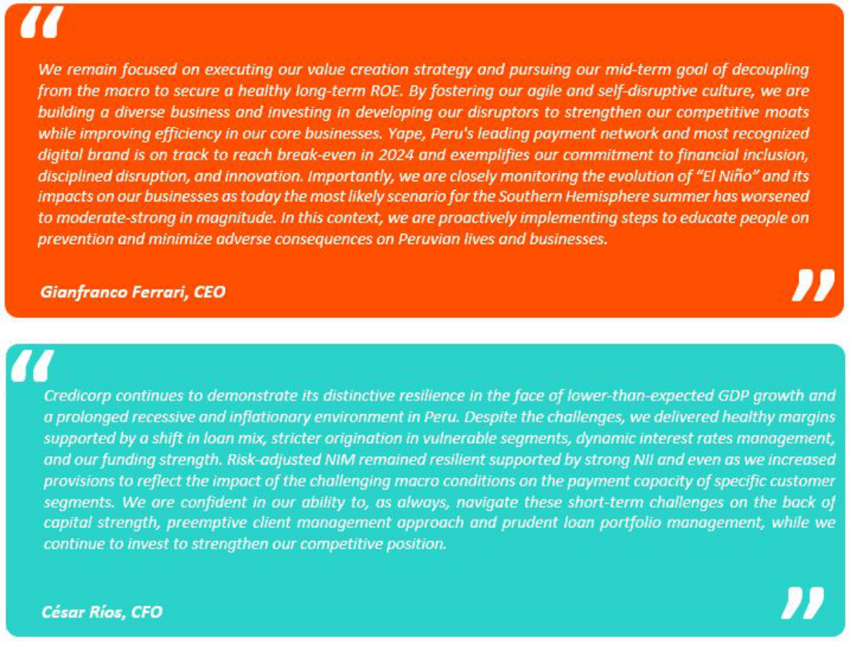

5

| ^{Earnings Release 3Q / 2023} Analysis of 3Q23 Consolidated Results

Third Quarter 2023 Earnings Conference Call

THIRD QUARTER 2023 EARNINGS CONFERENCE CALL

Date: Friday November 3rd, 2023

Time: 10:30 am ET (9:30 am Lima, Perú)

Hosts: Cesar Rios - Chief Financial Officer, Francesca Raffo – Chief Innovation Officer, Reynaldo Llosa - Chief Risk Officer, Diego Cavero – Head of Universal Banking, Cesar Rivera - Head of Insurance and Pensions, Carlos Sotelo - Mibanco CFO, Raimundo Morales – Yape CEO; and the Investor Relations Team.

To pre-register for the listen-only webcast presentation use the following link:

https://dpregister.com/DiamondPassRegistration/register?confirmationNumber=10183417&linkSecurityString=fab422 2fc1

Callers who pre-register will be given a conference passcode and unique PIN to gain immediate access to the call and bypass the live operator. Participants may pre-register at any time, including up to and after the call start time.

Those unable to pre-register may dial in by calling:
1 844 435 0321 (U.S. toll free)
1 412 317 5615 (International)

Conference ID: Credicorp Conference Call

The webcast will be archived for one year on our investor relations website at:

https://credicorp.gcs-web.com/events-and-presentations/upcoming-events

For a full version of Credicorp´s Second Quarter 2023 Earnings Release, please visit:

https://credicorp.gcs-web.com/financial-information/quarterly-results

6

| Earnings Release 3Q / 2023

Summary of Financial Performance and Outlook
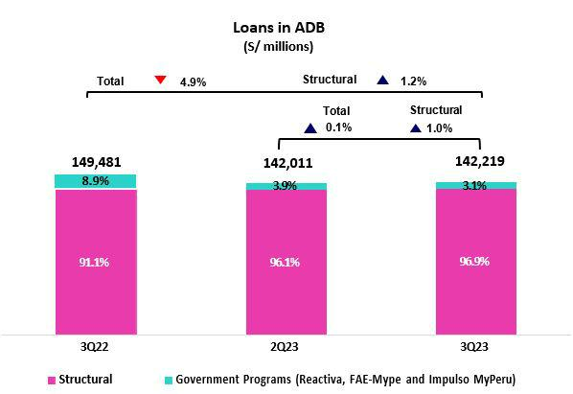

Loans in Average Daily Balances (ADB)

Structural loans measured in ADB rose 1.0% QoQ (+0.3%, neutral exchange rate) to total S/137,745 million. This growth was primarily attributable to Retail Banking at BCP, and to SME-Pyme in particular, and was partially offset by a decrease in the pace of loan growth in Wholesale Banking, which reflects the impact of a drop in private investment and the cancellation of the first fishing season due to the “El Niño Costero” phenomenon.

YoY, structural loan growth stood at 1.2%, driven primarily by Retail Banking at BCP, and by SME-Pyme and Individuals in particular, and secondarily by growth at Mibanco. As was the case QoQ, growth was partially offset by Wholesale Banking; the drivers were the same across both periods.

Government Loans (GP) represented 3.1% of total loans in average daily balances (2.9% in quarter-end balances).
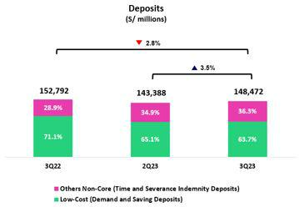

Deposits

Our deposit base measured in quarter-end balances resumed growth and increased 3.5% QoQ (+1.3% with Neutral FX). This uptick was mainly driven by an increase in Time Deposits and secondarily by growth in Demand Deposits, which was fueled by campaigns to capture more funding through digital products and by disbursements for Christmas campaigns.

In the YoY comparison, the deposit base dropped 2.8% (-0.5%, Neutral FX). Low-cost deposits, which represented 63.7% of our total deposit at quarter-end, continued to play a preponderant role in our funding mix.

Net Interest Income (NII) and Margin (NIM)

NII grew 1.6% QoQ to stand at S/3,254 million. This evolution was driven by a recomposition of the loan mix, which veered toward an increase in the weight of retail loans (SME-Pyme loans in particular) and by an increase in the investment balance. These dynamics were partially offset by an uptick in interest expenses, which were impacted by the deposit dynamics described above. In this context, the increase reported in the IEA Yield outstripped the growth registered in the Funding Cost. Consequently, NIM stood at 6.11%.
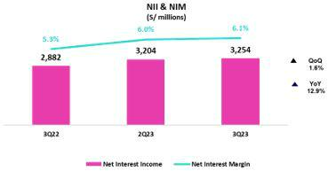

YoY, Net Interest Income rose 12.9%. This evolution was driven primarily by the recomposition of the portfolio mix, which was heavier in retail loans, and by the evolution of interest rates in both currencies.

7

| Earnings Release 3Q / 2023

Summary of Financial Performance and Outlook
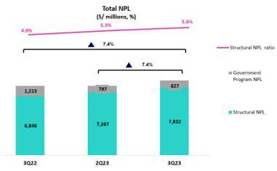

Portfolio Quality and Structural Cost of Risk

QoQ, the Structural NPL portfolio increased 7.8%. This growth was concentrated in: (i) Wholesale, given that some clients from the hotel and commercial real estate sector were included in the overdue portfolio (ii) Consumer and Credit Cards, mainly via sub-segments that registered overindebtedness; and (iii) SME-Pyme, due to a deterioration in the payment behavior of lower-ticket segments.

In this context, the structural NPL ratio stand at 5.6% and the structural coverage ratio for NPL loans stood at 101.4%.

Structural provisions remained high in Individuals and SME- Pyme and at Mibanco, where clients have been hard hit by an adverse macroeconomic environment marked by low demand, elevated inflation and high interest rates. The portfolio that was the most affected in Individuals corresponds to vulnerable sub- segments (which are more leveraged and have less job stability), while lower ticket segments were the most impacted in SME-Pyme. At Mibanco, the hardest hit clients were those with higher debt levels and those affected by climate and social anomalies.
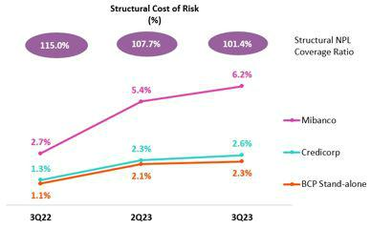

In this context, the Structural Cost of Risk stood at 2.6%. While Cost of Risk stood at 2.5%

8

| Earnings Release 3Q / 2023

Summary of Financial Performance and Outlook
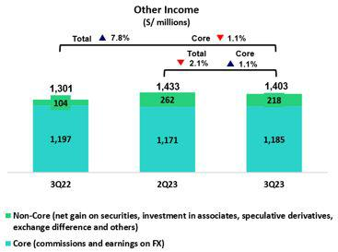

Other Income

Other Core Income¹ (Fees + Net gain on foreign Exchange transactions), excluding BCP Bolivia, rose 1.7% QoQ. This evolution was driven by an increase in total banking fees, which was partially offset by a drop in FX transactions. YoY, excluding BCP Bolivia, the -1.2% decline was attributable to a reduction in Fee income (-1.9%), associated to lower income in Prima, Credicorp Capital and BCP. Other Core Income dropped 1.9% YTD, driven by the same factors that drove the YoY evolution.

Other Non-core Income dropped 16.7% QoQ. This result was spurred by a reduction in Other Non-Operating Income, which was attributable to the fact that a gain was reported last quarter for a portfolio sale. YoY and YTD, growth was driven by an increase in the Gain on securities.
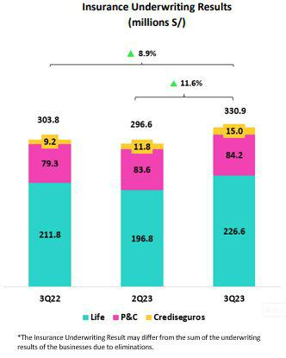

- When analyzing the results for fee income and FX transactions, it is important to note that both lines have been affected by our operation in BCP Bolivia, where we charge fees to FX clients to offset losses on buy-sell FX transactions.

Insurance Underwriting Result

The Insurance Underwriting Result rose 11.6% QoQ. This evolution was driven by improvements in the results in Life via Group Life and Credit Life, which registered lower insurance service expenses this quarter. YoY, the underwriting result rose 8.9%, driven primarily by the Life Business, which reported noteworthy performance for its Pensions line via positive price and volume dynamics. YTD, the Underwriting Result rose 31.1%, driven mainly by the Life Business via the Pensions line and to a lesser extent, through Credit Life and Group Life.

9

| Earnings Release 3Q / 2023

Summary of Financial Performance and Outlook
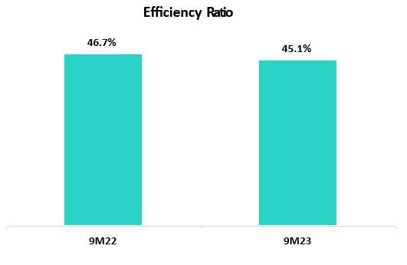

Efficiency

In 9M23, the Efficiency ratio stood at 45.1%, which represents an improvement of 160 bps compared to 9M22. This dynamic was driven by significant growth in income at BCP and Pacifico.

It is important to note that operating expenses rose 11.0% YTD, spurred mainly by BCP’s core businesses (without disruption) at BCP and disruptive initiatives at Credicorp.

- Operating Expenses and Income have been reformulated due to the application of IFRS 17 and as such, are reported differently than seen in earlier reports. This reformulation has led to a subsequent change in the way that the Efficiency Ratio is calculated. For more detail, please refer to appendix 12.1

Net earnings attributable to Credicorp
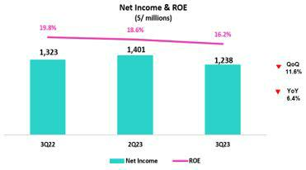

In 3Q23, net earnings attributable to Credicorp totaled S/1,238 million, which represented a variation of -11.6% QoQ and -6.4% YoY. Net shareholders’ equity totaled S/31,268 million (+4.1% QoQ and +14.6% YoY). Consequently, ROE stood at 16.2%.

Contributions* and ROE by subsidiary in 3Q23
(S/ millions)
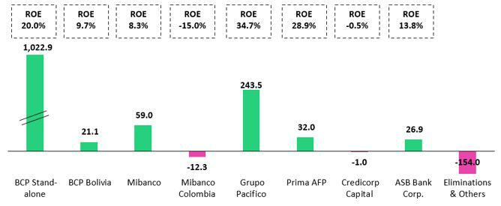

*Contributions to Credicorp reflect eliminations for consolidation purposes (eliminations for transactions among Credicorp’s subsidiaries or between Credicorp and its subsidiaries.
- At BCP Stand Alone, the figure is lower than net income because it does not include gains on investments in other Credicorp subsidiaries (Mibanco).
- At Mibanco, the figure is lower than net income because Credicorp owns 99.921% of Mibanco (directly and indirectly).
-The Contribution of Grupo Pacífico presented here is higher than the earnings reported for Pacifico Seguros because it includes 100% of Crediseguros (including 48% under Grupo Credito)

10

| Earnings Release 3Q / 2023

Summary of Financial Performance and Outlook
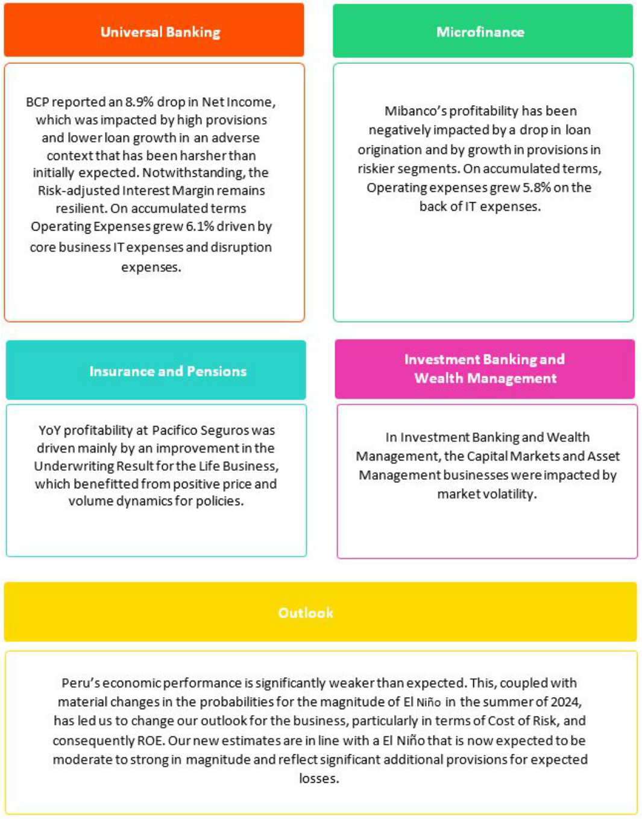

11

| Earnings Release 3Q / 2023

Financial Overview

Credicorp Ltd. |  | Quarter |  | % change |  | As of |  | % change
S/000 |  | Quarter |  |  |  |  |  | % change
S/000 | 3Q22 | 2Q23 | 3Q23 | QoQ | YoY | Sep 22 | Sep 23 | Sep 23 / Sep 22
Net interest, similar income and expenses | 2,882,401 | 3,204,156 | 3,254,043 | 1.6% | 12.9% | 7,951,214 | 9,590,288 | 20.6%
Provision for credit losses on loan portfolio, | (459,976) | (804,251) | (917,642) | 14.1% | 99.5% | (1,080,857) | (2,448,891) | 126.6%
net of recoveries
Net interest, similar income and
expenses, after provision for credit | 2,422,425 | 2,399,905 | 2,336,401 | -2.6% | -3.6% | 6,870,357 | 7,141,397 | 3.9%
losses on loan portfolio
Total other income | 1,301,252 | 1,433,124 | 1,402,603 | -2.1% | 7.8% | 3,738,234 | 4,169,002 | 11.5%
Insurance underwriting result | 303,760 | 296,564 | 330,900 | 11.6% | 8.9% | 704,624 | 923,805 | 31.1%
Total other expenses | (2,097,590) | (2,195,304) | (2,350,469) | 7.1% | 12.1% | (5,953,226) | (6,672,681) | 12.1%
Profit before income tax | 1,929,847 | 1,934,289 | 1,719,435 | -11.1% | -10.9% | 5,359,989 | 5,561,523 | 3.8%
Income tax | (575,083) | (504,472) | (455,865) | -9.6% | -20.7% | (1,634,265) | (1,453,803) | -11.0%
Net profit | 1,354,764 | 1,429,817 | 1,263,570 | -11.6% | -6.7% | 3,725,724 | 4,107,720 | 10.3%
Non-controlling interest | 31,855 | 28,550 | 25,397 | -11.0% | -20.3% | 88,061 | 84,007 | -4.6%
Net profit attributable to Credicorp | 1,322,909 | 1,401,267 | 1,238,173 | -11.6% | -6.4% | 3,637,663 | 4,023,713 | 10.6%
Net income / share (S/) | 16.6 | 17.6 | 15.5 | -11.6% | -6.4% | 45.6 | 50.4 | 10.6%
Loans | 151,392,202 | 142,845,549 | 145,129,260 | 1.6% | -4.1% | 151,392,202 | 145,129,260 | -4.1%
Deposits and obligations | 152,792,014 | 143,387,717 | 148,471,535 | 3.5% | -2.8% | 152,792,014 | 148,471,535 | -2.8%
Net equity | 27,292,658 | 30,027,036 | 31,267,592 | 4.1% | 14.6% | 27,292,658 | 31,267,592 | 14.6%
Profitability
Net interest margin | 5.33% | 6.02% | 6.11% | 9 bps | 78 bps | 4.80% | 5.96% | 116 bps
Risk-adjusted Net interest margin | 4.51% | 4.56% | 4.45% | -11 bps | -6 bps | 4.17% | 4.49% | 32 bps
Funding cost | 2.06% | 2.91% | 3.15% | 24 bps | 109 bps | 1.61% | 2.86% | 125 bps
ROAE | 19.8% | 18.6% | 16.2% | -240 bps | -360 bps | 18.0% | 17.8% | -20 bps
ROAA | 2.2% | 2.4% | 2.1% | -30 bps | -10 bps | 2.0% | 2.2% | 20 bps
Loan portfolio quality
Internal overdue ratio ⁽¹⁾ | 4.1% | 4.2% | 4.4% | 22 bps | 28 bps | 4.1% | 4.4% | 28 bps
Internal overdue ratio over 90 days | 3.1% | 3.4% | 3.5% | 14 bps | 46 bps | 3.1% | 3.5% | 46 bps
NPL ratio ⁽²⁾ | 5.3% | 5.6% | 6.0% | 33 bps | 65 bps | 5.3% | 6.0% | 65 bps
Cost of risk ⁽³⁾ | 1.2% | 2.3% | 2.5% | 28 bps | 131 bps | 1.0% | 2.2% | 130 bps
Coverage ratio of IOLs | 128.5% | 133.1% | 125.8% | -730 bps | -270 bps | 128.5% | 125.8% | -270 bps
Coverage ratio of NPLs | 99.6% | 98.7% | 93.0% | -570 bps | -660 bps | 99.6% | 93.0% | -660 bps
Operating efficiency
Efficiency ratio ⁽⁴⁾ | 45.5% | 44.6% | 46.3% | 170 bps | 80 bps | 46.7% | 45.1% | -160 bps
Operating expenses / Total average assets | 3.4% | 3.6% | 3.8% | 23 bps | 42 bps | 3.1% | 3.6% | 50 bps
Capital adequacy - BCP Stand-alone ⁽⁷⁾
Global Capital ratio ⁽⁸⁾ | n.a | 17.2% | 17.5% | 31 bps | n.a | n.a | 17.5% | n.a
Tier 1 ratio ⁽⁹⁾ | n.a | 12.8% | 13.0% | 26 bps | n.a | n.a | 13.0% | n.a
Common equity tier 1 ratio ⁽¹⁰⁾ | 11.8% | 12.8% | 13.0% | 25 bps | 121 bps | 11.8% | 13.0% | 121 bps
Capital adequacy - Mibanco ⁽⁷⁾
Global Capital ratio ⁽⁸⁾ | n.a | 18.8% | 19.8% | 97 bps | n.a | n.a | 19.8% | n.a
Tier 1 ratio ⁽⁹⁾ | n.a | 16.5% | 17.4% | 94 bps | n.a | n.a | 17.4% | n.a
Common equity tier 1 ratio ⁽¹⁰⁾⁽¹²⁾ | 16.0% | 16.6% | 17.6% | 96 bps | 156 bps | 16.0% | 17.6% | 156 bps
Employees | 35,679 | 37,366 | 37,161 | -0.5% | 4.2% | 35,679 | 37,161 | 4.2%
Share Information
Issued Shares | 94,382 | 94,382 | 94,382 | 0.0% | 0.0% | 94,382 | 94,382 | 0.0%
Treasury Shares ⁽¹¹⁾ | 14,849 | 14,829 | 14,847 | 0.1% | 0.0% | 14,849 | 14,847 | 0.0%
Outstanding Shares | 79,533 | 79,553 | 79,535 | 0.0% | 0.0% | 79,533 | 79,535 | 0.0%

- Net Interest Margin = Net Interest Income (Excluding Net Insurance Financial Expenses) / Average Interest Earning Assets

- Funding Cost = Interest Expense (Does not include Net Insurance Financial Expenses) / Average Funding
- Internal Overdue Loans: includes overdue loans and loans under legal collection, according to our internal policy for overdue loans. Internal Overdue Ratio: Internal overdue loans / Total loans
- Non-performing loans (NPL): Internal overdue loans + Refinanced loans. NPL ratio: NPL / Total loans.
- Cost of risk = Annualized provision for loan losses, net of recoveries / Total loans.

- Efficiency Ratio = (Salaries and employee benefits + Administrative expenses + Depreciation and amortization + Association in participation) / (Net interest, similar income and expenses + Fee Income+ Net gain on foreign exchange transactions + Net Gain From associates + Net gain on derivatives held for trading + Result on exchange differences + Insurance Underwriting Result)
- Regulatory Capital / Risk-weighted assets (legal minimum = 10% since July 2011).

- Tier 1 = Capital + Legal and other capital reserves + Accumulated earnings with capitalization agreement + (0.5 x Unrealized profit and net income in subsidiaries) - Goodwill - (0.5 x Investment in subsidiaries) + Perpetual subordinated debt (maximum amount that can be included is 17.65% of Capital + Reserves + Accumulated earnings with capitalization agreement + Unrealized profit and net income in subsidiaries - Goodwill).
- Common Equity Tier I = Capital + Reserves – 100% of applicable deductions (investment in subsidiaries, goodwill, intangibles and net deferred taxes that rely on future profitability) + retained earnings + unrealized gains.

- Consider shares held by Atlantic Security Holding Corporation (ASHC) and stock awards.
- Common Equity Tier I calculated based on IFRS Accounting

12

| Earnings Release 3Q / 2023 Analysis of 3Q23 Consolidated Results

Credicorp’s Strategy Update

Credicorp Strategy

Credicorp has demonstrated resilience in a challenging context, buoyed by its diversified loan portfolio and prudent management. The company has offset the impact of a deterioration in the loan portfolio by increasing the share of non-interest related income flows, which include those generated by Insurance and Yape, which are key elements of our strategy to decouple from the macro. Credicorp believes that by investing in technology and disruptive initiatives, it will maintain its competitive advantage and ensure sustainability down the line. By understanding market trends and satisfying clients’ needs, Credicorp aims to solidify its position and expand in new markets.

Main KPIs of Credicorp’s Strategy

Traditional Business Transformation ⁽¹⁾ | Subsidiary | 3Q22 | 2Q23 | 3Q23
Day to Day
Digital monetary transactions ⁽²⁾ | BCP | 60% | 73% | 76%
Transactional cost by unit | BCP | 0.09 | 0.08 | 0.07
Disbursements through leads ⁽³⁾ | Mibanco | 74% | 75% | 70%
Disbursements through alternative channels ⁽⁴⁾ | Mibanco | 43% | 44% | 44%
Mibanco Productivity ⁽⁵⁾ | Mibanco | 24.5 | 26.7 | 22.1
Cashless
Cashless transactions ⁽⁶⁾ | BCP | 45% | 50% | 51%
Mobile Banking rating iOS | BCP | 4.7 | 4.7 | 4.7
Mobile Banking rating Android | BCP | 3.9 | 4.5 | 4.2
Digital Acquisition
Digital sales ⁽⁷⁾ | BCP | 53% | 53% | 58%

- Figures for September 2022, June 2023, and September 2023

- Monetary Transactions conducted through Retail Banking, Internet Banking, Yape and Telecredito/Total Retail Monetary Transactions in Retail Banking.
- Disbursements generated through leads/Total disbursements.
- Disbursements conducted through alternative channels/Total disbursements.
- Number of loans disbursed/ Total relationship managers
- Amount transacted through Mobile Banking, Internet Banking, Yape y POS/ Total amount transacted through Retail Banking Minorista.
- Units sold by Retail Banking through digital channels/ Total number of units sold by Retail Banking.

13

| Earnings Release 3Q / 2023 Analysis of 3Q23 Consolidated Results

Credicorp’s Strategy Update

Disruptive Initiatives: Yape

Yape continues to leverage its monetization strategy to progress towards its goal of hitting breakeven at some point in 2024. At the end of 3Q23, Yape hit the 13.4-million user market, 9.8 million (73%) of whom make transactions at least once a month (MAU). Over the last quarter 794 million transactions were conducted (S/90.7 billion thus far this year). In September, Yape reached 29 transactions a month per MAU. The different functionalities that have been launched in recent months fueled the following scenario: by quarter-end, more than 6.5 million users had conducted transactions that generated income for Yape, for a total of S/2.9 a month per active Yapero. Yape users see the application as a tool for improving their day-to-day; this led Yape’s NPS to reach 76 points at quarter-end.

In 3Q23, the monetization drivers that stood out for each of Yape’s ambitions were:

To be the main payment venue in the country:

- Mobile Top-Ups: In 3Q23, 3.8 million Yape users made more than 42.0 million top-ups, which represents growth of 22.0% and 132.3% with regard to 2Q23 and 3Q22 respectively.

- Service Payments: In the third quarter, Yaperos paid 10.6 million service payments through the Yape app, which represents a 16-fold increase in the transaction volume registered in 1Q23 and a 2-fold growth with regard to 2Q23.

- Exchange rate: In September 2023, Yape launched its new exchange rate functionality and by quarter-end, more than 12 thousand transactions had been made.

To be present in the daily lives of all Yaperos:

- In 3Q23, 2.3 million transactions were conducted through Yape Promos; this translated into S/40 million in transactions at establishments.

To solve Yaperos’ financial needs:

- In 3Q23, 228 thousand microloans for S/63.8 million were placed, which represents a 37.6% increase in disbursements in QoQ terms.

Disruptive Initiatives: Yape | 3Q22 | 2Q23 | 3Q23
Users
Users (millions) | 11.2 | 12.6 | 13.4
Monthly Active Users (MAU) (millions) ⁽¹⁾ | 6.9 | 9 | 9.8
Fee Income Generating MAU (millions) | 2.4 | 5.2 | 6.5
Engagement
# Monthly Transactions (millions) | 120.2 | 178 | 220.7
TPV ⁽³⁾ (S/, millions) | 42.9 | 53.5 | 90.7
Experience
_{NPS} (2) | 70 | 78 | 76
Metric per Monthly Active User (MAU)
Monthly Transactions / MAU | 17 | 25 | 29
Monthly Revenues / MAU | 1.4 | 2.3 | 2.9
Monthly Cash Cost / MAU | 5.3 | 4.3 | 4.3
Monetization Drivers
Payments
# Mobile Top-Ups transactions (millions) | 18.1 | 34.4 | 42
# Bill Payments transactions (millions) | - | 5.1 | 10.6
Yape Promos
GMV ⁽⁴⁾ (S/, millions) | - | 25 | 41
Microloans
# Disbursements (thousands) | - | 165.8 | 228

- Yape users that have made at least one transaction over the last month.

- Net Promoting Score
- Total Payment Volume
- Gross Merchant Volume

14

| Earnings Release 3Q / 2023

Credicorp’s Strategy Update

Integrating Sustainability in Our Businesses

For more information about our sustainability, programs and initiatives, please see:

“Sustainability Strategy 2020-25” and the “Annual Report and Sustainability 2022”. Among the milestones hit during the third quarter 2023 in the framework of the Sustainability Program, the following stand out:

Environmental Front – Driving environmental sustainability through the financial sector and ESG risk management

- In Q3, we continued to roll out an environmental strategy at the corporate level:

- Footprint measurement: Prima and Pacifico completed the process to measure the financial footprint of the assets prioritized under the PCAF methodology. Both entities are reviewing results and broadening the scope of their measurements. At BCP, we continue to build internal capacities to measure prioritized sectors in Wholesale Banking (mining, hydrocarbons, energy, construction, fishing, agriculture and others).

- Business Opportunities: In August of this year, an ESG unit was created in Wholesale Banking to drive the bank’s green financing strategy and educate the bank’s clients, encouraging them to transition to sustainability. At the end of September 2023, 32 green operations were rolled out for US$ 309.9MM and S/25MM were placed in green mortgage loans.

- Risks: A process was developed to validate exclusions for corporate conduct relative to investments and financing. The BCP Environmental Taxonomy Tool was updated to determine eligibility for green loans, and we continued to roll out ESG risk questionnaires at BCP and Pacifico to analyze the risk management level of prioritized portfolios.

Social Front – Expanding social inclusion and educating people about finance and entrepreneurship

- Financial Inclusion: We released our third edition of the Financial Inclusion Index (2023 version) after completing in-depth information analysis in 2Q23.

- Financial Education: BCP continued to drive improvements in financial behavior (avoiding overindebtedness/overdrawn credit cards/Late Payments and encouraging savings) among 136 thousand clients thanks to its Education initiatives from the Business Front. Additionally, the bank has trained, in partnership with the Ministry of Social Development and Inclusion (MIDIS), leaders of more than 5 thousand Community Pots and Community Kitchens. Under its “Powerful Women” program, Mibanco Peru has trained more than 8 thousand representatives of 645 organizations. Through its ABC of Pension Savings Culture, Prima AFP presented learning capsules for “Ahorrando a Fondo” this quarter. These installments obtained 29 thousand views within the first week of launch. Pacifico Seguros, via its Insurance Education program, trained +800 individuals and +200 businesses about prevention in the context of the El Niño phenomenon in 3Q23.

For information on the progress of other initiatives from these and other platforms, please see the table below:

Progress on Initiatives | Company | 1Q23 | 2Q23 | 3Q23
Financial Inclusion
Financially included through BCP⁽¹⁾⁽²⁾ – cumulative since 2020 | BCP | 2.6 million | 3.1 million | 3.6 million
Stock of inclusive insurance policies – YTD | Pacifico Seguros | 2.8 million | 2.9 million | 3.1 million
Financial Education
Trained through online courses via ABC at BCP (ABC del BCP) – YTD 2023 | BCP | 117.5 thousand | 230.3 thousand | 397.9 thousand
Individuals trained in risk prevention via Safe Community (Comunidad Segura) – YTD | Pacifico Seguros | 0.3 thousand | 24.6 thousand | 33.2 thousand
2023
Young people trained through the ABC of the Pension Culture (ABC de la Cultura | Prima AFP | 5.6 thousand | 24.6 thousand | 59.9 thousand
Previsional) – YTD 2023
Clients trained through the Basic Program for Digital Guidance (Programa Básica de | Mibanco Perú | 108 thousand | 184 thousand | 227 thousand
Asesoría Digital) – YTD 2023
Opportunities and Products for Women
Number of disbursements through Loans for Women | Mibanco Perú | 12.9 thousand | 17 thousand | 17 thousand
Helping small businesses grow
Trained through Accompanying Entrepreneurs (Contigo Emprendedor) – YTD 2023 | BCP | 13.1 thousand | 44 thousand | 80.7 thousand
SME-Pymes financially included through loans (working capital and invoice | BCP | 7.7 thousand | 14.5 thousand | 22.7 thousand
discounting) – YTD 2023 |  |  |  | (3)
Microbusiness affiliated to Yape – YTD 2023 | BCP | 1.6 thousand | 3.9 thousand | 13 thousand
- Stock of financially included clients through BCP since 2020 : (i) New clients with savings accounts or a liated to Yape. (ii) New clients without debt in the financial system or BCP products in the last twelve months. (iii) Clients with 3 monthly average transactions in the last three months.
- The indicator was restated starting this quarter.
- YTD data to August 2023.

15

| Earnings Release 3Q / 2023 Analysis of 3Q23 Consolidated Results

01 Loan Portfolio


QoQ, structural loans in average daily balances (ADB) ADBs increased 1.0% and excluding the exchange rate effect rose 0.3%. The increase was driven primarily by the SME-Pyme segment, which has experienced a considerable upswing in balances quarter-over-quarter after clients with better risk profiles were targeted for financing. This growth was partially offset by a drop in wholesale banking balances, which reflects a decline in private investment and the fact that the first fishing campaign this year was canceled due to the El Niño Costero. Mibanco also reported a reduction in structural loan ADBs due to changes in credit guidelines in a context that suggests a greater focus on origination quality, which has temporarily affected origination levels. YoY, structural loan balances rose due to growth in balances in all Retail segments and at Mibanco. YTD, loans in ADBs grew 5.5% driven by the growth of loans in all Retail banking segments.

QoQ, growth in NPLs was driven by (i) Wholesale, whose NPL balance rose after some clients in the hotel and commercial real estate sectors fell delinquent; (ii) Individuals, where NPLs remain higher among vulnerable sub-segments, which presents higher levels of over-indebtedness and greater job instability, and due to reclassification of mortgage loans as refinanced; (iii) SME- Pyme, where low-ticket subsegments with higher risk continued to demonstrate poor payment performance; and (iv) Mibanco, where delinquency is concentrated in clients who are highly leveraged and among those who are affected by social conflicts or climate anomalies. YoY, growth in NPLs was driven mainly by the refinancing of debt in Wholesale Banking for clients in the real estate (offices) and tourism sectors in 2022 and 1Q23, and secondarily by growth in the overdue portfolio in Wholesale Banking, Individuals, SME-Pyme, and Mibanco due to the same factors as those described for the QoQ evolution. The aforementioned dynamics led the Structural NPL ratio to rise QoQ and YoY to stand at 5.6%.

1.1. Loans
Structural loans (in Average Daily Balances) ⁽¹⁾⁽²⁾⁽³⁾

Structural Loans |  | As of |  | Volume change |  | % change |  | % Part. in total structural loans
(S/ millions) | Sep 22 | Jun 23 | Sep 23 | QoQ | YoY | QoQ | YoY | Sep 22 | Jun 23 | Sep 23
BCP Stand-alone | 111,162 | 110,702 | 111,857 | 1,154 | 694 | 1.0% | 0.6% | 81.6% | 81.1% | 81.2%
Wholesale Banking | 55,899 | 52,025 | 52,090 | 65 | -3,810 | 0.1% | -6.8% | 41.1% | 38.1% | 37.8%
Corporate | 33,905 | 31,966 | 31,036 | -931 | -2,870 | -2.9% | -8.5% | 24.9% | 23.4% | 22.5%
Middle - Market | 21,994 | 20,059 | 21,054 | 996 | -940 | 5.0% | -4.3% | 16.2% | 14.7% | 15.3%
Retail Banking | 55,263 | 58,677 | 59,767 | 1,089 | 4,504 | 1.9% | 8.1% | 40.6% | 43.0% | 43.4%
SME - Business | 5,651 | 5,921 | 6,173 | 251 | 522 | 4.2% | 9.2% | 4.2% | 4.3% | 4.5%
SME - Pyme | 12,638 | 13,845 | 14,380 | 535 | 1,742 | 3.9% | 13.8% | 9.3% | 10.1% | 10.4%
Mortgage | 19,736 | 20,448 | 20,712 | 264 | 976 | 1.3% | 4.9% | 14.5% | 15.0% | 15.0%
Consumer | 12,446 | 12,771 | 12,654 | -117 | 208 | -0.9% | 1.7% | 9.1% | 9.4% | 9.2%
Credit Card | 4,792 | 5,692 | 5,848 | 156 | 1,056 | 2.7% | 22.0% | 3.5% | 4.2% | 4.2%
Mibanco | 12,782 | 13,728 | 13,642 | -86 | 860 | -0.6% | 6.7% | 9.4% | 10.1% | 9.9%
Mibanco Colombia | 1,163 | 1,340 | 1,557 | 217 | 394 | 16.2% | 33.9% | 0.9% | 1.0% | 1.1%
Bolivia | 8,992 | 8,834 | 8,957 | 123 | -35 | 1.4% | -0.4% | 6.6% | 6.5% | 6.5%
ASB | 2,053 | 1,831 | 1,733 | -99 | -321 | -5.4% | -15.6% | 1.5% | 1.3% | 1.3%
BAP’s total loans | 136,152 | 136,435 | 137,746 | 1,311 | 1,594 | 1.0% | 1.2% | 100.0% | 100.0% | 100.0%

For consolidation purposes. Loans generated in Foreign Currency (FC) are converted into Local Currency (LC).
- Includes Workout unit and other banking. For Quarter-end balance figures, please refer to “12. Annexes – 12.2 Loan Portfolio Quality”
- Structural Portfolio excludes the Loan offered through Reactiva Peru, FAE Mype, and Impulso MyPeru Government Programs (GP).
- Internal Management Figures.

QoQ, excluding the uptick in the Exchange rate (USDPEN:

+4.5%), structural loans rose 1.0% in average daily balances. FX neutral, loans rose 0.3%, driven by:

- SME-Pyme, after clients with better risk profiles were successfully targeted for financing. Growth was driven by an uptick in both short-term loans (working capital) for year-end campaigns and in long-term loans (to purchase fixed assets).

16

| Earnings Release 3Q / 2023

01. Loan Portfolio

The aforementioned was partially offset by a reduction in:

- Corporate loans, which reflected: i) a decrease in the demand for long-term financing in this segment in a context marked by low private investment and weak macroeconomic performance, and

  - a drop in short-term financing for the fishing sector after the first fishing campaign was canceled due to the El Niño Costero, and

- Mibanco, where the loan balance fell due to changes in the loan origination guidelines, which reflects a focus on improving quality.

YoY, structural loans in average daily balances rose 1.2% (+3.9 FX Neutral). Growth was driven primarily by:

- Retail banking, where all segments have evolved positively in comparison to 3Q22. This evolution
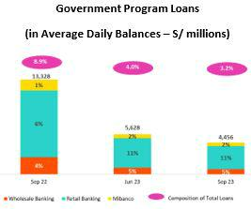

Analysis of 3Q23 Consolidated Results

was led by SME-Pyme and driven primarily by growth in loans to larger clients and better risk profiles and secondarily by an uptick in the Credit Card segment, which registered growth in balances for existing cards and by an uptick in Mortgage balances after new products were launched.

- Mibanco, where growth in balances reflects disbursements to clients with better risk profiles.

This growth was partially offset by a drop in average daily balances in Wholesale Banking, which was negatively impacted by a drop in private investment and the fact that the first fishing campaign of the year was canceled.

YTD, loans in average daily balances grew 5.5%. The growth was driven by higher disbursements in Retail Banking, where the growth of SMEs, Credit Cards, Mortgage, and Consumer stands out due to the same factors mentioned in the YoY dynamics.

ADB balances for Government Program Loans (GP) fell 20.9% QoQ and 66.6% YoY, driven primarily by amortizations at BCP and Mibanco. GP loans represented 3.2% of total ADBs at quarter-end (vs 4.0% on June 23 and 8.9% on Sep 22).

17

| Earnings Release 3Q / 2023 Analysis of 3Q23 Consolidated Results

01. Loan Portfolio

Total Loans (in Average Daily Balances) ⁽¹⁾⁽²⁾

Total Loans |  | As of |  | Volume change |  | % change |  | % Part. in total loans
(S/ millions) |  | As of
(S/ millions) | Sep 22 | Jun 23 | Sep 23 | QoQ | YoY | QoQ | YoY | Sep 22 | Jun 23 | Sep 23
Back to index
BCP Stand-alone | 122,986 | 115,772 | 115,851 | 79 | -7,135 | 0.1% | -5.8% | 82.3% | 81.5% | 81.5%
Wholesale Banking | 58,318 | 52,944 | 52,796 | -148 | -5,522 | -0.3% | -9.5% | 39.0% | 37.3% | 37.1%
Corporate | 34,180 | 32,093 | 31,134 | -959 | -3,046 | -3.0% | -8.9% | 22.9% | 22.6% | 21.9%
Middle - Market | 24,138 | 20,851 | 21,662 | 811 | -2,476 | 3.9% | -10.3% | 16.1% | 14.7% | 15.2%
Retail Banking | 64,668 | 62,828 | 63,055 | 227 | -1,613 | 0.4% | -2.5% | 43.3% | 44.2% | 44.3%
SME - Business | 9,156 | 7,420 | 7,292 | -129 | -1,864 | -1.7% | -20.4% | 6.1% | 5.2% | 5.1%
SME - Pyme | 18,538 | 16,497 | 16,549 | 52 | -1,990 | 0.3% | -10.7% | 12.4% | 11.6% | 11.6%
Mortgage | 19,736 | 20,448 | 20,712 | 264 | 976 | 1.3% | 4.9% | 13.2% | 14.4% | 14.6%
Consumer | 12,446 | 12,771 | 12,654 | -117 | 208 | -0.9% | 1.7% | 8.3% | 9.0% | 8.9%
Credit Card | 4,792 | 5,692 | 5,848 | 156 | 1,056 | 2.7% | 22.0% | 3.2% | 4.0% | 4.1%
Mibanco | 14,286 | 14,232 | 14,121 | -111 | -165 | -0.8% | -1.2% | 9.6% | 10.0% | 9.9%
Mibanco Colombia | 1,163 | 1,340 | 1,557 | 217 | 394 | 16.2% | 33.9% | 0.8% | 0.9% | 1.1%
Bolivia | 8,992 | 8,834 | 8,957 | 123 | -35 | 1.4% | -0.4% | 6.0% | 6.2% | 6.3%
ASB | 2,053 | 1,831 | 1,733 | -99 | -321 | -5.4% | -15.6% | 1.4% | 1.3% | 1.2%
BAP’s total loans | 149,480 | 142,009 | 142,219 | 210 | -7,261 | 0.1% | -4.9% | 100.0% | 100.0% | 100.0%

For consolidation purposes. Loans generated in Foreign Currency (FC) are converted into Local Currency (LC).
- Includes Workout unit and other banking. For Quarter-end balance figures, please refer to “12. Annexes – 12.2 Loan Portfolio Quality”.
- Internal Management Figures

Total loans measured in average daily balances rose QoQ,, but fell YoY given that growth in structural loans was insufficient to offset the drop in GP loans. Evolution of Loan Dollarization (in Average Daily Balances) ⁽¹⁾⁽²⁾
 |  | Local Currency (LC) |  |  |  |  | % change |  | % change |  | Foreign Currency |  |  | % change |  | % part. by currency
 |  |  |  |  |  |  |  |  | Structural |  |  | (FC)
Total Loans |  | Total |  | Structural |  |  |  |  |  |  |  | Total |  |  |  | Sep 23
(S/ millions) | Sep 22 | Jun 23Sep 23 Sep |  |  | Jun | Sep 23 | QoQ | YoY | QoQ | YoY | Sep | Jun 23Sep 23 |  | QoQ | YoY | LC | FC
 |  |  |  | 22 | 23 |  |  |  |  |  | 22
BCP Stand- | 85,883 | 80,560 | 79,89671,25375,20175,489 |  |  |  | -0.8% -7.0% |  | 0.4% | 5.9% | 9,478 | 9,585 | 9,722 | 1.4% | 2.6% | 69.6% | 30.4%
alone
Wholesale | 28,929 | 25,062 | 24,34125,41624,61624,143 |  |  |  | -2.9% -15.9% |  | -1.9% -5.0% |  | 7,507 | 7,589 | 7,694 | 1.4% | 2.5% | 47.3% | 52.7%
Banking
Corporate | 16,303 | 15,267 | 14,59215,04014,89015,140 |  |  |  | -4.4% -10.5% |  | 1.7% | 0.7% | 4,567 4,580 4,475 |  |  | -2.3% -2.0% |  | 47.6% | 52.4%
Middle- | 12,626 | 9,795 | 9,748 10,377 9,725 |  |  | 9,003 | -0.5% | -22.8% | -7.4% -13.2% |  | 2,940 | 3,009 | 3,220 | 7.0% | 9.5% | 47.0% | 53.0%
Market
Retail | 56,954 | 55,498 | 55,55545,83750,58651,346 |  |  |  | 0.1% | -2.5% | 1.5% | 12.0% | 1,970 | 1,996 | 2,028 | 1.6% | 2.9% | 88.3% | 11.7%
Banking
SME - | 6,099 | 4,486 | 4,302 | 2,399 | 2,836 | 2,987 | -4.1% -29.5% |  | 5.3% | 24.5% | 781 | 799 | 809 | 1.2% | 3.6% | 60.5% | 39.5%
Business
SME - Pyme | 18,376 | 16,332 | 16,37812,04613,41713,680 |  |  |  | 0.3% | -10.9% | 2.0% | 13.6% | 41 | 45 | 46 | 3.0% | 11.5% | 99.0% | 1.0%
Mortgage | 17,682 | 18,495 | 18,76817,35118,26418,495 |  |  |  | 1.5% | 6.1% | 1.3% | 6.6% | 525 | 532 | 526 | -1.1% | 0.2% | 90.4% | 9.6%
Consumer | 10,851 | 11,388 11,210 10,36711,514 11,388 |  |  |  |  | -1.6% | 3.3% | -1.1% | 9.8% | 407 | 376 | 390 | 3.7% | -4.1% | 89.2% | 10.8%
Credit Card | 3,946 | 4,796 4,898 3,674 4,555 4,796 |  |  |  |  | 2.1% | 24.1% | 5.3% | 30.5% | 216 | 244 | 257 | 5.3% | 18.8% | 84.3% | 15.7%
Mibanco | 13,812 | 13,746 | 13,633 11,83712,85613,268 |  |  |  | -0.8% | -1.3% | 3.2% | 12.1% | 121 | 132 | 132 | -0.2% | 9.2% | 96.6% | 3.4%
Mibanco | - | - | - | - | - | - | - | - | - | - | 297 | 365 | 421 | 15.3% 41.7% |  |  | -100.0%
Colombia | - | - | -
Bolivia | - | - | - | - | - | - | - | - | - | - | 2,297 | 2,405 | 2,422 | 0.7% | 5.4% |  | -100.0%
ASB | - | - | - | - | - | - | - | - | - | - | 525 | 498 | 469 | -6.0% -10.7% |  |  | -100.0%
Total loans | 99,69694,306 |  | 93,52983,09188,05888,757 |  |  |  | -0.8% -6.2% |  | 0.8% | 6.8% | 12,71712,985 13,166 |  |  | 1.4% | 3.5% | 66.4% | 33.6%

For consolidation purposes. Loans generated in Foreign Currency (FC) are converted into Local Currency (LC).

- Includes Workout unit and other banking. For Quarter-end balance figures, please refer to “12. Annexes – 12.2 Loan Portfolio Quality”.
- Internal Management Figures

At the end of September 2023, the dollarization level of structural loans rose 10 bps QoQ (35.6% on Sept 23). This growth was primary attributable to loan growth in Middle Market and secondarily to a variation in the exchange rate (+4.5% QoQ), which mainly affected Wholesale Banking, where it impacted both new disbursements and the stock of loans (disbursements that are generally in US Dollars).

YoY, the level of dollarization in the structural portfolio fell 340 bps. This evolution reflects growth in all of Retail Banking’s products, which are generally disbursed in soles, as well as a drop in the level registered by Wholesale Banking- whose disbursements are primarily in US Dollars- due to a drop in demand for loans in a context marked by a downturn in private investment.

18

| Earnings Release 3Q / 2023 Analysis of 3Q23 Consolidated Results

01. Loan Portfolio

Evolution of the Dollarization Level of Structural Loans (in Average Daily Balances)
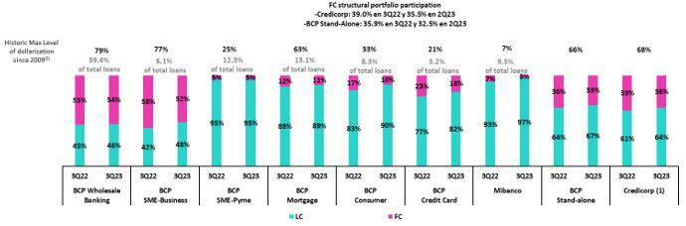

- The FC share of Credicorp’s loan portfolio is calculated including BCP Bolivia and ASB Bank Corp., however the chart shows only the loan books of BCP Stand-alone and Mibanco.

- The year with the historic maximum level of dollarization for Wholesale Banking was 2012, for Mibanco was 2016, for Credit Card was in 2021 and for the rest of segments was 2009. * For dollarization figures in the quarter-end period, please refer to “12. Annexes – 12.2 Loan Portfolio Quality

Evolution of Loans in Quarter-end Balances

Structural loans rose 2.2% in quarter-end balances, driven by the same factors as those seen in the analysis of loans in average daily balances. If we incorporate the contraction in the PG portfolio in the analysis, total loans grew 1.6% QoQ.

In the YoY evolution, structural loans increased 1.3% due to the same factors that drove the evolution of ADBs. If we include the drop in GP loans in the analysis, total loans decreased 4.1%.

1.2. Portfolio Quality

Quality of the Structural Portfolio (In Quarter-end Balances)

Structural Portfolio quality and Delinquency ratios |  | As of |  | % change
S/000 |  | As of
S/000 | Sep 22 | Jun 23 | Sep 23 | QoQ | YoY
Structural loans (Quarter-end balance) | 139,190,832 | 137,905,144 | 140,949,490 | 2.2% | 1.3%
Structural Allowance for loan losses | 7,875,552 | 7,824,302 | 7,942,818 | 1.5% | 0.9%
Structural Write-offs | 837,924 | 682,154 | 1,018,084 | 49.2% | 21.5%
Structural IOLs | 5,037,163 | 5,182,725 | 5,578,985 | 7.6% | 10.8%
Structural Refinanced loans | 1,808,982 | 2,084,124 | 2,253,098 | 8.1% | 24.6%
Structural NPLs | 6,846,145 | 7,266,849 | 7,832,083 | 7.8% | 14.4%
Structural IOL ratio | 3.62% | 3.76% | 3.96% | 20 bps | 34 bps
Structural NPL ratio | 4.92% | 5.27% | 5.56% | 29 bps | 64 bps
Structural Allowance for loan losses over Structural loans | 5.7% | 5.7% | 5.6% | -3 bps | -2 bps
Structural Coverage ratio of NPLs | 115.0% | 107.7% | 101.4% | -626 bps | -1363 bps

(1) The Structural Portfolio excludes Government Programs (GP) effects.

In 3Q23, Structural NPLs grew 7.8% QoQ. This evolution was primarily driven by specific clients from the hotel and commercial real estate sectors in Wholesale Banking, which have experienced ongoing difficulties since the pandemic, and entered the overdue portfolio this quarter. Additionally, the payment capacity of clients in Retail Banking and at Mibanco faced challenges in a recessive macroeconomic environment- whose impacts are reflected in the growth in overdue loans in SME-Pyme, Consumer, and Mibanco and in Refinanced Mortgage loans. YoY, the Structural NPLs increased 14.4%, driven by the same factors as those seen QoQ and accompanied by an uptick in refinanced loans in Wholesale Banking for the hotel and commercial real estate sectors refinanced at the end of 2022 and the beginning of 2023.

19

| Earnings Release 3Q / 2023 Analysis of 3Q23 Consolidated Results

01. Loan Portfolio
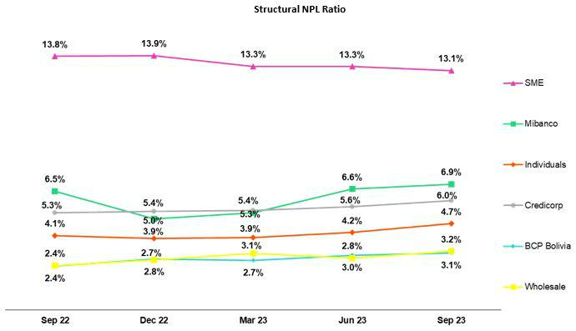

In the QoQ analysis, the volume of structural NPLs rose due to a deterioration in client payment capacity, which was in turn driven by the macroeconomic environment described above. The segments that contributed to growth were:

- Wholesale Banking, where specific clients in the hotel and commercial real estate sectors, whose operations have suffered from ongoing challenges since the pandemic, fell delinquent this quarter. It is important to note that these loans are backed by commercial guarantees that exceed 100% of each client’s total debt.

- Individuals:

  - Consumer and Credit Cards, where NPL loans were concentrated in more vulnerable sub-segments where clients are highly leveraged at the systemic level and impacted by job instability, both of which reflect the recessive environment in play throughout 2023.
  - Mortgage, given an uptick in refinanced loans of some clients who had benefitted from loan reprogramming during the pandemic.

- SME-Pyme, which experienced growth in NPL that was concentrated in lower-ticket loans (< S/90 thousand) that are also higher risk; holders of these loans have been impacted by the lack of economic reactivation, elevated inflation, and high- interest rates.

- Mibanco, where overdue loans are concentrated within a sub-set of clients that are highly leveraged and those who have been impacted by social conflicts or climate anomalies.

YoY, growth in NPLS was driven by:

- Wholesale Banking, due to the same dynamics in play QoQ and to the fact that during the second half of 2022 and the beginning of 2023, loans were refinanced for clients in the commercial real estate and tourism sectors, both of which were hit hard by the pandemic and have yet to recover due to a challenging macro backdrop. It is important to note that loans to these clients are backed by extensive collateral and covered by provisions set aside prior to this reporting period.

- Individuals:

  - Consumer and Credit Cards, where the overdue loan portfolio has been impacted by delinquency that has accumulated throughout the year. The uptick reported in delinquency this quarter was concentrated in the vulnerable clients subsegments (clients that are highly leveraged at the systemic level and are affected by job instability).

  - Mortgage, where the uptick in NPLs was driven by the same dynamics as those seen QoQ.

- SME-Pyme, given that the overdue portfolio has been impacted by delinquency accumulated over the year, which has been concentrated in lower-ticket clients (< a S/90 mil) who are also high-risk.

20

| Earnings Release 3Q / 2023 Analysis of 3Q23 Consolidated Results

- Loan Portfolio

  - Mibanco, where the recessive environment has impacted client payment capacity throughout the year, specifically among clients who are highly indebted and those affected by social conflicts or climate anomalies.

Due to the aforementioned, the structural NPL ratio rose 29 bps QoQ and 64 bps YoY to stand at 5.6%.

Structural Write-offs

(in Quarter-end balances– S/ millions)
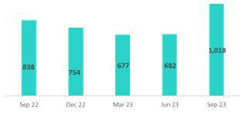

Coverage Ratio of Structural NPL Loans
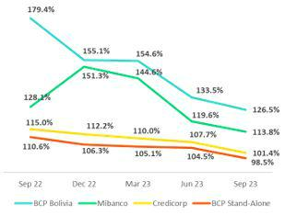

QoQ, structural write-offs remain at high levels and increased 49.2% after considerable write-offs were made in the SME-Pyme, Consumer and Credit Cards, and Mibanco. These segments continue to report write-offs of overdue loans from the highest-risk segments.

YoY, the uptick in structural write-offs (+21.5%) was fueled by Consumer, Credit Cards and Mibanco. This growth was driven by write-offs from the highest risk segments

QoQ, the coverage ratio for Structural NPLs fell 626 bps. This drop was driven mainly by Wholesale Banking where the new entries to the Overdue Portfolio had been previously provisioned and are backed by extensive guarantees and as result generated no impact on provisions.

YoY, the coverage ratio for Structural NPLs fell 13.63 pp. This result was driven primarily by Wholesale Banking since NPLs have experienced a significant uptick over the year due to growth in refinanced and overdue loans. These loans have not spurred a significant increase in provisions given that they are backed by commercial guarantees for amounts that far exceed total debt.

NPL Loans in the Government Loan Portfolio

(in Quarter-end balances– S/ millions)
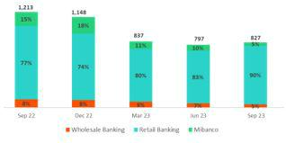

QoQ, the balance of Government Loan NPLs rose slightly given that due to the recessive environment, clients in SME-Business and SME- Pyme have fallen delinquent this quarter. These loans are backed by State guarantees. To execute the honoring processes, loans must have been delinquent more than 90 days. Average guarantees stand at 84%, 91%, and 97% for Wholesale Banking, Retail Banking, and Mibanco respectively. At the end of Sept 2023, a total of S/1,802 million had been received through honoring processes to execute State guarantees.

21

 | | Earnings Release 3Q / 2023 |  |  |  | Analysis of 3Q23 Consolidated Results
01. Loan Portfolio
 |  | Quality of the Total Portfolio (in Quarter-end Balances)
Loan Portfolio quality and Delinquency ratios |  |  |  | As of |  | % change
S/000 |  |  | Sep 22 | Jun 23 | Sep 23 | QoQ | YoY
Total loans (Quarter-end balance) |  |  | 151,392,202 | 142,845,549 | 145,129,260 | 1.6% | -4.1%
Allowance for loan losses |  |  | 8,030,104 | 7,956,184 | 8,056,216 | 1.3% | 0.3%
Write-offs |  |  | 837,924 | 682,154 | 1,018,084 | 49.2% | 21.5%
Internal overdue loans (IOLs) ⁽¹⁾⁽²⁾ |  |  | 6,250,131 | 5,979,395 | 6,406,345 | 7.1% | 2.5%
Internal overdue loans over 90-days ⁽¹⁾ |  |  | 4,667,608 | 4,862,669 | 5,133,832 | 5.6% | 10.0%
Refinanced Loans ⁽²⁾ |  |  | 1,808,982 | 2,084,124 | 2,253,098 | 8.1% | 24.6%
Non-performing loans (NPLs) ⁽³⁾ |  |  | 8,059,113 | 8,063,519 | 8,659,443 | 7.4% | 7.4%
IOL ratio |  |  | 4.13% | 4.19% | 4.41% | 22 bps | 28 bps
IOL over 90-days ratio |  |  | 3.08% | 3.40% | 3.54% | 14 bps | 46 bps
NPL ratio |  |  | 5.32% | 5.64% | 5.97% | 33 bps | 65 bps
Allowance for loan losses over Total loans |  |  | 5.30% | 5.57% | 5.55% | -2 bps | 25 bps
Coverage ratio of IOLs |  |  | 128.5% | 133.1% | 125.8% | -731 bps | -270 bps
Coverage ratio of IOL 90-days |  |  | 172.0% | 163.6% | 156.9% | -670 bps | -1512 bps
Coverage ratio of NPLs |  |  | 99.6% | 98.7% | 93.0% | -570 bps | -660 bps
- Includes Overdue Loans and Loans under legal collection (Quarter-end balances net of deferred earnings).
- Figures net of deferred earnings.
- Non-performing Loans include Internal Overdue Loans and Refinanced Loans (Quarter-end balances net of deferred earnings)

In the context described above, Credicorp’s NPL ratio rose 33 bps QoQ and 65 bps YoY to stand at 6.0% and the Coverage ratio of NPLs fell to 93.0%. This evolution was driven by growth in the structural NPLs

22

| Earnings Release 3Q / 2023 Analysis of 3Q23 Consolidated Results

02 Deposits


At the end of 3Q23, 63.7% of deposits were low-cost (Demand + Savings), which represents a competitive advantage in a context of high interest rates.

QoQ, our deposit base expanded 3.5% (+1.3%, FX neutral). This evolution was driven by an increase of 9.1% (6.7%, FX neutral) in Time Deposits and 2.7% (0.3%, FX neutral) in Demand Deposits balances, associated with clients seeking for accounts offering higher yield and campaigns to capture more deposits via digital products, respectively. Additionally, the migration of funding in soles from low-cost to time deposits decelerated in recent months.

YoY, the balance associated with low-cost deposits dropped 13.0% following the same downward trend as that seen systemwide. This evolution was fueled by a decline in balances for Savings Deposits and Demand Deposits at BCP and Mibanco, which reflected a normalization in liquidity levels post-pandemic and fund migration toward higher-yield deposits. Nonetheless, Credicorp continues to lead the market for low-cost deposits with a market share of 40.3% at the end of August 2023. Growth in Time Deposits YoY at BCP was attributable to the same drivers as those seen QoQ.

Deposits |  | As of |  | % change |  | Currency
S/000 | Sep 22 | Jun 23 | Sep 23 | QoQ | YoY | LC | FC
Demand deposits | 53,512,524 | 43,930,450 | 45,120,127 | 2.7% | -15.7% | 46.7% | 53.3%
Saving deposits | 55,154,337 | 49,456,054 | 49,395,543 | -0.1% | -10.4% | 56.3% | 43.7%
Time deposits | 39,372,047 | 45,107,429 | 49,213,763 | 9.1% | 25.0% | 49.0% | 51.0%
Severance indemnity deposits | 3,745,597 | 3,545,001 | 3,245,358 | -8.5% | -13.4% | 70.9% | 29.1%
Interest payable | 1,007,509 | 1,348,783 | 1,496,744 | 11.0% | 48.6% | 51.1% | 48.9%
Total Deposits | 152,792,014 | 143,387,717 | 148,471,535 | 3.5% | -2.8% | 51.1% | 48.9%

The balance for Total Deposits increased 3.5% QoQ (+1.3%, neutral exchange rate). The following dynamics were noteworthy:

- 9.1% growth in the balance of Time Deposits (+6.7%, neutral exchange rate), which was driven primarily by wholesale and retail clients at BCP, who migrated toward higher-yield deposits in both FC and LC. This scenario was replicated at BCP Bolivia and Mibanco as clients moved to secure higher rates. It is worth noting that at BCP, the pace of growth of Time Deposits in both currencies consistently decelerated in recent months.

- 2.7% growth in the balance Demand Deposits (+0.33%, neutral exchange rate). This uptick was fueled by growth in LC deposits held by corporate and retail clients at BCP, which received funding generated by campaigns to capture more deposits through digital products and disbursements for Christmas campaigns.

The aforementioned was partially offset by:

- A reduction of 0.1% in the balance for Savings Deposits (-2.0%, neutral exchange rate). This drop was primarily driven by a reduction in volumes of FC deposits at BCP and Mibanco after funds migrated to higher-yield deposits. LC deposits, in contrast, rose over the same period due to payments of statutory bonuses and a decline in the use of available funds.

YoY, the balance of Total Deposits decreased 2.8% (-0.5%, exchange rate neutral). The following dynamics stand out:

- A 10.4% reduction in the balance of Savings Deposits (-8.5%, exchange rate neutral) in both currencies. This drop was due to two factors: (i) a reduction in the liquidity levels of clients, who experienced a drop in buying power due to inflation, and (ii) an internal migration toward higher-yield deposits. It is important to note that BCP’s Savings Deposit level fell less than the level reported by the system.

- A 15.7% reduction in Demand Deposits (-13.5%, with a neutral exchange rate), which was triggered by fund outflows seeking higher-yield deposits in both LC and FC.

The aforementioned was partially offset by:

- An uptick of 25.0% (+28.2% neutral exchange rate) in the balance of Time Deposits, which was driven by the same dynamics as those seen in the QoQ analysis.

23

| Earnings Release 3Q / 2023 Analysis of 3Q23 Consolidated Results

02. Deposits

Low-cost deposit balances (Demand + Savings) rose 1.2% QoQ but fell 13.0% YoY. It is important to note that both deposit types account for a lions’ share of total deposits (63.7%). These figures remain above pre-pandemic levels (62.0% as of December 2019).

Dollarization Level of Deposits

Deposits by currency

(measured in quarter-end balances)
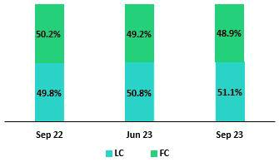

At the end of September 2023, the level of dollarization of Total Deposits dropped 30 bps QoQ. This decline was mainly attributable to Demand Deposits and, to a lesser extent, to Time Deposits, which reported an uptick in LC balances after clients migrated to higher-yield products. The dollarization level stood at 48.9% for the period, which remains below the average for the last 2 years (50.4%).

In YoY terms, the dollarization level fell 130 bps after Demand Deposits in FC and Savings Deposits fell -14.5% and -14.4% respectively while Time Deposits in LC rose 33.8%. These three movements were driven primarily by client migration to higher-yield deposits.

Deposits by currency and type

(measured in quarter-end balances)
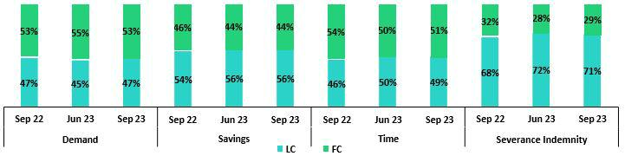

Loan/Deposit Ratio (L/D Ratio)

The L/D ratio dropped 150 bps and 890 bps QoQ at BCP and Mibanco respectively. The reduction at both BCP and Mibanco was driven by an uptick in total deposits, which was led by Time Deposits in LC and FC in a context marked by fund outflows from low-cost deposits to higher-yield deposits. At Mibanco, a drop in loan balances also contributed, although secondarily, to the drop in the L/C ratio. In this context, the L/C ratio at BAP stood at 97.7%.
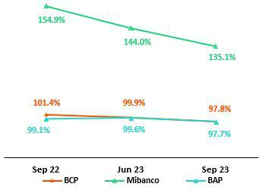

24

| Earnings Release 3Q / 2023 | Analysis of 3Q23 Consolidated Results
02. Deposits
L/D Ratio Local Currency | L/D Ratio Foreign Currency
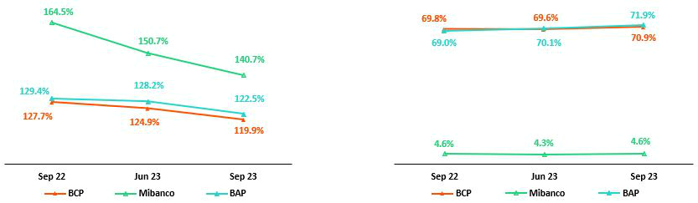

Share of the Market for Deposits in the Peruvian Financial System
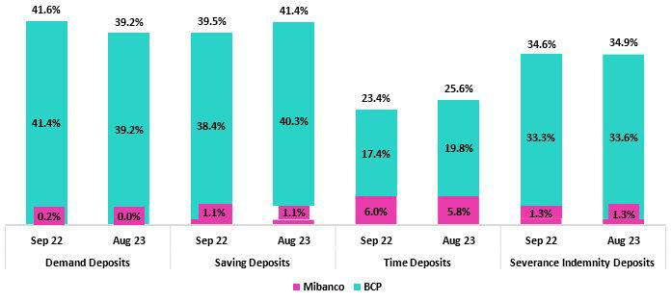

At the end of August 2023, the market shares of Total Deposits at BCP and Mibanco stood at 31.7% and 2.7% respectively (-14 bps and +2 bps versus September 2022). It is important to note that BCP continues to lead the market for deposits.

Low-cost deposits fell to the same extent systemwide and at BCP (-13.2% versus September 2022). In this context, BCP continues to lead the market for low-cost deposits with an MS of 39.8% at the end of August 2023 (+1 bps versus September 2022). In comparison to Sep 2022, BCP’s share of Savings Deposits was up 200 bps and for Time Deposits, 232 bps, which is proof of our strong market position. Credicorp’s MS for low-cost deposits stands at 40.3% (-10 bps versus September 2022).

25

| Earnings Release 3Q / 2023 Analysis of 3Q23 Consolidated Results

03 Interest-earning Assets (“IEAs”) and Funding


At the end of 3Q23, IEAs registered an uptick of 1.8% QoQ. This evolution was driven primarily by growth in balances for Investments and Loans and partially offset by a drop in Cash and due from banks. The increase registered in investment balances reflects efforts to capitalize on surplus liquidity and to take advantage of high interest rates. YoY, IEAs fell 2.8% due to a drop in loans and in Cash and due from banks, which was partially offset by an uptick in Investment balances.

Funding rose 2.0% QoQ, driven by growth in deposits. This evolution was partially offset by a reduction in BCRP instruments following repo expirations. Funding fell 5.0% YoY, which reflected a drop in deposits and repo expirations over the year.

3.1. IEAs¹

Interest Earning Assets |  |  | As of |  | % change
S/000 |  | Sep 22 | Jun 23 | Sep 23 | QoQ | YoY
Cash and due from banks |  | 29,330,082 | 26,036,894 | 24,907,836 | -4.3% | -15.1%
Total investments |  | 46,843,270 | 48,035,351 | 51,116,913 | 6.4% | 9.1%
Cash collateral, reverse repurchase agreements and securities borrowing |  | 1,586,967 | 1,863,243 | 1,513,622 | -18.8% | -4.6%
Total loans |  | 151,392,202 | 142,845,549 | 145,129,260 | 1.6% | -4.1%
Total interest earning assets |  | 229,152,521 | 218,781,037 | 222,667,631 | 1.8% | -2.8%

QoQ, IEAs rose 1.8% mainly driven by growth in investments in government securities. During the same period, Loans also registered an uptick. This increase recorded in IEAs was partially offset by a reduction in the balance of Cash and due from banks.

An uptick in the investment balance (+6.4%) was fueled by: i) moves to capitalize on surpluses via BCRP certificates of deposit and ii) purchases of Sovereign Bonds in anticipation of lower rates moving forward. The Loan balance rose this quarter, driven by growth in structural loans, which was concentrated in SME-Pyme.

YoY, IEAs registered a 2.8% decline, fueled by a drop in loans over the last 12 months and by a reduction in the balance of Cash and due from banks. The YoY loan balance reflects the impact of amortizations of Government Programs loans (GP). Cash and due from banks, in turn, dropped 15.1% due to a reduction in the deposit balance in the BCRP account. Both of these dynamics were partially offset by a higher balance of Total investments.

3.2. Funding²

Funding |  |  | As of |  | % change
S/000 |  | Sep 22 | Jun 23 | Sep 23 | QoQ | YoY
Deposits and obligations |  | 152,792,014 | 143,387,717 | 148,471,535 | 3.5% | -2.8%
Due to banks and correspondents |  | 9,002,035 | 10,062,290 | 10,493,411 | 4.3% | 16.6%
BCRP instruments |  | 14,449,597 | 11,772,772 | 9,616,150 | -18.3% | -33.5%
Repurchase agreements with clients and third parties |  | 2,125,983 | 2,534,108 | 2,121,870 | -16.3% | -0.2%
Bonds and notes issued |  | 17,019,694 | 14,235,697 | 14,914,632 | 4.8% | -12.4%
Total funding |  | 195,389,323 | 181,992,584 | 185,617,598 | 2.0% | -5.0%

Funding rose 2.0% QoQ, driven primarily by growth in deposit balances, and to a lesser extent by a bond issuance in the international market in anticipation of upcoming maturities. Growth in deposits in 3Q23 (+3.5%) was attributable to an uptick in time deposits as clients moved to take advantage of higher rates. This evolution was partially offset by a decrease in funding through BCRP instruments, which was spurred by expirations of GP repos and Securities repos.

YoY, funding fell 5.0% due to drop in deposits and in BCRP instruments due to repo expirations (GP and Securities). On the bonds and notes issued front, the balance fell following the maturity of a BCP corporate bond.

- Effective 1Q23, IEAs does not include “Financial assets designated at Fair Value through P&L” (mainly comprised of Investment Link contracts) as one of its components.

- Effective 1Q23, Funding includes Repurchase agreements with clients.

26

| Earnings Release 3Q / 2023 Analysis of 3Q23 Consolidated Results

04 Net Interest Income (NII)


Net interest income (NII) increased 1.6% QoQ in 3Q23. This evolution was driven primarily by a positive mix for structural loans, which registered higher growth in Retail banking segments, particularly in SME-Pyme. Secondarily, growth in investment balances to capitalize on surplus liquidity, taking advantage of high interest rates, also contributed to an uptick in NII this quarter. These dynamics offset the uptick registered in the funding cost.

NII rose 12.9% YoY due to a positive mix in IEAs, which was partially offset by the increase registered in the funding cost, attributable to growth in Time Deposits. YTD, IEAs registered similar mix dynamics as YoY, which fueled an increase in NII. NIM continued to follow an upward trend YoY, albeit at a slower pace, and rose 9 bps QoQ and 78 bps YoY to stand at 6.11%. Risk- adjusted NIM, in turn, dropped 11 bps QoQ and 6 bps YoY, to stand at 6.45%.

Net Interest Income / Margin |  | Quarter |  | % change |  | As of |  | % change
S/ 000 | 3Q22 | 2Q23 | 3Q23 | QoQ | YoY | Sep 22 | Sep 23 | Sep 23 / Sep 22
Interest Income | 3,988,684 | 4,653,246 | 4,819,101 | 3.6% | 20.8% | 10,649,143 | 13,928,453 | 30.8%
Interest Expense | (1,106,283) | (1,449,090) | (1,565,058) | 8.0% | 41.5% | (2,697,929) | (4,338,165) | 60.8%
Interest Expense (excluding Net Insurance | (988,293) | (1,333,924) | (1,448,593) | 8.6% | 46.6% | (2,374,221) | (3,990,784) | 68.1%
Financial Expenses)
Net Insurance Financial Expenses | (117,990) | (115,166) | (116,465) | 1.1% | -1.3% | (323,708) | (347,381) | 7.3%
Net Interest Income | 2,882,401 | 3,204,156 | 3,254,043 | 1.6% | 12.9% | 7,951,214 | 9,590,288 | 20.6%
Balances
Average Interest Earning Assets (IEA) | 225,371,577220,651,688220,724,334 |  |  | 0.0% | -2.1% | 229,932,415 | 222,362,151 | -3.3%
Average Funding | 192,002,398183,407,530183,805,091 |  |  | 0.2% | -4.3% | 196,017,913 | 185,774,857 | -5.2%
Yields
Yield on IEAs | 7.08% | 8.44% | 8.73% | 29bps | 165bps | 6.18% | 8.35% | 217bps
Cost of Funds | 2.06% | 2.91% | 3.15% | 24bps 109bps |  | 1.61% | 2.86% | 125bps
Net Interest Margin (NIM)⁽¹⁾ | 5.33% | 6.02% | 6.11% | 9bps | 78bps | 4.80% | 5.96% | 116bps
Risk-Adjusted Net Interest Margin | 4.51% | 4.56% | 4.45% | -11bps | -6bps | 4.17% | 4.49% | 32bps
Peru’s Reference Rate | 6.75% | 7.75% | 7.50% | -25bps 75bps |  | 6.75% | 7.50% | 75bps
FED funds rate | 3.25% | 5.25% | 5.50% | 25bps 225bps |  | 3.25% | 5.50% | 225bps

(1) For further detail on the new NIM calculation due to IFRS17, please refer to Annex 12.1.8

Although interest expenses grew at a faster pace than income, net interest income was up 1.6% QoQ, driven by an uptick in income in FC and LC. The pace of income growth decelerated QoQ (2Q23: +4.4% QoQ) but was nonetheless up 3.6%, driven by two factors:

- an increase in structural loan balances in Retail Banking, which was concentrated in SME-Pyme, outstripped the drop in balance in Wholesale Banking and ii) growth in investment balances, driven by an uptick in positions for BCRP Certificate of Deposits and sovereign bonds with attractive rates. Both factors led to an IEA composition with a preponderance of higher-yield components. In this context, the yield on IEAs stood at 8.73%, 29 bps above last quarter’s figure. Interest expenses rose 8.0%, driven primarily by growth in deposits, which registered a negative mix effect fueled by an ongoing migration of funds from low-cost to time deposits. Additionally, short-term obligations were renewed at higher rates. The combined impact of this negative mix and pricing effects led the cost of funding to rise 24 bps to stand at 3.15%.

YoY, net interest income rose 12.9%. As was the case QoQ, NII reported growth despite the fact that the upswing in expenses outpaced the expansion reported for income. Growth in income was driven primarily by the positive mix effect described in the QoQ analysis; secondarily by renewals of deposits in other Banks; and thirdly, by an uptick in the investment balance. These three drivers led the yield on IEAs to increase 165 bps in the last 12 months. On the expense side, the funding cost rose due to an increase in the share of time deposits within total deposits and to a lesser extent, due to renewals of debt at higher rates. In this context, interest expenses rose 41.5%.

Net Interest Margin

NIM continued to grow (+9pbs) but decelerated in QoQ terms (2Q23: +18 bps), standing at 6.11% at the end of 3Q23. Structural NIM also decelerated but maintained an upward trend. Finally, Risk-adjusted NIM dropped 2 bps over the same period to stand at 4.45%. This evolution was driven by an uptick in the provisions expense, which reflected a deterioration in client payment behavior.
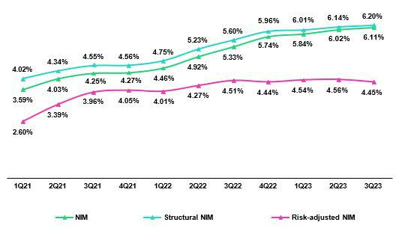

27

| Earnings Release 3Q / 2023 Analysis of 3Q23 Consolidated Results

04. Net Interest Income (NII)

Net Interest Margin Dynamics by Currency

 |  |  | Average | 3Q22 |  |  | Average |  | 2Q23 |  |  |  | Average | 3Q23
Interest Income / IEA |  |  | Average |  |  |  | Average |  |  |  |  |  | Average
S/ millions |  |  | BalanceIncome |  | Yields |  | Balance | Income |  | Yields |  |  | Balance | Income Yields
Cash and equivalents |  |  | 26,581 | 142 |  | 2.1% | 27,098 |  | 286 |  |  | 4.2% | 25,472 |  |  | 290 | 4.6%
Other IEA |  |  | 1,817 | 16 |  | 3.6% | 1,666 |  | 17 |  |  | 4.2% | 1,688 |  |  | 24 | 5.7%
Investments |  |  | 46,093 | 541 |  | 4.7% | 47,882 |  | 636 |  |  | 5.3% | 49,576 |  |  | 652 | 5.3%
Loans |  |  | 150,881 | 3,289 |  | 8.7% | 144,006 |  | 3,713 |  | 10.3% |  | 143,987 |  |  | 3,853 | 10.7%
Structural |  |  | 137,457 | 3,235 |  | 9.4% | 138,260 |  | 3,678 |  | 10.6% |  | 139,427 |  |  | 3,822 | 11.0%
Government Programs |  |  | 13,425 | 54 |  | 1.6% | 5,745 |  | 34 |  |  | 2.4% | 4,560 |  |  | 31 | 2.7%
Total IEA |  |  | 225,372 | 3,989 |  | 7.1% | 220,652 |  | 4,653 |  |  | 8.4% | 220,724 |  |  | 4,819 | 8.7%
IEA (LC) |  |  | 57.1% | 75.0% |  | 9.3% | 57.3% |  | 71.4% |  | 10.5% |  | 57.7% |  |  | 71.3% | 10.8%
IEA (FC) |  |  | 42.9% | 25.0% |  | 4.1% | 42.7% |  | 28.6% |  |  | 5.7% | 42.3% |  |  | 28.7% | 5.9%
 |  |  | Average | 3Q22 |  |  | Average |  | 2Q23 |  |  |  | Average |  |  | 3Q23
Interest Expense / Funding |  |  | Average |  |  |  | Average
S/ millions |  |  | BalanceExpenseYields |  |  |  | BalanceExpenseYields |  |  |  |  |  | BalanceExpenseYields
Deposits |  |  | 150,116 | 510 |  | 1.4% | 146,006 |  | 777 |  |  | 2.1% | 145,930 |  |  | 860 |  | 2.4%
BCRP + Due to Banks |  |  | 22,970 | 186 |  | 3.2% | 20,908 |  | 297 |  |  | 5.7% | 20,972 |  |  | 326 |  | 6.2%
Bonds and Notes |  |  | 16,800 | 212 |  | 5.0% | 14,274 |  | 149 |  |  | 4.2% | 14,575 |  |  | 149 |  | 4.1%
Others |  |  | 1,262 | 19925.5% |  |  | 1,242 |  | 22635.6% |  |  |  | 1,272 |  |  | 23035.8%
Total Funding |  |  | 192,002 | 1,106 |  | 2.1% | 183,408 |  | 1,449 |  |  | 2.9% | 183,805 |  |  | 1,565 |  | 3.2%
Funding (LC) |  |  | 50.9% | 60.3% |  | 2.4% | 50.8% |  | 60.3% |  |  | 3.4% | 50.9% |  |  | 59.8% |  | 3.7%
Funding (FC) |  |  | 49.1% | 39.7% |  | 1.7% | 49.2% |  | 39.7% |  |  | 2.4% | 49.1% |  |  | 40.2% |  | 2.6%
NIM |  |  | 225,372 | 2,882 |  | 5.1% | 220,652 |  | 3,204 |  |  | 5.8% | 220,724 |  |  | 3,254 |  | 5.9%
NIM (LC) |  |  | 57.1% | 80.7% |  | 7.2% | 57.3% |  | 76.4% |  |  | 7.7% | 57.7% |  |  | 76.8% |  | 7.9%
NIM (FC) |  |  | 42.9% | 19.3% |  | 2.3% | 42.7% |  | 23.6% |  |  | 3.2% | 42.3% |  |  | 23.2% |  | 3.2%


 | Sep 22 |  |  |  | Sep 23
 | Average |  |  |  | Average
 | BalanceIncome |  | Yields |  | Balance | IncomeYields
 | 30,863 | 225 |  | 0.7% | 25,903 |  | 854 | 3.3%
 | 1,677 | 49 |  | 2.9% | 1,308 |  | 58 | 4.4%
 | 47,898 | 1,471 |  | 3.1% | 48,274 |  | 1,880 | 3.9%
 | 149,495 | 8,904 |  | 6.0% | 146,878 |  | 11,137 | 7.6%
 | 134,059 | 8,725 |  | 6.5% | 140,032 |  | 11,029 | 7.9%
 | 15,436 | 179 |  | 1.2% | 6,845 |  | 109 | 1.6%
 | 229,932 10,649 |  |  | 4.6% | 222,362 |  | 13,928 | 6.3%
 | 56.4% | 77.2% |  | 6.3% | 57.2% |  | 71.3% | 7.8%
 | 43.6% | 22.8% |  | 2.4% | 42.8% |  | 28.7% | 4.2%
 | Sep 22 |  |  |  | Sep 23
Average |  |  |  |  | Average
BalanceExpenseYields |  |  |  |  | BalanceExpenseYields
151,194 |  | 1,106 |  | 0.7% | 147,746 |  | 2,314 | 1.6%
25,179 |  | 444 |  | 1.8% | 20,172 |  | 861 | 4.3%
17,421 |  | 552 |  | 3.2% | 15,961 |  | 481 | 3.0%
2,224 |  | 59712.3% |  |  | 1,895 |  | 68117.6%
196,018 |  | 2,698 |  | 1.2% | 185,775 |  | 4,338 | 2.1%
50.9% |  | 58.4% |  | 1.4% | 50.6% |  | 59.0% | 2.5%
49.1% |  | 41.6% |  | 1.0% | 49.4% |  | 41.0% | 1.8%
229,932 |  | 7,951 |  | 4.6% | 222,362 |  | 9,590 | 5.8%
56.4% |  | 83.6% |  | 5.1% | 57.2% |  | 76.9% | 5.8%
34.6% |  | 16.4% |  | 1.3% | 42.8% |  | 23.1% | 2.3%


(1) The yield calculation includes “Financial Expense associated with the insurance and reinsurance activity, net”.

QoQ Analysis

QoQ, Net Interest Income rose 1.6%, driven by growth in IEAs in LC and FC. IEAs in LC represented 57.7% of total IEAs and 71.3% of Net Interest Income generated in 3Q23.

Local Currency Dynamics (LC)

Net interest income in LC rose 2.1% due to the following dynamics:

As was the case last quarter, Retail loans’ share of total IEA rose via an uptick in SME-Pyme loans; this evolution offset the drop recorded this Q in Wholesale Banking balances. This shift toward a heavier weight for retail in the structural loan composition led to a 3.0% increase in income on LC loans and was the primary driver of growth in interest income. Renewals of investments and deposits in other Banks at higher rates also contributed to growth in income. In this context, the yield on IEAs in LC rose from 10.5% in 2Q23 to 10.8% in 3Q23, which led to growth of 3.4% in financial income in LC in 3Q23.

On the funding side, average daily balances in LC rose 0.4%, driven by an increase in the deposit balance (+0.7%), which was offset by expirations of repos (-1.5%) associated with Government loans and securities. The funding cost in LC rose to 3.7% in 3Q23, up from 3.4% last quarter. This evolution was driven by a shift in the deposit mix toward higher-rate deposits, which was reflected in an uptick in the share of time deposits. Consequently, interest expenses in LC rose 7.1% in 3Q23.

Foreign Currency Dynamics (FC)

Net Interest Income in FC was relatively stable (-0.1% QoQ) due to the following dynamics:

Average IEA in foreign currency fell 08% QoQ due to a reduction in available funds (-7.2%). This contraction was partially offset, in order of contribution to impact, by growth in loans and an uptick in the investment balance.

Nevertheless, the yield on average IEAs rose from 5.7% in 2Q23 to 5.9% in 2Q23 on the back of a more profitable mix, which was driven by the upticks in balances described earlier. It is important to note that the reduction in available funds did not lead to a relevant drop in interest income because this asset class has lower implicit rates. In this context, interest income in FC rose 4% in 3Q23.

Average funding in FC was relatively stable (+0.1% QoQ) due to growth in average daily balances in obligations and issuances, which was partially offset by a drop in the deposit balance. These movements in the composition of FC funding led the cost of funding to increase from 2.4% in 2Q23 to 2.6% in 3Q23. Consequently, interest expenses rose 9.3% QoQ.

28

| Earnings Release 3Q / 2023 Analysis of 3Q23 Consolidated Results

04. Net Interest Income (NII)

YoY Analysis

YoY, Net Interest Income rose 12.9%. This positive evolution took place despite drops in average IEA in LC (-1.2%) and FC (-3.2%).

Local Currency Dynamics (LC)

Net interest income in LC increased 7.5% YoY due to the following dynamics:

Average IEA in LC fell 1.2% YoY due to a 5.5% contraction in loan balances, which was driven by amortizations of Government Loans (GP). It is important to note that average daily balances of structural loans rose 4.1% over the period. Another factor worth mentioning is the uptick reported in investment balances, which reflects strategies to capitalize on surplus liquidity in a context marked by high rates. In this context, the IEA yield rose from 9.3% in 2Q23 to 10.8% in 3Q23. Consequently, interest income in LC increased 14.8% YoY.

Average funding in LC dropped 4.3% YoY due to reductions in balances for due to banks and BCRP instruments. These movements were driven by expirations of repos for GP loans and securities. Despite the repos dynamic, the cost of funding rose 125 bps YoY up to 3.7%, due to fund migration from low-cost to time deposits. Consequently, the interest rate expense in LC rose 40.1% YoY in 3Q23.

Foreign Currency Dynamics (FC)

Net interest income in FC rose 35.6% YoY due to the following dynamics:

Average IEA in FC dropped 3.2% YoY due primarily to a contraction in loans and secondarily to a drop in the balance of available funds. Despite the reduction in balances in both accounts, higher interest rates over the last 12 months have driven the yield on IEAs upward 180 bps. In this context interest income in LC rose 39.1% YoY.

Average funding in FC dropped 4.3% due primarily to a reduction in FC deposits and secondarily to a decrease in the balance for emissions, which reflects the expiration of a corporate bond in BCP over the period. The cost of funding YoY rose 86 bps, driven primarily by an uptick in rates associated with time deposits and secondarily by higher rates on obligations. In this context, interest expenses rose 43.5% YoY.

YTD Analysis

YTD, Net Interest Income rose 21.3%. This positive evolution took place despite drops in average IEA in LC (-1.9%) and FC (-5.1%).

Local Currency Dynamics (LC)

Net interest income in LC increased 11.0% YTD due to the following dynamics:

The YTD result at the end of Sep 23 was driven by dynamics similar to those seen YoY. Interest income rose 20.8% YTD, driven by a shift in the mix of structural loans toward a heavier weight in Retail and, to a lesser extent, by an increase in the investment balance. On the funding side, the volume fell, as was the case in the YoY comparison. YTD, the fact that the deposit mix was more heavily weighted toward time deposits led the interest expense to rise 62.4%.

Foreign Currency Dynamics (FC)

Net interest income in FC rose 64.1% YTD due to the following dynamics:

YTD, interest income in FC rose 64.7% as of Sep 23. This growth, which occurred despite a drop in volumes, was driven by higher rates on both loans and available funds. Interest expenses rose 58.5% YTD, driven by the same funding dynamics in play YoY.

29

| Earnings Release 3Q / 2023 Analysis of 3Q23 Consolidated Results

05 Provisions


Structural provisions remain at historical highs (without considering the pandemic) for Consumer Loans, Credit Cards and SME- Pyme at BCP and for Mibanco loans due to a recessive environment impacted by high inflation, low internal demand and high interest rates. Growth in provisions at BCP was spurred by i) vulnerable sub-segments in Individuals, customers who are overindebted at the system level and have less job stability; ii) higher-risk subsegments with lower tickets in SME-Pyme; and iii) Mortgage, after recognizing higher expected losses for certain clients who have become delinquent in consumer products or at other financial institutions. At Mibanco, the uptick in provisions was driven by a downturn in payment of customers who are overindebted, affected by social conflicts, or impacted by climatic anomalies.

In the aforementioned context, the Structural Cost of Risk (CofR) rose 23 bps QoQ and 134 bps YoY to stand at 2.6%. YTD, the Structural CofR rose 130 bps to stand at 2.3%.

The CofR rose 28 bps QoQ and 131 bps YoY to stand at 2.5%. YTD, the CofR rose 130 bps to stand at 2.2%.

Provisions and Cost of Risk

Provisions and the Cost of Risk (CoR)¹ of the Structural Loans Portfolio

Structural Loan Portfolio Provisions |  |  | Quarter |  | % change |  | Up to |  | % change
S/ 000 |  | 3Q22 | 2Q23 | 3Q23 | QoQ | YoY | Sep 22 | Sep 23 | Sep 23 / Sep 22
Gross provision for credit losses on loan portfolio |  | (505,657)(882,156) |  | (990,266) | 12.3% | 95.8% | (1,300,677)(2,671,551) |  | 105.4%
Recoveries of written-off loans |  | 85,273 | 81,872 | 91,108 | 11.3% | 6.8% | 262,109 | 248,089 | -5.3%
Provision for credit losses on loan portfolio, net of | recoveries | (420,384)(800,284) |  | (899,158) | 12.4% | 113.9% | (1,038,568)(2,423,462) |  | 133.3%
Structural Cost of risk ⁽¹⁾ |  | 1.2% | 2.3% | 2.6% | 23 bps 134 bps |  | 1.0% | 2.3% | 130 bps

- Provision for credit losses on loan portfolio, net of annualized recoveries / Total loans.

- The Cost of structural risk excludes Provisions for credit losses for the loan portfolio, net of recoveries and Placements of the government programs (PG) Reactiva Perú and FAE.

Structural provisions remain at historically high levels (without considering provisions during the pandemic) in Retail Banking and at Mibanco given that clients have been hit hard by an adverse macroeconomic context marked by low internal demand, high inflation and interest rates that have hit a peak. At BCP, the most affected segments were Consumer Loans and Credit Cards, driven by clients in vulnerable sub-segments that are overindebted at the system level and lack job stability, and SME-Pyme, which reported an uptick in provisions in the subsegment of clients with lower-tickets and higher risk. At Mibanco, clients who reported the highest level of deterioration were those who are most indebted and those affected by social conflicts or climate anomalies. Additionally, in 3Q23, more provisions were registered at BCP for Mortgage loans given that: i) higher expected losses were recognized for certain clients that have registered higher delinquency in other products at the bank or with other financial institutions and ii) as a portfolio was reclassified as refinanced.

The aforementioned was partially offset by a reduction in provisions for Wholesale Banking, which was driven by a reversal of provisions after some corporate clients reported improvements in their credit ratings and made payments on loans.

As a result of the uptick in provisions and the reduction registered in total loans, the structural CofR rose 23 bps to stand at 2.6%.

YoY and YTD, the uptick in provisions was attributable to: |  |  |  | Structural Cost of Risk by Subsidiary
• Consumer | loans, Credit Cards, | and | SME-Pyme, | where
deterioration | in payment behavior in | the | most vulnerable sub-
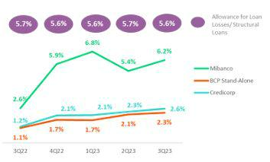
segments is more evident YoY than QoQ.

• Mortgage, due to an uptick in expected losses and to the aforementioned reclassification of a portfolio.

• Mibanco, where provisions remain high given the payment capacity of those clients that are overindebted and those who were affected by social conflicts or climate anomalies continued to be poor.

30

| Earnings Release 3Q / 2023 Analysis of 3Q23 Consolidated Results

05. Provisions

The aforementioned was offset by a drop in provisions for Wholesale Banking, which was positively impacted after some clients reported an improvement in their credit rating and resumed payments on delinquent loans.

As a result of the evolution of provisions, the structural CofR rose YoY and YTD by 134 bps and 130 bps, respectively.

Provisions and CofR in for Government Loans (GP)

GP Loan Portfolio Provisions |  | Quarter |  | % change |  | Up to |  | % change
S/ 000 | 3Q22 | 2Q23 | 3Q23 | QoQ | YoY | Sep 22 | Sep 23 | Sep 23 / Sep 22
Gross provision for credit losses on loan portfolio | (39,592) | (3,967) | (18,484) | 366.0% | -53.3% | (42,289) | (25,429) | -39.9%
Recoveries of written-off loans | - | - | - | - | - | 0 | 0 | -
Provision for credit losses on loan portfolio, net of recoveries | (39,592) | (3,967) | (18,484) | 366.0% | -53.3% | (42,289) | (25,429) | -39.9%
GP Cost of risk ⁽¹⁾ | 1.3% | 0.3% | 1.8% | 145 bps | 47 bps | 0.5% | 0.7% | 23 bps

(1). PG Cost of risk includes the Provisions for credit losses for the loan portfolio, net of recoveries and placements of the Reactiva Perú and FAE government programs.

Provisions for GP loans rose only slightly QoQ, YoY, and YTD given that ongoing honoring processes are underway to execute State guarantees.

The provisions balance for GP loans represents 1.4% of the total provisions balance at Credicorp. This relatively small balance reflects the extensive coverage offered by this type of loan, which ranges from 80% to 98%. For more information, see 1.2 Portfolio Quality – NPL Portfolio for Government Loans.

Provisions and CofR of Total Portfolio

Loan Portfolio Provisions |  |  | Quarter |  | % change |  | Up to |  | % change
S/ 000 |  | 3Q22 | 2Q23 | 3Q23 | QoQ | YoY | Sep 22 | Sep 23 | Sep 23 / Sep 22
Gross provision for credit losses on loan portfolio |  | (545,249)(886,123)(1,008,750) |  |  | 13.8% | 85.0% | (1,342,966)(2,696,980) |  | 100.8%
Recoveries of written-off loans |  | 85,273 | 81,872 | 91,108 | 11.3% | 6.8% | 262,109 | 248,089 | -5.3%
Provision for credit losses on loan portfolio, net of | recoveries | (459,976)(804,251) |  | (917,642) | 14.1% | 99.5% | (1,080,857)(2,448,891) |  | 126.6%
Cost of risk ⁽¹⁾ |  | 1.2% | 2.3% | 2.5%28 bps131 bps |  |  | 1.0% | 2.2% | 130 bps

(1). Provision for credit losses on loan portfolio, net of annualized recoveries / Total loans.

The CofR for the total portfolio, which is composed of structural and GP loans, reported growth of 28 bps QoQ, 131 bps YoY, and 171 bps YTD. Growth over these periods was driven by an uptick in provisions for structural loans.

QoQ Cost of Risk Evolution YoY Cost of Risk Evolution
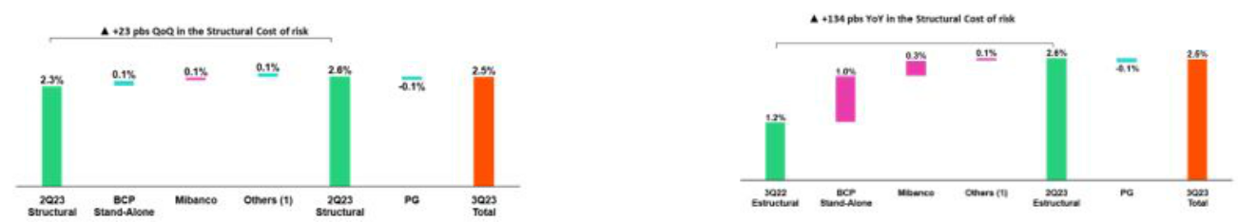

(1) Others include BCP Bolivia, Mibanco Colombia, ASB y eliminations. (1) Others include BCP Bolivia, Mibanco Colombia, ASB y eliminations

YTD Cost of Risk Evolution
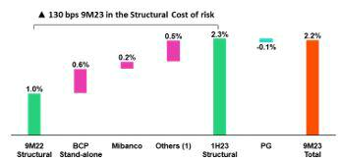

(1) Others include BCP Bolivia, Mibanco Colombia, ASB y eliminations

31

| Earnings Release 3Q / 2023 Analysis of 3Q23 Consolidated Results

06 Other Income


Other Core Income rose 1.1% QoQ and decreased -1.1% YoY. On accumulated basis, Other Core Income decreased 1.3%. If we excluded BCP Bolivia from the QoQ analysis, this line rose 1.7% driven by growth in banking fees via positive dynamics in fee income from credit cards, collection services and billing payments at BCP. These dynamics were partially offset by a reduction in the Gain on FX transactions, in context of lower client transactions. YoY, if we isolate the impact of BCP Bolivia, Other Core Income fell -1.2%, driven primarily by a decrease in fee income from Prima AFP, Credicorp Capital and BCP. This was partially offset by a 1.4% increase in the Gain on FX Transactions, which was fueled by Credicorp Capital. For the first nine months, excluding BCP Bolivia, Other Core Income fell 1.9%, driven by the same dynamics that drove the YoY evolution.

6.1. Other Core Income

Other Core Income |  | Quarter |  | % Change |  | As of |  | % Change
(S/ 000) | 3Q22 | 2Q23 | 3Q23 | QoQ | YoY | Sep 22 | Sep 23 | Sep 23/ Sep 22
Fee income | 934,984 | 960,550 | 975,955 | 1.6% | 4.4% | 2,747,562 | 2,818,286 | 2.6%
Net gain on foreign exchange transactions | 262,167 | 210,944 | 208,620 | -1.1% | -20.4% | 790,936 | 668,079 | -15.5%
Total other income Core | 1,197,151 | 1,171,494 | 1,184,575 | 1.1% | -1.1% | 3,538,498 | 3,486,365 | -1.5%

If we analyze the dynamic of Other Core Income, it is important to note that the Fee income and Net gain on FX transactions lines have been affected by our operation in BCP Bolivia, where we charge fees to FX clients to offset losses on buy-sell FX transactions.

QoQ, Total Other Income Core rose 1.1%, driven by an increase of 1.6% in fees and a drop of 1.1% in Net gain on FX transactions.

Excluding BCP Bolivia, Total Core Income rose 1.7%, which was driven by:

- The increase in Fee income (+2.9%), was driven primarily by BCP Peru. This dynamic will be discussed in the banking fees section.

- The aforementioned was partially offset by the Net gain on FX transactions, which decreased -2.6%

YoY, Total Other Income fell -1.1% due to a -20.4% reduction in the FX transactions volume, which was offset by an increase of 4.4% in Fee Income.

Excluding BCP Bolivia, Other Core Income fell -1.2%, driven by:

- A drop in Fee Income (-1.9%), associated with the dynamics in: (i) Prima AFP, due to an adjustment in the fee framework applicable to a significant share of affiliates (ii) Credicorp Capital primarily due to lower AUMs in the third-party fund distribution business. (within Asset Management); and (3) BCP, where the inter-city fee was eliminated in 1Q23.
- The above was partially offset by Net Gain on FX Transactions, which increased 1.4%, driven by Credicorp Capital.

YTD, excluding BCP Bolivia, Other Core income fell 1.9%, driven by the same dynamics that drove the YoY evolution.

Income for Banking Fees

Composition of fee income in the banking business

Banking Business Fees |  | Quarter |  | % Change |  | As of |  | % Change
S/ 000 | 3Q22 | 2Q23 | 3Q23 | QoQ | YoY | Sep 22 | Sep 23 | Sep 23/ Sep 23
Payments and transactionals ⁽¹⁾ | 328,202 | 344,632 | 366,111 | 6.2% | 11.6% | 923,349 | 1,085,140 | 17.5%
Liability accounts ⁽²⁾ | 237,873 | 182,018 | 178,224 | -2.1% | -25.1% | 689,866 | 538,214 | -22.0%
Loan Disbursement ⁽³⁾ | 100,721 | 91,599 | 89,916 | -1.8% | -10.7% | 283,255 | 276,716 | -2.3%
Off-balance sheet | 60,283 | 57,154 | 55,659 | -2.6% | -7.7% | 179,956 | 174,468 | -3.0%
Mibanco (Peru and Colombia) | 32,258 | 41,708 | 39,220 | -6.0% | 21.6% | 110,534 | 127,767 | 15.6%
Insurances | 31,382 | 30,540 | 32,960 | 7.9% | 5.0% | 90,508 | 94,602 | 4.5%
BCP Bolivia | 26,296 | 95,027 | 84,941 | -10.6% | 223.0% | 79,164 | 230,102 | 190.7%
Wealth Management and Corporate Finance | 15,593 | 16,878 | 16,428 | -2.7% | 5.4% | 52,504 | 48,560 | -7.5%
ASB | 10,422 | 10,560 | 10,153 | -3.9% | -2.6% | 30,248 | 30,500 | 0.8%
Others ⁽⁴⁾ | 13,850 | 15,318 | 16,803 | n.a | n.a | 31,104 | 45,020 | 44.7%
Total | 840,189 | 878,592 | 898,278 | 2.2% | 6.9% | 2,434,488 | 2,635,689 | 8.3%
- Corresponds to fees from: credit and debit cards; payments and collections.
- Corresponds to fees from: Account maintenance, interbank transfers, national money orders y international transfers.
- Corresponds to fees from retail and wholesale loan disbursements.
- Use of third-party network, other services to third parties and Commissions in foreign branches.

32

| Earnings Release 3Q / 2023 Analysis of 3Q23 Consolidated Results

06. Other Income

Banking fees rose 2.2% QoQ and 6.9% YoY. YTD at the end of September, total fees rose 8.3%.

Excluding BCP Bolivia from the variation analysis:

Total banking fees increased 3.8% QoQ, driven primarily by growth in Payment and Transactional at BCP, where growth in income from credit cards, collections services and bill payments stood out.

In the YoY analysis, total banking fees fell -0.1%, driven by the following dynamics:

- The positive evolution of Payments and Transactional at BCP, which experienced an uptick in income through credit cards, collection services and service payments.

- The reduction in the Liability Accounts and Transactional after inter-city fees were eliminated.

- The contraction in Loan Disbursement fees driven by lower income from foreign trade products.

In YTD analysis, banking fees rose 8.6%. This evolution was driven by the same factors as those seen in the YoY analysis.

6.2 Other Non-core income

Other Non-Core Income |  | Quarter |  | % change |  |  | As of |  |  | % change
(S/ 000) | 3Q22 | 2Q23 | 3Q23 | QoQ | YoY |  | Sep 22 | Sep 23 |  | Sep 23 / Sep 22
Net gain on securities | (25,460) | 68,603 | 53,591 | -21.9% | -310.5% |  | (176,507) | 192,230 |  | -208.9%
Net gain from associates ⁽¹⁾ | 25,806 | 23,689 | 32,056 | 35.3% | 24.2% |  | 79,039 | 82,957 |  | 5.0%
Net gain on derivatives held for trading | 53,008 | 16,671 | 38,545 | 131.2% | -27.3% |  | 59,330 | 48,646 |  | -18.0%
Net gain from exchange differences | (5,917) | 2,996 | 4,564 | 52.3% | -177.1% |  | (32,721) | 30,523 |  | -193.3%
Other non-financial income | 56,664 | 149,671 | 89,272 | -40.4% | 57.5% |  | 270,594 | 328,281 |  | 21.3%
Total other Non-Core Income | 104,101 | 261,630 | 218,028 | -16.7% | 109.4% |  | 199,735 | 682,637 |  | 241.8%
(1) Includes gains on other investments, which are mainly attributable to the Banmedica result.
QoQ Other Non-Core Income Evolution |  |  |  |  | YoY Other Non-Core Income Evolution
(Thousands of soles) |  |  |  |  |  | (Thousands of soles)
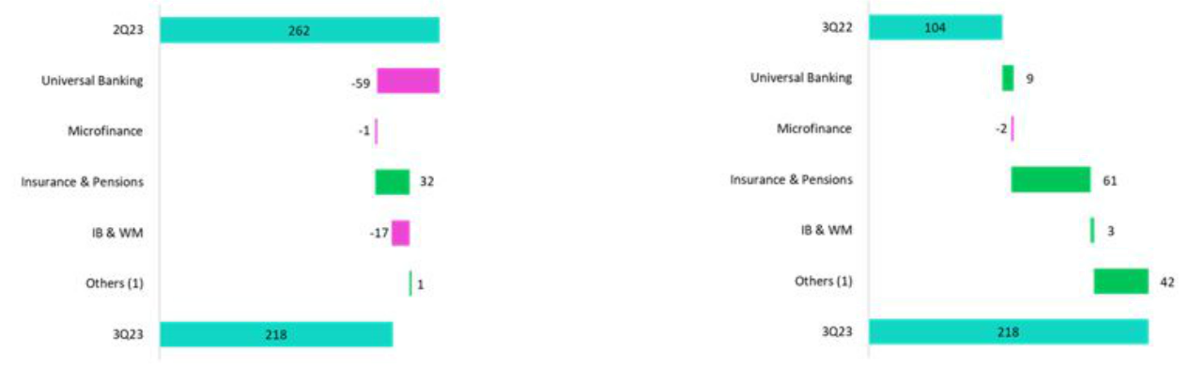

(1) Others includes: Grupo Crédito, Credicorp Individual, eliminations and others.

QoQ, Other Non-Core Income dropped. This evolution was driven mainly by the decrease in Other Non-Operating Income given that last quarter, gains were reported for a portfolio sale.

YoY, Other Non-Core Income rose. This result was primarily fueled by growth in the Net gain on securities in the Insurance and Pension business and was also impacted by an uptick in Other Non-Operating Income, which was associated with recognition of fees from previous periods.

YTD, the dynamic was similar to the YoY.

33

| Earnings Release 3Q / 2023 Analysis of 3Q23 Consolidated Results

07 Insurance Underwriting Results

The insurance underwriting result increased 11.6% QoQ due to uptick in the underwriting results in Life and Crediseguros. This evolution was driven primarily by a drop in total expenses for the Credit Life and Individual Life insurance products after IBNR-COVIDE reserves were released.

The insurance underwriting result rose 0.1% QoQ due to an improvement in the results for P&C. This evolution was mitigated by lower results in Life. P&C’s result rose due to the favorable evolution of P&C Risks and Medical

Insurance Underwriting Result |  |  | Quarter |  | Change % |  | As of |  | Change %
S/ millions |  | 3Q22 | 2Q23 | 3Q23 | QoQ | YoY | Sep 22 | Sep 23 | Sep23 / Sep22
 | Income from Insurance Services | 885.5 | 945.9 | 923.7 | -2.3% | 4.3% | 2,558.7 | 2,823.5 | 10.3%
Total | Expenses for Insurance Services | (496.4) | (550.4) | (505.4) | -8.2% | 1.8% | (1,540.8) | (1,601.0) | 3.9%
Total | Reinsurance Results | (85.3) | (98.9) | (87.4) | -11.7% | 2.4% | (313.2) | (298.7) | -4.6%
 | Insurance Undewrwriting Result | 303.8 | 296.6 | 330.9 | 11.6% | 8.9% | 704.6 | 923.8 | 31.1%
 | Income from Insurance Services | 397.4 | 427.0 | 404.6 | -5.2% | 1.8% | 1,232.1 | 1,244.9 | 1.0%
P&C | Expenses for Insurance Services | (241.2) | (274.1) | (256.2) | -6.6% | 6.2% | (698.5) | (816.4) | 16.9%
P&C | Reinsurance Results | (76.9) | (69.2) | (64.3) | -7.1% | -16.4% | (306.2) | (214.8) | -29.8%
 | Insurance Undewrwriting Result | 79.3 | 83.6 | 84.2 | 0.7% | 6.1% | 227.4 | 213.8 | -6.0%
 | Income from Insurance Services | 480.1 | 491.4 | 487.1 | -0.9% | 1.5% | 1,285.0 | 1,498.3 | 16.6%
Life | Expenses for Insurance Services | (254.3) | (270.7) | (243.3) | -10.1% | -4.4% | (839.8) | (771.2) | -8.2%
Life | Reinsurance Results | (14.0) | (24.0) | (17.3) | -27.9% | 23.1% | (6.9) | (68.4) | 890.9%
 | Insurance Undewrwriting Result | 211.8 | 196.8 | 226.6 | 15.1% | 7.0% | 438.2 | 658.7 | 50.3%
 | Income from Insurance Services | 18.9 | 29.6 | 33.9 | 14.6% | 79.5% | 54.7 | 86.5 | 58.2%
Crediseguros | Expenses for Insurance Services | (4.6) | (10.2) | (11.3) | 10.1% | 142.5% | (14.6) | (27.7) | 90.4%
 | Reinsurance Results | (5.0) | (7.6) | (7.6) | 0.6% | 52.8% | (13.3) | (20.9) | 57.6%
 | Insurance Undewrwriting Result | 9.2 | 11.8 | 15.0 | 27.6% | 62.3% | 26.8 | 37.9 | 41.1%

In the QoQ analysis, the Insurance Underwriting Result rose 11.6%. This evolution reflected an -8.2% reduction in service expenses, which was driven primarily by Life and P & C, and a more favorable Reinsurance result (-11.7%). This was partially attenuated by a reduction in income for insurance services, which was reported in both P&C and Life.

In the YoY analysis, the Insurance Underwriting Result increased by 8.9% due to an uptick in income for insurance services in Crediseguros, Life and P & C. This evolution was partially attenuated by higher expenses for insurance services in P & C.

YTD, the Underwriting Insurance Result rose 31.1%. This improvement is mainly attributable to an increase in income from insurance services (+10.3%) which was primarily driven by Life and Crediseguros- and was partially offset by an increase in expenses for insurance services (+3.9%), which was fueled mainly by P & C.

P & C

Income for Insurance Services Expenses for Insurance Services
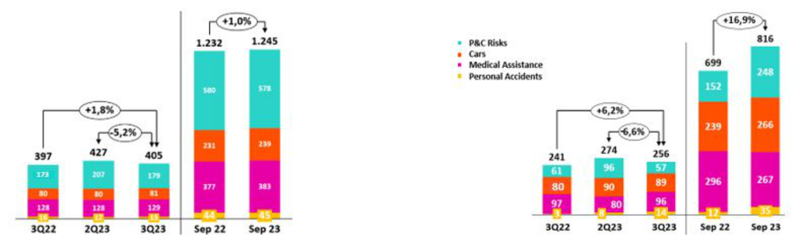

QoQ, the Insurance Underwriting Result rose 0.7%, driven by the following dynamics:

- Insurance income fell 5.2%, which was primarily attributable to a reduction in the premium level in P & C.

- Insurance service expenses fell 6.6% due to a drop in claims in P & C.

- The reinsurance result dropped 7.1%, driven by a reduction in ceded premiums.

34

| Earnings Release 3Q / 2023 Analysis of 3Q23 Consolidated Results

07. Insurance Underwriting Results

YoY, the Insurance Underwriting Result rose 6.1% due to the following dynamics:

- Income from insurance services rose 1.8% YoY, fueled mainly by growth in premiums in P & C, Cars and Medical Assistance.

- Expenses for life insurance services increased 6.2% YoY, which was primarily driven by (i) Cars, due to an increase in claims frequency; and (ii) P & C, where the credit card protection line was impacted by an uptick in unrecognized internet purchases.

- The reinsurance result dropped 16.4% in P & C after more reinsurance claims related to Cyclone Yaku were recovered.

YTD, the Insurance Underwriting Result fell 6.0%. This evolution was mainly driven by lower results for Personal Accidents and Cars. Life Insurance

Income for Insurance Services Expenses for Insurance Services
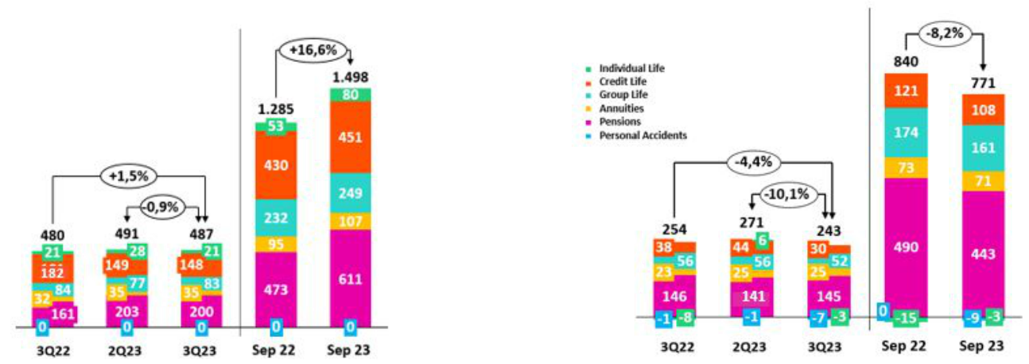

QoQ, the Insurance Underwriting result rose 15.1%. The following dynamics stood out:

- Income from insurance services dropped 0.9% due to (i) Individual Life, which reported a reduction in sales, (ii) Pensions, due to a decrease in the premium level in SISCO V. This was partially offset by an uptick in income in Group Life.

- Expenses for insurance services fell 10.1%, which was driven primarily by Credit Life and Individual Life via releases of IBNR COVID.

- The loss recovered for the insurance result fell 27.9%, which reflects an uptick in recoveries on reinsurance claims and a drop in ceded premiums through Pensions.

YoY, the Insurance Underwriting Result rose 7.0%. The following dynamics were noteworthy:

- Income from insurance services rose 1.5%. This growth was driven primarily by Pensions and reflects positive movements in both prices and the size of the tranche awarded under SISCO VI in comparison to the conditions obtained under SISCO V.

- Insurance expenses fell 4.4% YoY and 8.2% YTD, which was fueled mainly by the evolution in Pensions, Credit Life and Group Life, which reported a reduction in claims in comparison to periods affected by COVID-19.

- The loss on reinsurance increased 23.1%.

YTD, the Insurance Underwriting Result increased by 50.3%, driven primarily by better results in Pensions and Credit Life.

35

| Earnings Release 3Q / 2023 Analysis of 3Q23 Consolidated Results

08 Operating Expenses


Operating expenses rose YTD, driven primarily by core businesses at BCP and disruptive initiatives at the Credicorp level. At BCP, core businesses fueled growth in expenses through an uptick in IT expenses related to: (i) increased use of the Cloud as clients become more digital; (ii) investments to enhance digital capacities and improve cybersecurity; and (iii) moves to attract more specialized Digital talent. Expenses for disruptive initiatives at the Credicorp level increased 64.3% as some of these initiatives have scaled up. If we exclude expenses for disruption, YTD growth in Operating Expenses stands at 7.5%.

Total Operating Expenses

Operating expenses |  | Quarter |  | % change |  | As of |  | % change
S/ 000 | 3Q22 | 2Q23 | 3Q23 | QoQ | YoY | Sep 22 | Sep 23 | Sep 23 / Sep 22
Salaries and employees benefits | 984,336 | 1,054,735 | 1,061,402 | 0.6% | 7.8% | 2,866,013 | 3,145,695 | 9.8%
Administrative, general and tax expenses | 869,873 | 871,046 | 1,007,894 | 15.7% | 15.9% | 2,385,038 | 2,714,000 | 13.8%
Depreciation and amortization | 162,009 | 160,549 | 159,761 | -0.5% | -1.4% | 470,795 | 481,389 | 2.3%
Association in participation | 9,999 | 16,742 | 14,634 | -12.6% | 46.4% | 28,019 | 43,988 | 57.0%
Operating expenses | 2,026,217 | 2,103,072 | 2,243,691 | 6.7% | 10.7% | 5,749,865 | 6,385,072 | 11.0%

To analyze expenses, we will focus on YTD movements to eliminate the impact of seasonality between quarters.

Operating expenses remain high due to:

- Growth in Administrative and general expenses and taxes, which was driven mainly by BCP via an uptick in IT expenses associated with the transformation strategy; disruption expenses; and advertising and marketing.

- An increase in Employee salaries and benefits, which was driven primarily by an increase in the head count in core businesses and growth in the number of hires and the salary level of IT specialists, both at BCP.

The uptick in operating expenses YTD stood at 11.0% If we exclude disruptive expenses, operating expenses indicate growth of 7.5% YTD.

Administrative and general expenses

Administrative general, and tax expenses |  | Quarter |  | % change |  | As of |  | % change
S/000 | 3Q22 | 2Q23 | 3Q23 | QoQ | YoY | Sep 22 | Sep 23 | Sep 23 / Sep 22
IT expenses and IT third-party services | 240,603 | 256,348 | 271,304 | 5.8% | 12.8% | 645,517 | 768,584 | 19.1%
Advertising and customer loyalty programs | 173,517 | 174,021 | 171,902 | -1.2% | -0.9% | 439,880 | 481,690 | 9.5%
Taxes and contributions | 45,461 | 20,557 | 65,606 | 219.1% | 44.3% | 186,100 | 171,236 | -8.0%
Audit Services, Consulting and professional fees | 73,297 | 67,017 | 112,480 | 67.8% | 53.5% | 194,229 | 231,375 | 19.1%
Transport and communications | 73,494 | 57,437 | 57,518 | 0.1% | -21.7% | 161,510 | 165,991 | 2.8%
Repair and maintenance | 30,940 | 37,555 | 44,084 | 17.4% | 42.5% | 100,026 | 107,429 | 7.4%
Agents’ Fees | 25,574 | 27,747 | 29,310 | 5.6% | 14.6% | 78,683 | 83,209 | 5.8%
Services by third-party | 36,327 | 27,661 | 45,426 | 64.2% | 25.0% | 77,873 | 100,598 | 29.2%
Leases of low value and short-term | 24,171 | 25,282 | 27,754 | 9.8% | 14.8% | 67,712 | 78,152 | 15.4%
Miscellaneous supplies | 25,266 | 27,837 | 27,091 | -2.7% | 7.2% | 64,999 | 87,921 | 35.3%
Security and protection | 16,841 | 16,004 | 16,064 | 0.4% | -4.6% | 48,115 | 47,857 | -0.5%
Subscriptions and quotes | 13,703 | 16,024 | 14,391 | -10.2% | 5.0% | 41,592 | 43,501 | 4.6%
Electricity and water | 11,742 | 14,954 | 13,592 | -9.1% | 15.8% | 35,718 | 40,043 | 12.1%
Electronic processing | 7,770 | 9,791 | 9,959 | 1.7% | 28.2% | 23,671 | 28,480 | 20.3%
Insurance | 39,524 | 5,022 | 38,034 | 657.3% | -3.8% | 54,365 | 51,806 | -4.7%
Cleaning | 5,358 | 5,463 | 5,930 | 8.5% | 10.7% | 15,067 | 16,555 | 9.9%
Others ⁽¹⁾ | 26,285 | 82,326 | 57,449 | -30.2% | 118.6% | 149,981 | 209,573 | 39.7%
Total | 869,873 | 871,046 | 1,007,894 | 15.7% | 15.9% | 2,385,038 | 2,714,000 | 13.8%

Administrative and general expenses reported growth of 13.8% YTD at the end of September 2023. This uptick was driven primarily by core businesses and disruptive initiatives, mainly via expenses in the IT and marketing lines.

36

| Earnings Release 3Q / 2023 Analysis of 3Q23 Consolidated Results

08. Operating Expenses

Operating expenses for Core and Disruption ⁽¹⁾
Operating Expenses |  | Quarter |  | % change |  | As of |  | % change
S/ (000) | 3Q22 | 2Q23 | 3Q23 | QoQ | YoY | Sep 22 | Sep 23 | Sep 23 / Sep 22
Core Business BCP | 1,172,951 | 1,195,522 | 1,245,767 | 4.2% | 6.2% | 3,337,154 | 3,591,792 | 7.6%
Core Business Mibanco | 287,215 | 300,220 | 302,729 | 0.8% | 5.4% | 854,115 | 900,728 | 5.5%
Core Business Pacifico | 59,968 | 72,708 | 79,355 | 9.1% | 32.3% | 180,682 | 216,331 | 19.7%
Disruption ⁽³⁾ | 142,322 | 186,994 | 222,207 | 18.8% | 56.1% | 361,813 | 594,396 | 64.3%
Others ⁽²⁾ | 363,760 | 347,627 | 393,633 | 13.2% | 8.2% | 1,016,100 | 1,081,825 | 6.5%
Total | 2,026,217 | 2,103,072 | 2,243,691 | 6.7% | 10.7% | 5,749,864 | 6,385,072 | 11.0%
- Management figures.
- Includes disruptive initiatives at the subsidiaries and Krealo.
- Includes Credicorp Capital, ASB, Prima, BCP Bolivia, Mibanco Colombia, and other entities within the Group.

The 11.0% increase in operating expenses at Credicorp can be broken down as follows: 40.1% are attributable to BCP core and 34.0% to our disruptive initiatives.

BCP reported a 7.6% increase in expenses YTD, which can be broken down into two categories: technology expenses and Core business expenses excluding technology.

- Technology Expenses (IT)

  - In line with the upward trend in volumes of monetary and non-monetary transactions among increasingly digitalized clients, expenses for the use of cloud servers have grown.

  - Additionally, the bank has made significant investments in new capabilities.

  - More digital experts have been hired and their average salaries have also risen.

- Core business expenses excluding IT

  - Expenses for marketing and advertising rose to attract more deposits and drive sales of digital products.

  - More specialized personnel were hired for strategic projects.

Growth in disruptive expenses stood at 59.8% YTD and represented 9.1% of total expenses as of the end of September 2023. These expenses were associated with investment in talent to develop functionalities for initiatives such as Yape, IO, Culqui, Tenpo to strengthen our competitive moats in the long-term.

37

| Earnings Release 3Q / 2023 Analysis of 3Q23 Consolidated Results

09 Operating Efficiency

The efficiency ratio improved 160 bps YTD. This evolution was driven by an uptick in core income, which was fueled by growth in net interest income at BCP, via all of Retail Banking’s segments and loan growth at Mibanco. If we exclude disruptive expenses, the efficiency ratio stands at 40.9%.

Operating efficiency |  | Quarter |  | % change |  | As of |  | % change
S/000 |  | Quarter |  |  |  |  |  | % change
S/000 | 3Q22 | 2Q23 | 3Q23 | QoQ | YoY | Sep 22 | Sep 23 | Sep 23 / Sep 22
Operating expenses ⁽¹⁾ | 2,026,217 | 2,103,072 | 2,243,691 | 6.7% | 10.7% | 5,749,865 | 6,385,072 | 11.0%
Operating income ⁽²⁾ | 4,456,209 | 4,715,570 | 4,844,683 | 2.7% | 8.7% | 12,299,984 | 14,162,584 | 15.1%
Efficiency ratio ⁽³⁾ | 45.5% | 44.6% | 46.3% | 170 pbs | 80 bps | 46.7% | 45.1% | -160 pbs
Operating income has been re-expressed with regard to previous reports to reflect the application of IFRS 17. This standard applies solely to the Insurance Business. For more details, review annex 12.1.8.

- Operating expenses = Salaries and employees benefits + Administrative expenses + Depreciation and amortization + Association in participation + Acquisition cost.
- Operating income = Net interest, similar income, and expenses + Fee income + Net gain on foreign exchange transactions + Net gain from associates + Net gain on derivatives held for trading + Net gain from exchange differences + Net Insurance Underwriting Results.
- Operating expenses / Operating income (under IFRS 17).

Efficiency ratio reported by subsidiary

Efficiency Ratio |  | Quarter |  | % change |  |  | As of | % change
Efficiency Ratio | 3Q22 | 2Q23 | 3Q23 | QoQ | YoY | Sep 22 | Sep 23 | Sep 23 / Sep 22
BCP | 38.8% | 37.3% | 39.2% | 190 pbs | 40 pbs | 40.3% | 37.8% | -250 pbs
BCP Bolivia | 61.3% | 60.7% | 65.3% | 460 pbs | 400 pbs | 59.7% | 62.1% | 240 pbs
Mibanco Perú | 49.6% | 52.4% | 51.4% | -100 pbs | 180 pbs | 50.9% | 52.6% | 170 pbs
Mibanco Colombia | 80.3% | 88.8% | 86.0% | -280 pbs | 570 pbs | 78.3% | 89.1% | 1080 pbs
Pacífico | 24.2% | 26.3% | 24.7% | -160 pbs | 50 pbs | 29.4% | 24.2% | -520 pbs
Prima AFP | 50.2% | 49.8% | 51.6% | 180 pbs | 140 pbs | 52.4% | 50.3% | -210 pbs
Credicorp | 45.5% | 44.6% | 46.3% | 170 pbs | 80 pbs | 46.7% | 45.1% | -160 pbs

Our analysis will focus on YTD movements to eliminate seasonality between quarters.

The efficiency ratio improved, which was driven primarily by growth in core income at BCP via an increase in the structural loan volume and secondarily by an uptick in the Insurance Underwriting Result at Pacifico.

If we exclude expenses related to disruptive initiatives at the Credicorp level, the YTD efficiency ratio at the end of September 2023 stands at 40.9%.

38

| Earnings Release 3Q / 2023 Analysis of 3Q23 Consolidated Results

10 Regulatory Capital


Regulatory Capital at Credicorp was 1.44 times than the minimum requirement for Regulatory Capital.

The IFRS CET1 ratio at BCP Stand-alone increased 121 bps YoY to stand at 13.0%, which reflected the uptick reported in the YTD and Year-end Results (+21.9%) as well as a reduction in Unrealized Losses (-70.6%).

The IRFS CET1 Ratio at Mibanco rose 157 bps YoY to stand at 17.56%. A drop in RWAs (-1.6%) and an increase in YTD and Year- end results (+133.8%) drove this dynamic.

10.1 Regulatory Capital

Credicorp’s Regulatory Capital level stood at 1.44 at the end of 3Q23. In the QoQ analysis, the ratio dropped 2 bps. This evolution was driven by an increase in the regulatory capital requirement, which was partially offset by an uptick the Subordinated Debt balance. Both lines were affected by a higher exchange rate.

Figures in millions S/.
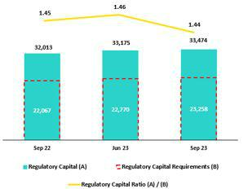

In the YoY analysis, the Regulatory Capital Ratio dropped 1bps due to an increase in the regulatory capital volume for portfolios at BCP Stand-alone and Mibanco. This growth was partially offset by an uptick in Discretinary and Restricted Reserves.

Analysis of Capital at the Subsidiaries

Under the current local regulation, which has been in effect since January 2023, three regulatory ratios exist: Common Equity Tier 1 (CET 1), Tier 1 Capital and Global Capital. For all effective purposes, Tier 1 Capital is equal to CET 1 Ratio in Credicorp’s case given that we possess no subordinated Tier 1 debt. Additionally, as has been our practice over the last few years, we use the IFRS CET 1 ratio, which differs slightly from CET 1 ratio (calculated under local accounting) primarily in the lines of Provisions and Unrealized Loss accounts. Accordingly, our analysis focuses solely on IFRS CET 1.

10.2 Analysis of Capital at BCP Stand-alone

At the end of 3Q23, BCP IFRS CET 1 ratio reported growth of 25 bps QoQ to stand at 13.04% at the end of 3Q23. This evolution was driven by an uptick in YTD and Year-end Results and was partially offset by growth in balance for Unrealized Losses. RWA levels increased 2.7%, fueled by growth in BCP’s loan portfolio. YoY, BCP IFRS CET 1 ratio increased 121 bps, driven by (i) higher YTD and Year-end results and (ii) a drop in balance for Unrealized Losses.
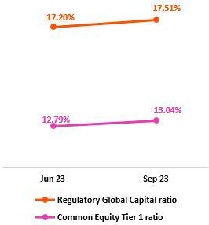

Finally, under the parameters of current regulation, the Global Capital Ratio at BCP Stand-alone stood at 17.51% (+31 bps QoQ). The uptick in this ratio was due primarily to (i) an uptick in YTD and Year-end Results and (ii) an increase in the balance for Subordinated Debt, which was fueled by a higher exchange rate. This was partially offset by growth in Credit Risk-Weighted Assets, which was driven by loan growth at BCP and by a higher exchange rate.

39

| Earnings Release 3Q / 2023 Analysis of 3Q23 Consolidated Results

10. Regulatory Capital

10.3 Analysis of Capital at Mibanco

At the end of 3Q23, Mibanco IFRS CET 1 ratio rose 96 bps to stand at 17.56%. This rise was primarily driven by a drop in RWAs associated with credit risk and operating risk. Growth in YTD and Year-end results also contributed to the uptick in IFRS CET 1. This was partially offset by an uptick in balance for Unrealized Losses. YoY, this ratio rose 157 bps to stand at 19.75%, due to a drop in the RWA level; growth in YTD and Year-end Results; and a reduction in Unrealized Losses.
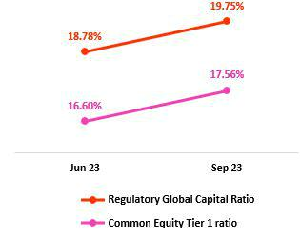

Under the new regulation, the Global Capital Ratio at Mibanco stood at 19.75% (+97 bps QoQ). This variation was driven by the same dynamics as those that drove the evolution of the CET 1 Ratio.

40

| Earnings Release 3Q / 2023 Analysis of 3Q23 Consolidated Results

11 Economic Outlook


In 3Q23, the Peruvian economy is expected to have contracted around 0.9% YoY (-0.5% YoY in 2Q23), accumulating its third consecutive quarter of YoY decline. Non-primary sectors fell 1.6%, due to lower domestic demand, where the fall in the construction (-9.0% YoY), non-primary manufacturing (-8.5% YoY) and services sectors (-0.4% YoY) stands out. While primary sectors grew 3.0% due to the favorable performance of the mining sector (+11.1% YoY). This offset the decline in the agricultural (-3.1% YoY), fishing (-28.9% YoY) and primary manufacturing (-2.3% YoY) sectors due to the El Niño Costero, which reached a strong intensity this quarter.

The annual inflation rate continued to decelerate, closing the quarter at 5.0% YoY (6.5% YoY in 2Q23). Real GDP, in turn, is expected to register no or slightly negative growth this year.

According to BCRP, the exchange rate closed at USDPEN 3.792 in 3Q23, which represents an appreciation of 4.6% compared to the print at the end of 2Q23 and 4.8% compared to the figure registered one year ago.

Peru: Economic Forecast

Peru | 2018 | 2019 | 2020 | 2021 | 2022 | 2023 ⁽³⁾
GDP (US$ Millions) | 226,919 | 232,519 | 205,755 | 225,803 | 244,789 | 267,500
Real GDP (% change) | 4.0 | 2.2 | -11.0 | 13.3 | 2.7 | 0.0
GDP per capita (US$) | 7,190 | 7,237 | 6,306 | 6,835 | 7,330 | 7,894
Domestic demand (% change) | 4.1 | 2.2 | -9.8 | 14.5 | 2.3 | -2.0
Gross fixed investment (as % GDP) | 22.2 | 22.5 | 21.0 | 25.1 | 25.3 | 23.9
Financial system loan without Reactiva (% change) (1) | 10.3 | 6.4 | -4.3 | 12.6 | 9.7 | 2.6
Inflation, end of period(2) | 2.2 | 1.9 | 2.0 | 6.4 | 8.5 | 4.0
Reference Rate, end of period | 2.75 | 2.25 | 0.25 | 2.50 | 7.50 | 6.75
Exchange rate, end of period | 3.37 | 3.31 | 3.62 | 3.99 | 3.81 | 3.80
Exchange rate, (% change) | 4.0% | -1.8% | 9.3% | 10.3% | -4.5% | -0.3%
Fiscal balance (% GDP) | (2.3) | (1.6) | (8.9) | (2.5) | (1.7) | (3.0)
Public Debt (as % GDP) | 25.6 | 26.6 | 34.6 | 35.9 | 33.8 | 34.0
Trade balance (US$ Millions) | 7,201 | 6,879 | 8,102 | 14,977 | 10,333 | 15,400
(As % GDP) | 3.2% | 3.0% | 3.9% | 6.6% | 4.2% | 5.8%
Exports | 49,066 | 47,980 | 42,826 | 62,967 | 66,235 | 65,000
Imports | 41,866 | 41,101 | 34,724 | 47,990 | 55,902 | 49,600
Current account balance (As % GDP) | -1.2% | -0.6% | 1.1% | -2.2% | -4.0% | -1.0%
Net international reserves (US$ Millions) | 60,121 | 68,316 | 74,707 | 78,495 | 71,883 | 74,000
(As % GDP) | 26.5% | 29.4% | 36.3% | 34.8% | 29.4% | 27.7%
(As months of imports) | 17 | 20 | 26 | 20 | 15 | 18

Sources: INEI, BCRP y SBS.
- Financial System, Current Exchange Rate
- Inflation target: 1% - 3%
- Grey area indicate estimates by BCP Economic Research as of october 2023

41

| Earnings Release 3Q / 2023 Analysis of 3Q23 Consolidated Results

11. Economic Outlook

Main Macroeconomic Variables

Gross Domestic Product

(Annual Real Variations, % YoY)
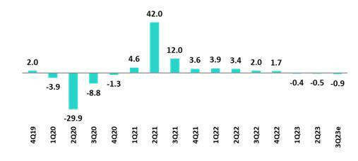

Source: BCRP

Estimate: BCP

In 3Q23, Peruvian economy is expected to have contracted 0.9% YoY, its third consecutive quarterly decline. The economic activity gauge fell 1.3% YoY in July and 0.6% YoY in August.

In the first eight months of the year, GDP fell 0.6% YoY. The primary sectors grew 3.0% YoY due to the favorable performance of the mining sector (11.1% YoY), which has offset the decline in the agricultural (-3.1% YoY), fishing (-28.9% YoY) and primary manufacturing (-2.3% YoY) sectors. Regarding the non-primary sectors, the 1.6% YoY contraction is attributable to weak domestic demand, where the negative prints for the construction sector (-9.0% YoY), non-primary manufacturing (-8.5% YoY) and services (-0.4% YoY) stand out.

According to the multisectoral committee in charge of the study of the El Niño phenomenon in Perú (ENFEN for its acronym in Spanish), the “El Niño Costero”, which has been developing since March, reached a “Strong” intensity in 3Q23 and considerably affected the fishing, agricultural and primary manufacturing sectors as well as textile production for the domestic market. YTD, these sectors have reported their worst accumulated performance in more than two decades. The expectation that “El Niño Costero” will continue until 1Q24 more than likely led agents to exercise greater caution with regard to private consumption and investment decisions, which were already affected by an environment of on-going food inflation; political uncertainty; and a slow normalization process after the post-pandemic rebound.

Annual Inflation and Central Bank Reference Rate

(%)
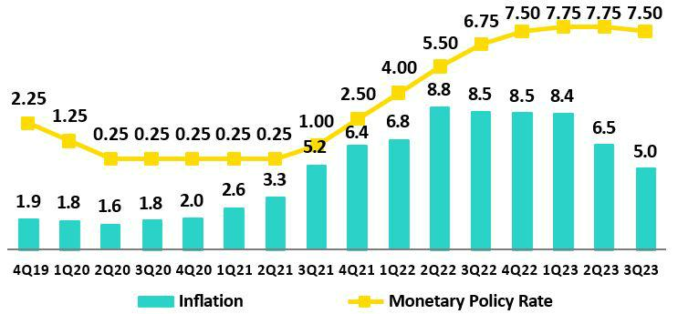

Source: BCRP and INEI

42

| Earnings Release 3Q / 2023 Analysis of 3Q23 Consolidated Results

11. Economic Outlook

Inflation measured using the Consumer Price index of Metropolitan Lima closed 3Q23 at 5.0% YoY, its lowest level since August 2021, after remaining above or close to 8.0% YoY between April 2022 and May 2023 (peak of 8.8% YoY in June 2022, highest in 26 years). In September 2023, monthly inflation rose 0.02%, the second lowest print of the year (June 2023: -0.15%); this evolution was mainly attributable to a drop in inflation for food and beverages. In the same period, core inflation (excluding food and energy) slowed to 3.6% YoY, an 18-month low.

After having maintained the rate at an all-time high of 7.75% since January, the Central Reserve Bank of Peru (BCRP) cut its monetary policy rate 25 basis points to 7.50% in September 2023. In October, the rate was cut to 7.25%.

Fiscal Balance and Current Account Balance

(% of GDP, Quarter)

The annualized fiscal deficit in the last 12 months to September 2023 rose to 2.8% of GDP. In 3Q23 tax revenues fell 10.5% YoY (revenues from income tax and sales tax fell 7.0% and 10.6%, respectively) while non-financial spending dropped 3.0% over the same period, dragged down by a 12.6% contraction in capital spending, which was driven primarily by local governments (current spending: +0.4% YoY).
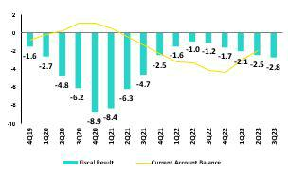

In 3Q23, there were no changes to Peru’s sovereign debt credit rating (Moody’s: Baa1, Fitch and Standard & Poor´s: BBB, all of them with negative outlook).

Regarding external accounts, the current account deficit fell from 2.9% of GDP in 1Q23 to 1.9% of GDP in 2Q23 (in cumulative terms for the last 4 quarters).

The 12-month accumulated trade balance surplus to August 2023 rose to USD 14.6 billion, which although higher than the USD 13.0 billion registered in June, was still far from the record high of USD 16.1 billion reached in March 2022. In the same period, exports fell 4.1% YoY to USD 65.3 billion, driven by a drop in prices but partially offset by higher volumes. Imports fell 7.2% YoY to USD 50.7 billion due to weak domestic demand.

Terms of trade grew 5.2% YoY in August 2023, which reflected the fact that the reduction registered for import prices (-8.3% YoY) outpaced the drop registered in export prices, which fell 3.5% YoY (due to lower prices for copper, zinc and hydrocarbons). In August, terms of trade rose 2.6% compared to the end of 2022.

Exchange Rate

(PEN per USD)

According to BCRP, the exchange rate closed 3Q23 at USDPEN 3.79, depreciation of 4.6% compared to the end of 2Q23 and an appreciation of 4.8% compared to a year ago. In July, the exchange rate appreciated to USDPEN 3.56, the lowest level since September 2020. Towards the end of 3Q23, with the exchange rate around USDPEN 3.80, the BCRP intervened, for the second time in the year, in the spot market selling USD 13 million.
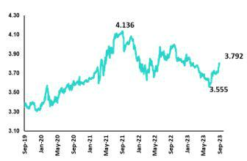

In the same period, Latam main currencies also depreciated compared to the previous quarter due to the strengthening of the global dollar. The Chilean peso weakened 11.3%, the Brazilian real 5.1% and the Mexican peso 1.7%. On the other hand, the Colombian peso, slightly appreciated 2.3%.

Net international reserves closed 3Q23 at USD 71.2 billion, below

2Q23’s level (USD 72.9 billion).

43

| Earnings Release 3Q / 2023 Analysis of 3Q23 Consolidated Results

Safe Harbor for Forward-Looking Statements

This material includes “forward-looking statements” within the meaning of Section 27A of the U.S. Securities Act of 1933 and Section 21E of the U.S. Securities Exchange Act of 1934. All statements other than statements of historical fact are forward-looking and may contain information about financial results, economic conditions, trends and known uncertainties. Forward-looking statements are not assurances of future performance. Instead, they are based only on our management’s current views, beliefs, expectations and assumptions regarding the future of our business, future plans and strategies, projections, anticipated events and trends, the economy and other future conditions.

Many forward-looking statements can be identified by words such as: “anticipate”, “intend”, “plan”, “goal”, “seek”, “believe”, “project”, “estimate”, “expect”, “strategy”, “future”, “likely”, “would”, “may”, “should”, “will”, “see” and similar references to future periods. Examples of forward-looking statements include, among others, statements or estimates we make regarding guidance relating to losses in our credit portfolio, efficiency ratio, provisions and non-performing loans, current or future market risk and future market conditions, expected macroeconomic events and conditions, our belief that we have sufficient capital and liquidity to fund our business operations, expectations of the effect on our financial condition of claims, legal actions, environmental costs, contingent liabilities and governmental and regulatory investigations and proceedings, strategy for customer retention, growth, governmental programs and regulatory initiatives, credit administration, product development, market position, financial results and reserves and strategy for risk management.

We caution readers that forward-looking statements involve known and unknown risks and uncertainties that could cause actual results, performance, or events to differ materially from those that we expect or that are expressed or implied in the forward-looking statements, depending on the outcome of certain factors, including, without limitation, adverse changes in:

- The occurrence of natural disasters or political or social instability in Peru;

- The adequacy of the dividends that our subsidiaries are able to pay to us, which may affect our ability to pay dividends to shareholders and corporate expenses;

- Performance of, and volatility in, financial markets, including Latin-American and other markets;

- The frequency, severity and types of insured loss events;

- Fluctuations in interest rate levels;

- Foreign currency exchange rates, including the Sol/US Dollar exchange rate;

- Deterioration in the quality of our loan portfolio;

- Increasing levels of competition in Peru and other markets in which we operate;

- Developments and changes in laws and regulations affecting the financial sector and adoption of new international guidelines;

- Changes in the policies of central banks and/or foreign governments;

- Effectiveness of our risk management policies and of our operational and security systems;

- Losses associated with counterparty exposures;

- The scope of the coronavirus (“COVID-19”) outbreak, actions taken to contain the COVID-19 and related economic effects from such actions and our ability to maintain adequate staffing; and

- Changes in Bermuda laws and regulations applicable to so-called non-resident entities.

See “Item 3. Key Information—3. D Risk Factors” and “Item 5. Operating and Financial Review and Prospects” in our most recent Annual Report on Form 20-F filed with the U.S. Securities and Exchange Commission for additional information and other such factors. You are cautioned not to place undue reliance on these forward-looking statements, which speak only as of the date hereof and are based only on information currently available to us. Therefore, you should not rely on any of these forward-looking statements.

We undertake no obligation to publicly update or revise these or any other forward-looking statements that may be made to reflect events or circumstances after the date hereof, whether as a result of changes in our business strategy or new information, to reflect the occurrence of unanticipated events or otherwise.

44

 | | Earnings Release 3Q / 2023 | Analysis of 3Q23 Consolidated Results
12 | Appendix
12.1. | Implementation of IFRS 17 – Restatement of figures and ratios for 2022 |  | 46
12.1.1. Introduction to the new standards IFRS 17 |  |  | 46
12.1.2. Conceptual Framework |  |  | 46
12.1.3. Recognition of Profit and Loss |  |  | 46
12.1.4. Valuation Methods |  |  | 46
12.1.5. Impact on Equity Under IFRS 17 |  |  | 47
12.1.6. Reformulation of Profit and Loss Statement at Pacífico Grupo Asegurador for year 2022 |  |  | 47
12.1.7. Reformulation of Credicorp’s Profit and Loss Statement for year 2022 |  |  | 48
12.1.8. Changes in the Methodology to Calculate Financial Indicators and their Reformulation for the year 2022 |  |  | 48
12.1.9. Glossary of Terms Under IFRS 17 |  |  | 51
12.2. | Physical Point of contact |  | 51
12.3. | Loan Portfolio Quality |  | 51
12.4 Net Interest Income (NII) |  |  | 56
12.5. | Regulatory Capital |  | 57
12.6. | Financial Statements and Ratios by Business |  | 61
12.6.1. Credicorp Consolidated |  |  | 61
12.6.2. Credicorp Stand-alone |  |  | 63
12.6.4. BCP Stand-alone |  |  | 64
12.6.5. BCP Bolivia |  |  | 66
12.6.6. Mibanco |  |  | 67
12.6.7. Prima AFP |  |  | 68
12.6.8. Grupo Pacifico |  |  | 69
12.7. | Table of calculations |  | 72
12.8. | Glossary of terms |  | 73
 |  |  | 45

| Earnings Release 3Q / 2023 Analysis of 3Q23 Consolidated Results

12. Appendix

12.1. Implementation of IFRS 17 – Restatement of figures and ratios for 2022

12.1.1. Introduction to the new standards IFRS 17

IFRS 17 was published in May 2017 as a replacement to IFRS 4 “Insurance Contracts.” The aim of this change is to ensure that consistent measurement criteria are applied to improve transparency and the comparability of Financial Statements. The new standard became effective in January 2023.

The primary objectives of this standard include:

- Improving comparability between insurers at the global level. IFRS 4 allowed entities to use a wide variety of accounting practices with regard to insurance contracts.

- Adequately reflecting the economic value of insurance contracts. Some previous accounting practices allowed under IFRS failed to adequately reflect real underlying financial situations or the financial yields on insurance contracts.

- Providing more useful information to users of financial statements.

12.1.2. Conceptual Framework

Insurance contracts combine attributes of risk coverage, provision of services and instruments of investments and by nature, generate cash flows (outflows such as claims payments, redemptios, expirations, pensions, attributable expenses, income such as premiums) during their term.

The difference between expected outflows and inflows (fulfillment cashflows), combined with recognition of cash value over time, constitute the best estimate of the company’s obligations. Due to potential underwriting deviations relative to expected flows, an additional reserve, known as Risk Adjustment (RA) must be set aside and the underwriting income that the company expects to obtain from its current product portfolio constitutes the Contractual Service Margin (CSM). These 3 concepts, combined with the claims reserves (including reserves for pending claims, IBNR reserves and liquidation expenses) constitute the company’s liabilities.

12.1.3. Recognition of Profit and Loss

The P & L under IFRS shows the difference between a company’s expected cash flows (valued in liabilities) and real flows that occur. Anticipated flows must be based on realistic parameters that reflect the company’s actual experience and current market interest rates.

The standard also requires that results be separated into 3 blocks: (i) Insurance service (or direct insurance), (ii) Reinsurance and (iii) Financial Results. This structure allows users to visualize the company’s sources of income.

Unlike IFRS4, which recognized profit and losses on products during their term, IFRS17 stipulates that expected losses must be recognized at a single moment, meaning upon issuance of policies, while recognition of underwriting income (CSM) must be made gradually over the effective period of products.

The company chose the Other Comprehensive Income (OCI) option, which recognizes movements of reserves generated by underwriting issues within the Profit and Loss Statement (changes in mortality, expenses, redemptions, etc.) while within Equity, only variations in liabilities generated by changes in interest rates are recognized. This variation produces an offset to that generated by investments that back reserves and lends stability to the Balance Sheet and the Profit and Loss Statement.

12.1.4. Valuation Methods

IFRS 17 introduces different approaches to valuate underwriting provisions based on the product’s characteristics (contract duration, cash flow).

- General Method (GM) or Building Block Approach (BBA): general default model valuation of insurance contracts.

- Variable Fee Approach (VFA): model for contract valuation in which cash flows depend on the value of the underlying assets that back said contracts

- Premium Allocation Approach (PAA): simplification of the general model.

46

| Earnings Release 3Q / 2023 Analysis of 3Q23 Consolidated Results

12. Appendix

12.1.5. Impact on Equity Under IFRS 17

The impact of the implementation of the IFRS 17 standard on the net equity balance of Pacífico Seguros is not material, registering at the end of December 2022 a net equity under IFRS 17 which is S/ 10 million greater than the net equity calculated under IFRS 4.

It should be mentioned that as of the end of December 2021 (date of the “first application” of the standard), the net equity of Pacífico Seguros under IFRS 17 was S/ 211 million less than the net equity registered under IFRS 4. This initial gap narrowed during 2022 as a result of a contraction in the value of liabilities under IFRS 17, associated with the interest rates increases.

12.1.6.Reformulation of Profit and Loss Statement at Pacífico Grupo Asegurador for year 2022
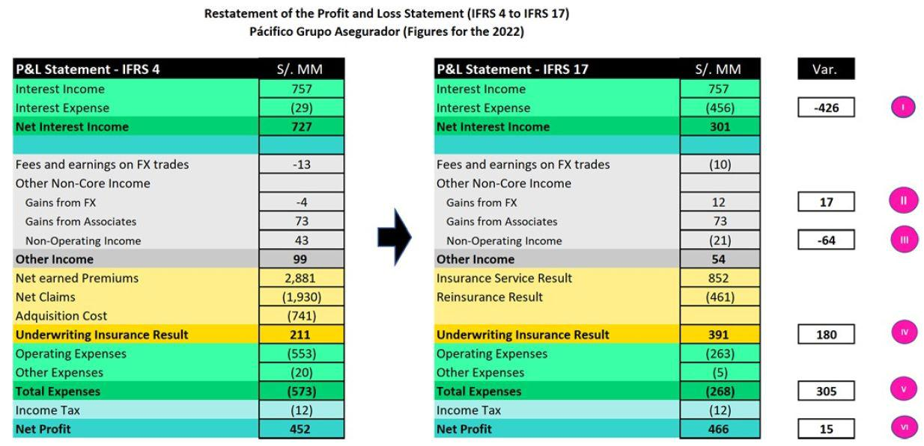

- A new sub-account, “Financial Expenses associated with insurance and reinsurance activities, net” is included in the account for Interest Expenses at Pacifico Seguros. This concept corresponds to interest accredited to reserves. This interest is attributable to an update of the present value of said reserves to the date of the close of the period. This concept was previously presented as part of reserves adjustment included in the underwriting result under IFRS4. IFRS17 separates the financial component from the underwriting component.

- An impact is registered in the “Gain on exchange rate difference” line because the structure of the assets and liabilities related to insurance activities has been modified. The monetary position of these assets and liabilities changes due to the way that assets and liabilities are recognized under IFRS17.

- Some concepts of income that were previously registered (under IFRS 4) as “Non-Operating Income” are now (under IFRS 17) reclassified and included in the cash flows associated with insurance contracts. As such, these concepts are now part of the Insurance Underwriting Result.

IV. Recognition of insurance underwriting income is completely different under IFRS 17. IFRS 17 recognizes that insurance contracts combine financial and service characteristics, and in many cases generate variable cash flows in the long-term. To adequately reflect these characteristics, IFRS combines measurements of future cash flows with recognition of the results of the insurance contract throughout the period in which the service is provided. IFRS 17 requires present value measurements of insurance obligations where estimates are recalculated in each reporting period. Contracts are measured using the components of: (i) Fulfilment Cash Flows, (ii) An explicit adjustment for risk or uncertainty of flows, or “Risk Adjustment” and (iii) a Contractual Service Margin, which represents unaccrued underwriting income associated with the contract. This Contractual Service Margin is recognized as income during the coverage term. Insurance contracts combine

47

| Earnings Release 3Q / 2023 Analysis of 3Q23 Consolidated Results

12. Appendix

financial and service characteristics, whereas IFRS combines future cash flows with registry of the results of the insurance contract during the service provision period.

- One of the changes generated by the application of IFRS 17 is that it sets forth a new concept for costs that are directly associated with obtaining and fulfilling insurance contracts. Said costs are denominated “Attributable Costs” and are included in the expected flows for the disbursements associated with these contracts. Under IFRS 4, some of these expenses were included in Total Expenses.

VI. The aggregate impact of implementing IFRS 17 in the Net Earnings of Pacifico Grupo Asegurador is not material and stands at S/15 million for the year 2022.

12.1.7. Reformulation of Credicorp’s Profit and Loss Statement for year 2022

Below, we reformulate Credicorp’s Profit and Loss Statement. As is evident in the image below, the impact of implementing IFRS at Pacífico Grupo Asegurador translates to Credicorp account by account in identical or highly similar amounts. The aggregate impact of implementing IFRS 17 on the Net Earnings of Credicorp is not material and amounts to S/15 million.
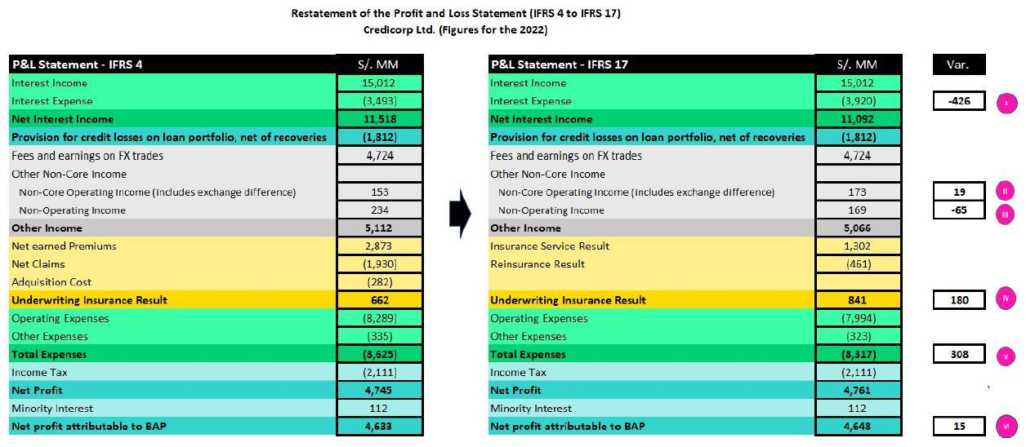

12.1.8. Changes in the Methodology to Calculate Financial Indicators and their Reformulation for the year 2022

- Net Interest Margin

The Net Interest Margin is reformulated in the following way:

Under IFRS 4, the numerator of the Net Interest Margin was comprised of the difference between Interest Income and Interest Expenses. Under IFRS 17, we need to adjust the formula because Interest Expenses now include the concept “Financial Expense associated with the insurance and reinsurance activity, net.” We seek to exclude the impact of this concept on the Net Interest Margin given that this particular kind of interest expense is not associated with a source of funding. As such, we adjust the numerator by reincorporating “Financial Expense associated with insurance and reinsurance activity, net” to “Net Interest Income” calculated under IFRS 17. It is important to note that as a result of this adjustment, the numerator of the Net Interest Margin under IRFS4 is identical to that seen under IFRS 17.

From now on, we will exclude from the denominator (average balance of Interest-earning Assets) the following: the balance associated with the account “Financial Assets at Fair Value through P&L” given that this account is primarily comprised of investments associated from Investment Link contracts, which do not accrue interests for Credicorp. This change is not related to IFRS 17.

Below, we present the aforementioned change in graphic form.

48

| Earnings Release 3Q / 2023 Analysis of 3Q23 Consolidated Results

12. Appendix
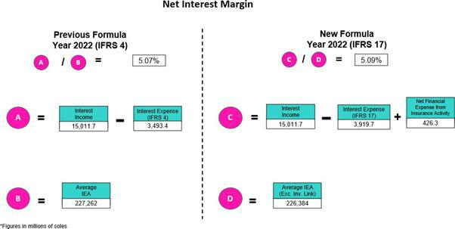

- Funding Cost

The Funding Cost indicator is being reformulated as follows: under IFRS 4, the numerator of the Funding Cost is comprised of the balance of the “Interest Expenses” account while under IFRS 17, we must adjust the formula given that Interest Expenses now include the concept of “Financial expense associated with insurance and reinsurance activity, net.” We seek to exclude the impact of this new concept on the Funding Cost given that this particular type of expense is not associated with a source of funding. As such, we adjust the numerator by deducting the “Financial Expense associated with insurance and reinsurance activity, net” from “Inter est Expenses “calculated under IFRS 17. It is important to note that as a result of this adjustment, the figure for the Funding Cost under IFRS is identical to the same figure under IFRS 17. The following figure is a graphic representation of the aforementioned change.
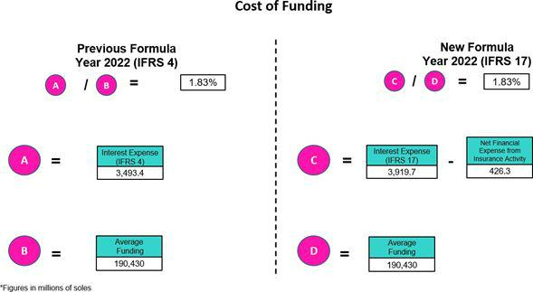

49

| Earnings Release 3Q / 2023 Analysis of 3Q23 Consolidated Results

  - Appendix

- Efficiency Ratio

The Efficiency Ratio is being reformulated as follows:

Under IFRS 4, the numerator of the Efficiency Ratio is comprised of the total of the “Salaries and Employee Benefits,” “Administrative Expenses,” “Depreciation and Amortization,” “Expenses for Participation in Association,” and the “Acquisition Cost” accounts. Collectively, these accounts constitute “Operating Expenses.” Under IFRS 17, we make an adjustment to the components of this group of “Operating Expenses” given that the “Acquisition Cost” no longer exists in the Profit and Loss Statement under IFRS 17. Consequently, under IFRS 17, the grouping of “Operating Expenses” is comprised solely of “Salaries and Employee Benefits,” “Administrative Expenses,” “Depreciation and Amortization,” and “Expenses for Participation in Association.” It is important to note that balances of these accounts under IFRS17 are not the same as the balances of the accounts with the same name under IFRS17.

Under IFRS 4, the denominator of the Efficiency Ratio is comprised of the total of the accounts grouped as Core Operating Income (“Interest Income, net”, “Fee income, net,” and “Net gain on FX transactions”); the accounts grouped as Non-Core Operating Income (“Gain on Investments in Associates, “Gain on derivatives,” “Net gain on Exchange Differences); and the “Net Earned Premiums” account. Collectively, all of these accounts constitute “Operating Income.” Under IFRS 17, we are adjusting the components of the grouping for “Operating Income” to replace the component of “Net Earned Premiums” with the “Insurance Underwriting Result.”

It is important to note that the result of replacing the “Net Earned Premiums “account with the “Insurance Underwriting Result” in the denominator of the efficiency ratio is in fact very significant (upward). The aforementioned is due to the fact that the balance of Insurance Technical results is usually materially lower than the balance of Net Earned Premiums as Insurance Technical results have embedded the impact of charges for Incurred Claims. Below, we present a graphic depiction of the aforementioned change.
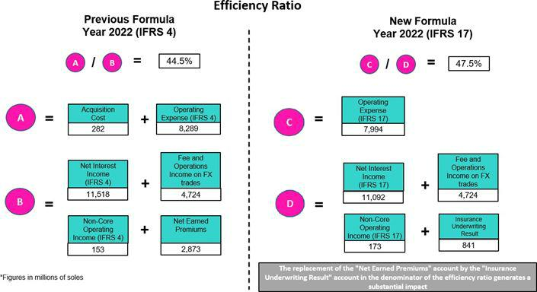

50

| Earnings Release 3Q / 2023 Analysis of 3Q23 Consolidated Results

12. Appendix

12.1.9. Glossary of Terms Under IFRS 17

Reserve for BEL (Best Estimate Liability) o | Represents the best estimate of the difference between payments for obligations (claims, income
Reserve for BEL (Best Estimate Liability) o | and expenses) and premiums, flowed and brought to present value at the time of valuation.
Fulfillment Cashflows.
Reserve for RA (risk Adjustment). | Represents the margin of prudence that will be used to cover deviations in the underwriting
Reserve for RA (risk Adjustment). | parameters beyond changes in the interest rate.
Reserve for CSM (Contractual Service Margin). | Represents the present value of future underwriting income (non- financial). Income accrues over
 | the life of the policy.
Attributable Expenses | Corresponds to necessary expenses to place a policy or maintain the same throughout its term. It is
Attributable Expenses | part of insurance flows.
Financial Expense associated with the | Represents interest accredited to reserves in the period after updating their present value. This
Financial Expense associated with the | concept was previously included in reserves under IFRS 4. IFRS 17 separates the financial
insurance and reinsurance activity, net
insurance and reinsurance activity, net | component from the underwriting component.
Onerous Contracts | The contracts that the company estimates will generate underwriting losses (not including financial
Onerous Contracts | income) during the policy term.
12.2. Physical Point of contact

Physical Point of Contact |  | As of |  | change (units)
(1) |  | As of |  | QoQ | YoY
(Units) | Sep 22 | Jun 23 | Sep 23 | QoQ | YoY
Branches | 681 | 665 | 661 | (4) | (20)
ATMs | 2,598 | 2,663 | 2,677 | 14 | 79
Agents ⁽²⁾ | 10,525 | 11,570 | 11,452 | (118) | 927
Total | 13,804 | 14,898 | 14,790 | (108) | 986
- Includes Physical Point of Contact of BCP Stand-Alone, Mibanco and BCP Bolivia
- Figures differ from previously reported due to changes in BCP Bolivia agents

12.3. Loan Portfolio Quality

Government Program (GP) Loan Portfolio Quality (in Quarter-end Balances)

GP Portfolio quality and Delinquency ratios (1) |  | As of |  | % change
S/ 000 | Sep 22 | Jun 23 | Sep 23 | QoQ | YoY
GP Total loans (Quarter-end balance) | 12,201,370 | 4,940,405 | 4,179,770 | -15.4% | -65.7%
GP Allowance for loan losses | 154,552 | 131,882 | 113,398 | -14.0% | -26.6%
GP IOLs | 1,212,968 | 796,670 | 827,360 | 3.9% | -31.8%
GP IOL ratio | 9.94% | 16.13% | 19.79% | 366 bps | 985 bps
GP Allowance for loan losses over GP Total loans | 1.3% | 2.7% | 2.7% | 4 bps | 144 bps
GP Coverage ratio of IOLs | 12.7% | 16.6% | 13.7% | -284 bps | 97 bps

(1) Government Programs (GP) include Reactiva Peru and FAE-Mype.

51

| Earnings Release 3Q / 2023 Analysis of 3Q23 Consolidated Results

12. Appendix

Portfolio Quality Ratios by Segment

Wholesale Banking
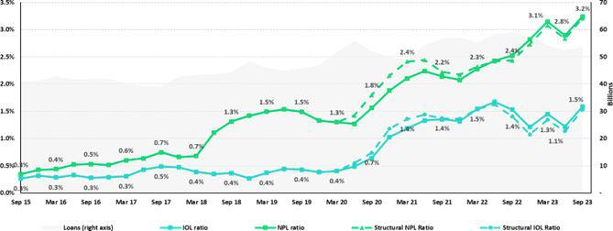

SME-Business
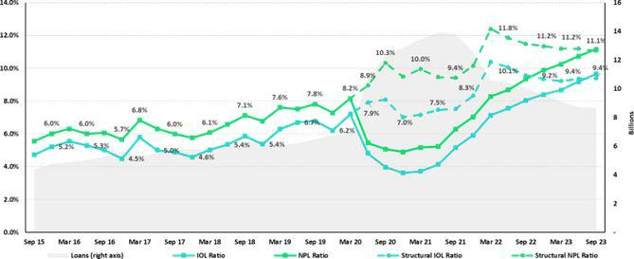

52

| Earnings Release 3Q / 2023 Analysis of 3Q23 Consolidated Results

12. Appendix

SME-Pyme
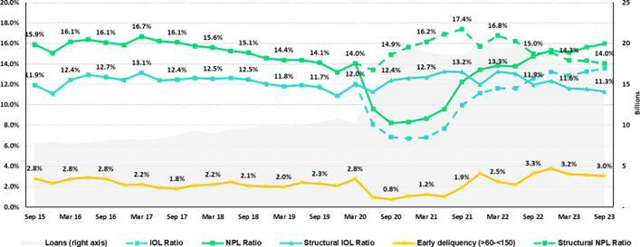

Mortgage
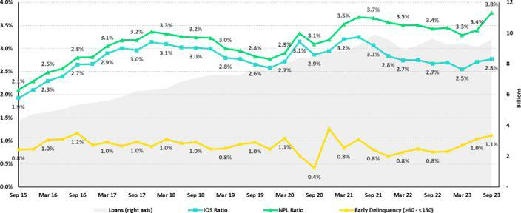

53

| Earnings Release 3Q / 2023 Analysis of 3Q23 Consolidated Results

12. Appendix

Consumer
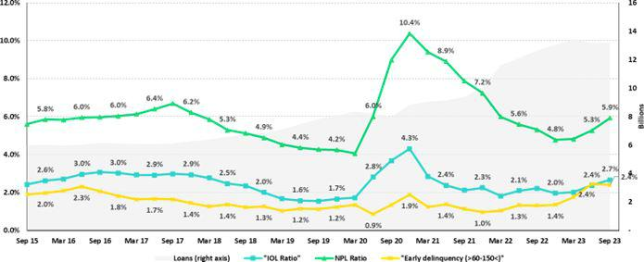

Credit Card
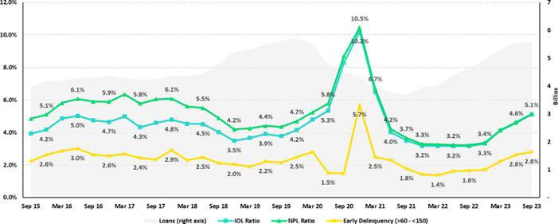

54

| Earnings Release 3Q / 2023 Analysis of 3Q23 Consolidated Results

12. Appendix

Mibanco
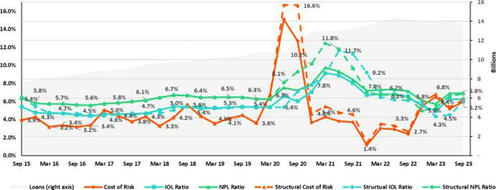

BCP Bolivia
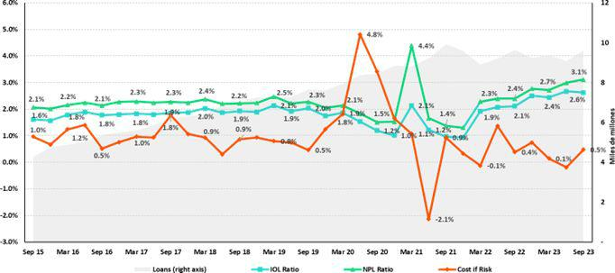

55

| Earnings Release 3Q / 2023 Analysis of 3Q23 Consolidated Results

12. Appendix

12.4 | Net Interest Income (NII)
 |  |  |  | NII Summary
Net interest income |  | 3Q22 | Quarter | 3Q23 | QoQ | % change | As of | Sep 23 | change %
S/ 000 |  | 3Q22 | 2Q23 | 3Q23 | QoQ | YoY | Sep 22 | Sep 23 | Sep 23 / Sep 22
Interest income |  | 3,988,684 | 4,653,246 | 4,819,101 | 3.6% | 20.8% | 10,649,143 | 13,928,453 | 30.8%
Interest on loans |  | 3,288,864 | 3,712,845 | 3,853,361 | 3.8% | 17.2% | 8,904,198 | 11,137,158 | 25.1%
Dividends on investments |  | 7,499 | 17,492 | 10,464 | -40.2% | 39.5% | 25,501 | 34,433 | 35.0%
Interest on deposits with banks |  | 141,896 | 286,459 | 289,934 | 1.2% | 104.3% | 229,256 | 853,764 | 272.4%
Interest on securities |  | 533,971 | 618,952 | 641,370 | 3.6% | 20.1% | 1,455,930 | 1,845,590 | 26.8%
Other interest income |  | 16,454 | 17,498 | 23,972 | 37.0% | 45.7% | 34,258 | 57,508 | 67.9%
Interest expense |  | (1,106,283) | (1,449,090) | (1,565,058) | 8.0% | 41.5% | (2,697,929) | (4,338,165) | 60.8%
Interest expense (excluding Net Insurance Financial Expenses) |  | (988,293) | (1,333,924) | (1,448,593) | 8.6% | 46.6% | (2,374,221) | (3,990,784) | 68.1%
Interest on deposits |  | 510,116 | 777,436 | 859,659 | 10.6% | 68.5% | 1,106,008 | 2,314,183 | 109.2%
Interest on borrowed funds |  | 185,891 | 296,854 | 325,619 | 9.7% | 75.2% | 443,653 | 861,406 | 94.2%
Interest on bonds and subordinated notes |  | 211,719 | 148,992 | 149,449 | 0.3% | -29.4% | 557,446 | 481,339 | -13.7%
Other interest expense |  | 80,567 | 110,642 | 113,866 | 2.9% | 41.3% | 267,114 | 333,856 | 25.0%
Net Insurance Financial Expenses |  | (117,990) | (115,166) | (116,465) | 1.1% | -1.3% | (323,708) | (347,381) | 7.3%
Net interest income |  | 2,882,401 | 3,204,156 | 3,254,043 | 1.6% | 12.9% | 7,951,214 | 9,590,288 | 20.6%
Risk-adjusted Net interest income |  | 2,422,425 | 2,399,905 | 2,336,401 | -2.6% | -3.6% | 6,870,357 | 7,141,397 | 3.9%
Average interest earning assets |  | 225,371,577 | 220,651,688 | 220,719,735 | 0.0% | -2.1% | 229,932,415 | 222,357,551 | -3.3%
Net interest margin (1) |  | 5.33% | 6.02% | 6.11% | 9pbs | 78pbs | 4.80% | 5.96% | 116pbs
Risk-adjusted Net interest margin (1) |  | 4.51% | 4.56% | 4.45% | -11pbs | -6pbs | 4.17% | 4.49% | 32pbs
Net provisions for loan losses / Net interest income |  | 15.96% | 25.10% | 28.20% | 310 pbs | 1224 pbs | 13.59% | 25.54% | 1195pbs

(1) Annualized. For further detail on the new NIM calculation due to IFRS17, please refer to Annex 12.1.8

Net Interest Margin (NIM) and Risk Adjusted NIM by subsidiary

NIM Breakdown | BCP Stand-alone | Mibanco | BCP Bolivia | Credicorp
3Q22 | 4.83% | 12.99% | 2.81% | 5.33%
2Q23 | 5.67% | 13.09% | 2.85% | 6.02%
3Q23 | 5.77% | 13.64% | 2.87% | 6.11%
NIM: Annualized Net interest income (excluding Net Insurance Financial Expenses) / Average period end and period beginning interest earning assets.

Risk Adjusted NIM | BCP Stand-alone | Mibanco | BCP Bolivia | Credicorp
Breakdown
3Q22 | 4.00% | 10.99% | 2.50% | 4.51%
2Q23 | 4.25% | 8.64% | 3.00% | 4.56%
3Q23 | 4.18% | 8.73% | 2.47% | 4.45%

Risk-Adjusted NIM: (Annualized Net interest income (excluding Net Insurance Financial Expenses) - annualized provisions) / Average period end and period beginning interest earning assets.

56

| Earnings Release 3Q / 2023 Analysis of 3Q23 Consolidated Results

12. Appendix

12.5. Regulatory Capital

Regulatory Capital and Capital Adequacy Ratios

(S/ Thousands, IFRS)

Capital Stock |  |  | As of |  |  |  | % change
S/000 | Sep 22 |  | Jun 23 |  | Sep 23 | QoQ |  | YoY
Capital Stock | 1,318,993 |  | 1,318,993 |  | 1,318,993 | 0.0% | 0.0%
Treasury Stocks
Treasury Stocks | (207,518) |  | (208,035) |  | (208,033) | 0.0% | 0.2%
Capital Surplus
Capital Surplus | 225,832 |  | 231,019 |  | 225,338 | -2.5% | -0.2%
Legal and Other capital reserves ⁽¹⁾ | 23,687,946 |  | 26,221,577 |  | 26,239,162 | 0.1% | 10.8%
Minority interest ⁽²⁾ | 488,486 |  | 207,919 |  | 210,283 | 1.1% | -57.0%
Loan loss reserves ⁽³⁾ | 2,139,971 |  | 1,903,625 |  | 1,946,059 | 2.2% | -9.1%
Perpetual subordinated debt | - |  | - |  | - | - | -
Subordinated Debt
Subordinated Debt | 6,015,765 |  | 5,595,446 |  | 5,844,106 | 4.4% | -2.9%
Investments in equity and subordinated debt of financial and insurance
companies | (868,747) |  | (1,265,052) |  | (1,259,626) | -0.4% | 45.0%
Goodwill | (788,179) |  | (830,725) |  | (842,678) | 1.4% | 6.9%
Current year Net Loss | - |  | - |  | - | - | -
Deduction for subordinated debt limit (50% of Tier I excluding deductions) | - |  | - |  | - | - | -
(4)
Deduction for Tier I Limit (50% of Regulatory capital) ⁽⁴⁾ | - |  | - |  | - | - | -
Total Regulatory Capital (A) | 32,012,549 |  | 33,174,767 |  | 33,473,604 | 0.9% | 4.6%
Tier 1 ⁽⁵⁾ | 16,961,210 |  | 17,834,543 |  | 17,821,987 | -0.1% | 5.1%
Tier 2 (6) + Tier 3 (7) | 15,051,339 |  | 15,340,224 |  | 15,651,617 | 2.0% | 4.0%
Financial Consolidated Group (FCG) Regulatory Capital Requirements ⁽⁸⁾ | 20,973,716 |  | 21,863,219 |  | 22,387,961 | 2.4% |  | 6.7%
Insurance Consolidated Group (ICG) Capital Requirements ⁽⁹⁾ | 1,558,334 |  | 1,532,425 |  | 1,550,765 | 1.2% |  | -0.5%
FCG Capital Requirements related to operations with ICG | (465,143) |  | (625,441) |  | (680,628) | 8.8% |  | 46.3%
ICG Capital Requirements related to operations with FCG | - |  | - |  | - | - |  | -
Total Regulatory Capital Requirements (B) | 22,066,907 |  | 22,770,203 |  | 23,258,098 | 2.1% |  | 5.4%
Regulatory Capital Ratio (A) / (B) | 1.45 |  | 1.46 |  | 1.44
Required Regulatory Capital Ratio ⁽¹⁰⁾ | 1.00 |  | 1.00 |  | 1.00
- Legal and other capital reserves include restricted capital reserves (PEN 14,745 million) and optional capital reserves (PEN 6,661 million).
- Minority interest includes Tier I (PEN 421 million)
- Up to 1.25% of total risk-weighted assets of Banco de Credito del Peru, Solucion Empresa Administradora Hipotecaria, Mibanco and ASB Bank Corp.
- Tier II + Tier III cannot be more than 50% of total regulatory capital.

- Tier I = capital + restricted capital reserves + Tier I minority interest - goodwill - (0.5 x investment in equity and subordinated debt of financial and insurance companies) + perpetual subordinated debt.

- Tier II = subordinated debt + TierII minority interest tier + loan loss reserves - (0.5 x investment in equity and subordinated debt of financial and insurance companies).
- Tier III = Subordinated debt covering market risk only.
- Includes regulatory capital requirements of the financial consolidated group.
- Includes regulatory capital requirements of the insurance consolidated group.
- Regulatory Capital / Total Regulatory Capital Requirements (legal minimum = 1.00).

57

| Earnings Release 3Q / 2023 Analysis of 3Q23 Consolidated Results

12. Appendix

Regulatory and Capital Adequacy Ratios at BCP Stand-alone

(S/ thousands, IFRS)

Regulatory Capital | Jun 23 | Sep 23 | Change %
(S/ thousand) | Jun 23 | Sep 23 | QoQ
Capital Stock | 12,973,175 | 12,973,175 | n.a
Reserves | 7,039,359 | 7,039,793 | n.a
Accumulated earnings | 3,346,790 | 4,474,351 | 33.7%
Loan loss reserves (1) | 1,625,735 | 1,667,750 | 2.6%
Perpetual subordinated debt | - | - | n.a
Subordinated Debt | 4,897,800 | 5,120,550 | 4.5%
Unrealized Profit or Losses | (834,411) | (916,337) | 9.8%
Investment in subsidiaries and others, net of unrealized profit and net income in subsidiaries | (2,667,540) | (2,714,749) | 1.8%
Intangibles | (1,036,167) | (1,124,983) | 8.6%
Goodwill | (122,083) | (122,083) | n.a
Total Regulatory Capital | 25,222,659 | 26,397,466 | 4.7%
Tier 1 Common Equity (2) | 18,699,124 | 19,609,166 | 4.9%
Regulatory Tier 1 Capital (3) | 18,699,124 | 19,609,166 | 4.9%
Regulatory Tier 2 Capital (4) | 6,523,535 | 6,788,300 | 4.1%
Total risk-weighted assets | Jun 23 | Sep 23 | Change %
(S/ thousand) | Jun 23 | Sep 23 | QoQ
Market risk-weighted assets (5) | 2,307,252 | 2,576,734 | 11.7%
Credit risk-weighted assets | 128,912,504 | 132,297,592 | 2.6%
Operational risk-weighted assets | 15,407,799 | 15,862,960 | 3.0%
Total | 146,627,555 | 150,737,286 | 2.8%
Capital requirement | Jun 23 | Sep 23 | Change %
(S/ thousand) | Jun 23 | Sep 23 | QoQ
Market risk capital requirement (5) | 230,725 | 257,673 | 11.7%
Credit risk capital requirement | 11,602,125 | 11,906,783 | 2.6%
Operational risk capital requirement | 1,540,780 | 1,586,296 | 3.0%
Additional capital requirements | 3,494,025 | 3,595,810 | 2.9%
Total | 16,867,655 | 17,346,562 | 2.8%
 | Jun 23 | Sep 23 | Change
Capital ratios under Local Regulation | Jun 23 | Sep 23 | QoQ
Common Equity Tier 1 ratio | 12.75% | 13.01% | 26 bps
Tier 1 Capital ratio | 12.75% | 13.01% | 26 bps
Regulatory Global Capital ratio | 17.20% | 17.51% | 31 bps

- Up to 1.25% of total risk-weighted assets.

- Common Equity Tier 1 = Capital Stock + Reserves + Accumulated earnings – Unrealized profits or losses - 100% deductions (investment in subsidiaries, goodwill, intangible assets and deferred tax assets based on future returns).
- Regulatory Tier 1 Capital = Common Equity Tier 1 + Tier 1 Subordinated Debt (Perpetual).
- Regulatory Tier 2 Capital = Subordinated Debt + Loan loss reserves.

58

| Earnings Release 3Q / 2023 Analysis of 3Q23 Consolidated Results

12. Appendix

Regulatory Capital and Capital Adequacy Ratios at Mibanco

(S/ thousands, IFRS)

Regulatory Capital | Jun 23 | Sep 23 | % Change QoQ
(S/ thousand) | Jun 23 | Sep 23 | % Change QoQ
Capital Stock | 1,840,606 | 1,840,606 | 0.0%
Reserves | 308,056 | 308,056 | 0.0%
Accumulated earnings | 611,151 | 669,894 | 9.6%
Loan loss reserves | 170,901 | 163,158 | -4.5%
Perpetual subordinated debt | - | - | n.a.
Subordinated debt | 173,000 | 173,000 | 0.0%
Unrealized Profit or Losses | (4,727) | (13,584) | 187.3%
Investment in subsidiaries and others, net of unrealized profit and net income in | (275) | (276) | 0.4%
subsidiaries
Intangibles | (138,239) | (140,573) | 1.7%
Goodwill | (139,180) | (139,180) | 0.0%
Total Regulatory Capital | 2,821,292 | 2,861,101 | 1.4%
Tier Common Equity (2) | 2,477,391 | 2,524,943 | 1.9%
Regulatory Tier 1 Capital (3) | 2,477,391 | 2,524,943 | 1.9%
Regulatory Tier 2 Capital (4) | 343,901 | 336,158 | -2.3%
Total risk-weighted assets | Jun 23 | Sep 23 | % Change
(S/ thousand) | Jun 23 | Sep 23 | QoQ
Market risk-weighted assets | 181,227 | 163,853 | -9.6%
Credit risk-weighted assets | 13,372,354 | 12,799,766 | -4.3%
Operational risk-weighted assets | 1,470,726 | 1,522,681 | 3.5%
Total | 15,024,307 | 14,486,300 | -3.6%
Capital requirement | Jun 23 | Sep 23 | % Change
(S/ thousand) | Jun 23 | Sep 23 | QoQ
Market risk capital requirement (5) | 18,123 | 16,385 | -9.6%
Credit risk capital requirement | 1,203,512 | 1,215,978 | 1.0%
Operational risk capital requirement | 147,073 | 152,268 | 3.5%
Additional capital requirements | 405,891 | 399,691 | -1.5%
Total | 1,774,599 | 1,784,322 | 0.5%
Capital Ratios under Local Regulation
 | Jun 23 | Sep 23 | Change
 | Jun 23 | Sep 23 | QoQ
Common Equity Tier 1 Ratio | 16.49% | 17.43% | 94 pbs
Tier 1 Capital ratio | 16.49% | 17.43% | 94 pbs
Regulatory Global Capital Ratio | 18.78% | 19.75% | 97 pbs
- Up to 1.25% of total risk-weighted assets.

- Common Equity Tier 1 = Capital Stock + Reserves + Accumulated earnings – Unrealized profits or losses - 100% deductions (investment in subsidiaries, goodwill, intangible assets and deferred tax assets based on future returns).
- Regulatory Tier 1 Capital = Common Equity Tier 1 + Tier 1 Subordinated Debt (Perpetual).
- Regulatory Tier 2 Capital = Subordinated Debt + Loan loss reserves.

59

| Earnings Release 3Q / 2023 Analysis of 3Q23 Consolidated Results

12. Appendix

Common Equity Tier 1 IFRS

BCP Stand-alone

Common Equity Tier 1 IFRS |  | Sep 22 | Jun 23 | Sep 23 |  | % Change |  | % Change
(S/. thousand) |  | Sep 22 | Jun 23 | Sep 23 |  | QoQ |  | YoY
Capital and reserves |  | 19,181,019 | 19,500,292 | 19,500,725 |  | 0.0% |  | 1.7%
Retained earnings |  | 4,187,468 | 4,000,489 | 5,104,881 |  | 27.6% |  | 21.9%
Unrealized gains (losses) |  | (1,274,918) | (274,021) | (375,086) |  | 36.9% |  | -70.6%
Goodwill and intangibles |  | (1,355,924) | (1,516,702) | (1,573,072) |  | 3.7% |  | 16.0%
Investments in subsidiaries |  | (2,653,531) | (2,800,043) | (2,851,285) |  | 1.8% |  | 7.5%
Total |  | 18,084,114 | 18,910,015 | 19,806,164 |  | 4.7% |  | 9.5%
Adjusted RWAs IFRS |  | 152,849,186 | 147,805,770 | 151,843,249 |  | 2.7% |  | -0.7%
Adjusted Credit RWAs IFRS |  | 136,220,546 | 130,090,719 | 133,403,554 |  | 2.5% |  | -2.1%
Others |  | 16,628,640 | 17,715,052 | 18,439,695 |  | 4.1% |  | 10.9%
CET1 ratio IFRS |  | 11.83% | 12.79% | 13.04% |  | 25 pbs |  | 121 pbs
 |  | Mibanco
Common Equity Tier 1 IFRS |  | Sep 22 | Jun 23 | Sep 23 |  | % Change |  | % Change
(S/. thousand) |  | Sep 22 | Jun 23 |  |  | QoQ |  | YoY
Capital and reserves |  | 2,632,956 | 2,676,791 | 2,676,791 |  | 0.0% |  | 1.7%
Retained earnings |  | 114,341 | 206,920 | 267,299 |  | 29.2% |  | 133.8%
Unrealized gains (losses) |  | (16,074) | (5,399) | (13,268) |  | 145.8% |  | -17.5%
Goodwill and intangibles |  | (338,330) | (344,323) | (345,258) |  | 0.3% |  | 2.0%
Investments in subsidiaries |  | (259) | (275) | (276) |  | 0.4% |  | 6.5%
Total |  | 2,392,634 | 2,533,715 | 2,585,288 |  | 2.0% |  | 8.1%
Adjusted RWAs IFRS |  | 14,956,200 | 15,261,939 | 14,719,637 |  | -3.6% |  | -1.6%
Adjusted Credit RWAs IFRS |  | 12,871,826 | 13,602,081 | 13,028,635 |  | -4.2% |  | 1.2%
Others |  | 2,084,374 | 1,659,857 | 1,691,001 |  | 1.9% |  | -18.9%
CET1 ratio IFRS |  | 16.00% | 16.60% | 17.56% |  | 96 pbs |  | 157 pbs

60

| Earnings Release 3Q / 2023 Analysis of 3Q23 Consolidated Results

12. Appendix

12.6. Financial Statements and Ratios by Business

12.6.1.Credicorp Consolidated

Credicorp Ltd. and Subsidiaries

Consolidated Statement of Financial Position

(In S/ thousands, IFRS)

 |  | As of |  | % change
 | Sep 22 | Jun 23 | Set 23 | QoQ | YoY
ASSETS
Cash and due from banks
Non-interest bearing | 6,919,212 | 7,154,236 | 8,047,624 | 12.5% | 16.3%
Interest bearing | 29,330,082 | 26,036,894 | 24,907,836 | -4.3% | -15.1%
Total cash and due from banks | 36,249,294 | 33,191,130 | 32,955,460 | -0.7% | -9.1%
Cash collateral, reverse repurchase agreements and securities borrowing | 1,586,967 | 1,863,243 | 1,513,622 | -18.8% | -4.6%
Fair value through profit or loss investments | 4,550,783 | 4,508,563 | 5,558,973 | 23.3% | 22.2%
Fair value through other comprehensive income investments | 34,263,930 | 33,344,169 | 35,475,821 | 6.4% | 3.5%
Amortized cost investments | 8,028,557 | 10,182,619 | 10,082,119 | -1.0% | 25.6%
Loans | 151,392,202 | 142,845,549 | 145,129,260 | 1.6% | -4.1%
Current | 145,142,071 | 136,866,154 | 138,722,915 | 1.4% | -4.4%
Internal overdue loans | 6,250,131 | 5,979,395 | 6,406,345 | 7.1% | 2.5%
Less - allowance for loan losses | (8,030,104) | (7,956,184) | (8,056,216) | 1.3% | 0.3%
Loans, net | 143,362,098 | 134,889,365 | 137,073,044 | 1.6% | -4.4%
Financial assets designated at fair value through profit or loss | 767,425 | 789,845 | 797,545 | 1.0% | 3.9%
Property, plant and equipment, net | 1,786,136 | 1,749,132 | 1,752,950 | 0.2% | -1.9%
Due from customers on acceptances | 697,119 | 226,161 | 325,771 | 44.0% | -53.3%
Investments in associantes | 660,849 | 675,623 | 707,457 | 4.7% | 7.1%
Intangible assets and goodwill, net | 2,767,341 | 3,046,846 | 3,118,496 | 2.4% | 12.7%
Reinsurance contract assets | 760,116 | 780,587 | 803,868 | 3.0% | 5.8%
Other assets (1) | 7,268,200 | 8,063,007 | 8,293,532 | 2.9% | 14.1%
Total Assets | 242,748,815 | 233,310,290 | 238,458,658 | 2.2% | -1.8%
LIABILITIES AND EQUITY
Deposits and obligations
Non-interest bearing | 46,625,814 | 39,475,762 | 40,363,636 | 2.2% | -13.4%
Interest bearing | 106,166,200 | 103,911,955 | 108,107,899 | 4.0% | 1.8%
Total deposits and obligations | 152,792,014 | 143,387,717 | 148,471,535 | 3.5% | -2.8%
Payables from repurchase agreements and securities lending | 16,575,580 | 14,306,880 | 11,738,020 | -18.0% | -29.2%
BCRP instruments | 14,449,597 | 11,772,772 | 9,616,150 | -18.3% | -33.5%
Repurchase agreements with third parties | 1,182,946 | 1,276,709 | 1,266,852 | -0.8% | 7.1%
Repurchase agreements with customers | 943,037 | 1,257,399 | 855,018 | -32.0% | -9.3%
Due to banks and correspondents | 9,002,035 | 10,062,290 | 10,493,411 | 4.3% | 16.6%
Bonds and notes issued | 17,019,694 | 14,235,697 | 14,914,632 | 4.8% | -12.4%
Banker’s acceptances outstanding | 697,119 | 226,161 | 325,771 | 44.0% | -53.3%
Liabilities by insurance contracts | 10,773,031 | 11,567,408 | 11,653,015 | 0.7% | 8.2%
Financial liabilities at fair value through profit or loss | 333,453 | 413,665 | 455,350 | 10.1% | 36.6%
Other liabilities | 7,694,342 | 8,471,819 | 8,499,868 | 0.3% | 10.5%
Total Liabilities | 214,887,268 | 202,671,637 | 206,551,602 | 1.9% | -3.9%
Net equity | 27,292,658 | 30,027,036 | 31,267,592 | 4.1% | 14.6%
Capital stock | 1,318,993 | 1,318,993 | 1,318,993 | 0.0% | 0.0%
Treasury stock | (207,518) | (208,035) | (208,033) | 0.0% | 0.2%
Capital surplus | 225,832 | 231,019 | 225,338 | -2.5% | -0.2%
Reserves | 23,687,946 | 26,221,577 | 26,239,162 | 0.1% | 10.8%
Other reserves | (996,001) | (13,015) | (29,526) | 126.9% | -97.0%
Retained earnings | 3,263,406 | 2,476,497 | 3,721,658 | 50.3% | 14.0%
Non-controlling interest | 568,889 | 611,617 | 639,464 | 4.6% | 12.4%
Total Net Equity | 27,861,547 | 30,638,653 | 31,907,056 | 4.1% | 14.5%
Total liabilities and equity | 242,748,815 | 233,310,290 | 238,458,658 | 2.2% | -1.8%
Off-balance sheet | 151,545,926 | 144,709,112 | 151,484,019 | 4.7% | 0.0%
Total performance bonds, stand-by and L/Cs. | 21,399,132 | 18,654,864 | 18,945,883 | 1.6% | -11.5%
Undrawn credit lines, advised but not committed | 87,600,569 | 85,762,478 | 88,183,227 | 2.8% | 0.7%
Total derivatives (notional) and others | 42,546,225 | 40,291,770 | 44,354,909 | 10.1% | 4.3%

(1) Includes mainly accounts receivables from brokerage and others

* Due to reclassifications, the Balance Sheet may differ from those reported in previous quarters.

61

| Earnings Release 3Q / 2023 Analysis of 3Q23 Consolidated Results

12. Appendix

Credicorp Ltd. and Subsidiaries

Consolidated Statement of Income
(In S/ thousands, IFRS)

 |  | Quarter |  |  | % change | Up to |  | % change
 | 3Q22 | 2Q23 | 3Q23 | QoQ | YoY | Sep 22 | Sep 23 | Sep 23/ Sep 22
Interest income and expense
Interest and similar income | 3,988,684 | 4,653,246 | 4,819,101 | 3.6% | 20.8% | 10,649,143 | 13,928,453 | 30.8%
Interest and similar expenses | (1,106,283) | (1,449,090) | (1,565,058) | 8.0% | 41.5% | (2,697,929) | (4,338,165) | 60.8%
Net interest, similar income and expenses | 2,882,401 | 3,204,156 | 3,254,043 | 1.6% | 12.9% | 7,951,214 | 9,590,288 | 20.6%
Gross provision for credit losses on loan portfolio | (545,249) | (886,123) | (1,008,750) | 13.8% | 85.0% | (1,342,966) | (2,696,980) | 100.8%
Recoveries of written-off loans | 85,273 | 81,872 | 91,108 | 11.3% | 6.8% | 262,109 | 248,089 | -5.3%
Provision for credit losses on loan portfolio, net of recoveries | (459,976) | (804,251) | (917,642) | 14.1% | 99.5% | (1,080,857) | (2,448,891) | 126.6%
 | - | - | -
Net interest, similar income and expenses, after provision for credit losses | 2,422,425 | 2,399,905 | 2,336,401 | -2.6% | -3.6% | 6,870,357 | 7,141,397 | 3.9%
on loan portfolio
Other income
Fee income | 934,984 | 960,550 | 975,955 | 1.6% | 4.4% | 2,747,562 | 2,818,286 | 2.6%
Net gain on foreign exchange transactions | 262,167 | 210,944 | 208,620 | -1.1% | -20.4% | 790,936 | 668,079 | -15.5%
Net loss on securities | (25,460) | 68,603 | 53,591 | -21.9% | -310.5% | (176,506) | 192,230 | -208.9%
Net gain from associates | 25,806 | 23,689 | 32,056 | 35.3% | 24.2% | 79,039 | 82,957 | 5.0%
Net gain (loss) on derivatives held for trading | 53,008 | 16,671 | 38,545 | 131.2% | -27.3% | 59,330 | 48,646 | -18.0%
Net gain (loss) from exchange differences | (5,917) | 2,996 | 4,564 | 52.3% | -177.1% | (32,721) | 30,523 | -193.3%
Others | 56,664 | 149,671 | 89,272 | -40.4% | 57.5% | 270,594 | 328,281 | 21.3%
Total non-financial income | 1,301,252 | 1,433,124 | 1,402,603 | -2.1% | 7.8% | 3,738,234 | 4,169,002 | 11.5%
Insurance underwriting result
Insurance Service Result | 422,963 | 393,487 | 417,014 | 6.0% | -1.4% | 1,052,511 | 1,217,378 | 15.7%
Reinsurance Result | (119,203) | (96,923) | (86,114) | -11.2% | -27.8% | (347,887) | (293,573) | -15.6%
Total insurance underwriting result | 303,760 | 296,564 | 330,900 | 11.6% | 8.9% | 704,624 | 923,805 | 31.1%
Total expenses
Salaries and employee benefits | (984,336) | (1,054,735) | (1,061,402) | 0.6% | 7.8% | (2,866,013) | (3,145,695) | 9.8%
Administrative, general and tax expenses | (869,873) | (871,046) | (1,007,894) | 15.7% | 15.9% | (2,385,038) | (2,714,000) | 13.8%
Depreciation and amortization | (162,009) | (160,549) | (159,761) | -0.5% | -1.4% | (470,795) | (481,389) | 2.3%
Association in participation | (9,999) | (16,742) | (14,634) | -12.6% | 46.4% | (28,019) | (43,988) | 57.0%
Other expenses | (71,373) | (92,232) | (106,778) | 15.8% | 49.6% | (203,361) | (287,609) | 41.4%
Total expenses | (2,097,590) | (2,195,304) | (2,350,469) | 7.1% | 12.1% | (5,953,226) | (6,672,681) | 12.1%
Profit before income tax | 1,929,847 | 1,934,289 | 1,719,435 | -11.1% | -10.9% | 5,359,989 | 5,561,523 | 3.8%
 |  |  | -
Income tax | (575,083) | (504,472) | (455,865) | -9.6% | -20.7% | (1,634,265) | (1,453,803) | -11.0%
Net profit | 1,354,764 | 1,429,817 | 1,263,570 | -11.6% | -6.7% | 3,725,724 | 4,107,720 | 10.3%
Non-controlling interest | 31,855 | 28,550 | 25,397 | -11.0% | -20.3% | 88,061 | 84,007 | -4.6%
Net profit attributable to Credicorp | 1,322,909 | 1,401,267 | 1,238,173 | -11.6% | -6.4% | 3,637,663 | 4,023,713 | 10.6%

62

| Earnings Release 3Q / 2023 Analysis of 3Q23 Consolidated Results

12. Appendix

12.6.2. Credicorp Stand-alone

Credicorp Ltd.

Separate Statement of Financal Position
(S/ thousands, IFRS)

 |  |  | As of |  | % change
 |  | Sep 22 | Jun 23 | Sep 23 | QoQ | YoY
 | ASSETS
 | Cash and cash equivalents | 125,092 | 122,665 | 79,883 | -34.9% | -36.1%
 | At fair value through profit or loss | 967,331 | 937,921 | 937,279 | -0.1% | -3.1%
 | Fair value through other comprehensive income investments | 313,739 | 317,479 | 303,303 | -4.5% | -3.3%
 | In subsidiaries and associates investments | 32,308,088 | 34,755,621 | 36,167,571 | 4.1% | 11.9%
 | Other assets | 12,115 | 197 | 324 | 64.5% | -97.3%
 | Total Assets | 33,726,365 | 36,133,883 | 37,488,360 | 3.7% | 11.2%
 | LIABILITIES AND NET SHAREHOLDERS’ EQUITY
 | Due to banks, correspondents and other entities | 256,528 | - | 30,165 | n.a | -88.2%
 | Bonds and notes issued | 1,993,778 | 1,803,725 | 1,851,185 | 2.6% | -7.2%
 | Other liabilities | 218,687 | 161,170 | 206,963 | 28.4% | -5.4%
 | Total Liabilities | 2,468,993 | 1,964,895 | 2,088,313 | 6.3% | -15.4%
 | NET EQUITY
 | Capital stock | 1,318,993 | 1,318,993 | 1,318,993 | 0.0% | 0.0%
 | Capital Surplus | 384,542 | 384,542 | 384,542 | 0.0% | 0.0%
 | Reserve | 23,300,350 | 25,905,604 | 25,905,576 | 0.0% | 11.2%
 | Unrealized results | (1,661,404) | (362,199) | (215,370) | -40.5% | -87.0%
 | Retained earnings | 7,914,891 | 6,922,048 | 8,006,306 | 15.7% | 1.2%
 | Total net equity | 31,257,372 | 34,168,988 | 35,400,047 | 3.6% | 13.3%
 | Total Liabilities And Equity | 33,726,365 | 36,133,883 | 37,488,360 | 3.7% | 11.2%
 |  |  | Quarter |  | % change |  |  | Up to |  | % Change
 |  | 3Q22 | 2Q23 | 3Q23 | QoQ | YoY |  | Sep 22 | Sep 23 | Sep 23 / Sep 22
 | Interest income
 | Net share of the income from investments in subsidiaries and associates | 1,379,036 | 3,244,084 | 1,288,466 | -60.3% | -6.6% |  | 4,040,880 | 4,532,550 | 12.2%
 | Interest and similar income | 307 | 9,296 | 429 | -95.4% | 39.7% |  | 7,661 | 9,725 | 26.9%
 | Net gain on financial assets at fair value through profit or loss | (10,214) | 26,377 | 8,845 | -66.5% | -186.6% |  | (78,428) | 35,222 | n.a
 | Total income | 1,369,129 | 3,279,757 | 1,297,740 | -60.4% | -5.2% |  | 3,970,113 | 4,577,497 | 15.3%
 | Interest and similar expense | (19,155) | (27,952) | (13,880) | -50.3% | -27.5% |  | (47,584) | (41,832) | -12.1%
 | Administrative and general expenses | (5,908) | (11,991) | (4,097) | -65.8% | -30.7% |  | (13,933) | (16,088) | 15.5%
 | Total expenses | (25,063) | (39,943) | (17,977) | -55.0% | -28.3% |  | (61,517) | (57,920) | -5.8%
 | Operating income | 1,344,066 | 3,267,766 | 1,293,643 | -60.4% | -3.8% |  | 3,908,596 | 4,533,457 | 16.0%
 | Net gain (losses) from exchange differences | 31 | (3,442) | 1,383 | -140.2% | 4361.3% |  | (866) | (2,059) | 137.8%
 | Other, net | 231 | 201 | 2,665 | n.a | n.a |  | 450 | 2,866 | 536.9%
 | Profit before income tax | 1,344,328 | 3,236,573 | 1,283,811 | -60.3% | -4.5% |  | 3,908,180 | 4,520,384 | 15.7%
 | Income tax | (42,000) | (93,888) | (46,850) | -50.1% | 11.5% |  | (126,290) | (140,738) | 11.4%
 | Net income | 1,302,328 | 3,142,685 | 1,236,961 | -60.6% | -5.0% |  | 3,781,890 | 4,379,646 | 15.8%
 | Double Leverage Ratio | 103.36% | 101.72% | 102.17% | 45bps | -119bps |  | 103.36% | 102.17% | -119bps

63

| Earnings Release 3Q / 2023 Analysis of 3Q23 Consolidated Results

12. Appendix

12.6.4. BCP Stand-alone

Banco de Crédito del Peru
Statement of Financial Position
(S/ thousands, IFRS)

 | Sep 22 | As of | Sep 23 | % change
 | Sep 22 | Jun 23 | Sep 23 | QoQ | YoY
ASSETS
Cash and due from banks
Non-interest bearing | 4,880,450 | 4,634,064 | 5,281,567 | 14.0% | 8.2%
Interest bearing | 27,042,976 | 24,308,715 | 23,133,255 | -4.8% | -14.5%
Total cash and due from banks | 31,923,426 | 28,942,779 | 28,414,822 | -1.8% | -11.0%
Cash collateral, reverse repurchase agreements and securities borrowing | 308,959 | 537,814 | 207,284 | -61.5% | -32.9%
Fair value through profit or loss investments | 307,513 | 221,253 | 1,229,265 | 455.6% | 299.7%
Fair value through other comprehensive income investments | 16,799,789 | 15,738,281 | 18,068,208 | 14.8% | 7.6%
Amortized cost investments | 7,206,315 | 9,467,981 | 9,310,033 | -1.7% | 29.2%
Loans | - | - | - | 1.7% | -5.2%
Loans | 126,176,601 | 117,611,694 | 119,635,051 | 1.7% | -5.2%
Current | 121,124,754 | 112,818,171 | 114,403,780 | 1.4% | -5.5%
Internal overdue loans | 5,051,847 | 4,793,523 | 5,231,271 | 9.1% | 3.6%
Less - allowance for loan losses | (6,450,828) | (6,410,732) | (6,534,389) | 1.9% | 1.3%
Loans, net | 119,725,773 | 111,200,962 | 113,100,662 | 1.7% | -5.5%
Property, furniture and equipment, net ⁽¹⁾ | 1,241,975 | 1,217,932 | 1,213,395 | -0.4% | -2.3%
Due from customers on acceptances | 697,119 | 226,161 | 325,771 | 44.0% | -53.3%
Investments in associates | 2,683,038 | 2,800,043 | 2,851,285 | 1.8% | 6.3%
Other assets ⁽²⁾ | 6,044,500 | 7,015,286 | 7,119,911 | 1.5% | 17.8%
Total Assets | - | - | - | 2.5% | -2.7%
Total Assets | 186,938,407 | 177,368,492 | 181,840,636 | 2.5% | -2.7%
Liabilities and Equity
Deposits and obligations
Non-interest bearing | 42,188,122 | 36,465,910 | 36,740,398 | 0.8% | -12.9%
Interest bearing | 82,294,328 | 81,295,129 | 85,638,878 | 5.3% | 4.1%
Total deposits and obligations | 124,482,450 | 117,761,039 | 122,379,276 | 3.9% | -1.7%
Payables from repurchase agreements and securities lending | 13,608,037 | 11,759,891 | 9,926,108 | -15.6% | -27.1%
BCRP instruments | 13,056,240 | 11,222,266 | 9,386,448 | -16.4% | -28.1%
Repurchase agreements with third parties | 551,797 | 537,625 | 539,660 | 0.4% | -2.2%
Due to banks and correspondents | 7,270,985 | 8,670,982 | 9,030,671 | 4.1% | 24.2%
Bonds and notes issued | 14,066,770 | 10,152,890 | 10,549,221 | 3.9% | -25.0%
Banker’s acceptances outstanding | 697,119 | 226,161 | 325,771 | 44.0% | -53.3%
Financial liabilities at fair value through profit or loss | 140,146 | 138,339 | 42,768 | -69.1% | -69.5%
Other liabilities ⁽³⁾ | 4,579,331 | 5,432,431 | 5,356,302 | -1.4% | 17.0%
Total Liabilities | 164,844,838 | 154,141,733 | 157,610,117 | 2.3% | -4.4%
Net equity | 22,093,569 | 23,226,759 | 24,230,519 | 4.3% | 9.7%
Capital stock | 11,882,984 | 12,679,794 | 12,679,794 | 0.0% | 6.7%
Reserves | 7,298,035 | 6,820,497 | 6,820,930 | 0.0% | -6.5%
Unrealized gains and losses | (1,274,918) | (274,021) | (375,086) | 36.9% | -70.6%
Retained earnings | 4,187,468 | 4,000,489 | 5,104,881 | 27.6% | 21.9%
Total Net Equity | 22,093,569 | 23,226,759 | 24,230,519 | 4.3% | 9.7%
Total liabilities and equity | 186,938,407 | 177,368,492 | 181,840,636 | 2.5% | -2.7%
Off-balance sheet | 135,853,514 | 129,969,150 | 138,269,632 | 6.4% | 1.8%
Total performance bonds, stand-by and L/Cs. | 20,443,858 | 17,955,670 | 18,226,992 | 1.5% | -10.8%
Undrawn credit lines, advised but not committed | 73,712,295 | 73,510,275 | 76,290,046 | 3.8% | 3.5%
Total derivatives (notional) and others | 41,697,361 | 38,503,205 | 43,752,594 | 13.6% | 4.9%

- Right of use asset of lease contracts is included by application of IFRS 16.
- Mainly includes intangible assets, other receivable accounts, trading derivatives receivable accounts and tax credit
- Mainly includes other payable accounts, trading derivatives payable accounts and taxes for payable.

64

| Earnings Release 3Q / 2023 Analysis of 3Q23 Consolidated Results

12. Appendix

Banco de Crédito del Perú
Statement of Income
(S/ thousands, IFRS)

 |  | Quarter |  | % change |  | Up to |  | % change
 | 3Q22 | 2Q23 | 3Q23 | QoQ | YoY | Sep 22 | Sep 23 | Sep 23 / Sep
 |  |  |  |  |  |  |  | 22
Interest income and expense
Interest and dividend income | 2,772,379 | 3,323,237 | 3,450,119 | 3.8% | 24.4% | 7,233,399 | 9,978,865 | 38.0%
Interest expense | (661,526) | (912,744) | (1,002,366) | 9.8% | 51.5% | (1,557,528) | (2,732,166) | 75.4%
Net interest income | 2,110,853 | 2,410,493 | 2,447,753 | 1.5% | 16.0% | 5,675,871 | 7,246,699 | 27.7%
Provision for credit losses on loan portfolio | (412,876) | (657,546) | (733,594) | 11.6% | 77.7% | (884,083) | (1,923,332) | 117.6%
Recoveries of written-off loans | 53,547 | 53,892 | 59,331 | 10.1% | 10.8% | 160,827 | 160,640 | -0.1%
Provision for credit losses on loan portfolio, net of recoveries | (359,329) | (603,654) | (674,263) | 11.7% | 87.6% | (723,256) | (1,762,692) | 143.7%
Risk-adjusted net interest income | 1,751,524 | 1,806,839 | 1,773,490 | -1.8% | 1.3% | 4,952,615 | 5,484,007 | 10.7%
Other income
Fee income | 761,968 | 723,231 | 757,688 | 4.8% | -0.6% | 2,196,473 | 2,179,126 | -0.8%
Net gain on foreign exchange transactions | 242,395 | 244,314 | 238,376 | -2.4% | -1.7% | 721,520 | 722,237 | 0.1%
Net gain (losses) on securities | 132,170 | 36,377 | 54,382 | 49.5% | -58.9% | 335,394 | 117,757 | -64.9%
Net gain from associates | 2,958 | (1,355) | 817 | n.a | -72.4% | 16,080 | (7,807) | -148.6%
Net gain (losses) on derivatives held for trading | 15,290 | 36,271 | 3,288 | -90.9% | -78.5% | (11,254) | 60,112 | n.a
Net gain (losses) from exchange differences | 10,109 | 7,961 | 5,587 | -29.8% | -44.7% | 7,341 | 18,239 | 148.5%
Others | 36,792 | 113,963 | 55,726 | -51.1% | 51.5% | 192,818 | 237,943 | 23.4%
Total other income | 1,201,682 | 1,160,762 | 1,115,864 | -3.9% | -7.1% | 3,458,372 | 3,327,607 | -3.8%
Total expenses
Salaries and employee benefits | (536,526) | (563,407) | (552,835) | -1.9% | 3.0% | (1,525,437) | (1,662,290) | 9.0%
Administrative expenses | (571,621) | (599,803) | (690,092) | 15.1% | 20.7% | (1,610,619) | (1,861,675) | 15.6%
Depreciation and amortization | (113,129) | (112,661) | (111,147) | -1.3% | -1.8% | (328,812) | (336,680) | 2.4%
Other expenses | (43,590) | (44,011) | (68,474) | 55.6% | 57.1% | (133,657) | (152,048) | 13.8%
Total expenses | (1,264,866) | (1,319,882) | (1,422,548) | 7.8% | 12.5% | (3,598,525) | (4,012,693) | 11.5%
Profit before income tax | 1,688,340 | 1,647,719 | 1,466,806 | -11.0% | -13.1% | 4,812,462 | 4,798,921 | -0.3%
Income tax | (398,244) | (393,752) | (362,413) | -8.0% | -9.0% | (1,209,863) | (1,176,960) | -2.7%
Net profit attributable to BCP Stand-alone | 1,290,096 | 1,253,967 | 1,104,393 | -11.9% | -14.4% | 3,602,599 | 3,621,961 | 0.5%

Banco de Crédito del Perú

Selected Financial Indicators

 |  | Quarter |  |  | Up to
 | 2Q22 | 2Q23 | 3Q23 | Sep 22 | Sep 23
Profitability
_{ROAA} (1)(2) | 2.8% | 2.8% | 2.5% | 2.6% | 2.7%
_{ROAE} (1)(2) | 24.0% | 22.3% | 18.6% | 22.3% | 20.4%
Net interest margin ⁽¹⁾⁽²⁾ | 4.8% | 5.7% | 5.8% | 4.3% | 5.7%
Risk adjusted NIM ⁽¹⁾⁽²⁾ | 4.0% | 4.3% | 4.2% | 3.8% | 4.3%
Funding Cost ⁽¹⁾⁽²⁾⁽³⁾ | 1.7% | 2.4% | 2.7% | 1.3% | 2.4%
Quality of loan portfolio
IOL ratio | 4.0% | 4.1% | 4.4% | 4.0% | 4.4%
NPL ratio | 5.3% | 5.7% | 6.1% | 5.3% | 6.1%
Coverage of IOLs | 127.7% | 133.7% | 124.9% | 127.7% | 124.9%
Coverage of NPLs | 95.7% | 95.1% | 89.3% | 95.7% | 89.3%
Cost of risk ⁽⁴⁾ | 1.1% | 2.1% | 2.3% | 0.8% | 2.0%
Operating efficiency
Oper. expenses as a percent. of total income - reported ⁽⁵⁾ | 38.9% | 37.3% | 39.2% | 40.3% | 37.8%
Oper. expenses as a percent. of av. tot. assets ⁽¹⁾⁽²⁾⁽⁵⁾ | 2.7% | 2.8% | 3.0% | 2.51% | 2.87%

- Ratios are annualized.

- Averages are determined as the average of period-beginning and period-ending balances.

- The funding costs differs from previously reported due to a methodology change in the denominator, which no longer includes the following accounts: acceptances outstanding, reserves for property and casualty claims, reserve for unearned premiums, reinsurance payable and other liabilities.
- Cost of risk: Annualized provision for loan losses / Total loans.

- Total income includes net interest income, fee income, net gain on foreign exchange transactions, result on exchange difference and net gain on derivatives. Operating expenses includes Salaries and social benefits, administrative, general and tax expenses and depreciation and amortization.

65

| Earnings Release 3Q / 2023 Analysis of 3Q23 Consolidated Results

12. Appendix

12.6.5. BCP Bolivia

BCP Bolivia

(S/ thousands, IFRS)

 |  |  |  | As of |  |  |  |  | % change
 | Sep 22 |  |  | Jun 23 |  | Sep 23 | QoQ |  | YoY
ASSETS
Cash and due from banks | 1,984,367 |  |  | 2,220,058 |  | 2,514,710 | 13.3% |  | 26.7%
Investments | 1,548,424 |  |  | 1,459,846 |  | 1,530,566 | 4.8% |  | -1.2%
Total loans | 9,642,982 |  |  | 9,087,400 |  | 9,598,393 | 5.6% |  | -0.5%
Current | 9,411,840 |  |  | 8,815,936 |  | 9,299,719 | 5.5% |  | -1.2%
Internal overdue loans | 203,915 |  |  | 242,399 |  | 251,779 | 3.9% |  | 23.5%
Refinanced | 27,227 |  |  | 29,064 |  | 46,895 | 61.3% |  | 72.2%
Allowance for loan losses | (414,697) |  |  | (362,495) |  | (377,842) | 4.2% |  | -8.9%
Net loans | 9,228,285 |  |  | 8,724,904 |  | 9,220,551 | 5.7% |  | -0.1%
Property, plant and equipment, net | 66,016 |  |  | 60,510 |  | 65,194 | 7.7% |  | -1.2%
Other assets | 316,286 |  |  | 262,197 |  | 270,614 | 3.2% |  | -14.4%
Total assets | 13,143,378 |  |  | 12,727,516 |  | 13,601,635 | 6.9% |  | 3.5%
LIABILITIES AND NET SHAREHOLDERS’ EQUITY
Deposits and obligations | 11,173,682 |  |  | 10,637,386 |  | 11,422,221 | 7.4% |  | 2.2%
Due to banks and correspondents | 86,986 |  |  | 81,339 |  | 91,033 | 11.9% |  | 4.7%
Bonds and subordinated debt | 101,757 |  |  | 154,264 |  | 162,809 | 5.5% |  | 60.0%
Other liabilities | 909,268 |  |  | 999,370 |  | 1,035,891 | 3.7% |  | 13.9%
Total liabilities | 12,271,692 |  |  | 11,872,360 |  | 12,711,954 | 7.1% |  | 3.6%
Net equity | 871,686 |  |  | 855,157 |  | 889,682 | 4.0% |  | 2.1%
TOTAL LIABILITIES AND NET SHAREHOLDERS’ EQUITY | 13,143,378 |  |  | 12,727,516 |  | 13,601,635 | 6.9% |  | 3.5%
 |  |  |  | Quarter |  |  |  |  | % change |  |  | Up to |  | % change
 |  | 3Q22 |  | 2Q23 |  | 3Q23 |  |  | QoQ |  | YoY | Sep 22 | Sep 23 | Sep 23 / Sep 22
Net interest income |  |  |  | 82,407 |  | 82,279 | 83,227 |  | 1.2% | 1.0% |  | 245,649 | 248,177 | 1.0%
Provision for loan losses, net of recoveries |  |  | (9,200) |  |  | 4,337 | (11,497) |  | -365.1% | 25.0% |  | (37,851) | (10,510) | -72.2%
Net interest income after provisions |  |  |  | 73,207 |  | 86,616 | 71,730 |  | -17.2% | -2.0% |  | 207,798 | 237,667 | 14.4%
Non-financial income |  |  |  | 47,041 |  | 57,444 | 59,541 |  | 3.7% | 26.6% |  | 130,668 | 162,290 | 24.2%
Total expenses |  |  | (65,850) |  | (92,555) |  | (91,978) |  | -0.6% | 39.7% |  | (182,709) | (277,082) | 51.7%
Translation result |  |  |  | (69) |  | (59) | (31) |  | -47.6% | -55.6% |  | (94) | (140) | 49.9%
Income taxes |  |  | (40,406) |  | (29,844) |  | (18,203) |  | -39.0% | -54.9% |  | (104,410) | (59,337) | -43.2%
Net income |  |  |  | 13,921 |  | 21,603 | 21,059 |  | -2.5% | 51.3% |  | 51,254 | 63,399 | 23.7%
Efficiency ratio |  |  |  | 60.4% |  | 60.6% | 65.1% |  | 448 pbs |  | 473 pbs | 58.6% | 61.7% | 309 pbs
ROAE |  |  |  | 6.6% |  | 10.1% | 9.7% |  | -47 pbs |  | 308 pbs | 18.0% | 19.8% | 171 pbs
L/D ratio |  |  |  | 86.3% |  | 85.4% | 84.0% |  | -140 pbs | -227 pbs
IOL ratio |  |  |  | 2.11% |  | 2.67% | 2.62% |  | -5 pbs |  | 51 pbs
NPL ratio |  |  |  | 2.40% |  | 2.99% | 3.11% |  | 12 pbs |  | 71 pbs
Coverage of IOLs |  |  | 203.4% |  | 149.5% |  | 150.1% |  | 53 pbs | -5330 pbs
Coverage of NPLs |  |  | 179.4% |  | 133.5% |  | 126.5% |  | -702 pbs | -5290 pbs
Branches |  |  |  | 45 |  | 46 | 46 |  | 0 | 1
Agentes |  |  |  | 1177 |  | 1355 | 1351 |  | -4 | 174
ATMs |  |  |  | 311 |  | 314 | 314 |  | 0 | 3
Employees |  |  |  | 1,622 |  | 1,729 | 1,732 |  | 3 | 110

66

| Earnings Release 3Q / 2023 Analysis of 3Q23 Consolidated Results

12. Appendix

12.6.6. Mibanco

MIBANCO
(In S/ thousands, IFRS)

 |  |  |  |  | As of |  |  |  | % change
 |  |  | Sep 22 |  | Jun 23 | Sep 23 |  |  | QoQ | YoY
ASSETS
Cash and due from banks |  |  |  | 1,869,624 | 1,605,462 |  | 1,618,194 |  | 0.8% | -13.4%
Investments |  |  |  | 1,771,298 | 1,574,763 |  | 1,789,628 |  | 13.6% | 1.0%
Total loans |  |  |  | 14,228,231 | 14,198,690 |  | 13,562,314 |  | -4.5% | -4.7%
Current |  |  |  | 13,213,979 | 13,220,657 |  | 12,622,778 |  | -4.5% | -4.5%
Internal overdue loans |  |  |  | 933,425 | 887,987 |  | 845,479 |  | -4.8% | -9.4%
Refinanced |  |  |  | 80,827 | 90,046 |  | 94,057 |  | 4.5% | 16.4%
Allowance for loan losses |  |  |  | (1,083,337) | (1,090,404) |  | (1,031,937) |  | -5.4% | -4.7%
Net loans |  |  |  | 13,144,894 | 13,108,286 |  | 12,530,377 |  | -4.4% | -4.7%
Property, plant and equipment, net |  |  |  | 132,815 | 130,977 |  | 131,899 |  | 0.7% | -0.7%
Other assets |  |  |  | 689,100 | 724,569 |  | 709,082 |  | -2.1% | 2.9%
Total assets |  |  |  | 17,607,731 | 17,144,058 |  | 16,779,181 |  | -2.1% | -4.7%
LIABILITIES AND NET SHAREHOLDERS’ EQUITY
Deposits and obligations |  |  |  | 9,185,353 | 9,858,344 |  | 10,036,767 |  | 1.8% | 9.3%
Due to banks and correspondents |  |  |  | 3,315,936 | 2,696,599 |  | 2,466,913 |  | -8.5% | -25.6%
Bonds and subordinated debt |  |  |  | 452,100 | 651,641 |  | 701,233 |  | 7.6% | 55.1%
Other liabilities |  |  |  | 1,923,119 | 1,059,119 |  | 643,403 |  | -39.3% | -66.5%
Total liabilities |  |  |  | 14,876,508 | 14,265,703 |  | 13,848,316 |  | -2.9% | -6.9%
Net equity |  |  |  | 2,731,223 | 2,878,354 |  | 2,930,865 |  | 1.8% | 7.3%
TOTAL LIABILITIES AND NET SHAREHOLDERS’ EQUITY |  |  |  | 17,607,731 | 17,144,058 |  | 16,779,181 |  | -2.1% | -4.7%
 | 2Q22 | Quarter |  | 2Q23 | % change |  |  | Up to | Sep 23 | % change
 | 2Q22 |  | 1Q23 | 2Q23 | QoQ | YoY | Sep 22 |  | Sep 23 | Sep 23 / Sep 22
Net interest income | 550,121 | 542,880 |  | 560,302 | 3.2% | 1.9% | 1,599,606 |  | 1,621,945 | 1.4%
Provision for loan losses, net of recoveries | (84,932) | (184,516) |  | (201,898) | 9.4% | 137.7% | (295,791) |  | (613,783) | 107.5%
Net interest income after provisions | 465,189 | 358,365 |  | 358,403 | 0.0% | -23.0% | 1,303,815 |  | 1,008,162 | -22.7%
Non-financial income | 30,844 | 37,606 |  | 31,726 | -15.6% | 2.9% | 91,172 |  | 105,670 | 15.9%
Total expenses | (291,817) | (306,677) |  | (314,070) | 2.4% | 7.6% | (870,139) |  | (923,728) | 6.2%
Translation result | - | - |  | - | 0.0% | 0.0% | - |  | - | 0.0%
Income taxes | (57,174) | (22,934) |  | (15,680) | -31.6% | -72.6% | (146,888) |  | (40,222) | -72.6%
Net income | 147,042 | 66,360 |  | 60,380 | -9.0% | -58.9% | 377,960 |  | 149,882 | -60.3%
Efficiency ratio | 50.0% | 52.7% |  | 51.7% | -99 bps | 172 bps | 51.3% |  | 52.9% | 162
ROAE | 22.1% | 9.3% |  | 8.3% | -104 bps | -1381 bps | 19.9% |  | 7.0% | -1288
ROAE incl. Goowdill | 21.0% | 8.9% |  | 7.9% | -98 bps | -1308 bps | 18.8% |  | 6.7% | -1216
L/D ratio | 154.9% | 144.0% |  | 135.1% | -890 bps | -1977 bps
IOL ratio | 6.6% | 6.3% |  | 6.2% | -2 bps | -33 bps
NPL ratio | 7.1% | 6.9% |  | 6.9% | 4 bps | -20 bps
Coverage of IOLs | 116.1% | 122.8% |  | 122.1% | -74 bps | 599 bps
Coverage of NPLs | 106.8% | 111.5% |  | 109.8% | -165 bps | 302 bps
Branches ⁽¹⁾ | 297 | 292 |  | 292 | - | -5
Employees | 9,596 | 10,094 |  | 9,940 | -154 | 344
- Includes Banco de la Nación branches.

67

| Earnings Release 3Q / 2023 Analysis of 3Q23 Consolidated Results

12. Appendix

12.6.7. Prima AFP

Prima AFP
(S/ Thousands, NIIF)

 |  |  |  | As of |  |  |  |  |  |  | % change
 |  | Sep 22 |  | Jun 23 |  |  | Sep 23 |  |  |  | QoQ | YoY
Total assets |  | 734,766 |  | 633,654 |  |  | 684,835 |  |  |  | 8.1% | -6.8%
Total liabilities |  | 278,345 |  | 205,962 |  |  | 225,257 |  |  |  | 9.4% | -19.1%
Net shareholders’ equity (1) |  | 456,421 |  | 427,692 |  |  | 459,578 |  |  |  | 7.5% | 0.7%
 |  | Quarter |  |  |  | % change |  |  |  | As of |  | % change
Back to index | 3Q22 | 2Q23 |  | 3Q23 |  | QoQ | YoY |  | Sep 22 |  | Sep 23 | Sep 23 / Sep 22
Income from commissions |  | 93,922 | 88,459 | 85,495 |  | -3.4% | -9.0% |  | 285,863 |  | 263,485 | -7.8%
Administrative and sale expenses |  | (40,561) | (38,279) | (37,756) |  | -1.4% | -6.9% |  | (130,147) |  | (115,021) | -11.6%
Depreciation and amortization |  | (6,449) | (6,262) | (6,429) |  | 2.7% | -0.3% |  | (18,910) |  | (18,884) | -0.1%
Operating income |  | 46,913 | 43,918 | 41,310 |  | -5.9% | -11.9% |  | 136,807 |  | 129,580 | -5.3%
Other income and expenses, net (profitability of lace)* |  | (1,469) | 6,685 | 4,315 |  | -35.5% | -393.6% |  | (23,255) |  | 19,741 | -184.9%
Income tax |  | (14,762) | (13,499) | (13,031) |  | -3.5% | -11.7% |  | (43,457) |  | (39,825) | -8.4%
Net income before translation results |  | 30,681 | 37,104 | 32,593 |  | -12.2% | 6.2% |  | 70,095 |  | 109,496 | 56.2%
Translations results |  | 49 | 310 | (596) |  | -292.2% | -1308.2% |  | (838) |  | (327) | -61.0%
Net income |  | 30,730 | 37,414 | 31,998 |  | -14.5% | 4.1% |  | 69,257 |  | 109,169 | 57.6%
ROAE ⁽¹⁾ |  | 27.9% | 36.6% | 28.9% |  | -775 pbs | 98 pbs |  | 17.9% |  | 30.4% | 1253 pbs
- The net profitability of lace and mutual funds is being presented net of taxes, for which the retroactive change was made (it was presented gross before)

- Net shareholders’ equity includes unrealized gains from Prima’s investment portfolio.

Funds under management

Funds under management | Jun 23 | % share | Sep 23 | % share
Fund 0 | 1,440 | 4.2% | 1,483 | 4.3%
Fund 1 | 5,848 | 17.3% | 5,899 | 17.0%
Fund 2 | 23,007 | 67.9% | 23,644 | 68.2%
Fund 3 | 3,598 | 10.6% | 3,629 | 10.5%
Total S/ Millions | 33,893 | 100.00% | 34,655 | 100.00%
Source: SBS.

Nominal profitability over the last 12 months

 | Jun 23 / Jun 22(1) | Sep 23 / Sep 22(1)
Fund 0 | 7.2% | 7.8%
Fund 1 | 12.5% | 14.3%
Fund 2 | 7.8% | 10.2%
Fund 3 | 0.1% | 3.0%
- Information available until August.

AFP commissions

Fee based on flow | 1.60% | Applied to the affiliates’ monthly remuneration.
Mixed fee
Flow | 0.18% | Applied to the affiliates’ monthly remuneration since June 2017. Feb 17- may 17 =0.87%.
Balance | 1.25% | Applies annualy to the new balance since February 2013 for new affiliates to the system and beginning on
 |  | June 2013 for old affiliates who have chosen this commission scheme.
Main indicators
Main indicators and market share |  | Prima | System | % share |  | Prima |  | System | % share
 |  | 2Q23 | 2Q23 | 2Q23 |  | 3Q23 |  | 3Q23 | 3Q23
Affiliates |  | 2,341,661 | 9,063,654 | 25.8% |  | 2,342,210 |  | 9,183,319 | 25.5%
New affiliations (1) |  | - | 118,899 | 0.0% |  | - |  | 123,295 | 0.0%
Funds under management (S/ Millions) |  | 33,893 | 112,828 | 30.0% |  | 34,655 |  | 115,565 | 30.0%
Collections (S/ Millions) |  | 995 | 3,708 | 26.8% |  | 997 |  | 3,690 | 27.0%
Voluntary contributions (S/ Millions) (2) |  | 794 | 1,984 | 40.0% |  | 814 |  | 2,009 | 40.5%
RAM Flow (S/ Millions) (3) |  | 1,463 | 4,818 | 30.4% |  | 1,383 |  | 4,571 | 30.3%
Source: SBS

- As of June 2019, another AFP has the exclusivity of affiliations.

- Information available until Feb 2023.
- Prima AFP estimate: Average of aggregated income for flow during the last 4 months.

68

| Earnings Release 3Q / 2023 Analysis of 3Q23 Consolidated Results

12. Appendix

12.6.8. Grupo Pacifico

GRUPO PACIFICO
(S/ in thousands )

 |  | As of |  |  | % Change
 | Sep 22 | Jun 23 | Sep 23 | QoQ | YoY
Total Assets | 14,134,050 | 15,402,511 | 15,796,121 | 2.6% | 11.8%
Investment on Securities (1) | 11,776,123 | 13,020,928 | 13,429,862 | 3.1% | 14.0%
Total Liabilities | 11,829,292 | 12,693,382 | 12,822,135 | 1.0% | 8.4%
Net Equity | 2,304,758 | 2,709,129 | 2,973,986 | 9.8% | 29.0%

 |  | Quarter |  |  | % Change | As of
 | 3Q22 | 2Q23 | 3Q23 | QoQ | YoY | Sep 22 | Sep 23
Insurance Service Result | 280,438 | 275,201 | 324,995 | 18.1% | 15.9% | 705,966 | 896,586
Reinsurance Result | -119,203 | -96,697 | -118,588 | 22.6% | -0.5% | -347,887 | -329,294
Insurance underwriting result | 161,235 | 178,504 | 206,407 | 15.6% | 28.0% | 358,079 | 567,292
Interest income | 197,607 | 209,171 | 195,214 | -6.7% | -1.2% | 558,457 | 594,348
Interest Expenses | -125,706 | -121,294 | -123,388 | 1.7% | -1.8% | -345,942 | -366,860
Net Interest Income | 71,901 | 87,877 | 71,826 | -18.3% | -0.1% | 212,515 | 227,488
Fee Income and Gain in FX | -2,556 | -3,462 | -2,561 | -26.0% | 0.2% | -7,757 | -9,207
Other Income No Core: | - | - | - | 0.0% | 0.0% | - | -
Net gain (loss) from exchange differences | -206 | -4,334 | 20,672 | -577.0% | -10135.0% | 1,454 | 14,995
Net loss on securities and associates | 5,448 | 21,536 | 27,460 | 27.5% | 404.0% | 2,808 | 79,086
Other Income not operational | 14,248 | 23,682 | 25,779 | 8.9% | 80.9% | 43,590 | 61,962
Other Income | 16,934 | 37,422 | 71,350 | 90.7% | 321.3% | 40,095 | 146,836
Operating expenses | -59,968 | -72,708 | -79,355 | 9.1% | 32.3% | -180,682 | -216,331
Other expenses | -7,182 | -21,292 | -19,594 | -8.0% | 172.8% | -11,369 | -40,232
Total Expenses | -67,150 | -94,000 | -98,949 | 5.3% | 47.4% | -192,051 | -256,563
Income tax | -3,028 | -3,116 | -4,307 | 38.2% | 42.3% | -9,222 | -10,623
Net income | 179,892 | 206,687 | 246,327 | 19.2% | 36.9% | 409,416 | 674,430
- Financial statements without consolidation adjustments.
(1) Excluding investments in real estate.

From 1Q15 and on, Grupo Pacifico’s financial statements refllect the agreement with Banmedica (in equal parts) of the businesses of:

- private health insurance managed by Grupo Pacifico and included in its Financial Statements in each of the accounting lines;

- corporate health insurance (dependent workers); and

- medical services.

The businesses described in ii) and iii) are managed by Banmedica, therefore they do not consolidate in Grupo Pacifico’s financial statements. The 50% of net income generated by Banmedica is recorded in Grupo Pacifico’s Income Statement as a gain/loss on investments in subsidiaries.

As explained before, corporate health insurance and medical services businesses are consolidated by Banmedica. The following table reflects the consolidated results from which Grupo Pacifico receives the 50% net income.

69

| Earnings Release 3Q / 2023 Analysis of 3Q23 Consolidated Results

12. Appendix

Corporate health insurance and Medical services ⁽¹⁾
(S/ in thousands)

 |  | Quarterly |  | % change |  | YTD |  | % change
 | 3Q22 | 2Q23 | 3Q23 | QoQ | YoY | Sep 22 | Sep 23 | Sep 23 / Sep 22
Results
Net earned premiums | 331,323 | 325,488 | 343,092 | 5.4% | 3.6% | 961,277 | 1,009,485 | 5.0%
Net claims | (276,094) | (277,753) | (273,212) | -1.6% | -1.0% | -818,435 | -810,004 | -1.0%
Net fees | (14,323) | (14,344) | (14,754) | 2.9% | 3.0% | -41,389 | -43,725 | 5.6%
Net underwriting expenses | (2,652) | (2,903) | (2,890) | -0.5% | 9.0% | -8,420 | -8,788 | 4.4%
Underwriting result | 38,253 | 30,488 | 52,237 | 71.3% | 36.6% | 93,033 | 146,968 | 58.0%
Net financial income | 2,749 | 3,653 | 3,741 | 2.4% | 36.1% | 6,390 | 11,527 | 80.4%
Total expenses | (20,826) | (20,237) | (23,152) | 14.4% | 11.2% | -59,948 | -65,857 | 9.9%
Other income | (2,854) | (5,791) | (1,639) | -71.7% | -42.6% | -1,588 | -4,722 | 197.3%
Traslations results | 2,046 | (2,417) | 2,769 | -214.6% | 35.3% | -567 | -828 | 46.0%
Income tax | (12,191) | (4,295) | (11,778) | 174.3% | -3.4% | -18,729 | -31,322 | 67.2%
Net income before Medical services | 7,176 | 1,401 | 22,178 | 1483.5% | 209.0% | 18,592 | 55,765 | 199.9%
Net income of Medical services | 27,598 | 33,467 | 26,436 | -21.0% | -4.2% | 81,134 | 88,366 | 8.9%
Net income | 34,775 | 34,868 | 48,614 | 39.4% | 39.8% | 99,725 | 144,130 | 44.5%

(1)Reported under IFRS 4 standards.

70

| Earnings Release 3Q / 2023 Analysis of 3Q23 Consolidated Results

12. Appendix

12.6.9. Investment Banking & Wealth Management

Investment Banking and Wealth Management
S/000 |  | Quarter |  |  | % change | As of |  | % change
S/ 000 | 3Q22 | 2Q23 | 3Q23 | QoQ | YoY | Sep 22 | Sep 23 | Set 23 / Set 22
Net interest income | 19,025 | 21,206 | 20,100 | -5.2% | 6% | 57,295 | 63,348 | 11%
Non-financial income | 177,191 | 207,535 | 182,989 | -11.8% | 3.3% | 503,834 | 583,309 | 15.8%
Fee income | 133,374 | 133,448 | 127,085 | -4.8% | -4.7% | 409,428 | 383,394 | -6.4%
Net gain on foreign exchange transactions | 2,503 | 12,836 | 11,709 | -8.8% | 367.8% | 23,001 | 40,629 | 76.6%
Net gain on sales of securities | 12,745 | 64,116 | 28,120 | -56.1% | 120.6% | 8,035 | 144,138 | N/A
Derivative Result | 35,975 | (21,679) | 21,771 | -200.4% | -39.5% | 72,317 | (28,766) | -139.8%
Result from exposure to the exchange rate | (15,651) | 8,513 | (7,650) | -189.9% | -51.1% | (33,319) | 23,860 | -171.6%
Other income | 8,245 | 10,301 | 1,954 | -81.0% | -76.3% | 24,372 | 20,054 | -17.7%
Operating expenses (1) | (159,294) | (167,982) | (175,514) | 4.5% | 10.2% | (482,429) | (506,605) | 5.0%
Operating income | 36,922 | 60,759 | 27,575 | -54.6% | -25.3% | 78,700 | 140,052 | 78.0%
Income taxes | (7,929) | (8,840) | (4,937) | -44.2% | -37.7% | (9,204) | (21,388) | 132.4%
Non-controlling interest | 763 | (1,681) | (3,281) | 95.2% | -530.0% | 1,979 | (5,137) | -359.6%
Net income | 28,230 | 53,600 | 25,919 | -51.6% | -8.2% | 67,517 | 123,801 | 83.4%

- Includes: Salaries and employee’s benefits + Administrative expenses + Assigned expenses + Depreciation and amortization + Tax and contributions + Other expenses.

71

| Earnings Release 3Q / 2023 Analysis of 3Q23 Consolidated Results

12. Appendix

12.7. Table of calculations

 |  | Table of calculations ⁽¹⁾
 | Net Interest Margin (NIM) |  | For further details on the new NIM calculation due to IFRS17, please refer to Annex 12.1
 | Risk-adjusted Net Interest |  | For further details on the new NIM calculation due to IFRS17, please refer to Annex 12.1
 | Margin (Risk-adjusted NIM)
Profitability | Funding cost |  | For further details on the new Funding cost calculation due to IFRS17, please refer to
Profitability |  |  |  |  |  |  |  |  |  | Annex 12.1
 | Return on average assets |  |  | Annualized Net Income attributable to Credicorp
 | (ROA) |  |  |  |  |  |  |  |  | Average Assets
 | Return on average equity |  |  | Annualized Net Income attributable to Credicorp
 | (ROE) |  |  |  |  |  |  |  |  | Average net equity
 | Internal overdue ratio |  |  |  |  |  |  |  |  | Internal overdue loans
 |  |  |  |  |  |  |  |  |  | Total loans
 | Non – performing loans ratio |  |  |  | (Internal overdue loans + Refinanced loans)
 | (NPL ratio) |  |  |  |  |  |  |  |  | Total loans
Portfolio quality | Coverage ratio of internal |  |  |  |  |  |  | Allowance for loans losses
Portfolio quality | overdue loans |  |  |  |  |  |  |  |  | Internal overdue loans
 | Coverage ratio of non |  |  |  |  |  |  | Allowance for loans losses
 | – performing loans |  |  |  |  |  |  |  |  | Non-performing loans
 | Cost of risk |  | Annualized provision for credit losses on loans portfolio, net of recoveries
 |  |  |  |  |  |  |  |  |  | Total loans
Operating | Efficiency ratio |  | For further details on the new Efficiency ratio calculation due to IFRS17, please refer to
performance | Efficiency ratio |  |  |  |  |  |  |  |  | Annex 12.1
 | BIS ratio |  |  |  |  |  |  |  |  | Regulatory Capital
 | BIS ratio |  |  |  |  |  |  |  |  | Risk-weighted assets
Capital Adequacy | Tier 1 ratio |  |  |  |  |  |  |  |  | Tier 1
 | Tier 1 ratio |  |  |  |  |  |  |  |  | Risk-weighted assets
 | Common Equity Tier 1 ratio | Capital + Reserves -100% of applicable deductions ⁽²⁾ + Retained Earnings+Unrealized gains or losses
 | Common Equity Tier 1 ratio |  |  |  |  |  |  |  |  | Risk -weighted assets
- Averages are determined as the average of period-beginning and period-ending balances.
- Includes investment in subsidiaries, goodwill, intangibles and deferred tax that rely on future profitability.

72

| Earnings Release 3Q / 2023 Analysis of 3Q23 Consolidated Results

12. Appendix

12.8. Glossary of terms


Term | Definition
Government Program Loans (“GP” or “GP Loans”) Loan Portfolio related to Reactiva Peru and FAE-Mype and Impulso Myperu programs to respond quickly and effectively to liquidity needs and maintain the payment chain.
Structural Loans | Loan Portfolio excluding GP Loans.
Structural Cost of Risk | Cost of Risk related to the Structural Loans. It excludes, in the numerator, provisions for credit
 | losses on GP loans, and in the denominator, the total amount of GP Loans.
Structural NPL ratio | NPL Ratio, excluding the impact of GP Loans.
Structural NIM | NIM related to Structural Loans and Other Interest Earning Assets. It deducts the impact of GP
 | Loans
Structural Funding Cost | Funding Cost deducting the impact in expenses and funding related to GP Loans

73

