SECURITIES AND EXCHANGE COMMISSION

Washington, D.C. 20549

FORM 6-K

Report of Foreign Private Issuer

Pursuant to Rule 13a-16 or 15d-16 under the

Securities Exchange Act of 1934

For the month of May 2021

Commission File Number: 001-14014

CREDICORP LTD.

(Translation of registrant’s name into English)

Clarendon House

Church Street

Hamilton HM 11 Bermuda

(Address of principal executive office)

Indicate by check mark whether the registrant files or will file annual reports under cover of Form 20-F or Form 40-F.

Form 20-F ☒ Form 40-F ☐

Indicate by check mark if the registrant is submitting the Form 6-K in paper as permitted by Regulation S-T Rule 101(b)(1): ____

Indicate by check mark if the registrant is submitting the Form 6-K in paper as permitted by Regulation S-T Rule 101(b)(7): ____

The information in this Form 6-K (including any exhibit hereto) shall not be deemed “filed” for purposes of Section 18 of the Securities Exchange Act of 1934 (the “Exchange Act”) or otherwise subject to the liabilities of that section, nor shall it be deemed incorporated by reference in any filing under the Securities Act of 1933 or the Exchange Act.

SIGNATURE

Pursuant to the requirements of the Securities Exchange Act of 1934, the registrant has duly caused this report to be signed on its behalf by the undersigned, thereunto duly authorized.

Date: May 06th, 2021

CREDICORP LTD.

(Registrant)

By: /s/ Miriam Bottger

Miriam Bottger
Authorized Representative

Exhibit 99.1


Table of Contents
Credicorp Ltd. (NYSE:BAP) |  | 3
Financial Overview |  | 3
01 | Interest-Earning Assets (IEA) | 8
02 | Funding Structure | 15
03 | Net Interest Income (NII) | 22
04 | Portfolio Quality | 27
05 | Non-Financial Income | 33
06 | Insurance Underwriting Results | 37
07 | Operating Expenses | 42
08 | Operating Efficiency | 45
09 | Regulatory Capital | 48
10 | Credicorp’s Distribution Model | 51
11 | Economic Perspectives | 55
12 | Appendix | 60



2



First Quarter Results
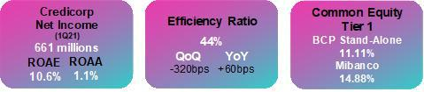

Economic activity in 1Q21 continued to post signs of recovery after having followed a downward trend over the last 4 quarters, registering an estimated inter-annual growth of 4% YoY despite localized lockdowns in February. This recovery was registered across all the sectors including financial transactions; demand for electricity; an uptick in VAT collections; an increase in public investment; and growth in cement consumption. Furthermore, in seasonally adjusted terms, GDP in the first quarter of 2021 stands very close to pre-pandemic levels.

Loan Growth

The QoQ contraction in average daily balances was driven by a decrease in funding needs in Wholesale segments. YoY, growth was attributable to the influx of low-interest government loans in LC in the SME-Pyme, SME-Business and Middle-Market segments at BCP Stand-alone.
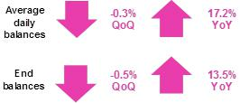

Net interest income and Net interest Margin

NII grew QoQ after registering a non-recurring charge at BCP Bolivia in 4Q20, which was partially offset by a charge of S/. 88 million for a liability management transaction in 1Q21 at BCP Stand-alone. If we exclude these effects, NII contracts due to repricing at lower interest rates and to a decrease in structural loans, which was offset by the favorable evolution of the deposit mix.
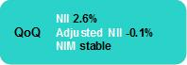

NII contracted YoY. This was primarily driven by change in the asset mix, which registered a higher preponderance of less profitable assets due to a decline in structural loan volumes and lower interest rates. The aforementioned was offset by a decrease in funding rates and an improvement in the funding mix.
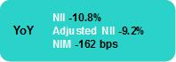

Provisions and Portfolio Quality

Provisions fell significantly QoQ due to improvements in the probabilities of default in the majority of BCP Stand-alone segments. This was partially offset by an increase in provisions of Mibanco, which was attributable to deterioration in the debt service capacity of clients, who were affected by the second wave of COVID-19 and requested new credit facilities. The YoY reduction was driven by an improvement in the economic outlook and in client payment behavior.
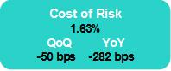

The NPL portfolio registered an increase after grace periods for clients that had availed of Credicorp’s facilities at the beginning of the pandemic began to expire.
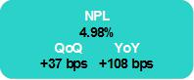

4

Non-Financial Income

The contraction over the quarter was due primarily to lower fee income in a context of low transactionality due to seasonality and the quarantine. Additionally, the net gain on securities contracted due to losses in ASB’s fixed income portfolio after an upswing in market rates.


The YoY increase was driven by the fact that the 1Q20 was impacted by net losses on securities and by fee exemptions at the beginning of the pandemic.

Underwriting Results

The underwriting results decreased QoQ and YoY -176.9% and -146.0% respectively. This drop was attributable to an increase in claims and in IBNR provisions in the Life business, which was in turn driven by COVID-19 related mortality. This result was partially mitigated by a decrease in claims in P&C, which benefitted from mobility restrictions.

Efficiency Ratio

The efficiency ratio situated at 44.0%, increasing +60bps YoY. Operating expenses remain under control. Nevertheless, a decrease in net interest income (including the charge for the liability management operation at BCP Stand-alone) drove a year-over-year deterioration in the efficiency ratio.

Net income at Credicorp and Contributions by LoB

Contribution* and ROAE by subsidiary in 1Q21 (S/ millions)

Credicorp: Net income S/ 660.8 millions, ROAE 10.6%
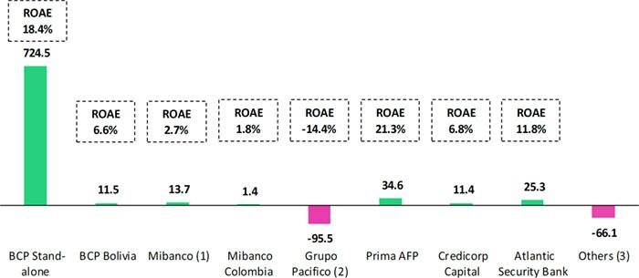

*Contributions to Credicorp reflect the eliminations for consolidation purposes (e.g. eliminations for transactions between Credicorp and its subsidiaries).

- The figure is lower than the net income of Mibanco because Credicorp owns 99.921% of Mibanco (directly and indirectly). ROAE including goodwill from the acquisition of BCP from the acquisition of Edyficar (Approximately US$ 50.7 million) was 6.07% in 1Q20, 4.51% in 4Q20 and 2.49% in 1Q21.

- The contribution is higher than Grupo Pacifico’s net income because Credicorp owns 65.20% directly, and 33.59% through Grupo Credito. Figures include unrealized gains or losses that are considered in Pacifico’s Net Equity from the investment portfolio of Pacifico Vida. ROAE excluding such unrealized gains was 16.54% in 1Q20, 1.47% in 4Q20 and -17.59% in 1Q21.
- Includes Grupo Credito excluding Prima, others of Atlantic Security Holding Corporation and others of Credicorp Ltd.

5



Overview Financial Information: First Quarter 2021

Credicorp Ltd. |  |  |  | Quarter |  |  |  | % change
S/ 000 |  | 1Q20 |  | 4Q20 |  | 1Q21 |  | QoQ |  |  | YoY
Net interest, similar income and expenses |  | 2,379,527 |  | 2,069,220 |  | 2,123,383 |  | 2.6% |  |  | -10.8%
Provision for credit losses on loan portfolio, net of recoveries |  | (1,341,481) |  | (732,665) |  | (557,647) |  | -23.9% |  |  | -58.4%
Net interest, similar income and expenses, after provision for credit losses on loan portfolio |  | 1,038,046 |  | 1,336,555 |  | 1,565,736 |  | 17.1% |  |  | 50.8%
Total other income |  | 958,255 |  | 1,330,406 |  | 1,194,530 |  | -10.2% |  |  | 24.7%
Insurance underwriting result |  | 141,926 |  | 84,866 |  | (65,247) |  | n.a |  |  | n.a
Total other expenses |  | (1,779,306) |  | (1,982,556) |  | (1,680,271) |  | -15.2% |  |  | -5.6%
Profit before income tax |  | 358,921 |  | 769,271 |  | 1,014,748 |  | 31.9% |  |  | 182.7%
Income tax |  | (145,746) |  | (103,460) |  | (337,599) |  | 226.3% |  |  | 131.6%
Net profit |  | 213,175 |  | 665,811 |  | 677,149 |  | 1.7% |  |  | 217.6%
Non-controlling interest |  | 3,901 |  | 12,407 |  | 16,351 |  | 31.8% |  |  | 319.1%
Net profit attributable to Credicorp |  | 209,274 |  | 653,404 |  | 660,798 |  | 1.1% |  |  | 215.8%
Net income / share (S/) |  | 2.62 |  | 8.19 |  | 8.28 |  | 1.1% |  |  | 215.8%
Loans |  | 120,708,515 |  | 137,659,885 |  | 137,031,239 |  | -0.5% |  |  | 13.5%
Deposits and obligations |  | 119,563,545 |  | 142,365,502 |  | 148,626,339 |  | 4.4% |  |  | 24.3%
Net equity |  | 23,205,639 |  | 24,945,870 |  | 24,529,958 |  | -1.7% |  |  | 5.7%
Profitability
Net interest margin |  | 5.35% |  | 3.73% |  | 3.73% |  | 0bps |  |  | -162bps
Risk-adjusted Net interest margin |  | 2.33% |  | 2.41% |  | 2.75% |  | 34bps |  |  | 42bps
Funding cost |  | 2.13% |  | 1.34% |  | 1.43% |  | 9bps |  |  | -70bps
ROAE |  | 3.4% |  | 10.8% |  | 10.6% |  | -20bps |  |  | 720bps
ROAA |  | 0.4% |  | 1.1% |  | 1.1% |  | 0bps |  |  | 70bps
Loan portfolio quality
Internal overdue ratio ⁽¹⁾ |  | 2.97% |  | 3.40% |  | 3.55% |  | 15bps |  |  | 58bps
Internal overdue ratio over 90 days |  | 2.13% |  | 2.69% |  | 2.77% |  | 8bps |  |  | 64bps
NPL ratio ⁽²⁾ |  | 3.90% |  | 4.61% |  | 4.98% |  | 37bps |  |  | 108bps
Cost of risk ⁽³⁾ |  | 4.45% |  | 2.13% |  | 1.63% |  | -50bps |  |  | -282bps
Coverage ratio of IOLs |  | 165.7% |  | 211.7% |  | 200.2% |  | -1150bps |  |  | 3450bps
Coverage ratio of NPLs |  | 126.1% |  | 156.1% |  | 142.9% |  | -1320bps |  |  | 1680bps
Operating efficiency
Efficiency ratio ⁽⁴⁾ |  | 43.4% |  | 47.2% |  | 44.0% |  | -320bps |  |  | 60bps
Operating expenses / Total average assets |  | 3.57% |  | 3.06% |  | 2.83% |  | -23bps |  |  | -74bps
Insurance ratios
Combined ratio of P&C ⁽⁵⁾ ⁽⁶⁾ |  | 94.4% |  | 81.4% |  | 85.5% |  | 410bps |  |  | -890bps
Loss ratio ⁽⁶⁾ |  | 59.9% |  | 75.4% |  | 96.4% |  | 2100bps |  |  | 3650bps
Capital adequacy ⁽⁷⁾
BIS ratio ⁽⁸⁾ |  | 13.52% |  | 14.93% |  | 16.46% |  | 153bps |  |  | 294bps
Tier 1 ratio ⁽⁹⁾ |  | 10.33% |  | 10.41% |  | 10.59% |  | 18bps |  |  | 26bps
Common equity tier 1 ratio (10) |  | 11.89% |  | 11.40% |  | 11.11% |  | -29bps |  |  | -78bps
Employees |  | 34,963 |  | 36,806 |  | 36,233 |  | -1.6% |  |  | 3.6%
Share Information
Outstanding Shares |  | 94,382 |  | 94,382 |  | 94,382 |  | 0.0% |  |  | 0.0%
Treasury Shares ⁽¹¹⁾ |  | 14,872 |  | 14,915 |  | 14,621 |  | -2.0% |  |  | -1.7%
Floating Shares |  | 79,510 |  | 79,467 |  | 79,761 |  | 0.4% |  |  | 0.3%

- Internal overdue loans includes overdue loans and loans under legal collection, according to our internal policy for overdue loans. Internal Overdue ratio: Internal overdue loans / Total loans.

- Non-performing loans (NPL): Internal overdue loans + Refinanced loans. NPL ratio: NPL / Total loans.
- Cost of risk: Annualized provision for loan losses, net of recoveries / Total loans.
- Efficiency ratio = (Salaries and employee benefits + Administrative expenses + Depreciation and amortization + Association in participation + Acquisition cost) / (Net interest, similar income and expenses + Fee Income + Net gain on foreign exchange transactions + Net Gain From associates + Net gain on derivatives held for trading + Result on exchange differences + Net Premiums Earned).

- Combined ratio = (Net claims / Net earned premiums) + [(Acquisition cost + Operating expenses) / Net earned premiums]. Does not include Life insurance business.
- Considers Grupo Pacifico’s figures before eliminations for consolidation to Credicorp.
- All Capital ratios are for BCP Stand-alone and based on Peru GAAP.
- Regulatory Capital / Risk-weighted assets (legal minimum = 10% since July 2011).
- Tier 1 = Capital + Legal and other capital reserves + Accumulated earnings with capitalization agreement + (0.5 x Unrealized profit and net income in subsidiaries) - Goodwill - (0.5 x Investment in subsidiaries) + Perpetual subordinated debt (maximum amount that can be included is 17.65% of Capital + Reserves + Accumulated earnings with capitalization agreement + Unrealized profit and net income in subsidiaries - Goodwill).
- Common Equity Tier I = Capital + Reserves – 100% of applicable deductions (investment in subsidiaries, goodwill, intangibles and net deferred taxes that rely on future profitability) + retained earnings + unrealized gains.
Adjusted Risk-Weighted Assets = Risk-weighted assets - (RWA Intangible assets, excluding goodwill, + RWA Deferred tax assets generated as a result of temporary differences in income tax, in excess of 10% of CET1, + RWA Deferred tax assets generated as a result of past losses).”
- These shares are held by Atlantic Security Holding Corporation (ASHC) and for shared based payments.

7



1. Interest Earning Assets (IEA)
Interest earning assets |  |  |  | As of |  |  |  | % change
S/ 000 |  | Mar 20 |  | Dec 20 |  | Mar 21 |  | QoQ |  |  | YoY
Cash and due from banks |  | 19,162,140 |  | 28,544,161 |  | 31,919,515 |  | 11.8% |  |  | 66.6%
Interbank funds |  | 376,289 |  | 32,221 |  | 63,301 |  | 96.5% |  |  | -83.2%
Total investments |  | 36,816,653 |  | 55,173,742 |  | 59,412,732 |  | 7.7% |  |  | 61.4%
Cash collateral, reverse repurchase agreements and securities borrowing |  | 4,424,345 |  | 2,394,302 |  | 1,769,690 |  | -26.1% |  |  | -60.0%
Financial assets designated at fair value through profit or loss |  | 559,321 |  | 823,270 |  | 888,420 |  | 7.9% |  |  | 58.8%
Total loans |  | 120,708,515 |  | 137,659,885 |  | 137,031,239 |  | -0.5% |  |  | 13.5%
Total interest earning assets |  | 182,047,263 |  | 224,627,581 |  | 231,084,897 |  | 2.9 | % |  | 26.9 | %

1.1. Structure and Evolution of IEA

Composition of IEA

At the end of March 2021, loans (the most profitable asset) represented 59.3% of IEAs, followed by investments with 25.7% and other assets with 15.0%.
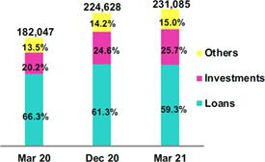

The current composition of IEA reflects a less profitable structure both QoQ and YoY, which is attributable to the fact that growth in investments and in other assets outpaced loan expansion. This led to a drop in the share of loans in total IEA. Additionally, it is important to note that this quarter, the share of government loans in total IEA fell, dropping from 10.9% last quarter to 10.5% in 1Q21

Total Loans Measured in Quarter-End Balances

QoQ, total loans measured in quarter-end fell -0.5% QoQ. This was attributable to a mix of factors:

- Wholesale Banking posted the largest decline in quarter-end balances at the portfolio level. This drop was primarily due to cancellations of short-term loans in a context marked by an economic recession and by a decrease in financing requirements in the Corporate segment, which moved to bolster liquidity at the beginning of the pandemic.

- Retail Banking quarter-end balances grew slightly, which partially offset the decrease registered in the Wholesale portfolio. SME-Business, Mortgage and Consumer reported growth in balances this quarter while SME-Pyme and Credit Cards registered a decline.

- Mibanco’s balances reported growth, which was driven by a recovery of disbursements in structural loans. BCP Bolivia registered a drop in balances due to the pandemic; a decrease in economic activity in the Wholesale segment; and a drop in microcredit balance after loans disbursements fell in a context of an increase in credit risk.

If we exclude loans granted through Government Programs (Reactiva Peru and FAE-MYPE) from the calculation base for quarter-end balances, we find that loans in the “Structural Portfolio” fell -0.2% QoQ.

YoY, loans measured in quarter-end balances increased +13.5% due to following factors:

- Growth in balances in the Retail Banking portfolio at BCP Stand-alone was led by the SME-Pyme segment, followed by the SME-Business, which registered an increase in disbursements for working capital in LC under the Reactiva Peru program. Expansion was also driven, although to a lesser extent, by an uptick in balances in the Mortgage and Consumer segments. Credit Cards, on the contrary, reported a drop in balances due to a decrease in card use in the context of the pandemic.

- Growth in Mibanco’s balances, which was attributable to loan disbursements under the Reactiva Peru and FAE-Mype programs and growth in BCP Bolivia’s portfolio, which was driven by an uptick in the demand for Wholesale loans.

9

- Loan growth was partially offset by a drop in Wholesale loan balances, which was driven by a decrease in loan demand from businesses that were adversely affected by confinement measures and/or had already shored up financing at the beginning of the pandemic.

If we exclude Government Loans from the calculation base, we find that loans in the structural portfolio fell -6.6% YoY.

It is important to note that YoY, growth in total loans was driven by a 9.3% appreciation in the US dollar. If we exclude the exchange rate effect, total loans register growth of 10.4% YoY in real terms for the total portfolio but reflect a decrease of -9.7% YoY in real terms for the structural portfolio. At the end of March 2021, FC loans accounted for 32.6% of total loans, which represented a decrease with regard to the 40.1% reported in March 2020. This drop was driven by growth in LC disbursements, which was in turn attributable to high inflows of government loans and to a decrease in FC loans, primarily in the Wholesale portfolio.

Total Investments
Total Investments |  |  |  | As of |  |  |  |  | % change
S/ 000 |  | Mar 20 |  | Dec 20 |  | Mar 21 |  | QoQ |  |  |  | YoY
Fair value through profit or loss investments |  | 4,185,638 |  | 6,467,471 |  | 8,083,128 |  |  | 25.0% |  |  | 93.1%
Fair value through other comprehensive income investments |  | 28,388,372 |  | 43,743,889 |  | 45,681,969 |  |  | 4.4% |  |  | 60.9%
Amortized cost investments |  | 4,242,643 |  | 4,962,382 |  | 5,647,635 |  |  | 13.8% |  |  | 33.1%
Total investments |  | 36,816,653 |  | 55,173,742 |  | 59,412,732 |  |  | 7.7 | % |  | 61.4 | %

Total investments increased +7.7% QoQ and +61.4% YoY. The QoQ evolution was primarily driven by growth in the fair value through profit and loss portfolio and in the fair value through other comprehensive investment portfolio at BCP Stand-alone. This expansion was fueled by growth in wholesale funding this quarter, which led to a subsequent increase in available funds. This quarter we increased the short-term investment portfolio while managing the exposure in the medium-term banking book, in a context of rising interest rates.

In YoY terms growth was driven by the fact that the bulk of government loans were used to pay suppliers; cover payroll; or for working capital. These funds bolstered balances across the financial system and in Credicorp’s case, spearheaded an increase in liquidity at BCP Stand-Alone. In this context, and in line with the strategy to optimize the structure of balance to increase the profitability of liquid assets, cash surplus was invested in low-risk instruments such as certificates of deposit and sovereign bonds, primarily in MN.

Other IEA

Available funds increased 11.8% QoQ and 66.6% YoY. The quarterly evolution was attributable to an uptick in the capture of wholesale deposits this quarter and to the temporary liquidity generated by a subordinated bond issue (liability management) at BCP Stand-alone. The yearly evolution was driven by the excess liquidity created by Government loans, which landed, in Credicorp’s case, in current accounts at BCP Stand-alone.

1.2. Credicorp Loans

1.2.1. Evolution of loans in average daily balances (ADB)

The ADB for loans dropped -0.3% QoQ but grew +17.3% YoY. The QoQ evolution was driven primarily by the decrease in the Wholesale portfolio. Growth in YoY terms was fueled by an uptick in the balances in SME-Pyme and SME-Business in the Retail Portfolio at BCP Stand-alone, which grew due to the influx of Reactiva loans. If we exclude Government loans from the calculation base, Structural Loans fell -0.2% QoQ and -3.8% YoY. The evolution of the ADB for loans was driven by the influx of local currency loans through Government programs; the availability of attractive rates; and a decrease in dollarization system-wide

ADB balances provide the most complete picture of how loan interest, which constitutes Credicorp’s primary source of income, has evolved. Additionally, average daily balances reflect trends or variations to a different degree than quarter-end balances which may include pre-payments or loans made at the end of the quarter. In comparative terms, these payments, affect average daily balances less than quarter-end balances and as such, the former provide a more balanced picture of loan evolution.

10

Evolution of ADB of loans by business segment ⁽¹⁾⁽²⁾⁽³⁾

 |  |  |  | TOTAL LOANS |  |  |  |  |  |  |  |  |  |  |  |  | % change
 | Expressed in million S/ |  |  |  |  |  | Structural |  |  |  |  | % change |  |  |  |  | Structural |  |  |  | % Part. in total loans |  |  |  |  |  | Structural
 | 1Q20 |  | 4Q20 |  | 1Q21 |  | 4Q20 |  | 1Q21 |  | QoQ |  |  | YoY |  |  | QoQ |  | YoY |  | 1Q20 |  | 4Q20 |  | 1Q21 |  | 1Q21
BCP Stand-alone | 95,083 |  | 112,981 |  | 111,969 |  | 91,075 |  | 90,319 |  | -0.9% |  |  | 17.8% |  |  | -0.8% |  | -5.0% |  | 81.5% |  | 82.4% |  | 81.9% |  | 80.5%
Wholesale Banking | 47,658 |  | 51,675 | 49,860 |  |  | 44,988 |  | 43,518 |  | -3.5% |  |  | 4.6% |  |  | -3.3% |  | -8.7% |  | 40.9% |  | 37.7% |  | 36.5% |  | 38.8%
Corporate | 29,146 |  | 28,522 | 27,271 |  |  | 27,771 |  | 26,621 |  |  | -4.4% |  | -6.4% |  |  | -4.1% |  | -8.7% |  | 25.0% |  | 20.8% |  | 19.9% |  | 23.7%
Middle - Market | 18,511 |  | 23,153 | 22,590 |  |  | 17,216 |  | 16,898 |  |  | -2.4% |  | 22.0% |  |  | -1.9% |  | -8.7% |  | 15.9% |  | 16.9% |  | 16.5% |  | 15.1%
Retail Banking | 47,425 |  | 61,306 | 62,109 |  |  | 46,088 |  | 46,801 |  | 1.3% |  |  | 31.0% |  |  | 1.5% |  | -1.3% |  | 40.7% |  | 44.7% |  | 45.4% |  | 41.7%
SME - Business | 5,456 |  | 10,893 | 10,793 |  |  | 4,652 |  | 4,287 |  | -0.9% |  |  | 97.8% |  |  | -7.8% |  | -21.4% |  | 4.7% |  | 7.9% |  | 7.9% |  | 3.8%
SME - Pyme | 10,330 |  | 19,239 | 19,562 |  |  | 10,262 |  | 10,760 |  | 1.7% |  |  | 89.4% |  |  | 4.9% |  | 4.2% |  | 8.9% |  | 14.0% |  | 14.3% |  | 9.6%
Mortgage | 16,905 |  | 17,218 | 17,720 |  |  | 17,218 |  | 17,720 |  |  | 2.9% |  | 4.8% |  |  | 2.9% |  | 4.8% |  | 14.5% |  | 12.6% |  | 13.0% |  | 15.8%
Consumer | 8,984 |  | 9,544 | 9,958 |  |  | 9,544 |  | 9,958 |  |  | 4.3% |  | 10.8% |  |  | 4.3% |  | 10.8% |  | 7.7% |  | 7.0% |  | 7.3% |  | 8.9%
Credit Card | 5,750 |  | 4,412 | 4,075 |  |  | 4,412 |  | 4,075 |  | -7.6% |  |  | -29.1% |  |  | -7.6% |  | -29.1% |  | 4.9% |  | 3.2% |  | 3.0% |  | 3.6%
Mibanco | 10,629 |  | 12,679 | 12,923 |  |  | 9,865 |  | 10,102 |  | 1.9% |  |  | 21.6% |  |  | 2.4% |  | -5.0% |  | 9.1% |  | 9.2% |  | 9.5% |  | 9.0%
Mibanco Colombia | 835 |  | 866 | 909 |  |  | 866 |  | 909 |  | 4.9% |  |  | 8.9% |  |  | 4.9% |  | 8.9% |  | 0.7% |  | 0.6% |  | 0.7% |  | 0.8%
Bolivia | 7,686 |  | 8,272 | 8,420 |  |  | 8,272 |  | 8,420 |  | 1.8% |  |  | 9.5% |  |  | 1.8% |  | 9.5% |  | 6.6% |  | 6.0% |  | 6.2% |  | 7.5%
ASB | 2,415 |  | 2,342 | 2,516 |  |  | 2,342 |  | 2,516 |  | 7.4% |  |  | 4.2% |  |  | 7.4% |  | 4.2% |  | 2.1% |  | 1.7% |  | 1.8% |  | 2.2%

Largest contraction in volumes

Highest growth in volumes

For consolidation purposes, loans generated in FC are converted to LC.
- Includes Work out unit, and other banking.
- Figures differ from previously reporte, please consider the data presented on this report that now inclides Mibanco Colombia.
- Structural Portfolio excludes the average daily balances from loans offered through de Reactiva Peru y FAE-Mype Government Programs.

QoQ growth in ADB for loans by segments

Expressed in millions of S/

-0.3% (-0.1% Structural Portfolio)
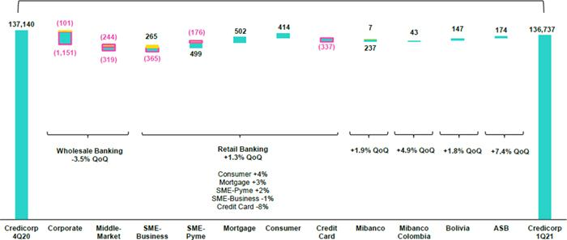

Government Programs (Reactiva and FAE-Mype)
Structural

The figure above shows a decrease of -0.3% QoQ (-0.1% structural) in loans measured in ADB, which was attributable to differing evolutions for diverse business segments.

The Wholesale Banking portfolio reported a drop of -3.5% QoQ in ADB due to a decrease in structural balances in the Corporate segment and, albeit to a lesser degree, to a drop in the Middle Market segment. Balances for Corporate Banking fell -4.4% QoQ while Middle Market Banking decreased -2.4% QoQ. This decline was attributable to the fact that many wholesale clients took a conservative approach to financing in a context of sluggish business activity due to the pandemic. In this context, less financing was sought, and clients moved to cancel short-term debt.

The Retail Banking portfolio evolved positively, advancing +1.3 QoQ in terms of ABD. This was attributable to growth in balances in the Mortgage, SME-Pyme and Consumer segments, which reverted a downward trend in 4Q20 in a context of economic recovery. On the contrary, loans in the Credit Card segment fell due to the drop in big-ticket purchases amid new confinement restrictions in 1Q21 and consequent constraints on the risk appetite for this segment. The SME-Business segment, like the Corporate segment, reported a decrease in structural balances. This was attributable to the fact that many clients received low-cost funding from Reactiva Peru and are managing excess liquidity in a context of economic contraction. This combination of factors prompted some clients to cancel debt.

11

Despite the effect of new confinement measures, Mibanco reported loan growth of +1.9% QoQ thanks to an uptick in structural loans this quarter. If we exclude Government loans from the calculation base, structural loans at Mibanco grew 2.4% QoQ. Mibanco Colombia registered record disbursement levels, which led growth in their portfolio balances of +4.9% QoQ. This was attributable to a recovery in the microfinance segment in Colombia and to company strategies to optimize the productivity and distribution of the salesforce.

At BCP Bolivia, the loan portfolio grew +1.8% QoQ, which reflected an increase in loan reprogramming and in the exchange rate.

YoY growth in the ADB of loans by segment

Expressed in millions of S/

+ 17.2% (-3.8% Structural Portfolio)
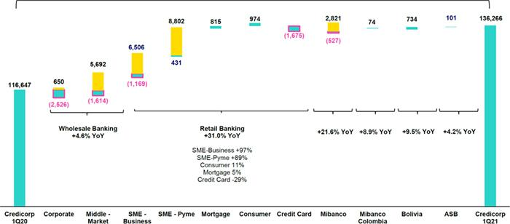

Government Programs (Reactiva y FAE-Mype)
Structural

An analysis of YoY growth by segment measured in ADB shows:

Growth in the SME-Business segments (+89.4% YoY), SME-Business (+97.8% YoY) and Middle Market (+22.0% YoY), bolstered by Reactiva Peru, led expansion in ADB. Growth in these segments was followed by expansion in Consumer (+10.8% YoY) and Mortgage (+4.8% YoY), which were negatively impacted by quarantine measures in 2Q20 and 3Q20 but in 4Q20, resumed growth alongside economic recovery. Credit cards, on the contrary, fell (-29% YoY) given that this product is used in sectors that have suffered the brunt of the pandemic’s impact and continue to lag due to on-going restrictions: travel, restaurants, retail purchases. To this is added the internal risk appetite constraints for this segment given the actual economic environment. If we exclude Government loans from the calculation base, SME-Pyme registered expansion of +4.2% while SME-Business contracted -21.4% YoY.

The ADB for the total Wholesale Banking portfolio registered growth of +4.6% YoY. Within this portfolio, the Middle Market Banking segment reported an increase of +22.0% YoY due to Reactiva Peru but the Corporate Banking segment registered a drop of -6.4% YoY after the demand for financing fell. The exchange rate effect, which was affected by the appreciation of the US Dollar, also drove variations. It is important to note that 40.7% of Middle Market loans and 57.7% of Corporate loans are denominated in FC. If we exclude the exchange rate effect, the Middle market segment reports growth of +18.7% while Corporate Banking registers a drop of -10.0%. If we exclude Government loans from the calculation base, Middle Market Banking and Corporate Banking fell -8.7% respectively.

Growth in Mibanco loans was situated at +21.6% YoY and driven by loans disbursed under Reactiva Peru and FAE-Mype. Loans under Reactiva and FAE represented approximately 22% of Mibanco’s average daily balances at the end of March 2021. If we exclude Government loans from the calculation base, Mibanco’s structural portfolio registered a drop of -5.0% YoY in average daily balances. Regarding Mibanco Colombia, loans in ADB registered growth of +8.9% YoY as disbursements have reached record levels this quarter due to the fact that the Colombian microfinance market has resumed growth and the company’s commercial and operating strategy yielded benefits.

12

The +9.5% YoY expansion reported for the ADB of BCP Bolivia’s loans was primarily attributable to growth in Corporate Banking and loan reprogramming. The Commercial Mortgage segment also contributed, albeit to a lesser degree, to growth in ADB. Nevertheless, total growth was offset by a drop in the retail portfolio, which absorbed the brunt of the pandemic and was affected by downturn in microloans in a risk adverse context marked by ongoing uncertainty.

1.2.2. Evolution of the level of loan dollarization at Credicorp by segment

Evolution of average daily balances by currency ⁽¹⁾⁽²⁾⁽³⁾

 |  |  | DOMESTIC CURRENCY LOANS |  |  |  |  |  |  |  |  |  |  |  |  |  | % change |  |  |  |  |  | FOREIGN CURRENCY LOANS |  |  |  |  |  |  |  |  | % part. by currency
 | Expressed in million S/ |  |  |  |  |  |  | Structural |  |  |  | % change |  |  |  |  | Structural |  |  |  |  |  | Expressed in million US$ |  |  |  |  |  |  |  |  | 1Q21
 | 1Q20 |  |  | 4Q20 |  | 1Q21 |  | 4Q20 |  | 1Q21 |  | QoQ |  |  | YoY |  | QoQ |  | YoY |  | 1Q20 |  | 4Q20 |  | 1Q21 |  | QoQ |  | YoY |  |  | LC |  |  | FC
BCP Stand-alone | 60,854 |  |  | 80,945 |  | 80,117 |  | 59,039 |  | 58,466 |  | -1.0% |  |  | 31.7% |  | -1.0% |  | -3.9% |  | 10,009 |  | 8,865 |  | 8,654 |  | -2.4% |  | -13.5% |  |  | 71.6% |  |  | 28.4%
Wholesale Banking | 20,733 |  | 26,490 |  |  | 24,935 |  | 19,802 |  | 18,593 |  | -5.9% |  |  | 20.3% |  | -6.1% |  | -10.3% |  | 7,873 |  | 6,969 |  | 6,772 |  | -2.8% |  | -14.0% |  |  | 50.0% |  |  | 50.0%
Corporate | 12,186 |  | 12,596 |  |  | 11,538 |  | 11,845 |  | 10,887 |  | -8.4% |  |  | -5.3% |  | -8.1% |  | -10.7% |  | 4,959 |  | 4,407 |  | 4,275 |  | -3.0% |  | -13.8% |  |  | 42.3% |  |  | 57.7%
Middle-Market | 8,546 |  | 13,894 |  |  | 13,398 |  | 7,957 |  | 7,706 |  | -3.6% |  |  | 56.8% |  | -3.2% |  | -9.8% |  | 2,914 |  | 2,562 |  | 2,497 |  | -2.6% |  | -14.3% |  |  | 59.3% |  |  | 40.7%
Retail Banking | 40,122 |  | 54,455 |  |  | 55,181 |  | 39,237 |  | 39,873 |  | 1.3% |  |  | 37.5% |  | 1.6% |  | -0.6% |  | 2,136 |  | 1,896 |  | 1,882 |  | -0.7% |  | -11.9% |  |  | 88.8% |  |  | 11.2%
SME - Business | 2,624 |  | 8,402 |  |  | 8,320 |  | 2,161 |  | 1,814 |  | -1.0% |  |  | 217.0% |  | -16.1% |  | -30.9% |  | 828 |  | 689 |  | 672 |  | -2.5% |  | -18.9% |  |  | 77.1% |  |  | 22.9%
SME - Pyme | 10,104 |  | 19,040 |  |  | 19,352 |  | 10,062 |  | 10,550 |  | 1.6% |  |  | 91.5% |  | 4.8% |  | 4.4% |  | 66 |  | 55 |  | 57 |  | 3.6% |  | -13.4% |  |  | 98.9% |  |  | 1.1%
Mortgage | 14,698 |  | 15,063 |  |  | 15,572 |  | 15,063 |  | 15,572 |  | 3.4% |  |  | 5.9% |  | 3.4% |  | 5.9% |  | 646 |  | 596 |  | 584 |  | -2.1% |  | -9.6% |  |  | 87.9% |  |  | 12.1%
Consumer | 7,763 |  | 8,119 |  |  | 8,436 |  | 8,119 |  | 8,436 |  | 3.9% |  |  | 8.7% |  | 3.9% |  | 8.7% |  | 357 |  | 394 |  | 414 |  | 4.8% |  | 15.9% |  |  | 84.7% |  |  | 15.3%
Credit Card | 4,932 |  | 3,831 |  |  | 3,502 |  | 3,831 |  | 3,502 |  | -8.6% |  |  | -29.0% |  | -8.6% |  | -29.0% |  | 239 |  | 161 |  | 156 |  | -3.1% |  | -34.9% |  |  | 85.9% |  |  | 14.1%
Mibanco | 10,064 |  | 12,191 |  |  | 12,441 |  | 9,377 |  | 9,619 |  | 2.1% |  |  | 23.6% |  | 2.6% |  | -4.4% |  | 165 |  | 135 |  | 131 |  | -3.0% |  | -20.6% |  |  | 96.3% |  |  | 3.7%
Mibanco Colombia | - |  | - |  |  | - |  | - |  | - |  | - |  |  | - |  | - |  | - |  | 244 |  | 240 |  | 247 |  | 3.0% |  | 1.1% |  |  | - |  |  | 100.0%
Bolivia | - |  | - |  |  | - |  | - |  | - |  | - |  |  | - |  | - |  | - |  | 2,247 |  | 2,289 |  | 2,287 |  | -0.1% |  | 1.8% |  |  | - |  |  | 100.0%
ASB | - |  | - |  |  | - |  | - |  | - |  | - |  |  | - |  | - |  | - |  | 706 |  | 648 |  | 684 |  | 5.5% |  | -3.2% |  |  | - |  |  | 100.0%
Total loans | 70,919 |  |  | 93,136 |  | 92,558 |  | 68,416 |  | 68,086 |  | -0.6 | % |  | 30.5 | % | -0.5 | % | -4.0 | % | 13,371 |  | 12,177 |  | 12,002 |  | -1.4 | % | -10.2 | % |  | 67.7 | % |  | 32.3 | %


Largest contraction in volumes
Highest growth in volumes

For consolidation purposes, loans generated in FC are converted to LC.
- Includes Work out unit, and other banking.
- Structural Portfolio excludes the average daily balances from loans offered through de Reactiva Peru y FAE-Mype Government Programs.
- Figures differ from previously reported. Please consider the data presented in this report that now includes Mibanco Colombia.

Loan evolution was mainly driven by LC balances both QoQ and YoY. In terms of the QoQ evolution, growth in LC volumes was driven by the Mortgage, Consumer, SME-Pyme and Mibanco segments, which also register higher levels of LC exposure. YoY, growth was driven by disbursements of government loans in LC, which were directed primarily towards clients in the SME-Pyme and SME-Business segments of Retail Banking; Middle Market clients in Wholesale Banking; and microfinance clients at Mibanco. In terms of structural loans in LC, the drop in balances QoQ and YoY was due primarily to a decrease in balances in the segments that benefitted from Reactiva Loans; a drop in LC loans in the Corporate segment; and the impact of the drop in Credit Card use in the context of the pandemic.

Loan volumes in FC fell QoQ and YoY in the majority of segments in a context of a downturn in commercial activity and the fact that the Government granted large numbers of low-interest loans in ME through pandemic relief programs.

13

YoY evolution of the dollarization level by segment at Credicorp ⁽¹⁾⁽²⁾⁽³⁾
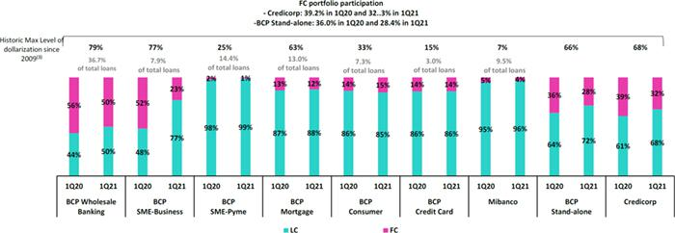

- Average daily balances.

- The FC share of Credicorp’s loan portfolio is calculated including BCP Bolivia and ASB, however the chart shows only the loan books of BCP Stand-alone and Mibanco.
- The year with the historic maximum level of dollarization for Wholesale Banking was 2012, for Mibanco was 2016 and for the rest of segments was 2009.

At BCP Stand-alone, the loan dollarization level fell YoY to situate at 28.4%. The downward trend was present across segments but the drop in the dollarization level was visible across segments but particularly prominent in SME-Business, where dollarization fell to 23% in March 2021 versus 52% in March 2020. The aforementioned was driven by a significant increase in the volume of loan disbursements in LC, which was linked to the Reactiva Peru program.

14

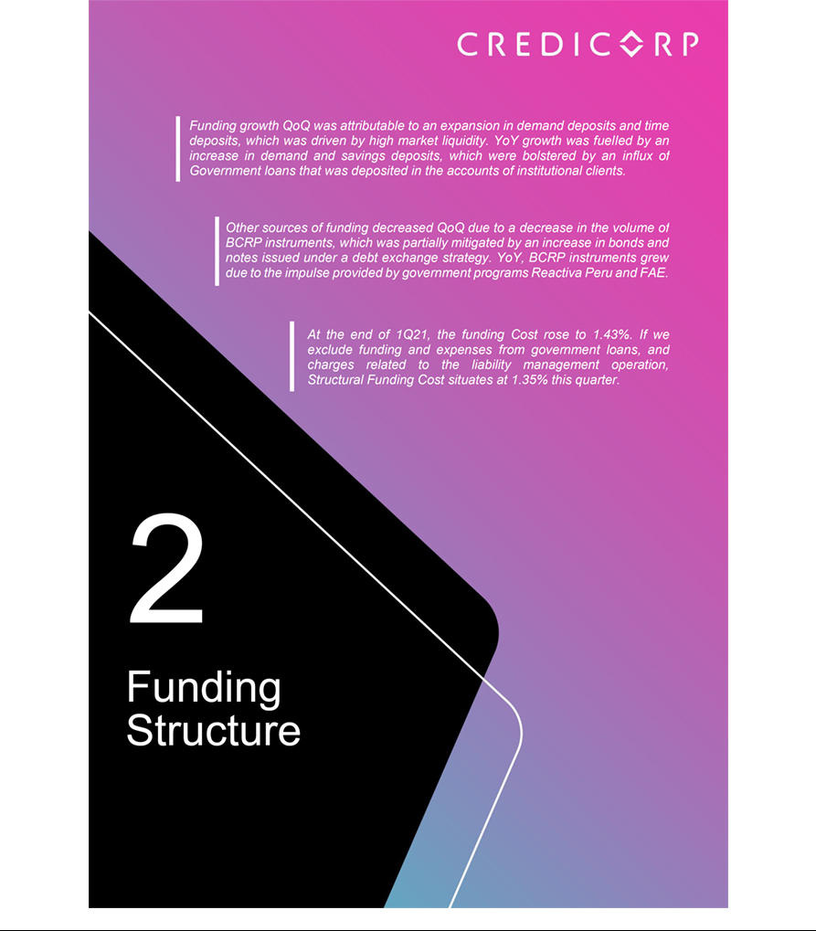

2. Funding Sources

2.1 Funding Structure

(1) Expenses are included in accordance with IFRS16.

The figure depicting the Evolution of Credicorp’s funding structure is calculated with quarter-end balances. In general, the funding structure reflects:

- Significant growth in deposits (+4.4% QoQ and +24.3% YoY), the main source of funding, which entail lower costs compared to Other sources of funding.

- QoQ, deposits registered a share of 75.3% of total funding (vs. 74.4% in 4Q20), followed by BCRP Instruments, with a 12.3% share (vs. 13.4% in 4Q20) and bonds, with a share of 9.3% (Vs. 8.5% in 4Q20).

- The funding structure varied YoY due to an increase in BCRP instruments (3.5% to 12.3%), which was driven by government facilities through Reactiva and FAE; this led to drop in the share of total deposits (78.7% to 75.3%).

- Growth in deposits represented 106.7% QoQ and 63.7% YoY in the total increase in funding.

2.2. Deposits
Deposits and obligations |  |  |  | As of |  |  |  |  |  | % change
S/ 000 |  | Mar 20 |  | Dec 20 |  | Mar 21 |  |  | QoQ |  |  |  | YoY
Demand deposits |  | 38,746,287 |  | 54,530,355 |  | 58,074,996 |  |  |  | 6.5% |  |  | 49.9%
Saving deposits |  | 37,872,908 |  | 50,069,129 |  | 51,013,689 |  |  |  | 1.9% |  |  | 34.7%
Time deposits |  | 35,045,214 |  | 29,324,090 |  | 31,389,760 |  |  |  | 7.0% |  |  | -10.4%
Severance indemnity deposits |  | 7,204,922 |  | 7,736,747 |  | 7,457,440 |  |  |  | -3.6% |  |  | 3.5%
Interest payable |  | 694,214 |  | 705,181 |  | 690,454 |  |  |  | -2.1% |  |  | -0.5%
Deposits and obligations |  | 119,563,545 |  | 142,365,502 |  | 148,626,339 |  |  |  | 4.4 | % |  | 24.3 | %

Deposits and obligations expanded +4.4% QoQ. The QoQ evolution of the deposit mix shows:

- A +6.5% increase in demand deposits; this was driven by an uptick in the deposit volume at BCP Stand-alone in Wholesale Banking in LC and FC and in current accounts in a context of high market liquidity. Growth was also driven although to a lesser extent, by an upswing in deposits after the government allowed AFP affiliates to withdraw funds from their pensions in January.

- The +7.0% growth in time deposits was attributable to (i) an increase in balances at BCP Stand-alone in FC, which was associated growth in accounts held by corporate and institutional clients and; (ii) to a lesser extent, to the exchange rate effect in a volatile context.

- The +1.9% growth QoQ in savings deposits, which reflected profit sharing in the month of March and was partially attenuated by a decrease in deposits by Individuals at Mibanco.

16

- The drop in severance indemnity deposits (-3.6%); this was due to seasonality in the last quarter of the year given that this deposit is made in the month of November.

In YoY terms, total deposits and obligations reported growth of +24.3%. This expansion was due to (i) an increase in the volume of government loans (Reactiva Perú an FAE) and subsequent growth in demand deposits and; (ii) Lockdowns in 2020 and at the beginning of the year, which led to an increase in savings deposits in a context of lower individual consumption. The aforementioned was attenuated by a drop in time deposits, which continued to be displaced by lower-cost deposits in the deposit mix, despite growth in the Middle Market segment of BCP Stand-alone.

2.2.1. Deposits: Dollarization level

Credicorp – Dollarization level of deposits measured in quarter-end balances

The dollarization level increased QoQ, driven by a variation in the share of LC and FC in total deposits: the LC deposit level fell from 53.5% last quarter to 51.9% in 1Q21 while FC deposits rose from 46.5% to 48.1%. The QoQ variation in FC was +8.1% while LC registered a slight increase of -1.2% due to (i) an increase in the volume of balances and (ii) to the exchange rate effect. In the YoY analysis, the dollarization level fell after growth in LC (+27.4%) outpaced expansion in FC (+21.3%).

- Demand and saving deposits increased in LC. Growth in deposits was led by Wholesale Banking clients while the expansion in savings was spurred by accounts held by individuals. The aforementioned offset the contraction in other type of deposits in LC.

- With regard to LC volumes, growth was primarily attributable to time deposits and demand deposits and, to a lesser extent, to savings deposits. The quarterly evolution was driven by an increase in FC deposits by institutional clients and to the exchange rate effect caused by the +3.8% appreciation in the US Dollar QoQ, which drove a consequent uptick in volumes of FC deposits.
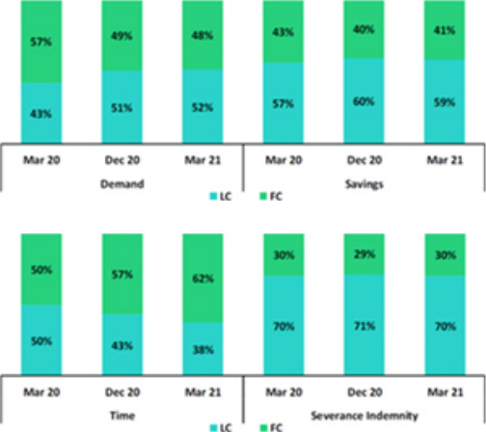

2.3. Other sources of funding
Other funding sources |  |  |  | As of |  |  |  |  |  | % change
S/ 000 |  | Mar 20 |  | Dec 20 |  | Mar 21 |  |  | QoQ |  |  |  | YoY
Due to banks and correspondents |  | 9,854,630 |  | 5,978,257 |  | 5,393,500 |  |  |  | -9.8% |  |  | -45.3%
BCRP instruments |  | 5,346,373 |  | 25,734,963 |  | 24,303,193 |  |  |  | -5.6% |  |  | 354.6%
Repurchase agreements |  | 1,935,879 |  | 1,072,920 |  | 1,159,587 |  |  |  | 8.1% |  |  | -40.1%
Bonds and notes issued |  | 15,178,148 |  | 16,319,407 |  | 17,863,198 |  |  |  | 9.5% |  |  | 17.7%
Total other funding sources |  | 32,315,030 |  | 49,105,547 |  | 48,719,478 |  |  |  | -0.8 | % |  | 50.8 | %

The total of Other sources of funding fell -0.8% QoQ in a context of low interest rates and a drop in the level of BCRP instruments, which was partially offset by the issuance of an international subordinated bond under BCP Stand-alone Liability management strategy.

BCRP Instruments registered a decreased, which was mainly driven by BCP Stand-alone after securities and currency transactions with BCRP expired and pre-payments were made on transactions associated with Reactiva Perú.

The level of Due to banks and correspondents fell due to the evolution at BCP Stand-alone, which registered the cancellation of obligations with foreign financial institutions in FC, which was offset by a slight increase at (i) Mibanco, due to an increase for long-term obligations with COFIDE and (ii) ASB, due to an increase in obligations in FC.

17

Bonds and issued notes increased driven by the Liability Management strategy at BCP, which registered growth in exchanges of subordinated callable bonds 2026 and 2027. These bonds were initially awarded at rates of 6.875% and 6.125% respectively. The new issuance of international subordinated bonds was made for US$ 500 million in March with a coupon rate of 3.25% and a premium of S/88 million with the objective of reprofiling expiration dates in a context of low market rates.

Repo operations increased slightly, driven by new regular repo operations at ASB and BCP Stand-alone, mainly in FC.

In the YoY evolution, Other sources of funding rose +50.8%. This was attributable to growth in BCRP Instruments, which was in turn fuelled by government facilities through the Reactiva and FAE programs. Growth in this line was also driven by bonds and issued notes, as explained earlier in this section.

2.4. Loans / Deposits (C/D)

Loan/Deposit ratio by subsidiary

The L/D ratio at Credicorp contracted QoQ, situating at 92.2%. This was driven by an increase in deposits (+4.4%) and a decrease in loans (-0.5%).
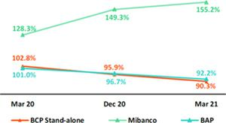

The analysis by subsidiary shows the same trend as that seen for BCP Stand-alone (90.3% Mar 21 vs 95.9% Dec 20). The QoQ decline in the L/D at BCP Stand-alone was attributable to growth in the deposit volume (+5.4%) versus a contraction in loans (-0.8%). The L/D ratio at Mibanco increased 155.2% over the same period.

In the YoY analysis, the L/D ratio at Credicorp and BCP Stand-alone given that the increase registered in the deposit volume (+24.3% and +27.3% respectively) outpaced growth in loans (+13.5% and +11.8% respectively). The L/D ratio at Mibanco followed the same trend as that seen in the QoQ analysis.

Loan/Deposit ratio by currency

Local Currency
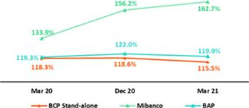

Foreign Currency
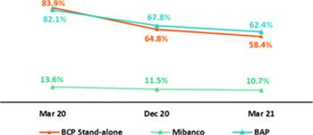

In the QoQ analysis by currency, the L/D ratio fell in LC at Credicorp and BCP Stand-alone after the deposits level rose (+1.9% and +1.2% respectively) in a context of high liquidity. The L/D ratios in FC at Credicorp, BCP Stand-alone and Mibanco contracted given that the deposit level rose while the loan level fell.

In the YoY analysis, Credicorp registered an increase in the L/D ratio in LC after loan expansion (+27.9%) outpaced the expansion registered in deposits (+27.2%).

Credicorp reported a drop in its L/D ratio in ME.

18

2.5. Funding Cost

Funding cost – Credicorp ⁽¹⁾⁽²⁾
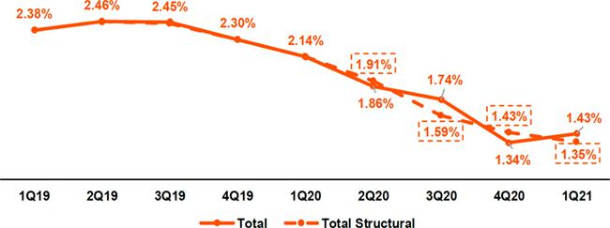

- Expenses are included in accordance with IFRS16.

- Structural Funding Cost deducts the impact in expenses and funding related to GP Loans (BCRP Repos) and deducts non-recurring events from Interest Expense.

Credicorp’s funding cost increased +9 bps QoQ. This was driven by an increase in interest expenses (+9.3%), which was generated by premiums (S/ 88 million) for the subordinated bond issuance for US$ 500 million at BCP Stand-alone, but will allow Credicorp to reap savings going forward. The aforementioned was partially offset by an increase in the funding volume (+3.1%). The structural funding cost was 1.35% (-8 bps QoQ).

In the YoY analysis, the funding cost fell -71 bps. This was attributable to an increase of +29.9% YoY in total funding, which was generated by the high levels of liquidity injected by government relief programs; the improvement in the deposit mix, which registered a decrease in interest on deposits of –11.7% YoY; and a rate effect, given that interest rates (national and international) are following a downward trend in a context of the economic contraction spurred by the pandemic.

Cost of funding in LC – Credicorp ⁽¹⁾⁽²⁾⁽³⁾
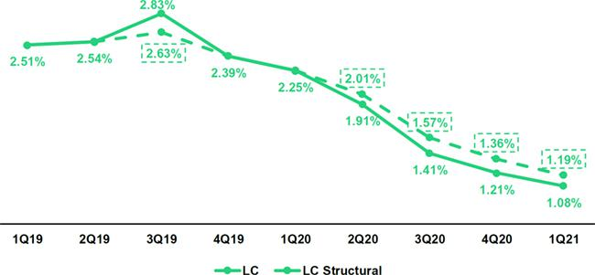

- The funding cost by currency is calculated with the average of period-beginning and period-end balances.

- Expenses are included in accordance with IFRS16.

- Structural Funding Cost deducts the impact in expenses and funding related to GP Loans (BCRP Repos) and deducts non-recurring events from Interest Expense

19

The decrease in the funding cost in LC (-13 bps), which was driven a contraction of -9.8% in interest expenses in a context of falling interest rates and a due to an increase of 0.5% in total funding in LC. Structural funding cost in LC was situated at 1.19% in 1Q21, which represented a decline QoQ (-17 bps).

Cost of Funding in FC – Credicorp ⁽¹⁾⁽²⁾⁽³⁾
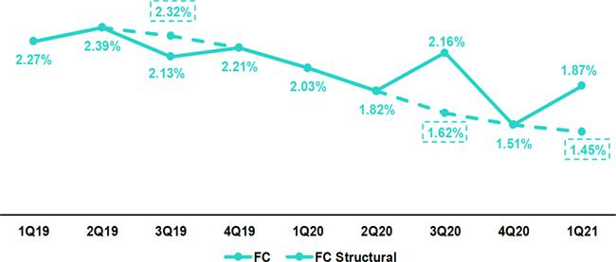

- The funding cost by currency is calculated with the average of period-beginning and period-end balances.

- Expenses are included in accordance with IFRS16.

- Structural Funding Cost deducts the impact in expenses and funding related to GP Loans (BCRP Repos) and deducts non-recurring events from Interest Expense

Growth in the cost of funding in FC (+36 bps), which was driven by an increase in interest expenses. This expansion was primarily attributable to expenses on bonds and notes issued, which registered a non-recurring charge for liability management that was partially offset by growth in FC deposits. The cost of structural funding in FC was situated at 1.45%.

The variation in the cost of funding in LC and FC YoY fell -116bps and -16 bps respectively, which ratifies Credicorp’s strategy to improve the profile of expirations and reduce the funding cost curve in local and foreign currencies.

Cost of funding by subsidiary ⁽¹⁾⁽²⁾
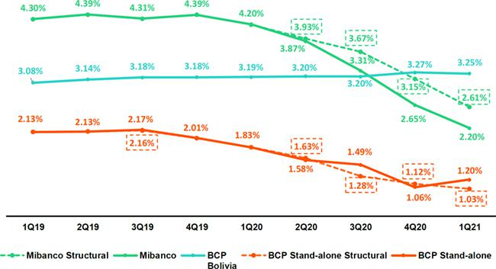

- Expenses are included in accordance with IFRS16.

- Structural Funding Cost deducts the impact in expenses and funding related to GP Loans (BCRP Repos) and deducts non-recurring events from Interest Expense.

  - The cost of funding at BCP Stand-alone followed a trend similar to that seen for the cost of funding at Credicorp, which reflected an increase of +14bps QoQ due to an increase in interest expenses (+16.2%). The aforementioned was partially attenuated by the increase in total funding (+3.54%) due to (i) growth in deposits and (ii) an increase in bonds and notes issued. YoY, the cost of funding fell (-38bps) due to (i) an improvement in the funding mix after the volume of lower-cost sources of funding increased and (iii) the rate effect, where all source of funding registered a drop in their implicit rates. The ratio for the cost of structural funding at BCP Stand-alone, excluding expenses, funds related to government loans and premiums for the bond issuance, situated at 1.06%, which represented a decline of -6 bps QoQ.

20

- Mibanco reported a considerable contraction in its cost of funding of -45bps QoQ. This was driven by a drop in interest expenses (-15.7% QoQ), which was mainly driven by a decrease in rates in the retail segment for time deposits. The total funding volume fell (-3.2% QoQ), which reflected withdrawals of deposits of government loans that had previously been held in its accounts. In the YoY analysis, interest expenses fell (-38.0%) due to the impact of an influx of low-rate government funds and to growth in total funding (+16.8%). The cost of structural funding at Mibanco, excluding the effects of Reactive and FAE, was situated at 2.61%. This represented a decrease of -56 bps QoQ.

- The cost of funding at BCP Bolivia fell slightly QoQ (-2 bps) due to an increase in average funding, which was offset by growth in interest expenses (+2.4%). The cost of funding YoY increased slightly (+6 bps), which was driven by an increase in expenses on deposits given that the expansion of higher-cost deposits (+18.0%) outpaced the growth registered by funding (+10.6%).

21

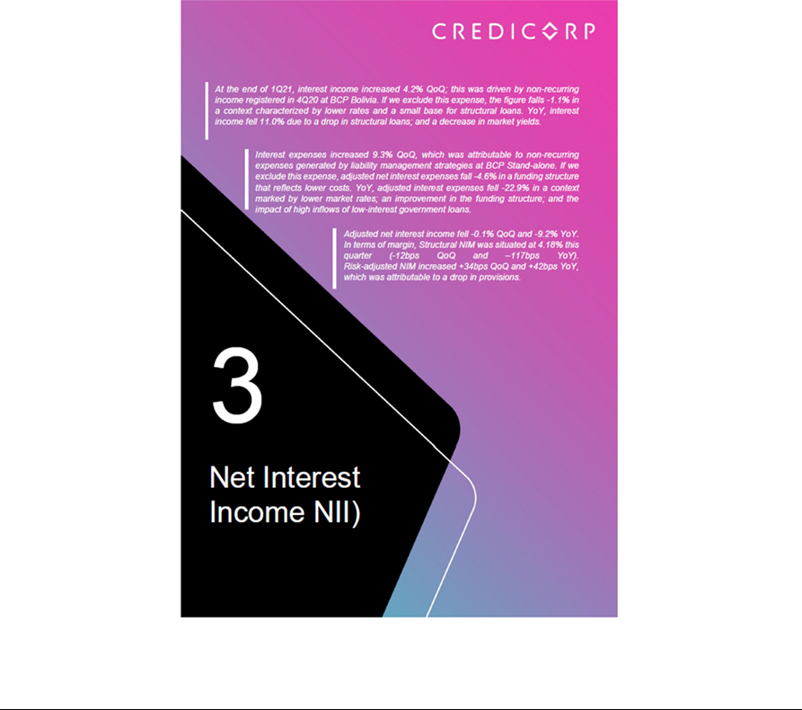

3. Net Interest Income
Net interest income |  |  |  |  |  | Quarter |  |  |  |  |  | % change
S/ 000 |  |  | 1Q20 |  |  | 4Q20 |  |  | 1Q21 |  |  | QoQ |  |  |  | YoY
Interest income |  |  | 3,163,609 |  |  | 2,703,100 |  |  | 2,816,073 |  |  | 4.2% |  |  |  | -11.0%
Interest on loans |  |  | 2,770,351 |  |  | 2,325,836 |  |  | 2,432,761 |  |  | 4.6% |  |  |  | -12.2%
Dividends on investments |  |  | 7,879 |  |  | 3,987 |  |  | 3,221 |  |  | -19.2% |  |  |  | -59.1%
Interest on deposits with banks |  |  | 49,113 |  |  | 8,456 |  |  | 7,896 |  |  | -6.6% |  |  |  | -83.9%
Interest on securities |  |  | 322,734 |  |  | 351,502 |  |  | 362,964 |  |  | 3.3% |  |  |  | 12.5%
Other interest income |  |  | 13,532 |  |  | 13,319 |  |  | 9,231 |  |  | -30.7% |  |  |  | -31.8%
Interest expense ⁽¹⁾ |  |  | 784,082 |  |  | 633,880 |  |  | 692,690 |  |  | 9.3% |  |  |  | -11.7%
Interest on deposits |  |  | 364,107 |  |  | 245,221 |  |  | 222,643 |  |  | -9.2% |  |  |  | -38.9%
Interest on borrow ed funds |  |  | 137,126 |  |  | 118,457 |  |  | 112,228 |  |  | -5.3% |  |  |  | -18.2%
Interest on bonds and subordinated notes |  |  | 198,114 |  |  | 185,104 |  |  | 266,971 |  |  | 44.2% |  |  |  | 34.8%
Other interest expense ⁽¹⁾ |  |  | 84,735 |  |  | 85,098 |  |  | 90,848 |  |  | 6.8% |  |  |  | 7.2%
Net interest income ⁽¹⁾
 |  |  | 2,379,527 |  |  | 2,069,220 |  |  | 2,123,383 |  |  | 2.6% |  |  |  | -10.8%
Risk-adjusted Net interest income ⁽¹⁾
 |  |  | 1,038,046 |  |  | 1,336,555 |  |  | 1,565,736 |  |  | 17.1% |  |  |  | 50.8%
Average interest earning assets ⁽¹⁾
 |  |  | 177,952,974 |  |  | 222,098,498 |  |  | 227,856,239 |  |  | 2.6% |  |  |  | 28.0%
Net interest margin ⁽²⁾
 |  |  | 5.35% |  |  | 3.73% |  |  | 3.73% |  |  | 0bps |  |  |  | -162bps
Risk-adjusted Net interest margin ⁽²⁾ |  |  | 2.33% |  |  | 2.41% |  |  | 2.75% |  |  | 34bps |  |  |  | 42bps
Net provisions for loan losses / Net interest income |  |  | 56.38% |  |  | 35.41% |  |  | 26.26% |  |  | -9.1% |  |  |  | -30.1%

- Figures differ from previously reported, please consider the data presented on this report.

- Annualized.

3.1. Interest Income

Interest income – Local currency

(S/ millions)

Interest income – Foreign Currency

(S/ millions)
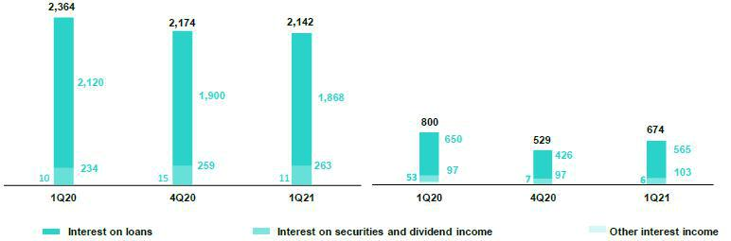

In the QoQ analysis, the 4.2% increase in Interest Income mainly reflects the 4.6% increase in interest on loans given that in 4Q20, a non-recurring charge was registered in this account for a deterioration in interest income at BCP Bolivia.

If we exclude the non-recurring charge from 4Q20 registered at BCP Bolivia and amortizations of the interest impairment relative to frozen loans, adjusted Interest Income fell -1.1% QoQ due to lower interest rates and the change in the AGI structure described below:

- The rate effect: the rate effect was negative, which was primarily attributable to loan repricing and an alignment with market rates, primarily in Retail Banking and in the Consumer and SME-Pyme segments in particular, and driven, although to a lesser extent, by the evolution of short-term working capital loans and foreign trade products within Wholesale Banking.

- Change in IEA mix: the growth in the investment portfolio and available funds increased the share of this assets in the IEA composition. This trend was fueled by the decrease in total loans balances, which was associated with an increase in cancelations from Wholesale clients. Growth in the Consumer, Mortgage and SME-Pyme segments was insufficient to offset the impact of this decline and consequently, the share of total loans within IEAs declined. In this context, interest on loans fell while interest on securities, which generate less income than interest on loans, increased.

23

In the YoY analysis, interest income fell -11.0%. If we exclude amortizations of provisions due to interest impairment relative to frozen loans, adjusted Interest Income fell -12.6% YoY. This was attributable to a less profitable asset mix, due to a decrease in the volume of structural loans, lower interest rates and the prevalence of low-interest government loans:

- Mix effect: the decrease in structural loans, which was primarily seen in Wholesale Banking and in the SME-Business and Credit Card segment in Retail Banking. This decline, coupled with growth in the investment portfolio and available funds due to high liquidity systemwide, led to a scenario in which structural loans accounted for a smaller percentage of the IEA mix. Additionally, the significant weight of government loans within total loans also added to this effect. The latter was partially offset by the growth in interest on securities due to the increase in the investment portfolio.

- Rate effect: the drop in interest rates in the structural portfolio, and the prevalence of low-rate government loans, drove this effect.

3.2. Interest Expenses

Interest expenses – Local Currency

(S/ millions)

Interest expenses – Foreign Currency

(S/ millions)
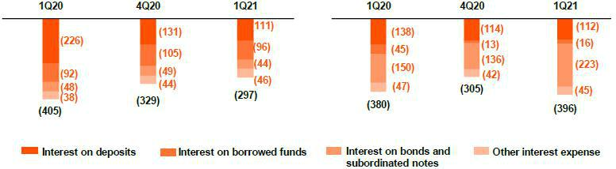

In the QoQ analysis, interest expenses increased 9.3%; this was primarily attributable to a non-recurring charge of S/88 million that was registered in the interest on bonds and subordinated notes account in FC, which was associated with a liability management transaction at BCP Stand-alone. If we exclude this non-recurring charge, adjusted interest expenses contracted -4.6% in a context of an improvement in the funding structure:

- Rate effect: a slight decline was evident QoQ in passive rates, mainly in severance indemnity deposits and time deposits.

- Mix effect: growth in demand deposits, followed by an uptick in savings and time deposits, improved the funding structure by increasing deposits’ share of total funding.

In the YoY analysis, interest expenses fell -11.7%. If we exclude the non-recurring charge for the liability management in BCP Stand-Alone this quarter, adjusted interest expenses fell -22.9%, which was attributable to:

- Rate effect: The contraction in interest expenses was attributable to a drop in the funding cost in a context marked by a decrease in market rates and the impact of low-cost funding generated by government loans.

- Mix effect: The reduction in the cost of funding and in interest expenses was also attributable, although to a lesser extent, to a significant flow of low-cost funding for government loans, which bolstered liquidity systemwide and led to an increase in retail funding.

24

3.3. Net Interest Margin (NIM) and risk-adjusted NIM

NIM and Risk-adjusted NIM at Credicorp
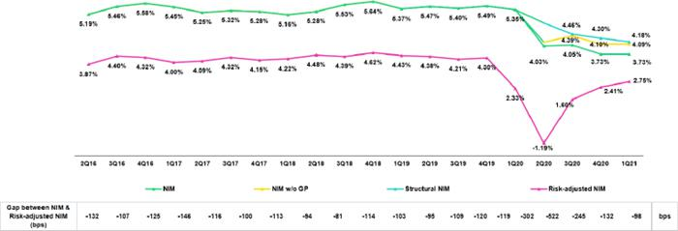

In 1Q21, NIM situated at 3.73%. This figure shows no variation with regard to 4Q20 but reflects a decline in terms of the 5.35% registered in 1Q20 and was impacted by non-recurring events, mainly the interest expenses associated with the liability management at BCP Stand-alone. The combined impact of non-recurring events led NIM to fall –7 bps in 1Q21. Additionally, NIM continue to be impacted by government loans, which led NIM to drop -36bps this quarter. Regarding the Structural NIM, which exclude non-recurring charges and GP loans, the evolution shows:

- The Structural Portfolio posted NIM of 4.18% in 1Q21, which reflected a drop of -12 bps QoQ and -117 YoY. Structural NIM declined due to:

  - The mix effect: the decline in structural loans and the consequent reduction in their share of IEAs, which was countered by an uptick in the share of investments and available funds.

  - Rate effect: The decrease in market rates had an impact on the repricing of the structural portfolio and on the generation of interest income.

The table below shows the NIM registered by each of Credicorp’s subsidiaries:

 |  | BCP |  | Mibanco ⁽¹⁾ |  | BCP |  | Credicorp ⁽¹⁾
NIM Breakdown |  | Stand-alone ⁽¹⁾ |  | Mibanco ⁽¹⁾ |  | Bolivia |  | Credicorp ⁽¹⁾
1Q20 |  | 4.70% |  | 15.16% |  | 3.60% |  | 5.35%
4Q20 |  | 3.60% |  | 10.20% |  | -2.99% |  | 3.73%
1Q21 |  | 3.23% |  | 10.37% |  | 2.77% |  | 3.73%

NIM: Annualized Net interest income / Average period end and period beginning interest earning assets.

- Credicorp also includes Credicorp Capital, Prima, Grupo Credito and Eliminations for consolidation purposes. In the QoQ evolution, NIM situated at 3.73% at the Credicorp level due to mixed evolutions at the subsidiary level:
  - At BCP Stand-alone, NIM fell -37pbs due to the increase in the IEA volume and to a change in the mix, which reflects a decrease in the share of structural loans. The non-recurring charge for the issuance premium relative to the liability management also had an impact.

  - Mibanco Perú registered a +17bps increase in NIM QoQ due to the recovery in structural loans, which registered an uptick in placements of smaller loan amounts at higher interest rates that bolstered recovery QoQ.

  - BCP Bolivia reported a recovery in its margin after having registered a non-recurring charge for interest impairment in 4Q20.

25

In the YoY evolution, Credicorp’s NIM fell -162pbs after:

- BCP Stand-alone’s NIM deteriorated -147bps YoY; this was due primarily to the impact of GP loans, which increased the amount of IEAs with lower interest rates; the decrease of structural loans and a subsequent decline in their share of IEAs; a drop in market rates; and a non-recurring charge for the liability management at BCP Stand-Alone.

- In Mibanco, NIM fell –479bps YoY due to the prevalence of GP loans; a decrease in the structural portfolio; and, to a lesser extent, to reversals of accrued interest for clients that reprogrammed loans but fell delinquent once grace periods expired. In BCP Bolivia, NIM fell due to a decrease in interest rates.

Risk-adjusted NIM increased +34bps QoQ and y +42bps YoY due to a decrease in provisions in 1Q20.

If we analyze risk-adjusted NIM by subsidiary, we find:

 |  | BCP |  |  |  |  | BCP |  | Credicorp ⁽¹⁾
Risk Adjusted NIM Breakdown |  | Stand-alone |  | Mibanco |  |  | Bolivia |  | Credicorp ⁽¹⁾
1Q20 |  | 1.45% |  |  | 9.54% |  | 2.11% |  | 2.33%
4Q20 |  | 2.28% |  |  | 7.09% |  | -4.37% |  | 2.41%
1Q21 |  | 2.37% |  |  | 6.81% |  | 1.90% |  | 2.75%

Risk-Adjusted NIM: (Annualized Net interest income - annualized provisions) / Average period end and period beginning interest earning assets.

(1) Credicorp also includes Credicorp Capital, Prima, Grupo Credito and Eliminations for consolidation purposes.

BCP Stand-alone registered an increase in risk-adjusted NIM of +10bps QoQ and +92bps YoY, which corresponds to a reduction in net provisions this quarter.

At Mibanco, risk-adjusted NIM reflected a deterioration of -28bps QoQ and -273bps YoY. The QoQ evolution was attributable to an increase in provisions after a number of clients registered a deterioration in their debt service capacity and migrated from stage 2 to stage 3. The YoY evolution was attributable to a decrease in NIM in a context marked by a high prevalence of low-rate government loans; a drop in structural loans; and interest reversals for delinquency relative to loans with expired grace periods. It is important to note that the increase in risk is within business expectations and is covered by the provisions that were set aside in 2020. This point will be further explained in section 4. Portfolio Quality.

At BCP Bolivia, NIM rose +627pbs QoQ due to the non-recurring charge registered in 4Q20 but fell -20pbs YoY due to a decrease in placement rates.

26



4. Portfolio Quality

4.1. Reprogrammed loans and payment ratios

In 1Q21, the payment ratio for past due installments remained stable QoQ at both BCP Stand-alone and Mibanco. In the case of Retail Banking at BCP Stand-alone, payments on loans due fell to 95% in March versus 94% in December, while the ratio at Mibanco remained at 93%. In both cases, the results reflect a higher volume of installments due, after the loans with grace periods expired.

At the end of March, on-time structural loans presented the following evolution:

In the case of Retail Banking at BCP Stand-alone, 76% of the portfolio is up-to-date; 20% is reprogrammed; and 4% is past due (versus 74%, 20% and6% at the end of 4Q20 respectively). At Mibanco, 57% of the portfolio is up-to-date; 34% is reprogrammed; and 9% is past due (versus 49%, 45% and 6% at the end of 4Q20 respectively).

If we include reprogrammed loans from Wholesale Banking at BCP Stand-alone and from BCP Bolivia, the level of reprogrammed loans for Credicorp represents approximately 15% of total loans. Loan reprogramming has helped attenuate portfolio deterioration.

4.2. Provisions and the CofR
Provision for credit losses on loan portfolio, net of recoveries |  |  |  |  | Quarter |  |  |  |  |  |  |  | % change
S/ 000 |  | 1Q20 |  |  | 4Q20 |  |  |  | 1Q21 |  |  |  | QoQ |  |  |  |  | YoY
Gross provision for credit losses on loan portfolio |  | (1,388,711) |  | (785,194) |  |  |  | (622,982) |  |  |  |  | -20.7% |  |  |  |  | -55.1%
Recoveries of written-off loans |  | 47,230 |  | 52,529 |  |  |  | 65,335 |  |  |  |  | 24.4% |  |  |  |  | 38.3%
Provision for credit losses on loan portfolio, net of recoveries |  | (1,341,481) |  | (732,665) |  |  |  | (557,647) |  |  |  |  | -23.9% |  |  |  |  | -58.4%
Cost of risk and Provisions |  |  |  |  | Quarter |  |  |  |  |  |  |  | % change
Cost of risk and Provisions |  | 1Q20 |  |  | 4Q20 |  |  |  | 1Q21 |  |  |  | QoQ |  |  |  |  | YoY
Cost of risk ⁽¹⁾ |  | 4.45% |  | 2.13% |  |  |  | 1.63% |  |  |  |  | -50 bps |  |  |  |  | -282 bps
Structural Cost of risk ⁽²⁾ |  | 4.45% |  | 2.64% |  |  |  | 1.92% |  |  |  |  | -72 bps |  |  |  |  | -253 bps
Provision for credit losses on loan portfolio, net of recoveries / Net interest
income |  | 56.4% |  | 35.4% |  |  |  | 26.3% |  |  |  |  | -910 bps |  |  |  |  | -3010 bps

- Annualized Provision for credit losses on loan portfolio, net of recoveries / Total loans.

- The Structural Cost of risk excludes the provisions for credit losses on loan portfolio, net of recoveries and total loans from the Reactiva Peru and FAE Government Programs.

Provisions continued to follow a downward trend, contracting -23.9% QoQ. This level was the lowest sign since the beginning of the pandemic. This contraction was attributable to:

- BCP Stand-alone: due to a reduction in the probability of default (PD) of the majority of segments, which reflects an uptick in transactional activity; a reduction in provisions due to a decrease in the volume of loans entering to Stage 3, in line with a decrease in total refinanced loans and an upturn in client payments; adequate management of Retail Banking products; and a reversal of provisions from clients in Stage 2.

- BCP Bolivia: due to the effect of the loan reprogramming, as established by the Bolivian government in the context of COVID-19.

The aforementioned was offset by growth in Mibanco’s provisions due to portfolio deterioration (mainly of clients that moved from Stage 2 to Stage 3) and due to alignment with bureau information after clients registered delinquency with other entities in the financial system.

28

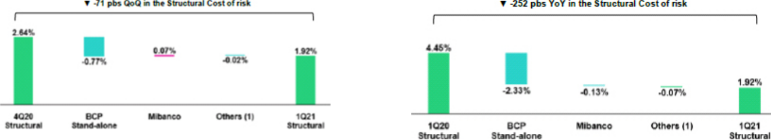

(1) Others include BCP Bolivia, ASB and eliminations. (1) Others include BCP Bolivia, ASB and eliminations

In the YoY analysis, provisions showed a significant reduction compared to 1Q20, due to the forward-looking provisions registered at the beginning of the pandemic and a reduction in the portfolio PD levels, particularly in the SME-Pyme segment. The reduction in forward-looking provisions was attributable to adjustments in macroeconomic projections at the model level, which had a greater impact on Individuals and Wholesale Banking and drove Credicorp’s drop in provisions of -58.4%.

In line with the aforementioned, the CofR at Credicorp fell -50 bps QoQ and -282 bps YoY. If we exclude Government Program loans (GP) and the corresponding provisions, the cost of risk of Credicorp’s structural portfolio is situated at 1.92% versus 2.64% in 4Q20.

4.3. Delinquency
Portfolio quality and Delinquency ratios |  |  |  |  | A s of |  |  |  | % change
 | S/ 000 |  | Mar 20 |  | Dec 20 |  | Mar 21 |  | QoQ |  |  | YoY
 | Total loans (Quarter-end balance) |  | 120,708,515 |  | 137,659,885 |  | 137,031,239 |  | -0.5% |  |  | 13.5%
 | Structural Loan Portfolio |  | 120,708,515 |  | 113,017,319 |  | 112,782,997 |  | -0.2% |  |  | -6.6%
 | Allowance for loan losses |  | 5,931,772 |  | 9,898,760 |  | 9,744,298 |  | -1.6% |  |  | 64.3%
 | Write-offs |  | 519,866 |  | 509,001 |  | 767,136 |  | 50.7% |  |  | 47.6%
 | Internal overdue loans (IOLs) ⁽¹⁾ |  | 3,579,504 |  | 4,675,731 |  | 4,868,483 |  | 4.1% |  |  | 36.0%
 | Internal overdue loans over 90-days ⁽¹⁾ |  | 2,572,478 |  | 3,709,865 |  | 3,789,286 |  | 2.1% |  |  | 47.3%
 | Refinanced loans |  | 1,125,394 |  | 1,664,626 |  | 1,951,855 |  | 17.3% |  |  | 73.4%
 | Non-performing loans (NPLs) ⁽²⁾ |  | 4,704,898 |  | 6,340,357 |  | 6,820,338 |  | 7.6% |  |  | 45.0%
 | IOL ratio |  | 2.97% |  | 3.40% |  | 3.55% |  | 15 bps |  |  | 58 bps
 | Structural IOL ratio |  | 2.97% |  | 4.14% |  | 4.32% |  | 18 bps |  |  | 135 bps
 | IOL over 90-days ratio |  | 2.13% |  | 2.69% |  | 2.77% |  | 8 bps |  |  | 64 bps
 | NPL ratio |  | 3.90% |  | 4.61% |  | 4.98% |  | 37 bps |  |  | 108 bps
 | Structural NPL ratio |  | 3.90% |  | 5.61% |  | 6.05% |  | 44 bps |  |  | 215 bps
 | Allowance for loan losses over Total loans |  | 4.91% |  | 7.19% |  | 7.11% |  | -10 bps |  |  | 220 bps
 | Coverage ratio of IOLs |  | 165.7% |  | 211.7% |  | 200.2% |  | -1150 bps |  |  | 3450 bps
 | Coverage ratio of IOL 90-days |  | 230.6% |  | 266.8% |  | 257.2% |  | -960 bps |  |  | 2660 bps
 | Coverage ratio of NPLs |  | 126.1% |  | 156.1% |  | 142.9% |  | -1320 bps |  |  | 1680 bps

- Includes overdue loans and loans under legal collection. (Quarter-end balances)

- Non-performing loans include internal overdue loans and refinanced loans. (Quarter-end balances)

In terms of delinquency, it is important to note that:

- Total IOL increased +4.1% QoQ and +36.0% YoY. In the QoQ analysis, growth in IOLs was driven mainly by Mibanco, where some clients registered a deterioration in their debt service capacity after grace periods expired. At BCP Bolivia, the increase during the same period was attributable to the deterioration of the portfolio, mainly in the Consumer and Mortgage segment. BCP Stand-alone, on the contrary, reported a contraction in IOL loans QoQ after the Credit Card segment registered a significant improvement in payment behavior. The reduction in the IOL level at BCP Stand-alone was partially attenuated by the deterioration posted by a small number of institutional clients in Wholesale Banking, particularly in the construction and telecommunications sectors. In the YoY analysis, deterioration was visible across segments and was particularly marked at BCP Stand-alone and Mibanco, which reflects the expiration of grace periods on loan facilities.

- Total refinanced loans increased +17.3% QoQ and +73.4% YoY. In the QoQ and YoY analysis, growth was driven mainly by BCP Stand-alone, and by the Consumer and SME-Pyme segments in particular, after clients who had initially not qualified for reprogramming facilities were offered refinancing options. BCP Bolivia also contributed to the expansion in refinanced loans after the Bolivian government decreed that all deferred loans were automatically eligible for refinancing and/or reprogramming. The aforementioned was partially offset by a reduction in refinanced loans at Mibanco after refinanced loans expired and migrated to the IOL portfolio, and due to the increase of write-offs.

29

- Total write-offs grew 50.7% QoQ and 47.6% YoY. In the QoQ analysis, the increase was driven by an uptick in Retail Banking, particularly in the Consumer and Credit Card segments. YoY growth, in turn, was attributable to a regulatory mandate, in place until 3Q20, which impeded loans from continuing to accumulate overdue days, which impeded loans from progressing naturally to a situation of loss and its subsequent write-off.

- Coverage ratios for IOL and NPL loans contracted QoQ, which was attributable to a slight decrease in the stock of provisions and to an increase in the IOL and refinanced portfolios. Significant YoY growth in coverage ratios was in line with a +64.3% increase in the stock of provisions in 2020 in the context of the pandemic.

When analyzing the evolution of delinquency indicators, it is necessary to note that: (i) traditional delinquency indicators (IOL and NPL ratios) continue to be distorted by the presence of loans that have collateral (commercial and residential properties). This means that a significant portion of loans that are more than 150 days overdue cannot be written-off, despite being fully provisioned, given that the judicial process to liquidate the collateral can take up to five years on average.
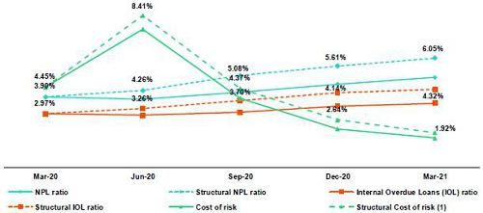

- The Structural Cost of risk excludes the provisions for credit losses on loan portfolio, net of recoveries and total loans from the Reactiva Peru and FAE Government Programs.

4.4. Delinquency by Segment

BCP Stand-alone – Wholesale Banking: NPL ratio by Segment NPL ratio by Segment

In the QoQ analysis, the IOL and NPL ratios deteriorated (+15 bps and +22 bps respectively). The increase in both ratios was driven by growth in IOL and refinanced loans, which was attributable to the evolution of a small number of clients in Middle Market Banking. The uptick in IOL loans was driven by the real estate and cinematographic industries, which have been heavily hit by both confinement and social distancing measures. Growth in refinanced loans was attributable to a client in the retail sector, which refinanced its position and extended its loan term. The increase in ratios was also attributable to a contraction in loans in the Wholesale segment, which is discussed in section 1.2.1 Evolution of loans in average daily balances (ADB).
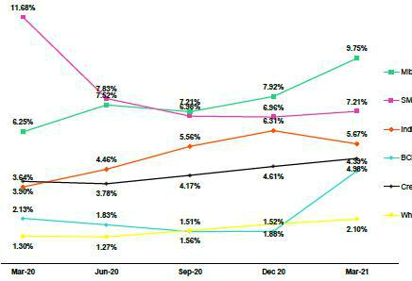

In the YoY analysis, deterioration in delinquency ratios was attributable to growth in the IOL portfolio, which was driven by a small number of clients in Corporate Banking in the transportation and energy sectors. Growth in the IOL portfolio reflected the impact of COVID-19, which meant that some clients were unable to service their debts. It is important to note that the number of refinanced loans fell over the period given that overdue loans migrated to the IOL portfolio. The -6% drop in loans negatively impacted the ratio.

30

BCP Stand-alone – Retail Banking:

The high-risk Retail Banking portfolio, which is comprised of the IOL and reprogrammed portfolio, fell 3%. This drop was mainly associated with a decrease in the balance of IOL loans, which fell across segments but was particularly marked in Mortgage and Credit Cards. Additionally, 63% of IOL loans are up to 30 days overdue, where the probability of payment is higher than that associated with loans that are between 60 and 120 days overdue (the composition of loans that are between 60 to 120 days overdue also registered a favorable decreasing, falling from 25% in 4Q20 to 20% in 1Q21).

The reduction in the IOL portfolio was driven primarily by loans to clients that received 1 or 2 facilities, which are considered higher risk. It is important to note that, as of 1Q21, only 7% of the total reprogramming facilities are still in grace periods.

Delinquency ratios in Retail Banking fell QoQ and YoY, which was primarily driven by a growth in loans and write-offs. For more information, see 1.2.1. Evolution of loans by business segment and 4.3 Delinquency.

In the SME-Pyme segment, play close attention to the early delinquency ratio, which excludes loans that are overdue < 60 days (volatile loans with a very high percentage of recovery, and those that are >150 days (loans that are fully provisioned but cannot be written-off due to the existence of collateral – commercial properties that take 5 years to liquidate. Collateral scenarios also affect IOL loans that are >150 days in the Mortgage segment.

In the QoQ analysis, the reduction in ratios was also attributable to a contraction in the NPL portfolio, which was seen particularly in the following segments:

- Credit cards: where the IOL and refinanced portfolios registered a drop due to an increase in the payment ratio (rose from 97% in 4Q20 to 98% in 1Q21). Additionally, the drop in the level of NPL loans was attributable to an increase in write-offs.

- Consumer: a lower volume of overdue loans and a higher level of write-offs, which was slightly offset by the increase in refinanced loans. The latter is the result of the impact of the quarantine for the entire month of February, when customers took advantage of credit facilities.

The aforementioned was partially offset by an increase in the NPL portfolio in the Mortgage and SME-Business segments, which was driven primarily by the increase registered in IOL loans after the grace periods on reprogrammed loans expired. In the Mortgage segment, the uptick in volumes of IOL loans corresponds to clients that obtained 1 or 2 facilities. Additionally, the uptick in the NPL portfolio was linked to an increase in the origination of Mivivienda loans, which reflects our strategy to penetrate riskier segments to maximize the portfolio’s profitability. In the case of SME-Business, the increase in the NPL portfolio was driven by clients that had not received neither facilities nor Reactiva loans, reflected in lower payment ratios. Deterioration at the portfolio was also due to an uptick in refinanced loans, after clients accepted facilities.

In the YoY analysis, the contraction in delinquency ratios was associated to with a significant increase in the inflow of GP loans. This was attenuated by an uptick in IOL and refinanced loans. This growth was, in large part, attributable to the negative effects generated by the pandemic throughout 2020, which rendered some clients incapable of servicing their debts. This deterioration led to an expected subsequent decline in the credit quality of these clients, who had availed of different facilities (freezing, skips, increasing installments, reprogramming, among others). A portion of these clients later fell in delinquent once grace periods ended. Growth in the number of clients unable to service their debt was driven primarily by the Consumer and SME-Pyme segments. In the Consumer segment, the increase was mainly fueled by an increase in volumes of overdue loans, which was primarily associated with clients with 1, 2 or more facilities. This increase was also attributable to an uptick in loan origination through digital channels, where risk profiles are higher, and to growth in refinanced loans, after clients were offered refinancing facilities. In SME-Pyme, new delinquency increased, which was driven primarily by clients that received 1, 2 or more facilities and by those that had not received Reactiva loans. In the last quarter, however, new delinquency was similar for portfolios with and without Reactiva given that the total portfolio reflected a significant decrease in the liquidity levels generated by Reactiva disbursements.

It is important to note that in the Consumer segment, we have set aside adequate levels of forward-looking provisions to mitigate risks of non-payment associated with clients that have been affected by the pandemic and with products sold through digital channels, where higher risk is offset by lower operating costs.

31

Mibanco:

At Mibanco, delinquency ratios increased QoQ and YoY due to a deterioration in the situation of clients that had not taken or qualified for the facilities offered or those whose grace periods had expired. It is important to note that growth in the IOL portfolio was driven by an increase in the volume of loans that expired throughout the quarter. The increase in expirations was associated primarily with the reprogrammed portfolio. Finally, portfolio deterioration was also driven by the quarantine in February, which slowed activity in the microfinance sector and subsequently affected loan payments. The aforementioned was slightly attenuated by an increase in write-offs, which are considered in the refinanced portfolio.

BCP Bolivia:

BCP Bolivia reported a deterioration in the QoQ and YoY ratios due to an increase in the IOL portfolio. This growth was driven by the Consumer and Mortgage segment, as well as by the refinanced portfolio. It is important to note that the uptick in refinanced loans reflected a massive, automatic reprogramming of loans after the government decreed that loan deferrals- with grace periods for capital and interest for up to 6 months- were mandatory.

32



5. Non-Financial Income (NFI)
Non-financial income |  |  |  |  |  |  |  |  |  |  | Quarter |  |  |  |  |  |  |  |  |  |  |  |  | % change
(S/ 000) |  |  |  |  |  | 1Q20 |  |  |  |  |  | 4Q20 |  |  |  |  |  | 1Q21 |  |  |  |  |  | QoQ |  |  |  |  | YoY
Fee income |  |  |  |  | 760,329 |  |  |  |  |  | 873,155 |  |  |  |  |  | 830,771 |  |  |  |  |  | -4.9% |  |  |  |  |  | 9.3%
Net gain on foreign exchange transactions |  |  |  |  | 166,983 |  |  |  |  |  | 151,464 |  |  |  |  |  | 179,889 |  |  |  |  |  | 18.8% |  |  |  |  |  | 7.7%
Net gain on securities |  |  |  |  | (120,633) |  |  |  |  |  | 162,523 |  |  |  |  |  | 16,287 |  |  |  |  |  | -90.0% |  |  |  |  |  | n.a.
Net gain from associates ⁽¹⁾ |  |  |  |  | 19,225 |  |  |  |  |  | 19,297 |  |  |  |  |  | 29,405 |  |  |  |  |  | 52.4% |  |  |  |  |  | 53.0%
Net gain on derivatives held for trading |  |  |  |  | 35,430 |  |  |  |  |  | 18,298 |  |  |  |  |  | 69,723 |  |  |  |  |  | 281.0% |  |  |  |  |  | 96.8%
Net gain from exchange differences |  |  |  |  | (20,849) |  |  |  |  |  | 11,152 |  |  |  |  |  | (5,536) |  |  |  |  |  | -149.6% |  |  |  |  |  | n.a.
Other non-financial income |  |  |  |  | 117,770 |  |  |  |  |  | 94,517 |  |  |  |  |  | 73,991 |  |  |  |  |  | -21.7% |  |  |  |  |  | -37.2%
Total non-financial income, net |  |  |  |  | 958,255 |  |  |  |  |  | 1,330,406 |  |  |  |  |  | 1,194,530 |  |  |  |  |  | -10.2 |  | % |  |  |  | 24.7 | %
(1) Includes gains on other investments, mainly made up of the profit of Banmedica.
 |  |  |  |  |  |  |  |  |  |  |  | Quarter |  |  |  |  |  |  |  |  |  |  |  | % change
(S/ 000) |  |  |  |  |  | 1Q20 |  |  |  |  |  | 4Q20 |  |  |  |  |  | 1Q21 |  |  |  |  |  | QoQ |  |  |  |  | YoY
(+) EPS contribution (50%) |  |  |  |  | 17,186 |  |  |  |  |  | 16,625 |  |  |  |  |  | 23,377 |  |  |  |  |  | 40.6% |  |  |  |  |  | 36.0%
(-) Private health insurance deduction (50%) |  |  |  |  | (6,430) |  |  |  |  |  | (17,079) |  |  |  |  |  | (13,906) |  |  |  |  |  | -18.6% |  |  |  |  |  | 116.3%
(=) Net gain from association with Banmedica |  |  |  |  |  | 10,756 |  |  |  |  |  | (454 |  | ) |  |  |  | 9,471 |  |  |  |  |  | n.a. |  |  |  |  | -11.9 | %
Evolution of non-financial income |  |  |  |  |  |  |  |  |  |  |  |  |  |  |  |  |  |  |  |  |  |  |  | QoQ evolution of non-financial income
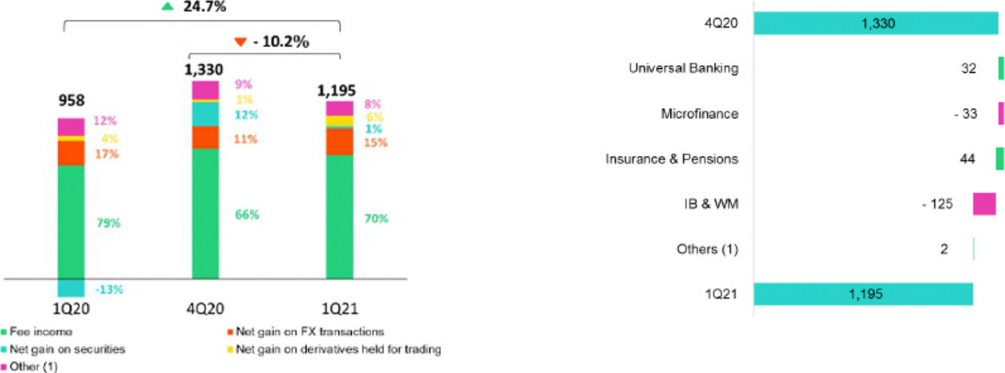

(1) Other includes Grupo Credito, Credicorp Stand-alone, eliminations and others.

- Includes gains on other investments, mainly made up of the profit of Banmedica.

The -10-2% drop QoQ in NFI was due to:

- A decrease in income attributable to the Net gain on securities (-90.0%), which was driven by losses on ASB’s fixed income portfolio due to higher market rates. This was offset by gains on the sale of sovereign bonds at BCP Stand-alone.

- The decrease in Fee Income (-4.9%), mainly at Mibanco, where extraordinary fee income was registered in 4Q20 for bancassurance that corresponds to loans that were reprogrammed during the quarantine in 2020 and, to a lesser extent, at BCP Stand-alone due to (i) the quarantine imposed by the government during the month of February and client migration to digital channels, which currently account for 79% of all transactions.

- A drop in net gains of Credicorp Capital’s capital market strategy, which consist on offsetting losses on Net gain on securities with Net gains on speculative derivatives.

- The loss on the Net gain for exchange differences due the -3.76% depreciation of the Sol against the US dollar.

34

YoY evolution of non-financial income
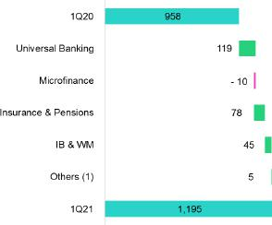

(1) Other includes Grupo Credito, Credicorp Stand-alone, eliminations and others.

YoY, growth of 24.7% in NII was attributable to:

- An increase in income from the Net Gain on Securities given that (i) in 1Q20, losses were reported due to a drop in markets in the month of March 2020 and (ii) gains on the sales of sovereign bonds in the months of January and February at BCP Stand-alone.

- Growth in Fee Income, which was primarily attributable to BCP Stand-alone given that in 1Q20, BCP Stand-alone granted fee waivers to its clients in the context of the pandemic and, to a lesser extent, due to the fact that commissions for mutual fund management at Credicorp Capital increased with respect to 1Q20.

- The increase in Net gains on speculative derivatives through derivative strategies at BCP Stand-alone and Credicorp Capital.

35

5.1. Fee Income
5.1.2. Fee Income in the Banking Business
 | Composition of fee income in the banking business
 | Fee Income |  |  |  |  |  | Quarter |  |  |  |  |  | % change
 | S/ 000 |  |  | 1Q20 |  |  | 4Q20 |  |  | 1Q21 |  |  | QoQ |  |  |  | YoY
 | Miscellaneous accounts ⁽¹⁾ |  |  | 164,963 |  |  | 184,634 |  |  | 181,065 |  |  | -1.9% |  |  |  | 9.8%
 | Credit cards ⁽²⁾ |  |  | 60,435 |  |  | 65,867 |  |  | 54,020 |  |  | -18.0% |  |  |  | -10.6%
 | Drafts and transfers |  |  | 61,846 |  |  | 83,451 |  |  | 84,625 |  |  | 1.4% |  |  |  | 36.8%
 | Personal loans ⁽²⁾ |  |  | 28,352 |  |  | 26,463 |  |  | 24,271 |  |  | -8.3% |  |  |  | -14.4%
 | SME loans ⁽²⁾ |  |  | 18,808 |  |  | 24,343 |  |  | 14,535 |  |  | -40.3% |  |  |  | -22.7%
 | Insurance ⁽²⁾ |  |  | 25,179 |  |  | 26,112 |  |  | 27,189 |  |  | 4.1% |  |  |  | 8.0%
 | Mortgage loans ⁽²⁾ |  |  | 9,402 |  |  | 11,066 |  |  | 7,763 |  |  | -29.9% |  |  |  | -17.4%
 | Off-balance sheet ⁽³⁾ |  |  | 50,093 |  |  | 53,825 |  |  | 59,864 |  |  | 11.2% |  |  |  | 19.5%
 | Payments and collections ⁽³⁾ |  |  | 101,283 |  |  | 106,078 |  |  | 106,384 |  |  | 0.3% |  |  |  | 5.0%
 | Commercial loans ⁽³⁾⁽⁴⁾ |  |  | 17,978 |  |  | 17,628 |  |  | 15,392 |  |  | -12.7% |  |  |  | -14.4%
 | Foreign trade ⁽³⁾ |  |  | 11,576 |  |  | 14,775 |  |  | 15,191 |  |  | 2.8% |  |  |  | 31.2%
 | Corporate finance and mutual funds ⁽⁴⁾ |  |  | 16,673 |  |  | 14,136 |  |  | 13,583 |  |  | -3.9% |  |  |  | -18.5%
 | Mibanco |  |  | 23,533 |  |  | 57,140 |  |  | 17,647 |  |  | -69.1% |  |  |  | -25.0%
 | BCP Bolivia |  |  | 26,350 |  |  | 27,886 |  |  | 34,532 |  |  | 23.8% |  |  |  | 31.1%
 | ASB |  |  | 8,412 |  |  | 6,101 |  |  | 11,858 |  |  | 94.4% |  |  |  | 41.0%
 | Others ⁽⁴⁾⁽⁵⁾ |  |  | 12,184 |  |  | 7,861 |  |  | 10,583 |  |  | 34.6% |  |  |  | -13.1%
 | Total fee income |  |  | 637,067 |  |  | 727,365 |  |  | 678,503 |  |  | -6.7 | % |  |  | 6.5 | %

Source: BCP

- Saving accounts, current accounts, debit card and master account.

- Mainly Retail fees.

- Mainly Wholesale fees.

- Figures differ from previously reported, please consider the data presented on this report.

- Includes fees from BCP Bolivia, Mibanco, network usage and other services to third parties, among others.

Fee income in the banking business contracted -6.7% QoQ. The segments that registered the largest contraction were:

- Mibanco, due to extraordinary income from bancassurance commissions in 4Q20.

- Credit cards, which was attributable to a drop in merchant-fee commissions after consumption levels fell below those seen in 4Q20 due to the quarantine in February and to high seasonality in the last quarter of the year.

- SME-Pyme loans, after fewer loans were granted in this segment in 1Q21, which reflected a drop of -13.23% in billing the first quarter.

At the YoY level, growth was driven primarily by:

- Drafts and transfers, which posted recovery after drafts and transfers were exempted from fees in 2020.

- Miscellaneous accounts, due to an increase in transactionality, mainly relative to transfers to correspondent accounts.

- Off balance sheet, which was attributable to an increase in transactions with wholesale clients (mining and airlines).

- BCP Bolivia, due to an increase in foreign transfers through transactions executed by mineral exporters

36



6. Insurance Underwriting Result
Insurance underwriting result ⁽¹⁾ |  |  |  |  | Quarter |  |  |  |  |  |  | % change
S/ 000 |  |  | 1Q20 |  |  | 4Q20 |  |  | 1Q21 |  |  | QoQ |  |  | YoY
Net earned premiums |  |  | 627,935 |  | 652,669 |  |  |  | 643,928 |  |  | -1.3% |  |  | 2.5%
Net claims |  |  | (373,502) |  | (492,738) |  |  |  | (623,353) |  |  | 26.5% |  |  | 66.9%
Acquisition cost ⁽²⁾ |  |  | (112,507) |  | (75,065) |  |  |  | (85,822) |  |  | 14.3% |  |  | -23.7%
Total insurance underwriting result |  |  | 141,926 |  |  | 84,866 |  |  | (65,247 | ) |  | -176.9 | % |  | -146.0 | %

6.1. Life Insurance
Total premiums life insurance | Net earned premiums ⁽¹⁾
(S/ millions) | (S/ millions)
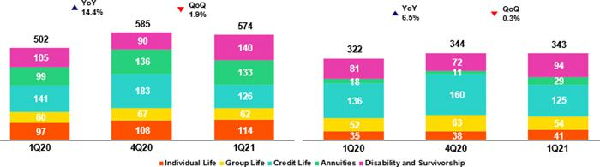

(1) Total premiums without premiums ceded ot reinsurance or premium reserves

Total premiums fell 1.9% QoQ, which was attributable to (i) Credit Life, due to premium reprogramming at Mibanco in 4Q20 via quarantine assistance measures; (ii) Group Life, due to a recovery in the extraordinary premium for SCTR in 4Q20, which was partially offset by an increase in renewed premiums for Statutory Life; (iii) Annuities, which was mainly attributable to an increase in sales of individual products. The aforementioned was mitigated by (iv) D&S, due to an increase in collections under the new SISCO V regimen through the AFPs due to an increase in rates; (v) Individual life, due to an increase in issuance and in the exchange rate effect.

Net earned premiums fell 0.3% due to the reasons outlined above and the higher ceded ratio in the AFP business (30% in 1Q21 vs. 20% in 4Q20); this was mitigated by a decrease in reserves for Annuities carry out in 1Q21, after changes were made in the parameters for investment rates and more funds were released for deaths.

In the YoY analysis, total premiums increased 14.4%, which was primarily attributable to (i) D&S, due to an increase in collections under the new SISCO V regimen given the increase in rates; (ii) Annuities, due to an increase in premiums for individual products; (iii) Individual Life, due to an increase in sales and in the exchange rate effect; (iv) Group Life, which was mainly attributable to growth in sales for Statutory Life. The aforementioned was attenuated by Credit Life, which registered a decrease in sales at Mibanco and in the Alliance channel after solidarity payments were recorded (delinquent debt assumed by the entity) in 1Q20.

Net earned premiums increased 6.5% for the reasons outline in the analysis of direct premiums; this was attenuated by an increase in reserves in Annuities and Individual Life; followed by a higher ceded ratio in AFP (30% in 1Q21 vs. 20% in 4Q20).

38

Net claims for life insurance
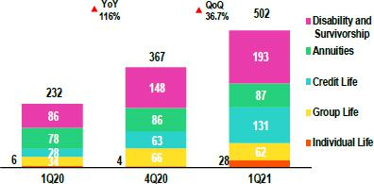

6.2. Property and Casulaty

Total premiums Property and Casualty

(S/ millions)

Net claims increased 36.7%, which was attributable to an increase in reported COVID-19 deaths and to an uptick in incurred but not reported claims (IBNR) relative to COVID-19. Claims for these concepts totaled S/ 141 million in 1Q21 (vs S/ 10 million in 4Q20) and were led by claims from Credit Life, D&S, Individual Life and Annuities (increase in the policy stock). The aforementioned was mitigated by Group Life, which reported fewer claims for the SCTR. In the YoY analysis, net claims increased 116.0%. Growth was seen across all lines due to an increase in mortality due to COVID-19.

Net earned premiums ⁽¹⁾
(S/ millions)
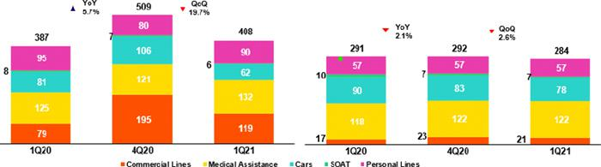

(1) Total premiums without premiums ceded to reinsurance or premium reserves.

Total premiums fell 19.7% QoQ, which was attributable to (i) Commercial lines, due to an increase in renewed premiums in 4Q20 in the aviation, fire and third-party liability segments; (ii) Cars, due to a decrease in new sales and a drop in the renewal stock; (iii) Soat, due to a drop in sales through the digital channel. The aforementioned was mitigated by Medical Assistance, where new sales and policy renewals for comprehensive health products registered and uptick and by Personal Lines, which registered an increase in renewed premiums for the Home Mortgage product.

Net earned premiums fell 2.6% for the reasons outlined in the analysis of total premiums, mitigated by a lower reserves for current risks in Cars and to a drop in ceded premiums in Commercial lines, which was driven by a decrease in the direct premium for facultative insurance.

In the YoY analysis, total premiums increased 5.7%; this was driven primarily by Commercial Lines, where new sales in the fire and third-party liability lines rose and by Medical Assistance, which registered an increase in new sales for comprehensive health products. These effects were attenuated by Cars and Soat, which reported a decrease in new sales and a drop in the renewal stock in the brokers and alliance channels, and by Personal Lines, which reported a decrease in sales of student accident insurance and travel insurance due to the current context.

Net earned premiums fell 2.1% due to an increase in ceded premiums in the Commercial Lines, which was in line with an uptick in direct premiums for facultative insurance; this was mitigated by a decrease in current risks in the Cars Line and Personal Lines.

39

Net claims in Property & Casualty
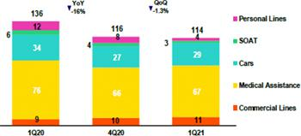

Net claims fell 1.3% QoQ. This was primarily attributable to Personal Lines, after fewer cases were reported for the card protection product, and Soat, which registered a decrease in the frequency of accidents due to confinement measures. The aforementioned was attenuated by Cars, after claims presented last quarter were released and the lowest record of cases; by Medical Assistance, which registered an increase in cases for comprehensive and oncological products after clients resumed use of these products; and by Commercial Lines, which reported an increase in severity in the maritime hull segment due to sinking of vessels.

In the YoY analysis, net claims fell 16.0%. This was primarily due to a decrease in claims in the majority of business lines, which was led by Cars and Soat, which reported a drop in claims in the context of the pandemic; by Personal lines, due to a decrease in claims frequency for the card protection products; by Student accidents, as schools and universities are closed; by Medical Assistance, after clients limited exposure by avoiding visits to clinics; and lastly, by the fact that a corporate account that registered high claims rates was lost. The aforementioned was attenuated by the Commercial Lines for the reasons outlined in the QoQ analysis.

6.3 Acquisition Cost
Acquisition cost |  |  |  |  |  |  | Quarter |  |  |  |  |  | % change
S/ 000 |  |  |  | 1Q20 |  |  | 4Q20 |  |  | 1Q21 |  |  | QoQ |  |  |  | YoY
 | Net fees |  |  | (66,650) |  |  | (63,831) |  |  | (55,605) |  |  | -12.9% |  |  |  | -16.6%
 | Underwriting expenses |  |  | (46,461) |  |  | (19,628) |  |  | (31,557) |  |  | 60.8% |  |  |  | -32.1%
 | Underwriting income |  |  | 604 |  |  | 8,394 |  |  | 1,340 |  |  | -84.0% |  |  |  | 121.9%
 | Acquisition cost |  |  | (112,507 | ) |  | (75,065 | ) |  | (85,822 | ) |  | 14.3 | % |  |  | -23.7 |  | %

Acquisition cost per business

(S/ millions)
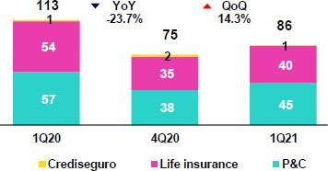

The acquisition cost increased 14.3% QoQ due to an increase in underwriting expenses. This was principally attributable to the P&C business, which registered both profit sharing and uncollectible premiums in the Cars line and an increase in sales expenses in the Medical Assistance and Commercial Lines; to the life businesses, where underwriting income fell due to the following effects in 4Q20: profit sharing with reinsurers and the release of uncollectible premiums. The aforementioned was attenuated by a decrease in net fees, which was associated with a decrease in direct premiums in both businesses.

In the YoY analysis, the acquisition cost fell 23.7%, mainly in the P&C business, which was primarily attributable to the reimbursement of premiums in Cars in 1Q20 for 8 million soles given that clients were unable to use their vehicles during the lockdown, and to an increase in uncollectible premiums last year. In the life business, the decrease in net fees, which was attributable to a drop in direct premiums in Credit Life via the alliance channel and lower underwriting expenses in Individual Life and Group Life, was noteworthy.

40

6.4 Underwriting Result by business

Underwriting result by business

(S/ millions)
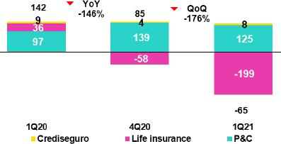

In the QoQ analysis, the decrease in the underwriting result was attributable to life insurance, and to a lesser extent to P&C. The result in life was due primarily to: (i) an increase in claims after more claims were reported and incurred but not reported claims (IBNR) for COVID-19 also rose; (ii) a decrease in the net premium due to extraordinary events were registered last quarter: Credit Life, after premiums for Mibanco and Group Life were reprogrammed after premiums for SCTR were recovered; (iii) increase in acquisition costs due to profit sharing registered last quarter. In P&C, the decrease in the underwriting result was driven by a drop in net premiums in the Cars Line, Commercial Lines and Medical Assistance and by an increase in the acquisition cost due to provisions for profit sharing and an increase in sales expenses in the Cars Line, Medical Assistance and Commercial Lines.

In the YoY analysis, the decrease in the result was attributable to the life business and attenuated by P&C. The drop in Life insurance was due to an increase in claims, which was primarily due to an upswing in reported cases and in IBNR for COVID-19. This was mainly driven by D&S, Credit Life, Group Life, Individual Life and, to a lesser extent, to Annuities, which experienced an increase in payments that was associated with growth in the policy stock. In P&C, the increase in the underwriting result was due to a decrease in claims mainly in Cars, Medical Assistance and Personal Lines due to the confinement; and in acquisition costs after premiums were reimbursed in the Cars segment in 1Q20 for 8 million soles.

41

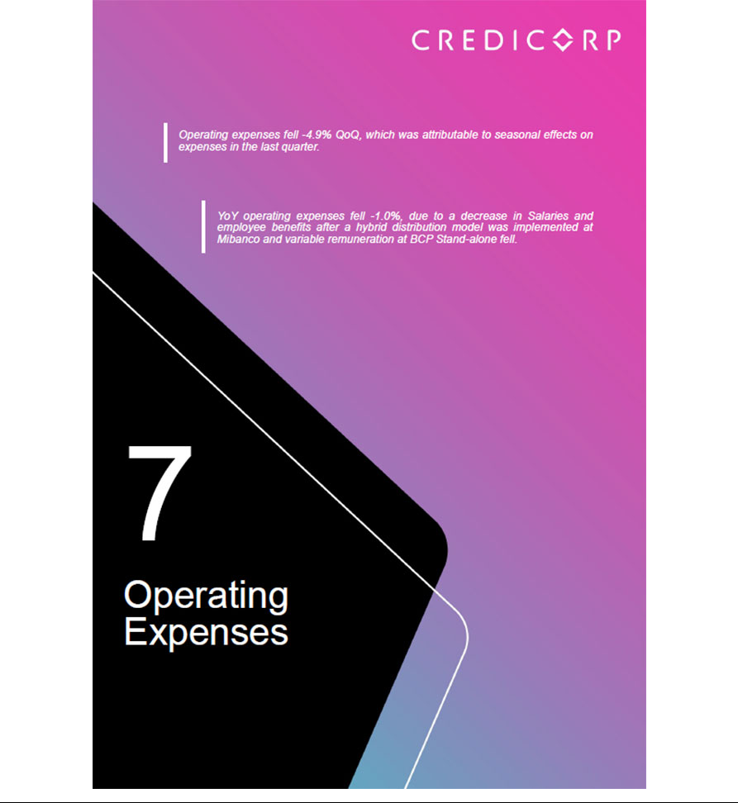

7. Operating Expenses
Operating expenses |  |  |  | Quarter |  |  |  |  | % change
S/ 000 |  | 1Q20 |  | 4Q20 |  | 1Q21 |  | QoQ |  |  |  | YoY
Salaries and employees benefits |  | 891,183 |  | 792,335 |  | 857,559 |  |  | 8.2% |  |  | -3.8%
Administrative, general and tax expenses |  | 542,104 |  | 749,393 |  | 580,842 |  |  | -22.5% |  |  | 7.1%
Depreciation and amortization |  | 169,959 |  | 158,494 |  | 166,765 |  |  | 5.2% |  |  | -1.9%
Association in participation |  | 6,430 |  | 17,079 |  | 13,906 |  |  | -18.6% |  |  | 116.3%
Acquisition cost ⁽¹⁾ |  | 112,507 |  | 75,065 |  | 85,822 |  |  | 14.3% |  |  | -23.7%
Operating expenses ⁽²⁾
 |  | 1,722,183 |  | 1,792,366 |  | 1,704,894 |  |  | -4.9% |  |  | -1.0%

- The acquisition cost of Pacifico iIncludes net fees and underwriting expenses.

- Operating expenses = Salaries and employees’ benefits + Administrative expenses + Depreciation and amortization + Association in participation + Acquisition cost.

Composition of operating expenses at the end of | In the QoQ analysis, operating expenses were down-4.9%, which was due to:
March-21 | (i) | A decrease in Administrative and general expenses and taxes
 |  | (drop of -22.5%); this was primarily attributable to the evolution
 |  | of BCP Stand-alone, which reflected the effect of high seasonality
 |  | in the last quarter of the year.
 | (ii) | The reduction of -18.6% in the Net gain from the Association
 |  | with Banmedica due to a drop in earnings from health and the
 |  | respective decline in payments to Banmedica for said earnings
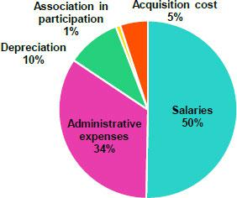

The aforementioned was slightly attenuated by the increase of 8.2% in Salaries and employee benefits after hiring and promotions resumed alongside payments for variable compensation.

In the YoY analysis, Operating Expenses fell -1.0% due to:

- -3.8% drop in Salaries and employee benefits, which was mainly attributable to BCP Stand-alone due to a drop in variable remuneration expenses and Mibanco, as a result of the advances in the implementation of its hybrid distribution model.

- A decrease in Acquisition Costs given that in 1Q20, this account reflected car premium reimbursements made during the quarantine to compensate clients for the period that they were unable to use their vehicles.

The reduction in expenses was partially offset by 116.7% growth in the Net Gain for the Association with Banmedic, which reflected higher earnings for health insurance and, which generated a subsequent increase in payments to Banmedica in a context marked by a heightened interest in health in general.

43

7.1. Administrative and general expenses and taxes
 |  |  | Administrative and general expenses and taxes
Administrative, general and tax expenses |  |  |  |  |  |  |  |  | Quarter |  |  |  |  |  |  |  |  |  |  |  |  | % change
S/ 000 |  |  | 1Q20 |  |  | % |  |  | 4Q20 |  |  |  | % |  |  | 1Q21 |  |  | % |  |  | QoQ |  |  |  | YoY
Repair and maintenance |  |  | 76,051 |  |  | 14% |  |  | 140,378 |  |  |  | 19% |  |  | 106,625 |  |  | 18% |  |  | -24.0% |  |  |  | 40.2%
Publicity |  |  | 75,256 |  |  | 14% |  |  | 129,314 |  |  |  | 17% |  |  | 72,270 |  |  | 12% |  |  | -44.1% |  |  |  | -4.0%
Taxes and contributions |  |  | 68,017 |  |  | 13% |  |  | 75,477 |  |  |  | 10% |  |  | 68,808 |  |  | 12% |  |  | -8.8% |  |  |  | 1.2%
Consulting and professional fees |  |  | 39,485 |  |  | 7% |  |  | 82,153 |  |  |  | 11% |  |  | 40,858 |  |  | 7% |  |  | -50.3% |  |  |  | 3.5%
Transport and communications |  |  | 35,466 |  |  | 7% |  |  | 50,052 |  |  |  | 7% |  |  | 42,697 |  |  | 7% |  |  | -14.7% |  |  |  | 20.4%
IBM services expenses |  |  | 30,309 |  |  | 6% |  |  | 43,411 |  |  |  | 6% |  |  | 40,445 |  |  | 7% |  |  | -6.8% |  |  |  | 33.4%
Comissions by agents |  |  | 21,429 |  |  | 4% |  |  | 23,077 |  |  |  | 3% |  |  | 25,036 |  |  | 4% |  |  | 8.5% |  |  |  | 16.8%
Security and protection |  |  | 15,979 |  |  | 3% |  |  | 26,113 |  |  |  | 3% |  |  | 15,959 |  |  | 3% |  |  | -38.9% |  |  |  | -0.1%
Sundry supplies |  |  | 23,639 |  |  | 4% |  |  | 21,311 |  |  |  | 3% |  |  | 14,819 |  |  | 3% |  |  | -30.5% |  |  |  | -37.3%
Leases of low value and short-term |  |  | 18,843 |  |  | 3% |  |  | 21,182 |  |  |  | 3% |  |  | 20,902 |  |  | 4% |  |  | -1.3% |  |  |  | 10.9%
Electricity and water |  |  | 11,813 |  |  | 2% |  |  | 14,532 |  |  |  | 2% |  |  | 10,691 |  |  | 2% |  |  | -26.4% |  |  |  | -9.5%
Subscriptions and quotes |  |  | 10,752 |  |  | 2% |  |  | 13,978 |  |  |  | 2% |  |  | 13,183 |  |  | 2% |  |  | -5.7% |  |  |  | 22.6%
Insurance |  |  | 4,910 |  |  | 1% |  |  | 17,550 |  |  |  | 2% |  |  | 8,274 |  |  | 1% |  |  | -52.9% |  |  |  | 68.5%
Electronic processing |  |  | 8,637 |  |  | 2% |  |  | 12,619 |  |  |  | 2% |  |  | 9,968 |  |  | 2% |  |  | -21.0% |  |  |  | 15.4%
Cleaning |  |  | 5,518 |  |  | 1% |  |  | 5,155 |  |  |  | 1% |  |  | 5,282 |  |  | 1% |  |  | 2.5% |  |  |  | -4.3%
Audit Services |  |  | 1,250 |  |  | 0% |  |  | 1,093 |  |  |  | 0% |  |  | 1,258 |  |  | 0% |  |  | 15.1% |  |  |  | 0.6%
Services by third-party and others ⁽¹⁾ |  |  | 92,290 |  |  | 17% |  |  | 71,998 |  |  |  | 10% |  |  | 83,767 |  |  | 14% |  |  | 16.3% |  |  |  | -9.2%
Total administrative and general expenses |  |  | 539,644 |  |  | 100 | % |  | 749,393 |  |  |  | 100 | % |  | 580,842 |  |  | 100 | % |  | -22.5 | % |  |  | 7.6 | %

- The balance consists mainly of security and protection services, cleaning service, representation expenses, electricity and water utilities, insurance policiy expenses, subscription expenses and commission expenses.

In the QoQ analysis, administrative and general expenses and taxes fell -22.5% due to:

- A decrease in Publicity expenses (-44%) given that advertising expenses were concentrated in 3Q20 and 4Q20 due to the quarantine imposed between March and September.

- A drop of -50.3% in the expense for Consultancy and professional fees due to seasonal effects on expenses in the last quarter of the year.

- The decrease in the expense for Repair and Maintenance (-24.0%) after expenses for investment in and maintenance of IT equipment was recognized in the last quarter of the year.

In the YoY analysis, expenses increased +7.6% after higher costs were registered for Repair and Maintenance and for IMB Services, which correspond to projects undertaken to prevent technological obsolescence and to manage IT vulnerabilities.

44

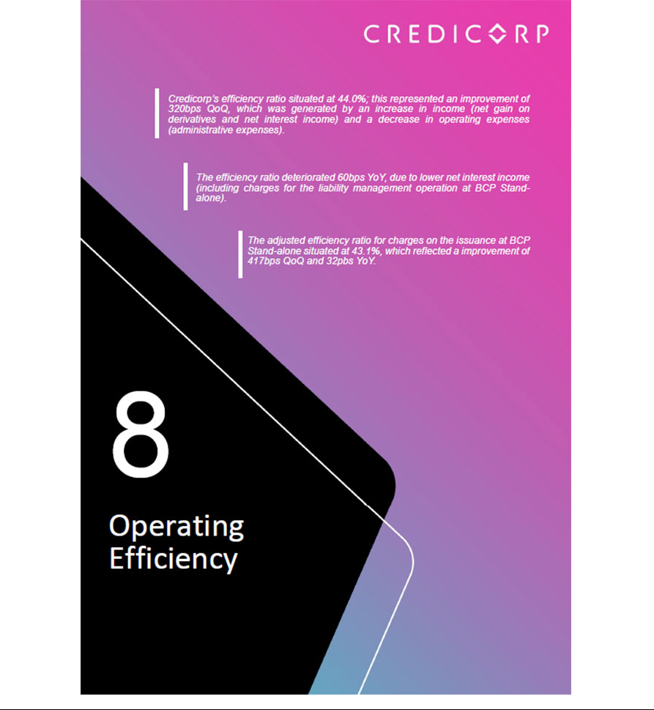

8. Operating Efficiency
Operating Efficiency |  |  |  | Quarter |  |  |  | % change
S/ 000 |  | 1Q20 |  | 4Q20 |  | 1Q21 |  | QoQ |  |  | YoY
Operating expenses⁽¹⁾ |  | 1,722,183 |  | 1,792,366 |  | 1,704,894 |  | -4.9% |  |  | -1.0%
Operating income⁽²⁾ |  | 3,968,580 |  | 3,795,255 |  | 3,871,563 |  | 2.0% |  |  | -2.4%
Efficiency ratio⁽³⁾ |  | 43.4% |  | 47.2% |  | 44.0% |  | -320 bps |  |  | 60 bps
Operating expenses / Total average assets⁽⁴⁾ |  | 3.57% |  | 3.06% |  | 2.83% |  | -23 bps |  |  | -74 bps

- Operating expenses = Salaries and employee’s benefits + Administrative expenses + Depreciation and amortization + Association in participation + Acquisition cost.

- Operating income = Net interest, similar income and expenses + Fee income + Net gain on foreign exchange transactions + Net gain from associates + Net gain on derivatives held for trading + Net gain from exchange differences + Net premiums earned
- Operating expenses / Operating income.

- Operating expenses / Average of Total Assets. Average is calculated with period beginning and period-ending balances.

8.1 Efficiency ratio by income and expense segment

In the QoQ analysis, the efficiency ratio improved 320pbs due to:

- An improvement in operating income due to an increase in Net gains on derivatives, which was associated with on-target trading strategies at BCP and Credicorp Capital and with an increase in Net Interest Income given that in 4Q20, impairment of reprogrammed loans was recognized and clients were reimbursed for interest accrued on refinanced loans in Bolivia.

- The decrease in Administrative and general expenses and taxes due to seasonal effects in the last quarter of the year.

YoY evolution of the efficiency ratio by account
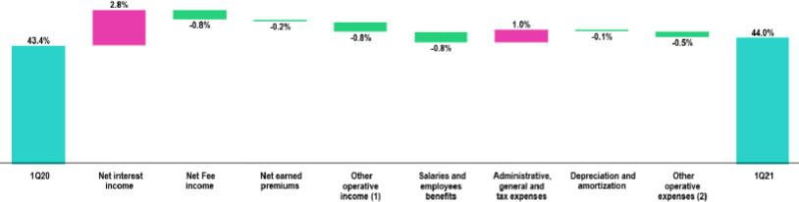

- Other operating income includes: Net gain on foreign exchange transactions, Net gain from associates, Net gain on derivatives held for trading and Net gain from exchange difference.

- Other operating expenses includes: Acquisition cost and Association in participation.

The 60bps deterioration YoY in the efficiency ratio was attributable to a drop in Net interest income, which was attributable to the charges related to the liability management operation carried out at BCP Stand-alone and to the significant weight of low-interest government loans in the portfolio and to the reduction in loans at BCP Stand-alone and Mibanco.

The reduction in operating expenses that was generated by a drop in Salaries and Employee benefits at BCP Stand-alone and Mibanco, coupled with the decrease in the Acquisition Cost after car premiums were returned in 1Q20, was insufficient to offset the efficiency deterioration.

46

8.2. Efficiency Ratio by Subsidiary ⁽¹⁾⁽²⁾

 | BCP |  |  |  | Microfinance ⁽³⁾
 | Stand-alone |  | BCP Bolivia |  | Microfinance ⁽³⁾ |  | Pacifico |  | Prima AFP |  | Credicorp
1Q20 | 38.8% |  | 56.4% |  | 58.4% |  | 40.6% |  | 40.6% |  | 43.4%
4Q20 | 41.5% |  | n.a. |  | 59.9% |  | 39.7% |  | 45.6% |  | 47.2%
1Q21 | 40.2% |  | 59.7% |  | 63.9% |  | 37.4% |  | 46.5% |  | 44.0%
Var. QoQ | -130 bps |  | n.a. |  | 400 bps |  | -230 bps |  | 90 bps |  | -320 bps
Var. YoY | 140 bps |  | n.a. |  | 550 bps |  | -320 bps |  | 590 bps |  | 60 bps

- (Salaries and employees benefits + Administrative, general and tax expenses + Depreciation and amortization + Acquisition cost + Association in participation) / (Net interest income + Fee income + Net gain on foreign exchange transactions + Net gain from associates + Net gain on derivatives held for trading + Result on exchange differences + Net premiums earned).
- The efficiency ratio differ from previously reported, please consider the data presented on this report.

- Microfinance includes Mibanco, Bancompartir and Encumbra

In the QoQ analysis, the efficiency ratio improved due to a reduction in operating expenses through:

- BCP Stand-alone and Credicorp Capital, which was driven by an increase in net gains on derivatives and

- the evolution of net interest income at BCP Bolivia, given that in 4Q20, clients were reimbursed for interest on refinanced loans and impairment was recognized for reprogrammed loans.

Evolución AaA del ratio de eficiencia por subsidiaria
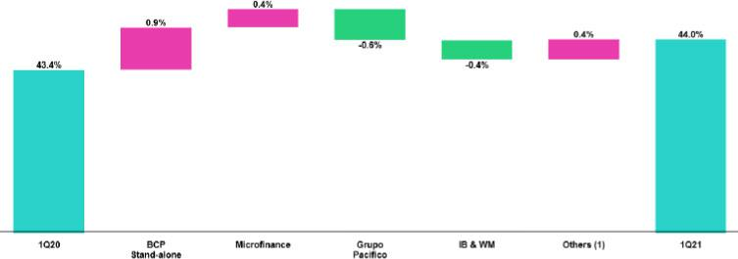

- Others includes: Credicorp Capital, Prima AFP, BCP Bolivia, ASB, Grupo Crédito, among other subsidiaries and the eliminations for consolidation purposes. In the YoY analysis, the efficiency ratil deteriorated 60pbs, which was attributable to:

- A decrease in net interest income at BCP Stand-alone and Mibanco, which was attributable to the charges related to the liability management operation carried out at BCP Stand-alone and the significant weight of low-interest government loans at the portfolio level.

- The reduction of fee income at Prima AFP due to a decrease in contributions and the fund withdrawals authorized by the government.

47



9. Regulatory Capital

9.1. Regulatory Capital - Credicorp

Total regulatory capital at Credicorp increased 6.6% QoQ and 10.8% YoY due to:

- The increase in subordinated debt in FC after issuances in the month of July 2020 and March 2021 at BCP Stand-alone via a Liability Management strategy and to an issuance at Mibanco.

- A lesser extent, growth in facultative reserves due to the preventive measures to head-off potential problems in an uncertain context for economic growth in Peru (adverse sanitary, political and economic context).
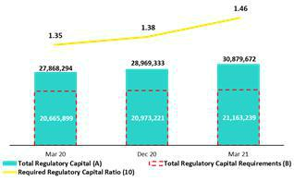

In terms of the Regulatory Capital Ratio, Credicorp maintained a comfortable level at the end of 1Q21 that represented 1.46 times the capital required by the regulator in Peru.

9.2. Regulatory Capital at BCP Individual – Peru GAAP

At the end of 1Q21, the Tier 1 ratio was situated at 10.59%. This result was driven by a +2.4% increase in Tier 1 capital, which was attributable to (i) capitalization of earnings from last year and (ii) facultative reserves. The BIS ratio was situated at 16.46%, which was attributable to a QoQ increase of +10.8% in regulatory capital. This was driven by (i) subordinated debt, which corresponds to the issuance of US$ 500 million under the Liability Management strategy in the month of March; and (ii) capitalization of earnings and reserves. These ratios were offset by total RWAS, which reflected growth of +0.6%. This expansion was primarily attributable to Credit RWAs, which were impacted by the exchange rate effect, and, although to a lesser extent, to growth in Operational RWAs.
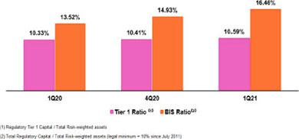

The YoY evolution shows the same trend as that seen in the QoQ analysis, reflecting an increase in the Tier 1 Ratio and in BIS, for the same reasons as those outlined above.

Ratio Common Equity Tier 1 – BCP Individual
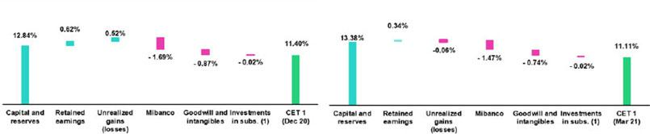

Figures at Dec20, Mibanco, Goodwill and investments differ from previously reported, please consider the data presented on this report.

(1) Includes investments in BCP Bolivia and other subsidiaries

Finally, the Tier 1 Common Equity Ratio (CET 1), which is considered the most rigorous ratio with which to measure capitalization levels, recorded a decrease of -29bps QoQ, situating a 11.11% at the end of 1Q21. This result was attributable to a drop in Common Equity Tier 1 (-2.1% QoQ), which was driven by unrealized losses in a volatile local market and attenuated by a capital increase.

49

In the YoY analysis, the CET1 ratio fell -78bps due to a -7.3% decrease in accumulated results given the postponement of dividend payments in March 20, to April due to the pandemic context.

9.3. Regulatory Capital Mibanco – Peru GAAP

Solvency Ratio – Mibanco

- Regulatory Tier 1 Capital / Total Risk-weighted assets.

- Total Regulatory Capital / Total Risk-weighted assets (legal minimum = 10% since July 2011).
- 4Q20 CET1 differ from previously reported, please consider the data presented on this report.
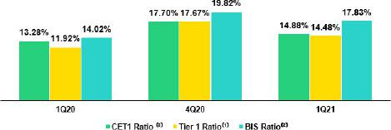

At the end of 1T21, the Tier 1 and BIS ratios at Mibanco decreased QoQ by -319 bps and -199 bps to situate at levels of 14.48% and 17.83% respectively. This was attributable as the new capital injected last quarter was used to increase the allowance for loan losses. The BIS Ratio was partially attenuated following the issuance of a subordinated bond in March.

The YoY evolution shows an increase of 256 bps and 381 bps in the Tier 1 and BIS ratios respectively. This first increase was attributable to the positive evolution of Tier 1 (+17.5%), while the second was driven by growth in total regulatory capital (+23.0%). Both of the aforementioned were, in turn, fueled by earnings capitalizations in June 2020. In adittion RWAS fell -3.3% in a context of heightened risk in the Mibanco portfolio.

Finally, the Tier 1 Common Equity Ratio (CET 1), which is considered the most rigorous ratio with which to measure capitalization levels, reported a contraction of -282 bps QoQ, situating at 14.88% in the 1Q21. This result was attributable to an -18.1% decrease in the CET1, which reflected a decrease in capital, as the new S/400 million capital increase of the last quarter was offset by the constitution of similar amount of additional voluntary provisions in local accounting directly offsetting shareholders equity. The aforementioned was partially attenuated by a -2.6% contraction in adjusted RWAs. These RWAs were generated by deferred assets (triggered by assets in excess of 10% of CET1). In the YoY analysis, the CET1 Ratio increased +160 bps due to a -7.2% contraction in RWAs, as explained in the QoQ analysis.

50

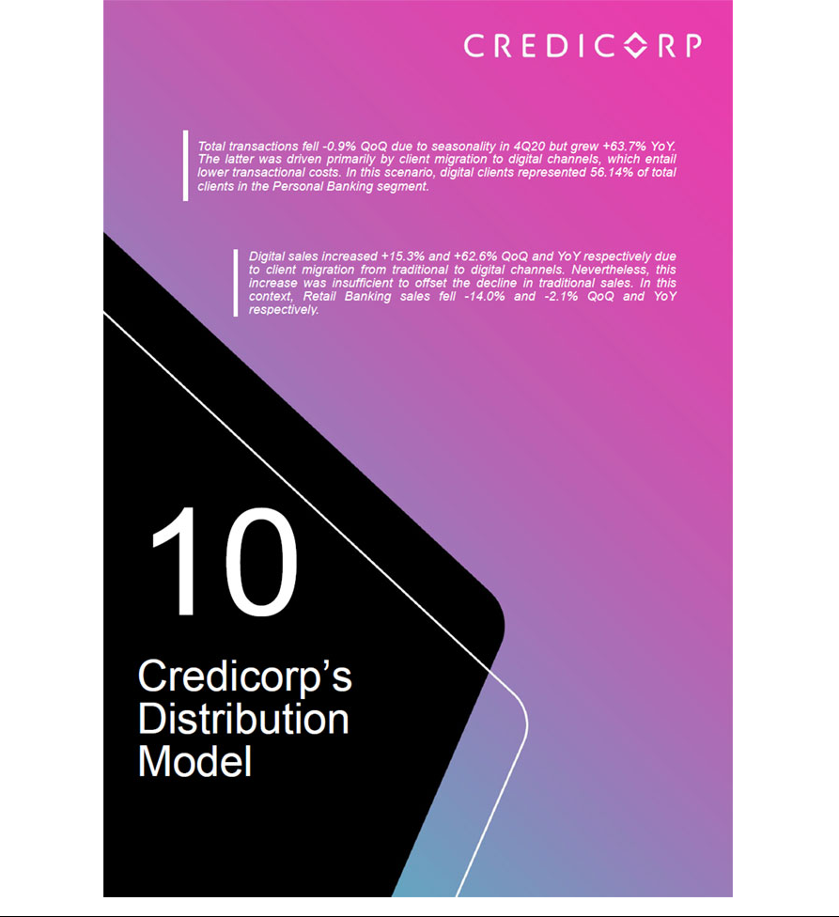

10. Distribution Model
10.1. Distribution model at BCP Stand-alone
10.1.1 Digital Clients in the Personal Banking |  | Composition of digital clients ⁽¹⁾ by segment
Evolution of digital clients ⁽¹⁾
 | Group |  |  | 1Q20 |  | 4Q20 |  |  | 1Q20
 | Enalta |  |  | 81.73% |  | 86.18% |  |  | 86.78%
 | Affluent | 73.79% |  |  |  | 80.14% |  |  | 80.88%
 | Consumer | 42.55% |  |  |  | 53.62% |  |  | 54.97%
 | Total | 44.19% |  |  |  | 54.86% |  |  | 56.14%
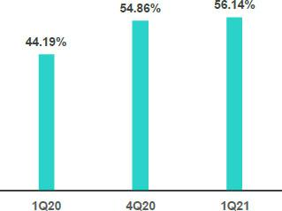

- Digital clients: Clients in retail banking that conduct 50% of their monetary transactions through digital channels or which have purchased products online in the last 12 months

- The digitalization level of total clients continued to follow the upward trend seen in previous quarters. In 2Q21, digital clients totaled 56.14% of total clients in Individuals Banking at BCP Stand-alone.

- If we conduct and analysis by segment, we see that the Enalta and Afluente segments are highly digitalized while the Consumer segment, which has the higher share of total clients in the Individuals Banking, is currently 54.97% digitalized. This segment governs the digitalization trend and during the quarantine in 2020, began to present more pronounced levels of digitalization.

10.1.2. Transactions by Channel

Evolution of transactions by channel monthly average transactions cost per unit

Expressed in thousands of transactions
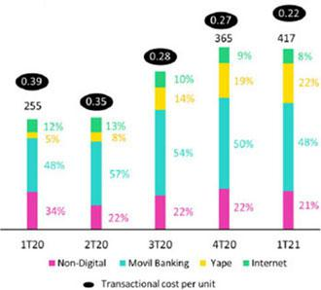

In the QoQ analysis, the monthly average of transactions fell -0.9% due to:

- Primarily, seasonality in the last quarter of the year and the quarantine imposed in the month of February, which led transactions to fall across channels with the exception of Yape and Kiosks, which grew 14.6% and 1.2% respectively.

52

- The channels that absorbed the brunt of the impact with Mobile Banking and Internet Banking, which fell -3.6% and -11.6% respectively.

Growth in the monthly average of transactions through Yape was highly correlated with growth in total users, which hit 5.9 million in 1Q21, of which 1.7 million were new clients at BCP Stand-alone through the Yapecard. Growth in transactions pushed down Yape’s monthly average transactions cost per unit, which fell significantly.

The YoY analysis reveals an increase of +63.7% in the monthly average of transactions, which was generated by:

- Dynamism in transactions through digital channels, which registered a significant increase in the transactions volume of +95.4%.

- The most significant variation was seen in Yape and Mobile Banking, which grew 607.9% and 63.5% respectively. This growth drove down the monthly average transactions cost per unit by -77.9% in the case of Yape while Mobile Banking’s growth remained flat.

It is important to note that in the last few quarters, clients have migrated to channels with lower transactional costs, favoring transactions through digital channels over those in traditional channels, such as tellers. As a result, the total transaction cost per unit has gone from 0.39 in 1Q20 to 0.22 in 1Q21.

10.1.3. Retail Banking Sales
 | Unit sold per Quarter |  |  |  |  |  |  | % Change
 | 1Q20 |  | 4Q20 |  |  | 1Q21 |  | TaT |  |  | AaA
Traditionals Sales | 1,196,073 |  | 1,517,113 |  |  | 1,079,959 |  | -28.8% |  |  | -9.7%
Selfserved Sales | 469,300 |  | 258,734 |  |  | 265,067 |  | 2.4% |  |  | -43.5%
Digital Sales | 439,591 |  | 620,133 |  |  | 714,816 |  | 15.3% |  |  | 62.6%
Total Sales⁽¹⁾
Total Sales⁽¹⁾ | 2,104,964 |  | 2,395,980 |  |  | 2,059,842 |  | -14.0% |  |  | -2.1%

- Includes advance on wages, personal loans, saving acount, time deposits, efectivo preferente, insurance, credit cards y SME working capital loans In the QoQ analysis, Retail Banking sales fell -14.0%, which was attributable to:

- A drop of -28.8% in sales through traditional channels due to seasonality in 4Q20 and to the quarantine imposed in the month of February. The products that were most impacted by the drop in sales were Savings accounts (-18.7), Consumer loans (-13.6%), SME-Pyme loans (-13.2%) and Working Capital Loans (-12.8%).

The decline was attenuated by growth in sales through digital and self-service channels, which grew +15.3% and 2.4% respectively. The uptick in digital sales was driven primarily by sales growth in Personal Loan (+67.0%) and Savings Accounts (8.3%) while the increase in self-service sales was attributable to growth in Savings Accounts (+1.9%) and Advance on wages (+4.2%).

In the YoY analysis, sales fell -2.1%, which was attributable to:

- A decrease in sales through traditional sales and self-service sales, which contracted -9.7% and – 43.5% respectively. The products that were most affected within traditional sales were SME-Pyme loans (-17.0%) and Consumer loans (-29.7%).

The decline was partially attenuated by growth of 62.6% in digital sales given that clients have migrated to digital channels to purchase products. The products that presented the most positive evolution were Savings Accounts (+229.9%), Insurance (+266.2%) and Personal loans (+30.8%).

53

10.2. Points of Contact
10.2.1 Point of Contact BCP
 |  |  | As of |  |  |  | change (units)
 | Mar 20 |  | Dec 20 |  | Mar 21 |  | QoQ |  | YoY
Branches | 404 |  | 388 |  | 388 |  | - |  | -16
ATMs | 2,290 |  | 2,317 |  | 2,306 |  | -11 |  | 16
Agentes BCP | 6,869 |  | 7,003 |  | 6,860 |  | -143 |  | -9
Total BCP’s Network | 9,563 |  | 9,708 |  | 9,554 |  | -154 |  | -9

BCP Stand-alone reduce its ATMs and Agentes BCP fell by -11 units and 143 units QoQ respectively due to the migration of its clients to digital channels. Branches also fell in this context, dropping -16 units with regard to 1Q20’s figure.

10.2.2 Points of contact BCP Bolivia
 |  |  | As of |  |  |  | change (units)
 | Mar 20 |  | Dec 20 |  | Mar 21 |  | QoQ |  | YoY
Branches | 54 |  | 54 |  | 54 |  | - |  | -
ATMs | 307 |  | 310 |  | 310 |  | - |  | 3
Agentes BCP Bolivia | 555 |  | 851 |  | 850 |  | -1 |  | 295
Total Bolivia’s Network | 916 |  | 1,215 |  | 1,214 |  | -1 |  | 298

At BCP Bolivia, points of contact increased YoY (+298) due to growth in Agentes BCP (+295) and ATMs (+3), in line with the strategy to expand in cost-efficient channels.

10.2.1. Physical points of contact Mibanco
 |  |  | As of |  |  |  | change (units)
 | Mar 20 |  | Dec 20 |  | Mar 21 |  | QoQ |  | YoY
Total Mibanco’s Network ⁽¹⁾ | 325 |  | 323 |  | 317 |  | -6 |  | -8

- Mibanco has no ATMs of Agentes given that it uses BCP’s network. The number of branches includes the Banco de la Nacion branches that can be used by Mibanco clients, which in Mar 20, Dec 20 and Mar 21 totaled 35, 34, and 34 respectively.

At Mibanco, branches registered a decrease of 6 units QoQ and 8 units YoY. This decline was attributable to social distancing measures and to client migration to other channels. It is important to note that Mibanco has an agreement with Banco de la Nacion to use the latter’s branches to reduce operating costs. At the end of 1Q21, these branches represented 11% (34 branches) of Mibanco’s total of 317 branches.

54

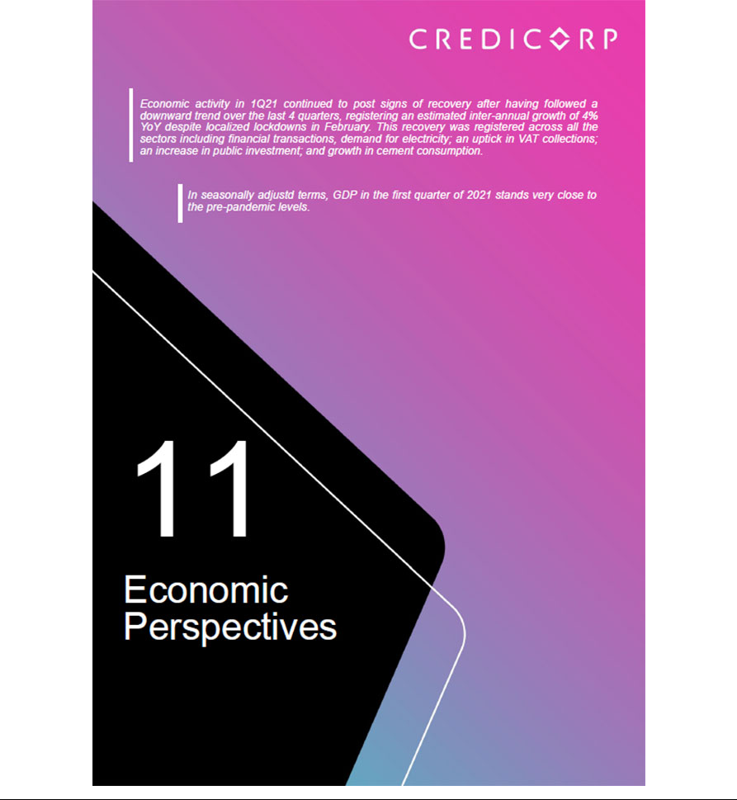

11. Economic Perspectives
11.1. Peru: Economic Forecasts
Peru |  | 2017 |  | 2018 |  | 2019 |  | 2020 |  | 2021⁽³⁾
GDP (US$ Millions) |  | 214,265 |  | 225,201 |  | 230,846 |  | 203,527 |  | 223,230
Real GDP (% change) |  | 2.5 |  | 4.0 |  | 2.2 |  | -11.1 |  | 9.0
GDP per capita (US$) |  | 6,738 |  | 6,994 |  | 7,103 |  | 6,238 |  | 6,768
Domestic demand (% change) |  | 1.5 |  | 4.2 |  | 2.4 |  | -9.8 |  | 8.5
Gross fixed investment (as % GDP) |  | 20.6 |  | 21.7 |  | 21.5 |  | 18.8 |  | 19.6
Public Debt (as % GDP) |  | 24.9 |  | 25.7 |  | 26.8 |  | 35.0 |  | 36.0
System loan growth (% change) ⁽¹⁾ |  | 5.6 |  | 10.1 |  | 6.2 |  | 12.4 |  | -
Inflation ⁽²⁾
 |  | 1.4 |  | 2.2 |  | 1.9 |  | 2.0 |  | 2.2
Reference Rate |  | 3.25 |  | 2.75 |  | 2.25 |  | 0.25 |  | 0.25
Exchange rate, end of period |  | 3.24 |  | 3.37 |  | 3.31 |  | 3.62 |  | 3.45 - 3.50
Exchange rate, (% change) |  | -3.5% |  | 4.1% |  | -1.7% |  | 9.3% |  | -4.7%
Fiscal balance (% GDP) |  | -3.1 |  | -2.5 |  | -1.6 |  | -8.9 |  | -5.5
Trade balance (US$ Millions) |  | 6,700 |  | 7,197 |  | 6,614 |  | 7,750 |  | 12,500
(As % GDP) |  | 3.1% |  | 3.2% |  | 2.9% |  | 3.8% |  | 5.6%
Exports |  | 45,422 |  | 49,066 |  | 47,688 |  | 42,413 |  | 53,000
Imports |  | 38,722 |  | 41,870 |  | 41,074 |  | 34,663 |  | 40,500
Current account balance (As % GDP) |  | -1.3% |  | -1.7% |  | -1.5% |  | 0.5% |  | -0.4%
Net international reserves (US$ Millions) |  | 63,621 |  | 60,121 |  | 68,316 |  | 74,707 |  | 74,500
(As % GDP) |  | 29.7% |  | 26.7% |  | 29.6% |  | 36.7% |  | 33.4%
(As months of imports) |  | 20 |  | 17 |  | 20 |  | 26 |  | 22

Sources: INEI, BCRP y SBS.

- Financial System, Current Exchange Rate

- Inflation target: 1% - 3%

- Estimates by BCP Economic Research as of April 2021.

10.2. Main Economic Variables

Gross Domestic Product

(Annual Variations, % y/y)
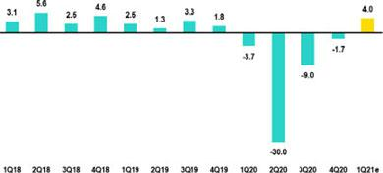

• Despite a focalized lockdown, GDP registered a notable recovery during the first quarter of 2021.

• After contracting 4.2% YoY in February, for March our estimates suggest that economic activity will rebound close to 20% YoY

• In March, electricity demand increased 15.5% YoY (61-months peak)

Source: INEI

- Strong rebounds were observed in the following indicators when compared to February:

  - Public investment of the general government, +122% YoY vs February +11%.

  - Domestic VAT revenues, +33% YoY vs February +6%.

  - Domestic cement consumption, +145% YoY vs February +15%

- GDP expanded close to 4% YoY in 1Q21, the first positive print in 5 quarters.

- In 2Q21, a noteworthy rebound of annual growth rates is expected due to an extremely low base-effect (GDP contracted 30% YoY in 2Q20 amid the nationwide lockdown of last year).

56

Inflation and Monetary Policy Rate (%)

• The headline inflation rate closed at 2.6% YoY for the first quarter of 2021(4Q20: 2.0%). This represented the highest level in 22 months but was nonetheless within the Central Bank’s target range.
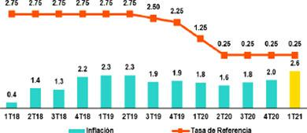

• Core inflation (excluding food and energy) situated at 1.8% YoY, registering 13 consecutive months below 2%.

• The reference rate has remained at 0.25% since April 2020

Fuente: INEI, BCRP

- In the last monetary policy meeting of April 2021, the Central Bank stressed that “the Board considers it appropriate to maintain a strong monetary stimulus for a prolonged period or for as long as the negative effects on inflation and its determinants persist. The Central Bank remains vigilant to increase monetary stimulus through several mechanisms”.

- Regarding Reactiva Perú, as of the end of the first quarter of 2021, repo operations with state guarantee that have been liquidated stood at PEN 49.9 billion (2020: PEN 50.7 billion).

Fiscal Result and Current Account Balance

(% of GDP, Quarter)

• The fiscal deficit represented 8.7% of GDP in 1Q21 (2020: 8.9%).
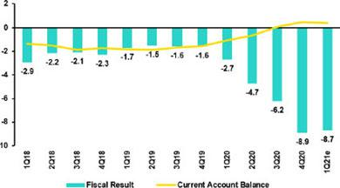

• In the first quarter of 2021, fiscal revenues grew 13% YoY (4Q20:

-3%) due to a:

a. Higher VAT revenues (+17% YoY).

b. An increase in Income Tax revenues (+19% YoY.

• In the first quarter of 2021, non-financial government spending increased 22% YoY.

*BCP estimates

Source: Central Bank

- Current spending rose 16% YoY through an increase in transfers (+29%) and in spending on goods and services (+22%),

- Public investment of the general government advanced 43% YoY

- In the first week of March 2021, Peru issued bonds for USD 4 billion in three tranches:

  - $1,750 million, tapping into Global bond 2032 with a coupon rate of 2.78%

  - $1,250 million million with a 20-year tenor and a coupon rate 3.30%

  - S1,000 million million with a 30-year tenor and a coupon rate 3.55%

- Peru also issued another bond for EUR 825 million with a 12-year tenor and a coupon rate of 1.25%. Total demand for this issuance exceeded US$ 10 billion.

- In January-February 2021, the trade balance posted a surplus of US$ 1,927 million, 120% above the figure recorded for the same period last year.

57

Exchange rate

(S/ por US$)

• The exchange rate closed 1Q21 at USDPEN 3.757. Consequently, the Peruvian Sol depreciated 3.8% compared 2020’s closing rate.
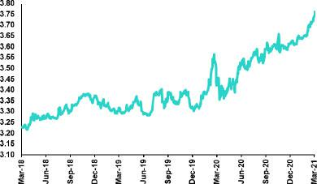

• In 1Q21, the exchange rate reached a historical peak of USDPEN 3.77 in a context of high political uncertainty on the local scene.

• In the first quarter of 2021, the Central Bank made sales in the spot FX market for US$ 2,396 million (in March alone it sold US$ 1,147 million).

• The BCRP used cross-currency swaps (sales) and BCRP readjustable deposit certificates to mitigate PEN depreciation. Outstanding cross-currency swaps stood at PEN 28,618 million (an almost 5-year peak), which represented an increase of PEN 20,483 million since end-2020.

Source: SBS

- Net International Reserves closed 1Q21 at US$ 79.9 billion compared to US$ 74.7 billion at the end of 2020.

58

Safe Harbor for Forward-Looking Statements

This material includes “forward-looking statements” within the meaning of Section 27A of the U.S. Securities Act of 1933 and Section 21E of the U.S. Securities Exchange Act of 1934. All statements other than statements of historical fact are forward-looking and may contain information about financial results, economic conditions, trends and known uncertainties. Forward-looking statements are not assurances of future performance. Instead, they are based only on our management’s current views, beliefs, expectations and assumptions regarding the future of our business, future plans and strategies, projections, anticipated events and trends, the economy and other future conditions.

Many forward-looking statements can be identified by words such as: “anticipate”, “intend”, “plan”, “goal”, “seek”, “believe”, “project”, “estimate”, “expect”, “strategy”, “future”, “likely”, “would”, “may”, “should”, “will”, “see” and similar references to future periods. Examples of forward-looking statements include, among others, statements or estimates we make regarding guidance relating to losses in our credit portfolio, efficiency ratio, provisions and non-performing loans, current or future market risk and future market conditions, expected macroeconomic events and conditions, our belief that we have sufficient capital and liquidity to fund our business operations, expectations of the effect on our financial condition of claims, legal actions, environmental costs, contingent liabilities and governmental and regulatory investigations and proceedings, strategy for customer retention, growth, governmental programs and regulatory initiatives, credit administration, product development, market position, financial results and reserves and strategy for risk management.

We caution readers that forward-looking statements involve known and unknown risks and uncertainties that could cause actual results, performance or events to differ materially from those that we expect or that are expressed or implied in the forward-looking statements, depending on the outcome of certain factors, including, without limitation, adverse changes in:

- Economic conditions in Peru;

- The occurrence of natural disasters or political or social instability in Peru;

- The adequacy of the dividends that our subsidiaries are able to pay to us, which may affect our ability to pay dividends to shareholders and corporate expenses;
- Performance of, and volatility in, financial markets, including Latin-American and other markets;

- The frequency, severity and types of insured loss events;

- Fluctuations in interest rate levels;

- Foreign currency exchange rates, including the Sol/US Dollar exchange rate;

- Deterioration in the quality of our loan portfolio;

- Increasing levels of competition in Peru and other markets in which we operate;

- Developments and changes in laws and regulations affecting the financial sector and adoption of new international guidelines;

- Changes in the policies of central banks and/or foreign governments;

- Effectiveness of our risk management policies and of our operational and security systems;

- Losses associated with counterparty exposures;

- The scope of the coronavirus (“COVID-19”) outbreak, actions taken to contain the COVID-19 and related economic effects from such actions and our ability to maintain adequate staffing; and
- Changes in Bermuda laws and regulations applicable to so-called non-resident entities.

See “Item 3. Key Information—3.D Risk Factors” and “Item 5. Operating and Financial Review and Prospects” in our most recent Annual Report on Form 20-F filed with the U.S. Securities and Exchange Commission for additional information and other such factors.

You are cautioned not to place undue reliance on these forward-looking statements, which speak only as of the date hereof and are based only on information currently available to us. Therefore, you should not rely on any of these forward-looking statements. We undertake no obligation to publicly update or revise these or any other forward-looking statements that may be made to reflect events or circumstances after the date hereof, whether as a result of changes in our business strategy or new information, to reflect the occurrence of unanticipated events or otherwise.

59



12.1. Credicorp

CREDICORP LTD. AND SUBSIDIARIES

CONSOLIDATED STATEMENT OF FINANCIAL POSITION

(In S/ thousands, IFRS)

 |  |  | As of |  |  |  | % change
 | Mar 2020 |  | Dec 2020 |  | Mar 2021 |  | QoQ |  |  | YoY
ASSETS
Cash and due from banks ⁽¹⁾
Non-interest bearing | 6,787,357 |  | 8,176,612 |  | 7,281,695 |  | -10.9% |  |  | 7.3%
Interest bearing | 19,538,429 |  | 28,576,382 |  | 31,982,816 |  | 11.9% |  |  | 63.7%
Total cash and due from banks | 26,325,786 |  | 36,752,994 |  | 39,264,511 |  | 6.8% |  |  | 49.1%
Cash collateral, reverse repurchase agreements and
securities borrowing | 4,424,345 |  | 2,394,302 |  | 1,769,690 |  | -26.1% |  |  | -60.0%
Fair value through profit or loss investments ⁽¹⁾⁽²⁾ | 4,185,638 |  | 6,467,471 |  | 8,083,128 |  | 25.0% |  |  | 93.1%
Fair value through other comprehensive income
investments ⁽¹⁾ | 28,388,372 |  | 43,743,889 |  | 45,681,969 |  | 4.4% |  |  | 60.9%
Amortized cost investments ⁽¹⁾ | 4,242,643 |  | 4,962,382 |  | 5,647,635 |  | 13.8% |  |  | 33.1%
Loans | 120,708,515 |  | 137,659,885 |  | 137,031,239 |  | -0.5% |  |  | 13.5%
Current | 117,129,011 |  | 132,984,154 |  | 132,162,756 |  | -0.6% |  |  | 12.8%
Internal overdue loans | 3,579,504 |  | 4,675,731 |  | 4,868,483 |  | 4.1% |  |  | 36.0%
Less - allowance for loan losses | (5,931,772) |  | (9,898,760) |  | (9,744,298) |  | -1.6% |  |  | 64.3%
Loans, net | 114,776,743 |  | 127,761,125 |  | 127,286,941 |  | -0.4% |  |  | 10.9%
Financial assets designated at fair value through profit or
loss | 559,321 |  | 823,270 |  | 888,420 |  | 7.9% |  |  | 58.8%
Accounts receivable from reinsurers and coinsurers | 787,672 |  | 919,419 |  | 981,379 |  | 6.7% |  |  | 24.6%
Premiums and other policyholder receivables | 822,669 |  | 937,223 |  | 827,807 |  | -11.7% |  |  | 0.6%
Property, plant and equipment, net | 2,203,086 |  | 2,077,803 |  | 1,996,860 |  | -3.9% |  |  | -9.4%
Due from customers on acceptances | 555,598 |  | 455,343 |  | 532,584 |  | 17.0% |  |  | -4.1%
Investments in associates | 618,310 |  | 645,886 |  | 620,603 |  | -3.9% |  |  | 0.4%
Intangible assets and goodwill, net | 2,424,404 |  | 2,639,297 |  | 2,599,291 |  | -1.5% |  |  | 7.2%
Other assets ⁽¹⁾ | 7,507,302 |  | 6,825,759 |  | 8,109,764 |  | 18.8% |  |  | 8.0%
Total Assets | 197,821,889 |  | 237,406,163 |  | 244,290,582 |  | 2.9% |  |  | 23.5%
LIABILITIES AND EQUITY
Deposits and obligations
Non-interest bearing | 32,231,854 |  | 47,623,119 |  | 48,469,215 |  | 1.8% |  |  | 50.4%
Interest bearing | 87,331,691 |  | 94,742,383 |  | 100,157,124 |  | 5.7% |  |  | 14.7%
Total deposits and obligations | 119,563,545 |  | 142,365,502 |  | 148,626,339 |  | 4.4% |  |  | 24.3%
Payables from repurchase agreements and securities
lending | 8,254,726 |  | 27,923,617 |  | 26,657,010 |  | -4.5% |  |  | 222.9%
BCRP instruments | 5,346,373 |  | 25,734,963 |  | 24,303,193 |  | -5.6% |  |  | 354.6%
Repurchase agreements with third parties | 1,935,879 |  | 1,072,920 |  | 1,159,587 |  | 8.1% |  |  | -40.1%
Repurchase agreements with customers ⁽¹⁾ | 972,474 |  | 1,115,734 |  | 1,194,230 |  | 7.0% |  |  | 22.8%
Due to banks and correspondents | 9,854,630 |  | 5,978,257 |  | 5,393,500 |  | -9.8% |  |  | -45.3%
Bonds and notes issued ⁽¹⁾ | 15,178,148 |  | 16,319,407 |  | 17,863,198 |  | 9.5% |  |  | 17.7%
Banker’s acceptances outstanding | 555,598 |  | 455,343 |  | 532,584 |  | 17.0% |  |  | -4.1%
Reserves for property and casualty claims | 1,637,791 |  | 2,050,474 |  | 2,248,082 |  | 9.6% |  |  | 37.3%
Reserve for unearned premiums | 8,338,154 |  | 9,624,602 |  | 9,561,612 |  | -0.7% |  |  | 14.7%
Accounts payable to reinsurers | 198,473 |  | 338,446 |  | 290,866 |  | -14.1% |  |  | 46.6%
Financial liabilities at fair value through profit or loss ⁽¹⁾ | 533,146 |  | 561,602 |  | 772,385 |  | 37.5% |  |  | 44.9%
Other liabilities ⁽¹⁾⁽²⁾ | 9,984,867 |  | 6,343,266 |  | 7,326,432 |  | 15.5% |  |  | -26.6%
Total Liabilities | 174,099,078 |  | 211,960,516 |  | 219,272,008 |  | 3.4% |  |  | 25.9%
Net equity | 23,205,639 |  | 24,945,870 |  | 24,529,958 |  | -1.7% |  |  | 5.7%
Capital stock | 1,318,993 |  | 1,318,993 |  | 1,318,993 |  | 0.0% |  |  | 0.0%
Treasury stock | (209,309) |  | (208,433) |  | (207,840) |  | -0.3% |  |  | -0.7%
Capital surplus | 165,188 |  | 192,625 |  | 224,591 |  | 16.6% |  |  | 36.0%
Reserves | 21,360,272 |  | 21,429,635 |  | 21,707,166 |  | 1.3% |  |  | 1.6%
Unrealized gains and losses | 359,565 |  | 1,865,898 |  | 840,581 |  | -55.0% |  |  | 133.8%
Retained earnings | 210,930 |  | 347,152 |  | 646,467 |  | 86.2% |  |  | 206.5%
Non-controlling interest | 517,172 |  | 499,777 |  | 488,616 |  | -2.2% |  |  | -5.5%
Total Net Equity | 23,722,811 |  | 25,445,647 |  | 25,018,574 |  | -1.7% |  |  | 5.5%
Total liabilities and equity | 197,821,889 |  | 237,406,163 |  | 244,290,582 |  | 2.9% |  |  | 23.5%
Off-balance sheet | 131,725,399 |  | 133,568,004 |  | 150,250,539 |  | 12.5% |  |  | 14.1%
Total performance bonds, stand-by and L/Cs. | 20,426,402 |  | 20,973,810 |  | 21,761,484 |  | 3.8% |  |  | 6.5%

Undrawn credit lines, advised but not committed | 79,703,253 | 86,074,859 | 90,946,335 | 5.7% | 14.1%
Total derivatives (notional) and others | 31,595,744 | 26,519,335 | 37,542,720 | 41.6% | 18.8%

- The amounts differ from those previously reported in 2020 period, due to the reclassifications.

- Includes mainly accounts receivables from brokerage and others.

61

CREDICORP LTD. AND SUBSIDIARIES

CONSOLIDATED STATEMENT OF INCOME

(In S/ thousands, IFRS)

 |  |  | Quarter |  |  |  | % change
 | 1Q20 |  | 4Q20 |  | 1Q21 |  | QoQ |  |  | YoY
Interest income and expense
Interest and dividend income | 3,163,609 |  | 2,703,100 |  | 2,816,073 |  | 4.2% |  |  | -11.0%
Interest expense ⁽¹⁾ | (784,082) |  | (633,880) |  | (692,690) |  | 9.3% |  |  | -11.7%
Net interest income | 2,379,527 |  | 2,069,220 |  | 2,123,383 |  | 2.6% |  |  | -10.8%
Gross provision for credit losses on loan portfolio | (1,388,711) |  | (785,194) |  | (622,982) |  | -20.7% |  |  | -55.1%
Recoveries of written-off loans | 47,230 |  | 52,529 |  | 65,335 |  | 24.4% |  |  | 38.3%
Provision for credit losses on loan portfolio, net of
recoveries | (1,341,481) |  | (732,665) |  | (557,647) |  | -23.9% |  |  | -58.4%
 | - |  | - |  | -
Risk-adjusted net interest income | 1,038,046 |  | 1,336,555 |  | 1,565,736 |  | 17.1% |  |  | 50.8%
Non-financial income
Fee income | 760,329 |  | 873,155 |  | 830,771 |  | -4.9% |  |  | 9.3%
Net gain on foreign exchange transactions | 166,983 |  | 151,464 |  | 179,889 |  | 18.8% |  |  | 7.7%
Net gain on sales of securities | (120,633) |  | 162,523 |  | 16,287 |  | 90.0% |  |  | n.a.
Net gain from associates | 19,225 |  | 19,297 |  | 29,405 |  | 52.4% |  |  | 53.0%
Net gain on derivatives held for trading | 35,430 |  | 18,298 |  | 69,723 |  | 281.0% |  |  | 96.8%
Net gain from exchange differences ⁽¹⁾ | (20,849) |  | 11,152 |  | (5,536) |  | n.a. |  |  | -73.4%
Other non-financial income ⁽¹⁾ | 117,770 |  | 94,517 |  | 73,991 |  | -21.7% |  |  | -37.2%
Total non-financial income | 958,255 |  | 1,330,406 |  | 1,194,530 |  | -10.2% |  |  | 24.7%
Insurance underwriting result
Net earned premiums ⁽¹⁾ | 627,935 |  | 652,669 |  | 643,928 |  | -1.3% |  |  | 2.5%
Net claims ⁽¹⁾ | (373,502) |  | (492,738) |  | (623,353) |  | 26.5% |  |  | 66.9%
Acquisition cost ⁽²⁾ | (112,507) |  | (75,065) |  | (85,822) |  | 14.3% |  |  | -23.7%
Total insurance underwriting result | 141,926 |  | 84,866 |  | (65,247) |  | n.a. |  |  | n.a.
Total expenses
Salaries and employee benefits | (891,183) |  | (792,335) |  | (857,559) |  | 8.2% |  |  | -3.8%
Administrative, general and tax expenses ⁽¹⁾ | (542,104) |  | (749,393) |  | (580,842) |  | -22.5% |  |  | 7.1%
Depreciation and amortization ⁽¹⁾ | (169,959) |  | (158,494) |  | (166,765) |  | 5.2% |  |  | -1.9%
Impairment loss on goodwill | - |  | - |  | - |  | n.a. |  |  | n.a.
Association in participation | (6,430) |  | (17,079) |  | (13,906) |  | -18.6% |  |  | 116.3%
Other expenses ⁽¹⁾ | (169,630) |  | (265,255) |  | (61,199) |  | -76.9% |  |  | -63.9%
Total expenses | (1,779,306) |  | (1,982,556) |  | (1,680,271) |  | -15.2% |  |  | -5.6%
Profit before income tax | 358,921 |  | 769,271 |  | 1,014,748 |  | 31.9% |  |  | 182.7%
Income tax | (145,746) |  | (103,460) |  | (337,599) |  | 226.3% |  |  | 131.6%
Net profit | 213,175 |  | 665,811 |  | 677,149 |  | 1.7% |  |  | 217.6%
Non-controlling interest | 3,901 |  | 12,407 |  | 16,351 |  | 31.8% |  |  | 319.1%
Net profit attributable to Credicorp | 209,274 |  | 653,404 |  | 660,798 |  | 1.1% |  |  | 215.8%

- The amounts differ from those previously reported in 2020 period due to reclassifications.

- The acquisition cost of Pacífico includes net fees and underwriting expenses.

62

12.2. Credicorp Stand-alone
Credicorp Ltd.
Separate Statement of Financal Position
(In S/ thousands, IFRS)
 |  |  | As of
 |  | Dec 20 |  |  |  |  | Mar 21
ASSETS
Cash and cash equivalents |  | 1,114,167 |  |  |  |  | 800,622
At fair value through profit or loss |  | 234,825 |  |  |  |  | 583,176
Fair value through other comprehensive income investments ⁽¹⁾ |  | 463,421 |  |  |  |  | 490,778
In subsidiaries and associates investments ⁽¹⁾ |  | 29,118,425 |  |  |  |  | 28,688,953
Loans |  | - |  |  |  |  | -
Other assets |  | 191 |  |  |  |  | 137,049
Total Assets |  | 30,931,029 |  |  |  |  | 30,700,578
LIABILITIES AND NET SHAREHOLDERS’ EQUITY
Bonds and notes issued |  | 1,794,879 |  |  |  |  | 1,875,925
Other liabilities |  | 110,827 |  |  |  |  | 133,300
Total Liabilities |  | 1,905,706 |  |  |  |  | 2,009,225
NET EQUITY
Capital stock |  | 1,318,993 |  |  |  |  | 1,318,993
Capital Surplus |  | 384,542 |  |  |  |  | 384,542
Reserve |  | 21,070,409 |  |  |  |  | 21,417,403
Unrealized results |  | 1,666,481 |  |  |  |  | 652,340
Retained earnings |  | 4,584,898 |  |  |  |  | 4,918,075
Total net equity |  | 29,025,323 |  |  |  |  | 28,691,353
Total Liabilities And Equity |  | 30,931,029 |  |  |  |  | 30,700,578
 |  | Quarter
 |  | 4Q20 |  |  |  |  | 1Q21
Interest income
Net share of the income from investments in subsidiaries and associates |  | 865,516 |  |  |  |  | 676,484
Interest and similar income |  | 11,259 |  |  |  |  | 3,038
Net gain on financial assets at fair value through profit or loss |  | - |  |  |  |  | (4,494)
Total income |  | 876,775 |  |  |  |  | 675,028
Interest and similar expense |  | (28,424) |  |  |  |  | (13,363)
Administrative and general expenses |  | (19,140) |  |  |  |  | (4,761)
Total expenses |  | (47,564) |  |  |  |  | (18,124)
Operating income |  | 829,211 |  |  |  |  | 656,904
Exchange differences, net |  | (4,660) |  |  |  |  | (1,268)
Other, net |  | 1,071 |  |  |  |  | (5)
Profit before income tax |  | 825,622 |  |  |  |  | 655,631
Income tax |  | (33,224) |  |  |  |  | (19,229)
Net income |  | 792,398 |  |  |  |  | 636,402
Double Leverage Ratio |  | 100.32 | % |  |  |  | 99.99 | %

(1) Figures differ from those presented in fiscal year 2020.

63

12.3. BCP Consolidated

BANCO DE CREDITO DEL PERU AND SUBSIDIARIES

CONSOLIDATED STATEMENT OF FINANCIAL POSITION

(In S/ thousands, IFRS)

 |  |  | As of |  |  |  | % change
 | Mar 20 |  | Dec 20 |  | Mar 21 |  | QoQ |  |  | YoY
ASSETS
Cash and due from banks
Non-interest bearing | 4,957,324 |  | 5,814,295 |  | 5,227,840 |  | -10.1% |  |  | 5.5%
Interest bearing | 18,437,537 |  | 27,257,699 |  | 30,566,460 |  | 12.1% |  |  | 65.8%
Total cash and due from banks | 23,394,861 |  | 33,071,994 |  | 35,794,300 |  | 8.2% |  |  | 53.0%
Cash collateral, reverse repurchase agreements and
securities borrowing | 3,324,737 |  | 1,345,981 |  | 772,790 |  | -42.6% |  |  | -76.8%
Fair value through profit or loss investments | 883,548 |  | 2,168,500 |  | 3,549,042 |  | 63.7% |  |  | 301.7%
Fair value through other comprehensive income
investments | 16,062,998 |  | 29,604,474 |  | 31,578,498 |  | 6.7% |  |  | 96.6%
Amortized cost investments | 4,223,311 |  | 4,933,333 |  | 5,466,463 |  | 10.8% |  |  | 29.4%
Loans | 110,087,710 |  | 125,716,877 |  | 124,970,804 |  | -0.6% |  |  | 13.5%
Current | 106,693,682 |  | 121,179,978 |  | 120,335,694 |  | -0.7% |  |  | 12.8%
Internal overdue loans | 3,394,028 |  | 4,536,899 |  | 4,635,110 |  | 2.2% |  |  | 36.6%
Less - allowance for loan losses | (5,571,581) |  | (9,266,046) |  | (9,090,737) |  | -1.9% |  |  | 63.2%
Loans, net | 104,516,129 |  | 116,450,831 |  | 115,880,067 |  | -0.5% |  |  | 10.9%
Property, furniture and equipment, net ⁽¹⁾ | 1,926,344 |  | 1,789,869 |  | 1,729,286 |  | -3.4% |  |  | -10.2%
Due from customers on acceptances | 555,598 |  | 455,343 |  | 532,584 |  | 17.0% |  |  | -4.1%
Other assets ⁽²⁾ | 5,937,221 |  | 5,882,200 |  | 6,480,856 |  | 10.2% |  |  | 9.2%
Total Assets | 160,824,747 |  | 195,702,525 |  | 201,783,886 |  | 3.1% |  |  | 25.5%
Liabilities and Equity
Deposits and obligations
Non-interest bearing (1) | 29,496,275 |  | 43,740,097 |  | 44,470,186 |  | 1.7% |  |  | 50.8%
Interest bearing (1) | 76,834,615 |  | 83,231,861 |  | 88,611,086 |  | 6.5% |  |  | 15.3%
Total deposits and obligations | 106,330,890 |  | 126,971,958 |  | 133,081,272 |  | 4.8% |  |  | 25.2%
Payables from repurchase agreements and securities
lending | 6,781,667 |  | 26,267,587 |  | 24,839,353 |  | -5.4% |  |  | 266.3%
BCRP instruments | 5,346,373 |  | 25,734,963 |  | 24,303,193 |  | -5.6% |  |  | 354.6%
Repurchase agreements with third parties | 1,435,294 |  | 532,624 |  | 536,160 |  | 0.7% |  |  | -62.6%
Due to banks and correspondents | 9,035,804 |  | 5,843,676 |  | 5,040,881 |  | -13.7% |  |  | -44.2%
Bonds and notes issued | 14,570,806 |  | 13,811,673 |  | 15,301,214 |  | 10.8% |  |  | 5.0%
Banker’s acceptances outstanding | 555,598 |  | 455,343 |  | 532,584 |  | 17.0% |  |  | -4.1%
Financial liabilities at fair value through profit or loss | 9,131 |  | 205,898 |  | 461,069 |  | 123.9% |  |  | 4949.5%
Other liabilities ⁽³⁾ | 4,708,160 |  | 3,811,752 |  | 4,197,747 |  | 10.1% |  |  | -10.8%
Total Liabilities | 141,992,056 |  | 177,367,887 |  | 183,454,120 |  | 3.4% |  |  | 29.2%
Net equity | 18,714,668 |  | 18,217,739 |  | 18,165,016 |  | -0.3% |  |  | -2.9%
Capital stock | 9,924,006 |  | 10,774,006 |  | 11,024,006 |  | 2.3% |  |  | 11.1%
Reserves | 4,476,256 |  | 5,947,808 |  | 6,488,641 |  | 9.1% |  |  | 45.0%
Unrealized gains and losses | (22,277) |  | 697,475 |  | (68,242) |  | -109.8% |  |  | 206.3%
Retained earnings | 4,336,683 |  | 798,450 |  | 720,611 |  | -9.7% |  |  | -83.4%
Non-controlling interest | 118,023 |  | 116,899 |  | 117,240 |  | 0.3% |  |  | -0.7%
Total Net Equity | 18,832,691 |  | 18,334,638 |  | 18,282,256 |  | -0.3% |  |  | -2.9%
Total liabilities and equity | 160,824,747 |  | 195,702,525 |  | 201,736,376 |  | 3.1% |  |  | 25.4%
Off-balance sheet | 119,606,613 |  | 114,520,519 |  | 130,403,638 |  | 13.9% |  |  | 9.0%
Total performance bonds, stand-by and L/Cs. | 18,238,079 |  | 19,477,129 |  | 20,320,600 |  | 4.3% |  |  | 11.4%
Undrawn credit lines, advised but not committed | 71,174,841 |  | 70,391,997 |  | 73,973,965 |  | 5.1% |  |  | 3.9%
Total derivatives (notional) and others | 30,193,693 |  | 24,651,393 |  | 36,109,073 |  | 46.5% |  |  | 19.6%

(1) Right of use asset of lease contracts is included by application of IFRS 16.

(2) Mainly includes intangible assets, other receivable accounts and tax credit.

(3) Mainly includes other payable accounts.

(4) Figures differ from those presented in fiscal year 2020.

64

BANCO DE CREDITO DEL PERU AND SUBSIDIARIES

CONSOLIDATED STATEMENT OF INCOME

(In S/ thousands, IFRS)

 |  |  | Quarter |  |  |  | % change
 | 1Q20 |  | 4Q20 |  | 1Q21 |  | QoQ |  |  | YoY
Interest income and expense
Interest and dividend income | 2,763,923 |  | 2,456,757 |  | 2,407,997 |  | -2.0% |  |  | -12.9%
Interest expense | (660,748) |  | (497,594) |  | (555,008) |  | 11.5% |  |  | -16.0%
Net interest income | 2,103,175 |  | 1,959,163 |  | 1,852,989 |  | -5.4% |  |  | -11.9%
Provision for credit losses on loan portfolio | (1,340,975) |  | (735,523) |  | (585,257) |  | -20.4% |  |  | -56.4%
Recoveries of written-off loans | 43,954 |  | 47,591 |  | 61,096 |  | 28.4% |  |  | 39.0%
Provision for credit losses on loan portfolio, net of
recoveries | (1,297,021) |  | (687,932) |  | (524,161) |  | -23.8% |  |  | -59.6%
Risk-adjusted net interest income | 806,154 |  | 1,271,231 |  | 1,328,828 |  | 4.5% |  |  | 64.8%
Non-financial income
Fee income | 602,585 |  | 694,348 |  | 631,778 |  | -9.0% |  |  | 4.8%
Net gain on foreign exchange transactions | 177,407 |  | 180,363 |  | 173,465 |  | -3.8% |  |  | -2.2%
Net gain on securities | (31,791) |  | 11,194 |  | 42,112 |  | 276.2% |  |  | n.a.
Net gain on derivatives held for trading | (568) |  | 5,538 |  | 12,320 |  | 122.5% |  |  | n.a.
Net gain from exchange differences | (19,157) |  | 4,870 |  | (2,821) |  | -157.9% |  |  | n.a.
Others | 92,808 |  | 29,187 |  | 58,392 |  | 100.1% |  |  | -37.1%
Total other income | 821,284 |  | 925,500 |  | 915,246 |  | -1.1% |  |  | 11.4%
Total expenses
Salaries and employee benefits | (657,774) |  | (534,217) |  | (603,175) |  | 12.9% |  |  | -8.3%
Administrative expenses | (407,377) |  | (585,547) |  | (433,717) |  | -25.9% |  |  | 6.5%
Depreciation and amortization | (132,139) |  | (120,927) |  | (127,578) |  | 5.5% |  |  | -3.5%
Other expenses | (151,363) |  | (135,309) |  | (49,176) |  | -63.7% |  |  | -67.5%
Total expenses | (1,348,653) |  | (1,376,000) |  | (1,213,646) |  | -11.8% |  |  | -10.0%
Profit before income tax | 278,785 |  | 820,731 |  | 1,030,428 |  | 25.6% |  |  | 269.6%
Income tax | (97,529) |  | (209,498) |  | (274,798) |  | 31.2% |  |  | 181.8%
Net profit | 181,256 |  | 611,233 |  | 755,630 |  | 23.6% |  |  | 316.9%
Non-controlling interest | (1,534) |  | (978) |  | (580) |  | -40.7% |  |  | -62.2%
Net profit attributable to BCP Consolidated | 179,722 |  | 610,255 |  | 755,050 |  | 23.7% |  |  | 320.1%
 |  |  |  |  |  |  |  |  |  | 65

BANCO DE CREDITO DEL PERU AND SUBSIDIARIES

SELECTED FINANCIAL INDICATORS

 |  |  | Quarter
 | 1Q20 |  | 4Q20 |  | 1Q20
Profitability
Earnings per share ⁽¹⁾ | 0.016 |  | 0.054 |  | 0.067
ROAA (2)(3) | 0.5% |  | 1.3% |  | 1.5%
ROAE (2)(3) | 3.8% |  | 13.8% |  | 16.6%
Net interest margin ⁽²⁾⁽³⁾ | 5.65% |  | 4.15% |  | 3.82%
Risk adjusted NIM ⁽²⁾⁽³⁾ | 2.17% |  | 2.69% |  | 2.74%
Funding Cost ⁽²⁾⁽³⁾⁽⁴⁾ | 1.99% |  | 1.16% |  | 1.26%
Quality of loan portfolio
IOL ratio | 3.08% |  | 3.61% |  | 3.71%
NPL ratio | 4.09% |  | 4.90% |  | 5.11%
Coverage of IOLs | 164.2% |  | 204.2% |  | 196.1%
Coverage of NPLs | 123.9% |  | 150.5% |  | 142.3%
Cost of risk ⁽⁵⁾ | 4.71% |  | 2.19% |  | 1.68%
Operating efficiency
Oper. expenses as a percent. of total income - reported ⁽⁶⁾ | 41.8% |  | 43.6% |  | 43.7%
Oper. expenses as a percent. of total income - including all other items | 46.1% |  | 47.7% |  | 43.8%
Oper. expenses as a percent. of av. tot. assets ⁽²⁾⁽³⁾⁽⁶⁾ | 3.06% |  | 2.56% |  | 2.34%
Capital adequacy ⁽⁷⁾
Total regulatory capital (S/ Million) | 19,215 |  | 21,210 |  | 23,508
Tier 1 capital (S/ Million) ⁽⁸⁾ | 14,672 |  | 14,784 |  | 15,134
Common equity tier 1 ratio ⁽⁹⁾ | 11.89% |  | 11.40% |  | 11.11%
BIS ratio ⁽¹⁰⁾ | 13.52% |  | 14.93% |  | 16.46%
Share Information
N° of outstanding shares (Million) | 11,317 |  | 11,317 |  | 11,317

- Shares outstanding of 10,217 million is used for all periods since shares have been issued only for capitalization of profits.

- Ratios are annualized.

- Averages are determined as the average of period-beginning and period-ending balances.

- The funding costs differs from previously reported due to a methodoloy change in the denominator, which no longer includes the following accounts: acceptances outstanding, reserves for property and casualty claims, reserve for unearned premiums, reinsurance payable and other liabilities.

- Cost of risk: Annualized provision for loan losses / Total loans.

- Total income includes net interest income, fee income, net gain on foreign exchange transactions, result on exchange difference and net gain on derivatives. Operating expenses includes Salaries and social benefits, administrative, general and tax expenses and depreciation and amortization.
- All capital ratios are for BCP Stand-alone and based on Peru GAAP

- Tier 1 = Capital + Legal and other capital reserves + Accumulated earnings with capitalization agreement + Unrealized profit and net income in subsidiaries - Goodwill - (0.5 x Investment in subsidiaries) + Perpetual subordinated debt (maximum amount that can be included is 17.65% of Capital + Reserves + Accumulated earnings with capitalization agreement + Unrealized profit and net income in subsidiaries - Goodwill).
- Common Equity Tier I = Capital + Reserves – 100% of applicable deductions (investment in subsidiaries, goodwill, intangibles and net deferred taxes that rely on future profitability) + retained earnings + unrealized gains.
- Regulatory capital/ risk-weighted assets. Risk weighted assets include market risk and operational risk.

66

12.4. BCP Stand-alone

BANCO DE CREDITO DEL PERU

STATEMENT OF FINANCIAL POSITION

(In S/ thousands, IFRS)

 |  |  | As of |  |  |  | % change
 | Mar 20 |  | Dec 20 |  | Mar 21 |  | QoQ |  |  | YoY
ASSETS
Cash and due from banks
Non-interest bearing | 4,320,100 |  | 5,322,420 |  | 4,774,267 |  | -10.3% |  |  | 10.5%
Interest bearing | 18,202,901 |  | 25,948,221 |  | 29,710,731 |  | 14.5% |  |  | 63.2%
Total cash and due from banks | 22,523,001 |  | 31,270,641 |  | 34,484,998 |  | 10.3% |  |  | 53.1%
Cash collateral, reverse repurchase agreements and
securities borrowing | 3,324,737 |  | 1,345,981 |  | 772,790 |  | -42.6% |  |  | -76.8%
Fair value through profit or loss investments | 883,548 |  | 2,168,500 |  | 3,549,042 |  | 63.7% |  |  | 301.7%
Fair value through other comprehensive income
investments | 14,565,157 |  | 28,452,224 |  | 30,302,999 |  | 6.5% |  |  | 108.1%
Amortized cost investments | 3,942,806 |  | 4,636,804 |  | 5,174,978 |  | 11.6% |  |  | 31.3%
Loans | 100,730,089 |  | 113,464,992 |  | 112,597,400 |  | -0.8% |  |  | 11.8%
Current | 97,920,461 |  | 109,850,172 |  | 109,158,605 |  | -0.6% |  |  | 11.5%
Internal overdue loans | 2,809,628 |  | 3,614,820 |  | 3,438,795 |  | -4.9% |  |  | 22.4%
Less - allowance for loan losses | (4,507,844) |  | (7,434,988) |  | (7,218,294) |  | -2.9% |  |  | 60.1%
Loans, net | 96,222,245 |  | 106,030,004 |  | 105,379,106 |  | -0.6% |  |  | 9.5%
Property, furniture and equipment, net | 1,523,405 |  | 1,429,864 |  | 1,386,433 |  | -3.0% |  |  | -9.0%
Due from customers on acceptances | 555,598 |  | 455,343 |  | 532,584 |  | 17.0% |  |  | -4.1%
Investments in associates | 2,127,154 |  | 2,098,825 |  | 2,106,918 |  | 0.4% |  |  | -1.0%
Other assets ⁽¹⁾ | 5,123,191 |  | 4,964,018 |  | 5,485,436 |  | 10.5% |  |  | 7.1%
Total Assets | 150,790,842 |  | 182,852,204 |  | 189,175,284 |  | 3.5% |  |  | 25.5%
Liabilities and Equity
Deposits and obligations
Non-interest bearing | 35,761,340 |  | 43,733,838 |  | 44,464,518 |  | 1.7% |  |  | 24.3%
Interest bearing | 62,258,736 |  | 74,612,197 |  | 80,288,334 |  | 7.6% |  |  | 29.0%
Total deposits and obligations | 98,020,076 |  | 118,346,035 |  | 124,752,852 |  | 5.4% |  |  | 27.3%
Payables from repurchase agreements and securities
lending | 6,722,157 |  | 23,736,011 |  | 22,313,686 |  | -6.0% |  |  | 231.9%
BCRP instruments | 5,286,863 |  | 23,203,388 |  | 21,777,527 |  | -6.1% |  |  | 311.9%
Repurchase agreements with third parties | 1,435,294 |  | 532,623 |  | 536,159 |  | 0.7% |  |  | -62.6%
Due to banks and correspondents | 8,229,065 |  | 4,910,261 |  | 4,288,270 |  | -12.7% |  |  | -47.9%
Bonds and notes issued | 14,435,544 |  | 13,678,986 |  | 15,010,690 |  | 9.7% |  |  | 4.0%
Banker’s acceptances outstanding | 555,598 |  | 455,343 |  | 532,584 |  | 17.0% |  |  | -4.1%
Financial liabilities at fair value through profit or loss | 9,131 |  | 205,898 |  | 461,069 |  | 123.9% |  |  | 4949.5%
Other liabilities ⁽²⁾ | 4,103,298 |  | 3,299,330 |  | 3,648,048 |  | 10.6% |  |  | -11.1%
Total Liabilities | 132,074,869 |  | 164,631,864 |  | 171,007,199 |  | 3.9% |  |  | 29.5%
Net equity | 18,715,973 |  | 18,220,340 |  | 18,168,085 |  | -0.3% |  |  | -2.9%
Capital stock | 9,924,006 |  | 10,774,006 |  | 11,024,006 |  | 2.3% |  |  | 11.1%
Reserves | 4,476,256 |  | 5,947,808 |  | 6,488,641 |  | 9.1% |  |  | 45.0%
Unrealized gains and losses | (22,277) |  | 697,475 |  | (68,242) |  | -109.8% |  |  | 206.3%
Retained earnings | 4,337,988 |  | 801,051 |  | 723,680 |  | -9.7% |  |  | -83.3%
Total Net Equity | 18,715,973 |  | 18,220,340 |  | 18,168,085 |  | -0.3% |  |  | -2.9%
Total liabilities and equity | 150,790,842 |  | 182,852,204 |  | 189,175,284 |  | 3.5% |  |  | 25.5%
Off-balance sheet | 116,914,484 |  | 112,868,480 |  | 117,468,548 |  | 4.1% |  |  | 0.5%
Total performance bonds, stand-by and L/Cs. | 18,238,441 |  | 19,477,403 |  | 20,320,875 |  | 4.3% |  |  | 11.4%
Undrawn credit lines, advised but not committed | 69,951,222 |  | 70,775,980 |  | 74,532,576 |  | 5.3% |  |  | 6.5%
Total derivatives (notional) and others | 28,724,821 |  | 22,615,097 |  | 22,615,097 |  | 0.0% |  |  | -21.3%

(1) Mainly includes intangible assets, other receivable accounts and tax credit.

(2) Mainly includes other payable accounts.

67

BANCO DE CREDITO DEL PERU

STATEMENT OF INCOME

(In S/ thousands, IFRS)

 |  |  | Quarter |  |  |  | % change
 | 1Q20 |  | 4Q20 |  | 1Q21 |  | QoQ |  |  | YoY
Interest income and expense
Interest and dividend income | 2,179,313 |  | 1,994,352 |  | 1,939,749 |  | -2.7% |  |  | -11.0%
Interest expense ⁽¹⁾ | (563,162) |  | (423,518) |  | (492,099) |  | 16.2% |  |  | -12.6%
Net interest income | 1,616,151 |  | 1,570,834 |  | 1,447,650 |  | -7.8% |  |  | -10.4%
Provision for credit losses on loan portfolio | (1,151,580) |  | (614,866) |  | (435,378) |  | -29.2% |  |  | -62.2%
Recoveries of written-off loans | 34,422 |  | 38,392 |  | 50,025 |  | 30.3% |  |  | 45.3%
Provision for credit losses on loan portfolio, net of
recoveries | (1,117,158) |  | (576,474) |  | (385,353) |  | -33.2% |  |  | -65.5%
Risk-adjusted net interest income | 498,993 |  | 994,360 |  | 1,062,297 |  | 6.8% |  |  | 112.9%
Non-financial income
Fee income | 578,583 |  | 636,331 |  | 614,423 |  | -3.4% |  |  | 6.2%
Net gain on foreign exchange transactions | 174,787 |  | 179,165 |  | 172,489 |  | -3.7% |  |  | -1.3%
Net gain on securities | (31,644) |  | 11,196 |  | 41,963 |  | 274.8% |  |  | -232.6%
Net gain from associates | 34,901 |  | 27,656 |  | 14,110 |  | -49.0% |  |  | -59.6%
Net gain on derivatives held for trading | (1,309) |  | 4,410 |  | 11,828 |  | 168.2% |  |  | -1003.6%
Net gain from exchange differences | (12,665) |  | 5,840 |  | (3,052) |  | -152.3% |  |  | -75.9%
Others | 72,084 |  | 31,447 |  | 49,931 |  | 58.8% |  |  | -30.7%
Total other income | 814,737 |  | 896,045 |  | 901,692 |  | 0.6% |  |  | 10.7%
Total expenses
Salaries and employee benefits | (447,977) |  | (366,503) |  | (418,397) |  | 14.2% |  |  | -6.6%
Administrative expenses | (359,641) |  | (527,586) |  | (379,632) |  | -28.0% |  |  | 5.6%
Depreciation and amortization ⁽²⁾ | (107,545) |  | (99,495) |  | (103,864) |  | 4.4% |  |  | -3.4%
Other expenses | (137,515) |  | (105,980) |  | (42,193) |  | -60.2% |  |  | -69.3%
Total expenses | (1,052,678) |  | (1,099,564) |  | (944,086) |  | -14.1% |  |  | -10.3%
Profit before income tax | 261,052 |  | 790,841 |  | 1,019,903 |  | 29.0% |  |  | 290.7%
Income tax | (80,487) |  | (180,154) |  | (264,385) |  | 46.8% |  |  | 228.5%
Net profit | 180,565 |  | 610,687 |  | 755,518 |  | 23.7% |  |  | 318.4%
Non-controlling interest | - |  | - |  | - |  | - |  |  | -
Net profit attributable to BCP Stand-alone | 180,565 |  | 610,687 |  | 755,518 |  | 23.7% |  |  | 318.4%

- As of 2019, financing expenses related to lease agreements is included according to the application of IFRS 16.

- From this quarter, the effect is being incorporated by the application of IFRS 16, which corresponds to a greater depreciation for the asset for right-of-use”. Likewise, the expenses related to the depreciation of improvements in building for rent is being reclassified to the item “Other expenses”.

68

BANCO DE CREDITO DEL PERU

SELECTED FINANCIAL INDICATORS

 |  |  | Quarter
 | 1Q20 |  | 4Q20 |  | 1Q21
Profitability
ROAA (2)(3) | 0.5% |  | 1.4% |  | 1.6%
ROAE (2)(3) | 3.8% |  | 13.8% |  | 16.6%
Net interest margin ⁽¹⁾⁽²⁾ | 4.12% |  | 3.60% |  | 3.23%
Risk adjusted NIM ⁽¹⁾⁽²⁾ | 1.45% |  | 2.28% |  | 2.37%
Funding Cost ⁽¹⁾⁽²⁾ | 1.83% |  | 1.06% |  | 1.20%
Quality of loan portfolio
IOL ratio | 2.79% |  | 3.19% |  | 3.05%
NPL ratio | 3.79% |  | 4.51% |  | 4.54%
Coverage of IOLs | 160.4% |  | 205.7% |  | 209.9%
Coverage of NPLs | 118.1% |  | 145.1% |  | 141.2%
Cost of risk ⁽³⁾ | 4.44% |  | 2.03% |  | 1.37%
Operating efficiency
Oper. expenses as a percent. of total income - reported ⁽⁴⁾ | 38.9% |  | 41.5% |  | 40.2%
Oper. expenses as a percent. of av. tot. assets ⁽¹⁾⁽²⁾ | 2.50% |  | 2.19% |  | 1.94%
Capital adequacy
Total regulatory capital (S/ Million) | 19,215 |  | 21,210 |  | 23,508
Tier 1 capital (S/ Million) ⁽⁵⁾ | 14,672 |  | 14,784 |  | 15,134
Common equity tier 1 ratio ⁽⁶⁾ | 11.89% |  | 11.40% |  | 11.11%
BIS ratio ⁽⁷⁾ | 13.52% |  | 14.93% |  | 16.46%

- Ratios are annualized.

- Averages are determined as the average of period-beginning and period-ending balances.

- Cost of risk: Annualized provision for loan losses / Total loans.

- Total income includes net interest income, fee income, net gain on foreign exchange transactions, result on exchange difference and net gain on derivatives. Operating expenses includes Salaries and social benefits, administrative, general and tax expenses and depreciation and amortization.
- Tier 1 = Capital + Legal and other capital reserves + Accumulated earnings with capitalization agreement + Unrealized profit and net income in subsidiaries - Goodwill - (0.5 x Investment in subsidiaries) + Perpetual subordinated debt (maximum amount that can be included is 17.65% of Capital + Reserves + Accumulated earnings with capitalization agreement + Unrealized profit and net income in subsidiaries - Goodwill).
- Common Equity Tier I = Capital + Reserves – 100% of applicable deductions (investment in subsidiaries, goodwill, intangibles and net deferred taxes that rely on future profitability) + retained earnings + unrealized gains.
- Regulatory capital/ risk-weighted assets. Risk weighted assets include market risk and operational risk.

69

12.5. Regulatory Capital
Regulatory Capital – BAP
Regulatory Capital and Capital Adequacy Ratios |  |  |  | As of |  |  |  | % Change
S/ 000 |  | Mar 20 |  | Dec 20 |  | Mar 21 |  | QoQ |  |  | YoY
Capital Stock |  | 1,318,993 |  | 1,318,993 |  | 1,318,993 |  | 0.0% |  |  | 0.0%
Treasury Stocks |  | (209,309) |  | (208,433) |  | (207,840) |  | -0.3% |  |  | -0.7%
Capital Surplus |  | 165,188 |  | 192,625 |  | 224,591 |  | 16.6% |  |  | 36.0%
Legal and Other capital reserves ⁽¹⁾ |  | 21,360,272 |  | 21,429,635 |  | 21,707,166 |  | 1.3% |  |  | 1.6%
Minority interest ⁽²⁾ |  | 386,326 |  | 443,402 |  | 456,849 |  | 3.0% |  |  | 18.3%
Loan loss reserves ⁽³⁾ |  | 1,728,836 |  | 1,838,145 |  | 1,809,048 |  | -1.6% |  |  | 4.6%
Perpetual subordinated debt |  | - |  | - |  | - |  | - |  |  | -
Subordinated Debt |  | 4,568,131 |  | 5,491,480 |  | 7,118,128 |  | 29.6% |  |  | 55.8%
Investments in equity and subordinated debt of financial
and insurance companies |  | (630,805) |  | (715,614) |  | (735,021) |  | 2.7% |  |  | 16.5%
Goodwill |  | (819,338) |  | (820,899) |  | (812,242) |  | -1.1% |  |  | -0.9%
Current year Net Loss |  | - |  | - |  | - |  | - |  |  | -
Deduction for subordinated debt limit (50% of Tier I
excluding deductions) ⁽⁴⁾ |  | - |  | - |  | - |  | - |  |  | -
Deduction for Tier I Limit (50% of Regulatory capital) ⁽⁴⁾ |  | - |  | - |  | - |  | - |  |  | -
Total Regulatory Capital (A) |  | 27,868,294 |  | 28,969,333 |  | 30,879,672 |  | 6.0 | % |  | 10.2 | %
Tier 1 ⁽⁵⁾ |  | 15,271,365 |  | 15,312,787 |  | 15,357,748 |  | 0.3% |  |  | 0.6%
Tier 2 ⁽⁶⁾ + Tier 3 ⁽⁷⁾ |  | 12,596,929 |  | 13,656,546 |  | 15,357,748 |  | 12.5% |  |  | 21.9%
Financial Consolidated Group (FCG) Regulatory Capital
Requirements ⁽⁸⁾ |  | 19,925,877 |  | 20,136,258 |  | 20,268,295 |  | 0.7% |  |  | 1.7%
Insurance Consolidated Group (ICG) Capital
Requirements ⁽⁹⁾ |  | 1,243,035 |  | 1,304,266 |  | 1,362,246 |  | 4.4% |  |  | 9.6%
FCG Capital Requirements related to operations with ICG |  | (503,013) |  | (467,303) |  | (467,303) |  | 0.0% |  |  | -7.1%
ICG Capital Requirements related to operations with FCG |  | - |  | - |  | - |  | - |  |  | -
Total Regulatory Capital Requirements (B) |  | 20,665,899 |  | 20,973,221 |  | 21,163,239 |  | 0.9 | % |  | 2.4 | %
Regulatory Capital Ratio (A) / (B) |  | 1.35 |  | 1.38 |  | 1.46
Required Regulatory Capital Ratio ⁽¹⁰⁾ |  | 1.00 |  | 1.00 |  | 1.00

- Legal and other capital reserves include restricted capital reserves (PEN 14,745 million) and optional capital reserves (PEN 6,661 million).

- Minority interest includes Tier I (PEN 421 million)

- Up to 1.25% of total risk-weighted assets of Banco de Credito del Peru, Solucion Empresa Administradora Hipotecaria, Mibanco and Atlantic Security Bank.

- Tier II + Tier III cannot be more than 50% of total regulatory capital.

- Tier I = capital + restricted capital reserves + Tier I minority interest - goodwill - (0.5 x investment in equity and subordinated debt of financial and insurance companies) + perpetual subordinated debt.
- Tier II = subordinated debt + TierII minority interest tier + loan loss reserves - (0.5 x investment in equity and subordinated debt of financial and insurance companies).
- Tier III = Subordinated debt covering market risk only.

- Includes regulatory capital requirements of the financial consolidated group.

- Includes regulatory capital requirements of the insurance consolidated group.

- Regulatory Capital / Total Regulatory Capital Requirements (legal minimum = 1.00).

70

Regulatory Capital at BCP Stand-alone – Peru GAAP
Regulatory Capital and Capital Adequacy Ratios -
SBS |  |  |  |  | As of |  |  |  |  | % change
S/ 000 |  |  | Mar 20 |  | Dec 20 |  | Mar 21 |  | QoQ |  |  |  | YoY
Capital Stock |  |  | 10,217,387 |  | 11,067,387 |  | 11,317,387 |  |  | 2.3% |  |  | 10.8%
Legal and Other capital reserves |  |  | 4,695,118 |  | 6,166,670 |  | 6,707,503 |  |  | 8.8% |  |  | 42.9%
Accumulated earnings with capitalization agreement |  |  | 850,000 |  | - |  | - |  |  | N/A |  |  | N/A
Loan loss reserves ⁽¹⁾ |  |  | 1,383,834 |  | 1,595,916 |  | 1,609,750 |  |  | 0.9% |  |  | 16.3%
Perpetual subordinated debt |  |  | - |  | - |  | - |  |  | N/A |  |  | N/A
Subordinated Debt |  |  | 4,128,099 |  | 4,817,188 |  | 6,276,991 |  |  | 30.3% |  |  | 52.1%
Investment in subsidiaries and others, net of unrealized
profit and net income |  |  | (1,937,102) |  | (2,314,790) |  | (2,281,859) |  |  | -1.4% |  |  | 17.8%
Investment in subsidiaries and others |  |  | (2,008,782) |  | (2,297,879) |  | (2,295,243) |  |  | -0.1% |  |  | 14.3%
Unrealized profit and net income in subsidiaries |  |  | 71,680 |  | (16,911) |  | 13,383 |  |  | -179.1% |  |  | -81.3%
Goodwill |  |  | (122,083) |  | (122,083) |  | (122,083) |  |  | 0.0% |  |  | 0.0%
Total Regulatory Capital - SBS |  |  | 19,215,253 |  | 21,210,287 |  | 23,507,689 |  |  | 10.8% |  |  | 22.3%
Off-balance sheet |  |  | 88,189,663 |  | 90,253,383 |  | 94,853,451 |  |  | 5.1% |  |  | 7.6%
Regulatory Tier 1 Capital ⁽²⁾ |  |  | 14,671,871 |  | 14,783,879 |  | 15,133,634 |  |  | 2.4% |  |  | 3.1%
Regulatory Tier 2 Capital ⁽³⁾ |  |  | 4,543,382 |  | 6,426,408 |  | 8,374,055 |  |  | 30.3% |  |  | 84.3%
Total risk-weighted assets - SBS ⁽⁴⁾ |  |  | 142,084,684 |  | 142,042,877 |  | 142,854,356 |  |  | 0.6% |  |  | 0.5%
Credit risk-weighted assets |  |  | 129,331,389 |  | 125,874,294 |  | 126,638,687 |  |  | 0.6% |  |  | -2.1%
Market risk-weighted assets ⁽⁵⁾ |  |  | 3,074,766 |  | 4,859,241 |  | 4,708,619 |  |  | -3.1% |  |  | 53.1%
Operational risk-weighted assets |  |  | 9,678,529 |  | 11,309,343 |  | 11,507,050 |  |  | 1.7% |  |  | 18.9%
Total capital requirement -SBS |  |  | 16,411,339 |  | 16,359,370 |  | 16,509,727 |  |  | 0.9% |  |  | 0.6%
Credit risk capital requirement |  |  | 12,933,139 |  | 12,587,429 |  | 12,663,869 |  |  | 0.6% |  |  | -2.1%
Market risk capital requirement |  |  | 307,477 |  | 485,924 |  | 470,862 |  |  | -3.1% |  |  | 53.1%
Operational risk capital requirement |  |  | 967,853 |  | 1,130,934 |  | 1,150,705 |  |  | 1.7% |  |  | 18.9%
Additional capital requirements |  |  | 2,202,871 |  | 2,155,082 |  | 2,224,292 |  |  | 3.2% |  |  | 1.0%
Common Equity Tier 1 - Basel ⁽⁶⁾ |  |  | 16,146,039 |  | 15,292,575 |  | 14,966,550 |  |  | -2.1% |  |  | -7.3%
Capital and reserves |  |  | 14,912,505 |  | 17,234,057 |  | 18,024,890 |  |  | 4.6% |  |  | 20.9%
Retained earnings |  |  | 4,273,266 |  | 832,931 |  | 460,214 |  |  | -44.7% |  |  | -89.2%
Unrealized gains (losses) |  |  | (20,316) |  | 691,094 |  | (77,354) |  |  | -111.2% |  |  | 280.8%
Goodwill and intangibles |  |  | (1,010,634) |  | (1,167,628) |  | (1,145,958) |  |  | -1.9% |  |  | 13.4%
Investments in subsidiaries |  |  | (2,008,782) |  | (2,297,879) |  | (2,295,243) |  |  | -0.1% |  |  | 14.3%
Adjusted Risk-Weighted Assets - Basel ⁽⁷⁾ |  |  | 135,790,140 |  | 134,192,100 |  | 134,747,468 |  |  | 0.4% |  |  | -0.8%
Total risk-weighted assets |  |  | 142,084,684 |  | 142,042,877 |  | 142,854,356 |  |  | 0.6% |  |  | 0.5%
(-) RWA Intangible assets, excluding goodwill. |  |  | 6,802,121 |  | 9,264,963 |  | 9,387,483 |  |  | 1.3% |  |  | 38.0%
(+) RWA Deferred tax assets generated as a result of
temporary differences in income tax, in excess of 10%
of CET1 |  |  | 507,578 |  | 1,414,185 |  | 1,280,595 |  |  | -9.4% |  |  | 152.3%
(+) RWA Deferred tax assets generated as a result of
past losses |  |  | - |  | - |  | - |  |  | - |  |  | -
Capital ratios
Regulatory Tier 1 ratio ⁽⁸⁾ |  |  | 10.33% |  | 10.41% |  | 10.59% |  |  | 18bps |  |  | 26bps
Common Equity Tier 1 ratio ⁽⁹⁾ |  |  | 11.89% |  | 11.40% |  | 11.11% |  |  | -29bps |  |  | -78bps
BIS ratio ⁽¹⁰⁾ |  |  | 13.52% |  | 14.93% |  | 16.46% |  |  | 153bps |  |  | 29bps
Risk-weighted assets / Regulatory capital |  |  | 7.39 |  | 6.70 |  | 6.08 |  |  | -9.3% |  |  | -17.8%

- Up to 1.25% of total risk-weighted assets.

- Regulatory Tier 1 Capital = Capital + Legal and other capital reserves + Accumulated earnings with capitalization agreement + (0.5 x Unrealized profit and net income in subsidiaries) - Goodwill - (0.5 x Investment in subsidiaries) + Perpetual subordinated debt (maximum amount that can be included is 17.65% of Capital + Reserves + Accumulated earnings with capitalization agreement + Unrealized profit and net income in subsidiaries - Goodwill).

- Regulatory Tier 2 Capital = Subordinated debt + Loan loss reserves + Unrestricted Reserves + (0.5 x Unrealized profit and net income in subsidiaries) - (0.5 x Investment in subsidiaries).
- Since July 2012, Total Risk-weighted assets = Credit risk-weighted assets * 1.00 + Capital requirement to cover market risk * 10 + Capital requirement to cover operational risk * 10 * 1.00 (since July 2014)
- It includes capital requirement to cover price and rate risk.

- Common Equity Tier I = Capital + Reserves – 100% of applicable deductions (investment in subsidiaries, goodwill, intangibles and net deferred taxes that rely on future profitability) + retained earnings + unrealized gains.
- Adjusted Risk-Weighted Assets = Risk-weighted assets - ( RWA Intangible assets, excluding goodwill, + RWA Deferred tax assets generated as a result of temporary differences in income tax, in excess of 10% of CET1, + RWA Deferred tax assets generated as a result of past losses).

- Regulatory Tier 1 Capital / Total Risk-weighted assets

- Common Equity Tier I / Adjusted Risk-Weighted Assets Risk-Weighted Assets

- Total Regulatory Capital / Total Risk-weighted assets (legal minimum = 10% since July 2011)

71

Regulatory Capital Mibanco – Peru GAAP
Regulatory Capital and Capital Adequacy Ratios -
SBS |  |  |  | As of |  |  |  |  | % change
S/ 000 |  | Mar 20 |  | Dec 20 |  | Mar 21 |  | QoQ |  |  |  | YoY
Capital Stock |  | 1,331,484 |  | 2,114,500 |  | 1,714,577 |  |  | -18.9% |  |  | 28.8%
Legal and Other capital reserves |  | 207,129 |  | 246,305 |  | 246,305 |  |  | 0.0% |  |  | 18.9%
Accumulated earnings with capitalization agreement |  | 156,000 |  | - |  | 5 |  |  | N/A |  |  | N/A
Loan loss reserves ⁽¹⁾ |  | 141,004 |  | 133,221 |  | 139,073 |  |  | 4.4% |  |  | -1.4%
Perpetual subordinated debt |  | - |  | - |  | - |  |  | NA |  |  | N/A
Subordinated Debt |  | 130,000 |  | 130,000 |  | 285,000 |  |  | 119.2% |  |  | 119.2%
Investment in subsidiaries and others, net of unrealized
profit and net income |  | - |  | - |  | - |  |  | - |  |  | -
Investment in subsidiaries and others |  | - |  | - |  | - |  |  | - |  |  | -
Unrealized profit and net income in subsidiaries |  | - |  | - |  | - |  |  | - |  |  | -
Goodwill |  | (139,180) |  | (139,180) |  | (139,180) |  |  | 0.0% |  |  | 0.0%
Accumulated Losses |  | - |  | (35,204) |  | - |  |  | - |  |  | -
Total Regulatory Capital - SBS |  | 1,826,436 |  | 2,449,642 |  | 2,245,780 |  |  | -8.3% |  |  | 23.0%
Regulatory Tier 1 Capital ⁽²⁾ |  | 1,552,693 |  | 2,183,682 |  | 1,823,859 |  |  | -16.5% |  |  | 17.5%
Regulatory Tier 2 Capital ⁽³⁾ |  | 273,743 |  | 265,960 |  | 426,804 |  |  | 60.5% |  |  | 55.9%
Total risk-weighted assets - SBS ⁽⁴⁾ |  | 13,030,959 |  | 12,356,336 |  | 12,595,303 |  |  | 1.9% |  |  | -3.3%
Credit risk-weighted assets |  | 10,929,378 |  | 10,314,642 |  | 10,530,894 |  |  | 2.1% |  |  | -3.6%
Market risk-weighted assets ⁽⁵⁾ |  | 152,782 |  | 134,862 |  | 184,495 |  |  | 36.8% |  |  | 20.8%
Operational risk-weighted assets |  | 1,948,798 |  | 1,906,832 |  | 1,879,913 |  |  | -1.4% |  |  | -3.5%
Total capital requirement |  | 1,448,821 |  | 1,373,162 |  | 1,399,942 |  |  | 2.0% |  |  | -3.4%
Credit risk capital requirement |  | 1,092,938 |  | 1,031,464 |  | 1,053,089 |  |  | 2.1% |  |  | -3.6%
Market risk-weighted assets |  | 15,278 |  | 13,486 |  | 18,450 |  |  | 36.8% |  |  | 20.8%
Operational risk capital requirement |  | 194,880 |  | 190,683 |  | 187,991 |  |  | -1.4% |  |  | -3.5%
Additional capital requirements |  | 145,725 |  | 137,528 |  | 140,412 |  |  | 2.1% |  |  | -3.6%
Common Equity Tier 1 - Basel ⁽⁶⁾ |  | 1,653,165 |  | 2,097,427 |  | 1,718,640 |  |  | -18.1% |  |  | 4.0%
Capital and reserves |  | 1,538,613 |  | 2,360,805 |  | 1,960,882 |  |  | -16.9% |  |  | 27.4%
Retained earnings |  | 329,218 |  | (35,204) |  | 88,907 |  |  | 152.6% |  |  | -73.0%
Unrealized gains (losses) |  | 5,549 |  | 7,691 |  | 2,904 |  |  | -137.8% |  |  | -47.7%
Goodwill and intangibles |  | (219,993) |  | (235,627) |  | (242,350) |  |  | 2.9% |  |  | 10.2%
Excess DT of 10% CET1 Basilea |  | - |  | - |  | (91,468) |  |  | N/A |  |  | N/A
Investments in subsidiaries |  | (223) |  | (238) |  | (234) |  |  | -1.9% |  |  | 5.0%
Adjusted Risk-Weighted Assets - Basel ⁽⁷⁾ |  | 12,447,266 |  | 11,851,948 |  | 11,546,385 |  |  | -2.6% |  |  | -7.2%
Total risk-weighted assets |  | 13,030,959 |  | 12,356,336 |  | 12,595,303 |  |  | 1.9% |  |  | -3.3%
(-) RWA Intangible assets, excluding goodwill. |  | 583,693 |  | 746,454 |  | 840,797 |  |  | 12.6% |  |  | 44.0%
(+) RWA Deferred tax assets generated as a result of
temporary differences in income tax, in excess of
10% of CET1 |  | - |  | 242,065 |  | 226,264 |  |  | -6.5% |  |  | N/A
(-) RWA assets that exceed 10% of CET1 SBS |  | - |  | - |  | 426,732 |  |  | N/A |  |  | N/A
(-) RWA difference between excees SBS and Basel
methodology |  | - |  | - |  | 7,652 |  |  | N/A |  |  | N/A
Capital ratios
Regulatory Tier 1 ratio ⁽⁸⁾ |  | 11.92% |  | 17.67% |  | 14.48% |  |  | -319bps |  |  | 256bps
Common Equity Tier 1 ratio ⁽⁹⁾ |  | 13.28% |  | 17.70% |  | 14.88% |  |  | -282bps |  |  | 16bps
BIS ratio ⁽¹⁰⁾ |  | 14.02% |  | 19.82% |  | 17.83% |  |  | -199bps |  |  | 381bps
Risk-weighted assets / Regulatory capital |  | 7.13 |  | 5.04 |  | 5.61 |  |  | 11.2% |  |  | -21.4%

- Up to 1.25% of total risk-weighted assets.

- Regulatory Tier 1 Capital = Capital + Legal and other capital reserves + Accumulated earnings with capitalization agreement + (0.5 x Unrealized profit and net income in subsidiaries) - Goodwill - (0.5 x Investment in subsidiaries) + Perpetual subordinated debt (maximum amount that can be included is 17.65% of Capital + Reserves + Accumulated earnings with capitalization agreement + Unrealized profit and net income in subsidiaries - Goodwill).

- Regulatory Tier 2 Capital = Subordinated debt + Loan loss reserves + Unrestricted Reserves + (0.5 x Unrealized profit and net income in subsidiaries) - (0.5 x Investment in subsidiaries).
- Since July 2012, Total Risk-weighted assets = Credit risk-weighted assets * 1.00 + Capital requirement to cover market risk * 10 + Capital requirement to cover operational risk * 10 * 1.00 (since July 2014)
- It includes capital requirement to cover price and rate risk.

- Common Equity Tier I = Capital + Reserves – 100% of applicable deductions (investment in subsidiaries, goodwill, intangibles and net deferred taxes that rely on future profitability) + retained earnings + unrealized gains.
- Adjusted Risk-Weighted Assets = Risk-weighted assets - ( RWA Intangible assets, excluding goodwill, + RWA Deferred tax assets generated as a result of temporary differences in income tax, in excess of 10% of CET1, + RWA Deferred tax assets generated as a result of past losses).
- Regulatory Tier 1 Capital / Total Risk-weighted assets

- Common Equity Tier I / Adjusted Risk-Weighted assets Risk-Weighted Assets

- Total Regulatory Capital / Total Risk-weighted assets (legal minimum = 10% since July 2011)

72

12.6. Mibanco

MIBANCO

(In S/ thousands, IFRS)

 |  |  |  |  |  | As of |  |  |  |  |  |  |  | % change
 |  | Mar 20 |  |  |  | Dec 20 |  |  |  | Mar 21 |  |  |  | QoQ |  |  |  |  | YoY
ASSETS
Cash and due from banks |  | 919,001 |  |  |  | 1,861,011 |  |  |  | 1,373,259 |  |  |  | -26.2% |  |  |  |  | 49.4%
Investments |  | 1,744,788 |  |  |  | 1,435,436 |  |  |  | 1,528,708 |  |  |  | 6.5% |  |  |  |  | -12.4%
Total loans |  | 10,732,068 |  |  |  | 12,928,787 |  |  |  | 12,990,370 |  |  |  | 0.5% |  |  |  |  | 21.0%
Current |  | 10,061,078 |  |  |  | 11,904,708 |  |  |  | 11,724,305 |  |  |  | -1.5% |  |  |  |  | 16.5%
Internal overdue loans |  | 574,899 |  |  |  | 913,273 |  |  |  | 1,187,277 |  |  |  | 30.0% |  |  |  |  | 106.5%
Refinanced |  | 96,091 |  |  |  | 110,806 |  |  |  | 78,789 |  |  |  | -28.9% |  |  |  |  | -18.0%
Allowance for loan losses |  | -1,051,741 |  |  |  | -1,821,546 |  |  |  | -1,862,739 |  |  |  | 2.3% |  |  |  |  | 77.1%
Net loans |  | 9,680,327 |  |  |  | 11,107,241 |  |  |  | 11,127,631 |  |  |  | 0.2% |  |  |  |  | 15.0%
Property, plant and equipment, net |  | 166,018 |  |  |  | 165,559 |  |  |  | 151,052 |  |  |  | -8.8% |  |  |  |  | -9.0%
Other assets |  | 1,018,840 |  |  |  | 1,080,247 |  |  |  | 1,120,807 |  |  |  | 3.8% |  |  |  |  | 10.0%
Total assets |  | 13,528,974 |  |  |  | 15,649,493 |  |  |  | 15,301,458 |  |  |  | -2.2% |  |  |  |  | 13.1%
LIABILITIES AND NET SHAREHOLDERS’
EQUITY
Deposits and obligations |  | 8,366,714 |  |  |  | 8,661,124 |  |  |  | 8,371,900 |  |  |  | -3.3% |  |  |  |  | 0.1%
Due to banks and correspondents |  | 2,235,744 |  |  |  | 1,362,275 |  |  |  | 1,423,122 |  |  |  | 4.5% |  |  |  |  | -36.3%
Bonds and subordinated debt |  | 135,262 |  |  |  | 132,687 |  |  |  | 290,524 |  |  |  | 119.0% |  |  |  |  | 114.8%
Other liabilities |  | 670,371 |  |  |  | 3,383,480 |  |  |  | 3,096,616 |  |  |  | -8.5% |  |  |  |  | 361.9%
Total liabilities |  | 11,408,091 |  |  |  | 13,539,566 |  |  |  | 13,182,162 |  |  |  | -2.6% |  |  |  |  | 15.6%
Net equity |  | 2,120,883 |  |  |  | 2,109,927 |  |  |  | 2,119,295 |  |  |  | 0.4% |  |  |  |  | -0.1%
TOTAL LIABILITIES AND NET
SHAREHOLDERS’ EQUITY |  | 13,528,974 |  |  |  | 15,649,493 |  |  |  | 15,301,458 |  |  |  | -2.2% |  |  |  |  | 13.1%
 |  |  |  |  |  | Quarter |  |  |  |  |  |  |  | % change
 |  | 1Q20 |  |  |  | 4Q20 |  |  |  | 1Q21 |  |  |  | QoQ |  |  |  |  | YoY
Net interest income |  | 485,079 |  |  |  | 386,545 |  |  |  | 403,407 |  |  |  | 4.4% |  |  |  |  | -16.8%
Provision for loan losses, net of recoveries |  | -179,839 |  |  |  | -117,946 |  |  |  | -138,718 |  |  |  | 17.6% |  |  |  |  | -22.9%
Net interest income after provisions |  | 305,240 |  |  |  | 268,599 |  |  |  | 264,689 |  |  |  | -1.5% |  |  |  |  | -13.3%
Non-financial income |  | 40,838 |  |  |  | 59,491 |  |  |  | 28,339 |  |  |  | -52.4% |  |  |  |  | -30.6%
Total expenses |  | -294,967 |  |  |  | -277,169 |  |  |  | -268,751 |  |  |  | -3.0% |  |  |  |  | -8.9%
Translation result |  | - |  |  |  | - |  |  |  | - |  |  |  | 0.0% |  |  |  |  | 0.0%
Income taxes |  | -17,016 |  |  |  | -27,942 |  |  |  | -10,222 |  |  |  | -63.4% |  |  |  |  | -39.9%
Net income |  | 34,095 |  |  |  | 22,979 |  |  |  | 14,055 |  |  |  | -38.8% |  |  |  |  | -58.8%
Efficiency ratio |  | 55.6% |  |  |  | 55.7% |  |  |  | 63.9% |  |  |  | 820bps |  |  |  |  | 830bps
ROAE |  | 6.5% |  |  |  | 4.8% |  |  |  | 2.7% |  |  |  | -210bps |  |  |  |  | -380bps
ROAE incl. Goow dill |  | 6.1% |  |  |  | 4.5% |  |  |  | 2.5% |  |  |  | -200bps |  |  |  |  | -360bps
L/D ratio |  | 128.3% |  |  |  | 149.3% |  |  |  | 155.2% |  |  |  | 590bps |  |  |  |  | 2690bps
IOL ratio |  | 5.4% |  |  |  | 7.1% |  |  |  | 9.1% |  |  |  | 200bps |  |  |  |  | 370bps
NPL ratio |  | 6.3% |  |  |  | 7.9% |  |  |  | 9.7% |  |  |  | 180bps |  |  |  |  | 340bps
Coverage of IOLs |  | 182.9% |  |  |  | 199.5% |  |  |  | 156.9% |  |  |  | -4260bps |  |  |  |  | -2600bps
Coverage of NPLs |  | 156.7% |  |  |  | 177.9% |  |  |  | 147.1% |  |  |  | -3080bps |  |  |  |  | -960bps
Branches ⁽¹⁾ |  | 325 |  |  |  | 323 |  |  |  | 317 |  |  |  | -6 |  |  |  |  | -8
Employees |  | 11,656 |  |  |  | 10,781 |  |  |  | 10,483 |  |  |  | -298 |  |  |  |  | -1,173

(1) Includes Banco de la Nacion branches, which in March-20 were 35 and in December-20 and January-21 were 34.

73

12.7. BCP Bolivia
 |  |  | BCP BOLIVIA
 |  | (In S/ thousands, IFRS)
 |  |  |  |  |  | As of |  |  |  |  |  |  |  | % change
 |  | Mar 20 |  |  |  | Dec 20 |  |  |  | Mar 21 |  |  |  | QoQ |  |  |  |  | YoY
ASSETS
Cash and due from banks |  | 2,080,341 |  |  |  | 2,325,205 |  |  |  | 2,124,586 |  |  |  | -8.6% |  |  |  |  | 2.1%
Investments |  | 1,406,483 |  |  |  | 1,483,229 |  |  |  | 1,568,083 |  |  |  | 5.7% |  |  |  |  | 11.5%
Total loans |  | 7,945,254 |  |  |  | 8,838,281 |  |  |  | 8,822,909 |  |  |  | -0.2% |  |  |  |  | 11.0%
Current |  | 7,775,930 |  |  |  | 8,703,786 |  |  |  | 8,435,719 |  |  |  | -3.1% |  |  |  |  | 8.5%
Internal overdue loans |  | 147,421 |  |  |  | 89,481 |  |  |  | 188,432 |  |  |  | 110.6% |  |  |  |  | 27.8%
Refinanced |  | 21,903 |  |  |  | 45,014 |  |  |  | 198,758 |  |  |  | 341.5% |  |  |  |  | N/A
Allowance for loan losses |  | (263,746) |  |  |  | (614,337) |  |  |  | (487,161) |  |  |  | -20.7% |  |  |  |  | 84.7%
Net loans |  | 7,681,508 |  |  |  | 8,223,944 |  |  |  | 8,335,748 |  |  |  | 1.4% |  |  |  |  | 8.5%
Property, plant and equipment, net |  | 51,639 |  |  |  | 54,898 |  |  |  | 55,179 |  |  |  | 0.5% |  |  |  |  | 6.9%
Other assets |  | 138,720 |  |  |  | 385,144 |  |  |  | 386,073 |  |  |  | 0.2% |  |  |  |  | 178.3%
Total assets |  | 11,358,690 |  |  |  | 12,472,420 |  |  |  | 12,469,669 |  |  |  | 0.0% |  |  |  |  | 9.8%
LIABILITIES AND NET SHAREHOLDERS’
EQUITY
Deposits and obligations |  | 9,769,903 |  |  |  | 10,722,703 |  |  |  | 10,691,224 |  |  |  | -0.3% |  |  |  |  | 9.4%
Due to banks and correspondents |  | 55,691 |  |  |  | 78,187 |  |  |  | 89,702 |  |  |  | 14.7% |  |  |  |  | 61.1%
Bonds and subordinated debt |  | 106,703 |  |  |  | 168,936 |  |  |  | 173,208 |  |  |  | 2.5% |  |  |  |  | 62.3%
Other liabilities |  | 716,332 |  |  |  | 811,553 |  |  |  | 795,200 |  |  |  | -2.0% |  |  |  |  | 11.0%
Total liabilities |  | 10,648,630 |  |  |  | 11,781,380 |  |  |  | 11,749,334 |  |  |  | -0.3% |  |  |  |  | 10.3%
Net equity |  | 710,060 |  |  |  | 691,040 |  |  |  | 720,335 |  |  |  | 4.2% |  |  |  |  | 1.4%
TOTAL LIABILITIES AND NET
SHAREHOLDERS’ EQUITY |  | 11,358,690 |  |  |  | 12,472,420 |  |  |  | 12,469,669 |  |  |  | 0.0% |  |  |  |  | 9.8%
 |  |  |  |  |  | Quarter |  |  |  |  |  |  |  | % change
 |  | 1Q20 |  |  |  | 4Q20 |  |  |  | 1Q21 |  |  |  | QoQ |  |  |  |  | YoY
Net interest income |  | 86,646 |  |  |  | -79,373 |  |  |  | 75,189 |  |  |  | -194.7% |  |  |  |  | -13.2%
Provision for loan losses, net of recoveries |  | (36,010) |  |  |  | (36,599) |  |  |  | (23,581) |  |  |  | -35.6% |  |  |  |  | -34.5%
Net interest income after provisions |  | 50,636 |  |  |  | (115,972) |  |  |  | 51,608 |  |  |  | n.a. |  |  |  |  | 1.9%
Non-financial income |  | 26,452 |  |  |  | 31,187 |  |  |  | 35,623 |  |  |  | 14.2% |  |  |  |  | 34.7%
Total expenses |  | (64,025) |  |  |  | (79,517) |  |  |  | (64,743) |  |  |  | -18.6% |  |  |  |  | 1.1%
Translation result |  | (27) |  |  |  | 215 |  |  |  | (12) |  |  |  | n.a. |  |  |  |  | n.a.
Income taxes |  | (6,207) |  |  |  | 143,500 |  |  |  | (11,023) |  |  |  | n.a. |  |  |  |  | n.a.
Net income |  | 6,829 |  |  |  | (20,587) |  |  |  | 11,453 |  |  |  | 155.6% |  |  |  |  | 67.7%
Efficiency ratio |  | 56.4% |  |  |  | n.a |  |  |  | 59.7% |  |  |  | n.a. |  |  |  |  | n.a.
ROAE |  | 3.8% |  |  |  | -11.9% |  |  |  | 6.6% |  |  |  | 1850pbs |  |  |  |  | 277pbs
L/D ratio |  | 81.3% |  |  |  | 82.4% |  |  |  | 82.5% |  |  |  | 10pbs |  |  |  |  | 120pbs
IOL ratio |  | 1.86% |  |  |  | 1.01% |  |  |  | 2.14% |  |  |  | 110pbs |  |  |  |  | 28pbs
NPL ratio |  | 2.13% |  |  |  | 1.52% |  |  |  | 4.39% |  |  |  | 290pbs |  |  |  |  | 226pbs
Coverage of IOLs |  | 178.9% |  |  |  | 686.6% |  |  |  | 258.5% |  |  |  | -42810pbs |  |  |  |  | 7962pbs
Coverage of NPLs |  | 155.8% |  |  |  | 456.8% |  |  |  | 125.8% |  |  |  | -33100pbs |  |  |  |  | -2994pbs
Branches |  | 54 |  |  |  | 54 |  |  |  | 54 |  |  |  | 0 |  |  |  |  | 0
Agentes |  | 555 |  |  |  | 851 |  |  |  | 850 |  |  |  | -1 |  |  |  |  | 295
ATMs |  | 307 |  |  |  | 310 |  |  |  | 310 |  |  |  | 0 |  |  |  |  | 3
Employees |  | 1,748 |  |  |  | 1,650 |  |  |  | 1,618 |  |  |  | -32 |  |  |  |  | -130
 |  |  |  |  |  |  |  |  |  |  |  |  |  |  |  |  |  |  | 74

12.8. IB & WM
Investment Banking & Wealth Management |  |  |  | Quarter |  |  |  |  | % change
S/ 000 |  | 1Q20 |  | 4Q20 |  | 1Q21 |  | QoQ |  |  |  | YoY
Net interest income |  | 13,735 |  | 19,349 |  | 23,087 |  |  | 19.3% |  |  | 68%
Non-financial income |  | 133,318 |  | 302,575 |  | 178,065 |  |  | -41.2% |  |  | 33.6%
Fee income |  | 112,658 |  | 156,753 |  | 147,594 |  |  | -5.8% |  |  | 31.0%
Net gain on foreign exchange transactions |  | -5,406 |  | -21,862 |  | 12,288 |  |  | n.a |  |  | n.a
Net gain on sales of securities |  | -25,193 |  | 101,559 |  | -44,052 |  |  | n.a |  |  | 74.9%
Derivative Result |  | 35,957 |  | 13,027 |  | 56,265 |  |  | 331.9% |  |  | 56.5%
Result from exposure to the exchange rate |  | 170 |  | 5,671 |  | -1,001 |  |  | n.a |  |  | n.a
Other income |  | 15,132 |  | 47,427 |  | 6,971 |  |  | -85.3% |  |  | -53.9%
Operating expenses ⁽²⁾ |  | -144,873 |  | -225,503 |  | -156,685 |  |  | -30.5% |  |  | 8.2%
Operating income |  | 2,180 |  | 96,421 |  | 44,467 |  |  | -53.9 | % |  | n.a
Income taxes |  | -2,301 |  | -12,595 |  | -7,137 |  |  | -43.3% |  |  | 210.2%
Non-controlling interest |  | 32 |  | 453 |  | 629 |  |  | 38.9% |  |  | n.a
Net income |  | -153 |  | 83,373 |  | 36,701 |  |  | -56.0 | % |  | n.a

* Unaudited results.

- Includes: Salaries and employee benefits + Administrative expenses + Assigned expenses + Depreciation and amortization + Tax and contributions + Other expenses.

75

12.9. Grupo Pacifico
 |  | GRUPO PACIFICO *
 |  | (S/ in thousands)
 |  |  |  |  |  | As of |  |  |  |  |  |  |  | % change
 |  | Mar 20 |  |  |  | Dec 20 |  |  |  | Mar 21 |  |  |  | QoQ |  |  |  |  | YoY
Total assets |  | 13,729,726 |  |  |  | 16,021,597 |  |  |  | 15,743,014 |  |  |  | -1.7% |  |  |  |  | 14.7%
Invesment on securities ⁽⁶⁾ |  | 10,586,838 |  |  |  | 12,348,185 |  |  |  | 12,210,160 |  |  |  | -1.1% |  |  |  |  | 15.3%
Technical reserves |  | 9,980,047 |  |  |  | 11,694,653 |  |  |  | 11,826,778 |  |  |  | 1.1% |  |  |  |  | 18.5%
Net equity |  | 2,724,095 |  |  |  | 2,971,337 |  |  |  | 2,374,371 |  |  |  | -20.1% |  |  |  |  | -12.8%
 |  |  |  |  |  | Quarter |  |  |  |  |  |  |  | % change
 |  | 1Q20 |  |  |  | 4Q20 |  |  |  | 1Q21 |  |  |  | QoQ |  |  |  |  | YoY
Net earned premiums |  | 640,707 |  |  |  | 657,373 |  |  |  | 651,510 |  |  |  | -0.9% |  |  |  |  | 1.7%
Net claims |  | (383,525) |  |  |  | (495,532) |  |  |  | (627,791) |  |  |  | -26.7% |  |  |  |  | -63.7%
Net fees |  | (156,165) |  |  |  | (173,855) |  |  |  | (142,700) |  |  |  | 17.9% |  |  |  |  | 8.6%
Net underwriting expenses |  | (50,159) |  |  |  | (11,234) |  |  |  | (30,218) |  |  |  | -169.0% |  |  |  |  | 39.8%
Underwriting result |  | 50,858 |  |  |  | (23,247) |  |  |  | (149,198) |  |  |  | N/A |  |  |  |  | -393.4%
Net financial income |  | 135,099 |  |  |  | 137,684 |  |  |  | 149,457 |  |  |  | 8.6% |  |  |  |  | 10.6%
Total expenses |  | (105,254) |  |  |  | (119,900) |  |  |  | (108,836) |  |  |  | 9.2% |  |  |  |  | -3.4%
Other income |  | 8,339 |  |  |  | 16,424 |  |  |  | 3,241 |  |  |  | -80.3% |  |  |  |  | -61.1%
Traslations results |  | 1,590 |  |  |  | (2,276) |  |  |  | 566 |  |  |  | -124.9% |  |  |  |  | -64.4%
EPS business deduction |  | 17,186 |  |  |  | 16,625 |  |  |  | 23,377 |  |  |  | 40.6% |  |  |  |  | 36.0%
Medical Assistance insurance deduction |  | (6,430) |  |  |  | (17,079) |  |  |  | (13,906) |  |  |  | 18.6% |  |  |  |  | -116.3%
Income tax |  | (1,550) |  |  |  | 391 |  |  |  | (1,399) |  |  |  | -457.4% |  |  |  |  | 9.7%
Income before minority interest |  | 99,838 |  |  |  | 8,621 |  |  |  | (96,698) |  |  |  | N/A |  |  |  |  | -196.9%
Non-controlling interest |  | (2,523) |  |  |  | (921) |  |  |  | (1,730) |  |  |  | -87.9% |  |  |  |  | 31.4%
Net income |  | 97,315 |  |  |  | 7,701 |  |  |  | (98,428) |  |  |  | N/A |  |  |  |  | -201.1%
Ratios
Ceded |  | 13.0% |  |  |  | 20.6% |  |  |  | 18.2% |  |  |  | -240bps |  |  |  |  | 520bps
Loss ratio ⁽¹⁾ |  | -59.9% |  |  |  | -75.4% |  |  |  | -96.4% |  |  |  | -2100bps |  |  |  |  | -3650bps
Fees + underwriting expenses, net / net earned
premiums |  | -32.2% |  |  |  | -28.2% |  |  |  | -26.5% |  |  |  | 170bps |  |  |  |  | 570bps
Operating expenses / net earned premiums |  | -16.4% |  |  |  | -18.2% |  |  |  | -16.7% |  |  |  | 150bps |  |  |  |  | -30bps
_{ROAE} (2)(3) |  | 14.5% |  |  |  | 1.2% |  |  |  | -14.5% |  |  |  | -1570bps |  |  |  |  | -2900bps
Return on written premiums |  | 10.6% |  |  |  | 0.7% |  |  |  | -9.8% |  |  |  | -1050bps |  |  |  |  | -2040bps
Combined ratio of Life ⁽⁴⁾ |  | 87.6% |  |  |  | 110.9% |  |  |  | 133.4% |  |  |  | 2250bps |  |  |  |  | 4580bps
Combined ratio of P&C ⁽⁵⁾ |  | 94.4% |  |  |  | 81.4% |  |  |  | 85.5% |  |  |  | 410bps |  |  |  |  | -890bps
Equity requirement ratio ⁽⁷⁾ |  | 1.27 |  |  |  | 1.34 |  |  |  | 1.25 |  |  |  | -920bps |  |  |  |  | -200bps

*Financial statements without consolidation adjustments.

- Excluding investments in real estate.

- Net claims / Net earned premiums.

- Includes unrealized gains.

- Annualized and average are determined as the average of period beginning and period ending.

- (Net claims / Net earned premiums) + Reserves / Net earned premiums) + [(Acquisition cost + total expenses) / Net earned premiums] - (Net Financial Income without real state sales, securities sales, impairment loss and fluctuation / Net earned premiums).
- (Net claims / Net earned premiums) + [(Acquisition cost + total expenses) / Net earned premiums].

- Support to cover credit risk, market risk and operational risk.

From 1Q15 and on, Grupo Pacifico’s financial statements reflect the association with Banmedica. This partnership includes:

The private health insurance business, which is managed by Grupo Pacifico and incorporated in each line of Grupo Pacifico’s financial statements; corporate health insurance for payroll employees; and medical services.

The businesses described in ii) and iii) are managed by Banmedica, therefore they do not consolidate in Grupo Pacifico’s financial statements. The 50% of net income generated by Banmedica is recorded in Grupo Pacifico’s Income Statement as a gain/loss on investments in subsidiaries.

As explained before, corporate health insurance and medical services businesses are consolidated by Banmedica. The following table reflects the consolidated results from which Grupo Pacifico receives the 50% net income.

76

Seguro de Salud Corporativo y Servicios Médicos

(En miles de S/)

 |  |  | Quarter |  |  |  | % change
 | 1Q20 |  | 4Q20 |  | 1Q21 |  | QoQ |  |  | YoY
Results
Net earned premiums | 278,256 |  | 288,742 |  | 277,944 |  | -3.7% |  |  | -0.1%
Net claims | (213,978) |  | (223,322) |  | (215,638) |  | 3.4% |  |  | -0.8%
Net fees | (12,118) |  | (11,583) |  | (12,309) |  | -6.3% |  |  | -1.6%
Net underwriting expenses | (2,845) |  | (1,997) |  | (2,877) |  | -44.1% |  |  | -1.1%
Underwriting result | 49,315 |  | 51,839 |  | 47,120 |  | -9.1% |  |  | -4.5%
Net financial income | 532 |  | 1,671 |  | 1,188 |  | -28.9% |  |  | 123.2%
Total expenses | (19,659) |  | (28,515) |  | (20,709) |  | 27.4% |  |  | -5.3%
Other income | 244 |  | 2,280 |  | -417 |  | -118.3% |  |  | -271.1%
Traslations results | 919 |  | 271 |  | 1,385 |  | 411.4% |  |  | 50.7%
Income tax | (9,825) |  | (9,023) |  | (8,645) |  | 4.2% |  |  | 12.0%
Net income before Medical services | 21,526 |  | 18,523 |  | 19,921 |  | 7.6% |  |  | -7.5%
Net income of Medical services | 12,765 |  | 14,647 |  | 26,750 |  | 82.6% |  |  | 109.6%
Net income | 34,290 |  | 33,170 |  | 46,671 |  | 40.7% |  |  | 36.1%
 |  |  |  |  |  |  |  |  |  | 77

12.10. Prima AFP
 |  |  |  |  | Quarter |  |  |  |  |  |  | % change
 |  | 1Q20 |  |  | 4Q20 |  |  | 1Q21 |  |  |  | QoQ |  |  |  |  | YoY
Income from commissions | 103,233 |  |  |  | 87,314 |  |  | 97,600 |  |  | 11.8% |  |  |  |  |  | -5.5%
Administrative and sale expenses | (35,807) |  |  |  | (33,670) |  |  | (38,878) |  |  | 15.5% |  |  |  |  |  | 8.6%
Depreciation and amortization | (6,100) |  |  |  | (5,795) |  |  | (5,923) |  |  | 2.2% |  |  |  |  |  | -2.9%
Operating income | 61,326 |  |  |  | 47,849 |  |  | 52,799 |  |  | 10.3% |  |  |  |  |  | -13.9%
Other income and expenses, net (profitability of lace) | (44,933) |  |  |  | 36,425 |  |  | (1,554) |  |  | -104.3% |  |  |  |  |  | -96.5%
Income tax | (20,155) |  |  |  | (21,190) |  |  | (16,227) |  |  | -23.4% |  |  |  |  |  | -19.5%
Net income before translation results | (3,762) |  |  |  | 63,084 |  |  | 35,018 |  |  | -44.5% |  |  |  |  |  | -1030.8%
Translations results | (317) |  |  |  | (134) |  |  | (422) |  |  | 215.7% |  |  |  |  |  | 33.3%
Net income | (4,079) |  |  |  | 62,950 |  |  | 34,596 |  |  | -45.0% |  |  |  |  |  | -948.1%
ROAE ⁽¹⁾
ROAE ⁽¹⁾ | -2.6% |  |  |  | 37.7% |  |  | 21.3% |  |  |  | -1639pbs |  |  |  |  | 2391pbs
 |  |  |  |  | As of |  |  |  |  |  |  | % change
 |  | 1Q20 |  |  | 4Q20 |  |  | 1Q21 |  |  |  | QoQ |  |  |  |  | YoY
Total assets |  | 973,862 |  |  | 1,107,706 |  |  | 1,016,650 |  |  |  | -8.2% |  |  |  |  | 4.4%
Total liabilities | 426,510 |  |  |  | 407,536 |  |  | 416,933 |  |  | 2.3% |  |  |  |  |  | -2.2%
Net shareholders’ equity | 547,352 |  |  |  | 700,170 |  |  | 599,717 |  |  | -14.3% |  |  |  |  |  | 9.6%

- The net profitability of lace and mutual funds is being presented net of taxes, for which the retroactive change was made (it was presented gross before)

(1) Net shareholders’ equity includes unrealized gains from Prima’s investment portfolio.

Funds under management
Funds under management |  |  |  |  |  |  |  |  |  |  |  |  |  |  | Dec 20 |  |  |  |  | % share |  |  |  |  |  | Mar 21 |  |  |  | % share
Fund 0 |  |  |  |  |  |  |  |  |  |  |  |  |  |  | 1,084 |  |  |  |  | 2.2% |  |  |  |  |  | 1,109 |  |  | 2.3%
Fund 1 |  |  |  |  |  |  |  |  |  |  |  |  |  |  | 7,817 |  |  |  |  | 15.7% |  |  |  |  |  | 7,495 |  |  | 15.6%
Fund 2 |  |  |  |  |  |  |  |  |  |  |  |  |  |  | 35,732 |  |  |  |  | 71.8% |  |  |  |  |  | 34,377 |  |  | 71.3%
Fund 3 |  |  |  |  |  |  |  |  |  |  |  |  |  |  | 5,157 |  |  |  |  | 10.4% |  |  |  |  |  | 5,218 |  |  | 10.8%
Total S/ Millions |  |  |  |  |  |  |  |  |  |  |  |  |  |  | 49,790 |  |  |  |  | 100 |  | % |  |  |  | 48,198 |  |  | 100 |  | %
Source: SBS
Nominal profitability over the last 12 months
 | Dec 20 / Dec 19 |  |  |  |  |  |  | Mar 21 / Mar 20
Fund 0 |  |  |  | 3.0% |  |  |  |  |  | 2.2%
Fund 1 |  |  |  | 9.9% |  |  |  |  |  | 15.5%
Fund 2 |  |  |  | 8.9% |  |  |  |  |  | 22.4%
Fund 3 |  |  |  | 3.0% |  |  |  |  |  | 28.6%
AFP fees
Comisión basada en el Flujo |  | 1.60% |  | Sobre la remuneración mensual del afiliado.
Comisión Mixta
Porción flujo |  | 0.18% |  | Sobre la remuneración mensual del afiliado a partir del devengue de junio 2017. Feb 17 - may 17 = 0.87% .
Porción saldo |  | 1.25% |  | Aplica anualmente sobre los nuevos saldos a partir de febrero 2013 para afiliados nuevos del sistema, y desde inicios
 |  |  |  | de junio 2013 para afiliados existentes que eligieron este esquema de comisiones.
Principales indicadores
 |  |  |  |  | Prima |  |  |  |  | System |  |  |  |  |  | % share |  |  |  |  | Prima |  |  |  |  | System |  |  |  | % share
Main indicators and market share |  |  |  |  | 4Q20 |  |  |  |  | 4Q20 |  |  |  |  |  | 4Q20 |  |  |  |  | 1Q21 |  |  |  |  | 1Q21 |  |  |  | 1Q21
Affiliates ⁽¹⁾ |  |  |  | 2,360,161 |  |  |  |  |  | 7,780,721 |  |  |  |  | 30.3% |  |  |  |  | 2,358,189 |  |  |  |  |  | 7,845,683 |  |  | 30.1%
New affiliations ⁽¹⁾ ⁽²⁾ |  |  |  |  |  |  | - |  |  | 113,328 |  |  |  |  | 0.0% |  |  |  |  | - |  |  |  |  |  | 67,790 |  |  | 0.0%
Funds under management (S/ Millions) |  |  |  |  |  |  | 49,790 |  |  | 164,875 |  |  |  |  | 30.2% |  |  |  |  | 48,198 |  |  |  |  |  | 160,128 |  |  | 30.1%
Collections (S/ Millions) ⁽¹⁾ |  |  |  |  |  |  | 962 |  |  | 3,113 |  |  |  |  | 30.9% |  |  |  |  | 633 |  |  |  |  |  | 2,242 |  |  | 28.3%
Voluntary contributions (S/ Millions) ⁽¹⁾ |  |  |  |  |  |  | 1,173 |  |  | 2,670 |  |  |  |  | 43.9% |  |  |  |  | 1,234 |  |  |  |  |  | 2,922 |  |  | 42.2%
RAM (S/ Millions) ⁽¹⁾ ⁽³⁾ |  |  |  |  |  |  | 1,288 |  |  | 4,158 |  |  |  |  | 31.0% |  |  |  |  | 1,279 |  |  |  |  |  | 4,232 |  |  | 30.2%

Source: SBS

- Information available as of February 2021.

- As of June 2019, another AFP has the exclusivity of affiliations.

- Prima AFP estimate: Average of aggregated income for flow during the last 4 months, excluding special collections and voluntary contribution fees.

78

12.11. Portfolio Quality indicators by Business Segment

Wholesale Banking
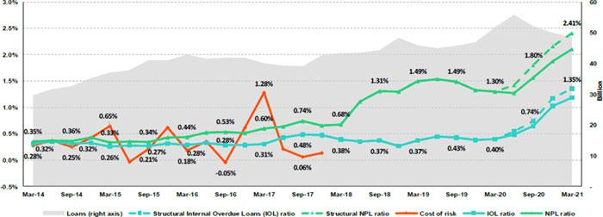

SME-Business
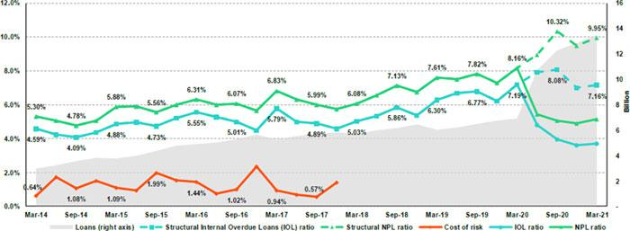

SME-Pyme
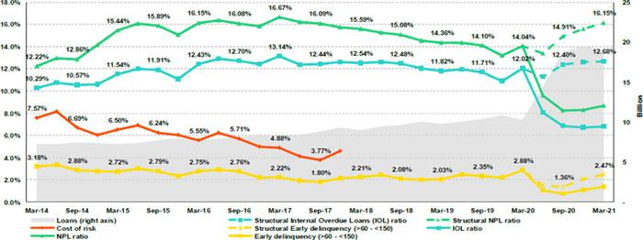

79

Mortgage
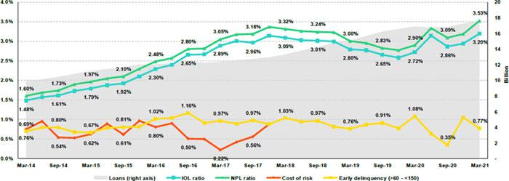

Consumer

Credit Card
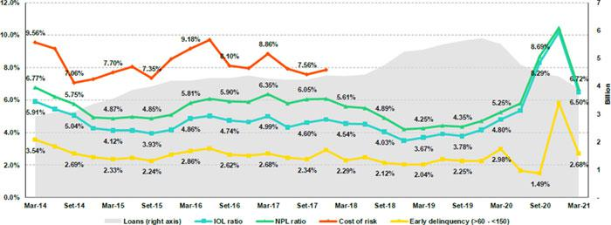

80

Mibanco
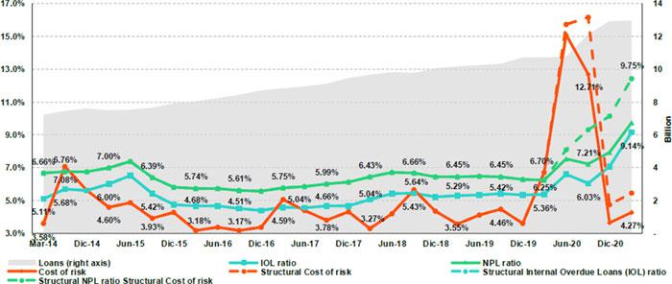

BCP Bolivia
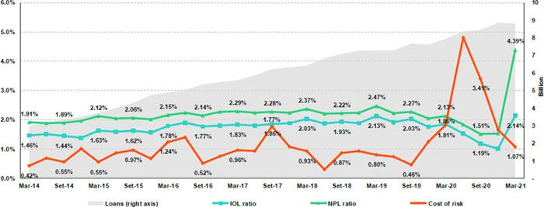

81

12.12. Table of calculations
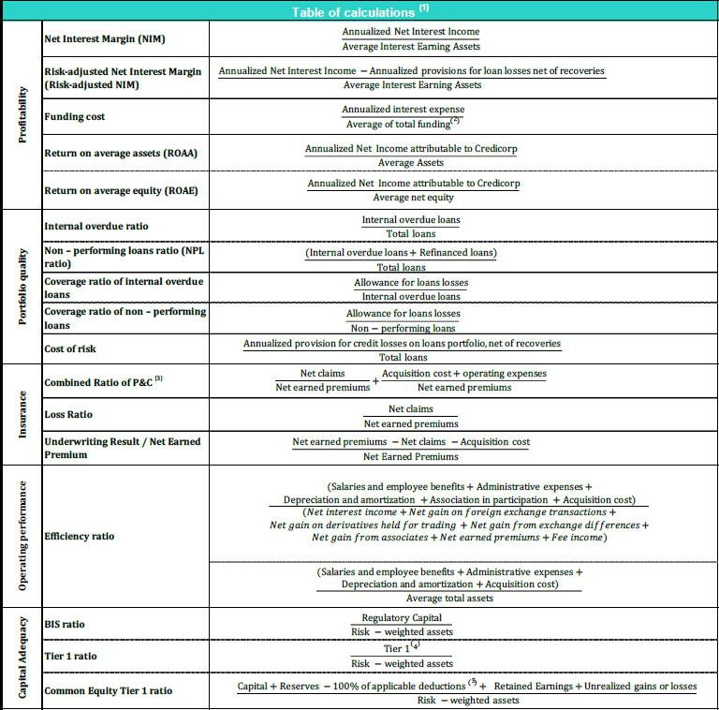

- Averages are determined as the average of period-beginning and period-ending balances.

- Includes total deposits, due to banks and correspondents, BCRP instruments, repurchase agreements and bonds and notes issued.

- Does not include Life insurance business.

- Tier 1 = Capital + Legal and other capital reserves + Accumulated earnings with capitalization agreement + (0.5 x Unrealized profit and net income in subsidiaries) - Goodwill - (0.5 x Investment in subsidiaries) + Perpetual subordinated debt (maximum amount that can be included is 17.65% of Capital + Reserves + Accumulated earnings with capitalization agreement + Unrealized profit and net income in subsidiaries - Goodwill).
- Includes investment in subsidiaries, goodwill, intangibles and deferred tax that rely on future profitability.

82

12.13. Glossary of terms

Colocaciones del Programa del Gobierno | Cartera de colocaciones compuesta por los programas del gobierno, Reactiva Perú y FAE-MYPE, para responder
(“PG” o “Colocaciones PG”) | rápida y efectivamente las necesidades de liquidez del sistema con el fin de mantener la cadena de pagos.
Colocaciones Estructurales | Colocaciones totales excluyendo las colocaciones PG.
One-Off Impairment | Gasto de desembolso único debido a las tasas de interés cero con el fin de financiar las cuotas congeladas.
Costo del Riesgo Estructural | Costo del Riesgo afectado por los ajustes estructurales. Excluye, en el numerador, las provisiones de perdidas
 | crediticias por PG y en el denominador las colocaciones PG.
Índice de Cartera Atrasada Estructural | El índice de Cartera Atrasada Estructural excluye el efecto de las colocaciones PG.
Mora temprana (>60 - <150) Estructural | El índice de Mora temprana Estructural excluye el impacto de las colocaciones PG.
Índice de Cartera Deteriorada Estructural | El índice de Cartera Deteriorada Estructural excluye el impacto de las colocaciones PG.
Margen Neto por intereses Estructural | MNI Estructural excluye el efecto de las colocaciones por GP y el One-Off Impairment.
Costo de Fondeo Estructural | Costo de Fondeo Estructural excluye el efecto del nivel de fondeo del Banco Central por colocaciones GP.
Crecimiento Ajustado del Ingreso | Crecimiento del ingreso ajustado por el One-Off Impairment.
Ratio de Eficiencia Ajustado | Ratio de Eficiencia ajustado por el One-Off Impairment en el ingreso operativo.
 | 83

