SECURITIES AND EXCHANGE COMMISSION

Washington, D.C. 20549

FORM 6-K

Report of Foreign Private Issuer

Pursuant to Rule 13a-16 or 15d-16 under the

Securities Exchange Act of 1934

For the month of February 2020

Commission File Number: 001-14014

CREDICORP LTD.

(Translation of registrant’s name into English)

Clarendon House

Church Street

Hamilton HM 11 Bermuda

(Address of principal executive office)

Indicate by check mark whether the registrant files or will file annual reports under cover of Form 20-F or Form 40-F.

Form 20-F ☒ Form 40-F ☐

Indicate by check mark if the registrant is submitting the Form 6-K in paper as permitted by Regulation S-T Rule 101(b)(1): ☐

Indicate by check mark if the registrant is submitting the Form 6-K in paper as permitted by Regulation S-T Rule 101(b)(7): ☐

The information in this Form 6-K (including any exhibit hereto) shall not be deemed “filed” for purposes of Section 18 of the Securities Exchange Act of 1934 (the “Exchange Act”) or otherwise subject to the liabilities of that section, nor shall it be deemed incorporated by reference in any filing under the Securities Act of 1933 or the Exchange Act.

SIGNATURE

Pursuant to the requirements of the Securities Exchange Act of 1934, the registrant has duly caused this report to be signed on its behalf by the undersigned, thereunto duly authorized.

Date: February 6th, 2020

CREDICORP LTD.

(Registrant)

By: /s/ Miriam Bottger

Miriam Bottger

Authorized Representative

Exhibit 99.1

Lima, Peru, February 5, 2020 – Credicorp (NYSE: BAP) announced its unaudited results for the fourth quarter of 2019. These results are consolidated according to IFRS in Soles.

Fourth Quarter and year-to-date 2019 results

In 4Q19, Credicorp registered net income of S/ 972.8 million, which translated into an ROAE and ROAA of 14.9% and 2.1% respectively. This result reflected a drop of -11% QoQ. The net income of Credicorp in 2019 was S/ 4,265 million, which represented an increase of +7.1%.

QoQ growth was attributable to an increase in net interest income (NII), which was driven by loan growth in local currency, primarily in Retail Banking. The aforementioned was offset by growth in the expense for provisions, mainly at BCP Stand-alone, and to an increase in operating expenses.

Higher net income in 2019 was due primarily to an increase in net interest income (NII) and to expansion in Non-financial income and in the net gain on securities in particular. This was, however, offset by growth in higher expenses for provisions for loan losses, the increase in operating expenses and an increase in tax provisions for withholding, which were set aside for taxes for dividend distribution for fiscal year 2019.

The results in 4Q19 and of the full year 2019 shows:

QoQ expansion in average daily loan balances in all segments, which was primarily attributable to loan growth in Retail Banking. The FY analysis, which eliminates seasonal effects, reveals that total loans measured in average daily balances grew 6.6%. This growth was led by Retail Banking and the Mortgage, Consumer, Credit Card and SME-Pyme segments in particular. Additionally, portfolio growth was driven mainly by local currency.

- NII expanded +3.4% QoQ and 6.9% FY. This was driven by an increase in average daily balances, which was mainly attributable to growth in higher-margin segments at BCP Stand-alone and in local currency. In this context, Retail Banking’s share of total loans. Interest expenses fell -3.3% QoQ and increased 8.9% FY after expenses for deposits rose due to the effect of the time deposit mix and the currency mix. Accordingly, the Net Interest Margin (NIM) was 5.46% in the 4Q19 and 5.39% in FY 2019, which represents an increase of +6 bps QoQ and +11 bps FY.

- Provisions for loan losses net recovered posted growth of 1.8%% QoQ and 20.5% FY. In this context, the cost of risk (CofR) for 4Q19 maintained steady QoQ at 1.77%. On the other hand, the CofR for FY 2019 was 1.60%, which represents a deterioration of +22 bps. This was primarily driven by an increase in the CofR at BCP Stand-alone after provisions were increased for the Retail Banking portfolio.

- In this context, the risk-adjusted NIM was 4.27% in the 4Q19 and 4.29% in the FY 2019. This represent an increase of +6 bps QoQ and a decrease of -4 pbs in the FY, which went hand-in-hand with an increase in the CofR.

- Non-financial increase fell slightly QoQ (-0.1%) after the net gain on securities (which posted an extraordinarily high level in 3Q19) and other non-financial income fell. This was attenuated by growth in net fee income in the banking business and at Credicorp Capital and to growth in the net gain on exchange differences. FY, non-financial income increased +11.1%, which was attributable to growth in the net gain on securities; net fee income; and other non-financial income.

- The insurance underwriting result increased +15.5% QoQ and +5.9% FY, which was driven mainly by growth in net earned premiums in the life insurance and P & C businesses.

- The efficiency ratio increased +250 bps QoQ, which reflected a seasonal increase in operating expenses given that in the second half of every year, expenses register an uptick. Nonetheless, in the FY 2019, the efficiency ratio fell -30 bps FY. This was attributable to growth in net interest income (NII), which offset the increase in salaries and employee benefits.


Table of Contents
 | Credicorp (NYSE: BAP): Fourth Quarter Results 2019 |  |  | 3
 |  | Financial Overview |  | 3
 |  | Credicorp and subsidiaries |  | 4
 | 1. | Interest-earning assets (IEA) |  | 5
 |  | 1.1. | Evolution of IEA | 5
 |  | 1.2. | Credicorp Loans | 6
 |  | 1.2.1. Loan evolution by business segment |  | 6
 |  | 1.2.2. Evolution of the level of dollarization by segment |  | 9
 |  | 1.2.3. BCRP de-dollarization plan at BCP Stand-alone |  | 10
 |  | 1.2.4. Market share in loans |  | 11
 | 2. | Funding Sources |  | 12
 |  | 2.1. | Funding Structure | 12
 |  | 2.2. | Deposits | 13
 |  | 2.2.1. Deposits: dollarization level |  | 14
 |  | 2.2.2. Market share in Deposits |  | 15
 |  | 2.3. | Other funding sources | 15
 |  | 2.4. | Loan / Deposit (L/D) | 16
 |  | 2.5. | Funding Cost | 17
 | 3. | Portfolio quality and Provisions for loan losses |  | 20
 |  | 3.1. | Provisions for loan losses | 20
 |  | 3.2. | Portfolio Quality: Delinquency ratios | 21
 |  | 3.2.1. Delinquency indicators by business line |  | 22
 | 4. | Net Interest Income (NII) |  | 27
 |  | 4.1. | Interest Income | 27
 |  | 4.2. | Interest Expenses | 28
 |  | 4.3. | Net Interest Margin (NIM) and Risk-Adjusted NIM | 29
 | 5. | Non-Financial Income |  | 32
 |  | 5.1. | Fee Income | 33
 |  | 5.1.1. By subsidiary |  | 33
 |  | 5.1.2. Fee income in the Banking Business |  | 35
 | 6. | Insurance Underwriting Result |  | 37
 |  | 6.1. | Net earned premiums | 37
 |  | 6.2. | Net claims | 38
 |  | 6.3. | Acquisition Cost | 39
 |  | 6.4. | Total Underwriting result | 40
 | 7. | Operating Expenses and Efficiency |  | 41
 |  | 7.1. | Credicorp’s Administrative, General and Tax Expenses | 43
 |  | 7.2. | Efficiency Ratio | 44
 | 8. | Regulatory Capital |  | 46
 |  | 8.1. | Regulatory Capital – BAP | 46
 |  | 8.2. | Regulatory Capital – BCP Stand-alone based on Peru GAAP | 47
 | 9. | Distribution channels |  | 49
 |  | 9.1. | Universal Banking | 49
 |  | 9.1.1. Points of contact by geographic area – BCP Stand-alone |  | 49
 |  | 9.1.2. Transactions per channel – BCP Stand-alone |  | 50
 |  | 9.1.3. Points of Contact – BCP Bolivia |  | 51
 |  | 9.2. | Microfinance | 51
 |  | 9.2.1. Points of Contact – Mibanco |  | 51
 | 10. |  | Economic Perspectives | 52
 |  | 10.1. Peru Economic Forecasts |  | 52
 |  | 10.2. Main Economic Variables |  | 52
 | 11. |  | Appendix | 56
 |  | 11.1. Credicorp |  | 56
 |  | 11.2. BCP Consolidated |  | 58
 |  | 11.3. Mibanco |  | 61
 |  | 11.4. BCP Bolivia |  | 62
 |  | 11.5. Credicorp Capital |  | 63
 |  | 11.6. Atlantic Security Bank |  | 64
 |  | 11.7. Grupo Pacifico |  | 66
 |  | 11.8. Prima AFP |  | 68
 |  | 11.9. Table of calculations |  | 69

Credicorp (NYSE: BAP): Fourth Quarter Results 2019

Financial Overview

Credicorp Ltd. |  |  |  | Quarter |  |  |  | % change |  |  |  |  |  | Year |  |  |  | % change
S/ 000 |  | 4Q18 |  | 3Q19 |  | 4Q19 |  | QoQ |  |  | YoY |  |  | 2018 |  | 2019 |  | 2019 / 2018
Net interest income |  | 2,244,252 |  | 2,277,384 |  | 2,354,122 |  | 3.4% |  |  |  | 4.9% |  | 8,489,104 |  | 9,077,181 |  | 6.9%
Provision for credit losses on loan portfolio, net of
recoveries |  | (407,954) |  | (502,772) |  | (511,660) |  | 1.8% |  |  |  | 25.4% |  | (1,531,708) |  | (1,845,937) |  | 20.5%
Risk-adjusted net interest income |  | 1,836,298 |  | 1,774,612 |  | 1,842,462 |  | 3.8% |  |  |  | 0.3% |  | 6,957,396 |  | 7,231,244 |  | 3.9%
Non-financial income ⁽¹⁾ |  | 1,153,234 |  | 1,270,586 |  | 1,269,497 |  | -0.1% |  |  |  | 10.1% |  | 4,410,808 |  | 4,902,039 |  | 11.1%
Insurance underwriting result ⁽¹⁾ |  | 121,154 |  | 125,775 |  | 145,213 |  | 15.5% |  |  |  | 19.9% |  | 471,418 |  | 499,024 |  | 5.9%
Total expenses ⁽¹⁾ |  | (1,749,181) |  | (1,651,622) |  | (1,885,784) |  | 14.2% |  |  |  | 7.8% |  | (6,247,409) |  | (6,658,591) |  | 6.6%
Profit before income tax |  | 1,361,505 |  | 1,519,351 |  | 1,371,388 |  | -9.7% |  |  |  | 0.7% |  | 5,592,213 |  | 5,973,716 |  | 6.8%
Income taxes |  | (384,352) |  | (403,771) |  | (378,431) |  | -6.3% |  |  |  | -1.5% |  | (1,520,909) |  | (1,621,385) |  | 6.6%
Net profit |  | 977,153 |  | 1,115,580 |  | 992,957 |  | -11.0% |  |  |  | 1.6% |  | 4,071,304 |  | 4,352,331 |  | 6.9%
Non-controlling interest |  | 20,220 |  | 22,545 |  | 20,127 |  | -10.7% |  |  |  | -0.5% |  | 87,439 |  | 87,027 |  | -0.5%
Net profit attributable to Credicorp |  | 956,933 |  | 1,093,035 |  | 972,830 |  | -11.0% |  |  |  | 1.7% |  | 3,983,865 |  | 4,265,304 |  | 7.1%
Net income / share (S/) |  | 12.00 |  | 13.70 |  | 12.20 |  | -11.0% |  |  |  | 1.7% |  | 49.95 |  | 53.48 |  | 7.1%
Loans
 |  | 110,759,390 |  | 112,209,990 |  | 115,609,679 |  | 3.0% |  |  |  | 4.4% |  | 110,759,390 |  | 115,609,679 |  | 4.4%
Deposits and obligations ⁽¹⁾ |  | 104,551,311 |  | 107,391,720 |  | 112,005,385 |  | 4.3% |  |  |  | 7.1% |  | 104,551,311 |  | 112,005,385 |  | 7.1%
Net equity |  | 23,839,243 |  | 26,000,638 |  | 26,237,960 |  | 0.9% |  |  |  | 10.1% |  | 23,839,243 |  | 26,237,960 |  | 10.1%

Profitability
Net interest margin ⁽¹⁾⁽²⁾ | 5.64% |  | 5.40% |  | 5.46% |  | 6 bps |  | -18 bps |  | 5.28% |  | 5.39% |  | 11 bps
Risk-adjusted Net interest margin ⁽¹⁾⁽²⁾ | 4.62% |  | 4.21% |  | 4.27% |  | 6 bps |  | -35 bps |  | 4.33% |  | 4.29% |  | -4 bps
Funding cost ⁽¹⁾⁽²⁾ | 2.39% |  | 2.46% |  | 2.33% |  | -13 bps |  | -6 bps |  | 2.25% |  | 2.37% |  | 12 bps
ROAE ⁽²⁾ | 16.3% |  | 17.1% |  | 14.9% |  | -220 bps |  | -140 bps |  | 17.5% |  | 17.0% |  | -50 bps
ROAA ⁽²⁾ | 2.2% |  | 2.4% |  | 2.1% |  | -30 bps |  | -10 bps |  | 2.3% |  | 2.3% |  | 0 bps
Loan portfolio quality
IOL ratio ⁽³⁾ | 2.81% |  | 2.98% |  | 2.85% |  | -13 bps |  | 4 bps |  | 2.81% |  | 2.85% |  | 4 bps
IOL over 90 days ratio | 2.13% |  | 2.26% |  | 2.15% |  | -11 bps |  | 2 bps |  | 2.13% |  | 2.15% |  | 2 bps
NPL ratio ⁽⁴⁾ | 3.97% |  | 4.07% |  | 3.88% |  | -19 bps |  | -9 bps |  | 3.97% |  | 3.88% |  | -9 bps
Cost of risk ⁽²⁾⁽⁵⁾ | 1.47% |  | 1.79% |  | 1.77% |  | -2 bps |  | 30 bps |  | 1.38% |  | 1.60% |  | 22 bps
Coverage ratio of IOLs | 158.9% |  | 148.8% |  | 153.7% |  | 490 bps |  | -520 bps |  | 158.9% |  | 153.7% |  | -520 bps
Coverage ratio of IOL 90-days | 210.4% |  | 196.0% |  | 204.5% |  | 850 bps |  | -590 bps |  | 210.4% |  | 204.5% |  | -590 bps
Coverage ratio of NPLs | 112.7% |  | 108.9% |  | 113.2% |  | 430 bps |  | 50 bps |  | 112.7% |  | 113.2% |  | 50 bps
Operating efficiency
Efficiency ratio ⁽¹⁾⁽⁶⁾ | 45.5% |  | 43.2% |  | 45.7% |  | 250 bps |  | 20 bps |  | 43.8% |  | 43.5% |  | -30 bps
Operating expenses / Total average assets ⁽⁷⁾ | 4.04% |  | 3.68% |  | 3.97% |  | 29 bps |  | -7 bps |  | 4.89% |  | 4.95% |  | 6 bps
Insurance ratios
Combined ratio of P&C ⁽¹⁾⁽⁸⁾⁽⁹⁾ | 100.2% |  | 97.9% |  | 94.1% |  | -380 bps |  | -610 bps |  | 100.3% |  | 98.4% |  | -190 bps
Loss ratio ⁽⁹⁾⁽¹⁰⁾ | 60.6% |  | 63.8% |  | 62.7% |  | -110 bps |  | 210 bps |  | 59.0% |  | 64.0% |  | 500 bps
Underwriting result / net earned premiums ⁽⁹⁾ | 7.5% |  | 7.2% |  | 8.9% |  | 170 bps |  | 140 bps |  | 8.1% |  | 7.1% |  | -100 bps
Capital adequacy ⁽¹¹⁾
BIS ratio ⁽¹²⁾ | 14.16% |  | 15.45% |  | 14.47% |  | -98 bps |  | 31 bps |  | 14.16% |  | 14.47% |  | 31 bps
Tier 1 ratio ⁽¹³⁾ | 10.28% |  | 11.79% |  | 11.07% |  | -72 bps |  | 79 bps |  | 10.28% |  | 11.07% |  | 79 bps
Common equity tier 1 ratio ⁽¹⁴⁾ | 11.55% |  | 11.95% |  | 12.35% |  | 40 bps |  | 80 bps |  | 11.55% |  | 12.35% |  | 80 bps
Employees ⁽¹⁾
Employees ⁽¹⁾ | 34,024 |  | 35,174 |  | 35,846 |  | 1.9% |  | 5.4% |  | 34,024 |  | 35,846 |  | 5.4%
Share Information
Outstanding Shares | 94,382 |  | 94,382 |  | 94,382 |  | 0.0% |  | 0.0% |  | 94,382 |  | 94,382 |  | 0.0%
Treasury Shares ⁽¹⁵⁾ | 14,621 |  | 14,621 |  | 14,621 |  | 0.0% |  | 0.0% |  | 14,621 |  | 14,621 |  | 0.0%
Floating Shares | 79,761 |  | 79,761 |  | 79,761 |  | 0.0% |  | 0.0% |  | 79,761 |  | 79,761 |  | 0.0%

- Figures differ from previously reported, please consider the data presented on this report.
- Annualized.
- Internal overdue loans: includes overdue loans and loans under legal collection, according to our internal policy for overdue loans. Internal Overdue ratio: Internal overdue loans / Total loans.
- Non-performing loans (NPL): Internal overdue loans + Refinanced loans. NPL ratio: NPL / Total loans.
- Cost of risk: Annualized Provision for credit losses on loan portfolio, net of recoveries / Total loans.
- Efficiency ratio = (Salaries and employee benefits + Administrative expenses + Depreciation and amortization + Association in participation + Acquisition cost) / (Net interest income + Fee Income + Net gain on foreign exchange transactions + Net Gain From associates + Net gain on derivatives held for trading + Result on exchange differences + Net Premiums Earned).
- Operating expenses / Average of Total Assets. Average is calculated with period-beginning and period-ending balances.
- Combined ratio = (Net claims / Net earned premiums) + [(Acquisition cost + Operating expenses) / Net earned premiums]. Does not include Life insurance business.
- Considers Grupo Pacifico’s figures before eliminations for consolidation to Credicorp.
- Net claims / Net earned premiums.
- All Capital ratios are for BCP Stand-alone and based on Peru GAAP.
- Regulatory Capital / Risk-weighted assets (legal minimum = 10% since July 2011).
- Tier 1 = Capital + Legal and other capital reserves + Accumulated earnings with capitalization agreement + (0.5 x Unrealized profit and net income in subsidiaries) - Goodwill - (0.5 x Investment in subsidiaries) + Perpetual subordinated debt (maximum amount that can be included is 17.65% of Capital + Reserves + Accumulated earnings with capitalization agreement + Unrealized profit and net income in subsidiaries - Goodwill).
- Common Equity Tier I = Capital + Reserves – 100% of applicable deductions (investment in subsidiaries, goodwill, intangibles and net deferred taxes that rely on future profitability) + retained earnings + unrealized gains.
Adjusted Risk-Weighted Assets = Risk-weighted assets - (RWA Intangible assets, excluding goodwill, + RWA Deferred tax assets generated as a result of temporary differences in income tax, in excess of 10% of CET1, + RWA Deferred tax assets generated as a result of past losses).
- These shares are held by Atlantic Security Holding Corporation (ASHC).

3

Credicorp and subsidiaries

Earnings contribution * |  |  |  | Quarter |  |  |  | % change |  |  |  | Year |  |  |  |  | % change
S/ 000 |  | 4Q18 |  | 3Q19 |  | 4Q19 |  | QoQ |  | YoY |  | 2018 |  |  | 2019 |  | 2019 / 2018
Universal Banking
BCP Stand-alone |  | 694,560 |  | 831,423 |  | 725,464 |  | -12.7% |  | 4.4% |  | 2,858,164 |  |  | 3,163,236 |  | 10.7%
BCP Bolivia |  | 22,876 |  | 25,575 |  | 13,487 |  | -47.3% |  | -41.0% |  | 78,260 |  |  | 78,508 |  | 0.3%
Microfinance
Mibanco ⁽¹⁾ |  | 99,778 |  | 95,137 |  | 100,034 |  | 5.1% |  | 0.3% |  | 445,169 |  |  | 391,688 |  | -12.0%
Bancompartir S.A |  | - |  | - |  | (1,630) |  | 0.0% |  | 0.0% |  | - |  |  | (1,630) |  | 0.0%
Encumbra |  | 1,952 |  | 852 |  | 1,323 |  | 55.3% |  | -32.2% |  | 5,123 |  |  | 5,263 |  | 2.7%
Insurance and Pensions
Grupo Pacifico ⁽²⁾ |  | 105,492 |  | 88,949 |  | 113,760 |  | 27.9% |  | 7.8% |  | 349,130 |  |  | 376,999 |  | 8.0%
Prima AFP |  | 30,471 |  | 42,394 |  | 46,829 |  | 10.5% |  | 53.7% |  | 139,586 |  |  | 196,590 |  | 40.8%
Investment Banking and Wealth
Management
Credicorp Capital |  | (15,712) |  | 13,010 |  | 4,631 |  | -64.4% |  | -129.5% |  | 34,261 |  |  | 43,883 |  | 28.1%
Atlantic Security Bank |  | 17,071 |  | 43,376 |  | 42,824 |  | -1.3% |  | 150.9% |  | 111,965 |  |  | 186,540 |  | 66.6%
Others ⁽³⁾ |  | 445 |  | (47,681) |  | (73,892) |  | 55.0% |  | -16704.9% |  | (37,793) |  |  | (175,773) |  | 365.1%
Net income attributed to Credicorp
 |  | 956,933 |  | 1,093,035 |  | 972,830 |  | -11.0% |  | 1.7% |  | 3,983,865 |  |  | 4,265,304 |  | 7.1%

*Contributions to Credicorp reflect the eliminations for consolidation purposes (e.g. eliminations for transactions among Credicorp’s subsidiaries or between Credicorp and its subsidiaries).

- The figure is lower than the net income of Mibanco because Credicorp owns 99.921% of Mibanco (directly and indirectly).

- The contribution is higher than Grupo Pacifico’s net income because Credicorp owns 65.20% directly, and 33.59% through Grupo Credito.

- Includes Grupo Credito excluding Prima (Servicorp and Emisiones BCP Latam), others of Atlantic Security Holding Corporation and others of Credicorp Ltd.

 |  |  |  |  |  | Quarter |  |  |  |  |  | Year
ROAE |  |  | 4Q18 |  |  | 3Q19 |  |  | 4Q19 |  | 2018 |  |  |  | 2019
Universal Banking
BCP Stand-alone |  | 19.4% |  |  | 21.7% |  |  | 18.2% |  |  | 20.3% |  |  |  | 20.4%
BCP Bolivia |  | 13.5% |  |  | 14.4% |  |  | 7.3% |  |  | 11.8% |  |  |  | 11.0%
Microfinance
Mibanco ⁽¹⁾ |  | 21.4% |  |  | 18.7% |  |  | 19.4% |  |  | 25.9% |  |  |  | 20.1%
Bancompartir |  | 0.0% |  |  | 0.0% |  |  | -16.0% |  |  | 0.0% |  |  |  | -16.0%
Encumbra |  | 13.3% |  |  | 5.8% |  |  | 8.9% |  |  | 9.1% |  |  |  | 8.9%
Insurance and Pensions
Grupo Pacifico ⁽²⁾ |  | 16.3% |  |  | 11.0% |  |  | 14.7% |  |  | 12.9% |  |  |  | 14.0%
Prima |  | 19.4% |  |  | 26.0% |  |  | 27.3% |  |  | 22.3% |  |  |  | 29.5%
Investment Banking and Wealth Management
Credicorp Capital |  | -8.8% |  |  | 9.3% |  |  | 3.1% |  |  | 4.6% |  |  |  | 6.5%
Atlantic Security Bank |  | 8.7% |  |  | 20.3% |  |  | 22.2% |  |  | 13.5% |  |  |  | 26.1%
Credicorp
 |  | 16.3% |  |  | 17.1% |  |  | 14.9% |  |  | 17.5% |  |  |  | 17.0%

- ROAE including goodwill of BCP from the acquisition of Edyficar (Approximately US$ 50.7 million) was 19.9% in 4Q18, 17.5% in 3Q19 and 18.2% in 4Q19. On an annual basis it was 24.0% for 2018 and 18.8% for 2019.

- Figures include unrealized gains or losses that are considered in Pacifico’s Net Equity from the investment portfolio of Pacifico Vida. ROAE excluding such unrealized gains was 19.3% in 4Q18, 16.3% in 3Q19 and 19.9% in 4Q19. On an annual basis it was 16.1% for 2018 and 16.5% for 2019.

4

- Interest-earning assets (IEA)

At the end of December 2019, IEAs posted growth of +1.7% QoQ, which was primarily attributable to an increase in loan balances. In the YoY evolution, which eliminates seasonal effects on loans, IEAs registered growth of +6.7%. This growth was mainly due to expansion relative to loans and available funds. Loans, which are the group’s most profitable asset, posted growth of +2.7% QoQ and +6.0% YoY in average daily balances. Expansion in this case was mainly attributable to the evolution of the loan portfolios at BCP Stand-alone subsidiary, where growth was driven primarily by an increase in the average daily balances of the Retail Banking portfolio, and, to a lesser degree, by an increase in average daily balances in the Wholesale Banking portfolio.

Interest earning assets |  |  |  | As of |  |  |  |  | % change
S/ 000 |  | Dec 18 |  | Sep 19 |  | Dec 19 |  | QoQ |  |  |  | YoY
Cash and due from banks |  | 14,478,739 |  | 20,004,002 |  | 19,670,279 |  |  | -1.7% |  |  | 35.9%
Interbank funds |  | 253,970 |  | 254,175 |  | 111,575 |  |  | -56.1% |  |  | -56.1%
Total investments |  | 32,863,118 |  | 33,956,227 |  | 33,547,444 |  |  | -1.2% |  |  | 2.1%
Cash collateral, reverse repurchase agreements and
securities borrowing |  | 4,082,942 |  | 3,903,051 |  | 4,288,524 |  |  | 9.9% |  |  | 5.0%
Financial assets designated at fair value through
profit or loss |  | 521,185 |  | 617,387 |  | 620,544 |  |  | 0.5% |  |  | 19.1%
Total loans ⁽¹⁾ |  | 110,759,390 |  | 112,209,990 |  | 115,609,679 |  |  | 3.0% |  |  | 4.4%
Total interest earning assets
 |  | 162,959,344 |  | 170,944,832 |  | 173,848,045 |  |  | 1.7% |  |  | 6.7%
(1) Quarter-end balances.
Total Investments |  |  |  | As of |  |  |  |  | % change
S/ 000 |  | Dec 18 |  | Sep 19 |  | Dec 19 |  | QoQ |  |  |  | YoY
Fair value through profit or loss investments |  | 3,512,445 |  | 3,808,137 |  | 3,864,531 |  |  | 1.5% |  |  | 10.0%
Fair value through other comprehensive income
investments |  | 25,195,835 |  | 26,794,192 |  | 26,205,867 |  |  | -2.2% |  |  | 4.0%
Amortized cost investments |  | 4,154,838 |  | 3,353,898 |  | 3,477,046 |  |  | 3.7% |  |  | -16.3%
Total investments
 |  | 32,863,118 |  | 33,956,227 |  | 33,547,444 |  |  | -1.2% |  |  | 2.1%

1.1. Evolution of IEA

Total loans

Total loans measured in quarter-end balances grew +3.0% QoQ, which was primarily attributable to growth in the loan portfolio at BCP Stand-alone and at

Mibanco:

- At BCP stand-alone, Retail Banking posted the highest growth. This expansion was driven by all segments and by Mortgage and SME-Pyme in particular. The growth posted in Wholesale Banking was primarily attributable to the expansion seen in the Corporate segment.

- At Mibanco, growth in quarter-end balances QoQ was generated primarily by the Corporate and Mortgage segments, followed by the Consumer segment.

YoY loans increased +4.4%, which was driven by growth in the majority of segments. Expansion was attributable, in order of contribution to growth, by:

- Growth in Retail Banking, which was led by the evolution of the Mortgage and Consumer segments.

- Loan growth at Mibanco and BCP Bolivia.

Investments

Total investments fell -1.2% QoQ. In the YoY evolution, total investments increased +2.1% and reflected a slight recomposition where fair value through comprehensive income investments (formerly investments available for sale) and fair value through profit and loss investments posted growth in their share of total investments while investments at amortized cost registered a decrease in their share.

5

Other IEA

Available funds fell -1.7% QoQ but grew 35.8% YoY due to growth FC funds held in the BCRP and in foreign banks, which was in turn attributable growth in funding in foreign currency at BCP Stand-alone.

1.2. Credicorp Loans

1.2.1. Loan evolution by business segment

The table below shows the composition of loans by subsidiary and business segment measured in average daily balances. These balances provide the most complete picture of how loan interest, which constitutes Credicorp’s primary source of income, has evolved. Additionally, average daily balances reflect trends or variations to a different degree than quarter-end balances, which may include pre-payments or loans made at the end of the quarter. In comparative terms, these payments, affect average daily balances less than quarter-end balances and as such, the former provide a more balanced picture of loan evolution.

Average daily loan balances posted growth of +2.7% QoQ, which was mainly attributable to expansion in Corporate Banking and, to a lesser extent, in the results of Retail Banking through the Mortgage and Consumer segments. In YoY terms, growth in average daily loan balances registered favorable results, situating at +6.0%. This expansion was led by Retail Banking segments, which increased their share of total loans during this period, primarily through the Mortgage, Consumer, SME-Pyme and Credit Card segments. In terms of Wholesale Banking results, Middle Market Banking registered higher growth YoY. Growth in loan balances QoQ and YoY was reported mainly in local currency.

Loan evolution measured in average daily balances by segment ⁽¹⁾

 | TOTAL LOANS |  |  |  |  |  |  |  | % change |  |  |  |  |  |  | % Part. in total loans
 | Expressed in million S/
 | 4Q18 |  | 3Q19 |  |  | 4Q19 |  |  | QoQ |  |  |  | YoY |  |  | 4Q18 |  | 3Q19 |  | 4Q19
BCP Stand-alone | 88,708 |  | 91,700 |  |  | 94,390 |  | 2.9% |  |  |  | 6.4% |  |  |  | 82.0% |  | 82.1% |  | 82.3%
Wholesale Banking | 46,476 |  | 46,434 |  |  | 47,446 |  | 2.2% |  |  | 2.1% |  |  |  | 43.0% |  |  | 41.6% |  | 41.4%
Corporate | 28,536 |  | 28,024 |  |  | 28,860 |  |  | 3.0% |  | 1.1% |  |  |  | 26.4% |  |  | 25.1% |  | 25.2%
Middle - Market | 17,939 |  | 18,410 |  |  | 18,586 |  |  | 1.0% |  | 3.6% |  |  |  | 16.6% |  |  | 16.5% |  | 16.2%
Retail Banking | 42,232 |  | 45,266 |  |  | 46,944 |  | 3.7% |  |  | 11.2% |  |  |  | 39.0% |  |  | 40.5% |  | 41.0%
SME - Business | 5,587 |  | 5,544 |  |  | 5,806 |  | 4.7% |  |  | 3.9% |  |  |  | 5.2% |  |  | 5.0% |  | 5.1%
SME - Pyme | 9,396 |  | 9,851 |  |  | 10,194 |  | 3.5% |  |  |  |  | 8.5% |  | 8.7% |  |  | 8.8% |  | 8.9%
Mortgage | 14,714 |  | 16,095 |  |  | 16,590 |  |  | 3.1% |  |  |  | 12.7% |  | 13.6% |  |  | 14.4% |  | 14.5%
Consumer | 7,506 |  | 8,239 |  |  | 8,659 |  |  | 5.1% |  |  |  | 15.4% |  | 6.9% |  |  | 7.4% |  | 7.6%
Credit Card | 5,029 |  | 5,538 |  |  | 5,695 |  | 2.8% |  |  |  |  | 13.3% |  | 4.6% |  |  | 5.0% |  | 5.0%
Mibanco | 9,763 |  | 10,068 |  |  | 10,310 |  | 2.4% |  |  | 5.6% |  |  |  | 9.0% |  |  | 9.0% |  | 9.0%
Bolivia | 7,152 |  | 7,431 |  |  | 7,563 |  | 1.8% |  |  | 5.7% |  |  |  | 6.6% |  |  | 6.7% |  | 6.6%
ASB | 2,547 |  | 2,467 |  |  | 2,363 |  | -4.2% |  |  | -7.2% |  |  |  | 2.4% |  |  | 2.2% |  | 2.1%
BAP’s total loans
BAP’s total loans | 108,170 |  | 111,666 |  |  | 114,626 |  | 2.7% |  |  |  |  | 6.0% |  |  | 100.0% |  | 100.0% |  | 100.0%


Highest growth in volumes

Largest contraction in volumes

For consolidation purposes, loans generated in FC are converted to LC.

(1) Includes Work out unit, and other banking.

6

Loan Growth QoQ in Average Daily Balances

Expressed in millions of S/

+2.7% QoQ
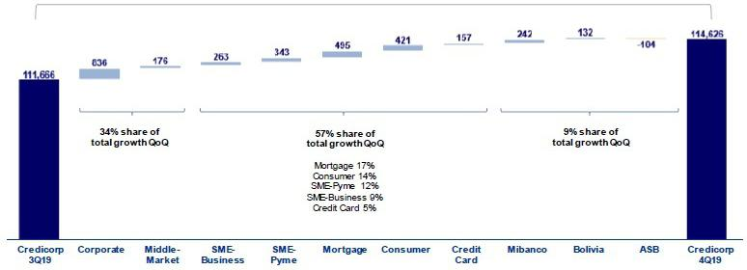

The analysis per segment of the evolution of QoQ growth in average daily loan balances reveals:

- Portfolio growth in all segments at BCP Stand-alone and in other subsidiaries with the exception of ASB.

- The segment of Corporate Banking at BCP Stand-alone was the main contributor to portfolio growth.

- Expansion in the Retail Banking portfolio, which was led by the Mortgage and Consumer segments.

It is important to note that real loan growth in average daily balances was situated at +3.0% QoQ, if we exclude the effect of a -2.0% depreciation in the US Dollar.

Loan Growth YoY in Average Daily Balances

Expressed in millions of S/

+6.0% YoY
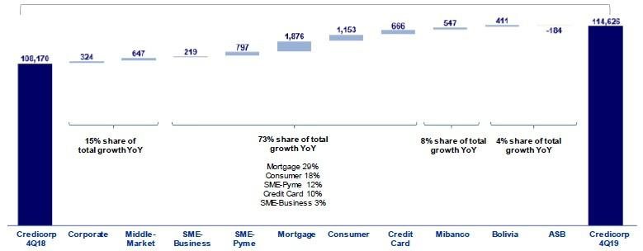

The YoY analysis per segment, measured in average daily balances, reveals the follow:

- Growth was noteworthy in Retail Banking, led by expansion in the Mortgage segment (+S/ 1,876 million +12.7% YoY), which has sustained an uptick in growth over various quarters.

7

- Other significant variations were reported in Retail Banking by the Consumer segment (+S/ 1,153 million), SME-Pyme (+S/ 797 million) and Credit Cards (+S/666 million) and in Wholesale Banking, through the Middle Banking segment (+S/647 million) and Corporate segment (+S /324 million) in Wholesale Banking.

- Loan expansion at Mibanco (+5.6% YoY) reflects its strategy to expand financial inclusion (bringing new clients into the System) while continuing to assist our current clients in their quest to grow.

- Growth in loans at BCP Bolivia was situated at +5.7% YoY. This evolution was mainly attributable to growth in the Wholesale Banking portfolio, both in the Corporate and SME-Business segments. The Wholesale Banking portfolio contributed, although to a lesser extent, to YoY growth, primarily through its Mortgage segment (regulated portfolio).

It is important to note that real loan growth YoY in average daily balances was situated at +6.2% YoY, if we exclude the effect of the -1.7% YoY depreciation of the dollar.

FY growth in average daily balances by segment

Expressed in millions S/

 | TOTAL LOANS |  |  |  |  | % change |  |  |  |  |  | % share
 | In millions of S/
 | 2018 |  | 2019 |  |  | S/ |  |  | % |  |  | 2018 |  |  | 2019
BCP Stand-alone | 85,043 |  | 90,935 |  | 5,892 |  |  |  | 6.9% |  |  | 81.8% |  |  | 82.1%
Wholesale Banking | 44,999 |  | 46,266 |  | 1,266 |  |  |  | 2.8% |  | 43.3% |  |  |  | 41.8%
Corporate | 28,037 |  | 28,155 |  | 118 |  |  |  | 0.4% |  | 27.0% |  |  |  | 25.4%
Middle - Market | 16,963 |  | 18,111 |  |  | 1,148 |  |  | 6.8% |  | 16.3% |  |  |  | 16.3%
Retail Banking | 40,044 |  | 44,670 |  |  | 4,626 |  |  | 11.6% |  | 38.5% |  |  |  | 40.3%
SME - Business | 5,332 |  | 5,487 |  | 155 |  |  |  | 2.9% |  | 5.1% |  |  |  | 5.0%
SME - Pyme | 8,903 |  | 9,754 |  | 851 |  |  |  | 9.6% |  | 8.6% |  |  |  | 8.8%
Mortgage | 13,977 |  | 15,831 |  | 1,854 |  |  |  | 13.3% |  | 13.4% |  |  |  | 14.3%
Consumer | 7,218 |  | 8,105 |  | 887 |  |  |  | 12.3% |  | 6.9% |  |  |  | 7.3%
Credit Card | 4,615 |  | 5,493 |  | 878 |  |  |  | 19.0% |  | 4.4% |  |  |  | 5.0%
Mibanco | 9,567 |  | 10,080 |  | 513 |  |  |  | 5.4% |  | 9.2% |  |  |  | 9.1%
Bolivia | 6,712 |  | 7,334 |  | 621 |  |  |  | 9.3% |  | 6.5% |  |  |  | 6.6%
ASB | 2,596 |  | 2,450 |  | -146 |  |  |  | -5.6% |  | 2.5% |  |  |  | 2.2%
BAP’s total loans
BAP’s total loans | 103,919 |  | 110,799 |  | 6,880 |  |  |  | 6.6% |  |  | 100.0% |  |  | 100.0%

Highest growth in volumes

Largest contraction in volumes

For consolidation purposes, loans generated in FC are converted to LC.

(1) Includes Work out unit, and other banking.

8

+6.6% Full Year Growth
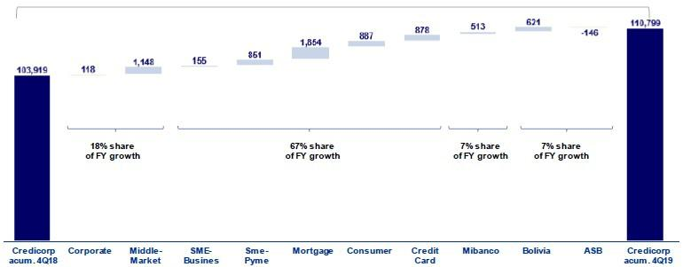

Finally, the level of average daily loan balances for FY 2019 reported an increase of +6.6% with regard to the level of average daily loan balances for FY 2018. This growth was primarily attributable to loan growth in Retail Banking, which was driven mainly by the Mortgage, Consumer, Credit Card and SME-Pyme segments. The other segments that contributed significantly to growth were the Middle Market Banking (within Corporate Banking), Mibanco and BCP Bolivia.

1.2.2. Evolution of the level of dollarization by segment

Loan evolution by currency - average daily balances ⁽¹⁾⁽²⁾

 |  |  | DOMESTIC CURRENCY LOANS |  |  |  |  |  |  |  |  |  |  |  |  |  | FOREIGN CURRENCY LOANS |  |  |  |  |  |  |  |  |  | % part. By currency
 |  |  | Expressed in million S/ |  |  |  |  |  |  |  |  |  |  |  |  |  | Expressed in million US$ |  |  |  |  |  |  |  |  |  | 4Q19
 | 4Q18 |  | 3Q19 |  | 4Q19 |  |  | QoQ |  |  |  | YoY |  |  | 4Q18 |  | 3Q19 |  | 4Q19 |  | QoQ |  |  | YoY |  |  | LC |  | FC
BCP Stand-alone | 54,843 |  | 57,636 |  | 60,870 |  |  | 5.6% |  |  | 11.0% |  |  |  | 10,041 |  | 10,132 |  | 10,000 |  | -1.3% |  |  | -0.4% |  |  | 64.5% |  | 35.5%
Wholesale | 20,633 |  | 19,964 |  | 21,613 |  |  | 8.3% |  | 4.7% |  |  |  | 7,662 |  |  | 7,873 |  | 7,707 |  | -2.1% |  |  | 0.6% |  | 45.6% |  |  | 54.4%
Banking
Corporate | 12,302 |  | 11,320 |  | 12,854 |  |  | 13.6% |  | 4.5% |  |  |  | 4,814 |  |  | 4,969 |  | 4,775 |  | -3.9% |  |  | -0.8% |  | 44.5% |  |  | 55.5%
Middle -
Market | 8,332 |  | 8,644 |  | 8,760 |  |  | 1.3% |  | 5.1% |  |  |  | 2,849 |  |  | 2,905 |  | 2,931 |  | 0.9% |  |  | 2.9% |  | 47.1% |  |  | 52.9%
Retail | 34,210 |  | 37,672 |  | 39,257 |  |  | 4.2% |  | 14.8% |  |  |  | 2,379 |  |  | 2,258 |  | 2,293 |  | 1.5% |  |  | -3.6% |  | 83.6% |  |  | 16.4%
Banking
SME -
Business | 2,556 |  | 2,614 |  | 2,695 |  |  | 3.1% |  | 5.5% |  |  |  | 899 |  |  | 871 |  | 928 |  | 6.5% |  |  | 3.3% |  | 46.4% |  |  | 53.6%
SME - Pyme | 9,124 |  | 9,628 |  | 9,982 |  |  | 3.7% |  |  |  | 9.4% |  | 81 |  |  | 66 |  | 63 |  | -4.6% |  |  | -21.8% |  | 97.9% |  |  | 2.1%
Mortgage | 11,892 |  | 13,632 |  | 14,250 |  |  | 4.5% |  |  |  | 19.8% |  | 837 |  |  | 733 |  | 698 |  | -4.7% |  |  | -16.6% |  | 85.9% |  |  | 14.1%
Consumer | 6,315 |  | 7,057 |  | 7,465 |  |  | 5.8% |  |  |  | 18.2% |  | 353 |  |  | 352 |  | 356 |  | 1.3% |  |  | 0.8% |  | 86.2% |  |  | 13.8%
Credit Card | 4,324 |  | 4,742 |  | 4,865 |  |  | 2.6% |  | 12.5% |  |  |  | 209 |  |  | 237 |  | 248 |  | 4.5% |  |  | 18.4% |  | 85.4% |  |  | 14.6%
Mibanco | 9,223 |  | 9,522 |  | 9,785 |  |  | 2.8% |  |  | 6.1% |  |  | 160 |  |  | 162 |  | 157 |  | -3.6% |  |  | -2.3% |  | 94.9% |  |  | 5.1%
Bolivia | - |  | - |  | - |  |  | - |  | - |  |  |  | 2,121 |  |  | 2,210 |  | 2,256 |  | 2.1% |  |  | 6.4% |  | - |  |  | 100.0%
ASB | - |  | - |  | - |  |  | - |  | - |  |  |  | 755 |  |  | 734 |  | 705 |  | -3.9% |  |  | -6.7% |  | - |  |  | 100.0%
Total loans
Total loans | 64,066 |  | 67,158 |  | 70,655 |  |  | 5.2% |  |  | 10.3% |  |  |  | 13,077 |  | 13,238 |  | 13,117 |  | -0.9% |  |  | 0.3% |  |  | 61.6% |  | 38.4%


Highest growth in volumes

Largest contraction in volumes

- Includes Work out unit, and other banking.
- Figures differ from previously reported, please consider the data presented on this report.

The analysis of loan expansion by currency shows that the QoQ and YoY expansion registered by the Wholesale and Retail segments, as well as by Mibanco, were driven by the LC portfolio. In contrast, a QoQ and YoY increase was posted in average daily balances in foreign currency in the Corporate Banking portfolio within Wholesale Banking and for the Mortgage and SME-Pyme segments in Retail Banking. A decrease was reported for the same period in the FC portfolio at ASB.

9

YoY evolution of the level of dollarization by segment ⁽¹⁾⁽²⁾⁽³⁾
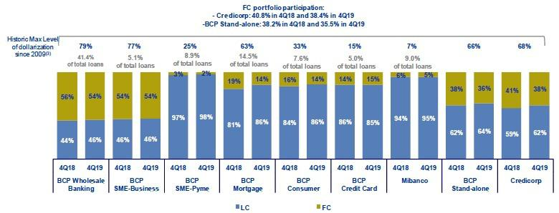

- Average daily balances.

- The FC share of Credicorp’s loan portfolio is calculated including BCP Bolivia and ASB, however the chart shows only the loan books of BCP Stand-alone and Mibanco.
- The year with the historic maximum level of dollarization for Wholesale Banking was 2012, for Mibanco was 2016 and for the rest of segments was 2009.

At BCP Individual, the loan dollarization level fell YoY to situate at 36%. The downward trend in the dollarization level for the Mortgage segment continued, after falling 19% in December 2018 to 14% in December 2019. The aforementioned is a reflection of the fact that a large proportion of mortgage loans are denominated in LC.

It is important to note that, as is evident in the figure below, the percentage of the loan portfolio that is highly exposed to FX-risk on credit risk remains very low.

FX risk on credit risk – BCP Stand-alone
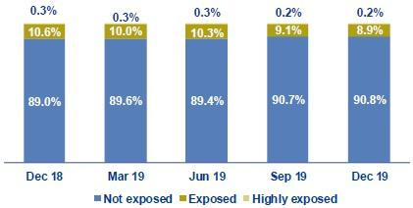

1.2.3. BCRP de-dollarization plan at BCP Stand-alone

At the end of 2014, BCRP set up a Program to reduce the dollarization level of the loan book in the Peruvian Banking System. As part of this Program, BCRP set some targets to reduce the loan balances in US Dollars progressively at the end of June 2015, December 2015, December 2016, December 2017, December 2018 and December 2019. The balances that are subject to reduction targets are the total FC portfolio, with some exceptions, and the balance of the joint mortgage and car loan portfolio. The balance required at the end of December 2019 is as follows:

- For the total portfolio in FC, the goal set for 2018 will continue to apply. In this context, the balance at the end of December 2018 must represent no more than 80% of the total loan balance in FC reported at the end of September 2013 (excluding loans that meet certain requirements.)

At the end of September 2019, BCP Stand-alone reported a compliance level of 106% with regard to the goal set by BCRP for December 2019.

10

- For the combined FC Mortgage and Car portfolio, the target was adjusted in December 2018 to stipulate that the balance at the end of December of 2019 must represent no more than 40% of the balance of the combined Mortgage and Car portfolio reported at the end of February 2013. Every year, the target will be adjusted by 10% to reach a minimum of 5% of Net Equity.

At the end of December 2019, BCP Stand-alone reported a compliance level of 92% of the dedollarization target set by BCRP.

1.2.4. Market share in loans

Market share in Peru⁽¹⁾
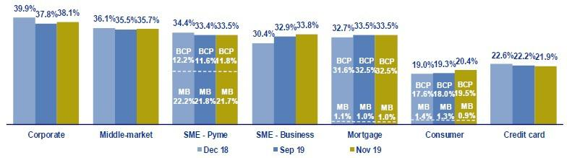

(1) Market shares are different that previously reported because now includes non-performing loans in the sample.

Peruvian Financial System

At the end of November 2019, BCP Stand-alone continued to lead the Peruvian financial market⁽¹⁾ with a market share (MS) of de 28.8%, which surpasses the 18.0% MS posted by its closest competitor. This level is higher than that obtained in 3Q19 (+20 bps) but lower than that registered in 4Q18 (-80 bps). Mibanco’s market share of the total financial system was situated at 3.2%, which was the same level posted in both 3Q19 and 4Q18.

In Wholesale Banking, the Corporate Banking segment reported growth of +40 bps in its MS with regard to 3Q19’s figure. Middle Market banking followed the same trend, increasing +20 bps. In the YoY evolution, Corporate Banking registered a drop of -170 bps in its MS while Middle Market banking was down -40bps. It is important to note that these segments at BCP continue to lead in their respective markets.

Within Retail Banking, BCP continued to lead the market in the Mortgage segment (+0 bps QoQ and +80 bps YoY) and in the SME-Business segment (+90 bps QoQ and +330 bps YoY) as both make gains in market share. In the Consumer and Credit Card segments, BCP continues to rank second for market share.

In the SME-Pyme segment, Mibanco continued to lead the market with an MS of 21.7%, which nonetheless represented a decline with regard to the figures reported in 3Q19 and 4Q18 of 22.2% respectively. BCP Stand-alone ranks second in this segment with an MS of 11.8%.

Bolivian Financial System

Finally, the MS of BCP Bolivia held steady in QoQ terms and in the previous year comparison. The subsidiary ranks fifth in the Bolivian financial system with a market share of 9.4%.

- Includes Multipurpose Banks, Finance Companies, Municipal and Rural Banks, EDPYMEs and Leasing and Mortgages Companies.

11

- Funding Sources

At the end of 2019, total funding increased QoQ and YoY. The funding structure at Credicorp registered an increase in deposits, posting an uptick in its share of total funding. It is important to note the on-going expansion reported for savings deposits and non-interest bearing demand deposits, both of which constitute lower cost sources of funding. During this same period, time deposits, which imply somewhat higher costs, also increased considerably. All of the aforementioned offset the contraction registered on wholesale funding. Regarding Credicorps funding cost, the increase of 12 basis points in 2019 is due to (i) the currency mix effect, which reflected an increase in funding in local currency, which accounted for 90% of total funding expansion, and (ii) the rate effect, generated by the increase in time deposits of 8.7%.

Funding |  |  |  | As of |  |  |  | % change
S/ 000 |  | Dec 18 |  | Sep 19 |  | Dec 19 |  | QoQ |  |  | YoY
Demand deposits |  | 32,515,165 |  | 32,626,001 |  | 34,213,188 |  | 4.9% |  |  | 5.2%
Saving deposits |  | 32,593,978 |  | 33,681,765 |  | 35,179,770 |  | 4.4% |  |  | 7.9%
Time deposits |  | 31,303,607 |  | 33,194,331 |  | 34,034,037 |  | 2.5% |  |  | 8.7%
Severance indemnity deposits |  | 7,571,375 |  | 7,205,449 |  | 7,897,199 |  | 9.6% |  |  | 4.3%
Interest payable |  | 567,186 |  | 684,174 |  | 681,191 |  | -0.4% |  |  | 20.1%
Deposits and obligations
 |  | 104,551,311 |  | 107,391,720 |  | 112,005,385 |  | 4.3% |  |  | 7.1%
Due to banks and correspondents
 |  | 8,448,139 |  | 8,624,286 |  | 8,841,732 |  | 2.5% |  |  | 4.7%
BCRP instruments |  | 5,226,870 |  | 4,144,908 |  | 4,381,011 |  | 5.7% |  |  | -16.2%
Repurchase agreements |  | 2,638,231 |  | 2,031,025 |  | 1,820,911 |  | -10.3% |  |  | -31.0%
Bonds and notes issued |  | 15,457,540 |  | 17,160,564 |  | 14,946,363 |  | -12.9% |  |  | -3.3%
Total funding
 |  | 136,322,091 |  | 139,352,503 |  | 141,995,402 |  | 1.9% |  |  | 4.2%

2.1. Funding Structure

Evolution of the funding structure and cost – BAP

(S/ billions)
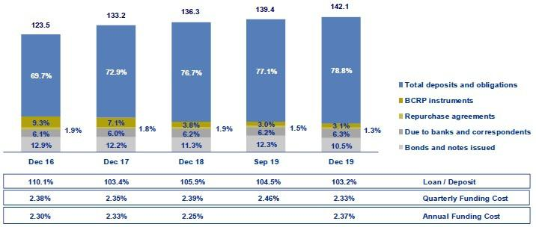

The figure depicting the Evolution of Credicorp’s funding structure and cost is calculated with quarter-end balances. In global terms, the funding structure reflects:

- The importance of deposits as the main source of funding, which imply lower costs than other alternatives in the mix. The share of deposits in total funding increased considerably QoQ and YoY, situating at 78.8% (vs. 77.1% in Sep 19 and 76.7% in Dec 18). This growth was attributable to an increase in the volumes posted by all deposit types both QoQ and YoY.

12

- The shares of savings deposits and non-interest bearing demand deposits within the deposits mix continued to increase, registering growth both QoQ and YoY. At the end of Dec 19, they represented 57.0% of total deposits (vs. 56.6% in Sep 19 and 56.9% in Dec 18). Both deposit types are considered lower-cost alternatives within the deposit mix. It is important to note the on-going growth in time deposits, which had a negative impact on the funding cost for deposits due to a volume effect and rate effect.

- In terms of other funding sources, the QoQ analysis shows a contraction; this was mainly attributable to a decrease in the volume of Bonds and notes issued (-12.9%), whose share of total funding (10.5%) has fallen to its lowest level since 2014. In the YoY analysis, the decline was associated primarily with a drop in the volume of BCRP instruments, which have fallen consistently since 2016, when the special instruments issued by BCRP under its de-dollarization initiative began to expire. The share of BCRP instruments in total funding fell to 3.1% at the end of Dec 19 (vs. 3.8% in Dec 18). For further details, see section 2.3 Other funding sources.

All of the aforementioned has allowed Credicorp to maintain a relatively stable cost of funding since 2016.

2.2. Deposits
Deposits and obligations |  |  |  |  | As of |  |  |  | % change
S/ 000 |  |  | Dec 18 |  | Sep 19 |  | Dec 19 |  | QoQ |  |  | YoY
 | Demand deposits |  | 32,515,165 |  | 32,626,001 |  | 34,213,188 |  | 4.9% |  |  | 5.2%
 | Saving deposits |  | 32,593,978 |  | 33,681,765 |  | 35,179,770 |  | 4.4% |  |  | 7.9%
 | Time deposits |  | 31,303,607 |  | 33,194,331 |  | 34,034,037 |  | 2.5% |  |  | 8.7%
 | Severance indemnity deposits |  | 7,571,375 |  | 7,205,449 |  | 7,897,199 |  | 9.6% |  |  | 4.3%
 | Interest payable |  | 567,186 |  | 684,174 |  | 681,191 |  | -0.4% |  |  | 20.1%
 | Deposits and obligations
 |  |  | 104,551,311 |  | 107,391,720 |  | 112,005,385 |  | 4.3% |  |  | 7.1%

Deposits and obligations grew 4.3% QoQ. The QoQ evolution of the mix of deposits shows:

- Growth in savings deposits, which increased 4.4% QoQ. This was driven primarily by an increase in the LC volume (which accounts for 84% of the increase). Growth reflects (i) payments of employee bonuses with saving accounts at BCP Stand-alone and Mibanco in the month of December and (ii) the results of campaigns to capture savings deposits through cost-efficient channels (Kiosko and Vía BCP). These channels drove almost 50% of the uptick in savings accounts openings at BCP Stand-alone.

- The 4.9% increase in demand deposits due to an increase in the deposit volume for non-interest bearing demand deposits (+40 bps), mainly from Middle-market at BCP Stand-alone.

- An increase in the volume of time deposits at Mibanco, after different campaigns were rolled out, and at BCP Bolivia, which is implementing a strategy to capture deposits that offer more stability in the mid-term.

- Severance indemnity deposits, growth of 9.6% was reported after employers deposited the obligatory payment required every 4Q (the second of two statutory deposits). This deposit was made in November.

In YoY terms, total deposits and obligations registered an increase across all deposit types, which translated into growth of 7.1% in the main source of funding.

13

2.2.1. Deposits: dollarization level

Dollarization Level of Deposits ⁽¹⁾ – BAP
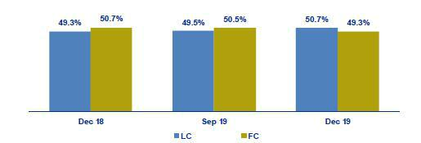

(1) Q-end balances.

Credicorp - Deposit Dollarization measured in quarter-end balances
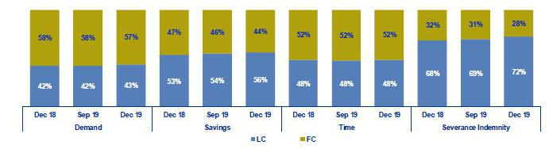

The dollarization level of Credicorp’s deposits fell QoQ after growth in LC volumes outpaced that of FC volumes.

Growth in LC volumes was seen across all deposit types, outpacing the expansion registered by FC volumes by four-fold. The increase in the LC volume was mainly attributable to savings deposits and to a lesser extent, to non-interest bearing demand deposits. Expansion in FC volumes was reported across all deposit types, with the exception of severance indemnity deposits, and was due primarily to growth in the level of savings deposits and interest-bearing demand deposits.

The YoY evolution shows a similar trend to that seen QoQ, where growth in LC was two times higher than that posted by FC. LC deposits increased 10.1% YoY, compared to 4.2% for FC deposits for the same period. The aforementioned was attributable to growth in all types of LC deposits, which was primarily associated with an increase in the volume of savings deposits and time deposits. In the case of FC deposits, growth was also registered across all deposit types, with the exception of severance indemnity deposits. The evolution described was aligned with Credicorp’s objective of maintaining an adequate match between assets and liabilities by currency, respecting the group’s appetite for risk.

14

2.2.2. Market share in Deposits

Market share in Peru
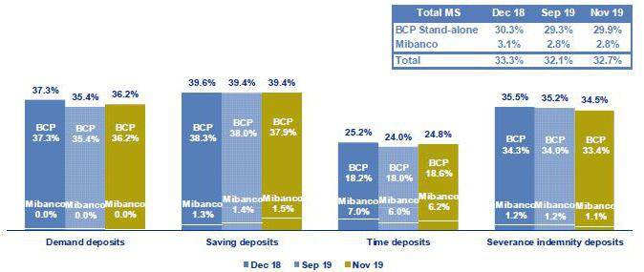

Source: SBS

Peruvian Financial System

At the end of Nov 19, Credicorp’s subsidiaries in Peru, BCP Stand-alone and Mibanco, reported an MS of 29.9% and 2.8% (in comparison to 29.3% and 2.8% at the end of Sep 19, respectively). Credicorp continued to lead the market for total deposits, and is situated significantly ahead of its closest competitor (which holds a 19.1% market share).

In the YoY analysis, BCP Stand-alone registered a drop with regard to the level registered at the end of Dec 18. This was mainly due to a decrease in the MS of demand deposits. The MS of Mibanco also fell YoY (2.8% Nov 19 vs. 3.1% Dec 18) due to a contraction in the MS of time deposits, which fell from 7.0% in Dec 18 to 6.2% in Nov 19.

Bolivian Financial System

BCP Bolivia continued to rank fifth in the Bolivian financial system with a MS of 9.8% at the end of Dec 19 in comparison to 9.6% in Sep 19. In the YoY analysis, the figure for MS was the same as that seen at the end of Dec 18 (9.8%).

2.3. Other funding sources
Other funding sources |  |  |  | As of |  |  |  |  | % change
S/ 000 |  | Dec 18 |  | Sep 19 |  | Dec 19 |  | QoQ |  |  |  | YoY
Due to banks and correspondents |  | 8,448,139 |  | 8,624,286 |  | 8,841,732 |  |  | 2.5% |  |  | 4.7%
BCRP instruments |  | 5,226,870 |  | 4,144,908 |  | 4,381,011 |  |  | 5.7% |  |  | -16.2%
Repurchase agreements |  | 2,638,231 |  | 2,031,025 |  | 1,820,911 |  |  | -10.3% |  |  | -31.0%
Bonds and notes issued |  | 15,457,540 |  | 17,160,564 |  | 14,946,363 |  |  | -12.9% |  |  | -3.3%
Total other funding sources |  | 31,770,780 |  | 31,960,783 |  | 29,990,017 |  |  | -6.2% |  |  | -5.6%

The Total of other funding sources fell -6.2% QoQ, which was primarily attributable to a decrease in the level of Bonds and notes issued. The aforementioned was slightly attenuated by an increase in Due to banks and correspondents and in BCRP instruments.

15

Due to banks and correspondents increased due to growth in the level of obligations with COFIDE and with companies in the Peruvian financial system through Mibanco and in LC. To a lesser extent, growth was attributable to new debt with foreign financial institutions in FC. These transactions were conducted in the month of November through BCP Stand-alone. The aforementioned was attenuated by a decrease in the exchange rate in a context in which FC represents approximately 60% of Due to banks and correspondents.

BCRP Instruments, where the slight increase QoQ was associated with growth in the level of regular repos with BCRP both at BCP Stand-alone and Mibanco.

Repurchase agreements fell QoQ due to the expiration of interbank repurchase agreements and Certificates of Deposits (CDs), mainly through ASB and BCP Stand-alone, both in FC.

Bonds and notes issued reported a contraction of -12.9% QoQ. This was due to (i) the expiration of corporate and subordinated bonds at BCP Stand-alone,

- the advance redemption of a hybrid bond at BCP Stand-alone, and (iii) the variation in the exchange rate, which had a negative effect given that 73% of the total volume is in FC.

In the YoY evolution, a 5.6% reduction in other funding sources is evident. This was attributable to a reconfiguration of the funding structure to decrease the level of BCRP Instruments and repurchase agreements and increase the level of lower-cost deposits with higher liquidity levels.

2.4. Loan / Deposit (L/D)

Loan / Deposit Ratio by Subsidiary
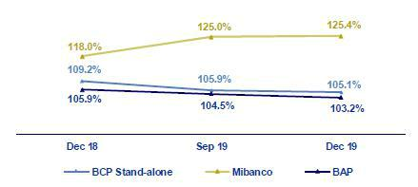

The L/D ratio at Credicorp fell QoQ to situate at 103.2% given that the increase in deposits (+4.3%) outpaced the growth posted by loans (+3.0%).

The analysis by subsidiary shows that the same trend is in play at BCP Stand-alone (105.1% Dec 19 vs. 105.9% Sep 19). The QoQ reduction in the L/D at BCP Stand-alone was generated in a scenario in which growth in the deposit volume (+3.5%) was greater than the expansion registered for loans (+2.7%); the aforementioned was driven by an increase in demand deposits and savings deposits. In the case of Mibanco, QoQ growth in the L/D was attributable to the fact that loan growth (+3.7%) outpaced the expansion registered for deposits (3.4%).

In the YoY analysis, the L/D ratio for Credicorp and its subsidiaries followed the same trend seen in the QoQ analysis, where growth in deposits exceeded loan growth (7.1% vs. 4.4%, respectively).

16

Loan / Deposit Ratio by Currency

Local Currency Foreign Currency
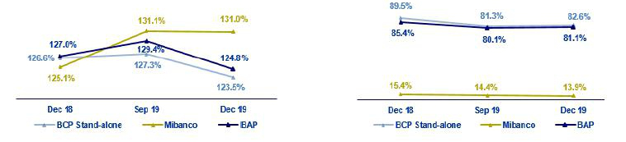

In the QoQ analysis by currency, a reduction is evident in the L/D ratio in LC at Credicorp, which was attributable to an increase in LC deposits, which was driven by demand deposits and savings deposits at BCP Stand-alone. The L/D in FC at Credicorp registered growth of 100 bps QoQ after loan growth (+3.0%) exceeded the expansion reported for deposits (+1.8%). The aforementioned was in turn driven by loan growth in FC (+1.5%) and a contraction in FC deposits (-0.1%) at BCP Stand-alone.

In the YoY analysis, the L/D ratio in LC and FC at Credicorp fell after the deposit level in both currencies increased and outpaced loan growth.

2.5. Funding Cost

Funding Cost – Credicorp ⁽¹⁾
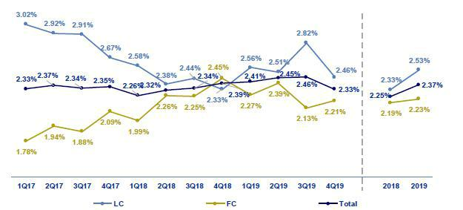

  - The funding cost by currency is calculated with the average of period-beginning and period-end balances. The funding cost at Credicorp fell QoQ and YoY. The QoQ evolution shows:
- Growth in the funding cost in FC (+8 bps), which was primarily attributable to an increase in interest expenses on bonds and notes issued; this accounts for 90% of the increase in expenses in FC (96% of which were generated by BCP Stand-alone).

- The reduction in the total funding cost (-13 bps), which was primarily due to a drop in the expense for all funding sources, which reflects the global trend toward lower interest rates. The mix of total funding has improved to favor higher volumes of lower-cost sources of funding, such as deposits.

17

- The drop in the cost of funding in LC (-36 bps), which was mainly driven by a decrease in interest expenses on bonds and notes issued at BCP Stand-alone after a drop was registered in the interest rates on corporate bonds issued in 3Q19.

In the YoY analysis, the funding cost fell -6 bps due to:

- A more favorable deposit mix where lower-cost deposits such as savings and non-interest bearing demand deposits grew 7.9% and 6.4%, respectively.

- Due to the recomposition of the funding structure, given that deposits’ share of total funding increased significantly (from 76.7% in 4Q18 to 78.8% in 4T19), edging out BCRP Instruments (substitution with a less expensive source of funding).

- The reduction in national and international interest rates since 3Q19 meant that the impact of this shift was more visible in 4Q19.

The FY analysis of the cost of funding reflects:

- The adoption of new requirements relative to IFRS 16, which has been in place since the beginning of 2019 and stipulates that part of the expenses for leases, which were previously registered in Administrative expenses, must be included in interest expenses.

- Higher expenses on deposits, which was mainly attributable to the volume, deposit mix and currency effects, where time deposits growth in LC (8.3%) is noteworthy.

- Higher interest expenses on bonds and notes issued at BCP Stand-alone in 3Q19, which was attributable to the liability management of bonds that carry one-off expenses.

- The aforementioned was partially attenuated by the group’s decision to secure lower-cost funding, such as deposits, and to reduce the volume of other, higher-cost funding sources such as BCRP Instruments and bonds and notes issued. Additionally, national and international interest rates fell in 3Q19, which had a positive effect on the funding cost in 4Q19.

All of the aforementioned led the funding cost to increase 12 bps.

The cost of funding by subsidiary is depicted in the following figure:

Funding Cost by subsidiary– Credicorp
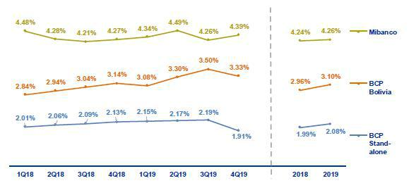

18

- The funding cost at BCP Stand-alone followed the same trend as that seen at Credicorp, where contractions were registered QoQ and YoY. In both cases, the decrease was generated by an increase in the volume of deposits and the impact of lower international interest rates (48% of the bank’s funding is in FC). In 2019, the funding cost increased 9 bps. This took place in a scenario marked by the following events at BCP Stand-alone: (i) the bank absorbed the most impact of the application of IFRS 16, (ii) the liability management of bonds in 3Q19, which included one-off expenses, and ii) 5.2% growth was recorded in time deposits, mainly in LC.

- The funding cost at Mibanco registered considerable growth both QoQ and YoY, which reflects efforts to roll out a strategy to capture more retail funding by offering competitive rates. In this context, the increase in interest expenses (4.9% QoQ and 4.2% YoY), which outpaced growth in total funding (4.2% QoQ and 0.5% YoY), led this ratio to increase. FY, the funding cost remained stable due to mix and volume effects. The mix effect was attributable to the fact that the interest rates on deposits were lower than those associated with other sources of funding. The volume effect was driven by an increase in total funding in 4Q18 and 4Q19 (calculation denominator) and by growth in the deposit volume, which represents 78.7% of the funding mix.

- The funding cost at BCP Bolivia increased QoQ and YoY, which was primarily attributable to an increase in interest expenses (3.0% and 7.9%, respectively) on deposits, due to volume and mix effect (time deposits posted the highest growth). FY, growth of 14 bps was attributable to an increase in interest expenses on deposits.

19

- Portfolio quality and Provisions for loan losses

The Cost of Risk (CofR) at Credicorp fell 2 bps QoQ. This was primarily attributable to a reduction in provisions for loan losses at Mibanco after adjustments were made to origination and collection guidelines in 1H19. This offset the increase in provisions at BCP Bolivia, which was attributable to political uncertainty. In YoY terms and FY, the CofR at Credicorp rose 30 bps and 22 bps respectively due to an increase in provisions requirements in Retail Banking. The delinquency rations improved QoQ, which was mainly due to a reduction in the IOL portfolio in Wholesale Banking.

Quarterly evolution of the Cost of Risk (bps) Full Year evolution of the Cost of Risk (bps)
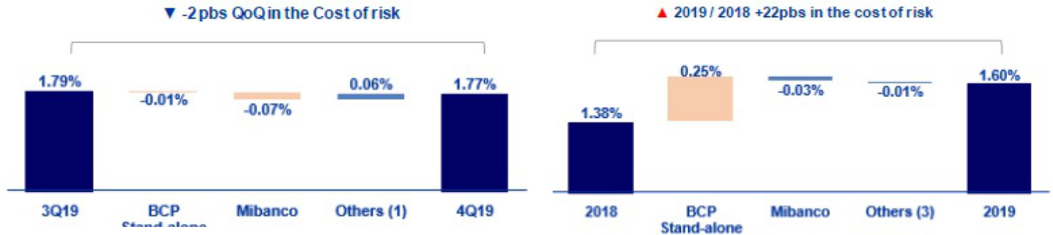

(1) Includes BCP Bolivia, Encumbra, Bancompartir, ASB and eliminations for consolidation purposes

3.1. Provisions for loan losses

Provision for credit losses on loan portfolio, net of |  |  |  | Quarter |  |  |  | % change |  |  |  |  | Year |  |  |  |  | % change
recoveries
S/ 000 |  | 4Q18 |  | 3Q19 |  | 4Q19 |  | QoQ |  |  | YoY |  | 2018 |  |  | 2019 |  | 2019 / 2018
Gross provision for credit losses on loan portfolio |  | (479,184) |  | (568,034) |  | (568,727) |  | 0.1% |  |  | 18.7% |  | (1,814,898) |  |  | (2,100,091) |  | 15.7%
Recoveries of written-off loans |  | 71,230 |  | 65,262 |  | 57,067 |  | -12.6% |  |  | -19.9% |  | 283,190 |  |  | 254,155 |  | -10.3%
Provision for credit losses on loan portfolio, net of |  | (407,954) |  | (502,772) |  | (511,660) |  | 1.8% |  |  | 25.4% |  | (1,531,708) |  |  | (1,845,936) |  | 20.5%
recoveries

Provisions for loan losses net recoveries were relatively stable QoQ. This was due to the fact that provisions requirements fell at Mibanco after adjustments were made in origination and collection guidelines. This offset the increase in provisions at BCP Bolivia, and for the SME-Pyme segment in particular, in a context marked by political uncertainty. Additionally, provisions at BCP Stand-alone fell after provisions were reversed for some companies in the construction sector; this offset the increase in provisions in Retail Banking. The YoY increase, and FY increase were 25.7% and 20.5% respectively. FY growth was attributable to:

- Consumer: Growth in digital loans, which target higher risk clients. It is important to note that this product may imply higher risk but also generates higher income.

- SME-Pyme: This increase reflects an increase in the level of deterioration of loans to finance fixed assets and revolving credit.

- Credit Card: This result reflects an increase in the probability of default in the portfolio. This situation was related to the increase in individual indebtedness seen across the Peruvian financial system.

The aforementioned was attenuated by a reversal in provisions in Wholesale Banking, specifically in the construction sector and in Mibanco for the reasons explained in the QoQ analysis.

Cost of risk

 |  |  |  | Quarter |  |  |  | % change |  |  |  |  | Year |  |  |  |  | % change
Cost of risk and Provisions |  | 4Q18 |  | 3Q19 |  | 4Q19 |  | QoQ |  |  | YoY |  | 2018 |  |  | 2019 |  | 2019 / 2018
Cost of risk ⁽¹⁾ |  | 1.47% |  | 1.79% |  | 1.77% |  | -2 bps |  |  | 30 bps |  | 1.38% |  |  | 1.60% |  | 22 bps
Provision for credit losses on loan portfolio, net of
recoveries / Net interest income |  | 18.2% |  | 22.1% |  | 21.7% |  | -30 bps |  |  | 360 bps |  | 18.0% |  |  | 20.3% |  | 190 bps

(1) Annualized Provision for credit losses on loan portfolio, net of recoveries / Total loans.

In this context, the CofR at Credicorp remained stable QoQ but deteriorated 30 bps YoY and 22 bps FY given that growth in provisions outpaced the expansion registered for loans.

20

3.2. Portfolio Quality: Delinquency ratios

Portfolio quality and Delinquency ratios |  |  |  | As of |  |  |  | % change
S/ 000 |  | Dec 18 |  | Sep 19 |  | Dec 19 |  | QoQ |  |  | YoY
Total loans (Quarter-end balance) |  | 110,759,390 |  | 112,209,990 |  | 115,609,679 |  | 3.0% |  |  | 4.4%
Allowance for loan losses
 |  | 4,952,392 |  | 4,977,809 |  | 5,070,279 |  | 1.9% |  |  | 2.4%
Write-offs
 |  | 518,558 |  | 456,932 |  | 509,571 |  | 11.5% |  |  | -1.7%
Internal overdue loans (IOLs) ⁽¹⁾
 |  | 3,117,078 |  | 3,346,389 |  | 3,297,791 |  | -1.5% |  |  | 5.8%
Internal overdue loans over 90-days ⁽¹⁾ |  | 2,353,669 |  | 2,539,751 |  | 2,479,940 |  | -2.4% |  |  | 5.4%
Refinanced loans |  | 1,278,169 |  | 1,225,691 |  | 1,182,797 |  | -3.5% |  |  | -7.5%
Non-performing loans (NPLs) ⁽²⁾ |  | 4,395,247 |  | 4,572,080 |  | 4,480,588 |  | -2.0% |  |  | 1.9%
IOL ratio
 |  | 2.81% |  | 2.98% |  | 2.85% |  | -13 bps |  |  | 4 bps
IOL over 90-days ratio ⁽³⁾ |  | 2.13% |  | 2.26% |  | 2.15% |  | -11 bps |  |  | 2 bps
NPL ratio |  | 3.97% |  | 4.07% |  | 3.88% |  | -19 bps |  |  | -9 bps
Coverage ratio of IOLs |  | 158.9% |  | 148.8% |  | 153.7% |  | 490 bps |  |  | -520 bps
Coverage ratio of IOL 90-days |  | 210.4% |  | 196.0% |  | 204.5% |  | 850 bps |  |  | -590 bps
Coverage ratio of NPLs |  | 112.7% |  | 108.9% |  | 113.2% |  | 430 bps |  |  | 50 bps

- Includes overdue loans and loans under legal collection. (Quarter-end balances)

- Non-performing loans include internal overdue loans and refinanced loans. (Quarter-end balances)

- Figures differ from previously reported, please consider the data presented in this report.

In terms of delinquency, it is important to note that:

- The total IOL portfolio fell 1.5% QoQ due to the increase in write-offs of the loans with more than 150 days of overdue and where already correctly provisioned in the SME-Pyme segment. In the YoY analysis, internal overdue loans increase 5.8%, which was primarily attributable to IOL loans of a small number of clients in the SME-Business and Wholesale segments. These loans have already been correctly provisioned.

- The NPL portfolio registered a 2.0% decrease QoQ. This was mainly attributable to the amortization of refinanced loans for Wholesale Banking loans in the construction sector, which led to a subsequent reduction in total refinanced loans. Despite this evolution, the NPL portfolio increased 1.9% YoY, in line with growth in the IOL portfolio.

Delinquency ratios improved favorably QoQ in the context described above; nonetheless, in the YoY analysis, the IOL ratio deteriorated 4 bps given that growth in the IOL portfolio outpaced the expansion registered for loan expansion. The NPL ratio improved 9 bps YoY, in line with a drop in refinanced loans, mainly in the Wholesale Banking segment.

The coverage ratios improved QoQ given that the increase registered by the IOL portfolio and refinanced loan balances fell below the growth registered in net provisions for loan losses. In the YoY analysis, however, coverage for the IOL portfolio deteriorated due to the increase in write-offs during the year, which drove a decrease in the Allowance for loan losses.

Prior to analyzing the evolution of delinquency ratios, it is important to note that:

- Traditional delinquency ratios (IOL and NPL ratios) continue to be distorted by the presence of loans with real estate collateral (commercial and residential properties). This means that a significant portion of loans that are more than 150 days past due cannot be written-off (despite the fact that provisions have been set aside) given that a judicial process must be initiated to liquidate the collateral, which takes five years on average.

- In the second half (2H) of every year, loans are more dynamic, particularly in the SME-Pyme and Mibanco segments given that the main campaigns (Christmas and year-end campaigns) are held in the second semester (2H) and these short-term loans are paid off in 1H of the following year

21

Delinquency Ratios
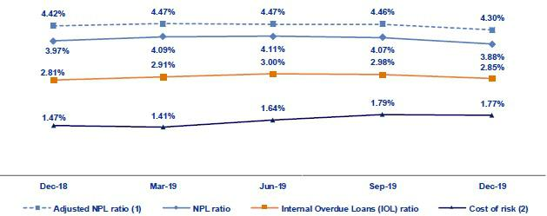

- Adjusted NPL ratio = (Non-performing loans+ Write-offs) / (Total loans + Write-offs).

- Cost of risk = Annualized provisions for loan losses net of recoveries / Total loans.

3.2.1. Delinquency indicators by business line

Wholesale Banking – Delinquency ratios
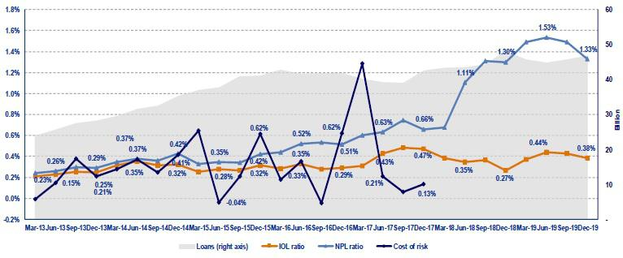

- The QoQ analysis shows a slight reduction in the IOL and NPL ratio. This decrease was primarily due to the amortization of loans that were included in the internal overdue loans, mainly from the construction sector. In the YoY evolution, the IOL and NPL ratio increased. This was primarily attributable to a migration of current loans to internal overdue loans in 1H19 and, to a lesser extent, to the reduction of loans measured in quarter-end balances.

22

SME-Business – Delinquency ratios
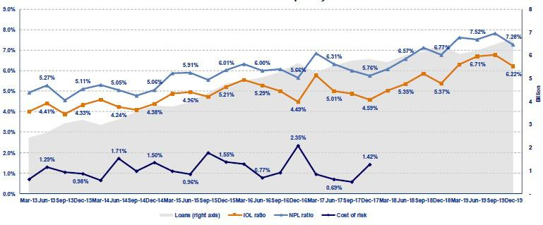

- Both the IOL and NPL ratios posted a decrease QoQ. This was mainly attributable to the fact that an IOL loan was recovered and subsequently migrated to the current loans portfolio. In the YoY analysis, however, the IOL and NPL ratios increased, which was attributable to a deterioration in the debt service capacity of a small number of clients in the 1S19. These loans have been fully provisioned or are backed by guarantees. It is important to note that this segment’s risk quality indicators are within the appetite for risk that has been set where the objective is to maximize the portfolio’s profitability by striking an adequate balance between risk quality and growth.

SME - Pyme – Delinquency ratios
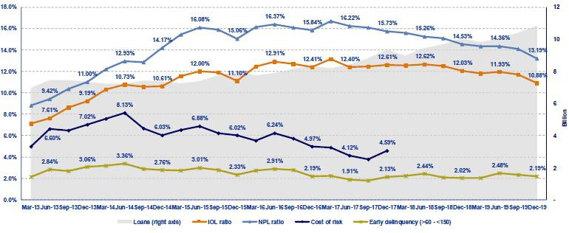

- In the SME-Pyme loan book, it is important to analyze the early delinquency ratio, which excludes loans that are overdue less than 60 days (volatile loans whose percentage of recovery is very high) and those overdue more than 150 days (loans that have been provisioned but which cannot be written off due to the existence of real estate collateral- commercial properties - that take five years on average to liquidate).

The early delinquency ratio registered an improvement QoQ. However, this ratio reported an increase YoY since the in the last three quarters. The aforementioned was attributable to the increase in provisions, which was in line with an uptick in deterioration for fixed asset loans and revolving credit. The IOL ratio and the NPL ratio, however, followed a different trend to post improvements QoQ and YoY. This was mainly attributable to the sale of a portfolio in the last quarter, the increase in the write-offs of loans with more than 150 overdue days, and to strong loan growth in SME-Pyme segment.

23

Mortgage – Delinquency ratios
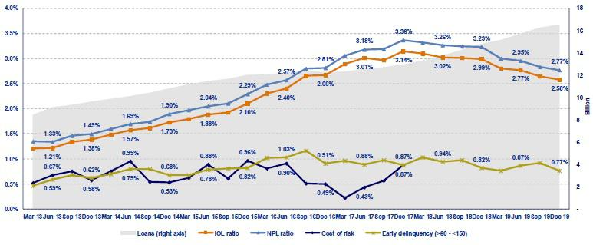

- In terms of Mortgage loans, it is important to remember that these ratios are also affected by the existence of real estate collateral, where the recovery process is protracted (around 5 years) and as such, impedes the bank’s capacity to write-off loans even if the same are completely provisioned.

Traditional delinquency ratios fell QoQ and YoY given that although total loans increased, the NPL portfolio remained at stable levels.

The early delinquency ratio, which excludes the effect of loans that are more than 150 days overdue, fell QoQ and YoY. It is important to note that this ratio is better than the average levels reported over the past three years and is within the business’s risk appetite.

Consumer – Delinquency ratios
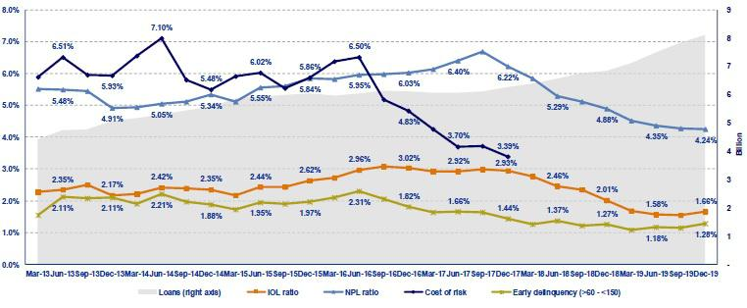

- The IOL ratio, NPL ratio and early delinquency ratio increased QoQ. This was due primarily to the increase registered for loans in riskier segments, which are sold through digital channels. In the YoY analysis, the IOL and NPL ratios posted improvements, in line with the sale of a portion of the IOL portfolio over the past three quarters.

It is important to note that the traditional delinquency ratios and early delinquency ratio are at the lowest levels seen in the past 5 years and reflect the positive results of different management and collections initiatives.

Although the delinquency ratios have improved, the consumer segment registered an increase in provisions that was, in part, attributable to the need to cover higher risks on certain products in the digital channel. Nevertheless, it is important to remember that products which imply higher risk also tend to generate higher profit and lower expenses.

24

Credit Card – Delinquency ratios
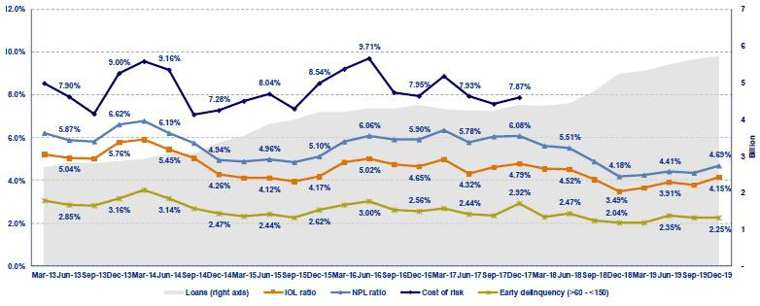

- The Credit Card segment registered an increase in its IOL and NPL ratios both QoQ and YoY. This growth has been on-going since the first quarter of the year and is attributable to the increase registered for individual indebtedness in the Peruvian financial system. This occurrence was attenuated by the sale of a portion of the IOL portfolio in the previous quarter. Early delinquency also increased YoY, which was attributable to the fact that more provisions were set aside in the second half of the year to cover an increase in the probability of default of the portfolio.

Mibanco – Delinquency ratios
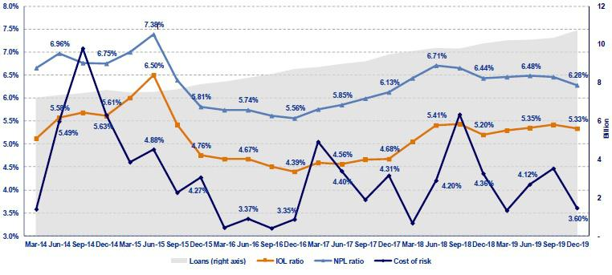

(vii)The IOL and NPL ratios fell QoQ. This was primarily attributable to growth in loans, which registered a decrease in risk after adjustments were made in 1H19, as indicated in section 3.1 Net provisions for loan losses. In the YoY analysis, the IOL portfolio posted growth, which was attributable to a drop in the number of loans that were written off during the year. The NPL ratio decrease YoY due to an improvement in the acceptance process for new loans, which led to the need for les refinancing.

The cost of risk improved QoQ and YoY, which reflected improvements in the new loan origination and in the collections process, as indicated in the previous paragraph.

25

BCP Bolivia – Delinquency ratios
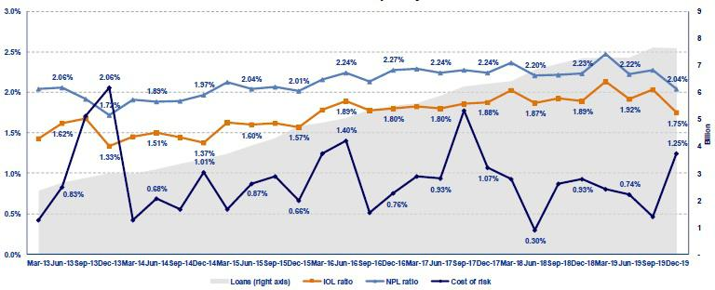

(viii)BCP Bolivia reported an improvement QoQ and YoY in its IOL and NPL ratio; this was primarily due to an increase in write-offs this quarter.

The cost of risk deteriorated QoQ and YoY; this was mainly attributable to an uncertain political environment in Bolivia, as indicated in section 3.1.

Net provisions for loan losses, at to loan growth.

26

- Net Interest Income (NII)

In 4Q19, NII, the main source of income, posted positive results QoQ, with +3.4% growth, and YoY, with +4.9% expansion. Additionally, average interest earning assets grew +2.2% QoQ and +8.4% YoY. This led NIM to increase 6 bps QoQ but fall -18 bps YoY. In 2019, NII increased +6.9%, which led to a +11bps increase in NIM. The improvement over 2018’s result was attributable to an increase in interest income on loans, which was in turn due to an increase in average daily loan balances. NIM improved 6bps QoQ as a result of the reduction of cost of risk QoQ. Nevertheless, due to an increase in the cost of risk, risk-adjusted NIM contracted -35 bps YoY and -4bps in 2019.

Net interest income |  |  |  | Quarter |  |  |  | % change |  |  |  |  | Year |  |  |  |  | % change
S/ 000 |  | 4Q18 |  | 3Q19 |  | 4Q19 |  | QoQ |  |  | YoY |  | 2018 |  |  | 2019 |  | 2019 / 2018
Interest income |  | 3,033,544 |  | 3,123,672 |  | 3,172,695 |  | 1.6% |  |  | 4.6% |  | 11,522,634 |  |  | 12,381,663 |  | 7.5%
Interest on loans |  | 2,625,181 |  | 2,701,117 |  | 2,768,468 |  | 2.5% |  |  | 5.5% |  | 10,041,097 |  |  | 10,664,519 |  | 6.2%
Dividends on investments |  | 6,205 |  | 2,915 |  | 3,764 |  | 29.1% |  |  | -39.3% |  | 24,391 |  |  | 25,259 |  | 3.6%
Interest on deposits with banks |  | 63,709 |  | 79,723 |  | 68,813 |  | -13.7% |  |  | 8.0% |  | 159,381 |  |  | 320,713 |  | 101.2%
Interest on securities |  | 327,208 |  | 325,311 |  | 311,414 |  | -4.3% |  |  | -4.8% |  | 1,252,799 |  |  | 1,311,442 |  | 4.7%
Other interest income |  | 11,241 |  | 14,606 |  | 20,236 |  | 38.5% |  |  | 80.0% |  | 44,966 |  |  | 59,730 |  | 32.8%
Interest expense |  | 789,292 |  | 846,288 |  | 818,573 |  | -3.3% |  |  | 3.7% |  | 3,033,530 |  |  | 3,304,483 |  | 8.9%
Interest on deposits |  | 324,622 |  | 372,822 |  | 367,257 |  | -1.5% |  |  | 13.1% |  | 1,202,025 |  |  | 1,458,910 |  | 21.4%
Interest on borrowed funds |  | 157,205 |  | 151,221 |  | 141,552 |  | -6.4% |  |  | -10.0% |  | 623,001 |  |  | 590,908 |  | -5.2%
Interest on bonds and subordinated notes |  | 233,233 |  | 236,567 |  | 209,238 |  | -11.6% |  |  | -10.3% |  | 911,006 |  |  | 900,172 |  | -1.2%
Other interest expense ⁽¹⁾ |  | 74,232 |  | 85,678 |  | 100,526 |  | 17.3% |  |  | 35.4% |  | 297,498 |  |  | 354,493 |  | 19.2%
Net interest income ⁽¹⁾
 |  | 2,244,252 |  | 2,277,384 |  | 2,354,122 |  | 3.4% |  |  | 4.9% |  | 8,489,104 |  |  | 9,077,180 |  | 6.9%
Risk-adjusted Net interest income ⁽¹⁾
 |  | 1,836,298 |  | 1,774,612 |  | 1,842,462 |  | 3.8% |  |  | 0.3% |  | 6,957,396 |  |  | 7,231,243 |  | 3.9%
Average interest earning assets
 |  | 159,104,005 |  | 168,631,427 |  | 172,406,741 |  | 2.2% |  |  | 8.4% |  | 160,750,873 |  |  | 168,413,997 |  | 4.8%
Net interest margin ⁽¹⁾⁽²⁾
 |  | 5.64% |  | 5.40% |  | 5.46% |  | 6bps |  |  | -18bps |  | 5.28% |  |  | 5.39% |  | 11bps
NIM on loans ⁽¹⁾⁽²⁾ |  | 7.75% |  | 7.74% |  | 7.82% |  | 8bps |  |  | 7bps |  | 7.62% |  |  | 7.46% |  | -16bps
Risk-adjusted Net interest margin ⁽¹⁾⁽²⁾ |  | 4.62% |  | 4.21% |  | 4.27% |  | 6bps |  |  | -35bps |  | 4.33% |  |  | 4.29% |  | -4bps
Net provisions for loan losses / Net interest
income ⁽¹⁾⁽²⁾ |  | 18.18% |  | 22.08% |  | 21.73% |  | -35bps |  |  | 355bps |  | 18.04% |  |  | 20.34% |  | 230bps

- Figures differ from previously reported, please consider the data presented on this report.
- Annualized.

4.1. Interest Income

Interest Income - LC

(S/ millions)

Interest Income – FC

(S/ millions)
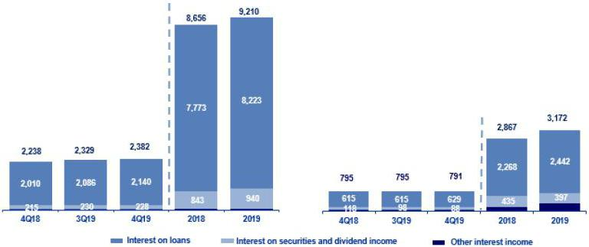

In the QoQ analysis, the increase of +1.6% in Interest Income was due primarily to growth in interest income on loans, which was attributable to:

- Slight acceleration in the growth of average daily loan balances (+2.7% QoQ), which was led by Retail Banking.

27

- The mix per segment given that although Wholesale Banking continues to account for the largest percentage of loans with a share of 41.4%, Retail Banking increased its share to 40.5% in 3Q19 and 41.0% in 4Q19. Additionally, although mortgage loans lead growth in terms of volumes, segments that offer higher margins, such as Consumer and SME-Pyme, also registered a significant increase.

- The currency mix given that loan expansion was generated mainly in LC (5.2%), which offers higher margins that FC. Accordingly, the currency mix also favored growth in interest income on loans.

In the YoY analysis, interest income expanded +4.6%, which represented lower growth than that registered in 3Q19. The increase in interest income was mainly attributable to growth in interest income on loans (+5.5%).

FY, interest income increased +6.9%. This was primarily due to an increase in interest income on loans, which was in turn attributable to:

- The volume effect due to an uptick in the pace of growth of average daily balances in all segments with the exception of ASB. This translated in growth of +6.6% of total loans and was driven primarily by Retail Banking, which registered a +11.6% increase in FY average daily loan balances.

- The mix by segment given that Retail Banking now accounts for 38.5% of total loans compared to 40.3% in 4Q18.

- The currency mix was also favorable given that the expansion in average daily balances was primarily driven by +9.2% growth in the FY LC portfolio.

To a lesser extent, interest income increased by:

- The increase in interest on deposits in other banks, which reflects an increase in the volume of BCRP funds. It is important to note that the majority of the funds held in BCRP are in FC given that the reserve requirement for this currency is much lower than that associated with LC.

- Slight growth in interest on securities, which was attributable to 10.0% YoY growth in the fair value through other comprehensive income investment portfolio and 4.0% in the fair value through profit and loss portfolio. Portfolio growth at the Credicorp level was attributable to expansion in the portfolios of Pacifico, ASB and Credicorp Capital which grew 158%, 35% and 8% respectively.

4.2. Interest Expenses

Interest Expenses – LC

(S/ millions)

Interest Expenses – FC

(S/ millions)
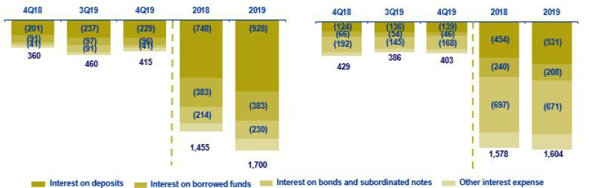

In the QoQ analysis, interest expenses fell +3.3%, which was attributable, in order of importance, to a drop in interest expenses on bonds and subordinated notes and a contraction in interest on loans.

28

The 11.6% decline in expenses for bonds and subordinated notes was associated with the issuances made at BCP Stand-alone in the third quarter of the year to replace bonds that expire in 2020. As indicated in the previous report, a debt restructuring strategy has been applied to extend the tenure and reduce rates. The positive effects of these transactions have materialized this quarter given that FC bonds expired during this period. The financing provided by these bonds was replaced by issuing an additional amount at lower rates.

The -6.45 contraction in expenses for interest on loans was attributable to the expiration of loans for working capital and repurchasing agreements with the Central Bank of Peru. These expirations have been replaced with financing that carries lower rates, which reflects the decrease posted in market rates.

In the YoY analysis, interest expenses grew +3.7%. Growth in this item was mainly attributable to +13.1% growth YoY in interest expenses on deposits.

FY, interest expenses grew +8.9%. This expansion was due primarily to a +21.4% increase in interest expenses on deposits, which as in turn attributable to:

- The volume effect, given that all deposit types posted growth YoY with the exception of interest-earning demand deposits, which registered relatively stable results.

- Th effect of the deposit mix, given that the deposits that registered the largest increase in volume were time deposits (+8.7%) and savings deposits (7.9%).

- The effect of the currency mix, given that the increase in the volume of deposits was posted in LC (10%).

The increase in interest expenses for deposits was offset by a drop in interest on loans and interest on bonds and subordinated notes, which fell -5.2% and -1.2% respectively after market rates declined.

4.3. Net Interest Margin (NIM) and Risk-Adjusted NIM

Credicorp’s NIM and Risk-Adjusted NIM ⁽¹⁾
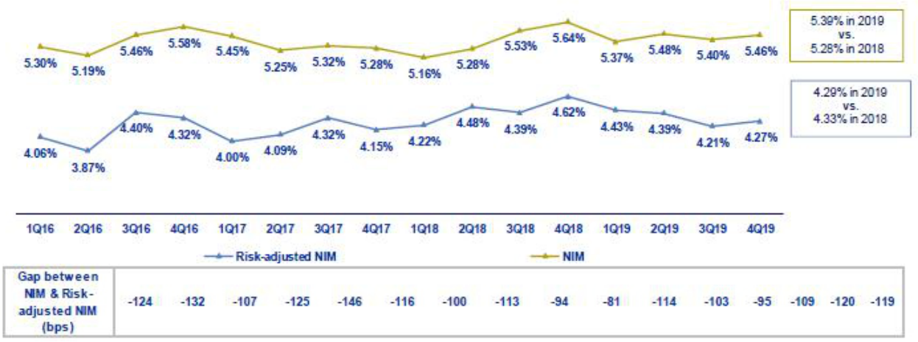

- Starting on 1Q17, we exclude derivatives from the NII result. For comparative purposes, figures starting from 1Q16 have been recalculated with the new methodology

NIM evolved favorably QoQ, YoY and FY, which was attributable to:

- Higher growth in NII, as indicated above. This was attributable to an improvement in loan growth, particularly in retail banking.

- An improvement in the funding structure, where deposits currently account for the largest proportion of funding within the funding structure.

29

Risk-adjusted NIM increased +6 bps QoQ the levels fell YoY and FY by -35 bps and -4 bps respectively due to an increase in provisions as explained in the previous section. As mentioned earlier, loan growth was driven primarily by Retail Banking which offers higher margins but also implies higher risk.

NIM on loans ⁽²⁾
NIM on loans increased +8 bps QoQ and +7 bps YoY after new pricing strategies were rolled out in retail banking to cover the new levels of risks that have been assumed. At the FY level, however, NIM on loans fell -16 bps. NIM on loan has been affected by downward pressures in a competitive context for both retail banking and Mibanco.
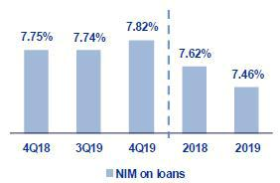

It is also important to analyze NIM by subsidiary. Next, we will present the interest margins for each of Credicorp’s subsidiaries.

 |  | BCP |  |  |  | BCP
NIM Breakdown |  | Stand-alone ⁽¹⁾ |  | Mibanco |  | Bolivia ⁽¹⁾ |  | Credicorp ⁽¹⁾⁽²⁾
4Q18 |  | 5.00% |  | 15.33% |  | 3.77% |  | 5.64%
3Q19 |  | 4.83% |  | 15.16% |  | 3.72% |  | 5.40%
4Q19 |  | 4.88% |  | 15.11% |  | 3.69% |  | 5.46%
Year 2018 |  | 4.53% |  | 15.64% |  | 3.69% |  | 5.28%
Year 2019 |  | 4.79% |  | 14.88% |  | 3.61% |  | 5.39%

NIM: Annualized Net interest income / Average period end and period beginning interest earning assets.

- Figures differ from previously reported, please consider the data presented on this report.

- Credicorp also includes Credicorp Capital, Prima, Grupo Credito and Eliminations for consolidation purposes.

In the FY evolution at Credicorp, a slight recovery is evident. This improvement corresponds to the positive evolution of NIM at BCP Stand-alone, which generates around 70% of interest income. The aforementioned offset the deterioration in NIM reported by Mibanco.

NIM at BCP Stand-alone improved 5bps QoQ and 26bps in 2019. The improvement in the margin was attributable to loan growth in segments with higher margins and to the implementation of new pricing strategies in retail banking, as outlined above.

NIM at Mibanco, accounts for 20% of interest income, deteriorated 5 bps QoQ, 22bps YoY and 76bps in 2019. This reduction was primarily attributable to lower interest rates in LC in a highly competitive market, which had a negative impact on interest generation on loans.

It is also important to analyze risk-adjusted NIM at each subsidiary. The table below shows the risk-adjusted net interest margins for each of the main subsidiaries at Credicorp.

- NIM on loans is calculated as follows:

The share of loans within total earning assets is calculated by dividing the average of the beginning and closing balances of total loans for the reporting period, by the average of the beginning and closing balances of the interest earning assets for the reporting period.

30

 |  | BCP |  |  |  | BCP
Risk Adjusted NIM Breakdown |  | Stand-alone ⁽¹⁾ |  | Mibanco |  | Bolivia ⁽¹⁾ |  | Credicorp ⁽¹⁾⁽²⁾
4Q18 |  | 4.07% |  | 11.86% |  | 3.00% |  | 4.62%
3Q19 | 3.67% |  |  | 11.50% |  | 3.33% |  | 4.21%
4Q19 | 3.72% |  |  | 12.07% |  | 2.67% |  | 4.27%
Year 2018 | 3.69% |  |  | 12.20% |  | 3.07% |  | 4.33%
Year 2019 | 3.73% |  |  | 11.58% |  | 2.96% |  | 4.29%

FY, Credicorp registered a slight drop in risk-adjusted NIM of 4 bps, which corresponds primarily to deterioration at Mibanco and to a lesser extent at BCP Bolivia. Risk-adjusted NIM at Mibanco deteriorated 62 bps in 2019 due to a drop in NIM.

At BCP Stand-alone, risk-adjusted NIM improved 7bps in 2019. Similar to NIM, growth in risk-adjusted NIM was attributable to the new pricing strategies that have been rolled out in Retail Banking over the last few quarters to cover higher risks.

31

- Non-Financial Income

In 2019, Non-financial income increased 11.1%. This was primarily attributable to an increase in the Net gain on securities (+173.8%); this component’s share of non-financial income rose to 9.5% (vs. 3.9% in 2018) after the sale and revaluation of investments at BCP Stand-alone. The main components of Non-financial income, Fee income and Net gain on foreign exchange transactions, also evolved positively with growth of 3.4% and 1.4% respectively, in line with an uptick in transactional activity at Credicorp.

Non-financial income |  |  |  | Quarter |  |  |  | % change |  |  |  |  |  | Year |  |  |  |  | % change
S/ 000 |  | 4Q18 |  | 3Q19 |  | 4Q19 |  | QoQ |  |  | YoY |  |  | 2018 |  |  | 2019 |  |  | 2019 / 2018
Fee income |  | 836,642 |  | 815,403 |  | 847,206 |  | 3.9% |  |  | 1.3% |  |  | 3,126,857 |  |  | 3,232,781 |  |  | 3.4%
Net gain on foreign exchange transactions |  | 212,213 |  | 188,073 |  | 193,528 |  | 2.9% |  |  | -8.8% |  |  | 737,954 |  |  | 748,382 |  | 1.4%
Net gain on securities ⁽¹⁾ |  | 47,139 |  | 150,427 |  | 102,011 |  | -32.2% |  |  | 116.4% |  |  | 170,575 |  |  | 466,970 |  | 173.8%
Net gain from associates ⁽¹⁾ ⁽²⁾ |  | 18,844 |  | 21,842 |  | 22,738 |  | 4.1% |  |  | 20.7% |  |  | 72,254 |  |  | 79,844 |  | 10.5%
Net gain on derivatives held for trading |  | (1,697) |  | 2,158 |  | 7,043 |  | 226.4% |  |  | 515.0% |  |  | 13,262 |  |  | 6,043 |  | -54.4%
Net gain from exchange differences |  | 268 |  | (1,964) |  | 22,258 |  | NA |  |  | NA |  |  | 16,022 |  |  | 24,351 |  | 52.0%
Other non-financial income |  | 39,825 |  | 94,647 |  | 74,713 |  | -21.1% |  |  | 87.6% |  |  | 273,884 |  |  | 343,668 |  | 25.5%
Total non-financial income, net
 |  | 1,153,234 |  | 1,270,586 |  | 1,269,497 |  | -0.1% |  |  | 10.1% |  |  | 4,410,808 |  |  | 4,902,039 |  |  | 11.1%

- The gain from other investments in related companies has been included in the item "Net gain from associates"; which previously was presented in the item "Net gain on sales of securities".

- Includes gains on other investments, mainly made up of the profit of Banmedica.

 |  |  |  | Quarter |  |  |  | % change |  |  |  |  | Year |  |  |  |  | % change
(S/ 000) |  | 4Q18 |  | 3Q19 |  | 4Q19 |  | QoQ |  |  | YoY |  | 2018 |  |  | 2019 |  | 2019 / 2018
(+) EPS contribution (50%) |  | 13,141 |  | 14,720 |  | 17,262 |  | 17.3% |  |  | 31.4% |  | 50,364 |  |  | 53,658 |  | 6.5%
(-) Private health insurance deduction (50%) |  | (171) |  | (5,350) |  | (9,806) |  | 83.3% |  |  | NA |  | (14,526) |  |  | (22,638) |  | 55.8%
(=) Net gain from association with Banmedica |  | 12,971 |  | 9,380 |  | 7,456 |  | -20.5 | % |  | -42.5 | % | 35,838 |  |  | 31,030 |  | -13.4 | %

The YoY evolution posted a slight contraction of -0.1% of non-financial income:

- The drop in the Net gain on securities was attributable to lower results for sales and fluctuations in the Trading portfolio and to the fact that in 3Q19, the result was exceptionally high after government bonds were sold in a context marked by declining international interest rates. The majority of this movement took place at BCP Stand-alone.

- The contraction in Other non-financial income, which was attributable to a drop-in income at BCP Stand-alone after a property (former Branches) was sold at a loss. It is also important to note that this account’s level has normalized, given that the last quarter reported extraordinary gains after the sale of holdings from the written-off and judicial loan portfolio and for the sale of assets from former branches.

All of the aforementioned was attenuated by:

- Growth in Fee income, which was attributable to higher income from the banking business, mainly due to personal loan services and drafts and transfers at BCP Stand-alone, and at Credicorp Capital for the corporate finance business.

- The increase in the Net gain from exchange differences at BCP Stand-alone primarily for the Trading position, which in the first 3 weeks of November maintained a long position for exchange rate depreciation (went from 3.347 to 3.378). Exchange rate volatility was primarily attributable to political uncertainty and geopolitical tensions.

The YoY analysis shows expansion of 10.1% in non-financial income due to:

- The increase in the Net gain on securities, mainly at ASB due to a gain generated by the sale of positions in the fair value through other comprehensive income portfolio and fair value through profit or loss investments, and to a lesser extent, to an improvement in results at Prima AFP due to an increase in the profitability of the reserve account associated with the portfolio growth.

32

- The increase in Other non-financial Income due to recoveries of expenses for judicial collections for personal loan products and credit cards.

- Growth in the Net gain from exchange differences, due to good results in 4Q19 as indicated in the QoQ analysis.

The aforementioned was offset by:

- The contraction in the Net gain on foreign exchange transactions due to lower incomes in Credicorp Capital, which was offset by the coverage of these positions through derivatives. To a lesser extent, the reduction was due to BCP Bolivia, due to lower commissioned spreads, and to BCP Stand-alone, due to the high incomes in 4Q18 (generated by a spread at maximum historical levels) and a reduction in transactions from an important portfolio.

FY (2019 vs. 2018), non-financial income increased 11.1% due to:

- The Net gain on securities, which was primarily attributable to an improvement in the results at ASB and BCP Stand-alone and, to a lesser extent, to positive results at Prima AFP and Credicorp Capital. The aforementioned was generated by higher gains on proprietary investment portfolios at each subsidiary due to both an increase in the mark-to-market value (MtM) and to the gain produced by the sale of some positions. In addition, the recovery in 2019 vs. 2018 is noteworthy given that last year, the scenario was marked by an upward tick in international interest rates, which negatively affected investments, whereas in 2019, the tables turned, and interest rates fell.

- Fee income, primarily due to the positive evolution of this component at BCP Stand-alone and Mibanco, which we will explain in greater detail in section 5.1.2 Fee Income in the Banking Business.

- Growth in Other non-financial income, mainly at BCP Stand-alone after the sale of different properties in 2019, in line with the strategy to migrate clients from traditional channels (branches) to cost-efficient channels (digital and agentes) and to sale of some loan portfolios.

The aforementioned was offset by:

- A contraction in the Net gain on derivatives held for trading at Credicorp Capital due to a drop-in income in the forwards business to cover exchange rate exposure on investments in the trading portfolio and for trading swaps, despite growth of 515.0% in 4Q19.

5.1. Fee Income

5.1.1. By subsidiary

The figure below shows the contribution of each of Credicorp’s subsidiaries to growth in fee income at Credicorp in 4Q19.

Evolution of fee income QoQ by subsidiary (S/ Million)

33

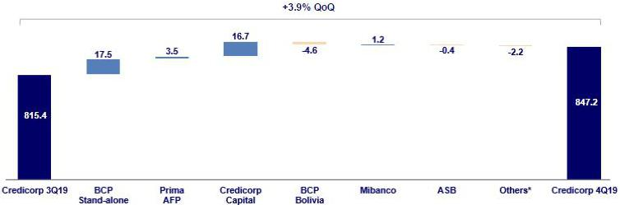

*Others include Encumbra, Bancompartir, Grupo Pacifico and eliminations for consolidation purposes.

The figure below shows the annual evolution of fee income by subsidiary:

Evolution of fee income YoY by subsidiary (S/ Million)
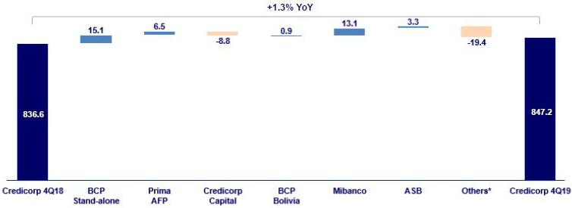

*Others include Encumbra, Bancompartir, Grupo Pacifico and eliminations for consolidation purposes.

The following figure shows the evolution of fee income by subsidiary FY:

Evolution of fee income YoY by subsidiary (S/ Million)
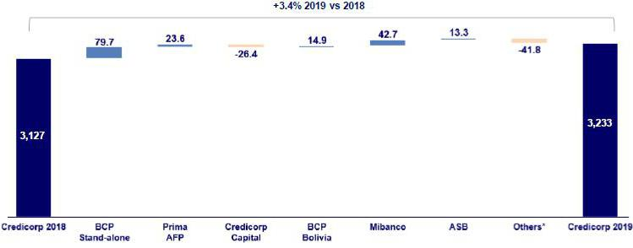

*Others include Encumbra, Bancompartir, Grupo Pacifico and eliminations for consolidation purposes.

34

5.1.2. Fee income in the Banking Business

The chart below shows the evolution of the main components of fee income in the banking business:

Composition of Fee Income in the Banking Business

Fee Income |  |  |  | Quarter |  |  |  | % change |  |  |  |  |  |  |  | Year |  |  |  |  | % change
S/ 000 |  | 4Q18 |  | 3Q19 |  | 4Q19 |  | QoQ |  |  | YoY |  |  |  |  | 2018 |  |  | 2019 |  | 2019 / 2018
Miscellaneous accounts ⁽¹⁾ |  | 187,989 |  | 184,826 |  | 186,506 |  | 0.9% |  |  |  | -0.8% |  |  |  | 721,377 |  |  | 718,581 |  | -0.4%
Credit cards ⁽²⁾ |  | 79,103 |  | 71,633 |  | 72,051 |  | 0.6% |  |  |  | -8.9% |  |  |  | 298,290 |  |  | 284,213 |  | -4.7%
Drafts and transfers |  | 62,602 |  | 68,526 |  | 71,547 |  | 4.4% |  |  |  | 14.3% |  |  |  | 225,825 |  |  | 264,791 |  | 17.3%
Personal loans ⁽²⁾ |  | 26,694 |  | 24,989 |  | 28,127 |  | 12.6% |  |  |  | 5.4% |  |  |  | 96,112 |  |  | 101,638 |  | 5.7%
SME loans ⁽²⁾ |  | 16,987 |  | 16,970 |  | 18,452 |  | 8.7% |  |  |  | 8.6% |  |  |  | 66,548 |  |  | 70,957 |  | 6.6%
Insurance ⁽²⁾ |  | 22,478 |  | 26,951 |  | 25,774 |  | -4.4% |  |  |  | 14.7% |  |  |  | 84,105 |  |  | 98,470 |  | 17.1%
Mortgage loans ⁽²⁾ |  | 11,000 |  | 9,213 |  | 10,678 |  | 15.9% |  |  |  | -2.9% |  |  |  | 40,028 |  |  | 39,057 |  | -2.4%
Off-balance sheet ⁽³⁾ |  | 54,050 |  | 53,954 |  | 51,875 |  | -3.9% |  |  |  | -4.0% |  |  |  | 208,530 |  |  | 208,836 |  | 0.1%
Payments and collections ⁽³⁾ |  | 107,599 |  | 108,619 |  | 109,321 |  | 0.6% |  |  |  | 1.6% |  |  |  | 412,214 |  |  | 426,661 |  | 3.5%
Commercial loans ⁽³⁾⁽⁴⁾ |  | 18,667 |  | 21,633 |  | 24,495 |  | 13.2% |  |  |  | 31.2% |  |  |  | 79,228 |  |  | 89,468 |  | 12.9%
Foreign trade ⁽³⁾ |  | 10,522 |  | 9,561 |  | 9,752 |  | 2.0% |  |  |  | -7.3% |  |  |  | 40,711 |  |  | 40,082 |  | -1.5%
Corporate finance and mutual funds ⁽⁴⁾ |  | 15,744 |  | 15,889 |  | 18,690 |  | 17.6% |  |  |  | 18.7% |  |  |  | 59,790 |  |  | 71,496 |  | 19.6%
ASB ⁽⁴⁾ |  | 8,259 |  | 11,923 |  | 11,550 |  | -3.1% |  |  |  | 39.8% |  |  |  | 32,363 |  |  | 45,659 |  | 41.1%
Others ⁽⁴⁾⁽⁵⁾ |  | 67,993 |  | 80,253 |  | 79,907 |  | -0.4% |  |  |  | 17.5% |  |  |  | 250,339 |  |  | 303,322 |  | 21.2%
Total fee income
 |  | 689,687 |  | 704,940 |  | 718,725 |  | 2.0% |  |  |  | 4.2% |  |  |  | 2,615,461 |  |  | 2,763,232 |  | 5.6%

Source: BCP
- Saving accounts, current accounts, debit card and master account.
- Mainly Retail fees.
- Mainly Wholesale fees.
- Figures differ from previously reported, please consider the data presented on this report.
- Includes fees from BCP Bolivia, Mibanco, network usage and other services to third parties, among others.

In the YoY analysis, fee income in the banking business increased 2.0% QoQ. The components that registered the highest quarterly growth were:

- Personal loans and Commercial loans, in line with loan growth this quarter.

- Drafts and transfers, which was mainly attributable to an increase in fees for transfers from saving products, domestic transfers, interbank transfers, and foreign transfers. The share of drafts and transfers increased to 10.0% (vs. 9.7% in 3Q19).

35

Growth was attenuated by:

- Off-balance sheet, given that the number of letters of guarantee dropped. The share of this component of total fee income for banking services fell to 7.2% (vs. 7.7% in 3Q19).

- Insurance, contracted 3.9%, mainly due to the expenses assumed by BCP Stand-alone in the month of November, relative to survivorship, property and car insurance.

In the YoY analysis, growth was situated at +4.2%. This increase was attributable to the same components responsible for the increase in fee income QoQ but is also associated with an improvement in the performance of Others, due to growth at Mibanco. The aforementioned offset the reduction in income from Credit Cards, due to a decrease in the billing volume, in line with a transactional strategy to encourage clients to migrate to digital channels, and to a drop in income from the Off-balance sheet, as mentioned in the QoQ analysis.

In the FY analysis (2019 vs. 2018), fee income for the banking business increased +5.6%; this was primarily attributable to:

- Others, mainly in Mibanco, due to a methodological change in insurance reporting, as explained in 1Q19, and through BCP Bolivia, due to an increase in the volume of drafts and foreign transfers. The aforementioned led the share of Others in total fee income for banking services to reach 11.0% in 2019 (vs. 9.6% in 2018).

- The increase in Drafts and Transfers for national transfers; foreign transfers; and interbank transfers, in line with a higher volume of transactional activity.

- A higher level of Collections and payments, due to an increase in services for collections, payments to companies for services and insurance coverage payments.

The aforementioned offset the drop in Credit Cards, as explained in the YoY analysis, and in Miscellaneous Accounts, due to a decrease in income for account maintenance.

36

6. Insurance Underwriting Result

The insurance underwriting result increased 15.5% QoQ. This was primarily attributable to an increase in net earned premiums in the life and P&C businesses and to a decrease in acquisition costs in P&C, which was attenuated by an increase in net claims in the life insurance business. In the YoY analysis, the underwriting result registered a 19.9% increase, which was mainly attributable to an increase in net earned premiums in both P&C and life; this was attenuated by an increase in net claims in life insurance and a higher acquisition cost in P&C. FY, the underwriting result increase 5.9%, which was mainly driven by an increase in the net earned premiums registered for both businesses and to a decrease in commissions for life insurance; this was attenuated by an increase in net claims for life insurance and to a lesser extent, to growth in claims at P&C.

Insurance underwriting result |  |  |  | Quarter |  |  |  |  | % change |  |  |  |  |  | Year |  |  |  | % change
S/ 000 |  | 4Q18 |  |  | 3Q19 |  | 4Q19 |  | QoQ |  |  | YoY |  |  | 2018 |  | 2019 |  |  | 2019/2018
Net earned premiums |  | 534,380 |  |  | 612,534 |  | 629,593 |  | 2.8% |  |  | 17.8% |  |  | 2,091,364 |  | 2,419,349 |  |  | 15.7%
Net claims |  | (325,402) |  | (392,520) |  |  | (395,718) |  | 0.8% |  |  | 21.6% |  | (1,239,636) |  |  | (1,554,477) |  | 25.4%
Acquisition cost ⁽¹⁾ |  | (87,824) |  | (94,239) |  |  | (88,662) |  | -5.9% |  |  | 1.0% |  | (380,310) |  |  | (365,848) |  | -3.8%
Total insurance underwriting result |  | 121,154 |  |  | 125,775 |  | 145,213 |  | 15.5 | % |  | 19.9 | % |  | 471,418 |  | 499,024 |  |  | 5.9 | %
(1) Includes net fees and underwriting expenses.
6.1. Net earned premiums
Total premiums by business |  |  |  |  |  |  |  |  |  |  |  | Net earned premiums by business
(S/ millions) |  |  |  |  |  |  |  |  |  |  |  |  |  | (S/ millions)
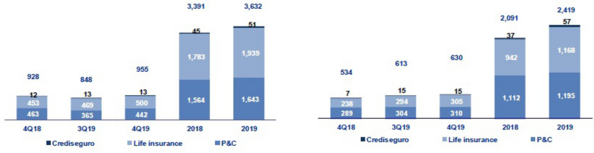

Total premiums increased +12.6% QoQ, which was attributable to growth in the premium level at P&C and to a lesser extent, in life insurance:

- Growth in P&C was registered in (i) Commercial lines due to an increase in policy renewals in the fire risks and marine hull segments, (ii) Cars due to an increase in sales of new policies; the aforementioned was slightly offset by a decrease in premium production in the Personal Lines and SOAT.

- Life insurance increased due to a growth in production in (i) Credit life, through the bancassurance channel and alliances, (ii) Annuities, mainly for individual annuities product, (iii) Disability and Survivorship (D&S), due to an increase in premiums through SISCO IV; this was attenuated by the result of Group Life, which registered a decline in the sales of SCTR and Statutory Life product.

Net earned premiums³ increased +2.8% QoQ due to the positive evolution in both businesses. Growth in life insurance premiums was reported in Credit Life and D&S for the reasons outlined in the analysis of total premiums. In P&C, the increase was primarily attributable to Cars due to higher sales and Personal Lines due to fewer reserves in line with the decrease in sales registered.

- Total premiums without considering reinsurance nor reserve premiums.

37

In the YoY analysis, total premiums increased +2.9%. This increase was primarily attributable to growth in life insurance, which was attenuated by the result in P&C. In the life insurance business, the increase was associated with growth in premium production in D&S lines after the company won two tranches of

the SISCO IV contract⁽⁴⁾ (2019-2020), which compared favorably with the single tranche won in SISCO III (2017-2018). Growth was also attributable to Credit Life, which registered an increase in premium production in the bancassurance and alliance channels; this was attenuated by a drop in premium production in Annuities through the individual annuity product. In P&C, the decline registered was mainly attributable to a drop in the commercial lines via the fire and aviation risks and in Cars, after fewer sales were made in the Alliance channel.

Net earned premiums increased +17.8% YoY, which was attributable to growth in both businesses. In the life insurance business, the increase was mainly attributable to: ii) D&S, after the premium level increased under the new SISCO IV tender; and ii) Credit Life, where growth was mainly associated with an increase in sales in the bancassurance channel. In P&C insurance, the increase was driven by Personal Lines, which reported an increase in issuances and average premiums; in Medical Assistance, after sales rose for comprehensive products; and Cars, given the fewer reserves registered.

FY, in 2019, total premiums increased +7.1% while the level of net premiums reported growth of +15.7% with regard to 2018. This increase was mainly attributable to the D&S lines in the life insurance business, after the company won two tranches of SISCO IV; and to Credit Life, due to an increase in premium production in the bancassurance channel and alliances. These results were attenuated by Group Life, which posted a decrease in premiums for renewals of the SCTR product. In the P&C business, growth was mainly attributable to the Medical Assistance line, which registered higher sales of

oncological and comprehensive products; to Personal Lines, which reported higher sales for financial products and properties; and to Cars and SOAT⁽⁵⁾ due to an uptick in sales.

6.2. Net claims

Net claims by business

(S/ millions)
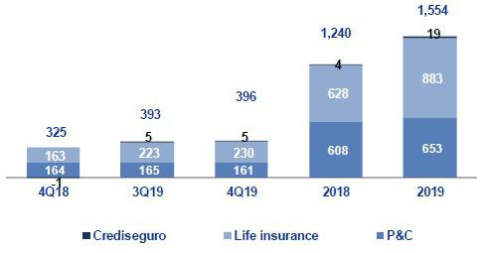

Net claims increased +0.8% QoQ due to an increase in life insurance; which was mitigated by the decreased in P&C. In the life insurance business, the increase is primarily attributable to the D&S lines, given that the discount rates used to calculate claims fell in a scenario in which the number of cases and average costs rose. Growth in life claims was also attributable, albeit it to a lesser extent, to Annuities after pension payments rose for individual annuity products; this was attenuated by a decrease in net claims in Credit Life. In P&C, net claims dropped in Medical Assistance after fewer incurred but not reported reserves were set aside for comprehensive products; this was attenuated by the result in Personal Lines, which registered an increase in case frequency.

In the YoY analysis, net claims rose +21.6% after claims in life insurance rose; this was mitigated by the evolution in P&C. The increase in the life insurance business was mainly attributable to the D&S lines, where growth was registered after the company won two tranches of SISCO IV, compared with the single tranche secured under SISCO II in 4Q18. Growth in claims was also due, albeit to a lesser extent, to Annuities after higher pensions payments were made for individual annuities. At the P&C level, the result was attributable to medical assistance due to a decrease in average costs and frequency relative to comprehensive products and to Cars, which registered a decrease in the average cost after claims were channeled to preferred repair shops; this was mitigated by Personal Lines, after claims frequency increased.

- Consist in the join administration of the risk of disability, survival and burial expenses of the AFP affiliates by the insurance companies that are winners in the public bidding process.
- Mandatory Traffic Accident Insurance.

38

FY, net claims increased +25.4%. This was primarily attributable to the evolution in the life insurance business (+40.7%), and to a lesser extent, to the results in P&C (+7.4%). The result in life insurance was primarily driven by the D&S lines, where the variation was mainly associated with the SISCO IV tender as indicated above, and, to a lesser extent, with Annuities, after pension payments increased in individual annuities. In the P&C business, the claims result was attributable primarily to SOAT, after an increase was registered in case frequency; to Medical Assistance, given that more IBNR reserves were set aside; and to Personal Lines, which experienced an uptick in case frequency.

6.3. Acquisition Cost

Acquisition cost per Business

(S/ millions)
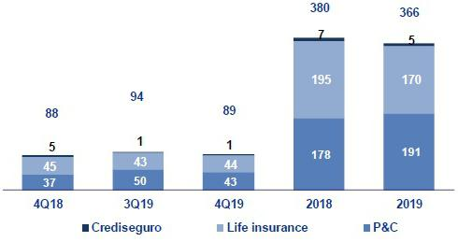

Acquisition cost |  |  |  |  | Quarter |  |  |  |  |  |  | % change |  |  |  |  |  | Year |  |  |  |  |  | % change
S/ 000 |  |  | 4Q18 |  |  | 3Q19 |  |  | 4Q19 |  |  | QoQ |  |  | YoY |  |  | 2018 |  |  | 2019 |  | 2019 / 2018
Net fees |  |  | (68,411) |  | (65,715) |  |  |  | (65,316) |  |  | -0.6% |  |  | -4.5% |  |  | (273,931) |  |  | (249,761) |  | -8.8%
Underwriting expenses |  |  | (24,470) |  | (30,039) |  |  |  | (35,206) |  |  | 17.2% |  |  | 43.9% |  |  | (115,790) |  |  | (149,057) |  | 28.7%
Underwriting income |  |  | 5,057 |  | 1,515 |  |  |  | 11,860 |  |  | N/A |  |  | 134.5% |  |  | 9,411 |  |  | 32,970 |  | 250.3%
Acquisition cost |  |  | (87,824 | ) |  | (94,239 | ) |  | (88,662 | ) |  | -5.9 | % |  | 1.0 | % |  | (380,310 | ) |  | (365,848 | ) |  | -3.8 | %

The acquisition cost fell -5.9% QoQ given that underwriting income increased in both businesses due to: i) profit sharing with reinsurers; and ii) an increase in commissions ceded in P&C, which was attenuated by an increase in underwriting expenses in life insurance. The decrease in the acquisition cost in P&C was due primarily to Commercial Lines after an increase was registered in fee income from reinsurers; in Cars, due to the release of expenses for promotions; and in Personal Lines, due to profit sharing with reinsurers. In life insurance, the increase was due primarily to growth in commissions through the Alliance channel in Credit Life after premiums increased; this was mitigated by income from profit sharing.

In the YoY analysis, the acquisition cost increased +1.0% due to the evolution in P&C and mitigated by the life insurance result. The result in P&C was due to an increase in fee income in Personal Lines after the premium level rose; to Commercial Lines, after commissions ceded to reinsurers fell; and to an increase in underwriting expenses. In the life insurance business, the decrease in the acquisition cost is due to profit sharing with reinsurers.

FY, the acquisition cost fell -3.8%. This was primarily due to the life insurance result, which was mitigated by growth in P&C. The drop registered in life insurance was attributable to a decrease in commissions in Credit Life through the alliance channel. In P&C, the increase in the acquisition cost was associated with growth in fee income in all business lines, which went hand-in-hand with an increase in the premium levels; and to an increase in underwriting expenses.

39

6.4. Total Underwriting result

Underwriting Result by Business

(S/ millions)
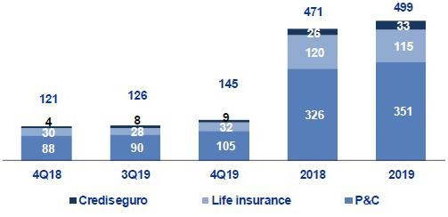

In the YoY analysis, the increase reported in the underwriting result was due primarily to the evolution in P&C and to a lesser extent, to results in life insurance. In P&C, the increase was attributable to growth in net premiums in Cars, Personal Lines and Medical Assistance; to a decrease in claims in Medical Assistance; and to a decrease in the acquisition cost after higher income was reported for underwriting and for commissions ceded in Wholesale Risks. In the life insurance business, the increase was attributable to growth in net premiums in Credit Life and in the D&S lines and to an increase in underwriting income, which was attenuated by growth in net claims in the D&S and Annuities lines and to an increase in commissions in line with growth in the premium level.

In the YoY analysis, the increase in the underwriting result was due primarily to business evolution in P&C and to a lesser extent, to the results in life insurance. In P&C, the variation was attributable to an increase in the net earned premium in the Personal Lines, Medical Assistance and Cars and to a decrease in net claims in Medical Life, the Commercial Lines and Cars; this was attenuated by an increase in the acquisition cost. In the life insurance business, the increase was attributable to growth in net earned premiums in the D&S, Credit Life and Group Life lines and to growth in underwriting income; these effects were attenuated by the increase in net claims in D&S, Annuities and Individual Life.

FY, the improvement in the underwriting result was attributable to an increase in the result posted by P&C, which was attenuated by a decrease in the underwriting result for the life business. In P&C, the result was drive by an increase in the net earned premium reported for Medical Assistance, Personal Lines, Cars and SOAT; this was attenuated by an increase in net claims and higher acquisition costs in all business lines. In the life insurance business, the drop reported in the underwriting result was attributable to an increase in net claims in all business lines; this was mitigated by an increase in the net earned premium, which was registered primarily in D&S, and to a lesser extent, to growth in Individual Life and Annuities and to a decrease in fee income in Credit Life.

40

7. Operating Expenses and Efficiency

In the YoY analysis, the operating efficiency ratio deteriorated 20 bps. This was primarily attributable to an increase in expenses for consultancy and marketing services. In contrast, the operating efficiency ratio improved 30 bps in 2019, which was associated with higher growth in operating income, particularly net interest income, which offset the increase in salaries and employee benefits.

Operating expenses |  |  |  | Quarter |  |  |  | % change |  |  |  |  | Year |  |  |  |  | % change
S/ 000 |  | 4Q18 |  | 3Q19 |  | 4Q19 |  | QoQ |  |  | YoY |  | 2018 |  |  | 2019 |  | 2019 / 2018
Salaries and employees benefits |  | 867,069 |  | 845,345 |  | 885,526 |  | 4.8% |  |  | 2.1% |  | 3,219,875 |  |  | 3,411,023 |  | 5.9%
Administrative, general and tax expenses |  | 682,118 |  | 560,780 |  | 675,142 |  | 20.4% |  |  | -1.0% |  | 2,330,045 |  |  | 2,280,399 |  | -2.1%
Depreciation and amortization ⁽¹⁾ |  | 110,412 |  | 185,574 |  | 201,790 |  | 8.7% |  |  | 82.8% |  | 429,122 |  |  | 708,442 |  | 65.1%
Association in participation |  | 171 |  | 5,348 |  | 9,806 |  | 83.4% |  |  | N/A |  | 14,526 |  |  | 22,636 |  | 55.8%
Acquisition cost ⁽²⁾ |  | 87,824 |  | 94,239 |  | 88,662 |  | -5.9% |  |  | 1.0% |  | 380,310 |  |  | 365,848 |  | -3.8%
Operating expenses ⁽³⁾
 |  | 1,747,594 |  | 1,691,286 |  | 1,860,926 |  | 10.0% |  |  | 6.5% |  | 6,373,878 |  |  | 6,788,348 |  | 6.5%
Operating income ⁽⁴⁾
 |  | 3,844,902 |  | 3,915,430 |  | 4,076,488 |  | 4.1% |  |  | 6.0% |  | 14,546,817 |  |  | 15,587,931 |  | 7.2%
Efficiency ratio ⁽⁵⁾
 |  | 45.5% |  | 43.2% |  | 45.7% |  | 250 bps |  |  | 20 bps |  | 43.8% |  |  | 43.5% |  | -30 bps
Operating expenses / Total average assets ⁽⁶⁾
 |  | 4.04% |  | 3.68% |  | 3.97% |  | 29 bps |  |  | -7 bps |  | 3.67% |  |  | 3.71% |  | 4 bps

- Since the 1Q19, the application of IFRS 16 is in effect, which corresponds to a greater depreciation for the asset for right-of-use. Likewise, the expenses related to the depreciation of improvements in building for rent is being reclassified to the item "Other expenses".
- The acquisition cost of Pacifico includes net fees and underwriting expenses.
- Operating expenses = Salaries and employee’s benefits + Administrative, general and tax expenses + Depreciation and amortization + Acquisition cost + Association in participation.
- Operating income = Net interest income + Fee income + Net gain on foreign exchange transactions + Net gain from associates + Net gain on derivatives held for trading + Result on exchange differences + Net premiums earned.
- Figures differ from previously reported, please consider the data presented on this report. Operating expenses / Operating income.
- Figures differ from previously reported, please consider the data presented on this report. Operating expenses / Average of Total Assets. Average is calculated with period-beginning and period-ending balances.

In the QoQ analysis, the deterioration in the efficiency ratio was due to the seasonal factors that affect operating expenses; as such, the YoY analysis provides a clearer picture of the evolution of efficiency.

The YoY analysis reveals a deterioration of 20 bps in the efficiency ratio, primarily due to the fact that operating expenses registered higher growth than operating income.

In the following figure, we can see the impact that the variation of each component of income and of operating expenses used to calculate the YoY efficiency ratio:

YoY evolution of the efficiency ratio by account
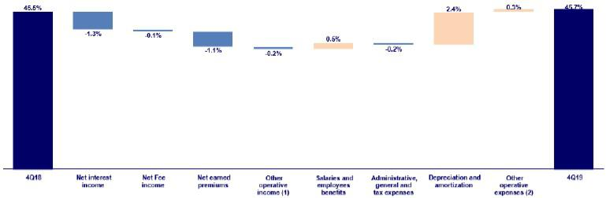

- Other operating income includes: Net gain on foreign exchange transactions, Net gain from associates, Net gain on derivatives held for trading and Net gain from exchange difference.

- Other operating expenses includes: Acquisition cost and Association in participation

41

Operating efficiency deteriorated in a scenario in which the growth of operating expenses outpaced the expansion registered in operating income. Operating expenses increased primarily due to depreciation and amortization and specifically speaking, to expenses associated with leasing. It is important to mention that this this line should be analyzed alongside general and administrative expenses and taxes given that under IFRS 16, part of the expenses for leasing, which were formerly included in general and administrative expenses, must be reclassified and included in Depreciation and Amortization. When we analyze administrative and general expenses and taxes alongside depreciation and amortization, we see that the increase is mainly attributable to an uptick in consultancy and marketing services, which we will explain further in section 7.1. Credicorp – Administrative and general expenses and taxes.

The aforementioned was offset by the increase in net interest income, which was attributable to: i) growth in average daily balances, primarily in the Retail Banking segment; ii) the increase in average daily balances, mainly in Retail Banking; and iii) the increase in Net premiums, which was primarily associated with growth in Life insurance at Grupo Pacifico.

FY, the efficiency ratio improved 30 bps. The following figure shows the impact of the variation of each account on the efficiency ratio at Credicorp.

FY evolution of the efficiency ratio by account
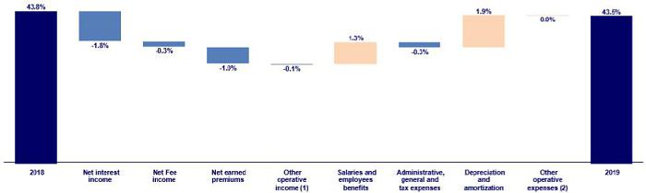

- Other operating income includes: Net gain on foreign exchange transactions, Net gain from associates, Net gain on derivatives held for trading and Net gain from exchange difference.

- Other operating expenses includes: Acquisition cost and Association in participation

When we analyze the impact of operating expenses, the improvement in the efficiency ratio was due to:

- Growth in net interest income, which was attributable to an increase in average daily loan balances in all segments, as indicated in section 4.1. Interest Income.

- The increase in net earned premiums at Grupo Pacífico, which was attributable mainly to the life insurance lines, as indicated in section 6.1 Net earned premiums.

- Higher net fee income at BCP Stand-alone and to a lesser extent, at BCP Bolivia and Mibanco, as indicated in section 5.1.2 Fee income in the banking business.

Growth in operating expenses, and the subsequent negative effect on the efficiency ratio, was due to the following:

- An increase in salaries and employee benefits, which was registered mainly at Mibanco and to a lesser extent, at BCP Stand-alone and Credicorp Capital. In the case of Mibanco, the increase was attributable primarily to an 11.8% increase in headcount in 2019 as the sales force was bolstered and efforts were made to build capacities to harness growth down the line. At BCP, the increase was mainly associated with an increase in fixed compensation after new employees with specialized profiles were hired in 1H19 and, to a lesser extent, with an increase to cover additional productivity incentives in Retail Banking. Salaries and employee benefits at Credicorp Capital was attributable to an increase in headcount, mainly in Peru and Chile.

- The increase in the depreciation and amortization line, due to growth in leasing expenses in 2019, as indicated in the YoY analysis.

42

7.1. Credicorp’s Administrative, General and Tax Expenses

Credicorp’s administrative, general and tax expenses

Administrative, general
and tax expenses ⁽¹⁾ |  |  |  |  |  | Quarter |  |  |  |  |  |  |  |  |  |  | % change |  |  |  |  | Year |  |  |  |  |  | % change
S/ 000 |  | 4Q18 |  | % |  | 3Q19 |  |  |  | % |  | 4Q19 |  | % |  |  | QoQ |  |  | YoY |  | 2018 |  |  |  | 2019 |  | 2019 / 2018
Marketing |  | 102,463 |  | 15% |  | 86,768 |  |  |  | 15% |  | 121,694 |  |  | 18% |  | 40.3% |  |  | 18.8% |  | 327,832 |  |  |  | 374,675 |  | 14.3%
Taxes and contributions |  | 68,646 |  | 10% |  | 65,981 |  |  |  | 12% |  | 77,685 |  |  | 12% |  | 17.7% |  |  | 13.2% |  | 244,400 |  |  |  | 274,556 |  | 12.3%
Insfrastructure |  | 77,747 |  | 11% |  | 76,719 |  |  |  | 14% |  | 83,411 |  |  | 12% |  | 8.7% |  |  | 7.3% |  | 288,163 |  |  |  | 304,862 |  | 5.8%
Systems outsourcing |  | 69,290 |  | 10% |  | 47,933 |  |  |  | 9% |  | 7,378 |  |  | 1% |  | -84.6% |  |  | -89.4% |  | 235,178 |  |  |  | 131,594 |  | -44.0%
Programs and systems |  | 77,169 |  | 11% |  | 69,462 |  |  |  | 12% |  | 84,076 |  |  | 12% |  | 21.0% |  |  | 9.0% |  | 265,958 |  |  |  | 286,925 |  | 7.9%
Communications |  | 28,008 |  | 4% |  | 18,937 |  |  |  | 3% |  | 22,413 |  |  | 3% |  | 18.4% |  |  | -20.0% |  | 91,375 |  |  |  | 85,287 |  | -6.7%
Rent |  | 50,720 |  | 7% |  | 12,037 |  |  |  | 2% |  | 28,675 |  |  | 4% |  | 138.2% |  |  | -43.5% |  | 194,838 |  |  |  | 92,203 |  | -52.7%
Consulting |  | 57,535 |  | 8% |  | 61,082 |  |  |  | 11% |  | 81,933 |  |  | 12% |  | 34.1% |  |  | 42.4% |  | 189,788 |  |  |  | 207,654 |  | 9.4%
Channels |  | 60,220 |  | 9% |  | 62,333 |  |  |  | 11% |  | 66,711 |  |  | 10% |  | 7.0% |  |  | 10.8% |  | 221,113 |  |  |  | 242,955 |  | 9.9%
Gastos Legales |  | 19,632 |  | 3% |  | 8,793 |  |  |  | 2% |  | 18,483 |  |  | 3% |  | 110.2% |  |  | -5.9% |  | 47,814 |  |  |  | 44,462 |  | -7.0%
Gastos de Representación |  | 5,503 |  | 1% |  | 5,300 |  |  |  | 1% |  | 5,086 |  |  | 1% |  | -4.0% |  |  | -7.6% |  | 17,914 |  |  |  | 20,568 |  | 14.8%
Seguros |  | 20,469 |  | 3% |  | 16,417 |  |  |  | 3% |  | 20,063 |  |  | 3% |  | 22.2% |  |  | -2.0% |  | 51,644 |  |  |  | 61,802 |  | 19.7%
Others ⁽²⁾ |  | 44,717 |  | 7% |  | 29,018 |  |  |  | 5% |  | 57,535 |  |  | 9% |  | 98.3% |  |  | 28.7% |  | 154,027 |  |  |  | 152,855 |  | -0.8%
Total administrative and
general expenses |  | 682,118 |  | 100% |  | 560,780 |  |  |  | 100% |  | 675,142 |  |  | 100% |  | 20.4% |  |  | -1.0% |  | 2,330,044 |  |  |  | 2,280,398 |  | -2.1%

- Administrative, general and tax expenses differ from previously reported because BCP Bolivia has been included.
- Others include ASB, BCP Bolivia, Grupo Credito and eliminations for consolidation.

The QoQ increase in administrative and general expenses and taxes was attributable primarily to a seasonal effect given that this item reaches its highest point in the last quarter of every year.

In the YoY analysis, which excludes the seasonal effect on operating expenses, reported a decrease that was mainly attributable to a drop in expenses for Systems Outsourcing and Leasing. This effect was registered due to the application of IFRS 16, which does not include financial leasing expenses in administrative and general expenses and taxes and instead reports approximately 90% of the same in the expenses for depreciation line.

The aforementioned offset the increase in

- Expenses for Consultants, mainly at BCP Stand-alone, for projects associated with transformation and improvements in IT models.

- The increase in Marketing, mainly at BCP Stand-alone, due to an increase in expenses for different campaigns to advertise Yape and to sell digital products, which are both part of the transformation strategy and, to a lesser extent, to the increase in expenses for Latam miles.

- The increase in Programming and Systems expenses, mainly at Prima AFP, which has invested in a project to improve the system’s functionality. Additionally, the balance of this account has grown across subsidiaries, which reflects Credicorp’s on-going efforts to improve the systems at its subsidiaries.

The FY posted an evolution similar to that of YoY; nevertheless, it also registered strong growth in expenses in Credicorp’s channels after fee income increased along with an uptick in the volume of national and international transfers, as is evident in chapter 5.1.2. Fee income for the Banking Business.

43

7.2. Efficiency Ratio
 |  | Efficiency Ratio by Subsidiary ⁽¹⁾⁽²⁾
 |  | BCP
 | Stand-alone |  |  | BCP Bolivia |  |  |  | Mibanco |  |  | pacifico |  | Prima AFP |  |  |  | credicorp
4Q18
4Q18 | 44.8% |  |  | 65.7% |  |  |  | 49.5% |  |  | 29.1% |  | 42.8% |  |  |  | 45.5%
3Q19 | 40.8% |  |  | 56.8% |  |  |  | 50.7% |  |  | 27.7% |  | 44.0% |  |  |  | 43.2%
4Q19 | 43.8% |  |  | 60.1% |  |  |  | 54.2% |  |  | 27.6% |  | 45.1% |  |  |  | 45.7%
Var. QoQ |  | 300bps |  |  | 330bps |  |  | 350bps |  |  | -10bps |  |  | 110bps |  |  | 250bps
Var. YoY |  | -100bps |  |  | -560bps |  |  | 470bps |  |  | -150bps |  |  | 230bps |  |  | 20bps
2018 | 41.8% |  |  | 63.3% |  |  |  | 48.0% |  |  | 31.1% |  | 45.2% |  |  |  | 43.8%
2019 | 40.7% |  |  | 60.0% |  |  |  | 52.9% |  |  | 27.7% |  | 42.8% |  |  |  | 43.5%
% change 2019 / 2018 |  | -110bps |  |  | -330bps |  |  | 490bps |  |  | -340bps |  |  | -240bps |  |  | -30bps

- (Salaries and employee’s benefits + Administrative, general and tax expenses + Depreciation and amortization + Acquisition cost + Association in participation) / (Net interest income + Fee income + Net gain on foreign exchange transactions + Net gain from associates + Net gain on derivatives held for trading + Result on exchange differences + Net premiums earned).
- The efficiency ratio differs from previously reported, please consider the data presented on this report.

In the QoQ analysis, the deterioration in the efficiency ratio was attributable to the seasonal nature of operating expenses. As such, the YoY analysis provides a clearer picture of the business result.

The following figure shows the contribution of each subsidiary to the evolution of the efficiency ratio YoY.

YoY evolution of the efficiency ratio by subsidiary
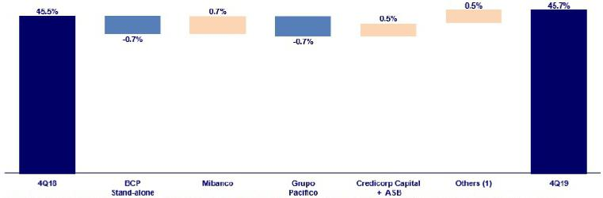

- Others includes: Credicorp Capital, Prima AFP, BCP Bolivia, ASB, Grupo Credito, among other subsidiaries and the eliminations for consolidation purposes.

In the YoY analysis, the efficiency ratio deteriorated 20 bps. This was primarily attributable to Mibanco, which registered an increase in salaries and employee benefits due to an increase in headcount. An increase was also reported in operating expenses at Credicorp Capital, mainly due to the higher salaries and employee benefits expenses, in line with the increase in the headcount.

The aforementioned was attenuated by an improvement in business evolution at Grupo Pacifico after net earned premiums registered an increase in the Life insurance line and at BCP Stand-alone, which went hand-in-hand with growth in net interest income. It is important to note that the increase in net earned premiums was offset by growth in net claims, which are not included in operating expenses.

In the FY analysis, the efficiency ratio by subsidiary improved 30 bps. The following figure shows the impact of the variation at each subsidiary on

Credicorp’s efficiency ratio:

44

FY evolution of the efficiency ratio by subsidiary
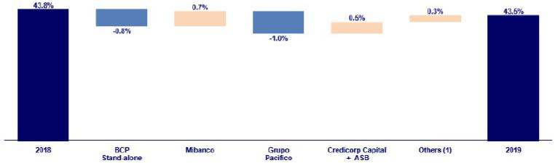

- Others includes: Credicorp Capital, Prima AFP, BCP Bolivia, ASB, Grupo Credito, among other subsidiaries and the eliminations for consolidation purposes.

The improvement in Credicorp’s efficiency ratio is attributable to:

- Grupo Pacífico, which reported an improvement that was primarily due to an increase in operating income after net earned premiums registered growth, mainly in the Life line. It is important to note that growth in net earned premiums was attenuated by the increase registered in net claims, which are not included in operating expenses and;

- The improvement in the efficiency ratio at BCP Stand-alone, in a scenario in which growth in operating income fell below that of operating expenses. The increase in operating expenses was due primarily to growth in interest income on loans, which went hand-in-hand with an increase in average daily balances. The aforementioned offset growth in administrative expenses, as indicated in section 7.1. Credicorp – Administrative and general expenses and taxes.

The aforementioned offset the deterioration in the efficiency ratio at (i) Mibanco, which was attributable to an increase in headcount for the sales force to strengthen long-term capabilities and to the reduction in net interest income, which was primarily due to and more competitive environment and (ii) Credicorp Capital, due to an increase in expenses for salaries and employee benefits after the headcount increased.

45

8. | Regulatory Capital
8.1. Regulatory Capital – BAP
Regulatory Capital and Capital Adequacy Ratios |  |  |  |  |  | As of |  |  |  | % Change
S/ 000 |  |  |  | 4Q18 |  | 3Q19 |  | 4Q19 |  | QoQ |  |  | YoY
Capital Stock |  |  |  | 1,318,993 |  | 1,318,993 |  | 1,318,993 |  | 0.0% |  |  | 0.0%
Treasury Stocks |  |  |  | (207,994) |  | (207,839) |  | (207,839) |  | 0.0% |  |  | -0.1%
Capital Surplus |  |  |  | 246,194 |  | 222,605 |  | 226,037 |  | 1.5% |  |  | -8.2%
Legal and Other capital reserves ⁽¹⁾ |  |  |  | 17,598,556 |  | 19,416,912 |  | 19,437,645 |  | 0.1% |  |  | 10.5%
Minority interest ⁽²⁾ |  |  |  | 311,230 |  | 357,157 |  | 393,019 |  | 10.0% |  |  | 26.3%
Loan loss reserves ⁽³⁾ |  |  |  | 1,591,484 |  | 1,633,135 |  | 1,690,510 |  | 3.5% |  |  | 6.2%
Perpetual subordinated debt |  |  |  | 674,600 |  | 592,025 |  | - |  | -100.0% |  |  | -100.0%
Subordinated Debt |  |  |  | 4,770,421 |  | 4,778,365 |  | 4,409,840 |  | -7.7% |  |  | -7.6%
Investments in equity and subordinated debt of financial and insurance
companies |  |  |  | (648,230) |  | (775,048) |  | (700,859) |  | -9.6% |  |  | 8.1%
Goodwill |  |  |  | (591,366) |  | (621,686) |  | (834,881) |  | 34.3% |  |  | 41.2%
Deduction for subordinated debt limit (50% of Tier I excluding
deductions) ⁽⁴⁾ |  |  |  | - |  | - |  | - |  | - |  |  | -
Deduction for Tier I Limit (50% of Regulatory capital) ⁽⁴⁾ |  |  |  | - |  | - |  | - |  | - |  |  | -
Total Regulatory Capital (A)
 |  |  |  | 25,063,888 |  | 26,714,619 |  | 25,732,465 |  | -3.7% |  |  | 2.7%
Tier 1 ⁽⁵⁾
 |  |  |  | 13,498,505 |  | 14,739,047 |  | 14,010,215 |  | -4.9% |  |  | 3.8%
Tier 2 ⁽⁶⁾ + Tier 3 ⁽⁷⁾ |  |  |  | 11,565,383 |  | 11,975,572 |  | 11,722,249 |  | -2.1% |  |  | 1.4%
Financial Consolidated Group (FCG) Regulatory Capital
Requirements ⁽⁸⁾ |  |  |  | 19,629,305 |  | 20,170,802 |  | 20,686,904 |  | 2.6% |  |  | 5.4%
Insurance Consolidated Group (ICG) Capital Requirements ⁽⁹⁾ |  |  |  | 1,019,984 |  | 1,139,617 |  | 1,199,850 |  | 5.3% |  |  | 17.6%
FCG Capital Requirements related to operations with ICG |  |  |  | (212,498) |  | (236,036) |  | (329,262) |  | 39.5% |  |  | 54.9%
ICG Capital Requirements related to operations with FCG |  |  |  | - |  | - |  | - |  | - |  |  | -
Total Regulatory Capital Requirements (B)
 |  |  |  | 20,436,791 |  | 21,074,383 |  | 21,557,491 |  | 2.3% |  |  | 5.5%
Regulatory Capital Ratio (A) / (B) |  |  |  | 1.23 |  | 1.27 |  | 1.19
Required Regulatory Capital Ratio ⁽¹⁰⁾ |  |  |  | 1.00 |  | 1.00 |  | 1.00

- Legal and other capital reserves include restricted capital reserves (S/ 13,465 million) and optional capital reserves (S/ 5,972 million).

- Minority interest includes Tier I (S/ 393 million).

- Up to 1.25% of total risk-weighted assets of Banco de Credito del Perú, Solucion Empresa Administradora Hipotecaria, Mibanco and Atlantic Security Bank.
- Tier II + Tier III cannot be more than 50% of total regulatory capital.

- Tier I = capital + restricted capital reserves + Tier I minority interest - goodwill - (0.5 x investment in equity and subordinated debt of financial and insurance companies) + perpetual subordinated debt.
- Tier II = subordinated debt + TierII minority interest tier + loan loss reserves - (0.5 x investment in equity and subordinated debt of financial and insurance companies).
- Tier III = Subordinated debt covering market risk only.

- Includes regulatory capital requirements of the financial consolidated group.

- Includes regulatory capital requirements of the insurance consolidated group.

- Regulatory Capital / Total Regulatory Capital Requirements (legal minimum = 1.00).

Total regulatory capital at Credicorp fell-3.7% QoQ. This was primarily due to -7.7% decrease in subordinated debt and in perpetual subordinated debt in its entirety after a subordinated bond expired and a perpetual subordinated bond at BCP Stand-alone was called. Growth of +2.7% was reported in YoY terms after an increase was registered in legal and restricted reserves, as announced in 1Q19. Additionally, Credicorp’s regulatory capital requirement rose 2.3% QoQ and 5.5% YoY.

Credicorp’s Regulatory Capital Ratio remained at comfortable levels at the end of 4Q19 and represented 1.19 times the capital required by the regulator in Peru at the end of 4Q19.

46

8.2. Regulatory Capital – BCP Stand-alone based on Peru GAAP

Regulatory Capital and Capital Adequacy Ratios |  |  |  | As of |  |  |  | % change
S/ 000 |  | 4Q18 |  | 3Q19 |  | 4Q19 |  | QoQ |  |  | YoY
Capital Stock |  | 8,770,365 |  | 10,217,387 |  | 10,217,387 |  | 0.0% |  |  | 16.5%
Legal and Other capital reserves |  | 4,184,309 |  | 4,695,118 |  | 4,695,118 |  | 0.0% |  |  | 12.2%
Accumulated earnings with capitalization agreement |  | - |  | 850,000 |  | 850,000 |  | 0.0% |  |  | n.a.
Loan loss reserves ⁽¹⁾ |  | 1,307,303 |  | 1,320,345 |  | 1,367,259 |  | 3.6% |  |  | 4.6%
Perpetual subordinated debt |  | 674,600 |  | 592,025 |  | - |  | -100.0% |  |  | -100.0%
Subordinated Debt |  | 4,224,153 |  | 4,319,204 |  | 3,980,904 |  | -7.8% |  |  | -5.8%
Unrealized profit (loss) |  | - |  | - |  | - |  | - |  |  | -
Investment in subsidiaries and others, net of unrealized profit and net income |  | (1,359,608) |  | (1,722,979) |  | (1,580,583) |  | -8.3% |  |  | 16.3%
Investment in subsidiaries and others |  | (1,794,992) |  | (2,006,574) |  | (1,965,037) |  | -2.1% |  |  | 9.5%
Unrealized profit and net income in subsidiaries |  | 435,384 |  | 283,595 |  | 384,454 |  | 35.6% |  |  | -11.7%
Goodwill |  | (122,083) |  | (122,083) |  | (122,083) |  | 0.0% |  |  | 0.0%
Total Regulatory Capital |  | 17,679,038 |  | 20,149,017 |  | 19,408,002 |  | -3.7% |  |  | 9.8%
Off-balance sheet |  |  |  |  |  |  |  |  | % |  |  | %
 |  | 84,543,806 |  | 88,421,907 |  | 86,319,031 |  | -2.4 | % |  | 2.1 | %
Tier 1 ⁽²⁾
 |  | 12,827,386 |  | 15,370,957 |  | 14,850,131 |  | -3.4% |  |  | 15.8%
Tier 2 ⁽³⁾ + Tier 3 ⁽⁴⁾ |  | 4,851,652 |  | 4,778,060 |  | 4,557,871 |  | -4.6% |  |  | -6.1%
Common Equity Tier 1 |  | 14,234,319 |  | 15,048,138 |  | 15,842,022 |  | 5.3% |  |  | 11.3%
Total risk-weighted assets - SBS |  | 124,798,031 |  | 130,413,864 |  | 134,128,850 |  | 2.8 | % |  | 7.5 | %
Market risk-weighted assets ⁽⁵⁾ |  | 1,760,750 |  | 2,143,263 |  | 2,263,835 |  | 5.6% |  |  | 28.6%
Credit risk-weighted assets |  | 114,006,079 |  | 118,791,053 |  | 122,233,929 |  | 2.9% |  |  | 7.2%
Operational risk-weighted assets |  | 9,031,203 |  | 9,479,548 |  | 9,631,086 |  | 1.6% |  |  | 6.6%
Adjusted Risk-Weighted Assets - Basel |  | 123,261,266 |  | 125,960,200 |  | 128,238,694 |  | 1.8 | % |  | 4.0 | %
Total risk-weighted assets |  | 124,798,031 |  | 130,413,864 |  | 134,128,850 |  | 2.8% |  |  | 7.5%
(-) RWA Intangible assets, excluding goodwill. |  | 2,082,049 |  | 4,846,465 |  | 6,330,168 |  | 30.6% |  |  | 204.0%
(+) RWA Deferred tax assets generated as a result of temporary
differences in income tax, in excess of 10% of CET1 |  | 545,285 |  | 392,802 |  | 440,012 |  | 12.0% |  |  | -
(+) RWA Deferred tax assets generated as a result of past losses |  | - |  | - |  | - |  | - |  |  | -
Total capital requirement |  | 15,914,011 |  | 16,547,822 |  | 16,982,136 |  | 2.6 | % |  | 6.7 | %
Market risk capital requirement ⁽⁵⁾ |  | 176,075 |  | 214,326 |  | 226,384 |  | 5.6% |  |  | 28.6%
Credit risk capital requirement |  | 11,400,608 |  | 11,879,105 |  | 12,223,393 |  | 2.9% |  |  | 7.2%
Operational risk capital requirement |  | 903,120 |  | 947,955 |  | 963,109 |  | 1.6% |  |  | 6.6%
Additional capital requirements |  | 3,434,207 |  | 3,506,435 |  | 3,569,251 |  | 1.8% |  |  | 3.9%
Capital ratios
Tier 1 ratio ⁽⁶⁾ |  | 10.28% |  | 11.79% |  | 11.07%
Common Equity Tier 1 ratio ⁽⁷⁾ |  | 11.55% |  | 11.95% |  | 12.35%
BIS ratio ⁽⁸⁾ |  | 14.17% |  | 15.45% |  | 14.47%
Risk-Weighted assets / Regulatory capital ⁽⁹⁾ |  | 7.06 |  | 6.47 |  | 6.91

- Up to 1.25% of total risk-weighted assets.

- Tier 1 = Capital + Legal and other capital reserves + Accumulated earnings with capitalization agreement + (0.5 x Unrealized profit and net income in subsidiaries) - Goodwill - (0.5 x Investment in subsidiaries) + Perpetual subordinated debt (maximum amount that can be included is 17.65% of Capital + Reserves + Accumulated earnings with capitalization agreement + Unrealized profit and net income in subsidiaries - Goodwill).
- Tier 2 = Subordinated debt + Loan loss reserves + (0.5 x Unrealized profit and net income in subsidiaries) - (0.5 x Investment in subsidiaries).

- Tier 3 = Subordinated debt covering market risk only. Tier 3 exists since 1Q10.

- It includes capital requirement to cover price and rate risk.

- Tier 1 / Total Risk-weighted assets.

- Common Equity Tier I = Capital + Reserves – 100% of applicable deductions (investment in subsidiaries, goodwill, intangibles and net deferred taxes that rely on future profitability) + retained earnings + unrealized gains. Adjusted Risk-Weighted Assets = Risk-weighted assets - (RWA Intangible assets, excluding goodwill, + RWA Deferred tax assets generated as a result of temporary differences in income tax, in excess of 10% of CET1, + RWA Deferred tax assets generated as a result of past losses).

- Regulatory Capital / Risk-weighted assets (legal minimum = 10% since July 2011).

- Since July 2012, Risk-weighted assets = Credit risk-weighted assets * 1.00 + Capital requirement to cover market risk * 10 + Capital requirement to cover operational risk * 10 * 1.00 (since July 2014).

47

At the end of 4Q19, the BIS and Tier 1 ratios at BCP Stand-alone fell QoQ to situate at 14.47% and 11.07% respectively. This was attributable to a -3.7% drop in total regulatory capital in a context in which total RWAs grew 2.8% QoQ.

Total capital fell QoQ due to a -7.8% drop in subordinated debt and perpetual subordinated debt in its entirety, which corresponded to the expiration of a subordinated debt and the call of a perpetual subordinated bond in accordance with the strategy to reduce rates, which began with the issuances made in the third quarter of the year. Total RWAs increased after the level of Credit RWAs rose. This growth primarily reflects the effect of 2.8% growth QoQ in quarter-end loan balances.

The YoY evolution reveals an increase in both the BIS Ratio and the Tier 1 Ratio with regard to the levels posted in 4Q18. This was attributable to a scenario in which growth in total regulatory capital and in Tier 1 capital outpaced the expansion registered for RWAs.

The YoY evolution of total RWAs mainly reflects growth of 7.2% in Credit RWAs and to a lesser extent, of Operational RWAs. The increase in Credit RWAs in particular reflects the strategy to grow in riskier segments as well as the fact that credit lines that were not used in 2019 (in accordance with the Peruvian regulator’s requirements) were included in the calculation of RWAs.

Common Equity Tier 1 Ratio – BCP Stand-alone

September 2019 December 2019
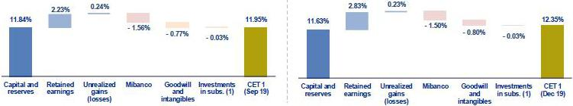

(1) Includes investments in BCP Bolivia and other subsidiaries.

Finally, Ratio Tier 1 Common Equity (CET1), which is considered the most rigorous ratio with which to measure capitalization levels, reported growth of +41 bps QoQ, situating at 12.35% at the end of 4Q19. This result was primarily attributable to a +5.3% increase in the CET1, which was driven by FY results this quarter. In the YoY analysis, the CET 1 Ratio increased 81 bps in a context in which adjusted RWAs increased 4.0%.

48

9. Distribution channels

The distribution channels at BCP Stand-alone, Mibanco and BCP Bolivia registered a total of 10,998 points of contact at the end of 4Q19. This level represents an increase of 156 points QoQ and expansion of 499 YoY, which was mainly attributable to growth in Agentes BCP at BCP Stand-alone and, to a lesser extent, at BCP Bolivia.

9.1. Universal Banking
9.1.1. Points of contact by geographic area – BCP Stand-alone
 |  |  | As of |  |  |  | change (units)
 | Dec 18 |  | Sep 19 |  | Dec 19 |  | QoQ |  | YoY
Lima | 263 |  | 255 |  | 253 |  | -2 |  | -10
Provinces | 157 |  | 149 |  | 149 |  | 0 |  | -8
Total Branches | 420 |  | 404 |  | 402 |  | -2 |  | -18
Lima | 1,501 |  | 1,514 |  | 1,533 |  | 19 |  | 32
Provinces | 770 |  | 752 |  | 752 |  | 0 |  | -18
Total ATM’s | 2,271 |  | 2,266 |  | 2,285 |  | 19 |  | 14
Lima | 3,457 |  | 3,503 |  | 3,581 |  | 78 |  | 124
Provinces | 3,307 |  | 3,548 |  | 3,606 |  | 58 |  | 299
Total Agentes BCP | 6,764 |  | 7,051 |  | 7,187 |  | 136 |  | 423
Total points of contact | 9,455 |  | 9,721 |  | 9,874 |  | 153 |  | 419

BCP Stand-alone registered an increase of 153 points of contact QoQ, to total 9,874 points of contact at the end of 4Q19. Growth in points of contact was due primarily to growth in the number of Agentes BCP, which increased by 136 points. Lima posted the highest growth with +76 Agentes while the Provinces were up +58 Agentes. The strategy used to open these new agentes entailed seeking penetration in areas where the population and number of transactions merited expanding coverage. Additionally, the strategy sought to penetrate uncovered cities.

The number of ATMs increased QoQ while the number of branches fell (+19 and -2, respectively). The increase in ATMs was primarily attributable to the higher demand in different points of Lima. During this period, the number of branches fell after two locations, one in La Victoria and the other in the Cercado de Lima, were closed as part of our Transformation Program.

In the YoY analysis, the total number of points of contact at BCP Stand-alone increased by 419 units. This was mainly due to growth in Agentes BCP (+423). The aforementioned is aligned with the strategy to be closer to our clients and to the population that has yet to join the financial system; in this context, 70.7% of the growth in Agentes took place in the provinces.

The contraction in offices was seen in both Lima (-10) and in the province (-8). This was attributable to the Transformation strategy at BCP Stand Alone, whose objective is to migrate clients to cost-efficient channels. The number of ATMs increased in Lima (32) after neutral points were installed and new balance inquiries were opened in locations in Lima and Callao. In contrast, the number of ATMs fell in the provinces ( -18) after ATMs were removed from branches.

49

9.1.2. Transactions per channel – BCP Stand-alone

Transactions per channel – BCP Stand-alone

 |  |  |  |  |  |  |  | Monthly average in each quater |  |  |  |  |  |  |  |  | % change |  |  |  |  |  | Year |  |  | % change
 |  |  | N˚ of Transactions per channel (1) |  | 4Q18 |  | % |  | 3Q19 |  | % |  | 4Q19 |  | % |  | QoQ |  | YoY |  | 2018 |  |  | 2019 |  | 2019 / 2018
Traditional |  |  | Teller |  | 8,253,527 |  | 4.9% |  | 7,711,756 |  | 3.6% |  | 7,715,870 |  | 3.1% |  | 0.1% |  | -6.5% |  | 32,375,509 |  |  | 31,007,089 |  | -4.2%
channels |  |  | Telephone banking |  | 5,352,943 |  | 3.2% |  | 4,803,032 |  | 2.3% |  | 5,056,869 |  | 2.0% |  | 5.3% |  | -5.5% |  | 19,489,811 |  | 19,497,295 |  |  | 0.0%
Cost-
efficient |  |  | Agentes BCP |  | 25,641,330 |  | 15.1% |  | 29,492,554 |  | 13.9% |  | 32,534,245 |  | 13.0% |  | 10.3% |  | 26.9% |  | 89,116,061 |  | 113,841,169 |  |  | 27.7%
channels |  |  | ATMs |  | 21,283,188 |  | 12.5% |  | 24,953,751 |  | 11.8% |  | 25,678,078 |  | 10.3% |  | 2.9% |  | 20.6% |  | 82,746,643 |  | 99,722,784 |  |  | 20.5%
Digital |  |  | Mobile banking |  | 60,966,991 |  | 35.9% |  | 95,336,208 |  | 45.1% |  | 120,275,484 |  | 48.1% |  | 26.2% |  | 97.3% |  | 187,538,750 |  | 365,203,135 |  |  | 94.7%
Digital |  |  | Internet banking Via BCP |  | 16,931,303 |  | 10.0% |  | 16,371,635 |  | 7.7% |  | 23,757,780 |  | 9.5% |  | 45.1% |  | 40.3% |  | 71,629,947 |  | 72,465,782 |  |  | 1.2%
channels |  |  | Balance inquiries |  | 1,441,490 |  | 0.8% |  | 1,342,920 |  | 0.6% |  | 1,238,521 |  | 0.5% |  | -7.8% |  | -14.1% |  | 6,482,625 |  | 5,103,150 |  |  | -21.3%
Others |  |  | Telecrédito |  | 12,037,379 |  | 7.1% |  | 12,536,785 |  | 5.9% |  | 13,208,492 |  | 5.3% |  | 5.4% |  | 9.7% |  | 44,541,673 |  | 48,849,268 |  |  | 9.7%
Others |  |  | Direct debit |  | 670,435 |  | 0.4% |  | 837,254 |  | 0.4% |  | 920,143 |  | 0.4% |  | 9.9% |  | 37.2% |  | 2,617,447 |  | 3,193,094 |  |  | 22.0%
 |  |  | Points of sale P.O.S. |  | 16,986,238 |  | 10.0% |  | 17,958,329 |  | 8.5% |  | 19,251,035 |  | 7.7% |  | 7.2% |  | 13.3% |  | 58,606,921 |  | 71,202,988 |  |  | 21.5%
 |  |  | Other ATMs netw ork |  | 237,932 |  | 0.1% |  | 258,168 |  | 0.1% |  | 290,695 |  | 0.1% |  | 12.6% |  | 22.2% |  | 862,224 |  | 984,297 |  |  | 14.2%
 |  |  | Total transactions |  | 169,802,756 |  | 100.0 | % | 211,602,391 |  | 100.0 | % | 249,927,212 |  | 100.0 | % | 18.1 | % | 47.2 | % | 596,007,611 |  |  | 831,070,050 |  | 39.4 | %

(1) Figures include monetary and non-monetary transactions.

In line with the increase in points of contact, the monthly average of transactions increased +18.1% QoQ and +47.2% YoY. In the QoQ analysis, transactions increased across channels, with the exception of Balance Inquiries, which fell 7.8% due to efforts to remodel 100 kiosks (no transactions could be made during this time). It is important to note that in 4Q19, the largest increase in volume was generated by Internet Banking Via BCP (+45.1% QoQ). This took place after we reworked our web page, which now has a new landing page that makes it easier to access different options for transactions and inquiries.

In the FY analysis, which excludes the seasonal effect, the monthly average of transactions posted an increase, which was due primarily to an increase in the volumes registered in the following channels:

- Mobile Banking (+94.7%), which continued to post an upward trend in its share of total transactions as the bank rolls out operating improvements for the mobile application “Banca Movil BCP”.

- Agentes BCP (+27.7%), which was due primarily to transactional growth in withdrawals and deposits. Growth was also registered in national drafts, issuances, releases and inquiries through this channel. The aforementioned was in line with an increase in new accounts and growth in Agentes BCP (+423 YoY).

- ATMs (+20.5% YoY), where growth was mainly attributable to the increase in non-monetary transactions, due to more client inquiries through this channel.

Additionally, transactions in the traditional channels continued to fall compared with 2018: (i) Tellers (-4.2%) and (ii) Telephone Banking (0.0%) given that mobile banking offers similar functions, as is the case with digital platforms at the branch level, which allow clients to make inquiries, open savings accounts and collect debit cards.

Growth in transactions in the banks in the region is conducted primarily through Mobile Banking (+97.3% YoY) and Internet Banking (+40.3% YoY), in keeping with our objective to manage an efficient and profitable customer service network. It is also important to note that the interbank application Yape reached 1.5 million users in 4Q19.

50

9.1.3. Points of Contact – BCP Bolivia
 |  |  |  | As of |  |  |  | change (units)
 | Dec 18 |  |  | Sep 19 |  | Dec 19 |  | QoQ |  |  | YoY
Branches |  | 56 |  | 56 |  | 54 |  | -2 |  |  | -2
ATMs⁽¹⁾ |  | 293 |  | 303 |  | 301 |  | -2 |  |  | 8
Agentes BCP Bolivia |  | 369 |  | 438 |  | 446 |  | 8 |  |  | 77
Total Bolivia’s Network |  | 718 |  | 797 |  | 801 |  | 4 |  |  | 83

(1) Figures differ than previously reported.

BCP Bolivia increased its numbers of contact QoQ by +4 after it opened new Agentes BCP (+8), in line with a growth strategy to top 450 Agentes at year-end while achieving greater cost efficiency.

The total number of contacts continued to grow YoY (+83), which was mainly attributable to an increase in the number of Agentes BCP (+77) and, to a lesser extent, to growth in ATMS (+8). During this period, the number branches, however, fell (-2). The increase in the number of agentes was due, once again, to our strategy to be cost efficient while compensating for branch closings.

9.2. Microfinance

9.2.1. Points of Contact – Mibanco

 |  |  |  | As of |  |  |  | change (units)
 | Dec 18 |  |  | Sep 19 |  | Dec 19 |  | QoQ |  | YoY
Total Mibanco’s Network ⁽¹⁾ |  | 326 |  | 324 |  | 323 |  | -1 |  | -3

- Mibanco does not have Agents or ATMs because it uses the BCP network. Mibanco branches include Banco de la Nacion branches, which in Sep 18, Jun 19 and Set 19 were 38, 35 and 35 respectively.

With regard to Mibanco, the points of contact fell by -1 in the QoQ analysis. In the YoY analysis, there was a drop of -3 points of contact after the Banco de la Nacion closed some branches. It is important to note that Mibanco has an agreement with the Banco de la Nacion that allows us to use its offices at the national level to reduce operating costs. At the end of 4Q19, these branches represented 11% (35 branches) of the universe of 323 branches.

51

10. Economic Perspectives

10.1. Peru Economic Forecasts

Peru |  |  | 2016 |  |  | 2017 |  |  | 2018 |  |  | 2019 ⁽³⁾ |  |  | 2020 ⁽³⁾
GDP (US$ Millions) |  |  | 194,653 |  |  | 214,397 |  |  | 225,364 |  |  | 227,767 |  |  | 239,708
Real GDP (% change) |  |  | 4.0 |  |  | 2.5 |  |  | 4.0 |  |  | 2.0 |  |  | 3.0
GDP per capita (US$) |  |  | 6,179 |  |  | 6,742 |  |  | 6,999 |  |  | 7,008 |  |  | 7,308
Domestic demand (% change) |  |  | 1.1 |  |  | 1.4 |  |  | 4.3 |  |  | 2.4 |  |  | 2.5-3.0
Total consumption (% change) |  |  | 3.2 |  |  | 2.3 |  |  | 3.6 |  |  | 2.9 |  |  | 3.0
Private Consumption (% change) |  |  | 3.7 |  |  | 2.6 |  |  | 3.8 |  |  | 3.0 |  |  | 3.0
Gross fixed investment (as % GDP) |  |  | 21.9 |  |  | 20.5 |  |  | 21.4 |  |  | 22.4 |  |  | 22.5
Private Investment (% change) |  |  | -5.4 |  |  | 0.2 |  |  | 4.4 |  |  | 4.0 |  |  | 0.0-2.0
Public Investment (% change) |  |  | 0.3 |  |  | -1.8 |  |  | 6.8 |  |  | -1.5 |  |  | 8.0
Public Debt (as % GDP) |  |  | 23.9 |  |  | 24.9 |  |  | 25.7 |  |  | 26.0 |  |  | 26.5
System loan growth (% change)⁽¹⁾ |  |  | 4.9 |  |  | 5.6 |  |  | 10.1 |  |  | - |  |  | -
Inflation⁽²⁾
 |  |  | 3.2 |  |  | 1.4 |  |  | 2.2 |  |  | 1.9 |  |  | 2.2
Reference Rate |  |  | 4.25 |  |  | 3.25 |  |  | 2.75 |  |  | 2.25 |  |  | 2.00-2.25
Exchange rate, end of period |  |  | 3.36 |  |  | 3.24 |  |  | 3.37 |  |  | 3.31 |  |  | 3.35-3.40
Exchange rate, (% change) |  |  | -1.7% |  |  | -3.5% |  |  | 4.1% |  |  | -1.7% |  |  | 1.1%
Fiscal balance (% GDP) |  |  | -2.6 |  |  | -3.1 |  |  | -2.5 |  |  | -1.6 |  |  | -1.9
Trade balance (US$ Millions) |  |  | 1,953 |  |  | 6,571 |  |  | 7,049 |  |  | 5,200 |  |  | 6,000
(As % GDP) |  |  | 1.0% |  |  | 3.1% |  |  | 3.1% |  |  | 2.3% |  |  | 2.5%
Exports |  |  | 37,082 |  |  | 45,275 |  |  | 48,942 |  |  | 46,400 |  |  | 47,000
Imports |  |  | 35,128 |  |  | 38,704 |  |  | 41,893 |  |  | 41,200 |  |  | 41,000
Current account balance (US$ Millions) |  |  | -5,303 |  |  | -2,537 |  |  | -3,349 |  |  | -4,100 |  |  | -4,554
(As % GDP) |  |  | -2.7% |  |  | -1.2% |  |  | -1.5% |  |  | -1.8% |  |  | -1.9%
Net international reserves (US$ Millions) |  |  | 61,686 |  |  | 63,621 |  |  | 60,121 |  |  | 68,316 |  |  | 69,000
(As % GDP) |  |  | 31.7% |  |  | 29.7% |  |  | 26.7% |  |  | 30.0% |  |  | 28.8%
(As months of imports) |  |  | 21 |  |  | 20 |  |  | 17 |  |  | 20 |  |  | 20

Source: INEI, BCRP, and SBS.

- Financial System, Current Exchange Rate.

- Inflation target: 1% - 3%.

- Estimates by BCP Economic Research as of January 2020.

10.2. Main Economic Variables

Economic Activity – GDP (% change YoY)
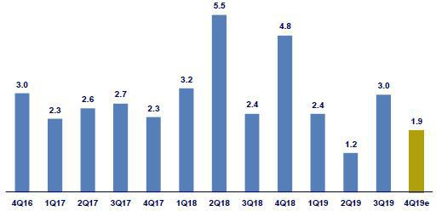

Fuente: INEI

52

Our estimates suggest GDP grew around 1.6% YoY in 4Q19 (3Q19: 3.0%). The deceleration registered QoQ is primarily attributable to the downturn in non-

primary sectors, where growth is expected to have situated at 2% (3Q19: 3.4%). In this context, the inter-annual drop registered for non-primary

manufacturing (Oct/Nov-19: -3.1% vs. 3Q19: +2.2%) and the construction sector (Oct/Nov-19: -1.3% vs. 3Q19: +2.9%), as well as a downturn in the service sectors (Oct/Nov-19: 3.0% vs. 3Q19: 3.7%), were noteworthy. In contrast, the primary sectors maintained their dynamism and expanded around 2.1%. This result went hand-in-hand with the YoY recovery in mining production (which returned to the positive terrain after 7 quarters).

With this result, in 2019 GDP expanded 2.0%. This represented a deceleration compared to 2018 (4.0%) and also fell below the result registered in 2017 (2.5%), when the economy was battered by the El Niño Phenomenon. The mild expansion in 2019 was mainly attributable to a contraction in the primary sectors of around 1.2% (2018: +3.5%) due to a decline in fishing, mining, and primary resource manufacturing. Public investment by the general government in this period fell 6% in 2019 (2018: +11%). Lastly, private spending (consumption and investment) expanded around 3.2% (2018: 3.9%, 2017: 2.1%).

Inflation and Monetary Policy rate (%)
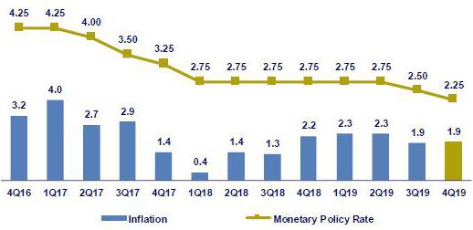

Source: INEI, BCRP

Headline inflation closed 2019 at 1.9% (3Q19: 1.9%) to stand slightly below the mid-point of the target range (1%-3%). It is important to note that poultry meat prices fell 7.3% in 2019, which represented the third consecutive year of dropping prices (chicken is an important part of the household’s consumption basket).

In 2019, the Central Bank lowered its reference rate 25pbs on two occasions (August and November), which led the rate to close the year at 2.25%. These rate cuts took place in a context of slower economic growth; a decline in growth expectations; and controlled inflation (within the target range).

Fiscal Result and Current Account Balance (% of GDP, Quarter)
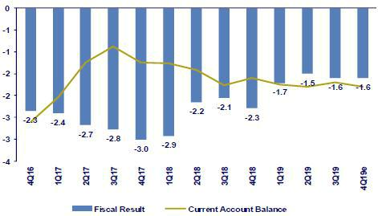

Source: BCRP

*BCP estimates

53

In 2019, the fiscal deficit represented 1.6% of GDP (2018: 2.3%), the lowest level since late-2015. The decline in the fiscal deficit was driven primarily by an increase in fiscal revenues, which represented 19.7% of GDP this year (2018: 19.3%). In 2019, this increase was attributable to non-resident income (asset sales and oversight by SUNAT, as well as tax revenues for fines and installment agreements. In contrast to the fiscal revenue result, in 2019 non-financial government spending held steady, representing 20.2% of GDP. It is important to highlight that in real terms, current spending expanded 3.1% due to higher wages and salaries (4.1%) and goods and services (4.8%) while public investment fell 6%, mainly due to under-execution at the local government level (-14%).

In Jan/Nov ’19, the trade balance totaled a surplus of USD 4,855 million, which is 19% below the figure registered for the same period last year. In this context, exports decreased 5.0% YoY in the same period (both prices and volumes posted declines) due to a decrease in traditional exports (-8.1%, copper: -9.4%) while non-traditional exports advanced 1.9% YoY (agro-exports: +5.3%). Imports fell 2.8% YoY in the same period but he 4.8% YoY increase in capital goods was noteworthy. Lastly, in Nov-19, terms of trade increased 1.8% YoY to register 5 consecutive months of increases after almost a year in decline.

Exchange rate (S/ per US$)
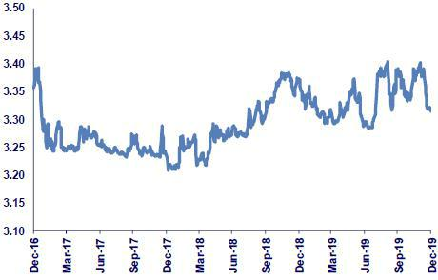

Source: SBS

In 2019, the exchange rate closed at USD PEN 3.314. In this context, PEN appreciated 2.0% compared to 3Q19 (USD PEN 3.383) and 1.7% compared to 2018 (USD PEN 3.373). In the last quarter of the year, high volatility was observed due to instability on the international and national fronts. On the international front, the main impacts were generated by trade tensions between US and the rest of the world (mainly China) and social unrest in Chile in mid-October (the exchange rate hit nearly USD PEN 3.40). On the local front, on September 30 President Vizcarra dissolved Congress, calling for parliamentary elections on 26-Jan-20. This event generated only limited volatility. It is important to note that although the exchange rate closed 2019 at USD PEN 3.314, PEN appreciation occurred mostly in late Dec-19, in line with expectations regarding the Phase One deal between US and China (average USD PEN during 4Q19: 3.36).

In 2019, the region’s FX evolution presented mixed results. On one hand, the Peruvian Sol and Mexican Peso (+3.7%) appreciated. On the other, the Chilean Peso (-8.5%), Brazilian Real (-3.7%) and Colombian Peso (-1.0%) depreciated. In parallel, in 2019 the Central Bank made spot purchases in the FX market for USD 405 million and issued FX Currency Swaps (sales) for USD 1,064 million in a context of depreciation pressure on the Peruvian Sol. Lastly, in 2019 Net International Reserves stood at USD 68,316 million, which represented an increase of USD 8,195 million compared to 2018. During this period, the FX position stood at USD 42,619 million, increasing USD 3,071 million over the year.

54

Safe Harbor for Forward-Looking Statements

This material includes “forward-looking statements” within the meaning of Section 21E of the Securities Exchange Act of 1934. All statements other than statements of historical information provided herein are forward-looking and may contain information about financial results, economic conditions, trends and known uncertainties. Forward-looking statements are neither historical facts nor assurances of future performance. Instead, they are based only on the Company’s current beliefs, expectations and assumptions regarding the future of our business, future plans and strategies, projections, anticipated events and trends, the economy and other future conditions.

Forward-looking statements can be identified by words such as: "anticipate”, "intend", "plan", "goal”, "seek”, "believe”, "project", "estimate”, "expect", "strategy”, "future”, "likely”, "may”, "should”, "will" and similar references to future periods. Examples of forward-looking statements include, among others, statements or estimates we make regarding guidance relating to Return on Average Equity, Sustainable Return on Average Equity, Cost of Risk, Loan growth, Efficiency ratio, BCP Stand-alone Common Equity Tier 1 Capital ratio and Net Interest Margin, current or future volatility in the credit markets and future market conditions, expected macroeconomic conditions, our belief that we have sufficient liquidity to fund our business operations during the next year, expectations of the effect on our financial condition of claims, litigation, environmental costs, contingent liabilities and governmental and regulatory investigations and proceedings, strategy for customer retention, growth, product development, market position, financial results and reserves and strategy for risk management.

The Company cautions readers that actual results could differ materially from those expected by the Company, depending on the outcome of certain factors, including, without limitation: (1) adverse changes in the Peruvian economy with respect to the rates of inflation, economic growth, currency devaluation, and other factors, (2) adverse changes in the Peruvian political situation, including, without limitation, the reversal of market-oriented reforms and economic recovery measures, or the failure of such measures and reforms to achieve their goals, and (3) adverse changes in the markets in which the Company operates, including increased competition, decreased demand for financial services, and other factors. Readers are cautioned not to place undue reliance on these forward-looking statements, which speak only as of the date hereof. Our actual results and financial condition may differ materially from those indicated in the forward-looking statements. Therefore, you should not rely on any of these forward-looking statements.

Any forward-looking statement made in this material is based only on information currently available to the Company and speaks only as of the date on which it is made. The Company undertakes no obligation to release publicly the result of any revisions to these forward-looking statements which may be made to reflect events or circumstances after the date hereof, including, without limitation, changes in the Company’s business strategy or planned capital expenditures, or to reflect the occurrence of unanticipated events

55

- Appendix

- Credicorp

CREDICORP LTD. AND SUBSIDIARIES

CONSOLIDATED STATEMENT OF FINANCIAL POSITION

(In S/ thousands, IFRS)

 |  |  | As of |  |  |  | % change
 | Dec 2018 |  | Sep 2019 |  | Dec 2019 |  | QoQ |  |  | YoY
ASSETS
Cash and due from banks ⁽¹⁾
Non-interest bearing | 7,435,807 |  | 6,138,225 |  | 6,177,356 |  | 0.6% |  |  | -16.9%
Interest bearing | 14,732,709 |  | 20,258,177 |  | 19,802,459 |  | -2.2% |  |  | 34.4%

Total cash and due from banks | 22,168,516 | 26,396,402 | 25,979,815 | -1.6% | 17.2%
Cash collateral, reverse repurchase agreements and
securities borrowing | 4,082,942 | 3,903,051 | 4,288,524 | 9.9% | 5.0%
Fair value through profit or loss investments | 3,512,445 | 3,808,137 | 3,864,531 | 1.5% | 10.0%
Fair value through other comprehensive income investments | 25,195,835 | 26,794,192 | 26,205,867 | -2.2% | 4.0%
Amortized cost investments | 4,154,838 | 3,353,898 | 3,477,046 | 3.7% | -16.3%
Loans | 110,759,390 | 112,209,990 | 115,609,679 | 3.0% | 4.4%
Current | 107,642,312 | 108,863,601 | 112,311,888 | 3.2% | 4.3%
Internal overdue loans | 3,117,078 | 3,346,389 | 3,297,791 | -1.5% | 5.8%
Less - allow ance for loan losses | (4,952,392) | (4,977,809) | (5,070,279) | 1.9% | 2.4%
Loans, net | 105,806,998 | 107,232,181 | 110,539,400 | 3.1% | 4.5%
Financial assets designated at fair value through profit or
loss ⁽²⁾ | 521,185 | 617,387 | 620,544 | 0.5% | 19.1%
Accounts receivable from reinsurers and coinsurers | 842,043 | 779,961 | 791,704 | 1.5% | -6.0%
Premiums and other policyholder receivables | 887,273 | 793,858 | 838,731 | 5.7% | -5.5%
Property, plant and equipment, net ⁽³⁾ | 1,480,702 | 2,925,381 | 2,519,889 | -13.9% | 70.2%
Due from customers on acceptances | 967,968 | 434,457 | 535,222 | 23.2% | -44.7%
Investments in associates ⁽⁴⁾ | 582,132 | 603,487 | 628,822 | 4.2% | 8.0%
Intangible assets and goodwill, net | 2,055,702 | 2,099,563 | 2,453,268 | 16.8% | 19.3%
Other assets ⁽⁵⁾ | 5,004,622 | 6,562,316 | 5,540,074 | -15.6% | 10.7%
Total Assets | 177,263,201 | 186,304,271 | 188,283,437 | 1.1% | 6.2%
LIABILITIES AND EQUITY
Deposits and obligations
Non-interest bearing | 26,609,832 | 26,707,196 | 28,316,170 | 6.0% | 6.4%
Interest bearing | 77,941,479 | 80,684,524 | 83,689,215 | 3.7% | 7.4%
Total deposits and obligations | 104,551,311 | 107,391,720 | 112,005,385 | 4.3% | 7.1%
Payables from repurchase agreements and securities lending | 9,415,356 | 7,684,690 | 7,678,016 | -0.1% | -18.5%
BCRP instruments | 5,226,870 | 4,144,908 | 4,381,011 | 5.7% | -16.2%
Repurchase agreements with third parties | 2,638,231 | 2,031,025 | 1,820,911 | -10.3% | -31.0%
Repuchase ageemens with cusomers | 1,550,255 | 1,508,757 | 1,476,094 | -2.2% | -4.8%
Due to banks and correspondents | 8,448,139 | 8,624,286 | 8,841,732 | 2.5% | 4.7%
Bonds and notes issued | 15,457,540 | 17,160,564 | 14,946,363 | -12.9% | -3.3%
Banker’s acceptances outstanding | 967,968 | 434,457 | 535,222 | 23.2% | -44.7%
Reserves for property and casualty claims | 1,366,670 | 1,547,981 | 1,576,228 | 1.8% | 15.3%
Reserve for unearned premiums | 7,086,002 | 7,597,409 | 8,374,005 | 10.2% | 18.2%
Accounts payable to reinsurers | 291,693 | 220,731 | 216,734 | -1.8% | -25.7%
Financial liabilities at fair value through profit or loss ⁽⁶⁾ | 362,310 | 417,695 | 493,700 | 18.2% | 36.3%
Other liabilities | 5,050,136 | 8,764,594 | 6,869,742 | -21.6% | 36.0%
Total Liabilities | 152,997,125 | 159,844,127 | 161,537,127 | 1.1% | 5.6%
Net equity | 23,839,243 | 26,000,638 | 26,237,960 | 0.9% | 10.1%
Capital stock | 1,318,993 | 1,318,993 | 1,318,993 | 0.0% | 0.0%
Treasury stock | (207,994) | (207,839) | (207,839) | 0.0% | -0.1%
Capital surplus | 246,194 | 222,605 | 226,037 | 1.5% | -8.2%
Reserves | 17,598,556 | 19,416,912 | 19,437,645 | 0.1% | 10.5%
Unrealized gains and losses | 708,453 | 1,844,990 | 1,088,189 | -41.0% | 53.6%
Retained earnings | 4,175,041 | 3,404,977 | 4,374,935 | 28.5% | 4.8%
Non-controlling interest | 426,833 | 459,506 | 508,350 | 10.6% | 19.1%
Total Net Equity | 24,266,076 | 26,460,144 | 26,746,310 | 1.1% | 10.2%

Total liabilities and equity | 177,263,201 |  | 186,304,271 |  | 188,283,437 |  | 1.1% |  | 6.2%
Off-balance sheet | 121,222,849 |  | 133,337,813 |  | 125,344,301 |  | -6.0% |  | 3.4%
Total performance bonds, stand-by and L/Cs. | 20,774,271 |  | 20,416,414 |  | 21,081,035 |  | 3.3% |  | 1.5%
Undrawn credit lines, advised but not committed | 74,234,033 |  | 80,887,384 |  | 75,613,805 |  | -6.5% |  | 1.9%
Total derivatives (notional) and others | 26,214,545 |  | 32,034,015 |  | 28,649,461 |  | -10.6% |  | 9.3%

- The amounts differ from those previously reported in 2018 period, due to the reclassification to the item "Cash collateral, reverse repurchase agreements and securities borrowing" mainly for the cash collateral in dollars delivered to the BCRP, previously presented in the item "Cash and due from banks".

- In the 2019 period, this item was opened in the statement of financial position; previously presented under the item "Investments at fair value through profit or loss".

- The amounts differ from those previously reported in 2018 period, due to the reclassification of the expenses on improvements in building for rent, previously presented in the item “Other assets”. Likewise, in the period 2019, the asset for the right to use the lease contracts was incorporated, in application of IFRS 16.
- Includes investments in associates, mainly Banmedica and Visanet, among others.

- Includes mainly accounts receivables from brokerage and others.

- In the 2019 period, this item was opened in the statement of financial position; previously presented in the item "Other liabilities".

56

CREDICORP LTD. AND SUBSIDIARIES

CONSOLIDATED STATEMENT OF INCOME

(In S/ thousands, IFRS)

 |  |  | Quarter |  |  |  | % change |  |  |  |  | Year |  |  |  |  | % change
 | 4Q18 |  | 3Q19 |  | 4Q19 |  | QoQ |  |  | YoY |  | 2018 |  |  | 2019 |  | 2019 / 2018
Interest income and expense
Interest and dividend income | 3,033,544 |  | 3,123,672 |  | 3,172,695 |  | 1.6% |  |  | 4.6% |  | 11,522,634 |  |  | 12,381,664 |  | 7.5%
Interest expense ⁽¹ ⁾ | (789,292) |  | (846,288) |  | (818,573) |  | -3.3% |  |  | 3.7% |  | (3,033,530) |  |  | (3,304,483) |  | 8.9%
Net interest income | 2,244,252 |  | 2,277,384 |  | 2,354,122 |  | 3.4% |  |  | 4.9% |  | 8,489,104 |  |  | 9,077,181 |  | 6.9%
Gross provision for credit losses on loan portfolio | (479,184) |  | (568,034) |  | (568,727) |  | 0.1% |  |  | 18.7% |  | (1,814,898) |  |  | (2,100,091) |  | 15.7%
Recoveries of written-off loans | 71,230 |  | 65,262 |  | 57,067 |  | -12.6% |  |  | -19.9% |  | 283,190 |  |  | 254,154 |  | -10.3%
Provision for credit losses on loan portfolio, net of | (407,954) |  | (502,772) |  | (511,660) |  | 1.8% |  |  | 25.4% |  | (1,531,708) |  |  | (1,845,937) |  | 20.5%
recoveries
Risk-adjusted net interest income | 1,836,298 |  | 1,774,612 |  | 1,842,462 |  | 3.8% |  |  | 0.3% |  | 6,957,396 |  |  | 7,231,244 |  | 3.9%
Non-financial income
Fee income | 836,642 |  | 815,403 |  | 847,206 |  | 3.9% |  |  | 1.3% |  | 3,126,857 |  |  | 3,232,781 |  | 3.4%
Net gain on foreign exchange transactions | 212,213 |  | 188,073 |  | 193,528 |  | 2.9% |  |  | -8.8% |  | 737,954 |  |  | 748,382 |  | 1.4%
Net gain on sales of securities ⁽²⁾ | 47,139 |  | 150,427 |  | 102,011 |  | -32.2% |  |  | 116.4% |  | 170,575 |  |  | 466,970 |  | 173.8%
Net gain from associates ⁽²⁾⁽³⁾ | 18,844 |  | 21,842 |  | 22,738 |  | 4.1% |  |  | 20.7% |  | 72,254 |  |  | 79,844 |  | 10.5%
Net gain on derivatives held for trading | (1,697) |  | 2,158 |  | 7,043 |  | 226.4% |  |  | -515.0% |  | 13,262 |  |  | 6,043 |  | -54.4%
Net gain from exchange differences | 268 |  | (1,964) |  | 22,258 |  | 1233.3% |  |  | 8205.2% |  | 16,022 |  |  | 24,351 |  | 52.0%
Other non-financial income | 39,825 |  | 94,647 |  | 74,713 |  | -21.1% |  |  | 87.6% |  | 273,884 |  |  | 343,668 |  | 25.5%
Total non-financial income | 1,153,234 |  | 1,270,586 |  | 1,269,497 |  | -0.1% |  |  | 10.1% |  | 4,410,808 |  |  | 4,902,039 |  | 11.1%
Insurance underwriting result
Net earned premiums | 534,380 |  | 612,534 |  | 629,593 |  | 2.8% |  |  | 17.8% |  | 2,091,364 |  |  | 2,419,349 |  | 15.7%
Net claims | (325,402) |  | (392,520) |  | (395,718) |  | 0.8% |  |  | 21.6% |  | (1,239,636) |  |  | (1,554,477) |  | 25.4%
Acquisition cost | (87,824) |  | (94,239) |  | (88,662) |  | -5.9% |  |  | 1.0% |  | (380,310) |  |  | (365,848) |  | -3.8%
Total insurance underwriting result | 121,154 |  | 125,775 |  | 145,213 |  | 15.5% |  |  | 19.9% |  | 471,418 |  |  | 499,024 |  | 5.9%
Total expenses
Salaries and employee benefits | (867,069) |  | (845,345) |  | (885,526) |  | 4.8% |  |  | 2.1% |  | (3,219,875) |  |  | (3,411,023) |  | 5.9%
Administrative, general and tax expenses | (682,118) |  | (560,780) |  | (675,142) |  | 20.4% |  |  | -1.0% |  | (2,330,045) |  |  | (2,280,399) |  | -2.1%
Depreciation and amortization ⁽⁴⁾ | (110,412) |  | (185,574) |  | (201,790) |  | 8.7% |  |  | 82.8% |  | (429,122) |  |  | (708,442) |  | 65.1%
Association in participation ⁽⁵⁾ | (171) |  | (5,348) |  | (9,806) |  | 83.4% |  |  | 5634.5% |  | (14,526) |  |  | (22,636) |  | 55.8%
Other expenses | (51,222) |  | (54,575) |  | (113,520) |  | 108.0% |  |  | 121.6% |  | (215,652) |  |  | (236,091) |  | 9.5%
Total expenses | (1,749,181) |  | (1,651,622) |  | (1,885,784) |  | 14.2% |  |  | 7.8% |  | (6,247,409) |  |  | (6,658,591) |  | 6.6%
Profit before income tax | 1,361,505 |  | 1,519,351 |  | 1,371,388 |  | -9.7% |  |  | 0.7% |  | 5,592,213 |  |  | 5,973,716 |  | 6.8%
Income tax | (384,352) |  | (403,771) |  | (378,431) |  | -6.3% |  |  | -1.5% |  | (1,520,909) |  |  | (1,621,385) |  | 6.6%
Net profit | 977,153 |  | 1,115,580 |  | 992,957 |  | -11.0% |  |  | 1.6% |  | 4,071,304 |  |  | 4,352,331 |  | 6.9%
Non-controlling interest | 20,220 |  | 22,545 |  | 20,127 |  | -10.7% |  |  | -0.5% |  | 87,439 |  |  | 87,027 |  | -0.5%
Net profit attributable to Credicorp | 956,933 |  | 1,093,035 |  | 972,830 |  | -11.0% |  |  | 1.7% |  | 3,983,865 |  |  | 4,265,304 |  | 7.1%

- As of 2019, financing expenses related to lease agreements is included according to the application of IFRS 16.
- Starting in 2019 the gain from other investments in related companies has been included in the item "Net gain in associates"; which previously was presented in the item "Net gain on securities".
- Includes gains on other investments, mainly made up of the profit of Banmedica.
- The acquisition cost of Pacifico iIncludes net fees and underwriting expenses.
- From 1Q19, the effect is being incorporated by the application of IFRS 16, which corresponds to a greater depreciation for the asset for right-of-use. Likewise, the expenses related to the depreciation of improvements in building for rent is being reclassified to the item "Other expenses".
- From this quarter, the item “Association in participation” was incorporated, which previously was presented in the item “Net gain on securities”

57

11.2. BCP Consolidated

BANCO DE CREDITO DEL PERU AND SUBSIDIARIES

CONSOLIDATED STATEMENT OF FINANCIAL POSITION

(In S/ thousands, IFRS)

 |  |  | As of |  |  |  | % change
 | Dec 18 |  | Sep 19 |  | Dec 19 |  | QoQ |  |  | YoY
ASSETS
Cash and due from banks
Non-interest bearing | 5,991,451 |  | 4,778,987 |  | 4,608,148 |  | -3.6% |  |  | -23.1%
Interest bearing | 14,081,216 |  | 19,146,069 |  | 19,148,673 |  | 0.0% |  |  | 36.0%
Total cash and due from banks | 20,072,667 |  | 23,925,056 |  | 23,756,821 |  | -0.7% |  |  | 18.4%
Cash collateral, reverse repurchase agreements and securities borrowing | 3,362,285 |  | 2,969,737 |  | 3,045,261 |  | 2.5% |  |  | -9.4%
Fair value through profit or loss investments | 75,948 |  | 182,957 |  | 242 |  | -99.9% |  |  | -99.7%
Fair value through other comprehensive income investments | 14,300,023 |  | 14,934,297 |  | 14,263,353 |  | -4.5% |  |  | -0.3%
Amortized cost investments | 3,799,355 |  | 3,293,125 |  | 3,455,877 |  | 4.9% |  |  | -9.0%
Loans | 101,193,839 |  | 102,338,510 |  | 104,886,920 |  | 2.5% |  |  | 3.6%
Current | 98,217,198 |  | 99,151,976 |  | 101,730,830 |  | 2.6% |  |  | 3.6%
Internal overdue loans | 2,976,641 |  | 3,186,534 |  | 3,156,090 |  | -1.0% |  |  | 6.0%
Less - allow ance for loan losses | (4,706,870) |  | (4,734,401) |  | (4,761,111) |  | 0.6% |  |  | 1.2%
Loans, net | 96,486,969 |  | 97,604,109 |  | 100,125,809 |  | 2.6% |  |  | 3.8%
Property, furniture and equipment, net ⁽¹⁾ | 1,246,807 |  | 2,670,154 |  | 2,250,466 |  | -15.7% |  |  | 80.5%
Due from customers on acceptances | 967,968 |  | 434,457 |  | 535,222 |  | 23.2% |  |  | -44.7%
Other assets ⁽² ⁾ | 4,456,929 |  | 5,195,664 |  | 4,993,797 |  | -3.9% |  |  | 12.0%
Total Assets | 144,768,951 |  | 151,209,556 |  | 152,426,848 |  | 0.8% |  |  | 5.3%
Liabilities and Equity
Deposits and obligations
Non-interest bearing | 23,571,249 |  | 24,483,137 |  | 26,372,428 |  | 7.7% |  |  | 11.9%
Interest bearing | 69,462,448 |  | 71,620,420 |  | 73,060,735 |  | 2.0% |  |  | 5.2%
Total deposits and obligations | 93,033,697 |  | 96,103,557 |  | 99,433,163 |  | 3.5% |  |  | 6.9%
Payables from repurchase agreements and securities lending | 7,169,908 |  | 5,721,581 |  | 5,803,336 |  | 1.4% |  |  | -19.1%
BCRP instruments | 5,226,870 |  | 4,144,908 |  | 4,381,011 |  | 5.7% |  |  | -16.2%
Repurchase agreements with third parties | 1,943,038 |  | 1,576,673 |  | 1,422,325 |  | -9.8% |  |  | -26.8%
Due to banks and correspondents | 8,583,889 |  | 8,714,198 |  | 8,865,310 |  | 1.7% |  |  | 3.3%
Bonds and notes issued | 14,736,828 |  | 16,546,780 |  | 14,312,926 |  | -13.5% |  |  | -2.9%
Banker’s acceptances outstanding | 967,968 |  | 434,457 |  | 535,222 |  | 23.2% |  |  | -44.7%
Financial liabilities at fair value through profit or loss | 35,145 |  | 13,977 |  | - |  | -100.0% |  |  | -100.0%
Other liabilities ⁽³⁾ | 3,156,219 |  | 5,542,036 |  | 4,506,805 |  | -18.7% |  |  | 42.8%
Total Liabilities | 127,683,654 |  | 133,076,586 |  | 133,456,762 |  | 0.3% |  |  | 4.5%
Net equity | 16,977,532 |  | 18,013,914 |  | 18,853,621 |  | 4.7% |  |  | 11.1%
Capital stock | 8,476,984 |  | 9,924,006 |  | 9,924,006 |  | 0.0% |  |  | 17.1%
Reserves | 3,965,447 |  | 4,476,256 |  | 4,476,256 |  | 0.0% |  |  | 12.9%
Unrealized gains and losses | 8,665 |  | 296,915 |  | 296,456 |  | -0.2% |  |  | 3321.3%
Retained earnings | 4,526,436 |  | 3,316,737 |  | 4,156,903 |  | 25.3% |  |  | -8.2%
Non-controlling interest | 107,765 |  | 119,056 |  | 116,465 |  | -2.2% |  |  | 8.1%
Total Net Equity | 17,085,297 |  | 18,132,970 |  | 18,970,086 |  | 4.6% |  |  | 11.0%
Total liabilities and equity | 144,768,951 |  | 151,209,556 |  | 152,426,848 |  | 0.8% |  |  | 5.3%
Off-balance sheet | 109,579,381 |  | 119,919,107 |  | 114,045,218 |  | -4.9% |  |  | 4.1%
Total performance bonds, stand-by and L/Cs. | 18,876,728 |  | 18,482,396 |  | 18,886,474 |  | 2.2% |  |  | 0.1%
Undrawn credit lines, advised but not committed | 65,983,775 |  | 70,846,512 |  | 67,865,642 |  | -4.2% |  |  | 2.9%
Total derivatives (notional) and others | 24,718,878 |  | 30,590,199 |  | 27,293,102 |  | -10.8% |  |  | 10.4%

- The amounts differ from those previously reported due to the reclassification of the expenses on improvements in building for rent, previously presented in the item “Other assets”. Likewise, in the 2019 the asset is incorporated for the right to use the lease contracts, in application of the IFRS 16.

- Mainly includes intangible assets, other receivable accounts and tax credit.

- Mainly includes other payable accounts.

58

BANCO DE CREDITO DEL PERU AND SUBSIDIARIES

CONSOLIDATED STATEMENT OF INCOME

(In S/ thousands, IFRS)

 |  |  | Quarter |  |  |  | % change |  |  |  |  | Year |  |  |  |  | % change
 | 4Q18 |  | 3Q19 |  | 4Q19 |  | QoQ |  |  | YoY |  | 2018 |  |  | 2019 |  | Dec 19 / Dec 18
Interest income and expense
Interest and dividend income | 2,683,753 |  | 2,780,173 |  | 2,808,740 |  | 1.0% |  |  | 4.7% |  | 10,211,253 |  |  | 10,972,575 |  | 7.5%
Interest expense ⁽¹⁾ | (683,378) |  | (737,099) |  | (704,713) |  | -4.4% |  |  | 3.1% |  | (2,631,510) |  |  | (2,874,581) |  | 9.2%
Net interest income | 2,000,375 |  | 2,043,074 |  | 2,104,027 |  | 3.0% |  |  | 5.2% |  | 7,579,743 |  |  | 8,097,994 |  | 6.8%
Provision for credit losses on loan portfolio | (461,057) |  | (557,416) |  | (541,714) |  | -2.8% |  |  | 17.5% |  | (1,755,269) |  |  | (2,030,835) |  | 15.7%
Recoveries of written-off loans | 70,579 |  | 64,728 |  | 58,614 |  | -9.4% |  |  | -17.0% |  | 280,207 |  |  | 254,039 |  | -9.3%
Provision for credit losses on loan portfolio, net of | (390,478) |  | (492,688) |  | (483,100) |  | -1.9% |  |  | 23.7%
recoveries |  |  |  |  |  |  |  |  |  |  |  | (1,475,062) |  |  | (1,776,796) |  | 20.5%
Risk-adjusted net interest income | 1,609,897 |  | 1,550,386 |  | 1,620,927 |  | 4.5% |  |  | 0.7% |  | 6,104,681 |  |  | 6,321,198 |  | 3.5%
Non-financial income
Fee income | 651,822 |  | 661,070 |  | 680,506 |  | 2.9% |  |  | 4.4% |  | 2,486,843 |  |  | 2,609,684 |  | 4.9%
Net gain on foreign exchange transactions | 198,051 |  | 184,383 |  | 197,954 |  | 7.4% |  |  | 0.0% |  | 699,002 |  |  | 736,487 |  | 5.4%
Net gain on securities | 22,347 |  | 85,506 |  | 22,004 |  | -74.3% |  |  | -1.5% |  | 31,375 |  |  | 133,812 |  | 326.5%
Net gain on derivatives held for trading | 2,163 |  | 2,762 |  | (3,866) |  | -240.0% |  |  | -278.7% |  | (2,383) |  |  | 24,484 |  | -1127.4%
Net gain from exchange differences | 5,621 |  | (4,515) |  | 20,298 |  | -549.6% |  |  | 261.1% |  | 25,825 |  |  | 21,767 |  | -15.7%
Others | 11,421 |  | 75,755 |  | 35,914 |  | -52.6% |  |  | 214.5% |  | 198,316 |  |  | 209,581 |  | 5.7%
Total other income | 891,425 |  | 1,004,961 |  | 952,810 |  | -5.2% |  |  | 6.9% |  | 3,438,978 |  |  | 3,735,815 |  | 8.6%
Total expenses
Salaries and employee benefits | (657,452) |  | (638,819) |  | (665,450) |  | 4.2% |  |  | 1.2% |  | (2,441,977) |  |  | (2,569,839) |  | 5.2%
Administrative expenses | (561,638) |  | (448,657) |  | (527,037) |  | 17.5% |  |  | -6.2% |  | (1,866,399) |  |  | (1,774,397) |  | -4.9%
Depreciation and amortization ⁽²⁾ | (85,083) |  | (151,466) |  | (168,223) |  | 11.1% |  |  | 97.7% |  | (328,751) |  |  | (585,545) |  | 78.1%
Other expenses | (40,199) |  | (39,504) |  | (56,693) |  | 43.5% |  |  | 41.0% |  | (184,099) |  |  | (155,234) |  | -15.7%
Total expenses | (1,344,372) |  | (1,278,446) |  | (1,417,403) |  | 10.9% |  |  | 5.4% |  | (4,821,226) |  |  | (5,085,015) |  | 5.5%
Profit before income tax | 1,156,950 |  | 1,276,901 |  | 1,156,334 |  | -9.4% |  |  | -0.1% |  | 4,722,433 |  |  | 4,971,998 |  | 5.3%
Income tax | (342,729) |  | (326,799) |  | (311,178) |  | -4.8% |  |  | -9.2% |  | (1,331,418) |  |  | (1,330,064) |  | -0.1%
Net profit | 814,221 |  | 950,102 |  | 845,156 |  | -11.0% |  |  | 3.8% |  | 3,391,015 |  |  | 3,641,934 |  | 7.4%
Non-controlling interest | (4,659) |  | (4,729) |  | (4,991) |  | 5.5% |  |  | 7.1% |  | (23,031) |  |  | (19,495) |  | -15.4%
Net profit attributable to BCP Consolidated | 809,562 |  | 945,373 |  | 840,165 |  | -11.1% |  |  | 3.8% |  | 3,367,984 |  |  | 3,622,439 |  | 7.6%

- As of 2019, financing expenses related to lease agreements is included according to the application of IFRS 16.
- From this quarter, the effect is being incorporated by the application of IFRS 16, which corresponds to a greater depreciation for the asset for right-of-use. Likewise, the expenses related to the depreciation of improvements in building for rent is being reclassified to the item "Other expenses".

59

BANCO DE CREDITO DEL PERU AND SUBSIDIARIES

SELECTED FINANCIAL INDICATORS

 |  |  | Quarter |  |  |  | Year
 | 4Q18 |  | 3Q19 |  | 4Q19 |  | 2018 |  |  | 2019
Profitability
Earnings per share ⁽¹⁾ | 0.079 |  | 0.093 |  | 0.082 |  | 0.330 |  |  | 0.355
_{ROAA}(2)(3) | 2.3% |  | 2.5% |  | 2.2% |  | 2.4% |  |  | 2.4%
_{ROAE}(2)(3) | 19.5% |  | 21.3% |  | 18.2% |  | 20.8% |  |  | 20.2%
Net interest margin ⁽²⁾⁽³⁾ | 6.03% |  | 5.79% |  | 5.85% |  | 5.60% |  |  | 5.75%
Risk adjusted NIM ⁽²⁾⁽³⁾ | 4.86% |  | 4.40% |  | 4.51% |  | 4.51% |  |  | 4.55%
Funding Cost ⁽²⁾⁽³⁾⁽⁴⁾ | 2.29% |  | 2.35% |  | 2.21% |  | 2.16% |  |  | 2.28%
Quality of loan portfolio
IOL ratio | 2.94% |  | 3.11% |  | 3.01% |  | 2.94% |  |  | 3.01%
NPL ratio | 4.18% |  | 4.29% |  | 4.12% |  | 4.18% |  |  | 4.12%
Coverage of IOLs | 158.1% |  | 148.6% |  | 150.9% |  | 158.1% |  |  | 150.9%
Coverage of NPLs | 111.3% |  | 107.8% |  | 110.3% |  | 111.3% |  |  | 110.3%
Cost of risk ⁽⁵⁾ | 1.54% |  | 1.93% |  | 1.84% |  | 1.46% |  |  | 1.69%
Operating efficiency
Oper. expenses as a percent. of total income - reported ⁽⁶⁾ | 45.6% |  | 42.9% |  | 45.4% |  | 43.0% |  |  | 42.9%
Oper. expenses as a percent. of total income - including all other items | 46.5% |  | 41.9% |  | 46.4% |  | 43.8% |  |  | 43.0%
Oper. expenses as a percent. of av. tot. assets ⁽²⁾⁽³⁾⁽⁶⁾ | 3.73% |  | 3.32% |  | 3.59% |  | 3.26% |  |  | 3.32%
Capital adequacy ⁽⁷⁾
Total regulatory capital (S/ Million) | 17,677 |  | 20,149 |  | 19,408 |  | 17,677 |  |  | 19,408
Tier 1 capital (S/ Million) ⁽⁸⁾ | 12,827 |  | 15,371 |  | 14,850 |  | 12,827 |  |  | 14,850
Common equity tier 1 ratio ⁽⁹⁾ | 11.55% |  | 11.95% |  | 12.35% |  | 11.55% |  |  | 12.35%
BIS ratio ⁽¹⁰⁾ | 14.16% |  | 15.45% |  | 14.47% |  | 14.16% |  |  | 14.47%
Share Information
N° of outstanding shares (Million) | 10,217 |  | 10,217 |  | 10,217 |  | 10,217.39 |  |  | 10,217.39

- Shares outstanding of 10,217 million is used for all periods since shares have been issued only for capitalization of profits.

- Ratios are annualized.

- Averages are determined as the average of period-beginning and period-ending balances.

- The funding costs differs from previously reported due to a methodology change in the denominator, which no longer includes the following accounts: acceptances outstanding, reserves for property and casualty claims, reserve for unearned premiums, reinsurance payable and other liabilities.
- Cost of risk: Annualized provision for loan losses / Total loans.

- Total income includes net interest income, fee income, net gain on foreign exchange transactions, result on exchange difference and net gain on derivatives. Operating expenses includes Salaries and social benefits, administrative, general and tax expenses and depreciation and amortization.
- All capital ratios are for BCP Stand-alone and based on Peru GAAP.

- Tier 1 = Capital + Legal and other capital reserves + Accumulated earnings with capitalization agreement + Unrealized profit and net income in subsidiaries - Goodwill - (0.5 x Investment in subsidiaries) + Perpetual subordinated debt (maximum amount that can be included is 17.65% of Capital + Reserves + Accumulated earnings with capitalization agreement + Unrealized profit and net income in subsidiaries - Goodwill).
- Common Equity Tier I = Capital + Reserves – 100% of applicable deductions (investment in subsidiaries, goodwill, intangibles and net deferred taxes that rely on future profitability) + retained earnings + unrealized gains.
- Regulatory capital/ risk-weighted assets. Risk weighted assets include market risk and operational risk.

60

11.3. Mibanco

MIBANCO

(In S/ thousands, IFRS)

 |  |  |  | As of |  |  |  | % change
 |  | Dec 18 |  | Sep 19 |  | Dec 19 |  | QoQ |  |  | YoY
 | ASSETS
Cash and due from banks |  | 1,012,566 |  | 1,138,736 |  | 1,146,596 |  | 0.7% |  |  | 13.2%
 | Investments | 2,244,798 |  | 1,608,428 |  | 1,521,121 |  | -5.4% |  |  | -32.2%
 | Total loans | 10,048,286 |  | 10,348,630 |  | 10,728,372 |  | 3.7% |  |  | 6.8%
 | Current | 9,401,674 |  | 9,680,999 |  | 10,055,027 |  | 3.9% |  |  | 6.9%
 | Internal overdue loans | 522,689 |  | 560,695 |  | 572,043 |  | 2.0% |  |  | 9.4%
 | Refinanced | 123,923 |  | 106,936 |  | 101,302 |  | -5.3% |  |  | -18.3%
 | Allowance for loan losses | -919,622 |  | -925,705 |  | -937,075 |  | 1.2% |  |  | 1.9%
 | Net loans | 9,128,664 |  | 9,422,925 |  | 9,791,296 |  | 3.9% |  |  | 7.3%
Property, plant and equipment, net |  | 181,468 |  | 177,728 |  | 176,460 |  | -0.7% |  |  | -2.8%
 | Other assets | 652,784 |  | 902,204 |  | 1,106,183 |  | 22.6% |  |  | 69.5%
 | Total assets | 13,220,280 |  | 13,250,021 |  | 13,741,657 |  | 3.7% |  |  | 3.9%
 | LIABILITIES AND NET SHAREHOLDERS’ EQUITY
Deposits and obligations |  | 8,513,718 |  | 8,279,992 |  | 8,558,303 |  | 3.4% |  |  | 0.5%
 | Due to banks and correspondents | 1,846,622 |  | 1,920,244 |  | 2,124,954 |  | 10.7% |  |  | 15.1%
Bonds and subordinated debt |  | 364,333 |  | 175,534 |  | 132,280 |  | -24.6% |  |  | -63.7%
 | Other liabilities | 597,089 |  | 740,737 |  | 839,842 |  | 13.4% |  |  | 40.7%
 | Total liabilities | 11,321,762 |  | 11,116,507 |  | 11,655,379 |  | 4.8% |  |  | 2.9%
 | Net equity | 1,898,518 |  | 2,133,514 |  | 2,086,278 |  | -2.2% |  |  | 9.9%
 | TOTAL LIABILITIES AND NET SHAREHOLDERS’
EQUITY |  | 13,220,280 |  | 13,250,021 |  | 13,741,657 |  | 3.7% |  |  | 3.9%
 |  |  |  | Quarter |  |  |  | % change |  |  |  |  | Year |  |  |  |  | % change
 |  | 4Q18 |  | 3Q19 |  | 4Q19 |  | QoQ |  |  | YoY |  | 2018 |  |  | 2019 |  | Dec 19 / Dec 18
 | Net interest income
 | Net interest income | 483,717 |  | 478,189 |  | 478,516 |  | 0.1% |  |  | -1.1% |  | 1,955,273 |  |  | 1,898,535 |  | -2.9%
 | Provision for loan losses, net of recoveries | -109,537 |  | -115,458 |  | -96,592 |  | -16.3% |  |  | -11.8% |  | -429,351 |  |  | -408,092 |  | -5.0%
 | Net interest income after provisions | 374,180 |  | 362,731 |  | 381,925 |  | 5.3% |  |  | 2.1% |  | 1,525,922 |  |  | 1,490,444 |  | -2.3%
 | Non-financial income | 38,382 |  | 42,400 |  | 56,241 |  | 32.6% |  |  | 46.5% |  | 154,184 |  |  | 186,781 |  | 21.1%
 | Total expenses | -256,705 |  | -267,903 |  | -286,882 |  | 7.1% |  |  | 11.8% |  | -1,025,475 |  |  | -1,108,214 |  | 8.1%
 | Translation result | - |  | - |  | - |  | 0.0% |  |  | 0.0% |  | - |  |  | - |  | 0.0%
 | Income taxes | -53,783 |  | -39,895 |  | -48,940 |  | 22.7% |  |  | -9.0% |  | -192,508 |  |  | -168,284 |  | -12.6%
 | Net income | 102,074 |  | 97,332 |  | 102,343 |  | 5.1% |  |  | 0.3% |  | 462,122 |  |  | 400,727 |  | -13.3%
 | Efficiency ratio | 49.5% |  | 50.7% |  | 54.2% |  | 350 pbs |  |  | 470 pbs |  | 48.6% |  |  | 53.1% |  | 450 bps
 | ROAE | 21.4% |  | 18.7% |  | 19.4% |  | 70 pbs |  |  | -200 pbs |  | 25.9% |  |  | 20.1% |  | -580 bps
 | ROAE incl. goow dill | 19.9% |  | 17.5% |  | 18.2% |  | 70 pbs |  |  | -170 pbs |  | 24.0% |  |  | 18.8% |  | -520 bps
 | L/D ratio | 118.0% |  | 125.0% |  | 125.4% |  | 40 pbs |  |  | 740 pbs
 | IOL ratio | 5.2% |  | 5.4% |  | 5.3% |  | -10 pbs |  |  | 10 pbs
 | NPL ratio | 6.4% |  | 6.5% |  | 6.3% |  | -20 pbs |  |  | -10 pbs
 | Coverage of IOLs | 175.9% |  | 165.1% |  | 163.8% |  | -130 pbs |  | -1210 pbs
 | Coverage of NPLs | 142.2% |  | 138.7% |  | 139.2% |  | 50 pbs |  |  | -300 pbs
 | Branches ⁽¹⁾ | 326 |  | 324 |  | 323 |  | -1 |  |  | -3
 | Employees | 10,335 |  | 11,355 |  | 11,553 |  | 198 |  |  | 1,218


(1) Includes Banco de la Nacion branches, which in December 18 were 37, in September 19 were 35 and in December 19 were 35.

61

11.4. BCP Bolivia

BCP BOLIVIA

(In S/ thousands, IFRS)

 |  |  | As of |  |  |  | % change
 | Dec 18 |  | Sep 19 |  | Dec 19 |  | QoQ |  |  | YoY
ASSETS
Cash and due from banks | 1,352,941 |  | 1,458,634 |  | 1,641,784 |  | 12.6% |  |  | 21.3%
Investments | 1,411,294 |  | 1,293,203 |  | 1,267,785 |  | -2.0% |  |  | -10.2%
Total loans | 7,250,534 |  | 7,653,370 |  | 7,619,923 |  | -0.4% |  |  | 5.1%
Current | 7,088,797 |  | 7,479,263 |  | 7,464,400 |  | -0.2% |  |  | 5.3%
Internal overdue loans | 136,964 |  | 155,533 |  | 133,219 |  | -14.3% |  |  | -2.7%
Refinanced | 24,773 |  | 18,573 |  | 22,303 |  | 20.1% |  |  | -10.0%
Allowance for loan losses | (237,518) |  | (235,398) |  | (231,885) |  | -1.5% |  |  | -2.4%
Net loans | 7,013,016 |  | 7,417,972 |  | 7,388,038 |  | -0.4% |  |  | 5.3%
Property, plant and equipment, net | 80,220 |  | 49,972 |  | 49,297 |  | -1.4% |  |  | -38.5%
Other assets | 99,421 |  | 113,729 |  | 134,024 |  | 17.8% |  |  | 34.8%
Total assets | 9,956,891 |  | 10,333,511 |  | 10,480,928 |  | 1.4% |  |  | 5.3%
LIABILITIES AND NET SHAREHOLDERS’ EQUITY
Deposits and obligations | 8,862,374 |  | 8,985,603 |  | 8,965,776 |  | -0.2% |  |  | 1.2%
Due to banks and correspondents | 31,617 |  | 29,501 |  | 42,435 |  | 43.8% |  |  | 34.2%
Bonds and subordinated debt | 105,602 |  | 105,678 |  | 103,916 |  | -1.7% |  |  | -1.6%
Other liabilities | 266,200 |  | 478,255 |  | 632,328 |  | 32.2% |  |  | 137.5%
Total liabilities | 9,265,793 |  | 9,599,036 |  | 9,744,455 |  | 1.5% |  |  | 5.2%
Net equity | 691,098 |  | 734,474 |  | 736,473 |  | 0.3% |  |  | 6.6%
TOTAL LIABILITIES AND NET SHAREHOLDERS’
EQUITY | 9,956,891 |  | 10,333,511 |  | 10,480,928 |  | 1.4% |  |  | 5.3%
 |  |  | Quarter |  |  |  | % change |  |  |  |  | Year |  |  |  |  | % change
 | 4Q18 |  | 3Q19 |  | 3Q19 |  | QoQ |  |  | YoY |  | 2018 |  |  | 2019 |  | Dec 19 / Dec 18
Net interest income
Net interest income | 81,922 |  | 84,321 |  | 85,970 |  | 2.0% |  |  | 4.9% |  | 309,035 |  |  | 329,033 |  | 6.5%
Provision for loan losses, net of recoveries | (16,883) |  | (8,866) |  | (23,777) |  | 168.2% |  |  | 40.8% |  | (52,152) |  |  | (60,661) |  | 16.3%
Net interest income after provisions | 65,039 |  | 75,455 |  | 62,193 |  | -17.6% |  |  | -4.4% |  | 256,883 |  |  | 268,371 |  | 4.5%
Non-financial income | 31,888 |  | 34,036 |  | 28,622 |  | -15.9% |  |  | -10.2% |  | 124,734 |  |  | 121,902 |  | -2.3%
Total expenses | (60,978) |  | (66,523) |  | (69,055) |  | 3.8% |  |  | 13.2% |  | (258,548) |  |  | (268,723) |  | 3.9%
Translation result | (17) |  | (7) |  | 35 |  | -614.8% |  |  | -306.2% |  | (186) |  |  | 20 |  | -111.0%
Income taxes | (13,057) |  | (17,386) |  | (8,309) |  | -52.2% |  |  | -36.4% |  | (44,623) |  |  | (43,063) |  | -3.5%
Net income | 22,876 |  | 25,575 |  | 13,487 |  | -47.3% |  |  | -41.0% |  | 78,260 |  |  | 78,508 |  | 0.3%
Efficiency ratio | 65.7% |  | 56.8% |  | 60.1% |  | 330 bps |  |  | -560 bps |  | 63.3% |  |  | 60.0% |  | -330 pbs
ROAE | 13.5% |  | 14.4% |  | 7.3% |  | -710 bps |  |  | -617 bps |  | 11.8% |  |  | 11.0% |  | -79 pbs
L/D ratio | 81.8% |  | 85.2% |  | 85.0% |  | -20 bps |  |  | 318 bps
IOL ratio | 1.89% |  | 2.03% |  | 1.75% |  | -30 bps |  |  | -14 bps
NPL ratio | 2.23% |  | 2.27% |  | 2.04% |  | -30 bps |  |  | -19 bps
Coverage of IOLs | 173.4% |  | 151.3% |  | 174.1% |  | 2280 bps |  |  | 64 bps
Coverage of NPLs | 146.9% |  | 135.2% |  | 149.1% |  | 1390 bps |  |  | 224 bps
Branches | 56 |  | 56 |  | 54 |  | -2 |  |  | -2
Agentes | 369 |  | 438 |  | 446 |  | 8 |  |  | 77
ATMs | 293 |  | 303 |  | 301 |  | -2 |  |  | 8
Employees | 1,701 |  | 1,732 |  | 1,745 |  | 13 |  |  | 44
 |  |  |  |  |  |  |  |  |  |  |  |  |  |  |  |  | 62



11.5. Credicorp Capital

Credicorp Capital |  |  |  | Quarter |  |  |  |  | % change |  |  |  |  | Year |  |  |  |  | % change
S/ 000 |  | 4Q18 |  | 3Q19 |  | 4Q19 |  | QoQ |  |  |  | YoY |  | 2018 |  |  | 2019 |  | 2019 / 2018
Net interest income |  | -9,028 |  | -9,271 |  | -14,922 |  |  | 61.0% |  |  | 65.3% |  | -42,194 |  |  | -39,490 |  | -6.4%
Non-financial income |  | 160,001 |  | 141,907 |  | 162,573 |  |  | 14.6% |  |  | 1.6% |  | 593,201 |  |  | 595,210 |  | 0.3%
Fee income |  | 122,097 |  | 96,586 |  | 113,292 |  |  | 17.3% |  |  | -7.2% |  | 421,540 |  |  | 395,172 |  | -6.3%
Net gain on foreign exchange transactions |  | 16,012 |  | 11,469 |  | 2,746 |  |  | -76.1% |  |  | -82.9% |  | 39,780 |  |  | 33,381 |  | -16.1%
Net gain on sales of securities |  | 24,137 |  | 32,455 |  | 28,974 |  |  | -10.7% |  |  | 20.0% |  | 108,818 |  |  | 159,366 |  | 46.5%
Derivative Result |  | -1,759 |  | 123 |  | 11,086 |  |  | NA |  |  | -730.2% |  | 17,060 |  |  | -18,067 |  | -205.9%
Result from exposure to the exchange rate |  | -3,267 |  | 389 |  | 4,947 |  |  | NA |  |  | -251.4% |  | -8,674 |  |  | 5,949 |  | -168.6%
Other income |  | 2,781 |  | 885 |  | 1,528 |  |  | 72.7% |  |  | -45.1% |  | 14,677 |  |  | 19,409 |  | 32.2%
Operating expenses ⁽¹⁾ |  | -159,033 |  | -114,119 |  | -139,549 |  |  | 22.3% |  |  | -12.3% |  | -487,068 |  |  | -494,191 |  | 1.5%
Operating income |  | -8,060 |  | 18,517 |  | 8,102 |  |  | -56.2% |  |  | -200.5% |  | 63,939 |  |  | 61,529 |  | -3.8%
Income taxes |  | -7,352 |  | -5,559 |  | -3,396 |  |  | -38.9% |  |  | -53.8% |  | -28,747 |  |  | -17,099 |  | -40.5%
Non-controlling interest |  | 300 |  | -52 |  | 74 |  |  | 42.3% |  |  | -75.3% |  | 931 |  |  | 547 |  | -41.2%
Net income |  | -15,712 |  | 13,010 |  | 4,632 |  |  | -64.4% |  |  | -129.5% |  | 34,261 |  |  | 43,883 |  | 28.1%

* Unaudited results.
- Includes since 4Q19 the provision of doubtful collections of Banco Compartir S.A.
- Includes: Salaries and employees benefits + Administrative expenses + Assigned expenses + Depreciation and amortization + Tax and contributions + Other expenses.

63

11.6. Atlantic Security Bank

ASB |  |  |  | Quarter |  |  |  | % change
US$ Millions |  | 4Q18 |  | 3Q19 |  | 4Q19 |  | QoQ |  | YoY
Total loans |  | 730.8 |  | 732.6 |  | 723.8 |  | -1.2% |  | -1.0%
Total investments |  | 870.5 |  | 733.6 |  | 747.2 |  | 1.9% |  | -14.2%
Total assets |  | 1,839.0 |  | 1,991.8 |  | 1,694.1 |  | -14.9% |  | -7.9%
Total deposits |  | 1,288.3 |  | 1,277.5 |  | 1,320.2 |  | 3.3% |  | 2.5%
Net shareholder’s equity |  | 232.1 |  | 264.5 |  | 195.9 |  | -26.0% |  | -15.6%
Net income |  | 5.1 |  | 12.9 |  | 12.8 |  | -1.0% |  | 153.0%
Interest earning assets
Interest earning assets* |  |  |  | Quarter |  |  |  | % change
US$ 000 |  | 4Q18 |  | 3Q19 |  | 4Q19 |  | QoQ |  | YoY
Due from banks |  | 132 |  | 157 |  | 103 |  | -34.4% |  | -22.4%
Total loans |  | 731 |  | 733 |  | 724 |  | -1.2% |  | -1.0%
Investments |  | 827 |  | 687 |  | 707 |  | 2.9% |  | -14.5%
Total interest earning assets |  | 1,690 |  | 1,576 |  | 1,533 |  | -2.7% |  | -9.3%

* Excludes investments in equities and mutual funds.

Liabilities

Liabilities |  |  |  | Quarter |  |  |  | % change
US$ 000 |  | 4Q18 |  | 3Q19 |  | 4Q19 |  | QoQ |  | YoY
Deposits |  | 1,288 |  | 1,278 |  | 1,320 |  | 3.3% |  | 2.5%
Borrowed Funds |  | 236 |  | 83 |  | 34 |  | -58.6% |  | -85.4%
Other liabilities |  | 83 |  | 367 |  | 144 |  | -60.8% |  | 74.0%
Total liabilities |  | 1,607 |  | 1,727 |  | 1,498 |  | -13.3% |  | -6.8%

64

Assets under management and Deposits

(US$ Millions)
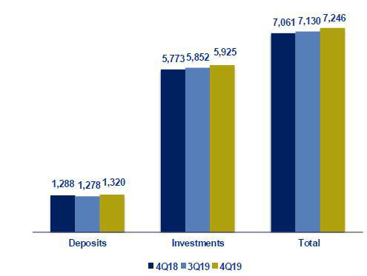

Portfolio distribution as of December 2019
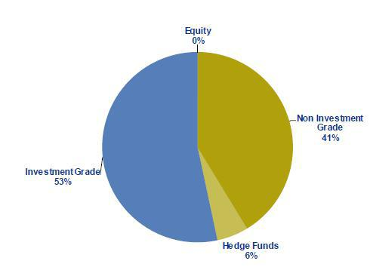

65

11.7. Grupo Pacifico

GRUPO PACIFICO *
(S/ in thousands )


 |  |  | As of |  |  |  | % change
 | Dic 18 |  | Sep 19 |  | Dic 19 |  | QoQ |  |  | YoY
Total assets | 12,223,495 |  | 13,640,680 |  | 13,838,009 |  | 1.4% |  |  | 13.2%
Invesment on securities ⁽¹⁾ | 8,921,449 |  | 10,331,786 |  | 10,758,564 |  | 4.1% |  |  | 20.6%
Technical reserves | 8,471,154 |  | 9,151,080 |  | 9,953,455 |  | 8.8% |  |  | 17.5%
Net equity | 2,614,480 |  | 3,423,666 |  | 2,801,556 |  | -18.2% |  |  | 7.2%


 | 4Q18 |  | Quarter |  | 4Q19 |  | % change |  |  | YoY |  | Year |  |  | 2019 |  | % change
 | 4Q18 |  | 3Q19 |  | 4Q19 |  | QoQ |  |  | YoY |  | 2018 |  |  | 2019 |  | 2019 / 2018
Net earned premiums | 536,901 |  | 615,145 |  | 630,804 |  | 2.5% |  |  | 17.5% |  | 2,100,348 |  |  | 2,427,437 |  | 15.6%
Net claims | 325,401 |  | 392,520 |  | 395,718 |  | 0.8% |  |  | 21.6% |  | 1,239,635 |  |  | 1,554,477 |  | 25.4%
Net fees | 147,799 |  | 147,821 |  | 152,229 |  | 3.0% |  |  | 3.0% |  | 572,556 |  |  | 572,914 |  | 0.1%
Net underwriting expenses | 23,312 |  | 30,293 |  | 26,644 |  | -12.0% |  |  | 14.3% |  | 118,556 |  |  | 127,710 |  | 7.7%
Underwriting result | 40,389 |  | 44,512 |  | 56,213 |  | 26.3% |  |  | 39.2% |  | 169,601 |  |  | 172,336 |  | 1.6%
Net financial income | 139,146 |  | 126,226 |  | 158,259 |  | 25.4% |  |  | 13.7% |  | 521,264 |  |  | 578,090 |  | 10.9%
Total expenses | 122,127 |  | 104,421 |  | 118,004 |  | 13.0% |  |  | -3.4% |  | 424,256 |  |  | 437,490 |  | 3.1%
Other income | 38,093 |  | 14,208 |  | 13,776 |  | -3.0% |  |  | -63.8% |  | 52,179 |  |  | 43,855 |  | -16.0%
Traslations results | -1,028 |  | 1,621 |  | -925 |  | -157.1% |  |  | -10.0% |  | 2,921 |  |  | -283 |  | -109.7%
Net gain on associates - EPS business and medical | 13,141 |  | 14,702 |  | 17,263 |  | 17.4% |  |  | 31.4% |  | 35,838 |  |  | 31,004 |  | -13.5%
Medical Assistance insurance deduction | 171 |  | 5,348 |  | 9,806 |  | 83.4% |  |  | N/A |  | 14,526 |  |  | 22,636 |  | 55.8%
Income tax | 689 |  | 1,491 |  | 1,654 |  | 10.9% |  |  | 140.1% |  | 4,256 |  |  | 6,021 |  | 41.5%
Income before minority interest | 106,755 |  | 90,008 |  | 115,121 |  | 27.9% |  |  | 7.8% |  | 353,292 |  |  | 381,492 |  | 8.0%
Non-controlling interest | 2,338 |  | 2,525 |  | 2,594 |  | 2.7% |  |  | 10.9% |  | 9,302 |  |  | 10,165 |  | 9.3%
Net income | 104,417 |  | 87,482 |  | 112,527 |  | 28.6% |  |  | 7.8% |  | 343,990 |  |  | 371,327 |  | 7.9%
Ratios
Ceded | 19.8% |  | 14.4% |  | 16.5% |  | 210 bps |  |  | -330 bps |  | 16.1% |  |  | 15.5% |  | -60 bps
Loss ratio ⁽²⁾ | 60.6% |  | 63.8% |  | 62.7% |  | -110 bps |  |  | 210 bps |  | 59.0% |  |  | 64.0% |  | 500 bps
Fees + underwriting expenses, net / net earned | 31.9% |  | 29.0% |  | 28.4% |  | -60 bps |  |  | -350 bps |  | 32.9% |  |  | 28.9% |  | -400 bps
Underwriting results / net earned premiums | 7.5% |  | 7.2% |  | 8.9% |  | 170 bps |  |  | 140 bps |  | 8.1% |  |  | 7.1% |  | -100 bps
Operating expenses / net earned premiums | 22.7% |  | 17.0% |  | 18.7% |  | 170 bps |  |  | -400 bps |  | 20.2% |  |  | 18.0% |  | -220 bps
_{ROAE}(3)(4) | 16.4% |  | 11.0% |  | 14.8% |  | 380 bps |  |  | -160 bps |  | 12.9% |  |  | 14.1% |  | 120 bps
Return on written premiums | 11.2% |  | 10.1% |  | 11.7% |  | 160 bps |  |  | 50 bps |  | 10.1% |  |  | 10.1% |  | 0 bps
Combined ratio of P&C ⁽⁵⁾ | 100.2% |  | 97.9% |  | 94.1% |  | -380 bps |  |  | -610 bps |  | 100.3% |  |  | 98.4% |  | -190 bps

*Financial statements without consolidation adjustments.
- Excluding investments in real estate.
- Net claims / Net earned premiums.
- Includes unrealized gains.
- Annualized and average are determined as the average of period beginning and period ending.
- (Net claims / Net earned premiums) + [(Acquisition cost + total expenses) / Net earned premiums].

From 1Q15 and on, Grupo Pacifico’s financial statements reflect the association with Banmedica. This partnership includes:

- the private health insurance business, which is managed by Grupo Pacifico and incorporated in each line of Grupo Pacifico’s financial statements;

- corporate health insurance for payroll employees; and

- medical services.

The businesses described in ii) and iii) are managed by Banmedica, therefore they do not consolidate in Grupo Pacifico’s financial statements. The 50% of net income generated by Banmedica is recorded in Grupo Pacifico’s Income Statement as a gain/loss on investments in subsidiaries.

As explained before, corporate health insurance and medical services businesses are consolidated by Banmedica. The following table reflects the consolidated results from which Grupo Pacifico receives the 50% net income.

66

Corporate Health Insurance and Medical Services

(S/ in thousands)

 |  | 4Q18 |  | Quarter |  | 4Q19 |  | % change |  |  | YoY |  | Year |  |  | 2019 |  | % change
 |  |  |  | 3Q19 |  |  |  | QoQ |  |  |  |  | 2018 |  |  | 2019 |  | 2019 / 2018
 | Results
 | Net earned premiums | 257,274 |  | 275,951 |  | 279,050 |  | 1.1% |  |  | 8.5% |  | 1,002,019 |  |  | 1,078,181 |  | 7.6%
 | Net claims | -224,156 |  | -233,949 |  | -228,400 |  | -2.4% |  |  | 1.9% |  | -848,003 |  |  | -921,650 |  | 8.7%
 | Net fees | -10,806 |  | -12,365 |  | -12,335 |  | -0.2% |  |  | 14.2% |  | -44,289 |  |  | -48,276 |  | 9.0%
 | Net underwriting expenses | -2,280 |  | -2,486 |  | -1,693 |  | -31.9% |  |  | -25.7% |  | -11,231 |  |  | -9,583 |  | -14.7%
 | Underwriting result | 20,032 |  | 27,151 |  | 36,622 |  | 34.9% |  |  | 82.8% |  | 98,496 |  |  | 98,673 |  | 0.2%
 | Net financial income | 1,396 |  | 1,612 |  | 1,573 |  | -2.4% |  |  | 12.7% |  | 4,985 |  |  | 5,760 |  | 15.6%
 | Total expenses | -20,204 |  | -18,352 |  | -20,715 |  | 12.9% |  |  | 2.5% |  | -74,902 |  |  | -74,806 |  | -0.1%
 | Other income | 5,174 |  | 251 |  | 905 |  | 260.1% |  |  | -82.5% |  | 5,223 |  |  | 2,789 |  | -46.6%
 | Traslations results | 40 |  | 1,030 |  | -716 |  | -169.5% |  |  | -1890.5% |  | 115 |  |  | 101 |  | -12.2%
 | Income tax | -1,497 |  | -3,716 |  | -5,804 |  | 56.2% |  |  | 287.6% |  | -10,538 |  |  | -10,575 |  | 0.4%
 | Net income before Medical services | 4,941 |  | 7,976 |  | 11,866 |  | 48.8% |  |  | 140.2% |  | 23,379 |  |  | 21,942 |  | -6.1%
 | Net income of Medical services | 21,261 |  | 21,341 |  | 22,577 |  | 5.8% |  |  | 6.2% |  | 77,027 |  |  | 85,009 |  | 10.4%
 | Net income | 26,202 |  | 29,317 |  | 34,443 |  | 17.5% |  |  | 31.5% |  | 100,405 |  |  | 106,951 |  | 6.5%

67

11.8. Prima AFP

 | 4Q18 |  | Quarter |  | 4Q19 |  | % change |  |  | YoY |  | Year |  | 2019 |  | % change
 | 4Q18 |  | 3Q19 |  | 4Q19 |  | QoQ |  |  | YoY |  | 2018 |  | 2019 |  | 2019 / 2018
Income from commissions | 94,082 |  | 97,099 |  | 100,567 |  | 3.6% |  |  | 6.9% |  | 379,720 |  | 403,289 |  | 6.2%
Administrative and sale expenses | (36,005) |  | (33,617) |  | (39,639) |  | 17.9% |  |  | 10.1% |  | -153,323 |  | -148,906 |  | -2.9%
Depreciation and amortization | (4,390) |  | (8,190) |  | (5,801) |  | -29.2% |  |  | 32.2% |  | -18,414 |  | -23,189 |  | 25.9%
Operating income | 53,687 |  | 55,292 |  | 55,126 |  | -0.3% |  |  | 2.7% |  | 207,983 |  | 231,195 |  | 11.2%
Other income and expenses, net
(profitability of lace) | (6,146) |  | 4,500 |  | 8,991 |  | 99.8% |  |  | -246.3% |  | -1,366 |  | 39,311 |  | -2977.3%
Income tax | (16,980) |  | (17,097) |  | (17,415) |  | 1.9% |  |  | 2.6% |  | -66,712 |  | -73,836 |  | 10.7%
Net income before translation | 30,561 |  | 42,695 |  | 46,703 |  | 9.4% |  |  | 52.8% |  | 139,905 |  | 196,670 |  | 40.6%
results
Translations results | (90) |  | (301) |  | 125 |  | -141.6% |  |  | -239.6% |  | -319 |  | -81 |  | -74.7%
Net income | 30,471 |  | 42,394 |  | 46,828 |  | 10.5% |  |  | 53.7% |  | 139,586 |  | 196,589 |  | 40.8%
ROAE | 19.4% |  | 26.0% |  | 27.3% |  | 129 pbs |  |  | 793 pbs |  | 22.3% |  | 29.5% |  | 724 pbs
 |  |  | As of |  |  |  | % change
 | 4Q18 |  | 3Q19 |  | 4Q19 |  | QoQ |  |  | YoY
Total assets | 874,649 |  | 937,573 |  | 982,591 |  | 4.8% |  |  | 12.3%
Total liabilities | 241,307 |  | 265,447 |  | 284,643 |  | 7.2% |  |  | 18.0%
Net shareholders’ equity ⁽¹⁾ | 633,342 |  | 672,126 |  | 697,948 |  | 3.8% |  |  | 10.2%

(1) Net shareholders' equity includes unrealized gains from Prima's investment portfolio.

Funds under management
Funds under management |  | Sep 19 |  | % share |  | Dec 19 |  | % share
Fund 0 |  | 713 |  | 1.4% |  | 751 |  | 1.4%
Fund 1 |  | 6,091 |  | 11.6% |  | 6,418 |  | 11.8%
Fund 2 |  | 39,303 |  | 74.8% |  | 40,657 |  | 75.0%
Fund 3 |  | 6,460 |  | 12.3% |  | 6,385 |  | 11.8%
Total S/ Millions |  | 52,566 |  | 100% |  | 54,211 |  | 100%

Source: SBS
Nominal profitability over the last 12 months
 |  | Sep 19 / Sep 18 |  | Dec 19 / Dec 18
Fund 0
Fund 0 |  | 4.2% |  | 4.4%
Fund 1 | 12.0% |  |  | 15.3%
Fund 2 | 7.5% |  |  | 13.1%
Fund 3 | -0.8% |  |  | 5.7%

AFP fees

Fee based on flow | 1.60%
Mixed fee
Flow | 0.18%
Balance | 1.25%
Main indicators

Applied to the affiliates’ monthly remuneration.

Applied to the affiliates’ monthly remuneration since June 2017. Feb 17- may 17 =0.87%.

Applies annualy to the new balance since February 2013 for new affiliates to the system and beginning on June 2013 for old affiliates who have chosen this commission scheme.

 |  | Prima |  | System |  | % share |  | Prima |  | System |  | % share
Main indicators and market share |  | 3Q19 |  | 3Q19 |  | 3Q19 |  | 4Q19 |  | 4Q19 |  | 4Q19
Affiliates |  | 2,343,978 |  | 7,331,986 |  | 32.0% |  | 2,355,005 |  | 7,426,667 |  | 31.7%
New affiliations ⁽¹⁾ |  | - |  | 112,487 |  | 0.0% |  | - |  | 111,398 |  | 0.0%
Funds under management (S/ Millions) |  | 52,566 |  | 169,231 |  | 31.1% |  | 54,211 |  | 174,823 |  | 31.0%
Collections (S/ Millions) ⁽²⁾ |  | 967 |  | 2,898 |  | 33.4% |  | 661 |  | 1,982 |  | 33.3%
Voluntary contributions (S/ Millions) ⁽³⁾ |  | 1,026 |  | 2,112 |  | 48.6% |  | 1,064 |  | 2,213 |  | 48.1%
RAM (S/ Millions) ⁽⁴⁾ |  | 2,847 |  | 7,310 |  | 38.1% |  | 2,892 |  | 7,418 |  | 39.0%

Source: SBS

- As of June 2019, another AFP has the exclusivity of affiliations.

- Information available to November.

- Information available to November.

- Prima AFP estimate: Average of aggregated income during the last 4 months, excluding special collections and voluntary contribution fees. Information available to November.

68

11.9. Table of calculations
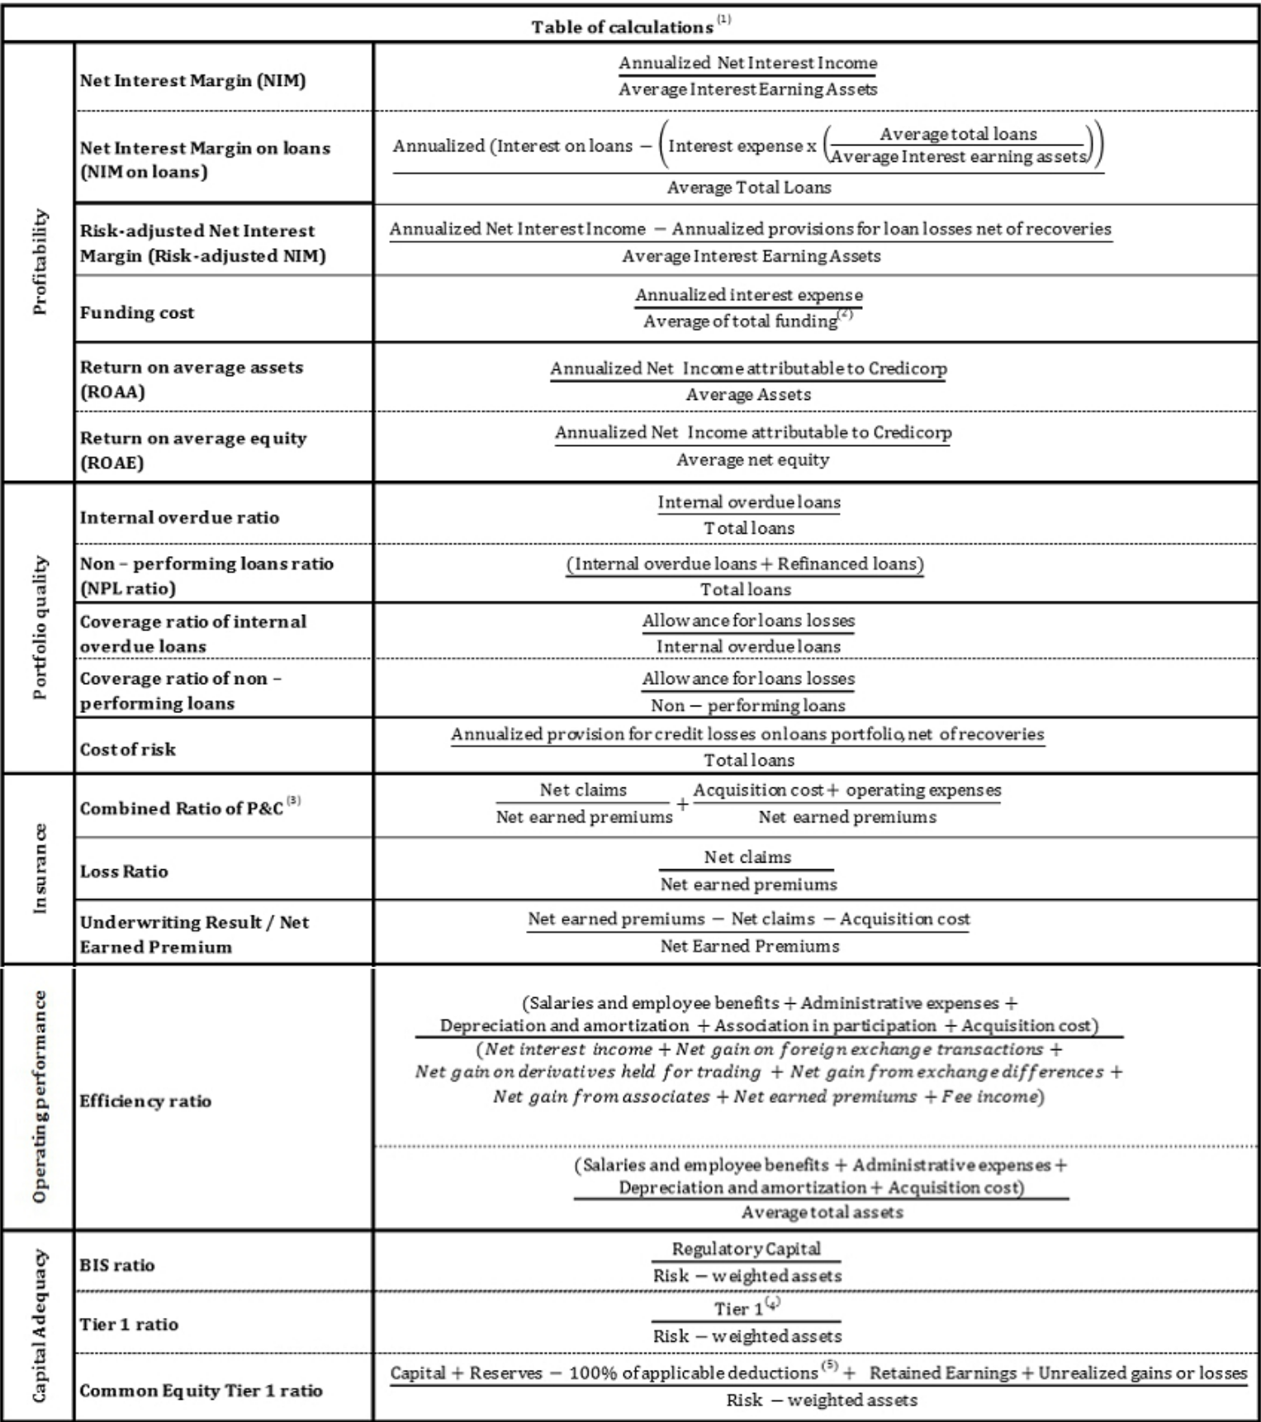

- Averages are determined as the average of period-beginning and period-ending balances.

- Includes total deposits, due to banks and correspondents, BCRP instruments, repurchase agreements and bonds and notes issued.

- Does not include Life insurance business.

- Tier 1 = Capital + Legal and other capital reserves + Accumulated earnings with capitalization agreement + (0.5 x Unrealized profit and net income in subsidiaries) - Goodwill - (0.5 x Investment in subsidiaries) + Perpetual subordinated debt (maximum amount that can be included is 17.65% of Capital + Reserves + Accumulated earnings with capitalization agreement + Unrealized profit and net income in subsidiaries - Goodwill).
- Includes investment in subsidiaries, goodwill, intangibles and deferred tax that rely on future profitability.

69

