SECURITIES AND EXCHANGE COMMISSION

Washington, D.C. 20549

FORM 6-K

Report of Foreign Private Issuer

Pursuant to Rule 13a-16 or 15d-16 under the

Securities Exchange Act of 1934

For the month of July 2024

Commission File Number: 001-14014

CREDICORP LTD.

(Translation of registrant’s name into English)

Of our subsidiary

Banco de Credito del Peru:

Calle Centenario 156

La Molina

Lima 12, Peru

(Address of principal executive office)

Indicate by check mark whether the registrant files or will file annual reports under cover of Form 20-F or Form 40-F.

Form 20-F ☒ Form 40-F☐

Indicate by check mark if the registrant is submitting the Form 6-K in paper as permitted by Regulation S-T Rule 101(b)(1): ____

Indicate by check mark if the registrant is submitting the Form 6-K in paper as permitted by Regulation S-T Rule 101(b)(7): ____

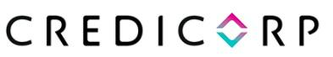
July 4, 2024

Securities and Exchange Commission - SEC

Re.: MATERIAL EVENT

Dear Sirs:

We hereby notify you as a Material Event that on July 4, 2024, S&P Global Ratings published the credit rating report for Credicorp Ltd. (Credicorp), affirming Credicorp’s credit rating at ‘BBB-’ and maintaining its stable outlook.

The information in this Form 6-K regarding the rating of S&P Global Ratings has been disclosed in Peru in conformity with Peruvian law (Article 30 of the Capital Markets Law, approved by Supreme Decree 020-2023-EF, and by the Regulation of the Disclosure of Material Events and Reserved Information approved by Resolution 005-2014-SMV/01 of the Peruvian Capital Markets Superintendency). The ratings of S&P Global Ratings do not necessarily represent the opinion of Credicorp, nor should they be seen as a recommendation to buy shares or any other securities of Credicorp. Credicorp accepts no liability for the completeness, timeliness, accuracy or selection of such information.

The information in this Form 6-K (including any exhibit hereto) shall not be deemed “filed” for purposes of Section 18 of the Securities Exchange Act of 1934 (the ‘Exchange Act’) or otherwise subject to the liabilities of that section, nor shall it be deemed incorporated by reference in any filing under the Securities Act of 1933 or the Exchange Act.

Sincerely,

/s/ Guillermo Morales

Authorized Representative

Credicorp Ltd.

SIGNATURE

Pursuant to the requirements of the Securities Exchange Act of 1934, the registrant has duly caused this report to be signed on its behalf by the undersigned, thereunto duly authorized.

Date: July 4, 2024

CREDICORP LTD.

(Registrant)

By: /s/ Guillermo Morales

Guillermo Morales

Authorized Representative

Exhibit 99.1
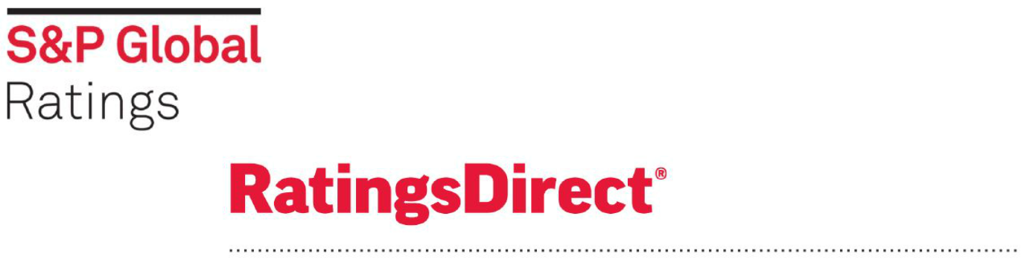

Credicorp Ltd.

Primary Credit Analyst:

Camilo Andres Perez, Mexico City + 52 55 5081 4446; camilo.perez@spglobal.com

Secondary Contact:

Ivana L Recalde, Buenos Aires + 54 11 4891 2127; ivana.recalde@spglobal.com

Table Of Contents

Ratings Score Snapshot

Credit Highlights

Outlook

Key Metrics

Anchor: ‘bbb-’ For Financial Institutions Operating In Peru

Business Position: Largest Financial Group In Peru

Capital And Earnings: Adequate Capitalization To Support Business

Strategy

Risk Position: Diversified Business Mix

Funding And Liquidity: Stable Funding Base And Healthy Liquidity

Support: No Uplift To The Group Credit Profile

Environmental, Social, And Governance

Key Statistics

Related Criteria

Related Research

WWW.STANDARDANDPOORS.COM/RATINGSDIRECT JULY 4, 2024 1

Credicorp Ltd.

Ratings Score Snapshot
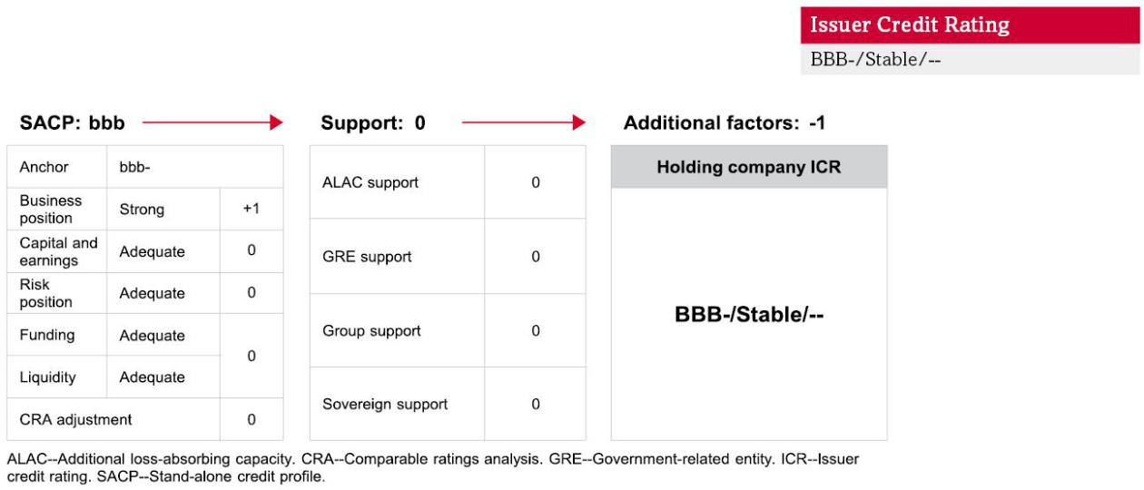

Credit Highlights

Overview

Key strengths | Key risks
High-quality and diverse asset base with dominant positions in most business segments. | Complex political landscape dents short- to medium-term economic growth in Peru, affecting
 | business conditions.
Sufficient liquidity at the holding company to meet obligations, limiting dependence on
dividends from operating subsidiaries.

Credicorp has investments in multiple large assets in the financial industry in Peru and some presence in other Latin American countries. The rating on the Bermuda-based nonoperating holding company (NOHC) incorporates the Credicorp group’s leading position in Peru’s financial industry, business diversification, steady earnings, adequate capitalization, manageable credit risks, diverse and stable funding base, and good liquidity coverage.

Our rating on Peru influences the creditworthiness of companies in the domestic financial sector, including Credicorp. Our foreign currency sovereign credit rating (BBB-/Stable/A-3) limits the group credit profile on Credicorp because we don’t think such a local entity could withstand a sovereign default scenario, given large asset exposure to the country.

WWW.STANDARDANDPOORS.COM/RATINGSDIRECT JULY 4, 2024 2

Credicorp Ltd.

Credicorp’s substantial liquid assets allow it to meet its financial obligations without depending on dividend streams, which mainly come from highly regulated entities. Therefore, we believe a hypothetical suspension of dividend flow from operating subsidiaries wouldn’t compromise the NOHC’s ability to honor its obligations. We expect Credicorp to have sufficient resources to repay its only debt issuance, which will come due June 2025. Its liquid assets, mainly cash and short-term investments in high-quality assets, cover its outstanding financial liabilities by 1.4x. This sound liquidity is also a cushion to cover hypothetical contingencies or capital needs at the operating subsidiaries.
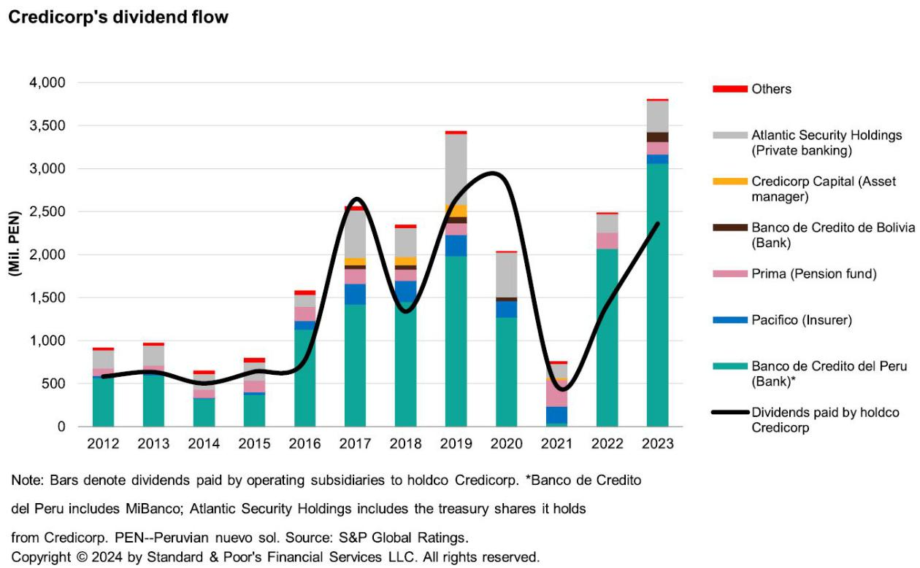

WWW.STANDARDANDPOORS.COM/RATINGSDIRECT JULY 4, 2024 3

Credicorp Ltd.

Outlook


The stable rating outlook on Credicorp for the next two years reflects that on Peru, which will continue influencing the group’s credit fundamentals. Credicorp receives a substantial portion of dividends from its Peruvian operations across various financial segments. In addition, the holding company has substantial liquid assets that would ensure debt service coverage even in a scenario of low or no dividends.

The stable outlook also indicates the resilience of the group’s largest subsidiary, Banco de Credito del Peru, which we don’t expect to downgrade unless its stand-alone credit profile falls below ‘bbb-’, which is unlikely.

Downside scenario

A downgrade of Peru could trigger a similar action on Credicorp. We could also lower the rating on Credicorp if its liquidity decreases and challenging business conditions significantly weaken dividends received.

Upside scenario

We could upgrade Credicorp if we were to take a similar action on the sovereign while the group’s intrinsic credit fundamentals remain unchanged.

Outlook

Key Metrics

Credicorp Ltd.--Key ratios and forecasts

 |  |  | --Fiscal year ended Dec. 31 --
(%)
(%) |  | 2021a | 2022a | 2023a | 2024f | 2025f
Growth in customer loans |  | 7.2 | 0.7 | (2.5) | 4.0-6.0 | 6.0-10.0
Net interest income/average earning assets (NIM) |  | 4.6 | 5.7 | 6.6 | 6.2-6.6 | 5.7-6.3
Return on average common equity |  | 13.9 | 16.7 | 15.8 | 15.0-16.0 | 13.0-15.0
New loan loss provisions/average customer loans |  | 0.8 | 1.2 | 2.5 | 2.0-2.3 | 1.6-2.0
Gross nonperforming assets/customer loans |  | 3.9 | 4.1 | 4.3 | 4.0-4.4 | 3.8-4.2
Risk-adjusted capital ratio |  | 8.7 | 9.0 | 9.7 | 9.8-10.0 | 9.6-10.2
All figures are S&P Global Ratings-adjusted. a--Actual. f--Forecast. NIM-- |  | Net interest margin.

Anchor: ‘bbb-’ For Financial Institutions Operating In Peru

Our bank criteria use our Banking Industry Country Risk Assessment’s economic risk and industry risk scores to determine a bank’s anchor, the starting point in assigning an issuer credit rating. Our anchor for a financial entity operating in Peru (where Credicorp mostly operates) is ‘bbb-’. (See “Banking Industry Country Risk Assessment: Peru,” Nov. 30, 2023.)

WWW.STANDARDANDPOORS.COM/RATINGSDIRECT JULY 4, 2024 4

Credicorp Ltd.

Business Position: Largest Financial Group In Peru

Credicorp’s solid business reflects its leading position in Peru’s financial sector, primarily through its largest subsidiary, Banco de Credito del Peru (BCP; BBB-/Stable/A-3), which owns MiBanco Banco de la Microempresa S.A. (BBB-/Stable/A-3). In addition, the group has presences in the insurance and pension funds industries through Pacifico Seguros and Prima AFP (both not rated). The company also has asset management and wealth management operations in Peru and other countries in the region through Credicorp Capital (not rated), as well as smaller banking operations including ASB Bank Corp. (BB+/Stable/B) and Banco de Credito de Bolivia (not rated).

BCP has made up 75%-80% of Credicorp’s earnings and dividends in recent years, while insurance and pension fund business have made up 10%-20% and banking operations in other jurisdictions and Credicorp Capital the rest. BCP, which has diversified operations across all retail and wholesale segments, is the leading bank in Peru, with a lending market share of about 37% including its microlender subsidiary, MiBanco. These factors confer stability to the bank’s business and dividend flows to Credicorp.

The group’s other businesses also have strong market presences:

- Pacifico Seguros is the second-largest insurance player in Peru, with a leading position in the health industry (43% of premiums) and the second position in the life (27% of premiums) and property/casualty segments (21% of premiums).

- Prima AFP is the second-largest player in Peru’s pension industry, with a 30% share in assets under management.

- Credicorp Capital has a wide presence in the asset management and wealth management segments, with a leading position in Peru’s brokerage and mutual funds market. It offers alternative investments, offshore platforms, and structured products.

- Among the group’s foreign operations, the main operation is BCP Bolivia, which is the sixth-largest bank in the country.

The group continues to invest in digital initiatives and fintech ventures across the Andean region. These have been embedded into different business units to complement product offerings and support Credicorp’s competitiveness. For example, Yape, a payment platform with 15 million total users (and 11.5 million active users), has been increasing its functionalities and supplementing the group’s banking and insurance products.

Other ongoing digital initiatives in domains such as payments, neobanks, insurtech, and others complement current businesses. We expect investment flows to continue in the coming years, supporting the group’s adaptability and competitive position amid rapid disruptive changes in the financial industry.

Credicorp’s results and dividend flows have recovered to pre-pandemic levels thanks to the increase in net interest margins amid higher interest rates, which has supported higher income from both the loan and investment portfolios. Better insurance underwriting results have also boosted earnings in recent years.

BCP’s funding structure, heavily composed of low-cost transactional deposits, has helped contain funding costs amid the high interest rates. On the other hand, the rising cost of risk--due to increased credit risks amid challenging economic conditions--somewhat limited earnings last year.

WWW.STANDARDANDPOORS.COM/RATINGSDIRECT JULY 4, 2024 5

Credicorp Ltd.

Credicorp’s return on average equity dipped to 15.8% in 2023 from 16.7% in 2022. We expect good profitability to continue in 2024, mainly because interest rates should remain relatively high during the year.

Capital And Earnings: Adequate Capitalization To Support Business Strategy

We consider Credicorp’s capitalization metrics commensurate with its business strategy. We expect its risk-adjusted capital ratio (calculated according to our methodology) to be roughly 9.9% in 2024-2025, slightly above the 9.7% at the end of 2023, thanks to its main operating subsidiaries’ improving capacity to build earnings. Good capital buffers would allow the group to weather a potential deterioration of the Peruvian banking industry.

Our base case considers the following:

- Peru’s GDP growth of about 2.7% in 2024 and 3.0% in 2025.

- Average monetary policy rate of 5.0% in 2024 and 4.0% in 2025.

- Annual loan portfolio growth of about 5% in 2024 and 8% in 2025, with focus on small and midsize enterprise and consumer lending.

- Resilient net interest margins in 2024 but somewhat lower ones in 2025.

- Cost of risk of about 2%-2.5% of total loans amid lower credit risks.

- Nonperforming loan ratios above pre-pandemic levels, though declining somewhat amid better macroeconomic prospects.

- Continued investment in digital initiatives.

- Dividend distributions from Credicorp to its shareholders of 50%-70% of results but with flexibility to reduce them if needed, as in 2021.

Credicorp has good regulatory capital metrics, with total regulatory capital at 1.3x the minimum requirement.

Risk Position: Diversified Business Mix

Credicorp has good business diversification, conservative growth strategies, and manageable credit risks, in our view. Meanwhile, BCP’s banking operations focus on lending, with no relevant concentrations among economic sectors or customers.

Although dollarization in the Peruvian financial system has fallen in the past decade thanks to the central bank’s measures, it remains high at about 30% of total loans, similar to Credicorp’s 35%. And as in the whole Peruvian banking industry, Credicorp’s asset quality remains strained due to the challenging macroeconomic scenario last year in Peru, stemming from volatile political conditions and adverse climate events that particularly hurt the quality of microcredits, loans to small and midsize enterprises, and consumer credits in the middle- to low-income segments.

WWW.STANDARDANDPOORS.COM/RATINGSDIRECT JULY 4, 2024 6

Credicorp Ltd.

Our base-case scenario assumes better domestic economic conditions and bank subsidiaries’ recent improvements to their new loan originations will help keep asset quality manageable in 2024-2025. However, we will monitor latent credit risks that could arise from continued political uncertainty and climate events in Peru.

Funding And Liquidity: Stable Funding Base And Healthy Liquidity

We consider the group’s funding structure and liquidity adequate, in line with our view of BCP’s funding and liquidity. Credicorp’s stable funding ratio has averaged 113% in the past three years, and broad liquid assets to short-term wholesale funding averaged 2.4x (according to S&P Global Ratings’ calculations).

Customer deposits make up roughly 80% of Credicorp’s consolidated funding base, and half are retail deposits, which we deem more stable during times of market distress. The funding base also includes interbank credit lines, market debt, and central bank repurchase agreements.

The NOHC’s substantial liquidity support its creditworthiness. We expect the company will maintain high liquid unencumbered assets to meet its financial obligations on its own. In 2020, Credicorp issued $500 million, which matures June 2025, to enhance the cash cushion for potential contingencies. Its double leverage remains adequate at about 100%.

Support: No Uplift To The Group Credit Profile

Credicorp is 12.2% owned by the Romero family (based on floating shares), and the rest is held by private and institutional investors. Because of this, we base our rating on Credicorp on its own credit quality, excluding parental support.

Despite the relevance of banking operations, our rating on Credicorp doesn’t include potential extraordinary government support. Although BCP would receive support, given its high systemic importance in Peru, we don’t expect such support would be extended to the holding company.

Environmental, Social, And Governance

Environmental, social, and governance (ESG) factors have no material influence on our credit rating analysis of Credicorp, as with industry and domestic peers. Peru is somewhat exposed to natural disasters such as earthquakes, volcanic activity, landslides, and the El Niño climate pattern. However, Credicorp, like other domestic financial entities, has been able to keep credit and operating losses moderate during such conditions.

In addition, the group has low exposure to the agricultural sector, which is vulnerable to these conditions. However, the Peruvian economy depends to some extent on the commodity metals sector, which domestic banks generally don’t directly finance. Still, banks are indirectly exposed to the agricultural and metals sectors through the whole supply chain (suppliers, subcontractors, and employees who are also retail clients).

WWW.STANDARDANDPOORS.COM/RATINGSDIRECT JULY 4, 2024 7

Credicorp Ltd.

Key Statistics

Table 1

Credicorp Ltd.--Key figures

 |  |  | --Year ended Dec. 31--
(Mil. PEN) |  | 2023 | 2022 |  | 2021 |  | 2020 |  |  | 2019
Adjusted assets |  | 236,216.8 | 233,854.2 |  | 242,111.9 |  | 234,766.9 |  | 185,324.4
Customer loans (gross) |  | 144,976.1 | 148,626.4 |  | 147,597.4 |  | 137,659.9 |  | 115,609.7
Adjusted common equity |  | 27,628.8 | 25,774.6 |  | 21,966.6 |  | 17,292.3 |  |  | 19,597.1
Operating revenues |  | 19,732.9 | 17,288.0 |  | 14,285.1 |  | 13,335.7 |  |  | 14,487.8
Noninterest expenses |  | 9,262.3 | 8,620.6 |  | 7,740.1 |  | 7,127.0 |  |  | 6,666.5
Core earnings |  | 4,959.9 | 4,745.4 |  | 3,671.8 |  | 398.1 |  |  | 4,352.3
PEN--PEN-Peruvian nuevo sol.
Table 2
Credicorp Ltd.--Business position
 |  |  |  |  |  |  |  |  | --Year ended Dec. 31--
(%)
(%) |  |  |  |  |  |  | 2023 |  |  | 2022 |  | 2021 | 2020 |  | 2019
Total revenues from business line (currency in millions) |  |  |  |  |  |  | 19,732.9 | 17,288.0 |  |  | 14,285.1 |  | 13,335.7 |  | 14,487.8
Commercial & retail banking/total revenues from business line |  |  |  |  |  |  | 81.2 |  |  | 81.2 |  | 84.4 | 83.1 |  | 85.2
Corporate finance/total revenues from business line |  |  |  |  |  |  | 4.7 |  |  | 4.7 |  | 6.0 | 7.4 |  | 6.6
Insurance activities/total revenues from business line |  |  |  |  |  |  | 5.7 |  |  | 5.7 |  | 5.9 | 8.5 |  | 5.8
Asset management/total revenues from business line |  |  |  |  |  |  | 8.4 |  |  | 8.4 |  | 2.8 | 2.8 |  | 3.1
Investment banking/total revenues from business line |  |  |  |  |  |  | 4.7 |  |  | 4.7 |  | 6.0 | 7.4 |  | 6.6
Return on average common equity |  |  |  |  |  |  | 15.8 |  |  | 16.7 |  | 13.9 | 1.4 |  | 17.0
Table 3
Credicorp Ltd.--Capital and earnings
 |  |  |  |  |  | --Year ended Dec. 31--
(%)
(%) |  |  |  |  | 2023 |  | 2022 | 2021 |  | 2020 |  | 2019
Adjusted common equity/total adjusted capital |  |  |  |  | 100.0 |  | 100.0 | 100.0 |  | 100.0 |  | 100.0
Net interest income/operating revenues |  |  |  |  | 67.9 |  | 66.6 | 65.5 |  | 64.3 |  | 62.7
Fee income/operating revenues |  |  |  |  | 19.3 |  | 21.1 | 24.5 |  | 21.8 |  | 22.3
Market-sensitive income/operating revenues |  |  |  |  | 6.9 |  | 6.7 | 7.9 |  |  | 8.9 | 9.0
Cost to income ratio |  |  |  |  | 46.9 |  | 49.9 | 54.2 |  | 53.4 |  | 46.0
Preprovision operating income/average assets |  |  |  |  | 4.4 |  | 3.6 | 2.7 |  |  | 2.9 | 4.3
Core earnings/average managed assets |  |  |  |  | 2.1 |  | 2.0 | 1.5 |  |  | 0.2 | 2.4
WWW.STANDARDANDPOORS.COM/RATINGSDIRECT |  |  |  |  |  |  |  |  |  |  |  |  |  |  |  | JULY 4, 2024 8

Credicorp Ltd.

Table 4

Credicorp Ltd.--Risk position

 |  |  |  |  | --Year ended Dec. 31--
(%) |  |  |  | 2023 | 2022 | 2021 | 2020 | 2019
Growth in customer loans |  |  |  | (2.5) | 0.7 | 7.2 | 19.1 | 4.4
Total managed assets/adjusted common equity (x) |  |  |  | 8.6 | 9.2 | 11.1 | 13.7 | 9.6
New loan loss provisions/average customer loans |  |  |  | 2.5 | 1.2 | 0.8 | 4.7 | 1.6
Net charge-offs/average customer loans |  |  |  | 2.0 | 1.5 | 1.8 | 0.8 | 1.4
Gross nonperforming assets/customer loans + other real estate owned |  |  |  | 4.3 | 4.1 | 3.9 | 3.5 | 3.0
Loan loss reserves/gross nonperforming assets |  |  |  | 132.6 | 128.8 | 148.8 | 205.3 | 148.6
Table 5
Credicorp Ltd.--Funding and liquidity
 |  | --Year ended Dec. 31--
(%)
(%) | 2023 | 2022 |  | 2021 | 2020 | 2019
Core deposits/funding base | 79.5 | 78.5 |  | 76.0 | 73.5 | 77.3
Customer loans (net)/customer deposits | 92.5 | 95.8 |  | 92.5 | 89.7 | 98.6
Long-term funding ratio | 85.3 | 86.1 |  | 89.5 | 86.5 | 90.9
Stable funding ratio | 113.4 | 110.8 |  | 110.4 | 115.7 | 114.3
Short-term wholesale funding/funding base | 17.1 | 15.8 |  | 11.8 | 15.1 | 10.6
Broad liquid assets/short-term wholesale funding (x) | 2.3 | 2.3 |  | 2.6 | 2.5 | 3.3
Broad liquid assets/total assets | 30.8 | 28.4 |  | 25.2 | 30.6 | 27.1
Broad liquid assets/customer deposits | 49.8 | 45.7 |  | 41.0 | 51.1 | 45.4
Net broad liquid assets/short-term customer deposits | 35.3 | 31.9 |  | 31.8 | 51.9 | 53.8
Short-term wholesale funding/total wholesale funding | 83.5 | 73.8 |  | 49.3 | 56.8 | 46.8
Credicorp Ltd.--Rating component scores
Holding company issuer credit rating | BBB-/Stable/--
SACP | bbb
Anchor | bbb-
Business position | Strong
Capital and earnings | Adequate
Risk position | Adequate
Funding | Adequate
Liquidity | Adequate
Comparable ratings analysis | 0
Support | 0
ALAC support | 0
GRE support | 0
Group support | 0
Sovereign support | 0
Additional factors | -1
ALAC--Additional loss-absorbing capacity. GRE--Government-related entity. SACP--Stand-alone credit profile.
WWW.STANDARDANDPOORS.COM/RATINGSDIRECT |  |  |  |  |  |  |  |  |  | JULY 4, 2024 9

Credicorp Ltd.

Related Criteria

- General Criteria: Hybrid Capital: Methodology And Assumptions, March 2, 2022

- Criteria | Financial Institutions | Banks: Banking Industry Country Risk Assessment Methodology And Assumptions, Dec. 9, 2021

- Criteria | Financial Institutions | General: Financial Institutions Rating Methodology, Dec. 9, 2021

- General Criteria: Environmental, Social, And Governance Principles In Credit Ratings, Oct. 10, 2021

- General Criteria: Group Rating Methodology, July 1, 2019

- Criteria | Financial Institutions | General: Risk-Adjusted Capital Framework Methodology, July 20, 2017

- General Criteria: Ratings Above The Sovereign--Corporate And Government Ratings: Methodology And Assumptions, Nov. 19, 2013

- General Criteria: Principles Of Credit Ratings, Feb. 16, 2011

Related Research

• Six Peruvian Financial Institutions Downgraded Following Same Action On Peru; Outlooks Stable, April 26, 2024

Ratings Detail (As Of July 4, 2024)*


Credicorp Ltd.

Issuer Credit Rating | BBB-/Stable/--
Senior Unsecured | BBB-
Issuer Credit Ratings History
26-Apr-2024 | BBB-/Stable/--
15-Oct-2021 | BBB/Negative/--
08-Jun-2020 | BBB/Stable/--
Sovereign Rating
Bermuda | A+/Stable/A-1
Related Entities
ASB Bank Corp.
Issuer Credit Rating | BB+/Stable/B
Banco de Credito del Peru
Issuer Credit Rating | BBB-/Stable/A-3
Senior Unsecured | BBB-
Subordinated | BB+
Banco de Credito del Peru, Panama Branch
Subordinated | BB+
MiBanco Banco de La Microempresa S.A.
Issuer Credit Rating | BBB-/Stable/A-3

*Unless otherwise noted, all ratings in this report are global scale ratings. S&P Global Ratings’ credit ratings on the global scale are comparable across countries. S&P Global Ratings’ credit ratings on a national scale are relative to obligors or obligations within that specific country. Issue and debt ratings could include debt guaranteed by another entity, and rated debt that an entity guarantees.

WWW.STANDARDANDPOORS.COM/RATINGSDIRECT JULY 4, 2024 10

Copyright © 2024 by Standard & Poor’s Financial Services LLC. All rights reserved.

No content (including ratings, credit-related analyses and data, valuations, model, software or other application or output therefrom) or any part thereof (Content) may be modified, reverse engineered, reproduced or distributed in any form by any means, or stored in a database or retrieval system, without the prior written permission of Standard & Poor’s Financial Services LLC or its affiliates (collectively, S&P). The Content shall not be used for any unlawful or unauthorized purposes. S&P and any third-party providers, as well as their directors, officers, shareholders, employees or agents (collectively S&P Parties) do not guarantee the accuracy, completeness, timeliness or availability of the Content. S&P Parties are not responsible for any errors or omissions (negligent or otherwise), regardless of the cause, for the results obtained from the use of the Content, or for the security or maintenance of any data input by the user. The Content is provided on an “as is” basis. S&P PARTIES DISCLAIM ANY AND ALL EXPRESS OR IMPLIED WARRANTIES, INCLUDING, BUT NOT LIMITED TO, ANY WARRANTIES OF MERCHANTABILITY OR FITNESS FOR A PARTICULAR PURPOSE OR USE, FREEDOM FROM BUGS, SOFTWARE ERRORS OR DEFECTS, THAT THE CONTENT’S FUNCTIONING WILL BE UNINTERRUPTED OR THAT THE CONTENT WILL OPERATE WITH ANY SOFTWARE OR HARDWARE CONFIGURATION. In no event shall S&P Parties be liable to any party for any direct, indirect, incidental, exemplary, compensatory, punitive, special or consequential damages, costs, expenses, legal fees, or losses (including, without limitation, lost income or lost profits and opportunity costs or losses caused by negligence) in connection with any use of the Content even if advised of the possibility of such damages.

Credit-related and other analyses, including ratings, and statements in the Content are statements of opinion as of the date they are expressed and not statements of fact. S&P’s opinions, analyses and rating acknowledgment decisions (described below) are not recommendations to purchase, hold, or sell any securities or to make any investment decisions, and do not address the suitability of any security. S&P assumes no obligation to update the Content following publication in any form or format. The Content should not be relied on and is not a substitute for the skill, judgment and experience of the user, its management, employees, advisors and/or clients when making investment and other business decisions. S&P does not act as a fiduciary or an investment advisor except where registered as such. While S&P has obtained information from sources it believes to be reliable, S&P does not perform an audit and undertakes no duty of due diligence or independent verification of any information it receives. Rating-related publications may be published for a variety of reasons that are not necessarily dependent on action by rating committees, including, but not limited to, the publication of a periodic update on a credit rating and related analyses.

To the extent that regulatory authorities allow a rating agency to acknowledge in one jurisdiction a rating issued in another jurisdiction for certain regulatory purposes, S&P reserves the right to assign, withdraw or suspend such acknowledgment at any time and in its sole discretion. S&P Parties disclaim any duty whatsoever arising out of the assignment, withdrawal or suspension of an acknowledgment as well as any liability for any damage alleged to have been suffered on account thereof.

S&P keeps certain activities of its business units separate from each other in order to preserve the independence and objectivity of their respective activities. As a result, certain business units of S&P may have information that is not available to other S&P business units. S&P has established policies and procedures to maintain the confidentiality of certain non-public information received in connection with each analytical process.

S&P may receive compensation for its ratings and certain analyses, normally from issuers or underwriters of securities or from obligors. S&P reserves the right to disseminate its opinions and analyses. S&P’s public ratings and analyses are made available on its Web sites, www.spglobal.com/ratings (free of charge), and www.ratingsdirect.com (subscription), and may be distributed through other means, including via S&P publications and third-party redistributors. Additional information about our ratings fees is available at www.spglobal.com/usratingsfees.

STANDARD & POOR’S, S&P and RATINGSDIRECT are registered trademarks of Standard & Poor’s Financial Services LLC.

WWW.STANDARDANDPOORS.COM/RATINGSDIRECT JULY 4, 2024 11

