UNITED STATES

SECURITIES AND EXCHANGE COMMISSION

Washington, D.C. 20549

FORM 6-K

Report of Foreign Private Issuer

Pursuant to Rule 13a-16 or 15d-16 under the
Securities Exchange Act of 1934

For the month of November 2025

Commission File Number: 001-14014

CREDICORP LTD.

(Translation of registrant’s name into English)

Of our subsidiary

Banco de Credito del Peru:
Calle Centenario 156
La Molina 15026
Lima, Peru
(Address of principal executive office)

Indicate by check mark whether the registrant files or will file annual reports under cover of Form 20-F or Form 40-F.

Form 20-F ☒ Form 40-F ☐

The information in this Form 6-K (including any exhibit hereto) shall not be deemed “filed” for purposes of Section 18 of the Securities Exchange Act of 1934 (the “Exchange Act”) or otherwise subject to the liabilities of that section, nor shall it be deemed incorporated by reference in any filing under the Securities Act of 1933 or the Exchange Act.

SIGNATURE

Pursuant to the requirements of the Securities Exchange Act of 1934, the registrant has duly caused this report to be signed on its behalf by the undersigned, thereunto duly authorized.

Date: November 17, 2025

CREDICORP LTD.

(Registrant)

By: /s/ Milagros Cigüeñas
Milagros Cigüeñas

Authorized Representative

Exhibit 99.1
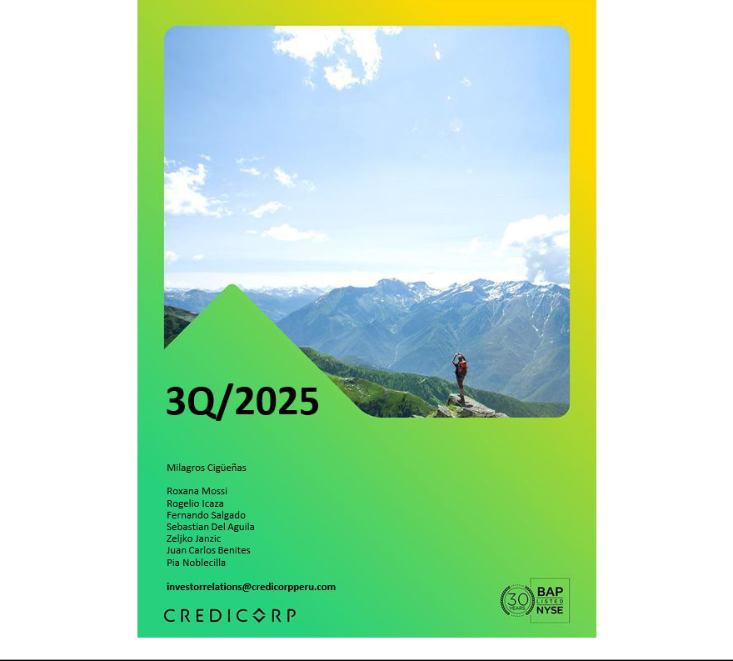

| Earnings Release 3Q / 2025 Analysis of 3Q25 Consolidated Results

Table of Contents

Operating and Financial Highlights | 03
Senior Management Quotes | 04
Third Quarter 2025 Earnings Conference Call | 05
Summary of Financial Performance and Outlook | 06
Financial Overview | 11
Credicorp’s Strategy Update | 12
Analysis of 3Q25 Consolidated Results

01

02

03

04

05

06

07

08

09

10

11

12

Loan Portfolio | 17
Deposits | 20
Interest Earning Assets and Funding | 23
Net Interest Income (NII) | 25
Portfolio Quality and Provisions | 28
Other Income | 32
Insurance Underwriting Results and the Medical Services | 36
Operating Expenses | 39
Operating Efficiency | 41
Regulatory Capital | 42
Economic Outlook | 44
Appendix | 48


| Earnings Release 3Q / 2025 Analysis of 3Q25 Consolidated Results

Credicorp Ltd. Reports Financial and Operating Results for 3Q25

Strong performance from Universal Banking and Insurance & Pensions, sustained recovery in Microfinance, and continued expansion of fee-based and

transactional income highlight the strength of our ecosystem

Risk adjusted NIM up 60 bps YoY reaching a record-high 5.53% reflecting increasing NIM and lower Cost of Risk from fortified risk management Innovation portfolio contributed 7.4% of risk-adjusted revenues, advancing decoupling strategy and tracking toward 10% target by 2026

ROE at 19.6%, reflecting solid business performance across core businesses and growing contribution of the innovation portfolio

Lima, Peru – November 13, 2025 – Credicorp Ltd. (“Credicorp” or “the Company”) (NYSE: BAP | BVL: BAP) , the leading financial services holding company in Peru with a presence in Chile, Colombia, Bolivia, and Panama today reported its unaudited results for the three-and nine-months ended September 30, 2025. Financial results are expressed in Soles and are presented in accordance with IFRS.

3Q25 OPERATING AND FINANCIAL HIGHLIGHTS

- Net income attributable to Credicorp increased 14.1% YoY and declined 4.6% QoQ to S/1,738.7 million, with ROE at 19.6% driven by contributions from all lines of business.

- Credicorp’s total assets declined 2.1% YoY due to a non-cash FX revaluation of Bolivia’s balance sheet. Loan and deposit figures exclude this accounting adjustment.

- Total Loans in quarter-end balances rose 4.4% YoY and 7.0% FX Neutral, reflecting growth at BCP through Retail Banking, by Mortgages and Consumer Loans, and Wholesale Banking. QoQ, Total Loans increased 1.6% and 2.4% FX Neutral, led by the same segments, along with SMEs at BCP and Mibanco.

- Total Deposits increased 5.9% (+10.8% FX Neutral) YoY and 1.3% (+3.8% FX Neutral) QoQ, mainly driven by growth in both Low-cost deposits and Term deposits. Low-cost deposits accounted for 69.8% of total deposits and 58.1% of the total funding base.

- Net interest income (NII) rose 2.7% YoY, driven by a further strengthened funding mix and higher-yielding loan portfolio; and increased 2.0% QoQ. Net Interest Margin (NIM) reached 6.57%, expanding 14 bps YoY and 15 bps QoQ.

- NPL Ratio improved across all segments, declining 105 bps YoY to 4.8%, principally reflecting debt repayments at BCP and a drop in overdue loans at BCP and Mibanco. QoQ, the NPL Ratio improved by 15 bps.

- Provisions declined by 30.5% YoY, driven by BCP and Mibanco, which registered improvements in payment performance due to economic recovery and an increase in lower-risk vintages’ share of the portfolio mix. QoQ, provisions increased 4.8%. Cost of Risk declined 71 bps YoY to 1.7%, while Risk-Adjusted NIM reached a record 5.5%.

- Other Core Income up 11.9% YoY, supported by the strong performance of BCP core business and the dynamism of Yape, reflecting the consistent execution of our revenue diversification and decoupling from macroeconomic factors strategy. Other Non-Core Income declined 19.0%, reflecting the base effect generated by an extraordinary income recorded last year.

- Insurance Underwriting Results rose 33.1% YoY, principally due to a stronger Insurance Service Result in the Life business; and was up 10.7% QoQ.

- Yape reached 15.5 million Monthly Active Users (MAU), with operating leverage continuing to expand and accounting for 6.6% of Credicorp’s total risk-adjusted revenue. Lending reached 20% of Yape revenues, up from 7% in 3Q24.

- Efficiency ratio at 45.7% for 9M25, on track with full-year guidance. Operating Expenses rose 12.8% YoY in this period, fueled mainly by BCP’s core business and innovation portfolio.

- IFRS CET 1 Ratio at 13.17% for BCP and at 17.14% for Mibanco.

| Earnings Release 3Q / 2025 Analysis of 3Q25 Consolidated Results

SENIOR MANAGEMENT QUOTES
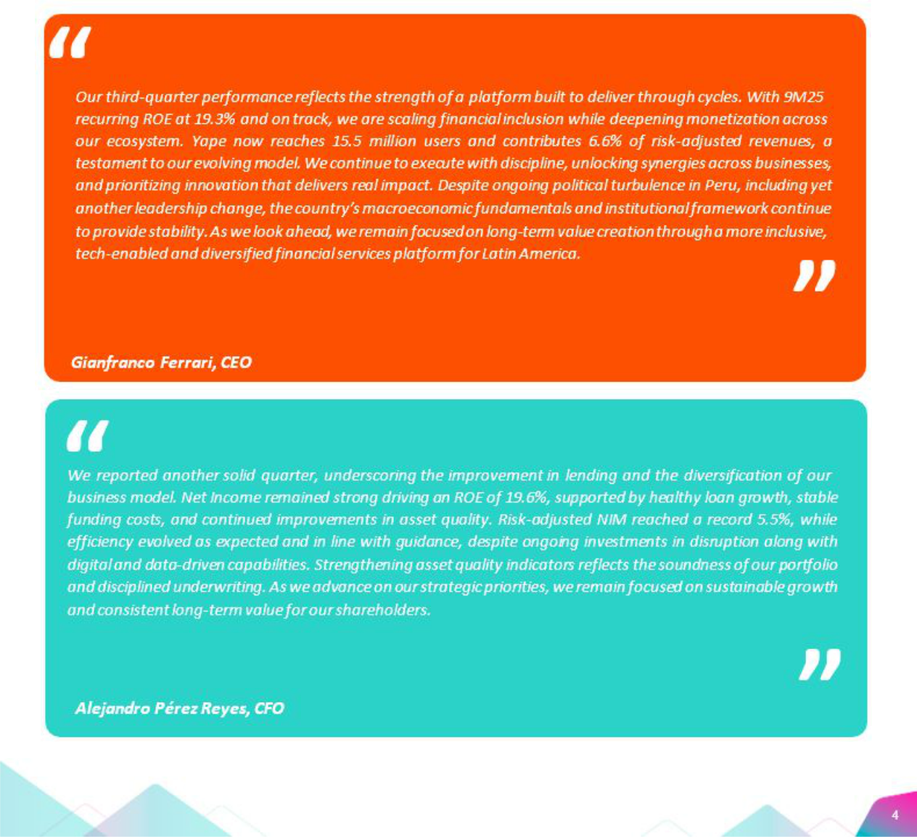


| Earnings Release 3Q / 2025 Analysis of 3Q25 Consolidated Results

Third Quarter 2025 Earnings Conference Call

THIRD 2025 EARNINGS CONFERENCE CALL

Date: Friday, November 14th, 2025

Time: 9:30 am E.T. (9:30 am Lima, Perú)

Hosts: Gianfranco Ferrari – Chief Executive Officer, - Alejandro Perez Reyes - Chief Financial Officer, Francesca Raffo – Chief Innovation Officer, Cesar Rios - Chief Risk Officer, Piero Travezan - Pacifico CFO, Rocio Benavides - Mibanco CFO and Investor Relations Team.

To pre-register for the listen-only webcast presentation use the following link:

https://dpregister.com/DiamondPassRegistration/register?confirmationNumber=10204236&linkSecurityString=10040c 5080c

Callers who pre-register will be given a conference passcode and unique PIN to gain immediate access to the call and bypass the live operator. Participants may pre-register at any time, including up to and after the call start time.

Those unable to pre-register may dial in by calling:

1 844 435 0321 (U.S. toll free)

1 412 317 5615 (International)

Participant Web Phone: Click here

Conference ID: Credicorp Conference Call

The webcast will be archived for one year on our investor relations website at:

https://credicorp.gcs-web.com/events-and-presentations/upcoming-events

For a full version of Credicorp´s Second Quarter 2025 Earnings Release, please visit:

https://credicorp.gcs-web.com/company-reports/quarterly-materials

| Earnings Release 3Q / 2025 Analysis of 3Q25 Consolidated Results

Loans and Deposits

Our balance in 3Q25 was impacted by an accounting adjustment (which did not affect cash flow) related to our operations in Bolivia. This adjustment entailed updating the exchange rate used to translate Bolivia’s balance to better reflect market conditions¹. In this context, the book value of Credicorp’s total assets dropped 2.1% but cash flow was unaffected.

Loans in End-of-Period (EOP)

Total loans measured in quarter-end balances rose 2.7% QoQ and 1.5%

YoY, impacted by the aforementioned accounting adjustment at BCP
Bolivia.

If we exclude this impact:

QoQ, the portfolio’s balance increased 1.6%. If we also exclude the effect of the depreciation of the USD against the PEN, the FX neutral growth was 2.4%. This evolution was driven mainly by: (i) Retail Banking and led in order of impact by SMEs, which reported an increase in negotiable incomes and working capital loans; Mortgage, which registered growth in demand in a more favorable economic context; and Consumer, which posted an upswing in disbursements through BCP Stand-alone and Yape; (ii) Wholesale Banking, led by Corporate Banking which reported growth in medium and long-term loans, and (iii) Mibanco, which reported a record high for disbursements in the month of September.
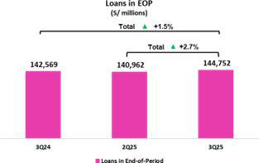

YoY, the portfolio’s balance rose 4.4%. Notwithstanding, growth stood at 7.0% with a Neutral exchange rate, driven mainly by (i) Retail Banking, which registered an increase through the same dynamics seen QoQ, and Consumer, which reported an uptick in disbursements alongside an increase in the risk appetite at BCP; and (ii) Wholesale Banking, particularly Middle Market Banking, which registered growth in demand for short-term financing.

Deposits

The balance for total deposits (measured in quarter-end balances) rose

2.4% QoQ and 2.6% YoY, impacted by the aforementioned asset
revaluation at BCP Bolivia.

If we exclude this impact, growth was driven by the following impacts: QoQ our deposit base increased 1.3%. Furthermore, applying a neutral exchange rate, growth would have been 3.8%. This evolution reflected an uptick in balances for Demand Deposits, Savings Deposits and Time Deposits. YoY, the deposit base increased 5.9% (+10.8% Neutral Exchange rate). This evolution was driven by (i) Low- cost deposits, which rose 11.1% and represented 69.8% of total deposits at quarter-end, and (ii) Time Deposits.
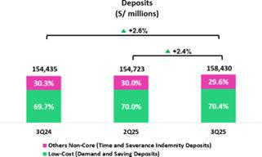

At BCP, the 30-day Liquidity Coverage Ratio (LCR) stood at 163.6% under regulatory standards and 129.7% according to stricter internal standards. The 30-day LCR in USD situated at 168.0% under regulatory standards and at 130.7% under stricter internal norms.

- The official exchange rate used to translate BCP Bolivia's balance sheet for 2Q24 was 6.85 bolivianos per dollar. However, for 2Q25 and 3Q25, the parallel market exchange rate was used, which was 15.9 and 11.90 bolivianos per dollar, respectively.

| Earnings Release 3Q / 2025 Analysis of 3Q25 Consolidated Results

Net Interest Income (NII) and Margin (NIM)

NII rose 2.0% QoQ, fueled primarily by growth in Interest and Similar Income. This evolution was driven by an increase in loans, which led the IEA mix to shift toward higher- yielding assets. Lower Interest and similar expenses also contributed to the increase in NII, although to a lesser extent, mainly through lower interest on bonds and notes issued after BCP registered debt maturities. In this context, NIM stood at 6.57% at quarter-end, compared to 6.42% in 1Q25 and 6.43% in 2Q24.
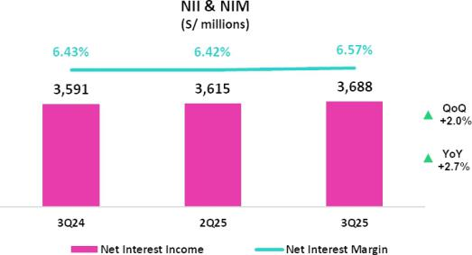

YoY, NII increased 2.7%, propelled mainly by a drop in Interest and Similar Expenses. This decline was primarily attributable to a context of lower rates and to an increase in low-cost deposits’ share of the funding base. Meanwhile, Interest and Similar Income registered a drop mainly due to the renewal of deposits and other assets at lower rates, which partially offset the reduction in Interest and Similar Expenses. In this scenario, NIM rose 14 bps YoY.

Portfolio Quality and the Cost of Risk

Indicators for portfolio quality and the Cost of Risk have improved

significantly in the last year and continue to strengthen, thanks to more
robust risk management, improvements in payment behavior and a

favorable macroeconomic environment.

QoQ, the NPL balance dropped slightly by 0.3%, driven mainly by BCP Stand -alone a n d Mibanco. A t BCP Stand-alone, the decline was fueled mainly by Retail Banking, which was positively impacted by (i) an improvement in origination and collections management in Consumer and Credit Cards, and (ii) debt payments by clients with loans under judicial recovery in SME-Pyme. This dynamic was partially offset by Wholesale Banking, where the NPL balance was up due to refinancing for one client. At Mibanco, the decline was driven by a decrease in overdue loans.
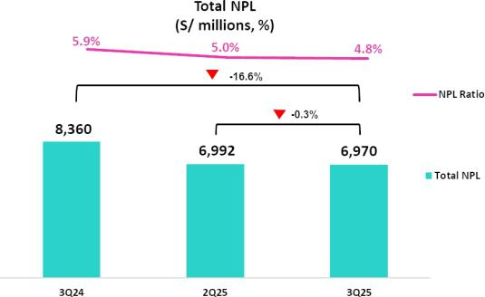

YoY, the NPL balance dropped 16.6%, fueled by all segments at BCP Stand -alone a n d Mibanco. A t BCP Stand-alone, the decline was mainly attributable to Retail Banking, led by: (i) Consumer and Credit Cards, on the back of growth in debt payments due to higher liquidity across the system, and (ii) SME -Pyme, due to a drop in overdue loans. Wholesale Banking also drove the reduction in the NPL balance, albeit to a lesser degree, fueled mainly by total debt repayments by two corporate clients. At Mibanco, the decline was attributable to the same dynamics seen QoQ.

In this context, the NPL ratio dropped 15 bps QoQ and 105 bps YoY to

stand at 4.8% at quarter-end.

| Earnings Release 3Q / 2025

Provisions rose 4.8% QoQ, driven by BCP Stand-alone and partially offset by Mibanco. At BCP Stand-alone, the increase in provisions reflected both the recurring dynamics of Retail Banking and specific impacts in Wholesale Banking. In Retail Banking, provisions for the Individuals segment remained stable, while provisions for SME-Pyme increased slightly due to a base effect resulting from higher reversals in the previous quarter. In Wholesale Banking provisions rose after a relevant increase was registered in the credit risk of a corporate client. At Mibanco, the lower provisions were explained by better collection management.

YoY and YTD, provisions decreased 30.5% and 36.6% respectively, driven by BCP Stand-alone a n d Mibanco, which registered improvements in payment performance due to economic recovery and an increase in lower-risk vintages’ share of the portfolio mix.

Other Income

Other Core Income reached a record high this quarter, growing 4.0% QoQ, 11.9% YoY, and 11.6% YTD, driven by the strong performance of BCP Stand-alone’s core business and the dynamism of Yape. This result reflects the consistent execution of our revenue diversification and decoupling from macroeconomic factors strategy, strengthening the resilience of our business model.

Other Non-Core Income decreased by 28.7% QoQ and 19.0% YoY, reflecting the base effect generated by extraordinary income recorded in previous quarters. YTD, this income increased by 7.4%, due to income related to the consolidation of Banmedica's operations and the exchange of sovereign bonds at BCP.

Insurance Underwriting Result

The Insurance Underwriting Result remained solid this quarter, supported by strong operating dynamics in both the P&C and Life businesses.

This result rose 10.7% QoQ and was driven mainly by (i) Life, which reported a decrease in Insurance Service Expenses, (ii) EPS, which showed higher Insurance Service Income supported by strong business performance that resulted in higher premiums, and (iii) P&C, which registered a more favorable Reinsurance Result.

YoY and YTD, the Insurance Underwriting Result rose 33.1% and 20.5%, respectively, driven by (i) Life, where lower Insurance Service Expenses were recorded, especially in D&S due to the non-awarding of the SISCO VIII contract; (ii) P & C, through an improvement in the Reinsurance Result, which was mainly attributable to Commercial Lines, and (iii) EPS, given a change in the perimeter following the consolidation of Banmedica’s operations.

Analysis of 3Q25 Consolidated Results
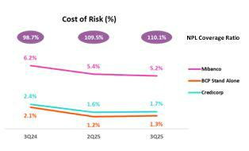
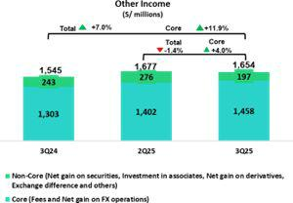

Insurance Underwriting Result*

(S/ millions)
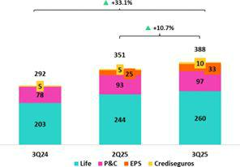

*Totals may differ from the sum of the parts due to eliminations in PGA consolidation.

| Earnings Release 3Q / 2025 Analysis of 3Q25 Consolidated Results

Efficiency
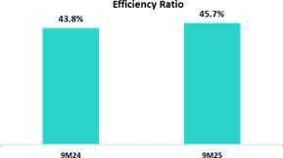

Operating expenses increased 12.8% YTD, fueled mainly by core business and BCP Stand-alone and by the innovation portfolio at Credicorp. Operating income, in turn, rose 8.2% over the same period.

In this context, the Efficiency Ratio for 9M25 stood at 45.7%, which is in line with our guidance for the year.

Net Earnings Attributable to Credicorp
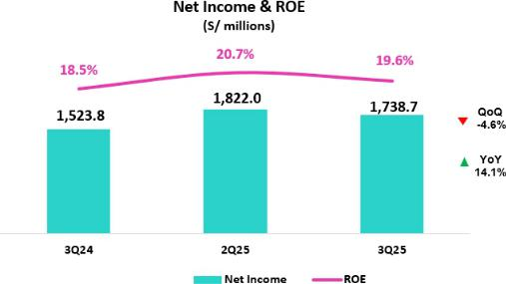

In 3Q25, Credicorp reported net attributable income of S/1,738.7 million (-4.6% QoQ and +14.1% YoY), driven by solid results across all lines of business. Net shareholders’ equity stood at S/36,560 million (+6.1% QoQ and +9.3% YoY). Consequently, ROE situated at 19.6%.

YTD, net attributable income rose 22.0%. In turn, ROE for 9M25 stood at 20.1%. If we exclude the effect of the extraordinary gain generated by the transaction with Empresas Banmédica, ROE stood at 19.3%.

Contributions and ROE by subsidiary in 3Q25

(S/ millions)
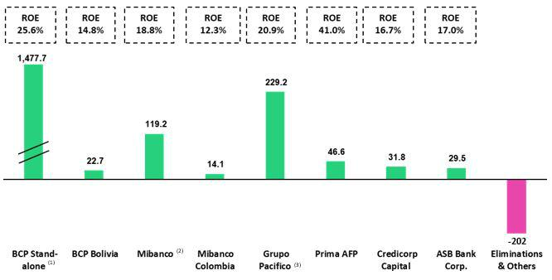

- In BCP Stand-alone, the figure is lower than the net profit since the contribution eliminates investment gains in other subsidiaries of Credicorp (Mibanco).

- In Mibanco, the figure is less than the net profit because Credicorp owns (directly and indirectly) 99.921% of Mibanco.

- The contribution for Grupo Pacifico presented here is greater than the profit of Pacifico Seguros since 100% of Crediseguros is being included (including 48% under Grupo Crédito).

| Earnings Release 3Q / 2025 Analysis of 3Q25 Consolidated Results

Universal Banking Microfinance


BCP reported solid profitability this quarter, backed by increasing margins; diversified sources of income; and a cost of risk level below that seen in 2024. NIM stood at 6.1%, driven mainly by a shift in the mix towards a higher preponderance of retail loans and by solid transactional funding. Core income remained robust, backed by a growing and diversified income base in both Yape and the core business. The CoR stood at 1.3%, due to a greater share of lower-risk loans in the portfolio, supported by a more favorable economic environment.


Insurance and Pensions

Profitability at Mibanco continued to recover, fueled primarily by a rebound in disbursements; fortified risk management; and efficient interest rate strategies. NIM remained strong, bolstered by active loan pricing and a reduction in the funding cost.

Mibanco Colombia’s results continued to improve on the back of restructuring efforts over the past year and an improvement in the economic environment for the microfinance sector. Growth remained stable, and risk levels controlled.


Investment Management and

Advisory


Grupo Pacífico's Net Income reflects a solid performance of the underlying business, particularly in the Life and P&C businesses, which continue to show robust underwriting results. The consolidation o Empresas Banmedica’s operations has further strengthened results for Medical Services. These positive dynamics were partially offset by a credit downgrade of two assets in the investment portfolio.



Operating profitability in the Investment Management and Advisory remained at sound levels. The core business reported solid results, where good performance helped offset an increase in operating expenses. The Asset Management and Wealth Management business reported a significant uptick in AUMs.

Outlook

We reaffirm our previously published guidance for ROE 2025 of around 19.0%. This expectation is based on (i) accelerated loan growth, led by the retail segment, (ii) the increase of our NIM, and (iii) a cost of risk again below previous expectations.


| Earnings Release 3Q / 2025 Analysis of 3Q25 Consolidated Results

Financial Overview

Credicorp Ltd. |  | Quarter |  |  | % change |  | Up to | % change
S/ 000 | 3Q24 | 2Q25 | 3Q25 | QoQ | YoY | Sep 24 | Sep 25 | Sep 25 / Sep 24
Net interest, similar income and expenses | 3,590,750 | 3,615,371 | 3,687,829 | 2.0% | 2.7% | 10,485,337 | 10,875,212 | 3.7%
Provision for credit losses on loan portfolio, net of recoveries | (868,081) | (575,159) | (602,918) | 4.8% | -30.5% | (2,776,151) | (1,759,970) | -36.6%
Net interest, similar income and expenses, after | 2,722,669 | 3,040,212 | 3,084,911 | 1.5% | 13.3% | 7,709,186 | 9,115,242 | 18.2%
provision for credit losses on loan portfolio
Other income | 1,545,344 | 1,677,373 | 1,654,191 | -1.4% | 7.0% | 4,529,233 | 5,021,780 | 10.9%
Insurance underwriting result | 291,776 | 350,873 | 388,350 | 10.7% | 33.1% | 886,338 | 1,068,357 | 20.5%
Medical services result | - | 123,319 | 123,953 | 0.5% | n.a. | - | 289,961 | n.a.
Total expenses | (2,448,229) | (2,630,310) | (2,744,642) | 4.3% | 12.1% | (7,055,916) | (7,907,826) | 12.1%
Profit before income tax | 2,111,560 | 2,561,467 | 2,506,763 | -2.1% | 18.7% | 6,068,841 | 7,587,514 | 25.0%
Income tax | (555,117) | (696,969) | (728,308) | 4.5% | 31.2% | (1,602,927) | (2,129,746) | 32.9%
Net profit | 1,556,443 | 1,864,498 | 1,778,455 | -4.6% | 14.3% | 4,465,914 | 5,457,768 | 22.2%
Non-controlling interest | 32,655 | 42,483 | 39,800 | -6.3% | 21.9% | 91,373 | 119,401 | 30.7%
Net profit attributable to Credicorp | 1,523,788 | 1,822,015 | 1,738,655 | -4.6% | 14.1% | 4,374,541 | 5,338,367 | 22.0%
Dividends paid to third parties | 875,992 | 3,181,440 | - | -100.0% | -100.0% | 3,667,644 | 3,181,440 | -13.3%
Net income / share (S/) | 19.1 | 22.8 | 21.8 | -4.6% | 14.1% | 54.8 | 66.9 | 22.0%
Dividends per Share (S/) | 11.00 | 39.89 | - | -100.0% | -100.0% | 46.0 | 39.9 | -13.3%
Loans | 142,568,785 | 140,961,978 | 144,752,254 | 2.7% | 1.5% | 142,568,785 | 144,752,254 | 1.5%
Deposits and obligations | 154,435,451 | 154,723,334 | 158,430,455 | 2.4% | 2.6% | 154,435,451 | 158,430,455 | 2.6%
Net equity | 33,462,591 | 34,459,012 | 36,560,502 | 6.1% | 9.3% | 33,462,591 | 36,560,502 | 9.3%
Profitability
Net interest margin⁽¹⁾ | 6.4% | 6.4% | 6.6% | 15 bps | 14 bps | 6.3% | 6.3% | 2 bps
Risk-adjusted Net interest margin | 4.9% | 5.4% | 5.5% | 9 bps | 60 bps | 4.7% | 5.3% | 64 bps
Funding cost⁽²⁾ | 2.7% | 2.4% | 2.4% | -1 bps | -25 bps | 0.03% | 2.4% | -43 bps
ROAE | 18.5% | 20.7% | 19.6% | -110 bps | 110 bps | 17.7% | 20.1% | 240 bps
ROAA | 2.4% | 2.9% | 2.8% | -10 bps | 40 bps | 2.4% | 2.8% | 40 bps
Loan portfolio quality
Internal overdue ratio⁽³⁾ | 4.2% | 3.6% | 3.4% | -16 bps | -81 bps | 4.2% | 3.4% | -81 bps
Internal overdue ratio over 90 days | 3.4% | 3.0% | 2.9% | -10 bps | -50 bps | 3.4% | 2.9% | -50 bps
NPL ratio⁽⁴⁾ | 5.9% | 5.0% | 4.8% | -15 bps | -105 bps | 5.9% | 4.8% | -105 bps
Cost of risk ⁽⁵⁾ | 2.4% | 1.6% | 1.7% | 6 bps | -71 bps | 2.6% | 1.6% | -95 bps
Coverage ratio of IOLs | 136.9% | 151.8% | 154.9% | 310 bps | 1800 bps | 136.9% | 154.9% | 1800 bps
Coverage ratio of NPLs | 98.7% | 109.5% | 110.1% | 60 bps | 1140 bps | 98.7% | 110.1% | 1140 bps
Operating efficiency
Operating income⁽⁶⁾ | 5,211,162 | 5,529,301 | 5,670,690 | 2.6% | 8.8% | 15,288,024 | 16,540,190 | 8.2%
Operating expenses⁽⁷⁾ | 2,313,324 | 2,483,493 | 2,629,461 | 5.9% | 13.7% | 6,696,919 | 7,555,043 | 12.8%
Efficiency ratio⁽⁸⁾ | 44.4% | 44.9% | 46.4% | 150 bps | 200 bps | 43.8% | 45.7% | 190 bps
Operating expenses / Total average assets | 3.7% | 3.9% | 4.2% | 27 bps | 48 bps | 3.7% | 3.9% | 20 bps
Capital adequacy - BCP Stand-alone
Global Capital Ratio ⁽⁹⁾ | 18.96% | 17.33% | 17.72% | 42 bps | -126 bps | 18.96% | 17.72% | -124 bps
Ratio Tier 1⁽¹⁰⁾ | 13.25% | 12.24% | 12.82% | 62 bps | -45 bps | 13.25% | 12.82% | -43 bps
Ratio common equity tier 1 ⁽¹¹⁾ ⁽¹³⁾ | 13.42% | 12.56% | 13.17% | 57 bps | -22 bps | 13.42% | 13.17% | -25 bps
Capital adequacy - Mibanco
Global Capital Ratio ⁽⁹⁾ | 20.22% | 19.61% | 21.13% | 153 bps | 88 bps | 20.22% | 21.13% | 90 bps
Ratio Tier 1⁽¹⁰⁾ | 17.85% | 16.48% | 17.13% | 63 bps | -75 bps | 17.85% | 17.13% | -80 bps
Ratio common equity tier 1 ⁽¹¹⁾ ⁽¹³⁾ | 18.35% | 16.73% | 17.14% | 44 bps | -125 bps | 18.35% | 17.14% | -130 bps
Employees⁽¹⁴⁾ | 46,555 | 48,241 | 48,878 | 1.3% | 5.0% | 46,555 | 48,878 | 5.0%
Share Information
Issued Shares | 94,382 | 94,382 | 94,382 | 0.0% | 0.0% | 94,382 | 94,382 | 0.0%
Treasury Shares⁽¹²⁾ | 14,949 | 15,016 | 15,016 | 0.0% | 0.4% | 14,949 | 15,016 | 0.4%
Outstanding Shares | 79,433 | 79,366 | 79,366 | 0.0% | -0.1% | 79,433 | 79,366 | -0.1%

- Net Interest Margin = Net Interest Income (Excluding Net Insurance Financial Expenses)/ Average Interest Earning Assets

- Funding Cost = Interest Expense (Does not include Net Insurance Financial Expenses) / Average Funding

- Internal Overdue Loans: include overdue loans and loans under legal collection, according to our internal policy for overdue loans. Internal Overdue Ratio: Internal overdue loans/ Total loans

- Non-performing loans (NPL): Internal overdue loans + Refinanced loans. NPL ratio: NPL / Total loans.

- Cost of risk = Annualized provision for loan losses, net of recoveries/ Total loans.

- Operating Income = Net interest, similar income and expenses + Fee Income+ Net gain on foreign exchange transactions + Net Gain From associates + Net gain on derivatives held for trading + Result on exchange differences + Insurance Underwriting Result + Results for Medical Services
- Operating Expenses = Salaries and employee benefits + Administrative expenses + Depreciation and amortization + Association in participation

- Efficiency Ratio = (Salaries and employee benefits + Administrative expenses + Depreciation and amortization + Association in participation) / (Net interest, similar income and expenses + Fee Income+ Net gain on foreign exchange transactions + Net Gain From associates + Net gain on derivatives held for trading + Result on exchange differences + Insurance Underwriting Result + Results for Medical Services)
- Regulatory Capital/ Risk-weighted assets (legal minimum = 10% since July 2011).

- Tier 1 = Capital + Legal and other capital reserves + Accumulated earnings with capitalization agreement + (0.5 x Unrealized profit and net income in subsidiaries) - Goodwill - (0.5 x Investment in subsidiaries) + Perpetual subordinated debt (the maximum amount that can be included is 17.65% of Capital + Reserves + Accumulated earnings with capitalization agreement + Unrealized profit and net income in subsidiaries - Goodwill).
- Common Equity Tier I = Capital + Reserves – 100% of applicable deductions (investment in subsidiaries, goodwill, intangibles, and net deferred taxes that rely on future profitability) + retained earnings+ unrealized gains.
- Consider shares held by Atlantic Security Holding Corporation (ASHC) and stock awards.

- Common Equity Tier I calculated based on IFRS Accounting.

- Internal management figures. Since 1Q25, it has included corporate health and medical services employees.


| Earnings Release 3Q / 2025 Analysis of 3Q25 Consolidated Results

Credicorp’s Strategy Update

Credicorp Strategy

At the Investor Day 2025, Credicorp reaffirmed its strategy, which is based on four fundamental fronts: (i) developing talent with an innovative mindset,

- on-going discipline in the execution stage, (iii) robust risk management and (iv) governance aligned with the best international practices and sustainability. Over the three decades following Credicorp’s listing on the NYSE, these fronts have allowed the company to decouple its performance from macroeconomic volatility. This attests to the Group’s unique capacity to anticipate and lead transformation in the financial sector in Latin America while generating an average annual return for shareholders of 14.1%, which has consistently topped the market average.

Currently, Credicorp has evolved from a traditional financial holding into an integral ecosystem for services. The strategy is articulated into three main pillars:

- Scalability and monetization of the ecosystem: Credicorp accelerates financial inclusion and expansion of the formal economy, generating new income flows and deepening relationships with more than 18 million clients.

- We drive growth through business synergies: By sharing capabilities in data, artificial intelligence, and cross-functional platforms, we diversify our value proposition, unlock new revenue streams, expand our reach to underserved segments and enhance operating efficiency.

- Discipline in execution and creation of sustainable value: maintaining an eye on long-term profitability and efficient allotment of capital, backed by robust governance.

At the event, Credicorp reaffirmed its goal to achieve a medium-term ROE of 19.5% and an efficiency ratio close to 42%, primarily supported by income growth outpacing expense growth. Income growth will be driven by accelerated loan expansion through deeper penetration into higher- yielding segments, and by scaling fee- based businesses. The innovation portfolio, led by Yape, continues to scale and monetize, representing 7.4% of risk-adjusted revenue for 3Q25, as we advance towards our target of 10% for 2026. Credicorp will continue to generate new sources of revenue through a diversified portfolio of initiatives, including consolidating its bancassurance business; developing supply chain finance solutions; and expanding microcredit, microinsurance, and Mibanco services. These initiatives will bolster resilience in the face of changing macroeconomic cycles.

To view a repeat of Investor Day, checkout the webcast in the following link: www.credicorpday.com Main KPIs of Credicorp’s Strategy
Core Businesses Transformation ⁽¹⁾ |  | Quarter |  |  | Up to
Core Businesses Transformation ⁽¹⁾ | 3Q24 | 2Q25 | 3Q25 | Sep 24 | Sep 25
Credicorp
Innovation Portfolio Risk-Adjusted Revenue Share ⁽²⁾ | 4.5% | 6.2% | 7.4% | 3.9% | 6.3%
BCP Stand-alone
Digital clients ⁽³⁾ | 74% | 78% | 79% | 74% | 78%
Digital monetary transactions ⁽⁴⁾ | 84% | 88% | 89% | 70% | 87%
Cashless transactions ⁽⁵⁾ | 60% | 65% | 65% | 58% | 64%
Mibanco
Disbursements through leads ⁽⁶⁾ | 66% | 65% | 68% | 69% | 67%
Disbursements through alternative channels ⁽⁷⁾ | 10% | 12% | 10% | 10% | 11%
Relationship managers productivity ⁽⁸⁾ | 23.6 | 25.9 | 29.2 | 23.4 | 26.4
Pacifico
Digital Policies (thousands) ⁽⁹⁾ | 650.3 | 579.0 | 580.5 | 1,761.8 | 1,881.8

- Management figures. Figures for September 2024, June 2025, and September 2025.

- As a percentage of Credicorpʼs total Risk-Adjusted Revenue.

- Retail clients that made 70%, or more, of their transactions through digital channels in the last 6 months (including Yape).

- Monetary Transactions conducted through Mobile Banking, Internet Banking, Yape and Telecredito/Total Monetary Transactions in Retail Banking.

- Amount transacted through Mobile Banking, Internet Banking, Yape y POS/Total amount transacted through Retail Banking.

- Disbursements generated through leads/Total disbursements.

- Disbursements conducted through alternative channels/Total disbursements. Figures differ from previously reported due to a methodological change.

- Number of loans disbursed/Total relationship managers.

- Number of insurance policies issued through digital channels.

| Earnings Release 3Q / 2025 Analysis of 3Q25 Consolidated Results

Credicorp’s Strategy Update

Yape

Main Management Indicators

Management KPI's ⁽¹⁾ |  | Quarter |  | Change % |  |  | Up to | Change %
Management KPI's ⁽¹⁾ | 3Q24 | 2Q25 | 3Q25 | QoQ | YoY | Sep 24 | Sep 25 | Sep 25 / Sep 24
Users
Users (millions) | 16.6 | 18.6 | 18.7 | 0.6% | 12.7% | 16.6 | 18.7 | 12.7%
Monthly Active Users (MAU) (millions) ⁽²⁾ | 13.0 | 14.9 | 15.5 | 3.6% | 18.8% | 13.0 | 15.5 | 18.8%
Revenue Generating MAU (millions) | 10.4 | 12.6 | 13.2 | 5.1% | 27.3% | 10.4 | 13.2 | 27.3%
Engagement
# Transactions (millions) | 1,664.2 | 2,384.9 | 2,640.1 | 10.7% | 58.6% | 4,192.5 | 7,050.4 | 68.2%
# Transactions / MAU | 44.1 | 54.5 | 58.5 | 7.4% | 32.6% | 44.1 | 58.5 | 32.6%
# Average Functionalities / MAU | 2.4 | 2.7 | 2.7 | 1.5% | 12.5% | 2.4 | 2.7 | 12.5%
Experience
NPS ⁽³⁾ | 73.5 | 77.0 | 76.0 | -100 bps | 250 bps | 73.5 | 76.0 | 250 bps
Unit Economics
Monthly Indicators ⁽⁴⁾
Revenues / MAU (S/) | 4.6 | 6.5 | 7.4 | 14.9% | 60.4% | 4.6 | 7.4 | 60.4%
Expenses / MAU (S/) | -4.2 | -4.4 | -5.0 | 15.4% | 20.6% | -4.2 | -5.0 | 20.6%
Quarterly Indicators ⁽⁵⁾
Revenues / MAU (S/) | 4.7 | 6.4 | 7.4 | 15.6% | 58.0% | 3.9 | 6.5 | 64.3%
Expenses / MAU (S/) | -4.2 | -4.5 | -4.8 | 6.5% | 14.7% | -4.0 | -4.5 | 13.6%
Drivers Monetization
Total TPV (S/, billions) ⁽⁶⁾ | 76.9 | 103.4 | 113.9 | 10.2% | 48.1% | 189.5 | 308.8 | 63.0%
Total Revenue Generating TPV (S/,
billions) ⁽⁷⁾
Payments | 6.3 | 10.1 | 12.0 | 18.6% | 91.1% | 15.0 | 30.9 | 106.6%
# Bill Payments transactions (millions) | 35 | 50 | 56 | 12.0% | 62.3% | 87 | 151 | 74.7%
Financials
# Loans Disbursements (thousands) | 1,296 | 3,855 | 4,196 | 8.8% | 223.8% | 2,560 | 11,151 | 335.6%
E-Commerce
GMV (S/, millions) ⁽⁸⁾ | 111.8 | 129.1 | 168.6 | 30.6% | 50.8% | 245.8 | 422.2 | 71.7%

- Management figures.

- Yape users that have made at least one outgoing transaction in the measurement month.

- Net Promoter Score.

- Monthly indicators consider the results of the last month of the quarter for the numerator and denominator.

- Quarterly indicators are calculated using the sum of the three months in the period for numerator accounts, and the average of the denominator—based on last month’s data from both the current and previous quarters.

- Total Payment Volume.

- Revenue Generating Total Payment Volume (TPV).

- Gross Merchant Volume includes the following functionalities: Yape Promos, Yape Store, Ticketing, Gaming, Delivery, Buses, Gas, Brand Solutions and Insurance.

Main Financial Results

Financial Results ⁽¹⁾ |  | Quarter |  | Change % |  |  | Up to | Change %
S/ millions | 3Q24 | 2Q25 | 3Q25 | QoQ | YoY | Sep 24 | Sep 25 | Sep 25 / Sep 24
Net Interest Income after Provisions ⁽²⁾ | 70.2 | 123.9 | 146.4 | 18.1% | 108.7% | 106.9 | 363.3 | 239.9%
Other Income ⁽³⁾ | 108.2 | 159.0 | 195.2 | 22.8% | 80.3% | 139.7 | 495.8 | 254.9%
Total Income | 178.4 | 282.9 | 341.6 | 20.7% | 91.5% | 246.6 | 859.1 | 248.4%
Total Operating Expenses | -158.4 | -197.1 | -220.1 | 11.7% | 39.0% | -426.7 | -596.9 | 39.9%
- Management figures. Beginning in 1Q25, reclassifications between Operating Expenses and Fee Income have been incorporated, along with new accounting allocations, primarily related to interest expenses associated with the Deposit Insurance Fund. Figures for prior periods have been restated for comparability and may differ from those previously reported.
- Includes interest income, interest expense and net provisions.

- Includes Other Income recorded in BCP and in Yape Market.

| Earnings Release 3Q / 2025 Analysis of 3Q25 Consolidated Results

Credicorp’s Strategy Update

Main Operating Results Evolution of MAU and Transactions

In 3Q25, Yape topped the 15.5-million mark for monthly active users (MAU), which is the equivalent of 82% of the EAP. With more than half a million new monthly active users (MAU) this quarter, we are closing in on our goal to reach 16.5 million users in 2026. During Investor Day, we announced a new goal of 18 million MAUs for 2028 as financial inclusion and business formalization advance and broaden our addressable market. Access to new segments will rise accordingly, laying the groundwork for additional avenues of growth.
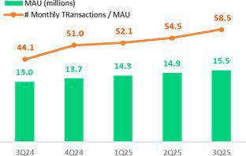

Frequency of use has also evolved positively, reaching 58.5 monthly transactions per user, of which 12% generate revenue. Revenue generating transactions have doubled over the last three years, although significant headroom exists to scale monetization even further. Going forward, growth will continue to leverage the power of the Credicorp ecosystem, which integrates engines at BCP, Mibanco and Pacifico. This will generate efficiencies and synergies in infrastructure, financing and risk management as we strengthen our competitive advantages and diversify revenue.

Monetization Drivers

In terms of operating efficiency, the gap between revenue and expenses
per user continues to widen, reaching S/7.4 in revenue and S/5.0 in Evolution of monthly revenue and expenses / MAU expenses per MAU. This attests to both sustained improvements in profitability and scalability.
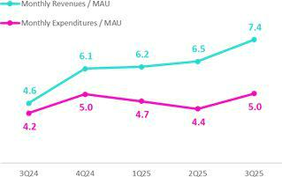

The payment business has consolidated as the primary driver of monetization, doubling its Revenue Generating Total Payment Volume (RGTPV) YoY. This growth was propelled by three fronts: (i) payments through QR (POS), which reflected growth in consumption due to statutory bonus payments and commercial campaigns; (ii) bill payments, which hit a record high for active users and average ticket, with a total of 56 million transactions this quarter; and (iii) checkout, which benefitted from the incorporation of new businesses with Yape’s checkout button. Over the next three years, Yape aims to triple its sources of fee income as it leverages an increase in the number of functionalities used per MAU, which currently stands at 2.7.

The financial business, which has the highest potential for long-term growth, maintained solid momentum. This evolution was driven primarily by the lending business, which now exceeds 3.4 million disbursed clients with at least one loan received. 30% of loan borrowers received their first formal loans in the financial system through Yape, which consolidates the app’s fundamental role in financial inclusion. Credicorp aspires to include 8 million people as of 2028 by focusing on penetrating the lowest levels of the socio-economic pyramid. Currently, Yape reports more than 4 million disbursements per quarter with average tickets that range between S/200 and S/2,500 depending on the product. To accelerate lending disbursements, Yape plans to increase its pool of pre-approved loans by 30% by 2028, up from the current 6 million as of 3Q25. The app has begun a pilot for the SME segment, seeking to extend portfolio durations and ticket sizes, where it leverages synergies of Credicorp’s ecosystem to bolster the value proposition. At quarter-end, the loan portfolio is primarily comprised of multi-installment loans, reflecting greater effectiveness in loan conversion. Revenue from floating continues to grow, impacted by inflows from statutory bonus payments.

In e- commerce the monthly GMV reached S/168.5 million, driven mainly by Yape Promos, which registered a signficant rise in visits and transactions over the period. Brand Solutions and Gaming also posted positive results on the back of an uptick in commercial campaigns.

| Earnings Release 3Q / 2025 Analysis of 3Q25 Consolidated Results

Credicorp’s Strategy Update

Financial Results Evolution of revenue by business

This quarter, Yape represented 6.6% of Credicorp’s risk- adjusted revenues, which reflects the positive impact of on-going growth in MAUs that actively contribute to revenue generation. The payment business produced 53% of Yape’s Revenue, led by Service Payments, QR and Top-ups, followed by Checkout, Yape Businesses and Remittances. The financial segment accounted for 43% of total revenue generation, where floating was the main generator, but lending increased its share, weighing in with 20% versus 7% from 3Q24. Finally, the e-commerce business accounted for 4% of total revenue this quarter, driven by the solid performance in Yape Promos. Yape is a strategic motor in Credicorp’s ecosystem and continues to advance its mission to deepen financial inclusion; scale monetization; and strengthen value propositions.
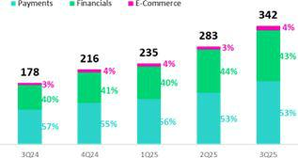

| Earnings Release 3Q / 2025 Analysis of 3Q25 Consolidated Results

Credicorp’s Strategy Update

Integrating Sustainability in Our Businesses

We continue to successfully roll out our Sustainability Strategy 2025–2030, which has an impact plan with three pillars (Inclusion Finances for the Future and Trust) and a transversal axis known as Visión País. Noteworthy milestones in 3Q25 include:

Inclusion

- BCP and Yape financially included 200 thousand people in 3Q25, to reach a total of 6.3 million since 2020 (+11% vs 4Q24). More than 3.4 million people have disbursed at least one loan through Yape to date, 30% of which were first-time borrowers in the formal financial system.

- At the end of 3Q25, Pacifico reported over 3.3 million clients protected by inclusive insurance products ¹, of which more than 2.9 million belong to mass-market segments, distributed through BCP, Mibanco, Yape, and third-party partnerships. In August, the company launched Compra Segura (in partnership with Falabella) to cover theft or accidental damage of purchases of S/ 50 and above; these policies also offer online medical consultations. Meanwhile, Pacífico Salud insured more than 416,000 individuals with inclusive health insurance plans YTD.
- To jump-start financial inclusion in peri-urban and rural areas, we are conducting pilots to develop innovative ways to generate trust and be closer to people. For example, Yape’s Financial Inclusion Project in Cuzco and Mibanco’s Sobre Ruedas aim to drive banking penetration in underserved areas in Lambayeque.

- We have broadened the scope our financial education programs. Thus far this year, the following initiatives have been particularly noteworthy: i) Academia del Progreso at Mibanco, which trained +372 thousand clients; ii) ABC at BCP, which improved the financial behavior of +491 thousand people; and iii) “Aprende con Yape”, which offers financial education modules through the app, imparted 146 thousand courses.

Finance for the future

- On the front Support to Micro, Small and Medium Enterprises (MSMEs), our main initiatives achieved the following:
  - Mibanco disbursed loans to more than 729 thousand SME clients, totaling S/ 11,812 million, while BCP served over 1 million SME clients with an accumulated amount of S/ 14,309 million.

  - Through the program “Contigo Emprendedor,” BCP had accompanied more than 190 thousand MSME clients as of the end of the third quarter through the advisory programs it offers on Whatsapp to strengthen financial management skills.

- On the Sustainable Finances front, our subsidiaries advance as follows:
  - Mibanco, through its Crediagua product, which expands access to drinking water and sewage connections, disbursed S/ 617 million thus far this year, benefiting +37 thousand people. In 3Q25, disbursements were up 46% QoQ.

  - Mibanco Colombia placed sustainable term certificates of deposit for US$ 13 million. These funds are for loans that comply with the bank’s Sustainable Financing Framework.

  - BCP has disbursed US$ 2,130 million in sustainable financing (environmental and social).
- Finally, we continue to strengthen the Resilience of individuals and businesses through risk prevention training. On this front, Pacifico has reached 315 thousand people thus far this year (including clients, non-clients and employees at businesses) through programs such as “ABC de Pacífico,” “Comunidad Segura” and “Protege365”.

Trust

- On the trust front, we advanced the “OrguYO” initiative at BCP, which aims to generate civic-mindedness and integrity through personal examples. We value the ripple effect that our employees can generate when they promote these values.

The table below summaries some of our main results:

Indicator | Company | Unit | 3Q24 | 2Q25 | 3Q25
Inclusion
People included financially through BCP and Yape – cumulative since 2020² | BCP Peru and Yape | Millions | 5.3 | 6.1 | 6.3
Clients included in inclusive insurance services | Pacifico | Millions | N.D. | 2.9 | 2.9
Finance for the Future
Total loan disbursements for MSMEs³ | Mibanco Peru | S/ Millions | 10,059 | 7,757 | 11,812
Disbursements of sustainable financings - YTD | BCP Peru | $ Millions | 1,110 | 1,517 | 2,130⁴

1 Simple and affordable optional insurance products with single or monthly payments of S/40 or less

2 Stock of financially included clients through BCP since 2020: (i) New clients with savings accounts or affiliated to Yape. (ii) New clients without debt in the financial system or BCP products in the last twelve months. (iii) Clients with 3 monthly average transactions in the last three months.
3 Includes MSMEs and individuals with businesses
4 Up to August.

| Earnings Release 3Q / 2025 Analysis of 3Q25 Consolidated Results

01 Loan Portfolio


This quarter, total loans were once again impacted by the asset revaluation at BCP Bolivia. If we exclude this impact, total loans in quarter-end balances increased 1.6% QoQ and 4.4% YoY, on track to meeting our guidance by year-end.

Excluding the impact of the USD devaluation against PEN, total loans in quarter-end balances grew 2.4% QoQ in FX neutral terms. The main dynamics that drove this evolution were (i) growth in disbursements in Small Businesses, (ii) growth in demand for loans in Mortgage and (iii) record-high disbursements in the month of September at Mibanco.

YoY, total loans in quarter-end balances rose 7.0% in FX neutral terms. The main drivers of this result were (i) growth in disbursements in Mortgage and an increase in the appetite for risk in Consumer (ii) an increase in the demand for short-term financing in Middle Market Banking and (iii) an upswing in the dynamism of disbursements at Mibanco.

Evolution of Loans in Quarter-end Balances

This quarter, total loans in quarter-end balances rose 2.7% and 1.5%, QoQ and YoY , respectively. These evolutions were impacted by asset revaluation at BCP Bolivia¹. If we exclude this impact, loans grew 1.6% QoQ and 4.4% YoY. If we analyze trends with USD/PEN neutral exchange rate, which paints a more focused picture of the state of commercial management, loans in quarter-end balances rose 2.4% QoQ and 7.0% YoY.

Total Loans (in Quarter-end Balances)

Total Loans |  | As of |  | Volume change |  | USD/PEN Neutral |  | USD/PEN Neutral
Total Loans |  | As of |  |  |  | Volume change |  |  | % Change
(S/ Millions) |  |  |  |  |  |  |  |  | % Change
(S/ Millions) | Sep 24 | Jun 25 | Sep 25 | QoQ | YoY | QoQ | YoY | QoQ | YoY
BCP Stand-alone | 117,687 | 120,999 | 123,089 | 1.7% | 4.6% | 2,929 | 8,186 | 2.4% | 7.0%
Mibanco | 12,119 | 12,785 | 13,096 | 2.4% | 8.1% | 311 | 977 | 2.4% | 8.1%
Mibanco Colombia | 1,774 | 1,976 | 2,158 | 9.2% | 21.7% | 227 | 533 | 11.5% | 30.1%
BCP Bolivia | 9,830 | 4,189 | 5,505 | 31.4% | -44.0% | n.a. | n.a. | n.a. | n.a.
ASB Bank Corp. | 1,928 | 1,559 | 1,422 | -8.8% | -26.3% | -108 | -408 | -6.9% | -21.2%
Others ⁽¹⁾ | -768 | -546 | -519 | -5.1% | -32.5% | 28 | 251 | -5.2% | -32.6%
Total Loans BAP | 142,569 | 140,962 | 144,752 | 2.7% | 1.5% | n.a. | n.a. | n.a. | n.a.
BCP Bolivia (Adjusted for Asset Revaluation) | 9,830 | 9,684 | 9,554 | -1.3% | -2.8% | 68 | 382 | 0.7% | 3.9%
Total Loans BAP (Adjusted for Asset Revaluation) | 142,569 | 146,457 | 148,801 | 1.6% | 4.4% | 3,455 | 9,921 | 2.4% | 7.0%

For consolidation purposes, loans generated in Foreign Currency (FC) are converted into Local Currency (LC).

(1) Includes eliminations for intercompany transactions.

QoQ, the FX neutral evolution of loans was mainly driven by BCP Stand -alone (+2.4%), followed by Mibanco (+2.4%). At Mibanco, loan growth was mainly fueled by an upswing in the dynamism of disbursements, which hit a record high in the month of September, led primarily by smaller and higher-yield tickets.

YoY, the FX neutral evolution of loans was mainly propelled by BCP Stand -alone (+7.0%), followed by Mibanco (+8.1%) and Mibanco Colombia (+30.1%). At Mibanco, loan growth was spurred primarily by an uptick in the dynamism of disbursements, whose pace picked up visibly as of the last quarter in 2024. At Mibanco Colombia, loans continued to recover significantly on the back of measures implemented last year to improve origination; in this context, YoY growth has been robust.

- As in recent quarters, this evolution is impacted by a non-cash accounting adjustment for the revaluation of assets related to the balance sheet of BCP Bolivia.

 | | Earnings Release 3Q / 2025 |  |  |  |  | Analysis of 3Q25 Consolidated Results
01. Loan Portfolio
Next, we will analyze loan dynamics by segment at BCP Stand-alone:
 | QoQ: Total Loans by Segment at BCP Stand-Alone (in Quarter-end Balances)
Total Loans |  | As of | QoQ Change |  | Balance in USD/PEN Neutral |  | QoQ Change
Total Loans |  | As of |  |  |  | As of | in USD/PEN Neutral
(S/ Millions) |  |  |  |  |  | As of
(S/ Millions) | Jun 25 | Sep 25 | Volume | % | Jun 25 | Sep 25 | Volume | %
BCP Stand-alone | 120,999 | 123,089 | 2,090 | 1.7% | 120,999 | 123,928 | 2,929 | 2.4%
Wholesale Banking | 53,025 | 53,340 | 315 | 0.6% | 53,025 | 53,982 | 956 | 1.8%
Corporate | 30,496 | 31,485 | 989 | 3.2% | 30,496 | 31,865 | 1,369 | 4.5%
Middle - Market | 22,529 | 21,855 | -674 | -3.0% | 22,529 | 22,117 | -413 | -1.8%
Retail Banking | 66,176 | 67,958 | 1,782 | 2.7% | 66,176 | 68,130 | 1,954 | 3.0%
SME - Business | 7,692 | 8,097 | 405 | 5.3% | 7,692 | 8,169 | 477 | 6.2%
SME - Pyme | 16,091 | 16,447 | 356 | 2.2% | 16,091 | 16,449 | 359 | 2.2%
Mortgage | 22,824 | 23,377 | 553 | 2.4% | 22,824 | 23,411 | 587 | 2.6%
Consumer | 13,446 | 13,781 | 335 | 2.5% | 13,446 | 13,822 | 376 | 2.8%
Credit Card | 6,124 | 6,257 | 133 | 2.2% | 6,124 | 6,278 | 154 | 2.5%
Others ⁽¹⁾ | 1,797 | 1,791 | -6 | -0.3% | 1,797 | 1,816 | 19 | 1.1%

For consolidation purposes, loans generated in Foreign Currency (FC) are converted into Local Currency (LC).

(1) Includes other assets and accruals.

Larger contraction in volume Larger expansion in volume

QoQ, total loans in quarter-end balances at followed by Wholesale Banking (+1.8%). In

BCP Stand-alone rose 2.4% in FX neutral terms. This growth was primarily led by Retail Banking (+3.0%),

Retail Banking, all segments evolved favorably in QoQ terms as follows:

- Small businesses, due to growth in disbursements of negotiable invoices and working capital loans in SME-Business and SME-Pyme, respectively.
- Mortgage, due to an uptick in demand for loans in a more favorable economic context marked by on-going low interest rates.
- Consumer, driven by growth in disbursements, mainly through BCP and Yape.

In Wholesale Banking, growth was driven by Corporate Banking, which reported an uptick in disbursements of medium and long -term loans, primarily for the Energy sector. Growth this quarter was partially offset by a drop in loans in Middle Market Banking, which was impacted by a seasonal effect through amortizations of loans to the fishing sector at the end of the first fishing campaign.

YoY: Total Loans by Segment at BCP Stand-Alone (in Quarter-end balances)

Total Loans |  | As of | YoY Change |  | Balance in Neutral USDPEN |  | YoY Change
(S/ Millions) |  |  |  |  |  | As of | in Neutral USDPEN
 | Sep 24 | Sep 25 | Volume | % | Sep 24 | Sep 25 | Volume | %
BCP Stand-alone | 117,687 | 123,089 | 5,402 | 4.6% | 117,687 | 125,873 | 8,186 | 7.0%
Wholesale Banking | 51,663 | 53,340 | 1,677 | 3.2% | 51,663 | 55,470 | 3,807 | 7.4%
Corporate | 31,383 | 31,485 | 102 | 0.3% | 31,383 | 32,746 | 1,363 | 4.3%
Middle - Market | 20,280 | 21,855 | 1,575 | 7.8% | 20,280 | 22,724 | 2,444 | 12.1%
Retail Banking | 64,384 | 67,958 | 3,574 | 5.6% | 64,384 | 68,528 | 4,144 | 6.4%
SME - Business | 7,912 | 8,097 | 184 | 2.3% | 7,912 | 8,337 | 425 | 5.4%
SME - Pyme | 16,268 | 16,447 | 178 | 1.1% | 16,268 | 16,456 | 188 | 1.2%
Mortgage | 21,614 | 23,377 | 1,764 | 8.2% | 21,614 | 23,490 | 1,876 | 8.7%
Consumer | 12,709 | 13,781 | 1,072 | 8.4% | 12,709 | 13,917 | 1,208 | 9.5%
Credit Card | 5,881 | 6,257 | 376 | 6.4% | 5,881 | 6,329 | 447 | 7.6%
Others ⁽¹⁾ | 1,640 | 1,791 | 151 | 9.2% | 1,640 | 1,875 | 234 | 14.3%

For consolidation purposes, loans generated in Foreign Currency (FC) are converted into Local Currency (LC).

(1) Includes other assets and accruals.

Larger contraction in volume Larger expansion in volume

YoY, total loans in quarter-end balances at BCP Stand-alone rose 7.0% in FX neutral terms. This increase was driven primarily by Retail Banking (+6.4%), followed by Wholesale Banking (7.4%).

In Retail Banking, all segments evolved positively YoY according to the following dynamics:

• Mortgage, due to the same dynamics in play QoQ.


| Earnings Release 3Q / 2025 Analysis of 3Q25 Consolidated Results

- Loan Portfolio

  - Consumer, due to growth in disbursements, which rose on the back of an increase in the appetite for risk at BCP, followed by an uptick in disbursements through Yape.

In Wholesale Banking, growth was driven mainly by:

- Middle Market Banking, due to growth in the demand for short-term loans, particularly in the agriculture sector.

- Corporate banking, spurred by the same dynamics seen QoQ.

Evolution of the Dollarization Level of Loans (in Quarter-end Balances)
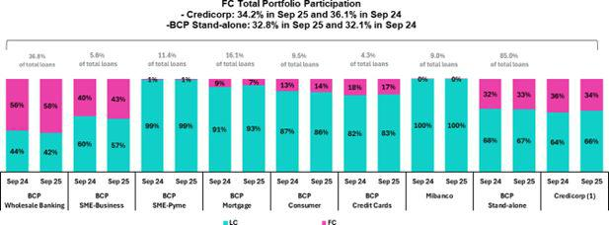

- The FC share of Credicorp’s loan portfolio is calculated including Mibanco Colombia, BCP Bolivia and ASB Bank Corp., however the chart shows only the loan books of BCP Stand-alone and Mibanco.

YoY, the dollarization level of the total portfolio dropped 189 bps. This evolution was driven mainly by loan growth in LC (+4.5%), primarily in the Individuals segment and secondarily by a drop in loans in FC (-3.8%), mainly attributable to BCP Bolivia and Mortgage.

Evolution of Loans in Average Daily Balances

Total loans in average daily balance (ADB) rose 0.7% and 3.3% QoQ and YoY, respectively. It is important to note that the figures for ADB loans are taken from internal management figures and exclude the impact of the revaluation of BCP Bolivia’s asset balance.

For more details on the dynamics of loans in ADB, please see Appendix 12.1.

| Earnings Release 3Q / 2025 Analysis of 3Q25 Consolidated Results

02 Deposits

This quarter, Total Deposits were once again impacted by asset revaluation at BCP Bolivia. If we exclude this impact, total deposits rose 1.3% QoQ and 5.9% YoY.


Excluding the impact of the USD devaluation against PEN, total deposits grew 3.8% QoQ in FX neutral terms. This growth was primarily attributable to: (i) growth in the balance of demand deposits held by wholesale clients, (ii) expansion in the balance of Savings Deposits, which were bolstered by statutory bonus payments in July and (iii) an increase in the balance of time deposits in LC, which rose on the back of our funding strategy’s focus on growing captures of wholesale clients.

YoY, Total Deposits rose 10.8% in FX neutral terms. This increase, which was driven by the same factors that drove growth QoQ, was partially offset by a decline in LC Demand Deposits due the remaining impact of pension fund withdrawals.

At the end of 3Q25, 69.8% of Total Deposits were low cost (Demand + Savings). Credicorp continued to lead the market for low-cost deposits, with a market share of 39.5% at the end of September

Deposits |  | As of |  |  | Volume (%) | USD/PEN Neutral |  | USD/PEN Neutral
 |  |  |  |  |  | Volume change |  |  | % Change
S/000 | Sep 24 | Jun 25 | Sep 25 | QoQ | YoY | QoQ | YoY | QoQ | YoY
Demand deposits | 53,149,144 | 49,237,039 | 50,930,173 | 3.4% | -4.2% | 2,883,595 | 2,332,144 | 5.6% | 4.4%
Saving deposits | 54,474,960 | 59,086,275 | 60,580,840 | 2.5% | 11.2% | 2,419,443 | 9,581,346 | 4.0% | 17.6%
Time deposits | 42,514,849 | 42,361,180 | 43,115,987 | 1.8% | 1.4% | 1,158,309 | 4,785,244 | 2.6% | 11.3%
Severance indemnity deposits | 2,989,705 | 3,268,583 | 2,956,446 | -9.5% | -1.1% | -275,884 | 34,792 | -8.4% | 1.2%
Interest payable | 1,306,793 | 770,257 | 847,009 | 10.0% | -35.2% | 10,367 | -1,108 | 0.8% | -0.1%
Low-cost deposits ⁽¹⁾ | 107,624,104 | 108,323,314 | 111,511,013 | 2.9% | 3.6%
Total Deposits | 154,435,451 | 154,723,334 | 158,430,455 | 2.4% | 2.6%
Adjusted by Bolivia's revaluation
Low-cost deposits ⁽¹⁾ | 107,624,104 | 111,757,648 | 114,236,696 | 2.2% | 6.1% | 5,303,038 | 11,913,490 | 4.7% | 11.1%
Total Deposits | 154,435,451 | 161,439,586 | 163,607,971 | 1.3% | 5.9% | 6,195,830 | 16,732,417 | 3.8% | 10.8%

(1) Includes Demand Deposits and Saving Deposits

This quarter, Total Deposits increased 2.4% and 2.6%, QoQ and YoY, respectively. Both evolutions were impacted by the revaluation of assets at BCP Bolivia¹. If we exclude this impact, Deposits rose 1.3% QoQ and 5.9% YoY. Excluding the impact of the USD devaluation against PEN , deposits increased 3.8% QoQ and 10.8% YoY in FX neutral terms, as follows:

QoQ, our Total Deposit balance rose 3.8%, due primarily to:

- Growth of 5.6% in the balance of Demand Deposits, fueled mainly by growth in volumes of FC deposits held by wholesale clients at BCP Stand-alone. These deposits rose primarily on the back of an upswing in institutional activity and secondarily due to a drop in the exchange rate, which led institutional clients to convert funds.

- An 4% increase in the balance of Savings Deposits, which was driven primarily by growth in volumes at BCP Stand-alone and in Individuals in particular, spurred by: (i) an increase in the volume in LC, fueled by statutory bonus payments in July and (ii) an increase in the FC volume, given that clients sought to save in USD following three consecutive quarters of declines in the USDPEN FX. Growth in the balance of Savings Deposits reflects the success of our transactional offering, which allows us to capture deposits in an environment marked by higher liquidity.

- An increase of 2.6% in the balance for Time Deposits, which was driven by growth in captures of LC deposits held by wholesale clients at BCP Stand-alone, in line with the objectives of our funding strategy.

YoY, our balance for Total Deposits increased 10.8%, driven primarily by:

Growth of 17.6% and 11.3% in the balance for Savings Deposits and Time Deposits, respectively. Both evolutions were mainly driven by the same dynamics observed QoQ. The balance for Demand Deposits rose 4.4%, driven primarily by the same factors in play QoQ; this evolution was offset by a drop in the LC balance, which was impacted by a remaining impact from last year’s pension fund withdrawals, which were initially received in Demand Deposit accounts.

Thanks to our investments in digital infrastructure and better customer engagement, we increased our low-cost deposits YoY by 13bps to account for 69.8% of total deposits. By September, this helped us reach a 39.5% market share in low-cost funding

- As in recent quarters, this evolution is impacted by a non-cash accounting adjustment for the revaluation of assets related to the balance sheet of BCP Bolivia


| Earnings Release 3Q / 2025 Analysis of 3Q25 Consolidated Results

02. Deposits

Dollarization Level of Deposits

Deposits by Currency | At the end of September 2025, the level of dollarization of Total Deposits
(measured at quarter-end balances) | dropped 53 bps QoQ to stand at 44.6% (still below the average for the
 | last 3 years of 48.7%). This evolution was primarily attributable to growth
 | in Savings Deposits in LC, which rose on the back of fund inflows from
 | statutory bonus payments in Individuals and secondarily, to growth in
 | Time Deposits in LC, which increased under strategic funding initiatives
 | to capture more low-cost funding.
 | YoY, the dollarization level dropped 341 bps. This evolution was primarily
 | driven by a drop in the USD/PEN FX, which impacted our balances in
 | FC, and by the same dynamics that led our balances in LC to rise QoQ.
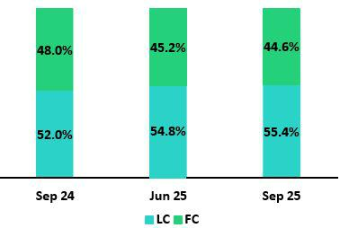

Deposits by Currency and Type

(measured at quarter-end balance)
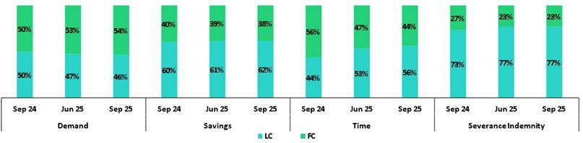

Loan/Deposit Ratio (L/D ratio)

QoQ, the L/D ratio rose 134 bps at BCP Stand -alone. This evolution was fueled by growth in the loan balance, which was mainly driven by retail, and partially offset by an increase in the balance of Low-Cost Deposits . At Mibanco, the ratio increased 219 bps- spurred mainly by an uptick in loans, which rose on the back of improvements in models and initiatives to broaden product offerings to new clients- and partially offset by an increase in Time Deposits.
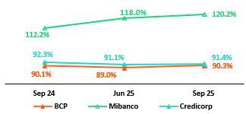

YoY, the L/D ticked up 19 bps and 796 bps at BCP Stand-alone and Mibanco, respectively. At BCP Stand -alone, the increase was driven by the loan balance across segments, which was offset by growth in Savings Deposits and Time Deposits. At Mibanco, the ratio rose on the back of loan growth, which was fueled by the same factors in play QoQ. This growth was partially offset by an increase in Savings Deposits, which was spurred by high liquidity throughout the system.

In this context, Credicorp’s L/D ratio stood at 91.4%.

| Earnings Release 3Q / 2025 Analysis of 3Q25 Consolidated Results

02. Deposits

L/D Ratio Local Currency L/D Ratio Foreign Currency
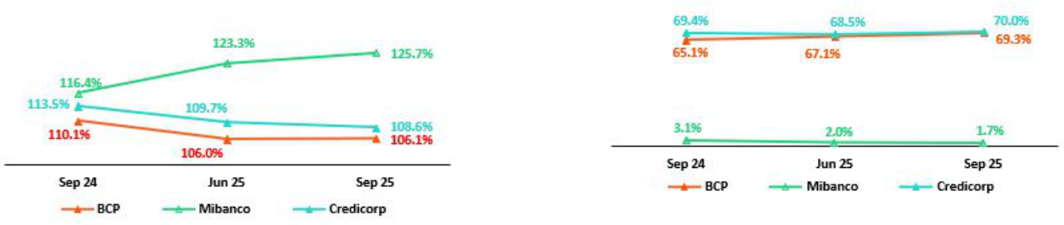

Market Share (MS) of Deposits in the Peruvian Financial System

Share of the Deposit Market in the Peruvian Financial System
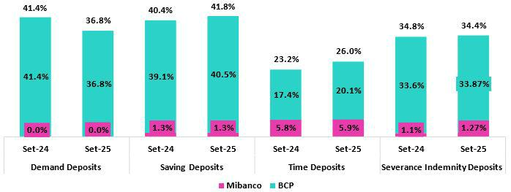

Ath the end of September 2025, the MS of Total Deposits held by BCP Stand Alone and Mibanco in Peru was 32.1% and 2.6% (51 bps and -3 pbs vs Sep 2024, respectively). In this context, BCP continued to lead the market for total deposits.

BCP registered YoY growth in the balance for Low -Cost Deposits (+2.2%). This figure, although below the rise reported by the financial system (+6.0%), allowed BCP to continue to lead the market for Low -Cost Deposits with an MS of 38.8% at the end of September 2025 (-142 bps vs Sep 2024). The financial system reported a decline in the balance for Time Deposits (-2.8% vs Sep 2024); BCP, in contrast, registered growth 8.9% with regard to Sep 2024. In this context, BCP’s MS rose (266 bps vs Sep 2024) to stand at 20.1% at the end of September 2025.

Credicorp’s share (BCP + Mibanco) of the Low-Cost Deposit market fell 138bps versus September 2024, standing at 39.5% at the end of September 2025. Credicorp’s share of the Time Deposit market rose 279bps versus September 2024 to stand at 26.0% at the end of September 2025.

| Earnings Release 3Q / 2025 Analysis of 3Q25 Consolidated Results

03 Interest-earning Assets (IEA) and Funding

In 3Q25, IEA rose 1.7% QoQ and 0.4% YoY. Funding, in turn, dropped 2.0% QoQ and 0.5% YoY. If we exclude the impact on Credicorp’s balance sheet of the accounting adjustment in BCP Bolivia, the evolution of IEA and Funding was driven by the following dynamics:


QoQ, IEA rose 0.9% due to loan expansion at BCP and Mibanco. Growth in the balance for Cash and due from banks, which reflected an increase in Deposits, also contributed to growth in IEA, albeit to a lesser extent. Funding rose 0.6%, primarily on the back of an increase in Deposits, while an uptick in the balance for BCRP Instruments, which reflects an increase in positions to diversify funding, acted as a secondary driver.

YoY, IEA rose 2.3%, driven by loan growth, primarily at BCP. This dynamic was partially offset by a reduction in balances for Cash and due from banks and Total investments as part of balance sheet management. Finally, Funding rose 3.1%, driven by Deposits, and low-cost deposits in particular. This growth was partially offset by a reduction for balances for Bonds and notes issued, impacted by recent debt expirations.

As was the case in previous quarters, our balance figures for 3Q25 continue to be impacted by an accounting adjustment (which does not affect cash flow). This year, Credicorp has revalued BCP Bolivia's balance sheet using an exchange rate that better reflects the market rate. This revaluation led Credicorp’s total assets to register an accounting contraction of 2.1% in September.

The analysis of the evolution of IEA and Funding will focus on the business’s underlying dynamics and exclude the aforementioned accounting adjustment.

3.1. IEA

Interest Earning Assets |  | As of |  | % change
S/000 | Sep 24 | Jun 25 | Sep 25 | QoQ | YoY
Cash and due from banks | 37,007,966 | 34,206,000 | 35,862,184 | 4.8% | -3.1%
Total investments | 53,328,873 | 51,603,447 | 51,186,579 | -0.8% | -4.0%
Cash collateral, reverse repurchase agreements and securities borrowing | 1,419,305 | 4,593,501 | 3,404,639 | -25.9% 139.9%
Loans | 142,568,785 | 140,961,978 | 144,752,254 | 2.7% | 1.5%
Total interest earning assets | 234,324,929 | 231,364,926 | 235,205,656 | 1.7% | 0.4%
Total interest earning assets (Adjusted for Asset Revaluation) | 234,324,929 | 237,642,758 | 239,824,996 | 0.9% | 2.3%
Total interest earning assets (Adjusted for Asset Revaluation, FX Neutral USDPEN) |  |  |  | 1.8% | 5.5%

IEA rose 1.7% QoQ and 0.4% YoY. If we exclude the effect of asset revaluation at BCP Bolivia, IEA evolved as follows:

QoQ, IEA increased 0.9%, driven primarily by loan growth at BCP, particularly in retail segments, followed by loan expansion at Mibanco (for more details on this evolution, review chapter 1. Loan Portfolio). Growth in Cash and due from banks was a secondary factor behind IEA growth, as BCP’s increased its balances of savings and times deposits as part of its funding strategy. The positive impact of the aforementioned drivers was partially offset by a reduction in Cash collateral, reverse repurchase agreements and securities borrowing.

YoY, IEA expanded 2.3%, driven by growth in the loan balance, mainly at BCP. Growth in cash collateral, reverse repurchase agreements, and securities borrowing also contributed to the uptick in IEAs, albeit to a lesser extent. These dynamics were partially offset by the following factors: i) a reduction in the Investment balance due to the liquidation of investments at BCP under a strategy to manage the balances, and ii) a drop in Cash and due from banks, which was attributable to cash outflows to pay bond expirations over the year.


| Earnings Release 3Q / 2025 Analysis of 3Q25 Consolidated Results

03. Interest-earning Assets (IEA) and Funding

3.2. Funding

Funding |  | As of |  | % change
S/ 000 | Sep 24 | Jun 25 | Sep 25 | QoQ | YoY
Deposits and obligations | 154,435,451 | 154,723,334 | 158,430,455 | 2.4% | 2.6%
Due to banks and correspondents | 12,704,234 | 11,152,813 | 11,241,079 | 0.8% | -
 |  |  |  |  | 11.5%
BCRP instruments | 4,788,939 | 5,096,459 | 6,643,892 | 30.4% | 38.7%
Repurchase agreements with clients and third parties | 2,594,165 | 6,168,934 | 3,537,281 | -42.7% 36.4%
Bonds and notes issued | 16,952,011 | 12,112,403 | 12,209,724 | 0.8% | -
 |  |  |  |  | 28.0%
Total funding | 191,474,800 | 189,253,943 | 192,062,431 | 1.5% | 0.3%
Total funding (Adjusted for Asset Revaluation) | 191,474,800 | 196,368,181 | 197,503,936 | 0.6% | 3.1%
Total funding (Adjusted for Asset Revaluation, FX Neutral USDPEN) |  |  |  | 2.5% | 1.3%

Funding dropped 2.0% QoQ and 0.5% YoY. If we exclude the impact of asset revaluation at BCP Bolivia, funding evolved as follows:

QoQ, funding rose 0.6%, driven mainly by an increase in the balance for Deposits and obligations. Growth was fueled both by higher low -cost deposits and by an increase in the uptake of wholesale time deposits at BCP, as part of the funding strategy ( for more details, review Chapter 2. Deposits). Funding also rose on the tails of growth in balance of BCRP Instruments, which reflected an increase in Repurchase agreements to diversify funding. These dynamics were partially offset by a drop in the balance of Repurchase agreements with clients and third parties, which was impacted by a base effect associated with extraordinary growth in 2Q25 under Credicorp Capital Colombia’s investment strategy.

YoY, funding rose 3.1%, driven mainly by growth in Deposits and obligations and in low-cost deposits in particular, which attests to Credicorp’s solid transactional offering. It is important to note that Yape’s strong role as a payment and distribution platform for the Group’s diverse product offering. The increase in the balance for BCRP Instruments- which was driven by the same factors as those in play QoQ- also elevated the funding volume YoY, albeit to a lesser extent. The reduction in Bonds and notes issued, which fell due to the expiration of bonds and BCP and an issuance at Credicorp, partially offset the Funding balance increase.

| Earnings Release 3Q / 2025 Analysis of 3Q25 Consolidated Results

04 Net Interest Income (NII)

In 2Q25 Net Interest Income (NII) rose 2.0% QoQ. This evolution was driven mainly by Interest on loans, which rose on the back of loan growth, particularly in retail segments.


YoY, NII increased 2.7% due to a reduction in Interest and similar expenses. This decline was fueled primarily by a drop in expenses for deposits, which reflected a decrease in interest rates, and secondarily by an increase in low-cost deposits’ share of the funding structure.

NIM expanded 14 bps YoY to stand at 6.57%, propelled by a drop in the funding cost in a context marked by a downward trend in interest rates. It is important to note that growth in retail loans helped contain the negative impact that rates exerted on the IEA yield. Finally, risk-adjusted NIM reached a record high¹ of 5.53%.
Net interest income |  | Quarter |  | % change |  | Up to |  | % Change
S/000 | 3Q24 | 2Q25 | 3Q25 | QoQ | YoY | Sep 24 | Sep 25 | Sep 25 / Sep 24
Interest and Similar Income | 4,995,971 | 4,922,292 | 4,987,693 | 1.3% | -0.2% | 14,857,135 | 14,804,775 | -0.4%
Interest and Similar Expenses | (1,405,221) | (1,306,921) | (1,299,864) | -0.5% | -7.5% | (4,371,798) | (3,929,563) | -10.1%
Interest Expense (excluding Net Insurance Financial Expenses) | (1,276,643) | (1,167,866) | (1,158,421) | -0.8% | -9.3% | (3,996,530) | (3,513,443) | -12.1%
Net Insurance Financial Expenses | (128,578) | (139,055) | (141,443) | 1.7% | 10.0% | (375,268) | (416,120) | 10.9%
Net Interest, similar income and expenses | 3,590,750 | 3,615,371 | 3,687,829 | 2.0% | 2.7% | 10,485,337 | 10,875,212 | 3.7%
Balances
Average Interest Earning Assets (IEA) | 231,316,507 | 233,761,957 | 233,285,291 | -0.2% | 0.9% | 229,452,866 | 237,958,451 | 3.7%
Average Funding | 190,855,164 | 191,161,476 | 190,658,187 | -0.3% | -0.1% | 188,110,844 | 195,494,018 | 3.9%
Yields
Yield on IEAs | 8.64% | 8.42% | 8.55% | 13 bps | -9 bps | 8.63% | 8.30% | -33 bps
Cost of Funds ⁽¹⁾ | 2.68% | 2.44% | 2.43% | -1 bps | -25 bps | 2.83% | 2.40% | -43 bps
Net Interest Margin (NIM)⁽¹⁾ | 6.43% | 6.42% | 6.57% | 15 bps | 14 bps | 6.31% | 6.33% | 2 bps
Risk-Adjusted Net Interest Margin⁽¹⁾ | 4.93% | 5.44% | 5.53% | 9 bps | 60 bps | 4.70% | 5.34% | 64 bps
Peru's Reference Rate | 5.25% | 4.50% | 4.25% | -25 bps | -100 bps | 5.25% | 4.25% | -100 bps
FED funds rate | 5.00% | 4.50% | 4.25% | -25 bps | -75 bps | 5.00% | 4.25% | -75 bps
(1) For further detail on the NIM and Cost of Funds calculation, please refer to Annex 12.8

QoQ, Net Interest Income (NII) rose 2.0%. This evolution was primarily driven by growth in Interest and Similar Income, which rose due to an expansion in loans, leading the IEA mix to shift toward higher-yielding assets. The decrease in Interest and Similar Expenses also contributed to the increase in NII, although to a lesser extent, primarily due to lower Interest on bonds and subordinated notes, which fell on the back of BCP debt maturities.

YoY, NII increased 2.7%, impacted by a decrease in Interest and Similar Expenses, which fell on the back of a drop in Interest on deposits in the context of declining rates. The lower interest rate environment complements our competitive advantage in low-cost deposits. Interest and Similar Income was affected by a drop in Interest on deposits in other banks and, to a lesser extent, in Interest on securities; both of these lines were impacted by renewals with lower interest rates. It is important to note that an increase in Interest on loans partially offset the drop in Interest and Similar Income, buoyed by an increase in the share of retails loans and microfinance loans in the loan mix.

YTD, NII rose 3.7% on the back of a drop in Interest and Similar Expenses. This reduction was driven mainly by a decrease in Interest on deposits, which was fueled by the same factors seen YoY. Interest and Similar Income contracted, impacted by a negative price effect, which led Interest on loans and securities to fall.

1 Since the implementation of IFRS 9 in 2018.

| Earnings Release 3Q / 2025 Analysis of 3Q25 Consolidated Results

04. Net Interest income (NII)

Net Interest Margin
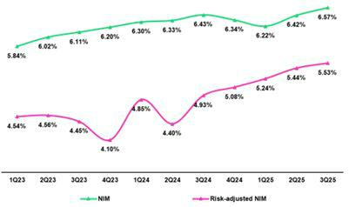

NIM rose 14 bps YoY to stand at 6.57%. This expansion reflected a 25 bps drop in the cost of funding in a context marked by declining rates. The IEA yield decreased 9 bps YoY, impacted by renewals of IEA at lower interest rates. Notwithstanding, the increase in the retail loans’ share of the mix helped buffer downward pressure on the margin. Risk-adjusted NIM rose 60 bps YoY to stand at a record high of 5.53%. This evolution underscores the strategic importance of expanding into new market segments as a driver of profitability.

Dynamics of the Net Interest Margin by Currency

Interest Income / IEA | Average | 3Q24 |  | Average | 2Q25 |  | Average | 3Q25 |  |  | Average | Sep 24 |  | Average | Sep 25
S/ millions | Average | Income | Yields | Average | Income | Yields | Average | Income | Yields |  | Average | Income | Yields | Average | Income | Yields
S/ millions | Balance | Income | Yields | Balance | Income | Yields | Balance | Income | Yields |  | Balance | Income | Yields | Balance | Income | Yields
Total (LC + FC)
Cash and equivalents | 32,083 | 365 | 4.6% | 35,864 | 342 | 3.8% | 35,034 | 316 | 3.6% |  | 31,494 | 1,019 | 4.3% | 37,991 | 1,003 | 3.5%
Other IEA | 1,598 | 26 | 6.5% | 3,215 | 69 | 8.6% | 3,999 | 68 | 6.8% |  | 1,415 | 80 | 7.5% | 2,219 | 157 | 9.4%
Investments | 52,877 | 681 | 5.2% | 53,604 | 670 | 5.0% | 51,396 | 643 | 5.0% |  | 52,772 | 2,042 | 5.2% | 52,506 | 1,996 | 5.1%
Loans | 144,757 | 3,924 | 10.8% | 141,079 | 3,841 | 10.9% | 142,857 | 3,961 | 11.1% |  | 143,773 | 11,715 | 10.9% | 145,242 | 11,649 | 10.7%
Total IEA | 231,315 | 4,996 | 8.6% | 233,762 | 4,922 | 8.4% | 233,286 | 4,988 | 8.6% |  | 229,454 | 14,856 | 8.6% | 237,958 | 14,805 | 8.3%
IEA (LC) | 55.7% | 68.8% | 10.7% | 56.5% | 71.1% | 10.6% | 56.7% | 71.4% | 10.8% |  | 56.3% | 69.4% | 10.6% | 55.8% | 71.0% | 10.6%
IEA (FC) | 44.3% | 31.2% | 6.1% | 43.5% | 28.9% | 5.6% | 43.3% | 28.6% | 5.7% |  | 43.7% | 30.6% | 6.0% | 44.2% | 29.0% | 5.4%
Interest Income / Funding | Average | 3Q24 |  | Average | 2Q25 |  | Average | 3Q25 |  |  | Average | Sep 24 |  | Average | Sep 25
S/ millions | Average | Expense | Yields | Average | Expense | Yields | Average | Expense | Yields |  | Average | Expense | Yields | Average | Expense | Yields
S/ millions | Balance | Expense | Yields | Balance | Expense | Yields | Balance | Expense | Yields |  | Balance | Expense | Yields | Balance | Expense | Yields
Total (LC + FC)
Deposits | 153,203 | 678 | 1.8% | 156,171 | 541 | 1.4% | 156,577 | 565 | 1.4% |  | 151,070 | 2,195 | 1.9% | 160,136 | 1,726 | 1.4%
BCRP + Due to Banks | 17,828 | 262 | 5.9% | 17,107 | 265 | 6.2% | 17,067 | 253 | 5.9% |  | 18,617 | 794 | 5.7% | 17,643 | 785 | 5.9%
Bonds and Notes | 17,453 | 201 | 4.6% | 13,252 | 193 | 5.8% | 12,161 | 165 | 5.4% |  | 15,773 | 598 | 5.1% | 14,739 | 525 | 4.7%
Others | 2,371 | 264 | 44.5% | 4,632 | 307 | 26.5% | 4,853 | 317 | 26.1% |  | 2,651 | 785 | 39.5% | 2,976 | 894 | 40.1%
Total Funding | 190,855 | 1,405 | 2.9% | 191,162 | 1,306 | 2.7% | 190,658 | 1,300 | 2.7% |  | 188,111 | 4,372 | 3.1% | 195,494 | 3,930 | 2.7%
Funding (LC) | 49.3% | 48.5% | 2.9% | 52.4% | 51.9% | 2.7% | 52.6% | 52.8% | 2.7% |  | 49.3% | 50.8% | 3.2% | 51.9% | 52.7% | 2.7%
Funding (FC) | 50.7% | 51.5% | 3.0% | 47.6% | 48.1% | 2.8% | 47.4% | 47.2% | 2.7% |  | 50.7% | 49.2% | 3.0% | 48.1% | 47.3% | 2.6%
_{NIM}(1) | 231,315 | 3,591 | 6.2% | 233,762 | 3,616 | 6.2% | 233,286 | 3,688 | 6.3% |  | 229,454 | 10,484 | 6.1% | 237,958 | 10,875 | 6.1%
NIM (LC) | 55.7% | 76.8% | 8.6% | 56.5% | 78.0% | 8.5% | 56.7% | 77.9% | 8.7% |  | 56.3% | 77.1% | 8.4% | 55.8% | 77.6% | 8.5%
NIM (FC) | 44.3% | 23.2% | 3.3% | 43.5% | 22.0% | 3.1% | 43.3% | 22.1% | 3.2% |  | 43.7% | 22.9% | 3.2% | 44.2% | 22.4% | 3.1%
(1) Unlike the NIM figure calculated according to the formula in Appendix 12.8, the NIM presented in this table includes “Financial Expense associated with the insurance and reinsurance activity, net”.

QoQ Analysis

QoQ, Net Interest Income (NII) rose 2.0%, bolstered by growth in NII in both LC and FC. IEA in LC represented 56.7% of total IEA at the end of 3Q25, and 71.4% of interest income generated over the quarter.

Dynamics of Local Currency (LC)

NII in LC increased 1.8% on the back of higher interest income. This evolution reflected growth in income from Loans, which rose primarily due to an uptick in volumes and secondarily, due to a mix effect, given that expansion was predominantly in retail segments. Higher income from loans was partially offset by a decline in market rates on Cash and equivalents and Investments. Interest expenses rose slightly, fueled by growth in expenses for Deposits, which rose on the back of an increase in the balance of time deposits.

Dynamics in Foreign Currency (FC)

NII in FC increased 2.5% QoQ, driven by a drop in interest expenses, where the decline was fueled mainly by a drop in expenses for Bonds and notes issued following the expiration of a BCP bond. Interest income reported a marginal increase in its contribution to NII, which was driven by a more profitable Loan mix. It is important to note that the remainder of IEA in FC reported a drop in interest income due to a downward trend in market rates.

| Earnings Release 3Q / 2025 Analysis of 3Q25 Consolidated Results

04. Net Interest income (NII)

YoY Analysis

YoY, NII rose 2.7%, reporting a rise in NII in LC while NII in FC declined.

Local Currency Dynamics (LC)

NII in LC increased 4.2% YoY, driven mainly by an uptick in interest income, and despite an increase in interest expenses. The following dynamics drove this evolution:

Interest income from loans increased, impacted by an increase in retail and microfinance loans’ share of the portfolio and by a volume effect at the total loan level. As a result, the yield on interest-earning assets in LC rose 8 bps to 10.8%.

On the interest expense side, costs rose due to increased funding through BCRP instruments. This was partially offset by lower expenses on Bonds and Notes issued, and to a lesser extent, by a decline in deposit-related expenses, which was attributable to a drop in market rates. In this context, the cost of funding in LC decreased 16 bps to 2.7%.

Foreign Currency Dynamics (FC)

NI in FC dropped 2.2% YoY due to the following:

Interest income fell, driven mainly by a drop in income from Loans, which was impacted by lower interest rates. In this context, the yield on IEA in FC dropped 41 bps to stand at 5.7%

The reduction in interest expenses, which was impacted primarily by a drop in interest rates on deposits and to a lesser extent by expirations of bonds at BCP and Credicorp, partially offset the drop in income. In this context, the cost of funding in FC dropped 27 bps to stand at 2.7%.

YTD Analysis

YTD, NII rose 3.7% on the back of growth in both LC and FC.

Local Currency Dynamics (LC)

NII in LC increased 4.3%, driven mainly by growth in interest income and secondarily, by a reduction in interest expenses. On the income side, growth was fueled by higher income from Loans, which rose on the back of the same portfolio dynamics mentioned in the YoY analysis. In the case of expenses, the drop was propelled by a decrease in expenses for Deposits, which was driven by the same factors in play YoY.

Foreign Currency Dynamics (FC)

NII in FC increased 1.7%, where the decline in interest expenses was partially offset by a decrease in interest income. Expenses fell primarily on the back of drop in interest on deposits, which was driven by the same factors in play YoY, and secondarily by a reduction in the funding volume through BCRP + banks. Interest income, in turn, fell due to a decrease in income from Loans, which was mainly attributable to declining market rates.

| Earnings Release 3Q / 2025 Analysis of 3Q25 Consolidated Results

05 Portfolio Quality and Provisions

Portfolio quality indicators have continued to evolve positively over the last year, driven by fortified risk management and backed by improvements in payment performance and in the Peruvian economy.


QoQ, the drop in the NPL balance at BCP Stand-alone was fueled mainly by ongoing improvements in origination and debt collections management in Consumer and Credit Cards. At Mibanco, the reduction in the NPL balance was spurred primarily by a drop in overdue loans. In this context, the NPL ratio dropped 15 bps and 105 bps QoQ and YoY, respectively, to stand at 4.8%.

Provisions rose QoQ, driven by an increase at BCP Stand -alone, reflecting both the recurring dynamics of Retail Banking and specific impacts within Wholesale Banking, with Individuals stable, SMEs slightly higher due to a base effect, and one corporate client showing increased credit risk. This evolution was partially offset by a drop in provisions at Mibanco, which reflects improvements in debt collections management. YoY, provisions dropped 30.5%, driven by BCP Stand-alone and Mibanco. In this context, the cost of risk rose slightly 6 bps QoQ and fell 71 bps YoY, to stand at 1.7% at quarter-end.

Our portfolio quality indicators have improved substantially over the last twelve months and continue to follow a positive trend in all segments, led by Retail Banking, which benefitted from fortified risk management and backed by improvements in payment performance and in the Peruvian economy.

5.1 Portfolio Quality

Total Portfolio Quality (in quarter-end balances)

Loan Portfolio quality and Delinquency ratios |  | As of |  | % change
S/000 | Sep 24 | Jun 25 | Sep 25 | QoQ | YoY
Total loans (Quarter-end balance) | 142,568,785 | 140,961,978 | 144,752,254 | 2.7% | 1.5%
Write-offs | 923,946 | 581,373 | 713,933 | 22.8% | -22.7%
Internal overdue loans (IOLs) | 6,026,341 | 5,044,212 | 4,953,303 | -1.8% | -17.8%
Internal overdue loans over 90-days | 4,851,591 | 4,171,379 | 4,142,080 | -0.7% | -14.6%
Refinanced loans | 2,333,814 | 1,947,709 | 2,016,442 | 3.5% | -13.6%
Non-performing loans (NPLs) | 8,360,155 | 6,991,921 | 6,969,745 | -0.3% | -16.6%
IOL ratio | 4.2% | 3.6% | 3.4% | -16 bps | -81 bps
IOL over 90-days ratio | 3.4% | 3.0% | 2.9% | -10 bps | -54 bps
NPL ratio | 5.9% | 5.0% | 4.8% | -15 bps | -105 bps

QoQ, the NPL balance dropped 0.3%, led primarily by BCP Stand-alone and secondarily by Mibanco. Write-offs rose 22.8%, spurred by extraordinary write-offs, mainly of loans in the judicial recovery stage in SME-Pyme.

QoQ, at BCP Stand-alone, the decrease in the NPL balance was driven primarily by Retail Banking. This evolution was mainly attributable to (i) improvements in origination and debt collections management in Consumer and Credit Cards, and (ii) debt repayments by clients with loans under judicial recovery in SME-Pyme. The reduction in the balance in Retail Banking was upset by an uptick in NPLs in Wholesale Banking, which was fueled mainly by refinancing of a client in the real estate sector. At Mibanco , the reduction in the NPL balance was attributable to a drop in overdue loans, which fell primarily on the back of stricter origination and improvements in debt collections management that began one year ago. Currently, 78% of the loan portfolio is comprised of new, healthier loans that were originated under these policies.

YoY, the NPL balance dropped 16.6%, led primarily by BCP Stand -alone and to a lesser extent by Mibanco. The reduction in write-offs (-22.7%) was spurred mainly by an improvement in origination quality in the Retail segment.

YoY, at BCP Stand-alone, the decrease in the NPL balance was driven primarily by Retail Banking and secondarily by Wholesale Banking. In Retail, the reduction was mainly attributable, in order of impact, to an uptick in debt repayments due to an increase in liquidity in the system, followed by the same dynamics seen in the QoQ Analysis, in the Consumer and Credit Card segments; and a reduction in overdue loans, which was concentrated mainly among clients with medium ticket (> S/ 150 thousand) and lower risk

| Earnings Release 3Q / 2025 Analysis of 3Q25 Consolidated Results

05. Portfolio Quality and Provisions

loans in SME-Pyme. In Wholesale, the drop in NPLs was primarily spurred by total debt repayment by two corporate clients in the real estate sector.

Finally, at Mibanco, the reduction in NPLs was driven by the same dynamics in play QoQ.

NPL Ratio for Total Loans

The NPL ratio at Credicorp fell 15 bps QoQ to stand at 4.8%. This decline was driven mainly by loan growth and secondarily, by the same drivers that drove the NPL evolution in the QoQ analysis.
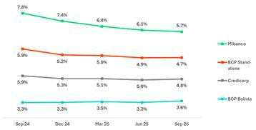

If we analyze the QoQ evolution of the NPL ratio by subsidiary, we see:

● BCP Stand-alone, where the NPL ratio dropped 12 bps. In the case of Small Businesses and Mortgage, the reduction in the NPL ratio was attributable mainly to loan growth whereas in Consumer and Credit Cards, the decline was spurred primarily by a drop in NPL volumes.

- Mibanco, where the NPL ratio fell 41 bps. This evolution was fueled primarily by a drop in NPL volumes and secondarily, by loan growth.

NPL Ratio for Total Loans at BCP ⁽¹⁾
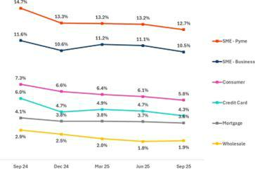

The NPL ratio at Credicorp dropped 105 bps YoY to stand at 4.8%. This decline was driven mainly by the same dynamics that fueled the evolution of NPLs YoY and secondarily, by loan growth.

If we analyze the YoY evolution of the NPL Ratio by Subsidary, we see:

● BCP Stand-alone, where the NPL ratio fell 119 bps YoY. Across segments, except for Mortgage, the reduction in the NPL ratio was mainly attributable to a drop in NPL volumes. In the case of Mortgage, the decline in the NPL ratio was driven primarily by loan growth and secondarily, by a reduction in NPL volumes.

- It corresponds to management information by segment in BCP Stand-Alone.

  - Mibanco, where the NPL ratio dropped 215 bps YoY, fueled mainly by a reduction in NPL volumes and secondarily, by loan growth.

| Earnings Release 3Q / 2025 Analysis of 3Q25 Consolidated Results

05. Portfolio Quality and Provisions

5.2 | Provisions and Cost of Risk of the Total Portfolio
Loan Portfolio Provisions |  |  | Quarter |  | % change |  |  | Up to | % change
S/000 |  | 3Q24 | 2Q25 | 3Q25 | QoQ | YoY | Sep 24 | Sep 25 | Sep 25 / Sep 24
Gross provision for credit losses on loan portfolio |  | (981,870) | (683,965) | (720,445) | 5.3% | -26.6% | (3,085,607) | (2,100,143) | -31.9%
Recoveries of written-off loans |  | 113,789 | 108,806 | 117,527 | 8.0% | 3.3% | 309,456 | 340,173 | 9.9%
Provision for credit losses on loan portfolio, net of recoveries |  | (868,081) | (575,159) | (602,918) | 4.8% | -30.5% | (2,776,151) | (1,759,970) | -36.6%
Cost of risk ⁽¹⁾ |  | 2.4% | 1.6% | 1.7% | 6 bps | -71 bps | 2.6% | 1.6% | -95 bps

(1) Provisions for credit losses on loan portfolio, net of annualized recoveries / Average Total Loans. It includes reversal of provisions for “El Niño” Phenomenon in 1Q24.

QoQ, provisions rose 4.8%. This evolution was driven by BCP Stand-alone and partially offset by Mibanco . At BCP Stand-alone, growth in provisions reflected both the recurring dynamics of Retail Banking and specific impacts within Wholesale Banking. In Retail Banking, provisions for Individuals remained stable while provisions for SMEs rose slightly due to a base effect stemming from higher reversals last quarter linked to increased debt repayments in SME-Business. In Wholesale Banking, there was a relevant increase in the credit risk of one corporate client. At Mibanco, provisions contracted slightly on the back of improvements in debt collections management. In this context, the CoR at Credicorp rose slightly by 6 bps QoQ but remained low again this quarter at 1.7%. This result was attributable to the risk management measures instituted this year and to improvements in the Peruvian economy.

Cost of Risk by Subsidiary

YoY, provisions dropped 30.5%, driven by BCP Stand-alone and Mibanco. This evolution was fueled by improvements in payment performance in a context of economic recovery. At BCP Individual, the reduction in provisions was attributable to Individuals and SME-Pyme, where the decine was mainly due to an increase in lower-risk vintages’ share of total loans. This evolution was partially offset by Wholesale, which was impacted by the base effect generated by an uptick in reversals due to an increase in debt repayments. At Mibanco, the decrease was led by an improvement in underlying risk as lower-risk vintages gained traction and currently represent 78% of total loans. In this context, the CoR at Credicorp dropped 71 bps YoY to stand at 1.7%.
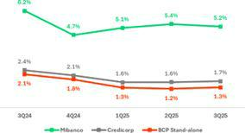

YTD, provisions fell 36.6%. This evolution was driven by BCP Stand-alone and Mibanco, via the same dynamics as those seen YoY. In this scenario, the CoR at Credicorp decreased 95 pbs to stand at 1.7%.

QoQ Cost of Risk Evolution YoY Cost of Risk Evolution
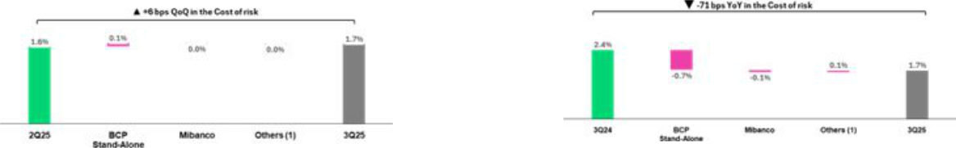

(1) Others include BCP Bolivia, Mibanco Colombia, ASB and eliminations.
(1) Others include BCP Bolivia, Mibanco Colombia, ASB and eliminations.

YTD Cost of Risk Evolution*
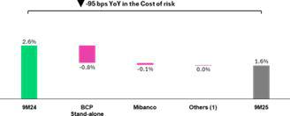

  - It includes reversal of provisions for “El Niño” Phenomenon in 1Q24.

- Others include BCP Bolivia, Mibanco Colombia, ASB and eliminations.

| Earnings Release 3Q / 2025 Analysis of 3Q25 Consolidated Results

05. Portfolio Quality and Provisions

NPL Coverage Ratio (in Quarter-end balances)

Loan Portfolio Quality and Delinquency Ratios |  | As of |  | % change
S/000 | Sep 24 | Jun 25 | Sep 25 | QoQ | YoY
Total loans (Quarter-end balance) | 142,568,785 | 140,961,978 | 144,752,254 | 2.7% | 1.5%
Allowance for loan losses | 8,250,023 | 7,658,595 | 7,674,040 | 0.2% | -7.0%
Non-performing loans (NPLs) | 8,360,155 | 6,991,921 | 6,969,745 | -0.3% | -16.6%
Allowance for loan losses over Total loans | 5.8% | 5.4% | 5.3% | -13 bps | -49 bps
Coverage ratio of NPLs | 98.7% | 109.5% | 110.1% | 58 bps | 1143 bps
Allowance for loan losses
(in S/ millions)
 | QoQ, the allowance for loan losses rose slightly by 0.2%, driven mainly
 | by BCP Bolivia and Mibanco.
 | YoY, the allowance for loan losses fell 7.0%, fueled primarily by |  |  |  | Retail
 | Banking at BCP Stand-alone and secondarily by BCP Bolivia.
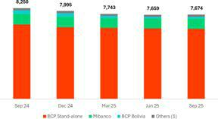

(1) Others include Mibanco Colombia, ASB and eliminations.

NPL Coverage Ratio

The NPL Coverage Ratio at Credicorp stood at 110.1% at the end of 3Q25.
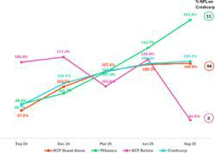

QoQ

The NPL Coverage Ratio at Credicorp rose 58 bps, driven by the evolution at BCP Stand-alone and Mibanco.

A t BCP Stand-alone, the NPL Coverage Ratio increased 25 bps to stand at 109.6%. This evolution was primarily attributable to a decrease in NPLs, as described in the QoQ analysis. At Mibanco, the NPL Coverage Ratio rose 730 bps to stand at 121.0%. This evolution was also driven by the drop in NPLs, which is summarized in the QoQ analysis.

YoY

The Total NPL Coverage Ratio at Credicorp increased 1,143 bps, fueled mainly by BCP Stand-alone and Mibanco.

At BCP Stand-alone, the Total NPL Coverage Ratio was up 1,235 bps, driven primarily by a decrease in NPLs, as discussed in the YoY analysis. At Mibanco, the ratio was up 2,203 bps YoY. This evolution was also attributable to a reduction in NPLs, as outlined in the YoY analysis.

| Earnings Release 3Q / 2025 Analysis of 3Q25 Consolidated Results

06 Other Income


Other Income declined 1.4% QoQ but increased 7.0% YoY. The volatility in these results reflects fluctuations in Other Non-Core Income, which included atypical items in prior quarters. Focusing on recurring components within Other Core Income:

QoQ, Other Core Income grew 4.0%, primarily driven by an uptick in Universal Banking. Growth was supported by higher fees at Yape, fueled by increased revenue-generating transactions, and FX gains at BCP Bolivia, following the successful rollout of new foreign exchange products.

YoY, Other Core Income rose 11.9%, mainly due to higher total fees at BCP Stand-alone and FX gains within Universal Banking, underscoring consistent execution of our revenue diversification and decoupling strategy.

- Other Income¹
Other Income ⁽¹⁾ |  | Quarter |  | % Change |  | Up to |  | % change
(S/ 000) | 3Q24 | 2Q25 | 3Q25 | QoQ | YoY | Sep 24 | Sep 25 | Sep 25 / Sep 24
Other Core Income | 1,302,675 | 1,401,569 | 1,457,604 | 4.0% | 11.9% | 3,761,186 | 4,197,011 | 11.6%
Other Non-Core Income | 242,670 | 275,804 | 196,587 | -28.7% | -19.0% | 768,047 | 824,769 | 7.4%
Total Other Income | 1,545,345 | 1,677,373 | 1,654,191 | -1.4% | 7.0% | 4,529,233 | 5,021,780 | 10.9%
- Beginning in 1Q25, accounting reclassifications have been incorporated affecting Fee Income, Net Gain on Foreign Exchange Transactions, and Net Gain on Derivatives Held for Trading. Prior periods have been restated for comparability and may differ from previously reported figures.

Other Income dropped 1.4% QoQ but rose 7.0% YoY and 10.9% YTD.

6.1. Other Core Income¹
Other Core Income ⁽¹⁾ |  | Quarter |  | % Change |  | Up to |  | % change
(S/ 000) | 3Q24 | 2Q25 | 3Q25 | QoQ | YoY | Sep 24 | Sep 25 | Sep 25 / Sep 24
Fee Income | 982,818 | 1,024,553 | 1,063,032 | 3.8% | 8.2% | 2,786,611 | 3,081,609 | 10.6%
Net Gain on Foreign Exchange Transactions | 319,856 | 377,016 | 394,572 | 4.7% | 23.4% | 974,575 | 1,115,402 | 14.5%
Total Other Core Income | 1,302,674 | 1,401,569 | 1,457,604 | 4.0% | 11.9% | 3,761,186 | 4,197,011 | 11.6%
- Beginning in 1Q25, accounting reclassifications have been incorporated affecting Fee Income, Net Gain on Foreign Exchange Transactions, and Net Gain on Derivatives Held for Trading. Prior periods have been restated for comparability and may differ from previously reported figures.

Income diversification, coupled with heightened digital capacities, continued to drive growth in Other Core Income.

- QoQ,Other Core Income hit an all-time high, buoyed mainly by growth in Fee Income (+3.8%), which will be discussed in the following section. The Net Gain on FX Transactions rose 4.7% after registering record-high gains once again at BCP Stand-alone and a recovery at BCP Bolivia. The positive performance of BCP Bolivia was driven by the increased dynamism of the Treasury Desk, which achieved higher transaction volumes thanks to sales of new products in the foreign exchange business.

- YoY, growth was driven by an increase in Fee Income (+8.2%), with the underlying drivers to be detailed in the next section. Additionally, Net Gain on FX Transactions rose by 23.4%, primarily led by BCP Stand-alone and, to a lesser extent, by BCP Bolivia, both supported by higher transaction volumes.

- YTD, growth was driven mainly by an upswing in Fee Income (+10.6%); details on the dynamics will be discussed in the next section. The Net Gain on FX transactions rose 14.5%, buoyed by on-going growth in transaction volumes. This performance reflects two complementary strategies: (i) strengthening digital channels to capture transactional opportunities, which position us to capture transactional opportunities through mobile banking at BCP Stand-alone, and (ii) disciplined pricing and spread management to boost volumes, where commercial management initiatives were more active in and focused on the Retail Banking segment. Together, these initiatives position us to deliver sustainable FX revenue growth and reinforce our competitive edge.

| Earnings Release 3Q / 2025 Analysis of 3Q25 Consolidated Results

06. Other Income

Fee Income by Subsidiary

Fee Income by Subsidiary |  | Quarter |  | % Change |  |  | Up to | % change
(S/ 000) | 3Q24 | 2Q25 | 3Q25 | QoQ | YoY | Sep 24 | Sep 25 | Sep 25 / Sep 24
BCP Stand-Alone ⁽¹⁾ | 804,058 | 853,720 | 873,187 | 2.3% | 8.6% | 2,251,040 | 2,558,334 | 13.7%
BCP Bolivia ⁽²⁾ | 18,380 | 14,552 | 10,244 | -29.6% | -44.3% | 54,363 | 37,640 | -30.8%
Mibanco | 18,412 | 27,633 | 28,873 | 4.5% | 56.8% | 64,358 | 84,845 | 31.8%
Mibanco Colombia | 12,333 | 12,395 | 14,314 | 15.5% | 16.1% | 34,625 | 35,835 | 3.5%
Pacífico | (3,218) | (6,287) | (5,123) | -18.5% | 59.2% | (8,905) | (15,167) | 70.3%
Prima | 90,748 | 97,233 | 95,006 | -2.3% | 4.7% | 284,379 | 286,311 | 0.7%
ASB | 15,760 | 12,841 | 12,615 | -1.8% | -20.0% | 48,307 | 39,282 | -18.7%
Credicorp Capital | 141,657 | 134,297 | 148,115 | 10.3% | 4.6% | 423,287 | 418,676 | -1.1%
Eliminations and Other ⁽³⁾ | (115,312) | (121,831) | (114,199) | -6.3% | -1.0% | (364,843) | (364,147) | -0.2%
Total Net Fee Income | 982,818 | 1,024,553 | 1,063,032 | 3.8% | 8.2% | 2,786,611 | 3,081,609 | 10.6%
- Beginning in 1Q25, accounting reclassifications related to credit card loyalty program expenses and Yape’s transactional fee expenses have been incorporated. These reclassifications affected Administrative and General Expenses as well as Fee Income. Prior periods have been restated for comparability and may differ from previously reported figures.
- Beginning in 1Q25, reclassifications related to FX operations at BCP Bolivia have been incorporated. These reclassifications affected Fee Income and Net Gain on Derivatives Held for Trading, which are now consolidated into Net Gain on Foreign Exchange Transactions. Prior periods have been restated for comparability and may differ from previously reported figures.
- Correspond mainly to the eliminations of bancassurance between Pacifico, BCP, and Mibanco.

QoQ, YoY and YTD, growth of 3.8%, 8.2% and 10.6% were reported, respectively. Across periods, growth was driven mainly by an increase in total fees at BCP Stand-alone (the dynamics will be discussed in the next chapter). In the QoQ analysis, growth was also spurred by Credicorp Capital, which reported an increase in AUM volumes in Colombia, which rose through product sales to institutional clients, and in Chile, where growth was registered in the investment fund management and securities custody businesses. In the YoY and YTD analysis, Mibanco drove the improvement in performance through an uptick in fees for obligatory insurance policies, which rose alongside growth in disbursements. This evolution was partially attenuated by BCP Bolivia, which reported a drop in the transactions volume of cards in USD.

Fee Income at BCP Stand-alone

Composition of Fee Income at BCP Stand-alone (*)

BCP Stand-alone Fees (*) |  | Quarter |  | % Change |  |  | Up to | % change
(S/ 000,000) | 3Q24 | 2Q25 | 3Q25 | QoQ | YoY | Sep 24 | Sep 25 | Sep 25 / Sep 24
Payments and transactional services ⁽¹⁾ | 300 | 287 | 270 | -5.7% | -9.9% | 835 | 840 | 0.6%
Yape ⁽²⁾ | 94 | 132 | 165 | 25.3% | 74.6% | 218 | 417 | 91.2%
Liability and Transactional Accounts ⁽³⁾ | 198 | 201 | 204 | 1.7% | 3.2% | 567 | 602 | 6.1%
Loan Disbursement ⁽⁴⁾ | 96 | 104 | 103 | -1.1% | 7.1% | 287 | 305 | 6.3%
Off-balance sheet | 57 | 53 | 54 | 1.3% | -5.2% | 169 | 163 | -3.6%
Insurances | 34 | 40 | 35 | -12.2% | 2.4% | 102 | 122 | 19.7%
Wealth Management and Corporate Finance | 13 | 20 | 19 | -3.1% | 51.2% | 40 | 54 | 35.8%
Others ⁽⁵⁾ | 12 | 18 | 23 | 27.2% | 87.1% | 33 | 55 | 66.4%
Total | 804 | 854 | 873 | 2.3% | 8.6% | 2,251 | 2,558 | 16.5%

(*) Management figures.

- Corresponds to fees from credit and debit cards, payments and collections. Beginning in 1Q25, accounting reclassifications related to expenses associated with the credit card loyalty program have been incorporated. These reclassifications affected Administrative and General Expenses and Fee Income. Figures for prior periods have been restated for comparability and may differ from those previously reported.
- Not includes fees related to E-Commerce. Not includes FX and remittances. Beginning in 1Q25, accounting reclassifications associated with Yape’s transactional fee expenses have been incorporated. These reclassifications affected Administrative and General Expenses and Fee Income. Figures for prior periods have been restated for comparability and may differ from those previously reported.
- Corresponds to fees from Account maintenance, interbank transfers, national transfers, and international transfers.

- Corresponds to fees from retail and wholesale loan disbursements.

- Use of third-party networks, other services to third parties, and Commissions in foreign branches

QoQ, Fee Income at BCP Stand-alone rose 2.3%, driven mainly by:

- Yape (+25.3%), which registered improved results in (i) QR (POS) merchant fee, driven by an upswing in activity in July (due to growth in consumer liquidity following statutory bonus payment) and in August (due to retail campaigns). Growth over the period was also driven by (ii) bill payments, which reflect the beginning of the educational centers registration cycle for the second half of the year, and an uptick in the use of (iii) Checkout, which experienced growth in the number of affiliated establishments.
- Other (+27.2%), reflecting growth in income from overseas branches.

| Earnings Release 3Q / 2025 Analysis of 3Q25 Consolidated Results

06. Other Income

Core Businesses, which include (i) Payment and Transactional Services, (ii) Liability and Transactional Accounts, and (iii) Loan Disbursements, which represent more recurring and stable accounts, reported a drop mainly through Payment and Transactional Services. The Merchant Fee, which is pegged to the dynamics of debit and credit card transactional activity and billing, maintained solid results that were, however, offset by growth in expenses related to loyalty programs and Visa fees.

YoY, Fee Income rose 8.6%, driven by:

- Yape (+75.0%): Growth was spurred by the same functionalities responsible for the QoQ evolution, which represent the app’s most consolidated performers. The following businesses also contributed to growth (i) Top-ups, where Yape continues to strengthen its market share; (ii) Remittances, reflecting the power of new strategic alliances that have bolstered our access to channels and countries for distribution; and (iii) Yape Businesses, whose TPV continues to trend gradually upward.
- Others (+71.5%), related to Other Services and overseas branches.

Positive results for Core Businesses were driven by growth in Loan disbursements (+7.1%), which rose on the back of an uptick in origination, and by Liability and transactional accounts, which reported growth in the volume of interbank and foreign transfers and an increase in current account openings. This performance was offset by a reduction in the Payment and Transactional Services line, which declined despite growth in transactional activity, impacted by a high base effect due to an extraordinary income recorded in 3Q24, as well as by higher Visa fees.

YTD (Sep 25 vs Sep 24) growth stood at 16.5%, which was attributable to:

- Yape (+91.4%), as mature functionalities and new solutions advanced significantly.

- Core businesses, registered positive results through (i) Liability and Transactional Accounts, which rose on the back of Wires and Transfers and Current Accounts, (ii) Loan disbursements, associated with an uptick in the dynamism of the loan portfolio, and (iii) Payments and Transactional Services, which reported growth due to growth in billing for debit and credit cards.

6.2 Other Non-core Income

Other Non-Core Income |  | Quarter |  | % change |  |  | Up to | % change
(S/ 000) | 3Q24 | 2Q25 | 3Q25 | QoQ | YoY | Sep 24 | Sep 25 | Sep 25 / Sep 24
Net Gain on Securities | 120,033 | 179,174 | 111,977 | -37.5% | -6.7% | 274,489 | 263,002 | -4.2%
Net Gain from Associates ⁽¹⁾ | 35,600 | 6,556 | 5,192 | -20.8% | -85.4% | 96,623 | 35,816 | -62.9%
Net Gain of Derivatives Held for Trading ⁽²⁾ | (3,499) | 21,418 | 244 | -98.9% | -107.0% | 78,233 | 40,161 | -48.7%
Net Gain from Exchange Differences | (6,139) | 10,195 | 7,518 | -26.3% | -222.5% | (19,693) | 33,672 | -271.0%
Other Non-operative Income | 96,675 | 58,461 | 71,656 | 22.6% | -25.9% | 338,395 | 452,118 | 33.6%
Total Other Non-Core Income | 242,670 | 275,804 | 196,587 | -28.7% | -19.0% | 768,047 | 824,769 | 7.4%
- Includes gains on other investments. Beginning in 1Q25, revenues from the EPS and Medical Services businesses are no longer reported under Net Gain from Associates. Instead, they are fully consolidated into the Underwriting Insurance Result and the newly created Medical Services Result, respectively.
- Beginning in 1Q25, accounting reclassifications related to FX operations at BCP Bolivia have been incorporated. These reclassifications affected Fee Income and Net Gain on Derivatives Held for Trading, which are now consolidated into Net Gain on Foreign Exchange Transactions. Figures for prior periods have been restated for comparability and may differ from those previously reported.
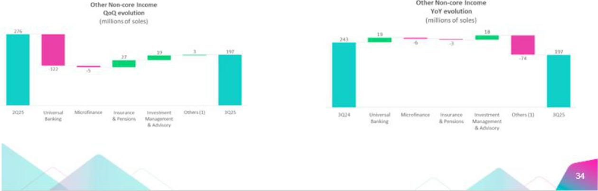

| Earnings Release 3Q / 2025 Analysis of 3Q25 Consolidated Results

06. Other Income
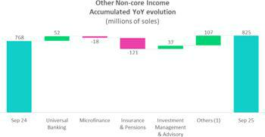

(1) Others: include Grupo Credito, Credicorp Stand-alone, eliminations and others.

QoQ, Other Non-Core Income dropped 28.7%, driven mainly by:

- Net gain (loss) on securities : dropped 37.5%, spurred mainly by a base effect at BCP Stand-alone, which was associated with a sovereign bond exchange in 2Q25. This decline was partially offset by Credicorp Capital, which reported positive results for Trading in the Capital Markets in Colombia after a strategy was executed to repurchase government papers and exchange bonds.

- Net gain (loss) on derivatives held for trading : fell 98.9% due to lower results for coverage strategies for portfolios in local currencies and for Forward contracts, mainly at Credicorp Capital.

This impact was partially offset by Other Non-Operating Income (+22.6%), which rose due to releases of administrative and contingent provisions at Pacifico.

YoY, Other Non-Core income dropped 19.0%, due to:

- Other non-operating income: fell 25.9%, impacted by extraordinary income in 3Q24 in Others, which registered a reversal of provisions at ASHC.
- Net gain on investment in associates : decreased 85.4%, mainly attributable to Pacifico, which experienced a change in accounting after the acquisition of Banmedica; currently, the results for corporate health insurance and medical services are consolidated in the Insurance Underwriting Result and Medical Services line rather than in the gain from associates line.

- Net gain (loss) on securities : dropped 6.7%, impacted primarily by Pacífico, which was impacted by credit downgrades on a couple of assets in the investment portfolio. The YoY decline was also driven by BCP Bolivia, which was affected by a base effect associated with the release of anticipated losses on investments in 3Q24, and by BCP Stand-alone, which registered a base effect related to sovereign bonds exchanges and sales in 3Q24. This contraction was partially offset by an uptick in the gain on securities at Credicorp Capital, which was driven by the same dynamics as those seen QoQ.

The reduction in Other Non- Core Income was partially offset by the YoY increase in the Net Gain (Loss) on Exchange Differences, which reflected the base effect generated by USDPEN exchange rate volatility in 3Q24.

YTD, Other Non-Core Income rose 7.4%, driven by

- Other Non-Operating Income: increased 33.6%, buoyed by an extraordinary gain following the acquisition of Banmédica.

- Net Gain (Loss) on exchange differences : up mainly through ASB, due to treasury gains to cover exposure in local currencies.

Growth in Other Non-Core Income YTD was partially attenuated by a Net gain on associates (-62.9%), which reflects an accounting adjustment at Pacífico, and by a Net Gain (Loss) on derivatives held for trading (-48.7%), in line with a reduction in results at ASB and Credicorp Capital due to exposure in local currency portfolios. The YTD result was also impacted, albeit to a lesser extent, by a decrease in the Net Gain on Securities (-4.2%), related to a deterioration of some investments in Pacifico, and by the devaluation of a fund in Others, which was partially offset by BCP Stand-alone, attributable to a sovereign bond exchange in 2Q25.

| Earnings Release 3Q / 2025 Analysis of 3Q25 Consolidated Results

07 Results for Insurance Underwriting and Medical Services


QoQ, the Insurance Underwriting Result rose 10.7%. This evolution was driven primarily by (i) Life, attributable to a drop in expenses for Insurance Service Expenses on the back of a decrease in claims in D&S and Group Life, (ii) EPS, which showed higher Insurance Service Income supported by a solid commercial performance that resulted in higher premiums, and (iii) P&C, due to a more favorable reinsurance Result in Commercial Lines.

YoY and YTD, results increased 33.1% and 20.5% respectively, through (i) Life, due to a reduction in Insurance Service Expenses in D&S and Individual Life and growth in Income in Credit Life; (ii) P & C, due to the same dynamics exposed on the QoQ analysis; and (iii) the EPS business, due to the change in perimeter given the consolidation of Banmedica's operations.

Insurance Underwriting Results |  |  | Quarterly |  | % Change |  |  |  | Up to | %Change
S/millions |  | 3Q24 | 2Q25 | 3Q25 | QoQ |  | YoY | Sep 24 | Sep 25 | Sep 25 / Sep 24
 | Insurance Service Income | 940.9 | 1,185.6 | 1,212.4 | 2.3% |  | 28.9% | 2,788.0 | 3,386.0 | 21.4%
Total | Insurance Service Expenses | (514.7) | (738.8) | (746.6) | 1.1% |  | 45.1% | (1,487.1) | (2,057.2) | 38.3%
Total | Reinsurance Results | (134.4) | (96.0) | (77.4) | -19.3% |  | -42.4% | (414.6) | (260.4) | -37.2%
 | Insurance Underwriting Result | 291.8 | 350.9 | 388.3 | 10.7% |  | 33.1% | 886.3 | 1,068.4 | 20.5%
 | Insurance Service Income | 471.1 | 480.0 | 490.1 | 2.1% |  | 4.0% | 1,382.8 | 1,460.1 | 5.6%
P&C | Insurance Service Expenses | (278.8) | (298.7) | (319.7) | 7.1% |  | 14.7% | (818.7) | (943.7) | 15.3%
P&C | Reinsurance Results | (114.0) | (88.7) | (72.9) | -17.8% |  | -36.1% | (334.2) | (234.0) | -30.0%
 | Insurance Underwriting Result | 78.4 | 92.6 | 97.5 | 5.2% |  | 24.3% | 230.0 | 282.4 | 22.8%
 | Insurance Service Income | 453.0 | 330.9 | 326.7 | -1.3% |  | -27.9% | 1,347.2 | 990.5 | -26.5%
Life | Insurance Service Expenses | (233.8) | (79.0) | (38.0) | -52.0% |  | -83.8% | (671.1) | (229.3) | -65.8%
Life | Reinsurance Results | (15.8) | (7.6) | (28.9) | 281.1% |  | 83.4% | (66.1) | (49.8) | -24.7%
 | Insurance Underwriting Result | 203.4 | 244.3 | 259.9 | 6.4% |  | 27.8% | 610.0 | 711.4 | 16.6%
 | Insurance Service Income | 23.5 | 13.3 | 14.8 | 11.7% |  | -37.0% | 73.9 | 45.4 | -38.5%
Crediseguros | Insurance Service Expenses | (7.1) | (4.2) | (2.2) | -48.3% |  | -69.6% | (12.7) | (12.2) | -4.3%
Crediseguros | Reinsurance Results | (11.2) | (3.8) | (2.9) | -24.1% |  | -74.3% | (29.8) | (9.5) | -68.0%
 | Insurance Underwriting Result | 5.2 | 5.3 | 9.8 | 85.5% |  | 90.2% | 31.3 | 23.7 | -24.2%
 | Insurance Service Income | 0.0 | 383.3 | 401.1 | 4.6% |  | n.a. | 0.0 | 914.5 | n.a.
EPS | Insurance Service Expenses | 0.0 | (357.3) | (369.5) | 3.4% |  | n.a. | 0.0 | (849.7) | n.a.
EPS | Reinsurance Results | 0.0 | (1.3) | 1.7 | -233.9% |  | n.a. | 0.0 | 0.0 | n.a.
 | Insurance Underwriting Result | 0.0 | 24.7 | 33.3 | 34.6% |  | n.a. | 0.0 | 64.8 | n.a.

QoQ, the Insurance Underwriting Result increased 10.7%, driven by growth in income from Insurance Services (+2.3%) and a more favorable Reinsurance Result (-19.3%). The positive impact of both these drivers was attenuated by growth in Insurance Service Expenses (+1.1%).

YoY and YTD, the Insurance Underwriting Result increased 33.1% and 20.5%, respectively. This evolution was fueled by growth in Insurance Service Income (+28.9% and +21.4%) and by a more favorable Reinsurance Result (-42.4% and -37.2%). These impacts were partially attenuated by an increase in Insurance Service Expenses (+45.1% and +38.3%).

P%C Insurance

Insurance Service Income Insurance Service Expenses
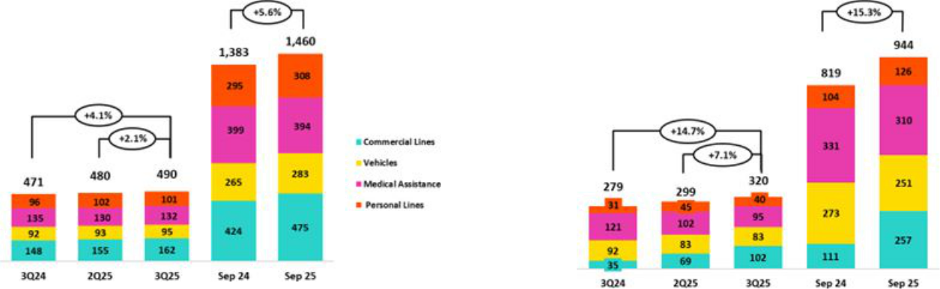

- As of 1Q25, the business previously known as “P & C Risks” has been reclassified into two separate categories: Personal Lines and Commercial Lines to better reflect the nature of insured risks. Historical figures have been adjusted for comparability purposes

| Earnings Release 3Q / 2025 Analysis of 3Q25 Consolidated Results

07. Results for Insurance Underwriting and Medical Services

QoQ, the Insurance Underwriting Result increased 5.2% on the back of the following dynamics:

- Insurance Service Income rose slightly by 2.1%, driven mainly by (i) Commercial Lines and Medical Assistance, which registered an increase in premiums for seasonal renewals, and (ii) Vehicles, due to a reduction in reserves set aside for current risks (RRC).

- Insurance Service Expenses rose 7.1%, driven primarily by Commercial Lines, which reported an increase in claims in the Fire and Transportation lines.

- The Reinsurance Result improved, fueled by an increase in claims recovered from the reinsurer in Commercial Lines.

YoY, the Insurance Underwriting Result increased 24.3% through the following dynamics:

- Insurance Service Income rose 4.0%, attributable primarily to (i) Commercial lines, which reported an increase in the release of reserves for current risks, (ii) Personal Lines, where the card protection product registered higher sales through the Bancassurance and Alliances channel, and (iii) Soat, which registered a drop in reserves set aside for current risks.

- Insurance Service Expenses increased 14.7%, driven by the same dynamics in play QoQ.
- The Reinsurance Result improved, fueled by the same drivers that drove the QoQ result.

YTD, the Insurance Underwriting Result increased 22.8% on the tails of (i) a more favorable Reinsurance Result, which reflects an increase in claims recovered from the reinsurer in the Commercial Lines and Personal Lines, and (ii) an increase in Insurance Service Income, which rose on the back of higher premiums in Commercial Lines, Personal Lines and Vehicles.

Life Insurance
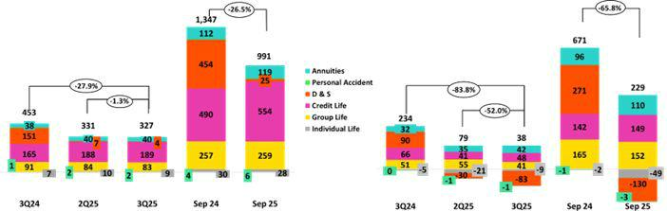

QoQ, the Insurance Underwriting Result increased 6.4% through the following dynamics:

- Insurance Service Income dropped 1.3%, due primarily to (i) D&S, which reported a decrease in premiums regularized under the SISCO VII contract, and (ii) Group Life, which registered a decrease in premiums through Collective Life.

- Insurance Service Expenses dropped 52.0%, due primarily to (i) D&S, which reported an increase in releases of reserves for claims under SISCO VII, and (ii) Group Life, which registered a decrease in D & S claims.

- The Reinsurance Result deteriorated due to the evolution of D&S, which reported a reserves release for claims recovered from the reinsurer.

YoY, the Insurance Underwriting Result increased 27.8% through the following dynamics:

- Insurance Service Income dropped 27.9%; this evolution was driven primarily by D&S and reflects the fact that Company was not awarded tranches of the SISCO VIII contract (versus tranches awarded perceived under SISCO VII). The aforementioned was partially attenuated by Credit Life, which reported growth in premiums allotted to the period through the Bancassurance and Alliance channels.

| Earnings Release 3Q / 2025 Analysis of 3Q25 Consolidated Results

- Results for Insurance Underwriting and Medical Services

  - Insurance Service Expenses fell 83.8%, fueled mainly by (i) D&S, given that no tranches of the SISCO VII were awarded to the Company, and (ii) Credit Life, due to a decrease in claims through the Bancassurance Channel.

  - The Reinsurance Result deteriorated, driven mainly by D&S and via the same drivers that drove the QoQ result.

YTD, the Insurance Underwriting Result rose 16.6%. This evolution was spurred primarily by a drop in Insurance Service Income in D&S and secondarily, in Individual Life. Lastly, an increase in Insurance Service Income in Credit Life, which was fueled by growth in new premiums distributed through Bancassurance and Alliances, also contributed to an improvement in the underwriting result.

Result for Medical Services

In March 2025, Credicorp completed its acquisition of the remaining 50% stake in Empresas Banmédica under the joint venture with Pacífico Compañía de Seguros y Reaseguros S.A. ("Pacifico Seguros") set forth in December 2014. This transaction allowed Credicorp, through its subsidiaries Pacifico Seguros y Grupo Crédito S.A., to assume fully ownership of Pacífico S.A. Entidad Prestadora de Salud ("Pacifico EPS"), which manages corporate healthcare for employees, medical services, and private medical insurance in Peru. This acquisition strengthens Credicorp’s capacity to create a more sustainable and inclusive economy by improving access to health insurance and services and bolstering efforts to expand financial inclusion.

Consequently, as of March 2025, the EPS business’s result is primarily consolidated in Credicorp’s Insurance Underwriting Result line while the Medical Services business is reported in a new account named “Medical Services Result”. It is important to note that in 1Q25, only the month of March was included.

YTD, the Result for Medical Services contributed S/ 290M.
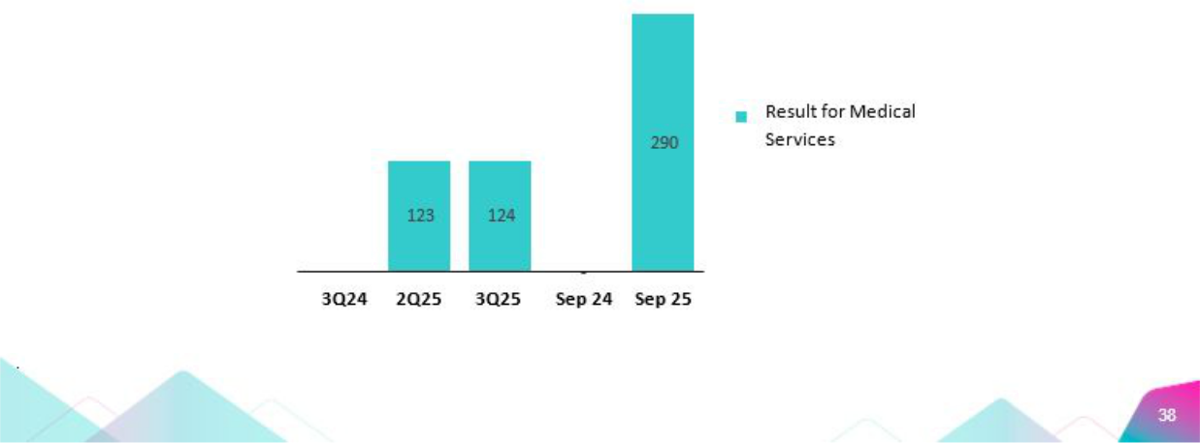

| Earnings Release 3Q / 2025 Analysis of 3Q25 Consolidated Results

08 Operating Expenses


Operating expenses rose 12.8% YTD, driven mainly by core businesses at BCP Stand-alone and innovation initiatives at the Credicorp level. Core business expenses at BCP Stand-alone increased due to: (i) an uptick in the employee salaries and benefits line, which reflects an increase in provisioning for variable compensation and an increase in headcount; and (ii) an uptick in administrative expenses, mainly through BCP Stand-alone, which reflects an increase in cloud use among increasingly digitalized clients, and via Pacifico, which reflects the consolidation of 100% of the operations formerly held under the joint venture with Empresas Banmedica. Expenses for initiatives in the innovation portfolio at the Credicorp level increased 16.1%.

Total Operating Expenses

Operating expenses |  | Quarter |  | % change |  | Up to |  | % change
S/000 | 3Q24 | 2Q25 | 3Q25 | QoQ | YoY | Sep 24 | Sep 25 | Sep 25 / Sep 24
Salaries and employees benefits | 1,155,966 | 1,304,466 | 1,341,137 | 2.8% | 16.0% | 3,404,858 | 4,007,293 | 17.7%
Administrative and general expenses | 971,449 | 965,994 | 1,068,459 | 10.6% | 10.0% | 2,740,755 | 2,904,287 | 6.0%
Depreciation and amortization | 179,495 | 212,662 | 219,800 | 3.4% | 22.5% | 526,845 | 636,228 | 20.8%
Association in participation | 6,414 | 371 | 65 | -82.5% | -99.0% | 24,461 | 7,235 | -70.4%
Operating expenses ⁽¹⁾ | 2,313,324 | 2,483,493 | 2,629,461 | 5.9% | 13.7% | 6,696,919 | 7,555,043 | 12.8%

The analysis of expenses is based on YTD movements to eliminate the effects of seasonality between quarters. YTD, Operating Expenses rose 12.8%, driven mainly by:

- Growth in the Employee Salaries and Benefits line, which was driven mainly by (i) BCP Stand-alone, fueled primarily by an increase in provisions for variable compensation and secondarily by an increase in headcount for new projects, and (ii) Pacifico, on the back of growth in compensation.

- An increase in Administrative Expenses, which was fueled by BCP Stand-alone and Pacifico. At BCP Stand-alone, an increase was reported in transactions through digital channels, which triggered an upswing in expenses for cloud use and other IT-related services. At Pacifico, growth in this line was driven primarily by the full consolidation of Empresas Banmedica operations following Credicorp’s acquisition in March 2025 of this company’s 50% share in a joint venture with Pacífico Compañía de Seguros Reaseguros S.A.

Administrative Expenses

Administrative and General Expenses |  | Quarter |  | % change |  |  | Up to | % change
S/000 | 3Q24 | 2Q25 | 3Q25 | QoQ | YoY | Sep 24 | Sep 25 | Sep 25 / Sep 24
IT expenses and IT third-party services | 287,372 | 324,083 | 336,894 | 4.0% | 17.2% | 865,274 | 963,006 | 11.3%
Advertising | 123,174 | 112,027 | 133,510 | 19.2% | 8.4% | 314,914 | 330,927 | 5.1%
Taxes and contributions | 90,080 | 86,321 | 90,710 | 5.1% | 0.7% | 277,415 | 260,378 | -6.1%
Audit Services, Consulting and professional fees | 101,570 | 92,086 | 120,177 | 30.5% | 18.3% | 236,407 | 283,335 | 19.9%
Transport and communications | 62,568 | 58,391 | 64,565 | 10.6% | 3.2% | 176,857 | 175,766 | -0.6%
Repair and maintenance | 36,316 | 37,886 | 43,719 | 15.4% | 20.4% | 103,552 | 113,240 | 9.4%
Agents' Fees | 29,957 | 28,067 | 27,807 | -0.9% | -7.2% | 86,720 | 81,976 | -5.5%
Services by third-party | 36,689 | 26,634 | 27,766 | 4.3% | -24.3% | 101,054 | 75,836 | -25.0%
Leases of low value and short-term | 26,378 | 34,937 | 34,858 | -0.2% | 32.1% | 87,845 | 102,972 | 17.2%
Miscellaneous supplies | 23,552 | 18,192 | 16,993 | -6.6% | -27.8% | 66,905 | 54,568 | -18.4%
Security and protection | 16,909 | 16,940 | 16,888 | -0.3% | -0.1% | 49,356 | 50,774 | 2.9%
Subscriptions and quotes | 18,349 | 19,773 | 20,774 | 5.1% | 13.2% | 59,741 | 58,877 | -1.4%
Electricity and water | 11,857 | 12,513 | 11,390 | -9.0% | -3.9% | 37,207 | 34,178 | -8.1%
Electronic processing | 7,578 | 7,762 | 8,935 | 15.1% | 17.9% | 21,342 | 24,332 | 14.0%
Insurance | 28,296 | 16,441 | 34,401 | 109.2% | 21.6% | 40,838 | 62,561 | 53.2%
Cleaning | 5,761 | 7,014 | 6,474 | -7.7% | 12.4% | 17,134 | 20,046 | 17.0%
Others | 65,043 | 66,927 | 72,598 | 8.5% | 11.6% | 198,194 | 211,515 | 6.7%
Total | 971,449 | 965,994 | 1,068,459 | 10.6% | 10.0% | 2,740,755 | 2,904,287 | 6.0%

YTD, administrative expenses rose 6.0%. Growth in operating expenses was fueled mainly by BCP Stand-alone and, to a lesser extent, by Pacifico, which reported higher expenses for IT, system outsourcing, Auditing and Consulting, and professional fees for digital transformation initiatives.

- On the heels of Credicorp’s acquisition of the 50% stake held by Empresas Banmedica in the joint venture with Pacifico Compañia de Seguros y Reaseguros S.A., the holding began consolidating all expenses relative to this operation in March 2025. Accordingly, all expenses that were previously reported in the Association in Participation are now consolidated on a line-by-line basis for each line account presented in the consolidated financial statement.

| Earnings Release 3Q / 2025 Analysis of 3Q25 Consolidated Results

08. Operating Expenses

Operating Expenses for Core Businesses and the Innovation Portfolio

Operating Expenses ⁽¹⁾ |  | Quarter |  |  | % change | Up to |  | % change
S/ 000 | 3Q24 | 2Q25 | 3Q25 | QoQ | YoY | Sep 24 | Sep 25 | Sep 25 / Sep 24
Operating Expenses Ex Innovation | 2,024,870 | 2,168,180 | 2,284,842 | 5.4% | 12.8% | 5,868,270 | 6,593,174 | 12.4%
Innovation Portfolio ⁽²⁾ | 288,454 | 315,313 | 344,619 | 9.3% | 19.5% | 828,649 | 961,869 | 16.1%
Total Operating Expenses | 2,313,324 | 2,483,493 | 2,629,461 | 5.9% | 13.7% | 6,696,919 | 7,555,043 | 12.8%

- Management figures.

- Includes innovation portfolio initiatives in subsidiaries and Krealo.

YoY, operating expenses were up 12.8%, driven mainly by Core business at BCP Stand-alone and our innovation portfolio at the Credicorp level. Disruption expenses accounted for 12.7% of total expenses, up 16.1% YTD. Yape, Tenpo and Culqi were the main contributors to disruptive expenses and represented 83% of total expenses for these initiatives.

Growth in core business expenses at BCP Stand-alone was attributable to:

- Core business expenses excluding IT

  - An increase in the Employee Salaries and Benefits line, due to (i) provisions for variable compensation, which rose alongside better results, and (ii) an increase in headcount.

- Technology expenses (IT)
  - More specialized personnel with digital capacities were hired at higher-than-average salaries. This is aligned with the execution of strategic projects.

  - Growth in expenses for the use of data processing servers, in line with growth in the transaction volume via digital channels as clients become increasingly digitalized. Total monetary transactions and transactions through digital channels rose 58.2% and 68.2%, respectively.

| Earnings Release 3Q / 2025 Analysis of 3Q25 Consolidated Results

09 Operating Efficiency

The efficiency ratio evolved as anticipated and remains within the guidance range. YTD, it increased by 187 basis points as operating expense growth outpaced the expansion in operating income. This evolution reflects higher expenses in core business expansion at BCP Stand-alone and innovation initiatives at the Credicorp level, which aimed to strengthen capabilities, drive future efficiency, and secure sustainable competitive advantages over the long term.

Efficiency Ratio ⁽¹⁾ reported by subsidiary

Subsidiary |  | Quarter |  |  | % change |  | As of | % change
 | 3Q24 | 2Q25 | 3Q25 | QoQ | YoY | Sep 24 | Sep 25 | Sep 25 / Sep 24
BCP Stand-alone | 36.4% | 38.3% | 39.9% | 160 bps | 354 bps | 36.2% | 38.7% | 249 bps
BCP Bolivia | 80.3% | 67.3% | 59.0% | -828 bps | -2127 bps | 64.3% | 65.5% | 121 bps
Mibanco Peru | 54.2% | 52.0% | 49.4% | -255 bps | -476 bps | 52.8% | 51.4% | -144 bps
Mibanco Colombia | 72.0% | 65.5% | 63.7% | -178 bps | -833 bps | 78.6% | 66.4% | -1226 bps
Pacífico | 25.5% | 37.5% | 38.2% | 70 bps | 1269 bps | 26.9% | 36.1% | 914 bps
Prima AFP | 50.7% | 51.4% | 52.5% | 111 bps | 176 bps | 51.1% | 52.7% | 163 bps
Credicorp | 44.4% | 44.9% | 46.4% | 145 bps | 198 bps | 43.8% | 45.7% | 187 bps

- Operating expenses / Operating income (under IFRS 1). Operating expenses = Salaries and employee benefits + Administrative expenses + Depreciation and amortization + Association in participation + Acquisition cost. Operating income = Net interest, similar income, and expenses + Fee income + Net gain on foreign exchange transactions + Net gain from associates + Net gain on derivatives held for trading + Net gain from exchange differences + Insurance Underwriting Results + Results for Medical Services

Our analysis is based on YTD movements, which eliminates seasonal impacts between quarters.

The efficiency ratio evolved as anticipated and remains within the guidance range. The efficiency ratio increased by 187 bps, driven primarily by an increase in expenses for (i) core business at BCP, which rose on the back of higher expenses for Salaries and Employee Benefits, Administrative Expenses, and (ii) initiatives in the innovation portfolio at the Credicorp level. It is important to note that expansion in Operating Income has accompanied growth in Operating Expenses.

It is important to note that as of 1Q25, a change was implemented in the calculation of the efficiency ratio. Specifically, within Operating Income, expenses for credit card loyalty programs are netted in the Fee Income line instead of the General and Administrative Expenses line, as was the case prior to 1Q25.

| Earnings Release 3Q / 2025 Analysis of 3Q25 Consolidated Results

10 Regulatory Capital


At the end of 3Q25, the regulatory capital ratio stood at 134%, which was above the minimum required.

BCP Stand-alone’s IFRS CET1 dropped 25 bps YoY, situating at 13.17%, which was above our internal appetite of 11%. This reduction was driven by growth in RWAs for credit risk, which rose alongside portfolio growth, and was partially offset by an increase in Retained Earnings, which ticked up alongside business growth.

The Mibanco IFRS CET1 ratio dropped 121bps YoY to stand at 17.14%. This level stood above our internal appetite of 15% and was driven by growth in RWAs, which rose hand-in-hand with loan portfolio growth, and by a reduction in Retained Earnings following dividend payments.

10.1 Regulatory Capital at Credicorp

Capital Analysis of the Financial Group

At the end of 3Q25, Credicorp’s Regulatory Capital Ratio stood 134%
above the regulatory minimum. This attests to the Group’s financial ^{Capital Coverage Ratios} solidity and stability. The ratio decreased 39 bps QoQ due to an uptick in
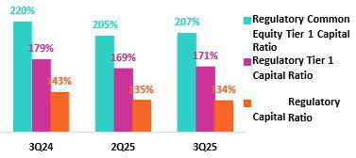
capital requirements due to the expansion of BCP and Mibanco’s portfolio. This reduction was offset mainly by an increase in Retained Earnings, which was driven by business growth and by a lesser extent, b y higher Unrealized Gains driven by a revaluation of portfolio due to lower rates. YoY, the ratio fell 902bps, impacted by an increase in capital requirements due to the same dynamics seen QoQ and a decrease in Subordinated Debt. This reduction was offset by a rise in Retained Earnings, which was driven by the same dynamics that drove the QoQ result and a higher Reserves for profit sharing in 2024.

The Regulatory Tier 1 Ratio stood at 171% (+203bps QoQ, -803 bps YoY), while the CET1 ratio was situated at 207% (+284bps QoQ, -1238bps YoY), both above the regulatory minimum. Growth in both ratios was driven by the same dynamics that fueled the Regulatory Capital Ratio, with the exception of Subordinated Debt, which had no impact on either the Regulatory Tier 1 or CET1 ratios.

10.2 Analysis of Capital at BCP Stand-alone | The IFRS CET 1 ratio at BCP Stand-alone rose 61bps QoQ to stand at
 | 13.17% at the end of 3Q25. This level, which is above our internal
 | appetite of 11%, was driven by an increase in Retained Earnings, which
 | rose hand-in-hand with business growth. The increase reported for
 | RWAs partially offset this rise and reflected an uptick in the balance
 | through expansion in the retail portfolio. YoY, the ratio dropped 25bps,
 | fueled mainly by an increase in RWA for credit risk in particular. This
 | reduction was offset by growth in Retained Earnings, which increased on
 | the back of the same dynamics that spurred growth QoQ.
 | Finally, under local regulatory parameters, the local CET1 ratio stood at
 | 12.82%, which compares favorable with the minimum requirement of
 | 7.75% in place at the end of September 2025. The Regulatory Capital
 | Ratio stood at 17.72% (+38bps QoQ); this ratio is above the minimum of
 | 14.37% required by the regulatory entity at the end of September 2025.
 | QoQ and YoY, variations in the local CET1 ratio were driven by the same
 | dynamics that drove the evolution of IFRS CET1, while changes in the
 | Regulatory Capital Ratio were propelled by the same drivers of IFRS
 | CET1 in both periods and by a drop in subordinated debt.
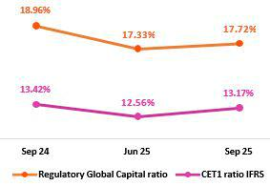

| Earnings Release 3Q / 2025 Analysis of 3Q25 Consolidated Results

10. Regulatory Capital

10.3 Analysis of Capital at Mibanco | At the end of 3Q25, the IFRS CET 1 ratio at Mibanco stood at 17.14%
 | (+42bps QoQ), which was above our internal appetite of 15%. QoQ, the
 | increase in this ratio was driven by an upswing in Retained earnings,
 | which ticked up on the back of business growth. The increase in
 | Retained earnings was offset by growth in RWAs, which rose alongside
 | portfolio expansion. YoY, the ratio dropped 121bps, driven by an uptick
 | in RWAs, which was fueled by the same dynamics in play QoQ, and by a
 | drop in Retained earnings following dividend Payments.
 | Under current regulatory parameters, local CET 1 ratio stood at 17.13%,
 | which compares favorably with the minimum of 7.75% required by the
 | regulator at the end of September 2025. The variations in this ratio QoQ
 | and YoY were driven by the same dynamics as those that drove the
 | evolution of IFRS CET 1. The Regulatory Global Capital Ratio stood at
 | 21.13% (up 152 bps QoQ) remains comfortably above the minimum of
 | 14.62% required by the regulator. The QoQ variation was led by the
 | same factors that drove the evolution of the IFRS CET 1 ratio. YoY, local
 | CET 1 ratio rose 91bps, fueled mainly by an issuance of Subordinated
 | Debt, which offset the reduction in Retained Earnings and the rise in
 | RWAS that accompanied portfolio growth.
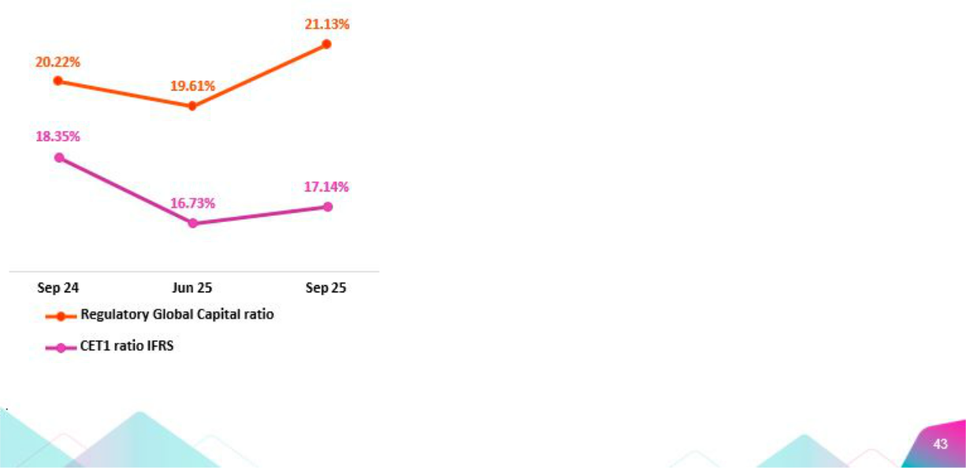

| Earnings Release 3Q / 2025 Analysis of 3Q25 Consolidated Results

11 Economic Outlook


In 3Q25, GDP grew around 3.5% YoY, supported by high terms of trade, a continued recovery in formal employment, and inflation comfortably within the BCRP’s target range. The acceleration compared to 2Q25 was mainly due to a rebound in primary sectors. Non-primary sectors grew approximately 3.4% YoY.

Inflation slowed marginally, closing the quarter at 1.4% YoY (compared to 1.7% YoY in2Q25), marking ten consecutive months below the midpoint of the target range (1%–3%). Meanwhile, in its October meeting, the BCRP decided to keep the reference interest rate unchanged at 4.25%.

According to the BCRP, the exchange rate closed 3Q25 at USDPEN 3.47, its lowest level since 2020. Thus, the sol appreciated 1.9% compared to the end of 2Q25 and 7.8% compared to the end of 4Q24 (USDPEN 3.77).

Peru: Economic Forecast

Peru | 2020 | 2021 | 2022 | 2023 | 2024 | 2025 ⁽⁴⁾ | 2026 ⁽⁴⁾
GDP (US$ Millions) | 210 | 230 | 248 | 272 | 295 | 337 | 365
Real GDP (% change) | -10.9 | 13.4 | 2.8 | -0.4 | 3.3 | 3.4 | 3.2
GDP per capita (US$) | 6,428 | 6,956 | 7,438 | 8,072 | 8,671 | 9,801 | 10,530
Domestic demand (% change) | -9.3 | 13.9 | 2.4 | -1.1 | 3.9 | 6.0 | 3.7
Gross fixed investment (as % GDP) | 21 | 25 | 25 | 22 | 22 | 23 | 23
Financial system loan without Reactiva (% change) ⁽¹⁾ | -4.3 | 12.6 | 9.7 | 2.8 | 1.3 | 5.5 | 6.9
Inflation, end of period ⁽²⁾ | 2.0 | 6.4 | 8.5 | 3.2 | 2.0 | 1.4 | 2.0
Reference Rate, end of period | 0.25 | 2.50 | 7.50 | 6.75 | 5.00 | 4.25 | 4.00
Exchange rate, end of period | 3.62 | 3.99 | 3.81 | 3.71 | 3.76 | 3.45 | 3.35
Exchange rate, (% change) ⁽³⁾ | -9.3% | -10.3% | 4.5% | 2.7% | -1.3% | 8.2% | 2.9%
Fiscal balance (% GDP) | -8.7 | -2.5 | -1.7 | -2.7 | -3.5 | -2.3 | -2.3
Public Debt (as % GDP) | 34 | 35 | 33 | 32 | 32 | 32 | 32
Trade balance (US$ Millions) | 8 | 15 | 10 | 17 | 24 | 29 | 30
(As % GDP) | 3.9% | 6.6% | 4.2% | 6.3% | 8.2% | 8.6% | 8.2%
Exports | 43 | 63 | 66 | 67 | 76 | 85 | 90
Imports | 35 | 48 | 56 | 50 | 52 | 56 | 60
Current account balance (As % GDP) | 0.8% | -2.2% | -4.0% | 0.3% | 2.2% | 1.7% | 1.2%
Net international reserves (US$ Millions) | 75 | 78 | 72 | 71 | 79 | 88 | 88
(As % GDP) | 35.6% | 34.2% | 28.9% | 26.1% | 26.8% | 26.1% | 24.1%
(As months of imports) | 26 | 20 | 15 | 17 | 18 | 19 | 18

Sources: INEI, BCRP y SBS.

- Financial System, Current Exchange Rate, End of Period

- Inflation target: 1% - 3%

- Negative % change indicates depreciation.

- Grey area indicate estimates by BCP Economic Research as of August 2025

| Earnings Release 3Q / 2025 Analysis of 3Q25 Consolidated Results

11. Economic Outlook

Main Macroeconomic Variables
Gross Domestic Product | In 3Q25, GDP grew around 3.5% YoY, accelerating compared to the
(Annual Real Variations, % YoY) | previous quarter (2.8% YoY) due to a rebound in primary sectors such as
 | agriculture, fishing, and hydrocarbons. Non-primary sectors grew
 | approximately 3.4% YoY (2Q25: 3.2% YoY). Meanwhile, domestic
 | demand is estimated to have grown around 6% YoY, marking its fourth
 | consecutive quarter growing at that rate, in a context of high terms of
 | trade, a recovery in formal employment, and inflation comfortably within
 | the BCRP’s target range.
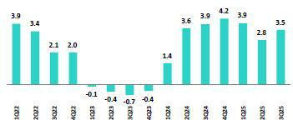

It is important to highlight the double-digit growth in key indicators for private investment, such as heavy vehicle sales, imports of capital goods, and terms of trade (at a 75-year high). Meanwhile, investment expectations remain in the optimistic range, according to the BCRP survey.

Annual Inflation and Central Bank Reference Rate | The annual inflation rate in Metropolitan Lima slowed from 1.7% YoY at
(%) | the end of 2Q25 to 1.4% at the end of 3Q25, below 2.0% (the midpoint of
 | the BCRP’s target range of 1%–3%) for the tenth consecutive month.
 | This makes it one of the lowest inflation rates among emerging and
 | developed economies. Meanwhile, core inflation (excluding food and
 | energy) rose slightly from 1.7% to 1.8% over the same period, marking its
 | seventh consecutive month below 2.0%.
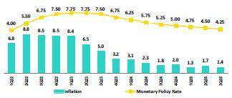

At its October 2025 monetary policy meeting, the BCRP decided to keep its rate at 4.25%, after cutting it by 25 basis points in September. Thus, it has accumulated three cuts so far this year (75 basis points). Since September 2023, when the easing cycle began, the reference rate has been reduced by a total of 350 basis points.

Fiscal Balance and Current Account Balance | The annualized fiscal deficit as of September 2025 stood at 2.4% of GDP,
(% of GDP, Quarter) | its lowest level since 1Q23. In 3Q25, fiscal revenues increased 8.4%
 | YoY, driven by higher corporate income tax collections and domestic
 | general sales tax, in a context of cyclical economic recovery and
 | historically high terms of trade. Meanwhile, non-financial public spending
 | remained practically stable (-0.8% YoY), reflecting a 7.7% YoY increase
 | in current expenditures (wages: +5.1% and goods and services: +8.6%)
 | and a 5.0% YoY rise in public investment.
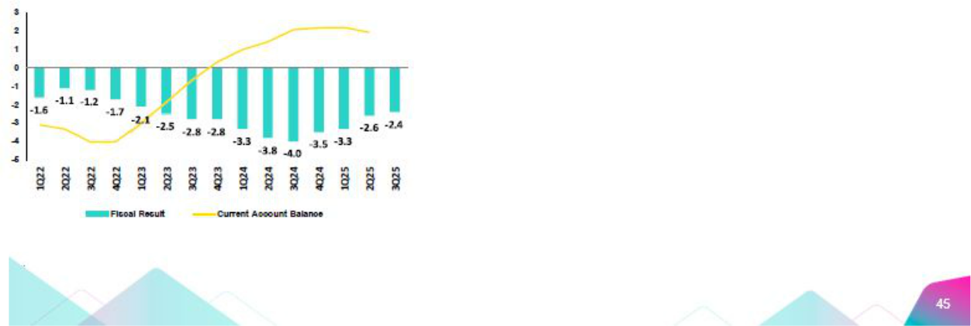

| Earnings Release 3Q / 2025 Analysis of 3Q25 Consolidated Results

11. Economic Outlook

The three main rating agencies assign different assessments to Peru’s sovereign debt. Moody’s gives it a Baa1 rating (three notches above investment grade), Fitch assigns BBB (two notches above investment grade), and S&P rates it BBB- (the minimum investment grade level). All three maintain a stable outlook for the country’s credit rating.

Regarding external accounts, the current account surplus closed 2Q25 at 1.9% of GDP (accumulated over the last four quarters), a decrease compared to the 2.2% of GDP surplus at the end of 1Q25. Thus, it has recorded seven consecutive quarters of surplus, marking the longest surplus episode since the 2004–2007 period.

The 12-month accumulated trade balance surplus as of August 2025 stood at US$26.9 billion (a historical high). Imports grew 10.1% YoY to US$56.2 billion, driven by a 14.4% increase in capital goods and an 18.1% rise in consumer goods. Exports grew 15.1% to US$83.0 billion, reaching a record high. Export growth was led by gold shipments (+41% YoY) amid favorable prices.

In August 2025, terms of trade grew 13.0% YoY, remaining near historical highs, driven by a 10.9% YoY increase in export prices (mainly due to higher prices for gold, silver, and copper). Import prices, meanwhile, fell 1.9% YoY amid lower prices for oil and industrial inputs.

Exchange Rate

(PEN per USD)
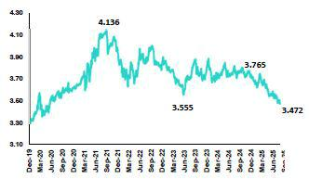

According to the BCRP, the exchange rate closed 3Q25 at USDPEN 3.47, its lowest level since June 2020. Thus, the exchange rate appreciated 1.9% compared to the end of 2Q25 and 7.8% compared to the end of 4Q24 (USDPEN 3.77). Global dollar weakness stabilized in 3Q25, and the DXY index appreciated 0.9% versus the previous quarter, although appetite for regional currencies continued. Most appreciated (Mexican peso +2.3%, Brazilian real +2.0%, and Colombian peso +4.1%), except for the Chilean peso (which depreciated 3.3%) due to political uncertainty ahead of the November elections. Year-to-date through the end of 3Q25, the global dollar DXY has depreciated by about 10%.

During 3Q25, the BCRP did not intervene in the spot foreign exchange market. However, it intervened in the forward market by partially renewing (allowing to expire) FX swap sales, which reduced the balance of this instrument by PEN 5.6 billion to PEN 38.7 billion between 2Q25 and 3Q25. Year -to -date, the balance has fallen by about PEN 10 billion, and on May 13 it intervened only once in the spot market with the sale of US$1 million.

Net International Reserves (NIR) closed 3Q25 at US$85.1 billion, similar to US$85.2 billion at the end of 2Q25 and above the US$79.0 billion recorded at the end of 4Q24. Meanwhile, the BCRP’s foreign exchange position closed 3Q25 at US$57.2 billion, an increase of US$1.2 billion during 3Q25 and US$3.7 billion compared to the end of 4Q24.

On September 17, Congress approved the eighth pension funds withdrawal. According to the SBS, the estimated potential withdrawal amounts to S/. 31.6 billion. And on October 10, Congress approved the impeachment of President Dina Boluarte, with 122 votes in favor, for “permanent moral incapacity.” The President of Congress, Jose Jerí, assumed the position of interim president in accordance with Article 115 of the Political Constitution of Peru, which establishes that, in the event of the president’s vacancy and the absence of vice presidents, the President of Congress must assume the role of head of state.

| Earnings Release 3Q / 2025 Analysis of 3Q25 Consolidated Results

11. Economic Outlook

Many forward-looking statements can be identified by words such as: “anticipate”, “intend”, “plan”, “goal”, “seek”, “believe”, “project”, “estimate”, “expect”, “strategy”, “future”, “likely”, “would”, “may”, “should”, “will”, “see” and similar references to future periods. Examples of forward-looking statements include, among others, statements or estimates we make regarding guidance relating to losses in our credit portfolio, efficiency ratio, provisions and non-performing loans, current or future market risk and future market conditions, expected macroeconomic events and conditions, our belief that we have sufficient capital and liquidity to fund our business operations, expectations of the effect on our financial condition of claims, legal actions, environmental costs, contingent liabilities and governmental and regulatory investigations and proceedings, strategy for customer retention, growth, governmental programs and regulatory initiatives, credit administration, product development, market position, financial results and reserves and strategy for risk management.

We caution readers that forward-looking statements involve known and unknown risks and uncertainties that could cause actual results, performance, or events to differ materially from those that we expect or that are expressed or implied in the forward-looking statements, depending on the outcome of certain factors, including, without limitation, adverse changes in:

- The occurrence of natural disasters or political or social instability in Peru;

- The adequacy of the dividends that our subsidiaries are able to pay to us, which may affect our ability to pay dividends to shareholders and corporate expenses;

- Performance of, and volatility in, financial markets, including Latin-American and other markets;
- The frequency, severity and types of insured loss events;
- Fluctuations in interest rate levels;
- Foreign currency exchange rates, including the Sol/US Dollar exchange rate;
- Deterioration in the quality of our loan portfolio;
- Increasing levels of competition in Peru and other markets in which we operate;
- Developments and changes in laws and regulations affecting the financial sector and adoption of new international guidelines;
- Changes in the policies of central banks and/or foreign governments;
- Effectiveness of our risk management policies and of our operational and security systems;
- Losses associated with counterparty exposures;
- The scope of the coronavirus (“COVID-19”) outbreak, actions taken to contain the COVID-19 and related economic effects from such actions and our ability to maintain adequate staffing; and

- Changes in Bermuda laws and regulations applicable to so-called non-resident entities.

See “Item 3. Key Information—3. D Risk Factors” and “Item 5. Operating and Financial Review and Prospects” in our most recent Annual Report on Form 20-F filed with the U.S. Securities and Exchange Commission for additional information and other such factors. You are cautioned not to place undue reliance on these forward-looking statements, which speak only as of the date hereof and are based only on information currently available to us. Therefore, you should not rely on any of these forward-looking statements.

We undertake no obligation to publicly update or revise these or any other forward-looking statements that may be made to reflect events or circumstances after the date hereof, whether as a result of changes in our business strategy or new information, to reflect the occurrence of unanticipated events or otherwise.

 | | Earnings Release 3Q / 2025 | Analysis of 3Q25 Consolidated Results
12 Appendix
12.1. | Evolution of Loans in Average Daily Balances | 49
12.2. | Loan Portfolio Quality | 49
12.3. | Net Interest Income (NII) | 53
12.4. | Net Interest Margin (NIM) and Risk Adjusted NIM | 53
12.5. | Physical Point of Contact | 54
12.6. | Regulatory Capital | 54
12.7. | Financial Statements and Ratios by Business | 58
12.7.1. Credicorp Consolidated |  | 58
12.7.2. Credicorp Stand-alone |  | 60
12.7.3. BCP Consolidated |  | 61
12.7.4. BCP Stand-alone |  | 63
12.7.5. BCP Bolivia |  | 65
12.7.6. Mibanco |  | 66
12.7.7. Prima AFP |  | 67
12.7.8. Grupo Pacifico |  | 68
12.7.9. Investment Management and Advisory |  | 69
12.8. | Table of Calculations | 70
12.9. | Glossary of terms | 71


| Earnings Release 3Q / 2025 Analysis of 3Q25 Consolidated Results

12. Appendix

12.1. Evolution of Loans in Average Daily Balances

Total Loans (in Average Daily Balances) ⁽¹⁾⁽²⁾
Total Loans |  | As of |  | Volume change |  | % change |  |  | % Part. in total loans
(S/ millions) | Sep 24 | Jun 25 | Sep 25 | QoQ | YoY | QoQ | YoY | Sep 24 | Jun 25 | Sep 25
BCP Stand-alone | 116,637 | 119,142 | 121,189 | 2,047 | 4,552 | 1.7% | 3.9% | 82.2% | 81.8% | 82.6%
Wholesale Banking | 52,817 | 54,096 | 54,645 | 549 | 1,828 | 1.0% | 3.5% | 37.2% | 37.1% | 37.2%
Corporate | 31,545 | 32,206 | 32,544 | 338 | 999 | 1.1% | 3.2% | 22.2% | 22.1% | 22.2%
Middle - Market | 21,272 | 21,891 | 22,101 | 211 | 829 | 1.0% | 3.9% | 15.0% | 15.0% | 15.1%
Retail Banking | 63,819 | 65,046 | 66,544 | 1,498 | 2,724 | 2.3% | 4.3% | 45.0% | 44.7% | 45.4%
SME - Business | 7,732 | 7,521 | 7,751 | 230 | 19 | 3.1% | 0.2% | 5.4% | 5.2% | 5.3%
SME - Pyme | 16,176 | 15,922 | 16,193 | 271 | 17 | 1.7% | 0.1% | 11.4% | 10.9% | 11.0%
Mortgage | 21,440 | 22,439 | 22,986 | 547 | 1,546 | 2.4% | 7.2% | 15.1% | 15.4% | 15.7%
Consumer | 12,615 | 13,207 | 13,511 | 305 | 897 | 2.3% | 7.1% | 8.9% | 9.1% | 9.2%
Credit Card | 5,856 | 5,957 | 6,102 | 145 | 246 | 2.4% | 4.2% | 4.1% | 4.1% | 4.2%
Mibanco | 12,199 | 12,514 | 12,734 | 220 | 534 | 1.8% | 4.4% | 8.6% | 8.6% | 8.7%
Mibanco Colombia | 1,721 | 1,889 | 2,004 | 115 | 283 | 6.1% | 16.5% | 1.2% | 1.3% | 1.4%
Bolivia | 9,555 | 10,542 | 9,363 | -1,179 | -192 | -11.2% | -2.0% | 6.7% | 7.2% | 6.4%
ASB Bank Corp. | 1,867 | 1,560 | 1,431 | -129 | -436 | -8.3% | -23.4% | 1.3% | 1.1% | 1.0%
BAP's total loans | 141,978 | 145,647 | 146,720 | 1,073 | 4,742 | 0.7% | 3.3% | 100.0% | 100.0% | 100.0%

For consolidation purposes, loans generated in FC are converted to LC.

- Includes Special accounts, and other banking.

- Portfolio Management Figures. Non-audited figures.

12.2. Loan Portfolio Quality

Portfolio Quality Ratios by Segment

Wholesale Banking
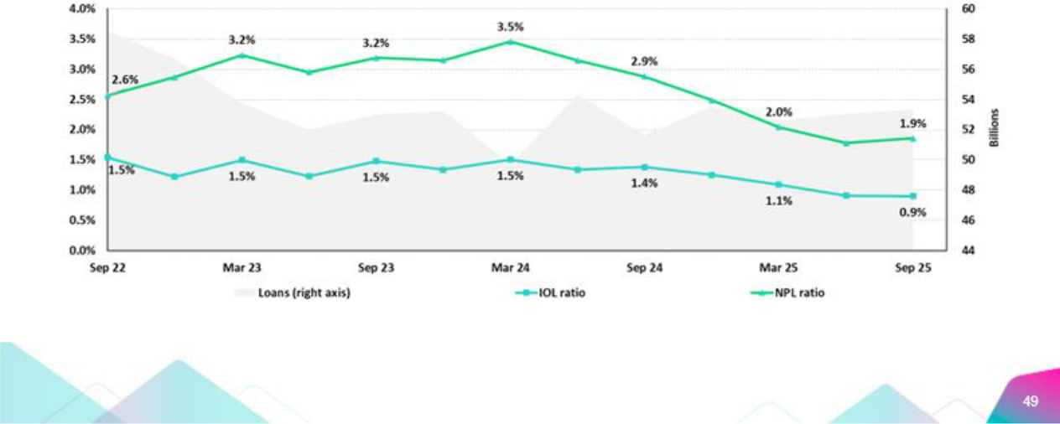

| Earnings Release 3Q / 2025 Analysis of 3Q25 Consolidated Results

12. Appendix

SME-Business
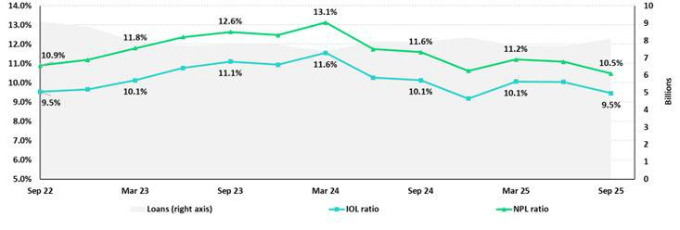

SME-Pyme
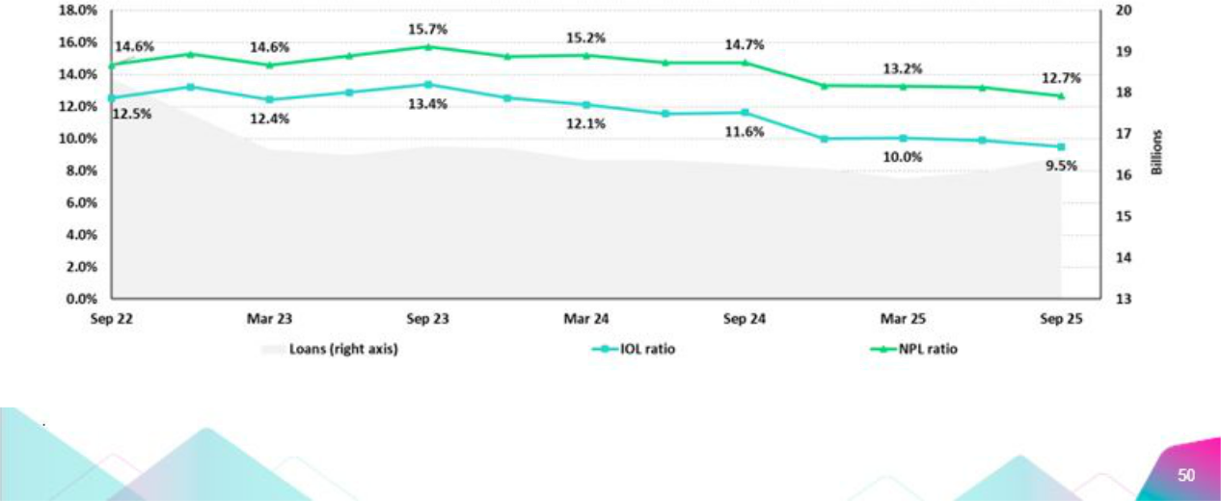

| Earnings Release 3Q / 2025 Analysis of 3Q25 Consolidated Results

12. Appendix

Mortgage
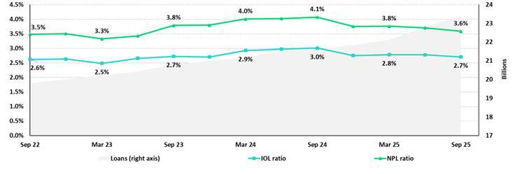

Consumer
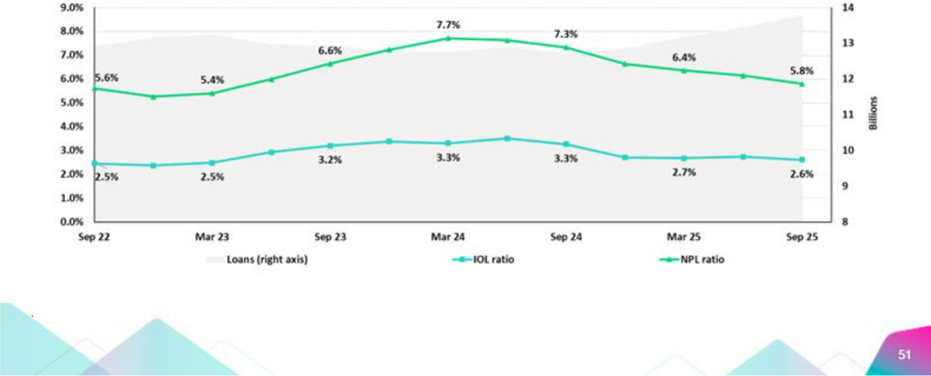

| Earnings Release 3Q / 2025 Analysis of 3Q25 Consolidated Results

12. Appendix

Credit Cards
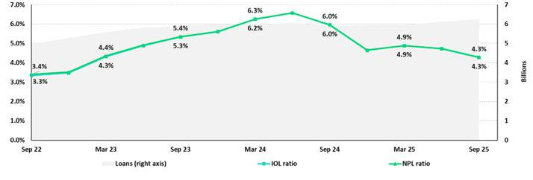

Mibanco
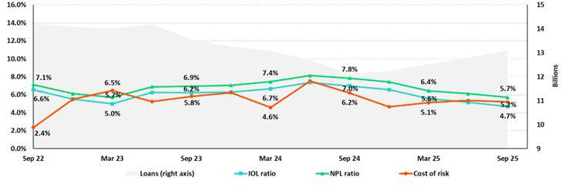

BCP Bolivia
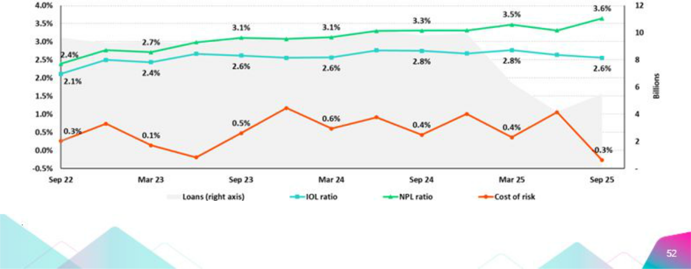

| Earnings Release 3Q / 2025 Analysis of 3Q25 Consolidated Results

12. Appendix

12.3. Net Interest Income (NII)

NII Summary

Net interest income |  | Quarter |  | % change |  | Up to |  | % Change
S/000 | 3Q24 | 2Q25 | 3Q25 | QoQ | YoY | Sep 24 | Sep 25 | Sep 25 / Sep 24
Interest income | 4,995,971 | 4,922,292 | 4,987,693 | 1.3% | -0.2% | 14,857,135 | 14,804,775 | -0.4%
Interest on loans | 3,924,222 | 3,840,725 | 3,960,980 | 3.1% | 0.9% | 11,714,388 | 11,649,345 | -0.6%
Dividends on investments | 13,187 | 22,923 | 19,179 | -16.3% | 45.4% | 34,184 | 67,211 | 96.6%
Interest on deposits with banks | 365,361 | 342,323 | 316,420 | -7.6% | -13.4% | 1,019,649 | 1,003,365 | -1.6%
Interest on securities | 667,195 | 647,186 | 623,216 | -3.7% | -6.6% | 2,008,167 | 1,928,274 | -4.0%
Other interest income | 26,006 | 69,135 | 67,898 | -1.8% | 161.1% | 80,747 | 156,580 | 93.9%
Interest expense | 1,405,221 | 1,306,921 | 1,299,864 | -0.5% | -7.5% | 4,371,798 | 3,929,563 | -10.1%
Interest expense (excluding Net Insurance Financial Expenses) | 1,276,643 | 1,167,866 | 1,158,421 | -0.8% | -9.3% | 3,996,530 | 3,513,443 | -12.1%
Interest on deposits | 677,509 | 541,014 | 565,344 | 4.5% | -16.6% | 2,195,045 | 1,725,971 | -21.4%
Interest on borrowed funds | 262,319 | 265,710 | 252,490 | -5.0% | -3.7% | 794,488 | 784,402 | -1.3%
Interest on bonds and subordinated notes | 200,801 | 193,125 | 164,653 | -14.7% | -18.0% | 598,170 | 525,802 | -12.1%
Other interest expense | 136,014 | 168,017 | 175,934 | 4.7% | 29.3% | 408,827 | 477,268 | 16.7%
Net Insurance Financial Expenses | 128,578 | 139,055 | 141,443 | 1.7% | 10.0% | 375,268 | 416,120 | 10.9%
Net interest, similar income and expenses | 3,590,750 | 3,615,371 | 3,687,829 | 2.0% | 2.7% | 10,485,337 | 10,875,212 | 3.7%
Provision for credit losses on loan portfolio, net of recoveries | 868,081 | 575,159 | 602,918 | 4.8% | -30.5% | 2,776,151 | 1,759,970 | -36.6%
Net interest, similar income and expenses, after provision for credit losses on | 2,722,669 | 3,040,212 | 3,084,911 | 1.5% | 13.3% | 7,709,186 | 9,115,242 | 18.2%
loan portfolio
Average interest earning assets | 231,316,507 | 233,761,957 | 233,285,291 | -0.2% | 0.9% | 229,452,866 | 237,958,451 | 3.7%
Net interest margin ⁽¹⁾ | 6.43% | 6.42% | 6.57% | 15 bps | 14 bps | 6.3% | 6.3% | 2 bps
Risk-adjusted Net interest margin ⁽¹⁾ | 4.93% | 5.44% | 5.53% | 9 bps | 60 bps | 4.7% | 5.3% | 64 bps
Net provisions for loan losses / Net interest income ⁽¹⁾ | 24.18% | 15.91% | 16.35% | 44 bps | -783 bps | 26.5% | 16.2% | -1030 bps

(1) Annualized. For further detail on the NIM calculation due to IFRS17, please refer to Annex 12.8.

12.4. Net Interest Margin (NIM) and Risk-Adjusted NIM by Subsidiary

NIM Breakdown | 3Q24 | 2Q25 | 3Q25
BCP | 6.17% | 6.00% | 6.11%
Mibanco | 13.86% | 14.38% | 15.02%
BCP Bolivia | 2.95% | 2.57% | 3.21%
Credicorp | 6.43% | 6.42% | 6.57%

NIM: Annualized Net interest income (excluding Net Insurance Financial Expenses) / Average period end and period beginning interest-earning assets.

Risk Adjusted NIM | 3Q24 | 2Q25 | 3Q25
Breakdown | 3Q24 | 2Q25 | 3Q25
BCP | 4.75% | 5.22% | 5.25%
Mibanco | 9.12% | 10.34% | 11.03%
BCP Bolivia | 2.59% | 1.89% | 3.45%
Credicorp | 4.93% | 5.44% | 5.53%

Risk-Adjusted NIM: (Annualized Net interest income (excluding Net Insurance Financial Expenses) - annualized provisions) / Average period end and period beginning interest-earning assets.


| Earnings Release 3Q / 2025 Analysis of 3Q25 Consolidated Results

12. Appendix

12.5. Physical Point of contact

Physical Point of Contact ⁽¹⁾ |  | As of |  | Change (units)
(Units) | Sep 24 | Jun 25 | Sep 25 | QoQ | YoY
Branches ⁽²⁾ | 319 | 319 | 318 | (1) | (1)
ATMs | 2,451 | 2,449 | 2,410 | (39) | (41)
Agents | 10,112 | 10,330 | 10,417 | 87 | 305
Total | 12,882 | 13,098 | 13,145 | 47 | 263

- Includes Physical Point of Contact of BCP Stand-Alone, Mibanco and BCP Bolivia

- Includes Banco de la Nacion branches, which in September 24 were 36, in June were 36 and in September 25 were 36

12.6. Regulatory Capital

Regulatory Capital and Capital Adequacy Ratios

(IFRS)

Regulatory Capital and Capital Adequacy Ratios |  | As of |  | Change %
S/000 | Sep 24 | Jun 25 | Sep 25 | QoQ | YoY
Capital Stock | 1,318,993 | 1,318,993 | 1,318,993 | - | -
Treasury Stocks | (208,901) | (209,845) | (209,845) | 0.0% | 0.5%
Capital Surplus | 179,027 | 133,387 | 139,527 | 4.6% | -22.1%
Legal and Other Capital reserves | 27,187,346 | 29,602,851 | 29,628,427 | 0.1% | 9.0%
Minority interest | 479,027 | 474,990 | 475,729 | 0.2% | -0.7%
Current and Accumulated Earnings ⁽¹⁾ | 5,432,237 | 5,123,469 | 6,737,239 | 31.5% | 24.0%
Unrealized Gains or Losses ⁽²⁾ | (227,247) | (246,716) | 392,256 | -259.0% | -272.6%
Goodwill | (734,431) | (1,692,823) | (1,290,496) | -23.8% | 75.7%
Intangible Assets ⁽³⁾ | (2,050,646) | (2,655,440) | (2,864,488) | 7.9% | 39.7%
Deductions in Common Equity Tier 1 instruments ⁽⁴⁾ | (678,924) | (73,488) | (81,609) | 11.1% | -88.0%
Subordinated Debt | 7,939,610 | 7,240,645 | 7,246,406 | 0.1% | -8.7%
Loan loss reserves ⁽⁵⁾ | 1,967,574 | 1,972,667 | 2,036,080 | 3.2% | 3.5%
Deductions in Tier 2 instruments ⁽⁶⁾ | (1,525,608) | (1,289,380) | (1,438,739) | 11.6% | -5.7%
Total Regulatory Capital (A) | 39,078,056 | 39,699,311 | 42,089,481 | 6.0% | 7.7%
Total Regulatory Common Equity Tier 1 Capital (B) | 30,696,480 | 31,775,379 | 34,245,733 | 7.8% | 11.6%
Total Regulatory Tier 1 Capital (C) | 30,696,480 | 31,775,379 | 34,245,733 | 7.8% | 11.6%
Total Regulatory Capital Requirement (D) | 27,276,454 | 29,484,940 | 30,993,862 | 5.1% | 13.6%
Total Regulatory Common Equity Tier 1 Capital Requirement (E) | 13,968,158 | 15,535,244 | 16,281,634 | 4.8% | 16.6%
Total Regulatory Tier 1 Capital Requirement (F) | 17,131,013 | 18,788,044 | 19,727,355 | 5.0% | 15.2%
Regulatory Capital Ratio (A) / (D) | 143% | 135% | 136% | 116 pp | -747 bps
Regulatory Common Equity Tier 1 Capital Ratio (B) / (E) | 220% | 205% | 210% | 580 pp | -943 bps
Regulatory Tier 1 Capital Ratio (C) / (F) | 179% | 169% | 174% | 447 pp | -559 bps

- Earnings include Banco de Crédito del Perú and Mibanco Perú. Losses include all subsidiaries.

- Gains include Investment Grade Government Bonds and Peruvian Central Bank Certificates of Deposits. Losses include all bonds.

- Different to Goodwill. Includes Diferred Tax Assets.

- Investments in Equity.

- Up to 1.25% of total risk-weighted assets of Banco de Crédito del Perú, Solución Empresa Administradora Hipotecaria, Mibanco and Atlantic Security Bank.

- Investments in Tier 2 Subordinated Debt.

| Earnings Release 3Q / 2025 Analysis of 3Q25 Consolidated Results

12. Appendix

Regulatory and Capital Adequacy Ratios at BCP Stand-alone

Regulatory Capital |  | Quarter |  | % Change
(S/ thousand) | Sep 24 | Jun 25 | Sep 25 | QoQ | YoY
Capital Stock | 12,973,175 | 12,973,175 | 12,973,175 | 0.0% | 0.0%
Reserves | 6,591,330 | 6,125,452 | 6,125,452 | 0.0% | -7.1%
Accumulated earnings | 5,426,132 | 5,129,250 | 6,730,631 | 31.2% | 24.0%
Loan loss reserves ⁽¹⁾ | 1,689,307 | 1,757,305 | 1,800,868 | 2.5% | 6.6%
Subordinated Debt | - | - | - | n.a | n.a
Unrealized Profit or Losses | 7,232,550 | 6,552,700 | 6,419,500 | -2.0% | -11.2%
Investment in subsidiaries and others, net of unrealized profit and net income in | (322,210) | (200,969) | (10,363) | -94.8% | -96.8%
subsidiaries
Intangibles | (2,537,005) | (2,380,842) | (2,535,672) | 6.5% | -0.1%
Goodwill | (1,330,135) | (1,549,091) | (1,624,042) | 4.8% | 22.1%
Total Regulatory Capital | (122,083) | (122,083) | (122,083) | 0.0% | 0.0%
Tier 1 Common Equity ⁽²⁾ | 29,601,060 | 28,284,896 | 29,757,465 | 5.2% | 0.5%
Regulatory Tier 1 Capital ⁽³⁾ | 20,679,203 | 19,974,891 | 21,537,097 | 7.8% | 4.1%
Regulatory Tier 2 Capital ⁽⁴⁾ | 20,679,203 | 19,974,891 | 21,537,097 | 7.8% | 4.1%
Total risk-weighted assets |  | Quarter |  | % Change
(S/ thousand) | Sep 24 | Jun 25 | Sep 25 | QoQ | YoY
Market risk-weighted assets | 4,301,156 | 4,400,226 | 5,329,045 | 21.1% | 23.9%
Credit risk-weighted assets | 133,937,442 | 139,386,096 | 142,895,450 | 2.5% | 6.7%
Operational risk-weighted assets | 17,871,737 | 19,384,021 | 19,751,032 | 1.9% | 10.5%
Total | 156,110,335 | 163,170,343 | 167,975,527 | 2.9% | 7.6%
Capital requirement |  | Quarter |  | % Change
(S/ thousand) | Sep 24 | Jun 25 | Sep 25 | QoQ | YoY
Market risk capital requirement | 430,116 | 440,023 | 532,904 | 21.1% | 23.9%
Credit risk capital requirement | 12,724,057 | 13,938,610 | 14,289,545 | 2.5% | 12.3%
Operational risk capital requirement | 1,787,174 | 1,938,402 | 1,975,103 | 1.9% | 10.5%
Additional capital requirements | 5,647,686 | 7,142,933 | 7,348,282 | 2.9% | 30.1%
Total | 20,589,033 | 23,459,967 | 24,145,835 | 2.9% | 17.3%
Capital Ratios under Local Regulation
Capital ratios under Local Regulation |  | Quarter |  | % Change
 | Sep 24 | Jun 25 | Sep 25 | QoQ | YoY
Common Equity Tier 1 ratio | 13.25% | 12.24% | 12.82% | 58 bps | -42 bps
Tier 1 Capital ratio | 13.25% | 12.24% | 12.82% | 58 bps | -42 bps
Regulatory Global Capital ratio | 18.96% | 17.33% | 17.72% | 38 bps | -125 bps

- Up to 1.25% of total risk-weighted assets.

- Common Equity Tier 1 = Capital Stock + Reserves + Accumulated earnings – Unrealized profits or losses - 100% deductions (investment in subsidiaries, goodwill, intangible assets and deferred tax assets based on future returns).
- Regulatory Tier 1 Capital = Common Equity Tier 1 + Tier 1 Subordinated Debt (Perpetual).

- Regulatory Tier 2 Capital = Subordinated Debt + Loan loss reserves.

| Earnings Release 3Q / 2025 Analysis of 3Q25 Consolidated Results

12. Appendix

Regulatory Capital and Capital Adequacy Ratios at Mibanco

Regulatory Capital |  | As of |  |  | % Change
(S/ thousand) | Sep 24 | Jun 25 | Sep 25 | QoQ | YoY
Capital Stock | 1,840,606 | 1,840,606 | 1,840,606 | 0.0% | 0.0%
Reserves | 334,650 | 365,847 | 365,847 | 0.0% | 9.3%
Accumulated earnings | 424,627 | 238,272 | 394,428 | 65.5% | -7.1%
Loan loss reserves ⁽¹⁾ | 143,193 | 153,732 | 158,725 | 3.2% | 10.8%
Perpetual subordinated debt | - | - | - | n.a | n.a.
Subordinated debt | 167,000 | 261,000 | 388,551 | 48.9% | 132.7%
Unrealidez Profit or Losses | 6,366 | 3,035 | 7,294 | 140.3% | 14.6%
Investment in subsidiaries and others, net of unrealized profit and net income in subsidiaries | (293) | (148) | (164) | 10.3% | -44.1%
Intangibles | (128,688) | (124,515) | (124,978) | 0.4% | -2.9%
Goodwill | (139,180) | (139,180) | (139,180) | 0.0% | 0.0%
Total Regulatory Capital | 2,648,281 | 2,598,649 | 2,891,129 | 11.3% | 9.2%
Tier Common Equity ⁽²⁾ | 2,338,088 | 2,183,917 | 2,343,853 | 7.3% | 0.2%
Regulatory Tier 1 Capital ⁽³⁾ | 2,338,088 | 2,183,917 | 2,343,853 | 7.3% | 0.2%
Regulatory Tier 2 Capital ⁽⁴⁾ | 310,193 | 414,732 | 547,276 | 32.0% | 76.4%
Total risk-weighted assets |  | As of |  |  | % change
(S/ thousand) | Sep 24 | Jun 25 | Sep 25 | QoQ | YoY
Market risk-weighted assets | 238,117 | 193,276 | 221,008 | 14.3% | -7.2%
Credit risk-weighted assets | 11,263,844 | 12,139,570 | 12,539,729 | 3.3% | 11.3%
Operational risk-weighted assets | 1,594,338 | 920,354 | 922,672 | 0.3% | -42.1%
Total | 13,096,299 | 13,253,200 | 13,683,410 | 3.2% | 4.5%
Capital requirement |  | As of |  |  | % change
(S/ thousand) | Sep 24 | Jun 25 | Sep 25 | QoQ | YoY
Market risk capital requirement | 23,812 | 19,328 | 22,101 | 14.3% | -7.2%
Credit risk capital requirement | 1,070,065 | 1,213,957 | 1,253,973 | 3.3% | 17.2%
Operational risk capital requirement | 159,434 | 92,035 | 92,267 | 0.3% | -42.1%
Additional capital requirements | 160,510 | 182,094 | 188,096 | 3.3% | 17.2%
Total | 1,413,821 | 1,507,414 | 1,556,437 | 3.3% | 10.1%
Capital Ratios under Local Regulation
Capital ratios under Local Regulation |  | As of |  |  | % change
 | Sep 24 | Jun 25 | Sep 25 | QoQ | YoY
Common Equity Tier 1 Ratio | 17.85% | 16.48% | 17.13% | 65 bps | -72 bps
Tier 1 Capital ratio | 17.85% | 16.48% | 17.13% | 65 bps | -72 bps
Regulatory Global Capital Ratio | 20.22% | 19.61% | 21.13% | 152 bps | 91 bps

- Up to 1.25% of total risk-weighted assets.

- Common Equity Tier 1 = Capital Stock + Reserves + Accumulated earnings – Unrealized profits or losses - 100% deductions (investment in subsidiaries, goodwill, intangible assets and deferred tax assets based on future returns).
- Regulatory Tier 1 Capital = Common Equity Tier 1 + Tier 1 Subordinated Debt (Perpetual).

- Regulatory Tier 2 Capital = Subordinated Debt + Loan loss reserves.

| Earnings Release 3Q / 2025 Analysis of 3Q25 Consolidated Results

12. Appendix

Common Equity Tier 1 IFRS

BCP Stand-alone

Common Equity Tier 1 IFRS |  |  | As of |  |  |  | % Change
(S/ thousand) |  | Sep 24 | Jun 25 | Sep 25 |  |  | QoQ | YoY
Capital and reserves | 19,052,262 |  | 18,586,384 | 18,586,384 |  |  | 0.0% | -2.4%
Retained earnings | 6,076,551 |  | 5,926,516 | 7,524,062 |  |  | 27.0% | 23.8%
Unrealized gains (losses) | 222,730 |  | 282,927 | 505,339 |  |  | 78.6% | 126.9%
Goodwill and intangibles | (1,599,568) |  | (1,739,625) | (1,806,698) |  |  | 3.9% | 12.9%
Investments in subsidiaries | (2,669,334) |  | (2,463,279) | (2,585,795) |  |  | 5.0% | -3.1%
Total | 21,082,641 |  | 20,592,923 | 22,223,292 |  |  | 7.9% | 5.4%
Adjusted RWAs IFRS | 157,046,547 |  | 163,938,888 | 168,714,799 |  |  | 2.9% | 7.4%
Adjusted Credit RWAs IFRS | 134,873,654 |  | 140,154,641 | 143,634,722 |  |  | 2.5% | 6.5%
Others | 22,172,893 |  | 23,784,246 | 25,080,077 |  |  | 5.4% | 13.1%
CET1 ratio IFRS | 13.42% |  | 12.56% | 13.17% |  |  | 61 bps | -25 bps
 |  |  | Mibanco
Common Equity Tier 1 IFRS |  |  | As of |  |  |  | % Change
(S/ thousand) |  | Sep 24 | Jun 25 | Sep 25 |  | QoQ |  | YoY
Capital and reserves |  | 2,703,385 | 2,734,582 | 2,734,582 |  | 0.0% |  | 1.2%
Retained earnings |  | 36,907 | (202,552) | (80,674) |  | -60.2% |  | -318.6%
Unrealized gains (losses) |  | 3,081 | 2,712 | 7,100 |  | 161.8% |  | 130.4%
Goodwill and intangibles |  | (303,850) | (296,719) | (296,196) |  | -0.2% |  | -2.5%
Investments in subsidiaries |  | (296) | (152) | (171) |  | 12.2% |  | -42.4%
Total |  | 2,439,227 | 2,237,872 | 2,364,642 |  | 5.7% |  | -3.1%
Adjusted RWAs IFRS |  | 13,291,063 | 13,378,616 | 13,792,869 |  | 3.1% |  | 3.8%
Adjusted Credit RWAs IFRS |  | 11,455,585 | 12,264,985 | 12,649,188 |  | 3.1% |  | 10.4%
Others |  | 1,835,478 | 1,113,630 | 1,143,680 |  | 2.7% |  | -37.7%
CET1 ratio IFRS |  | 18.35% | 16.73% | 17.14% |  | 42 bps |  | -121 bps

| Earnings Release 3Q / 2025 Analysis of 3Q25 Consolidated Results

12. Appendix

12.7. Financial Statements and Ratios by Business

12.7.1. Credicorp Consolidated

Consolidated Statement of Financial Position

(S/ Thousands, IFRS)

 |  | As of |  |  | % change
 | Sep 24 | Jun 25 | Sep 25 | QoQ | YoY
ASSETS
Cash and due from banks
Non-interest bearing | 7,222,945 | 7,266,155 | 7,237,295 | -0.4% | 0.2%
Interest bearing | 37,007,966 | 34,206,000 | 35,862,184 | 4.8% | -3.1%
Total cash and due from banks | 44,230,911 | 41,472,155 | 43,099,479 | 3.9% | -2.6%
Cash collateral, reverse repurchase agreements and securities borrowing | 1,419,305 | 4,593,501 | 3,404,639 | -25.9% | 139.9%
Fair value through profit or loss investments | 4,642,905 | 4,819,230 | 4,356,311 | -9.6% | -6.2%
Fair value through other comprehensive income investments | 39,832,274 | 37,852,722 | 38,005,522 | 0.4% | -4.6%
Amortized cost investments | 8,853,694 | 8,931,495 | 8,824,746 | -1.2% | -0.3%
Loans | 142,568,785 | 140,961,978 | 144,752,254 | 2.7% | 1.5%
Current | 136,542,444 | 135,917,766 | 139,798,951 | 2.9% | 2.4%
Internal overdue loans | 6,026,341 | 5,044,212 | 4,953,303 | -1.8% | -17.8%
Less - allowance for loan losses | (8,250,023) | (7,658,595) | (7,674,040) | 0.2% | -7.0%
Loans, net | 134,318,762 | 133,303,383 | 137,078,214 | 2.8% | 2.1%
Financial assets designated at fair value through profit or loss | 900,107 | 904,621 | 956,885 | 5.8% | 6.3%
Property, plant and equipment, net | 1,836,732 | 2,646,168 | 2,725,302 | 3.0% | 48.4%
Due from customers on acceptances | 466,957 | 559,370 | 553,561 | -1.0% | 18.5%
Investments in associates | 729,770 | 43,199 | 52,388 | 21.3% | -92.8%
Intangible assets and goodwill, net | 3,167,296 | 4,444,424 | 4,596,373 | 3.4% | 45.1%
Reinsurance contract assets | 880,563 | 949,932 | 853,974 | -10.1% | -3.0%
Other assets ⁽¹⁾ | 8,480,514 | 8,425,175 | 10,793,207 | 28.1% | 27.3%
Total Assets | 249,759,790 | 248,945,375 | 255,300,601 | 2.6% | 2.2%
LIABILITIES AND EQUITY
Deposits and obligations
Non-interest bearing | 47,436,563 | 45,734,508 | 46,588,002 | 1.9% | -1.8%
Interest bearing | 106,998,888 | 108,988,826 | 111,842,453 | 2.6% | 4.5%
Total deposits and obligations | 154,435,451 | 154,723,334 | 158,430,455 | 2.4% | 2.6%
Payables from repurchase agreements and securities lending | 7,383,104 | 11,265,393 | 10,181,173 | -9.6% | 37.9%
BCRP instruments | 4,788,939 | 5,096,459 | 6,643,892 | 30.4% | 38.7%
Repurchase agreements with third parties | 2,517,833 | 5,974,353 | 3,401,635 | -43.1% | 35.1%
Repurchase agreements with customers | 76,332 | 194,581 | 135,646 | -30.3% | 77.7%
Due to banks and correspondents | 12,704,234 | 11,152,813 | 11,241,079 | 0.8% | -11.5%
Bonds and notes issued | 16,952,011 | 12,112,403 | 12,209,724 | 0.8% | -28.0%
Banker’s acceptances outstanding | 466,957 | 559,370 | 553,561 | -1.0% | 18.5%
Insurance contract liability | 13,289,394 | 13,954,799 | 14,203,439 | 1.8% | 6.9%
Financial liabilities at fair value through profit or loss | 698,747 | 840,022 | 928,814 | 10.6% | 32.9%
Other liabilities | 9,752,701 | 9,262,741 | 10,296,583 | 11.2% | 5.6%
Total Liabilities | 215,682,599 | 213,870,875 | 218,044,828 | 2.0% | 1.1%
Net equity | 33,462,591 | 34,459,012 | 36,560,502 | 6.1% | 9.3%
Capital stock | 1,318,993 | 1,318,993 | 1,318,993 | 0.0% | 0.0%
Treasury stock | (208,901) | (209,845) | (209,845) | 0.0% | 0.5%
Capital surplus | 179,027 | 133,388 | 139,528 | 4.6% | -22.1%
Reserves | 27,187,346 | 29,602,851 | 29,628,427 | 0.1% | 9.0%
Other reserves | 470,550 | 19,199 | 353,144 | 1739.4% | -25.0%
Retained earnings | 4,515,576 | 3,594,426 | 5,330,255 | 48.3% | 18.0%
Non-controlling interest | 614,600 | 615,488 | 695,271 | 13.0% | 13.1%
Total Net Equity | 34,077,191 | 35,074,500 | 37,255,773 | 6.2% | 9.3%
Total liabilities and equity | 249,759,790 | 248,945,375 | 255,300,601 | 2.6% | 2.2%
Off-balance sheet | 155,876,986 | 144,197,254 | 153,289,772 | 6.3% | -1.7%
Total performance bonds, stand-by and L/Cs. | 20,206,333 | 21,026,042 | 21,007,568 | -0.1% | 4.0%
Undrawn credit lines, advised but not committed | 88,226,431 | 75,858,566 | 78,586,547 | 3.6% | -10.9%
Total derivatives (notional) and others | 47,444,222 | 47,312,646 | 53,695,657 | 13.5% | 13.2%

(1) Includes mainly accounts receivables from brokerage and others.

* Due to reclassifications, the Balance Sheet may differ from those reported in previous quarters.

| Earnings Release 3Q / 2025 Analysis of 3Q25 Consolidated Results

12. Appendix

Consolidated Statement of Income

(S/ Thousands, IFRS)

 |  | Quarter |  | % change |  |  | Up to | % change
 | 3Q24 | 2Q25 | 3Q25 | QoQ | YoY | Sep 24 | Sep 25 | Sep 25 / Sep 24
Interest income and expense
Interest and similar income | 4,995,971 | 4,922,292 | 4,987,693 | 1.3% | -0.2% | 14,857,135 | 14,804,775 | -0.4%
Interest and similar expenses | (1,405,221) | (1,306,921) | (1,299,864) | -0.5% | -7.5% | (4,371,798) | (3,929,563) | -10.1%
Net interest, similar income and expenses | 3,590,750 | 3,615,371 | 3,687,829 | 2.0% | 2.7% | 10,485,337 | 10,875,212 | 3.7%
Provision for credit losses on loan portfolio | (981,870) | (683,965) | (720,445) | 5.3% | -26.6% | (3,085,607) | (2,100,143) | -31.9%
Recoveries of written-off loans | 113,789 | 108,806 | 117,527 | 8.0% | 3.3% | 309,456 | 340,173 | 9.9%
Provision for credit losses on loan portfolio, net of recoveries | (868,081) | (575,159) | (602,918) | 4.8% | -30.5% | (2,776,151) | (1,759,970) | -36.6%
Net interest, similar income and expenses, after provision for credit
losses on loan portfolio | 2,722,669 | 3,040,212 | 3,084,911 | 1.5% | 13.3% | 7,709,186 | 9,115,242 | 18.2%
Other income
Fee income | 982,818 | 1,024,553 | 1,063,032 | 3.8% | 8.2% | 2,786,611 | 3,081,609 | 10.6%
Net gain on foreign exchange transactions | 319,856 | 377,016 | 394,572 | 4.7% | 23.4% | 974,575 | 1,115,402 | 14.5%
Net loss on securities | 120,033 | 179,174 | 111,977 | -37.5% | -6.7% | 274,489 | 263,002 | -4.2%
Net gain from associates | 35,600 | 6,556 | 5,192 | -20.8% | -85.4% | 96,623 | 35,816 | -62.9%
Net gain (loss) on derivatives held for trading | (3,499) | 21,418 | 244 | -98.9% | -107.0% | 78,233 | 40,161 | -48.7%
Net gain (loss) from exchange differences | (6,139) | 10,195 | 7,518 | -26.3% | -222.5% | (19,693) | 33,672 | -271.0%
Others | 96,675 | 58,461 | 71,656 | 22.6% | -25.9% | 338,395 | 452,118 | 33.6%
Total other income | 1,545,344 | 1,677,373 | 1,654,191 | -1.4% | 7.0% | 4,529,233 | 5,021,780 | 10.9%
Insurance underwriting result
Insurance Service Result | 419,805 | 445,152 | 467,467 | 5.0% | 11.4% | 1,286,468 | 1,328,725 | 3.3%
Reinsurance Result | (128,029) | (94,279) | (79,117) | -16.1% | -38.2% | (400,130) | (260,368) | -34.9%
Total insurance underwriting result | 291,776 | 350,873 | 388,350 | 10.7% | 33.1% | 886,338 | 1,068,357 | 20.5%
Medical services result
Sales of medical services | - | 473,746 | 421,360 | -11.1% | n.a. | - | 973,227 | n.a.
Cost of sales of medical services | - | (350,427) | (297,407) | -15.1% | n.a. | - | (683,266) | n.a.
Total medical services result | - | 123,319 | 123,953 | 0.5% | n.a. | - | 289,961 | n.a.
Total Expenses
Salaries and employee benefits | (1,155,966) | (1,304,466) | (1,341,137) | 2.8% | 16.0% | (3,404,858) | (4,007,293) | 17.7%
Administrative, general and tax expenses | (971,449) | (965,994) | (1,068,459) | 10.6% | 10.0% | (2,740,755) | (2,904,287) | 6.0%
Depreciation and amortization | (179,495) | (212,662) | (219,800) | 3.4% | 22.5% | (526,845) | (636,228) | 20.8%
Impairment loss on goodwill | (23,046) | - | - | n.a. | -100.0% | (23,046) | - | -100.0%
Association in participation | (6,414) | (371) | (65) | -82.5% | -99.0% | (24,461) | (7,235) | -70.4%
Other expenses | (111,859) | (146,817) | (115,181) | -21.5% | 3.0% | (335,951) | (352,783) | 5.0%
Total expenses | (2,448,229) | (2,630,310) | (2,744,642) | 4.3% | 12.1% | (7,055,916) | (7,907,826) | 12.1%
Profit before income tax | 2,111,560 | 2,561,467 | 2,506,763 | -2.1% | 18.7% | 6,068,841 | 7,587,514 | 25.0%
Income tax | (555,117) | (696,969) | (728,308) | 4.5% | 31.2% | (1,602,927) | (2,129,746) | 32.9%
Net profit | 1,556,443 | 1,864,498 | 1,778,455 | -4.6% | 14.3% | 4,465,914 | 5,457,768 | 22.2%
Non-controlling interest | 32,655 | 42,483 | 39,800 | -6.3% | 21.9% | 91,373 | 119,401 | 30.7%
Net profit attributable to Credicorp | 1,523,788 | 1,822,015 | 1,738,655 | -4.6% | 14.1% | 4,374,541 | 5,338,367 | 22.0%

| Earnings Release 3Q / 2025 Analysis of 3Q25 Consolidated Results

12. Appendix

12.7.2. Credicorp Stand-alone

Statement of Financial Position

(S/ Thousands, IFRS)

 |  | As of |  | % change
 | Sep 24 | Jun 25 | Sep 25 | QoQ | YoY
ASSETS
Cash and cash equivalents | 594,754 | 141,342 | 121,123 | -14.3% | -79.6%
At fair value through profit or loss | - | - | - | n.a. | n.a.
Fair value through other comprehensive income investments | 1,279,564 | 109,057 | 101,222 | -7.2% | -92.1%
In subsidiaries and associates investments | 37,481,263 | 38,318,421 | 40,527,583 | 5.8% | 8.1%
Investments at amortized cost | 629,491 | - | - | n.a. | n.a.
Other assets | 856,336 | 9,359 | 9,626 | 2.9% | n.a.
Total Assets | 40,841,408 | 38,578,179 | 40,759,554 | 5.7% | -0.2%
LIABILITIES AND NET SHAREHOLDERS' EQUITY
Due to banks, correspondents and other entities | - | - | - | n.a. | n.a.
Bonds and notes issued | 1,814,219 | - | - | n.a. | n.a.
Other liabilities | 1,294,018 | 150,294 | 211,103 | 40.5% | -83.7%
Total Liabilities | 3,108,237 | 150,294 | 211,103 | 40.5% | -93.2%
NET EQUITY
Capital stock | 1,318,993 | 1,318,993 | 1,318,993 | 0.0% | 0.0%
Capital Surplus | 384,542 | 384,542 | 384,542 | 0.0% | 0.0%
Reserve | 26,651,433 | 28,465,226 | 28,438,904 | -0.1% | 6.7%
Unrealized results | 292,640 | (323,985) | 51,015 | n.a. | -82.6%
Retained earnings | 9,085,563 | 8,583,109 | 10,354,997 | 20.6% | 14.0%
Total net equity | 37,733,171 | 38,427,885 | 40,548,451 | 5.5% | 7.5%
Total Liabilities And Equity | 40,841,408 | 38,578,179 | 40,759,554 | 5.7% | -0.2%

Statement of Income

(S/ Thousands, IFRS)

 |  | Quarter |  | % Change |  |  | Up to | % Change
 | 3Q24 | 2Q25 | 3Q25 | QoQ | YoY | Sep 24 | Sep 25 | Sep 25 / Sep 24
Interest income
Net share of the income from investments in subsidiaries and | 1,735,379 | 2,490,226 | 1,820,418 | -26.9% | 4.9% | 5,191,851 | 5,971,110 | 15.0%
associates
Interest and similar income | 22,290 | 19,281 | 300 | -98.4% | -98.7% | 69,067 | 40,893 | -40.8%
Net gain on financial assets at fair value through profit or loss | - | - | - | n.a. | n.a. | 1,234 | - | n.a.
Total income | 1,757,669 | 2,509,507 | 1,820,718 | -27.4% | 3.6% | 5,262,152 | 6,012,003 | 14.2%
Interest and similar expense | (13,527) | (11,388) | (9) | n.a. | n.a. | (40,600) | (24,525) | -39.6%
Administrative and general expenses | (4,034) | (5,211) | (4,435) | -14.9% | 9.9% | (13,951) | (14,714) | 5.5%
Total expenses | (17,561) | (16,599) | (4,444) | -73.2% | -74.7% | (54,551) | (39,239) | -28.1%
Operating income | 1,740,108 | 2,492,908 | 1,816,274 | -27.1% | 4.4% | 5,207,601 | 5,972,764 | 14.7%
Results from exchange differences | (119) | (3,468) | 67 | n.a. | n.a. | (2,856) | (3,336) | 16.8%
Other, net | (367) | (121) | (7) | -94.2% | -98.1% | (345) | (313) | -9.3%
Profit before income tax | 1,739,622 | 2,489,319 | 1,816,334 | -27.0% | 4.4% | 5,204,400 | 5,969,115 | 14.7%
Income tax | (43,118) | (52,310) | (60,945) | 16.5% | 41.3% | (138,101) | (158,326) | 14.6%
Net income | 1,696,504 | 2,437,009 | 1,755,389 | -28.0% | 3.5% | 5,066,299 | 5,810,789 | 14.7%
Double Leverage Ratio | 99.3% | 99.7% | 99.9% | 23 bps | 62 bps | 99.3% | 99.9% | 62 bps

| Earnings Release 3Q / 2025 Analysis of 3Q25 Consolidated Results

12. Appendix

12.7.3BCP Consolidated

Consolidated Statement of Financial Position

(S/ Thousands, IFRS)
 |  | As of |  |  | % change
 | Sep 24 | Jun 25 | Sep 25 | QoQ | YoY
ASSETS
Cash and due from banks
Non-interest bearing | 5,134,613 | 5,990,377 | 5,571,298 | -7.0% | 8.5%
Interest bearing | 36,092,693 | 32,653,406 | 33,968,802 | 4.0% | -5.9%
Total cash and due from banks | 41,227,306 | 38,643,783 | 39,540,100 | 2.3% | -4.1%
Cash collateral, reverse repurchase agreements and securities borrowing | 622,399 | 574,653 | 1,211,354 | 110.8% | 94.6%
Fair value through profit or loss investments | 704,968 | 617,368 | 368,478 | -40.3% | -47.7%
Fair value through other comprehensive income investments | 22,888,341 | 21,881,734 | 21,868,305 | -0.1% | -4.5%
Amortized cost investments | 8,178,619 | 8,262,941 | 8,124,785 | -1.7% | -0.7%
Loans | 129,063,925 | 133,011,844 | 135,408,707 | 1.8% | 4.9%
Current | 123,400,733 | 128,218,187 | 130,730,717 | 2.0% | 5.9%
Internal overdue loans | 5,663,192 | 4,793,657 | 4,677,990 | -2.4% | -17.4%
Less - allowance for loan losses | (7,714,711) | (7,310,931) | (7,284,860) | -0.4% | -5.6%
Loans, net | 121,349,214 | 125,700,913 | 128,123,847 | 1.9% | 5.6%
Property, furniture and equipment, net ⁽¹⁾ | 1,479,708 | 1,604,393 | 1,558,842 | -2.8% | 5.3%
Due from customers on acceptances | 466,957 | 559,370 | 553,851 | -1.0% | 18.6%
Investments in associates | 29,053 | 22,452 | 25,660 | 14.3% | -11.7%
Other assets ⁽²⁾ | 7,959,779 | 7,431,802 | 8,255,103 | 11.1% | 3.7%
Total Assets | 204,906,344 | 205,299,409 | 209,630,325 | 2.1% | 2.3%
Liabilities and Equity
Deposits and obligations
Non-interest bearing | 45,310,064 | 44,615,769 | 42,835,241 | -4.0% | -5.5%
Interest bearing | 95,985,178 | 102,043,442 | 104,254,936 | 2.2% | 8.6%
Total deposits and obligations | 141,295,242 | 146,659,211 | 147,090,177 | 0.3% | 4.1%
Payables from repurchase agreements and securities lending | 5,621,745 | 5,968,190 | 7,347,033 | 23.1% | 30.7%
BCRP instruments | 4,788,939 | 5,096,459 | 6,642,780 | 30.3% | 38.7%
Repurchase agreements with third parties | 832,806 | 871,731 | 704,253 | -19.2% | -15.4%
Due to banks and correspondents | 12,210,085 | 10,402,291 | 10,529,292 | 1.2% | -13.8%
Bonds and notes issued | 13,351,992 | 10,170,286 | 10,114,714 | -0.5% | -24.2%
Banker’s acceptances outstanding | 466,957 | 559,370 | 553,851 | -1.0% | 18.6%
Financial liabilities at fair value through profit or loss | 354,562 | 387,867 | 455,454 | 17.4% | 28.5%
Other liabilities ⁽³⁾ | 6,110,653 | 6,224,139 | 6,785,425 | 9.0% | 11.0%
Total Liabilities | 179,411,236 | 180,371,354 | 182,875,946 | 1.4% | 1.9%
Net equity | 25,347,135 | 24,790,836 | 26,610,823 | 7.3% | 5.0%
Capital stock | 12,679,794 | 12,679,794 | 12,679,794 | 0.0% | 0.0%
Reserves | 6,372,468 | 5,906,590 | 5,906,590 | 0.0% | -7.3%
Unrealized gains and losses | 223,921 | 284,780 | 507,687 | 78.3% | 126.7%
Retained earnings | 6,070,952 | 5,919,672 | 7,516,752 | 27.0% | 23.8%
Non-controlling interest | 147,973 | 137,219 | 143,556 | 4.6% | -3.0%
Total Net Equity | 25,495,108 | 24,928,055 | 26,754,379 | 7.3% | 4.9%
Total liabilities and equity | 204,906,344 | 205,299,409 | 209,630,325 | 2.1% | 2.3%
Off-balance sheet | 144,241,520 | 139,056,539 | 146,718,825 | 5.5% | 1.7%
Total performance bonds, stand-by and L/Cs. | 19,593,247 | 20,908,399 | 20,740,429 | -0.8% | 5.9%
Undrawn credit lines, advised but not committed | 77,964,739 | 71,484,467 | 72,873,063 | 1.9% | -6.5%
Total derivatives (notional) and others | 46,683,534 | 46,663,673 | 53,105,333 | 13.8% | 13.8%

- Right of use asset of lease contracts is included by application of IFRS 16.

- Mainly includes intangible assets, other receivable accounts, trading derivatives receivable accounts and tax credit.

- Mainly includes other payable accounts, trading derivatives payable accounts and taxes for payable.

| Earnings Release 3Q / 2025 Analysis of 3Q25 Consolidated Results

12. Appendix

Consolidated Statement of Income

(S/ Thousands, IFRS)
 |  | Quarter |  | % change |  |  | Up to | % Change
 | 3Q24 | 2Q25 | 3Q25 | QoQ | YoY | Sep 24 | Sep 25 | Sep 25 / Sep 24
Interest income and expense
Interest and similar income | 4,363,712 | 4,309,924 | 4,359,098 | 1.1% | -0.1% | 12,964,152 | 12,929,405 | -0.3%
Interest and similar expense ⁽¹⁾ | (1,040,332) | (953,011) | (930,847) | -2.3% | -10.5% | (3,261,405) | (2,859,195) | -12.3%
Interest income and expense | 3,323,380 | 3,356,913 | 3,428,251 | 2.1% | 3.2% | 9,702,747 | 10,070,210 | 3.8%
Provision for credit losses on loan portfolio | (935,374) | (633,988) | (675,251) | 6.5% | -27.8% | (2,897,123) | (1,958,121) | -32.4%
Recoveries of written-off loans | 107,848 | 105,024 | 113,472 | 8.0% | 5.2% | 293,820 | 327,474 | 11.5%
Provision for credit losses on loan portfolio, net of recoveries | (827,526) | (528,964) | (561,779) | 6.2% | -32.1% | (2,603,303) | (1,630,647) | -37.4%
Net interest, similar income and expenses, after provision for credit | 2,495,854 | 2,827,949 | 2,866,472 | 1.4% | 14.8% | 7,099,444 | 8,439,563 | 18.9%
losses on loan portfolio
Other income
Fee income | 822,829 | 881,866 | 902,082 | 2.3% | 9.6% | 2,316,923 | 2,644,037 | 14.1%
Net gain on foreign exchange transactions | 299,425 | 349,277 | 349,768 | 0.1% | 16.8% | 853,029 | 1,004,844 | 17.8%
Net gain (loss) on securities | 24,114 | 121,126 | 2,683 | -97.8% | -88.9% | 47,504 | 135,170 | 184.5%
Net gain on derivatives held for trading | 13,639 | 30,207 | 33,178 | 9.8% | 143.3% | 52,793 | 78,020 | 47.8%
Net loss (gain) from exchange differences | (10,714) | 7,542 | (1,064) | n.a. | n.a. | (3,466) | 7,261 | n.a.
Others | 19,336 | 30,426 | 28,774 | -5.4% | 48.8% | 150,980 | 83,173 | -44.9%
Total other income | 1,168,629 | 1,420,444 | 1,315,421 | -7.4% | 12.6% | 3,417,763 | 3,952,505 | 15.6%
Total expenses
Salaries and employee benefits | (850,918) | (951,711) | (958,832) | 0.7% | 12.7% | (2,467,693) | (2,890,077) | 17.1%
Administrative expenses | (726,190) | (732,853) | (805,053) | 9.9% | 10.9% | (2,068,890) | (2,166,648) | 4.7%
Depreciation and amortization ⁽²⁾ | (146,719) | (176,020) | (181,978) | 3.4% | 24.0% | (429,259) | (526,134) | 22.6%
Other expenses | (62,292) | (57,093) | (55,223) | -3.3% | -11.3% | (178,795) | (165,841) | -7.2%
Total expenses | (1,786,119) | (1,917,677) | (2,001,086) | 4.3% | 12.0% | (5,144,637) | (5,748,700) | 11.7%
Profit before income tax | 1,878,364 | 2,330,716 | 2,180,807 | -6.4% | 16.1% | 5,372,570 | 6,643,368 | 23.7%
Income tax | (472,791) | (576,345) | (577,612) | 0.2% | 22.2% | (1,335,341) | (1,703,419) | 27.6%
Net profit | 1,405,573 | 1,754,371 | 1,603,195 | -8.6% | 14.1% | 4,037,229 | 4,939,949 | 22.4%
Non-controlling interest | (3,172) | (5,135) | (6,114) | 19.1% | 92.7% | (9,551) | (15,970) | 67.2%
Net profit attributable to BCP Consolidated | 1,402,401 | 1,749,236 | 1,597,081 | -8.7% | 13.9% | 4,027,678 | 4,923,979 | 22.3%

- Financing expenses related to lease agreements are included according to the application of IFRS 16.

- The effect of the application of IFRS 16 is included, which corresponds to a greater depreciation for the asset for right-of-use".

Selected Financial Indicators

 |  | Quarter |  |  | Change
 | 3Q24 | 2Q25 | 3Q25 | QoQ | YoY
Profitability
_{ROAA} (1)(2) | 2.8% | 3.4% | 3.1% | -29 bps | 32 bps
_{ROAE} (1)(2) | 22.9% | 29.3% | 24.9% | -449 bps | 195 bps
Net interest margin ⁽¹⁾⁽²⁾ | 6.84% | 6.73% | 6.89% | 16 bps | 5 bps
Risk-adjusted Net interest margin ⁽¹⁾⁽²⁾ | 5.13% | 5.67% | 5.76% | 9 bps | 63 bps
Funding cost ⁽¹⁾⁽²⁾⁽³⁾ | 2.43% | 2.19% | 2.13% | -6 bps | -30 bps
Loan portfolio quality
Internal overdue ratio | 4.4% | 3.6% | 3.5% | -15 bps | -93 bps
NPL ratio | 6.1% | 5.0% | 4.9% | -15 bps | -128 bps
Coverage ratio of IOLs | 136.2% | 152.5% | 155.7% | 321 bps | 1950 bps
Coverage ratio of NPLs | 97.4% | 109.8% | 110.9% | 102 bps | 1341 bps
Cost of risk ⁽⁴⁾ | 2.5% | 1.6% | 1.7% | 7 bps | -85 bps
Operating efficiency
Operating expenses / Total income ⁽⁵⁾ | 38.8% | 40.2% | 41.3% | 107 bps | 254 bps
Operating expenses / Total average assets ⁽¹⁾⁽²⁾⁽⁵⁾ | 3.4% | 3.6% | 3.7% | 17 bps | 37 bps

- Ratios are annualized.

- Averages are determined as the average of period-beginning and period-ending balances.

- The funding costs differs from previously reported due to a methodology change in the denominator, which no longer includes the following accounts: acceptances outstanding, reserves for property and casualty claims, reserve for unearned premiums, reinsurance payable and other liabilities.
- Cost of risk: Annualized provision for loan losses / Average total loans.

- Total income includes net interest income, fee income, net gain on foreign exchange transactions, result on exchange difference and net gain on derivatives. Operating expenses includes Salaries and social benefits, administrative, general and tax expenses and depreciation and amortization.

| Earnings Release 3Q / 2025 Analysis of 3Q25 Consolidated Results

12. Appendix

12.7.4. BCP Stand-alone

Statement of Financial Position

(S/ Thousands, IFRS)

 |  | As of |  |  | % change
 | Sep 24 | Jun 25 | Sep 25 | QoQ | YoY
ASSETS
Cash and due from banks
Non-interest bearing | 4,561,696 | 5,338,286 | 4,968,923 | -6.9% | 8.9%
Interest bearing | 35,307,925 | 31,838,979 | 32,541,803 | 2.2% | -7.8%
Total cash and due from banks | 39,869,621 | 37,177,265 | 37,510,726 | 0.9% | -5.9%
Cash collateral, reverse repurchase agreements and securities borrowing | 622,399 | 574,653 | 1,211,354 | 110.8% | 94.6%
Fair value through profit or loss investments | 704,968 | 617,368 | 368,478 | -40.3% | -47.7%
Fair value through other comprehensive income investments | 19,855,738 | 19,097,277 | 19,479,618 | 2.0% | -1.9%
Amortized cost investments | 8,116,588 | 8,169,062 | 8,025,196 | -1.8% | -1.1%
Loans | 117,687,023 | 120,998,975 | 123,089,317 | 1.7% | 4.6%
Current | 112,874,488 | 116,868,257 | 119,030,125 | 1.8% | 5.5%
Internal overdue loans | 4,812,535 | 4,130,718 | 4,059,192 | -1.7% | -15.7%
Less - allowance for loan losses | (6,768,497) | (6,418,672) | (6,378,494) | -0.6% | -5.8%
Loans, net | 110,918,526 | 114,580,303 | 116,710,823 | 1.9% | 5.2%
Property, furniture and equipment, net ⁽¹⁾ | 1,246,350 | 1,395,819 | 1,358,608 | -2.7% | 9.0%
Due from customers on acceptances | 466,957 | 559,370 | 553,851 | -1.0% | 18.6%
Investments in associates | 2,682,807 | 2,478,728 | 2,601,973 | 5.0% | -3.0%
Other assets ⁽²⁾ | 7,227,029 | 6,772,832 | 7,675,404 | 13.3% | 6.2%
Total Assets | 191,710,983 | 191,422,677 | 195,496,031 | 2.1% | 2.0%
Liabilities and Equity
Deposits and obligations
Non-interest bearing | 45,296,819 | 44,639,208 | 42,813,340 | -4.1% | -5.5%
Interest bearing | 85,282,102 | 91,339,219 | 93,468,558 | 2.3% | 9.6%
Total deposits and obligations | 130,578,921 | 135,978,427 | 136,281,898 | 0.2% | 4.4%
Payables from repurchase agreements and securities lending | 5,122,666 | 5,227,145 | 6,850,850 | 31.1% | 33.7%
BCRP instruments | 4,289,860 | 4,355,414 | 6,146,597 | 41.1% | 43.3%
Repurchase agreements with third parties | 832,806 | 871,731 | 704,253 | -19.2% | -15.4%
Due to banks and correspondents | 11,160,491 | 8,935,346 | 8,904,033 | -0.4% | -20.2%
Bonds and notes issued | 13,045,879 | 9,772,249 | 9,508,030 | -2.7% | -27.1%
Due from customers on acceptances | 466,957 | 559,370 | 553,851 | -1.0% | 18.6%
Financial liabilities at fair value through profit or loss | 354,562 | 387,867 | 455,454 | 17.4% | 28.5%
Other liabilities ⁽³⁾ | 5,629,964 | 5,766,446 | 6,326,130 | 9.7% | 12.4%
Total Liabilities | 166,359,440 | 166,626,850 | 168,880,246 | 1.4% | 1.5%
Net equity | 25,351,543 | 24,795,827 | 26,615,785 | 7.3% | 5.0%
Capital stock | 12,679,794 | 12,679,794 | 12,679,794 | 0.0% | 0.0%
Reserves | 6,372,468 | 5,906,590 | 5,906,590 | 0.0% | -7.3%
Unrealized gains and losses | 222,730 | 282,927 | 505,339 | 78.6% | 126.9%
Retained earnings | 6,076,551 | 5,926,516 | 7,524,062 | 27.0% | 23.8%
Total Net Equity | 25,351,543 | 24,795,827 | 26,615,785 | 7.3% | 5.0%
Total liabilities and equity | 191,710,983 | 191,422,677 | 195,496,031 | 2.1% | 2.0%
Off-balance sheet | 140,242,082 | 135,664,961 | 143,063,117 | 5.5% | 2.0%
Total performance bonds, stand-by and L/Cs. | 19,593,247 | 20,908,399 | 20,740,429 | -0.8% | 5.9%
Undrawn credit lines, advised but not committed | 75,257,883 | 68,251,113 | 69,365,422 | 1.6% | -7.8%
Total derivatives (notional) and others | 45,390,952 | 46,505,449 | 52,957,266 | 13.9% | 16.7%

- Right of use asset of lease contracts is included by application of IFRS 16.

- Mainly includes intangible assets, other receivable accounts, trading derivatives receivable accounts and tax credit.

- Mainly includes other payable accounts, trading derivatives payable accounts and taxes for payable.

| Earnings Release 3Q / 2025 Analysis of 3Q25 Consolidated Results

12. Appendix

Statement of Income

(S/ Thousands, IFRS)

 |  | Quarter |  | % Change |  |  | Up to | % Change
 | 3Q24 | 2Q25 | 3Q25 | QoQ | YoY | Sep 24 | Sep 25 | Sep 25 / Sep 24
Interest income and expense
Interest and similar income | 3,616,878 | 3,535,213 | 3,570,917 | 1.0% | -1.3% | 10,705,542 | 10,625,131 | -0.8%
Interest and similar expenses ⁽¹⁾ | (856,286) | (783,739) | (776,188) | -1.0% | -9.4% | (2,672,158) | (2,374,392) | -11.1%
Interest income and expense | 2,760,592 | 2,751,474 | 2,794,729 | 1.6% | 1.2% | 8,033,384 | 8,250,739 | 2.7%
Provision for credit losses on loan portfolio | (714,464) | (441,020) | (484,000) | 9.7% | -32.3% | (2,216,084) | (1,392,022) | -37.2%
Recoveries of written-off loans | 79,057 | 81,258 | 89,802 | 10.5% | 13.6% | 199,291 | 255,899 | 28.4%
Provision for credit losses on loan portfolio, net of recoveries | (635,407) | (359,762) | (394,198) | 9.6% | -38.0% | (2,016,793) | (1,136,123) | -43.7%
Net interest, similar income and expenses, after provision for | 2,125,185 | 2,391,712 | 2,400,531 | 0.4% | 13.0% | 6,016,591 | 7,114,616 | 18.2%
credit losses on loan portfolio
Other income
Fee income | 804,059 | 853,720 | 873,187 | 2.3% | 8.6% | 2,251,041 | 2,558,334 | 13.7%
Net gain on foreign exchange transactions | 297,478 | 347,077 | 347,104 | 0.0% | 16.7% | 845,918 | 997,874 | 18.0%
Net gain on securities | 73,084 | 215,491 | 117,414 | -45.5% | 60.7% | 217,145 | 433,302 | 99.5%
Net gain (loss) from associates | 3,078 | 1,352 | 1,137 | -15.9% | -63.1% | 5,190 | 3,998 | -23.0%
Net gain on derivatives held for trading | 13,899 | 35,945 | 36,289 | 1.0% | 161.1% | 49,775 | 85,986 | 72.7%
Net loss (gain) from exchange differences | (10,324) | 1,622 | (4,779) | n.a. | -53.7% | 4,773 | (1,608) | n.a.
Others | 18,406 | 27,968 | 27,933 | -0.1% | 51.8% | 135,047 | 79,081 | -41.4%
Total other income | 1,199,680 | 1,483,175 | 1,398,285 | -5.7% | 16.6% | 3,508,889 | 4,156,967 | 18.5%
Total expenses
Salaries and employee benefits | (640,392) | (721,895) | (728,954) | 1.0% | 13.8% | (1,852,662) | (2,196,784) | 18.6%
Administrative expenses | (644,392) | (655,997) | (729,297) | 11.2% | 13.2% | (1,837,459) | (1,947,733) | 6.0%
Depreciation and amortization ⁽²⁾ | (123,740) | (152,670) | (158,769) | 4.0% | 28.3% | (359,984) | (456,581) | 26.8%
Other expenses | (57,047) | (51,591) | (49,126) | -4.8% | -13.9% | (160,644) | (149,070) | -7.2%
Total expenses | (1,465,571) | (1,582,153) | (1,666,146) | 5.3% | 13.7% | (4,210,749) | (4,750,168) | 12.8%
Profit before income tax | 1,859,294 | 2,292,734 | 2,132,670 | -7.0% | 14.7% | 5,314,731 | 6,521,415 | 22.7%
Income tax | (456,956) | (542,848) | (535,124) | -1.4% | 17.1% | (1,285,796) | (1,595,713) | 24.1%
Net profit | 1,402,338 | 1,749,886 | 1,597,546 | -8.7% | 13.9% | 4,028,935 | 4,925,702 | 22.3%
Non-controlling interest
Net profit attributable to BCP | 1,402,338 | 1,749,886 | 1,597,546 | -8.7% | 13.9% | 4,028,935 | 4,925,702 | 22.3%

- Financing expenses related to lease agreements are included according to the application of IFRS 16.

- The effect of the application of IFRS 16 is included, which corresponds to a greater depreciation for the asset for right-of-use".

Selected Financial Indicators

 |  | Quarter |  |  | Change
 | 3Q24 | 2Q25 | 3Q25 | QoQ | YoY
Profitability
_{ROAA} (1)(2) | 2.9% | 3.6% | 3.3% | -31 bps | 36 bps
_{ROAE} (1)(2) | 22.9% | 29.3% | 24.9% | -449 bps | 195 bps
Net interest margin ⁽¹⁾⁽²⁾ | 6.17% | 6.00% | 6.11% | 10 bps | -6 bps
Risk-adjusted Net interest margin ⁽¹⁾⁽²⁾ | 4.75% | 5.22% | 5.25% | 3 bps | 50 bps
Funding cost ⁽¹⁾⁽²⁾⁽³⁾ | 2.16% | 1.95% | 1.93% | -2 bps | -23 bps
Loan portfolio quality
Internal overdue ratio | 4.1% | 3.4% | 3.3% | -12 bps | -79 bps
NPL ratio | 5.9% | 4.9% | 4.7% | -12 bps | -119 bps
Coverage ratio of IOLs | 140.6% | 155.4% | 157.1% | 175 bps | 1649 bps
Coverage ratio of NPLs | 97.2% | 109.3% | 109.6% | 25 bps | 1235 bps
Cost of risk ⁽⁴⁾ | 2.1% | 1.2% | 1.3% | 9 bps | -84 bps
Operating efficiency
Operating expenses / Total income ⁽⁵⁾ | 36.4% | 38.3% | 39.9% | 160 bps | 354 bps
Operating expenses / Total average assets ⁽¹⁾⁽²⁾⁽⁵⁾ | 3.0% | 3.2% | 3.3% | 18 bps | 39 bps

- Ratios are annualized.

- Averages are determined as the average of period-beginning and period-ending balances.

- The funding costs differs from previously reported due to a methodoloy change in the denominator, which no longer includes the following accounts: acceptances outstanding, reserves for property and casualty claims, reserve for unearned premiums, reinsurance payable and other liabilities.
- Cost of risk: Annualized provision for loan losses / Average total loans.

- Total income includes net interest income, fee income, net gain on foreign exchange transactions, result on exchange difference and net gain on derivatives. Operating expenses includes Salaries and social benefits, administrative, general and tax expenses and depreciation and amortization.

| Earnings Release 3Q / 2025 Analysis of 3Q25 Consolidated Results

12. Appendix

12.7.5. BCP Bolivia

Statement of Financial Position

(S/ Thousands, IFRS)

 |  | As of |  | % change
 | Sep 24 | Jun 25 | Sep 25 | QoQ | YoY
ASSETS
Cash and due from banks | 2,215,684 | 1,218,865 | 1,680,867 | 37.9% | -24.1%
Investments | 1,405,967 | 685,760 | 892,962 | 30.2% | -36.5%
Loans | 9,829,567 | 4,189,040 | 5,505,442 | 31.4% | -44.0%
Current | 9,504,083 | 4,050,247 | 5,304,797 | 31.0% | -44.2%
Internal overdue loans | 270,433 | 110,562 | 140,924 | 27.5% | -47.9%
Refinanced loans | 55,051 | 28,231 | 59,721 | 111.5% | 8.5%
Less - allowance for loan losses | (357,720) | (153,555) | (190,124) | 23.8% | -46.9%
Loans, net | 9,471,846 | 4,035,485 | 5,315,318 | 31.7% | -43.9%
Property, furniture and equipment, net | 130,797 | 52,161 | 69,397 | 33.0% | -46.9%
Other assets | 264,972 | 194,583 | 184,907 | -5.0% | -30.2%
Total assets | 13,489,266 | 6,186,854 | 8,143,451 | 31.6% | -39.6%
LIABILITIES AND NET SHAREHOLDERS' EQUITY
Deposits and obligations | 11,704,551 | 5,195,468 | 6,934,203 | 33.5% | -40.8%
Due to banks and correspondents | 2,032 | - | - | n.a. | n.a.
Bonds and subordinated debt | 162,042 | 64,048 | 109,107 | 70.4% | -32.7%
Other liabilities | 651,779 | 374,043 | 432,084 | 15.5% | -33.7%
Total liabilities | 12,520,404 | 5,633,559 | 7,475,394 | 32.7% | -40.3%
Net equity | 968,862 | 553,295 | 668,057 | 20.7% | -31.0%
TOTAL LIABILITIES AND NET EQUITY | 13,489,266 | 6,186,854 | 8,143,451 | 31.6% | -39.6%

Statement of Income

(S/ Thousands, IFRS)

 |  | Quarter |  |  | % change |  | Up to |  | % Change
 | 3Q24 | 2Q25 | 3Q25 | QoQ | YoY |  | Sep 24 | Sep 25 | Sep 25 / Sep 24
Interests income, net | 87,688 | 41,983 | 47,796 | 13.8% | -45.5% |  | 265,584 | 160,845 | -39.4%
Provisions for doubtful accounts receivable, net of recoveries | (10,542) | (11,042) | 3,686 | -133.4% | -135.0% |  | (48,661) | (13,099) | -73.1%
Net interest income after provisions | 77,146 | 30,941 | 51,482 | 66.4% | -33.3% |  | 216,923 | 147,746 | -31.9%
Non financial income | 36,365 | 30,938 | 47,804 | 54.5% | 31.5% |  | 190,879 | 139,557 | -26.9%
Total expenses | (77,107) | (44,737) | (72,016) | 61.0% | -6.6% |  | (276,878) | (210,615) | -23.9%
Translation result | 849 | 2,934 | 2,537 | -13.5% | 198.8% |  | 450 | 9,239 | 1953.1%
Income tax | (20,638) | (5,846) | (7,147) | 22.3% | -65.4% |  | (61,365) | (24,810) | -59.6%
Net profit | 16,615 | 14,230 | 22,660 | 59.2% | 36.4% |  | 70,009 | 61,117 | -12.7%
 |  | Selected Financial Indicators
 |  | Quarter |  |  | Change |  | Up to |  | Change
 | 3Q24 | 2Q25 | 3Q25 | QoQ | YoY |  | Sep 24 | Sep 25 | Sep 25 / Sep 24
Efficiency ratio | 80.3% | 67.3% | 59.0% | -828 bps | -2127 bps |  | 64.3% | 65.5% | 121 bps
ROAE | 6.8% | 9.0% | 14.8% | 583 bps | 803 bps |  | 10.1% | 9.7% | -32 bps
L/D ratio | 84.0% | 80.6% | 79.4% | -123 bps | -459 bps
IOL ratio | 2.8% | 2.6% | 2.6% | -8 bps | -19 bps
NPL ratio | 3.3% | 3.3% | 3.6% | 33 bps | 33 bps
Coverage of IOLs | 132.3% | 138.9% | 134.9% | -397 bps | 264 bps
Coverage of NPLs | 109.9% | 110.6% | 94.8% | -1588 bps | -1515 bps
Branches | 46 | 46 | 46 | - | -
Agentes | 1,541 | 2,056 | 2,227 | 171 | 686
ATMs | 314 | 314 | 313 | -1 | -1
Employees | 1,791 | 1,897 | 1,908 | 11 | 117

| Earnings Release 3Q / 2025 Analysis of 3Q25 Consolidated Results

12. Appendix

12.7.6. Mibanco

Statement of Financial Position

(S/ Thousands, IFRS)

 |  | As of |  |  | % change
 | Sep 24 | Jun 25 | Sep 25 | QoQ |  | YoY
ASSETS
Cash and due from banks | 1,590,356 | 1,668,841 | 2,109,302 | 26.4% |  | 32.6%
Investments | 3,094,635 | 2,878,335 | 2,488,277 | -13.6% |  | -19.6%
Total loans | 12,118,953 | 12,785,249 | 13,095,856 | 2.4% |  | 8.1%
Current | 11,168,560 | 12,004,020 | 12,349,782 | 2.9% |  | 10.6%
Internal overdue loans | 846,455 | 659,287 | 614,819 | -6.7% |  | -27.4%
Refinanced | 103,938 | 121,942 | 131,255 | 7.6% |  | 26.3%
Allowance for loan losses | (940,310) | (887,976) | (902,499) | 1.6% |  | -4.0%
Net loans | 11,178,643 | 11,897,273 | 12,193,357 | 2.5% |  | 9.1%
Property, plant and equipment, net | 132,430 | 126,975 | 124,994 | -1.6% |  | -5.6%
Other assets | 795,856 | 715,448 | 636,681 | -11.0% |  | -20.0%
Total assets | 16,791,920 | 17,286,872 | 17,552,611 | 1.5% |  | 4.5%
LIABILITIES AND NET SHAREHOLDERS' EQUITY
Deposits and obligations | 10,800,163 | 10,836,660 | 10,897,835 | 0.6% |  | 0.9%
Due to banks and correspondents | 1,958,657 | 2,309,869 | 2,418,667 | 4.7% |  | 23.5%
Bonds and subordinated debt | 306,113 | 398,037 | 606,683 | 52.4% |  | 98.2%
Other liabilities | 983,614 | 1,207,564 | 968,418 | -19.8% |  | -1.5%
Total liabilities | 14,048,547 | 14,752,130 | 14,891,603 | 0.9% |  | 6.0%
Net equity | 2,743,373 | 2,534,742 | 2,661,008 | 5.0% |  | -3.0%
TOTAL LIABILITIES AND NET SHAREHOLDERS' EQUITY | 16,791,920 | 17,286,872 | 17,552,611 | 1.5% |  | 4.5%

Statement of Income

(S/ Thousands, IFRS)

 |  | Quarter |  |  | % change |  |  |  | Up to |  | % change
 | 3Q24 | 2Q25 | 3Q25 |  | QoQ | YoY |  | Sep 24 | Sep 25 | Sep 25 / Sep 24
Net interest income | 562,421 | 604,031 | 632,469 | 4.7% |  | 12.5% | 1,665,550 |  | 1,816,400 | 9.1%
Provision for loan losses, net of recoveries | (192,435) | (169,741) | (167,975) | -1.0% |  | -12.7% | (585,934) |  | (495,928) | -15.4%
Net interest income after provisions | 369,986 | 434,290 | 464,494 | 7.0% |  | 25.5% | 1,079,616 |  | 1,320,472 | 22.3%
Non-financial income | 30,861 | 37,492 | 34,834 | -7.1% |  | 12.9% | 97,947 |  | 105,141 | 7.3%
Total expenses | (320,796) | (335,792) | (335,075) | -0.2% |  | 4.5% | (934,374) |  | (998,811) | 6.9%
Translation result | (337) | (79) | 54 | -168.4% |  | -116.0% | (1,394) |  | (774) | -44.5%
Income taxes | (15,890) | (33,369) | (42,430) | 27.2% |  | 167.0% | (49,684) |  | (107,222) | 115.8%
Net income | 63,824 | 102,542 | 121,877 | 18.9% |  | 91.0% | 192,111 |  | 318,806 | 65.9%
 |  | Selected Financial Indicators
 |  | Quarter |  |  | Change |  |  |  | Up to |  | Change
 | 3Q24 | 2Q25 | 3Q25 |  | QoQ | YoY |  | Sep 24 | Sep 25 |  | Sep 25 / Sep 24
Efficiency ratio | 54.2% | 52.0% | 49.4% |  | -255 bps | -476 bps |  | 52.8% | 51.4% |  | -144 bps
ROAE | 9.4% | 16.3% | 18.8% |  | 242 bps | 934 bps |  | 8.9% | 16.0% |  | 703 bps
ROAE incl. GoodWill | 9.0% | 15.5% | 17.8% |  | 232 bps | 884 bps |  | 8.5% | 15.1% |  | 664 bps
L/D ratio | 112.2% | 118.0% | 120.2% |  | 219 bps | 796 bps
IOL ratio | 7.0% | 5.2% | 4.7% |  | -46 bps | -229 bps
NPL ratio | 7.8% | 6.1% | 5.7% |  | -41 bps | -215 bps
Coverage of IOLs | 111.1% | 134.7% | 146.8% |  | 1210 bps | 3570 bps
Coverage of NPLs | 98.9% | 113.7% | 121.0% |  | 730 bps | 2203 bps
Branches ⁽¹⁾ | 285 | 283 | 284 |  | 1 | -1
Employees | 10,107 | 9,679 | 9,756 |  | 77 | -351

(1) Includes Banco de la Nacion branches, which in September 24 were 36, in June 25 were 36 and in September 25 were 36.

| Earnings Release 3Q / 2025 Analysis of 3Q25 Consolidated Results

12. Appendix

12.7.7. Prima AFP

Statement of Financial Position

(S/ Thousands, IFRS)

 |  | As of |  |  | % change
 | Sep 24 | Jun 25 | Sep 25 | QoQ | YoY
Cash and due from banks | 144,402 | 5,582 | 52,644 | n.a. | -63.5%
Non-interest bearing | 4,555 | 3,876 | 3,595 | -7.2% | -21.1%
Interest bearing | 139,847 | 1,706 | 49,049 | n.a. | -64.9%
Fair value through profit or loss investments | 317,682 | 361,646 | 371,402 | 2.7% | 16.9%
Fair value through other comprehensive income investments | 1,171 | 1,405 | 1,729 | 23.1% | 47.7%
Property, plant and equipment, net | 7,638 | 5,751 | 6,084 | 5.8% | -20.3%
Other Assets | 260,067 | 212,969 | 214,975 | 0.9% | -17.3%
Total Assets | 730,960 | 587,353 | 646,834 | 10.1% | -11.5%
Due to banks and correspondents | 6 | 11 | 4 | -63.6% | -33.3%
Lease payable | 4,203 | 2,401 | 2,886 | 20.2% | -31.3%
Other liabilities | 212,464 | 153,573 | 165,759 | 7.9% | -22.0%
Total Liabilities | 216,673 | 155,985 | 168,649 | 8.1% | -22.2%
Capital stock | 40,505 | 40,505 | 40,505 | 0.0% | 0.0%
Reserves | 20,243 | 20,243 | 20,243 | 0.0% | 0.0%
Other reserves | 425 | 681 | 909 | 33.5% | 113.9%
Retained earnings | 344,510 | 304,309 | 304,309 | 0.0% | -11.7%
Net Income for the Period | 108,604 | 65,630 | 112,219 | 71.0% | 3.3%
Total Liabilities and Equity | 730,960 | 587,353 | 646,834 | 10.1% | -11.5%

Statement of Income

(S/ Thousands, IFRS)

 |  | Quarter |  | % change |  |  | Up to | % change
 | 3Q24 | 2Q25 | 3Q25 | QoQ | YoY | Sep 24 | Sep 25 | Sep 25 / Sep 24
Financial income | 1,429 | 557 | 432 | -22.4% | -69.8% | 3,892 | 2,470 | -36.5%
Financial expenses | (1,055) | (518) | (910) | 75.7% | -13.7% | (2,301) | (1,881) | -18.3%
Interest income, net | 374 | 39 | (478) | n.a. | -227.8% | 1,591 | 589 | -63.0%
Fee income | 90,748 | 97,233 | 95,006 | -2.3% | 4.7% | 284,378 | 286,311 | 0.7%
Net gain (loss) on securities | 2,579 | 8,618 | 19,532 | n.a. | n.a. | n.a. | n.a. | n.a.
Net gain (loss) from exchange differences | 110 | 202 | 226 | n.a. | n.a. | n.a. | n.a. | n.a.
Other income | 124 | 463 | 1,110 | 139.7% | 795.2% | 1,509 | 1,779 | 17.9%
Salaries and employee benefits | (22,384) | (24,878) | (23,947) | -3.7% | 7.0% | (68,086) | (72,256) | 6.1%
Administrative expenses | (17,272) | (18,206) | (18,686) | 2.6% | 8.2% | (58,025) | (58,469) | 0.8%
Depreciation and amortization | (6,603) | (6,970) | (7,078) | 1.5% | 7.2% | (19,769) | (20,918) | 5.8%
Other expenses | (245) | (594) | (267) | n.a. | 9.0% | (1,178) | (1,026) | -12.9%
Profit before income tax | 47,431 | 55,907 | 65,418 | 17.0% | 37.9% | 152,565 | 157,458 | 3.2%
Income tax | (12,744) | (14,749) | (18,829) | 27.7% | 47.7% | (43,961) | (45,239) | 2.9%
Net profit | 34,687 | 41,158 | 46,589 | 13.2% | 34.3% | 108,604 | 112,219 | 3.3%
 |  | Selected Financial Indicators
 |  | Quarter |  | Change |  |  | Up to | Change
 | 3Q24 | 2Q25 | 3Q25 | QoQ | YoY | Sep 24 | Sep 25 | Sep 25 / Sep 24
ROE | 27.9% | 40.1% | 41.0% | 89 pbs | 1305 pbs | 28.6% | 31.4% | 283 pbs
Net Interest Margin | 0.3% | 0.0% | -0.5% | -53 pbs | -83 pbs | 0.5% | 0.2% | -29 pbs
Efficiency Ratio | 50.7% | 51.4% | 52.5% | 111 pbs | 176 pbs | 51.1% | 52.7% | 163 pbs
Operating Expenses / Total Average Assets | 26.5% | 32.2% | 32.2% | 6 pbs | 575 pbs | 26.4% | 31.0% | 456 pbs
 |  | Main Indicators and Market Share
 |  |  | Prima | System | Share % | Prima | System | Share %
 |  |  | 2Q25 | 2Q25 | 2Q25 | 3Q25 | 3Q25 | 3Q25
AUMs (S/ Millions) |  |  | 32,943 | 113,513 | 29% | 35,067 | 122,262 | 29%
Affiliates (S/ Millions) |  |  | 2,339,871 | 10,049,438 | 23% | 2,343,615 | 10,167,243 | 23%
Collections (S/ Millions) |  |  | 1,121 | 4,348 | 26% | 1,092 | 4,320 | 25%

Source: Superintendencia de Banca, Seguros y AFPs.

| Earnings Release 3Q / 2025 Analysis of 3Q25 Consolidated Results

12. Appendix

12.7.8. Grupo Pacifico

Key Indicators of Financial Position

(S/ Thousands, IFRS)

 |  | As of |  |  | % Change
 | Sep 24 | Jun 25 | Sep 25 | QoQ | YoY
Total assets | 17,683,826 | 19,964,153 | 20,594,428 | 3.2% | 16.5%
Total Invesment ⁽¹⁾ | 13,550,847 | 14,228,488 | 14,661,176 | 3.0% | 8.2%
Total Liabilities | 14,442,027 | 15,922,813 | 16,308,599 | 2.4% | 12.9%
Net equity | 3,226,717 | 3,341,104 | 3,602,690 | 7.8% | 11.7%

Statement of Income

(S/ Thousands, IFRS)

 |  | Quarter |  |  | % Change |  | Up to | % change
 | 3Q24 | 2Q25 | 3Q25 | QoQ | YoY | Sep 24 | Sep 25 | Sep 25 / Sep 24
Insurance Service Result | 308,072 | 340,560 | 359,462 | 5.6% | 16.7% | 936,853 | 979,953 | 4.6%
Reinsurance Result | (151,920) | (105,650) | (108,282) | 2.5% | -28.7% | (427,209) | (308,793) | -27.7%
Insurance underwriting result | 156,152 | 234,910 | 251,180 | 6.9% | 60.9% | 509,644 | 671,160 | 31.7%
Sale of medical services | - | 474,732 | 421,839 | -11.1% | n.a. | - | 974,838 | n.a.
Cost of sales of medical services | - | (351,512) | (297,919) | -15.2% | n.a. | - | (684,824) | n.a.
Medical services result | - | 123,220 | 123,920 | 0.6% | n.a. | - | 290,014 | n.a.
Interest income | 209,425 | 234,866 | 220,584 | -6.1% | 5.3% | 626,145 | 693,663 | 10.8%
Interest Expenses | (135,554) | (156,502) | (158,576) | 1.3% | 17.0% | (396,116) | (460,776) | 16.3%
Interest expenses attributable to insurance activities | (128,578) | (139,054) | (141,444) | 1.7% | 10.0% | (375,268) | (416,120) | 10.9%
Net Interest Income | 73,871 | 78,364 | 62,008 | -20.9% | -16.1% | 230,029 | 232,887 | 1.2%
Fee Income and Gain in FX | (4,676) | (6,397) | (5,160) | -19.3% | 10.4% | (10,200) | (15,708) | 54.0%
Other Income No Core:
Net gain (loss) from exchange differences | 191 | 488 | 1,454 | 198.0% | 661.3% | (1,808) | 1,591 | -188.0%
Net loss on securities and associates | 29,761 | (15,390) | (12,740) | -17.2% | -142.8% | 77,839 | (62,526) | -180.3%
Other Income not operational | 26,029 | 34,343 | 46,175 | 34.5% | 77.4% | 99,988 | 106,782 | 6.8%
Other Income | 51,305 | 13,044 | 29,729 | 127.9% | -42.1% | 165,819 | 30,139 | -81.8%
Operating expenses | (64,307) | (161,499) | (165,580) | 2.5% | 157.5% | (215,878) | (432,494) | 100.3%
Other expenses | (24,098) | (25,822) | (18,325) | -29.0% | -24.0% | (58,428) | (47,984) | -17.9%
Total Expenses | (88,405) | (187,321) | (183,905) | -1.8% | 108.0% | (274,306) | (480,478) | 75.2%
Income tax | (3,615) | (37,568) | (49,398) | 31.5% | 1266.5% | (31,006) | (103,018) | 232.3%
Net income | 189,308 | 224,649 | 233,534 | 4.0% | 23.4% | 600,180 | 640,704 | 6.8%

*Financial statements without consolidation adjustments.

(1) Excluding investments in real estate.

Up to February 2025, Grupo Pacifico’s financial statements reflect the agreement with Banmedica (in equal parts) of the businesses of:

- private health insurance managed by Grupo Pacifico and included in its Financial Statements in each of the accounting lines;

- corporate health insurance (dependent workers); and

- medical services.

The businesses described in ii) and iii) are managed by Banmedica, therefore they do not consolidate in Grupo Pacifico’s financial statements. The 50% of net income generated by Banmedica is recorded in Grupo Pacifico’s Income Statement as a gain/loss on investments in subsidiaries.

As explained before, corporate health insurance and medical services businesses are consolidated by Banmedica. The following table reflects the consolidated results from which Grupo Pacifico receives the 50% net income.

| Earnings Release 3Q / 2025 Analysis of 3Q25 Consolidated Results

12. Appendix

12.7.9. Investment Management & Advisory *

Investment Management & Advisory * |  | Quarter |  |  | % change |  | Up to | % Change
S/ 000 | 3Q24 | 2Q25 | 3Q25 | QoQ | YoY | Sep 24 | Sep 25 | Sep 25 / Sep 24
Net interest income | 9,934 | 13,978 | 12,434 | -11.0% | 25.2% | 21,672 | 36,853 | 70.0%
Other income | 241,628 | 232,110 | 260,937 | 12.4% | 8.0% | 730,832 | 757,973 | 3.7%
Fee income | 157,828 | 147,138 | 161,004 | 9.4% | 2.0% | 471,750 | 458,414 | -2.8%
Net gain on foreign exchange transactions | 19,448 | 21,497 | 17,871 | -16.9% | -8.1% | 51,169 | 54,437 | 6.4%
Net gain on sales of securities | 72,105 | 64,298 | 107,080 | 66.5% | 48.5% | 172,315 | 212,570 | 23.4%
Derivative Result | (17,139) | (8,789) | (32,934) | 274.7% | 92.2% | 25,440 | (37,859) | -248.8%
Result from exposure to the exchange rate | 6,061 | 4,870 | 4,028 | -17.3% | -33.5% | (11,290) | 21,497 | -290.4%
Other income | 3,325 | 3,096 | 3,888 | 25.6% | 16.9% | 21,448 | 48,914 | 128.1%
Operating expenses ⁽¹⁾ | (187,915) | (183,696) | (190,831) | 3.9% | 1.6% | (540,699) | (576,601) | 6.6%

Operating income | 63,647 | 62,392 | 82,540 | 32.3% | 29.7% | 211,805 | 218,225 | 3.0%
Income taxes | (11,053) | (11,686) | (21,056) | 80.2% | 90.5% | (45,938) | (43,840) | -4.6%
Non-controlling interest | 86 | 167 | 142 | -15.0% | 65.1% | 236 | 461 | 95.3%
Net income | 52,508 | 50,539 | 61,342 | 21.4% | 16.8% | 165,631 | 173,924 | 5.0%

*Includes ASB and Credicorp Capital. Does not include Wealth Management at BCP.

(1) Includes: Salaries and employee’s benefits + Administrative expenses + Assigned expenses + Depreciation and amortization + Tax and contributions + Other expenses.

| Earnings Release 3Q / 2025 Analysis of 3Q25 Consolidated Results

12. Appendix

12.8. Table of calculations


Table of calculations ⁽¹⁾
 | Interest earning assets |  |  |  |  |  |  |  |  | Cash and due from banks+Total investments
 | Interest earning assets |  |  |  |  | +Cash collateral, reverse repurchase agreements and securities borrowing+Loans
 | Funding |  |  |  |  | Deposits and obligations+Due to banks and correspondents+BCRP instruments
 | Funding |  |  |  |  | +Repurchase agreements with clients and third parties+Bonds and notes issued
 | Net Interest Margin (NIM) |  |  |  |  |  |  |  | Net Interest Income (excluding Net Insurance Financial Expenses)
 | Net Interest Margin (NIM) |  |  |  |  |  |  |  |  |  | Average Interest Earning Assets
 | Risk-adjusted Net Interest Margin |  |  | Annualized Net Interest Income (excluding Net Insurance Financial Expenses)-Annualized Provisions)
 | (Risk-adjusted NIM) |  |  |  |  |  |  |  | Average period end and period beginning interest earning assets
 | Funding cost |  |  |  |  |  |  | Interest Expense (Does not Include Net Insurance Financial Expenses)
 | Funding cost |  |  |  |  |  |  |  |  |  |  |  |  | Average Funding
 | Core income |  |  |  |  | Net Interest Income+Fee Income+Net Gain on Foreign exchange transactions
 | Other core income |  |  |  |  |  |  |  | Fee Income+Net Gain on Foreign exchange transactions
 | Other non-core income |  |  |  | Net Gain Securities+Net Gain from associates+Net Gain of derivatives held for trading
 | Other non-core income |  |  |  |  |  |  |  | +Net Gain from exchange differences+Other non operative income
 | Return on average assets (ROA) |  |  |  |  |  |  |  |  | Annualized Net |  |  |  | Income attributable to Credicorp
 | Return on average assets (ROA) |  |  |  |  |  |  |  |  |  |  |  |  | Average Assets
 | Return on average equity (ROE) |  |  |  |  |  |  |  |  | Annualized Net |  |  |  | Income attributable to Credicorp
 | Return on average equity (ROE) |  |  |  |  |  |  |  |  |  |  |  | Average Net Equity
 | Internal overdue ratio |  |  |  |  |  |  |  |  |  |  |  | (Internal overdue loans)
 | Internal overdue ratio |  |  |  |  |  |  |  |  |  |  |  |  | Total Loans
 | Non – performing loans ratio (NPL |  |  |  |  |  |  |  |  |  | (Internal overdue loans+Refinanced loans)
 | ratio) |  |  |  |  |  |  |  |  |  |  |  |  | Total Loans
 | Coverage ratio of internal overdue |  |  |  |  |  |  |  |  |  |  | Allowance for loans losses
 | loans |  |  |  |  |  |  |  |  |  |  |  | Internal overdue loans
 | Coverage ratio of non – |  |  |  |  |  |  |  |  |  |  | Allowance for loans losses
 | performing
 | performing |  |  |  |  |  |  |  |  |  |  |  | Non-performing loans
 | loans
 | Cost of risk |  |  |  |  |  | Annualized provision for credit losses on loans portfolio, net of recoveries
 | Cost of risk |  |  |  |  |  |  |  |  |  |  |  | Average Total Loans
 | Operating expenses |  |  |  | Salaries and employees benefits+Administrtive expenses+Depreciation and amortization
 | Operating expenses |  |  |  |  |  |  |  |  | +Association in participation +Acquisition cost
 | Operating Income |  |  |  | Net interest, similar income, and expenses+Fee income+Net gain on foreign exchange transactions
 | Operating Income |  | +Net gain from associates+Net gain on derivatives held for trading+Net gain from echange differences
 |  |  | Salaries and employee benefits + Administrative expenses + Depreciation and amortization + Association in participation
 | Efficiency ratio |  |  |  |  | Net interest, similar income and expenses + Fee Income + Net gain on foreign
 | Efficiency ratio |  |  |  | exchange transactions + Net gain from associates+Net gain on derivatives held for trading
 |  |  |  |  |  |  |  |  | + Result on exchange differences+Insurance Underwriting Result
 | Liquidity Coverage ratio |  |  |  |  | Total High Quality Liquid Assets + Min(Total Inflow 30 days; 75% * Total Outflow 30 days)
 | Liquidity Coverage ratio |  |  |  |  |  |  |  |  |  |  |  | Total Outflow 30 days
 | Regulatory Capital ratio |  |  |  |  |  |  |  |  |  |  |  |  | Regulatory Capital
 | Regulatory Capital ratio |  |  |  |  |  |  |  |  |  |  |  | (Risk -weighted assets)
 | Tier 1 ratio |  |  |  |  |  |  |  |  |  |  |  |  |  | Tier 1 |  | (2)
 | Tier 1 ratio |  |  |  |  |  |  |  |  |  |  |  | Risk -weighted assets
 | Common Equity Tier 1 ratio ⁽³⁾ |  |  |  | Capital+Reserves -100% of applicable deductions |  |  |  |  |  |  |  |  |  |  | (4) | + Retained Earnings+Unrealized gains or losses
 | Common Equity Tier 1 ratio ⁽³⁾ |  |  |  |  |  |  |  |  |  |  |  | Risk -weighted assets

- Averages are determined as the average of period-beginning and period-ending balances.

- Includes investment in subsidiaries, goodwill, intangibles and deferred tax that rely on future profitability.

- Common Equity Tier 1 = Capital Stock + Reserves + Accumulated earnings – Unrealized profits or losses - 100% deductions (investment in subsidiaries, goodwill, intangible assets and deferred tax assets based on future returns).
- Includes investment in subsidiaries, goodwill, intangible assets and deferred taxes based on future returns.

| Earnings Release 3Q / 2025 Analysis of 3Q25 Consolidated Results

12. Appendix

12.9. Glossary of terms

Term | Definition
AFP | Administradora de Fondo de Pensiones or Private Pension Funds Administrators
BCRP | Banco Central de Reserva del Perú or Peruvian Central Bank
 | Stock of financially included clients through BCP since 2020. New clients with BCP
Financially Included | savings accounts or new Yape affiliates that: (i) Do not have debt in the financial system nor other BCP products in
Financially Included | the 12 months prior to their inclusion,
 | and (ii) Have performed at least 3 monthly transactions on average through any BCP channel in the last 3 months
GMV | Gross Merchant Volume
Government Program Loans ("GP" or "GP Loans") | Loan Portfolio related to Reactiva Peru, FAE-Mype and Impulso Myperu programs to respond quickly and
Government Program Loans ("GP" or "GP Loans") | effectively to liquidity needs and maintain the payment chain
MAU | Monthly Active Users
MEF | Ministry of Economy and Finance of Peru
TPV | Total Payment Volume

