SECURITIES AND EXCHANGE COMMISSION

Washington, D.C. 20549

FORM 6-K

Report of Foreign Private Issuer

Pursuant to Rule 13a-16 or 15d-16 under the

Securities Exchange Act of 1934

For the month of October 2021

Commission File Number: 001-14014

CREDICORP LTD.

(Translation of registrant’s name into English))

Of our subsidiary

Banco de Credito del Peru:

Calle Centenario 156

La Molina

Lima 12, Peru

(Address of principal executive office)

Indicate by check mark whether the registrant files or will file annual reports under cover of Form 20-F or Form 40-F.

Form 20-F ☒ Form 40-F ☐

Indicate by check mark if the registrant is submitting the Form 6-K in paper as permitted by Regulation S-T Rule 101(b)(1): ☐

Indicate by check mark if the registrant is submitting the Form 6-K in paper as permitted by Regulation S-T Rule 101(b)(7): ☐

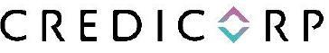

October 15, 2021

Securities and Exchange Commission - SEC

Re.: MATERIAL EVENT

Dear Sirs:

We hereby notify you as a Material Event that the company S&P Global Ratings has changed the outlook of Credicorp Ltd. from stable to negative reflecting the action on the sovereign risk of Peru. The credit rating of BBB has been confirmed.

The information in this Form 6-K regarding the rating of S&P Global Ratings has been disclosed in Peru in conformity with Peruvian law (Article 28 of the Capital Markets Law, approved by Supreme Decree 093-2002-EF, and by the Regulation of the Disclosure of Material Facts and Reserved Information approved by Resolution 005-2014-SMV/01 of the Peruvian Capital Markets Superintendency). The ratings of S&P Global Ratings do not necessarily represent the opinion of Credicorp Ltd. nor should they be seen as a recommendation to buy shares or any other securities of Credicorp Ltd. Credicorp Ltd. accepts no liability for the completeness, timeliness, accuracy or selection of such information.

The information in this Form 6-K (including any exhibit hereto) shall not be deemed “filed” for purposes of Section 18 of the Securities Exchange Act of 1934 (the ‘Exchange Act’) or otherwise subject to the liabilities of that section, nor shall it be deemed incorporated by reference in any filing under the Securities Act of 1933 or the Exchange Act.

Sincerely,

/s/ Miriam Böttger

Authorized Representative

Credicorp Ltd.

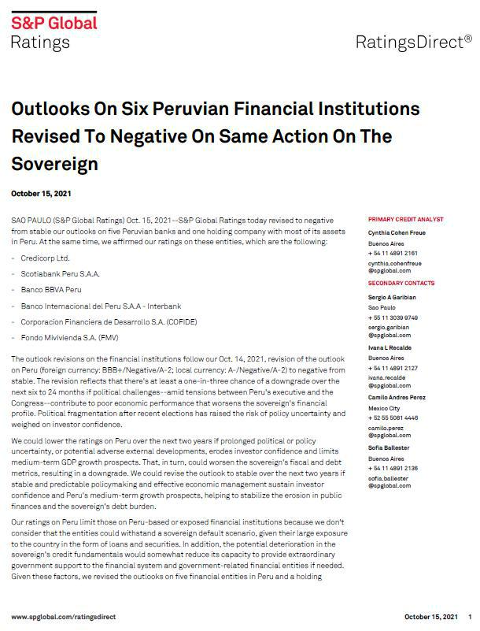

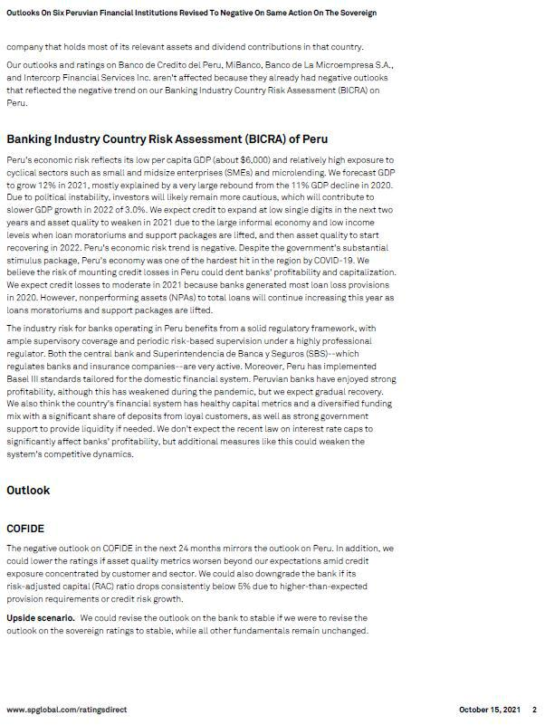

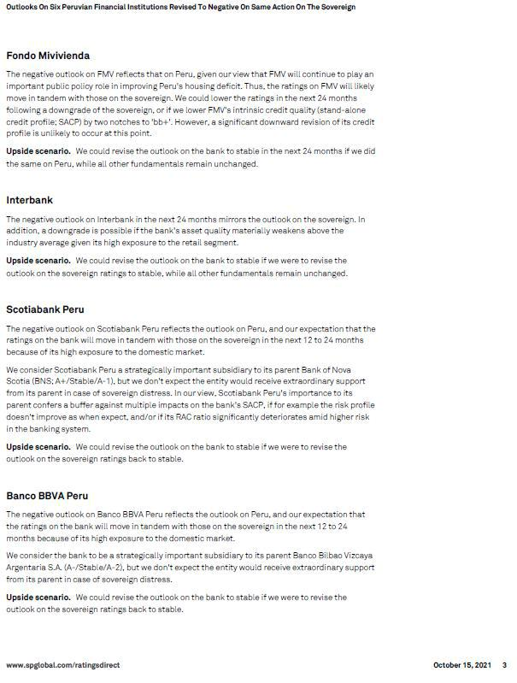

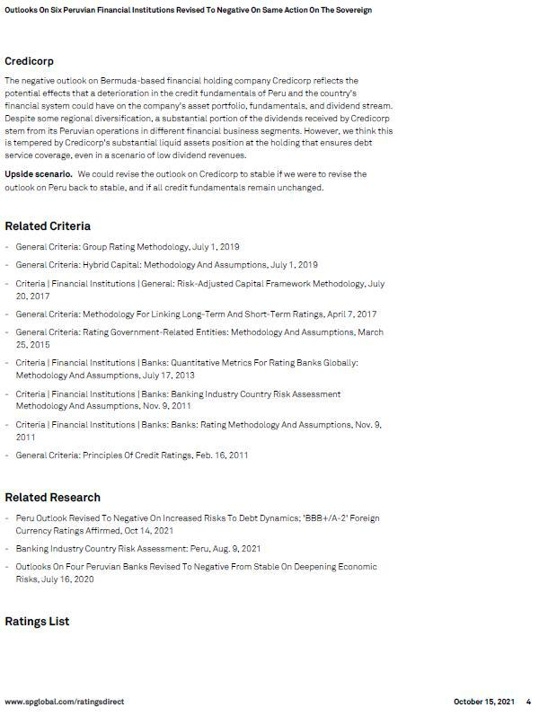

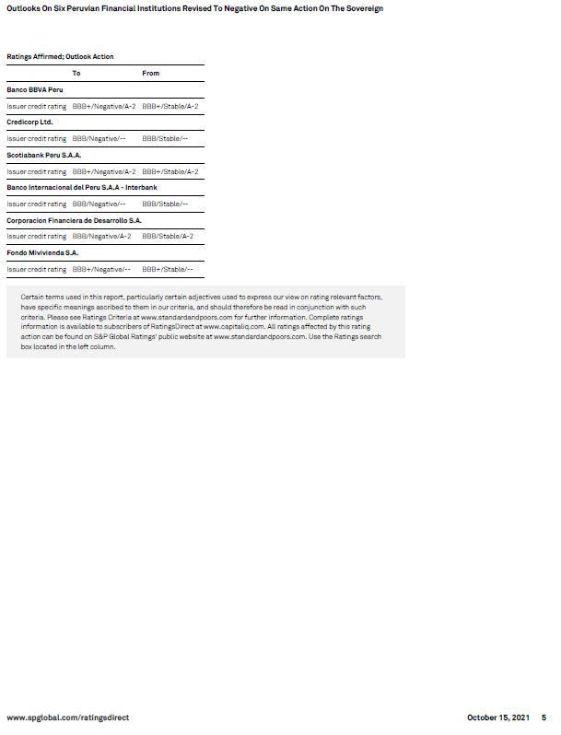

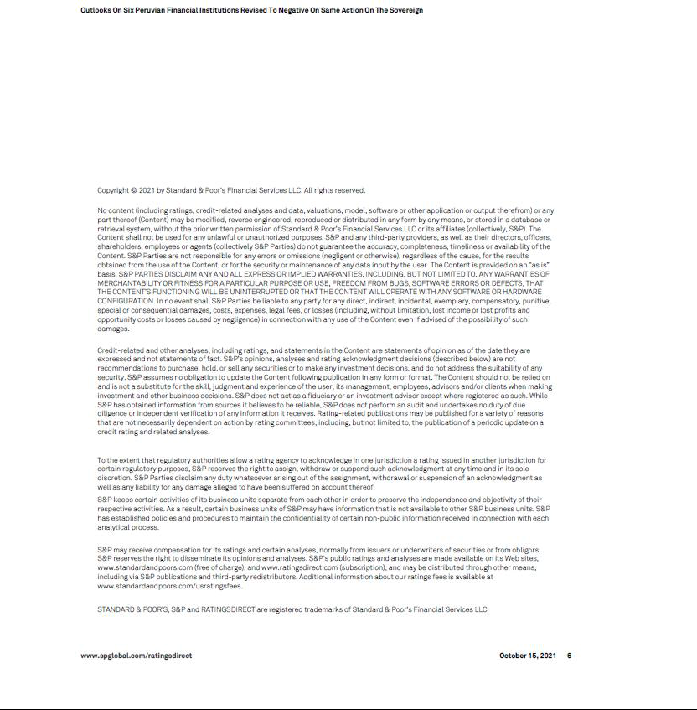

SIGNATURE

Pursuant to the requirements of the Securities Exchange Act of 1934, the registrant has duly caused this report to be signed on its behalf by the undersigned, thereunto duly authorized.

Date: October 15, 2021

CREDICORP LTD.

(Registrant)

By: /s/ Miriam Böttger

Miriam Böttger

Authorized Representative

