SECURITIES AND EXCHANGE COMMISSION

Washington, D.C. 20549

FORM 6-K

Report of Foreign Private Issuer

Pursuant to Rule 13a-16 or 15d-16 under the

Securities Exchange Act of 1934

For the month of February 2023

Commission File Number: 001-14014

CREDICORP LTD.

(Translation of registrant’s name into English)

Of our subsidiary

Banco de Credito del Peru:

Calle Centenario 156

La Molina

Lima 12, Peru

(Address of principal executive office)

Indicate by check mark whether the registrant files or will file annual reports under cover of Form 20-F or Form 40-F.

Form 20-F ☒ Form 40-F ☐

Indicate by check mark if the registrant is submitting the Form 6-K in paper as permitted by Regulation S-T Rule 101(b)(1): ____

Indicate by check mark if the registrant is submitting the Form 6-K in paper as permitted by Regulation S-T Rule 101(b)(7): ____

The information in this Form 6-K (including any exhibit hereto) shall not be deemed “filed” for purposes of Section 18 of the Securities Exchange Act of 1934 (the “Exchange Act”) or otherwise subject to the liabilities of that section, nor shall it be deemed incorporated by reference in any filing under the Securities Act of 1933 or the Exchange Act.

SIGNATURE

Pursuant to the requirements of the Securities Exchange Act of 1934, the registrant has duly caused this report to be signed on its behalf by the undersigned, thereunto duly authorized.

Date: February 9th, 2023

CREDICORP LTD.

(Registrant)

By: /s/ Guillermo Morales

Guillermo Morales

Authorized Representative

Exhibit 99.1
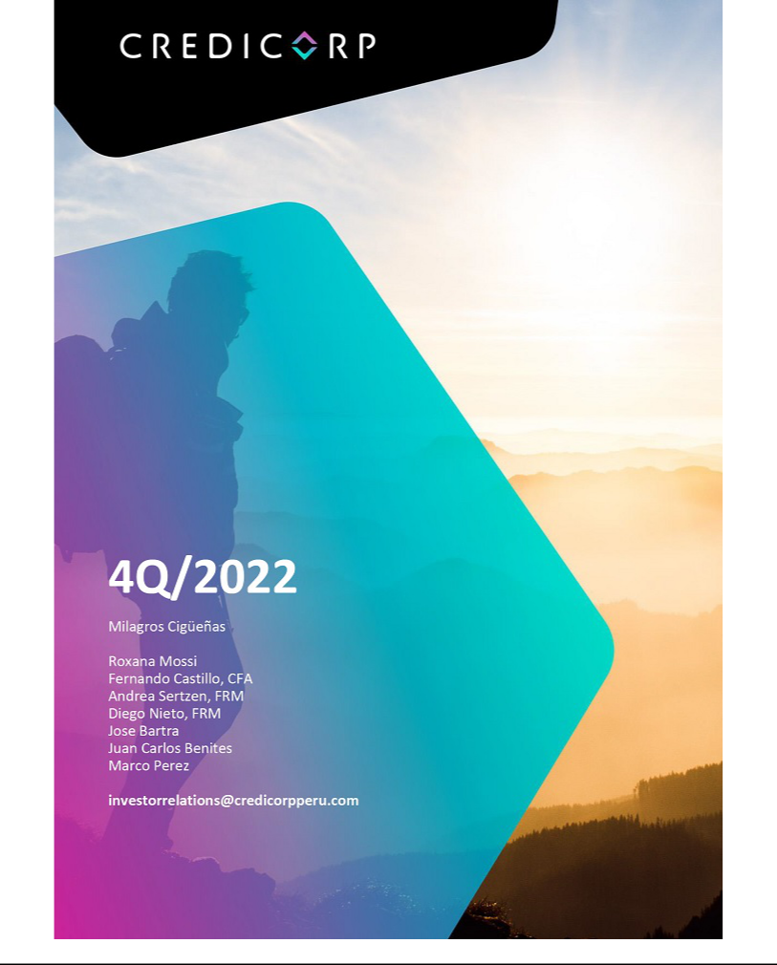

| Earnings Release 4Q / 2022

Table of Contents

Operating and Financial Highlights | 03
Senior Management Quotes | 04
Fourth Quarter 2022 Earnings Conference Call | 05
Summary of Financial Performance and Outlook | 06
Financial Overview | 11
Credicorp’s Strategy Update | 12
Analysis of 4Q22 Consolidated Results

01

02

03

04

05

06

07

08

09

10

11

12

Loans and Portfolio Quality | 15
Deposits | 21
Interest Earning Assets and Funding | 24
Net Interest Income | 25
Provisions | 28
Other Income | 31
Insurance Underwriting Results | 33
Operating Expenses | 36
Operating Efficiency | 38
Regulatory Capital | 39
Economic Outlook | 41
Appendix | 46

2

| Earnings Release 4Q / 2022

Operating and Financial Highlights

Credicorp Ltd. Reports Fourth Quarter 2022 Financial and Operating Results ROE of 15.3% with solid growth in Core Income and Higher Cost of Risk Posting Yet Another Quarter of Growth in Revenues Despite a Turbulent Backdrop, Which Led to Higher Provisioning

Lima, Peru – February 09, 2023 – Credicorp Ltd. (“Credicorp” or “the Company”) (NYSE: BAP | BVL: BAP), the leading financial services holding company in Peru with presence in Chile, Colombia, Bolivia and Panama today reported its unaudited results for the quarter and year ended December 31, 2022. Financial results are expressed in Soles and are presented in accordance with International Financial Reporting Standards (IFRS).

4Q22 OPERATING AND FINANCIAL HIGHLIGHTS

- Net Income attributable to Credicorp declined 17.7% QoQ but was 1.1% higher YoY, reaching S/1,072 million, with solid growth in core income being offset by higher cost of risk and seasonally higher expenses. ROAE declined to 15.3% in the quarter, down from 16.4% in 3Q21, and reached 16.7% in 2022.

- Structural Loans, as measured in average daily balances, increased 0.8% QoQ (+4.0% FX Neutral) and 10.4% YoY (+11.5% FX Neutral) in average daily balances, driven primarily by Retail Banking at BCP and Mibanco.

- Total Deposits reached S/147,021 million, down 1.1% QoQ and flat YoY on an FX Neutral basis, with more migration into Time Deposits and away from Demand and Savings Deposits because of the high interest rate environment. Low-cost Deposits accounted for 55.7% of Total Funding.

- The Structural NPL ratio was essentially flat QoQ at 4.95%, to reflect a greater amount of refinancing of loans in Wholesale Banking, especially in the Real Estate and Tourism sectors.

- Structural Provisions increased 70.1% QoQ from what was still a low base. We strengthened provision levels at BCP to reflect an update in our credit variables related to macroeconomic factors such as inflation, interest rates and GDP growth, as well as the negative impact of inflation on payment behavior for consumers. Provisions for Mibanco were also higher from an unusually low level in 3Q21. The Structural Cost of Risk increased 85 bps QoQ to 2.06%. Structural NPL Coverage declined to 112.2%.

- Core Income increased 5.5% QoQ and 20.9% YoY, mainly driven by Net Interest Income (NII), which was up 8.0% QoQ and 30.9% YoY. Benefitting from the effect of higher interest rates, Net Interest Margin increased 42 bps QoQ and 148 bps YoY to 5.73%. This offset a 4.2% QoQ decline in fee income.

- Efficiency Ratio weakened 320 bps QoQ to 46.0% due to seasonal factors. Compared to 4Q21, there was an improvement of 340 bps, largely because of higher core income, which more than offset increases in administrative expenses, part of which were related to the growth of our disruptive initiatives and investments in our digital transformation. For 2022, our efficiency ratio was 44.4%, 150 bps better than the figure of 2021. Excluding expenses related to our disruptive initiatives, our 2022 efficiency ratio would have improved 263 bps compared to 2021.

- Capital levels for our businesses improved in 2022, with the CET1 Ratio for BCP Stand-Alone up 67 bps to 12.6%, while for Mibanco it increased 122 bps to 16.5%. As of 2022, both subsidiaries report solvency levels in IFRS and as such, CET1 ratio figures will differ from reported figures in 4Q21.

- Further Progress in our Strategic Initiatives: i) Disruptive initiatives and our innovation strategies generated 290 bps impact on efficiency ratio; ii) Multiple initiatives across our subsidiaries to increase financial inclusion and financial education, examples include 1.1 million financially included through Yape and over 47MM views of financial education materials delivered by BCP.

3

|

SENIOR MANAGEMENT QUOTES
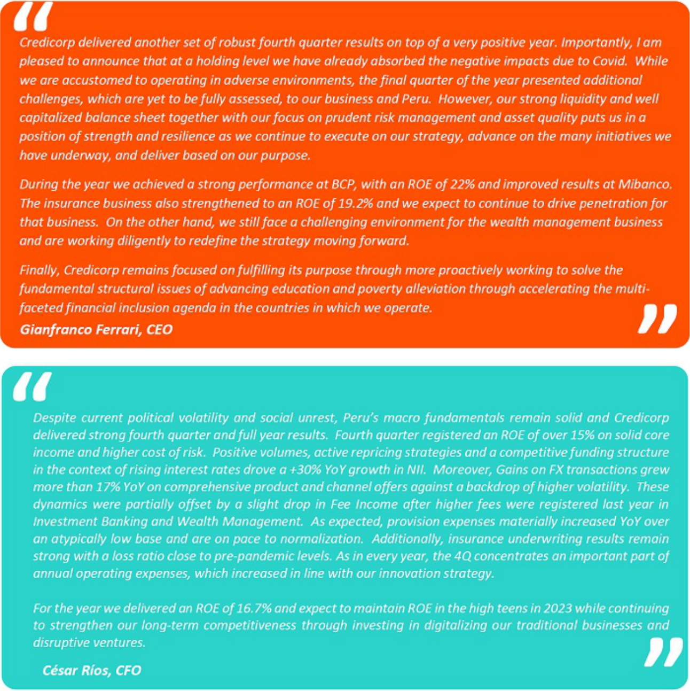

4

| Earnings Release 4Q / 2022

Fourth Quarter 2022 Earnings Conference Call

FOURTH QUARTER 2022 EARNINGS CONFERENCE CALL

Date: Friday February 10, 2023

Time: 09:30 am ET (9:30 am Lima, Peru time)

Hosts: Gianfranco Ferrari - CEO, Cesar Rios - Chief Financial Officer, Francesca Raffo – Chief Innovation Officer, Reynaldo Llosa - Chief Risk Officer, Diego Cavero - Head of Universal Banking, Cesar Rivera - Head of Insurance and Pensions, Carlos Sotelo – Mibanco CFO, and the Investor Relations Team.

To pre-register for the listen-only webcast presentation use the following link:

https://dpregister.com/sreg/10174956/f59cdd5450

Callers who pre-register will be given a conference passcode and unique PIN to gain immediate access to the call and bypass the live operator.

Participants may pre-register at any time, including up to and after the call start time.

Those unable to pre-register may dial in by calling:

1 844 435 0321 (U.S. toll free)
1 412 317 5615 (International)

Conference ID: Credicorp Conference Call

The webcast will be archived for one year on our investor relations website at:

https://credicorp.gcs-web.com/events-and-presentations/upcoming-events

For a full version of Credicorp´s Third Quarter 2022 Earnings Release, please visit:

https://credicorp.gcs-web.com/financial-information/quarterly-results

5

| Earnings Release 4Q / 2022

Summary of Financial Performance and Outlook

Loans (in Average Daily Balances)
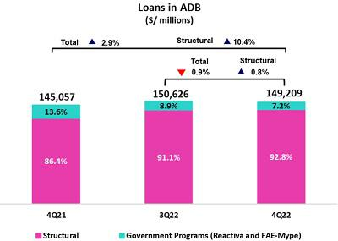

Structural loans measured in ADB rose 4.0% QoQ (FX neutral) to stand at S/138,419 million. This was driven primarily by Retail Banking in BCP Stand-alone and Mibanco.

YoY, growth in structural loans stood at 11.5% (FX neutral). This evolution was primarily spurred by Wholesale Banking as well as Consumer and Mortgage at BCP Stand-alone, and to a lesser extent, by Mibanco. All of this in line with the economic recovery.

The Government Program portfolio (GP) represented 7.2% of total average daily balances (6.4% at quarter-end).

Deposits
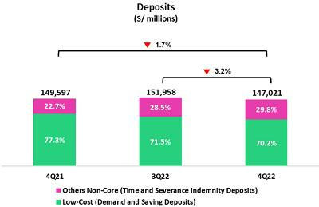

Our deposit base, measured in quarter-end balances, fell 1.1% QoQ (FX neutral). This drop was mainly attributable to a decrease in captures of Demand Deposits at BCP in both LC and FC, in line with the decrease in liquidity seen system-wide.

In the YoY comparison, the deposit base remained stable (FX Neutral). A noteworthy dynamic this period reflects the migration of funds from Low-cost Deposits to Time Deposits in both LC and FC, which reflects the impact of rising interest rates.

Net interest income (NII) and Margin (NIM)
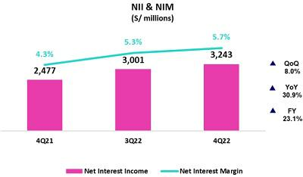

NII rose 8.0% QoQ to stand at S/3,243 million driven by: i) our disciplined pricing management in a context of increasing market rates,

- the evolution of loan mix towards retail segments; and iii) our financial strength by maintaining a low-cost funding structure. As a result, the uptick in the IEA Yield outpaced the increase registered for the Funding Cost.

YoY, Net Interest Income rose 30.9%, impacted by an uptick in market rates and in LC loan volumes.

These dynamics were maintained throughout the year, and as a result, accumulated NII grew 23.1% in 2022.

6

Earnings Release 4Q / 2022

Summary of Financial Performance and Outlook

Structural Portfolio Quality and Cost of Risk (CofR)
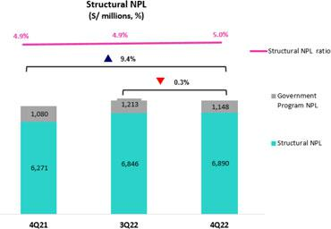

QoQ, the structural NPL portfolio rose 0.6%. The increase in volume of the NPL portfolio was concentrated in: (i) Wholesale Banking, due to growth in refinanced loans, particularly in the Real Estate and Tourism sectors and (ii) SME-Pyme, which reflected entry into new segments with clients with higher risk profiles. The aforementioned was partially offset by the improvement on Mibanco and Consumer segment NPL Portfolio as write-offs were registered this quarter. In this context, the structural NPL ratio stood at 5.0% (+3 bps) at the end of 4Q22.

YoY, structural NPLs rose 9.9%, driven by the aforementioned dynamics.

The structural CofR increased 85 bps QoQ, which reflected growth in provisions for: (i) Retail Banking at BCP Stand-alone, driven by the update of our estimates for key macroeconomic variables such as inflation, interest rates and GDP growth, as well as the negative impact that increasing inflation had on payment behavior in the Consumer segment (ii) Mibanco, given an unusually low base and an increase in the loan portfolio default ratio associated to the maturity of specific vintages. As a result, the structural CofR stood at 2.06%.
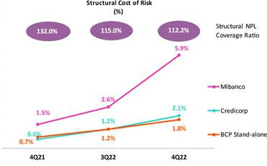

YoY, a significant increase in the structural CofR was registered (+150 bps). This reflects a base effect given that the provisions level was particularly low in 4Q21. Growth in provisions was driven by: Loans in Consumer, SME-Pyme and Mibanco.

On an accumulated basis, the structural CofR increased 27 bps, on its way to normalization towards pre-pandemic levels.

The structural NPL coverage ratio continued to follow a downward trajectory and stood at 112.2%.

7

Earnings Release 4Q / 2022

Summary of Financial Performance and Outlook

Other income

Other Core Income (Fees+ Gains on FX transactions) fell 0.7% QoQ. This was due primarily to a drop in fee income at BCP Stand-alone, which reflected the elimination of fees for intercity transfers. YoY, Other Core Income remained flat as higher gains on FX transactions and in fee income at BCP Stand-alone were completely offset by a drop in fee income from Investment Banking and Wealth Management.
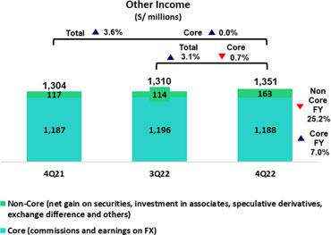

Other Non-core income rose significantly both QoQ and YoY due to an increase in Net gain on securities, which reflected positive variations in the fixed income portfolio at Credicorp Stand-alone and an improvement in the results of the trading strategy utilized by Credicorp Capital Colombia and ASB.

On a full year basis, Other Core Income increased 7.0% compared to the level reached in 2021 due to higher transaction in POS; higher personal loan disbursements fees; and an increase in bank-to-bank transfers. While Other Non-core income decreased 25.2% mainly due to a lower net gain in speculative derivatives.

Insurance Underwriting Result
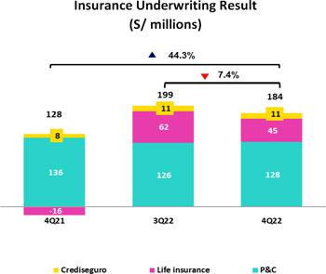

The insurance underwriting result fell 7.4% QoQ. This result was attributable to a drop in net earned premiums in the Life business, due to a particularly high base in 3Q22, as well as higher claims in the General business, associated with Commercial Lines and Cars. In YoY terms, the insurance underwriting result rose 44.3%, fueled by a significant decrease in claims in the Life Business, in line with the improvement in sanitary conditions, and by higher net premiums earned in both businesses, in line with the economic recovery.

On a full year basis, the insurance technical result returned to positive territory due to the dynamics mentioned in the YoY analysis.

8

Earnings Release 4Q / 2022

Summary of Financial Performance and Outlook

Efficiency
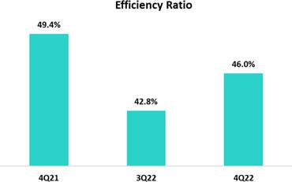

On a full year basis, the Efficiency ratio improved to 44.5%, or by, 150 bps compared to 2021. This was mainly due to the growth in Core Income at BCP Stand-alone and Mibanco.

Excluding expenses related to disruptive initiatives, the efficiency ratio would be 41.6%, 263 bps better than in 2021.

Net earnings attributable to Credicorp

Net earnings attributable to Credicorp totaled S/1,072 million, which reflected a drop of -17.7% QoQ and an uptick of 1.1% YoY With these results, net shareholders’equity stood at S/28,988 million (+6.9% QoQ). Consequently, ROE stood at 15.3% this quarter.

At a cumulative level, Credicorp 2022 results are also impacted by lower results at the holding level (Credicorp Ltd.), which primarily reflects the lower net financial results and higher expenses for withholding taxes. The net financial result is impacted in 2022 by the increase in the negative carry of the holding's senior bond. This negative carry increased in line with the devaluation of the investments made with the use of proceeds of the senior bond. Regarding tax expenses, in 2022 witholding tax provisions increased driven by higher expectations for dividend payments.
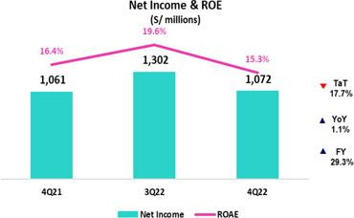

As a result, net income attributable to Credicorp increased 29.3% compared to the 2021 level, reaching S/4,633 million. In this context, ROE was 16.7%, 276 bps above the level reached in 2021.

Contributions* and ROE by subsidiary in 4Q22

(S/ millions)
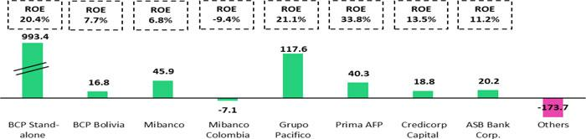

*Contributions to Credicorp reflect the eliminations for consolidation purposes (eliminations for transactions among Credicorp’s subsidiaries or between Credicorp and its subsidiaries).

- The figure is lower than the net income of BCP Stand Alone as contribution do not consider investments in other Credicorp subsidiaries (Mibanco).
- The figure is lower than the net income of Mibanco as Credicorp owns 99.924% of Mibanco (directly and indirectly).
- The contribution of Grupo Pacífico presented here is greater than the profit of Pacífico Seguros since it is including 100% of Crediseguros (including 48% under Grupo Credito).

9

Earnings Release 4Q / 2022

Summary of Financial Performance and Outlook


Universal Banking


In 2022, BCP experienced higher profitability, driven by Core

Income, in particular NII, which was propelled by strong structural loan origination and higher interest rates. These tailwinds were partially offset by a normalization of provisions.


Microfinance



Mibanco experienced a substantial recovery in profitability in 2022 driven mainly by favorable NII dynamics, associated with effective practices of pricing and commercial execution. For its part, the hybrid model allowed to optimize efficiency and scale the credit evaluation, resulting in record levels of billing.


Insurance and Pensions


In 2022, the bottom line for Pacifico Seguros returned to positive territory, as a result of lower levels of claims in Life as the health situation improved and a growth in net earned premiums earned.

Investment Banking and

Wealth Management


The Investment Banking and Wealth Management business continued to be challenged and found a drop in profitability mainly due to lower levels of assets under management.

Outlook


We expect to close 2023 with a ROE of around 17.5%. We anticipate this result will be fueled by: i) high single digit growth in the structural loan portfolio; ii) a further expansion of the net interest margin; and iii) a controlled cost of risk.

10

Earnings Release 4Q / 2022

Financial Overview


Credicorp Ltd. |  | Quarter |  | % change |  | As of |  | % change
S/ 000 | 4Q21 | 3Q22 | 4Q22 | QoQ | YoY | 2021 | 2022 | 2022 / 2021
Net interest, similar income and expenses | 2,477,234 | 3,001,459 | 3,243,018 | 8.0% | 30.9% | 9,359,604 | 11,518,095 | 23.1%
Provision for credit losses on loan portfolio, net | (126,782) | (459,976) | (730,681) | 58.9% | 476.3% | (1,212,223) | (1,811,538) | 49.4%
of recoveries
Net interest, similar income and expenses, after | 2,350,452 | 2,541,483 | 2,512,337 | -1.1% | 6.9% | 8,147,381 | 9,706,557 | 19.1%
provision for credit losses on loan portfolio
Total other income | 1,304,163 | 1,310,186 | 1,350,661 | 3.1% | 3.6% | 4,929,717 | 5,108,349 | 3.6%
Insurance underwriting result | 127,657 | 198,842 | 184,168 | -7.4% | 44.3% | (3,721) | 661,598 | n.a
Total other expenses | (2,223,165) | (2,141,153) | (2,474,609) | 15.6% | 11.3% | (7,740,561) | (8,620,615) | 11.4%
Profit (loss) before income tax | 1,559,107 | 1,909,358 | 1,572,557 | -17.6% | 0.9% | 5,332,816 | 6,855,889 | 28.6%
Income tax | (471,860) | (575,083) | (476,236) | -17.2% | 0.9% | (1,660,987) | (2,110,501) | 27.1%
Net profit (loss) | 1,087,247 | 1,334,275 | 1,096,321 | -17.8% | 0.8% | 3,671,829 | 4,745,388 | 29.2%
Non-controlling interest | 26,631 | 31,855 | 24,231 | -23.9% | -9.0% | 87,247 | 112,292 | 28.7%
Net profit (loss) attributable to Credicorp | 1,060,616 | 1,302,420 | 1,072,090 | -17.7% | 1.1% | 3,584,582 | 4,633,096 | 29.3%
Net profit (loss) / share (S/) | 13.30 | 16.33 | 13.44 | -17.7% | 1.1% | 44.94 | 58.09 | 29.3%
Loans | 147,597,412 | 151,392,202 | 148,626,374 | -1.8% | 0.7% | 147,597,412 | 148,626,374 | 0.7%
Deposits and obligations | 149,596,545 | 151,958,000 | 147,020,787 | -3.2% | -1.7% | 149,596,545 | 147,020,787 | -1.7%
Net equity | 26,496,767 | 27,109,054 | 28,988,140 | 6.9% | 9.4% | 26,496,767 | 28,988,140 | 9.4%
Profitability
Net interest margin | 4.25% | 5.31% | 5.73% | 42 pbs | 148 pbs | 4.10% | 5.07% | 97 pbs
Risk-adjusted Net interest margin | 4.03% | 4.50% | 4.44% | -6 pbs | 41 pbs | 3.57% | 4.27% | 70 pbs
Funding cost | 1.24% | 2.07% | 2.36% | 29 pbs | 112 pbs | 1.29% | 1.83% | 54 pbs
ROAE | 16.4% | 19.6% | 15.3% | -430 pbs | -110 pbs | 13.9% | 16.7% | 280 pbs
ROAA | 1.7% | 2.2% | 1.8% | -40 pbs | 10 pbs | 1.5% | 1.9% | 40 pbs
Loan portfolio quality
Internal overdue ratio ⁽¹⁾ | 3.76% | 4.13% | 4.00% | -13 pbs | 24 pbs | 3.76% | 4.00% | 24 pbs
Internal overdue ratio over 90 days | 2.85% | 3.08% | 3.11% | 3 pbs | 26 pbs | 2.85% | 3.11% | 26 pbs
NPL ratio ⁽²⁾ | 4.98% | 5.32% | 5.41% | 9 pbs | 43 pbs | 4.98% | 5.41% | 43 pbs
Cost of risk ⁽³⁾ | 0.34% | 1.22% | 1.97% | 75 pbs | 163 pbs | 0.82% | 1.22% | 40 pbs
Coverage ratio of IOLs | 152.7% | 128.5% | 132.5% | 400 pbs | -2020 pbs | 152.7% | 132.5% | -2020 pbs
Coverage ratio of NPLs | 115.3% | 99.6% | 97.9% | -170 pbs | -1740 pbs | 115.3% | 97.9% | -1740 pbs
Operating efficiency
Efficiency ratio ⁽⁴⁾ | 49.4% | 42.8% | 46.0% | 320 pbs | -340 pbs | 45.9% | 44.4% | -150 pbs
Operating expenses / Total average assets | 3.56% | 3.57% | 4.00% | 43 pbs | 44 pbs | 3.19% | 3.56% | 40 pbs
Insurance ratios
Combined ratio of P&C ⁽⁵⁾ ⁽⁶⁾ | 87.0% | 91.2% | 93.1% | 190 pbs | 610 pbs | 87.0% | 93.1% | 610 pbs
Loss ratio | 1.5% | 63.6% | 65.4% | 180 pbs | -610 pbs | 87.7% | 67.2% | -2050 pbs
Capital adequacy - BCP Stand-alone
Global Capital ratio ⁽⁷⁾ | 14.94% | 14.93% | 14.43% | -50 pbs | -51 pbs | 15.16% | 14.93% | -23 pbs
Tier 1 ratio ⁽⁸⁾ | 9.94% | 9.94% | 10.02% | 8 pbs | 8 pbs | 9.94% | 10.02% | 8 pbs
Common equity tier 1 ratio ⁽⁹⁾ ⁽¹¹⁾ | 11.91% | 11.83% | 12.59% | 76 pbs | 68 pbs | 11.91% | 12.59% | 68 pbs
Capital adequacy - Mibanco
Global Capital ratio ⁽⁷⁾ | 16.40% | 14.61% | 14.69% | 8 pbs | -171 pbs | 16.40% | 14.69% | -171 pbs
Tier 1 ratio ⁽⁸⁾ | 13.96% | 12.36% | 12.38% | 2 pbs | -158 pbs | 13.96% | 12.38% | -158 pbs
Common equity tier 1 ratio ⁽⁹⁾ ⁽¹¹⁾ | 15.24% | 16.00% | 16.46% | 46 pbs | 122 pbs | 15.24% | 16.46% | 122 pbs
Employees | 36,358 | 35,692 | 36,968 | 3.6% | 1.7% | 36,358 | 36,968 | 1.7%
Share Information
Issued Shares | 94,382 | 94,382 | 94,382 | 0.0% | 0.0% | 94,382 | 94,382 | 0.0%
Treasury Shares ⁽¹⁰⁾ | 14,850 | 14,849 | 14,849 | 0.0% | 0.0% | 14,850 | 14,849 | 0.0%
Outstanding Shares | 79,532 | 79,533 | 79,533 | 0.0% | 0.0% | 79,532 | 79,533 | 0.0%
- Internal overdue loans include overdue loans and loans under legal collection, according to our internal policy for overdue loans. Internal Overdue ratio: Internal overdue loans / Total loans.
- Non-performing loans (NPL): Internal overdue loans + Refinanced loans. NPL ratio: NPL / Total loans.
- Cost of risk: Annualized provision for loan losses, net of recoveries / Total loans.
- Efficiency ratio = (Salaries and employee benefits + Administrative expenses + Depreciation and amortization + Association in participation + Acquisition cost) / (Net interest, similar income and expenses + Fee Income + Net gain on foreign exchange transactions + Net Gain From associates + Net gain on derivatives held for trading + Result on exchange differences + Net Premiums Earned).
- Combined ratio = (Net claims / Net earned premiums) + [(Acquisition cost + Operating expenses) / Net earned premiums]. Does not include Life insurance business.
- Considers Grupo Pacifico's figures before eliminations for consolidation to Credicorp.
- Regulatory Capital / Risk-weighted assets (legal minimum = 10% since July 2011).
- Tier 1 = Capital + Legal and other capital reserves + Accumulated earnings with capitalization agreement + (0.5 x Unrealized profit and net income in subsidiaries) - Goodwill - (0.5 x Investment in subsidiaries) + Perpetual subordinated debt (maximum amount that can be included is 17.65% of Capital + Reserves + Accumulated earnings with capitalization agreement + Unrealized profit and net income in subsidiaries - Goodwill).

- Common Equity Tier I = Capital + Reserves – 100% of applicable deductions (investment in subsidiaries, goodwill, intangibles and net deferred taxes that rely on future profitability) + retained earnings + unrealized gains. Adjusted Risk-Weighted Assets = Risk-weighted assets - (RWA Intangible assets, excluding goodwill, + RWA Deferred tax assets generated as a result of temporary differences in income tax, in excess of 10% of CET1, + RWA Deferred tax assets generated as a result of past losses)."

- Consider shares held by Atlantic Security Holding Corporation (ASHC) and stock awards.
- Common Equity Tier I calculated based on IFRS Accounting.

11

Earnings Release 4Q / 2022

Credicorp’s Strategy Update

Credicorp Strategy

Despite a challenging environment market by more uncertainty, Credicorp continues to fulfill its purpose as it successfully executes its strategy.

In 2022, Credicorp rolled out an expansion of its appetite for innovation investment, which impacted the cost to income ratio by 290bps. Credicorp leverages its competitive advantages to be a key enabler of financial inclusion and financial education in the Andean region and is driving multiple initiatives across subsidiaries. Over this period, Credicorp has financially included more than 1.1 million people through Yape while BCP’s financial education web series topped 47MM views.

In this first stage, investments in innovation mainly prioritize the domains of payments, digital loans, neobanks, acquisition and value-added services to SMEs. Regarding the Krealo portfolio, our corporate venture capital center registered significant growth at Tenpo in 2022, which added 1 million new clients in Chile this year. Additionally, Krealo added 2 ventures to its portfolio: Samishop in Peru, whose aim is to reinforce the ecosystem of value-added services that we offer to SMEs, and Monokera in Colombia, whose objective is to drive penetration of digital insurance products in the region. Going forward, our innovation initiatives will begin to generate revenue.

Main KPIs of Credicorp’s Strategy

Experience | Efficiency | Growth
Traditional Business Transformation ⁽¹⁾ |  | Subsidiary | 4Q20 | 4Q21 | 4Q22
Day to Day
Digital clients ⁽²⁾ |  | BCP | 40% | 54% | 67%
Digital monetary transactions ⁽³⁾ |  | BCP | 44% | 51% | 66%
Transactional cost by unit |  | BCP | 0.29 | 0.19 | 0.08
Disbursements through leads ⁽⁴⁾ |  | Mibanco | 46% | 73% | 76%
Disbursements through alternative channels ⁽⁵⁾ |  | Mibanco | 16% | 44% | 45%
Mibanco Productivity ⁽⁶⁾ |  | Mibanco | 13.1 | 24.4 | 25.9
Cashless
Cashless transactions ⁽⁷⁾ |  | BCP | 36% | 41% | 48%
Mobile Banking rating Apple |  | BCP | 3.1 | 2.8 | 3.7
Digital Acquisition
Digital sales ⁽⁸⁾ |  | BCP | 47% | 50% | 61%
- Figures for December 2019, 2021, and 2022
- Digital Client: Retail Banking clients that conduct 50% of their monetary transactions through digital channels or have purchased an online in the last 12 months. Since this quarter Digital Clients includes Yapecard Clients. Digital clients/ Total Retail Banking clients.
- Retail Monetary Transactions conducted through Retail Banking, Internet Banking, Yape and Telecredito/Total Retail Monetary Transactions in Retail Banking.
- Disbursements generated through leads/Total disbursements.
- Disbursements conducted through alternative channels/Total disbursements.
- Number of loans disbursed/ Total relationship managers.
- Amount transacted through Mobile Banking, Internet Banking, Yape y POS/ Total amount transacted through Retail Banking.
- Units sold by Retail Banking through digital channels/ Total number of units sold by Retail Banking.
- Retail Banking loans disbursed through digital channels/ Total Retail banking loans disbursed.

12

Earnings Release 4Q / 2022

Credicorp’s Strategy Update

Disruptive Initiatives: Yape

Yape continues to grow focused on three sustaining pillars:

Be the main payment method used in the country:

At the end of 2022, Yape’s user base topped 11.9 million, more than 70% of whom are active users. To bolster the user base and levels of usability, Yape continues to roll out campaigns to encourage affiliation; increase the use of the application at different microbusinesses; and boost the use of QR codes provided by POS. In 2022, 13 million payments were made with QR from POS for a total of S/484 million. This number of payments represents 7% of total payments through POS at BCP.

On the mobile top-off front, we continued to make considerable headway. Since its launch in November 2021, more than 63 million top-offs have been made. This led YAPE to register an MS of 25% of the mobile phone top-off market.

On November 1st, Yape rolled out a web-based payment application. More than 180 businesses signed up for this functionality in only two months and more than 180 thousand transactions were processed. It is important to note that this was achieved without the need for advertising campaigns.

Be present in the daily lives of all Yaperos:

In September, we launched Yape Promos, a functionality that allows clients to utilize discounts at different establishments, including restaurants, healthcare providers, transportation companies and affiliated entertainment centers. In the 4 months since it was rolled out, Yape Promos registered 270,000 transactions for a total of S/ 5.6 million.

Solve the financial needs of Yaperos:

Yape launched a Microloan functionality at the end of August. At the close of 2022, 130 thousand loans were disbursed. This functionality has successfully referred Yaperos with higher financing needs to the corresponding channels.


 | Disruptive Initiatives: Yape ⁽¹⁾ | 4Q20 | 4Q21 | 4Q22
 | Day to Day
 | % Microbusiness users ⁽²⁾ | 12% | 17% | 19%
 | Mobile phone top-ups (thousands) | - | - | 9,887
 | Cashless
 | Users (thousands) | 5.1 | 8.4 | 11,9
 | % User’s clients of BCP ⁽³⁾ | 100% | 79% | 72%
 | % of Yapecard Users ⁽⁴⁾ | - | 20% | 24%
 | Active users (thousands) ⁽⁵⁾ | 2.4 | 4.5 | 8.3
 | % Active users on a monthly basis ⁽⁶⁾ | 47% | 54% | 70%
 | No. of monthly Transactions (thousands) | 20.0 | 57.6 | 162.6
 | Monthly transaction amount (millions, S/) | 1,512 | 3,728 | 8,764
 | Number of monthly transactions by Active Yapero ⁽⁷⁾ | 4.4 | 12.8 | 19.5
- Figures for December 2020, 2021, and 2022
- Yape users that are Microbusinesses/Total Yape users
- BCP clients that are Yape users/Total Yape users
- Yapecard users / Total Yape users
- Yape users that have conducted at least one transaction a month
- Yape users that have conducted at least one transaction in the past month/Total Yape Users
- Number of Yape transactions/Active Users

13

Earnings Release 4Q / 2022

Credicorp’s Strategy Update

Integrating sustainability in our businesses

For more information on our sustainability strategy, program and initiatives, please review our “2020-25 Sustainability Strategy” and our “2021 Annual and Sustainability Report”. At the end of 2022, the milestones Credicorp hit regarding the implementation of our Sustainability Program include:

Governance Front – Recognition received in 2022

Credicorp was recognized as EMPRESA ALAS20 PERU for 2022 given the results of two competition categories: Leading Company in Sustainability and Leading Company in Investor Relations. Additionally, Credicorp Capital placed first in this competition in the category of Leading Investor in Corporate Governance in Peru.

ALAS20, Sustainable Leader Agenda, is the only Latin American initiative that evaluates, rates and recognizes excellence in public disclosure of information regarding sustainable development, corporate governance and responsible investing by companies and investors in the region. This effort, which began in 2013, is organized by GOVERNART, a think tank and ESG advisory firm.

Environmental Front – Driving environmental sustainability from the financial sector

In 2022, we committed to becoming a carbon -neutral company at our own operational emissions by 2032. Additionally, we developed our ESG risk management framework, a key tool that uses Sustainable Finance and Responsible Investing initiatives to help our clients transition to sustainable business practices. Our initiatives by subsidiary are described below.

Sustainable Finance:

- At BCP, we began to integrate the retail portfolio under the Framework scope.

- In 2022, BCP granted a total of $162 million in green loans. Six of these loans were verified by external auditors and 1 was validated internally via our Environmental Taxonomy and Sustainable Operations Committee.

Responsible Investing:

- Credicorp Capital developed Sustainable Investment Guidelines for different investment strategies.

- Prima analyzed 94% of its portfolio with ESG criteria (outpacing the goal of 80% in 2022).
- Pacifico assessed the 79% of its local portfolio and the 90% of the foreign portfolio with ESG questionnaires based on SASB standards.

Social Front – Expanding financial inclusion and educating about finance and entrepreneurship

Financial Inclusion:

- In 2022, Yape incorporated more than 1.1 million users into the financial system. At Pacifico, 2.6 million clients now possess inclusive insurance products that cost less than S/20 a month. These products help our clients cover life, oncological, business and credit/debit card risks.
- In 2022, BCP financially included more than 47 thousand SME-Pymes and disbursed in more than S/1,700 million for working capital loans and invoice discounting.

Financial Education:

- More than 233 thousand people were trained through BCP’s online campus in 2022. This total topped 2021’s figure by 4.3 times. Additionally, 235 thousand individuals were offered financing under the Contigo Emprendedor program.
- Mibanco impacted more than 247 thousand entrepreneurs by providing financial and digital education tools and knowledge.
- BCP Bolivia signed an agreement with the Emprender Futuro foundation and trained 2,659 women from around the country via online workshops and on-site education. Additionally, more than 19 thousand people were trained through the bank Academia de Clientes program, which targets users in rural communities.

- Pacifico closed the year with a total of 11 thousand people trained in risk prevention through its Comunidad Segura program.

14

Earnings Release 4Q / 2022 Analysis of 4Q22 Consolidated Results

01 Loan Portfolio


The structural loan balance at BCP Stand-alone registered growth in average daily balances QoQ. This increase was driven primarily by Retail Banking, and SME-Pyme and Mortgage in particular. The uptick in SME-Pyme reflected successful efforts to penetrate new segments while growth in Mortgage was fueled by a drop in prepayments in a context of stable growth. Mibanco also posted growth, bolstered by disbursements through alternative channels. YoY, growth in structural loans was driven by BCP and Mibanco. The increase registered in average daily balances for retail loans- which also offer higher margins- led this loan type’s share of total loans to stand at 41% at quarter-end. FY, growth of 11.3% in structural loans was driven by fishing and agricultural campaigns in Wholesale; an uptick in growth in Consumer; and an improvement in loan growth through the hybrid model at Mibanco, which registered a 9.4% share of Credicorp loan portfolio.

The structural NPL portfolio grew QoQ and YoY, which was driven by an uptick in refinanced loans in Wholesale Banking and overdue loans in SME-Pyme. The aforementioned was partially offset by the improvement on Mibanco and Consumer segment NPL Portfolio as write-offs were registered this quarter.

1.1. Loans

Structural loans (in Average Daily Balances)⁽¹⁾⁽²⁾⁽³⁾
Structural Loans |  | As of |  | Volume change |  |  | % change |  | % Part. in total structural
Structural Loans |  | As of |  |  |  |  |  |  |  | loans
(S/ millions) |  |  |  |  |  |  |  |  |  | loans
(S/ millions) | Dec 21 | Sep 22 | Dec 22 | QoQ | YoY | QoQ |  | YoY | Dec 21 | Sep 22 | Dec 22
BCP Stand-alone | 101,729 | 112,276 | 113,050 | 774 | 11,322 | 0.7% |  | 11.1% | 81.2% | 81.8% | 81.7%
Wholesale Banking | 52,289 | 56,969 | 56,246 | -723 | 3,956 | -1.3% |  | 7.6% | 41.7% | 41.5% | 40.6%
Corporate | 31,426 | 34,686 | 33,868 |  |  | -2.4% |  | 7.8% | 25.1% | 25.3% | 24.5%
 |  |  |  | -818 | 2,443
Middle - Market | 20,864 | 22,282 | 22,377 | 95 | 1,514 | 0.4% |  | 7.3% | 16.6% | 16.2% | 16.2%
Retail Banking | 49,439 | 55,308 | 56,805 | 1,497 | 7,365 | 2.7% |  | 14.9% | 39.4% | 40.3% | 41.0%
SME - Business | 5,302 | 5,714 | 5,862 | 148 | 561 | 2.6% |  | 10.6% | 4.2% | 4.2% | 4.2%
SME - Pyme | 11,597 | 12,637 | 13,029 |  | 1,432 | 3.1% |  | 12.4% | 9.3% | 9.2% | 9.4%
 |  |  |  | 393
Mortgage | 18,432 | 19,739 | 20,074 | 335 |  | 1.7% |  | 8.9% | 14.7% | 14.4% | 14.5%
 |  |  |  |  | 1,642
Consumer | 10,296 | 12,444 | 12,736 | 292 | 2,441 | 2.3% |  | 23.7% | 8.2% | 9.1% | 9.2%
Credit Card | 3,813 | 4,774 | 5,103 | 330 | 1,290 | 6.9% |  | 33.8% | 3.0% | 3.5% | 3.7%
Mibanco | 10,991 | 12,782 | 13,121 |  |  | 2.7% |  | 19.4% | 8.8% | 9.3% | 9.5%
 |  |  |  | 339 | 2,130
Mibanco Colombia | 1,064 | 1,163 | 1,174 | 12 | 111 | 1.0% |  | 10.4% | 0.8% | 0.8% | 0.8%
Bolivia | 9,230 | 8,992 | 9,034 | 41 | -197 | 0.5% |  | -2.1% | 7.4% | 6.6% | 6.5%
ASB Bank Corp. | 2,311 | 2,053 | 2,039 | -14 | -272 | -0.7% |  | -11.8% | 1.8% | 1.5% | 1.5%
BAP’s total loans | 125,325 | 137,267 | 138,419 | 1,152 | 13,094 | 0.8% |  | 10.4% | 100.0% | 100.0% | 100.0%

For consolidation purposes, Loans generated in Foreign Currency (FC) are converted to Local Currency (LC).
- Includes Work out unit, and other banking. For Quarter- end Balances figures, please refer to “12. Annexes — 12.2 Loan Portfolio Quality
- Structural Portfolio excludes the Loans offered through Reactiva Peru and FAE-Mype Government Programs (GP).
- Internal Management Figures

QoQ, if we exclude the exchange rate effect (USDPEN: -4.2%), structural loans in average daily balances increased 4.0%. This evolution was mainly driven by:

- Retail Banking, where all segments registered favorable evolution. The SME-Pyme segment led expansion through growth in the small client segment (loans<90 thousand soles). It is important to note that this new segment has a higher risk profile, which is nonetheless offset by higher interest rates. Mortgage also evolved positively prepayment levels fell.

- Mibanco, where the hybrid model led to an uptick in disbursements through alternative channels to clients with lower risk; this growth offset the drop in disbursements through traditional channels.

The aforementioned positive evolution was partially offset by a reduction in ADB in Wholesale Banking, which reflects amortization of Corporate loans at year-end.

YoY, if we exclude the exchange rate effect (USDPEN: -4.3%), structural loans in average daily balances rose 11.5%. This growth was driven mainly by:

15

Earnings Release 4Q / 2022

- Loan Portfolio

  - Wholesale Banking, where Corporate and Middle-Market Banking led growth in ADB due to a variation in the base effect, which reflected higher debt amortization in 4Q21 than in 4Q22. Despite this growth, Wholesale Banking’s share of loan volume fell 64 bps in a context marked my heightened competition from new entrants to the corporate segment.

  - Retail Banking at BCP, where the Consumer and Mortgage segments led expansion followed by the SME-Pyme and Credit Card segments. These dynamics were driven by an uptick in consumption in a context of economic activation.

Government Program Loans

(in Average Daily Balances - S/ millions)
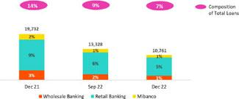

Analysis of 4Q22 Consolidated Results


- Mibanco, due to the same drivers as those seen in the QoQ dynamic.

FY, loans in average daily balances rose 11.3%; excluding the variation in the exchange rate (USDPEN: -4.3%), balances rose 11.9%, driven by BCP Stand-alone and Mibanco. This growth was led by:

- Wholesale Banking, which participated actively in lending during the fishing and agricultural campaigns.

- Consumer, due to an uptick in cash loan disbursements this year.

- Mibanco, which thanks to the hybrid model has experienced growth in loan disbursements through alternative channels. In this context, Mibanco’s share of total loans at Credicorp rose from 8.7% to 9.3%.

Government Program loans (GP) fell 19.6% QoQ and 45.5% YoY. Both drops were primarily attributable to amortizations by Small, Medium and Large Companies at BCP Stand-alone. GP loans in quarter-end balances represented 6% of total quarter-end balances (vs 8% in Sep22 and 12% in Dec21).

The term for total amortization of GP loans in the Wholesale Banking, Retail Banking and Mibanco portfolios expires, on average, in 1.2, 1.6 and 2.7 years respectively.

16

Earnings Release 4Q / 2022 Analysis of 4Q22 Consolidated Results

01. Loan Portfolio

Total loans (in Average Daily Balances) ⁽¹⁾ ⁽²⁾

Total Loans |  | As of |  | Volume change |  | % change |  | % Part. in total loans
(S/ millions) | Dec 21 | Sep 22 | Dec 22 | QoQ | YoY | QoQ | YoY | Dec 21 | Sep 22 | Dec 22
BCP Stand-alone | 119,100 | 124,101 | 122,671 | -1,429 | 3,571 | -1.2% | 3.0% | 82.1% | 82.4% | 82.2%
Wholesale Banking | 56,359 | 59,387 | 58,121 | -1,266 | 1,762 | -2.1% | 3.1% | 38.9% | 39.4% | 39.0%
Corporate | 31,851 | 34,961 | 34,086 |  |  | -2.5% | 7.0% | 22.0% | 23.2% | 22.8%
 |  |  |  | -875 | 2,235
Middle - Market | 24,508 | 24,426 | 24,036 | -390 | -472 | -1.6% | -1.9% | 16.9% | 16.2% | 16.1%
Retail Banking | 62,741 | 64,713 | 64,550 | -163 | 1,809 | -0.3% | 2.9% | 43.3% | 43.0% | 43.3%
SME - Business | 10,484 | 9,219 | 8,695 |  |  | -5.7% | -17.1% | 7.2% | 6.1% | 5.8%
 |  |  |  | -525 | -1,790
SME - Pyme | 19,717 | 18,537 | 17,943 | -595 | -1,774 | -3.2% | -9.0% | 13.6% | 12.3% | 12.0%
Mortgage | 18,432 | 19,739 | 20,074 | 335 | 1,642 | 1.7% | 8.9% | 12.7% | 13.1% | 13.5%
Consumer | 10,296 | 12,444 | 12,736 | 292 | 2,441 | 2.3% | 23.7% | 7.1% | 8.3% | 8.5%
Credit Card | 3,813 | 4,774 | 5,103 | 330 | 1,290 | 6.9% | 33.8% | 2.6% | 3.2% | 3.4%
Mibanco | 13,352 | 14,286 | 14,261 | -25 | 909 | -0.2% | 6.8% | 9.2% | 9.5% | 9.6%
Mibanco Colombia | 1,064 | 1,163 | 1,174 | 12 | 111 | 1.0% | 10.4% | 0.7% | 0.8% | 0.8%
Bolivia | 9,230 | 8,992 | 9,034 | 41 | -197 | 0.5% | -2.1% | 6.4% | 6.0% | 6.1%
ASB Bank Corp. | 2,311 | 2,084 | 2,068 | -16 | -243 | -0.8% | -10.5% | 1.6% | 1.4% | 1.4%
BAP’s total loans | 145,057 | 150,626 | 149,209 | -1,417 | 4,151 | -0.9% | 2.9% | 100.0% | 100.0% | 100.0%

For consolidation purposes, Loans generated in Foreign Currency (FC) are converted to Local Currency (LC). |  |  | Higher volume contracted
(1) | Includes Work out unit, and other banking. For Quarter-end Balances figures, please refer to “12. Annexes – 12.2 Loan Portfolio Quality”. |  | Higher volume expansion
(2) | Internal Management Figures

QoQ total loans dropped and reflected the fact that growth in structural loans was insufficient to offset the drop in GP loans. YoY total loans were up, driven by the positive evolution of BCP Stand-alone’s structural portfolio; this improvement was partially offset by a contraction in GP loans.

Evolution of the Dollarization Level of Loans (in Average Daily Balances) ⁽¹⁾⁽²⁾

 |  | Local Currency (LC) - S/ millions |  |  |  |  |  |  | % Structural |  | Foreign Currency (FC) - US$ |  |  |  |  |  | % part. by
 |  |  |  |  |  |  | % change |  |  |  |  | millions |  |  | % change |  | currency
Total Loans |  |  |  |  |  |  |  |  | change |  |  | millions
Total Loans |  | Total |  |  | Structural |  |  |  |  |  |  | Total |  |  |  |  | Dec 22
 | Dec 21 | Sep 22 | Dec 22 | Dec 21 | Sep 22 | Dec 22 | QoQ | YoY | QoQ | YoY | Dec 21 | Sep 22 | Dec 22 |  | QoQ | YoY | LC | FC
BCP Stand-alone | 84,592 | 85,871 | 85,076 | 67,221 | 74,047 | 75,455 | -0.9% | 0.6% | 1.9% | 12.2% | 8,600 | 9,765 | 9,679 |  | -0.9% | 12.5% | 69.4% | 30.6%
Wholesale Banking | 28,967 | 28,943 | 28,350 | 24,898 | 26,524 | 26,474 | -2.0% | -2.1% | -0.2% | 6.3% | 6,827 | 7,777 | 7,665 |  | -1.4% | 12.3% | 48.8% | 51.2%
Corporate | 15,077 | 16,303 | 16,044 | 14,652 | 16,029 | 15,827 | -1.6% | 6.4% | -1.3% | 8.0% | 4,181 | 4,767 | 4,645 |  | -2.5% | 11.1% | 47.1% | 52.9%
Middle - Market | 13,890 | 12,639 | 12,306 | 10,246 | 10,495 | 10,647 | -2.6% | -11.4% | 1.4% | 3.9% | 2,646 | 3,011 | 3,020 |  | 0.3% | 14.1% | 51.2% | 48.8%
Retail Banking | 55,625 | 56,929 | 56,726 | 42,323 | 47,523 | 48,981 | -0.4% | 2.0% | 3.1% | 15.7% | 1,774 | 1,988 | 2,014 |  | 1.3% | 13.6% | 87.9% | 12.1%
SME - Business | 7,780 | 6,100 | 5,535 | 2,597 | 2,595 | 2,703 | -9.3% | -28.8% | 4.2% | 4.1% | 674 | 797 | 813 |  | 2.1% | 20.7% | 63.7% | 36.3%
SME - Pyme | 19,517 | 18,368 | 17,767 | 11,398 | 12,467 | 12,854 | -3.3% | -9.0% | 3.1% | 12.8% | 50 | 43 | 45 |  | 4.1% | -9.1% | 99.0% | 1.0%
Mortgage | 16,391 | 17,684 | 18,006 | 16,391 | 17,684 | 18,006 | 1.8% | 9.9% | 1.8% | 9.9% | 509 | 525 | 532 |  | 1.4% | 4.6% | 89.7% | 10.3%
Consumer | 8,898 | 10,850 | 11,190 | 8,898 | 10,850 | 11,190 | 3.1% | 25.8% | 3.1% | 25.8% | 348 | 407 | 398 |  | -2.3% | 14.3% | 87.9% | 12.1%
Credit Card | 3,039 | 3,927 | 4,227 | 3,039 | 3,927 | 4,227 | 7.6% | 39.1% | 7.6% | 39.1% | 193 | 216 | 226 |  | 4.4% | 16.9% | 82.8% | 17.2%
Mibanco | 12,880 | 13,812 | 13,784 | 10,519 | 12,309 | 12,644 | -0.2% | 7.0% | 2.7% | 20.2% | 118 | 121 | 123 |  | 1.6% | 4.5% | 96.7% | 3.3%
Mibanco Colombia | - | - | - | - | - | - | - | - | - | - | 265 | 297 | 303 |  | 1.8% | 14.1% | - | 100.0%
Bolivia | - | - | - | - | - | - | - | - | - | - | 2,300 | 2,297 | 2,326 |  | 1.3% | 1.1% | - | 100.0%
ASB Bank Corp. | - | - | - | - | - | - | - | - | - | - | 576 | 525 | 525 |  | 0.0% | -7.6% | - | 100.0%
Total loans | 97,472 | 99,684 | 98,860 | 77,740 | 86,356 | 88,099 | -0.8% | 1.4% | 2.0% | 13.3% | 11,859 | 13,005 | 12,955 |  | -0.4% | 9.3% | 66.3% | 33.7%
(1) Includes Work out unit, and other banking. |  |  |  |  |  |  |  |  |  |  |  |  |  |  | Higher volume contracted
(2) Internal Management Figures. |  |  |  |  |  |  |  |  |  |  |  |  |  |  | Higher volume expansion

At the end of December 2022, the dollarization level of structural loans fell 74 bps in QoQ terms (36.4% in Dec22). This evolution was driven by growth in retail banking loans in soles (the majority of this portfolio is LC-denominated) and by downward pressures on the US Dollar, which impacted Wholesale Banking and SME Business at BCP Stand-alone. Structural loans in LC rose 2.0%, led by SME-Pyme followed by Consumer.

17

Earnings Release 4Q / 2022 Analysis of 4Q22 Consolidated Results

01. Loan Portfolio

YoY, the dollarization level of the structural portfolio fell (-160bps). This evolution was attributable to the fact that the uptick in LC loans (13.3%) outpaced the growth registered in FC (+9.3%). The increase in LC was led by the Consumer, Mortgage and SME-Pyme segments at BCP Stand-alone, which benefitted from economic reactivation and entries into new segments. In FC, the increase was driven by Wholesale Banking.

Evolution of the Dollarization Level of Structural Loans (in Average Daily Balances)*
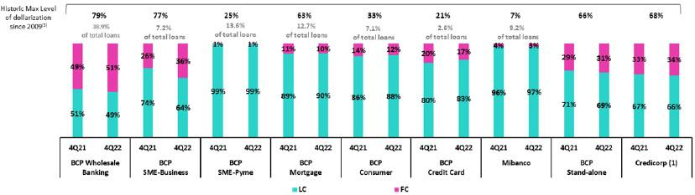

- The FC share of Credicorp’s loan portfolio is calculated including BCP Bolivia and ASB Bank Corp., however the chart shows only the loan books of BCP Stand-alone and Mibanco.
- The year with the historic maximum level of dollarization for Wholesale Banking was 2012, for Mibanco was 2016, for Credit Card was in 2021 and for the rest of segments was 2009. * For dollarization figures in quarter-end period, please refer to “12. Annexes – 12.2 Loan Portfolio Quality

Loan Evolution in Quarter-end Balances

Structural loans remained relatively stable, registering a reduction of -0.1% QoQ in quarter-end balances. If we isolate the impact o the exchange rate, structural loans grew 0.1% QoQ, driven by the same factors as those seen in the quarterly analysis of average daily balances. If we include the contraction of GP loans in the analysis, total loans increased 0.7% QoQ (-0.7% excluding the exchange rate effect).

QoQ, structural loans rose 7.9%. If we exclude the exchange rate effect, structural loans grew 27.3% due to the same factors discussed in the analysis of average daily balances. If we include the drop in GP loans in the calculation, total loans increased 0.7% YoY.

1.2. Portfolio Quality

Quality of the Structural Portfolio (in Quarter-end balances)

Structural Portfolio quality and Delinquency ratios (1) |  | As of |  |  | % change
S/ 000 | Dec 21 | Sep 22 | Dec 22 | QoQ | YoY
Structural loans (Quarter-end balance)⁽²⁾ | 128,956,585 | 139,190,832 | 139,115,242 | -0.1% | 7.9%
Structural Allowance for loan losses⁽²⁾ | 8,280,467 | 7,875,552 | 7,733,575 | -1.8% | -6.6%
Structural Write-offs | 683,181 | 837,924 | 754,326 | -10.0% | 10.4%
Structural IOLs | 4,471,348 | 5,037,163 | 4,791,245 | -4.9% | 7.2%
Structural Refinanced loans | 1,799,541 | 1,808,982 | 2,098,748 | 16.0% | 16.6%
Structural NPLs | 6,270,889 | 6,846,145 | 6,889,993 | 0.6% | 9.9%
Structural IOL ratio | 3.47% | 3.62% | 3.44% | -18 bps | -3 bps
Structural NPL ratio | 4.86% | 4.92% | 4.95% | 3 bps | 9 bps
Structural Allowance for loan losses over Structural loans | 6.4% | 5.7% | 5.6% | -10 bps | -86 bps
Structural Coverage ratio of NPLs | 132.0% | 115.0% | 112.2% | -280 bps | -1981 bps

(1) The Structural Portfolio excludes Government Programs (GP) effects.

The volume of the NPL loans increased QoQ and YoY by 0.6% and 9.9% respectively, reflecting growth in refinanced loans in Wholesale Banking and overdue loans in Pyme. The QoQ and YoY decrease in the NPL volume at Mibanco was insufficient to offset the aforementioned growth.

18

Earnings Release 4Q / 2022 Analysis of 4Q22 Consolidated Results

01. Loan Portfolio

Structural NPL Ratio
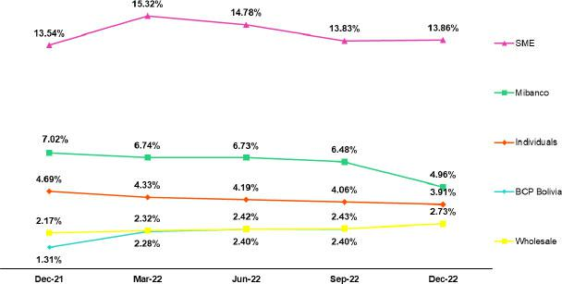

In the QoQ and YoY analysis, the segments that drove growth in the structural NPL portfolio were:

- Wholesale Banking, due to an increase in refinanced loans for a small number of clients in the real estate sector (builders and office rental companies) and the tourism sector, mainly in Corporate Banking.
- Small and Medium Businesses, where growth corresponds mainly to SME-Pyme, which registered an increase in overdue loans after new segments with higher risk profiles and commensurately higher margins (debt below S/90,000) reported an increase in delinquency. It is important to note that this deterioration is within the risk appetite for this new segment.

Growth in NPL loans was partially offset by a reduction in NPLs within Mibanco and Consumer after new entrants to the NPL portfolio were offset by charge-offs this quarter. For more information on charge-offs, see the Structural Charge-Offs section.

Structural write-offs

(in quarter-end balances – S/ thousands)

QoQ, structural loans fell -10%. This evolution was attributable to the fact that regulatory restrictions that impeded taking charge-offs on structural loans held by clients that also possess Reactiva loans were lifted. Consequently, the first wave of charge-offs was rolled out in the SME-Pyme sector in 3Q22 and continued through this quarter. Although charge-offs in 4Q22 were lower than those registered last quarter, the level is high and is expected to remain so over coming quarters.
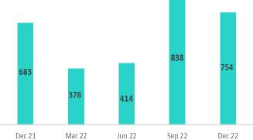

The reduction in charge-offs in SME-Pyme was partially offset by an uptick in charge-offs at Mibanco, which conducted its first wave of charge-offs of structural loans of clients that also possess Reactiva loans recently in 4Q22.

YoY, growth in NPLs (+10%) was driven by an increase in charge-offs in Small and Medium Businesses. This growth was primarily driven by an increase in charge-offs in SME-Pyme (after the aforementioned regulatory restrictions were lifted) and, to a lesser extent, by an uptick in charge-offs in Consumer and Credit Cards. The aforementioned was partially offset by the reduction of write-offs in Mibanco.

Coverage Ratio of Structural NPL Loans

19

Earnings Release 4Q / 2022 Analysis of 4Q22 Consolidated Results

01. Loan Portfolio

NPL loans in the Government Loan Portfolio (in quarter-end balances– S/ thousands)
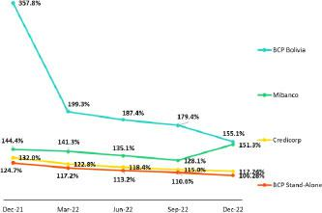
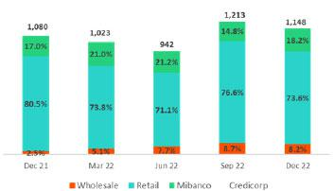

QoQ, the reduction in the Structural NPL coverage ratio was driven by growth in refinanced loans in Wholesale Banking and overdue loans in SME-Pyem.

YoY, the Structural NPL coverage ratio continues to follow a downward trend, which reflects growth in NPL loans and provisions releases at BCP Bolivia given that payment performance has exceeded expectations.

QoQ, the non-performing GP loan volume decreased due to an uptick in honoring processes for Reactiva loans. At the end of December 2022, Credicorp received a total of S/1,133 million against state guarantees.

Prior to initiating honoring processes, loans must be more than 90 days delinquent. Average guarantees stand at 84%, 91% and 97% for Wholesale Banking, Retail Banking and Mibanco respectively.

Quality of the Total Portfolio (in quarter-end balances)

Loan Portfolio Quality and Delinquency Ratios |  | As of |  | % change
S/ 000 | Dec 21 | Sep 22 | Dec 22 | QoQ | YoY
Total loans (Quarter-end balance) | 147,597,412 | 151,392,202 | 148,626,374 | -1.8% | 0.7%
Allowance for loan losses | 8,477,308 | 8,030,104 | 7,872,402 | -2.0% | -7.1%
Write-offs | 683,181 | 837,924 | 754,326 | -10.0% | 10.4%
Internal overdue loans (IOLs) ⁽¹⁾⁽²⁾ | 5,551,258 | 6,250,131 | 5,939,744 | -5.0% | 7.0%
Internal overdue loans over 90-days ⁽¹⁾ | 4,203,671 | 4,667,608 | 4,620,461 | -1.0% | 9.9%
Refinanced loans ⁽²⁾ | 1,799,541 | 1,808,982 | 2,098,748 | 16.0% | 16.6%
Non-performing loans (NPLs) ⁽³⁾ | 7,350,799 | 8,059,113 | 8,038,492 | -0.3% | 9.4%
IOL ratio | 3.76% | 4.13% | 4.00% | -13 bps | 24 bps
IOL over 90-days ratio | 2.85% | 3.08% | 3.11% | 3 bps | 26 bps
NPL ratio | 4.98% | 5.32% | 5.41% | 9 bps | 43 bps
Allowance for loan losses over Total loans | 5.74% | 5.30% | 5.30% | 0 bps | -44 bps
Coverage ratio of IOLs | 152.7% | 128.5% | 132.5% | 406 bps | -2017 bps
Coverage ratio of IOL 90-days | 201.7% | 172.0% | 170.4% | -166 bps | -3128 bps
Coverage ratio of NPLs | 115.3% | 99.6% | 97.9% | -171 bps | -1739 bps

- Includes Overdue Loans and Loans under legal collection (Quarter-end balances net of deferred earnings).
- Figures net of deferred earnings.
- Non-performing Loans include Internal overdue loans and Refinanced loans (Quarter-end balances net of deferred earnings).

In the aforementioned context, the NPL Ratio at Credicorp grew 9bps QoQ and 43bps YoY.

20

Earnings Release 4Q / 2022 Analysis of 4Q22 Consolidated Results

02 Deposits


At the end of 4Q22, low-cost deposits accounted for 70.2% of our deposit base. We currently lead the competitive market for low-cost deposits, registering a market share of 41.09% at year-end. In YoY terms, low-cost deposits fell 8.7% (constant exchange rate). This drop was mainly driven by a decline in Demand Deposits held by companies, which was attributable to both amortizations of Reactiva loans and a normalization in liquidity levels. Over the same period, Savings Deposits in LC migrated to FC due to uncertainty on the political and exchange rate fronts.

The ongoing uptick in Time Deposits was associated with fund migration from low-cost deposits to time deposits as clients sought to take advantage of the higher interest rates offered by the latter.

At the end of December 2022, the market share held by BCP Stand-alone and Mibanco was situated at 34.7% (-100bps with regard to Dec21). This decline was primarily due to a drop in BCP Stand-alone’s share of Demand Deposits, which are less attractive in a high interest rate environment.


 | Deposits |  | As of |  |  | change % |  | Currency
 | S/ 000 | Dec 21 | Sep 22 | Dec 22 | QoQ | YoY | LC | FC
 | Demand deposits | 58,629,661 | 53,512,524 | 48,467,247 | -9.4% | -17.3% | 44.9% | 55.1%
 | Saving deposits | 56,945,262 | 55,154,337 | 54,769,045 | -0.7% | -3.8% | 55.4% | 44.6%
 | Time deposits | 29,251,493 | 38,538,033 | 38,897,010 | 0.9% | 33.0% | 48.4% | 51.6%
 | Severance indemnity deposits | 4,017,065 | 3,745,597 | 3,824,629 | 2.1% | -4.8% | 69.8% | 30.2%
 | Interest payable | 753,064 | 1,007,509 | 1,062,856 | 5.5% | 41.1% | 50.2% | 49.8%
 | Total Deposits | 149,596,545 | 151,958,000 | 147,020,787 | -3.2% | -1.7% | 50.2% | 49.8%
(1) CTS: Compensación por tiempo de servicios.

Our deposit base fell 3.2% QoQ. If we apply a constant exchange rate, deposits fell 1.1%. The following FX neutral dynamics were noteworthy:

- The 7.2% reduction in Demand Deposits. This decline was driven by a drop in both LC and FC deposits system-wide, which reflected a reduction in liquidity after clients used up the remnants of funds from government stimulus payments.

The aforementioned was partially offset by:

- 1.2% growth in Savings Deposits in both LC and FC.

- Growth of 3.2% in Time Deposits. This increase was driven primarily by an uptick in LC deposits at BCP Stand-alone, which captured more deposits in a context of rising interest rates. In FC, these deposits fell due to a migration to LC.

Low-cost deposits (Demand + savings) represented 70.2% of total deposits, which reflects a drop of 90bps QoQ.

In the YoY analysis, deposits fell 1.7%. If we apply a constant exchange rate, deposits register no variation. The following dynamics are noteworthy:

- A 36.1% increase in Time Deposits, which was mainly associated with fund migration from low-cost deposits to time deposits in a context of higher interest rates in both LC and FC. ASB, which experienced an increase in fund inflows from Peru due to the political-economic juncture also contributed to this dynamic.

The aforementioned was partially offset by:

- A 15.3% drop in Demand Deposits in both currencies. This decline was driven primarily by companies, which moved to amortize Reactiva and sought to cover seasonal expenses and other liquidity requirements.
- The 1.9% reduction in Savings Deposits, which was attributable to a decrease in captures of savings in LC. This decline was partially offset by an uptick in FC balances, which was fueled by fund migration from LC deposits in an uncertain environment.

21

Earnings Release 4Q / 2022 Analysis of 4Q22 Consolidated Results

02. Deposits

Level of Dollarization of Deposits

Deposits by currency

(measured in quarter -end balances)
At the end of December 2022, the level of dollarization of Total Deposits fell 10bps QoQ (-93bps excluding the exchange rate effect). This decline was driven by a drop in Time Deposits, which were impacted by fund migration from FC to LC in the Wholesale Portfolio at BCP Stand-alone.
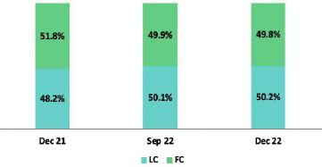

In YoY terms, the dollarization level fell 200bps, which reflected growth in LC deposits (+2.0%) and a drop in FC deposits (-2.0%, if we maintain a constant exchange rate). Growth in LC was driven primarily by Time Deposits, which offered higher interest rates, while the decline in FC was due to a drop in Demand Deposits after an increase was registered in outflows of funds in US Dollars.

Deposits by currency and type

(measured in quarter -end balances)
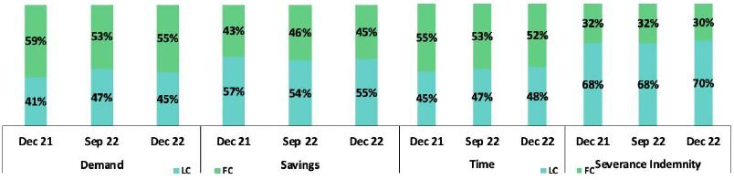

Loan / Deposit Ratio (L/D Ratio)
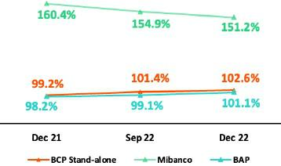

In QoQ terms, the L/D ratio increased 119 bps at BCP Stand-alone and declined 365 bps at Mibanco. The L/D ratio at BAP situated at 101.1%. The increase at BAP was driven by two factors: i) a decrease in total deposits, which was fueled primarily by a drop in Demand Deposits at BCP Stand-alone after funds migrated to products that offer higher rates, and ii) a decrease in the total loan balance, which was driven by BCP Stand-alone and, to a lesser extent, by Mibanco.

22

Earnings Release 4Q / 2022 Analysis of 4Q22 Consolidated Results

02. Deposits

L/D Ratio Local Currency L/D Ratio Foreign Currency
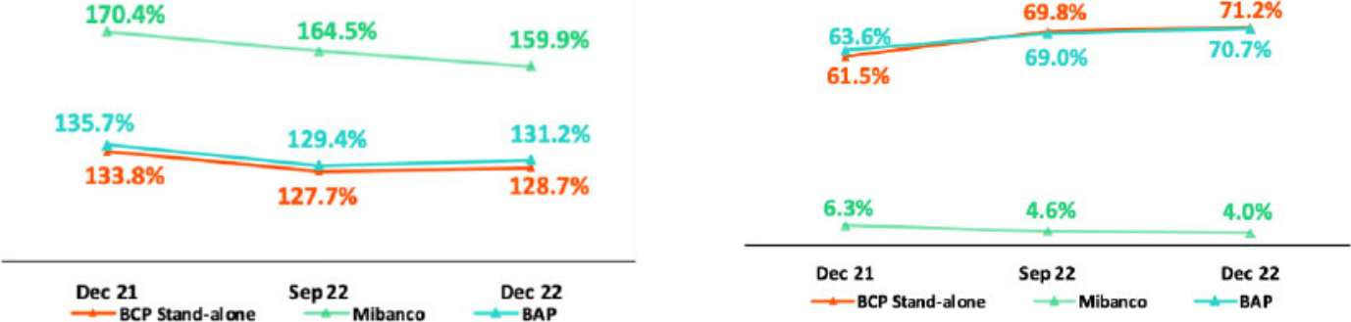

Share of the Market for Deposits in the Peruvian Financial System
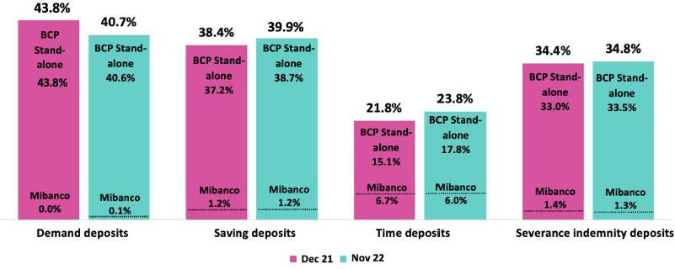

At the end of November 2022, Total Deposits at BCP Stand-alone and Mibanco registered a MS of 32.2% and 2.5% respectively (-120bps + 20bps respectively with regard to December 2021).

BCP Stand -alone reported a noteworthy increase in its share of Time Deposits (+270 bps), which reflected the migration of funds from low-cost deposits to Time Deposits in a context of rising rates. BCP Stand-alone posted a drop in its share of Demand Deposits after clients used funds to amortize loans under Reactiva (where BCP was a primary lender) and covered seasonal expenses or other liquidity requirements.

BCP Stand-alone continues to lead the local market for low-cost deposits and registered an MS of 41.1% at the end of November 2022 (-0.6% with regard to December 2021).

23

Earnings Release 4Q / 2022 Analysis of 4Q22 Consolidated Results

03 Interest-earning Assets (IEA) and Funding


At the end of 4Q22, IEA registered a drop of 3.1% QoQ due to a decrease in balances for Available Funds, Investments and Loans after clients drew down accounts to amortize GP loans. Structural loans grew 1.6% (FX neutral), driven by Retail Banking and Mibanco. YoY, IEA dropped 3.8%. This evolution was spurred by a decrease in the balances of Available Funds and Investments, and reflected the same drop in liquidity levels seen across the system. Over the same period, structural loans grew 9.7% (FX neutral), spurred, to a large extent, by an upturn in results in Retail Banking and Microfinance post-pandemic.

Funding fell 4.7% and 5.3% QoQ and YoY respectively, which reflects a drop in balances of BCRP instruments and deposits, reflecting fund drawdowns to amortize GP loans.

3.1. IEA

Interest Earning Assets |  | As of |  | % change
S/000 | Dec 21 | Sep 22 | Dec 22 | QoQ | YoY
Cash and due from banks | 32,395,408 | 29,330,082 | 26,897,216 | -8.3% | -17.0%
Total investments | 48,952,540 | 46,843,270 | 45,431,224 | -3.0% | -7.2%
Cash collateral, reverse repurchase agreements and securities borrowing | 1,766,948 | 1,586,967 | 1,101,856 | -30.6% | -37.6%
Financial assets designated at fair value through profit or loss | 987,082 | 767,425 | 768,801 | 0.2% | -22.1%
Loans | 147,597,412 | 151,392,202 | 148,626,374 | -1.8% | 0.7%
Total interest earning assets | 231,699,390 | 229,919,946 | 222,825,471 | -3.1% | -3.8%

QoQ, IEA dropped 3.1% due to a decrease in Available Funds, Loans and Investments. The declines in Available Funds reflect a downturn in liquidity (seen across the financial system) as clients chose to use resources to amortize GP loans. Investments fell this quarter due to a reduction in holdings of repurchase agreements of CDs, which were not renewed to maintain liquidity.

Total loans fell 1.8%, which was attributable to a decrease in the exchange rate and amortizations of GP loans. Structural loans grew 1.6% (FX neutral), driven primarily by the positive evolution of loans through Retail and Mibanco.

YoY, IEA fell 3.8% due to a drop in the balances of Available Funds and Investments. This decline was partially offset by Loan growth. As seen in the quarterly dynamic, the reductions in Available Funds and Investments were associated with a drop in liquidity (systemwide) after clients earmarked funds for GP loan amortization.

Total loans grew 0.7%. This low growth reflects the negative impacts generated by a variation in the exchange rate and a decrease in GP loan balances. Structural loans rose 9.7% (FX neutral), which reflects post-pandemic recovery across portfolios and in Retail Banking and Microfinance in particular. GP loans fell 49.1% YoY.

3.2. Funding

Funding |  | As of |  |  | % change
S/ 000 | Dec 21 | Sep 22 | Dec 22 | QoQ | YoY
Deposits and obligations | 149,596,545 | 151,958,000 | 147,020,787 | -3.2% | -1.7%
Due to banks and correspondents | 7,212,946 | 9,002,035 | 8,937,411 | -0.7% | 23.9%
BCRP instruments | 19,692,474 | 14,449,597 | 11,297,659 | -21.8% | -42.6%
Repurchase agreements | 1,296,277 | 1,182,946 | 976,020 | -17.5% | -24.7%
Bonds and notes issued | 17,823,146 | 17,853,708 | 17,007,194 | -4.7% | -4.6%
Total funding | 195,621,388 | 194,446,286 | 185,239,071 | -4.7% | -5.3%

QoQ and YoY, funding dropped 4.7% and 5.3% respectively due to a decline in balances of BCRP instruments and a reduction in deposits volumes, which reflected the impact of GP loan amortizations. It is important to note that QoQ, deposits fell 1.1% (FX neutral) after funds exited demand deposits. YoY, the deposit balance remained stable (FX neutral) in a context marked by migrations between deposit types as clients seek higher-yield alternatives.

24

Earnings Release 4Q / 2022 Analysis of 4Q22 Consolidated Results

04 Net Interest Income (NII)


In 4Q22, growth in Net Interest Income was fueled by our disciplined pricing management in an environment of increasing market rates. In this context, IEA Yields exceeded the Cost of Funding. Volume dynamics also contributed to growth in IEA Yields via a higher-yield IEA mix. The broad base of low-cost deposits (55.7% of funding) and a decrease in the funding volume attenuated the uptick in interest expenses generated by the rising Cost of Funds.

In this context, the Net Interest Margin grew 42 bps QoQ and 148 bps YoY to stand at 5.73%. while the Structural Net Interest Margin stood at 5.95%.

Net Interest Income / Margin |  | Quarter |  | % change |  | As of |  | % change
S/ 000 | 4Q21 | 3Q22 | 4Q22 | QoQ | YoY | Dec 21 | Dec 22 | Dec 22 / Dec 21
Interest Income | 3,091,754 | 3,988,681 | 4,362,142 | 9.4% | 41.1% | 11,850,406 | 15,011,282 | 26.7%
Interest Expense | 614,520 | 987,222 | 1,119,124 | 13.4% | 82.1% | 2,490,802 | 3,493,187 | 40.2%
Net Interest Income | 2,477,234 | 3,001,459 | 3,243,018 | 8.0% | 30.9% | 9,359,604 | 11,518,095 | 23.1%
Balances
Average Interest Earning Assets (IEA) | 233,022,571 | 226,137,887 | 226,372,709 | 0.1% | -2.9% | 228,163,486 | 227,262,431 | -0.4%
Average Funding | 197,645,370 | 191,147,468 | 189,842,678 | -0.7% | -3.9% | 193,546,219 | 190,430,229 | -1.6%
Yields
Yield on IEAs | 5.31% | 7.06% | 7.71% | 65pbs | 240pbs | 5.19% | 6.61% | 142pbs
Cost of Funds | 1.24% | 2.07% | 2.36% | 29pbs | 112pbs | 1.29% | 1.83% | 54pbs
Net Interest Margin (NIM) | 4.25% | 5.31% | 5.73% | 42pbs | 148pbs | 4.10% | 5.07% | 97pbs
Risk-Adjusted Net Interest Margin | 4.03% | 4.50% | 4.44% | -6pbs | 41pbs | 3.57% | 4.27% | 70pbs
Peru's Reference Rate | 2.50% | 6.75% | 7.50% | 75pbs | 500pbs | 2.50% | 7.50% | 500pbs
FED funds rate | 0.25% | 3.25% | 4.50% | 125pbs | 425pbs | 0.25% | 4.50% | 425pbs

Net Interest Income grew 8.0% QoQ, 30.9% YoY and 23.1% FY in 2022 due to an increase in market rates, which was driven primarily by rates for IEA and for structural loans and available funds in particular.

QoQ, structural loans in quarter-end balances remained stable given that loan growth in Retail Banking was offset by a decrease in the loan balances of Corporate clients, after moves to amortize debt. An uptick in the share of Mortgage, Consumer and Credit Card products in the IEA mix, coupled with higher interest rates, drove the yield on IEAs upward.

The funding volume dropped due to a decrease in liquidity across the system, in line with amortizations of GP loans. The Funding Cost rose in tandem with higher rates. In net terms, growth in the IEA Yield topped the increase registered for the funding cost, which led NIM to rise 42bps QoQ and stand at 5.73%.

YoY and FY at the end of 2022, growth in interest income offset an uptick in financial expenses. This evolution was mainly attributable to the fact that the impact of interest rate hikes in the AGI exceeded the negative pressure that said hikes exercised o n the funding cost, which was buffered by BCP’s s m x, wh w-cost deposits were preponderant (represented 55.7% of total deposits at the end of 2022). Growth in structural loans also contributed, albeit to a lesser extent, to the favorable evolution of interest income. In this context, NIM rose 148bps YoY and 97bps FY to stand at 5.73% in 4Q22 and 5.07% in 2022.

For more information on interest income and expenses, please see Annex 12.3.

Net Interest Margin

Structural NIM stood above pre-pandemic level, bolstered by the positive pricing effect generated by our active interest rate management within our business segments. Notwithstanding, a large volume of loan provisions was set aside; this affected risk-adjusted NIM, which stood at 4.44% in 4Q22.
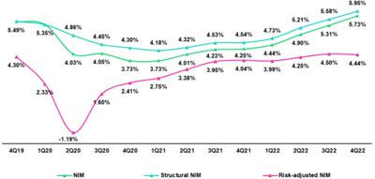

To analyze the evolution of Net Interest Income, it is important to differentiate dynamics by currency given that trends in volumes and variations in market rates are different for each. The reference rate in LC (BCRP) increased 75bps QoQ and 500bps YoY while the rate in FC (FED funds rate) rose 125bps QoQ and 425bps YoY.

25

Earnings Release 4Q / 2022 Analysis of 4Q22 Consolidated Results

04. Net Interest Income (NII)

Dynamics of Net Interest Income by Currency

Interest Income / IEA |  |  | 4Q21 |  |  | 3Q22 |  |  | 4Q22
S/ millions | Average |  |  |  | Average |  |  | Average
 | Balance | Income |  | Yields | Balance Income |  | Yields | Balance Income |  | Yields
Cash and equivalents | 34,271 |  | 23 | 0.3% | 26,581 | 139 | 2.1% | 28,114 | 236 | 3.4%
Other IEA | 3,145 |  | 12 | 1.5% | 2,583 | 10 | 1.5% | 2,113 | 48 | 9.1%
Investments | 48,531 |  | 402 | 3.3% | 46,093 | 551 | 4.8% | 46,137 | 563 | 4.9%
Loans | 147,074 |  | 2,654 | 7.2% | 150,881 | 3,289 | 8.7% | 150,009 | 3,515 | 9.4%
Structural | 127,228 |  | 2,582 | 8.1% | 137,457 | 3,235 | 9.4% | 139,153 | 3,459 | 9.9%
Government Programs | 19,846 |  | 72 | 1.5% | 13,425 | 54 | 1.6% | 10,856 | 56 | 2.1%
Total IEA | 233,023 |  | 3,092 | 5.3% | 226,138 | 3,989 | 7.1% | 226,373 | 4,362 | 7.7%
IEA (LC) | 56.2% |  | 76.5% | 7.2% | 57.0% | 75.0% | 9.3% | 56.4% | 73.1% | 10.0%
IEA (FC) | 43.8% |  | 23.5% | 2.8% | 43.0% | 25.0% | 4.1% | 43.6% | 26.9% | 4.8%
Interest Expense / Funding |  |  | 4Q21 |  |  | 3Q22 |  |  | 4Q22
S/ millions | Average |  |  |  | Average |  |  | Average
 | Balance | Expense |  | Yields | Balance Expense |  | Yields | Balance Expense |  | Yields
Deposits | 151,072 |  | 223 | 0.6% | 149,699 | 510 | 1.4% | 149,489 | 582 | 1.6%
BCRP + Due to Banks | 27,559 |  | 112 | 1.6% | 22,970 | 186 | 3.2% | 21,843 | 240 | 4.4%
Bonds and Notes | 17,700 |  | 185 | 4.2% | 17,217 | 189 | 4.4% | 17,430 | 189 | 4.3%
Others | 1,314 |  | 95 | 29.0% | 1,262 | 103 | 32.6% | 1,079 | 108 | 40.1%
Total Funding | 197,645 |  | 615 | 1.2% | 191,147 | 987 | 2.1% | 189,843 | 1,119 | 2.4%
Funding (LC) | 51.5% |  | 49.5% | 1.2% | 51.1% | 57.9% | 2.3% | 51.0% | 59.0% | 2.7%
Funding (FC) | 48.5% |  | 50.5% | 1.3% | 48.9% | 42.1% | 1.8% | 49.0% | 41.0% | 2.0%
NIM | 233,023 |  | 2,477 | 4.3% | 226,138 | 3,001 | 5.3% | 226,373 | 3,243 | 5.7%
NIM (LC) | 56.2% |  | 83.2% | 6.3% | 57.0% | 80.7% | 7.5% | 56.4% | 78.0% | 7.9%
NIM (FC) | 43.8% |  | 16.8% | 1.6% | 43.0% | 19.3% | 2.4% | 43.6% | 22.0% | 2.9%

QoQ analysis

Average |  | Dec 21 |  | Average | Dec 22
Balance | Income |  | Yields | Balance Income |  | Yields
30,486 |  | 50 | 0.2% | 29,646 | 459 | 1.5%
2,986 |  | 63 | 2.1% | 2,312 | 91 | 3.9%
52,063 |  | 1,567 | 3.0% | 47,192 | 2,043 | 4.3%
142,629 |  | 10,171 | 7.1% | 148,112 | 12,419 | 8.4%
120,973 |  | 9,847 | 8.1% | 134,021 | 12,184 | 9.1%
21,656 |  | 323 | 1.5% | 14,090 | 235 | 1.7%
228,163 |  | 11,850 | 5.2% | 227,262 | 15,011 | 6.6%
59.2% |  | 75.8% | 6.7% | 56.6% | 76.0% | 8.9%
40.8% |  | 24.2% | 3.1% | 43.4% | 24.0% | 3.7%
Average |  | Dec 21 |  | Average | Dec 22
BalanceExpense |  |  | Yields | BalanceExpense |  | Yields
145,981 |  | 865 | 0.6% | 148,309 | 1,688 | 1.1%
29,309 |  | 435 | 1.5% | 23,570 | 683 | 2.9%
17,071 |  | 837 | 4.9% | 17,415 | 728 | 4.2%
1,185 |  | 353 | 29.8% | 1,136 | 394 | 34.6%
193,546 |  | 2,491 | 1.3% | 190,430 | 3,493 | 1.8%
54.2% |  | 46.4% | 1.1% | 50.8% | 57.6% | 2.1%
45.8% |  | 53.6% | 1.5% | 49.2% | 42.4% | 1.6%
228,163 |  | 9,360 | 8.2% | 227,262 | 11,518 | 10.1%
59.2% |  | 83.7% | 5.8% | 56.6% | 81.6% | 7.3%
40.8% |  | 16.3% | 1.6% | 43.4% | 18.4% | 2.1%

QoQ, Net Interest Income rose 8.0%. This evolution was spurred primarily by an increase in rates on Available Funds and Loans in both LC and FC. IEA in LC represented 56.4% of total IEA and accounted for 78% of Net Interest Income generated in 4Q22. Nonetheless, it is important to note that growth in Net Interest Income in FC was higher than that registered by LC. This evolution was driven by the following dynamics:

Dynamics in Local Currency (LC)

Net Interest Income in LC rose 4.4% after growth in interest income outstripped the increase registered in expenses. This scenario was fueled by the following dynamics:

Average IEA in LC fell slightly and reported mixed variations across components. Average structural loans rose 2.0% while GP loans, liquid assets and investments fell. Movements in these accounts generated a higher-yield IEA mix in LC. Rates for IEA in LC increased, led by rates on available funds and loans. As a result, the IEA Yield in LC rose from 9.3% in 3Q22 to 10.0% in 4Q22. In this context, the price effect was the dominant dynamic and led interest income in LC to grow 6.5%.

Average funding in LC fell 0.9% due to a drop in the funding balance for Reactiva loans. This evolution was partially offset by growth in average deposits, which was driven by an uptick in retail funding in recent quarters. The funding cost in LC increased from 2.3% in 3Q22 to 2.7% in 4Q22, spurred primarily by higher market rates, which impacted the BCRP Instruments and due to banks and correspondents, and lastly, deposits. Interest expenses in LC rose 15.5% due mainly to a price effect.

Foreign Currency Dynamics (FC)

Net Interest Income in FC rose 23.3%. Average IEA in FC rose 1.5%, which reflects growth in average available funds due to an uptick in the average funding sources at BCP Stand-alone and Mibanco. The fact that the increase reported for available funds outpaced the growth registered by other assets led to a lower-yield mix of IEA in FC. Notwithstanding, the price effect generated by rising market rates offset the negative effect created by the mix and led the IEA yield in FC to increase from 4.1% to 4.8%. Growth in interest rates, coupled with an expansion in the IEA volume, led interest income in FC to rise 17.9%.

Average funding in FC fell 0.4% due to a decrease in deposits and in demand deposits in particular. This dynamic was partially offset by growth in bank funding, which generated a negative mix effect. The increase registered in the cost of funding was primarily driven by an uptick in FC rates and secondarily by the negative mix effect generated by an uptick in wholesale funding volumes. In this context, interest expenses in FC rose 10.4%.

26

Earnings Release 4Q / 2022 Analysis of 4Q22 Consolidated Results

04. Net Interest Income (NII)

YoY Analysis

YoY, Net Interest Income rose 30.9%. This evolution was fueled mainly by the trajectory of rates and volumes in LC and by rate dynamics in FC.

Local Currency Dynamics (LC)

Net Interest Income in LC rose 22.7% YoY. Average IEA in LC fell 2.6% YoY, in line with quarterly dynamics and the IEA Yield hit 10.0% in 4Q22. In this context, income in LC increased 34.8% due to a positive price effect across IEA and to growth in the structural loan volume.

Average funding in LC dropped 4.9% due to a decrease in the repos balance with BCRP, which reflected amortizations of Reactiva loans. This evolution was offset by an uptick in time deposits in an environment marked by rising rates and clients seeking higher yields. The rates of funding components in LC rose, in particular for interest-bearing deposits and bank financing, in line with an increase in the reference rate. The cost of funding in LC rose from 1.2% in 4Q21 to 2.7% in 4Q22. A price effect, coupled with a more expensive funding structure, led interest expenses in LC to double.

Dynamics in Foreign Currency (FC)

Net Interest Income in FC grew 71.6%. Average IEA in FC fell 3.2% after loan growth was offset by a drop in available funds and in the investment balance. This dynamic generated a mix effect that positively impacted the IEA yield in FC. The IEA yield in FC rose from 2.8% in 4Q21 to stand at 4.8% in 4Q22, driven by an increase in market rates and the mix effect described above. In this scenario, positive price and mix effects led interest income in FC to rise 61.5%.

Average funding in FC fell 2.9% due to a drop in lower-cost funding sources. This was partially offset by an increase in time deposits, which was driven by clients chasing higher yields. The funding cost in FC rose from 1.3% in 4Q21 to 2.0% in 4Q22 in a context marked by rising interest rates in FC. Interest expenses in FC rose 48.0%, spurred primarily by higher passive rates.

FY Analysis at the end of 2022

In the FY analysis, Net Interest Income rose 23.1%. The dynamics that drove this evolution were similar to those seen in the YoY evolution for LC but differed from those reported for FC.

Dynamics in local currency (LC)

The dynamics driving average IEA and the IEA yield in LC are the same as those explained in the QoQ and YoY analysis and led income in LC to increase 27.0%.

Average funding in LC fell 7.6% due to a decrease in repos with BCRP, which was driven by amortizations of GP loans. This evolution was offset by an increase in time deposits in an environment marked by rising rates and client shifts to higher-yield products. Rates on interest-bearing deposits and those applicable to banking financing in LC increased, in line with market dynamics. The cost of funding in LC rose from 1.1% in 2021 to 2.1% in 2022. The combination of a price effect and the impact of more expensive funding led interest expenses in LC to grow 73.8% in 2022.

Dynamics in foreign currency (FC)

Net Interest Income in FC increased 38.5%. Average IEA in FC rose 5.8%, fueled by an uptick in available funds and structural loans. The increase in available funds was driven by growth in FC deposits. The IEA yield in FC increased from 3.1% in 2021 to 3.7% in 2022. This evolution was driven by an increase m k s s s’ sh f h IEA m x A ff , s m x and an uptick in the IEA volume led interest income in FC to rise 25.7%.

Average funding in FC rose 5.5% due to growth in average due to banks and correspondents. The cost of funding in FC rose from 1.5% in 2021 to 1.6% in 2022. This evolution was driven mainly by growth in rates for bank financing, whose effect was attenuated by a less costly funding mix. Accordingly, interest expenses in FC grew 11.1%, prompted mainly by growth in passive rates and secondarily by an increase in the funding volume in FC.

27

Earnings Release 4Q / 2022 Analysis of 4Q22 Consolidated Results

05 Provisions

QoQ, the provisions expense rose. This evolution was driven primarily by updates to macroeconomic projections to reflect a deterioration in inflation, which impacted mainly Consumer and Credit Card. Additionally, payment behavior in the consumer sector was affected by growth in observed inflation. Mibanco reported growth in provisions due to a base effect, which was generated by methodological changes that reduced provisions in the last quarter and, and to maturities of a set number of vintages, which reflects the change in credit policy mid-year. The aforementioned led the default ratio in the risk model to rise.


YoY and FY, provisions rose over an atypically high base to the impact of actual inflation throughout the year in the consumer segment; growth in disbursements to higher risk segments on SME-Pyme loans; and the inclusion of maturities of specific vintages with in Mibanco’s risk modeI.

In the aforementioned context, the Structural Cost of Risk (CofR) stood at 2.06% at the end of 4Q22 and 1.26% FY.

Provisions ⁽¹⁾ and Cost of Risk (CoR) of the Structural Portfolio

Structural Loan Portfolio Provisions |  | Quarter |  | % change |  | Year |  | % change
S/ 000 | 4Q21 | 3Q22 | 4Q22 | QoQ | YoY | 2021 | 2022 | 2022 / 2021
Gross provision for credit losses on loan portfolio | (284,126) | (505,657) | (799,864) | 58.2% | 181.5% | (1,620,262) | (2,100,541) | 29.6%
Recoveries of written-off loans | 103,022 | 85,273 | 84,908 | -0.4% | -17.6% | 346,728 | 347,017 | 0.1%
Provision for credit losses on loan portfolio, net of recoveries | (181,104) | (420,384) | (714,956) | 70.1% | 294.8% | (1,273,534) | (1,753,524) | 37.7%
Structural Cost of risk ⁽¹⁾ | 0.56% | 1.21% | 2.06% | 85 bps | 150 bps | 0.99% | 1.26% | 27 bps

- Annualized Provision for credit losses on loan portfolio, net of recoveries.
- The Structural Cost of risk excludes the Provisions for credit losses on loan portfolio, net of recoveries and Total Loans from the Reactiva Peru and FAE Government Programs.

QoQ, Structural provisions rose. This increase, which was fueled mainly by BCP Stand-alone and Mibanco, led the structural CofR to rise 85 pbs. The segments that drove the increase in the CofR were:

- Individuals, due primarily to i) the impact of new macroeconomic projections, which captured the impact of higher inflation on the Consumer and Credit Card segments in particular, an uptick in reference rates, and lower-than-expected GDP; ii) the impact of rising actual inflation rates on payments in the Consumer segment.
- Mibanco, due to i) a base effect given that provisions in 3Q22 were unusually low due to methodological changes, which reduced provisions this quarter and ii) the incorporation of maturities of a set number of new vintages with higher default ratios in the loan risk model after available information was deemed sufficient to trigger inclusion.

- Wholesale, which was driven by growth over an atypically lower based given that clients that had previously been in default made debt payments in 3Q22.

The increase in total provisions was partially offset the decrease in provisions for SME-Pyme due to methodological changes were made to the provisions model. This reduction was partially offset by worse than expected payment performance in the segment for loans under 90,000 soles. The aforementioned offset was insufficient to prevent an increase in total provisions.

28

Earnings Release 4Q / 2022 Analysis of 4Q22 Consolidated Results

05. Provisions

YoY and FY, the Structural CofR Ratio registered an increase of 150bps and 27bps, respectively, in line with growth in provisions. Growth in the provisions expense was spurred by:

Structural Cost of Risk by Subsidiary
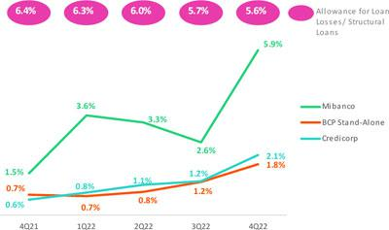

●

●

●

Individuals – Consumer, due to i) the negative impact of growth in

actual inflation on payment behavior and ii) a base effect given that
provisions in 2021 were atypically low.
SME-Pyme, due to an uptick in disbursements to segments
characterized by a higher risk profile on one hand and higher
margins on the other.

Mibanco, due to i) a base effect given that in 2021, provisions were
unusually low given that disbursements were more heavily
concentrated among clients with better risk profiles and collections
were up in a post-pandemic environment; and ii) the incorporation
of maturities of a set number of new vintages in the risk model in
2022, as explained in the QoQ dynamics.

Growth in the total provisions expense was partially offset by a drop in the provisions expense in the Wholesale segment, which reflects the fact that expenses in 4Q21 were impacted by a more significant downturn in client behavior than that registered in 4Q22.

Provisions and CoR in the Government Loan Portfolio (PG)

GP Loan Portfolio Provisions |  | Quarter |  | % change |  | Year |  | % change
S/ 000 | 4Q21 | 3Q22 | 4Q22 | QoQ | YoY | 2021 | 2022 | 2022 / 2021
Gross provision for credit losses on loan portfolio | 54,322 | (39,592) | (15,725) | -60.3% | -172.9% | 61,311 | (58,014) | -194.6%
Recoveries of written-off loans | - | - | - | - | - | - | - | -
Provision for credit losses on loan portfolio, net of recoveries | 54,322 | (39,592) | (15,725) | -60.3% | -128.9% | 61,311 | (58,014) | -194.6%
GP Cost of risk ⁽¹⁾ | -1.17% | 1.30% | 0.66% | -64 bps | 183 bps | -0.33% | 0.61% | 94 bps

(1) The GP Cost of risk includes the Provisions for credit losses on loan portfolio, net of recoveries and Total Loans from the Reactiva Peru and FAE Government Programs.

GP provisions fell significantly QoQ due to an upturn in honoring processes to execute State guarantees. YoY, the growth in provisions reflects a deterioration in payment behavior after grace periods for reprograming expired.

The provisions balance for GP represents 1.8% of the total provisions balance at Credicorp. The GP balance is quite small, which reflects the broad coverage offered by State guarantees, which cover between 80% and 98% of the disbursement amount. For more information, see 1.2 Portfolio Quality-NPL loans in the Government Program Portfolio.

Provisions and CoR of Total Portfolio

Loan Portfolio Provisions |  | Quarter |  | % change |  | Year |  | % change
S/ 000 | 4Q21 | 3Q22 | 4Q22 | QoQ | YoY | 2021 | 2022 | 2022 / 2021
Gross provision for credit losses on loan portfolio | (229,804) | (545,249) | (815,589) | 49.6% | 254.9% | (1,558,951) | (2,158,555) | 38.5%
Recoveries of written-off loans | 103,022 | 85,273 | 84,908 | -0.4% | -17.6% | 346,728 | 347,017 | 0.1%
Provision for credit losses on loan portfolio, net of recoveries | (126,782) | (459,976) | (730,681) | 58.9% | 476.3% | (1,212,223) | (1,811,538) | 49.4%
Cost of risk ⁽¹⁾ | 0.34% | 1.22% | 1.97% | 75 bps | 163 bps | 0.82% | 1.22% | 40 bps

(1) Annualized Provision for credit losses on loan portfolio, net of recoveries / Total Loans.

The CofR of the total portfolio, which is comprised of structural loans and government program loans (GP), reported growth of de 75pbs TaT, 163pbs y 40 AaA for the reasons described above.

29

Earnings Release 4Q / 2022 Analysis of 4Q22 Consolidated Results

05. Provisions

QoQ Evolution of the Cost of Risk YoY Evolution of the Cost of Risk
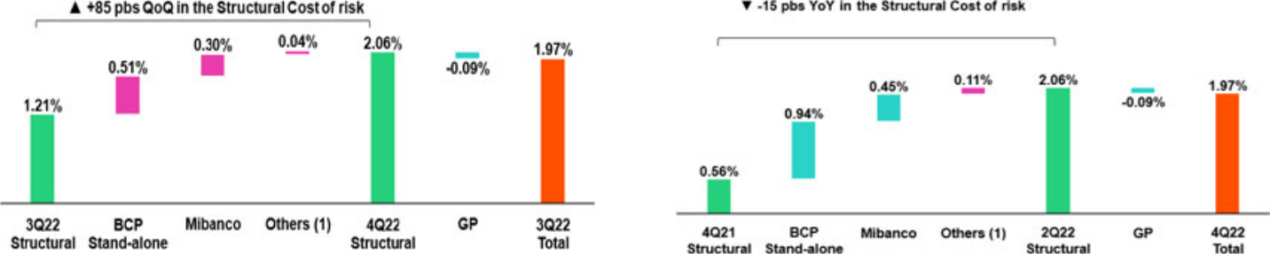

(1) Others include BCP Bolivia, Mibanco Colombia, ASB Bank Corp and eliminations. (1) Others include BCP Bolivia, Mibanco Colombia, ASB Bank Corp and eliminations.

Full Year Evolution of the Cost of Risk
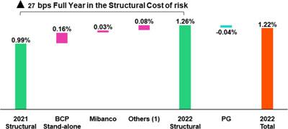

(1) Others include BCP Bolivia, Mibanco Colombia, ASB Bank Corp and eliminations.

30

Earnings Release 4Q / 2022 Analysis of 4Q22 Consolidated Results

06 Other Income


Other core income fell 0.7% QoQ, driven primarily by a drop in Fee Income due to the elimination of fees for inter-city transfers; this was partially offset by an increase in Net gain of FX transactions. During FY22, the upward trend in this income component continued and situated at +7.0%, spurred by an uptick in fee income and gains on FX transactions. Other non-core income rose QoQ and YoY (46.3% and 45.5% respectively) due to positive variations in investment values and improvements in yields on funds at Credicorp and ASB. During FY22 a decrease was registered in gains on speculative derivatives and securities.

6.1 Other core income

Core Other Income |  | Quarter |  | % Change |  | As of |  | % Change
(S/ 000) | 4Q21 | 3Q22 | 4Q22 | QoQ | YoY | Dec 21 | Dec 22 | Dec 22/ Dec 21
Fee income | 924,161 | 934,244 | 894,552 | -4.2% | -3.2% | 3,493,734 | 3,640,319 | 4.2%
Net gain on foreign exchange transactions | 263,017 | 262,167 | 293,215 | 11.8% | 11.5% | 922,917 | 1,084,151 | 17.5%
Total other income Core | 1,187,178 | 1,196,411 | 1,187,767 | -0.7% | 0.0% | 4,416,651 | 4,724,470 | 7.0%

QoQ, other core income fell in line with a drop in fee income. This evolution was attributable to:

- Universal Banking, whose variations will be explained in the Fee Income in the Banking Business section;

- Insurance and Pensions, mainly reflecting funds outflows and a reduction in the main driver to the decrease; and
- Investment Banking and Wealth Management, which reflects a reduction in fee income in the Asset Management business. This segment was impacted by a drop in the capture level of capital for mutual funds in Peru due to market conditions.

The drop in fee income was partially offset by an uptick in the Net gain on FX transactions after the Group successfully leveraged opportunities in a context marked by higher exchange rate volatility.

YoY, there was no variation registered, The drop in fee income in Investment Banking and Wealth Management driven by a decrease in the capital capture level in Peru’s mutual fund business was offset by an increase in the Net gain on FX transactions at BCP Stand-alone, which reflected exchange rate volatility in 4Q22, and in fee income.

During FY22, Other Core Income rose due to an increase in fee income and in the Net gain on FX transactions at BCP Stand-alone, which reflected an uptick in transactions and in exchange rate volatility respectively. The aforementioned growth was partially offset by a drop in fee income in Investment Banking and Wealth Management, which was associated with the fact that extraordinary fees were charged for trading and up-fronts for third-party funds through international platforms during a particularly tumultuous electoral cycle.

Fee income by banking business

Composition of fee income by banking business


 | Banking Business Fees |  | Quarter |  | % Change |  | As of |  | % Change
 | S/ 000 | 4Q21 | 3Q22 | 4Q22 | QaQ | YoY | Dec 21 | Dec 22 | Dec 22 / Dec 21
 | Payments and transactionals ⁽¹⁾ | 293,356 | 328,202 | 333,779 | 1.70% | 13.78% | 1,012,151 | 1,258,273 | 24.32%
 | Liability accounts ⁽²⁾ | 223,859 | 237,873 | 226,496 | -4.78% | 1.18% | 1,310,947 | 1,427,262 | 8.87%
 | Loan Disbursement ⁽³⁾ | 89,067 | 100,721 | 97,336 | -3.36% | 9.28% | 1,181,798 | 1,296,936 | 9.74%
 | Off-balance sheet | 62,521 | 60,283 | 63,247 | 4.92% | 1.16% | 571,232 | 623,777 | 9.20%
 | Mibanco (Peru and Colombia) | 37,818 | 32,258 | 34,164 | 5.91% | -9.66% | 352,556 | 378,092 | 7.24%
 | Insurances | 28,551 | 31,382 | 28,617 | -8.81% | 0.23% | 215,010 | 254,014 | 18.14%
 | BCP Bolivia | 26,852 | 26,296 | 24,479 | -6.91% | -8.84% | 233,787 | 222,771 | -4.71%
 | Wealth Management and Corporate Finance | 27,643 | 15,593 | 12,880 | -17.40% | -53.41% | 180,429 | 156,149 | -13.46%
 | ASB | 9,810 | 10,422 | 11,040 | 5.93% | 12.54% | 99,523 | 95,729 | -3.81%
 | Others ⁽⁴⁾ | 12,318 | -4,922 | -16,494 | n.a | -233.90% | 87,209 | 25,261 | -71.03%
 | Total | 811,795 | 838,108 | 815,544 | -2.69% | 0.46% | 5,244,642 | 5,738,263 | 9.41%
- Corresponds to fees from: credit and debit cards; payments and collections.
- Corresponds to fees from: Account maintenance, interbank transfers, national money orders y international transfers.
- Corresponds to fees from retail and wholesale loan disbursements.
- Use of third-party network, other services to third parties and Commissions in foreign branches.

31

Earnings Release 4Q / 2022 Analysis of 4Q22 Consolidated Results

06. Other Income

Fee income for banking services fell QoQ due to:

- A drop in Liabilities Accounts due to the elimination of fees for inter-city transfers in 4Q22 in certain channels; and

- Others, which was mainly driven by higher fees paid to third parties due to higher transactional volumes.

YoY and FY, fee income for banking services followed an upward trend due to growth in:

- Payment methods and Services, which was associated with an increase in transactions and ongoing migration to digital channels and POS, which, unlike cash, generate fee income. The consumption volume with debt cards rose 17% YoY and 29% FY, while credit card consumption was up 27% YoY and 36% FY.
- Fee income from Credit Disbursements, which was driven mainly by Personal Loans, where fees were up 27%.
- Passive and transactional accounts, which rose 9% FY after interbank transactions were made available the whole 2022.

6.2 Other non-core income

Non-core Other income |  | Quarter |  | % Change |  | As of |  |  | % Change
(S/ 000) | 4Q21 | 3Q22 | 4Q22 | QoQ | YoY | Dec 21 |  | Dec 22 | Dec 22/ Dec 21
Net gain on securities | 2,550 | (25,459) | 77,512 | n.a | 2939.7% | (45,371) |  | (98,993) | n.a.
Net gain from associates ⁽¹⁾ | 13,224 | 25,806 | 25,422 | -1.5% | 92.2% | 74,021 |  | 104,461 | 41.1%
Net gain on derivatives held for trading | 46,546 | 53,008 | 5,857 | -89.0% | -87.4% | 221,064 |  | 65,187 | -70.5%
Net gain from exchange differences | (22,083) | (4,071) | 22,039 | n.a | n.a | (3,215) |  | (16,158) | 402.6%
Other non-financial income | 76,748 | 64,491 | 32,064 | -50.3% | -58.2% | 266,567 |  | 329,382 | 23.6%
Total other income Non-Core | 116,985 | 113,775 | 162,894 | 43.2% | 39.2% | 513,066 |  | 383,879 | -25.2%

(1) Includes gains on other investments, which are mainly attributable to the Banmedica result.

YoY evolution of non-core income

(millions of soles)
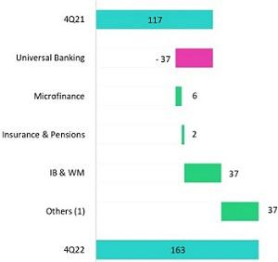

FY evolution of non-core income

(millions of soles)
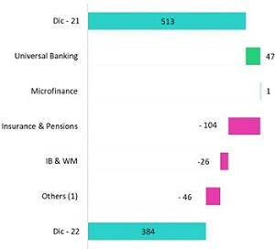

(1) Others includes Grupo Credito, Credicorp Individual, eliminations and others.

Other non-core income rose QoQ and YoY, driven primarily by:

- A increase in the Net gain on securities at Credicorp Stand-alone due to positive fluctuations in the fixed income portfolio.

- Investment Banking and Wealth Management, due to the positive results generated by trading strategies at Credicorp Capital Colombia and ASB.

FY, other non-core income fell due to:

- A drop in the Net gain on Speculative Derivatives due to:

  - Losses generated by the trading portfolio at BCP Stand-alone. These losses were offset by growth in interest income on fixed income investments in LC

  - Losses generated by the trading portfolio at Credicorp Capital Colombia, where lower gains on derivatives were offset by higher gains on securities.

- Net loss on securities, given that fixed income investments were impacted by rate hikes in 2022.

32

Earnings Release 4Q / 2022 Analysis of 4Q22 Consolidated Results

07 Insurance Underwriting Results


The insurance underwriting result fell 7.4% QoQ. This evolution was driven primarily by the Life Business, which reported a drop in premiums across businesses (primarily through Group Life and Credit Life), and secondarily by P & C, which registered an increase in claims through Commercial Lines, Cars and Personal Lines.

In the YoY and FY analysis, the insurance underwriting result rose due to a drop in claims in the Life Business and to growth in net earned premiums in both businesses due to higher sales and price adjustments, in line with economic reactivation. The aforementioned was partially attenuated by FY growth in claims in P & C.

Insurance underwriting result ⁽¹⁾ |  |  | Quarter |  | % change |  | As of |  |  | % change
S/ 000 |  | 4Q21 | 3Q22 | 4Q22 | QoQ | YoY | Dec 21 |  | Dec 22 | 2022 / 2021
 | Net earned premiums | 712,087 | 751,936 | 735,276 | -2.2% | 3.3% | 2,671,530 |  | 2,873,295 | 7.6%
 | Net claims | (509,278) | (478,039) | (481,087) | 0.6% | -5.5% | (2,341,917) |  | (1,929,890) | -17.6%
Total | Acquisition cost ⁽²⁾ | (75,152) | (75,055) | (70,021) | -6.7% | -6.8% | (333,334) |  | (281,807) | -15.5%
 | Total insurance underwriting result | 127,657 | 198,842 | 184,168 | -7.4% | 44.3% | (3,721) |  | 661,598 | n.a.
 | Loss Ratio | 71.5% | 63.6% | 65.4% | 180 pbs | -610 pbs | 87.7% |  | 67.2% | -2050 pbs
Life | Net earned premiums | 375,454 | 411,042 | 385,805 | -6.1% | 2.8% | 1,397,423 |  | 1,527,790 | 9.3%
Life | Net claims | (350,672) | (315,334) | (309,769) | -1.8% | -11.7% | (1,742,093) |  | (1,276,025) | -26.8%
 | Loss Ratio | 93.4% | 76.7% | 80.3% | 360 pbs | -1310 pbs | 124.7% |  | 83.5% | -4120 pbs
P&C | Net earned premiums | 318,949 | 324,127 | 329,815 | 1.8% | 3.4% | 1,205,197 |  | 1,276,351 | 5.9%
P&C | Net claims | (149,749) | (158,037) | (165,963) | 5.0% | 10.8% | (564,232) |  | (633,897) | 12.3%
 | Loss Ratio | 47.0% | 48.8% | 50.3% | 150 pbs | 330 pbs | 46.8% |  | 49.7% | 290 pbs

- Includes the results of the Life, Property & Casualty and Crediseguros business.
- Includes net fees and underwriting expenses.

In QoQ terms, the underwriting result fell 7.4%. This evolution was driven primarily by a 2.2% drop in net earned premiums and by an uptick in claims. Life drove the reduction in premiums via (i) Group Life, which reported extraordinary premiums for statutory bonuses in 3Q22 and (ii) Credit Life, due to the registration of retroactive premium returns in 4Q22. The levels of reported claims in P & C rose this quarter, mainly through the Commercial Lines, due to a higher frequency in Transportation and Vehicles products.

YoY, the insurance underwriting result improved significantly. The following factors fueled this dynamic:

- Growth in net earned premiums in Life (+2.8%) and P & C (+3.4%) respectively, which was spurred by economic recovery post-pandemic. D & S and SCTR (complementary insurance for high-risk occupations) were the main drivers of this evolution via an uptick in collections and price adjustments/broadening of the scope of activities respectively.
- A decrease in claims in the Life business (-11.7%), which reflected a drop in COVID-19 claims.
- A 6.8% drop in the acquisition cost, in line with a reduction in commissions (associated primarily with Credit Life, where an alliance expired).

33

Earnings Release 4Q / 2022 Analysis of 4Q22 Consolidated Results

07. Insurance Underwriting Results

Net Earned Premiums by Business
Net earned premiums in Life ⁽¹⁾ | Net Earned Premiums in P& C ⁽¹⁾
(S/ millions) | (S/ millions)
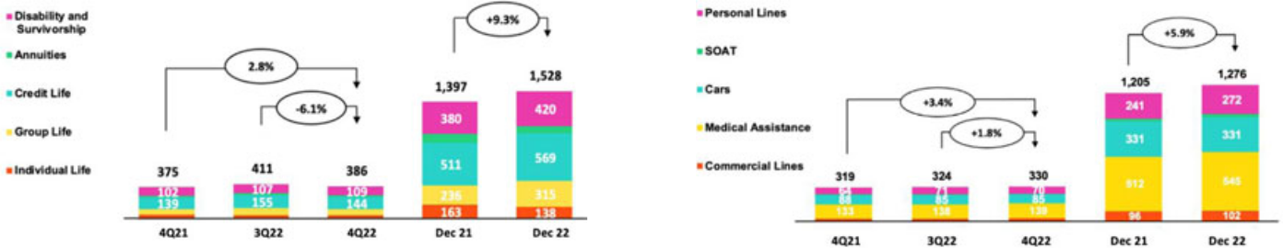

In the QoQ analysis, net earned premiums in the Life Business fell 6.1%. This drop was driven mainly by (i) Group Life, which reported extraordinary premiums due to seasonal bonuses pending registration and regularizations of SCTR (complementary insurance for high-risk occupations) in 3Q22, and (ii) Credit Life, which was primarily attributable to the registration of refunds of retroactive Mibanco premiums. This was partially mitigated by (i) D & S, due to higher contributors under the SISCO V regime.

In the P & C business, net earned premiums rose 1.8% QoQ. The increase in (i) Commercial Lines, which reflected growth in renewals in the Fire, Third Party Liability and Transportation lines. This was partially attenuated by (i) Personal lines, due to a drop in sales of Home Mortgage products, and (ii) Cars, via growth in reserves for current risk.

YoY and FY, net earned premiums in the Life business reported growth of 2.8% and 9.3% respectively. This evolution was driven mainly by (i) Group Life, in line with price adjustments and growth in sales of new SCTR (complementary insurance for high-risk occupations), (ii) D & S, which reported growth in its insured base and, (iii) Credit Life, due to growth in the Bancassurance Channel. The aforementioned transpired in a context marked by economic recovery and a decrease in the impact of inflation. Net earned premiums in P & C also rose, standing at 3.4% YoY and 5.9% FY, driven by: (i) Personal Lines, due to growth in sales in the bancassurance channel for Card Protection Products and, (ii) Medical Assistance, due to an increase in sales of Compensatory Oncological Products.

Net Claims by Business

The Net Loss Ratio stood at 65.4%, (+180 bps QoQ). This result was driven primarily by the increase in the Net Loss Ratio of the Life business (+360 bps QoQ). The aforementioned was mainly associated with a reduction in net earned premiums and with an increase in claims for the following products: (i) Individual Life, due to the creation of IBNR reserves and, (ii) Group Life, due to growth in judicial recovery cases and the effect of inflation in SCTR (complementary high-risk insurance), mitigated by lower regular claims and COVID-19 in D & S.
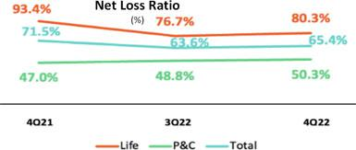

The Loss Ratio for P&C increased 150 bps QoQ and stood at 50.3%. This growth was driven by Commercial Lines and Cars, mitigated by Medical Assistance due to IBNR releases.

In the YoY and FY analysis, the Net Loss Ratio improved due to a drop in net claims of 5.5% and 17.6% respectively, where the Life business was the main driver. The reduction in claims was associated with a decrease in the impact of COVID-19 due to an improvement in the sanitary situation. In the P&C business, the Loss Ratio increased due to higher claims in Commercial Lines in Transportation and TREC lines in a context of economic recovery.

- Total premiums less premiums ceded to reinsurance and adjustments in constitution of technical reserves.

34

Earnings Release 4Q / 2022 Analysis of 4Q22 Consolidated Results

07. Insurance Underwriting Results

Acquisition Cost

Acquisition cost |  | Quarter |  | % change |  | Year |  | % change
S/000 | 4Q21 | 3Q22 | 4Q22 | QoQ | YoY | Dec 2021 | Dec 2022 | 2022 / 2021
Net fees | (56,359) | (43,738) | (38,840) | -11.2% | -31.1% | (217,389) | (161,805) | -25.6%
Underwriting expenses | (22,526) | (32,619) | (32,788) | 0.5% | 45.6% | (119,468) | (124,636) | 4.3%
Underwriting income | 3,734 | 1,302 | 1,607 | 23.4% | -57.0% | 3,524 | 4,634 | 31.5%
Acquisition cost | (75,152) | (75,055) | (70,021) | -6.7% | -6.8% | (333,334) | (281,807) | -15.5%

The acquisition cost fell 6.7% QoQ, which reflected a decrease in net commissions in both businesses and a reduction in underwriting expenses in P & C. At P & C, the drop in the acquisition cost was driven by a reduction in underwriting expenses for reserve releases in Cars and Soat. In the Life business, the acquisition cost fell due to a decrease in premiums in Credit Life, which was partially offset by an uptick in underwriting expenses in Individual Life.

In the YoY and FY analysis, the acquisition cost dropped 6.8% and 15.5% respectively. This evolution was driven mainly by a drop in commissions in the Life business (associated with Credit Life, where an alliance expired). The aforementioned was partially offset by an increase in underwriting expenses in both Life and P & C, which reflected growth in provisions for uncollectible premiums and reinsurance respectively.

35

Earnings Release 4Q / 2022 Analysis of 4Q22 Consolidated Results

08 Operating Expenses

Operating expenses rose, driven primarily by Administrative and General Expenses via Information Technology Expenses (IT) and Advertising and Fidelity Programs. Growth in these components reflects investment under our transformation strategy; an uptick in transactions; and efforts to bolster client fidelity. Salaries and employee benefits increased reflects an improvement in commercial results. If we exclude expenses for disruption, the FY variations for Operating Expenses stand at 8.16%.

Operating expenses |  | Quarter |  | % change |  | As of |  | % change
S/ 000 | 4Q21 | 3Q22 | 4Q22 | QoQ | YoY | 2021 | 2022 | 2022 / 2021
Salaries and employees benefits | 1,013,176 | 1,021,946 | 1,077,461 | 5.4% | 6.3% | 3,668,476 | 4,052,780 | 10.5%
Administrative, general and tax expenses | 898,677 | 868,805 | 1,063,611 | 22.4% | 18.4% | 2,953,717 | 3,505,101 | 18.7%
Depreciation and amortization | 181,660 | 173,500 | 176,645 | 1.8% | -2.8% | 683,254 | 683,504 | 0.0%
Association in participation | 13,965 | 9,999 | 12,936 | 29.4% | -7.4% | 47,176 | 40,955 | -13.2%
Acquisition cost ⁽¹⁾ | 75,152 | 75,055 | 70,021 | -6.7% | -6.8% | 333,334 | 281,807 | -15.5%
Operating expenses | 2,182,630 | 2,149,305 | 2,400,674 | 11.7% | 10.0% | 7,685,957 | 8,564,147 | 11.4%

(1) The acquisition cost of Pacifico includes net fees and underwriting expenses.

The analysis of expenses includes FY movements, which eliminates the effects of seasonality between quarters and YoY movements.

Operating expenses continue to rise due to:

- Growth in Administrative and General Expenses and Taxes, which was attributable to an increase in IT expenses to m m ’s s y, software improvements, and an uptick in expenses for transactions and fidelity programs.
- The increase in Salaries and employee benefits; 40% of this expansion was attributable to both an uptick in variable compensation, in line with better yearly results, and to moves to hire personnel who specialize in disruptive projects and IT.

Administrative and general expenses and taxes

Administrative and general expenses |  | Quarter |  | % Change |  | As of |  | % change
S/ 000 | 4Q21 | 3Q22 | 4Q22 | QoQ | YoY | 2021 | 2022 | 2022 / 2021
IT expenses and IT third-party services | 240,939 | 238,753 | 262,252 | 9.8% | 8.8% | 741,429 | 938,014 | 26.5%
Advertising and customer loyalty programs | 185,896 | 173,728 | 212,920 | 22.6% | 14.5% | 486,885 | 653,430 | 34.2%
Taxes and contributions | 62,644 | 51,963 | 100,950 | 94.3% | 61.1% | 289,484 | 305,486 | 5.5%
Audit Services, Consulting and professional fees | 96,684 | 74,804 | 140,293 | 87.5% | 45.1% | 312,978 | 338,269 | 8.1%
Transport and communications | 66,209 | 75,269 | 63,906 | -15.1% | -3.5% | 208,244 | 229,110 | 10.0%
Repair and maintenance | 33,109 | 21,955 | 45,220 | 106.0% | 36.6% | 123,232 | 137,946 | 11.9%
Agents' Fees | 27,960 | 25,574 | 27,673 | 8.2% | -1.0% | 104,700 | 106,356 | 1.6%
Services by third-party | 28,917 | 29,929 | 36,647 | 22.4% | 26.7% | 99,440 | 118,778 | 19.4%
Leases of low value and short-term | 23,805 | 22,142 | 25,997 | 17.4% | 9.2% | 86,417 | 91,680 | 6.1%
Miscellaneous supplies | 15,035 | 25,266 | 22,848 | -9.6% | 52.0% | 57,093 | 87,848 | 53.9%
Security and protection | 16,381 | 16,841 | 16,365 | -2.8% | -0.1% | 63,500 | 64,480 | 1.5%
Subscriptions and quotes | 14,883 | 14,013 | 14,833 | 5.9% | -0.3% | 55,331 | 58,251 | 5.3%
Electricity and water | 14,384 | 11,867 | 15,006 | 26.5% | 4.3% | 48,886 | 51,117 | 4.6%
Electronic processing | 7,574 | 7,770 | 12,225 | 57.3% | 61.4% | 39,528 | 35,896 | -9.2%
Insurance | 13,344 | 40,561 | 8,629 | -78.7% | -35.3% | 62,142 | 62,994 | 1.4%
Cleaning | 4,987 | 5,358 | 5,368 | 0.2% | 7.6% | 20,105 | 20,435 | 1.6%
Others ⁽¹⁾ | 45,926 | 33,012 | 52,479 | 59.0% | 14.3% | 154,323 | 205,011 | 32.8%
Total | 898,677 | 868,805 | 1,063,611 | 22.4% | 18.4% | 2,953,717 | 3,505,101 | 18.7%

(1) Others consists mainly of security and protection services, cleaning service, representation expenses, electricity and water utilities, insurance policy expenses, subscription expenses and commission expenses.

Administrative and general expenses and Taxes rose YoY and FY due to:

- Growth in IT and outsourcing of systems, which was attributable to an uptick in transactions, cybersecurity projects, upgrades of infrastructure, development of new applications, license renewals, and software improvements,

36

Earnings Release 4Q / 2022 Analysis of 4Q22 Consolidated Results

- Operating Expenses

  - Increase in expenses under the Client Fidelity Program, which was driven by a rebound in consumption of LATAM miles after credit and debit card use at establishments rose; The bank registered an uptick of 33% in card use at establishments this year. The increase registered in Advertising expenses was mainly driven by disruptive initiatives. If we exclude expenses related to Tenpo, one of our disruptive initiatives in Chile, the Advertising and fidelity program expense registers a 9.4% increase FY.

  - Growth in Other expenses, which corresponds to provisions set aside for disruptive projects related to Yape and our Corporate Venture Capital, Krealo.

37

Earnings Release 4Q / 2022 Analysis of 4Q22 Consolidated Results

09 Operating Efficiency

The efficiency ratio improved FY by 150bps. This reflects growth in core income, which was driven by an increase in net interest income in a context marked by rising rates and an uptick in the loan volume. If we exclude disruption expenses from our calculation, the efficiency ratio stands at 41.6%, which represents an improvement of 263 bps with regard to 2021.

Operating Efficiency |  | Quarter |  | % change |  | As of |  | % change
S/ 000 | 4Q21 | 3Q22 | 4Q22 | QoQ | YoY | 2021 | 2022 | 2022 / 2021
Operating expenses ⁽¹⁾ | 2,182,630 | 2,149,305 | 2,400,674 | 11.7% | 10.0% | 7,685,957 | 8,564,147 | 11.4%
Operating income ⁽²⁾ | 4,414,186 | 5,024,549 | 5,219,379 | 3.9% | 18.2% | 16,739,655 | 19,269,608 | 15.1%
Efficiency ratio ⁽³⁾ | 49.4% | 42.8% | 46.0% | 320 bps | -340 bps | 45.9% | 44.4% | -150 bps
- Operating expenses = Salaries and employees’ benefits + Administrative expenses + Depreciation and amortization + Association in participation + Acquisition cost.
- Operating income = Net interest, similar income and expenses + Fee income + Net gain on foreign exchange transactions + Net gain from associates + Net gain on derivatives held for trading + Net gain from exchange differences + Net premiums earned
- Operating expenses / Operating income.

Efficiency ratio reported by subsidiary

 | BCP | BCP | Mibanco | Mibanco | Pacifico | Prima AFP | Credicorp
 | Stand-alone | Bolivia | Peru | Colombia | Pacifico | Prima AFP | Credicorp
4Q21 | 47.4% | 70.0% | 55.6% | 67.1% | 35.2% | 61.2% | 49.4%
3Q22 | 38.8% | 61.3% | 49.6% | 80.6% | 33.8% | 50.2% | 42.8%
4Q22 | 41.9% | 64.5% | 52.3% | 93.3% | 36.7% | 46.1% | 46.0%
Var. QoQ | 310 bps | 320 bps | 270 bps | 1270 bps | 290 bps | -410 bps | 320 bps
Var. YoY | -550 bps | -550 bps | -330 bps | 2620 bps | 150 bps | -1510 bps | -340 bps
2021 | 43.4% | 60.3% | 55.4% | 76.2% | 35.4% | 50.7% | 45.9%
2022 | 40.7% | 60.9% | 51.3% | 81.8% | 35.3% | 51.0% | 44.4%
% change | -270 bps | 60 bps | -410 bps | 560 bps | -10 bps | 30 bps | -150 bps
2022 / 2021

To analyze expenses, we use FY movements to eliminate the impact of seasonality between quarters and YoY movements.

FY, the efficiency ratio improved, driven primarily by an uptick in core income at BCP Individual and Mibanco. Within core income, growth was highest for net interest income. This increase was fueled by an upturn in market rates and in the loan volume. Expansion in core income offset the increase registered for expenses.

If we exclude expenses related to internal disruptive initiatives (Yape) and our Corporate Venture Capital Center (Krealo) from calculation in 2022 and 2021, the efficiency ratio stands at 41.6%, which represents an improvement of 263 bps FY.

38

Earnings Release 4Q / 2022 Analysis of 4Q22 Consolidated Results

10 Regulatory Capital


Credicorp’s ReguIatory CapitaI Ratio stood 1.34 times above the IeveI required by the reguIator.

BCP Stand- aIone’s CET Ratio in creased 67 bps QoQ to stand at 12.6%. Growth in capital and reserves (+5.2%), coupled with an uptick FY results (+45.2%), offset growth in RWAs (+5.3%).

The CET1 Ratio at ratio at Mibanco increased 122 bps YoY to stand at 16.5%. An improvement in FY results offset growth in RWAs (+10.9%).

10.1 Credicorp’s Regulatory Capital

Credicrop’s regulatory capital ratio stood 1.34 times above the level required by the regulator at the end of 4Q22. In the QoQ analysis, the ratio fell 11 bps due to 6.9% growth in capital requirements, which was associated with an uptick in loans at BCP Stand-alone and Mibanco. The ratio’s evolution this quarter was driven by (i) a drop in the subordinated debt level (associated with the exchange rate effect) and,
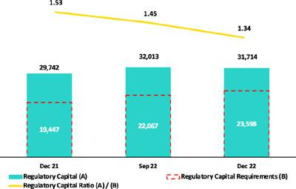
- a decrease in minority interests that are eligible for use as regulatory capital.

In the YoY analysis, the Regulatory Capital ratio fell 19 bps due to a 21.3% increase in capital requirements, which was associated with loan growth at BCP Stand-alone and Mibanco. This evolution was partially offset by (i) growth in discretionary and restricted reserves, which was attributable to partial capitalization of earnings in 2021 and, (ii) growth in the provisions eligible for use as regulatory capital, which reflected an uptick in loan growth.

Figures in millions S/.

10.2 BCP Stand-alones’ Regulatory Capital

At the end of 4Q22, the Tier 1 and Global Capital Ratios at BCP Stand-alone stood at 10.0% (+8bps QoQ) and 14.4% (-50bps QoQ), respectively. This slight increase in the Tier 1 ratio was driven primarily by a drop in the volume of risk-weighted assets (RWAs). The decrease in the Global Capital Ratio was mainly associated with a drop in legal reserves, which was spurred by a declaration of extraordinary dividends in 3Q22. In the YoY analysis these ratios followed the same trajectories as those seen QoQ, and registered variations of +8 bps and -51 bps respectively.
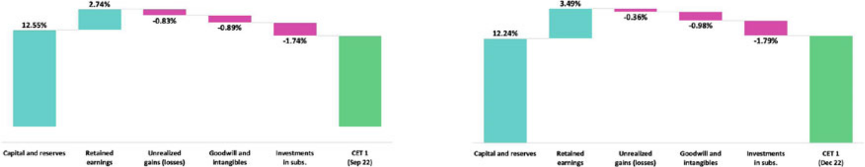
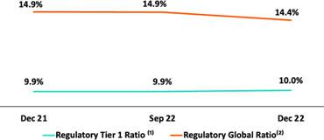

39

Earnings Release 4Q / 2022 Analysis of 4Q22 Consolidated Results

10. Regulatory Capital

Ratio Common Equity Tier 1 Ratio IFRS – BCP Stand-alone

Theo Common Equity Tier 1 Ratio (CET 1) at BCP, which is calculated according to IFRS accounting, reported growth of 76 bps QoQ and stood at 12.59% at the end of 4Q22. This evolution was attributable to an uptick in FY Results (+25.4%) and by a decrease in the RWA volume (-1.5%), which reflected a drop in loan volumes. Finally, in the YoY analysis, the CET 1 Ratio increased 67 bps (which outpaced the 5.35 increase registered for RWAs), driven by (i) growth in Retained Earnings (+45.2%), which was associated with earnings generations in 2022 and (ii) Capital and Reserves (+5.2%), which reflected partial capitalization of results in 2021.

10.3 Mibanco’s Regulatory Capital

At the end of 4Q22, the Tier 1 and Global Capital Ratios at Mibanco stood at 12.4% (+2bps QoQ) and 14.7% (+8bps QoQ) respectively. These variations respond to a 1.2% decrease in risk-weighted assets (RWAs), which was attributable to a drop in the loan volume.
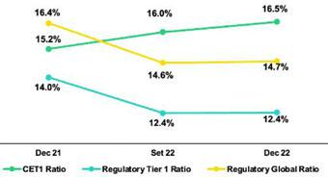

The YoY evolution shows that the Tier 1 and Global Capital Ratios fell 158 bps and 171 bps respectively. Both variations were attributable to growth of 12.8% in RWAs, which was in turn associated with loan growth.

Finally, the CET 1 ratio, calculated according to IFRS, reported growth of 46 bps QoQ and 122 bps YoY. The increase in the Common Equity Tier 1 Ratio (+19.8% YoY) completely offset growth in RWAs (+10.9% YoY), which was primarily attributable to an uptick in RWAs for credit risk.

40

Earnings Release 4Q / 2022 Analysis of 4Q22 Consolidated Results

11 Economic Outlook

Estimates indicate that the Peruvian economy grew around 1.6% YoY in 4Q22, driven primarily by the mining sector. This was partially offset by the slowdown in non-primary activities due to less dynamism in private consumption and lower levels of private investment.

The annual Inflation rate closed the year at 8.5% YoY, after having reached a peak of 8.8% in 2Q22. On the other hand, it is estimated that real GDP will grow 2.0% this year.

According to BCRP, the Exchange rate closed at USPEN 3.813 in 4Q22, which represents an appreciation of 4.3% from the 3.982 registered in 3Q22.

Peru: Economic Forecast

Peru | 2018 | 2019 | 2020 | 2021 | 2022 ⁽³⁾ | 2023 ⁽⁴⁾
GDP (US$ Millions) | 226,856 | 232,447 | 205,553 | 225,861 | 241,146 | 256,369
Real GDP (% change) | 4.0 | 2.2 | -11.0 | 13.6 | 2.6 | 2.0
GDP per capita (US$) | 7,045 | 7,152 | 6,300 | 6,837 | 7,221 | 7,587
Domestic demand (% change) | 4.1 | 2.2 | -9.9 | 14.7 | 2.4 | 1.3
Gross fixed investment (as % GDP) | 22.2 | 22.5 | 21.1 | 25.2 | 24.7 | 23.6
Financial system loan without Reactiva (% change) ⁽¹⁾ | 10.3 | 6.4 | -4.3 | 12.6 | 10.1 | 7.0
Inflation, end of period⁽²⁾ | 2.2 | 1.9 | 2.0 | 6.4 | 8.5 | 4.5
Reference Rate, end of period | 2.75 | 2.25 | 0.25 | 2.50 | 7.50 | 6.75
Exchange rate, end of period | 3.37 | 3.31 | 3.62 | 3.99 | 3.81 | 3.85
Exchange rate, (% change) | 4.0% | -1.8% | 9.3% | 10.3% | -4.5% | 1.0%
Fiscal balance (% GDP) | -2.3 | -1.6 | -8.9 | -2.5 | -1.6 | -1.5
Public Debt (as % GDP) | 25.6 | 26.6 | 34.6 | 35.9 | 34.0 | 33.7
Trade balance (US$ Millions) | 7,201 | 6,879 | 8,196 | 14,833 | 9,500 | 9,500
(As % GDP) | 3.2% | 3.0% | 4.0% | 6.6% | 3.9% | 3.7%
Exports | 49,066 | 47,980 | 42,905 | 63,151 | 65,730 | 63,460
Imports | 41,866 | 41,101 | 34,709 | 48,317 | 56,230 | 53,960
Current account balance (US$ Millions) | -3,915 | -2,397 | 2,398 | -5,273 | -12,169 | -10,200
Current account balance (As % GDP) | -1.3% | -0.7% | 1.2% | -2.3% | -5.0% | -4.0%
Net international reserves (US$ Millions) | 60,121 | 68,316 | 74,707 | 78,495 | 71,883 | 72,000
(As % GDP) | 26.5% | 29.4% | 36.3% | 34.8% | 29.8% | 28.1%
(As months of imports) | 17 | 20 | 26 | 19 | 15 | 16
Sources: INEI, BCRP, y SBS.
- Financial System, Current Exchange Rate
- Inflation target: 1% - 3%
- Estimates by BCP Economic Research as of January 2023
- BCP Economic Research estimates as of January 2023, subject to revision

41

Earnings Release 4Q / 2022 Analysis of 4Q22 Consolidated Results

11. Economic Outlook

Main Macroeconomic Variables

Gross Domestic Product

(Annual Variations, % YoY)
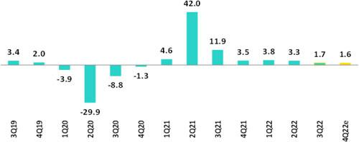

Sources: BCRP

In Q422, the Peruvian economy is expected to grow around 1.6% YoY (Q322 1.7% YoY). Estimates indicate that recovery in the primary sectors is primarily attributable to the launch of commercial operations at Quellaveco while growth in the primary sectors has continued to slow as private consumption and private investment weaken. According to INEI, the monthly economic activity index grew 1.7% YoY in November (2.0% YoY in October) and 2.7% YoY in the period January to November.

Annual Inflation and Central Bank Reference Rate

(%)
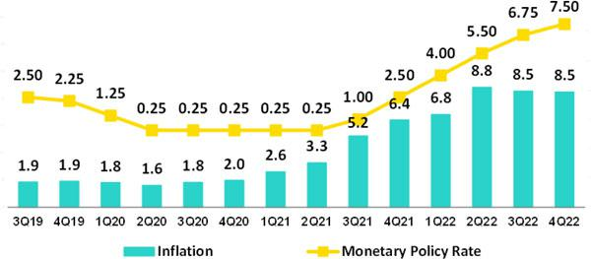

Sources: BCRP and INEI

Inflation, measured through the Consumer Price index for Metropolitan Lima, closed Q422 at 8.5%, the highest print in 26 years and above the upper boundary of the BCRP´s target range of 1%3% for the second year in a row. In the same period, core inflation (excludes food and energy) rose to 5.6%, which is close the highest print registered in the past 22 years.

The Central Bank of Perú (BCRP) increased its monetary policy rate from 0.25% in July 2021 to 7.50% in December 2022. In its meeting on January 12th, BCRP raised its rate again by 25 basis points to 7.75%, a new historical high. The entity began to slow the pace of interest rate hikes in September, cutting its increases from 50 basis points to 25 basis points. Its objective is to bring inflation expectations back into the target range. As of December 2022, inflation expectations among agents in the financial system and economic analysts for the end of 2023 stood at 4.30% (end of 2024 between 3.00% - 3.50%).

42

Earnings Release 4Q / 2022 Analysis of 4Q22 Consolidated Results

11. Economic Outlook

Fiscal Balance and Current Account Balance

(% of GDP, Quarter)
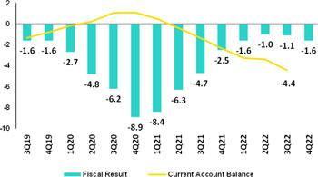

The annualized fiscal deficit to December was 1.6% of GDP, compared to 2.5% of GDP at the end of 2021. This reduction was primarily driven by an increase in tax revenues (12.7%). Over the same period, current expenditures fell 0.9% due to a decrease in expenses related to COVID-19 while expenses for gross capital formation for public investment rose 19.1%.

Source: BCRP*

Estimate: BCP

In December, Standard & Poor´s lowered the outlook for Peru´s long-term debt in foreign currency from stable to negative (and kept the credit rating at

- due to conflict between the executive and legislative branches, which threatens to weaken the government’s ability to implement timely policies. In October, Fitch followed by changing the outlook to negative and holding the rating at BBB. Moody’s, in turn, assigned a credit rating of Baa1 with stable outlook.

Regarding external accounts, the current account deficit closed Q322 at 4.4% of GDP in accumulated terms for the last 4 quarters.

The 12-month accumulated trade balance surplus to November 2022 was USD 9.7 billion, which falls below the USD 11.4 billion registered in October and far from the historical record of USD 16.1 billion reported in March 2022. Over the same period, exports grew 6.7% YoY to USD 65.9 billion and imports reached a historic high of USD 56.2 billion (18.3% YoY).

Terms of trade fell 17.6% YoY in November 2022 due to a 12.7% YoY drop in export prices. This drop was driven mainly by a decrease in prices for natural gas and copper and an increase of 5.9% YoY in imports prices. In November, the terms of trade stood around the levels posted in late 2019 and early 2020 and was 19% below the all-time high reached in June 2021.

Exchange Rate

(PEN per USD)

According to BCRP, the exchange rate closed 4Q22 in USDPEN 3.8125, which represents an appreciation of 4.3% compared to the figure at the end of Q322, and 4.1% compared to the print at the end of 2021. The political events of December 2022 (the attempted coup of Pedro Castillo, his subsequent impeachment and the swearing in of Dina Boluarte as the new president of Peru) had a limited effect on the exchange rate. In Q422, the main currencies of Latam appreciated compared to Q322 due to a global weakening of the dollar. The exception was the Colombian peso, which depreciated 5.3%. The Chilean peso, Mexican peso and Brazilian real appreciated 12.2%, 3.2% and 2.4% respectively.
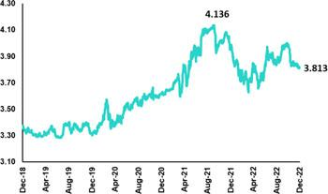

Net International Reserves closed Q422 at USD 71.9 billion, which falls below the falls below the figure reported in Q322 (USD 74.0 billion) and the print at end of 2021 (USD 78.5 billion). The Central Bank’s foreign exchange position stood at USD 52.0 billion, which reflects a marginal drop of USD 0.4 billion compared to the figure at the end of Q322.

43

Earnings Release 4Q / 2022 Analysis of 4Q22 Consolidated Results

11. Economic Outlook

In Q422, BCRP intervened only once in the FX spot market to sell USD 10 million. This sales level was lower than the net sales of USD 214 million registered in Q322. FY, the BCRP sold USD 1.2 billion in the spot market (equivalent to 10% of 2021 net sales); intervention was concentrated in the first semester of the year.

44

Earnings Release 4Q / 2022 Analysis of 4Q22 Consolidated Results

Safe Harbor for Forward-Looking Statements

This material includes “forward-looking statements” within the meaning of Section 27A of the U.S. Securities Act of 1933 and Section 21E of the U.S. Securities Exchange Act of 1934. All statements other than statements of historical fact are forward-looking and may contain information about financial results, economic conditions, trends and known uncertainties. Forward-looking statements are not assurances of future performance. Instead, they are based only on our management’s current views, expectations and assumption regarding the future of our business, future plans and strategies, projections, anticipated events and trends, the economy and other future conditions.

Many forward-looking statements can be identified by words such as: “anticipate”; “intend”, “plan”, “goal”, “seek”, “believe”, “project”, “estimate”, “expect”, “strategy”, “future”, “likely”, “would”, “may”, “should”, “will”, “see” and similar references to future periods. Examples of forward-looking statements include, among others, statements or estimates we make regarding guidance relating to losses in our credit portfolio, efficiency ratio, provisions and non-performing loans, current or future market risk and future market conditions, expected macroeconomic events and conditions, our belief that we have sufficient capital and liquidity to fund our business operations, expectations of the effect on our financial condition of claims, legal actions, environmental costs, contingent liabilities and governmental and regulatory investigations and proceedings, strategy for customer retention, growth, governmental programs and regulatory initiatives, credit administration, product development, market position, financial results and reserves and strategy for risk management.

We caution readers that forward-looking statements involve known and unknown risks and uncertainties that could cause actual results, performance or events to differ materially from those that we expect or that are expressed or implied in the forward-looking statements, depending on the outcome of certain factors, including, without limitation, adverse changes in:

- The occurrence of natural disasters or political or social instability in Peru;

- The adequacy of the dividends that our subsidiaries are able to pay to us, which may affect our ability to pay dividends to shareholders and corporate expenses;

- Performance of, and volatility in, financial markets, including Latin-American and other markets;
- The frequency, severity and types of insured loss events;
- Fluctuations in interest rate levels;
- Foreign currency exchange rates, including the Sol/US Dollar exchange rate;
- Deterioration in the quality of our loan portfolio;
- Increasing levels of competition in Peru and other markets in which we operate;
- Developments and changes in laws and regulations affecting the financial sector and adoption of new international guidelines;
- Changes in the policies of central banks and/or foreign governments;
- Effectiveness of our risk management policies and of our operational and security systems;
- Losses associated with counterparty exposures;
- The scope of the coronavirus (“COVID-19”) outbreak, actions taken to contain the COVID-19 and related economic effects from such actions and our ability to maintain adequate staffing; and

- Changes in Bermuda laws and regulations applicable to so-called non-resident entities.

See “Item 3. Key Information—3.D Risk Factors” and “Item 5. Operating and Financial Review and Prospects” in our most recent Annual Report on Form 20-F filed with the U.S. Securities and Exchange Commission for additional information and other such factors. You are cautioned not to place undue reliance on these forward-looking statements, which speak only as of the date hereof and are based only on information currently available to us. Therefore, you should not rely on any of these forward-looking statements. We undertake no obligation to publicly update or revise these or any other forward-looking statements that may be made to reflect events or circumstances after the date hereof, whether as a result of changes in our business strategy or new information, to reflect the occurrence of unanticipated events or otherwise.

45

Earnings Release 4Q / 2022 Analysis of 4Q22 Consolidated Results

12 | Appendix
12.1 Physical Channels |  | 47
12.2. | Loan Portfolio Quality | 47
12.3. | Net Interest Income (INI) | 52
12.4. | Regulatory Capital | 53
12.5. | Financial Statements and Ratios by Business | 56
12.5.1. Credicorp Consolidated |  | 56
12.5.2. Credicorp Stand-alone |  | 58
12.5.3. BCP Consolidated |  | 59
12.5.4. BCP Stand-alone |  | 61
12.5.5. BCP Bolivia |  | 63
12.5.6. Mibanco |  | 64
12.5.7. Prima AFP |  | 65
12.5.8. Grupo Pacifico |  | 66
12.5.9. Investment Banking & Wealth Management |  | 68
12.6. | Table of calculations | 69
12.7. | Glossary of terms | 70
 |  | 46

Earnings Release 4Q / 2022 Analysis of 4Q22 Consolidated Results

12. Appendix

12.1. | Physical Point of contact
 |  | Physical Point of Contact |  | As of |  | change (units)
 |  | (Units) | Sep-21 | Jun-22 | Sep-22 | QoQ | YoY
 |  | Branches | 721 | 691 | 681 | -10 | -40
 |  | ATMs | 2,554 | 2,540 | 2,598 | 58 | 44
 |  | Agentes | 7,896 | 9,863 | 10,525 | 662 | 2,629
 |  | Total | 11,171 | 13,094 | 13,804 | 710 | 2,633
12.2. | Loan Portfolio Quality

Loan Portfolio Quality (in Quarter-end Balances)
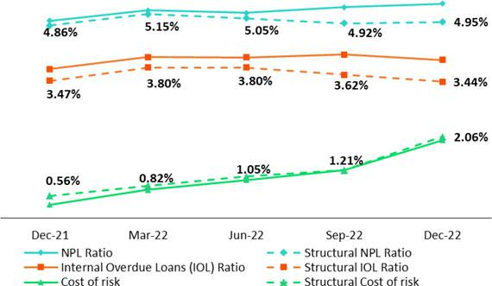

Government Program (GP) Loan Portfolio Quality (in Quarter-end Balances)

GP Portfolio quality and Delinquency ratios (1) |  | As of |  |  | % change
S/ 000 | Dec 21 | Sep 22 | Dec 22 | QoQ | YoY
GP Total loans (Quarter-end balance) | 18,640,827 | 12,201,370 | 9,511,132 | -22.0% | -49.0%
GP Allowance for loan losses | 196,841 | 154,552 | 138,827 | -10.2% | -29.5%
GP IOLs | 1,079,910 | 1,212,968 | 1,148,499 | -5.3% | 6.4%
GP IOL ratio | 5.79% | 9.94% | 12.08% | 214 bps | 629 bps
GP Allowance for loan losses over GP Total loans | 1.1% | 1.3% | 1.5% | 19 bps | 40 bps
GP Coverage ratio of IOLs | 18.2% | 12.7% | 12.1% | -65 bps | -614 bps

(1) Government Programs (GP) include Reactiva Peru and FAE-Mype.

47

Earnings Release 4Q / 2022 Analysis of 4Q22 Consolidated Results

12. Appendix

Portfolio Quality Ratios by Segment

Wholesale Banking
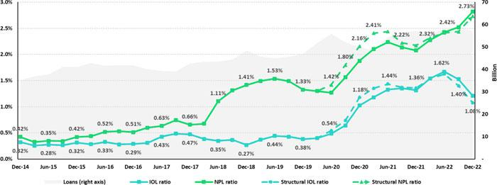

SME-Business
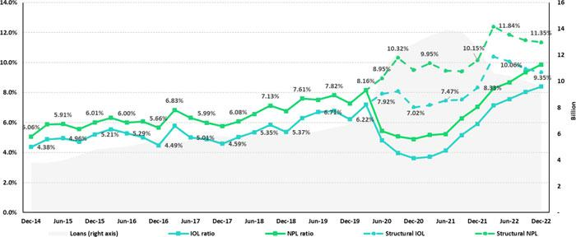

48

Earnings Release 4Q / 2022 Analysis of 4Q22 Consolidated Results

12. Appendix

SME-Pyme
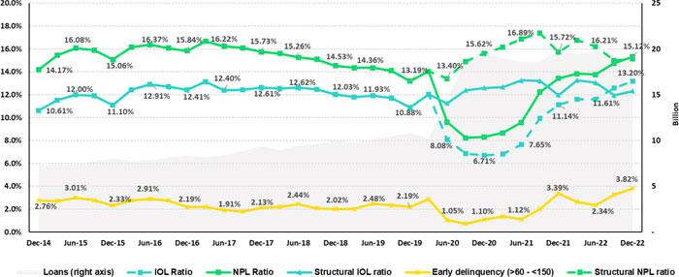

Mortgage
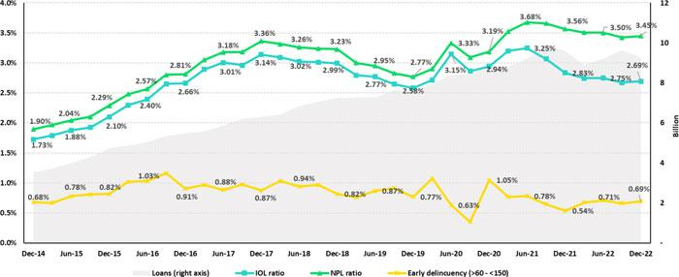

49

Earnings Release 4Q / 2022 Analysis of 4Q22 Consolidated Results

12. Appendix

Consumer
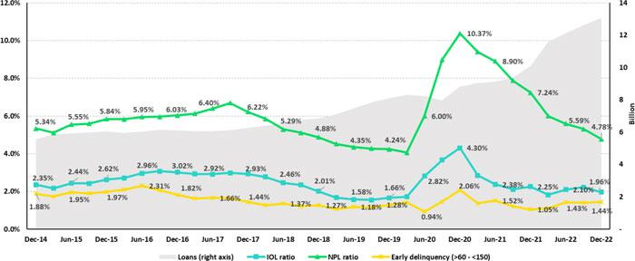

Credit Card
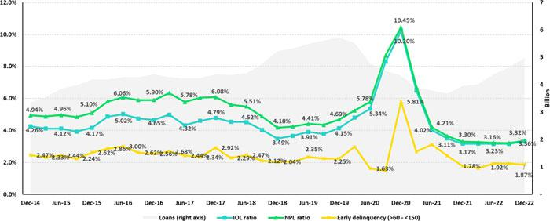

50

Earnings Release 4Q / 2022 Analysis of 4Q22 Consolidated Results

12. Appendix

Mibanco
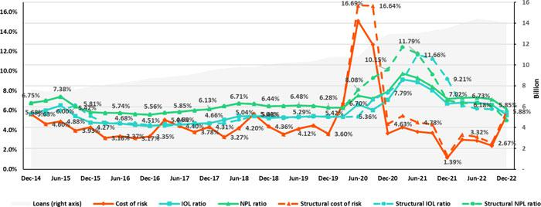

BCP Bolivia
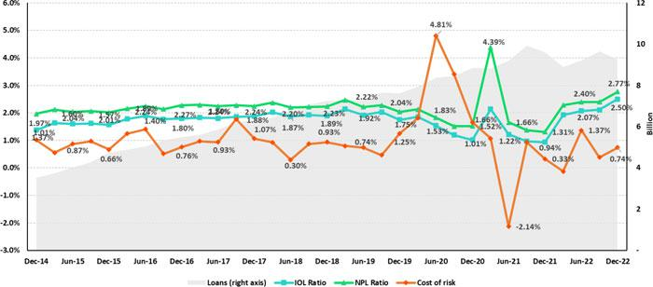

51

Earnings Release 4Q / 2022 Analysis of 4Q22 Consolidated Results

12. Appendix

12.3 Net Interest Income (NII)

NII Summary

 | Net interest income |  |  |  | Quarter |  |  |  | % change |  | As of |  | % change
 | S/ 000 |  |  | 4Q21 | 3Q22 | 4Q22 | QoQ |  |  | YoY | Dec 21 | Dec 22 | Dec 22 / Dec 21
 | Interest income |  |  | 3,091,754 | 3,988,681 | 4,362,142 | 9.4% |  |  | 41.1% | 11,850,406 | 15,011,282 | 26.7%
 | Interest on loans |  |  | 2,654,383 | 3,288,864 | 3,515,083 | 6.9% |  |  | 32.4% | 10,170,680 | 12,419,281 | 22.1%
 | Dividends on investments |  |  | 6,212 | 7,498 | 3,726 | -50.3% |  |  | -40.0% | 40,637 | 29,226 | -28.1%
 | Interest on deposits with banks |  |  | 23,480 | 139,077 | 236,319 | 69.9% |  |  | n.a. | 49,637 | 458,531 | n.a.
 | Interest on securities |  |  | 395,815 | 543,325 | 559,041 | 2.9% |  |  | 41.2% | 1,526,793 | 2,013,694 | 31.9%
 | Other interest income |  |  | 11,864 | 9,917 | 47,973 | 383.7% |  |  | 304.4% | 62,659 | 90,550 | 44.5%
 | Interest expense |  |  | 614,520 | 987,222 | 1,119,124 | 13.4% |  |  | 82.1% | 2,490,802 | 3,493,187 | 40.2%
 | Interest on deposits |  |  | 222,992 | 510,116 | 582,237 | 14.1% |  |  | 161.1% | 865,474 | 1,688,245 | 95.1%
 | Interest on borrowed funds |  |  | 111,625 | 185,858 | 239,583 | 28.9% |  |  | 114.6% | 435,426 | 683,078 | 56.9%
 | Interest on bonds and subordinated notes |  |  | 184,797 | 188,503 | 188,983 | 0.3% |  |  | 2.3% | 836,978 | 728,218 | -13.0%
 | Other interest expense |  |  | 95,106 | 102,745 | 108,321 | 5.4% |  |  | 13.9% | 352,924 | 393,646 | 11.5%
 | Net interest income |  |  | 2,477,234 | 3,001,459 | 3,243,018 | 8.0% |  |  | 30.9% | 9,359,604 | 11,518,095 | 23.1%
 | Risk-adjusted Net interest income |  |  | 2,350,452 | 2,541,483 | 2,512,337 | -1.1% |  |  | 6.9% | 8,147,381 | 9,706,815 | 24.1%
 | Average interest earning assets |  |  | 233,022,571 | 226,137,887 | 226,372,709 | 0.1% |  |  | -2.9% | 228,163,486 | 227,262,431 | -0.4%
 | Net interest margin ⁽¹⁾ |  |  | 4.25% | 5.31% | 5.73% | 42bps |  |  | 148bps | 4.10% | 5.07% | 97bps
 | Risk-adjusted Net interest margin ⁽¹⁾ |  |  | 4.03% | 4.50% | 4.44% | -6bps |  |  | 41bps | 3.57% | 4.27% | 70bps
 | Net provisions for loan losses / Net interest income |  |  | 5.12% | 15.33% | 22.53% | 7.2% |  |  | 17.4% | 12.95% | 15.73% | 2.78%
 | (1) Annualized.
 |  |  | Net Interest Margin (NIM) and Risk Adjusted NIM by subsidiary
 | NIM Breakdown | BCP Stand-alone | Mibanco |  | BCP | Credicorp
 | NIM Breakdown | BCP Stand-alone |  |  | Bolivia | Credicorp
 | 4Q21 | 3.68% | 12.83% |  | 2.71% | 4.25%
 | 3Q22 | 4.83% | 12.99% |  | 2.81% | 5.31%
 | 4Q22 | 5.41% | 12.73% |  | 2.71% | 5.73%


NIM: Annualized Net interest income / Average period end and period beginning interest earning assets.


Risk Adjusted NIM | BCP | Mibanco | BCP | Credicorp
Breakdown | Stand-alone | Mibanco | Bolivia | Credicorp
4Q21 | 3.48% | 11.81% | 2.45% | 4.03%
3Q22 | 4.00% | 10.99% | 2.50% | 4.50%
4Q22 | 4.24% | 8.14% | 2.13% | 4.44%

Risk-Adjusted NIM: (Annualized Net interest income - annualized provisions) / Average period end and period beginning interest earning assets.

52

Earnings Release 4Q / 2022 Analysis of 4Q22 Consolidated Results

12. Appendix

12.4. Regulatory Capital

Regulatory Capital and Capital Adequary Ratios

(S/ thousands, IFRS)

 |  | As of |  | % Change
 | Dec 21 | Sep 22 | Dec 22 | QoQ | YoY
Capital Stock | 1,318,993 | 1,318,993 | 1,318,993 | 0.0% | 0.0%
Treasury Stocks | (207,538) | (207,518) | (207,518) | 0.0% | 0.0%
Capital Surplus | 228,857 | 225,832 | 231,556 | 2.5% | 1.2%
Legal and Other capital reserves ⁽¹⁾ | 21,364,272 | 23,687,946 | 23,702,590 | 0.1% | 10.9%
Minority interest ⁽²⁾ | 420,062 | 488,486 | 430,709 | -11.8% | 2.5%
Loan loss reserves ⁽³⁾ | 2,001,065 | 2,139,971 | 2,128,732 | -0.5% | 6.4%
Perpetual subordinated debt | - | - | - | - | -
Subordinated Debt | 6,125,315 | 6,015,765 | 5,770,557 | -4.1% | -5.8%
Investments in equity and subordinated debt of financial and insurance | (712,518) | (868,747) | (889,246) | 2.4% | 24.8%
Goodwill | (796,859) | (788,179) | (772,213) | -2.0% | -3.1%
Current year Net Loss | - | - |  | - | -
Deduction for subordinated debt limit (50% of Tier I excluding deductions) ⁽⁴⁾ | - | - |  | - | -
Deduction for Tier I Limit (50% of Regulatory capital) ⁽⁴⁾ | - | - |  | - | -
Regulatory Capital (A) | 29,741,649 | 32,012,549 | 31,714,160 | -0.9% | 6.6%
Tier 1 ⁽⁵⁾ | 15,352,163 | 16,961,210 | 16,914,873 | -0.3% | 10.2%
Tier 2 ⁽⁶⁾ + Tier 3 ⁽⁷⁾ | 14,389,486 | 15,051,339 | 14,799,287 | -1.7% | 2.8%
Financial Consolidated Group (FCG) Regulatory Capital Requirements ⁽⁸⁾ | 18,530,113 | 20,973,716 | 22,506,113 | 7.3% | 21.5%
Insurance Consolidated Group (ICG) Capital Requirements ⁽⁹⁾ | 1,430,567 | 1,558,334 | 1,562,893 | 0.3% | 9.2%
FCG Capital Requirements related to operations with ICG | (513,262) | (465,143) | (471,371) | 1.3% | -8.2%
ICG Capital Requirements related to operations with FCG | - | - |  | - | -
Regulatory Capital Requirements (B) | 19,447,418 | 22,066,907 | 23,597,635 | 6.9% | 21.3%
Regulatory Capital Ratio (A) / (B) | 1.53 | 1.45 | 1.34
Required Regulatory Capital Ratio ⁽¹⁰⁾ | 1.00 | 1.00 | 1.00

- Legal and other capital reserves include restricted capital reserves (PEN 14,745 million) and optional capital reserves (PEN 6,661 million).
- Minority interest includes Tier I (PEN 421 million)
- Up to 1.25% of total risk-weighted assets of Banco de Credito del Peru, Solucion Empresa Administradora Hipotecaria, Mibanco and ASB Bank Corp.
- Tier II + Tier III can not be more than 50% of total regulatory capital.
- Tier I = capital + restricted capital reserves + Tier I minority interest - goodwill - (0.5 x investment in equity and subordinated debt of financial and insurance companies)+ perpetual subordinated debt.
- Tier II = subordinated debt + TierII minority interest tier + loan loss reserves - (0.5 x investment in equity and subordinated debt of financial and insurance companies).
- Tier III = Subordinated debt covering market risk only.
- Includes regulatory capital requirements of the financial consolidated group.
- Includes regulatory capital requirements of the insurance consolidated group.
- Regulatory Capital / Total Regulatory Capital Requirements (legal minimum = 1.00).

53

Earnings Release 4Q / 2022 Analysis of 4Q22 Consolidated Results

12. Appendix

Regulatory and Capital Adecuacy Ratios at BCP Stand-alone

(In S/ thousands)

Regulatory Capital and Capital Adequacy Ratios - SBS |  | As of |  | % change
S/ 000 | Dec 21 | Sep 22 | Dec 22 | QoQ | YoY
Capital Stock | 11,317,387 | 12,176,365 | 12,176,365 | 0.0% | 7.6%
Legal and Other capital reserves | 6,707,831 | 7,516,897 | 6,759,527 | -10.1% | 0.8%
Accumulated earnings with capitalization agreement | - | - | - | n.a. | n.a.
Loan loss reserves (1) | 1,735,372 | 1,845,016 | 1,838,178 | -0.4% | 5.9%
Perpetual subordinated debt | - | - | - | n.a. | n.a.
Subordinated Debt | 5,397,450 | 5,374,350 | 5,148,900 | -4.2% | -4.6%
Investment in subsidiaries and others, net of unrealized profit and net income | (2,263,805) | (2,436,525) | (2,436,525) | 0.0% | 7.6%
Investment in subsidiaries and others | (2,435,661) | (2,774,129) | (2,844,248) | 2.5% | 16.8%
Unrealized profit and net income in subsidiaries | 171,857 | 337,605 | 407,723 | 20.8% | 137.2%
Goodwill | (122,083) | (122,083) | (122,083) | 0.0% | 0.0%
Total Regulatory Capital - SBS | 22,772,151 | 24,354,019 | 23,364,361 | -4.1% | 2.6%
Off-balance sheet | 94,628,498 | 94,156,153 | 93,211,649 | -1.0% | -1.5%
Regulatory Tier 1 Capital ⁽²⁾ | 15,142,988 | 16,219,133 | 16,219,133 | 0.0% | 7.1%
Regulatory Tier 2 Capital ⁽³⁾ | 7,629,163 | 8,134,886 | 7,145,228 | -12.2% | -6.3%
Total risk-weighted assets - SBS ⁽⁴⁾ | 152,376,235 | 163,140,250 | 161,938,838 | -0.7% | 6.3%
Credit risk-weighted assets | 137,707,535 | 146,511,610 | 145,968,020 | -0.4% | 6.0%
Market risk-weighted assets ⁽⁵⁾ | 2,408,770 | 2,618,693 | 1,560,281 | -40.4% | -35.2%
Operational risk-weighted assets | 12,259,930 | 14,009,947 | 14,410,537 | 2.9% | 17.5%
Total capital requirement - SBS | 14,433,033 | 16,360,962 | 17,730,539 | 8.4% | 22.8%
Credit risk capital requirement | 11,016,603 | 12,453,487 | 12,407,282 | -0.4% | 12.6%
Market risk capital requirement | 240,877 | 261,869 | 156,028 | -40.4% | -35.2%
Operational risk capital requirement | 1,225,993 | 1,400,995 | 1,441,054 | 2.9% | 17.5%
Additional capital requirements | 1,949,560 | 2,244,611 | 3,726,175 | 66.0% | 91.1%
Common Equity Tier 1 - Basel IFRS ⁽⁶⁾ | 17,024,608 | 18,084,114 | 18,949,687 | 1.6% | 19.8%
Capital and reserves | 17,512,975 | 19,181,019 | 18,423,649 | 0.0% | 5.8%
Retained earnings | 3,615,646 | 4,187,468 | 5,249,495 | 41.1% | n.a.
Unrealized gains (losses) | (495,371) | (1,274,918) | (549,319) | -21.1% | 93.7%
Goodwill and intangibles | (1,302,414) | (1,355,924) | (1,472,073)
Investments in subsidiaries | (2,306,228) | (2,653,531) | (2,702,065) | 3.4% | 5.2%
Risk-Weighted Assets - Basel IFRS ⁽⁷⁾ | 142,915,780 | 152,849,186 | 150,535,662 | -1.5% | 5.3%
Total risk-weighted assets | 152,376,235 | 163,140,250 | 161,938,838 | -0.7% | 6.3%
(-) RWA Intangible assets, excluding goodwill. | 10,993,753 | 11,847,404 | 13,065,877 | 10.3% | 18.8%
(+) RWA Deferred tax assets generated as a result of temporary differences in income | 1,001,471 | 909,119 | 917,317 | 0.9% | -8.4%
tax, in excess of 10% of CET1
(+) RWA Deferred tax assets generated as a result of past losses |  |  |  | n.a. | n.a.
(+) IFRS Adjustments ⁽¹¹⁾ | 531,826 | 647,220 | 745,384 | 15.2% | 40.2%
Capital ratios
Regulatory Tier 1 ratio ⁽⁸⁾ | 9.94% | 9.94% | 10.02% | 8 bps | 8 bps
Common Equity Tier 1 ratio ⁽⁹⁾⁽¹²⁾ | 11.91% | 11.83% | 12.59% | 76 bps | 68 bps
Regulatory Global Capital ratio ⁽¹⁰⁾ | 14.94% | 14.93% | 14.43% | -50 bps | -51 bps
Risk-weighted assets / Regulatory capital | 6.69 | 6.70 | 6.93 | 3.5% | 3.6%
- Up to 1.25% of total risk-weighted assets.
- Regulatory Tier 1 Capital = Capital + Legal and other capital reserves + Accumulated earnings with capitalization agreement + (0.5 x Unrealized profit and net income in subsidiaries) - Goodwill - (0.5 x Investment in subsidiaries) + Perpetual subordinated debt (maximum amount that can be included is 17.65% of Capital + Reserves + Accumulated earnings with capitalization agreement + Unrealized profit and net income in subsidiaries - Goodwill).

- Regulatory Tier 2 Capital = Subordinated debt + Loan loss reserves + Unrestricted Reserves + (0.5 x Unrealized profit and net income in subsidiaries) - (0.5 x Investment in subsidiaries).
- Since July 2012, Total Risk-weighted assets = Credit risk-weighted assets * 1.00 + Capital requirement to cover market risk * 10 + Capital requirement to cover operational risk * 10 * 1.00 (since July 2014)
- It includes capital requirement to cover price and rate risk.
- Common Equity Tier I = Capital + Reserves 100% of applicable deductions (investment in subsidiaries, goodwill, intangibles and net deferred taxes that rely on future profitability) + retained earnings + unrealized gains. Figures differ from previously reported cause current calculations are based on IFRS figures.
- Adjusted Risk-Weighted Assets = Risk-weighted assets - (RWA Intangible assets, excluding goodwill, + RWA Deferred tax assets generated as a result of temporary differences in income tax, in excess of 10% of CET1, + RWA Deferred tax assets generated as a result of past losses). Figures differ from previously reported cause current calculations are based on IFRS figures.
- Regulatory Tier 1 Capital / Total Risk-weighted assets
- Common Equity Tier I / Adjusted Risk-Weighted Assets Risk-Weighted Assets
- Total Regulatory Capital / Total Risk-weighted assets (legal minimum = 10% since July 2011)
- Adjustments for differences in balance assets under Local Accounting (which regulatory Rwas are calculated) and IFRS in the Right of use account (lease). As of March 2022, the ‘Right of Use’ account increased to S/ 364M, explained the 64% of the adjustment. The rest adjustments correspond to differences in stock of provisions and Deferred Taxes.
- Common Equity Tier I calculated based on IFRS Accounting

54

Earnings Release 4Q / 2022 Analysis of 4Q22 Consolidated Results

12. Appendix

Regulatory Capital and Capital Adequacy Ratios at Mibanco

(S/ thousands)

 |  | As of |  | % change
 | Dec 21 | Set 22 | Dec 22 | QoQ | YoY
Capital Stock | 1,714,577 | 1,840,606 | 1,840,606 | 0.0% | 7.4%
Legal and Other capital reserves | 246,305 | 264,221 | 264,221 | 0.0% | 7.3%
Accumulated earnings with capitalization agreement | 143,318 | - | - | N/A | -100.0%
Loan loss reserves ⁽¹⁾ | 155,006 | 176,520 | 183,155 | 3.8% | 18.2%
Perpetual subordinated debt |  |  |  | N/A | n.a.
Subordinated Debt | 185,000 | 179,000 | 179,000 | 0.0% | -3.2%
Investment in subsidiaries and others, net of unrealized profit and net income | - | - | - | N/A | n.a.
Investment in subsidiaries and others |  |  |  | N/A | n.a.
Unrealized profit and net income in subsidiaries |  |  |  | N/A | n.a.
Goodwill | (139,180) | (139,180) | (139,180) | 0.0% | 0.0%
Accumulated Losses | - | - | - | N/A | n.a.
Total Regulatory Capital - SBS | 2,305,026 | 2,321,167 | 2,327,801 | 0.3% | 1.0%
Regulatory Tier 1 Capital ⁽²⁾ | 1,962,285 | 1,962,906 | 1,962,906 | 0.0% | 0.0%
Regulatory Tier 2 Capital ⁽³⁾ | 342,741 | 358,260 | 364,895 | 1.9% | 6.5%
Total risk-weighted assets - SBS ⁽⁴⁾ | 14,055,965 | 15,882,853 | 15,850,329 | -0.2% | 12.8%
Credit risk-weighted assets | 12,017,913 | 13,811,480 | 14,345,663 | 3.9% | 19.4%
Market risk-weighted assets ⁽⁵⁾ | 149,357 | 115,614 | 96,803 | -16.3% | -35.2%
Operational risk-weighted assets | 1,888,695 | 1,955,759 | 1,407,863 | -28.0% | -25.5%
Total capital requirement | 1,533,787 | 1,744,815 | 1,950,545 | 11.8% | 27.2%
Credit risk capital requirement | 1,201,791 | 1,381,148 | 1,434,566 | 3.9% | 19.4%
Market risk-weighted assets | 14,936 | 11,561 | 9,680 | -16.3% | -35.2%
Operational risk capital requirement | 188,869 | 195,576 | 140,786 | -28.0% | -25.5%
Additional capital requirements | 128,191 | 156,530 | 365,512 | 133.5% | 185.1%
Common Equity Tier 1 - Basel IFRS ⁽⁶⁾ | 2,030,025 | 2,392,634 | 2,431,337 | 1.6% | 19.8%
Capital and reserves | 2,489,011 | 2,632,956 | 2,632,956 | 0.0% | 5.8%
Retained earnings | (119,674) | 114,341 | 161,295 | 41.1% | n.a.
Unrealized gains (losses) | (6,548) | (16,074) | (12,686) | -21.1% | 93.7%
Goodwill and intangibles | (332,765) | (338,589) | (350,228) | 3.4% | 5.2%
Adjusted Risk-Weighted Assets- Basel IFRS ⁽⁷⁾ | 13,324,701 | 14,956,205 | 14,772,095 | -1.2% | 10.9%
Total risk-weighted assets | 14,055,965 | 15,882,853 | 15,850,329 | -0.2% | 12.8%
(-) RWA Intangible assets, excluding goodwill. | 1,175,376 | 1,276,505 | 1,408,551 | 10.3% | 19.8%
(+) RWA Deferred tax assets generated as a result of temporary differences in income | 224,040 | 163,152 | 159,880 | -2.0% | -28.6%
tax, in excess of 10% of CET1
(+) IFRS Adjustments | 188,455 | 173,700 | 158,796 | -8.6% | -15.7%
(+) RWA for Market Risk difference (exchange risk) for temporary difference | 31,618 | 13,007 | 11,641 | -10.5% | -63.2%
(-) RWA assets that exceed 10% of CET1 SBS |  | - | - | N/A | n.a.
(-) RWA difference between excees SBS and Basel methodology |  | - | - | N/A | n.a.
(-) RWA adjustment for state coverage, originated by temporary difference | - | - | - | N/A | -
(+) RWA Deferred tax assets generated as a result of past losses | - | - | - | N/A | -
Capital ratios
Regulatory Tier 1 ratio ⁽⁸⁾ | 13.96% | 12.36% | 12.38% | 2bps | -158bps
Common Equity Tier 1 ratio ⁽⁹⁾⁽¹¹⁾ | 15.24% | 16.00% | 16.46% | 46bps | 122bps
Regulatory Global Capital ratio ⁽¹⁰⁾ | 16.40% | 14.61% | 14.69% | 8bps | -171bps
Risk-weighted assets / Regulatory capital | 6.10 | 6.84 | 6.81 | -0.5% | 11.7%

- Up to 1.25% of total risk-weighted assets.
- Regulatory Tier 1 Capital = Capital + Legal and other capital reserves + Accumulated earnings with capitalization agreement + (0.5 x Unrealized profit and net income in subsidiaries) - Goodwill - (0.5 x Investment in subsidiaries) + Perpetual subordinated debt (maximum amount that can be included is 17.65% of Capital + Reserves + Accumulated earnings with capitalization agreement + Unrealized profit and net income in subsidiaries - Goodwill).

- Regulatory Tier 2 Capital = Subordinated debt + Loan loss reserves + Unrestricted Reserves + (0.5 x Unrealized profit and net income in subsidiaries) - (0.5 x Investment in subsidiaries).
- Since July 2012, Total Risk-weighted assets = Credit risk-weighted assets * 1.00 + Capital requirement to cover market risk * 10 + Capital requirement to cover operational risk * 10 * 1.00 (since July 2014)
- It includes capital requirement to cover price and rate risk.
- Common Equity Tier I = Capital + Reserves 100% of applicable deductions (investment in subsidiaries, goodwill, intangibles and net deferred taxes that rely on future profitability) + retained earnings + unrealized gains.
- Adjusted Risk-Weighted Assets = Risk-weighted assets - (RWA Intangible assets, excluding goodwill, + RWA Deferred tax assets generated as a result of temporary differences in income tax, in excess of 10% of CET1, + RWA Deferred tax assets generated as a result of past losses). Figures differ from previously reported cause current calculations are based on IFRS figures.
- Regulatory Tier 1 Capital / Total Risk-weighted assets
- Common Equity Tier I / Adjusted Risk-Weighted Assets Risk-Weighted Assets
- Total Regulatory Capital / Total Risk-weighted assets (legal minimum = 10% since July 2011)
- Common Equity Tier I calculated based on IFRS Accounting

55

Earnings Release 4Q / 2022 Analysis of 4Q22 Consolidated Results

12. Appendix

12.5. Financial Statements and Ratios by Business

12.5.1. Credicorp Consolidated

CREDICORP LTD. AND SUBSIDIARIES

CONSOLIDATED STATEMENT OF FINANCIAL POSITION

(In S/ thousands, IFRS)

 |  | As of |  | % change
 | Dec 21 | Sep 22 | Dec 22 | QoQ | YoY
ASSETS
Cash and due from banks
Non-interest bearing | 6,925,332 | 6,919,212 | 7,286,624 | 5.3% | 5.2%
Interest bearing | 32,395,408 | 29,330,082 | 26,897,216 | -8.3% | -17.0%
Total cash and due from banks | 39,320,740 | 36,249,294 | 34,183,840 | -5.7% | -13.1%
Cash collateral, reverse repurchase agreements and securities borrowing | 1,766,948 | 1,586,967 | 1,101,856 | -30.6% | -37.6%
Fair value through profit or loss investments | 5,928,538 | 4,550,783 | 4,199,334 | -7.7% | -29.2%
Fair value through other comprehensive income investments | 34,758,443 | 34,263,930 | 30,786,161 | -10.1% | -11.4%
Amortized cost investments | 8,265,559 | 8,028,557 | 10,445,729 | 30.1% | 26.4%
Loans | 147,597,412 | 151,392,202 | 148,626,374 | -1.8% | 0.7%
Current | 142,046,154 | 145,142,071 | 142,686,630 | -1.7% | 0.5%
Internal overdue loans | 5,551,258 | 6,250,131 | 5,939,744 | -5.0% | 7.0%
Less - allowance for loan losses | (8,477,308) | (8,030,104) | (7,872,402) | -2.0% | -7.1%
Loans, net | 139,120,104 | 143,362,098 | 140,753,972 | -1.8% | 1.2%
Financial assets designated at fair value through profit or loss | 987,082 | 767,425 | 768,801 | 0.2% | -22.1%
Accounts receivable from reinsurers and coinsurers | 1,198,379 | 1,063,972 | 1,106,674 | 4.0% | -7.7%
Premiums and other policyholder receivables | 921,103 | 803,886 | 913,124 | 13.6% | -0.9%
Property, plant and equipment, net | 1,895,196 | 1,786,136 | 1,824,931 | 2.2% | -3.7%
Due from customers on acceptances | 532,404 | 697,119 | 699,678 | 0.4% | 31.4%
Investments in associates | 658,697 | 660,849 | 726,993 | 10.0% | 10.4%
Intangible assets and goodwill, net | 2,710,080 | 2,767,341 | 2,899,429 | 4.8% | 7.0%
Other assets ⁽¹⁾ | 6,783,467 | 7,327,839 | 6,364,696 | -13.1% | -6.2%
Total Assets | 244,846,740 | 243,916,196 | 236,775,218 | -2.9% | -3.3%
LIABILITIES AND EQUITY
Deposits and obligations
Non-interest bearing | 51,851,206 | 46,625,814 | 43,346,151 | -7.0% | -16.4%
Interest bearing | 97,745,339 | 105,332,186 | 103,674,636 | -1.6% | 6.1%
Total deposits and obligations | 149,596,545 | 151,958,000 | 147,020,787 | -3.2% | -1.7%
Payables from repurchase agreements and securities lending | 22,013,866 | 16,575,580 | 12,966,725 | -21.8% | -41.1%
BCRP instruments | 19,692,474 | 14,449,597 | 11,297,659 | -21.8% | -42.6%
Repurchase agreements with third parties | 1,296,277 | 1,182,946 | 976,020 | -17.5% | -24.7%
Repurchase agreements with customers | 1,025,115 | 943,037 | 693,046 | -26.5% | -32.4%
Due to banks and correspondents | 7,212,946 | 9,002,035 | 8,937,411 | -0.7% | 23.9%
Bonds and notes issued | 17,823,146 | 17,853,708 | 17,007,194 | -4.7% | -4.6%
Banker’s acceptances outstanding | 532,404 | 697,119 | 699,678 | 0.4% | 31.4%
Reserves for property and casualty claims | 2,555,580 | 2,608,744 | 2,643,176 | 1.3% | 3.4%
Reserve for unearned premiums | 9,978,931 | 9,101,140 | 9,347,783 | 2.7% | -6.3%
Accounts payable to reinsurers | 463,825 | 328,031 | 420,094 | 28.1% | -9.4%
Financial liabilities at fair value through profit or loss | 337,909 | 333,453 | 191,010 | -42.7% | -43.5%
Other liabilities | 7,294,149 | 7,780,443 | 7,961,651 | 2.3% | 9.2%
Total Liabilities | 217,809,301 | 216,238,253 | 207,195,509 | -4.2% | -4.9%
Net equity | 26,496,767 | 27,109,054 | 28,988,140 | 6.9% | 9.4%
Capital stock | 1,318,993 | 1,318,993 | 1,318,993 | 0.0% | 0.0%
Treasury stock | (207,534) | (207,518) | (207,518) | 0.0% | 0.0%
Capital surplus | 228,853 | 225,832 | 231,556 | 2.5% | 1.2%
Reserves | 21,364,272 | 23,687,946 | 23,659,626 | -0.1% | 10.7%
Unrealized gains and losses | 235,902 | (1,482,023) | (650,116) | -56.1% | n.a.
Retained earnings | 3,556,281 | 3,565,824 | 4,635,599 | 30.0% | 30.3%
 | - | - | -
Non-controlling interest | 540,672 | 568,889 | 591,569 | 4.0% | 9.4%
Total Net Equity | 27,037,439 | 27,677,943 | 29,579,709 | 6.9% | 9.4%
 | - | - | -
Total liabilities and equity | 244,846,740 | 243,916,196 | 236,775,218 | -2.9% | -3.3%
 | - | - | -
Off-balance sheet | 151,136,879 | 151,545,926 | 150,977,864 | -0.4% | -0.1%
Total performance bonds, stand-by and L/Cs. | 22,914,343 | 21,399,132 | 20,928,054 | -2.2% | -8.7%
Undrawn credit lines, advised but not committed | 88,382,322 | 87,600,569 | 86,597,041 | -1.1% | -2.0%
Total derivatives (notional) and others | 39,840,214 | 42,546,225 | 43,452,769 | 2.1% | 9.1%

(1) Includes mainly accounts receivables from brokerage and others.

56

Earnings Release 4Q / 2022 Analysis of 4Q22 Consolidated Results

12. Appendix

CREDICORP LTD. AND SUBSIDIARIES

CONSOLIDATED STATEMENT OF INCOME

(In S/ thousands, IFRS)

 |  | Quarter |  | % change |  | As of |  | % change
 | 4Q21 | 3Q22 | 4Q22 | QoQ | YoY | 2021 | 2022 | Dec 21/ Dec 22
Interest income and expense
Interest and dividend income | 3,091,754 | 3,988,681 | 4,362,142 | 9.4% | 41.1% | 11,850,406 | 15,011,282 | 26.7%
Interest expense ⁽¹⁾ | (614,520) | (987,222) | (1,119,124) | 13.4% | 82.1% | (2,490,802) | (3,493,187) | 40.2%
Net interest income | 2,477,234 | 3,001,459 | 3,243,018 | 8.0% | 30.9% | 9,359,604 | 11,518,095 | 23.1%
Gross provision for credit losses on loan portfolio | (229,804) | (545,249) | (815,589) | 49.6% | 254.9% | (1,558,951) | (2,158,555) | 38.5%
Recoveries of written-off loans | 103,022 | 85,273 | 84,908 | -0.4% | -17.6% | 346,728 | 347,017 | 0.1%
Provision for credit losses on loan portfolio, net | (126,782) | (459,976) | (730,681) | 58.9% | 476.3%
of recoveries |  |  |  |  |  | (1,212,223) | (1,811,538) | 49.4%
of recoveries | - | - | - |  |  | (1,212,223) | (1,811,538) | 49.4%
Risk-adjusted net interest income | 2,350,452 | 2,541,483 | 2,512,337 | -1.1% | 6.9% | 8,147,381 | 9,706,557 | 19.1%
Non-financial income
Fee income | 924,161 | 934,244 | 894,552 | -4.2% | -3.2% | 3,493,734 | 3,640,319 | 4.2%
Net gain (loss) on foreign exchange transactions | 263,017 | 262,167 | 293,215 | 11.8% | 11.5% | 922,917 | 1,084,151 | 17.5%
Net gain (loss) on sales of securities | 2,550 | (25,459) | 77,512 | n.a. | n.a. | (45,371) | (98,993) | 118.2%
Net gain (loss) from associates | 13,224 | 25,806 | 25,422 | -1.5% | 92.2% | 74,021 | 104,461 | 41.1%
Net gain (loss) on derivatives held for trading | 46,546 | 53,008 | 5,857 | -89.0% | -87.4% | 221,064 | 65,187 | -70.5%
Net gain (loss) from exchange differences | (22,083) | (4,071) | 22,039 | n.a. | n.a. | (3,215) | (16,158) | 402.6%
Other non-financial income | 76,748 | 64,491 | 32,064 | -50.3% | -58.2% | 266,567 | 329,382 | 23.6%
Total non-financial income | 1,304,163 | 1,310,186 | 1,350,661 | 3.1% | 3.6% | 4,929,717 | 5,108,349 | 3.6%
Insurance underwriting result
Net earned premiums | 712,087 | 751,936 | 735,276 | -2.2% | 3.3% | 2,671,530 | 2,873,295 | 7.6%
Net claims | (509,278) | (478,039) | (481,087) | 0.6% | -5.5% | (2,341,917) | (1,929,890) | -17.6%
Acquisition cost ⁽¹⁾ | (75,152) | (75,055) | (70,021) | -6.7% | -6.8% | (333,334) | (281,807) | -15.5%
Total insurance underwriting result | 127,657 | 198,842 | 184,168 | -7.4% | 44.3% | (3,721) | 661,598 | n.a.
Total expenses
Salaries and employee benefits | (1,013,176) | (1,021,946) | (1,077,461) | 5.4% | 6.3% | (3,668,476) | (4,052,780) | 10.5%
Administrative, general and tax expenses | (898,677) | (868,805) | (1,063,611) | 22.4% | 18.4% | (2,953,717) | (3,505,101) | 18.7%
Depreciation and amortization | (181,660) | (173,500) | (176,645) | 1.8% | -2.8% | (683,254) | (683,504) | 0.0%
Association in participation | (13,965) | (9,999) | (12,936) | 29.4% | -7.4% | (47,176) | (40,955) | -13.2%
Other expenses | (115,687) | (66,903) | (143,956) | 115.2% | 24.4% | (387,938) | (338,275) | -12.8%
Total expenses | (2,223,165) | (2,141,153) | (2,474,609) | 15.6% | 11.3% | (7,740,561) | (8,620,615) | 11.4%
Profit before income tax | 1,559,107 | 1,909,358 | 1,572,557 | -17.6% | 0.9% | 5,332,816 | 6,855,889 | 28.6%
Income tax | (471,860) | (575,083) | (476,236) | -17.2% | 0.9% | (1,660,987) | (2,110,501) | 27.1%
Net profit | 1,087,247 | 1,334,275 | 1,096,321 | -17.8% | 0.8% | 3,671,829 | 4,745,388 | 29.2%
Non-controlling interest | 26,631 | 31,855 | 24,231 | -23.9% | -9.0% | 87,247 | 112,292 | 28.7%
Net profit attributable to Credicorp | 1,060,616 | 1,302,420 | 1,072,090 | -17.7% | 1.1% | 3,584,582 | 4,633,096 | 29.3%

(1) The acquisition cost of Pacífico iIncludes net fees and underwriting expenses.

57

Earnings Release 4Q / 2022 Analysis of 4Q22 Consolidated Results

12. Appendix

12.5.2. Credicorp Stand-alone

Credicorp Ltd.

Separate Statement of Financal Position

(S/ thousands, IFRS)

 |  |  | As of |  |  |  |  | % change
 |  | Dec 21 | Sep 22 |  | Dec 22 |  |  | QoQ | YoY
ASSETS
Cash and cash equivalents |  | 179,104 | 125,092 |  |  | 136,399 |  | 9.0% | -23.8%
At fair value through profit or loss |  | 1,050,218 | 967,331 |  |  | 958,939 |  | -0.9% | n.a
Fair value through other comprehensive income investments |  | 346,979 | 313,739 |  |  | 306,343 |  | -2.4% | -11.7%
In subsidiaries and associates investments |  | 31,168,827 | 32,308,088 |  | 33,878,318 |  |  | 4.9% | 8.7%
Other assets |  | 172 | 12,115 |  |  | 135 |  | n.a | n.a
Total Assets |  | 32,745,300 | 33,726,365 |  | 35,280,134 |  |  | 4.6% | 7.7%
LIABILITIES AND NET SHAREHOLDERS' EQUITY
Due to banks, correspondents and other entities |  | - | 256,528 |  |  | - |  | n.a. | n.a.
Bonds and notes issued |  | 1,980,311 | 1,993,778 |  | 1,898,066 |  |  | -4.8% | -4.2%
Other liabilities |  | 159,403 | 218,687 |  |  | 220,642 |  | 0.9% | 38.4%
Total Liabilities |  | 2,139,714 | 2,468,993 |  |  | 2,118,708 |  | -14.2% | -1.0%
NET EQUITY
Capital stock |  | 1,318,993 | 1,318,993 |  | 1,318,993 |  |  | 0.0% | 0.0%
Capital Surplus |  | 384,542 | 384,542 |  |  | 384,542 |  | 0.0% | 0.0%
Reserve |  | 20,945,491 | 23,300,350 |  | 23,300,350 |  |  | 0.0% | 11.2%
Unrealized results |  | 62,163 | (1,661,404) |  |  | (835,079) |  | -49.7% | n.a.
Retained earnings |  | 7,894,397 | 7,914,891 |  | 8,992,620 |  |  | 13.6% | 13.9%
Total net equity |  | 30,605,586 | 31,257,372 |  | 33,161,426 |  |  | 6.1% | 8.4%
Total Liabilities And Equity |  | 32,745,300 | 33,726,365 |  | 35,280,134 |  |  | 4.6% | 7.7%
 |  |  | Quarter |  |  | % change |  |  |  |  |  | Year |  | % Change
 |  | 4Q21 | 3Q22 | 4Q22 |  | QoQ |  | YoY |  |  | 2021 |  | 2022 | 2022/2021
Interest income
Net share of the income from investments in subsidiaries and associates |  | 1,092,707 | 1,379,036 | 1,115,614 |  | -19.1% |  | 2.1% |  |  | 3,751,366 |  | 5,156,494 | 37.5%
Interest and similar income |  | 308 | 307 |  | 1,040 | 238.8% |  | 237.7% |  |  | 24,317 |  | 8,701 | -64.2%
Net gain on financial assets at fair value through profit or loss |  | (2,258) | (10,214) |  | 32,597 | -419.1% |  | -1543.6% |  |  | 2,006 |  | (45,831) | n.a.
Total income |  | 1,090,757 | 1,369,129 | 1,149,251 |  | -16.1% |  | 5.4% |  |  | 3,777,689 |  | 5,119,364 | 35.5%
Interest and similar expense |  | (15,018) | (19,155) | (20,550) |  | 7.3% |  | 36.8% |  |  | (57,899) |  | (68,134) | 17.7%
Administrative and general expenses |  | (7,601) | (5,908) |  | (9,272) | 56.9% |  | 22.0% |  |  | (20,561) |  | (23,205) | 12.9%
Total expenses |  | (22,619) | (25,063) | (29,822) |  | 19.0% |  | 31.8% |  |  | (78,460) |  | (91,339) | 16.4%
Operating income |  | 1,068,138 | 1,344,066 | 1,119,429 |  | -16.7% |  | 4.8% |  |  | 3,699,229 |  | 5,028,025 | 35.9%
Net gain (losses) from exchange differences |  | (142) | 31 |  | 85 | 174.2% |  | -159.9% |  |  | (1,840) |  | (781) | -57.6%
Other, net |  | (8) | 231 |  | 106 | n.a |  | n.a |  |  | (29) |  | 556 | n.a.
Profit before income tax |  | 1,067,988 | 1,344,328 | 1,119,620 |  | -16.7% |  | 4.8% |  |  | 3,697,360 |  | 5,027,800 | 36.0%
Income tax |  | (19,228) | (42,000) | (42,000) |  | 0.0% |  | n.a |  |  | (78,082) |  | (168,290) | 115.5%
Net income |  | 1,048,760 | 1,302,328 | 1,077,620 |  | -17.3% |  | 2.8% |  | 3,619,278 |  |  | 4,859,510 | 34.3%
Double Leverage Ratio |  | 101.84% | 103.36% | 102.16% |  | -120bps |  | 32bps |  |  | 101.84% |  | 102.16% | 32bps

58

Earnings Release 4Q / 2022 Analysis of 4Q22 Consolidated Results

12. Appendix

12.5.3. BCP Consolidated

BANCO DE CREDITO DEL PERU AND SUBSIDIARIES

CONSOLIDATED STATEMENT OF FINANCIAL POSITION

(In S/ thousands, IFRS)

 |  | As of |  | % change
 | Dec 21 | Sep 22 | Dec 22 | QoQ | YoY
ASSETS
Cash and due from banks
Non-interest bearing | 4,895,726 | 5,458,040 | 5,780,728 | 5.9% | 18.1%
Interest bearing | 30,481,516 | 28,265,953 | 25,594,929 | -9.4% | -16.0%
Total cash and due from banks | 35,377,242 | 33,723,993 | 31,375,657 | -7.0% | -11.3%
Cash collateral, reverse repurchase agreements and securities borrowing | 344,460 | 308,959 | 244,017 | -21.0% | -29.2%
Fair value through profit or loss investments | 1,261,896 | 307,513 | 1,011 | -99.7% | -99.9%
Fair value through other comprehensive income investments | 19,339,377 | 18,277,389 | 15,260,159 | -16.5% | -21.1%
Amortized cost investments | 7,677,804 | 7,500,013 | 9,831,983 | 31.1% | 28.1%
Loans | 134,734,202 | 138,419,933 | 136,046,442 | -1.7% | 1.0%
Current | 129,311,792 | 132,426,874 | 130,396,010 | -1.5% | 0.8%
Internal overdue loans | 5,422,410 | 5,993,059 | 5,650,432 | -5.7% | 4.2%
Less - allowance for loan losses | (7,937,985) | (7,541,660) | (7,408,223) | -1.8% | -6.7%
Loans, net | 126,796,217 | 130,878,273 | 128,638,219 | -1.7% | 1.5%
Property, furniture and equipment, net ⁽¹⁾ | 1,628,645 | 1,500,806 | 1,536,875 | 2.4% | -5.6%
Due from customers on acceptances | 532,404 | 697,119 | 699,678 | 0.4% | 31.4%
Investments in associates | 27,928 | 29,953 | 28,578 | -4.6% | 2.3%
Other assets ⁽²⁾ | 6,321,863 | 6,645,503 | 5,662,055 | -14.8% | -10.4%
Total Assets | 199,307,836 | 199,869,521 | 193,278,232 | -3.3% | -3.0%
Liabilities and Equity
Deposits and obligations
Non-interest bearing ⁽¹⁾ | 44,598,038 | 42,200,017 | 39,399,007 | -6.6% | -11.7%
Interest bearing ⁽¹⁾ | 87,552,576 | 91,406,523 | 90,420,659 | -1.1% | 3.3%
Total deposits and obligations | 132,150,614 | 133,606,540 | 129,819,666 | -2.8% | -1.8%
Payables from repurchase agreements and securities lending | 20,250,739 | 15,001,393 | 11,843,594 | -21.1% | -41.5%
BCRP instruments | 19,692,474 | 14,449,597 | 11,297,659 | -21.8% | -42.6%
Repurchase agreements with third parties | 558,265 | 551,796 | 545,935 | -1.1% | -2.2%
Due to banks and correspondents | 6,684,191 | 8,563,079 | 8,539,195 | -0.3% | 27.8%
Bonds and notes issued | 14,482,984 | 14,518,870 | 13,840,114 | -4.7% | -4.4%
Banker’s acceptances outstanding | 532,404 | 697,119 | 699,678 | 0.4% | 31.4%
Financial liabilities at fair value through profit or loss | - | 140,146 | 7,669 | -94.5% | n.a
 | 4,444,071 | 5,102,548 | 5,256,079 | 3.0% | 18.3%
Total Liabilities | 178,545,003 | 177,629,695 | 170,005,995 | -4.3% | -4.8%
Net equity | 20,633,464 | 22,091,980 | 23,121,902 | 4.7% | 12.1%
Capital stock | 11,024,006 | 11,882,984 | 11,882,984 | 0.0% | 7.8%
Reserves | 6,488,969 | 7,298,035 | 6,540,665 | -10.4% | 0.8%
Unrealized gains and losses | (495,371) | (1,274,918) | (549,319) | -56.9% | 10.9%
Retained earnings | 3,615,860 | 4,185,879 | 5,247,572 | 25.4% | 45.1%
Non-controlling interest | 129,369 | 147,846 | 150,335 | 1.7% | 16.2%
Total Net Equity | 20,762,833 | 22,239,826 | 23,272,237 | 4.6% | 12.1%
Total liabilities and equity | 199,307,836 | 199,869,521 | 193,278,232 | -3.3% | -3.0%
Off-balance sheet | 136,495,830 | 139,052,767 | 137,999,722 | -0.8% | 1.1%
Total performance bonds, stand-by and L/Cs. | 21,203,561 | 20,443,858 | 19,737,892 | -3.5% | -6.9%
Undrawn credit lines, advised but not committed | 75,333,998 | 76,051,652 | 75,276,664 | -1.0% | -0.1%
Total derivatives (notional) and others | 39,958,271 | 42,557,257 | 42,985,166 | 1.0% | 7.6%

- Right of use asset of lease contracts is included by application of IFRS 16.
- Mainly includes intangible assets, other receivable accounts and tax credit.
- Mainly includes other payable accounts.

59

Earnings Release 4Q / 2022 Analysis of 4Q22 Consolidated Results

12. Appendix

BANCO DE CREDITO DEL PERU AND SUBSIDIARIES

CONSOLIDATED STATEMENT OF INCOME

(In S/ thousands, IFRS)

 |  | Quarter |  | % change |  | Year |  | % change
 | 4Q21 | 3Q22 | 4Q22 | QoQ | YoY | 2021 | 2022 | 2022 / 2021
Interest income and expense
Interest and dividend income | 2,626,005 | 3,462,081 | 3,821,770 | 10.4% | 45.5% | 10,022,744 | 12,985,696 | 29.6%
Interest expense | (459,334) | (799,839) | (913,761) | 14.2% | 98.9% | (1,896,683) | (2,798,234) | 47.5%
Net interest income | 2,166,671 | 2,662,242 | 2,908,009 | 9.2% | 34.2% | 8,126,061 | 10,187,462 | 25.4%
Provision for credit losses on loan portfolio | (224,506) | (522,071) | (783,402) | 50.1% | 248.9% | (1,539,152) | (2,045,832) | 32.9%
Recoveries of written-off loans | 95,748 | 78,403 | 79,076 | 0.9% | -17.4% | 323,538 | 321,151 | -0.7%
Provision for credit losses on loan portfolio, net of
recoveries | (128,758) | (443,668) | (704,326) | 58.8% | 447.0% | (1,215,614) | (1,724,681) | 41.9%
Risk-adjusted net interest income | 2,037,913 | 2,218,574 | 2,203,683 | -0.7% | 8.1% | 6,910,447 | 8,462,781 | 22.5%
Non-financial income
Fee income | 749,416 | 784,132 | 766,960 | -2.2% | 2.3% | 2,718,531 | 3,036,631 | 11.7%
Net gain on foreign exchange transactions | 239,930 | 246,518 | 271,267 | 10.0% | 13.1% | 888,261 | 1,003,855 | 13.0%
Net gain (loss) on securities | (7,511) | (5,587) | (9,162) | 64.0% | 22.0% | (125,890) | (19,258) | -84.7%
Net gain (loss) on derivatives held for trading | 27,477 | 17,037 | 17,756 | 4.2% | -35.4% | 72,103 | 4,778 | -93.4%
Net gain (loss) from exchange differences | (4,593) | 10,962 | 3,265 | -70.2% | n.a. | 60,439 | 6,219 | -89.7%
Others | 33,562 | 36,947 | 8,862 | -76.0% | -73.6% | 165,125 | 212,490 | 28.7%
Total other income | 1,038,281 | 1,090,009 | 1,058,948 | -2.8% | 2.0% | 3,778,569 | 4,244,715 | 12.3%
Total expenses
Salaries and employee benefits | (715,877) | (732,377) | (768,578) | 4.9% | 7.4% | (2,581,498) | (2,883,985) | 11.7%
Administrative expenses | (694,702) | (641,330) | (810,501) | 26.4% | 16.7% | (2,279,368) | (2,622,756) | 15.1%
Depreciation and amortization | (137,757) | (133,638) | (139,688) | 4.5% | 1.4% | (522,347) | (530,005) | 1.5%
Other expenses | (65,712) | (48,213) | (76,515) | 58.7% | 16.4% | (224,875) | (226,318) | 0.6%
Total expenses | (1,614,048) | (1,555,558) | (1,795,282) | 15.4% | 11.2% | (5,608,088) | (6,263,064) | 11.7%
Profit before income tax | 1,462,146 | 1,753,025 | 1,467,349 | -16.3% | 0.4% | 5,080,928 | 6,444,432 | 26.8%
Income tax | (416,361) | (455,802) | (403,338) | -11.5% | -3.1% | (1,418,736) | (1,760,657) | 24.1%
Net profit | 1,045,785 | 1,297,223 | 1,064,011 | -18.0% | 1.7% | 3,662,192 | 4,683,775 | 27.9%
Non-controlling interest | (5,979) | (7,385) | (2,318) | -68.6% | -61.2% | (13,139) | (21,286) | 62.0%
Net profit attributable to BCP Consolidated | 1,039,806 | 1,289,838 | 1,061,693 | -17.7% | 2.1% | 3,649,053 | 4,662,489 | 27.8%

BANCO DE CREDITO DEL PERU AND SUBSIDIARIES

SELECTED FINANCIAL INDICATORS

 |  | Quarter |  |  | As of
 | 4Q21 | 3Q22 | 4Q22 | Dec 21 | Dec 22
Profitability
Earnings per share ⁽¹⁾ | 0.085 | 0.106 | 0.087 | 0.300 | 0.383
_{ROAA} (2)(3) | 2.1% | 2.6% | 2.2% | 1.8% | 2.4%
_{ROAE} (2)(3) | 20.7% | 24.0% | 18.8% | 18.8% | 21.3%
Net interest margin ⁽²⁾⁽³⁾ | 4.45% | 5.61% | 6.12% | 4.22% | 5.35%
Risk adjusted NIM ⁽²⁾⁽³⁾ | 4.19% | 4.67% | 4.64% | 3.59% | 4.44%
Funding Cost ⁽²⁾⁽³⁾⁽⁴⁾ | 1.05% | 1.90% | 2.18% | 1.09% | 1.66%
Quality of loan portfolio
IOL ratio | 4.02% | 4.33% | 4.15% | 4.02% | 4.15%
NPL ratio | 5.33% | 5.61% | 5.67% | 5.33% | 5.67%
Coverage of IOLs | 146.4% | 125.8% | 131.1% | 146.4% | 131.1%
Coverage of NPLs | 110.6% | 97.2% | 96.0% | 110.6% | 96.0%
Cost of risk ⁽⁵⁾ | 0.38% | 1.28% | 2.07% | 0.90% | 1.27%
Operating efficiency
Oper. expenses as a percent. of total income - reported ⁽⁶⁾ | 48.7% | 40.5% | 43.3% | 45.4% | 42.4%
Oper. expenses as a percent. of av. tot. assets ⁽²⁾⁽³⁾⁽⁶⁾ | 3.08% | 3.07% | 3.50% | 2.7% | 3.1%
Share Information
N° of outstanding shares (Million) | 12,176 | 12,176 | 12,176 | 12,176 | 12,176

- Shares outstanding of 12,176 million is used for all periods since shares have been issued only for capitalization of profits.
- Ratios are annualized.
- Averages are determined as the average of period-beginning and period-ending balances.
- The funding costs differs from previously reported due to a methodoloy change in the denominator, which no longer includes the following accounts: acceptances outstanding, reserves for property and casualty claims, reserve for unearned premiums, reinsurance payable and other liabilities.
- Cost of risk: Annualized provision for loan losses / Total loans.
- Total income includes net interest income, fee income, net gain on foreign exchange transactions, result on exchange difference and net gain on derivatives. Operating expenses includes Salaries and social benefits, administrative, general and tax expenses and depreciation and amortization.

60

Earnings Release 4Q / 2022 Analysis of 4Q22 Consolidated Results

12. Appendix

12.5.4. BCP Stand-alone

BANCO DE CREDITO DEL PERU

STATEMENT OF FINANCIAL POSITION

(S/ thousands, IFRS)

 |  | As of |  |  | % change
 | Dec 2021 | Sep 2022 | Dec 2022 | QoQ | YoY
ASSETS
Cash and due from banks
Non-interest bearing | 4,366,498 | 4,880,450 | 5,070,067 | 3.9% | 16.1%
Interest bearing | 29,965,362 | 27,042,976 | 24,573,419 | -9.1% | -18.0%
Total cash and due from banks | 34,331,860 | 31,923,426 | 29,643,486 | -7.1% | -13.7%
Cash collateral, reverse repurchase agreements and securities borrowing | 344,460 | 308,959 | 244,017 | -21.0% | -29.2%
Fair value through profit or loss investments | 1,261,896 | 307,513 | 1,011 | -99.7% | -99.9%
Fair value through other comprehensive income investments | 18,041,469 | 16,799,789 | 14,098,087 | -16.1% | -21.9%
Amortized cost investments | 7,384,150 | 7,206,315 | 9,534,621 | 32.3% | 29.1%
Loans | 122,752,170 | 126,176,601 | 123,707,601 | -2.0% | 0.8%
Current | 118,242,794 | 121,124,754 | 118,841,510 | -1.9% | 0.5%
Internal overdue loans | 4,509,376 | 5,051,847 | 4,866,091 | -3.7% | 7.9%
Less - allowance for loan losses | (6,786,094) | (6,450,828) | (6,402,939) | -0.7% | -5.6%
Loans, net | 115,966,076 | 119,725,773 | 117,304,662 | -2.0% | 1.2%
Property, furniture and equipment, net ⁽¹⁾ | 1,332,705 | 1,241,975 | 1,281,645 | 3.2% | -3.8%
Due from customers on acceptances | 532,404 | 697,119 | 699,678 | 0.4% | 31.4%
Investments in associates | 2,333,611 | 2,683,038 | 2,730,184 | 1.8% | 17.0%
Other assets ⁽²⁾ | 5,492,025 | 6,044,500 | 5,071,892 | -16.1% | -7.6%
Total Assets | 187,020,656 | 186,938,407 | 180,609,283 | -3.4% | -3.4%
Liabilities and Equity
Deposits and obligations
Non-interest bearing | 44,590,124 | 42,188,122 | 39,395,493 | -6.6% | -11.6%
Interest bearing | 79,200,967 | 82,294,328 | 81,232,946 | -1.3% | 2.6%
Total deposits and obligations | 123,791,091 | 124,482,450 | 120,628,439 | -3.1% | -2.6%
Payables from repurchase agreements and securities lending | 18,042,526 | 13,608,037 | 10,879,734 | -20.0% | -39.7%
BCRP instruments | 17,484,261 | 13,056,240 | 10,333,799 | -20.9% | -40.9%
Repurchase agreements with third parties | 558,265 | 551,797 | 545,935 | -1.1% | -2.2%
Due to banks and correspondents | 5,842,071 | 7,270,985 | 7,251,352 | -0.3% | 24.1%
Bonds and notes issued | 14,294,675 | 14,066,770 | 13,287,386 | -5.5% | -7.0%
Banker’s acceptances outstanding | 532,404 | 697,119 | 699,678 | 0.4% | 31.4%
Financial liabilities at fair value through profit or loss | - | 140,146 | 7,669 | -94.5% | n.a.
Other liabilities ⁽³⁾ | 3,884,639 | 4,579,331 | 4,731,200 | 3.3% | 21.8%
Total Liabilities | 166,387,406 | 164,844,838 | 157,485,458 | -4.5% | -5.4%
Net equity | 20,633,250 | 22,093,569 | 23,123,825 | 4.7% | 12.1%
Capital stock | 11,024,006 | 11,882,984 | 11,882,984 | 0.0% | 7.8%
Reserves | 6,488,969 | 7,298,035 | 6,540,665 | -10.4% | 0.8%
Unrealized gains and losses | (495,371) | (1,274,918) | (549,319) | -56.9% | 10.9%
Retained earnings | 3,615,646 | 4,187,468 | 5,249,495 | 25.4% | 45.2%
Total Net Equity | 20,633,250 | 22,093,569 | 23,123,825 | 4.7% | 12.1%
Total liabilities and equity | 187,020,656 | 186,938,407 | 180,609,283 | -3.4% | -3.4%
Off-balance sheet | 133,169,883 | 135,853,514 | 134,450,003 | -1.0% | 1.0%
Total performance bonds, stand-by and L/Cs. | 21,203,561 | 20,443,858 | 19,738,086 | -3.5% | -6.9%
Undrawn credit lines, advised but not committed | 73,424,937 | 73,712,295 | 73,473,563 | -0.3% | 0.1%
Total derivatives (notional) and others | 38,541,385 | 41,697,361 | 41,238,354 | -1.1% | 7.0%

- Mainly includes intangible assets, other receivable accounts and tax credit.
- Mainly includes other payable accounts.

61

Earnings Release 4Q / 2022 Analysis of 4Q22 Consolidated Results

12. Appendix

BANCO DE CREDITO DEL PERU

STATEMENT OF INCOME

(S/ thousands, IFRS)

 |  | Quarter |  | % change |  | Year |  | % change
 | 4Q21 | 3Q22 | 4Q22 | QoQ | YoY | 2021 | 2022 | 2022 / 2021
Interest income and expense
Interest and dividend income | 2,059,066 | 2,772,379 | 3,119,180 | 12.5% | 51.5% | 7,925,892 | 10,352,579 | 30.6%
Interest expense ⁽¹⁾ | (399,009) | (661,526) | (751,858) | 13.7% | 88.4% | (1,667,138) | (2,309,386) | 38.5%
Net interest income | 1,660,057 | 2,110,853 | 2,367,322 | 12.2% | 42.6% | 6,258,754 | 8,043,193 | 28.5%
Provision for credit losses on loan portfolio | (161,595) | (412,876) | (564,240) | 36.7% | 249.2% | (1,038,026) | (1,448,323) | 39.5%
Recoveries of written-off loans | 68,765 | 53,547 | 53,602 | 0.1% | -22.1% | 245,038 | 214,429 | -12.5%
Provision for credit losses on loan portfolio, net of recoveries | (92,830) | (359,329) | (510,638) | 42.1% | 450.1% | (792,988) | (1,233,894) | 55.6%
Risk-adjusted net interest income | 1,567,227 | 1,751,524 | 1,856,684 | 6.0% | 18.5% | 5,465,766 | 6,809,299 | 24.6%
Other income
Fee income | 719,473 | 761,968 | 741,992 | -2.6% | 3.1% | 2,641,301 | 2,938,465 | 11.3%
Net gain on foreign exchange transactions | 237,450 | 242,395 | 267,859 | 10.5% | 12.8% | 880,261 | 989,379 | 12.4%
Net gain (losses) on securities | 115,361 | 132,170 | 37,096 | -71.9% | -67.8% | 47,632 | 372,490 | 682.0%
Net gain from associates | (7,952) | 2,958 | (864) | -129.2% | -89.1% | 81,970 | 15,216 | -81.4%
Net gain (losses) on derivatives held for trading | 26,429 | 15,290 | 9,957 | -34.9% | -62.3% | 73,593 | (1,297) | -101.8%
Net gain (losses) from exchange differences | (1,993) | 10,109 | 4,812 | -52.4% | -341.4% | 57,451 | 12,153 | -78.8%
Others | 34,444 | 36,792 | 9,937 | -73.0% | -71.2% | 158,160 | 202,755 | 28.2%
Total other income | 1,123,212 | 1,201,682 | 1,070,789 | -10.9% | -4.7% | 3,940,368 | 4,529,161 | 14.9%
Total expenses
Salaries and employee benefits | (512,934) | (536,526) | (564,902) | 5.3% | 10.1% | (1,825,012) | (2,090,339) | 14.5%
Administrative expenses | (621,878) | (571,621) | (736,377) | 28.8% | 18.4% | (2,043,570) | (2,346,996) | 14.8%
Depreciation and amortization ⁽²⁾ | (117,924) | (113,129) | (119,047) | 5.2% | 1.0% | (437,740) | (447,859) | 2.3%
Other expenses | (48,719) | (43,590) | (59,997) | 37.6% | 23.1% | (178,800) | (193,654) | 8.3%
Total expenses | (1,301,455) | (1,264,866) | (1,480,323) | 17.0% | 13.7% | (4,485,122) | (5,078,848) | 13.2%
Profit before income tax | 1,388,984 | 1,688,340 | 1,447,150 | -14.3% | 4.2% | 4,921,012 | 6,259,612 | 27.2%
Income tax | (353,540) | (398,244) | (385,123) | -3.3% | 8.9% | (1,274,774) | (1,594,986) | 25.1%
Net profit attributable to BCP Stand-alone | 1,035,444 | 1,290,096 | 1,062,027 | -17.7% | 2.6% | 3,646,238 | 4,664,626 | 27.9%

BANCO DE CREDITO DEL PERU

SELECTED FINANCIAL INDICATORS

 |  | Quarter |  |  | As of
 | 4Q21 | 3Q22 | 4Q22 | 2021 | 2022
Profitability
_{ROAA} (2)(3) | 2.2% | 2.8% | 2.3% | 2.0% | 2.5%
_{ROAE} (2)(3) | 20.6% | 24.0% | 18.8% | 18.8% | 21.3%
Net interest margin ⁽²⁾⁽³⁾ | 3.68% | 4.83% | 5.41% | 3.52% | 4.57%
Risk adjusted NIM ⁽²⁾⁽³⁾ | 3.48% | 4.01% | 4.24% | 3.07% | 3.87%
Funding Cost ⁽²⁾⁽³⁾⁽⁴⁾ | 0.98% | 1.69% | 1.93% | 1.03% | 1.47%
Quality of loan portfolio
IOL ratio | 3.67% | 4.00% | 3.93% | 3.67% | 3.93%
NPL ratio | 5.04% | 5.34% | 5.53% | 5.04% | 5.53%
Coverage of IOLs | 150.5% | 127.7% | 131.6% | 150.5% | 131.6%
Coverage of NPLs | 109.6% | 95.7% | 93.5% | 109.6% | 93.5%
Cost of risk ⁽⁵⁾ | 0.30% | 1.14% | 1.65% | 0.65% | 1.00%
Operating efficiency
Oper. expenses as a percent. of total income - reported ⁽⁶⁾ | 47.4% | 38.9% | 41.9% | 43.4% | 40.8%
Oper. expenses as a percent. of av. tot. assets ⁽²⁾⁽³⁾⁽⁶⁾ | 2.65% | 2.66% | 3.09% | 2.33% | 2.66%

- Shares outstanding of 12,176 million is used for all periods since shares have been issued only for capitalization of profits.
- Ratios are annualized.
- Averages are determined as the average of period-beginning and period-ending balances.
- The funding costs differs from previously reported due to a methodology change in the denominator, which no longer includes the following accounts: acceptances outstanding, reserves for property and casualty claims, reserve for unearned premiums, reinsurance payable and other liabilities.
- Cost of risk: Annualized provision for loan losses / Total loans.
- Total income includes net interest income, fee income, net gain on foreign exchange transactions, result on exchange difference and net gain on derivatives. Operating expenses includes Salaries and social benefits, administrative, general and tax expenses and depreciation and amortization.

62

Earnings Release 4Q / 2022 Analysis of 4Q22 Consolidated Results

12. Appendix

12.5.5. BCP Bolivia

BCP BOLIVIA

(S/ thousands, IFRS)

 |  |  | As of |  | % change
 |  | Dec 21 | Sep 22 | Dec 22 | QoQ | YoY
 | ASSETS
 | Cash and due from banks | 2,374,838 | 1,984,367 | 1,945,704 | -1.9% | -18.1%
 | Investments | 1,778,292 | 1,548,424 | 1,526,954 | -1.4% | -14.1%
 | Total loans | 9,596,816 | 9,642,982 | 9,253,908 | -4.0% | -3.6%
 | Current | 9,471,577 | 9,411,840 | 8,997,604 | -4.4% | -5.0%
 | Internal overdue loans | 89,850 | 203,915 | 231,247 | 13.4% | 157.4%
 | Refinanced | 35,390 | 27,227 | 25,057 | -8.0% | -29.2%
 | Allowance for loan losses | (448,075) | (414,697) | (397,602) | -4.1% | -11.3%
 | Net loans | 9,148,741 | 9,228,285 | 8,856,305 | -4.0% | -3.2%
 | Property, plant and equipment, net | 67,170 | 66,016 | 63,957 | -3.1% | -4.8%
 | Other assets | 430,775 | 316,286 | 304,873 | -3.6% | -29.2%
 | Total assets | 13,799,816 | 13,143,378 | 12,697,793 | -3.4% | -8.0%
 | LIABILITIES AND NET SHAREHOLDERS' EQUITY
 | Deposits and obligations | 11,554,075 | 11,173,682 | 10,985,892 | -1.7% | -4.9%
 | Due to banks and correspondents | 106,430 | 86,986 | 77,909 | -10.4% | -26.8%
 | Bonds and subordinated debt | 185,592 | 101,757 | 99,065 | -2.6% | -46.6%
 | Other liabilities | 1,119,145 | 909,268 | 675,099 | -25.8% | -39.7%
 | Total liabilities | 12,965,242 | 12,271,692 | 11,837,965 | -3.5% | -8.7%
 | Net equity | 834,574 | 871,686 | 859,828 | -1.4% | 3.0%
 | TOTAL LIABILITIES AND NET SHAREHOLDERS' EQUITY | 13,799,816 | 13,143,378 | 12,697,793 | -3.4% | -8.0%
 |  |  | Quarter |  | % change |  | As of |  | % change
 |  | 4Q21 | 3Q22 | 4Q22 | QoQ | YoY | 2021 | 2022 | 2022 / 2021
 | Net interest income | 83,842 | 82,407 | 78,977 | -4.2% | -5.8% | 336,530 | 324,626 | -3.5%
 | Provision for loan losses, net of recoveries | (7,908) | (9,200) | (17,126) | 86.2% | 116.6% | (5,535) | (54,977) | n.a
 | Net interest income after provisions | 75,934 | 73,207 | 61,850 | -15.5% | -18.5% | 330,995 | 269,649 | -18.5%
 | Non-financial income | 48,202 | 47,041 | 46,134 | -1.9% | -4.3% | 166,326 | 176,802 | 6.3%
 | Total expenses | (90,747) | (65,850) | (84,186) | 27.8% | -7.2% | (361,989) | (266,895) | -26.3%
 | Translation result | 10 | (69) | 188 | -371.4% | N/A | (70) | 95 | -234.8%
 | Income taxes | (10,866) | (40,406) | (7,228) | -82.1% | -33.5% | (62,994) | (111,638) | 77.2%
 | Net income | 22,532 | 13,921 | 16,759 | -20.4% | -25.6% | 72,267 | 68,013 | -5.9%
 | Efficiency ratio | 70.2% | 60.4% | 63.4% | 300 pbs | -680 pbs | 59.6% | 59.8% | 20 pbs
 | ROAE | 10.8% | 6.6% | 7.7% | 110 pbs | -301 pbs | 9.5% | 8.0% | -144 pbs
 | L/D ratio | 81.9% | 84.0% | 86.3% | 230 pbs | 442 pbs
 | IOL ratio | 0.97% | 2.07% | 2.11% | 0 pbs | 114 pbs
 | NPL ratio | 1.37% | 2.40% | 2.40% | 0 pbs | 103 pbs
 | Coverage of IOLs | 488.3% | 216.5% | 203.4% | -1310 pbs | -28496 pbs
 | Coverage of NPLs | 343.0% | 187.4% | 179.4% | -800 pbs | -16359 pbs
 | Branches | 45 | 45 | 45 | 0 | 0
 | Agentes | 1011 | 1177 | 1355 | 178 | 344
 | ATMs | 310 | 311 | 312 | 1 | 2
 | Employees | 1,568 | 1,622 | 1,696 | 74 | 128
 |  |  |  |  |  |  |  |  | 63

Earnings Release 4Q / 2022 Analysis of 4Q22 Consolidated Results

12. Appendix

12.5.6. Mibanco

MIBANCO

(In S/ thousands, IFRS)

 |  | As of |  | % change
 | Dec 21 | Sep 22 | Dec 22 | QoQ | YoY
ASSETS
Cash and due from banks | 1,107,339 | 1,869,624 | 1,850,881 | -1.0% | 67.1%
Investments | 1,591,562 | 1,771,298 | 1,459,434 | -17.6% | -8.3%
Total loans | 13,512,892 | 14,228,231 | 14,089,071 | -1.0% | 4.3%
Current | 12,544,853 | 13,213,979 | 13,228,543 | 0.1% | 5.4%
Internal overdue loans | 905,082 | 933,425 | 776,023 | -16.9% | -14.3%
Refinanced | 62,957 | 80,827 | 84,505 | 4.5% | 34.2%
Allowance for loan losses | -1,145,702 | -1,083,337 | -998,261 | -7.9% | -12.9%
Net loans | 12,367,190 | 13,144,894 | 13,090,810 | -0.4% | 5.9%
Property, plant and equipment, net | 144,237 | 132,815 | 133,756 | 0.7% | -7.3%
Other assets | 952,303 | 689,100 | 691,093 | 0.3% | -27.4%
Total assets | 16,162,630 | 17,607,731 | 17,225,973 | -2.2% | 6.6%
LIABILITIES AND NET SHAREHOLDERS' EQUITY
Deposits and obligations | 8,426,058 | 9,185,353 | 9,315,188 | 1.4% | 10.6%
Due to banks and correspondents | 2,413,663 | 3,315,936 | 3,074,234 | -7.3% | 27.4%
Bonds and subordinated debt | 188,310 | 452,100 | 552,728 | 22.3% | 193.5%
Other liabilities | 2,771,810 | 1,923,119 | 1,502,258 | -21.9% | -45.8%
Total liabilities | 13,799,841 | 14,876,508 | 14,444,408 | -2.9% | 4.7%
Net equity | 2,362,789 | 2,731,223 | 2,781,565 | 1.8% | 17.7%
TOTAL LIABILITIES AND NET SHAREHOLDERS' EQUITY | 16,162,630 | 17,607,731 | 17,225,973 | -2.2% | 6.6%
 |  | Quarter |  | % change |  | As of |  | % change
 | 4Q21 | 3Q22 | 4Q22 | QoQ | YoY | 2021 | 2022 | 2022 / 2021
Net interest income | 505,001 | 550,121 | 539,510 | -1.9% | 6.8% | 1,860,353 | 2,139,116 | 15.0%
Provision for loan losses, net of recoveries | -40,058 | -84,932 | -194,245 | 128.7% | 384.9% | -425,938 | -490,035 | 15.0%
Net interest income after provisions | 464,943 | 465,189 | 345,266 | -25.8% | -25.7% | 1,434,415 | 1,649,081 | 15.0%
Non-financial income | 31,668 | 30,844 | 35,755 | 15.9% | 12.9% | 98,766 | 126,927 | 28.5%
Total expenses | -314,635 | -291,817 | -316,253 | 8.4% | 0.5% | -1,124,072 | -1,186,392 | 5.5%
Translation result | - | - | - | 0.0% | 0.0% | - | - | 0.0%
Income taxes | -62,113 | -57,174 | -17,814 | -68.8% | -71.3% | -142,971 | -164,702 | 15.2%
Net income | 119,863 | 147,042 | 46,954 | -68.1% | -60.8% | 266,138 | 424,914 | 59.7%
Efficiency ratio | 55.6% | 49.6% | 52.3% | -74 bps | -7 bps | 55.40% | 51.30% | -410 bps
ROAE | 20.8% | 22.1% | 6.8% | 184 bps | 816 bps | 12.13% | 16.42% | 430 bps
ROAE incl. Goowdill | 19.6% | 21.0% | 6.5% | 178 bps | 792 bps | 11.39% | 15.57% | 420 bps
L/D ratio | 160.4% | 154.9% | 151.2% | -626 bps | 74 bps
IOL ratio | 6.7% | 6.6% | 5.5% | -23 bps | -147 bps
NPL ratio | 7.2% | 7.1% | 6.1% | -19 bps | -127 bps
Coverage of IOLs | 126.6% | 116.1% | 128.6% | -322 bps | -2336 bps
Coverage of NPLs | 118.4% | 106.8% | 116.0% | -387 bps | -2644 bps
Branches ⁽¹⁾ | 315 | 297 | 297 | - | -18
Employees | 9,878 | 9,596 | 9,725 | 129 | -153

(1) Includes Banco de la Nacion branches, which in December 21, September 22 and December 22 were 34.

64

Earnings Release 4Q / 2022 Analysis of 4Q22 Consolidated Results

12. Appendix

12.5.7. Prima AFP

 |  | As of |  | % change
 | Dec 21 | Sep 22 | Dec 22 | QoQ | YoY
Total assets | 839,772 | 734,766 | 734,967 | 0.0% | -12.5%
Total liabilities | 265,185 | 278,345 | 238,178 | -14.4% | -10.2%
Net shareholders' equity | 574,587 | 456,421 | 496,789 | 8.8% | -13.5%

 |  | Quarter |  | % change |  | YTD |  | % change
 | 4Q21 | 3Q22 | 4Q22 | QoQ | YoY | Dec 21 | Dec 22 | Dec 22 / Dec 21
Income from commissions | 89,170 | 93,922 | 87,868 | -6.4% | -1.5% | 378,722 | 373,731 | -1.3%
Administrative and sale expenses | (45,101) | (40,561) | (34,262) | -15.5% | -24.0% | (164,396) | (164,409) | 0.0%
Depreciation and amortization | (6,144) | (6,449) | (5,603) | -13.1% | -8.8% | (23,454) | (24,513) | 4.5%
Operating income | 37,926 | 46,913 | 48,003 | 2.3% | 26.6% | 190,872 | 184,810 | -3.2%
Other income and expenses, net (profitability of lace)* | 8,750 | (1,469) | 4,402 | -399.6% | -49.7% | 11,401 | (18,853) | -265.4%
Income tax | (10,400) | (14,762) | (12,302) | -16.7% | 18.3% | (56,353) | (55,759) | -1.1%
Net income before translation results | 36,275 | 30,681 | 40,103 | 30.7% | 10.6% | 145,921 | 110,197 | -24.5%
Translations results | (812) | 49 | 151 | 206.8% | -118.6% | 136 | (686) | -604.0%
Net income | 35,463 | 30,730 | 40,254 | 31.0% | 13.5% | 146,057 | 109,511 | -25.0%
ROAE ⁽¹⁾ | 25.5% | 27.9% | 33.8% | 591 pbs | 830 pbs | 22.9% | 20.4% | -248 pbs

- The net profitability of lace and mutual funds is being presented net of taxes, for which the retroactive change was made (it was presented gross before)
(1) Net shareholders' equity includes unrealized gains from Prima's investment portfolio.

Funds under management

Funds under management |  | Sep 22 |  | % share | Dec 22 | % share
Fund 0 |  | 1,321 |  | 4.3% | 1,350 | 4.2%
Fund 1 |  | 5,078 |  | 16.5% | 5,316 | 16.7%
Fund 2 |  | 20,517 |  | 66.7% | 21,384 | 67.1%
Fund 3 |  | 3,840 |  | 12.5% | 3,800 | 11.9%
Total S/ Millions |  | 30,755 |  | 100% | 31,850 | 100%
Source: SBS.
Nominal profitability over the last 12 months
 | Sep 22 / Sep 21 |  |  | Dec 22 / Dec 21⁽¹⁾
Fund 0 | 3.7% |  |  | 5.2%
Fund 1 | -8.4% |  |  | -5.3%
Fund 2 | -8.1% |  |  | -7.0%
Fund 3 | -7.1% |  |  | -8.2%

(1) Included new methodology of SBS to calculate quota value.

AFP Commissions

Fee based on flow | 1.60% | Applied to the affiliates' monthly remuneration.
Mixed fee
Flow | 0.18% | Applied to the affiliates' monthly remuneration since June 2017. Feb 17- may 17 =0.87%.
Balance | 1.25% | Applies annualy to the new balance since February 2013 for new affiliates to the system and beginning on June
Balance | 1.25% | 2013 for old affiliates who have chosen this commission scheme.

Main Indicators

Main indicators and market share | Prima | System | % share | Prima | System | % share
Main indicators and market share | 3Q22 | 3Q22 | 3Q22 | 4Q22 | 4Q22 | 4Q22
Affiliates | 2,346,509 | 8,684,144 | 27.0% | 2,344,701 | 8,816,304 | 26.6%
New affiliations ⁽¹⁾ | - | 158,592 | 0.0% | - | 136,632 | 0.0%
Funds under management (S/ Millions) | 30,755 | 103,106 | 29.8% | 31,850 | 105,863 | 30.1%
Collections (S/ Millions) | 982 | 3,641 | 27.0% | 1005 | 3,620 | 27.8%
Voluntary contributions (S/ Millions) | 810 | 2,214 | 36.6% | 781 | 2,110 | 37.0%
RAM Flow (S/ Millions) ⁽²⁾ | 1,409 | 4,538 | 31.1% | 1,340 | 4,452 | 30.1%

Source: SBS
- As of June 2019, another AFP has the exclusivity of affiliations.
- Prima AFP estimate: Average of aggregated income for flow during the last 4 months, excluding special collections and voluntary contribution fees.

65

Earnings Release 4Q / 2022 Analysis of 4Q22 Consolidated Results

12. Appendix

12.5.8. Grupo Pacifico

GRUPO PACIFICO

(S/ in thousands )

 |  | As of |  | % change
 | Dec 21 | Set 22 | Dec 22 | QoQ | YoY
Total assets | 16,487,225 | 15,302,437 | 15,899,565 | 3.9% | -3.6%
Invesment on securities ⁽¹⁾ | 12,491,114 | 11,776,123 | 12,126,609 | 3.0% | -2.9%
Technical reserves | 12,543,226 | 11,715,964 | 11,997,576 | 2.4% | -4.4%
Net equity | 2,280,033 | 2,104,227 | 2,381,740 | 13.2% | 4.5%

 |  | Quarter |  | % change |  | As of |  | % change
 | 4Q21 | 3Q22 | 4Q22 | QoQ | YoY | 2021 | 2022 | 2022 / 2021
Net earned premiums | 714,026 | 753,089 | 737,505 | -2.1% | 3.3% | 2,686,710 | 2,881,289 | 7.2%
Net claims | (509,279) | (478,040) | (481,087) | 0.6% | -5.5% | (2,346,469) | (1,929,890) | -17.8%
Net fees | (165,647) | (160,758) | (158,535) | -1.4% | -4.3% | (602,506) | (620,686) | 3.0%
Net underwriting expenses | (18,792) | (31,317) | (31,181) | -0.4% | 65.9% | (115,944) | (120,003) | 3.5%
Underwriting result | 20,309 | 82,975 | 66,702 | -19.6% | n.a. | (378,210) | 210,710 | n.a.
Net financial income | 163,616 | 187,362 | 193,128 | 3.1% | 18.0% | 654,276 | 711,761 | 8.8%
Total expenses | (131,029) | (123,397) | (167,812) | 36.0% | 28.1% | (455,035) | (531,281) | 16.8%
Other income | 17,650 | 6,494 | 19,891 | 206.3% | 12.7% | 47,481 | 44,833 | -5.6%
Traslations results | (1,559) | 1,603 | (373) | n.a. | -76.1% | (537) | (4,473) | n.a.
EPS business deduction | 8,785 | 17,393 | 23,417 | 34.6% | 166.6% | 53,956 | 73,404 | 36.0%
Medical Assistance insurance deduction | (13,965) | (9,999) | (12,936) | 29.4% | -7.4% | (47,176) | (40,955) | -13.2%
Income tax | (1,486) | (3,028) | (3,096) | 2.2% | 108.4% | (5,247) | (12,318) | 134.8%
Income before minority interest | 62,321 | 159,402 | 118,922 | -25.4% | 90.8% | (130,491) | 451,680 | n.a.
Non-controlling interest | (760) | (1,431) | (1,535) | 7.3% | 101.9% | (4,394) | (6,077) | 38.3%
Net income | 61,560 | 157,972 | 117,386 | -25.7% | 90.7% | (134,885) | 445,603 | n.a.
Ratios
Ceded | 21.4% | 15.4% | 21.5% | 610 bps | 10 bps | 18.2% | 18.4% | 30 bps
Loss ratio ⁽²⁾ | -71.3% | -63.5% | -65.2% | -170 bps | 610 bps | -87.3% | -67.0% | 2030 bps
Fees + underwritting expenses, net / net earned premiums | -25.8% | -25.5% | -25.7% | -20 bps | 10 bps | -26.7% | -25.7% | 100 bps
Operating expenses / net earned premiums | -18.4% | -16.4% | -22.8% | -640 bps | -440 bps | -16.9% | -18.4% | -150 bps
_{ROAE} (3)(4) | 11.8% | 30.1% | 21.0% | -910 bps | 920 bps | -4.9% | 19.2% | 2410 bps
Return on written premiums | 4.8% | 14.3% | 9.7% | -460 bps | 490 bps | -10.5% | 20.1% | 3060 bps
Combined ratio of Life ⁽⁵⁾ | 96.7% | 79.6% | 84.6% | 500 bps | -1210 bps | 96.7% | 84.6% | -1210 bps
Combined ratio of P&C ⁽⁶⁾ | 87.0% | 91.2% | 93.1% | 190 bps | 610 bps | 87.0% | 93.1% | 610 bps
Equity requirement ratio ⁽⁷⁾ | 1.18 | 1.15 | 1.15 | 0 bps | -300 bps | 1.18 | 1.15 | -300 bps

*Financial statements without consolidation adjustments.
- Excluding investments in real estate.
- Net claims / Net earned premiums.
- Includes unrealized gains.
- Annualized and average are determined as the average of period beginning and period ending.
- (Net claims / Net earned premiums) + Reserves / Net earned premiums) + [(Acquisition cost + total expenses) / Net earned premiums] - (Net Financial Income without real state sales, securities sales, impairment loss and fluctuation / Net earned premiums).
- (Net claims / Net earned premiums) + [(Acquisition cost + total expenses) / Net earned premiums].
- Support to cover credit risk, market risk and operational risk.

From 1Q15 and on, Grupo Pacifico’s financial statements reflect the agreement with Banmedica (in equal parts) of the businesses of:

- private health insurance managed by Grupo Pacifico and included in its Financial Statements in each of the accounting lines;
- corporate health insurance (dependent workers); and
- medical services.

The businesses described in ii) and iii) are managed by Banmedica, therefore they do not consolidate in Grupo Pacifico’s financial statement. The 50% of net income generated by Banmedica is recorded in Grupo Pacifico’s income Statement as a gain/loss on investments in subsidiaries.

As explained before, corporate health insurance and medical services businesses are consolidated by Banmedica. The following table reflects the consolidated results from which Grupo Pacifico receives the 50% net income.

66

Earnings Release 4Q / 2022 Analysis of 4Q22 Consolidated Results

12. Appendix

Corporate health insurance and Medical services

(S/ in thousands )

 |  |  | Quarter |  | % change |  | As of |  | % change
 |  | 4Q21 | 3Q22 | 4Q22 | QoQ | YoY | 2021 | 2022 | 2022 / 2021
 | Results
 | Net earned premiums | 303,539 | 331,323 | 320,372 | -3.3% | 5.5% | 1,171,433 | 1,281,649 | 9.4%
 | Net claims | (271,100) | (276,094) | (258,466) | -6.4% | -4.7% | (1,019,908) | (1,076,901) | 5.6%
 | Net fees | (13,613) | (14,323) | (14,511) | 1.3% | 6.6% | (50,990) | (55,900) | 9.6%
 | Net underwriting expenses | (2,282) | (2,652) | (3,176) | 19.8% | 39.2% | (10,137) | (11,596) | 14.4%
 | Underwriting result | 16,544 | 38,253 | 44,219 | 15.6% | 167.3% | 90,397 | 137,251 | 51.8%
 | Net financial income | 1,351 | 2,749 | 2,639 | -4.0% | 95.4% | 6,217 | 9,030 | 45.2%
 | Total expenses | (25,499) | (20,826) | (24,389) | 17.1% | -4.4% | (88,112) | (84,337) | -4.3%
 | Other income | 3,940 | (2,854) | 2,767 | n.a. | -29.8% | 3,502 | 1,178 | -66.4%
 | Traslations results | (2,818) | 2,046 | (2,843) | -239.0% | 0.9% | 6,659 | (3,410) | n.a.
 | Income tax | (118) | (12,191) | (3,977) | -67.4% | n.a | (13,436) | (22,706) | 69.0%
 | Net income before Medical services | (6,601) | 7,176 | 18,416 | 156.6% | -379.0% | 5,227 | 37,007 | 608.0%
 | Net income of Medical services | 24,088 | 27,598 | 28,336 | 2.7% | 17.6% | 102,352 | 109,470 | 7.0%
 | Net income | 17,487 | 34,775 | 46,752 | 34.4% | 167.3% | 107,579 | 146,477 | 36.2%
 |  |  |  |  |  |  |  |  | 67

Earnings Release 4Q / 2022 Analysis of 4Q22 Consolidated Results

12. Appendix

12.5.9. Investment Banking & Wealth Management

Investment Banking and Wealth Management |  | Quarter |  | % change |  | As of |  | % change
S/ 000 | 4Q21 | 3Q22 | 4Q22 | QoQ | YoY | 2021 | 2022 | 2022 / 2021
Net interest income | 14,681 | 19,025 | 22,012 | 15.7% | 50% | 75,113 | 79,307 | 5.6%
Non-financial income | 184,296 | 177,191 | 190,667 | 7.6% | 3.5% | 793,451 | 694,501 | -12.5%
Fee income | 155,193 | 133,374 | 124,761 | -6.5% | -19.6% | 620,753 | 534,189 | -13.9%
Net gain on foreign exchange transactions | 9,485 | 2,503 | 9,758 | 289.9% | 2.9% | 18,927 | 32,759 | 73.1%
Net gain on sales of securities | -6,334 | 12,745 | 42,349 | 232.3% | n.a | 28,588 | 50,384 | 76.2%
Derivative Result | 19,062 | 35,975 | -11,908 | n.a | n.a | 148,677 | 60,409 | -59.4%
Result from exposure to the exchange rate | -12,397 | -15,651 | 19,483 | n.a | -257.2% | -60,445 | -13,836 | -77.1%
Other income | 19,287 | 8,245 | 6,224 | -24.5% | -67.7% | 36,951 | 30,596 | -17.2%
Operating expenses ⁽¹⁾ | -189,766 | -159,294 | -163,684 | 2.8% | -13.7% | -675,254 | -646,113 | -4.3%
Operating income | 9,211 | 36,922 | 48,995 | 32.7% | 431.9% | 193,310 | 127,695 | -33.9%
Income taxes | 347 | -7,929 | -12,803 | 61.5% | n.a | -25,388 | -22,007 | -13.3%
Non-controlling interest | 923 | 763 | -2,829 | n.a | n.a | 4,032 | -850 | -121.1%
Net income | 8,635 | 28,230 | 39,021 | 38.2% | 351.9% | 163,890 | 106,538 | -35.0%

- Includes: Salaries and employee’s benefits + Administrative expenses + Assigned expenses + Depreciation and amortization + Tax and contributions + Other expenses.

68

Earnings Release 4Q / 2022 Analysis of 4Q22 Consolidated Results

12. Appendix

12.6. Table of calculations
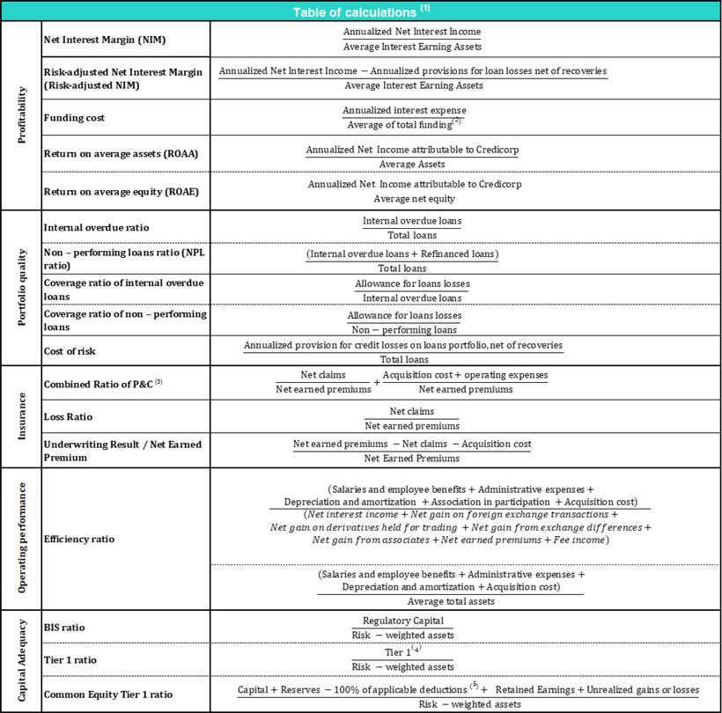

- Averages are determined as the average of period-beginning and period-ending balances.
- Includes total deposits, due to banks and correspondents, BCRP instruments, repurchase agreements and bonds and notes issued.
- Does not include Life insurance business.
- Tier 1 = Capital + Legal and other capital reserves + Accumulated earnings with capitalization agreement + (0.5 x Unrealized profit and net income in subsidiaries) - Goodwill - (0.5 x Investment in subsidiaries) + Perpetual subordinated debt (maximum amount that can be included is 17.65% of Capital + Reserves + Accumulated earnings with capitalization agreement + Unrealized profit and net income in subsidiaries - Goodwill).

- Includes investment in subsidiaries, goodwill, intangibles and deferred tax that rely on future profitability.

69

Earnings Release 4Q / 2022 Analysis of 4Q22 Consolidated Results

12. Appendix

12.7. Glossary of terms

Term | Definition
Government Program Loans ("GP" or "GP Loans") | Loan Portfolio related to Reactiva Peru and FAE-Mype programs to respond quickly and
Government Program Loans ("GP" or "GP Loans") | effectively to liquidity needs and maintain the payment chain.
Structural Loans | Loan Portfolio excluding GP Loans.
Non-Recurring Events at Interest Income | Impairment charge (related to the government facility that allowed for deferment of certain
Non-Recurring Events at Interest Income | installments at zero cost) and subsequent amortization thereof.
Non-Recurring Events at Interest Expenses | Charges related to the liability management operation at BCP Stand-alone (3Q20 and 1Q21).
Structural Cost of Risk | Cost of Risk related to the Structural Loans. It excludes, in the numerator, provisions for
Structural Cost of Risk | credit losses on GP loans, and in the denominator, the total amount of GP Loans.
Structural NPL ratio | NPL Ratio related to Structural Loans. It excludes the impact of GP Loans.
Structural NIM | NIM related to Structural Loans and Other Interest Earning Assets. It deducts the impact of
Structural NIM | GP Loans and Non-recurring Events from Interest Income and Interest Expenses.
Structural Funding Cost | Funding Cost deducting the impact in expenses and funding related to GP Loans and
Structural Funding Cost | deducting Non-recurring Events from Interest Expenses
 | 70

