SECURITIES AND EXCHANGE COMMISSION

Washington, D.C. 20549

FORM 6-K

Report of Foreign Private Issuer

Pursuant to Rule 13a-16 or 15d-16 under the

Securities Exchange Act of 1934

For the month of Feb 2024

Commission File Number: 001-14014

CREDICORP LTD.

(Translation of registrant’s name into English)

Of our subsidiary

Banco de Credito del Peru:

Calle Centenario 156

La Molina

Lima 12, Peru

(Address of principal executive office)

Indicate by check mark whether the registrant files or will file annual reports under cover of Form 20-F or Form 40-F.

Form 20-F ☒ Form 40-F ☐

Indicate by check mark if the registrant is submitting the Form 6-K in paper as permitted by Regulation S-T Rule 101(b)(1): ____

Indicate by check mark if the registrant is submitting the Form 6-K in paper as permitted by Regulation S-T Rule 101(b)(7): ____

The information in this Form 6-K (including any exhibit hereto) shall not be deemed “filed” for purposes of Section 18 of the Securities Exchange Act of 1934 (the “Exchange Act”) or otherwise subject to the liabilities of that section, nor shall it be deemed incorporated by reference in any filing under the Securities Act of 1933 or the Exchange Act.

SIGNATURE

Pursuant to the requirements of the Securities Exchange Act of 1934, the registrant has duly caused this report to be signed on its behalf by the undersigned, thereunto duly authorized.

Date: February 9th, 2024

CREDICORP LTD.

(Registrant)

By: /s/ Guillermo Morales

Guillermo Morales

Authorized Representative

Exhibit 99.1
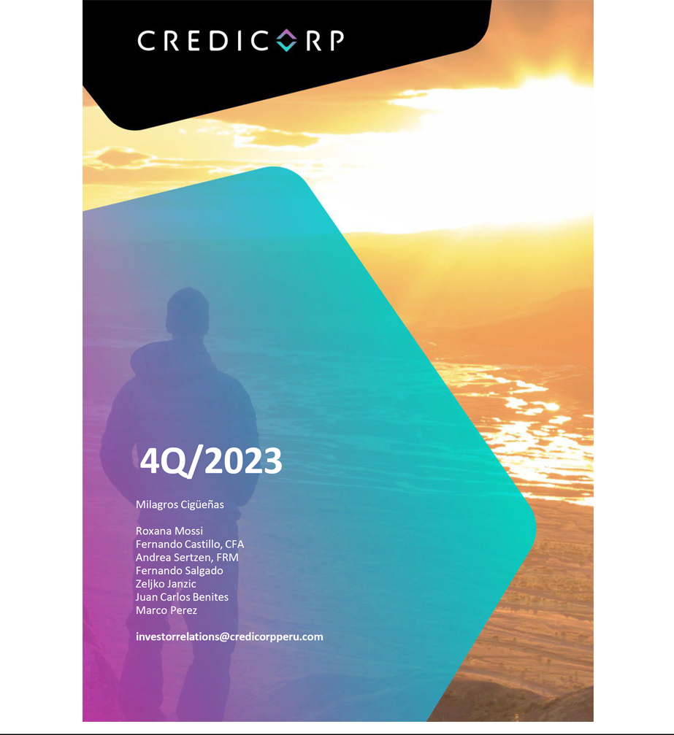

| Earnings Release 4Q / 2023

Table of Contents

Operating and Financial Highlights |  | 03
Senior Management Quotes |  | 05
Fourth Quarter 2023 Earnings Conference Call |  | 06
Summary of Financial Performance and Outlook |  | 07
Financial Overview |  | 12
Credicorp’s Strategy Update |  | 13
Analysis of 4Q23 Consolidated Results
01 | Loans and Portfolio Quality | 17
02 | Deposits | 24
03 | Interest Earning Assets and Funding | 27
04 | Net Interest Income (NII) | 28
05 | Provisions | 32
06 | Other Income | 34
07 | Insurance Underwriting Results | 37
08 | Operating Expenses | 39
09 | Operating Efficiency | 41
10 | Regulatory Capital | 42
11 | Economic Outlook | 44
12 | Appendix | 49
 | Datos elaborados por BCP para uso Interno | 2

| Earnings Release 4Q / 2023

Operating and Financial Highlights

Credicorp Ltd. Reports Financial and Operating Results for 4Q23 and FY23

Resilient profitability in challenging context supported by Universal Banking and Insurance. Despite the provision related to El Niño Phenomenon (FEN) in 4Q23, ROE stood at 10.6% in the quarter and 15.8% in the year.

NIM increased 10 bps QoQ to 6.21% while risk-adjusted NIM declined 35 bps to 4.10%,

reflecting 45 bps impact from FEN provision.

Prudent provisioning amid controlled delinquency with

Cost of Risk of 3.2%, impacted by 70 bps due to the FEN Provision. Structural NPL coverage stood at 102.4%

Lima, Peru – February 08, 2024 – Credicorp Ltd. (“Credicorp” or “the Company”) (NYSE: BAP | BVL: BAP), the leading financial services holding company in Peru with a presence in Chile, Colombia, Bolivia, and Panama today reported its unaudited results for the quarter ended December 31, 2023. Financial results are expressed in Soles and are presented in accordance with International Financial Reporting Standards (IFRS). Effective 1Q23, the Company reports under IFRS 17 accounting standards for insurance contracts. While the impact on consolidated net income is not material, the reclassification of line items in the P&L has impacted the efficiency ratio. To facilitate comparability, figures for 4Q22 and FY22 have been restated to reflect IFRS 17.

4Q23 OPERATING AND FINANCIAL HIGHLIGHTS

- Net Income attributable to Credicorp declined 16.7% YoY to S/841.8 million while shareholders’ equity rose 11.9%. On-going challenges on the macro front led to higher provisions at Mibanco and BCP, which, together with an impairment charge in Mibanco Colombia impacted the bottom line. ROE dropped to 10.6% in 4Q23 from 16.2% in 3Q23 and 14.4% in 4Q22. FY23 ROE stood at 15.8%, 98 bps lower compared to 16.8% in FY22.

- Structural Loans measured in average daily balances (ADB) increased 0.4% QoQ and 0.3% YoY. Loan growth in Retail Banking at BCP was largely offset by drop in loans in Wholesale Banking, which was impacted by a decline in private investment, and by a decrease in Mibanco’s risk appetite due to a challenging context.

- Total Deposits declined 0.5% QoQ at year-end, as the contraction of Time Deposits more than offset the expansion of Low-Cost Deposits. YoY, Deposits increased 0.5%, driven mainly by fund migration from Savings Deposits to Time Deposits as clients sought higher rates. Low-cost Deposits accounted for 68.1% of total deposits at quarter end, leading the market with a 41.6% share.

- The Structural NPL ratio increased 7 bps QoQ to 5.6%, as adverse events and weak macro context continued to impact client payment performance, albeit to a lesser extent than in past quarters. At BCP, key drivers were (i) SME- Pyme, although new vintages present better performance, (ii) Consumer and Credit Cards, mainly in loans more than 120 days past due. At Mibanco, delinquency increased among clients with higher-ticket loans and those impacted by social conflicts or climatic conditions.

- Structural Provisions increased 31.1% QoQ, which reflects the impact of provisions set aside for El Niño for approximately S/250 million. If we exclude this impact, Structural Provisions rose 2.8% QoQ driven by a base effect in Wholesale Banking while SME-Pyme remains impacted by a recessive environment. The aforementioned dynamics were partially offset by reversals in Mortgages provisions and by a portfolio contraction at Mibanco. The Cost of Risk increased 71 bps sequentially to 3.2% while the Structural Cost of Risk increased 78 bps sequentially to 3.3%. The Structural NPL Coverage ratio, in turn, stood at 102.4%.

- Core Income increased 2.6% QoQ, mainly driven by a 2.9% increase in Net Interest Income (NII), proof of the resilience of business operations in a context marked by lower interest rates. Excluding BCP Bolivia, Fee Income and FX transactions were up 2.1% QoQ, reflecting an uptick in FX volumes as BCP leveraged growth in year-end volumes and higher fee income from Credicorp Capital. For FY23, Core Income rose 11.4%, supported by 16.6% growth in NII.

Datos elaborados por BCP para uso Interno | 3

| Earnings Release 4Q / 2023

Operating and Financial Highlights

- Net Interest Margin (NIM) increased 10 bps QoQ to 6.21% due to a stable yield on IEA and a decrease in the funding cost. YoY, NIM increased 46 bps after growth in the yield on IEAs surpassed the expansion registered for the funding cost. Risk-adjusted NIM fell 35 bps QoQ to 4.10%, impacted by provisions set aside for El Niño, which accounted for 45 bps of drop reported this quarter.

- Insurance Underwriting Results declined 13.2% QoQ, driven by a higher claims expenses in P&C and Life businesses, but increased 110.0% YoY, driven by the Life Business.

- Efficiency Ratio improved 142 bps in 2023 reaching 46.1%, on the back of positive operating leverage at BCP and Pacifico.

- Yape, continues to scale, reaching 11 million monthly active users. The app continues to add user-friendly features while bolstering engagement and fee generation. With revenue per monthly active user (MAU) up by 34.5% QoQ, and despite a seasonal uptick in costs, Yape remains on track to reaching cashflow break-even in 2024.

- Credicorp maintains a solid capital base, with a IFRS CET1 Ratio for BCP of 13.2%, up 16 bps QoQ. Mibanco IFRS CET1 Ratio stood at 18.4%, up 80 bps QoQ; both these levels are above internal targets of 11% and 15%, respectively.

- At BCP stand-alone, 30-day local currency Liquidity Coverage Ratio (LCR) currency stood at 170.4% under regulatory standards and 133.6% based on more stringent internal standards, while USD 30-day LCR stood at 171.3% and 108.0% under regulatory and more stringent internal standards, respectively.

- In December 2023, Credicorp published its Inaugural Task Force on Climate-Related Financial Disclosures (TCFD) Report, building on its environmental commitment to being a local leader in supporting the transition towards an environmentally sustainable economy by building capabilities and knowledge that encourage sustainable businesses and promptly managing environmental risks.

Datos elaborados por BCP para uso Interno | 4

| Earnings Release 4Q / 2023

Senior Management Quotes

SENIOR MANAGEMENT QUOTES
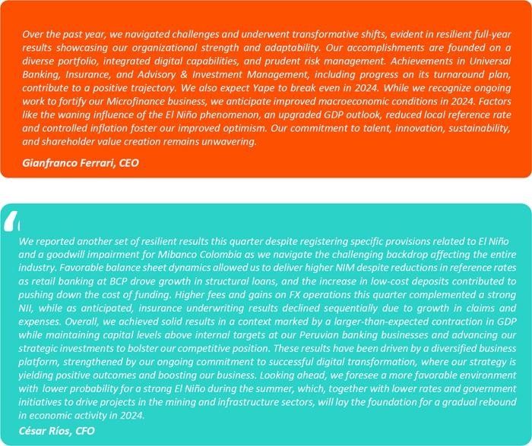

Datos elaborados por BCP para uso Interno | 5

| Earnings Release 4Q / 2023

Fourth Quarter 2023 Earnings Conference Call

FOURTH QUARTER 2023 EARNINGS CONFERENCE CALL

Date: Friday February 9th, 2024

Time: 9:30 am ET (9:30 am Lima, Perú)

Hosts: Gianfranco Ferrari – Chief Executive Officer, Cesar Rios - Chief Financial Officer, Francesca Raffo – Chief Innovation Officer, Reynaldo Llosa - Chief Risk Officer, Diego Cavero – Head of Universal Banking, Cesar Rivera - Head of Insurance and Pensions, Carlos Sotelo - Mibanco CFO and Investor Relations Team.

To pre-register for the listen-only webcast presentation use the following link:

https://dpregister.com/DiamondPassRegistration/register?confirmationNumber=10185821&linkSecurityString=fb6ad9 ac89

Callers who pre-register will be given a conference passcode and unique PIN to gain immediate access to the call and bypass the live operator. Participants may pre-register at any time, including up to and after the call start time.

Those unable to pre-register may dial in by calling:
1 844 435 0321 (U.S. toll free)
1 412 317 5615 (International)
Participant Web Phone: Click Here

Conference ID: Credicorp Conference Call

The webcast will be archived for one year on our investor relations website at:

https://credicorp.gcs-web.com/events-and-presentations/upcoming-events

For a full version of Credicorp´s Third Quarter 2023 Earnings Release, please visit:

https://credicorp.gcs-web.com/financial-information/quarterly-results

Datos elaborados por BCP para uso Interno | 6

| Earnings Release 4Q / 2023

Summary of Financial Performance and Outlook

Loans in Average Daily Balances (ADB)
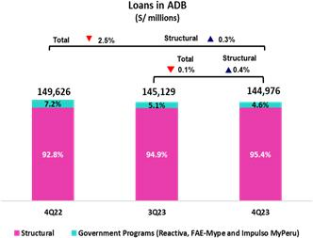

Structural loans measured in ADB increased 0.4% QoQ (+0.7% Neutral Exchange Rate) to stand at S/138,348 million. Growth was mainly attributable to Retail Banking at BCP, led by an uptick in SME-Pyme and Mortgages. This evolution was partially offset by a drop in balances in Wholesale Banking, which was fueled by a reduction in private investment, and by lower balances at Mibanco, where a decline reflected tighter lending conditions implemented.

YoY, structural loan growth stood at 0.3% (+0.7% Neutral Exchange Rate).

This evolution was driven by Retail Banking at BCP and by SME-Pyme,
Mortgages and Credit Cards in particular, and was offset by a drop in
Wholesale Banking balances, which was spurred by the same factors seen
QoQ.

The Government Loan Portfolio (GP) represented 2.7% of total loans in average daily balances this quarter (2.5% in quarter-end balances), which were concentrated in BCP SME-Pyme and BCP SME-Business.
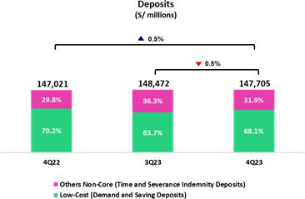

Deposits

Our deposit base measured in quarter-end balances decreased 0.5% QoQ (+0.6% Neutral Exchange Rate). This latter growth was mainly attributable to a growth in Low-Cost Deposits.

In the YoY comparison, the deposit base increased 0.5% (+1.9% Neutral Exchange Rate). Low-cost deposits, which represented 68.1% of our total deposit base at the end of the quarter, continued to play a predominant role in our funding mix.

Net Interest Income (NII) and Margin (NIM)

NII rose 2.9% QoQ to stand at S/3,348 million. This evolution was driven by an uptick in financial income, which was primarily fueled by growth in structural loans, driven by Retail Banking. Interest expenses fell 2.7% QoQ due to liability repricing in a cycle of lower interest rates and to an uptick in Low-Cost Deposits’ share of our funding base. In this context, the drop reported in the Funding Cost outpaced the reduction registered for the IEA yield; these factors led NIM to stand at 6.21% at quarter-end.
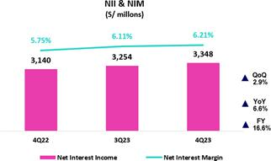

YoY and YTD, Net Interest Income rose 6.6% and 16.6% respectively, driven primarily by the evolution of rates for both currencies and by a shift in the loan mix toward retail.

Datos elaborados por BCP para uso Interno | 7

| Earnings Release 4Q / 2023

Summary of Financial Performance and Outlook

Portfolio Quality and Structural Cost of Risk
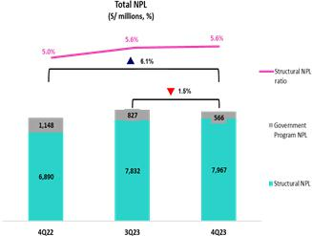

QoQ, the structural NPL balance rose 1.7%. This growth was concentrated in: (i) SME-Pyme, where the uptick in delinquency was concentrated in old vintages while indicators for early delinquency for new vintages improved,

- Consumer and Credit Cards, where growth in the NPL volumen was concentrated in loans overdue more than 120 days; and (iii) Mibanco, where early delinquency was concentrated concentrated in loans with higher tickets; note that in 3Q23, we began implementing stricter credit policies and expect to see improvement down the line. These dynamics were partially offset by Corporate, driven by recoveries associated to two specific loans.

In this context, the structural NPL ratio stood at 5.6% while the structural NPL Coverage ratio situated at 102.4%

Structural provisions this quarter reflected provisions set aside for the El Niño Phenomenon for approximately S/250 MM, which was based on the information available at the close of the books. If we exclude this effect, structural provisions rose 2.8% QoQ, driven by Wholesale Banking via a base effect and by SME-Pyme, due to a downturn in client payment performance. These dynamics were partially offset by reversals for sub-products in Mortgage and by lower provisions at Mibanco.
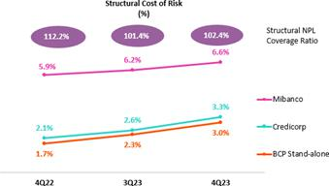

YTD, structural provisions excluding provisions set aside for El Niño Phenomenon, increased 91.0%, driven by Retail Banking at BCP and Consumer, Credit Cards and SME-Pyme in particular, which were impacted by an uptick in the deterioration of old vintages. Provisions at Mibanco also rose significantly. The aforementioned dynamics were partially offset by reversals of provisions in Wholesale Banking during the year, which reflected recoveries of impaired loans.

In this context, the Structural Cost of Risk stood at 3.3% and the Cost of

Risk, at 3.2%. YTD, the Structural Cost of Risk situated at 2.5% and the
Cost of Risk, at 2.5%.

Datos elaborados por BCP para uso Interno | 8

| Earnings Release 4Q / 2023

Summary of Financial Performance and Outlook

Other Income
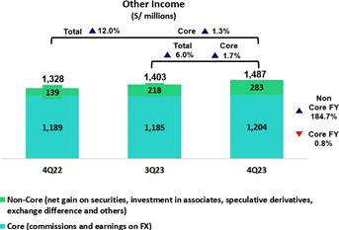

Other Core Income¹ (Fees + Gains on FX transactions), excluding BCP Bolivia, rose 2.1% QoQ. This evolution was driven mainly by an increase in the net gain on FX transactions at BCP Stand-alone and, to a lesser extent, by an uptick in Fee Income at Credicorp Capital. YoY, excluding BCP Bolivia, the 1.4% increase was attributable to growth in the balance for fees at Credicorp Capital, driven by an uptick in fees through BCP Stand-alone.

Other Non-core income rose 29.6% and 102.8 % QoQ and YoY respectively. These increases were mainly driven by Other Income, which was up due to sales of judicial recoveries and, to a lesser extent, due to an uptick in the Net Gain on Securities at BCP. YTD, growth was driven by an increase in the Net gain on Securities, which was attributable to good results for trading strategies at Credicorp Capital and ASB and growth in income from the investment portfolio at Pacífico.

- When analyzing the results for fee income and FX transactions, it is important to note that both lines have been affected by our operation in BCP Bolivia, where we charge fees to FX clients to offset losses on buy-sell FX transactions.

Insurance Underwriting Result
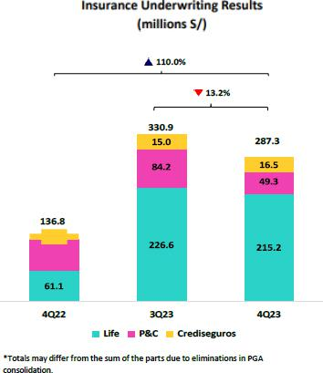

The Insurance Underwriting Result dropped 13.2% QoQ. This evolution was fueled by higher claims expenses in our P&C and Life businesses.

YTD, the underwriting results were up 43.9% due to an increase in income from Life and a more favorable reinsurance result. These dynamics were partially attenuated by an increase in expenses for insurance services, primarily in the P&C business.

Datos elaborados por BCP para uso Interno | 9

| Earnings Release 4Q / 2023

Summary of Financial Performance and Outlook

Efficiency
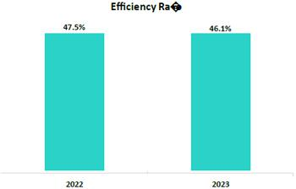

At the end of 2023, the Efficiency ratio stood at 46.1%, which represents an improvement of 142 bps versus the figure in 2022. This dynamic was in line with a 13.2% uptick in operating income, where growth outpaced the uptick registered for operating expenses.

Operating expenses rose 9.8% YTD, driven primarily by disruptive initiatives at Credicorp and core expenses (non – disruption) at BCP.

- Operating Expenses and Income have been reformulated due to the application of IFRS 17 and as such, are reported differently than seen in earlier reports. This reformulation has led to a subsequent change in the way that the Efficiency Ratio is calculated. For more detail, please refer to appendix 12.1

Net earnings attributable to Credicorp
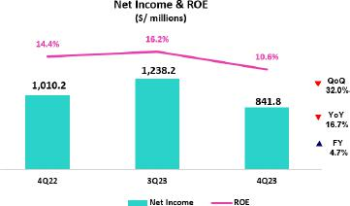

In 4Q23, net income attributable to Credicorp stood at S/841.8 million, down -32.0% QoQ and up -16.7% YoY. Net Shareholders’ Equity was S/32,460 million (+3.8% QoQ and +11.9% YoY). Consequently, ROE stood at 10.6%.

YTD, in addition to recurring dynamics, this year’s results were impacted by a deterioration in goodwill at Mibanco Colombia and by an increase in provisions for withholding tax at the holding level, which was attributable to higher expectations for dividend payments.

Consequently, net income attributable to Credicorp rose 4.7% versus the figure in 2022 to stand at S/4,866 million. In this context, ROE stood at 15.8%, 98 bps below the level reported in 2022.

Contributions and ROE by subsidiary in 4Q23

(S/ millions)
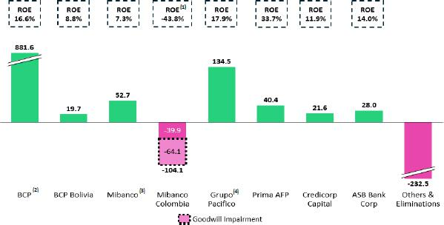

- This figure excludes the impact of the goodwill Impairment on Mibanco Colombia’s performance.

- At BCP Stand Alone, the figure is lower than net income because it does not include gains on investments in other Credicorp subsidiaries (Mibanco).

- At Mibanco, the figure is lower than net income because Credicorp owns 99.921% of Mibanco (directly and indirectly).

- The Contribution of Grupo Pacífico presented here is higher than the earnings reported for Pacifico Seguros because it includes 100% of Crediseguros (including 48% under Grupo Credito)

Datos elaborados por BCP para uso Interno | 10

| Earnings Release 4Q / 2023

Summary of Financial Performance and Outlook
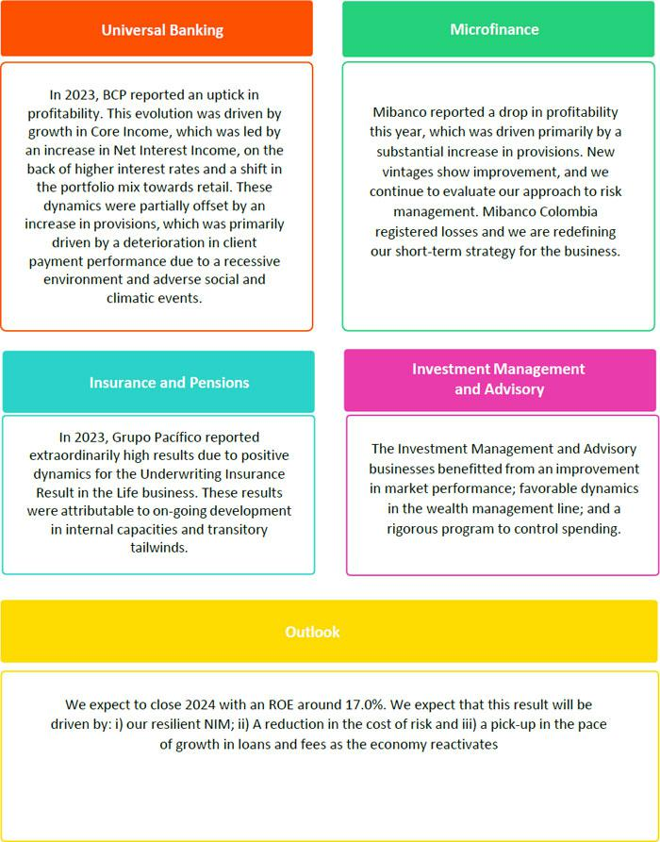

Datos elaborados por BCP para uso Interno | 11

| | Earnings Release 4Q / 2023
Financial Overview
Credicorp Ltd. |  |  | Quarter |  | % change |  | As of |  | % change
S/000 |  |  | Quarter |  |  |  | As of |  | % change
S/000 |  | 4Q22 | 3Q23 | 4Q23 | QoQ | YoY | 2022 | 2023 | 2023 / 2022
Net interest, similar income and expenses |  | 3,140,404 | 3,254,043 | 3,347,684 | 2.9% | 6.6% | 11,091,618 | 12,937,972 | 16.6%
Provision for credit losses on loan portfolio, net of recoveries |  | (730,681) | (917,642) | (1,173,454) | 27.9% | 60.6% | (1,811,538) | (3,622,345) | 100.0%
Net interest, similar income and expenses, after provision for credit losses on loan |  | 2,409,723 | 2,336,401 | 2,174,230 | -6.9% | -9.8% | 9,280,080 | 9,315,627 | 0.4%
portfolio
Total other income |  | 1,327,862 | 1,402,603 | 1,486,823 | 6.0% | 12.0% | 5,066,096 | 5,655,825 | 11.6%
Insurance underwriting result |  | 136,824 | 330,900 | 287,295 | -13.2% | 110.0% | 841,448 | 1,211,100 | 43.9%
Total other expenses |  | (2,363,787) | (2,350,469) | (2,661,542) | 13.2% | 12.6% | (8,317,013) | (9,334,223) | 12.2%
Profit before income tax |  | 1,510,622 | 1,719,435 | 1,286,806 | -25.2% | -14.8% | 6,870,611 | 6,848,329 | -0.3%
Income tax |  | (476,236) | (455,865) | (434,648) | -4.7% | -8.7% | (2,110,501) | (1,888,451) | -10.5%
Net profit |  | 1,034,386 | 1,263,570 | 852,158 | -32.6% | -17.6% | 4,760,110 | 4,959,878 | 4.2%
Non-controlling interest |  | 24,231 | 25,397 | 10,331 | -59.3% | -57.4% | 112,292 | 94,338 | -16.0%
Net profit attributable to Credicorp |  | 1,010,155 | 1,238,173 | 841,827 | -32.0% | -16.7% | 4,647,818 | 4,865,540 | 4.7%
Dividends distribution, net of treasury shares effect (S/000) |  | - | - | - | - | - | 1,196,422 | 1,994,037 | 66.7%
Net income / share (S/) |  | 12.7 | 15.5 | 10.6 | -32.0% | -16.7% | 58.3 | 61.0 | 4.7%
Dividends per Share (S/) |  | - | - | - | - | - | 15.0 | 25.0 | 66.7%
Loans |  | 148,626,374 | 145,129,260 | 144,976,051 | -0.1% | -2.5% | 148,626,374 | 144,976,051 | -2.5%
Deposits and obligations |  | 147,020,787 | 148,471,535 | 147,704,994 | -0.5% | 0.5% | 147,020,787 | 147,704,994 | 0.5%
Net equity |  | 29,003,644 | 31,267,592 | 32,460,004 | 3.8% | 11.9% | 29,003,644 | 32,460,004 | 11.9%
Profitability
Net interest margin⁽¹⁾ |  | 5.75% | 6.11% | 6.21% | 10 bps | 46 bps | 5.09% | 6.01% | 92 bps
Risk-adjusted Net interest margin |  | 4.45% | 4.45% | 4.10% | -35 bps | -35 bps | 4.29% | 4.38% | 9 bps
Funding cost⁽²⁾ |  | 2.35% | 3.15% | 3.03% | -12 bps | 68 bps | 1.83% | 2.91% | 108 bps
ROE |  | 14.4% | 16.2% | 10.6% | -559 bps | -379 bps | 16.8% | 15.8% | -98 bps
ROA |  | 2.1% | 2.1% | 1.4% | -69 bps | -74 bps | 2.0% | 2.0% | 4 bps
Loan portfolio quality
Internal overdue ratio⁽³⁾ |  | 4.0% | 4.4% | 4.2% | -18 bps | 23 bps | 4.0% | 4.2% | 23 bps
Internal overdue ratio over 90 days |  | 3.1% | 3.5% | 3.5% | -8 bps | 35 bps | 3.1% | 3.5% | 35 bps
NPL ratio⁽⁴⁾ |  | 5.4% | 6.0% | 5.9% | -8 bps | 48 bps | 5.4% | 5.9% | 48 bps
Cost of risk⁽⁵⁾ |  | 2.0% | 2.5% | 3.2% | 71 bps | 127 bps | 1.2% | 2.5% | 128 bps
Coverage ratio of IOLs |  | 132.5% | 125.8% | 135.1% | 937 bps | 258 bps | 132.5% | 135.1% | 258 bps
Coverage ratio of NPLs |  | 97.9% | 93.0% | 97.0% | 399 bps | -91 bps | 97.9% | 97.0% | -91 bps
Operating efficiency
Efficiency ratio⁽⁶⁾ |  | 49.5% | 46.3% | 49.0% | 265 bps | -57 bps | 47.5% | 46.1% | -142 bps
Operating expenses / Total average assets |  | 3.8% | 3.8% | 4.0% | 26 bps | 22 bps | 4.4% | 4.9% | 50 bps
Capital adequacy - BCP Stand-alone
Global Capital ratio⁽⁷⁾ |  | n.a | 17.5% | 17.5% | -5 bps | n.a | n.a | 17.5% | n.a
Tier 1 ratio(8) |  | n.a | 13.0% | 13.1% | 8 bps | n.a | n.a | 13.1% | n.a
Common equity tier 1 ratio⁽⁹⁾⁽¹¹⁾ |  | 12.6% | 13.0% | 13.2% | 16 bps | 61 bps | 12.6% | 13.2% | 61 bps
Capital adequacy - Mibanco
Global Capital ratio⁽⁷⁾ |  | n.a | 19.8% | 20.6% | 81 bps | n.a | n.a | 20.6% | n.a
Tier 1 ratio⁽⁸⁾ |  | n.a | 17.4% | 18.2% | 79 bps | n.a | n.a | 18.2% | n.a
Common equity tier 1 ratio⁽⁹⁾⁽¹¹⁾ |  | 16.5% | 17.6% | 18.4% | 80 bps | 191 bps | 16.5% | 18.4% | 191 bps
Employees |  | 36,968 | 37,161 | 37,074 | -0.2% | 0.3% | 36,968 | 37,074 | 0.3%
Share Information
Issued Shares |  | 94,382 | 94,382 | 94,382 | 0.0% | 0.0% | 94,382 | 94,382 | 0.0%
Treasury Shares ⁽¹⁰⁾ |  | 14,849 | 14,847 | 14,847 | 0.0% | 0.0% | 14,849 | 14,847 | 0.0%
Outstanding Shares |  | 79,533 | 79,535 | 79,535 | 0.0% | 0.0% | 79,533 | 79,535 | 0.0%

- Net Interest Margin = Net Interest Income (Excluding Net Insurance Financial Expenses) / Average Interest Earning Assets

- Funding Cost = Interest Expense (Does not include Net Insurance Financial Expenses) / Average Funding
- Internal Overdue Loans: includes overdue loans and loans under legal collection, according to our internal policy for overdue loans. Internal Overdue Ratio: Internal overdue loans / Total loans
- Non-performing loans (NPL): Internal overdue loans + Refinanced loans. NPL ratio: NPL / Total loans.
- Cost of risk = Annualized provision for loan losses, net of recoveries / Total loans.
- Efficiency Ratio = (Salaries and employee benefits + Administrative expenses + Depreciation and amortization + Association in participation) / (Net interest, similar income and expenses + Fee Income + Net gain on foreign exchange transactions + Net Gain From associates + Net gain on derivatives held for trading + Result on exchange differences + Insurance Underwriting Result)
- Regulatory Capital / Risk-weighted assets (legal minimum = 10% since July 2011).
- Tier 1 = Capital + Legal and other capital reserves + Accumulated earnings with capitalization agreement + (0.5 x Unrealized profit and net income in subsidiaries) - Goodwill - (0.5 x Investment in subsidiaries) + Perpetual subordinated debt (maximum amount that can be included is 17.65% of Capital + Reserves + Accumulated earnings with capitalization agreement + Unrealized profit and net income in subsidiaries - Goodwill).
- Common Equity Tier I = Capital + Reserves – 100% of applicable deductions (investment in subsidiaries, goodwill, intangibles and net deferred taxes that rely on future profitability) + retained earnings + unrealized gains.
- Consider shares held by Atlantic Security Holding Corporation (ASHC) and stock awards.
- Common Equity Tier I calculated based on IFRS Accounting

Datos elaborados por BCP para uso Interno | 12

| Earnings Release 4Q / 2023

Credicorp’s Strategy Update

Credicorp’s Strategy

Credicorp has demonstrated resilience in a challenging context. The company has leveraged its financial strength, prudent approach to risk management, client-centered focus, and digital capacities developed over the last decade to navigate complex junctures and bolster its leadership. In 2023, Credicorp anticipated the credit cycle and revised its appetite for risk while proactively offering financial assistance to clients. The company has developed its proposition for transaction value and increased its insurance offerings to reach more clients while improving its performance indicators for user experience and frequency of use.

Credicorp continues to invest in technology and disruptive initiatives to maintain a competitive advantage and ensure sustainability down the line. By understanding market trends and satisfying clients’ needs, Credicorp aims to solidify its position and expand into new markets.

Main KPIs of Credicorp’s Strategy

Traditional Business Transformation ⁽¹⁾ | Subsidiary | 4Q22 | 3Q23 | 4Q23
Day to Day
Digital monetary transactions ⁽²⁾ | BCP | 67% | 76% | 80%
Transactional cost by unit | BCP | 0.11 | 0.07 | 0.07
Disbursements through leads ⁽³⁾ | Mibanco | 76% | 70% | 71%
Disbursements through alternative channels ⁽⁴⁾ | Mibanco | 45% | 44% | 41%
Mibanco Productivity ⁽⁵⁾ | Mibanco | 25.9 | 22.1 | 21.6
Cashless
Cashless transactions ⁽⁶⁾ | BCP | 48% | 51% | 56%
Mobile Banking rating iOS | BCP | 4.7 | 4.7 | 4.7
Mobile Banking rating Android | BCP | 3.7 | 4.2 | 4.7
Digital Acquisition
Digital sales ⁽⁷⁾ | BCP | 61% | 58% | 61%

- Figures for December 2022, September 2023, and December 2023

- Monetary Transactions conducted through Retail Banking, Internet Banking, Yape and Telecredito/Total Retail Monetary Transactions in Retail Banking.

- Disbursements generated through leads/Total disbursements.

- Disbursements conducted through alternative channels/Total disbursements.

- Number of loans disbursed/ Total relationship managers

- Amount transacted through Mobile Banking, Internet Banking, Yape y POS/ Total amount transacted through Retail Banking Minorista.

- Units sold by Retail Banking through digital channels/ Total number of units sold by Retail Banking.

Datos elaborados por BCP para uso Interno | 13

| Earnings Release 4Q / 2023

Credicorp’s Strategy Update

Disruptive Initiatives: Yape

The year 2023 has been a great one for Yape, which is well on track to reaching breakeven in 2024. At the end of 2023, thanks to the new functionalities that have been added to the application, Yape hit the 14.2-million user mark and 10.7 of this pool (75%) engage in transactions at least once a month (MAU). In 4Q23, 1.027 million transactions were conducted, which represents a growth of 29% versus the figure in 3Q23 and 133% compared to the print in 4Q22. This year, 2,918 million transactions were recorded, which represents a growth of 143% over the figure posted in 2022. In the aforementioned context, Yape achieved a TPV of S/137,830 million soles for 2023, which reflects a growth of 108% with regard to 2022. At the end of December, Yape reported an average of 35 transactions per month per MAU, which represents an improvement of 22% with regard to the figure in September and 72% compared to the print at the end of December 2022.

The different functionalities launched in 2022 have allowed 7.9 million users to engage in transactions that generate income for Yape (73% of active users), where the monthly revenue per active yapero stood at S/3.9. These new functionalities have improved the client experience, which was reflected in an NPS of 80 points at the end of the quarter; this represents a 4-point improvement over the figure reported in September and is 9 points above the print at the end of December 2022.

In 4Q23, the drivers of monetization that stood out for each of Yape’s ambitions were:

Be the main payment venue in the country:

- Mobile top-ups: In 4Q23, 4.6 million Yape users made more than 50.7 million top-ups, which represents growth of 20.6% QoQ, 93.3% YoY and 500% with regard to 2022.
- Payment services: In 4Q23, Yaperos made 18.1 million service payments through Yape, which represents growth of 70% versus the print in 3Q23 and is 2.5 times above the number of transactions reported in 2Q23 and 28 times that posted in 1Q23- the quarter when this functionality was launched.

- FX transactions: In September 2023, Yape launched a new Exchange-rate functionality. In 4Q23, more than 139 thousand transactions were reported.

Be present in the day-to-day of all Yaperos:

- Yape Promos: In 4Q23, 2.6 million transactions were conducted through Yape Promos, which represents growth of 20% over the figure reported for 3Q23 and is 89 times above the print in 4Q22. This transaction level translates into a GMV of S/40.9 million (+6% QoQ and 68.7 times the YoY figure) in 4Q23 and 114.9 million for the year.

- Store: In October, Yape launched its Marketplace, where Yaperos can purchase appliances and technology devices. In 4Q23, more than 24 thousand transactions were reported.

Resolve Yaperos’ financial needs:

- This quarter, more than 285.5 thousand single installment loans were disbursed (+30 QoQ and +170% YoY) for a total of S/65.3 million. This represents an increase of 29.5% versus the disbursement level in 3Q23 and is 2.2 higher than 4Q23’s figure. In 4Q23, 5 thousand single installment loan was disbursed for a total of 5.5 million.

Datos elaborados por BCP para uso Interno | 14

| Earnings Release 4Q / 2023

Credicorp’s Strategy Update

Main KPIs of Yape

Disruptive Initiatives: Yape |  | 4Q22 | 3Q23 | 4Q23
Users
Users (millions) |  | 11.9 | 13.4 | 14.2
Monthly Active Users (MAU) (millions) ⁽¹⁾ |  | 7.9 | 9.8 | 10.7
Fee Income Generating MAU (millions) |  | 3.4 | 6.5 | 7.9
Engagement
# Monthly Transactions (millions) |  | 162.5 | 285.8 | 378.3
TPV ⁽³⁾ (S/, millions) |  | 66.2 | 90.7 | 137.8
Experience
NPS ⁽²⁾ |  | 71 | 76 | 80
Metric per Monthly Active User (MAU)
Monthly Transactions / MAU |  | 21 | 29 | 35
Monthly Revenues / MAU |  | 1.8 | 2.9 | 3.9
Monthly Cash Cost / MAU |  | 6.8 | 4.3 | 5.1
Monetization Drivers
Payments
# Mobile Top-Ups transactions (millions) |  | 26.2 | 42 | 50.7
# Bill Payments transactions (millions) |  | - | 10.6 | 18.1
Yape Promos
GMV (4) (S/, millions) |  | 5.2 | 38.6 | 40.9
Microloans
# Disbursements (thousands) |  | 105.7 | 219.8 | 290.5
(1) Yape users that have made at least one transaction over the last month.
(2) Net Promoting Score
(3) Total Payment Volume
(4) Gross Merchant Volume
Datos elaborados por BCP para uso Interno |  |  |  | 15

| Earnings Release 4Q / 2023

Credicorp’s Strategy Update

Integrating Sustainability in Our Businesses

For more information on our sustainability strategy, program and initiatives, please review: “Sustainability Strategy 2020-25” and “Sustainability and Annual Report 2022”. The following stand out among the milestones hit in the framework of the Sustainability Program in the 4Q23:

Governance Front – Aligning our corporate governance to best practice and international standards

- Board Composition: An external assessment of the board and its committees was conducted, and we already have an action plan based on the recommendations of the analysis.

Environmental Front – Driving environmental sustainability from the financial sector and ESG Risk Management

- Credicorp publishes its first TCFD report: The TCFD report (Task force on Climate-Related Financial Disclosures) describes the measures adopted to June 2023 under our environmental strategy and addresses issues related to climate change in the ambits of corporate governance, business strategy, operations, risks, metrics at both the corporate level and at subsidiaries.

- Business Opportunities: At the end of 4Q23, BCP approved 59 green transactions for US$ 585.8MM, which represents almost double the figure reported at the end of the 3Q23 (32 transactions for US$ 309.9MM). YTD, 43 transactions were conducted for S/8.6MM for Sustainable Car Loans and 83 Green Mortgage Loan transactions were completed for S/50MM.

- Carbon Footprint Measurement: At BCP, after having built capacities in 3Q23, we developed a map of our initiatives to reduce our Carbon Footprint. Additionally, we reviewed the mitigation activities that have been implemented and those that are under exploration. Data was compiled on the footprints of prioritized sectors of the Wholesale Banking portfolio.

- Risks: Within the platform for the ESG Risk Enabler, BCP defined the appetite indicators that will be applied to assessments of Investment Portfolios and Financing. ESG risk training for the Financing portfolio was conducted as part of an on-going effort to strengthen the capacities of the Wholesale Banking teams.

Social Front – Expanding financial inclusion and educating about finance and entrepreneurship

- Financial Inclusion: The “Agente Móvil” Chaski has reached 50 rural areas and 10 urban locations in the departments of Arequipa, Cuzco, and Moquegua.
- Financial Education: BCP continued to drive improvements in financial behavior (preventing Overindebtedness/Overdraws on Credit Cards/Late payments and Promoting Savings) and trained 214 thousand clients through its Education Initiatives for Business. Through its “Mujeres Poderosas” program, Mibanco Perú trained more than 13 thousand representatives from approximately one thousand social organizations at the national level. Prima AFP relaunched its educational web page “Ahorrando a Fondo,” and had reached more than 4 million people by year-end via approximately 485 thousand sessions. Pacifico, in turn, provided training to public employees from Disaster Risk management and Brigades in the regions of Libertad and Piura, which are at higher risk under El Nino scenarios. The company rolled out communications campaigns and strengthened capacities to manage humanitarian efforts.

The progress made on other initiatives in these and other platforms on the social front are summarized in the table below:

Progress on Initatves | Company | 1Q23 | 2Q23 | 3Q23 | 4Q23
Financial Inclusion
Financially included through BCP⁽¹⁾ – cumulatve since 2020 | BCP | 2.6 million | 3.1 million | 3.6 million | 4.1 million
Stock of inclusive insurance policies – YTD | Pacífco Seguros | 2.8 million | 2.9 million | 3.1 million | 3.2 million
Financial Educaton
Trained through online courses via ABC at BCP (ABC del BCP) – YTD 2023 | BCP | 117.5 thousand | 230.3 thousand | 397.9 thousand | 614.1 thousand
Individuals trained in risk preventon via Safe Community (Comunidad Segura) – YTD 2023 | Pacífco Seguros | 0.3 thousand | 24.6 thousand | 33.2 thousand | 38.4 thousand
Young people trained through the ABC of the Pension Culture (ABC de la Cultura Previsional) | Prima AFP | 5.6 thousand | 24.6 thousand | 59.9 thousand | 138.0 thousand
– YTD 2023
Clients trained through the Basic Program for Digital Guidance (Programa Básico de Asesoría | Mibanco Perú | 108.0 thousand | 184.0 thousand | 227.0 thousand | 272.0 thousand
Digital) – YTD 2023
Opportunites and Products for Women
Number of disbursements through Loans for Women ⁽²⁾ | Mibanco Perú | 12.9 thousand | 17.0 thousand | 17.0 thousand | 12.0 thousand
Helping small businesses grow
Trained via Accompanying Entrepreneurs (Contgo Emprendedor) – YTD 2023 | BCP | 13.1 thousand | 44 thousand | 80.7 thousand | 121.0 thousand
SME-Pymes fnancially included through loans (working capital and invoice discountng) – | BCP | 7.7 thousand | 14.5 thousand | 23.6 thousand | 34.5 thousand⁽³⁾
YTD 2023
Microbusiness afliated to Yape – YTD 2023 | BCP | 1.6 thousand | 3.9 thousand | 13.0 thousand | 26.9 thousand
- Stock of financially included clients through BCP since 2020: (i) New clients with savings accounts or affiliated to Yape. (ii) New clients without debt in the financial system or BCP products in the last twelve months. (iii) Clients with 3 monthly average transactions in the last three months.
- Non-cumulative. Figure for the period.
- Real information up to November (extrapolated through December)

Datos elaborados por BCP para uso Interno | 16

| Earning Release 4Q / 2023 Analysis of 4Q23 Consolidated Results

01 Loan Portfolio


QoQ, structural loans in average daily balances (ADB) ADBs increased 0.4% (neutral FX +0.7%), driven primarily by the SME-Pyme and Middle-Market Banking. This growth was partially offset by a drop in i) Corporate Banking, in a context marked by low private investment and a weak macroeconomic environment and ii) Mibanco, due to changes towards stricter credit guidelines. YoY, structural loan balances rose 0.3% (neutral FX +0.7%), due to growth in balances in Retail Banking, except for Consumer. YTD, loans in ADBs grew 4.1%, driven by loan growth across Retail banking segments.

QoQ, growth in structural NPLs was driven by (i) SME-Pyme, which continued to present deterioration in old vintages; (ii) Consumer and Credit Cards, where growth in NPLs was concentrated in tranches for loans overdue more than 120 days.; and (iii) Mibanco, where delinquency was concentrated mainly among clients with high ticket loans and those who continued to be affected by social conflicts or climatic anomalies. YoY growth in NPLs was driven mainly by the same factors explained in the QoQ analysis for Individuals and SME-Pyme, and, to a lesser extent, by refinancing of debt in Wholesale Banking for clients in the commercial real estate and tourism sectors throughout 1Q23. The aforementioned dynamics led the Structural NPL ratio to rise QoQ and YoY to stand at 5.6%.

1.1. Loans

Structural Loans (in Average Daily Balances) ⁽¹⁾⁽²⁾⁽³⁾
Structural Loans |  | As of |  | Year |  |  | Volume Change |  |  |  | % Change |  |  | % Part. in total structural loans
(S/ millions) | Dec 22 | Sep 23 | Dec 23 | 2022 | 2023 | QoQ |  | YoY | FY | QoQ | YoY | FY | Dec 22 | Sep 23 | Dec 23 | 2022 | 2023
BCP Stand-alone | 112,566 | 111,857 | 112,644 | 107,607 | 111,749 | 787 | 78 |  | 4,141 | 0.7% | 0.1% | 3.8% | 81.6% | 81.2% | 81.4% | 81.5% | 81.3%
Wholesale Banking | 55,622 | 52,090 | 51,880 | 53,735 | 52,442 | -210 | -3,742 |  | -1,293 | -0.4% | -6.7% | -2.4% | 40.3% | 37.8% | 37.5% | 40.7% | 38.2%
Corporate | 33,400 | 31,036 | 30,472 | 32,343 | 31,504 | -563 | -2,927 |  | -839 | -1.8% | -8.8% | -2.6% | 24.2% | 22.5% | 22.0% | 24.5% | 22.9%
Middle - Market | 22,222 | 21,055 | 21,407 | 21,392 | 20,938 | 353 |  | -814 | -454 | 1.7% | -3.7% | -2.1% | 16.1% | 15.3% | 15.5% | 16.2% | 15.2%
Retail Banking | 56,944 | 59,767 | 60,764 | 53,872 | 59,307 | 997 |  | 3,820 | 5,434 | 1.7% | 6.7% | 10.1% | 41.3% | 43.4% | 43.9% | 40.8% | 43.1%
SME - Business | 5,827 | 6,172 | 6,245 | 5,323 | 6,022 | 73 |  | 418 | 699 | 1.2% | 7.2% | 13.1% | 4.2% | 4.5% | 4.5% | 4.0% | 4.4%
SME - Pyme | 13,180 | 14,380 | 14,902 | 12,466 | 14,178 | 523 |  | 1,722 | 1,712 | 3.6% | 13.1% | 13.7% | 9.6% | 10.4% | 10.8% | 9.4% | 10.3%
Mortgage | 20,073 | 20,712 | 21,061 | 19,484 | 20,626 | 349 |  | 989 | 1,142 | 1.7% | 4.9% | 5.9% | 14.6% | 15.0% | 15.2% | 14.8% | 15.0%
Consumer | 12,738 | 12,654 | 12,604 | 12,000 | 12,753 | -50 |  | -134 | 753 | -0.4% | -1.0% | 6.3% | 9.2% | 9.2% | 9.1% | 9.1% | 9.3%
Credit Card | 5,126 | 5,848 | 5,951 | 4,599 | 5,728 | 102 |  | 825 | 1,129 | 1.7% | 16.1% | 24.5% | 3.7% | 4.2% | 4.3% | 3.5% | 4.2%
Mibanco | 13,121 | 13,642 | 13,102 | 12,407 | 13,452 | -539 |  | -19 | 1,045 | -4.0% | -0.1% | 8.4% | 9.5% | 9.9% | 9.5% | 9.4% | 9.8%
Mibanco Colombia | 1,174 | 1,557 | 1,667 | 1,142 | 1,454 | 110 |  | 493 | 312 | 7.0% | 41.9% | 27.3% | 0.9% | 1.1% | 1.2% | 0.9% | 1.1%
Bolivia | 9,034 | 8,957 | 9,186 | 8,813 | 8,982 | 229 | 152 |  | 170 | 2.6% | 1.7% | 1.9% | 6.5% | 6.5% | 6.6% | 6.7% | 6.5%
ASB | 2,039 | 1,733 | 1,749 | 2,056 | 1,818 | 16 | -290 |  | -239 | 0.9% | -14.2% | -11.6% | 1.5% | 1.3% | 1.3% | 1.6% | 1.3%
BAP’s total loans | 137,934 | 137,745 | 138,348 | 132,025 | 137,454 | 602 | 413 |  | 5,429 | 0.4% | 0.3% | 4.1% | 100.0% | 100.0% | 100.0% | 100.0% | 100.0%

For consolidation purposes. Loans generated in Foreign Currency (FC) are converted into Local Currency (LC).
- Includes Workout unit and other banking. For Quarter-end balance figures, please refer to “12. Annexes – 12.2 Loan Portfolio Quality”
- Structural Portfolio excludes the Loan offered through Reactiva Peru, FAE Mype, and Impulso MyPeru Government Programs (GP).
- Internal Management Figures.

QoQ, if we exclude the impact of a reduction in the Exchange rate (USDPEN: -2.2%), structural loans increased 0.7% in average daily balances. Loans grew 0.4%, driven by:

- SME-Pyme, which reported sustained growth throughout the year, driven by an uptick at year-end in both short-term loans (working capital) with better risk profiles and by long-term loans (for fixed asset purchases).

- Middle Market Banking, where loans were up due to the growth in working capital disbursements and, to a lesser extent, due to favorable results from the second fishing and agricultural campaigns.

- Mortgage, due to an uptick in the last quarter of the year, due to new product offerings that are tailored to meet a broader cross-section of needs in the market.

The aforementioned was partially offset by a reduction in loans through:

- Corporate Banking, where loan disbursements fell due to a drop in demand for long-term financing in a context marked by low private investment and a weak macroeconomic environment.

- Mibanco, after credit guidelines were tightened and emphasis was placed on lending to clients with better risk profiles.

YoY, structural loans in average daily balances grew 0.3% (+0.7 Neutral FX). Expansion was mainly driven by:

- Retail Banking, where all segments evolved positively in comparison to 4Q22 with the exception of Consumer, which registered changes to credit guidelines to improve the portfolio’s credit quality. Noteworthy growth in SME-Business in YoY terms was attributable to an uptick in working capital loans through year-end campaigns.

Datos elaborados por BCP para uso Interno | 17

| Earning Release 4Q / 2023

01. Loan Portfolio

The aforementioned was partially offset by a reduction in loan disbursements via:

- Wholesale Banking, where lending declined due to a macroeconomic context marked by low private investment and less appetite for long-term debt.

- Mibanco, where a drop in loans was driven by the same dynamics as those seen QoQ.

Government Program Loans

(in Average Daily Balances - S/ millions)
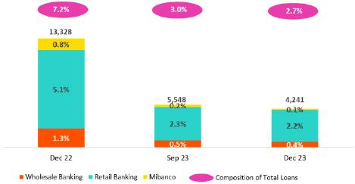

Analysis of 4Q23 Consolidated Results

YTD, loans in average daily balances rose 4.1%. Growth was driven mainly by Retail Banking and reflected the same dynamics as those in play YoY. At Mibanco, YTD loan growth was primarily attributable to a significant uptick in lending in 2Q23 following a difficult 1Q23, which was marked by social protests and climate anomalies. The focus in subsequent quarters was on lending to clients with better risk profiles.

Government Program Loans (GP) in average daily balances (GP) fell 9.8% QoQ and 6.4% YoY, which was mainly attributable to an uptick in amortizations at BCP and Mibanco. GP loans represent 2.7% of total loans in average daily balances (vs 3.0% in Sept 23 and 7.2% in December 22).

Datos elaborados por BCP para uso Interno | 18

 |  | | Earning Release 4Q / 2023 |  |  |  |  |  |  |  |  |  | Analysis of 4Q23 Consolidated Results
01. Loan Portfolio
 |  |  |  | Total Loans (in Average Daily Balances) ⁽¹⁾⁽²⁾
Total Loans |  | As of |  | Year |  |  |  | Volume Change |  |  |  | % Change |  |  | % Part. in total loans
(S/ millions) |  | As of |  |  |  |  |  |  |  |  |  | % Change
(S/ millions) | Dec 22 | Sep 23 | Dec 23 | 2022 | 2023 |  | QoQ |  | YoY | FY | QoQ | YoY | FY | Dec 22 | Sep 23 | Dec 23 | 2022 | 2023
BCP Stand-alone | 121,963 | 115,851 | 115,997 | 120,364 | 116,582 |  | 145 | -5,966 |  | -3,782 | 0.1% | -4.9% | -3.1% | 82.1% | 81.5% | 81.5% | 82.2% | 81.6%
Wholesale Banking | 57,497 | 52,796 | 52,469 | 56,441 | 53,338 |  | -328 | -5,028 |  | -3,103 | -0.6% | -8.7% | -5.5% | 38.7% | 37.1% | 36.9% | 38.5% | 37.3%
Corporate | 33,617 | 31,134 | 30,554 | 32,648 | 31,625 |  | -580 | -3,062 |  | -1,023 | -1.9% | -9.1% | -3.1% | 22.6% | 21.9% | 21.5% | 22.3% | 22.1%
Middle - Market | 23,881 | 21,662 | 21,914 | 23,793 | 21,713 |  | 252 |  | -1,966 | -2,080 | 1.2% | -8.2% | -8.7% | 16.1% | 15.2% | 15.4% | 16.2% | 15.2%
Retail Banking | 64,465 | 63,055 | 63,528 | 63,923 | 63,244 |  | 473 |  | -938 | -679 | 0.7% | -1.5% | -1.1% | 43.4% | 44.3% | 44.7% | 43.6% | 44.3%
SME - Business | 8,583 | 7,292 | 7,168 | 9,135 | 7,441 |  | -124 |  | -1,415 | -1,694 | -1.7% | -16.5% | -18.5% | 5.8% | 5.1% | 5.0% | 6.2% | 5.2%
SME - Pyme | 17,947 | 16,549 | 16,744 | 18,705 | 16,696 |  | 195 |  | -1,203 | -2,009 | 1.2% | -6.7% | -10.7% | 12.1% | 11.6% | 11.8% | 12.8% | 11.7%
Mortgage | 20,073 | 20,712 | 21,061 | 19,484 | 20,626 |  | 349 |  | 989 | 1,142 | 1.7% | 4.9% | 5.9% | 13.5% | 14.6% | 14.8% | 13.3% | 14.4%
Consumer | 12,738 | 12,654 | 12,604 | 12,000 | 12,753 |  | -50 |  | -134 | 753 | -0.4% | -1.0% | 6.3% | 8.6% | 8.9% | 8.9% | 8.2% | 8.9%
Credit Card | 5,126 | 5,848 | 5,951 | 4,599 | 5,728 |  | 102 |  | 825 | 1,129 | 1.7% | 16.1% | 24.5% | 3.5% | 4.1% | 4.2% | 3.1% | 4.0%
Mibanco | 14,261 | 14,121 | 13,665 | 14,075 | 14,029 |  | -456 |  | -596 | -46 | -3.2% | -4.2% | -0.3% | 9.6% | 9.9% | 9.6% | 9.6% | 9.8%
Mibanco Colombia | 1,174 | 1,557 | 1,667 | 1,142 | 1,454 |  | 110 | 493 |  | 312 | 7.0% | 41.9% | 27.3% | 0.8% | 1.1% | 1.2% | 0.8% | 1.0%
Bolivia | 9,034 | 8,957 | 9,186 | 8,813 | 8,982 |  | 229 | 152 |  | 170 | 2.6% | 1.7% | 1.9% | 6.1% | 6.3% | 6.5% | 6.0% | 6.3%
ASB | 2,039 | 1,733 | 1,749 | 2,056 | 1,818 |  | 16 | -290 |  | -239 | 0.9% | -14.2% | -11.6% | 1.4% | 1.2% | 1.2% | 1.4% | 1.3%
BAP’s total loans | 148,471 | 142,219 | 142,263 | 146,449 | 142,864 |  | 44 | -6,208 |  | -3,585 | 0.0% | -4.2% | -2.4% | 100.0% | 100.0% | 100.0% | 100.0% | 100.0%

For consolidation purposes. Loans generated in Foreign Currency (FC) are converted into Local Currency (LC).
- Includes Workout unit and other banking. For Quarter-end balance figures, please refer to “12. Annexes – 12.2 Loan Portfolio Quality”.
- Internal Management Figures

Total loans rose QoQ by fell YoY and YTD, after growth in structural loans was insufficient to offset the drop in GP loans.

Evolution of Loan Dollarization (in Average Daily Balances) ⁽¹⁾⁽²⁾


 | Total Loans |  |  | Local Currency (LC) |  |  |  | % change |  | % change |  | Foreign Currency (FC) |  |  | % change |  | % part. by currency
 | (S/ millions) |  | Total |  |  | Structural |  |  |  | Structural |  |  | Total |  |  |  | Sep 23
 | Back to index | Dec 22 | Sep 23 | Dec 23 | Dec 22 | Sep 23 | Dec 23 | QoQ | YoY | QoQ | YoY | Dec 22 | Sep 23 | Dec 23 | QoQ | YoY | LC | FC
 | BCP Stand-alone | 85,106 | 79,896 | 79,423 | 75,709 | 75,902 | 76,070 | -0.6% | -6.7% | 0.2% | 0.5% | 9,490 | 9,722 | 9,725 | 0.0% | 2.5% | 69.6% | 30.4%
 | Wholesale Banking | 28,351 | 24,341 | 23,452 | 26,475 | 23,634 | 22,863 | -3.7% | -17.3% | -3.3% | -13.6% | 7,505 | 7,695 | 7,716 | 0.3% | 2.8% | 47.3% | 52.7%
 | Corporate | 16,044 | 14,592 | 14,017 | 15,827 | 14,494 | 13,935 | -3.9% | -12.6% | -3.9% | -12.0% | 4,525 | 4,475 | 4,397 | -1.7% | -2.8% | 47.6% | 52.4%
 | Middle-Market | 12,307 | 9,748 | 9,434 | 10,648 | 9,141 | 8,927 | -3.2% | -23.3% | -2.3% | -16.2% | 2,980 | 3,220 | 3,318 | 3.1% | 11.4% | 47.0% | 53.0%
 | Retail Banking | 56,755 | 55,555 | 55,972 | 49,233 | 52,267 | 53,208 | 0.7% | -1.4% | 1.8% | 8.1% | 1,985 | 2,028 | 2,009 | -0.9% | 1.2% | 88.3% | 11.7%
 | SME - Business | 5,530 | 4,302 | 4,242 | 2,775 | 3,183 | 3,320 | -1.4% | -23.3% | 4.3% | 19.6% | 786 | 809 | 778 | -3.8% | -1.0% | 60.5% | 39.5%
 | SME - Pyme | 17,779 | 16,378 | 16,589 | 13,013 | 14,209 | 14,747 | 1.3% | -6.7% | 3.8% | 13.3% | 43 | 46 | 41 | -10.6% | -4.3% | 99.0% | 1.0%
 | Mortgage | 18,005 | 18,768 | 19,095 | 18,005 | 18,768 | 19,095 | 1.7% | 6.0% | 1.7% | 6.0% | 532 | 526 | 523 | -0.5% | -1.7% | 90.4% | 9.6%
 | Consumer | 11,192 | 11,210 | 11,075 | 11,192 | 11,210 | 11,075 | -1.2% | -1.0% | -1.2% | -1.0% | 398 | 390 | 407 | 4.1% | 2.2% | 89.2% | 10.8%
 | Credit Card | 4,249 | 4,898 | 4,971 | 4,249 | 4,898 | 4,971 | 1.5% | 17.0% | 1.5% | 17.0% | 226 | 257 | 260 | 1.3% | 15.3% | 84.3% | 15.7%
 | Mibanco | 13,784 | 13,633 | 13,181 | 12,644 | 13,153 | 12,618 | -3.3% | -4.4% | -4.1% | -0.2% | 123 | 132 | 129 | -2.6% | 4.7% | 96.6% | 3.4%
 | Mibanco Colombia | - | - | - | - | - | - | - | - | - | - | 303 | 421 | 443 | 5.3% | 46.6% | - | 100.0%
 | Bolivia | - | - | - | - | - | - | - | - | - | - | 2,326 | 2,422 | 2,443 | 0.9% | 5.0% | - | 100.0%
 | ASB | - | - | - | - | - | - | - | - | - | - | 525 | 469 | 465 | -0.8% | -11.4% | - | 100.0%
 | Total loans | 98,890 | 93,529 | 92,604 | 88,353 | 89,055 | 88,689 | -1.0% | -6.4% | -0.4% | 0.4% | 12,766 | 13,166 | 13,204 | 0.3% | 3.4% | 66.4% | 33.6%
For consolidation purposes. Loans generated in Foreign Currency (FC) are converted into Local Currency (LC).
- Includes Workout unit and other banking. For Quarter-end balance figures, please refer to “12. Annexes – 12.2 Loan Portfolio Quality”.
- Internal Management Figures

At the end of December 2023, the dollarization level of structural loans rose 55 bps QoQ (35.9% in Dec 23). This result was driven mainly by loan growth via Middle Market Banking, which was attributable to the same dynamics as those seen QoQ.

YoY, the dollarization level of the structural portfolio fell 5bps, spurred by growth in Retail Banking products, where disbursements are generally made in soles, and by a reduction in loans via Wholesale Banking, whose disbursements are typically in US Dollars. The decline in Wholesale loans was attributable to a drop in the demand for loans in a context marked by les private investment.

Datos elaborados por BCP para uso Interno | 19

| Earning Release 4Q / 2023 Analysis of 4Q23 Consolidated Results

01. Loan Portfolio

Evolution of the Dollarization Level of Structural Loans (in Average Daily Balances)
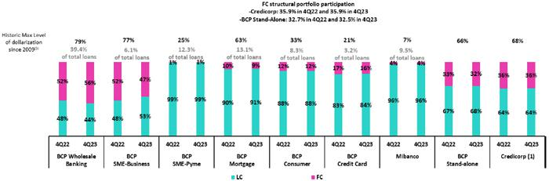

- The FC share of Credicorp’s loan portfolio is calculated including BCP Bolivia and ASB Bank Corp., however the chart shows only the loan books of BCP Stand-alone and Mibanco.

- The year with the historic maximum level of dollarization for Wholesale Banking was 2012, for Mibanco was 2016, for Credit Card was in 2021 and for the rest of segments was 2009. * For dollarization figures in the quarter-end period, please refer to “12. Annexes – 12.2 Loan Portfolio Quality

Evolution of Loans in Quarter-end Balances

Structural loans rose 0.3% in quarter-end balances, driven by the same factors as those seen in the analysis of loans in average daily balances. If we incorporate the contraction in the PG portfolio in the analysis, total loans decreased 0.1% QoQ, given that amortizations in government programs were not offset by the growth in structural loans.

In the YoY evolution, structural loans rose 1.6% and total loans fell 2.5%, respectively, due to amortizations in government programs.

1.2. Portfolio Quality

Quality of the Structural Portfolio (In Quarter-end Balances)


 | Structural Portfolio quality and Delinquency ratios |  | As of |  |  | % change
 | S/000 |  | As of |  |  | % change
 | S/000 | Dec 22 | Sep 23 | Dec 23 | QoQ | YoY
 | Back to index
 | Structural loans (Quarter-end balance) | 139,115,242 | 140,949,490 | 141,380,548 | 0.3% | 1.6%
 | Structural Allowance for loan losses | 7,733,575 | 7,941,933 | 8,158,704 | 2.7% | 5.5%
 | Structural Write-offs | 754,326 | 1,018,084 | 879,401 | -13.6% | 16.6%
 | Structural IOLs | 4,791,245 | 5,578,985 | 5,560,513 | -0.3% | 16.1%
 | Structural Refinanced loans | 2,098,748 | 2,253,098 | 2,406,058 | 6.8% | 14.6%
 | Structural NPLs | 6,889,993 | 7,832,083 | 7,966,571 | 1.7% | 15.6%
 | Structural IOL ratio | 3.4% | 4.0% | 3.9% | -3 bps | 49 bps
 | Structural NPL ratio | 5.0% | 5.6% | 5.6% | 7 bps | 68 bps
 | Structural Allowance for loan losses over Structural loans | 5.6% | 5.6% | 5.8% | 14 bps | 21 bps
 | Structural Coverage ratio of NPLs | 112.2% | 101.4% | 102.4% | 101 bps | -983 bps

(1) The Structural Portfolio excludes Government Programs (GP) effects.

In 4Q23, Structural Non-Performing Loans (NPL) registered slight growth of 1.7% QoQ. This evolution was primarily driven by SME-Pyme, which registered further deterioration of old vintages. Throughout the year, payment capacity of clients in Personal Banking was impacted by a recessive environment, which led to growth in delinquency that was concentrated primarily in tranches for loans overdue more than 120 days in Consumer and Credit Cards.

YoY, Structural NPLs rose 15.6%, driven by the same factores seen in the QoQ evolution; a deterioration in loans with higher tickets at Mibanco; as well as newly delinquent loans and refinancing for some clients in Wholesale Banking.

Datos elaborados por BCP para uso Interno | 20

| Earning Release 4Q / 2023 Analysis of 4Q23 Consolidated Results

01. Loan Portfolio

Structural NPL Ratio
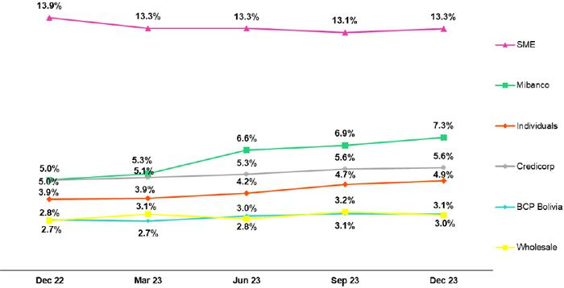

In the QoQ analysis, the Structural NPL volume increased due to a deterioration in client payment capacity in an adverse macroeconomic scenario. The segments that contributed to this uptick were:

- SME-Pyme, which continued to register deterioration in vintages prior to adjustments in credit guidelines; this deterioration was concentrated in profiles with higher risk. For loans disbursed after adjustments were made, indicators of early delinquency began to improve in the last few months of the year.

- Consumer and Credit Cards, where growth in NPLs was concentrated in tranches for loans overdue more than 120 days.
- Mibanco, where delinquency was concentrated in loans with higher tickets. This quarter, credit guidelines were further tightened.

The aforementioned was partially offset by payments of overdue loans and recovery of judicial loans, both associated with corporate clients in Wholesale Banking.

YoY, growth in the NPL volume was driven by:

- SME-Pyme, driven by the same factors as those seen QoQ, where delinquency was concentrated in clients with smaller tickets (< a S/90 mil) and higher risk.

- Individuals:
  - Consumer and Credit Cards, due to the same dynamics as those seen QoQ.
  - Mortgage, attributable to the growth in refinanced loans disbursed in 3Q23 that had benefitted from loan reprogramming during the pandemic.

- Wholesale Banking, due to growth in overdue loans and an uptick in refinancing throughout the year for clients in the commercial real estate and tourism sectors, both of which were severely impacted by the pandemic and continued to experience distress due to an adverse marcoeconomic context. It is important to note that these loans are backed by extensive guarantees (collateral) and were previously provisioned.

- Mibanco, due to the same dynamics seen QoQ and impacted by a recessive environment and the consequent impact on payment capacities.

In the aforementioned context, the Structural NPL ratio rose 7 bps QoQ and 68 bps YoY to stand at 5.6%.

Datos elaborados por BCP para uso Interno | 21

| Earning Release 4Q / 2023

01. Loan Portfolio

Write-offfs in the Structural Loan Portfolio

(in Quarter-end balances– S/ millions)
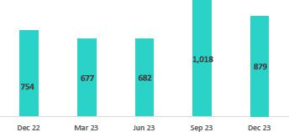

Coverage Ratio of Structural NPL Loans
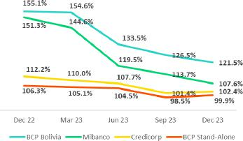

NPL Loans in the Government Loan Portfolio (in Quarter-end balances– S/ millions)
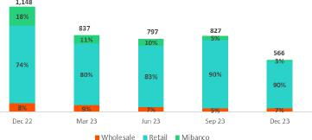

Analysis of 4Q23 Consolidated Results

QoQ, write-offs of structural loans remained at high levels but nonetheless fell 13.6%. This reflects the fact that a higher number of write-offs were reported last quarter in the SME-Pyme, Consumer and Credit Card segments as well as at Mibanco.

YTD, growth in write-offs of structural loans (+16.6%) was driven by Credit Cards, Consumer and SME-Pyme. This increase corresponds to write-offs of loans from the highest-risk segments.

QoQ, the Coverage Ratio for NPL loans rose 101 bps. This evolution was driven primarily by provisions set aside for the El Niño Phenomenon.

YoY, the Coverage Ratio for NPL loans fell 9.83 pp, driven primarily by Wholesale Banking, where the structural NPL volume rose significantly over the year due to an uptick in refinanced and overdue loans. Nevertheless, these loans did not trigger higher provisions because they are backed by collateral whose value far exceeds the borrower’s total debt.

QoQ, NPLs in the Government Loan portfolio (GP) dropped due to an increase in the execution of loan honoring processes for Reactiva loans, mainly in SME-Pyme. These loans are backed by State guarantees. To execute payment processes, loans must be more than 90 days past due. Average guarantees stand at 84%, 91% and 97% for Wholesale Banking, Retail Banking and Mibanco respectively. At the end of December 2023, a total S/ 1,769 million was collected through honoring processes to execute State guarantees.

Datos elaborados por BCP para uso Interno | 22

| | Earning Release 4Q / 2023 |  |  | Analysis of 4Q23 Consolidated Results
01. Loan Portfolio
 | Total Portfolio Quality (in Quarter-end Balances)
Loan Portfolio quality and Delinquency ratios |  |  | As of |  |  | % change
S/ 000 |  | Dec 22 | Sep 23 | Dec 23 | QoQ | YoY
Total loans (Quarter-end balance) |  | 148,626,374 | 145,129,260 | 144,976,051 | -0.1% | -2.5%
Allowance for loan losses |  | 7,872,402 | 8,056,216 | 8,277,916 | 2.8% | 5.2%
Write-offs |  | 754,326 | 1,018,084 | 879,401 | -13.6% | 16.6%
Internal overdue loans (IOLs) ⁽¹⁾⁽²⁾ |  | 5,939,744 | 6,406,345 | 6,126,487 | -4.4% | 3.1%
Internal overdue loans over 90-days ⁽¹⁾ |  | 4,620,461 | 5,133,832 | 5,018,489 | -2.2% | 8.6%
Refinanced Loans ⁽²⁾ |  | 2,098,748 | 2,253,098 | 2,406,058 | 6.8% | 14.6%
Non-performing loans (NPLs) ⁽³⁾ |  | 8,038,492 | 8,659,443 | 8,532,545 | -1.5% | 6.1%
IOL ratio |  | 4.0% | 4.4% | 4.2% | -18 bps | 23 bps
IOL over 90-days ratio |  | 3.1% | 3.5% | 3.5% | -8 bps | 35 bps
NPL ratio |  | 5.4% | 6.0% | 5.9% | -8 bps | 48 bps
Allowance for loan losses over Total loans |  | 5.3% | 5.6% | 5.7% | 16 bps | 41 bps
Coverage ratio of IOLs |  | 132.5% | 125.8% | 135.1% | 937 pbs | 258 bps
Coverage ratio of IOL 90-days |  | 170.4% | 156.9% | 164.9% | 803 pbs | -543 pbs
Coverage ratio of NPLs |  | 97.9% | 93.0% | 97.0% | 399 bps | -91 bps

- Includes Overdue Loans and Loans under legal collection (Quarter-end balances net of deferred earnings).

- Figures net of deferred earnings.
- Non-performing Loans include Internal Overdue Loans and Refinanced Loans (Quarter-end balances net of deferred earnings)

In the aforementioned context, Credicorp’s NPL ratio fell 8 bps QoQ but rose 48 bps to stand at 5.9% at the end of 4Q23. Coverage for NPLs stood at 97.0%. This represented an uptick of 399 bps QoQ and was in line with growth in the balance for provisions and in execution of Reactiva honoring processes. YoY, the NPL ratio dropped 91 bps, which reflected an increase in the NPL volume.

Datos elaborados por BCP para uso Interno | 23

| Earnings Release 4Q / 2023 Analysis of 4Q23 Consolidated Results

02 Deposits


QoQ, our deposit base contracted 0.5% (+0.6%, FX neutral). This evolution was driven by 6.9% growth (+8.2%, FX neutral) in Demand Deposits and 6.0% (+7.0%, FX neutral) in Savings Deposits; this was partially offset by a reduction in Time Deposits (- 12.6%).

YoY, the balance for low-cost deposits fell 2.5%, which represented a less significant decline that that seen systemwide. This evolution was driven by a reduction in balances for Savings and Demand Deposits at BCP and Mibanco, which reflected on-going fund migration mainly by wholesale and retail clients to higher-yield deposits.

68.1% of our deposit base was low-cost (Demand + Savings). In this scenario, Credicorp continued to lead the market for low-cost deposits with a share of 41.6% at the end of December 2023, which represents a competitive advantage in a context of high interest rates.

Deposits |  | As of |  |  | % change |  | Currency
S/ 000 | Dec 22 | Sep 23 | Dec 23 | QoQ | YoY | LC | FC
Demand deposits | 48,467,247 | 45,120,127 | 48,229,322 | 6.9% | -0.5% | 46.4% | 53.6%
Saving deposits | 54,769,045 | 49,395,543 | 52,375,813 | 6.0% | -4.4% | 57.8% | 42.2%
Time deposits | 38,897,010 | 49,213,763 | 42,484,664 | -13.7% | 9.2% | 46.5% | 53.5%
Severance indemnity deposits | 3,824,629 | 3,245,358 | 3,185,603 | -1.8% | -16.7% | 72.1% | 27.9%
Interest payable | 1,062,856 | 1,496,744 | 1,429,592 | -4.5% | 34.5% | 50.9% | 49.1%
Total Deposits | 147,020,787 | 148,471,535 | 147,704,994 | -0.5% | 0.5% | 50.9% | 49.1%

Our Total Deposit balance fell 0.5% QoQ. Notwithstanding, if we maintain a neutral Exchange rate, the increase stands at 0.6%. Growth in total deposits was driven by:

- Growth of 6.9% in the balance of Demand Deposits (+8.2%, neutral exchange rate). This uptick was attributable to an increase in FC and LC balances for deposits held by corporate and institutional clients at BCP, which was impacted by expirations of renumerated deposits.

- Increase of 6.0% in Savings Deposits (+7.0%, exchange rate neutral). This growth was driven by an increase in deposit balances in both currencies at BCP, which were bolstered by inflow from year-end and statutory bonuses.

The aforementioned was partially offset by:

- A 13.7% reduction in the balance of Time Deposits (-12.6%, neutral exchange rate), which was driven primarily by expirations of deposits held by corporate and institutional clients at BCP. These funds subsequently migrated to deposits with lower interest. It is important to note that this decline occurred after various months of on-going increases in the balance and reversed the trend toward recording higher balances for higher-yield deposits.

YoY, the Total Deposit balance increased 0.5% (+1.9% neutral exchange rate). The following dynamics stood out:

- 9.2% growth (+10.9% neutral exchange rate) in the Time Deposit balance, which was driven primarily by Wholesale and Retail clients at BCP, who transferred funds to high-yield deposits in FC. This dynamic also fueled, albeit to a lesser extent, fund migration at Mibanco and BCP Bolivia as clients sought out higher interest.

The aforementioned was partially offset by:

- A 4.4% reduction in the balance for Savings Deposits (-3.2%, neutral exchange rate) in FC, primarily at BCP and secondarily at Mibanco and BCP Bolivia. This decline was primarily fueled by internal migration of funds to deposits that bear lower interest rates. It is important to note that this decline in the balance of BCP is smaller compared to the generalized decline registered system-wide.

- A 16.7% reduction in Severance Indemnity (CTS) (-16.0%, neutral exchange rate), which reflects client fund withdrawals to cover liquidity needs and fund migration to higher-yield deposits in both LC and FC in a context of higher interest rates.

Datos elaborados por BCP para uso Interno | 24

| Earnings Release 4Q / 2023 Analysis of 4Q23 Consolidated Results

02. Deposits

Low-cost deposit volumes (Demand + Savings) rose 6.4% QoQ but fell 2.5% YoY. It is important to note that we have managed to recover a significant proportion of our total deposits being low-cost, representing 68.1% (+445 bps QoQ), which reflects prudent management of our mix and a solid capacity to obtain favorable financial margins.

Dollarization level of Deposits

Deposits by Currency
(measured in quarter-end balances) | At the end of December 2023, the level of dollarization of Total Deposits
 | increased 20 bps QoQ, standing at 49.1%, which fell below the average
 | registered for the past 2 years (50.0%). This increase was primarily driven
 | by Time Deposits, where the drop in the balance of LC deposits outpaced
 | the reduction registered for FC deposits due to expirations of corporate
 | and institutional deposits. Demand Deposits, in turn, registered a larger
 | increase in the balance of LC deposits versus FC deposits.
 | YoY, dollarization dropped 70 bps due to a drop in Savings Deposits
 | (-9.6%) and Time Deposits (-3.3%), both in FC. Both of these variations
 | were driven primarily by fund migration to higher-yield deposits. Growth in
 | balances for Demand Deposits (+2.96%) and Time Deposits (+5.1%) in
 | LC contributed to this dynamic.
 | Deposits by Currency and Type
 | (measured in quarter-end balances)
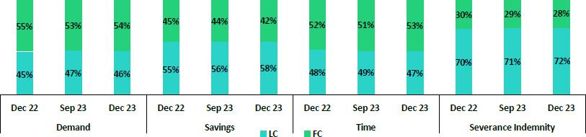
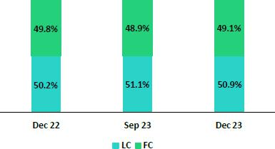

Loan / Deposit Ratio (L/D Ratio)

The L/D ratio dropped 30 bps and 240 bps QoQ in BCP and Mibanco respectively. The decrease at BCP and Mibanco was driven by a drop in total loan volumes attributable to cancellations of GP loans. In this scenario, BAP’s L/D ratio stood at 98.2%.
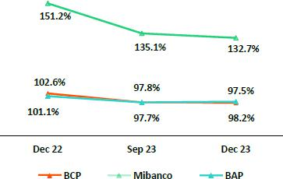

Datos elaborados por BCP para uso Interno | 25

| Earnings Release 4Q / 2023 Analysis of 4Q23 Consolidated Results

02. Deposits

L/D Ratio Local Currency L/D Ratio Foreign Currency
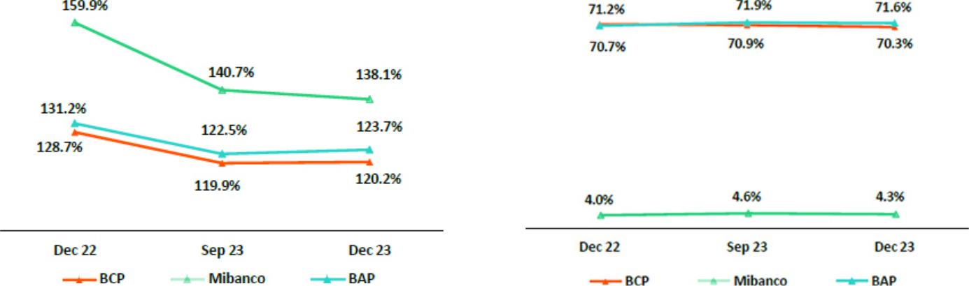

Market Share of Deposits in the Peruvian Financial System
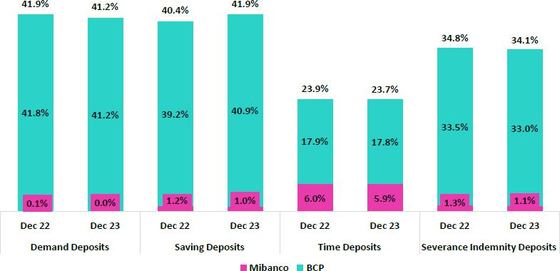

At the end of December 2023, the MS of Total Deposits held by BCP and Mibanco in Peru respectively was 32.0% and 2.6% (-39 bps and -5 bps with regard to September 2023. Additionally, BCP continues to lead the market.

Low-cost deposits increased systemwide (+5.7% with regard to September 2023). BCP experienced growth (+8.0%) above the system average and It continues to lead the market in low-cost deposits with a market share of 41.1% as of December 2023 (+88 bps compared to September 2023). Time Deposit balances at BCP registered a more significant decline (-20.3% versus Sept 23) than that reported by the system (-4.5% versus Sept 23). Consequently BCP’s market share (MS) fell 353 bps QoQ to stand at 17.8% in December 2023.

In turn, Credicorp's low-cost deposits MS stood at 41.6% (+86 bps compared to September 2023).

Datos elaborados por BCP para uso Interno | 26

| Earnings Release 4Q / 2023 Analysis of 4Q23 Consolidated Results

03 Interest-earning Assets (IEA) and Funding


At the end of 4Q23, IEAs registered slight growth (+0.7%), which was driven primarily by an uptick in Investment balances after the Group increased its positions in Sovereign Bonds to take advantage of attractive rates. Available funds also rose after surpluses were capitalized through short-term deposits. YoY, IEAs grew 1.0%, which reflected an increase in positions in government securities. This Dynamic was partially offset by a drop in the balance for total loans, and secondarily by a decrease in the balance for Cash and due from banks.

Funding fell slightly QoQ (-0.5%) and YoY (-0.6%), which was attributable to a drop in funding with Repos. This dynamic was partially offset by move to increase Due to banks to cover short-term funding needs.

3.1. IEA¹


Interest Earning Assets |  | As of |  | % change
S/000 | Dec 22 | Sep 23 | Dec 23 | QoQ | YoY
Cash and due from banks | 26,897,216 | 24,907,836 | 25,734,256 | 3.3% | -4.3%
Total investments | 45,431,224 | 51,116,913 | 52,215,528 | 2.1% | 14.9%
Cash collateral, reverse repurchase agreements and securities borrowing | 1,101,856 | 1,513,622 | 1,410,647 | -6.8% | 28.0%
Total loans | 148,626,374 | 145,129,260 | 144,976,051 | -0.1% | -2.5%
Total interest earning assets | 222,056,670 | 222,667,631 | 224,336,482 | 0.7% | 1.0%
(1) Effective 1Q23, IEAs does not include “Financial assets designated at Fair Value through P&L” (mainly comprised of Investment Link contracts) as one of its components.

QoQ, the IEA balance rose 0.7%. This evolution was primarily attributable to an increase in Total Investments is government securities. Available funds also registered growth, which was attributable to a decision to capitalize surpluses through short-term BCRP deposits. The aforementioned was offset by a drop in the balance for Total loans. As was the case last quarter, growth in the Investment balance (+2.1%) was attributable to a strategy to capitalize surpluses. The position in sovereign bonds had an additional increase, as was the case in previous quarters. On the other hand, the position in BCRP certificates of deposit decreased.

YoY, IEA increased 1.0%. This growth was driven by an increase in positions in government securities. This was partially offset by a drop in the loan balance, which was impacted by Government Programs (GP) amortization and a complex macroeconomic juncture, and secondarily, by a reduction in the balance of Cash and due from banks.

3.2. Funding¹


Funding |  | As of |  | % change
S/000 | Dec 22 | Sep 23 | Dec 23 | QoQ | YoY
Deposits and obligations | 147,020,787 | 148,471,535 | 147,704,994 | -0.5% | 0.5%
Due to banks and correspondents | 8,937,411 | 10,493,411 | 12,278,681 | 17.0% | 37.4%
BCRP instruments | 11,297,659 | 9,616,150 | 7,461,674 | -22.4% | -34.0%
Repurchase agreements with clients and third parties | 1,669,066 | 2,121,870 | 2,706,753 | 27.6% | 62.2%
Bonds and notes issued | 17,007,194 | 14,914,632 | 14,594,785 | -2.1% | -14.2%
Total funding | 185,932,117 | 185,617,598 | 184,746,887 | -0.5% | -0.6%
(1) Effective 1Q23, Funding includes Repurchase agreements with clients.

QoQ, funding fell 0.5% due to a decline in the balance of BCRP instruments, which was driven primarily by a decrease in the appetite for funding through Repos in a context of relatively unattractive rates and secondarily, by expirations of the remaining balance of Repos for GP. A decline in deposits, which was attributable to the expiration of term deposits from corporate and institutional clients, also contributed to the decrease in funding, albeit to a lesser extent. Both of these dynamics were partially offset by an increase in Due to banks and correspondents, which were taken to cover funding needs prior to a bond issuance in January 2024.

YoY, funding fell 0.6% due to reduction in BCRP instruments, which was driven by the same dynamics as those seen QoQ. Additionally, the balance for Bonds and Issued Notes fell due to expirations of corporate bonds at BCP.

Datos elaborados por BCP para uso Interno | 27

| Earnings Release 4Q / 2023 Analysis of 4Q23 Consolidated Results

04 Net Interest Income (NII)


In 4Q23, Net Interest Income (NII) rose 2.9% QoQ, driven primarily by an uptick in interest income on loans. This evolution reflected growth in structural retail loans, partially offset by a drop in wholesale banking. Low-cost Deposits registered an uptick in the balance while the balance for Time Deposits fell; these variations led interest expenses to decline. These balance sheet dynamics, in a local context of dropping interest rates, led the IEA yield to remain relatively stable while the funding cost fell.

YoY, NII increased 6.6%, due to a pickup in interest income, driven by the same dynamics of the loan mix as QoQ, and despite an uptick in interest expenses due to growth in the balance for Time deposits. YTD, NII grew 16.6%, fueled by an increase in interest income, which outpaced the increase in interest expenses.

In this context, NIM rose 10 bps QoQ and 46 bps YoY to stand at 6.21%. On a full-year basis, NIM increased 92 bps up to 6.01%. Risk-adjusted NIM dropped 35 bps QoQ and in YoY terms to stand at 4.10%, which reflects the impact of the provisions set aside for the El Nino Phenomenon. Risk-adjusted NIM for the full year was 9 bps above the previous year’s figures and stood at 4.38%.


Net Interest Income / Margin |  | Quarter |  | % change |  | As of |  | % change
S/ 000 | 4Q22 | 3Q23 | 4Q23 | QoQ | YoY | 2022 | 2023 | 2023 / 2022
Interest Income | 4,362,139 | 4,819,101 | 4,870,042 | 1.1% | 11.6% | 15,011,282 | 18,798,495 | 25.2%
Interest Expense | (1,221,735) | (1,565,058) | (1,522,358) | -2.7% | 24.6% | (3,919,664) | (5,860,523) | 49.5%
Interest Expense (excluding Net Insurance Financial Expenses) | (1,118,966) | (1,448,593) | (1,402,925) | -3.2% | 25.4% | (3,493,187) | (5,393,709) | 54.4%
Net Insurance Financial Expenses | (102,769) | (116,465) | (119,433) | 2.5% | 16.2% | (426,477) | (466,814) | 9.5%
Net Interest Income | 3,140,404 | 3,254,043 | 3,347,684 | 2.9% | 6.6% | 11,091,618 | 12,937,972 | 16.6%
Balances
Average Interest Earning Assets (IEA) | 225,604,596 | 220,724,334 | 223,502,057 | 1% | -1% | 226,384,489 | 223,196,576 | -1.4%
Average Funding | 190,660,720 | 183,805,091 | 185,182,243 | 1% | -3% | 191,289,310 | 185,339,502 | -3.1%
Yields
Yield on IEAs | 7.73% | 8.73% | 8.72% | -1bps | 99bps | 6.6% | 8.4% | 179bps
Cost of Funds | 2.35% | 3.15% | 3.03% | -12bps | 68bps | 1.8% | 2.9% | 108bps
Net Interest Margin (NIM)⁽¹⁾ | 5.75% | 6.11% | 6.21% | 10bps | 46bps | 5.1% | 6.0% | 92bps
Risk-Adjusted Net Interest Margin | 4.45% | 4.45% | 4.10% | -35bps | -35bps | 4.3% | 4.4% | 9bps
Peru's Reference Rate | 7.50% | 7.50% | 6.75% | -75bps | -75bps | 7.50% | 6.75% | -75bps
FED funds rate | 4.50% | 5.50% | 5.50% | 0bps | 100bps | 4.50% | 5.50% | 100bps
(1) For further detail on the new NIM calculation due to IFRS17, please refer to Annex 12.1.8

QoQ, Net Interest Income (NII) reported growth of 2.9%. This evolution was primarily attributable to an uptick in financial income, which was primarily driven by an increase in income from loans. The positive contribution of loans was due to a decrease in the weight of wholesale loans within the total portfolio versus an increase in the share of retail loans, which was primarily driven by growth in SME-Pyme loans. Investments were the secondary driver of the improvement in NII. Interest expenses, in turn, dropped 2.7% this quarter, spurred by recovery in the balance of Low-cost deposits and the expiration of other more costly sources of funding such as Time Deposits. Despite a context of dropping interest rates, the aforementioned income and expense dynamics led the IEA yield to remain relatively stable (-1 pbs) while the cost of funding fell 12 bps.

YoY, NII rose 6.6% despite the fact that growth in expenses outpaced the expansion registered for income. In the case of income, growth was driven by an increase in income from loans, which reflected an uptick in retail loans’ weight within the mix. It is important to note that YoY, both SME-Pyme and Credit Cards increased their share in the loan portfolio. An increase in positions in securities within Investments also contributed to growth in income, although to a lesser extent. Expenses rose 24.6% YoY. This evolution was fueled primarily by growth in the balance of time deposits, which had been placed at high interest rates, and to a lesser extent by an increase in the balance of Due to banks and correspondents.

YTD, NII rose 16.6%, which reflected growth in income from loans. This evolution was partially offset primarily by higher expenses for deposits and secondarily by growth in Due to banks.

Datos elaborados por BCP para uso Interno | 28

| Earnings Release 4Q / 2023 Analysis of 4Q23 Consolidated Results

04. Net Interest Income (NII)

Net Interest Margin

NIM increased 10 bps QoQ and reported an uptick in the pace of growth compared to the previous quarter. This evolution was driven by a reduction in interest expenses due to a recovery in the balance of Low-cost deposits. Risk-adjusted NIM dropped 35 bps over the same period and stood at 4.10%, impacted by provisions set aside for FEN, which reduced this line by 45 bps in 4Q23. YTD, the dynamics of the balance led NIM to increase to 6.01% in 2023, which represented a 92 bps increase over the figure in 2022, while risk-adjusted NIM stood at 4.38%, 9 bps above last year’s figure.
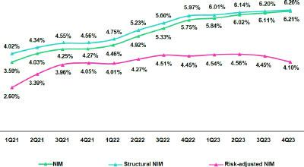

Net Interest Margin Dynamics by Currency

Interest Income / IEA |  | 4Q22 |  |  | 3Q23 |  |  | 4Q23
S/ millions | Average |  |  | Average |  |  | Average
 | Balance | Income | Yields | Balance | Income | Yields | Balance | Income | Yields
Cash and equivalents | 28,114 | 238 | 3.4% | 25,472 | 290 | 4.6% | 25,321 | 279 | 4.4%
Other IEA | 1,344 | 45 | 13.4% | 1,688 | 24 | 5.7% | 1,462 | 28 | 7.5%
Investments | 46,137 | 564 | 4.9% | 49,576 | 652 | 5.3% | 51,666 | 655 | 5.1%
Loans | 150,009 | 3,515 | 9.4% | 143,987 | 3,853 | 10.7% | 145,053 | 3,908 | 10.8%
Structural | 139,153 | 3,459 | 9.9% | 139,427 | 3,822 | 11.0% | 141,165 | 3,862 | 10.9%
Government Programs | 10,856 | 56 | 2.1% | 4,560 | 31 | 2.7% | 3,888 | 45 | 4.7%
Total IEA | 225,605 | 4,362 | 7.7% | 220,724 | 4,819 | 8.7% | 223,502 | 4,870 | 8.7%
IEA (LC) | 56.6% | 73.1% | 10.0% | 57.7% | 71.3% | 10.8% | 57.6% | 70.5% | 10.7%
IEA (FC) | 43.4% | 26.9% | 4.8% | 42.3% | 28.7% | 5.9% | 42.4% | 29.5% | 6.1%
Interest Expense / Funding |  | 4Q22 |  |  | 3Q23 |  |  | 4Q23
S/ millions | Average |  |  | Average |  |  | Average
 | Balance | Expense | Yields | Balance | Expense | Yields | Balance | Expense | Yields
Deposits | 149,906 | 582 | 1.6% | 145,930 | 860 | 2.4% | 148,088 | 827 | 2.2%
BCRP + Due to Banks | 21,843 | 240 | 4.4% | 20,972 | 326 | 6.2% | 19,925 | 297 | 6.0%
Bonds and Notes | 17,013 | 171 | 4.0% | 14,575 | 149 | 4.1% | 14,755 | 153 | 4.1%
Others | 1,079 | 230 | 46.9% | 1,272 | 230 | 35.8% | 1,201 | 245 | 41.8%
Total Funding | 190,661 | 1,222 | 2.3% | 183,805 | 1,565 | 3.2% | 185,182 | 1,522 | 3.0%
Funding (LC) | 50.8% | 58.6% | 2.7% | 50.9% | 59.8% | 3.7% | 50.2% | 55.9% | 3.3%
Funding (FC) | 49.2% | 41.4% | 2.0% | 49.1% | 40.2% | 2.6% | 49.8% | 44.1% | 2.7%
NIM | 225,605 | 3,140 | 5.6% | 220,724 | 3,254 | 5.9% | 223,502 | 3,348 | 6.0%
NIM (LC) | 56.6% | 78.7% | 7.8% | 57.7% | 76.8% | 7.9% | 57.6% | 77.2% | 8.0%
NIM (FC) | 43.4% | 21.3% | 2.7% | 42.3% | 23.2% | 3.2% | 42.4% | 22.8% | 3.2%
(1) The yield calculation includes “Financial Expense associated with the insurance and reinsurance activity, net”.

Average | 2022 |  | Average | 2023
Balance | Income | Yields | Balance | Income | Yields
29,646 | 463 | 1.6% | 26,316 | 1,133 | 4.3%
1,434 | 94 | 6.6% | 1,256 | 85 | 6.8%
47,192 | 2,035 | 4.3% | 48,823 | 2,535 | 5.2%
148,112 | 12,419 | 8.4% | 146,801 | 15,045 | 10.2%
134,021 | 12,184 | 9.1% | 140,248 | 14,891 | 10.6%
14,090 | 235 | 1.7% | 6,553 | 154 | 2.4%
226,384 | 15,011 | 6.6% | 223,197 | 18,798 | 8.4%
56.8% | 76.0% | 8.9% | 57.4% | 71.1% | 10.4%
43.2% | 24.0% | 3.7% | 42.6% | 28.9% | 5.7%
Average | 2022 |  |  | 2023
Average |  |  | Average
Balance | Expense | Yields | Balance | Expense | Yields
150,064 | 1,688 | 1.1% | 147,363 | 3,141 | 2.1%
23,452 | 683 | 2.9% | 19,988 | 1,159 | 5.8%
17,283 | 722 | 4.2% | 15,801 | 634 | 4.0%
2,226 | 826 | 17.9% | 2,188 | 926 | 21.0%
193,024 | 3,920 | 1.8% | 185,340 | 5,861 | 2.9%
50.2% | 58.4% | 2.1% | 50.1% | 58.2% | 3.3%
49.8% | 41.6% | 1.5% | 49.9% | 41.8% | 2.5%
226,384 | 11,091 | 4.9% | 223,197 | 12,938 | 5.8%
56.8% | 82.2% | 7.1% | 57.4% | 77.0% | 7.8%
43.2% | 17.8% | 2.0% | 42.6% | 23.0% | 3.1%

QoQ Analysis

QoQ, Net Interest Income (NII) rose 2.9%, driven by an uptick in NII in both LC and FC. IEAs in LC represented 57.6% of total IEAs and accounted for 70.5% of the Net Interest Income generated in 4Q23.

Dynamics in Local Currency (LC)

NII in LC rose 3.4%, driven by the following dynamics:

Average IEA in LC increased 1.1%, spurred primarily by investments, while loans and the remainder of IEA registered a drop in balances. Despite an uptick in IEA volumes, interest income remained stable given that short-term loans and available funds were renewed at lower rates. This evolution was partially offset by a positive shift in the mix, which reported an increase in retail banking loans’ share of total loans. In this context, the IEA yield in LC dropped 12 bps to 10.7%.

On the funding side, average balances in LC dropped 0.6% QoQ due to a decrease in the balances for BCRP and Due to Banks. The aforementioned was partially offset by growth in deposits (1.6% QoQ). This evolution was fueled by growth in Low-cost deposits, compensating for a reduction in time deposits. A more favorable funding mix led to a 34 bps reduction in the cost of funding and was reflected in a 9.0% decrease in interest expenses in LC in 4Q23.

Datos elaborados por BCP para uso Interno | 29

| Earnings Release 4Q / 2023 Analysis of 4Q23 Consolidated Results

04. Net Interest Income (NII)

Dynamics in Foreign Currency (FC)

NII in FC increased 1.3% QoQ due to the following dynamics:

Average IEA in foreign currency rose 1.5% QoQ, driven by an uptick in the loan volume (+2.4%), which was fueled primarily by growth in the balances of short-term loans in Middle Market Banking and, to a lesser extent, by growth in the investments balance. Wholesale Banking loans were lent at relatively high rates in US Dollars, which contributed to an increase in the IEA yield from 5.9% to 6.1% (+13 bps). In this context, interest income in FC rose 3.7% in 4Q23.

Average funding in FC rose 2.2% QoQ, fueled mainly by growth in average balances for deposits and followed by Due to banks. It is important to note that growth in FC deposits led the mix to shift to a less favorable composition, which led the funding cost to rise (+12 bps QoQ) but at a slower pace than that registered in previous quarters. At quarter-end in 4Q23, the funding cost stood at 2.7% and interest expenses increased 6.7%.

YoY Analysis

YoY, NII rose 6.6%, driven by both NII in LC and FC:

Dynamics in Local Currency (LC)

NII in LC rose 4.5% YoY due to the following dynamics:

Average IEA in LC rose 0.8% YoY due to growth in the investment balance (+19.6% YoY). This evolution offset a drop in total loans (-4.8% YoY), which registered a decline due to the amortization of Government Program loans (GP). Notwithstanding, growth in structural loans (+2.6% YoY) with a more favorable rate mix, coupled with an uptick in income from Investments, increased the IEA yield by 68 bps to 10.7%. In this context, interest income in LC rose 7.7% YoY.

Average funding in LC dropped 4.0% YoY. This was driven by a drop in the balances of BCRP and Due to Banks, which reflects a reduction in Repos balances that includes the expiration of the remaining balance for GP loans. Notwithstanding, the accumulation of time deposits over the year increased the cost of funding 67 bps YoY to stand at 3.3% at year-end. In this context, interest expenses in LC rose 18.8% YoY.

Dynamics in Foreign Currency (FC)

NII in FC rose 14.5% YoY due to the following dynamics:

Average IEA in FC dropped 3.2% YoY. This evolution was primarily driven by a contraction in Available Funds due to a drop in the BCRP account in FC. Nevertheless, rising rates in US dollars over the period allowed the Group to renew a portion of the loan portfolio at higher rates, which led the IEA yield in FC to rise from 5.9% to 6.1%. In this context, interest income rose 22.3%.

Average funding in FC, in turn, dropped 1.8% YoY. This evolution was spurred mainly by a decline in Bonds and notes, which reflects, in order of impact, the expiration of corporate bonds at BCP and lower balances for BCRP Instruments and Deposits. Despite these dynamics, the cost of funding increased 70 bps YoY due to an uptick in the share of time deposits within the deposit mix in a context marked by rising rates in FC. In this context, interest expenses rose 32.7%.

YTD Analysis

In 2023, NII rose 21.3%, despite the fact that average IEA dropped in both LC (-1.9%) and FC (-5.1%).

Dynamics in Local Currency (LC)

NII in LC rose 9.2% YTD on the back of the following dynamics:

YTD to December 2023, very similar dynamics to those reported YoY were observed. In this context, interest income increased 17.1% due primarily to growth in structural loans, which was concentrated in Retail Banking, and secondarily to the yield on higher balances for investments. On the funding side, the same growth seen YoY for growth in deposits, concentrated in time deposits was seen YTD, combined with a higher expense in repos (included in BCRP + Due to banks), which led to an uptick in interest expenses to the order of 48.8%.

Datos elaborados por BCP para uso Interno | 30

| Earnings Release 4Q / 2023 Analysis of 4Q23 Consolidated Results

04. Net Interest Income (NII)

Dynamics in Foreign Currency (LC)

NII in FC rose 51.2% YTD due to the following dynamics:

YTD, interest income in FC rose 50.9% in 2023. This growth, as was the case YoY, was driven by a combination of higher balances and higher market rates. It is important to note that YTD, the impact of rates was greater than that seen YoY. Interest expenses in FC over the period rose 50.5%, which was driven primarily by the evolution of deposits YoY and secondarily by higher expenses for Due to banks and correspondents due to an uptick in market rates.

Datos elaborados por BCP para uso Interno | 31

| Earning Release 4Q / 2023 Analysis of 4Q23 Consolidated Results

05 Provisions


Provisions for structural loans remained high and included an additional charge this quarter for provisions for the expected losses related to the “El Niño” Phenomenon (FEN), which were set aside based on the information available at the closing of books. If we exclude this impact, provisions rose slightly QoQ, driven by Wholesale Banking due a base effect and by SME-Pyme, due to an uptick in deterioration of the payment capacity of clients affected by the recessive environment. Consequently, the Structural Cost of Risk (CofR) rose 78 bps QoQ (+72 bps for FEN) to stand at 3.3%.

YoY and YTD, provisions rose. This evolution was fueled by Consumer and Credit Cards, which registered a deterioration in payment capacity among clients from older vintages, and by SME-Pyme, due to a base effect and an uptick in the deterioration of old loans concentrated in higher-risk segments. At Mibanco, the increase in provisions was spurred by a drop in the payment capacity of overindebted clients. In this context, the Structural CofR rose 127 bps YoY and 129 bps YTD to stand at 2.5%.

The CofR increased 71 bps QoQ and 127 bps YoY to stand at 3.2%. YTD, the CofR rose 128 bps and situated at 2.5%.

Provisions and Cost of Risk

Provisions and the Cost of Risk (CoR)¹ of the Structural Loans Portfolio

Structural Loan Portfolio Provisions |  | Quarter |  |  | % change |  | Up to | % change
S/ 000 | 4Q22 | 3Q23 | 4Q23 | QoQ | YoY | 2022 | 2023 | 2023 / 2022
Gross provision for credit losses on loan portfolio | (799,864) | (990,266) | (1,265,092) | 27.8% | 58.2% | (2,100,541) | (3,937,528) | 87.5%
Recoveries of written-off loans | 84,908 | 91,108 | 86,709 | -4.8% | 2.1% | 347,017 | 334,798 | -3.5%
Provision for credit losses on loan portfolio, net of recoveries | (714,956) | (899,158) | (1,178,383) | 31.1% | 64.8% | (1,753,524) | (3,602,730) | 105.5%
Structural Cost of risk ⁽¹⁾ | 2.1% | 2.6% | 3.3% | 78 bps | 127 bps | 1.3% | 2.5% | 129 bps

- Provision for credit losses on loan portfolio, net of annualized recoveries / Total loans.

- The Cost of structural risk excludes Provisions for credit losses for the loan portfolio, net of recoveries and Placements of the government programs (PG) Reactiva Perú, FAE and Impulso MyPerú.

This past quarter, structural provisions remained high and includes an additional charge for provisions set aside for “El Niño”. Next, we will explain the quarterly, yearly and YTD dynamics for provisions excluding this impact.

QoQ, provisions rose 2.8%, driven primarily by Wholesale Banking due to a base effect that includes a decrease in reversals of provisions given that some corporate clients paid their debt in 3Q23 and by SME-Pyme, fueled by an uptick in deterioration of the payment performance of older vintages due to a recessive economic environment. The aforementioned was partially offset by reversals for sub-products of Mortgage Loans and by a more significant contraction in loans at Mibanco. Consequently, the Structural Cost of Risk (CofR) rose 78 bps QoQ (+72 bps for FEN).

YoY, provisions increased 29.3%, driven by SME-Pyme, due to a base effect for reversals reported in 4Q22, and by Consumer and Credit Cards, due to an uptick in deterioration of previous vintages. This growth was partially offset by Wholesale Banking, which was attributable to a base effect due to higher provisions in 4Q22, and by Mibanco, due to an uptick in the contraction reported for loans.

Structural Cost of Risk by Subsidiary ⁽¹⁾
YTD, provisions rose 91.0%, fueled by:
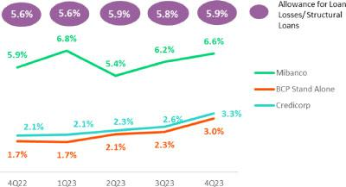

- Consumer and Credit Card, due to the same dynamics seen YoY.

- SME-Pyme, due to an uptick in the deterioration of previous vintages, which was concentrated in higher-risk segments with lower tickets (< S/ 90,000).

- Mibanco, affected by a deterioration in the payment capacity of overindebted clients.

The aforementioned was offset by reversals in Wholesale Banking, which were discussed in the QoQ and YoY analyses.

(1) Includes the specific provision for the expected impact of “El Niño” Phenomenon.
Datos elaborados por BCP para uso Interno | 32

| Earning Release 4Q / 2023 Analysis of 4Q23 Consolidated Results

05. Provisions

The evolution of provisions led the Structural CofR ratio to rise 127 bps YoY (+72 bps for FEN) and 129 bps YTD (+18 bps for FEN). Provisions and CofR in for Government Loans (GP)
GP Loan Portfolio Provisions |  | Quarter |  | % change |  | Up to |  | % change
S/ 000 | 4Q22 | 3Q23 | 4Q23 | QoQ | YoY | 2022 | 2023 | 2023 / 2022
Gross provision for credit losses on loan portfolio | (15,725) | (18,484) | 4,929 | -126.7% | -131.3% | (58,014) | (19,615) | -66.2%
Recoveries of written-off loans | - | - | - | - | - | - | - | -
Provision for credit losses on loan portfolio, net of recoveries | (15,725) | (18,484) | 4,929 | -126.7% | -131.3% | (58,014) | (19,615) | -66.2%
GP Cost of risk (1) | 0.7% | 1.8% | -0.5% | -232 pbs | -121 pbs | 0.6% | 0.5% | -14 pbs

(1) PG Cost of risk includes the Provisions for credit losses for the loan portfolio, net of recoveries and placements of the Reactiva Perú, FAE and Impulso MyPerú government programs.

Provisions for GP loans fell slightly QoQ, YoY and YTD due to on-going execution of honoring processes for State guarantees.

The provisions balance for GP loans represents 1.4% of Credicorp’s total provisions balance. The relatively small balance reflects the ample coverage in place for this type of loan, which ranges between 80% and 98%. For more information, see 1.2 Portfolio Quality – Government Program NPLs.

Provisions and CofR of Total Portfolio

Loan Portfolio Provisions |  | Quarter |  |  | % change |  | Up to | % change
S/ 000 | 4Q22 | 3Q23 | 4Q23 | QoQ | YoY | 2022 | 2023 | 2023 / 2022
Gross provision for credit losses on loan portfolio | (815,589) | (1,008,750) | (1,260,163) | 24.9% | 54.5% | (2,158,555) | (3,957,143) | 83.3%
Recoveries of written-off loans | 84,908 | 91,108 | 86,709 | -4.8% | 2.1% | 347,017 | 334,798 | -3.5%
Provision for credit losses on loan portfolio, net of recoveries | (730,681) | (917,642) | (1,173,454) | 27.9% | 60.6% | (1,811,538) | (3,622,345) | 100.0%
Cost of risk ⁽¹⁾ | 2.0% | 2.5% | 3.2% | 71 pbs | 127 pbs | 1.2% | 2.5% | 128 pbs

(1) Provision for credit losses on loan portfolio, net of annualized recoveries / Total loans.

The CofR for the total portfolio, which is comprised of structural and GP loans, rose 71 bps QoQ, 127 bps YoY and 128 bps YTD. Growth in these periods was driven by an increase in provisions for structural loans and for an additional charge to set aside provisions for the El Niño Phenomenon (FEN).

QoQ Cost of Risk Evolution YoY Cost of Risk Evolution
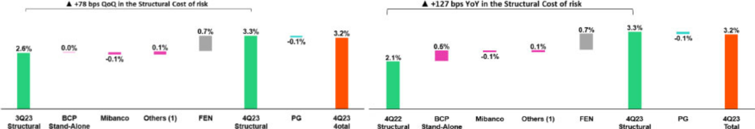

(1) Others include BCP Bolivia, Mibanco Colombia, ASB y eliminations. (1) Others include BCP Bolivia, Mibanco Colombia, ASB y eliminations.

YTD Cost of Risk Evolution
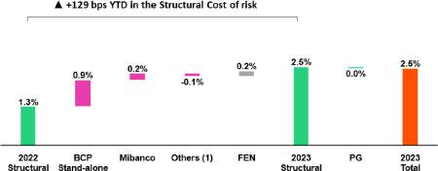

(1) Others include BCP Bolivia, Mibanco Colombia, ASB y eliminations.
Datos elaborados por BCP para uso Interno | 33

| Earning Release 4Q / 2023 Analysis of 4Q23 Consolidated Results

06 Other Income


Other Core Income rose 1.7% QoQ and 1.3% YoY. This evolution was driven primarily by an increase in fee income at BCP Bolivia, which was fueled by an uptick in foreign transfers. If we exclude the effects of these operations, Other Core Income rose 2.1% and 1.4% QoQ and YoY, respectively. This growth was spurred mainly by BCP Stand-alone, due to an uptick in FX transactions, and by higher Fee Income at Credicorp Capital. YTD, core income fell 0.8% (1.1% if we exclude Bolivia) due to the elimination of intercity transfer fees at BCP Stand-alone.

QoQ, YoY and YTD, Other Non-Core Income rose in line with an uptick in the Net Gain on Securities, which reflected growth in the trading revenues at Credicorp Capital and ASB and positive variations in the value of investment portfolios at Pacifico and the reserves account at Prima..

6.1. Other Core Income

Other Core Income |  | Quarter |  |  | % Change |  | Year | % Change
(S/ 000) | 4Q22 | 3Q23 | 4Q23 | QoQ | YoY | 2022 | 2023 | 2023 / 2022
Fee income | 895,295 | 975,955 | 986,173 | 1.0% | 10.2% | 3,642,857 | 3,804,459 | 4.4%
Net gain on foreign exchange transactions | 293,215 | 208,620 | 218,047 | 4.5% | -25.6% | 1,084,151 | 886,126 | -18.3%
Total other income Core | 1,188,510 | 1,184,575 | 1,204,220 | 1.7% | 1.3% | 4,727,008 | 4,690,585 | -0.8%

In 2023, BCP Bolivia implemented a strategy to attenuate the impact of the Central Bank of Bolivia’s decision to restrict US Dollar purchases. This entailed adjusting the fee structure for foreign transfers, which led to fee income to rose and posting a gain net of losses on FX transactions of S/14.8 million this year.

If we exclude transactions at BCP Bolivia, the results of Other Core income reflect the following dynamics:

QoQ, Other Core Income rose 2.1%, driven primarily by an uptick in the Net gain on FX Transactions at BCP Stand-alone. This evolution reflected our treasury team’s efforts to take advantage of seasonality at year-end to offer more advantageous spreads. Additionally, Credicorp Capital registered an increase in Fee income.

This growth was partially offset by a reduction in net fee income in the banking business at BCP Stand-alone.

YoY, the increase of 1.4% was driven mainly by an uptick in fee income from Credicorp Capital, as explained in the QoQ dynamics, and growth in fee income via the banking business at BCP Stand-alone.

YTD, a 1.1% drop was reported in fee income decrease in the fee balance at BCP, which was driven by the elimination of intercity transfer fees. Fee income from the banking business
Composition of fee income in the banking business ^{(*)}
Banking Business Fees |  | Quarter |  | % Change |  |  | Year | % Change
S/ 000 | 4Q22 | 3Q23 | 4Q23 | QoQ | YoY | 2022 | 2023 | 2023 / 2022
Payments and transactionals ⁽¹⁾ | 302.470 | 373.972 | 363.596 | -2.8% | 20.2% | 1,191.005 | 1,384.930 | 16.3%
Liability accounts ⁽²⁾ | 226.496 | 178.224 | 185.751 | 4.2% | -18.0% | 916.363 | 723.965 | -21.0%
Loan Disbursement ⁽³⁾ | 97.336 | 89.916 | 96.564 | 7.4% | -0.8% | 380.579 | 373.280 | -1.9%
Off-balance sheet | 63.247 | 55.659 | 56.510 | 1.5% | -10.7% | 243.203 | 230.978 | -5.0%
Mibanco (Peru and Colombia) | 34.165 | 39.220 | 34.484 | -12.1% | 0.9% | 134.888 | 153.177 | 13.6%
Insurances | 28.617 | 32.960 | 31.693 | -3.8% | 10.7% | 119.125 | 126.295 | 6.0%
BCP Bolivia | 24.479 | 84.941 | 104.959 | 23.6% | 328.8% | 102.488 | 335.061 | 226.9%
Wealth Management and Corporate Finance | 12.880 | 16.428 | 10.704 | -34.8% | -16.9% | 65.384 | 59.264 | -9.4%
ASB | 8.936 | 10.153 | 4.946 | -51.3% | -44.7% | 34.499 | 33.417 | -3.1%
Others ⁽⁴⁾ | 14.882 | 16.803 | 9.168 | -45.4% | -38.4% | 53.683 | 54.182 | 0.9%
Total | 813.508 | 898.278 | 898.375 | 0.0% | 10.4% | 3,241.217 | 3,474.550 | 7.2%

(*) This table corresponds to management numbers.

- Corresponds to fees from: credit and debit cards; payments and collections.
- Corresponds to fees from: Account maintenance, interbank transfers, national money orders y international transfers.
- Corresponds to fees from retail and wholesale loan disbursements.
- Use of third-party network, other services to third parties and Commissions in foreign branches.

Datos elaborados por BCP para uso Interno | 34

| Earning Release 4Q / 2023 Analysis of 4Q23 Consolidated Results

06. Other Income

If we exclude fee income from BCP Bolivia, the results for Fee income from banking services presented the following dynamics:

QoQ, the result dropped 3.0%, driven primarily by the regularization of fee payments that BCP Stand-alone makes to Pacifico for Bancassurance.

However, the contraction was offset at the consolidated level by growth in the line for the underwriting insurance result.

YoY, Fee income from banking services rose 0.6%. This evolution primarily reflects an increase in total fees from the payment and services venue, which rose due to growth in transactions via:
- Debit card billing (+14.0%);
- Credit card billing (+8.8%) y
- More transactions through Yape (+133%).

YTD, Fee income from banking services would have remained stable as growth in payments and services offset lower revenues due to the elimination of intercity transfer fees.

6.2 Other Non-Core Income

Other Non-Core Income |  | Quarter |  | % change |  |  | Year | % change
(S/ 000) | 4Q22 | 3Q23 | 4Q23 | QoQ | YoY | 2022 | 2023 | 2023 / 2022
Net gain on securities | 77,513 | 53,591 | 115,825 | 116.1% | 49.4% | -98,993 | 308,055 | n.a.
Net gain from associates ⁽¹⁾ | 25,422 | 32,056 | 34,132 | 6.5% | 34.3% | 104,461 | 117,089 | 12.1%
Net gain on derivatives held for trading | 5,857 | 38,545 | 5,019 | -87.0% | -14.3% | 65,187 | 53,665 | -17.7%
Net gain from exchange differences | 33,108 | 4,564 | 15,255 | 234.2% | -53.9% | 387 | 45,778 | n.a.
Other non-financial income | -2,548 | 89,272 | 112,372 | 25.9% | -4510.2% | 268,046 | 440,653 | 64.4%
Total other Non-Core Income | 139,352 | 218,028 | 282,603 | 29.6% | 102.8% | 339,088 | 965,240 | 184.7%

(1) Includes gains on other investments, which are mainly attributable to the Banmedica result.

QoQ Other Non-Core Income Evolution

(Thousands of soles)
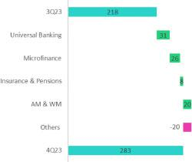

YoY Other Non-Core Income Evolution

(Thousands of soles)
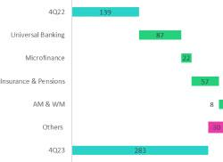

FY Other Non-Core Income Evolution

(Thousands of soles)
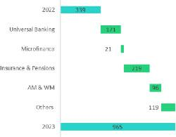

(1) Others includes: Grupo Crédito, Credicorp Individual, eliminations and others.

Datos elaborados por BCP para uso Interno | 35

| Earning Release 4Q / 2023 Analysis of 4Q23 Consolidated Results

06. Other Income

QoQ, Other Non-Core Income rose. This evolution was driven primarily by an uptick in the Net Gain on Securities via adept trading strategies at Credicorp Capital and secondarily by a positive result for Other Income, which was impacted mainly by the sale of judicial recoveries at BCP Stand-alone.

YoY, Other Non-Core Income rose due to growth in Other Income. This result was spurred by the same drivers as those seen in QoQ and by an increase in the Net Gain on Securities at BCP Stand-alone given that, in 4Q22, losses generated by the trading portfolio were offset by growth in interest income on fixed-income investments.

YTD, the improvement in results reflects an increase in the Net Gain on Securities due to good results for trading strategies at Credicorp Capital and ASB; growth in income in the investment portfolio at Pacifico; and a revaluation of reserves at Prima AFP.

Datos elaborados por BCP para uso Interno | 36

| Earnings Release 4Q / 2023 Analysis of 4Q23 Consolidated Results

07 Insurance Underwriting Results


The insurance underwriting result fell 13.2% QoQ due to a drop in underwriting results in P & C and Life. The decline at P & C was attributable to an uptick in Expenses for insurance services, which was primarily attributable to an increase in claims in P & C Risks and Medical Assistance. In the Life line, the underwriting result dropped due to an increase in Expenses for insurance service derived from a greater frequency of claims in D & S and Credit Life. It should be noted that, in both P & C and Life, the higher Expenses for insurance services were mitigated by the higher Income from the insurance service.


YTD, the insurance underwriting result rose 43.9%, driven by an improvement in the result for the Life business and Crediseguros. The uptick in Life was spurred mainly by favorable price and volume dynamics for insurance in the D & S line.

Insurance Underwriting Result |  |  | Quarter |  | Change % |  | As of |  | Change %
S/ millions |  | 4Q22 | 3Q23 | 4Q23 | QoQ | YoY | Dec 22 | Dec 23 | 2023 / 2022
 | Income from Insurance Services | 929.7 | 923.7 | 1,019.6 | 10.4% | 9.7% | 3,478.5 | 3,843.1 | 10.5%
Total | Expenses for Insurance Services | (675.9) | (505.4) | (634.0) | 25.4% | -6.2% | (2,216.8) | (2,235.0) | 0.8%
Total | Reinsurance Results | (117.0) | (87.4) | (98.4) | 12.6% | -15.9% | (420.3) | (397.1) | -5.5%
 | Insurance Undewrwriting Result | 136.8 | 330.9 | 287.3 | -13.2% | 110.0% | 841.4 | 1,211.1 | 43.9%
 | Income from Insurance Services | 437.7 | 404.6 | 449.8 | 11.2% | 2.8% | 1,660.0 | 1,694.7 | 2.1%
P&C | Expenses for Insurance Services | (282.7) | (256.2) | (323.7) | 26.4% | 14.5% | (981.2) | (1,138.5) | 16.0%
P&C | Reinsurance Results | (92.7) | (64.3) | (76.8) | 19.4% | -17.2% | (389.0) | (293.1) | -24.7%
 | Insurance Undewrwriting Result | 62.4 | 84.2 | 49.3 | -41.4% | -20.9% | 289.8 | 263.1 | -9.2%
 | Income from Insurance Services | 453.4 | 487.1 | 534.8 | 9.8% | 18.0% | 1,738.3 | 2,033.1 | 17.0%
Life | Expenses for Insurance Services | (372.1) | (243.3) | (305.1) | 25.4% | -18.0% | (1,212.0) | (1,076.3) | -11.2%
Life | Reinsurance Results | (20.2) | (17.3) | (14.5) | -16.2% | -28.1% | (27.1) | (83.0) | 206.6%
 | Insurance Undewrwriting Result | 61.1 | 226.6 | 215.2 | -5.0% | 252.3% | 499.3 | 873.9 | 75.0%
 | Income from Insurance Services | 23.5 | 33.9 | 37.1 | 9.5% | 58.3% | 78.1 | 123.6 | 58.2%
Crediseguros | Expenses for Insurance Services | (5.3) | (11.3) | (11.5) | 2.0% | 114.9% | (19.9) | (39.2) | 96.9%
Crediseguros | Reinsurance Results | (6.7) | (7.6) | (9.1) | 19.1% | 36.0% | (19.9) | (30.0) | 50.3%
 | Insurance Undewrwriting Result | 11.4 | 15.0 | 16.5 | 10.2% | 44.9% | 38.3 | 54.4 | 42.2%

In the QoQ analysis, the Insurance Underwriting Result dropped 13.2%. This evolution was driven by an uptick in expenses for insurance services (+25.4%) in both P & C and Life and by a less favorable reinsurance result. These dynamics were partially mitigated by growth in income for insurance services, which was spurred mainly by the Life business.

YTD, the Insurance Underwriting Result rose 43.9%. This variation was driven mainly by an increase in income from insurance services (+10.5%), primarily in Life and Crediseguros, and secondarily by a less favorable reinsurance result. These dynamics were partially offset by an uptick in expenses for insurance services (+0.8%), mainly in P & C due to growth in claims.

P & C Insurance

Income from the Insurance Services Expenses from the Insurance Services
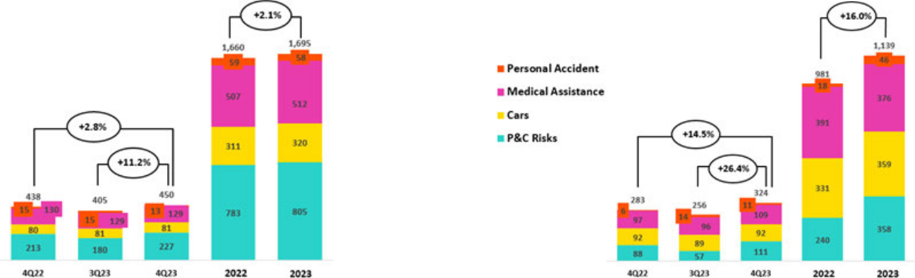

Datos elaborados por BCP para uso Interno | 37

| Earnings Release 4Q / 2023 Analysis of 4Q23 Consolidated Results

Insurance Underwriting Results

QoQ, the Insurance Underwriting Result dropped 41.4%. The following dynamics stood out:

- Income from insurance services increased 11.2%, driven mainly by growth in underwritten premiums for P & C products and for Fire, Maritime Hulls and Mortgage in particular.
- Expenses for insurance services increased 26.4% due to growth in claims in P & C Risks and Medical Assistance.
- The reinsurance result rose 19.4%; this was driven by an increase in the volume of ceded premiums, which was in line with an uptick in underwritten premiums in P & C.

In the YTD analysis, the Insurance Underwriting Result fell 9.2%, fueled by the following dynamics:

- Income from insurance services rose 2.1%, driven mainly by growth in the premium volume via P & C products and through Fire, Maritime Hulls and Card Protection in particular. The Cars line also contributed to an increase in income through higher premium subscriptions in the corporate channel and via growth in SOAT, through bancassurance.

- Expenses for insurance services rose 16.0%, mainly due to higher claims in (i) P & C Risks, primarily through Fire products, where more reserves were established, and Card Protection, due to the increase in the incidence of unrecognized online purchases, and (ii) Vehicular, due to the increase in the frequency of accidents. Likewise, there were higher attributable expenses compared to the previous year.

- The reinsurance result dropped 24.7%, fueled by reinsurance recoveries on claims for the Yaku Cyclone.

Life Insurance

Income from Insurance Services Expenses from Insurance Services
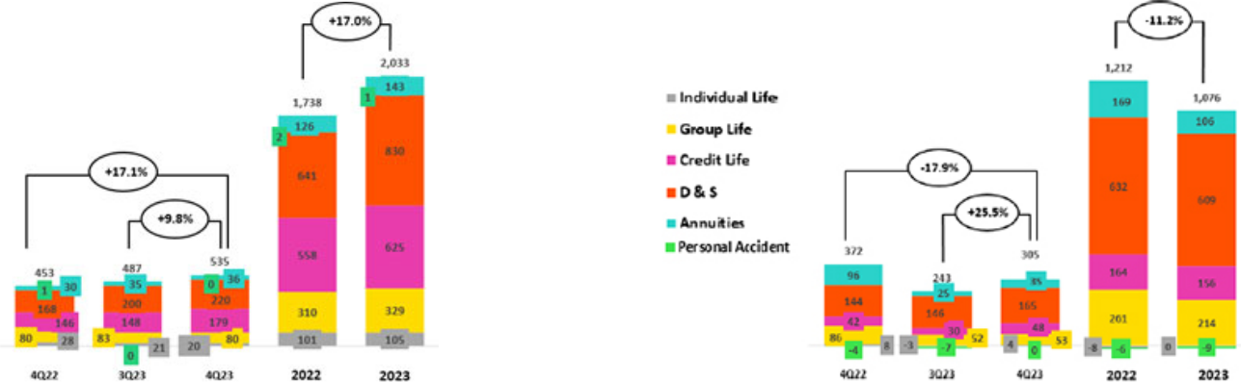

QoQ, the Insurance Underwriting Result fell 5.0%. The following dynamics were noteworthy:

- Income from insurance services rose 9.8% due to (i) Credit Life, which experienced growth in the premium volume for Bancassurance at BCP, and (ii) D & S, which also reflected an uptick in premium collections.

- Expenses for insurance services increased 25.4%, which reflected growth in claims in all line businesses, which was led by Credit Life and AFP, which registered an increase in claims frequency.
- The reinsurance result dropped 16.2%, which was mainly driven by an increase in claims recovered from the reinsurer of SCTR products in Group Life.

YTD, the Insurance Underwriting Result rose 75.0%. The following dynamics stood out:

- Income from insurance services increased 17.0%. This growth was attributable primarily to (i) D & S, after Pacifico reaped the benefits of obtaining a larger portion of and better rates under SISCO VI versus SISCO V, (ii) Credit Life, due to an increase in sales of Bancassurance through BCP and Banco de la Nación, (iii) Group Life, through SCTR products and Statutory Life, which reflected an uptick in underwritten premiums.

- Expenses for insurance services fell 11.2% YTD, which was influenced by the lower levels of claims in Group Life, D & S and Credit Life versus periods affected by COVID-19. This was mitigated by higher attributable expenses.
- The loss reported for the reinsurance result rose 206.6%, which reflects growth in ceded premiums in the D & S line.

Datos elaborados por BCP para uso Interno | 38

| Earning Release 4Q / 2023 Analysis of 4Q23 Consolidated Results

08 Operating Expenses

Operating expenses rose YTD, driven primarily by disruptive initiatives at the Credicorp level and by core business at BCP Stand-alone. Expenses for disruptive initiatives at the Credicorp level, which are concentrated in Yape and Tenpo, rose 66.6%. Core business expenses at BCP increased in IT-related expenses for (i) an uptick in cloud use given ongoing increases in client digitalization; (ii) investments to improve digital capacities and an improvement in cybersecurity; and (iii) measures to attract more specialized digital talent. If we exclude expenses for disruption, growth to date in operating expenses stands at 5.6%.

Total Operating Expenses

Operating expenses |  | Quarter |  | % change |  | Year |  | % change
S/ 000 | 4Q22 | 3Q23 | 4Q23 | QoQ | YoY | 2022 | 2023 | 2022/2023
Salaries and employees benefits | 1,036,148 | 1,061,402 | 1,119,758 | 5.5% | 8.1% | 3,902,161 | 4,265,453 | 9.3%
Administrative, general and tax expenses | 1,029,027 | 1,007,894 | 1,089,203 | 8.1% | 5.8% | 3,414,065 | 3,803,203 | 11.4%
Depreciation and amortization | 165,694 | 159,761 | 177,618 | 11.2% | 7.2% | 636,489 | 659,007 | 3.5%
Association in participation | 12,936 | 14,634 | 9,109 | -37.8% | -29.6% | 40,955 | 53,097 | 29.6%
Operating expenses | 2,243,805 | 2,243,691 | 2,395,688 | 6.8% | 6.8% | 7,993,670 | 8,780,760 | 9.8%

In the analysis of expenses, we consider solely YTD movements to eliminate the impact of seasonality between quarters.

Operating expenses remain high due to:

- Growth in Administrative and general expenses and taxes, mainly at BCP and associated with IT expenses related to an uptick in transactionality as well as development of and investment in disruption. Expenses for Advertising and Fidelity programs rose for both the core business and disruptive initiatives.

- An increase in Salaries and Employee Benefits, which was primarily attributable to an increase in the headcount of specialized IT personnel.

The uptick in operating expenses YTD stood at 9.8%. If we exclude disruption expenses, growth in operating expenses YTD was 5.6%. Administrative and General Expenses
Administrative general, and tax expenses |  | Quarter |  | % change |  | Year |  | % change
S/000 | 4Q22 | 3Q23 | 4Q23 | QoQ | YoY | 2022 | 2023 | 2022/2023
IT expenses and IT third-party services | 262,822 | 271,304 | 311,417 | 14.8% | 18.5% | 908,339 | 1,080,001 | 18.9%
Advertising and customer loyalty programs | 212,707 | 171,902 | 239,028 | 39.0% | 12.4% | 652,587 | 720,718 | 10.4%
Taxes and contributions | 94,071 | 65,606 | 93,090 | 41.9% | -1.0% | 280,171 | 264,326 | -5.7%
Audit Services, Consulting and professional fees | 139,096 | 112,480 | 105,340 | -6.3% | -24.3% | 333,325 | 336,715 | 1.0%
Transport and communications | 63,981 | 57,518 | 60,869 | 5.8% | -4.9% | 225,491 | 226,860 | 0.6%
Repair and maintenance | 36,079 | 44,084 | 49,698 | 12.7% | 37.7% | 136,105 | 157,127 | 15.4%
Agents’ Fees | 27,673 | 29,310 | 31,911 | 8.9% | 15.3% | 106,356 | 115,120 | 8.2%
Services by third-party | 35,338 | 45,426 | 43,936 | -3.3% | 24.3% | 113,211 | 144,534 | 27.7%
Leases of low value and short-term | 23,968 | 27,754 | 30,205 | 8.8% | 26.0% | 91,680 | 108,357 | 18.2%
Miscellaneous supplies | 22,845 | 27,091 | 30,589 | 12.9% | 33.9% | 87,844 | 118,510 | 34.9%
Security and protection | 16,365 | 16,064 | 16,575 | 3.2% | 1.3% | 64,480 | 64,432 | -0.1%
Subscriptions and quotes | 14,322 | 14,391 | 18,444 | 28.2% | 28.8% | 55,914 | 61,945 | 10.8%
Electricity and water | 14,848 | 13,592 | 16,316 | 20.0% | 9.9% | 50,566 | 56,359 | 11.5%
Electronic processing | 12,225 | 9,959 | 11,284 | 13.3% | -7.7% | 35,896 | 39,764 | 10.8%
Insurance | 8,629 | 38,034 | 4,518 | -88.1% | -47.6% | 62,994 | 56,324 | -10.6%
Cleaning | 5,368 | 5,930 | 6,122 | 3.2% | 14.0% | 20,435 | 22,677 | 11.0%
Others ⁽¹⁾ | 38,690 | 57,449 | 19,861 | -65.4% | -48.7% | 188,671 | 229,434 | 21.6%
Total | 1,029,027 | 1,007,894 | 1,089,203 | 8.1% | 5.8% | 3,414,065 | 3,803,203 | 11.4%

Administrative and general expenses rose 11.4% in 2023, driven primarily by growth in IT and advertising expenses in BCP’s core business and for disruptive initiatives.

Datos elaborados por BCP para uso Interno | 39

 | | Earning Release 4Q / 2023 |  |  |  | Analysis of 4Q23 Consolidated Results
08. Operating Expenses
Operating Expense in Core Businesses and Disruption ⁽¹⁾
Operating Expenses |  | Quarter |  | % change |  | As of |  | % change
S/ (000) | 4Q22 | 3Q23 | 4Q23 | QoQ | YoY | 2022 | 2023 | 2022/2023
Core Business BCP | 1,332,331 | 1,245,767 | 1,356,334 | 8.9% | 1.8% | 4,669,486 | 4,948,125 | 6.0%
Core Business Mibanco | 300,155 | 302,729 | 299,717 | -1.0% | -0.1% | 1,154,270 | 1,200,445 | 4.0%
Core Business Pacifico | 82,114 | 79,355 | 85,485 | 7.7% | 4.1% | 262,796 | 301,816 | 14.8%
Disruption (2) | 196,125 | 222,207 | 335,077 | 50.8% | 70.8% | 557,938 | 929,473 | 66.6%
Others (3) | 333,081 | 393,633 | 319,075 | -18.9% | -4.2% | 1,349,180 | 1,400,900 | 3.8%
Total | 2,243,805 | 2,243,691 | 2,395,688 | 6.8% | 6.8% | 7,993,670 | 8,780,760 | 9.8%

- Management figures.
- Includes disruptive initiatives at the subsidiaries and Krealo.
- Includes Credicorp Capital, ASB, Prima, BCP Bolivia, Mibanco Colombia, and other entities within the Group.

YTD, growth of 9.8% in operating expenses at Credicorp was driven by disruptive initiatives at the Credicorp level, which were responsible for 47.2% of total growth, and by our core business at BCP, which accounted for 35.4%.

Growth in disruption expenses reached 66.6% YTD and represented 10.6% of total expenses in 2023. These expenses were attributable to investments in personnel and in developing functionalities through initiatives such as Yape, Tenpo, Culqi, Tyba, among others. These investments aim to strengthen our leadership in the long term.

In the case of BCP’s core business, YTD growth of 6.0% was driven by both IT expenses and core business expenses excluding technology:

- Technology Expenses (IT)

  - In line with an increase in the transactional volume of increasingly digitalized clients, expenses for the use of the bank’s servers rose. The monetary and non-monetary transactions through digital channels rose 116.5% and 87.8% respectively.
  - Additionally, strategic IT projects were carried out to develop new capabilities.
  - More personnel with specialized digital capacities were hired; the average salary paid to this personnel also rose.

- Expenses in the core business excluding IT

  - Expenses for marketing and advertising rose to attract more deposits and drive sales of digital products.
  - Expenses for supplies increased due to the increase in the number of debit and credit cards, as well as physical and digital tokens.
  - An uptick in expenses for Fidelity programs, in line with growth in the use of credit cards (+15.8%) this year.

Datos elaborados por BCP para uso Interno | 40

| Earnings Release 4Q / 2023 Analysis of 4Q23 Consolidated Results

09 Operating Efficiency

The efficiency ratio registered an improvement of 142 bps YTD as income growth was higher than expenses growth. This evolution was in line with an uptick in core income, which was driven by growth in net interest income at BCP. NII was up over the period due to the loan book growth and an improvement in the loan mix, which reflected growth in retail loans.

Efficiency Ratio reported by subsidiary

 | Subsidiary |  | Quarter |  | % change |  |  | As of | % change
 | Subsidiary | 4Q22 | 3Q23 | 4Q23 | QoQ | YoY | 2022 | 2023 | 2022/2023
BCP |  | 41.9% | 39.2% | 41.8% | 260 bps | -10 bps | 40.7% | 38.8% | -190 bps
BCP Bolivia |  | 64.5% | 65.3% | 59.0% | -630 bps | -550 bps | 60.9% | 61.3% | 40 bps
Mibanco Perú |  | 52.3% | 51.4% | 52.9% | 150 bps | 60 bps | 51.3% | 52.7% | 140 bps
Mibanco Colombia |  | 93.3% | 86.0% | 98.2% | 1220 bps | 490 bps | 81.8% | 91.6% | 980 bps
Pacífico |  | 53.7% | 24.7% | 34.9% | 1020 bps | -1880 bps | 34.3% | 26.5% | -780 bps
Prima AFP |  | 46.1% | 51.6% | 54.2% | 260 bps | 810 bps | 51.0% | 51.3% | 30 bps
Credicorp |  | 49.5% | 46.3% | 49.0% | 265 bps | -57 bps | 47.5% | 46.1% | -142 bps

Operating income has been re-expressed with regard to previous reports to reflect the application of IFRS 17. This standard applies solely to the Insurance Business. For more details, review annex 12.1.8.

- Operating expenses = Salaries and employees benefits + Administrative expenses + Depreciation and amortization + Association in participation + Acquisition cost.
- Operating income = Net interest, similar income, and expenses + Fee income + Net gain on foreign exchange transactions + Net gain from associates + Net gain on derivatives held for trading + Net gain from exchange differences + Net Insurance Underwriting Results.
- Operating expenses / Operating income (under IFRS 17).

This analysis considers movements at the YTD level to eliminate the impact of seasonality between quarters.

The efficiency ratio improved, primarily due to an uptick in core income at BCP due to the loan book growth and an improvement in the structural mix. This evolution was driven by growth in retail banking loans, which was fueled mainly by SME-Pyme, and to a lesser extent, by growth in the Insurance Underwriting Result at Pacifico.

Datos elaborados por BCP para uso Interno | 41

| Earnings Release 4Q / 2023 Analysis of 4Q23 Consolidated Results

10 Regulatory Capital


Credicorp’s Regulatory Capital fell to 1.3 times the minimum requirement for Regulatory Capital, which reflects a gradual increase in the buffers for capital conservation and market concentration at BCP Stand-alone and Mibanco.

IFRS CET1 at BCP Stand-alone rose 61 bps YoY to stand at 13.2%, which reflects an uptick in Retained Earnings (+15.4%) as well as growth in the balance for Capital and Reserves (+3.4%).

The IFRS CET1 at Mibanco rose 191 bps YoY to stand at 18.37%. A decline in RWAs (-1.6%), and an uptick in Retained Earnings (+99.1%), impacted this dynamic.

10.1 Regulatory Capital at Credicorp
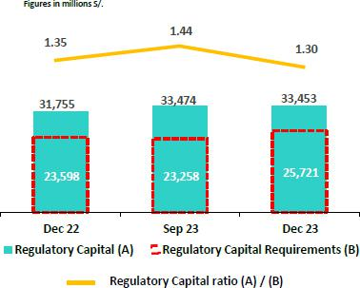

Credicorp’s Regulatory Capital Ratio stood at 1.30 at the end of 4Q23. In the QoQ analysis, the ratio dropped 14 bps due to an uptick in the regulatory capital requirement, which reflects a gradual increase in the buffers for capital conservation and market concentration at BCP Stand-alone and Mibanco. Our prudent solvency management has, nonetheless, allowed us to maintain a very comfortable position with regard to the minimums required by the regulator for BCP and Mibanco.

In the YoY analysis, the Regulatory Capital Ratio fell 5 bps due to an uptick in the volume of regulatory capital required, which was driven by the same dynamics seen above. This evolution was partially offset by growth in the balance of Facultative and Restricted Reserves.

Analysis of Capital at the Subsidiaries

Under the current local regulation, which has been in effect since January 2023, three regulatory ratios exist: Common Equity Tier 1 (CET 1), Tier 1 Capital and Global Capital. For all effective purposes, Tier 1 Capital is equal to CET 1 Ratio in Credicorp’s case given that we possess no subordinated Tier 1 debt. Additionally, as has been our practice over the last few years, we use the IFRS CET 1 ratio, which differs slightly from CET 1 (calculated under local accounting); these differences primarily impact the Provisions and Unrealized Loss accounts.

10.2 Analysis of Capital at BCP

IFRS CET 1 at BCP Stand-alone rose 16 bps QoQ to stand at 13.20% at the end of 4Q23, while our internal appetite stood at 11.%. This evolution was attributable to an uptick in Retained Earnings, which was partially offset by a drop in the balance for Capital and Reserves after an extraordinary dividend was announced in the month of October. The RWA levels rose 1.6%, which reflected growth in retail loans. YoY, the IFRS CET 1 ratio increased 61 bps, driven by (i) an uptick in YTD and Period Results, and (ii) growth in the balance for Capital and Reserves.
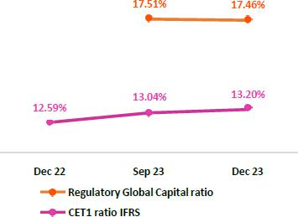

Finally, the Global Capital ratio at BCP Stand-alone stood at 17.46% (- 5 bps QoQ). This compares favorably with the minimum ratio set by the regulator at the end of December 2023 of 12.59%, and stands as proof of our prudent approach to solvency management. In QoQ terms, the drop reported in this ratio was driven by growth in RWAs for credit risk, which was in turn fueled by an uptick in retail loans, and was partially offset by (i) an increase in YTD and Period results, and (ii) growth in the balance for Capital and Reserves. The local CET 1 ratio stood at 13.09% versus the 6.68% required at the end of December 2023.

Datos elaborados por BCP para uso Interno | 42

| Earnings Release 4Q / 2023 Analysis of 4Q23 Consolidated Results

10. Regulatory Capital

10.3 Analysis of Capital at Mibanco

At the end of 4Q23, the IFRS CET 1 ratio at Mibanco stood at 18.37% (+80 bps QoQ), while our internal appetite sets this ratio at 15%. This increase was primarily attributable to a reduction in the loan portfolio. The uptick registered in the YTD and Period Results also contributed, albeit to a lesser extent, to an increase in IFRS CET 1. Growth in this ratio QoQ was partially offset by a drop in the balance for Goodwill and Intangibles. YoY, this ratio rose 191 bps due to a drop in RWAs; an uptick in the YTD and Period results; and growth in the balance for Capital and Reserves.
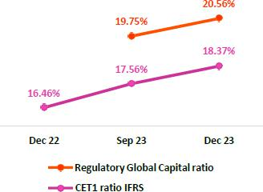

The Global Capital Ratio at Mibanco stood at 20.56% (+81 bps QoQ), while the minimum required by the regulator stood at 12.81%. As such, our level remains very comfortable. This variation was driven by the same dynamics as those seen in the evolution of the IFRS CET 1 ratio. The local CET 1 ratio stood at 18.22% in 4Q23, whereas the minimum requirement at the end of December 2023 was 6.68%.

Datos elaborados por BCP para uso Interno | 43

| Earnings Release 4Q / 2023 Analysis of 4Q23 Consolidated Results

11 Economic Outlook


In 4Q23, the Peruvian economy would have contracted around 0.2% YoY (-0.9% YoY in 3Q23), accumulating its fourth consecutive quarter of year-on-year decline. The decline in non-primary sectors slowed but continued to be dragged down by the contraction of construction, non-primary manufacturing and services. For their part, the primary sectors grew due to the production of copper from Quellaveco, the greater extraction of minerals with higher average ore grades from several mining companies and an early opening of the second fishing season.

The annual inflation rate continued to decelerate, closing the quarter at 3.2% YoY (5.0% YoY in 3Q23). Real GDP, in turn, is estimated to post negative growth of -0.5% in 2023.

According to the BCRP, the exchange rate closed at USDPEN 3.710 in 4Q23, an appreciation of 2.2% compared to the end of 3Q23 and 2.7% compared to a year ago.

Peru: Economic Forecast

 | 2018 | 2019 | 2020 | 2021 | 2022 | 2023 ⁽³⁾ | 2024 ⁽³⁾
GDP (US$ Millions) | 226,919 | 232,519 | 205,755 | 225,803 | 244,789 | 266,782 | 277,498
Real GDP (% change) | 4.0 | 2.2 | (11.0) | 13.3 | 2.7 | (0.5) | 2.5
GDP per capita (US$) | 7,190 | 7,237 | 6,306 | 6,835 | 7,330 | 7,872 | 8,137
Domestic demand (% change) | 4.1 | 2.2 | (9.8) | 14.5 | 2.3 | (1.9) | 2.4
Gross fixed investment (as % GDP) | 22.4 | 21.8 | 19.9 | 21.6 | 22.0 | 23.6 | 23.6
Financial system loan without Reactiva (% change) (1) | 10.3 | 6.4 | (4.3) | 12.6 | 9.7 | 3.0 | 5.5
Inflation, end of period(2) | 2.2 | 1.9 | 2.0 | 6.4 | 8.5 | 3.2 | 2.2
Reference Rate, end of period | 2.8 | 2.3 | 0.3 | 2.5 | 7.5 | 6.8 | 4.8
Exchange rate, end of period | 3.4 | 3.3 | 3.6 | 4.0 | 3.8 | 3.7 | 3.8
Exchange rate, (% change) | 0.0 | (0.0) | 0.1 | 0.1 | (0.0) | (0.0) | 0.0
Fiscal balance (% GDP) | (2.3) | (1.6) | (8.9) | (2.5) | (1.6) | (2.8) | (2.5)
Public Debt (as % GDP) | 25.6 | 26.6 | 34.6 | 35.9 | 34.0 | 33.3 | 33.8
Trade balance (US$ Millions) | 7,201 | 6,879 | 8,196 | 14,927 | 9,565 | 16,700 | 15,100
(As % GDP) | 0.0 | 0.0 | 0.0 | 0.1 | 0.0 | 0.1 | 0.1
Exports | 49,066 | 47,980 | 42,905 | 63,151 | 65,834 | 67,200 | 68,100
Imports | 41,866 | 41,101 | 34,709 | 48,223 | 56,269 | 50,500 | 53,000
Current account balance (As % GDP) | (0.0) | (0.0) | 0.0 | (0.0) | (0.0) | (0.0) | (0.0)
Net international reserves (US$ Millions) | 60,121 | 68,316 | 74,707 | 78,495 | 71,883 | 71,033 | 72,500
(As % GDP) | 26.5% | 29.4% | 36.3% | 34.8% | 29.4% | 26.6% | 26.1%
(As months of imports) | 17 | 20 | 26 | 20 | 15 | 17 | 16
Sources: INEI, BCRP y SBS.
(1) Financial System, Current Exchange Rate
(2) Inflation target: 1% - 3%
(3) Grey area indicate estimates by BCP Economic Research as of January 2024
 | Datos elaborados por BCP para uso Interno |  |  |  |  |  | 44

| Earnings Release 4Q / 2023 Analysis of 4Q23 of Consolidated Results

11. Economic Outlook

Main Macroeconomic Variables

Gross Domestic Product

(Annual Real Variations, % YoY)
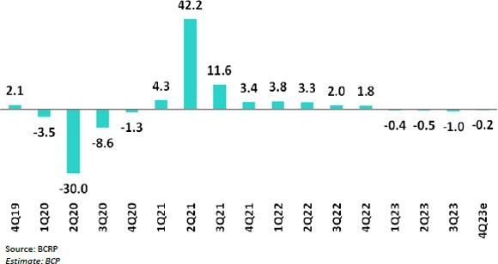

In 4Q23, the Peruvian economy is expected to have contracted around 0.2% YoY, the smallest contraction of the year, although the fourth consecutive quarter of decline. The primary sectors would have grown due to (i) Quellaveco’s copper production and the greater extraction of minerals with higher average ore grades from several mining companies and (ii) the early beginning of the second anchovy fishing season (it started a month earlier than in 2022). Regarding the non-primary sectors, the decline slowed but continue to be dragged down by the contraction of construction, non-primary manufacturing and services.

In 2023, GDP fell 0.5%, the worst performance of the Peruvian economy since 1998 (excluding the pandemic). Several factors explained this contraction; within the most important, the social protests of the beginning of the year and the weather phenomenon El Niño Costero reduced GDP growth by two percentage points, according to the Central Bank of Perú (BCRP).

Annual Inflation and Central Bank Reference Rate

(%)
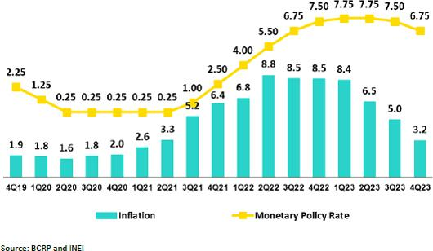

Datos elaborados por BCP para uso Interno | 45

| Earnings Release 4Q / 2023 Analysis of 4Q23 Consolidated Results

11. Economic Outlook

Inflation, measured using the Consumer Price index of Metropolitan Lima, slowed from 8.5% YoY at the end of 4Q22 to 3.2% YoY at the end of 4Q23 due to the reversal of supply shocks in the agricultural sector, normalization of global supply chains and the fall in the 2023 average commodity prices (wheat: -28%, corn: -18%; soy: -8%) and crude oil (WTI -17%). Core inflation (excludes food and energy), in December 2023, slowed to 2.9% YoY and returned to the BCRP target range of between 1% - 3% after two consecutive years of surpassing it.

At its December meeting, the BCRP cut its policy rate by 25 bps. to 6.75%, its fourth consecutive cut of that magnitude. Thus, in 4Q23, the cumulative cuts totaled 75 bps. The rate cut cycle, which began in September, occur after 7 consecutive months where the BCRP kept the policy rate at its historical level of 7.75% (the last rate hike of 25 pbs. was decided in January 2023). In January 2024, the monetary authority cut its rate again by 25 bps to 6.50%.

Fiscal Balance and Current Account Balance

(% of GDP, Quarter)

The annualized fiscal deficit in the last 12 months to December 2023 rose to 2.8% of GDP, compared to 1.7% of GDP in 4Q22. This increase was explained, to a greater extent, by the fall in fiscal revenues from 22.1% of GDP to 19.8% of GDP. The drop in income tax and value added tax revenue stood out owing to the contraction of domestic demand and lower metals and energy prices. Non-financial spending rose 1.2% YoY due to an increase in current spending (4.2% YoY).
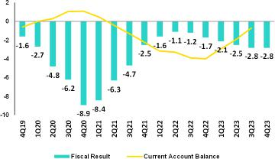

In October 2023, Fitch affirmed BBB Peru’s sovereign debt credit rating with negative outlook. Moody’s and S&P assign a rating of Baa1 and BBB, respectively, both with negative outlook. Hence, the three credit rating agencies assign a negative outlook on Peru’s rating. S&P and Fitch have the rating two-steps above investment grade.

Regarding external accounts, the current account deficit fell from 4.0% of GDP at the end of 2022 to 0.7% of GDP in 3Q23 (in cumulative terms for the last 4 quarters).

The 12-month accumulated trade balance surplus to November 2023 stood at USD 16.9 billion, a historical high and larger than the USD 15.1 billion registered in September. In the same period, exports barely grew 0.6% YoY to USD 67 billion, affected by lower prices of traditional products, which were, in part, offset by higher volumes. Imports fell 10.3% YoY to USD 50.1 billion due to lower import volumes of industrial supplies and construction materials, as well as lower commodity prices, mainly oil and food.

Terms of trade grew 12.5% YoY in November 2023, because of higher export prices (5.8% YoY) and lower import prices (-6.0% YoY). On the former, predominantly higher copper, gold and non-traditional agricultural products prices drove the increase, while on the latter, the fall was explained by lower oil and food prices. In November, terms of trade rose 4.6% compared with the end of 2022

Datos elaborados por BCP para uso Interno | 46

| Earnings Release 4Q / 2023 Analysis of 4Q23 Consolidated Results

11. Economic Outlook

Exchange Rate

(PEN per USD)

According to BCRP, the exchange rate closed 4Q23 at USDPEN 3.71, an appreciation of 2.2% compared with the end of 3Q23 and 2.7% with respect to the end of 2022. In October, the exchange rate weakened towards USDPEN 3.88, close to the highest level of the year of USDPEN 3.90 reached in January, due to the increase in the US 10-year treasury yield to its highest since 2007. Hence, the BCRP intervened in the spot market, for the third time in the year, selling USD 67 million. As such, in 2023, the BCRP sold USD 81 million in the spot market, much lower than the USD 1.2 billion sold in 2022.
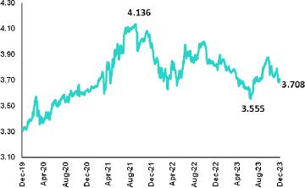

Latam main currencies also appreciated in 4Q23 compared with the previous quarter due to the weakening of the global dollar after signs from the Federal Reserve of possible rate cuts in 2024. The Colombian peso appreciated 5.0%, the Brazilian real 3.6%, the

Mexican peso 2.6% and the Chilean peso 1.3%.

Net international reserves closed 4Q23 at USD 71.0 billion, similar to the end of 3Q23 level (USD 71.2 billion). The FX position of the BCRP stood at USD 51.6 billion in 4Q23, a decrease of USD 1.3 billion with respect to the end of 3Q23.

Datos elaborados por BCP para uso Interno | 47

| Earnings Release 4Q / 2023 Analysis of 4Q23 Consolidated Results

Safe Harbor for Forward-Looking Statements

This material includes “forward-looking statements” within the meaning of Section 27A of the U.S. Securities Act of 1933 and Section 21E of the U.S. Securities Exchange Act of 1934. All statements other than statements of historical fact are forward-looking and may contain information about financial results, economic conditions, trends and known uncertainties. Forward-looking statements are not assurances of future performance. Instead, they are based only on our management’s current views, beliefs, expectations and assumptions regarding the future of our business, future plans and strategies, projections, anticipated events and trends, the economy and other future conditions.

Many forward-looking statements can be identified by words such as: “anticipate”, “intend”, “plan”, “goal”, “seek”, “believe”, “project”, “estimate”, “expect”, “strategy”, “future”, “likely”, “would”, “may”, “should”, “will”, “see” and similar references to future periods. Examples of forward-looking statements include, among others, statements or estimates we make regarding guidance relating to losses in our credit portfolio, efficiency ratio, provisions and non-performing loans, current or future market risk and future market conditions, expected macroeconomic events and conditions, our belief that we have sufficient capital and liquidity to fund our business operations, expectations of the effect on our financial condition of claims, legal actions, environmental costs, contingent liabilities and governmental and regulatory investigations and proceedings, strategy for customer retention, growth, governmental programs and regulatory initiatives, credit administration, product development, market position, financial results and reserves and strategy for risk management.

We caution readers that forward-looking statements involve known and unknown risks and uncertainties that could cause actual results, performance, or events to differ materially from those that we expect or that are expressed or implied in the forward-looking statements, depending on the outcome of certain factors, including, without limitation, adverse changes in:

- The occurrence of natural disasters or political or social instability in Peru;

- The adequacy of the dividends that our subsidiaries are able to pay to us, which may affect our ability to pay dividends to shareholders and corporate expenses;
- Performance of, and volatility in, financial markets, including Latin-American and other markets;
- The frequency, severity and types of insured loss events;
- Fluctuations in interest rate levels;
- Foreign currency exchange rates, including the Sol/US Dollar exchange rate;
- Deterioration in the quality of our loan portfolio;
- Increasing levels of competition in Peru and other markets in which we operate;
- Developments and changes in laws and regulations affecting the financial sector and adoption of new international guidelines;
- Changes in the policies of central banks and/or foreign governments;
- Effectiveness of our risk management policies and of our operational and security systems;
- Losses associated with counterparty exposures;
- The scope of the coronavirus (“COVID-19”) outbreak, actions taken to contain the COVID-19 and related economic effects from such actions and our ability to maintain adequate staffing; and
- Changes in Bermuda laws and regulations applicable to so-called non-resident entities.

See “Item 3. Key Information—3. D Risk Factors” and “Item 5. Operating and Financial Review and Prospects” in our most recent Annual Report on Form 20-F filed with the U.S. Securities and Exchange Commission for additional information and other such factors. You are cautioned not to place undue reliance on these forward-looking statements, which speak only as of the date hereof and are based only on information currently available to us. Therefore, you should not rely on any of these forward-looking statements.

We undertake no obligation to publicly update or revise these or any other forward-looking statements that may be made to reflect events or circumstances after the date hereof, whether as a result of changes in our business strategy or new information, to reflect the occurrence of unanticipated events or otherwise.

Datos elaborados por BCP para uso Interno | 48

 |  | | Earnings Release 4Q / 2023 | Analysis of 4Q23 Consolidated Results
12 |  | Appendix
12.1. | Implementation of IFRS 17 – Restatement of figures and ratios for 2022 |  |  | 50
12.1.1. Introduction to the new standards IFRS 17 |  |  |  | 50
12.1.2. Conceptual Framework |  |  |  | 50
12.1.3. Recognition of Profit and Loss |  |  |  | 50
12.1.4. Valuation Methods |  |  |  | 50
12.1.5. Impact on Equity Under IFRS 17 |  |  |  | 51
12.1.6. Reformulation of Profit and Loss Statement at Pacífico Grupo Asegurador for year 2022 |  |  |  | 51
12.1.7. Reformulation of Credicorp’s Profit and Loss Statement for year 2022 |  |  |  | 52
12.1.8. Changes in the Methodology to Calculate Financial Indicators and their Reformulation for the year 2022 |  |  |  | 52
12.1.9. Glossary of Terms Under IFRS 17 |  |  |  | 55
12.2. | Physical Point of contact |  |  | 55
12.3. | Loan Portfolio Quality |  |  | 55
12.4 Net Interest Income (NII) |  |  |  | 60
12.5. | Regulatory Capital |  |  | 61
12.6. | Financial Statements and Ratios by Business |  |  | 65
12.6.1. Credicorp Consolidated |  |  |  | 65
12.6.2. Credicorp Stand-alone |  |  |  | 67
12.6.3. BCP Consolidated |  |  |  | 68
12.6.4. BCP Stand-alone |  |  |  | 70
12.6.5. BCP Bolivia |  |  |  | 72
12.6.6. Mibanco |  |  |  | 73
12.6.7. Prima AFP |  |  |  | 74
12.6.8. Grupo Pacifico |  |  |  | 75
12.6.9. Investment Management and Advisory |  |  |  | 77
12.7. | Table of calculations |  |  | 78
12.8. | Glossary of terms |  |  | 79
 |  | Datos elaborados por BCP para uso Interno |  | 49

| Earnings Release 4Q / 2023 Analysis of 4Q23 Consolidated Results

12. Appendix

12.1. Implementation of IFRS 17 – Restatement of figures and ratios for 2022

12.1.1. Introduction to the new standards IFRS 17

IFRS 17 was published in May 2017 as a replacement to IFRS 4 “Insurance Contracts.” The aim of this change is to ensure that consistent measurement criteria are applied to improve transparency and the comparability of Financial Statements. The new standard became effective in January 2023.

The primary objectives of this standard include:

- Improving comparability between insurers at the global level. IFRS 4 allowed entities to use a wide variety of accounting practices with regard to insurance contracts.

- Adequately reflecting the economic value of insurance contracts. Some previous accounting practices allowed under IFRS failed to adequately reflect real underlying financial situations or the financial yields on insurance contracts.
- Providing more useful information to users of financial statements.

12.1.2. Conceptual Framework

Insurance contracts combine attributes of risk coverage, provision of services and instruments of investments and by nature, generate cash flows (outflows such as claims payments, redemptios, expirations, pensions, attributable expenses, income such as premiums) during their term.

The difference between expected outflows and inflows (fulfillment cashflows), combined with recognition of cash value over time, constitute the best estimate of the company’s obligations. Due to potential underwriting deviations relative to expected flows, an additional reserve, known as Risk Adjustment (RA) must be set aside and the underwriting income that the company expects to obtain from its current product portfolio constitutes the Contractual Service Margin (CSM). These 3 concepts, combined with the claims reserves (including reserves for pending claims, IBNR reserves and liquidation expenses) constitute the company’s liabilities.

12.1.3. Recognition of Profit and Loss

The P & L under IFRS shows the difference between a company’s expected cash flows (valued in liabilities) and real flows that occur. Anticipated flows must be based on realistic parameters that reflect the company’s actual experience and current market interest rates.

The standard also requires that results be separated into 3 blocks: (i) Insurance service (or direct insurance), (ii) Reinsurance and (iii) Financial Results. This structure allows users to visualize the company’s sources of income.

Unlike IFRS4, which recognized profit and losses on products during their term, IFRS17 stipulates that expected losses must be recognized at a single moment, meaning upon issuance of policies, while recognition of underwriting income (CSM) must be made gradually over the effective period of products.

The company chose the Other Comprehensive Income (OCI) option, which recognizes movements of reserves generated by underwriting issues within the Profit and Loss Statement (changes in mortality, expenses, redemptions, etc.) while within Equity, only variations in liabilities generated by changes in interest rates are recognized. This variation produces an offset to that generated by investments that back reserves and lends stability to the Balance Sheet and the Profit and Loss Statement.

12.1.4. Valuation Methods

IFRS 17 introduces different approaches to valuate underwriting provisions based on the product’s characteristics (contract duration, cash flow).

- General Method (GM) or Building Block Approach (BBA): general default model valuation of insurance contracts.

- Variable Fee Approach (VFA): model for contract valuation in which cash flows depend on the value of the underlying assets that back said contracts

- Premium Allocation Approach (PAA): simplification of the general model.

Datos elaborados por BCP para uso Interno | 50

| Earnings Release 4Q / 2023 Analysis of 4Q23 Consolidated Results

12. Appendix

12.1.5. Impact on Equity Under IFRS 17

The impact of the implementation of the IFRS 17 standard on the net equity balance of Pacífico Seguros is not material, registering at the end of December 2022 a net equity under IFRS 17 which is S/ 10 million greater than the net equity calculated under IFRS 4.

It should be mentioned that as of the end of December 2021 (date of the "first application" of the standard), the net equity of Pacífico Seguros under IFRS 17 was S/ 211 million less than the net equity registered under IFRS 4. This initial gap narrowed during 2022 as a result of a contraction in the value of liabilities under IFRS 17, associated with the interest rates increases.

12.1.6. Reformulation of Profit and Loss Statement at Pacífico Grupo Asegurador for year 2022
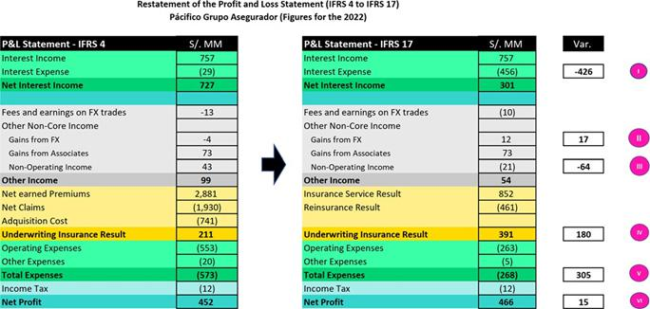

- A new sub-account, “Financial Expenses associated with insurance and reinsurance activities, net” is included in the account for Interest Expenses at Pacifico Seguros. This concept corresponds to interest accredited to reserves. This interest is attributable to an update of the present value of said reserves to the date of the close of the period. This concept was previously presented as part of reserves adjustment included in the underwriting result under IFRS4. IFRS17 separates the financial component from the underwriting component.

- An impact is registered in the “Gain on exchange rate difference” line because the structure of the assets and liabilities related to insurance activities has been modified. The monetary position of these assets and liabilities changes due to the way that assets and liabilities are recognized under IFRS17.

- Some concepts of income that were previously registered (under IFRS 4) as “Non-Operating Income” are now (under IFRS 17) reclassified and included in the cash flows associated with insurance contracts. As such, these concepts are now part of the Insurance Underwriting Result.

IV. Recognition of insurance underwriting income is completely different under IFRS 17. IFRS 17 recognizes that insurance contracts combine financial and service characteristics, and in many cases generate variable cash flows in the long-term. To adequately reflect these characteristics, IFRS combines measurements of future cash flows with recognition of the results of the insurance contract throughout the period in which the service is provided. IFRS 17 requires present value measurements of insurance obligations where estimates are recalculated in each reporting period. Contracts are measured using the components of: (i) Fulfilment Cash Flows, (ii) An explicit adjustment for risk or uncertainty of flows, or “Risk Adjustment” and (iii) a Contractual Service Margin, which represents unaccrued underwriting income associated with the contract. This Contractual Service Margin is recognized as income during the coverage term. Insurance contracts combine financial and service characteristics, whereas IFRS combines future cash flows with registry of the results of the insurance contract during the service provision period.

Datos elaborados por BCP para uso Interno | 51

| Earnings Release 4Q / 2023 Analysis of 4Q23 Consolidated Results

  - Appendix

- One of the changes generated by the application of IFRS 17 is that it sets forth a new concept for costs that are directly associated with obtaining and fulfilling insurance contracts. Said costs are denominated “Attributable Costs” and are included in the expected flows for the disbursements associated with these contracts. Under IFRS 4, some of these expenses were included in Total Expenses.

VI. The aggregate impact of implementing IFRS 17 in the Net Earnings of Pacifico Grupo Asegurador is not material and stands at S/15 million for the year 2022.

12.1.7. Reformulation of Credicorp’s Profit and Loss Statement for year 2022

Below, we reformulate Credicorp’s Profit and Loss Statement. As is evident in the image below, the impact of implementing IFRS at Pacífico Grupo Asegurador translates to Credicorp account by account in identical or highly similar amounts. The aggregate impact of implementing IFRS 17 on the Net Earnings of Credicorp is not material and amounts to S/15 million.
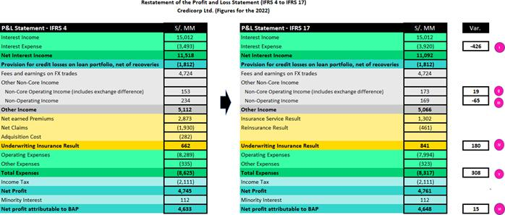

12.1.8. Changes in the Methodology to Calculate Financial Indicators and their Reformulation for the year 2022

- Net Interest Margin

The Net Interest Margin is reformulated in the following way:

Under IFRS 4, the numerator of the Net Interest Margin was comprised of the difference between Interest Income and Interest Expenses. Under IFRS 17, we need to adjust the formula because Interest Expenses now include the concept “Financial Expense associated with the insurance and reinsurance activity, net.” We seek to exclude the impact of this concept on the Net Interest Margin given that this particular kind of interest expense is not associated with a source of funding. As such, we adjust the numerator by reincorporating “Financial Expense associated with insurance and reinsurance activity, net” to “Net Interest Income” calculated under IFRS 17. It is important to note that as a result of this adjustment, the numerator of the Net Interest Margin under IRFS4 is identical to that seen under IFRS 17.

From now on, we will exclude from the denominator (average balance of Interest-earning Assets) the following: the balance associated with the account “Financial Assets at Fair Value through P&L” given that this account is primarily comprised of investments associated from Investment Link contracts, which do not accrue interests for Credicorp. This change is not related to IFRS 17.

Below, we present the aforementioned change in graphic form.

Datos elaborados por BCP para uso Interno | 52

| Earnings Release 4Q / 2023 Analysis of 4Q23 Consolidated Results

12. Appendix
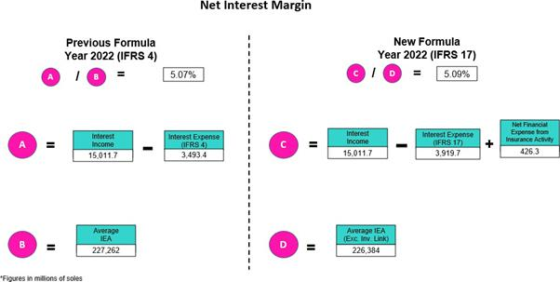

- Funding Cost

The Funding Cost indicator is being reformulated as follows: under IFRS 4, the numerator of the Funding Cost is comprised of the balance of the “Interest Expenses” account while under IFRS 17, we must adjust the formula given that Interest Expenses now include the concept of “Financial expense associated with insurance and reinsurance activity, net.” We seek to exclude the impact of this new concept on the Funding Cost given that this particular type of expense is not associated with a source of funding. As such, we adjust the numerator by deducting the “Financial Expense associated with insurance and reinsurance activity, net” from “Interest Expenses “calculated under IFRS 17. It is important to note that as a result of this adjustment, the figure for the Funding Cost under IFRS is identical to the same figure under IFRS 17. The following figure is a graphic representation of the aforementioned change.
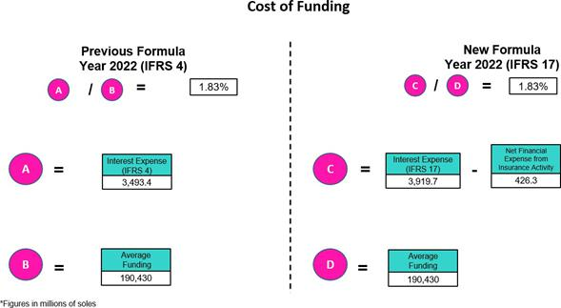

Datos elaborados por BCP para uso Interno | 53

| Earnings Release 4Q / 2023 Analysis of 4Q23 Consolidated Results

  - Appendix

III.Efficiency Ratio

The Efficiency Ratio is being reformulated as follows:

Under IFRS 4, the numerator of the Efficiency Ratio is comprised of the total of the “Salaries and Employee Benefits,” “Administrative Expenses,” “Depreciation and Amortization,” “Expenses for Participation in Association,” and the “Acquisition Cost” accounts. Collectively, these accounts constitute “Operating Expenses.” Under IFRS 17, we make an adjustment to the components of this group of “Operating Expenses” given that the “Acquisition Cost” no longer exists in the Profit and Loss Statement under IFRS 17. Consequently, under IFRS 17, the grouping of “Operating Expenses” is comprised solely of “Salaries and Employee Benefits,” “Administrative Expenses,” “Depreciation and Amortization,” and “Expenses for Participation in Association.” It is important to note that balances of these accounts under IFRS17 are not the same as the balances of the accounts with the same name under IFRS17.

Under IFRS 4, the denominator of the Efficiency Ratio is comprised of the total of the accounts grouped as Core Operating Income (“Interest Income, net”, “Fee income, net,” and “Net gain on FX transactions”); the accounts grouped as Non-Core Operating Income (“Gain on Investments in Associates, “Gain on derivatives,” “Net gain on Exchange Differences); and the “Net Earned Premiums” account. Collectively, all of these accounts constitute “Operating Income.” Under IFRS 17, we are adjusting the components of the grouping for “Operating Income” to replace the component of “Net Earned Premiums” with the “Insurance Underwriting Result.”

It is important to note that the result of replacing the “Net Earned Premiums “account with the “Insurance Underwriting Result” in the denominator of the efficiency ratio is in fact very significant (upward). The aforementioned is due to the fact that the balance of Insurance Technical results is usually materially lower than the balance of Net Earned Premiums as Insurance Technical results have embedded the impact of charges for Incurred Claims. Below, we present a graphic depiction of the aforementioned change.
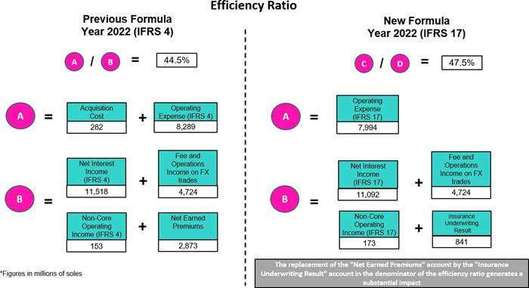

Datos elaborados por BCP para uso Interno | 54

| |  | Earnings Release 4Q / 2023 |  |  |  | Analysis of 4Q23 Consolidated Results
12. Appendix
12.1.9. Glossary of Terms Under IFRS 17
Reserve for BEL (Best Estimate Liability) o |  |  | Represents the best estimate of the difference between payments for obligations
 |  |  | (claims, income and expenses) and premiums, flowed and brought to present value
 | Fulfillment Cashflows.
 | Fulfillment Cashflows. |  | at the time of valuation.
Reserve for RA (risk Adjustment). |  |  | Represents the margin of prudence that will be used to cover deviations in the
 |  |  | underwriting parameters beyond changes in the interest rate.
Reserve for CSM (Contractual Service Margin). |  |  | Represents the present value of future underwriting income (non-financial). Income
 |  |  | accrues over the life of the policy.
 | Attributable Expenses |  | Corresponds to necessary expenses |  |  | to place a |  | policy or maintain | the same
 | Attributable Expenses |  | throughout its term. It is part of insurance flows.
Financial Expense associated with the insurance |  |  | Represents interest accredited to reserves in the period after updating their present
 |  |  | value. This concept was previously included in reserves under IFRS 4. IFRS 17
and reinsurance activity, net
 |  |  | separates the financial component from the underwriting component.
 | Onerous Contracts |  | The contracts that the company estimates will generate underwriting losses (not
 | Onerous Contracts |  | including financial income) during the policy term.
12.2. Physical Point of contact
 | Physical Point of Contact ⁽¹⁾ |  |  |  | As of |  |  | change (units)
 | (Units) |  |  | Dec 22 | Sep 23 | Dec 23 |  | QoQ | YoY
 | Branches |  |  | 674 | 661 | 659 |  | (2) | (15)
 | ATMs |  |  | 2,625 | 2,677 | 2,746 |  | 69 | 121
 | Agents ⁽²⁾ |  |  | 11,254 | 11,452 | 12,034 |  | 582 | 780
 | Total |  |  | 14,553 | 14,790 | 15,439 |  | 649 | 886

- Includes Physical Point of Contact of BCP Stand-Alone, Mibanco and BCP Bolivia

- Figures differ from previously reported due to changes in BCP Bolivia agents

12.3. Loan Portfolio Quality

Government Program (GP) Loan Portfolio Quality (in Quarter-end Balances)

GP Portfolio quality and Delinquency ratios ⁽¹⁾ |  | As of |  |  | % change
S/000 | Dec 22 | Sep 23 | Dec 23 | QoQ | YoY
GP Total loans (Quarter-end balance) | 9,511,132 | 4,179,770 | 3,595,503 | -14.0% | -62.2%
GP Allowance for loan losses | 138,827 | 114,283 | 119,212 | 4.3% | -14.1%
GP IOLs | 1,148,499 | 827,360 | 565,974 | -31.6% | -50.7%
GP IOL ratio | 12.08% | 19.79% | 15.74% | -405 bps | 366 bps
GP Allowance for loan losses over GP Total loans | 1.5% | 2.7% | 3.3% | 59 bps | 186 bps
GP Coverage ratio of IOLs | 12.1% | 13.8% | 21.1% | 725 bps | 897 bps

(1) Government Programs (GP) include Reactiva Peru, FAE-Mype and Impulso MyPeru.

Datos elaborados por BCP para uso Interno | 55

| Earnings Release 4Q / 2023 Analysis of 4Q23 Consolidated Results

12. Appendix

Portfolio Quality Ratios by Segment

Wholesale Banking
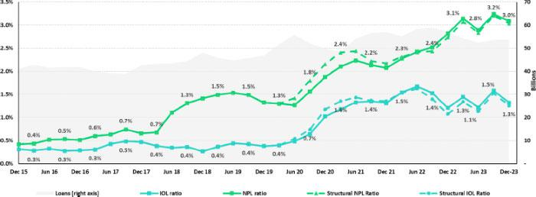

SME-Business
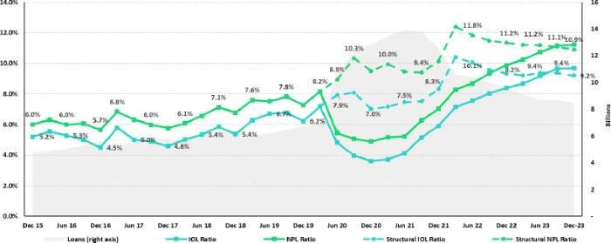

Datos elaborados por BCP para uso Interno | 56

| Earnings Release 4Q / 2023 Analysis of 4Q23 Consolidated Results

12. Appendix

SME-Pyme
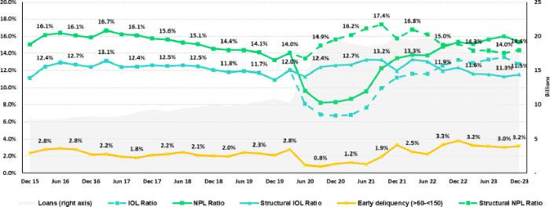

Mortgage
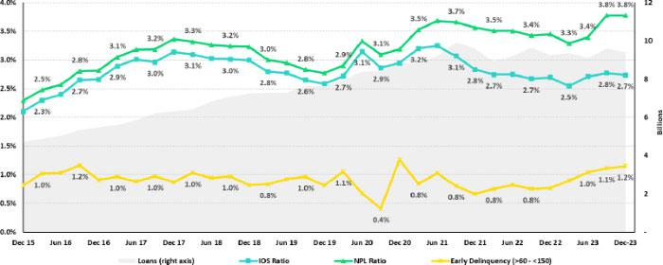

Datos elaborados por BCP para uso Interno | 57

| Earnings Release 4Q / 2023 Analysis of 4Q23 Consolidated Results

12. Appendix

Consumer
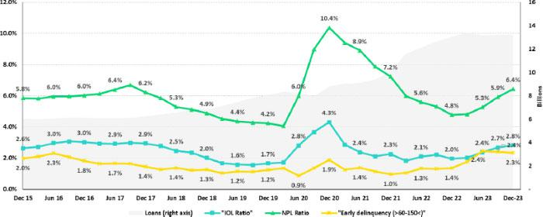

Credit Card
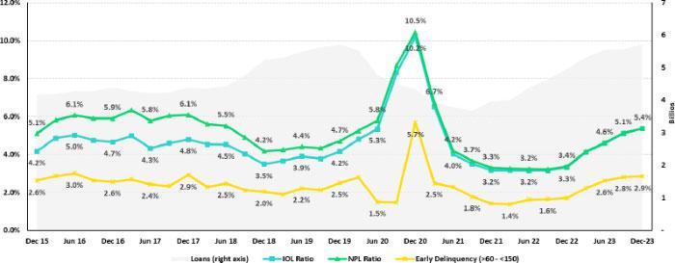

Datos elaborados por BCP para uso Interno | 58

| Earnings Release 4Q / 2023 Analysis of 4Q23 Consolidated Results

12. Appendix

Mibanco
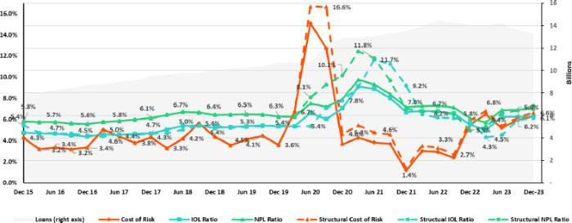

BCP Bolivia
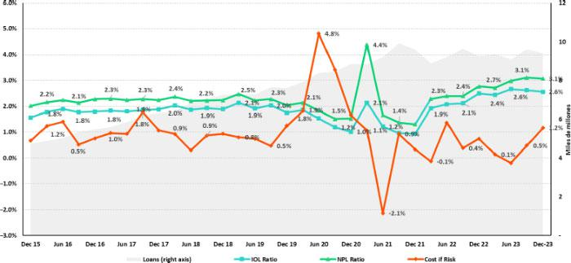

Datos elaborados por BCP para uso Interno | 59

 | | Earnings Release 4Q / 2023 |  |  |  |  |  |  |  | Analysis of 4Q23 Consolidated Results
12. Appendix
12.4 Net Interest Income (NII)
 |  |  |  | NII Summary
Net interest income |  |  |  | Quarter |  |  |  | % change |  | As of |  |  |  | change %
S/ 000 |  |  | 4Q22 | 3Q23 | 4Q23 |  |  | QoQ | YoY | 2022 |  | 2023 |  | 2023 / 2022
Interest income |  |  | 4,362,139 | 4,819,101 | 4,870,042 |  |  | 1.1% | 11.6% | 15,011,282 |  | 18,798,495 |  | 25.2%
Interest on loans |  |  | 3,515,083 | 3,853,361 | 3,907,705 |  |  | 1.4% | 11.2% | 12,419,281 |  | 15,044,863 |  | 21.1%
Dividends on investments |  |  | 3,725 | 10,464 | 11,647 |  |  | 11.3% | 212.7% | 29,226 |  | 46,080 |  | 57.7%
Interest on deposits with banks |  |  | 238,132 | 289,934 | 279,446 |  |  | -3.6% | 17.3% | 467,388 |  | 1,133,210 |  | 142.5%
Interest on securities |  |  | 560,287 | 641,370 | 643,737 |  |  | 0.4% | 14.9% | 2,016,217 |  | 2,489,327 |  | 23.5%
Other interest income |  |  | 44,912 | 23,972 | 27,507 |  |  | 14.7% | -38.8% | 79,170 |  | 85,015 |  | 7.4%
Interest expense |  |  | (1,221,735) | (1,565,058) | (1,522,358) |  |  | -2.7% | 24.6% | (3,919,664) |  | (5,860,523) |  | 49.5%
Interest expense (excluding Net Insurance |  |  | (1,118,966) | (1,448,593) | (1,402,925) |  |  | -3.2% | 25.4% | (3,493,187) |  | (5,393,709) |  | 54.4%
Financial Expenses) |  |  | (1,118,966) | (1,448,593) |  |  |  | -3.2% | 25.4% | (3,493,187) |  |  |  | 54.4%
Interest on deposits |  |  | 582,237 | 859,659 | 827,124 |  |  | -3.8% | 42.1% | 1,688,245 |  | 3,141,307 |  | 86.1%
Interest on borrowed funds |  |  | 239,425 | 325,619 | 297,260 |  |  | -8.7% | 24.2% | 683,078 |  | 1,158,666 |  | 69.6%
Interest on bonds and subordinated notes |  |  | 170,772 | 149,449 | 152,960 |  |  | 2.3% | -10.4% | 728,218 |  | 634,299 |  | -12.9%
Other interest expense |  |  | 126,532 | 113,866 | 125,581 |  |  | 10.3% | -0.8% | 393,646 |  | 459,437 |  | 16.7%
Net Insurance Financial Expenses |  |  | (102,769) | (116,465) | (119,433) |  |  | 2.5% | 16.2% | (426,477) |  | (466,814) |  | 9.5%
Net interest income |  |  | 3,140,404 | 3,254,043 | 3,347,684 |  |  | 2.9% | 6.6% | 11,091,618 |  | 12,937,972 |  | 16.6%
Risk-adjusted Net interest income |  |  | 2,409,723 | 2,336,401 | 2,174,230 |  |  | -6.9% | -9.8% | 9,280,080 |  | 9,315,627 |  | 0.4%
Average interest earning assets |  |  | 225,604,596 | 220,724,334 | 223,502,057 |  |  | 1.3% | -0.9% | 226,384,489 |  | 223,196,576 |  | -1.4%
Net interest margin ⁽¹⁾ |  |  | 5.75% | 6.11% | 6.21% |  |  | 10bps | 46bps | 5.09% |  | 6.01% |  | 92bps
Risk-adjusted Net interest margin ⁽¹⁾ |  |  | 4.45% | 4.45% | 4.10% |  |  | -35bps | -35bps | 4.29% |  | 4.38% |  | 9bps
Net provisions for loan losses / Net interest |  |  | 23.27% | 28.20% | 35.05% |  |  |  |  | 16.33% |  | 28.00% |  | 1167bps
income |  |  | 23.27% | 28.20% |  |  |  | 685bps | 1178bps | 16.33% |  |  |  | 1167bps
(1) Annualized. For further detail on the new NIM calculation due to IFRS17, please refer to Annex 12.1.8
 |  |  | Net Interest Margin (NIM) and Risk Adjusted NIM by subsidiary
 |  | NIM Breakdown |  |  |  | BCP Stand- |  |  | Mibanco | BCP Bolivia |  | Credicorp
 |  |  |  |  |  | alone |  |  | Mibanco | BCP Bolivia |  | Credicorp
 |  |  | 4Q22 |  |  | 5.41% |  |  | 12.73% | 2.71% |  | 5.75%
 |  |  | 3Q23 |  |  | 5.77% |  |  | 13.64% | 2.87% |  | 6.11%
 |  |  | 4Q23 |  |  | 5.99% |  |  | 13.35% | 2.87% |  | 6.21%

NIM: Annualized Net interest income (excluding Net Insurance Financial Expenses) / Average period end and period beginning interest earning assets.

Risk Adjusted NIM Breakdown | BCP | Mibanco | BCP | Credicorp
Risk Adjusted NIM Breakdown | Stand-alone | Mibanco | Bolivia | Credicorp
4Q22 | 4.24% | 8.14% | 2.13% | 4.45%
3Q23 | 4.18% | 8.73% | 2.47% | 4.45%
4Q23 | 2.81% | 8.17% | 1.93% | 4.10%

Risk-Adjusted NIM: (Annualized Net interest income (excluding Net Insurance Financial Expenses) - annualized provisions) / Average period end and period beginning interest earning assets.

Datos elaborados por BCP para uso Interno | 60

| Earnings Release 4Q / 2023 Analysis of 4Q23 Consolidated Results

12. Appendix

12.5. Regulatory Capital

Regulatory Capital and Capital Adequacy Ratios

(S/ Thousands, IFRS)

 |  | As of |  |  | % change
 | Dec 22 | Sep 23 | Dec 23 | QoQ | YoY
Capital Stock | 1,318,993 | 1,318,993 | 1,318,993 | 0.0% | 0.0%
Treasury Stocks | (207,518) | (208,033) | (208,033) | 0.0% | 0.2%
Capital Surplus | 231,556 | 225,338 | 228,239 | 1.3% | -1.4%
Legal and Other capital reserves ⁽¹⁾ | 23,702,590 | 26,239,162 | 26,252,578 | 0.1% | 10.8%
Minority interest ⁽²⁾ | 471,171 | 210,283 | 205,548 | -2.3% | -56.4%
Loan loss reserves ⁽³⁾ | 2,128,732 | 1,946,059 | 1,969,001 | 1.2% | -7.5%
Perpetual subordinated debt | - | - | -
Subordinated Debt | 5,770,557 | 5,844,106 | 5,720,210 | -2.1% | -0.9%
Investments in equity and subordinated debt of financial and insurance | (889,246) | (1,259,626) | (1,235,434) | -1.9% | 38.9%
companies
Goodwill | (772,213) | (842,678) | (798,482) | -5.2% | 3.4%
Current year Net Loss | - | - | -
Deduction for subordinated debt limit (50% of Tier I excluding | - | - | -
deductions) ⁽⁴⁾ | - | - | -
Deduction for Tier I Limit (50% of Regulatory capital) ⁽⁴⁾ | - | - | -
Total Regulatory Capital (A) | 31,754,622 | 33,473,604 | 33,452,620 | -0.1% | 5.3%
Tier 1 ⁽⁵⁾ | 16,955,335 | 17,821,987 | 17,876,445 | 0.3% | 5.4%
Tier 2 ⁽⁶⁾ + Tier 3 ⁽⁷⁾ | 14,799,287 | 15,651,617 | 15,576,175 | -0.5% | 5.2%
Financial Consolidated Group (FCG) Regulatory Capital Requirements | 22,506,113 | 22,387,961 | 24,780,032 | 10.7% | 10.1%
(8)
Insurance Consolidated Group (ICG) Capital Requirements ⁽⁹⁾ | 1,562,893 | 1,550,765 | 1,593,590 | 2.8% | 2.0%
FCG Capital Requirements related to operations with ICG | (471,371) | (680,628) | (652,893) | -4.1% | 38.5%
ICG Capital Requirements related to operations with FCG | - | - | -
Total Regulatory Capital Requirements (B) | 23,597,634 | 23,258,098 | 25,720,729 | 10.6% | 9.0%
Regulatory Capital Ratio (A) / (B) | 1.35 | 1.44 | 1.30
Required Regulatory Capital Ratio ⁽¹⁰⁾ | 1.00 | 1.00 | 1.00

- Legal and other capital reserves include restricted capital reserves (PEN 14,745 million) and optional capital reserves (PEN 6,661 million).

- Minority interest includes Tier I (PEN 421 million)
- Up to 1.25% of total risk-weighted assets of Banco de Credito del Peru, Solucion Empresa Administradora Hipotecaria, Mibanco and ASB Bank Corp.
- Tier II + Tier III cannot be more than 50% of total regulatory capital.
- Tier I = capital + restricted capital reserves + Tier I minority interest - goodwill - (0.5 x investment in equity and subordinated debt of financial and insurance companies) + perpetual subordinated debt.

- Tier II = subordinated debt + Tier II minority interest tier + loan loss reserves - (0.5 x investment in equity and subordinated debt of financial and insurance companies).
- Tier III = Subordinated debt covering market risk only.
- Includes regulatory capital requirements of the financial consolidated group.
- Includes regulatory capital requirements of the insurance consolidated group.
- Regulatory Capital / Total Regulatory Capital Requirements (legal minimum = 1.00).

Datos elaborados por BCP para uso Interno | 61

| Earnings Release 4Q / 2023 Analysis of 4Q23 Consolidated Results

12. Appendix

Regulatory and Capital Adequacy Ratios at BCP Stand-alone

(S/ thousands, IFRS)

Regulatory Capital |  | Quarter |  | % change
(S/ thousand) |  | Sep 23 | Dec 23 | QoQ
Capital Stock |  | 12,973,175 | 12,973,175 | 0.0%
Reserves |  | 7,039,793 | 6,590,921 | -6.4%
Accumulated earnings |  | 4,474,351 | 5,383,865 | 20.3%
Loan loss reserves (1) |  | 1,667,750 | 1,695,577 | 1.7%
Perpetual subordinated debt |  | - | - | n.a
Subordinated Debt |  | 5,120,550 | 5,007,150 | -2.2%
Unrealized Profit or Losses |  | (916,337) | (668,717) | -27.0%
Investment in subsidiaries and others, net of unrealized profit and net income in |  |  |  | 2.1%
subsidiaries |  | (2,714,749) | (2,772,786) | 2.1%
Intangibles |  | (1,124,983) | (1,294,279) | 15.0%
Goodwill |  | (122,083) | (122,083) | 0.0%
Total Regulatory Capital |  | 26,397,466 | 26,792,823 | 1.5%
Tier 1 Common Equity (2) |  | 19,609,166 | 20,090,096 | 2.5%
Regulatory Tier 1 Capital (3) |  | 19,609,166 | 20,090,096 | 2.5%
Regulatory Tier 2 Capital (4) |  | 6,788,300 | 6,702,727 | -1.3%
Total risk-weighted assets |  | Quarter |  | % change
(S/ thousand) |  | Sep 23 | Dec 23 | QoQ
Market risk-weighted assets (5) |  | 2,576,734 | 2,680,010 | 4.0%
Credit risk-weighted assets |  | 132,297,592 | 134,427,146 | 1.6%
Operational risk-weighted assets |  | 15,862,960 | 16,365,974 | 3.2%
Total |  | 150,737,286 | 153,473,130 | 1.8%
Capital requirement |  | Quarter |  | % change
(S/ thousand) |  | Sep 23 | Dec 23 | QoQ
Market risk capital requirement (5) |  | 257,673 | 268,001 | 4.0%
Credit risk capital requirement |  | 11,906,783 | 12,098,443 | 1.6%
Operational risk capital requirement |  | 1,586,296 | 1,636,597 | 3.2%
Additional capital requirements |  | 3,595,810 | 5,383,837 | 49.7%
Total |  | 17,346,562 | 19,386,878 | 11.8%
 | Capital Ratios under Local Regulation
 |  | Sep 23 | Dec 23 | Change
Common Equity Tier 1 ratio | 13.01% |  | 13.09% | 8 pbs
Tier 1 Capital ratio | 13.01% |  | 13.09% | 8 pbs
Regulatory Global Capital ratio | 17.51% |  | 17.46% | -5 pbs
- Up to 1.25% of total risk-weighted assets.
- Common Equity Tier 1 = Capital Stock + Reserves + Accumulated earnings – Unrealized profits or losses - 100% deductions (investment in subsidiaries, goodwill, intangible assets and deferred tax assets based on future returns).
- Regulatory Tier 1 Capital = Common Equity Tier 1 + Tier 1 Subordinated Debt (Perpetual).
- Regulatory Tier 2 Capital = Subordinated Debt + Loan loss reserves.

Datos elaborados por BCP para uso Interno | 62

| Earnings Release 4Q / 2023 Analysis of 4Q23 Consolidated Results

12. Appendix

Regulatory Capital and Capital Adequacy Ratios at Mibanco

(S/ thousands, IFRS)

Regulatory Capital |  | Quarter |  | % change
(S/ thousand) |  | Sep 23 | Dec 23 | QoQ
Capital Stock |  | 1,840,606 | 1,840,606 | 0.0%
Reserves |  | 308,056 | 308,056 | 0.0%
Accumulated earnings |  | 669,894 | 717,919 | 7.2%
Loan loss reserves |  | 163,158 | 157,368 | -3.5%
Perpetual subordinated debt |  | - | - | n.a
Subordinated debt |  | 173,000 | 173,000 | 0.0%
Unrealidez Profit or Losses |  | (13,584) | (1,695) | -87.5%
Investment in subsidiaries and others, net of unrealized profit and net income in |  |  |  | 2.2%
subsidiaries |  | (276) | (282) | 2.2%
Intangibles |  | (140,573) | (156,884) | 11.6%
Goodwill |  | (139,180) | (139,180) | 0.0%
Total Regulatory Capital |  | 2,861,101 | 2,898,907 | 1.3%
Tier Common Equity (2) |  | 2,524,943 | 2,568,539 | 1.7%
Regulatory Tier 1 Capital (3) |  | 2,524,943 | 2,568,539 | 1.7%
Regulatory Tier 2 Capital (4) |  | 336,158 | 330,368 | -1.7%
Total risk-weighted assets |  | Quarter |  | % change
(S/ thousand) |  | Sep 23 | Dec 23 | QoQ
Market risk-weighted assets |  | 163,853 | 220,327 | 34.5%
Credit risk-weighted assets |  | 12,799,766 | 12,349,400 | -3.5%
Operational risk-weighted assets |  | 1,522,681 | 1,527,140 | 0.3%
Total |  | 14,486,300 | 14,096,867 | -2.7%
Capital requirement |  | Quarter |  | % change
(S/ thousand) |  | Sep 23 | Dec 23 | QoQ
Market risk capital requirement (5) |  | 16,385 | 22,033 | 34.5%
Credit risk capital requirement |  | 1,215,978 | 1,111,446 | -8.6%
Operational risk capital requirement |  | 152,268 | 152,714 | 0.3%
Additional capital requirements |  | 399,691 | 557,637 | 39.5%
Total |  | 1,784,322 | 1,843,830 | 3.3%
 | Capital Ratios under Local Regulation
 |  | Sep 23 | Dec 23 | % change
Common Equity Tier 1 Ratio | 17.43% |  | 18.22% | 79 pbs
Tier 1 Capital ratio | 17.43% |  | 18.22% | 79 pbs
Regulatory Global Capital Ratio | 19.75% |  | 20.56% | 81 pbs
- Up to 1.25% of total risk-weighted assets.
- Common Equity Tier 1 = Capital Stock + Reserves + Accumulated earnings – Unrealized profits or losses - 100% deductions (investment in subsidiaries, goodwill, intangible assets and deferred tax assets based on future returns).
- Regulatory Tier 1 Capital = Common Equity Tier 1 + Tier 1 Subordinated Debt (Perpetual).
- Regulatory Tier 2 Capital = Subordinated Debt + Loan loss reserves.

Datos elaborados por BCP para uso Interno | 63

| Earnings Release 4Q / 2023 Analysis of 4Q23 Consolidated Results

12. Appendix

Common Equity Tier 1 IFRS

BCP Stand-alone

 | Common Equity Tier 1 IFRS |  | Quarter |  | % Change | % Change
 | (S/. thousand) | Dec 22 | Sep 23 | Dec 23 | QoQ | YoY
 | Capital and reserves | 18,423,649 | 19,500,725 | 19,051,853 | -2.3% | 3.4%
 | Retained earnings | 5,249,495 | 5,104,881 | 6,058,923 | 18.7% | 15.4%
 | Unrealized gains (losses) | (549,319) | (375,086) | (109,202) | -70.9% | -80.1%
 | Goodwill and intangibles | (1,472,073) | (1,573,072) | (1,670,116) | 6.2% | 13.5%
 | Investments in subsidiaries | (2,702,065) | (2,851,285) | (2,917,670) | 2.3% | 8.0%
 | Total | 18,949,687 | 19,806,164 | 20,413,787 | 3.1% | 7.7%
 | Adjusted RWAs IFRS | 150,535,662 | 151,843,249 | 154,627,042 | 1.8% | 2.7%
 | Adjusted Credit RWAs IFRS | 134,564,844 | 133,403,554 | 135,581,058 | 1.6% | 0.8%
 | Others | 15,970,818 | 18,439,695 | 19,045,984 | 3.3% | 19.3%
 | CET1 ratio IFRS | 12.59% | 13.04% | 13.20% | 16 pbs | 61 pbs
 |  |  | Mibanco
 | Common Equity Tier 1 IFRS |  | Quarter |  | % Change | % Change
 | (S/. thousand) | Dec 22 | Sep 23 | Dec 23 | QoQ | YoY
 | Capital and reserves | 2,632,956 | 2,676,791 | 2,676,791 | 0.0% | 1.7%
 | Retained earnings | 161,295 | 267,299 | 321,189 | 20.2% | 99.1%
 | Unrealized gains (losses) | (12,686) | (13,268) | (1,403) | -89.4% | -88.9%
 | Goodwill and intangibles | (349,967) | (345,258) | (360,171) | 4.3% | 2.9%
 | Investments in subsidiaries | (261) | (276) | (282) | 2.2% | 8.1%
 | Total | 2,431,337 | 2,585,288 | 2,636,124 | 2.0% | 8.4%
 | Adjusted RWAs IFRS | 14,772,095 | 14,719,637 | 14,351,724 | -2.5% | -2.8%
 | Adjusted Credit RWAs IFRS | 13,255,788 | 13,028,635 | 12,597,373 | -3.3% | -5.0%
 | Others | 1,516,307 | 1,691,001 | 1,754,350 | 3.7% | 15.7%
 | CET1 ratio IFRS | 16.46% | 17.56% | 18.37% | 80 pbs | 191 pbs
 |  | Datos elaborados por BCP para uso Interno |  |  |  | 64

| Earnings Release 4Q / 2023 Analysis of 4Q23 Consolidated Results

12. Appendix

12.6. Financial Statements and Ratios by Business

12.6.1. Credicorp Consolidated

CREDICORP LTD. AND SUBSIDIARIES

CONSOLIDATED STATEMENT OF FINANCIAL POSITION
(In S/ thousands, IFRS)

 | Dec 22 | As of | Dec 23 | QoQ | % change
 | Dec 22 | Sep 23 | Dec 23 | QoQ | YoY
ASSETS
Cash and due from banks
Non-interest bearing | 7,286,624 | 8,047,624 | 8,196,692 | 1.9% | 12.5%
Interest bearing | 26,897,216 | 24,907,836 | 25,734,256 | 3.3% | -4.3%
Total cash and due from banks | 34,183,840 | 32,955,460 | 33,930,948 | 3.0% | -0.7%
Cash collateral, reverse repurchase agreements and securities borrowing | 1,101,856 | 1,513,622 | 1,410,647 | -6.8% | 28.0%
Fair value through profit or loss investments | 4,199,334 | 5,558,973 | 4,982,661 | -10.4% | 18.7%
Fair value through other comprehensive income investments | 30,786,161 | 35,475,821 | 37,043,940 | 4.4% | 20.3%
Amortized cost investments | 10,445,729 | 10,082,119 | 10,188,927 | 1.1% | -2.5%
Loans | 148,626,374 | 145,129,260 | 144,976,051 | -0.1% | -2.5%
Current | 142,686,630 | 138,722,915 | 138,849,564 | 0.1% | -2.7%
Internal overdue loans | 5,939,744 | 6,406,345 | 6,126,487 | -4.4% | 3.1%
Less - allowance for loan losses | (7,872,402) | (8,056,216) | (8,277,916) | 2.8% | 5.2%
Loans, net | 140,753,972 | 137,073,044 | 136,698,135 | -0.3% | -2.9%
Financial assets designated at fair value through profit or loss | 768,801 | 797,545 | 810,932 | 1.7% | 5.5%
Property, plant and equipment, net | 1,824,931 | 1,752,950 | 1,857,240 | 5.9% | 1.8%
Due from customers on acceptances | 699,678 | 325,771 | 412,401 | 26.6% | -41.1%
Investments in associates | 726,993 | 707,457 | 748,663 | 5.8% | 3.0%
Intangible assets and goodwill, net | 2,899,429 | 3,118,496 | 3,225,499 | 3.4% | 11.2%
Assets by reinsurance contracts |  | 803,868 | 872,046 | 8.5% | 17.2%
Other assets ⁽¹⁾ | 6,293,599 | 8,293,532 | 6,658,149 | -19.7% | 6.0%
Total Assets | 236,750,138 | 238,458,658 | 238,840,188 | 0.2% | 1.5%
LIABILITIES AND EQUITY
Deposits and obligations
Non-interest bearing | 43,346,151 | 40,363,636 | 42,234,498 | 4.6% | -2.6%
Interest bearing | 103,674,636 | 108,107,899 | 105,470,496 | -2.4% | 1.7%
Total deposits and obligations | 147,020,787 | 148,471,535 | 147,704,994 | -0.5% | 0.5%
Payables from repurchase agreements and securities lending | 12,966,725 | 11,738,020 | 10,168,427 | -13.4% | -21.6%
BCRP instruments | 11,297,659 | 9,616,150 | 7,461,674 | -22.4% | -34.0%
Repurchase agreements with third parties | 976,020 | 1,266,852 | 1,134,886 | -10.4% | 16.3%
Repurchase agreements with customers | 693,046 | 855,018 | 1,571,867 | 83.8% | 126.8%
Due to banks and correspondents | 8,937,411 | 10,493,411 | 12,278,681 | 17.0% | 37.4%
Bonds and notes issued | 17,007,194 | 14,914,632 | 14,594,785 | -2.1% | -14.2%
Banker’s acceptances outstanding | 699,678 | 325,771 | 412,401 | 26.6% | -41.1%
Liabilities by insurance contracts | 12,411,053 | 11,653,015 | 12,318,133 | 5.7% | 10.4%
Financial liabilities at fair value through profit or loss | 191,010 | 455,350 | 641,915 | 41.0% | 236.1%
Other liabilities | 7,943,225 | 8,499,868 | 7,613,787 | -10.4% | -2.9%
Total Liabilities | 207,160,838 | 206,551,602 | 205,733,123 | -0.4% | 0.0%
Net equity | 28,997,731 | 31,267,592 | 1,318,993 | 0.0% | 0.0%
Net equity | 28,997,731 | 31,267,592 | 32,460,004 | 3.8% | 11.9%
Capital stock | 1,318,993 | 1,318,993 | 1,318,993 | 0.0% | 0.0%
Treasury stock | (207,518) | (208,033) | (208,033) | 0.0% | 0.2%
Capital surplus | 231,556 | 225,338 | 228,239 | 1.3% | -1.4%
Reserves | 23,659,626 | 26,239,162 | 26,252,578 | 0.1% | 11.0%
Other reserves | (650,116) | (29,526) | 295,783 | n.a | -207.1%
Retained earnings | 4,635,599 | 3,721,658 | 4,572,444 | 22.9% | 6.9%
Non-controlling interest | 591,569 | 639,464 | 647,061 | 1.2% | 9.4%
Total Net Equity | 29,579,709 | 31,907,056 | 33,107,065 | 3.8% | 11.9%
Total liabilities and equity | 236,775,218 | 238,458,658 | 238,840,188 | 0.2% | 1.5%
Off-balance sheet | 150,977,864 | 151,484,019 | 149,769,480 | -1.1% | -0.8%
Total performance bonds, stand-by and L/Cs. | 20,928,054 | 18,945,883 | 20,051,616 | 5.8% | -4.2%
Undrawn credit lines, advised but not committed | 86,597,041 | 88,183,227 | 87,091,701 | -1.2% | 0.6%
Total derivatives (notional) and others | 43,452,769 | 44,354,909 | 42,626,163 | -3.9% | -1.9%

(1) Includes mainly accounts receivables from brokerage and others

* Due to reclassifications, the Balance Sheet may differ from those reported in previous quarters.

Datos elaborados por BCP para uso Interno | 65

| Earnings Release 4Q / 2023 |  |  |  |  |  | Analysis of 4Q23 Consolidated Results
12. Appendix
 | CREDICORP LTD. AND SUBSIDIARIES
 | CONSOLIDATED STATEMENT OF INCOME
 | (In S/ thousands, IFRS)
 |  |  | Quarter |  |  | % change |  | Up to |  | % change
 |  | 4Q22 | 3Q23 | 4Q23 |  | QoQ | YoY | Dec 22 | Dec 23 | Dec 23 / Dec 22
Interest income and expense
Interest and similar income |  | 4,362,142 | 4,819,101 | 4,870,042 |  | 1.1% | 11.6% | 15,011,282 | 18,798,495 | 25.2%
Interest and similar expenses |  | (1,227,364) | (1,565,058) | (1,522,358) |  | -2.7% | 24.6% | (3,919,664) | (5,860,523) | 49.5%
Net interest, similar income and expenses |  | 3,134,778 | 3,254,043 | 3,347,684 |  | 2.9% | 6.6% | 11,091,618 | 12,937,972 | 16.6%
Gross provision for credit losses on loan portfolio |  | (815,589) | (1,008,750) | (1,260,163) |  | 24.9% | 54.5% | (2,158,555) | (3,957,143) | 83.3%
Recoveries of written-off loans |  | 84,908 | 91,108 | 86,709 |  | -4.8% | 2.1% | 347,017 | 334,798 | -3.5%
Provision for credit losses on loan portfolio, net of recoveries |  | (730,681) | (917,642) | (1,173,454) |  | 27.9% | 60.6% | (1,811,538) | (3,622,345) | 100.0%
Net interest, similar income and expenses, after provision for credit losses on loan |  | 2,404,097 | 2,336,401 | 2,174,230 |  | -6.9% | -9.8% | 9,280,080 | 9,315,627 | 0.4%
portfolio |  | 2,404,097 | 2,336,401 | 2,174,230
Other income
Fee income |  | 894,552 | 975,955 | 986,173 |  | 1.0% | 10.2% | 3,642,857 | 3,804,459 | 4.4%
Net gain on foreign exchange transactions |  | 293,215 | 208,620 | 218,047 |  | 4.5% | -25.6% | 1,084,151 | 886,126 | -18.3%
Net loss on securities |  | 77,512 | 53,591 | 115,825 |  | 116.1% | 49.4% | (98,993) | 308,055 | -411.2%
Net gain from associates |  | 25,422 | 32,056 | 34,132 |  | 6.5% | 34.3% | 104,461 | 117,089 | 12.1%
Net gain (loss) on derivatives held for trading |  | 5,857 | 38,545 | 5,019 |  | -87.0% | -14.3% | 65,187 | 53,665 | -17.7%
Net gain (loss) from exchange differences |  | 22,039 | 4,564 | 15,255 |  | 234.2% | -53.9% | 387 | 45,778 | 11728.9%
Others |  | 19,630 | 89,272 | 112,372 |  | 25.9% | -4510.2% | 268,046 | 440,653 | 64.4%
Total other income |  | 1,338,227 | 1,402,603 | 1,486,823 |  | 6.0% | 12.0% | 5,066,096 | 5,655,825 | 11.6%
Insurance underwriting result
Insurance Service Result |  | 331,030 | 417,014 | 385,043 |  | -7.7% | 54.1% | 1,302,347 | 1,602,421 | 23.0%
Reinsurance Result |  | (119,436) | (86,114) | (97,748) |  | 13.5% | -13.5% | (460,899) | (391,321) | -15.1%
Total insurance underwriting result |  | 211,594 | 330,900 | 287,295 |  | -13.2% | 110.0% | 841,448 | 1,211,100 | 43.9%
Total expenses
Salaries and employee benefits |  | (1,040,066) | (1,061,402) | (1,119,758) |  | 5.5% | 8.1% | (3,902,161) | (4,265,453) | 9.3%
Administrative, general and tax expenses |  | (1,042,882) | (1,007,894) | (1,089,203) |  | 8.1% | 5.8% | (3,414,065) | (3,803,203) | 11.4%
Depreciation and amortization |  | (165,180) | (159,761) | (177,618) |  | 11.2% | 7.2% | (636,489) | (659,007) | 3.5%
Impairment loss on goodwill |  | - | - | (71,959) |  | n.a | n.a | - | (71,959) | n.a
Association in participation |  | (12,936) | (14,634) | (9,109) |  | -37.8% | -29.6% | (40,955) | (53,097) | 29.6%
Other expenses |  | (137,891) | (106,778) | (193,895) |  | 81.6% | 61.6% | (323,343) | (481,504) | 48.9%
Total expenses |  | (2,398,955) | (2,350,469) | (2,661,542) |  | 13.2% | 12.6% | (8,317,013) | (9,334,223) | 12.2%
Profit before income tax |  | 1,554,963 | 1,719,435 | 1,286,806 |  | -25.2% | -14.8% | 6,870,611 | 6,848,329 | -0.3%
Income tax |  | (476,236) | (455,865) | (434,648) |  | -4.7% | -8.7% | (2,110,501) | (1,888,451) | -10.5%
Net profit |  | 1,078,727 | 1,263,570 | 852,158 |  | -32.6% | -17.6% | 4,760,110 | 4,959,878 | 4.2%
Non-controlling interest |  | 24,231 | 25,397 | 10,331 |  | -59.3% | -57.4% | 112,292 | 94,338 | -16.0%
Net profit attributable to Credicorp |  | 1,054,496 | 1,238,173 | 841,827 |  | -32.0% | -16.7% | 4,647,818 | 4,865,540 | 4.7%
 | Datos elaborados por BCP para uso Interno |  |  |  |  |  |  |  |  | 66

 | | Earnings Release 4Q / 2023 |  |  |  |  | Analysis of 4Q23 Consolidated Results
12. Appendix
12.6.2. Credicorp Stand-alone
 | Statement of Financal Position
 | (S/ thousands, IFRS)
 |  | Dec 22 | As of | Dec 23 | % change
 |  | Dec 22 | Sep 23 | Dec 23 | QoQ | YoY
ASSETS
Cash and cash equivalents |  | 136,399 | 79,883 | 529,773 | 563.2% | 288.4%
At fair value through profit or loss |  | 958,939 | 937,279 | 501,026 | -46.5% | -47.8%
Fair value through other comprehensive income |  | 306,343 | 303,303 | 1,418,293 | 367.6% | 363.0%
investments
In subsidiaries and associates investments |  | 33,878,318 | 36,167,571 | 36,150,565 | 0.0% | 6.7%
Held to maturity
Other assets |  | 135 | 324 | 99 | -69.4% | -26.7%
Total Assets |  | 35,280,134 | 37,488,360 | 38,766,733 | 3.4% | 9.9%
LIABILITIES AND NET SHAREHOLDERS’ EQUITY
Due to banks, correspondents and other entities |  | - | 30,165 | 30,866 | 2.3% | n.a
Bonds and notes issued |  | 1,898,066 | 1,851,185 | 1,798,858 | -2.8% | -5.2%
Other liabilities |  | 220,642 | 206,963 | 255,707 | 23.6% | 15.9%
Total Liabilities |  | 2,118,708 | 2,088,313 | 2,085,431 | -0.1% | -1.6%
NET EQUITY
Capital stock |  | 1,318,993 | 1,318,993 | 1,318,993 | 0.0% | 0.0%
Capital Surplus |  | 384,542 | 384,542 | 384,542 | 0.0% | 0.0%
Reserve |  | 23,300,350 | 25,905,576 | 25,905,526 | 0.0% | 11.2%
Unrealized results |  | (835,079) | (215,370) | 68,056 | -131.6% | -108.1%
Retained earnings |  | 8,992,620 | 8,006,306 | 9,004,185 | 12.5% | 0.1%
Total net equity |  | 33,161,426 | 35,400,047 | 36,681,302 | 3.6% | 10.6%
Total Liabilities And Equity |  | 35,280,134 | 37,488,360 | 38,766,733 | 3.4% | 9.9%

Statement of Income

(S/ Thousands, IFRS)
 | 4Q22 | Quarter | 4Q23 | % change |  | Up to |  | % Change
 | 4Q22 | 3Q23 | 4Q23 | QoQ | YoY | Dec 22 | Dec 23 | Dec 22 / Dec 23
Interest income
Net share of the income from investments in subsidiaries and | 1,115,614 | 1,288,466 | 906,901 | -29.6% | -18.7% | 5,156,494 | 5,439,451 | 5.5%
associates
Interest and similar income | 1,040 | 429 | 1,170 | 172.7% | 12.5% | 8,701 | 10,895 | 25.2%
Net gain on financial assets at fair value through profit or loss | 35,329 | 8,845 | 32,430 | 266.6% | -8.2% | (43,099) | 67,652 | -257.0%
Total income | 1,151,983 | 1,297,740 | 940,501 | -27.5% | -18.4% | 5,122,096 | 5,517,998 | 7.7%
Interest and similar expense | (20,550) | (13,880) | (14,444) | 4.1% | -29.7% | (68,134) | (56,276) | -17.4%
Administrative and general expenses | (9,272) | (4,097) | (9,274) | 126.4% | 0.0% | (23,205) | (25,362) | 9.3%
Total expenses | (29,822) | (17,977) | (23,718) | 31.9% | -20.5% | (91,339) | (81,638) | -10.6%
Operating income | 1,122,161 | 1,279,763 | 916,783 | -28.4% | -18.3% | 5,030,757 | 5,436,360 | 8.1%
Net gain (losses) from exchange differences | (2,647) | 1,383 | 510 | -63.1% | -119.3% | (3,513) | (1,549) | -55.9%
Other, net | 106 | 2,665 | 111 | -95.8% | 4.7% | 556 | 2,977 | 435.4%
Profit before income tax | 1,119,620 | 1,283,811 | 917,404 | -28.5% | -18.1% | 5,027,800 | 5,437,788 | 8.2%
Income tax | (42,000) | (46,850) | (68,500) | 46.2% | 63.1% | (168,290) | (209,238) | 24.3%
Net income | 1,077,620 | 1,236,961 | 848,904 | -31.4% | -21.2% | 4,859,510 | 5,228,550 | 7.6%
Double Leverage Ratio | 102.2% | 102.2% | 98.6% | -360 bps | -360 bps | 102.2% | 98.6% | -360 bps
 |  | Datos elaborados por BCP para uso Interno |  |  |  |  |  | 67

 | | Earnings Release 4Q / 2023 |  |  |  | Analysis of 4Q23 Consolidated Results
12. Appendix
12.6.3 BCP Consolidated
 | Consolidated Statement of Financial Position
 |  | (S/ Thousands, IFRS)
 |  |  |  | As of |  |  |  | % change
 |  |  | Dec 22 | Sep 23 | Dec 23 |  | QoQ | YoY
 | ASSETS
 | Cash and due from banks
 | Non-interest bearing |  | 5,780,728 | 6,041,081 | 6,025,352 |  | -0.3% | 4.2%
 | Interest bearing |  | 25,594,929 | 23,912,271 | 24,668,794 |  | 3.2% | -3.6%
 | Total cash and due from banks |  | 31,375,657 | 29,953,352 | 30,694,146 |  | 2.5% | -2.2%
 | Cash collateral, reverse repurchase agreements and securities borrowing |  | 244,017 | 207,284 | 100,211 |  | -51.7% | -58.9%
 | Fair value through profit or loss investments |  | 1,011 | 1,229,265 | 362,360 |  | -70.5% | n.a
 | Fair value through other comprehensive income investments |  | 15,260,159 | 19,717,481 | 20,592,731 |  | 4.4% | 34.9%
 | Amortized cost investments |  | 9,831,983 | 9,450,388 | 9,557,451 |  | 1.1% | -2.8%
 | Loans |  | 136,046,442 | 131,843,710 | 131,767,137 |  | -0.1% | -3.1%
 | Current |  | 130,396,010 | 125,761,669 | 125,948,604 |  | 0.1% | -3.4%
 | Internal overdue loans |  | 5,650,432 | 6,082,041 | 5,818,533 |  | -4.3% | 3.0%
 | Less - allowance for loan losses |  | (7,408,223) | (7,570,703) | (7,772,720) |  | 2.7% | 4.9%
 | Loans, net |  | 128,638,219 | 124,273,007 | 123,994,417 |  | -0.2% | -3.6%
 | Property, furniture and equipment, net ⁽¹⁾ |  | 1,536,875 | 1,449,222 | 1,559,485 |  | 7.6% | 1.5%
 | Due from customers on acceptances |  | 699,678 | 325,771 | 412,401 |  | 26.6% | -41.1%
 | Investments in associates |  | 28,578 | 17,941 | 21,426 |  | 19.4% | -25.0%
 | Other assets ⁽²⁾ |  | 5,662,055 | 7,736,054 | 6,510,227 |  | -15.8% | 15.0%
 | Total Assets |  | 193,278,232 | 194,359,765 | 193,804,855 |  | -0.3% | 0.3%
 | Liabilities and Equity
 | Deposits and obligations
 | Non-interest bearing ⁽¹⁾ |  | 39,399,007 | 36,743,810 | 39,377,289 |  | 7.2% | -0.1%
 | Interest bearing ⁽¹⁾ |  | 90,420,659 | 95,597,397 | 92,931,227 |  | -2.8% | 2.8%
 | Total deposits and obligations |  | 129,819,666 | 132,341,207 | 132,308,516 |  | 0.0% | 1.9%
 | Payables from repurchase agreements and securities lending |  | 11,843,594 | 10,155,810 | 8,005,844 |  | -21.2% | -32.4%
 | BCRP instruments |  | 11,297,659 | 9,616,150 | 7,461,674 |  | -22.4% | -34.0%
 | Repurchase agreements with third parties |  | 545,935 | 539,660 | 544,170 |  | 0.8% | -0.3%
 |  |  |  | 0 | 0 | 0
 | Due to banks and correspondents |  | 8,539,195 | 10,116,035 | 11,870,116 |  | 17.3% | 39.0%
 | Bonds and notes issued |  | 13,840,114 | 11,250,454 | 10,961,427 |  | -2.6% | -20.8%
 | Banker’s acceptances outstanding |  | 699,678 | 325,771 | 412,401 |  | 26.6% | -41.1%
 | Financial liabilities at fair value through profit or loss |  | 7,669 | 42,768 | 91,966 |  | 115.0% | n.a.
 | Other liabilities ⁽³⁾ |  | 5,256,079 | 5,741,077 | 4,995,178 |  | -13.0% | -5.0%
 | Total Liabilities |  | 170,005,995 | 169,973,122 | 168,645,448 |  | -0.8% | -0.8%
 | Net equity |  | 23,121,902 | 24,228,926 | 24,998,419 |  | 3.2% | 8.1%
 | Capital stock |  | 11,882,984 | 12,679,794 | 12,679,794 |  | 0.0% | 6.7%
 | Reserves |  | 6,540,665 | 6,820,930 | 6,372,059 |  | -6.6% | -2.6%
 | Unrealized gains and losses |  | (549,319) | (373,385) | (108,012) |  | -71.1% | -80.3%
 | Retained earnings |  | 5,247,572 | 5,101,587 | 6,054,578 |  | 18.7% | 15.4%
 | Non-controlling interest |  | 150,335 | 157,717 | 160,988 |  | 2.1% | 7.1%
 | Total Net Equity |  | 23,272,237 | 24,386,643 | 25,159,407 |  | 3.2% | 8.1%
 | Total liabilities and equity |  | 193,278,232 | 194,359,765 | 193,804,855 |  | -0.3% | 0.3%
 | Off-balance sheet |  | 137,999,722 | 141,192,730 | 138,140,917 |  | -2.2% | 0.1%
 | Total performance bonds, stand-by and L/Cs. |  | 19,737,892 | 18,226,797 | 19,328,506 |  | 6.0% | -2.1%
 | Undrawn credit lines, advised but not committed |  | 75,276,664 | 79,083,109 | 76,719,565 |  | -3.0% | 1.9%
 | Total derivatives (notional) and others |  | 42,985,166 | 43,882,824 | 42,092,846 |  | -4.1% | -2.1%

- Right of use asset of lease contracts is included by application of IFRS 16.

- Mainly includes intangible assets, other accounts receivable and tax credit.
- Mainly includes other accounts payable.

Datos elaborados por BCP para uso Interno | 68

| Earnings Release 4Q / 2023 |  |  |  |  |  | Analysis of 4Q23 Consolidated Results
12. Appendix
 | Consolidated Statement of Income
 |  | (S/ Thousands, IFRS)
 |  | Quarter |  |  | % change |  | As of |  | % Change
 | 4Q22 | 3Q23 | 4Q23 |  | QoQ | YoY | Dec 22 | Dec 23 | Dec 22 / Dec
 | 4Q22 | 3Q23 | 4Q23 |  |  |  |  |  | 23
Interest income and expense
Interest and dividend income | 3,821,770 | 4,227,671 | 4,265,959 |  | 0.9% | 11.6% | 12,985,696 | 16,463,174 | 26.8%
Interest expense | (913,761) | (1,216,744) | (1,153,770) |  | -5.2% | 26.3% | (2,798,234) | (4,477,974) | 60.0%
Net interest income | 2,908,009 | 3,010,927 | 3,112,189 |  | 3.4% | 7.0% | 10,187,462 | 11,985,200 | 17.6%
Provision for credit losses on loan portfolio | (783,402) | (961,880) | (1,160,527) |  | 20.7% | 48.1% | (2,045,832) | (3,768,729) | 84.2%
Recoveries of written-off loans | 79,076 | 85,160 | 81,398 |  | -4.4% | 2.9% | 321,151 | 313,405 | -2.4%
Provision for credit losses on loan portfolio, net of recoveries | (704,326) | (876,720) | (1,079,129) |  | 23.1% | 53.2% | (1,724,681) | (3,455,324) | 100.3%
Risk-adjusted net interest income | 2,203,683 | 2,134,207 | 2,033,060 |  | -4.7% | -7.7% | 8,462,781 | 8,529,876 | 0.8%
Non-financial income
Fee income | 766,960 | 784,742 | 773,261 |  | -1.5% | 0.8% | 3,036,631 | 3,039,965 | 0.1%
Net gain on foreign exchange transactions | 271,267 | 240,236 | 268,615 |  | 11.8% | -1.0% | 1,003,855 | 997,648 | -0.6%
Net gain (loss) on securities | (9,162) | (2,166) | 10,759 |  | -596.7% | -217.4% | (19,258) | (23,102) | 20.0%
Net gain (loss) on derivatives held for trading | 17,756 | 16,774 | 21,750 |  | 29.7% | 22.5% | 4,778 | 99,156 | n.a
Net gain (loss) from exchange differences | 3,265 | (9,335) | 8,795 |  | -194.2% | 169.4% | 6,219 | 9,431 | 51.6%
Others | 8,862 | 54,370 | 101,244 |  | 86.2% | n.a | 212,490 | 345,103 | 62.4%
Total other income | 1,058,948 | 1,084,621 | 1,184,424 |  | 9.2% | 11.8% | 4,244,715 | 4,468,201 | 5.3%
Total expenses
Salaries and employee benefits | (768,578) | (757,403) | (788,885) |  | 4.2% | 2.6% | (2,883,985) | (3,071,184) | 6.5%
Administrative expenses | (810,501) | (767,623) | (874,101) |  | 13.9% | 7.8% | (2,622,756) | (2,954,789) | 12.7%
Depreciation and amortization | (139,688) | (132,205) | (146,657) |  | 10.9% | 5.0% | (530,005) | (547,006) | 3.2%
Other expenses | (76,515) | (78,749) | (124,472) |  | 58.1% | 62.7% | (226,318) | (296,430) | 31.0%
Total expenses | (1,795,282) | (1,735,980) | (1,934,115) |  | 11.4% | 7.7% | (6,263,064) | (6,869,409) | 9.7%
Profit before income tax | 1,467,349 | 1,482,848 | 1,283,369 |  | -13.5% | -12.5% | 6,444,432 | 6,128,668 | -4.9%
Income tax | (403,338) | (378,054) | (327,708) |  | -13.3% | -18.8% | (1,760,657) | (1,545,006) | -12.2%
Net profit | 1,064,011 | 1,104,794 | 955,661 |  | -13.5% | -10.2% | 4,683,775 | 4,583,662 | -2.1%
Non-controlling interest | (2,318) | (2,998) | (2,670) |  | -10.9% | 15.2% | (21,286) | (10,081) | -52.6%
Net profit attributable to BCP Consolidated | 1,061,693 | 1,101,796 | 952,991 |  | -13.5% | -10.2% | 4,662,489 | 4,573,581 | -1.9%

Selected Financial Indicators

 |  | Quarter |  |  | As of
 | 4Q22 | 3Q23 | 4Q23 | Dec 22 | Dec 23
Profitability
ROAA (1)(2) | 2.2% | 2.3% | 2.0% | 2.4% | 2.4%
ROAE (1)(2) | 18.8% | 18.6% | 15.5% | 21.3% | 18.6%
Net interest margin (1)(2) | 6.1% | 6.5% | 6.7% | 5.3% | 6.4%
Risk adjusted NIM (1)(2) | 4.6% | 4.6% | 4.4% | 4.4% | 4.6%
Funding Cost (1)(2)(3) | 2.2% | 3.0% | 2.8% | 1.7% | 2.7%
Quality of loan portfolio
IOL ratio | 4.2% | 4.6% | 4.4% | 4.2% | 4.4%
NPL ratio | 5.7% | 6.3% | 6.2% | 5.7% | 6.2%
Coverage of IOLs | 131.1% | 124.5% | 133.6% | 131.1% | 133.6%
Coverage of NPLs | 96.0% | 91.6% | 95.3% | 96.0% | 95.3%
Cost of risk (4) | 2.1% | 2.7% | 3.3% | 1.3% | 2.6%
Operating efficiency
Oper. expenses as a percent. of total income - reported (5) | 43.3% | 41.0% | 43.2% | 42.4% | 40.7%
Oper. expenses as a percent. of av. tot. assets (1)(2)(5) | 3.5% | 3.4% | 3.7% | 3.1% | 3.4%
 | Datos elaborados por BCP para uso Interno |  |  |  | 69

| Earnings Release 4Q / 2023 |  | Analysis of 4Q23 Consolidated Results
12. Appendix
12.6.4. BCP Stand-alone
 | Statement of Financial Position
 | (S/ Thousands, IFRS)
 |  | As of |  | % change
 | Dec 22 | Sep 23 | Dec 23 | QoQ | YoY
ASSETS
Cash and due from banks
Non-interest bearing | 5,070,067 | 5,281,567 | 5,236,016 | -0.9% | 3.3%
Interest bearing | 24,573,419 | 23,133,255 | 24,554,369 | 6.1% | -0.1%
Total cash and due from banks | 29,643,486 | 28,414,822 | 29,790,385 | 4.8% | 0.5%
Cash collateral, reverse repurchase agreements and securities borrowing | 244,017 | 207,284 | 100,211 | -51.7% | -58.9%
Fair value through profit or loss investments | 1,011 | 1,229,265 | 362,360 | -70.5% | n.a
Fair value through other comprehensive income investments | 14,098,087 | 18,068,208 | 18,178,514 | 0.6% | 28.9%
Amortized cost investments | 9,534,621 | 9,310,033 | 9,415,232 | 1.1% | -1.3%
Loans | 123,707,601 | 119,635,051 | 119,425,134 | -0.2% | -3.5%
Current | 118,841,510 | 114,403,780 | 114,445,408 | 0.0% | -3.7%
Internal overdue loans | 4,866,091 | 5,231,271 | 4,979,726 | -4.8% | 2.3%
Less - allowance for loan losses | (6,402,939) | (6,534,389) | (6,764,601) | 3.5% | 5.6%
Loans, net | 117,304,662 | 113,100,662 | 112,660,533 | -0.4% | -4.0%
Property, furniture and equipment, net ⁽¹⁾ | 1,281,645 | 1,213,395 | 1,300,690 | 7.2% | 1.5%
Due from customers on acceptances | 699,678 | 325,771 | 412,401 | 26.6% | -41.1%
Investments in associates | 2,730,184 | 2,851,285 | 2,917,670 | 2.3% | 6.9%
Other assets ⁽²⁾ | 5,071,892 | 7,119,911 | 5,776,165 | -18.9% | 13.9%
Total Assets | 180,609,283 | 181,840,636 | 180,914,161 | -0.5% | 0.2%
Liabilities and Equity
Deposits and obligations
Non-interest bearing | 39,395,493 | 36,740,398 | 39,385,047 | 7.2% | 0.0%
Interest bearing | 81,232,946 | 85,638,878 | 83,047,645 | -3.0% | 2.2%
Total deposits and obligations | 120,628,439 | 122,379,276 | 122,432,692 | 0.0% | 1.5%
Payables from repurchase agreements and securities lending | 10,879,734 | 9,926,108 | 7,583,520 | -23.6% | -30.3%
BCRP instruments | 10,333,799 | 9,386,448 | 7,039,350 | -25.0% | -31.9%
Repurchase agreements with third parties | 545,935 | 539,660 | 544,170 | 0.8% | -0.3%
Due to banks and correspondents | 7,251,352 | 9,030,671 | 10,497,414 | 16.2% | 44.8%
Bonds and notes issued | 13,287,386 | 10,549,221 | 10,350,260 | -1.9% | -22.1%
Banker’s acceptances outstanding | 699,678 | 325,771 | 412,401 | 26.6% | -41.1%
Financial liabilities at fair value through profit or loss | 7,669 | 42,768 | 91,966 | 115.0% | n.a
Other liabilities ⁽³⁾ | 4,731,200 | 5,356,302 | 4,544,335 | -15.2% | -3.9%
Total Liabilities | 157,485,458 | 157,610,117 | 155,912,588 | -1.1% | -1.0%
Net equity | 23,123,825 | 24,230,519 | 25,001,573 | 3.2% | 8.1%
Capital stock | 11,882,984 | 12,679,794 | 12,679,794 | 0.0% | 6.7%
Reserves | 6,540,665 | 6,820,930 | 6,372,059 | -6.6% | -2.6%
Unrealized gains and losses | (549,319) | (375,086) | (109,202) | -70.9% | -80.1%
Retained earnings | 5,249,495 | 5,104,881 | 6,058,922 | 18.7% | 15.4%
Total Net Equity | 23,123,825 | 24,230,519 | 25,001,573 | 3.2% | 8.1%
Total liabilities and equity | 180,609,283 | 181,840,636 | 180,914,161 | -0.5% | 0.2%
Off-balance sheet | 134,450,003 | 138,269,632 | 134,844,989 | -2.5% | 0.3%
Total performance bonds, stand-by and L/Cs. | 19,738,086 | 18,226,992 | 19,328,506 | 6.0% | -2.1%
Undrawn credit lines, advised but not committed | 73,473,563 | 76,290,046 | 74,091,027 | -2.9% | 0.8%
Total derivatives (notional) and others | 41,238,354 | 43,752,594 | 41,425,456 | -5.3% | 0.5%

- Right of use asset of lease contracts is included by application of IFRS 16.
- Mainly includes intangible assets, other receivable accounts, trading derivatives receivable accounts and tax credit
- Mainly includes other payable accounts, trading derivatives payable accounts and taxes for payable.

Datos elaborados por BCP para uso Interno | 70

| Earnings Release 4Q / 2023 |  |  |  | Analysis of 4Q23 Consolidated Results
12. Appendix
 | Statement of Income
 | (S/ Thousands, IFRS)
 | 4Q22 | Quarter | 4Q23 | % change |  | Up to |  | % change
 | 4Q22 | 3Q23 | 4Q23 | QoQ | YoY | Dec 22 | Dec 23 | Dec 22 / Dec 23
Interest income and expense
Interest and dividend income | 3,119,180 | 3,450,119 | 3,507,996 | 1.7% | 12.5% | 10,352,579 | 13,486,861 | 30.3%
Interest expense | (751,858) | (1,002,366) | (936,600) | -6.6% | 24.6% | (2,309,386) | (3,668,766) | 58.9%
Net interest income | 2,367,322 | 2,447,753 | 2,571,396 | 5.1% | 8.6% | 8,043,193 | 9,818,095 | 22.1%
Provision for credit losses on loan portfolio | (564,240) | (733,594) | (922,169) | 25.7% | 63.4% | (1,448,323) | (2,845,501) | 96.5%
Recoveries of written-off loans | 53,602 | 59,331 | 52,943 | -10.8% | -1.2% | 214,429 | 213,583 | -0.4%
Provision for credit losses on loan portfolio, net of recoveries | (510,638) | (674,263) | (869,226) | 28.9% | 70.2% | (1,233,894) | (2,631,918) | 113.3%
Risk-adjusted net interest income | 1,856,684 | 1,773,490 | 1,702,170 | -4.0% | -8.3% | 6,809,299 | 7,186,177 | 5.5%
Other income
Fee income | 741,992 | 757,688 | 748,269 | -1.2% | 0.8% | 2,938,465 | 2,927,395 | -0.4%
Net gain on foreign exchange transactions | 267,859 | 238,376 | 266,027 | 11.6% | -0.7% | 989,379 | 988,264 | -0.1%
Net gain (losses) on securities | 37,096 | 54,382 | 63,754 | 17.2% | 71.9% | 372,490 | 181,511 | -51.3%
Net gain from associates | (864) | 817 | (1,373) | -268.1% | 58.9% | 15,216 | (9,180) | -160.3%
Net gain (losses) on derivatives held for trading | 9,957 | 3,288 | 29,594 | 800.1% | 197.2% | (1,297) | 89,706 | n.a
Net gain (losses) from exchange differences | 4,812 | 5,587 | (13) | -100.2% | -100.3% | 12,153 | 18,226 | 50.0%
Others | 9,937 | 55,726 | 77,366 | 38.8% | 678.6% | 202,755 | 315,309 | 55.5%
Total other income | 1,070,789 | 1,115,864 | 1,183,624 | 6.1% | 10.5% | 4,529,161 | 4,511,231 | -0.4%
Total expenses
Salaries and employee benefits | (564,902) | (552,835) | (592,595) | 7.2% | 4.9% | (2,090,339) | (2,254,885) | 7.9%
Administrative expenses | (736,377) | (690,092) | (794,793) | 15.2% | 7.9% | (2,346,996) | (2,656,468) | 13.2%
Depreciation and amortization | (119,047) | (111,147) | (123,363) | 11.0% | 3.6% | (447,859) | (460,043) | 2.7%
Other expenses | (59,997) | (68,474) | (100,066) | 46.1% | 66.8% | (193,654) | (252,114) | 30.2%
Total expenses | (1,480,323) | (1,422,548) | (1,610,817) | 13.2% | 8.8% | (5,078,848) | (5,623,510) | 10.7%
Profit before income tax | 1,447,150 | 1,466,806 | 1,274,977 | -13.1% | -11.9% | 6,259,612 | 6,073,898 | -3.0%
Income tax | (385,123) | (362,413) | (320,936) | -11.4% | -16.7% | (1,594,986) | (1,497,896) | -6.1%
Net profit attributable to BCP Stand-alone | 1,062,027 | 1,104,393 | 954,041 | -13.6% | -10.2% | 4,664,626 | 4,576,003 | -1.9%

Selected Financial Indicators

 | 4Q22 | Quarter | 4Q23 | Dec 22 | Up to
 | 4Q22 | 3Q23 | 4Q23 | Dec 22 | Dec 23
Profitability
_{ROAA} (1)(2) | 2.3% | 2.5% | 2.1% | 2.5% | 2.5%
_{ROAE} (1)(2) | 18.8% | 18.6% | 15.5% | 21.3% | 19.0%
Net interest margin ⁽¹⁾⁽²⁾ | 5.4% | 5.8% | 6.0% | 4.6% | 5.7%
Risk adjusted NIM ⁽¹⁾⁽²⁾ | 4.2% | 4.2% | 4.0% | 3.9% | 4.2%
Funding Cost ⁽¹⁾⁽²⁾⁽³⁾ | 1.9% | 2.7% | 2.5% | 1.5% | 2.4%
Quality of loan portfolio
IOL ratio | 3.9% | 4.4% | 4.2% | 3.9% | 4.2%
NPL ratio | 5.5% | 6.1% | 6.0% | 5.5% | 6.0%
Coverage of IOLs | 131.6% | 124.9% | 135.8% | 131.6% | 135.8%
Coverage of NPLs | 93.5% | 89.3% | 93.8% | 93.5% | 93.8%
Cost of risk ⁽⁴⁾ | 1.7% | 2.3% | 2.9% | 1.0% | 2.2%
Operating efficiency
Oper. expenses as a percent. of total income - reported ⁽⁵⁾ | 41.9% | 39.2% | 41.8% | 40.8% | 38.8%
Oper. expenses as a percent. of av. tot. assets ⁽¹⁾⁽²⁾⁽⁵⁾ | 3.1% | 3.0% | 3.3% | 2.7% | 3.0%

- Ratios are annualized.

- Averages are determined as the average of period-beginning and period-ending balances.
- The funding costs differs from previously reported due to a methodology change in the denominator, which no longer includes the following accounts: acceptances outstanding, reserves for property and casualty claims, reserve for unearned premiums, reinsurance payable and other liabilities.
- Cost of risk: Annualized provision for loan losses / Total loans.
- Total income includes net interest income, fee income, net gain on foreign exchange transactions, result on exchange difference and net gain on derivatives. Operating

expenses includes Salaries and social benefits, administrative, general and tax expenses and depreciation and amortization.

Datos elaborados por BCP para uso Interno | 71

| Earnings Release 4Q / 2023 |  |  |  | Analysis of 4Q23 Consolidated Results
12. Appendix
12.6.5. BCP Bolivia
 | Statement of Financial Position
 | (S/ Thousands, IFRS)
 |  | Dec 22 | As of | Dec 23 | QoQ | % change
 |  | Dec 22 | Sep 23 | Dec 23 | QoQ | YoY
ASSETS
Cash and due from banks |  | 1,945,704 | 2,514,710 | 2,552,099 | 1.5% | 31.2%
Investments |  | 1,526,954 | 1,530,566 | 1,522,673 | -0.5% | -0.3%
Total loans |  | 9,253,908 | 9,598,393 | 9,401,800 | -2.0% | 1.6%
Current |  | 8,997,604 | 9,299,719 | 9,112,231 | -2.0% | 1.3%
Internal overdue loans |  | 231,247 | 251,779 | 240,528 | -4.5% | 4.0%
Refinanced |  | 25,057 | 46,895 | 49,040 | 4.6% | 95.7%
Allowance for loan losses |  | (397,602) | (377,842) | (351,688) | -6.9% | -11.5%
Net loans |  | 8,856,305 | 9,220,551 | 9,050,112 | -1.8% | 2.2%
Property, plant and equipment, net |  | 63,957 | 65,194 | 66,129 | 1.4% | 3.4%
Other assets |  | 304,873 | 270,614 | 309,865 | 14.5% | 1.6%
Total assets |  | 12,697,793 | 13,601,635 | 13,500,877 | -0.7% | 6.3%
LIABILITIES AND NET SHAREHOLDERS’ EQUITY
Deposits and obligations |  | 10,985,892 | 11,422,221 | 11,482,143 | 0.5% | 4.5%
Due to banks and correspondents |  | 77,909 | 91,033 | 78,296 | -14.0% | 0.5%
Bonds and subordinated debt |  | 99,065 | 162,809 | 161,916 | -0.5% | 63.4%
Other liabilities |  | 675,099 | 1,035,891 | 889,949 | -14.1% | 31.8%
Total liabilities |  | 11,837,965 | 12,711,954 | 12,612,305 | -0.8% | 6.5%
Net equity |  | 859,828 | 889,682 | 888,573 | -0.1% | 3.3%
TOTAL LIABILITIES AND NET SHAREHOLDERS’ EQUITY |  | 12,697,793 | 13,601,635 | 13,500,877 | -0.7% | 6.3%

Statement of Income

(S/ Thousands, IFRS)

 | 4Q22 | Quarter | 4Q23 |  | % change | YoY | Dec 22 | Up to | % change
 | 4Q22 | 3Q23 | 4Q23 |  | QoQ | YoY | Dec 22 | Dec 23 | Dec 23 / Dec 22
Net interest income | 78,977 | 83,227 | 84,160 |  | 1.1% | 6.6% | 324,626 | 332,337 | 2.4%
Provision for loan losses, net of recoveries | (17,126) | (11,497) | (27,530) |  | 139.5% | 60.8% | (52,119) | (38,040) | -27.0%
Net interest income after provisions | 61,850 | 71,730 | 56,630 |  | -21.1% | -8.4% | 353,664 | 294,297 | -16.8%
Non-financial income | 46,134 | 59,541 | 48,427 |  | -18.7% | 5.0% | 216,446 | 210,717 | -2.6%
Total expenses | (84,186) | (91,978) | (82,730) |  | -10.1% | -1.7% | (339,458) | (359,811) | 6.0%
Translation result | 188 | (31) | 190 |  | -717.4% | 1.0% | 112 | 50 | -55.5%
Income taxes | (7,228) | (18,203) | (2,865) |  | -84.3% | -60.4% | (142,278) | (62,202) | -56.3%
Net income | 16,759 | 21,059 | 19,652 |  | -6.7% | 17.3% | 88,487 | 83,051 | -6.1%
 |  | Selected Financial Indicators
 | 4Q22 | Quarter | 4Q23 |  | % change | YoY | Dec 22 | As of | % change
 | 4Q22 | 3Q23 | 4Q23 |  | QoQ | YoY | Dec 22 | Dec 23 | Dec 23 / Dec 22
Efficiency ratio | 64.5% | 65.3% | 59.0% |  | -9.7% | -8.5% | 60.90% | 61.32% | 40 bps
ROAE | 7.7% | 9.7% | 8.8% |  | -8.4% | 14.2% | 18.04% | 19.75% | 180 bps
L/D ratio | 84.2% | 84.0% | 81.9% |  | -2.6% | -2.8%
IOL ratio | 2.5% | 2.6% | 2.6% |  | -2.5% | 2.4%
NPL ratio | 2.8% | 3.1% | 3.1% |  | -1.0% | 11.2%
Coverage of IOLs | 171.9% | 150.1% | 146.2% |  | -2.6% | -15.0%
Coverage of NPLs | 155.1% | 126.5% | 121.5% |  | -4.0% | -21.7%
Branches | 45 | 46 | 46 |  | 0.0% | 2.2%
Agentes | 1,355 | 1,351 | 1,350 |  | -0.1% | -0.4%
ATMs | 312 | 314 | 315 |  | 0.3% | 1.0%
Employees | 1,696 | 1,732 | 1,726 |  | -0.3% | 1.8%
 | Datos elaborados por BCP para uso Interno |  |  |  |  |  |  |  | 72

| Earnings Release 4Q / 2023 Analysis of 4Q23 Consolidated Results

- Appendix

12.6.6. Mibanco

Statement of Financial Position
(S/ Thousands, IFRS)

 |  | As of |  | % change
 | Dec 22 | Sep 23 | Dec 23 | QoQ | YoY
ASSETS
Cash and due from banks | 1,850,881 | 1,618,194 | 1,121,452 | -30.7% | -39.4%
Investments | 1,459,434 | 1,789,628 | 2,556,436 | 42.8% | 75.2%
Total loans | 14,089,071 | 13,562,314 | 13,269,018 | -2.2% | -5.8%
Current | 13,228,543 | 12,622,778 | 12,333,980 | -2.3% | -6.8%
Internal overdue loans | 776,023 | 845,479 | 834,356 | -1.3% | 7.5%
Refinanced | 84,505 | 94,057 | 100,682 | 7.0% | 19.1%
Allowance for loan losses | (998,261) | (1,031,937) | (1,002,847) | -2.8% | 0.5%
Net loans | 13,090,810 | 12,530,377 | 12,266,171 | -2.1% | -6.3%
Property, plant and equipment, net | 133,756 | 131,899 | 139,064 | 5.4% | 4.0%
Other assets | 691,093 | 709,082 | 815,263 | 15.0% | 18.0%
Total assets | 17,225,973 | 16,779,181 | 16,898,386 | 0.7% | -1.9%
LIABILITIES AND NET SHAREHOLDERS' EQUITY
Deposits and obligations | 9,315,188 | 10,036,767 | 9,999,230 | -0.4% | 7.3%
Due to banks and correspondents | 3,074,234 | 2,466,913 | 2,411,642 | -2.2% | -21.6%
Bonds and subordinated debt | 552,728 | 701,233 | 611,166 | -12.8% | 10.6%
Other liabilities | 1,502,258 | 643,403 | 879,725 | 36.7% | -41.4%
Total liabilities | 14,444,408 | 13,848,316 | 13,901,763 | 0.4% | -3.8%
Net equity | 2,781,565 | 2,930,865 | 2,996,623 | 2.2% | 7.7%
TOTAL LIABILITIES AND NET SHAREHOLDERS' EQUITY | 17,225,973 | 16,779,181 | 16,898,386 | 0.7% | -1.9%

Statement of Income

(S/ Thousands, IFRS)

 |  | Quarter |  |  | % change | Up to |  | % change
 | 4Q22 | 3Q23 | 4Q23 | QoQ | YoY | Dec 22 | Dec 23 | Dec 23 / Dec 22
Net interest income | 539,510 | 560,302 | 538,522 | -3.9% | -0.2% | 2,139,116 | 2,160,467 | 1.0%
Provision for loan losses, net of recoveries | (194,245) | (201,898) | (208,880) | 3.5% | 7.5% | (490,035) | (822,663) | 67.9%
Net interest income after provisions | 345,266 | 358,403 | 329,642 | -8.0% | -4.5% | 1,649,081 | 1,337,804 | -18.9%
Non-financial income | 35,736 | 31,716 | 55,766 | 75.8% | 56.0% | 127,702 | 161,438 | 26.4%
Total expenses | (316,253) | (314,070) | (324,854) | 3.4% | 2.7% | (1,186,392) | (1,248,582) | 5.2%
Translation result | - | - | - | n.a | n.a | - | - | n.a
Income taxes | (17,814) | (15,680) | (6,670) | -57.5% | -62.6% | (164,702) | (46,892) | -71.5%
Net income | 61,719 | 70,005 | 51,898 | -25.9% | -15.9% | 439,679 | 211,406 | -51.9%

Selected Financial Indicators

 |  | Quarter |  |  |  | % change |  | As of | % change
 | 4Q22 | 3Q23 | 4Q23 |  | QoQ | YoY | Dec 22 | Dec 23 | Dec 23 / Dec 22
Efficiency ratio | 52.3% | 51.4% | 52.9% |  | 150 bps | 60 bps | 51.3% | 52.7% | 140 bps
ROAE | 6.8% | 8.3% | 7.3% |  | -100 bps | 50 bps | 16.4% | 7.1% | -930 bps
ROAE incl. Goodwill | 6.5% | 7.9% | 7.0% |  | -100 bps | 50 bps | 15.6% | 6.8% | -880 bps
L/D ratio | 151.2% | 135.1% | 132.7% |  | -240 bps | -1850 bps
IOL ratio | 5.5% | 6.2% | 6.3% |  | 10 bps | 80 bps
NPL ratio | 6.1% | 6.9% | 7.0% |  | 10 bps | 90 bps
Coverage of IOLs | 128.6% | 122.1% | 120.2% |  | -190 bps | -840 bps
Coverage of NPLs | 116.0% | 109.8% | 107.3% |  | -260 bps | -880 bps
Branches ⁽¹⁾ | 287 | 292 | 292 |  | - | 5
Employees | 9,725 | 9,940 | 9,842 |  | (98) | 117
(1) Includes Banco de la Nación branches, which in December 22 were 34 and in September 23 and December 23 were 36.
 |  | Datos elaborados por BCP para uso Interno |  |  |  |  |  |  | 73

| Earnings Release 4Q / 2023 Analysis of 4Q23 Consolidated Results

- Appendix

- Prima AFP

Key Indicators of Financial Position
(S/ Thousands, IFRS)

 |  | As of |  |  | % change
 | Dec 22 | Sep 23 | Dec 23 | QoQ | YoY
Total assets | 734,967 | 684,835 | 740,729 | 8.2% | 0.8%
Total liabilities | 238,178 | 225,257 | 240,657 | 6.8% | 1.0%
Net shareholders’ equity (1) | 496,789 | 459,578 | 500,072 | 8.8% | 0.7%

Statement of Income

(S/ Thousands, IFRS)
 |  | Quarter |  | % change |  | As of |  | % change
Back to index | 4Q22 | 3Q23 | 4Q23 | QoQ | YoY | Dec 22 | Dec 23 | Dec 23 / Dec 22
Income from commissions | 87,868 | 85,495 | 87,477 | 2.3% | -0.4% | 373,731 | 350,963 | -6.1%
Administrative and sale expenses | (36,063) | (37,756) | (41,049) | 8.7% | 13.8% | (166,210) | (156,070) | -6.1%
Depreciation and amortization | (5,603) | (6,429) | (6,388) | -0.6% | 14.0% | (24,513) | (25,273) | 3.1%
Operating income | 46,202 | 41,310 | 40,040 | -3.1% | -13.3% | 183,008 | 169,620 | -7.3%
Other income and expenses, net (profitability of lace)* | 6,203 | 4,315 | 13,653 | 216.4% | 120.1% | (17,051) | 33,394 | -295.8%
Income tax | (12,302) | (13,031) | (12,848) | -1.4% | 4.4% | (55,759) | (52,673) | -5.5%
Net income before translation results | 40,103 | 32,593 | 40,845 | 25.3% | 1.9% | 110,197 | 150,342 | 36.4%
Translations results | 151 | (596) | (466) | -21.8% | -408.1% | (686) | (793) | 15.5%
Net income | 40,254 | 31,998 | 40,379 | 26.2% | 0.3% | 109,511 | 149,549 | 36.6%
ROAE ⁽¹⁾ | 33.8% | 28.9% | 33.7% | 480 pbs | -10 pbs | 20.4% | 30.0% | 960 pbs

- The net profitability of lace and mutual funds is being presented net of taxes, for which the retroactive change was made (it was presented gross before)

(1) Net shareholders' equity includes unrealized gains from Prima's investment portfolio.

Funds under management

Funds under management | Sep 23 | Sep 23 | Dec 23 | % share
Funds under management | Sep 23 | % share | Dec 23 | % share
Fund 0 | 1,483 | 4.3% | 1,555 | 4.2%
Fund 1 | 5,899 | 17.0% | 6,385 | 17.3%
Fund 2 | 23,644 | 68.2% | 25,292 | 68.6%
Fund 3 | 3,629 | 10.5% | 3,619 | 9.8%
Total S/ Millions | 34,655 | 100% | 36,851 | 100%
Source: SBS.

Nominal profitability over the last 12 months

 |  |  |  | Sep 23 / Sep 22(1) |  | Dec 23 / Dec 22(1)
Fund 0 |  |  |  | 7.8% |  |  | 8.4%
Fund 1 |  |  |  | 14.3% |  |  | 16.4%
Fund 2 |  |  |  | 10.2% |  |  | 10.3%
Fund 3 |  |  |  | 3.0% |  |  | 5.0%
(1) Includes new methodology of SBS to calculate quota value.
AFP commissions
Fee based on flow | 1.60% |  | Applied to the affiliates' monthly remuneration.
Mixed fee |  |  | Applies annualy to the new balance since February 2013
Balance | 1.25% |  | for new affiliates to the system and beginning on June
Balance | 1.25% |  | 2013 for old affiliates who have chosen this commission
 |  |  |  | scheme.
Main indicators
Main indicators and market share | Prima |  |  | System | % |  | Prima |  | Prima | Prima
Main indicators and market share | 3Q23 |  |  | 3Q23 | share |  | 4Q23 |  | 4Q23 | 4Q23
 |  |  |  |  | 3Q23
Affiliates |  |  | 2,342,210 | 9,183,319 | 25.5% |  | 2,342,422 |  | - | 25.2%
New affiliations |  |  | - | 123,295 | 0.0% |  | - |  | 107,451 | 0.0%
Funds under management (S/ Millions) |  |  | 34,655 | 115,565 | 30.0% |  | 36,851 |  | 122,806 | 30.0%
Collections (S/ Millions) |  |  | 997 | 3,690 | 27.0% |  | 1,030 |  | 3,783 | 27.2%
Voluntary contributions (S/ Millions) |  |  | 814 | 2,009 | 40.9% |  | 817 |  | 1,945 | 42.0%
RAM Flow (S/ Millions) (3) |  |  | 1,383 | 4,571 | 30.3% |  | 1,399 |  | 4,627 | 30.2%

Source: SBS
(1) Prima AFP estimate: Average of aggregated income for flow during the last 4 months.

Datos elaborados por BCP para uso Interno | 74

 | | Earnings Release 4Q / 2023 |  |  |  |  |  | Analysis of 4Q23 Consolidated Results
12. Appendix
12.6.8. Grupo Pacifico |  |  | Key Indicators of Financial Position
 |  |  |  | (S/ Thousands, IFRS)
 |  |  |  | Dec 22 | As of | Dec 23 |  | QoQ | % Change
 |  |  |  | Dec 22 | Sep 23 | Dec 23 |  | QoQ |  | YoY
Total Assets |  |  |  | 15,895,361 | 15,796,121 | 16,549,171 |  | 4.8% | 4.1%
Investment on Securities (1) |  |  |  | 10,736,289 | 11,974,672 | 12,704,842 |  | 6.1% | 18.3%
Total Liabilities |  |  |  | 13,486,189 | 12,822,135 | 13,443,688 |  | 4.8% | -0.3%
Net Equity |  |  |  | 2,390,599 | 2,956,944 | 3,086,571 |  | 4.4% | 29.1%
 |  |  |  | Statement of Income
 |  |  |  | (S/ Thousands, IFRS)
 |  | 4Q22 |  | Quarter | 4Q23 | QoQ | % Change |  |  | Dec 22 | As of
 |  |  |  | 3Q23 | 4Q23 | QoQ |  | YoY |  | Dec 22 |  | Dec 23
Insurance Service Result |  | 146,137 |  | 324,995 | 255,886 | -21.3% | 75.1% |  |  | 852,103 | 1,152,472
Reinsurance Result |  | -113,012 |  | -118,588 | -96,996 | -18.2% | -14.2% |  |  | -460,899 | -426,290
Insurance underwriting result |  | 33,125 |  | 206,407 | 158,890 | -23.0% | 379.7% |  |  | 391,204 | 726,182
Interest income |  | 198,145 |  | 195,214 | 183,933 | -5.8% | -7.2% |  |  | 756,602 | 778,281
Interest Expenses |  | -109,852 |  | -123,388 | -126,387 | 2.4% | 15.1% |  |  | -455,794 | -493,247
Net Interest Income |  | 88,293 |  | 71,826 | 57,546 | -19.9% | -34.8% |  |  | 300,808 | 285,034
Fee Income and Gain in FX |  | -2,628 |  | -2,561 | -2,744 | 7.1% | 4.4% |  |  | -10,385 | -11,951
Other Income No Core:
Net gain (loss) from exchange differences |  | 10,768 |  | 20,672 | 893 | -95.7% | -91.7% |  |  | 12,222 | 15,888
Net loss on securities and associates |  | 17,574 |  | 27,460 | 39,233 | 42.9% | 123.2% |  |  | 20,382 | 118,319
Other Income not operational |  | -11,517 |  | 25,779 | 32,649 | 26.6% | -383.5% |  |  | 32,073 | 94,611
Other Income |  | 14,197 |  | 71,350 | 70,031 | -1.8% | 393.3% |  |  | 54,292 | 216,867
Operating expenses |  | -82,114 |  | -79,355 | -85,485 | 7.7% | 4.1% |  |  | -262,796 | -301,816
Other expenses |  | 6,582 |  | -19,594 | -35,317 | 80.2% | -636.6% |  |  | -4,787 | -75,549
Total Expenses |  | -75,532 |  | -98,949 | -120,802 | 22.1% | 59.9% |  |  | -267,583 | -377,365
Income tax |  | -3,096 |  | -4,307 | -29,667 | 588.8% | 858.2% |  |  | -12,318 | -40,290
Net income |  | 56,987 |  | 246,327 | 135,998 | -44.8% | 138.6% |  |  | 466,403 | 810,428

*Financial statements without consolidation adjustments.

(1) Excluding investments in real estate.

From 1Q15 and on, Grupo Pacifico’s financial statements reflect the agreement with Banmedica (in equal parts) of the businesses of:

- private health insurance managed by Grupo Pacifico and included in its Financial Statements in each of the accounting lines;
- corporate health insurance (dependent workers); and
- medical services.

The businesses described in ii) and iii) are managed by Banmedica, therefore they do not consolidate in Grupo Pacifico’s financial statements. The 50% of net income generated by Banmedica is recorded in Grupo Pacifico’s Income Statement as a gain/loss on investments in subsidiaries.

As explained before, corporate health insurance and medical services businesses are consolidated by Banmedica. The following table reflects the consolidated results from which Grupo Pacifico receives the 50% net income.

Datos elaborados por BCP para uso Interno | 75

| Earnings Release 4Q / 2023 Analysis of 4Q23 Consolidated Results

12. Appendix

Corporate health insurance and Medical Services (1)

(S/ in thousands)

 |  | Quarterly |  | % change |  | As of |  | % change
 | 4Q22 | 3Q23 | 4Q23 | QoQ | YoY | Dec 22 | Dec 23 | Dec 23 / Dec 22
Results
Net earned premiums | 320,372 | 343,092 | 350,926 | 2.3% | 9.5% | 1,281,649 | 1,360,411 | 6.1%
Net claims | (258,466) | (273,212) | (260,201) | -4.8% | 0.7% | (1,076,901) | (1,070,205) | -0.6%
Net fees | (14,511) | (14,754) | (14,818) | 0.4% | 2.1% | (55,900) | (58,543) | 4.7%
Net underwriting expenses | (3,176) | (2,890) | (3,262) | 12.9% | 2.7% | (11,596) | (12,051) | 3.9%
Underwriting result | 44,219 | 52,237 | 72,645 | 39.1% | 64.3% | 137,251 | 219,613 | 60.0%
Net financial income | 2,639 | 3,741 | 5,035 | 34.6% | 90.8% | 9,030 | 16,562 | 83.4%
Total expenses | (24,389) | (23,152) | (33,987) | 46.8% | 39.4% | (84,337) | (99,844) | 18.4%
Other income | 2,767 | (1,639) | 2,036 | -224.2% | -26.4% | 1,178 | (2,686) | -327.9%
Traslations results | (2,843) | 2,769 | (1,596) | -157.6% | -43.9% | (3,410) | (2,423) | -28.9%
Income tax | (3,977) | (11,778) | (13,532) | 14.9% | 240.2% | (22,706) | (44,855) | 97.5%
Net income before Medical services | 18,416 | 22,178 | 30,602 | 38.0% | 66.2% | 37,007 | 86,367 | 133.4%
Net income of Medical services | 28,336 | 26,436 | 30,083 | 13.8% | 6.2% | 109,470 | 118,449 | 8.2%
Net income | 46,752 | 48,614 | 60,685 | 24.8% | 29.8% | 146,477 | 204,816 | 39.8%
(1) Reported under IFRS 4 standards.
 | Datos elaborados por BCP para uso Interno |  |  |  |  |  |  | 76

| Earnings Release 4Q / 2023 |  |  |  |  | Analysis of 4Q23 Consolidated Results
12. Appendix
12.6.9. Investment Management & Advisory *
Investment Management & Advisory |  | Quarter |  | % change |  |  | As of | % change
S/000 | 4Q22 | 3Q23 | 4Q23 | QoQ | YoY | Dic 22 | Dic 23 | Dic 23 / Dic 22
Net interest income | 22,012 | 20,100 | 18,757 | -6.7% | -15% | 79,307 | 82,105 | 3.5%
Non-financial income | 190,667 | 182,989 | 226,078 | 23.5% | 18.6% | 694,501 | 809,387 | 16.5%
Fee income | 124,761 | 127,085 | 147,019 | 15.7% | 17.8% | 534,189 | 530,413 | -0.7%
Net gain on foreign exchange transactions | 9,758 | 11,709 | 14,844 | 26.8% | 52.1% | 32,759 | 55,473 | 69.3%
Net gain on sales of securities | 42,349 | 28,120 | 64,928 | 130.9% | 53.3% | 50,384 | 209,066 | 314.9%
Derivative Result | (11,908) | 21,771 | (16,731) | -176.8% | 40.5% | 60,409 | (45,497) | -175.3%
Result from exposure to the exchange rate | 19,483 | (7,650) | 9,470 | -223.8% | -51.4% | (13,836) | 33,330 | -340.9%
Other income | 6,224 | 1,954 | 6,548 | 235.1% | 5.2% | 30,596 | 26,602 | -13.1%
Operating expenses ⁽¹⁾ | (163,684) | (175,514) | (192,097) | 9.4% | 17.4% | (646,113) | (698,702) | 8.1%
Operating income | 48,995 | 27,575 | 52,738 | 91.3% | 7.6% | 127,695 | 192,790 | 51.0%
Income taxes | (12,803) | (4,937) | (10,006) | 102.7% | -21.8% | (22,007) | (31,394) | 42.7%
Non-controlling interest | (2,829) | (3,281) | (6,818) | 107.8% | 141.0% | (850) | (11,955) | n.a
Net income | 39,021 | 25,919 | 49,550 | 91.2% | 27.0% | 106,538 | 173,351 | 62.7%

* Includes ASB and Credicorp Capital. Does not include Wealth Management at BCP.

(1) Includes: Salaries and employee’s benefits + Administrative expenses + Assigned expenses + Depreciation and amortization + Tax and contributions + Other expenses.

Datos elaborados por BCP para uso Interno | 77

 | | Earnings Release 4Q / 2023 |  |  |  |  |  |  |  |  |  |  |  | Analysis of 4Q23 Consolidated Results
12. Appendix
12.7.Table of calculations
 |  |  | Table of calculations ⁽¹⁾
 | Net Interest Margin (NIM) |  | For further details on the new NIM calculation due to IFRS17, please refer to Annex 12.1
 | Risk-adjusted Net Interest Margin |  | For further details on the new NIM calculation due to IFRS17, please refer to Annex 12.1
 | (Risk-adjusted NIM)
Profitability | Funding cost |  | For further details on the new Funding cost calculation due to IFRS17, please refer to Annex 12.1
 | Return on average assets (ROA) |  |  |  |  |  | Annualized Net Income attributable to Credicorp
 | Return on average assets (ROA) |  |  |  |  |  |  |  |  |  |  | Average Assets
 | Return on average equity (ROE) |  |  |  |  | Annualized Net Income attributable to Credicorp
 | Return on average equity (ROE) |  |  |  |  |  |  |  |  |  | Average net equity
 | Internal overdue ratio |  |  |  |  |  |  |  |  | Internal overdue loans
 | Internal overdue ratio |  |  |  |  |  |  |  |  |  |  | Total loans
 | Non – performing loans ratio |  |  |  |  |  | (Internal overdue loans + Refinanced loans)
 | (NPL ratio) |  |  |  |  |  |  |  |  |  |  | Total loans
Portfolio quality | Coverage ratio of internal |  |  |  |  |  |  |  | Allowance for loans losses
Portfolio quality | overdue loans |  |  |  |  |  |  |  |  | Internal overdue loans
 | Coverage ratio of non – |  |  |  |  |  |  |  | Allowance for loans losses
 | performing loans |  |  |  |  |  |  |  | Non – performing loans
 | Cost of risk |  |  |  | Annualized provision for credit losses on loans portfolio, net of recoveries
 | Cost of risk |  |  |  |  |  |  |  |  |  |  | Total loans
Operating | Efficiency ratio |  | For further details on the new Efficiency ratio calculation dur to IFRS17, please refer to Annex 12.1
performance | Efficiency ratio
 | BIS ratio |  |  |  |  |  |  |  |  |  | Regulatory Capital
 | BIS ratio |  |  |  |  |  |  |  | Risk – weighted assets
Capital Adequacy | Tier 1 ratio |  |  |  |  |  |  |  |  |  |  | Tier 1
Capital Adequacy | Tier 1 ratio |  |  |  |  |  |  |  | Risk – weighted assets
 | Common Equity Tier 1 ratio | Capital + Reserves – 100% of applicable deductions |  |  |  |  |  |  |  |  |  |  | (2) | + Retained Earnings + Unrealized gains or losses
 | Common Equity Tier 1 ratio |  |  |  |  |  |  |  | Risk – weighted assets

- Averages are determined as the average of period-beginning and period-ending balances.

- Includes investment in subsidiaries, goodwill, intangibles and deferred tax that rely on future profitability.

Datos elaborados por BCP para uso Interno | 78

| Earnings Release 4Q / 2023 |  | Analysis of 4Q23 Consolidated Results
12. Appendix
12.8.Glossary of terms
Term |  | Definition
Government Program Loans (“GP” or “GP | Loan Portfolio related to Reactiva Peru and FAE-Mype and Impulso Myperu programs to respond
Loans”) | quickly and effectively to liquidity needs and maintain the payment chain.
Structural Loans | Loan Portfolio excluding GP Loans.
Structural Cost of Risk | Cost of Risk related to the Structural Loans. It excludes, in the numerator, provisions for credit
Structural Cost of Risk | losses on GP loans, and in the denominator, the total amount of GP Loans.
Structural NPL ratio | NPL Ratio, excluding the impact of GP Loans.
Structural NIM | NIM related to Structural Loans and Other Interest Earning Assets. It deducts the impact of GP
Structural NIM | Loans
Structural Funding Cost | Funding Cost deducting the impact in expenses and funding related to GP Loans
 | Datos elaborados por BCP para uso Interno | 79

