SECURITIES AND EXCHANGE COMMISSION

Washington, D.C. 20549

FORM 6-K

Report of Foreign Private Issuer

Pursuant to Rule 13a-16 or 15d-16 under the

Securities Exchange Act of 1934

For the month of May 2023

Commission File Number: 001-14014

CREDICORP LTD.

(Translation of registrant’s name into English)

Of our subsidiary

Banco de Credito del Peru:

Calle Centenario 156

La Molina

Lima 12, Peru

(Address of principal executive office)

Indicate by check mark whether the registrant files or will file annual reports under cover of Form 20-F or Form 40-F.

Form 20-F ☒ Form 40-F ☐

Indicate by check mark if the registrant is submitting the Form 6-K in paper as permitted by Regulation S-T Rule 101(b)(1): ____

Indicate by check mark if the registrant is submitting the Form 6-K in paper as permitted by Regulation S-T Rule 101(b)(7): ____

The information in this Form 6-K (including any exhibit hereto) shall not be deemed “filed” for purposes of Section 18 of the Securities Exchange Act of 1934 (the “Exchange Act”) or otherwise subject to the liabilities of that section, nor shall it be deemed incorporated by reference in any filing under the Securities Act of 1933 or the Exchange Act.

SIGNATURE

Pursuant to the requirements of the Securities Exchange Act of 1934, the registrant has duly caused this report to be signed on its behalf by the undersigned, thereunto duly authorized.

Date: May 8th, 2023

CREDICORP LTD.

(Registrant)

By: /s/ Guillermo Morales

Guillermo Morales

Authorized Representative

Exhibit 99.1
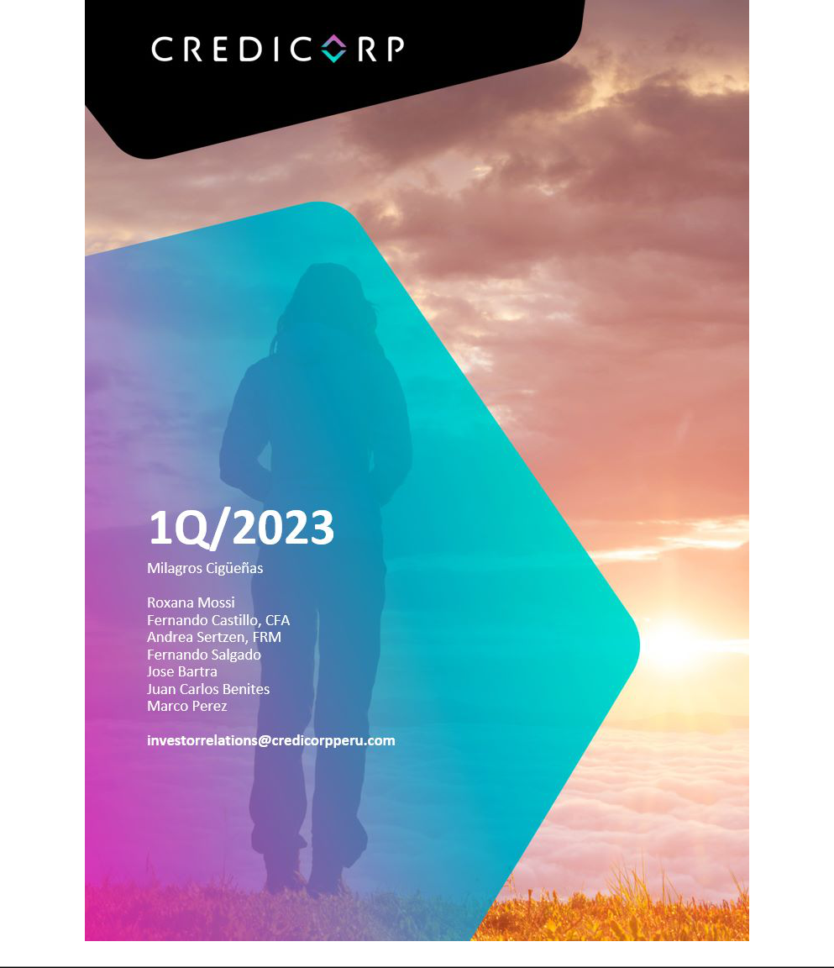

| Earnings Release 1Q / 2023

Table of Contents

Operating and Financial Highlights | 03
Senior Management Quotes | 05
Fourth Quarter 2023 Earnings Conference Call | 06
Summary of Financial Performance and Outlook | 07
Financial Overview | 12
Credicorp’s Strategy Update | 13
Analysis of 1Q23 Consolidated Results

01

02

03

04

05

06

07

08

09

10

11

12

Loans and Portfolio Quality | 16
Deposits | 24
Interest Earning Assets and Funding | 26
Net Interest Income | 27
Provisions | 30
Other Income | 33
Insurance Underwriting Results | 36
Operating Expenses | 39
Operating Efficiency | 41
Regulatory Capital | 42
Economic Outlook | 44
Appendix | 48

2

| Earnings Release 1Q / 2023

Operatng and Financial Highlights

Credicorp Ltd. Reports First Quarter 2023 Financial and Operatng Results

ROE of 18.7% Driven by Resilient Core Income

Cost of Risk Stable Sequentally Remaining High impacted by Social and Climatc Events in Peru

Lima, Peru – May 5, 2023 – Credicorp Ltd. (“Credicorp” or “the Company”) (NYSE: BAP | BVL: BAP), the leading fnancial services holding company in Peru with a presence in Chile, Colombia, Bolivia and Panama today reported its unaudited results for the quarter ended March 31, 2023. Financial results are expressed in Soles and are presented in accordance with Internatonal Financial Reportng Standards (IFRS). Efectve 1Q23, the Company reports under IFRS 17 accountng standards for insurance contracts. While the impact on consolidated net income is not material, the reclassifcaton of line items in the P&L has impacted the efciency rato. To facilitate comparability, fgures for 1Q22 and 4Q22 have been restated to refect IFRS 17.

1Q23 OPERATING AND FINANCIAL HIGHLIGHTS

- Net Income atributable to Credicorp increased 18.1% YoY to stand at S/1,384 million, driven by an improvement in performance in Universal Banking and strong results in the Insurance business. ROAE rose to 18.7% in the quarter, up from 17.0% in 1Q22 and seasonally higher than the 15.3% reported in 4Q22.

- Structural Loans, measured in average daily balances, declined 0.7% QoQ, primarily due to seasonality in Wholesale Banking, but increased 9.7% YoY led by growth in Retail Banking at BCP and by Mibanco.

- Total Deposits at quarter-end increased 1.1% QoQ and 0.5% YoY to S/148,623 million, where the high interest rate backdrop contnued to drive migraton from Demand and Saving Deposits to Time Deposits. Low-cost Deposits represented 54.7% of total funding.

- The Structural NPL rato increased 17 bps QoQ to 5.12%, driven by an increase coin the volume of the overdue portolio in Wholesale Banking, which was already provisioned given that our models antcipate deterioraton; Mibanco, which was impacted by social and climatc events in an adverse macroeconomic environment; and Consumer and Credit Card loans, afer higher-risk segments were targeted in 2022.

- Structural Provisions increased 1.3% QoQ, driven by Retail Banking at BCP and Mibanco and, partally ofset by Wholesale Banking. At BCP, provisions in retail banking rose, refectng a downturn in customer payment as well as the impacts of an update to macroeconomic outlook variables such as infaton, interest rates and GDP growth. Mibanco increased provisions due to social and climate events. In this context, stringent originaton standards were applied in specifc consumer segments at BCP, and the risk appette was adjusted in a number of geographies and segments at Mibanco. The Structural Cost of Risk remained stable QoQ while Structural NPL Coverage dropped to 110.0%, which refects an uptck in the weight of collateralized refnanced wholesale loans.

- Core Income declined 1.4% QoQ but increased 18.9% YoY refectng structural loan growth and a high interest rate environment. Net Interest Income (NII) remained stable QoQ and was up 28.8% YoY, while FX Volumes and Fees contracted in both periods. On the back of higher interest rates, the Net Interest Margin increased 9 bps QoQ and 138 bps YoY to stand at 5.84%.

- The Efciency Rato, which has been restated under IFRS17, improved 290 bps in the QoQ comparision and stood at 44.3%. This improvement was mainly driven by an uptck in operatng income at BCP stand-alone and Pacifco, which more than ofset the growth reported for expenses in a context marked by on-going investment in disruptve initatves and digital transformaton.

3

| Earnings Release 1Q / 2023

Operatng and Financial Highlights

- The CET1 Rato for BCP Stand-Alone at quarter-end was 11.9%, up 30 bps YoY but down 66 bps QoQ which refected a dividend declaraton this quarter, CET1 at Mibanco rose 38 bps YoY to stand at 16.4% but declined 8 bps QoQ.

- At BCP stand-alone, 30-day local currency LCR currency stood at 154.1% under regulatory standards and 138.7% based on more stringent internal standards, while USD 30-day LCR stood at 203.7% and 123.1% under regulatory and more stringent internal standards, respectvely.

- Credicorp maintains a diversifed, liquid investment portolio with investment portolios Held to Maturity and Available for Sale accountng for 5% and 15% of Interest Earnings Assets, respectvely.

- Advancing our Strategic Initatves: Yape contnues to drive fnancial inclusion and topped 8.8 million monthly actve users (MAU) by quarter-end. Monthly income per MAU contnues to increase and reached S/1.8 in 1Q23. We believe Yape is on track to reach cashfow breakeven in 2024

- On the ESG front, we recently added two new members to our Board and increased the partcipaton of women to 1/3; maintained the independence of the majority of members; and added expertse in digital transformaton and fntech innovaton. We also defned our corporate environmental strategy and roadmap, which includes developing capabilites to measure our portolio carbon footprint; promotng green fnancing; and fne-tuning management of environmental risks. Implementaton will begin in 2Q23. More informaton can be found in our recently published 2022 Annual and Sustainability Report.

- On April 27, the Board of Directors declared a cash dividend of S/25.00 per share equivalent to a total payment of S/ 2,359,557,925 to be paid out on June 9th, 2023.

4

| Earnings Release 1Q / 2023

Senior Management Quotes

SENIOR MANAGEMENT QUOTES
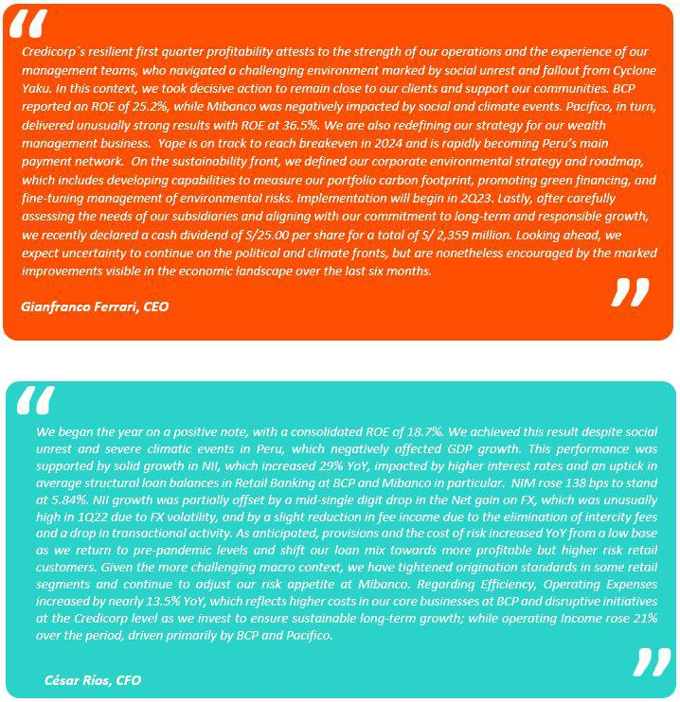

5

| Earnings Release 1Q / 2023

Senior Management Quotes

FIRST QUARTER 2023 EARNINGS CONFERENCE CALL

Date: Monday May 8th, 2023

Time: 10:30 am ET (9:30 am Lima, Peru tme)

Hosts: Gianfranco Ferrari - CEO, Cesar Rios - Chief Financial Ofcer, Francesca Rafo – Chief Innovaton Ofcer, Reynaldo Llosa - Chief Risk Ofcer, Cesar Rivera - Head of Insurance and Pensions, Carlos Sotelo – Mibanco CFO, and the Investor Relatons Team.

To pre-register for the listen-only webcast presentaton use the following link:
htps://dpregister.com/DiamondPassRegistraton/register?confrmatonNumber=10177940&linkSecurityString=f920c53eb4

Callers who pre-register will be given a conference passcode and unique PIN to gain immediate access to the call and bypass the live operator. Partcipants may pre-register at any tme, including up to and afer the call start tme.

Those unable to pre-register may dial in by calling:

1 844 435 0321 (U.S. toll free)

1 412 317 5615 (Internatonal)

Conference ID: Credicorp Conference Call

The webcast will be archived for one year on our investor relatons website at:
htps://credicorp.gcs-web.com/events-and-presentatons/upcoming-events

For a full version of Credicorp´s Fourth Quarter 2022 Earnings Release, please visit:
htps://credicorp.gcs-web.com/fnancial-informaton/quarterly-results

6

| Earnings Release 1Q / 2023

Summary of Financial Performance and Outlook

Loans (in Average Daily Balances)
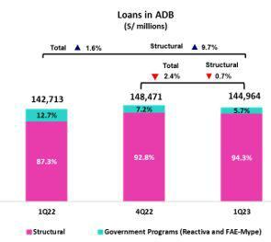

Structural balances, measured in ADB, dropped 0.7% QoQ to stand at S/136,758 million.
This decrease was fueled mainly by Wholesale Banking at BCP and was partally ofset by
Retail Banking at BCP and by Mibanco.

YoY, structural loans grew 9.7%, driven mainly by Retail Banking via Consumer and Mortgage and secondarily by Wholesale Banking, via Corporate banking.

The Government Loan Portolio (GP) represented 5.7% of the total portolio in average daily balances (4.9% in quarter-end balances).

Deposits

Our deposit base measured in quarter-end balances increased 1.1% QoQ. This growth was mainly atributable to growth in Time Deposits at BCP, which was concentrated in FC and in line with higher interest rates.
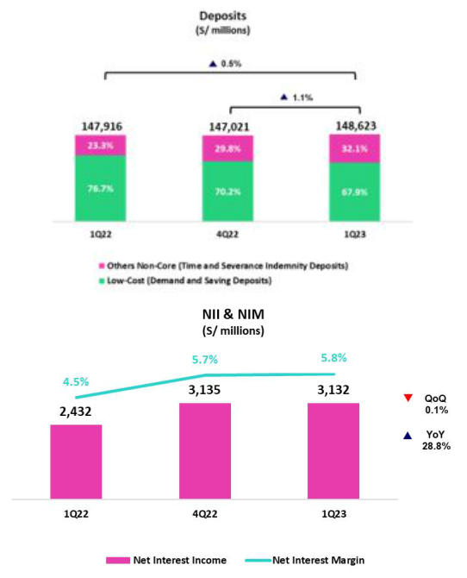

In the YoY comparison, the deposit base increased 0.5%. The migraton from Low-cost Deposits to Time Deposits in both LC and FC led this evoluton and refected the impact of rising rates.

Net interest income (NII) and Margin (NIM)

NII remained relatvely stable QoQ and stood at S/3,132 million. Growth in Income was spurred by the recompositon of the loan portolio mix and by repricing of Available Funds, while the uptck in expenses refected the migraton from Low-Cost Deposits to Time Deposits. In this context, growth in the IEA yield was similar to the expansion registered by the Funding cost. NIM¹ stood at 5.84%.

YoY, Net interest income rose 28.8%, driven primarily by the evoluton of rates in both currencies and by growth in the LC loan portolio.

(1) For further details on the new NIM calculaton due to IFRS17, please refer to Annex 12.1.8

7

| Earnings Release 1Q / 2023

Summary of Financial Performance and Outlook

Structural Portolio Quality and Cost of Risk (CofR)
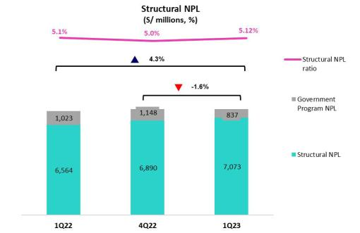

QoQ, the balance of the structural NPL portolio rose 2.7%. Growth in the NPL volume was concentrated in (i) Wholesale Banking, due to an increase in overdue loans, partcularly in the Constructon sector (ii) Mibanco, atributable to the negatve impact of social protests and (iii) Consumer and Credit Card, which refects the impact of penetraton of higher-risk segments. In this context, the structural NLP rato stood at 5.12% (+17 bps) at the end of 1Q23.

YoY, the structural NPL volume rose 7.8%, driven by Wholesale Banking, Consumer and Credit Cards.

The structural CofR increased 4 bps QoQ, spurred by an uptck in provisions in (i) SME at BCP, due to a deterioraton in payment behavior afer the bank incurred in higher-risk segments (ii) Individuals, atributable to a deterioraton in payment behavior in Consumer and Credit Cards due to the reason outlined above. (iii) Mibanco, due to the negatve impact of social protests in the south and intense rains in the north. In this context, the structural CofR stood at 2.10%.
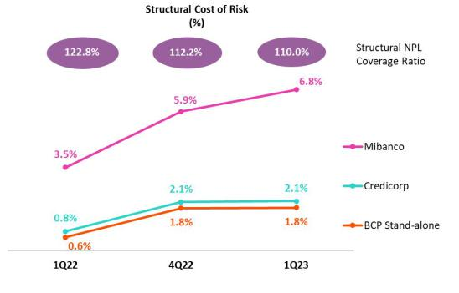

YoY, the structural CofR rose signifcantly (+128 bps), in line with growth in provisions. This increase was led by Individuals and Mibanco Due to a deterioraton in payment behavior and a partcularly low provision base in 1Q22. Provisions for SMEs contnue at high levels, despite a YoY improvement, in line with portolio deterioraton.

The structural NPL coverage rato contnues to follow a downward trend and stood at 110.0% in 1Q23.

8

| Earnings Release 1Q / 2023

Summary of Financial Performance and Outlook

Other income
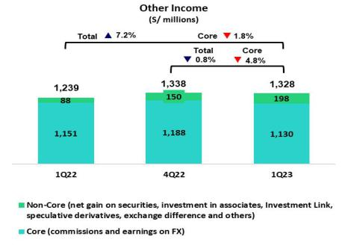

Other Core Income (Commissions + Gains on FX transactons) fell 4.8% QoQ and 1.8% YoY due to a drop in the net gain on FX transactons. The aforementoned drop QoQ and YoY refects a seasonal efect on transacton volumes and income from the net gain on foreign exchange transactons at BCP Stand-alone. QoQ and YoY, fee income decreased due to the eliminaton of inter-plaza fees in Universal Banking.

Other Non-core income¹ increased 31.4% QoQ, which refected the impact of a sale of a judicial portolio. YoY, growth of 124.6% was driven by an uptck in the Net gain on securites.

(1) For more details regarding the content of this grouping, please refer to Annex 12.1.8

Insurance Underwritng Result
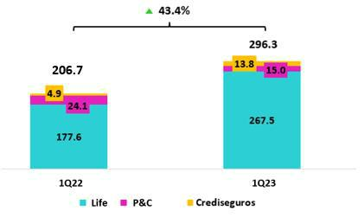

The Insurance Underwritng Result¹ rose 43.4% YoY. This evoluton was mainly atributable to the Life business, which registered an improvement due to an uptck in writen premiums in D&S and Credit Life. The P&C business reported a drop in its result, which refects an uptck in claims, partcularly in P&C Risks and Cars.

- For more details regarding the new compositon of Insurance Underwritng Result to refect IFRS17, please refer to Annex
12.1.8

9

| Earnings Release 1Q / 2023

Summary of Financial Performance and Outlook

Efciency
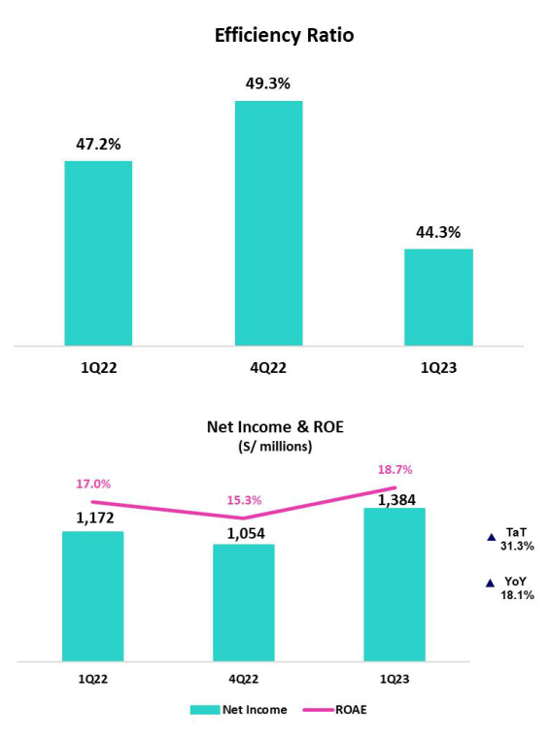

In 1Q23, the Efciency rato¹ stood at 44.3%. This evoluton represented an improvement of 290 bps with regard to 1Q22 and refected an uptck in operatng income at BCP and Pacífco.

(1) For more details regarding the new calculaton of the Efciency rato due to IFRS17, please refer to Annex 12.1.8

Net Income atributable to Credicorp

In 1Q23, net income atributable to Credicorp was S/1,384 million, up +31.3% QoQ and +18.1% YoY. With these results, net shareholders’ equity was S/30,360 million (+4.7% QoQ). In this scenario, ROE stood at 18.7%.

Contributons* and ROE by subsidiary in 1Q23
(S/ millions)
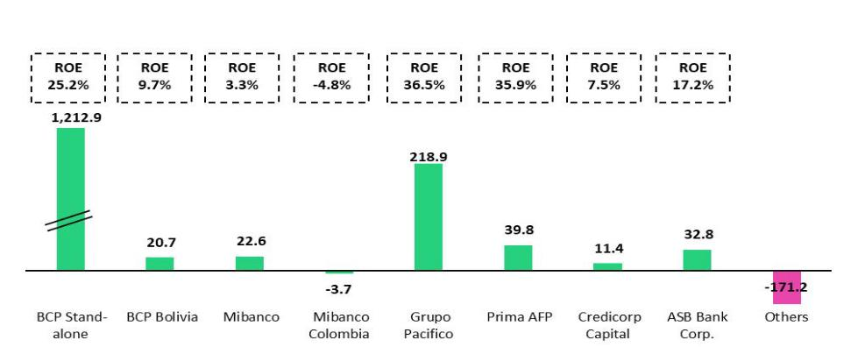

*Contributons to Credicorp refect eliminatons for consolidaton purposes (eliminatons for transactons among Credicorp’s subsidiaries or between Credicorp and its subsidiaries).
- At BCP Stand Alone, the fgure is lower than net income because it does not include gains on investments in other Credicorp subsidiaries (Mibanco).
- At Mibanco, the fgure is lower than net income because Credicorp owns 99.924% of Mibanco (directly and indirectly).
- The contributon of Grupo Pacífco presented here is higher than the earnings reported for Pacífco Seguros because it includes 100% of Crediseguros (including 48% under Grupo Credito).

10

| Earnings Release 1Q / 2023

Summary of Financial Performance and Outlook
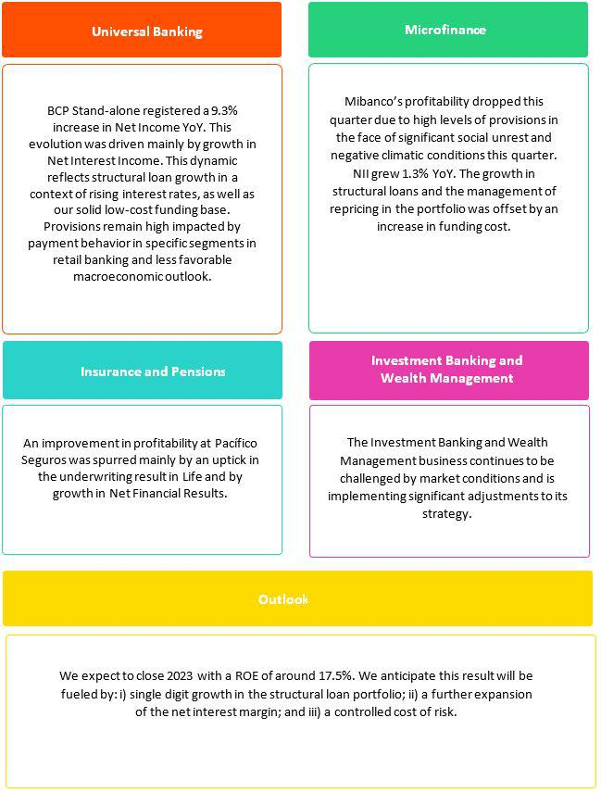

11

| Earnings Release 1Q / 2023

Financial Overview

Credicorp Ltd. |  | Quarter |  | % change
S/ 000 | 1Q22 | 4Q22 | 1Q23 | QoQ | YoY
Net interest, similar income and expenses | 2,431,707 | 3,134,778 | 3,132,089 | -0.1% | 28.8%
Provision for credit losses on loan portfolio, net of recoveries | (257,590) | (730,681) | (726,998) | -0.5% | 182.2%
Net interest, similar income and expenses, after provision for credit losses on loan | 2,174,117 | 2,404,097 | 2,405,091 | 0.0% | 10.6%
portfolio
Total other income | 1,239,398 | 1,338,227 | 1,328,064 | -0.8% | 7.2%
Insurance underwriting result | 206,667 | 211,594 | 296,341 | 40.1% | 43.4%
Total other expenses | (1,874,519) | (2,398,955) | (2,121,697) | -11.6% | 13.2%
Profit (loss) before income tax | 1,745,663 | 1,554,963 | 1,907,799 | 22.7% | 9.3%
Income tax | (546,000) | (476,236) | (493,466) | 3.6% | -9.6%
Net profit (loss) | 1,199,663 | 1,078,727 | 1,414,333 | 31.1% | 17.9%
Non-controlling interest | 27,786 | 24,231 | 30,060 | 24.1% | 8.2%
Net profit (loss) attributable to Credicorp | 1,171,877 | 1,054,496 | 1,384,273 | 31.3% | 18.1%
Net profit (loss) / share (S/) | 14.69 | 13.22 | 17.36 | 31.3% | 18.1%
Loans | 144,621,513 | 148,626,374 | 145,165,713 | -2.3% | 0.4%
Deposits and obligations | 147,915,964 | 147,020,787 | 148,623,300 | 1.1% | 0.5%
Net equity | 26,818,054 | 28,997,731 | 30,359,898 | 4.7% | 13.2%
Profitability
Net interest margin ⁽¹⁾ | 4.46% | 5.75% | 5.84% | 9 bps | 138 bps
Risk-adjusted Net interest margin | 4.01% | 4.45% | 4.54% | 9 bps | 53 bps
Funding cost ⁽²⁾ | 1.32% | 2.35% | 2.61% | 26 bps | 129 bps
ROAE | 17.0% | 15.3% | 18.7% | 340 bps | 170 bps
ROAA | 1.9% | 1.9% | 2.3% | 40 bps | 40 bps
Loan portfolio quality
Internal overdue ratio ⁽³⁾ | 4.06% | 4.00% | 3.99% | -1 bps | -7 bps
Internal overdue ratio over 90 days | 3.06% | 3.11% | 3.02% | -9 bps | -4 bps
NPL ratio ⁽⁴⁾ | 5.25% | 5.41% | 5.45% | 4 bps | 20 bps
Cost of risk ⁽⁵⁾ | 0.71% | 1.97% | 2.00% | 3 bps | 129 bps
Coverage ratio of IOLs | 140.7% | 132.5% | 136.7% | 420 bps | -400 bps
Coverage ratio of NPLs | 108.9% | 97.9% | 100.1% | 220 bps | -880 bps
Operating efficiency
Efficiency ratio ⁽⁶⁾ | 47.2% | 49.3% | 44.3% | -500 bps | -290 bps
Operating expenses / Total average assets | 2.98% | 3.76% | 3.43% | -33 bps | 45 bps
Capital adequacy - BCP Stand-alone
Global Capital ratio ⁽⁷⁾ | 15.79% | 14.43% | 14.93% | 50 bps | -86 bps
Tier 1 ratio ⁽⁸⁾ | 10.74% | 10.02% | 10.74% | 72 bps | 0 bps
Common equity tier 1 ratio ⁽⁹⁾ ⁽¹¹⁾ | 11.63% | 12.59% | 11.93% | -66 bps | 30 bps
Capital adequacy - Mibanco
Global Capital ratio ⁽⁷⁾ | 15.61% | 14.69% | 14.79% | 10 bps | -82 bps
Tier 1 ratio ⁽⁸⁾ | 13.24% | 12.38% | 12.48% | 10 bps | -76 bps
Common equity tier 1 ratio ⁽⁹⁾ ⁽¹¹⁾ | 14.91% | 16.10% | 16.25% | 15 bps | 134 bps
Employees | 36,202 | 36,970 | 37,166 | 0.5% | 2.7%
Share Information
Issued Shares | 94,382 | 94,382 | 94,382 | 0.0% | 0.0%
Treasury Shares ⁽¹⁰⁾ | 14,862 | 14,849 | 14,887 | 0.3% | 0.2%
Outstanding Shares | 79,520 | 79,533 | 79,495 | 0.0% | 0.0%
- Net Interest Margin = Net Interest Income (Excluding Net Insurance Financial Expenses) / Average Interest Earning Assets
- Funding Cost = Interest Expense (Does not include Net Insurance Financial Expenses) / Average Funding
- Internal Overdue Loans: includes overdue loans and loans under legal collecton, according to our internal policy for overdue loans. Internal Overdue Rato: Internal overdue loans / Total loans
- Non-performing loans (NPL): Internal overdue loans + Refnanced loans. NPL rato: NPL / Total loans.
- Cost of risk = Annualized provision for loan losses, net of recoveries / Total loans.
- Efciency Rato = (Salaries and employee benefts + Administratve expenses + Depreciaton and amortzaton + Associaton in partcipaton) / (Net interest, similar income and expenses + Fee Income + Net gain on foreign exchange transactons + Net Gain From associates + Net gain on derivatves held for trading + Result on exchange diferences + Insurance Underwritng Result)
- Regulatory Capital / Risk-weighted assets (legal minimum = 10% since July 2011).
- Tier 1 = Capital + Legal and other capital reserves + Accumulated earnings with capitalizaton agreement + (0.5 x Unrealized proft and net income in subsidiaries) - Goodwill - (0.5 x Investment in subsidiaries) + Perpetual subordinated debt (maximum amount that can be included is 17.65% of Capital + Reserves + Accumulated earnings with capitalizaton agreement + Unrealized proft and net income in subsidiaries - Goodwill).
- Common Equity Tier I = Capital + Reserves – 100% of applicable deductons (investment in subsidiaries, goodwill, intangibles and net deferred taxes that rely on future proftability) + retained earnings + unrealized gains.
Adjusted Risk-Weighted Assets = Risk-weighted assets - (RWA Intangible assets, excluding goodwill, + RWA Deferred tax assets generated as a result of temporary diferences in income tax, in excess of 10% of CET1, + RWA Deferred tax assets generated as a result of past losses).”
- Consider shares held by Atlantc Security Holding Corporaton (ASHC) and stock awards.
- Common Equity Tier I calculated based on IFRS Accountng.

12

| Earnings Release 1Q / 2023

Credicorp’s Strategy Update

Credicorp Strategy

Credicorp is advancing in its executon of a long-term strategy that focuses on three priorites: acceleratng digital transformaton and innovaton; ensuring with have the best talent in place; and integratng sustainability at the core of our businesses.

On June 20, 2023, we will hold Credicorp’s Investor Day in New York through a hybrid format. Senior Management will present relevant advances and provide details on how each business leverages its synergies and Credicorp’s new capacites to strengthen the Group’s sustainable growth.

The following link contains details on this event htps://www.credicorpday.com/

Main KPIs of Credicorp’s Strategy

Experience | Efciency |  |  | Growth
Traditonal Business Transformaton ⁽¹⁾ |  | Subsidiary | 1Q22 | 4Q22 | 1Q23
Day to Day
Digital monetary transactons ⁽²⁾ |  | BCP | 52% | 65% | 69%
Transactonal cost by unit |  | BCP | 0.15 | 0.08 | 0.08
Disbursements through leads ⁽³⁾ |  | Mibanco | 77% | 76% | 77%
Disbursements through alternatve channels ⁽⁴⁾ |  | Mibanco | 46% | 45% | 43%
Mibanco Productvity ⁽⁵⁾ |  | Mibanco | 28.8 | 25.9 | 28.0
Cashless
Cashless transactons ⁽⁶⁾ |  | BCP | 36% | 48% | 48%
Mobile Banking ratng |  | BCP | 4.3 | 3.7 | 3.7
Digital Acquisiton
Digital sales ⁽⁷⁾ |  | BCP | 50% | 61% | 48%
- Figures for March 2022, December 2022, and March 2022
- Retail Monetary Transactons conducted through Retail Banking, Internet Banking, Yape and Telecredito/Total Retail Monetary Transactons in Retail Banking.
- Disbursements generated through leads/Total disbursements.
- Disbursements conducted through alternatve channels/Total disbursements.
- Number of loans disbursed/ Total relatonship managers.
- Amount transacted through Mobile Banking, Internet Banking, Yape y POS/ Total amount transacted through Retail Banking.
- Units sold by Retail Banking through digital channels/ Total number of units sold by Retail Banking.

13

| Earnings Release 1Q / 2023

Credicorp’s Strategy Update

Disruptve Initatves: Yape

At the end of 1Q23, Yape had more than 12.3 million users, 71% of whom made transactons at least once a month. Additonally, 63% of Yape’s users utlize a BCP savings account to channel payments and 31%, Yapecard. The remaining 6% use Yape’s partnership platorms with Mibanco, Banco de la Nación and diferent Municipal Saving Banks. As of 2Q23, Yape users will be able to make transfers to users of other digital wallets that coexist in the Peruvian ecosystem.

Yape contnues to grow by focusing on three main pillars:

- Be the main payment venue in the country:

As part of this frst pillar, Yape has launched four major initatves:
  - Mobile top-ofs in November 2021. In 1Q23, Yape users purchased more than 30.4 million top-ofs. This represented S/10.5 million in income for Yape last quarter.

  - QR payments through the main payment gateways since July 2022. In 1Q23, the total volume of QR transactons stood at 8.4 million and represented a total transacton amount of S/280 million. These payments represented 9% of the payments made through POS at BCP.

  - Payment butons in October 2022. Yape clients can use this functonality to make direct payments through the web pages of afliated establishments. In 1Q23, 668 thousand transactons were conducted through this functonality for a total transacton amount of S/41.6 million.

  - Service payments in January 2023. With this new functonality, Yape clients can pay receipts for electricity, water, gas and monthly telephone plans, among others. By the end of 2023, Yape users had conducted a total of 647 thousand transactons through this new functonality, which represented a total transacton amount of S/39 million.

- Be present in the daily lives of all Yaperos:

In September 2022, we launched Yape Promos, a functonality that ofers Yape clients special discounts at afliated establishments. In 1Q23, 476 thousand transactons were conducted through Yape Promos, which represented a total transacton amount of S/9.8 million.

- Provide solutons to Yaperos’ fnancial needs:

Yape launched a Microloan functonality at the end of August 2022. In 1Q23, 148 thousand disbursements were made for a total of S/33.5 million. Additonally, thanks to data analysis, Yape has begun to derive Yaperos with larger credit needs to other channels for a complete credit risk assessment.

Disruptve Initatves: Yape | 1Q22 | 4Q22 | 1Q23
Day to Day
% Microbusiness users ⁽¹⁾ | 19% | 19% | 19%
Monthly Mobile Top-ofs (thousands) | 6,190 | 26,216 | 30,399
Cashless
Users (millions) | 9.1 | 11.9 | 12.3
% of Users that are BCP Clients ⁽²⁾ | 63% | 63% | 66%
% of Yapecard Users ⁽³⁾ | 34% | 34% | 31%
Actve Users (millions) ⁽⁴⁾ | 5.1 | 8.2 | 8.8
% Users who are actve monthly users ⁽⁵⁾ | 56% | 70% | 71%
No. of transactons a quarter (millions) | 177.9 | 399.5 | 480.3
Monthly transacton quarterly (millions) | 10,698 | 20,845 | 24,046
Monthly transactons by Actve Yapero ⁽⁶⁾ | 13.6 | 19.6 | 20.3
- Yape users that are Microbusinesses/ Total Yape Users
- BCP clients that are Yape users/ Total Yape Users
- Yapecard Users / Total Yape Users
- Yape users that have conducted at least one transacton in the last month
- Yape users that have conducted at least one transacton in the last month/Total Yape users
- Number of Yape users/ Actve users

14

| Earnings Release 1Q / 2023

Credicorp’s Strategy Update

Integratng sustainability in our businesses

For more informaton about our sustainability strategy, program and initatves, please review the following documents:

“Sustainability Strategy 2020-25” and “Annual and Sustainability Report 2022.” Noteworthy milestones hit in the frst quarter of 2023 in the framework of the Sustainability Program include:

Governance Front – Strengthening our governance structure

- Two new members joined the board; women’s partcipaton on the Board increased to one third; the majority of the Board contnues to be independent and now has more members with expertse in digital innovaton and transformaton.

- The holding published its Annual and Sustainability Report 2022, which was developed with GRI and SASB standards. An in-depth Materiality Analysis was conducted in 2022, which contemplated identfying priority issues to be included in the Sustainability Report; validatng or adjustng our strategy; and aligning our management with the issues prioritzed by our stakeholders.

  - On the Asset Management front, we published an update of the Corporate Policy for Responsible and Sustainable Investments and developed Guidelines for Responsible and Sustainable Investments for Listed Companies, which currently includes corporate fxed income and equity investments. Credicorp Capital was awarded Euromoney’s Award of Excellence in the category of Best ESG Investment Team in Wealth Management in Latam.

Environmental Front – Driving environmental sustainability from the fnancial sector

  - In line with our commitment to become carbon-neutral with regard to own emissions by 2032, we completed the measurement and auditng of the carbon footprints of Credicorp’s subsidiaries in 2022.

- In terms of our ESG risk management framework, we contnued to apply questonnaires to clients in prioritzed sectors to improve the identfcaton and measurement of environmental risks. In 2022, 85 clients were assessed. Additonally, we set up guidelines to initate relatons with relevant issuers for the investment portolio.

- The environmental strategy was approved, which is equipped with plans of acton to 2025 at the corporate level and for 7 of Credicorp’s main subsidiaries. This efort includes a strategy associated with measuring the portolio’s emissions; exploring other relevant environmental issues in the countries in which we operate; identfying opportunites for growth in products and services, among others. Additonally, we developed a specifc strategy for wholesale banking at BCP to capture opportunites for fnancial products and services within 4 priority sectors.

Social Front – Expanding fnancial inclusion and educatng about fnance and entrepreneurship

Financial Inclusion:

- Credicorp presented its study on gender gaps in fnancial inclusion based on the Financial Inclusion Index 2022, which was conducted in the fve countries in which Credicorp operates. According to the study, the gender gap narrowed moderately in 2022.

- Yape fnancially included 100 thousand people this quarter, reaching an accumulated total of 1.1 million afliates. Additonally, Yape afliated 1.5 thousand microbusinesses within Yape’s ecosystem. BCP fnancially included 7 thousand micro, small and medium businesses this quarter through working capital loans (132 thousand clients fnancially included in 2022) and invoice discountng (1.7 thousand clients fnancially included in 2022).

- At Pacífco, we contnued to make headway in our commitment to fnancial inclusion through our insurance services and issued a total of 2.7 million inclusive policies by quarter-end.

Financial Educaton:

- We contnue to focus on promotng fnancial educaton through all of our subsidiaries. At BCP, more than 310 thousand people have partcipated in our fnancial educaton programs. At BCP Bolivia, the number of partcipants topped 51 thousand while Pacífco Seguros and Prima registered a total count of 400 thousand and 60 thousand partcipants respectvely.

- Mibanco has entered into educatonal partnerships with Fundación Oli and Socios en Salud to reach individuals at the base of the economic pyramid. Additonally, the bank worked with the Ministry of Producton to roll out on-site workshops, webinars and fairs for microentrepreneurs throughout the country. In 2022, more than 247 thousand entrepreneurs benefted from the tools and knowledge imparted through fnancial and digital educaton.

15

| Earnings Release 1Q / 2023 Analysis of 1Q23 Consolidated Results

01 Loan Portolio


The structural loan volume, measured in average daily balances, fell QoQ due to amortzatons of Wholesale Banking loans due to a seasonal efect that is present every frst quarter. This reducton was partally ofset by a slight increase in loans volumes in ADB in Retail Banking and Mibanco, which have shifed their focus to concentrate on lower-risk clients in an adverse environment marked by social protests and damaging rains. YoY, structural loans in average daily balances grew due to expansion in Retail Banking segments; disbursements for working capital loans in Wholesale Banking; and growth in Mibanco’s portolio during the second half of 2022.


The Structural NPL Rato rose QoQ and YoY due to (i) growth in the NPL loan volume in Wholesale Banking, where the new overdue portolio was already 100% provisioned given that provision models had collected said impairment in advance; (ii) deterioraton in Mibanco’s portolio, which was impacted by social protests and damaging rains; and (iii) growth in the overdue portolio in Retail Banking, which was concentrated in the higher-risk disbursements made in 2022. This growth was partally ofset by the sale of a judicial portolio and write-ofs registered in Retail Banking in 1Q23.

1.1. | Loans
 |  |  |  | Structural loans (in Average Daily Balances) ⁽¹⁾⁽²⁾⁽³⁾
Structural Loans |  |  | As of |  | Volume change |  | % change |  | % Part. in total structural loans
(S/ millions) |  | Mar 22 | Dec 22 | Mar 23 | QoQ | YoY | QoQ | YoY | Mar 22 | Dec 22 | Mar 23
BCP Stand-alone |  | 101,453 | 112,342 | 111,263 | -1,078 | 9,810 | -1.0% | 9.7% | 81.4% | 81.6% | 81.4%
Wholesale Banking |  | 51,063 | 55,622 | 53,775 | -1,847 | 2,712 | -3.3% | 5.3% | 41.0% | 40.4% | 39.3%
 | Corporate | 30,663 | 33,400 | 32,545 |  |  | -2.6% | 6.1% | 24.6% | 24.3% | 23.8%
 |  |  |  |  | -855 | 1,881
 | Middle - Market | 20,400 | 22,222 | 21,230 | -992 | 831 | -4.5% | 4.1% | 16.4% | 16.1% | 15.5%
Retail Banking |  | 50,390 | 56,720 | 57,488 | 768 | 7,098 | 1.4% | 14.1% | 40.4% | 41.2% | 42.0%
 | SME - Business | 4,709 | 5,750 | 5,546 | -205 | 837 | -3.6% | 17.8% | 3.8% | 4.2% | 4.1%
 | SME - Pyme | 11,844 | 13,033 | 13,257 | 224 |  | 1.7% | 11.9% | 9.5% | 9.5% | 9.7%
 |  |  |  |  |  | 1,413
 | Mortgage | 18,830 | 20,073 | 20,282 | 209 | 1,452 | 1.0% | 7.7% | 15.1% | 14.6% | 14.8%
 | Consumer | 10,975 | 12,738 | 12,984 | 247 | 2,009 | 1.9% | 18.3% | 8.8% | 9.2% | 9.5%
 | Credit Card | 4,032 | 5,126 | 5,420 | 294 | 1,388 | 5.7% | 34.4% | 3.2% | 3.7% | 4.0%
Mibanco |  | 11,411 | 13,121 | 13,335 | 214 | 1,924 | 1.6% | 16.9% | 9.2% | 9.5% | 9.8%
Mibanco Colombia |  | 1,077 | 1,174 | 1,250 | 76 | 173 | 6.5% | 16.0% | 0.9% | 0.9% | 0.9%
Bolivia |  | 8,602 | 9,034 | 8,951 | -82 | 349 | -0.9% | 4.1% | 6.9% | 6.6% | 6.5%
ASB |  | 2,103 | 2,039 | 1,958 | -81 | -145 | -4.0% | -6.9% | 1.7% | 1.5% | 1.4%
BAP's total loans |  | 124,647 | 137,710 | 136,758 | -952 | 12,112 | -0.7% | 9.7% | 100.0% | 100.0% | 100.0%

For consolidaton purposes, Loans generated in Foreign Currency (FC) are converted to Local Currency (LC).
- Includes Work out unit, and other banking. For Quarter-end Balances fgures, please refer to “12. Annexes – 12.2 Loan Portolio Quality”.

- Structural Portolio excludes the Loans ofered through Reactva Peru and FAE-Mype Government Programs (GP).

- Internal Management Figures

QoQ, structural loans in average daily balances reported a slight decline due to:

- Wholesale Banking, where Corporate Banking and Middle Market Banking reported a drop in their balances due to seasonality, which refected moves by clients in these segments to amortze working capital loans and fnancing for fxed assets in 1Q23.

The aforementoned was partally ofset by slight growth in:

- Retail Banking, where all segments, with the excepton of SME-Business, registered slight growth with regard to 4Q22 for reasons that will be explained in the YoY dynamics. This growth was partally ofset by the sale of a judicial portolio, which was mainly compromised of SME-Pyme and Mortgage loans in partcular.

- Mibanco, where despite the adverse context generated by protests in the south of the country and intense rains in the north, average daily loan balances have increased.

16

| Earnings Release 1Q / 2023

01. Loan Portfolio

In the current context, Mibanco has chosen to focus on clients that present lower risk according to the adjustments in risk appette implemented in the second half of last year.

YoY, structural loans in average daily balances rose 9.7%. This increase was driven primarily by:

- Retail Banking, where all segments evolved positvely with regard to 1Q22. This evoluton was led by the Consumer segment, where higher growth was fueled by wage advances and cash loans through disbursements concentrated in lower-risk clients, followed by Mortgage, which benefted from an uptck in new loans and a drop in prepayments in comparison to previous quarters. In the case of SME-Pyme, growth was concentrated in loans for working capital and refnancing of fxed assets in the case of larger clients with lower risk profles. Credit Cards registered growth due to a 37% YoY increase in new card issuances and to growth in consumpton in both physical establishments and online. E-commerce’s share of consumpton rose from 20% in 1Q22 to 31.7% in 1Q23.

Government Program Loans
(in Average Daily Balances – S/ millions)
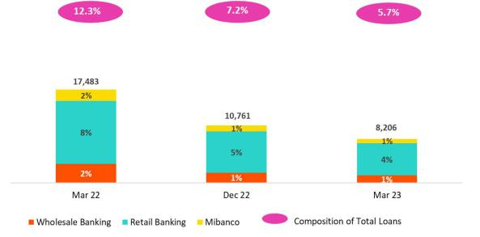

Analysis of 1Q23 Consolidated Results

- Wholesale Banking, where Corporate Banking led growth through an uptck in disbursements for working capital.

- Mibanco, whose balances refect the impact of record-high disbursements in the second half of 2022 (see previous quarter); these disbursements were generated through leads and alternatve channels.

The aforementoned was partally ofset by the sale of portolio in Retail Banking.

ADBs for Government Program loans (GP) dropped -23.7% QoQ and -53-1% YoY. This evoluton was driven mainly by amortzatons at both BCP and Mibanco. GP loans in average daily balances represented 5.7% of total loans (vs 7.2% in December 22 and 12.3% in March 22).

17

| Earnings Release 1Q / 2023 Analysis of 1Q23 Consolidated Results

01. Loan Portfolio

Total loans (in Average Daily Balances) ⁽¹⁾ ⁽²⁾

Total Loans |  | As of |  | Volume change |  | % change |  | % Part. in total loans
(S/ millions) | Mar 22 | Dec 22 | Mar 23 | QoQ | YoY | QoQ | YoY | Mar 22 | Dec 22 | Mar 23
BCP Stand-alone | 117,349 | 121,963 | 118,707 | -3,256 | 1,358 | -2.7% | 1.2% | 82.2% | 82.1% | 81.9%
Wholesale Banking | 54,604 | 57,497 | 55,141 | -2,356 | 537 | -4.1% | 1.0% | 38.3% | 38.7% | 38.0%
Corporate | 31,054 | 33,617 | 32,717 | -899 |  | -2.7% | 5.4% | 21.8% | 22.6% | 22.6%
 |  |  |  |  | 1,663
Middle - Market | 23,550 | 23,881 | 22,424 | -1,456 | -1,126 | -6.1% | -4.8% | 16.5% | 16.1% | 15.5%
Retail Banking | 62,744 | 64,465 | 63,566 | -900 | 821 | -1.4% | 1.3% | 44.0% | 43.4% | 43.8%
SME - Business | 9,509 | 8,583 | 7,884 | -699 | -1,625 | -8.1% | -17.1% | 6.7% | 5.8% | 5.4%
SME - Pyme | 19,398 | 17,947 | 16,996 | -951 | -2,402 | -5.3% | -12.4% | 13.6% | 12.1% | 11.7%
Mortgage | 18,830 | 20,073 | 20,282 | 209 | 1,452 | 1.0% | 7.7% | 13.2% | 13.5% | 14.0%
Consumer | 10,975 | 12,738 | 12,984 | 247 | 2,009 | 1.9% | 18.3% | 7.7% | 8.6% | 9.0%
Credit Card | 4,032 | 5,126 | 5,420 | 294 | 1,388 | 5.7% | 34.4% | 2.8% | 3.5% | 3.7%
Mibanco | 13,582 | 14,261 | 14,098 | -163 | 516 | -1.1% | 3.8% | 9.5% | 9.6% | 9.7%
Mibanco Colombia | 1,077 | 1,174 | 1,250 | 76 | 173 | 6.5% | 16.0% | 0.8% | 0.8% | 0.9%
Bolivia | 8,602 | 9,034 | 8,951 | -82 | 349 | -0.9% | 4.1% | 6.0% | 6.1% | 6.2%
ASB | 2,103 | 2,039 | 1,958 | -81 | -145 | -4.0% | -6.9% | 1.5% | 1.4% | 1.4%
BAP's total loans | 142,713 | 148,471 | 144,964 | -3,507 | 2,251 | -2.4% | 1.6% | 100.0% | 100.0% | 100.0%

For consolidation purposes, Loans generated in Foreign Currency (FC) are converted to Local Currency (LC).
- Includes Work out unit, and other banking. For Quarter-end Balances fgures, please refer to “12. Annexes – 12.2 Loan Portolio Quality”.

- Internal Management Figures

QoQ total loans dropped and refected the fact that growth in structural loans was insufcient to ofset the drop in GP loans. YoY total loans were up, driven by the positve evoluton of the structural portolio at BCP Stand-alone and Mibanco; this improvement was partally ofset by a contracton in GP loans.

Evoluton of the Dollarizaton Level of Loans (in Average Daily Balances) ⁽¹⁾⁽²⁾
 |  | Local Currency (LC) - S/ millions |  |  |  |  | % change |  | % Structural |  | Foreign Currency (FC) - US$ millions |  |  | % change |  | % part. by currency
Total Loans | Total |  |  | Structural |  |  |  |  | change |  |  | Total |  |  |  | Dec 22
 | Mar 22Dec 22Mar 23 |  |  | Mar 22 | Dec 22Mar 23 |  | QoQ | YoY | QoQ | YoY | Mar 22 | Dec 22 | Mar 23 | QoQ YoY |  | LC | FC
BCP Stand-alone | 85,29085,10682,117 |  |  | 67,221 | 74,05975,485 |  | -3.5% | -3.7% | 1.9% | 12.3% | 8,513 | 9,490 | 9,615 | 1.3% 12.9% |  | 69.4% | 30.6%
Wholesale Banking | 29,12428,35125,984 |  |  | 24,898 | 26,51126,475 |  | -8.4% -10.8% |  | -0.1% 6.3% |  | 6,766 | 7,505 | 7,662 | 2.1% 13.2% |  | 48.8% | 51.2%
Corporate | 15,503 16,044 |  | 15,065 | 14,652 | 16,028 | 15,827 |  | -2.8% |  |  | 4,129 | 4,525 | 4,639 |  |  | 47.1% | 52.9%
 |  |  |  |  |  |  | -6.1% | -2.8% | -1.3% | 8.0% | 4,129 | 4,525 | 4,639 | 2.5% 12.3% |  | 47.1% | 52.9%
Middle - Market | 13,621 12,307 |  | 10,919 | 10,246 | 10,482 | 10,648 | -11.3% | -19.8% | 1.6% | 3.9% | 2,637 | 2,980 | 3,023 | 1.5% | 14.6% | 51.2% | 48.8%
Retail Banking | 56,16656,75556,133 |  |  | 42,323 | 47,54949,009 |  | -1.1% | -0.1% | 3.1% | 15.8% | 1,747 | 1,985 | 1,953 | -1.6%11.8% |  | 87.9% | 12.1%
SME - Business | 7,061 | 5,530 | 4,970 | 2,597 | 2,594 | 2,698 | -10.1% | -29.6% | 4.0% | 3.9% | 650 | 786 | 766 | -2.6%17.8% |  | 63.7% | 36.3%
SME - Pyme | 19,240 17,779 |  | 16,830 | 11,398 | 12,476 | 12,866 | -5.3% | -12.5% | 3.1% | 12.9% | 42 | 43 | 44 | 1.1% 3.4% |  | 99.0% | 1.0%
Mortgage | 16,919 18,005 |  | 18,264 | 16,391 | 17,682 | 18,005 | 1.4% | 7.9% | 1.8% | 9.8% | 507 | 532 | 530 | -0.4% 4.5% |  | 89.7% | 10.3%
Consumer | 9,617 11,192 |  | 11,514 | 8,898 | 10,851 | 11,192 | 2.9% | 19.7% | 3.1% | 25.8% | 361 | 398 | 386 | -2.9% 7.0% |  | 87.9% | 12.1%
Credit Card | 3,329 | 4,249 | 4,555 | 3,039 | 3,946 | 4,249 | 7.2% | 36.8% | 7.7% | 39.8% | 187 | 226 | 227 | 0.7% 21.8% |  | 82.8% | 17.2%
Mibanco | 13,10913,78413,619 |  |  | 10,519 | 12,30912,644 |  | -1.2% | 3.9% | 2.7% | 20.2% | 126 | 123 | 126 | 2.5% 0.2% |  | 96.7% | 3.3%
Mibanco Colombia | - | - | - | 0 | 0 | 0 | - | - | - | - | 286 | 303 | 329 | 8.6% 14.8% |  |  | -100.0%
Bolivia | - | - | - | 0 | 0 | 0 | - | - | - | - | 2,284 | 2,326 | 2,352 | 1.2% 3.0% |  |  | -100.0%
ASB Bank Corp. | - | - | - | 0 | 0 | 0 | - | - | - | - | 558 | 525 | 515 | -2.0% -7.8% |  |  | -100.0%
Total loans | 98,39998,89095,735 |  |  | 77,740 | 86,36888,129 |  | -3.2% | -2.7% | 2.0% | 13.4% | 11,767 | 12,766 | 12,936 | 1.3% 9.9% |  | 66.3% | 33.7%

For consolidaton purposes, Loans generated in Foreign Currency (FC) are converted to Local Currency (LC).
- Includes Work out unit, and other banking. For Quarter-end Balances fgures, please refer to “12. Annexes – 12.2 Loan Portolio Quality”

- Internal Management Figures

At the end of March 2023, the dollarizaton level of structural loans fell -80bps QoQ (35.6% in March23). This evoluton was spurred by growth in LC loans in all of Retail Banking’s segments (disbursements made primarily in Soles) and by the variaton in the exchange rate (-1.4%), which afects Wholesale Banking portolios in partcular (disbursements made primarily in US Dollars).

18

| Earnings Release 1Q / 2023 Analysis of 1Q23 Consolidated Results

01. Loan Portfolio

YoY, the dollarizaton level of the structural portolio fell -207bps afer growth in structural loans in LC (+13.4%) outpaced expansion in FC (+9.9%). Growth in LC was led by Consumer, Mibanco, Mortgage and SME-Pyme. In FC, the increase was driven by Wholesale Banking, where disbursements are concentrated in US Dollars.

Evoluton of the Dollarizaton Level of Structural Loans (in Average Daily Balances) *
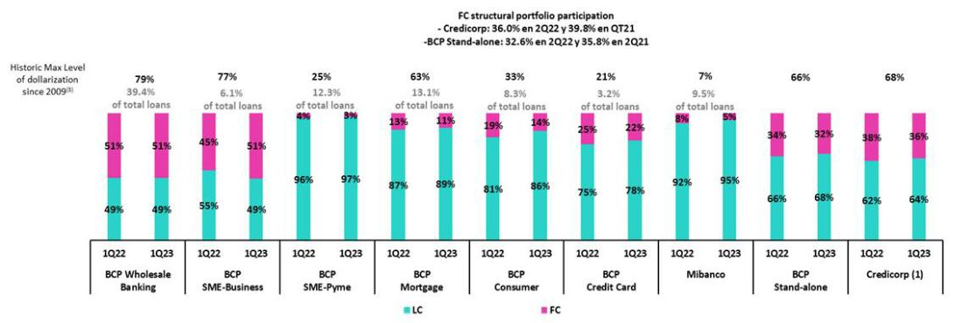

- The FC share of Credicorp’s loan portolio is calculated including BCP Bolivia and ASB Bank Corp., however the chart shows only the loan books of BCP Stand-alone and Mibanco.

- The year with the historic maximum level of dollarizaton for Wholesale Banking was 2012, for Mibanco was 2016, for Credit Card was in 2021 and for the rest of segments was 2009. * For dollarizaton fgures in quarter-end period, please refer to “12. Annexes – 12.2 Loan Portolio Quality

Loan Evoluton in Quarter-end Balances

Structural loans fell -0.7% QoQ in quarter-end balances due to the same factors outlined in the analysis of loans measured in average daily balances. If we include the contracton in the GP portolio in the analysis, total loans fell -2.3% QoQ.

In YoY terms, structural loans rose 8.2% in quarter-end balances due to the same drivers as those that fueled the evoluton of average daily balances. If we include GP loans in the analysis, total loans rose 0.4% YoY.

1.2. Portolio Quality

Quality of the Structural Portolio (in Quarter-end balances)

Structural Portolio quality and Delinquency ratos |  | As of |  |  | % change
S/ 000 | Mar 22 | Dec 22 | Mar 23 | QoQ | YoY
Structural loans (Quarter-end balance)⁽²⁾ | 127,585,105 | 139,115,242 | 138,073,343 | -0.7% | 8.2%
Structural Allowance for loan losses⁽²⁾ | 8,061,670 | 7,733,575 | 7,779,501 | 0.6% | -3.5%
Structural Write-ofs | 378,093 | 754,326 | 677,148 | -10.2% | 79.1%
Structural IOLs | 4,850,191 | 4,791,245 | 4,952,108 | 3.4% | 2.1%
Structural Refnanced loans | 1,714,074 | 2,098,748 | 2,121,068 | 1.1% | 23.7%
Structural NPLs | 6,564,265 | 6,889,993 | 7,073,176 | 2.7% | 7.8%
Structural IOL rato | 3.80% | 3.44% | 3.59% | 15 bps | -21 bps
Structural NPL rato | 5.15% | 4.95% | 5.12% | 17 bps | -3 bps
Structural Allowance for loan losses over Structural loans | 6.3% | 5.6% | 5.6% | 7 bps | -69 bps
Structural Coverage rato of NPLs | 122.8% | 112.2% | 110.0% | -225 bps | -1282 bps

(1) The Structural Portolio excludes Government Programs (GP) efects.

The volume of structural NPL loans rose QoQ and YoY by 2.7% and 7.8% respectvely. QoQ, the increase was driven by growth in IOL loans in Wholesale Banking. This increase was partally ofset by the sale of a judicial portolio in Retail Banking this quarter. It is important to note that, thanks to Wholesale provisions models that foresaw the potental for deterioraton, the IOL portolio was completely provisioned prior to advancement to the IOL stage. YoY, dynamics were driven by an increase in refnanced loans in Wholesale Banking.

19

| Earnings Release 1Q / 2023 Analysis of 1Q23 Consolidated Results

01. Loan Portfolio

Structural NPL Rato
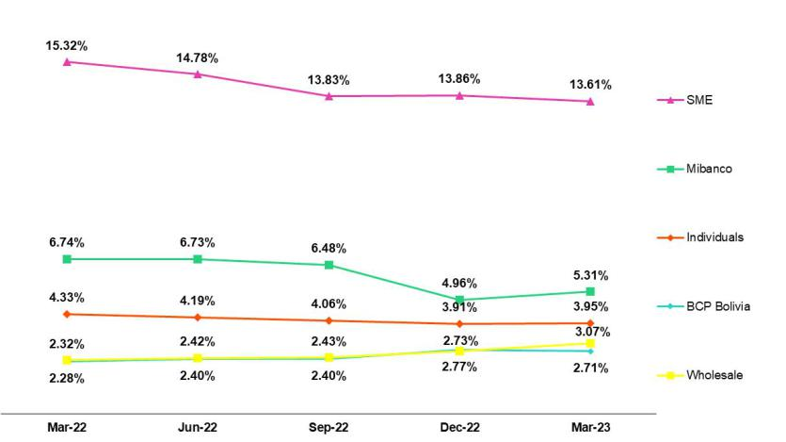

In the QoQ analysis, the structural NPL rato rose, which refects an increase in NPL volumes. The segments that contributed to growth were:

- Wholesale Banking, due to an uptck in overdue loans afer leters of credit were executed to cover loans to a client in the constructon sector. It is important to note that these loans were already 100% provisioned given that provisions models had antcipated deterioraton.

- Mibanco, which was heavily impacted by the protests in the south of the country, damaging rains in the north and an adverse macroeconomic climate. These events have generated an increase in the IOL portolio given that some clients who received early relief measures at the end of 4Q22 or 1Q23; nonetheless fell delinquent. In 1Q23, an additonal tranche of clients was ofered refnancing.

- Consumer and Credit Cards, which reported deterioraton in the portolio disbursed in 2022 afer penetratng segments with higher risk profles. In this scenario, adjustments were made to credit guidelines to shif the focus to clients with beter profles.

Growth in the structural NPL rato was partally ofset by the sale of a judicial recovery portolio in Retail Banking, which was concentrated primarily in SME-Pyme and Mortgage loans. Had the bank not taken the aforementoned measures, the SME-Pyme segment would have reported deterioraton in disbursements of higher-risk loans disbursed in 2022.

YoY, the structural NPL rato fell slightly by 3bps, which refects the impact of loan growth as outlined in the previous chapter. The uptck in loan volumes was partally ofset by an increase in NPL loans, which was driven by:

- Wholesale Banking, given that in 2022, loans were refnanced for clients in the commercial real estate and tourism sectors, both of which were heavily impacted by the pandemic. It is important to note that these loans are backed by collateral levels that far exceed total debt.
- Consumer and Credit Cards, where deterioraton was driven by the same factors as those presented in the QoQ analysis.

- Mibanco, where deterioraton was spurred by the same factor as those outlined in the QoQ analysis

As was the case QoQ, the uptck in the structural loan rato was partally ofset by the sale of a portolio.

20

| Earnings Release 1Q / 2023 | Analysis of 1Q23 Consolidated Results
01. Loan Portfolio
Structural write-ofs | QoQ, structural loans fell -10.2%. This evoluton was atributable to the fact that
(in quarter-end balances – S/ thousands) | regulatory restrictons that impeded taking charge-ofs on structural loans held by clients
 | that also possess Reactva loans were lifed. Consequently, the frst wave of charge-ofs
 | was rolled out in the SME-Pyme sector in 3Q22 and contnued through this quarter.
 | Although charge-ofs in 4Q22 were lower than those registered last quarter, the level is
 | high and is expected to remain so over coming quarters.
 | YoY, growth in the NPL volume (+79.1%) was fueled by write-ofs in SME-Pyme, Consumer
 | and Mibanco. Growth in NLP loans in SME-Pyme and Mibanco was primarily driven by the
 | factors indicated above while the uptck in Consumer was atributable to write-ofs that
 | had been postponed during the pandemic.
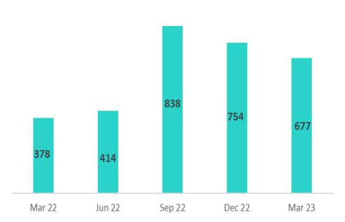

Coverage Rato of Structural NPL Loans
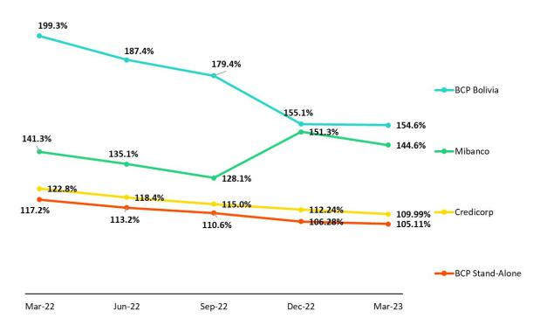

In the last few quarters, the coverage rato for structural NPL loans has presented an on-going reducton. This decline was primarily driven by Wholesale Banking, which experienced a signifcant uptck in structural loan volumes in 2022 and 1Q23 due to the impulse of refnanced loans. This growth was not accompanied by a commensurate increase in provisions given that these loans are backed by collateral levels that far exceed total debt.

NPL loans in the Government Loan Portolio | QoQ, the volume of NPLs dropped due to growth in honoring processes for Reactva
(in quarter-end balances– S/ thousands) | Loans. At the end of March 2023, a total of S/1,430 million was received for the concept of
 | state guarantees.
 | To execute these guarantees, loans must present delinquency for more than 90 days.
 | Average guarantee levels stand at 84%, 91% and 97% for Wholesale Banking, Retail
 | Banking and Mibanco respectvely.
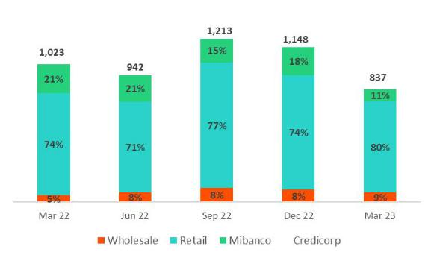

21

| Earnings Release 1Q / 2023 Analysis of 1Q23 Consolidated Results

01. Loan Portfolio

Quality of the Total Portolio (in quarter-end balances)

Loan Portolio Quality and Delinquency Ratos |  | As of |  |  | % change
S/ 000 | Mar 22 | Dec 22 | Mar 23 | QoQ | YoY
Total loans (Quarter-end balance) | 144,621,513 | 148,626,374 | 145,165,713 | -2.3% | 0.4%
Allowance for loan losses | 8,262,383 | 7,872,402 | 7,915,350 | 0.5% | -4.2%
Write-ofs | 378,093 | 754,326 | 677,148 | -10.2% | 79.1%
Internal overdue loans (IOLs) (1)(2) | 5,872,999 | 5,939,744 | 5,789,497 | -2.5% | -1.4%
Internal overdue loans over 90-days (1) | 4,424,384 | 4,620,461 | 4,386,959 | -5.1% | -0.8%
Refnanced loans (2) | 1,714,074 | 2,098,748 | 2,121,068 | 1.1% | 23.7%
Non-performing loans (NPLs) (3) | 7,587,073 | 8,038,492 | 7,910,565 | -1.6% | 4.3%
IOL rato | 4.06% | 4.00% | 3.99% | -1 bps | -7 bps
IOL over 90-days rato | 3.06% | 3.11% | 3.02% | -9 bps | -4 bps
NPL rato | 5.25% | 5.41% | 5.45% | 4 bps | 20 bps
Allowance for loan losses over Total loans | 5.71% | 5.30% | 5.45% | 15 bps | -26 bps
Coverage rato of IOLs | 140.7% | 132.5% | 136.7% | 418 bps | -400 bps
Coverage rato of IOL 90-days | 186.7% | 170.4% | 180.4% | 1005 bps | -632 bps
Coverage rato of NPLs | 108.9% | 97.9% | 100.1% | 200 bps | -880 bps

- Includes Overdue Loans and Loans under legal collecton (Quarter-end balances net of deferred earnings).
- Figures net of deferred earnings.
- Non-performing Loans include Internal overdue loans and Refnanced loans (Quarter-end balances net of deferred earnings).

Accordingly, Credicorp’s NPL rato rose 4bps QoQ and 20bps YoY, in line with growth in structural NPL volumes.

22

| Earnings Release 1Q / 2023 Analysis of 1Q23 Consolidated Results

02 Deposits

At the end of 1Q23, 67.9% of deposits were low-cost, which represents a compettve advantage in a context of record-high interest rates. YoY, low-cost deposits fell 11.0%, which was primarily fueled by on-going growth in Time Deposits afer corporate clients migrated funds to this deposit type to take advantage of higher rates. However, low-cost deposit levels remain high. Demand deposits at BCP Stand-alone and Mibanco also dropped over the period, which refected a normalizaton in liquidity levels.

At the end of March 2023, the market share (MS) for total deposits, which consolidates BCP Stand-alone and Mibanco, stood at 34.8% (-90bps with regard to March 22).

Deposits |  | As of |  | % change |  |  | Currency
S/ 000 | Mar 22 | Dec 22 | Mar 23 | QoQ | YoY | LC | FC
Demand deposits | 56,923,859 | 48,467,247 | 47,483,662 | -2.0% | -16.6% | 46.7% | 53.3%
Saving deposits | 56,454,479 | 54,769,045 | 53,418,288 | -2.5% | -5.4% | 55.9% | 44.1%
Time deposits | 30,029,261 | 38,897,010 | 43,194,573 | 11.0% | 43.8% | 46.5% | 53.5%
Severance indemnity deposits | 3,750,593 | 3,824,629 | 3,322,691 | -13.1% | -11.4% | 70.2% | 29.8%
Interest payable | 757,772 | 1,062,856 | 1,204,086 | 13.3% | 58.9% | 50.3% | 49.7%
Total Deposits | 147,915,964 | 147,020,787 | 148,623,300 | 1.1% | 0.5% | 50.3% | 49.7%

Our Total Deposit base increased 1.1% QoQ and 0.5% YoY. This growth was driven by the following dynamics:

- Growth of 11.0% in Time Deposits, which was driven primarily by FC deposits by corporate clients at BCP Stand-alone and secondarily by Mibanco, where clients moved to take advantage of higher rates.

The aforementoned was partally ofset by:

- A 2.5% reducton in Savings Deposits in both LC and FC, which was mainly atributable to a drop in volumes at BCP Stand-alone and at BCP Bolivia. The reducton in volumes at BCP Stand-alone was driven by clients’ moves to migrate funds to higher-yield deposits to take advantage of record-high interest rates while at BCP Bolivia, the decline refects the impact of an adverse macroeconomic environment.

- The 2.0% decline in Demand Deposits. This decline was triggered by a drop in FC deposits, which was in turn spurred by a reducton in the demand deposits at BCP and ASB afer funds migrated to higher-yield deposits. The drop in FC was partally ofset by an increase in LC over the period.

The low-cost deposit volume (Demand + savings) has fallen and is returning to pre-pandemic levels. Nevertheless, this deposit type contnues to represent a sizeable share of total deposits (67.9%).

Deposit Dollarizaton Level

Deposits by currency | At the end of March 2023, the dollarizaton level of Total Deposits fell 10 bps QoQ. This
(measured in quarter -end balances) | drop was driven by Demand Deposits, which were impacted by the migraton of funds
 | from FC to LC at BCP Stand-alone in a context marked by a lower exchange rate and an
 | improvement in market expectatons.
 | In YoY terms, the dollarizaton level fell 150 bps. This evoluton was driven by a drop in
 | Demand Deposits in FC (-23.5%) and Savings Deposits in FC (-5.5%) and by growth in Time
 | Deposits in LC (42.05%). These three movements refected migraton to more proftable
 | deposits.
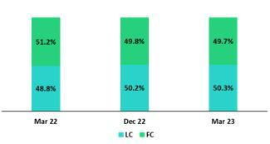

23

| Earnings Release 1Q / 2023 Analysis of 1Q23 Consolidated Results

02. Deposits

Deposits by currency and type

(measured in quarter -end balances)
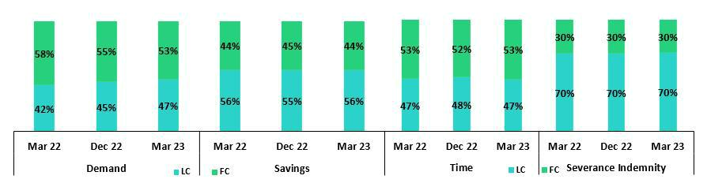

Loan / Deposit Rato (L/D Rato)

The L/D rato fell at BCP Stand-alone and Mibanco QoQ by 475 bps and 500 bps respectvely. This led the L/D rato at BAP to decline in QoQ terms and stand at 97.7% at quarter-end (101.1% in 4Q22.). The aforementoned reducton was driven primarily by a drop in loan balances at BCP and Mibanco, and secondarily by growth in deposits, and in Time Deposits at BCP Stand-alone in partcular, in a context of higher interest rates.
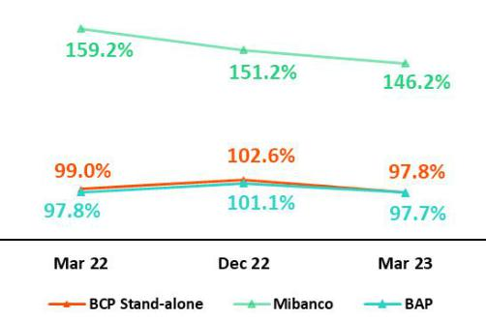

L/D Rato Local Currency L/D Rato Foreign Currency
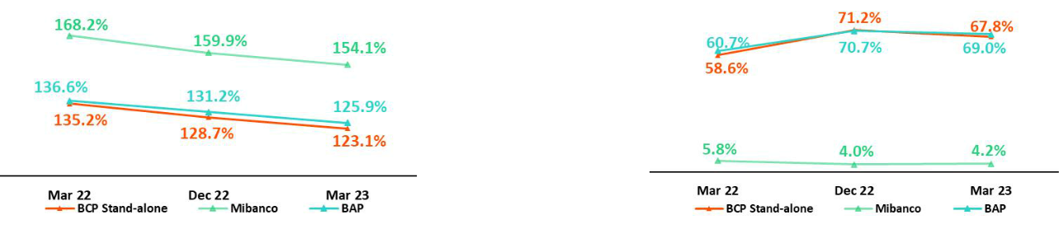

24

| Earnings Release 1Q / 2023 Analysis of 1Q23 Consolidated Results

02. Deposits

Share of the Market for Deposits in the Peruvian Financial System
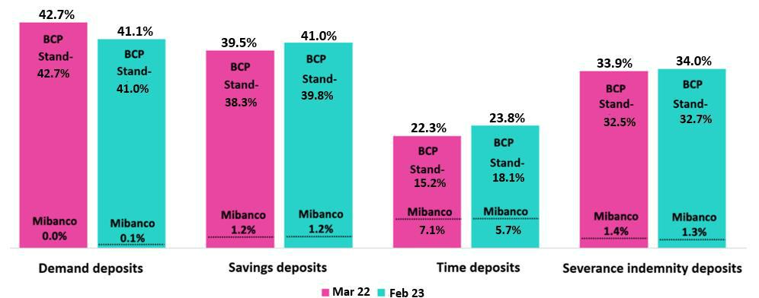

At the end of February 2023, the MS of Total Deposits of BCP Stand-alone and Mibanco in Peru stood at 32.3% and 2.5% respectvely (-100bps and +100bps with regard to March 2022).
With this result, BCP Stand-alone contnues to lead the market by a solid margin.

Growth in BCP Stand-alone’s share of Time Deposits, which was equivalent to 290 bps, refected fund migraton from low-cost to higher-yield deposits. Demand Deposits at the bank fell this quarter, which refects businesses’ moves to cover seasonal expenses and other liquidity needs.

It is important to note that BCP Stand-alone, with a 41.9% share as of February 2023 (+1.0% with regard to March 2022) contnues to lead the market for low-cost deposits in the Peruvian fnancial system.

25

| Earnings Release 1Q / 2023 Analysis of 1Q23 Consolidated Results

03 Interest-earning Assets (IEA) and Funding


At the end of 1Q23 IEAs registered QoQ growth of 0.2%, driven by an uptck in Available Funds and Investments. Growth in both of the aforementoned accounts was ofset by a drop in the Loan balance in a context of amortzatons of Government Loans (GP). YoY, the IEAs balance fell 0.6% due to a reducton in balances of Available Funds and Investments in a context marked by lower liquidity system-wide. This decline was partally ofset by the increase in the loans volume. Structural loans balance, in quarter end fgures, rose 8.2%, driven primarily by the evoluton of loans in Retail Banking at BCP and Mibanco.


Funding fell 0.6% QoQ and 2.6% YoY due to a drop in balances of BCRP, and Bonds and Issued Notes, which refects amortzaton of Reactva loans and the expiraton of a bond at BCP at the end of March.

3.1. IEA¹

Interest Earning Assets |  | As of |  | % change
S/000 | Mar 22 | Dec 22 | Mar 23 | QoQ | YoY
Cash and due from banks | 29,563,512 | 26,897,216 | 28,158,941 | 4.7% | -4.8%
Total investments | 48,145,429 | 45,431,224 | 47,729,504 | 5.1% | -0.9%
Cash collateral, reverse repurchase agreements and securites borrowing | 1,516,855 | 1,101,856 | 1,468,180 | 33.2% | -3.2%
Total loans | 144,621,513 | 148,626,374 | 145,165,713 | -2.3% | 0.4%
Total interest earning assets | 223,847,309 | 222,056,670 | 222,522,338 | 0.2% | -0.6%

QoQ, IEAs grew 0.2% due to an increase in Available Funds and Investments. This growth was partally ofset by a drop in Loans.

The uptck registered in Available Funds was fueled by growth in the funding base of BCP and Mibanco. The majority of these funds are deposited in BCRP accounts, which currently produce favorable yields. Investment rose due to a move to increase the positon in debt instruments issued by BCRP. Total loans fell 2.3%, which refected amortzatons of GP loans and a drop in the exchange rate. Structural loans fell 0.7%, which was primarily driven by a decrease in the loan balance of the Wholesale Banking portolio.

YoY, IEA dropped 0.6%. This evoluton refected the decrease in balances for Available Funds and Investments, which was partally ofset by an increase in Total Loans. The drops registered in Available Funds and Investments were atributable to a system-wide decrease in liquidity afer clients moved to amortze GP loans.

Total loans reported growth of 0.4% YoY. This slight growth was spurred by a drop in GP loan balances. Over the same period, the structural loan volume rose 8.2%, driven primarily by an uptck in volumes at Retail Banking at BCP and Mibanco. GP loans, in turn, dropped 58.4% YoY.

3.2. Funding

Funding |  | As of |  | % change
S/ 000 | Mar 22 | Dec 22 | Mar 23 | QoQ | YoY
Deposits and obligatons | 147,915,964 | 147,020,787 | 148,623,300 | 1.1% | 0.5%
Due to banks and correspondents | 6,362,990 | 8,937,411 | 10,199,650 | 14.1% | 60.3%
BCRP instruments | 17,532,350 | 11,297,659 | 9,780,540 | -13.4% | -44.2%
Repurchase agreements with clients and third partes⁽²⁾ | 1,856,645 | 1,669,066 | 1,905,955 | 14.2% | 2.7%
Bonds and notes issued | 16,044,671 | 17,007,194 | 14,313,030 | -15.8% | -10.8%
Total funding | 189,712,620 | 185,932,117 | 184,822,475 | -0.6% | -2.6%

QoQ and YoY, funding dropped 0.6% and 2.6% respectvely due a decrease in balances for BCRP instruments (associated with the amortzaton of Reactva Loans) and a reducton in the balance of Bonds and Issued Notes, which refects the expiraton of a bond at the end of March. It is important to note that deposits rose 1.1% QoQ, due primarily to growth in tme deposits. YoY, the deposit volume remained relatvely stable.

- Efectve 1Q23, IEA does not include “Financial assets designated at Fair Value through P&L” (mainly comprised of Investment Link contracts) as one of its components
- Efectve 1Q23, Funding includes Repurchase agreements with clients

26

| Earnings Release 1Q / 2023 Analysis of 1Q23 Consolidated Results

04 Net Interest Income (NII)


In 1Q23, Net Interest Income remained stable QoQ. Our disciplined management of pricing led growth in IEA yields to slightly outpace expansion in the Funding Cost. It is relevant to note that comparatvely speaking, there were two fewer business days in 1Q23 than in 4Q22, which negatvely impacted Net Interest Income.


YoY, Net interest Income rose 28.8%, driven by higher interest rates. Rising rates favorably impacted IEA Yields (+244bps), where growth helped mitgate the downside of rate increases at the funding cost level (+129bps). Growth in structural loans also contributed, although to a lesser extent, to higher NII over the period.

In this context, in 1Q23, the Net Interest Margin rose 9bps QoQ and 138bps YoY to stand at 5.84% and the Structural Net Interest Margin, 6.02%

Net Interest Income / Margin |  | Quarter |  |  | % change
S/ 000 | 1Q22 | 4Q22 | 1Q23 | QoQ | YoY
Interest Income | 3,172,346 | 4,362,142 | 4,456,106 | 2.2% | 40.5%
Interest Expense | (740,639) | (1,227,364) | (1,324,017) | 7.9% | 78.8%
Interest Expense (excluding Net Insurance Financial Expenses) | (638,881) | (1,119,124) | (1,208,267) | 8.0% | 89.1%
Net Insurance Financial Expenses | (101,758) | (108,240) | (115,750) | 6.9% | 13.8%
Net Interest Income | 2,431,707 | 3,134,778 | 3,132,089 | -0.1% | 28.8%
Balances
Average Interest Earning Assets (IEA) | 227,279,809 | 225,604,596 | 222,289,504 | -1.5% | -2.2%
Average Funding | 193,179,562 | 190,660,720 | 185,377,296 | -2.8% | -4.0%
Yields
Yield on IEAs | 5.58% | 7.73% | 8.02% | 29bps | 244bps
Cost of Funds | 1.32% | 2.35% | 2.61% | 26bps | 129bps
Net Interest Margin (NIM) ⁽¹⁾ | 4.46% | 5.75% | 5.84% | 9bps | 138bps
Risk-Adjusted Net Interest Margin | 4.01% | 4.45% | 4.54% | 9bps | 53bps
Peru’s Reference Rate | 4.00% | 7.50% | 7.75% | 25bps | 375bps
FED funds rate | 0.50% | 4.50% | 5.00% | 50bps | 450bps

(1) For further detail on the new NIM calculaton due to IFRS17, please refer to Annex 12.1.8

QoQ, Net interest income registered a litle decrease (-0.1%) given that growth in expenses outstripped expansion in income. The increase in income was driven by IEA yields, where despite the reducton in the loan balance, the recompositon of the loan portolio mix, together with the current interest rate environment, resulted in a positve impact. Expansion in interest expenses was fueled by an uptck in the Funding Cost, which was in turn spurred by growth in the share of more expensive sources of funding in the mix. In net terms, the increase registered in IEA yields was slightly above the growth registered for the funding cost; consequently, NIM rose 9bps QoQ to stand at 5.84%.

YoY, Net interest income rose 28.8%, driven by the fact that growth in income outstripped the expansion in expenses in an environment marked by rising interest rates. This evoluton was primarily atributable to the fact that the positve efect of interest rate hikes on IEAs outweighed the negatve efect of said hikes on the Funding Cost. In this context, NIM rose 138bps YoY.

Net Interest Margin |  | Structural NIM contnued to rise QoQ thanks to the positve efect generated by actve
 |  | interest rate management in our business segments and to efectve repricing of
 |  | investments. This quarter, risk-adjusted NIM rose slightly to stand at 4.54% at quarter-end.
 |  | To analyze the evoluton of Net Interest Income, it is important to diferentate dynamics
 |  | by currency given that the trends in volumes market rate variatons difer for each. The
 |  | reference rate in LC (BCRP) increased 25bps QoQ and 375bps YoY, while the rate in FC (FED
 |  | funds rate) rose 50bps QoQ and 450bps YoY.
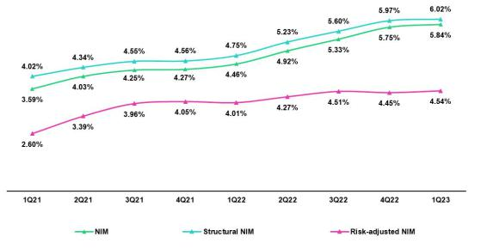

27

| Earnings Release 1Q / 2023 Analysis of 1Q23 Consolidated Results

04. Net Interest Income (NII)

Dynamics of Net Interest Margin by Currency

Interest Income / IEA |  | 1Q22 |  |  | 4Q22 |  |  |  | 1Q23
S/ millions | Average |  |  | Average |  |  |  | Average
 | Balance | Income | Yields | Balance | Income | Yields |  | Balance | Income | Yields
Cash and equivalents | 30,979 | 35 | 0.5% | 28,114 | 236 | 3.4% |  | 27,528 | 277 | 4.0%
Other IEA | 1,642 | 19 | 4.5% | 1,344 | 48 | 14.3% |  | 1,285 | 16 | 5.0%
Investments | 48,549 | 433 | 3.6% | 46,137 | 563 | 4.9% |  | 46,580 | 592 | 5.1%
Loans | 146,109 | 2,686 | 7.4% | 150,009 | 3,515 | 9.4% |  | 146,896 | 3,571 | 9.7%
Structural | 128,256 | 2,619 | 8.2% | 139,153 | 3,459 | 9.9% |  | 138,594 | 3,528 | 10.2%
Government Programs | 17,853 | 66 | 1.5% | 10,856 | 56 | 2.1% |  | 8,302 | 43 | 2.1%
Total IEA | 227,280 | 3,172 | 5.6% | 225,605 | 4,362 | 7.7% |  | 222,290 | 4,456 | 8.0%
IEA (LC) | 58.0% | 78.8% | 7.6% | 56.6% | 73.1% | 10.0% |  | 56.9% | 71.2% | 10.0%
IEA (FC) | 42.0% | 21.2% | 2.8% | 43.4% | 26.9% | 4.8% |  | 43.1% | 28.8% | 5.3%
Interest Expense⁽¹⁾/ Funding |  | 1Q22 |  |  | 4Q22 |  |  |  | 1Q23
S/ millions | Average |  |  | Average |  |  |  | Average
 | Balance | Expense | Yields | Balance | Expense | Yields |  | Balance | Expense | Yields
Deposits | 148,756 | 259 | 0.7% | 149,489 | 582 | 1.6% |  | 147,822 | 677 | 1.8%
BCRP + Due to Banks | 25,400 | 116 | 1.8% | 21,843 | 240 | 4.4% |  | 20,108 | 239 | 4.8%
Bonds and Notes | 16,934 | 174 | 4.1% | 17,430 | 189 | 4.3% |  | 15,660 | 183 | 4.7%
Others | 1,257 | 90 | 28.6% | 1,079 | 108 | 40.1% |  | 1,091 | 109 | 40.1%
Total Funding | 193,180 | 639 | 1.3% | 190,661 | 1,119 | 2.3% |  | 185,377 | 1,208 | 2.6%
Funding (LC) | 51.2% | 53.6% | 1.4% | 50.8% | 59.0% | 2.7% |  | 50.5% | 55.7% | 2.9%
Funding (FC) | 48.8% | 46.4% | 1.3% | 49.2% | 41.0% | 2.0% |  | 49.5% | 44.3% | 2.3%
NIM | 227,280 | 2,533 | 4.5% | 225,605 | 3,243 | 5.7% |  | 222,290 | 3,248 | 5.8%
NIM (LC) | 58.0% | 85.2% | 6.5% | 56.6% | 78.0% | 7.9% |  | 56.9% | 77.0% | 7.9%
NIM (FC) | 42.0% | 14.8% | 1.6% | 43.4% | 22.0% | 2.9% |  | 43.1% | 23.0% | 3.1%
(1) Excluding Net Insurance Financial Expenses.

QoQ analysis

QoQ, Net interest income remained relatvely stable given that the dynamics in LC and FC ofset one another. IEAs in LC represented 56.9% of total IEA and accounted for 77% of Net interest income generated in 1Q23.

Dynamics in Local Currency (LC)

Net interest income in LC fell 1.2%, which was atributable to the following dynamics:

Average IEA in LC dropped 1.0%, driven by amortzatons of Government Program loans (-23.5%). The aforementoned was partally ofset by growth in Investments (+4.0%) and Structural Loans (+0.5%). The implicit rates of the main components of IEA in LC remained stable. In 1Q23, the yield on IEA in LC stood at 10.0%. The aforementoned contracton in IEAs led to a consequent drop in Interest income in LC (-0.4%).

Average funding in LC fell 3.3%, which was atributable to a decrease in balances for Reactva funding and Deposits. The funding cost in LC rose from 2.7% in 4Q22 to 2.9% in 1Q23, which refected fund migraton from low-cost deposits to Time Deposits. Interest expenses (excluding Net Insurance Financial Expenses) in LC rose 1.9%, driven primarily by an increase in the funding cost.

Foreign Currency Dynamics (FC)

Net interest Income in FC rose 3.8% due to the following dynamics:

Average IEA in FC dropped 2.1%, in line with a decrease in the exchange rate and a drop in Total loans (controlling for the exchange rate). Nonetheless, interest rate hikes led the Yield on IEAs in FC to increase from 4.8% to 5.3%. This price efect drove expansion in Interest income in FC (+9.2%).

Average funding in FC fell 2.2%. This evoluton was primarily atributable to an exchange rate efect and to a drop in the balance of Bonds and Issued Notes, which refected the impact of a bond expiraton at BCP in March. Despite the aforementoned, the Funding cost rose this quarter, primarily due to an increase in rates in FC and secondarily, to the negatve mix efect generated by fund migraton from Low-cost deposits to Time deposits. In this context, Interest expenses (excluding Net Insurance Financial Expenses) in FC rose 16.6%.

28

| Earnings Release 1Q / 2023 Analysis of 1Q23 Consolidated Results

04. Net Interest Income (NII)

YoY Analysis

YoY, Net interest income rose 28.8% mainly infuenced by the evoluton of interest rates and volumes in FC, as well as by the interest rate dynamics in LC:

Local Currency Dynamics (LC)
Net interest income in LC rose 15.9% YoY due to the following dynamics:

Average IEA in LC dropped 4.2% YoY, which refected the impact of amortzatons of Government Program loans and a drop in Available funds. The Yield on IEAs stood at 10.0% in 1Q23. In this context, LC income increased 27.0%, driven by a positve price efect across the IEAs and by growth in the Structural loan volume.

Average funding in LC declined 5.4%, which was atributable to a decrease in repo balances with BCRP, in line with amortzatons of Reactva loans. This reducton was ofset by an increase in Time deposits as clients sought to take advantage of higher rates. Nonetheless, the rates of the main components of funding in LC rose, in partcular for interest-bearing deposits and bank fnancing, in line with an increase in reference rate. The funding cost in LC increased from 1.4% in 1Q22 to 2.9% in 1Q23. Interest expenses (excluding Net Insurance Financial Expenses) rose 96.6% this quarter, driven by a price efect and by an increase in the cost of the funding structure.

Dynamics in Foreign Currency (FC)

Net interest income in FC expanded 107.9% due to the following dynamics:

Average IEA in FC increased 0.6%, driven by Loan growth and partally ofset by a drop in the balances of Investments and Available funds. This dynamic generated a positve mix efect on IEAs in FC. In this context, the yield on IEA in FC rose from 2.8% in 1Q22 to 5.3% in 1Q23, fueled by interest rate hikes and the aforementoned mix efect. In net terms, positve price and mix efects led Interest income in FC to increase 90.6%.

Average funding in FC dropped 2.6%, which was atributable to a reducton in balances of Deposits, and Bonds and Issued Notes. Notwithstanding, the funding cost in FC rose from 1.3% in 1Q22 to 2.3% in 1Q23, which refected the positve impact of higher rates in FC. This quarter, Interest rate expenses (excluding Net Insurance Financial Expenses) in FC expanded 80.5% due to a price efect.

29

| Earnings Release 1Q / 2023 Analysis of 1Q23 Consolidated Results

05 Provisions


QoQ, the provisions expense rose due to (i) deterioraton in payment behavior in Retail Banking, which was concentrated in disbursements made in 2022 in segments with higher risk profles and in SME-Pyme, Consumer and Credit Cards in partcular; and (ii) the impact in Mibanco in the context marked by social protests, intense rains and deterioraton in macroeconomic factors. This growth was ofset by a drop in expenses in Wholesale Banking, which was driven by a decrease in exposure this quarter.


Provisions rose YoY, triggered by deterioraton in the payment behavior in Consumer and Credit Cards and by Mibanco, which have been impacted by the current environment in Peru and macroeconomic factors. SME-Pyme provisions levels remain high in line with its portolio deterioraton. This uptck was partally ofset by an improvement in payment behavior in Wholesale Banking.

In the aforementoned context, the Structural Cost of Risk (CofR) stood at 2.10% in 1Q23.

Provisions and Cost of Risk (CoR) ⁽¹⁾ of the Structural Portolio

Structural Loan Portolio Provisions |  | Quarter |  |  | % change
S/ 000 | 1Q22 | 4Q22 | 1Q23 | QoQ | YoY
Gross provision for credit losses on loan portolio | (354,553) | (799,864) | (799,129) | -0.1% | 125.4%
Recoveries of writen-of loans | 93,091 | 84,908 | 75,109 | -11.5% | -19.3%
Provision for credit losses on loan portolio, net of recoveries | (261,462) | (714,956) | (724,020) | 1.3% | 176.9%
Structural Cost of risk ⁽²⁾ | 0.82% | 2.06% | 2.10% | 4 bps | 128 bps

- Annualized Provision for credit losses on loan portolio, net of recoveries.
- The Structural Cost of risk excludes the Provisions for credit losses on loan portolio, net of recoveries and Total Loans from the Reactva Peru and FAE Government Programs.

QoQ, structural provisions rose slightly. This led to a 4 bps increase in the structural CofR. The segments that drove the rato upward were:

- SME-Pyme, spurred by a deterioraton in payment behavior afer the bank incurred in higher-risk segments in 2022.

- Individuals, due to primarily to deterioraton in payment behavior in Consumer and Credit Cards given that in 2022, new segments with higher risk profles were penetrated, and secondarily to an update in macroeconomic factors, which capture new expectatons for higher infaton and lower GDP in 2023.

- Mibanco, whose portolio was severely impacted by an environment punctuated by social protests in the south and intense rains in the north and by updates of macroeconomic factors to beter capture deterioraton in the macroeconomic context.

Growth in total provisions was partally ofset by a drop in provisions in Wholesale Banking, which experienced a decrease in its exposure level that refected a reducton in balances and debt payments by clients that were in default.

30

| Earnings Release 1Q / 2023 Analysis of 1Q23 Consolidated Results

05. Provisions

YoY the structural CofR increased 128bp, in line with growth in provisions. The uptick in | Structural Cost of Risk by Subsidiary
provisions expenses was driven by
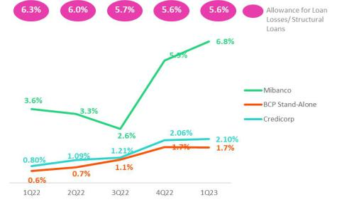

- Individuals (Consumer and Credit Cards), spurred, as well the case QoQ, by a deterioraton in payment behavior and a low base efect.

- Mibanco, due to the same environmental impacts outlined in the QoQ dynamics and a low base efect.

- SME-Pyme, where provisions levels contnue to be high in line with the deterioraton of the loan portolio despite a slight improvement with respect to 1Q22.

Growth in total provisions expenses was partally ofset by a decline in the provisions expense in the Wholesale Banking segments, which registered an improvement in payment behavior with regard to 1Q22.

In this context, we are closely monitoring our asset quality metrics and have implemented stricter originaton guidelines at specifc segments within Consumer, Credit Cards and SME-Pyme.

Likewise, since the second half of last year, we have reviewed the risk appette at Mibanco and turn our focus on clients with beter risk profles.

Provisions and CoR in the Government Loan Portolio (PG)

GP Loan Portolio Provisions |  | Quarter |  | % change
S/ 000 | 1Q22 | 4Q22 | 1Q23 | QoQ | YoY
Gross provision for credit losses on loan portolio | 3,872 | (15,725) | (2,978) | -81.1% | -506.1%
Recoveries of writen-of loans | - | - | - | - | -
Provision for credit losses on loan portolio, net of recoveries | 3,872 | (15,725) | (2,978) | -81.1% | -176.9%
GP Cost of risk ⁽¹⁾ | -0.09% | 0.66% | 0.17% | -49 bps | 26 bps

(1) The GP Cost of risk includes the Provisions for credit losses on loan portolio, net of recoveries and Total Loans from the Reactva Peru and FAE Government Programs.

GP provisions fell signifcantly both QoQ and YoY due the fact that honoring processes to execute State guarantees are on-going.

The GP provisions balance represents 1.7% of Credicorp’s total provisions. This relatvely small balance is due to the existence of ample state guarantees with coverage levels that range between 80% and 98% of the loan amount. For more informaton, see 1.2 Portolio Quality – Government Program Loan NPLs.

Provisions and CoR of Total Portolio

Loan Portolio Provisions |  | Quarter |  |  | % change
S/ 000 | 1Q22 | 4Q22 | 1Q23 | QoQ | YoY
Gross provision for credit losses on loan portolio | (350,681) | (815,589) | (802,107) | -1.7% | 128.7%
Recoveries of writen-of loans | 93,091 | 84,908 | 75,109 | -11.5% | -19.3%
Provision for credit losses on loan portolio, net of recoveries | (257,590) | (730,681) | (726,998) | -0.5% | 182.2%
Cost of risk ⁽¹⁾ | 0.71% | 1.97% | 2.00% | 3 bps | 129 bps
(1) Annualized Provision for credit losses on loan portolio, net of recoveries / Total Loans.

The CofR of the total portolio, which is comprised of structural and GP loans, reported growth of 3bps QoQ and 129 bps YoY, which refected growth in structural provisions.

31

| Earnings Release 1Q / 2023 Analysis of 1Q23 Consolidated Results

05. Provisions

QoQ Evoluton of the Cost of Risk YoY Evoluton of the Cost of Risk
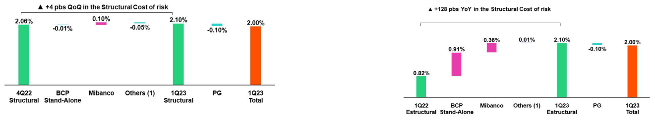

(1) Others include BCP Bolivia, Mibanco Colombia, ASB Bank Corp and eliminatons.

32

| Earnings Release 1Q / 2023 Analysis of 1Q23 Consolidated Results

06 Other Income

Other Core Income fell QoQ and YoY by 4.8% and 1.8% respectvely. This evoluton was driven by drop in the Net gain on FX transactons in BCP, which refected a decrease in the volatlity of the US Dollar and the eliminaton of the inter-city transfers commission in BCP.

Non-core other income increased 31.4% QoQ, which refects an uptck in other non-fnancial income at BCP, and rose 124.6% YoY, fueled by growth in Net gains on securites in the Insurance and Pension businesses.

6.1 Other Core Income

Core Other Income |  | Quarter |  |  | % Change
(S/ 000) | 1Q22 | 4Q22 | 1Q23 | QoQ | YoY
Fee income | 891,628 | 894,552 | 881,781 | -1.4% | -1.1%
Net gain on foreign exchange transactons | 259,710 | 293,215 | 248,515 | -15.2% | -4.3%
Total other income Core | 1,151,338 | 1,187,767 | 1,130,296 | -4.8% | -1.8%

QoQ and YoY, other core income fell. This decline was primarily driven by a drop in the Net gain on FX transactons, which was in turn fueled by:

- BCP: Exchange rate seasonality. In the last quarter of every year, a seasonal efect leads transacton volumes and income for Net gains on FX transactons to rise.

- BCP Bolivia: The Central Bank of Bolivia restricted purchase/sale of US Dollars, which directly impacted the transactons volume.

Additonally, net fee income fell due to the eliminaton of inter-city fees in universal banking. This reducton was partally ofset by BCP Bolivia, which increased its fee for foreign transfers from 2.5% to 7.5% of the total transfer amount. For more details, see the secton on fee income in the banking business.

Fee income in the banking business

Compositon of fee income in the banking business

Banking Business Fees |  | Quarter |  | % Change
S/ 000 | 1Q22 | 4Q22 | 1Q23 | QaQ | YoY
Payments and transactonals ⁽¹⁾ | 290,197 | 333,779 | 325,994 | -2.33% | 12.34%
Liability accounts ⁽²⁾ | 217,956 | 226,496 | 177,971 | -21.42% | -18.35%
Loan Disbursement ⁽³⁾ | 90,576 | 97,336 | 95,201 | -2.19% | 5.11%
Of-balance sheet | 60,370 | 63,247 | 61,654 | -2.52% | 2.13%
Mibanco (Peru and Colombia) | 33,276 | 34,164 | 59,208 | 73.30% | 77.93%
Insurances | 30,303 | 28,617 | 31,102 | 8.68% | 2.64%
BCP Bolivia | 27,400 | 24,479 | 37,765 | 54.28% | 37.83%
Wealth Management and Corporate Finance | 18,785 | 12,880 | 15,254 | 18.43% | -18.80%
ASB | 12,280 | 11,040 | 3,098 | -71.94% | -74.77%
Others ⁽⁴⁾ | 4,596 | -16,494 | 12,830 | n.a | 179.15%
Total | 785,739 | 815,544 | 820,077 | 0.56% | 4.37%

- Corresponds to fees from: credit and debit cards; payments and collections.
- Corresponds to fees from: Account maintenance, interbank transfers, national money orders y international transfers.
- Corresponds to fees from retail and wholesale loan disbursements.
- Use of third-party network, other services to third parties and Commissions in foreign branches.

Commissions for banking services rose slightly QoQ. This evoluton was driven primarily by:

33

| Earnings Release 1Q / 2023 Analysis of 1Q23 Consolidated Results

- Other Income

  - Others: Last quarter, fees paid to acquirers were renegotated, which generated extraordinary payments in 4Q22. In 1Q23, this efect was reversed.
  - Mibanco: Which registered a drop in fees paid to third-partes for business-channeling agreements afer the bank negotated beter conditons.

  - BCP Bolivia: Which reported growth in fees from foreign transfers afer the interest rate on transfers was raised from 2.5% to 7.5% of the total transacton amount. This ofset the drop in FX transactons due to the politcal juncture.

The aforementoned was partally ofset by:

Passive and Transactonal Accounts due to:

- The eliminaton of inter-city fees in 4Q22 for both savings and current accounts. In the last few months of 2022, these fees were eliminated, but only in some channels. In 1Q23, the process to eliminate fees across channels was completed. Accordingly, 1Q23 refects the brunt of the impact of this change.

YoY, growth in banking fees was driven by:

- Payment methods and services venues: which was driven by growth in transactons and on-going migraton to digital channels and POS, which, unlike cash, generate fee income. YoY growth in billing for debit and credit cards stood at 19% and 26% respectvely.

- Mibanco: spurred by the same reasons as those discussed for the QoQ evoluton and by a drop in fees paid to third partes for business-channeling agreements afer the bank negotated more favorable contract conditons.

Growth in YoY terms was partally ofset by the same drivers as those that ofset expansion QoQ.

6.2 Other non-core income

Non-core Other income |  | Quarter |  | % Change
(S/ 000) | 1Q22 | 4Q22 | 1Q23 | QoQ | YoY
Net gain on securites | (56,866) | 77,512 | 70,036 | -9.6% | n.a
Net gain from associates ⁽¹⁾ | 24,014 | 25,422 | 27,212 | 7.0% | 13.3%
Net gain on derivatves held for trading | (5,982) | 5,857 | (6,570) | n.a | 9.8%
Net gain from exchange diferences | (8,363) | 22,039 | 22,963 | 4.2% | n.a
Other non-fnancial income | 135,257 | 19,630 | 84,127 | 328.6% | -37.8%
Total other income Non-Core | 88,060 | 150,460 | 197,768 | 31.4% | 124.6%
(1) Includes gains on other investments, which are mainly attributable to the Banmedica result
QoQ evoluton of non-core income |  | YoY evoluton of non-core income
(millions of soles) |  |  | (millions of soles)
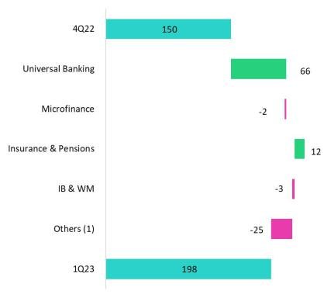
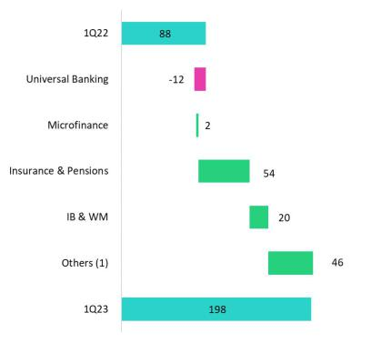

(1) Others includes Grupo Credito, Credicorp Individual, eliminatons and others

34

| Earnings Release 1Q / 2023 Analysis of 1Q23 Consolidated Results

06. Other Income

Other non-core income rose QoQ, which was driven mainly by:

- Universal Banking: Due to income from the sale of an overdue and judicial recovery portolio in retail banking.

The aforementoned was partally ofset by a drop in the Net gain on securites in the Miscellaneous line, which was driven by a drop in the value of Credicorp’s investments in mutual funds.

Other Non-Core Income rose YoY, which was primarily atributable to:

- Insurance and Pensions: Growth in the Net gain on securites due to a drop in losses reported on fxed income investments in 1Q22 and to an improvement in the EPS business, where we share 50% of profts, and which generated a direct impact on the investment in the associates line.
- Others: Atributable to an increase in the value of Credicorp’s investments for the purchase of Investment Grade Bonds.

- Investment Banking and Wealth Management: Due to positve results through the trading strategies at Credicorp Capital Colombia and ASB.

35

| Earnings Release 1Q / 2023 Analysis of 1Q23 Consolidated Results

07 Insurance Underwritng Results

Introducton of IFRS 17

Insurance contracts combine service and fnancial aspects and, in many cases, generate long-term variable cash fows. To adequately refect the impact of these aspects, IFRS 17 combines measuring future cash fows with reportng of insurance contract results during the period that the service is provided. This requires companies to present separate results for insurance, reinsurance and fnancial results.

IFRS was issued in 2017 to replace IFRS 4 “Insurance Contracts” to ensure that companies apply consistent criteria to improve the usefulness, transparency and comparability of Financial Statements. The standard went into efect in January 2023.


Components

Cash fows (premiums, claims and expenses), adjusted according to the discount rate. Risk adjustment (RA), compensaton required for assuming non-fnancial risk. Contractual service margin (CSM), which represents unearned underwritng income that is recognized as income during the coverage period

These components are subject to updates of cash fows based on estmates of the amount, temporality and risk of fows and discount rates

Benefits

Improves the comparability of insurance enttes at a global level. IFRS 4 allowed enttes to use a broad range of accountng practces for insurance contracts.

Adequately refects the economic value of insurance contracts. Some previous practces for insurance accountng permited under IFRS did not adequately refect true underlying fnancial situatons or the fnancial yields of these insurance contracts.

Provides beter informaton to users of fnancial statements.

Valuaton methods

IFRS 17 introduces diferent approaches to valuing underwritng provisions based on the product’s characteristcs (Contract duraton, cash fow)

- Premium Allocaton Approach (PAA): simplifcaton of the general measurement model.

- Building Block Approach (BBA): general measurement model for default valuaton of insurance contracts.

- Variable Fee Approach (VFA): model for contract valuaton where cash fows depend on the value of the underlying assets that back said contracts.

36

| Earnings Release 1Q / 2023 Analysis of 1Q23 Consolidated Results

07. Insurance Underwritng Results

Insurance Underwritng Result

The insurance underwritng result rose 43.4% YoY due to an improvement in the results of Life Insurance. This evoluton was atenuated by a drop in P&C’s results. The uptck in Life was mainly driven by D&S and Credit Life, which refects growth in premiums due to an increase in sales and price adjustments and to a drop in claims for both regular cases and COVID-19. The decrease in P&C’s results refects an uptck in claims in P&C Risks and Cars.

Insurance Underwriting Results | Quarter |  | % Change | Life |  | % Change | P&C |  | % Change | Crediseguros |  | % Change
 | 1Q22 | 1Q23 | YoY | 1Q22 | 1Q23 | YoY | 1Q22 | 1Q23 | YoY | 1Q22 | 1Q23 | YoY
Income from Insurance Contracts | 843,862 | 957,336 | 13.4% | 454,746 | 562,481 | 23.7% | 369,575 | 373,248 | 1.0% | 19,541 | 21,607 | 10.6%
Expenses for Insurance Contracts | (534,603) | (550,459) | 3.0% | (282,567) | (270,629) | -4.2% | (240,078) | (272,680) | 13.6% | (11,957) | (7,150) | -40.2%
Insurance Results | 309,258 | 406,877 | 31.6% | 172,178 | 291,852 | 69.5% | 129,496 | 100,567 | -22.3% | 7,584 | 14,457 | 90.6%
Reinsurance Results | (102,591) | (110,536) | 7.7% | 5,414 | (24,326) | -549.3% | (105,364) | (85,541) | -18.8% | (2,641) | (669) | -74.7%
Insurance Underwriting Results | 206,667 | 296,341 | 43.4% | 177,592 | 267,526 | 50.6% | 24,133 | 15,027 | -37.7% | 4,943 | 13,789 | 179.0%
Income from Insurance Contracts*
 | P&C |  |  |  | Life Insurance
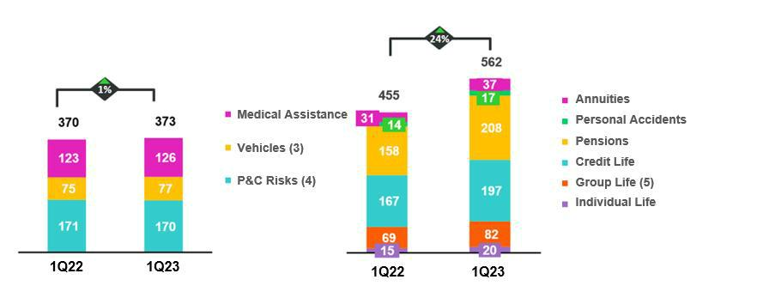

*The products corresponding to Life and P&C businesses have changed from previous reported.

- Includes Cars, and SOAT.

- Includes Wholesale Risks and Personal Lines without AP.

- Includes SCTR (Complementary Insurance for High-risk Occupatons, Statutory Life and Group Life.

In the YoY analysis, income from insurance contracts increased 13.4%. This evoluton was driven primarily by Life and to a lesser extent, P&C. In the Life business, income was up 23.7%, spurred by (i) D&S, which refected an improvement in the terms of tender for the SISCO VI contract⁽1⁾ versus those atached to the SISCO V tender; (ii) Credit Life, due to growth in premiums from bancassurance policies at BCP Stand-alone and Banco de la Nación, which was triggered by rate adjustments and loan growth; (iii) Group Life, through the SCTR (Complementary Insurance for High-Risk Occupatons). In P&C, income rose 1.0%, driven by Cars and Medical Assistance.

- Public tender to select the insurance companies that will collectvely manage disability, survivorship and burial risks for AFP afliates in the 2023 period.

37

| Earnings Release 1Q / 2023 Analysis of 1Q23 Consolidated Results

07. Insurance Underwritng Results

Expenses for Insurance Contracts

P&C Life Insurance
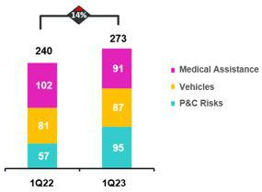
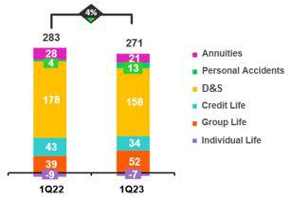

In the YoY analysis, expenses for insurance contracts rose 3.0%, driven by P&C. In the P&C, business, expenses rose 13.6% YoY due to: (i) P&C Risks, through the Card Protecton product, which experienced growth in the incidence of unrecognized internet purchases; and (ii) Cars, due to the increase in case frequency. The aforementoned was partally ofset by Medical Assistance, which reported a release of COVID-19 IBRN reserves. Life Insurance contracts fell 4.2%, driven mainly by D&S and Credit Life afer COVID-19 cases fell in comparison to 1Q22.

Expenses for Reinsurance Contracts

Expenses for reinsurance contracts rose 7.7%. This increase was atributable to the Life Business and led by the D&S product, which registered an uptck in ceded premiums under the new SISCO VI contract. The aforementoned was mitgated by the evoluton at the P&C business, which reported growth in claims under our reinsurance policies for P& C Risks.

Insurance Underwritng Results

The insurance underwritng result increased 43.4% YoY, driven by the Life Business. The increase reported in the Life business was driven by growth in premiums and a drop in claims in the Credit Life and D& S lines. The drop reported in the result for P&C was atributable to an increase in claims P&C Risks and Cars, which was mitgated by decrease in claims in Medical Assistance.

38

| Earnings Release 1Q / 2023 Analysis of 1Q23 Consolidated Results

08 Operatng Expenses

Operatng expenses rose YoY. This evoluton was primarily driven by Administratve and general expenses through the Informaton Technology (IT) Expenses and Advertsing and Fidelity Programs lines. Growth in expenses for these concepts is in line with our transformaton strategy and also refects an uptck in transactons and in costs associated with client fdelity programs. This quarter, Salaries and employee benefts also rose afer specialized personnel were hired for IT projects. If we exclude disrupton expenses, the YoY variaton in Operatng expenses stands at 8.9%.

Total operatng expenses¹

Operatng expenses |  | Quarter |  |  | % change
S/ 000 | 1Q22 | 4Q22 | 1Q23 | QoQ | YoY
Salaries and employees benefts | 939,518 | 1,040,066 | 1,029,558 | -1.0% | 9.6%
Administratve, general and tax expenses | 696,065 | 1,042,882 | 835,060 | -19.9% | 20.0%
Depreciaton and amortzaton | 151,894 | 165,180 | 160,924 | -2.6% | 5.9%
Associaton in partcipaton | 7,691 | 12,936 | 12,612 | -2.5% | 64.0%
Operatng expenses | 1,795,168 | 2,261,064 | 2,038,154 | -9.9% | 13.5%

(1) Due to the applicaton of IFRS 17, which impacts reportng for Insurance contracts, Operatng Expenses have been restated and as such, difer with regard to calculatons in previous reports. For more details, review annex 12.1.8.

The expense analysis will focus on YoY movements to eliminate seasonality efects between quarters.

Operatng expenses contnue to rise due to:

- Growth in Administratve and general expenses and taxes, mainly at BCP; this uptck was driven by an increase in transactonal expenses and fdelity programs, growth in IT expenses related to the transformaton strategy; and disruptve expenses.
- An increase in Salaries and employee benefts, which was primarily fueled by growth in expenses for salaries of specialized personnel for disruptve and IT projects.

If we exclude disruptve expenses, growth stands at 8.9% YoY.

Administratve and general expenses and taxes

Administratve and general expenses |  | Quarter |  |  | % Change
S/ 000 | 1Q22 | 4Q22 | 1Q23 | QoQ | YoY
IT expenses and IT third-party services | 196,985 | 254,965 | 240,932 | -5.5% | 22.3%
Advertsing and customer loyalty programs | 110,314 | 212,710 | 135,767 | -36.2% | 23.1%
Taxes and contributons | 67,657 | 94,647 | 85,073 | -10.1% | 25.7%
Audit Services, Consultng and professional fees | 51,692 | 138,978 | 51,878 | -62.7% | 0.4%
Transport and communicatons | 39,117 | 63,049 | 51,036 | -19.1% | 30.5%
Repair and maintenance | 29,913 | 44,734 | 25,790 | -42.3% | -13.8%
Agents' Fees | 27,018 | 27,673 | 26,152 | -5.5% | -3.2%
Services by third-party | 22,925 | 35,285 | 27,511 | -22.0% | 20.0%
Leases of low value and short-term | 20,931 | 25,997 | 25,116 | -3.4% | 20.0%
Miscellaneous supplies | 19,077 | 22,848 | 32,993 | 44.4% | 72.9%
Security and protecton | 15,476 | 16,365 | 15,789 | -3.5% | 2.0%
Subscriptons and quotes | 13,012 | 14,271 | 13,086 | -8.3% | 0.6%
Electricity and water | 10,550 | 14,865 | 11,497 | -22.7% | 9.0%
Electronic processing | 7,693 | 12,225 | 8,730 | -28.6% | 13.5%
Insurance | 8,291 | 8,629 | 8,750 | 1.4% | 5.5%
Cleaning | 4,506 | 5,368 | 5,162 | -3.8% | 14.6%
Others ⁽¹⁾ | 50,908 | 50,273 | 69,798 | 38.8% | 37.1%
Total | 696,065 | 1,042,882 | 835,060 | -19.9% | 20.0%

(1) Others consists mainly of security and protecton services, cleaning service, representaton expenses, electricity and water utlites, insurance policy expenses, subscripton expenses and commission expenses.

39

| Earnings Release 1Q / 2023 Analysis of 1Q23 Consolidated Results

08. Operatng Expenses

The 13.5% increase in Credicorp’s expenses in YoY terms was atributable primarily to an uptck in expenses at BCP (46%) and secondarily, to expansion in expenses for our disruptve initatves (38%). Given that these expenses, when combined, generated 80% of the increase reported YoY, the explanaton that follows focuses analyzing movements within each.

Operatng Expense per Business

Operatng expenses |  | Quarter |  |  | % change
S/ 000 | 1Q22 | 4Q22 | 1Q23 | QoQ | YoY
BCP | 1,039,586 | 1,332,331 | 1,146,710 | -13.9% | 10.3%
Milbanco | 282,253 | 300,155 | 297,780 | -0.8% | 5.5%
Pacifco | 58,769 | 88,790 | 64,268 | -27.6% | 9.4%
Disrupton | 88,684 | 196,125 | 180,481 | -8.0% | 103.5%
Others ⁽¹⁾ | 325,876 | 343,664 | 348,915 | 1.5% | 7.1%
Total | 1,795,168 | 2,261,064 | 2,038,154 | -9.9% | 13.5%
(1) Include Credicorp Capital, ASB, Prima, BCP Bolivia, Mibanco Colombia and other enttes within the Group.

In the case of BCP, growth of 10.3% YoY was atributable to recurring expenses, excluding IT and technology expenses:

- Recurring expenses excluding Technology

  - Growth in expenses for client Fidelity Program, which was driven by an uptck in the consumpton of LATAM miles via the use of credit and debit cards at establishments. Billing evolved positvely YoY for both debit and credit cards, which registered YoY growth of 19% and 26% respectvely.
  - Higher expenses were incurred to purchase chips for cards, which were also impacted by an increase in the price of silicon.

  - Increase in expenses for special projects, in line with the company’s strategy and to maintain our long-term leadership.

- Technology expenses (IT)

  - Growth in the transactons volume led to an uptck in expenses for the use of the bank’s data service centers;

  - Additonally, costs to use IT applicatons, licenses and other sofware rose to enhance capacites and improve cybersecurity.

  - 16% more personnel who specialize in digital capacites were hired; this increase in hiring of this profle led to a consequent 8% uptck in the average salary at BCP.

Disrupton expenses rose 103.5% and represented 9% of OPEX in 1Q23. This growth was driven by investment in improvements in diferent functonalites and by growth in expenses for specialized personnel, which was led by initatves such as Yape, Tenpo, Culqi, Tyba and others. Through these initatves, we seek to strengthen our leadership in the market. If we exclude disruptve expenses, the YoY variaton of operatng expenses stands at 8.9%.

40

| Earnings Release 1Q / 2023 Analysis of 1Q23 Consolidated Results

09 Operatng Efciency

The efciency rato improved YoY by 290 bps, in line with an uptck in core income due to growth in net interest income, which refected the fruits of disciplined pricing management in a context of rising interest rates.

Operatng Efciency |  | Quarter |  | % change |  |  | Year | % change
S/ 000 | 1Q22 | 4Q22 | 1Q23 | QoQ | YoY | Mar 2022 | Mar 2023 | Mar 2023 / Mar 2022
Operatng expenses (1) | 1,795,168 | 2,261,064 | 2,038,154 | -9.9% | 13.5% | 1,795,168 | 2,038,154 | 13.5%
Operatng income (2) | 3,799,381 | 4,587,457 | 4,602,331 | 0.3% | 21.1% | 3,787,935 | 4,598,052 | 21.4%
Efciency rato (3) | 47.2% | 49.3% | 44.3% | -500 bps | -290 bps | 47.4% | 44.3% | -310 bps
Due to the applicaton of IFRS 17, which impacts reportng for Insurance contracts, Operatng Income has been restated and as such, difers with regard calculatons in previous reports. For more details, review annex 12.1.8

- Operatng expenses = Salaries and m y ’s benefts + Administratve expenses + Depreciaton and amortzaton + Associaton in partcipaton + Acquisiton cost.

- Operatng income = Net interest, similar income and expenses + Fee income + Net gain on foreign exchange transactons + Net gain from associates + Net gain on derivatves held for trading + Net gain from exchange diferences + Net Insurance Underwritng Results

- Operatng expenses / Operatng income (under IFRS 17)

Efficiency ratio by Subsidiary

The expense analysis will focus on YoY movements to eliminate the efects of seasonality between quarters.

 | BCP | BCP | Mibanco | Mibanco | Pacifco | Prima AFP | Credicorp
IFRS 17 | Stand-alone | Bolivia | Peru | Colombia | Pacifco | Prima AFP | Credicorp
1Q22 | 40.6% | 59.9% | 53.0% | 79.0% | 32.0% | 54.5% | 47.2%
4Q22 | 41.9% | 64.5% | 52.3% | 93.3% | 28.7% | 46.1% | 49.4%
1Q23 | 36.8% | 60.2% | 54.1% | 93.2% | 22.1% | 49.6% | 44.3%
Var. YoY | -380 bps | 30 bps | 110 bps | 1420 bps | -990 bps | -490 bps | -290 bps

To facilitate comparability as we transiton from IFRS 4 to IFRS 17, it is important to note that if IFRS 4 had been applicable in 1Q23, Credicorp’s efciency rato would have stood at 42.9%

YoY, the efciency rato improved. This evoluton was driven primarily by growth in core income at BCP Stand-alone. Within core income, growth in net interest income was partcularly noteworthy and refects disciplined pricing management in a context of rising interest rates.

41

| Earnings Release 1Q / 2023 Analysis of 1Q23 Consolidated Results

10 Regulatory Capital

Credicorp’s Regulatory Capital stood at 1.43 tmes the minimum level required by the regulatory entty.

BCP Stand-alone’s CET1 rato increased 30 bps to 11.9% An uptck in the balance of Retained Earnings (+57.8%), and Share Capital and Legal Reserves (+1.7%) drove this dynamic.

Mibanco’s CET 1 rato rose 38 bps YoY to stand at 16.4%. Growth in levels for Capital and Reserves and Retained Earnings fueled this dynamic.

Credicorp’s Regulatory Capital Rato stood 1.43 tmes above the minimum level required by the regulatory entty at the end of 1Q23. In the QoQ analysis the rato rose 8 bps, afer a drop in loan volumes led to a subsequent decrease in the regulatory capital level.

In the YoY analysis, the Regulatory Capital Rato fell 8 bps. This evoluton refected an uptck in the regulatory capital levels required for loan portolios at BCP Stand-alone and Mibanco, which was triggered by growth in loan volumes. The aforementoned increases were partally ofset by growth in the balance of Discretonary and Restricted Reserves.

Figures in millions S/.

10.1 Credicorp’s Regulatory Capital
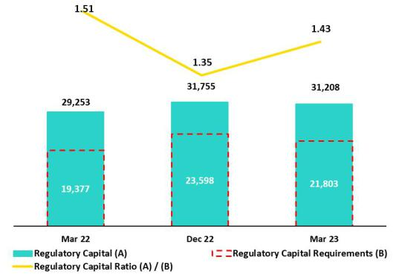

In 2022, to further align local regulatons with the methodology and parameters of Basel III, the Superintendency of Banking, Insurance and AFP (SBS) issued a series of rulings that modifed the concepts and methodologies used to calculate regulatory capital and solvency ratos and reset minimum thresholds.

Under this regulaton, the components that fnancial enttes must use to calculate efectve equity for each level are as follows:

- Common Equity Tier 1 (CET 1): will include Share Capital + Reserves+ Earnings and Retained Earnings + Unrealized Gains and Losses – Investment in Subsidiaries – Goodwill and Intangibles.
- Tier 1 Capital (Tier 1): will include CET 1 + Tier 1 subordinated debt.

- Global Capital: will include Tier 1 + Tier 2 Subordinated Debt and generic provisions (up to 1.25% of Risk-weighted Assets).

The changes required by SBS set new minimum limits of capital for each level:

- CET 1: minimum of 4.5% of Risk-weighted Assets (RWAs).

- Tier 1: minimum of 6.0% de RWAs.

- Global Capital: minimum of 10.0% of RWAs (2 percentage points above that required by Basel III)

Additonally, the regulaton requires the following bufers: 2.5% of maintenance capital + 2% capital for risk of market concentraton risk or systemic risk + 1.5% for economic cycle when the monthly GDP has grown more than 4% in the last 30 months. All of these aspects must be covered by CET 1.

It is important to note that compliance of the aforementoned limits will be gradual with a fnal efectve date set for 2026.

42

| Earnings Release 1Q / 2023 Analysis of 1Q23 Consolidated Results

10. Regulatory Capital

10.2 Analysis of Capital at BCP Stand-alone
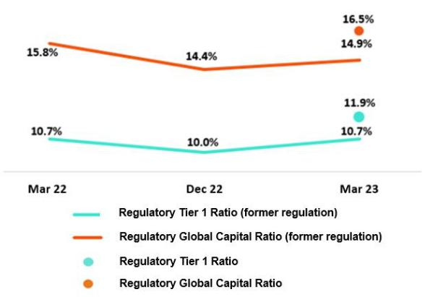

At the end of 1Q23, and based on the parameters of the former regulaton, the Regulatory Tier 1 Rato and Regulatory Global Capital Rato for BCP Stand-alone stood at 10.7% (+72 bps QoQ) and 14.9% (+50 bps QoQ) respectvely. These slight increases were primarily driven by an increase in the balances for Share Capital and Legal Reserves, which rose due to earnings capitalizaton in 2022. The uptck in these ratos was also impacted, albeit to a lesser extent, by a drop in loan balances for RWAs. In the YoY analysis, the Regulatory Tier 1 Rato registered no variaton.

At the end of 1Q23, and based on the new regulaton, the Regulatory Tier 1 Capital Rato and the Regulatory Global Capital Rato stood at 11.9% and 16.5% respectvely. Both ratos stand above the regulatory minimum.

The Common Equity Tier 1 (CET 1)¹ rato at BCP registered a decrease of 66 bps QoQ and stood at 11.9% at the end of 1Q23. This drop was triggered by dividend declaraton, which reduced the balance of Retained Earnings. The reducton in RWA levels, driven by a decrease in the loan volume, partally ofset the decrease in this rato. Finally, in the YoY analysis, the CET 1 rato rose 30 bps, fueled by (i) an uptck in Retained Earnings and (ii) higher levels of Share Capital and Legal Reserves.

10.3 Analysis of Capital at Mibanco

At the end of 1Q23, based on calculatons under the previous regulaton, Tier 1 and Regulatory Global Capital ratos at Mibanco stood at 12.48% (+10 bps QoQ) and 14.79% (+10 bps QoQ), respectvely. These variatons refect the increase in Retained Earnings and an uptck in balances of Reserves. The YoY evoluton registered a reducton of 76 bps and 82 bps in the Regulatory Tier 1 and Regulatory Global Capital ratos respectvely. Both variatons were driven by growth in RWAs, which was associated with loan expansion.
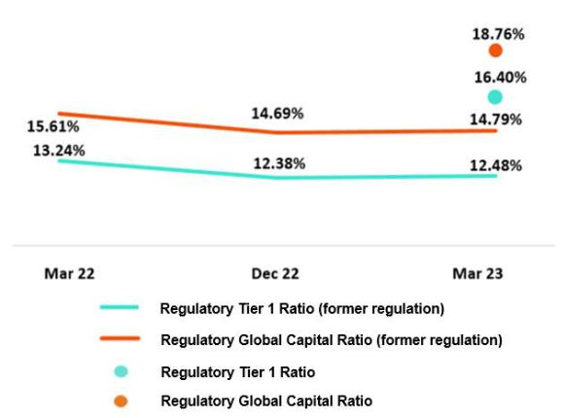

At the end of 1Q23, based on the parameters of the new regulaton, the Regulatory Tier 1 Rato and the Regulatory Global Capital Rato for Mibanco stood at 16.40% and 18.76% respectvely. Both are above the regulatory minimum.

Finally, the CET1 Rato fell 8 bps QoQ due to an increase in RWAS. Growth in the later was atributable to a deterioraton in the portolio’s credit risk profle, which refected the negatve impacts of an adverse economic environment in the wake of protests in the south and rains in the north. YoY, this rato rose 38 bps due to growth in levels of Capital, Reserves and Retained Earnings

- CET 1, unlike the other capital ratos, is calculated in accordance with IFRS.

43

| Earnings Release 1Q / 2023 Analysis of 1Q23 Consolidated Results

11 Economic Outlook

In 1Q23, the Peruvian economy is estmated to have contracted slightly by around 0.4% YoY (compared to 1.7% YoY in 4Q22), afected by social protests in January and February and intense rains and foods caused by Cyclone Yaku in March. These factors exacerbated the slowdown that was already being observed in non-primary sectors, with private consumpton contnuing to lose momentum and private investment deterioratng.
The annual infaton rate closed the year at 8.4% YoY, remaining close to its 26-year high (8.8% in 2Q22). On the other hand, real GDP is estmated to grow by 1.8% this year.

According to the Central Reserve Bank of Peru (BCRP), the exchange rate closed at USDPEN 3.7617 in 1Q23, representng an appreciaton of 1.3% compared to the end of 4Q22 and a depreciaton of 1.9% compared to a year ago.

Peru: Economic Forecast
Peru | 2018 | 2019 | 2020 | 2021 | 2022 | 2023 ⁽³⁾
GDP (US$ Millions) | 226,856 | 232,447 | 205,553 | 225,953 | 244,752 | 263,866
Real GDP (% change) | 4.0 | 2.2 | -11.0 | 13.6 | 2.7 | 1.8
GDP per capita (US$) | 7,045 | 7,152 | 6,300 | 6,840 | 7,329 | 7,809
Domestc demand (% change) | 4.1 | 2.2 | -9.9 | 14.7 | 2.3 | 0.9
Gross fxed investment (as % GDP) | 22.2 | 22.5 | 21.1 | 25.2 | 25.4 | 24.2
Financial system loan without Reactva (% change) (1) | 10.3 | 6.4 | -4.3 | 12.6 | 9.7 | 5.0
Infaton, end of period(2) | 2.2 | 1.9 | 2.0 | 6.4 | 8.5 | 4.8
Reference Rate, end of period | 2.75 | 2.25 | 0.25 | 2.50 | 7.50 | 6.75
Exchange rate, end of period | 3.37 | 3.31 | 3.62 | 3.99 | 3.81 | 3.80
Exchange rate, (% change) | 4.0% | -1.8% | 9.3% | 10.3% | -4.5% | -0.3%
Fiscal balance (% GDP) | -2.3 | -1.6 | -8.9 | -2.5 | -1.6 | -2.0
Public Debt (as % GDP) | 25.6 | 26.6 | 34.6 | 35.9 | 34.0 | 33.8
Trade balance (US$ Millions) | 7,201 | 6,879 | 8,196 | 14,927 | 9,565 | 9,000
(As % GDP) | 3.2% | 3.0% | 4.0% | 6.6% | 3.9% | 3.4%
Exports | 49,066 | 47,980 | 42,905 | 63,151 | 65,834 | 64,800
Imports | 41,866 | 41,101 | 34,709 | 48,223 | 56,269 | 55,800
Current account balance (US$ Millions) | -2,895 | -1,680 | 2,398 | -5,179 | -10,644 | -9,157
Current account balance (As % GDP) | -1.3% | -0.7% | 1.2% | -2.3% | -4.3% | -3.5%
Net internatonal reserves (US$ Millions) | 60,121 | 68,316 | 74,707 | 78,495 | 71,883 | 72,000
(As % GDP) | 26.5% | 29.4% | 36.3% | 34.7% | 29.4% | 27.3%
(As months of imports) | 17 | 20 | 26 | 20 | 15 | 15

Sources: INEI, BCRP, y SBS.
- Financial System, Current Exchange Rate
- Infaton target: 1% - 3%
- Grey area indicates estmates by BCP Economic Research as of April 2023

44

| Earnings Release 1Q / 2023 Analysis of 1Q23 Consolidated Results

11. Economic Outlook

Main Macroeconomic Variables

Gross Domestc Product
(Annual Variatons, % YoY)
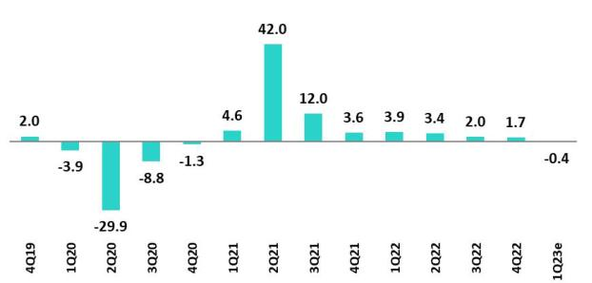

Sources: BCRP

In 1Q23, the Peruvian economy is expected to slightly contract around 0.4% YoY (4Q22 1.7% YoY) afected by the social protests of January and February and the heavy rains and foods caused by the Cyclone Yaku. These factors exacerbated the slowdown that was already taking place in the non-primary sectors as private consumpton contnues losing dynamism and private investment deteriorates. In the primary sector, growth in copper producton from Quellaveco would have atenuated the impact of this events. According to INEI, the monthly economic actvity index fell 0.6% YoY in February and 1.1% YoY in January.

Annual Infaton and Central Bank Reference Rate
(%)
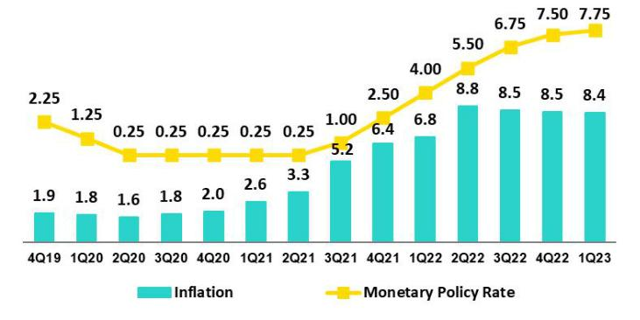

Sources: BCRP and INE

Infaton, measured using the Consumer Price index of Lima Metropolitana, closed 1Q23 at 8.4% YoY, accumulatng eleven consecutve months above 8.0% YoY and remains close to its highest level in 26 years (8.8% YoY in June 2022). In the same period, core infaton (excludes food and energy) stood at 5.9% YoY, highest in 23 years. As of March 2023, infaton expectatons of the fnancial system for late 2023 and late 2024 stood at 5.00% and 3.50%, both above the upper bound of the BCRP´s target range between 1% and 3%.

The Central Bank of Perú (BCRP) increased its monetary policy rate from 0.25% in July 2021 to 7.75% in January 2023, a historical high. On its February meetng, it surprised markets by keeping its rate stable, decision that was repeated at its March and April meetng.

45

| Earnings Release 1Q / 2023 Analysis of 1Q23 Consolidated Results

11. Economic Outlook

Fiscal Balance and Current Account Balance
(% of GDP, Quarter)
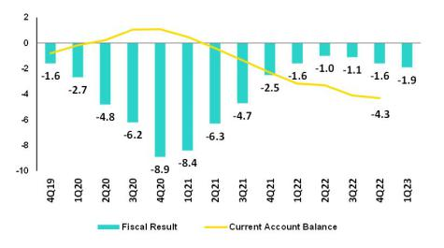

The annualized fscal defcit in the last 12 months to March 2023 was 1.9% of GDP, higher than in December 2022 (1.6% of GDP). In 1Q23, the increase was explained, to a greater extent, by less dynamic tax revenues (+1.0% YoY), mainly due to lower revenues from the regularizaton of income tax. Non-fnancial spending grew 8.7% YoY, refectng an increase in current expenditures (+7.2% YoY) and capital expenditures (14.4% YoY), related to public investment.

Source: BCRP*
Estmate: BCP

In January 2023, Moody’s changed the outlook for Peru’s long-term debt in foreign currency to negatve from stable (and kept the credit ratng at Baa1). This decision came afer Fitch and Standard & Poor’s changed the outlook to negatve in October and December, respectvely, and afrmed their credit ratng in BBB

Regarding the external accounts, the current account defcit closed Q422 at 4.3% of GDP in accumulated terms for the last 4 quarters.

The 12-month accumulated trade balance surplus to February 2023 was USD 8.7 billion, lower than the registered in January of USD 9.5 billion and far from the historical record of USD 16.1 billion of March 2022. Exports, on the same period, fell 1.9% YoY to USD 64.1 billion, driven by lower volumes and prices, while imports grew 11.9 YoY to USD 55.5 billion.

Terms of trade fell 7.0% YoY in February 2023 due to an 8.1% YoY drop in export prices, mainly lower natural gas, zinc and copper prices and a contracton of 1.2% YoY in imports prices. In YTD, terms of trade increased 1.7% and are 10.6% above October 2022 levels (lowest print since April 2020).

Exchange Rate
(PEN per USD)

According to the BCRP, the exchange rate closed 1Q23 in USDPEN 3.7617, an appreciaton of 1.3% compared to the end of 4Q22 and a depreciaton of 1.9% compared to one year ago. In the same period, Latam main currencies also appreciated compared to the previous quarter due to the weakening of the global dollar and stll high commodity prices. Thus, the Mexican peso appreciated 7.5%, the Chilean peso 6.5%, the Brazilian Real 4.2% and the Colombian Peso 3.9%.
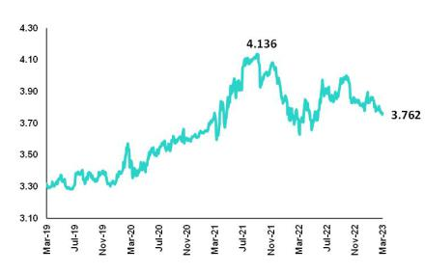

Net Internatonal Reserves closed 1Q23 at USD 72.7 billion, above 4Q22 (USD 71.9 billion) but below 1Q22 (USD 75.3 billion). The Central Bank’s foreign exchange positon stood at USD 53.0 billion, a slight increase of USD 1.0 billion compared to the end of 4Q22.

1.0 billion compared to the end of 4Q22.

During 1Q23, the BCRP intervened only once in the FX spot market selling USD 1 million, lower than the net sales of USD 10 million in 4Q22, which were also done in a one-day operaton. In 2022, the BCRP sold USD 1.2 billion in the spot market (equivalent to 10% of 2021 net sales), with the interventon concentrated in the frst semester of the year.

46

| Earnings Release 1Q / 2023 Analysis of 1Q23 Consolidated Results

Safe Harbor for Forward-Looking Statements

This material includes “forward-looking statements” within the meaning of Secton 27A of the U.S. Securites Act of 1933 and Secton 21E of the U.S. Securites Exchange Act of 1934. All statements other than statements of historical fact are forward-looking and may contain informaton about fnancial results, economic conditons, trends and known uncertaintes. Forward-looking statements are not assurances of future performance. Instead, they are based only on our management’s current views, beliefs, expectatons and assumptons regarding the future of our business, future plans and strategies, projectons, antcipated events and trends, the economy and other future conditons.

Many forward-looking statements can be identfed by words such as: “antcipate”, “intend”, “plan”, “goal”, “seek”, “believe”, “project”, “estmate”, “expect”, “strategy”, “future”, “likely”, “would”, “may”, “should”, “will”, “see” and similar references to future periods. Examples of forward-looking statements include, among others, statements or estmates we make regarding guidance relatng to losses in our credit portolio, efciency rato, provisions and non-performing loans, current or future market risk and future market conditons, expected macroeconomic events and conditons, our belief that we have sufcient capital and liquidity to fund our business operatons, expectatons of the efect on our fnancial conditon of claims, legal actons, environmental costs, contngent liabilites and governmental and regulatory investgatons and proceedings, strategy for customer retenton, growth, governmental programs and regulatory initatves, credit administraton, product development, market positon, fnancial results and reserves and strategy for risk management.

We cauton readers that forward-looking statements involve known and unknown risks and uncertaintes that could cause actual results, performance or events to difer materially from those that we expect or that are expressed or implied in the forward-looking statements, depending on the outcome of certain factors, including, without limitaton, adverse changes in:

- The occurrence of natural disasters or politcal or social instability in Peru;
- The adequacy of the dividends that our subsidiaries are able to pay to us, which may afect our ability to pay dividends to shareholders and corporate expenses;
- Performance of, and volatlity in, fnancial markets, including Latn-American and other markets;
- The frequency, severity and types of insured loss events;
- Fluctuatons in interest rate levels;
- Foreign currency exchange rates, including the Sol/US Dollar exchange rate;
- Deterioraton in the quality of our loan portolio;
- Increasing levels of competton in Peru and other markets in which we operate;
- Developments and changes in laws and regulatons afectng the fnancial sector and adopton of new internatonal guidelines;
- Changes in the policies of central banks and/or foreign governments;
- Efectveness of our risk management policies and of our operatonal and security systems;
- Losses associated with counterparty exposures;

- The scope of the coronavirus (“COVID-19”) outbreak, actons taken to contain the COVID-19 and related economic efects from such actons and our ability to maintain adequate stafng; and
- Changes in Bermuda laws and regulatons applicable to so-called non-resident enttes.

See “Item 3. Key Informaton—3.D Risk Factors” and “Item 5. Operatng and Financial Review and Prospects” in our most recent Annual Report on Form 20-F fled with the U.S. Securites and Exchange Commission for additonal informaton and other such factors.

You are cautoned not to place undue reliance on these forward-looking statements, which speak only as of the date hereof and are based only on informaton currently available to us. Therefore, you should not rely on any of these forward-looking statements. We undertake no obligaton to publicly update or revise these or any other forward-looking statements that may be made to refect events or circumstances afer the date hereof, whether as a result of changes in our business strategy or new informaton, to refect the occurrence of unantcipated events or otherwise.

47

 | | Earnings Release 1Q / 2023 | Analysis of 1Q23 Consolidated Results
12 Appendix
12.1. Implementaton of IFRS 17 – Restatement of fgures and ratos for 2022 |  | 49
 | 12.1.1. Introducton to the new standards IFRS 17 | 49
 | 12.1.2. Conceptual Framework | 49
 | 12.1.3. Recogniton of Proft and Loss | 49
 | 12.1.4. Valuaton Methods | 49
 | 12.1.5. Impact on Equity Under IFRS 17 | 50
 | 12.1.6. Reformulaton of Proft and Loss Statement at Pacífco Grupo Asegurador for year 2022 | 50
 | 12.1.7. Reformulaton Credicorp’s Proft and Loss Statement for year 2022 | 51
 | 12.1.8. Changes in the Methodology to Calculate Financial Indicators and their Reformulaton for the year 2022 | 51
 | 12.1.9. Glossary of Terms Under IFRS 17 | 54
12.2. | Physical Point of contact | 54
12.3. | Loan Portolio Quality | 55
12.4 Net Interest Income (NII) |  | 60
12.5. | Regulatory Capital | 61
12.6. | Financial Statements and Ratos by Business | 66
12.6.1. Credicorp Consolidated |  | 66
 | 12.6.2. Credicorp Stand-alone | 68
 | 12.6.3. BCP Consolidated | 69
 | 12.6.4. BCP Stand-alone | 71
 | 12.6.5. BCP Bolivia | 73
 | 12.6.6. Mibanco | 74
 | 12.6.7. Prima AFP | 75
 | 12.6.8. Grupo Pacifco | 76
12.7. | Table of calculatons | 79
12.8. | Glossary of terms | 80
 |  | 48

| Earnings Release 1Q / 2023 Analysis of 1Q23 Consolidated Results

12. Appendix

12.1. Implementaton of IFRS 17 – Restatement of fgures and ratos for 2022

12.1.1. Introducton to the new standards IFRS 17

IFRS 17 was published in May 2017 as a replacement to IFRS 4 “Insurance Contracts.” The aim of this change is to ensure that consistent measurement criteria are applied to improve transparency and the comparability of Financial Statements. The new standard became efectve in January 2023.

The primary objectves of this standard include:

- Improving comparability between insurers at the global level. IFRS 4 allowed enttes to use a wide variety of accountng practces with regard to insurance contracts.

- Adequately refectng the economic value of insurance contracts. Some previous accountng practces allowed under IFRS failed to adequately refect real underlying fnancial situatons or the fnancial yields on insurance contracts.
- Providing more useful informaton to users of fnancial statements.

12.1.2. Conceptual Framework

Insurance contracts combine atributes of risk coverage, provision of services and instruments of investments and by nature, generate cash fows (outlows such as claims payments, redemptos, expiratons, pensions, atributable expenses, income such as premiums) during their term.

The diference between expected outlows and infows (fulfllment cashfows), combined with recogniton of cash value over tme, consttute the best estmate of the company’s obligatons. Due to potental underwritng deviatons relatve to expected fows, an additonal reserve, known as Risk Adjustment (RA) must be set aside and the underwritng income that the company expects to obtain from its current product portolio consttutes the Contractual Service Margin (CSM). These 3 concepts, combined with the claims reserves (including reserves for pending claims, IBNR reserves and liquidaton expenses) consttute the company’s liabilites.

12.1.3. Recogniton of Proft and Loss

The P & L under IFRS shows the diference between a company’s expected cash fows (valued in liabilites) and real fows that occur. Antcipated fows must be based on realistc parameters that refect the company’s actual experience and current market interest rates.

The standard also requires that results be separated into 3 blocks: (i) Insurance service (or direct insurance), (ii) Reinsurance and (iii) Financial Results. This structure allows users to visualize the company’s sources of income.

Unlike IFRS4, which recognized proft and losses on products during their term, IFRS17 stpulates that expected losses must be recognized at a single moment, meaning upon issuance of policies, while recogniton of underwritng income (CSM) must be made gradually over the efectve period of products.

The company chose the Other Comprehensive Income (OCI) opton, which recognizes movements of reserves generated by underwritng issues within the Proft and Loss Statement (changes in mortality, expenses, redemptons, etc.) while within Equity, only variatons in liabilites generated by changes in interest rates are recognized. This variaton produces an ofset to that generated by investments that back reserves and lends stability to the Balance Sheet and the Proft and Loss Statement.

12.1.4. Valuaton Methods

IFRS 17 introduces diferent approaches to valuate underwritng provisions based on the product’s characteristcs (contract duraton, cash fow).

- General Method (GM) or Building Block Approach (BBA): general default model valuaton of insurance contracts.

- Variable Fee Approach (VFA): model for contract valuaton in which cash fows depend on the value of the underlying assets that back said contracts

- Premium Allocaton Approach (PAA): simplifcaton of the general model.

49

| Earnings Release 1Q / 2023 Analysis of 1Q23 Consolidated Results

12. Appendix

12.1.5. Impact on Equity Under IFRS 17

The impact of the implementaton of the IFRS 17 standard on the net equity balance of Pacífco Seguros is not material, registering at the end of December 2022 a net equity under IFRS 17 which is S/ 10 million greater than the net equity calculated under IFRS 4.

It should be mentoned that as of the end of December 2021 (date of the “frst applicaton” of the standard), the net equity of Pacífco Seguros under IFRS 17 was S/ 211 million less than the net equity registered under IFRS 4. This inital gap narrowed during 2022 as a result of a contracton in the value of liabilites under IFRS 17, associated with the interest rates increases.

12.1.6. Reformulaton of Proft and Loss Statement at Pacífco Grupo Asegurador for year 2022
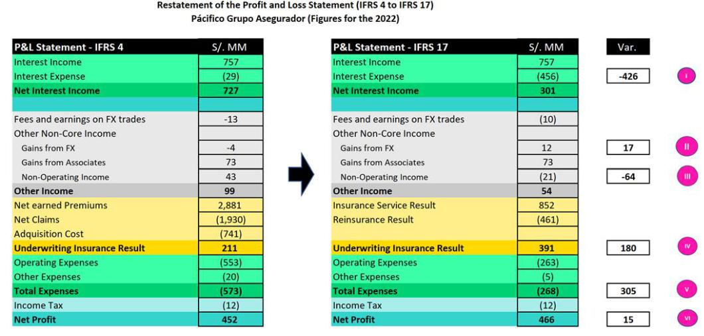

- A new sub-account, “Financial Expenses associated with insurance and reinsurance actvites, net” is included in the account for Interest Expenses at Pacifco Seguros. This concept corresponds to interest accredited to reserves. This interest is atributable to an update of the present value of said reserves to the date of the close of the period. This concept was previously presented as part of reserves adjustment included in the underwritng result under IFRS4. IFRS17 separates the fnancial component from the underwritng component.

- An impact is registered in the “Gain on exchange rate diference” line because the structure of the assets and liabilites related to insurance actvites has been modifed. The monetary positon of these assets and liabilites changes due to the way that assets and liabilites are recognized under IFRS17.

- Some concepts of income that were previously registered (under IFRS 4) as “Non-Operatng Income” are now (under IFRS 17) reclassifed and included in the cash fows associated with insurance contracts. As such, these concepts are now part of the Insurance Underwritng Result.

IV. Recogniton of insurance underwritng income is completely diferent under IFRS 17. IFRS 17 recognizes that insurance contracts combine fnancial and service characteristcs, and in many cases generate variable cash fows in the long-term. To adequately refect these characteristcs, IFRS combines measurements of future cash fows with recogniton of the results of the insurance contract throughout the period in which the service is provided. IFRS 17 requires present value measurements of insurance obligatons where estmates are recalculated in each reportng period. Contracts are measured using the components of: (i) Fulflment Cash Flows, (ii) An explicit adjustment for risk or uncertainty of fows, or “Risk Adjustment” and (iii) a Contractual Service Margin, which represents unaccrued underwritng income associated with the contract. This Contractual Service Margin is recognized as income during the coverage term. Insurance contracts combine

50

| Earnings Release 1Q / 2023 Analysis of 1Q23 Consolidated Results

12. Appendix

fnancial and service characteristcs, whereas IFRS combines future cash fows with registry of the results of the insurance contract during the service provision period.

- One of the changes generated by the applicaton of IFRS 17 is that it sets forth a new concept for costs that are directly associated with obtaining and fulflling insurance contracts. Said costs are denominated “Atributable Costs” and are included in the expected fows for the disbursements associated with these contracts. Under IFRS 4, some of these expenses were included in Total Expenses.

VI. The aggregate impact of implementng IFRS 17 in the Net Earnings of Pacifco Grupo Asegurador is not material and stands at S/15 million for the year 2022.

12.1.7. Reformulaton of Credicorp’s Proft and Loss Statement for year 2022

Below, we reformulate Credicorp’s Proft and Loss Statement. As is evident in the image below, the impact of implementng IFRS at Pacífco Grupo Asegurador translates to Credicorp account by account in identcal or highly similar amounts. The aggregate impact of implementng IFRS 17 on the Net Earnings of Credicorp is not material and amounts to S/15 million.
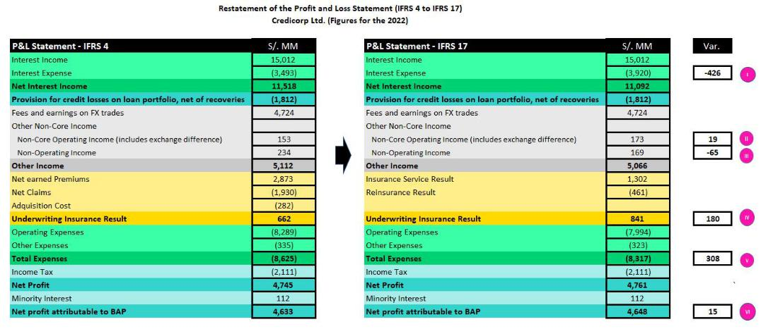

12.1.8. Changes in the Methodology to Calculate Financial Indicators and their Reformulaton for the year 2022

- Net Interest Margin

The Net Interest Margin is reformulated in the following way:

Under IFRS 4, the numerator of the Net Interest Margin was comprised of the diference between Interest Income and Interest Expenses. Under IFRS 17, we need to adjust the formula because Interest Expenses now include the concept “Financial Expense associated with the insurance and reinsurance actvity, net.” We seek to exclude the impact of this concept on the Net Interest Margin given that this partcular kind of interest expense is not associated with a source of funding. As such, we adjust the numerator by reincorporatng “Financial Expense associated with insurance and reinsurance actvity, net” to “Net Interest Income” calculated under IFRS 17. It is important to note that as a result of this adjustment, the numerator of the Net Interest Margin under IRFS4 is identcal to that seen under IFRS 17.

From now on, we will exclude from the denominator (average balance of Interest-earning Assets) the following: the balance associated with the account “Financial Assets at Fair Value through P&L” given that this account is primarily comprised of investments associated from Investment Link contracts, which do not accrue interests for Credicorp. This change is not related to IFRS 17.

Below, we present the aforementoned change in graphic form.

51

| Earnings Release 1Q / 2023 Analysis of 1Q23 Consolidated Results

12. Appendix
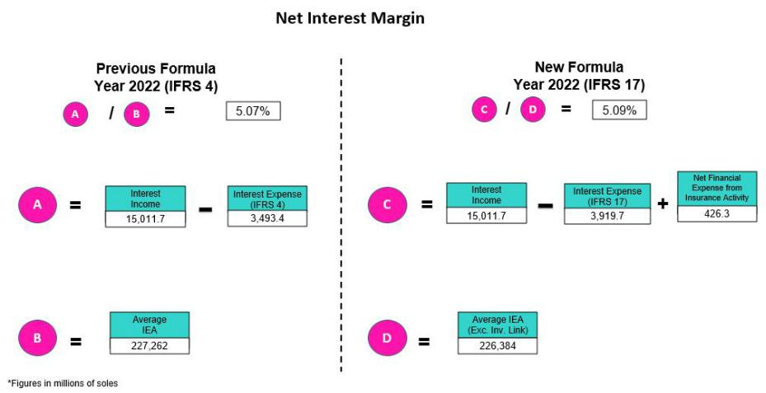

- Funding Cost

The Funding Cost indicator is being reformulated as follows: under IFRS 4, the numerator of the Funding Cost is comprised of the balance of the “Interest Expenses” account while under IFRS 17, we must adjust the formula given that Interest Expenses now include the concept of “Financial expense associated with insurance and reinsurance actvity, net.” We seek to exclude the impact of this new concept on the Funding Cost given that this partcular type of expense is not associated with a source of funding. As such, we adjust the numerator by deductng the “Financial Expense associated with insurance and reinsurance actvity, net” from “Interest Expenses “calculated under IFRS 17. It is important to note that as a result of this adjustment, the fgure for the Funding Cost under IFRS is identcal to the same fgure under IFRS 17. The following fgure is a graphic representaton of the aforementoned change.
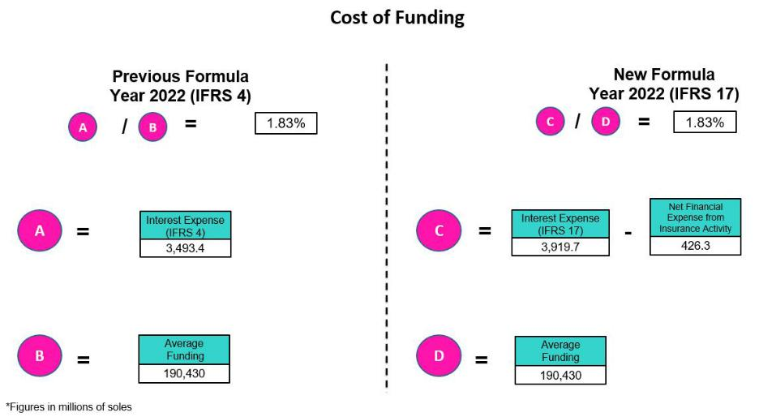

52

| Earnings Release 1Q / 2023 Analysis of 1Q23 Consolidated Results

12. Appendix

- Efciency Rato

The Efciency Rato is being reformulated as follows:

Under IFRS 4, the numerator of the Efciency Rato is comprised of the total of the “Salaries and Employee Benefts,” “Administratve Expenses,” “Depreciaton and Amortzaton,” “Expenses for Partcipaton in Associaton,” and the “Acquisiton Cost” accounts. Collectvely, these accounts consttute “Operatng Expenses.” Under IFRS 17, we make an adjustment to the components of this group of “Operatng Expenses” given that the “Acquisiton Cost” no longer exists in the Proft and Loss Statement under IFRS 17. Consequently, under IFRS 17, the grouping of “Operatng Expenses” is comprised solely of “Salaries and Employee Benefts,” “Administratve Expenses,” “Depreciaton and Amortzaton,” and “Expenses for Partcipaton in Associaton.” It is important to note that balances of these accounts under IFRS17 are not the same as the balances of the accounts with the same name under IFRS17.

Under IFRS 4, the denominator of the Efciency Rato is comprised of the total of the accounts grouped as Core Operatng Income (“Interest Income, net”, “Fee income, net,” and “Net gain on FX transactons”); the accounts grouped as Non-Core Operatng Income (“Gain on Investments in Associates, “Gain on derivatves,” “Net gain on Exchange Diferences); and the “Net Earned Premiums” account. Collectvely, all of these accounts consttute “Operatng Income.” Under IFRS 17, we are adjustng the components of the grouping for “Operatng Income” to replace the component of “Net Earned Premiums” with the “Insurance Underwritng Result.”

It is important to note that the result of replacing the “Net Earned Premiums “account with the “Insurance Underwritng Result” in the denominator of the efciency rato is in fact very signifcant (upward). The aforementoned is due to the fact that the balance of Insurance Technical results is usually materially lower than the balance of Net Earned Premiums as Insurance Technical results have embedded the impact of charges for Incurred Claims. Below, we present a graphic depicton of the aforementoned change.
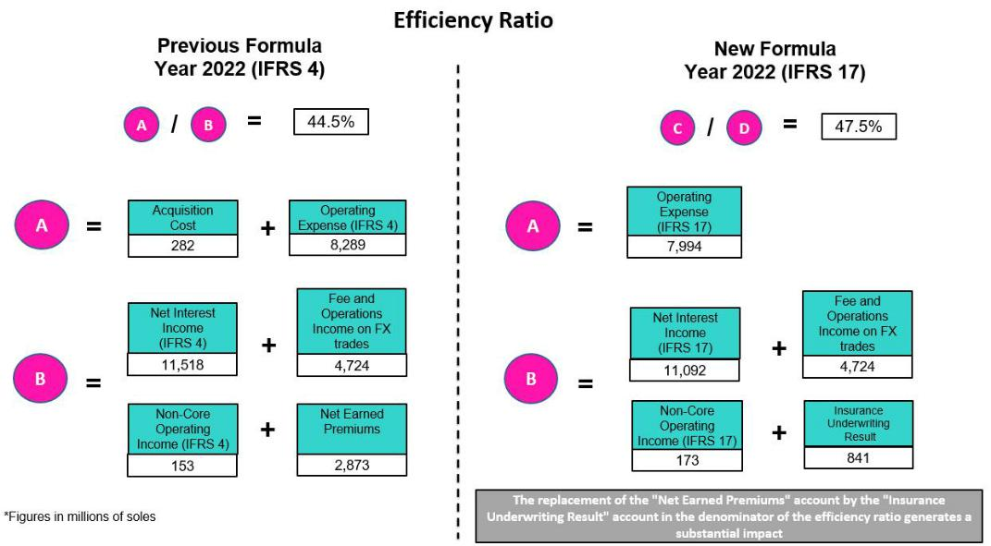

53

| Earnings Release 1Q / 2023 Analysis of 1Q23 Consolidated Results

12. Appendix

12.1.9. Glossary of Terms Under IFRS 17

Reserve for BEL (Best Estmate |  | Represents the best estmate of the diference between payments for obligatons (claims, income and expenses) and
Liability) o Fulfllment Cashfows. |  | premiums, fowed and brought to present value at the tme of valuaton.
Reserve for RA (risk Adjustment). |  | Represents the margin of prudence that will be used to cover deviatons in the underwritng parameters beyond changes
 |  | in the interest rate.
Reserve for CSM (Contractual |  | Represents the present value of future underwritng income (non-fnancial). Income accrues over the life of the policy.
 | Service Margin).
 | Atributable Expenses | Corresponds to necessary expenses to place a policy or maintain the same throughout its term. It is part of insurance
 |  | fows.
Financial Expense associated with |  | Represents interest accredited to reserves in the period afer updatng their present value. This concept was previously
the insurance and reinsurance |  | included in reserves under IFRS 4. IFRS 17 separates the fnancial component from the underwritng component.
 | actvity, net
 | Onerous Contracts | The contracts that the company estmates will generate underwritng losses (not including fnancial income) during the
 |  | policy term.
12.2. Physical Point of contact
 | Physical Point of Contact ⁽¹⁾ |  |  | As of |  |  | change (units)
 | (Units) |  | Mar 22 | Dec 22 | Mar 23 |  | QoQ | YoY
 | Branches |  | 706 | 678 | 675 |  | -3 | -31
 | ATMs |  | 2,551 | 2,595 | 2,626 |  | 31 | 75
 | Agentes ⁽²⁾ |  | 8,916 | 10,935 | 11,254 |  | 319 | 2,338
 | Total |  | 12,173 | 14,208 | 14,555 |  | 347 | 2,382

- Includes Physical Point of Contact of BCP Stand-Alone, Mibanco and BCP Bolivia

- Figures difer from previously reported due to changes in BCP Bolivia agents

54

| Earnings Release 1Q / 2023 Analysis of 1Q23 Consolidated Results

12. Appendix

12.3. Loan Portolio Quality

Loan Portolio Quality (in Quarter-end Balances
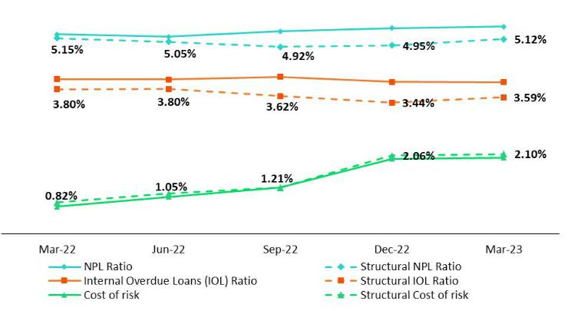

Government Program (GP) Loan Portolio Quality (in Quarter-end Balances)

GP Portolio quality and Delinquency ratos ⁽¹⁾ |  | As of |  | % change
S/000 | Mar 22 | Dec 22 | Mar 23 | QoQ | YoY
Total loans (Quarter-end balance) | 17,036,408 | 9,511,132 | 7,092,370 | -25.4% | -58.4%
Allowance for loan losses | 200,713 | 138,827 | 135,849 | -2.1% | -32.3%
IOLs | 1,022,808 | 1,148,499 | 837,389 | -27.1% | -0.18
IOL rato | 6.00% | 12.08% | 11.81% | -27 bps | 581 bps
Allowance for loan losses over GP Total loans | 1.2% | 1.5% | 1.9% | 46 bps | 74 bps
Coverage rato of IOLs | 19.6% | 12.1% | 16.2% | 413 bps | -340 bps

(1) Government Programs (GP) include Reactva Peru and FAE-Mype.

55

| Earnings Release 1Q / 2023 Analysis of 1Q23 Consolidated Results

12. Appendix

Portolio Quality Ratos by Segment

Wholesale Banking
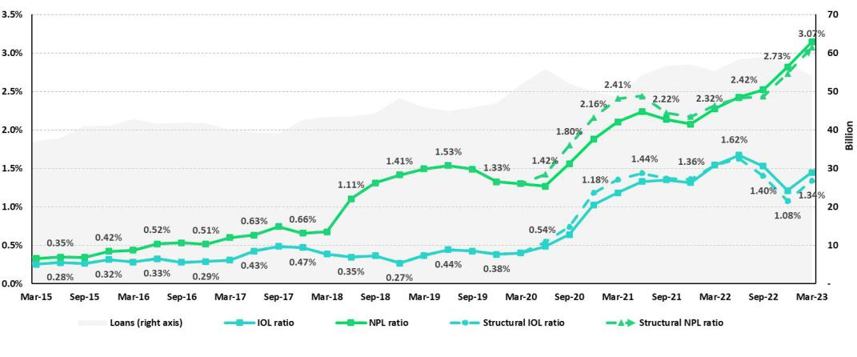

SME-Business
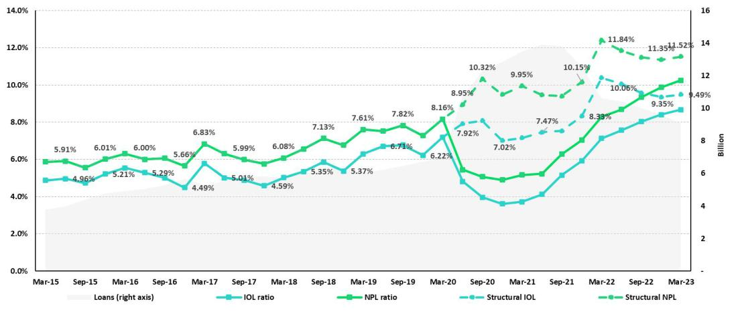

56

| Earnings Release 1Q / 2023 Analysis of 1Q23 Consolidated Results

12. Appendix

SME-Pyme
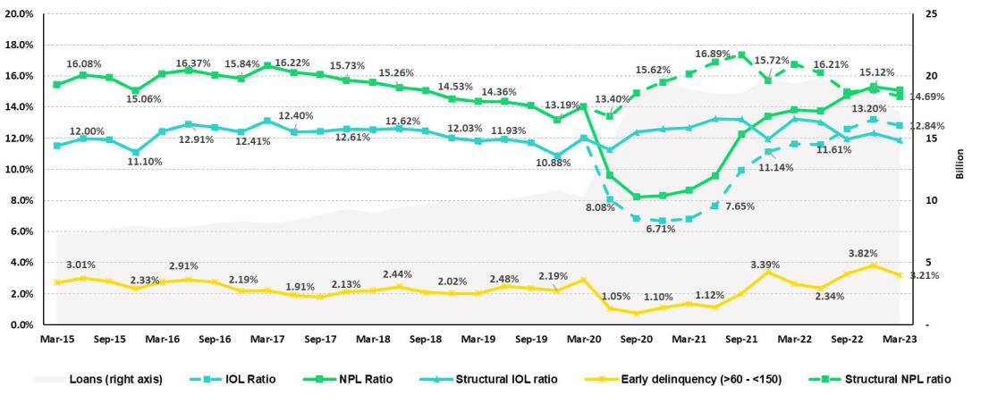

Mortgage
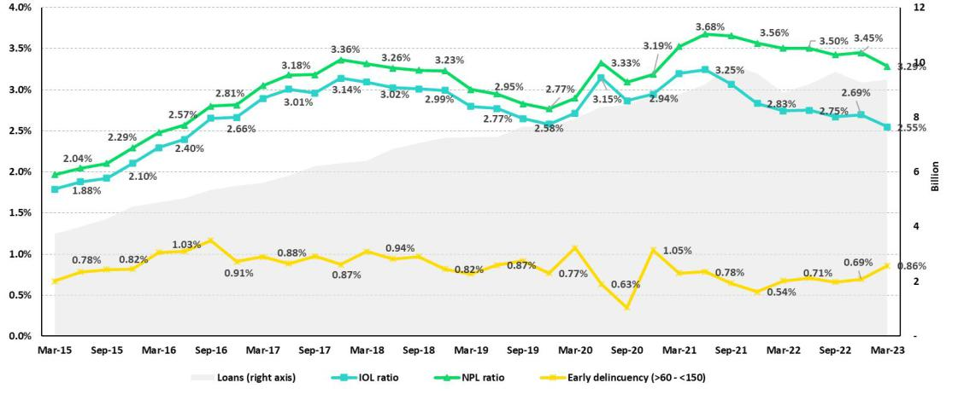

57

| Earnings Release 1Q / 2023 Analysis of 1Q23 Consolidated Results

12. Appendix

Consumer
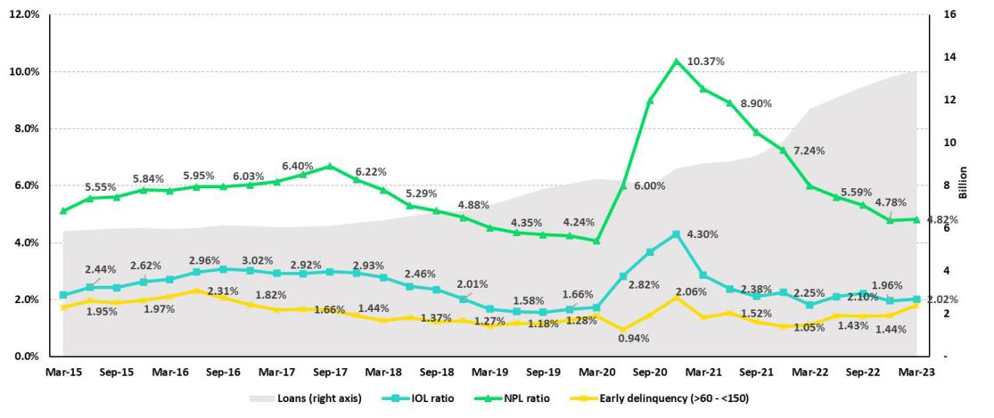

Credit Card
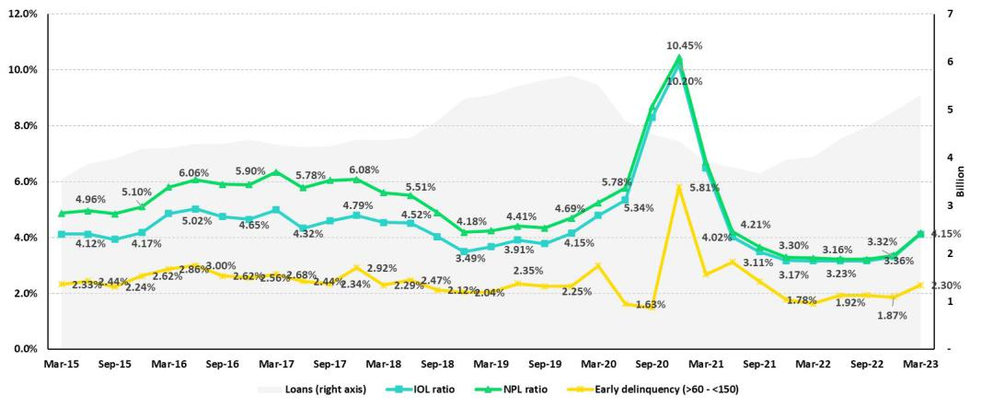

58

| Earnings Release 1Q / 2023 Analysis of 1Q23 Consolidated Results

12. Appendix

Mibanco
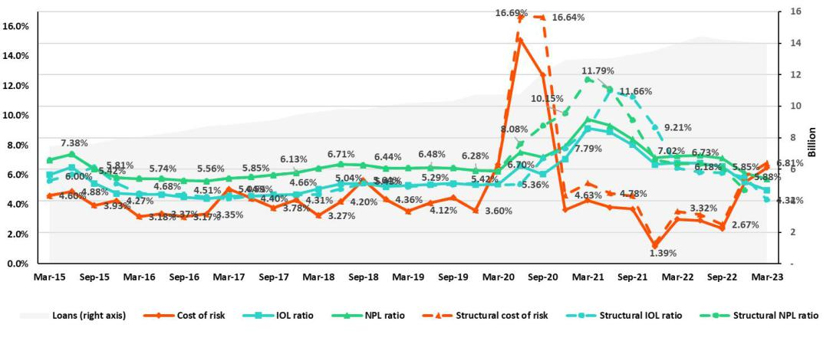

BCP Bolivia
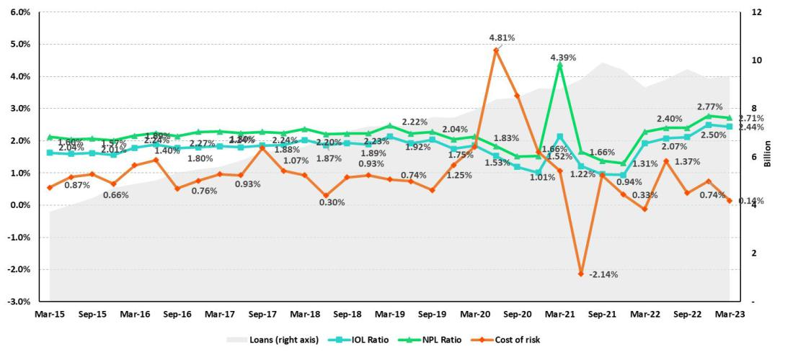

59

| Earnings Release 1Q / 2023 Analysis of 1Q23 Consolidated Results

12. Appendix

12.4 Net Interest Income (NII)

NII Summary

Net interest income |  | Quarter |  |  | % change
S/ 000 | 1Q22 | 4Q22 | 1Q23 | QoQ | YoY
Interest income | 3,172,346 | 4,362,142 | 4,456,106 | 2.2% | 40.5%
Interest on loans | 2,685,552 | 3,515,083 | 3,570,952 | 1.6% | 33.0%
Dividends on investments | 4,320 | 3,726 | 6,477 | 73.8% | 49.9%
Interest on deposits with banks | 36,834 | 236,319 | 277,371 | 17.4% | n.a.
Interest on securities | 438,023 | 559,041 | 585,268 | 4.7% | 33.6%
Other interest income | 7,617 | 47,973 | 16,038 | -66.6% | 110.6%
Interest expense | (740,639) | (1,227,364) | (1,324,017) | 7.9% | 78.8%
Interest expense (excluding Net Insurance Financial Expenses) | (638,881) | (1,119,124) | (1,208,267) | 8.0% | 89.1%
Interest on deposits | 258,939 | 582,237 | 677,088 | 16.3% | 161.5%
Interest on borrowed funds | 116,231 | 239,583 | 238,933 | -0.3% | 105.6%
Interest on bonds and subordinated notes | 179,609 | 188,983 | 182,898 | -3.2% | 1.8%
Other interest expense | 84,102 | 108,321 | 109,348 | 0.9% | 30.0%
Net Insurance Financial Expenses | (101,758) | (108,240) | (115,750) | 6.9% | 13.8%
Net interest income | 2,431,707 | 3,134,778 | 3,132,089 | -0.1% | 28.8%
Risk-adjusted Net interest income | 2,275,875 | 2,512,337 | 2,520,841 | 0.3% | 10.8%
Average interest earning assets | 227,279,809 | 225,604,596 | 222,289,504 | -1.5% | -2.2%
Net interest margin ⁽¹⁾ | 4.46% | 5.75% | 5.84% | 9bps | 138bps
Risk-adjusted Net interest margin ⁽¹⁾ | 4.01% | 4.45% | 4.54% | 9bps | 53bps
Net provisions for loan losses / Net interest income | 10.59% | 23.31% | 23.21% | -0.1% | 12.6%
(1) Annualized. For further detail on the new NIM calculaton due to IFRS17, please refer to Annex 12.1.8

Net Interest Margin (NIM) and Risk Adjusted NIM by subsidiary

NIM Breakdown | BCP Stand-alone | Mibanco | BCP Bolivia | Credicorp
1Q22 | 3.85% | 12.71% | 2.76% | 4.46%
4Q22 | 5.41% | 12.73% | 2.71% | 5.75%
1Q23 | 5.55% | 12.52% | 2.86% | 5.84%
NIM: Annualized Net interest income (excluding Net Insurance Financial Expenses) / Average period end and period beginning interest earning assets.

Risk Adjusted NIM Breakdown | BCP Stand-alone | Mibanco | BCP Bolivia | Credicorp
1Q22 | 3.52% | 10.10% | 2.86% | 4.01%
4Q22 | 4.24% | 8.14% | 2.13% | 4.45%
1Q23 | 4.42% | 7.03% | 2.74% | 4.54%
Risk-Adjusted NIM: (Annualized Net interest income (excluding Net Insurance Financial Expenses) - annualized provisions) / Average period end and period beginning interest earning assets.

60

| Earnings Release 1Q / 2023 Analysis of 1Q23 Consolidated Results

12. Appendix

12.5. Regulatory Capital
Regulatory Capital and Capital Adequacy Ratos
(S/ Thousands, IFRS)

 |  | As of |  | % Change
 | Mar 22 | Dec 22 | Mar 23 | QoQ | YoY
Capital Stock | 1,318,993 | 1,318,993 | 1,318,993 | 0.0% | 0.0%
Treasury Stocks | (207,700) | (207,518) | (208,041) | 0.3% | 0.2%
Capital Surplus | 227,361 | 231,556 | 226,189 | -2.3% | -0.5%
Legal and Other capital reserves ⁽¹⁾ | 21,292,614 | 23,702,590 | 23,603,001 | -0.4% | 10.9%
Minority interest ⁽²⁾ | 493,113 | 471,171 | 514,951 | 9.3% | 4.4%
Loan loss reserves ⁽³⁾ | 1,971,343 | 2,128,732 | 1,908,632 | -10.3% | -3.2%
Perpetual subordinated debt | - | - | - | - | -
Subordinated Debt | 5,695,192 | 5,770,557 | 5,649,060 | -2.1% | -0.8%
Investments in equity and subordinated debt of fnancial and insurance companies | (727,620) | (889,246) | (1,002,770) | 12.8% | 37.8%
Goodwill | (809,980) | (772,213) | (802,366) | 3.9% | -0.9%
Current year Net Loss | - | - | - | - | -
Deducton for subordinated debt limit (50% of Tier I excluding deductons) ⁽⁴⁾ | - | - | - | - | -
Deducton for Tier I Limit (50% of Regulatory capital) (4) | - | - | - | - | -
Regulatory Capital (A) | 29,253,316 | 31,754,622 | 31,207,649 | -1.7% | 6.7%
Tier 1 ⁽⁵⁾ | 15,402,884 | 16,955,335 | 16,906,310 | -0.3% | 9.8%
Tier 2 ⁽⁶⁾ + Tier 3 ⁽⁷⁾ | 13,850,433 | 14,799,287 | 14,301,339 | -3.4% | 3.3%
Financial Consolidated Group (FCG) Regulatory Capital Requirements ⁽⁸⁾ | 18,372,067 | 22,506,113 | 20,915,785 | -7.1% | 13.8%
Insurance Consolidated Group (ICG) Capital Requirements ⁽⁹⁾ | 1,450,871 | 1,562,893 | 1,406,417 | -10.0% | -3.1%
FCG Capital Requirements related to operatons with ICG | (446,149) | (471,371) | (518,975) | 10.1% | 16.3%
ICG Capital Requirements related to operatons with FCG | - | - | - | - | -
Regulatory Capital Requirements (B) | 19,376,789 | 23,597,634 | 21,803,226 | -7.6% | 12.5%
Regulatory Capital Rato (A) / (B) | 1.51 | 1.35 | 1.43
Required Regulatory Capital Rato ⁽¹⁰⁾ | 1.00 | 1.00 | 1.00
- Legal and other capital reserves include restricted capital reserves (PEN 14,745 million) and optonal capital reserves (PEN 6,661 million).
- Minority interest includes Tier I (PEN 421 million)
- Up to 1.25% of total risk-weighted assets of Banco de Credito del Peru, Solucion Empresa Administradora Hipotecaria, Mibanco and ASB Bank Corp.
- Tier II + Tier III cannot be more than 50% of total regulatory capital.
- Tier I = capital + restricted capital reserves + Tier I minority interest - goodwill - (0.5 x investment in equity and subordinated debt of fnancial and insurance companies) + perpetual subordinated debt.
- Tier II = subordinated debt + TierII minority interest ter + loan loss reserves - (0.5 x investment in equity and subordinated debt of fnancial and insurance companies).
- Tier III = Subordinated debt covering market risk only.
- Includes regulatory capital requirements of the fnancial consolidated group.
- Includes regulatory capital requirements of the insurance consolidated group.
- Regulatory Capital / Total Regulatory Capital Requirements (legal minimum = 1.00).

61

| Earnings Release 1Q / 2023 Analysis of 1Q23 Consolidated Results

12. Appendix

Regulatory and Capital Adecuacy Ratos at BCP Stand-alone
(S/ thousands, IFRS, under regulaton as of December 2022)

Regulatory Capital and Capital Adequacy Ratos - SBS |  | As of |  | % change
S/ 000 | Mar 22 | Dec 22 | Mar 23 | QoQ | YoY
Capital Stock | 12,176,365 | 12,176,365 | 12,973,175 | 6.5% | 6.5%
Legal and Other capital reserves | 7,516,510 | 6,759,527 | 7,038,881 | 4.1% | -6.4%
Accumulated earnings with capitalizaton agreement | - | - | - | - | n.a.
Loan loss reserves ⁽¹⁾ | 1,707,458 | 1,838,178 | 1,634,876 | -11.1% | -4.3%
Perpetual subordinated debt | - | - | - | 0.0% | n.a.
Subordinated Debt | 5,007,300 | 5,148,900 | 5,078,700 | -1.4% | 1.4%
Investment in subsidiaries and others, net of unrealized proft and net income in | (2,432,571) | (2,436,525) | (2,838,434) | 16.5% | 16.7%
subsidiarie
Investment in subsidiaries and others | (2,535,289) | (2,844,248) | (2,895,934) | 1.8% | 14.2%
Unrealized proft and net income in subsidiaries | 102,718 | 407,723 | 57,500 | -85.9% | -44.0%
Goodwill | (122,083) | (122,083) | (122,083) | 0.0% | 0.0%
Total Regulatory Capital - SBS | 23,852,979 | 23,364,361 | 23,765,115 | 1.7% | -0.4%
Of-balance sheet | 87,775,815 | 93,211,649 | 91,770,539 | -1.5% | 4.6%
Regulatory Tier 1 Capital ⁽²⁾ | 16,220,724 | 16,219,133 | 17,094,343 | 5.4% | 5.4%
Regulatory Tier 2 Capital ⁽³⁾ | 7,632,256 | 7,145,228 | 6,670,772 | -6.6% | -12.6%
Total risk-weighted assets - SBS (4) | 151,045,319 | 161,938,838 | 159,163,098 | -1.7% | 5.4%
Credit risk-weighted assets | 135,397,192 | 145,968,020 | 142,566,176 | -2.3% | 5.3%
Market risk-weighted assets ⁽⁵⁾ | 2,231,891 | 1,560,281 | 1,715,934 | 10.0% | -23.1%
Operatonal risk-weighted assets | 13,416,236 | 14,410,537 | 14,880,988 | 3.3% | 10.9%
Total capital requirement - SBS | 14,355,691 | 17,730,539 | 17,312,244 | -2.4% | 20.6%
Credit risk capital requirement | 10,831,775 | 12,407,282 | 12,118,125 | -2.3% | 11.9%
Market risk capital requirement | 223,189 | 156,028 | 171,593 | 10.0% | -23.1%
Operatonal risk capital requirement | 1,341,624 | 1,441,054 | 1,488,099 | 3.3% | 10.9%
Additonal capital requirements | 1,959,102 | 3,726,175 | 3,534,427 | -5.1% | 80.4%
Common Equity Tier 1 - Basel IFRS ⁽⁶⁾ | 16,477,382 | 18,949,687 | 17,588,721 | -7.2% | 19.8%
Capital and reserves | 19,180,633 | 18,423,649 | 19,499,813 | 5.8% | 5.8%
Retained earnings | 1,740,668 | 5,249,495 | 2,746,522 | -47.7% | n.a.
Unrealized gains (losses) | (780,063) | (549,319) | (467,041) | -15.0% | 93.7%
Goodwill and intangibles | (1,266,218) | (1,472,073) | (1,454,205) | -1.2%
Investments in subsidiaries | (2,397,638) | (2,702,065) | (2,736,368) | 1.3% | 5.2%
Risk-Weighted Assets - Basel IFRS ⁽⁷⁾ | 141,697,998 | 150,535,662 | 160,419,724 | 6.6% | 13.2%
Total risk-weighted assets | 151,045,319 | 161,938,838 | 159,163,098 | -1.7% | 5.4%
(-) RWA Intangible assets, excluding goodwill. | 10,798,886 | 13,065,877 | - | -100.0% | -100.0%
(+) RWA Deferred tax assets generated as a result of temporary diferences in income | 882,435 | 917,317 | - | -100.0% | -100.0%
tax, in excess of 10% of CET1
(+) RWA Deferred tax assets generated as a result of past losses | - | - |  | 0.0% | n.a.
(+) IFRS Adjustments ⁽⁸⁾ | 569,130 | 745,384 | 1,256,627 | 68.6% | 120.8%
Capital ratos
Regulatory Tier 1 rato ⁽⁹⁾ | 10.74% | 10.02% | 10.74% | 72 bps | 0 bps
Common Equity Tier 1 rato ⁽¹⁰⁾⁽¹¹⁾ | 11.63% | 12.59% | 11.93% | -66 bps | 30 bps
Regulatory Global Capital rato ⁽¹²⁾ | 15.79% | 14.43% | 14.93% | 50 bps | -86 bps
Risk-weighted assets / Regulatory capital | 6.33 | 6.93 | 6.70 | -3.4% | 5.8%
- Up to 1.25% of total risk-weighted assets.
- Regulatory Tier 1 Capital = Capital + Legal and other capital reserves + Accumulated earnings with capitalizaton agreement + (0.5 x Unrealized proft and net income in subsidiaries) - Goodwill - (0.5 x Investment in subsidiaries) + Perpetual subordinated debt (maximum amount that can be included is 17.65% of Capital + Reserves + Accumulated earnings with capitalizaton agreement + Unrealized proft and net income in subsidiaries - Goodwill).
- Regulatory Tier 2 Capital = Subordinated debt + Loan loss reserves + Unrestricted Reserves + (0.5 x Unrealized proft and net income in subsidiaries) - (0.5 x Investment in subsidiaries).
- Since July 2012, Total Risk-weighted assets = Credit risk-weighted assets * 1.00 + Capital requirement to cover market risk * 10 + Capital requirement to cover operatonal risk * 10 * 1.00 (since July 2014)
- It includes capital requirement to cover price and rate risk.
- Common Equity Tier I = Capital + Reserves – 100% of applicable deductons (investment in subsidiaries, goodwill, intangibles and net deferred taxes that rely on future proftability) + retained earnings + unrealized gains. Figures difer from previously reported cause current calculatons are based on IFRS fgures.
- Adjusted Risk-Weighted Assets = Risk-weighted assets - (RWA Intangible assets, excluding goodwill, + RWA Deferred tax assets generated as a result of temporary diferences in income tax, in excess of 10% of CET1, + RWA Deferred tax assets generated as a result of past losses). Figures difer from previously reported cause current calculatons are based on IFRS fgures.
- Regulatory Tier 1 Capital / Total Risk-weighted assets
- Common Equity Tier I / Adjusted Risk-Weighted Assets Risk-Weighted Assets
- Total Regulatory Capital / Total Risk-weighted assets (legal minimum = 10% since July 2011)
- Adjustments for diferences in balance assets under Local Accountng (which regulatory Rwas are calculated) and IFRS in the Right of use account (lease). As of March 2022, the ‘Right of Use’ account increased to S/ 364M, explained the 64% of the adjustment. The rest adjustments correspond to diferences in stock of provisions and Deferred Taxes.
- Common Equity Tier I calculated based on IFRS Accountng

62

| Earnings Release 1Q / 2023 Analysis of 1Q23 Consolidated Results

12. Appendix

Regulatory and Capital Adequacy Ratos at BCP Stand-alone
(S/ thousands, IFRS, under current regulaton as of January 2023)
Regulatory Capital |  | 1Q23
(S/ thousand) |  | 1Q23
Capital Stock |  | 12,973,175
Reserves |  | 7,038,881
Accumulated earnings |  | 2,050,746
Loan loss reserves ⁽¹⁾ |  | 1,634,876
Perpetual subordinated debt |  | -
Subordinated Debt |  | 5,078,700
Unrealized Proft or Losses |  | (1,046,284)
Investment in subsidiaries and others, net of unrealized proft and net income in subsidiaries |  | (2,613,563)
Intangibles |  | (934,718)
Goodwill |  | (122,083)
Total Regulatory Capital |  | 24,059,729
Tier 1 Common Equity ⁽²⁾ |  | 17,346,153
Regulatory Tier 1 Capital ⁽³⁾ |  | 17,346,153
Regulatory Tier 2 Capital ⁽⁴⁾ |  | 6,713,576
Total risk-weighted assets |  | 1Q23
(S/ thousand) |  | 1Q23
Market risk-weighted assets (5) |  | 1,715,934
Credit risk-weighted assets |  | 129,623,885
Operatonal risk-weighted assets |  | 14,880,988
Total |  | 146,220,807
Capital requirement |  | 1Q23
(S/ thousand) |  | 1Q23
Market risk capital requirement ⁽⁵⁾ |  | 171,589
Credit risk capital requirement |  | 11,018,030
Operatonal risk capital requirement |  | 1,488,062
Additonal capital requirements |  | 3,534,427
Total |  | 16,212,108

- Up to 1.25% of total risk-weighted assets.
- Regulatory Tier 1 Capital = Capital + Legal and other capital reserves + Accumulated earnings with capitalizaton agreement + (0.5 x Unrealized proft and net income in subsidiaries) - Goodwill - (0.5 x Investment in subsidiaries) + Perpetual subordinated debt (maximum amount that can be included is 17.65% of Capital + Reserves + Accumulated earnings with capitalizaton agreement + Unrealized proft and net income in subsidiaries - Goodwill).
- Regulatory Tier 1 Capital = Tier 1 Common Equity + Tier 1 Subordinated debt (perpetual)
- Regulatory Tier 2 Capital = Deuda Subordinated Debt + Loan los reserves

Capital ratos

Regulatory Tier 1 rato | 11.86%
Regulatory Global Capital rato | 16.45%
Common Equity Tier 1 rato IFRS (9)(12) | 11.93%

63

| Earnings Release 1Q / 2023 Analysis of 1Q23 Consolidated Results

12. Appendix

Regulatory Capital and Capital Adequacy Ratos at Mibanco

(S/ thousands, IFRS, under regulaton as of December 2022)

 |  | As of |  | % change
 | Mar 22 | Dec 22 | Mar 23 | QoQ | YoY
Capital Stock | 1,840,606 | 1,840,606 | 1,840,606 | 0.0% | 0.0%
Legal and Other capital reserves | 264,221 | 264,221 | 308,056 | 16.6% | 16.6%
Accumulated earnings with capitalization agreement | - | - | - | n.a. | n.a.
Loan loss reserves ⁽¹⁾ | 163,711 | 183,155 | 193,129 | 5.4% | 18.0%
Perpetual subordinated debt | - | - | - | n.a. | n.a.
Subordinated Debt | 185,000 | 179,000 | 179,000 | 0.0% | -3.2%
Investment in subsidiaries and others, net of unrealized proft and | - | - | - | n.a. | n.a.
net income
Investment in subsidiaries and others | - | - | - | n.a. | n.a.
Unrealized proft and net income in subsidiaries | - | - | - | n.a. | n.a.
Goodwill | (139,180) | (139,180) | (139,180) | 0.0% | 0.0%
Total Regulatory Capital | 2,314,357 | 2,327,801 | 2,381,611 | 2.3% | 2.9%
Regulatory Tier 1 Capital ⁽²⁾ | 1,962,906 | 1,962,906 | 2,006,801 | 2.2% | 2.2%
Regulatory Tier 2 Capital ⁽³⁾ | 351,451 | 364,895 | 374,810 | 2.7% | 6.6%
Total risk-weighted assets - SBS ⁽⁴⁾ | 14,825,319 | 15,850,329 | 16,104,381 | 1.6% | 8.6%
Credit risk-weighted assets | 12,747,979 | 14,345,663 | 14,535,512 | 1.3% | 14.0%
Market risk-weighted assets ⁽⁵⁾ | 177,097 | 96,803 | 141,441 | 46.1% | -20.1%
Operatonal risk-weighted assets | 1,900,243 | 1,407,863 | 1,427,428 | 1.4% | -24.9%
Total capital requirement - SBS | 1,363,550 | 1,735,360 | 1,791,008 | 3.2% | 31.3%
Credit risk capital requirement | 1,019,838 | 1,219,381 | 1,235,519 | 1.3% | 21.1%
Market risk capital requirement ⁽⁵⁾ | 17,710 | 9,680 | 14,144 | 46.1% | -20.1%
Operatonal risk capital requirement | 190,024 | 140,786 | 142,743 | 1.4% | -24.9%
Additonal capital requirements | 135,978 | 365,512 | 398,603 | 9.1% | 193.1%
Common Equity Tier 1 - Basel IFRS ⁽⁶⁾ | 2,065,340 | 2,353,353 | 2,415,504 | 2.6% | 17.0%
Capital and reserves | 2,104,827 | 2,104,827 | 2,148,662 | 2.1% | 2.1%
Retained earnings | 224,613 | 540,906 | 556,972 | 3.0% | n.a.
Unrealized gains (losses) | (7,360) | (11,830) | (15,467) | 30.7% | 110.1%
Goodwill and intangibles | (256,740) | (280,267) | (274,382) | -2.1% | 6.9%
Investments in subsidiaries | - | (283) | (281) | -0.7% | n.a.
Adjusted Risk-Weighted Assets - Basel IFRS ⁽⁷⁾ | 13,854,030 | 14,613,299 | 14,860,252 | 1.7% | 7.3%
Total risk-weighted assets - SBS | 14,825,319 | 15,850,329 | 14,729,206 | -7.1% | -0.6%
(-) RWA Intangible assets, excluding goodwill | 1,166,501 | 1,408,551 | - | -100.0% | -100.0%
(+) RWA Deferred tax assets generated as a result of temporary | 161,572 | 159,880 | - | -100.0% | -100.0%
differences in income tax, in excess of 10% of CET1, and other local
adjustments | 33,640 | 11,641 | - | -100.0% | -100.0%
 |  |  |  | n.a. | n.a.
(+) IFRS Adjustments ⁽¹¹⁾ | - | - | - | n.a. | n.a.
Capital ratos
Regulatory Tier 1 rato ⁽⁸⁾ | 13.24% | 12.38% | 12.46% | 8 bps | -78 bps
Common Equity Tier 1 rato IFRS ⁽⁹⁾⁽¹²⁾ | 14.91% | 16.10% | 16.25% | 15 bps | 134 bps
Regulatory Global Capital rato ⁽¹⁰⁾ | 15.61% | 14.69% | 14.79% | 10 bps | -82 bps
Risk-weighted assets / Regulatory capital | 6.41 | 6.81 | 6.76 | -0.7% | 5.6%

64

| Earnings Release 1Q / 2023 Analysis of 1Q23 Consolidated Results

12. Appendix

Regulatory Capital and Capital Adequacy Ratos at Mibanco
(S/ thousands, IFRS, under current regulaton as of January 2023)
Capital regulatorio |  | 1Q23
(S/ miles) |  | 1Q23
Capital |  | 1,840,606
Reservas |  | 308,056
Utlidades y Resultados Acumulados |  | 556,972
Provisiones ⁽¹⁾ |  | 168,965
Deuda Subordinada Perpetua |  | 0
Deuda Subordinada |  | 179,000
Pérdida No Realizada |  | -15,467
Inversiones en subsidiarias y otros, netas de ganancias no realizadas y utlidades |  | -281
Intangibles |  | -135,202
Goodwill |  | -139,180
Patrimonio Efectvo Total |  | 2,763,469
Capital Ordinario Nivel 1 ⁽²⁾ |  | 2,415,504
Patrimonio Efectvo Nivel 1 ⁽³⁾ |  | 2,415,504
Patrimonio Efectvo Nivel 2 ⁽⁴⁾ |  | 347,965
Actvos ponderados por riesgo |  | 1Q23
(S/ miles) |  | 1Q23
Actvos ponderados por riesgo de mercado |  | 141,441
Actvos ponderados por riesgo creditcio |  | 13,160,337
Actvos ponderados por riesgo operacional |  | 1,427,428
Total |  | 14,729,206
Requerimiento de patrimonio |  | 1Q23
(S/ miles) |  | 1Q23
Requerimiento de patrimonio por riesgo de mercado |  | 14,144
Requerimiento de patrimonio por riesgo creditcio |  | 1,118,629
Requerimiento de patrimonio por riesgo operacional |  | 142,743
Requerimientos adicionales de capital |  | 398,603
Total |  | 1,674,118

- (1) Up to 1.25% of total risk-weighted assets.
- Common Equity Tier 1 = Capital Stock + Reserves + Accumulated earnings – Unrealized profts or losses - 100% deductons (investment in subsidiaries, goodwill, intangible assets and deferred tax assets based on future returns).
- Regulatory Tier 1 Capital = Common Equity Tier 1 + Tier 1 Subordinated Debt (Perpetual).
- Regulatory Tier 2 Capital = Subordinated Debt + Loan loss reserves.

Ratos de Capital

Rato Capital Ordinario Nivel 1 | 16.40%
Rato Patrimonio Efectvo Nivel 1 | 16.40%
Rato Patrimonio Efectvo Total | 18.76%
Rato CET1 NIIF | 16.38%

65

| Earnings Release 1Q / 2023 Analysis of 1Q23 Consolidated Results

12. Appendix

12.6. Financial Statements and Ratos by Business

12.6.1. Credicorp Consolidated

CREDICORP LTD. AND SUBSIDIARIES
CONSOLIDATED STATEMENT OF FINANCIAL POSITION
(In S/ thousands, IFRS)

 |  | As of |  | % change
 | Mar 22 | Dec 22 | Mar 23 | QoQ | YoY
ASSETS
Cash and due from banks
Non-interest bearing | 6,748,517 | 7,286,624 | 6,946,112 | -4.7% | 2.9%
Interest bearing | 29,563,512 | 26,897,216 | 28,158,941 | 4.7% | -4.8%
Total cash and due from banks | 36,312,029 | 34,183,840 | 35,105,053 | 2.7% | -3.3%
Cash collateral, reverse repurchase agreements and securites borrowing | 1,516,855 | 1,101,856 | 1,468,180 | 33.2% | -3.2%
Fair value through proft or loss investments | 4,628,870 | 4,199,334 | 4,080,266 | -2.8% | -11.9%
Fair value through other comprehensive income investments | 35,452,509 | 30,786,161 | 33,395,987 | 8.5% | -5.8%
Amortzed cost investments | 8,064,050 | 10,445,729 | 10,253,251 | -1.8% | 27.1%
Loans | 144,621,513 | 148,626,374 | 145,165,713 | -2.3% | 0.4%
Current | 138,748,514 | 142,686,630 | 139,376,216 | -2.3% | 0.5%
Internal overdue loans | 5,872,999 | 5,939,744 | 5,789,497 | -2.5% | -1.4%
Less - allowance for loan losses | (8,262,383) | (7,872,402) | (7,915,350) | 0.5% | -4.2%
Loans, net | 136,359,130 | 140,753,972 | 137,250,363 | -2.5% | 0.7%
Financial assets designated at fair value through proft or loss | 856,337 | 768,801 | 795,225 | 3.4% | -7.1%
Accounts receivable from reinsurers and coinsurers | 174,982 | 110,963 | 107,619 | -3.0% | -38.5%
Premiums and other policyholder receivables | 873,505 | 921,611 | 842,865 | -8.5% | -3.5%
Property, plant and equipment, net | 1,864,825 | 1,824,931 | 1,786,992 | -2.1% | -4.2%
Due from customers on acceptances | 524,448 | 699,678 | 496,170 | -29.1% | -5.4%
Investments in associates | 629,009 | 726,993 | 660,741 | -9.1% | 5.0%
Intangible assets and goodwill, net | 2,703,238 | 2,899,429 | 2,942,367 | 1.5% | 8.8%
Assets by insurance and reinsurance contracts
Other assets ⁽¹⁾ | 6,901,336 | 6,293,599 | 8,118,268 | 29.0% | 17.6%
Total Assets | 237,871,204 | 236,750,138 | 238,324,333 | 0.7% | 0.2%
LIABILITIES AND EQUITY
Deposits and obligatons
Non-interest bearing | 50,939,859 | 43,346,151 | 41,596,964 | -4.0% | -18.3%
Interest bearing | 96,976,105 | 103,674,636 | 107,026,336 | 3.2% | 10.4%
Total deposits and obligatons | 147,915,964 | 147,020,787 | 148,623,300 | 1.1% | 0.5%
Payables from repurchase agreements and securites lending | 19,388,995 | 12,966,725 | 11,686,495 | -9.9% | -39.7%
BCRP instruments | 17,532,350 | 11,297,659 | 9,780,540 | -13.4% | -44.2%
Repurchase agreements with third partes | 1,218,028 | 976,020 | 1,206,574 | 23.6% | -0.9%
Repurchase agreements with customers | 638,617 | 693,046 | 699,381 | 0.9% | 9.5%
Due to banks and correspondents | 6,362,990 | 8,937,411 | 10,199,650 | 14.1% | 60.3%
Bonds and notes issued | 16,044,671 | 17,007,194 | 14,313,030 | -15.8% | -10.8%
Banker’s acceptances outstanding | 524,448 | 699,678 | 496,170 | -29.1% | -5.4%
Liabilites by insurance and reinsurance contracts | 11,984,619 | 11,974,714 | 12,291,538 | 2.6% | 2.6%
Accounts payable to reinsurers | 414,506 | 420,094 | 343,067 | -18.3% | -17.2%
Financial liabilites at fair value through proft or loss | 232,185 | 191,010 | 417,146 | 118.4% | 79.7%
Other liabilites | 7,655,867 | 7,943,225 | 9,019,443 | 13.5% | 17.8%
Total Liabilites | 210,524,245 | 207,160,838 | 207,389,839 | 0.1% | -1.5%
Net equity | 26,818,054 | 28,997,731 | 30,359,898 | 4.7% | 13.2%
Capital stock | 1,318,993 | 1,318,993 | 1,318,993 | 0.0% | 0.0%
Treasury stock | (207,700) | (207,518) | (208,041) | 0.3% | 0.2%
Capital surplus | 227,361 | 231,556 | 226,189 | -2.3% | -0.5%
Reserves | 21,292,614 | 23,659,626 | 23,603,001 | -0.2% | 10.9%
Other reserves | -318,628 | (434,838) | (403,391) | -7.2% | 26.6%
Retained earnings | 4,505,414 | 4,429,912 | 5,823,147 | 31.5% | 29.2%
 | - | - | -
Non-controlling interest | 528,905 | 591,569 | 574,596 | -2.9% | 8.6%
Total Net Equity | 27,346,959 | 29,589,300 | 30,934,494 | 4.5% | 13.1%
 | - | - | -
Total liabilites and equity | 237,871,204 | 236,750,138 | 238,324,333 | 0.7% | 0.2%
 | - | - | -
Of-balance sheet | 142,337,944 | 150,977,864 | 154,477,055 | 2.3% | 8.5%

Total performance bonds, stand-by and L/Cs. | 21,196,817 | 20,928,054 | 18,731,789 | -10.5% | -11.6%
Undrawn credit lines, advised but not commited | 80,155,277 | 86,597,041 | 87,232,214 | 0.7% | 8.8%
Total derivatves (notonal) and others | 40,985,850 | 43,452,769 | 48,513,052 | 11.6% | 18.4%
(1) Includes mainly accounts receivables from brokerage and others.

66

| Earnings Release 1Q / 2023 Analysis of 1Q23 Consolidated Results

12. Appendix

CREDICORP LTD. AND SUBSIDIARIES
CONSOLIDATED STATEMENT OF INCOME
(In S/ thousands, IFRS)

 |  | Quarter |  | % change
 | 1Q22 | 4Q22 | 1Q23 | QoQ | YoY
Interest income and expense
Interest and similar income | 3,172,346 | 4,362,142 | 4,456,106 | 2.2% | 40.5%
Interest and similar expenses | (740,639) | (1,227,364) | (1,324,017) | 7.9% | 78.8%
Net interest, similar income and expenses | 2,431,707 | 3,134,778 | 3,132,089 | -0.1% | 28.8%
Gross provision for credit losses on loan portolio | (350,681) | (815,589) | (802,107) | -1.7% | 128.7%
Recoveries of writen-of loans | 93,091 | 84,908 | 75,109 | -11.5% | -19.3%
Provision for credit losses on loan portolio, net of recoveries | (257,590) | (730,681) | (726,998) | -0.5% | 182.2%
 | - | - | -
Net interest, similar income and expenses, afer provision for credit losses on loan | 2,174,117 | 2,404,097 | 2,405,091 | 0.0% | 10.6%
portolio
Other income
Fee income | 891,628 | 894,552 | 881,781 | -1.4% | -1.1%
Net gain on foreign exchange transactons | 259,710 | 293,215 | 248,515 | -15.2% | -4.3%
Net loss on securites | (56,866) | 77,512 | 70,036 | -9.6% | n.a
Net gain from associates | 24,014 | 25,422 | 27,212 | 7.0% | 13.3%
Net gain (loss) on derivatves held for trading | (5,982) | 5,857 | (6,570) | -212.2% | 9.8%
Net gain (loss) from exchange diferences | (8,363) | 22,039 | 22,963 | 4.2% | -374.6%
Others | 135,257 | 19,630 | 84,127 | 328.6% | -37.8%
Total non-fnancial income | 1,239,398 | 1,338,227 | 1,328,064 | -0.8% | 7.2%
Insurance underwritng result
Insurance Service Result | 309,258 | 331,030 | 406,877 | 22.9% | 31.6%
Reinsurance Result | (102,591) | (119,436) | (110,536) | -7.5% | 7.7%
Total insurance underwritng result | 206,667 | 211,594 | 296,341 | 40.1% | 43.4%
Total expenses
Salaries and employee benefts | (939,518) | (1,040,066) | (1,029,558) | -1.0% | 9.6%
Administratve, general and tax expenses | (696,065) | (1,042,882) | (835,060) | -19.9% | 20.0%
Depreciaton and amortzaton | (151,894) | (165,180) | (160,924) | -2.6% | 5.9%
Associaton in partcipaton | (7,691) | (12,936) | (12,612) | -2.5% | 64.0%
Other expenses | (79,351) | (137,891) | (83,543) | -39.4% | 5.3%
Total expenses | (1,874,519) | (2,398,955) | (2,121,697) | -11.6% | 13.2%
Proft before income tax | 1,745,663 | 1,554,963 | 1,907,799 | 22.7% | 9.3%
Income tax | (546,000) | (476,236) | (493,466) | 3.6% | -9.6%
Net proft | 1,199,663 | 1,078,727 | 1,414,333 | 31.1% | 17.9%
Non-controlling interest | 27,786 | 24,231 | 30,060 | 24.1% | 8.2%
Net proft atributable to Credicorp | 1,171,877 | 1,054,496 | 1,384,273 | 31.3% | 18.1%

67

| Earnings Release 1Q / 2023 Analysis of 1Q23 Consolidated Results

12. Appendix

12.6.2. Credicorp Stand-alone
 |  | Credicorp Ltd.
 | Separate Statement of Financal Positon
 | (S/ thousands, IFRS)
 |  |  | As of |  | % change
 |  | Mar 22 | Dec22 | Mar23 | QoQ | YoY
ASSETS
Cash and cash equivalents |  | 168,634 | 136,399 | 131,218 | -3.8% | -22.2%
At fair value through proft or loss |  | 947,826 | 958,939 | 949,378 | -1.0% | n.a
Fair value through other comprehensive income investments |  | 343,373 | 306,343 | 318,962 | 4.1% | -7.1%
In subsidiaries and associates investments |  | 31,647,183 | 33,878,318 | 35,207,564 | 3.9% | 11.3%
Other assets |  | 106 | 135 | 69,217 | n.a | n.a
Total Assets |  | 33,107,122 | 35,280,134 | 36,676,339 | 4.0% | 10.8%
LIABILITIES AND NET SHAREHOLDERS’ EQUITY
Due to banks, correspondents and other enttes |  | - | - | - | n.a. | n.a.
Bonds and notes issued |  | 1,850,185 | 1,898,066 | 1,885,839 | -0.6% | 1.9%
Other liabilites |  | 195,286 | 220,642 | 267,558 | 21.3% | 37.0%
Total Liabilites |  | 2,045,471 | 2,118,708 | 2,153,397 | 1.6% | 5.3%
NET EQUITY
Capital stock |  | 1,318,993 | 1,318,993 | 1,318,993 | 0.0% | 0.0%
Capital Surplus |  | 384,542 | 384,542 | 384,542 | 0.0% | 0.0%
Reserve |  | 20,945,491 | 23,300,350 | 23,300,350 | 0.0% | 11.2%
Unrealized results |  | (638,233) | (835,079) | (592,006) | -29.1% | n.a.
Retained earnings |  | 9,050,858 | 8,992,620 | 10,111,063 | 12.4% | 11.7%
Total net equity |  | 31,061,651 | 33,161,426 | 34,522,942 | 4.1% | 11.1%
Total Liabilites And Equity |  | 33,107,122 | 35,280,134 | 36,676,339 | 4.0% | 10.8%
 |  |  | Quarter |  | % change
 |  | 1Q22 | 4Q22 | 1Q23 | QoQ | YoY
Interest income
Net share of the income from investments in subsidiaries and associates |  | 1,236,032 | 1,115,614 | 1,439,211 | 29.0% | 16.4%
Interest and similar income |  | 298 | 1,040 | 300 | -71.2% | 0.7%
Net gain on fnancial assets at fair value through proft or loss |  | (26,898) | 32,597 | 3,759 | -88.5% | n.a
Total income |  | 1,209,432 | 1,149,251 | 1,433,270 | 25.6% | 19.3%
Interest and similar expense |  | (13,651) | (20,550) | (4,407) | -78.6% | -67.7%
Administratve and general expenses |  | (4,259) | (9,272) | (13,796) | 48.8% | 223.9%
Total expenses |  | (17,910) | (29,822) | (18,203) | -39.0% | 1.6%
Operatng income |  | 1,191,522 | 1,119,429 | 1,425,067 | 27.3% | 19.6%
Net gain (losses) from exchange diferences |  | (145) | 85 | (158) | -285.9% | 9.0%
Other, net |  | 232 | 106 | 102 | n.a | n.a
Proft before income tax |  | 1,191,609 | 1,119,620 | 1,425,011 | 27.3% | 19.6%
Income tax |  | (42,000) | (42,000) | (46,795) | 11.4% | 11.4%
Net income |  | 1,149,609 | 1,077,620 | 1,378,216 | 27.9% | 19.9%
Double Leverage Rato |  | 101.89% | 102.16% | 101.98% | -18bps | 10bps

68

| Earnings Release 1Q / 2023 Analysis of 1Q23 Consolidated Results

12. Appendix

12.6.3. BCP Consolidated

BANCO DE CREDITO DEL PERU AND SUBSIDIARIES

CONSOLIDATED STATEMENT OF FINANCIAL POSITION
(In S/ thousands, IFRS)

 |  | As of |  | % change
 | Mar 22 | Dec 22 | Mar 23 | QoQ | YoY
ASSETS
Cash and due from banks
Non-interest bearing | 4,959,579 | 5,780,728 | 5,456,302 | -5.6% | 10.0%
Interest bearing | 28,253,501 | 25,594,929 | 26,924,509 | 5.2% | -4.7%
Total cash and due from banks | 33,213,080 | 31,375,657 | 32,380,811 | 3.2% | -2.5%
 |  | - | -
Cash collateral, reverse repurchase agreements and securities borrowing | 202,127 | 244,017 | 232,059 | -4.9% | 14.8%
 |  | - | -
Fair value through profit or loss investments | 729,168 | 1,011 | 39,638 | 3820.7% | -94.6%
Fair value through other comprehensive income investments | 20,202,882 | 15,260,159 | 17,702,831 | 16.0% | -12.4%
Amortized cost investments | 7,538,562 | 9,831,983 | 9,661,389 | -1.7% | 28.2%
 |  | - | -
Loans | 132,578,949 | 136,046,442 | 132,290,495 | -2.8% | -0.2%
Current | 126,930,472 | 130,396,010 | 126,846,139 | -2.7% | -0.1%
Internal overdue loans | 5,648,477 | 5,650,432 | 5,444,356 | -3.6% | -3.6%
Less - allowance for loan losses | (7,769,920) | (7,408,223) | (7,450,091) | 0.6% | -4.1%
Loans, net | 124,809,029 | 128,638,219 | 124,840,404 | -3.0% | 0.0%
 |  | - | -
Property, furniture and equipment, net ⁽¹⁾ | 1,593,758 | 1,536,875 | 1,489,392 | -3.1% | -6.5%
Due from customers on acceptances | 524,448 | 699,678 | 496,170 | -29.1% | -5.4%
Investments in associates | 31,859 | 28,578 | 18,246 | -36.2% | -42.7%
Other assets ⁽²⁾ | 6,100,840 | 5,662,055 | 6,873,005 | 21.4% | 12.7%
 |  | - | -
Total Assets | 194,945,753 | 193,278,232 | 193,733,945 | 0.2% | -0.6%
 |  | - | -
Liabilities and Equity |  | - | -
Deposits and obligations |  | - | -
Non-interest bearing ⁽¹⁾ | 45,297,294 | 39,399,007 | 37,978,204 | -3.6% | -16.2%
Interest bearing ⁽¹⁾ | 85,125,304 | 90,420,659 | 93,952,305 | 3.9% | 10.4%
Total deposits and obligations | 130,422,598 | 129,819,666 | 131,930,509 | 1.6% | 1.2%
 |  | - | -
Payables from repurchase agreements and securities lending | 18,064,487 | 11,843,594 | 10,318,686 | -12.9% | -42.9%
BCRP instruments | 17,532,350 | 11,297,659 | 9,780,540 | -13.4% | -44.2%
Repurchase agreements with third parties | 532,137 | 545,935 | 538,146 | -1.4% | 1.1%
Due to banks and correspondents | 5,872,463 | 8,539,195 | 9,647,935 | 13.0% | 64.3%
Bonds and notes issued | 13,575,977 | 13,840,114 | 10,972,861 | -20.7% | -19.2%
Banker’s acceptances outstanding | 524,448 | 699,678 | 496,170 | -29.1% | -5.4%
Financial liabilities at fair value through profit or loss | - | 7,669 | 193,031 | 2417.0% | n.a
Other liabilities ⁽³⁾ | 6,211,275 | 5,256,079 | 8,245,729 | 56.9% | 32.8%
Total Liabilities | 174,671,248 | 170,005,995 | 171,804,921 | 1.1% | -1.6%
 |  | - | -
Net equity | 20,140,022 | 23,121,902 | 21,777,751 | -5.8% | 8.1%
Capital stock | 11,882,984 | 11,882,984 | 12,679,794 | 6.7% | 6.7%
Reserves | 7,297,648 | 6,540,665 | 6,820,019 | 4.3% | -6.5%
Unrealized gains and losses | (780,063) | (549,319) | (467,041) | -15.0% | -40.1%
Retained earnings | 1,739,453 | 5,247,572 | 2,744,979 | -47.7% | 57.8%
 |  | - | -
Non-controlling interest | 134,483 | 150,335 | 151,273 | 0.6% | 12.5%
 |  | - | -
Total Net Equity | 20,274,505 | 23,272,237 | 21,929,024 | -5.8% | 8.2%
 |  | - | -
Total liabilities and equity | 194,945,753 | 193,278,232 | 193,733,945 | 0.2% | -0.6%
 |  | - | -
Off-balance sheet | 131,406,579 | 137,999,722 | 142,247,161 | 3.1% | 8.2%
Total performance bonds, stand-by and L/Cs. | 19,638,213 | 19,737,892 | 17,932,260 | -9.1% | -8.7%
Undrawn credit lines, advised but not committed | 70,893,784 | 75,276,664 | 76,157,911 | 1.2% | 7.4%
Total derivatives (notional) and others | 40,874,582 | 42,985,166 | 48,156,990 | 12.0% | 17.8%
- Right of use asset of lease contracts is included by applicaton of IFRS 16.
- Mainly includes intangible assets, other receivable accounts and tax credit.
- Mainly includes other payable accounts.

69

| Earnings Release 1Q / 2023 Analysis of 1Q23 Consolidated Results

12. Appendix

BANCO DE CREDITO DEL PERU AND SUBSIDIARIES
CONSOLIDATED STATEMENT OF INCOME

(In S/ thousands, IFRS)

 |  | Quarter |  | % change
 | 1Q22 | 4Q22 | 1Q23 | QoQ | YoY
Interest income and expense
Interest and dividend income | 2,712,960 | 3,821,770 | 3,902,811 | 2.1% | 43.9%
Interest expense | (494,035) | (913,761) | (994,836) | 8.9% | 101.4%
Net interest income | 2,218,925 | 2,908,009 | 2,907,975 | 0.0% | 31.1%
Provision for credit losses on loan portfolio | (340,235) | (783,402) | (782,079) | -0.2% | 129.9%
Recoveries of written-off loans | 86,428 | 79,076 | 69,694 | -11.9% | -19.4%
Provision for credit losses on loan portfolio, net of recoveries | (253,807) | (704,326) | (712,385) | 1.1% | 180.7%
Risk-adjusted net interest income | 1,965,118 | 2,203,683 | 2,195,590 | -0.4% | 11.7%
Non-financial income
Fee income | 731,705 | 766,960 | 727,489 | -5.1% | -0.6%
Net gain on foreign exchange transactions | 242,504 | 271,267 | 242,570 | -10.6% | 0.0%
Net gain (loss) on securities | (1,898) | (9,162) | (2,584) | -71.8% | 36.1%
Net gain (loss) on derivatives held for trading | (10,978) | 17,756 | 22,288 | 25.5% | n.a
Net gain (loss) from exchange differences | (17,051) | 3,265 | 4,308 | 31.9% | n.a
Others | 120,328 | 8,862 | 71,277 | 704.3% | -40.8%
Total other income | 1,064,610 | 1,058,948 | 1,065,348 | 0.6% | 0.1%
Total expenses
Salaries and employee benefits | (694,339) | (768,578) | (750,011) | -2.4% | 8.0%
Administrative expenses | (532,560) | (810,501) | (645,131) | -20.4% | 21.1%
Depreciation and amortization | (126,426) | (139,688) | (134,267) | -3.9% | 6.2%
Other expenses | (49,556) | (76,515) | (43,944) | -42.6% | -11.3%
Total expenses | (1,402,881) | (1,795,282) | (1,573,353) | -12.4% | 12.2%
Profit before income tax | 1,626,847 | 1,467,349 | 1,687,585 | 15.0% | 3.7%
Income tax | (466,694) | (403,338) | (422,491) | 4.7% | -9.5%
Net profit | 1,160,153 | 1,064,011 | 1,265,094 | 18.9% | 9.0%
Non-controlling interest | (5,157) | (2,318) | (1,112) | -52.0% | -78.4%
Net profit attributable to BCP Consolidated | 1,154,996 | 1,061,693 | 1,263,982 | 19.1% | 9.4%

BANCO DE CREDITO DEL PERU AND SUBSIDIARIES

SELECTED FINANCIAL INDICATORS

 |  | Quarter
 | 1Q22 | 4Q22 | 1Q23
Proftability
Earnings per share ⁽¹⁾ | 0.09 | 0.08 | 0.10
_{ROAA} (2)(3) | 2.3% | 2.2% | 2.6%
_{ROAE} (2)(3) | 22.7% | 18.8% | 22.5%
Net interest margin ⁽²⁾⁽³⁾ | 4.63% | 6.12% | 6.22%
Risk adjusted NIM ⁽²⁾⁽³⁾ | 4.10% | 4.64% | 4.70%
Funding Cost ⁽²⁾⁽³⁾⁽⁴⁾ | 1.16% | 2.18% | 2.43%
Quality of loan portolio
IOL rato | 4.26% | 4.15% | 4.12%
NPL rato | 5.52% | 5.67% | 5.69%
Coverage of IOLs | 137.6% | 131.1% | 136.8%
Coverage of NPLs | 106.2% | 96.0% | 98.9%
Cost of risk ⁽⁵⁾ | 0.77% | 2.07% | 2.15%
Operatng efciency
Oper. expenses as a percent. of total income - reported ⁽⁶⁾ | 42.8% | 43.3% | 39.2%
Oper. expenses as a percent. of av. tot. assets ⁽²⁾⁽³⁾⁽⁶⁾ | 2.75% | 3.50% | 3.16%
Share Informaton
N° of outstanding shares (Million) | 12,973 | 12,973 | 12,973
- Shares outstanding of 12,176 million is used for all periods since shares have been issued only for capitalizaton of profts.
- Ratos are annualized.
- Averages are determined as the average of period-beginning and period-ending balances.
- The funding costs difers from previously reported due to a methodoloy change in the denominator, which no longer includes the following accounts: acceptances outstanding, reserves for property and casualty claims, reserve for unearned premiums, reinsurance payable and other liabilites.
- Cost of risk: Annualized provision for loan losses / Total loans.
- Total income includes net interest income, fee income, net gain on foreign exchange transactons, result on exchange diference and net gain on derivatves. Operatng expenses includes Salaries and social benefts, administratve, general and tax expenses and depreciaton and amortzaton.

70

| Earnings Release 1Q / 2023 Analysis of 1Q23 Consolidated Results

12. Appendix

12.6.4. BCP Stand-alone
 | BANCO DE CREDITO DEL PERU
 | STATEMENT OF FINANCIAL POSITION
 | (S/ thousands, IFRS)
 |  |  | As of |  | % change
 |  | Mar 22 | Dec 22 | Mar 23 | QoQ | YoY
ASSETS
Cash and due from banks
Non-interest bearing |  | 4,429,348 | 5,070,067 | 4,832,635 | -4.7% | 9.1%
Interest bearing |  | 27,448,742 | 24,573,419 | 26,052,997 | 6.0% | -5.1%
Total cash and due from banks |  | 31,878,090 | 29,643,486 | 30,885,632 | 4.2% | -3.1%
Cash collateral, reverse repurchase agreements and securites borrowing |  | 202,127 | 244,017 | 232,059 | -4.9% | 14.8%
Fair value through proft or loss investments |  | 729,168 | 1,011 | 39,638 | 3820.7% | -94.6%
Fair value through other comprehensive income investments |  | 18,749,758 | 14,098,087 | 16,582,128 | 17.6% | -11.6%
Amortzed cost investments |  | 7,249,994 | 9,534,621 | 9,369,229 | -1.7% | 29.2%
Loans |  | 120,541,004 | 123,707,601 | 119,751,399 | -3.2% | -0.7%
Current |  | 115,852,249 | 118,841,510 | 115,009,487 | -3.2% | -0.7%
Internal overdue loans |  | 4,688,755 | 4,866,091 | 4,741,912 | -2.6% | 1.1%
Less - allowance for loan losses |  | (6,616,033) | (6,402,939) | (6,404,541) | 0.0% | -3.2%
Loans, net |  | 113,924,971 | 117,304,662 | 113,346,858 | -3.4% | -0.5%
Property, furniture and equipment, net ⁽¹⁾ |  | 1,314,065 | 1,281,645 | 1,238,722 | -3.3% | -5.7%
Due from customers on acceptances |  | 524,448 | 699,678 | 496,170 | -29.1% | -5.4%
Investments in associates |  | 2,429,540 | 2,730,184 | 2,736,368 | 0.2% | 12.6%
Other assets ⁽²⁾ |  | 5,360,983 | 5,071,892 | 6,203,938 | 22.3% | 15.7%
Total Assets |  | 182,363,144 | 180,609,283 | 181,130,742 | 0.3% | -0.7%
Liabilites and Equity
Deposits and obligatons
Non-interest bearing |  | 45,294,239 | 39,395,493 | 37,968,322 | -3.6% | -16.2%
Interest bearing |  | 76,416,598 | 81,232,946 | 84,477,317 | 4.0% | 10.5%
Total deposits and obligatons |  | 121,710,837 | 120,628,439 | 122,445,639 | 1.5% | 0.6%
Payables from repurchase agreements and securites lending |  | 16,093,566 | 10,879,734 | 9,578,869 | -12.0% | -40.5%
BCRP instruments |  | 15,561,430 | 10,333,799 | 9,040,723 | -12.5% | -41.9%
Repurchase agreements with third partes |  | 532,137 | 545,935 | 538,146 | -1.4% | 1.1%
Due to banks and correspondents |  | 4,905,616 | 7,251,352 | 8,535,930 | 17.7% | 74.0%
Bonds and notes issued |  | 13,319,276 | 13,287,386 | 10,396,500 | -21.8% | -21.9%
Banker’s acceptances outstanding |  | 524,448 | 699,678 | 496,170 | -29.1% | -5.4%
Financial liabilites at fair value through proft or loss |  | - | 7,669 | 193,031 | 2417.0% | n.a.
Other liabilites ⁽³⁾ |  | 5,668,164 | 4,731,200 | 7,705,309 | 62.9% | 35.9%
Total Liabilites |  | 162,221,907 | 157,485,458 | 159,351,448 | 1.2% | -1.8%
Net equity |  | 20,141,237 | 23,123,825 | 21,779,294 | -5.8% | 8.1%
Capital stock |  | 11,882,984 | 11,882,984 | 12,679,794 | 6.7% | 6.7%
Reserves |  | 7,297,648 | 6,540,665 | 6,820,019 | 4.3% | -6.5%
Unrealized gains and losses |  | (780,063) | (549,319) | (467,041) | -15.0% | -40.1%
Retained earnings |  | 1,740,668 | 5,249,495 | 2,746,522 | -47.7% | 57.8%
Total Net Equity |  | 20,141,237 | 23,123,825 | 21,779,294 | -5.8% | 8.1%
Total liabilites and equity |  | 182,363,144 | 180,609,283 | 181,130,742 | 0.3% | -0.7%
Of-balance sheet |  | 127,873,817 | 134,450,003 | 138,810,501 | 3.2% | 8.6%
Total performance bonds, stand-by and L/Cs. |  | 19,638,213 | 19,738,086 | 17,932,454 | -9.1% | -8.7%
Undrawn credit lines, advised but not commited |  | 68,137,602 | 73,473,563 | 73,838,085 | 0.5% | 8.4%
Total derivatves (notonal) and others |  | 40,098,002 | 41,238,354 | 47,039,962 | 14.1% | 17.3%
- Mainly includes intangible assets, other receivable accounts and tax credit.
- Mainly includes other payable accounts.

71

| Earnings Release 1Q / 2023 Analysis of 1Q23 Consolidated Results

12. Appendix

BANCO DE CREDITO DEL PERU
STATEMENT OF INCOME
(S/ thousands, IFRS)

 |  | Quarter |  | % change
 | 1Q22 | 4Q22 | 1Q23 | QoQ | YoY
Interest income and expense
Interest and dividend income | 2,120,216 | 3,119,180 | 3,205,509 | 2.8% | 51.2%
Interest expense ⁽¹⁾ | (414,863) | (751,858) | (817,056) | 8.7% | 96.9%
Net interest income | 1,705,353 | 2,367,322 | 2,388,453 | 0.9% | 40.1%
Provision for credit losses on loan portolio | (202,768) | (564,240) | (532,192) | -5.7% | 162.5%
Recoveries of writen-of loans | 56,125 | 53,602 | 47,417 | -11.5% | -15.5%
Provision for credit losses on loan portolio, net of recoveries | (146,643) | (510,638) | (484,775) | -5.1% | 230.6%
Risk-adjusted net interest income | 1,558,710 | 1,856,684 | 1,903,678 | 2.5% | 22.1%
Other income
Fee income | 706,861 | 741,992 | 698,207 | -5.9% | -1.2%
Net gain on foreign exchange transactons | 238,738 | 267,859 | 239,547 | -10.6% | 0.3%
Net gain (losses) on securites | 90,463 | 37,096 | 26,998 | -27.2% | -70.2%
Net gain from associates | 5,701 | (864) | (7,269) | 741.3% | -227.5%
Net gain (losses) on derivatves held for trading | (9,976) | 9,957 | 20,553 | 106.4% | -306.0%
Net gain (losses) from exchange diferences | (10,017) | 4,812 | 4,691 | -2.5% | -146.8%
Others | 110,750 | 9,937 | 68,255 | 586.9% | -38.4%
Total other income | 1,132,520 | 1,070,789 | 1,050,982 | -1.8% | -7.2%
Total expenses
Salaries and employee benefts | (501,213) | (564,902) | (546,048) | -3.3% | 8.9%
Administratve expenses | (463,927) | (736,377) | (571,780) | -22.4% | 23.2%
Depreciaton and amortzaton ⁽²⁾ | (105,859) | (119,047) | (112,872) | -5.2% | 6.6%
Other expenses | (43,686) | (59,997) | (39,563) | -34.1% | -9.4%
Total expenses | (1,114,685) | (1,480,323) | (1,270,263) | -14.2% | 14.0%
Proft before income tax | 1,576,545 | 1,447,150 | 1,684,397 | 16.4% | 6.8%
Income tax | (420,120) | (385,123) | (420,795) | 9.3% | 0.2%
Net proft atributable to BCP Stand-alone | 1,156,425 | 1,062,027 | 1,263,602 | 19.0% | 9.3%

- As of 2019, fnancing expenses related to lease agreements is included according to the applicaton of IFRS 16.
- From this quarter, the efect is being incorporated by the applicaton of IFRS 16, which corresponds to a greater depreciaton for the asset for right-of-use”. Likewise, the expenses related to the depreciaton of improvements in building for rent is being reclassifed to the item “Other expenses”.

BANCO DE CREDITO DEL PERU
SELECTED FINANCIAL INDICATORS

 |  | Quarter
 | 1Q22 | 4Q22 | 1Q23
Proftability
_{ROAA} (1)(2) | 2.5% | 2.3% | 2.8%
_{ROAE} (1)(2) | 22.7% | 18.8% | 22.5%
Net interest margin ⁽¹⁾⁽²⁾ | 3.85% | 5.41% | 5.55%
Risk adjusted NIM ⁽¹⁾⁽²⁾ | 3.52% | 4.24% | 4.42%
Funding Cost ⁽¹⁾⁽²⁾⁽³⁾ | 1.04% | 1.93% | 2.16%
Quality of loan portolio
IOL rato | 3.89% | 3.93% | 3.96%
NPL rato | 5.22% | 5.53% | 5.61%
Coverage of IOLs | 141.1% | 131.6% | 135.1%
Coverage of NPLs | 105.2% | 93.5% | 95.3%
Cost of risk ⁽⁴⁾ | 0.49% | 1.65% | 1.62%
Operatng efciency
Oper. expenses as a percent. of total income - reported ⁽⁵⁾ | 40.7% | 41.9% | 36.8%
Oper. expenses as a percent. of av. tot. assets ⁽¹⁾⁽²⁾⁽⁵⁾ | 2.32% | 3.09% | 2.72%
- Ratos are annualized.
- Averages are determined as the average of period-beginning and period-ending balances.
- The funding costs difers from previously reported due to a methodology change in the denominator, which no longer includes the following accounts: acceptances outstanding, reserves for property and casualty claims, reserve for unearned premiums, reinsurance payable and other liabilites.
- Cost of risk: Annualized provision for loan losses / Total loans.
- Total income includes net interest income, fee income, net gain on foreign exchange transactons, result on exchange diference and net gain on derivatves. Operatng expenses includes Salaries and social benefts, administratve, general and tax expenses and depreciaton and amortzaton.

72

| Earnings Release 1Q / 2023 Analysis of 1Q23 Consolidated Results

12. Appendix

12.6.5. BCP Bolivia
 |  | BCP BOLIVIA
 | (S/ thousands, IFRS)
 |  |  | As of |  | % change
 |  | Mar 22 | Dec 22 | Mar 23 | QoQ | YoY
ASSETS
Cash and due from banks |  | 2,220,657 | 1,945,704 | 1,979,856 | 1.8% | -10.8%
Investments |  | 1,598,725 | 1,526,954 | 1,668,326 | 9.3% | 4.4%
Total loans |  | 8,890,948 | 9,253,908 | 9,362,120 | 1.2% | 5.3%
Current |  | 8,688,239 | 8,997,604 | 9,108,055 | 1.2% | 4.8%
Internal overdue loans |  | 170,937 | 231,247 | 228,195 | -1.3% | 33.5%
Refnanced |  | 31,772 | 25,057 | 25,869 | 3.2% | -18.6%
Allowance for loan losses |  | (404,078) | (397,602) | (392,762) | -1.2% | -2.8%
Net loans |  | 8,486,870 | 8,856,305 | 8,969,357 | 1.3% | 5.7%
Property, plant and equipment, net |  | 62,645 | 63,957 | 63,692 | -0.4% | 1.7%
Other assets |  | 368,350 | 304,873 | 290,842 | -4.6% | -21.0%
Total assets |  | 12,737,246 | 12,697,793 | 12,972,073 | 2.2% | 1.8%
LIABILITIES AND NET SHAREHOLDERS’ EQUITY
Deposits and obligatons |  | 10,678,175 | 10,985,892 | 10,836,041 | -1.4% | 1.5%
Due to banks and correspondents |  | 89,938 | 77,909 | 81,653 | 4.8% | -9.2%
Bonds and subordinated debt |  | 171,787 | 99,065 | 94,607 | -4.5% | -44.9%
Other liabilites |  | 1,007,946 | 675,099 | 1,109,657 | 64.4% | 10.1%
Total liabilites |  | 11,947,847 | 11,837,965 | 12,121,958 | 2.4% | 1.5%
Net equity |  | 789,399 | 859,828 | 850,115 | -1.1% | 7.7%
TOTAL LIABILITIES AND NET SHAREHOLDERS’ EQUITY |  | 12,737,246 | 12,697,793 | 12,972,073 | 2.2% | 1.8%
 |  |  | Quarter |  | % change
 |  | 1Q22 | 4Q22 | 1Q23 | QoQ | YoY
Net interest income |  | 81,157 | 78,977 | 82,670 | 4.7% | 1.9%
Provision for loan losses, net of recoveries |  | 2,858 | (17,126) | (3,349) | -80.4% | -217.2%
Net interest income afer provisions |  | 84,015 | 61,850 | 79,321 | 28.2% | -5.6%
Non-fnancial income |  | 39,645 | 46,134 | 45,306 | -1.8% | 14.3%
Total expenses |  | (72,563) | (84,186) | (92,549) | 9.9% | 27.5%
Translaton result |  | 17 | 188 | (51) | -127.1% | -399.7%
Income taxes |  | (30,640) | (7,228) | (11,290) | 56.2% | -63.2%
Net income |  | 20,474 | 16,759 | 20,738 | 23.7% | 1.3%
Efciency rato |  | 59.9% | 64.5% | 60.2% | -427 pbs | 35 pbs
ROAE |  | 10.1% | 7.7% | 9.7% | 196 pbs | -39 pbs
L/D rato |  | 83.3% | 84.2% | 86.4% | 217 pbs | 314 pbs
IOL rato |  | 1.92% | 2.50% | 2.44% | -6 pbs | 52 pbs
NPL rato |  | 2.28% | 2.77% | 2.71% | -6 pbs | 43 pbs
Coverage of IOLs |  | 236.4% | 171.9% | 172.1% | 18 pbs | -6427 pbs
Coverage of NPLs |  | 199.3% | 155.1% | 154.6% | -54 pbs | -4475 pbs
Branches |  | 45 | 45 | 46 | 1 | 1
Agentes |  | 1078 | 1355 | 1355 | 0 | 277
ATMs |  | 310 | 312 | 313 | 1 | 3
Employees |  | 1,586 | 1,696 | 1,690 | -6 | 104

73

| Earnings Release 1Q / 2023 |  |  |  | Analysis of 1Q23 Consolidated Results
12. Appendix
12.6.6. Mibanco
 |  | MIBANCO
 | (In S/ thousands, IFRS)
 |  |  | As of |  | % change
 |  | Mar 22 | Dec 22 | Mar 23 | QoQ | YoY
ASSETS
Cash and due from banks |  | 1,400,085 | 1,850,881 | 1,733,556 | -6.3% | 23.8%
Investments |  | 1,746,228 | 1,459,434 | 1,412,863 | -3.2% | -19.1%
Total loans |  | 13,983,905 | 14,089,071 | 14,006,154 | -0.6% | 0.2%
Current |  | 12,965,841 | 13,228,543 | 13,204,563 | -0.2% | 1.8%
Internal overdue loans |  | 951,029 | 776,023 | 696,787 | -10.2% | -26.7%
Refnanced |  | 67,035 | 84,505 | 104,805 | 24.0% | 56.3%
Allowance for loan losses |  | -1,146,067 | -998,261 | -1,040,487 | 4.2% | -9.2%
Net loans |  | 12,837,838 | 13,090,810 | 12,965,667 | -1.0% | 1.0%
Property, plant and equipment, net |  | 139,875 | 133,756 | 131,164 | -1.9% | -6.2%
Other assets |  | 854,944 | 691,093 | 753,989 | 9.1% | -11.8%
Total assets |  | 16,978,970 | 17,225,973 | 16,997,238 | -1.3% | 0.1%
LIABILITIES AND NET SHAREHOLDERS’ EQUITY
Deposits and obligatons |  | 8,782,960 | 9,315,188 | 9,577,206 | 2.8% | 9.0%
Due to banks and correspondents |  | 2,952,092 | 3,074,234 | 2,759,826 | -10.2% | -6.5%
Bonds and subordinated debt |  | 256,701 | 552,728 | 576,360 | 4.3% | 124.5%
Other liabilites |  | 2,523,136 | 1,502,258 | 1,282,571 | -14.6% | -49.2%
Total liabilites |  | 14,514,889 | 14,444,408 | 14,195,963 | -1.7% | -2.2%
Net equity |  | 2,464,082 | 2,781,565 | 2,801,275 | 0.7% | 13.7%
TOTAL LIABILITIES AND NET SHAREHOLDERS’ EQUITY |  | 16,978,970 | 17,225,973 | 16,997,238 | -1.3% | 0.1%
 |  |  | Quarter |  | % change
 |  | 1Q22 | 4Q22 | 1Q23 | QoQ | YoY
Net interest income |  | 512,222 | 539,510 | 518,763 | -3.8% | 1.3%
Provision for loan losses, net of recoveries |  | -105,337 | -194,245 | -227,369 | 17.1% | 115.8%
Net interest income afer provisions |  | 406,885 | 345,266 | 291,394 | -15.6% | -28.4%
Non-fnancial income |  | 30,620 | 35,755 | 36,337 | 1.6% | 18.7%
Total expenses |  | -288,029 | -316,253 | -302,982 | -4.2% | 5.2%
Translaton result |  | 0 | 0 | 0 | 0.0% | 0.0%
Income taxes |  | -46,540 | -17,814 | -1,607 | -91.0% | -96.5%
Net income |  | 102,935 | 46,954 | 23,142 | -50.7% | -77.5%
Efciency rato |  | 53.0% | 52.3% | 54.1% | -74 bps | -7 bps
ROAE |  | 17.1% | 6.8% | 3.3% | 184 bps | 816 bps
ROAE incl. Goowdill |  | 16.3% | 6.5% | 3.2% | 178 bps | 792 bps
L/D rato |  | 159.2% | 151.2% | 146.2% | -626 bps | 74 bps
IOL rato |  | 6.8% | 5.5% | 5.0% | -23 bps | -147 bps
NPL rato |  | 7.3% | 6.1% | 5.7% | -19 bps | -127 bps
Coverage of IOLs |  | 120.5% | 128.6% | 149.3% | -322 bps | -2336 bps
Coverage of NPLs |  | 112.6% | 116.0% | 129.8% | -387 bps | -2644 bps
Branches ⁽¹⁾
Branches ⁽¹⁾ |  | 310 | 297 | 296 | -1 | -14
Employees |  | 9,810 | 9,725 | 9,904 | 179 | 94

(1) Includes Banco de la Nacion branches, which in December 21, September 22 and December 22 were 34.

74

| Earnings Release 1Q / 2023 Analysis of 1Q23 Consolidated Results

12. Appendix

12.6.7. Prima AFP

 |  | As of |  | % change
 | Mar 22 | Dec 22 | Mar 23 | QoQ | YoY
Total assets | 872,173 | 734,967 | 790,586 | 7.6% | -9.4%
Total liabilities | 460,279 | 238,178 | 400,483 | 68.1% | -13.0%
Net shareholders' equity | 411,894 | 496,789 | 390,103 | -21.5% | -5.3%
 |  | Quarter |  |  | % change
 | 1Q22 | 4Q22 | 1Q23 | QoQ | YoY
Income from commissions | 93,192 | 87,868 | 89,532 | 1.9% | -3.9%
Administratve and sale expenses | (43,800) | (34,262) | (38,986) | 13.8% | -11.0%
Depreciaton and amortzaton | (6,215) | (5,603) | (6,194) | 10.5% | -0.3%
Operatng income | 43,178 | 48,003 | 44,352 | -7.6% | 2.7%
Other income and expenses, net (proftability of lace)* | (4,133) | 4,402 | 8,742 | 98.6% | -311.5%
Income tax | (13,194) | (12,302) | (13,295) | 8.1% | 0.8%
Net income before translaton results | 25,851 | 40,103 | 39,799 | -0.8% | 54.0%
Translatons results | (1,416) | 151 | (41) | -127.3% | -97.1%
Net income | 24,434 | 40,254 | 39,758 | -1.2% | 62.7%
ROAE ⁽¹⁾ | 19.8% | 33.8% | 35.9% | 208 pbs | 1604 pbs

- The net proftability of lace and mutual funds is being presented net of taxes, for which the retroactve change was made (it was presented gross before)
(1) Net shareholders’ equity includes unrealized gains from Prima’s investment portolio.

Funds under management

Funds under management | Dic 22 | % share | Mar 23 | % share
Fund 0 | 1,350 | 4.24% | 1,403 | 4.26%
Fund 1 | 5,316 | 16.69% | 5,533 | 16.80%
Fund 2 | 21,384 | 67.14% | 22,256 | 67.59%
Fund 3 | 3,800 | 11.93% | 3,736 | 11.35%
Total S/ Millions | 31,850 | 100% | 32,928 | 100%
Source: SBS.
Nominal proftability over the last 12 months

 |  |  | Dec 22 / Dec 21 | Mar 23 / Mar 22
Fund 0 |  | 5.2% |  |  | 6.4%
Fund 1 |  | -5.3% |  |  | 1.0%
Fund 2 |  | -7.0% |  |  | -2.2%
Fund 3 |  | -8.2% |  | -11.2%
(1) Included new methodology of SBS to calculate quota value.
AFP commissions
Fee based on fow | 1.60% | Applied to the afliates’ monthly remuneraton.
Mixed fee
Flow | 0.18% | Applied to the afliates’ monthly remuneraton since June 2017. Feb 17- may 17 =0.87%.
Balance | 1.25% | Applies annualy to the new balance since February 2013 for new afliates to the system and beginning on June
Balance |  | 2013 for old afliates who have chosen this commission scheme.
Main indicators
Main indicators and market share |  |  | Prima | System | % share |  | Prima | System |  | % share
Main indicators and market share |  |  | 4Q22 | 4Q22 | 4Q22 |  | 1Q23 | 1Q23 |  | 1Q23
Afliates |  |  | 2,344,701 | 8,816,304 | 26.6% | 2,343,434 |  | 8,905,304 |  | 26.3%
New afliatons ⁽¹⁾ |  |  | - | 136,632 | 0.0% | - |  | 91,429 |  | 0.0%
Funds under management (S/ Millions) |  |  | 31,850 | 105,863 | 30.1% | 32,382 |  | 107,712 |  | 30.1%
Collectons (S/ Millions) |  |  | 1005 | 3,620 | 27.8% | 664 |  | 2,365 |  | 28.1%
Voluntary contributons (S/ Millions) |  |  | 781 | 2,110 | 37.0% | 800 |  | 2,087 |  | 38.3%
RAM Flow (S/ Millions) ⁽²⁾ |  |  | 1,340 | 4,452 | 30.1% | 1,382 |  | 4,590 |  | 30.1%

Source: SBS
- As of June 2019, another AFP has the exclusivity of afliatons.
- Prima AFP estmate: Average of aggregated income for fow during the last 4 months, excluding special collectons and voluntary contributon fees.

75

| Earnings Release 1Q / 2023 Analysis of 1Q23 Consolidated Results

12. Appendix

12.6.8. Grupo Pacifco
GRUPO PACIFICO *

(S/ in thousands, IFRS 17)

 |  | As of | % change
 | Mar 22 | Mar 23 | YoY
Balance
Total assets | 15,600,882 | 16,302,041 | 4.5%
Total Invesment ⁽¹⁾ | 10,525,652 | 11,191,968 | 6.3%
Total Liabilities | 13,433,886 | 13,857,430 | 3.2%
Net equity | 2,149,890 | 2,431,696 | 13.1%

 |  | Quarter | % change |  | YTD | % change
 | 1Q22 | 1Q23 | YoY | 1Q22 | 1Q23 | YoY
Insurance Service Result | 209,092 | 296,390 | 41.8% | 209,092 | 296,390 | 41.8%
Reinsurance Result | -102,591 | -114,009 | 11.1% | -102,591 | -114,009 | 11.1%
Insurance underwriting result | 106,501 | 182,381 | 71.2% | 106,501 | 182,381 | 71.2%
Interest income | 170,571 | 189,963 | 11.4% | 170,571 | 189,963 | 11.4%
Interest Expenses | -108,711 | -102,453 | -5.8% | -108,711 | -102,453 | -5.8%
Net Interest Income | 61,860 | 87,510 | 41.5% | 61,860 | 87,510 | 41.5%
Fee Income and Gain in FX | -2,863 | -3,184 | 11.2% | -2,863 | -3,184 | 11.2%
Other Income No Core: |  |  |  | -
Net gain (loss) from exchange differences | 3,360 | -1,343 | -140.0% | 3,360 | -1,343 | -140.0%
Net loss on securities and associates | -10,387 | 30,090 | -389.7% | -10,387 | 30,090 | -389.7%
Other Income not operational | 11,313 | 12,501 | 10.5% | 11,313 | 12,501 | 10.5%
Other Income | 1,423 | 38,064 | N/A | 1,423 | 38,064 | N/A
Operating expenses | -58,769 | -64,268 | 9.4% | -58,769 | -64,268 | 9.4%
Other expenses | -984 | 654 | -166.5% | -984 | 654 | -166.5%
Total Expenses | -59,753 | -63,614 | 6.5% | -59,753 | -63,614 | 6.5%
Income tax | -2,684 | -3,200 | 19.2% | -2,684 | -3,200 | 19.2%
Net Income | 107,347 | 241,141 | 124.6% | 107,347 | 241,141 | 124.6%
*Financial statements without consolidaton adjustments.
(1) Excluding investments in real estate.

From 1Q15 and on, Grupo Pacifco’s fnancial statements refect the agreement with Banmedica (in equal parts) of the businesses of:
- private health insurance managed by Grupo Pacifco and included in its Financial Statements in each of the accountng lines;

- corporate health insurance (dependent workers); and

- medical services.

The businesses described in ii) and iii) are managed by Banmedica, therefore they do not consolidate in Grupo Pacifco’s fnancial statements. The 50% of net income generated by Banmedica is recorded in Grupo Pacifco’s Income Statement as a gain/loss on investments in subsidiaries.

As explained before, corporate health insurance and medical services businesses are consolidated by Banmedica. The following table refects the consolidated results from which Grupo Pacifco receives the 50% net income.

76

| Earnings Release 1Q / 2023 Analysis of 1Q23 Consolidated Results

12. Appendix

Corporate health insurance and Medical services

(S/ in thousands )

 | Quarter |  | % change
 | 1Q22 | 1Q23 | YoY
Results
Net earned premiums | 314,362 | 340,905 | 8.4%
Net claims | -276,082 | -259,039 | -6.2%
Net fees | -13,671 | -14,627 | 7.0%
Net underwriting expenses | -3,263 | -2,995 | -8.2%
Underwriting result | 21,346 | 64,243 | 201.0%
Net financial income | 1,883 | 4,133 | 119.5%
Total expenses | -18,870 | -22,469 | 19.1%
Other income | 1,226 | 2,709 | 121.0%
Traslations results | -4,397 | -1,180 | -73.2%
Income tax | -424 | -15,249 | N/A
Net income before Medical services | 763 | 32,187 | N/A
Net income of Medical services | 28,460 | 28,462 | 0.0%
Net income | 29,222 | 60,649 | 107.5%

(1) Reported under IFRS 4 standards.

77

| Earnings Release 1Q / 2023 Analysis of 1Q23 Consolidated Results

12. Appendix

12.6.9. Investment Banking & Wealth Management

Investment Banking and Wealth Management |  | Quarter |  | % change
S/ 000 | 1Q22 | 4Q22 | 1Q23 | QoQ | YoY
Net interest income | 19,340 | 22,012 | 22,042 | 0.1% | 14%
Non-fnancial income | 179,997 | 190,667 | 192,785 | 1.1% | 7.1%
Fee income | 137,586 | 124,761 | 122,861 | -1.5% | -10.7%
Net gain on foreign exchange transactons | 10,646 | 9,758 | 16,084 | 64.8% | 51.1%
Net gain on sales of securites | 10,696 | 42,349 | 51,902 | 22.6% | 385.2%
Derivatve Result | 10,841 | -11,908 | -28,858 | 142.3% | -366.2%
Result from exposure to the exchange rate | 2,227 | 19,483 | 22,997 | 18.0% | n.a
Other income | 8,001 | 6,224 | 7,799 | 25.3% | -2.5%
Operatng expenses (1) | -162,258 | -163,684 | -163,109 | -0.4% | 0.5%
Operatng income | 37,079 | 48,995 | 51,718 | 5.6% | 39%
Income taxes | -1,548 | -12,803 | -7,611 | -40.6% | 391.7%
Non-controlling interest | 757 | -2,829 | -175 | -93.8% | -123.1%
Net income | 34,774 | 39,021 | 44,282 | 13.5% | 27.3%
- Includes: Salaries and employee’s benefts + Administratve expenses + Assigned expenses + Depreciaton and amortzaton + Tax and contributons + Other expenses.

78

| Earnings Release 1Q / 2023 Analysis of 1Q23 Consolidated Results

12. Appendix

12.7. Table of calculatons

 |  |  | Table of calculatons ⁽¹⁾
 | Net Interest Margin (NIM) |  | For further details on the new NIM calculaton due to IFRS17, please refer to Annex 12.1
 | Risk-adjusted Net Interest Margin |  | For further details on the new NIM calculaton due to IFRS17, please refer to Annex 12.1
 | (Risk-adjusted NIM)
Proftability | Funding cost |  | For further details on the new Funding cost calculaton due to IFRS17, please refer to Annex 12.1
 | Return on average assets (ROA) |  |  |  | Annualized Net Income atributable to Credicorp
 | Return on average assets (ROA) |  |  |  |  |  |  |  | Average Assets
 | Return on average equity (ROE) |  |  |  | Annualized Net Income atributable to Credicorp
 | Return on average equity (ROE) |  |  |  |  |  |  | Average net equity
 | Internal overdue rato |  |  |  |  |  |  | Internal overdue loans
 | Internal overdue rato |  |  |  |  |  |  |  | Total loans
 | Non – performing loans rato |  |  |  | (Internal overdue loans + Refnanced loans)
 | (NPL rato) |  |  |  |  |  |  |  | Total loans
Portolio quality | Coverage rato of internal overdue loans |  |  |  |  | Allowance for loans losses
Portolio quality | Coverage rato of internal overdue loans |  |  |  |  |  |  | Internal overdue loans
 | Coverage rato of non – performing loans |  |  |  |  | Allowance for loans losses
 | Coverage rato of non – performing loans |  |  |  |  |  | Non – performing loans
 | Cost of risk |  |  | Annualized provision for credit losses on loans portolio, net of recoveries
 | Cost of risk |  |  |  |  |  |  |  | Total loans
Operatng | Efciency rato |  | For further details on the new Efciency rato calculaton due to IFRS17, please refer to Annex 12.1
performance | Efciency rato
 | BIS rato |  |  |  |  |  |  |  | Regulatory Capital
 | BIS rato |  |  |  |  |  |  | Risk – weighted assets
Capital Adequacy | Tier 1 rato |  |  |  |  |  |  |  | Tier 1
Capital Adequacy | Tier 1 rato |  |  |  |  |  |  | Risk – weighted assets
 | Common Equity Tier 1 rato | Capital+Reserves -100% of applicable deductons |  |  |  |  |  |  |  |  | (2) | + Retained Earnings + Unrealized gains or losses
 | Common Equity Tier 1 rato |  |  |  |  |  |  | Risk – weighted assets

- Averages are determined as the average of period-beginning and period-ending balances.
- Includes investment in subsidiaries, goodwill, intangibles and deferred tax that rely on future proftability.

79

| Earnings Release 1Q / 2023 Analysis of 1Q23 Consolidated Results

12. Appendix

12.8. Glossary of terms

Term | Defniton
Government Program Loans (“GP” or “GP Loans”) | Loan Portolio related to Reactva Peru and FAE-Mype programs to respond quickly and efectvely to liquidity needs
Government Program Loans (“GP” or “GP Loans”) | and maintain the payment chain.
Structural Loans | Loan Portolio excluding GP Loans.
Structural Cost of Risk | Cost of Risk related to the Structural Loans. It excludes, in the numerator, provisions for credit losses on GP loans,
Structural Cost of Risk | and in the denominator, the total amount of GP Loans.
Structural NPL rato | NPL Rato, excluding the impact of GP Loans.
Structural NIM | NIM related to Structural Loans and Other Interest Earning Assets. It deducts the impact of GP Loans
Structural Funding Cost | Funding Cost deductng the impact in expenses and funding related to GP Loans
 | 80

