SECURITIES AND EXCHANGE COMMISSION

Washington, D.C. 20549

FORM 6-K

Report of Foreign Private Issuer

Pursuant to Rule 13a-16 or 15d-16 under the

Securities Exchange Act of 1934

For the month of May 2020

Commission File Number: 001-14014

CREDICORP LTD.

(Translation of registrant’s name into English)

Clarendon House

Church Street

Hamilton HM 11 Bermuda

(Address of principal executive office)

Indicate by check mark whether the registrant files or will file annual reports under cover of Form 20-F or Form 40-F.

Form 20-F ☒ Form 40-F ☐

Indicate by check mark if the registrant is submitting the Form 6-K in paper as permitted by Regulation S-T Rule 101(b)(1): ☐

Indicate by check mark if the registrant is submitting the Form 6-K in paper as permitted by Regulation S-T Rule 101(b)(7): ☐

The information in this Form 6-K (including any exhibit hereto) shall not be deemed “filed” for purposes of Section 18 of the Securities Exchange Act of 1934 (the “Exchange Act”) or otherwise subject to the liabilities of that section, nor shall it be deemed incorporated by reference in any filing under the Securities Act of 1933 or the Exchange Act.

SIGNATURE

Pursuant to the requirements of the Securities Exchange Act of 1934, the registrant has duly caused this report to be signed on its behalf by the undersigned, thereunto duly authorized.

Date: May 8th, 2020

CREDICORP LTD.

(Registrant)

By: /s/ Miriam Bottger

Miriam Bottger
Authorized Representative

Exhibit 99.1


Lima, Peru, May 7, 2020 – Credicorp Ltd. (NYSE: BAP) announced its unaudited results for the first quarter of 2020.

These results are consolidated according to IFRS in Soles.

First Quarter 2020 results

In 1Q20, Credicorp reported net income of S/ 209.3 million, which translated into an ROAE and ROAA of 3.4% and 0.4% respectively. This result represented a decline of -79% QoQ and -81% YoY in net profit, driven by a global event without precedent: the pandemic caused by COVID-19.

The majority of Credicorp’s income is generated in Peru, where the government took swift and decisive action to contain the propagation of COVID-19 by declaring an obligatory quarantine on March 16, which is expected to be lifted on Sunday, May 10. To contain the impact generated by partially paralyzing the economy for nearly 2 months, the Ministry of Finance, the Central Bank and the Congress are announcing and implementing ample package of measures to mitigate and stimulate the economy for the equivalent of approximately 16% of GDP. These measures provide economic support for households and companies, access to private savings (pension funds, CTS, etc) for individuals, injection of liquidity into the economy through a Government-backed guarantee via the Reactiva Peru program and FAE program, tax alleviation, public spending measures and finally, other economic stimulus measures yet to be announced.

Credicorp is managing this crisis by focusing on 4 fronts: 1) Employees, by seeking to safeguard their wellbeing and provide optimum working conditions for thousands of employees, 2) Clients, by offering facilities such as debt reprogramming and cost-free services to alleviate the pressure experienced by some sectors of customers, 3) Business Continuity, implementing contingency plans to ensure operating continuity and to maintain our solvency and liquidity; and 4) Social responsibility, by contributing to alleviating the distress of the most vulnerable populations through donations and social programs.

Extreme economic uncertainty and volatility in the financial markets have exposed our assets to higher risk, which has hit our loan and investment portfolios particularly hard. In the loan portfolio, the most vulnerable segments are: Mibanco and within BCP stand-alone SME-Pyme and individuals, where debt reprogramming rates reached 22%, 43% and 15%% respectively at the end of March. Beginning in the second quarter, we expect to take a highly proactive approach to mitigation, by offering working capital financing to businesses through the Reactivate Peru Program. Nevertheless, given that we foresee a severe economic downturn and a subsequent material increase in the probability of default in certain sectors of clients, we have set aside advance provisions for credit risk based on expected losses, in line with IFRS9. This factor has been the main driver of the drop in our income and profitability this quarter. In this new context, net interest income and non-financial income have also decelerated and adversely impacted our results in 2020.

The results in 1Q20 show:

QoQ expansion in average daily loan balances, which was driven primarily by loan growth in the Mortgage and Consumer segments. In the YoY analysis, which eliminates the seasonal effect, total loans measured in average daily balances grew 7.8%. Expansion was led by Retail Banking, and by the Mortgage and Consumer segments in particular. Additionally, portfolio growth was mainly in local currency.

- NII expanded +0.6% Qo and 8.3% YoY in a context in which interest expenses fell -2.9% QoQ and -2.5% YoY due to: i) an improvement in the funding structure to favor growth in the share of deposits and ii) a reduction in the funding curve, which was driven by issuances at BCP Stand-alone in 2019. In this context, the Net Interest Margin (NIM) was situated at 5.35% in 1Q20, which represented a decline of -14 bps QoQ and -4 bps YoY.

- Net provisions for loan losses net recoveries increased 162.2% QoQ and 250.1% YoY. In this context, the cost of risk (CofR) in 1Q20 increased +268 bps QoQ and +304 YoY, to situate at +4.45% (of which 2.36pp related to COVID 19). Accordingly, risk-adjusted NIM fell -197bps QoQ and -212 YoY to situate at 2.33%.

- Non-financial income registered a contraction QoQ and YoY, which was primarily driven by losses in the Net gain on securities due to recent volatility in the global markets in the context generated by COVID-19.

- The insurance underwriting result fell -1.8% QoQ, which was due primarily to an increase in acquisition costs in both the P & C and the Life businesses. YoY, the underwriting result increased +30.1% due to growth in net earned premiums for life insurance and to a decrease in net claims in P & C.

- The efficiency ratio fell -230pbs QoQ due to seasonal effects on expenses. Nevertheless, in the YoY analysis, the efficiency ratio rose +100bps, which was mainly due to an increase in salaries and employee benefits in the Microfinance line, which offset growth in net interest income.


Table of Contents
Credicorp Ltd. (NYSE: BAP): First Quarter Results 2020 |  |  | 3
 | Financial Overview |  | 3
 | Credicorp and subsidiaries |  | 4
1. | Interest-earning assets (IEA) |  | 5
 | 1.1. | Evolution of IEA | 5
 | 1.2. | Credicorp Loans | 6
 | 1.2.1. Loan evolution by business segment |  | 6
 | 1.2.2. Evolution of the level of dollarization by segment |  | 8
 | 1.2.3. BCRP de-dollarization plan at BCP Stand-alone |  | 9
 | 1.2.4. Market share in loans |  | 10
2. | Funding Sources |  | 11
 | 2.1. | Funding Structure | 11
 | 2.2. | Deposits | 12
 | 2.2.1. Deposits: dollarization level |  | 13
 | 2.2.2. Market share in Deposits |  | 14
 | 2.3. | Other funding sources | 14
 | 2.4. | Loan / Deposit (L/D) | 15
 | 2.5. | Funding Cost | 16
3. Portfolio quality and Provisions for loan losses |  |  | 18
 | 3.1. | Provisions for loan losses | 18
 | 3.2. | Portfolio Quality: Delinquency ratios | 19
 | 3.2.1. Delinquency indicators by business line |  | 21
4. Net Interest Income (NII) |  |  | 25
 | 4.1. | Interest Income | 25
 | 4.2. | Interest Expenses | 26
 | 4.3. | Net Interest Margin (NIM) and Risk-Adjusted NIM | 27
5. | Non-Financial Income |  | 29
 | 5.1. | Fee Income | 30
 | 5.1.1. By subsidiary |  | 30
 | 5.1.2. Fee income in the Banking Business |  | 31
6. | Insurance Underwriting Result |  | 33
 | 6.1. | Life Insurance | 33
 | 6.2. | Property and Casualty Insurance | 35
 | 6.3. | Acquisition Cost | 36
 | 6.4 Underwriting Result by Business |  | 37
7. Operating Expenses and Efficiency |  |  | 38
 | 7.1. | Credicorp’s Administrative, General and Tax Expenses | 39
 | 7.2. | Efficiency Ratio | 40
8. | Regulatory Capital |  | 41
 | 8.1. | Regulatory Capital – BAP | 41
 | 8.2. | Regulatory Capital – BCP Stand-alone based on Peru GAAP | 42
9. | Distribution channels |  | 44
 | 9.1. | Universal Banking | 44
 | 9.1.1. Points of contact by geographic area – BCP Stand-alone |  | 44
 | 9.1.2. Transactions per channel – BCP Stand-alone |  | 45
 | 9.1.3. Points of Contact – BCP Bolivia |  | 46
 | 9.2. | Microfinance | 46
 | 9.2.1. Points of Contact – Mibanco |  | 46
10. Economic Perspectives |  |  | 47
 | 10.1. Peru Economic Forecasts |  | 47
 | 10.2. Main Economic Variables |  | 47
11. Appendix |  |  | 51
 | 11.1. Credicorp |  | 51
 | 11.2. BCP Consolidated |  | 53
 | 11.3. Mibanco |  | 56
 | 11.4. BCP Bolivia |  | 57
 | 11.5. Credicorp Capital |  | 58
 | 11.6. Atlantic Security Bank |  | 59
 | 11.7. Grupo Pacifico |  | 61
 | 11.8. Prima AFP |  | 63
 | 11.9. Table of calculations |  | 64

 | Credicorp Ltd. (NYSE: BAP): First Quarter Results 2020
Financial Overview
Credicorp Ltd. |  |  |  |  | Quarter |  |  |  | % change
S/ 000 |  |  | 1Q19 |  | 4Q19 |  | 1Q20 |  | QoQ |  |  | YoY
Net interest income ⁽¹⁾ | 2,197,168 |  |  |  | 2,364,826 |  | 2,379,300 |  | 0.6% |  |  | 8.3%
Provision for credit losses on loan portfolio, net of
recoveries | (383,211) |  |  |  | (511,660) |  | (1,341,481) |  | 162.2% |  |  | 250.1%
Risk-adjusted net interest income⁽¹⁾ | 1,813,957 |  |  |  | 1,853,166 |  | 1,037,819 |  | -44.0% |  |  | -42.8%
Non-financial income ⁽¹⁾ | 1,176,337 |  |  |  | 1,265,196 |  | 957,864 |  | -24.3% |  |  | -18.6%
Insurance underwriting result ⁽¹⁾ | 109,111 |  |  |  | 144,490 |  | 141,926 |  | -1.8% |  |  | 30.1%
Total expenses ⁽¹⁾ | (1,553,976) |  |  |  | (1,886,670) |  | (1,778,635) |  | -5.7% |  |  | 14.5%
Profit before income tax ⁽¹⁾ | 1,545,429 |  |  |  | 1,376,182 |  | 358,974 |  | -73.9% |  |  | -76.8%
Income taxes ⁽¹⁾ | (422,165) |  |  |  | (383,225) |  | (145,799) |  | -62.0% |  |  | -65.5%
Net profit | 1,123,264 |  |  |  | 992,957 |  | 213,175 |  | -78.5% |  |  | -81.0%
Non-controlling interest | 22,397 |  |  |  | 20,127 |  | 3,901 |  | -80.6% |  |  | -82.6%
Net profit attributable to Credicorp | 1,100,867 |  |  |  | 972,830 |  | 209,274 |  | -78.5% |  |  | -81.0%
Net income / share (S/) | 13.80 |  |  |  | 12.20 |  | 2.62 |  | -78.5% |  |  | -81.0%
Loans | 108,350,384 |  |  |  | 115,609,679 |  | 120,708,515 |  | 4.4% |  |  | 11.4%
Deposits and obligations | 103,727,257 |  |  |  | 112,005,385 |  | 119,563,545 |  | 6.7% |  |  | 15.3%
Net equity | 23,692,091 |  |  |  | 26,237,960 |  | 23,205,639 |  | -11.6% |  |  | -2.1%

Profitability
Net interest margin ⁽¹⁾⁽²⁾ | 5.39% | 5.49% | 5.35% | -14 bps | -4 bps
Risk-adjusted Net interest margin ⁽¹⁾⁽²⁾ | 4.45% | 4.30% | 2.33% | -197 bps | -212 bps
Funding cost ⁽¹⁾⁽²⁾ | 2.38% | 2.30% | 2.13% | -17 bps | -25 bps
ROAE ⁽²⁾ | 18.5% | 14.9% | 3.4% | -1150 bps | -1510 bps
ROAA ⁽²⁾ | 2.5% | 2.1% | 0.4% | -170 bps | -210 bps
Loan portfolio quality
IOL ratio ⁽³⁾ | 2.91% | 2.85% | 2.97% | 12 bps | 6 bps
IOL over 90 days ratio | 2.09% | 2.15% | 1.86% | -29 bps | -23 bps
NPL ratio ⁽⁴⁾ | 4.09% | 3.88% | 3.90% | 2 bps | -19 bps
Cost of risk ⁽²⁾⁽⁵⁾ | 1.41% | 1.77% | 4.45% | 268 bps | 304 bps
Coverage ratio of IOLs | 154.2% | 153.7% | 165.7% | 1200 bps | 1150 bps
Coverage ratio of IOL 90-days | 214.8% | 204.5% | 264.8% | 6030 bps | 5000 bps
Coverage ratio of NPLs | 109.7% | 113.2% | 126.1% | 1290 bps | 1640 bps
Operating efficiency
Efficiency ratio ⁽¹⁾⁽⁶⁾ | 42.4% | 45.7% | 43.4% | -230 bps | 100 bps
Operating expenses / Total average assets ⁽¹⁾⁽⁷⁾ | 3.60% | 3.99% | 3.57% | -42 bps | -3 bps
Insurance ratios
Combined ratio of P&C ⁽⁸⁾⁽⁹⁾ | 104.4% | 94.1% | 94.4% | 30 bps | -1000 bps
Loss ratio ⁽⁹⁾⁽¹⁰⁾ | 65.6% | 62.7% | 59.9% | -280 bps | -570 bps
Capital adequacy ⁽¹¹⁾
BIS ratio ⁽¹²⁾ | 15.49% | 14.47% | 13.52% | -95 bps | -197 bps
Tier 1 ratio ⁽¹³⁾ | 11.73% | 11.07% | 10.33% | -74 bps | -140 bps
Common equity tier 1 ratio ⁽¹⁴⁾ | 11.39% | 12.35% | 11.89% | -46 bps | 50 bps
Employees | 34,266 | 35,846 | 38,327 | 6.9% | 11.9%
Share Information
Outstanding Shares | 94,382 | 94,382 | 94,382 | 0.0% | 0.0%
Treasury Shares ⁽¹⁵⁾ | 14,621 | 14,621 | 14,621 | 0.0% | 0.0%
Floating Shares | 79,761 | 79,761 | 79,761 | 0.0% | 0.0%

- Figures differ from previously reported, please consider the data presented on this report.

- Annualized.

- Internal overdue loans: includes overdue loans and loans under legal collection, according to our internal policy for overdue loans. Internal Overdue ratio: Internal overdue loans / Total loans.
- Non-performing loans (NPL): Internal overdue loans + Refinanced loans. NPL ratio: NPL / Total loans.

- Cost of risk: Annualized Provision for credit losses on loan portfolio, net of recoveries / Total loans.

- Efficiency ratio = (Salaries and employee benefits + Administrative expenses + Depreciation and amortization + Association in participation + Acquisition cost) / (Net interest income + Fee Income + Net gain on foreign exchange transactions + Net Gain From associates + Net gain on derivatives held for trading + Result on exchange differences + Net Premiums Earned).

- Operating expenses / Average of Total Assets. Average is calculated with period-beginning and period-ending balances. "

- Combined ratio = (Net claims / Net earned premiums) + [(Acquisition cost + Operating expenses) / Net earned premiums]. Does not include Life insurance business.
- Considers Grupo Pacifico's figures before eliminations for consolidation to Credicorp.

- Net claims / Net earned premiums.

- All Capital ratios are for BCP Stand-alone and based on Peru GAAP.

- Regulatory Capital / Risk-weighted assets (legal minimum = 10% since July 2011).

- Tier 1 = Capital + Legal and other capital reserves + Accumulated earnings with capitalization agreement + (0.5 x Unrealized profit and net income in subsidiaries) - Goodwill - (0.5 x Investment in subsidiaries) + Perpetual subordinated debt (maximum amount that can be included is 17.65% of Capital + Reserves + Accumulated earnings with capitalization agreement + Unrealized profit and net income in subsidiaries - Goodwill).

- Common Equity Tier I = Capital + Reserves – 100% of applicable deductions (investment in subsidiaries, goodwill, intangibles and net deferred taxes that rely on future profitability) + retained earnings + unrealized gains.
Adjusted Risk-Weighted Assets = Risk-weighted assets - (RWA Intangible assets, excluding goodwill, + RWA Deferred tax assets generated as a result of temporary differences in income tax, in excess of 10% of CET1, + RWA Deferred tax assets generated as a result of past losses)."
- These shares are held by Atlantic Security Holding Corporation (ASHC).

3

Credicorp and subsidiaries
Earnings contribution * |  |  |  | Quarter |  |  |  | % change
S/ 000 |  | 1Q19 |  | 4Q19 |  | 1Q20 |  | QoQ |  |  | YoY
Universal Banking
BCP Stand-alone |  | 815,966 |  | 725,464 |  | 142,204 |  | -80.4% |  |  | -82.6%
BCP Bolivia |  | 12,640 |  | 13,487 |  | 6,829 |  | -49.4% |  |  | -46.0%
Microfinance
Mibanco ⁽¹⁾ |  | 99,611 |  | 100,034 |  | 33,326 |  | -66.7% |  |  | -66.5%
Bancompartir S.A |  | - |  | (1,630) |  | (3,412) |  | 0.0% |  |  | 0.0%
Encumbra |  | 1,825 |  | 1,323 |  | 1,047 |  | -20.9% |  |  | -42.6%
Insurance and Pensions
Grupo Pacifico ⁽²⁾ |  | 77,157 |  | 113,760 |  | 98,661 |  | -13.3% |  |  | 27.9%
Prima AFP |  | 57,000 |  | 46,829 |  | (4,079) |  | -108.7% |  |  | -107.2%
Investment Banking and Wealth Management
Credicorp Capital |  | 15,419 |  | 4,631 |  | 359 |  | -92.2% |  |  | -97.7%
Atlantic Security Bank |  | 49,748 |  | 42,824 |  | (512) |  | -101.2% |  |  | -101.0%
Others ⁽³⁾ |  | (28,499) |  | (73,892) |  | (65,149) |  | -11.8% |  |  | 128.6%
Net income attributed to Credicorp |  | 1,100,867 |  | 972,830 |  | 209,274 |  | -78.5% |  |  | -81.0%

*Contributions to Credicorp reflect the eliminations for consolidation purposes (e.g. eliminations for transactions among Credicorp’s subsidiaries or between Credicorp and its subsidiaries).
- The figure is lower than the net income of Mibanco because Credicorp owns 99.921% of Mibanco (directly and indirectly).

- The contribution is higher than Grupo Pacifico’s net income because Credicorp owns 65.20% directly, and 33.59% through Grupo Credito.

- Includes Grupo Credito excluding Prima (Servicorp and Emisiones BCP Latam), others of Atlantic Security Holding Corporation and others of Credicorp Ltd.

 |  |  |  | Quarter
ROAE |  | 1Q19 |  | 4Q19 |  | 1Q20
Universal Banking
BCP Stand-alone |  | 22.5% |  | 18.2% |  | 3.5%
BCP Bolivia |  | 7.4% |  | 7.3% |  | 3.8%
Microfinance
Mibanco ⁽¹⁾ |  | 21.3% |  | 19.4% |  | 6.5%
Bancompartir |  | 0.0% |  | -16.0% |  | -10.9%
Encumbra |  | 12.4% |  | 8.9% |  | 7.4%
Insurance and Pensions
Grupo Pacifico⁽²⁾ |  | 11.8% |  | 14.7% |  | 14.4%
Prima |  | 37.6% |  | 27.3% |  | -2.6%
Investment Banking and Wealth Management
Credicorp Capital |  | 9.8% |  | 3.1% |  | 0.2%
Atlantic Security Bank |  | 25.9% |  | 22.2% |  | -0.3%
Credicorp |  | 18.5% |  | 14.9% |  | 3.4%

- ROAE including goodwill of BCP from the acquisition of Edyficar (Approximately US$ 50.7 million) was 19.8% in 1Q19, 18.2% in 4Q19 and 6.1% in 1Q20.
- Figures include unrealized gains or losses that are considered in Pacifico’s Net Equity from the investment portfolio of Pacifico Vida.

ROAE excluding such unrealized gains was 14.4% in 1Q19, 19.9% in 4Q19 and 16.5% in 1Q20.

4

- Interest-earning assets (IEA)

At the end of March 2020, IEAs posted growth of +4.6% QoQ. This expansion was mainly attributable to an increase in loan and investment balances. The YoY evolution, which eliminates the effects of seasonality on loans, reflects growth of +11.6% in IEA, which was primarily driven by loan expansion, and, albeit to a lesser extent, by an increase in available funds and investments. Loans, the most profitable asset, registered growth of+1.0% QoQ and +7.8% YoY in average daily balances. This was mainly attributable to the increase in loans at BCP Stand-alone, which was led by the Retail Banking portfolio.

Interest earning assets |  |  |  | As of |  |  |  | % change
S/ 000 |  | Mar 19 |  | Dec 19 |  | Mar 20 |  | QoQ |  |  | YoY
Cash and due from banks⁽¹⁾ |  | 14,816,077 |  | 19,690,884 |  | 19,162,140 |  | -2.7% |  |  | 29.3%
Interbank funds ⁽¹⁾ |  | 288,093 |  | 111,575 |  | 376,289 |  | 237.3% |  |  | 30.6%
Total investments |  | 34,960,529 |  | 33,547,444 |  | 36,638,448 |  | 9.2% |  |  | 4.8%
Cash collateral, reverse repurchase agreements and securities
borrow ing |  | 4,026,447 |  | 4,288,524 |  | 4,424,345 |  | 3.2% |  |  | 9.9%
Financial assets designated at fair value through profit or loss |  | 576,618 |  | 620,544 |  | 559,321 |  | -9.9% |  |  | -3.0%
Total loans ⁽²⁾ |  | 108,350,384 |  | 115,609,679 |  | 120,708,515 |  | 4.4% |  |  | 11.4%
Total interest earning assets |  | 163,018,148 |  | 173,868,650 |  | 181,869,058 |  | 4.6% |  |  | 11.6%

- Figures differ from previously reported, please consider the data presented on this report.

- Quarter-end balances.

Total Investments |  |  |  | As of |  |  |  |  | % change
S/ 000 |  | Mar 19 |  | Dec 19 |  | Mar 20 |  | QoQ |  |  |  | YoY
Fair value through profit or loss investments |  | 4,136,148 |  | 3,864,531 |  | 4,021,899 |  |  | 4.1% |  |  | -2.8%
Fair value through other comprehensive income investments |  | 27,184,560 |  | 26,205,867 |  | 28,374,836 |  |  | 8.3% |  |  | 4.4%
Amortized cost investments |  | 3,639,821 |  | 3,477,046 |  | 4,241,713 |  |  | 22.0% |  |  | 16.5%
Total investments |  | 34,960,529 |  | 33,547,444 |  | 36,638,448 |  |  | 9.2% |  |  | 4.8%

1.1. Evolution of IEA

Total loans

Total loans, measured in quarter-end balances, grew +4.4% QoQ. It is important to note that this growth is mainly attributable to the translation effect on the FC portfolio, which was spurred by a 3.7% appreciation in the US Dollar. If we exclude this effect, total loans would have grown 2.9% in real terms. At the end of March 2020, FC loans represented 40.1% of total loans measured in quarter-end balances. The portfolio’s quarterly evolution was mainly attributable to shifts in loan balances at BCP Stand-alone, which posted mixed results:

- The largest increase in the portfolio was driven by Wholesale banking, which registered double-digit growth (+10.5% QoQ). This was primarily attributable to the translation effect caused by the appreciation of the US Dollar.

- The Retail Banking portfolio remained stable, registering positive variations in the balances of the Mortgage, Consumer and Business segments while the Credit Card and SME-Pyme segments reported negative variations. It is important to note that the SME-Pyme segment registers a degree of seasonality in 1Q every year when balances fall in comparison to those reported in the last few months of the previous year, which are bolstered by Christmas and year-end campaigns.

YoY, loans increased +11.4% (+9.9% YoY if we exclude the exchange rate variation). This growth was attributable to expansion across all segments in 2019, which was attributable, in order of the contribution to total growth, to the following:

- Growth in the Wholesale Banking portfolio, led by Corporate Banking; this was primarily attributable to an increase in loan disbursements for medium and long-term loans in LC and to financing for working capital in both LC and FC.

- Growth in Retail Banking loans, which was led by the Mortgage segment and followed by the Consumer, SME Business, SME-Pyme and Credit Card segments.

- Expansion in Mibanco’s portfolio (+5.3% YoY) and BCP Bolivia (+4.3% YoY)

5

Investments

Total investments increased +4.8% YoY. In the QoQ evolution, total investments rose +9.2%. Expansion was driven by growth in the fair value through other comprehensive income portfolio (formerly investments available for sale) at BCP Stand-alone, which was driven by purchases of low risk assets in a context of attractive prices due to the adverse scenario generated by COVID-19. This phenomenon has depressed the markets and financial assets across the globe but on the flip side, has generated investment opportunities.

Other IEA

Available funds fell -2.7% QoQ after a reduction was registered in FC funds, which were transferred to other profitable assets when the Central Bank freed up reserves to inject liquidity into the financial system to battle the effects of COVID-19. In the YoY evolution, available funds grew +29.3%, driven by an increase in FC funds held in BCRP and, to a lesser extent, by an increase in FC balances held in foreign Banks

1.2. Credicorp Loans

1.2.1. Loan evolution by business segment

The table below shows the structure of loans by subsidiary and business segment measured in average daily balances. These balances provide the most complete picture of how loan interests, which constitutes Credicorp’s primary source of income, has evolved. Additionally, average daily balances reflect trends or variations to a different degree than quarter-end balances which may include pre-payments or loans made at the end of the quarter. In comparative terms, these payments, affect average daily balances less than quarter-end balances and as such, the former provide a more balanced picture of loan evolution.

Average daily balances registered growth of +1.0% QoQ due to an increase in the balances of Consumer, Mortgage and Corporate Banking loans within BCP, and growth in Mibanco. This was partially offset by the drop in SME-Business and Middle Market banking within BCP. In the YoY evolution, growth in average daily loan balances was situated at +7.8%, driven by an upward tick in 2019 that was led by the Mortgage, Consumer and SME-Pyme segments in Retail Banking and the Corporate Banking segment in Wholesale Banking. Growth QoQ and YoY in loan balances were concentrated in local currency.

Loan evolution measured in average daily balances by segment ⁽¹⁾⁽²⁾

 |  | TOTAL LOANS |  |  |  |  | % change |  |  |  |  |  | % Part. in total loans
 | Expressed in million S/
BCP Stand-alone | 1Q19 |  | 4Q19 |  | 1Q20 |  | QoQ |  |  | YoY |  |  | 1Q19 |  | 4Q19 |  |  | 1Q20
BCP Stand-alone | 88,020 |  | 94,390 |  | 95,083 |  | 0.7% |  |  | 8.0% |  |  | 81.9% |  | 82.3% |  |  | 82.1%
Wholesale Banking | 45,299 | 47,446 |  |  | 47,658 |  | 0.4% |  | 5.2% |  |  | 42.2% |  |  | 41.4% |  |  | 41.2%
Corporate | 27,670 | 28,860 |  |  | 29,146 |  | 1.0% |  | 5.3% |  |  | 25.7% |  |  | 25.2% |  |  | 25.2%
Middle - Market | 17,629 | 18,586 |  |  | 18,511 |  | -0.4% |  | 5.0% |  |  | 16.4% |  |  | 16.2% |  |  | 16.0%
Retail Banking | 42,720 | 46,944 |  |  | 47,425 |  | 1.0% |  | 11.0% |  |  | 39.8% |  |  | 41.0% |  |  | 40.9%
SME - Business | 5,258 | 5,806 |  |  | 5,456 |  | -6.0% |  | 3.8% |  |  | 4.9% |  |  | 5.1% |  |  | 4.7%
SME - Pyme | 9,413 | 10,194 |  |  | 10,330 |  | 1.3% |  | 9.7% |  |  | 8.8% |  |  | 8.9% |  |  | 8.9%
Mortgage | 15,100 | 16,590 |  |  | 16,905 |  | 1.9% |  | 12.0% |  |  | 14.1% |  |  | 14.5% |  |  | 14.6%
Consumer | 7,645 | 8,659 |  |  | 8,984 |  | 3.8% |  | 17.5% |  |  | 7.1% |  |  | 7.6% |  |  | 7.8%
Credit Card | 5,305 | 5,695 |  |  | 5,750 |  | 1.0% |  | 8.4% |  |  | 4.9% |  |  | 5.0% |  |  | 5.0%
Mibanco | 9,910 | 10,310 |  |  | 10,629 |  | 3.1% |  | 7.3% |  |  | 9.2% |  |  | 9.0% |  |  | 9.2%
Bolivia | 7,096 | 7,563 |  |  | 7,686 |  | 1.6% |  | 8.3% |  |  | 6.6% |  |  | 6.6% |  |  | 6.6%
ASB | 2,442 | 2,368 |  |  | 2,415 |  | 2.0% |  |  | -1.1% |  | 2.3% |  |  | 2.1% |  |  | 2.1%
BAP's total loans | 107,468 | 114,631 |  |  | 115,813 |  | 1.0% |  | 7.8% |  |  | 100.0% |  |  | 100.0% |  |  | 100.0%


Highest growth in volumes

Largest contraction in volumes

For consolidation purposes, loans generated in FC are converted to LC.

- Figures differ from previously reported, please consider the data presented on this report.

- Includes Work out unit, and other banking.

6

Loan Growth QoQ in Average Daily Balances

Expressed in millions of S/

+1.0% QoQ
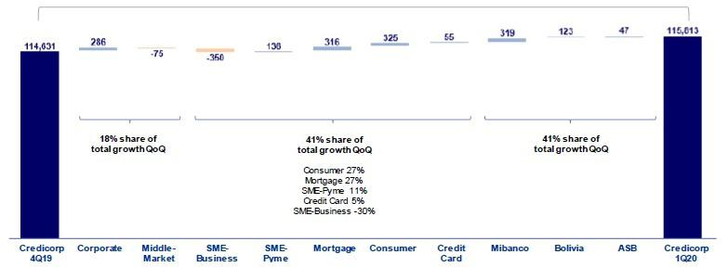

In the analysis by segment, QoQ growth in average daily balances reflects mixed results in a context marked by COVID-19 and by a seasonal effect that pressured loan growth downwards:

- In the Retail Banking portfolio, the Consumer and Mortgage segments posted good growth, followed by SME-Pyme and Credit Cards. However, the SME-Business segment registered a drop in QoQ terms due to the seasonal effect experienced in this part of the year.

- Growth in the microfinance portfolio, and, to a lesser extent, expansion in loans at BCP Bolivia.

- Within the Wholesale Banking portfolio, growth in Corporate Banking was attributable to an appreciation in the US Dollar given that FC loans account for 58% of total Wholesale Banking loans. The contraction in the Middle Market portfolio was even greater in real terms due to the translation effect given that 54% of all Middle Market loans are in FC.

Loan Growth YoY in Average Daily Balances

Expressed in millions of S/

+7.8% YoY
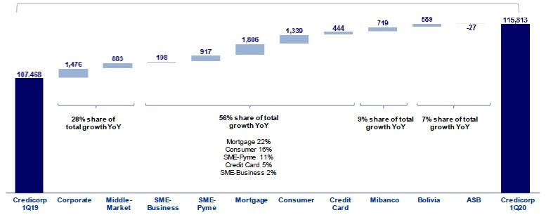

7

The analysis of YoY growth by segment, measured in average daily balances, reveals:

- Noteworthy growth in Retail Banking, led by expansion in the mortgage segment (+S/1,806 million, +12.0% YoY), which continued the upward climb reported in past quarters. Record growth for this segment was registered in 2019, fueled by market dynamism and Mivivienda loans.

- Other significant variations, which were registered in the Consumer segment (+S/1,339 million, +17.5% YoY), SME-Pyme (+S/917 million, +9.7%) and Credit Cards (+S/444 million, +8.4%) within Retail Banking and in the Corporate Banking (+S/1,476 million, +5.3%) and Middle Market Banking (+S/883 million, +5.0%) within Wholesale Banking. It is important to note the Corporate Banking and Middle Market Banking would have grown +3.5% (+971 million) and +3.3% (+585 million) respectively if we exclude the YoY dollar appreciation of +3.6%.

- Growth in Mibanco loans (+7.3% YoY), which reflects the bank’s strategy to grow its portfolio and remain focused on financial inclusion (new clients in the System) while meeting the needs of existing clients, many of whom face adversity due to the global spread of COVID-19. This phenomenon has hit microbusinesses particularly hard.

- Growth of +8.3% YoY in loans at BCP Bolivia. This evolution was primarily attributable to expansion in the Retail portfolio, which was led by the Mortgage segment (regulated portfolio) followed by the Consumer segment. Wholesale Banking also contributed to YoY growth, although to a lesser extent. Expansion in this portfolio was led by Middle Market banking, followed by Corporate Banking.

1.2.2. Evolution of the level of dollarization by segment

Loan evolution by currency - average daily balances ⁽¹⁾⁽²⁾

 |  |  | DOMESTIC CURRENCY LOANS |  |  |  |  |  |  |  |  |  |  |  |  |  |  | FOREIGN CURRENCY LOANS |  |  |  |  |  |  |  |  |  |  |  | % part. by currency
 |  |  |  | Expressed in million S/ |  |  |  |  |  |  |  |  |  |  |  |  |  | Expressed in million US$ |  |  |  |  |  |  |  |  |  |  |  | 1Q20
 | 1Q19 |  |  | 4Q19 |  | 1Q20 |  | QoQ |  |  |  | YoY |  |  |  | 1Q19 |  | 4Q19 |  | 1Q20 |  | QoQ |  |  |  | YoY |  |  |  | LC |  |  | FC
BCP Stand-alone | 54,956 |  |  | 60,870 |  | 60,854 |  | 0.0% |  |  |  | 10.7% |  |  |  | 9,963 |  | 10,000 |  | 10,009 |  | 0.1% |  |  |  | 0.5% |  |  |  | 64.0% |  |  | 36.0%
Wholesale Banking | 19,753 |  | 21,614 |  |  | 20,733 |  | -4.1% |  |  | 5.0% |  |  |  | 7,698 |  |  | 7,707 |  | 7,873 |  | 2.2% |  |  | 2.3% |  |  |  | 43.5% |  |  |  | 56.5%
Corporate | 11,551 |  | 12,854 |  |  | 12,186 |  |  | -5.2% |  | 5.5% |  |  |  | 4,857 |  |  | 4,775 |  | 4,959 |  |  | 3.9% |  |  |  | 2.1% |  | 41.8% |  |  |  | 58.2%
Middle-Market | 8,202 |  | 8,760 |  |  | 8,546 |  |  | -2.4% |  | 4.2% |  |  |  | 2,841 |  |  | 2,931 |  | 2,914 |  | -0.6% |  |  |  |  | 2.6% |  | 46.2% |  |  |  | 53.8%
Retail Banking | 35,203 |  | 39,257 |  |  | 40,122 |  | 2.2% |  |  | 14.0% |  |  |  | 2,265 |  |  | 2,293 |  | 2,136 |  | -6.9% |  |  | -5.7% |  |  |  | 84.6% |  |  |  | 15.4%
SME - Business | 2,490 |  | 2,695 |  |  | 2,624 |  | -2.6% |  |  | 5.4% |  |  |  | 834 |  |  | 928 |  | 828 |  |  | -10.8% |  | -0.7% |  |  |  | 48.1% |  |  |  | 51.9%
SME - Pyme | 9,161 |  | 9,982 |  |  | 10,104 |  | 1.2% |  |  |  |  | 10.3% |  | 76 |  |  | 63 |  | 66 |  | 4.2% |  |  | -13.3% |  |  |  | 97.8% |  |  |  | 2.2%
Mortgage | 12,477 |  | 14,249 |  |  | 14,698 |  |  | 3.1% |  |  |  | 17.8% |  | 790 |  |  | 698 |  | 646 |  |  | -7.5% |  |  |  | -18.3% |  | 86.9% |  |  |  | 13.1%
Consumer | 6,478 |  | 7,465 |  |  | 7,763 |  |  | 4.0% |  |  |  | 19.9% |  | 352 |  |  | 356 |  | 357 |  | 0.2% |  |  | 1.5% |  |  |  | 86.4% |  |  |  | 13.6%
Credit Card | 4,598 |  | 4,865 |  |  | 4,932 |  | 1.4% |  |  | 7.2% |  |  |  | 213 |  |  | 248 |  | 239 |  | -3.4% |  |  | 12.3% |  |  |  | 85.8% |  |  |  | 14.2%
Mibanco | 9,364 |  | 9,785 |  |  | 10,064 |  | 2.9% |  |  | 7.5% |  |  |  | 164 |  |  | 157 |  | 165 |  | 5.4% |  |  | 0.4% |  |  |  | 94.7% |  |  |  | 5.3%
Bolivia | - |  | - |  |  | - |  | - |  |  | - |  |  |  | 2,139 |  |  | 2,256 |  | 2,247 |  | -0.4% |  |  |  |  | 5.1% |  | - |  |  |  | 100.0%
ASB | - |  | - |  |  | - |  | - |  |  | - |  |  |  | 736 |  |  | 706 |  | 706 |  | 0.0% |  |  | -4.0% |  |  |  | - |  |  |  | 100.0%
Total loans | 64,320 |  | 70,655 |  |  | 70,919 |  | 0.4% |  |  | 10.3% |  |  |  | 13,002 |  |  | 13,119 |  | 13,127 |  | 0.1% |  |  | 1.0% |  |  |  | 61.2% |  |  |  | 38.8%



Highest growth in volumes
Largest contraction in volumes

- Figures differ from previously reported, please consider the data presented on this report.

- Includes Work out unit, and other banking.

The QoQ analysis of loan expansion by currency reveals that growth in LC was led by the Retail Banking segment and Mibanco. The evolution of Wholesale Banking, however, partially offset this growth. The Corporate Banking segment contributed positively to growth in the FC portfolio, which was partially offset by the evolution of the SME-Business and Mortgage segments within Retail Banking.

In the YoY evolution, the Wholesale Banking and Retail Banking segments and Mibanco contributed to growth in the LC portfolio. Within the portfolio denominated in FC, the Wholesale Banking portfolio and BCP Bolivia bolstered expansion, which was partially offset by the drop in balances in FC in the Mortgage segment.

8

YoY evolution of the level of dollarization by segment ⁽¹⁾⁽²⁾⁽³⁾
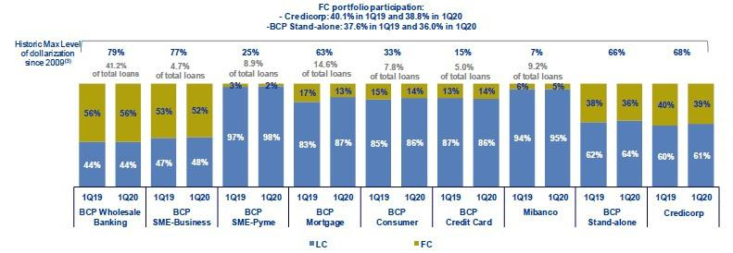

- Average daily balances.

- The FC share of Credicorp’s loan portfolio is calculated including BCP Bolivia and ASB, however the chart shows only the loan books of BCP Stand-alone and Mibanco.
- The year with the historic maximum level of dollarization for Wholesale Banking was 2012, for Mibanco was 2016 and for the rest of segments was 2009.

At BCP Stand-alone, the level of loan dollarization fell YoY to situate at 36%. Dollarization continued to follow a downward trend across segments, led by the Mortgage segment, where the level fell from 17% in March 2019 to 13% in March 2020. The aforementioned was attributable to the fact that a high percentage of mortgage loans were disbursed in FC and also reflects compliance with the dollarization targets set by the Central Bank.

It is important to note that, as is evident in the figure below, the percentage of the loan portfolio that is highly exposed to FX-risk on credit risk remains very low.

FX risk on credit risk – BCP Stand-alone
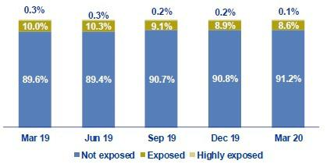

1.2.3. BCRP de-dollarization plan at BCP Stand-alone

At the end of 2014, BCRP set up a Program to reduce the dollarization level of the loan book in the Peruvian Banking System. As part of this Program, BCRP set some targets to reduce the loan balances in US Dollars progressively at the end of June 2015, December 2015, December 2016, December 2017, December 2018 and December 2019. Nevertheless, for the remainder of 2020, BCRP has suspended the requirement for additional reserves for FC loans and consequently suspended the reduction targets for loan balances in FC. BCRP’s decisions were driven by the need to shore up the financial system’s liquidity to mitigate the impact of the COVID-19 crisis on all fronts.

9

1.2.4. Market share in loans

Market share in Peru⁽¹⁾
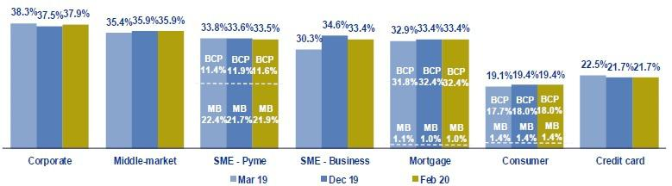

(1) Market shares are different that previously reported because now includes non-performing loans in the sample.

Peruvian Financial System

At the end of February 2020, BCP Stand-alone continued to lead the Peruvian financial market (1) with a market share (MS) of 28.8, which topped the 17.7% posted by its closest competitor. Mibanco’s MS of the total financial system was situated at 3.2%, which was similar to the figures posted for 4Q19 and 1Q19.

Within Wholesale Banking, Corporate Banking registered an advance of +40 bps in its MS versus the figure posted in 4Q19. Middle Market Banking’s MS, on the other hand, held steady at 35.9%. In the YoY evolution, Corporate Banking registered a -40 bps decline in its MS while Middle Market Banking reported a +50 bps increase in its MS. It is important to note that these BCP segments continue to lead their respective markets.

In Retail Banking, BCP continued to lead the market in the Mortgage segment (+0 bps QoQ and +60 bps YoY) and in SME-Business (-120 bps QoQ and +310 bps YoY). In the Consumer and Credit Card segments, BCP was situated second in both markets.

In the SME-Pyme segment, Mibanco continued to lead the pack with an MS of 21.9%, which topped the MS registered in 4Q19 of 21.7% but fell below the 22.4% reported in 1Q19 due to a highly competitive context for microlending in 2019. BCP continued to rank second in the microlending segment with an MS of 11.6%.

Bolivian Financial System

Finally, BCP Bolivia’s MS remained at the levels recorded last quarter and for the previous year. The subsidiary continues to rank fifth in the Bolivian financial system with a market share of 9.4%.

10

- Funding Sources

In 1Q20, total funding increased +7.0% QoQ and +13.6% YoY. Growth was primarily attributable to an increase in Deposits and obligations, which reported expansion in their share of total funding. This was driven mainly by growth in the volume of demand deposits, primarily non-interest bearing, and savings deposits, which constitute lowest-cost sources of funding. Within other sources of funding, the highest growth was seen in Due to banks and correspondents. The funding mix and the rate effect contributed to a contraction of -17 bps QoQ and -25 bps YoY in Credicorp’s funding cost.

Funding |  |  |  | As of |  |  |  | % change
S/ 000 |  | Mar 19 |  | Dec 19 |  | Mar 20 |  | QoQ |  |  | YoY
Demand deposits |  | 31,695,558 |  | 34,213,188 |  | 38,746,287 |  | 13.2% |  |  | 22.2%
Saving deposits |  | 32,968,147 |  | 35,179,770 |  | 37,872,908 |  | 7.7% |  |  | 14.9%
Time deposits |  | 31,399,811 |  | 34,034,037 |  | 35,045,214 |  | 3.0% |  |  | 11.6%
Severance indemnity deposits |  | 7,074,344 |  | 7,897,199 |  | 7,204,922 |  | -8.8% |  |  | 1.8%
Interest payable |  | 589,397 |  | 681,191 |  | 694,214 |  | 1.9% |  |  | 17.8%
Deposits and obligations |  | 103,727,257 |  | 112,005,385 |  | 119,563,545 |  | 6.7% |  |  | 15.3%
Due to banks and correspondents |  | 7,219,120 |  | 8,841,732 |  | 9,854,630 |  | 11.5% |  |  | 36.5%
BCRP instruments |  | 4,984,192 |  | 4,381,011 |  | 5,346,373 |  | 22.0% |  |  | 7.3%
Repurchase agreements |  | 2,324,385 |  | 1,820,911 |  | 1,935,879 |  | 6.3% |  |  | -16.7%
Bonds and notes issued |  | 15,472,882 |  | 14,946,363 |  | 15,197,237 |  | 1.7% |  |  | -1.8%
Total funding |  | 133,727,836 |  | 141,995,402 |  | 151,897,664 |  | 7.0% |  |  | 13.6%

2.1. Funding Structure

Evolution of the funding structure and cost – BAP

(S/ billions)
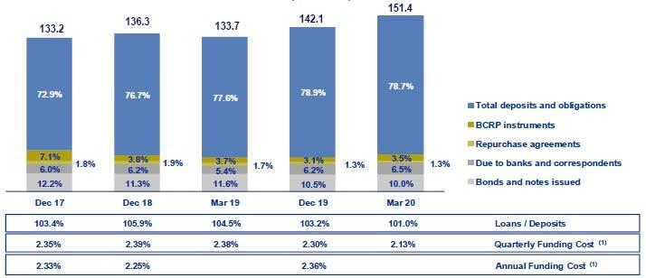

  - Figures differ from previously reported due to the implementation of IFRS 19, where financing expenses related to lease agreements are included. The figure depicting the Evolution of Credicorp’s structure and funding cost is calculated with period-end balances. In general, the funding structure reflects:

- The on-going growth in deposits, the main source of funding, which imply lower costs than other funding sources. The share of deposits in total funding increased considerably YoY to situate at 78.7% (vs 77.6% in Mar 19). This growth was due to an increase in the volume of all deposit types, which reflects expansion of +15.3% YoY.

- Within the deposit mix, demand deposits and savings deposits reported significant growth at the end of Mar 20, increasing their share of total deposits to 64.1% (vs 62.0% in Dec 19 and 62.3% in Mar 19). Both deposit types offer the lowest costs within the mix of deposits.

11

- Expansion of +7.8% QoQ and YoY in Other funding sources, which was mainly attributable to an increase in the volume of Due to banks and correspondents (+11.5% QoQ and +36.5% YoY) and BCRP Instruments (+22.0% QoQ and +7.3% YoY), which we will explain further in section 2.3 Other sources of funding.

2.2. Deposits

Deposits and obligations |  |  |  | As of |  |  |  | % change
S/ 000 |  | Mar 19 |  | Dec 19 |  | Mar 20 |  | QoQ |  |  | YoY
Demand deposits |  | 31,695,558 |  | 34,213,188 |  | 38,746,287 |  | 13.2% |  |  | 22.2%
Saving deposits |  | 32,968,147 |  | 35,179,770 |  | 37,872,908 |  | 7.7% |  |  | 14.9%
Time deposits |  | 31,399,811 |  | 34,034,037 |  | 35,045,214 |  | 3.0% |  |  | 11.6%
Severance indemnity deposits |  | 7,074,344 |  | 7,897,199 |  | 7,204,922 |  | -8.8% |  |  | 1.8%
Interest payable |  | 589,397 |  | 681,191 |  | 694,214 |  | 1.9% |  |  | 17.8%
Deposits and obligations |  | 103,727,257 |  | 112,005,385 |  | 119,563,545 |  | 6.7% |  |  | 15.3%

Deposits and obligations expanded +6.7% QoQ. The QoQ evolution of the deposit mix shows:

- The increase in demand deposits, which represents 60% of the growth in total deposits, was primarily due to increase in volume from Wholesale Banking clients at BCP Stand-alone, who increased their demand for liquidity, and in a lesser extent, to the evolution at ASB, due to the transfer of client balances to their accounts, to reduce the exposure of their investment portfolios due to the market volatility. This evolution reflects the impact of COVID-19 and a variation in the exchange rate, exercising a preponderant effect on FC deposits, given that volumes in FC represent 57% of the total volume and 65% of the increase of demand deposits.

- Growth in savings deposits, which increased +7.7% QoQ due to higher volumes in LC (which accounted for 67% of the increase). This expansion was due to (i) profit sharing and/or bonuses for individual persons with savings accounts at BCP Stand-alone or Mibanco in the month of March, (ii) the obligatory lockdown established by the Peruvian government since March 15th, and (iii) an increase in the number of savings accounts opened through cost-efficient channels (Kiosko and Vía BCP). These channels represent 41% of total account openings (vs 34% in 4Q19).

- The increase in the volume of time deposits at (i) BCP Stand-alone after more time deposits were opened in February through Wholesale Banking (especially at Corporate Banking), after competitive rates were offered for professional funding, and (ii) BCP Bolivia, due to a strategy to capture more stable deposits in the medium term.

- The contraction in severance indemnity deposits due to (i) the measure implemented by the Ministry of Economy and Finance in March, which allowed independent workers to withdraw up to S/2,400 from their accounts to cover liquidity needs due to the impact of COVID-19, and
  - seasonality every 1Q, where employees tend to withdraw funds after the second yearly severance payment is made in the month of November.

In YoY terms, total deposits and obligations registered growth in all types of deposits, which translated into an increase of +15.3% in the main source of funding, which was primarily due to:

- The increase in demand deposits due to growth in the volume of non-interest bearing demand deposits (+20.0%), which was primarily attributable to current accounts held by Corporate Banking clients at BCP Stand-alone and mainly driven by FC (represents 60% of the total increase in demand deposits).

- Growth in savings deposits due to (i) a drop in the consumption level of individual persons through credit and debit cards due to the quarantine imposed to control the COVID-19 contagion, and (ii) the results of the campaigns to capture savings accounts, mainly through digital channels, which have registered high levels of acceptance of and use by BCP Stand-alone’s clients.

12

- +11.6% increase in time deposits, in line with the QoQ analysis, mainly driven by volumes in FC (represent 70% of the increase in time deposits).

2.2.1. Deposits: dollarization level

Dollarization Level of Deposits ⁽¹⁾ – BAP
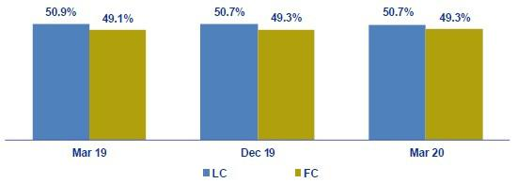

(1) Q-end balances.

Credicorp – Deposit Dollarization measured in quarter-end balances
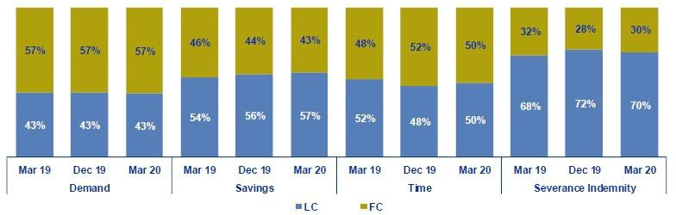

The dollarization level of Credicorp’s deposits remained stable QoQ after volumes in LC and FC grew at proportional levels, posting increases of +6.7% and +6.8% respectively.

Growth in LC volumes was due primarily to savings deposits, demand deposits (particularly non-interest bearing deposits), and to a lesser extent, to time deposits. The expansion in FC volumes was attributable primarily to demand deposits via non-interest bearing demand deposits and to a lesser extent, to savings deposits. The increase in savings deposits was mainly attributable to accounts opened by individual persons while growth in demand deposits was associated with institutional clients in Wholesale Banking at BCP Stand-alone in both LC and FC.

The YoY evolution reveals slight growth in the dollarization level (+20 bps), which was attributable to +15.8% growth in FC, which outpaced the increase of +14.8% registered in LC. The aforementioned was driven by an increase in all types of FC deposits, with the exception of severance indemnity deposits. The largest contributor to growth in FC were demand deposits (+23.6%), led by non-interest bearing deposits (which represent 40% of the total increase in FC deposits) and time deposits (+17.0%). In the case of LC deposits, all deposits types increased, mainly driven by savings deposits (accounts 47% of total increase in LC deposits).

All of the aforementioned is aligned with the objective to maintain an adequate balance between assets and liabilities by currency in accordance with Credicorp’s appetite for risk.

13

2.2.2. Market share in Deposits

Market share in Peru
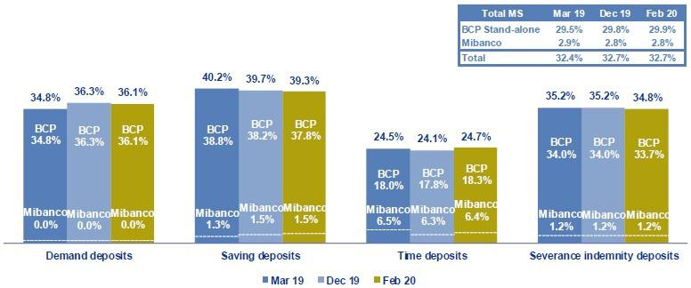

Source: SBS

(1) Figures may not add due to rounding.

Peruvian Financial System

At the end of Feb 20, the subsidiaries of Credicorp in Peru, BCP Stand-alone and Mibanco, reported market shares (MS) of 29.9% and 2.8% respectively. Consequently, Credicorp continued to rank first in the financial system for total deposits, with an MS that was significantly higher than its closest competitor (which has an MS of 19.0%).

In the YoY analysis, BCP Stand-alone’s MS increased +40 bps with regard to the figure at the end of Mar 19. This was primarily attributable to an increase in the share of demand deposits (+130 bps). Mibanco’s market share (MS), however, fell YoY (2.8% Feb 20 vs 2.9% Mar 19) due to a slight contraction in the MS of time deposits, which fell -10 bps.

Bolivian Financial System

BCP Bolivia continued to rank fifth in the Bolivian financial system with an MS of 9.7% at the end of Mar 20 versus 9.8% at the end of Dec 19. In the YoY analysis, the MS fell slightly at the end of Mar 19 (9.9%).

2.3. Other funding sources

Other funding sources |  |  |  | As of |  |  |  |  | % change
S/ 000 |  | Mar 19 |  | Dec 19 |  | Mar 20 |  | QoQ |  |  |  | YoY
Due to banks and correspondents |  | 7,219,120 |  | 8,841,732 |  | 9,854,630 |  |  | 11.5% |  |  | 36.5%
BCRP instruments |  | 4,984,192 |  | 4,381,011 |  | 5,346,373 |  |  | 22.0% |  |  | 7.3%
Repurchase agreements |  | 2,324,385 |  | 1,820,911 |  | 1,935,879 |  |  | 6.3% |  |  | -16.7%
Bonds and notes issued |  | 15,472,882 |  | 14,946,363 |  | 15,197,237 |  |  | 1.7% |  |  | -1.8%
Total other funding sources |  | 30,000,579 |  | 29,990,017 |  | 32,334,119 |  |  | 7.8% |  |  | 7.8%

The total of Other funding sources increased +7.8% QoQ due to an increase in the volume of all Other sources of funding. This expansion was primarily attributable to an increase in the level of Due to banks and correspondents and of BCRP Instruments, which combined represented 84% of the increase of these sources of funding.

Due to banks and correspondents registered an increase in the level of obligations at (i) ASB, due to a single short term operation to cover liquidity measures, and to a lesser extent, at (ii) Mibanco, due to new debts with companies in the national financial system and with COFIDE, in LC, and at (iii) BCP Stand-alone, due to new operations with foreign financial institutions, in FC. It is important to note that 61% of this line is denominated in FC and as such, was impacted by the upward trend in the valuation of the US Dollar.

14

Growth in BCRP Instruments was attributable to new Certificates of Deposits (CDs) agreements and an increase in regular repos at BCP Stand-alone in March, after the bank took advantage of the attractive rates offered through BCRP lending operations. BCRP’s objective was to provide short-term liquidity to companies impacted by COVID-19.

Repurchase agreements increased primarily attributable to new interbank repurchase agreements at BCP Bolivia and to a lesser extent, at ASB, both in FC.

Bonds and issued notes registered growth after a corporate bond was issued at BCP Stand-alone in February. Growth in this line was also attributable to a variation in the exchange rate given that 75% of the total volume of this line is in FC and 100% of the increase was in FC.

In the YoY evolution, Other sources of funding rose +7.8%, which was primarily attributable to an increase in the level of Due to banks and correspondents, which accounted for 88% of total growth in this line.

2.4. Loan / Deposit (L/D)

Loan / Deposit Ratio by Subsidiary
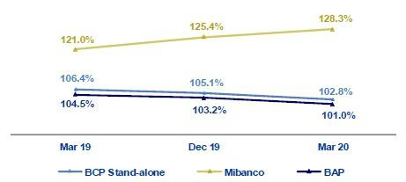

The L/D ratio at Credicorp fell QoQ to 101.0%. This was attributable the fact that growth in deposits (+6.7%) outpaced the expansion registered for loans (+4.4%).

The analysis by subsidiary followed the same trend as that seen for BCP Stand-alone (102.8% Mar 20 vs 105.1% Dec 19). The QoQ drop in the L/D at BCP Stand-alone arose when growth in the deposit volume (+7.8%) outpaced the expansion in loans (+5.4%). The aforementioned was primarily driven by the increase in the level of demand deposits and savings deposits. In the case of Mibanco, QoQ growth in the L/D was attributable to a -2.2% drop in deposits.

In the YoY analysis, the L/D ratio at Credicorp and its subsidiaries reflects the same dynamism as that seen in the QoQ analysis. At the Credicorp level, on-going growth in deposits exceeded the expansion posted for loans (+15.3% vs +11.4%, respectively).

15

Loan / Deposit Ratio by Currency

Local Currency Foreign Currency
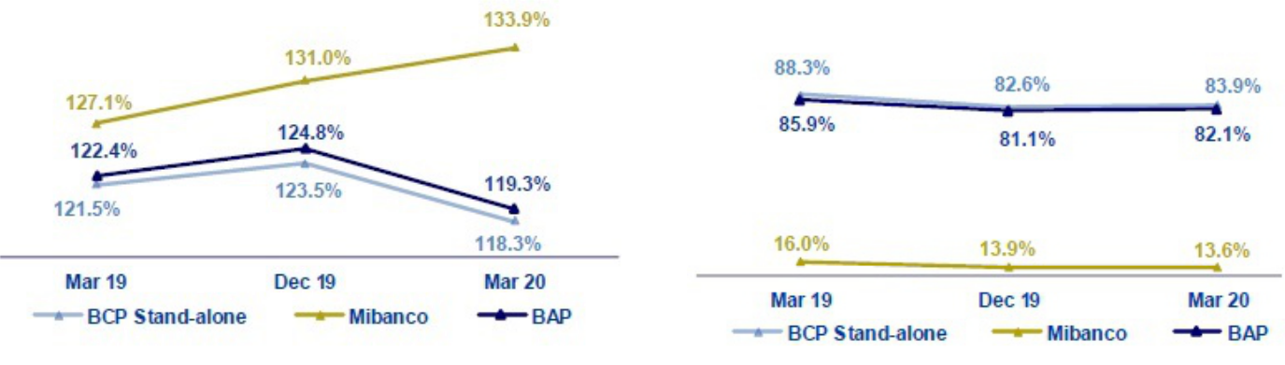

The QoQ analysis by currency shows a reduction in the L/D ratio in LC at Credicorp, which was in line with higher growth in LC deposits, mainly driven by demand deposits and savings deposits through BCP Stand-alone. The L/D in FC at Credicorp registered growth of 100 bps QoQ after the increase in loans (+8.2%) outpaced the expansion registered for deposits (+6.8%). The aforementioned was driven by the fact that loan growth in FC (+9.9%) exceeded the expansion posted for FC deposits (+8.2%) at BCP Stand-alone.

In the YoY analysis, the L/D ratio in LC and FC fell after the increase posted by both currencies outpaced the growth reported for loans.

2.5. Funding Cost

Funding Cost – Credicorp ^{(1,2)}
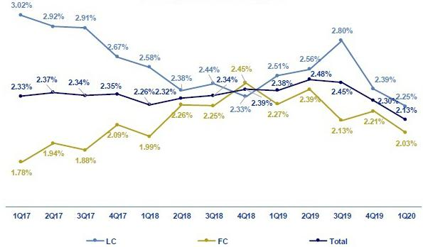

- The funding cost by currency is calculated with the average of period-beginning and period-end balances.

- Figures differ from previously reported due to the implementation of IFRS 16, where financing expenses related to lease agreements are included.

16

The funding cost at Credicorp fell QoQ and YoY. The QoQ evolution shows:

- The contraction in the funding cost in FC (-18 bps), which was due primarily to a drop in interest expenses on bonds and issued notes, which accounted for 80% of the total decrease in FC expenses. The aforementioned was a product of BCP Stand-alone’s liability management at lower rates at the end of last year.

- The drop in the total funding cost (-17 bps) was primarily attributable to a decrease in expenses for all sources of funding as international rates continued to follow a downward trend. In addition, the total funding mix has improved due to an increase in the volume of low-cost sources of funding, such as deposits.

- The drop in the funding cost in LC (-14 bps) was due primarily to an increase in the total volume of funding in LC (denominator of the calculation), which grew 6.6%, while interest expenses dropped 0.1% due to lower expenses from due to banks and correspondents.

The YoY analysis shows a -25 bps decrease in the total funding cost, which was attributable to:

- A more favorable deposit mix given that lower-cost deposits, such as demand deposits and savings deposits, posted the highest growth (+22.2% and +14.9% respectively). Additionally, due to the currency mix, where growth in FC deposits outpaced that attributable to LC.

- The recomposition of the funding structure, where deposits registered a significant increase in their share of total funding (going from 77.6% in 1Q19 to 78.7% in 1Q20). In this context, deposits represented 83% of the total increase in funding.

- The reduction in national and international interest rates, which led to a drop in the funding cost of all funding sources.

The cost of funding by subsidiary is depicted in the following figure:

Funding Cost by subsidiary– Credicorp ⁽¹⁾
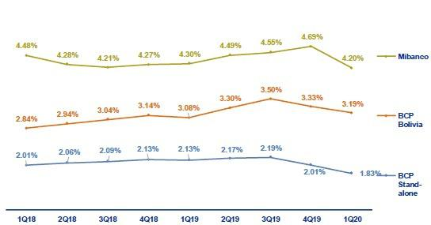

- Figures differ from previously reported due to the implementation of IFRS 16, where financing expenses related to lease agreements are included.

  - The funding cost at BCP Stand-alone followed the same trend as the funding cost at Credicorp, which reflected a contraction QoQ and YoY that was primarily attributable to (i) the funding mix, which reported higher volumes of deposits (which represent 85% of the increase in funding YoY), (ii) an improvement in the deposit mix where demand deposits and savings deposits registered the most significant increases (represented 92% of the growth in total deposits YoY), and (iii) the rate effect, due to high exposure to lower international rates (50% of funding is in FC).

  - The funding cost at Mibanco registered a considerable contraction QoQ and YoY. In the QoQ analysis, interest expenses fell due to drop-in expenses for leasing. In the YoY analysis, the reduction was attributable to a decrease in financial expenses for (i) bonds and issued notes, which reported a drop-in volume (-63%), and, to a lesser extent, (ii) deposits, due to a decrease in the level of the most expensive deposits, such as time deposits (-3%), which were replaced by savings deposits (retail).

  - The funding cost at BCP Bolivia fell QoQ, which was primarily due to a denominator effect given that funding growth outpaced expenses (+9.3% vs +5.5%, respectively). YoY, the funding cost increased due to the effect of both the volume and mix, where time deposits registered the highest growth.

17

- Portfolio quality and Provisions for loan losses

The Cost of Risk (CofR) at Credicorp increased significantly QoQ and YoY. This was attributable to expectations that Peru and the region will enter a recession and to a decrease in the debt service capacity of some clients due to the global impact of COVID-19. The aforementioned led to a significant increase in provisions for loan losses for all segments at each subsidiary. The total impact will be felt throughout the year. In terms of the portfolio’s quality ratios, the NPL ratio deteriorated due to a degree of deterioration in the SME-Pyme and Credit Card segments; nevertheless, this has been attenuated by the measures taken by the government and Credicorp to mitigate damage to the economy and clients respectively. In this context, the coverage ratio for NPL loans rose from 109.7% in 1Q19 to 126.1% in 1Q20..

Quarterly evolution of the Cost of Risk (bps)
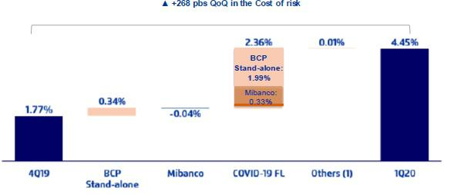

(1) Includes BCP Bolivia, Encumbra, Bancompartir, ASB and eliminations for consolidation purposes
3.1. Provisions for loan losses
Provision for credit losses on loan portfolio, net of
recoveries |  |  |  | Quarter |  |  |  | % change
S/ 000 |  | 1Q19 |  | 4Q19 |  | 1Q20 |  | QoQ |  |  | YoY
Gross provision for credit losses on loan portfolio |  | (453,285) |  | (568,727) |  | (1,388,711) |  | 144.2% |  |  | 206.4%
Recoveries of written-off loans |  | 70,074 |  | 57,067 |  | 47,230 |  | -17.2% |  |  | -32.6%
Provision for credit losses on loan portfolio, net of
recoveries |  | (383,211) |  | (511,660) |  | (1,341,481) |  | 162.2% |  |  | 250.1%

Net provisions for loan losses after recoveries increased significantly QoQ and YoY, in line with expectations of a recession in Peru and the region and with the reduction in the debt service capacity of some clients due to COVID-19. Credicorp and the government have taken different measures to attenuate the deterioration in the situation of clients and the economy respectively. Credicorp has offered its clients the following facilities:

- BCP has offered its clients in Retail Banking the opportunity to reschedule their loans for 30 or 90 days without incurring in overdue fees and interest on capital.

- Mibanco has also offered loan extension to some clients with a grace period of up to 6 months, which includes interest on capital.

- In April both subsidiaries have granted clients the option to postpone payments in April and May without incurring additional interest.

These benefits have been granted without affecting clients’ risk ratings.

18

The aforementioned attenuated the provisions for credit losses on loan portfolio, net of recoveries; nevertheless, there were several factors that could not be offset and will continue to affect that portfolio throughout the year:

- Changes in macroeconomic expectations due to COVID-19: the change in the expectations for a recession in the Peruvian economy impact is specific to this quarter in the framework of expected losses. Nevertheless, provisions may increase if expectations continue to deteriorate.

- Portfolio deterioration: various clients have been affected by a stoppage in their operations or sales due to the lockdown. This was reflected mainly in the retail segment at BCP Stand-alone, and was particularly marked in the SME-Pyme, credit card, consumer and mortgage segments.

The impact of COVID-19 on the Middle-Market and SME-Business portfolios will be attenuated by the Reactiva Peru loan program offered by the Peruvian government. Through this effort, eligible companies will receive loans backed by government guarantees with coverage rates between 80%-98%. Additionally, through the Enterprise Support Fund (FAE) we will be able to provide loans to the SME-Pyme segment and Mibanco, where loans will be backed by government guarantees for 90%-98% of the total amount.

Finally, provisions at BCP Stand-alone increased on top of provisions related to COVID-19, mainly attributable to deterioration in the SME-Pyme segment, and in non-revolving loans in particular, and to a lesser extent, to the deterioration of the Credit card segment, which reflected over indebtedness in the financial system.

Cost of risk
 |  |  |  | Quarter |  |  |  | % change
Cost of risk and Provisions |  | 1Q19 |  | 4Q19 |  | 1Q20 |  | QoQ |  |  | YoY
Cost of risk ⁽¹⁾ |  | 1.41% |  | 1.77% |  | 4.45% |  | 268 bps |  |  | 304 bps
Provision for credit losses on loan portfolio, net of recoveries /
Net interest income |  | 17.4% |  | 21.6% |  | 56.4% |  | 3480 bps |  |  | 3890 bps

- Annualized Provision for credit losses on loan portfolio, net of recoveries / Total loans.

Due to the scenario outlined above, Credicorp’s CofR increased 268 bps QoQ and 304 bps YoY.

3.2. Portfolio Quality: Delinquency ratios
Portfolio quality and Delinquency ratios |  |  |  | As of |  |  |  | % change
S/ 000 |  | Mar 19 |  | Dec 19 |  | Mar 20 |  | QoQ |  |  | YoY
Total loans (Quarter-end balance) |  | 108,350,384 |  | 115,609,679 |  | 120,708,515 |  | 4.4% |  |  | 11.4%
Allowance for loan losses |  | 4,862,801 |  | 5,070,279 |  | 5,931,772 |  | 17.0% |  |  | 22.0%
Write-offs |  | 433,231 |  | 509,571 |  | 519,866 |  | 2.0% |  |  | 20.0%
Internal overdue loans (IOLs) ⁽¹⁾ |  | 3,153,187 |  | 3,297,791 |  | 3,579,504 |  | 8.5% |  |  | 13.5%
Internal overdue loans over 90-days ⁽¹⁾ |  | 2,263,777 |  | 2,479,940 |  | 2,239,789 |  | -9.7% |  |  | -1.1%
Refinanced loans |  | 1,278,459 |  | 1,182,797 |  | 1,125,394 |  | -4.9% |  |  | -12.0%
Non-performing loans (NPLs) ⁽²⁾ |  | 4,431,646 |  | 4,480,588 |  | 4,704,898 |  | 5.0% |  |  | 6.2%
IOL ratio |  | 2.91% |  | 2.85% |  | 2.97% |  | 12 bps |  |  | 6 bps
IOL over 90-days ratio ⁽³⁾ |  | 2.09% |  | 2.15% |  | 1.86% |  | -29 bps |  |  | -23 bps
NPL ratio |  | 4.09% |  | 3.88% |  | 3.90% |  | 2 bps |  |  | -19 bps
Coverage ratio of IOLs |  | 154.2% |  | 153.7% |  | 165.7% |  | 1200 bps |  |  | 1150 bps
Coverage ratio of IOL 90-days |  | 214.8% |  | 204.5% |  | 264.8% |  | 6030 bps |  |  | 5000 bps
Coverage ratio of NPLs |  | 109.7% |  | 113.2% |  | 126.1% |  | 1290 bps |  |  | 1640 bps

- Includes overdue loans and loans under legal collection. (Quarter-end balances)

- Non-performing loans include internal overdue loans and refinanced loans. (Quarter-end balances)

- Figures differ from previously reported, please consider the data presented in this report.

In terms of portfolio delinquency, it is important to note:

- Unlike provisions, the portfolio’s delinquency level was not impacted by COVID-19 as of March. This was attributable to Credicorp’s quick move to offer clients debt rescheduling or debt freezing facilities.

- The total IOL portfolio increased 8.5% QoQ and 13.5% YoY, mainly through Retail Banking , in particular in the SME-business segment after a small number of clients experienced a deterioration in their debt service capacity. These loans have been correctly provisioned but cannot be written off given that they have guarantees. Additionally, the SME-PYME segment registered an increase, which was primarily attributable to a deterioration in revolving loans over the quarter.

- The NPL portfolio increased 5.0% QoQ and 6.2% YoY. This growth fell below that posted by the IOL portfolio due a 4.9% decrease QoQ and 12.0% YoY in the refinanced portfolio. QoQ, the reduction was mainly attributable to the retail banking segment while YoY, the result was driven by amortizations of refinanced loans for the construction sector in Wholesale Banking last quarter, which offset the increase in NPL loans in the SME-Pyme and Credit Card segments.

19

In this context, the delinquency ratios deteriorated QoQ. In YoY terms, however, the NPL ratio improved in 19 bps after loans grew 11.4%, offsetting the increase registered in the IOL portfolio.

The coverage ratios improved QoQ and YoY, in line with an increase in provisions due to COVID-19, which offset growth in the IOL and NPL portfolios.

Before analyzing the evolution of the delinquency indicators, it is important to note that:

- Traditional delinquency ratios (IOL and NPL ratios) continue to be distorted by the presence of loans with real estate collateral (commercial and residential properties). This means that a significant portion of loans that are more than 150 days past due cannot be written-off (despite the fact that provisions have been set aside) given that a judicial process must be initiated to liquidate the collateral, which takes five years on average.

- In the second half (2H) of every year, loans are more dynamic, particularly in the SME-Pyme and Mibanco segments given that the main campaigns (Christmas and year-end campaigns) are held in the second semester (2H) and these short-term loans are paid off in 1H of the following year

Delinquency Ratios
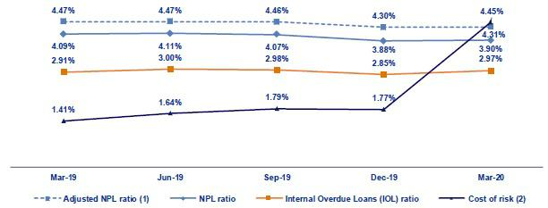

- Adjusted NPL ratio = (Non-performing loans+ Write-offs) / (Total loans + Write-offs).

- Cost of risk = Annualized provisions for loan losses net of recoveries / Total loans.

20

3.2.1. Delinquency indicators by business line

Wholesale Banking – Delinquency ratios
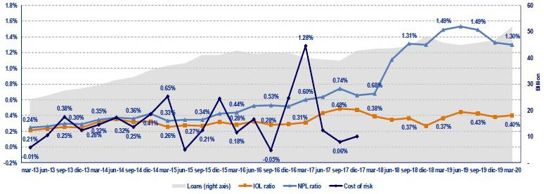

- The IOL ratio increased slightly QoQ and YoY after some clients in the Middle-Market segment experienced a deterioration in their debt service capacity; nevertheless, this was attenuated by loan growth. The NPL ratio registered an improvement YoY, in line with the amortization of refinanced loans, primarily in the construction sector, over the last quarter.

SME-Business – Delinquency ratios
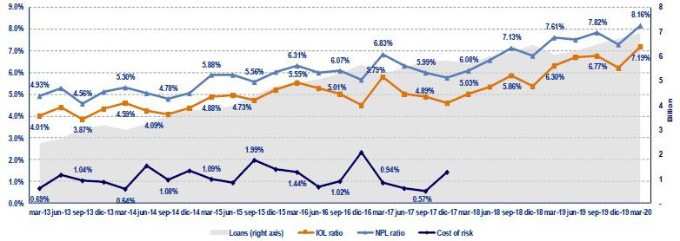

- The IOL and NPL ratios increased QoQ and YoY, which was primarily due to the deterioration in the debt service capacity of some clients. All of these loans are fully provisioned but are nonetheless covered by guarantees, which means they cannot be written off and subsequently removed from the IOL portfolio. It is important to note that this sector maintains credit quality indicators that are within the risk appetite defined by the organization. The objective is to maximize the portfolio’s profitability by striking an adequate balance between risk and growth.

21

SME - Pyme – Delinquency ratios
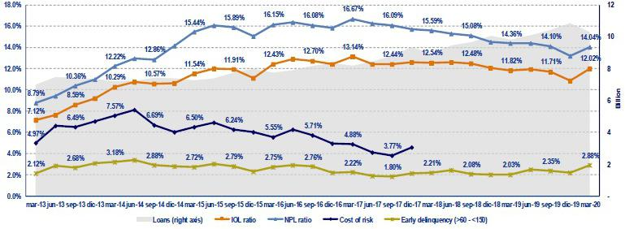

- In the SME-Pyme loan book, it is important to analyze the early delinquency ratio, which excludes loans that are overdue less than 60 days (volatile loans whose percentage of recovery is very high) and those overdue more than 150 days (loans that have been provisioned but which cannot be written off due to the existence of real estate collateral- commercial properties - that take five years on average to liquidate).

Traditional delinquency ratios increased QoQ and YoY, which was mainly attributable to a drop in the loan balance and to a lesser extent, to the deterioration seen since 2019 in revolving and long-term loans. Early delinquency also increased, which was primarily due to deterioration in revolving loans.

Mortgage – Delinquency ratios
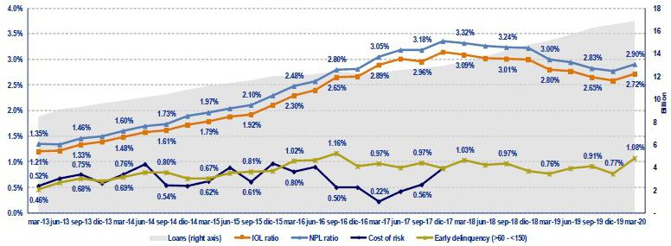

- With regard to mortgage loans, it is important to remember that these ratios are also affected by the existence of real estate collateral, where the recovery process is protracted (around 5 years) and as such, impedes the bank’s capacity to write-off loans even if the same are completely provisioned.

Traditional delinquency ratios increased QoQ, which was mainly driven by an increase in Mivivienda loans in 2019 and in 1Q20, which constitute riskier loans than the traditional mortgage portfolio. The YoY analysis reveals an improvement, which was mainly attributable to loan growth.

The early delinquency ratio, which excludes the effect of loans that are more than 150 days past due, increased QoQ and YoY. The aforementioned was attributable to an increase in loans through Mivivienda.

22

Consumer – Delinquency ratios
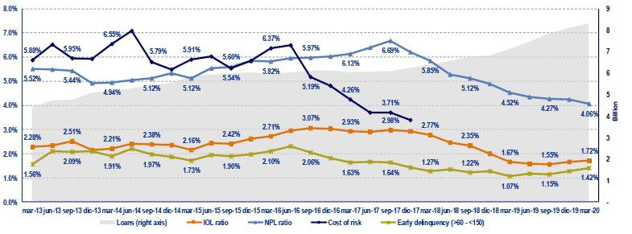

- The IOL ratio increased QoQ and YoY, which was primarily driven by deterioration in the debt service capacity of over-indebted clients in the financial system, which affected clients who are current and those with refinanced loans. NPL ratio decreased QoQ and YoY, given that loan growth offset growth in the NPL portfolio.

The early delinquency ratio increased QoQ and YoY, in line with deterioration in the debt service capacity of over-indebted clients in the financial system.

Credit Card – Delinquency ratios
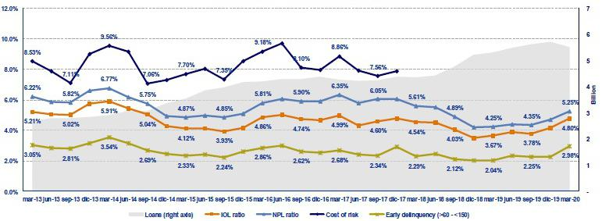

- The Credit Card segment registered an increase QoQ and YoY in its delinquency ratios. This growth began last year and coincides with an increase in per capita indebtedness in the Peruvian financial system.

23

Mibanco – Delinquency ratios

- The IOL and NPL ratios remained stable QoQ, given that loan growth offset the expansion in the IOL portfolio. In the YoY analysis, the IOL portfolio increased, in line with a drop in write off loans in 2019. The NPL ratio, on the other hand, fell due to an improvement in new loan acceptances since the beginning of 2019, which has led to a decrease in refinanced loans.

The cost of risk increased significantly QoQ and YoY, which reflects the impact of COVID-19 on the loan portfolios as indicated in section 3.1 Net provisions for loan losses.

BCP Bolivia – Delinquency ratios
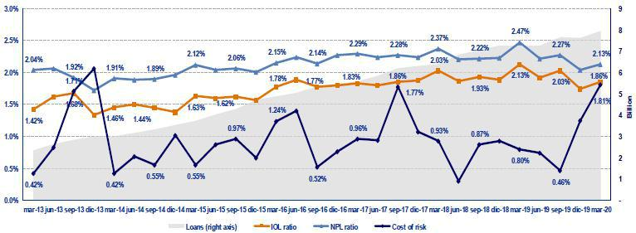

- BCP Bolivia reported deterioration QoQ, which was driven by deterioration in the SME-Pyme segment due to the political juncture in play since 3Q19. The IOL and NPL portfolios posted an improvement YoY after overdue loans were written off in 2019.

The cost of risk deteriorated QoQ and YoY, which was mainly attributable to provisions that were set aside in the context of COVID-19, which has generated a change in macroecomic expectations for Bolivia and in the debt service capacity of BCP Bolivia’s clients.

24

4. Net Interest Income (NII)

In 1Q20, NII, the main component of income, increased +0.6% QoQ and +8.3% YoY, while average interest-earning assets increased +3.2% QoQ and +9.1% YoY. The aforementioned led to a decrease of -14bps QoQ and -4pbs YoY. These results were attributable to the advent of a more favorable funding structure, which led to a decrease in interest expenses of -2.9% QoQ and -2.5% YoY and offset the QoQ contraction in interest income. Nevertheless, this reduction was insufficient to offset growth in average interest-earning assets. Risk-adjusted NIM contracted -197pbs QoQ and -212bps YoY due to: an increase in the cost of risk after a material change affected expectations for economic growth in Peru in the framework of the COVID-19 pandemic and the subsequent measures enacted by the Peruvian government to slow its advance.

Net interest income |  |  |  |  |  | Quarter |  |  |  |  |  | % change
S/ 000 |  |  | 1Q19 |  |  | 4Q19 |  |  | 1Q20 |  |  | QoQ |  |  |  | YoY
Interest income |  |  | 3,001,674 |  |  | 3,172,695 |  |  | 3,163,609 |  |  | -0.3% |  |  |  | 5.4%
Interest on loans |  |  | 2,562,286 |  |  | 2,768,468 |  |  | 2,770,351 |  |  | 0.1% |  |  |  | 8.1%
Dividends on investments |  |  | 9,667 |  |  | 3,764 |  |  | 7,879 |  |  | 109.3% |  |  |  | -18.5%
Interest on deposits with banks |  |  | 86,699 |  |  | 68,813 |  |  | 49,113 |  |  | -28.6% |  |  |  | -43.4%
Interest on securities |  |  | 332,788 |  |  | 311,414 |  |  | 322,734 |  |  | 3.6% |  |  |  | -3.0%
Other interest income |  |  | 10,234 |  |  | 20,236 |  |  | 13,532 |  |  | -33.1% |  |  |  | 32.2%
Interest expense |  |  | 804,506 |  |  | 807,869 |  |  | 784,309 |  |  | -2.9% |  |  |  | -2.5%
Interest on deposits |  |  | 353,834 |  |  | 367,257 |  |  | 364,107 |  |  | -0.9% |  |  |  | 2.9%
Interest on borrowed funds |  |  | 145,303 |  |  | 141,552 |  |  | 137,126 |  |  | -3.1% |  |  |  | -5.6%
Interest on bonds and subordinated notes |  |  | 226,498 |  |  | 209,238 |  |  | 198,114 |  |  | -5.3% |  |  |  | -12.5%
Other interest expense ⁽¹⁾⁽³⁾ |  |  | 78,871 |  |  | 89,822 |  |  | 84,962 |  |  | -5.4% |  |  |  | 7.7%
Net interest income ⁽¹⁾⁽³⁾
 |  |  | 2,197,168 |  |  | 2,364,826 |  |  | 2,379,300 |  |  | 0.6% |  |  |  | 8.3%
Risk-adjusted Net interest income ⁽¹⁾⁽³⁾
 |  |  | 1,813,957 |  |  | 1,853,166 |  |  | 1,037,819 |  |  | -44.0% |  |  |  | -42.8%
Average interest earning assets |  |  | 162,988,747 |  |  | 172,406,741 |  |  | 177,868,854 |  |  | 3.2 | % |  |  | 9.1 | %
Net interest margin ⁽¹⁾⁽²⁾⁽³⁾ |  |  | 5.39% |  |  | 5.49% |  |  | 5.35% |  |  | -14bps |  |  |  | -4bps
NIM on loans ⁽¹⁾⁽²⁾⁽³⁾ |  |  | 7.38% |  |  | 7.85% |  |  | 7.61% |  |  | -24bps |  |  |  | 23bps
Risk-adjusted Net interest margin ⁽¹⁾⁽²⁾⁽³⁾ |  |  | 4.45% |  |  | 4.30% |  |  | 2.33% |  |  | -197bps |  |  |  | -212bps
Net provisions for loan losses / Net interest income ⁽¹⁾⁽²⁾⁽³⁾ |  |  | 17.44% |  |  | 21.64% |  |  | 56.38% |  |  | 3474bps |  |  |  | 3894bps

- Figures differ from previously reported, please consider the data presented on this report.

- Annualized.

- Figures differ from those presented previously

4.1. Interest Income

Interest Income - LC

(S/ millions)

Interest Income – FC

(S/ millions)
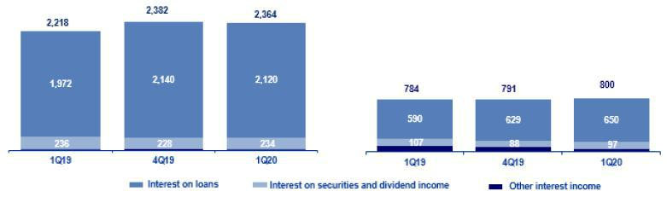

In the QoQ analysis, the -0.3% drop in Interest Income was primarily attributable to a contraction of -28.6% in interest on deposits in other banks after international interest rates fell. This decline was also associated, albeit to a lesser extent, to the release of FC reserves, which led to a drop in the balance of available funds in FC of -3.5% and to a decrease in the pay rate of legal reserves in FC. The aforementioned led interest income on deposits in other banks in FC to fall 31.1%.

25

Additionally, interest income on loans remained mostly stable (+0.1%). This result was attributable to a -0.9% drop in interest income on LC loans, which was offset by a +3.4% increase in interest income on FC loans.

In the YoY analysis, interest income rose +5.4%, which outpaced the growth posted in 4Q19. Growth in interest income was mainly attributable to an increase in interest on loans (+8.1%). This expansion was attributable to:

- The volume effect, due to an acceleration in the growth of average daily balances in all segments with the exception of ASB, which translated into growth of +8.0% in total loans. This increase was mainly driven by Retail Banking, which registered an increase of +11.0% in average daily loan balances YoY.

- The mix by segment given that Retail Banking represented 40.8% of total loans versus 39.8% in 1Q19.

- The currency mix was also favorable given that growth in average daily balances was primarily attributable to loan expansion of +10.7% in the LC YoY.

The advances outlined above were partially offset by a drop in income from deposits in other banks after both local and international interest rates fell. Also, BCRP’s release of legal reserves in LC and FC to inject liquidity to tackle the economic consequences of COVID-19, reducing the balances of deposits in others banks.

4.2. Interest Expenses

Interest Expenses – LC

(S/ millions)
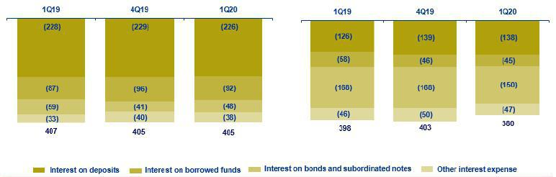

Interest Expenses – FC

(S/ millions)

In the QoQ analysis, interest expenses registered a reduction of -2.9%. This was primarily attributable a decrease in interest on bonds and subordinated notes and, to a lesser extent, to the contraction in interest on loans.

The 5.3% reduction in expenses for bonds and subordinated notes was the result of BCP Stand-alone’s liability management in the third and fourth quarters of 2019. As indicated in previous reports, in 2019, bonds were issued in LC and FC at very favorable rates, which coupled with expirations and calls for bonds, extended the tenure and reduced funding rates.

The contraction of -3.1% in expenses for interest on loans, which was attributable to a drop in rates in the national and international markets. The payment for interest in LC fell -3.8%, while in FC, the drop was -1.8%.

In the YoY analysis, interest expenses fell -2.5%. This was attributable firstly to a contraction in interest expenses on bonds and subordinated notes and secondly, to a decrease in interest expenses on loans, which offset growth in expenses on deposits.

Interest expenses on bonds and subordinated notes fell -12.5%, after BCP Stand-alone implemented a debt restructuring strategy in the last two quarters of 2019. This strategy was divided into two phases. During the first phase, a liability management of corporate bonds issued by BCP Stand-alone was carried, in both LC and FC. In the second phase, a perpetual subordinated debt was called at BCP Stand-alone. The aforementioned increased the tenure and reduced rates.

26

Additionally, interest expenses on borrowed funds fell -5.6% after rates fell in the international market. This mainly impacted interest on borrowed funds in FC, which fell -22.5% in comparison to last year’s figure.

The aforementioned was slightly offset by the +2.9% increase in interest on deposits. This growth was mainly driven by an increase in the volume of the most expensive deposits, time deposits (+11.6%),

4.3. Net Interest Margin (NIM) and Risk-Adjusted NIM

Credicorp’s NIM and Risk-Adjusted NIM ⁽¹⁾
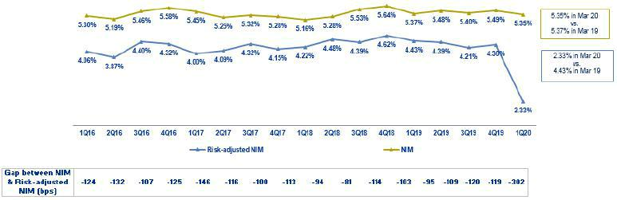

- Starting on 1Q17, we exclude derivatives from the NII result. For comparative purposes, figures starting from 1Q16 have been recalculated with the new methodology

NIM dropped QoQ and YoY. This was attributable to:

- The increase in average interest-earning assets of +3.2% and +9.1% with regard to 4Q19 and 1Q19, respectively.

- Slower growth in net interest income, despite lower interest expenses; this was primarily attributable to an improvement in the funding structure, where deposits now account for a larger share of the funding structure.

Risk-adjusted NIM fell -197 bps QoQ and -212bps YoY, which was attributable to an increase in provisions after expectations for economic growth in Peru decreased due to the COVID-19 pandemic and to the government’s decision to lockdown the country to slow the virus’s spread.

27

NIM on loans ⁽¹⁾
NIM on loans fell -24bps QoQ. This contraction was attributable to a decrease in market interest rates in 1Q20 in both LC and FC. This was attributable to the measures to reactivate the economy in the context of the COVID-19 pandemic. Nevertheless, YoY the NIM on loans increased after new pricing strategies were implemented in retail banking and at Mibanco to cover higher risks that were assumed in 2019.
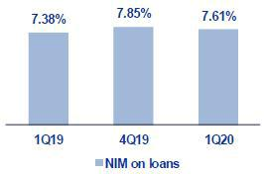

It is also important to analyze NIM by subsidiary. The table below contains the interest margins at each of Credicorp’s subsidiaries.

 |  | BCP |  |  |  | BCP
MM Breakdown |  | Stand-alone ⁽¹⁾ |  | Mibanco ⁽¹⁾ |  | Bolivia |  | Credicorp ⁽¹⁾⁽²⁾
1Q19 |  | 4.74% |  | 14.70% |  | 3.52% |  | 5.39%
4Q19 |  | 4.92% |  | 15.11% |  | 3.69% |  | 5.49%
1Q20 |  | 4.70% |  | 15.16% |  | 3.60% |  | 5.35%

NIM: Annualized Net interest income / Average period end and period beginning interest earning assets.

- Figures differ from previously reported, please consider the data presented on this report.

- Credicorp also includes Credicorp Capital, Prima, Grupo Credito and Eliminations for consolidation purposes.

In the YoY evolution at the Credicorp level, NIM fell in line with deterioration in BCP Stand-alone’s NIM, which represents 68% of net interest income. This decrease was insufficient to offset the improvement in Mibanco’s NIM.

BCP Stand-alone’s NIM deteriorated -21bps QoQ and -4pbs YoY. The reduction in the margin was driven by lower market rates. This mainly affected Wholesale Banking’s segments, which are more sensitive to interest rate movements.

Mibanco’s NIM, which represents 20% of the net interest income, increased +5pbs QoQ and +46pbs YoY after new pricing strategy was implemented. These measures allowed improving disbursement rates during the quarter.

It is also important to analyze risk-adjusted NIM by business line. The following table shows the net risk-adjusted margins for each of Credicorp’s main subsidiaries.

 |  | BCP |  |  |  | BCP
Risk Adjusted NIM Breakdown |  | Stand-alone ⁽¹⁾ |  | Mibanco ⁽¹⁾ |  | Bolivia |  | Credicorp ⁽¹⁾⁽²⁾
1Q19 |  | 3.86% |  | 11.86% |  | 2.86% |  | 4.62%
4Q19 |  | 3.75% |  | 12.07% |  | 2.67% |  | 4.21%
1Q20 |  | 1.45% |  | 9.54% |  | 2.11% |  | 4.30%

Risk-Adjusted NIM: (Annualized Net interest income - annualized provisions) / Average period end and period beginning interest earning assets.

- Figures differ from previously reported, please consider the data presented on this report.

- Credicorp also includes Credicorp Capital, Prima, Grupo Credito and Eliminations for consolidation purposes.

Credicorp reported a significant deterioration in the risk-adjusted NIM of -197bps QoQ and -212bps YoY, which reflects deterioration at the main subsidiaries after the cost of risk rose following a material change in expectations for economic growth in a COVID-19 scenario. This led risk-adjusted NIM to fall -230bps QoQ and -241bps YoY at BCP Stand-alone and -232bps QoQ and -254bps at Mibanco.

- NIM on loans is calculated as follows:

The share of loans within total earning assets is calculated by dividing the average of the beginning and closing balances of total loans for the reporting period, by the average of the beginning and closing balances of the interest earning assets for the reporting period.

28

- Non-Financial Income

In 1Q20, non-financial income contracted QoQ and YoY. This was primarily attributable to losses on Net gain on securities, which stemmed from recent volatility in the global markets due to the Covid-19 crisis. Impacts were seen in proprietary investment portfolios, mainly at Prima AFP, Credicorp and BCP Stand-alone. The main components of Non-financial income, Fee income and Net gain on foreign exchange transactions registered a decrease in income after transactional activity dropped due to the quarantine imposed by the Peruvian government in mid-March.

Non-financial income |  |  |  | Quarter |  |  |  | % change
S/ 000 |  | 1Q19 |  | 4Q19 |  | 1Q20 |  | QoQ |  |  | YoY
Fee income |  | 782,922 |  | 847,206 |  | 760,329 |  | -10.3% |  |  | -2.9%
Net gain on foreign exchange transactions |  | 178,423 |  | 193,528 |  | 166,983 |  | -13.7% |  |  | -6.4%
Net gain on securities |  | 113,545 |  | 102,011 |  | (120,633) |  | -218.3% |  |  | -206.2%
Net gain from associates ⁽¹⁾ |  | 14,786 |  | 22,738 |  | 19,225 |  | -15.4% |  |  | 30.0%
Net gain on derivatives held for trading |  | (2,434) |  | 7,043 |  | 35,430 |  | 403.1% |  |  | NA
Net gain from exchange differences ⁽²⁾ |  | 13,490 |  | 17,957 |  | (21,240) |  | -218.3% |  |  | -257.4%
Other non-financial income |  | 75,605 |  | 74,713 |  | 117,770 |  | 57.6% |  |  | 55.8%
Total non-financial income, net |  | 1,176,337 |  | 1,265,196 |  | 957,864 |  | -24.3 | % |  | -18.6 | %

- Includes gains on other investments, mainly made up of the profit of Banmedica.

- Figures differ from previously reported due to the implementation of IFRS 16.

 |  |  |  | Quarter |  |  |  |  | % change
(S/ 000) |  | 1Q19 |  | 4Q19 |  | 1Q20 |  | QoQ |  |  |  | YoY
(+) EPS contribution (50%) |  | 8,918 |  | 17,262 |  | 17,186 |  |  | -0.4% |  |  | 92.7%
(-) Private health insurance deduction (50%) |  | (2,736) |  | (9,806) |  | (6,430) |  |  | -34.4% |  |  | 135.0%
(=) Net gain from association with Banmedica |  | 6,182 |  | 7,456 |  | 10,756 |  |  | 44.3 | % |  | 74.0 | %

The QoQ evolution registered a contraction of 24.3% in non-financial income due to:

- The drop in the Net gain on securities, due to (i) Prima AFP, which posted a reduction in the profitability of its legal reserves after funds withdrawn and market volatility increased, (ii) losses on proprietary investment portfolios at Credicorp Capital, which registered negative results for mark-to-market (MtM) in the Trading portfolio, and (iii) BCP Stand-alone, due to realized losses after the sale of sovereign, Colombian and American bonds. All of the aforementioned was driven by market volatility and a drop in the value of assets due to the impact of COVID-19. Finally, the QoQ reduction was attributable to non-recurring positive results in 4Q19 after positions were sold in the fair value through other comprehensive investments, registered in the results of Credicorp Capital and ASB.

- The contraction of Fee income, (i) in line with seasonality in 1Q every year, after the usual drop in operations at the banking services in comparison to those at the end of the year, mainly at BCP Stand-alone, and to a lesser extent, at Mibanco, and (ii) due to a decrease in the income reported by Credicorp Capital for the corporate finance business due to an unfavorable environment for transaction execution. For more information, see 5.1.2 Fee income in the banking business.

- The reduction in the Net gain from exchange differences, due to the loss reported for the exchange differences relative to IFRS 16, mainly in the month of January and at BCP Stand-alone, and to a lesser extent, at Mibanco.

- The decrease in Net gain on foreign exchange transactions, due to lower volumes operated by Wholesale and Retail Banking clients at BCP Stand-alone, mainly in March.

The aforementioned was slightly attenuated by:

- Other non-financial income due to (i) BCP Stand-alone, for the transfer of a legal collection portfolio under cession in the month of February, and (ii) Mibanco, due to the sale of a property (building on Aramburu) in the month of March.

29

- The increase in the Net gain on speculative derivatives after advance executions of derivatives associated with structured products in the Asset Management business line at Credicorp Capital.

In the YoY analysis, there was a drop of 18.6% in non-financial income due to:

- Losses on the Net gain on securities mainly at Prima AFP and Credicorp Capital, due to the same circumstances discussed in the QoQ analysis. Losses were also attributable to an extraordinary result in 1Q19, which was generated by the favorable evolution of the financial markets in 2019 manifested through Credicorp Capital, Prima AFP and ASB.

- The negative result for the Net gain from exchange differences, which was attributable to the same factors discussed in the QoQ analysis.

- The decrease in Fee income, which was attributable to the (i) facilities and fees exemptions extended to our clients in the framework of the crisis generated by the pandemic, (ii) the decrease in consumption and service volumes due to the obligatory quarantine imposed by the Peruvian government in mid-March, and (iii) the decrease in transactional activity at BCP Stand-alone and Mibanco, described in greater detail in section 5.1.1 Fee income for the Banking Business.

The aforementioned was partially offset by growth in the Other non-financial income and the Net gain on speculative derivatives, which was attributable to the same circumstances explained in the QoQ analysis.

5.1. Fee Income

5.1.1. By subsidiary

The chart below shows the contribution of each of Credicorp’s subsidiaries to growth in the group’s fee income in 1Q20.

Evolution of fee income QoQ by subsidiary (S/ Million)
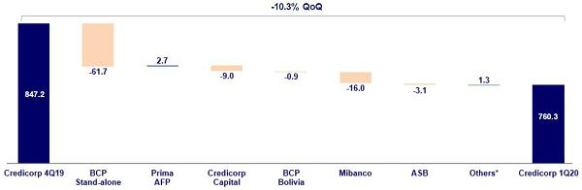

*Others include Encumbra, Bancompartir, Grupo Pacifico and eliminations for consolidation purposes.

30

The figure below shows the annual evolution of fee income by subsidiary:

Evolution of fee income YoY by subsidiary (S/ Million)
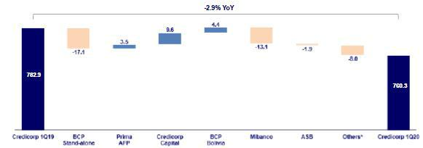

*Others include Encumbra, Bancompartir, Grupo Pacifico and eliminations for consolidation purposes.

5.1.2. Fee income in the Banking Business

The chart below shows the evolution of the main components of fee income in the banking business: Next, we show the evolution of the main components of fee income in the banking business:

Composition of Fee Income in the Banking Business

Fee Income |  |  |  |  |  | Quarter |  |  |  |  |  |  | % change
S/ 000 |  |  | 1Q19 |  |  | 4Q19 |  |  | 1Q20 |  |  | QoQ |  |  |  |  | YoY
Miscellaneous accounts ⁽¹⁾ |  |  | 177,517 |  |  | 186,506 |  |  | 164,963 |  |  |  | -11.6% |  |  |  | -7.1%
Credit cards ⁽²⁾ |  |  | 69,499 |  |  | 72,051 |  |  | 60,435 |  |  |  | -16.1% |  |  |  | -13.0%
Drafts and transfers |  |  | 60,232 |  |  | 71,547 |  |  | 61,846 |  |  |  | -13.6% |  |  |  | 2.7%
Personal loans ⁽²⁾ |  |  | 23,590 |  |  | 28,125 |  |  | 28,352 |  |  |  | 0.8% |  |  |  | 20.2%
SME loans ⁽²⁾ |  |  | 18,565 |  |  | 18,452 |  |  | 18,808 |  |  |  | 1.9% |  |  |  | 1.3%
Insurance ⁽²⁾ |  |  | 22,210 |  |  | 25,776 |  |  | 25,179 |  |  |  | -2.3% |  |  |  | 13.4%
Mortgage loans ⁽²⁾ |  |  | 9,428 |  |  | 10,678 |  |  | 9,402 |  |  |  | -12.0% |  |  |  | -0.3%
Off-balance sheet ⁽³⁾ |  |  | 47,302 |  |  | 48,215 |  |  | 50,093 |  |  |  | 3.9% |  |  |  | 5.9%
Payments and collections ⁽³⁾ |  |  | 103,763 |  |  | 109,311 |  |  | 101,283 |  |  |  | -7.3% |  |  |  | -2.4%
Commercial loans ⁽³⁾⁽⁴⁾ |  |  | 22,423 |  |  | 24,391 |  |  | 17,978 |  |  |  | -26.3% |  |  |  | -19.8%
Foreign trade ⁽³⁾ |  |  | 14,948 |  |  | 13,516 |  |  | 11,576 |  |  |  | -14.4% |  |  |  | -22.6%
Corporate finance and mutual funds ⁽⁴⁾ |  |  | 15,028 |  |  | 18,690 |  |  | 16,673 |  |  |  | -10.8% |  |  |  | 10.9%
_{ASB} (4) |  |  | 10,271 |  |  | 11,550 |  |  | 8,412 |  |  |  | -27.2% |  |  |  | -18.1%
Others ⁽⁴⁾⁽⁵⁾ |  |  | 69,836 |  |  | 79,916 |  |  | 62,067 |  |  |  | -22.3% |  |  |  | -11.1%
Total fee income |  |  | 664,612 |  |  | 718,725 |  |  | 637,067 |  |  |  | -11.4 | % |  |  | -4.1 | %

Source: BCP

- Saving accounts, current accounts, debit card and master account.

- Mainly Retail fees.

- Mainly Wholesale fees.

- Figures differ from previously reported, please consider the data presented on this report.

- Includes fees from BCP Bolivia, Mibanco, network usage and other services to third parties, among others.

In the QoQ analysis, fee income in the banking business fell -11.4% QoQ. The lines that registered the most significant contractions this quarter were:

- Miscellaneous accounts, mainly for (i) Debit cards, due to the reduction in fees for card replacement and a decrease in cash withdrawals, and to a lesser extent, due to (ii) Savings accounts and (iii) Current accounts, which experienced a decrease in the fees generated for account maintenance.

31

- Others, mainly at Mibanco, which represents 90% of the contraction due to a drop in income from obligatory insurance and a decrease in fees assessed for overdue loans. This last decrease was generated after the bank offered to freeze installment payments for up to two quotas without penalties or to waive fees.

- Credit cards, due to (i) seasonality from every 1Q due to an increase in transactional activity through year-end transactions, (ii) a decrease in fees from establishments due to a drop in consumption, (iii) a drop in fees for overdue loans due to no collections from clients who have availed of skip programs or installment payments freezing, and (iv) a decrease in card membership fees (fees suspended until July). All of the aforementioned was attributable to the measures taken during the quarantine for COVID-19, which began on March 15, and to subsequent fallout.

- Drafts and transfers, due to (i) a drop in transactions of approximately 50% in the month of March (versus February), which affected the volume of local and foreign transfers, and (ii) facilities offered for free local transfers for 30 days, which led fee income for this component to fall 50% with regard to February’s level and (iii) seasonality from every 4Q, which registered a higher number of transactions.

In the YoY analysis, the contracting of 4.1% was attributable to (i) Miscellaneous Accounts, (ii) Credit cards and (iii) Others, which was attributable to the same factors discussed in the QoQ analysis, and to a decrease in transactional activity during the pandemic. Additionally, the drop in income is in line with the transactional strategy to encourage clients to migrate to digital channels,

32

6. Insurance Underwriting Result

The insurance underwriting result fell 1.8% QoQ, which was primarily attributable to an increase in the acquisition costs in both P&C and Life insurance. This was mitigated by a decrease in claims in P&C and an increase in net premiums in Life insurance. In the YoY analysis, the underwriting result rose 30.1%, which was driven primarily by an increase in net earned premiums in both Life insurance and P&C business; and by a decrease in claims in P&C business, which was attenuated by an increase in the acquisition costs of both businesses.

Insurance underwriting result ⁽¹⁾ |  |  |  |  |  | Quarter |  |  |  |  |  | % change
S/ 000 |  |  | 1Q19 |  |  | 4Q19 |  |  | 1Q20 |  |  | QoQ |  |  | YoY
Net earned premiums |  |  | 584,209 |  |  | 620,578 |  |  | 627,935 |  |  | 1.2% |  |  | 7.5%
Net claims |  |  | (383,817) |  |  | (387,426) |  |  | (373,502) |  |  | -3.6% |  |  | -2.7%
Acquisition cost ⁽²⁾ |  |  | (91,281) |  |  | (88,662) |  |  | (112,507) |  |  | 26.9% |  |  | 23.3%
Total insurance underwriting result |  |  | 109,111 |  |  | 144,490 |  |  | 141,926 |  |  | -1.8 | % |  | 30.1 | %

- Includes the results of the Life, Property & Casualty and Crediseguros business

- Includes net fees and underwriting expenses.

6.1. Life Insurance

Life insurance total premiums

(S/ millions)
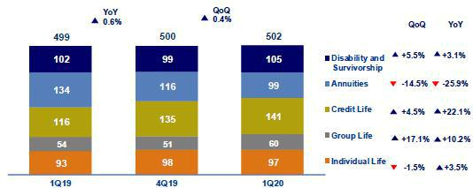

Total premiums increased 0.4% QoQ, which was attributable to (i) Group Life, mainly through Statutory Life due to new regulations, which went into effect in January 2020 in which companies must insure their employees, since the first working day; (ii) Credit Life, through the alliance channel after solidarity payments (late payments assumed by the entity) were made; (iii) in D&S, after an increase in premiums was registered through SISCO IV. The aforementioned was attenuated by Annuities and driven primarily by a decrease in sales of individual annuities and Individual Life after issuances fell in the direct channel; both lines were affected by a decrease in the number of selling days due to the quarantine.

In the YoY analysis, total premiums increased 0.6%; this was mainly driven by (i) Credit Life, where growth was attributable to an increase in premiums in the alliance and bancassurance channel and to solidarity payments (debts assumed by the entity); (ii) Group Life, due to an increase in statutory life products after a new regulation went into effect in January 2020 in which companies must insure their employees, since the first working day and to growth in Collective Life, which was reflected in an increase in premium turnover in the bancassurance line; (iii) Individual Life, due to an increase in premium turnover for renewals; and (iv) D&S, due to an increase in premiums through SISCO IV. The aforementioned was attenuated by a decrease in premiums in Annuities due to individual annuities and to a decrease in selling days due to the quarantine.

33

Life insurance net earned premiums ⁽¹⁾
(S/ millions)
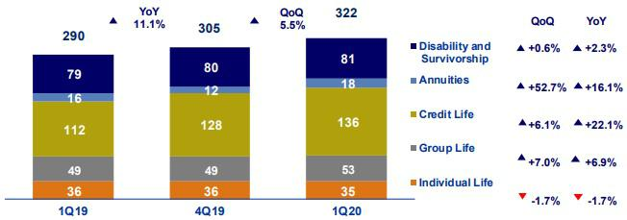

(1) Total premiums without considering reinsurance nor reserve premiums.

Net earned premiums increased 5.5% QoQ. This was primarily attributable to the evolution of Credit Life and Statutory Life, which mirrored that seen in the analysis of total premiums, and to the performance of Annuities, which was driven by a decrease in reserves due to adjustments in the parameters for investment rates.

In the YoY analysis, net earned premiums increased 11.1%. This was primarily driven by: (i) Credit Life, which reported an increase in sales through the alliance and bancassurance channels and to the increase registered for solidarity payment; (ii) Group Life, which was mainly attributable to an increase in sales of the collective life product through the bancassurance channel; (iii) Annuities, due to a decrease in reserves after adjustments were made to the parameters for investment rates; and (iv) in D&S, due to an increase in the premiums reported in SISCO IV. The aforementioned was attenuated by Individual Life after a higher adjustment was made to reserves.

Life insurance net claims

(S/ millions)
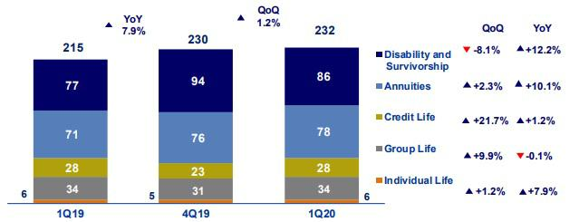

Net claims increased 1.2% QoQ. This was attributable to: (i) Credit Life, which higher claims reported in the bancassurance channel increased; (ii) Group Life, after more IBNR reserves were set aside for statutory life and collective life products; and, (iii) Annuities due to an increase in pension payments for individual annuities. The aforementioned was mitigated by D&S after provisions for claims through SISCO IV were released.

34

In the YoY analysis, net claims increased 7.9%, which was primarily driven by D&S through SISCO II and SISCO III due to a decrease in interest rates and in Annuities due to growth in pension payments through individual annuities.

6.2. Property and Casualty Insurance

Property and Casualty total premiums⁾
(S/ millions)
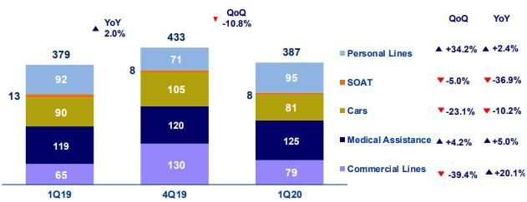

Total premiums fell -10.8% QoQ, which was attributable to (i) Commercial Lines, due to a decrease in renewals in the fire and third-party liability lines, which was mitigated by an increase in sales in the agriculture and aviation lines; (ii) Cars, due to a decrease in sales of new policies through the brokers channel and to a drop in production due to the quarantine imposed mid-March; and (iii) SOAT due a decrease in sales through the brokers channel. The aforementioned was offset by (i) Personal Lines, due to renewed premiums for the mortgage product; and (ii) Medical assistance, due to an increase in sales of comprehensive health products through the brokers channel.

In the YoY analysis, total premiums increased 2.0% due to (i) Commercial Lines, which experienced growth in the agriculture and aviation lines; (ii) Medical Assistance, due to an increase in sales of oncological and comprehensive health products; and (iii) Personal Lines, due to an increase in the price of the card protection product and to an increase in sales of personal accident products. These effects were attenuated by a decrease in sales of new policies for Cars and SOAT in the brokers channel and to the decrease in the number of selling days after the quarantine was imposed mid-March.

Property & Casualty net earned premiums ⁽¹⁾
(S/ millions)
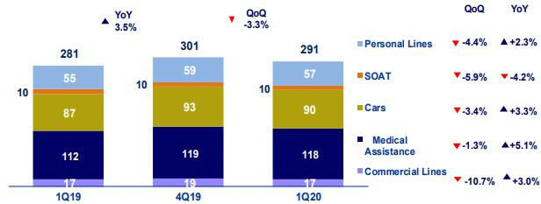

(1) Total premiums without considering reinsurance nor reserve premiums.

35

Net earned premiums fell-3.3% QoQ, which was primarily attributable to the reasons outlined in the analysis of total premiums and to an increase in unexpired risk reserves (URR) for products in the Personal Lines and Medical Assistance.

In the YoY analysis, net premiums increased 3.5%. This was primarily attributable to Medical Assistance and the Personal Lines, for the same reasons as those attributable to the evolution of total premiums, and to the performance of Cars, which was marked by a decrease in the reserves set aside for unexpired risk after direct premiums fell.

Property & Casualty net claims

(S/ millions)
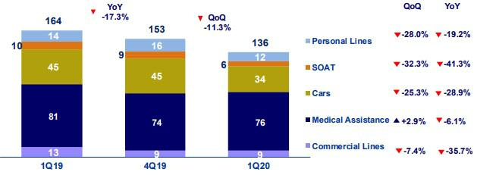

Net claims dropped -11.3% QoQ, which was attributable to a decrease in claims notifications after the quarantine was imposed mid-March. This decrease was mainly registered in the Cars, SOAT and Personal Lines. The decrease in claims was also attributable to an improvement in claims management in Cars. The aforementioned was attenuated by the evolution of Medical Assistance, which registered an increase in IBNR reserves.

In the YoY analysis, net claims fell -17.3%. The decrease in claims was seen across business lines after fewer notifications for claims were received due to the quarantine that was instituted in mid-March and to an improvement in claims management in Cars.

6.3. Acquisition Cost

Acquisition cost per Business

(S/ millions)
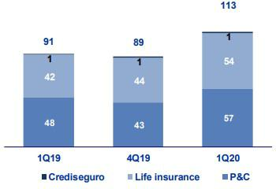

36

Acquisition cost |  |  |  |  |  | Quarter |  |  |  |  |  |  | % change
S/ 000 |  |  | 1Q19 |  |  | 4Q19 |  |  | 1Q20 |  |  | QoQ |  |  |  |  | YoY
Net fees |  |  | (60,013) |  |  | (65,316) |  |  | (66,650) |  |  |  | 2.0% |  |  |  | 11.1%
Underwriting expenses |  |  | (34,576) |  |  | (35,206) |  |  | (46,461) |  |  |  | 32.0% |  |  |  | 34.4%
Underwriting income |  |  | 3,308 |  |  | 11,860 |  |  | 604 |  |  |  | -94.9% |  |  |  | -81.7%
Acquisition cost |  |  | (91,281 | ) |  | (88,662 | ) |  | (112,507 | ) |  |  | 26.9 | % |  |  | 23.3 | %

The acquisition cost rose +26.9% QoQ. This was attributable to an increase in the net underwriting expense in P&C and to an increase in fees associated with life insurance. In P&C, growth was driven mainly by an increase in the underwriting expenses for Cars after 8 million soles in premiums were returned to clients who were unable to use their cars during the quarantine; higher reserves for uncollectible premiums, mainly in the Commercial, Cars and Medical Assistance lines; and a decrease in underwriting income for Commercial lines. In the Life business, the increase was due to growth in fees through the Alliances channel for Credit Life, after premiums rose, and to a decrease in underwriting income after profit sharing with reinsurers in 4Q19.

In the YoY analysis, the acquisition cost increased +23.3% in both the Life and P&C businesses. In Life insurance, growth was attributable to an increase in fees for Credit Life after premium rose through the Alliance channel. In P&C, growth was attributable to the increase discussed in the previous paragraph and to a move to set aside more reserves for uncollectible premiums in Cars, Commercial Lines and Medical Assistance.

6.4 Underwriting Result by Business

Underwriting Result by Business

(S/ millions)
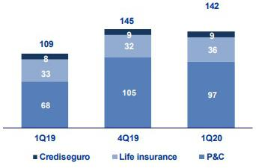

In the QoQ analysis, the decrease in the underwriting result was attributable to P&C and mitigated by Life insurance. In P&C, the reduction was attributable to: (i) an increase in underwriting expenses after premiums were reimbursed in Cars and to a move to set aside more reserves for uncollectible premiums;

- decrease in net premiums across business lines, which was mitigated by a decrease in claims given that fewer claims notifications were received during the quarantine imposed in mid-March. In Life insurance business, growth was attributable to an increase in net earned premiums in Credit Life, Annuities and Group Life, which was attenuated by an increase in the acquisition cost due to growth in fees after premiums rose, and to a decrease in the underwriting income after profit sharing in 4Q19.

In the YoY analysis, the increase in the underwriting result was primarily attributable to P&C and to a lesser extent, to Life insurance. In P&C, the increase was associated with a drop in claims after fewer claims notifications were received during the quarantine period imposed in Mid-March and to an increase in net premiums in the Medical Assistance and Personal Lines. The aforementioned was attenuated by an increase in the acquisition cost after premiums were reimbursed in Cars. In the Life insurance business, the variation was attributable to an increase in premiums in Credit Life, Group Life and Annuities, which was attenuated by growth in claims in D&S and Annuities and by an increase in fees in Credit Life after premiums rose.

37

7. Operating Expenses and Efficiency

The improvement QoQ in the operating efficiency ratio was attributable to a seasonal effect on expenses, which reach their highest level in the last quarter of the year. In the YoY analysis, which excludes the seasonal effect, the operating efficiency ratio deteriorated 100 bps, which was primarily due to an increase in salaries and employee benefits in the Microfinance line, which offset the increase in net interest income.

Operating expenses |  |  |  | Quarter |  |  |  | % change
S/ 000 |  | 1Q19 |  | 4Q19 |  | 1Q20 |  | QoQ |  |  | YoY
Salaries and employees benefits |  | 834,317 |  | 885,526 |  | 891,183 |  | 0.6% |  |  | 6.8%
Administrative, general and tax expenses |  | 538,157 |  | 701,225 |  | 539,644 |  | -23.0% |  |  | 0.3%
Depreciation and amortization |  | 131,325 |  | 176,593 |  | 171,748 |  | -2.7% |  |  | 30.8%
Association in participation |  | 2,736 |  | 9,806 |  | 6,430 |  | -34.4% |  |  | 135.0%
Acquisition cost ⁽¹⁾ |  | 91,281 |  | 88,662 |  | 112,507 |  | 26.9% |  |  | 23.3%
Operating expenses ⁽²⁾
 |  | 1,597,816 |  | 1,861,812 |  | 1,721,512 |  | -7.5% |  |  | 7.7%
Operating income ⁽³⁾
 |  | 3,768,564 |  | 4,073,876 |  | 3,967,962 |  | -2.6% |  |  | 5.3%
Efficiency ratio ⁽⁴⁾
 |  | 42.4% |  | 45.7% |  | 43.4% |  | -230bps |  |  | 100bps
Operating expenses / Total average assets ⁽⁵⁾
 |  | 3.60% |  | 3.99% |  | 3.57% |  | -42bps |  |  | -3bps

- The acquisition cost of Pacifico iIncludes net fees and underwriting expenses.

- Operating expenses = Salaries and employees benefits + Administrative, general and tax expenses + Depreciation and amortization + Acquisition cost + Association in participation.
- Operating income = Net interest income + Fee income + Net gain on foreign exchange transactions + Net gain from associates + Net gain on derivatives held for trading + Result on exchange differences + Net premiums earned.
- Figures differ from previously reported, please consider the data presented on this report. Operating expenses / Operating income.

"(5) Figures differ from previously reported, please consider the data presented on this report. Operating expenses / Average of Total Assets. Average is calculated with period-beginning and period-ending balances.

In the QoQ analysis, the improvement in the efficiency ratio was attributable to a seasonal effect on operating expenses; as such, the YoY analysis provides a clearer picture of the evolution of efficiency.

In the YoY analysis, the efficiency ratio deteriorated 100 bps. This was primarily attributable to the fact that operating expenses posted a higher increase than growth in operating income.

The figure below depicts the impact of the variation of each component of operating income and operating expenses in the YoY efficiency ratio:

YoY evolution of the efficiency ratio by account
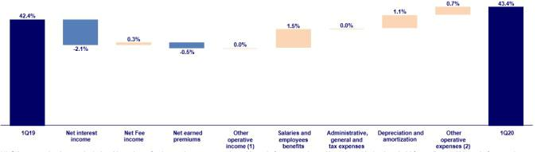

- Other operating income includes: Net gain on foreign exchange transactions, Net gain from associates, Net gain on derivatives held for trading and Net gain from exchange difference.
- Other operating expenses includes: Acquisition cost and Association in participation

An analysis of the impact of operating expenses shows that the negative effect on the operating efficiency ratio was due to:

- An increase in salaries and employee benefits, mainly in the Microfinance business and, to a lesser extent, at BCP Stand-alone. In the case of Microfinance, the increase was attributable to (i) Mibanco, due to an increase in headcount in 2019, which was primarily to bolster commercial teams to build the capacities needed to ensure growth down the line at Mibanco and (ii) Bancompartir, which is included in Credicorp’s balance sheet since December 2019. At BCP Stand-alone, growth was attributable to hiring of individuals with specialized profiles in 2019.

38

- The increase in the depreciation and amortization line due to the higher amortization expenses for software, in line with the investment of new software to support our Yape and Credit Card business.

- An increase in the acquisition cost, which was attributable to growth in net earned premiums and the reimbursement of 50% of the premiums paid by clients for cars for personal use in March.

In terms of operating income, the effects that positively impacted the operating efficiency ratio were:

- Growth in net interest income, in line with the expansion in average daily loan balances in all segments, as indicated in section 4.1. Interest Income.

- The increase in net earned premiums at Grupo Pacífico, which was seen in both the life and P&C lines, as explained in further detail in section 6.1 Net earned premiums.

It is important to note that in the current global context, Credicorp is looking to reduce growth in operating expenses given that it expects operating income for the year to fall.

7.1. Credicorp’s Administrative, General and Tax Expenses

Credicorp’s administrative, general and tax expenses

Administrative, general and tax expenses |  |  |  |  |  | Quarter |  |  |  |  |  |  |  |  |  | % change
S/ 000 |  | 1Q19 |  | % |  | 4Q19 |  |  | % |  | 1Q20 |  | % |  |  | QoQ |  |  | YoY
Marketing |  | 78,500 |  | 15% |  | 121,694 |  |  | 17% |  | 76,376 |  |  | 14% |  | -37.2% |  |  | -2.7%
Taxes and contributions |  | 66,709 |  | 12% |  | 77,685 |  |  | 11% |  | 68,017 |  |  | 13% |  | -12.4% |  |  | 2.0%
Insfrastructure |  | 67,944 |  | 13% |  | 83,411 |  |  | 12% |  | 77,185 |  |  | 14% |  | -7.5% |  |  | 13.6%
Systems outsourcing |  | 31,872 |  | 6% |  | 7,378 |  |  | 1% |  | 48,729 |  |  | 9% |  | 560.5% |  |  | 52.9%
Programs and systems |  | 63,848 |  | 12% |  | 84,076 |  |  | 12% |  | 68,119 |  |  | 13% |  | -19.0% |  |  | 6.7%
Communications |  | 22,714 |  | 4% |  | 22,413 |  |  | 3% |  | 17,585 |  |  | 3% |  | -21.5% |  |  | -22.6%
Rent |  | 30,462 |  | 6% |  | 28,675 |  |  | 4% |  | 25,192 |  |  | 5% |  | -12.1% |  |  | -17.3%
Consulting |  | 33,775 |  | 6% |  | 81,933 |  |  | 12% |  | 26,958 |  |  | 5% |  | -67.1% |  |  | -20.2%
Channels |  | 52,768 |  | 10% |  | 66,711 |  |  | 10% |  | 51,053 |  |  | 9% |  | -23.5% |  |  | -3.2%
Gastos Legales |  | 6,673 |  | 1% |  | 18,483 |  |  | 3% |  | 5,525 |  |  | 1% |  | -70.1% |  |  | -17.2%
Gastos de Representación |  | 5,114 |  | 1% |  | 5,086 |  |  | 1% |  | 4,469 |  |  | 1% |  | -12.1% |  |  | -12.6%
Seguros |  | 11,556 |  | 2% |  | 20,063 |  |  | 3% |  | 22,032 |  |  | 4% |  | 9.8% |  |  | 90.7%
Others ⁽¹⁾ |  | 66,222 |  | 12% |  | 83,618 |  |  | 12% |  | 48,404 |  |  | 9% |  | -42.1% |  |  | -26.9%
Total administrative and general expenses |  | 538,157 |  | 100 | % | 701,225 |  |  | 100 | % | 539,644 |  |  | 100 | % | -23.0 | % |  | 0.3 | %

(1) Others include ASB, BCP Bolivia, Grupo Credito and eliminations for consolidation.

The QoQ drop in administrative and general expenses and taxes was due primarily to a seasonal effect given that these expenses reach their highest point in the last quarter of every year.

In the YoY analysis, which excludes the seasonal effect on operating expenses, administrative and general expenses and taxes remained stable; nonetheless, some account registered significant increases.

- Total expenses for Programs, Systems and Systems Outsourcing increased, mainly in BCP Stand-alone, due to the higher expenses for the management of our IT infrastructure and the spending on new programs for projects related to the Transformation Strategy.

- The increase in Infrastructure, which was mainly attributable to the purchase and distribution of medical supplies and to an increase in expenses for the cleaning of different branches at BCP Stand-alone

39

The aforementioned was attenuated by a decrease in expenses for consultants, primarily at BCP Stand-alone, given that in 1Q19, more consultants were needed to implement a variety of projects related to the transformation strategy.

7.2. Efficiency Ratio

 |  |  | Efficiency Ratio by Subsidiary ⁽¹⁾⁽²⁾
 | BCP |  | BCP
 | Stand-alone |  | Bolivia |  | Microfinance |  | Pacifico |  | Prima AFP |  | Credicorp
1Q19 | 38.1% |  | 61.8% |  | 55.0% |  | 39.0% |  | 41.6% |  | 42.4%
4Q19 | 43.8% |  | 60.1% |  | 56.4% |  | 44.7% |  | 45.1% |  | 45.7%
1Q20 | 38.8% |  | 57.0% |  | 58.4% |  | 41.5% |  | 40.6% |  | 43.4%
Var. QoQ | -500bps |  | -310bps |  | 200bps |  | -320bps |  | -450bps |  | -230bps
Var. YoY | 70bps |  | -480bps |  | 340bps |  | 250bps |  | -100bps |  | 100bps

- (Salaries and employee’s benefits + Administrative, general and tax expenses + Depreciation and amortization + Acquisition cost + Association in participation) / (Net interest income + Fee income + Net gain on foreign exchange transactions + Net gain from associates + Net gain on derivatives held for trading + Result on exchange differences + Net premiums earned).

- The efficiency ratio differs from previously reported, please consider the data presented on this report.

In the QoQ analysis, the improvement in the efficiency ratio was attributable to a seasonal effect on operating expenses. As such, the YoY analysis provides a clearer picture of the business’s result.

The figure below shows the contribution of each subsidiary to the evolution of the efficiency ratio YoY.

YoY evolution of the efficiency ratio by subsidiary
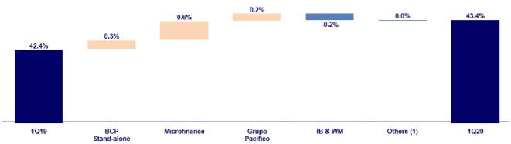

- Others includes: Credicorp Capital, Prima AFP, BCP Bolivia, ASB, Grupo Credito, among other subsidiaries and the eliminations for consolidation purposes.

In the YoY analysis, efficiency deteriorated 100 bps, which was attributable to:

- The incorporation of Bancompartir, which was included in the balance sheet since December 2019 within the Microfinance business line. This subsidiary contributed 50 bps to total deterioration given that more than 2,000 employees were added to Credicorp’s payroll after the acquisition. The aforementioned was not offset by the net interest income at Bancocompartir. Mibanco also registered slight deterioration, which was mainly attributable to on-going increases in headcount in 2019;

- BCP Stand-alone registered an increase in administrative and general expenses, which was mainly attributable to payments to renew licenses for software programs and to higher marketing expenses for advertising campaigns through digital channels. Additionally, the expense for salaries and employee benefits increased due to growth in the headcount in 2019 and to a transportation bonus to help personnel reach branches during the quarantine. The aforementioned was attenuated by an increase in net interest income, in line with growth in average daily balances; and

- Grupo Pacifico, which was attributable to an increase in the acquisition cost in the life business due to growth in sales of D&S policies through the alliance channel and in the P&C business due to the reimbursement of 50% of the premiums for car insurance for some clients for the months of March and April.

40

8. | Regulatory Capital
8.1. Regulatory Capital – BAP
Regulatory Capital and Capital Adequacy Ratios |  |  |  |  | As of |  |  |  | % Change
S/ 000 |  |  | 1Q19 |  | 4Q19 |  | 1Q20 |  | QoQ |  |  | YoY
Capital Stock |  |  | 1,318,993 |  | 1,318,993 |  | 1,318,993 |  | 0.0% |  |  | 0.0%
Treasury Stocks |  |  | (207,897) |  | (207,839) |  | (209,309) |  | 0.7% |  |  | 0.7%
Capital Surplus |  |  | 222,349 |  | 226,037 |  | 165,188 |  | -26.9% |  |  | -25.7%
Legaland Other capital reserves ⁽¹⁾ |  |  | 19,408,876 |  | 19,437,645 |  | 21,360,272 |  | 9.9% |  |  | 10.1%
Minority interest ⁽²⁾ |  |  | 357,833 |  | 393,019 |  | 386,326 |  | -1.7% |  |  | 8.0%
Loan loss reserves ⁽³⁾ |  |  | 1,575,966 |  | 1,690,510 |  | 1,728,836 |  | 2.3% |  |  | 9.7%
Perpetuals ubordinated debt |  |  | 580,650 |  | - |  | - |  | - |  |  | -100.0%
Subordinated Debt |  |  | 4,777,811 |  | 4,409,840 |  | 4,568,131 |  | 3.6% |  |  | -4.4%
Investments in equity and subordinated debt of financial and insurance
companies |  |  | (615,275) |  | (700,859) |  | (630,805) |  | -10.0% |  |  | 25%
Goodwill |  |  | (602,485) |  | (834,881) |  | (819,338) |  | -1.9% |  |  | 36.0%
Deduction for subordinated debt limit (50% of Tier 1 excluding deductions) ⁽⁴⁾ |  |  | - |  | - |  | - |  | - |  |  | -
Deduction for Tier 1 Limit 50% of Regulatory capital ⁽⁴⁾ |  |  | - |  | - |  | - |  | - |  |  | -
Total Regulatory Capital (A) |  |  | 28,816,810 |  | 25,732,465 |  | 27,868,293 |  | 8.3 | % |  | 3.9 | %
Tier 1 ⁽⁵⁾ |  |  | 14,827,121 |  | 14,010,215 |  | 15,271,385 |  | 9.08% |  |  | 3.0%
Tier 2 ⁽⁶⁾ + Tier ⁽⁷⁾ |  |  | 11,989,689 |  | 11,722,249 |  | 12,596,929 |  | 7.5% |  |  | 5.1%
Financial Consolidated Group (FCG) Regulatory Capital Requirement ⁽⁸⁾ |  |  | 19,595,889 |  | 20,750,935 |  | 19,925,877 |  | -4.0% |  |  | 1.7%
Insurance Consoldated Group (CG) Captal Requirements ⁽⁹⁾ |  |  | 1,019,984 |  | 1,199,850 |  | 1243,035 |  | 3.6% |  |  | 21.9%
FCG Capital Requirements rebted to operations with ICG |  |  | (216,360) |  | (329,262) |  | (503,013) |  | 52.8% |  |  | 132.5%
CG Capital Requirements related to operations with FCG |  |  | - |  | - |  | - |  | - |  |  | -
Total Regulatory Capital Requirements (B) |  |  | 20,399,513 |  | 21,621,522 |  | 20,665,899 |  | -4.4 | % |  | 1.3 | %
Regulatory Capital Ratio (A) / (B) |  |  | 1.31 |  | 1.19 |  | 1.35
Required Regulatory Capital Ratio ⁽¹⁰⁾ |  |  | 1.00 |  | 1.00 |  | 1.00

- Legal and other capital reserves include restricted capital reserves (S/ 14,745 million) and optional capital reserves (S/ 6,615 million).

- Minority interest includes Tier I (S/ 386 million)

- Up to 1.25% of total risk-weighted assets of Banco de Credito del Perú, Solucion Empresa Administradora Hipotecaria, Mibanco and Atlantic Security Bank.
- Tier II + Tier III cannot be more than 50% of total regulatory capital.

- Tier I = capital + restricted capital reserves + Tier I minority interest - goodwill - (0.5 x investment in equity and subordinated debt of financial and insurance companies) + perpetual subordinated debt.
- Tier II = subordinated debt + Tier II minority interest tier + loan loss reserves - (0.5 x investment in equity and subordinated debt of financial and insurance companies).
- Tier III = Subordinated debt covering market risk only.

- Includes regulatory capital requirements of the financial consolidated group.

- Includes regulatory capital requirements of the insurance consolidated group.

- Regulatory Capital / Total Regulatory Capital Requirements (legal minimum = 1.00).

Total regulatory capital at Credicorp increased 8.3% QoQ and 3.9% YoY. This was driven by an increase in legal and other capital reserves; and loan loss reserves. Both of which reflect preventive measures to absorb the potential effects of variations in expectations for economic growth in Peru due to the COVID-19 pandemic. Credicorp’s regulatory capital requirement fell -4.4% QoQ but increased +1.3% YoY, which was in line with the equity requirements set for companies in the financial sector.

Credicorp’s regulatory capital ratio remained at a comfortable level at the end of 4Q19 and represented 1.35 times the capital required by the regulator in Peru at the end of 4Q19.

41

8.2. Regulatory Capital – BCP Stand-alone based on Peru GAAP

Regulatory Capital and Capital Adequacy Ratios |  |  |  | As of |  |  |  | % change
S/ 000 |  | 1Q19 |  | 4Q19 |  | 1Q20 |  | QoQ |  |  | YoY
Capital Stock |  | 10,217,387 |  | 10,217,387 |  | 10,217,387 |  | 0.0% |  |  | 0.0%
Legal and Other capital reserves |  | 4,695,118 |  | 4,695,118 |  | 4,695,118 |  | 0.0% |  |  | 0.0%
Accumulated earnings with capitalization agreement |  | - |  | 850,000 |  | 850,000 |  | 0.0% |  |  | n.a.
Loan loss reserves ⁽¹⁾ |  | 1,284,021 |  | 1,367,259 |  | 1,383,834 |  | 1.2% |  |  | 7.8%
Perpetual subordinated debt |  | 580,650 |  | - |  | - |  | n.a. |  |  | n.a.
Subordinated Debt |  | 4,236,505 |  | 3,980,904 |  | 4,128,099 |  | 3.7% |  |  | -2.6%
Investment in subsidiaries and others, net of unrealized profit and net income |  | (1,722,979) |  | (1,580,583) |  | (1,937,102) |  | 22.6% |  |  | 12.4%
Investment in subsidiaries and others |  | (1,812,955) |  | (1,965,037) |  | (2,008,802) |  | 2.2% |  |  | 10.8%
Unrealized profit and net income in subsidiaries |  | 89,976 |  | 384,454 |  | 71,700 |  | -81.4% |  |  | -20.3%
Goodwill |  | (122,083) |  | (122,083) |  | (122,083) |  | 0.0% |  |  | 0.0%
Total Regulatory Capital |  | 19,168,618 |  | 19,408,002 |  | 19,215,253 |  | -1.0% |  |  | 0.2%
Off-balance sheet |  | 84,074,345 |  | 86,273,789 |  | 88,755,362 |  | 2.9 | % |  | 5.6 | %
Tier 1 ⁽²⁾ |  | 14,509,582 |  | 14,850,131 |  | 14,671,871 |  | -1.2% |  |  | 1.1%
Tier 2 ⁽³⁾ + Tier 3 ⁽⁴⁾ |  | 4,659,036 |  | 4,557,871 |  | 4,543,382 |  | -0.3% |  |  | -2.5%
Common Equity Tier 1 |  | 13,742,713 |  | 15,842,022 |  | 16,146,020 |  | 1.9% |  |  | 17.5%
Total risk-weighted assets - SBS |  | 123,718,427 |  | 134,128,850 |  | 142,084,684 |  | 5.9 | % |  | 14.8 | %
Credit risk-weighted assets |  | 112,023,537 |  | 122,233,929 |  | 129,331,389 |  | 5.8% |  |  | 15.5%
Market risk-weighted assets ⁽⁵⁾ |  | 2,528,029 |  | 2,263,835 |  | 3,074,766 |  | 35.8% |  |  | 21.6%
Operational risk-weighted assets |  | 9,166,861 |  | 9,631,086 |  | 9,678,529 |  | 0.5% |  |  | 5.6%
Adjusted Risk-Weighted Assets - Basel |  | 120,622,867 |  | 128,238,694 |  | 135,790,140 |  | 5.9 | % |  | 12.6 | %
Total risk-weighted assets |  | 123,718,427 |  | 134,128,850 |  | 142,084,684 |  | 5.9% |  |  | 14.8%
(-) RWA Intangible assets, excluding goodwill. |  | 3,491,859 |  | 6,330,168 |  | 6,802,121 |  | 7.5% |  |  | 94.8%
(+) RWA Deferred tax assets generated as a result of temporary |  | 396 299 |  | 440 012 |  | 507 578 |  | 15.4% |  |  | -
differences in income tax, in excess of 10% of CET1
(+) RWA Deferred tax assets generated as a result of past losses |  | - |  | - |  | - |  | - |  |  | -
Total capital requirement |  | 15,765,636 |  | 16,982,136 |  | 16,346,724 |  | -3.7 | % |  | 3.7 | %
Credit risk capital requirement |  | 11,202,354 |  | 12,223,393 |  | 12,933,139 |  | 5.8% |  |  | 15.5%
Market risk-weighted assets ⁽⁵⁾ |  | 252,803 |  | 226,384 |  | 307,477 |  | 35.8% |  |  | 21.6%
Operational risk capital requirement |  | 916,686 |  | 963,109 |  | 967,853 |  | 0.5% |  |  | 5.6%
Additional capital requirements |  | 3,393,794 |  | 3,569,251 |  | 2,138,255 |  | -40.1% |  |  | -37.0%
Capital ratios
Tier 1 ratio ⁽⁶⁾ |  | 11.73% |  | 11.07% |  | 10.33%
Common Equity Tier 1 ratio ⁽⁷⁾ |  | 11.39% |  | 12.35% |  | 11.89%
BIS ratio ⁽⁸⁾ |  | 15.49% |  | 14.47% |  | 13.52%
Risk-weighted assets / Regulatory capital ⁽⁹⁾ |  | 6.45 |  | 6.91 |  | 7.39

- Up to 1.25% of total risk-weighted assets.

- Tier 1 = Capital + Legal and other capital reserves + Accumulated earnings with capitalization agreement + (0.5 x Unrealized profit and net income in subsidiaries) - Goodwill - (0.5 x Investment in subsidiaries) + Perpetual subordinated debt (maximum amount that can be included is 17.65% of Capital + Reserves + Accumulated earnings with capitalization agreement + Unrealized profit and net income in subsidiaries - Goodwill).
- Tier 2 = Subordinated debt + Loan loss reserves + (0.5 x Unrealized profit and net income in subsidiaries) - (0.5 x Investment in subsidiaries).

- Tier 3 = Subordinated debt covering market risk only. Tier 3 exists since 1Q10.

- It includes capital requirement to cover price and rate risk.

- Tier 1 / Total Risk-weighted assets

"(7) Common Equity Tier I = Capital + Reserves – 100% of applicable deductions (investment in subsidiaries, goodwill, intangibles and net deferred taxes that rely on future profitability) + retained earnings + unrealized gains.

Adjusted Risk-Weighted Assets = Risk-weighted assets - (RWA Intangible assets, excluding goodwill, + RWA Deferred tax assets generated as a result of temporary differences in income tax, in excess of 10% of CET1, + RWA Deferred tax assets generated as a result of past losses)."
- Regulatory Capital / Risk-weighted assets (legal minimum = 10% since July 2011)

- Since July 2012, Risk-weighted assets = Credit risk-weighted assets * 1.00 + Capital requirement to cover market risk * 10 + Capital requirement to cover operational risk * 10 * 1.00 (since July 2014).

42

At the end of 1Q20, the BIS and Tier 1 ratios at BCP Stand-alone were situated at 13.52% and 10.33% respectively. This was attributable to an increase of 5.9% QoQ in RWAs.

Total regulatory capital fell 1% QoQ, which was attributable to a decrease in unrealized gains and earnings at the subsidiary level. Total RWAs increased due to growth in Credit RWAs (+5.8% QoQ) in line with the 5.4% growth QoQ in quarter- end loan balances.

The YoY evolution shows a drop in the BIS Ration and in the Tier 1 ratio with regard to the levels reported in 1Q19. This was attributable to the fact that the growth posted for RWAs outpaced the expansion registered for regulatory and TIER 1 capital.

The YoY evolution of total RWAs mainly reflects growth of 15.5% in Credit RWAS and to a lesser extent, an expansion in market risk and operational RWAs. This growth primarily reflects the effect of 12.0% growth YoY in quarter-end loan balances.

Common Equity Tier 1 Ratio – BCP Stand-alone

December 2019 March 2020
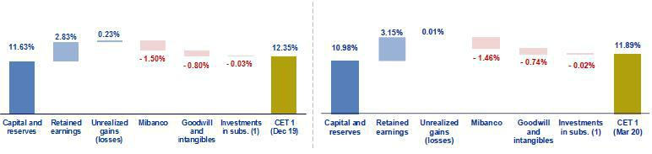

(1) Includes investments in BCP Bolivia and other subsidiaries

Finally, the Tier 1 Common Equity (CET1) ratio, which is considered the most rigorous indicator with which to measure capitalization levels, reported a drop of -46 bps QoQ and situated at 11.89% at the end of 1Q20. This was mainly attributable to +5.9% QoQ growth in adjusted RWAs. In the YoY analysis, the CET1 ratio increased 50 bps in a context in which the Tier 1 Common Equity rose 17.5% while adjusted RWAs increased 12.6%.

43

- Distribution channels

Distribution channels at BCP Stand-alone, Mibanco and BCP Bolivia totaled 10,806 points of contact at the end of March 2020, which represented a drop of 194 points QoQ due to a decrease in Agentes BCP. YoY, however, the total expanded +356 YoY, which was mainly driven by growth in cost-efficient channels at BCP Bolivia, bolstered by more Agentes, and, to a lesser extent, by expansion of these channels at BCP Stand-alone.

Consolidated Points of Contact

 |  |  | As of |  |  |  | change (units)
 | Mar 19 |  | Dic 19 |  | Mar 20 |  | TaT |  | AaA
BCP Stand-alone
Branches | 405 |  | 404 |  | 404 |  | - |  | -1
ATMs | 2,244 |  | 2,285 |  | 2,291 |  | 6 |  | 47
Agentes BCP | 6,759 |  | 7,187 |  | 6,869 |  | -318 |  | 110
Total BCP Stand-alone | 9,408 |  | 9,876 |  | 9,564 |  | -312 |  | 156
Total Mibanco's Network ⁽¹⁾ | 324 |  | 323 |  | 325 |  | 2 |  | 1
BCP Bolivia
Branches | 56 |  | 54 |  | 55 |  | 1 |  | -1
ATMs | 299 |  | 301 |  | 307 |  | 6 |  | 8
Agentes BCP Bolivia | 363 |  | 446 |  | 555 |  | 109 |  | 192
Total Bolivia's Network | 718 |  | 801 |  | 917 |  | 116 |  | 199
Total points of contact | 10,450 |  | 11,000 |  | 10,806 |  | -194 |  | 356

- Mibanco does not have Agents or ATMs because it uses the BCP network. Mibanco branches include Banco de la Nacion branches, which in Mar 19, Dec 19 and Mar 20 were 35.

9.1. Universal Banking

9.1.1. Points of contact by geographic area – BCP Stand-alone

 |  |  | As of |  |  |  | change (units)
 | Mar 19 |  | Dec 19 |  | Mar 20 |  | QoQ |  | YoY
Lima | 256 |  | 255 |  | 255 |  | 0 |  | -1
Provinces | 149 |  | 149 |  | 149 |  | 0 |  | 0
Total Branches⁽¹⁾ | 405 |  | 404 |  | 404 |  | 0 |  | -1
Lima | 1,490 |  | 1,533 |  | 1,536 |  | 3 |  | 46
Provinces | 754 |  | 752 |  | 755 |  | 3 |  | 1
Total ATM's | 2,244 |  | 2,285 |  | 2,291 |  | 6 |  | 47
Lima | 3,460 |  | 3,581 |  | 3,418 |  | -163 |  | -42
Provinces | 3,299 |  | 3,606 |  | 3,451 |  | -155 |  | 152
Total Agentes BCP | 6,759 |  | 7,187 |  | 6,869 |  | -318 |  | 110
Total points of contact | 9,408 |  | 9,876 |  | 9,564 |  | -312 |  | 156

(1) Figures differ from previously reported, consider the amounts presented in this report.

BCP Stand-alone registered a drop of 312 points of contact QoQ to situate at a total of 9,564 points at the end of March 2020. The decline was due primarily to a decrease in the number of Agentes BCP, which fell 318 points (-163 points in Lima and -155 in the provinces). Our service channels are evaluated on a regular basis to determine if they should remain open or be relocated. Decisions on these matters are executed in the first quarter of the year. In 2020, the plan was to relocate a large number of agents. As such, non-performing channels were closed at the beginning to the first quarter. Nevertheless, the advent of COVID-19 and the ensuing sanitary emergency paralyzed the movements of most of the population affected plans to relocate Agentes, which will commence when the state of emergency is lifted.

Additionally, the number of branches remain stable QoQ and ATMs increased by +6. Growth at the branch level was seen in areas that required more coverage to meet the needs of BCP’s clients. Expansion in ATMs was due to openings of neutral points in Lima and provinces.

44

In the YoY analysis, BCP Stand-alone’s total points of contact increased +156 units. This was driven primarily by growth in Agentes BCP in the provinces (+152) and by an increase in ATMs (+47) after neutral points were installed in Lima and new modules were set up at our branches in Lima and Callao in 2019. The aforementioned reflects the bank’s strategy to be closer to our clients and to the population that has yet to access the financial system by providing cost-efficient channels and ensuring better coverage in the locations where we already have a presence.

9.1.2. Transactions per channel – BCP Stand-alone

Transactions per channel – BCP Stand-alone

 |  |  |  |  |  |  |  |  |  | Monthly average in each quarter |  |  |  |  |  |  |  |  |  |  |  |  |  | % change
 |  | N° of Transactions per channel ⁽¹⁾ |  |  | 1Q19 |  |  | % |  |  |  | 4Q19 |  |  | % |  |  | 1Q20 |  |  | % |  |  | QoQ |  |  |  | YoY
Traditional | Teller |  |  |  | 7,836,871 |  |  | 4.4% |  | 7,715,870 |  |  |  |  | 3.1% |  |  | 6,699,584 |  |  | 2.9% |  |  | -13.2% |  |  |  | -14.5%
channels | Telephone banking |  |  |  | 4,947,564 |  |  | 2.8% |  | 5,056,869 |  |  |  |  | 2.0% |  |  | 4,354,138 |  |  | 1.9% |  |  | -13.9% |  |  |  | -12.0%
Cost-
efficient | Agentes BCP |  |  |  | 24,802,140 |  |  | 14.0% |  | 32,534,245 |  |  |  |  | 13.0% |  |  | 28,285,371 |  |  | 12.2% |  |  | -13.1% |  |  |  | 14.0%
channels | ATMs |  |  |  | 24,405,732 |  |  | 13.8% |  | 25,678,078 |  |  |  |  | 10.3% |  |  | 21,110,659 |  |  | 9.1% |  |  | -17.8% |  |  |  | -13.5%
Digital | Mobile banking |  |  |  | 68,528,959 |  |  | 38.6% |  | 120,275,484 |  |  |  |  | 48.1% |  |  | 114,479,895 |  |  | 49.4% |  |  | -4.8% |  |  |  | 67.1%
channels |  | Internet banking Via BCP |  |  | 16,185,835 |  |  | 9.1% |  | 23,757,780 |  |  |  |  | 9.5% |  |  | 22,449,556 |  |  | 9.7% |  |  | -5.5% |  |  |  | 38.7%
 |  | Balance inquiries |  |  | 1,295,030 |  |  | 0.7% |  | 1,238,521 |  |  |  |  | 0.5% |  |  | 991,474 |  |  | 0.4% |  |  | -19.9% |  |  |  | -23.4%
 | Telecrédito |  |  |  | 11,318,983 |  |  | 6.4% |  | 13,208,492 |  |  |  |  | 5.3% |  |  | 13,571,633 |  |  | 5.9% |  |  | 2.7% |  |  |  | 19.9%
Others | Direct debit |  |  |  | 717,284 |  |  | 0.4% |  | 920,143 |  |  |  |  | 0.4% |  |  | 1,028,329 |  |  | 0.4% |  |  | 11.8% |  |  |  | 43.4%
 | Points of sale P.O.S. |  |  |  | 17,205,460 |  |  | 9.7% |  | 19,251,035 |  |  |  |  | 7.7% |  |  | 18,389,832 |  |  | 7.9% |  |  | -4.5% |  |  |  | 6.9%
 | Other ATMs network |  |  |  | 212,155 |  |  | 0.1% |  | 290,695 |  |  |  |  | 0.1% |  |  | 256,084 |  |  | 0.1% |  |  | -11.9% |  |  |  | 20.7%
 | Total transactions |  |  |  | 177,456,012 |  |  | 100.0% |  | 249,927,212 |  |  |  |  | 100.0% |  |  | 231,616,556 |  |  | 100.0% |  |  | -7.3% |  |  |  | 30.5%

(1) Figures include monetary and non-monetary transactions.

In the current context, which has been marked by stringent restrictions on movements and economic activities since mid-March to stem contagion from COVID-19, the average number of transactions fell -7.3% QoQ. The majority of this decline was concentrated in March, when the Peruvian government instituted a State of Emergency and called for obligatory social isolation. In contrast, the level of transactions grew +30.5% YoY with regard to the figure registered at the same time last year.

In the QoQ analysis, the drop in transactions was seen across channels with the exception of Telecredito (+2.7) and Direct debit (+11.8%). It is important to note that in 1Q20, the largest drop in volume was registered in Mobile Banking (-4.8%) and ATMs (-17.8%) due to the COVID-19 crisis.

In the YoY analysis, the monthly average of translations increased. This was mainly driven by an increase in volume through the following channels:

- Mobile Banking (+67.1% YoY), which continued to post an uptick in its share of total transactions after operating improvements were rolled out for the “Mobile Banking BCP” application and our clients on-going shift to digital channels.

- Internet Banking Vía BCP (+38.7% YoY), driven by the effort to remodel our web page that allow our clients to conduct transactions and find information with greater ease and speed.

- Agentes BCP (+14.0% YoY), which registered in increase in locations.

Transactions through traditional channels continued to fall YoY: (i) ATMs (-13.5%), (ii) Tellers (-14.5%), iii) Telephone Banking (-12.0%) and v) Balance Inquiry Modules (-23.4%). The aforementioned was given that i) digital channels such as mobile and internet banking offer similar functions and ii) on-going efforts are in play to implement other digital platforms in branches, which will allow clients to consult information, open savings accounts and pick up debit cards.

Growth in banking transactions in the region will continue to be directed mainly through digital channels. The current scenario of social distancing and public health measures will drive even more demand for these services. Growth in the volume of transactions will be seen primarily through Mobile Banking and Internet Banking, which will blend well with our objective to possess an efficient and profitable network of customer service channels. Lastly, it is important to note that the interbank payment application Yape hit the 2.5 million user mark in 1Q20 and has become a useful instrument for both individuals and businesses to conduct efficient transactions without generating costs.

45

9.1.3. Points of Contact – BCP Bolivia

 |  |  |  | As of |  |  |  | change (units)
 | Mar 19 |  |  | Dec 19 |  | Mar 20 |  | QoQ |  | YoY
Branches |  | 56 |  | 54 |  | 55 |  | 1 |  | -1
ATMs |  | 299 |  | 301 |  | 307 |  | 6 |  | 8
Agentes BCP Bolivia |  | 363 |  | 446 |  | 555 |  | 109 |  | 192
Total Bolivia's Network |  | 718 |  | 801 |  | 917 |  | 116 |  | 199

At BCP Bolivia, points of contact growth by 116 QoQ after an increase in Agentes BCP Bolivia (+109) were deployed in line with our strategy to growth points of contacts through cost-efficient channels.

YoY evolution experienced a similar trend, where the total number of points of contact in BCP Bolivia increased +199 YoY. This was primarily attributable to growth in the number of Agentes BCP Bolivia (+192) and, to a lesser extent, to expansion in the number of ATMs (+8). The number of branches, nonetheless, fell by 1 YoY. One more time, the increases in the number of Agentes and ATMs was attributable to the bank’s strategy to bet on cost-efficient channels to reach more clients and also reflects, although to a lesser extent, a move to offset the effect of branch closings.

9.2. Microfinance

9.2.1. Points of Contact – Mibanco

 |  |  |  | As of |  |  |  | change (units)
 | Mar 19 |  |  | Dec 19 |  | Mar 20 |  | QoQ |  | YoY
Total Mibanco's Network ⁽¹⁾ |  | 324 |  | 323 |  | 325 |  | 2 |  | 1

- Mibanco does not have Agents or ATMs because it uses the BCP network. Mibanco branches include Banco de la Nacion branches, which in Mar 19, Dic

19 and Mar 20 were 35.

At Mibanco, the points of contact increased by 2 QoQ. In the YoY analysis, we see a +1 increase in branches. It is important to note that Mibanco has an agreement with the Banco de la Nacion to use the latter’s branches at the national level to reduce operating costs. At the end of 1Q20, these branches represented 11% (35 branches) of the 325 operated by Mibanco.

46

10. Economic Perspectives

10.1. Peru Economic Forecasts

Peru |  | 2016 |  | 2017 |  | 2018 |  | 2019 ⁽³⁾ |  | 2020 ⁽³⁾
GDP (US$ Millions) |  | 194,653 |  | 214,397 |  | 225,364 |  | 230,413 |  | 200,000
Real GDP (% change) |  | 4.0 |  | 2.5 |  | 4.0 |  | 2.2 |  | -7 - -13
GDP per capita (US$) |  | 6,179 |  | 6,742 |  | 6,999 |  | 7,090 |  | 6,098
Domestic demand (% change) |  | 1.1 |  | 1.4 |  | 4.3 |  | 2.3 |  | -8 - -13
Gross fixed investment (as % GDP) |  | 21.9 |  | 20.5 |  | 21.4 |  | 21.2 |  | -19 - -20
Public Debt (as % GDP) |  | 23.9 |  | 24.9 |  | 25.7 |  | 26.8 |  | 34.3 - 38.5
System loan growth (% change)⁽¹⁾ |  | 4.9 |  | 5.6 |  | 10.1 |  | 6.2 |  | -
Inflation⁽²⁾
 |  | 3.2 |  | 1.4 |  | 2.2 |  | 1.9 |  | 0.0 - 0.5
Reference Rate
 |  | 4.25 |  | 3.25 |  | 2.75 |  | 2.25 |  | 0.25
Exchange rate, end of period |  | 3.36 |  | 3.24 |  | 3.37 |  | 3.31 |  | 3.40-3.45
Exchange rate, (% change) |  | -1.7% |  | -3.5% |  | 4.1% |  | -1.7% |  | 4.1%
Fiscal balance (% GDP)
 |  | -2.6 |  | -3.1 |  | -2.5 |  | -1.6 |  | -9.4
Trade balance (US$ Millions) |  | 1,953 |  | 6,700 |  | 7,197 |  | 6,614 |  | 3,000
(As % GDP) |  | 1.0% |  | 3.1% |  | 3.2% |  | 2.9% |  | 1.5%
Exports |  | 37,082 |  | 45,422 |  | 49,066 |  | 47,688 |  | 37,000
Imports |  | 35,128 |  | 38,722 |  | 41,870 |  | 41,074 |  | 34,000
Current account balance (US$ Millions) |  | -5,064 |  | -2,779 |  | -3,821 |  | -3,530 |  | -5,000
(As % GDP) |  | -2.6% |  | -1.3% |  | -1.7% |  | -1.5% |  | -2.5%
Net international reserves (US$ Millions) |  | 61,686 |  | 63,621 |  | 60,121 |  | 68,316 |  | 68,000
(As % GDP) |  | 31.7% |  | 29.7% |  | 26.7% |  | 29.6% |  | 34.0%
(As months of imports) |  | 21 |  | 20 |  | 17 |  | 20 |  | 24

Source: INEI, BCRP, and SBS.

- Financial System, Current Exchange Rate.

- Inflation target: 1% - 3%.

- Estimates by BCP Economic Research as of April 2020.

10.2. Main Economic Variables

Economic Activity – GDP (% change YoY)
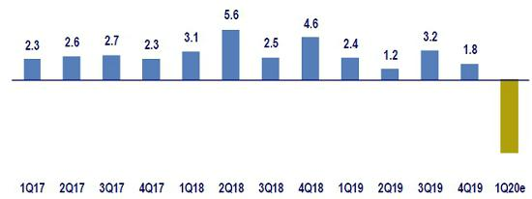

Fuente: INEI

After expanding 3.0% YoY in January and 3.8% YoY in February 2020, economic activity was severely affected by government measures to halt the COVID-19 contagion, including instituting mandatory social isolation beginning on March 16th. Some indicators that show the impact on economic activity in March include: electricity production (declined 27% YoY in the second half of the month), public investment by the general government (fell 25% YoY in March), and wholesale poultry sales (declined 10% YoY in March and 25% YoY in the last week of March).

47

Inflation and Monetary Policy rate (%)
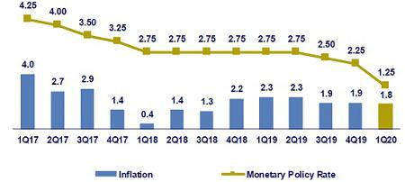

Source: INEI, BCRP

The inflation rate closed 1Q20 at 1.8% YoY (vs 1.9% in 2019), and stood slightly below the mid-point of the target range (1%-3%). Furthermore, core inflation (excluding Food and Energy) decelerated to 1.7% YoY (vs 2.3% in 2019), the lowest level in 9 years.

In March 2020, the Central Bank (BCRP) held an extraordinary (unprecedented) monetary policy meeting, where it lowered its monetary policy rate by 100bps to 1.25%; this level not observed since the global financial crisis of 2009. The institution took into account the deterioration of the international environment due to COVID-19 contagion, as well as the local context. In April 2020, the BCRP held another extraordinary meeting and agreed to cut an additional 100bps to situate the rate at 0.25%, a new historical minimum. In addition, the BCRP took different measures to inject liquidity to the economy such as extending its operation’s terms; exercising flexibility with regard to reserve requirements for institutions of the financial system; and providing liquidity through specific operations (Asset Repos and FX Repos).

Fiscal Result and Current Account Balance (% of GDP, Quarter)
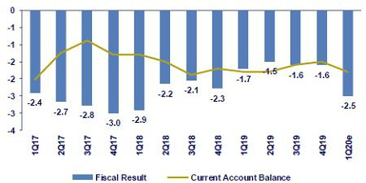

Source: BCRP

*BCP estimates

In March 2020, fiscal revenues at the general government level declined 19% YoY in real terms (the worst print since July 2009). The strong contraction was attributable to a decline in VAT revenues of 11% YoY, and 24% in income tax. The decline in fiscal revenues is primarily attributable to the measures adopted by the government during the national sanitary emergency. Some of the measures of note are: (i) deferral of yearly income tax declarations, (ii) deferral of internal tribute payment and declarations, and (iii) flexibility regarding terms for installment payments, extensions and tax-debt refinancing. During the same period, General government non-financial spending increased 12% YoY in real terms. Current expenditure in particular advanced 15% YoY, a 26-month peak, due to an increase in national government transfers (+94%). In contrast, public investment from the general government declined 25% YoY in real terms.

48

In the January/February 2020, the trade balance registered a surplus of US$ 680 million, which represents a 15% contraction compared to the same period of last year. Exports declined 3.0% YoY in said period. It is important to highlight that the price of copper declined from US$/lb. 2.70 at the end of 2019 to a minimum of US$/lb. 2.20 in March, and currently stands around US$/lb. 2.30. Additionally, imports decreased 1.6% YoY. Finally, in January/February 2020 terms of trade increased 3.8% YoY. It is important to note that oil prices were severely affected in 1Q20, which has continued into April. In particular, WTI crude oil fell from US$/bbl. 61 at the end of 2019 to USD/bbl. 22.5 in the last two weeks of March. Furthermore, in April the price stood on negative ground for the first time in history (spot price on April 20th: US$/bbl. -37.6) due to insufficient storage in Oklahoma for inventory.

Exchange rate (S/ per US$)
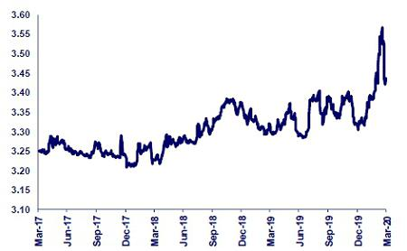

Source: SBS

The exchange rate closed in 1Q20 at USDPEN 3.437. In this context, the Peruvian Sol depreciated 3.7% compared to 2019 (USDPEN 3.314). In March, the Peruvian Sol encountered significant depreciation pressures in the international environment in the context generated by the COVID-19 contagion and its effects on the global economy and financial markets. In this scenario, national currency increased from USDPEN 3.38 towards mid-February to a new peak of USDPEN 3.57 on March 18th (still below its historical peak of USDPEN 3.65 in September 2002).

The Central Bank mitigated the Peruvian Sol’s depreciation though FX Swaps for S/ 7,296 million in 1Q20 (S/ 6,170 million were placed in March specifically).

International net reserves stood at US$ 68,022 million at the end of 1Q20, which represents a decline of US$ 294 million compared to the figure at the end of 2019.

Finally, by the end of 1Q20 all currencies in the region depreciated compared to the end of 2019 (Brazilian Real: -29%, Mexican Peso: -25%, Colombian Peso: -24%, Chilean Peso: -13%). The Peruvian Sol was the only currency in the region which did not exceed its historical peak during the period of extreme risk aversion that began in March 2020.

49

Safe Harbor for Forward-Looking Statements

This material includes “forward-looking statements” within the meaning of Section 21E of the Securities Exchange Act of 1934. All statements other than statements of historical information provided herein are forward-looking and may contain information about financial results, economic conditions, trends and known uncertainties. Forward-looking statements are neither historical facts nor assurances of future performance. Instead, they are based only on the Company’s current beliefs, expectations and assumptions regarding the future of our business, future plans and strategies, projections, anticipated events and trends, the economy and other future conditions.

Forward-looking statements can be identified by words such as: "anticipate”, "intend", "plan", "goal”, "seek”, "believe”, "project", "estimate”, "expect", "strategy”, "future”, "likely”, "may”, "should”, "will" and similar references to future periods. Examples of forward-looking statements include, among others, statements or estimates we make regarding guidance relating to Return on Average Equity, Sustainable Return on Average Equity, Cost of Risk, Loan growth, Efficiency ratio, BCP Stand-alone Common Equity Tier 1 Capital ratio and Net Interest Margin, current or future volatility in the credit markets and future market conditions, expected macroeconomic conditions, our belief that we have sufficient liquidity to fund our business operations during the next year, expectations of the effect on our financial condition of claims, litigation, environmental costs, contingent liabilities and governmental and regulatory investigations and proceedings, strategy for customer retention, growth, product development, market position, financial results and reserves and strategy for risk management.

The Company cautions readers that actual results could differ materially from those expected by the Company, depending on the outcome of certain factors, including, without limitation: (1) adverse changes in the Peruvian economy with respect to the rates of inflation, economic growth, currency devaluation, and other factors, (2) adverse changes in the Peruvian political situation, including, without limitation, the reversal of market-oriented reforms and economic recovery measures, or the failure of such measures and reforms to achieve their goals, and (3) adverse changes in the markets in which the Company operates, including increased competition, decreased demand for financial services, and other factors. Readers are cautioned not to place undue reliance on these forward-looking statements, which speak only as of the date hereof. Our actual results and financial condition may differ materially from those indicated in the forward-looking statements. Therefore, you should not rely on any of these forward-looking statements.

Any forward-looking statement made in this material is based only on information currently available to the Company and speaks only as of the date on which it is made. The Company undertakes no obligation to release publicly the result of any revisions to these forward-looking statements which may be made to reflect events or circumstances after the date hereof, including, without limitation, changes in the Company’s business strategy or planned capital expenditures, or to reflect the occurrence of unanticipated events

50

- Appendix

- Credicorp

CREDICORP LTD. AND SUBSIDIARIES

CONSOLIDATED STATEMENT OF FINANCIAL POSITION

(In S/ thousands, IFRS)

 |  |  | As of |  |  |  | % change
 | Mar 2019 |  | Dec 2019 |  | Mar 2020 |  | QoQ |  |  | YoY
ASSETS
Cash and due from banks ⁽¹⁾
Non-interest bearing | 7,015,680 |  | 6,177,356 |  | 6,810,729 |  | 10.3% |  |  | -2.9%
Interest bearing | 15,104,170 |  | 19,802,459 |  | 19,538,429 |  | -1.3% |  |  | 29.4%
Total cash and due from banks | 22,119,850 |  | 25,979,815 |  | 26,349,158 |  | 1.4% |  |  | 19.1%
Cash collateral, reverse repurchase agreements and securities
borrowing ⁽¹⁾ | 4,026,447 |  | 4,288,524 |  | 4,424,345 |  | 3.2% |  |  | 9.9%
Fair value through profit or loss investments | 4,136,148 |  | 3,864,531 |  | 4,021,899 |  | 4.1% |  |  | -2.8%
Fair value through other comprehensive income investments | 27,184,560 |  | 26,205,867 |  | 28,374,836 |  | 8.3% |  |  | 4.4%
Amortized cost investments | 3,639,821 |  | 3,477,046 |  | 4,241,713 |  | 22.0% |  |  | 16.5%
Loans | 108,350,384 |  | 115,609,679 |  | 120,708,515 |  | 4.4% |  |  | 11.4%
Current | 105,197,197 |  | 112,311,888 |  | 117,129,011 |  | 4.3% |  |  | 11.3%
Internal overdue loans | 3,153,187 |  | 3,297,791 |  | 3,579,504 |  | 8.5% |  |  | 13.5%
Less - allowance for loan losses | (4,862,801) |  | (5,070,279) |  | (5,931,772) |  | 17.0% |  |  | 22.0%
Loans, net | 103,487,583 |  | 110,539,400 |  | 114,776,743 |  | 3.8% |  |  | 10.9%
Financial assets designated at fair value through profit or loss ⁽²⁾ | 576,618 |  | 620,544 |  | 559,321 |  | -9.9% |  |  | -3.0%
Accounts receivable from reinsurers and coinsurers | 805,009 |  | 791,704 |  | 787,672 |  | -0.5% |  |  | -2.2%
Premiums and other policyholder receivables | 845,702 |  | 838,731 |  | 822,669 |  | -1.9% |  |  | -2.7%
Property, plant and equipment, net ⁽³⁾ | 2,262,407 |  | 2,266,196 |  | 2,203,086 |  | -2.8% |  |  | -2.6%
Due from customers on acceptances | 611,142 |  | 535,222 |  | 555,598 |  | 3.8% |  |  | -9.1%
Investments in associates ⁽⁴⁾ | 574,283 |  | 628,822 |  | 618,310 |  | -1.7% |  |  | 7.7%
Intangible assets and goodwill, net | 2,050,664 |  | 2,453,268 |  | 2,424,404 |  | -1.2% |  |  | 18.2%
Other assets ⁽⁵⁾ | 5,219,974 |  | 5,538,382 |  | 7,516,326 |  | 35.7% |  |  | 44.0%
Total Assets | 177,540,208 |  | 188,028,052 |  | 197,676,080 |  | 5.1% |  |  | 11.3%
LIABILITIES AND EQUITY
Deposits and obligations
Non-interest bearing | 26,856,618 |  | 28,316,170 |  | 32,231,854 |  | 13.8% |  |  | 20.0%
Interest bearing | 76,870,639 |  | 83,689,215 |  | 87,331,691 |  | 4.4% |  |  | 13.6%
Total deposits and obligations | 103,727,257 |  | 112,005,385 |  | 119,563,545 |  | 6.7% |  |  | 15.3%
Payables from repurchase agreements and securities lending | 8,806,221 |  | 7,678,016 |  | 8,254,726 |  | 7.5% |  |  | -6.3%
BCRP instruments | 4,984,192 |  | 4,381,011 |  | 5,346,373 |  | 22.0% |  |  | 7.3%
Repurchase agreements w ith third parties | 2,324,385 |  | 1,820,911 |  | 1,935,879 |  | 6.3% |  |  | -16.7%
Repurchase agreements with customers | 1,497,644 |  | 1,476,094 |  | 1,473,059 |  | -0.2% |  |  | -1.6%
Due to banks and correspondents | 7,219,120 |  | 8,841,732 |  | 9,854,630 |  | 11.5% |  |  | 36.5%
Bonds and notes issued | 15,472,882 |  | 14,946,363 |  | 15,197,237 |  | 1.7% |  |  | -1.8%
Banker’s acceptances outstanding | 611,142 |  | 535,222 |  | 555,598 |  | 3.8% |  |  | -9.1%
Reserves for property and casualty claims | 1,465,338 |  | 1,576,228 |  | 1,637,791 |  | 3.9% |  |  | 11.8%
Reserve for unearned premiums | 7,238,393 |  | 8,374,005 |  | 8,338,154 |  | -0.4% |  |  | 15.2%
Accounts payable to reinsurers | 280,663 |  | 216,734 |  | 198,473 |  | -8.4% |  |  | -29.3%
Financial liabilities at fair value through profit or loss ⁽⁶⁾ | 517,255 |  | 493,700 |  | 335,853 |  | -32.0% |  |  | -35.1%
Other liabilities | 8,093,950 |  | 6,614,357 |  | 10,017,262 |  | 51.4% |  |  | 23.8%
Total Liabilities | 153,432,221 |  | 161,281,742 |  | 173,953,269 |  | 7.9% |  |  | 13.4%
Net equity | 23,692,091 |  | 26,237,960 |  | 23,205,639 |  | -11.6% |  |  | -2.1%
Capital stock | 1,318,993 |  | 1,318,993 |  | 1,318,993 |  | 0.0% |  |  | 0.0%
Treasury stock | (207,897) |  | (207,839) |  | (209,309) |  | 0.7% |  |  | 0.7%
Capital surplus | 222,349 |  | 226,037 |  | 165,188 |  | -26.9% |  |  | -25.7%
Reserves | 19,408,876 |  | 19,437,645 |  | 21,360,272 |  | 9.9% |  |  | 10.1%
Unrealized gains and losses | 1,128,884 |  | 1,088,189 |  | 359,565 |  | -67.0% |  |  | -68.1%
Retained earnings | 1,820,886 |  | 4,374,935 |  | 210,930 |  | -95.2% |  |  | -88.4%
Non-controlling interest | 415,896 |  | 508,350 |  | 517,172 |  | 1.7% |  |  | 24.4%
Total Net Equity | 24,107,987 |  | 26,746,310 |  | 23,722,811 |  | -11.3% |  |  | -1.6%
Total liabilities and equity | 177,540,208 |  | 188,028,052 |  | 197,676,080 |  | 5.1% |  |  | 11.3%
Off-balance sheet | 121,965,125 |  | 125,344,301 |  | 131,725,399 |  | 5.1% |  |  | 8.0%
Total performance bonds, stand-by and L/Cs. | 18,784,417 |  | 21,081,035 |  | 20,426,402 |  | -3.1% |  |  | 8.7%
Undrawn credit lines, advised but not committed | 76,521,908 |  | 75,613,805 |  | 79,703,253 |  | 5.4% |  |  | 4.2%
Total derivatives (notional) and others | 26,658,800 |  | 28,649,461 |  | 31,595,744 |  | 10.3% |  |  | 18.5%

- The amounts differ from those previously reported in 2018 period, due to the reclassification to the item "Cash collateral, reverse repurchase agreements and securities borrowing" mainly for the cash collateral in dollars delivered to the BCRP, previously presented in the item "Cash and due from banks".

- In the 2019 period, this item was opened in the statement of financial position; previously presented under the item "Investments at fair value through profit or loss".
- The amounts differ from those previously reported in 2018 period, due to the reclassification of the expenses on improvements in building for rent, previously presented in the item “Other assets”. Likewise, in the period 2019, the asset for the right to use the lease contracts was incorporated, in application of IFRS 16.

- Includes investments in associates, mainly Banmedica and Visanet, among others.

- Includes mainly accounts receivables from brokerage and others.

- In the 2019 period, this item was opened in the statement of financial position; previously presented in the item "Other liabilities".

51

CREDICORP LTD. AND SUBSIDIARIES

CONSOLIDATED STATEMENT OF INCOME

(In S/ thousands, IFRS)

 |  |  | Quarter |  |  |  | % change
 | 1Q19 |  | 4Q19 |  | 1Q20 |  | QoQ |  |  | YoY
Interest income and expense
Interest and dividend income | 3,001,674 |  | 3,172,695 |  | 3,163,609 |  | -0.3% |  |  | 5.4%
Interest expense ⁽¹⁾ | (804,506) |  | (807,869) |  | (784,309) |  | -2.9% |  |  | -2.5%
Net interest income | 2,197,168 |  | 2,364,826 |  | 2,379,300 |  | 0.6% |  |  | 8.3%
Gross provision for credit losses on loan portfolio | (453,285) |  | (568,727) |  | (1,388,711) |  | 144.2% |  |  | 206.4%
Recoveries of written-off loans | 70,074 |  | 57,067 |  | 47,230 |  | -17.2% |  |  | -32.6%
Provision for credit losses on loan portfolio, net of recoveries | (383,211) |  | (511,660) |  | (1,341,481) |  | 162.2% |  |  | 250.1%
Risk-adjusted net interest income | 1,813,957 |  | 1,853,166 |  | 1,037,819 |  | -44.0% |  |  | -42.8%
Non-financial income
Fee income | 782,922 |  | 847,206 |  | 760,329 |  | -10.3% |  |  | -2.9%
Net gain on foreign exchange transactions | 178,423 |  | 193,528 |  | 166,983 |  | -13.7% |  |  | -6.4%
Net gain on sales of securities ⁽²⁾ | 113,545 |  | 102,011 |  | (120,633) |  | -218.3% |  |  | -206.2%
Net gain from associates ⁽²⁾⁽³⁾ | 14,786 |  | 22,738 |  | 19,225 |  | -15.4% |  |  | 30.0%
Net gain on derivatives held for trading | (2,434) |  | 7,043 |  | 35,430 |  | 403.1% |  |  | -1555.6%
Net gain from exchange differences | 13,490 |  | 17,957 |  | (21,240) |  | -218.3% |  |  | -257.4%
Other non-financial income | 75,605 |  | 74,713 |  | 117,770 |  | 57.6% |  |  | 55.8%
Total non-financial income | 1,176,337 |  | 1,265,196 |  | 957,864 |  | -24.3% |  |  | -18.6%
Insurance underwriting result
Net earned premiums | 584,209 |  | 620,578 |  | 627,935 |  | 1.2% |  |  | 7.5%
Net claims | (383,817) |  | (387,426) |  | (373,502) |  | -3.6% |  |  | -2.7%
Acquisition cost ⁽⁴⁾ | (91,281) |  | (88,662) |  | (112,507) |  | 26.9% |  |  | 23.3%
Total insurance underwriting result | 109,111 |  | 144,490 |  | 141,926 |  | -1.8% |  |  | 30.1%
Total expenses
Salaries and employee benefits | (834,317) |  | (885,526) |  | (891,183) |  | 0.6% |  |  | 6.8%
Administrative, general and tax expenses | (538,157) |  | (701,225) |  | (539,644) |  | -23.0% |  |  | 0.3%
Depreciation and amortization ⁽⁵⁾ | (131,325) |  | (176,593) |  | (171,748) |  | -2.7% |  |  | 30.8%
Impairment loss on goodwill | - |  | - |  | - |  | - |  |  | -
Association in participation ⁽⁶⁾ | (2,736) |  | (9,806) |  | (6,430) |  | -34.4% |  |  | 135.0%
Other expenses | (47,441) |  | (113,520) |  | (169,630) |  | 49.4% |  |  | 257.6%
Total expenses | (1,553,976) |  | (1,886,670) |  | (1,778,635) |  | -5.7% |  |  | 14.5%
Profit before income tax | 1,545,429 |  | 1,376,182 |  | 358,974 |  | -73.9% |  |  | -76.8%
Income tax | (422,165) |  | (383,225) |  | (145,799) |  | -62.0% |  |  | -65.5%
Net profit | 1,123,264 |  | 992,957 |  | 213,175 |  | -78.5% |  |  | -81.0%
Non-controlling interest | 22,397 |  | 20,127 |  | 3,901 |  | -80.6% |  |  | -82.6%
Net profit attributable to Credicorp | 1,100,867 |  | 972,830 |  | 209,274 |  | -78.5% |  |  | -81.0%

- As of 2019, financing expenses related to lease agreements is included according to the application of IFRS 16.

- Starting in 2019 the gain from other investments in related companies has been included in the item "Net gain in associates"; which previously was presented in the item "Net gain on securities".
- Includes gains on other investments, mainly made up of the profit of Banmedica.

- The acquisition cost of Pacifico includes net fees and underwriting expenses.

- From 1Q19, the effect is being incorporated by the application of IFRS 16, which corresponds to a greater depreciation for the asset for right-of-use". Likewise, the expenses related to the depreciation of improvements in building for rent is being reclassified to the item "Other expenses".
- From this quarter, the item “Association in participation” was incorporated, which previously was presented in the item “Net gain on securities”

52

11.2. BCP Consolidated

BANCO DE CREDITO DEL PERU AND SUBSIDIARIES

CONSOLIDATED STATEMENT OF FINANCIAL POSITION

(In S/ thousands, IFRS)

 |  |  | As of |  |  |  | % change
 | Mar 2019 |  | Dec 2019 |  | Mar 2020 |  | QoQ |  |  | YoY
ASSETS
Cash and due from banks
Non-interest bearing | 5,816,012 |  | 4,608,148 |  | 4,957,324 |  | 7.6% |  |  | -14.8%
Interest bearing | 14,327,957 |  | 19,148,673 |  | 18,437,537 |  | -3.7% |  |  | 28.7%
Total cash and due from banks | 20,143,969 |  | 23,756,821 |  | 23,394,861 |  | -1.5% |  |  | 16.1%
Cash collateral, reverse repurchase agreements and securities
borrowing | 3,103,156 |  | 3,045,261 |  | 3,324,737 |  | 9.2% |  |  | 7.1%
Fair value through profit or loss investments | 598,964 |  | 242 |  | 883,548 |  | 365002.5% |  |  | 47.5%
Fair value through other comprehensive income investments | 16,114,399 |  | 14,263,353 |  | 16,062,998 |  | 12.6% |  |  | -0.3%
Amortized cost investments | 3,370,918 |  | 3,455,877 |  | 4,223,311 |  | 22.2% |  |  | 25.3%
Loans | 99,021,030 |  | 104,886,920 |  | 110,087,710 |  | 5.0% |  |  | 11.2%
Current | 96,026,987 |  | 101,730,830 |  | 106,693,682 |  | 4.9% |  |  | 11.1%
Internal overdue loans | 2,994,043 |  | 3,156,090 |  | 3,394,028 |  | 7.5% |  |  | 13.4%
Less - allowance for loan losses | (4,619,470) |  | (4,761,111) |  | (5,571,581) |  | 17.0% |  |  | 20.6%
Loans, net | 94,401,560 |  | 100,125,809 |  | 104,516,129 |  | 4.4% |  |  | 10.7%
Property, furniture and equipment, net ⁽¹⁾ | 2,020,366 |  | 1,996,773 |  | 1,926,344 |  | -3.5% |  |  | -4.7%
Due from customers on acceptances | 611,142 |  | 535,222 |  | 555,598 |  | 3.8% |  |  | -9.1%
Other assets ⁽²⁾ | 4,244,196 |  | 4,992,105 |  | 5,937,221 |  | 18.9% |  |  | 39.9%
Total Assets | 144,608,670 |  | 152,171,463 |  | 160,824,747 |  | 5.7% |  |  | 11.2%
Liabilities and Equity
Deposits and obligations
Non-interest bearing ⁽¹⁾ | 28,436,099 |  | 26,372,428 |  | 29,496,275 |  | 11.8% |  |  | 3.7%
Interest bearing ⁽¹⁾ | 64,385,457 |  | 73,060,735 |  | 76,834,615 |  | 5.2% |  |  | 19.3%
Total deposits and obligations | 92,821,556 |  | 99,433,163 |  | 106,330,890 |  | 6.9% |  |  | 14.6%
Payables from repurchase agreements and securities lending | 6,634,166 |  | 5,803,336 |  | 6,781,667 |  | 16.9% |  |  | 2.2%
BCRP instruments | 4,984,192 |  | 4,381,011 |  | 5,346,373 |  | 22.0% |  |  | 7.3%
Repurchase agreements with third parties | 1,649,974 |  | 1,422,325 |  | 1,435,294 |  | 0.9% |  |  | -13.0%
Due to banks and correspondents | 7,307,596 |  | 8,865,310 |  | 9,035,804 |  | 1.9% |  |  | 23.6%
Bonds and notes issued | 14,808,551 |  | 14,312,926 |  | 14,570,806 |  | 1.8% |  |  | -1.6%
Banker’s acceptances outstanding | 611,142 |  | 535,222 |  | 555,598 |  | 3.8% |  |  | -9.1%
Financial liabilities at fair value through profit or loss | 177,013 |  | - |  | 9,131 |  | - |  |  | -94.8%
Other liabilities ⁽³⁾ | 5,619,291 |  | 4,251,420 |  | 4,708,160 |  | 10.7% |  |  | -16.2%
Total Liabilities | 127,979,315 |  | 133,201,377 |  | 141,992,056 |  | 6.6% |  |  | 10.9%
Net equity | 16,520,005 |  | 18,853,621 |  | 18,714,668 |  | -0.7% |  |  | 13.3%
Capital stock | 9,924,006 |  | 9,924,006 |  | 9,924,006 |  | 0.0% |  |  | 0.0%
Reserves | 4,476,247 |  | 4,476,256 |  | 4,476,256 |  | 0.0% |  |  | 0.0%
Unrealized gains and losses | 120,338 |  | 296,456 |  | (22,277) |  | -107.5% |  |  | -118.5%
Retained earnings | 1,999,414 |  | 4,156,903 |  | 4,336,683 |  | 4.3% |  |  | 116.9%
Non-controlling interest | 109,350 |  | 116,465 |  | 118,023 |  | 1.3% |  |  | 7.9%
Total Net Equity | 16,629,355 |  | 18,970,086 |  | 18,832,691 |  | -0.7% |  |  | 13.2%
Total liabilities and equity | 144,608,670 |  | 152,171,463 |  | 160,824,747 |  | 5.7% |  |  | 11.2%
Off-balance sheet | 109,963,761 |  | 114,045,218 |  | 119,606,613 |  | 4.9% |  |  | 8.8%
Total performance bonds, stand-by and L/Cs. | 16,877,145 |  | 18,886,474 |  | 18,238,079 |  | -3.4% |  |  | 8.1%
Undrawn credit lines, advised but not committed | 67,926,878 |  | 67,865,642 |  | 71,174,841 |  | 4.9% |  |  | 4.8%
Total derivatives (notional) and others | 25,159,738 |  | 27,293,102 |  | 30,193,693 |  | 10.6% |  |  | 20.0%

- The amounts differ from those previously reported due to the reclassification of the expenses on improvements in building for rent, previously presented in the item “Other assets”. Likewise, in the 2019 the asset is incorporated for the right to use the lease contracts, in application of the IFRS 16.

- Mainly includes intangible assets, other receivable accounts and tax credit.

- Mainly includes other payable accounts.

53

BANCO DE CREDITO DEL PERU AND SUBSIDIARIES

CONSOLIDATED STATEMENT OF INCOME

(In S/ thousands, IFRS)

 |  |  | Quarter |  |  |  | % change
 | 1Q19 |  | 4Q19 |  | 1Q20 |  | QoQ |  |  | YoY
Interest income and expense
Interest and dividend income | 2,656,215 |  | 2,808,740 |  | 2,763,923 |  | -1.6% |  |  | 4.1%
Interest expense ⁽¹⁾ | (690,156) |  | (694,009) |  | (660,975) |  | -4.8% |  |  | -4.2%
Net interest income | 1,966,059 |  | 2,114,731 |  | 2,102,948 |  | -0.6% |  |  | 7.0%
Provision for credit losses on loan portfolio | (437,214) |  | (541,714) |  | (1,340,975) |  | 147.5% |  |  | 206.7%
Recoveries of written-off loans | 69,836 |  | 58,614 |  | 43,954 |  | -25.0% |  |  | -37.1%
Provision for credit losses on loan portfolio, net of recoveries | (367,378) |  | (483,100) |  | (1,297,021) |  | 168.5% |  |  | 253.0%
Risk-adjusted net interest income | 1,598,681 |  | 1,631,631 |  | 805,927 |  | -50.6% |  |  | -49.6%
Non-financial income
Fee income | 632,326 |  | 680,506 |  | 602,585 |  | -11.5% |  |  | -4.7%
Net gain on foreign exchange transactions | 170,019 |  | 197,954 |  | 177,407 |  | -10.4% |  |  | 4.3%
Net gain on securities | 5,870 |  | 22,004 |  | (31,791) |  | -244.5% |  |  | -641.6%
Net gain on derivatives held for trading | 12,670 |  | (3,866) |  | (568) |  | -85.3% |  |  | -104.5%
Net gain from exchange differences | 10,861 |  | 15,997 |  | (19,548) |  | -222.2% |  |  | -280.0%
Others | 50,785 |  | 35,914 |  | 92,808 |  | 158.4% |  |  | 82.7%
Total other income | 882,531 |  | 948,509 |  | 820,893 |  | -13.5% |  |  | -7.0%
Total expenses
Salaries and employee benefits | (626,768) |  | (665,450) |  | (657,774) |  | -1.2% |  |  | 4.9%
Administrative expenses | (459,366) |  | (553,843) |  | (404,917) |  | -26.9% |  |  | -11.9%
Depreciation and amortization ⁽²⁾ | (71,354) |  | (143,026) |  | (133,928) |  | -6.4% |  |  | 87.7%
Other expenses | (31,090) |  | (56,693) |  | (151,363) |  | 167.0% |  |  | 386.9%
Total expenses | (1,188,578) |  | (1,419,012) |  | (1,347,982) |  | -5.0% |  |  | 13.4%
Profit before income tax | 1,292,634 |  | 1,161,128 |  | 278,838 |  | -76.0% |  |  | -78.4%
Income tax | (355,078) |  | (315,972) |  | (97,582) |  | -69.1% |  |  | -72.5%
Net profit | 937,556 |  | 845,156 |  | 181,256 |  | -78.6% |  |  | -80.7%
Non-controlling interest | (4,931) |  | (4,991) |  | (1,534) |  | -69.3% |  |  | -68.9%
Net profit attributable to BCP Consolidated | 932,625 |  | 840,165 |  | 179,722 |  | -78.6% |  |  | -80.7%

- As of 2019, financing expenses related to lease agreements is included according to the application of IFRS 16.

- From this quarter, the effect is being incorporated by the application of IFRS 16, which corresponds to a greater depreciation for the asset for right-of-use". Likewise, the expenses related to the depreciation of improvements in building for rent is being reclassified to the item "Other expenses".

54

BANCO DE CREDITO DEL PERU AND SUBSIDIARIES

SELECTED FINANCIAL INDICATORS

 |  |  | Quarter
 | 1Q19 |  | 4Q19 |  | 1Q20
Profitability
Earnings per share ⁽¹⁾ | 0.091 |  | 0.082 |  | 0.018
_{ROAA} (2)(3) | 2.6% |  | 2.2% |  | 0.5%
_{ROAE} (2)(3) | 22.3% |  | 18.2% |  | 3.8%
Net interest margin ⁽²⁾⁽³⁾ | 5.75% |  | 5.84% |  | 5.65%
Risk adjusted NIM ⁽²⁾⁽³⁾ | 4.68% |  | 4.51% |  | 2.16%
Funding Cost ⁽²⁾⁽³⁾⁽⁴⁾ | 2.25% |  | 2.16% |  | 1.99%
Quality of loan portfolio
IOL ratio | 3.02% |  | 3.01% |  | 3.08%
NPL ratio | 4.29% |  | 4.12% |  | 4.09%
Coverage of IOLs | 154.3% |  | 150.9% |  | 164.2%
Coverage of NPLs | 108.8% |  | 110.3% |  | 123.9%
Cost of risk ⁽⁵⁾ | 1.48% |  | 1.84% |  | 4.71%
Operating efficiency
Oper. expenses as a percent. of total income - reported ⁽⁶⁾ | 41.5% |  | 45.3% |  | 41.8%
Oper. expenses as a percent. of total income - including all other items | 41.7% |  | 46.3% |  | 46.1%
Oper. expenses as a percent. of av. tot. assets ⁽²⁾⁽³⁾⁽⁶⁾ | 3.20% |  | 3.58% |  | 3.06%
Capital adequacy ⁽⁷⁾
Total regulatory capital (S/ Million) | 19,169 |  | 19,408 |  | 19,215
Tier 1 capital (S/ Million) ⁽⁸⁾ | 14,510 |  | 14,850 |  | 14,672
Common equity tier 1 ratio ⁽⁹⁾ | 11.39% |  | 12.35% |  | 11.89%
BIS ratio ⁽¹⁰⁾ | 15.49% |  | 14.47% |  | 13.52%
Share Information
N° of outstanding shares (Million) | 10,217 |  | 10,217 |  | 10,217

- Shares outstanding of 10,217 million is used for all periods since shares have been issued only for capitalization of profits.

- Ratios are annualized.

- Averages are determined as the average of period-beginning and period-ending balances.

- The funding costs differs from previously reported due to a methodology change in the denominator, which no longer includes the following accounts: acceptances outstanding, reserves for property and casualty claims, reserve for unearned premiums, reinsurance payable and other liabilities.
- Cost of risk: Annualized provision for loan losses / Total loans.

- Total income includes net interest income, fee income, net gain on foreign exchange transactions, result on exchange difference and net gain on derivatives. Operating expenses includes Salaries and social benefits, administrative, general and tax expenses and depreciation and amortization.
- All capital ratios are for BCP Stand-alone and based on Peru GAAP

- Tier 1 = Capital + Legal and other capital reserves + Accumulated earnings with capitalization agreement + Unrealized profit and net income in subsidiaries - Goodwill - (0.5 x Investment in subsidiaries) + Perpetual subordinated debt (maximum amount that can be included is 17.65% of Capital + Reserves + Accumulated earnings with capitalization agreement + Unrealized profit and net income in subsidiaries - Goodwill).
- Common Equity Tier I = Capital + Reserves – 100% of applicable deductions (investment in subsidiaries, goodwill, intangibles and net deferred taxes that rely on future profitability) + retained earnings + unrealized gains.
- Regulatory capital/ risk-weighted assets. Risk weighted assets include market risk and operational risk.

55

11.3. Mibanco

MIBANCO

(In S/ thousands, IFRS)

 |  |  |  |  |  | As of |  |  |  |  |  |  | % change
 |  | Mar 19 |  |  |  | Dec 19 |  |  |  | Mar 20 |  |  | QoQ |  |  | YoY
ASSETS
Cash and due from banks |  | 1,013,959 |  |  |  | 1,146,596 |  |  |  | 919,001 |  |  | -19.8% |  |  | -9.4%
Investments |  | 1,910,967 |  |  |  | 1,521,121 |  |  |  | 1,744,788 |  |  | 14.7% |  |  | -8.7%
Total loans |  | 10,192,327 |  |  |  | 10,728,372 |  |  |  | 10,732,068 |  |  | 0.0% |  |  | 5.3%
Current |  | 9,534,598 |  |  |  | 10,055,027 |  |  |  | 10,061,078 |  |  | 0.1% |  |  | 5.5%
Internal overdue loans |  | 539,299 |  |  |  | 572,043 |  |  |  | 574,899 |  |  | 0.5% |  |  | 6.6%
Refinanced |  | 118,431 |  |  |  | 101,302 |  |  |  | 96,091 |  |  | -5.1% |  |  | -18.9%
Allowance for loan losses |  | -908,751 |  |  |  | -937,075 |  |  |  | -1,051,741 |  |  | 12.2% |  |  | 15.7%
Net loans |  | 9,283,576 |  |  |  | 9,791,296 |  |  |  | 9,680,327 |  |  | -1.1% |  |  | 4.3%
Property, plant and equipment, net |  | 185,620 |  |  |  | 176,460 |  |  |  | 166,018 |  |  | -5.9% |  |  | -10.6%
Other assets |  | 978,521 |  |  |  | 1,106,183 |  |  |  | 1,018,840 |  |  | -7.9% |  |  | 4.1%
Total assets |  | 13,372,643 |  |  |  | 13,741,657 |  |  |  | 13,528,974 |  |  | -1.5% |  |  | 1.2%
LIABILITIES AND NET SHAREHOLDERS' EQUITY
Deposits and obligations |  | 8,426,560 |  |  |  | 8,558,303 |  |  |  | 8,366,714 |  |  | -2.2% |  |  | -0.7%
Due to banks and correspondents |  | 1,705,072 |  |  |  | 2,124,954 |  |  |  | 2,235,744 |  |  | 5.2% |  |  | 31.1%
Bonds and subordinated debt |  | 367,579 |  |  |  | 132,280 |  |  |  | 135,262 |  |  | 2.3% |  |  | -63.2%
Other liabilities |  | 939,018 |  |  |  | 839,842 |  |  |  | 670,371 |  |  | -20.2% |  |  | -28.6%
Total liabilities |  | 11,438,229 |  |  |  | 11,655,379 |  |  |  | 11,408,091 |  |  | -2.1% |  |  | -0.3%
Net equity |  | 1,934,414 |  |  |  | 2,086,278 |  |  |  | 2,120,883 |  |  | 1.7% |  |  | 9.6%
TOTAL LIABILITIES AND NET SHAREHOLDERS' EQUITY |  | 13,372,643 |  |  |  | 13,741,657 |  |  |  | 13,528,974 |  |  | -1.5% |  |  | 1.2%
 |  |  |  |  |  | Quarter |  |  |  |  |  |  | % change
 |  | 1Q19 |  |  |  | 4Q19 |  |  |  | 1Q20 |  |  | QoQ |  |  | YoY
Net interest income |  | 467,942 |  |  |  | 478,516 |  |  |  | 485,079 |  |  | 1.4% |  |  | 3.7%
Provision for loan losses, net of recoveries |  | -90,492 |  |  |  | -96,592 |  |  |  | -179,839 |  |  | 86.2% |  |  | 98.7%
Net interest income after provisions |  | 377,449 |  |  |  | 381,925 |  |  |  | 305,240 |  |  | -20.1% |  |  | -19.1%
Non-financial income⁽¹⁾ |  | 45,645 |  |  |  | 53,246 |  |  |  | 40,838 |  |  | -23.3% |  |  | -10.5%
Total expenses⁽¹⁾ |  | -281,030 |  |  |  | -283,888 |  |  |  | -294,967 |  |  | 3.9% |  |  | 5.0%
Translation result |  | - |  |  |  | - |  |  |  | - |  |  | 0.0% |  |  | 0.0%
Income taxes |  | -40,155 |  |  |  | -48,940 |  |  |  | -17,016 |  |  | -65.2% |  |  | -57.6%
Net income |  | 101,910 |  |  |  | 102,343 |  |  |  | 34,095 |  |  | -66.7% |  |  | -66.5%
Efficiency ratio ⁽¹⁾ |  | 54.7% |  |  |  | 54.0% |  |  |  | 55.6% |  |  | 160 bps |  |  | 90 bps
ROAE |  | 21.3% |  |  |  | 19.4% |  |  |  | 6.5% |  |  | -1290 bps |  |  | -1480 bps
ROAE incl. goow dill |  | 19.8% |  |  |  | 18.2% |  |  |  | 6.1% |  |  | -1210 bps |  |  | -1370 bps
L/D ratio |  | 121.0% |  |  |  | 125.4% |  |  |  | 128.3% |  |  | 290 bps |  |  | 730 bps
IOL ratio |  | 5.3% |  |  |  | 5.3% |  |  |  | 5.4% |  |  | 10 bps |  |  | 10 bps
NPL ratio |  | 6.5% |  |  |  | 6.3% |  |  |  | 6.3% |  |  | 0 bps |  |  | -20 bps
Coverage of IOLs |  | 168.5% |  |  |  | 163.8% |  |  |  | 182.9% |  |  | 1910 bps |  |  | 1440 bps
Coverage of NPLs |  | 138.2% |  |  |  | 139.2% |  |  |  | 156.7% |  |  | 1750 bps |  |  | 1850 bps
Branches ⁽²⁾ |  | 324 |  |  |  | 323 |  |  |  | 325 |  |  | 2 |  |  | 1
Employees |  | 10,699 |  |  |  | 11,553 |  |  |  | 11,656 |  |  | 103 |  |  | 957

- Figures differ than previously reported, consider the data presented in this report.

- Includes Banco de la Nacion branches, which in March 19 were 35, in December 19 were 35 and in March 20 were 35...

56

11.4. BCP Bolivia

BCP BOLIVIA

(In S/ thousands, IFRS)

 |  |  |  |  |  | As of |  |  |  |  | % change
 |  | Mar 19 |  |  |  | Dec 19 |  |  | Mar 20 |  | QoQ |  |  | YoY
ASSETS
Cash and due from banks |  | 1,170,662 |  |  |  | 1,641,784 |  |  | 2,080,341 |  | 26.7% |  |  | 77.7%
Investments |  | 1,467,974 |  |  |  | 1,267,785 |  |  | 1,406,483 |  | 10.9% |  |  | -4.2%
Total loans |  | 7,275,812 |  |  |  | 7,619,923 |  |  | 7,945,254 |  | 4.3% |  |  | 9.2%
Current |  | 7,095,956 |  |  |  | 7,464,400 |  |  | 7,775,930 |  | 4.2% |  |  | 9.6%
Internal overdue loans |  | 155,155 |  |  |  | 133,219 |  |  | 147,421 |  | 10.7% |  |  | -5.0%
Refinanced |  | 24,701 |  |  |  | 22,303 |  |  | 21,903 |  | -1.8% |  |  | -11.3%
Allowance for loan losses |  | (235,077) |  |  |  | (231,885) |  |  | (263,746) |  | 13.7% |  |  | 12.2%
Net loans |  | 7,040,735 |  |  |  | 7,388,038 |  |  | 7,681,508 |  | 4.0% |  |  | 9.1%
Property, plant and equipment, net |  | 45,074 |  |  |  | 49,297 |  |  | 51,639 |  | 4.7% |  |  | 14.6%
Other assets |  | 123,197 |  |  |  | 134,024 |  |  | 138,720 |  | 3.5% |  |  | 12.6%
Total assets |  | 9,847,642 |  |  |  | 10,480,928 |  |  | 11,358,690 |  | 8.4% |  |  | 15.3%
LIABILITIES AND NET SHAREHOLDERS' EQUITY
Deposits and obligations |  | 8,728,073 |  |  |  | 8,965,776 |  |  | 9,769,903 |  | 9.0% |  |  | 11.9%
Due to banks and correspondents |  | 29,034 |  |  |  | 42,435 |  |  | 55,691 |  | 31.2% |  |  | 91.8%
Bonds and subordinated debt |  | 103,559 |  |  |  | 103,916 |  |  | 106,703 |  | 2.7% |  |  | 3.0%
Other liabilities |  | 320,461 |  |  |  | 632,328 |  |  | 716,332 |  | 13.3% |  |  | 123.5%
Total liabilities |  | 9,181,126 |  |  |  | 9,744,455 |  |  | 10,648,630 |  | 9.3% |  |  | 16.0%
Net equity |  | 666,516 |  |  |  | 736,473 |  |  | 710,060 |  | -3.6% |  |  | 6.5%
TOTAL LIABILITIES AND NET SHAREHOLDERS' EQUITY |  | 9,847,642 |  |  |  | 10,480,928 |  |  | 11,358,690 |  | 8.4% |  |  | 15.3%
 |  |  |  |  |  | Quarter |  |  |  |  | % change
 |  | 1Q19 |  |  |  | 4Q19 |  |  | 1Q20 |  | QoQ |  |  | YoY
Net interest income |  | 77,694 |  |  |  | 85,970 |  |  | 86,646 |  | 0.8% |  |  | 11.5%
Provision for loan losses, net of recoveries |  | (14,560) |  |  |  | (23,777) |  |  | (36,010) |  | 51.4% |  |  | 147.3%
Net interest income after provisions |  | 63,134 |  |  |  | 62,193 |  |  | 50,636 |  | -18.6% |  |  | -19.8%
Non-financial income |  | 29,012 |  |  |  | 28,622 |  |  | 26,452 |  | -7.6% |  |  | -8.8%
Total expenses |  | (72,995) |  |  |  | (69,055) |  |  | (64,025) |  | -7.3% |  |  | -12.3%
Translation result |  | (7) |  |  |  | 35 |  |  | (27) |  | -179.4% |  |  | 300.9%
Income taxes |  | (6,505) |  |  |  | (8,309) |  |  | (6,207) |  | -25.3% |  |  | -4.6%
Net income |  | 12,640 |  |  |  | 13,487 |  |  | 6,829 |  | -49.4% |  |  | -46.0%
Efficiency ratio |  | 61.8% |  |  |  | 60.1% |  |  | 57.0% |  | -310 bps |  |  | -480 bps
ROAE |  | 7.4% |  |  |  | 7.3% |  |  | 3.8% |  | -350 bps |  |  | -367 bps
L/D ratio |  | 83.4% |  |  |  | 85.0% |  |  | 81.3% |  | -370 bps |  |  | -204 bps
IOL ratio |  | 2.13% |  |  |  | 1.75% |  |  | 1.86% |  | 20 bps |  |  | -27 bps
NPL ratio |  | 2.47% |  |  |  | 2.04% |  |  | 2.13% |  | 10 bps |  |  | -34 bps
Coverage of IOLs |  | 151.5% |  |  |  | 174.1% |  |  | 178.9% |  | 480 bps |  |  | 2740 bps
Coverage of NPLs |  | 130.7% |  |  |  | 149.1% |  |  | 155.8% |  | 670 bps |  |  | 2506 bps
Branches |  | 56 |  |  |  | 54 |  |  | 55 |  | 1 |  |  | -1
Agentes |  | 363 |  |  |  | 446 |  |  | 555 |  | 109 |  |  | 192
ATMs |  | 299 |  |  |  | 301 |  |  | 307 |  | 6 |  |  | 8
Employees |  | 1,663 |  |  |  | 1,745 |  |  | 1,748 |  | 3 |  |  | 85

57

11.5. Credicorp Capital

Credicorp Capital |  |  |  | Quarter |  |  |  | % change
S/ 000 |  | 1Q19 |  | 4Q19 |  | 1Q20 |  | QoQ |  | YoY
Net interest income |  | -9,091 |  | -14,922 |  | -9,443 |  | -36.7% |  | 0.038719613
Non-financial income |  | 151,689 |  | 162,573 |  | 136,964 |  | -15.8% |  | -9.7%
Fee income |  | 94,650 |  | 113,292 |  | 104,251 |  | -8.0% |  | 10.1%
Net gain on foreign exchange transactions |  | 10,125 |  | 2,746 |  | 1,547 |  | -43.7% |  | -84.7%
Net gain on sales of securities |  | 50,485 |  | 28,974 |  | -20,475 |  | -170.7% |  | -140.6%
Derivative Result |  | -15,470 |  | 11,086 |  | 43,951 |  | 296.5% |  | -384.1%
Result from exposure to the exchange rate |  | 1,688 |  | 4,947 |  | 170 |  | -96.6% |  | -89.9%
Other income |  | 10,211 |  | 1,528 |  | 7,520 |  | 392.1% |  | -26.4%
Operating expenses ⁽¹⁾ |  | -122,277 |  | -139,549 |  | -124,830 |  | -10.5% |  | 2.1%
Operating income |  | 20,321 |  | 8,102 |  | 2,691 |  | -66.8 | % | -86.8 | %
Income taxes |  | -4,750 |  | -3,396 |  | -2,301 |  | -32.2% |  | -51.6%
Non-controlling interest |  | 152 |  | 74 |  | 32 |  | -56.8% |  | -78.9%
Net income |  | 15,419 |  | 4,632 |  | 358 |  | -92.3 | % | -97.7 | %

* Unaudited results.

- Includes: Salaries and employee’s benefits + Administrative expenses + Assigned expenses + Depreciation and amortization + Tax and contributions + Other expenses.

58

11.6. Atlantic Security Bank

ASB |  |  |  | Quarter |  |  |  | % change
US$ Millions |  | 1Q19 |  | 4Q19 |  | 1Q20 |  | QoQ |  | YoY
Total loans |  | 732.3 |  | 723.8 |  | 765.0 |  | 5.7% |  | 4.5%
Total investments |  | 899.7 |  | 747.2 |  | 782.7 |  | 4.8% |  | -13.0%
Total assets |  | 1,982.0 |  | 1,694.1 |  | 1,903.4 |  | 12.4% |  | -4.0%
Total deposits |  | 1,258.3 |  | 1,320.2 |  | 1,418.3 |  | 7.4% |  | 12.7%
Net shareholder's equity |  | 227.9 |  | 195.9 |  | 161.9 |  | -17.3% |  | -28.9%
Net income |  | 15.0 |  | 12.8 |  | -0.1 |  | -100.6 | % | -100.5 | %
Interest earning assets
Interest earning assets* |  |  |  | Quarter |  |  |  | % change
US$ 000 |  | 1Q19 |  | 4Q19 |  | 1Q20 |  | QoQ |  | YoY
Due from banks |  | 112 |  | 103 |  | 99 |  | -4.0% |  | -11.9%
Total loans |  | 732 |  | 724 |  | 765 |  | 5.7% |  | 4.5%
Investments |  | 827 |  | 707 |  | 742 |  | 5.0% |  | -10.3%
Total interest earning assets |  | 1,671 |  | 1,533 |  | 1,606 |  | 4.7 | % | -3.9 | %

* Excludes investments in equities and mutual funds.

Liabilities

Liabilities |  |  |  | Quarter |  |  |  | % change
US$ 000 |  | 1Q19 |  | 4Q19 |  | 1Q20 |  | QoQ |  | YoY
Deposits |  | 1,258 |  | 1,320 |  | 1,418 |  | 7.4% |  | 12.7%
Borrowed Funds |  | 235 |  | 34 |  | 89 |  | 157.8% |  | -62.3%
Other liabilities |  | 260 |  | 144 |  | 234 |  | 63.2% |  | -9.9%
Total liabilities |  | 1,754 |  | 1,498 |  | 1,741 |  | 16.2 | % | -0.7 | %

59

Assets under management and Deposits

(US$ Millions)
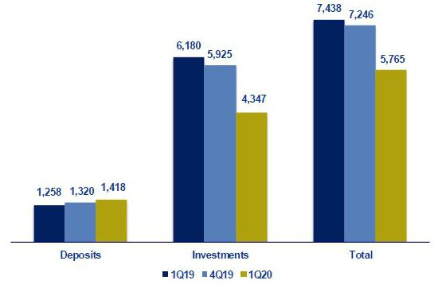

Portfolio distribution as of March 2020
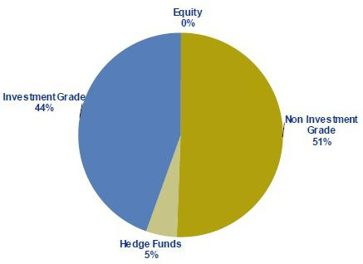

60

11.7. Grupo Pacifico

GRUPO PACIFICO *

(S/ in thousands)

 |  |  | As of |  |  |  |  | % change
 | Mar 19 |  | Dec 19 |  | Mar 20 |  | QoQ |  |  |  | YoY
Total assets | 12,695,204 |  | 13,838,009 |  | 13,729,726 |  |  | -0.8% |  |  | 8.1%
Invesment on securities ⁽¹⁾ | 9,264,180 |  | 10,758,564 |  | 10,586,838 |  |  | -1.6% |  |  | 14.3%
Technical reserves | 8,710,591 |  | 9,953,455 |  | 9,980,047 |  |  | 0.3% |  |  | 14.6%
Net equity | 2,663,129 |  | 2,801,556 |  | 2,724,095 |  |  | -2.8% |  |  | 2.3%

 |  |  | Quarter |  |  |  | % change
 | 1Q19 |  | 4Q19 |  | 1Q20 |  | QoQ |  |  | YoY
Net earned premiums | 588,942 |  | 630,804 |  | 640,707 |  | 1.6% |  |  | 8.8%
Net claims | 386,521 |  | 395,718 |  | 383,525 |  | -3.1% |  |  | -0.8%
Net fees | 134,507 |  | 152,229 |  | 156,165 |  | 2.6% |  |  | 16.1%
Net underwriting expenses | 37,011 |  | 26,644 |  | 50,159 |  | 88.3% |  |  | 35.5%
Underwriting result | 30,902 |  | 56,213 |  | 50,858 |  | -9.5% |  |  | 64.6%
Net financial income | 143,356 |  | 158,259 |  | 135,099 |  | -14.6% |  |  | -5.8%
Total expenses | 107,450 |  | 118,004 |  | 105,254 |  | -10.8% |  |  | -2.0%
Other income | 7,098 |  | 13,776 |  | 8,339 |  | -39.5% |  |  | 17.5%
Traslations results | -501 |  | -925 |  | 1,590 |  | -271.8% |  |  | -417.5%
Net gain on associates - EPS business and medical services | 8,918 |  | 17,263 |  | 17,186 |  | -0.4% |  |  | 92.7%
Medical Assistance insurance deduction | 2,736 |  | 9,806 |  | 6,430 |  | -34.4% |  |  | 135.0%
Income tax | 1,517 |  | 1,654 |  | 1,550 |  | -6.3% |  |  | 2.2%
Income before minority interest | 78,070 |  | 115,121 |  | 99,838 |  | -13.3% |  |  | 27.9%
Non-controlling interest | 2,592 |  | 2,594 |  | 2,523 |  | -2.7% |  |  | -2.7%
Net income | 75,478 |  | 112,527 |  | 97,315 |  | -13.5% |  |  | 28.9%

Ratios
Ceded | 12.2% | 16.5% | 13.0% | -350 bps | 80 bps
Loss ratio ⁽²⁾ | 65.6% | 62.7% | 59.9% | -280 bps | -570 bps
Fees + underwriting expenses, net / net earned premiums | 29.1% | 28.4% | 32.2% | 380 bps | 310 bps
Operating expenses / net earned premiums | 18.2% | 18.7% | 16.4% | -230 bps | -180 bps
_{ROAE} (3)(4) | 11.8% | 14.8% | 14.5% | -30 bps | 270 bps
Return on written premiums | 8.4% | 11.7% | 10.6% | -110 bps | 220 bps
Combined ratio of Life ⁽⁵⁾ | 87.3% | 89.6% | 87.6% | -200 bps | 30 bps
Combined ratio of P&C ⁽⁶⁾ | 104.4% | 94.1% | 94.4% | 30 bps | -1000 bps

*Financial statements without consolidation adjustments.

- Excluding investments in real estate.

- Net claims / Net earned premiums.

- Includes unrealized gains.

- Annualized and average are determined as the average of period beginning and period ending.

- (Net claims / Net earned premiums) + Reserves / Net earned premiums) + [(Acquisition cost + total expenses) / Net earned premiums] - (Net Financial Income without real estate sales, securities sales, impairment loss and fluctuation / Net earned premiums).
- (Net claims / Net earned premiums) + [(Acquisition cost + total expenses) / Net earned premiums].

From 1Q15 and on, Grupo Pacifico’s financial statements reflect the association with Banmedica. This partnership includes:

- the private health insurance business, which is managed by Grupo Pacifico and incorporated in each line of Grupo Pacifico’s financial statements;

- corporate health insurance for payroll employees; and

- medical services.

61

The businesses described in ii) and iii) are managed by Banmedica, therefore they do not consolidate in Grupo Pacifico’s financial statements. The 50% of net income generated by Banmedica is recorded in Grupo Pacifico’s Income Statement as a gain/loss on investments in subsidiaries.

As explained before, corporate health insurance and medical services businesses are consolidated by Banmedica. The following table reflects the consolidated results from which Grupo Pacifico receives the 50% net income.

Corporate Health Insurance and Medical Services

(S/ in thousands)

 |  |  | Quarter |  |  |  | % change
 | 1Q19 |  | 4Q19 |  | 1Q20 |  | QoQ |  |  | YoY
Results
Net earned premiums | 258,455 |  | 279,050 |  | 278,256 |  | -0.3% |  |  | 7.7%
Net claims | -233,597 |  | -228,400 |  | -213,978 |  | -6.3% |  |  | -8.4%
Net fees | -11,879 |  | -12,335 |  | -12,118 |  | -1.8% |  |  | 2.0%
Net underwriting expenses | -2,912 |  | -1,693 |  | -2,845 |  | 68.1% |  |  | -2.3%
Underwriting result | 10,068 |  | 36,622 |  | 49,315 |  | 34.7% |  |  | 389.8%
Net financial income | 1,505 |  | 1,573 |  | 532 |  | -66.2% |  |  | -64.6%
Total expenses | -17,535 |  | -20,715 |  | -19,659 |  | -5.1% |  |  | 12.1%
Other income | 1,012 |  | 905 |  | 244 |  | -73.1% |  |  | -75.9%
Traslations results | -17 |  | -716 |  | 919 |  | -228.4% |  |  | -5603.0%
Income tax | 1,615 |  | -5,804 |  | -9,825 |  | 69.3% |  |  | -708.4%
Net income before Medical services | -3,353 |  | 11,866 |  | 21,526 |  | 81.4% |  |  | -742.0%
Net income of Medical services | 21,108 |  | 22,577 |  | 12,765 |  | -43.5% |  |  | -39.5%
Net income | 17,756 |  | 34,443 |  | 34,290 |  | -0.4% |  |  | 93.1%

62

11.8. Prima AFP

 |  |  |  |  |  | Quarter |  |  |  |  |  |  |  |  | % change
 |  | 1Q19 |  |  |  | 4Q19 |  |  |  |  | 1Q20 |  |  |  | QoQ |  |  |  |  | YoY
Income from commissions | 99,758 |  |  |  | 100,567 |  |  |  |  | 103,233 |  |  |  | 2.7% |  |  |  |  |  | 3.5%
Administrative and sale expenses | (37,292) |  |  |  | (39,639) |  |  |  |  | (35,807) |  |  |  | -9.7% |  |  |  |  |  | -4.0%
Depreciation and amortization | (4,473) |  |  |  | (5,801) |  |  |  |  | (6,100) |  |  |  | 5.1% |  |  |  |  |  | 36.4%
Operating income | 57,993 |  |  |  | 55,126 |  |  |  |  | 61,326 |  |  |  | 11.2% |  |  |  |  |  | 5.7%
Other income and expenses, net (profitability of lace) | 17,712 |  |  |  | 8 |  | ,991 |  |  | (44,933) |  |  |  | -599.7% |  |  |  |  |  | -353.7%
Income tax | (18,829) |  |  |  | (17,415) |  |  |  |  | (20,155) |  |  |  | 15.7% |  |  |  |  |  | 7.0%
Net income before translation results | 56,876 |  |  |  | 46,703 |  |  |  |  | (3,762) |  |  |  | -108.1% |  |  |  |  |  | -106.6%
Translations results | 124 |  |  |  |  |  | 125 |  |  | (317) |  |  |  | -353.0% |  |  |  |  |  | -356.3%
Net income | 57,000 |  |  |  | 46,828 |  |  |  |  | (4,079) |  |  |  | -108.7% |  |  |  |  |  | -107.2%
ROAE | 37.6 |  | % |  |  |  | 27.3 | % |  | -2.6 |  | % |  |  | -2996 pbs |  |  |  |  | -4021 pbs
 |  |  |  |  |  | As of |  |  |  |  |  |  |  |  | % change
 |  | Mar 19 |  |  |  | Dec 19 |  |  |  |  | Mar 20 |  |  |  | QoQ |  |  |  |  | YoY
Total assets |  | 982,264 |  |  |  | 9 | 82,591 |  |  |  | 9 73,862 |  |  |  | -0.9% |  |  |  |  | -0.9%
Total liabilities | 402,446 |  |  |  | 2 |  | 84,643 |  |  | 4 26,510 |  |  |  | 49.8% |  |  |  |  |  | 6.0%
Net shareholders' equity ⁽¹⁾ | 579,818 |  |  |  | 6 |  | 97,948 |  |  | 5 47,352 |  |  |  | -21.6% |  |  |  |  |  | -5.6%

(1) Net shareholders' equity includes unrealized gains from Prima's investment portfolio.

Funds under management
Funds under management |  | Dec 19 |  | % share |  | Mar 20 |  | % share
Fund 0 |  | 751 |  | 1.4% |  | 776 |  | 1.7%
Fund 1 |  | 6,418 |  | 11.8% |  | 5,842 |  | 12.5%
Fund 2 |  | 40,657 |  | 75.0% |  | 35,336 |  | 75.4%
Fund 3 |  | 6,385 |  | 11.8% |  | 4,910 |  | 10.5%
Total S/ Millions |  | 54,211 |  | 100 | % | 46,864 |  | 100 | %

Source: SBS
Nominal profitability over the last 12 months
 |  |  |  |  | Dec 19 / Dec 18 Mar 20 / Mar 19
Fund 0
Fund 0 |  |  |  |  |  |  | 4.4% |  |  |  | 4.3%
Fund 1 |  |  |  |  |  |  | 15.3% |  |  |  | 3.3%
Fund 2 |  |  |  |  |  |  | 13.1% |  |  |  | -1.8%
Fund 3 |  |  |  |  |  |  | 5.7% |  |  |  | -11.8%
AFP fees
Fee based on
flow | 1.60% | Applied to the affiliates' monthly remuneration.
Mixed fee
Flow | 0.18% | Applied to the affiliates' monthly remuneration since June 2017. Feb 17- may 17 =0.87%.
 |  | Applies annualy to the new balance since February 2013 for new affiliates to the system and beginning on June
Balance | 1.25% | 2013 for old affiliates who have chosen this commission scheme.
Main indicators
 |  |  |  | Prima |  |  | System |  |  |  | % share |  |  |  | Prima |  | System |  | % share
Main indicators and market share |  |  |  | 4Q19 |  |  | 4Q19 |  |  |  | 4Q19 |  |  |  | 1Q20 |  | 1Q20 |  | 1Q20
Affiliates |  |  |  | 2,355,005 |  |  | 7,426,667 |  |  |  | 31.7% |  |  |  | 2,365,347 |  | 7,521,916 |  | 31.4%
New affiliations ⁽¹⁾ |  | - |  |  |  |  | 111,398 |  |  |  | 0.0% |  |  |  | - |  | 100,553 |  | 0.0%
Funds under management (S/ Millions) |  | 54,211 |  |  |  |  | 174,823 |  |  |  | 31.0% |  |  |  | 46,864 |  | 154,044 |  | 30.4%
Collections (S/ Millions) |  | 661 |  |  |  |  | 1,982 |  |  |  | 33.3% |  |  |  | 1,002 |  | 3,089 |  | 32.4%
Voluntary contributions (S/ Millions) |  | 1,103 |  |  |  |  | 2 ,295 |  |  |  | 48.1% |  |  |  | 977 |  | 2,057 |  | 47.5%
RAM (S/ Millions) ⁽²⁾ |  | 2,868 |  |  |  |  | 7,422 |  |  |  | 38.6% |  |  |  | 2,827 |  | 7,411 |  | 38.1%

Source: SBS

- As of June 2019, another AFP has the exclusivity of affiliations.

- Prima AFP estimate: Average of aggregated income during the last 4 months, excluding special collections and voluntary contribution fees. Information available to February.

63

11.9. Table of calculations
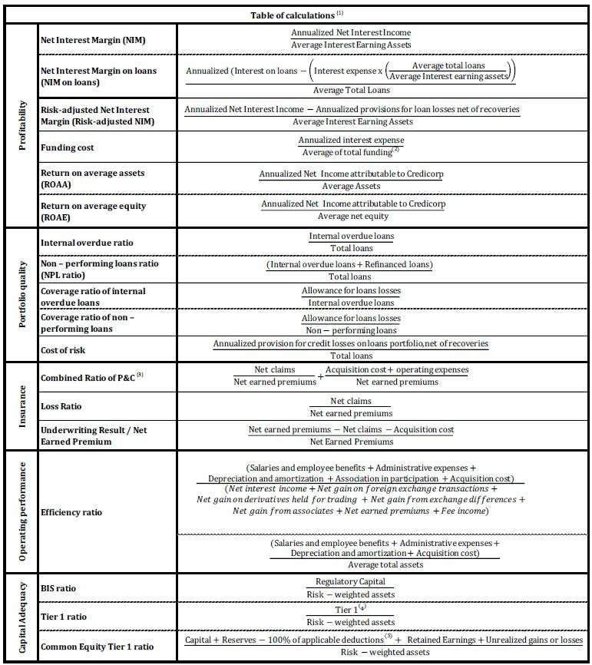

- Averages are determined as the average of period-beginning and period-ending balances.

- Includes total deposits, due to banks and correspondents, BCRP instruments, repurchase agreements and bonds and notes issued.

- Does not include Life insurance business.

- Tier 1 = Capital + Legal and other capital reserves + Accumulated earnings with capitalization agreement + (0.5 x Unrealized profit and net income in subsidiaries) - Goodwill - (0.5 x Investment in subsidiaries) + Perpetual subordinated debt (maximum amount that can be included is 17.65% of Capital + Reserves + Accumulated earnings with capitalization agreement + Unrealized profit and net income in subsidiaries - Goodwill).
- Includes investment in subsidiaries, goodwill, intangibles and deferred tax that rely on future profitability.

64

