SECURITIES AND EXCHANGE COMMISSION
Washington, D.C. 20549

FORM 6-K

Report of Foreign Private Issuer
Pursuant to Rule 13a-16 or 15d-16 under the
Securities Exchange Act of 1934

For the month of March 2024

Commission File Number: 001-14014

CREDICORP LTD.
(Translation of registrant’s name into English)

Of our subsidiary
Banco de Credito del Peru:
Calle Centenario 156
La Molina 15026
Lima, Peru
(Address of principal executive office)

Indicate by check mark whether the registrant files or will file annual reports under cover of Form 20-F or Form 40-F.

Form 20-F ☒ Form 40-F☐

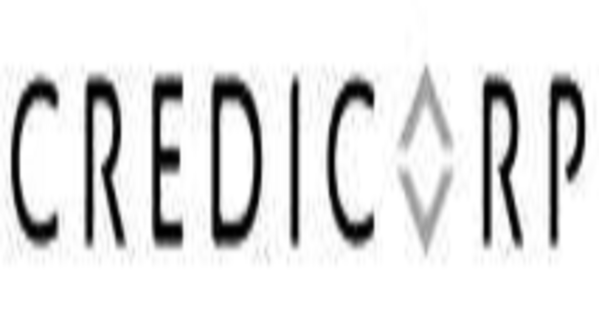
March 8th, 2024

Securities and Exchange Commission - SEC
Re.: MATERIAL EVENT

Dear Sirs:

Please find attached a copy of Credicorp’s Annual and Sustainability Report 2023, approved by the Company’s Board of Directors in its session held on February 29, 2024, and which will be presented to the Annual General Meeting of Shareholders on March 27, 2024.

The information in this Form 6-K (including any exhibit hereto) shall not be deemed “filed” for purposes of Section 18 of the Securities Exchange Act of 1934 (the ‘Exchange Act’) or otherwise subject to the liabilities of that section, nor shall it be deemed incorporated by reference in any filing under the Securities Act of 1933 or the Exchange Act.

Sincerely,

/s/ Guillermo Morales
Authorized Representative
Credicorp Ltd.

SIGNATURE

Pursuant to the requirements of the Securities Exchange Act of 1934, the registrant has duly caused this report to be signed on its behalf by the undersigned, thereunto duly authorized.

Date: March 8, 2024

 | CREDICORP LTD.
 | (Registrant)
 | By: | /s/ Guillermo Morales
 |  | Guillermo Morales
 |  | Authorized Representative

Exhibit 99.1

Annual and Sustainability Report

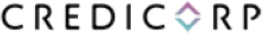

2023

1

Annual Report

Letter from the Chairman of the Board | 3
Our Purpose, Vision and Values | 8
Credicorp at a glance | 10
Group Description | 12
Our businesses in 2023 | 19
Economic Enviroment | 24
Economic and Financial Performance | 28
Risk Management | 39
Financial Statement | 51
External Auditing | 56
Annexes | 59

2

Letter from the Chairman of the Board

GRI 2-22

Dear shareholders, clients, employees and members of the communities we serve,

It is my pleasure to present our Annual and Sustainability Report 2023, which provides details on the progress we have made in executing our corporate strategy. In this space, I will share some reflections about the environment we operate in and highlight Credicorp’s most relevant milestones this year. I will also shed light on our outlook for 2024. I am proud to say that thanks to the efforts of our leaders and the commitment of our employees, we have adapted to complex environments; maintained our client-centered focus; and advanced our goal to be agents of change and drive development in the countries in which operate.

In a year of economic challenges, our agile and prudent management helped us navigate volatility and strengthen our competitive position

The year 2023 held positive surprises for the global economy even as new challenges arose, such as the regional banking crisis in the United States and war in the Middle East. Despite widespread expectations, the United States and the Eurozone sidestepped a recession and demonstrated resilience in a cycle of hikes in reference rates, which hit the highest levels seen in more than two decades. In the second half of the year, as inflation continued to slow, the market began to internalize rate cuts in 2023. This expectation was confirmed when the US Federal Reserve changed its tone at year-end. On the emerging market front, China was able to mitigate the impact of the real estate crisis and surpassed its government’s target for growth. In Latin America, most of the Central Banks began a rate cut cycle and growth in the largest economies in the region, Mexico and Brazil, reported surprisingly favorable results.

Despite advances this year, the dynamics on the economic front were challenging for our countries.

Peru reported its largest economic contraction since 1990 (excluding the pandemic) with a 0.6% drop in GDP. According to the Central Reserve Bank of Peru (BCRP), temporary factors, including social conflicts at the beginning of the year and the advent of an unexpected Coastal El Niño phenomenon as of March, led growth to drop two percentage points this year. On the positive side, inflation fell from 8.5% at the end of 2022 to 3.2% and is very close to BCRP’s range of 1% to 3%. In this context marked by economic contraction and dropping inflation, BCRP began interest rate cuts in September. By the end of December, the rate had fallen 100 bps to stand at 6.75%.

It is important to mention the performance of the economies of Bolivia, Colombia and Chile, where we operate. The Bolivian economy decelerated around 2% in 2023 in a context punctuated by persistent fiscal imbalances; limited access to external financing; an ongoing drop in international reserves; and an uptick in exchange rate volatility. GDP in Colombia fell significantly to stand at 1.2% after reporting one of the highest growth rates in the world in 2022. Political uncertainty and high inflation affected both consumption and investment, which registered its worst decline since 1999. In Chile, the economy stagnated due to a drop in private consumption and investment, which led the Central Bank of Chile to cut its monetary policy 200 bps to 8.25%.

In this challenging context, at Credicorp we leverage our financial strength, prudence, and experience with successfully operating in complex environments. Our client-centered focus and the digital capacities developed over the last decade helped us agilely navigate this juncture and strengthen our leadership in the markets where we compete.

Throughout 2023, we anticipated the credit cycle by reviewing our risk appetites; improving collections processes; and proactively offering financial assistance to clients in their time of need. Although the results of these actions were positive, it took us a while to calibrate adjustments correctly and we learned valuable lessons during this experience. We continued to develop our transactional and insurance value propositions as we reached more clients and registered increases in indicators for experience and frequency of use. Regardless, we recognize that we have not met all the objectives set for experience indicators in some banking segments. At this time, I would like to highlight that we are leveraging the scope of our reach in Peru to impart

3

prevention training to communities in regions vulnerable to the impacts of the El Niño Phenomenon. Credicorp’s solid strategic focus, our leaders’ disciplined approach to investing in talent development and technological capacities, and an unwavering commitment to our purpose have driven progress this year.

We anticipate challenges and opportunities as we advance our strategic priorities and generate resilient results

This year we advanced our three strategic priorities, which enable us to anticipate new challenges and opportunities and ensure our competitiveness in the long term. The priorities are integrating Sustainability in our strategy, accelerating Digital Transformation and Innovation, and securing the best Talent.

We integrate Sustainability in our strategy to become the agent of change we aspire to be. We have consolidated our position as the main engine of financial inclusion in Peru and have included more than 4.1 million people in the financial system through Yape and Savings Accounts BCP. This year, Mibanco banked more than 63 thousand people and entrepreneurs through microloans, 55.9% of which were made to women. We also made progress in democratizing access to insurance through the inclusive insurance products developed by Pacifico. These accessible and simple products now accompany more than 2.3 million Peruvians. At the beginning of 2023, we began implementing our new environmental strategy, which we communicated to the market in our first TCFD report (Working Group for Financial Transparency related to Climate Change). I would like to highlight that we have labeled more than US$ 585 million in loans as green at BCP, which tops the amount posted last year by threefold. We have just begun this trip but have a clear vision of where we want to go. In the context of the El Niño Phenomenon, we launched actions from our fronts at Pacífico, BCP and Mibanco to promote prevention and early management of this phenomenon in Peru’s most vulnerable regions. On the governance front, we strengthened competencies and improved the diversity of our Board with a new nomination. Our Board and its committees underwent external assessment this year and the recommendations were used to develop a plan of action. An important conclusion of this analysis was that, in general, our practices relative to the structure, composition and functioning of the Board are aligned with the good governance recommendations of national bodies, institutional investors, and proxy advisors. Lastly, in addition to the impact generated by our Sustainability initiatives, I am happy to say that thanks to our operations in 2023, we distributed more than S/1,912 million through tax revenues and investments in communities.

We accelerate Digital Transformation and Innovation at the Credicorp level to back our aspirations for growth. We continued to make material investments in developing our technology, data analytics and cybersecurity capacities. The progress on our digital transformation journey has allowed us to expand our scale while maintaining stability as we develop and launch new solutions that offer enhanced agility. We leverage data analytics to manage risks, optimize efficiency, increase income, and improve client experience by generating value propositions that are seen as superior and more relevant. We reduced our risk ratios and cybernetic vulnerability by strengthening our technological tools and processes and educating employees and clients about risks. Additionally, we created a Corporate Head of Technology role to exploit opportunities that currently exist among our companies and to create synergies. Finally, we are exploring ways to take advantage of the opportunities that Artificial Intelligence offers and have prioritized improvements in productivity and client experience. Initially, we are implementing use cases such as optimizing services at the BCP contact center and introducing the GitHub Copilot to our development teams’ work at BCP and Pacifico.

We secure the best Talent and provide on-going training to our employees to prepare them for growth. We are convinced that to sustain success, we must reinvent ourselves and embrace our talent’s continuous development. On this front, I would like to highlight the achievements of our Community of Learning, which acts as a space for our leaders to generate and share knowledge while creating synergies between the Group’s companies. In 2023, we concluded the first season of learning, which was dedicated to Data & Analytics. More than 250 of the organization’s leaders participated of which, 88% significantly increased their knowledge of this topic. We have already begun the second season, which focuses on strengthening fundamental Cybersecurity capacities. Our commitment to developing our talent is also reflected in the dynamics of corporate succession. Along these lines, in 2023 more than 80% of the vacancies for leadership positions were filled through internal promotions. To promote the retention of leaders and align their incentives with our objective to generate sustainable value, we have modified the structure for variable compensation and have included a component linked to long-term performance metrics.

4

We are developing our businesses

At Credicorp, we see innovation as a via to challenge and disrupt our businesses. Just shy of the one-year mark of having defined our disruptive innovation strategy and its governance, we would like to report that 20 initiatives are now in place and in different stages of development. In the medium term, our aspiration is that these initiatives come to generate 10% of the Group’s revenue (net of provisions).

Yape, with more than 10.5 million active users in Peru, is our most mature initiative. Currently, our focus is on developing functionalities that meet Peruvians’ day-to-day needs as we achieve monetization. We hope to reach break-even in coming months. This year alone, we launched 10 functionalities and the traction that our indicators for frequency of use have experienced have allowed us to advance our aspiration to become a superapp for Peruvians.

In the Krealo portfolio, our venture capital corporate center, Tenpo, our digital wallet in Chile, stands out. In 2023, Tenpo launched the first 100% digital credit card in the Chilean market and entered the scaling stage after surpassing our targets for the number of active users; transaction amount; and NPS indicator (Net Promoter Score). Krealo continues to expand its investments to support the strategic value of our current businesses as we explore innovative technologies to enable our business models.

In Universal Banking, we deepened our transactional capacities through digitalization

At BCP, we consolidated our position as a transactional hub in Peru and registered an 80% increase in the number of monetary transactions in 2023. This position was supported by a comprehensive value proposal with a multi-channel distribution network that focuses on client experience. On the physical front, this year we transformed the design of more than 100 branches to make service more agile and incorporated spaces to promote financial education. On the digital front, new functionalities were added and improvements were made to the user interface, which led to a 4-point increase in Mobile Banking’s NPS and 11 percentage points in the indicator for digital clients, which reached 68% at year-end. All these advances played a key role in optimizing our efficiency, and our efficiency ratio fell 2.3 percentage points this year. Finally, the credit cycle has taught us the importance of improving loan risk management in the consumer segment. We have adjusted our predictive models and monitoring practices and are better prepared to conduct more granular follow-up and make timely changes to guidelines, if necessary.

At BCP Bolivia, business developed in a complex environment that was impacted by a lack of US dollars and the failure of the country’s third largest bank. Despite this, we emerged stronger with higher solvency levels and firmer control over delinquency. We progressed on the digital front and reported growth in the number of bank accounts opened every month and advanced our Yape Bolivia app, which topped the one-million user mark in 2023. This has allowed us to increase transactionality as we work to generate more resilient income. In 2024, we will seek to optimize the financial margin through price management and low-cost deposit captures.

In Microfinance, we are strengthening risk management to resume growth and profitability while we build more diversified and resilient business models in the medium term.

Due to the macroeconomic conditions mentioned in this letter, 2023 was a tough year for the microfinance industry in Peru and Colombia. In Peru, efforts made over the last few years to consolidate our hybrid model allowed Mibanco to register profitability, albeit weak, at year-end. Moreover, the level reported topped the average registered for the microfinance system. Our centralized intelligence allowed us to agilely adjust commercial guidelines and mitigate the impact of portfolio deterioration. We closed the year with lessons learned and new capacities to implement more preventive models and conduct more granular follow-up on the portfolio’s behavior. We are now better prepared to reactivate our growth in 2024.

The Colombian microfinance system has been hit by inflation and elevated funding costs and has experienced a substantial reduction in the interest rate ceiling for microloans, which has generated challenges for the macroeconomy and led to structural changes that have impacted the outlook for growth for both the country and the banking sector. In this context, we are reviewing our strategy to recover profitability at Mibanco Colombia and are adjusting our short-term plans for growth. Nonetheless, we continue to believe that this country represents significant potential for medium and long-term growth.

5

In the Insurance and Pensions line, we contribute to developing systems in which more Peruvians choose to participate

Pacífico Seguros registered extraordinary results and has protected the happiness of more than 5 million Peruvians. By strengthening our digital capacities, we consolidated our position at the insurer with the #1 Client NPS in the market. We focused on growing in the retail segment, particularly through bancassurance and Yape. Moving forward, we will continue to penetrate the Peruvian market by accelerating efforts to create products that can be distributed through Credicorp’s ecosystems and have developed friendly architecture to facilitate coupling and provide post-sale service that facilitates mass self-service. The objective is to protect more Peruvians and consolidate our position as the insurance company that provides the best experience in the market.

At Prima AFP, we put the affiliate at the center of our decisions to achieve sustainability in the pension system. In this regard, we have strengthened the company by developing a team dedicated to improving client experience. To drive our growth, we emphasized affiliate retention and improved the productivity of our sales force by 40%. It is important to mention that at mid-year, Credicorp presented a plan to reform the Private Pension System with the purpose of building an open and inclusive system that shares risk.

In Investment Management and Advisory, we restructured our businesses and are on our way to recovering our profitability as we move towards sustainable levels

At Credicorp Capital and ASB Bank Corp., we revised our strategy and reorganized our business to drive profitable and sustainable growth through our asset management, wealth management, capital markets and fiduciary businesses. To do this, we rationalized businesses that are intensive in terms of capital and volatility, such as trading, and have left the corporate finance business. We are meeting the objectives proposed at the beginning of the year and are on our way to recovering our ROE as we move towards sustainable levels.

We Generate Resilient Results

In a very challenging context for the economies of the countries in which we operate, net earnings after minority interests stood S/ 4,866 million, which translated into an ROE of 15.8%.

Our Universal Banking business line was the primary contributor this year. BCP reported a return on equity of 20.6%, which was driven by an increase in the net margin in a context of higher rates. This growth was partially offset by an uptick in provisions, which was fueled by a deterioration in client payment capacities. On the other hand, our Microfinance business line was severely affected by a high level of provisions, associated with the deterioration of clients’ payment capacity. The Insurance and Pension Fund line registered extraordinary results. Grupo Pacifico leveraged development of its internal pricing and distribution capacities to take advantage of transitory tailwinds. Finally, profitability in the Investment Management and Advisory line experienced a slight rebound, which was driven by market dynamics, rigorous spending control, and growth in assets under management.

Total loans dropped 2.5%, highly impacted by a significant contraction in government program loans (-62.2%). This Dynamic was partially offset by growth in structural loans at BCP (+1.2%), which was led by Individuals and SME-Business.

In terms of portfolio quality, the structural NPL ratio rose (5.6% vs 5.0% at the end of 2022). This evolution was mainly driven by growth in the NPL portfolio at both Mibanco and BCP, which registered an uptick in NPLs through Credit Card, Consumer and SME-Pyme. Growth in provisions was driven by adverse macroeconomic, social and environmental conditions, which impacted client payment capacities; a shift in the loan mix toward an increase in the weight of retail loans; and by additional provisions for a severe El Niño in the summer of 2024. In this context, the cost of risk stood at 2.5% (versus 1.2% in 2022).

In an environment marked by high interest rates, the net interest margin stood at 6.01%, which represented growth of 92 basis points over the figure reported in 2022. This evolution was fueled by our repricing strategy and supported by our transactional deposit base. The shift toward a higher-yield asset structure also contributed to this result.

Other Income rose 11.6% in 2023, driven by the positive evolution of the Net Gain on Securities, which reported losses last year, and by an uptick in Fee Income (+4.4%). The Insurance Underwriting Result reported extraordinary growth of 43.9% this year, driven primarily by the Life Insurance Business.

6

In the aforementioned scenario, operating income increased 13.2% in 2023. Operating expenses rose 9.8% over the period, spurred by an uptick in spending for disruptive businesses (and for Yape and Tenpo in particular) and by growth in IT expenses at BCP. These factors led the efficiency ratio to stand at 46.1% at year-end, 142 basis points below the level reported last year.

We continue to prioritize responsible capital management at all our subsidiaries. Our solvency levels remained adequate, and we distributed cash dividends equivalent to S/1,994.0 million.

We look toward the future with confidence

Our organization enters 2024 with a strengthened competitive position and favorable external outlooks. Inflation has moderated in the United States, which has led the market to expect rate cuts from the Federal Reserve this year. This evolution should favor emerging markets. The price of copper should remain at good levels despite a moderate deceleration in China, bolstered by solid fundamentals due to a global transition to green technology. The normalization of inflation and interest rates in Peru gives us reason to be optimistic. The current environment, coupled with a dissipation in the probability of severe impacts from El Niño Phenomenon, leads us to expect a rebound of around 2.5%. Additionally, we anticipate GDP recovery in Chile, Colombia and Bolivia to stand at 2.1%, 1.7%, and 1.5% respectively.

In Peru, the political environment appears to be more stable than at the beginning of 2023; this is, without a doubt, fundamental to recovering business confidence. Accordingly, the government must drive the country’s economic reactivation and implement structural reforms in sectors such as education and health to recover the confidence of companies and individuals as it sets the stage to attract private investment within a secure legal framework.

To drive growth and ensure democracy and stability, the private sector must work alongside the public sector to develop projects that translate into more opportunities and enhanced wellbeing for our communities. At Credicorp, we are committed to helping close the education gap, which continues to be a major problem and is closely linked with poverty. Our efforts are not limited solely to financial education and inclusion. In 2023, we announced a commitment to spend S/500 million to execute projects to improve education infrastructure over the next few years through the Works for Taxes mechanism. We have also joined forces with UNICEF on the Project “Conectados para Aprender,” and will provide technological equipment and improve the internet connection of 120 schools in vulnerable locations to 2026 to benefit more than 59 thousand students.

Our governments’ leaders are not solely responsible for guaranteeing democracy and stability in our countries. As individuals and institutions, our acts of solidarity and empathy are key to achieving these objectives. By promoting inclusion, transparency and responsibility, we contribute to building the values we need to develop fairer and more equitable societies. I firmly believe that actors across society must genuinely collaborate to blaze the path toward a more sustainable and prosperous future.

Finally, I would like to thank our clients and investors for their confidence and recognize the efforts of the more than 37 thousand employees who work day-to-day to continue transforming our great corporation. Their talent and effort have made our organization stronger, maintained resilient results, and driven the development of the countries in which we operate.

With gratitude and optimism, I look forward to 2024. | 
Luis Enrique Romero Belimeslis
Executive Chairman

7

Our Purpose, Vision and Values

GRI 2-23

Purpose

Contribute to improving lives by driving the changes that our countries need.

Vision

To be a sustainable financial services leader in Latin America. We are purpose-led, future-oriented and focused on creating superior value for our employees, customers, shareholders and the countries we operate in.

Values

 | - | Respect
 | - | Fairness
 | - | Honesty
 | - | Sustainability

8

Statement of Responsibility

“This document contains truthful information regarding business developments at Credicorp Ltd. and Subsidiaries in 2023. The signatories shall be liable, within the ambit of their faculties according to the norms of the Civil Code, for damages that any lack of veracity or insufficiency that the contents of these documents may generate.”

 |  |  | 
 | Cesar Ries Briceño |  | José Luis Monuz Rivera
 | Chief Financial Officer |  | Head of Accounting
 |  |  | C.P.C. N° 14902

29/02/2024

9

Credicorp at a glance

GRI 2-1, 2-6

Who we are?

We are Peru’s leading financial group with over 135 years of experience in this market. We have a solid universal banking, insurance and pension platform that serves all segments of the Peruvian population, complemented by an important and growing presence in microfinance, investment banking, and wealth management in Latin America.

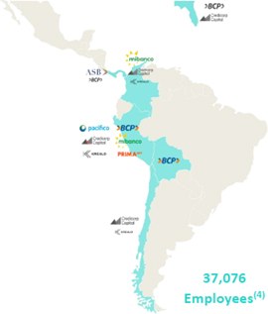

Total Income1

S/ 19,805 million

Income remained resilient and grew 16.5% in 2023, amid an adverse macroeconomic context.

Loan Portfolio

S/ 144,976 million

A contraction of -2.5% compared to 2022.

Net Income (attributable to Credicorp)

S/ 4,866 million

In 2023, we record a Net Income above the S/ 4,647 million generated in 2022 and above pre-pandemic levels. In 2023, we record a Net Income above the S/ 4,648 million generated in 2022 and above pre-pandemic levels.

Main subsidiaries | Clients2
Peru
BCP | Over 15 million
Mibanco | Over 2.0 million
Pacífico | Over 5.5 million
Prima AFP | Over 2.3 million
Bolivia
BCP | Over 800 thousand
Colombia
Mibanco | Over 600 thousand
Regional3
Credicorp Capital | Over 9 thousand

1. Includes Net Interest Income, Other Income and Insurance Technical Results.
2. A natural or legal person could be a client of more than one subsidiary. A natural or legal person could be a client of more than one subsidiary.
3. Includes Peru, Colombia, Chile and Miami.
4. For more information about our employees, review chapter "2.2) Social Impact of Our Operations: Employees Management" from the Sustainability Report.

10

Relevant Figures and Indicators

 | Ratios | 2020 | 2021 | 20222 | 20232
Loan growth1 | In local currency (%) | 24.8 | 13.5 | 4.3 | -5.0
Loan growth1 | In foreign currency (%) | -1.0 | -7.3 | 4.7 | 5.7
Loan growth1 | Total (%) | 16.6 | 9.9 | 3.9 | -2.4
Margins and Profitability | Net interest margin (NIM, %) | 4.3 | 4.1 | 5.1 | 6.0
Margins and Profitability | Cost of risk (%) | 4.3 | 0.8 | 1.2 | 2.5
Margins and Profitability | Return on average assets (ROAA, %) | 0.2 | 1.5 | 1.9 | 2.0
Margins and Profitability | Return on average equity (ROAE, %) | 1.4 | 13.9 | 16.8 | 15.8
Efficiency | Efficiency ratio (%) 4 | 46.3 | 45.9 | 47.5 | 46.1
Portfolio Quality | Internal overdue ratio (%) 5 | 3.4 | 3.8 | 4.0 | 4.2
Portfolio Quality | NPL ratio (%) 6 | 4.6 | 5.0 | 5.4 | 5.9
Capital | BCP Global Capital ratio (%) 7 | 14.9 | 14.9 | 14.4 | 17.5
Capital | BCP Common Equity Tier 1 ratio (%) 8 | 11.4 | 11.9 | 12.6 | 13.2
Capital | Mibanco Common Equity Tier 1 ratio (%) 8 | 17.7 | 15.2 | 16.5 | 18.4
Empleados | Permanent personnel | 36,806 | 36,396 | 36,968 | 37,076
Shares | Number of shares outstanding (millions9 | 79.47 | 79.53 | 79.53 | 79.54

1 Average Daily Balances.
2 Figures for 2022 and 2023 incorporate the adoption of IFRS 17 standard.
3 Net Interest Margin formula is: (Net Interest Income - Net Financial Expense from Insurance Activity) / (Average of the Interest Earning Assets, where the balance of Interest Earning Assets is equivalent to Cash and Due from Banks+ Total Investments+ Cash collateral, reverse repurchase agreements and securities borrowing + Total Loans)
4 Efficiency Ratio formula is: (Salaries and Employee benefits+ Administrative Expenses+ Depreciation and Amortization + Association in Participation) / (Net interest, similar income, and expenses + Fee income + Net gain on foreign exchange transactions + Net gain from associates + Net gain on derivatives held for trading + Net gain from exchange differences + Net Insurance Underwriting Results).
5 Internal overdue loans / total loans.
6 Non-performing loans) = internal overdue loans + refinanced and restructured loans. NPL ratio = NPLs / total loans.
7 Regulatory Capital / Risk-weighted assets (legal minimum=10% since July 2011).
8 Common Equity Tier 1 Ratio = (Capital + Reserves - 100% of applicable deductions (investment in subsidiaries, goodwill, intangibles and deferred tax that rely on future profitability) + Retained Earnings + Unrealized gains or losses) / Risk-weighted assets. Based on NIIF.
9 Net of treasury shares. The total number of issued shares is 94.38 million.

11

Chapter 1

Group Description

General Information

GRI 2-1, 2-6

Commercial Name: | Credicorp Ltd.
Address: | Clarendon House  2 Church Street  Hamilton, Bermuda
Address of the Main Subsidiary and Headquarters: | Calle Centenario 156, La Molina. Lima, Perú
Telephone: | +51 1 313-2000
Fax: | +51 1 313-2121

Credicorp Ltd. was established on August 17, 1995, in the City of Hamilton in Bermuda and is registered under registry No. EC21045. The company’s duration is indefinite.

Company Purpose

Credicorp is a business group that, through its subsidiaries and associates, offers a wide range of financial, insurance and health services and products, mainly throughout Peru and in other countries such as Colombia, Bolivia, Chile, Panama and the United States. Its main subsidiaries are: Banco de Crédito del Peru (BCP), Mibanco, BCP Bolivia, Pacífico Compania de Seguros y Reaseguros, Prima AFP, ASB Bank Corp. (formerly Atlantic Security Bank) and Credicorp Capital.

Credicorp was set up in 1995 through the acquisition of common shares of the Banco de Crédito del Peru (BCP), Atlantic Security Holding Corporation (ASHC) and Pacífico Compania de Seguros y Reaseguros S.A. (PPS). Through an Exchange Offer in October 1995, Credicorp acquired 90.1% of the shares of BCP, 98.2% of the shares of ASHC, and 75.8% of those of PPS. Trading of the common shares on the New York Stock Exchange began immediately after the Exchange Offer culminated and the closing price on this date was US$ 11.61 (adjusted to reflect stock dividends). On March 19, 1996, Credicorp acquired, through an Exchange Offer with similar terms to the one made in October 1995, the remaining 1.8% of shares in circulation of ASHC.

In 2012, Credicorp, as part of its strategic plan, embarked on efforts to create a regional platform and a reorganization process to regroup the company’s businesses. In April 2012, Credicorp, through its BCP subsidiary, acquired 51% of the shares of Correval S.A. Sociedad Comisionista de Bolsa, an investment bank in Bogota, Colombia. In July 2012, Credicorp, through its BCP subsidiary, acquired 60.6% of the shares of IM Trust S.A. Corredores de Bolsa, an investment bank in Santiago, Chile. In November 2012 and June 2013 respectively, IM Trust and Correval were transferred to Credicorp Capital Ltd. (subsidiary chartered in Bermuda to engage in investment banking activities in Chile, Colombia and Peru); this had no impact on Credicorp’s financial statements. To conduct investment banking operations in Peru, Credicorp Capital Peru S.A.A. was chartered in Peru in April 2012 through a spin-off of a block of BCP’s assets. The assets that

12

were transferred include Credibolsa, Credititulos, Credifondo and BCP’s investment banking activities. The spin-off of this block of assets had no impact on Credicorp’s consolidated financial statements. In addition, in 2014, through Financiera Edyficar (a subsidiary of Banco de Crédito del Peru), Credicorp acquired a majority stake of Mibanco’s shares. In November 2015, the 85.50% share that Grupo Crédito held in Credicorp Capital Peru S.A.A. was spun off and placed in Credicorp Capital Holding Peru, a subsidiary of Credicorp Capital Ltd. This act concluded the company’s reorganization process, whose purpose was to regroup the subsidiaries and shareholdings of Credicorp Capital Ltd. to improve business management. The split-off of this equity had no impact on Credicorp’s consolidated financial statement.

At the beginning of 2016, BCP Bolivia ceased to exist as a subsidiary of BCP and became a subsidiary of the holding known as Inversiones Credicorp Bolivia S.A. (ICBSA), which is in turn a direct subsidiary of the Grupo Crédito. In May and August 2016, Credicorp Capital Ltd., through Credicorp Capital Holding Chile, acquired 39.4% of the shares of Inversiones IMT S.A., becoming the owner of 100% of total shares in the company. Between May and September 2016, Credicorp Capital Ltd., through Credicorp Holding Colombia S.A.S., acquired 49% of the shares of Credicorp Capital Colombia S.A., achieving a 100% stake in the organization.

In January 2017, May 2018 and May 2019, as part of the reorganization of subsidiaries, Grupo Crédito purchased 9%, 2.77% and 0.96% of BCP’s shares respectively from Credicorp Ltd. By December 2019, Grupo Crédito possessed 97.71% of BCP and Credicorp Ltd. ceased to hold direct shares in BCP.

In January 2019, 91.36% of the Compania Incubadora de Soluciones Moviles S.A. – Culqi was acquired and Tenpo S.P.A (formerly Krealo S.P.A) was chartered. In March 2019, Credicorp Capital Negocios Digitales S.A.S. was chartered; in July, 100% of Tenpo Technologies S.P.A. (formerly Tenpo SPA) and 100% of Tenpo Prepago (formerly Multicaja Prepago S.A.) were acquired; in September, 85% of Fondo de Inversion Independencia II was acquired; and in November, 100% of Ultraserfinco S.A. was acquired. Finally, in December, 77.46% of Banco Compartir S.A was acquired.

In June 2020, the merger by absorption between Credicorp Capital Colombia S.A. and Ultraserfinco S.A. was carried out; the latter being extinguished. Likewise, in October 2020, the merger by absorption between Banco Compartir S.A and Edyficar S.A.S. was carried out and formed Mibanco - Banco de la Microempresa de Colombia S.A.

On January 2, 2021, Ultralat Capital Market Inc. and Credicorp Capital Securities Inc. merged into a single entity. The new company operates under the corporate name of “Credicorp Capital LLC.”, which was authorized on February 2, 2021.

On August 2, 2021, the merger by absorption between Atlantic Security Bank and ASB Bank Corp. was approved and registered in the Public Registry of Panama, leaving ASB Bank Corp as the surviving entity. In addition, ASB Bank Corp owns a 100% stake in Laurentian Corporate Service Ltd. since the merger with Atlantic Security Bank.

Credicorp’s subsidiaries are organized into four lines of business (LoBs):

 | - | Universal Banking, which includes Banco de Crédito del Peru and Banco de Crédito de Bolivia.
 | - | Microfinance, which includes Mibanco and Mibanco Colombia.
 | - | Insurance and Pension, which includes Grupo Pacífico and Prima AFP.
 | - | Investment Management & Advisory, which includes Credicorp Capital and ASB Bank Corp (formerly Atlantic Security Bank).

13

These LoBs are complemented by Krealo, Credicorp’s corporate arm for venture capital investments. Krealo identifies and invests in opportunities that complement Credicorp’s lines of business.

Credicorp’s Organizational Chart

The chart below depicts Credicorp’s configuration:

Credicorp Ltd. and Subsidiaries

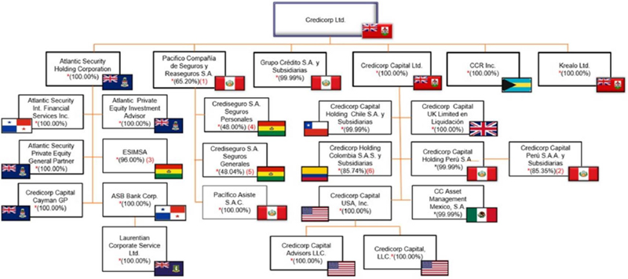

* Percentage of participation of the controlling majority shareholder.
(1) Grupo Crédito has a 33.66% stake.
(2) Credicorp Capital Ltd. has a 12.84% stake.
(3) Processing Solutions S.A. (Peru) and Inversiones 2020 has a 2.0% stake.
(4) Pacífico Seguros is the controlling entity. Inversiones Credicorp, Bolivia S.A has a 51.95% stake.
(5) Pacífico Seguros is the controlling entity. Inversiones Credicorp, Bolivia S.A has a 51.87% stake.
(6) Grupo Crédito S.A. has a 14.26% stake.

14

Grupo Credito S.A. and Subsidiaries

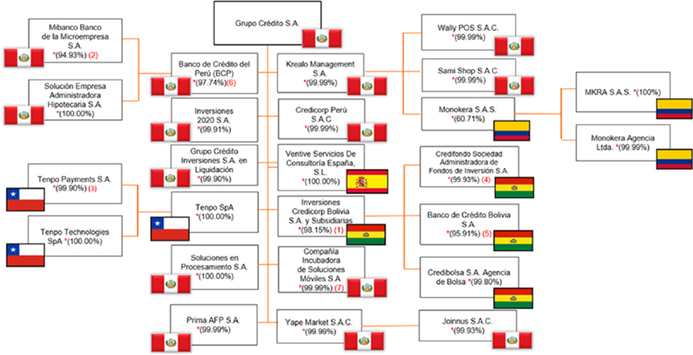

*Percentage of participation of the direct majority shareholder
(1) BCP has a 1.77% stake and Credicorp Ltd. has a 0.08% stake.
(2) Grupo Crédito S.A. has a 4.99% stake.
(3) Tenpo Technologies SpA has a 0.10% stake.
(4) BCP has a 0.07% stake.
(5) Credicorp Ltd. has a 4.01% stake. Inversiones 2020, Mibanco S.A and SEAH has a 0.028% stake, each one.
(6) BCP y Grupo Crédito S.A. are the only associates of “Patronato BCP” and “Instituto Bicentenario”, a non-profit civil association.
(7) Credicorp Peru S.A.C. has a 0.01% stake.

15

Capital and Main Shareholders

Capital issued by Credicorp Ltd. amounts to US$ 471,911,585 and is represented by 94,382,317 shares with a nominal value of US$ 5.00 each. All of Credicorp’s issued shares are common and equal, and shareholders have the same rights conferred by Bermuda Law and Credicorp’s Bylaws, which are detailed in the Shareholder’s Guide.

Shareholder Structure (%)1
As of February 14th, 2024

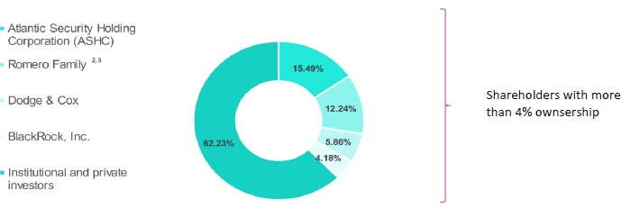
Source: Form 13G

The table below shows the composition of shares with voting rights as of December 31, 2023, considering the percentage of share ownership relative to the total number of shares:

Percentage of Ownership | Number of | Share
Percentage of Ownership | Shareholders | Percentage
Less than 1% | 5,510 | 5.58%
Between 1% - 4.9% | 1 | 4.92%
Between 5% - 9.9% | 1 | 5.41%
Greater than 10% | 1 | 15.49%
N.D.4 | N.D. | 68.60%

(1) Ownership is calculated including those declared by shareholders in their Form 13G filed as of February 14, 2024.
(2) Ownership is calculated considering what was declared by the Romero Family in the last Form 13G sent to the SEC dated February 13, 2024.
(3) Group of shareholders. Includes shares that are directly or indirectly held by the Romero family or by companies that they own or represent.
(4) 68.60% of Credicorp’s shares correspond to holdings whose purchase or sale was conducted through the NYSE, where it is not possible to identify the final beneficiary due to NYSE’s rules of disclosure.

16

Market Dynamics

The main financial markets registered positive results are year-end, bolstered mainly by the resilience of the US economy; adequate control of inflationary pressures; anticipation that FED’s rate hike cycle had come to an end; and market enthusiasm for the potential of new AI technologies. These dynamics offset market concerns about the impact of the crisis that hit regional banks in the United States in the second half of the year and market turbulence fueled by geopolitical tensions in Ukraine; Gaza and the Persian Gulf; as well as between China and Taiwan. The S&P 500, Dow Jones Industrial (DJIA) and Nasdaq registered growth 24.2%, 13.7%, 43.4% over the figures reported for 2022.

The local securities market also posted positive results at the end of 2023 despite an adverse macroeconomic context impacted by negative transitory shocks (social protests, Yaku Cyclone and Coastal El Niño Phenomenon). The Lima Stock Exchange reported growth of 21.7% in 2023, which was driven by a significant improvement in the outlook for different economic sectors, and the mining sector in particular, at year-end.

Share Price

In 2023, the Coastal El Niño Phenomenon; limited private investment; and political uncertainty at the start of the year negatively impacted Peru’s economic performance and expectations. Despite this adverse scenario, Credicorp remained resilient and registered positive results. In this context, Credicorp’s share Price at year-end stood at US$ 149.93, which represented growth of 8.6% versus the figure in 2022. In 2023, the share price hit a peak of US$158.47 and a minimum of US$116.42.

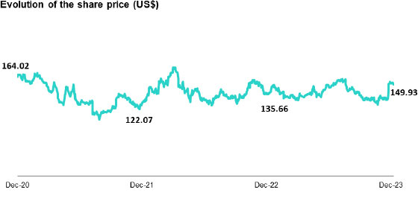
Source: Bloomberg.
17

Market Capitalization and Liquidity

At the end of 2023, Credicorp’s market capitalization was situated at US$ 11,924.76 million. This represents an increase of 10.5% over the figure of US$ 10,789.46 million registered at the end of 2022. Credicorp’s daily trading volume was 325,650 shares in 2023, which reflects a 20.5% decrease with regard to the average posted last year.

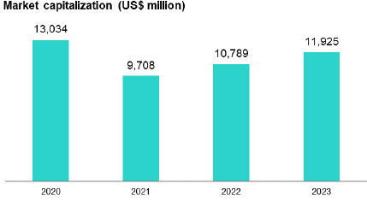
Source: Bloomberg

Dividends

In accordance with our dividend policy, and aligned with prudent capital management, Credicorp Ltd.s’ Board, in its session on April 28, 2023, announced the distribution of dividends equivalent to S/ 25 per share. It is important to note that Credicorp makes every effort to compensate our shareholders’ investments within a framework defined by our obligations, results, plans and stakeholders’ expectations.

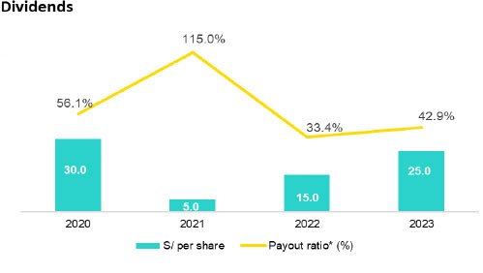
(*) Distribution of dividends, net of the effect of treasury shares

18

Chapter 2

Our businesses in 2023

Material Issue: Innovation and Digital Transformation
GRI 2-6, 3-3
Pillar 2

Credicorp is a financial holding. It is comprised of 4 business lines and our Innovation Portfolio.

 | 1. | Universal Banking

Banco de Crédito BCP – The N°1 bank in loans and deposits in Peru

BCP is a part of the Peruvian financial system and acts and a financial service provider. It engages in commercial banking and provides financing and savings solutions. Through its Wholesale Banking division, the bank offers services that have been specially designed for corporate clients and large companies, while the SME- Business and Individuals1 serves small and medium businesses as well as individuals.

 | ● | Leader in Loans and Deposits in Peru. MS2 of 29.1% and 32.0%, respectively.
 | ● | Loans for S/ 112,210 million.

BCP’s purpose is to “Transform plans into reality.” The bank has two north stars that guide its journey: (i) to be number 1 in client experience, and (ii) register the best efficiency ratio in Latin America.

At BCP, we strive to unlock potential growth in underpenetrated financial markets like Peru’s. To achieve this, we have developed advanced credit models as we leverage our capacities in Data & Analytics, Pricing and Risk Management and implement strategies for digital distribution. Moving forward, as we grow alongside the economy in the segments where we are already present, our most relevant avenues for new growth will be: (i) financial inclusion, to expand the size of the market, and (ii) new business development. We provide an integral experience with an increasingly digital focus, which leads to high transactionality to cover our clients’ day-to-day banking needs. In that sense, we grew by more than 80% in terms of number of transactions in 2023 and low-cost deposits (where volumes are highly correlated with transactionality) represent more than 76% of our deposit base. Additionally, fee income at BCP (also related to transactionality) accounts for 21% of our total income and has bolstered our resilience during adverse economic cycles.

To provide the best experience, we need to ensure that our operating stability is exceptional and count on our ability to roll out new functionalities quickly. As such, we have been aggressively investing in modern and flexible information technology architecture that permits reuse of components. Today, our average uptime indicator is world-class (99.8%); 100% of our front-end applications are cloud-based; and we have 500 reusable APIs. This year, new functionalities and improvements have been included in the user interface, which led to a 4-point increase in the NPS for Mobile Banking and growth of 11 percentage points in the indicator for digital clients, which stood at 68% at year end.

(1) As of 2024, Retail Banking’s name will be changed to SME-Business and Individuals.
(2) Share of the market within the Financial System (includes Multiple Banking, financial companies, municipal savings and loans and lending companies). To December 2023.

19

Banco de Crédito de Bolivia – Top 5 in loans and deposits in the Bolivian Financial System

The Banco de Crédito de Bolivia is a universal bank with a solid position at the national level. It has an extensive network of service and sales channels (more than 1,700 points of service). BCP Bolivia engages in on-going innovation to position itself as the bank of choice in the Bolivian financial system.

 | ● | Loans totaled S/ 9,402 million with a MS of 8.8%.
 | ● | Deposits totaled S/11,482 million with a MS of 9.0%.

BCP Bolivia’s purpose is to “give opportunities”. We aspire to lead the banking system for profitability; be the N° 1 bank in client experience; and lead the payment market through Yape. We focus on strengthening our digital channels to improve transactionality and increase low-cost deposit balances. By the end of December 2023, the number of accounts opened monthly rose two-fold compared to the figure in 2022, driven by growth in Yape Bolivia, which topped one million users at year-end.

 | 2. | Microfinance

Mibanco – Leader in Microfinance in Latin America and second most relevant player in the world3

Mibanco is an entity in the Peruvian Financial System that serves micro and small businesses. It has an extensive network of points of service, including mobile banking, App Mibanco, Telephone Banking, correspondent agents and BCP ATMs.

 | ● | Regional leader in microfinance, with 22.3% of MS4 in Peru in terms of loans.
 | ● | Loans totaled S/ 13,269 million.

Mibanco’s purpose is to “Transform people’s lives while maintaining a commitment to financial inclusion, progress and working together to contribute to the country’s growth.” We aspire to provide the best experience in the microfinance system; achieve higher profitability; and be N°1 in responsible financial inclusion.

In Peru, we continue to consolidate our hybrid model, which leverages 3 enablers: (i) centralized enablers, (ii) alternative channels, (iii) commercial execution. On the centralized intelligence front, loans disbursed via commercial offerings generated by the centralized intelligence engine represented 70.7% of total disbursements in 2023. Fifteen percent (15.0%) of total disbursements were made through alternative channels in 2023. In the short-term, we plan to strengthen capacities to implement more preventive risk models and will conduct more granular follow-up on the portfolio. In the medium term, we aspire to provide our clients with a comprehensive value proposition to diversify the bank’s sources of income. We would like to build a hybrid Plus model, where centralized intelligence will play a role in offering loans, liability products and transactional services.

(3) According to FMO, The Dutch Entrepreneurial Development Bank.
(4) To November 2023

20

 | 3. | Insurance and Pensions

Grupo Pacifico – Top 2 in net earned premiums in the Peruvian Insurance market.

Grupo Pacífico is a leading institution in the Peruvian insurance system. The company has two businesses that serve a diverse cross-section of the market: Life and P & C. In 2015, Grupo Pacífico signed a participation in association agreement with Banmédica to participate as equal partners in the health and medical insurance services. This agreement covers private medical insurance (Medical Assistance), currently managed by Pacifico Seguros (and reported within the P & C business), corporate health insurance for employees (insurance EPS), and medical service subsidiaries (clinics, laboratories, oncological centers). Under the terms of the contract, Grupo Pacifico transferred operating control of EPS insurance and the medical service subsidiaries to Banmédica. Consequently, the results for EPS insurance and medical services are not consolidated in Grupo Pacifico’s accounting balances and are reported as investment in associates.

 | ● | 2nd place in Net Earned Premiums5 with S/ 3,232 million in the Peruvian insurance market.

Pacifico Seguros’s purpose is to “Protect people’s happiness.” Three objectives guide the company on its journey: (i) Increase our sales so that more people are protected; this implies developing new products and channels and leveraging the scope offered by Credicorp’s channels, (ii) Have the highest NPS in the market, surprising clients with an extraordinary experience and putting them at the center of everything we do, and, (iii) Continue leading the market in efficiency to offer better protection and value for clients and our stakeholders. We know that talent is key to developing and strengthening internal capacities to achieve our objectives. To this end, approximately 25% of our staff is “technological talent.”

In 2023, we were ranked #1 for both NPS and efficiency. In this context, our client NPS rose 7 percentage points to stand at 40 at year-end. We also scaled our digital assets, such as Mi Espacio Pacifico, which reported 487 thousand active users at the end of December. In this scenario, premiums sold through digital channels rose 18% this year while the number of transactions that were self-managed by clients rose 35%.

Prima AFP – Second largest actor in the Peruvian Pensions Market

Prima is a private pension fund manager. It was chartered in 2005 and currently ranks 2nd in the market for funds under management, which totaled S/ 36,851 million at the end of 2023 and represented an MS of 30.0%. Prima AFP’s purpose is to “Guide and accompany people as they progress”.

(5) Net earned premiums: Retained premiums from insurance and accepted reinsurance plus an adjustment for underwriting reserves and accepted reinsurance. Definition of the Superintendency of Banking, Insurance and AFP (SBS).

 | 4. | Investment Management & Advisory

Credicorp Capital

Credicorp Capital aspires to be the preferred provider of advisory services and investment management with the best talent in the region. It runs operations in Peru, Colombia, Chile and the United States through four business units: (i) Asset Management, (ii) Wealth Management, (iii) Capital Markets and (iv) Fiduciary Businesses.

21

ASB Bank Corp

ASB is our banking platform in Panama. Its balance backs Credicorp’s Wealth Management business. Additionally, ASB serves as a platform for a portion of the Group’s trading strategies in the Capital Markets business.

 | ● | Assets under management for approximately US$ 16,520 million in Wealth Management
 | ● | Assets under management for approximately US$ 19,634 million in Asset Management

At Credicorp Capital and ASB Bank Corp., we review our strategy and reorganize our business to drive profitable and sustainable growth through our asset management, wealth management, capital markets and fiduciary businesses. To accomplish this, we rationalize businesses that consume elevated levels of capital and are highly volatile, such as trading, and have eliminated our corporate finance business. In 2023, we focused on i) strengthening our Business Center in the United States, where we will increase our commercial capacities and include banking services, and ii) generating a new value proposition for the affluent segment in Colombia, hand-in-hand with the development of our digital investment platform, Tyba.

 | 5. | Innovation at Credicorp

Credicorp believes that digital transformation is fundamental to ensuring that its businesses can further their purpose to contribute to improving people’s lives by driving the changes our countries need. For this reason, and to strengthen our culture of innovation and entrepreneurship at the corporate level; align the spaces in which we can innovate; and optimize the return on our innovation portfolio, we have begun the process to implement our system for corporate innovation.

This system focuses on the most disruptive initiatives, which i) seek to generate new sources of income through our business models, ii) can compete with our traditional businesses and/or iii) are supported by the most technological components.

The main bodies of governance of this system can be summarized as follows:

 | ● | Innovation committee: defines the innovation strategy and guidelines for portfolio management, on behalf of the Board. It is comprised of the CEO, COO and Chief Innovation Officer (CINO) and the CFO and CEO of Krealo participate on a recurring basis.
 | ● | Valuation Committee: defines the methodologies and parameters to conduct valuations of the investments that comprise the disruptive innovation portfolio. This is presided by the CFO.
 | ● | Innovation Round Table: Forum of discussion, coordination and collaboration for the leaders of the Innovation Units (UdI).
 | ● | Innovation Office: in conjunction with CINO, designs and makes recommends the disruptive innovation strategy at the corporate level; manages the innovation portfolio; and works to develop the enablers that optimize the innovation efforts of the innovation units.
 | ● | The Innovation Committee, Innovation Round Table, and Innovation Office are led by the CINO; their objective is to provide support and constantly develop the system and governance model for corporate innovation.
 | ● | Innovation Units (UdI): explore and develop innovation initiatives. These units are established in our Lines of Business to maintain a decentralized system for innovation and entrepreneurship. Accordingly, each innovation unit receives a mandate that is aligned with the needs of the Business Line to which it belongs and with the transversal innovation system. There are 4 main units: i) Innovation laboratories; ii) Krealo, our corporate venture capital; iii) a special unit that focuses on scaling initiatives with proven potential; and iv) selected disruptive initiatives that are key to the business.

22

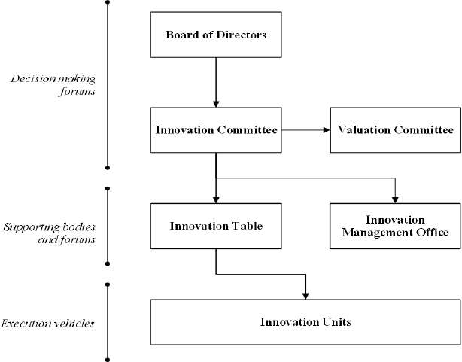

Initiatives in the Innovation Portfolio

Yape, with more than 10.5 million active users in Peru, is our most mature initiative and is currently in the monetization and value proposition expansion stage. This year alone, we launched 10 functionalities; the traction we have experienced has allowed us to set more aggressive targets.

Initiatives at our corporate center for risk capital are evolving and Tenpo, our digital wallet in Chile, stands out. In 2023, Tenpo launched the first 100% digital credit card in the Chilean market and has entered the scaling phase. Krealo, in turn, expanded its portfolio with three investments: i) Plurall, which offers financial solutions for microbusiness owners in Colombia by leveraging use of data and artificial intelligence, and ii) Finnerio Connect, a pioneer in the development of ecosystems for Open Finance in Latin America, and ii) Datamart, which is redefining the way private information is shared between financial institutions and their clients.

23

Chapter 3

Economic Environment

A. Growth

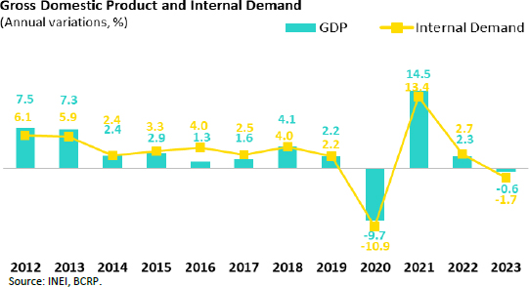

In 2023, GDP fell 0.6%, the worst print registered by the Peruvian economy since 1990 (-5.0%), excluding the pandemic. Several factors led to this contraction, the most important of which were social conflicts and El Niño Costero, which reduced GDP growth by almost two percentage points (BCRP).

The social protests at beginning of the year, triggered by the failed coup d’état by former president Pedro Castillo, were concentrated in regions that represent around 15% of GDP and affected non-primary sectors (commerce, services, transportation, construction) as well as some mining units, which experienced blockages and supply shortages.

The coastal El Niño was an unanticipated shock that affected the economy for at least ten months. In February, the Multisectoral Commission in charge of studying the El Niño phenomenon (ENFEN) indicated in that it did not expect an occurrence in 2023. One month later, in March, it activated the alert for a weak El Niño. It April, it changed its alert to moderate and in August, to strong. The climate anomalies mainly affected the anchovy fishing, agricultural and primary manufacturing sectors as well as textile production for the domestic market. These sectors registered their worst performance in more than two decades. Furthermore, the expectation that El Niño Costero would extend and intensify its destructive impact in the first quarter of 2024 led economic agents to exercise more caution on the consumption and investment fronts.

In addition to the social conflicts at the beginning of the year and El Niño Costero, the Peruvian economy in 2023 was also affected by: (i) persistently high inflation (especially in food prices) despite a recent slowdown, (ii) real wages that remained below pre-pandemic levels, (iii) real interest rates at two-decade highs due to the Central Bank’s effort to control inflation, (iv) political uncertainty, and (v) an absence of new large private investment projects.

24

In sum, GDP fell 0.6% in 2023. The agricultural and fishing sectors fell 2.9% and 19.7%, respectively. Primary manufacturing fell 1.8%, while mining production increased 9.5% due to the first full year of copper production at Quellaveco. In this context, primary GDP grew 2.9% while non-primary GDP fell 1.5%, driven mainly by contractions in construction (-7.9%), non-primary manufacturing (-8.2%) and services (-0.4%).

Finally, domestic demand fell 1.7% due to a 7.2% drop in private investment (lack of large new projects after Quellaveco began operating, which required an investment of US$ 5.5 billion); private consumption grew just 0.1%, its worst print since 1999 (-1.4%), excluding the pandemic.

B. Inflation

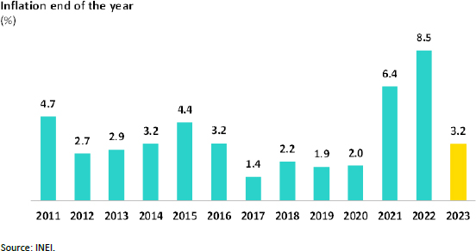

Inflation slowed from 8.5% in December 2022 to 3.2% in December 2023 due to the reversal of supply shocks in the agriculture and livestock sector at the beginning of the year; normalization of global supply chains; and a drop in average commodity prices (wheat: -28%, corn: -18%; soy: -8%) and crude oil (WTI -17%) for 2023. Core inflation (excludes food and energy) closed the year 2023 at 2.9% YoY, returning to BCRP’s target range of between 1% and 3% after two consecutive years of surpassing the upper limit.

25

C. Reference Rate

Source: BCRP

In 2023, BCRP began the cycle of monetary policy rate cuts. In September, after seven consecutive months of maintaining the rate at 7.75%, BCRP reduced the rate 25 bps to 7.50%. Successive cuts were made over the remainder of the year, leading the rate to stand at 6.75% at year-end.

D. Public Finances and External Sector

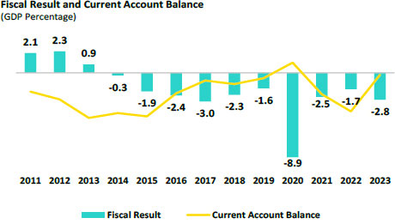
Source: BCRP.

The fiscal deficit closed the year 2023 at 2.8% of GDP, higher than the 1.7% registered at the end of 2022. This increase was driven primarily by a decrease in fiscal revenues, which went from 22.1% of GDP to 19.7% of GDP. The drop in income tax collection and general sales tax stood out, spurred by a contraction in domestic demand and lower commodity prices. Non-financial public spending grew 1.2%, due to the increase in current spending (4.2%). Public debt, in turn, fell 33.8% of GDP in 2022 to 32.9% of GDP in 2023.

26

In October 2023, Fitch affirmed BBB Peru’s sovereign debt credit rating with negative outlook, while in January, due to the intensification of social and political risks, Moody’s modified the outlook for Peru’s long-term debt in foreign currency from stable to negative (kept the rating at Baa1). S&P modified the outlook to negative in December 2022 (BBB rating). Hence, all three credit rating agencies assigned a negative outlook to Peru’s rating. S&P and Fitch set the rating two-steps above investment grade.

The current account deficit fell from 4.0% of GDP at the end of 2022 to 0.6% in 2023, the highest print in 16 years, excluding the pandemic. This reduction was driven mainly by an increase in the trade balance surplus from US$ 10.3 billion in 2022 to US$ 17.4 billion in 2023, a historic high. Imports fell 11.0% due to weak domestic demand and a drop in food commodity and oil prices, while exports grew 1.5%. The reduction in the current account deficit was fueled by a decrease in maritime shipping costs; lower earnings at companies that receive direct foreign investment; and an uptick in foreign remittance flows.

The terms of trade grew 5.3% YoY in 2023, driven by a 6.8% YoY drop in import prices (lower oil and agricultural prices), greater than the 1.9% drop in export prices (metals and hydrocarbons). In 2023, the terms of trade stood at 115.1, just 3% below its historic high reached in June 2021.

E. Exchange Rate

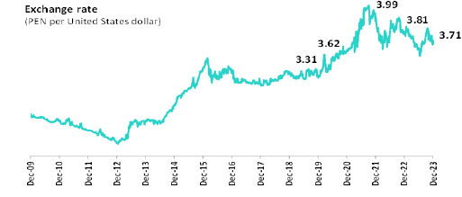
Source: BCRP.

According to BCRP, the exchange rate closed the year 2023 at USD/PEN 3.71, an appreciation of 2.7% versus the figure at the end of 2022. Throughout the year, the Peruvian sol fluctuated between 3.90 at the end of January and 3.56 in July. In the Latam region, the Colombian peso, the Mexican peso, and the Brazilian real appreciated 20.1%, 12.8% and 9.5% respectively, while the Chilean peso depreciated 3.6%. These variations occurred in a year where the global dollar weakened 0.5% (year average) due to expectations of an impending end to the Fed’s rate hike cycle.

In 2023, the BCRP sold US$ 81 million in the spot market, far below the US$ 1.2 billion sold in 2022 and record sales of US$ 11.6 billion in 2021. The stock of BCRP FX swaps closed at PEN 45,176 million (PEN 38,100 million in 2022).

Finally, Net International Reserves closed the year at US$ 71.0 billion compared to US$ 71.9 billion in 2022, which represented 27% of GDP.

27

Chapter 4

Economic and Financial Performance

Material Issue: Economic and Financial Performance, Responsible and Sustainable Finance and Investments
GRI 3-3, 201-1
SASB FN-CB-410-a.1
Pillar 1

Business sustainability at Credicorp depends, to a large extent, on the positive impacts that our companies generate for stakeholders and society over time. Credicorp’s LOBs are key drivers in the markets in which they participate, and the organization plays a fundamental role in adequately transferring, for example, resources generated by savings accounts to financing and investment efforts, which in turn generate value for society and promote economic development. On the insurance and pension fronts, we work to ensure our clients’ wellbeing today and down the line with products that protect and grow their assets.

In the material analysis performed, Economic and Financial Performance were ranked among the primary material issues for both Credicorp and its stakeholders. Given the relevance of this issue, the following chapter provides details on the holding’s financial evolution and the economic contribution that the Group generates, whose benefits are transferred to society through multiple venues.

Economic Value Generated and Distributed

Credicorp generates economic value through its operations, financial income and other income, which are distributed among different stakeholders and the society. In 2023, the economic value generated was S/ 24,484 million, which represents 22% more than in 2022. This value is distributed as follows:

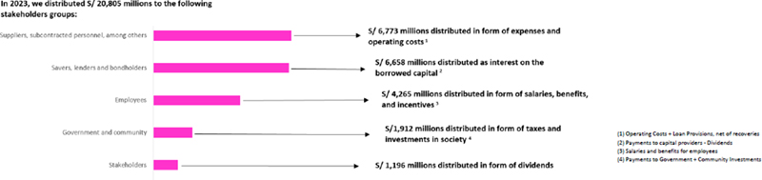

Finally, the economic value retained by Credicorp amounted to S/ 3,679 million at the end of 2023.

28

Financial Performance – We registered solid results at year-end in 2023 despite an adverse context

Net Earnings  attributable to Credicorp |  | Net Interest Margin (NIM) |  | Risk Adjusted NIM
S/ 4,865.5 millions  (vs S/ 4,647.8 millions in 2022) |  | 6.01%  (vs 5.09% in 2022) |  | 4.38% (vs 4.29% in 2022)

In 2023, Credicorp reported net earnings of S/4,865.5 million, which translated into an ROE and ROA of 15.8 % and 2.0% respectively. These results reflect the company’s resilience and strength in adverse contexts. The year 2023 was turbulent and challenging in an environment marked by unfavorable economic, social and environmental fronts. Notwithstanding, the company’s adequate liquidity and capitalization levels, in conjunction with a prudent approach to risk management and on-going investment over the years in digital talent and capacities, have put Credicorp in good stead to overcome obstacles; strengthen its competitive position; and continue executing its strategy.

Higher net earnings this year were primarily attributable to an uptick in net interest income, which rose 16.6% in an environment marked by falling interest rates. The recovery posted by other income also had a positive influence, which was mainly driven by: i)higher Net gain on securities, in line with the improvement in market conditions and ii) an improvement in the Insurance Underwriting Result, which was driven by the company’s solid underlying performance and temporary tailwinds. These dynamics were partially offset by an uptick in allowances for loan losses (net recoveries), which was spurred by a deterioration in payment capacities due to adverse events throughout the year, and by growth in operating expenses.

Net Income and ROE
(S/ millions, %)

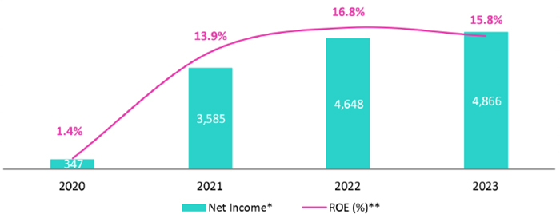

* 2023 figures reflect IFRS 17, 2022 figures have been restated.
**ROE = Net Income / Average Net equity, calculated as the average of period-beginning and period-ending balances.

29

Assets and Loans: Amortization of Government Program Loans in 2023 is offset by growth in Investments

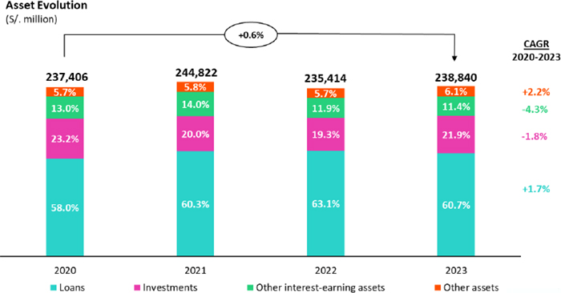

At the end of 2023, Credicorp’s assets registered a 1.5% increase versus the figure in 2022. This evolution was mainly driven by an uptick in the Total Investment balance. This dynamic was partially offset by a drop in the Loan balance, which was attributable to both the amortization of government loans and a context hindered by lower levels of private investment. In this scenario, Total loans’ share of Total Assets fell from 63.1% at the end of 2022 to 60.7% at the close of 2023.

30

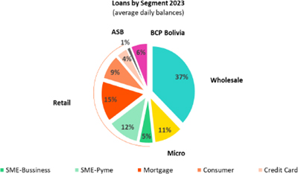
Loans by industry
(Year-end balances)
Industry | Loans (%)
Commerce | 17.9%
Manufacturing | 16.5%
Mortgage loans | 17.1%
Consumer loans | 13.0%
Real Estate and leasing | 6.6%
Community services | 4.7%
Communications, werehousing and transport | 5.2%
Agriculture | 3.3%
Mining | 2.7%
Electricity, Gas and Water | 3.3%
Construction | 2.4%
Financial Brokering | 2.3%
Restaurant & Hotels | 1.8%
Education, Health and Others | 1.1%
Others | 2.0%
Total loans | 100.0%

Loans

Total loans in quarter-end balances fell 2.5% versus the figure in 2022, while structural loans5 rose 1.6% over the same period. If we isolate the exchange rate effect, the drop in total loans stands at 1.5% and structural loans register an increase of 2.7%.

The positive evolution of structural loans was driven by growth in all segments of SME-Business and Individuals, which was partially offset by a contraction in Wholesale balances, which reflected the impact of low levels of private investment. Government Program Loans (GP) contracted 62.2%. At the end of December, this portfolio only represented 2.5% of total loans (vs. 6.4% at the end of 2022).

Investment Portfolio

Total investments rose 14.9% in 2023, driven by a strategy rolled out in 2023 to capitalize on excess liquidity, particularly through purchases of government bonds and BCRP Certificates of Deposit.

(5) Excludes from Total Loans the loans granted to clients through the Government Programs Reactiva Peru, FAE-Mype and Impulso MyPeru.

31

Other Interest-Earning Assets

Other Interest Earning Assets fell 3.1% in 2023, driven primarily by the evolution of Available Funds that earn interest, which fell 4.3% over the year. This dynamic was partially offset by growth in Escrow funds, Repos and Equity financing, which rose 28.0%.

Competitive Funding Structure

In 2023, Credicorp’s total funding structure fell 0.6%. This drop was primarily driven by a contraction in BCRP Instruments (-34.0%), which was due, in large part, to amortization of GP loans. The decrease in balances for Bonds and Issued notes also contributed to this result (-14.2%). The aforementioned was partially offset by growth in Others (+41.3%), and in Due to Banks and Correspondents in particular (+37.4%). It is important to note that the Deposit balance was impacted by a migration of funds from low-cost (savings and demand) to time deposits as clients sought out higher interest rates.

Credicorp’s funding cost rose 2.91% in 2023, which represents an increase of 108 pbs over last year’s result. This evolution was in line with an uptick in interest rates and the aforementioned migration in the deposit base.

Notably, time deposits rose 9.2% this year while demand and savings deposits fell 0.5% and 4.4% respectively. The fact that the company has a broad base of transactional deposits (demand, savings) helped mitigate the price effect on the funding cost, which was impacted by higher interest rates.

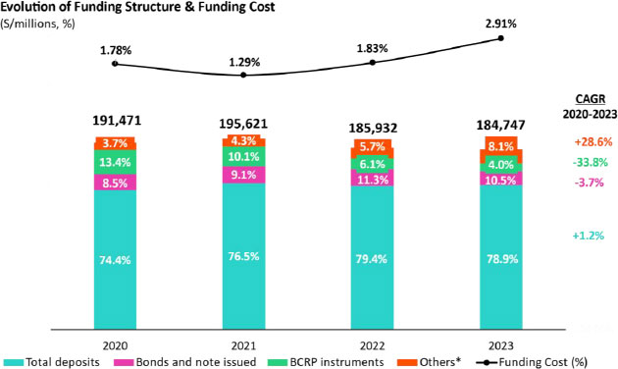
*Due to banks and correspondents + Repurchase agreements

32

NIM6 rose in line with the evolution of interest-earning assets, where higher-yield assets increased their share of total assets due to an uptick in interest rates.

Net interest income, which is the most important component of income, increased 25.2% in 2023. This growth was driven mainly by higher income from loans, which rose due to an uptick in structural loans in Individuals and SME-Business at BCP. Additionally, these loans registered an increase in their share of the structural loan mix. The uptick registered for the investment balance, which reflects a move to increase our position in government securities, also bolstered net interest income this year.

Interest expenses rose 49.5% this year, spurred mainly by growth in time deposits and, to a lesser extent, by an uptick in the balance for Due to Banks and correspondents in a context of higher rates.

Net interest income (NII) rose 16.6% in 2023. The Net Interest Margin stood at 6.01%, which represented an increase of 92 bps compared to the level reported in 2022. Risk-adjusted NIM increased 9bps, rising from 4.29% in 2022 to 4.38% in 2023.

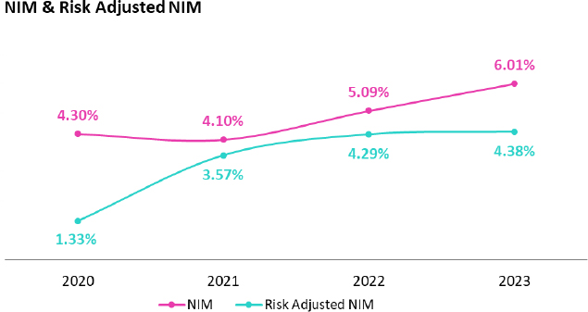

(6) Net Interest Margin formula is: (Net Interest Income- Net Financial Expense from Insurance Activity)/ Average of the Interest Earning Assets, where the balance of Interest Earning Assets is equivalent to Cash and Due from Banks+ Total Investments+ Cash collateral, reverse repurchase agreements and securities borrowing + Gross Loans

33

Cost of Risk stood at 2.5% in a challenging economic, social and environmental context

In 2023, provisions rose 100% YoY. This evolution was mainly driven by a deterioration in client payment capacities in a complicated economic, social and environmental context. Growth in provisions was primarily fueled by Individuals and SME-Business at BCP- and by Consumer, Credit Card and SME-Pyme segments in particular- and by higher provisions at Mibanco. The uptick in provisions in the aforementioned segments at BCP was fueled by an increase in deterioration in vintages from the first half of the year. At Mibanco, the increase in provisions was driven by a drop in the payment capacities of clients that are overindebted and those who were impacted by social protests and climate events.

In the aforementioned context, the structural Cost of Risk (CofR) stood at 2.55% (versus 1.26% in 2022). If we include the impact of the evolution of Government Loans, the CofR stood at 2.50% (versus 1.22% last year)

The structural NPL ratio in 2023 registered a significant variation and stood at 5.6%, 68 bps above the figure reported in 2022. This increase was mainly attributable to growth in the NPL loan volume, which was driven primarily by Individuals and SME-Business at BCP. The global NPL ratio rose +48 bps (going from 5.4% to 5.9%). In this scenario, structural NPL Coverage ratio stood at 102.4% in 2023 versus 112.2% in 2022. If we include the impact of Government Loans, the global NPL ratio stood at 97.0% in 2022 (compared to 97.9% in 2022).

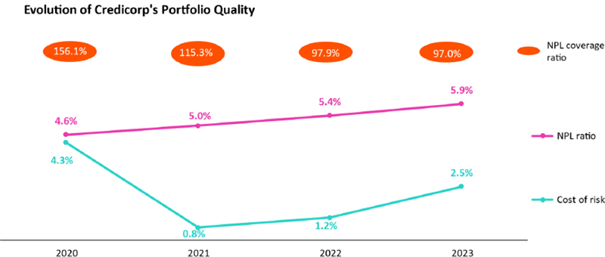

34

Growth in Other Income reflects an increase in non-core income in a context impacted by fee elimination

In 2023, Other income rose 11.6% with regard to 2022 despite a slight drop of 0.8% in Other Core Income (Fee income and Net gain on FX transactions), which was driven by the elimination of fees for intercity transfers and a drop in the Net gain on FX transactions, after demand fell due to a less volatile FX context. It is important to note that growth in the fee volume through payment channels and services offset the aforementioned contractions to a significant extent. Growth in non-core income this year was mainly fueled by the positive evolution of the Net gain on securities, which was attributable to good results for our trading strategies at Credicorp Capital and ASB; the performance of the investment portfolio Grupo Pacifico; and a revaluation of reserves at Prima AFP.

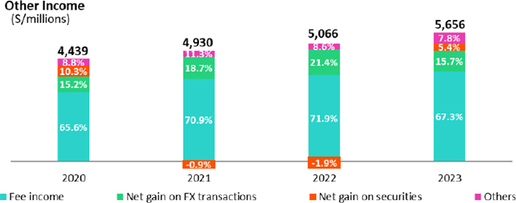

35

The Insurance Underwriting Result rose, driven by positive dynamics in the Life business

The Insurance Underwriting Result rose 43.9%, spurred mainly by higher results in the Life business (+75.0%). The evolution in life was driven primarily by transitory favorable price and volume dynamics for D & S products and by the distribution of Credit Life products through bancassurance channels. The improvement registered by Life was partially attenuated by a reduction in P & C’s result (-9.2%), which was fueled by an uptick in claims, particularly for P&C products.

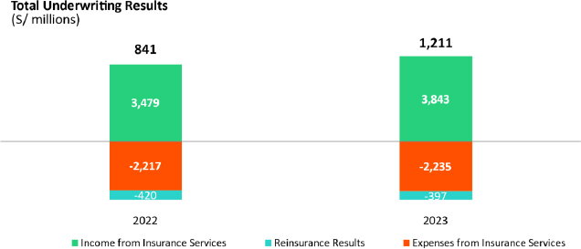

36

Positive evolution of the efficiency ratio, which reflects our ability to leverage our investments to improve our competitiveness

Operating income rose 13.2% on the back of growth in Net interest income, where growth was led by an uptick in loans measured in average daily balances and an improvement in the mix after disbursements in Individuals and SME-Business rose. Operating expenses increased 9.8%, spurred primarily to an uptick in expenses for disruptive initiatives and technology expenses excluding disruption at BCP, which reflected investments to support growth in digital transactions; develop new capacities; and hire specialized personnel in digital capacities.

In the aforementioned context, the efficiency ratio improved 142 bps with regard to the figure in 2022 and stood at 46.1% at year-end.

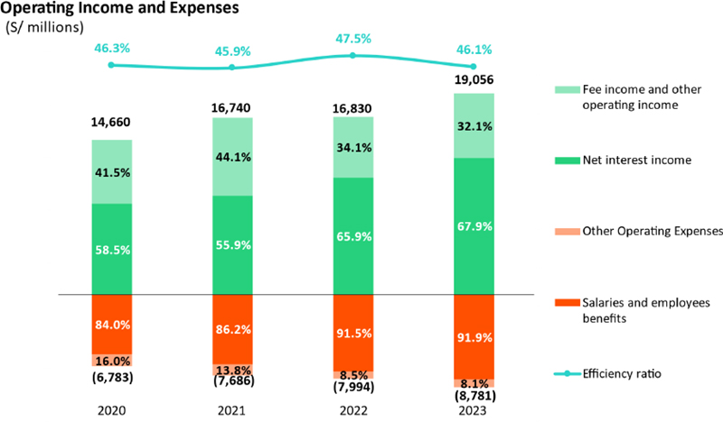

37

Our prudent solvency level sustains our strategic initiatives

The regulatory capital ratio stood 1.3 times above the regulator’s requirement. This indicator reported a slight decline of 5 bps compared to 2022’s figure. This evolution was mainly driven by an uptick in regulatory capital requirements at our banking businesses, which reflected a gradual increase in the conservation and market concentration buffers at BCP and Mibanco.

IFRS Common Equity Tier 1 (CET1) stood at 13.20% this year at BCP Stand-alone and 18.37% at Mibanco. An uptick in Retained Earnings at BCP Standalone (+61 pbs) and at Mibanco (+191 pbs) were mainly due to the higher balances of Retained Earnings (+15% and +99%, respectively).

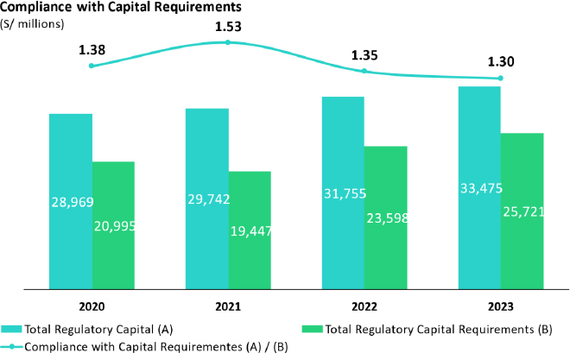

38

Chapter 5

Risk Management

Material Issue: Comprehensive Risk Management, Cybersecurity, Privacy and Ethical Data Management
GRI 3-3,
SASB FN-CB-230-a.2, FN-CB-550-a.2
Pillars 1 and 2

Risk management is of utmost importance to all companies and to the financial industry in particular, where interaction between institutions and other market agents is intense. In this context, systemic risk is high. Financial companies must ensure the security of their clients by adeptly managing their balances and ensuring that an adequate capital base is in place in case unexpected events arise. Credicorp is equipped with frameworks and processes that implement comprehensive risk management via effective monitoring, assessment, and treatment of its risks and those of its subsidiaries. The Group is aware that risk management plays a key role on multiple fronts, and, similar to other stakeholder groups, listed this issue on the top of its materiality list in 2023. This chapter provides details on our corporate vision, financial risk management, ESG risks and non-financial risks as well as of our management of capital.

I. Corporate Vision

A. Corporate Principles

Risk management at the Credicorp Group plays a fundamental role in our business activities. Accordingly, we have defined six corporate principles for risk management in the organization:

 | 1. | Involvement of Executive Management.

 | 2. | Independence of risk functions.

 | 3. | Sufficiency and quality of our risk management resources.

 | 4. | Measuring performance based on the risk assumed.

 | 5. | Risk follow-up and validation.

 | 6. | Compliance with the corporate code of ethics.

39

Risk Culture

Risk assessment at Credicorp is conducted by specialized personnel with adequate knowledge of processes to identify, assess, measure, treat and control risks. To consolidate a risk culture that is aligned with best practices in the industry, we employ periodic programs and offer ad-hoc courses for different risk teams and the entire organization.

The remote model of work, which was prevalent during the pandemic, shifted toward a hybrid model. This new work modality along with increased Internet interaction, implies latent risks for cybersecurity. As such, and as part of our risk culture, we continue to roll out awareness programs as we prepare Credicorp’s employees to recognize through and follow protocols for response.

Appetite for Risk

Appetite for risk refers to the maximum amount of relevant risk that we are willing to assume and can withstand to achieve our business objectives; this entails establishing the maximum deviations that we consider acceptable.

The main objective is to develop a risk profile that reflects the Board’s expectations, which is manifested in six strategic pillars: (i) solvency, (ii) liquidity, (iii) profit and growth, (iv) stability of results, (v) balance sheet structure and (vi) cybersecurity risks. These six pillars are supported by a taxonomy of risk that allows us to monitor our risk profile qualitatively and quantitatively..

The appetite for risk is composed of the following elements:

(i) Statement of the risk appetite: define the general principles and qualitative declarations that guide the group’s risk strategy, which also serves as inputs to define the target risk profile,

(ii) Metric dashboard: define the levels of risk exposure across our six strategic pillars through several metrics,

(iii) Limits: seek to ensure that risk-taking is within the tolerance level established across business units’ roles and responsibilities.

The appetite for risk is integrated in the processes for strategic and capital guidelines as well as in the process to define the budget. This facilitates strategic decision making throughout the organization.

B. Corporate governance of risk management

Credicorp’s Board has the power to make decisions about the overall focus of risk management at Credicorp Ltd., which includes approving its appetite for risk. The board is also informed about the level of compliance with the appetite for risk, levels of risk exposure, and improvements in the comprehensive management of Grupo Crédito S.A. and Credicorp’s other subsidiaries.

The Board of Grupo Crédito S.A. has the authority to make decisions applicable to Credicorp’s subsidiaries, including those related to risk management, such as approving the appetite for risk at Credicorp’s subsidiaries.

The same individuals sit on the Board (and the Committees) of Credicorp and Grupo Crédito S.A. and the management structure of both companies has been aligned.

Credicorp’s Risk Committee

This committee represents Credicorp’s Board and proposes levels of apetite for risk for Credicorp Ltd. The committee acknowledge the level of compliance with the appetite for risk and the level of exposure assumed by Grupo Crédito and Credicorp’s subsidiaries and oversees relevant improvements in comprehensive risk management at these entities.

40

Grupo Crédito Risk Committee

This committee represents Grupo Crédito’s Board in decision-making processes relative to risk management at Grupo Crédito and Credicorp’s subsidiaries. Additionally, the committee presents proposals to the Board of Grupo Crédito to set levels of appetite for risk for the group’s businesses. The Committee defines the strategies that will be used to adequately manage different types of risk; supervise the appetite for risk; and determine the principles, policies, and general limits to which Grupo Credicorp and Credicorp’s subsidiaries Will be subject.

In addition to efficiently managing all types of risk, the Risk Committee of Grupo Crédito is supported by the following committees, which report changes and relevant concerns regarding risk management on a periodic basis:

 | I. | Credit Committee

 | II. | Country Risk Committee

 | III. | Corporate Wholesale Risk Committee

 | IV. | Corporate Retail Risk Committee

 | V. | Operating Risk Methodology Committee

 | VI. | Corporate Risk Model Committee

 | VII. | Corporate Committee for Market, Structural, Trading and Liquidity Risk

Central Risk Management

Central Risk Management (led by the Chief Risk Officer at Credicorp) is responsible for implementing the policies, procedures, methodologies and the actions required to identify, measure, monitor, mitigate, report and control the different types of risk to which the Grupo Crédito and Credicorp’s subsidiaries are exposed. This division is also responsible for participating in the design and definition of strategic plans for business units to ensure alignment with the risk parameters approved by Credicorp’s Board. Finally, Central Risk Management disseminates information on the importance of adequate risk management and works with units to determine the specific role that each must play in identifying risk and defining corresponding actions.

Corporate Policies

Corporate risk management policies establish the roles and responsibilities that have been defined and assigned to manage the risks we face. Our framework policy guides risk management in general, but we also have specific policies that govern our most relevant risks. It is important to note that each of the Group’s companies has unique characteristics (in terms of size and the complexity of its operations), which have been taken into consideration to develop and implement each policy.

II. Financial Risks

C. Credit Risk

Loans, provisions and coverage

Credit risk is the most significant risk for our activities and is defined as the probability of suffering losses due to debt repayment problems relative to borrowers or to counterparties in exposures assumed off and on the balance sheets.

At the end of December 2023, the balance of direct and indirect loans was S/163,535 million, which represented decrease of 2.7% with regard to the level reported in December 2022. Provisions for loan losses totaled S/8,646 million. In this context, at the end of December 2023, the coverage ratio was situated at 5.29%, versus 5.07% at the end of December 2022.

41

Loans, provisions and the Credicorp’s coverage ratio by subsidiary

Company | Direct and Indirect Loans |  | Provisions |  | Coverage Ratio
Company | 2022 | 2023 | 2022 | 2023 | 2022 | 2023
BCP and branches | 140,215 | 136,437 | 7,026 | 7,102 | 5.01% | 5.21%
Mibanco | 13,966 | 13,165 | 998 | 1,003 | 7.15% | 7.62%
BCP Bolivia | 10,274 | 10,037 | 433 | 383 | 4.21% | 3.82%
ASB | 2,362 | 2,067 | 0 | 0 | 0.00% | 0.00%
Mibanco Colombia | 1,205 | 1,704 | 66 | 139 | 5.48% | 8.16%
Others | 96 | 125 | 8 | 19 | 8.33% | 15.20%
Total | 168,118 | 163,535 | 8,531 | 8,646 | 5.07% | 5.29%
Figures in S/. millions
Source: Corporate Accounting.

Credit Process

 | A) | Wholesale Banking

Acceptance:

The Group has policies to approve transactions that are subject to credit risk. These policies are based on conservative criteria, which are applied to common structures in each of the Group’s companies. Analysis focuses primarily on the client’s capacity to generate sufficient resources to reimburse the company, within the time frames stipulated in agreements, for the principal of the loan and its respective interest.

Risk assessments are conducted periodically at the client or economic group levels. In particular, we analyze the client’s financial situation and payment capacity. Assessments are supported by standardized processes, which are inturn supported by rating models that calculate the probabilities of default to be used to approve credit lines and control portfolio quality.

In 2023, the Group took concrete action to improve the acceptance process across units. At BCP Wholesale Banking this year, a project to renew the technology utilized in loans processes continued; new services to activate credit lines were developed; and data on scores and financial statements were transferred to CLOUD environments. At BCP Bolivia, an application was implemented to assess guarantees for loans in the agriculture and livestock sector to pinpoint the georeferenced location of properties in rural areas and determine exposure in areas with high climate risk.

Follow-up:

The follow-up process seeks to maintain adequate portfolio quality, which entails assigning levels of loan deterioration and implementing the corresponding corrective actions. To maintain an adequate level of portfolio risk, the Group uses an early alert system to quickly identify changes in client risks. Information from this system is used to assign levels of deterioration and take corrective action.

42

In 2023, the Group implemented a monitoring scheme in Wholesale Banking to keep a watchful eye on economic sectors and clients that may be impacted by the El Niño Phenomenon. Specific guidelines were set up to manage this risk.

Progress on the follow-up front at BCP also included adding sustainable activities (under an environmental focus) to the taxonomy used to grant loans for specific economic sectors. At BCP Bolivia, in turn, a drop in Net International Reserves led to restrictions on access to foreign currency; to determine the magnitude of this risk, steps were taken to segment the portfolio by degree of potential impact.

Recovery:

The main objective of the recovery process is to normalize clients’ situations. If this is not possible, we opt to maximize debt recovery. Along these lines, we have worked on improving processes to provide more personalized services to our clients.

To meet our objective, the companies in the Group restructure the payment conditions for clients that are experiencing economic deterioration. Additionally, legal processes are executed to recover guarantees and processes to recover overdue loans or negotiations to execute the sale of corresponding guarantees or dations in payment.

In 2023, improvements were made in Wholesale Banking and Retail Banking to better manage internal recovery processes relative to written-off and/or judicial recovery loans that were 100% provisioned and to sell adjudicated properties.

 | B) | SME- Business and Individuals Banking

Acceptance:

The processes for acceptance and portfolio management of the main portfolios are conducted with scoring and rating models, whose probabilities of default are used for loan assessment. These acceptance models, coupled with norms for loan issuance, are defined by the risk units in accordance with the guidelines approved by the different risk committees of the Group’s companies.

In 2023, the Group made a number of improvements in acceptance in SME-Business and Individuals at BCP: i) Improvements in score models, rating and acceptance guidelines that include a larger number of variables and modules that recognize early delinquency ii) Improvements in our income estimates, which allows us to generate larger volumes of credit offerings that respond to clients’ needs, (iii) adjustments to parameters for disbursements through Leads and improvements in managing clients with high probability of deterioration to protect portfolio were made iv) Adjustments to the cut-off point for the probability of default among high risk segments that have been impacted by an adverse macroeconomic environment marked by social conflict and climatic problems. Additionally, at Mibanco The autonomies of leaders that have disbursed loans that present high deterioration were reduced and alerts were introduced for origination and assessment at points of sale.

Follow-up:

The Group uses behavior models, which group clients by level of risk to subsequently implement preventive and corrective actions. We conduct follow-up on loans by tracking indicators for delinquency at the portfolio level and for vintages; and expected losses.

In 2023, the Group focused on the following in the SME-Business and Individuals portfolios: i) identifying early alerts and management pre-delinquency actions, ii) understand the profiles of vulnerable sub-segments and those that may begin to show signs of vulnerability, iii) generate a larger volume of openings and more in-depth reviews of borrowers’ credit situations at the system level and iv) increase the volume of financial assistance provided to clients experiencing payment problems due to macroeconomic context, v) changes in Variable Compensation to incentivize collections, vi) improvements in the operativity of the loan committee; vii) designing a playbook for assistance that can be provided to clients that may be affected by the El Niño Phenomenon.

43

Recovery:

The recovery process for retail clients aims to reduce the provisions level; minimize losses; improve delinquency ratios; and maximize recovery in the active, judicial recovery and written-off portfolios. These efforts focus on enhancing profitability, efficiency and the client experience.

In 2023, to improve the recovery level, the Group implemented actions to manage new high-risk portfolios: (i) changes in acceptance, (ii) new alternatives to assist clients, (iii) more digitality to reach more clients, (iv) strengthening management in more advanced stages, (v) configuration of specialized teams.

Extensive preparations were rolled out to handle fallout from a potential El Niño Phenomenon. This entailed defining the service flow; defining alternatives for assistance to be offered to clients; implementing new digital channels (Mobile Banking); and training teams to serve clients that may potentially be impacted.

Models and methodologies for credit risk management

Statistical models constitute a fundamental part of our credit risk management strategy. As such, the Models and Methodologies Area for Risk Management (MMGR) at BCP provides support to build, adjust and/or calibrate models to manage our companies’ credit risks. This area is in charge of providing governance guidelines for credit risk models and overseeing their correct application within the group.

In 2023, with the results of on-going modeling of models, calibration was conducted with early metrics of payment behavior. In parallel, at the portfolio level, the assumptions introduced during the pandemic were discarded and the Group returned to analytical normality. At year-end an additional dimension was introduced in the models to better capture the impact of macroeconomic deterioration.

Additionally, we continued to use alternative sources of information in risk models in both the SME-Pyme and individuals segments.

Statistical models constitute a fundamental part of our credit risk management strategy. As such, the Models and Methodologies Area for Risk Management (MMGR) at BCP provides support to build, adjust and/or calibrate models to manage our companies’ credit risks. This area is in charge of providing governance guidelines for credit risk models and overseeing their correct application within the group.

In 2023, due to high inflation and an increase in provisions at the system and Group levels, models were periodically calibrated for Cash Loans, Credit Cards and Working Capital. Additionally, a new set of acceptance models were rolled out in the second half of the year for SME-Business and new models were developed for acceptance of Cash Loans and Credit Cards.

D. Market Risk

We separate market risk into two groups: (i) exposure that arises from a fluctuation in the market value of the positions acquired, which are primarily registered in the fair value through profit and loss investments (Trading Book) and ii) exposure that arises due to a fluctuation in the value of asset and liability and the matching of structural positions registered at amortized cost and in the fair value through other comprehensive income portfolio (Banking Book).

Trading Book

To manage the trading book, Credicorp applies the VaR (Value at Risk) methodology to its trading portfolio to calculate the market risk of the main positions taken and to determine the maximum loss expected considering a defined probability of occurrence (1%) and based on a series of assumptions that cover a variety of changes in market conditions.

44

Risk Type | 2022 | 2023
Interest rate Risk | 74,343 | 29,399
Price Risk | 5,219 | 5,291
Volatility risk | 2,032 | 20
Diversification effect | (7,347) | (5,850)
VaR Consolidated by risk type | 74,247 | 28,860
Figures in S/ thousands.
The VaR calculation does not include the effects of the exchange rate, given that these effects are measured in the sensibility of the net monetary position.

The Group's VaR showed a decrease as of December 31, 2023, mainly due to lower interest rate risk due to a lower sensitive amount of the portfolio and the registration of fewer upward rate shocks during the last year. The VaR remained contained within the risk appetite limits established by the Risk Management of each Subsidiary.

Indicators for stressed VaR and economic capital, which reflect the trading portfolio’s exposure to extreme movements in the risk factors to which it is subject, are also used in Trading Book Management. These indicators have a structure or limits and autonomies for each of the Group’s companies, which depends on the size of the positions and/or volatility of the risk factors contemplated for each financial instrument. Reports are prepared on a regular basis for the Group’s different committees. The appetite for risk for the Group’s Trading Book is periodically reviewed by the Corporate Committee for Market, Structural, Trading and Liquidity Risk and by the Risk Committees.

Exchange rate risk is measured through the sensitivity of each foreign exchange position that affects the consolidated results or other comprehensive income. The market risk unit at each subsidiary monitors and controls each foreign exchange position and the exchange rate risk derived from the same. Exchange rate strategies are also applied to the Group’s Trading Book portfolios, whose limits are defined on a per-portfolio basis and aligned with the limit set for the global FX position. These aspects are closely monitored, and the Group’s Risk Committees are periodically informed of findings.

In 2023, curves were implemented for Secured Overnight Financing Rate (SOFR) to feed the valuation and calculation of market risks for instruments denominated in currency pairs other than the Sol-US Dollar.

Banking Book

Banking book management at Credicorp covers the identification, measurement, evaluation, control and monitoring of liquidity Risk and structural risk relative to the Interest Rate.

Liquidity risk is defined as an inability to pay or refinance obligations that have been previously agreed on to maturity due to situations of mismatching of assets and liabilities, and the inability to liquidate investment positions that are subject to price risk, without generating adverse changes in the value of these positions. Credicorp’s subsidiaries manage liquidity risk with corporate indicators such as Internal Liquidity Coverage Ratio (RCL, Spanish acronym), the Internal Net Stable Funding Ratio (RFNE, Spanish acronym) and an analysis of liquidity gaps.

These indicators have structures that contemplate limits and autonomies for each of the subsidiaries, which are subsequently included in the companies’ contingency plans for liquidity. At the Credicorp level, there are limits for risk appetite incorporated in these indicators, which are monitored and communicated to the Risk Committees.

In 2023, after central banks bank to gradually withdraw liquidity stimuli, we focused on follow-up, calibration and updating of the models and assumptions used to evaluate the sufficiency of liquid assets at the Group’s companies.

Interest rate risk in the Banking Book refers to variations in rates that gain impacted expected gains or the market value to a balance’s assets and liabilities. As such, we monitor all products sensitive to interest rate risk through gap analysis; sensitivity analysis of the risk margin (Gains on Risk); and economic value of equity analysis.

45

In 2023, to ensure that exposure to interest rate risk is aligned with the Group’s appetite and strategy, on-going follow-up was conducted with interest rate simulation models; prepayment conduct models; and products whose contracts have no expiration date.

E. Calculations of IFRS 9 provisions

The estimate of loan losses under IFRS 9 at Credicorp is the product of the following parameters: (i) probability of default (PD), (ii) loss given default (LGD) and (iii) exposure at the time of default (EAD), discounted at the reporting date using the effective interest rate or an approximation of the same. This also takes into consideration information on current conditions as well as projections of future macroeconomic events and conditions in three scenarios (base, optimistic and pessimistic), which are weighted to obtained expected loss.

The Model Risk Management Area, Internal and External Auditing validate methodologies and procedures to ensure that provisions are adequately estimated.

In 2023, we continued to calibrate models to maintain an adequate level of precision in calculations of credit risk and associated provisions and added an update to macroeconomic projections. We also estimated the expected impact of the El Niño Phenomenon on the Group’s credit risk and subsequently added provisions. At BCP Peru, a Strategic Tool was officially rolled out to calculate IFRS 9 provisions, which strengthened the bank’s commitment to using best technological and cybersecurity practices.

F. Model Risk Management

The mission of the Model Risk Management Area BCP (ARM) is to manage the portfolio for the Group’s models to minimize potential losses due to errors in construction, maintenance or use.

In 2023, follow-up was conducted on dashboards for regulatory alignment, one internal and the other regulatory (Peruvian regulation). The regulatory model required adjustments after changes were made to the regulatory framework that governs the risk model in the Peruvian Financial System. Internal alignment of the risk model increased the advance by 4%. The Group has fully aligned its models with Peruvian regulations.

G. Insurance Underwriting Risk

The main risk that Credicorp faces in terms of insurance contracts is that the real costs of claims and payments or the advent of the same differ from expectations. This risk is affected by claims frequency, the severity of claims, real compensation and the subsequent development of long-term claims. As such, the group’s objective is to guarantee that enough reserves are in place to cover these obligations.

Policy to set aside Underwriting Reserves

Credicorp permanently monitors the sufficiency of its reserves by taking measures when necessary to anticipate potential adverse results. The corporation hires independent and highly prestigious advisory firms that provide actuarial services. These companies are responsible for certifying the existence of adequate underwriting reserves at the companies that are part of Credicorp’s insurance group.

To protect the interests of our insured, and to comply with regulatory requirements, Credicorp monitors and measures the variables that may compromise the insurance group’s solvency and, as such, affect its capacity to honor its future obligations. As such, we quantify the impact that future strategic decisions may have on these indicators. The methodologies that are used to determine the reserve levels at the group’s insurance companies follow the guidelines set by current regulations.

46

In 2023, in the phase of alerts of a potential El Niño phenomenon in 2024, preventive actions were taken on the risk management front to handle claims that may arise in different business lines.

III. Non-financial Risks

Non-financial risk (NFR) is a broad term that is generally defined by exclusion, meaning that any risk that is different from traditional financial risks relate to the market, credit and liquidity. NFR can imply strategic, commercial and economic risk and/or risk of substantial reputational damage. NFR include the seven types of operating risks defined by the Basel Accords as well as other important risks such as technological, cybernetic, conduct, model, compliance, strategic and from third parties.

Non-financial Risk management has become challenging given the complexity added by rapid changes in technology; extensive automation of processes; more dependence on systems rather than people; and transformational processes such as business agility. These changes in the way that financial institutions do business have given way to new risk exposure, whether from attacks that affect the services of the Group’s companies, data theft or on-line fraud.

Operating Risks

Operating risks encompass losses due to inadequate processes, employee or IT errors, relationships with third parties or external events. These risks can produce financial losses and generate repercussions at the legal and regulatory level but exclude strategic and reputation risks. In this context, operating risks are grouped into internal fraud; external fraud; labor relations and occupational safety; relations with our clients; business products and practices; damage to material assets; business and system interruption; and errors relative to execution, delivery and management of processes.

The Group’s approach to operating risk is supported by one of its pillars: developing an efficient culture for risk management that is grounded in an on-going process to correctly identify, weight and monitor risk as we fulfill legal and regulatory requirements.

In 2023, on the Business Continuity Management front, the Group reviewed and updated corporate policies, procedures and the methodology to Analyze Business Impact (BIA) based on current standards and regulatory requirements.

In addition, in 2023, to address potential impacts of the El Niño Phenomenon, action plans were rolled out on different fronts for operating risk: safety, employees, infrastructure and maintenance, supplies, communications, products and channels. The Project Committee presided by the Central Risk Management division reviewed the development and follow-up of these plans.

The Group is covered if operating risks materialize. Coverage is primarily through insurance contracts that are individual or corporate in nature and issued by local and international insurers. These policies cover losses for fraud, third-party and professional liability, cyber risks, damages to physical assets, among others.

 | A) | Fraud and Physical Security Management

Corporate Security and Cyber Crime management, which falls under the operating risk umbrella, is managed by a unit that specializes in detection, response to and mitigation of incidents of fraud and security and Disaster Risk Management. This area has teams that specialize in research, cybercrime, computer forensics, internal fraud risk assessments, physical and technological security, disaster risk management, and strategic intelligence activities.

47

In 2023, to ensure that the Group adopted effective preventive and response measures to incidents entailing physical security, the Committee to Provide Crisis Support assessed information on incidents stemming from social conflicts and natural disasters (rains, rockslide, overflowing of rivers, Cyclone Yaku).

In terms of the El Niño Phenomenon, potential scenarios were identified and work began to roll out on-going monitoring of forecasts on the phenomenon’s intensity. Possible impacts include (i) occupational safety and health of employees and their families, (ii) effects on housing and transportation, (iii) lack of water, food and medication, (iv) flooding and/or water filtrations at branches and offices, and (v) impacts on operating continuity at branches and offices (determination of branches and offices that are exposed).

 | B) | Cybersecurity

At Credicorp, we are aware that cyber incidents have risen exponentially over the years, particularly in terms of frequency and reputational damage. We believe that maintaining our clients’ trust is fundamental. We prioritize strengthening and developing cybersecurity, which is contemplated in the strategies of each of our lines of business. Credicorp is equipped with a governance framework, which covers employees, suppliers, Executive Management and the Board of Directors. We have increased the robustness of our processes and are continuously implementing new technologies to protect the organization against threats, including phishing, data filtration, ransomware, cyber fraud, distributed denial-of-service (DDoS), and significant incidences of cybersecurity among suppliers, etc.

In a global environment that is increasingly complex, cyberattacks have risen both in terms of frequency and sophistication. Accordingly, our Cybersecurity Strategy must adapt and keep pace with these threats. We have implemented significant changes in how we work to facilitate the transition to a long-term situation of remote or hybrid work. This new focus is challenging and means that we must provide our employees with efficient access to their applications and work tools while protecting the company from potential cyber incidents.

Credicorp and its stakeholders believe that Cybersecurity is among the business’s material issues . Consequently, Credicorp’s businesses address cyber risks in their strategic plans and apply data-driven and proven strategies to protect their organizations, which bolsters Credicorp’s resistance and resilience when faced with cyber incidents.

Governance Framework

Given its relevance, cybersecurity at Credicorp involves the entire organization. Members of the Board and Executive Management make periodic statements regarding the cybersecurity risks and threats that have been identified. The company has a corporate Chief Information Security Officer (CISO), who is responsible for defining corporate strategy and supervising as well as overseeing cybersecurity and information security at all Credicorp’s subsidiaries. The head of cybersecurity at each subsidiary reports to the CISO. Additionally, the Risk Committees at each subsidiary are responsible for reviewing the status of the risks that have been identified and approving treatment measures. These committees also approve and follow-up on the Cybersecurity Program.

The Cybersecurity strategy is permanently reviewed to contemplate changes on the global scene and in regulations, best practices, and standards to ensure business continuity and protect resilience and data privacy.

Cybersecurity Program

The Cybersecurity Program assesses the current level of cybersecurity maturity and detects areas that require improvement. In simple terms, it helps us understand the degree to which our companies are exposed to cybersecurity risks and identify, assess, mitigate and supervise the cybernetic threats to which we are exposed.

48

We are equipped with security services and technologies and perform monitoring and control to identify cybersecurity and information security risks:

 | - | Throughout the year, we have conducted constant scanning of our environments, including ethical hacking tests of the environment and applications.
 | - | Management and monitoring of information technology and security in the on-premises, perimetral and cloud domains.
 | - | Orchestrated and automated response to security incidents.
 | - | Intelligence on internal and external threats to make informed decisions on emerging and new threats and new cybersecurity attacks.
 | - | Preventive security assessments of suppliers, consumers, and strategic allies throughout the contract period.

We apply the principle of security by design by default to develop safe software. This entails modeling threats; utilizing instruments to review code during the development process; and analyzing software composition in the pipeline. These measures contribute significantly to early detection of vulnerabilities in libraries and dependencies, which strengthens security throughout the development process.

We strive to ensure that our employees and providers are prepared and commit to addressing cybersecurity issues to ensure that the measures, processes and technologies that are part of the Cybersecurity Program are efficient. Our Programa de Cultura RNF has the following scope:

 | ● | Induction of new employees prior to their start date to prepare them to handle cybersecurity risks and threats.
 | ● | Obligatory training in Cybersecurity and Data Protection for all employees, in accordance with regulatory requirements; this goes hand-in-hand with campaigns to create awareness to strengthen the contents of each course.
 | ● | Training for target groups, provided to specific units that need to reinforce their knowledge of Cybersecurity.
 | ● | Specialization courses, provided to our specialists.

All contents are periodically reviewed at least once a year. Additionally, we roll out campaigns and phishing scenarios for our employees and clients.

Results

In 2023, we registered no incidents of data filtration due to cyberattacks. Notwithstanding, we are constantly defending the organization from cyber threats and are monitoring our network devices, applications and servers and permanently assessing the effectiveness of our controls.

Programs to Create Awareness of Cybersecurity | 2023
# internal courses rolled out in the organization(1) | 8
% employees that participate | 98.19%
% IT providers that participate | 95.14%
Phishing tests | 2023
# of simulations for all employees | 8
% of employees that failed the last simulation | 7.54%
# of simulations for employees with critical roles | 8
% of employees with critical roles who failed the last simulation | 2.78%

49

IV. Capital Management

Solvency Management

Credicorp actively manages the capital base to cover the risks that are inherent to its activities. The Group’s capital adequacy is monitored through, among other measures, the norms and ratios established by the regulator.

The objectives of capital management are:

 | I. | Fulfill the requirements established for the risk appetite and those set by the regulators of the sectors where the group’s businesses operate.

 | II. | Safeguard the capacity to continue operating to generate returns for shareholders.

 | III. | Maintain a solid capital base to support the development of its activities.

At the end of December of 2023 and 2022, net equity at the companies dedicated to financial activities and insurance totaled approximately S/33,452.6 million and S/31,754.6 million respectively. Under local accounting, the Group’s effective equity exceed the minimum equity required by approximately S/7,731.9 million at the as of December 31, 2023 (approximately S/8,157.0 million as of December 31, 2022).

Our banking companies in Peru carry out stress tests annually, in line with the regulatory requirement (SBS No. 3780-2011). Stress tests are a set of procedures and routines that seek to simulate extreme scenarios that affect the institution, in order to identify and evaluate solvency, income level and management vulnerabilities under an adverse macroeconomic and market scenario for a horizon. not less than three years. The results are communicated to the Risk Management Committee and Board of Directors for their approval.

Economic Capital

Economic capital represents the level of backing that a financial entity needs to protect itself from economic insolvency, which can be generated by unexpected shocks that adversely affect the value of assets and liabilities. Since 2011, Credicorp has used an economic capital model to preserve its target solvency levels in a sustained manner to maintain the organization’s international risk rating above scales equivalent to BBB+ and ensure the adequate risk-adjusted profitability.

Economic capital models work to complement the regulatory capital requirements and align with the industry’s best practices. As such, the main risks that each of the Group’s subsidiaries faces (credit risk, ALM risk, market risk, underwriting risk, business risk and operating risk) are consolidated in a single metric, incorporating the benefits of the diversification of distinct risk factors.

50

Chapter 6

Financial Statements

GRI 207-1, 207-2, 207-4

CREDICORP LTD. AND SUBSIDIARIES
CONSOLIDATED STATEMENT OF FINANCIAL POSITION
AS OF DECEMBER 31, 2023, 2022 (RESTATED) AND JANUARY 01, 2022 (RESTATED)
 |  | Note |  | As of  December 31, 2023 |  | As of  December 31,2022  (Restated) (*) |  | As of January 01,  2022 (Restated)  (*)
 |  |  |  | S/(000) |  | S/(000) |  | S/(000)
Assets
Cash and due from banks:
Non-interest-bearing |  |  |  | 7,952,371 |  | 7,286,624 |  | 6,925,332
Interest-bearing |  |  |  | 25,978,577 |  | 26,897,216 |  | 32,395,408
 |  | 4 |  | 33,930,948 |  | 34,183,840 |  | 39,320,740
Cash collateral, reverse repurchase agreements and securities borrowing |  | 5(a) |  | 1,410,647 |  | 1,101,856 |  | 1,766,948
Investments:
At fair value through profit or loss |  | 6(a) |  | 4,982,661 |  | 4,199,334 |  | 5,928,538
At fair value through other comprehensive |  |  |  | 32,774,078 |  | 29,678,061 |  | 34,440,091
At fair value through other comprehensive pledged as collateral |  |  |  | 4,269,862 |  | 1,108,100 |  | 318,352
 |  | 6(b) |  | 37,043,940 |  | 30,786,161 |  | 34,758,443
Amortized cost |  |  |  | 7,924,830 |  | 6,905,201 |  | 4,411,592
Amortized cost pledged as collateral |  |  |  | 2,264,097 |  | 3,540,528 |  | 3,853.967
 |  | 6(c) |  | 10,188,927 |  | 10,445,729 |  | 8,265,559
Loans: |  | 7
Loans |  |  |  | 144,976,051 |  | 148,626,374 |  | 147,597,412
Allowance for loan losses |  |  |  | (8,277,916) |  | (7,872,402) |  | (8,477,308)
 |  |  |  | 136,698,135 |  | 140,753,972 |  | 139,120,104
Financial assets designated at fair value through profit |  |  |  | 810,932 |  | 768,801 |  | 987,082
Reinsurance contract assets |  | 8(a) |  | 872,046 |  | 744,008 |  | 812,466
Property, furniture and equipment, net |  | 9 |  | 1,357,525 |  | 1,281,098 |  | 1,308,779
Due from customers on banker's acceptances |  | 7(b) |  | 412,401 |  | 699,678 |  | 532,404
Intangible assets and goodwill, net |  | 10 |  | 3,225,499 |  | 2,899,429 |  | 2,710,080
Right-of-use assets, net |  | 11(a) |  | 499,715 |  | 543,833 |  | 536,417
Deferred tax assets, net |  | 17(c) |  | 1,182,195 |  | 1,134,747 |  | 1,146,468
Other assets |  | 12 |  | 6,224,617 |  | 5,871,671 |  | 6,199,844
Total assets |  |  |  | 238,840,188 |  | 235,414,157 |  | 243,443,872

(*) See note 3(b)
The accompanying notes are an integral part of these consolidated financial statements.

51

 |  | Note |  | As of December  31, 2023 |  | As of  December 31, 2022  (Restated) (*) |  | As of January  01, 2022  (Restated) (*)
 |  |  |  | S/(000) |  | S/(000) |  | S/(000)
Liabilities
Deposits and obligations:
Non-interest-bearing |  |  |  | 42,234,498 |  | 43,346,151 |  | 51,851,206
Interest-bearing |  |  |  | 105,470,496 |  | 103,674,636 |  | 97,745,339
 |  | 13(a) |  | 147,704,994 |  | 147,020,787 |  | 149,596,545
Payables from repurchase agreements and securities lending |  | 5(b) |  | 10,168,427 |  | 12,966,725 |  | 22,013,866
Due to banks and correspondents |  | 14(a) |  | 12,278,681 |  | 8,937,411 |  | 7,212,946
Due from customers on banker's acceptances |  | 3(o) |  | 412,401 |  | 699,678 |  | 532,404
Lease liabilities |  | 11(b) |  | 512,579 |  | 578,074 |  | 655,294
Financial liabilities at fair value through profit or loss |  | 3(z) |  | 641,915 |  | 191,010 |  | 337,909
Insurance contract liability |  | 8(b) |  | 12,318,133 |  | 11,154,008 |  | 11,920,974
Bonds and notes issued |  | 15 |  | 14,594,785 |  | 17,007,194 |  | 17,823,146
Deferred tax liabilities, net |  | 17(c) |  | 107,517 |  | 75,005 |  | 74,167
Other liabilities |  | 12 |  | 6,993,691 |  | 7,189,052 |  | 6,444,097
Total liabilities |  |  |  | 205,733,123 |  | 205,818,944 |  | 216,611,348
Equity, net |  | 16
Equity attributable to Credicorp's equity holders:
Capital stock |  |  |  | 1,318,993 |  | 1,318,993 |  | 1,318,993
Treasury stock |  |  |  | (208,033) |  | (207,518) |  | (207,534)
Capital surplus |  |  |  | 228,239 |  | 231,556 |  | 228,853
Reserves and others |  |  |  | 26,548,361 |  | 23,383,454 |  | 21,768,421
Retained earnings |  |  |  | 4,572,444 |  | 4,277,159 |  | 3,183,119
 |  |  |  | 32,460,004 |  | 29,003,644 |  | 26,291,852
Non-controlling interest |  |  |  | 647,061 |  | 591,569 |  | 540,672
Total equity, net |  |  |  | 33,107,065 |  | 29,595,213 |  | 26,832,524
Total liabilities and net equity |  |  |  | 238,840,188 |  | 235,414,157 |  | 243,443,872

52

CREDICORP LTD. AND SUBSIDIARIES

CONSOLIDATED STATEMENT OF INCOME
FOR THE YEARS ENDED DECEMBER 31, 2023, 2022 (RESTATED) AND 2021

 |  | Note |  | 2023 |  | 2022  (Restated) |  | 2021
 |  |  |  | S/(000) |  | S/(000) |  | S/(000)
Interest and similar income |  | 19 |  | 18,798,495 |  | 15,011,282 |  | 11,850,406
Interest and similar expenses |  | 19 |  | (5,860,523) |  | (3,919,664) |  | (2,490,802)
Net interest, similar income, and expenses |  |  |  | 12,937,972 |  | 11,091,618 |  | 9,359,604
Provision for gross credit losses on loan portfolio |  | 7(c) |  | (3,957,143) |  | (2,158,555) |  | (1,558,951)
Recoveries of written-off loans |  |  |  | 334,798 |  | 347,017 |  | 346,728
Provision for credit losses on loan porfolio, net of recoveries |  |  |  | (3,622,345) |  | (1,811,538) |  | (1,212,223)
Net interest, similar income, and expenses, after provision for credit losses on loan portfolio |  |  |  | 9,315,627 |  | 9,280,080 |  | 8,147,381
Other income
Commissions and fees |  | 20 |  | 3,804,459 |  | 3,642,857 |  | 3,493,734
Net gain on foreign exchange transactions |  |  |  | 886,126 |  | 1,084,151 |  | 922,917
Net gain on securities |  | 21 |  | 425,144 |  | 5,468 |  | 28,650
Net gain on derivatives heId for trading |  |  |  | 53,665 |  | 65,187 |  | 221,064
Exchange difference result |  |  |  | 45,778 |  | 337 |  | (3,215)
Others |  | 25 |  | 440,653 |  | 268,046 |  | 266,567
Total other income |  |  |  | 5,655,825 |  | 5,066,096 |  | 4,929,717
Insurance and underwriting result
Insurance service result |  | 22 (a) |  | 1,602,421 |  | 1,302,347 |  | —
Underwriting result |  | 22 (a) |  | (391,321) |  | (460,899) |  | —
Net premiums earned |  | 22 (g) |  | — |  | — |  | 2,671,530
Net claims incurred for life, general and health insurance contracts |  | 22 (h) |  | — |  | — |  | (2,341,917)
Acquisition cost |  |  |  | — |  | — |  | (333,334)
Total insurance and underwriting result |  |  |  | 1,211,100 |  | 841,448 |  | (3,721)
Other expenses
Salaries and employee benefits |  | 23 |  | (4,265,453) |  | (3,902,161) |  | (3,658,476)
Administrative expenses |  | 24 |  | (3,803,203) |  | (3,414,065) |  | (2,953,717)
Depreciation and amortization |  | 9 and 10(a) |  | (511,174) |  | (485,207) |  | (521,967)
Impairment loss on goodwill |  | 10(b) |  | (71,959) |  | - |  | -
Depreciation for right-of-use assets |  | 11(a) |  | (147,833) |  | (151,282) |  | (161,287)
Others |  | 25 |  | (534,601) |  | (364,298) |  | (435,114)
TotaI other expenses |  |  |  | (9,334,223) |  | (8,317,013) |  | (7,740,561)

53

CONSOLIDATED STATEMENT OF INCOME (continued)

 |  | Note |  | 2023 |  | 2022  (Restated) |  | 2021
 |  |  |  | S/(000) |  | S/(000) |  | S/(000)
Net result before income tax |  |  |  | 6,848,329 |  | 6,870,611 |  | 5,332,816
Income tax |  | 17(b) |  | (1,888,451) |  | (2,110,501) |  | (1,660,987)
Net result after income tax |  |  |  | 4,959,878 |  | 4,760,110 |  | 3,671,829
Attributable to:
Credicorp's equity holders |  |  |  | 4,865,540 |  | 4,647,018 |  | 3,584,582
Non-controlling interest |  |  |  | 94,338 |  | 112,292 |  | 87,247
 |  |  |  | 4,959,878 |  | 4,760,110 |  | 3,671,829
Net basic and dilutive earnings per share attributable to Credicorp's equity holders (in soles):
Basic |  | 26 |  | 61.22 |  | 58.44 |  | 45.09
Diluted |  | 26 |  | 61.08 |  | 58.32 |  | 44.99

The accompanying notes are an integral part of these consolidated financial statements.

54

CREDICORP LTD. AND SUBSIDIARIES

CONSOLIDATED STATEMENT OF COMPREHENSIVE INCOME
FOR THE YEARS ENDED DECEMBER 31, 2023, 2022 (RESTATED) AND 2021

 |  |  |  | 2023 |  | 2022  (Restated) |  | 2021
 |  |  |  | S/(000) |  | S/(000) |  | S/(000)
Net profit for the year |  |  |  | 4,959,878 |  | 4,760,110 |  | 3,671,829
Other comprehensive income:
To be reclassified to profit or loss in subsequent periods:
Net Gain (loss) on investments at fair value through other comprehensive income |  | 16(d) |  | 1,334,943 |  | (1,614,053) |  | (2,491,907)
Income tax |  | 16(d) |  | (58,489) |  | 82,459 |  | 52,086
 |  |  |  | 1,276,454 |  | (1,531,594) |  | (2,439,821)
Net movement of cash flow hedge reserves |  | 16(d) |  | (17,443) |  | 1,246 |  | 58,586
Income tax |  | 16(d) |  | 5,104 |  | (158) |  | (16,834)
 |  |  |  | (12,339) |  | 1,080 |  | 41,752
Other reserves |  | 16(d) |  | (762,811) |  | 1,144,140 |  | 769,291
Income tax |  | 16(d) |  | — |  | — |  | (26,846)
 |  |  |  | (762,811) |  | 1,144,140 |  | 742,445
Exchange differences on translation of foreign operations |  | 16(d) |  | 73,464 |  | (302,083) |  | 161,168
Net movement in hedges of net investments in foreign businesses |  | 16(d) |  | 18,950 |  | 39,587 |  | (57,319)
 |  |  |  | 92,414 |  | (262,496) |  | 103,849
Total |  |  |  | 593,718 |  | (648,862) |  | (1,551,775)
Not to be reclassified to profit or loss in subsequent periods:
Net loss on equity instruments designated at fair value through other comprehensive income |  | 16(d) |  | (8,329) |  | (38,563) |  | (113,686)
Income tax |  | 16(d) |  | (3,791) |  | 2,109 |  | 5,402
Total |  |  |  | (12,120) |  | (36,454) |  | (108,284)
TotaI other comprehensive income |  | 16(d) |  | 581,598 |  | (685,316) |  | (1,660,059)
Total comprehensive income for the year, net of income tax |  |  |  | 5,541,476 |  | 4,074,794 |  | 2,011,770
Attributable to:
Credicorp's equity holders |  |  |  | 5,437,495 |  | 3,967,497 |  | 1,954,586
Non-controlling interest |  |  |  | 103,981 |  | 107,297 |  | 57,184
 |  |  |  | 5,541,476 |  | 4,074,794 |  | 2,011,770

The accompanying notes are an integral part of these consolidated financial statements.

55

External Auditing

In accordance with SBS Resolution N°17026-20100, the information below provides details on the fees charged by independent auditors Tanaka, Valdivia y Asociados S.C.R.L (2023) and Gaveglio Aparicio y Asociados S.C.R.L. (2022 and 2021). This resolution stipulates that:

 | 1. | The concept of Auditing Fees must divulge the total fees charged by the auditing company for auditing services provided in each of the last three fiscal years.
 | 2. | The concept of Auditing Fees must divulge the total fees charged by auditing firms for advisory services and services related to conducting auditing or reviewing the financial statements of the company and which are not included in the concept described in the previous paragraph. The purpose of the services included in this category was meant to guarantee the reasonability of the Financial Statements.
 | 3. | The concept of Tax Fees must divulge the total fees billed in the last three fiscal years for professional services to ensure tax compliance, provide tax advisory services and conduct tax planning.
 | 4. | The concept of Other Fees must divulge the total fees billed in the last three fiscal years for products and services that are not included in the previous points.

All fees were approved by the auditing committee.

Below, we provide details on the independent External Auditors Tanaka, Valdivia y Asociados S.C.R.L, a member firm of EY, for the year 2023; and for Gaveglio Aparicio y Asociados S.C.R.L., a member firm of PwC, for the years 2022 and 2021, as a reference to annual payment for independent external auditing services and for other projects conducted for the company.

Years ending on December 31 (S/000) | 2021 | 2022 | 2023
Auditing | 23,775 | 25,177 | 18,423
Related to Auditing | 849 | 581 | 705
Taxes | 663 | 724 | 2,261
Others | 244 | 62 | 618
Total | 25,531 | 26,544 | 22,007
56

Policy for External Auditing Fees

Fees

The Auditing Committee has set limits for payments to external auditors for “Taxes” and “Other” services. These payments may not exceed 35% of the total paid in a fiscal year. The Committee has the authority to change this limit to meet the needs of the corporation and to compensate independent auditors for highly complex services. Additionally, when the Committees considers it necessary to approve an exception, it assesses whether the service required is consistent with the rules for Independence for external auditors as defined by the United States Securities and Exchange Commission. For the years ending 2023, 2022 and 2021, payments for services related to “Taxes” and “Others” represented 12%, 3% and 4%, respectively of all fees paid to external auditors.

Competencies and Rotation

The Auditing Committee must high the best qualified external auditors by considering: the firm’s prestige and whether the service can improve Credicorp’s ability to manage and control risks as well as improve the quality of its auditing. The Auditing Committee is informed if external auditors fulfill standards for rotation of team members. These standards require that the partner responsible for auditing and/or the concurring partner are changed every five (05) years.

*For more information, visit the “CG documents” section of our website

Tax Management

To ensure that the administration of each of the Companies of the Credicorp Group, herewith EGC, applies and executes tax practices that reflect strict compliance with current legislation and act with transparency, clarity, order and coherence to fulfill the formal and substantial tax obligations responsibly and efficiently while promoting cooperative relations with different tax authorities. Our Tax Policy provides details on a series of principles and procedures that govern EGC, employees and managers of the Group. It also indicates which individuals are responsible for the process to ensure compliance with the policy and its scope.

Principles

Compliance with the tax obligations of EGC, as well as its relations with the Tax Administration in the countries in which each operates, is governed by the following principles:

a) Compliance with tax rules in the different countries and territories in which the EGC operate.

b) Adopt business decisions based on reasonable interpretation.

c) Mitigate tax risks, ensuring that taxation is adequately aligned with the business activity developed by each EGC.

d) Collaboration with tax authorities is based on respect for the law, trust, collaboration and good faith, notwithstanding legitimate controversies that, respecting the aforementioned principles and in defense of social interests may arise with said authorities due to a difference in interpretation of applicable rules.

e) Transfers of operations to entities of the group that may be residents of countries with low or no tax impositions and/or will not be promoted; additionally, structures will not be designed for operations with the sole purpose of originating a lower tax burden
57

For more information, visit the section of our web “Corporate Governance Documents”. It is important to note that through Alerta GenETICA (See section: “Alerta GenETICA – Our Ethics Line”), people can report incidents that breach our tax practices and policies.

Individuals in charge

The General Management of each EGC will be in charge of ensuring compliance with this Policy and will actively and permanently participate in work to advance on this front. General Management, where applicable, will request an opinion from the units responsible for legal and/tax matters at each EGC or from external tax advisors.

Country by country reporting

Credicorp Ltd. Must prepare a country-by-country for the group’s fiscal year, which beginning on or after January 1, 2016, and present said report to the tax authority in the jurisdiction where the company has its tax domicile within the 12 months following the end of the fiscal year, according to the current OECD framework:

https://www.oecd.org/tax/beps/country-by-country-reporting-handbook-on-effective-implementation.pdf

In compliance with the aforementioned, Credicorp Ltd. presented a country-by-country report to the regulator in Bermuda for the period corresponding to FY 2022 in December 15, 2023, The country-by-country report was also presented to the tax regulator in Peru, SUNAT (National Superintendence for Customs and Tax Administration) in October 23, 2023
58

Annexes

A. Economic Groups

GRI 2-2, 2-6

In accordance with the stipulations in Circular 090-2017-SMV, companies that list on the Lima Stock Exchange must produce an Annual Report according to the guidelines set forth in the “Manual to Prepare Annual Reports, Quarterly Reports and other Informative Documents” and in the “Common Rules to Determine the Contents of Informative Documents.” In compliance with the requirements established by the Superintendence of the Securities Market and with those set forth in the aforementioned rules, the following section of our Annual Report contains, among other elements, a brief description of each of the subsidiaries in the Credicorp economic group.

Credicorp Ltd. (“Credicorp”)

Credicorp is a holding company and the main shareholder of Grupo Crédito S.A., Atlantic Security Holding Corporation, Pacífico Compania de Seguros y Reaseguros S.A., Credicorp Capital Ltd. and CCR Inc. Founded in Bermuda in 1995, Credicorp’s principal activity is to manage coordinately the design and execution of its subsidiaries’ business plans to implement universal banking and financial services in Peru while selectively diversifying at the regional level. Credicorp operates mainly through its eight main subsidiaries: Banco de Crédito del Perú S.A., Banco de Crédito de Bolivia S.A., Mibanco, Banco de la Microempresa S.A, Mibanco – Banco de la Microempresa de Colombia S.A., Pacífico Compañía de Seguros y Reaseguros S.A., Prima AFP, Credicorp Capital Ltd. and ASB Bank Corp.

Subsidiary Companies of Credicorp

Grupo Crédito S.A.

100% subsidiary of Credicorp. The company's purpose is to engage in all types of commercial activities, investments in securities, buying and selling of stocks and securities, and business in general. Currently, it owns 97.74% of BCP's shares and subsidiaries, 99.99% of PRIMA AFP, 99.99% of Credicorp Peru S.A.C., 99.90% of Grupo Crédito Inversiones S.A., 99.99% of Soluciones en Procesamiento Peru S.A. - Servicorp, 99.91% of Inversiones 2020 S.A., 98.15% of Inversiones Credicorp Bolivia S.A., which in turn has 95.84% of Banco de Crédito de Bolivia S.A., 99.93% of Credifondo Sociedad Administradora de Fondos de Inversión S.A. Bolivia and 99.80% of Credibolsa S.A. Agencia de Bolsa - Bolivia. Furthermore, Grupo Crédito S.A. owns 100.00% of Compañía Incubadora de Soluciones Móviles S.A., 100.00% of Tenpo S.P.A. (formerly Krealo S.P.A.) and subsidiaries, 100% of Krealo Management S.A., 100% of Ventive Servicios De Consultoría España, S.L. and 100% of Yape Market S.A.C.

Atlantic Security Holding Corporation

This company was incorporated in the Cayman Islands. It is a wholly owned subsidiary of Credicorp. Atlantic Security Holding Corporation owns 100% of the shares of ASB Bank Corp. (formerly Atlantic Security Bank - ASB), Atlantic Security Int. Financial Services Inc., Atlantic Security Private Equity General Partner, Atlantic Private Equity Investment Advisor and 96% of ESIMSA.

CCR Inc.

This vehicle was established in Bermuda to manage BCP’s securitization transactions in the international market, which are guaranteed by future collections on payment orders for international fund transfers in US Dollars that are received by the foreign banks associated with the Society for Worldwide Interbank Financial Telecommunications (SWIFT). This subsidiary is 100% owned by Credicorp.
59

Credicorp Capital Ltd.

Credicorp Capital Ltd is 100% subsidiary of Credicorp, was chartered in Bermuda in 2012. Credicorp Capital Ltd holds 99.99% of the shares of Credicorp Capital Holding Chile S.A.; 100% of Credicorp Capital Holding Colombia S.A.S.; 100% of Credicorp Capital UK Limited; 99.99% of Credicorp Capital Holding Peru S.A.A.; and 100% of Credicorp Capital USA Inc. and subsidiaries.

Pacífico Compañía de Seguros y Reaseguros S.A.

On August 1, 2017, the merger by absorption between El Pacífico Vida Compañía de Seguros y Reaseguros and El Pacifico Peruano Suiza Compania de Seguros y Reaseguros ("PPS") was carried out, forming the new entity Pacifico Compania de Seguros y Reaseguros S.A., of which Credicorp Ltd. owns 65.20% and Grupo Credito participates with 33.66%.

Pacífico Peruano Suiza Companía de Seguros y Reaseguros ("PPS") was an insurance company that arose from the merger of El Pacífico Compania de Seguros y Reaseguros and Peruano Suiza Compania de Seguros y Reaseguros, companies that had a presence in the Peruvian insurance market for more than 45 years. El Pacifico Vida Compania de Seguros y Reaseguros began operations on January 1, 1997 and had positioned itself as a specialist in this type of insurance.

In 1999, PPS established a new subsidiary called Pacífico S.A. Entidad Prestadora de Salud (Pacifico Salud "EPS"), owning 99.99% of the shares. The main activity of Pacífico Salud comprises the provision of health prevention and recovery services as an alternative to social security. In January 2015, a Joint Venture was established with Banmedica, of which Pacifico Compania de Seguros y Reaseguros S.A. owns 50%, so Pacifico EPS became an associate.

Pacifico Compania de Seguros y Reaseguros S.A. directly owns 48% of Crediseguro S.A. Seguros Personales and 48.04% of Crediseguro S.A. Seguros Generales, both companies domiciled in Bolivia. Likewise, it owns 100% of Pacifico Asiste S.A.C.

Krealo Ltd.

Company incorporated in Bermuda in November 2022, 100% subsidiary of Credicorp. Its purpose is to be a holding company.

Subsidiary Companies of the Grupo Crédito S.A.

Banco de Crédito del Perú – BCP

BCP is a commercial bank. It was established in Peru in 1889. The Bank´s operations are currently governed by the General Law of the Financial and Insurance Systems and Organic Systems of the SBS. Grupo Credito is the main shareholder; it owns 97.74% of the shares directly. BCP is the largest institution in the Peruvian financial system and is the leading financial service provider.

Prima AFP

This company is a private pension fund manager and is 99.99% owned by Grupo Credito S.A. It was founded in 2005. In 2006, Prima AFP acquired 100% of the shares of AFP Union Vida, another pension fund manager, through a merger.

Credicorp Perú S.A.C. (ex - Cobranzas y Recuperos S.A.C.)

Credicorp Peru engages in all kinds of commercial activities, investments in securities, buying and selling shares and securities as well as new business development. The company also engages in extra-judicial and judicial collections for all types of credit instruments, securities or overdue loan portfolios that are either acquired or received from affiliated companies or third parties. Grupo Crédito holds 99.99% of the shares in this company.
60

Inversiones 2020 S.A.

Inversiones 2020 is 99.91% subsidiary of Grupo Crédito. It was established in October 1999 and its corporate purpose is to manage and promote the sale of foreclosed real estate properties and/or BCP’s properties. In July 2008, it absorbed the companies Inversiones Conexas y Complementarias S.A. and BCP Sociedad de Proposito Especial.

Inversiones Credicorp Bolivia S.A.

This company is a subsidiary of Grupo Crédito, which owns 98.15% of total shares. It was established in February 2013. To date, Inversiones Credicorp Bolivia SA holds 99.93% of the shares of Credifondo SAFI Bolivia, 99.80% of Credibolsa S.A. Agencia de Bolsa (Bolivia), 51.95% of Crediseguro S.A. Seguros Personales, 51.87% of Crediseguros S.A. Seguros Generales, and 95.91% of Banco de Crédito Bolivia S.A.

Compañía Incubadora de Soluciones Móviles S.A. - Culqi

In January 2019, Grupo Crédito acquired 91.36% of the shares of this entity. Currently, Currently, Grupo Crédito directly and indirectly owns 100% of the stake. Culqi was created in December 2013. Its main objective is to develop and operate a technological platform for online payments for digital businesses. Through APIs and e-commerce tools, which are designed for software developers, Culqi connects payment venues and platforms (such as credit cards, debit cards and prepaid cards) with websites, mobile applications, chatbots, IVRs, among others. Culqi also develops online payment bridges; onsite payment through POS or other devices; and methods to capture information, including QR.

Ventive Servicios De Consultoría España, S.L

In June 2021, Grupo Crédito established Ventive Servicios De Consultoría España, S.L with the purpose of providing consulting services to Credicorp Group.

Tenpo S.P.A (antes Krealo S.P.A.)

In January 2019, Grupo Crédito set up Tenpo S.P.A. (formerly Krealo S.P.A.) in Chile to make investments in companies, real estate, and movable assets. Tenpo S.P.A. (formerly Krealo S.P.A.) acquired 100% of Tenpo Technologies S.P.A. (formerly Tenpo S.P.A.), which provides services and sells digital products, computing tools and telecommunication-related products, and 100% of Tenpo Prepago S.A. (formerly Multicaja Prepago S.A.), which issues and operates prepaid cards.

Yape Market S.A.C.

In July 2022, Grupo Crédito S.A. established Yape Market S.A.C. and currently owns 99.99% of the company. The business aims to promote and manage sales and placement of products and services through electronic media. It may also engage in activities related to e-commerce, technological platforms, and online advertising.

Krealo Management S.A.

Krealo Management S.A. was incorporated in September 2022 with the purpose of being a Peruvian holding company. It currently owns 99.99% of Wally POS S.A.C., 99.99% of Sami Shop S.A.C., and 60.71% of Monokera S.A.S.

Joinnus

Joinnus was acquired in March 2023. The company is a subsidiary of Yape Market S.A.C, which currently holds 100% of shares. Joinnus is a digital platform that sells tickets to events and shows.
61

Wally POS S.A.C.

Wally POS S.A.C. was acquired in February 2022 with the purpose of facilitating the management of clients' businesses through electronic tools and software that allow for control of key aspects such as electronic invoicing, inventory control, and reporting. Currently, Krealo Management holds 99.99% ownership of the company.

Sami Shop S.A.C.

Sami Shop S.A.C was acquired in June 2022, and currently, Krealo Management owns 99.99% of the company. It is a company that offers e-commerce platforms to small, medium, and large businesses. It aims to solve the problem that many businesses face when creating an online store that can actually sell, by resolving all the processes of online sales, such as payment methods, integrations with the commerce's own systems, and logistics.

Monokera S.A.S.

Monokera S.A.S. was acquired in December 2022, and currently, Krealo Management holds a 59.96% stake in the company. It is a colombian company that offers e-commerce platforms for contracting insurance products.

Monokera Agencia LTDA.

Monokera Agencia LTDA. was created in March 2023 to offer insurance, as well as promote insurance contracts and renewals, on behalf of one or various insurance companies. This endeavor leverages the low-commission model that Monokera SAS has implemented with channels. Currently, 99.9999% of the shares of Monokera Agencia LTDA are held by Monokera SAS and 0.00001% by MKRA S.A.S.

MKRA S.A.S.

MKRA S.A.S. was created in February 2023 after Monokera Agencia Ltda. and Monokera SAS joined forces, given that two companies are needed to set up a limited company. 100% of the capital of MKRA S.A.S belongs to Monokera S.A.S. The company has no employees at this time and is legally represented by the legal representative of Monokera S.A.S.

Subsidiary Companies of Inversiones Credicorp Bolivia S.A.

Banco de Crédito de Bolivia S.A.

Banco de Crédito de Bolivia S.A. is a subsidiary of Inversiones Credicorp Bolivia S.A., which, together with Credicorp, holds 100% of its shares. It was acquired from the Peruvian Government in November 1993, when it was operating under the name Banco Popular S.A. This bank began operations in 1942 as a branch of Banco Popular del Peru.

The Banco de Crédito de Bolivia is a commercial bank that serves clients in the corporate banking, middle market banking and personal banking segments. It differentiates among these segments to serve them more efficiently.

Credibolsa S.A. Agencia de Bolsa

This company was chartered on October 21, 1994, in Bolivia. Its purpose is to conduct stock exchange operations through securities trading. Credibolsa S.A. Agencia de Bolsa can also trade securities for third parties; provide advisory and financial consulting services; manage securities portfolios; or represent foreign brokerage firms and foreign natural or legal persons who
62

engage in activities relative to the securities market. The company can make public offers of securities through issuers, invest in the shares of other companies that provide services that are necessary or complementary to the securities market, among other activities. Inversiones Credicorp Bolivia holds 99.80% of total shares in this entity.

Credifondo SAFI S.A.

This company was chartered on April 7, 2000, in Bolivia to offer investment fund management services. Inversiones Credicorp Bolivia holds 99.93% of the total shares of this entity.

Crediseguro S.A. Seguros Personales

Crediseguro S.A. Seguros Personales is a limited company. It was incorporated on January 24, 2012 and its legal domicile is in the city of La Paz – Bolivia. The company’s sole purpose is, in accordance with Insurance Law N° 1883 of June 25,1998, to conduct, on its own account, or for third party accounts or accounts associated with third parties, both in Bolivia and abroad, activities related to personal insurance to insure natural persons, covering services relative to health or physical integrity. For this purpose, the company may engage in all businesses and activities that are related to insurance, co-insurance and reinsurance of persons or businesses that are authorized to operate by entities that work in the personal insurance segment. Inversiones Credicorp Bolivia S.A. owns 51.95% of this company and Pacífico Compania de Seguros y Reaseguros S.A., 48.00%.

Crediseguro S.A. Seguros Generales

This company was chartered in La Paz, Bolivia on 2017. Inversiones Credicorp Bolivia S.A. owns 51.87% of the total shares of this entity, and Pacífico Compañia de Seguros y Reaseguros S.A., 48.04%.

Subsidiary Companies of Atlantic Security Holding Corporation

ASB Bank Corp, (formerly Atlantic Security Bank – ASB)

This bank was chartered in Cayman Islands in 1981, subsequently, Atlantic Security Bank (ASB) and ASB Bank Corp merged, leaving the latter as the only existing company registered in Panama. ASB Corp. engages in fund management, private banking, proprietary investment management and commercial banking. It is wholly (100%) owned by the Atlantic Security Holding Corp.

Atlantic Security Private Equity General Partner

This company was established in Cayman Islands to maintain the investment in the Carlyle Peru Fund. It is a wholly (100%) owned subsidiary of the Atlantic Security Holding Corp.

Atlantic Private Equity Investment Advisor

The company was established in Cayman Islands to provide advisory services to the Carlyle Peru Fund. It is a wholly (100%) owned subsidiary of Atlantic Security Holding Corp.

Atlantic Security International Financial Services Inc.

Company incorporated in Panama with the purpose of carrying out financial activities. It is a 100% subsidiary of Atlantic Security Holding Corp.

ESIMSA

Empresa de Servicios Inmobiliarios y de Mantenimiento S.A. (ESIMSA) is a limited liability company. It was established on October 3, 2012, in La Paz - Bolivia. ASHC holds 96% of the total shares in this entity.
63

The purpose of this company is to engage in proprietary, third party or third-party associated transactions involving the real estate business and associated activities. The company provides services relative to real estate and movable properties.

Credicorp Capital Cayman GP

Company incorporated in Cayman Islands in October 2022 for the purpose of conducting financial activities. It is a 100% subsidiary of Atlantic Security Holding Corp.

Subsidiary Companies of Credicorp Capital Ltd.

Credicorp Capital Holding Chile S.A.

This company was established in Chile in 2012. Credicorp Capital Ltd. owns 99.99% of its shares. Credicorp Capital Holding Chile S.A. owns, in turn, 99.99% of Credicorp Capital Chile.

Credicorp Capital Chile S.A.

This company was chartered on October 7, 1985. Its purpose is to engage in all types of investments involving movable and immovable assets, both tangible and intangible, shares, bonds, debentures, and rights or shares in any companies, promissory notes, bills of exchange, certificates of deposit, negotiable documents and, in general, all kinds of transferable securities and commercial effects in addition to issuing common or performance bonds to all types of persons. It holds 99.90% of the shares of Credicorp Capital Asesorias Financieras S.A., 99.95% of Credicorp Capital S.A. Administradora de Inversiones, 99.93% of Credicorp Capital S.A. Corredores de Bolsa, 100% of IM Trust International S.A. and 99.94% of Credicorp Capital Asset Management S.A. Adm. General de Fondos.

Credicorp Capital S.A. Corredores de Bolsa

Company established in October 1985 in Santiago, its purpose is exclusively to carry out securities brokerage operations on its own behalf or on behalf of others as a stockbroker, executing all types of operations typical of stockbrokers. Credicorp Capital Chile S.A owns a 99.93% stake.

Credicorp Capital Asset Management S.A. Administradora General de Fondos

Company established in September 2003 in Santiago, its exclusive purpose is the administration of third-party resources, in accordance with Law No. 20,712 on Administration of Third-Party Funds and Individual Portfolios, without prejudice to being able to carry out other activities complementary to the business. that are authorized by the Financial Market Commission. Credicorp Capital Chile S.A owns a 99.94% stake.

Credicorp Capital Asesorías Financieras S.A.

Public limited company established in November 2006, its purpose is to provide advisory services in financial, accounting, management, and administration matters; the preparation of economic studies and analysis; and the representation and/or advice of natural or legal persons in carrying out transactions or operations of a financial or commercial nature. Credicorp Capital Chile S.A owns a 99.90% stake.

Credicorp Capital S.A. Administradora de Inversiones

Company established in November 1987 in Santiago, its purpose is to carry out all types of investments in movable or immovable property, tangible and intangible, bonds, rights, quotas and participations in any type of companies, promissory notes, bills of exchange, certificates of deposit, negotiable documents and, in general, in all types of securities and commercial instruments. Credicorp Capital Chile S.A owns a 99.95% stake.
64

Credicorp Capital UK Limited

Company incorporated in England in January 2014, with the aim of attracting clients from the United Kingdom. Credicorp Capital Ltd. owns 100% of the stake. It is currently in the process of liquidation.

Credicorp Capital Holding Perú S.A.

Company established in Peru in June 2015, with the purpose of being the Peruvian Investment Banking Holding. It directly owns 85.35% of Credicorp Capital Perú S.A.A. and Credicorp Capital Ltd. participates in 12.84%.

Credicorp Capital Perú S.A.A.

Credicorp Capital Peru S.A.A began its operations in May 2012 and is a subsidiary of Credicorp Capital Holding Peru S.A. and Credicorp Capital Ltd, which hold 85.07% and 12.795% of its shares respectively. Currently, Credicorp Capital Peru S.A.A. holds 99.99% of the shares of Credicorp Capital Sociedad Agente de Bolsa S.A., 99.99% of Credicorp Capital Sociedad Administradora de Fondos, 99.99% of Credicorp Capital Sociedad Titulizadora S.A., and 99.99% of Credicorp Capital Servicios Financieros S.A. In addition, Credicorp Capital Peru S.A.A. also holds 45% of the shares of Fiduciaria S.A.

Credicorp Holding Colombia S.A.S.

Company incorporated in Colombia in 2012, Credicorp Capital Ltd. owns 84.75% and Grupo Crédito owns 14.26% of participation. Credicorp Holding Colombia S.A.S. It is also the owner of 92.74% of Credicorp Capital Colombia S.A. (in June 2020 it merged with Ultraserfinco S.A.); 94.93% of Credicorp Capital Fiduciaria S.A.; 100% of Credicorp Negocios Digitales S.A.S.; 100% of Credicorp Capital Servicios S.A.S., 94.90% of Credicorp Capital Corporación Financiera S.A. and 89.11% of Mibanco – Banco de la Microempresa de Colombia S.A. (formerly Banco Share S.A., which in October 2020 merged with Edyficar S.A.S).

Credicorp Capital USA Inc.

The company was acquired by the Group in November 2019, it is 100% subsidiary of Credicorp Capital Ltd. Also, Credicorp Capital USA Inc. holds 100% of Credicorp Capital Advisors LLC and Credicorp Capital LLC (formerly Ultralat Capital Market Inc).

Credicorp Capital Asset Management México S.A.

CC Asset Management S.A. was established in March 2022 and has the purpose of promoting foreign financial services and products. It is wholly owned by Credicorp Capital Ltd.

Subsidiary Companies of Credicorp Capital Perú S.A.A.

Credicorp Capital Sociedad Agente de Bolsa S.A.

This company was established in 1991 in Peru and its one of the main brokerage houses on the Lima Stock Exchange. It offers services to buy and sell securities and actively participates in placing financial instruments. Credicorp Capital Peru S.A.A holds 99.99% of the shares of Credicorp Capital Sociedad Agente de Bolsa S.A.

Credicorp Capital S.A. Sociedad Administradora de Fondos

This company is a mutual fund manager and is one of the largest in the system. Credifondo, which was established in 1994, manages different mutual funds that channel clients’ resources to investment opportunities with varying levels of risk and anticipated returns. Credicorp Capital Peru S.A.A. owns 99.99% of its shares.
65

Credicorp Capital Sociedad Titulizadora S.A.

This is securitization company was established in 1998 and acts as a fiduciary in asset securitization processes. Credititulos acts as a vehicle to purchase assets, which are subsequently transformed into financial products, which are sold on the market. Credicorp Capital Peru S.A.A. owns 99.99% of its shares.

Credicorp Capital Servicios Financieros S.A.

The company was chartered in Peru in 2012 with the purpose of providing advisory services at the corporate and financial levels. It is a subsidiary of Credicorp Capital Peru, which holds 99.99% of the total shares in this entity.

Subsidiary Companies of Credicorp Holding Colombia S.A.S.

Credicorp Capital Colombia S.A.

This company was chartered in Colombia in 1987 to execute commissions contracts for the purchase and sale of securities. It also conducts transactions for its proprietary account to help stabilize market prices and provide liquidity. Credicorp Capital Colombia S.A. manages its clients’ securities to execute collections on capital and yields for subsequent reinvestment. This company also manages investment funds; provides advisory services in the capital markets; acts as a broker for securities in the National Registry of Securities; manages third-party portfolios and correspondence agreements; and acts as a broker in the foreign exchange market. Credicorp Holding Colombia S.A.S. holds 92.74%, Credicorp Capital Ltd. holds 10.10% and Credicorp Capital Fiduciaria S.A. holds 7.26%.

On June 27, 2020, the merger by absorption between Credicorp Capital Colombia S.A. and Ultraserfinco S.A. was carried out; the latter being extinguished.

Credicorp Capital Fiduciaria S.A.

This company was chartered in Colombia on April 25, 2012, with the purpose of executing all or some of the transactions, actions or services relative to its businesses and fiduciary mandates.

Credicorp Holding Colombia S.A.S. holds 94.93% and Credicorp Capital Servicios S.A.S., 5.04%.

Mibanco – Banco de la Microempresa Colombia S.A.

This company was chartered on October 23, 1969 through Public Registry No. 8136. Its primary purpose is to engage in all the businesses and transactions permitted for banking establishments under Colombian law, particularly with regard to capturing resources to engage in active loan operations, notwithstanding the transactions and investments contemplated in the applicable regimen and within the conditions or limitations indicated for said effect. The bank’s purpose is to promote the development of the microfinance market in Colombia by providing loans to micro and small businesses. Credicorp Holding Colombia S.A.S. holds 89.11% of the total shares in this entity.

On October 30th, 2020, the merger by absorption between Banco Compartir S.A. and Edyficar S.A.S was carried out, which formed Mibanco - Banco de la Microempresa de Colombia S.A.

Credicorp Capital Servicios S.A.S.

Company incorporated in December 2019 in Colombia; its purpose is to carry out commercial activities. Credicorp Holding Colombia S.A.S. owns 100% participation.
66

Credicorp Negocios Digitales S.A.S

This company was chartered in March 2019 in Colombia to engage in information system development; computer consulting; and administration of information installations. Credicorp Holding Colombia S.A.S. holds 100% of the shares of this entity.

Credicorp Capital Corporación Financiera S.A.

This company was established in July 2022 with the purpose of providing financial services such as savings accounts, standardized and OTC derivatives, fixed income operations, and spot currency trading. It is expected to obtain authorization from the Colombian Superintendency of Finance in March 2023. Credicorp Holding Colombia S.A.S. owns 94.90% of the shares, and Credicorp Capital Servicios S.A.S. owns 5.10%.

Subsidiary Companies of the Banco de Crédito del Peru

Mibanco S.A.

Mibanco S.A., is a limited liability company that was established in Peru on March 2nd, 1998. At the end of December 2021, BCP held 94.93% of this entity and Grupo Crédito, 4.99%.The corporate purpose of the bank is to engage in multiple banking services with a special emphasis on the micro and small business segments. The Bank’s operations are governed by the General Law of the Financial System and of Insurance and Organic System of the Superintendence of Banking, Insurance and AFP (herewith “Law of Banking, Insurance and AFP”) – Law N°26702. Mibanco S.A. is authorized by SBS to operate as a bank in accordance with the legal provisions in effect in Peru.

Solucion Empresa Administradora Hipotecaria S.A.

This company specializes in offering mortgage loans. It was initially established as a financial company in 1979. After several modifications to the company’s structure, it became a mortgage loan company in May 2010. BCP owns 100% of its shares.
67

B. | Sanctions imposed by regulators

Material Issues: Government, Ethics and Anti-Corruption
GRI 3-3, 2-27
SASB FN-CB-510a.1
Pillar 3

Resolution SBS N°2755-2018, which approves the Regulations for Violations and Sanctions of the Superintendency of Banking, Insurance and AFP (herewith the “SBS Regulation for Violations and Sanctions”) sets forth that the Board must inform the General Shareholders’ Meeting of the sanctions imposed by the Superintendency of Banking, Insurance and AFP (SMBS) on supervised companies, their shareholders, directors, managers, and main officers for commission of serious or very serious violations.

In this regard, we must inform you that in the month of January 2023, SBS declared unfounded the appeal filed by Banco de Crédito del Perú against the SBS decision of October 2022, that imposed on the Banco de Credit of Peru a fine of 25 UIT (S/115,000.00) for commiting the following serious infraction: “not evaluating the risks prior to the issuance of new products or services and/or important changes in the business environment , operational or computer” typified in numeral 48 of Section II of Annex 1 of the Regulation of Infractions and Sanctions of the SBS.

In August 2023, SBS declared unfounded the appeal filed by Banco de Crédito del Perú against the SBS decision of June 2023, which imposed a fine of 75 UIT (S/ 371,250.00) on Banco de Crédito del Perú, for committing the the following serious infraction: “not complying with the current regulatory framework related to the application of advance payments and/or advance payments” typified in numeral 28 of Section II of Annex 2 of SBS Regulation for Violations and Sanctions; as well as a fine of 60 UIT (S/ 297,000.00) for committing the following serious infraction: “employing business practices that do not comply with the aspects indicated in the current regulatory framework for management of market behavior,” typified in numeral 41 of Section II of Annex 1 of SBS Regulation for Violations and Sanctions.

Additionally, in the month of September 2023, SBS imposed a fine of 25 UIT (S/123,750.00) on Prima AFP S.A. for the commission of the following serious violation: “exceeding the limits, and in the corresponding case, the maximum sub-limits for investment of pension funds set forth in the current regulatory framework” typified in numeral 72 of Section II of Annex 4 of SBS Regulation for Violations and Sanctions.

In the month of September 2023, the National Authority for Personal Data Protection imposed a sanction of 9 UIT (S/44,550.00) on Pacifico Compañía de Seguros y Reaseguros S.A for commission of the following serious violation: “failure to comply with the obligation to maintain confidentiality stipulated in article 17 of Law Nº29733,” typified in letter g) of numeral 2 of the Regulation of the Law for Personal Data Protection approved by Supreme Decree N°003-2013-JUS; and applied a sanction of 7.13 UIT (S/35,293.50) for the following serious violation: “not addressing, impeding or creating obstacles to the exercise of the rights of owners of personal data in accordance with that stipulated in Title III of Law Nº29733 and its Regulation” typified in letter a) of numeral 2 of the Regulation of the Law for Personal Data Protection.
68

C. | Legal Processes

Material issues: Government, Ethics and Anti-Corruption
GRI 2-27
SASB FN-CB-510a.1
Pilar 3

Unless indicated in the last section of this paragraph, Credicorp Ltd. is not involved in judicial processes either as a plaintiff or defendant. Nevertheless, Credicorp Ltd. was the subject of an Administrative Sanctioning Procedure, which was initiated by the Superintendence of the Peruvian Securities Market (SMV) at the end of 2019 for failing to provide timely information to the market about the contributions made to political campaigns in 2011 and 2016 (in the latter case, contributions were made by three of the Group’s subsidiaries). Credicorp Ltd. was notified of the ruling of first instance that levied monetary sanctions; Credicorp appealed this ruling. Given that SMV failed to appeal within the timeframes required by law, Credicorp Ltd. has presented a legal recourse (a contentious-administrative action), which was admitted by the competent Court. The Administrative Sanctioning Procedure has ended, and the controversy must be reviewed and decided by the Court. Notwithstanding, Credicorp Ltd. paid the fine imposed by the administrative ruling of the first instance, in compliance with applicable rules. To date, the controversy remains unresolved, and the Court’s review and decision are pending.

Three of Credicorp’s subsidiaries, the Banco de Crédito del Perú, Mibanco and Grupo Pacifico were involved in one Administrative Sanctioning Procedure each. These procedures were initiated by the Superintendence of the Peruvian Securities Market (SMV) at the end of 2019 for the following: failure to timely inform the market of contributions made to the political campaign in 2016. These companies were notified about the rulings of first instance, which levied monetary sanctions. Said administrative rulings of first instance were appealed in a timely manner by each of the companies. Given that the appeals were not resolved by SMV within the timeframes contemplated by law, each of the three subsidiaries has filed a legal recourse (a contentious- administrative action); all three remedies were admitted by the Court. Given that the administrative sanctioning procedures have ended, controversies must be reviewed and decided by the Court. Notwithstanding, each of the three subsidiaries has paid the fine imposed by the administrative ruling in the first instance, in compliance with applicable rules. To date, the controversies have yet to be resolved and are pending review and decision by the Court.

Some of the Group’s subsidiaries are involved in judicial processes and Administrative Sanctioning Procedures. Among the most relevant judicial processes underway, we have the processes for (i) Madoff Trustee Litigation and (ii) Fairfield Litigation, which involve ASB Bank Corp., subsidiary of Credicorp Ltd., as a defendant. For more details, see “Form 20-F 2020” (20-F page 268).

It should be noted that through a Material Fact dated January 30, 2024, Credicorp has informed the market that all pending litigation against ASB Bank Corp. before the Bankruptcy Court of the Southern District of the city of New York has been totally and definitively resolved. York, USA. These litigations were related to: (i) The lawsuit filed by Bernard L. Madoff Investment Securities LLC. (“BLMIS”) and the substantially consolidated estate of Bernard L. Madoff (the “Madoff Trustee”) (the “Madoff Claim” or “Madoff Trustee Litigation,” referenced at the beginning of this paragraph), and (ii) The lawsuit brought by Fairfield Sentry Limited. (“Fairfield Sentry”), and his representative, Kenneth Krys (the “Fairfield Liquidator”) (the “Fairfield Lawsuit” or “Fairfield Litigation,” mentioned at the beginning of this paragraph). In the context of said litigation, the Madoff Trustee had sought the recovery of approximately US$120.0 million as principal amount (plus certain fees, costs, interest and expenses) and the Fairfield Liquidator had sought the recovery of approximately US$115.2 million as principal amount (plus certain fees, costs, interest and expenses). On January 30, 2024, (i) the Madoff Trustee and ASB Bank Corp. entered into a settlement and release agreement (the “Madoff Agreement”), and (ii) the Fairfield Liquidator and ASB Bank Corp. simultaneously entered into a settlement and release agreement (the “Fairfield Agreement”), which, without admission of liability, resolves all disputes relating to the Madoff Lawsuit and the Fairfield Lawsuit between ASB Bank Corp., the Madoff Trustee, and the Fairfield Liquidator. Under the terms of the agreements, after the approval of the Madoff Settlement by the Bankruptcy Court, among other things, ASB Bank Corp. will pay the Madoff Trustee the amount of US$42,750,000.00 (for which ASB Bank Corp. and its affiliates are properly provisioned) and the Madoff Trustee and the Fairfield Liquidator will dismiss the Madoff Claim and the Fairfield Claim, as applicable, definitively and without cost to either party. A copy of the Madoff Agreement has been filed with the Bankruptcy Court and is pending approval by the Bankruptcy Court.
69

In addition, Credicorp Ltd. notified the SMV in November 2021 that its Deputy CEO on that date (current CEO), Mr. Gianfranco Ferrari de las Casas, was understood to be under investigation, in the preparatory investigation carried out against Mr. Yehude Simon M. and other sixty-five (65) people, in the preparatory investigation, for alleged primary complicity in the crime against the public administration, aggravated collusion, incompatible negotiation, or improper use of position and criminal organization to the detriment of the Peruvian State , in relation to the financial advisory services provided by the Banco de Crédito del Perú to the Olmos Project. To date, Mr. Gianfranco Ferrari de las Casas continues to be included in the aforementioned preparatory investigation in relation to the Olmos Project. Mr. Ferrari de las Casas has presented, as procedural means of defense, respective exceptions of prescription and inadmissibility of action, with the purpose of being excluded from the criminal process.

Credicorp Ltd. has carefully reviewed the actions of the officers of the Banco de Credito del Peru with regard to the Proyecto Olmos and has found that the facts under investigation do not imply any liability for our company or its officers.

Credicorp Ltd. bases this vision on the qualified opinion of external consultants specialized in the matter. Therefore, it is considered that the opening of the aforementioned preparatory investigation will not have any impact on the normal functioning of the company, nor will it affect the dedication and performance of its officials in their usual duties.
70

D. Superintendent Resolution 119-2017-SMV/02

REPORT ON THE SHAREHOLDER STRUCTURE BY INVESTOR TYPE (10190)

Company Name:

Credicorp Ltd.

Fiscal Year: |  | 2023

METODOLOGIA:

The information to be presented refers to the shares or representative values for participation in a Company that are listed on the S&P/BVL Peru Select Index, in accordance with the information published on the web page of the Lima Stock Exchange at the end of the fiscal year reported.

The Company must indicate, for each share or representative value of the same that is listed on the aforementioned index, the composition of the share structure by shareholder type.

Shareholder Structure by Investor Type:

Share: | BMG2519Y1084

Ownership by shareholder type of a share or representative value of participation that is listed on the S&P Peru Selective Index (end of the fiscal year) | Number of  holders | % of  participation (3)
1. Members of the board and executive management, including relative (1). | 21 | 0.24%
2. Employees at the company, not included in number 1. | 1,053 | 0.42%
3. Natural person not included in numbers 1 and 2. | 4,294 | 2.98%
4. Pension funds managed by Pension Fund Managers under the supervision of the Superintendence of Banking, Insurance and AFP. | 0 | 0.00%
5. Pension fund managed by the Oficina de Normalizacion Previsional (ONP). | 0 | 0.00%
6. Entities of the Peruvian State with the exception of the assumption included number 5. | 1 | 0.14%
7. Banks, finance institution, municipal savings and loans, rural savings and loan and cooperatives for savings and loans, under the supervision of the Superintendence of Banking Insurance and AFP. | 1 | 0.00%
8. Co-Insurance companies under the supervision of the Superintendence of Banking, Insurance and AFP. | 0 | 0.00%
9. Brokerage firms, under the supervision of SMV. | 4 | 0.00%

71

10. Investment funds, mutual funds and trusts covered by the Law for the Securities Market and the Law for Investment Funds and Banking Trusts covered by the General Law for the Financial System. | 21 | 0.63%
11. Autonomous equity and banking trust abroad to the extent that the same can be identified. | 0 | 0.00%
12. Foreign depositaries that figure as shareholders in the framework of ADR or ADS programs. | 0 | 0.00%
13. Foreign depositaries that figure as shareholders not included in number 12. | 1 | 89.69%
14. Foreign custodians that figure as shareholders. | 0 | 0.00%
15. Entities not included in the descriptions in the previous numeral (2). | 114 | 5.90%
16. Shares on the S&P/BVL Peru Select Index or representative value of these shares in the company’s portfolio. | 2 | 0.00%
TOTAL | 5,512 | 100.00%
Ownership by shareholders or representative value that is listed on the S&P/BVL Peru Select Index according to residency (at the end of the fiscal year). | Number of holders | % of participation (3)
Domiciled | 5,314 | 5.29%
Not Domiciled | 198 | 94.71%
TOTAL | 5,512 | 100.00%

(1) Term “Relatives” in accordance with the Rules for Indirect Property, Association and Economic Groups.
(2) Term “Entities” according to the Rules for Indirect Property, Association and Economic Groups.
(3) Two Decimals.

72

E. Contacts

Banco de Crédito BCP

Headquarters Lima, Perú
Calle Centenario 156, La Molina - Lima 12,
Perú
Phone +51 1 313-2000

Miami, United States of America
121 Alhambra Plaza, Suite 1200
Coral Gables, Florida 33134
Estados Unidos de América
Phone +1 305 448-0971

Panama, Panama Republic
Calle 50 y Elvira Méndez
Edificio Tower Financial Center, piso 13
Corregimiento de Bella Vista, Ciudad de Panamá,
Panama Republic
Phone +507 2 215-7311
Postal Box 0819-01233

Mibanco

Headquarters, Lima
Av. República de Panamá 4575, Surquillo Lima,
Perú
Phone +51 1 319-9999

BCP Bolivia

Headquarters, La Paz
Calle Colón esquina Mercado No. 1308 La
Paz, Bolivia
Phone + 591 2 217-5000

ASB Bank Corp

Calle 50, Tower Financial Center Floor 6
City of Panama
Panama
Phone +507 340-5000

Grupo Pacífico

Headquarters, Lima

Juan de Arona 830, San
Isidro Lima 27, Perú
Teléfono +51 1 518-4000
Credicorp Capital Ltd.

Lima, Perú
Av. El De​rby 055, Torre 3, piso 7, Santiago de Surco,
Lima
Phone +51 1 416-3333

Santiago, Chile
Av. Apo​q​uindo 3721, Piso 9, Las Condes,
Santiago de Chile
Teléfono +56 2 245-01600

Bogotá, Colombia
Calle 34 N° 6-65, Bogotá
Teléfono +01 800​ 126 660

Prima AFP

Sede Central, Lima
Calle Chinchón 980, San
Isidro Lima 27, Perú
Teléfono +51 1 615-7272

Investor Relations Credicorp

Lima, Perú
investorrelations@credicorpperu.com

F. Complementary information

Information Related to the Stock Market

Credicorp’s common actions are negotiated in New York’s stock market and in BVL. The following chart shows, for the indicated periods, the maximum and minimum sell prices of the common actions in the BVL. Common actions are quoted in American dollars in the NYSE and in the BVL.

Quotes 2023
CREDICORP LTD.

Equity

 |  |  |  | QUOTES 2023
ISIN CODE | Mnemonic | Year-Month | Opening | Closing | Max | Min | Average Price
 |  |  | $ | $ | $ | $ | $
BMG2519Y1084 | BAP | 2023-01 | 136.72 | 133.55 | 149.19 | 132.00 | 143.33
BMG2519Y1084 | BAP | 2023-02 | 133.00 | 127.10 | 138.41 | 125.22 | 129.15
BMG2519Y1084 | BAP | 2023-03 | 129.10 | 132.40 | 135.28 | 121.17 | 124.83
BMG2519Y1084 | BAP | 2023-04 | 132.84 | 135.00 | 135.00 | 128.40 | 130.45
BMG2519Y1084 | BAP | 2023-05 | 135.00 | 128.88 | 148.00 | 127.00 | 139.07
BMG2519Y1084 | BAP | 2023-06 | 130.80 | 147.85 | 149.30 | 130.80 | 144.43
BMG2519Y1084 | BAP | 2023-07 | 147.50 | 156.70 | 158.00 | 147.50 | 152.12
BMG2519Y1084 | BAP | 2023-08 | 157.61 | 141.40 | 160.00 | 137.60 | 146.78
BMG2519Y1084 | BAP | 2023-09 | 142.00 | 128.00 | 142.98 | 128.00 | 133.93
BMG2519Y1084 | BAP | 2023-10 | 128.20 | 124.70 | 134.00 | 122.80 | 125.32
BMG2519Y1084 | BAP | 2023-11 | 127.30 | 124.50 | 131.50 | 116.90 | 123.57
BMG2519Y1084 | BAP | 2023-12 | 125.90 | 149.50 | 154.80 | 123.70 | 147.40

Sustainability Report

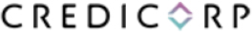

2023

1

1.1. CONTENTS

1. GENERAL | 1
1.2. LETTER FROM THE PRESIDENT OF THE SUSTAINABILITY COMMITTEE | 3
1.3. EXECUTIVE SUMMARY | 5
1.4. 2023 ACHIEVEMENTS | 6
1.6. PRIORITIZED MATERIAL TOPICS AND THE SDGs | 10
1.7. THE KEY ENABLERS OF SUSTAINABILITY INTEGRATION | 12
2. SOCIAL MANAGEMENT | 15
2.1. THE SOCIAL IMPACT OF OUR BUSINESS | 16
2.2. THE SOCIAL IMPACT OF OUR OPERATIONS: EMPLOYEE MANAGEMENT | 26
2.3. SUSTAINABLE SUPPLIER MANAGEMENT | 36
2.4. THE SOCIAL IMPACT IN OUR COMMUNITIES | 37
3. ENVIRONMENTAL MANAGEMENT | 38
3.1. THE ENVIRONMENTAL STRATEGY | 39
3.2. SUSTAINABLE FINANCE | 41
3.3. RESPONSIBLE AND SUSTAINABLE INVESTMENT | 41
3.4. ESG RISK MANAGEMENT | 42
3.5. SOCIAL IMPACT OF CLIMATE RISKS | 44
3.6. OUR DIRECT ENVIRONMENTAL IMPACT | 45
4. CORPORATE GOVERNANCE | 47
4.1. OUR CORPORATE GOVERNANCE | 48
4.2. THE COMPENSATION MODEL FOR THE BOARD AND EXECUTIVE TEAM | 51
4.3. SUSTAINABILITY GOVERNANCE | 53
4.4. ETHICS, COMPLIANCE, AND HUMAN RIGHTS | 54

2

1.2. LETTER FROM THE PRESIDENT OF THE SUSTAINABILITY COMMITTEE
GRI 2-22

Dear shareholders, clients, employees, and members of the communities we serve

As President of Credicorp’s Board of Directors Sustainability Committee, I am proud to present our 2023 Sustainability Report. In this document, we explain the Group’s progress and achievements in sustainability during the year, consistent with the purpose and vision we set out in our Sustainability Strategy 2020-2025. This report has been prepared by following the GRI guidelines and the SASB standards.

While less politically uncertain than the previous year, 2023 was still an economically challenging time for the entire region. Our deep commitment to people’s well-being and the region’s progress, coupled with our financial strength and digital capabilities, has allowed us to cope with this demanding context while also generating positive impacts through our businesses and operations on society and the environment. All this, without a doubt, has been thanks to the efforts of our thousands of employees and our leaders.

Our sustainability strategy draws from our purpose of contributing to improving lives by driving the changes our countries need. It is from this purpose that our vision springs of being a sustainable financial services leader in Latin America that is future-oriented and focused on creating superior value for our employees, clients, shareholders, and the countries we operate in. With great responsibility, we have taken up our role as a change agent in society, promoting the sustainable development agenda through our core businesses and forming partnerships that strengthen our impact. The progress made over the past three years is proof of this work.

Financial inclusion lies at the heart of our social strategy. Yape has proven to be an exceptional tool to promote financial inclusion, providing access to financial services for the first time to more than 1.7 million1 people in Peru, in turn generating usage frequency and more transactions. Today, Yape also operates in Bolivia, where it has over 1 million users. We are proud to announce that BCP also financially included 2.4 million2 people through savings accounts.

For its part, Mibanco banked more than 63,000 individuals and individuals with a business through micro-loans, 55.9% of whom are women. Women’s financial inclusion is vital to progressing equity efforts in Peru, so we have strengthened our value proposition for them by creating Mundo Mujer; now, we focus not just on providing access to credit but also on delivering financial education, savings products, and other services. We also continue to work toward opening up access to insurance by creating Seguros para todos, our insurance-for-all strategy that protects more than 2.3 million people with our inclusive, low-cost, and more accessible products.

This year also saw the rollout of our Corporate Environmental Strategy, a significant milestone in consolidating our sustainability strategy that allowed us to make substantial progress on this front. In 2023, through BCP, we reached more than US$585 million in green-labeled loans. We also made significant progress in measuring the carbon footprint of our credit and investment portfolios, generating more information and knowledge for the responsible management of our portfolios. This year, we also released our first TCFD (Task Force onClimate-Related Financial Disclosures) report, in which we announced these and other environmental management achievements.

1, 2 Cumulative total from 2020 al 2023. It includes people who made at least three average monthly transactions in the last three months.

3

It is also clear that the environmental and social fronts are closely linked. In 2023, Peru suffered the effects of Cyclone Yaku and the threat of the El Nino phenomenon, leaving thousands of people in the affected areas vulnerable and affecting the normal functioning of the economy. BCP, Pacífico Seguros, and Mibanco joined forces for a campaign (Con la camiseta bien puesta) that has delivered over 800 awareness and prevention training programs at community fairs in the affected regions and reached more than 6,000 people to date. Our companies also rolled various measures—from education and prevention efforts to financing solutions and benefits for affected clients—supporting people to more easily find their way through this challenging situation.

On the governance front, through a new nomination, we continued strengthening the competencies and widening the diversity of our board. Always striving for continuous improvement, we undertook an external evaluation of our board and its committees. Our progress to date has resulted in a positive perception of our structures, composition, and functioning, aligned with good practices in the market. The recommendations of this analysis will enable us to strengthen our governance further.

In 2024, we will focus on expanding our positive impact on the ecosystem by strengthening our offering of sustainable products and solutions, influencing the adoption of sustainable practices through relationships and partnerships with other actors, and enhancing our capacities on the environmental and climate change fronts. This approach is made possible by the effort and commitment of our leaders and employees, who are our most important asset.

In this context of volatility and uncertainty, exacerbated by the economic crisis and conflicts around the world, we believe it is essential that the private sector take on a role as a change agent, generating well-being, safeguarding institutions, and fostering collaboration toward the sustainable development goals and the progress of our nations. Once again, we renew our commitment to improving lives, by driving the changes our countries need.

4

1.3. EXECUTIVE SUMMARY
GRI 2-2, 2-3, 2-5, 2-14

This document reports how the Group and its subsidiary companies are progressing along the path to sustainability3. It places particular emphasis on the material topics for our businesses and stakeholders. Our strategy includes a deeper understanding of our role as a change agent, aligning with our priority SDGs, and, in parallel, integrating sustainability more fully into how we manage our businesses. During 2023, we continued making sustainability part of our mindset through the change management enabler and key finance and risk functions and processes to ensure better decision-making. As a result of our strategy implementation, we present Group and subsidiary achievements on the social and environmental fronts.

On the social front, we report our progress on the goals of increasing responsible financial inclusion that is complemented by comprehensive financial education, helping small businesses grow, and generating opportunities and products for women. Our social impact also manifests in our community engagement and through our relationship with suppliers along our value chain, in line with our vision of supporting their journey to greater sustainability.
On the environmental front, we published our first TCFD report and rolled out our corporate environmental strategy to deliver on our ambition to be local leaders in supporting the transition to an environmentally sustainable economy. We also designed a strategic sustainable financing roadmap and progressed with integrating sustainability criteria into our investment processes. On the risk management front, we deepened our approach to sustainability from both environmental and social perspectives. Finally, we report on progress regarding our direct carbon footprint.

Underpinning our entire strategy is our solid corporate governance and a diverse board composed primarily of independent members. We report on our main structures and how, from the highest levels of the organization downwards, we manage and supervise the sustainability strategy and integration. We conclude by describing advances in the following key focus areas for our governance: business ethics, regulatory compliance, and our commitment to human rights.

3 This report is for Credicorp Ltd., registered in Hamilton, Bermuda. Consistent with the scope of Credicorp’s Corporate Sustainability Policy, it presents information from the company’s most important subsidiaries: Banco de Crédito del Peru (BCP), Mibanco Perú, Mibanco Colombia, BCP Bolivia, Pacífico Seguros, Prima AFP, and Credicorp Capital. Through these companies, Credicorp Ltd operates in Peru, Colombia, Bolivia, Chile, Panama, and the United States. Unless stated otherwise, the information is consolidated at the Credicorp Ltd level. The report covers the period from January 1 to December 31, 2023.
The Sustainability Report is attached to our corporate Annual Report. These documents were published together in February 2024. Please note that both have been subject to a governance process of review and approval. They are ultimately approved by the Board of Directors. The information presented in this report has not been externally verified. The financial information in the Annual Report comes from the audited financial statements. Credicorp’s carbon footprint information is audited by an external consultant. This report was prepared in accordance with the Global Reporting Initiative (GRI) standards and also used the Sustainability Accounting Standard Board (SASB) Commercial Banking Industry Standards.

5

1.4. 2023 ACHIEVEMENTS

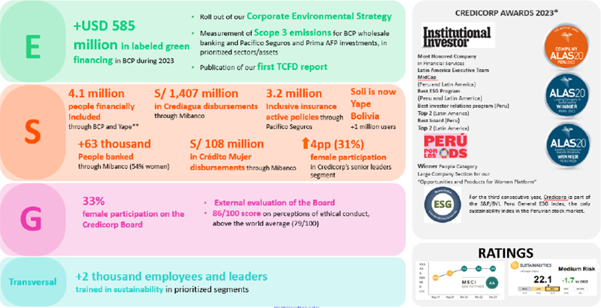

*The awards and recognitions received by Credicorp’s subsidiaries are listed in the respective sustainability reports.
**Cumulative from 2020 to 2023. Includes people who made at least three average monthly transactions in the last three months.

6

1.5. OUR SUSTAINABILITY STRATEGY

GRI 2- 29

Strategic  partnerships | We contribute our own strengths and draw on those of others to achieve greater impact. These partnerships become most relevant when we deploy our financial education programs and inclusive products.
Leadership and culture  that transforms | Having leaders and employees who are active change agents, both internally and externally, is the key to increasing our impact.

1.5.2. The Integrated Sustainability Strategy

Our sustainability strategy rests on three essential pillars aligned with our business strategy and stakeholder needs and expectations.

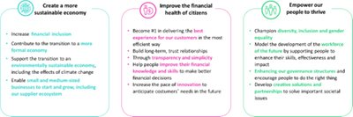

For each pillar, we have developed platforms that form a set of business model initiatives which each target a specific objective, for example, increasing financial inclusion. They allow us to advance in a coordinated way from the corporate level through to the subsidiary companies. In addition, we complement our strategy with sustainability enablers4 which
Our sustainability strategy is the roadmap for delivering the objectives that will enable us to achieve our purpose. It focuses on where we can generate the most value for the business and our stakeholders. | Our purpose is to  contribute to improving lives by driving the changes that our countries need

1.5.1. A change agent

We prioritize activities and programs that aim to not only generate a change in ourselves but also catalyze it in others. As a change agent, we target these four dimensions:

The ability to influence  our stakeholders | By adopting sustainable practices and initiatives, Credicorp generates positive knock on effects for our financial sector peers, our clients, employees, and communities, with whom we seek to share and promote best practices that positively impact the countries where we operate.
Impact through  products and services | One of the ways to create a positive impact is through our products and services. For example, we promote financial inclusion and education through solutions ranging from digital wallets, microcredits, and loans for women through to web platforms for financial education and personalized advice.

4 Further information is available here on our website our Sustainability Strategy 2020-2025

7

are levers for taking forward the internal changes necessary to integrate sustainability into our operations and processes. To support this integration, we have prioritized work fronts corresponding to Credicorp’s main corporate functions, including risk, finance, ethics and compliance, corporate governance, and human management and development.

Testimony to Credicorp’s implementation and integration of its strategy comes in the form of several awards bestowed on the company by recognized authorities: Institutional Investor, Perú Sostenible, and GovernArt (ALAS20). In addition, in its report ESG integrated: Adjusting valuations for ESG credentials, HSBC has highlighted Credicorp’s progress and ranks it among the top 5 (out of 60 emerging market banks) with significantly stronger ESG credentials. It regards the Group as standing out among emerging market financial institutions for the independence and gender diversity of our board, for being one of the few companies to have audited operational GHG emissions,5 and for having facilitated financial inclusion in Peru through its digital payment platform.

5Scope 1, Scope 2 and Scope 3 emissions under operational control (portfolio emissions not included).

8

1.5.3. We create value for our stakeholders

Our approach to major stakeholders6

Clients  We deliver products, services, solutions, and tools that help small businesses grow, bring people into the financial system, and better harness the benefits that inclusion provides through financial education. We leverage innovation to strengthen our value offering and respond to client needs. Our gender and diversity approach brings our initiatives within reach of the users who need them most. We use simplicity and transparency to lift confidence in the system. |  | Employees  We believe that our more than 37,0006 employees are the key to success. We help them to become the best version of themselves and impact positively on the lives of others. To make Credicorp the best place for the best, we work hard on culture, equity, inclusion, training, and performance management. |  | Suppliers  We promote sustainable management with our suppliers through an ethics-based negotiation process that is traceable, transparent, and auditable. We support our SME suppliers with simpler processes, shorter payment times, and responsible engagement that leads to greater satisfaction. |  | Community  We make our presence felt in communities across the region. To complement our business strategy, we work with other actors on projects that tackle social challenges, encouraging our own staff to also participate. We focus on education and emergency response, the two areas where our scale, resources, and expertise can leave the greatest impact.
Investors and shareholders  We develop and maintain long-term relationships with shareholders and investors built on trust. So they can fully evaluate us, we regularly communicate strategies, performance, and results via various market communication channels and mechanisms. We also proactively open dialog spaces that deliver the more detailed information these stakeholders seek and where we learn more about their needs and the expectations they have of us. |  | Governance  We give priority to dynamic and transparent government engagement. Regulatory compliance is the starting point for all our processes, policies, and internal regulations. These must also reflect our commitment to the fight against corruption. Generating value for society, the environment, and the company is the cornerstone of our relationship with government. |  | Communications media  We always provide relevant information to media organizations about the achievements, progress, and developments we generate through our businesses. We also respond clearly and transparently when the media asks about topics of public interest, delivering first-hand information to those who require it. |  | Public opinion  We make available relevant and timely information about Credicorp’s business so that interested parties can inform themselves and clarify doubts. We also gather perceptions and main concerns so we can find solutions aimed at building trust in the Group.

6 Further detail on how we engage with our stakeholders is available in the annexes and the Credicorp Sustainability Policy.
7 Includes the employees of the following subsidiaries: BCP, BCP Bolivia, Mibanco, Mibanco Colombia, Prima AFP, Pacífico Insurance, and Credicorp Capital. The Group’s total number of employees exceeds 44,000.

9

1.6. PRIORITIZED MATERIAL TOPICS AND SDGs
GRI 3-1, 3-2

We align our strategy to the main material topics for our business and stakeholders, which we subject to an in-depth analysis every two years. During 2023, we performed an update and validation of the topics using secondary sources. In 2024, we will again undertake an in-depth study. The materiality analysis showed the main material topics to be unchanged and that the strategic plan to 2025 keeps us on the right track to deliver the greatest impact in everything we do. The materiality update identified some topics so closely related as to warrant combining; for example, financial inclusion and financial education. As an additional material topic for our stakeholders, ethical data management was added to cybersecurity and data privacy.

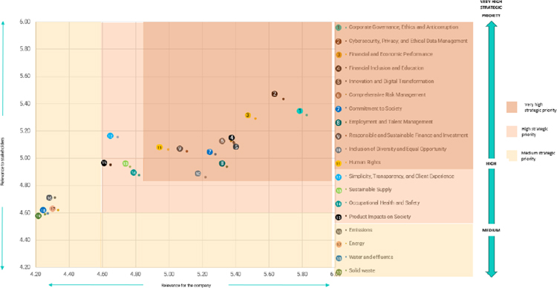

10

In addition to aligning with our stakeholders’ most relevant topics, the strategic pillars contribute mainly to seven of the Sustainable Development Goals (SDGs) we have defined as priorities.

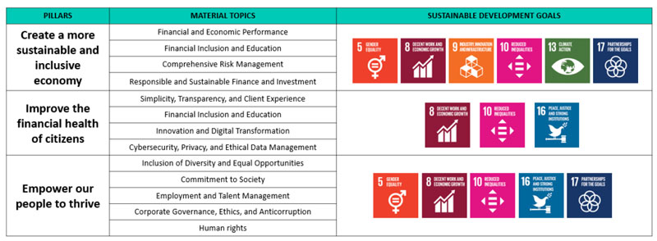 | 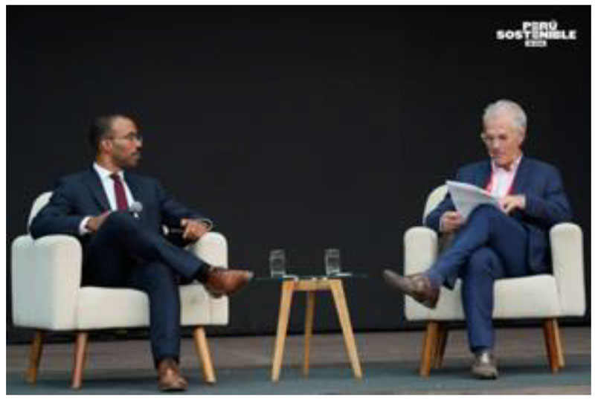
 | Marcus Burke, Manager, Equity Action of the WBCSD and Gianfranco
 | Ferrari, CEO of Credicorp at Sustainable Peru 2023 event

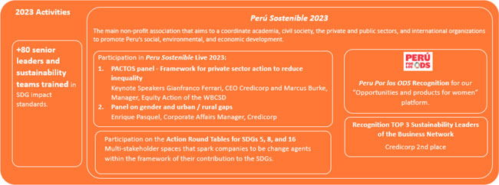

11

1.7. THE KEY ENABLERS OF SUSTAINABILITY INTEGRATION

Topics Materials Comprehensive Risk Management, Innovation and Digital Transformation
GRI 3-3

1.7.1. The change management program

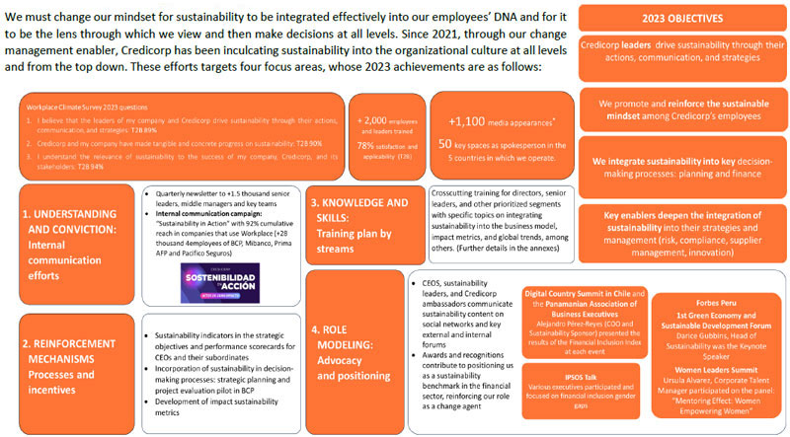

(*) Credicorp metrics only.

12

1.7.2. ESG risk management

ESG risk management provides us with a comprehensive view of our businesses’ exposure to sustainability-related risks so we can understand and manage those risks and make better, more informed decisions.
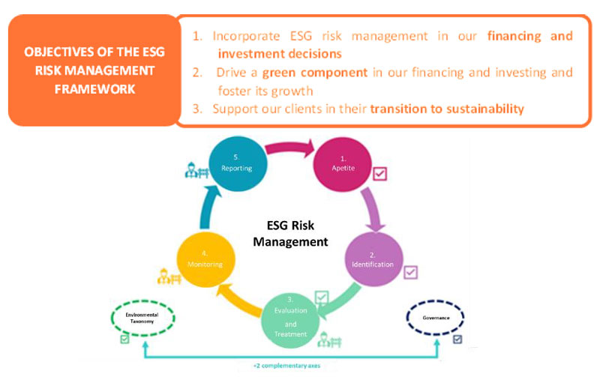
We have progressed the main areas of our ESG risk management by defining risk appetite and exclusions, identifying and prioritizing the main ESG risks to manage, and updating standards and processes for our main financing and investment activities. We have also moved forward in identifying and managing ESG risks in accordance with the TCFD recommendations.

Further information on our progress is available in the following subsections: “Environmental risk management” and “Human Rights” (in the “Compliance” section).
1.7.3. Planning and finance

Planning and finance is an important enabler for successfully integrating sustainability into company management. It contributes to aligning execution with the corporate strategy and, above all, to incorporating the sustainability perspective into decision-making and measuring business success (including performance and impact).

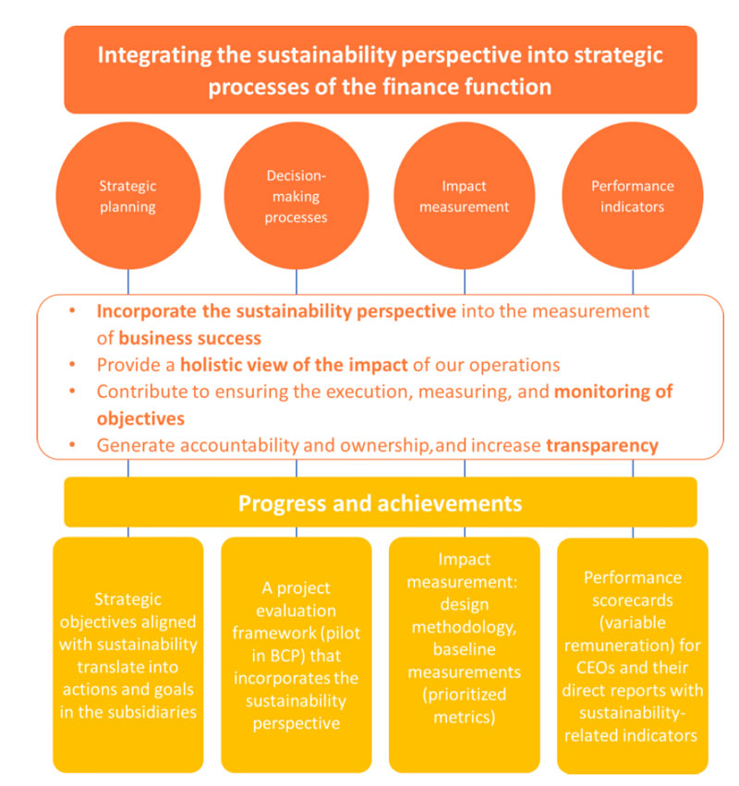

13

1.7.4. Innovation

Sustainability presents complex challenges and demands that we implement creative and innovative solutions which respond to our stakeholders’ needs cost-effectively over time. A pivotal ambition to improve the financial health of citizens (Pillar 2 of our sustainability strategy) is to speed up the pace of innovation and stay ahead of future client needs.

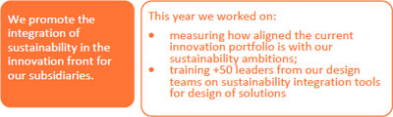

To ensure long-term value creation, the ESG lens must be an integral part of the innovation process.

The initiatives in the innovation portfolio are directly linked to the ambitions prioritized in the sustainability strategy. For example:

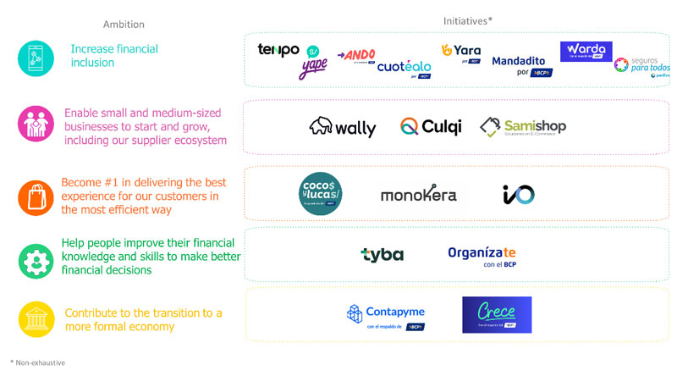
We held a “Creating positive impact from innovation” workshop aimed at the design leaders of the key subsidiaries (BCP, Mibanco, Prima AFP, Credicorp Capital, Pacífico Seguros, Yape and Culqi) in which we trained more than 50 people. The objective was to raise awareness on sustainability issues and provide tools to integrate sustainability criteria into the innovation processes.

+93% T2B satisfaction | 100% T2B applicability rate in the workshop

14

2. SOCIAL MANAGEMENT

The social challenges facing our region are complex and require joint and collaborative work. We strengthen the positive impact of our initiatives through efforts with different actors: companies, our employees, institutions, and society in general. We also generate and share knowledge that can serve everyone through instruments such as the Credicorp Financial Inclusion Index.

15

2.1. THE SOCIAL IMPACT OF OUR BUSINESS

Topics Materials Financial Inclusion and Education / Simplicity, transparency and client experience / Inclusion of diversity and equal opportunities, Responsible finance and investment GRI 3-3, 203-1, 203-2, 417-1 SASB FN-CB-410a.2

2.1.1. Comprehensive inclusion and financial education

At Credicorp, we bring a holistic vision to promoting financial inclusion and education so that more people and businesses become financially empowered, build good credit records, and lead a healthy and mutually beneficial relationship with the financial sector. Our goal is to contribute to the well-being of people through a value proposition that responds to their needs and allows them to improve their quality of life. We particularly focus on vulnerable individuals.

Financial inclusion contributes to people’s well-being.

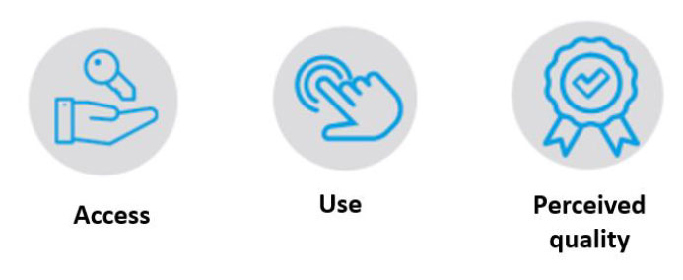

The Credicorp Financial Inclusion Index
Aware of the need to deepen how we understand financial inclusion, Credicorp began a partnership in 2021 with IPSOS to develop the Credicorp Financial Inclusion Index. This tool measures and monitors how financial inclusion is evolving across eight countries in Latin America. Now that it has been in operation for three straight years, the index is beginning to reveal trends.

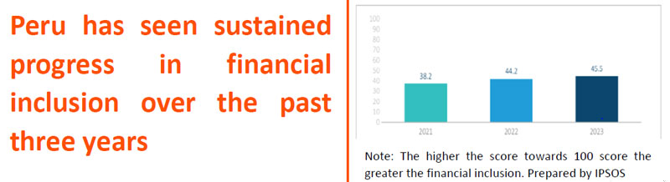

Of the three dimensions it measures—access, use and perceived quality—the least developed in the region are use (30.5 out of 100) and access (45.1 out of 100). The challenge this finding presents demands joint efforts by multiple actors.

In Credicorp’s role as a change agent, we publish the annual index results on our website and undertake numerous dissemination activities across the eight countries. With its growing use and dissemination, the index has become a highly complete and updated map of the state of financial inclusion in Latin America. As such, it is now a valuable tool for monitoring, analysis, and debate and spurs us to continue working on our strategy and action plans. Further details are available here: Credicorp Financial Inclusion Index 2023.

16

2.1.1.1. Our financial inclusion initiatives

Credicorp develops products, services, and channels to financially include more people, help them grow economically, and strengthen their financial resilience.

In 2023, Mibanco became the first entity specialized in microfinance in Peru to obtain an A+ score in the Social and Environmental Rating evaluation from MicroFinanza Rating (MFR) in recognition of the bank’s commitment to social development and client service and protection. Measurements taken by MFR in 2021 showed the following positive impacts of Mibanco’s financial inclusion efforts: 45% of households and more than half of micro-businesses were able to increase their income, and 27% of households increased their ability to pay for education. These results reinforce our commitment to financial inclusion, which we regard as closely connected to people’s well-being.

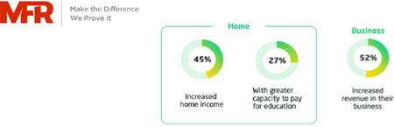

Credicorp’s subsidiaries offer a robust portfolio of inclusive solutions:
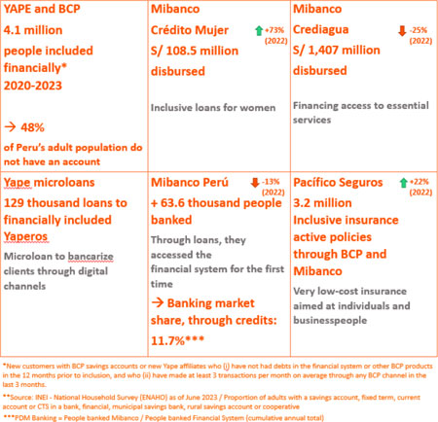

The contraction of the Peruvian economy in the last year (0.6% drop in GDP) coupled with the climate emergency in the country’s north and social conflicts in the south in early 2023 impacted the growth of microfinance segment loans, as the Crediagua product results and the figures for the number of banked clients demonstrate. Consistent with its purpose, Mibanco is committed to digitalization and strengthening its inclusive products offering to continue supporting entrepreneurs to progess.
17

2.1.1.1.1 The Yape ecosystem

Some 4.1 million people have been financially included8 since 2020 through BCP and the Yape virtual wallet. Over 1.7 million did so through Yape alone, of whom around 36% were in Metropolitan Lima, Lima Region and Callao and the rest in the provinces (including 5% in La Libertad, 5% in Lambayeque and 5% in Arequipa). Our approach to inclusion means reaching people throughout the entire country and not only in the capital. We have also introduced Yape to Bolivia.

The Yape ecosystem relies on BCP’s marketing channels, is fed by other companies’ inclusive products, and heavily leverages partnerships and financial education to increase uptake and use.

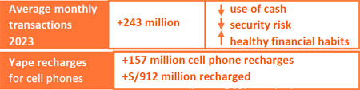

Conscious of the relevance of usage, as we move forward toward our goals and develop impact metrics, we continue to measure financial inclusion more rigorously. The inclusion figures for Yape count people who opened an account and made, on average, at least three transactions a month during a three-month period. We consider clients who have met

these criteria to have evolved financially and demonstrated that they are using the tool.

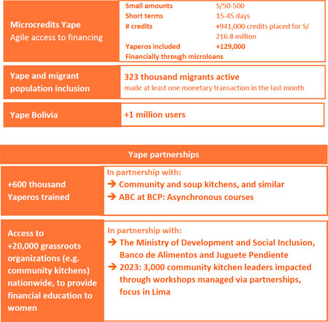
The Yape ecosystem incorporates products and services that deepen financial inclusion and increase usage

8 To fit the definition of financially included, a client must have made at least three transactions on average in the last 3 months, and at the time of opening their account in BCP or Yape with a DNI, have not had an account with the bank or an active credit product in the last 12 months in the system of the Superintendence of Banking and Insurance.

18

2.1.1.1.2 Other financial inclusion initiatives

Pacífico Seguros Insurance for All (Seguros para Todos)

Given that more than 50% of the population in Peru falls into economic segments C and D, it is vital that inclusion strategies bring protection to more people regardless of socio-economic status. Seguros para Todos is an affordable insurance strategy through which Pacífico Seguros aims to cover as many people as possible.

The company defines inclusive insurance as an optional product starting at S/ 4.00 per month up to a maximum of S/20.00 per month or a single payment, and with an underwriting process and use experience that are clear, simple, and transparent for the client. By the end of 2023, through Mibanco and BCP, Credicorp was selling ten different inclusive insurance products. We will continue to expand our offering during 2024.

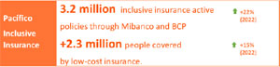

Mibanco Perú

Through Mibanco, Credicorp is focusing on responsibly banking our clients in a way that is consistent with our purpose and delivers what small entrepreneurs need. The following initiatives are spurring financial inclusion across the country.

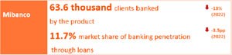

Crediagua aims to raise awareness among low-income earners about how better health is the key to family well-being and development. The product
enhances our role as a change agent: we provide access to an essential service (water), contribute to sensitization about health practices, and open up financial inclusion opportunities for our clients.

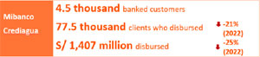

This inclusion in the form of loans is complemented by Simi, an initiative that uses language to promote financial inclusion. Mibanco is the first financial institution in the country to provide clients and users with guidance in native languages, such as Quechua and Aymara. We are reasserting these indigenous languages because we believe that linguistic differences should not hamper people’s attempts to enter any system, let alone the financial system.

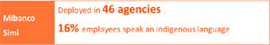

BCP Perú

In addition to gender diversity and financial inclusion, Credicorp’s subsidiaries are implementing various inclusion initiatives. For example, BCP has been helping persons with hearing disabilities to access its web and digital applications more easily. For persons with physical disabilities, it has been implementing an infrastructure adaptation plan for its agencies and our customer service centers.
19

2.1.1.2. Financial education

Credicorp’s financial education programs raise awareness about the importance of responsible money and financial services management, the system's role, and the opportunities it provides. These initiatives help to increase confidence in the system and, consequently, to improve the well-being of the people who benefit from it.

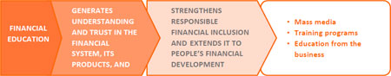

Through the use of digital mass media, we spread the reach of our financial education towards millions of people, be they clients or members of society more broadly:

Financial education mass communication

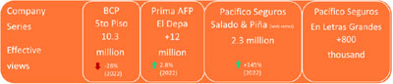

In 2023, we focused on addressing topics for more specific audiences in our mass media education initiatives; for example, the El Niño phenomenon, which is of particular interest to those in the area it most affects. This change has meant a reduced number of chapters and, therefore, fewer effective views.

9 Peru’s principal consumer goods company producing industrial items, mass consumption products, and animal feed.
We also offer a range of content freely available on the web that is linked to financial education, and to our products, services, and channels, especially the digital ones.

Financial Education initiatives

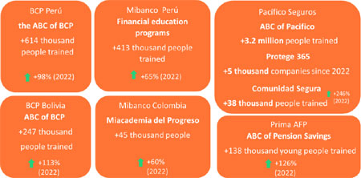

In addition, we use partnerships to broaden our reach. For example, Mibanco’s Miconsultor program, in collaboration with universities in Lima and Peru’s provinces, reached 1,145 microentrepreneurs and 8,125 participating student consultants since the start of the programme (2011). For the second year, Mibanco joined Ollas que desarrollan, Alicorp’s9 development (desarrollo) work in community kitchens (ollas) within the framework of the Mujeres Poderosas program. It seeks to use financial and digital education to strengthen female leaders and users of grassroots social organizations. In 2023, more than 13,000 women were reached, helping to close gender gaps.
20

Our financial education programs encourage the responsible use of products and services. They place particular emphasis on the importance of:

the savings culture as an enabler of financial resilience. Examples include Prima AFP’s educational videos (Aprende Ahorando a Fondo), launched this year on YouTube about Peru’s private pension system, and a video podcast (Micros Abiertos), which discusses a company product (Cuentas Metas) that encourages voluntary savings;
avoiding the over-indebtedness that comes from credit card overdrafts and late payments. An example is BCP’s Improving Financial Behavior Program. In 2023, we optimized our strategy by exploring and adding new behaviors and helped more than 214,000 people change their conduct and enjoy better financial health.

BCP Program: Improving Financial Behavior

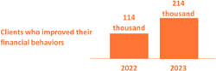
2.1.2. Helping small businesses grow

Micro, small, and medium-sized businesses (MSM Es) are the engine of the economy, creating the most employment in Peru and becoming crucial to raising people’s quality of life.

96.4%10 of Peru’s companies are considered MSEs, and more than 52%11 of these are led by women.

Credicorp optimizes its products to address emerging MSME needs and deliver a competitive advantage through collaborative work between companies and synergies between initiatives. We seek to financially include individuals who own a business as well as legal entities, that previously faced limited access to credit. We are always testing new ways of understanding and assessing them. We design self-service processes to improve their experience.

We also identify key ways for boosting and formalizing these entrepreneurs (86.7%12 of SMEs sit outside the formal sector) because we understand that entering the system lowers risk and drives healthy growth.

Initiatives aimed at MSMEs delivered the following results:

10, Encuesta Nacional de Hogares 2022
11 ComexPerú (2022). Micro and small enterprises in Peru. 2022 results.
21

Initiatives aimed at MSMEs

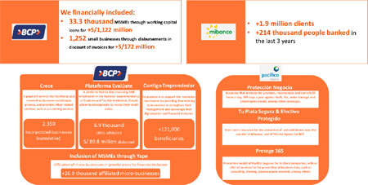

2.1.2.1. Mibanco micro-loans for MSEs

Mibanco aims to transform lives. It is committed to people’s financial inclusion and their progress, working together with them to contribute to the country’s growth. Our market share in the segment of micro and small enterprises (with less than S/150,000 of debt in the financial system) reached 22.1%, with more than 629,000 customers and gross loans of S/13,165 million. The range of products for this segment includes working capital loans, lines of credit, agricultural and livestock loans, property loans and commercial loans.

In 2024, the company aims to drive entrepreneur business growth by strengthening its solutions on the back of innovative digital experiences that deliver more access to financial tools and services. We will work on two fronts:
The experimentation platform: Incubating and validating the digital pilots hand-in-hand with developing and digitalizing new financial products.

Entrepreneur development: Educational content aimed at entrepreneurs and the generation of communities with shared interests so as to strengthen their development.

2.1.2.2. BCPs Contigo Emprendedor Program

Contigo Emprendedor (We’re with you, entrepreneur) is one of Peru’s most comprehensive programs for entrepreneurs, providing free training in management, digital tools, and financial education. The initiative is supported by staff volunteers from the ranks of BCP and other subsidiaries and draws on technology to deliver courses (e.g., WhatsApp, Virtual Campus, and Digital Entrepreneurs) to achieve a greater reach.

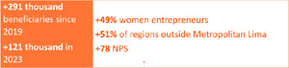

2.1.3.Opportunities and products for women

Gender inequality is one of the greatest challenges facing our region. By observing the disaggregated figures in our Financial Inclusion Index, Credicorp can closely monitor the reality of women’s inclusion and its evolution across different countries. Those facing the biggest hurdles are often indigenous housewives over 43 years, located away from the main cities, and with limited digital access and formal education. Significant challenges exist in credit use and transaction frequency.

In Latin America, 1 in 4 women are not financially included.
22

available savings products, complementary cancer insurance, and educational resources.

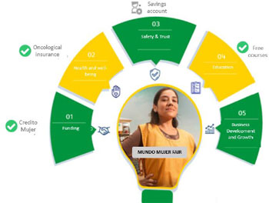

Mibanco’s Mujeres Poderosas program, aimed at leaders of women’s organizations at the base of the pyramid, offers financial education, digitalization, and empowerment (poder) through workshops and technology tools that seek a new model of responsible financial inclusion.

Mibanco Colombia is rolling out Mujeres Pa’lante, a credit product that funds working capital and fixed assets for the financial inclusion of female micro-business owners and the progress (pa’lante) of their families. To date, we have banked 6.9 thousand women and placed more than S/ 17.3 million12 in loans.

BCP Bolivia’s Taller24, is a workshop (taller) program that has been running for two years and trained more than 4 thousand female entrepreneurs in leadership, sales strengthening, and financial management.
Credicorp’s companies build products and programs that help to lift women's engagement with the financial system and contribute to closing gender gaps.

2.1.4.1. Crédito Mujer and Mundo Mujer

Crédito Mujer is our main loan (crédito) product targeting the needs of women (mujer) entrepreneurs. It is a response to the limited access to financial services those women on small incomes face. The requirements do away with the need for a woman’s spouse to sign, thus empowering her and delivering greater financial freedom.

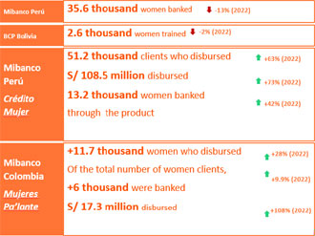

The success of Crédito Mujer has led us to create Mundo Mujer. This value proposition goes above and beyond a loan product by taking into account the broader world (mundo) of a female business owner and making

12 The local currency amount is $17,677 million colombian pesos.
23

2.1.3.2. Digitization and data contribute to closing gaps

Our Yape digital wallet is a powerful tool for women’s financial inclusion:

Upon analyzing information from Yaperas, we discovered that women exhibit a much lower takeup of credit than men. We studied the causes and identified numerous adoption barriers, such as lack of trust. The need for a different value proposition was clear.
Thus, Yape developed a strategy to position credit specifically as a tool for growth by drawing on testimonials, speaking in a more urban dialect (rather than the language of banking), and delivering simple messages on popular channels (TikTok, Instagram). The outcome was improved female uptake,

Taking this same approach, BCP’s Consumer Studies team created the Equity Roundtable, a space for dialog and participation that provided a voice for a diverse range of women around the country, with the aim of co-creating initiatives based on their financial needs.

2.1.4. Simplicity, transparency, and the client experience

As trust is the foundation for constructing solid and long-term relationships with our clients, Credicorp aims to build solutions, communications, and channels that are simple, transparent, and respond to user needs.

2.1.4.1. Case study Prima AFP

Having identified the specific needs of its members, Prima AFP launched an improved, more straightforward, and easier-to-read pension entitlement statement (Mi Estado Prima) in July 2022. In 2023, these benefits continue to materialise, reflected in an increase in openings and number of sessions, as well as high levels of customer perceptions of understanding and usefulness.
 | 2022* | 2023
Average visits per month Mi Estado Prima (Analytics) | 94,286 | 138,683
# claims for missing or erroneous information | 67 | 24*
Overall satisfaction T2B | 66% | 74%
Easier to understand T2B | 72% | 80%
More useful information T2B | 72% | 80%
*Sent from July 2022 and December 2022 onwards in the same e-mail with the standard EECC.

2.1.4.2. Case study: Complaint management in BCP

BCP has implemented several initiatives to speed up client complaint response times: 1) we provide tools to front office staff to deliver immediate solutions; 2) we have an expert back office team that analyzes products and case histories to deliver comprehensive solutions; and 3) we deploy specialist teams to resolve the most complex case histories. The result has been a substantial impact on the complaints journey NPS:

80% of complaints and dectmands serviced within  48 hours  (the regulations stipulate up to 15 working days) | NPS complaints  +9 point  2022 2023  55 64

24

2.1.4.3. Client satisfaction

At Credicorp, offering the best experience to our clients is a strategic ambition and priority. To measure performance and strengthen relationships, our companies use the Net Promoter Score (NPS) as a long-term indicator of how loyal clients are and whether they will recommend us. The 2023 results of our main subsidiary, BCP Peru, is a good example: its consolidated NPS was 54.

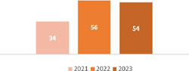

BCP continues to progress in improving the client experience by innovating in its physical infrastructure as well as in the use of products and services. The initiatives include:

A new physical layout for agencies.

Measures to ensure digital channels have optimal operational stability.

A fraud-focused approach that attacks the root causes of client complaints.

An enhanced web-based appointment booking system.

A streamlined process for credit card requests.

Other group companies have also rolled out initiatives to lift their NPS performance:

Mibanco Perú:
New service models for the three main target markets (micro, small, and medium businesses) focused on the needs and expectations of each client type.
The Introduction Protocol, which describes a business advisor’s first contact with a new client to get the relationship off to the right start.
The NPS indicator on the agenda of monthly committee meetings for business leaders and support staff.

Mibanco Colombia
Mystery shopper via telephone calls, in addition to in-person visits.
Continual service protocol updates in the form of preventive collection and remote disbursement scripts, speech for the WhatsApp channel, and the web page chatbot.

Prima AFP
Ongoing communication through available channels on profitability results and economic environment (during the months of negative profitability)
Focus on communicating main attributes: profitability and backing by Credicorp.
Better communications focused on transparency and simplicity.

25

Through streamed management, we ensure our employees have the right conditions to reach their full potential and then excel and become the best version of themselves.

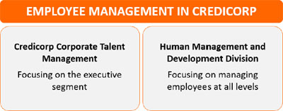

2.2.1. Leadership management and development: Credicorp corporate talent management

Management for the executive segment follows a corporate approach resting on four pillars:

Attraction & |  | Performance |  | Development |  | Best Top
Employer |  | & Total |  | & Leadership |  | Management
Brand |  | Rewards

2.2.1.1. Attraction and the Credicorp employer brand

Our proactive recruitment approach aims to identify the right professionals for both existing positions and future senior roles. We have developed a long-term vision that enables us to meet immediate needs while building a strong and diverse team that is aligned with our strategic priorities going forward.

As we reinforce our “Passion for Talent” mindset, we are strengthening our leadership training to manage the attraction, recruitment, and selection processes so these identify and attract highly qualified professionals.
2.2. THE SOCIAL IMPACT OF OUR OPERATIONS: EMPLOYEE MANAGEMENT

Employment and talent management, inclusion of diversity and equal opportunities
GRI 3-3, 404-2, 405-1, 405-2

Credicorp’s ability to positively impact society starts with the employees of its own companies. Our most valuable asset is our team.

+37 thousand employees in 6 countries

Solid governance and the highest management standards

Distribution of our employees by company and country

* Subsidiaries outside the scope of the report

** One person from Mexico is included.
Subsidiary | 2023** | 2022
BCP | 17,844 | 17,695
Pacífico Seguros | 2,601 | 2,444
Prima AFP | 569 | 572
Mibanco | 9,842 | 9,725
Credicorp Capital | 1,929 | 1,939
BCP Bolivia | 1,803 | 1,763
Mibanco Colombia | 2,297 | 2,665
Grupo Crédito | 139 | 116
BCP Miami* | 44 | 42
BCP Panamá Agency* | 7 | 7
Total Grupo Credicorp | 37,076 | 36,968

Country | 2023** | 2022
Peru | 31,520 | 31,094
Bolivia | 1,803 | 1,763
USA | 84 | 74
Colombia | 3,326 | 3,660
Panama | 152 | 159
Chile | 191 | 218
Credicorp | 37,076 | 36,968

26

In December 2022, we officially launched our corporate Employer Brand initiative:

Pillars of the Credicorp employer brand

 | Be your own best version |  |  | A positive impact, always

 | People first |  |  | An innovator’s DNA

We aspire to position ourselves by 2026 among the five leading employer brands in the region, especially in Peru, Chile, and Colombia. The central focus of this initiative is to attract diverse profiles and look beyond the finance industry.

The best place for the best

Our companies can leverage the Credicorp brand as an umbrella brand to strengthen their value proposition, highlighting the Group’s cohesion and the mobility available within it.

2.2.1.2. Total performance and reward

Under this pillar, we aim to align our management of the executive segment with the interests of the organization. We have put in place clear indicators that ensure performance-based compensation.

The approach contained in our senior leaders compensation strategy looks both to the short and long terms. Our leaders are incentivized by meeting immediate and individual results and also by the value generated by the company in the long term. Many of our leaders have chosen to receive company shares as part of their package, demonstrating their commitment to the organization’s future successes and challenges.

The broad guidelines contained in the executive segment compensation strategy are defined by the Compensation and Nominations Committee of Credicorp’s board. The Committee also evaluates and recommends
nominations and in the last two years has been focusing on performance and succession planning.

We are aiming for compensation and performance criteria to be standard across the entire organization to ensure objective and homogeneous assessment that guarantees equity. These criteria stem from decision-making taken by consensus, a reflection of the Group’s culture and how we do things at Credicorp.

Further details on the compensation model are contained in Section 4.2 Compensation Model for the Board and Executive Management of this report.

2.2.1.3. Development and leadership

We have created an upskilling and reskilling model that drives each leader to take responsibility for their own development. The Credicorp Learning Community is a space for generating knowledge and sharing it among leaders of the Group's companies, supporting them in developing the technological-digital and leadership capabilities that our business objectives and purpose demand. The program operates through what we call Learning Seasons, the first of which (on data and analytics) saw 97% of leaders attain the two highest knowledge grades. The next season, on cybersecurity, was launched in early November 2023.

2.2.1.4. Best Top Management

Our proactive approach to developing future leaders also includes identifying them from among our current employees and tracking how we tap this exceptional talent and potential.

Each year, in conjunction with the heads of each area, our Credicorp Corporate Talent Management team undertakes a structured process to identify and assess young talent within the organization. This crosscutting process includes all the Group’s companies and draws on a methodology and specific profiles aligned with our strategy. We manage this group in an
27

integrated manner, supporting its development and promoting its continuous growth.

Through this process, we discover the capabilities, profile, and potential of these individuals so we can place them in critical positions.

Place the right people in the right place for the right things to happen.

Our succession strategy provides another means for having strong and empowered leaders who can guide the organization to continued success. It covers two time horizons (three and five years) which allow us to deliver operational continuity and stability in the business as we guide the organization toward continuous success. We are currently working to extend its reach so that we can maintain a steady flow of leaders able to take on high-impact roles regardless of changes in the business landscape.

2.2.2. Employee management and development: The Human Management and Development Division

In parallel to the strategy developed for Credicorp’s executive segment, we manage the comprehensive development of all our employees using our Human Management and Development Division’s four strategic pillars:

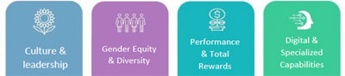
2.2.2.1. Culture and leadership

We consider the culture of each of our companies to be fundamental assets. It is through their principles and values that we put into practice the behaviors which define our essence and differentiate us from other companies in each of the markets where we operate.

Each company has developed a distinctive culture:


Our goal is to promote culture and leadership that uses a sustainable approach to contribute to the companies’ strategies.

We develop our culture to adapt to new environments using digitalization, agility, diversity, and inclusion. For information on the strategic focus area of gender equity and diversity in employee management and the gender equity strategy for the executive segment, refer to Section 2.2.3 Gender equity and inclusion of diversity.

Always focused on how applicable our principles and behaviors are and on finding a more quantitative way to measure our purpose, we have been working to strengthen the framework for measuring our results around culture. Integrating sustainability into our culture through the change management program has strengthened our corporate culture around our purpose.

We are also preparing our leaders for the future by strengthening and developing leadership capacities focused on three thematic areas: personal leadership, team leadership, and business leadership.
28

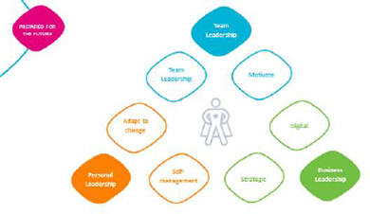

2.2.2.2. Performance and total rewards

The objective of this strategic focus area in employee management is to align the interests of our employees with those of the organization. We have a corporate strategy in place that underscores our appetite and aspiration, seeking to reward and differentiate high-performance individuals who contribute to greater productivity in all Credicorp companies.

One of our fundamental pillars is a meritocratic culture, which we have strengthened by managing performance more explicitly: making a direct link between goal achievement and compensation. This model contributes to establishing specific responsibilities and modeling behaviors that translate into results. The primary tool for strengthening performance is feedback from the leader, peers, and employees.

Further details about the metrics for periodic evaluation by gender and job category are available in the performance management section of the annexes to this report.

In relation to total reward and as part of the value proposition for employees, Credicorp grants a series of benefits that vary depending on the company. They include flexible working hours, financial and health benefits, assistance lines and even discounts to venues.
We also promote mental and physical well-being through various priority initiatives, broadening our value proposition through benefits tailored to respond to needs. We have adopted a hybrid working model combining working from home with a minimum of two days per week attendance at the office. It has now been implemented as a corporate policy, even in those Group companies that did not previously have such a scheme.

We are confident of continuing to reap the benefits that come from office attendance: teaching, learning, strategic reflection, and team problem-solving.
Further details on employment benefits are available in the social chapter of the annexes to this report.

2.2.2.3. Digital and specialist capacity

At Credicorp, we understand how strategically important digital profiles are for transforming and digitalizing our companies. Across the group, we currently have over 4,000 such individuals.

We define a digital profile as a staff member that has digital and technological knowledge and experience, who uses agile methodologies and work structures, and contributes to digital product maintenance. They are found in eight cross-cutting specialties: IT, data & analytics, cybersecurity, agility, digital marketing, CRM, pricing, innovation, and strategic design.

As digital profiles are scarce worldwide, we are committed to developing a value proposition that attracts those with the right capabilities so that we can select, grow, and retain them and earn their loyalty.

Our strategy focuses on attracting and retaining digital talent and developing an environment that fosters their growth, contributing positively to Credicorp’s digital transformation and that of the region. It sits on the following pillars:

29

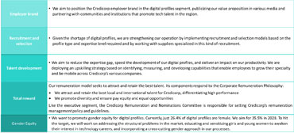

2.2.2.4 Agility

A capability that we have incorporated into our teams to help them adjust to the new context is agility, which allows us to respond quickly as the market changes, while striking a balance between strategic alignment and team autonomy. Simultaneously, we generate value for our clients and the business in a digital, disrupted, and highly competitive world. Credicorp has become an international benchmark in agility. Our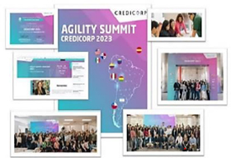 participation in the global agility community is a testament to our commitment to innovation and continuous improvement. In 2023, the group was proud to organize and host the second edition of our business agility conference. Known as the Agility Summit Credicorp, the event brings together specialists from within the group and the entire community. In 2023, it attracted more than 2,100 participants and 60 presentations in virtual and face-to-face environments. The themes addressed by Credicorp experts

13 Unlike earlier reports, the figures here are for Mibanco and BCP only.
and international guests included business agility, innovation, industry trends, and the digital transformation
The result of a focused attempt to develop skills in our teams, agility has become the management and operational byword for many of our areas.

Four years ago, before the pandemic, BCP’s started out with three tribes. Today, it boasts more than 50 tribes and COEs. This expansion has extended to all Credicorp subsidiaries, and each is now at its unique stage of evolution in the business agility transformation.

2.2.2.5. Workplace Sustainability and Freedom of Association

Respectful of local and international labor law, no Credicorp group company policies or guidelines hinder our employees from freely joining a union and bargaining collectively. Nor have we identified any significant risk to the exercise of these rights across our operations. |  | We respect labor standards and the right of all employees to freedom of association
Seven unions were representing employees in Credicorp subsidiaries during 2023. Over the years, we have reached agreements with each of them whenever a set of industrial claims has arisen.

We address freedom of association and collective bargaining through a corporate policy (for internal use only) approved by the Corporate Labor Relations area that contains a range of guidelines, including how to manage union relations. This document sets out the scope for action and identifies which teams are to take charge of negotiations and collecting information. The most recent policy update took place in June 2021.

 | 2021 | 2022 | 202313
Unionized employees | 925 | 853 | 791
Union organizations | 7 | 7 | 7
% of all employees | 3.02 | 2.74 | 2.5

30

During 2023, three collective agreements were signed across the Credicorp group.

2.2.3. Gender equity and inclusion of diversity

At Credicorp, we promote equal professional career opportunities for all people in the Group regardless of gender, origin, religious beliefs, sexual orientation, socioeconomic status, or any other circumstance.

We are building an increasingly inclusive culture in our workforce, across the business and in the community. Outside the organization, we have implemented initiatives to include vulnerable sectors through our products and programs (for further details, see Section 2.1.1 Comprehensive inclusion and financial education). Within Credicorp, given how important it is for leaders to promote our vision for equity, we have strengthened the gender equity program to afford it a more top-down approach. At the same time, we have made more visible our priorities and our progress.

The four focus areas of our gender equity program



The Program Leader reports quarterly to the Senior Gender Equity Committee (which includes the Corporate CEO).
Quarterly reports to the Credicorp Management Committee, which includes participation by the CEOs of the Group’s main companies.
Annual report to Sustainability Committee.

2.2.3.1. Gender balance

We proactively aim for gender balance at all levels of the organization. We can report progress in female participation, especially among senior leadership positions and at board level. During 2023, the Credicorp board welcomed its third female member (a second had joined in 2020), bringing the total representation to 33%.

Gender balance Credicorp  (women/total segment) % | 2021 | 2022 | 2023
Senior Leaders | 26% | 27% | 31%
Middle Management | 39% | 38% | 35%
Non-managerial employees | 56% | 55% | 55%
Total Credicorp | 56% | 55% | 54%
The Board | 22% | 22% | 33%
Note: Further details on gender balance are available in the annexes.

We are also implementing various initiatives to strengthen female participation in leadership groups—such as Credicorp's mentoring for women and men, women’s networks and having women as spokespeople for the organization—and to empower and give more visibility to our female leaders. Our employer brand strategy focuses on gender equity and the proactive search for female talent.

The Women's Mentoring Program

Our Women’s Mentoring Program is a testament to our commitment to gender equity. It covers senior leaders and middle managers and is reflected throughout the organization. One of the program’s most inspiring features is how many participating women—who form part of communities of technical expertise, be they technology or finance—have become motivated to step into mentorship roles beyond our organization. It is a clear example of how we positively impact women’s careers and, at the same time, their environment.

31

Our main challenge is to improve the gender balance at the senior level. We employ several strategies, including introducing more women into middle management so that they are positioned to eventually reach higher leadership. The middle management ranks have grown strongly in recent years because of the entry of digital profiles, a specialty dominated by men in the market (approximately 80%). Our increased demand for digital profiles, particularly in BCP, has led us to design a specific strategy to improve the gender balance in such profiles. It begins with initiatives at the entry level, training more junior staff, and starting to position ourselves as an attractive company for both male and female digital profiles while simultaneously encouraging re-skilling. All digital profile attraction and retention programs, whether at Credicorp or BCP, have a gender component.

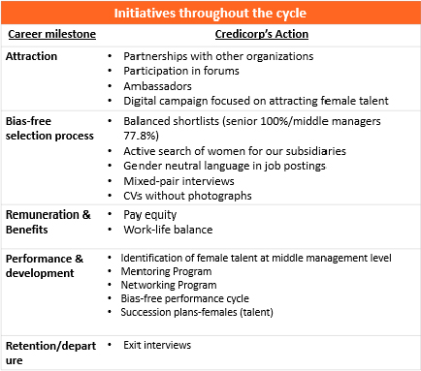
We monitor and review the different milestones in women’s careers and continue taking specific steps, beginning with the selection process onwards, to enable women to drive their careers forward free of those distortions or biases that could otherwise exert a negative influence. With a bias-free selection process now implemented in Credicorp’s companies, during 2024, we will continue to work on the unconscious biases that can also affect the evaluation and promotion processes.

2.2.3.2. Pay gap

In 2023, we conducted our third pay gap measurement through the Equal Pay Gap14, an international standard that measures differences between positions that carry the same level of responsibility.

In Credicorp, there are no pay gaps due to gender bias in compensation management.

At the Group level, the 2023 Equal Pay Gap result was -1.7% (it was -2.1% in 2022). The indicator shows that total annual compensation for women with the same responsibilities and at the same salary band is 1.7% lower than that of their male counterparts, a difference that is therefore not material.

2.2.3.3. Workplace Sexual Harassment (WSH)

We are continually working to maintain a safe workplace with a culture of zero tolerance for sexual harassment (WSH). Our efforts to create

14 This indicator calculates the gap by salary level. By comparing positions with the same value and therefore similar levels of total annual compensation, it provides a more accurate picture.

32

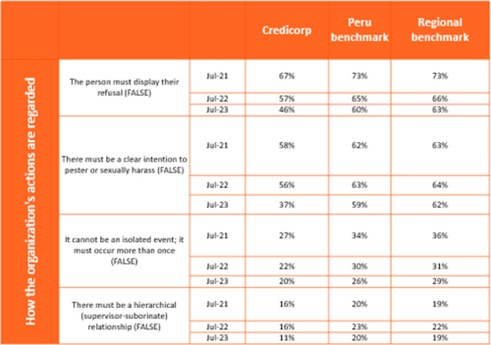

Note: The percentages indicate those who chose “true” when the correct answer was “false.” The lower the percentage, the better the level of understanding of the topic.

The survey results also show significant improvement for Credicorp in awareness levels and knowledge regarding prevention and response systems. The result is well ahead of the regional benchmark but slightly under the Peruvian benchmark. In 2024, we will continue working to improve our scores, maintain the WSH zero-tolerance policy, and train more employees (we trained 85% in 2023, up from 70% in 2021):
awareness, address WSH cases, and communicate these outcomes from the CEO level have been showing results.

During 2023, we sent out communications and held workshops and training to draw attention to unacceptable conduct and, in particular, to sensitize employees about comments that can be considered sexist.

We are aware that one of the first consequences of raising WSH visibility and awareness is often more reporting of its incidence. Although case numbers across our companies in 2023 stayed low in relation to the total number of personnel, our goal remains to continuously increase the understanding of what constitutes WSH and the degree of trust in Credicorp’s reporting processes.

32 WSH reports +36,000 employees

In 2023, we began following up with whistleblowers to seek their feedback about the process, make improvements, and ensure they face no adverse consequences for their actions.

For the third consecutive year, we participated in ELSA, 15 a workplace anti-harassment initiative that helps us measure our progress in learning about the issue and knowing about existing prevention systems. The results show that we have made progress in understanding since more Credicorp employees answered correctly than in the previous year. We also exceeded the 2023 benchmark for Peru and the region.

15 Espacios Laborales Sin Acoso (Workplaces Free of Harassment), an international initiative created by Genderlab with the support of the IDB.

33

requirements and also extend to same-sex couples and those with adopted children.
To foster the paternity benefit, we have made considerable efforts to show that it will not prejudice career development or bring about financial loss. Since implementation, more than 98% of employees in a position to access the arrangement have done so.16 To improve work-life balance and identify other possible initiatives, related questions have formed part of our workplace satisfaction survey.

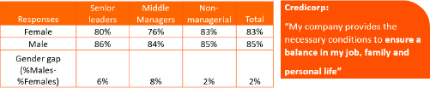

Source: Data from the 2022 work climate surveys. Preparation: Own

2.2.4. Employee Experience

Credicorp measures all its activities and initiatives under the different pillars through its employee experience model. We monitor the results of our strategy through periodic eNPS measurements and workplace satisfaction surveys to assess and understand how our employees feel. These metrics are essential to maintaining a healthy work environment and identifying areas for possible improvement.
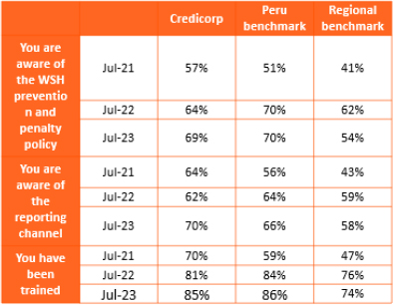

 | ● | Employees are aware of the prevention and penalty policies (69% in 2023) and reporting channels (70% in 2023)
 | ● | Employees better understand what WSH is.

2.2.3.4. Work-life and family balance

We aim to be a company that encourages parental co-responsibility

To meet this aspiration, each company in the Group offers two cross-cutting family benefits that exceed the national minimum legislative

Paternity leave | Graduated return
21 days after birth | from maternity
 | for up to 7 months after birth

16 Further detail on parental leave is available in the annexes to this report.

34

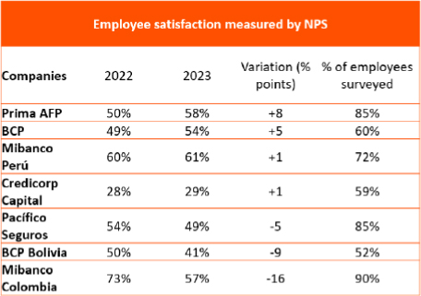

They allow us to prioritize and target steps that make an impact in those group companies facing the greatest challenges.

Further details on employee management are available in the annexes to this report.

35

2.3. SUSTAINABLE SUPPLIER MANAGEMENT

Material topic Human Rights
GRI 2-6, 3-3, 308-1, 414-1
Pillar 3

As a change agent, Credicorp believes in its ability to positively influence the value chain, particularly its suppliers. In 2023, we engaged a

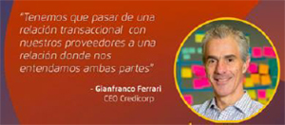

consultant to strengthen our sustainable supplier management by setting up a strategy based on the following inputs: analyzing gaps compared to other regional financial institutions, identifying opportunities for improvement, and determining how much of an appetite was present. As a result, we now have a work plan for the next two years that includes milestones and responsibilities. Initiatives on this front include:

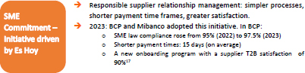

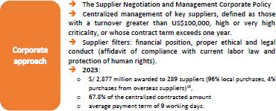

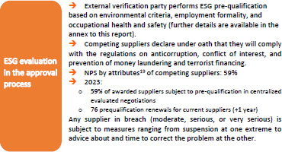

17 May 2023
18 Local suppliers are those registered in Peru. Credicorp’s main categories of expenditure and investment are detailed in the Expenses and Investment category table in the annexes.

19 A survey that compiles information about how the participating suppliers and winning bidders viewed the process. The attributes evaluated are as follows: transparency, communication, scheduling, and tender closing

36

2.4. THE SOCIAL IMPACT IN OUR COMMUNITIES

Material themes Commitment to society
GRI 3- 3, 413-1

Credicorp exercises its role as a change agent in the community through social responsibility initiatives that foster inclusion and innovation, responding to the needs of our environment by driving the changes our countries need. More information about the projects run by each of Credicorp’s subsidiaries is listed in the respective sustainability reports.

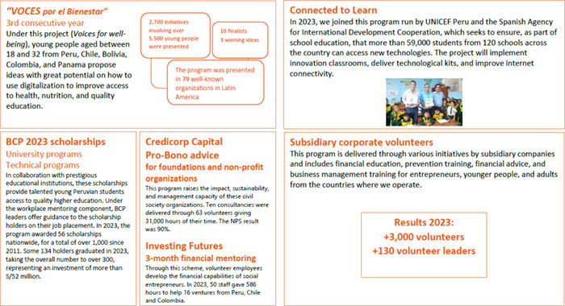

37

3. ENVIRONMENTAL MANAGEMENT
ENVIRONMENTAL MANAGEMENT

At Credicorp, our purpose of contribute to improving lives by driving the changes our countries need motivates us to support the transition to an environmentally sustainable economy. Our environmental roadmap has led us forward in identifying and properly managing the environmental risks and the opportunities presented by sustainable finance. Our work to strengthen capabilities and knowledge about this global challenge has led us to continue improving our objectives and lifting our aspirations.

38

3.1. THE ENVIRONMENTAL STRATEGY

In the first quarter of 2023, Credicorp rolled out its Corporate Environmental Strategy. Our vision is to be a local leader in supporting the transition to an environmentally sustainable economy by building capacities and knowledge that drive sustainable businesses and manage environmental risks early on.

To strengthen our environment and climate change management, the strategy determined five pillars that trigger activity under the themes of strategy and ambition, growth, risks, program and delivery, and reporting.

3.1.1. Pillars and 2023 achievements

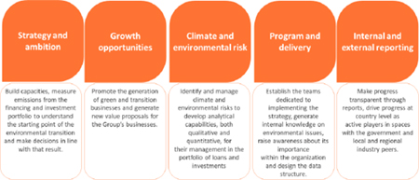

3.1.1.1. Portfolio emissions measurement

Measuring the portfolio footprint is critical to identifying its composition in terms of environmental impact and identifying and prioritizing emission reduction levers hand-in-hand with our clients and the companies we invest in.

We have carried out our first emissions measurement using the Partnerships for Carbon Accounting Financials (PCAF) methodology, which allows us to guage the carbon footprint of the prioritized porfolios even when client and emitter data is unavailable. The estimates are based on variables such as revenue, energy consumption, and production data. We worked to raise awareness and train the organization, including the corporate environmental team, the risk team and the subsidiaries’ business and investment teams.

39

By prioritizing the wholesale banking segment for this first measurement and selecting the ten critical sectors for ESG risk management (mining, hydrocarbons, fishing, energy, construction, building materials supplies, real estate, transport, agriculture, and textiles), BCP was able to analyze 47% of its wholesale banking financing portfolio, obtaining data for 22% of its portfolio. Prma AFP and Pacífico Seguros prioritized their most relevant asset classes and those where information was available. Pacífico Seguros analyzed 84% of its investment portfolio and obtained a measurement of 523,516 TnCO2e financed with a coverage of 68% of the portfolio.20 According to Prima AFP’s latest Responsible Investments Report (October 2023), the company analyzed 37% of the investment portfolio and obtained a measurement of 581,990 tCO2e, covering 35.7% of the portfolio21. At the time of preparing this report, it has been possible to cover 75% of the portfolio. The results will be published in Prima’s next report.

3.1.1.2. The first TCFD report
We have issued our first report under the Task Force for Climate-related Financial Disclosures (TCFD) framework. In it, we detail our climate change governance embedded in our sustainability governance (both at the board level, on the steering committee,22 and for the sustainability team); our strategy; and our environmental risk management.

Using the TCFD reporting framework, measuring the impact of our financed GHG emissions, enhancing our green financing, and continuing to strengthen environmental risk management are key elements in the implementation of our environmental strategy.

Our TCFD report complements our alignment with CDP, another reporting initiative through which we have been disclosing our climate change management since 2010.

3.1.1.3. Capacity and knowledge generation

A vital element of the first year of strategy implementation has been strengthening the team and building the internal capacity of various areas across all subsidiaries. Further details on environmental training are contained in the annexes to this report.

20Including direct investments in corporate fixed income, sovereign bonds, and indirect investments through public third party funds.
21 Including direct investments, both equities and corporate bonds.
22 The Sustainability Steering Committee is responsible for giving visibility, prioritization, and focus to the strategy and program. It consists of Credicorp’s CEO and the subsidiary CEOs; the corporate COO, CRO and CFO; the Corporate Talent Manager; the Corporate HR Manager; and the Corporate Sustainability Leader, who convenes the committee.

40

3.2. SUSTAINABLE FINANCE
Material topics Responsible and sustainable finance and investments GRI 3-3

2023 achievements

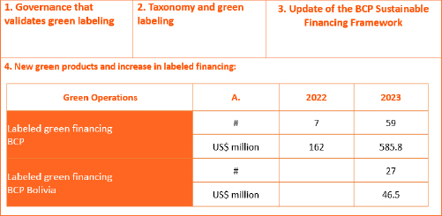

Credicorp’s strategic roadmap for sustainable financing puts the initial focus on BCP’s wholesale banking. In 2023, we defined a process and governance structure for labeling green and sustainable financing.

BCP’s ESG risk credit policy is also critical for addressing the obstacles we encounter along the path to sustainable financing described in section 3.4.2.

During 2023, we strengthened BCP’s wholesale banking sustainable finance team and so were able to roll out a broader portfolio of green loans, including working capital lines and foreign trade products, in addition to the more traditional medium-term loans. We delivered a significant increase in green-labeled short- and medium-term financing (under a use
of proceeeds approach) over the 2022 close (+282%). In the retail banking segment, we launched the green mortgage credit product aligned with the taxonomy's environmental criteria.

3.3. RESPONSIBLE AND SUSTAINABLE INVESTMENT
Material topics Responsible and sustainable finance and investments GRI 3-3

Because we understand how our investments can impact the transition to an environmentally sustainable, low-carbon economy, at Credicorp it is essential that we consider ESG issues when analyzing and making investment decisions. Our subsidiaries draw on several responsible and sustainable investment strategies: negative screening, ESG integration, active ownership, best-in-class selection, and thematic and impact investment.

3.3.1. ESG integration

Credicorp’s subsidiaries Prima AFP, Pacífico Seguros, and Credicorp Capital include ESG factors when analyzing and making investment decisions, including tools such as ESG criteria from external suppliers, questionnaires based on SASB and PRI guidelines, and internal questionnaires. We have assessed a significant percentage of our portfolio under ESG criteria.

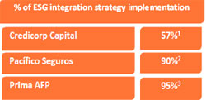

(1) Data to end 2022 (2) and (3) Data to end 2023 | % of total portfolio

41

2023 achievements

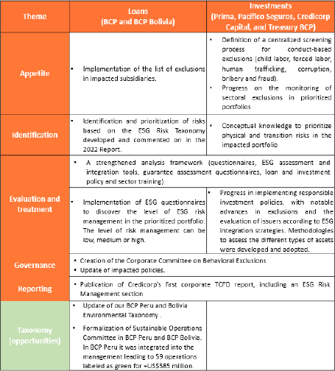
3.3.2 Active Ownership

At Credicorp, we work to influence companies and guide them towards more sustainable practices. We want our engagement activities to contribute to a more environmentally sustainable future.

Further details on our engagement initiatives are available in our TCFD Report. For other investment strategies, see the Corporate Policy for Responsible and Sustainable Investments.

3.4. ESG RISK MANAGEMENT
Materials topics Comprehensive Risk Management, Economic
Performance
GRI 3-3, 201-2

Through Credicorp’s ESG Risk Management Framework, we gain knowledge about clients that allows us to become a partner as they move toward increasingly sustainable practices. Instead of merely identifying exclusions, our ESG strategy focuses on supporting clients in the transition.

We have set up the ESG risk enabler, bringing together all ESG risk management stakeholders in a monthly forum led by Credicorp’s Chief Risk Officer. This enabler drives initiatives in various subsidiaries and operates through a risk management framework consisting of six focus areas: (1) Appetite; (2) Identification, Assessment, and Treatment; (3) Monitoring; (4) Reporting; (5) Organization and Governance; and (6) Taxonomy (for the identification of green opportunities).

42

3.4.1. Taxonomy and appetite

We have advanced along several fronts, from implementing corporate policies that define appetite and identify ESG risks to creating qualitative heat maps of sectoral risks to assess how vulnerable the main economic sectors are to climate-related physical and transition risks. We have also evaluated our clients and issuers under exclusion criteria that include thermal coal production and trading.

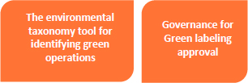

For a loan operation to be labeled green, it must meet the eligibility criteria of BCP’s Environmental Taxonomy. Internal governance is led by the Sustainable Operations Committee, whose objectives are (i) to review loan operations with sustainable potential and approve their categorization for labeling and (ii) to set the guidelines for developing sustainable finance products in BCP.

The company’s corporate policies and those of the subsidiaries demonstrate our commitment to responsible climate risk management and integrating ESG into investments and operations.
Corporate-level policies and guidelines | Corporate Policy for Responsible and Sustainable Investments | ESG integration into investment decisions. Exclusion of thermal coal companies
Corporate-level policies and guidelines | Environmental Policy Credicorp | Carbon neutrality commitment in our direct operations to 2032 (excluding financed emissions)
Corporate-level policies and guidelines | Supplier Management | ESG supplier evaluation employing questions related to Environmental Management System certification (ISO 14000) or other national and international standards
Policies at the subsidiary level | BCP ESG Risk Credit Policy | Management of environmental, social, and governance risks and thermal coal financing exclusion
Policies at the subsidiary level | BCP Project Financing Socio-environmental Risk Policy | Responsible management of project finance +US$10 million, complying with the Equator Principles and local regulations
Policies at the subsidiary level | Responsible and sustainable investment policies applied by the principal subsidiaries | Individual policies for portfolio management

3.4.2 Identification, Evaluation, and Treatment

Since June 2023, BCP has been implementing its new ESG Risk Credit Policy. Replacing the previous Environmental Credit Policy, the new policy expanded the scope to clients with approved credit lines starting from US$10 million in ten sectors: mining, hydrocarbons, fisheries, energy, construction, building supplies, real estate, transport, agriculture, and textiles. The previous policy had only covered four environmental risk sectors: mining, hydrocarbons, energy, and fisheries. Noteworthy is that the policy excludes financing for activities such as tobacco, thermal coal, weapons of war, money laundering, human rights abuses, and others in which the bank does not wish to participate.

43

From July 2023 onwards, the participating subsidiaries (BCP, Mibanco, and Pacífico Seguros) carried out preventative training, communication campaigns using various channels (social networks, web series, radio spots, the print media), and decentralized forums and fairs in vulnerable areas of Lima and along the coast (Trujillo, Chiclayo, Piura).

The following boxes provide detailed information of our companies’ climate risk efforts:

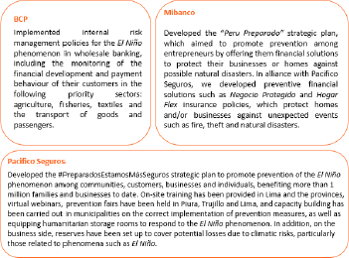

Further details are available at the following websites: PreparadosySeguros and ConLaCamisetaSiempre.
The following table shows the number of clients assessed under the current ESG Risk Credit Policy between June and December 2023:

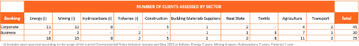

Further details are available in BCP’s Integrated Annual Report and Sustainability Report.

3.5. SOCIAL IMPACT OF CLIMATE RISKS
Latin America as a region, and Peru in particular, are highly vulnerable to extreme weather events. During 2023, Peru suffered climatic emergencies associated with Cyclone Yaku in the first quarter and then strong rains that began in the final quarter.

Peru is highly vulnerable to climate risks, which affect not just nature, infrastructure, and production, but also people’s lives.

With this in mind, Credicorp’s subsidiaries have responded by joining forces for a campaign that aims to raise awareness and improve our stakeholders’ resilience: “Con La Camiseta Puesta ante el Fenómeno El Niño”. We have also broadened the support we can offer to include recommendations for how to draft an action plan, asynchronous digital advice to clients who need to reorganize their financial affairs, and loans to clients facing financial hardship.

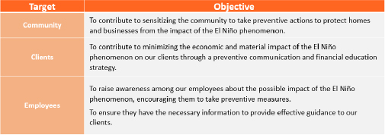

44

3.6. OUR DIRECT ENVIRONMENTAL IMPACT
Since we work in an industry that is not highly polluting, Credicorp’s direct environmental impact is relatively small. Nonetheless, we are committed to eco-efficiency in our operations and more sustainably managing natural resources. Our subsidiaries have rolled out numerous eco-efficiency initiatives pursuant to their environmental plans, as follows:

3.6.1. Energy eco-efficiency initiatives

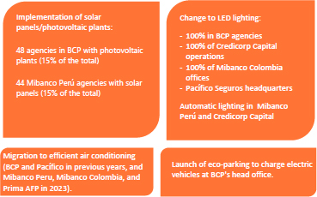

3.6.2. Water consumption eco-efficiency initiatives

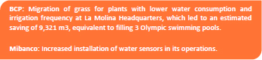

3.6.3. Waste eco-efficiency initiatives

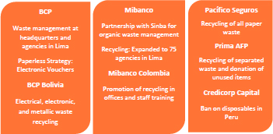

Our goal is to be carbon neutral in net emissions by 2032 in our operations.

During 2023, we implemented a series of initiatives pursuant to our environmental management plans that contributed to reducing GHG emissions. These initiatives resulted in a combined reduction of 1,470 tCO2eq; however, our footprint has increased mainly due to increased air travel, air conditioning use and a more emissions-intensive electricity grid in Peru due to higher thermal generation in 2023. In line with our commitment, emissions that could not be reduced will be offset through carbon credits aligned to our offset guidelines to achieve a net annual reduction of 10% from the 2022 baseline. Our subsidiaries Prima and Pacífico Seguros are already carbon neutral in their direct footprint.

45

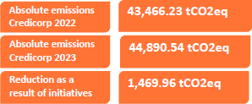

We measure our GHG emissions by following to the GHG Protocol standards of the World Resources Institute (WRI) and the World Business Council for Sustainable Development (WBCSD) and ISO 14064-I:2018. The results of the GHG inventories are verified by a third party.

Further details are available in the environmental chapter in the annexes.

47

46

4. CORPORATE GOVERNANCE

Corporate governance, ethics, and anti-corruption lie at the heart of our sustainability strategy and are at the top of the list of material topics for the company and its stakeholders. Efficient, effective, and ethical decision-making is essential for business management and ensuring our sustainability strategy is implemented. That’s why we work on a coordinated governance that focuses on continuous improvement of structures, policies, and control mechanisms that strengthen us institutionally, consistent with SDG 16: Peace, justice and strong Institutions.

47

4.1. OUR CORPORATE GOVERNANCE
Material topics Corporate governance, ethics, and anti-corruption GRI 2-9, 2-10, 2-11, 2-12, 2-13, 2-15, 2-16, 2,17, 2-18, 3-3

Credicorp seeks continuous improvement and alignment of its corporate governance framework with international best practices and standards.

Our corporate governance structure consist of:

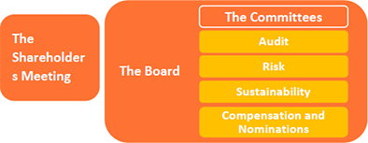

4.1.1. General Shareholders’ Meeting

The Ordinary General Shareholders Meeting held every year has the following objectives:

 | ● | To receive the auditor’s annual report and the financial statements for the year ended 31 December of the previous year
 | ● | To elect directors (3-year periods) and to set their compensation

 | ● | To designate the external auditors for the year, and
 | ● | To decide on any other matter that is submitted to the Shareholders Meeting.

Further details about convening the meeting, shareholder participation, and procedures before and during the meeting are available in our Shareholders Guide.

4.1.2. Our Board

The Board of Directors is responsible for administering and managing the businesses of Credicorp Ltd. The conduct of its members is guided by the principles of loyalty and good faith pursuant to their mandate to ensure long-term benefits for the company and its stakeholders.

The board meets at least once every two months, and the quorum for its sessions is a simple majority of members. For a motion to be carried, the majority of those present must agree. In 2023, nine meetings were held, and all members attended each one.

The following boxes provide more detailed information about the board’s 2023 achievements as part of its continuous improvement process:

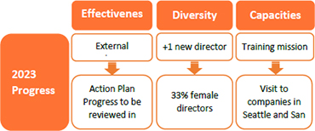
48

Board skills and diversity matrix

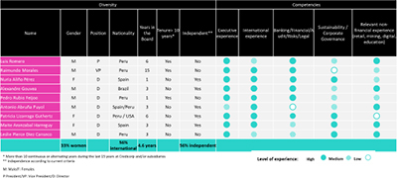

Complementing the board’s existing independence and gender diversity, its new members have brought additional capacities and in-depth local and international expertise (in banking, finance, insurance, legal, business management, and private equity) and new capabilities (in issues such as digitalization, transformation, commercial, marketing, education, and sustainability).

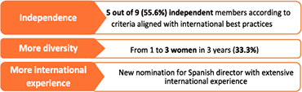
In 2023, seven directors and four executives (CEO, COO, CINO, and the BCP CEO) undertook a mission of inspiration and education to meet senior executives from global companies working in payments, technology, consulting, and fintech. The main themes covered included technology in the future, cybersecurity, artificial intelligence, trends in financial services (open banking, blockchain, embedded finance), and topics related to how culture evolves and the future role of boards.

Board members also attended several sustainability training programs with a particular emphasis on the environment. Further details are available in the change management section of this report.

4.1.2.1. The board’s 2023 independence, diversity, and competencies

It is essential that we have diverse leadership with capabilities that respond to Credicorp’s current and future strategic needs and that strikes the right balance between independence and non-independence. The board’s nine directors are elected by the General Shareholders Meeting for three years and maybe re-elected. The board should also have no less than three independent directors; where possible, most of its members should be independent. The aim is for at least two women to sit on the board.

Luis Romero Belismelis, as Chair of the Board of Directors of Credicorp Ltd., is responsible for, among other issues, the company’s governance and performance. He must also lead and manage measures to ensure that Credicorp meets its obligations.

Conyers Corporate Services Ltd (Bermuda) performs the Corporate Secretary role. Guillermo Jesús Morales Valentín is the Deputy Secretary.
49

4.1.2.2. Board committees

Three of the board’s four committees are chaired by independent directors, and all have at least one female director. During 2023, with the renewal of the board, Pedro Rubio joined the Sustainability Committee, bringing extensive experience in the universal banking business, especially wholesale, which will help us continue to drive into the business the integration of sustainability and the vision of opportunity it presents.

 | Audit  Committee | Risk  Committee | Compensation and  Nominations  Committee | Sustainability  Committee
# of  meetings | 13 | 1 | 1 | 5
Attendance | 100% | 80% | 100% | 96%

4.1.2.3 Board evaluation

In 2023, an external board evaluation was conducted, led by a renowned global consulting firm and expert in corporate governance issues. Its scope included how the board operates as a collegiate body and in coordination with its four committees. The analysis looked at ratings, indexes, proxy advisors, corporate governance codes, and a review of best practices by industry peers. It also drew on interviews with and questionnaires for Credicorp’s directors and management. An important conclusion from the analysis is that, in general terms, Credicorp’s board and committees operate in a structure, composition, and function that is consistent with the good governance recommendations of national bodies, institutional investors, and proxy advisors. Following the final report submitted to the board in December 2023, an action plan was established to execute the recommendations. Implementation will be monitored by the Sustainability
Committee. The board also agreed to repeat the exercise every three to five years.

Additionally, each board member completes a performance self-assessment during the year using the following criteria: (i) as an individual—involvement and participation, contribution to the achievement of institutional objectives; and (ii) as a collegiate body—meetings and operativity of the board, board dynamics, members’ knowledge of the company’s strategy, mission, vision, statute, and regulations, among other matters. The insights gathered by this survey inform the board’s continuous improvement initiatives.

More information about: | Consult:
The objectives and functions of our committees | Form 20-F 2022, section GC Board Committee Structure
The process and selection of our directors | Corporate Governance Policy
The experience of our directors | Biographies of directors
The board’s functions, guidelines, and conflicts of interest policies | Board Regulations and Code of Ethics Credicorp.
The convening of and participation in shareholders meetings | Shareholder’s Guide
Senior leaders | Credicorp website, Management Structure

50

4.2. COMPENSATION MODEL FOR THE BOARD AND EXECUTIVE MANAGEMENT
Material topics Corporate governance, ethics, and anti-corruption GRI 2-19, 2-20, 3-3

4.2.1. Compensation for the Board of Directors

The compensation for members of the boards of Credicorp and its subsidiaries is proposed by the Credicorp Compensation and Nominations Committee and approved at the General Shareholders Meeting for each company. Each package consists of annual compensation for the individual sitting on the board and additional compensation for those participating on a board committee.

Further details on the composition of the Credicorp board and those of its subsidiaries are available in Form 20-F, published on our website.

4.2.2. Compensation for the Executive Segment

Aiming to have the region’s best Top Management, Credicorp’s compensation model strengthens our attraction and retention strategy. Its components respond to the group’s corporate compensation philosophy:
We attract and retain the best local and international talent for Credicorp
We reward in a differentiated manner our executives’ high performance and their ethical conduct
We align executive and shareholder interests by sharing Credicorp’s risks and successes
We generate passion for creating long-term value for Credicorp and its stakeholders

We transparently manage performance and compensation for executives using simple and easy-to-understand models
We promote diversity and ensure pay equity and equal opportunities

The responsible body is the Credicorp Compensation and Nominations Committee. One of its primary functions on salaries is to set Credicorp’s compensation policy and guidelines and approve the Total Annual Compensation proposals, including incentive plans and payment adjustments for Credicorp’s senior management. The company’s Corporate Talent Manager undertakes the role of Committee Secretary. The Corporate Compensation Manager provides specific technical advice and participates on an ongoing basis.

Compensation management at Credicorp aims to ensure a balance between its executives’ total annual compensation and their competitive ability to:
Attract competent and qualified staff
Retain those most qualified
Reward those who contribute the most to achieving the organization’s objectives
Keep employees motivated
Improve the organization’s efficiency
Ensure the salary budget is sensible
Comply with the relevant legal regulations

To ensure that compensation is internally consistent, we apply the Hay Group’s point factor methodology to analyze the relative value of the positions and the level of executive performance. By classifying and sorting positions based on content and requirements of Knowledge, Complexity and Responsibility over Results, the system allows us to set fair and equitable compensation considering skill, effort, and responsibility, regardless of the individual’s age, race, creed, gender, or marital status.
51

Incentive linked to sustainability | 10% - 20% of the performance scorecard (variable incentive)

4.2.3.3. The long-term incentive

The long-term incentive aims to align the interests of executives with those of the shareholders so that they all share Credicorp’s successes and risks and to foster long-term value creation for the organization and its stakeholders.

It has two components:
Retention: The aim is to retain executives by delivering restricted shares (BAP) over three years, with 1/3 released each year.
Value generation: The aim is to guide executives’ performance toward creating long-term value for Credicorp by linking payment to the fulfillment of long-term strategic indicators.

Each executive’s total annual compensation consists of a fixed salary complemented by two variable components: a short-term incentive and a long-term incentive. The higher the executive’s level in the organization, the more significant the variable components become, constituting between 40% and 70% of the total package.

4.2.3. Fixed and variable compensation

4.2.3.1. The fixed salary

The fixed salary is that assured for under the law of the country where Credicorp operates. It is based on the position’s value and the degree of responsibility, has no variable component and is never linked to results achieved. Salary increases for the executive segment take into account:
The outcome of the annual individual performance evaluation
The position’s place within the salary band
Salary equity
Seniority
Talent metrics
Organizational budget

4.2.3.2. The short-term incentive

The short-term incentive encourages executives to achieve Credicorp’s annual goals by meeting individual and organizational objectives. The performance scorecards for top executives consist of profitability, efficiency, customer experience, transformation and sustainability (ESG) indicators that vary by subsidiary and align with the company’s business strategy and/or the overall corporate strategy. This incentive payment is triggered when Credicorp’s minimum net profit is delivered, calculated as a proportion of that total target met, and on the individual’s results against their particular objectives.
52

4.3. SUSTAINABILITY GOVERNANCE

Credicorp’s sustainability governance gives visibility to the sustainability strategy at various levels of the organization, ensures the integration of sustainability into our business management and its alignment with the business strategy, allows for coordinated efforts between corporate and subsidiary teams, generates accountability for results, prioritization of initiatives and setting ambitious goals, and moves us forward on our path to becoming a sustainable financial services leader in the region.  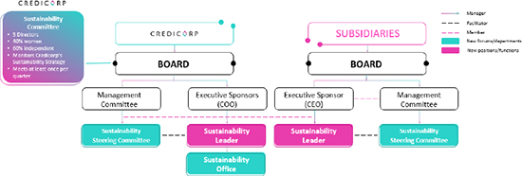  There is oversight of the sustainability program at all levels, from the board level through to the teams responsible for implementation. Each subsidiary replicates a governance structure similar to that existing at the corporate level but adapted to its own internal arrangements. |  | 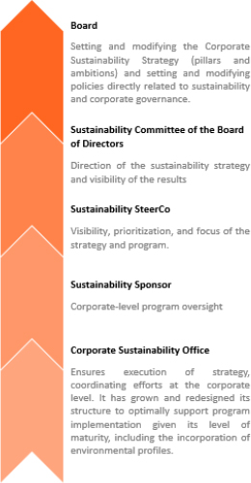

53

4.4. ETHICS, COMPLIANCE, AND HUMAN RIGHTS
Material topics: Corporate governance, ethics and anti-corruption, human rights, cybersecurity, privacy, and ethical data management.
GRI 2-23, 2-24, 2-25, 2-26, 3-3
SASB FN-CB-510a.2

Credicorp’s corporate Compliance and Ethics Division has evolved from its initial focus on ensuring regulatory compliance into one that leads the organization and its employees to contribute to our positive impact on society. Together with corporate governance, compliance and ethics are our principal material topics and key enablers for the sustainability strategy.

THE ETHICS AND COMPLIANCE PROGRAM 2023 ACHIEVEMENTS

Integration with the BCP employee experience model23: Our Credicorp Purpose is the big WHY. At BCP, it is delivered through the principles and behaviors that make up the Samay Culture, which defines HOW we do what we do to achieve the purpose. The past year saw the relaunch of these behaviors and the introduction of compliance with the Code of Ethics as a prerequisite for meeting the company’s “Safe and rule-abiding” principle. Similarly, to leverage the update, BCP implemented initiatives in two of the seven journeys along the employee experience model: Onboarding, and My Development and Learning.

The ethics indicator: We have developed this indicator to objectively assess the conduct of staff working in commercial areas

 | 23 | Credicorp’s main subsidiary, with 48% of its total workforce in 2023

and ensure relationships with our clients are ethically grounded. The initiative will also make each team’s ethical performance visible to the relevant Credicorp leaders. We aim for this indicator to become part of the performance checklist for leaders and employees alike.

Measuring the ethical culture: We conducted a survey on the perception of our ethical culture to obtain an objective and external measure of how Credicorp disseminates the Code of Ethics, how far the staff trusts the reporting channel, and how well Credicorp manages issues such as ethical leadership and fairness within the organization. The contractor, Ethisphere, is a leading company in ethical matters. It promotes, defines, and measures related corporate standards. The results at the Credicorp level were positive: we exceeded the benchmark by seven points. The project also helped us put in place action plans that will close gaps identified in some teams at the corporate level. Implementation is scheduled for 2024.

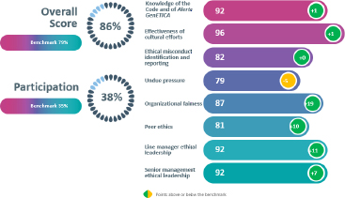
54

On the Ethisphere scale for how well staff know the code and Alerta GenETICA24 we recorded an index of 92/100, one point above the reference benchmark. This result stems from the campaigns undertaken during 2022, the year in which we revised our Code of Ethics.



GenÉtica Lab: Our training and awareness format is aimed at Credicorp leaders working in teams where risks are high. In 2023, 129 leaders from Credicorp’s Peruvian subsidiaries attended 13 workshops that reinforced in a fun and practical way our compliance guidelines, ethics policies, and the ethical behaviors that apply to leadership. The workshops achieved a 98% NPS.

Alerta GenÉtica Corporate Campaign: The objective was to increase the effectiveness25 of the reports we receive. The result was 35% effectiveness, a figure still below the standard of 41%26.

In 2024, we will continue implementing innovative initiatives that help disseminate best practices, foster ethical employee behavior, and lift the effectiveness of reports. These include:
 | ● | Proyecto Aliados: The “Partner’s” project designates employees in strategic areas to promote compliance and ethics topics. It will help identify and mitigate risks, disseminate best practices, develop controls, and reward positive behavior.

 | ● | Alertas Éticas: “Ethical Alerts” sets out possible scenarios of alerts for timely identification of behaviors that breach the Code of Ethics.

4.4.1. The Code of Ethics & GenÉtica Credicorp

Our Code of Ethics guides the conduct of every individual in Credicorp in their relationships with the company’s stakeholders. Employees undertake to comply with it when the employment relationship begins and then renew that commitment each year using digital means.

The code is freely available on our website. We recorded over 1,500 more consultations during 2023 than occurred in 2022 (7,000).

Our ethical approach is more than just a manual: it has become how we do business. That is why we came up with GenÉTICA, a concept that guides us when making daily decisions and reminds us that everyone, whether employees or directors, can use ethics to deliver our purpose. More information is available here.

24 Alerta GenÉTICA is our complaints channel available to our employees, clients, suppliers and any other individual seeking to report conduct of members of Credicorp that may violate our Code.
25 An effective report is one that is verified and / or leads to corrective measures. In 2023, we began to assess the effectiveness of the reports we receive. Our measurement consists of calculating what percentage of the valid reports received each year qualify as effective.
26 Source: Hotline & Incident Management. Benchmark Report 2023. NAVEX
55

Suppliers aligned with our ethics and integrity

Credicorp’s Code of Conduct for Suppliers and Third Parties recognizes that these organizations are partners in delivering our purpose. We seek service providers that share our values: respect, equity, honesty, and sustainability. Aligned with the sustainability approach and our updated Code of Ethics, we have reinforced with suppliers topics such as human rights, social responsibility, and occupational health and safety (OH&S).

In 2023, we also provided training on human rights-related aspects of the Code of Conduct (OH&S, anti-corruption, use of our ethics line) to 227 suppliers and obtained a satisfaction level of 93% T2B.

4.4.2. Alerta GenÉTICA – Reporting channel

Alerta GenÉTICA is the channel we make available to all our stakeholders should they witness or suspect a violation of the Code of Ethics. All reports received are reviewed and investigated by control units. If, after the investigation, non-compliance with the Code or its complementary policies is found, the Labor Relations or Human Management and Development teams choose and apply the corresponding disciplinary measure, ranging from a reprimand letter to dismissal, and without prejudice to any legal consequences arising from prevailing laws.

Our Credicorp Alerta GenÉtica Corporate Policy is available on our website here in Spanish and here in English.

 | ● | How do we make it work?
 | ● | We always act
 | ● | Zero retaliation

 | ● | 100% confidential

Organizational justice demands that we take action on reports and, once a breach of our Code and our values is confirmed, take the necessary corrective and disciplinary measures. This key element for fostering a trusting environment among our employees allows them to experience how ethics is immersed in our organizational culture.

In 2023, Alerta GenÉTICA delivered the following results:

 | ● | 729 reports were received, an increase of 43% on the 2022 result. This outcome stems from training and awareness-raising that motivated our employees to speak up.
 | ● | 84% of the reports received were anonymous (a similar result to 2022).
 | ● | 65% of the reports were from BCP Perú, the holding’s largest employer (48% of total staff).
 | ● | 63% of the reports were valid: they contained sufficient information for an investigation to commence. Of these, and following investigation, 186 corrective and disciplinary measures were sought and applied, as follows:
 | ● | termination: 14%
 | ● | suspension: 15%
 | ● | reprimand letters: 15%
 | ● | warning emails: 11%
 | ● | Other (feedback and improvements): 46%

56

Distribution by category of valid reports received in the last three years

Valid reports by category | 2023 | 2022 | 2021
Workplace hostility | 233 | 182 | 169
Unfair practices and conflicts of interest | 93 | 84 | 65
Fraud | 27 | 41 | 65
Unethical behavior | 55 | 55 | 58
Other | 47 | 17 | 28
Bribery and corruption | 4 | 2 | 8
Total (general) | 459 | 381 | 393

Distribution by company of valid reports received in the last three years

Valid reports by the | 2023 | 2022 | 2021
company
BCP | 290 | 254 | 250
Mibanco | 105 | 80 | 92
Mibanco Colombia | 15 | 8 | 15
BCP Bolivia | 25 | 23 | 15
Credicorp Capital | 2 | 6 | 6
Colombia
Pacífico Seguros | 12 | 5 | 13
Prima AFP | 3 | 0 | 1
Credicorp Capital Perú | 1 | 2 | 1
Credicorp Capital Chile | 0 | 0 | 0
Other | 6 | 3 | 0
Total (general) | 459 | 381 | 393

4.4.3 Business advice

Using personalized advice and a preventive risk management approach, we help the business develop products and processes that are suitable for our clients and comply with regulations. The responsible team specializes in assessing these from a compliance and ethics perspective. In 2023, over 800 such initiatives were examined, and over 1,200 action plans were developed.
57

4.4.4. Compliance programs

Credicorp’s compliance programs form part of our compliance and ethics management system and link to our commitment to promote ethics and integrity—fundamental elements of our organizational culture—while ensuring regulatory compliance and financial crime prevention. They address four of our seven priority SDGs.

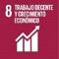 | 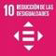 | 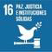 | 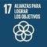
Policies: Market conduct Occupational safety and health | Policies: Regulatory compliance Market abuse prevention Financial stability Fair competition Human rights | Policies: Money laundering Fiscal transparency FACTCA and CRS Anti-corruption Ethics | Policies: Personal data protection

2023 Achievements

Regulatory compliance | ○ Implementation of monitoring control dashboard.  ○ Penalty process rolled out to group companies.  ○ Communications, training, and evaluation for the Regulatory Compliance team and across the business,developed through Entrena tu GenÉTICA.

Anti-  corruption |  | ○ Corporate Policy for the Prevention of Corruption and Bribery updated and published.  ○ The stock of relevant, high, and critical (RAC) risks in 2023 sitting at 41. The group’s risk management methodology requires us to reduce this number; accordingly, we undertook a specific assessment of processes that these risks impact and, during the year, 32% of the identified risks were lowered.  ○ All Credicorp directors and 96% of staff trained. Anti-corruption policies and procedures communicated to 69% of the suppliers operating high-risk areas.  ○ No confirmed cases of corruption identified during the year.  ○ BCP, Mibanco, and Pacífico in Peru hold ISO 37001 (Anti-Bribery) certification. BCP has also obtained accreditation from Empresarios por la Integridad ( Entrepreneurs for Integrity), an institution that provides guidelines and best practices for the fight against corruption.

Tax transparency  FATCA (Foreign Account Tax Compliance Act) and CRS (Common Reporting Standard) | ○ Successful dispatch to tax authorities in eight countries of over 70 FATCA and CRS reports, each qualitatively and quantitatively validated by each entity to assure quality:  ○ 12,151 clients with foreign tax residence  ○ 26,298 bank accounts reported.  ○ Over USD7,309 million reported in balances and returns.  ○ Over 16,000 Credicorp employees trained.  ○ Twelve virtual communication sessions held for the sales force.

Prevention of  money  laundering and  terrorist  financing | ○ An internal audit rating above 95%.  ○ Cash deposit controls in USDwith above 75% effectiveness.  ○ Quality of regulatory information above 86%.  ○ Improvements in final beneficiary identification.  ○ KRIs steady in the optimal zone.  ○ 100% implementation of audit and regulatory recommendations.  ○ 2023 courses delivered to 16,150 employees.  ○ Three new analytical models.

58

Personal data protection (PDP) | ○ Guidelines developed for cookies, including an audit of BCP Perú’s web pages. Guidelines developed for treatment and implementation of cookies, including an audit of BCP Perú’s web pages.  ○ Content developed to reinforce key concepts, such as capture, storage, and informed consent. Guidelines rolled out requiring initiative design to include privacy considerations, achievingreduction of empty consent across the corporate level; BCP Perú’s score for this indicator improved from 12% to 8%.  ○ Implementation at the corporate level of the guide for enriching personal data to mitigate reputational impact and financial penalties, and demonstrate due diligence should the regulator conduct an inspection.  ○ 10 training sessions held for specialists in the compliance team.  ○ A cookies master class held for technical teams and products.  ○ Courses and training for business areas and PDP teams in group companies held on issues including consent management, ARCO rights, cookie management, and regional regulatory trends.  ○ PDP risk assessment conducted in BCP Panamá and ASB Panamá.

Occupational health and safety (OH&S) | ○ Occupational medical examinations resumed for over 17,800 employees of Credicorp Perú to feed into an update of the companies’ epidemiological profile.  ○ 220 investigations carried out into employee reports of unwanted events.  ○ Over 750 workplace inspections undertaken to assess occupational risk prevention.  ○ Over 100 communications on preventive OH&S topics rolled out and circulated to over 31,000 employees.  ○ Over 70,000 hours of OH&S training materials developed.  ○ Zero occupational illnesses reported.  ○ More than 6,550 IPERC matrices were developed to identify dangers, risks, and control measures for occupational hazards.

4.4.4.1. Human rights

At Credicorp, we assert that all human beings have the right to lead a dignified life and be treated equally.

Credicorp’s human rights approach dates back to 2021, when the concept arose as a material topic in our sustainability strategy.

A 2022 evaluation identified ten priority thematic focus areas.

Thematic area | Responsable
Sexual harassment | Gender equity program
Labor rights | Workplace relations
Privacy
Corruption | Compliance and ethics
Financial crime
Health and safety
People trafficking (*)
Forced labor (*)
Child labor (*)
Discrimination (*)
(*) Additional controls need to be implemented and existing controls strengthened.
59

We now have controls that mitigate identified risks in the priority thematic areas. Initiatives are also under development to help reduce risks in the following more exposed thematic areas based on our assessment:

SUPPLIER ESG

We encourage our suppliers to integrate ESG standards in their business management. We aim to begin implementing an ESG supplier strategy in 2024. It will set out the guidelines for transmitting to suppliers our human rights expectations and commitments. It will also train our staff to ensure their supplier management activities integrate responsible conduct and human rights.

The Sustainable Supplier Management section contains more detailed information.

ESG RISKS

To strengthen our ESG risk management framework at the corporate level, we are implementing several initiatives to address human rights. A good example is the behavioral exclusions contained in the Corporate Responsible Investment Policy. Through our provider, RepRisk, we will receive alerts on companies that may be in breach. These companies will then be evaluated by our Exclusions Committee to ensure that any investments we make respect human rights.

RESPONSIBLE AI

While artificial intelligence offers endless opportunities, it also presents risks that must be managed. Our vision is to ensure these resources are appropriately used, with proper respect for and promotion of human
rights. That is why, with a multidisciplinary team, we are in the process of implementing the framework for responsible artificial intelligence based on the following eight principles:



ACCESSIBILITY

The Group’s companies have been implementing a range of inclusion of diversity initiatives related to physical and digital accessibility. From a human rights perspective, these initiatives allow us to address the anti-discrimination thematic area. Further details are available in section 2.1.1.1.2 Other financial inclusion initiatives.

In 2023, we set up the following human rights governance model:

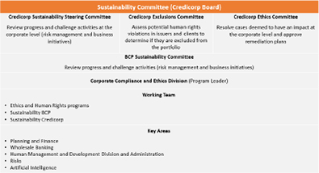
60

At board level, our governance body is the Sustainability Committee, which is supported by three internal committees that operationally may also decide on issues with a human rights impact, as follows:
 | ● | Credicorp Sustainability Steering Committee
 | ● | Exclusions Committee
 | ● | Credicorp Ethics Committee

At BCP, the bank’s Sustainability Committee (a management committee) reviews progress on activities presented by the working team in coordination with the key areas that manage human rights risks.

Our efforts in 2024 will be to reinforce the human rights focus in the prioritized thematic areas and engage a consultant to strengthen the long-term strategy. We will also reinforce our policies and publicize them to help internalize the program’s concepts.

4.4.5. Compliance innovation and ethics

Credicorp has been working to increase the effectiveness of its compliance and ethics processes and improve the experience of our clients and the business areas. During 2024, we plan to take advantage of the cognitive AI technologies that Credicorp has already been using, among other innovations.

61

ANNEXES

1.5. OUR SUSTAINABILITY STRATEGY

1.5.1. A change agent63

GRI 2-28
Membership associations*

In 2023, we were part of a set of local and international initiatives that allowed us to continue developing our commitment to the 2030 Agenda, our sustainability strategy, and our role as a change agent. In Peru, we participate in the network of the largest companies promoting sustainable development: Perú Sostenible. We are also part of other movements of business leaders and participatory spaces promoted by the government.

In sustainability, the more of us there are, the more value and positive impact we can create.

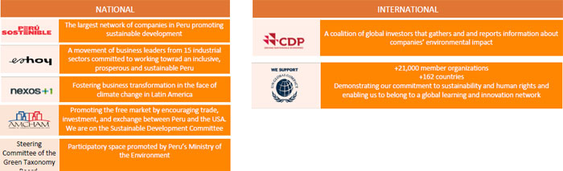

63 Further details of the affiliations and memberships of Credicorp’s subsidiaries are available in the respective Sustainability Reports.

62

1.5.1. The Integrated Sustainability Strategy

Indicators dashboard (non-exhaustive)
Pillar1 To create a more sustainable and inclusive economy
Ambition | Subsidiary | Indicator | Unit | 2022 | 2023 | Variation
Financial inclusion | BCP | Total Yape users (cumulative since 2020) | # millions | 11.9 | 14.2 | 19%
Financial inclusion | BCP | People financially included through Yape and BCP savings accounts (cumulative since 2020) | # thousands | 2,456 | 4,142 | 69%
Financial inclusion | BCP | People financially included through BCP savings accounts (cumulative since 2020) | # thousands | 1,522 | 2,405 | 58%
Financial inclusion | BCP | People financially included through Yape (cumulative since 2020) | # thousands | 934 | 1,737 | 86%
Financial inclusion | BCP | Women financially included through Yape | % | 49.4% | 49.5% | 0.1 pp
Financial inclusion | BCP | Transactions through Yape (monthly average) | # millions | 162 | 243 | 50%
Financial inclusion | BCP | People financially included through Yape micro-credits | # thousands | 25 | 129 | 416%
Financial inclusion | BCP | Micro-credits disbursed through Yape | # thousands | 130 | 941.4 | 624%
Financial inclusion | BCP | Micro-credits disbursed through Yape | S/ millions | 25 | 216.8 | 767%
Financial inclusion | BCP BOLIVIA | Soli virtual wallet users (now Yape), people and businesses | # thousands | 442 | 1,275 | 188%
Financial inclusion | BCP BOLIVIA | Usability of the Soli virtual wallet (now YAPE) | % | 28 | 34 | 6 pp
Financial inclusion | MIBANCO PERU | Clients who accessed Crediagua | # thousands | 97.7 | 77.5 | -21%
Financial inclusion | MIBANCO PERU | People banked through Crediagua | # thousands | 5.6 | 4.5 | -20%
Financial inclusion | MIBANCO PERU | Number of loans through Crediagua | # thousands | 106 | 83 | -22%
Financial inclusion | MIBANCO PERU | Total disbursed through Crediagua | S/ millions | 1.869 | 1,406.9 | -25%
Financial inclusion | MIBANCO PERU | Female clients in Mibanco portfolio | % | 50.6 | 51.8 | 1.2 pp
Financial inclusion | MIBANCO PERU | Banked clients (active) | # thousands | 72.9 | 63.6 | -13%
Financial inclusion | MIBANCO PERU | Banked clients (passive) | # thousands | 16.5 | 13.7 | -17%
Financial inclusion | MIBANCO COLOMBIA | Banked clients (active) | # thousands | 27 | 19 | -28%
Financial inclusion | PACIFICO SEGUROS | Active inclusive insurance policies through BCP and Mibanco | # | 2,615,690 | 3,187,641 | 22%
Helping small businesses grow | BCP | Disbursements of working capital credits for financially included MSMEs | S/ millions | 1,766 | 1,122 | -36%
Helping small businesses grow | BCP | Number of MSMEs financially included through working capital credits | # thousands | 49 | 33.3 | -32%
Helping small businesses grow | BCP | Plataforma Evalúate: Affiliated SMEs amount disbursed | S/ millions | NA | 90 | -
Helping small businesses grow | BCP | Plataforma Evalúate: Affiliated SMEs | # | NA | 6,931 | -
Helping small businesses grow | BCP | Crece: Completed businesses registered (cumulative) | # | NA | 2,350 | -
Helping small businesses grow | BCP | Contigo Emprendedor program beneficiaries | # | 110,690 | 121,019 | 9%
Helping small businesses grow | BCP | Number MSMEs financially included through credits for invoice factoring | # | 785 | 1,252 | 59%
Helping small businesses grow | BCP | Credits for SME invoice factoring - Annual cumulative (financially included) | S/ millions | 83.2 | 172 | 106%
Sustainable AUMs | PACIFICO SEGUROS | % ESG integration over total portfolio | % | 44 | 90 | 46 pp
Sustainable AUMs | Credicorp Capital | % ESG integration over total portfolio | % | 57 | NA | -
Sustainable AUMs | Credicorp Capital | Credicorp Capital PRI score | # stars | 3 | 3 | -
Sustainable AUMs | PRIMA AFP | % ESG integration over total portfolio | % | 94 | 95 | 1 pp

63

Sustainable Finance | BCP BOLIVIA | Outstanding green financing balances | # | NA | 27 | -
Sustainable Finance | BCP BOLIVIA | Outstanding green financing balances | US$ million | NA | 46.5 | -
Sustainable Finance | BCP | Green labeled financing | # | 7 | 59 | 743%
Sustainable Finance | BCP | Green labeled financing | US$ million | 162 | 585.8 | 259%
Pillar 2: Improve citizens’ financial health
Ambition | Subsidiary | Indicator | Unit | 2022 | 2023 | Variation
Financial education | BCP | Entrepreneurs benefited by Contigo Emprendedor program | # | 110,690 | 121,019 | 9%
Financial education | BCP | Contigo Emprendedor program volunteers | # | 660 | 2,213 | 235%
Financial education | BCP | People who improved their financial behavior | # | 113,600 | 214,000 | 88%
Financial education | BCP | People trained through the ABC at BCP (on-line and face-to-face) | # | 310,311 | 614,061 | 98%
Financial education | BCP | Cumulative reproductions of the BCP 5th floor web series | # thousands | 49,000 | 46,100 | -6%
Financial education | BCP | Effective views of the BCP 5th floor web series - Annual cumulative | Millions | 13.9 | 10.3 | -26%
Financial education | BCP BOLIVIA | Clients trained through the ABC at BCP | # | 116,153 | 247,856 | 9%
Financial education | MIBANCO PERU | People trained by financial education programs | # | 251,153 | 413,260 | 65%
Financial education | MIBANCO COLOMBIA | People trained by the Mi academia del progreso program | # | 28,545 | 45,752 | 60%
Financial education | MIBANCO COLOMBIA | Clients trained through the Basic Program of Financial and Digital Advisory | # | 244,529 | 272,289 | 11%
Financial education | PACIFICO SEGUROS | People reached by the ABC at Pacifico | # | 5,100,000 | 3,194,860 | -37%
Financial education | PACIFICO SEGUROS | Effective views of the educational content of the En Letras Grandes video podcast | # thousands | NA | 800
Financial education | PACIFICO SEGUROS | Effective views of the educational content of the Salado y Piña video show | Millions | 0.94 | 2.3 | 145%
Financial education | PACIFICO SEGUROS | People educated about risk prevention (Comunidad Segura) | # | 11,117 | 38,419 | 246%
Financial education | PACIFICO SEGUROS | Companies reached by risk prevention advisory services and training through Protege 365 (cumulative since 2022) | # | 2,197 | 5,594 | 155%
Financial education | PRIMA AFP | People reached by the ABC de la Cultura previsional (culture of prevention) program | # | 61,026 | 138,060 | 126%
Financial education | PRIMA AFP | Effective visualizations of the El Depa web series | # millions | 11.7 | 12.0 | 3%
Pillar 3: Empower our people to thrive
Ambition | Subsidiary | Indicator | Unit | 2022 | 2023 | Variation
Opportunities and products for women | MIBANCO PERU | Clients who disbursed through Crédito Mujer | # | 31,366 | 51,178 | 63%
Opportunities and products for women | MIBANCO PERU | Crédito Mujer disbursements | S/ millions | 62.8 | 108.5 | 73%
Opportunities and products for women | MIBANCO PERU | Women banked through Crédito Mujer | # thousands | 9.3 | 13.2 | 42%
Opportunities and products for women | MIBANCO PERU | Loans through Crédito Mujer | # | 36,904 | 59,867 | 62%
Opportunities and products for women | MIBANCO COLOMBIA | Clients who disbursed through Mujeres Pa’ Lante | # | 9,214 | 11,798 | 28%
Opportunities and products for women | MIBANCO COLOMBIA | Disbursements by Mujeres Pa’ Lante | S/ millions | 8.4 | 17.4 | 108%
Opportunities and products for women | MIBANCO COLOMBIA | Women banked through Mujeres Pa’ Lante | # | 6,295 | 6,919 | 10%

64

1.5.3. Creation of shared value Approach to stakeholder engagement

GRI 2-29

In 2022, we published our Credicorp Sustainability Policy, which sets out the general principles for cultivating and strengthening our relationships with each stakeholder group. Further details about our engagement principles are found here.

Key groups
In the Sustainability Policy, we define a two-step process for identifying stakeholders. First, we identify those groups that are directly or indirectly affected by our activities or have an interest in or the ability to influence Credicorp's results positively or negatively. Then, we prioritize the groups identified according to three characteristics: urgency, power, and legitimacy. By urgency we mean sensitivity to delays in meeting their requirements and the importance we attach to this group. By power we mean the capacity to affect our organization. By legitimacy we mean actions that are desirable, proper, or appropriate within a social system of norms, values, and beliefs.

On this basis, Credicorp has the following priority stakeholders. However, in addition to those mentioned, Credicorp and its subsidiaries also interact with other stakeholders (such as NGOs, academia, and industry associations) that are also managed within the framework of strategic partnerships or when the situation warrants it.

 | 1. | Employees
 | 2. | Clients
 | 3. | Investors / shareholders
 | 4. | Government and regulators
 | 5. | Suppliers
 | 6. | Community
 | 7. | Communications media
 | 8. | Public opinion

Dialog spaces
We maintain a strong relationship with our stakeholders. We use different key communication channels to address their needs, concerns, and expectations about our activities and those of our subsidiaries.

We also undertake an in-depth materiality exercise at least every two years drawing on studies, interviews, surveys, among other means, to gather stakeholder perceptions. While different areas of Credicorp and its subsidiaries lead the relationship with each stakeholder group, they each have the responsibility of coordinating with the Sustainability Office the collection of the aforementioned information, which complements our reviews and updates of the corporate sustainability strategy.

Credicorp is always open to listening to the expectations, needs, and concerns of these and other stakeholders through its public channels and those of its subsidiaries.

65

 | Employees | Clients | Investors and shareholders | Government and regulators | Suppliers | Community | Communications media | Public opinion
Communication and dialog channels | Bidirectional and ongoing communication. Perception surveys on:  ● the climate in the workplace  ● the organizational culture  ● personal experience at every stageof the organization’s life cycle  ● experience working with the supervisor  In addition, each subsidiary has communication channels that include forums, events, platforms, newsletters, and open door sessions with leaders. | Studies or satisfaction surveys, and the gathering of perception and concerns. Digital and face-to-face platforms, business officials, social networks, chatbots, mobile applications, claims system, informal meetings, and market research daily measurements | We proactively manage interactions:  ● Conference calls: quarterly results reporting  ● Calls or one-on-one meetings  ● Conferences and non-deal-roadshows (NDRs) to strengthen relationships with investors in other regions.  ● Ad-hoc events such as Investor Days, Digital Days, and ESG roadshows.  ● The biennial Investor Survey, using an external agent to collect feedback on the Group, its strategies, and how the Investor Relations team is performing | Having a positive and collaborative relationship with the government as a stakeholder and the regulatory bodies is essential.  We channel our initiatives through the business associations of which we are part.  We undertake a quarterly reputation study to discover our levels of trust and how Credicorp and its subsidiaries are regarded, including how representatives of the public sector and regulatory bodies perceive us. This enables us to design initiatives to bed down healthy relationships and improve teamwork. | We promote a dynamic supplier ecosystem with good business practices.  In 2021, Credicorp set up the Corporate Supplier Negotiation and Management Area with the aim of having a centralized and efficient strategy to the highest commercial and ethical standards. The centralized purchasing process complies with the guidelines defined by ISO 37001 Anti-Bribery Management. | Different parts of the community are directly or indirectly impacted by the operations and businesses of Credicorp and its subsidiaries.  Our subsidiaries measure the most significant impacts of their programs. They also offer dialog and exchange spaces. At the company level, social media channels are always active for any communication. | In addition to the media, this group includes journalists and people who have influence on public opinion and society. Managing a fluid relationship with the media is key to communicating the company's purpose, vision, and objectives.  We conducted a quarterly reputation study with opinion leaders.  We maintain a very fluid relationship by providing them with relevant information about the financial industry, which they share with the public as press content. We provider training to journalists to strengthen their skills and to enable them to more solidly address issues related to national economic activity. | We conduct a survey of a representative group of the urban Peruvian population over the age of 18 to determine the level of trust in Credicorp and its Peruvian subsidiaries. The data informs our companies’ communication plans with the public and design the social responsibility programs.
Frequency | Quarterly and/or annual | Quarterly, monthly and in some cases daily for all channels of the subsidiaries | Quarterly results. Ad hoc meetings (Investor Day), annual surveys. Calls or one-to-one meetings at the frequency required by investors | A quarterly study, ongoing conversations |  |  | Quarterly survey | Quarterly survey

66

1.6. SUSTAINABILITY INTEGRATION ENABLERS
1.6.1. The change management program

MATERIAL TOPIC EMPLOYMENT AND TALENT MANAGEMENT
GRI 404-2 Programs for upgrading employee skills and transition assistance programs
The Change Management Training Program: Training to leaders and prioritized streams in specific themes for each line of business:

Training by segments
 | Credicorp and Subsidiaries  Directors | Senior Leaders and Middle Managers | Specialized teams | Business line leaders
Topics | Social Vertical:  The difference between philanthropy and sustainability  The importance of impact evidence  Driving sustainability from their role as directors  Environmental Vertical64:  Climate change  Internal and portfolio carbon footprints | Social Vertical:  Reflection and alignment on where we (the Group and its companies) find ourselves on our sustainability journey and social benchmarks  Systems to integrate sustainability  12 ODS standards impact steps, how business impact is integrated, metrics, and tools  Environmental Vertical:  Update on global and local trends  Reporting standards, nature (TNFD), business opportunities, and reflection on the priority and impact of new environmental issues  Transversal:  The sustainability imperative  Climate change  Applying sustainability to financial institutions | BCP and BCP Bolivia loan analysis:  Sectoral ESG risks  PCAF methodology for measuring the loan portfolio footprint  Investment teams:  PCAF methodology for measuring the investment portfolio footprint  Subsidiary innovation teams:  Sustainability strategy and case history presentation  Sustainability tools co-creation for solutions design | Pacífico Seguros – Leaders of personal, life, vehicle, and bancaseguros business lines: How to find insurance business opportunities taking account of sustainability? Success stories  Credicorp Capital (2 training sessions):  ○ Training for advisors and bankers in identifying responsible and sustainable investment strategies appropriate to the client profile  ○ Climate risk management in investment
# people | 29 | 1,641 | ○ Credit risk: 190  ○ Investment: 30  ○ Innovation: 51 | ○ Pacífico Seguros: 45  ○ Credicorp Capital: 158
# people | 2 hours and 45 minutes65 | 5 hours and 30 minutes | ○ Credit risk: 13.5 hours  ○ Investment: 3 hours  ○ Innovation: 7 hours | ○ Pacífico Seguros: 2 hours  ○ Credicorp Capital: 4.5 hours
T2B Satisfaction | 100%66 | 60% | ○ Credit risk: 86%  ○ Innovation: 94%  ○ Investment: 67% | ○ Pacífico Seguros: 93%  ○ Credicorp Capital: 65%
T2B Applicability | 92% | 71% | ○ Credit risk: 87%  ○ Innovation: 100%  ○ Investment: 100% | ○ Pacífico Seguros: 97%  ○ Credicorp Capital: 60%

64 | Training provided to 5 board members (the Sustainability Committee)
65 | 2 hours of training were provided to 5 board members (the Sustainability Committee)
66 | Covers results for training in social issues.

67

1.7. PRIORITIZED MATERIAL TOPICS AND SDGs

GRI 3-2

Material topics definition
Relevant topic | Impact description | Indicators
Corporate Governance, Ethics, and Anti-corruption | Governance structure, policies, procedures, and mechanisms for strategic decision-making, such as accountability, stakeholder relationships, the culture of sustainability culture, those that frame ethical behavior inside and outside the organization, and the timely servicing and monitoring of fiscal and regulatory regulations to which we must align. | Universal GRI standards (GRI 2-27 and GRI 2-9 to GRI 2-21)  GRI 205-Anti-corruption  GRI 206-Anti-competitive behavior  SASB-Business Ethics
Cybersecurity, Privacy, and Ethical Data Management67 | Privacy, security, and the ethical management of our clients’ data and actions to protect from digital attacks infrastructure(software, hardware, etc.) and the organization’s most important systems. | SASB-Data Security  GRI 418-Customer Privacy  Own indicators
Financial and Economic Performance* | The financial health of the Group and the generation of economic value | GRI 201-Economic performance  SASB-Activity metrics
Comprehensive Risk Management | The identification, control, and monitoring in all Group operations of risks, opportunities, and economic, environmental, and social impacts | SASB-Systemic Risk Management
Financial Inclusion and Education | Mechanisms to educate clients and citizens about financial services, financial management; the promotion of clients and citizens digital skills and to lower entry barriers that our community might find when accessing the financial system: achieving greater use of the financial system through different initiatives, products, and services. | SASB-Generation of financial inclusion and capacity GRI 203 Indirect Economic Impacts
Innovation and the Digital Transformation | Transformation of the business model through digitalization processes and use of technological tools to streamline internal processes and provide a better client experience. | Own indicators
Commitment to Society | Development of initiatives or programs for society, contributing to social progress | GRI 413-Local Communities
Employment and Talent Management | Labor management processes aligned to the Group’s purpose that ensure the professional development of employees | GRI 401-Employment  GRI 404-Training and Education
Responsible and Sustainable Finance and Investment | Development and supply of responsible financial products and services suited to clients, including those with added social and environmental value, and that facilitate the transition to more environmentally sustainable business models and activities | SASB-Incorporation of Environmental, Social and Governance Factors in Credit Analysis
Inclusion of Diversity and Equal Opportunities | Equal opportunities for the personal growth and fulfillment of all employees, regardless of gender, race, sexual orientation, and socioeconomic status | GRI 405-Diversity and Equal Opportunities  GRI 406-Non-discrimination
Human Rights | The Human Rights Management System, through the Human Rights Policy and the procedures that protect them for company employees, suppliers, communities, and society in general | Universal Standards (GRI 2-22 a GR 2-24)  GRI 407-Freedom of Association and Collective Bargaining  GRI 408-Child Labor  GRI 409-Forced or Compulsory labor
Simplicity, Transparency, and Client Experience | Simple and transparent explanations of products and services conditions, their prices and commissions, increasing client trust and satisfaction | GRI 417-Marketing and labeling  Own indicators

67 The information corresponding to this material topic is found in the Annual Report, and a table with relevant data is also attached in the annex.

68

2. ANNEX SOCIAL CHAPTER

2.1. SOCIAL IMPACT OF OUR BUSINESS

2.1.1. Comprehensive financial inclusion

MATERIAL TOPIC FINANCIAL EDUCATION AND INCLUSION
SASB FN-CB-240a.3 Number of no-cost retail checking accounts provided to previously unbanked or underbanked clients

ACCOUNTING PARAMETER | SASB CODE | 2023
Number of no-cost retail checking accounts provided to previously unbanked or underbanked customers | FN-CB-240a.3 | 5,767,184
Total (includes BCP Perú, Mibanco Perú, and Mibanco Colombia) |  | 5,767,184

2.1.2. Helping small businesses grow

MATERIAL TOPIC FINANCIAL EDUCATION AND INCLUSION
SASB FN-CB-240A.1, SASB FN-CB-240A.2
ACCOUNTING PARAMETER | SASB CODE | 2023
ACCOUNTING PARAMETER | SASB CODE | Number | S/ millions
Number and amount of loans outstanding that qualify for programs designed to promote small business and community development | FN_CB-240a.1 | 1,237,582 | 22,581.60
Number and amount of past due and nonaccrual loans or loans subject to forbearance that qualify for programs designed to promote small business and community development | FN-CB-240a.2 | 147,907 | 1,645.80
Total (includes BCP Perú, BCP Bolivia, Mibanco Perú, and Mibanco Colombia) |  | 1,385,489.0 | 24,227.4

69

2.1.4. Simplicity, transparency, and client experience

MATERIAL TOPIC SIMPLICITY, TRANSPARENCY, AND THE CLIENT
EXPERIENCE
GRI 417- 2, 417- 3

We are committed to complying with the regulations that apply in the different jurisdiction where we operate regarding communicating our product information. We also follow ASBANC’s self-regulation guidelines and use its manuals to guide our communications.

GRI 417-2 Incidence of non-compliance concerning product and service information and labeling | 2023 | 2022
That resulted in fines and penalties | 1 | 0
That resulted in warnings | 1 | 12
Of voluntary codes | 0 | 0
Total cases | 2 | 12
Includes BCP Perú, BCP Bolivia, Mibanco Perú, Mibanco Colombia, Pacífico Seguros,
Prima AFP, and Credicorp Capital
GRI 417-3 Incidence of non-compliance concerning marketing and communications |  | 2023
That resulted in fines and penalties |  | 1
That resulted in warnings |  | 3
Of voluntary codes |  | 4
Total cases |  | 8

70

2.2. SOCIAL IMPACT OF OUR OPERATIONS: EMPLOYEE MANAGEMENT68

GRI 2-7
GRI 2-7 Employees by gender | 2023 |  | 2022 |  | 2021
GRI 2-7 Employees by gender | Q | % | Q | % | Q | %
Total number of employees | 37,076 | 100% | 36,968 | 100% | 36,396 | 100%
Female | 20,108 | 54% | 20,240 | 55% | 20,234 | 56%
Male | 16,968 | 46% | 16,728 | 45% | 16,162 | 44%
Number of permanent employees | 36,693 | 100% | 36,545 | 100% | 34,483 | 100%
Female | 19,955 | 54% | 20,006 | 55% | 19,081 | 55%
Male | 16,738 | 46% | 16,539 | 45% | 15,402 | 45%
Number of temporary employees | 383 | 100% | 423 | 100% | 1,913 | 100%
Female | 153 | 40% | 234 | 55% | 1,153 | 60%
Male | 230 | 60% | 189 | 45% | 760 | 40%
Number of full time employees | 36,099 | 100% | 34,225 | 100% | 33,024 | 100%
Female | 19,419 | 54% | 18,232 | 53% | 17,804 | 54%
Male | 16,680 | 46% | 15,993 | 47% | 15,220 | 46%
Number of part time employees | 977 | 100% | 2,743 | 100% | 3,372 | 100%
Female | 689 | 71% | 2,008 | 73% | 2,430 | 72%
Male | 288 | 29% | 735 | 27% | 942 | 28%
Number of non-guaranteed hour employees69 | - | 0% | - | 0% | - | 0%

 | 68 | The results reported in this section (GRI 2-7) include the following companies: BCP Perú, BCP Bolivia, Mibanco Perú, Mibanco Colombia, Prima AFP, Pacífico Seguros, Credicorp Capital, BCP Miami, BCP Panamá, and Grupo Crédito.
 | 69 | No subsidiary has employees with these characteristics.

71

GRI 2-7 Employees by country | 2023 |  | 2022 |  | 2021
GRI 2-7 Employees by country | Q | % | Q | % | Q | %
Total number of employees | 37,076 | 100% | 36,968 | 100% | 36,396 | 100%
Peru | 31,520 | 85.0% | 31,094 | 84.1% | 31,018 | 85.2%
Bolivia | 1,803 | 4.9% | 1,763 | 4.8% | 1,633 | 4.5%
USA | 84 | 0.2% | 74 | 0.2% | 74 | 0.2%
Colombia | 3,325 | 9.0% | 3,660 | 9.9% | 3,274 | 9.0%
Panama | 152 | 0.4% | 159 | 0.4% | 168 | 0.5%
Chile | 191 | 0.5% | 218 | 0.6% | 229 | 0.6%
Mexico | 1 | 0.0%

GRI 2-7 Number of permanent employees by country | 2023 |  | 2022 |  | 2021
GRI 2-7 Number of permanent employees by country | Q | % | Q | % | Q | %
Total number of employees | 36,693 | 100% | 36,545 | 100% | 34,483 | 100%
Peru | 31,232 | 85.1% | 30,820 | 84.3% | 29,778 | 86.4%
Bolivia | 1,800 | 4.9% | 1,756 | 4.8% | 1,622 | 4.7%
USA | 83 | 0.2% | 72 | 0.2% | 70 | 0.2%
Colombia | 3,247 | 8.8% | 3,533 | 9.7% | 2,650 | 7.7%
Panama | 143 | 0.4% | 147 | 0.4% | 135 | 0.4%
Chile | 187 | 0.5% | 217 | 0.6% | 228 | 0.7%
Mexico | 1 | 0.0%

GRI 2-7 Number of temporary employees by country | 2023 |  | 2022 |  | 2021
GRI 2-7 Number of temporary employees by country | Q | % | Q | % | Q | %
Total number of employees | 383 | 100% | 423 | 100% | 1,913 | 100%
Peru | 288 | 75.2% | 274 | 64.8% | 1,240 | 64.8%
Bolivia | 3 | 0.8% | 7 | 1.7% | 11 | 0.6%
USA | 1 | 0.3% | 2 | 0.5% | 4 | 0.2%
Colombia | 78 | 20.4% | 127 | 30.0% | 624 | 32.6%
Panama | 9 | 2.3% | 12 | 2.8% | 33 | 1.7%
Chile | 4 | 1.0% | 1 | 0.2% | 1 | 0.1%
Mexico | - | 0.0%
72

GRI 2-7 Full-time employees by country | 2023 |  | 2022 |  | 2021
GRI 2-7 Full-time employees by country | Q | % | Q | % | Q | %
Total number of employees | 36,099 | 100% | 34,225 | 100% | 33,024 | 100%
Peru | 30,543 | 84.6% | 28,351 | 82.8% | 27,646 | 83.7%
Bolivia | 1,803 | 5.0% | 1,763 | 5.2% | 1,633 | 4.9%
USA | 84 | 0.2% | 74 | 0.2% | 74 | 0.2%
Colombia | 3.325 | 9.2% | 3,660 | 10.7% | 3,274 | 9.9%
Panama | 152 | 0.4% | 159 | 0.5% | 168 | 0.5%
Chile | 191 | 0.5% | 218 | 0.6% | 229 | 0.7%
Mexico | 1 | 0.0%

GRI 2-7 Part-time employees by country | 2023 |  | 2022 |  | 2021
GRI 2-7 Part-time employees by country | Q | % | Q | % | Q | %
Total number of employees | 977 | 100% | 2,743 | 100% | 3,372 | 100%
Peru | 977 | 100.0% | 2,743 | 100.0% | 3,372 | 100.0%
Bolivia | - | 0.0% | - | 0.0% | - | 0.0%
USA | - | 0.0% | - | 0.0% | - | 0.0%
Colombia | - | 0.0% | - | 0.0% | - | 0.0%
Panama | - | 0.0% | - | 0.0% | - | 0.0%
Chile | - | 0.0% | - | 0.0% | - | 0.0%
Mexico | - | 0.0%

73

2.2.1. Culture and leadership70

MATERIAL TOPIC EMPLOYMENT AND TALENT MANAGEMENT
GRI 401-1 New employee hires and employee turnover

GRI 401-1 New employee hires by gender and age (*) | 2023 | 2022 | 2021
Female | 5,753 | 4,834 | 4,521
Male | 4,818 | 4,025 | 3,586
Total new hires | 10,571 | 8,859 | 8,107
Under 30 years | 6,657 | 5,898 | 5,409
Between 30 and 50 years | 3,837 | 2,910 | 2,625
Over 50 years | 77 | 51 | 73
Total new hires | 10,571 | 8,859 | 8,107
% of hiring | 28.6% | 24.5% | 22.7%
Average number of employees | 36,903 | 36,171 | 35,763
(*) Includes only external hiring

GRI 401-1 New employee hires by gender and age for each country | TOTAL GENERAL |  |  | Peru |  |  | Bolivia |  |  | United States |  |  | Colombia |  |  | Panama |  |  | Chile |  |  | Mexico
 | 2023 | 2022 | 2021 | 2023 | 2022 | 2021 | 2023 | 2022 | 2021 | 2023 | 2022 | 2021 | 2023 | 2022 | 2021 | 2023 | 2022 | 2021 | 2023 | 2022 | 2021 | 2023 | 2022 | 2021
Female | 5,715 | 4,834 | 4,521 | 4,738 | 4,229 | 3,705 | 407 | 255 | 139 | 3 | 2 | 4 | 548 | 325 | 653 | 9 | 11 | 8 | 10 | 12 | 12 | 0 | - | -
Male | 4,856 | 4,025 | 3,586 | 3,958 | 3,550 | 2,834 | 445 | 221 | 149 | 3 | 5 | 4 | 425 | 209 | 565 | 7 | 8 | 6 | 18 | 32 | 28 | 0 | - | -
Total new hires | 10,571 | 8,859 | 8,107 | 8,696 | 7,779 | 6,539 | 852 | 476 | 288 | 6 | 7 | 8 | 973 | 534 | 1,218 | 16 | 19 | 14 | 28 | 44 | 40 | - | - | -
Under 30 years | 6,657 | 5,898 | 5,409 | 5,603 | 5,274 | 4,613 | 559 | 305 | 158 | 0 | 5 | 3 | 466 | 272 | 608 | 13 | 14 | 10 | 16 | 28 | 17 | 0 | - | -
Between 30 and 50 years | 3,837 | 2,910 | 2,625 | 3,033 | 2,462 | 1,896 | 284 | 169 | 94 | 6 | 2 | 5 | 499 | 256 | 603 | 3 | 5 | 4 | 12 | 16 | 23 | 0 | - | -
Over 50 years | 77 | 51 | 73 | 60 | 43 | 30 | 9 | 2 | 36 | 0 | - | - | 8 | 6 | 7 | 0 | - | - | 0 | - |  | 0 | - | -
Total new hires | 10,571 | 8,859 | 8,107 | 8,696 | 7,779 | 6,539 | 852 | 476 | 288 | 6 | 7 | 8 | 973 | 534 | 1,218 | 16 | 19 | 14 | 28 | 44 | 40 | - | - | -
% de Contratación | 28.65% | 24.49% |  | 27.33% | 25.37% | 21.24% | 48.77% | 28.18% | 17.36% | 16.67% | 20.59% | 28.57% | 27.46% | 15.60% | 42.12% | 11.68% | 13.48% | 10.00% | 14.14% | 20.28% | 15.94% | 0.00% | 0.00% | -
Average number of employees | 36,903 | 36,171 |  | 31,823 | 30,666 | 30,793 | 1,747 | 1,689 | 1,659 | 36 | 34 | 28 | 3,543 | 3,424 | 2,892 | 137 | 141 | 140 | 198 | 217 | 251 | 1 | 1 | -

70 The scope of the tables in this section includes the following companies: BCP Perú, BCP Bolivia, Mibanco Perú, Mibanco Colombia, Prima AFP, Pacífico Seguros, and Credicorp Capital.
74

GRI 401-1 Employee turnover by gender and age | TOTAL
GRI 401-1 Employee turnover by gender and age | 2023 | 2022
Female | 5,339 | 5,247
Male | 4,191 | 4,031
Total | 9,530 | 9,278
Under 30 years | 4,803 | 4,926
Between 30 and 50 years | 4,504 | 4,100
Over 50 years | 223 | 252
Total | 9,530 | 9,278
Turnover rate | 25.8% | 25.7%
Average number of employees | 36,903 | 36,171

GRI 401-1 Turnover by country | TOTAL |  |  | Peru |  |  | Bolivia |  |  | United States |  |  | Colombia |  |  | Panama |  |  | Chile |  |  | Mexico
GRI 401-1 Turnover by country | 2023 | 2022 | 2021 | 2023 | 2022 | 2021 | 2023 | 2022 | 2021 | 2023 | 2022 | 2021 | 2023 | 2022 | 2021 | 2023 | 2022 | 2021 | 2023 | 2022 | 2021 | 2023 | 2022 | 2021
Female | 5,339 | 5,247 | 4,782 | 4,460 | 4,556 | 4,195 | 193 | 207 | 161 | 5 | 3 | 4 | 648 | 451 | 399 | 10 | 11 | 5 | 23 | 19 | 18 | 0 | 0 | 0
Male | 4,191 | 4,031 | 3,463 | 3,400 | 3,314 | 2,866 | 199 | 248 | 157 | 5 | 6 | 3 | 535 | 412 | 371 | 10 | 12 | 15 | 42 | 39 | 51 | 0 | 0 | 0
Total | 9,530 | 9,278 | 8,245 | 7,860 | 7,870 | 7,061 | 392 | 455 | 318 | 10 | 9 | 7 | 1,183 | 863 | 770 | 20 | 23 | 20 | 65 | 58 | 69 | 0 | 0 | 0
Under 30 years | 4,803 | 5,898 | 5,409 | 4,210 | 5,274 | 4,613 | 199 | 305 | 158 | 0 | 5 | 3 | 374 | 272 | 608 | 6 | 14 | 10 | 14 | 28 | 17 | 0 | 0 | 0
Between 30 and 50 years | 4,504 | 2,910 | 2,625 | 3,488 | 2,462 | 1,896 | 185 | 169 | 94 | 10 | 2 | 5 | 762 | 256 | 603 | 14 | 5 | 4 | 45 | 16 | 23 | 0 | 0 | 0
Over 50 years | 223 | 51 | 73 | 162 | 43 | 30 | 8 | 2 | 36 | 0 | 0 | 0 | 47 | 6 | 7 | 0 | 0 | 0 | 6 | 0 | 0 | 0 | 0 | 0
Total | 9,530 | 8,859 | 8,107 | 7,860 | 7,779 | 6,539 | 392 | 476 | 288 | 10 | 7 | 8 | 1,183 | 534 | 1,218 | 20 | 19 | 14 | 65 | 44 | 40 | 0 | 0 | 0
Turnover rate | 25.8% | 24.5% | 22.4% | 24.7% | 25.4% | 21.2% | 22.4% | 28.2% | 17.4% | 27.8% | 20.6% | 28.6% | 33.4% | 15.6% | 42.1% | 14.6% | 13.5% | 10.0% | 32.8% | 20.3% | 15.9% | 0.0% | 0.0% | -
Total average number of employees | 36,903 | 36,171 | 36,171 | 31,823 | 30,666 | 30.793 | 1,747 | 1,689 | 1,659 | 36 | 34 | 28 | 3,543 | 3,424 | 2,892 | 137 | 141 | 140 | 198 | 217 | 251 | 1 | 1 | 0
75

2.2.2. Gender equity and inclusion of diversity71

MATERIAL TOPICS INCLUSION OF DIVERSITY AND EQUAL OPPORTUNITIES
GRI 405-1

GRI 405-1 Diversity of governance bodies and employees | Senior leaders |  |  |  | Middle managers |  |  |  | Non-managerial |  |  |  | TOTAL
GRI 405-1 Diversity of governance bodies and employees | 2023 |  | 2022 |  | 2023 |  | 2022 |  | 2023 |  | 2022 |  | 2023 |  | 2022
GRI 405-1 Diversity of governance bodies and employees | Q | % | Q | % | Q | % | Q | % | Q | % | Q | % | Q | % | Q | %
Employees by gender, by labor category | 255 | 100% | 242 | 100% | 1,298 | 100% | 1,149 | 100% | 35,333 | 100% | 35,412 | 100% | 36,886 | 100% | 36,803 | 100%
Females | 78 | 31% | 66 | 27% | 461 | 36% | 433 | 38% | 19,452 | 55% | 19,643 | 55% | 19.991 | 54% | 20,142 | 55%
Males | 177 | 69% | 176 | 73% | 837 | 64% | 716 | 62% | 15,881 | 45% | 15,769 | 45% | 16,895 | 46% | 16,661 | 45%
Employees by gender, by labor category | 255 | 100% | 242 | 100% | 1,298 | 100% | 1,149 | 100% | 35,333 | 100% | 35,412 | 100% | 36,886 | 100% | 36,803 | 100%
Under 30 years | 0 | 0% | 0 | 0% | 20 | 2% | 16 | 1% | 12,574 | 36% | 13,224 | 37% | 12,594 | 34% | 13,240 | 36%
Between 30 and 50 years | 164 | 64% | 158 | 65% | 1,115 | 86% | 986 | 86% | 21,267 | 60% | 20,682 | 58% | 22,546 | 61% | 21,826 | 59%
Over 50 years | 91 | 36% | 84 | 35% | 163 | 13% | 147 | 13% | 1,492 | 4% | 1,506 | 4% | 1,746 | 5% | 1,737 | 5%

2.2.3. Total performance and reward72

MATERIAL TOPIC EMPLOYMENT AND TALENT MANAGEMENT
GRI 2-30, 401-2, 401-3, 404-1, 404-2, 404-3 , 403-8, 403-9, 403-10
GRI 401-2 Benefits provided to full-time employees that are not provided to part-time or temporary employees
General
Life insurance
Paid parental leave
Bereavement or serious accident leave for a direct family member
Financial
Loans at special rates for freely available credits
Special rates and upgrades for credit cards and preferential exchange rate

71 The results reported in this section include the following companies: BCP Perú, BCP Bolivia, Mibanco Perú, Mibanco Colombia, Prima AFP, Pacífico Seguros, and Credicorp Capital.
72 The results reported in this section include the following companies: BCP Perú, BCP Bolivia, Mibanco Perú, Mibanco Colombia, Prima AFP, Pacífico Seguros, and Credicorp Capital.
76

Health
Health Plan
Nursing mothers
Well-being and quality of life
Flexible working hours
Summer Fridays (half working day)
Days off for marriage
Graduated from maternity
Hybrid working
Assistance lines: emotional, nutritional, legal, and financial support
Emotional support and mental health
Employee free personalized nutrition program

GRI 401-3 Parental Leave | TOTAL
GRI 401-3 Parental Leave | 2023
a. The number of employees who were been entitled to parental leave, by gender. | 2,010
Female | 1,210
Male | 800
b. Total number of employees that took parental leave, by gender. | 2,009
Female | 1,210
Male | 799
c. Total number of employees that returned to work in the reporting period after parental leave (during the reporting period) by gender. | 1,887
Female | 1,122
Male | 765
d. Total number of employees that returned to work after parental leave ended that were still employed 12 months after their return to work, by gender. | 1,448
Female | 847
Male | 601
e. Number of employees who returned from parental leave in 2022 | 1,574
Female | 946
Male | 628
(*) Due to an adjustment in the calculation methodology, the 2023 data are not comparative with those reported in previous years.
77

GRI 401-3 Return to work rate | TOTAL
GRI 401-3 Return to work rate | 2023
Rate of return to work of employees who took parental leave, by gender. | 93.9%
Female | 92.7%
Male | 95.7%
Retention rate  (The total number of employees retained 12 months after returning to work following a period of parental leave/Total number of employees returning from parental leave in the prior reporting period(s)*100 | 92.0%
Female | 89.5%
Male | 95.7%

GRI 403-8 Coverage of the occupational health and safety system in the workplace73 | Q | %
The occupational health and safety management system
Employees covered by the Occupational Health and Safety Management System | 31,689 | 100
Contractors covered by the occupational health and safety management system | 0% | -
Occupational health and safety management system with internal audit
Employees covered by the occupational health and safety management system subject to internal audit | 31,689 | 100
Contractors covered by the occupational health and safety management system subject to internal audit | 0% | -
Occupational health and safety management system with external audit
Employees covered by the occupational health and safety management system subject to external audit | 31,689 | 100
Contractors covered by the occupational health and safety management system subject to external audit | 0% | -
TOTAL EMPLOYEES | 31,689
TOTAL CONTRACTORS | 0
TOTAL EMPLOYEES AND CONTRACTORS | 31,689

73 Includes BCP Perú, Mibanco Perú, Pacífico Seguros, Prima AFP y Credicorp Capital:
78

 | Total
GRI 403-9 Work-related injuries74 | Q | Rate
For all employees
Fatalities as a result of a work-related injury | 0 | 0
High-consequence work-related injuries (excluding fatalities) | 0 | 0
Recordable work-related injuries. | 81 | 1.26
Number of hours worked | 64,117,052 | -
For all contractors
Deaths resulting from an injury due to an occupational accident | 0 | -
Work-related accident injuries with major consequences (excluding deaths) | 0 | -
Work-related injuries. | 11 | -
Number of hours worked | 0 | -

GRI 403-10 Work-related ill health75 | Total
For all employees | _
Fatalities as a result of work-related ill health | 0
Recordable work-related ill health | 0
For all contractors | _
Fatalities as a result of work-related ill health | 0
Cases of work-related ill health | 0

GRI 404-1 Average hours of training per year per employee, by gender, by occupational category | 2023 |  | 2022
 | Hours | Average hours | Hours | Average hours
Total and average total hours by gender | 1,004,567 | 24.3 | 1,503,249 | 39.2
Female | 585,209 | 25.7 | 873,051 | 41.1
Male | 419,357 | 22.6 | 630,198 | 36,8
Total
Total and average total hours by labor category | 1,004,567 |  | 1,503,249
Leaders | 8,734 | 36 | 3,313 | 12
Middle-management | 77,593 | 44 | 74,482 | 50
Non-managerial employees | 918,239 | 23 | 1,425,454 | 39
Total employees trained | 41,338 |  | 38,374
Females | 22,767 |  | 21,230
Males | 18,571 |  | 17,144
Total employees trained | 41,338 |  | 38,374
Senior leaders | 245 |  | 276
Middle managers | 1,763 |  | 1,502
Non-managerial employees | 39,330 |  | 36,596

74 Includes the following subsidiaries: BCP Perú, Mibanco Perú, Pacífico Seguros, Prima AFP and Credicorp Capital.
75 Includes the following subsidiaries: BCP Perú, Mibanco Perú, Pacífico Seguros, Prima AFP and Credicorp Capital.
79

GRI 404-2 Programs for upgrading employee skills and transition assistance programs

During 2023, we focused on training our employees in the development and learning of areas such as Agility, Innovation, Data Driven and Employee and Client Experience, Integrating modules in soft skills such as leadership and teamwork. Learning plans were defined to close gaps in specialized roles and adapt to digital transformation, offering upskilling and reskilling programs for tribe units and COEs. We promoted the collaborative and personalized learning culture through Udemy licenses, addressing topics such as data analytics and project management. In addition, we conducted cross-cutting campaigns, including courses on cybersecurity. The year culminated with more than 41 thousand employees trained across the Group during more than 1 million training hours, n average of 24.3 hours per employee.

GRI 404-3 Percentage of employees receiving  regular performance and career development reviews | 2023 |  | 2022*
 | Q | % | Q | %
Employees by gender who received a performance review | 31,788 | 94% | 31,757 | 98%
Female | 16,999 | 94% | 17,118 | 98%
Male | 14,789 | 93% | 14,639 | 98%
Employees by labor category who received a performance review | 31,788 | 94% | 31,757 | 98%
Senior leaders | 199 | 92% | 217 | 95%
Middle managers | 1,283 | 98% | 1,069 | 98%
Non-managerial employees | 30,306 | 93% | 30,471 | 98%
TOTAL EMPLOYEES at the time of review | 33,952 |  | 32,410
Females | 18,055 |  | 17,463
Males | 15,897 |  | 14,947
TOTAL EMPLOYEES at the time of review | 33,952 |  | 32,410
Senior leaders | 217 |  | 229
Middle managers | 1,310 |  | 1,087
Non-managerial employees | 32,425 |  | 31,094
(*) Includes the following subsidiaries: BCP Perú, Mibanco Perú, Pacífico Seguros, Prima AFP, Mibanco Colombia, and Credicorp Capital.
80

2.3. SUSTAINABLE SUPPLIER MANAGEMENT

ESG assessment for suppliers

ESG questions to standardized supplier treatment
Formality
General questions: constitution, accounting, permits
Environmental
Questions on carbon footprint measurement, Environmental Management System, environmental initiatives or programs, Environmental Management System Certification (ISO 14000) or other national or international standards, environmental management indicators and training programs (informative section, non-mandatory).
Workplace
Questions on labor formality, payment of legal obligations, payment of remuneration, health insurance, bonuses, utilities, severance paid, paid vacations, attendance, child labor policies.
Occupational Safety and Health( OSH) System
Questions about policy, IPERC Matrix, OSH program, OSH Committee or supervisor, occupational safety procedures, Complementary Insurance for Workplace Risk, safety statistics, medical examinations, training, and contingency plan.

Table Category of expenses and investment40

Company | Category of expenditure | % | Suppliers | Location | Estimated payment value (millions)
Total | Software | 19%
Total | Commissions, contributions, and investments | 17% |  | National 96%
Total | Data Center | 12% | Over 13 thousand
Total | Health and disaster service payments | 8% |  | Foreign 4% | S/ 5,547
Total | Building maintenance and remodeling | 6%
Total | Insurance | 5%
Total | Marketing | 5%

40 Information for BCP Perú, Mibanco Perú, Mibanco Colombia, Pacífico Seguros, Prima AFP, Credicorp Capital Perú.
81

 | 3. | ENVIRONMENTAL MANAGEMENT ANNEX41

3.6. OUR DIRECT ENVIRONMENTAL IMPACT
GRI 302-1, 302-2, 302-3, 302-4, 303-3, 305-1, 305-2, 305-3, 305-4, 305-5, 306-3, 306-4, 306-5

GRI 305-1, 305-2, 305-3 Carbon footprint | 2023 |  | 2022
GRI 305-1, 305-2, 305-3 Carbon footprint | tCO2eq | % | tCO2eq | %
Total GHG emissions | 44,890.54 | 100% | 43,466,22 | 100%
Scope 1 | 2,321.19 | 5.17% | 2,065,28 | 4.75%
Air conditioning: | 1,439.65 | 3.2% | 1,098,54 | 2.5%
Transport in own vehicles | 188.76 | 0.4% | 595.23 | 1.4%
Fuel consumption of stationary equipment | 514.94 | 1.1% | 211.22 | 0.5%
Kitchen | 167.33 | 0.4% | 146.68 | 0.3%
Extinguishers | 8.75 | 0.0% | 12.94 | 0.0%
Fertilizers | 1.77 | 0.0% | 0.67 | 0.0%
Scope 2 | 16,862.82 | 37.56% | 16,078,63 | 36.99%
Electricity Consumption | 16,862.82 | 37.6% | 16,078,63 | 37.0%
Scope 3 | 25,706.53 | 57.26% | 25,322,31 | 58.26%
Employee travel to work | 15,570.57 | 34.7% | 15,846,14 | 36.5%
Air travel | 4,467.63 | 10.0% | 3,251,30 | 7.5%
Waste generation | 860.20 | 1.9% | 1,534,27 | 3.5%
Paper and cardboard consumption | 1,070.36 | 2.4% | 1,123,08 | 2.6%
Electricity consumption when working from home | 687.80 | 1.5% | 656.54 | 1.5%
Housing | 493.95 | 1.1% | 457.27 | 1.1%
Third party electricity consumption | 346.62 | 0.8% | 387.81 | 0.9%
Transport of cash | 310.78 | 0.7% | 287.34 | 0.7%
Transport of personnel in buses or vans hired by the company | 104.90 | 0.2% | 268.95 | 0.6%
National travel | 238.15 | 0.5% | 266.92 | 0.6%
Card imports | 223.78 | 0.5% | 220.55 | 0.5%
Courier services | 210.84 | 0.5% | 219.80 | 0.5%
Water consumption | 221.00 | 0.5% | 212.55 | 0.5%
Ambulances | 243.67 | 0.5% | 170,67 | 0.4%
Taxi services | 259.93 | 0.6% | 165.90 | 0.4%
Waste transport | 3.86 | 0.0% | 18.56 | 0.0%
Transportation between missions | - | 0.0% | 3.93 | 0.0%
Outsourced transport (card delivery) | 0.03 | 0.0% | 0.10 | 0.0%
Transport by boat | - | 0.0% | 0.06 | 0.0%
Pacífico Asiste (Category 5) | 392.45 | 0.9% | 230.57 | 0.5%

41 The results reported in this section include the following companies: BCP Perú, BCP Bolivia, Mibanco Perú, Mibanco Colombia, Prima AFP, Pacífico Seguros, and Credicorp Capital.
82

GRI 305-4 Carbon footprint | 2023 | 2022
GHG emission intensity (per number of employees) | 1.21 | 1.18
Number of employees | 37,025.00 | 36,919.00
The number of employees excludes BCP Miami and the BCP Panama agency.

GRI 305-5 Reduction of GHG emissions | 2023 |  | 2022
GRI 305-5 Reduction of GHG emissions | tCO2eq | Subsidiary | tCO2eq | Subsidiary
GHG emissions reduction initiatives | 1,469.96
Solar panel implementation - Phase 1 | 39.85 | BCP | - | -
Solar panel implementation - Phase 2 | 153.25 | BCP | - | -
Migration to efficient air conditioning equipment - Phase 1 | 351.95 | BCP | - | -
Migration to efficient air conditioning equipment - Phase 2 | 196.81 | BCP | - | -
Migration to LED lighting in 100% of agencies to be transformed | 54.36 | BCP | - | -
Strengthening solid waste management in offices and agencies in Lima | 19.73 | BCP | - | -
Implementation of water efficiency measures at (migration of American grass to ground cover - succulents or succulent plants - La Molina Headquarters) (m2) | 0.00 | BCP | - | -
Roll out of paperless strategies: Electronic vouchers at ATMs, efficient supply distribution | 189.04 | BCP | - | -
Digital transformation - closing of premises | 96.18 | BCP | - | -
Solar panel park | 55.77 | Mibanco | - | -
Energy-efficient AC equipment | 4.10 | Mibanco | - | -
Recyclables waste management | 3.79 | Mibanco | - | -
Organic waste composting | 12.55 | Mibanco | - | -
Solid waste recycling | 0.08 | Prima AFP | - | -
Migration of information to the cloud | 9.55 | Prima AFP | - | -
Changeover of extinguishing equipment | 2.38 | Mibanco Colombia | - | -
Solid waste recycling | 39.98 | BCP Bolivia | - | -
Electronic policies | 240.60 | Pacífico Seguros | - | -
83

GRI 302-1, 302-2 Energy: Electricity and fuel | 2023 |  | 2022
Energy sources | MWh | % | MWh | %
Total energy consumption | 78,566.77 | 100% | 78,355.11 | 100%
Renewable energy | 40,278.23 | 51% | 41,064.85 | 52%
Non-renewable energy | 38,288.54 | 49% | 37,290.22 | 48%
Electricity Consumption | 74,964.75 | 95.42% | 74,476.39 | 95.05%
Non-renewable energy consumption | 3,437.37 | 4.38% | 3,697.27 | 4.72%
Diesel | 1,967.93 | 2.5% | 2,417.61 | 3.1%
Gasoline | 669.62 | 0.9% | 591.26 | 0.8%
Natural gas | 392.31 | 0.5% | 455.22 | 0.6%
LPG | 376.77 | 0.5% | 233.18 | 0.3%
Other | 30.74 | 0.0% | 0.00 | 0.0%
Energy consumption from renewable sources (biofuel, biomass, etc.) | 164.65 | 0.21% | 181.45 | 0.23%

GRI 302-3 Energy intensity: Electricity and fuel | 2023 | 2022
Energy intensity (per # of collaborators) | 2.12 | 2.12
Number of employees | 37,025.00 | 36,919.00
*The number of employees excludes BCP Miami and the BCP Panama agency.

GRI 302-4 Reduction of energy consumption: Electricity and fuel | 2023 |  | 2022
 | MWh | Subsidiary | MWh | Subsidiary
Initiatives to reduce energy consumption | 4,507.60
Solar panel implementation - Phase 1 | 198.70 | BCP | - | -
Solar panel implementation - Phase 2 | 717.16 | BCP | - | -
Migration to efficient air conditioning equipment - Phase 1 | 1,647.01 | BCP | - | -
Migration to efficient air conditioning equipment - Phase 2 | 921.00 | BCP | - | -
Migration to LED lighting in 100% of agencies to be transformed | 254.39 | BCP | - | -
Digital transformation - closing of premises | 444.59 | BCP | - | -
Solar panel park | 260.97 | Mibanco | - | -
Energy efficient AC equipment | 19.18 | Mibanco | - | -
Migration of information to the cloud | 44.60 | Prima AFP | - | -

GRI 303-3 Water withdrawal | 2023 |  | 2022
GRI 303-3 Water withdrawal | m3 | % | m3 | %
Credicorp | 653,846.91 | 100% | 632,801.00 | 100%
84

GRI 306-3, 306-4, 306-5 Waste by type | 2023 |  | 2022
GRI 306-3, 306-4, 306-5 Waste by type | t | % | t | %
Total waste generated | 1,157.14 | 100.0% | 1,367.53 | 100%
Intended for disposal | 1,070.09 | 92.5% | 1,301.00 | 95.1%
Reused/recycled/sold | 87.05 | 7.5% | 66.53 | 4.9%
Non-hazardous waste | 1,157.14 | 100% | 1,367.53 | 100.0%
Hazardous waste | 0 | 0.0% | 0.00 | 0.0%

Paper Consumption | 2023 |  | 2022
Paper Consumption | t | % | t | %
Credicorp | 1,096.73 | 100% | 1,052.00 | 100%
85

 | 4. | ANNEX CHAPTER CORPORATE GOVERNANCE

4.4. ETHICS, COMPLIANCE, AND HUMAN RIGHTS42

Ethics and compliance

MATERIAL TOPIC GOVERNANCE, ETHICS, AND ANTICORRUPTION
GRI 2-27, 205-1, 205-2, 205-3, 206-1, 415-1
SASB FN-CB-510A1

GRI 205-1 Operations assessed for risks  related to corruption | 2023
Total number of operations | 41
Operations where corruption risk assessments were conducted | 13
% Operations where corruption risk assessments were conducted | 32%
These operations refer to processes internally qualified as RAC (Relevant, High and Critical) in which corruption risk assessments were performed.

GRI 205-2 Communication and training about  anti-corruption policies and procedures | 2023
Total business partners to whom the organization’s anti-corruption policies and procedures have been communicated | 35,080
MEMBERS OF THE HIGHEST GOVERNANCE BODY | 112
Members of the governing body who have received training in anti-corruption | 112
Number of sessions/trainings
Number of members of the highest governance body to whom the organization’s anti-corruption policies and procedures have been communicated | 112
% of members of the highest governance body to whom the organization’s anti-corruption policies and procedures have been communicated | 100%
% members of the highest governance body who have received anti-corruption training | 100%
EMPLOYEES | 36,886
Employees to whom the organization’s anti-corruption policies and procedures have been communicated | 31,941
% of employees to whom the organization’s anti-corruption policies and procedures have been communicated | 87%
Employees who have received anti-corruption training | 31,941
% of employees who have received anti-corruption training | 87%
BUSINESS PARTNERS | 4,404
Business partners to whom the organization’s anti-corruption policies and procedures have been communicated | 3,027
% of business partners to whom the organization’s anti-corruption policies and procedures have been communicated | 69%

42 Unless otherwise indicated, the results reported in this section include the following companies BCP Perú, BCP Bolivia, Mibanco Perú, Mibanco Colombia, Prima AFP, Pacífico Seguros y Credicorp Capital. Salvo se indique lo contrario.
86

GRI 205-3 Confirmed incidents of corruption and  actions taken | 2023 | 2022
Number of Operations | 0 | *
* None of the cases reported by Alerta GenÉTICA turned out to a corruption case.
GRI 206-1 Legal actions for anti-competitive  behavior, anti-trust, and monopoly practices | 2023 | 2022
Number of legal actions (total) | 0 | *
*Neither Credicorp, nor any of its subsidiaries has a completed legal action (RS 2022).

GRI 415-1 Our Approach to Contributions to Political Parties

The guidelines that Credicorp has established in relation to contributions and political contributions have evolved in recent years and are embodied in our Anti-corruption Policy that indicates:
Neither Credicorp nor any of its subsidiaries may make contributions or deliver any benefit whatsoever to political organizations or their members, under any modality (monetary and non-monetary), directly or indirectly. Pursuant to these guidelines, Credicorp and its subsidiaries did not make any direct or indirect contributions to political parties and/or representatives during 2023.

HUMAN RIGHTS

MATERIAL TOPIC HUMAN RIGHTS
GRI 406-1, 408-1, 409-1

GRI 406-1 Incidence of discrimination and corrective actions taken | 2023 | 2022
Total number of incidents | 3 | 1
Incidents reviewed by the organization | 2 | 1
Incidents with remediation plans being implemented | 0
Incidents with remediation plans implemented with results reviewed through routine internal management review processes | 0
Incidents no longer subject to action | 1

GRI 408-1 Operations and suppliers at significant risk for incidents of child labor | 2023 | 2022*
Total number of incidents | 0 | 0
* In 2022, for the centralized tender processes, we evaluated 53% of pre-qualified suppliers. In addition, we issued 76 one-year pre-qualifications to current suppliers. No provider was identified at risk of violating child labor, forced labor or any human right.
87

GRI 409-1 Operations and suppliers at significant risk for incidents of forced or compulsory labor | 2023 | 2022*
Total number of incidents | 0 | 0
* In 2022, for the centralized tender processes, we evaluated 53% of pre-qualified suppliers. In addition, we issued 76 one-year pre-qualifications to current suppliers. No provider was identified at risk of violating child labor, forced labor or any human right.
88

4.4.3. Compliance programs: Other programs 2023 achievements
MATERIAL TOPIC GOVERNANCE, ETHICS, AND ANTI-CORRUPTION
GRI 3-3

89
Fair  competition | ● We have zero tolerance for anti-competitive behaviors. Our Peruvian subsidiaries follow the Compliance Guide issued by Indecopi, the regulatory body under the Law for the Repression of Anti-Competitive Behavior. During the second half of 2023, we:  ● Updated and published the Fair Competition Policy.  ● Provided focused training on fair competition risks and concepts to the Yape sales teams, the SME Tribe, and the Digital Sales Tribe.  ● Rolled out two information capsules containing concepts and guidelines for avoiding risks in fair competition.  ● Developed for roll out in 2024 a fair competition communications workshop for teaching the guidelines on effective communication that avoids risks in fair competition.  ● Monitored free risk analysis on the participation of BCP representatives on industry bodies and the company’s contracts with suppliers.  ● Reduced two RAC items by activating a specific protocol on how to act when Indecopi conducts a fair competition inspection and another on third-party technology services contracting.  ● Neither Credicorp nor any of its subsidiaries has a completed anti-competitive legal action.

Market  conduct | During 2023, we sought to maintain commercial best practice, comply with the increased market conduct regulations, have our employees internalize the guidelines, and deliver our clients a product and service offer based on their real needs.  ● Our employees complied with training in good sales practices and client service. We achieved 94% participation in the regulatory courses and an average score of 18 out of 20.  ● Together with the Product Tribes and staff of the Division of Service Channels and Labor Relations, we defined changes in the unusual sales alerts and frequency of our Responsible Sales Monitoring Model for consumer products. We also delivered training and presented results to various committees with area, regional, and agency managers on the penalties applying to bad practices and the strengthened processes based on case studies.  ● We increased the scope of program monitoring to identify non-compliance and/or eventualities in the processes and make timely corrections. By the end of 2023, we had undertaken 100% of the planned monitoring (28 activities) and obtained an average compliance of 88% (“regular”). We made 65 recommendations, of which 60% have now been implemented.  ● We rolled out a strategic project (Proyecto Estratégico de Gestión de Visita SBS) to manage SBS inspection visits and generate efficiencies when meeting its requirements.

Market  abuse  prevention | To encourage market and financial institution transparency, we prohibit the use of insider information and market manipulation. More specifically, during 2023:  ● Prima AFP developed a specific Conflict of Interest Guide to enable the company to identify and manage potential conflict of interest scenarios.  ● Credicorp Capital ratified its adherence to the Assets Manager Code of Conduct of the CFA Institute in Peru, Chile, and Colombia.  ● In response to a new portfolio management regulation in Peru, we conducted a risk analysis and updated our policy and suitability guidelines.  We assessed 192 cases of possible misuse of insider information and potential market manipulation. Suspicious transactions were identified in seven of those cases, and appropriate measures were taken.

CIBERSECURITY, PRIVACY, AND ETHICAL DATA MANAGEMENT

MATERIAL TOPICS CIBERSECURITY, PRIVACY, AND ETHICAL DATA MANAGEMENT
GRI 418-1
GRI 418-1 Substantiated complaints concerning breaches of customer privacy and losses of customer data | 2023 | 2022
Total number of substantiated complaints | 0 | 0

ECONOMIC AND FINANCIAL PERFORMANCE (IN ANNUAL REPORT)

MATERIAL TOPIC ECONOMIC AND FINANCIAL PERFORMANCE
SASB FN-CB-000.A, FB-CB-000.B
SASB FN-CB-000. Number and value of checking and savings accounts  by segment: (a) personal and (b) small business | 2023* |  | 2022* |  | 2021*
 | Number | S/ millions | Number | S/ millions | Number | S/ millions
Total | 23,649,614.81 | 63,064.06 | 19,816,207.00 | 67,172.28 | 16,703,439.00 | 63,613.11
Personal | 19,412,221 | 42,714 | 15,889,413 | 46,766 | 14,791,802 | 47,737
Checking accounts | 1,031,957 | 1,452 | 1,228,268 | 2,829 | 1,261,375 | 3,245
Savings accounts | 18,380,264 | 41,262 | 14,661,145 | 43,937 | 13,530,427 | 44,492
Small Businesses | 4,237,394 | 20.350 | 3,926,794 | 20,406 | 1,911,637 | 15,876
Checking accounts | 423,822 | 13,128 | 445.157 | 13,013 | 291,064 | 11,966
Savings accounts | 3,813,572 | 7,221 | 3,481,637 | 7,393 | 1,620,573 | 3,910
 |  | 1,000,000
* This indicator includes data for BCP Perú, BCP Bolivia, Mibanco Perú and Mibanco Colombia (except small businesses that Mibanco Colombia does not report)

FN-CB-OOO.B Number and value of loans by segment: (a) personal,  (b) small business, and (c) corporate | 2023 |  | 2022 |  | 2021
 | Number | S/ millions | Number | S/ millions | Number | S/ millions
Total | 2,312,590 | 97,542 | 2,970,254 | 21,667 | 2,210,052 | 93,051
Personal | 855,337 | 13,847 | 1,140,364 | 2,328 | 875,669 | 10,490
Small Businesses | 1,181,439 | 26,611 | 1,550,614 | 14,874 | 1,292,082 | 28,430
Corporate - Corporate Banking | 191,261 | 35,759 | 201,314 | 4,466 | 8,653 | 30,875
Corporate - Business Banking * | 84,553 | 21,325 | 77,962 | 0.023 | 33,648 | 23,256
This indicator includes figures for Mibanco Perú, Mibanco Colombia, BCP Perú and BCP Bolivia. * Includes only BCP Perú
90

GRI and SASB content index

Statement of use | CREDICORP has prepared the report according to GRI standards for the period from 01/01/2023 To 31/12/2023.
GRI used | GRI 1- Foundation 2021
Applicable GRI sectoral standards | N/A
SASB standards used | COMMERCIAL BANKS

GRI STANDARD/ OTHER SOURCE | CONTENTS | LOCATION | OMISSION |  |  | SDG | UNGC
GRI STANDARD/ OTHER SOURCE | CONTENTS | LOCATION | REQUIREMENTS OMITTED | REASON | EXPLANATION | SDG | UNGC
General Disclosures
GRI 2- General disclosures 2021 | 1. The organization and its reporting practices
GRI 2- General disclosures 2021 | 2-1 Organizational details | ANNUAL REPORT- Credicorp at a glance / ANNUAL REPORT- Company Description Annexes / ANNUAL REPORT- ANNEX A. Economic Groups
GRI 2- General disclosures 2021 | 2-2 Entities included in the organization’s sustainability reporting | SUSTAINABILITY REPORT- 1.3. EXECUTIVE SUMMARY
GRI 2- General disclosures 2021 | 2-3 Reporting period, frequency, and contact point | ANNUAL REPORT- ANNEX E- CONTACTS / SUSTAINABILITY REPORT- 1.3. EXECUTIVE SUMMARY
GRI 2- General disclosures 2021 | 2-4 Restatements of information | There is no re-statement of information presented in previous reports, except where indicated.
GRI 2- General disclosures 2021 | 2-5 External assurance | SUSTAINABILITY REPORT- 1.3. EXECUTIVE SUMMARY |  |  |  |  | 10
GRI 2- General disclosures 2021 | 2. Activities and workers
GRI 2- General disclosures 2021 | 2-6 Activities, value chain and other business relationships | ANNUAL REPORT- Credicorp at a glance / ANNUAL REPORT- Company Description Annexes / ANNUAL REPORT- Chapter 2. Economic Groups Our Business in 2023 / ANNUAL REPORT- ANNEX A. Economic Groups / SUSTAINABILITY REPORT- 2.3. SUSTAINABLE SUPPLIER MANAGEMENT
GRI 2- General disclosures 2021 | 2-7 employees | SUSTAINABILITY REPORT- ANNEX 2.2. THE SOCIAL IMPACT OF OUR OPERATIONS: EMPLOYEE MANAGEMENT |  |  |  | 8.5 - 10.3

91

 | 2-8 workers who are not employees | _ | GRI 2-8 | Information not available or incomplete | No data is available and consolidated. We are working to be able to respond in future reports. | 8.5
 | 3. Governance
 | 2-9 Governance structure and composition | SUSTAINABILITY REPORT- 4.1. OUR CORPORATE GOVERNANCE |  |  |  | 5.5 - 16.7 | 1, 6, 7, 10
 | 2-10 Nomination and selection of the highest governance body | SUSTAINABILITY REPORT- 4.1. OUR CORPORATE GOVERNANCE |  |  |  | 5.5 - 16.7
 | 2-11 Chair of the highest governance body | SUSTAINABILITY REPORT- 4.1. OUR CORPORATE GOVERNANCE |  |  |  | 16.6
 | 2-12 Role of the highest governance body in overseeing the management of impacts | SUSTAINABILITY REPORT- 4.1. OUR CORPORATE GOVERNANCE  See Corporate Governance Policy |  |  |  | 16.7 | 1, 7, 10
 | 2-13 Delegation of responsibility for managing impacts | SUSTAINABILITY REPORT- 4.1. OUR CORPORATE GOVERNANCE  See Corporate Governance Policy |  |  |  |  | 1, 7, 10
 | 2-14 Role of the highest governance body in sustainability reporting | SUSTAINABILITY REPORT- 1.3. EXECUTIVE SUMMARY |  |  |  |  | 1, 7
 | 2-15 Conflicts of interest | SUSTAINABILITY REPORT- 4.1. OUR CORPORATE GOVERNANCE  See Corporate Governance Policy |  |  |  | 16.6
 | 2-16 Communication of critical concerns | SUSTAINABILITY REPORT- 4.1. OUR CORPORATE GOVERNANCE  See Corporate Governance Policy
 | 2-17 Collective knowledge of the highest governance body | SUSTAINABILITY REPORT- 4.1. OUR CORPORATE GOVERNANCE
 | 2-18 Evaluation of the performance of the highest governance body | SUSTAINABILITY REPORT- 4.1. OUR CORPORATE GOVERNANCE
 | 2-19 Remuneration policies | SUSTAINABILITY REPORT- 4.2. THE REMUERATION MODEL FOR THE BOARD AND EXECUTIVE STREAM |  |  |  |  | 1, 7, 10
 | 2-20 Process to determine remuneration | SUSTAINABILITY REPORT- 4.2. THE REMUERATION MODEL FOR THE BOARD AND EXECUTIVE STREAM
 | 2-21 Annual total compensation ratio | _ | GRI 2-21 | Confidentiality issues | Given the local context, the information is confidential to safeguard the personal safety of

92

 |  |  |  |  | our employees and senior management.
 | 4. Strategy, policies and practices
 | 2-22 Declaration on sustainable development strategy | ANNUAL REPORT- Letter from the Chair / SUSTAINABILITY REPORT- 1.2. LETTER FROM THE PRESIDENT OF THE SUSTAINABILITY COMMITTEE
 | 2-23 Policy commitments | ANNUAL REPORT- Our purpose, vision, and values / SUSTAINABILITY REPORT- 4.4. ETHICS, COMPLIANCE, AND HUMAN RIGHTS |  |  |  | 16.3 | 1, 2, 3, 4, 5, 6, 7, 8, 10
 | 2-24 Embedding policy commitments | SUSTAINABILITY REPORT- 4.4. ETHICS, COMPLIANCE, AND HUMAN RIGHTS |  |  |  |  | 1, 7
 | 2-25 Processes to remediate negative impacts | SUSTAINABILITY REPORT- 4.4. ETHICS, COMPLIANCE, AND HUMAN RIGHTS |  |  |  |  | 1, 7, 10
 | 2-26 Mechanisms for seeking advice and raising concerns | SUSTAINABILITY REPORT- 4.4. ETHICS, COMPLIANCE, AND HUMAN RIGHTS |  |  |  | 16.3 | 1, 3, 7, 10
 | 2-27 Compliance with laws and regulations | ANNUAL REPORT- ANNEX B. Penalties imposed by regulators / ANNUAL REPORT- ANNEX C. Legal proceedings / SUSTAINABILITY REPORT- ANNEX 4.4. ETHICS, COMPLIANCE, AND HUMAN RIGHTS
 | 2- 28 Membership associations | SUSTAINABILITY REPORT- ANNEX 1.5. OUR SUSTAINABILITY STRATEGY
 | 5. Stakeholder engagement
 | 2-29 Approach to stakeholder engagement | SUSTAINABILITY REPORT- 1.5. OUR SUSTAINABILITY STRATEGY / SUSTAINABILITY REPORT - ANNEX 1.5. OUR SUSTAINABILITY STRATEGY
 | 2-30 Collective bargaining agreements | SUSTAINABILITY REPORT- ANNEX 2.2. THE SOCIAL IMPACT OF OUR OPERATIONS: EMPLOYEE MANAGEMENT |  |  |  | 8.8 | 3
Material topics
GRI 3- Material Topics 2021 | 3-1 Process to determine material topics | SUSTAINABILITY REPORT- 1.6. PRIORITIZED MATERIAL AND SDG TOPICS |  |  |  |  | 1, 2, 3, 4, 5, 6, 7, 8, 10
GRI 3- Material Topics 2021 | 3-2 List of material topics | SUSTAINABILITY REPORT- 1.6. MATERIAL ISSUES AND PRIORITIZED SDGS / SUSTAINABILITY REPORT - ANNEX 1.7. PRIORITIZED MATERIAL AND SDG TOPICS |  |  |  |  | 1, 2
FINANCIAL AND ECONOMIC PERFORMANCE

93

GRI 3- Material Topics 2021 | 3-3 Management of material topics | ANNUAL REPORT- Chapter 4: Economic and Financial Performance / SUSTAINABILITY REPORT- 3.4. ESG RISK MANAGEMENT |  |  |  |  | 1, 2, 7, 8, 9, 10
GRI 201- 2016 ECONOMIC PERFORMANCE | 201-1 Direct economic value generated and distributed | ANNUAL REPORT- Chapter 4: Financial and Economic Performance |  |  |  | 8.1 - 8.2 - 9.1 - 9.4 - 9.5
GRI 201- 2016 ECONOMIC PERFORMANCE | 201-2 Financial implications and other risks and opportunities due to climate change | SUSTAINABILITY REPORT- 3.4. ESG RISK MANAGEMENT |  |  |  | 13.1 | 7, 8, 9
GRI 201- 2016 ECONOMIC PERFORMANCE | 201-3 Defined benefit plan obligations and other retirement plans | Neither Credicorp nor any of its subsidiaries has these plans implemented for its employees
GRI 201- 2016 ECONOMIC PERFORMANCE | 201-4 Financial assistance received from government | We have received no assistance from any of the governments in the countries in which we operate.
SASB- ACTIVITY METRICS | FN-CB-000.A Number and value of checking and savings accounts  by segment: (a) personal and (b) small businesses | SUSTAINABILITY REPORT- ANNEX 4.4. ETHICS, COMPLIANCE, AND HUMAN RIGHTS
SASB- ACTIVITY METRICS | FN-CB-000.B (1) Number and (2) value of loans by segment: (a) personal, (b) small businesses, and (c) corporate | SUSTAINABILITY REPORT- ANNEX 4.4. ETHICS, COMPLIANCE, AND HUMAN RIGHTS
FINANCIAL INCLUSION AND EDUCATION
GRI 3- Material Topics 2021 | 3-3 Management of material topics | SUSTAINABILITY REPORT |  |  |  |  | 1, 2, 7, 8, 9, 10
GRI 203- INDIRECT ECONOMIC IMPACTS 2016 | 203-1 Infrastructure investments and services supported | SUSTAINABILITY REPORT- 2.1. THE SOCIAL IMPACT OF OUR BUSINESS |  |  |  | 5.4 - 9.1 - 9.4 - 11.2
GRI 203- INDIRECT ECONOMIC IMPACTS 2016 | 203-2 Significant indirect economic impacts | SUSTAINABILITY REPORT- 2.1. THE SOCIAL IMPACT OF OUR BUSINESS |  |  |  | 1.2 - 1.4 - 3.8 - 8.2 - 8.3 - 8.5
SASB- GENERATION OF INCLUSION AND FINANCIAL CAPACITY | FN-CB-240a.1 Number and (2) amount of loans outstanding that qualify for programs designed to promote small business and community development | SUSTAINABILITY REPORT- ANNEX 2.1. THE SOCIAL IMPACT OF OUR BUSINESS
SASB- GENERATION OF INCLUSION AND FINANCIAL CAPACITY | FN-CB-240a.2 Number and (2) amount of past due and nonaccrual loans or loans subject to forbearance that qualify for programs designed to promote small business and community development | SUSTAINABILITY REPORT- ANNEX 2.1. THE SOCIAL IMPACT OF OUR BUSINESS
SASB- GENERATION OF INCLUSION AND FINANCIAL CAPACITY | SASB FN-CB-240a.3 Number of no-cost retail checking accounts provided to previously unbanked or underbanked customers | SUSTAINABILITY REPORT- ANNEX 2.1. THE SOCIAL IMPACT OF OUR BUSINESS
SASB- GENERATION OF INCLUSION AND FINANCIAL CAPACITY | FN-CB-240a.4 Number of participants in financial literacy initiatives for unbanked, underbanked, or underserved customers | SUSTAINABILITY REPORT - 2.1. THE SOCIAL IMPACT OF OUR BUSINESS The Integrated Sustainability Strategy
GOVERNANCE, ETHICS, AND ANTI-CORRUPTION
GRI 3- Material Topics 2021 | 3-3 Management of material topics | ANNUAL REPORT- ANNEX B. Penalties imposed by regulators / ANNUAL REPORT- 4.1. OUR CORPORATE GOVERNANCE / SUSTAINABILITY REPORT- 4.2. THE REMUERATION MODEL FOR THE BOARD AND EXECUTIVE STREAM / SUSTAINABILITY |  |  |  |  | 1, 2, 7, 8, 9, 10

94

 |  | REPORT- 4.4. ETHICS, COMPLIANCE, AND HUMAN RIGHTS / SUSTAINABILITY REPORT - ANNEX 4.4. ETHICS, COMPLIANCE, AND HUMAN RIGHTS
GRI 205- ANTI-CORRUPTION 2016 | 205-1 Operations assessed for risks related to corruption | SUSTAINABILITY REPORT- ANNEX 4.4. ETHICS, COMPLIANCE, AND HUMAN RIGHTS |  |  |  | 16.5 | 1, 7, 10
GRI 205- ANTI-CORRUPTION 2016 | 205-2 Communication and training about anti-corruption policies and procedures | SUSTAINABILITY REPORT- ANNEX 4.4. ETHICS, COMPLIANCE, AND HUMAN RIGHTS |  |  |  | 16.5 | 10
GRI 205- ANTI-CORRUPTION 2016 | 205-3 Confirmed incidents of corruption and actions taken | SUSTAINABILITY REPORT- ANNEX 4.4. ETHICS, COMPLIANCE, AND HUMAN RIGHTS |  |  |  | 16.5 | 10
GRI 206: ANTI-COMPETITIVE BEHAVIOR 2016 | 206-1 Legal actions for anti-competitive behavior, anti-trust, and monopoly practices | SUSTAINABILITY REPORT- ANNEX 4.4. ETHICS, COMPLIANCE, AND HUMAN RIGHTS |  |  |  | 16.3
SASB- BUSINESS ETHICS | FN-CB-510a.1 Total amount of monetary losses as a result of legal proceedings associated with fraud, insider trading, antitrust, anti-competitive behavior, market manipulation, malpractice, or other related financial industry laws or regulations | ANNUAL REPORT- ANNEX B. Penalties imposed by regulators / ANNUAL REPORT- ANNEX C. Legal proceedings
SASB- BUSINESS ETHICS | FN-CB-510a.2 Description of whistleblower policies and procedures | SUSTAINABILITY REPORT- 4.4. ETHICS, COMPLIANCE, AND HUMAN RIGHTS
EMPLOYMENT AND TALENT MANAGEMENT
GRI 3- Material Topics 2021 | 3-3 Management of material topics | SUSTAINABILITY REPORT- 2.2. THE SOCIAL IMPACT OF OUR OPERATIONS: EMPLOYEE MANAGEMENT |  |  |  |  | 1, 2, 7, 8, 9, 10
GRI 401: EMPLOYMENT 2016 | 401-1 New employee hires and employee turnover | SUSTAINABILITY REPORT- ANNEX 2.2. THE SOCIAL IMPACT OF OUR OPERATIONS: EMPLOYEE MANAGEMENT |  |  |  | 5.1 - 8.5 - 8.6 - 10.3
GRI 401: EMPLOYMENT 2016 | 401-2 Benefits provided to full-time employees that are not provided to temporary or part-time employees | SUSTAINABILITY REPORT- ANNEX 2.2. THE SOCIAL IMPACT OF OUR OPERATIONS: EMPLOYEE MANAGEMENT |  |  |  | 3.2 - 5.4 - 8.5
GRI 401: EMPLOYMENT 2016 | 401-3 Parental Leave | SUSTAINABILITY REPORT- ANNEX 2.2. THE SOCIAL IMPACT OF OUR OPERATIONS: EMPLOYEE MANAGEMENT |  |  |  | 5.1 - 5.4 - 8.5
GRI 404: TRAINING AND EDUCATION 2016 | 404-1 Average hours of training per year per employee | SUSTAINABILITY REPORT- ANNEX 2.2. THE SOCIAL IMPACT OF OUR OPERATIONS: EMPLOYEE MANAGEMENT |  |  |  | 4.3 - 4.4 - 4.5 - 5.1 - 8.2 - 8.5 - 10.3
GRI 404: TRAINING AND EDUCATION 2016 | GRI 404-2 Programs for upgrading employee skills and transition assistance | SUSTAINABILITY REPORT- 2.2. THE SOCIAL IMPACT OF OUR OPERATIONS: EMPLOYEE MANAGEMENT/ SUSTAINABILITY REPORT - ANNEX 1.6. THE KEY ENABLERS OF SUSTAINABILITY INTEGRATION / SUSTAINABILITY REPORTING - 2.2. THE SOCIAL IMPACT OF OUR OPERATIONS: EMPLOYEE MANAGEMENT |  |  |  | 8.2 - 8.5

95

 | GRI 404-3 Percentage of employees receiving regular performance and  career development reviews | SUSTAINABILITY REPORT- ANNEX 2.2. THE SOCIAL IMPACT OF OUR OPERATIONS: EMPLOYEE MANAGEMENT |  |  |  | 5.1 - 8.5 - 10.3
INCLUSION OF DIVERSITY AND EQUAL OPPORTUNITIES
GRI 3: Material Topics 2021 | 3-3 Management of material topics | SUSTAINABILITY REPORT- 2.1. THE SOCIAL IMPACT OF OUR BUSINESS / SUSTAINABILITY REPORT - 2.1. THE SOCIAL IMPACT OF OUR BUSINESS / SUSTAINABILITY REPORT - 2.2. THE SOCIAL IMPACT OF OUR OPERATIONS: EMPLOYEE MANAGEMENT |  |  |  |  | 1, 2, 7, 8, 9, 10
GRI 405: DIVERSITY AND EQUAL OPPORTUNITIES 2016 | 405-1 Diversity of governance bodies and employees | SUSTAINABILITY REPORT- 2.2. THE SOCIAL IMPACT OF OUR OPERATIONS: EMPLOYEE MANAGEMENT/ SUSTAINABILITY REPORT - ANNEX 2.2. THE SOCIAL IMPACT OF OUR OPERATIONS: EMPLOYEE MANAGEMENT |  |  |  | 5.1 - 5.5 - 8.5 | 1, 6
GRI 405: DIVERSITY AND EQUAL OPPORTUNITIES 2016 | 405-2 Ratio of basic salary and remuneration of women to men | SUSTAINABILITY REPORT- 2.2. THE SOCIAL IMPACT OF OUR OPERATIONS: EMPLOYEE MANAGEMENT |  |  |  | 5.1 - 8.5 - 10.3 | 6
GRI 406: NON-DISCRIMINATION 2016 | 406-1 Incidents of discrimination and corrective actions taken | SUSTAINABILITY REPORT- ANNEX 4.4. ETHICS, COMPLIANCE, AND HUMAN RIGHTS |  |  |  | 5.1 - 8.8
HUMAN RIGHTS
GRI 3: Material Topics 2021 | 3-3 Management of material topics | SUSTAINABILITY REPORT- 2.3. SUSTAINABLE SUPPLIER MANAGEMENT / SUSTAINABILITY REPORT - 4.4. ETHICS, COMPLIANCE, AND HUMAN RIGHTS |  |  |  |  | 1, 2, 3, 4, 5, 6, 7, 8, 9, 10
GRI 407: FREEDOM OF ASSOCIATION AND COLLECTIVE BARGAINING 2016 | GRI 407-1 Operations and suppliers in which the right to freedom of association and collective bargaining may be at risk | - | GRI 407-1 | Information not available or incomplete | No data is available and consolidated. We are working to be able to respond in future reports. | 8.8
GRI 408: CHILD LABOR 2016 | GRI 408-1 Operations and suppliers at significant risk for incidents of child labor | SUSTAINABILITY REPORT- ANNEX 4.4. ETHICS, COMPLIANCE, AND HUMAN RIGHTS |  |  |  | 5.2 - 8.7 - 16.2
GRI 409: FORCED OFR COMPULSORY LABOR 2016 | GRI 409-1 Operations and suppliers at significant risk for incidents of forced or compulsory labor | SUSTAINABILITY REPORT- ANNEX 4.4. ETHICS, COMPLIANCE, AND HUMAN RIGHTS |  |  |  | 5.2 - 8.7

96

COMMITMENT TO SOCIETY
GRI 3: Material Topics 2021 | 3-3 Management of material topics | SUSTAINABILITY REPORT- 2.4. THE SOCIAL IMPACT IN OUR COMMUNITIES |  |  |  |  | 1, 2, 7, 8, 9, 10
GRI 413: LOCAL COMMUNITIES 2016 | 413-1 Operations with local community engagement, impact assessments, and development programs | SUSTAINABILITY REPORT- 2.4. THE SOCIAL IMPACT IN OUR COMMUNITIES
GRI 413: LOCAL COMMUNITIES 2016 | 413-2 Operations with significant actual and potential negative impacts on local communities | - | GRI 413-2 | Information not available or incomplete | No data is available and consolidated. We are working to be able to respond in future reports. | 1.4 - 2.3
SIMPLICITY, TRANSPARENCY, AND CLIENT EXPERIENCE
GRI 3: Material Topics 2021 | 3-3 Management of material topics | SUSTAINABILITY REPORT- 2.1. THE SOCIAL IMPACT OF OUR BUSINESS |  |  |  |  | 1, 2, 7, 8, 9, 10
GRI 417: MARKETING AND LABELING 2016 | 417-1 Requirements for product and service information and labeling | SUSTAINABILITY REPORT- 2.1. THE SOCIAL IMPACT OF OUR BUSINESS |  |  |  | 12.8
GRI 417: MARKETING AND LABELING 2016 | 417-2 Incidents of non-compliance concerning product and service information and labeling | SUSTAINABILITY REPORT- ANNEX 2.1. THE SOCIAL IMPACT OF OUR BUSINESS |  |  |  | 16.3
GRI 417: MARKETING AND LABELING 2016 | 417-3 Incidence of non-compliance concerning marketing and communications | SUSTAINABILITY REPORT- ANNEX 2.1. THE SOCIAL IMPACT OF OUR BUSINESS |  |  |  | 16.3
CYBERSECURITY, PRIVACY, AND ETHICAL DATA MANAGEMENT
GRI 3: Material Topics 2021 | 3-3 Management of material topics | ANNUAL REPORT- Chapter 5: Risk Management / SUSTAINABILITY REPORT- 4.4. ETHICS, COMPLIANCE, AND HUMAN RIGHTS |  |  |  |  | 1, 2, 7, 8, 9, 10
GRI 418: CUSTOMER PRIVACY 2016 | 418-1 Substantiated complaints concerning breaches of customer privacy and losses of customer data | ANNUAL REPORT- Chapter 5: Risk Management / SUSTAINABILITY REPORT- ANEXO 4.4. ETHICS, COMPLIANCE, AND HUMAN RIGHTS |  |  |  | 16.3 - 16.10
SASB- DATA SECURITY | FN-CB-230a.1. (1) Number of data breaches, (2) percentage that are personal data breaches, (3) number of account holders affected | ANNUAL REPORT- Chapter 5: Risk Management
SASB- DATA SECURITY | FN-CB-230a.2 Description of approach to identifying and addressing data security risks | ANNUAL REPORT- Chapter 5: Risk Management
RESPONSIBLE AND SUSTAINABLE FINANCE AND INVESTMENT
GRI 3: Material Topics 2021 | 3-3 Management of material topics | ANNUAL REPORT- Chapter 4: Economic and Financial Performance / SUSTAINABILITY REPORT- 2.1. THE SOCIAL IMPACT OF OUR BUSINESS / SUSTAINABILITY REPORT - 3.2. SUSTAINABLE FINANCE |  |  |  |  | 1, 2, 7, 8, 9, 10

97

SASB- INCORPORATION OF ENVIRONMENTAL, SOCIAL, AND GOVERNANCE FACTORS IN CREDIT ANALYSIS | FN-CB-410a.1 Commercial and industrial credit exposure, by industry. | ANNUAL REPORT- Chapter 4: Financial and Economic Performance
 | FN-CB-410a.2 Description of approach to incorporation of environmental, social and governance (ESG) factors in credit analysis | SUSTAINABILITY REPORT- 2.1. THE SOCIAL IMPACT OF OUR BUSINESS
COMPREHENSIVE RISK MANAGEMENT
GRI 3: Material Topics 2021 | 3-3 Management of material topics | ANNUAL REPORT- Chapter 5: Risk Management / SUSTAINABILITY REPORT- 1.7. THE KEY ENABLERS OF SUSTAINABILITY INTEGRATION / SUSTAINABILITY REPORTING - 3.4. ESG RISK MANAGEMENT |  |  |  |  | 1, 2, 7, 8, 9, 10
SASB- SYSTEMIC RISK MANAGEMENT | FN-CB-550a.1 Global Systemically Important Bank (G-SIB) score, by category | The organization is not a G-SIB bank
SASB- SYSTEMIC RISK MANAGEMENT | FN-CB-550a.2 Description of approach to integrate results of mandatory and voluntary stress tests into capital adequacy planning, long-term corporate strategy, and other business activities | ANNUAL REPORT- Chapter 5: Risk Management
INNOVATION AND THE DIGITAL TRANSFORMATION
GRI 3: Material Topics 2021 | 3-3 Management of material topics | ANNUAL REPORT- Chapter 2: Our business in 2023 / SUSTAINABILITY REPORT- 1.7. KEY SUSTAINABILITY INTEGRATION ENABLERS |  |  |  |  | 1, 2, 7, 8, 9, 10

Contents of GRI standards not identified as material according to materiality results but are reported by Credicorp

GRI STANDARD/ OTHER SOURCE | CONTENTS | LOCATION | OMISSION |  |  | SDG | UNGC
GRI STANDARD/ OTHER SOURCE | CONTENTS | LOCATION | REQUIREMENTS OMITTED | REASON | EXPLANATION | SDG | UNGC
PROCUREMENT PRACTICES
GRI 204: PROCUREMENT PRACTICES 2016 | 204-1 Proportion of spending on local suppliers | SUSTAINABILITY REPORT- 2.3. SUSTAINABLE SUPPLIER MANAGEMENT |  |  |  | 8.3
TAXATION
GRI 207: TAX 2019 | 207-1 Approach to tax | ANNUAL REPORT- Chapter 6: Financial statements: |  |  |  | 1.1 - 1.3 - 10.4 - 17.1 - 17.3
GRI 207: TAX 2019 | 207-2 Tax governance, control, and risk management | ANNUAL REPORT- Chapter 6: Financial statements: |  |  |  | 1.1 - 1.3 - 10.4 - 17.1 - 17.3
GRI 207: TAX 2019 | 207-4 Country-by-country reporting | ANNUAL REPORT- Chapter 6: Financial statements: |  |  |  | 1.1 - 1.3 - 10.4 - 17.1 - 17.3
ENERGY

98

GRI 302: ENERGY 2016 | 302-1 Energy consumption within the organization | SUSTAINABILITY REPORT- ANNEX 3.6. OUR DIRECT ENVIRONMENTAL IMPACT |  |  |  | 7.2 - 7.3 - 8.4 - 12.2 - 13.1 | 7, 8, 9
GRI 302: ENERGY 2016 | 302-2 Energy consumption outside of the organization | SUSTAINABILITY REPORT- ANNEX 3.6. OUR DIRECT ENVIRONMENTAL IMPACT |  |  |  | 7.2 - 7.3 - 8.4 - 12.2 - 13.1 | 7, 8, 9
GRI 302: ENERGY 2016 | 302-3 Energy intensity | SUSTAINABILITY REPORT- ANNEX 3.6. OUR DIRECT ENVIRONMENTAL IMPACT |  |  |  | 7.2 - 7.3 - 8.4 - 12.2 - 13.1 | 7, 8, 9
GRI 302: ENERGY 2016 | 302-4 Reduction of energy consumption | SUSTAINABILITY REPORT- ANNEX 3.6. OUR DIRECT ENVIRONMENTAL IMPACT |  |  |  | 7.2 - 7.3 - 8.4 - 12.2 - 13.1 | 7, 8, 9
WATER AND EFFLUENTS
GRI 303: WATER AND EFFLUENTS 2018 | 303-3 Water withdrawal | SUSTAINABILITY REPORT- ANNEX 3.6. OUR DIRECT ENVIRONMENTAL IMPACT |  |  |  | 6.4
EMISSIONS
GRI 305: EMISSIONS 2016 | 305-1 Direct (Scope 1) GHG emissions | SUSTAINABILITY REPORT- ANNEX 3.6. OUR DIRECT ENVIRONMENTAL IMPACT |  |  |  | 3.9 - 12.4 - 13.1 - 14.3 - 15.2 | 7, 8
GRI 305: EMISSIONS 2016 | 305-2 Energy indirect (Scope 2) GHG emissions | SUSTAINABILITY REPORT- ANNEX 3.6. OUR DIRECT ENVIRONMENTAL IMPACT |  |  |  | 3.9 - 12.4 - 13.1 - 14.3 - 15.2 | 7, 8
GRI 305: EMISSIONS 2016 | 305- 3 Other indirect (Scope 3) GHG emissions | SUSTAINABILITY REPORT- ANNEX 3.6. OUR DIRECT ENVIRONMENTAL IMPACT |  |  |  | 3.9 - 12.4 - 13.1 - 14.3 - 15.2 | 7, 8
GRI 305: EMISSIONS 2016 | 305-4 GHG emissions intensity | SUSTAINABILITY REPORT- ANNEX 3.6. OUR DIRECT ENVIRONMENTAL IMPACT |  |  |  | 3.9 - 12.4 - 13.1 - 14.3 - 15.2 | 7, 8
GRI 305: EMISSIONS 2016 | 305-5 Reduction of GHG emission | SUSTAINABILITY REPORT- ANNEX 3.6. OUR DIRECT ENVIRONMENTAL IMPACT |  |  |  | 3.9 - 12.4 - 13.1 - 14.3 - 15.2 | 7, 8
WASTE
GRI 306: WASTE 2020 | 306-3 Waste generated | SUSTAINABILITY REPORT- ANNEX 3.6. OUR DIRECT ENVIRONMENTAL IMPACT |  |  |  | 3.9 - 6.6 - 11.6 - 12.4 - 12.5 - 15.1 | 7, 8
GRI 306: WASTE 2020 | 306- 4 Waste diverted from disposal | SUSTAINABILITY REPORT- ANNEX 3.6. OUR DIRECT ENVIRONMENTAL IMPACT |  |  |  | 3.9 - 11.6 - 12.4 - 12.5 | 7, 8
GRI 306: WASTE 2020 | 306- 5 Waste directed to disposal | SUSTAINABILITY REPORT- ANNEX 3.6. OUR DIRECT ENVIRONMENTAL IMPACT |  |  |  | 3.9 - 6.6 - 11.6 - 12.4 - 12.5 - 15.1 | 7, 8

99

ENVIRONMENTAL EVALUATION OF SUPPLIERS
GRI 308: SUPPLIER ENVIRONMENTAL ASSESSMENT 2016 | 308-1 New suppliers that were screened using environmental criteria | SUSTAINABILITY REPORT- 2.3. SUSTAINABLE SUPPLIER MANAGEMENT
SOCIAL EVALUATION OF SUPPLIERS
GRI 414: SUPPLIER SOCIAL ASSESSMENT 2016 | 414-1 New suppliers that were screened using social criteria | SUSTAINABILITY REPORT- 2.3. SUSTAINABLE SUPPLIER MANAGEMENT |  |  |  | 5.2 - 8.8 - 16.1
OCCUPATIONAL HEALTH AND SAFETY
GRI 403: OCCUPATIONAL HEALTH AND SAFETY 2018 | 403-2 Hazard identification, risk assessment, and incident investigation. | SUSTAINABILITY REPORT- 4.4. ETHICS, COMPLIANCE, AND HUMAN RIGHTS |  |  |  | 8.8
GRI 403: OCCUPATIONAL HEALTH AND SAFETY 2018 | 403-5 Worker training on occupational health and safety | SUSTAINABILITY REPORT- 4.4. ETHICS, COMPLIANCE, AND HUMAN RIGHTS |  |  |  | 8.8
GRI 403: OCCUPATIONAL HEALTH AND SAFETY 2018 | 403-6 Promotion of worker health | SUSTAINABILITY REPORT- 4.4. ETHICS, COMPLIANCE, AND HUMAN RIGHTS |  |  |  | 3.2 - 3.5 - 3.7 - 3.8
GRI 403: OCCUPATIONAL HEALTH AND SAFETY 2018 | 403-8 Workers covered by an occupational health and safety management system | SUSTAINABILITY REPORT- ANNEX 2.2. THE SOCIAL IMPACT OF OUR OPERATIONS: EMPLOYEE MANAGEMENT |  |  |  | 8.8
GRI 403: OCCUPATIONAL HEALTH AND SAFETY 2018 | 403- 9 Work-related injuries | SUSTAINABILITY REPORT- ANNEX 2.2. THE SOCIAL IMPACT OF OUR OPERATIONS: EMPLOYEE MANAGEMENT |  |  |  | 3.6 - 3.9 - 8.8 - 16.1 | 3, 4, 5, 6
GRI 403: OCCUPATIONAL HEALTH AND SAFETY 2018 | 403-10 Work-related ill health | SUSTAINABILITY REPORT- ANNEX 2.2. THE SOCIAL IMPACT OF OUR OPERATIONS: EMPLOYEE MANAGEMENT |  |  |  | 3.3 - 3.4 - 3.9 - 8.8 - 16.1
PUBLIC POLICY
GRI 415: PUBLIC POLICY 2016 | We do not contribute to political parties and / or their representatives. | SUSTAINABILITY REPORT- ANNEX 4.4. ETHICS, COMPLIANCE, AND HUMAN RIGHTS |  |  |  | 16.5

100

