UNITED STATES

SECURITIES AND EXCHANGE COMMISSION

Washington, D.C. 20549

SCHEDULE 13G

Under the Securities Exchange Act of 1934

(Rule 13d-102)

(Amendment No. 18)*

CREDICORP LTD.

(Name of Issuer)

Common Shares, par value $5.00 per share

(Title of Class of Securities)

G2519Y108

(CUSIP Number)

N/A

(Date of Event Which Requires Filing of this Statement)

Check the appropriate box to designate the rule pursuant to which this Schedule is filed:

- Rule 13d-1(b)

- Rule 13d-1(c)

- Rule 13d-1(d)

*The remainder of this cover page shall be filled out for a reporting person’s initial filing on this form with respect to the subject class of securities, and for any subsequent amendment containing information which would alter the disclosures provided in a prior cover page.

The information required in the remainder of this cover page shall not be deemed to be “filed” for the purpose of Section 18 of the Securities Exchange Act of 1934 ( “Act”) or otherwise subject to the liabilities of that section of the Act but shall be subject to all other provisions of the Act (however, see the Notes).

(Continued on following pages)

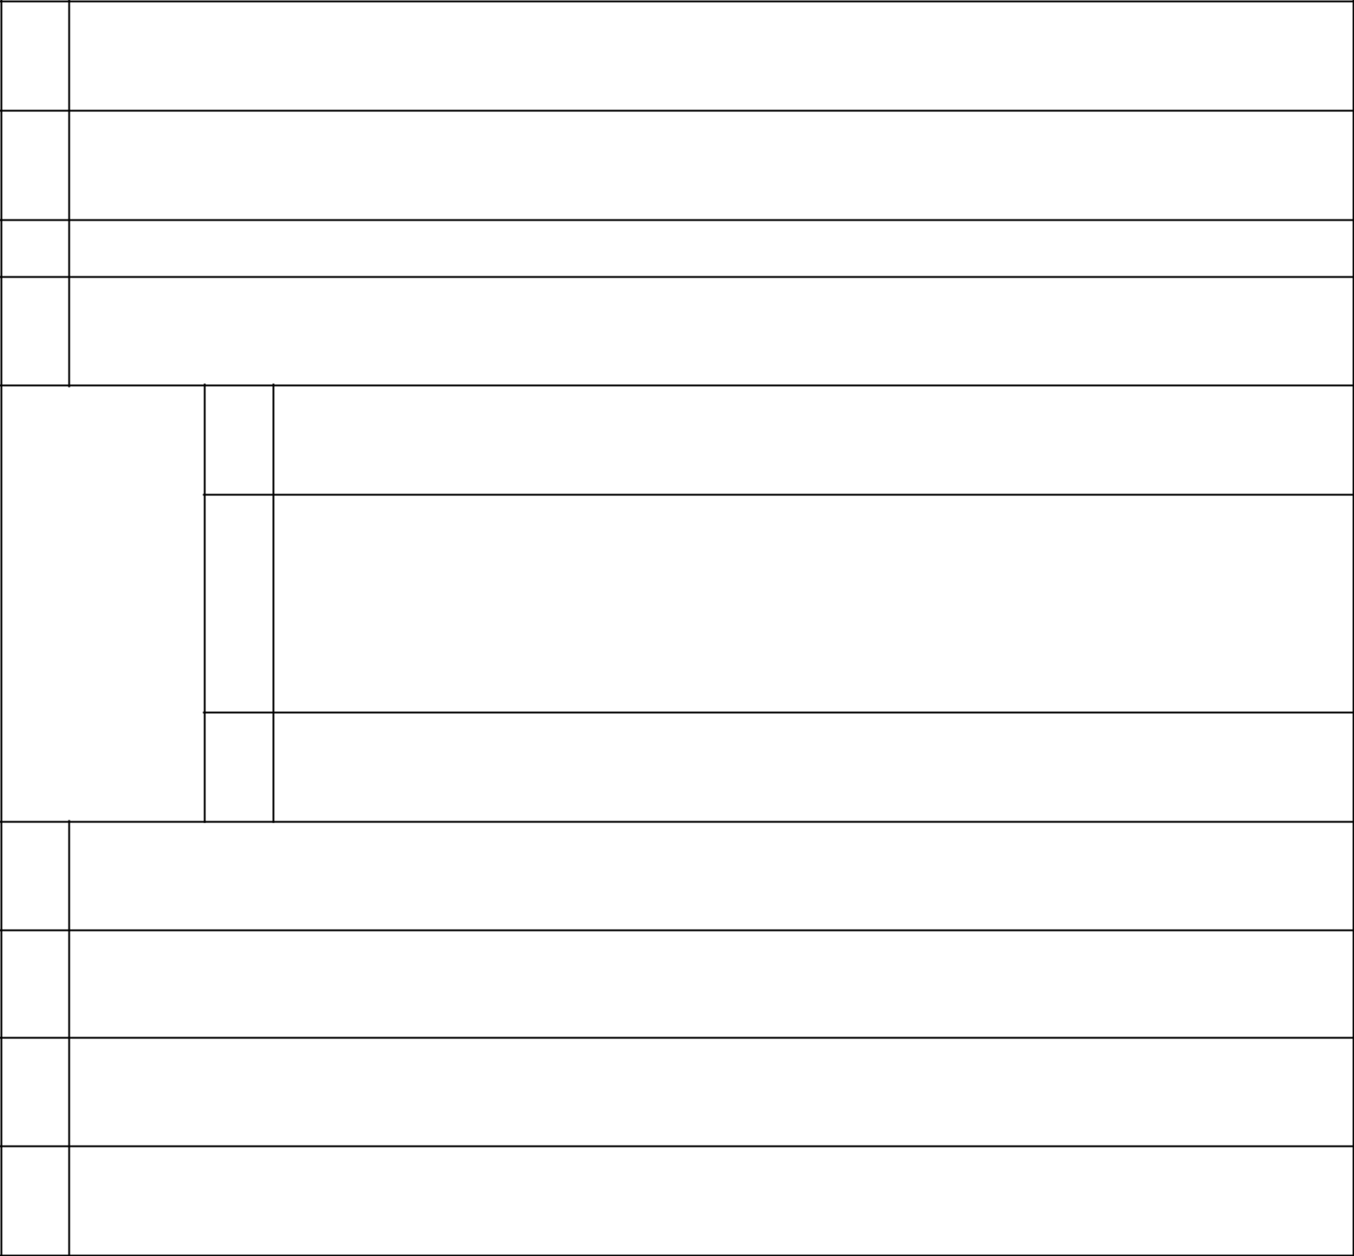
- NAMES OF REPORTING PERSONS Ursula Martina Bernard Valderrama
- CHECK THE APPROPRIATE BOX IF A MEMBER OF A GROUP (SEE INSTRUCTIONS)

  - ☒

  - ☐

- SEC USE ONLY

- CITIZENSHIP OR PLACE OF ORGANIZATION Peru
    - SOLE VOTING POWER 0

NUMBER OF | (6) | SHARED VOTING POWER
SHARES |  | 4,692
BENEFICIALLY |  | 4,692
OWNED BY
EACH | (7) | SOLE DISPOSITIVE POWER
REPORTING
PERSON |  | 0
WITH

  - SHARED DISPOSITIVE POWER 4,692
- AGGREGATE AMOUNT BENEFICIALLY OWNED BY EACH REPORTING PERSON 4,692
- CHECK BOX IF THE AGGREGATE AMOUNT IN ROW (9) EXCLUDES CERTAIN SHARES (SEE INSTRUCTIONS)

☐

- PERCENT OF CLASS REPRESENTED BY AMOUNT IN ROW (9) 0.005%
- TYPE OF REPORTING PERSON (SEE INSTRUCTIONS) IN

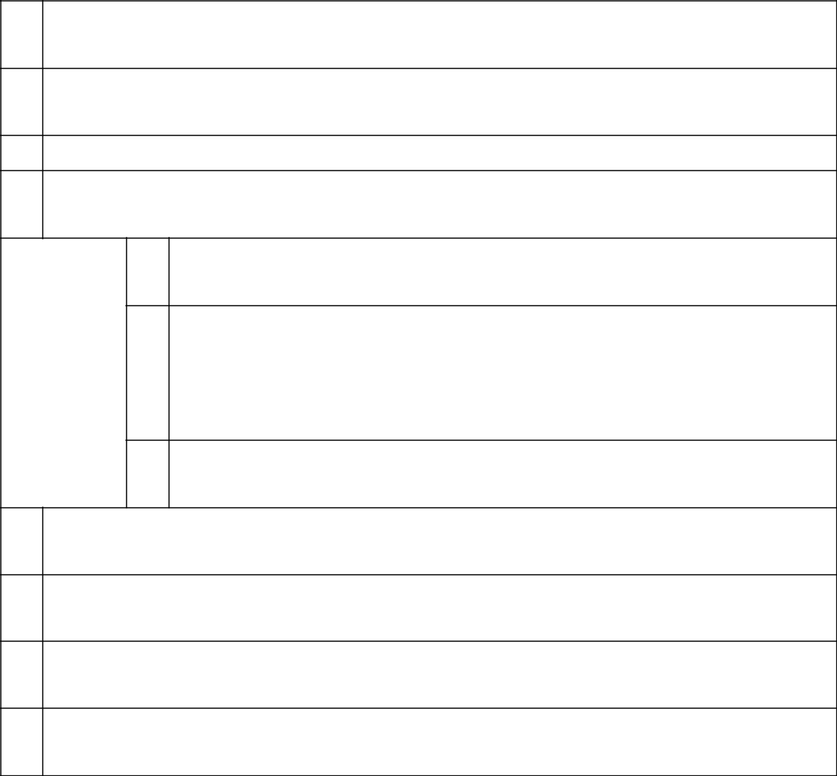
  - NAMES OF REPORTING PERSONS Grupo Rosta Internacional S.A.
- CHECK THE APPROPRIATE BOX IF A MEMBER OF A GROUP (SEE INSTRUCTIONS)

    - ☒

    - ☐

- SEC USE ONLY

- CITIZENSHIP OR PLACE OF ORGANIZATION Panama
      - SOLE VOTING POWER 4,314

NUMBER OF | (6) | SHARED VOTING POWER
SHARES |  | 0
BENEFICIALLY |  | 0
OWNED BY
EACH | (7) | SOLE DISPOSITIVE POWER
REPORTING
PERSON |  | 4,314
WITH

  - SHARED DISPOSITIVE POWER 0
- AGGREGATE AMOUNT BENEFICIALLY OWNED BY EACH REPORTING PERSON 4,314
- CHECK BOX IF THE AGGREGATE AMOUNT IN ROW (9) EXCLUDES CERTAIN SHARES (SEE INSTRUCTIONS)

☐

- PERCENT OF CLASS REPRESENTED BY AMOUNT IN ROW (9) 0.005%
- TYPE OF REPORTING PERSON (SEE INSTRUCTIONS) CO

- NAMES OF REPORTING PERSONS Ana Silvia Guzman Portilla de Romero
- CHECK THE APPROPRIATE BOX IF A MEMBER OF A GROUP (SEE INSTRUCTIONS)

  - ☒

  - ☐

- SEC USE ONLY

- CITIZENSHIP OR PLACE OF ORGANIZATION Peru
    - SOLE VOTING POWER 600

NUMBER OF | (6) | SHARED VOTING POWER
SHARES |  | 0
BENEFICIALLY |  | 0
OWNED BY
EACH | (7) | SOLE DISPOSITIVE POWER
REPORTING
PERSON |  | 600
WITH

  - SHARED DISPOSITIVE POWER 0
- AGGREGATE AMOUNT BENEFICIALLY OWNED BY EACH REPORTING PERSON 600
- CHECK BOX IF THE AGGREGATE AMOUNT IN ROW (9) EXCLUDES CERTAIN SHARES (SEE INSTRUCTIONS)

☐

- PERCENT OF CLASS REPRESENTED BY AMOUNT IN ROW (9) 0.001%
- TYPE OF REPORTING PERSON (SEE INSTRUCTIONS) IN

- NAMES OF REPORTING PERSONS High Inter Projects, Corp.*
- CHECK THE APPROPRIATE BOX IF A MEMBER OF A GROUP (SEE INSTRUCTIONS)

  - ☒

  - ☐

- SEC USE ONLY

- CITIZENSHIP OR PLACE OF ORGANIZATION Panama
    - SOLE VOTING POWER 2,943,868

NUMBER OF | (6) | SHARED VOTING POWER
SHARES |  | 0
BENEFICIALLY |  | 0
OWNED BY
EACH | (7) | SOLE DISPOSITIVE POWER
REPORTING
PERSON |  | 2,943,868
WITH

    - SHARED DISPOSITIVE POWER 0
  - AGGREGATE AMOUNT BENEFICIALLY OWNED BY EACH REPORTING PERSON 2,943,868
  - CHECK BOX IF THE AGGREGATE AMOUNT IN ROW (9) EXCLUDES CERTAIN SHARES (SEE INSTRUCTIONS)

☐

  - PERCENT OF CLASS REPRESENTED BY AMOUNT IN ROW (9)

3.119%

  - TYPE OF REPORTING PERSON (SEE INSTRUCTIONS) CO

* High Inter Projects, Corp. is owned and controlled by various members of the Romero family, which includes Dionisio Romero Paoletti, Calixto Romero Guzmán, José Antonio Onrubia Holder and Luis Romero Belismelis.

- NAMES OF REPORTING PERSONS Teresa Holder de Onrubia
- CHECK THE APPROPRIATE BOX IF A MEMBER OF A GROUP (SEE INSTRUCTIONS)

  - ☒

  - ☐

- SEC USE ONLY

- CITIZENSHIP OR PLACE OF ORGANIZATION Peru
    - SOLE VOTING POWER 41,116

NUMBER OF | (6) | SHARED VOTING POWER
SHARES |  | 0
BENEFICIALLY |  | 0
OWNED BY
EACH | (7) | SOLE DISPOSITIVE POWER
REPORTING
PERSON |  | 41,116
WITH

  - SHARED DISPOSITIVE POWER 0
- AGGREGATE AMOUNT BENEFICIALLY OWNED BY EACH REPORTING PERSON 41,116
- CHECK BOX IF THE AGGREGATE AMOUNT IN ROW (9) EXCLUDES CERTAIN SHARES (SEE INSTRUCTIONS)

☐

- PERCENT OF CLASS REPRESENTED BY AMOUNT IN ROW (9) 0.044%
- TYPE OF REPORTING PERSON (SEE INSTRUCTIONS) IN

- NAMES OF REPORTING PERSONS Inversiones Casa Real S.A.
- CHECK THE APPROPRIATE BOX IF A MEMBER OF A GROUP (SEE INSTRUCTIONS)

  - ☒

  - ☐

- SEC USE ONLY

- CITIZENSHIP OR PLACE OF ORGANIZATION Panama
    - SOLE VOTING POWER 3,000

NUMBER OF | (6) | SHARED VOTING POWER
SHARES |  | 0
BENEFICIALLY |  | 0
OWNED BY
EACH | (7) | SOLE DISPOSITIVE POWER
REPORTING
PERSON |  | 3,000
WITH

  - SHARED DISPOSITIVE POWER 0
- AGGREGATE AMOUNT BENEFICIALLY OWNED BY EACH REPORTING PERSON 3,000
- CHECK BOX IF THE AGGREGATE AMOUNT IN ROW (9) EXCLUDES CERTAIN SHARES (SEE INSTRUCTIONS)

☐

- PERCENT OF CLASS REPRESENTED BY AMOUNT IN ROW (9) 0.003%
- TYPE OF REPORTING PERSON (SEE INSTRUCTIONS) CO

- NAMES OF REPORTING PERSONS Inversiones Piuranas S.A.*
- CHECK THE APPROPRIATE BOX IF A MEMBER OF A GROUP (SEE INSTRUCTIONS)

  - ☒

  - ☐

- SEC USE ONLY

- CITIZENSHIP OR PLACE OF ORGANIZATION Peru
    - SOLE VOTING POWER 158,000

NUMBER OF | (6) | SHARED VOTING POWER
SHARES |  | 0
BENEFICIALLY |  | 0
OWNED BY
EACH | (7) | SOLE DISPOSITIVE POWER
REPORTING
PERSON |  | 158,000
WITH

  - SHARED DISPOSITIVE POWER 0
- AGGREGATE AMOUNT BENEFICIALLY OWNED BY EACH REPORTING PERSON 158,000
- CHECK BOX IF THE AGGREGATE AMOUNT IN ROW (9) EXCLUDES CERTAIN SHARES (SEE INSTRUCTIONS)

☐

- PERCENT OF CLASS REPRESENTED BY AMOUNT IN ROW (9) 0.167%
- TYPE OF REPORTING PERSON (SEE INSTRUCTIONS) CO

*Inversiones Piuranas S.A. is owned and controlled by various members of the Romero family, which includes Dionisio Romero Paoletti, Calixto Romero Guzmán, José Antonio Onrubia Holder and Luis Romero Belismelis.

- NAMES OF REPORTING PERSONS La Roncadora S.A.*
- CHECK THE APPROPRIATE BOX IF A MEMBER OF A GROUP (SEE INSTRUCTIONS)

  - ☒

  - ☐

- SEC USE ONLY

- CITIZENSHIP OR PLACE OF ORGANIZATION Panama
    - SOLE VOTING POWER 40,090

NUMBER OF | (6) | SHARED VOTING POWER
SHARES |  | 0
BENEFICIALLY |  | 0
OWNED BY
EACH | (7) | SOLE DISPOSITIVE POWER
REPORTING
PERSON |  | 40,090
WITH

  - SHARED DISPOSITIVE POWER 0
- AGGREGATE AMOUNT BENEFICIALLY OWNED BY EACH REPORTING PERSON 40,090
- CHECK BOX IF THE AGGREGATE AMOUNT IN ROW (9) EXCLUDES CERTAIN SHARES (SEE INSTRUCTIONS)

☐

- PERCENT OF CLASS REPRESENTED BY AMOUNT IN ROW (9) 0.042%
- TYPE OF REPORTING PERSON (SEE INSTRUCTIONS) CO

*La Roncadora S.A. is controlled by various members of the Onrubia Holder family, which includes José Antonio Onrubia Holder, Eduardo Onrubia Holder, Luis Fernando Martin Onrubia Holder, and María Inmaculada Onrubia Holder.

- NAMES OF REPORTING PERSONS Eduardo Victoriano Onrubia Holder
- CHECK THE APPROPRIATE BOX IF A MEMBER OF A GROUP (SEE INSTRUCTIONS)

  - ☒

  - ☐

- SEC USE ONLY

- CITIZENSHIP OR PLACE OF ORGANIZATION Peru
    - SOLE VOTING POWER 0

NUMBER OF | (6) | SHARED VOTING POWER
SHARES |  | 40,090
BENEFICIALLY |  | 40,090
OWNED BY
EACH | (7) | SOLE DISPOSITIVE POWER
REPORTING
PERSON |  | 0
WITH

  - SHARED DISPOSITIVE POWER 40,090
- AGGREGATE AMOUNT BENEFICIALLY OWNED BY EACH REPORTING PERSON 40,090
- CHECK BOX IF THE AGGREGATE AMOUNT IN ROW (9) EXCLUDES CERTAIN SHARES (SEE INSTRUCTIONS)

☐

- PERCENT OF CLASS REPRESENTED BY AMOUNT IN ROW (9) 0.042%
- TYPE OF REPORTING PERSON (SEE INSTRUCTIONS) IN

- NAMES OF REPORTING PERSONS José Antonio Onrubia Holder
- CHECK THE APPROPRIATE BOX IF A MEMBER OF A GROUP (SEE INSTRUCTIONS)

  - ☒

  - ☐

- SEC USE ONLY

- CITIZENSHIP OR PLACE OF ORGANIZATION Peru
    - SOLE VOTING POWER 169,612

NUMBER OF | (6) | SHARED VOTING POWER
SHARES |  | 8,730,350
BENEFICIALLY |  | 8,730,350
OWNED BY
EACH | (7) | SOLE DISPOSITIVE POWER
REPORTING
PERSON |  | 169,612
WITH

  - SHARED DISPOSITIVE POWER 8,730,350
- AGGREGATE AMOUNT BENEFICIALLY OWNED BY EACH REPORTING PERSON 8,899,962
- CHECK BOX IF THE AGGREGATE AMOUNT IN ROW (9) EXCLUDES CERTAIN SHARES (SEE INSTRUCTIONS)

☐

- PERCENT OF CLASS REPRESENTED BY AMOUNT IN ROW (9) 9.430%
- TYPE OF REPORTING PERSON (SEE INSTRUCTIONS) IN

- NAMES OF REPORTING PERSONS Luis Fernando Martin Onrubia Holder
- CHECK THE APPROPRIATE BOX IF A MEMBER OF A GROUP (SEE INSTRUCTIONS)

  - ☒

  - ☐

- SEC USE ONLY

- CITIZENSHIP OR PLACE OF ORGANIZATION Peru
    - SOLE VOTING POWER 0

NUMBER OF | (6) | SHARED VOTING POWER
SHARES |  | 40,090
BENEFICIALLY |  | 40,090
OWNED BY
EACH | (7) | SOLE DISPOSITIVE POWER
REPORTING
PERSON |  | 0
WITH

  - SHARED DISPOSITIVE POWER 40,090
- AGGREGATE AMOUNT BENEFICIALLY OWNED BY EACH REPORTING PERSON 40,090
- CHECK BOX IF THE AGGREGATE AMOUNT IN ROW (9) EXCLUDES CERTAIN SHARES (SEE INSTRUCTIONS)

☐

- PERCENT OF CLASS REPRESENTED BY AMOUNT IN ROW (9) 0.042%
- TYPE OF REPORTING PERSON (SEE INSTRUCTIONS) IN

- NAMES OF REPORTING PERSONS María Inmaculada Onrubia Holder
- CHECK THE APPROPRIATE BOX IF A MEMBER OF A GROUP (SEE INSTRUCTIONS)

  - ☒

  - ☐

- SEC USE ONLY

- CITIZENSHIP OR PLACE OF ORGANIZATION Peru
    - SOLE VOTING POWER 0

NUMBER OF | (6) | SHARED VOTING POWER
SHARES |  | 40,090
BENEFICIALLY |  | 40,090
OWNED BY
EACH | (7) | SOLE DISPOSITIVE POWER
REPORTING
PERSON |  | 0
WITH

  - SHARED DISPOSITIVE POWER 40,090
- AGGREGATE AMOUNT BENEFICIALLY OWNED BY EACH REPORTING PERSON 40,090
- CHECK BOX IF THE AGGREGATE AMOUNT IN ROW (9) EXCLUDES CERTAIN SHARES (SEE INSTRUCTIONS)

☐

- PERCENT OF CLASS REPRESENTED BY AMOUNT IN ROW (9) 0.042%
- TYPE OF REPORTING PERSON (SEE INSTRUCTIONS) IN

- NAMES OF REPORTING PERSONS Patrimonio Fideicometido Angolo*
- CHECK THE APPROPRIATE BOX IF A MEMBER OF A GROUP (SEE INSTRUCTIONS)

  - ☒

  - ☐

- SEC USE ONLY

- CITIZENSHIP OR PLACE OF ORGANIZATION Peru
    - SOLE VOTING POWER 33,363

NUMBER OF | (6) | SHARED VOTING POWER
SHARES |  | 0
BENEFICIALLY |  | 0
OWNED BY
EACH | (7) | SOLE DISPOSITIVE POWER
REPORTING
PERSON |  | 33,363
WITH

    - SHARED DISPOSITIVE POWER 0
  - AGGREGATE AMOUNT BENEFICIALLY OWNED BY EACH REPORTING PERSON 33,363
  - CHECK BOX IF THE AGGREGATE AMOUNT IN ROW (9) EXCLUDES CERTAIN SHARES (SEE INSTRUCTIONS)

☐

  - PERCENT OF CLASS REPRESENTED BY AMOUNT IN ROW (9)

0.035%

  - TYPE OF REPORTING PERSON (SEE INSTRUCTIONS) OO

* Patrimonio Fideicometido Angolo is one of several trusts formed for the benefit of certain individuals who are members of the Romero family.

  - NAMES OF REPORTING PERSONS Reverades Holding Inc.*
- CHECK THE APPROPRIATE BOX IF A MEMBER OF A GROUP (SEE INSTRUCTIONS)

    - ☒

    - ☐

- SEC USE ONLY

- CITIZENSHIP OR PLACE OF ORGANIZATION Seychelles
      - SOLE VOTING POWER 838,712

NUMBER OF | (6) | SHARED VOTING POWER
SHARES |  | 0
BENEFICIALLY |  | 0
OWNED BY
EACH | (7) | SOLE DISPOSITIVE POWER
REPORTING
PERSON |  | 838,712
WITH

  - SHARED DISPOSITIVE POWER 0
- AGGREGATE AMOUNT BENEFICIALLY OWNED BY EACH REPORTING PERSON 838,712
- CHECK BOX IF THE AGGREGATE AMOUNT IN ROW (9) EXCLUDES CERTAIN SHARES (SEE INSTRUCTIONS)

☐

- PERCENT OF CLASS REPRESENTED BY AMOUNT IN ROW (9) 0.889%
- TYPE OF REPORTING PERSON (SEE INSTRUCTIONS) CO

*Reverades Holding Inc. is controlled by Dionisio Romero Seminario.

- NAMES OF REPORTING PERSONS Rittenhouse Capital Ltd.*
- CHECK THE APPROPRIATE BOX IF A MEMBER OF A GROUP (SEE INSTRUCTIONS)

  - ☒

  - ☐

- SEC USE ONLY

- CITIZENSHIP OR PLACE OF ORGANIZATION Cayman Islands
    - SOLE VOTING POWER 5,547,276**

NUMBER OF | (6) | SHARED VOTING POWER
SHARES |  | 0
BENEFICIALLY |  | 0
OWNED BY
EACH | (7) | SOLE DISPOSITIVE POWER
REPORTING
PERSON |  | 5,547,276**
WITH

  - SHARED DISPOSITIVE POWER 0
- AGGREGATE AMOUNT BENEFICIALLY OWNED BY EACH REPORTING PERSON 5,547,276
- CHECK BOX IF THE AGGREGATE AMOUNT IN ROW (9) EXCLUDES CERTAIN SHARES (SEE INSTRUCTIONS)

☐

- PERCENT OF CLASS REPRESENTED BY AMOUNT IN ROW (9) 5.877%
- TYPE OF REPORTING PERSON (SEE INSTRUCTIONS) CO

*Rittenhouse Capital Ltd. is owned and controlled by various members of the Romero family, which includes Dionisio Romero Paoletti, Calixto Romero Guzmán, José Antonio Onrubia Holder and Luis Romero Belismelis.
- Rittenhouse Capital Ltd. has entered into a lending arrangement with an unaffiliated international bank under which it has pledged as collateral a variable number of shares (and associated ancillary rights). Under the relevant loan documents, with a scheduled maturity date of October 30, 2025, upon the occurrence of certain customary events the lender may exercise its rights to, among other remedies, foreclose on, and dispose of, the pledged shares and related collateral.

- NAMES OF REPORTING PERSONS Alfredo Romero Belismelis
- CHECK THE APPROPRIATE BOX IF A MEMBER OF A GROUP (SEE INSTRUCTIONS)

  - ☒

  - ☐

- SEC USE ONLY

- CITIZENSHIP OR PLACE OF ORGANIZATION Peru
    - SOLE VOTING POWER 0

NUMBER OF | (6) | SHARED VOTING POWER
SHARES |  | 700,387
BENEFICIALLY |  | 700,387
OWNED BY
EACH | (7) | SOLE DISPOSITIVE POWER
REPORTING
PERSON |  | 0
WITH

  - SHARED DISPOSITIVE POWER 700,387
- AGGREGATE AMOUNT BENEFICIALLY OWNED BY EACH REPORTING PERSON 700,387
- CHECK BOX IF THE AGGREGATE AMOUNT IN ROW (9) EXCLUDES CERTAIN SHARES (SEE INSTRUCTIONS)

☐

- PERCENT OF CLASS REPRESENTED BY AMOUNT IN ROW (9) 0.742%
- TYPE OF REPORTING PERSON (SEE INSTRUCTIONS) IN

- NAMES OF REPORTING PERSONS Fernando Romero Belismelis
- CHECK THE APPROPRIATE BOX IF A MEMBER OF A GROUP (SEE INSTRUCTIONS)

  - ☒

  - ☐

- SEC USE ONLY

- CITIZENSHIP OR PLACE OF ORGANIZATION Peru
    - SOLE VOTING POWER 0

NUMBER OF | (6) | SHARED VOTING POWER
SHARES |  | 705,079
BENEFICIALLY |  | 705,079
OWNED BY
EACH | (7) | SOLE DISPOSITIVE POWER
REPORTING
PERSON |  | 0
WITH

  - SHARED DISPOSITIVE POWER 705,079
- AGGREGATE AMOUNT BENEFICIALLY OWNED BY EACH REPORTING PERSON 705,079
- CHECK BOX IF THE AGGREGATE AMOUNT IN ROW (9) EXCLUDES CERTAIN SHARES (SEE INSTRUCTIONS)

☐

- PERCENT OF CLASS REPRESENTED BY AMOUNT IN ROW (9) 0.747%
- TYPE OF REPORTING PERSON (SEE INSTRUCTIONS) IN

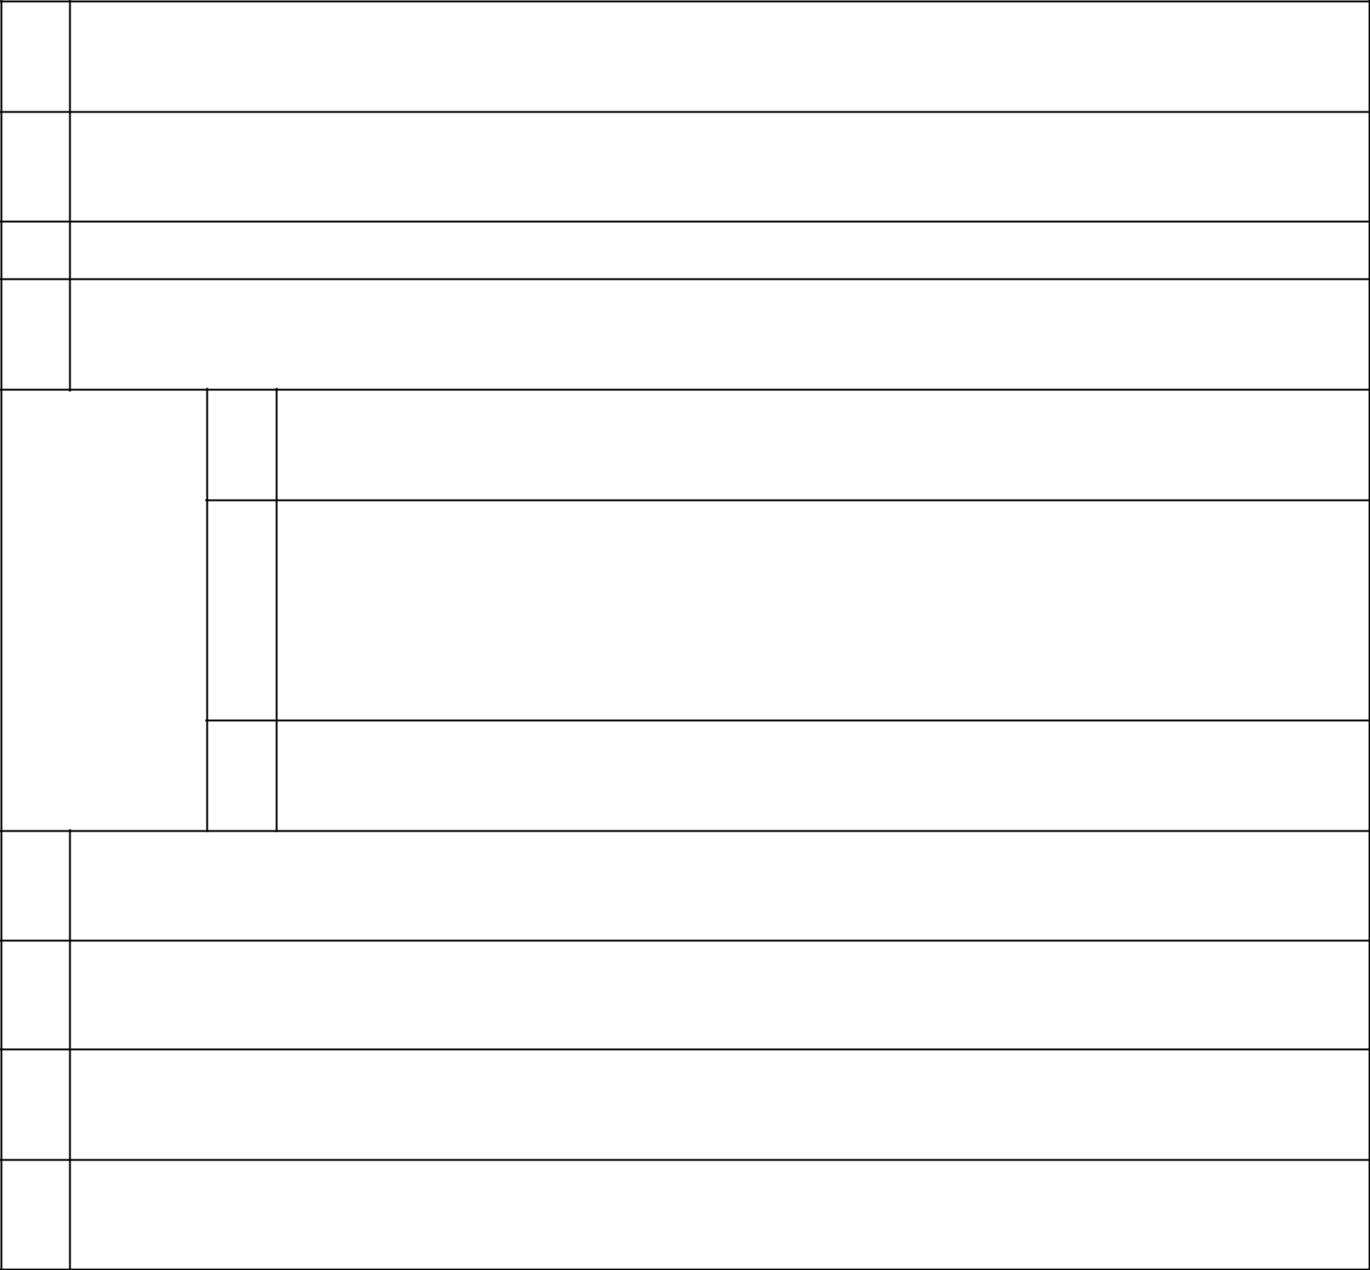
- NAMES OF REPORTING PERSONS José Roberto Romero Belismelis
- CHECK THE APPROPRIATE BOX IF A MEMBER OF A GROUP (SEE INSTRUCTIONS)

  - ☒

  - ☐

- SEC USE ONLY

- CITIZENSHIP OR PLACE OF ORGANIZATION Peru
    - SOLE VOTING POWER 0

NUMBER OF | (6) | SHARED VOTING POWER
SHARES |  | 15,214
BENEFICIALLY |  | 15,214
OWNED BY
EACH | (7) | SOLE DISPOSITIVE POWER
REPORTING
PERSON |  | 0
WITH

  - SHARED DISPOSITIVE POWER 15,214
- AGGREGATE AMOUNT BENEFICIALLY OWNED BY EACH REPORTING PERSON 15,214
- CHECK BOX IF THE AGGREGATE AMOUNT IN ROW (9) EXCLUDES CERTAIN SHARES (SEE INSTRUCTIONS)

☐

- PERCENT OF CLASS REPRESENTED BY AMOUNT IN ROW (9) 0.016%
- TYPE OF REPORTING PERSON (SEE INSTRUCTIONS) IN


- NAMES OF REPORTING PERSONS Luis Enrique Romero Belismelis
- CHECK THE APPROPRIATE BOX IF A MEMBER OF A GROUP (SEE INSTRUCTIONS)

  - ☒

  - ☐

- SEC USE ONLY

- CITIZENSHIP OR PLACE OF ORGANIZATION Peru
    - SOLE VOTING POWER 9,584

NUMBER OF | (6) | SHARED VOTING POWER
SHARES |  | 9,382,894
BENEFICIALLY |  | 9,382,894
OWNED BY
EACH | (7) | SOLE DISPOSITIVE POWER
REPORTING
PERSON |  | 9,584
WITH

  - SHARED DISPOSITIVE POWER 9,382,894
- AGGREGATE AMOUNT BENEFICIALLY OWNED BY EACH REPORTING PERSON 9,392,478
- CHECK BOX IF THE AGGREGATE AMOUNT IN ROW (9) EXCLUDES CERTAIN SHARES (SEE INSTRUCTIONS)

☐

- PERCENT OF CLASS REPRESENTED BY AMOUNT IN ROW (9) 9.952%
- TYPE OF REPORTING PERSON (SEE INSTRUCTIONS) IN

- NAMES OF REPORTING PERSONS Manuel Antonio Romero Belismelis
- CHECK THE APPROPRIATE BOX IF A MEMBER OF A GROUP (SEE INSTRUCTIONS)

  - ☒

  - ☐

- SEC USE ONLY

- CITIZENSHIP OR PLACE OF ORGANIZATION Peru
    - SOLE VOTING POWER 31,873

NUMBER OF | (6) | SHARED VOTING POWER
SHARES |  | 715,601
BENEFICIALLY |  | 715,601
OWNED BY
EACH | (7) | SOLE DISPOSITIVE POWER
REPORTING
PERSON |  | 31,873
WITH

  - SHARED DISPOSITIVE POWER 715,601
- AGGREGATE AMOUNT BENEFICIALLY OWNED BY EACH REPORTING PERSON 747,474
- CHECK BOX IF THE AGGREGATE AMOUNT IN ROW (9) EXCLUDES CERTAIN SHARES (SEE INSTRUCTIONS)

☐

- PERCENT OF CLASS REPRESENTED BY AMOUNT IN ROW (9) 0.792%
- TYPE OF REPORTING PERSON (SEE INSTRUCTIONS) IN

- NAMES OF REPORTING PERSONS Calixto Romero Guzmán
- CHECK THE APPROPRIATE BOX IF A MEMBER OF A GROUP (SEE INSTRUCTIONS)

  - ☒

  - ☐

- SEC USE ONLY

- CITIZENSHIP OR PLACE OF ORGANIZATION Peru
    - SOLE VOTING POWER 0

NUMBER OF | (6) | SHARED VOTING POWER
SHARES |  | 8,649,144
BENEFICIALLY |  | 8,649,144
OWNED BY
EACH | (7) | SOLE DISPOSITIVE POWER
REPORTING
PERSON |  | 0
WITH

  - SHARED DISPOSITIVE POWER 8,649,144
- AGGREGATE AMOUNT BENEFICIALLY OWNED BY EACH REPORTING PERSON 8,649,144
- CHECK BOX IF THE AGGREGATE AMOUNT IN ROW (9) EXCLUDES CERTAIN SHARES (SEE INSTRUCTIONS)

☐

- PERCENT OF CLASS REPRESENTED BY AMOUNT IN ROW (9) 9.164%
- TYPE OF REPORTING PERSON (SEE INSTRUCTIONS) IN

- NAMES OF REPORTING PERSONS Ana María Romero Paoletti de Sacchi
- CHECK THE APPROPRIATE BOX IF A MEMBER OF A GROUP (SEE INSTRUCTIONS)

  - ☒

  - ☐

- SEC USE ONLY

- CITIZENSHIP OR PLACE OF ORGANIZATION Peru
    - SOLE VOTING POWER 0

NUMBER OF | (6) | SHARED VOTING POWER
SHARES |  | 4,150
BENEFICIALLY |  | 4,150
OWNED BY
EACH | (7) | SOLE DISPOSITIVE POWER
REPORTING
PERSON |  | 0
WITH

  - SHARED DISPOSITIVE POWER 4,150
- AGGREGATE AMOUNT BENEFICIALLY OWNED BY EACH REPORTING PERSON 4,150
- CHECK BOX IF THE AGGREGATE AMOUNT IN ROW (9) EXCLUDES CERTAIN SHARES (SEE INSTRUCTIONS)

☐

- PERCENT OF CLASS REPRESENTED BY AMOUNT IN ROW (9) 0.004%
- TYPE OF REPORTING PERSON (SEE INSTRUCTIONS) IN

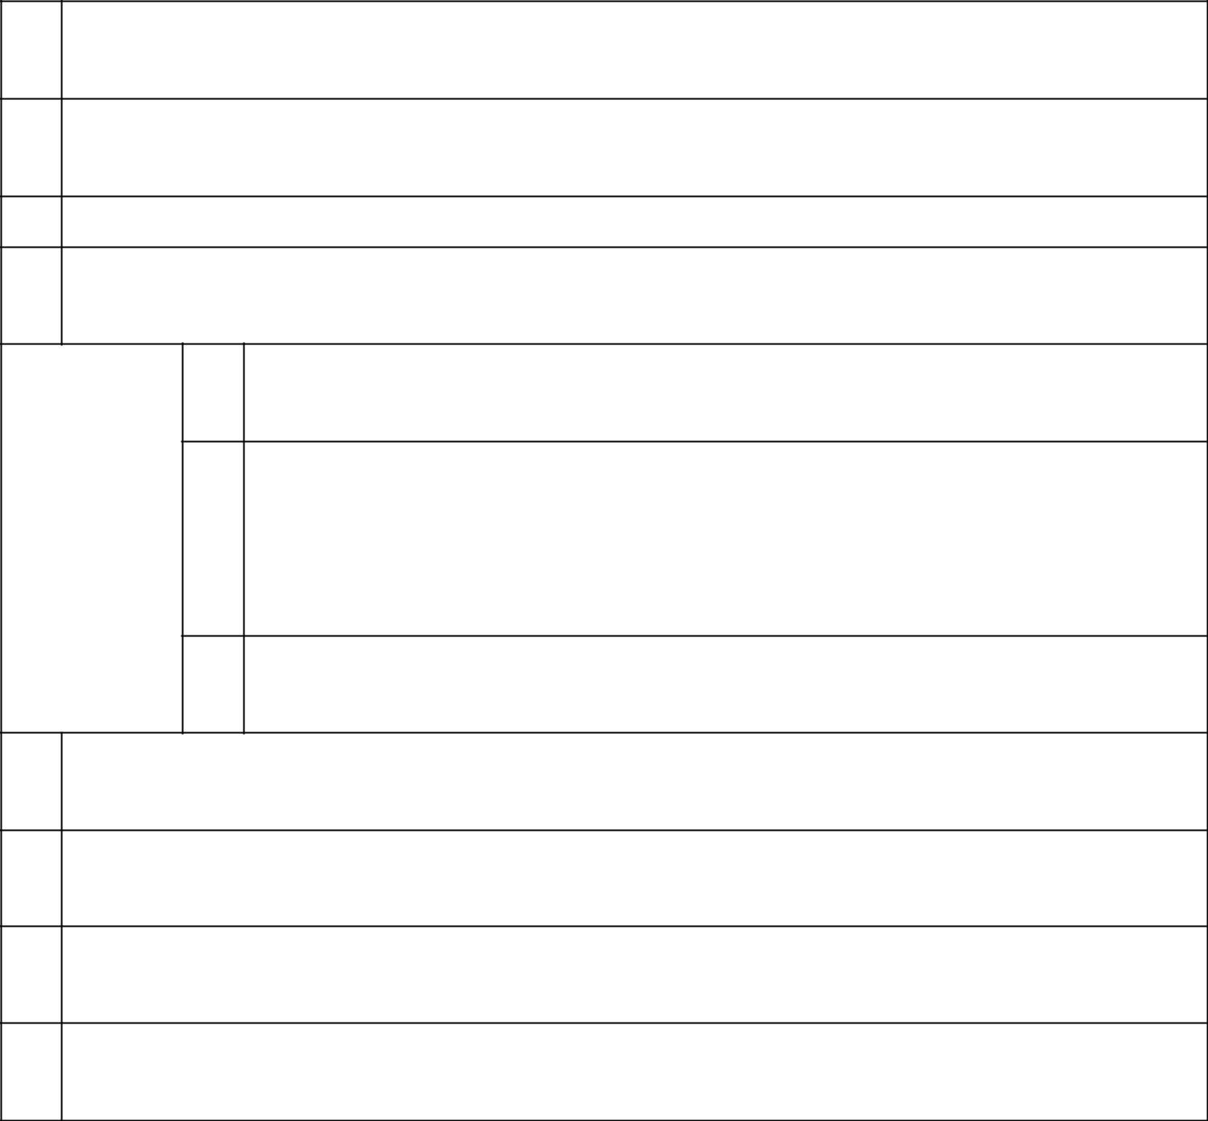
- NAMES OF REPORTING PERSONS Dionisio Romero Paoletti
- CHECK THE APPROPRIATE BOX IF A MEMBER OF A GROUP (SEE INSTRUCTIONS)

  - ☒

  - ☐

- SEC USE ONLY

- CITIZENSHIP OR PLACE OF ORGANIZATION Peru
    - SOLE VOTING POWER 132,897

NUMBER OF | (6) | SHARED VOTING POWER
SHARES |  | 8,649,144
BENEFICIALLY |  | 8,649,144
OWNED BY
EACH | (7) | SOLE DISPOSITIVE POWER
REPORTING
PERSON |  | 132,897
WITH

  - SHARED DISPOSITIVE POWER 8,649,144
- AGGREGATE AMOUNT BENEFICIALLY OWNED BY EACH REPORTING PERSON 8,782,041
- CHECK BOX IF THE AGGREGATE AMOUNT IN ROW (9) EXCLUDES CERTAIN SHARES (SEE INSTRUCTIONS)

☐

- PERCENT OF CLASS REPRESENTED BY AMOUNT IN ROW (9) 9.305%
- TYPE OF REPORTING PERSON (SEE INSTRUCTIONS) IN

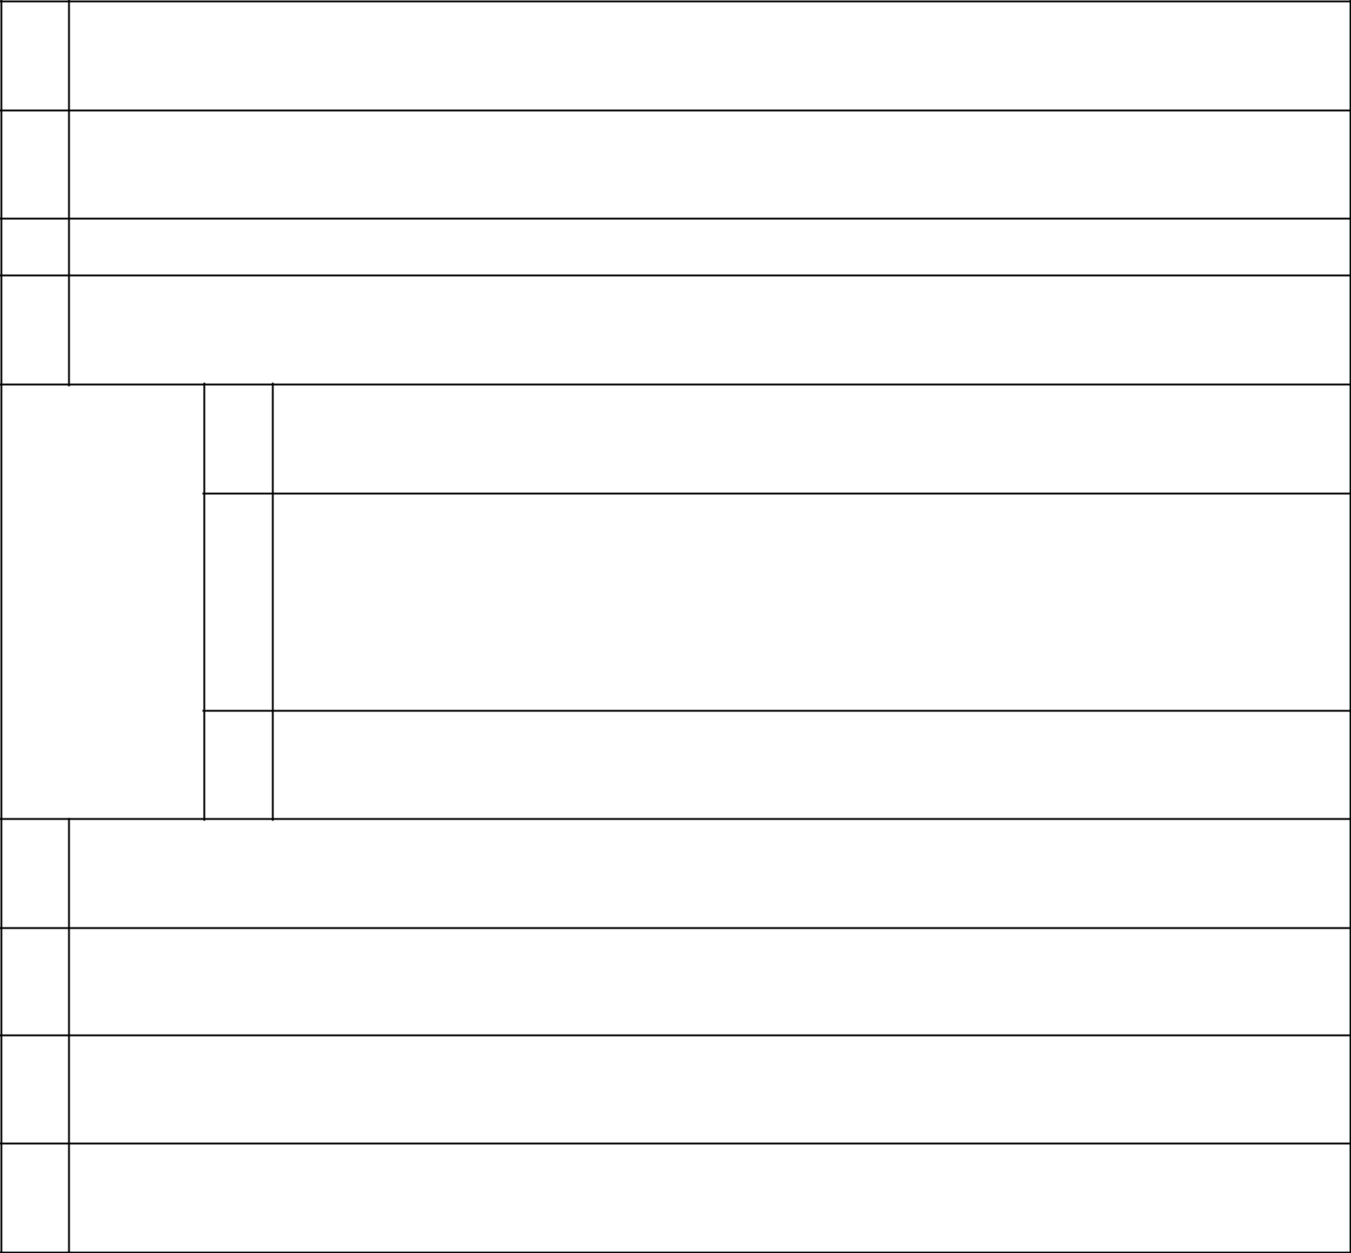
- NAMES OF REPORTING PERSONS Marianella Romero Guzmán
- CHECK THE APPROPRIATE BOX IF A MEMBER OF A GROUP (SEE INSTRUCTIONS)

  - ☒

  - ☐

- SEC USE ONLY

- CITIZENSHIP OR PLACE OF ORGANIZATION Peru
    - SOLE VOTING POWER 1,379

NUMBER OF | (6) | SHARED VOTING POWER
SHARES |  | 0
BENEFICIALLY |  | 0
OWNED BY
EACH | (7) | SOLE DISPOSITIVE POWER
REPORTING
PERSON |  | 1,379
WITH

  - SHARED DISPOSITIVE POWER 0
- AGGREGATE AMOUNT BENEFICIALLY OWNED BY EACH REPORTING PERSON 1,379
- CHECK BOX IF THE AGGREGATE AMOUNT IN ROW (9) EXCLUDES CERTAIN SHARES (SEE INSTRUCTIONS)

☐

- PERCENT OF CLASS REPRESENTED BY AMOUNT IN ROW (9)

0.001%

- TYPE OF REPORTING PERSON (SEE INSTRUCTIONS) IN

- NAMES OF REPORTING PERSONS Dionisio Romero Seminario
- CHECK THE APPROPRIATE BOX IF A MEMBER OF A GROUP (SEE INSTRUCTIONS)

  - ☒

  - ☐

- SEC USE ONLY

- CITIZENSHIP OR PLACE OF ORGANIZATION Peru
    - SOLE VOTING POWER 0

NUMBER OF | (6) | SHARED VOTING POWER
SHARES |  | 1,714,359
BENEFICIALLY |  | 1,714,359
OWNED BY
EACH | (7) | SOLE DISPOSITIVE POWER
REPORTING
PERSON |  | 0
WITH

  - SHARED DISPOSITIVE POWER 1,714,359
- AGGREGATE AMOUNT BENEFICIALLY OWNED BY EACH REPORTING PERSON 1,714,359
- CHECK BOX IF THE AGGREGATE AMOUNT IN ROW (9) EXCLUDES CERTAIN SHARES (SEE INSTRUCTIONS)

☐

- PERCENT OF CLASS REPRESENTED BY AMOUNT IN ROW (9) 1.816%
- TYPE OF REPORTING PERSON (SEE INSTRUCTIONS) IN

- NAMES OF REPORTING PERSONS Rubyfield Investments Ltd.*
- CHECK THE APPROPRIATE BOX IF A MEMBER OF A GROUP (SEE INSTRUCTIONS)

  - ☒

  - ☐

- SEC USE ONLY

- CITIZENSHIP OR PLACE OF ORGANIZATION Seychelles
    - SOLE VOTING POWER 875,647

NUMBER OF | (6) | SHARED VOTING POWER
SHARES |  | 0
BENEFICIALLY |  | 0
OWNED BY
EACH | (7) | SOLE DISPOSITIVE POWER
REPORTING
PERSON |  | 875,647
WITH

  - SHARED DISPOSITIVE POWER 0
- AGGREGATE AMOUNT BENEFICIALLY OWNED BY EACH REPORTING PERSON 875,647
- CHECK BOX IF THE AGGREGATE AMOUNT IN ROW (9) EXCLUDES CERTAIN SHARES (SEE INSTRUCTIONS)

☐

- PERCENT OF CLASS REPRESENTED BY AMOUNT IN ROW (9) 0.928%
- TYPE OF REPORTING PERSON (SEE INSTRUCTIONS) CO

*Rubyfield Investments Ltd. is controlled by Dionisio Romero Seminario.

- NAMES OF REPORTING PERSONS Paolo Mario Sacchi Giurato
- CHECK THE APPROPRIATE BOX IF A MEMBER OF A GROUP (SEE INSTRUCTIONS)

  - ☒

  - ☐

- SEC USE ONLY

- CITIZENSHIP OR PLACE OF ORGANIZATION Peru
    - SOLE VOTING POWER 0

NUMBER OF | (6) | SHARED VOTING POWER
SHARES |  | 4,150
BENEFICIALLY |  | 4,150
OWNED BY
EACH | (7) | SOLE DISPOSITIVE POWER
REPORTING
PERSON |  | 0
WITH

  - SHARED DISPOSITIVE POWER 4,150
- AGGREGATE AMOUNT BENEFICIALLY OWNED BY EACH REPORTING PERSON 4,150
- CHECK BOX IF THE AGGREGATE AMOUNT IN ROW (9) EXCLUDES CERTAIN SHARES (SEE INSTRUCTIONS)

☐

- PERCENT OF CLASS REPRESENTED BY AMOUNT IN ROW (9) 0.004%
- TYPE OF REPORTING PERSON (SEE INSTRUCTIONS) IN

- NAMES OF REPORTING PERSONS Maray S.A.*
- CHECK THE APPROPRIATE BOX IF A MEMBER OF A GROUP (SEE INSTRUCTIONS)

  - ☒

  - ☐

- SEC USE ONLY

- CITIZENSHIP OR PLACE OF ORGANIZATION Peru
    - SOLE VOTING POWER 693,073

NUMBER OF | (6) | SHARED VOTING POWER
SHARES |  | 0
BENEFICIALLY |  | 0
OWNED BY
EACH | (7) | SOLE DISPOSITIVE POWER
REPORTING
PERSON |  | 693,073
WITH

    - SHARED DISPOSITIVE POWER 0
  - AGGREGATE AMOUNT BENEFICIALLY OWNED BY EACH REPORTING PERSON 693,073
  - CHECK BOX IF THE AGGREGATE AMOUNT IN ROW (9) EXCLUDES CERTAIN SHARES (SEE INSTRUCTIONS)

☐

  - PERCENT OF CLASS REPRESENTED BY AMOUNT IN ROW (9)

0.734%

  - TYPE OF REPORTING PERSON (SEE INSTRUCTIONS) CO

* Maray S.A. is owned and controlled by various members of the Romero Belismelis family, which includes Alfredo Romero Belismelis, Fernando Romero Belismelis, José Roberto Romero Belismelis, Luis Romero Belismelis, and Manuel Antonio Romero Belismelis.

- NAMES OF REPORTING PERSONS Ana Sylvia Romero Guzmán
- CHECK THE APPROPRIATE BOX IF A MEMBER OF A GROUP (SEE INSTRUCTIONS)

  - ☒

  - ☐

- SEC USE ONLY

- CITIZENSHIP OR PLACE OF ORGANIZATION Peru
    - SOLE VOTING POWER 1,379

NUMBER OF | (6) | SHARED VOTING POWER
SHARES |  | 0
BENEFICIALLY |  | 0
OWNED BY
EACH | (7) | SOLE DISPOSITIVE POWER
REPORTING
PERSON |  | 1,379
WITH

  - SHARED DISPOSITIVE POWER 0
- AGGREGATE AMOUNT BENEFICIALLY OWNED BY EACH REPORTING PERSON 1,379
- CHECK BOX IF THE AGGREGATE AMOUNT IN ROW (9) EXCLUDES CERTAIN SHARES (SEE INSTRUCTIONS)

☐

- PERCENT OF CLASS REPRESENTED BY AMOUNT IN ROW (9) 0.001%
- TYPE OF REPORTING PERSON (SEE INSTRUCTIONS) IN

Statement for Schedule 13G

Item 1 (a). Name of issuer:

Credicorp Ltd.

Item (b). Address of issuer’s principal executive offices:

Credicorp Ltd.

c/o Banco de Crédito del Perú

Calle Centenario N° 156

Las Laderas de Melgarejo

La Molina

Lima 12, Perú

Item 2(a). Name of person filing:

See Exhibit B attached hereto.

Item 2(b). Address or principal business office or, if none, residence:

Calle Centenario N° 156

Las Laderas de Melgarejo

La Molina

Lima 12, Perú

Item 2(c). Citizenship:

See Item 4 on Page 2

See Item 4 on Page 3

See Item 4 on Page 4

See Item 4 on Page 5

See Item 4 on Page 6

See Item 4 on Page 7

See Item 4 on Page 8

See Item 4 on Page 9

See Item 4 on Page 10

See Item 4 on Page 11

See Item 4 on Page 12

See Item 4 on Page 13

See Item 4 on Page 14

See Item 4 on Page 15

See Item 4 on Page 16

See Item 4 on Page 17

See Item 4 on Page 18

See Item 4 on Page 19

See Item 4 on Page 20

See Item 4 on Page 21

See Item 4 on Page 22

See Item 4 on Page 23

See Item 4 on Page 24

See Item 4 on Page 25

See Item 4 on Page 26

See Item 4 on Page 27

See Item 4 on Page 28

See Item 4 on Page 29

Item 2(d). Title of class of securities:

Common Shares, par value $5.00 per share

Item 2(e). CUSIP No.:

G2519Y108

Item 3. If this statement is filed pursuant to §§ 240.13d-1(b) or 240.13d-2(b) or (c), check whether the person filing is a:

Not applicable.

Item 4. Ownership.

(a) Amount beneficially owned:

See Item 9 on Page 2

See Item 9 on Page 3

See Item 9 on Page 4

See Item 9 on Page 5

See Item 9 on Page 6

See Item 9 on Page 7

See Item 9 on Page 8

See Item 9 on Page 9

See Item 9 on Page 10

See Item 9 on Page 11

See Item 9 on Page 12

See Item 9 on Page 13

See Item 9 on Page 14

See Item 9 on Page 15

See Item 9 on Page 16

See Item 9 on Page 17

See Item 9 on Page 18

See Item 9 on Page 19

See Item 9 on Page 20

See Item 9 on Page 21

See Item 9 on Page 22

See Item 9 on Page 23

See Item 9 on Page 24

See Item 9 on Page 25

See Item 9 on Page 26

See Item 9 on Page 27

See Item 9 on Page 28

See Item 9 on Page 29

(b) Percent of class:

See Item 11 on Page 2

See Item 11 on Page 3

See Item 11 on Page 4

See Item 11 on Page 5

See Item 11 on Page 6

See Item 11 on Page 7

See Item 11 on Page 8

See Item 11 on Page 9

See Item 11 on Page 10

See Item 11 on Page 11

See Item 11 on Page 12

See Item 11 on Page 13

See Item 11 on Page 14

See Item 11 on Page 15

See Item 11 on Page 16

See Item 11 on Page 17

See Item 11 on Page 18

See Item 11 on Page 19

See Item 11 on Page 20

See Item 11 on Page 21

See Item 11 on Page 22

See Item 11 on Page 23

See Item 11 on Page 24

See Item 11 on Page 25

See Item 11 on Page 26

See Item 11 on Page 27

See Item 11 on Page 28

See Item 11 on Page 29

(c) Number of shares as to which the person has:

(i) Sole power to vote or to direct the vote

See Item 5 on Page 2

See Item 5 on Page 3

See Item 5 on Page 4

See Item 5 on Page 5

See Item 5 on Page 6

See Item 5 on Page 7

See Item 5 on Page 8

See Item 5 on Page 9

See Item 5 on Page 10

See Item 5 on Page 11

See Item 5 on Page 12

See Item 5 on Page 13

See Item 5 on Page 14

See Item 5 on Page 15

See Item 5 on Page 16

See Item 5 on Page 17

See Item 5 on Page 18

See Item 5 on Page 19

See Item 5 on Page 20

See Item 5 on Page 21

See Item 5 on Page 22

See Item 5 on Page 23

See Item 5 on Page 24

See Item 5 on Page 25

See Item 5 on Page 26

See Item 5 on Page 27

See Item 5 on Page 28

See Item 5 on Page 29

(ii) Shared power to vote or to direct the vote

See Item 6 on Page 2

See Item 6 on Page 3

See Item 6 on Page 4

See Item 6 on Page 5

See Item 6 on Page 6

See Item 6 on Page 7

See Item 6 on Page 8

See Item 6 on Page 9

See Item 6 on Page 10

See Item 6 on Page 11

See Item 6 on Page 12

See Item 6 on Page 13

See Item 6 on Page 14

See Item 6 on Page 15

See Item 6 on Page 16

See Item 6 on Page 17

See Item 6 on Page 18

See Item 6 on Page 19

See Item 6 on Page 20

See Item 6 on Page 21

See Item 6 on Page 22

See Item 6 on Page 23

See Item 6 on Page 24

See Item 6 on Page 25

See Item 6 on Page 26

See Item 6 on Page 27

See Item 6 on Page 28

See Item 6 on Page 29

- Sole power to dispose or to direct the disposition of

See Item 7 on Page 2 See Item 7 on Page 3 See Item 7 on Page 4 See Item 7 on Page 5 See Item 7 on Page 6 See Item 7 on Page 7 See Item 7 on Page 8 See Item 7 on Page 9 See Item 7 on Page 10 See Item 7 on Page 11 See Item 7 on Page 12 See Item 7 on Page 13 See Item 7 on Page 14 See Item 7 on Page 15 See Item 7 on Page 16 See Item 7 on Page 17 See Item 7 on Page 18 See Item 7 on Page 19 See Item 7 on Page 20 See Item 7 on Page 21 See Item 7 on Page 22 See Item 7 on Page 23 See Item 7 on Page 24 See Item 7 on Page 25 See Item 7 on Page 26 See Item 7 on Page 27 See Item 7 on Page 28 See Item 7 on Page 29

- Shared power to dispose or to direct the disposition of

See Item 8 on Page 1 See Item 8 on Page 2 See Item 8 on Page 3 See Item 8 on Page 4 See Item 8 on Page 5 See Item 8 on Page 6 See Item 8 on Page 7 See Item 8 on Page 8 See Item 8 on Page 9 See Item 8 on Page 10 See Item 8 on Page 11 See Item 8 on Page 12 See Item 8 on Page 13 See Item 8 on Page 14 See Item 8 on Page 15 See Item 8 on Page 16 See Item 8 on Page 17 See Item 8 on Page 18 See Item 8 on Page 19 See Item 8 on Page 20 See Item 8 on Page 21 See Item 8 on Page 22 See Item 8 on Page 23 See Item 8 on Page 24 See Item 8 on Page 25 See Item 8 on Page 26 See Item 8 on Page 27 See Item 8 on Page 28

Item 5. Ownership of 5 Percent or Less of a Class.

Not applicable.

Item 6. Ownership of More than 5 Percent on Behalf of Another Person.

Not applicable.

Item 7. Identification and Classification of the Subsidiary Which Acquired the Security Being Reported on by the Parent Holding Company or Control Person.

Not applicable.

Item 8. Identification and Classification of Members of the Group.

See Exhibit C attached hereto.

Item 9. Notice of Dissolution of Group.

Not applicable.

Item 10. Certifications.

Not applicable.

SIGNATURE

After reasonable inquiry and to the best of my knowledge and belief, I certify that the information set forth in this statement is true, complete and correct.

February 13, 2023

(Date)

/s/ Luis Enrique Romero Belismelis

(Signature)

Name: Luis Enrique Romero Belismelis

Title: Authorized Signatory

EXHIBITS

Exhibit A Joint Filing Statement

Exhibit B Names of Persons Filing

Exhibit C Identification and Classification of Members of Group

Exhibit D Powers of Attorney with English Translations

Exhibit A to Schedule 13G

Joint Filing Agreement

Pursuant to Rule 13d-1(k)

The undersigned persons (the "Reporting Persons") hereby agree that a joint statement on this Schedule 13G, and any amendments thereto, be filed on their behalf by Luis Enrique Romero Belismelis.

Each of the Reporting Persons is responsible for the completeness and accuracy of the information concerning each of them contained therein, but none of the Reporting Persons is responsible for the completeness or accuracy of the information concerning any other Reporting Person.

Date: February 13, 2023

Ursula Martina Bernard Valderrama

Grupo Rosta Internacional

Ana Sylvia Guzman Portilla de Romero

High Inter Projects, Corp.

Teresa Holder de Onrubia

Inversiones Casa Real

Inversiones Piuranas S.A.

La Roncadora S.A.

Eduardo Victoriano Onrubia Holder

José Antonio Onrubia Holder

Luis Fernando Martin Onrubia Holder

María Inmaculada Onrubia Holder

Patrimonio Fideicometido Angolo

Reverades Holding Inc.

Rittenhouse Capital Ltd.

Alfredo Romero Belismelis

Fernando Romero Belismelis

José Roberto Romero Belismelis

Luis Romero Belismelis

Manuel Antonio Romero Belismelis

Calixto Romero Guzmán

Ana María Romero Paoletti de Sacchi

Dionisio Romero Paoletti

Marianella Romero Guzmán

Dionisio Romero Seminario

Rubyfield Investments Ltd.

Paolo Mario Sacchi Giurato

Maray S.A.

Ana Sylvia Romero Guzmán

By: | /s/ Luis Enrique Romero Belismelis
 | Name: Luis Enrique Romero Belismelis
 | Title: Attorney-in-fact

Exhibit B to Schedule 13G

Names of Persons Filing

Shareholders:

Ursula Martina Bernard Valderrama

Grupo Rosta Internacional

Ana Sylvia Guzman Portilla de Romero

High Inter Projects, Corp.

Teresa Holder de Onrubia

Inversiones Casa Real

Inversiones Piuranas S.A.

La Roncadora S.A.

Eduardo Victoriano Onrubia Holder

José Antonio Onrubia Holder

Luis Fernando Martin Onrubia Holder

María Inmaculada Onrubia Holder

Patrimonio Fideicometido Angolo

Reverades Holding Inc.

Rittenhouse Capital Ltd.

Alfredo Romero Belismelis

Fernando Romero Belismelis

José Roberto Romero Belismelis

Luis Romero Belismelis

Manuel Antonio Romero Belismelis

Calixto Romero Guzmán

Ana María Romero Paoletti de Sacchi

Dionisio Romero Paoletti

Marianella Romero Guzmán

Dionisio Romero Seminario

Rubyfield Investments Ltd.

Paolo Mario Sacchi Giurato

Maray S.A.

Ana Sylvia Romero Guzmán

Address:

Calle Centenario N° 156

Las Laderas de Melgarejo

La Molina

Lima 12, Perú

Exhibit C to Schedule 13G

Identification and Classification of Members of Group

Members of Group :
Ursula Martina Bernard Valderrama (IN)
Grupo Rosta Internacional (CO)
Ana Silvia Guzman Portilla de Romero (IN)
High Inter Projects, Corp. (CO)
Teresa Holder de Onrubia (IN)
Inversiones Casa Real (CO)
Inversiones Piuranas S.A. (CO)
La Roncadora S.A. (CO)
Eduardo Victoriano Onrubia Holder (IN)
José Antonio Onrubia Holder (IN)
Luis Fernando Martin Onrubia Holder (IN)
María Inmaculada Onrubia Holder (IN)
Patrimonio Fideicometido Angolo (OO)
Reverades Holding Inc. (CO)
Rittenhouse Capital Ltd. (CO)
Alfredo Romero Belismelis (IN)
Fernando Romero Belismelis (IN)
José Roberto Romero Belismelis (IN)
Luis Romero Belismelis (IN)
Manuel Antonio Romero Belismelis (IN)
Calixto Romero Guzmán (IN)
Ana María Romero Paoletti de Sacchi (IN)
Dionisio Romero Paoletti (IN)
Marianella Romero Guzmán (IN)
Dionisio Romero Seminario (IN)
Rubyfield Investments Ltd. (CO)
Paolo Mario Sacchi Giurato (IN)
Maray S.A. (CO)
Ana Sylvia Romero Guzmán (IN)
Aggregate Amount of Common Shares Beneficially Owned by Group: | 11,551,019
Percent of Class: | 12.24%

Exhibit D to Schedule 13G

Powers of Attorney

INDEX

D1 | Ursula Martina Bernard Valderrama
D2 | Grupo Rosta Internacional
D3 | Ana Silvia Guzman Portilla de Romero
D4 | High Inter Projects, Corp.
D5 | Teresa Holder de Onrubia
D6 | Inversiones Casa Real
D7 | Inversiones Piuranas S.A.
D8 | La Roncadora S.A.
D9 | Eduardo Victoriano Onrubia Holder
D10 | José Antonio Onrubia Holder
D11 | Luis Fernando Martin Onrubia Holder
D12 | María Inmaculada Onrubia Holder
D13 | Patrimonio Fideicometido Angolo
D14 | Reverades Holding Inc.
D15 | Rittenhouse Capital Ltd.
D16 | Alfredo Romero Belismelis
D17 | Fernando Romero Belismelis
D18 | Jose Roberto Romero Belismelis
D19 | Luis Romero Belismelis
D20 | Manuel Antonio Romero Belismelis
D21 | Marianella Romero Guzmán
D22 | Ana María Romero Paoletti de Sacchi
D23 | Calixto Romero Seminario
D24 | Dionisio Romero Seminario
D25 | Rubyfield Investments Ltd.
D26 | Paolo Mario Sacchi Giurato
D27 | Maray S.A.
D28 | Ana Sylvia Romero Guzmán

Exhibit D.1 to Schedule 13G

POWER OF ATTORNEY

The undersigned, Ursula Martina Bernard Valderrama, an individual whose address is Calle Once 286, Rinconada Baja, La Molina, Lima - Perú,

does hereby appoint Luis Enrique Romero Belismelis, whose address is Calle Centenario 156, Las Laderas de Melgarejo, La Molina, Lima 12, Perú, as his

attorney-in-fact, for his and in his name, to execute and cause to be filed or delivered, as required by Section 13(d) of the Securities Exchange Act of 1934,

any number, as appropriate, or original and copies of the Securities and Exchange Commission Schedule 13G (“Schedule 13G”), any amendments thereto,

and any agreement to file Schedule 13G jointly with any other reporting person, in respect of the shares of Credicorp Ltd. common stock par value

US$5.00 per share, owned by the undersigned and generally to take such other actions and perform such other things necessary to effectuate the foregoing

as fully in all respects as he could do if personally present.

Signed as of the 7th day of February, 2023

/s/ Ursula Martina Bernard Valderrama

Name: Ursula Martina Bernard Valderrama

Exhibit D.2 to Schedule 13G

POWER OF ATTORNEY

The undersigned, Grupo Rosta Internacional, the principal business address of which is Calle 50 y 74 San Francisco P.H. 909, Pisos 15 y 16, Panamá, does hereby appoint Luis Enrique Romero Belismelis, whose address is Calle Centenario 156, Las Laderas de Melgarejo, La Molina, Lima 12, Perú, as its attorney-in-fact, for its and in its name, to execute and cause to be filed or delivered, as required by Section 13(d) of the Securities Exchange Act of 1934, any number, as appropriate, or original and copies of the Securities and Exchange Commission Schedule 13G (“Schedule 13G”), any amendments thereto, and any agreement to file Schedule 13G jointly with any other reporting person, in respect of the shares of Credicorp Ltd. common stock par value US$5.00 per share, owned by the undersigned and generally to take such other actions and perform such other things necessary to effectuate the foregoing as fully in all respects as it could do if any of its representatives were personally present.

Signed as of the 27th day of January, 2023

GRUPO ROSTA INTERNACIONAL

By: | /s/ Alfredo Romero Belismelis
Name: | Alfredo Romero Belismelis
Title: | Attorney-in-fact

Exhibit D.3 to Schedule 13G

POWER OF ATTORNEY

The undersigned, Ana Silvia Guzman Portilla de Romero, an individual whose address is Calle Estados Unidos 720, Jesús María, Lima, Perú, does

hereby appoint Luis Enrique Romero Belismelis, whose address is Calle Centenario 156, Las Laderas de Melgarejo, La Molina, Lima 12, Perú, as his

attorney-in-fact, for his and in his name, to execute and cause to be filed or delivered, as required by Section 13(d) of the Securities Exchange Act of 1934,

any number, as appropriate, or original and copies of the Securities and Exchange Commission Schedule 13G (“Schedule 13G”), any amendments thereto,

and any agreement to file Schedule 13G jointly with any other reporting person, in respect of the shares of Credicorp Ltd. common stock par value

US$5.00 per share, owned by the undersigned and generally to take such other actions and perform such other things necessary to effectuate the foregoing

as fully in all respects as he could do if personally present.

Signed as of the 27st day of January, 2023

/s/ Ana Silvia Guzman Portilla de Romero

Name: Ana Silvia Guzman Portilla de Romero

Exhibit D.4 to Schedule 13G

POWER OF ATTORNEY

The undersigned, High Inter Projects Corp., the principal business address of which is Scotia Plaza No 18, Avenida Federico Boyd y Calle 51, Pisos 9,1 0 y 11, Panamá, does hereby appoint Luis Enrique Romero Belismelis, whose address is Calle Centenario 156, Las Laderas de Melgarejo, La Molina, Lima 12, Perú, as its attorney-in-fact, for its and in its name, to execute and cause to be filed or delivered, as required by Section 13(d) of the Securities Exchange Act of 1934, any number, as appropriate, or original and copies of the Securities and Exchange Commission Schedule 13G (“Schedule 13G”), any amendments thereto, and any agreement to file Schedule 13G jointly with any other reporting person, in respect of the shares of Credicorp Ltd. common stock par value US$5.00 per share, owned by the undersigned and generally to take such other actions and perform such other things necessary to effectuate the foregoing as fully in all respects as it could do if any of its representatives were personally present.

Signed as of the 11 day of February, 2023

HIGH INTER PROJECTS CORP.

By: | /s/ Marco Aurelio Peschiera Fernández
Name: | Marco Aurelio Peschiera Fernández
Title: | Attorney-in-fact
By: | /s/ Dionisio Romero Paoletti
Name: | Dionisio Romero Paoletti
Title: | Attorney-in-fact

Exhibit D.5 to Schedule 13G

POWER OF ATTORNEY

The undersigned, Teresa Holder de Onrubia, an individual whose address is Lima-Perú, does hereby appoint Luis Enrique Romero Belismelis, whose address is Calle Centenario 156, Las Laderas de Melgarejo, La Molina, Lima 12, Perú, as his attorney-in-fact, for his and in his name, to execute and cause to be filed or delivered, as required by Section 13(d) of the Securities Exchange Act of 1934, any number, as appropriate, or original and copies of the Securities and Exchange Commission Schedule 13G (“Schedule 13G”), any amendments thereto, and any agreement to file Schedule 13G jointly with any other reporting person, in respect of the shares of Credicorp Ltd. common stock par value US$5.00 per share, owned by the undersigned and generally to take such other actions and perform such other things necessary to effectuate the foregoing as fully in all respects as he could do if personally present.

Signed as of the 27th day of January, 2023

/s/ Teresa Holder de Onrubia

Name: Teresa Holder de Onrubia

Exhibit D.6 to Schedule 13G

POWER OF ATTORNEY

The undersigned, Inversiones Casa Real, the principal business address of which is Calle 50 y 74 San Francisco P.H. 909, Pisos 15 y 16, Panamá,

does hereby appoint Luis Enrique Romero Belismelis, whose address is Calle Centenario 156, Las Laderas de Melgarejo, La Molina, Lima 12, Perú, as its

attorney-in-fact, for its and in its name, to execute and cause to be filed or delivered, as required by Section 13(d) of the Securities Exchange Act of 1934,

any number, as appropriate, or original and copies of the Securities and Exchange Commission Schedule 13G (“Schedule 13G”), any amendments thereto,

and any agreement to file Schedule 13G jointly with any other reporting person, in respect of the shares of Credicorp Ltd. common stock par value

US$5.00 per share, owned by the undersigned and generally to take such other actions and perform such other things necessary to effectuate the foregoing

as fully in all respects as it could do if any of its representatives were personally present.

Signed as of the 27th day of January, 2023

INVERSIONES CASA REAL

By: | /s/ Alfredo Romero Belismelis
Name: | Alfredo Romero Belismelis
Title: | Attorney-in-fact

Exhibit D.7 to Schedule 13G

POWER OF ATTORNEY

The undersigned, Inversiones Piuranas S.A., the principal business address of which is Av. Circunvalación Golf Los Inkas 134, Piso 13, Santiago de Surco, Lima, Perú, does hereby appoint Luis Enrique Romero Belismelis, whose address is Calle Centenario 156, Las Laderas de Melgarejo, La Molina, Lima 12, Perú, as its attorney-in-fact, for its and in its name, to execute and cause to be filed or delivered, as required by Section 13(d) of the Securities Exchange Act of 1934, any number, as appropriate, or original and copies of the Securities and Exchange Commission Schedule 13G (“Schedule 13G”), any amendments thereto, and any agreement to file Schedule 13G jointly with any other reporting person, in respect of the shares of Credicorp Ltd. common stock par value US$5.00 per share, owned by the undersigned and generally to take such other actions and perform such other things necessary to effectuate the foregoing as fully in all respects as it could do if any of its representatives were personally present.

Signed as of the 27th day of January, 2023

INVERSIONES PIURANAS S.A.

By: | /s/ Marco Peschiera Fernández
Name: | Marco Peschiera Fernández
Title: | Attorney-in-fact

Exhibit D.8 to Schedule 13G

POWER OF ATTORNEY

The undersigned, La Roncadora S.A., the principal business address of which is Panamá, does hereby appoint Luis Enrique Romero Belismelis, whose address is Calle Centenario 156, Las Laderas de Melgarejo, La Molina, Lima 12, Perú, as its attorney-in-fact, for its and in its name, to execute and cause to be filed or delivered, as required by Section 13(d) of the Securities Exchange Act of 1934, any number, as appropriate, or original and copies of the Securities and Exchange Commission Schedule 13G (“Schedule 13G”), any amendments thereto, and any agreement to file Schedule 13G jointly with any other reporting person, in respect of the shares of Credicorp Ltd. common stock par value US$5.00 per share, owned by the undersigned and generally to take such other actions and perform such other things necessary to effectuate the foregoing as fully in all respects as it could do if any of its representatives were personally present.

Signed as of the 31st day of January, 2023

LA RONCADORA S.A.

By: | /s/ Luis Fernando Onrubia Holder
Name: | Luis Fernando Onrubia Holder
Title: | Attorney-in-fact

Exhibit D.9 to Schedule 13G

POWER OF ATTORNEY

The undersigned, Eduardo Victoriano Onrubia Holder, an individual whose address is Jr. Flor de Roca 177, Urbanización Casuarinas, Santiago de Surco, Lima, Perú, does hereby appoint Luis Enrique Romero Belismelis, whose address is Calle Centenario 156, Las Laderas de Melgarejo, La Molina, Lima 12, Perú, as his attorney-in-fact, for his and in his name, to execute and cause to be filed or delivered, as required by Section 13(d) of the Securities Exchange Act of 1934, any number, as appropriate, or original and copies of the Securities and Exchange Commission Schedule 13G (“Schedule 13G”), any amendments thereto, and any agreement to file Schedule 13G jointly with any other reporting person, in respect of the shares of Credicorp Ltd. common stock par value US$5.00 per share, owned by the undersigned and generally to take such other actions and perform such other things necessary to effectuate the foregoing as fully in all respects as he could do if personally present.

Signed as of the 31st day of January, 2023

/s/ Eduardo Victoriano Onrubia Holder

Name: Eduardo Victoriano Onrubia Holder

Exhibit D.10 to Schedule 13G

POWER OF ATTORNEY

The undersigned, José Antonio Onrubia Holder, an individual whose address is Av. Circunvalación Golf Los Inkas 134, Piso 12, Santiago de Surco, Lima, Perú, does hereby appoint Luis Enrique Romero Belismelis, whose address is Calle Centenario 156, Las Laderas de Melgarejo, La Molina, Lima 12, Perú, as his attorney-in-fact, for his and in his name, to execute and cause to be filed or delivered, as required by Section 13(d) of the Securities Exchange Act of 1934, any number, as appropriate, or original and copies of the Securities and Exchange Commission Schedule 13G (“Schedule 13G”), any amendments thereto, and any agreement to file Schedule 13G jointly with any other reporting person, in respect of the shares of Credicorp Ltd. common stock par value US$5.00 per share, owned by the undersigned and generally to take such other actions and perform such other things necessary to effectuate the foregoing as fully in all respects as he could do if personally present.

Signed as of the 31st day of January, 2023

/s/ José Antonio Onrubia Holder

Name: José Antonio Onrubia Holder

Exhibit D.11 to Schedule 13G

POWER OF ATTORNEY

The undersigned, Luis Fernando Martin Onrubia Holder, an individual whose address is Calle El Picacho 140, Urbanización La Planicie, La Molina, Lima, Perú, does hereby appoint Luis Enrique Romero Belismelis, whose address is Calle Centenario 156, Las Laderas de Melgarejo, La Molina, Lima 12, Perú, as his attorney-in-fact, for his and in his name, to execute and cause to be filed or delivered, as required by Section 13(d) of the Securities Exchange Act of 1934, any number, as appropriate, or original and copies of the Securities and Exchange Commission Schedule 13G (“Schedule 13G”), any amendments thereto, and any agreement to file Schedule 13G jointly with any other reporting person, in respect of the shares of Credicorp Ltd. common stock par value US$5.00 per share, owned by the undersigned and generally to take such other actions and perform such other things necessary to effectuate the foregoing as fully in all respects as he could do if personally present.

Signed as of the 31st day of January, 2023

/s/ Luis Fernando Martin Onrubia Holder

Name: Luis Fernando Martin Onrubia Holder

Exhibit D.12 to Schedule 13G

POWER OF ATTORNEY

The undersigned, María Inmaculada Onrubia Holder, an individual whose address is Calle Tomas Edison 105, San Isidro, Lima, Perú, does hereby appoint Luis Enrique Romero Belismelis, whose address is Calle Centenario 156, Las Laderas de Melgarejo, La Molina, Lima 12, Perú, as his attorney-in-fact, for his and in his name, to execute and cause to be filed or delivered, as required by Section 13(d) of the Securities Exchange Act of 1934, any number, as appropriate, or original and copies of the Securities and Exchange Commission Schedule 13G (“Schedule 13G”), any amendments thereto, and any agreement to file Schedule 13G jointly with any other reporting person, in respect of the shares of Credicorp Ltd. common stock par value US$5.00 per share, owned by the undersigned and generally to take such other actions and perform such other things necessary to effectuate the foregoing as fully in all respects as he could do if personally present.

Signed as of the 31st day of January, 2023

/s/ María Inmaculada Onrubia Holder

Name: María Inmaculada Onrubia Holder

Exhibit D.13 to Schedule 13G

POWER OF ATTORNEY

The undersigned, Patrimonio Fideicometido Angolo, the principal business address of which is Av. El Derby 055, Torre 4, Piso 10, Santiago de Surco, Lima, does hereby appoint Luis Enrique Romero Belismelis, whose address is Calle Centenario 156, Las Laderas de Melgarejo, La Molina, Lima 12, Perú, as its attorney-in-fact, for its and in its name, to execute and cause to be filed or delivered, as required by Section 13(d) of the Securities Exchange Act of 1934, any number, as appropriate, or original and copies of the Securities and Exchange Commission Schedule 13G (“Schedule 13G”), any amendments thereto, and any agreement to file Schedule 13G jointly with any other reporting person, in respect of the shares of Credicorp Ltd. common stock par value US$5.00 per share, owned by the undersigned and generally to take such other actions and perform such other things necessary to effectuate the foregoing as fully in all respects as it could do if any of its representatives were personally present.

Signed as of the 27th day of January, 2023

PATRIMONIO FIDEICOMETIDO ANGOLO

By: | /s/ Luis Romero Belismelis
Name: | Luis Romero Belismelis
Title: | Attorney-in-fact

Exhibit D.14 to Schedule 13G

POWER OF ATTORNEY

The undersigned, Reverades Holding Inc., the principal business address of which is Seychelles, does hereby appoint Luis Enrique Romero Belismelis, whose address is Calle Centenario 156, Las Laderas de Melgarejo, La Molina, Lima 12, Perú, as its attorney-in-fact, for its and in its name, to execute and cause to be filed or delivered, as required by Section 13(d) of the Securities Exchange Act of 1934, any number, as appropriate, or original and copies of the Securities and Exchange Commission Schedule 13G (“Schedule 13G”), any amendments thereto, and any agreement to file Schedule 13G jointly with any other reporting person, in respect of the shares of Credicorp Ltd. common stock par value US$5.00 per share, owned by the undersigned and generally to take such other actions and perform such other things necessary to effectuate the foregoing as fully in all respects as it could do if any of its representatives were personally present.

Signed as of the 27th day of January, 2023

REVERADES HOLDING INC.

By: | /s/ Dionisio Romero Seminario
Name: | Dionisio Romero Seminario
Title: | Attorney-in-fact

Exhibit D.15 to Schedule 13G

POWER OF ATTORNEY

The undersigned, Rittenhouse Capital Ltd., the principal business address of which is Cayman Corporate Centre, 27 Hospital Road, George Town, Grand Cayman, KY1-9008, does hereby appoint Luis Enrique Romero Belismelis, whose address is Calle Centenario 156, Las Laderas de Melgarejo, La Molina, Lima 12, Perú, as its attorney-in-fact, for its and in its name, to execute and cause to be filed or delivered, as required by Section 13(d) of the Securities Exchange Act of 1934, any number, as appropriate, or original and copies of the Securities and Exchange Commission Schedule 13G (“Schedule 13G”), any amendments thereto, and any agreement to file Schedule 13G jointly with any other reporting person, in respect of the shares of Credicorp Ltd. common stock par value US$5.00 per share, owned by the undersigned and generally to take such other actions and perform such other things necessary to effectuate the foregoing as fully in all respects as it could do if any of its representatives were personally present.

Signed as of the 7th day of February, 2023

RITTENHOUSE CAPITAL LTD.

By: | /s/ Marco Aurelio Peschiera Fernández
Name: | Marco Aurelio Peschiera Fernández
Title: | Attorney-in-fact

Exhibit D.16 to Schedule 13G

POWER OF ATTORNEY

The undersigned, Alfredo Romero Belismelis, an individual whose address is Av. Rinconada Baja 1241, La Molina, Lima, Perú, does hereby appoint Luis Enrique Romero Belismelis, whose address is Calle Centenario 156, Las Laderas de Melgarejo, La Molina, Lima 12, Perú, as his attorney-in-fact, for his and in his name, to execute and cause to be filed or delivered, as required by Section 13(d) of the Securities Exchange Act of 1934, any number, as appropriate, or original and copies of the Securities and Exchange Commission Schedule 13G (“Schedule 13G”), any amendments thereto, and any agreement to file Schedule 13G jointly with any other reporting person, in respect of the shares of Credicorp Ltd. common stock par value US$5.00 per share, owned by the undersigned and generally to take such other actions and perform such other things necessary to effectuate the foregoing as fully in all respects as he could do if personally present.

Signed as of the 27th day of January, 2023

/s/ Alfredo Romero Belismelis

Name: Alfredo Romero Belismelis

Exhibit D.17 to Schedule 13G

POWER OF ATTORNEY

The undersigned, Fernando Romero Belismelis, an individual whose address is Calle Once 286, Rinconada Baja, La Molina, Lima, Perú, does

hereby appoint Luis Enrique Romero Belismelis, whose address is Calle Centenario 156, Las Laderas de Melgarejo, La Molina, Lima 12, Perú, as his

attorney-in-fact, for his and in his name, to execute and cause to be filed or delivered, as required by Section 13(d) of the Securities Exchange Act of 1934,

any number, as appropriate, or original and copies of the Securities and Exchange Commission Schedule 13G (“Schedule 13G”), any amendments thereto,

and any agreement to file Schedule 13G jointly with any other reporting person, in respect of the shares of Credicorp Ltd. common stock par value

US$5.00 per share, owned by the undersigned and generally to take such other actions and perform such other things necessary to effectuate the foregoing

as fully in all respects as he could do if personally present.

Signed as of the 7th day of Febrero, 2023

/s/ Fernando Romero Belismelis

Name: Fernando Romero Belismelis

Exhibit D.18 to Schedule 13G

POWER OF ATTORNEY

The undersigned, José Roberto Romero Belismelis, an individual whose address is Av. Rinconada Baja 1241, La Molina, Lima, Perú, does hereby appoint Luis Enrique Romero Belismelis, whose address is Calle Centenario 156, Las Laderas de Melgarejo, La Molina, Lima 12, Perú, as his attorney-in-fact, for his and in his name, to execute and cause to be filed or delivered, as required by Section 13(d) of the Securities Exchange Act of 1934, any number, as appropriate, or original and copies of the Securities and Exchange Commission Schedule 13G (“Schedule 13G”), any amendments thereto, and any agreement to file Schedule 13G jointly with any other reporting person, in respect of the shares of Credicorp Ltd. common stock par value US$5.00 per share, owned by the undersigned and generally to take such other actions and perform such other things necessary to effectuate the foregoing as fully in all respects as he could do if personally present.

Signed as of the 27th day of January, 2023

/s/ José Roberto Romero Belismelis

Name: José Roberto Romero Belismelis

Exhibit D.19 to Schedule 13G

POWER OF ATTORNEY

The undersigned, Dionisio Romero Paoletti, an individual whose address is Av. Circunvalación Golf Los Inkas 134, Piso 12, Santiago de Surco, Lima, Perú, does hereby appoint Luis Enrique Romero Belismelis, whose address is Calle Centenario 156, Las Laderas de Melgarejo, La Molina, Lima 12, Perú, as his attorney-in-fact, for his and in his name, to execute and cause to be filed or delivered, as required by Section 13(d) of the Securities Exchange Act of 1934, any number, as appropriate, or original and copies of the Securities and Exchange Commission Schedule 13G (“Schedule 13G”), any amendments thereto, and any agreement to file Schedule 13G jointly with any other reporting person, in respect of the shares of Credicorp Ltd. common stock par value US$5.00 per share, owned by the undersigned and generally to take such other actions and perform such other things necessary to effectuate the foregoing as fully in all respects as he could do if personally present.

Signed as of the 7th day of February, 2023

/s/ Dionisio Romero Paoletti

Name: Dionisio Romero Paoletti

Exhibit D.20 to Schedule 13G

POWER OF ATTORNEY

The undersigned, Manuel Antonio Romero Belismelis, an individual whose address is Av. Rinconada Baja 1241, La Molina, Lima, Perú, does

hereby appoint Luis Enrique Romero Belismelis, whose address is Calle Centenario 156, Las Laderas de Melgarejo, La Molina, Lima 12, Perú, as his

attorney-in-fact, for his and in his name, to execute and cause to be filed or delivered, as required by Section 13(d) of the Securities Exchange Act of 1934,

any number, as appropriate, or original and copies of the Securities and Exchange Commission Schedule 13G (“Schedule 13G”), any amendments thereto,

and any agreement to file Schedule 13G jointly with any other reporting person, in respect of the shares of Credicorp Ltd. common stock par value

US$5.00 per share, owned by the undersigned and generally to take such other actions and perform such other things necessary to effectuate the foregoing

as fully in all respects as he could do if personally present.

Signed as of the 27th day of January, 2023

/s/ Manuel Antonio Romero Belismelis

Name: Manuel Antonio Romero Belismelis

Exhibit D.21 to Schedule 13G

POWER OF ATTORNEY

The undersigned, Calixto Romero Guzmán, an individual whose address is Av. Circunvalación Golf Los Inkas 134, Piso 12, Santiago de Surco, Lima, Perú, does hereby appoint Luis Enrique Romero Belismelis, whose address is Calle Centenario 156, Las Laderas de Melgarejo, La Molina, Lima 12, Perú, as his attorney-in-fact, for his and in his name, to execute and cause to be filed or delivered, as required by Section 13(d) of the Securities Exchange Act of 1934, any number, as appropriate, or original and copies of the Securities and Exchange Commission Schedule 13G (“Schedule 13G”), any amendments thereto, and any agreement to file Schedule 13G jointly with any other reporting person, in respect of the shares of Credicorp Ltd. common stock par value US$5.00 per share, owned by the undersigned and generally to take such other actions and perform such other things necessary to effectuate the foregoing as fully in all respects as he could do if personally present.

Signed as of the 27th day of January, 2023

/s/ Calixto Romero Guzmán

Name: Calixto Romero Guzmán

Exhibit D.22 to Schedule 13G

POWER OF ATTORNEY

The undersigned, Ana María Romero Paoletti de Sacchi, an individual whose address is Calle Once 190, Rinconada Baja, La Molina, Lima, Perú,

does hereby appoint Luis Enrique Romero Belismelis, whose address is Calle Centenario 156, Las Laderas de Melgarejo, La Molina, Lima 12, Perú, as his

attorney-in-fact, for his and in his name, to execute and cause to be filed or delivered, as required by Section 13(d) of the Securities Exchange Act of 1934,

any number, as appropriate, or original and copies of the Securities and Exchange Commission Schedule 13G (“Schedule 13G”), any amendments thereto,

and any agreement to file Schedule 13G jointly with any other reporting person, in respect of the shares of Credicorp Ltd. common stock par value

US$5.00 per share, owned by the undersigned and generally to take such other actions and perform such other things necessary to effectuate the foregoing

as fully in all respects as he could do if personally present.

Signed as of the 25th day of January, 2023

/s/ Ana María Romero Paoletti de Sacchi

Name: Ana María Romero Paoletti de Sacchi

Exhibit D.23 to Schedule 13G

POWER OF ATTORNEY

The undersigned, Marianella Romero Guzmán, an individual whose address is Calle Estados Unidos 720, Jesus María, Lima-Perú, does hereby appoint Luis Enrique Romero Belismelis, whose address is Calle Centenario 156, Las Laderas de Melgarejo, La Molina, Lima 12, Perú, as his attorney-in-fact, for his and in his name, to execute and cause to be filed or delivered, as required by Section 13(d) of the Securities Exchange Act of 1934, any number, as appropriate, or original and copies of the Securities and Exchange Commission Schedule 13G (“Schedule 13G”), any amendments thereto, and any agreement to file Schedule 13G jointly with any other reporting person, in respect of the shares of Credicorp Ltd. common stock par value US$5.00 per share, owned by the undersigned and generally to take such other actions and perform such other things necessary to effectuate the foregoing as fully in all respects as he could do if personally present.

Signed as of the 27th day of January, 2023

/s/ Marianella Romero Guzmán

Name: Marianella Romero Guzmán

Exhibit D.24 to Schedule 13G

POWER OF ATTORNEY

The undersigned, Dionisio Romero Seminario, an individual whose address is Calle Centenario 156, Las Laderas de Melgarejo, La Molina, does

hereby appoint Luis Enrique Romero Belismelis, whose address is Calle Centenario 156, Las Laderas de Melgarejo, La Molina, Lima 12, Perú, as his

attorney-in-fact, for his and in his name, to execute and cause to be filed or delivered, as required by Section 13(d) of the Securities Exchange Act of 1934,

any number, as appropriate, or original and copies of the Securities and Exchange Commission Schedule 13G (“Schedule 13G”), any amendments thereto,

and any agreement to file Schedule 13G jointly with any other reporting person, in respect of the shares of Credicorp Ltd. common stock par value

US$5.00 per share, owned by the undersigned and generally to take such other actions and perform such other things necessary to effectuate the foregoing

as fully in all respects as he could do if personally present.

Signed as of the 7th day of February, 2023

/s/ Dionisio Romero Seminario

Name: Dionisio Romero Seminario

Exhibit D.25 to Schedule 13G

POWER OF ATTORNEY

The undersigned, Rubyfield Investments Ltd., the principal business address of which is Seychelles, does hereby appoint Luis Enrique Romero Belismelis, whose address is Calle Centenario 156, Las Laderas de Melgarejo, La Molina, Lima 12, Perú, as its attorney-in-fact, for its and in its name, to execute and cause to be filed or delivered, as required by Section 13(d) of the Securities Exchange Act of 1934, any number, as appropriate, or original and copies of the Securities and Exchange Commission Schedule 13G (“Schedule 13G”), any amendments thereto, and any agreement to file Schedule 13G jointly with any other reporting person, in respect of the shares of Credicorp Ltd. common stock par value US$5.00 per share, owned by the undersigned and generally to take such other actions and perform such other things necessary to effectuate the foregoing as fully in all respects as it could do if any of its representatives were personally present.

Signed as of the 7th day of February, 2023

RUBYFIELD INVESTMENTS LTD.

By: | /s/ Dionisio Romero Seminario
Name: | Dionisio Romero Seminario
Title: | Attorney-in-fact

Exhibit D.26 to Schedule 13G

POWER OF ATTORNEY

The undersigned, Paolo Mario Sacchi Giurato, an individual whose address is Calle Once 190, Rinconada Baja, La Molina, Lima, Perú, does

hereby appoint Luis Enrique Romero Belismelis, whose address is Calle Centenario 156, Las Laderas de Melgarejo, La Molina, Lima 12, Perú, as his

attorney-in-fact, for his and in his name, to execute and cause to be filed or delivered, as required by Section 13(d) of the Securities Exchange Act of 1934,

any number, as appropriate, or original and copies of the Securities and Exchange Commission Schedule 13G (“Schedule 13G”), any amendments thereto,

and any agreement to file Schedule 13G jointly with any other reporting person, in respect of the shares of Credicorp Ltd. common stock par value

US$5.00 per share, owned by the undersigned and generally to take such other actions and perform such other things necessary to effectuate the foregoing

as fully in all respects as he could do if personally present.

Signed as of the 25th day of January, 2023

/s/ Paolo Mario Sacchi Giurato

Name: Paolo Mario Sacchi Giurato

Exhibit D.27 to Schedule 13G

POWER OF ATTORNEY

The undersigned, Maray S.A., the principal business address of which is Av. Circunvalación Golf Los Inkas 134, Piso 11, Santiago de Surco, Lima, Perú, does hereby appoint Luis Enrique Romero Belismelis, whose address is Calle Centenario 156, Las Laderas de Melgarejo, La Molina, Lima 12, Perú, as its attorney-in-fact, for its and in its name, to execute and cause to be filed or delivered, as required by Section 13(d) of the Securities Exchange Act of 1934, any number, as appropriate, or original and copies of the Securities and Exchange Commission Schedule 13G (“Schedule 13G”), any amendments thereto, and any agreement to file Schedule 13G jointly with any other reporting person, in respect of the shares of Credicorp Ltd. common stock par value US$5.00 per share, owned by the undersigned and generally to take such other actions and perform such other things necessary to effectuate the foregoing as fully in all respects as it could do if any of its representatives were personally present.

Signed as of the 27th day of January, 2023

MARAY S.A.

By: | /s/ Luis Romero Belismelis
Name: | Luis Romero Belismelis
Title: | Attorney-in-fact

Exhibit D.28 to Schedule 13G

POWER OF ATTORNEY

The undersigned, Ana Sylvia Romero Guzmán, an individual whose address is Calle Once 190, La Molina, Lima, Perú, does hereby appoints Luis Enrique Romero Belismelis, whose address is Calle Centenario 156, Las Laderas de Melgarejo, La Molina, Lima 12, Perú, as his attorney-in-fact, for his and in his name, to execute and cause to be filed or delivered, as required by Section 13(d) of the Securities Exchange Act of 1934, any number, as appropriate, or original and copies of the Securities and Exchange Commission Schedule 13G (“Schedule 13G”), any amendments thereto, and any agreement to file Schedule 13G jointly with any other reporting person, in respect of the shares of Credicorp Ltd. common stock par value US$5.00 per share, owned by the undersigned and generally to take such other actions and perform such other things necessary to effectuate the foregoing as fully in all respects as he could do if personally present.

Signed as of the 7th day of February, 2023

By: /s/ Ana Sylvia Romero Guzmán

Name: Ana Sylvia Romero Guzmán

