UNITED STATES

SECURITIES AND EXCHANGE COMMISSION

Washington, D.C. 20549

SCHEDULE 13G

Under the Securities Exchange Act of 1934

(Rule 13d-102)

(Amendment No. 16)*

CREDICORP LTD.

(Name of Issuer)

Common Shares, par value $5.00 per share

(Title of Class of Securities)

G2519Y108

(CUSIP Number)

N/A

(Date of Event Which Requires Filing of this Statement)

Check the appropriate box to designate the rule pursuant to which this Schedule is filed:

- Rule 13d-1(b)

- Rule 13d-1(c) x Rule 13d-1(d)

*The remainder of this cover page shall be filled out for a reporting person’s initial filing on this form with respect to the subject class of securities, and for any subsequent amendment containing information which would alter the disclosures provided in a prior cover page.

The information required in the remainder of this cover page shall not be deemed to be “filed” for the purpose of Section 18 of the Securities Exchange Act of 1934 ( “Act”) or otherwise subject to the liabilities of that section of the Act but shall be subject to all other provisions of the Act (however, see the Notes).

(Continued on following pages)

CUSIP No. G2519Y108 SCHEDULE 13G Page 2 of 74 Pages
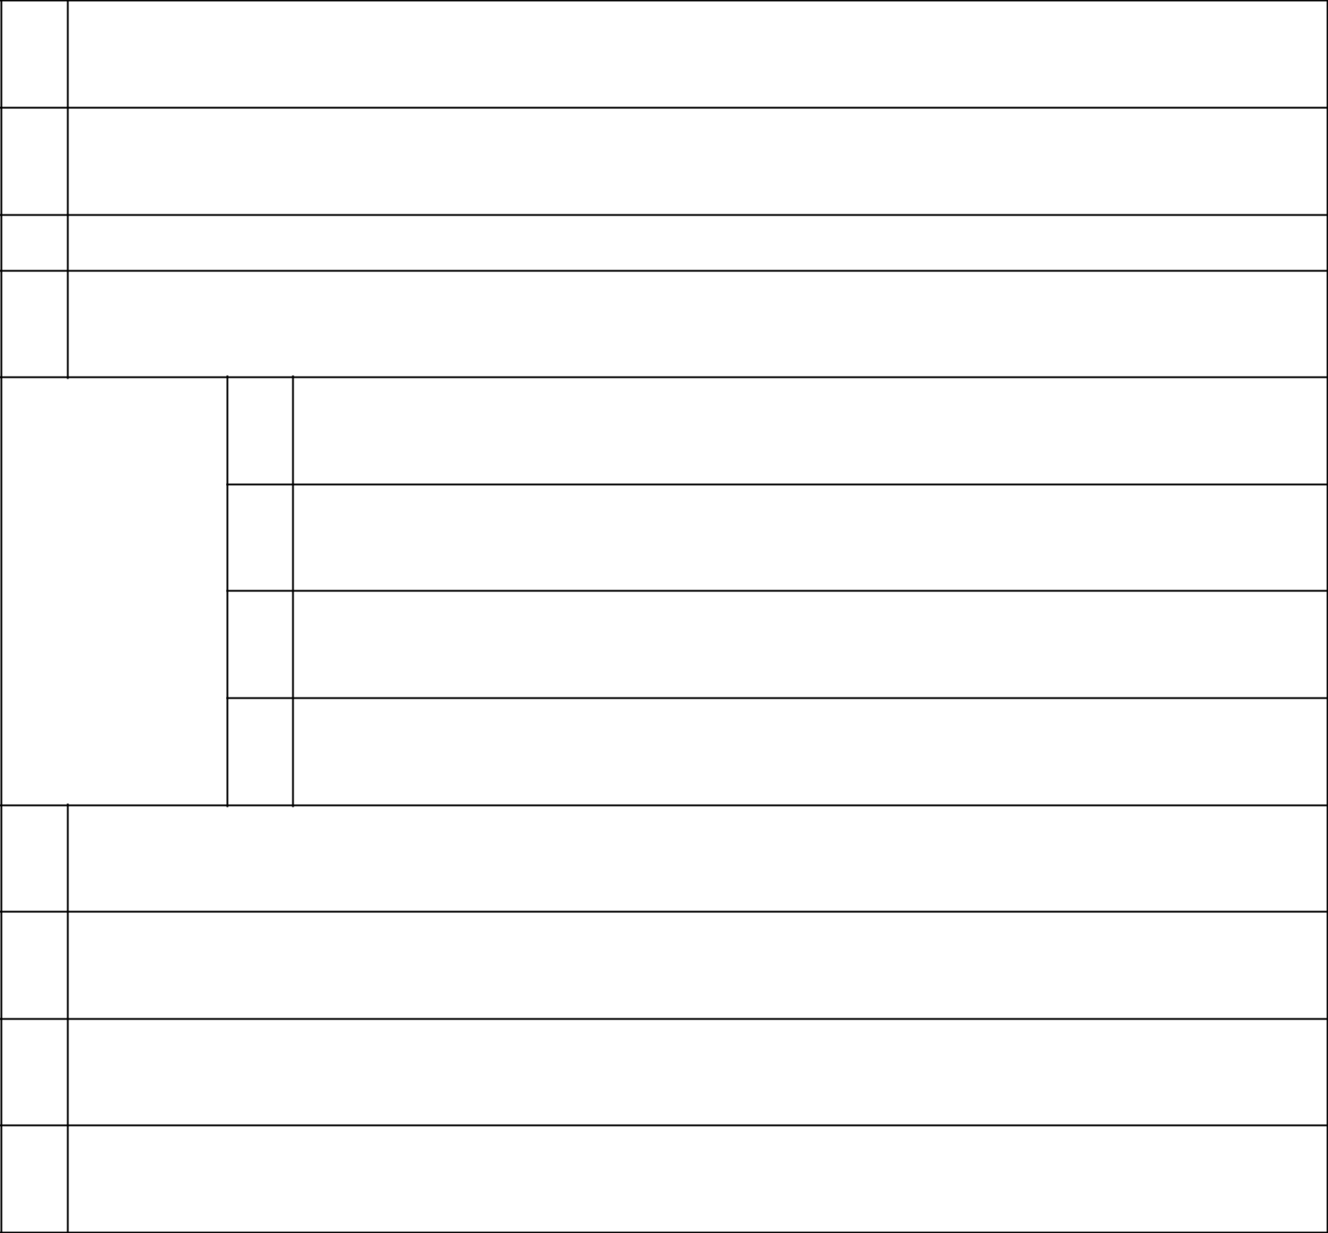

- NAMES OF REPORTING PERSONS Arnueld Limited
- CHECK THE APPROPRIATE BOX IF A MEMBER OF A GROUP (SEE INSTRUCTIONS)

  - ☒

  - ☐

- SEC USE ONLY

- CITIZENSHIP OR PLACE OF ORGANIZATION Nevis

NUMBER OF

SHARES

BENEFICIALLY

OWNED BY

EACH

REPORTING

PERSON

WITH

- SOLE VOTING POWER 15,641
- SHARED VOTING POWER 0
- SOLE DISPOSITIVE POWER 15,641
- SHARED DISPOSITIVE POWER 0

- AGGREGATE AMOUNT BENEFICIALLY OWNED BY EACH REPORTING PERSON 15,641
- CHECK BOX IF THE AGGREGATE AMOUNT IN ROW (9) EXCLUDES CERTAIN SHARES (SEE INSTRUCTIONS)

☐

- PERCENT OF CLASS REPRESENTED BY AMOUNT IN ROW (9) 0.017%
- TYPE OF REPORTING PERSON (SEE INSTRUCTIONS) CO

CUSIP No. G2519Y108 SCHEDULE 13G Page 3 of 74 Pages
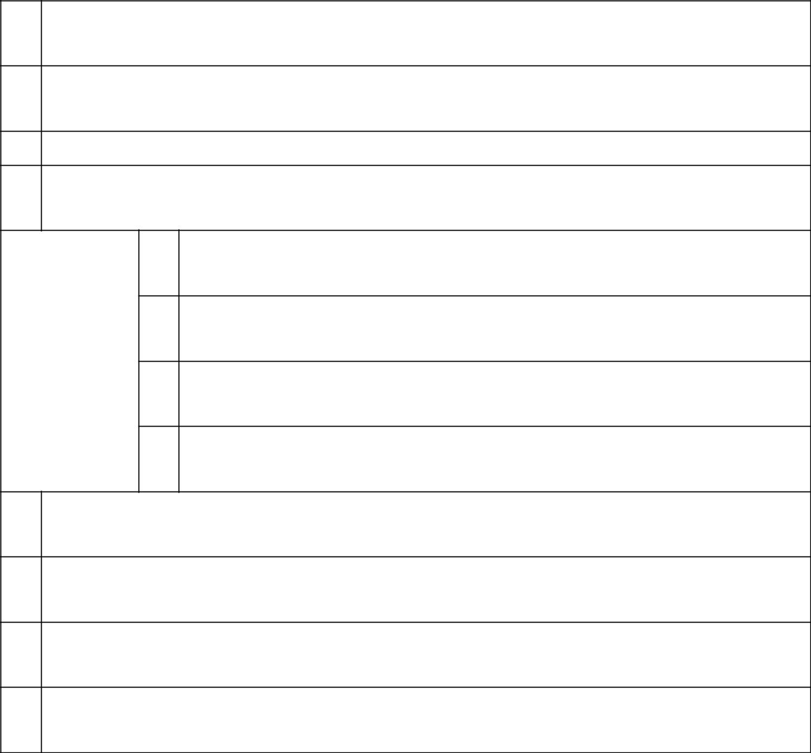

- NAMES OF REPORTING PERSONS Ursula Martina Bernard Valderrama
- CHECK THE APPROPRIATE BOX IF A MEMBER OF A GROUP (SEE INSTRUCTIONS)

  - ☒

  - ☐

- SEC USE ONLY

- CITIZENSHIP OR PLACE OF ORGANIZATION Peru

NUMBER OF

SHARES

BENEFICIALLY

OWNED BY

EACH

REPORTING

PERSON

WITH

- SOLE VOTING POWER 0
- SHARED VOTING POWER 4,322
- SOLE DISPOSITIVE POWER 0
- SHARED DISPOSITIVE POWER 4,322

- AGGREGATE AMOUNT BENEFICIALLY OWNED BY EACH REPORTING PERSON 4,322
- CHECK BOX IF THE AGGREGATE AMOUNT IN ROW (9) EXCLUDES CERTAIN SHARES (SEE INSTRUCTIONS)

☐

- PERCENT OF CLASS REPRESENTED BY AMOUNT IN ROW (9) 0.005%
- TYPE OF REPORTING PERSON (SEE INSTRUCTIONS) IN

CUSIP No. G2519Y108 SCHEDULE 13G Page 4 of 74 Pages
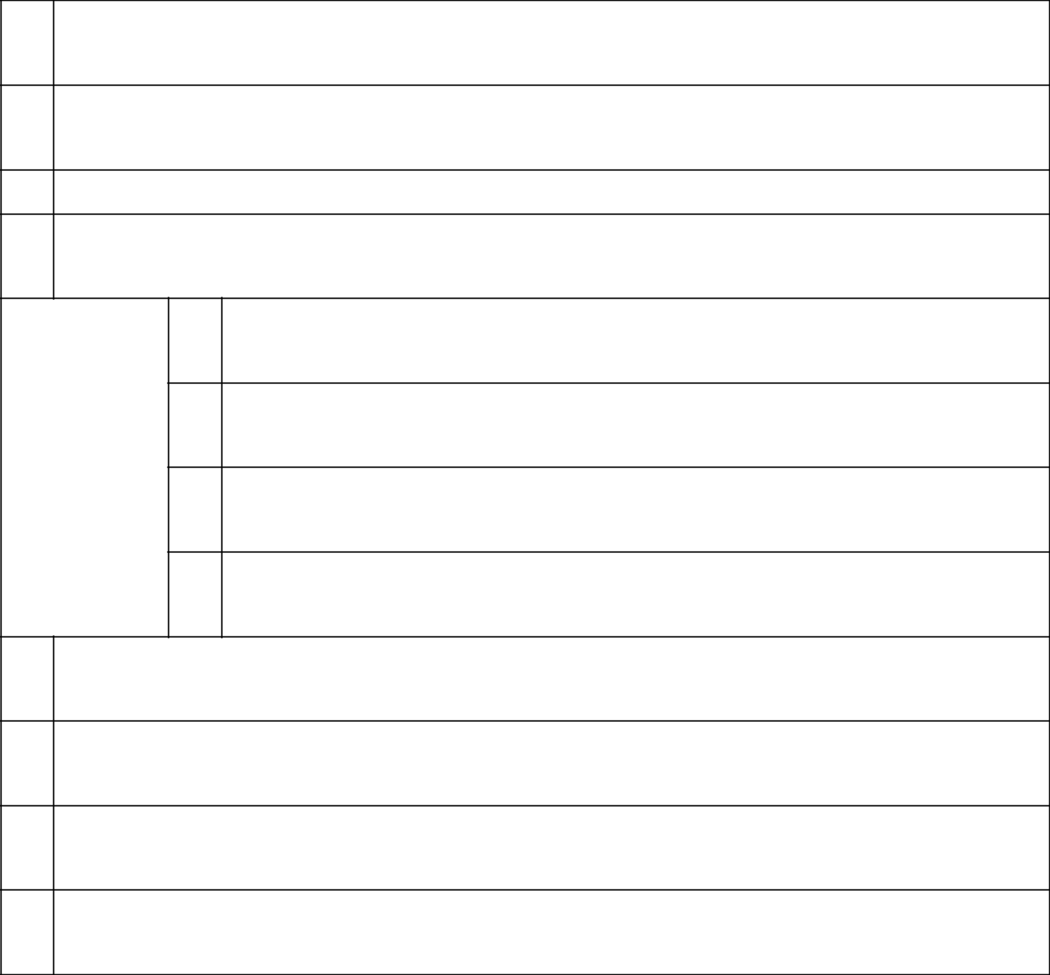

- NAMES OF REPORTING PERSONS Fideicomiso Solmar*
- CHECK THE APPROPRIATE BOX IF A MEMBER OF A GROUP (SEE INSTRUCTIONS)

  - ☒

  - ☐

- SEC USE ONLY

- CITIZENSHIP OR PLACE OF ORGANIZATION Peru

NUMBER OF

SHARES

BENEFICIALLY

OWNED BY

EACH

REPORTING

PERSON

WITH

- SOLE VOTING POWER 151,168
- SHARED VOTING POWER 0
- SOLE DISPOSITIVE POWER 151,168
- SHARED DISPOSITIVE POWER 0

  - AGGREGATE AMOUNT BENEFICIALLY OWNED BY EACH REPORTING PERSON 151,168
  - CHECK BOX IF THE AGGREGATE AMOUNT IN ROW (9) EXCLUDES CERTAIN SHARES (SEE INSTRUCTIONS)

☐

  - PERCENT OF CLASS REPRESENTED BY AMOUNT IN ROW (9)

0.16%

  - TYPE OF REPORTING PERSON (SEE INSTRUCTIONS) OO
* Fideicomiso Solmar is one of several trusts formed for the benefit of certain individuals who are members of the Romero Group.

CUSIP No. G2519Y108 SCHEDULE 13G Page 5 of 74 Pages
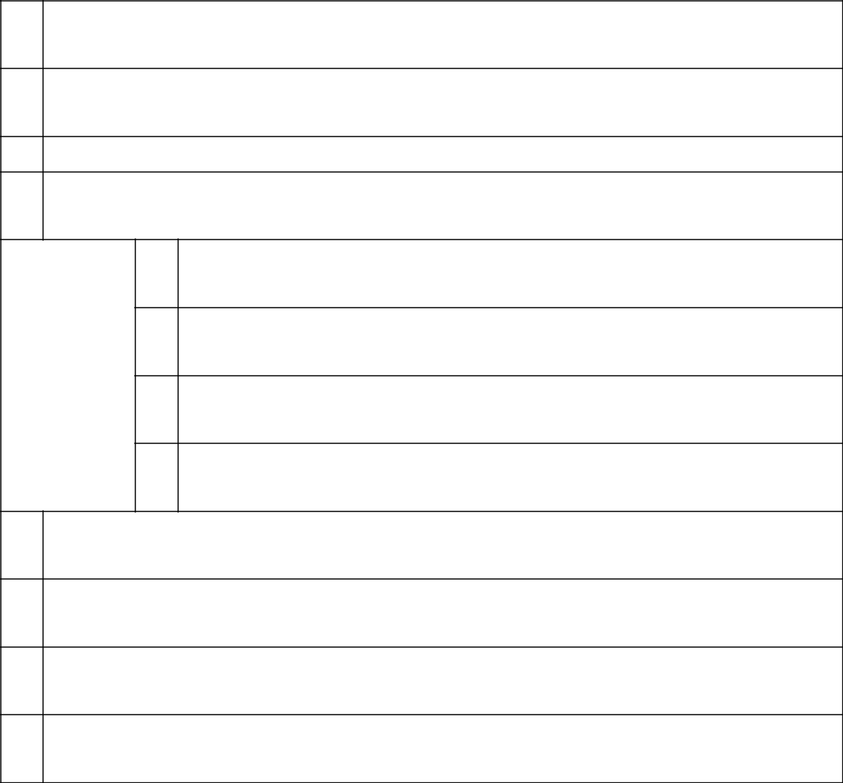

- NAMES OF REPORTING PERSONS Grupo Rosta Internacional
- CHECK THE APPROPRIATE BOX IF A MEMBER OF A GROUP (SEE INSTRUCTIONS)

  - ☒

  - ☐

- SEC USE ONLY

- CITIZENSHIP OR PLACE OF ORGANIZATION Panama

NUMBER OF

SHARES

BENEFICIALLY

OWNED BY

EACH

REPORTING

PERSON

WITH

- SOLE VOTING POWER 4,314
- SHARED VOTING POWER 0
- SOLE DISPOSITIVE POWER 4,314
- SHARED DISPOSITIVE POWER 0

- AGGREGATE AMOUNT BENEFICIALLY OWNED BY EACH REPORTING PERSON 4,314
- CHECK BOX IF THE AGGREGATE AMOUNT IN ROW (9) EXCLUDES CERTAIN SHARES (SEE INSTRUCTIONS)

☐

- PERCENT OF CLASS REPRESENTED BY AMOUNT IN ROW (9) 0.005%
- TYPE OF REPORTING PERSON (SEE INSTRUCTIONS) CO

CUSIP No. G2519Y108 SCHEDULE 13G Page 6 of 74 Pages
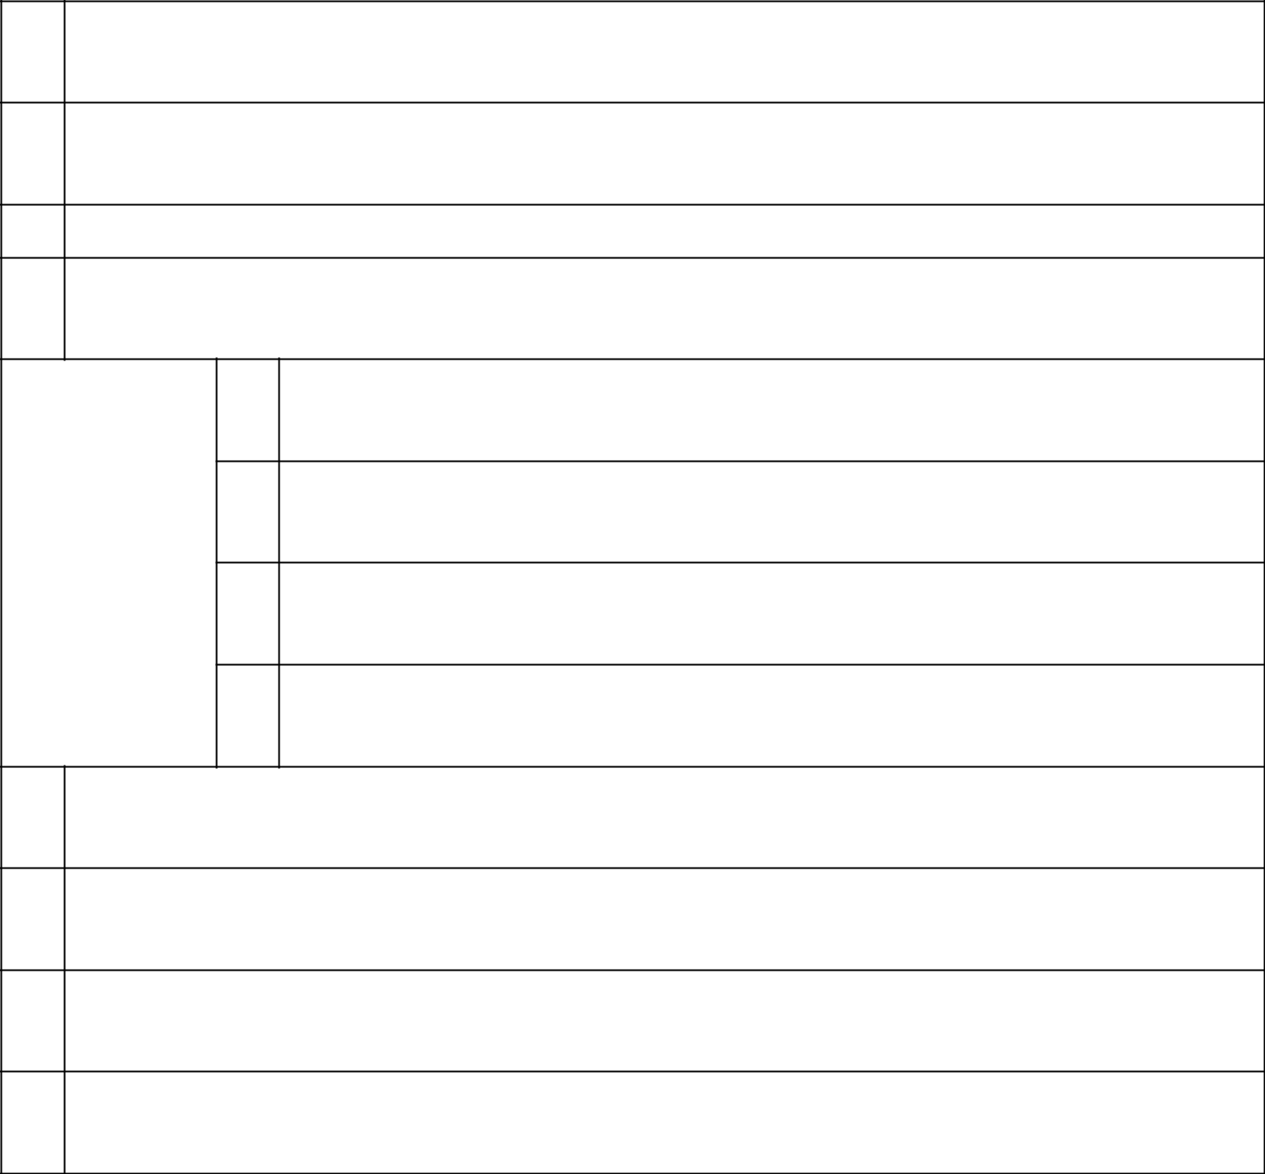

- NAMES OF REPORTING PERSONS Ana Silvia Guzman Portilla de Romero

- CHECK THE APPROPRIATE BOX IF A MEMBER OF A GROUP (SEE INSTRUCTIONS)

  - ☒

  - ☐

- SEC USE ONLY

- CITIZENSHIP OR PLACE OF ORGANIZATION Peru

NUMBER OF

SHARES

BENEFICIALLY

OWNED BY

EACH

REPORTING

PERSON

WITH

- SOLE VOTING POWER 600
- SHARED VOTING POWER 0
- SOLE DISPOSITIVE POWER 600
- SHARED DISPOSITIVE POWER 0

- AGGREGATE AMOUNT BENEFICIALLY OWNED BY EACH REPORTING PERSON 600
- CHECK BOX IF THE AGGREGATE AMOUNT IN ROW (9) EXCLUDES CERTAIN SHARES (SEE INSTRUCTIONS)

☐

- PERCENT OF CLASS REPRESENTED BY AMOUNT IN ROW (9) 0.001%
- TYPE OF REPORTING PERSON (SEE INSTRUCTIONS) IN

CUSIP No. G2519Y108 SCHEDULE 13G Page 7 of 74 Pages

- NAMES OF REPORTING PERSONS High Inter Projects, Corp.*
- CHECK THE APPROPRIATE BOX IF A MEMBER OF A GROUP (SEE INSTRUCTIONS)

  - ☒

  - ☐

- SEC USE ONLY

- CITIZENSHIP OR PLACE OF ORGANIZATION Panama

NUMBER OF

SHARES

BENEFICIALLY

OWNED BY

EACH

REPORTING

PERSON

WITH

- SOLE VOTING POWER 2,943,868
- SHARED VOTING POWER 0
- SOLE DISPOSITIVE POWER 2,943,868
- SHARED DISPOSITIVE POWER 0

  - AGGREGATE AMOUNT BENEFICIALLY OWNED BY EACH REPORTING PERSON 2,943,868
  - CHECK BOX IF THE AGGREGATE AMOUNT IN ROW (9) EXCLUDES CERTAIN SHARES (SEE INSTRUCTIONS)

☐

  - PERCENT OF CLASS REPRESENTED BY AMOUNT IN ROW (9)

3.119%

  - TYPE OF REPORTING PERSON (SEE INSTRUCTIONS) CO
* High Inter Projects, Corp. is owned and controlled by various members of the Romero family, which includes Dionisio Romero Paoletti, Calixto Romero Guzmán, José Antonio Onrubia Holder and Luis Romero Belismelis.

CUSIP No. G2519Y108 SCHEDULE 13G Page 8 of 74 Pages

- NAMES OF REPORTING PERSONS Teresa Holder de Onrubia
- CHECK THE APPROPRIATE BOX IF A MEMBER OF A GROUP (SEE INSTRUCTIONS)

  - ☒

  - ☐

- SEC USE ONLY

- CITIZENSHIP OR PLACE OF ORGANIZATION Peru

NUMBER OF

SHARES

BENEFICIALLY

OWNED BY

EACH

REPORTING

PERSON

WITH

- SOLE VOTING POWER 305,696
- SHARED VOTING POWER 0
- SOLE DISPOSITIVE POWER 305,696
- SHARED DISPOSITIVE POWER 0

- AGGREGATE AMOUNT BENEFICIALLY OWNED BY EACH REPORTING PERSON 305,696
- CHECK BOX IF THE AGGREGATE AMOUNT IN ROW (9) EXCLUDES CERTAIN SHARES (SEE INSTRUCTIONS)

☐

- PERCENT OF CLASS REPRESENTED BY AMOUNT IN ROW (9) 0.324%
- TYPE OF REPORTING PERSON (SEE INSTRUCTIONS) IN

CUSIP No. G2519Y108 SCHEDULE 13G Page 9 of 74 Pages

- NAMES OF REPORTING PERSONS Inversiones Casa Real
- CHECK THE APPROPRIATE BOX IF A MEMBER OF A GROUP (SEE INSTRUCTIONS)

  - ☒

  - ☐

- SEC USE ONLY

- CITIZENSHIP OR PLACE OF ORGANIZATION Panama

NUMBER OF

SHARES

BENEFICIALLY

OWNED BY

EACH

REPORTING

PERSON

WITH

- SOLE VOTING POWER 3,000
- SHARED VOTING POWER 0
- SOLE DISPOSITIVE POWER 3,000
- SHARED DISPOSITIVE POWER 0

- AGGREGATE AMOUNT BENEFICIALLY OWNED BY EACH REPORTING PERSON 3,000
- CHECK BOX IF THE AGGREGATE AMOUNT IN ROW (9) EXCLUDES CERTAIN SHARES (SEE INSTRUCTIONS)

☐

- PERCENT OF CLASS REPRESENTED BY AMOUNT IN ROW (9) 0.003%
- TYPE OF REPORTING PERSON (SEE INSTRUCTIONS) CO

CUSIP No. G2519Y108 SCHEDULE 13G Page 10 of 74 Pages

- NAMES OF REPORTING PERSONS Inversiones Piuranas S.A.*
- CHECK THE APPROPRIATE BOX IF A MEMBER OF A GROUP (SEE INSTRUCTIONS)

  - ☒

  - ☐

- SEC USE ONLY

- CITIZENSHIP OR PLACE OF ORGANIZATION Peru

NUMBER OF

SHARES

BENEFICIALLY

OWNED BY

EACH

REPORTING

PERSON

WITH

- SOLE VOTING POWER 158,000
- SHARED VOTING POWER 0
- SOLE DISPOSITIVE POWER 158,000
- SHARED DISPOSITIVE POWER 0

- AGGREGATE AMOUNT BENEFICIALLY OWNED BY EACH REPORTING PERSON 158,000
- CHECK BOX IF THE AGGREGATE AMOUNT IN ROW (9) EXCLUDES CERTAIN SHARES (SEE INSTRUCTIONS)

☐

- PERCENT OF CLASS REPRESENTED BY AMOUNT IN ROW (9) 0.167%
- TYPE OF REPORTING PERSON (SEE INSTRUCTIONS) CO
*Inversiones Piuranas S.A. is owned and controlled by various members of the Romero family, which includes Dionisio Romero Paoletti, Calixto Romero Guzmán, José Antonio Onrubia Holder and Luis Romero Belismelis.

CUSIP No. G2519Y108 SCHEDULE 13G Page 11 of 74 Pages

- NAMES OF REPORTING PERSONS La Roncadora S.A.*
- CHECK THE APPROPRIATE BOX IF A MEMBER OF A GROUP (SEE INSTRUCTIONS)

  - ☒

  - ☐

- SEC USE ONLY

- CITIZENSHIP OR PLACE OF ORGANIZATION Panama

NUMBER OF

SHARES

BENEFICIALLY

OWNED BY

EACH

REPORTING

PERSON

WITH

- SOLE VOTING POWER 40,090
- SHARED VOTING POWER 0
- SOLE DISPOSITIVE POWER 40,090
- SHARED DISPOSITIVE POWER 0

- AGGREGATE AMOUNT BENEFICIALLY OWNED BY EACH REPORTING PERSON 40,090
- CHECK BOX IF THE AGGREGATE AMOUNT IN ROW (9) EXCLUDES CERTAIN SHARES (SEE INSTRUCTIONS)

☐

- PERCENT OF CLASS REPRESENTED BY AMOUNT IN ROW (9) 0.042%
- TYPE OF REPORTING PERSON (SEE INSTRUCTIONS) CO
*La Roncadora S.A. is controlled by various members of the Onrubia Holder family, which includes José Antonio Onrubia Holder, Eduardo Onrubia Holder, Luis Fernando Martin Onrubia Holder, and María Inmaculada Onrubia Holder.

CUSIP No. G2519Y108 SCHEDULE 13G Page 12 of 74 Pages

- NAMES OF REPORTING PERSONS Eduardo Victoriano Onrubia Holder
- CHECK THE APPROPRIATE BOX IF A MEMBER OF A GROUP (SEE INSTRUCTIONS)

  - ☒

  - ☐

- SEC USE ONLY

- CITIZENSHIP OR PLACE OF ORGANIZATION Peru

NUMBER OF

SHARES

BENEFICIALLY

OWNED BY

EACH

REPORTING

PERSON

WITH

- SOLE VOTING POWER 0
- SHARED VOTING POWER 40,090
- SOLE DISPOSITIVE POWER 0
- SHARED DISPOSITIVE POWER 40,090

- AGGREGATE AMOUNT BENEFICIALLY OWNED BY EACH REPORTING PERSON 40,090
- CHECK BOX IF THE AGGREGATE AMOUNT IN ROW (9) EXCLUDES CERTAIN SHARES (SEE INSTRUCTIONS)

☐

- PERCENT OF CLASS REPRESENTED BY AMOUNT IN ROW (9) 0.042%
- TYPE OF REPORTING PERSON (SEE INSTRUCTIONS) IN

CUSIP No. G2519Y108 SCHEDULE 13G Page 13 of 74 Pages

- NAMES OF REPORTING PERSONS José Antonio Onrubia Holder
- CHECK THE APPROPRIATE BOX IF A MEMBER OF A GROUP (SEE INSTRUCTIONS)

  - ☒

  - ☐

- SEC USE ONLY

- CITIZENSHIP OR PLACE OF ORGANIZATION Peru

NUMBER OF

SHARES

BENEFICIALLY

OWNED BY

EACH

REPORTING

PERSON

WITH

- SOLE VOTING POWER 207,978
- SHARED VOTING POWER 8,689,234
- SOLE DISPOSITIVE POWER 207,978
- SHARED DISPOSITIVE POWER 8,689,234

- AGGREGATE AMOUNT BENEFICIALLY OWNED BY EACH REPORTING PERSON 8,897,212
- CHECK BOX IF THE AGGREGATE AMOUNT IN ROW (9) EXCLUDES CERTAIN SHARES (SEE INSTRUCTIONS)

☐

- PERCENT OF CLASS REPRESENTED BY AMOUNT IN ROW (9) 9.427%
- TYPE OF REPORTING PERSON (SEE INSTRUCTIONS) IN

CUSIP No. G2519Y108 SCHEDULE 13G Page 14 of 74 Pages

- NAMES OF REPORTING PERSONS Luis Fernando Martin Onrubia Holder
- CHECK THE APPROPRIATE BOX IF A MEMBER OF A GROUP (SEE INSTRUCTIONS)

  - ☒

  - ☐

- SEC USE ONLY

- CITIZENSHIP OR PLACE OF ORGANIZATION Peru

NUMBER OF

SHARES

BENEFICIALLY

OWNED BY

EACH

REPORTING

PERSON

WITH

- SOLE VOTING POWER 202,546
- SHARED VOTING POWER 40,090
- SOLE DISPOSITIVE POWER 202,546
- SHARED DISPOSITIVE POWER 40,090

- AGGREGATE AMOUNT BENEFICIALLY OWNED BY EACH REPORTING PERSON 242,636
- CHECK BOX IF THE AGGREGATE AMOUNT IN ROW (9) EXCLUDES CERTAIN SHARES (SEE INSTRUCTIONS)

☐

- PERCENT OF CLASS REPRESENTED BY AMOUNT IN ROW (9) 0.257%
- TYPE OF REPORTING PERSON (SEE INSTRUCTIONS) IN

CUSIP No. G2519Y108 SCHEDULE 13G Page 15 of 74 Pages

- NAMES OF REPORTING PERSONS María Inmaculada Onrubia Holder
- CHECK THE APPROPRIATE BOX IF A MEMBER OF A GROUP (SEE INSTRUCTIONS)

  - ☒

  - ☐

- SEC USE ONLY

- CITIZENSHIP OR PLACE OF ORGANIZATION Peru

NUMBER OF

SHARES

BENEFICIALLY

OWNED BY

EACH

REPORTING

PERSON

WITH

- SOLE VOTING POWER 667
- SHARED VOTING POWER 191,258
- SOLE DISPOSITIVE POWER 667
- SHARED DISPOSITIVE POWER 191,258

- AGGREGATE AMOUNT BENEFICIALLY OWNED BY EACH REPORTING PERSON 191,925
- CHECK BOX IF THE AGGREGATE AMOUNT IN ROW (9) EXCLUDES CERTAIN SHARES (SEE INSTRUCTIONS)

☐

- PERCENT OF CLASS REPRESENTED BY AMOUNT IN ROW (9) 0.203%
- TYPE OF REPORTING PERSON (SEE INSTRUCTIONS) IN

CUSIP No. G2519Y108 SCHEDULE 13G Page 16 of 74 Pages

- NAMES OF REPORTING PERSONS Patrimonio Fideicometido Angolo*
- CHECK THE APPROPRIATE BOX IF A MEMBER OF A GROUP (SEE INSTRUCTIONS)

  - ☒

  - ☐

- SEC USE ONLY

- CITIZENSHIP OR PLACE OF ORGANIZATION Peru

NUMBER OF

SHARES

BENEFICIALLY

OWNED BY

EACH

REPORTING

PERSON

WITH

- SOLE VOTING POWER 24,663
- SHARED VOTING POWER 0
- SOLE DISPOSITIVE POWER 24,663
- SHARED DISPOSITIVE POWER 0

  - AGGREGATE AMOUNT BENEFICIALLY OWNED BY EACH REPORTING PERSON 24,663
  - CHECK BOX IF THE AGGREGATE AMOUNT IN ROW (9) EXCLUDES CERTAIN SHARES (SEE INSTRUCTIONS)

☐

  - PERCENT OF CLASS REPRESENTED BY AMOUNT IN ROW (9)

0.026%

  - TYPE OF REPORTING PERSON (SEE INSTRUCTIONS) OO
* Patrimonio Fideicometido Angolo is one of several trusts formed for the benefit of certain individuals who are members of the Romero Group.

CUSIP No. G2519Y108 SCHEDULE 13G Page 17 of 74 Pages

- NAMES OF REPORTING PERSONS Reverades Holding Inc.*
- CHECK THE APPROPRIATE BOX IF A MEMBER OF A GROUP (SEE INSTRUCTIONS)

  - ☒

  - ☐

- SEC USE ONLY

- CITIZENSHIP OR PLACE OF ORGANIZATION Seychelles

NUMBER OF

SHARES

BENEFICIALLY

OWNED BY

EACH

REPORTING

PERSON

WITH

- SOLE VOTING POWER 838,712
- SHARED VOTING POWER 0
- SOLE DISPOSITIVE POWER 838,712
- SHARED DISPOSITIVE POWER 0

- AGGREGATE AMOUNT BENEFICIALLY OWNED BY EACH REPORTING PERSON 838,712
- CHECK BOX IF THE AGGREGATE AMOUNT IN ROW (9) EXCLUDES CERTAIN SHARES (SEE INSTRUCTIONS)

☐

- PERCENT OF CLASS REPRESENTED BY AMOUNT IN ROW (9) 0.889%
- TYPE OF REPORTING PERSON (SEE INSTRUCTIONS) CO
*Reverades Holding Inc. is controlled by Dionisio Romero Seminario.

CUSIP No. G2519Y108 SCHEDULE 13G Page 18 of 74 Pages

- NAMES OF REPORTING PERSONS Rittenhouse Capital Ltd.*
- CHECK THE APPROPRIATE BOX IF A MEMBER OF A GROUP (SEE INSTRUCTIONS)

  - ☒

  - ☐

- SEC USE ONLY

- CITIZENSHIP OR PLACE OF ORGANIZATION Cayman Islands

NUMBER OF

SHARES

BENEFICIALLY

OWNED BY

EACH

REPORTING

PERSON

WITH

- SOLE VOTING POWER 5,547,276**
- SHARED VOTING POWER 0
- SOLE DISPOSITIVE POWER 5,547,276**
- SHARED DISPOSITIVE POWER 0

- AGGREGATE AMOUNT BENEFICIALLY OWNED BY EACH REPORTING PERSON 5,547,276
- CHECK BOX IF THE AGGREGATE AMOUNT IN ROW (9) EXCLUDES CERTAIN SHARES (SEE INSTRUCTIONS)

☐

- PERCENT OF CLASS REPRESENTED BY AMOUNT IN ROW (9) 5.877%
- TYPE OF REPORTING PERSON (SEE INSTRUCTIONS) CO
*Rittenhouse Capital Ltd. is owned and controlled by various members of the Romero family, which includes Dionisio Romero Paoletti, Calixto Romero Guzmán, José Antonio Onrubia Holder and Luis Romero Belismelis.

- Rittenhouse Capital Ltd. has entered into a lending arrangement with an unaffiliated international bank under which it has pledged as collateral a variable number of shares (and associated ancillary rights). Under the relevant loan documents, with a scheduled maturity date of October 30, 2025, upon the occurrence of certain customary events the lender may exercise its rights to, among other remedies, foreclose on, and dispose of, the pledged shares and related collateral.

CUSIP No. G2519Y108 SCHEDULE 13G Page 19 of 74 Pages


- NAMES OF REPORTING PERSONS Alfredo Romero Belismelis
- CHECK THE APPROPRIATE BOX IF A MEMBER OF A GROUP (SEE INSTRUCTIONS)

  - ☒

  - ☐

- SEC USE ONLY

- CITIZENSHIP OR PLACE OF ORGANIZATION Peru

NUMBER OF

SHARES

BENEFICIALLY

OWNED BY

EACH

REPORTING

PERSON

WITH

- SOLE VOTING POWER 0
- SHARED VOTING POWER 700,387
- SOLE DISPOSITIVE POWER 0
- SHARED DISPOSITIVE POWER 700,387

- AGGREGATE AMOUNT BENEFICIALLY OWNED BY EACH REPORTING PERSON 700,387
- CHECK BOX IF THE AGGREGATE AMOUNT IN ROW (9) EXCLUDES CERTAIN SHARES (SEE INSTRUCTIONS)

☐

- PERCENT OF CLASS REPRESENTED BY AMOUNT IN ROW (9) 0.742%
- TYPE OF REPORTING PERSON (SEE INSTRUCTIONS) IN

CUSIP No. G2519Y108 SCHEDULE 13G Page 20 of 74 Pages

- NAMES OF REPORTING PERSONS Fernando Romero Belismelis
- CHECK THE APPROPRIATE BOX IF A MEMBER OF A GROUP (SEE INSTRUCTIONS)

  - ☒

  - ☐

- SEC USE ONLY

- CITIZENSHIP OR PLACE OF ORGANIZATION Peru

NUMBER OF

SHARES

BENEFICIALLY

OWNED BY

EACH

REPORTING

PERSON

WITH

- SOLE VOTING POWER 0
- SHARED VOTING POWER 707,195
- SOLE DISPOSITIVE POWER 0
- SHARED DISPOSITIVE POWER 707,195

- AGGREGATE AMOUNT BENEFICIALLY OWNED BY EACH REPORTING PERSON 707,195
- CHECK BOX IF THE AGGREGATE AMOUNT IN ROW (9) EXCLUDES CERTAIN SHARES (SEE INSTRUCTIONS)

☐

- PERCENT OF CLASS REPRESENTED BY AMOUNT IN ROW (9) 0.749%
- TYPE OF REPORTING PERSON (SEE INSTRUCTIONS) IN

CUSIP No. G2519Y108 SCHEDULE 13G Page 21 of 74 Pages

- NAMES OF REPORTING PERSONS José Roberto Romero Belismelis
- CHECK THE APPROPRIATE BOX IF A MEMBER OF A GROUP (SEE INSTRUCTIONS)

  - ☒

  - ☐

- SEC USE ONLY

- CITIZENSHIP OR PLACE OF ORGANIZATION Peru

NUMBER OF

SHARES

BENEFICIALLY

OWNED BY

EACH

REPORTING

PERSON

WITH

- SOLE VOTING POWER 0
- SHARED VOTING POWER 15,214
- SOLE DISPOSITIVE POWER 0
- SHARED DISPOSITIVE POWER 15,214

- AGGREGATE AMOUNT BENEFICIALLY OWNED BY EACH REPORTING PERSON 15,214
- CHECK BOX IF THE AGGREGATE AMOUNT IN ROW (9) EXCLUDES CERTAIN SHARES (SEE INSTRUCTIONS)

☐

- PERCENT OF CLASS REPRESENTED BY AMOUNT IN ROW (9) 0.016%
- TYPE OF REPORTING PERSON (SEE INSTRUCTIONS) IN

CUSIP No. G2519Y108 SCHEDULE 13G Page 22 of 74 Pages

- NAMES OF REPORTING PERSONS Luis Romero Belismelis
- CHECK THE APPROPRIATE BOX IF A MEMBER OF A GROUP (SEE INSTRUCTIONS)

  - ☒

  - ☐

- SEC USE ONLY

- CITIZENSHIP OR PLACE OF ORGANIZATION Peru

NUMBER OF

SHARES

BENEFICIALLY

OWNED BY

EACH

REPORTING

PERSON

WITH

- SOLE VOTING POWER 750
- SHARED VOTING POWER 9,370,630
- SOLE DISPOSITIVE POWER 750
- SHARED DISPOSITIVE POWER 9,370,630

- AGGREGATE AMOUNT BENEFICIALLY OWNED BY EACH REPORTING PERSON 9,371,380
- CHECK BOX IF THE AGGREGATE AMOUNT IN ROW (9) EXCLUDES CERTAIN SHARES (SEE INSTRUCTIONS)

☐

- PERCENT OF CLASS REPRESENTED BY AMOUNT IN ROW (9) 9.929%
- TYPE OF REPORTING PERSON (SEE INSTRUCTIONS) IN

CUSIP No. G2519Y108 SCHEDULE 13G Page 23 of 74 Pages
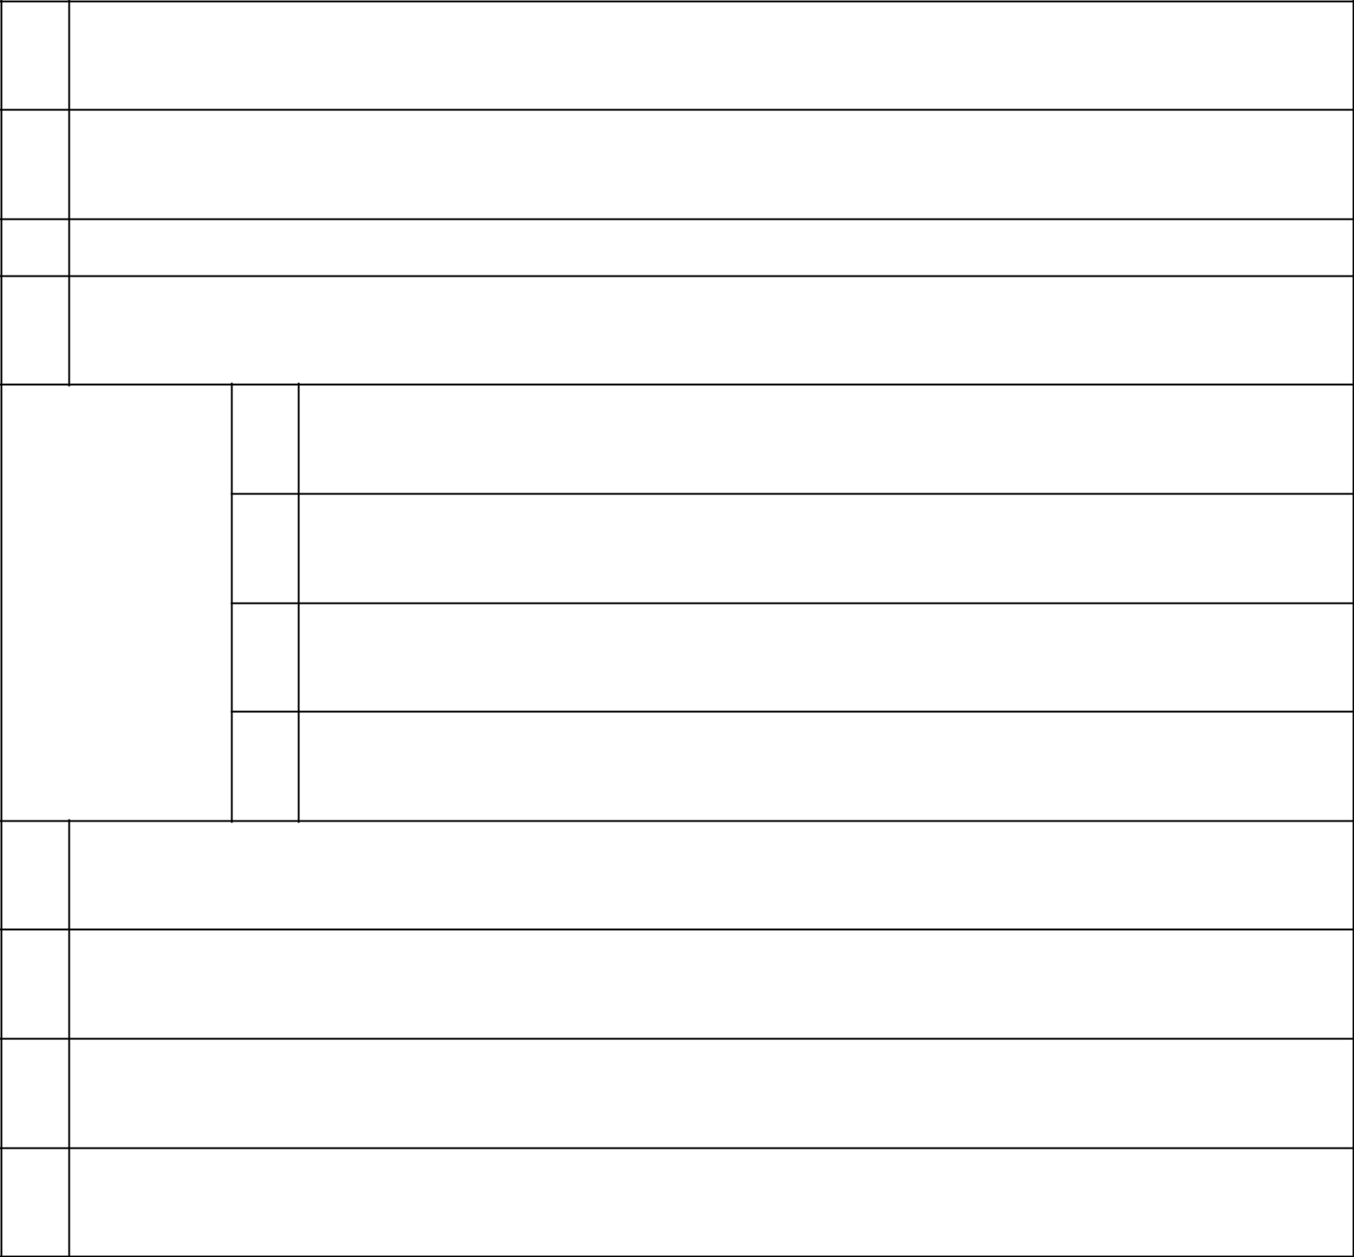

- NAMES OF REPORTING PERSONS Manuel Antonio Romero Belismelis
- CHECK THE APPROPRIATE BOX IF A MEMBER OF A GROUP (SEE INSTRUCTIONS)

  - ☒

  - ☐

- SEC USE ONLY

- CITIZENSHIP OR PLACE OF ORGANIZATION Peru

NUMBER OF

SHARES

BENEFICIALLY

OWNED BY

EACH

REPORTING

PERSON

WITH

- SOLE VOTING POWER 30,861
- SHARED VOTING POWER 726,928
- SOLE DISPOSITIVE POWER 30,861
- SHARED DISPOSITIVE POWER 726,928

- AGGREGATE AMOUNT BENEFICIALLY OWNED BY EACH REPORTING PERSON 757,789
- CHECK BOX IF THE AGGREGATE AMOUNT IN ROW (9) EXCLUDES CERTAIN SHARES (SEE INSTRUCTIONS)

☐

- PERCENT OF CLASS REPRESENTED BY AMOUNT IN ROW (9) 0.803%
- TYPE OF REPORTING PERSON (SEE INSTRUCTIONS) IN

CUSIP No. G2519Y108 SCHEDULE 13G Page 24 of 74 Pages
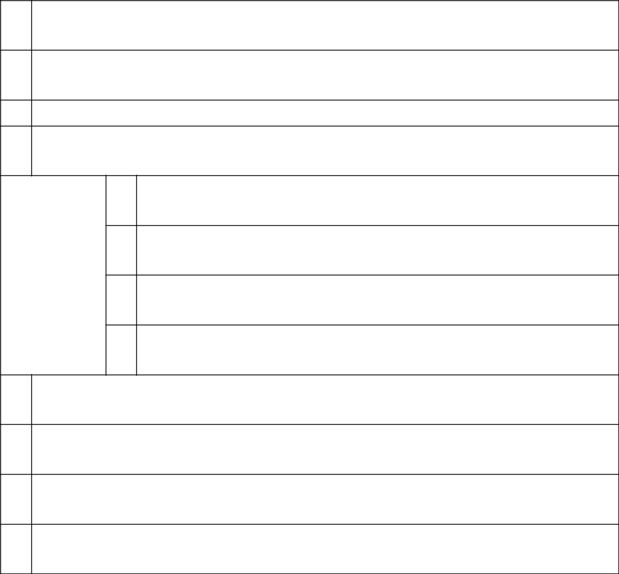

- NAMES OF REPORTING PERSONS Calixto Romero Guzmán
- CHECK THE APPROPRIATE BOX IF A MEMBER OF A GROUP (SEE INSTRUCTIONS)

  - ☒

  - ☐

- SEC USE ONLY

- CITIZENSHIP OR PLACE OF ORGANIZATION Peru

NUMBER OF

SHARES

BENEFICIALLY

OWNED BY

EACH

REPORTING

PERSON

WITH

- SOLE VOTING POWER 0
- SHARED VOTING POWER 8,649,144
- SOLE DISPOSITIVE POWER 0
- SHARED DISPOSITIVE POWER 8,649,144

- AGGREGATE AMOUNT BENEFICIALLY OWNED BY EACH REPORTING PERSON 8,649,144
- CHECK BOX IF THE AGGREGATE AMOUNT IN ROW (9) EXCLUDES CERTAIN SHARES (SEE INSTRUCTIONS)

☐

- PERCENT OF CLASS REPRESENTED BY AMOUNT IN ROW (9) 9.164%
- TYPE OF REPORTING PERSON (SEE INSTRUCTIONS) IN

CUSIP No. G2519Y108 SCHEDULE 13G Page 25 of 74 Pages

- NAMES OF REPORTING PERSONS Ana María Romero Paoletti de Sacchi

- CHECK THE APPROPRIATE BOX IF A MEMBER OF A GROUP (SEE INSTRUCTIONS)

  - ☒

  - ☐

- SEC USE ONLY

- CITIZENSHIP OR PLACE OF ORGANIZATION Peru

NUMBER OF

SHARES

BENEFICIALLY

OWNED BY

EACH

REPORTING

PERSON

WITH

- SOLE VOTING POWER 0
- SHARED VOTING POWER 6,150
- SOLE DISPOSITIVE POWER 0
- SHARED DISPOSITIVE POWER 6,150

- AGGREGATE AMOUNT BENEFICIALLY OWNED BY EACH REPORTING PERSON 6,150
- CHECK BOX IF THE AGGREGATE AMOUNT IN ROW (9) EXCLUDES CERTAIN SHARES (SEE INSTRUCTIONS)

☐

- PERCENT OF CLASS REPRESENTED BY AMOUNT IN ROW (9) 0.007%
- TYPE OF REPORTING PERSON (SEE INSTRUCTIONS) IN

CUSIP No. G2519Y108 SCHEDULE 13G Page 26 of 74 Pages

- NAMES OF REPORTING PERSONS Dionisio Romero Paoletti
- CHECK THE APPROPRIATE BOX IF A MEMBER OF A GROUP (SEE INSTRUCTIONS)

  - ☒

  - ☐

- SEC USE ONLY

- CITIZENSHIP OR PLACE OF ORGANIZATION Peru

NUMBER OF

SHARES

BENEFICIALLY

OWNED BY

EACH

REPORTING

PERSON

WITH

- SOLE VOTING POWER 139,486
- SHARED VOTING POWER 8,649,144
- SOLE DISPOSITIVE POWER 139,486
- SHARED DISPOSITIVE POWER 8,649,144

- AGGREGATE AMOUNT BENEFICIALLY OWNED BY EACH REPORTING PERSON 8,788,630
- CHECK BOX IF THE AGGREGATE AMOUNT IN ROW (9) EXCLUDES CERTAIN SHARES (SEE INSTRUCTIONS)

☐

- PERCENT OF CLASS REPRESENTED BY AMOUNT IN ROW (9) 9.312%
- TYPE OF REPORTING PERSON (SEE INSTRUCTIONS) IN

CUSIP No. G2519Y108 SCHEDULE 13G Page 27 of 74 Pages


- NAMES OF REPORTING PERSONS Marianella Romero Guzmán
- CHECK THE APPROPRIATE BOX IF A MEMBER OF A GROUP (SEE INSTRUCTIONS)

  - ☒

  - ☐

- SEC USE ONLY

- CITIZENSHIP OR PLACE OF ORGANIZATION Peru

NUMBER OF

SHARES

BENEFICIALLY

OWNED BY

EACH

REPORTING

PERSON

WITH

- SOLE VOTING POWER 1,379
- SHARED VOTING POWER 0
- SOLE DISPOSITIVE POWER 1,379
- SHARED DISPOSITIVE POWER 0

- AGGREGATE AMOUNT BENEFICIALLY OWNED BY EACH REPORTING PERSON 1,379

- CHECK BOX IF THE AGGREGATE AMOUNT IN ROW (9) EXCLUDES CERTAIN SHARES (SEE INSTRUCTIONS)

☐

- PERCENT OF CLASS REPRESENTED BY AMOUNT IN ROW (9) 0.001%
- TYPE OF REPORTING PERSON (SEE INSTRUCTIONS) IN

CUSIP No. G2519Y108 SCHEDULE 13G Page 28 of 74 Pages

- NAMES OF REPORTING PERSONS Dionisio Romero Seminario
- CHECK THE APPROPRIATE BOX IF A MEMBER OF A GROUP (SEE INSTRUCTIONS)

  - ☒

  - ☐

- SEC USE ONLY

- CITIZENSHIP OR PLACE OF ORGANIZATION Peru

NUMBER OF

SHARES

BENEFICIALLY

OWNED BY

EACH

REPORTING

PERSON

WITH

- SOLE VOTING POWER 0
- SHARED VOTING POWER 1,714,359
- SOLE DISPOSITIVE POWER 0
- SHARED DISPOSITIVE POWER 1,714,359

- AGGREGATE AMOUNT BENEFICIALLY OWNED BY EACH REPORTING PERSON 1,714,359
- CHECK BOX IF THE AGGREGATE AMOUNT IN ROW (9) EXCLUDES CERTAIN SHARES (SEE INSTRUCTIONS)

☐

- PERCENT OF CLASS REPRESENTED BY AMOUNT IN ROW (9) 1.816%
- TYPE OF REPORTING PERSON (SEE INSTRUCTIONS) IN

CUSIP No. G2519Y108 SCHEDULE 13G Page 29 of 74 Pages
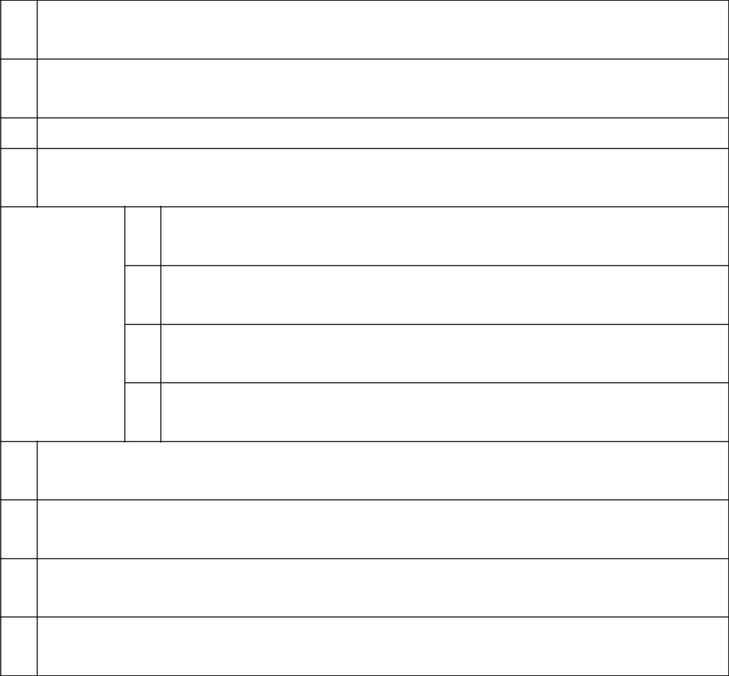

- NAMES OF REPORTING PERSONS Rubyfield Investments Ltd.*
- CHECK THE APPROPRIATE BOX IF A MEMBER OF A GROUP (SEE INSTRUCTIONS)

  - ☒

  - ☐

- SEC USE ONLY

- CITIZENSHIP OR PLACE OF ORGANIZATION Seychelles

NUMBER OF

SHARES

BENEFICIALLY

OWNED BY

EACH

REPORTING

PERSON

WITH

- SOLE VOTING POWER 875,647
- SHARED VOTING POWER 0
- SOLE DISPOSITIVE POWER 875,647
- SHARED DISPOSITIVE POWER 0

- AGGREGATE AMOUNT BENEFICIALLY OWNED BY EACH REPORTING PERSON 875,647
- CHECK BOX IF THE AGGREGATE AMOUNT IN ROW (9) EXCLUDES CERTAIN SHARES (SEE INSTRUCTIONS)

☐

- PERCENT OF CLASS REPRESENTED BY AMOUNT IN ROW (9) 0.928%
- TYPE OF REPORTING PERSON (SEE INSTRUCTIONS) CO
*Rubyfield Investments Ltd. is controlled by Dionisio Romero Seminario.

CUSIP No. G2519Y108 SCHEDULE 13G Page 30 of 74 Pages

- NAMES OF REPORTING PERSONS Paolo Mario Sacchi Giurato
- CHECK THE APPROPRIATE BOX IF A MEMBER OF A GROUP (SEE INSTRUCTIONS)

  - ☒

  - ☐

- SEC USE ONLY

- CITIZENSHIP OR PLACE OF ORGANIZATION Peru

NUMBER OF

SHARES

BENEFICIALLY

OWNED BY

EACH

REPORTING

PERSON

WITH

- SOLE VOTING POWER 111
- SHARED VOTING POWER 6,150
- SOLE DISPOSITIVE POWER 111
- SHARED DISPOSITIVE POWER 6,150

- AGGREGATE AMOUNT BENEFICIALLY OWNED BY EACH REPORTING PERSON 6,261
- CHECK BOX IF THE AGGREGATE AMOUNT IN ROW (9) EXCLUDES CERTAIN SHARES (SEE INSTRUCTIONS)

☐

- PERCENT OF CLASS REPRESENTED BY AMOUNT IN ROW (9) 0.007%
- TYPE OF REPORTING PERSON (SEE INSTRUCTIONS) IN

CUSIP No. G2519Y108 SCHEDULE 13G Page 31 of 74 Pages

- NAMES OF REPORTING PERSONS Maray S.A.*
- CHECK THE APPROPRIATE BOX IF A MEMBER OF A GROUP (SEE INSTRUCTIONS)

  - ☒

  - ☐

- SEC USE ONLY

- CITIZENSHIP OR PLACE OF ORGANIZATION Peru

NUMBER OF

SHARES

BENEFICIALLY

OWNED BY

EACH

REPORTING

PERSON

WITH

- SOLE VOTING POWER 693,073
- SHARED VOTING POWER 0
- SOLE DISPOSITIVE POWER 693,073
- SHARED DISPOSITIVE POWER 0

  - AGGREGATE AMOUNT BENEFICIALLY OWNED BY EACH REPORTING PERSON 693,073
  - CHECK BOX IF THE AGGREGATE AMOUNT IN ROW (9) EXCLUDES CERTAIN SHARES (SEE INSTRUCTIONS)

☐

  - PERCENT OF CLASS REPRESENTED BY AMOUNT IN ROW (9)

0.734%

  - TYPE OF REPORTING PERSON (SEE INSTRUCTIONS) CO
* Maray S.A. is owned and controlled by various members of the Romero Belismelis family, which includes Alfredo Romero Belismelis, Fernando Romero Belismelis, José Roberto Romero Belismelis, Luis Romero Belismelis, and Manuel Antonio Romero Belismelis.

CUSIP No. G2519Y108 SCHEDULE 13G Page 32 of 74 Pages

- NAMES OF REPORTING PERSONS Ana Sylvia Romero Guzmán
- CHECK THE APPROPRIATE BOX IF A MEMBER OF A GROUP (SEE INSTRUCTIONS)

  - ☒

  - ☐

- SEC USE ONLY

- CITIZENSHIP OR PLACE OF ORGANIZATION Peru

NUMBER OF

SHARES

BENEFICIALLY

OWNED BY

EACH

REPORTING

PERSON

WITH

- SOLE VOTING POWER 1,379
- SHARED VOTING POWER 0
- SOLE DISPOSITIVE POWER 1,379
- SHARED DISPOSITIVE POWER 0

- AGGREGATE AMOUNT BENEFICIALLY OWNED BY EACH REPORTING PERSON 1,379
- CHECK BOX IF THE AGGREGATE AMOUNT IN ROW (9) EXCLUDES CERTAIN SHARES (SEE INSTRUCTIONS)

☐

- PERCENT OF CLASS REPRESENTED BY AMOUNT IN ROW (9) 0.001%
- TYPE OF REPORTING PERSON (SEE INSTRUCTIONS) IN

CUSIP No. G2519Y108 SCHEDULE 13G Page 33 of 74 Pages

Statement for Schedule 13G

Item 1 (a). Name of issuer:

Credicorp Ltd.

Item (b). Address of issuer’s principal executive offices:

Credicorp Ltd.

c/o Banco de Crédito del Perú

Calle Centenario N° 156

Las Laderas de Melgarejo

La Molina

Lima 12, Perú

Item 2(a). Name of person filing:

See Exhibit B attached hereto.

Item 2(b). Address or principal business office or, if none, residence:

Calle Centenario N° 156

Las Laderas de Melgarejo

La Molina

Lima 12, Perú

Item 2(c). Citizenship:

See Item 4 on Page 2

See Item 4 on Page 3

See Item 4 on Page 4

See Item 4 on Page 5

See Item 4 on Page 6

See Item 4 on Page 7

See Item 4 on Page 8

See Item 4 on Page 9

See Item 4 on Page 10

See Item 4 on Page 11

See Item 4 on Page 12

See Item 4 on Page 13

See Item 4 on Page 14

See Item 4 on Page 15

See Item 4 on Page 16

See Item 4 on Page 17

See Item 4 on Page 18

See Item 4 on Page 19

See Item 4 on Page 20

See Item 4 on Page 21

See Item 4 on Page 22

See Item 4 on Page 23

See Item 4 on Page 24

See Item 4 on Page 25

See Item 4 on Page 26

See Item 4 on Page 27

See Item 4 on Page 28

See Item 4 on Page 29

See Item 4 on Page 30

See Item 4 on Page 31

See Item 4 on Page 32

CUSIP No. G2519Y108 SCHEDULE 13G Page 34 of 74 Pages

Item 2(d). Title of class of securities:

Common Shares, par value $5.00 per share

Item 2(e). CUSIP No.:

G2519Y108

Item 3. If this statement is filed pursuant to §§ 240.13d-1(b) or 240.13d-2(b) or (c), check whether the person filing is a:

Not applicable.

Item 4. Ownership.

(a) Amount beneficially owned:

See Item 9 on Page 2

See Item 9 on Page 3

See Item 9 on Page 4

See Item 9 on Page 5

See Item 9 on Page 6

See Item 9 on Page 7

See Item 9 on Page 8

See Item 9 on Page 9

See Item 9 on Page 10

See Item 9 on Page 11

See Item 9 on Page 12

See Item 9 on Page 13

See Item 9 on Page 14

See Item 9 on Page 15

See Item 9 on Page 16

See Item 9 on Page 17

See Item 9 on Page 18

See Item 9 on Page 19

See Item 9 on Page 20

See Item 9 on Page 21

See Item 9 on Page 22

See Item 9 on Page 23

See Item 9 on Page 24

See Item 9 on Page 25

See Item 9 on Page 26

See Item 9 on Page 27

See Item 9 on Page 28

See Item 9 on Page 29

See Item 9 on Page 30

See Item 9 on Page 31

See Item 9 on Page 32

CUSIP No. G2519Y108 SCHEDULE 13G Page 35 of 74 Pages

(b) Percent of class:

See Item 11 on Page 2

See Item 11 on Page 3

See Item 11 on Page 4

See Item 11 on Page 5

See Item 11 on Page 6

See Item 11 on Page 7

See Item 11 on Page 8

See Item 11 on Page 9

See Item 11 on Page 10

See Item 11 on Page 11

See Item 11 on Page 12

See Item 11 on Page 13

See Item 11 on Page 14

See Item 11 on Page 15

See Item 11 on Page 16

See Item 11 on Page 17

See Item 11 on Page 18

See Item 11 on Page 19

See Item 11 on Page 20

See Item 11 on Page 21

See Item 11 on Page 22

See Item 11 on Page 23

See Item 11 on Page 24

See Item 11 on Page 25

See Item 11 on Page 26

See Item 11 on Page 27

See Item 11 on Page 28

See Item 11 on Page 29

See Item 11 on Page 30

See Item 11 on Page 31

See Item 11 on Page 32

- Number of shares as to which the person has:

  - Sole power to vote or to direct the vote

See Item 5 on Page 2

See Item 5 on Page 3

See Item 5 on Page 4

See Item 5 on Page 5

See Item 5 on Page 6

See Item 5 on Page 7

See Item 5 on Page 8

See Item 5 on Page 9

See Item 5 on Page 10

See Item 5 on Page 11

See Item 5 on Page 12

See Item 5 on Page 13

See Item 5 on Page 14

See Item 5 on Page 15

See Item 5 on Page 16

See Item 5 on Page 17

See Item 5 on Page 18

See Item 5 on Page 19

See Item 5 on Page 20

See Item 5 on Page 21

See Item 5 on Page 22

CUSIP No. G2519Y108 SCHEDULE 13G Page 36 of 74 Pages

See Item 5 on Page 23

See Item 5 on Page 24

See Item 5 on Page 25

See Item 5 on Page 26

See Item 5 on Page 27

See Item 5 on Page 28

See Item 5 on Page 29

See Item 5 on Page 30

See Item 5 on Page 31

See Item 5 on Page 32

(ii) Shared power to vote or to direct the vote

See Item 6 on Page 2

See Item 6 on Page 3

See Item 6 on Page 4

See Item 6 on Page 5

See Item 6 on Page 6

See Item 6 on Page 7

See Item 6 on Page 8

See Item 6 on Page 9

See Item 6 on Page 10

See Item 6 on Page 11

See Item 6 on Page 12

See Item 6 on Page 13

See Item 6 on Page 14

See Item 6 on Page 15

See Item 6 on Page 16

See Item 6 on Page 17

See Item 6 on Page 18

See Item 6 on Page 19

See Item 6 on Page 20

See Item 6 on Page 21

See Item 6 on Page 22

See Item 6 on Page 23

See Item 6 on Page 24

See Item 6 on Page 25

See Item 6 on Page 26

See Item 6 on Page 27

See Item 6 on Page 28

See Item 6 on Page 29

See Item 6 on Page 30

See Item 6 on Page 31

See Item 6 on Page 32

- Sole power to dispose or to direct the disposition of

See Item 7 on Page 2 See Item 7 on Page 3 See Item 7 on Page 4 See Item 7 on Page 5 See Item 7 on Page 6 See Item 7 on Page 7 See Item 7 on Page 8 See Item 7 on Page 9 See Item 7 on Page 10

CUSIP No. G2519Y108 SCHEDULE 13G Page 37 of 74 Pages

See Item 7 on Page 11

See Item 7 on Page 12

See Item 7 on Page 13

See Item 7 on Page 14

See Item 7 on Page 15

See Item 7 on Page 16

See Item 7 on Page 17

See Item 7 on Page 18

See Item 7 on Page 19

See Item 7 on Page 20

See Item 7 on Page 21

See Item 7 on Page 22

See Item 7 on Page 23

See Item 7 on Page 24

See Item 7 on Page 25

See Item 7 on Page 26

See Item 7 on Page 27

See Item 7 on Page 28

See Item 7 on Page 29

See Item 7 on Page 30

See Item 7 on Page 31

See Item 7 on Page 32

- Shared power to dispose or to direct the disposition of

See Item 8 on Page 2 See Item 8 on Page 3 See Item 8 on Page 4 See Item 8 on Page 5 See Item 8 on Page 6 See Item 8 on Page 7 See Item 8 on Page 8 See Item 8 on Page 9 See Item 8 on Page 10 See Item 8 on Page 11 See Item 8 on Page 12 See Item 8 on Page 13 See Item 8 on Page 14 See Item 8 on Page 15 See Item 8 on Page 16 See Item 8 on Page 17 See Item 8 on Page 18 See Item 8 on Page 19 See Item 8 on Page 20 See Item 8 on Page 21 See Item 8 on Page 22 See Item 8 on Page 23 See Item 8 on Page 24 See Item 8 on Page 25 See Item 8 on Page 26 See Item 8 on Page 27 See Item 8 on Page 28 See Item 8 on Page 29 See Item 8 on Page 30 See Item 8 on Page 31 See Item 8 on Page 32

CUSIP No. G2519Y108 SCHEDULE 13G Page 38 of 74 Pages

Item 5. Ownership of 5 Percent or Less of a Class.

Not applicable.

Item 6. Ownership of More than 5 Percent on Behalf of Another Person.

Not applicable.

Item 7. Identification and Classification of the Subsidiary Which Acquired the Security Being Reported on by the Parent Holding Company or Control Person.

Not applicable.

Item 8. Identification and Classification of Members of the Group.

See Exhibit C attached hereto.

Item 9. Notice of Dissolution of Group.

Not applicable.

Item 10. Certifications.

Not applicable.

CUSIP No. G2519Y108 SCHEDULE 13G Page 39 of 74 Pages

SIGNATURE

After reasonable inquiry and to the best of my knowledge and belief, I certify that the information set forth in this statement is true, complete and correct.

February 11, 2021

(Date)

/s/ Dionisio Romero Paoletti

(Signature)

Name: Dionisio Romero Paoletti

Title: Authorized Signatory

CUSIP No. G2519Y108 SCHEDULE 13G Page 40 of 74 Pages

EXHIBITS

Exhibit A Joint Filing Statement

Exhibit B Names of Persons Filing

Exhibit C Identification and Classification of Members of Group

Exhibit D Powers of Attorney with English Translations

CUSIP No. G2519Y108 SCHEDULE 13G Page 41 of 74 Pages

Exhibit A to Schedule 13G

Joint Filing Agreement

Pursuant to Rule 13d-1(k)

The undersigned persons (the "Reporting Persons") hereby agree that a joint statement on this Schedule 13G, and any amendments thereto, be filed on their behalf by Dionisio Romero Paoletti.

Each of the Reporting Persons is responsible for the completeness and accuracy of the information concerning each of them contained therein, but none of the Reporting Persons is responsible for the completeness or accuracy of the information concerning any other Reporting Person.

Date: February 11, 2021

Arnueld Limited

Ursula Martina Bernard Valderrama

Fideicomiso Solmar

Grupo Rosta Internacional

Ana Sylvia Guzman Portilla de Romero

High Inter Projects, Corp.

Teresa Holder de Onrubia

Inversiones Casa Real

Inversiones Piuranas S.A.

La Roncadora S.A.

Eduardo Victoriano Onrubia Holder

José Antonio Onrubia Holder

Luis Fernando Martin Onrubia Holder

María Inmaculada Onrubia Holder

Patrimonio Fideicometido Angolo

Reverades Holding Inc.

Rittenhouse Capital Ltd.

Alfredo Romero Belismelis

Fernando Romero Belismelis

José Roberto Romero Belismelis

Luis Romero Belismelis

Manuel Antonio Romero Belismelis

Calixto Romero Guzmán

Ana María Romero Paoletti de Sacchi

Dionisio Romero Paoletti

Marianella Romero Guzmán

Dionisio Romero Seminario

Rubyfield Investments Ltd.

Paolo Mario Sacchi Giurato

Maray S.A.

Ana Sylvia Romero Guzmán

By: /s/ Dionisio Romero Paoletti

Name: Dionisio Romero Paoletti

Title: Attorney-in-fact

CUSIP No. G2519Y108 SCHEDULE 13G Page 42 of 74 Pages

Exhibit B to Schedule 13G

Names of Persons Filing

Shareholders:

Arnueld Limited

Ursula Martina Bernard Valderrama

Fideicomiso Solmar

Grupo Rosta Internacional

Ana Sylvia Guzman Portilla de Romero

High Inter Projects, Corp.

Teresa Holder de Onrubia

Inversiones Casa Real

Inversiones Piuranas S.A.

La Roncadora S.A.

Eduardo Victoriano Onrubia Holder

José Antonio Onrubia Holder

Luis Fernando Martin Onrubia Holder

María Inmaculada Onrubia Holder

Patrimonio Fideicometido Angolo

Reverades Holding Inc.

Rittenhouse Capital Ltd.

Alfredo Romero Belismelis

Fernando Romero Belismelis

José Roberto Romero Belismelis

Luis Romero Belismelis

Manuel Antonio Romero Belismelis

Calixto Romero Guzmán

Ana María Romero Paoletti de Sacchi

Dionisio Romero Paoletti

Marianella Romero Guzmán

Dionisio Romero Seminario

Rubyfield Investments Ltd.

Paolo Mario Sacchi Giurato

Maray S.A.

Ana Sylvia Romero Guzmán

Address:

Calle Centenario N° 156

Las Laderas de Melgarejo

La Molina

Lima 12, Perú

CUSIP No. G2519Y108 | SCHEDULE 13G | Page 43 of 74 Pages
 | Exhibit C to Schedule 13G
 | Identification and Classification of Members of Group
Members of Group:
Arnueld Limited (CO)
Ursula Martina Bernard Valderrama (IN)
Fideicomiso Solmar (OO)
Grupo Rosta Internacional (CO)
Ana Silvia Guzman Portilla de Romero (IN)
High Inter Projects, Corp. (CO)
Teresa Holder de Onrubia (IN)
Inversiones Casa Real (CO)
Inversiones Piuranas S.A. (CO)
La Roncadora S.A. (CO)
Eduardo Victoriano Onrubia Holder (IN)
José Antonio Onrubia Holder (IN)
Luis Fernando Martin Onrubia Holder (IN)
María Inmaculada Onrubia Holder (IN)
Patrimonio Fideicometido Angolo (OO)
Reverades Holding Inc. (CO)
Rittenhouse Capital Ltd. (CO)
Alfredo Romero Belismelis (IN)
Fernando Romero Belismelis (IN)
José Roberto Romero Belismelis (IN)
Luis Romero Belismelis (IN)
Manuel Antonio Romero Belismelis (IN)
Calixto Romero Guzmán (IN)
Ana María Romero Paoletti de Sacchi (IN)
Dionisio Romero Paoletti (IN)
Marianella Romero Guzmán (IN)
Dionisio Romero Seminario (IN)
Rubyfield Investments Ltd. (CO)
Paolo Mario Sacchi Giurato (IN)
Maray S.A. (CO)
Ana Sylvia Romero Guzmán (IN)
Aggregate Amount of Common Shares Beneficially Owned by Group: |  | 12,212,591
Percent of Class: |  | 12.94%

CUSIP No. G2519Y108 SCHEDULE 13G Page 44 of 74 Pages

Exhibit D to Schedule 13G

Powers of Attorney

INDEX

D1 Arnueld Limited

D2 Ursula Martina Bernard Valderrama

D3 Fideicomiso Solmar

D4 Grupo Rosta Internacional

D5 Ana Silvia Guzman Portilla de Romero

D6 High Inter Projects, Corp.

D7 Teresa Holder de Onrubia

D8 Inversiones Casa Real

D9 Inversiones Piuranas S.A.

D10 La Roncadora S.A.

D11 Eduardo Victoriano Onrubia Holder

D12 José Antonio Onrubia Holder

D13 Luis Fernando Martin Onrubia Holder

D14 María Inmaculada Onrubia Holder

D15 Patrimonio Fideicometido Angolo

D16 Reverades Holding Inc.

D17 Rittenhouse Capital Ltd.

D18 Alfredo Romero Belismelis

D19 Fernando Romero Belismelis

D20 Jose Roberto Romero Belismelis

D21 Luis Romero Belismelis

D22 Manuel Antonio Romero Belismelis

D23 Marianella Romero Guzmán

D24 Ana María Romero Paoletti de Sacchi

D25 Calixto Romero Seminario

D26 Dionisio Romero Seminario

D27 Rubyfield Investments Ltd.

D28 Paolo Mario Sacchi Giurato

D29 Maray S.A.

D30 Ana Sylvia Romero Guzmán

CUSIP No. G2519Y108 SCHEDULE 13G Page 45 of 74 Pages

Exhibit D.1 to Schedule 13G

POWER OF ATTORNEY

The undersigned, Arnueld Limited, the principal business address of which is Nevis, does hereby appoint Dionisio Romero Paoletti, whose address is Calle Centenario 156, Las Laderas de Melgarejo, La Molina, Lima 12, Perú, as its attorney-in-fact, for its and in its name, to execute and cause to be filed or delivered, as required by Section 13(d) of the Securities Exchange Act of 1934, any number, as appropriate, or original and copies of the Securities and Exchange Commission Schedule 13G (“Schedule 13G”), any amendments thereto, and any agreement to file Schedule 13G jointly with any other reporting person, in respect of the shares of Credicorp Ltd. common stock par value US$5.00 per share, owned by the undersigned and generally to take such other actions and perform such other things necessary to effectuate the foregoing as fully in all respects as it could do if any of its representatives were personally present.

Signed as of the 11 day of February, 2019

ARNUELD LIMITED

By: | /s/ Manuel Romero Belismelis
Name: | Manuel Romero Belismelis
Title: | Attorney-in-fact

CUSIP No. G2519Y108 SCHEDULE 13G Page 46 of 74 Pages

Exhibit D.2 to Schedule 13G

POWER OF ATTORNEY

The undersigned, Ursula Martina Bernard Valderrama, an individual whose address is Calle Once 286, Rinconada Baja, La Molina, Lima - Perú,

does hereby appoint Dionisio Romero Paoletti, whose address is Calle Centenario 156, Las Laderas de Melgarejo, La Molina, Lima 12, Perú, as his

attorney-in-fact, for his and in his name, to execute and cause to be filed or delivered, as required by Section 13(d) of the Securities Exchange Act of 1934,

any number, as appropriate, or original and copies of the Securities and Exchange Commission Schedule 13G (“Schedule 13G”), any amendments thereto,

and any agreement to file Schedule 13G jointly with any other reporting person, in respect of the shares of Credicorp Ltd. common stock par value

US$5.00 per share, owned by the undersigned and generally to take such other actions and perform such other things necessary to effectuate the foregoing

as fully in all respects as he could do if personally present.

Signed as of the 11 day of February, 2019

/s/ Ursula Martina Bernard Valderrama

Name: Ursula Martina Bernard Valderrama

CUSIP No. G2519Y108 SCHEDULE 13G Page 47 of 74 Pages

Exhibit D.3 to Schedule 13G

POWER OF ATTORNEY

The undersigned, Fideicomiso Solmar, the principal business address of which is Av. El Derby 055, Torre 4, Piso 10, Santiago de Surco, Lima,

does hereby appoint Dionisio Romero Paoletti, whose address is Calle Centenario 156, Las Laderas de Melgarejo, La Molina, Lima 12, Perú, as its

attorney-in-fact, for its and in its name, to execute and cause to be filed or delivered, as required by Section 13(d) of the Securities Exchange Act of 1934,

any number, as appropriate, or original and copies of the Securities and Exchange Commission Schedule 13G (“Schedule 13G”), any amendments thereto,

and any agreement to file Schedule 13G jointly with any other reporting person, in respect of the shares of Credicorp Ltd. common stock par value

US$5.00 per share, owned by the undersigned and generally to take such other actions and perform such other things necessary to effectuate the foregoing

as fully in all respects as it could do if any of its representatives were personally present.

Signed as of the 11 day of February, 2019

FIDEICOMISO SOLMAR

By: | /s/ María Inmaculada Onrubia Holder
Name: | María Inmaculada Onrubia Holder
Title: | Attorney-in-fact

CUSIP No. G2519Y108 SCHEDULE 13G Page 48 of 74 Pages

Exhibit D.4 to Schedule 13G

POWER OF ATTORNEY

The undersigned, Grupo Rosta Internacional, the principal business address of which is Calle 50 y 74 San Francisco P.H. 909, Pisos 15 y 16, Panamá, does hereby appoint Dionisio Romero Paoletti, whose address is Calle Centenario 156, Las Laderas de Melgarejo, La Molina, Lima 12, Perú, as its attorney-in-fact, for its and in its name, to execute and cause to be filed or delivered, as required by Section 13(d) of the Securities Exchange Act of 1934, any number, as appropriate, or original and copies of the Securities and Exchange Commission Schedule 13G (“Schedule 13G”), any amendments thereto, and any agreement to file Schedule 13G jointly with any other reporting person, in respect of the shares of Credicorp Ltd. common stock par value US$5.00 per share, owned by the undersigned and generally to take such other actions and perform such other things necessary to effectuate the foregoing as fully in all respects as it could do if any of its representatives were personally present.

Signed as of the 11 day of February, 2019

GRUPO ROSTA INTERNACIONAL

By: | /s/ Alfredo Romero Belismelis
Name: | Alfredo Romero Belismelis
Title: | Attorney-in-fact

CUSIP No. G2519Y108 SCHEDULE 13G Page 49 of 74 Pages

Exhibit D.5 to Schedule 13G

POWER OF ATTORNEY

The undersigned, Ana Silvia Guzman Portilla de Romero, an individual whose address is Calle Estados Unidos 720, Jesús María, Lima, Perú, does hereby appoint Dionisio Romero Paoletti, whose address is Calle Centenario 156, Las Laderas de Melgarejo, La Molina, Lima 12, Perú, as his attorney-in-fact, for his and in his name, to execute and cause to be filed or delivered, as required by Section 13(d) of the Securities Exchange Act of 1934, any number, as appropriate, or original and copies of the Securities and Exchange Commission Schedule 13G (“Schedule 13G”), any amendments thereto, and any agreement to file Schedule 13G jointly with any other reporting person, in respect of the shares of Credicorp Ltd. common stock par value US$5.00 per share, owned by the undersigned and generally to take such other actions and perform such other things necessary to effectuate the foregoing as fully in all respects as he could do if personally present.

Signed as of the 11 day of February, 2019

/s/ Ana Silvia Guzman Portilla de Romero

Name: Ana Silvia Guzman Portilla de Romero

CUSIP No. G2519Y108 SCHEDULE 13G Page 50 of 74 Pages

Exhibit D.6 to Schedule 13G

POWER OF ATTORNEY

The undersigned, High Inter Projects Corp., the principal business address of which is Scotia Plaza No 18, Avenida Federico Boyd y Calle 51, Pisos 9,1 0 y 11, Panamá, does hereby appoint Dionisio Romero Paoletti, whose address is Calle Centenario 156, Las Laderas de Melgarejo, La Molina, Lima 12, Perú, as its attorney-in-fact, for its and in its name, to execute and cause to be filed or delivered, as required by Section 13(d) of the Securities Exchange Act of 1934, any number, as appropriate, or original and copies of the Securities and Exchange Commission Schedule 13G (“Schedule 13G”), any amendments thereto, and any agreement to file Schedule 13G jointly with any other reporting person, in respect of the shares of Credicorp Ltd. common stock par value US$5.00 per share, owned by the undersigned and generally to take such other actions and perform such other things necessary to effectuate the foregoing as fully in all respects as it could do if any of its representatives were personally present.

Signed as of the 11 day of February, 2019

HIGH INTER PROJECTS CORP.

By: | /s/ Dionisio Romero Paoletti
Name: | Dionisio Romero Paoletti
Title: | Attorney-in-fact
By: | /s/ Luis Romero Belismelis
Name: | Luis Romero Belismelis
Title: | Attorney-in-fact

CUSIP No. G2519Y108 SCHEDULE 13G Page 51 of 74 Pages

Exhibit D.7 to Schedule 13G

POWER OF ATTORNEY

The undersigned, Teresa Holder de Onrubia, an individual whose address is Lima-Perú, does hereby appoint Dionisio Romero Paoletti, whose address is Calle Centenario 156, Las Laderas de Melgarejo, La Molina, Lima 12, Perú, as his attorney-in-fact, for his and in his name, to execute and cause to be filed or delivered, as required by Section 13(d) of the Securities Exchange Act of 1934, any number, as appropriate, or original and copies of the Securities and Exchange Commission Schedule 13G (“Schedule 13G”), any amendments thereto, and any agreement to file Schedule 13G jointly with any other reporting person, in respect of the shares of Credicorp Ltd. common stock par value US$5.00 per share, owned by the undersigned and generally to take such other actions and perform such other things necessary to effectuate the foregoing as fully in all respects as he could do if personally present.

Signed as of the 11 day of February, 2019

/s/ Teresa Holder de Onrubia

Name: Teresa Holder de Onrubia

CUSIP No. G2519Y108 SCHEDULE 13G Page 52 of 74 Pages

Exhibit D.8 to Schedule 13G

POWER OF ATTORNEY

The undersigned, Inversiones Casa Real, the principal business address of which is Calle 50 y 74 San Francisco P.H. 909, Pisos 15 y 16, Panamá,

does hereby appoint Dionisio Romero Paoletti, whose address is Calle Centenario 156, Las Laderas de Melgarejo, La Molina, Lima 12, Perú, as its

attorney-in-fact, for its and in its name, to execute and cause to be filed or delivered, as required by Section 13(d) of the Securities Exchange Act of 1934,

any number, as appropriate, or original and copies of the Securities and Exchange Commission Schedule 13G (“Schedule 13G”), any amendments thereto,

and any agreement to file Schedule 13G jointly with any other reporting person, in respect of the shares of Credicorp Ltd. common stock par value

US$5.00 per share, owned by the undersigned and generally to take such other actions and perform such other things necessary to effectuate the foregoing

as fully in all respects as it could do if any of its representatives were personally present.

Signed as of the 11 day of February, 2019

INVERSIONES CASA REAL

By: | /s/ Luis Romero Belismelis
Name: | Luis Romero Belismelis
Title: | Attorney-in-fact

CUSIP No. G2519Y108 SCHEDULE 13G Page 53 of 74 Pages

Exhibit D.9 to Schedule 13G

POWER OF ATTORNEY

The undersigned, Inversiones Piuranas S.A., the principal business address of which is Av. Circunvalación Golf Los Inkas 134, Piso 13, Santiago de Surco, Lima, Perú, does hereby appoint Dionisio Romero Paoletti, whose address is Calle Centenario 156, Las Laderas de Melgarejo, La Molina, Lima 12, Perú, as its attorney-in-fact, for its and in its name, to execute and cause to be filed or delivered, as required by Section 13(d) of the Securities Exchange Act of 1934, any number, as appropriate, or original and copies of the Securities and Exchange Commission Schedule 13G (“Schedule 13G”), any amendments thereto, and any agreement to file Schedule 13G jointly with any other reporting person, in respect of the shares of Credicorp Ltd. common stock par value US$5.00 per share, owned by the undersigned and generally to take such other actions and perform such other things necessary to effectuate the foregoing as fully in all respects as it could do if any of its representatives were personally present.

Signed as of the 11 day of February, 2019

INVERSIONES PIURANAS S.A.

By: | /s/ Marco Peschiera Fernández
Name: | Marco Peschiera Fernández
Title: | Attorney-in-fact

CUSIP No. G2519Y108 SCHEDULE 13G Page 54 of 74 Pages

Exhibit D.10 to Schedule 13G

POWER OF ATTORNEY

The undersigned, La Roncadora S.A., the principal business address of which is Panamá, does hereby appoint Dionisio Romero Paoletti, whose address is Calle Centenario 156, Las Laderas de Melgarejo, La Molina, Lima 12, Perú, as its attorney-in-fact, for its and in its name, to execute and cause to be filed or delivered, as required by Section 13(d) of the Securities Exchange Act of 1934, any number, as appropriate, or original and copies of the Securities and Exchange Commission Schedule 13G (“Schedule 13G”), any amendments thereto, and any agreement to file Schedule 13G jointly with any other reporting person, in respect of the shares of Credicorp Ltd. common stock par value US$5.00 per share, owned by the undersigned and generally to take such other actions and perform such other things necessary to effectuate the foregoing as fully in all respects as it could do if any of its representatives were personally present.

Signed as of the 11 day of February, 2019

LA RONCADORA S.A.

By: | /s/ José Antonio Onrubia Holder
Name: | José Antonio Onrubia Holder
Title: | Attorney-in-fact

CUSIP No. G2519Y108 SCHEDULE 13G Page 55 of 74 Pages

Exhibit D.11 to Schedule 13G

POWER OF ATTORNEY

The undersigned, Eduardo Victoriano Onrubia Holder, an individual whose address is Jr. Flor de Roca 177, Urbanización Casuarinas, Santiago de Surco, Lima, Perú, does hereby appoint Dionisio Romero Paoletti, whose address is Calle Centenario 156, Las Laderas de Melgarejo, La Molina, Lima 12, Perú, as his attorney-in-fact, for his and in his name, to execute and cause to be filed or delivered, as required by Section 13(d) of the Securities Exchange Act of 1934, any number, as appropriate, or original and copies of the Securities and Exchange Commission Schedule 13G (“Schedule 13G”), any amendments thereto, and any agreement to file Schedule 13G jointly with any other reporting person, in respect of the shares of Credicorp Ltd. common stock par value US$5.00 per share, owned by the undersigned and generally to take such other actions and perform such other things necessary to effectuate the foregoing as fully in all respects as he could do if personally present.

Signed as of the 11 day of February, 2019

/s/ Eduardo Victoriano Onrubia Holder

Name: Eduardo Victoriano Onrubia Holder

CUSIP No. G2519Y108 SCHEDULE 13G Page 56 of 74 Pages

Exhibit D.12 to Schedule 13G

POWER OF ATTORNEY

The undersigned, José Antonio Onrubia Holder, an individual whose address is Av. Circunvalación Golf Los Inkas 134, Piso 12, Santiago de Surco, Lima, Perú, does hereby appoint Dionisio Romero Paoletti, whose address is Calle Centenario 156, Las Laderas de Melgarejo, La Molina, Lima 12, Perú, as his attorney-in-fact, for his and in his name, to execute and cause to be filed or delivered, as required by Section 13(d) of the Securities Exchange Act of 1934, any number, as appropriate, or original and copies of the Securities and Exchange Commission Schedule 13G (“Schedule 13G”), any amendments thereto, and any agreement to file Schedule 13G jointly with any other reporting person, in respect of the shares of Credicorp Ltd. common stock par value US$5.00 per share, owned by the undersigned and generally to take such other actions and perform such other things necessary to effectuate the foregoing as fully in all respects as he could do if personally present.

Signed as of the 11 day of February, 2019

/s/ José Antonio Onrubia Holder

Name: José Antonio Onrubia Holder

CUSIP No. G2519Y108 SCHEDULE 13G Page 57 of 74 Pages

Exhibit D.13 to Schedule 13G

POWER OF ATTORNEY

The undersigned, Luis Fernando Martin Onrubia Holder, an individual whose address is Calle El Picacho 140, Urbanización La Planicie, La Molina, Lima, Perú, does hereby appoint Dionisio Romero Paoletti, whose address is Calle Centenario 156, Las Laderas de Melgarejo, La Molina, Lima 12, Perú, as his attorney-in-fact, for his and in his name, to execute and cause to be filed or delivered, as required by Section 13(d) of the Securities Exchange Act of 1934, any number, as appropriate, or original and copies of the Securities and Exchange Commission Schedule 13G (“Schedule 13G”), any amendments thereto, and any agreement to file Schedule 13G jointly with any other reporting person, in respect of the shares of Credicorp Ltd. common stock par value US$5.00 per share, owned by the undersigned and generally to take such other actions and perform such other things necessary to effectuate the foregoing as fully in all respects as he could do if personally present.

Signed as of the 11 day of February, 2019

/s/ Luis Fernando Martin Onrubia Holder

Name: Luis Fernando Martin Onrubia Holder

CUSIP No. G2519Y108 SCHEDULE 13G Page 58 of 74 Pages

Exhibit D.14 to Schedule 13G

POWER OF ATTORNEY

The undersigned, María Inmaculada Onrubia Holder, an individual whose address is Calle Tomas Edison 105, San Isidro, Lima, Perú, does hereby appoint Dionisio Romero Paoletti, whose address is Calle Centenario 156, Las Laderas de Melgarejo, La Molina, Lima 12, Perú, as his attorney-in-fact, for his and in his name, to execute and cause to be filed or delivered, as required by Section 13(d) of the Securities Exchange Act of 1934, any number, as appropriate, or original and copies of the Securities and Exchange Commission Schedule 13G (“Schedule 13G”), any amendments thereto, and any agreement to file Schedule 13G jointly with any other reporting person, in respect of the shares of Credicorp Ltd. common stock par value US$5.00 per share, owned by the undersigned and generally to take such other actions and perform such other things necessary to effectuate the foregoing as fully in all respects as he could do if personally present.

Signed as of the 11 day of February, 2019

/s/ María Inmaculada Onrubia Holder

Name: María Inmaculada Onrubia Holder

CUSIP No. G2519Y108 SCHEDULE 13G Page 59 of 74 Pages

Exhibit D.15 to Schedule 13G

POWER OF ATTORNEY

The undersigned, Patrimonio Fideicometido Angolo, the principal business address of which is Av. El Derby 055, Torre 4, Piso 10, Santiago de Surco, Lima, does hereby appoint Dionisio Romero Paoletti, whose address is Calle Centenario 156, Las Laderas de Melgarejo, La Molina, Lima 12, Perú, as its attorney-in-fact, for its and in its name, to execute and cause to be filed or delivered, as required by Section 13(d) of the Securities Exchange Act of 1934, any number, as appropriate, or original and copies of the Securities and Exchange Commission Schedule 13G (“Schedule 13G”), any amendments thereto, and any agreement to file Schedule 13G jointly with any other reporting person, in respect of the shares of Credicorp Ltd. common stock par value US$5.00 per share, owned by the undersigned and generally to take such other actions and perform such other things necessary to effectuate the foregoing as fully in all respects as it could do if any of its representatives were personally present.

Signed as of the 11 day of February, 2019

PATRIMONIO FIDEICOMETIDO ANGOLO

By: | /s/ Luis Romero Belismelis
Name: | Luis Romero Belismelis
Title: | Attorney-in-fact

CUSIP No. G2519Y108 SCHEDULE 13G Page 60 of 74 Pages

Exhibit D.16 to Schedule 13G

POWER OF ATTORNEY

The undersigned, Reverades Holding Inc., the principal business address of which is Seychelles, does hereby appoint Dionisio Romero Paoletti, whose address is Calle Centenario 156, Las Laderas de Melgarejo, La Molina, Lima 12, Perú, as its attorney-in-fact, for its and in its name, to execute and cause to be filed or delivered, as required by Section 13(d) of the Securities Exchange Act of 1934, any number, as appropriate, or original and copies of the Securities and Exchange Commission Schedule 13G (“Schedule 13G”), any amendments thereto, and any agreement to file Schedule 13G jointly with any other reporting person, in respect of the shares of Credicorp Ltd. common stock par value US$5.00 per share, owned by the undersigned and generally to take such other actions and perform such other things necessary to effectuate the foregoing as fully in all respects as it could do if any of its representatives were personally present.

Signed as of the 11 day of February, 2019

REVERADES HOLDING INC.

By: | /s/ Dionisio Romero Seminario
Name: | Dionisio Romero Seminario
Title: | Attorney-in-fact

CUSIP No. G2519Y108 SCHEDULE 13G Page 61 of 74 Pages

Exhibit D.17 to Schedule 13G

POWER OF ATTORNEY

The undersigned, Rittenhouse Capital Ltd., the principal business address of which is Cayman Corporate Centre, 27 Hospital Road, George Town, Grand Cayman, KY1-9008, does hereby appoint Dionisio Romero Paoletti, whose address is Calle Centenario 156, Las Laderas de Melgarejo, La Molina, Lima 12, Perú, as its attorney-in-fact, for its and in its name, to execute and cause to be filed or delivered, as required by Section 13(d) of the Securities Exchange Act of 1934, any number, as appropriate, or original and copies of the Securities and Exchange Commission Schedule 13G (“Schedule 13G”), any amendments thereto, and any agreement to file Schedule 13G jointly with any other reporting person, in respect of the shares of Credicorp Ltd. common stock par value US$5.00 per share, owned by the undersigned and generally to take such other actions and perform such other things necessary to effectuate the foregoing as fully in all respects as it could do if any of its representatives were personally present.

Signed as of the 11 day of February, 2019

RITTENHOUSE CAPITAL LTD.

By: /s/ Nicola Corsetti

Name: Nicola Corsetti

Title: Attorney-in-fact

CUSIP No. G2519Y108 SCHEDULE 13G Page 62 of 74 Pages

Exhibit D.18 to Schedule 13G

POWER OF ATTORNEY

The undersigned, Alfredo Romero Belismelis, an individual whose address is Av. Rinconada Baja 1241, La Molina, Lima, Perú, does hereby appoint Dionisio Romero Paoletti, whose address is Calle Centenario 156, Las Laderas de Melgarejo, La Molina, Lima 12, Perú, as his attorney-in-fact, for his and in his name, to execute and cause to be filed or delivered, as required by Section 13(d) of the Securities Exchange Act of 1934, any number, as appropriate, or original and copies of the Securities and Exchange Commission Schedule 13G (“Schedule 13G”), any amendments thereto, and any agreement to file Schedule 13G jointly with any other reporting person, in respect of the shares of Credicorp Ltd. common stock par value US$5.00 per share, owned by the undersigned and generally to take such other actions and perform such other things necessary to effectuate the foregoing as fully in all respects as he could do if personally present.

Signed as of the 11 day of February, 2019

/s/ Alfredo Romero Belismelis

Name: Alfredo Romero Belismelis

CUSIP No. G2519Y108 SCHEDULE 13G Page 63 of 74 Pages

Exhibit D.19 to Schedule 13G

POWER OF ATTORNEY

The undersigned, Fernando Romero Belismelis, an individual whose address is Calle Once 286, Rinconada Baja, La Molina, Lima, Perú, does hereby appoint Dionisio Romero Paoletti, whose address is Calle Centenario 156, Las Laderas de Melgarejo, La Molina, Lima 12, Perú, as his attorney-in-fact, for his and in his name, to execute and cause to be filed or delivered, as required by Section 13(d) of the Securities Exchange Act of 1934, any number, as appropriate, or original and copies of the Securities and Exchange Commission Schedule 13G (“Schedule 13G”), any amendments thereto, and any agreement to file Schedule 13G jointly with any other reporting person, in respect of the shares of Credicorp Ltd. common stock par value US$5.00 per share, owned by the undersigned and generally to take such other actions and perform such other things necessary to effectuate the foregoing as fully in all respects as he could do if personally present.

Signed as of the 11 day of February, 2019

/s/ Fernando Romero Belismelis

Name: Fernando Romero Belismelis

CUSIP No. G2519Y108 SCHEDULE 13G Page 64 of 74 Pages

Exhibit D.20 to Schedule 13G

POWER OF ATTORNEY

The undersigned, José Roberto Romero Belismelis, an individual whose address is Av. Rinconada Baja 1241, La Molina, Lima, Perú, does hereby appoint Dionisio Romero Paoletti, whose address is Calle Centenario 156, Las Laderas de Melgarejo, La Molina, Lima 12, Perú, as his attorney-in-fact, for his and in his name, to execute and cause to be filed or delivered, as required by Section 13(d) of the Securities Exchange Act of 1934, any number, as appropriate, or original and copies of the Securities and Exchange Commission Schedule 13G (“Schedule 13G”), any amendments thereto, and any agreement to file Schedule 13G jointly with any other reporting person, in respect of the shares of Credicorp Ltd. common stock par value US$5.00 per share, owned by the undersigned and generally to take such other actions and perform such other things necessary to effectuate the foregoing as fully in all respects as he could do if personally present.

Signed as of the 11 day of February, 2019

/s/ José Roberto Romero Belismelis

Name: José Roberto Romero Belismelis

CUSIP No. G2519Y108 SCHEDULE 13G Page 65 of 74 Pages

Exhibit D.21 to Schedule 13G

POWER OF ATTORNEY

The undersigned, Luis Romero Belismelis, an individual whose address is Av. Circunvalación Golf Los Inkas 134, Piso 12, Santiago de Surco, Lima, Perú, does hereby appoint Dionisio Romero Paoletti, whose address is Calle Centenario 156, Las Laderas de Melgarejo, La Molina, Lima 12, Perú, as his attorney-in-fact, for his and in his name, to execute and cause to be filed or delivered, as required by Section 13(d) of the Securities Exchange Act of 1934, any number, as appropriate, or original and copies of the Securities and Exchange Commission Schedule 13G (“Schedule 13G”), any amendments thereto, and any agreement to file Schedule 13G jointly with any other reporting person, in respect of the shares of Credicorp Ltd. common stock par value US$5.00 per share, owned by the undersigned and generally to take such other actions and perform such other things necessary to effectuate the foregoing as fully in all respects as he could do if personally present.

Signed as of the 11 day of February, 2020

/s/ Luis Romero Belismelis

Name: Luis Romero Belismelis

CUSIP No. G2519Y108 SCHEDULE 13G Page 66 of 74 Pages

Exhibit D.22 to Schedule 13G

POWER OF ATTORNEY

The undersigned, Manuel Antonio Romero Belismelis, an individual whose address is Av. Rinconada Baja 1241, La Molina, Lima, Perú, does hereby appoint Dionisio Romero Paoletti, whose address is Calle Centenario 156, Las Laderas de Melgarejo, La Molina, Lima 12, Perú, as his attorney-in-fact, for his and in his name, to execute and cause to be filed or delivered, as required by Section 13(d) of the Securities Exchange Act of 1934, any number, as appropriate, or original and copies of the Securities and Exchange Commission Schedule 13G (“Schedule 13G”), any amendments thereto, and any agreement to file Schedule 13G jointly with any other reporting person, in respect of the shares of Credicorp Ltd. common stock par value US$5.00 per share, owned by the undersigned and generally to take such other actions and perform such other things necessary to effectuate the foregoing as fully in all respects as he could do if personally present.

Signed as of the 11 day of February, 2019

/s/ Manuel Antonio Romero Belismelis

Name: Manuel Antonio Romero Belismelis

CUSIP No. G2519Y108 SCHEDULE 13G Page 67 of 74 Pages

Exhibit D.23 to Schedule 13G

POWER OF ATTORNEY

The undersigned, Calixto Romero Guzmán, an individual whose address is Av. Circunvalación Golf Los Inkas 134, Piso 12, Santiago de Surco, Lima, Perú, does hereby appoint Dionisio Romero Paoletti, whose address is Calle Centenario 156, Las Laderas de Melgarejo, La Molina, Lima 12, Perú, as his attorney-in-fact, for his and in his name, to execute and cause to be filed or delivered, as required by Section 13(d) of the Securities Exchange Act of 1934, any number, as appropriate, or original and copies of the Securities and Exchange Commission Schedule 13G (“Schedule 13G”), any amendments thereto, and any agreement to file Schedule 13G jointly with any other reporting person, in respect of the shares of Credicorp Ltd. common stock par value US$5.00 per share, owned by the undersigned and generally to take such other actions and perform such other things necessary to effectuate the foregoing as fully in all respects as he could do if personally present.

Signed as of the 11 day of February, 2019

/s/ Calixto Romero Guzmán

Name: Calixto Romero Guzmán

CUSIP No. G2519Y108 SCHEDULE 13G Page 68 of 74 Pages

Exhibit D.24 to Schedule 13G

POWER OF ATTORNEY

The undersigned, Ana María Romero Paoletti de Sacchi, an individual whose address is Calle Once 190, Rinconada Baja, La Molina, Lima, Perú,

does hereby appoint Dionisio Romero Paoletti, whose address is Calle Centenario 156, Las Laderas de Melgarejo, La Molina, Lima 12, Perú, as his

attorney-in-fact, for his and in his name, to execute and cause to be filed or delivered, as required by Section 13(d) of the Securities Exchange Act of 1934,

any number, as appropriate, or original and copies of the Securities and Exchange Commission Schedule 13G (“Schedule 13G”), any amendments thereto,

and any agreement to file Schedule 13G jointly with any other reporting person, in respect of the shares of Credicorp Ltd. common stock par value

US$5.00 per share, owned by the undersigned and generally to take such other actions and perform such other things necessary to effectuate the foregoing

as fully in all respects as he could do if personally present.

Signed as of the 11 day of February, 2019

/s/ Ana María Romero Paoletti de Sacchi

Name: Ana María Romero Paoletti de Sacchi

CUSIP No. G2519Y108 SCHEDULE 13G Page 69 of 74 Pages

Exhibit D.25 to Schedule 13G

POWER OF ATTORNEY

The undersigned, Marianella Romero Guzmán, an individual whose address is Calle Estados Unidos 720, Jesus María, Lima-Perú, does hereby appoint Dionisio Romero Paoletti, whose address is Calle Centenario 156, Las Laderas de Melgarejo, La Molina, Lima 12, Perú, as his attorney-in-fact, for his and in his name, to execute and cause to be filed or delivered, as required by Section 13(d) of the Securities Exchange Act of 1934, any number, as appropriate, or original and copies of the Securities and Exchange Commission Schedule 13G (“Schedule 13G”), any amendments thereto, and any agreement to file Schedule 13G jointly with any other reporting person, in respect of the shares of Credicorp Ltd. common stock par value US$5.00 per share, owned by the undersigned and generally to take such other actions and perform such other things necessary to effectuate the foregoing as fully in all respects as he could do if personally present.

Signed as of the 11 day of February, 2020

/s/ Marianella Romero Guzmán

Name: Marianella Romero Guzmán

CUSIP No. G2519Y108 SCHEDULE 13G Page 70 of 74 Pages

Exhibit D.26 to Schedule 13G

POWER OF ATTORNEY

The undersigned, Dionisio Romero Seminario, an individual whose address is Calle Centenario 156, Las Laderas de Melgarejo, La Molina, does hereby appoint Dionisio Romero Paoletti, whose address is Calle Centenario 156, Las Laderas de Melgarejo, La Molina, Lima 12, Perú, as his attorney-in-fact, for his and in his name, to execute and cause to be filed or delivered, as required by Section 13(d) of the Securities Exchange Act of 1934, any number, as appropriate, or original and copies of the Securities and Exchange Commission Schedule 13G (“Schedule 13G”), any amendments thereto, and any agreement to file Schedule 13G jointly with any other reporting person, in respect of the shares of Credicorp Ltd. common stock par value US$5.00 per share, owned by the undersigned and generally to take such other actions and perform such other things necessary to effectuate the foregoing as fully in all respects as he could do if personally present.

Signed as of the 11 day of February, 2019

/s/ Dionisio Romero Seminario

Name: Dionisio Romero Seminario

CUSIP No. G2519Y108 SCHEDULE 13G Page 71 of 74 Pages

Exhibit D.27 to Schedule 13G

POWER OF ATTORNEY

The undersigned, Rubyfield Investments Ltd., the principal business address of which is Seychelles, does hereby appoint Dionisio Romero Paoletti, whose address is Calle Centenario 156, Las Laderas de Melgarejo, La Molina, Lima 12, Perú, as its attorney-in-fact, for its and in its name, to execute and cause to be filed or delivered, as required by Section 13(d) of the Securities Exchange Act of 1934, any number, as appropriate, or original and copies of the Securities and Exchange Commission Schedule 13G (“Schedule 13G”), any amendments thereto, and any agreement to file Schedule 13G jointly with any other reporting person, in respect of the shares of Credicorp Ltd. common stock par value US$5.00 per share, owned by the undersigned and generally to take such other actions and perform such other things necessary to effectuate the foregoing as fully in all respects as it could do if any of its representatives were personally present.

Signed as of the 11 day of February, 2019

RUBYFIELD INVESTMENTS LTD.

By: | /s/ Dionisio Romero Seminario
Name: | Dionisio Romero Seminario
Title: | Attorney-in-fact

CUSIP No. G2519Y108 SCHEDULE 13G Page 72 of 74 Pages

Exhibit D.28 to Schedule 13G

POWER OF ATTORNEY

The undersigned, Paolo Mario Sacchi Giurato, an individual whose address is Calle Once 190, Rinconada Baja, La Molina, Lima, Perú, does hereby appoint Dionisio Romero Paoletti, whose address is Calle Centenario 156, Las Laderas de Melgarejo, La Molina, Lima 12, Perú, as his attorney-in-fact, for his and in his name, to execute and cause to be filed or delivered, as required by Section 13(d) of the Securities Exchange Act of 1934, any number, as appropriate, or original and copies of the Securities and Exchange Commission Schedule 13G (“Schedule 13G”), any amendments thereto, and any agreement to file Schedule 13G jointly with any other reporting person, in respect of the shares of Credicorp Ltd. common stock par value US$5.00 per share, owned by the undersigned and generally to take such other actions and perform such other things necessary to effectuate the foregoing as fully in all respects as he could do if personally present.

Signed as of the 11 day of February, 2019

/s/ Paolo Mario Sacchi Giurato

Name: Paolo Mario Sacchi Giurato

CUSIP No. G2519Y108 SCHEDULE 13G Page 73 of 74 Pages

Exhibit D.29 to Schedule 13G

POWER OF ATTORNEY

The undersigned, Maray S.A., the principal business address of which is Av. Circunvalación Golf Los Inkas 134, Piso 11, Santiago de Surco, Lima, Perú, does hereby appoint Dionisio Romero Paoletti, whose address is Calle Centenario 156, Las Laderas de Melgarejo, La Molina, Lima 12, Perú, as its attorney-in-fact, for its and in its name, to execute and cause to be filed or delivered, as required by Section 13(d) of the Securities Exchange Act of 1934, any number, as appropriate, or original and copies of the Securities and Exchange Commission Schedule 13G (“Schedule 13G”), any amendments thereto, and any agreement to file Schedule 13G jointly with any other reporting person, in respect of the shares of Credicorp Ltd. common stock par value US$5.00 per share, owned by the undersigned and generally to take such other actions and perform such other things necessary to effectuate the foregoing as fully in all respects as it could do if any of its representatives were personally present.

Signed as of the 11 day of February, 2019

MARAY S.A.

By: | /s/ Luis Romero Belismelis
Name: | Luis Romero Belismelis
Title: | Attorney-in-fact

CUSIP No. G2519Y108 SCHEDULE 13G Page 74 of 74 Pages

Exhibit D.30 to Schedule 13G

POWER OF ATTORNEY

The undersigned, Ana Sylvia Romero Guzmán, an individual whose address is Las Moreras 169, San Isidro, Lima, Perú, does hereby appoints Dionisio Romero Paoletti, whose address is Calle Centenario 156, Las Laderas de Melgarejo, La Molina, Lima 12, Perú, as his attorney-in-fact, for his and in his name, to execute and cause to be filed or delivered, as required by Section 13(d) of the Securities Exchange Act of 1934, any number, as appropriate, or original and copies of the Securities and Exchange Commission Schedule 13G (“Schedule 13G”), any amendments thereto, and any agreement to file Schedule 13G jointly with any other reporting person, in respect of the shares of Credicorp Ltd. common stock par value US$5.00 per share, owned by the undersigned and generally to take such other actions and perform such other things necessary to effectuate the foregoing as fully in all respects as he could do if personally present.

Signed as of the 30 day of January, 2020

By: /s/ Ana Sylvia Romero Guzmán

Name: Ana Sylvia Romero Guzmán

