SECURITIES AND EXCHANGE COMMISSION

Washington, D.C. 20549

FORM 6-K

Report of Foreign Private Issuer

Pursuant to Rule 13a-16 or 15d-16 under the

Securities Exchange Act of 1934

For the month of November 2021

Commission File Number: 001-14014

CREDICORP LTD.

(Translation of registrant’s name into English)

Clarendon House

Church Street

Hamilton HM 11 Bermuda

(Address of principal executive office)

Indicate by check mark whether the registrant files or will file annual reports under cover of Form 20-F or Form 40-F.

Form 20-F ☒ Form 40-F ☐

Indicate by check mark if the registrant is submitting the Form 6-K in paper as permitted by Regulation S-T Rule 101(b)(1): ☐

Indicate by check mark if the registrant is submitting the Form 6-K in paper as permitted by Regulation S-T Rule 101(b)(7): ☐

The information in this Form 6-K (including any exhibit hereto) shall not be deemed “filed” for purposes of Section 18 of the Securities Exchange Act of 1934 (the “Exchange Act”) or otherwise subject to the liabilities of that section, nor shall it be deemed incorporated by reference in any filing under the Securities Act of 1933 or the Exchange Act.

SIGNATURE

Pursuant to the requirements of the Securities Exchange Act of 1934, the registrant has duly caused this report to be signed on its behalf by the undersigned, thereunto duly authorized.

Date: November 4th, 2021

CREDICORP LTD.

(Registrant)

By: /s/ Miriam Bottger

Miriam Bottger
Authorized Representative

Exhibit 99.1


Table of Contents
Credicorp Ltd. (NYSE:BAP) |  | 3
Financial Overview |  | 3
01 | Interest-Earning Assets (IEA) | 8
02 | Funding Structure | 14
03 | Net Interest Income (NII) | 20
04 | Portfolio Quality | 25
05 | Other income | 33
06 | Insurance Underwriting Results | 37
07 | Operating Expenses | 42
08 | Operating Efficiency | 45
09 | Regulatory Capital | 48
10 | BCP Digital Transformation | 51
11 | Economic Perspectives | 55
12 | Appendix | 60



2



Third Quarter Results
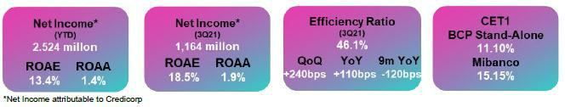

Economic activity registered growth of 11.8% YoY in August, standing above pre-pandemic levels. The August 2021 level was 1.6% higher than the level reported in August 2019. Activity in the construction sector reported a particularly noteworthy expansion of 18% versus its August 2019 level. This recovery was driven primarily by the country’s strong macroeconomic fundamentals, which allowed the government to implement very expansive monetary and fiscal policies. This was accompanied by a favorable international environment, where copper prices stood at high levels. Additionally, the sanitary crisis has improved significantly, mortality rates have dropped, and the vaccination program is advancing. Currently, 81% of adults over the age of 18 have received at least one dose, and 65%, both doses.

Loan Growth

Growth QoQ, YoY and 9M YoY in loans was driven, to a significant extent, by the exchange rate. If we exclude this effect, structural loans grew 5.0% QoQ, 3.5%
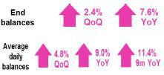

YoY, and 0.1% 9M YoY. This evolution was primarily attributable to loan growth in Wholesale Banking.

Net Interest Income and Margin

QoQ, NII rose due to an increase in active interest rates and growth in structural loans. This was slightly offset by the funding mix effect in a context marked by a decline in government loans and an uptick in debt obligations, which impact in interest expense was higher than the positive effect generated by the increase in low-cost deposits.
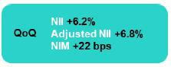

YoY, NII increased due to a reduction in interest expenses. This evolution was attributable to high expenses last year through a large liability management transaction at BCP Stand-alone; a drop in market rates; and an uptick in balances of low-cost deposits in a context of excess liquidity due to government relief measures. A recovery in loan volumes and in the average investment volume also contributed, although to a lesser extent, to growth in NII.
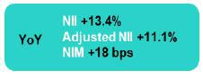

YTD, NII reflects lower interest expense due to the same drivers as those explained for the YoY evolution. This was partially offset by a decrease in interest income from lower volumes of structural loan and a drop in active interest rates.
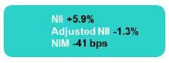

Net provisions for loan losses and Portfolio Quality

Provisions fell QoQ, driven by an improvement in payment behavior at BCP Stand-alone and Mibanco. This was partially offset by an increase in provisions at Mibanco, which was attributable to changes in write-off policies. YoY and YTD, the drop in provisions was driven by improvements in payment behavior and economic reactivation.
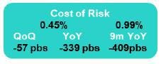

The NPL ratio deteriorated QoQ due to grace period expirations in the Government Loan Portfolio. If we consider only the structural loans, NPL shows an improvement of 78bps. YoY, the ratio increased for both the structural and government loan portfolios, in a context marked by grace period expirations.
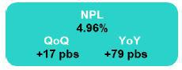

4

Core Other Income

Expansion in Core Other income was driven by growth in fees at BCP after consumption in establishments rose and interbank and international transfers increased and stood at pre-pandemic levels.
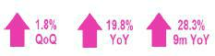

Other Income

Growth was mainly attributable to the factors outlined above. In the case of YoY and 9M YoY, results were partially offset by a drop in non-core Other income due to a loss reported in the net gain on securities following the sale of sovereign bonds at BCP.
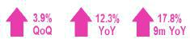

Underwriting Result

The underwriting result was positive, which was driven by a drop in claims in Life after Covid-related mortality dropped and the vaccination rate rose. An improvement this quarter was also driven by growth in premiums across business lines.

Operating Efficiency

The efficiency ratio was situated at 46.1%, which reflected deterioration of 240bps QoQ and 110bps YoY due to growth in expenses for digital transformation and disruptive initiatives at BCP Stand-alone. In the accumulated analysis, ithe ratio improved 120bps due to an uptick in income.

Net Income at Credicorp and Contribution by Business Line

Contribution* and ROAE by subsidiary in 3Q21 (S/ millions)

Credicorp Consolidated: Net Income of S/1,164 million, ROAE of 18.5%
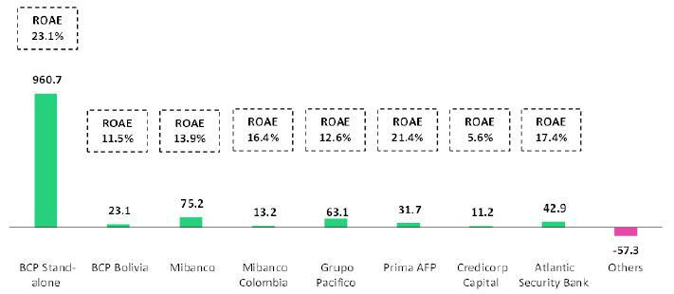

*Contributions to Credicorp reflect the eliminations for consolidation purposes (eliminations for transactions among Credicorp’s subsidiaries or between Credicorp and its subsidiaries).

- In Mibanco, the figure is lower than the net income because Credicorp owns 99.921% of Mibanco (directly and indirectly). ROAE including goodwill of BCP from the acquisition of Edyficar (Approximately US$ 50.7 million) was 33.2% in 3Q20, 9.7% in 2Q21 and 13.1% in 3Q21. YTD was -26.4% for September 2020 and 8.4% for September 2021.

- In Grupo Pacifico, the contribution is higher than the net income because Credicorp owns 65.20% directly, and 33.57% through Grupo Credito. Figures include unrealized gains or losses that are considered in Pacifico’s Net Equity from the investment portfolio of Pacifico Vida. ROAE excluding such unrealized gains was 2.5% in 3Q20, -32.6% in 2Q21 and 13.3% in 3Q21. YTD was 10.5% for September 2020 and -12.0% for September 2021.
- Others includes Grupo Credito excluding Prima (Servicorp and Emisiones BCP Latam), others of Atlantic Security Holding Corporation and others of Credicorp Ltd.

5

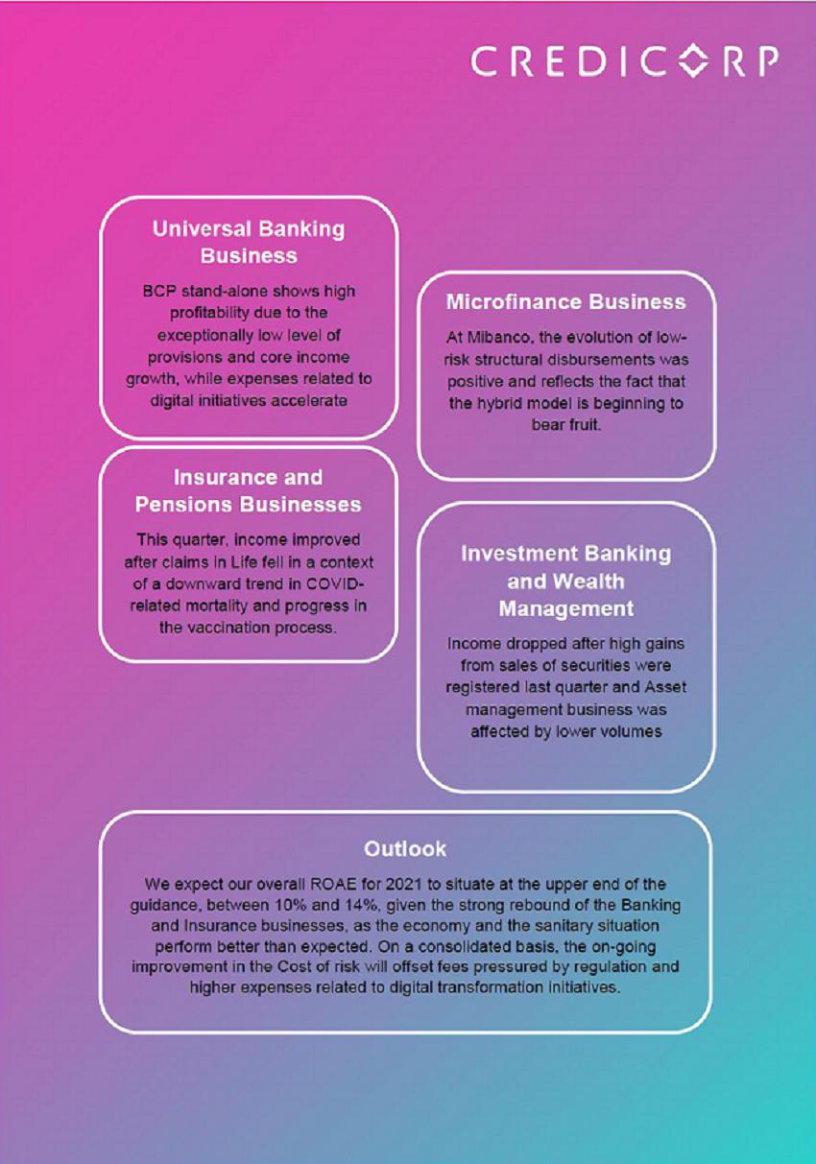

Overview Financial Information: Third Quarter 2021

Credicorp Ltd. |  |  |  | Quarter |  |  |  | % change |  |  |  |  | YTD |  |  |  |  | % change
S/ 000 |  | 3Q20 |  | 2Q21 |  | 3Q21 |  | QoQ |  |  | YoY |  | Sep 20 |  |  | Sep 21 |  | Sep 21 / Sep 20
Net interest, similar income and expenses |  | 2,161,905 |  | 2,309,042 |  | 2,451,708 |  | 6.2% |  |  | 13.4% |  | 6,502,782 |  |  | 6,884,133 |  | 5.9%
Provision for credit losses on loan portfolio,
net of recoveries |  | (1,305,905) |  | (363,380) |  | (164,414) |  | -54.8% |  |  | -87.4% |  | (5,187,843) |  |  | (1,085,441) |  | -79.1%
Net interest, similar income and
expenses, after provision for credit losses |  | 856,000 |  | 1,945,662 |  | 2,287,294 |  | 17.6% |  |  | 167.2% |  | 1,314,939 |  |  | 5,798,692 |  | 341.0%
on loan portfolio |  |  |  | 1,945,662
Total other income |  | 1,102,766 |  | 1,191,694 |  | 1,238,683 |  | 3.9% |  |  | 12.3% |  | 3,076,684 |  |  | 3,624,907 |  | 17.8%
Insurance underwriting result |  | (4,340) |  | (136,335) |  | 70,204 |  | n.a. |  |  | n.a. |  | 273,266 |  |  | (131,378) |  | -148.1%
Total other expenses |  | (1,802,009) |  | (1,860,447) |  | (1,977,794) |  | 6.3% |  |  | 9.8% |  | (5,209,713) |  |  | (5,518,512) |  | 5.9%
Profit (loss) before income tax |  | 152,417 |  | 1,140,574 |  | 1,618,387 |  | 41.9% |  |  | 961.8% |  | (544,824) |  |  | 3,773,709 |  | n.a.
Income tax |  | (55,829) |  | (423,491) |  | (428,037) |  | 1.1% |  |  | 666.7% |  | 213,151 |  |  | (1,189,127) |  | n.a.
Net profit (loss) |  | 96,588 |  | 717,083 |  | 1,190,350 |  | 66.0% |  |  | 1132.4% |  | (331,673) |  |  | 2,584,582 |  | n.a.
Non-controlling interest |  | (8,018) |  | 17,614 |  | 26,651 |  | 51.3% |  |  | n.a. |  | (25,163) |  |  | 60,616 |  | n.a.
Net profit (loss) attributable to Credicorp |  | 104,606 |  | 699,469 |  | 1,163,699 |  | 66.4% |  |  | 1012.5% |  | (306,510) |  |  | 2,523,966 |  | n.a.
Net profit (loss) / share (S/) |  | 1.31 |  | 8.77 |  | 14.59 |  | 66.4% |  |  | 1012.5% |  | (3.84) |  |  | 31.64 |  | n.a.
Loans |  | 136,148,711 |  | 143,091,752 |  | 146,551,226 |  | 2.4% |  |  | 7.6% |  | 136,148,711 |  |  | 146,551,226 |  | 7.6%
Deposits and obligations |  | 137,202,674 |  | 149,161,803 |  | 152,548,368 |  | 2.3% |  |  | 11.2% |  | 137,202,674 |  |  | 152,548,368 |  | 11.2%
Net equity |  | 23,594,717 |  | 25,073,706 |  | 25,192,570 |  | 0.5% |  |  | 6.8% |  | 23,594,717 |  |  | 25,192,570 |  | 6.8%
Profitability
Net interest margin |  | 4.05% |  | 4.01% |  | 4.23% |  | 22bps |  |  | 18bps |  | 4.41% |  |  | 4.00% |  | -41bps
Risk-adjusted Net interest margin |  | 1.60 % |  | 3.38 % |  | 3.95 % |  | 57bps |  |  | 235bps |  | 0.89% |  |  | 3.37% |  | 248bps
Funding cost |  | 1.74 % |  | 1.18 % |  | 1.21 % |  | 3bps |  |  | -53bps |  | 1.90% |  |  | 1.28% |  | -62bps
ROAE |  | 1.8 % |  | 11.3 % |  | 18.5 % |  | 720bps |  |  | 1670bps |  | -1.6% |  |  | 13.4% |  | 1500bps
ROAA |  | 0.2 % |  | 1.1 % |  | 1.9 % |  | 80bps |  |  | 170bps |  | -0.2% |  |  | 1.4% |  | 160bps
Loan portfolio quality
Internal overdue ratio ⁽¹⁾ |  | 3.04 % |  | 3.53 % |  | 3.73 % |  | 20bps |  |  | 69bps |  | 3.04% |  |  | 3.73% |  | 69bps
Internal overdue ratio over 90 days |  | 2.53 % |  | 2.67 % |  | 2.76 % |  | 9bps |  |  | 23bps |  | 2.53% |  |  | 2.76% |  | 23bps
NPL ratio ⁽²⁾ |  | 4.17 % |  | 4.79 % |  | 4.96 % |  | 17bps |  |  | 79bps |  | 4.17% |  |  | 4.96% |  | 79bps
Cost of risk ⁽³⁾ |  | 3.84 % |  | 1.02 % |  | 0.45 % |  | -57bps |  |  | -339bps |  | 5.08% |  |  | 0.99% |  | -409bps
Coverage ratio of IOLs |  | 233.1 % |  | 185.8 % |  | 165.8 % |  | -2000bps |  |  | -6730bps |  | 233.1% |  |  | 165.8% |  | -6730bps
Coverage ratio of NPLs |  | 169.9 % |  | 137.0% |  | 124.8 % |  | -1220bps |  |  | -4510bps |  | 169.9% |  |  | 124.8% |  | -4510bps
Operating efficiency
Efficiency ratio ⁽⁴⁾ |  | 45.0 % |  | 43.7 % |  | 46.1 % |  | 240bps |  |  | 110bps |  | 45.9% |  |  | 44.7% |  | -120bps
Operating expenses / Total average assets |  | 2.93% |  | 2.96 % |  | 3.20% |  | 24bps |  |  | 27bps |  | 3.17% |  |  | 3.00% |  | -20bps
Insurance ratios
Combined ratio of P&C ⁽⁵⁾ ⁽⁶⁾ |  | 84.8 % |  | 88.9 % |  | 94.1 % |  | 520bps |  |  | 930bps |  | 84.8% |  |  | 94.1% |  | 930bps
Loss ratio ⁽⁶⁾ |  | 86.0% |  | 107.4 % |  | 76.5 % |  | -3090bps |  |  | -950bps |  | 86.0% |  |  | 76.5% |  | -950bps
Capital adequacy - BCP Stand-alone ⁽⁷⁾
BIS ratio ⁽⁸⁾ |  | 15.39% |  | 15.34 % |  | 15.16 % |  | -18bps |  |  | -23bps |  | 15.39% |  |  | 15.16% |  | -23bps
Tier 1 ratio ⁽⁹⁾ |  | 10.70 % |  | 10.31 % |  | 10.00 % |  | -31bps |  |  | -70bps |  | 10.70% |  |  | 10.00% |  | -70bps
Common equity tier 1 ratio ⁽¹⁰⁾ |  | 11.45 % |  | 11.23 % |  | 11.10 % |  | -13bps |  |  | -35bps |  | 11.45% |  |  | 11.10% |  | -35bps
Capital adequacy - Mibanco ⁽⁷⁾
BIS ratio ⁽⁸⁾ |  | 17.69 % |  | 17.22 % |  | 16.79 % |  | -43bps |  |  | -90bps |  | 17.69% |  |  | 16.79% |  | -90bps
Tier 1 ratio ⁽⁹⁾ |  | 15.47 % |  | 14.66 % |  | 14.30 % |  | -36bps |  |  | -117bps |  | 15.47% |  |  | 14.30% |  | -117bps
Common equity tier 1 ratio ⁽¹⁰⁾ |  | 16.22% |  | 15.26% |  | 15.15 % |  | -11bps |  |  | -107bps |  | 16.22% |  |  | 15.15% |  | -107bps
Employees |  | 37,572 |  | 35,776 |  | 35,733 |  | -0.1% |  |  | -4.9% |  | 37,572 |  |  | 35,733 |  | -4.9%
Share Information
Issued Shares |  | 94,382 |  | 94,382 |  | 94,382 |  | 0.0% |  |  | 0.0% |  | 94,382 |  |  | 94,382 |  | 0.0%
Treasury Shares ⁽¹¹⁾ |  | 14,977 |  | 14,866 |  | 14,866 |  | 0.0% |  |  | -0.7% |  | 14,977 |  |  | 14,866 |  | -0.7%
Outstanding Shares |  | 79,405 |  | 79,516 |  | 79,516 |  | 0.0% |  |  | 0.1% |  | 79,405 |  |  | 79,516 |  | 0.1%

- Internal overdue loans includes overdue loans and loans under legal collection, according to our internal policy for overdue loans. Internal Overdue ratio: Internal overdue loans / Total loans.
- Non-performing loans (NPL): Internal overdue loans + Refinanced loans. NPL ratio: NPL / Total loans.

- Cost of risk: Annualized provision for loan losses, net of recoveries / Total loans.

- Efficiency ratio = (Salaries and employee benefits + Administrative expenses + Depreciation and amortization + Association in participation + Acquisition cost) / (Net interest, similar income and expenses + Fee Income + Net gain on foreign exchange transaction + Net Gain From associates + Net gain on derivatives held for trading + Result on exchange differences + Net Premiums Earned).

- Combined ratio = (Net claims / Net earned premiums) + [(Acquisition cost + Operating expenses) / Net earned premiums]. Does not include Life insurance business.
- Considers Grupo Pacifico's figures before eliminations for consolidation to Credicorp.

- All Capital ratios are for BCP Stand-alone and based on Peru GAAP.

- Regulatory Capital / Risk-weighted assets (legal minimum = 10% since July 2011).

- Tier 1 = Capital + Legal and other capital reserves + Accumulated earnings with capitalization agreement + (0.5 x Unrealized profit and net income in subsidiaries) - Goodwill - (0.5 x Investment in subsidiaries) + Perpetual subordinated debt (maximum amount that can be included is 17.65% of Capital + Reserves + Accumulated earnings with capitalization agreement + Unrealized profit and net income in subsidiaries - Goodwill).
- Common Equity Tier I = Capital + Reserves – 100% of applicable deductions (investment in subsidiaries, goodwill, intangibles and net deferred taxes that rely on future profitability) + retained earnings + unrealized gains.
Adjusted Risk-Weighted Assets = Risk-weighted assets - (RWA Intangible assets, excluding goodwill, + RWA Deferred tax assets generated as a result of temporary differences in income tax, in excess of 10% of CET1, + RWA Deferred tax assets generated as a result of past losses)."
- These shares are held by Atlantic Security Holding Corporation (ASHC) and for shared based payments.

7



1. Interest-earning assets (IEA)
Interest earning assets |  |  |  | As of |  |  |  | % change
S/ 000 |  | Sep 20 |  | Jun 21 |  | Sep 21 |  | QoQ |  |  | YoY
Cash and due from banks |  | 28,219,512 |  | 29,058,684 |  | 36,137,443 |  | 24.4% |  |  | 28.1%
Interbank funds |  | 2,031 |  | 16,790 |  | 9,782 |  | -41.7% |  |  | 381.6%
Total investments |  | 51,648,986 |  | 54,772,644 |  | 48,110,456 |  | -12.2% |  |  | -6.9%
Cash collateral, reverse repurchase agreements and securities
borrowing |  | 2,821,116 |  | 1,616,654 |  | 2,555,337 |  | 58.1% |  |  | -9.4%
Financial assets designated at fair value through profit or loss |  | 729,059 |  | 921,851 |  | 981,508 |  | 6.5% |  |  | 34.6%
Total loans |  | 136,148,711 |  | 143,091,752 |  | 146,551,226 |  | 2.4% |  |  | 7.6%
Total interest earning assets |  | 219,569,415 |  | 229,478,375 |  | 234,345,752 |  | 2.1 | % |  | 6.7 | %

1.1. Structure and Evolution of IEA

IEA composition
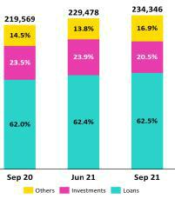

At the end of September 2021, loans, our most profitable asset, represented 62.5% of IEAs, followed by investments with 20.5% and other assets¹ with 16.9%. IEAs increased +2.1% QoQ and +6.7% YoY thanks to loan growth.

Loans continued to increase their share of total IEAs, spurred by structural disbursements and the exchange rate effect, while government loans (GP) continued to post a decrease in their share of the IEA structure. The share of government loans within total IEAs fell from 11.1% in Sept-20 to 10.0% in June-21 and 9.0% in Sept-21. Structural loans, in turn, registered a share of 51.0% of total IEAs in Sept-20; 52.3% in June-21; and 53.6% in Sept-21.

The share of investments of total IEAs fell while that of liquid assets increased, because of the expiration of certificate of deposits, which were not renewed.

Total Loans (Quarter-end Balances)

It is important to note that both the QoQ and YoY increases in loans was largely attributable to an exchange rate effect, which was fueled by the +7.2% and +14.9% appreciation of the US Dollar against the Sol QoQ and YoY respectively.

QoQ, loans in quarter-end balances increased +2.4% and structural loans, +4.5%. Both of these metrics were driven by the exchange rate effect. If we exclude the effect, total loans grew +0.1% QoQ and structural loans, 1.7%. The aforementioned was driven by:

- Structural growth was led by Wholesale Banking at BCP Stand-alone and was spurred by economic reactivation and financing demand from the corporate segment.

- Growth in the structural portfolio of Retail Banking was driven primarily by the SME-Business and SME-Pyme segments and secondarily by the Mortgage segment.

- Mibanco’s portfolio reported a structural increase of +4.1%. This was fueled by an uptick in disbursements, which topped pre-pandemic levels this quarter.

GP loans in quarter-end balances fell -8.6% QoQ.

Similar to the quarterly evolution, total loans measured in quarter-end balances in YoY terms rose +7.6% while structural loans expanded +12.2% due to an increase in the exchange rate. If we exclude the exchange rate effect, total loans grew +2.8% and structural loans, +6.3%. This was attributable to:

- Growth in the Wholesale Banking portfolio, which was driven by an uptick in disbursements due to: a reactivation of internal demand and a subsequent increase in financing demand; and the impulse provided by the fishing and agricultural campaigns that began at the end of 2Q21.

- Includes Cash and Due from Banks; Interbank Funds; Cash Collateral,reverse repurchase agreements, and securities borrowings, and Financial Assets designated at fair value through profit or loss.

9

- Growth in the Retail Banking portfolio, which was led primarily by Mortgage and secondarily by SME-Business, SME-Pyme and Consumer. The Credit Card segment registered a decrease in loan balances.

- Growth of 13.5% in the Mibanco portfolio, which continued to follow an upward trend to top the disbursement levels reported pre-pandemic this quarter.

GP loans fell -13.4% YoY.
Total Investments
Total Investments |  |  |  | As of |  |  |  | % change
S/ 000 |  | Sep 20 |  | Jun 21 |  | Sep 21 |  | QoQ |  |  | YoY
Fair value through profit or loss investments |  | 6,658,680 |  | 6,791,288 |  | 6,660,487 |  | -1.9% |  |  | 0.0%
Fair value through other comprehensive income investments |  | 40,712,831 |  | 40,273,400 |  | 33,262,618 |  | -17.4% |  |  | -18.3%
Amortized cost investments |  | 4,277,475 |  | 7,707,956 |  | 8,187,351 |  | 6.2% |  |  | 91.4%
Total investments |  | 51,648,986 |  | 54,772,644 |  | 48,110,456 |  | -12.2 | % |  | -6.9 | %

Total investments fell -12.2% QoQ and -6.9% YoY. Both results were driven by a strategy to reduce exposure to interest rate movements by selling investments in the 2Q21, and to expirations of certificate of deposits in the 3Q21, which were not renewed.

Other IEA

Available funds increased 24.4% QoQ and 28.1% YoY. This evolution was attributable to an influx of cash driven by (i) expirations of certificates of deposits that were not subsequently renewed and (ii) growth in deposits after clients withdrew savings from pensions funds.

1.2. Credicorp Loans

1.2.1. Evolution of loans in average daily balances (ADB)

The ADB of loans show growth of +4.8% QoQ and +9.0% YoY. Similar to the scenario described above for quarter-end balances, the most significant driver of growth was the uptick in the exchange rate. This impacted the most dollarized portfolios such as Wholesale Banking, and businesses such as Mibanco Colombia and BCP Bolivia, which make disbursements in FC.

If we exclude the exchange rate effect, QoQ growth in structural loans was mainly attributable to the evolution of Wholesale Banking and YoY, to an increase in balances in the Middle Market, Mortgage, SME-Pyme and Consumer segments at BCP Stand-alone and to growth in balances at Mibanco.

ADB balances provide the most complete picture of how loan interest, which constitutes Credicorp’s primary source of income, has evolved. Additionally, average daily balances reflect trends or variations to a different degree than quarter-end balances which may include pre-payments or loans made at the end of the quarter. In comparative terms, these payments, affect average daily balances less than quarter-end balances and as such, the former provide a more balanced picture of loan evolution.

It is important to note that structural loans registered higher growth than total loans QoQ, which reflects the gradual amortization of government loans.

10

Evolution of loans in ADB by business segment ⁽¹⁾⁽²⁾

 |  |  |  |  | TOTAL LOANS |  |  |  |  |  |  |  |  |  |  |  |  |  | % change
 | Expressed in million S/ |  |  |  |  |  |  |  | Structural |  |  |  |  | % change |  |  |  |  | Structural |  |  |  | % Part. in total loans |  |  |  |  |  | Structural
 | 3Q20 |  | 2Q21 |  | 3Q21 |  | 3Q20 |  |  | 2Q21 |  | 3Q21 |  | QoQ |  | YoY |  |  | QoQ |  | YoY |  | 3Q20 |  | 2Q21 |  | 3Q21 |  | 3Q21
BCP Stand-alone | 111,385 |  | 114,614 |  | 120,754 |  | 93,444 |  |  | 93,595 |  | 101,515 |  | 5.4% |  | 8.4% |  |  | 8.5% |  | 8.6% |  | 82.9% |  | 82.0% |  | 82.5% |  | 81.5%
Wholesale Banking | 54,838 |  | 51,862 |  | 57,863 |  | 48,330 |  | 46,067 |  |  | 53,080 |  | 11.6% |  | 5.5% |  |  | 15.2% |  | 9.8% |  | 40.8% |  | 37.1% |  | 39.5% |  | 42.6%
Corporate | 31,448 |  | 28,869 |  | 32,642 |  | 30,626 |  | 28,288 |  |  | 32,147 |  | 13.1% |  | 3.8% |  |  | 13.6% |  | 5.0% |  | 23.4% |  | 20.7% |  | 22.3% |  | 25.8%
Middle - Market | 23,389 |  | 22,993 |  | 25,221 |  | 17,704 |  | 17,780 |  |  | 20,933 |  | 9.7% |  | 7.8% |  |  | 17.7% |  | 18.2% |  | 17.4% |  | 16.5% |  | 17.2% |  | 16.8%
Retail Banking | 56,547 |  | 62,752 |  | 62,891 |  | 45,113 |  | 47,528 |  |  | 48,434 |  | 0.2% |  | 11.2% |  |  | 1.9% |  | 7.4% |  | 42.1% |  | 44.9% |  | 43.0% |  | 38.9%
SME - Business | 10,014 |  | 11,279 |  | 11,400 |  | 4,574 |  | 4,866 |  |  | 5,524 |  | 1.1% |  | 13.8% |  |  | 13.5% |  | 20.8% |  | 7.5% |  | 8.1% |  | 7.8% |  | 4.4%
SME - Pyme | 16,062 |  | 19,647 |  | 19,626 |  | 10,068 |  | 10,836 |  |  | 11,046 |  | -0.1% |  | 22.2% |  |  | 1.9% |  | 9.7% |  | 12.0% |  | 14.1% |  | 13.4% |  | 8.9%
Mortgage | 16,816 |  | 17,884 |  | 18,133 |  | 16,816 |  | 17,884 |  |  | 18,133 |  | 1.4% |  | 7.8% |  |  | 1.4% |  | 7.8% |  | 12.5% |  | 12.8% |  | 12.4% |  | 14.6%
Consumer | 9,018 |  | 10,076 |  | 10,000 |  | 9,018 |  | 10,076 |  |  | 10,000 |  | -0.8% |  | 10.9% |  |  | -0.8% |  | 10.9% |  | 6.7% |  | 7.2% |  | 6.8% |  | 8.0%
Credit Card | 4,637 |  | 3,866 |  | 3,731 |  | 4,637 |  | 3,866 |  |  | 3,731 |  | -3.5% |  | -19.5% |  |  | -3.5% |  | -19.5% |  | 3.5% |  | 2.8% |  | 2.5% |  | 3.0%
Mibanco | 11,593 |  | 13,023 |  | 13,082 |  | 9,729 |  | 10,232 |  |  | 10,428 |  | 0.5% |  | 12.8% |  |  | 1.9% |  | 7.2% |  | 8.6% |  | 9.3% |  | 8.9% |  | 8.4%
Mibanco Colombia | 788 |  | 963 |  | 1,047 |  | 788 |  | 963 |  |  | 1,047 |  | 8.8% |  | 32.9% |  |  | 8.8% |  | 32.9% |  | 0.6% |  | 0.7% |  | 0.7% |  | 0.8%
Bolivia | 8,149 |  | 8,747 |  | 9,408 |  | 8,149 |  | 8,747 |  |  | 9,408 |  | 7.6% |  | 15.5% |  |  | 7.6% |  | 15.5% |  | 6.1% |  | 6.3% |  | 6.4% |  | 7.6%
ASB | 2,438 |  | 2,390 |  | 2,122 |  | 2,438 |  | 2,390 |  |  | 2,122 |  | -11.2% |  | -13.0% |  |  | -11.2% |  | -13.0% |  | 1.8% |  | 1.7% |  | 1.4% |  | 1.7%
BAP's total loans | 134,353 |  | 139,736 |  | 146,413 |  | 114,547 |  |  | 115,927 |  | 124,520 |  | 4.8 | % | 9.0 | % |  | 7.4 | % | 8.7 | % | 100.0 | % | 100.0 | % | 100.0 | % | 100.0 | %



Largest contraction in volumes
Highest growth in volumes

For consolidation purposes, loans generated in FC are converted to LC.

- Structural Portfolio excludes the average daily balances from loans offered through de Reactiva Peru y FAE-Mype Government Programs.

- Figures differ from previously reported.

QoQ loan growth in ADB by segment

Expressed in millions of S/

+4.8% (+7.4% Structural Portfolio)
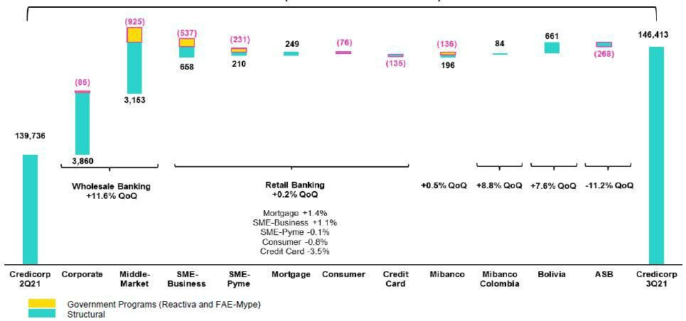

The figure above shows an increase of +4.8% QoQ (+7.4% structural) of loans measured in quarter-end balances; growth in both cases was driven by the exchange rate effect. If we exclude this effect, total loans grew +2.8% and structural loans, +5.0%. The structural variation was due to the following, in order of magnitude of impact:

- Growth in the Wholesale Loan portfolio due to an increase in structural balances in the Corporate segment and, to a lesser extent, to growth in the Middle Market segment. Expansion was primarily driven by economic recovery and by the increase in financing demand in these segments.

- Growth in Retail Banking, where SME-Business made the highest contribution to portfolio growth, followed by SME-Pyme and Mortgage.

- Credit Card and Consumer loan balances fell QoQ due to a decrease in the dynamism of these segments and to the fact that clients have used liquidity to reduce their balances.

- Growth at Mibanco, where balances hit levels this quarter that topped those seen pre-pandemic. Mibanco Colombia resumed growth and registered record-highs for disbursements after having frozen disbursements in 2Q21 in a context of rising social tensions.

GP fell -8.0% QoQ.

11

YoY loan growth in ADB by segment

Expressed in millions of S/

+9.0% (+8.7% Structural Portfolio)
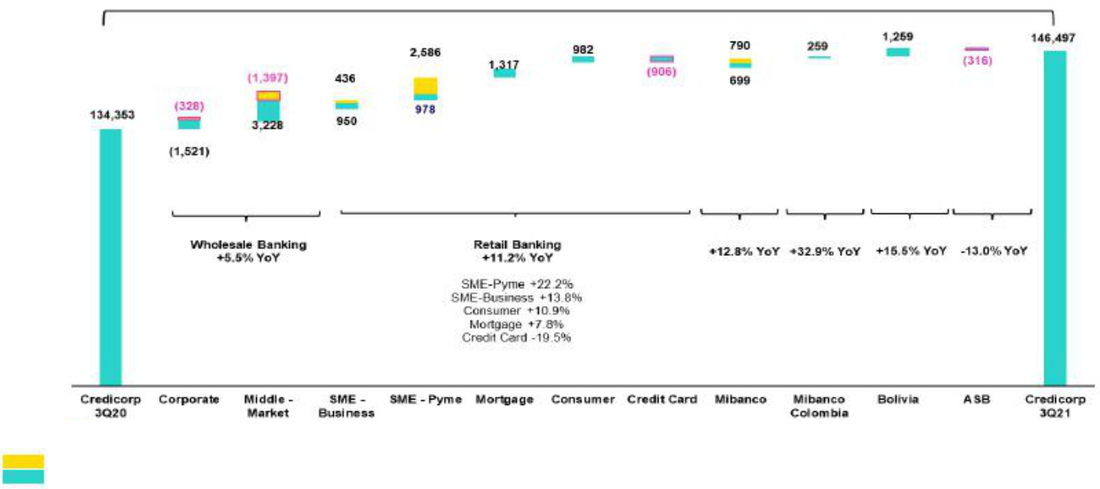

Government Programs (Reactiva and FAE-Mype)

Structural

YoY growth was also impacted by a depreciation in LC. If we exclude the exchange rate effect and government loans from the calculation base, total loans increased +4.5% and structural loans, +3.5%. The structural evolution was attributable to:

- Growth in the Retail Banking portfolio, which was led Mortgage segment followed by SME-Pyme, Consumer and SME-Business. The dynamism of Retail Banking was partially offset by a decrease in Credit Card balances, which were adversely affected by the sanitary crisis; contention measures; a decrease in the appetite for risk; and the fact that clients used their liquidity to pay down balances in this segment.

- Growth in the Wholesale Banking portfolio, which registered an improvement in Middle Market banking that was offset by a reduction in Corporate banking, whose clients had taken advantage of low rates in 2020 and are paying off these loans.

- Growth in Mibanco loans, in a scenario marked by on-going recovery in structural loans, which topped pre-pandemic levels in 3Q21. Mibanco Colombia’s portfolio grew 17.0% YoY, which was attributable to an uptick in disbursements and structural increase in productivity after social tensions eased and the confidence level of economic agents improved.

Loan growth in ADB (9 months) by segment

Expressed in millions of S/

+11.4% (+0.2% Structural Portfolio)
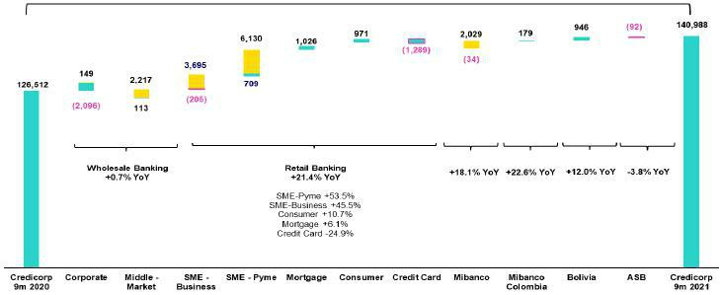

Government Programs (Reactiva and FAE-Mype)
Structural

12

Growth in ADB (9 months) of +11.4% was primarily driven by government loans and by the exchange rate effect created by the depreciation of the Sol. The Mortgage and Consumer segments also contributed to this growth. Similar to the scenario seen in the YoY analysis, the Corporate Banking and the Credit Card segments registered the most significant drop in balances given that clients leveraged higher liquidity levels and funds from government relief programs to amortize financial obligations.

1.2.2. Evolution of the loan dollarization level at Credicorp by segment

Evolution of average daily loan balances by currency ⁽¹⁾⁽²⁾

 |  |  | DOMESTIC CURRENCY LOANS |  |  |  |  |  |  |  |  |  |  |  |  |  |  |  |  |  | % change |  |  |  |  |  |  | FOREIGN CURRENCY LOANS |  |  |  |  |  |  |  |  |  | % part. by currency
 | Expressed in million S/ |  |  |  |  |  |  |  | Structural |  |  |  |  | % change |  |  |  |  |  |  | Structural |  |  |  |  |  |  |  | Expressed in million US$ |  |  |  |  |  |  |  |  |  | 3Q21
 | 3Q20 |  | 2Q21 |  | 3Q21 |  | 3Q20 |  | 2Q21 |  | 3Q21 |  |  | QoQ |  |  | YoY |  |  |  | QoQ |  |  | YoY |  |  | 3Q20 |  | 2Q21 |  | 3Q21 |  | QoQ |  | YoY |  |  | LC |  |  | FC
BCP Stand-
alone | 78,056 |  | 80,960 |  | 83,442 |  | 60,115 |  | 59,941 |  | 64,202 |  | 3.1% |  |  | 6.9% |  |  |  | 7.1% |  |  |  | 6.8% |  | 9,375 |  | 8,805 |  |  | 9,135 |  | 3.8% |  | -2.6% |  | 69.1% |  |  |  | 30.9%
Wholesale
Banking | 28,201 |  | 25,860 |  | 28,562 |  | 21,694 |  | 20,065 |  | 23,779 |  | 10.4% |  |  | 1.3% |  |  |  | 18.5% |  |  |  | 9.6% |  | 7,493 |  | 6,803 |  |  | 7,173 |  | 5.4% |  | -4.3% |  | 49.4% |  |  |  | 50.6%
Corporate | 14,204 |  | 12,572 |  | 14,771 |  | 13,381 |  | 11,990 |  | 14,276 |  | 17.5% |  |  | 4.0% |  |  |  |  | 19.1% |  |  | 6.7% |  | 4,851 |  | 4,264 |  |  | 4,375 |  | 2.6% |  | -9.8% |  | 45.3% |  |  |  | 54.7%
Middle-
Market | 13,997 |  | 13,288 |  | 13,791 |  | 8,313 |  | 8,074 |  | 9,503 |  | 3.8% |  |  |  | -1.5% |  |  |  | 17.7% |  |  | 14.3% |  | 2,642 |  | 2,539 |  |  | 2,798 |  | 10.2% |  | 5.9% |  | 54.7% |  |  |  | 45.3%
Retail
Banking | 49,855 |  | 55,100 |  | 54,880 |  | 38,421 |  | 39,876 |  | 40,423 |  | -0.4% |  |  | 10.1% |  |  |  | 1.4% |  |  |  | 5.2% |  | 1,882 |  | 2,002 |  |  | 1,962 |  | -2.0% |  | 4.2% |  | 87.3% |  |  |  | 12.7%
SME -
Business | 7,545 |  | 8,284 |  | 8,076 |  | 2,105 |  | 1,871 |  | 2,199 |  | -2.5% |  |  | 7.0% |  |  |  | 17.6% |  |  |  | 4.5% |  | 694 |  | 783 |  |  | 815 |  | 4.1% |  | 17.4% |  | 70.8% |  |  |  | 29.2%
SME -
Pyme | 15,862 |  | 19,463 |  | 19,441 |  | 9,868 |  | 10,653 |  | 10,861 |  | -0.1% |  |  |  | 22.6% |  |  | 2.0% |  |  |  | 10.1% |  | 56 |  | 48 |  |  | 45 |  | -5.5% |  | -19.4% |  | 99.1% |  |  |  | 0.9%
Mortgage | 14,673 |  | 15,722 |  | 15,960 |  | 14,673 |  | 15,722 |  | 15,960 |  | 1.5% |  |  |  | 8.8% |  |  | 1.5% |  |  |  | 8.8% |  | 603 |  | 566 |  |  | 532 |  | -6.0% |  | -11.8% |  | 88.0% |  |  |  | 12.0%
Consumer | 7,717 |  | 8,491 |  | 8,469 |  | 7,717 |  | 8,491 |  | 8,469 |  | -0.3% |  |  | 9.7% |  |  |  | -0.3% |  |  |  | 9.7% |  | 366 |  | 415 |  |  | 375 |  | -9.7% |  | 2.4% |  | 84.7% |  |  |  | 15.3%
Credit
Card | 4,058 |  | 3,139 |  | 2,933 |  | 4,058 |  | 3,139 |  | 2,933 |  | -6.6% |  |  | -27.7% |  |  |  | -6.6% |  |  |  | -27.7% |  | 163 |  | 190 |  |  | 195 |  | 2.8% |  | 19.8% |  | 78.6% |  |  |  | 21.4%
Mibanco | 11,085 |  | 12,551 |  | 12,614 |  | 9,221 |  | 9,760 |  | 9,960 |  | 0.5% |  |  |  | 13.8% |  |  | 2.0% |  |  |  | 8.0% |  | 143 |  | 124 |  |  | 115 |  | -7.2% |  | -19.8% |  | 96.4% |  |  |  | 3.6%
Mibanco
Colombia | - |  | - |  | - |  | - |  | - |  | - |  | - |  |  | - |  |  |  | - |  |  |  | - |  | 221 |  | 252 |  |  | 256 |  | 1.7% |  | 15.6% |  | - |  |  |  | 100.0%
Bolivia | - |  | - |  | - |  | - |  | - |  | - |  | - |  |  | - |  |  |  | - |  |  |  | - |  | 2,292 |  | 2,289 |  |  | 2,302 |  | 0.6% |  | 0.5% |  | - |  |  |  | 100.0%
ASB | - |  | - |  | - |  | - |  | - |  | - |  | - |  |  | - |  |  |  | - |  |  |  | - |  | 686 |  | 626 |  |  | 519 |  | -17.0% |  | -24.3% |  | - |  |  |  | 100.0%
Total loans |  |  |  |  |  |  |  |  |  |  |  |  |  |  | % |  |  | % |  |  |  | % |  |  | % |  |  |  |  |  |  |  |  | % |  | % |  |  | % |  |  | %
Total loans | 89,141 |  | 93,511 |  | 96,056 |  | 69,336 |  | 69,701 |  | 74,162 |  | 2.7 |  | % |  | 7.8 | % |  | 6.4 |  | % |  | 7.0 | % | 12,717 |  | 12,095 |  |  | 12,328 |  | 1.9 | % | -3.1 | % |  | 65.6 | % |  | 34.4 | %

Largest contraction in volumes
Highest growth in volumes

For consolidation purposes, loans generated in FC are converted to LC.

- Structural Portfolio excludes the average daily balances from loans offered through de Reactiva Peru y FAE-Mype Government Programs.

- Figures differ from previously reported.

YoY evolution of the dollarization level by Credicorp segment ⁽¹⁾⁽²⁾⁽³⁾
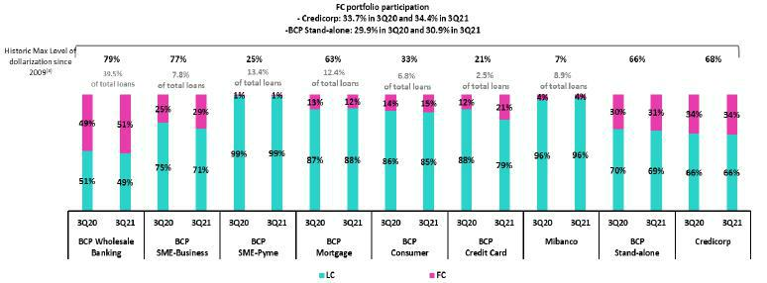

- Average daily balances.

- The FC share of Credicorp’s loan portfolio is calculated including BCP Bolivia and ASB, however the chart shows only the loan books of BCP Stand-alone and Mibanco.
- The year with the historic maximum level of dollarization for Wholesale Banking was 2012, for Mibanco was 2016, for Credit Card was in 2021 and for the rest of segments was
2009.

Portfolio dollarization levels were pressured upward by the exchange rate effect (depreciation in LC) and by amortizations of government loans. In particular, dollarization in the Credit Card segment increased throughout the pandemic and reached a record high this quarter in a context of diminishing loan balances in LC in this segment.

13



2. Funding Sources

2.1 Funding Structure
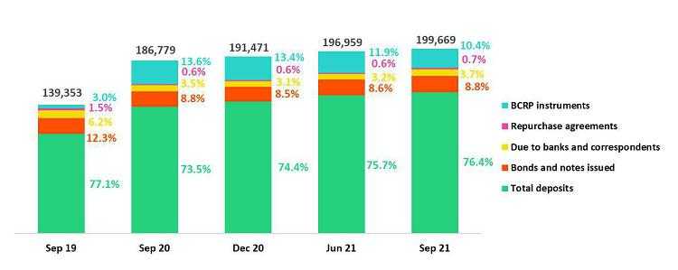

The level of total funding increased +1.4% QoQ. If we control for the |  | (iii) On-going reduction in the share of BCRP Instruments (10.4% vs
exchange rate effect, the level falls -1.9%. In terms of structure, the |  | 11.9% in 2Q21). This decrease was driven by amortizations of
following dynamics were of interest: |  | government program loans at BCP Stand-alone and Mibanco.
(i) | On-going growth in the share of Deposits in the funding structure | In the YoY analysis, total funding increased +6.9%. If we control for
 | (76.4% vs 75.7% in 2Q21); this level is close to that seen pre- | the exchange rate effect, the level increases +0.2%. Growth in the
 | pandemic. Growth in LC deposits and the depreciation of the Sol | share of deposits (76.4% vs 73.5%), which was driven by an
 | contributed to this result. | increase in personal liquidity via government facilities, was
 | The increase in the share of Due to banks and correspondents, | noteworthy. This was offset by a drop in BCRP Instruments
(ii) |  | (10.4% vs 13.6%), which was attributable to amortizations of
 | which rose from 3.2% in 2Q21 to 3.7% in 3Q21. This growth was | government program loans.
 | primarily attributable to new debt obligations at BCP Stand-alone to
 | offset outflows of funds from deposits to foreign accounts.

2.2. Deposits
Deposits |  |  |  | As of |  |  |  |  | % change
S/ 000 |  | Sep 20 |  | Jun 21 |  | Sep 21 |  | QoQ |  |  |  | YoY
Demand deposits |  | 53,574,151 |  | 59,998,764 |  | 61,112,084 |  |  | 1.9% |  |  | 14.1%
Saving deposits |  | 45,999,882 |  | 52,687,270 |  | 54,365,781 |  |  | 3.2% |  |  | 18.2%
Time deposits |  | 29,785,440 |  | 30,302,103 |  | 31,601,351 |  |  | 4.3% |  |  | 6.1%
Severance indemnity deposits |  | 7,127,617 |  | 5,456,510 |  | 4,681,224 |  |  | -14.2% |  |  | -34.3%
Interest payable |  | 715,584 |  | 717,156 |  | 787,928 |  |  | 9.9% |  |  | 10.1%
Total Deposits |  | 137,202,674 |  | 149,161,803 |  | 152,548,368 |  |  | 2.3 | % |  | 11.2 | %

Deposits expanded +2.3% QoQ. Notwithstanding, if we control for the exchange rate, we observe a contraction of -1.2%. The main drivers of these movements were:

- Growth in savings deposits, which expanded +3.2% QoQ (0.2% controlling for the exchange rate). This expansion primarily reflects an uptick in deposits in LC (after bi-yearly bonuses were paid) and a depreciation in the exchange rate. These effects offset the drop in FC deposits (expressed in US Dollars), which were affected by fund transfers abroad.

- Growth in time deposits of +4.3% (0.4% controlling for the exchange rate), which was driven by a depreciation in local currency and by growth in the deposits in FC (expressed in US Dollars). These effects offset the decrease in time deposits in LC.

- The increase in demand deposits, which grew +1.9% (-1.9% controlling for the exchange rate). The depreciation of the Sol and the increase in LC balances associated with withdrawals from pension funds largely offset the drop in FC balances (expressed in US Dollars).

15

- A significant drop in Severance Indemnity Deposits, after funds were freed up for withdrawal.

In YoY terms, total deposits grew +11.2% (+3.9% controlling for the exchange rate). The increase was primarily driven by savings and demand deposits and was attributable to: (i) depreciation in the sol; and (ii) facilities to draw down funds from Pension funds and Severance Indemnity accounts, which clients subsequently transferred to low-cost bank accounts.

2.2.1. Deposits: Dollarization Level

Total Deposits by Currency

(measured in quarter-end balances)

The share of FC deposits within total deposits rose from 50.2% in 2Q21 to 50.7% in 3Q21. This increase was attributable to the exchange rate effect and amply offset the decrease in time deposits in foreign currency expressed in US Dollars. Had the exchange rate remained constant, dollarization would have fallen to 49.0%.
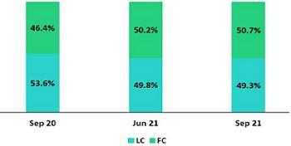

In the YoY analysis, the dollarization level increased, driven by the 14.9% depreciation in the Sol. If we exclude this effect, dollarization stands at 47.2% in FC.

Deposits by type and currency

(measured in quarter-end balances)

2.3. Other sources of funding
Other funding sources |  |  |  | As of |  |  |  |  | % change
S/ 000 |  | Sep 20 |  | Jun 21 |  | Sep 21 |  | QoQ |  |  |  | YoY
Due to banks and correspondents |  | 6,601,722 |  | 6,239,161 |  | 7,466,434 |  |  | 19.7% |  |  | 13.1%
BCRP instruments |  | 25,344,724 |  | 23,329,990 |  | 20,746,109 |  |  | -11.1% |  |  | -18.1%
Repurchase agreements |  | 1,204,487 |  | 1,276,678 |  | 1,330,811 |  |  | 4.2% |  |  | 10.5%
Bonds and notes issued |  | 16,425,832 |  | 16,951,481 |  | 17,577,630 |  |  | 3.7% |  |  | 7.0%
Total other funding sources |  | 49,576,765 |  | 47,797,310 |  | 47,120,984 |  |  | -1.4 | % |  | -5.0 | %

The total of Other Sources of Funding fell -1.4% QoQ. This evolution shows:

A drop in BCRP Instruments, mainly at BCP Stand-alone, due to amortization of government program loans.

An increase in Due to Banks and Correspondents, which was attributable to an increase in debt obligations at BCP Stand-alone after more loans were assumed with foreign financial institutions in FC to offset the effects of outflows of other sources of funding.

Growth in Bonds and Notes issued, which was primarily driven by the exchange rate effect given that 78% of the total balance is in FC. This increase was partially offset by expirations of corporate bonds.

Repurchase agreements registered a slight increase through new inter-bank repos at BCP Bolivia.

16

The YoY evolution registered a decrease of -5.0%, which was primarily attributable to a drop in the balance of BCRP Instruments at BCP Stand-alone -after clients amortized government program loans. This was partially offset by the exchange rate variation given the high balances of debt held in FC.

2.4. Loans / Deposits (L/D)

Loan/Deposit ratio by subsidiary

The L/D ratio at Credicorp remained stable QoQ.

As indicated in the figure to the left, the ratio increased slightly at BCP Stand-alone but fell at Mibanco.
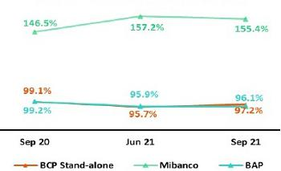

In YoY analysis, the L/D ratio at Credicorp and BCP Stand-alone fell slightly while Mibanco’s ratio increased.

Local Currency Foreign Currency
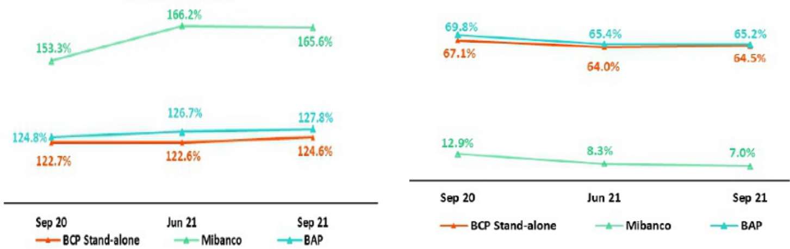

In the QoQ analysis by currency, the L/D ratio in LC at Credicorp and BCP Stand-alone registered slight growth but fell for Mibanco. The L/D ratio in FC fell somewhat at Credicorp and Mibanco but rose slightly at BCP Stand-alone. In the YoY analysis, Credicorp reported growth in the L/D ratio in LC at Credicorp, BCP and Mibanco. The increase of 12.3% at Mibanco was noteworthy and was driven by record-high disbursements in September. The L/D ratio in FC for Credicorp, BCP and Mibanco dropped for the same period.

2.5. Funding Cost

Funding Cost – Credicorp ⁽¹⁾⁽²⁾
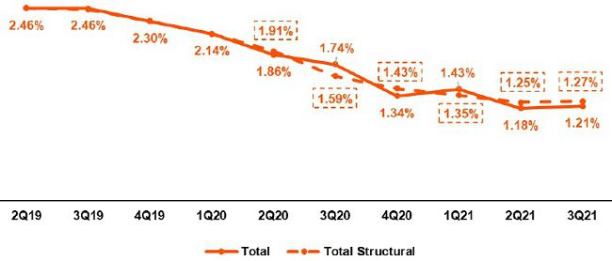

- Expenses are included in accordance with IFRS16.

- Structural Funding Cost deducts the impact in expenses and funding related to GP Loans (BCRP Repos) and deducts non-recurring events from Interest Expense.
* 2Q21 Structural Funding Cost differed from previously reported

17

The funding cost at Credicorp rose slightly to 1.21% (+3bps QoQ), which was attributable to the increase in debt obligations with foreign financial institution at BCP Stand-alone in FC and to the depreciation of the Sol². These effects were partially offset by an increase in low-cost deposits’ share in the funding mix. The structural funding cost, which is not affected by the presence of government program loans, grew slightly to 1.27% (+2bps QoQ).

In the YoY analysis, the Cost of Funding fell -53bps, which was primarily due to an increase in low-cost deposit’s share of the funding mix and to a reduction in the interest rate of bonds and notes issued.

Cost of Funding– Credicorp in Local Currency ⁽¹⁾⁽²⁾
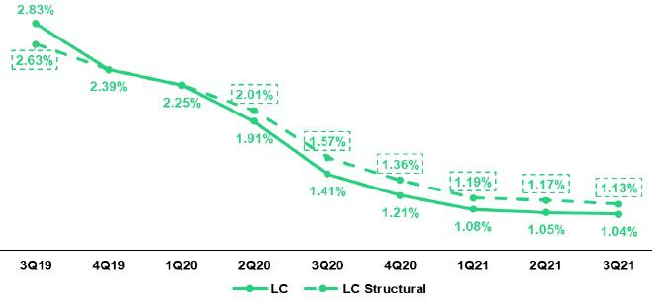

- Expenses are included in accordance with IFRS16.

- Structural Funding Cost deducts the impact in expenses and funding related to GP Loans (BCRP Repos) and deducts non-recurring events from Interest Expense

The funding cost in LC (-1bps) remained stable. In terms of structural funding, the cost of funding in LC fell to 1.13% in 3Q21 (-4bps).

Funding cost – Credicorp in Foreign Currency ⁽¹⁾⁽²⁾
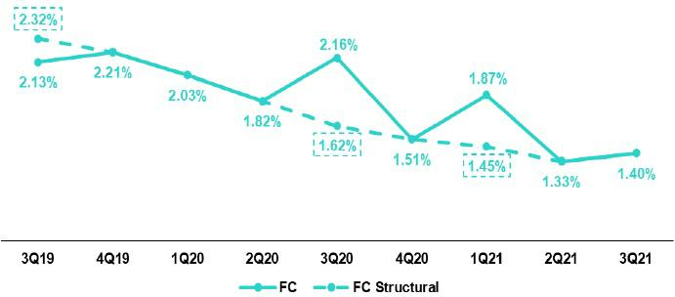

- Expenses are included in accordance with IFRS16.

- Structural Funding Cost deducts the impact in expenses and funding related to GP Loans (BCRP Repos) and deducts non-recurring events from Interest Expense

The increase in the cost of funding in FC (+7bps) was attributable to a decrease in balances of low-cost deposits in FC (expressed in US Dollars) and to an increase in debt obligations with banks at BCP Stand-alone.

Funding costs in LC and FC fell -37bps and -76bps YoY respectively, in line with the strategy to optimize Credicorp’s liabilities.

- Depreciation of the sol increases the relevance of Foreign-currency denominated funding, which is relatively more expensive than our local-currency denominated funding sources.

18

Funding cost by subsidiary ⁽¹⁾⁽²⁾
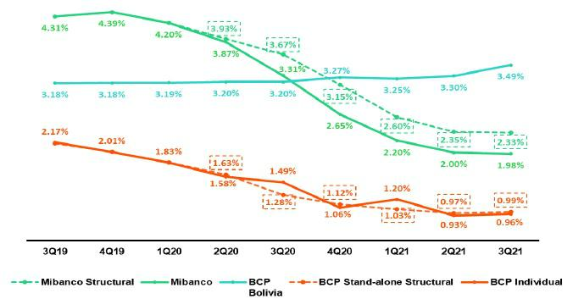

  - Expenses are included in accordance with IFRS16.

  - Structural Funding Cost deducts the impact in expenses and funding related to GP Loans (BCRP Repos) and deducts non-recurring events from Interest Expense.

- The funding cost at BCP Stand-alone increased slightly to 0.96% (+3bps QoQ). This growth was driven by the depreciation of the Sol and by new debt obligations that were assumed to offset the outflow of deposits to foreign accounts. In the YoY analysis, a -53bps decrease in the cost of funding was associated with (i) an increase in the share of deposits and to (ii) the rate effect, which was mainly associated with issued bonds.

- The funding cost at Mibanco decreased slightly (-2bps QoQ). In the YoY analysis, a -33bps drop is evident. This variation was driven by an increase in the share of low-cost deposits and obligations with BCRP (Reactiva) within the funding mix.

- The funding cost at BCP Bolivia increased to 3.49% (+19bps). In the YoY analysis, we see growth of 29bps.

19



2. Net interest income (NII)

Net interest income |  |  |  |  | Quarter |  |  |  | % change |  |  |  |  | YTD |  |  |  |  | % change
 | S/ 000 |  | 3Q20 |  | 2Q21 |  | 3Q21 |  | QoQ |  |  | YoY |  | Sep 20 |  |  | Sep 21 |  | Sep-21 / Sep-20
 | Interest income |  | 2,953,570 |  | 2,891,579 |  | 3,051,000 |  | 5.5% |  |  | 3.3% |  | 8,844,548 |  |  | 8,758,652 |  | -1.0%
 | Interest on loans |  | 2,578,362 |  | 2,476,187 |  | 2,607,349 |  | 5.3% |  |  | 1.1% |  | 7,701,998 |  |  | 7,516,297 |  | -2.4%
 | Dividends on investments |  | 8,871 |  | 11,536 |  | 19,668 |  | 70.5% |  |  | 121.7% |  | 21,617 |  |  | 34,425 |  | 59.2%
 | Interest on deposits with banks |  | 7,981 |  | 6,076 |  | 12,185 |  | 100.5% |  |  | 52.7% |  | 66,358 |  |  | 26,157 |  | -60.6%
 | Interest on securities |  | 347,309 |  | 382,140 |  | 385,874 |  | 1.0% |  |  | 11.1% |  | 1,020,660 |  |  | 1,130,978 |  | 10.8%
 | Other interest income |  | 11,047 |  | 15,640 |  | 25,924 |  | 65.8% |  |  | 134.7% |  | 33,915 |  |  | 50,795 |  | 49.8%
 | Interest expense ⁽¹⁾ |  | 791,665 |  | 582,537 |  | 599,292 |  | 2.9% |  |  | -24.3% |  | 2,341,766 |  |  | 1,874,519 |  | -20.0%
 | Interest on deposits |  | 258,838 |  | 210,275 |  | 209,564 |  | -0.3% |  |  | -19.0% |  | 943,114 |  |  | 642,482 |  | -31.9%
 | Interest on borrow ed funds |  | 143,739 |  | 101,265 |  | 110,308 |  | 8.9% |  |  | -23.3% |  | 438,684 |  |  | 323,801 |  | -26.2%
 | Interest on bonds and subordinated notes |  | 301,347 |  | 178,664 |  | 179,476 |  | 0.5% |  |  | -40.4% |  | 698,808 |  |  | 625,111 |  | -10.5%
 | Other interest expense ⁽¹⁾ |  | 87,741 |  | 92,333 |  | 99,944 |  | 8.2% |  |  | 13.9% |  | 261,160 |  |  | 283,125 |  | 8.4%
 | Net interest income ⁽¹⁾
 |  |  | 2,161,905 |  | 2,309,042 |  | 2,451,708 |  | 6.2% |  |  | 13.4% |  | 6,502,782 |  |  | 6,884,133 |  | 5.9%
 | Adjusted Net interest income ⁽²⁾
 |  |  | 2,179,853 |  | 2,266,743 |  | 2,420,842 |  | 6.8% |  |  | 11.1% |  | 6,937,888 |  |  | 6,848,096 |  | -1.3%
 | Risk-adjusted Net interest income ⁽¹⁾
 |  |  | 856,000 |  | 1,945,662 |  | 2,287,294 |  | 17.6% |  |  | 167.2% |  | 1,314,939 |  |  | 5,798,692 |  | 341.0%
 | Average interest earning assets ⁽¹⁾
 |  |  | 213,481,060 |  | 230,237,853 |  | 231,912,064 |  | 0.7% |  |  | 8.6% |  | 196,714,050 |  |  | 229,486,667 |  | 16.7%
 | Net interest margin ⁽³⁾
 |  |  | 4.05% |  | 4.01% |  | 4.23% |  | 22bps |  |  | 18bps |  | 4.41% |  |  | 4.00% |  | -41bps
 | Risk-adjusted Net interest margin ⁽³⁾ |  | 1.60% |  | 3.38% |  | 3.95% |  | 57bps |  |  | 235bps |  | 0.89% |  |  | 3.37% |  | 248bps
 | Net provisions for loan losses / Net interest |  | 60.41% |  | 15.74% |  | 6.71% |  | -9.0% |  |  | -53.7% |  | 79.78% |  |  | 15.77% |  | -64.01%
income

- Figures differ from previously reported.

- Adjusted for (i) impairment from cero interest-rate loans and (ii) expenses related to liability management operations at BCP Stand-Alone.

- Anualizado.

3.1. Net Interest Income

Interest income – local currency

(S/ millions)
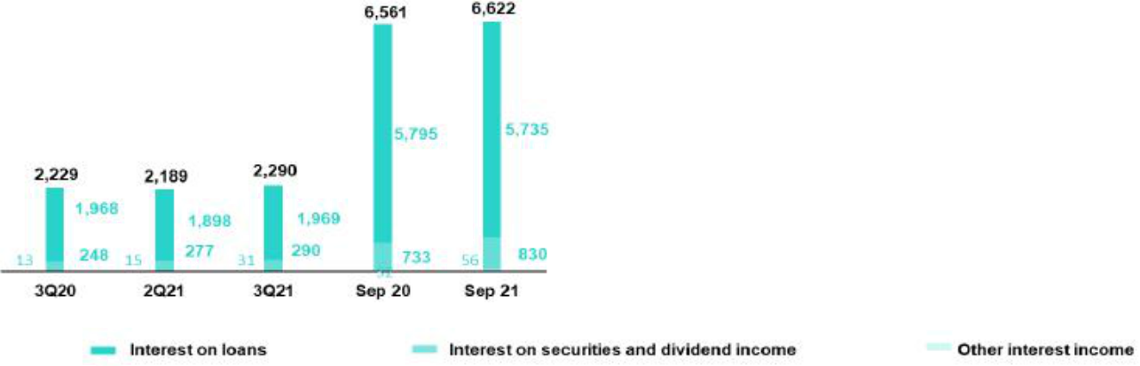

Interest income – foreign currency

(S/ millions)

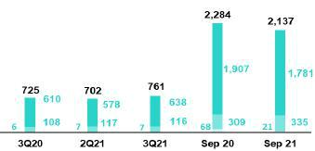

In the QoQ analysis, the +5.5% increase in interest income was driven, to a large extent, by the uptick in the exchange rate. If we exclude this effect, interest income rose 4.3% in a context of higher interest rates and an increase in loans at BCP Stand-alone and to a lesser extent, by Mibanco. Interest generation was driven by the following dynamics:

- Rate effect: QoQ, the rates evolved positive, mainly in the investment portfolio. This evolution was driven by an increase in yields due to an uptick in market rates. The rate effect was also positive for total loans but was partially offset by a drop in rates in Wholesale Banking due to the competitive environment.

- Volume effect: The volume effect, driven by loan growth, was positive but was partially offset by a drop in total investments in BCP Stand-alone’s portfolio. This dynamic generated a more profitable IEA structure.

In the YoY analysis, interest income rose +3.3% (+5.5% adjusted, excluding non-recurring charges for impairment amortization). This evolution was driven to a significant extent by an uptick in the exchange rate. If we exclude the exchange rate effect, interest income grew 0.5% (+2.6% adjusted), in a context affected by the increase in the volume of structural loans and investments.

In terms of the volume and rate effects, the evolutions were as follows

- Volume Effect: driven primarily by growth in structural loans and in the investment portfolio.

- Rate effect: the rate effect was negative and partially offset the positive effect generated by the mix. YoY, active interest rates fell, mainly in Wholesale Banking, where working capital and financing for invoices were the most affected. Retail Banking segments, specifically Mortgage and Credit Card, were also negatively impacted by interest rates. This was, however, partially offset by growth in yields after moves were made to increase the duration of the portfolio.

21

YTD, interest income fell -1.0% (-5.9% adjusted, excluding non-recurring charges for impairment amortization). This evolution was driven by a drop in interest on loans and in interest on deposits in other banks. Lower interest from loans was primarily due to a drop in structural loan volumes, in particular in the Corporate and Credit Card segments. The performance of the loan portfolio and of liquid assets were impacted by lower interest rates. This dynamic was partially offset by an increase in interest from securities, which was attributable to an uptick in the average investment amount.

3.2. Interest Expenses

Interest expenses – Local Currency

(S/ millions)
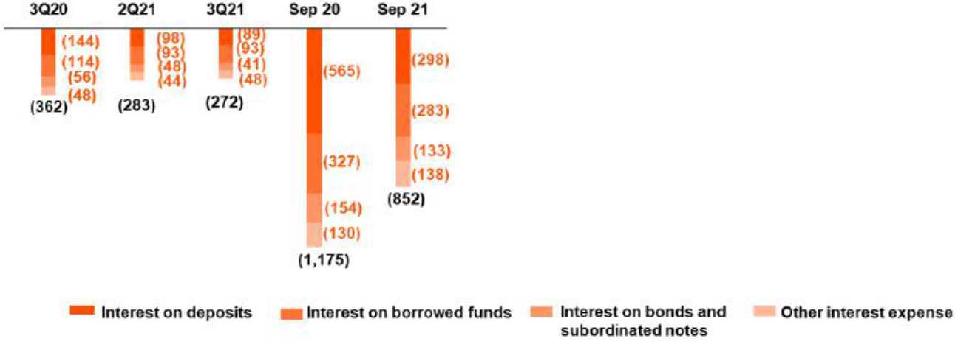

Interest expenses – Foreign currency

(S/ millions)

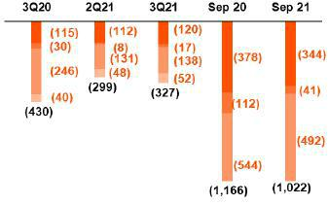

In the QoQ analysis interest expenses rose +2.9%; this was attributable to an increase in FC expenses, which was driven by the exchange rate effect. If we exclude this effect, interest expenses rose 0.2%, which was attributable to:

- The mix effect: funding from low-cost government loans was replaced by debt obligations with foreign banks, which have higher interest rates.

- Rate effect: the increase in market rates also contributed, although to a lesser extent, to growth in interest expenses.

In the YoY analysis, interest expenses fell -24.3% (-12.3% when adjusted for non-recurring expenses in 3Q20 for a liability management transaction). If we apply a constant rate of exchange, interest expenses fell -29% YoY (-17.7% when adjusted for non-recurring). This dynamic was attributable to:

- Rate effect: reduction in the rate on Bonds and Issued Notes, which was mainly attributable to a subordinated debt transaction at BCP Stand-alone. The decrease in market rates also contributed, albeit to a lesser extent, to a reduction in interest expenses.

- Mix effect: Low-cost deposits increased their share of total funding (demand deposits and savings deposits) while due to banks and correspondents registered a reduction in share during the same period.

YTD, interest expenses fell -20.0%. This variation reflects the positive effect generated by the drop in market rates; the impact of the liability management transaction at BCP Stand-alone in 3Q20 and 1Q21; and a change in the funding mix, where lower-cost sources of funding tied to government pandemic relief initiatives replaced higher-cost funding sources in the mix.

22

3.3. Net interest margin (NIM) and Risk-adjusted NIM

NIM and Risk-adjusted NIM at Credicorp
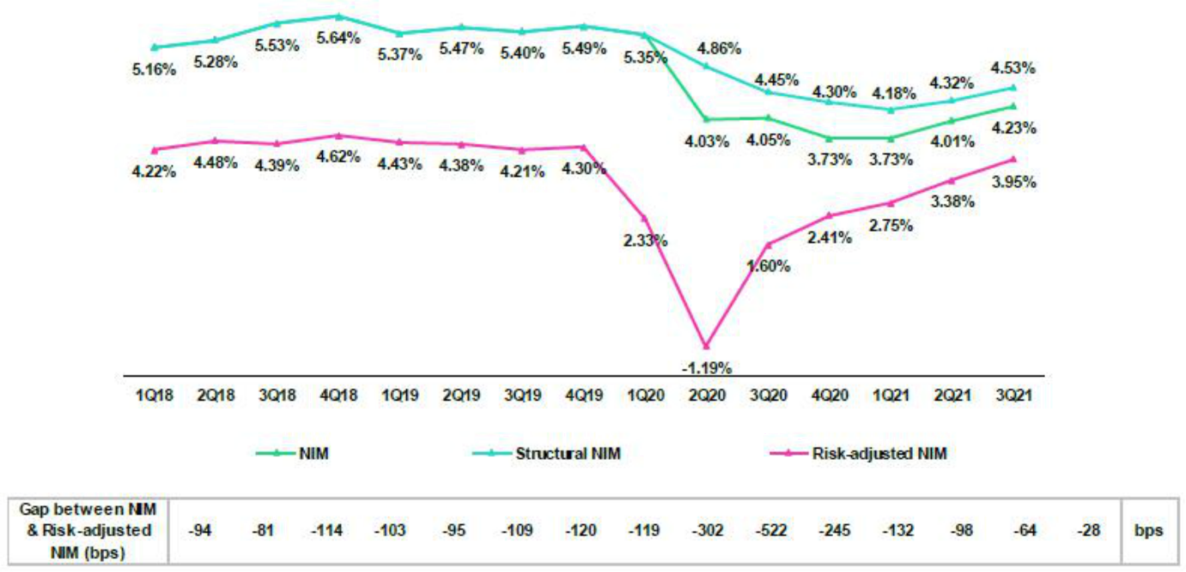

NIM stood at 4.23% in 3Q21, which topped the 4.01% reported in 2Q21 and the 4.05% registered in 3Q20. The margin was impacted by non-recurring charges for impairment amortization. The impact of these charges on NIM was positive: +5bps for 3Q21. Also, NIM continued to be impacted by the presence of government loans. The impact of these loans on NIM is negative: -35 bps in 3T21. The analysis of structural NIM, which excludes non-recurring charges and government loans, indicates:

- The Structural Portfolio reported an NIM of 4.53% in 3Q21; this represented an improvement of +21bps QoQ, which reflected a positive variation in interest rates and a more profitable mix of IEAs.

- Structural NIM increased +8bps YoY, rising from 4.45% to 4.53% due to:

  - The mix effect: an increase in the volume of structural loans; growth in average investments; and a lower-cost liability structure positively affected the margin.
  - Rate effect: a drop in passive liability rates, which was partially offset by a drop in active interest rates.

- YTD, structural NIM grew +6bps, going from 4.29% to 4.35%. These results were driven by the same factors as those seen YoY.

The table below shows the NIM and Risk-adjusted NIM for Credicorp’s main subsidiaries:

 |  |  | BCP |  |  |  | BCP |  |  |  |  | Risk Adjusted NIM | BCP |  |  |  | BCP |  | Credicorp ⁽¹⁾
NIM Breakdown Stand-alone |  |  |  |  | Mibanco |  | Bolivia |  | Credicorp ⁽¹⁾ |  |  | Breakdown | Stand-alone |  | Mibanco |  | Bolivia
 |  |  |  |  |  |  |  |  |  |  |  | 3Q20 | 1.58% |  | 0.79% |  | 0.74% |  | 1.60%
 | 3Q20 |  | 3.53% |  | 11.96% |  | 3.51% |  | 4.05%
 | 2Q21 |  | 3.43% |  | 11.88% |  | 2.83% |  | 4.01% |  |  | 2Q21 | 2.81% |  | 8.66% |  | 4.57% |  | 3.38%
 |  |  |  |  |  |  |  |  |  |  |  | 3Q21 | 3.49% |  | 9.46% |  | 2.47% |  | 3.95%
 | 3Q21 |  | 3.57% |  | 12.59% |  | 3.23% |  | 4.23%
 | Sep 20 |  | 3.93% |  | 11.30% |  | 3.51% |  | 4.41% |  |  | Sep 20 | 0.51% |  | 1.86% |  | 0.70% |  | 0.89%
 |  |  |  |  |  |  |  |  |  |  |  | Sep 21 | 2.91% |  | 8.19% |  | 2.92% |  | 3.37%
 | Sep 21 |  | 3.44% |  | 11.45% |  | 2.90% |  | 4.00%

NIM: Annualized Net interest income / Average period end and period beginning interest earning assets.

Risk-Adjusted NIM: (Annualized Net interest income - annualized provisions) / Average period end and period beginning interest earning assets.

(1) Credicorp also includes Mibanco colombia, Credicorp Capital, Prima, Pacífico, ASB and Eliminations for consolidation purposes.

23

The dynamics of NIM at BCP Stand-alone, which is the primary contributor to NIM at the holding level, mirror the results detailed above for Credicorp. As such, our analysis will focus on relevant variations at Mibanco and BCP Bolivia:

- Mibanco Peru reported a +71bps increase QoQ in NIM due to a reversal of interest provisions for reprogrammed loans that became past due³. This reversal was triggered after write-offs this quarter to compensate for the fact that the interest income provisions had been also recorded in IFRS provisions for credit losses for delinquent loans. Other factors that positively contributed to the margin were: an uptick in structural loans and a more profitable IEA mix.

YoY, NIM at Mibanco increased +63bps due to (i) an increase in structural loans and (ii) reversals of interest provisions for reprogrammed loans that became past due.

- QoQ, BCP Bolivia registered an increase in NIM due to the exchange rate effect. YoY, NIM fell after yields and loan levels declined, and the focus shifted from origination to bolstering collections.

Risk-adjusted NIM at Credicorp increased +57bps QoQ +235bps YoY; and +248bps YTD. Growth in all cases was driven by a significant reduction in provisions and by the same factors that drove variations in NIM.

- In recent months, we registered provisions for interest income that was accrued over the reprogrammed loans grace periods and was not paid-back when grace periods expired due to delinquency.

24



4. Portfolio Quality

4.1. Net provisions for loan losses and CofR

Provision for credit losses on loan portfolio, net of recoveries S/ 000 |  |  |  |  |  |  |  |  | Quarter |  |  |  |  |  |  | % change |  |  |  |  |  |  |  |  | YTD |  |  |  |  |  |  |  |  | % change
 |  |  |  | 3Q20 |  |  |  |  | 2Q21 |  |  |  | 3Q21 |  |  | QoQ |  |  |  |  | YoY |  |  |  | 9M - 20 |  |  |  |  | 9M - 21 |  |  | 9M - 21 / 9M - 20
Gross provision for credit losses on loan portfolio |  |  |  | (1,348,726) |  |  |  |  | (441,007) |  |  |  | (265,158) |  | -39.9% |  |  |  |  |  | -80.3% |  |  | (5,295,095) |  |  |  |  |  | (1,329,147) |  |  |  | -74.9%
Recoveries of written-off loans |  |  | 42,821 |  |  |  |  | 77,627 |  |  |  |  | 100,744 |  | 29.8% |  |  |  |  |  | 135.3% |  |  | 107,252 |  |  |  |  |  | 243,706 |  |  |  | 127.2%
Provision for credit losses on loan portfolio, net of recoveries |  |  | (1,305,905) |  |  |  |  | (363,380) |  |  |  |  | (164,414) |  | -54.8% |  |  |  |  |  | -87.4% |  |  | (5,187,843) |  |  |  |  |  | (1,085,441) |  |  |  | -79.1%
 |  |  |  |  |  |  |  | Quarter |  |  |  |  |  |  |  | % change |  |  |  |  |  |  |  |  |  | YTD |  |  |  |  |  |  |  | % change
 |  |  |  |  |  |  |  |  |  |  |  |  |  |  |  |  |  |  |  |  |  |  |  |  |  |  |  |  |  |  |  |  |  | 9M - 21 / 9M -
Cost of risk and Provisions |  |  | 3Q20 |  |  |  |  |  | 2Q21 |  |  |  | 3Q21 |  |  | QoQ |  |  |  |  | YoY |  |  |  | 9M - 20 |  |  |  |  | 9M - 21 |  |  |  | 20
Cost of risk ⁽¹⁾ |  |  | 3.84% |  |  |  |  | 1.02% |  |  |  |  | 0.45% |  |  | -57 bps |  |  |  |  | -339 bps |  |  | 5.08% |  |  |  |  |  | 0.99% |  |  |  | -409 bps
Structural Cost of risk ⁽²⁾ |  |  | 4.37% |  |  |  |  | 1.23% |  |  |  |  | 0.54% |  |  | -69 bps |  |  |  |  | -383 bps |  |  | 6.01% |  |  |  |  |  | 1.15% |  |  |  | -486 bps

- Annualized Provision for credit losses on loan portfolio, net of recoveries / Total loans.

- The Structural Cost of risk excludes the provisions for credit losses on loan portfolio, net of recoveries and total loans from the Reactiva Peru and FAE Government Programs.

Net provisions for loan losses fell -54.8% QoQ, following the same trend seen in previous quarters. This represents the largest drop in expenses in more than 8 years, as the conservative level of allowances for loan losses remains 1.8x above the level reported pre-pandemic. In this context, the cost of risk fell -57 bps. This was primarily due to:

- BCP Stand-alone: due to the reduction in risk in the Individuals Banking and Wholesale Banking portfolios, which was driven by growth in income levels due to an influx of statutory bi-yearly bonus payments for individuals and companies’ uptick in sales. This positive evolution meant that the volume of loans that advanced from Stage 2 to Stage 3 fell. The provisions contraction was also attributable to an increase in recoveries of write-offs.

- Mibanco: due to lower passes between Stages and a decrease in the PD Bottom Up, which is related to better payment behaviors, an improvement in the portfolio quality of the new disbursements, and due to methodological adjustments. The aforementioned was slightly offset by higher provisions related to adjustments in write-offs policies, which require the establishment of total expenses for subsequent write-offs.

The aforementioned was partially attenuated by an increase in expenses at BCP Bolivia, which was attributable to an extraordinary provisions reversal in 2Q21, and adjustments to the PD model, which reflected operations pending to reprogram loans as mandated by the government of Bolivia.

If we exclude the effects of government loans, the structural cost of risk stands at 0.54%, +9 bps higher than the total ratio given that S/21 billion in government loans are excluded from the denominator.

QoQ evolution of the Cost of Risk YoY evolution of the Cost of Risk
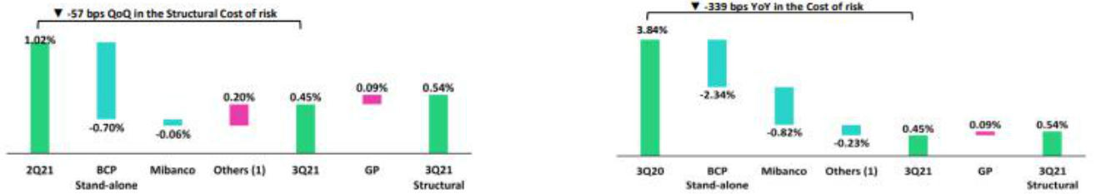

(1) Others include BCP Bolivia, ASB and eliminations. (1) Others include BCP Bolivia, ASB and eliminations.

In the YoY analysis, provisions fell -87.4% due to (i) significant provisioning in 3Q20 in a context of high uncertainty relative to COVID-19 and (ii) the recovery in macroeconomic projections. This improvement was driven by all the banking subsidiaries, and was reflected in a drop of -339 bps in the cost of risk. This contraction was spurred by:

- BCP Stand-alone: particularly in the SME-Pyme segments and Wholesale Banking. In SME-Pyme, the drop was driven by the fact that provisions were higher in 3Q20 due to adjustments to the LGD model to incorporate the impact of COVID-19. On the Wholesale Banking end, the reduction in provisions was due to positive client payment behavior, the fact that an important client emerged from default and a decrease in risk levels.

- Mibanco: due to improvements in clients payment behavior, which generated adjustments to the stress levels in the models, requiring lower provisions in the new disbursements, and a significant increase in the recovery of written-off loans.

26

- BCP Bolivia: attributable to the fact that provisioning levels were very high last year and included earmarked expenses for SME-Pyme clients and the Consumer portfolio in anticipation of an increase in the probability of loan losses.

The aforementioned was partially attenuated by growth in provisions for larger loans volumes in the structural portfolios at all subsidiaries, which increased +12.2% YoY in aggregate. It is important to note that the devaluation of local currency also spurred growth in loans.

If we exclude government loans and provisions, the structural cost of risk was 0.54%, +9 bps higher than the total ratio. This evolution was driven primarily by the loan effect.

YTD Evolution of the Cost of Risk
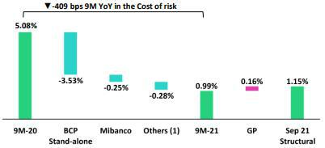

(1) Others include BCP Bolivia, ASB and eliminations.

In the YTD analysis, net provisions for loan losses decreased -79.1% given that forward-looking provisions were set aside in 2020 in context of greater

uncertainty. The contractions at each subsidiary were driven by the same factors as those mentioned in the YoY analysis. In this scenario, the cost of risk fell to

0.99% at the end of September, which represented a contraction of -409 bps. If we exclude the effect of government loans, the structural cost of risk stands at

1.15%.

4.2. Delinquency

In terms of portfolio delinquency, it is important to divide the analysis to contemplate the evolution of the Structural Portfolio and the Government Portfolio:

Structural Loan Portfolio:
Structural Portfolio quality and Delinquency ratios ⁽¹⁾ |  |  |  | As of |  |  |  | % change
S/ 000 |  | Sep 20 |  | Jun 21 |  | Sep 21 |  | QoQ |  |  | YoY
Structural Total loans (Quarter-end balance) |  | 111,873,729 |  | 120,095,401 |  | 125,528,623 |  | 4.5 | % |  | 12.2 | %
Structural Allowance for loan losses |  | 9,507,815 |  | 9,245,140 |  | 8,934,930 |  | -3.4% |  |  | -6.0%
Structural Write-offs |  | 20,249 |  | 742,211 |  | 670,273 |  | -9.7% |  |  | 3210.2%
Structural IOLs |  | 4,142,844 |  | 4,913,569 |  | 4,776,182 |  | -2.8% |  |  | 15.3%
Structural Refinanced loans |  | 1,539,484 |  | 1,800,076 |  | 1,798,965 |  | -0.1% |  |  | 16.9%
Structural NPLs |  | 5,682,328 |  | 6,713,645 |  | 6,575,146 |  | -2.1% |  |  | 15.7%
Structural IOL ratio |  | 3.70% |  | 4.09% |  | 3.80% |  | -29 bps |  |  | 10 bps
Structural NPL ratio ⁽²⁾ |  | 5.08% |  | 5.59% |  | 5.24% |  | -35 bps |  |  | 16 bps
Structural Allowance for loan losses over Structural Total loans |  | 8.5% |  | 7.7% |  | 7.1% |  | -58 bps |  |  | -138 bps
Structural Coverage ratio of NPLs |  | 167.3% |  | 137.7% |  | 135.9% |  | -182 bps |  |  | -3143 bps

- The Structural Portfolio excludes Government Programs (GP) effects.

- Figures differ from previously reported, due to the methodological change in the calculation, which includes the overdue portfolio instead of the Portfolio Management figures.

27

In the QoQ analysis:

- IOL portfolio: a drop of -2.8% in IOL loans, primarily in Mibanco and Individuals at BCP Stand-alone, which posted an improvement in payment behavior.

- Refinanced portfolio: the slight reduction of -0.1% was attributable to a decrease in the volume of refinanced loans in Individuals and Wholesale Banking at BCP Stand-alone and at Mibanco.

- Write-offs: the drop of -9.7% was associated with BCP Stand-alone, after a significant rebound was registered in the levels of write-offs in 2Q21. This was partially attenuated by growth in charge-offs at Mibanco.

- NPL ratio: in the aforementioned context, the NPL ratio fell -35 bps, which was primarily attributable to a -2.1% reduction in NPL loans and an increase of +4.5% in total loans.

- Coverage ratio of NPLs: the ratio fell -182 bps this quarter, which was attributable to the fact that the reduction in the allowance for loan losses was greater than the decrease posted for NPL loans.

In the YoY analysis:

- IOL portfolio: the +15.3% increase was driven by the fact that in 3Q20, the vast majority of loans were within grace period. Growth in IOLs was registered primarily by (i) SMEs, due to the expiration of grace periods of clients with loan facilities granted during the pandemic, (ii) Wholesale Banking, after specific clients in the transportation and energy sector reported deterioration, and (iii) Mibanco, which was affected by a dip in transactional activity in the microbusiness segment due to the economic closure and the maturity of reprogrammed loans during the pandemic.

- Refinanced portfolio: the increase of +16.9% was attributable to an uptick in reprogramming in Retail Banking at BCP Stand-alone as clients continued to struggle under the weight of the pandemic.

- Write-offs: growth was reported in all banking subsidiaries, led by Mibanco and BCP Stand-alone, given that write-offs were temporally suspended in 3Q20.

- NPL Ratio: in the aforementioned context, growth of +16 bps in this ratio was attributable to grace period expirations, which was subsequently reflected in an uptick in non-payments. The aforementioned was partially offset by loan growth (+12.2%).

- Coverage of the NPL portfolio: the contraction was driven by growth in IOL loans, given that the pandemic continues to generate negative impacts, and by a drop of -6.0% in allowances.

Government Loan Portfolio:
GP Portfolio quality and Delinquency ratios ⁽¹⁾ |  |  |  | As of |  |  |  | % change
S/ 000 |  | Sep 20 |  | Jun 21 |  | Sep 21 |  | QoQ |  |  | YoY
GP Total loans (Quarter-end balance) |  | 24,274,982 |  | 22,996,351 |  | 21,022,603 |  | -8.6 | % |  | -13.4 | %
GP Allowance for loan losses |  | 148,568 |  | 146,011 |  | 142,519 |  | -2.4% |  |  | -4.1%
GP IOLs |  | - |  | 140,784 |  | 697,503 |  | 395.4% |  |  | -
GP NPLs |  | - |  | 140,784 |  | 697,503 |  | 395.4% |  |  | -
GP IOL ratio |  | - |  | 0.61% |  | 3.32% |  | 271 bps |  |  | -
GP NPL ratio |  | - |  | 0.61% |  | 3.32% |  | 271 bps |  |  | -
GP Allowance for loan losses over GP Total loans |  | 0.6% |  | 0.6% |  | 0.7% |  | 5 bps |  |  | 7 bps
GP Coverage ratio of NPLs |  | - |  | 103.7% |  | 20.4% |  | -8328 bps |  |  | -

- Government Programs (GP) include Reactiva Peru and FAE. In the QoQ analysis:

  - IOL portfolio: growth was attributable to grace period expirations, particularly in the SME-Pyme segment.

  - NPL ratio: the increase was attributable to an increase in the volume of overdue loans and to a reduction in total loans.

  - Coverage of NPL loans: the reduction in this ratio was due primarily to growth in IOL loans.

Next, we will discuss the evolution of consolidated figures, which incorporate the effects of the evolutions of both the structural portfolio and government loan portfolio:

28

Total Portfolio:
Portfolio quality and Delinquency ratios |  |  |  | As of |  |  |  | % change
S/ 000 |  | Sep 20 |  | Jun 21 |  | Sep 21 |  | QoQ |  |  | YoY
Total loans (Quarter-end balance) |  | 136,148,711 |  | 143,091,752 |  | 146,551,226 |  | 2.4 | % |  | 7.6 | %
Allowance for loan losses |  | 9,656,383 |  | 9,391,151 |  | 9,077,449 |  | -3.3% |  |  | -6.0%
Write-offs |  | 20,249 |  | 742,211 |  | 670,273 |  | -9.7% |  |  | n.a
Internal overdue loans (IOLs) ⁽¹⁾ |  | 4,142,844 |  | 5,054,353 |  | 5,473,685 |  | 8.3% |  |  | 32.1%
Internal overdue loans over 90-days ⁽¹⁾ |  | 3,442,908 |  | 3,817,463 |  | 4,051,717 |  | 6.1% |  |  | 17.7%
Refinanced loans |  | 1,539,484 |  | 1,800,076 |  | 1,798,965 |  | -0.1% |  |  | 16.9%
Non-performing loans (NPLs) ⁽²⁾ |  | 5,682,328 |  | 6,854,429 |  | 7,272,649 |  | 6.1% |  |  | 28.0%
IOL ratio |  | 3.04% |  | 3.53% |  | 3.73% |  | 20 bps |  |  | 69 bps
IOL over 90-days ratio |  | 2.53% |  | 2.67% |  | 2.76% |  | 9 bps |  |  | 23 bps
NPL ratio |  | 4.17% |  | 4.79% |  | 4.96% |  | 17 bps |  |  | 79 bps
Allowance for loan losses over Total loans |  | 7.1% |  | 6.6% |  | 6.2% |  | -37 bps |  |  | -90 bps
Coverage ratio of IOLs |  | 233.1% |  | 185.8% |  | 165.8% |  | -1996 bps |  |  | -6725 bps
Coverage ratio of IOL 90-days |  | 280.5% |  | 246.0% |  | 224.0% |  | -2197 bps |  |  | -5643 bps
Coverage ratio of NPLs |  | 169.9% |  | 137.0% |  | 124.8% |  | -1219 bps |  |  | -4512 bps

- Includes overdue loans and loans under legal collection. (Quarter-end balances).

- Non-performing loans include internal overdue loans and refinanced loans. (Quarter-end balances).

When analyzing the evolution of delinquency indicators, it is necessary to note that: (i) traditional delinquency indicators (IOL and NPL ratios) continue to be distorted by the presence of loans that have collateral (commercial and residential properties). This means that a significant portion of loans that are more than 150 days overdue cannot be written off, despite being fully provisioned, given that the judicial process to liquidate the collateral can take up to five years on average.
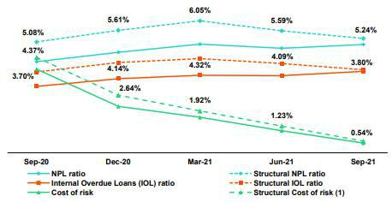

- The Structural Cost of risk excludes the provisions for credit losses on loan portfolio, net of recoveries and total loans from the Reactiva Peru and FAE Government Programs.

In the aforementioned context, the NPL ratio at Credicorp increased +17 bps QoQ, which was primarily driven by a deterioration in the IOL portfolio from the Government Program loans.

In the YoY analysis, the ratio increased +79 bps. This evolution was fueled by grace period expirations in both the Structural Portfolio and Government Loan Portfolio, which reflected growth in both IOL and refinanced loans. Expansion in both of these portfolios was fueled by the on-going effects of the pandemic.

29

4.2.1 Delinquency by Segment

NPL Ratio by Segment
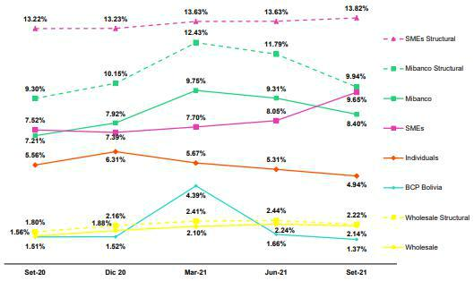

In the analysis of the NPL ratio by segment, it is important to note the following movements:

Structural Portfolio

In the QoQ analysis:

- Wholesale: the ratio fell -22 bps due to loan growth, as indicated in section 1.2.1. Loan evolution by business segment, and to a drop in refinanced loans, which was fueled by the exit of a number of clients in the agriculture sector.

- SMEs: the ratio increased +19 bps, especially due to clients who also have GP loans and whose grace periods expired in the quarter; however, the majority of overdue loans were in early tranches of delinquency. The aforementioned was partially attenuated by a loan expansion of +5.6%.

- Individuals: the drop of -38 bps was attributable to a decrease in overdue loans in the Credit Card and Consumer segments, which was driven by individual’s higher income levels after they received bi-yearly bonuses.

- Mibanco: the significant reduction of -185 bps was attributable to a drop in IOL and refinanced loan volumes and to an increase in loans. The contraction in the NPL portfolio is the result of better risk disbursements and collections actions, higher write-offs and lower deterioration of reprogrammed loans in grace period.

- BCP Bolivia: the drop of -28 bps was attributable to a decrease in the IOL loan volume due to government reprogramming; these loans are considered as current in the loan book.

In the YoY analysis:

- Wholesale Banking: increase of +42 bps, which reflected an uptick in IOL loans. This evolution was attributable to several clients in the leisure, tourism and real estate industries, whose services have been negatively impacted by the pandemic and political instability.

- SMEs: growth of +60 bps, which was attributable to an increase in refinanced loans in Pyme-SME and in IOL loans in SME-Business.

- Individuals: significant drop of -62 bps, spurred by improvements in payment behavior after clients registered higher levels of liquidity following AFP and Severance Indemnity fund releases.

- Mibanco: the increase of +64 bps in the ratio was attributable to growth in IOL loans, which was concentrated in the small business segment. This was slightly attenuated by an increase in write-offs and by loan growth.

- BCP Bolivia: the reduction of 14 bps reflects the same trend as that seen QoQ and was also driven by an uptick in loans.

30

Government Loan Portfolio:

In the QoQ analysis:

The 3Q21 presented the second quarter of installment maturities of the GP Portfolio, which consequently registered an increase of the overdue loans. This growth reflects the on-going impact of the pandemic. In this context, deterioration was registered in all segments, led by SMEs and followed by Mibanco and Wholesale Banking. It is important to note that part of the NPL portfolio is being reprogrammed or has already regularized payment dates. Additionally, lower loan volumes, which reflected advanced amortizations payments, affected delinquency ratios deterioration.

Total Portfolio:

In the QoQ and YoY analysis:

The ratios of the total portfolio reflect the evolution of the structural portfolio, negatively impacted by the recent deterioration of the Government Program portfolio.

4.3 Reprogramming and Payments Management⁴

4.3.1 Structural Portfolio⁵

At the end of September, Credicorp’s structural portfolio reported growth of +4.5% QoQ and +12.2% YoY. For more information about this evolution, see section 1.2.1. Evolution of loans by business segment. The reprogrammed structural loan portfolio registered an on-going reduction and represent 14% of structural loans, which reflect a contraction of -80 bps QoQ and -330 bps YoY.

Evolution of the Payment Ratio⁶ (%)
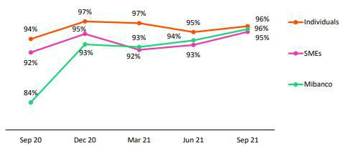

This quarter, the payment ratio for overdue installments improved QoQ and YoY in all segments given that the volume of expired installments increased alongside expirations in grace periods. The improvements reported for the ratios reflect an uptick in income through growth in transaction levels and sales at companies and an increase in individual funds after deposits of bi-yearly bonus payments (statutory) were made in July and pensions and severance indemnity withdrawals.

The majority of delinquency⁷ is concentrated in early delinquency tranches where recovery levels are high, which is not reflected in the loan book overdue portfolio. At Retail Banking, delinquency situates at 5.2%, which represents a contraction of -120 bps QoQ. 75% of this delinquency is contained in the less than 30 days overdue tranches (loans have not migrated to more advanced stages of delinquency). Late delinquency (31 to 120 days), which includes loans that are considered more difficult to recover, improved -20 bps QoQ alongside an uptick in positive payment behavior, particularly among clients that have received 2 or more facilities, which are also considered higher risk profiles. At Mibanco, the overdue loan portfolio decreased -180 bps QoQ, situating at 6.8%, after an uptick in transactions and income levels led to a subsequent improvement in payment ratios.

- Portfolio Management figures, which focus on analyzing new delinquency. Figures do not include loans that are over 120 days overdue, special accounts and the under legal collections portfolio.
- Figures do not include the government loan portfolios (GP).
- Payment ratio: loan balances with up-to-date payments/balances of loans with due installments.
- The overdue portfolio includes capital and interest on overdue loans beginning on day 1 and ending on day 120.

31

4.3.2 Government Loans (GP)⁸

Government Loans by Segment (S/ millions)
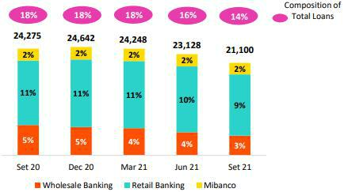

At the end of 3Q21, government loans decreased -8.8%. The reduction in the portfolio balance is due to the fact that most of the grace periods expired and clients made advanced amortizations, mainly driven by the SME-Business and Middle Market Banking. At quarter-end, government loans represented 14% of Credicorp’s total loans (in comparison to 16% in Jun 21). The reprogrammed portfolio increased QoQ and by quarter-end, represented 32% of total government loans. This growth was spurred by an increase in requests for reprogramming (under facilities mandated by the Peruvian government until 4Q21).

In the YoY analysis, the government loan portfolio decreased -13.1%. The trend is similar to that seen in the QoQ analysis, which translated into a -4pp drop in comparison to the results reported at the end of Sep 20.

Composition of the portfolio by segment (S/ millions)
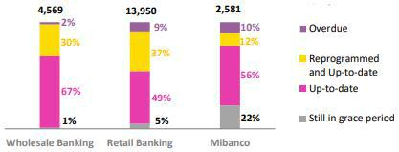

In 3Q21, the reprogrammed portfolio increased across segments after the government mandated facilities in 2Q21 that allowed clients who meet certain criteria to request reprogramming. It is important to note that total maturity of the Wholesale Banking, Retail Banking and Mibanco portfolios expire in 2.2 years, 3.2 years and 2.0 years on average respectively.

Finally, it is important to note that the government loan portfolios are backed by state guarantees. At the end of September, average guarantees were situated at 84%, 92% and 97% for Wholesale Banking, Retail Banking and Mibanco respectively. Loans that enter more than 90 days of delinquency are transferred to Special Accounts and Payment Solutions for subsequent execution of collateral agreements with regulatory entities.

- Government loans include current, overdue and reprogrammed loans through Reactiva Peru and FAE

32



5. Other Income⁹

Other Income |  |  |  | Quarter |  |  |  | % change |  |  |  |  |  | YTD |  |  |  | % change
(S/000) |  | 3Q20 |  | 2Q21 |  | 3Q21 |  | QoQ |  |  | YoY |  | Sep 20 |  | Sep 21 |  |  | Sep 21 / Sep 20
Fee income |  | 775,805 |  | 862,411 |  | 876,391 |  | 1.6% |  |  | 13.0% |  | 2,039,622 |  | 2,569,573 |  |  | 26.0%
Net gain on foreign exchange transactions |  | 155,028 |  | 232,668 |  | 238,886 |  | 2.7% |  |  | 54.1% |  | 471,319 | 651,443 |  |  | 38.2%
Net gain on securities |  | 135,957 |  | (69,947) |  | 5,739 |  | -108.2% |  |  | -95.8% |  | 295,887 | (47,921) |  |  | -116.2%
Net gain from associates ⁽¹⁾ |  | 11,245 |  | 12,302 |  | 19,090 |  | 55.2% |  |  | 69.8% |  | 45,376 | 60,797 |  |  | 34.0%
Net gain on derivatives held for trading |  | (21,297) |  | 45,413 |  | 43,086 |  | -5.1% |  |  | n.a. |  | 22,491 | 158,222 |  |  | 603.5%
Net gain from exchange differences |  | 6,530 |  | 45,924 |  | 3,233 |  | -93.0% |  |  | -50.5% |  | 9,526 | 43,621 |  |  | 357.9%
Other non-financial income |  | 39,498 |  | 62,923 |  | 52,258 |  | -16.9% |  |  | 32.3% |  | 192,463 | 189,172 |  |  | -1.7%
Total non-financial income, net |  | 1,102,766 |  | 1,191,694 |  | 1,238,683 |  | 3.9 | % |  | 12.3 | % | 3,076,684 |  | 3,624,907 |  |  | 17.8 | %

- Includes gains on other investments, mainly made up of the profit of Banmedica.
- 3Q20 Figures differ from what was previously reported by reclassification of IFRS16.

Evolution of Other income QoQ evolution of Other income
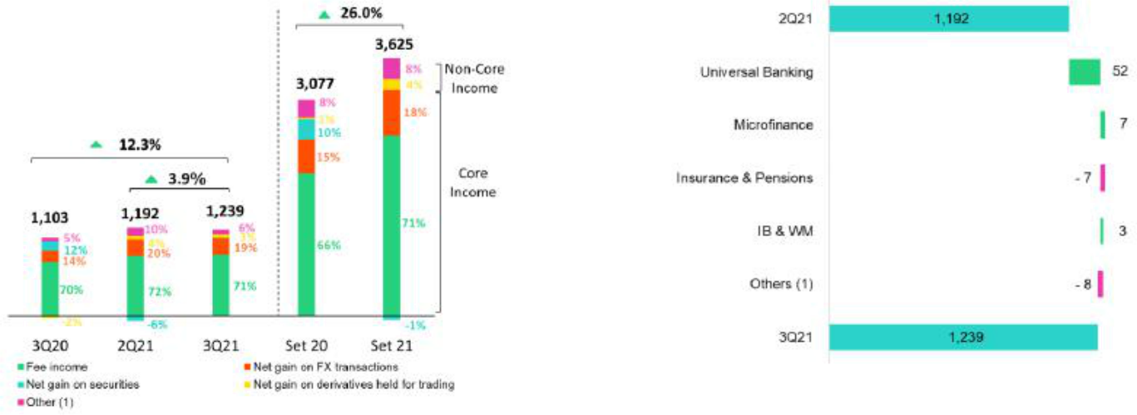

- Others includes Net gain from associates, Net gain from exchange difference and Other non-financial income.

- Others includes Grupo Crédito, Credicorp Stand-alone, elimination and others.

In the QoQ analysis, core other income was relatively stable, reporting a slight increase of +1.84%. This growth was driven by a marginal increase in Fee Income in Universal Banking (+4.74%) and Microfinanzas (+55.9%), which we will explain in greater detail in the next section; and higher Net gain on foreign exchange transactions in Universal Banking, driven by higher FX transactions at BCP Bolivia.

The aforementioned scenario was partially offset by a decrease in Fee Income in Investment Banking and Wealth Management (-11.9%); this was driven by the fact that extraordinary income for brokerage and up-front fees to enter third-party funds was comparatively higher in 2Q21.

Core other income grew +27.7% due to:

- The positive evolution of Universal Banking, since losses were recorded from sales of sovereign bonds in 2Q21.

- Growth in Net earnings for investment in associates, which was generated by an increase in gains in the EPS business due to a decrease in COVID-19 claims.

The aforementioned was partially offset by a decrease in results for the Net gain on derivatives and for the Net gain from exchange differences given that during 2Q21 a large volume of foreign currency was sold, taking advantage of the volatility of the exchange rate to offset the losses generated by the sale of sovereign bonds.

The results led other income to increase +3.9%.

- Previously reported as Non-financial income

34

YoY evolution of Other Income YTD evolution of Other income
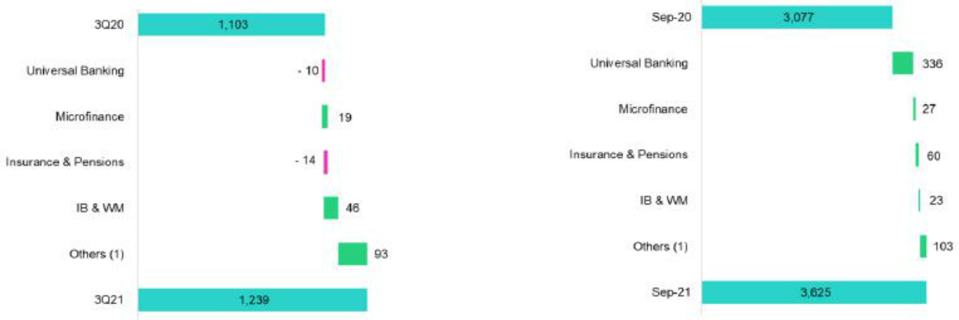

- Others includes Grupo Crédito, Credicorp Stand-alone, elimination and others.

YoY, core other income rose due to:

- An improvement in the results at Universal Banking, which was spurred by an increase in Fee Income and by growth in Net gains on Foreign Exchange transactions. Growth in the former was due to the elimination of fee exemptions (which were in place during the quarantine last year), while the increase in the latter was attributable to higher transactions due to exchange rate volatility.

- Growth in Fee Income in Microfinance, given that clients received exemptions in 2020 as part of pandemic relief measures.

In contrast, non-core other income fell due to:

- The reduction in Net gains on securities in Universal Banking after sovereign bonds were sold as part of a strategy to reduce portfolio sensitivity.

This was offset by an improvement in results for Investment Banking and Wealth Management given that in 3Q20, losses were reported due to the reduction in market values for an investment in the fair values with changes to other comprehensive income portfolio at ASB.

- Others includes Grupo Crédito, Credicorp Stand-alone, elimination and others.

At the YTD level, the positive evolution of core other income was attributable to growth in Fee Income in Universal Banking, Microfinance and Investment Banking and Wealth Management. In the first case, growth was attributable to the fact that the fee exemptions that were in place most of last year were not in effect in 2021. In the case of Investment Banking and Wealth Management, the uptick was attributable to an increase in fees reported for brokerage and to enter third-party funds.

During the same period, Non-core other income evolved negatively due to the losses registered in the Net gain on securities in Universal Banking, which was generated by the sale of bonds from BCP Stand-alone’s fixed income portfolio under a strategy to reduce the portfolio’s sensitivity.

The aforementioned was partially offset by an increase in Net gains from exchange differences in Universal Banking in the first half of the year due to exchange rate volatility during the elections period.

In this context, other income rose +17.8%.

35

5.1. Fee Income

5.1.2. Fee income in the Banking Business

Fee Income |  |  |  | Quarter |  |  |  | % change |  |  |  |  |  | YTD |  |  |  | % change
S/ 000 |  | 3Q20 |  | 2Q21 |  | 3Q21 |  | QoQ |  |  | YoY |  | Sep 20 |  | Sep 21 |  |  | Sep 21 / Sep 20
Miscellaneous accounts ⁽¹⁾ |  | 165,699 |  | 180,183 |  | 211,284 |  | 17.3% |  |  | 27.5% |  | 446,247 | 572,531 |  |  | 28.3%
Credit cards ⁽²⁾ |  | 51,781 |  | 56,218 |  | 44,557 |  | -20.7% |  |  | -14.0% |  | 124,822 | 154,794 |  |  | 24.0%
Drafts and transfers |  | 62,106 |  | 98,796 |  | 108,981 |  | 10.3% |  |  | 75.5% |  | 164,947 | 292,403 |  |  | 77.3%
Personal loans ⁽²⁾ |  | 29,197 |  | 27,608 |  | 17,925 |  | -35.1% |  |  | -38.6% |  | 68,847 | 69,804 |  |  | 1.4%
SME loans ⁽²⁾ |  | 20,161 |  | 16,821 |  | 7,441 |  | -55.8% |  |  | -63.1% |  | 45,419 | 38,797 |  |  | -14.6%
Insurance ⁽²⁾ |  | 23,990 |  | 26,897 |  | 28,713 |  | 6.8% |  |  | 19.7% |  | 71,916 | 82,800 |  |  | 15.1%
Mortgage loans ⁽²⁾ |  | 14,085 |  | 9,373 |  | 7,277 |  | -22.4% |  |  | -48.3% |  | 22,617 | 24,413 |  |  | 7.9%
Off-balance sheet ⁽³⁾ |  | 48,430 |  | 60,592 |  | 65,919 |  | 8.8% |  |  | 36.1% |  | 147,754 | 186,376 |  |  | 26.1%
Payments and collections ⁽³⁾ |  | 99,836 |  | 108,670 |  | 117,185 |  | 7.8% |  |  | 17.4% |  | 283,443 | 332,238 |  |  | 17.2%
Commercial loans ⁽³⁾⁽⁴⁾ |  | 16,626 |  | 16,766 |  | 16,504 |  | -1.6% |  |  | -0.7% |  | 45,052 | 48,662 |  |  | 8.0%
Foreign trade ⁽³⁾ |  | 12,079 |  | 17,905 |  | 18,497 |  | 3.3% |  |  | 53.1% |  | 33,615 | 51,593 |  |  | 53.5%
Corporate finance and mutual funds ⁽⁴⁾ |  | 13,162 |  | 13,011 |  | 9,165 |  | -29.6% |  |  | -30.4% |  | 41,986 | 35,759 |  |  | -14.8%
Mibanco |  | 3,639 |  | 10,727 |  | 18,583 |  | 73.2% |  |  | 410.6% |  | 27,811 | 46,956 |  |  | 68.8%
BCP Bolivia |  | 19,863 |  | 30,558 |  | 30,494 |  | -0.2% |  |  | 53.5% |  | 70,283 | 95,585 |  |  | 36.0%
ASB |  | 10,024 |  | 21,590 |  | 24,545 |  | 13.7% |  |  | 144.9% |  | 39,549 | 57,993 |  |  | 46.6%
Others ⁽⁴⁾⁽⁵⁾ |  | 11,290 |  | 5,019 |  | 16,150 |  | 221.8% |  |  | 43.1% |  | 28,398 | 31,752 |  |  | 11.8%
Total fee income |  | 601,968 |  | 700,733 |  | 743,220 |  | 6.1 | % |  | 23.5 | % | 1,662,708 |  | 2,122,456 |  |  | 27.7 | %

Source: BCP
- Saving accounts, current accounts, debit card and master account.
- Mainly Retail fees.
- Mainly Wholesale fees.
- Figures differ from previously reported, please consider the data presented on this report.
- Includes fees from trust business, wealth management, network usage and other services to third parties, among others.

Fee income in the banking business grew 6.1% QoQ. The items that reported the most significant increases were:

- Miscellaneous accounts, where growth was mainly driven by an increase in consumption in establishments through POS with credit and debit cards (+30.9%) and an increase in fees for account maintenance (+8.2%).

- Others, which was driven by an increase in fees for network use by non-clients and for other third-party services.

- Drafts and transfers, which continue to grow due to an uptick in outflows to foreign destinations due to political uncertainty.

- Mibanco, which registered an improvement due to a decrease in commissions paid to third parties for physical agreements given that fewer disbursements were made through these channels and the conditions for third-party contracts improved.

This growth was partially offset by a decrease in the fee level for Credit Cards, Personal Loans and SME-Pyme loans after penalty fees for past due payments were waived in June in accordance with new legislation.

At the YoY and 9 month YoY analyses, growth was primarily attributable to Miscellaneous Accounts and Drafts and Transfers, which were impacted in 2020 by fee exemptions to aid clients during the quarantine.

It is important to note that despite the fact that we stopped collecting fees for inter-place transfers and past-due penalties, we are 4.4% above pre-pandemic levels due to growth in fees for drafts and transfers (+51.31%), off balance sheets (+28.6%) and POS consumption with debit and credit cards (+19.5%).

36



37

6. Insurance Underwriting Result

Insurance underwriting result ⁽¹⁾ |  |  |  | Quarter |  |  |  | % change |  |  |  |  | YTD |  |  |  |  | % change
S/ 000 |  | 3Q20 |  | 2Q21 |  | 3Q21 |  | QoQ |  |  | YoY |  | 9M-20 |  |  | 9M-21 |  | 9M-21 / 9M-20
Net earned premiums |  | 595,394 |  | 639,944 |  | 675,571 |  | 5.6% |  |  | 13.5% |  | 1,775,390 |  |  | 1,959,443 |  | 10.4%
Net claims |  | (513,091) |  | (691,335) |  | (517,951) |  | -25.1% |  |  | 0.9% |  | (1,215,376) |  |  | (1,832,639) |  | 50.8%
Acquisition cost ⁽²⁾ |  | (86,644) |  | (84,944) |  | (87,416) |  | 2.9% |  |  | 0.9% |  | (286,748) |  |  | (258,182) |  | -10.0%
Total insurance underwriting result |  | (4,340 | ) | (136,335 | ) | 70,204 |  | 151.5 | % |  | n.a. |  | 273,266 |  |  | (131,378 | ) | -148.1 | %

- Includes the results of the Life, Property & Casualty and Crediseguros business.

- Includes net fees and underwriting expenses.

6.1. Life Insurance

Total life insurance premiums

(S/ millions)
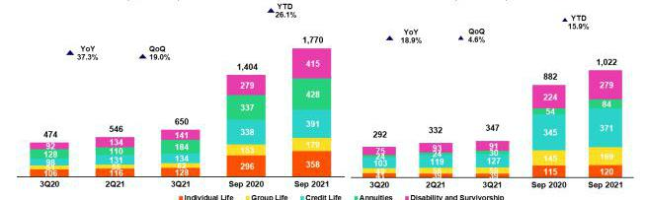

Net earned premiums (10)

(S/ millions)

Total premiums grew 19.0% QoQ, which was driven by: (i) Annuities, primarily associated with an increase in sales in Annuities for Survivorship due to COVID-19 cases; (ii) Individual Life, due to an increase in sales and to and uptick in the exchange rate; (iii) Group Life, which was attributable to an increase in volumes of renewals for the SCTR product (Complementary Insurance for high-risk Occupations); (iv) D&S, after collections recovery of premiums for SISCO V⁽¹¹⁾; y (v) Credit Life, which was primarily generated through the bancassurance channel due to an increase in Mibanco loans.

In the YoY analysis, total premiums increased 37.3%, which was driven by (i) Annuities, primarily due to an increase in sales in Annuities for Survivorship; (ii) D&S, due to an increase in collections under SISCO V due higher premium rates; (iii) Credit Life, due to a decrease in loan volumes at Mibanco in 3Q20 in a challenging economic context; (iv) Individual Life, which was attributable to an increase in sales and in the exchange rate; and (v) Group Life, primarily due to an uptick in volumes of renewals.

Net earned premiums increased 4.6% QoQ, driven by the same factors outlined in the QoQ analysis. This was partially offset by an increase in the number of underwriting reserves that were set aside to cover growth in sales. In the YoY analysis, net earned premiums rose 18.9% due to the effects described in the analysis of total premiums; this evolution was offset by an increase in reserves for Annuities and Individual Life, and higher ceded premiums in D&S due to the conditions of the new SISCO V contract.

YTD, total premiums and net earned premiums increased 26.1% and 15.9% respectively, driven by the factors outlined in the YoY analysis.

- Total premiums excluding premiums ceded to reinsurance and premium reserves.

- Collective Disability, Survival and Burial Insurance of the private pension system.

38

Net life insurance claims

(S/ millions)
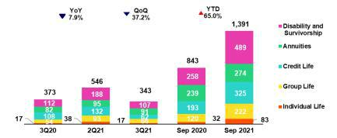

Net claims fell 37.2% QoQ, which was attributable to the release of IBNR COVID-19 provisions for a total of S/104 million (vs S/35 million in reserves in 2Q21). We expect IBNR releases to continue if cases continue to be registered. COVID-19 reported claims during the second wave totaled S/ 150 million (vs S/ 219 million in 2Q21), driven by the evolution of Credit Life in particular.

In the YoY analysis, claims fell 7.9% due to releases of IBNR provisions (vs S/ 50 million in reserves in 3Q20), which reflected an improvement in the sanitary situation and an increase in ceded premiums in the D&S line due to the conditions of the new SISCO V contract, YTD, net claims increased 65.0%, which was attributable to an uptick in reported claims for COVID-19 at the end of September 21 for S/ 487.6 million. This result was mitigated by a decrease in the IBNR provisions set aside for COVID-19 and an increase in ceded premiums.

After registering a peak in COVID-19 claims in 2Q21, the claims level began falling in July and the trend remains favorable due to progress in the vaccination process. Currently the vaccination level of the population reaches 70% with at least one doses.

6.2. P&C Insurance

Total P&C Premiums | Net earned premiums ⁽¹²⁾
(S/ millions) | (S/ millions)
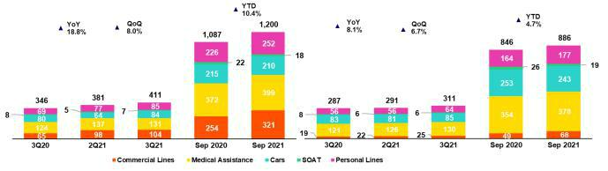

Total premiums increased 8.0% QoQ, which was attributable to: (i) Cars, driven by an increase in new sales and renewals in the brokers channel and in bancassurance due to recovery in the Cars segment; (ii) Personal Lines, mainly due to an increase in policy issuances for the Mortgage Product and growth in volumes of renewals for Card Protection; (iii) Commercial Lines, due to an uptick in new sales in the Aviation and Third-party Liability Lines and (iv)
SOAT⁽¹³⁾, which was associated with an increase in sales in the digital and bancassurance channels. The aforementioned was attenuated by the evolution of Medical Assistance, which reported a high volume of renewals last quarter.

In the YoY analysis, total premiums increased 18.8%, which was driven primarily by (i) Commercial Lines, due to an increase in new sales in the Fire, Third-party Liability and Aviation lines; (ii) Personal lines, due to an increase in sales for Card Protection, Personal life Accidents and Mortgage products; (iii) Medical Assistance, due to an increase in renewal volumes for comprehensive health and oncological products; (iv) Cars, due to an increase in renewals in the broker and digital channels. The aforementioned was attenuated by the evolution of SOAT, which registered a decrease in new sales through the broker and bancassurance channels.

- Total premiums less premiums ceded to reinsurance and premium reserves.

- Mandatory Insurance Against Traffic Accidents.

39

Net earned premiums QoQ increased 6.7% due to the factors described in the analysis of total premiums. These effects were partially mitigated by higher levels of ceded premiums in the Commercial Lines and by an increase in the underwriting reserves set aside in Cars and SOAT. Net earned premiums YoY increased 8.1%, driven by the factors outlined in the QoQ analysis.

YTD, total premiums increased 10.4% while net earned premiums rose 4.7%. This evolution was attributable to the factors explained in the YoY analysis and was attenuated by a decrease in renewals in Cars.

Net Claims in P&C

(S/ millions)
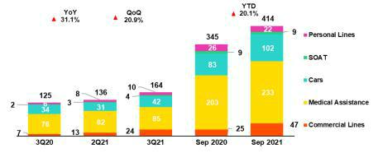

Net claims increased 20.9% QoQ, which was driven by: (i) Commercial Lines, and the Machinery line in particular due to damage associated with sinkholes at mining sites and to damaged merchandise in the transportation line; (ii) Cars, due to an increase in claims frequency and in the use of vehicles; (iii) Medical Assistance, due to a recovery in the demand for non-Covid medical services and, (iv) Personal Lines, mainly relative to the card protection product.

In the YoY analysis, net claims increased 31.1%, which was attributable to (i) Commercial Lines, given an uptick in the severity of cases in the transportation, machinery and Maritime Hulls lines; (ii) Medical Assistance, due to an increase in the severity of COVID claims and to growth in the number of medical services for other illnesses; (iii) Cars and SOAT, due to an increase in claims frequency; and (iv) Personal Lines, which was driven primarily by the card protection product. YTD, net claims increased 20.1% due to the reasons outlined in the YoY analysis; this was attenuated by the evolution of Personal Lines, which experienced a drop in case frequency for the card protection product.

6.3. Acquisition Cost

Acquisition cost |  |  |  | Quarter |  |  |  | % change |  |  |  |  |  | YTD |  |  |  | % change
S/ 000 |  | 3Q20 |  | 2Q21 |  | 3Q21 |  | QoQ |  |  | YoY |  | 9M-20 |  |  | 9M-21 |  | 9M-21 / 9M-20
Net fees |  | (59,653) |  | (53,808) |  | (51,617) |  | -4.1% |  |  | -13.5% |  | (175,388) |  |  | (161,030) |  | -8.2%
Underwriting expenses |  | (27,716) |  | (31,842) |  | (33,543) |  | 5.3% |  |  | 21.0% |  | (113,366) |  |  | (96,942) |  | -14.5%
Underwriting income |  | 725 |  | 706 |  | (2,256) |  | n.a. |  |  | n.a. |  | 2,004 |  |  | (210) |  | -110.5%
Acquisition cost |  | (86,644 | ) | (84,944 | ) | (87,416 | ) | 2.9 | % |  | 0.9 | % | (286,749 | ) |  | (258,182 | ) | -10.0 | %

Acquisition cost per business

(S/ million)
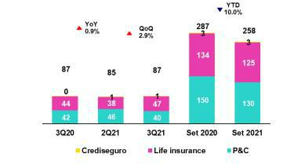

40

The acquisition cost increased 2.9% QoQ, which was primarily attributable to the Life business due to: (i) growth in underwriting expenses, after uncollectible reinsurance premiums were registered in Credit Life and Group Life, and (ii) a decrease in underwriting income due to profit sharing in Credit life and (iii) growth in commissions in Credit Life and Annuities. The aforementioned was mitigated by the evolution of the P&C business, which recorded a decrease in commissions in Personal Lines and a drop in underwriting expenses in Medical Assistance, both of which were associated with a decrease in provisions for doubtful collections.

In the YoY analysis, the acquisition cost increased, 0.9% which was primarily driven by the Life business (for the same reasons indicated in the QoQ analysis) and by an increase in underwriting expenses in P&C after more provisions were set aside for doubtful collections in the Commercial Lines and Cars. The aforementioned was mitigated by a decrease in commissions in P&C, which was spurred mainly by drops in Commercial Lines, Medical Assistance and Personal Lines.

YTD, the acquisition cost fell 10.0%. This was primarily attributable to the uptick registered in underwriting expenses last year in P&C, which was driven mainly by Cars and attributable to reimbursements of premiums during the pandemic (clients were unable to use their cars). The Life business reported a decrease in underwriting expenses, mainly through Individual Life. Finally, fee income dropped in the P&C business, which was primarily attributable to the evolution of Cars and of the Life business.

6.4. Underwriting Result by Business

Underwriting Result by Business

(S/ millions)
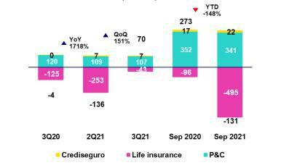

In the QoQ analysis, the underwriting result returned to a positive range, due primarily to an improvement in the life insurance result. This advance was driven by an increase in net earned premiums and to a decrease in claims due to an improvement in the sanitary situation. In P&C, the reduction in the underwriting result was attributable to an increase in claims, which was seen primarily in Commercial Lines due to an uptick in claim severity, which was accompanied by growth in claims in Cars and Medical Assistance, which was driven by an uptick in case frequency.

In the YoY analysis, the improvement in the underwriting result was attributable to an increase in net earned premiums in both businesses, and to lower life business claims given the release of IBNR claims of COVID-19 provisions after the second wave of the pandemic subsided. The aforementioned was attenuated by an uptick in claims in P&C, which was primarily attributable to Medical Assistance, Commercial Lines and Cars.

YTD, the decrease in the result was attributable to the results for Life and, to a lesser extent, to the results posted by P&C. In Life, the reduction in the result was associated with an increase in claims during the second wave of COVID-19. This effect was partially mitigated by an increase in net premiums and a decrease in acquisition costs. In P&C, the drop in the underwriting result was driven by an uptick in claims in Medical Assistance and in Commercial Lines and Cars, which registered an increase in claims frequency. This effect was partially mitigated by an increase in sales reported by Commercial Lines and Medical Assistance.

41



7. Operating Expenses

Operating expenses |  |  |  | Quarter |  |  |  | % change |  |  |  |  |  |  | YTD |  |  | % change
S/ 000 |  | 3Q20 |  | 2Q21 |  | 3Q21 |  | QoQ |  |  | YoY |  | 9M - 20 |  |  | 9M - 21 |  | 9M - 21 / 9M - 20
Salaries and employees benefits |  | 803,438 |  | 882,177 |  | 915,564 |  | 3.8% |  |  | 14.0% |  | 2,520,618 |  |  | 2,655,300 |  | 5.3%
Administrative, general and tax expenses ⁽¹⁾ |  | 591,213 |  | 672,804 |  | 803,156 |  | 19.4% |  |  | 35.8% |  | 1,644,010 |  | 2,056,803 |  |  | 25.1%
Depreciation and amortization ⁽¹⁾ |  | 166,105 |  | 163,869 |  | 170,960 |  | 4.3% |  |  | 2.9% |  | 505,374 |  | 501,594 |  |  | -0.7%
Association in participation |  | 10,566 |  | 8,879 |  | 10,426 |  | 17.4% |  |  | -1.3% |  | 34,940 |  | 33,211 |  |  | -4.9%
Acquisition cost ⁽²⁾ |  | 86,643 |  | 84,944 |  | 87,416 |  | 2.9% |  |  | 0.9% |  | 286,748 |  | 258,182 |  |  | -10.0%
Operating expenses ⁽³⁾ |  |  |  |  |  |  |  |  | % |  |  | %
 |  | 1,657,965 |  | 1,812,673 |  | 1,987,522 |  | 9.6 | % |  | 19.9 | % | 4,991,690 |  | 5,505,090 |  |  | 10.3%

- 3Q20 figures differ from what was previously reported by reclassification of IFRS16.
- The acquisition cost of Pacifico includes net fees and underwriting expenses.
- Operating expenses = Salaries and employee’s benefits + Administrative expenses + Depreciation and amortization + Association in participation + Acquisition cost.

In the QoQ, YoY and 9 month YoY analyses, operating expenses rose due to:
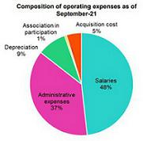

- Growth in administrative and general expenses and taxes, which was primarily attributable to BCP Stand-alone, where efforts are underway to accelerate the organization’s digital transformation by increasing investment in technology, data analysis and consultancy among others.

(ii)The increase in Salaries and Employee Benefits, given that more provisions were set aside for employee profit sharing, which was in line with growth in earnings this quarter, and more personnel with specialized technical profiles were hired under the organization’s digital transformation strategy.

It is important to note that exchange rate volatility significantly impacted expenses this quarter. If we exclude this effect, growth in spending situates at 9.1% (50bps less).

7.1. Administrative and general expenses and taxes

Administrative and general expenses and taxes

Administrative, general and tax expenses |  |  |  | Quarter |  |  |  | % change |  |  |  |  |  | YTD |  |  | % change
S/ 000 |  | 3Q20 |  | 2Q21 |  | 3Q21 |  | QoQ |  |  | YoY |  | 9M - 20 |  | 9M - 21 |  | 9M - 21 / 9M - 20
IT, Repair and maintenance |  | 107,236 |  | 125,427 |  | 154,788 |  | 23.4% |  |  | 44.3% |  | 289,039 |  | 386,840 |  | 33.8%
Marketing |  | 90,912 |  | 104,862 |  | 123,370 |  | 17.6% |  |  | 35.7% |  | 219,673 | 300,502 |  |  | 36.8%
Taxes and contributions |  | 59,866 |  | 77,406 |  | 80,626 |  | 4.2% |  |  | 34.7% |  | 191,227 | 226,840 |  |  | 18.6%
Consulting and professional fees |  | 45,962 |  | 57,720 |  | 112,917 |  | 95.6% |  |  | 145.7% |  | 131,859 | 211,495 |  |  | 60.4%
Transport and communications |  | 44,794 |  | 53,394 |  | 59,008 |  | 10.5% |  |  | 31.7% |  | 113,003 | 155,100 |  |  | 37.3%
IT third-party services |  | 40,148 |  | 42,826 |  | 49,786 |  | 16.3% |  |  | 24.0% |  | 103,463 | 133,057 |  |  | 28.6%
Comissions by agents |  | 22,270 |  | 25,218 |  | 26,486 |  | 5.0% |  |  | 18.9% |  | 62,775 | 11,120 |  |  | -82.3%
Security and protection |  | 16,101 |  | 15,691 |  | 15,469 |  | -1.4% |  |  | -3.9% |  | 47,903 | 47,119 |  |  | -1.6%
Sundry supplies |  | 12,679 |  | 14,171 |  | 13,067 |  | -7.8% |  |  | 3.1% |  | 46,226 | 42,058 |  |  | -9.0%
Leases of low value and short-term |  | 14,157 |  | 20,145 |  | 23,517 |  | 16.7% |  |  | 66.1% |  | 50,551 | 64,564 |  |  | 27.7%
Electricity and water |  | 12,171 |  | 12,709 |  | 11,102 |  | -12.6% |  |  | -8.8% |  | 37,117 | 34,502 |  |  | -7.0%
Subscriptions and quotes |  | 12,263 |  | 13,462 |  | 13,312 |  | -1.1% |  |  | 8.6% |  | 35,234 | 39,957 |  |  | 13.4%
Insurance |  | 20,392 |  | 5,320 |  | 36,968 |  | 594.9% |  |  | 81.3% |  | 28,497 | 50,562 |  |  | 77.4%
Electronic processing |  | 8,824 |  | 11,123 |  | 10,864 |  | -2.3% |  |  | 23.1% |  | 24,301 | 31,954 |  |  | 31.5%
Cleaning |  | 6,705 |  | 5,206 |  | 4,630 |  | -11.1% |  |  | -30.9% |  | 17,745 | 15,118 |  |  | -14.8%
Audit Services |  | 3,693 |  | 2,206 |  | 2,479 |  | 12.4% |  |  | -32.9% |  | 6,163 | 5,944 |  |  | -3.6%
Services by third-party and others ⁽¹⁾ |  | 73,040 |  | 85,919 |  | 64,767 |  | -24.6% |  |  | -11.3% |  | 239,234 | 300,071 |  |  | 25.4%
Total administrative and general expenses |  | 591,212 |  | 672,805 |  | 803,156 |  | 19.4 | % |  | 35.8 | % | 1,644,010 |  | 2,056,803 |  | 25.1 | %

- The balance consists mainly of security and protection services, cleaning service, representation expenses, electricity and water utilities, insurance policiy expenses, subscription expenses and commission expenses.

43

In the QoQ, YoY and 9 month YoY analyses, administrative and general expenses and taxes rose due to:

- Growth in expenses in IT, Repairs and Maintenance, which was associated with the development of new IT projects for digital transformation; business improvements; and sustainability.

- Growth in expenses in Marketing due to an uptick in consumption of LATAM miles through the client fidelity program after consumption with credit and debit cards rose in a context of economic reactivation post-quarantine.

- An increase in expenses for Consultancy and professional services due to an uptick in investment in the digital transformation program and in new disruptive initiatives.

44

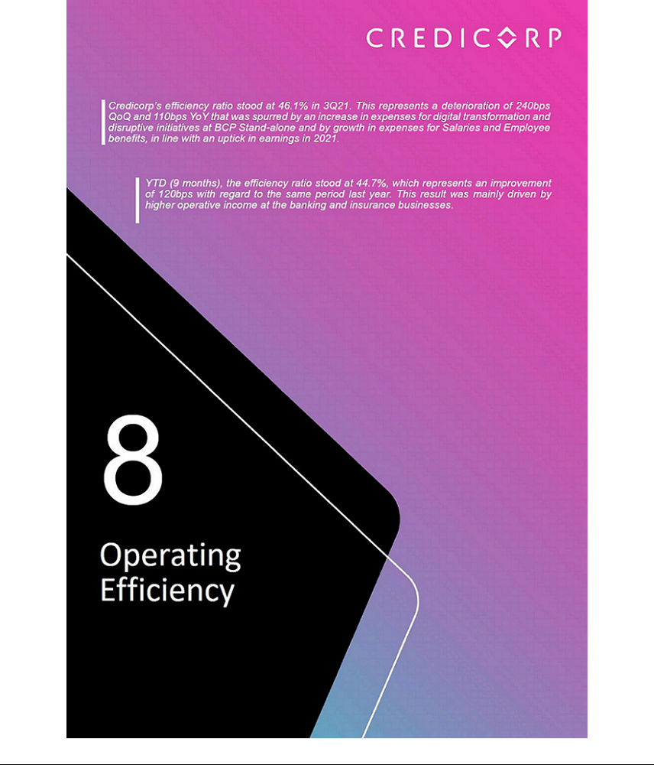

8. Operating Efficiency

Operating Efficiency |  |  |  | Quarter |  |  |  | % change |  |  |  |  | Year |  |  |  |  | % change
S/ 000 |  | 3Q20 |  | 2Q21 |  | 3Q21 |  | QoQ |  |  | YoY |  | 9M - 20 |  |  | 9M - 21 |  | 9M - 21 / 9M - 20
Operating expenses ⁽¹⁾ |  | 1,657,964 |  | 1,812,674 |  | 1,987,522 |  | 9.6% |  |  | 19.9% |  | 4,991,690 |  |  | 5,505,090 |  | 10.29%
Operating income ⁽²⁾ |  | 3,684,610 |  | 4,147,704 |  | 4,307,965 |  | 3.9% |  |  | 16.9% |  | 10,866,506 |  |  | 12,327,232 |  | 13.4%
Efficiency ratio ⁽³⁾ |  | 45.0% |  | 43.7% |  | 46.1% |  | 240 bps |  |  | 110 bps |  | 45.9% |  |  | 44.7% |  | -120 bps
Operating expenses / Total average assets ⁽⁴⁾ |  | 2.93% |  | 2.96% |  | 3.20% |  | 24 bps |  |  | 27 bps |  | 3.17% |  |  | 3.00% |  | -17 bps

- Operating expenses = Salaries and employee’s benefits + Administrative expenses + Depreciation and amortization + Association in participation + Acquisition cost.
- Operating income = Net interest, similar income and expenses + Fee income + Net gain on foreign exchange transactions + Net gain from associates + Net gain on derivatives held for trading + Net gain from exchange differences + Net premiums earned
- Operating expenses / Operating income.
- Operating expenses / Average of Total Assets. Average is calculated with period beginning and period-ending balances.

8.1 Efficiency ratio by income and expense item

QoQ and YoY, the efficiency ratio deteriorated 240 bps and 110 pbs. This decline was attributable to an increase in Administrative and general expenses and taxes, which was driven by an uptick in investment in digital transformation at BCP Stand-alone, and by growth in Salaries and Employee Benefits, which was fueled by an increase in provisions for profit sharing and by growth in expenses to hire personnel with specialized technical profiles.

YTD evolution of the efficiency ratio by account
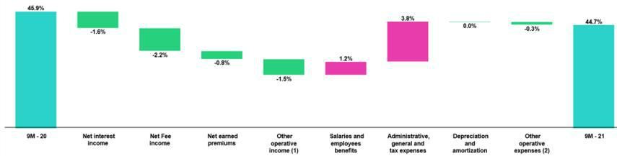

- Other operating income includes: Net gain on foreign exchange transactions, Net gain from associates, Net gain on derivatives held for trading and Net gain from exchange difference.
- Other operating expenses includes: Acquisition cost and Association in participation.

YTD (9 months)¹⁴, the efficiency ratio improved 120pbs due to:

- The increase in Fee Income, given that throughout the most part of 2020, fee exemptions were offered to clients to mitigate the impact of the pandemic. During this same period, restrictions on mobility were in place that reduced the transactions base.

- Growth in Net interest income, which was driven by an uptick in structural loans at Mibanco this quarter.

- An increase in income from Net earned premiums, which rose after Pacifico was awarded a larger tranche of SISCO V, which offers a better premiums structure than SISCO IV, and due to growth in premiums for credit life insurance, in line with an uptick in loan disbursements at Mibanco.

- Growth in Net gains on foreign exchange transactions, which were affected by the volatility created by political uncertainty.

The improvement this quarter was partially offset by growth in Administrative and general expenses and taxes (increase in expenses related to digital transformation at BCP Stand-alone) and in Salaries and employee benefits (increase in provisions for profit sharing, in line with an improvement in results).

- This is the most efficient measurement of said indicator given that it eliminates the effects of seasonality between quarters.

46

8.2. Efficiency ratio reported by subsidiary ⁽¹⁾

 | BCP |  | BCP Bolivia |  | Mibanco Peru |  | Mibanco |  | Pacifico |  | Prima AFP |  | Credicorp
 | Stand-alone |  |  |  |  |  | Colombia
3Q20 | 40.8% |  | 51.2% |  | 58.7% |  | 113.3% |  | 35.4% |  | 49.3% |  | 45.0%
2Q21 | 40.3% |  | 58.9% |  | 55.6% |  | 74.1% |  | 36.6% |  | 44.9% |  | 43.7%
3Q21 | 45.3% |  | 53.0% |  | 49.7% |  | 86.4% |  | 36.9% |  | 51.1% |  | 46.1%
Var. QoQ | 500 bps |  | -590 bps |  | -590 bps |  | 1230 bps |  | 30 bps |  | 620 bps |  | 240 bps
Var. YoY | 450 bps |  | 180 bps |  | -900 bps |  | -2690 bps |  | 150 bps |  | 180 bps |  | 110 bps
9M - 20 | 40.8% |  | 52.9% |  | 65.2% |  | 98.4% |  | 38.7% |  | 47.9% |  | 45.9%
9M - 21 | 42.0% |  | 56.9% |  | 55.4% |  | 79.9% |  | 37.0% |  | 47.5% |  | 44.7%
% change | 120 bps |  | 400 bps |  | -980 bps |  | -1850 bps |  | -170 bps |  | -40 bps |  | -120 bps
9M - 21 / 9M - 20

- (Salaries and employees benefits + Administrative, general and tax expenses + Depreciation and amortization + Acquisition cost + Association in participation) / (Net interest income + Fee income + Net gain on foreign exchange transactions + Net gain from associates + Net gain on derivatives held for trading + Result on exchange differences + Net premiums earned).

In the QoQ and YoY analysis, the efficiency ratio deteriorated due to an increase in expenses for digital transformation and for disruptive initiatives at BCP Stand-alone. The improvement registered in Mibanco’s results, which were boosted by growth in structural loans and better funding structure, was insufficient to offset the aforementioned increase.

YTD evolution of the efficiency ratio by subsidiary
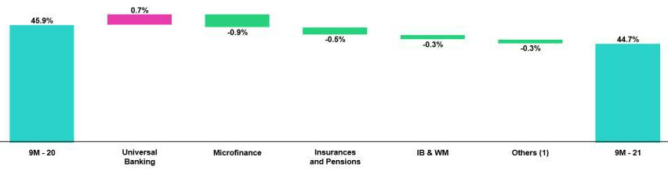

(1) Others includes Grupo Credito, among other subsidiaries and consolidation eliminations.

YTD (9 months), the efficiency ratio improved due to:

- Growth in interest income at Mibanco due to an uptick in structural loan disbursements in 2Q21 and 3Q21.

- Growth in premiums at Pacifico, after the company won a larger tranche of the SISCO V tender, which contemplates a better premiums structure than SISCO IV; expansion was also fueled by an increase in health insurance policy renewals.

- An increase in fee income from Investment Banking and Wealth Management, as a result of the increase in clients that entered international platforms through ASB services, mainly during 2Q21.

47



9. Regulatory capital

9.1. Regulatory Capital at Credicorp
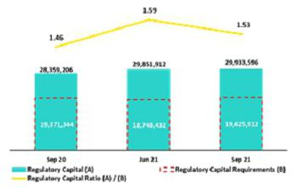

The regulatory capital ratio stood at 1.53 at the end of 3Q21. The following dynamics were noteworthy:

In the QoQ analysis, the regulatory capital ratio fell slightly, driven by a +4.7% QoQ increase in Credicorp’s Regulatory Capital Requirement, which was mainly attributable to BCP Stand-alone.

It is important to note that the Regulatory Capital level remained relatively constant given that the effect of the dividend declaration in the month of August was largely offset by growth in subordinated debt balance (which was attributable to the exchange rate effect).

In the YoY analysis, the capital ratio registered a slight increase, which was attributable to (i) the exchange rate effect at the subordinated debt level and, (ii) a base effect, associated with losses incurred in 3Q20.

9.2. Regulatory Capital BCP Individual – Peru GAAP

At the end of 3Q21, the Tier 1 and BIS ratios at BCP Stand-alone registered

a decline and stood at 10.00% and 15.16% respectively. This was

attributable to growth of +3.0% QoQ in RWAs, which was driven by (i) an

uptick in the exchange rate and to a lesser extent, (ii) an increase in

structural loans.

The decrease in the BIS ratio was partially offset by +1.8% growth in

regulatory capital, which was attributable to an increase in subordinated debt

due to an uptick in the exchange rate.

- Regulatory Tier 1 Capital / Total Risk-weighted assets

- Total Regulatory Capital / Total Risk-weighted assets (legal minimum = 10% since July 2011).

The YoY evolution shows the same trend, which reflects a decrease in the BIS ratio and in the Tier 1 ratio in comparison to the levels reported in 3Q20. Both ratios were affected by 8.2% growth in RWAs. These reductions were partially offset by an increase in capital levels and in reserves, which was driven by an improvement in BCP’s results. The BIS ratio fell to a less significant degree than Tier 1 due to an increase in subordinated debt through a liability management transaction at BCP Stand-alone.

Common Equity Tier 1 Ratio– BCP Stand-alone
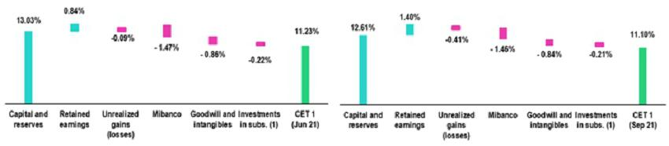

(*) Figures at Jun21 differ from previously reported.

(1) Includes investments in BCP Bolivia and other subsidiaries.

Finally, the Common Equity Tier 1 ratio (CET 1), which is considered the most rigorous indicator of capitalization levels, posted a drop of -13bps QoQ to stand at 11.10% at the end of 3Q21. This evolution was primarily attributable to an increase in RWAs (+3.3% QoQ). Growth in RWAs was driven by an uptick in the exchange rate, which subsequently affected the loan portfolio and, to a lesser extent, by a decrease in unrealized gains. These effects were partially offset by an improvement in retained earnings.

49

In the YoY analysis, the CET1 ratio fell -35bps due to a +7.2% increase in RWAs and to a decrease in unrealized gains. These effects were partially offset by an increase in retained earnings and, to a lesser extent, to growth in the levels of capital and reserves.

9.3. Regulatory Capital Mibanco – Perú GAAP
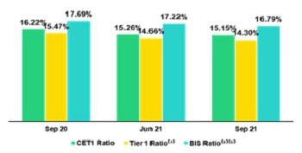

At the end of 3Q21, the Tier 1 and BIS ratios at Mibanco stood at 14.30% and 16.79%, which represented a QoQ drop of -36bps and -43bps respectively. This evolution was attributable to growth in RWAs, which was in turn driven by loan expansion. The aforementioned was partially attenuated by an increase in share earnings agreements.

- Regulatory Tier 1 Capital / Total Risk-weighted assets

- Total Regulatory Capital / Total Risk-weighted assets (legal minimum = 10% since July 2011).

The YoY evolution reflects a decrease of -117bps and -90bps in the Tier 1 and BIS ratios respectively. Both variations were attributable to a +13.9% increase in RWAs, which was driven by the same factors that impacted the QoQ evolution. The drop in the Tier 1 Ratio was partially attenuated by growth in Tier 1 Regulatory Capital (+2.6%) while the decrease in BIS ratio was mitigated by growth in Total Regulatory Capital (+2.6%). Growth in both of these capital ratios was attributable to an increase in share earnings agreements.

Finally, the Common Equity Tier 1 ratio (CET 1), which is considered the most rigorous indicator of capitalization levels, registered a decrease of -11bps QoQ and stood at 15.15% in 3Q21. This decrease was primarily due to growth of +6.1% in RWAs, which was attributable to loan expansion. This effect was partially mitigated by an increase in Common Equity Tier 1, which was driven by growth in retained earnings (+42.9%). In the YoY analysis, the CET1 ratio fell -107bps due to the effect described in the QoQ analysis.

50

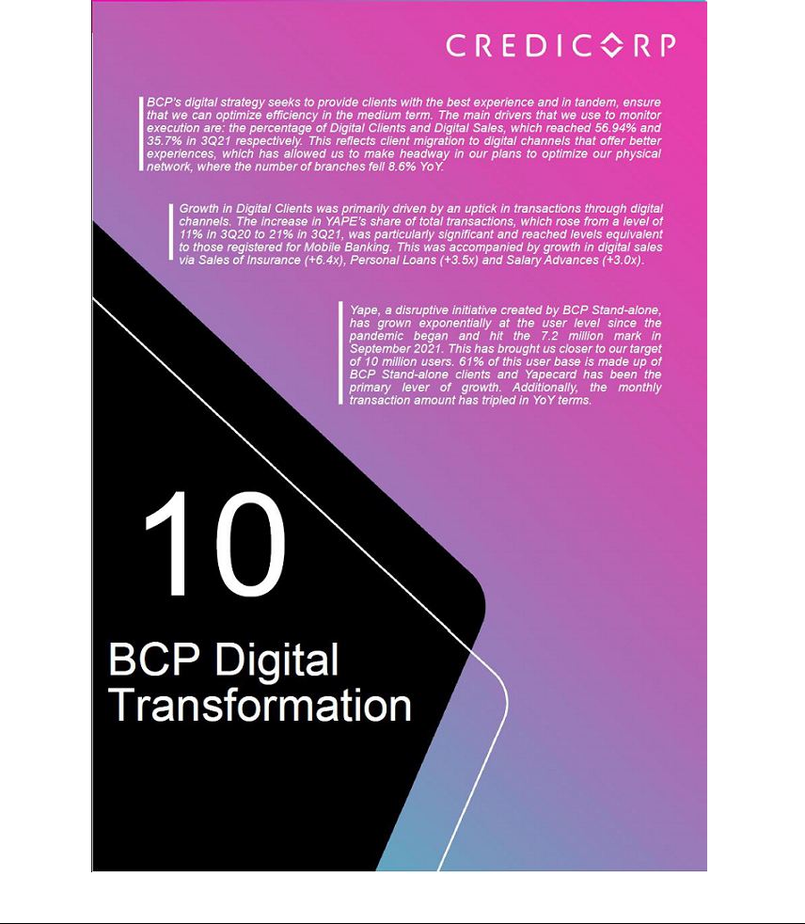

10. Digital Transformation at BCP Stand-alone
10.1. Client digitalization in Personal Banking
Evolution of digital clients ⁽¹⁾ |  | Composition of digital clients ⁽¹⁾ by segment
 | Group |  |  | 3Q20 |  | 2Q21 |  | 3Q21
 | Enalta |  |  | 85.49% |  | 86.96% |  | 87.08%
 | Affluent | 79.38% |  |  |  | 81.23% |  | 81.31%
 | Consumer | 51.97% 55.15% |  |  |  |  |  | 55.82%
 | Total |  |  | 53.31 | % | 56.33 | % | 56.94 | %
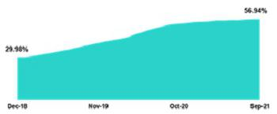

- Digital clients: Retail Baking clients that conduct 50% of their monetary transactions through digital channels or who purchased online products in the last

12 months.

The number of digital clients this quarter has followed the upward trend seen in previous quarters. In 3Q21, digital clients represented 56.94% of all Personal Banking clients. Through the digital education program, 55.82% of the clients in the Consumer segment have been digitalized. By driving migration to digital channels, we increase the convenience of services and improve customer experiences while optimizing our efficiency in the medium term. In this context, we are accelerating initiatives to improve digital functions and products.

10.2. Migration of Transactions to digital channels

Evolution of the monthly average transactions by channel

Expressed in millions of transactions
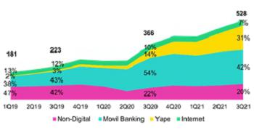

Evolution of the monthly averages for monetary transactions by

channel and unit cost

Expressed in millions of transactions
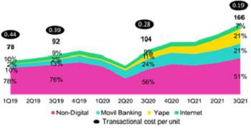

The total monthly average transactions grew 10.9%

QoQ and +44.4% YoY, which was driven primarily by monetary transactions (+18.8% QoQ and +60.2% YoY).

Growth in monetary transactions was seen across channels.

In digital channels, growth in monthly average transactions was particularly noteworthy for:

- Yape, which grew 32.6% QoQ and 220.7% YoY, (see section 10.5. Disruptive Initiatives – Yape.).

- Mobile Banking grew 14.5% QoQ and 35.7% YoY, which reflected the significant upward trend in play since the beginning of the pandemic. A new version of the mobile banking platform was launched in June to improve the customer experience.

In traditional channels, growth in monthly average transactions was significant in:

- POS, which grew +23.3% QoQ and +94.8% YoY, hand-in-hand with economic reactivation and in consumption in business establishments with credit and debit cards.

- Agentes BCP, which registered growth of +9.1% QoQ and +20.0% YoY, in line with the increase in the number of agents generated by the strategy to optimize the physical network.

52

The results of the migration of transactions to digital and cost-efficient channels, the monthly average transaction per unit cost fell from 0.28 in 3Q20 to 0.19 in 3Q21.

10.3. Self-service and Digital Sales

Self-service and digital sales, measured in units, continued to follow an upward trend.

At the end of 3Q21, self-service sales represented 16% of total units sold, compared to 10% at the end of 3Q20, while digital sales represent 36% of total units sold, compared to 29% in 3Q20.

Retail Banking Sales

 |  |  | Unit sold per Quarter |  |  |  |  |  | % Change |  |  |  |  | Unit sold YTD |  |  |  | % Change
 | 3Q20 |  |  | 2Q21 |  | 3Q21 |  | TaT |  |  |  | AaA |  | Sep 20 |  | Sep 21 |  | Jun 21/ Jun 20
Traditionals Sales | 975,019 |  |  | 1,459,229 |  | 1,140,335 |  |  | -21.9% |  |  | 17.0% |  | 2,952,832 |  | 3,666,699 |  | 24.2%
Selfserved Sales ⁽¹⁾ | 159,462 |  | 337,929 |  |  | 376,945 |  |  | 11.5% |  |  | 136.4% |  | 772,295 |  | 979,941 |  | 26.9%
Digital Sales ⁽²⁾ | 462,048 |  | 816,952 |  |  | 842,501 |  |  | 3.1% |  |  | 82.3% |  | 1,418,335 |  | 2,388,461 |  | 68.4%
Total Sales | 1,596,529 |  |  | 2,614,110 |  | 2,359,781 |  |  | -9.7 | % |  | 47.8 | % | 5,143,462 |  | 7,035,101 |  | 36.8 | %

- Sales made through ATMs and Kioskos BCP.

- Sales made through Mobile Banking, Internet Banking, Yape and other digital channels.

In Self-Service sales, the YoY growth trend Savings account (+129%) and Advances on Wages (+199%).

In Digital Sales, the YoY growth trend was particularly positive for Advances on Wages (+197%), Insurance (+540%) and Personal Loans (+251%).

The decrease in total sales QoQ was driven by seasonality in April and May, when statutory Severance Indemnity Deposits are made.

10.4. Optimization of BCP’s Physical Network

The advance of client migration to physical channels has allowed us to optimize BCP’s physical network. The optimization process entails branch closings; an increase in agents; and growth in ATMs to complement our transactional capacity. This process also involves remodeling and redesigning office space emphasize the commercial side of the business.

BCP point of contact
 |  |  | As of |  |  |  | change (units)
 | Sep 20 |  | Jun 21 |  | Sep 21 |  | QoQ |  | YoY
Branches | 393 |  | 363 |  | 359 |  | -4 |  | -34
ATMs | 2,299 |  | 2,291 |  | 2,248 |  | -43 |  | -51
Agentes BCP | 6,997 |  | 6,818 |  | 6,998 |  | 180 |  | 1
Total BCP’s Network | 9,689 |  | 9,472 |  | 9,605 |  | 133 |  | -84

10.5. Disruptive Initiatives – Yape

Yape was initially designed to allow users to make money transfers or payments through mobile phones or with a QR code. The application’s objective was to replace cash in small recurring transfers or to pay services. Today, Yape’s ambition is far greater:

- To become a SuperApp.

- To contribute to increasing financial inclusion for Peruvians who lack access to banking services.

- To become the main digital channel that companies use to sell in Peru.

53

Evolution of Yape users | Yape users by user type
Expressed in millions of clients | Yape users by user type
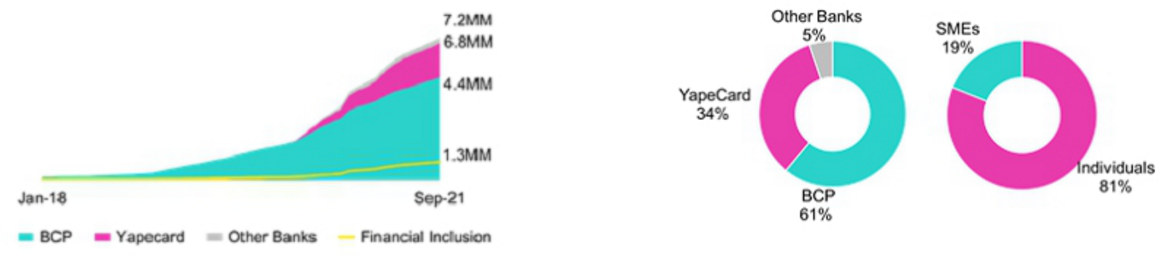

The number of Yape users has registered pronounced growth since the beginning of the pandemic. In this context, we have gone from registering a user base of 2.5 million to posting a level of 7.2 million users at the end of September. This growth was strengthened by the creation of the Yapecard in May 2020, which allows users to open a digital wallet solely with a DNI and without a bank account. Currently, 49% of Yape’s users are active on a monthly basis.

Yape has spurred the financial inclusion of 1.3 million people in Peru, primarily through Yapecard. This product began channeling government social assistance payments to beneficiaries in November 2020, which captured new users that had yet to be bancarized. Yape will channel a new round of government assistance payments to vulnerable families in 4Q21.

Finally, if we look at the current composition of Yape users, BCP’s clients represent 61% of total users; Yapecard users, 34%, and associated financial institutions, 5%. Additionally, 19% of the users are microbusinesses, which have digitalized their collections and transactions through Yape.

Evolutuion of the monthly transactions volume and average ticket per | The monthly transactions volume through Yape began to growth
transaction | exponentially as of March 2020 (14-fold increase to date) due to:
Volume expressed in millions of soles | (i) Migration from cash use to Yape given social distancing measures.
 | (ii) Yapecard’s penetration of non-bancarized segments.
 | The average ticket per transaction continued to average S/59 soles, which
 | shows that Yape is used for small cash payments. As such, cash is Yape’s
 | competition (and captive market) rather than other mobile banking
 | applications offered by financial institutions.
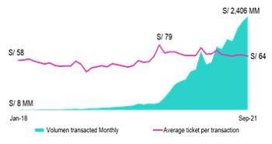

54



11. Economic Perspectives
11.1. Peru: Economic Forecasts
Peru |  | 2017 |  | 2018 |  | 2019 |  | 2020 |  | 2021 ⁽³⁾
GDP (US$ Millions) |  | 214,330 |  | 225,430 |  | 230,966 |  | 205,188 |  | 219,444
Real GDP (% change) |  | 2.5 |  | 4.0 |  | 2.2 |  | -11.0 |  | 12.0
GDP per capita (US$) |  | 6,740 |  | 7,001 |  | 7,107 |  | 6,289 |  | 6,653
Domestic demand (% change) |  | 1.5 |  | 4.2 |  | 2.3 |  | -9.4 |  | 12.5
Gross fixed investment (as % GDP) |  | 20.6 |  | 21.6 |  | 21.1 |  | 18.7 |  | 20.5
Public Debt (as % GDP) |  | 24.9 |  | 25.8 |  | 26.8 |  | 34.7 |  | 34.5
System loan growth (% change)⁽¹⁾ |  | 5.6 |  | 10.1 |  | 6.2 |  | 12.4 |  | -
Inflation⁽²⁾
 |  | 1.4 |  | 2.2 |  | 1.9 |  | 2.0 |  | 6.0
Reference Rate |  | 3.25 |  | 2.75 |  | 2.25 |  | 0.25 |  | 2.00
Exchange rate, end of period |  | 3.24 |  | 3.37 |  | 3.31 |  | 3.62 |  | 4.00
Exchange rate, (% change) |  | 0.0% |  | 0.9% |  | 1.4% |  | 4.7% |  | 10.6%
Fiscal balance (% GDP) |  | -3.1 |  | -2.5 |  | -1.6 |  | -8.9 |  | -4.4
Trade balance (US$ Millions) |  | 6,700 |  | 7,197 |  | 6,614 |  | 7,750 |  | 16,000
(As % GDP) |  | 3.1% |  | 3.2% |  | 2.9% |  | 3.8% |  | 7.3%
Exports |  | 45,422 |  | 49,066 |  | 47,688 |  | 42,413 |  | 59,000
Imports |  | 38,722 |  | 41,870 |  | 41,074 |  | 34,663 |  | 43,000
Current account balance (US$ Millions) |  | -2,779 |  | -3,821 |  | -3,531 |  | 995 |  | -3,796
Current account balance (As % GDP) |  | -1.3% |  | -1.7% |  | -1.5% |  | 0.5% |  | -1.7%
Net international reserves (US$ Millions) |  | 63,621 |  | 60,121 |  | 68,316 |  | 74,707 |  | 75,000
(As % GDP) |  | 29.7% |  | 26.7% |  | 29.6% |  | 36.4% |  | 34.2%
(As months of imports) |  | 20 |  | 17 |  | 20 |  | 26 |  | 21

Source: INEI, BCRP, and SBS.

- Financial System, Current Exchange Rate.

- Inflation target: 1% - 3%.

- Estimates by BCP Economic Research as of July 2021.

10.2. Main Economic Variables

Gross Domestic Product

(Annual Variations, % YoY)

In August, the economy grew 11.8% YoY and was 1.6% above its level in August 2020.
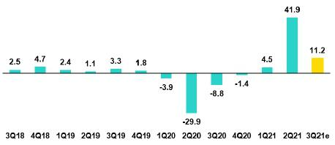

Our estimates suggested that the economy would have rebounded 11.2% in 3Q21, after falling -8.8% YoY in the third quarter of last year as a result of quarantines, thus reaching 1.5% above the levels of the third quarter of 2020.

So far this year, Jan-Sep, GDP has accumulated a rebound of 17.4% and 0.4% versus 2020.

Source: Banco Central de Reserva del Perú. Estimate: BCP

56

Inflation and Monetary Policy Rate (%)

Annual inflation ended 3Q21 at 5.2% YoY (2Q21: 3.3%) and continue at the upper limit of BCRP's target range (1% - 3%).
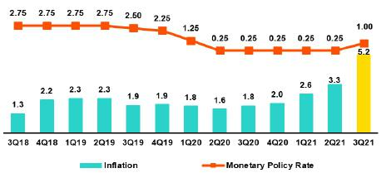

The acceleration of inflation in 3Q21 is mainly explained by food and energy in response to factors such as a higher exchange rate and higher prices of agricultural commodities; for example, in 3Q21 soybean prices rose 23% compared to 3Q20, likewise, corn prices rose 42%, wheat 26% and WTI oil 87%.

Source: Banco Central de Reserva del Perú

Core inflation (excluding food and energy) stood at 2.6% YoY (2Q21: 1.9%).

The reference rate remained at 0.25% until July 2021. Since August 2021, the Central Reserve Bank (BCRP) has made increases in its reference rate by +25 bps in Aug 21 to 0.50%, and by +50 bps in Sep 21 to 1.00%. BCRP’s board considered that monetary policy continues to be expansionary with a historically low benchmark interest rate, and that the September decision does not necessarily imply a cycle of successive increases in the benchmark interest rate.

At the end of 3Q21, the reporting operations with state guarantee (associated with the Reactiva Peru program) totalled S/43.7 billion (2Q21: S/47.9 billion).

Fiscal Result and Current Account Balance

(% of GDP, Quarter)

In annualized terms, the fiscal deficit decreased to 4.8% of GDP in 3Q21 (2Q21: -6.4%).
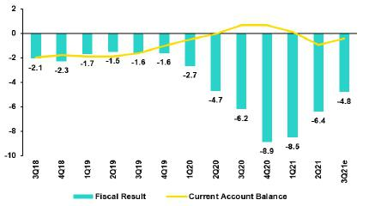

General government revenue grew 47.1% YoY after falling 38% YoY in 3Q20 and 17.6% compared to the same period of 2019.

The increase in tax revenue of 51.9% (22.7% compared to the same period of 2019) is explained by the favourable situation of higher mineral prices and the recovery of economic activity, as well as greater extraordinary income from tax debts and supervision. In this period, non-tax income grew 32.7% compared to 3Q20 (2.8% versus the same period in 2019).

* BCP Estimate

Source: Banco Central de Reserva del Perú

The increase in non-financial expenses of the general government in the period to 3Q21 in 20.6% versus 3Q20 (25.6% compared to 2019) was mainly explained by 95% higher public investment (27% compared to similar period of 2019) in the three levels of government and, to a lesser extent, due to the 11.7% higher current expenditure (24.8% compared to the same period of 2019), mostly in goods and services to address COVID-19.

In September 2021, Moody’s cut Peru's credit rating from A3 to Baa1, with a stable outlook.

In the Jan-Aug 2021 period, the trade balance accumulated a surplus of US$ 8,009 million, which is almost 165% greater than the same period of the previous year (Jan-Aug 2020: US$ 3,036 million).

Exports grew 58.5% YoY in said period, due to higher traditional shipments (+ 68.3%), while non-traditional shipments increased 36% YoY. Also, imports advanced 43.5% YoY; with an increase in inputs of 53.2%, and imports of capital goods increased 47% YoY.

57

In the last twelve months until Aug-21, the accumulated trade surplus reaches US$ 13.2 billion, a new all-time high. Finally, in Aug-21, terms of trade rose 5.3% YoY, favored by higher export prices. In 3Q21, the international price of copper averaged US$ 4.26 / lb, an increase of 44% versus USD 2.96 / lb in 3Q20 and US$ 2.63 / lb in 3Q19.

Exchange rate

(S/ por US$)

The exchange rate ended 3Q21 at USDPEN 4.1345 (historical maximum), which represented a 7% depreciation of the Peruvian Sol compared to the end of 2Q21 (USDPEN 3.8659), 14.3% compared to the end of 2020 (USDPEN 3.6180) and 24.8% compared to the end of 2019 (USDPEN 3.3123).
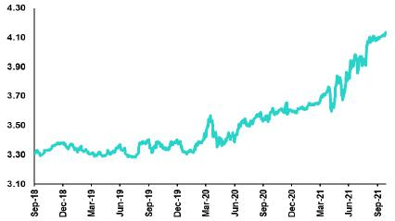

It is important to note that the currencies in the region presented similar results during 3Q21: there was a depreciation of the Brazilian Real (9.54%), the Chilean Peso (10.31%), the Colombian Peso (1.44%) and the Mexican Peso (3.53%).

Source: SBS

During 3Q21, BCRP made net sales in the spot exchange market for US$ 4,279 million, and accumulated sales between January and September by US$ 9,249 million. Likewise, the bank continued to use a set of FX instruments to mitigate pressures on the exchange rate: at the end of 3Q21 the balance of ADC of BCRP stood at S/ 3.9 billion (2Q21: S/ 7.7 billion), and the balance of Swaps Foreign exchange (sale) was S/ 29.4 billion (2Q21: S/ 26.9 billion).

Net International Reserves ended 3Q21 at US$ 76.0 billion versus US$ 71.9 billion at the end of 2Q21 (at the end of 2020 they were US$ 74.7 billion). Finally, the exchange position of BCRP was US$ 55.9 billion, a drop of US$ 2.5 billion compared to the end of 2Q21 (at the end of 2020 it was US$ 58.8 billion).

58

Safe Harbor for Forward-Looking Statements

This material includes “forward-looking statements” within the meaning of Section 27A of the U.S. Securities Act of 1933 and Section 21E of the U.S. Securities Exchange Act of 1934. All statements other than statements of historical fact are forward-looking and may contain information about financial results, economic conditions, trends and known uncertainties. Forward-looking statements are not assurances of future performance. Instead, they are based only on our management’s current views, beliefs, expectations and assumptions regarding the future of our business, future plans and strategies, projections, anticipated events and trends, the economy and other future conditions.

Many forward-looking statements can be identified by words such as: “anticipate”, “intend”, “plan”, “goal”, “seek”, “believe”, “project”, “estimate”, “expect”, “strategy”, “future”, “likely”, “would”, “may”, “should”, “will”, “see” and similar references to future periods. Examples of forward-looking statements include, among others, statements or estimates we make regarding guidance relating to losses in our credit portfolio, efficiency ratio, provisions and non-performing loans, current or future market risk and future market conditions, expected macroeconomic events and conditions, our belief that we have sufficient capital and liquidity to fund our business operations, expectations of the effect on our financial condition of claims, legal actions, environmental costs, contingent liabilities and governmental and regulatory investigations and proceedings, strategy for customer retention, growth, governmental programs and regulatory initiatives, credit administration, product development, market position, financial results and reserves and strategy for risk management.

We caution readers that forward-looking statements involve known and unknown risks and uncertainties that could cause actual results, performance or events to differ materially from those that we expect or that are expressed or implied in the forward-looking statements, depending on the outcome of certain factors, including, without limitation, adverse changes in:

- Economic conditions in Peru;

- The occurrence of natural disasters or political or social instability in Peru;

- The adequacy of the dividends that our subsidiaries are able to pay to us, which may affect our ability to pay dividends to shareholders and corporate expenses;
- Performance of, and volatility in, financial markets, including Latin-American and other markets;

- The frequency, severity and types of insured loss events;

- Fluctuations in interest rate levels;

- Foreign currency exchange rates, including the Sol/US Dollar exchange rate;

- Deterioration in the quality of our loan portfolio;

- Increasing levels of competition in Peru and other markets in which we operate;

- Developments and changes in laws and regulations affecting the financial sector and adoption of new international guidelines;

- Changes in the policies of central banks and/or foreign governments;

- Effectiveness of our risk management policies and of our operational and security systems;

- Losses associated with counterparty exposures;

- The scope of the coronavirus (“COVID-19”) outbreak, actions taken to contain the COVID-19 and related economic effects from such actions and our ability to maintain adequate staffing; and
- Changes in Bermuda laws and regulations applicable to so-called non-resident entities.

See “Item 3. Key Information—3.D Risk Factors” and “Item 5. Operating and Financial Review and Prospects” in our most recent Annual Report on Form 20-F filed with the U.S. Securities and Exchange Commission for additional information and other such factors.

You are cautioned not to place undue reliance on these forward-looking statements, which speak only as of the date hereof and are based only on information currently available to us. Therefore, you should not rely on any of these forward-looking statements. We undertake no obligation to publicly update or revise these or any other forward-looking statements that may be made to reflect events or circumstances after the date hereof, whether as a result of changes in our business strategy or new information, to reflect the occurrence of unanticipated events or otherwise.

59



12.1. Credicorp

CREDICORP LTD. AND SUBSIDIARIES

CONSOLIDATED STATEMENT OF FINANCIAL POSITION

(In S/ thousands, IFRS)

 |  |  |  | As of |  |  |  | % change
 |  | Sep 2020 |  | Jun 2021 |  | Sep 2021 |  | QoQ |  |  | YoY
 | ASSETS
 | Cash and due from banks
 | Non-interest bearing | 6,916,416 |  | 8,883,164 |  | 8,360,631 |  | -5.9% |  |  | 20.9%
 | Interest bearing | 28,221,543 |  | 29,075,474 |  | 36,147,225 |  | 24.3% |  |  | 28.1%
 | Total cash and due from banks | 35,137,959 |  | 37,958,638 |  | 44,507,856 |  | 17.3% |  |  | 26.7%
 | Cash collateral, reverse repurchase agreements and
securities borrowing |  | 2,821,116 |  | 1,616,654 |  | 2,555,337 |  | 58.1% |  |  | -9.4%
 | Fair value through profit or loss investments | 6,658,680 |  | 6,791,288 |  | 6,660,487 |  | -1.9% |  |  | 0.0%
 | Fair value through other comprehensive income
 | investments | 40,712,831 |  | 40,273,400 |  | 33,262,618 |  | -17.4% |  |  | -18.3%
 | Amortized cost investments | 4,277,475 |  | 7,707,956 |  | 8,187,351 |  | 6.2% |  |  | 91.4%
 | Loans | 136,148,711 |  | 143,091,752 |  | 146,551,226 |  | 2.4% |  |  | 7.6%
 | Current | 132,005,867 |  | 138,037,399 |  | 141,077,541 |  | 2.2% |  |  | 6.9%
 | Internal overdue loans | 4,142,844 |  | 5,054,353 |  | 5,473,685 |  | 8.3% |  |  | 32.1%
 | Less - allow ance for loan losses | (9,656,383) |  | (9,391,151) |  | (9,077,449) |  | -3.3% |  |  | -6.0%
 | Loans, net | 126,492,328 |  | 133,700,601 |  | 137,473,777 |  | 2.8% |  |  | 8.7%
 | Financial assets designated at fair value through profit
or loss |  | 729,059 |  | 921,851 |  | 981,508 |  | 6.5% |  |  | 34.6%
 | Accounts receivable from reinsurers and coinsurers | 833,039 |  | 1,043,042 |  | 1,097,493 |  | 5.2% |  |  | 31.7%
 | Premiums and other policyholder receivables | 801,480 |  | 780,824 |  | 801,531 |  | 2.7% |  |  | 0.0%
 | Property, plant and equipment, net | 2,073,864 |  | 1,944,127 |  | 1,911,478 |  | -1.7% |  |  | -7.8%
 | Due from customers on acceptances | 256,238 |  | 558,934 |  | 776,863 |  | 39.0% |  |  | 203.2%
 | Investments in associates | 627,786 |  | 627,683 |  | 648,041 |  | 3.2% |  |  | 3.2%
 | Intangible assets and goodw ill, net | 2,474,665 |  | 2,647,676 |  | 2,682,216 |  | 1.3% |  |  | 8.4%
 | Other assets ⁽¹⁾ | 7,780,221 |  | 8,455,556 |  | 9,995,835 |  | 18.2% |  |  | 28.5%
 | Total Assets | 231,676,741 |  | 245,028,230 |  | 251,542,391 |  | 2.7% |  |  | 8.6%
 | LIABILITIES AND EQUITY
 | Deposits and obligations
 | Non-interest bearing | 45,680,396 |  | 52,879,988 |  | 54,546,530 |  | 3.2% |  |  | 19.4%
 | Interest bearing | 91,522,278 |  | 96,281,815 |  | 98,001,838 |  | 1.8% |  |  | 7.1%
 | Total deposits and obligations | 137,202,674 |  | 149,161,803 |  | 152,548,368 |  | 2.3% |  |  | 11.2%
 | Payables from repurchase agreements and securities
 | lending | 27,778,922 |  | 25,963,227 |  | 23,363,030 |  | -10.0% |  |  | -15.9%
 | BCRP instruments | 25,344,724 |  | 23,329,990 |  | 20,746,109 |  | -11.1% |  |  | -18.1%
 | Repurchase agreements w ith third parties | 1,204,487 |  | 1,276,678 |  | 1,330,811 |  | 4.2% |  |  | 10.5%
 | Repurchase agreements w ith customers | 1,229,711 |  | 1,356,559 |  | 1,286,110 |  | -5.2% |  |  | 4.6%
 | Due to banks and correspondents | 6,601,722 |  | 6,239,161 |  | 7,466,434 |  | 19.7% |  |  | 13.1%
 | Bonds and notes issued | 16,425,832 |  | 16,951,481 |  | 17,577,630 |  | 3.7% |  |  | 7.0%
 | Banker’s acceptances outstanding | 256,238 |  | 558,934 |  | 776,863 |  | 39.0% |  |  | 203.2%
 | Reserves for property and casualty claims | 1,982,653 |  | 2,492,303 |  | 2,583,777 |  | 3.7% |  |  | 30.3%
 | Reserve for unearned premiums | 9,111,195 |  | 9,664,914 |  | 9,928,912 |  | 2.7% |  |  | 9.0%
 | Accounts payable to reinsurers | 222,194 |  | 317,185 |  | 278,220 |  | -12.3% |  |  | 25.2%
 | Financial liabilities at fair value through profit or loss | 352,889 |  | 313,256 |  | 879,177 |  | 180.7% |  |  | 149.1%
 | Other liabilities | 7,675,618 |  | 7,789,038 |  | 10,434,536 |  | 34.0% |  |  | 35.9%
 | Total Liabilities | 207,609,937 |  | 219,451,302 |  | 225,836,947 |  | 2.9% |  |  | 8.8%
 | Net equity | 23,594,717 |  | 25,073,706 |  | 25,192,569 |  | 0.5% |  |  | 6.8%
 | Capital stock | 1,318,993 |  | 1,318,993 |  | 1,318,993 |  | 0.0% |  |  | 0.0%
 | Treasury stock | (209,305) |  | (207,756) |  | (207,745) |  | 0.0% |  |  | -0.7%
 | Capital surplus | 157,767 |  | 224,103 |  | 215,071 |  | -4.0% |  |  | 36.3%
 | Reserves | 21,405,740 |  | 21,725,663 |  | 21,350,150 |  | -1.7% |  |  | -0.3%
 | Unrealized gains and losses | 1,224,135 |  | 677,159 |  | 19,435 |  | -97.1% |  |  | -98.4%
 | Retained earnings | (302,613) |  | 1,335,544 |  | 2,496,665 |  | 86.9% |  |  | -925.0%
 | Non-controlling interest | 472,087 |  | 503,222 |  | 512,875 |  | 1.9% |  |  | 8.6%

 | Total Net Equity | 24,066,804 | 25,576,928 | 25,705,444 | 0.5% | 6.8%
 | Total liabilities and equity | 231,676,741 | 245,028,230 | 251,542,391 | 2.7% | 8.6%
 | Off-balance sheet | 131,512,273 | 149,828,527 | 154,907,974 | 3.4% | 17.8%
 | Total performance bonds, stand-by and L/Cs. | 18,519,960 | 22,723,385 | 22,665,879 | -0.3% | 22.4%
 | Undrawn creditlines, advised but not committed | 81,926,284 | 91,280,633 | 94,165,966 | 3.2% | 14.9%
 | Total derivatives (notional) and others | 31,066,029 | 35,824,509 | 38,076,129 | 6.3% | 22.6%

(1) Includes mainly accounts receivables from brokerage and others.

61

CREDICORP LTD. AND SUBSIDIARIES

CONSOLIDATED STATEMENT OF INCOME

(In S/ thousands, IFRS)

 |  |  |  | Quarter |  |  |  | % change |  |  |  |  | YTD |  |  |  |  |  | % change
 |  | 3Q20 |  | 2Q21 |  | 3Q21 |  | QoQ |  |  | YoY |  | Sep 20 |  |  | Sep 21 |  |  | Sep 21 / Sep 20
 | Interest income and expense
 | Interest and dividend income | 2,953,570 |  | 2,891,579 |  | 3,051,000 |  | 5.5% |  |  | 3.3% |  | 8,844,548 |  |  | 8,758,652 |  | -1.0%
 | Interest expense ⁽¹⁾ | (791,665) |  | (582,537) |  | (599,292) |  | 2.9% |  |  | -24.3% |  | (2,341,766) |  |  | (1,874,519) |  | -20.0%
 | Net interest income | 2,161,905 |  | 2,309,042 |  | 2,451,708 |  | 6.2% |  |  | 13.4% |  | 6,502,782 |  |  | 6,884,133 |  | 5.9%
 | Gross provision for credit losses on loan portfolio | (1,348,726) |  | (441,007) |  | (265,158) |  | -39.9% |  |  | -80.3% |  | (5,295,095) |  |  | (1,329,147) |  | -74.9%
 | Recoveries of written-off loans | 42,821 |  | 77,627 |  | 100,744 |  | 29.8% |  |  | 135.3% |  | 107,252 |  |  | 243,706 |  | 127.2%
 | Provision for credit losses on loan portfolio, net of | (1,305,905) |  | (363,380) |  | (164,414) |  | -54.8% |  |  | -87.4% |  | (5,187,843) |  |  | (1,085,441) |  | -79.1%
recoveries
 | Risk-adjusted net interest income | 856,000 |  | 1,945,662 |  | 2,287,294 |  | 17.6% |  |  | 167.2% |  | 1,314,939 |  |  | 5,798,692 |  | 341.0%
 | Non-financial income
 | Fee income | 775,805 |  | 862,411 |  | 876,391 |  | 1.6% |  |  | 13.0% |  | 2,039,622 |  |  | 2,569,573 |  | 26.0%
 | Net gain on foreign exchange transactions | 155,028 |  | 232,668 |  | 238,886 |  | 2.7% |  |  | 54.1% |  | 471,319 |  |  | 651,443 |  | 38.2%
 | Net gain on sales of securities | 135,957 |  | (69,947) |  | 5,739 |  | n.a. |  |  | -95.8% |  | 295,887 |  |  | (47,921) |  | -116.2%
 | Net gain from associates | 11,245 |  | 12,302 |  | 19,090 |  | 55.2% |  |  | 69.8% |  | 45,376 |  |  | 60,797 |  | 34.0%
 | Net gain on derivatives held for trading | (21,297) |  | 45,413 |  | 43,086 |  | -5.1% |  |  | n.a. |  | 22,491 |  |  | 158,222 |  | 603.5%
 | Net gain from exchange differences ⁽¹⁾ | 6,530 |  | 45,924 |  | 3,233 |  | -93.0% |  |  | -50.5% |  | 9,526 |  |  | 43,621 |  | 357.9%
 | Other non-financial income ⁽¹⁾ | 39,498 |  | 62,923 |  | 52,258 |  | -16.9% |  |  | 32.3% |  | 192,463 |  |  | 189,172 |  | -1.7%
 | Total non-financial income | 1,102,766 |  | 1,191,694 |  | 1,238,683 |  | 3.9% |  |  | 12.3% |  | 3,076,684 |  |  | 3,624,907 |  | 17.8%
 | Insurance underwriting result
 | Net earned premiums | 595,394 |  | 639,944 |  | 675,571 |  | 5.6% |  |  | 13.5% |  | 1,775,390 |  |  | 1,959,443 |  | 10.4%
 | Net claims | (513,091) |  | (691,335) |  | (517,951) |  | -25.1% |  |  | 0.9% |  | (1,215,376) |  |  | (1,832,639) |  | 50.8%
 | Acquisition cost ⁽²⁾ | (86,643) |  | (84,944) |  | (87,416) |  | 2.9% |  |  | 0.9% |  | (286,748) |  |  | (258,182) |  | -10.0%
 | Total insurance underwriting result | (4,340) |  | (136,335) |  | 70,204 |  | n.a. |  |  | n.a. |  | 273,266 |  |  | (131,378) |  | -148.1%
 | Total expenses
 | Salaries and employee benefits | (803,438) |  | (882,177) |  | (915,564) |  | 3.8% |  |  | 14.0% |  | (2,520,618) |  |  | (2,655,300) |  | 5.3%
 | Administrative, general and tax expenses ⁽¹⁾ | (591,212) |  | (672,805) |  | (803,156) |  | 19.4% |  |  | 35.8% |  | (1,644,010) |  |  | (2,056,803) |  | 25.1%
 | Depreciation and amortization ⁽¹⁾ | (166,105) |  | (163,869) |  | (170,960) |  | 4.3% |  |  | 2.9% |  | (505,374) |  |  | (501,594) |  | -0.7%
 | Impairment loss on goodwill | (63,978) |  | - |  | - |  | n.a. |  |  | n.a. |  | (63,978) |  |  | - |  |  | n.a.
 | Association in participation | (10,566) |  | (8,879) |  | (10,426) |  | 17.4% |  |  | -1.3% |  | (34,940) |  |  | (33,211) |  | -4.9%
 | Other expenses ⁽¹⁾ | (166,710) |  | (132,717) |  | (77,688) |  | -41.5% |  |  | -53.4% |  | (440,793) |  |  | (271,604) |  | -38.4%
 | Total expenses | (1,802,009) |  | (1,860,447) |  | (1,977,794) |  | 6.3% |  |  | 9.8% |  | (5,209,713) |  |  | (5,518,512) |  | 5.9%
 | Profit before income tax | 152,417 |  | 1,140,574 |  | 1,618,387 |  | 41.9% |  |  | 961.8% |  | (544,824) |  |  | 3,773,709 |  | -792.6%
 | Income tax | (55,829) |  | (423,491) |  | (428,037) |  | 1.1% |  |  | 666.7% |  | 213,151 |  |  | (1,189,127) |  |  | n.a.
 | Net profit | 96,588 |  | 717,083 |  | 1,190,350 |  | 66.0% |  |  | 1132.4% |  | (331,673) |  |  | 2,584,582 |  | -879.3%
 | Non-controlling interest | (8,018) |  | 17,614 |  | 26,651 |  | 51.3% |  |  | n.a. |  | (25,163) |  |  | 60,616 |  |  | n.a.
 | Net profit attributable to Credicorp | 104,606 |  | 699,469 |  | 1,163,699 |  | 66.4% |  |  | 1012.5% |  | (306,510) |  |  | 2,523,966 |  |  | n.a.

- The amounts differ from those previously reported in 2020 period due to reclassifications.

- The acquisition cost of Pacifico includes net fees and underwriting expenses.

62

Regulatory Capital and Capital Adequacy Ratios

(S/ thousands, IFRS)

 |  |  |  | As of |  |  |  | % Change
 |  | Sep 20 |  | Jun 21 |  | Sep 21 |  | QoQ |  |  | YoY
 | Capital Stock | 1,318,993 |  | 1,318,993 |  | 1,318,993 |  | 0.0% |  |  | 0.0%
 | Treasury Stocks | (209,305) |  | (207,756) |  | (207,745) |  | 0.0% |  |  | -0.7%
 | Capital Surplus | 157,767 |  | 224,103 |  | 215,071 |  | -4.0% |  |  | 36.3%
 | Legal and Other capital reserves ⁽¹⁾ | 21,405,740 |  | 21,725,663 |  | 21,350,150 |  | -1.7% |  |  | -0.3%
 | Minority interest ⁽²⁾ | 421,250 |  | 429,448 |  | 423,897 |  | -1.3% |  |  | 0.6%
 | Loan loss reserves ⁽³⁾ | 1,818,720 |  | 1,913,045 |  | 1,993,306 |  | 4.2% |  |  | 9.6%
 | Perpetual subordinated debt | - |  | - |  | - |  | - |  |  | -
 | Subordinated Debt | 5,241,953 |  | 5,979,619 |  | 6,393,706 |  | 6.9% |  |  | 22.0%
 | Investments in equity and subordinated debt of
 | financial and insurance companies | (699,066) |  | (717,711) |  | (727,585) |  | 1.4% |  |  | 4.1%
 | Goodwill | (790,335) |  | (813,492) |  | (826,196) |  | 1.6% |  |  | 4.5%
 | Current year Net Loss | (306,510) |  | - |  | - |  | - |  |  | -
 | Deduction for subordinated debt limit (50% of
Tier I excluding deductions) ⁽⁴⁾ |  | - |  | - |  | - |  | - |  |  | -
 | Deduction for Tier I Limit (50% of Regulatory
 | capital) ⁽⁴⁾ | - |  | - |  | - |  | - |  |  | -
 | Regulatory Capital (A) | 28,359,206 |  | 29,851,912 |  | 29,933,596 |  | 0.3% |  |  | 5.6%
 | Tier 1 ⁽⁵⁾ | 14,987,233 |  | 15,337,348 |  | 15,305,134 |  | -0.2% |  |  | 2.1%
 | Tier 2 ⁽⁶⁾ + Tier 3 ⁽⁷⁾ | 13,371,972 |  | 14,514,564 |  | 14,628,462 |  | 0.8% |  |  | 9.4%
 | Financial Consolidated Group (FCG) Regulatory
 | Capital Requirements ⁽⁸⁾ | 18,607,279 |  | 17,894,230 |  | 18,710,799 |  | 4.6% |  |  | 0.6%
 | Insurance Consolidated Group (ICG) Capital
Requirements ⁽⁹⁾ |  | 1,241,465 |  | 1,325,595 |  | 1,418,922 |  | 7.0% |  |  | 14.3%
 | FCG Capital Requirements related to operations
 | with ICG | (477,400) |  | (471,394) |  | (503,809) |  | 6.9% |  |  | 5.5%
 | ICG Capital Requirements related to operations
with FCG |  | - |  | - |  | - |  | - |  |  | -
 | Regulatory Capital Requirements (B)
 | Regulatory Capital Requirements (B) | 19,371,344 |  | 18,748,432 |  | 19,625,912 |  | 4.7% |  |  | 1.3%
 | Regulatory Capital Ratio (A) / (B) | 1.46 |  | 1.59 |  | 1.53
 | Required Regulatory Capital Ratio ⁽¹⁰⁾ | 1.00 |  | 1.00 |  | 1.00

- Legal and other capital reserves include restricted capital reserves (PEN 14,745 million) and optional capital reserves (PEN 6,661 million).

- Minority interest includes Tier I (PEN 429 million)

- Up to 1.25% of total risk-weighted assets of Banco de Credito del Peru, Solucion Empresa Administradora Hipotecaria, Mibanco and Atlantic Security Bank.
- Tier II + Tier III cannot be more than 50% of total regulatory capital.

- Tier I = capital + restricted capital reserves + Tier I minority interest - goodwill - (0.5 x investment in equity and subordinated debt of financial and insurance companies) + perpetual subordinated debt.
- Tier II = subordinated debt + TierII minority interest tier + loan loss reserves - (0.5 x investment in equity and subordinated debt of financial and insurance companies).
- Tier III = Subordinated debt covering market risk only.

- Includes regulatory capital requirements of the financial consolidated group.

- Includes regulatory capital requirements of the insurance consolidated group.

- Regulatory Capital / Total Regulatory Capital Requirements (legal minimum = 1.00).

63

12.2. Credicorp Stand-alone
 |  |  | Credicorp Ltd.
 |  |  | Separate Statement of Financal Position
 |  |  | (S/ thousands, IFRS)
 |  |  |  |  |  |  | As of |  |  |  |  |  |  |  |  | % change
 |  |  | Sep 20 |  |  |  | Jun 21 |  |  |  |  | Sep 21 |  |  |  | QoQ |  |  |  |  | YoY
 | ASSETS
 | Cash and cash equivalents |  | 777,709 |  |  |  | 1,019,773 |  |  |  |  | 598,770 |  |  | -41.3% |  |  |  |  |  | -23.0%
 | At fair value through profit or loss |  | - |  |  |  | 520,413 |  |  |  |  | 1,091,138 |  |  | 109.7% |  |  |  |  |  | n.a
 | Fair value through other comprehensive income
investments |  |  | 459,217 |  |  |  | 397,551 |  |  |  |  | 342,485 |  |  | -13.9% |  |  |  |  |  | -25.4%
 | In subsidiaries and associates investments |  | 27,361,569 |  |  |  | 29,354,310 |  |  |  |  | 29,862,234 |  |  | 1.7% |  |  |  |  |  | 9.1%
 | Loans |  | 1,064,712 |  |  |  | - |  |  |  |  | - |  |  | 0.0% |  |  |  |  |  | 0.0%
 | Other assets |  | 300 |  |  |  | 345 |  |  |  |  | 328 |  |  | -4.9% |  |  |  |  |  | 9.3%
 | Total Assets |  | 29,663,507 |  |  |  | 31,292,392 |  |  |  |  | 31,894,955 |  |  | 1.9% |  |  |  |  |  | 7.5%
 | LIABILITIES AND NET SHAREHOLDERS’
 | EQUITY
 | Dividend Payable |  | - |  |  |  | - |  |  |  |  | 471,912 |  |  |  | n.a. |  |  |  |  | n.a.
 | Bonds and notes issued |  | 1,795,528 |  |  |  | 1,914,141 |  |  |  |  | 2,066,412 |  |  | 8.0% |  |  |  |  |  | 15.1%
 | Other liabilities |  | 99,861 |  |  |  | 149,936 |  |  |  |  | 143,382 |  |  | -4.4% |  |  |  |  |  | 43.6%
 | Total Liabilities |  | 1,895,389 |  |  |  | 2,064,077 |  |  |  |  | 2,681,706 |  |  | 29.9% |  |  |  |  |  | 41.5%
 | NET EQUITY
 | Capital stock |  | 1,318,993 |  |  |  | 1,318,993 |  |  |  |  | 1,318,993 |  |  | 0.0% |  |  |  |  |  | 0.0%
 | Capital Surplus |  | 384,542 |  |  |  | 384,542 |  |  |  |  | 384,542 |  |  | 0.0% |  |  |  |  |  | 0.0%
 | Reserve |  | 21,070,409 |  |  |  | 21,417,403 |  |  |  |  | 20,945,491 |  |  | -2.2% |  |  |  |  |  | -0.6%
 | Unrealized results |  | 1,020,916 |  |  |  | 495,986 |  |  |  |  | (281,545) |  |  |  | n.a. |  |  |  |  | n.a.
 | Retained earnings |  | 3,973,258 |  |  |  | 5,611,391 |  |  |  |  | 6,845,768 |  |  | 22.0% |  |  |  |  |  | 72.3%
 | Total net equity |  | 27,768,118 |  |  |  | 29,228,315 |  |  |  |  | 29,213,249 |  |  | -0.1% |  |  |  |  |  | 5.2%
 | Total Liabilities And Equity |  | 29,663,507 |  |  |  | 31,292,392 |  |  |  |  | 31,894,955 |  |  | 1.9% |  |  |  |  |  | 7.5%
 |  |  |  |  |  |  | Quarter |  |  |  |  |  |  |  |  | % change
 |  |  | 3Q20 |  |  |  | 2Q21 |  |  |  |  | 3Q21 |  |  |  | QoQ |  |  |  |  | YoY
 | Interest income
 | Net share of the income from investments in
 | subsidiaries and associates |  | 238,049 |  |  |  | 725,297 |  |  |  |  | 1,256,878 |  |  | 73.3% |  |  |  |  |  | 428.0%
 | Interest and similar income |  | 8,378 |  |  |  | 7,062 |  |  |  |  | 13,909 |  |  | 97.0% |  |  |  |  |  | 66.0%
 | Net gain on financial assets at fair value through profit
 | or loss |  | - |  |  |  | 4,898 |  |  |  |  | 3,860 |  |  | -21.2% |  |  |  |  |  | n.a
 | Total income |  | 246,427 |  |  |  | 737,257 |  |  |  |  | 1,274,647 |  |  | 72.9% |  |  |  |  |  | 417.3%
 | Interest and similar expense |  | (15,052) |  |  |  | (14,357) |  |  |  |  | (15,161) |  |  | 5.6% |  |  |  |  |  | n.a
 | Administrative and general expenses |  | (16,216) |  |  |  | (3,832) |  |  |  |  | (4,367) |  |  | 14.0% |  |  |  |  |  | -73.1%
 | Total expenses |  | (31,268) |  |  |  | (18,189) |  |  |  |  | (19,528) |  |  | 7.4% |  |  |  |  |  | -37.5%
 | Operating income |  | 215,159 |  |  |  | 719,068 |  |  |  |  | 1,255,119 |  |  | 74.5% |  |  |  |  |  | 483.3%
 | Exchange differences, net |  | (4,622) |  |  |  | (15) |  |  |  |  | (415) |  |  | 2666.7% |  |  |  |  |  | -91.0%
 | Other, net |  | (123) |  |  |  | (10) |  |  |  |  | (6) |  |  | -40.0% |  |  |  |  |  | -95.1%
 | Profit before income tax |  | 210,414 |  |  |  | 719,043 |  |  |  |  | 1,254,698 |  |  | 74.5% |  |  |  |  |  | 496.3%
 | Income tax |  | (32,986) |  |  |  | (19,546) |  |  |  |  | (20,079) |  |  | 2.7% |  |  |  |  |  | n.a
 | Net income |  | 177,428 |  |  |  | 699,497 |  |  |  |  | 1,234,619 |  |  | 76.5% |  |  |  |  |  | 595.8%
 | Double Leverage Ratio |  | 98.54% |  |  |  | 100.43 | % |  |  |  | 102.22 | % |  |  | 179bps |  |  |  |  | 369bps
 |  |  |  |  |  |  |  |  |  |  |  |  |  |  |  |  |  |  |  |  | 64

12.3. BCP Consolidated

BANCO DE CREDITO DEL PERU AND SUBSIDIARIES

CONSOLIDATED STATEMENT OF FINANCIAL POSITION

(In S/ thousands, IFRS)

 |  |  |  | As of |  |  |  | % change
 |  | Sep 20 |  | Jun 21 |  | Sep 21 |  | QoQ |  |  | YoY
 | ASSETS
 | Cash and due from banks
 | Non-interest bearing | 5,097,856 |  | 6,919,815 |  | 6,157,037 |  | -11.0% |  |  | 20.8%
 | Interest bearing | 26,887,477 |  | 26,482,164 |  | 33,783,609 |  | 27.6% |  |  | 25.6%
 | Total cash and due from banks | 31,985,333 |  | 33,401,979 |  | 39,940,646 |  | 19.6% |  |  | 24.9%
 | Cash collateral, reverse repurchase agreements and
 | securities borrowing | 1,767,692 |  | 544,937 |  | 1,027,761 |  | 88.6% |  |  | -41.9%
 | Fair value through profit or loss investments | 1,874,577 |  | 2,118,559 |  | 1,406,424 |  | -33.6% |  |  | -25.0%
 | Fair value through other comprehensive income
investments |  | 27,515,047 |  | 25,735,158 |  | 18,191,125 |  | -29.3% |  |  | -33.9%
 | Amortized cost investments | 4,251,291 |  | 7,366,267 |  | 7,597,755 |  | 3.1% |  |  | 78.7%
 | Loans | 124,515,950 |  | 130,864,182 |  | 133,369,027 |  | 1.9% |  |  | 7.1%
 | Current | 120,522,261 |  | 126,045,797 |  | 128,090,680 |  | 1.6% |  |  | 6.3%
 | Internal overdue loans | 3,993,689 |  | 4,818,385 |  | 5,278,347 |  | 9.5% |  |  | 32.2%
 | Less - allowance for loan losses | (9,078,981) |  | (8,797,871) |  | (8,474,947) |  | -3.7% |  |  | -6.7%
 | Loans, net | 115,436,969 |  | 122,066,311 |  | 124,894,080 |  | 2.3% |  |  | 8.2%
 | Property, furniture and equipment, net ⁽¹⁾ | 1,803,139 |  | 1,681,651 |  | 1,634,143 |  | -2.8% |  |  | -9.4%
 | Due from customers on acceptances | 256,238 |  | 558,934 |  | 776,863 |  | 39.0% |  |  | 203.2%
 | Other assets ⁽²⁾ | 6,522,817 |  | 6,772,279 |  | 7,497,739 |  | 10.7% |  |  | 14.9%
 | Total Assets | 191,413,103 |  | 200,246,075 |  | 202,966,536 |  | 1.4% |  |  | 6.0%
 | Liabilities and Equity
 | Deposits and obligations
 | Non-interest bearing ⁽¹⁾ | 49,111,613 |  | 45,881,848 |  | 47,262,689 |  | 3.0% |  |  | -3.8%
 | Interest bearing ⁽¹⁾ | 73,488,701 |  | 86,547,213 |  | 86,404,649 |  | -0.2% |  |  | 17.6%
 | Total deposits and obligations | 122,600,314 |  | 132,429,061 |  | 133,667,338 |  | 0.9% |  |  | 9.0%
 | Payables from repurchase agreements and securities
 | lending | 25,869,675 |  | 23,879,115 |  | 21,308,690 |  | -10.8% |  |  | -17.6%
 | BCRP instruments | 25,344,725 |  | 23,329,990 |  | 20,746,109 |  | -11.1% |  |  | -18.1%
 | Repurchase agreements with third parties | 524,950 |  | 549,125 |  | 562,581 |  | 2.5% |  |  | 7.2%
 | Due to banks and correspondents | 6,410,499 |  | 5,636,702 |  | 6,973,909 |  | 23.7% |  |  | 8.8%
 | Bonds and notes issued | 14,081,882 |  | 14,368,316 |  | 14,838,736 |  | 3.3% |  |  | 5.4%
 | Banker’s acceptances outstanding | 256,238 |  | 558,934 |  | 776,863 |  | 39.0% |  |  | 203.2%
 | Financial liabilities at fair value through profit or
 | loss | 116,523 |  | 84,071 |  | 484,531 |  | 476.3% |  |  | 315.8%
 | Other liabilities ⁽³⁾ | 4,743,779 |  | 4,261,450 |  | 5,287,243 |  | 24.1% |  |  | 11.5%
 | Total Liabilities | 174,078,910 |  | 181,217,649 |  | 183,337,310 |  | 1.2% |  |  | 5.3%
 | Net equity | 17,238,525 |  | 18,908,512 |  | 19,505,851 |  | 3.2% |  |  | 13.2%
 | Capital stock | 10,774,006 |  | 11,024,006 |  | 11,024,006 |  | 0.0% |  |  | 2.3%
 | Reserves | 5,945,313 |  | 6,488,969 |  | 6,488,969 |  | 0.0% |  |  | 9.1%
 | Unrealized gains and losses | 330,977 |  | (123,542) |  | (583,178) |  | n.a. |  |  | n.a.
 | Retained earnings | 188,229 |  | 1,519,079 |  | 2,576,054 |  | 69.6% |  |  | 1268.6%
 | Non-controlling interest | 95,668 |  | 119,914 |  | 123,375 |  | 2.9% |  |  | 29.0%
 | Total Net Equity | 17,334,193 |  | 19,028,426 |  | 19,629,226 |  | 3.2% |  |  | 13.2%
 | Total liabilities and equity | 191,413,103 |  | 200,246,075 |  | 202,966,536 |  | 1.4% |  |  | 6.0%
 | Off-balance sheet | 114,983,316 |  | 131,540,506 |  | 139,250,038 |  | 5.9% |  |  | 21.1%
 | Total performance bonds, stand-by and L/Cs. | 16,977,684 |  | 21,228,772 |  | 20,761,917 |  | -2.2% |  |  | 22.3%
 | Undrawn credit lines, advised but not committed | 68,867,418 |  | 75,964,511 |  | 80,631,043 |  | 6.1% |  |  | 17.1%
 | Total derivatives (notional) and others | 29,138,214 |  | 34,347,223 |  | 37,857,078 |  | 10.2% |  |  | 29.9%

- Right of use asset of lease contracts is included by application of IFRS 16.

- Mainly includes intangible assets, other receivable accounts and tax credit.

- Mainly includes other payable accounts.

- Figures differ from those presented in fiscal year 2020.

65

BANCO DE CREDITO DEL PERU AND SUBSIDIARIES

CONSOLIDATED STATEMENT OF INCOME

(In S/ thousands, IFRS)

 |  |  |  | Quarter |  |  |  | % change |  |  |  |  | YTD |  |  |  |  |  | % change
 |  | 3Q20 |  | 2Q21 |  | 3Q21 |  | QoQ |  |  | YoY |  | Sep 20 |  |  | Sep 21 |  |  | 9M-2021 / 9M-2020
 | Interest income and expense
 | Interest and dividend income | 2,553,354 |  | 2,446,731 |  | 2,542,011 |  | 3.9% |  |  | -0.4% |  | 7,642,396 |  |  | 7,396,739 |  | -3.2%
 | Interest expense | (655,384) |  | (438,943) |  | (443,398) |  | 1.0% |  |  | -32.3% |  | (1,952,448) |  |  | (1,437,349) |  | -26.4%
 | Net interest income | 1,897,970 |  | 2,007,788 |  | 2,098,613 |  | 4.5% |  |  | 10.6% |  | 5,689,948 |  |  | 5,959,390 |  | 4.7%
 | Provision for credit losses on loan
portfolio |  | (1,250,211) |  | (480,116) |  | (249,273) |  | -48.1% |  |  | -80.1% |  | (5,016,939) |  |  | (1,314,646) |  | -73.8%
 | Recoveries of written-off loans | 40,126 |  | 73,023 |  | 93,671 |  | 28.3% |  |  | 133.4% |  | 100,264 |  |  | 227,790 |  | 127.2%
 | Provision for credit losses on loan | (1,210,085) |  | (407,093) |  | (155,602) |  | -61.8% |  |  | -87.1% |  | (4,916,675) |  |  | (1,086,856) |  | -77.9%
portfolio, net of recoveries
 | Risk-adjusted net interest income | 687,885 |  | 1,600,695 |  | 1,943,011 |  | 21.4% |  |  | 182.5% |  | 773,273 |  |  | 4,872,534 |  | 530.1%
 | Non-financial income
 | Fee income | 572,044 |  | 648,980 |  | 688,357 |  | 6.1% |  |  | 20.3% |  | 1,554,562 |  |  | 1,969,115 |  | 26.7%
 | Net gain on foreign exchange
 | transactions | 152,862 |  | 240,553 |  | 234,313 |  | -2.6% |  |  | 53.3% |  | 474,174 |  |  | 648,331 |  | 36.7%
 | Net gain on securities | 73,630 |  | (130,474) |  | (30,017) |  | -77.0% |  |  | n.a. |  | 114,189 |  |  | (118,379) |  | -203.7%
 | Net gain on derivatives held for
 | trading | 12,502 |  | 31,844 |  | 462 |  | -98.5% |  |  | -96.3% |  | 46,913 |  |  | 44,626 |  | -4.9%
 | Net gain from exchange
 | differences | 1,320 |  | 56,816 |  | 11,037 |  | -80.6% |  |  | 736.1% |  | (9,028) |  |  | 65,032 |  |  | n.a.
 | Others | 36,309 |  | 41,734 |  | 31,437 |  | -24.7% |  |  | -13.4% |  | 150,629 |  |  | 131,563 |  | -12.7%
 | Total other income | 848,667 |  | 889,453 |  | 935,589 |  | 5.2% |  |  | 10.2% |  | 2,331,439 |  |  | 2,740,288 |  | 17.5%
 | Total expenses
 | Salaries and employee benefits | (568,595) |  | (632,636) |  | (629,810) |  | -0.4% |  |  | 10.8% |  | (1,816,262) |  |  | (1,865,621) |  | 2.7%
 | Administrative expenses | (452,624) |  | (516,669) |  | (634,281) |  | 22.8% |  |  | 40.1% |  | (1,241,305) |  |  | (1,584,666) |  | 27.7%
 | Depreciation and amortization | (127,028) |  | (125,592) |  | (131,420) |  | 4.6% |  |  | 3.5% |  | (391,175) |  |  | (384,590) |  | -1.7%
 | Other expenses | (86,663) |  | (59,093) |  | (50,893) |  | -13.9% |  |  | -41.3% |  | (315,412) |  |  | (159,163) |  | -49.5%
 | Total expenses | (1,234,910) |  | (1,333,990) |  | (1,446,404) |  | 8.4% |  |  | 17.1% |  | (3,764,154) |  |  | (3,994,040) |  | 6.1%
 | Profit before income tax | 301,642 |  | 1,156,158 |  | 1,432,196 |  | 23.9% |  |  | 374.8% |  | (659,442) |  |  | 3,618,782 |  |  | n.a.
 | Income tax | (32,021) |  | (356,194) |  | (371,383) |  | 4.3% |  |  | 1059.8% |  | 292,510 |  |  | (1,002,375) |  |  | n.a.
 | Net profit | 269,621 |  | 799,964 |  | 1,060,813 |  | 32.6% |  |  | 293.4% |  | (366,932) |  |  | 2,616,407 |  |  | n.a.
 | Non-controlling interest | 8,220 |  | (2,742) |  | (3,838) |  | 40.0% |  |  | n.a. |  | 20,952 |  |  | (7,160) |  |  | n.a.
 | Net profit attributable to BCP | 277,841 |  | 797,222 |  | 1,056,975 |  | 32.6% |  |  | 280.4% |  | (345,980) |  |  | 2,609,247 |  |  | n.a.
 | Consolidated |  |  |  |  | 1,056,975 |  |  |  |  |  |  |  |  |  | 2,609,247

66

BANCO DE CREDITO DEL PERU AND SUBSIDIARIES

SELECTED FINANCIAL INDICATORS

 |  |  |  | Quarter |  |  |  | YTD
 |  | 3Q20 |  | 2Q21 |  | 3Q21 |  | Sep 20 |  |  | Sep 21
 | Profitability
 | Earnings per share ⁽¹⁾ | 0.025 |  | 0.070 |  | 0.093 |  | (0.031) |  |  | 0.231
 | _{ROAA} (2)(3) | 0.6% |  | 1.6% |  | 2.1% |  | -0.3% |  |  | 1.8%
 | _{ROAE} (2)(3) | 6.5% |  | 17.2% |  | 22.0% |  | -2.6% |  |  | 18.4%
 | Net interest margin ⁽²⁾⁽³⁾ | 4.20% |  | 4.12% |  | 4.32% |  | 4.58% |  |  | 4.11%
 | Risk adjusted NIM ⁽²⁾⁽³⁾ | 1.52% |  | 3.28% |  | 4.00% |  | 0.63% |  |  | 3.43%
 | Funding Cost ⁽²⁾⁽³⁾⁽⁴⁾ | 1.60% |  | 0.99% |  | 1.00% |  | 1.75% |  |  | 1.10%
 | Quality of loan portfolio
 | IOL ratio | 3.03% |  | 3.71% |  | 3.68% |  | 3.03% |  |  | 3.68%
 | NPL ratio | 3.99% |  | 5.11% |  | 5.03% |  | 3.99% |  |  | 5.03%
 | Coverage of IOLs | 214.7% |  | 196.1% |  | 182.6% |  | 214.7% |  |  | 182.6%
 | Coverage of NPLs | 163.5% |  | 142.3% |  | 133.7% |  | 163.5% |  |  | 133.7%
 | Cost of risk ⁽⁵⁾ | 7.94% |  | 1.68% |  | 1.24% |  | 5.26% |  |  | 1.09%
 | Operating efficiency
 | Oper. expenses as a percent. of total income - reported ⁽⁶⁾ | 43.5% |  | 42.7% |  | 46.0% |  | 44.5% |  |  | 44.1%
 | Oper. expenses as a percent. of total income - including all
other items |  | 45.0% |  | 46.0% |  | 47.7% |  | 46.9% |  |  | 45.9%
 | Oper. expenses as a percent. of av. tot. assets ⁽²⁾⁽³⁾⁽⁶⁾ | 2.46% |  | 2.54% |  | 2.77% |  | 2.68% |  |  | 2.57%
 | Share Information
 | N° of outstanding shares (Million) | 11,317 |  | 11,317 |  | 11,317 |  | 11,317 |  |  | 11,317

- Shares outstanding of 11,317 million is used for all periods since shares have been issued only for capitalization of profits.

- Ratios are annualized.

- Averages are determined as the average of period-beginning and period-ending balances.

- The funding costs differs from previously reported due to a methodoloy change in the denominator, which no longer includes the following accounts: acceptances outstanding, reserves for property and casualty claims, reserve for unearned premiums, reinsurance payable and other liabilities.
- Cost of risk: Annualized provision for loan losses / Total loans.

- Total income includes net interest income, fee income, net gain on foreign exchange transactions, result on exchange difference and net gain on derivatives. Operating expenses includes Salaries and social benefits, administrative, general and tax expenses and depreciation and amortization.

67

12.4. BCP Stand-alone
 | BANCO DE CREDITO DEL PERU
 | STATEMENT OF FINANCIAL POSITION
 |  | (S/ thousands, IFRS)
 |  |  |  |  | As of |  |  |  | % change
 |  |  | Sep 20 |  | Jun 21 |  | Sep 21 |  | QoQ |  |  | YoY
 | ASSETS
 | Cash and due from banks
 | Non-interest bearing | 4,571,558 |  |  | 6,413,791 |  | 5,666,863 |  | -11.6% |  |  | 24.0%
 | Interest bearing | 25,949,154 |  |  | 25,585,201 |  | 32,819,306 |  | 28.3% |  |  | 26.5%
 | Total cash and due from banks | 30,520,712 |  |  | 31,998,992 |  | 38,486,169 |  | 20.3% |  |  | 26.1%
 | Cash collateral, reverse repurchase agreements and securities
 | borrowing | 1,767,692 |  |  | 544,937 |  | 1,027,761 |  | 88.6% |  |  | -41.9%
 | Fair value through profit or loss investments | 1,874,577 |  |  | 2,118,559 |  | 1,406,424 |  | -33.6% |  |  | -25.0%
 | Fair value through other comprehensive income investments | 26,341,443 |  |  | 24,477,519 |  | 16,931,666 |  | -30.8% |  |  | -35.7%
 | Amortized cost investments | 3,958,403 |  |  | 7,071,197 |  | 7,307,678 |  | 3.3% |  |  | 84.6%
 | Loans | 113,384,719 |  |  | 118,872,541 |  | 121,459,651 |  | 2.2% |  |  | 7.1%
 | Current | 110,133,503 |  |  | 115,221,323 |  | 117,256,286 |  | 1.8% |  |  | 6.5%
 | Internal overdue loans | 3,251,216 |  |  | 3,651,218 |  | 4,203,365 |  | 15.1% |  |  | 29.3%
 | Less - allowance for loan losses | (7,255,183) |  |  | (7,124,855) |  | (6,976,762) |  | -2.1% |  |  | -3.8%
 | Loans, net | 106,129,536 |  |  | 111,747,686 |  | 114,482,889 |  | 2.4% |  |  | 7.9%
 | Property, furniture and equipment, net | 1,431,269 |  |  | 1,359,061 |  | 1,328,385 |  | -2.3% |  |  | -7.2%
 | Due from customers on acceptances | 256,238 |  |  | 558,934 |  | 776,863 |  | 39.0% |  |  | 203.2%
 | Investments in associates | 1,691,592 |  |  | 2,142,791 |  | 2,214,558 |  | 3.3% |  |  | 30.9%
 | Other assets ⁽¹⁾ | 5,617,808 |  |  | 5,836,135 |  | 6,576,750 |  | 12.7% |  |  | 17.1%
 | Total Assets | 179,589,270 |  |  | 187,855,811 |  | 190,539,143 |  | 1.4% |  |  | 6.1%
 | Liabilities and Equity
 | Deposits and obligations
 | Non-interest bearing | 49,107,276 |  |  | 45,880,454 |  | 47,272,754 |  | 3.0% |  |  | -3.7%
 | Interest bearing | 65,263,615 |  |  | 78,320,355 |  | 77,851,798 |  | -0.6% |  |  | 19.3%
 | Total deposits and obligations | 114,370,891 |  |  | 124,200,809 |  | 125,124,552 |  | 0.7% |  |  | 9.4%
 | Payables from repurchase agreements and securities lending | 24,169,302 |  |  | 21,394,306 |  | 19,109,582 |  | -10.7% |  |  | -20.9%
 | BCRP instruments | 23,644,352 |  |  | 20,845,181 |  | 18,547,001 |  | -11.0% |  |  | -21.6%
 | Repurchase agreements with third parties | 524,950 |  |  | 549,125 |  | 562,581 |  | 2.5% |  |  | 7.2%
 | Due to banks and correspondents | 5,349,981 |  |  | 4,830,856 |  | 6,191,543 |  | 28.2% |  |  | 15.7%
 | Bonds and notes issued | 13,946,887 |  |  | 14,179,541 |  | 14,652,059 |  | 3.3% |  |  | 5.1%
 | Banker’s acceptances outstanding | 256,238 |  |  | 558,934 |  | 776,863 |  | 39.0% |  |  | 203.2%
 | Financial liabilities at fair value through profit or loss | 116,523 |  |  | 84,071 |  | 484,531 |  | 476.3% |  |  | 315.8%
 | Other liabilities ⁽²⁾ | 4,138,755 |  |  | 3,695,174 |  | 4,690,015 |  | 26.9% |  |  | 13.3%
 | Total Liabilities | 162,348,577 |  |  | 168,943,691 |  | 171,029,145 |  | 1.2% |  |  | 5.3%
 | Net equity | 17,240,693 |  |  | 18,912,120 |  | 19,509,998 |  | 3.2% |  |  | 13.2%
 | Capital stock | 10,774,006 |  |  | 11,024,006 |  | 11,024,006 |  | 0.0% |  |  | 2.3%
 | Reserves | 5,945,313 |  |  | 6,488,969 |  | 6,488,968 |  | 0.0% |  |  | 9.1%
 | Unrealized gains and losses | 330,977 |  |  | (123,542) |  | (583,178) |  | n.a. |  |  | n.a.
 | Retained earnings | 190,397 |  |  | 1,522,687 |  | 2,580,202 |  | 69.5% |  |  | 1255.2%
 | Total Net Equity | 17,240,693 |  |  | 18,912,120 |  | 19,509,998 |  | 3.2% |  |  | 13.2%
 | Total liabilities and equity | 179,589,270 |  |  | 187,855,811 |  | 190,539,143 |  | 1.4% |  |  | 6.1%
 | Off-balance sheet | 112,924,725 |  |  | 119,457,875 |  | 135,953,567 |  | 13.8% |  |  | 20.4%
 | Total performance bonds, stand-by and L/Cs. | 16,978,003 |  |  | 21,229,047 |  | 20,762,191 |  | -2.2% |  |  | 22.3%
 | Undrawn credit lines, advised but not committed | 68,568,756 |  |  | 75,613,731 |  | 79,357,524 |  | 5.0% |  |  | 15.7%
 | Total derivatives (notional) and others | 27,377,966 |  |  | 22,615,097 |  | 35,833,852 |  | 58.5% |  |  | 30.9%

- Mainly includes intangible assets, other receivable accounts and tax credit.

- Mainly includes other payable accounts.

68

BANCO DE CREDITO DEL PERU

STATEMENT OF INCOME

(S/ thousands, IFRS)

 |  |  |  | Quarter |  |  |  | % change |  |  |  |  | YTD |  |  |  |  | % change
 |  | 3Q20 |  | 2Q21 |  | 3Q21 |  | QoQ |  |  | YoY |  | Sep 20 |  |  | Sep 21 |  | 9M-2021 / 9M-2020
 | Interest income and expense
 | Interest and dividend income | 2,055,845 |  | 1,930,221 |  | 1,996,856 |  | 3.5% |  |  | -2.9% |  | 6,203,562 |  |  | 5,866,826 |  | -5.4%
 | Interest expense ⁽¹⁾ | (572,738) |  | (382,994) |  | (393,036) |  | 2.6% |  |  | -31.4% |  | (1,681,851) |  |  | (1,268,129) |  | -24.6%
 | Net interest income | 1,483,107 |  | 1,547,227 |  | 1,603,820 |  | 3.7% |  |  | 8.1% |  | 4,521,711 |  |  | 4,598,697 |  | 1.7%
 | Provision for credit losses on loan portfolio | (853,111) |  | (337,668) |  | (103,385) |  | -69.4% |  |  | -87.9% |  | (4,021,827) |  |  | (876,431) |  | -78.2%
 | Recoveries of written-off loans | 33,342 |  | 55,807 |  | 70,441 |  | 26.2% |  |  | 111.3% |  | 81,853 |  |  | 176,274 |  | 115.4%
 | Provision for credit losses on loan portfolio, net of | (819,769) |  | (281,861) |  | (32,944) |  | -88.3% |  |  | -96.0% |  | (3,939,974) |  |  | (700,157) |  | -82.2%
recoveries
 | Risk-adjusted net interest income | 663,338 |  | 1,265,366 |  | 1,570,876 |  | 24.1% |  |  | 136.8% |  | 581,737 |  |  | 3,898,540 |  | 570.2%
 | Other income
 | Fee income | 568,394 |  | 637,821 |  | 669,583 |  | 5.0% |  |  | 17.8% |  | 1,526,026 |  |  | 1,921,827 |  | 25.9%
 | Net gain on foreign exchange transactions | 151,694 |  | 238,775 |  | 231,547 |  | -3.0% |  |  | 52.6% |  | 468,691 |  |  | 642,810 |  | 37.2%
 | Net gain on securities | 174,600 |  | (130,488) |  | (30,044) |  | -77.0% |  |  | -117.2% |  | 120,627 |  |  | (118,568) |  | -198.3%
 | Net gain from associates | (254,578) |  | 52,809 |  | 73,843 |  | 39.8% |  |  | n.a. |  | (386,729) |  |  | 140,762 |  | n.a.
 | Net gain on derivatives held for trading | 11,496 |  | 31,076 |  | 4,260 |  | -86.3% |  |  | -62.9% |  | 44,624 |  |  | 47,164 |  | 5.7%
 | Net gain from exchange differences | 2,806 |  | 55,219 |  | 7,277 |  | -86.8% |  |  | 159.3% |  | 1,261 |  |  | 59,444 |  | 4614.0%
 | Others | 36,864 |  | 41,144 |  | 32,642 |  | -20.7% |  |  | -11.5% |  | 128,930 |  |  | 123,716 |  | -4.0%
 | Total other income | 691,276 |  | 926,356 |  | 989,108 |  | 6.8% |  |  | 43.1% |  | 1,903,430 |  |  | 2,817,155 |  | 48.0%
 | Total expenses
 | Salaries and employee benefits | (386,520) |  | (444,586) |  | (449,094) |  | 1.0% |  |  | 16.2% |  | (1,235,296) |  |  | (1,312,078) |  | 6.2%
 | Administrative expenses | (413,568) |  | (461,867) |  | (580,194) |  | 25.6% |  |  | 40.3% |  | (1,118,675) |  |  | (1,421,692) |  | 27.1%
 | Depreciation and amortization ⁽²⁾ | (103,615) |  | (104,592) |  | (111,360) |  | 6.5% |  |  | 7.5% |  | (318,722) |  |  | (319,816) |  | 0.3%
 | Other expenses | (73,863) |  | (50,765) |  | (37,124) |  | -26.9% |  |  | -49.7% |  | (279,520) |  |  | (130,081) |  | -53.5%
 | Total expenses | (977,566) |  | (1,061,810) |  | (1,177,772) |  | 10.9% |  |  | 20.5% |  | (2,952,213) |  |  | (3,183,667) |  | 7.8%
 | Profit before income tax | 377,048 |  | 1,129,912 |  | 1,382,212 |  | 22.3% |  |  | 266.6% |  | (467,046) |  |  | 3,532,028 |  | n.a.
 | Income tax | (98,775) |  | (332,151) |  | (324,697) |  | -2.2% |  |  | 228.7% |  | 122,825 |  |  | (921,234) |  | n.a.
 | Net profit attributable to BCP Stand-alone | 278,273 |  | 797,761 |  | 1,057,515 |  | 32.6% |  |  | 280.0% |  | (344,221) |  |  | 2,610,794 |  | n.a.

- As of 2019, financing expenses related to lease agreements is included according to the application of IFRS 16.

- From this quarter, the effect is being incorporated by the application of IFRS 16, which corresponds to a greater depreciation for the asset for right-of-use". Likewise, the expenses related to the depreciation of improvements in building for rent is being reclassified to the item "Other expenses".

69

BANCO DE CREDITO DEL PERU

SELECTED FINANCIAL INDICATORS

 |  |  |  | Quarter |  |  |  | YTD
 |  | 3Q20 |  | 2Q21 |  | 3Q21 |  | Sep 20 |  |  | Sep 21
 | Profitability
 | ROAA (2)(3) | 0.6% |  | 1.7% |  | 2.2% |  | -0.3% |  |  | 1.9%
 | ROAE (2)(3) | 6.5% |  | 17.2% |  | 22.0% |  | -2.5% |  |  | 18.5%
 | Net interest margin ⁽¹⁾⁽²⁾ | 3.53% |  | 3.43% |  | 3.57% |  | 3.93% |  |  | 3.44%
 | Risk adjusted NIM ⁽¹⁾⁽²⁾ | 1.58% |  | 2.81% |  | 3.49% |  | 0.51% |  |  | 2.91%
 | Funding Cost ⁽¹⁾⁽²⁾ | 1.49% |  | 0.93% |  | 0.95% |  | 1.62% |  |  | 1.04%
 | Quality of loan portfolio
 | IOL ratio | 2.87% |  | 3.07% |  | 3.46% |  | 2.87% |  |  | 3.46%
 | NPL ratio | 4.07% |  | 4.50% |  | 4.86% |  | 4.07% |  |  | 4.86%
 | Coverage of IOLs | 223.2% |  | 195.1% |  | 166.0% |  | 223.2% |  |  | 166.0%
 | Coverage of NPLs | 157.0% |  | 133.1% |  | 118.3% |  | 157.0% |  |  | 118.3%
 | Cost of risk ⁽³⁾ | 2.89% |  | 0.95% |  | 0.11% |  | 4.63% |  |  | 0.77%
 | Operating efficiency
 | Oper. expenses as a percent. of total income - reported ⁽⁴⁾ | 40.8% |  | 40.3% |  | 45.3% |  | 40.7% |  |  | 42.0%
 | Oper. expenses as a percent. of total income - including all other items | 45.0% |  | 42.9% |  | 45.4% |  | 45.9% |  |  | 42.9%
 | Oper. expenses as a percent. of av. tot. assets ⁽¹⁾⁽²⁾ | 2.06% |  | 2.15% |  | 2.41% |  | 2.22% |  |  | 2.18%

- Ratios are annualized.

- Averages are determined as the average of period-beginning and period-ending balances.

- Cost of risk: Annualized provision for loan losses / Total loans.

- Total income includes net interest income, fee income, net gain on foreign exchange transactions, result on exchange difference and net gain on derivatives. Operating expenses includes Salaries and social benefits, administrative, general and tax expenses and depreciation and amortization.

70

Regulatory Capital and Capital Adequacy Ratios at BCP Stand-alone

(S/ thousands, Peru GAAP)

Regulatory Capital and Capital Adequacy Ratios - SBS |  |  |  |  | As of |  |  |  | % change
S/ 000 |  |  | Sep 20 |  | Jun 21 |  | Sep 21 |  | QoQ |  | YoY
 | Capital Stock |  | 11,067,387 |  | 11,317,387 |  | 11,317,387 |  | 0.0% |  | 2.3%
 | Legal and Other capital reserves |  | 6,164,175 |  | 6,707,831 |  | 6,707,831 |  | 0.0% |  | 8.8%
 | Accumulated earnings with capitalization agreement |  | - |  | - |  | - |  | n.a. |  | n.a.
 | Loan loss reserves ⁽¹⁾ |  | 1,565,704 |  | 1,676,768 |  | 1,720,951 |  | 2.6% |  | 9.9%
 | Perpetual subordinated debt |  | - |  | - |  | - |  | n.a. |  | n.a.
 | Subordinated Debt |  | 4,787,489 |  | 5,223,300 |  | 5,595,900 |  | 7.1% |  | 16.9%
 | Investment in subsidiaries and others, net of unrealized profit and net income |  | (1,934,790) |  | (2,263,859) |  | (2,263,805) |  | 0.0% |  | 17.0%
 | Investment in subsidiaries and others |  | (2,018,037) |  | (2,326,241) |  | (2,377,058) |  | 2.2% |  | 17.8%
 | Unrealized profit and net income in subsidiaries |  | 83,247 |  | 62,381 |  | 113,253 |  | 81.5% |  | 36.0%
 | Goodwill |  | (122,083) |  | (122,083) |  | (122,083) |  | 0.0% |  | 0.0%
 | Total Regulatory Capital - SBS |  | 21,527,881 |  | 22,539,343 |  | 22,956,180 |  | 1.8% |  | 6.6%
 | Off-balance sheet |  | 85,546,759 |  | 96,842,778 |  | 100,119,715 |  | 3.4% |  | 17.0%
 | Regulatory Tier 1 Capital ⁽²⁾ |  | 14,971,384 |  | 15,142,961 |  | 15,142,988 |  | 0.0% |  | 1.1%
 | Requlatory Tier 2 Capital ⁽³⁾ |  | 6,556,497 |  | 7,396,382 |  | 7,813,192 |  | 5.6% |  | 19.2%
 | Total risk-weighted assets - SBS ⁽⁴⁾ |  | 139,910,769 |  | 146,936,014 |  | 151,415,294 |  | 3.0% |  | 8.2%
 | Credit risk-weighted assets |  | 125,256,288 |  | 132,013,903 |  | 135,576,214 |  | 2.7% |  | 8.2%
 | Market risk-weighted assets ⁽⁵⁾ |  | 4,701,577 |  | 3,127,460 |  | 3,792,119 |  | 21.3% |  | -19.3%
 | Operational risk-weighted assets |  | 9,952,904 |  | 11,794,652 |  | 12,046,961 |  | 2.1% |  | 21.0%
 | Total capital requirement -SBS |  | 15,355,747 |  | 13,925,638 |  | 14,356,117 |  | 3.1% |  | -6.5%
 | Credit risk capital requirement |  | 12,525,629 |  | 10,561,112 |  | 10,846,097 |  | 2.7% |  | -13.4%
 | Market risk capital requirement |  | 470,158 |  | 312,746 |  | 379,212 |  | 21.3% |  | -19.3%
 | Operational risk capital requirement |  | 995,290 |  | 1,179,465 |  | 1,204,696 |  | 2.1% |  | 21.0%
 | Additional capital requirements |  | 1,364,670 |  | 1,872,315 |  | 1,926,112 |  | 2.9% |  | 41.1%
 | Common Equity Tier 1 - Basel ⁽⁶⁾ |  | 15,256,858 |  | 15,531,636 |  | 15,871,353 |  | 2.2% |  | 4.0%
 | Capital and reserves |  | 17,231,562 |  | 18,025,217 |  | 18,025,217 |  | 0.0% |  | 4.6%
 | Retained earnings |  | 785,734 |  | 1,159,776 |  | 2,006,514 |  | 73.0% |  | 155.4%
 | Unrealized gains (losses) |  | 326,616 |  | (130,864) |  | (584,466) |  | 346.6% |  | -278.9%
 | Goodwill and intangibles |  | (1,069,018) |  | (1,196,253) |  | (1,196,454) |  | 0.0% |  | 11.9%
 | Investments in subsidiaries |  | (2,018,037) |  | (2,326,241) |  | (2,379,458) |  | 2.3% |  | 17.9%
 | Adjusted Risk-Weighted Assets - Basel ⁽⁷⁾ |  | 133,285,120 |  | 138,305,356 |  | 142,930,956 |  | 3.3% |  | 7.2%
 | Total risk-weighted assets |  | 139,910,769 |  | 146,936,014 |  | 151,415,294 |  | 3.0% |  | 8.2%
 | (-) RWA Intangible assets, excluding goodwill. |  | 7,924,480 |  | 9,951,130 |  | 9,837,459 |  | -1.1% |  | 24.1%
 | (+) RWA Deferred tax assets generated as a result of temporary differences
 | in income tax, in excess of 10% of CET1 |  | 1,298,830 |  | 1,320,471 |  | 1,353,120 |  | 2.5% |  | 4.2%
 | (+) RWA Deferred tax assets generated as a result of past losses |  | - |  | - |  | - |  | - |  | -
 | Capital ratios
 | Regulatory Tier 1 ratio ⁽⁸⁾ |  | 10.70% |  | 10.31% |  | 10.00% |  | -31bps |  | -70bps
 | Common Equity Tier 1 ratio ⁽⁹⁾ |  | 11.45% |  | 11.23% |  | 11.10% |  | -13bps |  | -35bps
 | BIS ratio ⁽¹⁰⁾ |  | 15.39% |  | 15.34% |  | 15.16% |  | -18bps |  | -23bps
 | Risk-weighted assets / Regulatory capital |  | 6.50 |  | 6.52 |  | 6.60 |  | 1.2% |  | 1.5%

- Up to 1.25% of total risk-weighted assets.

- Regulatory Tier 1 Capital = Capital + Legal and other capital reserves + Accumulated earnings with capitalization agreement + (0.5 x Unrealized profit and net income in subsidiaries) - Goodwill - (0.5 x Investment in subsidiaries) + Perpetual subordinated debt (maximum amount that can be included is 17.65% of Capital + Reserves + Accumulated earnings with capitalization agreement + Unrealized profit and net income in subsidiaries - Goodwill).
- Regulatory Tier 2 Capital = Subordinated debt + Loan loss reserves + Unrestricted Reserves + (0.5 x Unrealized profit and net income in subsidiaries) - (0.5 x Investment in subsidiaries).
- Since July 2012, Total Risk-weighted assets = Credit risk-weighted assets * 1.00 + Capital requirement to cover market risk * 10 + Capital requirement to cover operational risk * 10 * 1.00 (since July 2014)
- It includes capital requirement to cover price and rate risk.

- Common Equity Tier I = Capital + Reserves – 100% of applicable deductions (investment in subsidiaries, goodwill, intangibles and net deferred taxes that rely on future profitability) + retained earnings + unrealized gains.
- Adjusted Risk-Weighted Assets = Risk-weighted assets - (RWA Intangible assets, excluding goodwill, + RWA Deferred tax assets generated as a result of temporary differences in income tax, in excess of 10% of CET1, + RWA Deferred tax assets generated as a result of past losses).
- Regulatory Tier 1 Capital / Total Risk-weighted assets

- Common Equity Tier I / Adjusted Risk-Weighted Assets

- Total Regulatory Capital / Total Risk-weighted assets (legal minimum = 10% since July 2011)

71

12.5. BCP Bolivia
 |  |  |  |  |  |  |  |  |  |  | BCP BOLIVIA
 |  |  |  |  |  |  |  |  |  | (S/ thousands, IFRS)
 |  |  |  |  |  |  |  |  |  | As of |  |  |  |  |  |  |  | % change
 |  |  |  | Sep 20 |  |  |  |  | Jun 21 |  |  |  |  |  | Sep 21 |  |  | QoQ |  | YoY
 | ASSETS
 | Cash and due from banks | 2,184,964 |  |  |  |  |  |  | 2,228,226 |  |  |  |  |  | 2,625,523 |  |  | 17.8% |  | 20.2%
 | Investments | 1,282,579 |  |  |  |  |  |  | 1,671,904 |  |  |  |  |  | 1,794,096 |  |  | 7.3% |  | 39.9%
 | Total loans | 8,449,617 |  |  |  |  |  |  | 9,197,759 |  |  |  |  |  | 9,919,102 |  |  | 7.8% |  | 17.4%
 | Current | 8,321,906 |  |  |  |  |  |  | 9,045,300 |  |  |  |  |  | 9,782,780 |  |  | 8.2% |  | 17.6%
 | Internal overdue loans | 100,875 |  |  |  |  |  |  |  | 112,005 |  |  |  |  | 95,751 |  |  | -14.5% |  | -5.1%
 | Refinanced |  |  |  | 26,835 |  |  |  |  | 40,455 |  |  |  |  | 40,572 |  |  | 0.3% |  | 51.2%
 | Allowance for loan losses | (434,471) |  |  |  |  |  |  |  | (433,953) |  |  |  |  | (467,583) |  |  | 7.7% |  | 7.6%
 | Net loans | 8,015,146 |  |  |  |  |  |  | 8,763,806 |  |  |  |  |  | 9,451,520 |  |  | 7.8% |  | 17.9%
 | Property, plant and equipment, net |  |  |  | 50,678 |  |  |  |  | 56,091 |  |  |  |  | 61,986 |  |  | 10.5% |  | 22.3%
 | Other assets | 192,489 |  |  |  |  |  |  |  | 393,292 |  |  |  |  | 414,892 |  |  | 5.5% |  | 115.5%
 | Total assets | 11,725,856 |  |  |  |  |  |  | 13,113,320 |  |  |  |  |  | 14,348,016 |  |  | 9.4% |  | 22.4%
 | LIABILITIES AND NET
 | SHAREHOLDERS’ EQUITY
 | Deposits and obligations | 10,023,973 |  |  |  |  |  |  | 11,057,286 |  |  |  |  |  | 12,114,178 |  |  | 9.6% |  | 20.9%
 | Due to banks and correspondents |  |  |  | 83,660 |  |  |  |  | 119,795 |  |  |  |  | 89,697 |  |  | -25.1% |  | 7.2%
 | Bonds and subordinated debt | 110,625 |  |  |  |  |  |  |  | 178,578 |  |  |  |  | 191,218 |  |  | 7.1% |  | 72.9%
 | Other liabilities | 824,117 |  |  |  |  |  |  |  | 994,580 |  |  |  |  | 1,111,166 |  |  | 11.7% |  | 34.8%
 | Total liabilities | 11,042,375 |  |  |  |  |  |  | 12,350,240 |  |  |  |  |  | 13,506,259 |  |  | 9.4% |  | 22.3%
 | Net equity | 683,481 |  |  |  |  |  |  |  | 763,080 |  |  |  |  | 841,757 |  |  | 10.3% |  | 23.2%
 | TOTAL LIABILITIES AND NET
SHAREHOLDERS’ EQUITY |  | 11,725,856 |  |  |  |  |  |  | 13,113,320 |  |  |  |  |  | 14,348,016 |  |  | 9.4% |  | 22.4%
 |  |  |  |  |  | Quarter |  |  |  |  |  |  |  |  | % change |  |  |  |  |  | Year |  |  |  |  | % change
 |  | 3Q20 |  |  |  | 2Q21 |  |  |  |  | 3Q21 |  |  |  | QoQ |  |  | YoY |  | Sep 20 |  |  |  | Sep 21 |  | 9M-21/ 9M-20
 | Net interest income
 | Net interest income | 91,255 |  |  |  | 79,897 |  |  |  |  | 97,603 |  |  |  | 22.2% |  |  | 7.0% |  | 169,809 |  |  |  | 155,086 |  | -8.7%
 | Provision for loan losses, net of
recoveries |  | (71,996) |  |  | 49,116 |  |  |  |  | (23,161) |  |  |  |  | n.a. |  |  | -67.8% |  | (136,716) |  |  |  | 25,534 |  | -118.7%
 | Net interest income after provisions | 19,260 |  |  | 129,012 |  |  |  |  | 74,441 |  |  |  |  | -42.3% |  |  | 286.5% |  | 33,093 |  |  |  | 180,620 |  | 445.8%
 | Non-financial income | 27,561 |  |  | 37,598 |  |  |  |  | 44,902 |  |  |  |  | 19.4% |  |  | 62.9% |  | 51,403 |  |  |  | 73,222 |  | 42.4%
 | Total expenses | (61,480) |  |  | (127,985) |  |  |  |  | (78,514) |  |  |  |  | -38.7% |  |  | 27.7% |  | (119,359) |  |  |  | (192,727) |  | 61.5%
 | Translation result | (93) |  |  | 21 |  |  |  |  | (89) |  |  |  |  | -523.9% |  |  | -4.2% |  | 11 |  |  |  | 9 |  | -20.9%
 | Income taxes | (6,165) |  |  | (23,486) |  |  |  |  | (17,619) |  |  |  |  | -25.0% |  |  | 185.8% |  | 2,098 |  |  |  | (34,509) |  | n.a.
 | Net income | (20,916) |  |  | 15,161 |  |  |  |  | 23,121 |  |  |  |  | -52.5% |  |  | -210.5% |  | (32,754) |  |  |  | 26,615 |  | -181.3%
 | Efficiency ratio | 51.2% |  |  | 58.9% |  |  |  |  | 53.0% |  |  |  |  | -590pbs |  |  | 180pbs |  | 52.9% |  |  |  | 56.9% |  | 400pbs
 | ROAE | -12.1% |  |  | 8.2% |  |  |  |  | 11.5% |  |  |  |  | 330pbs |  |  | 2365pbs |  | -15.1% |  |  |  | 13.0% |  | 2810pbs
 | L/D ratio | 84.3% |  |  | 83.2% |  |  |  |  | 81.9% |  |  |  |  | -130pbs |  |  | -241pbs
 | IOL ratio | 1.19% |  |  | 1.22% |  |  |  |  | 0.97% |  |  |  |  | -20pbs |  |  | -22pbs
 | NPL ratio | 1.51% |  |  | 1.66% |  |  |  |  | 1.37% |  |  |  |  | -30pbs |  |  | -14pbs
 | Coverage of IOLs | 430.7% |  |  | 387.4% |  |  |  |  | 488.3% |  |  |  |  | 10090pbs |  |  | 5763pbs
 | Coverage of NPLs | 340.2% |  |  | 284.6% |  |  |  |  | 343.0% |  |  |  |  | 5840pbs |  |  | 280pbs
 | Branches | 54 |  |  | 47 |  |  |  |  | 43 |  |  |  |  | -4 |  |  | -11
 | Agentes | 664 |  |  | 851 |  |  |  |  | 876 |  |  |  |  | 25 |  |  | 212
 | ATMs | 310 |  |  | 305 |  |  |  |  | 306 |  |  |  |  | 1 |  |  | -4
 | Employees | 1,659 |  |  | 1,564 |  |  |  |  | 1,575 |  |  |  |  | 11 |  |  | -84
 |  |  |  |  |  |  |  |  |  |  |  |  |  |  |  |  |  |  |  |  |  |  |  |  |  | 72


12.6. Mibanco

Mibanco

(S/ thousands, IFRS)

 |  |  |  |  |  |  |  |  |  | As of |  |  |  |  |  |  |  |  |  |  |  |  | % change
 |  |  |  | Sep 20 |  |  |  |  |  | Jun 20 |  |  |  |  |  | Sep 21 |  |  |  |  |  | QoQ |  |  |  |  | YoY
 | ASSETS
 | Cash and due from banks |  | 1,532,886 |  |  |  |  | 1,477,527 |  |  |  |  |  |  |  | 1,577,391 |  |  |  |  |  | 6.8% |  |  |  |  | 2.9%
 | Investments |  | 1,453,377 |  |  |  |  | 1,533,808 |  |  |  |  |  |  |  | 1,525,592 |  |  |  |  |  | -0.5% |  |  |  |  | 5.0%
 | Total loans |  | 12,146,975 |  |  |  |  | 13,039,316 |  |  |  |  |  |  |  | 13,288,672 |  |  |  |  |  | 1.9% |  |  |  |  | 9.4%
 | Current |  | 11,271,599 |  |  |  |  | 11,824,810 |  |  |  |  |  |  |  | 12,172,179 |  |  |  |  |  | 2.9% |  |  |  |  | 8.0%
 | Internal overdue loans |  | 732,964 |  |  |  |  | 1,158,977 |  |  |  |  |  |  |  | 1,067,142 |  |  |  |  |  | -7.9% |  |  |  |  | 45.6%
 | Refinanced |  | 142,412 |  |  |  |  |  |  |  | 55,529 |  |  |  |  |  | 49,351 |  |  |  |  | -11.1% |  |  |  |  | -65.3%
 | Allowance for loan losses |  | -1,807,822 |  |  |  |  | -1,662,457 |  |  |  |  |  |  |  | -1,487,787 |  |  |  |  |  | -10.5% |  |  |  |  | -17.7%
 | Net loans |  | 10,339,153 |  |  |  |  | 11,376,859 |  |  |  |  |  |  |  | 11,800,884 |  |  |  |  |  | 3.7% |  |  |  |  | 14.1%
 | Property, plant and equipment, net |  | 158,793 |  |  |  |  |  |  |  | 148,899 |  |  |  |  |  | 145,753 |  |  |  |  | -2.1% |  |  |  |  | -8.2%
 | Other assets |  | 1,073,139 |  |  |  |  | 1,075,526 |  |  |  |  |  |  |  | 1,035,653 |  |  |  |  |  | -3.7% |  |  |  |  | -3.5%
 | Total assets |  | 14,557,348 |  |  |  |  | 15,612,618 |  |  |  |  |  |  |  | 16,085,272 |  |  |  |  |  | 3.0% |  |  |  |  | 10.5%
 | LIABILITIES AND NET
 | SHAREHOLDERS’ EQUITY
 | Deposits and obligations |  | 8,289,196 |  |  |  |  | 8,292,913 |  |  |  |  |  |  |  | 8,620,050 |  |  |  |  |  | 3.9% |  |  |  |  | 4.0%
 | Due to banks and correspondents |  | 2,138,329 |  |  |  |  | 1,898,921 |  |  |  |  |  |  |  | 2,232,497 |  |  |  |  |  | 17.6% |  |  |  |  | 4.4%
 | Bonds and subordinated debt |  | 134,995 |  |  |  |  |  |  |  | 188,775 |  |  |  |  |  | 186,677 |  |  |  |  | -1.1% |  |  |  |  | 38.3%
 | Other liabilities |  | 2,307,485 |  |  |  |  | 3,058,752 |  |  |  |  |  |  |  | 2,803,336 |  |  |  |  |  | -8.4% |  |  |  |  | 21.5%
 | Total liabilities |  | 12,870,004 |  |  |  |  | 13,439,362 |  |  |  |  |  |  |  | 13,842,559 |  |  |  |  |  | 3.0% |  |  |  |  | 7.6%
 | Net equity |  | 1,687,344 |  |  |  |  | 2,173,257 |  |  |  |  |  |  |  | 2,242,714 |  |  |  |  |  | 3.2% |  |  |  |  | 32.9%
 | TOTAL LIABILITIES AND NET
SHAREHOLDERS’ EQUITY |  |  | 14,557,348 |  |  |  |  | 15,612,618 |  |  |  |  |  |  |  | 16,085,272 |  |  |  |  |  | 3.0% |  |  |  |  | 10.5%
 |  |  |  |  |  | Quarter |  |  |  |  |  |  |  |  |  |  |  | % change |  |  |  |  |  |  |  |  |  |  | YTD |  |  |  |  | % change
 |  |  | 3Q20 |  |  | 2Q21 |  |  |  |  |  | 3Q21 |  |  |  |  |  | QoQ |  |  |  |  | YoY |  |  |  |  | Sep 20 |  |  |  | Sep 21 |  | Sep 21 / Sep 20
 | Net interest income |  | 413,164 |  |  | 458,762 |  |  |  |  |  | 493,183 |  |  |  |  |  | 7.5% |  |  |  |  | 19.4% |  |  |  |  | 1,163,502 |  |  |  | 1,355,353 |  | 16.5%
 | Provision for loan losses, net of
recoveries |  |  | -385,892 |  |  | -124,451 |  |  |  |  | -122,711 |  |  |  |  |  | -1.4% |  |  |  |  | -68.2% |  |  |  |  | -972,335 |  |  |  |  | -385,880 |  | -60.3%
 | Net interest income after
 | provisions |  | 27,272 |  |  | 334,311 |  |  |  |  | 370,472 |  |  |  |  |  | 10.8% |  |  |  |  |  | N/A |  |  |  | 191,166 |  |  |  |  | 969,472 |  | 407.1%
 | Non-financial income |  | 7,906 |  |  | 16,552 |  |  |  |  | 22,207 |  |  |  |  |  | 34.2% |  |  |  |  | 180.9% |  |  |  |  | 50,714 |  |  |  |  | 67,098 |  | 32.3%
 | Total expenses |  | -260,131 |  |  | -271,465 |  |  |  |  | -269,221 |  |  |  |  |  | -0.8% |  |  |  |  | 3.5% |  |  |  |  | -813,533 |  |  |  |  | -809,437 |  | -0.5%
 | Translation result |  | - |  |  |  |  | - |  |  | - |  |  |  |  |  | 0.0% |  |  |  |  | 0.0% |  |  |  |  | - |  |  |  |  | - |  | 0.0%
 | Income taxes |  | 66,568 |  |  | -24,093 |  |  |  |  | -46,543 |  |  |  |  |  | 93.2% |  |  |  |  | -169.9% |  |  |  |  | 169,659 |  |  |  |  | -80,858 |  | -147.7%
 | Net income |  | -158,385 |  |  | 55,305 |  |  |  |  | 76,915 |  |  |  |  |  | 39.1% |  |  |  |  | -148.6% |  |  |  |  | -401,993 |  |  |  |  | 146,275 |  | -136.4%
 | Efficiency ratio |  | 58.7% |  |  |  |  | 55.6% |  |  | 49.7% |  |  |  |  |  |  | -590bps |  |  |  |  | -900bps |  |  |  | 65.2% |  |  |  |  | 55.7% |  | -950bps
 | ROAE |  | -35.8% |  |  |  |  | 10.3% |  |  | 13.9% |  |  |  |  |  |  | 360bps |  |  |  |  | 4970bps |  |  |  | -28.4% |  |  |  |  | 9.0% |  | 3740bps
 | ROAE incl. Goowdill |  | -33.2% |  |  |  |  | 9.7% |  |  | 13.2% |  |  |  |  |  |  | 350bps |  |  |  |  | 4640bps |  |  |  | -26.4% |  |  |  |  | 8.5% |  | 3490bps
 | L/D ratio |  | 146.5% |  |  | 157.2% |  |  |  |  | 154.2% |  |  |  |  |  |  | -300bps |  |  |  |  | 770bps
 | IOL ratio |  | 6.0% |  |  |  |  | 8.9% |  |  | 8.0% |  |  |  |  |  |  | -90bps |  |  |  |  | 200bps
 | NPL ratio |  | 7.2% |  |  |  |  | 9.3% |  |  | 8.4% |  |  |  |  |  |  | -90bps |  |  |  |  | 120bps
 | Coverage of IOLs |  | 246.6% |  |  | 143.4% |  |  |  |  | 139.4% |  |  |  |  |  |  | -400bps |  |  |  |  | -10720bps
 | Coverage of NPLs |  | 206.5% |  |  | 136.9% |  |  |  |  | 133.3% |  |  |  |  |  |  | -360bps |  |  |  |  | -7320bps
 | Branches ⁽¹⁾ |  | 323 |  |  |  |  | 319 |  |  | 318 |  |  |  |  |  | -1 |  |  |  |  | -5
 | Employees |  | 11,133 |  |  | 10,057 |  |  |  |  | 9,874 |  |  |  |  |  | -183 |  |  |  |  | -1,259


(1) Includes Banco de la Nacion branches, which in September 20 were 34, in June 21 were 34 and in September 21 were 34

73

Regulatory Capital and Capital Adequacy Ratios at Mibanco

(S/ thousands, Peru GAAP)

 |  |  | As of |  |  |  | % change
 | Sep 20 |  | Jun 21 |  | Sep 21 |  | QoQ |  |  | YoY
Capital Stock | 1,714,369 |  | 1,714,577 |  | 1,714,577 |  | 0.0% |  |  | 0.0%
Legal and Other capital reserves | 246,305 |  | 246,305 |  | 246,305 |  | 0.0% |  |  | 0.0%
Accumulated earnings with capitalization agreement | - |  | 46,524 |  | 94,945 |  | 104.1% |  |  | n.a.
Loan loss reserves ⁽¹⁾ | 127,730 |  | 138,555 |  | 146,213 |  | 5.5% |  |  | 14.5%
Perpetual subordinated debt | - |  | - |  | - |  | n.a. |  |  | n.a.
Subordinated Debt | 130,000 |  | 185,000 |  | 185,000 |  | 0.0% |  |  | 42.3%
Investment in subsidiaries and others, net of unrealized profit and
net income | - |  | - |  | - |  | - |  |  | -
Investment in subsidiaries and others | - |  | - |  | - |  | - |  |  | -
Unrealized profit and net income in subsidiaries | - |  | - |  | - |  | - |  |  | -
Goodwill | (139,180) |  | (139,180) |  | (139,180) |  | 0.0% |  |  | 0.0%
Total Regulatory Capital - SBS | 2,079,224 |  | 2,191,781 |  | 2,247,861 |  | 2.6% |  |  | 8.1%
Regulatory Tier 1 Capital ⁽²⁾ | 1,818,754 |  | 1,865,495 |  | 1,913,912 |  | 2.6% |  |  | 5.2%
Regulatory Tier 2 Capital ⁽³⁾ | 260,469 |  | 326,287 |  | 333,948 |  | 2.3% |  |  | 28.2%
Total risk-weighted assets - SBS ⁽⁴⁾ | 11,755,497 |  | 12,728,511 |  | 13,385,231 |  | 5.2% |  |  | 13.9%
Credit risk-weighted assets | 9,736,476 |  | 10,662,694 |  | 11,237,705 |  | 5.4% |  |  | 15.4%
Market risk-weighted assets ⁽⁵⁾ | 114,638 |  | 195,522 |  | 266,551 |  | 36.3% |  |  | 132.5%
Operational risk-weighted assets | 1,904,383 |  | 1,870,294 |  | 1,880,975 |  | 0.6% |  |  | -1.2%
Total capital requirement | 1,176,550 |  | 1,273,851 |  | 1,339,523 |  | 5.2% |  |  | 13.9%
Credit risk capital requirement | 973,648 |  | 1,066,269 |  | 1,123,771 |  | 5.4% |  |  | 15.4%
Market risk-weighted assets | 11,464 |  | 19,552 |  | 26,655 |  | 36.3% |  |  | 132.5%
Operational risk capital requirement | 190,438 |  | 187,029 |  | 188,097 |  | 0.6% |  |  | -1.2%
Additional capital requirements | 1,000 |  | 1,000 |  | 1,000 |  | 0.0% |  |  | 0.0%
Common Equity Tier 1 - Basel ⁽⁶⁾ | 1,790,675 |  | 1,797,589 |  | 1,892,846 |  | 5.3% |  |  | 5.7%
Capital and reserves | 1,960,674 |  | 1,960,882 |  | 1,960,882 |  | 0.0% |  |  | 0.0%
Retained earnings | 73,928 |  | 140,952 |  | 201,478 |  | 42.9% |  |  | 172.5%
Unrealized gains (losses) | 8,214 |  | 1,563 |  | (5,892) |  | -477.1% |  |  | -171.7%
Goodwill and intangibles | (229,447) |  | (243,880) |  | (246,432) |  | 1.0% |  |  | 7.4%
Excess DT of 10% CET1 Basilea | (22,694) |  | (61,928) |  | (17,191) |  | -72.2% |  |  | -24.2%
Adjusted Risk-Weighted Assets - Basel ⁽⁷⁾ | 11,042,007 |  | 11,783,071 |  | 12,496,366 |  | 6.1% |  |  | 13.2%
Total risk-weighted assets | 11,755,497 |  | 12,728,511 |  | 13,385,231 |  | 5.2% |  |  | 13.9%
(-) RWA Intangible assets, excluding goodwill. | 713,490 |  | 836,447 |  | 1,049,881 |  | 25.5% |  |  | 47.1%
(+) RWA Deferred tax assets generated as a result of temporary
differences in income tax, in excess of 10% of CET1 | - |  | 232,440 |  | 238,755 |  | 2.7% |  |  | n.a.
(-) RWA assets that exceed 10% of CET1 SBS | - |  | 352,031 |  | 75,000 |  | -78.7% |  |  | n.a.
(-) RWA difference between excees SBS and Basel methodology | - |  | (10,598) |  | 2,738 |  | n.a. |  |  | n.a.
Capital ratios
Regulatory Tier 1 ratio ⁽⁸⁾ | 15.47% |  | 14.66% |  | 14.30% |  | -36bps |  |  | -117bps
Common Equity Tier 1 ratio ⁽⁹⁾ | 16.22% |  | 15.26% |  | 15.15% |  | -11bps |  |  | -107bps
BIS ratio ⁽¹⁰⁾ | 17.69% |  | 17.22% |  | 16.79% |  | -43bps |  |  | -90bps
Risk-weighted assets / Regulatory capital | 5.65 |  | 5.81 |  | 5.95 |  | 2.5% |  |  | 5.3%

- Up to 1.25% of total risk-weighted assets.

- Regulatory Tier 1 Capital = Capital + Legal and other capital reserves + Accumulated earnings with capitalization agreement + (0.5 x Unrealized profit and net income in subsidiaries) - Goodwill - (0.5 x Investment in subsidiaries) + Perpetual subordinated debt (maximum amount that can be included is 17.65% of Capital + Reserves + Accumulated earnings with capitalization agreement + Unrealized profit and net income in subsidiaries - Goodwill).
- Regulatory Tier 2 Capital = Subordinated debt + Loan loss reserves + Unrestricted Reserves + (0.5 x Unrealized profit and net income in subsidiaries) - (0.5 x Investment in subsidiaries).
- Since July 2012, Total Risk-weighted assets = Credit risk-weighted assets * 1.00 + Capital requirement to cover market risk * 10 + Capital requirement to cover operational risk * 10 * 1.00 (since July 2014)
- It includes capital requirement to cover price and rate risk.

- Common Equity Tier I = Capital + Reserves – 100% of applicable deductions (investment in subsidiaries, goodwill, intangibles and net deferred taxes that rely on future profitability) + retained earnings + unrealized gains.
- Adjusted Risk-Weighted Assets = Risk-weighted assets - (RWA Intangible assets, excluding goodwill, + RWA Deferred tax assets generated as a result of temporary differences in income tax, in excess of 10% of CET1, + RWA Deferred tax assets generated as a result of past losses).
- Regulatory Tier 1 Capital / Total Risk-weighted assets

- Common Equity Tier I / Adjusted Risk-Weighted Assets

- Total Regulatory Capital / Total Risk-weighted assets (legal minimum = 10% since July 2011)

74

12.8. Investment Banking & Wealth Management
 |  |  |  | Investment Banking & Wealth Management
 |  |  |  |  |  | (S/ thousands, IFRS)
Banca de Inversión y Gestión de |  |  |  | Quarter |  |  |  |  | %change |  |  |  |  | YTD |  |  |  |  |  | % change
Patrimonios S/ 000 |  | 3Q20 |  | 2Q21 |  |  | 3Q21 |  | QoQ |  |  | YoY |  | Sep 20 |  |  | Sep 21 |  |  | Sep 21 / Sep 20
Net interest income |  | 17,786 |  | 23,055 |  |  | 14,290 |  | -38.0% |  |  | -20% |  | 49,055 |  |  | 60,432 |  |  | 23.2%
Non-financial income |  | 170,987 |  | 213,732 |  | 217,358 |  |  | 1.7% |  |  | 27.1% |  | 586,730 |  |  | 609,155 |  | 3.8%
Fee income |  | 143,492 |  | 168,937 |  | 149,029 |  |  | -11.8% |  |  | 3.9% |  | 349,752 |  |  | 465,560 |  | 33.1%
Net gain on foreign exchange
transactions |  | 8,846 |  | -8,270 |  | -3,033 |  |  | -63.3% |  |  | n.a |  | 11,649 |  |  | 985 |  | -91.5%
Net gain on sales of securities |  | 58,045 |  | 44,184 |  | 34,790 |  |  | -21.3% |  |  | -40.1% |  | 211,388 |  |  | 34,922 |  | -83.5%
Derivative Result |  | -33,610 |  | 14,447 |  | 42,607 |  |  | 194.9% |  |  | n.a |  | -24,399 |  |  | 113,319 |  |  | n.a
Result from exposure to the
exchange rate |  | 5,306 |  | -11,695 |  | -10,599 |  |  | -9.4% |  |  | n.a |  | 21,077 |  |  | -23,295 |  |  | n.a
Other income |  | -11,092 |  | 6,129 |  | 4,564 |  |  | -25.5% |  |  | n.a |  | 17,263 |  |  | 17,664 |  | 2.3%
Operating expenses ⁽¹⁾ |  | -208,324 |  | -162,087 |  | -166,716 |  |  | 2.9% |  |  | -20.0% |  | -503,081 |  |  | -485,488 |  | -3.5%
Operating income |  | -19,551 |  | 74,700 |  |  | 64,932 |  | -13.1 | % |  | n.a |  | 132,704 |  |  | 184,099 |  |  | 38.7 | %
Income taxes |  | -14,397 |  | -9,314 |  |  | -9,284 |  | -0.3% |  |  | -35.5% |  | -23,940 |  |  | -25,735 |  |  | 7.5%
Non-controlling interest |  | 219 |  | 943 |  | 1,537 |  |  | 63.0% |  |  | n.a |  | 363 |  |  | 3,109 |  |  | n.a
Net income |  | -34,167 |  | 64,443 |  |  | 54,111 |  | -16.0 | % |  | n.a |  | 108,401 |  |  | 155,255 |  |  | 43.2 | %

* Unaudited results.

- Includes: Salaries and employee benefits + Administrative expenses + Assigned expenses + Depreciation and amortization + Tax and contributions + Other expenses.

75

12.9. Grupo Pacifico
 |  |  | As of |  |  |  | % change
 | Sep 20 |  | Jun 21 |  | Sep 21 |  | QoQ |  | YoY
Total assets | 15,115,751 |  | 15,775,105 |  | 15,949,391 |  | 1.1% |  | 5.5%
Invesment on securities ⁽⁶⁾ | 11,625,405 |  | 12,102,502 |  | 12,129,220 |  | 0.2% |  | 4.3%
Technical reserves | 11,098,905 |  | 12,173,277 |  | 12,531,003 |  | 2.9% |  | 12.9%
Net equity | 2,829,498 |  | 2,125,685 |  | 1,895,643 |  | -10.8% |  | -33.0%

 |  |  |  | Quarter |  |  |  | % change |  |  |  |  | YTD |  |  |  |  | % change
 |  | 3Q20 |  | 2Q21 |  | 3Q21 |  | QoQ |  |  | YoY |  | Sep20 |  |  | Sep21 |  | Sep 21 / Sep 20
 | Net earned premiums | 602,361 |  | 643,970 |  | 677,204 |  | 5.2% |  |  | 12.4% |  | 1,803,822 |  |  | 1,972,683 |  | 9.4%
 | Net claims | (517,735) |  | (691,450) |  | (517,950) |  | -25.1% |  |  | 0.0% |  | (1,236,412) |  |  | (1,837,191) |  | 48.6%
 | Net fees | (123,463) |  | (144,590) |  | (149,570) |  | 3.4% |  |  | 21.1% |  | (398,378) |  |  | (436,859) |  | 9.7%
 | Net underwriting expenses | (26,991) |  | (31,136) |  | (35,798) |  | 15.0% |  |  | 32.6% |  | (117,255) |  |  | (97,152) |  | -17.1%
 | Underwriting result | (65,828) |  | (223,206) |  | (26,115) |  | -88.3% |  |  | -60.3% |  | 51,776 |  |  | (398,519) |  | n.a.
 | Net financial income | 149,354 |  | 159,184 |  | 182,019 |  | 14.3% |  |  | 21.9% |  | 422,101 |  |  | 490,661 |  | 16.2%
 | Total expenses | (105,640) |  | (103,844) |  | (111,326) |  | 7.2% |  |  | 5.4% |  | (323,726) |  |  | (324,006) |  | 0.1%
 | Other income | 9,972 |  | 10,177 |  | 16,413 |  | 61.3% |  |  | 64.6% |  | 29,746 |  |  | 29,832 |  | 0.3%
 | Traslations results | (1,500) |  | (92) |  | 547 |  | n.a. |  |  | -136.5% |  | 241 |  |  | 1,022 |  | 324.6%
 | EPS business & Medical Services deduction | 9,417 |  | 8,800 |  | 12,994 |  | 47.7% |  |  | 38.0% |  | 43,409 |  |  | 45,171 |  | 4.1%
 | Medical Assistance insurance deduction | (10,566) |  | (8,879) |  | (10,426) |  | 17.4% |  |  | -1.3% |  | (34,940) |  |  | (33,211) |  | -5.0%
 | Income tax | 86 |  | (2,029) |  | (333) |  | -83.6% |  |  | n.a. |  | (2,589) |  |  | (3,761) |  | 45.3%
 | Income before minority interest | (14,705) |  | (159,887) |  | 63,773 |  | -139.9% |  |  | n.a. |  | 186,018 |  |  | (192,812) |  | -203.7%
 | Non-controlling interest | 1,496 |  | (659) |  | (1,245) |  | 89.0% |  |  | -183.2% |  | (2,875) |  |  | (3,633) |  | 26.4%
 | Net income | (13,209) |  | (160,546) |  | 62,529 |  | -138.9% |  |  | n.a. |  | 183,143 |  |  | (196,445) |  | -207.3%
 | Ratios
 | Ceded | 12.4% |  | 15.5% |  | 16.8% |  | 130bps |  |  | 440bps |  | 14.3% |  |  | 16.9% |  | 260bps
 | Loss ratio ⁽¹⁾ | 86.0% |  | 107.4% |  | 76.5% |  | -3090bps |  |  | -950bps |  | 68.5% |  |  | 93.1% |  | 2460bps
 | Fees + underwriting expenses, net / net earned
 | premiums | 25.0% |  | 27.3% |  | 27.4% |  | 10bps |  |  | 240bps |  | 28.6% |  |  | 27.1% |  | -150bps
 | Operating expenses / net earned premiums | 17.5% |  | 16.1% |  | 16.4% |  | 30bps |  |  | -110bps |  | 17.9% |  |  | 16.4% |  | -150bps
 | _{ROAE} (2)(3) | -2.1% |  | -28.4% |  | 13.1% |  | 4150bps |  |  | 1520bps |  | -2.1% |  |  | 13.1% |  | 1520bps
 | Return on written premiums | -1.5% |  | -17.0% |  | 5.6% |  | 2260bps |  |  | 710bps |  | 7.1% |  |  | -6.4% |  | -1350bps
 | Combined ratio of Life ⁽⁴⁾ | 115.4% |  | 143.3% |  | 95.1% |  | -4820bps |  |  | -2030bps |  | 115.4% |  |  | 95.1% |  | -2030bps
 | Combined ratio of P&C ⁽⁵⁾ | 84.8% |  | 88.9% |  | 94.1% |  | 520bps |  |  | 930bps |  | 84.8% |  |  | 94.1% |  | 930bps
 | Equity requirement ratio ⁽⁷⁾ | 1.33 |  | 1.22 |  | 1.19 |  | -200bps |  |  | -1380bps |  | 1.33 |  |  | 1.19 |  | -1380bps

*Financial statements without consolidation adjustments.

- Net claims / Net earned premiums.

- Includes unrealized gains.

- Annualized and average are determined as the average of period beginning and period ending.

- (Net claims / Net earned premiums) + Reserves / Net earned premiums) + [(Acquisition cost + total expenses) / Net earned premiums] - (Net Financial Income without real state sales, securities sales, impairment loss and fluctuation / Net earned premiums).
- (Net claims / Net earned premiums) + [(Acquisition cost + total expenses) / Net earned premiums].

- Excluding investments in real estate.

- Support to cover credit risk, market risk and operational risk.

From 1Q15 and on, Grupo Pacifico’s financial statements reflect the association with Banmedica. This partnership includes:

The private health insurance business, which is managed by Grupo Pacifico and incorporated in each line of Grupo Pacifico’s financial statements; corporate health insurance for payroll employees; and medical services.

The businesses described in ii) and iii) are managed by Banmedica, therefore they do not consolidate in Grupo Pacifico’s financial statements. The 50% of net income generated by Banmedica is recorded in Grupo Pacifico’s Income Statement as a gain/loss on investments in subsidiaries.

As explained before, corporate health insurance and medical services businesses are consolidated by Banmedica. The following table reflects the consolidated results from which Grupo Pacifico receives the 50% net income.

76

Corporate health insurance and Medical services

(S/ thousands, IFRS)

 |  |  |  | Quarter |  |  |  | % change |  |  |  | YTD |  |  |  |  | % change
 |  | 3Q20 |  | 2Q21 |  | 3Q21 |  | QoQ |  | YoY |  | Set 20 |  |  | Set 21 |  | Set20 / Set21
 | Results
 | Net earned premiums | 285,899 |  | 288,352 |  | 301,598 |  | 4.6% |  | 5.5% |  | 830,770 |  |  | 867,894 |  | 4.5%
 | Net claims | (243,096) |  | (273,350) |  | (259,820) |  | 4.9% |  | -6.9% |  | -630,785 |  |  | -748,809 |  | 18.7%
 | Net fees | (12,185) |  | (12,231) |  | (12,836) |  | -4.9% |  | -5.3% |  | -35,758 |  |  | -37,377 |  | 4.5%
 | Net underwriting expenses | (2,646) |  | (2,412) |  | (2,566) |  | -6.4% |  | 3.0% |  | -8,421 |  |  | -7,856 |  | -6.7%
 | Underwriting result | 27,972 |  | 358 |  | 26,376 |  | n.a. |  | -5.7% |  | 155,806 |  |  | 73,853 |  | -52.6%
 | Net financial income | 1,658 |  | 1,904 |  | 1,775 |  | -6.8% |  | 7.0% |  | 4,180 |  |  | 4,866 |  | 16.4%
 | Total expenses | (18,340) |  | (19,179) |  | (22,725) |  | -18.5% |  | -23.9% |  | -57,766 |  |  | -62,613 |  | 8.4%
 | Other income | 513 |  | -13 |  | -8 |  | 38.0% |  | -101.5% |  | 919 |  |  | -438 |  | -147.6%
 | Traslations results | 776 |  | 3,005 |  | 5,087 |  | 69.3% |  | n.a. |  | 3,081 |  |  | 9,477 |  | 207.6%
 | Income tax | (3,655) |  | 3,503 |  | (8,175) |  | n.a. |  | 123.7% |  | -33,179 |  |  | -13,318 |  | -59.9%
 | Net income before Medical services | 8,923 |  | -10,422 |  | 2,329 |  | -122.3% |  | -73.9% |  | 73,041 |  |  | 11,828 |  | -83.8%
 | Net income of Medical services | 9,936 |  | 27,939 |  | 23,575 |  | -15.6% |  | 137.3% |  | 13,532 |  |  | 78,264 |  | 478.3%
 | Net income | 18,860 |  | 17,517 |  | 25,904 |  | 47.9% |  | 37.3% |  | 86,574 |  |  | 90,091 |  | 4.1%
 |  |  |  |  |  |  |  |  |  |  |  |  |  |  |  |  | 77

12.10. Prima AFP

Prima AFP

(S/ thousands, IFRS)

 |  |  | As of |  |  |  | % change
 | 3Q20 |  | 2Q21 |  | 3Q21 |  | QoQ |  |  | YoY
Total assets | 1,015,828 |  | 867,605 |  | 796,553 |  | -8.2% |  |  | -21.6%
Total liabilities | 379,394 |  | 223,284 |  | 257,554 |  | 15.3% |  |  | -32.1%
Net shareholders’ equity | 636,434 |  | 644,321 |  | 538,999 |  | -16.3% |  |  | -15.3%

 |  |  | Quarter |  |  |  | % change |  |  |  |  | YTD |  |  |  |  | % change
 | 3Q20 |  | 2Q21 |  | 3Q21 |  | QoQ |  |  | YoY |  | Sep 20 |  |  | Sep 21 |  | Sep 21 / Sep 20
Income from commissions | 89,242 |  | 97,331 |  | 94,620 |  | -2.8% |  |  | 6.0% |  | 264,771 |  |  | 289,552 |  | 9.4%
Administrative and sale expenses | (36,958) |  | (38,412) |  | (42,006) |  | 9.4% |  |  | 13.7% |  | (102,893) |  |  | (119,296) |  | 15.9%
Depreciation and amortization | (5,982) |  | (5,541) |  | (5,845) |  | 5.5% |  |  | -2.3% |  | (18,208) |  |  | (17,310) |  | -4.9%
Operating income | 46,302 |  | 53,378 |  | 46,769 |  | -12.4% |  |  | 1.0% |  | 143,670 |  |  | 152,946 |  | 6.5%
Other income and expenses, net
(profitability of lace) | 4,855 |  | 6,577 |  | (2,371) |  | -136.1% |  |  | -148.8% |  | (16,058) |  |  | 2,652 |  | -116.5%
Income tax | (12,918) |  | (16,134) |  | (13,592) |  | -15.8% |  |  | 5.2% |  | (41,832) |  |  | (45,953) |  | 9.9%
Net income before translation results | 38,239 |  | 43,822 |  | 30,806 |  | -29.7% |  |  | -19.4% |  | 85,779 |  |  | 109,646 |  | 27.8%
Translations results | (202) |  | 479 |  | 891 |  | 85.9% |  |  | -541.3% |  | (589) |  |  | 948 |  | -261.0%
Net income | 38,037 |  | 44,301 |  | 31,697 |  | -28.5% |  |  | -16.7% |  | 85,190 |  |  | 110,594 |  | 29.8%
ROAE ⁽¹⁾ | 24.6% |  | 28.5% |  | 21.4% |  | -706pbs |  |  | -321pbs |  | 17.0% |  |  | 23.8% |  | 678pbs

(1) Net shareholders' equity includes unrealized gains from Prima's investment portfolio.

(*) The net profitability of lace and mutual funds is being presented net of taxes, for which the retroactive change was made (it was presented gross before).

Funds under management
Funds under management |  |  |  |  | Jun 21 |  |  |  | % share |  |  |  | Sep 21 |  |  |  |  | % share
 | Fund 0 |  |  |  | 1,175 |  |  | 2.5% |  |  |  |  | 1,205 |  |  |  |  |  |  | 3.1%
 | Fund 1 |  |  |  | 7,156 |  |  | 15.2% |  |  |  |  | 6,394 |  |  |  |  |  |  | 16.5%
 | Fund 2 |  |  |  | 33,757 |  |  | 71.6% |  |  |  |  | 26,698 |  |  |  |  |  |  | 69.0%
 | Fund 3 |  |  |  | 5,027 |  |  | 10.7% |  |  |  |  | 4,421 |  |  |  |  |  |  | 11.4%
 | Total S/ Millions |  |  |  | 47,114 |  |  | 100% |  |  |  |  | 38,719 |  |  |  |  |  |  | 100%
Source: SBS
Nominal profitability over the last 12 months
 |  | Jun 21 / Jun 20 |  |  | Sep 21 / Sep 20
 | Fund 0 |  | 1.5% |  | 1.0%
 | Fund 1 |  | 9.6% |  | 4.2%
 | Fund 2 |  | 27.3% |  | 11.7%
 | Fund 3 |  | 17.2% |  | 23.1%
AFP fees
 | Fee based on flow | 1.60% | Applied to the affiliates’ monthly remuneration.
 | Mixed fee
 | Flow | 0.18% | Applied to the affiliates’ monthly remuneration since June 2017. Feb 17- may 17 =0.87%.
 |  |  | Applies annualy to the new balance since February 2013 for new affiliates to the system and beginning on June 2013
 | Balance | 1.25% | for old affiliates who have chosen this commission scheme.
Main Indicators
 |  |  |  |  |  |  |  |  |  | Prima |  |  | System |  | % share |  |  |  |  | Prima |  |  |  | System |  | % share
Main indicators and market share |  |  |  |  |  |  |  |  |  | 2Q21 |  |  | 2Q21 |  |  | 2Q21 |  |  |  | 3Q21 |  |  |  | 3Q21 |  |  | 3Q21
 | Affiliates |  |  |  |  |  |  |  |  | 2,353,808 |  |  | 7,987,142 |  |  | 29.5% |  |  |  | 2,351,087 |  |  |  | 8,120,364 |  |  | 29.0%
 | New affiliations ⁽²⁾ |  |  |  |  |  |  | - |  |  |  |  | 114,820 |  | 0.0% |  |  |  |  | - |  |  |  | 139,360 |  | 0.0%
 | Funds under management (S/ Millions) |  |  |  |  |  |  | 47,114 |  |  |  |  | 158,148 |  | 29.8% |  |  |  |  | 38,719 |  |  |  | 129,169 |  | 30.0%
 | Collections (S/ Millions) ⁽¹⁾ |  |  |  |  |  |  | 689 |  |  |  |  | 3,295 |  | 20.9% |  |  |  |  | 1,016 |  |  |  | 3,591 |  | 28.3%
 | Voluntary contributions (S/ Millions) ⁽¹⁾ |  |  |  |  |  |  | 1,011 |  |  |  |  | 2,476 |  | 40.8% |  |  |  |  | 1,073 |  |  |  | 2,620 |  | 41.0%
 | RAM (S/ Millions) ⁽³⁾ |  |  |  |  |  |  | 1,379 |  |  |  |  | 4,479 |  | 30.8% |  |  |  |  | 1,316 |  |  |  | 4,322 |  | 30.4%

Source: SBS

- Information available as of August 2021.

- As of June 2021, another AFP has the exclusivity of affiliations.

- Prima AFP estimate: Average of aggregated income for flow during the last 4 months, excluding special collections and voluntary contribution fees.

78

12.11. Portfolio Quality indicators by Business Segment

Wholesale Banking
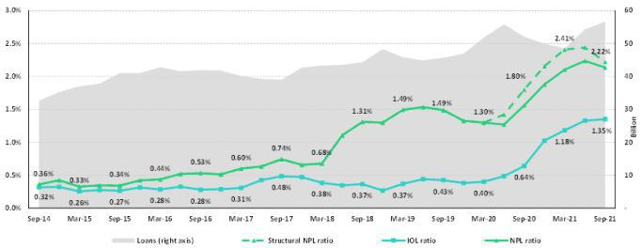

SME-Business
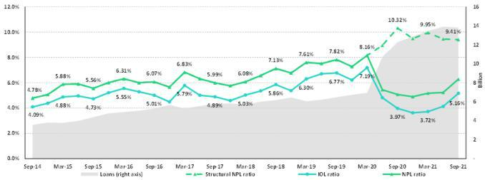

SME-Pyme
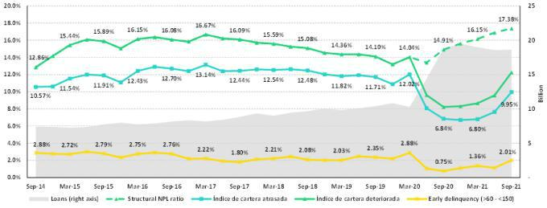

79

Mortgage
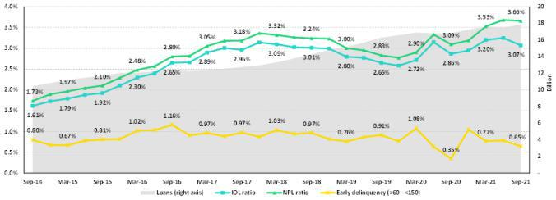

Consumer
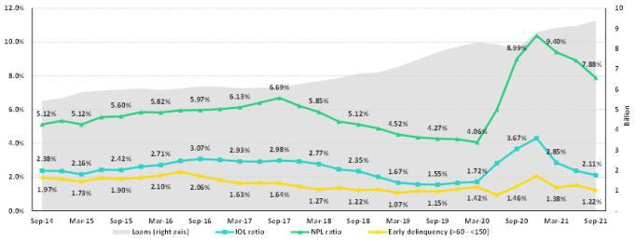

Credit Card
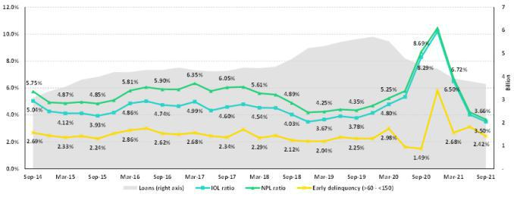

80

Mibanco
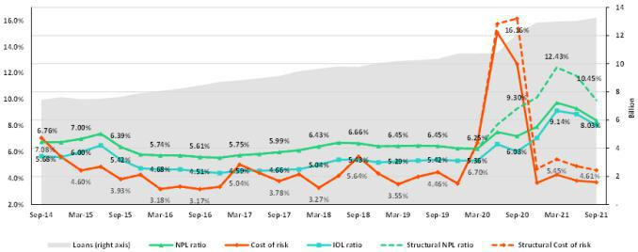

BCP Bolivia
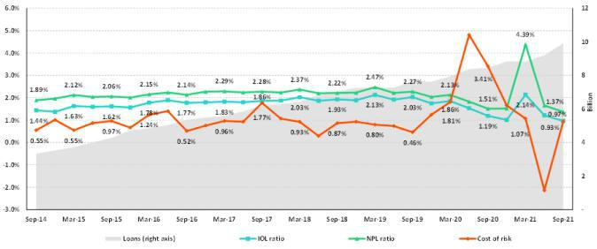

81

12.12. Table of calculations
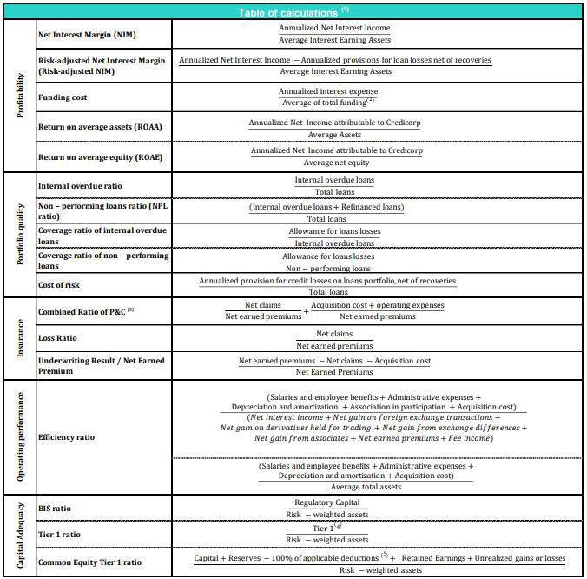

- Averages are determined as the average of period-beginning and period-ending balances.

- Includes total deposits, due to banks and correspondents, BCRP instruments, repurchase agreements and bonds and notes issued.

- Does not include Life insurance business.

- Tier 1 = Capital + Legal and other capital reserves + Accumulated earnings with capitalization agreement + (0.5 x Unrealized profit and net income in subsidiaries) - Goodwill - (0.5 x Investment in subsidiaries) + Perpetual subordinated debt (maximum amount that can be included is 17.65% of Capital + Reserves + Accumulated earnings with capitalization agreement + Unrealized profit and net income in subsidiaries - Goodwill).
- Includes investment in subsidiaries, goodwill, intangibles and deferred tax that rely on future profitability.

82

12.13. Glossary of terms

Government Program Loans (“GP or GP loans”) | Loan Portfolio related to Reactiva Peru and FAE-Mype programs to respond quickly and
Government Program Loans (“GP or GP loans”) | effectively to liquidity needs and maintain the payment chain.
Structural Loans | Loan Portfolio excluding GP Loans.
Non-Recurring Events at Interest Income | Impairment charge (related to the government facility that allowed for deferrement of certain
Non-Recurring Events at Interest Income | installments at zero cost) and subsequent amortization thereof.
Non-Recurring Events at Interest Expense | Charges related to the liability management operation at BCP (3Q20,1Q21).
Structural Cost of risk | Cost of Risk related to the Structural Loans. It excludes, in the numerator, provisions for credit
Structural Cost of risk | losses on GP loans, and in the denominator, the total amount of GP Loans.
Structural NPL ratio | NPL Ratio related to Structural Loans. It excludes the impact of GP Loans.
Structural NIM | NIM related to structural loans and other interest earning assets. It deducts the impact from GP
Structural NIM | loans and non-recurring events from Interest Income and Interest Expenses.
Structural Funding Cost | Funding Cost deducting the impact in expenses and funding related to GP Loans and deducting
Structural Funding Cost | non-recurring events from Interest Expense.
 | 83

